
PROJECT REPORT
ON
ROUTE SURVEY
OF
OKE-OSE- SENTU ROAD, OFF OLD JEBBA ROAD, ILORIN EAST LOCAL GOVERNMENT AREA, KWARA STATE.

BY

BADMUS FATHIA ARIKE
MATRIC NO.: ND/23/SGI/FT/070

BEING A PROJECT REPORT SUBMITTED TO THE DEPARTMENT OF SURVEYING AND GEO-INFORMATICS, INSTITUTE OF ENVIRONMENTAL STUDIES.

IN PARTIAL FULFILMENT OF THE REQUIREMENT FOR THE AWARD OF ORDINARY NATIONAL DIPLOMA (OND) IN SURVEYING AND GEO-INFORMATICS, KWARA STATE POLYTECHNIC, ILORIN.

JUNE, 2025
CERTIFICATION
This is to certify that BADMUS FATHIA ARIKE; with matriculation number ND/23/SGI/FT/0070 has satisfactorily carried out the survey duties contained in his project under my instruction and direct supervision.
I hereby declare, that he has conducted himself with due diligence, honesty and sobriety on the project.

____________________ ___________________
Surv. Abdulsalam Ayuba Sign and Date
Project supervisor

____________________ ___________________
Surv. S. A. Awoleye Sign and Date
Project Coordinator

____________________ __________________
Surv. I. I. Abimbola Sign and DateHead of Department

____________________ __________________
External Examiner Sign and Date

DEDICATION
This project is dedicated to Almighty God and my lovely parents MR AND MRS BADMUS who saw me through the programme.

ACKNOWLEDGEMENT
All glory, Honor and Adoration to God Almighty, the gracious one who has given me the opportunity to complete my ND programme.
My appreciation goes to my supervisor Surv. Abdulsalam Ayuba, for his encouragement and motivation as regard the writing of this project thank you and God bless you. And to all lecturers in the Department of Surveying and Geoinformatics, Surv. I .I.Abimbola (HOD). Surv. A. G. Aremu, Surv. R. S. Awoleye, Surv. R. O. Asonibare, Surv. Ayuba Abdulsalam, Surv. Oguntayo Benard, Surv. Babatunde Kabir, Surv. Bello F.D, Surv. Sam and others. May God bless you all (Amen).
I also express my sincere gratitude to my wonderful parent Mr. and Mrs. BADMUS for their financial moral support toward the completion of this program. You will reap the fruit of your labor. (Amen).

ABSTRACT
The Route Survey from G.T Junction way to Sentu Village was carried out by carried out recce survey, planning at the office. Differential GPS GNNSS receiver was used for the traversing and detailing while the controls establishment and benchmarks was also done by DGPS all across the route line at every 1km and the data was processed using CivilCAD2014 with the AutoCAD 2007. Series of engineering plans was produces like horizontal alignment plan and vertical alignment plan.

TABLE OF CONTENTS
TITLE PAGE - - - - - - - - i
CERTIFICATION - - - - - - - - ii
DEDICATION - - - - - - - - iii
ACKNOWLEDGEMENT - - - - - - - iv
ABSRACT - - - - - - - - - v
TABLE OF CONTENT - - - - - - - vi
CHAPTER ONE:
1.0 INTRODUCTION - - - - - - - 1
1.1 AIM - - - - - - - - - 2
1.2 OBJECTIVE - - - - - - - 3
1.3 SCOPE - - - - - - - - 3
1.4 PERSONNEL - - - - - - - 4
1.5 LOCATION - - - - - - - - 4
1.5.1 MAP OF THE SITE LOCATION - - - - - 5
CHAPTER TWO
LITERATURE REVIEW - - - - - - - 7
CHAPTER THREE
3.0 METHODOLOGY - - - - - - - 12
3.1 RECONNAISSANCE - - - - - - 12
3.1.1 OFFICE PLANNING - - - - - - 13
3.1.2 FIELD PLANNING - - - - - - 13
3.1.3 FIELD PREPARATION - - - - - 14
3.2 MOMENTATION - - - - - - - 14
3.3 EQUIPMENT USED - - - - - - 15
3.4 METHOD USED - - - - - - - 16
CHAPTER FOUR
4.0 DATA PROCESSING AND RESULT ANALYSIS - - 18
4.1 DATA DOWNLOADING - - - - - 18
4.2 DATA PROCESSING - - - - - - 19
4.3 RESULT ANALYSIS - - - - - - 19
4.3.1 LONGITUDINAL /HORIZONTAL ALIGNMENT PROFILE 19
4.4 INFORMATION PRESENTATION/ PLAN PRODUCTION 20
CHAPTER FIVE:
5.0 SUMMARY AND CONCLUSION - - - - 24
5.1 SUMMARY - - - - - - - 24
5.2 PROBLEMS ENCOUNTERED - - - - - 24
5.3 SOLUTION TO THE PROBLEM - - - - 25
5.3 CONCLUSIONS - - - - - - - 25
5.4 RECOMMENDATION - - - - - - 25
REFERENCE - - - - - - - 26
APPENDIX - - - - - - - - 28

CHAPTER ONE
1.0 INTRODUCTION
Route surveying is a major type of surveying under the broad engineering surveying which is one of the branches of surveying. Route survey is a large-scale engineering survey carried out for the purpose of obtaining necessary data required by the engineers for planning, and design of any route such as highways, railways, canals and pipelines etc. This kind of information is obtained by the Surveyor for proper assessment of natural and manmade features as well as to provide information for vertical and horizontal alignment along the route for setting out routes and constructions. It requires surveyors with excellent experience in planning, designing and setting out for the construction works.
A route survey is a detailed investigation and analysis of a proposed or existing pathway for transportation or infrastructure development. The route survey of Oke-Ose-Sentu road, in Ilorin, Kwara State, involves the systematic collection of data on the physical, environmental, and socio-economic characteristics of the area to guide planning and construction activities OkeOseSentu road, in Ilorin, is a significant urban area that requires thorough assessment to improve traffic flow, safety, and accessibility. The survey aims to identify the current conditions of the road, existing infrastructure, traffic patterns, and potential challenges such as drainage, land use, and encroachments. This information is crucial for designing road improvements, expansions, or new developments that meet the needs of the community and support sustainable urban growth.
Route surveying is comprised of all survey operations required for design and construction of engineering works such as highways, pipelines, canals, or railroads. At Caltrans a route surveying system is generally associated with highway design and construction.
Engineering surveying may be regarded as a specialty within the broader professional practice of engineering and includes all surveying activities required to support the conception planning, design, construction, maintenance, and operation of engineered projects. Engineering surveying excludes the of real property, for the establishment of land boundaries, right of way, easements, and the dependent or independent surveys or resurveys of the public land survey system. ASCE believes that this definition should be adopted by state engineering licensing boards.
Road failure could be cracks, potholes, bulges, and depression, which makes road networks unsafe and not motor-able to road users. Road failure in Nigeria is a major problem after the problem of power supply, it has not only caused a setback to the Nigerian economy but has led to the loss of lives and properties in millions of Naira annually. Rehabilitation of this road network has become a financial burden to the Federal, State, and Local government. Federal Road Safety Corps (FRSC 2011) reported that Nigeria ranks 191 of 192 countries in the world with unsafe roads, and as a result, 162 deaths per 10,000 populations occur from road crashes. Most accidents recorded occurred within the bad portions that are due to failure. Vehicles in the bid to avoid potholes, cracks, depressions take the wrong direction sometimes in the dark, jump into these bad spots, and results in a head-on collision. Herbert Macaulay Yaba Lagos state road also has been affected; vehicles spend longer hours before getting to their destinations due to road failure and this has negatively affected the socio-economic activities of people living along with the road network.

1.1 AIM
The aim of the route survey project at OkeOse is to carry out a detailed route survey that includes determining the exact location, alignment, and profile of the road segment for construction or improvement purposes. This involves producing both horizontal and vertical alignment plans, marking chainages, conducting traversing to establish spot heights, and collecting data for design and earthwork volume computations.

1.2 OBJECTIVE
Objectives of the Project
The following objectives were strictly followed for the actualization of the aims of the project.
- Carryout proper reconnaissance which involves office planning and field reconnaissance for route survey of OkeOseSentu road.
- Carryout the three (3) dimensional observation (X,Y,Z) of the profile and cross section of the route as well as fixing of all the details along the route of the project site.
- Carryout the design of the route by following the survey rules and departmental instructions.
- Present all the information in both soft and hardcopy For route survey of OkeOseSentu road.

1.3 SCOPE
A route survey project-such as the one proposed for OkeOseSentu road encompasses the systematic collection and analysis of data necessary for the planning, design, and eventual construction or rehabilitation of a roadway. The scope defines the boundaries, tasks, and deliverables required to achieve the project’s objectives.

1.4 PERSONNEL
The personnel involved in this execution of this project are as follows.
NAME | MATRIC NUMBER
ALADE FLORENCE ABOSEDE | ND/23/SGI/FT/0071
AWOSUNLE BOLUWATIFE OLUWAPONMILE | ND/23/SGI/FT/0072
KAZEEM FARIDAH ENIOLA | ND/23/SGI/FT/0069
MURITALA MUJIDAH KEHINDE | ND/23/SGI/FT/0068
BADMUS FATHIA ARIKE ADE | ND/23/SGI/FT/0070
AZEEZ FARUQ AYOMIDE | ND/23/SGI/FT/006
OLAREWAJU BOLUWATIFE ADURAMIGBA | ND/23/SGI/FT/0067

1.5 LOCATION
The study area is at Sentu – Oke-Ose Road, off Old Jebba road, Ilorin East Local Government Area Kwara State. The length of this project is 5km covered the Latitude (8⁰32’54.40”)N Longitude (4⁰39’10.90”)E and Latitude (8⁰30’52.57”)N Longitude (4⁰40’55.30”)E.

1.5.1 MAP OF THE SITE LOCATION
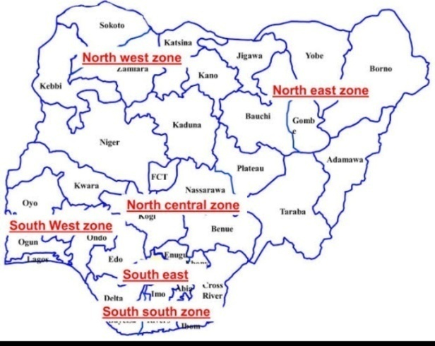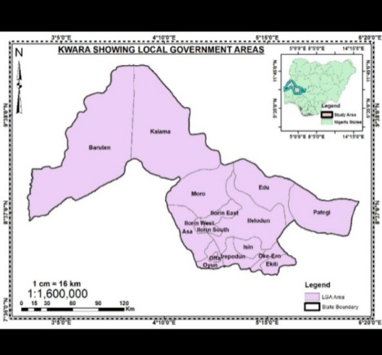

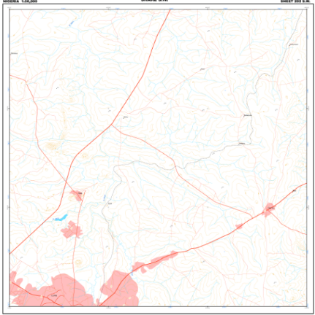
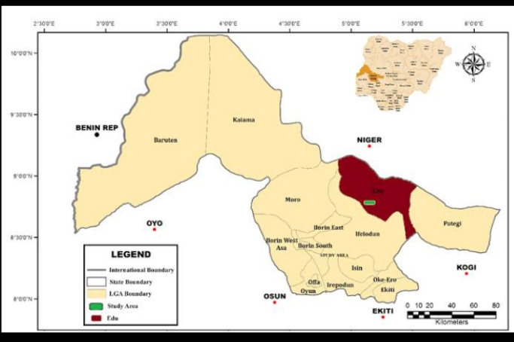

FIG.1.0 Showing Nigeria map, Kwara state map, and topographical map covering the project area .

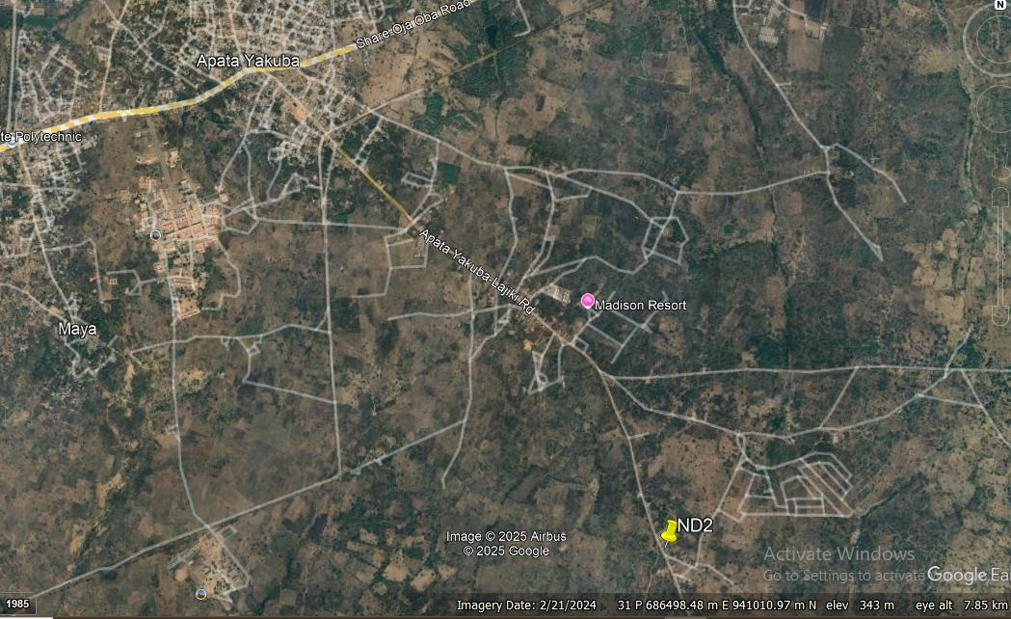

Fig. 1.1 showing the imagery covering the project area

CHAPTER TWO
2.0 LITERATURE REVIEW
A literature review on route survey covers the methodologies, technologies, and applications involved in establishing horizontal and vertical alignments for transportation routes such as roads, railways, and pipelines. Route surveying involves determining terrain, topography, and ground configuration to plan and construct transportation facilities, focusing on horizontal and vertical control for design and construction.
Various methodologies are used, including traditional surveying, GPS-based techniques, and advanced technologies like LiDAR, each with strengths and limitations. Applications span transportation planning, urban development, environmental monitoring, and infrastructure maintenance, highlighting the importance of accurate route data. Challenges include data accuracy, cost-effectiveness, and processing large datasets; my research aims to improve these aspects and integrate new technologies.
Studies also emphasize the importance of systematic route selection criteria in route surveys and navigation experiments to ensure reliability and reduce bias, considering factors like route length, environment type, and decision points along the route.
Important references for further reading include works by Smith et al. (2018) on route survey methodologies, Johnson (2019) on urban infrastructure, Chen et al. (2020) on LiDAR and GPS integration, and Lee (2021) on comprehensive route survey technologies.
Route Surveying is such a survey exercise that requires all field works and calculations made for the purpose of locating and constructing a cross country social utilities such as highways, railways, canals, transmission lines and pipelines. This involves the determination of the ground configuration and location of physical features (naturals and man-made) along the route, establishing the line on the ground and computing the volume of earthwork. The main purpose of any route survey is to:
- Select one or more tentative general route for the roadway or utility
- Gather enough information about the general route to make it possible for the route designers to select the final location of the route, and
- Mark this final location selected from the available options.
With these purpose, route survey usually entails reconnaissance, preliminary and final-location survey phases that satisfy respectively, each of the purposes given above. Sometimes, the prevailing circumstances may preclude the requirement to perform all three phases; for example if a new road or utility line is to be constructed on a military installation, having a well-marked vertical and horizontal control networks and up-to-date topographic maps and utility maps, then the reconnaissance and preliminary survey phases may not necessarily be required.
Punmia et al (2005) explained route surveying as surveys along a comparatively narrow strip of territory for the location, design and construction of any route of transportation, such as highways and railroads, aqueducts, canals and flumes, pipeline for water, sewage, oil and gas, cableways, belt conveyors and power, telephone and telegraph transmission line is called ‘ROUTE SURVEY’. At this stage, it must be noted that the examples mentioned above cannot design themselves until some methods are used to make them refined.
It is worthy to note the construction of roads in Nigeria dated back to decades ago or during colonial era; roads are commonly found narrow till now, few are found serviceably and their horizontal and vertical alignment are much influenced by their topography. The road construction was then constrained by non-availability of earth moving equipment, limited funds, no skillful personnel and fewer numbers of vehicles on roads.
More so, certain procedures or method are used when carrying out a route survey explained by Basak (1994) that when the question of constructing a new road for public demand or some strategic reasons arises, the procedures to be taken are:
- To find the necessity for the existence of the road
- The marking of the tentative alignment
- The reconnaissance survey
- Preliminary location survey traverse
- Final location survey and report
He further explained that the tentative alignments are marked on the general map and contour map and contour map of the area through which the route is expected to pass.
Meanwhile, in every construction work, the surveyor stands to perform certain roles and also must be familiar with some procedures of the work at hand as at the time of execution. In view of the foregoing, Anderson and Raymond (1985) stressed that “In order to plan and perform, the surveyors needed to acquire the data of a route survey and the surveyor must be familiar with the following:
- The geometry of horizontal and vertical control and how they are used in the route alignment procedure.
- The methods of acquiring terrain data utilized in route design.
- The procedures followed in processing terrain data to obtain earth work volumes
- Establishment on the ground, a system of staves both in plane and elevation, from which measurement of earth work and structures can be taken conveniently by the construction force
- Giving lines and grades as needed either to replace stakes disturbed by construction or to reach additional points on the structure itself.
- Making measurements necessary to verify the location of completed part of the structure as-built survey.
In addition to the above, the surveyor concerned must also learn or be familiar with the reasoning and interpretation of maps, the symbols and signs, scales, directive, locations etc. certain parameters therefore are necessary to explain routes e.g. cross section, longitudinal sections, curves and setting.
Engineering surveying involves determining the position of natural and man-made features on or beneath the Earth’s surface and utilizing these features in the planning, design and construction works. It is a critical part of any engineering project. Without an accurate understanding of the size, shape and nature of the site the project risks expensive and time-consuming errors or even catastrophic failure. Olalekan et al. (2018).
Ajibola et al. (2020). Rural Roads play a vital role in the development of any emergent country. In India, rural roads share more than 85% of the road network of the country. A well-planned road network in rural areas is one of the most important infrastructure elements which improves rural accessibility and contributes to the rural development as a whole. Planning the road network in rural areas is crucial, not only in terms of network efficiency (concerning accessibility), but also regarding construction and operation costs, as limited funding is available.
John, H. and Gorden, H. (1976): Route surveying includes the field and office work required to plan, design, and lay out any “long and narrow transportation facility. Ahmed Abdel-Rahim 2011 Route surveying which is a branch of Surveying has three different components, measuring distance, angles and elevation. Route surveys are essential in the planning, design, and execution of infrastructure projects. In the case of Kwara State, Nigeria, route surveys provide valuable data for infrastructure planning, urban development, and transportation networks. The focus of this literature review is to examine previous studies, reports, and relevant academic literature related to route surveys, particularly in the context of the administrative block of Kwara State. This review aims to highlight the importance of route surveys, methodologies used, challenges faced, and their relevance to urban planning and transportation development in Kwara State

CHAPTER THREE
3.0 METHODOLOGY
This can be termed as a set of methods and principles used to perform a particular activity. For the activities to be successfully performed, proper planning is very important. This involves development of a work plan showing how goals and objectives are to be accomplished. Hence, planning is one of the essential factors for the effective project execution and management. Proper planning was taken for the execution of this project and this involved;
- The choice of the most appropriate techniques for carry out of the project
- Selection of equipment used
- The design of a monitoring scheme that really helped in achieving the required accuracy for the project, starting from reconnaissance to the final product of the project.

3.1 RECONNAISSANCE
This is an important and first aspect in any survey project carried out to obtain the general view of the study area in terms of the nature of the terrain and to adequately plan the best ways to the set aim and objectives of the project. The importance of reconnaissance to any survey work of any size and nature cannot be over-emphasized. Experience has proved that time spent in carrying out a good reconnaissance is not a wasted time since it contributes to the quick execution of any survey exercise and promotes easy survey work. Reconnaissance simply connotes the summation of all activities preceding the actual execution of a survey job. It involves taking a general study or view of an area of operation with a view of knowing how best the operation is to be carried out in terms of energy and time. As this project was concerned, the reconnaissance was carried out in two stages.
The two stages of reconnaissance are;
- Office planning
- Field planning

3.1.1 OFFICE PLANNING
Office planning is also known as office reconnaissance. It is a vital component of route surveying, enabling surveyors to gather existing data and information before conducting fieldwork. This process involves a thorough review of available resources, including maps, aerial imagery, and existing reports.

3.1.2. FIELD PLANNING
The field reconnaissance was first carried out before the actual operation. This aspect involved site visitation to the project site by all the group members to have a pre-requisite knowledge of how it looks and how the field operation will be carried out.
During the visit, the control points planned to be used were marked, the reconnaissance facilitated the planning and carrying out of the actual survey as it was taking into consideration, the possible problem that are likely to be encountered, how such problems can be overcome or reduced to the barest minimum.

3.2 FIELD PREPARATION
This involved the operation carried out before the actual observation. The operation involved marking of chainages which is done at 25cm interval.

3.3. MOMENTATION
Temporary bench mark (TBM) were established and coordinated along the entire route of the project, which were meant to serve as controls for establishing Centerline chainage, setting out of curve and other road features during the actual construction.
The position of these beacons were selected in such a way that they are intervisible to each other, not too far from the proposed road and considerable number of Centerline can be set out from them.
The property beacon used were precast with dimensions 18cm square by 75cm in length. 65cm of the precast beacon was buried beneath the surface and 10cm above. This was done in compliance with the specification of cadastral survey regulations as specified in CAP 425 law of the federation of Nigeria. The property beacon was made of concrete mixture of ratio 3:2:1 of sand, granite and cement. The iron rod protruding at the center of the beacon formed the station mark.
The numbering was done serially from the beginning to the end of the proposed road and were prefixed with the identification number KP ND11 001

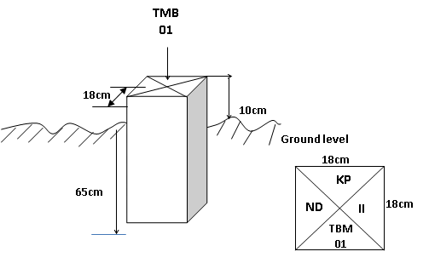

Fig. 3.0 showing typical survey beacon
3.4. EQUIPMENT USED

3.4.1 HARDWARE USED
- Differential GPS
- Handheld GPS
- Linen tape
- Power supplies
- Nails and bottles cork
- Hammer
- Cabling and connectors

3.4. 11. SOFTWARE USED
- AutoCAD/ CivilCAD 2014
- Microsoft office (word and excel)
- Notepad

3.5. METHOD USED
CORS TECHNOLOGY
CORS stands for (Continuously Operating Reference Station). It is a type of GPS or GNSS (Global Navigation Satellite System) station that:
  - Collects and transmits GPS/GNSS data continuously.
  - Provides real-time corrections to improve the accuracy of GPS signals.
CORS are used to enhance the precision and reliability of GPS positioning for various applications, including surveying, mapping, navigation, and more.
How you use a CORS with a data logger when collecting survey data:
How to Use a CORS with a Data Logger
1. Set Up Your GNSS Receiver & Data Logger
- Mount the GNSS antenna securely on your survey pole or tripod.
- Connect your data logger/controller to the GNSS receiver. The data logger is usually a handheld device or tablet used to configure settings and record data.
2. Configure the CORS Connection
- On the data logger, enter the CORS network settings:
- Enter the username
- IP address & port of the CORS provider.
- You’ll need mobile internet (, hotspot) on your data logger or receiver to access the CORS network in real time.

3. Select Correction Service Type
- Choose RTK corrections (Real-Time Kinematic) if you want live centimeter-level accuracy.
- Some systems also allow post-processing (PPK), where you log raw data and apply CORS corrections later.
4. Start Receiving Corrections
- Once connected, the GNSS receiver will start applying correction data from the CORS.
- The data logger will show “Fixed RTK” or “Float RTK” status, indicating correction quality.
5. Begin Surveying & Logging Points
- Move to the points you want to survey.
- Use the data logger to record positions, adding descriptions, codes, or attributes as needed.
- Each recorded point will have high-precision coordinates
6. Save & Export Data
- After collecting your points, you can export the data (CSV, DXF, shapefiles, etc.) from the data logger for further use in GIS, CAD, or mapping software.
In Simple Terms:
The CORS sends corrections to your rover via the internet. Your data logger controls the receiver and records corrected point data.

CHAPTER FOUR
4.0 DATA PROCESSING AND RESULT ANALYSIS
This stage involves downloading of the acquired data on field from the digital equipment to the personal computer for further processing. The data obtained were downloaded using a data transfer cable. After successfully downloaded of those data, they were edited using Microsoft Excel and Notepad Software which made it possible to easily import the edited copy into AutoCAD for drafting and designing. The coordinate obtained were in X, Y, Z format which were used for plotting the route’s longitudinal profile

4.1. DATA DOWNLO1ADING
- The instrument was connected to the personal computer via downloading cable, the corresponding software was launched and the instrument port was selected.
- All the folders on the instrument were displayed. The folder containing the data for the group was then copied and pasted on another folder already created on the local drive of the personal computer.
- The folder was launched and the file containing the data was opened with notepad application.
- The results were in the format; Point ID, Easting, Northings and Height. The downloaded data were edited in Notepad, Microsoft Excel and a script were prepared in Notepad in order to be plotted in AutoCAD.

4.2 DATA PROCESSING
Data processing is a critical component of route surveys, enabling the transformation of raw data into usable information for design, analysis, and decision-making. Route surveys involve collecting vast amounts of data, including topographic information, environmental factors, and infrastructure details.
The data processing stage involves several key steps, including data cleaning, transformation, analysis, and visualization. Data cleaning removes errors, inconsistencies, and outliers, ensuring the accuracy and reliability of the data. Data transformation converts the data into suitable formats, while data analysis applies algorithm
The downloaded data from the equipment was further edited using Microsoft Excel and Notepad, the final edited copy was saved as text file containing X, Y, Z coordinates of all points observed in the field.

4.3 RESULT ANALYSIS
The results were analyzed so as to check the accuracy of the job by comparing the result obtained with the minimum allowable error acceptable for this order of survey job in accordance with survey rules and departmental instructions.

4.3.1 LONGITUDINAL /HORIZONTAL ALIGNMENT PROFILE
- In CivilCAD environment, Road menu was clicked and HORIZONTAL ALIGNMENT chosen
- Options button was clicked in the appeared dialogue box and Define section was then clicked to choose the section format and the distance between the sections. Format 2 was chosen and the distance between sections was taken to be 25m.
- Having chosen these options, OK was clicked twice.
- Pick tool was selected from the right pane dialogue box to pick the intersection points (IP), and appropriate radius values of curve was given to each IP as specified by the client.
- Apply button was then clicked to effect all the given parameters on the drawing. On each IP position, information about the IP is been displayed. Such information are; IP number, X coordinate, Y coordinate, Radius of Curve, Length of curve, Deflection angle and so on.

4.4 INFORMATION PRESENTATION/ PLAN PRODUCTION
The data acquired were processed into plan for visual presentation with AutoCAD/CivilCAD. The visual display graphical information in AutoCAD was printed as hardcopy of the plan. The longitudinal section, and profile were plotted.

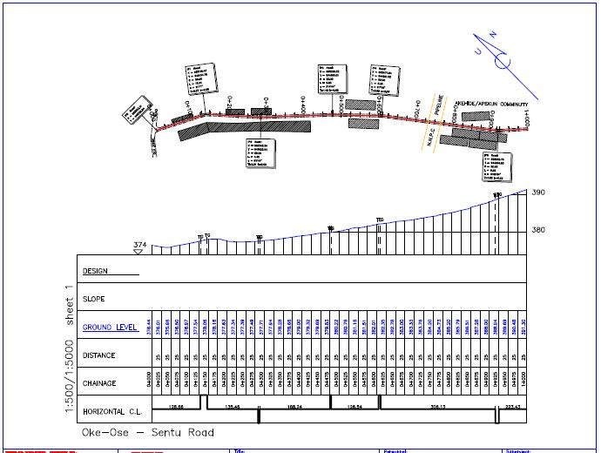

Fig. 4.0 showing the Profile and Longitudinal Section from Chainage 0+000 – 1+000

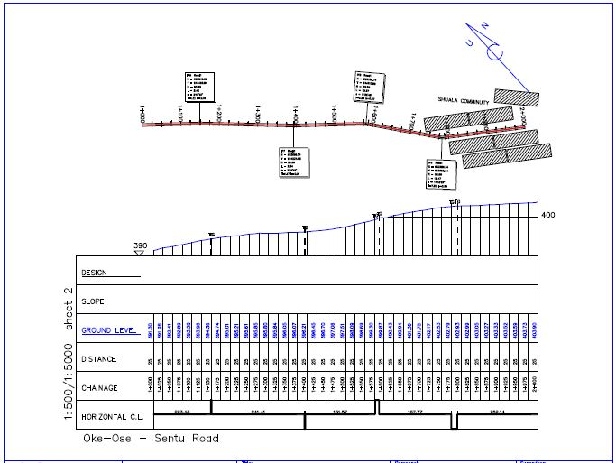

Fig. 4.1 showing the Profile and Longitudinal Section from Chainage 1+000 – 2+000

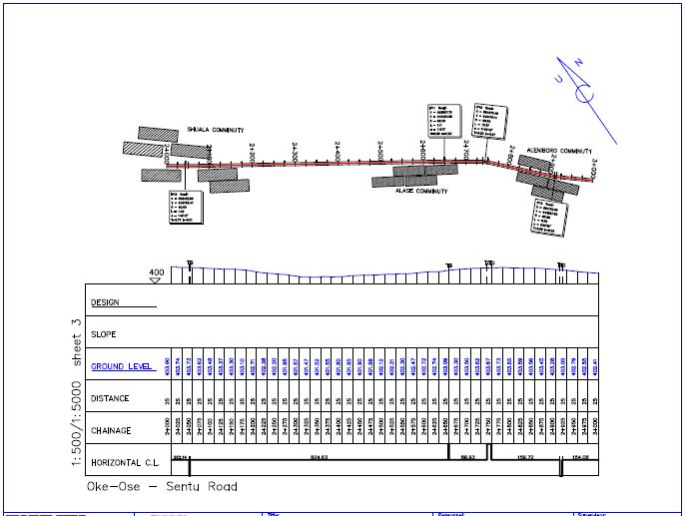

Fig. 4.2 showing the Profile and Longitudinal Section from Chainage 2+000 – 3+000

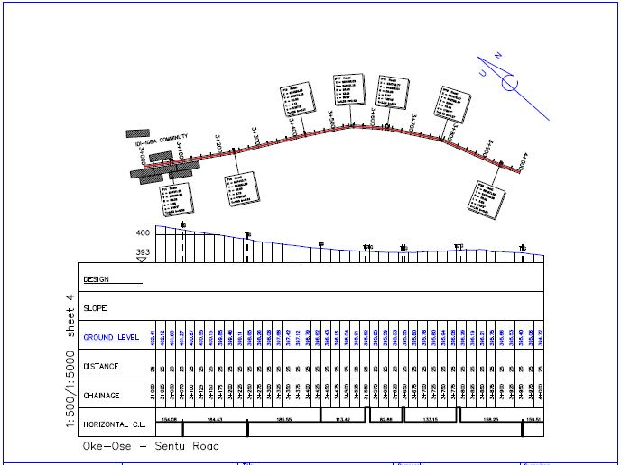

Fig. 4.3 showing the Profile and Longitudinal Section from Chainage 3+000 – 4+000

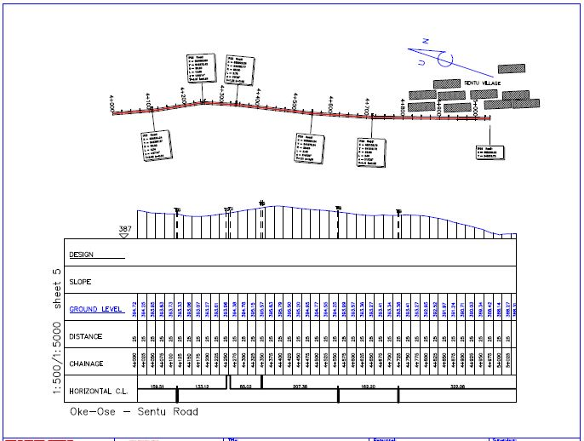

Fig. 4.4 showing the Profile and Longitudinal Section from Chainage 4+000 – 5+025

CHAPTER 5
5.0 SUMMARY, PROBLEM ENCOUNTERED, RECOMMENDATION AND CONCLUSION.

5.1 SUMMARY
The project covered a total length of 5km. The field work however involved the following processes; Recce, monumentation traversing and detailing. CORS was used for data acquisition and its software for downloading and transforming the acquired data respectively. The adjusted coordinates were used for the production of the final plans.

5.2. PROBLEMS ENCOUNTERED
- Accuracy concerns: Accuracy decrease distance from the CORS station. Interference from vegetation or buildings which also affect signal quality.
- Station Maintenance: CORS require regular maintenance and monitoring to ensure their reliability and accuracy. Unmaintained stations can introduce errors into the positioning data.
- Inadequate CORS Coverage: In areas with sparse CORS networks, the ability to provide accurate positioning across the entire route can be limited.

5.3 SOLUTION TO THE PROBLEMS
- Optimize station placement: Choose CORS that are strategically located for optimal coverage and accuracy in your survey area.
- Use higher-quality receivers: Employ survey-grade GPS receivers that are more robust to interference and capable of maintaining high accuracy.
- Implement error detection and correction techniques: Utilize post-processing techniques or real-time kinematic (RTK) methods to minimize errors.

5.4 RECOMMENDATION
Using CORS stations in route surveys offers significant advantages in terms of accuracy, efficiency, and cost-effectiveness. Choosing the appropriate CORS network, utilizing compatible equipment, and implementing effective field procedures are crucial for achieving high-quality survey results. By leveraging this technology, surveyors can achieve higher quality results while reducing project timelines and expenses.

5.5 CONCLUSION
CORS systems are a valuable tool for route surveys, providing accurate, reliable, and efficient positioning solutions. With their ability to deliver centimeter-level accuracy and streamline survey workflows, CORS systems are becoming increasingly important for a wide range of surveying and mapping applications.

REFERENCE
Ajibola et al. (2020).Rural Roads, Standard Publishers Distributors. 4th Edition.
Abynayaka (1977), Paul and Radnor (1976), UNESCO (1991), World Bank (1991), Jain and Kumar (1998), FMWH (1995); Poor Maintenance according to John and Gordon (1976), Oglesby and Garry (1978), TRRL (1991); and Traffic Effects and Human Impacts on the Roads according to AASHTO (1976), FMWH (1995) ANSMWH (1998), and Ibrahim (2011).
Dr. I.P. Ifabiyi (2013): “Geotechnical Investigation of Road Failure along Ilorin-Ajase – Ipo Road Kwara State, Nigeria”.
Gupta, B. L. and Gupta, A. (2003): “Roads, Railways, Bridges, Tunnel and Harbor Dock Engineering”; Standard Publishers Distributors, NaiSarak, Delhi. 5th Edition.
John, H. and Gorden, H. (1976): “A practical Guide to Earth Road Construction and Maintenance”, Engineering Manual Vol. 2, No. 1. Pp. 43-45.
Momoh, L.O., Akintorinwa, O. and Olorunfemi, M.O. (2008): “Geophysical Investigation of Highway Failure- A Case Study from the Basement Complex Terrain of Southwestern Nigeria”. Journal of Applied Sciences Research. 4(6): 637-648.
Oglesby, C. H. and Garry, H. R. (1978): “Highway Engineering”, fourth edition, John Willey and sons, New York, p.691.
Ogunola, 1999, Geographic Information System
Olalekan et al. (2018). Defined Engineering Surveying
Priscilla. A. Glasgow Fundamentals of Survey Research methodology April 2005
Pinsonneault, A., & Kraemer, K. L. (1993). Survey research methodology in management information systems: An assessment. Journal of Management Information Systems, 10, 75-105.
Salant, P., &Dillman, D. A. (1994). How to conduct your own survey. New York.

APPENDIX
Name | N | E | H
Base_0 | 937113.1 | 671374.3 | 290.1564
PT1 | 945199.3 | 682040.6 | 376.7882
PT2 | 945213.6 | 682040.1 | 376.9413
PT3 | 945211.5 | 682003.7 | 375.523
PT4 | 945195.8 | 682006.7 | 375.3559
PT5 | 945196.7 | 682015.1 | 376.0015
PT6 | 945195.3 | 682015.3 | 375.6575
PT7 | 945198.1 | 682029.9 | 376.6706
PT8 | 945197 | 682030 | 376.6791
TBM | 945198.3 | 682030.3 | 376.5831
PT9 | 945196.8 | 682023.3 | 376.4395
TBM2 | 945195.5 | 682016 | 376.149
PT10 | 945180.9 | 682042.2 | 375.4776
PT11 | 945189.1 | 682045.9 | 376.1932
PT12 | 945185.8 | 682044.1 | 375.9832
PT13 | 945169.6 | 682068.4 | 375.8128
PT14 | 945173.3 | 682070.4 | 376.1018
PT15 | 945177.4 | 682070.2 | 376.1243
PT16 | 945164.7 | 682102.3 | 377.128
PT17 | 945158.5 | 682099.6 | 376.68
PT18 | 945154.6 | 682097.6 | 376.4599
PT19 | 945140.1 | 682122.3 | 376.9666
PT20 | 945144.6 | 682125.7 | 377.2596
PT21 | 945148.2 | 682127.9 | 377.3442
PT22 | 945120.7 | 682147.4 | 377.4701
PT23 | 945124.2 | 682150.8 | 378.0427
PT24 | 945125.9 | 682152.4 | 378.0537
PT25 | 945098.5 | 682168.5 | 378.0107
PT26 | 945101.5 | 682173.1 | 378.1797
PT27 | 945105.2 | 682176.5 | 378.1743
PT28 | 945081 | 682188.1 | 377.3532
PT29 | 945075.5 | 682192.4 | 377.1792
PT30 | 945070.3 | 682187.8 | 376.6787
PT31 | 945073.3 | 682183.8 | 376.4857
PT32 | 945080.9 | 682194.6 | 377.4948
PT33 | 945085.9 | 682197.4 | 377.5604
PT34 | 945063.1 | 682219.9 | 377.4999
PT35 | 945058.1 | 682215.5 | 377.3388
PT36 | 945052.9 | 682210.7 | 377.3088
PT37 | 945031.9 | 682232.7 | 377.3118
PT38 | 945036 | 682236.9 | 377.4859
PT39 | 945040.9 | 682242.2 | 377.962
PT40 | 945019.5 | 682262.2 | 377.834
PT41 | 945015.2 | 682258.3 | 377.7304
PT42 | 945011 | 682255.5 | 377.7909
PT43 | 944991.5 | 682273.8 | 377.8099
PT44 | 944994.4 | 682278.7 | 377.9765
PT45 | 944998.6 | 682283.3 | 378.3025
PT46 | 944979.2 | 682305.5 | 378.9486
PT47 | 944974.5 | 682300.9 | 378.4325
PT48 | 944970.2 | 682296.8 | 378.4865
PT49 | 944949.1 | 682317.9 | 378.8185
PT50 | 944953.3 | 682323.2 | 378.8761
PT51 | 944958.3 | 682328.4 | 379.2777
PT52 | 944942.5 | 682346.5 | 379.5567
PT53 | 944939.2 | 682351.6 | 379.7302
PT54 | 944949 | 682356.3 | 379.9093
PT55 | 944952.4 | 682352.9 | 379.9308
PT56 | 944934.6 | 682344.2 | 379.2306
PT57 | 944928.6 | 682339.6 | 379.1981
PT58 | 944909.6 | 682361.3 | 379.4121
PT59 | 944915.3 | 682366.2 | 379.7087
PT60 | 944919 | 682370.1 | 380.1443
PT61 | 944900 | 682390.6 | 380.2548
PT62 | 944895.8 | 682386.2 | 379.8353
PT63 | 944891.8 | 682382.8 | 379.7662
PT64 | 944872.1 | 682400.3 | 380.2427
PT65 | 944876.4 | 682405.1 | 380.2813
PT66 | 944879.6 | 682408.2 | 380.6578
PT67 | 944862.6 | 682424.9 | 380.9054
PT68 | 944858.9 | 682421.8 | 380.8158
PT69 | 944855.1 | 682417.9 | 380.8773
PT70 | 944851.4 | 682421.7 | 381.0128
PT71 | 944843.4 | 682416.4 | 380.5042
PT72 | 944848.8 | 682411.8 | 380.4407
PT73 | 944836.2 | 682437.8 | 381.1378
PT74 | 944835.4 | 682436.9 | 381.2068
PT75 | 944839.1 | 682440.6 | 381.1278
PT76 | 944843.1 | 682444.7 | 381.3639
PT77 | 944817.3 | 682455.6 | 381.5858
PT78 | 944816.1 | 682454.6 | 381.7118
PT79 | 944820.7 | 682459.4 | 381.6384
PT80 | 944824.3 | 682463.1 | 381.8139
PT81 | 944806 | 682480.9 | 382.633
PT82 | 944797.9 | 682472.8 | 382.1354
PT83 | 944801.9 | 682477 | 382.1574
PT84 | 944785.9 | 682496.9 | 382.6775
PT85 | 944778.8 | 682489.9 | 382.4644
PT86 | 944782.6 | 682493.5 | 382.4369
PT87 | 944764.9 | 682513 | 382.8735
PT88 | 944762.1 | 682509.8 | 382.9524
PT89 | 944758.6 | 682506.3 | 382.7369
PT90 | 944737.4 | 682521 | 383.1014
PT91 | 944740.6 | 682526.5 | 383.1414
PT92 | 944744.8 | 682531 | 383.4055
PT93 | 944721.6 | 682544.4 | 383.583
PT94 | 944718.3 | 682540.9 | 383.5089
PT95 | 944715.2 | 682536.7 | 383.4319
PT96 | 944694.3 | 682552.6 | 383.8999
PT97 | 944687.7 | 682545.1 | 383.3217
PT98 | 944678.5 | 682553.9 | 383.4058
PT99 | 944684.7 | 682563.7 | 384.1829
PT100 | 944691.4 | 682573.8 | 384.36
PT101 | 944702.8 | 682568.4 | 384.2641
PT102 | 944705.4 | 682578.7 | 384.5537
PT103 | 944698.9 | 682584.3 | 384.4892
PL | 944699.7 | 682541.9 | 383.8583
PL1 | 944671.7 | 682562.9 | 384.1068
PT104 | 944679 | 682577.9 | 384.475
PT105 | 944676.2 | 682575.2 | 384.6084
PT106 | 944671.7 | 682571.4 | 384.1429
PT107 | 944654.1 | 682586.9 | 384.8209
PT108 | 944657.7 | 682590.8 | 385.0929
PT109 | 944661 | 682594.8 | 384.9365
PT110 | 944640.3 | 682610.2 | 385.5405
PT111 | 944637.8 | 682607 | 385.5779
PT112 | 944633.8 | 682603.1 | 385.6409
PT113 | 944614 | 682619.2 | 386.2424
PT114 | 944612.7 | 682618.6 | 386.0484
PT115 | 944616.5 | 682623.3 | 386.1459
PT116 | 944619.5 | 682626.9 | 386.2865
PT117 | 944598.9 | 682640.3 | 386.9915
PT118 | 944592.9 | 682633.9 | 387.0579
PT119 | 944598.5 | 682628.4 | 386.9764
PT120 | 944586.2 | 682627.1 | 387.1628
PT121 | 944584.8 | 682632 | 387.3333
PT122 | 944575 | 682630.7 | 387.2937
PT123 | 944575.1 | 682626.5 | 387.2332
PT124 | 944573.1 | 682649.1 | 387.7229
PT125 | 944575.7 | 682653.2 | 387.7684
PT126 | 944578.9 | 682658.2 | 387.681
PT127 | 944558.3 | 682672.7 | 388.857
PT128 | 944554.5 | 682669.7 | 388.8159
PT129 | 944550.8 | 682667.6 | 388.7539
PT130 | 944535.3 | 682684.2 | 389.5004
PT131 | 944537.9 | 682688 | 389.5585
PT132 | 944540.6 | 682690.9 | 389.5255
AkehindeApekun Community | 944577.7 | 682638.6 | 387.7788
AkehindeApekun Community1 | 944518.9 | 682702.6 | 390.1885
PT133 | 944522.5 | 682706 | 390.2825
PT134 | 944525.4 | 682708.1 | 390.3206
PT135 | 944509.9 | 682727.9 | 391.0931
PT136 | 944505.8 | 682725.4 | 391.1421
PT137 | 944501.5 | 682723 | 391.112
PT138 | 944486.2 | 682741.6 | 391.9906
PT139 | 944488.9 | 682744.5 | 391.8936
PT140 | 944492 | 682747.1 | 391.7972
PT141 | 944476.5 | 682767.2 | 392.2418
PT142 | 944472.7 | 682765 | 392.3517
PT143 | 944468.2 | 682762 | 392.3047
PT144 | 944451.4 | 682782.2 | 392.9462
PT145 | 944455 | 682785.1 | 392.8338
PT146 | 944458.7 | 682787.8 | 393.0683
PT147 | 944441.5 | 682807.9 | 393.1609
PT148 | 944438.6 | 682804.9 | 393.3268
PT149 | 944433.6 | 682801 | 393.3697
TBM4 | 944424.8 | 682795.9 | 393.9601
TBM5 | 944435.8 | 682821.7 | 393.8164
PT150 | 944424.5 | 682828.5 | 393.5674
PT151 | 944419.9 | 682824.7 | 393.9648
PT152 | 944415.5 | 682820.9 | 393.9723
PT153 | 944399.9 | 682839 | 394.2888
PT154 | 944403.6 | 682842.6 | 394.3559
PT155 | 944409.9 | 682847.6 | 394.176
PT156 | 944390 | 682864.5 | 394.4079
PT157 | 944385.6 | 682860.7 | 394.7839
PT158 | 944380.6 | 682856.8 | 394.8008
PT159 | 944364.9 | 682872.9 | 395.0643
PT160 | 944368.9 | 682876.6 | 395.0744
PT161 | 944373.9 | 682881.5 | 394.702
PT162 | 944354.8 | 682897.6 | 395.1435
PT163 | 944350.9 | 682892.9 | 395.2114
PT164 | 944347.4 | 682889.1 | 395.5428
PT165 | 944330.1 | 682906.4 | 395.8108
PT166 | 944334.3 | 682912.1 | 395.6854
PT167 | 944338.7 | 682916.6 | 395.3885
PT168 | 944320.8 | 682935 | 395.728
PT169 | 944315.9 | 682930.3 | 395.9204
PT170 | 944311.3 | 682926.1 | 395.8679
PT171 | 944296.1 | 682942.1 | 395.8444
PT172 | 944299.5 | 682946.2 | 395.8974
PT173 | 944304.1 | 682951.5 | 395.673
PT174 | 944289 | 682967.9 | 395.7765
PT175 | 944283.3 | 682964.5 | 395.8435
PT176 | 944277 | 682958.6 | 395.9109
PT177 | 944262.5 | 682977.1 | 396.1149
PT178 | 944267.7 | 682981.6 | 396.042
PT179 | 944273.4 | 682986.3 | 395.8726
PT180 | 944255.4 | 683004.7 | 396.0681
PT181 | 944250.1 | 683000.1 | 396.048
PT182 | 944245.1 | 682995.7 | 396.0924
PT183 | 944230.6 | 683014.2 | 396.131
PT184 | 944234.6 | 683018.3 | 396.144
PT185 | 944237.9 | 683022.1 | 396.0736
PT186 | 944223.4 | 683039 | 396.3541
PT187 | 944219 | 683035.5 | 396.4091
PT188 | 944214.8 | 683032.7 | 396.3505
PT189 | 944199.5 | 683049.1 | 396.6295
PT190 | 944203.9 | 683052.7 | 396.5721
PT191 | 944207.9 | 683056.3 | 396.4497
PT192 | 944191.8 | 683073.5 | 396.8382
PT193 | 944186.1 | 683070.4 | 396.9311
PT194 | 944182.9 | 683068 | 396.9721
PT195 | 944169.1 | 683086.8 | 397.4131
PT196 | 944171.7 | 683089.9 | 397.2822
PT197 | 944174.7 | 683092.7 | 397.2282
PT198 | 944160.1 | 683110.5 | 397.8203
PT199 | 944157.2 | 683108.5 | 397.7892
PT200 | 944153.1 | 683104.5 | 397.7321
PT201 | 944137.1 | 683123.9 | 398.4182
PT202 | 944140.5 | 683127.2 | 398.4042
PT203 | 944143.3 | 683129.7 | 398.3403
PT204 | 944127.5 | 683147.2 | 398.7463
PT205 | 944124.6 | 683144.5 | 398.9343
PT206 | 944121.7 | 683142 | 399.0392
PT207 | 944105.7 | 683158.6 | 400.0922
PT208 | 944110.8 | 683159.7 | 399.4933
PT209 | 944106.7 | 683155.6 | 399.5002
PT210 | 944113.4 | 683164.4 | 399.2974
PT211 | 944098.7 | 683178.1 | 399.5654
PT212 | 944095 | 683174.7 | 399.7783
PT213 | 944091.5 | 683171.6 | 399.8762
PT214 | 944074.9 | 683183.7 | 400.4902
PT215 | 944077.8 | 683189.3 | 400.3653
PT216 | 944080.9 | 683193.5 | 400.1593
PT217 | 944063.6 | 683204 | 400.6243
PT218 | 944061.2 | 683200.2 | 400.8602
PT219 | 944058.2 | 683196.6 | 400.8792
PT220 | 944040.4 | 683210.2 | 401.2952
PT221 | 944043 | 683214.5 | 401.1792
PT222 | 944045.5 | 683218.2 | 401.4213
PT223 | 944028.7 | 683229.1 | 401.7632
PT224 | 944025.9 | 683225.4 | 401.5782
PT225 | 944023.6 | 683223 | 401.6441
PT226 | 944005.5 | 683234.9 | 402.0471
PT227 | 944007.6 | 683238.4 | 401.8831
PT228 | 944009.8 | 683241.8 | 402.0652
PT229 | 943990.8 | 683255.3 | 402.3592
PT230 | 943987.5 | 683250.9 | 402.3871
PT231 | 943985.1 | 683247.3 | 402.353
PT232 | 943965.5 | 683261.2 | 402.636
PT233 | 943968.2 | 683265.1 | 402.6051
PT234 | 943971.1 | 683267.8 | 402.6341
PT235 | 943953.9 | 683283.3 | 402.9241
PT236 | 943950.3 | 683280.3 | 402.867
PT237 | 943946.2 | 683276.6 | 402.855
PT238 | 943930 | 683293.6 | 403.034
PT239 | 943937.8 | 683302.3 | 402.9241
PT240 | 943934.5 | 683298.7 | 402.9391
PT241 | 943922.9 | 683319.2 | 403.0002
PT242 | 943918.8 | 683316.4 | 403.1341
PT243 | 943914.3 | 683313.5 | 403.171
PT244 | 943900.2 | 683331 | 403.3321
PT245 | 943905.3 | 683335.2 | 403.3572
PT246 | 943909.6 | 683338.2 | 403.0542
PT247 | 943896.5 | 683357.2 | 403.2603
PT248 | 943892 | 683355 | 403.4442
PT249 | 943886.5 | 683352.5 | 403.4612
PT250 | 943874.9 | 683368.9 | 403.4962
PT251 | 943880.5 | 683372.6 | 403.4413
PT252 | 943885.1 | 683375.7 | 403.2514
PT253 | 943875.4 | 683394.6 | 403.4564
PT254 | 943869 | 683391.3 | 403.5534
PT255 | 943861.9 | 683387.7 | 403.7203
PT256 | 943850.9 | 683406.5 | 403.4833
PT257 | 943855.2 | 683410.6 | 403.6394
PT258 | 943859.4 | 683413.5 | 403.4705
PT259 | 943845 | 683434.6 | 403.5495
PT260 | 943841.1 | 683433.2 | 403.7225
PT261 | 943834.4 | 683432.3 | 403.7144
PT262 | 943823.2 | 683448.8 | 403.5955
PT263 | 943827.3 | 683452.4 | 403.7766
PT264 | 943831.5 | 683456.2 | 403.7476
PT265 | 943818 | 683475.5 | 403.5397
PT266 | 943814.3 | 683472.6 | 403.7506
PT267 | 943809.1 | 683469.6 | 403.6386
SUHALLAH COMMUNITY | 943829.5 | 683463.2 | 404.2717
PT268 | 943804.4 | 683495.6 | 403.6028
PT269 | 943799.5 | 683493 | 403.7517
PT270 | 943794.4 | 683489.8 | 403.5156
TBM6 | 943829.4 | 683463.1 | 404.2497
PT271 | 943791.1 | 683515.3 | 403.5258
PT272 | 943786.5 | 683512 | 403.6738
PT273 | 943781.5 | 683509 | 403.4507
PT274 | 943777.3 | 683536 | 403.4439
PT275 | 943772.1 | 683532.8 | 403.5268
PT276 | 943768.3 | 683529.1 | 403.3418
PT277 | 943755.1 | 683548.2 | 403.3119
PT278 | 943759.4 | 683551.8 | 403.3889
PT279 | 943763.8 | 683554.9 | 403.425
PT280 | 943749.8 | 683573 | 403.3001
PT281 | 943745.3 | 683570.5 | 403.414
PT282 | 943740.2 | 683568.9 | 403.22
PT283 | 943727.7 | 683587.6 | 402.9841
PT284 | 943731.9 | 683591.5 | 403.2912
PT285 | 943736.2 | 683594.5 | 403.1083
PT286 | 943723.5 | 683614.3 | 402.8764
PT287 | 943718.5 | 683611.9 | 403.0073
PT288 | 943713.2 | 683608.8 | 402.8282
PT289 | 943701.6 | 683627 | 402.5364
PT290 | 943706.2 | 683630.6 | 402.6514
PT291 | 943709.9 | 683633.3 | 402.3815
PT292 | 943698.1 | 683652.8 | 402.3056
PT293 | 943693.6 | 683650.3 | 402.3576
PT294 | 943688.5 | 683647.2 | 401.9605
PT295 | 943675 | 683666.9 | 402.0186
PT296 | 943680.3 | 683670.3 | 402.1567
PT297 | 943684.1 | 683672.8 | 402.0927
PT298 | 943661.1 | 683686.9 | 401.5427
PT299 | 943666 | 683689.7 | 402.0488
PT300 | 943669.9 | 683693 | 401.6279
PT301 | 943656.8 | 683711.7 | 401.458
PT302 | 943652.5 | 683710.4 | 401.4469
PT303 | 943645.9 | 683707.4 | 401.3538
PT304 | 943635.7 | 683726.8 | 401.412
PT305 | 943638.6 | 683728.8 | 401.502
PT306 | 943642.6 | 683732.5 | 401.4641
PT307 | 943628.5 | 683753.3 | 401.6352
PT308 | 943626.2 | 683750.7 | 401.4542
PT309 | 943622.4 | 683748.9 | 401.4881
PT310 | 943610.3 | 683766.1 | 401.4962
PT311 | 943612 | 683767.3 | 401.5643
PT312 | 943617.2 | 683773.3 | 401.5304
PT313 | 943604.4 | 683790 | 401.5655
PT314 | 943601.1 | 683787.6 | 401.6204
PT315 | 943598.2 | 683786.3 | 401.6554
PT316 | 943586 | 683803.2 | 401.7885
PT317 | 943588.5 | 683805.9 | 401.8065
PT318 | 943591.7 | 683808.3 | 401.8456
PT319 | 943579.1 | 683826.5 | 401.9187
PT320 | 943575.4 | 683824.7 | 401.8486
PT321 | 943571.4 | 683822.3 | 401.9046
PT322 | 943561.4 | 683841 | 401.9397
PT323 | 943563.7 | 683842.6 | 401.8987
PT324 | 943567 | 683844.8 | 401.9258
PT325 | 943554.4 | 683864.9 | 402.0649
PT326 | 943551.4 | 683862.7 | 402.0289
PT327 | 943548.9 | 683861.3 | 402.0618
PT328 | 943535.8 | 683879.3 | 402.1429
PT329 | 943538.9 | 683881.2 | 402.114
PT330 | 943542.1 | 683883.1 | 402.204
PT331 | 943530.9 | 683903.2 | 402.2822
PT332 | 943526.9 | 683900.9 | 402.2491
PT333 | 943523.2 | 683899 | 402.4031
PT334 | 943511.5 | 683917.6 | 402.2792
PT335 | 943514.7 | 683919.6 | 402.2862
PT336 | 943518 | 683921.5 | 402.3533
PT337 | 943505.8 | 683941.2 | 402.4984
PT338 | 943501.2 | 683938.9 | 402.5274
PT339 | 943497.3 | 683936.9 | 402.5353
ALASE VILLAGE | 943494.8 | 683935.2 | 402.6553
PT340 | 943487.3 | 683956.8 | 402.7385
PT341 | 943489.8 | 683959.7 | 402.7575
PT342 | 943493.1 | 683961.9 | 402.6666
PT343 | 943480.1 | 683981.2 | 402.8557
PT344 | 943477.5 | 683979.1 | 402.7316
PT345 | 943473.3 | 683976.6 | 402.8186
PT346 | 943460.8 | 683994.8 | 403.0757
PT347 | 943467 | 683999.7 | 403.3348
PT348 | 943464.3 | 683997.8 | 403.0817
PT349 | 943448.8 | 684014.6 | 403.3758
PT350 | 943451.9 | 684017.1 | 403.2569
PT351 | 943454.9 | 684019.1 | 403.3959
PT352 | 943443.2 | 684038.5 | 403.588
PT353 | 943439.8 | 684037 | 403.432
PT354 | 943435.2 | 684034.5 | 403.5069
PT355 | 943423 | 684052.1 | 403.583
PT356 | 943427.3 | 684055.4 | 403.6141
PT357 | 943430.5 | 684057.4 | 403.6992
PT358 | 943414.9 | 684079.3 | 403.8163
PT359 | 943410.1 | 684075.5 | 403.6772
PT360 | 943407.4 | 684073.9 | 403.5122
PT361 | 943388.6 | 684091.5 | 403.7762
PT362 | 943391.8 | 684094.3 | 403.7163
PT363 | 943395.6 | 684098.3 | 403.7253
PT364 | 943379.3 | 684114.2 | 403.6714
PT365 | 943375.8 | 684111.6 | 403.6683
PT366 | 943372.6 | 684109.1 | 403.6363
PT367 | 943355.7 | 684124.8 | 403.5133
PT368 | 943358.2 | 684127.4 | 403.6634
PT369 | 943361.6 | 684130.6 | 403.6694
PT370 | 943344.2 | 684147 | 403.5245
PT371 | 943340.8 | 684143.2 | 403.5764
PT372 | 943338.1 | 684139.7 | 403.5203
PT373 | 943320.7 | 684154.6 | 403.5264
PT374 | 943323.6 | 684158.2 | 403.5614
PT375 | 943327.6 | 684162.3 | 403.4665
PT376 | 943309.8 | 684176.9 | 403.4535
PT377 | 943306 | 684172.2 | 403.3285
PT378 | 943301.7 | 684169.1 | 403.5694
ALENIBORO COMMUNITY | 943295.2 | 684165.9 | 403.0973
PT379 | 943284.4 | 684187.7 | 403.1025
PT380 | 943287.9 | 684190.6 | 403.1965
PT381 | 943291.5 | 684193.6 | 403.4116
PT382 | 943277.6 | 684210.4 | 403.1217
PT383 | 943273.9 | 684207.8 | 402.9646
PT384 | 943270.9 | 684205.8 | 402.9056
PT385 | 943256.6 | 684222.1 | 402.6606
PT386 | 943261.4 | 684225.9 | 402.7717
PT387 | 943264.2 | 684227.8 | 402.9428
PT388 | 943242.7 | 684239.7 | 402.5087
PT389 | 943246.5 | 684242.8 | 402.5398
PT390 | 943250.5 | 684245.9 | 402.5219
PT391 | 943235.6 | 684264.6 | 402.2889
PT392 | 943231.3 | 684261.2 | 402.3969
PT393 | 943226.9 | 684258.4 | 402.4078
PT394 | 943213.6 | 684275.3 | 402.0999
PT395 | 943217.4 | 684278.3 | 402.158
PT396 | 943221.3 | 684281.9 | 402.013
PT397 | 943205.2 | 684300.2 | 401.8681
PT398 | 943201.3 | 684296.6 | 401.715
PT399 | 943198.1 | 684293.6 | 401.552
PT400 | 943184.5 | 684309 | 401.327
PT401 | 943187 | 684311.4 | 401.3761
PT402 | 943190.6 | 684314.5 | 401.3481
PT403 | 943176.7 | 684332.8 | 401.1502
PT404 | 943173.7 | 684330.5 | 400.8842
PT405 | 943170.3 | 684328.3 | 401.0601
PT406 | 943155.2 | 684345.6 | 400.8052
PT407 | 943157.8 | 684348.9 | 400.6273
PT408 | 943161.3 | 684352 | 400.7473
PT409 | 943145.2 | 684369.7 | 400.2214
PT410 | 943142.3 | 684367.6 | 400.2464
PT411 | 943138.9 | 684364.7 | 400.4823
PT412 | 943123.2 | 684381.9 | 400.2554
PT413 | 943126.2 | 684384.6 | 399.9804
PT414 | 943129.1 | 684387.6 | 400.0895
PT415 | 943114.8 | 684405.8 | 399.7496
PT416 | 943111.1 | 684403.8 | 399.6165
PT417 | 943107.5 | 684401 | 399.6505
PT418 | 943091.8 | 684419 | 399.2945
PT419 | 943095.4 | 684421.5 | 399.1506
PT420 | 943099 | 684423.8 | 399.3997
PT421 | 943085.3 | 684442.7 | 399.0988
PT422 | 943081.9 | 684440.7 | 399.0557
PT423 | 943078.5 | 684438.6 | 398.9587
IDI IGBA COMMUNITY | 943075.7 | 684436.2 | 399.0676
PT424 | 943066 | 684459 | 398.5508
PT425 | 943068.5 | 684460.3 | 398.3778
PT426 | 943071.9 | 684463.4 | 398.8219
PT427 | 943056.6 | 684483 | 398.321
PT428 | 943054.5 | 684481.1 | 398.1469
PT429 | 943052.2 | 684479.7 | 398.1649
PT430 | 943038.9 | 684498.5 | 397.99
PT431 | 943041.6 | 684500.8 | 397.8441
PT432 | 943044.2 | 684502.6 | 397.9951
PT433 | 943030.7 | 684521.9 | 397.7282
PT434 | 943027.2 | 684519.9 | 397.5842
PT435 | 943024.1 | 684518 | 397.6521
PT436 | 943011.3 | 684536.3 | 397.4482
PT437 | 943014 | 684538.6 | 397.3783
PT438 | 943017.8 | 684541.3 | 397.3963
PT439 | 943003.6 | 684559.8 | 397.0914
PT440 | 943000.7 | 684557.8 | 397.0834
PT441 | 942996.4 | 684555 | 397.1223
PT442 | 942983.3 | 684573.3 | 396.8934
PT443 | 942987.1 | 684576.8 | 396.7625
PT444 | 942990.2 | 684578.7 | 396.8495
PT445 | 942977.3 | 684597.1 | 396.7316
PT446 | 942974.4 | 684595.6 | 396.6306
PT447 | 942970.1 | 684593.1 | 396.6015
PT448 | 942957.6 | 684611.6 | 396.4636
PT449 | 942961.3 | 684614.5 | 396.4547
PT450 | 942964.4 | 684616.6 | 396.4018
PT451 | 942948.4 | 684638.3 | 396.2329
PT452 | 942945.3 | 684636.3 | 396.1168
PT453 | 942942 | 684634.4 | 396.2358
PT454 | 942928.3 | 684652.7 | 396.0799
PT455 | 942931.6 | 684655 | 396.0239
PT456 | 942934.4 | 684657.2 | 396.01
PT457 | 942919.5 | 684675.9 | 395.8801
PT458 | 942916.5 | 684673.4 | 395.897
PT459 | 942913.4 | 684670.9 | 396.0229
PT460 | 942898.1 | 684689.1 | 395.992
PT461 | 942901.2 | 684692 | 395.8401
PT462 | 942903.6 | 684694.2 | 395.6701
PT463 | 942881.3 | 684705.4 | 395.6951
PT464 | 942883.5 | 684707.9 | 395.6491
PT465 | 942885.9 | 684710.8 | 395.6662
PT466 | 942863.4 | 684720.8 | 395.5871
PT467 | 942865.9 | 684724 | 395.6482
PT468 | 942867.8 | 684726.7 | 395.4832
PT469 | 942849.4 | 684738.7 | 395.5092
PT470 | 942847.1 | 684735.9 | 395.6041
PT471 | 942845.2 | 684732.9 | 395.5361
PT472 | 942823.2 | 684742.6 | 395.53
PT473 | 942828 | 684748.8 | 395.4821
PT474 | 942831.8 | 684754.3 | 395.5552
PT475 | 942814.7 | 684767 | 395.5912
PT476 | 942808.3 | 684778.1 | 395.5143
PT477 | 942802.6 | 684776.2 | 395.4882
PT478 | 942804.9 | 684770.5 | 395.5472
PT479 | 942800.7 | 684764.9 | 395.5571
PT480 | 942798.3 | 684761.2 | 395.465
PT481 | 942784.9 | 684770.4 | 395.723
PT482 | 942787.1 | 684773.9 | 395.6591
PT483 | 942789.1 | 684777.2 | 395.4491
PT484 | 942771.9 | 684790.5 | 395.7091
PT485 | 942769.6 | 684787.7 | 395.6871
PT486 | 942767.3 | 684783.1 | 395.841
PT487 | 942746.2 | 684794.2 | 395.841
PT488 | 942747.2 | 684798.3 | 395.719
PT489 | 942750.1 | 684802.4 | 395.9241
PT490 | 942728.6 | 684812.4 | 395.961
PT491 | 942726.5 | 684808.8 | 396.019
PT492 | 942724 | 684805.7 | 396.0389
PT493 | 942703.8 | 684815.8 | 396.1288
PT494 | 942705.5 | 684820 | 396.0899
PT495 | 942706.9 | 684823.5 | 396.205
PT496 | 942685.2 | 684832 | 395.9899
PT497 | 942683.3 | 684828.8 | 396.1598
PT498 | 942681.9 | 684824.9 | 396.3408
SABO COMMUNITY | 942700.7 | 684830.8 | 396.12
PT499 | 942662.3 | 684838.5 | 396.1607
PT500 | 942660.6 | 684835.9 | 396.1627
PT501 | 942659.4 | 684832.4 | 396.1977
PT502 | 942637.5 | 684838.7 | 396.8165
PT503 | 942638.6 | 684844.3 | 395.8056
PT504 | 942640.3 | 684848.8 | 395.7327
PT505 | 942618.5 | 684855.9 | 396.0546
PT506 | 942617 | 684852 | 396.0585
PT507 | 942615.5 | 684848.3 | 395.6225
PT508 | 942594.7 | 684855 | 395.6774
PT509 | 942594.9 | 684860.6 | 395.6794
PT510 | 942596.2 | 684864.5 | 395.5445
PT511 | 942572.8 | 684870.5 | 395.4184
PT512 | 942571.9 | 684865.3 | 395.5373
PT513 | 942570.1 | 684861.2 | 395.5612
PT514 | 942547.4 | 684867.6 | 395.5091
PT515 | 942548.3 | 684871.6 | 395.4762
PT516 | 942549.5 | 684876.4 | 395.4712
PT517 | 942527.1 | 684883.1 | 395.1201
PT518 | 942525.3 | 684878.2 | 395.104
PT519 | 942523.8 | 684874.8 | 395.165
PT520 | 942504.5 | 684881.6 | 395.2779
PT521 | 942504.7 | 684886.6 | 394.918
PT522 | 942505.6 | 684890.5 | 394.842
PT523 | 942483.6 | 684899 | 394.4579
PT524 | 942481 | 684894.2 | 394.3448
PT525 | 942479.3 | 684890.8 | 394.3748
PT526 | 942459.5 | 684899 | 394.0797
PT527 | 942461.3 | 684903.1 | 393.9368
PT528 | 942462.9 | 684907.1 | 393.9938
PT529 | 942443.1 | 684917.1 | 393.9038
PT530 | 942440.8 | 684913.1 | 393.9077
PT531 | 942438.5 | 684909.2 | 394.0016
PT532 | 942417.9 | 684919.9 | 393.6826
PT533 | 942418.8 | 684923.7 | 393.6616
PT534 | 942420.7 | 684927.4 | 393.8017
PT535 | 942399.4 | 684937.8 | 393.8146
PT536 | 942397.4 | 684934.3 | 393.7496
PT537 | 942395.4 | 684931.4 | 393.8265
PT538 | 942376.3 | 684940.9 | 393.1745
PT539 | 942377.8 | 684945.1 | 393.1815
PT540 | 942379.9 | 684949.1 | 393.3016
PT541 | 942357.8 | 684960.9 | 392.8755
PT542 | 942355.1 | 684957 | 393.0325
PT543 | 942352.5 | 684953 | 392.9864
PT544 | 942333.7 | 684964.1 | 393.1104
PT545 | 942335.1 | 684966.8 | 393.0774
PT546 | 942336.9 | 684970.1 | 393.0615
PT547 | 942316.8 | 684980.7 | 393.4094
PT548 | 942315 | 684977.4 | 393.2634
PT549 | 942312.8 | 684974 | 393.4113
PT550 | 942292.9 | 684984.6 | 393.6503
PT551 | 942294.5 | 684988.8 | 393.5963
PT552 | 942295.8 | 684992.1 | 393.8044
PT553 | 942274.7 | 685002.9 | 394.0113
PT554 | 942272.4 | 684998.6 | 393.9422
PT555 | 942270.3 | 684995.2 | 394.0232
PT556 | 942250.1 | 685002.7 | 394.3881
PT557 | 942251.4 | 685006.3 | 394.2462
PT558 | 942252.9 | 685010.2 | 394.5312
PT559 | 942230.9 | 685016.9 | 394.6821
PT560 | 942229.3 | 685012.6 | 394.62
PT561 | 942228.5 | 685008.6 | 394.753
PT562 | 942205.9 | 685014 | 395.0919
PT563 | 942206.3 | 685017.4 | 394.9939
PT564 | 942207.4 | 685022.4 | 395.108
PT565 | 942184.5 | 685026.3 | 395.5768
PT566 | 942183.8 | 685022.3 | 395.4278
PT567 | 942182.4 | 685018.3 | 395.5327
PT568 | 942160.9 | 685023.1 | 395.6606
PT569 | 942161.6 | 685026.9 | 395.7736
PT570 | 942162.3 | 685031 | 395.7387
PT571 | 942138.4 | 685037.3 | 395.8365
PT572 | 942137.3 | 685032 | 395.9045
PT573 | 942136.1 | 685027.6 | 395.9264
PT574 | 942114.1 | 685033.3 | 395.6873
PT575 | 942114.6 | 685036.9 | 395.6823
PT576 | 942115.6 | 685041.7 | 395.5394
PT577 | 942091.7 | 685045.3 | 395.4452
PT578 | 942090.9 | 685041.8 | 395.3602
PT579 | 942089.5 | 685038 | 395.4101
PT580 | 942067.4 | 685042.8 | 395.185
PT581 | 942067.8 | 685046.3 | 395.104
PT582 | 942068.7 | 685050.1 | 395.1771
PT583 | 942045.6 | 685056 | 394.803
PT584 | 942044.4 | 685052.1 | 394.8289
PT585 | 942043.3 | 685047.6 | 395.2068
PT586 | 942022.1 | 685052.6 | 394.8137
PT587 | 942023 | 685057.5 | 394.6988
PT588 | 942024 | 685060.7 | 394.4838
PT589 | 942001.2 | 685064.5 | 394.5327
PT590 | 942000.6 | 685061.4 | 394.4856
PT591 | 941999.9 | 685057.7 | 394.6626
PT592 | 941977.9 | 685061.9 | 394.4264
PT593 | 941978.2 | 685065.2 | 394.2385
PT594 | 941978.6 | 685068.7 | 394.2355
PT595 | 941956.1 | 685074 | 394.0724
PT596 | 941955.4 | 685070.6 | 393.9873
PT597 | 941954.9 | 685067.3 | 394.1103
PT598 | 941931.1 | 685071.5 | 393.9181
PT599 | 941931.8 | 685075.7 | 393.5872
PT600 | 941932.6 | 685079 | 393.5632
PT601 | 941910.1 | 685084.5 | 393.4451
PT602 | 941908.9 | 685081.2 | 393.3271
PT603 | 941907.5 | 685077.6 | 393.454
PT604 | 941884.6 | 685083.9 | 393.3579
PT605 | 941886.8 | 685091.8 | 393.294
PT606 | 941885.6 | 685088.1 | 393.2559
PT607 | 941864.5 | 685098.7 | 393.3139
PT608 | 941862.4 | 685093.9 | 393.4578
PT609 | 941861.7 | 685089.2 | 393.2957
PT610 | 941840.8 | 685096.2 | 393.3476
PT611 | 941841.2 | 685100.2 | 393.3317
PT612 | 941842.5 | 685104.1 | 393.2928
PT613 | 941820.2 | 685110.7 | 393.4426
PT614 | 941818.7 | 685106.7 | 393.3076
PT615 | 941816.1 | 685101.4 | 393.4565
PT616 | 941795.8 | 685109.6 | 393.6834
PT617 | 941798.4 | 685117.8 | 393.4445
PT618 | 941797.1 | 685114.5 | 393.4265
PT619 | 941773.6 | 685116.6 | 393.4543
PT620 | 941774.7 | 685120.4 | 393.3884
PT621 | 941776.1 | 685125.5 | 393.5564
PT622 | 941752.8 | 685132.1 | 393.1173
PT623 | 941751 | 685126.7 | 393.2072
PT624 | 941749.3 | 685122.2 | 393.2872
PT625 | 941729 | 685128.8 | 392.9981
PT626 | 941729.5 | 685133.2 | 392.8461
PT627 | 941730.9 | 685137.2 | 392.7742
PT628 | 941709.3 | 685144.1 | 392.3991
PT629 | 941707.5 | 685139.3 | 392.423
PT630 | 941705.3 | 685135.4 | 392.5969
PT631 | 941685.8 | 685151.3 | 391.8119
PT632 | 941684.1 | 685145.7 | 391.8919
PT633 | 941682.6 | 685141.8 | 391.8788
PT634 | 941659.5 | 685148.9 | 391.2957
PT635 | 941660.7 | 685153.8 | 390.9597
PT636 | 941662.3 | 685158.4 | 391.1748
PT637 | 941642.6 | 685165.6 | 390.7387
PT638 | 941640.6 | 685161.2 | 390.6247
PT639 | 941638.7 | 685156.8 | 390.7506
PT640 | 941617.1 | 685164.8 | 390.1645
PT641 | 941618.4 | 685169.5 | 390.0186
PT642 | 941620.9 | 685174.6 | 390.0676
PT643 | 941599.5 | 685181.6 | 389.3895
PT644 | 941597.4 | 685176.9 | 389.4675
PT645 | 941595.2 | 685171.8 | 389.3384
PT646 | 941573.5 | 685179 | 388.6103
PT647 | 941574.9 | 685183.3 | 388.5753
PT648 | 941576.8 | 685187.9 | 388.2504
PT649 | 941555.5 | 685194.7 | 387.9843
PT650 | 941553.8 | 685190.8 | 387.9912
PT651 | 941552 | 685188.1 | 387.8992
PT652 | 941534.2 | 685203.7 | 388.6022
PT653 | 941510.7 | 685205.6 | 388.307

