KWARA STATE POLYTECHNIC, ILORIN
INSTITUTE OF ENVIRONMENTAL STUDIES
DEPARTMENT OF SURVEYING AND GEO-INFORMATICS

A PROJECT REPORT ON :
CADASTRAL LAYOUT SURVEY
OF
OLD INSTITUTE OF ENVIRONMENTAL STUDIES (IES) AND VILLAGE, KWARA STATE POLYTECHNIC ILORIN ALONG OLD JEBBA ROAD,MORO LOCAL GOVERNMENT AREA, KWARA STATE.

SUBMITTED BY: ALATISE YUSUF OLATUNJI

MATRICULATION: ND/23/SGI/FT/082

SUPERVISOR IN CHARGE: SURV. R. O. ASONIBARE & MRS. S. O. ADEOTI

INSTITUTION: INSTITUTE OF ENVIRONMENTAL STUDIES

DATE: JULY, 2025

CERTIFICATE

I, ALATISE YUSUF OLATUNJI with Matric Number ND/23/SGI/FT/082 hereby certify that the information contained in this project report were obtained as a result of observations and movements taken by me and the Topographical Survey was done in accordance to Surveying rules and regulations and Departmental instructions.

Signature of student: ___________________________
Name of student: ___________________________
Date of completion: ___________________________

Matric Number: ND/23/SGI/FT/082

CERTIFICATION
This is to certify that ALATISE YUSUF OLATUNJI with Matric number ND/23/SGI/FT/082 carried out this project and has been approved as meeting the requirement for the award of National Diploma (ND) in Surveying and Geo-informatics in the Department of Surveying and Geo-informatics of the Institute of Environmental Studies, Kwara state polytechnic, Ilorin.

Project supervisor _________________________

MRS. S. O. ADEOTI Signature and Date
& SURV. ASONIBARE

Project Cordinator _____________
SURV. R.S AWOLEYE Signature and Date

Head of Department _______________

SURV. AMBIMBOLA ISAU Signature and Date

______________
External Moderator Signature and Date

DEDICATION

This project is dedicated to Almighty God, the creator of heaven and earth, ancient of days, and it is Also dedicated to my Love parents MR & MRS ALATISE.

ACKNOWLEDGMENT

I will like to express my profound appreciation to almighty God who in his infinite mercy, that gave me the ability to complete my program in peace and God health, if not for God, where will I be today?.All things are possible because of him and through him for the knowledge, wisdom and understanding, protection and provision on me through my ND programme. I thank Him for the great things he has done, most especially for the success of this project, God be the glory.
My appreciation goes to my lovely parent in person of MR & MRS ALATISE for their support and their prayer, throughout this journey thank for all the beautiful star and end through my ND program. I know I can’t repay you back but I have special prayer to offer you both, wishing you both long life and prosperity in good health and wealth, more success, blessing and happiness along with a lot of luck (Amen).
And I also appreciate my supervisors MRS ADEOTI and SURV. ASONIBARE for their support on this project. And my appreciation also goes to all my lecturers Surv. Ayuba, Surv. Awoleye, Surv. Kazeem, Surv. Diran, Surv. Banji. Surv. Kazeem, may Almighty Allah continue to bless you all and help you.

ABSTRACT

The overall intent of this project report is to show the Layout Survey of part of unilorin cooperative sociaety at Ajia Baako village area, Moro local government area, Kwara State. A total station was used in acquiring data (x,y,) coordinates within the study area, with ground survey method. The data acquired were processed. The use of some software like AUTOCAD, Microsoft excel, notepad, and Microsoft. The end result was the production of the location plan of different kinds of plan and maps all at suitable scale both in soft and hardcopy formats. Finally, a project report was written.

TABLE OF CONTENTS

TITLE PAGE 1
CERTIFICATE 2
CERTIFICATION 3
DEDICATION 4
ACKNOWLEDGEMENT 5
ABSTRACT 6
TABLE OF CONTENT 7 - 9

CHAPTER ONE
1.0 INTRODUCTION 10
1.1 BACKGROUND OF THE STUDY 10-14
1.2 STATEMENT OF PROBLEM 14
1.3 STUDY AREA 14 - 15
1.4 AIMS AND OBJECTIVES 15
1.4.1 AIMS 15
1.4.2 OBJECTIVES. 15
1.5 SIGNIFICANCE OF THE STUDY. 16
1.6 SCOPE OF THE PROJECT. 16
1.7 PERSONNEL 17
CHAPTER TWO
2.0 LITERATURE REVIEW. 18 - 23

CHAPTER THREE

3.0 METHODOLOGY 24
3.1 PLANNING. 24
3.2 RECONNAISSANCE 24
3.2.1 FIELD RECONNAISSANCE 25
3.2.2 OFFICE PLANNING 25
3.3 INSTRUMENTS TEST 26
3.4 TEST OF TOTAL STATION COLLIMINATION TEST 26
3.5.1. PROCEDURE FOR COLLINATION AND VERTICAL INDEX ADJUSTMENT 27
3.5.2 CONTROL CHECK. 27 - 28
3.6. FIELD OBSERVATION. 28
3.6.1 ANGULAR MEASUREMENT ( PERIMETER TRAVERSING). 28 - 29
3.6.2 LINEAR MEASUREMENT 29
3.7. SCHEDULE OF FIELD WORK 30
3.8 DATA ACQUISITION 30
3.8.1. EQUIPMENT USED 30
3.9. MONUMENTATION 31
3.10. TRAVERSING 31 - 32
CHAPTER FOUR
4.0 DATA DOWNLOADING AND PROCESSING 33
4.1 DATA PROCESSING AND ANALYSIS 33 - 34
4.2 PLOTTING AND PLAN PRODUCTION 34 - 35
4.3 PROJECT STATISTICS 35
4.4 TRAVERSE FIELD WORK REDUCTION 36
4.4.1 LINEAR MEASUREMENT 36
4.4.2 BACK COMPUTATION 37
4.5 AREA COMPUTATION 37 - 39
4.6 DISCUSSION OF THE RESULTS 39
4.7 INFORMATION PRESENTATION IN GRAPHICAL FORM 44
4.7.1 ANALOGUE PLAN PRODUCTION 44
4.7.2 DIGITAL PLAN PRODUCTION 45

CHAPTER FIVE

5.0 SUMMARY, CONCLUSION AND RECOMMENDATIONS 46
5.1 SUMMARY 46
5.2 CONCLUSION 46
5.3 RECOMMENDATIONS 47
REFERENCE 48
APPENDIX 48 - 51

CHAPTER ONE

1.0 INTRODUCTION

1.1 BACKGROUND OF THE STUDY

Since time of creation, man has been known to have sense of living in a comfortable environment, it Is imperative that form part of human existence, meanwhile the need to manage the land is vital that is why human struggle is to acquire certain portion of land to support their existence, hence, the issue of ownership land tenure arose. In doing this, the concept of estate surveying cannot be overemphasized,
Surveying is a geographical mathematical aspect of science and profession, which is use to determine and delineate the jurisdiction and the portion of features on, above or beneath the surface of the earth. Survey also controls major construction work such as bridge, railways and road. Hence surveying can be defined as an act, science and technology of making measurement of relatives positions of point above or beneath the earth surface and plotting of these measurement to some suitable scale to form map of plan (Dorsett, 2007). Maity, S. K. (2021) opined that surveying as an act to determine the relative position of point on, above or beneath the survey of the earth, with respect to each other, by measurement of horizontal and vertical distances, angles and direction.
Surveying is defined as the measurement of dimensional relationship, as a horizontal distance, direction, and angles on the earth especially for use in locating property boundaries, construction layout, and map making (Houlton, 2012)
Surveying is a means of taking general view by observation and measurement to
determine the boundary, size, position, quality, conditional value of land, estates, building, farm, mines and plotting of all these measurements to some suitable scale to form a map or plan. (Wilson ‚2001).
The American Congress on Surveying and Mapping (ACSM) define surveying as the science and art the of making all essential measurements to determine the relevance position of points, physical and cultural details, above, on, or beneath the earth surface and depict them in a visible form, or to establish the positions of points or details.
Surveying consists of different operations and techniques but the following basic principles provide unity and disciplines to the subject.
(a)Working from whole to parts: -This means that for any particular survey operations, whether it is for an entire country or an area of small extent. st must be connected to the main
frame works of higher accuracy that could be made once the frames work has been established.
- Choosing the method of surveying: - This is adopted in order to meet the desired and required accuracy which the more refined techniques and instrument employed, the greater the accuracy that will be obtained.
- Provision of adequate check: - This is an important aspect of surveying exercise as it will show the possibility of detecting error and how it will be handle. Therefore, survey as well as estate survey involves stages such as planning, data acquisition processing, and information presentation.
Survey can be divided into two main types.
(a)Plane surveying: - This is referred to as surveying dealing with an area of limited extent of country land and it is always assured that the earth surface is planes, hence neglecting the earth curvature.
(b) Geodetic surveying: - This is defined as the science of determining the size, shape of the earth and its gravity fields. For this observation to be of any value, it must be of the highest accuracy by putting the earth curvature into consideration. Furthermore, surveying can be subdivided into some other branches which include:

- Topographic surveying
- Hydrographic surveying
- Engineering surveying
- Aerial photograph and remote sensing.
- Mining surveying
- Cadastral surveying
- Photogrammetric surveying

TOPOGRAPHICAL SURVEYING: - This IS the surveying made for the production of the topographical maps that show natural and man-made features that are presents on a pieces of land and it, shows both the contour lines to illustrate the height or the terrain of the land.

HYDROGRAPHICAL SURVEYING: - These are surveys of water bodies particularly the sea, made for the purpose of showing depth of water, points, the nature of the bottom, amounts, of store homes where edge of water merges with dry land nor earth light and house beacons.

ENGINEERING SURVEYING: - It involves the preparation of a topographical map generally on it is large scale and such maps from the basis for the design of engineering works such as roads, dams, factories, it is also coming out with the special object of supplying particular
information for engineering projects usually at large scale than that used for the normal
topographic map.

AERIAL AND REMOTE SENSING SURVEYING: - It is defined as the science and art of obtaining information about object area or phenomenon through the analysis of data acquired by a device that is not in contact with the object, area or phenomenon under investigation.

MINING SURVEYING: - This consists of the specialized techniques required determine the position of underground resources.

CADASTRAL SURVEYING: - This is the survey made for the purpose of producing plan showing property boundaries or plan on which area necessary for assessment of property or land taxes may av be computed.

PHOTOGRAMMETRY SURVEYING: - This is the art, science and technology of obtaining reliable information about physical object and environment through the process of recording, representation of energy pattern derived from non-contact sensor systems.
For The purpose of the project assignment cadastral layout survey will be treated as a subject in this project given
Cadastral layout survey is the actual survey operation carried out in marking on ground and marking all necessary measurement to obtain coordinate of layout plots and all details in a layout plan. In other word it could seen as the setting out of layout plan.
Therefore, cadastral layout surveying can be defined as an aspect of proportion survey carried out on a large area of land owned by an individual, authority or cooperated bodies for the purpose of utilizing it for a specific purpose (Chandra, 2006).
cadastral survey plan showing landed property and boundary together with details in it, accurately defined by a survey points permanently marked on the ground. In this case the survey has a legal force. (Basal, 2005).

1.2 STATEMENT OF PROBLEM

The landed property is always a subject of dispute. For this reason, government, individuals, firms, association or corporate bodies need to know the extent of their property. This brought about this project which is the cadastral layout survey which could be served as base map for the future planning and development of the site.

1.3 STUDY AREA
The project site is located at Kwara State Polytechnic ( Old IES institute, village), Ilorin Kwara State of Nigeria having a latitude of N 8° 28’ 55.4196” and Longitude of E 4° 31’ 34.4208”.
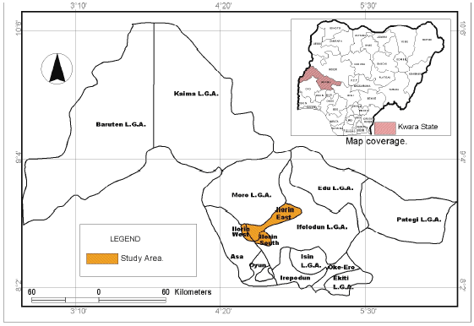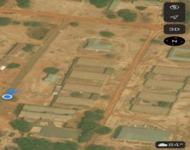
fig 1. Image showing study area

1.4 AIM AND OBJECTIVES
1.4.1 AIM
The project is aimed to carry our cadastral layout survey of old IES at village, part of Kwara state polytechnic, Ilorin Kwara state

1.4.2 OBJECTIVES OF THE STUDY

These are the step-by-step activities carried out in order to achieve the aim. The objectives of the project exercise include
- Third order theodolite traverse
- Perimeter leveling
- Detailing by tacheometry.
- Computation
- Plan production
- Report writing

1.5 SIGNIFICANCE OF THE STUDY

Cadastral survey provides a foundation for effective land management and administration, ensuring accurate property boundaries, facilitating land transactions, and resolving ownership disputes. It clarifies ownership rights, improves land use planning, and enables the creation of a reliable land information system

1.5 SCOPE OF THE PROJECT

The scope or the project assignment covered the following
• Reconnaissance
2. Control check
3. Test of instrument
4. Selection of station
5. Third order survey
6. Detailing by chain survey
7. Data processing or computation
8. Data presentation
9. Subdivision of plot

PERSONNEL

The under listed names are the member of the group who participate immensely in project given

NAME | MATRIC NUMBER
ALATISE YUSUF OLATUNJI | ND/23/SGI/FT/0082
YUSUF RUKAYAT OLAJUMOKE | ND/23/SGI/FT/0084
ATEKOLU FAITH IYANUOLUWA | ND/23/SGI/FT/0087
IBRAHIM ADENIKE JANET | ND/23/SGI/FT/0083
AMUPITAN DUPE BLESSING | ND/23/SGI/FT/00845
ABDUL-RAHMAN ABDUL-QUYUM OLAMIDE | ND/22/SGI/FT/0038
AFOLAYAN CHRISTIANA ADENIKE | ND/23/SGI/FT/0079

CHAPTER TWO

LITERATURE REVIEW

Cadastral layout surveys have undergone significant transformations in recent years, driven by advances in technology and the need for more efficient and effective land administration systems. This essay provides an overview of the current state of research in cadastral layout surveys, highlighting key trends, findings, and future directions.

One of the most notable trends in cadastral layout surveys is the increasing adoption of 3D cadastre. This approach focuses on managing and modeling multi-layered rights, restrictions, and responsibilities on land, which is critical for effective land administration, particularly in urban areas with complex property structures. By leveraging 3D modeling and spatial analysis, 3D cadastre enables more accurate and efficient management of land rights, reducing disputes and improving land governance.

Another significant trend is the development of technical infrastructure cadastre, which involves modeling and efficiently managing complex layers of ownership of space underneath the land. This is essential for urban planning and infrastructure development, as it enables authorities to better manage underground infrastructure, such as utilities and transportation systems.

In addition to these trends, research has also focused on marine cadastre, public law restrictions (PLRs) cadastre, disaster-responsive cadastre, and fit-for-purpose land administration (FFPLA). Marine cadastre deals with the use of coastal and marine areas, management of property rights, and prevention of disputes, while PLRs cadastre involves implementing and managing public law restrictions to conserve and sustainably use restricted areas in the public’s interest. Disaster-responsive cadastre emphasizes the importance of accessing land and property information during disasters, and FFPLA offers rapid and cost-effective solutions for land administration with fewer procedures.

Studies have shown that 3D cadastre is the most researched trend, while PLRs cadastre and disaster-responsive cadastre are less explored. Furthermore, there is a growing need for more research on integrating new technologies, such as remote sensing and artificial intelligence, into cadastral systems. These technologies have the potential to significantly improve the efficiency and accuracy of land administration, enabling authorities to make more informed decisions and better manage land resources.

Looking to the future, it is clear that continued research in cadastral systems is essential to support sustainable development, disaster management, and efficient land administration. Future studies should focus on developing more effective and efficient cadastral systems that incorporate new technologies and approaches, improving the management of complex property structures and rights in land, and enhancing disaster responsiveness and resilience in land administration systems.

The cadastral trends selected for this study, including 3D cadastre, technical infrastructure cadastre, disaster-responsive cadastre, marine cadastre, public law restrictions cadastre, and fit-for-purpose land administration, are described in the introduction. Theme-specific keywords were used for each trend. These keywords are present in the relevant sections. The WoS search engine searched for theme-specific publications by title, abstract, and keywords. The keywords “cadastre”, “cadastral”, “cadastral system”, and “land administration” were used for all trends. Theme-specific terms are also included and explained detailed in the relevant sections on each trend. The keywords searched for relating to each trend may produce results that are irrelevant to cadastres and LA. For example, the keyword “public law restriction” may produce results from the field of law, the keyword “fit for purpose” may produce results from various fields of science, and the keyword “disaster” may produce results from the field of geosciences. Therefore, the common search terms mentioned above were used for every trend analysis. Nevertheless, there may be results unrelated to cadastres or LA. For this reason, not all of the search results are directly included in this review, and a manual selection was also carried out. The search results were restricted to 2014–2024 (including 2024). Manual elimination was performed by first reviewing the relevance of the results to the search topic and then reviewing the titles and abstracts of the studies. The global agenda is rapidly changing due to various triggers, such as population growth and technological advances. Therefore, papers published in the last decade were selected to capture and reflect the current state of trends in LA. This study is limited to English language publications and is considered more accessible to the international research community. Although a systematic literature analysis was conducted in this study, no coding or analysis models were applied to interpret thematic patterns. The study aims to identify general trends, current developments, and key findings in the literature rather than specific themes and patterns. Although the thematic coding method is particularly useful for a detailed analysis of large and diverse data, given the aims of this study, a descriptive and analytical approach was preferred. Therefore, it was deemed unnecessary to apply the thematic coding method within the scope of the study, and this literature review has been structured based on the content of the available sources. Based on the relevant search criteria, 367 articles were chosen to be analyzed in this article. Out of these, 185 were about 3D cadastres, 58 articles were about marine cadastres, 57 articles were about FFPLA, 33 articles were about technical infrastructure cadastres, 8 articles were about the cadastre of public law restrictions, and 26 articles were about disaster-responsive cadastres
A systematic literature review (SLR) was conducted to understand current cadastral trends and the international agenda’s approach to them. It was performed based on the Preferred Reporting Items for Systematic Reviews and Meta-Analysis (PRISMA [32] guidelines).
This study employed an eight-step methodology, illustrated in Figure 1, to determine the relevance of international agendas to site-specific cadastral trends..

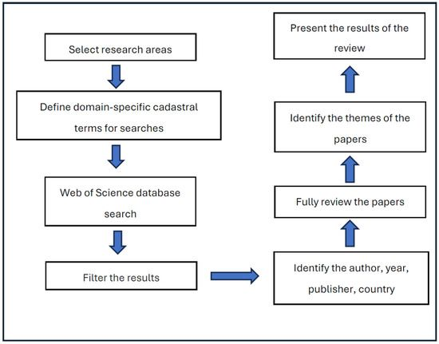

FEATURES OF CADASTRAL LAYOUT SURVEY

• Boundary determination
• Property mapping
• Reference points
• Precise measurements
• Data collection
• Accuracy
• Detail
• Reliability
• Comprehensive

REASON OF THE CADASTRAL LAYOUT SURVEY

• Establish property boundaries : Determine accurate property lines and corners.
• Support land registration : Provide evidence for land registration and titling.
• Facilitate property transactions : Enable smooth buying, selling, and transferring of property.
• Inform urban planning : Support urban planning, development, and infrastructure projects.
• Resolve boundary disputes : Help resolve conflicts and disputes over property boundaries.
• Ensure accurate land records : Maintain accurate and up-to-date land records.
• Support property development : Inform construction, infrastructure development, and land use planning.
• Enhance land security : Provide a clear and reliable record of property ownership and boundaries.
• Promote transparency and accountability : Ensure transparency and accountability in land administration.
• Support economic development : Contribute to economic development by providing a stable and reliable land tenure system.

CHAPTER THREE

3.0. METHODOLOGY
A digital integrated cadastre was selected as a development route for both cases. Stakeholders want digital data for both ownership records and maps. A digital cadastre also provides transparency and facilitates verification of the cadastre data. (Kaufmann, Steudler, 1998)
The principles of FIG Cadastre 2014 are implemented by step-by-step approach
taking into consideration local capacity and resources.

3.1. PLANNING
This involves preparation for the successful execution of any project, the following issues were considered during planning.
The purpose of the survey
The required accuracy
The method of data acquisition

3.2. RECONNAISSANCE
The preliminary stage of any survey work is referred to as reconnaissance. During this stage, the general view of the project site was done to have a full and overall picture of the entire
prolect area hefore actual measurement or survey takes place
Reconnaissance connotes one’s description to ensure successful execution of the project. It is carried out in two stages namely
(a) Office planning
(b) Field reconnaissance

3.2.1 FIELD RECONNAISSANCE
In the process of obtaining field reconnaissance, the site was visited, Recce diagram was carried out in order to decide on how best to do the job of the approved layout, the map covering the project site which was prepared by Ministry of Lands and Survey as a guide. The existing control points were located and the values were collected from the survey that did the part of the control to be use lather checking will be done for the in-situ.

3.2.2 OFFICE PLANNING
The relevant maps in the department were checked in order to get information’s about the site. The coordinates of the nearby control points were also obtained from the Ministry of lands and survey Department. These are the information of the controls within the project site.

Table 2.1 Coordinates of the boundaries
PILLAR NO | EASTERN | NORTHERN
Pillar 1 | 678924.506 | 946917.784
Pillar 2 | 679052.529 | 946908.475
Pillar 3 | 679030.412 | 946759.687
Pillar 4 | 678902.389 | 946768.996

3.3. INSTRUMENT TEST

All instrument used in carrying out the project were tested before the field operation was carried out in order to obtain a desired result that will comply with the planning so as to obtain the required accuracy.

3.4. TEST OF TOTAL STATION COLLIMINATION TEST

The following test was carried out to test the workability of the equipment before the data capturing process. The tests are of two types which are

i. Temporary Adjustment

ii. Permanent Adjustment

TEMPORARY ADJUSTMENTS: These are the ones that are carried out on every station before observation. They are;

i. Centering of instrument
ii. Removal of parallax

PERMANENT ADJUSTMENTS: The permanent adjustment are the following

1. Collimation adjustment
2. Vertical Index adjustment

3.5.1 PROCEDURE FOR COLLIMATION AND VERTICAL INDEX ADJUSTMENT

The instrument was set up on station which is pillar 1 and all necessary temporary adjustments were done. A target was set up at Pillar 1 to the line of site. It was aimed and bisected. The instrument was switch on and program which is on-board of the instrument was switch to the collimation program. Then, horizontal collimation and vertical index were in sequence recorded and stored in the memory of the instrument. The telescope was transited and the same target bisected. Both the new vertical index and collimation were recorded and stored accordingly. It was transited to the same target with both horizontal and vertical readings recorded to check the instrument’s accuracy.

3.5.2 CONTROL CHECK

Before embarking on angular measurement, control check and observation was carried out on the control pillars. The total station was set on PILLAR 2 and all the necessary temporary station adjustment were carried out. Targets were also set up on PILLAR 1 and PILLAR 3 respectively.
Target on PILLAR 1 was back sight to obtain the horizontal circle reading on face left and reading were recorded, the theodolite was transited to face right and the horizontal circle reading was obtained. Also, target on PILLAR 3 was focused and bisected on foresight, the same process is repeated, but in this case the horizontal and vertical circle reading was taken both on face left and face right. All readings taken were booked in the field book

3.5.3 observed controls
PILLAR NO | NORTHING (m) | EASTERN (m)
Pillar 1 | 946917.784 | 678924.506
Pillar 2 | 946808.475 | 679052.529
Pillar 3 | 946759.687 | 679030.412

3.5.4 show the results of our control check
PILLAR NO | REMARK | NORTHING | EASTING
Pillar 1. | Given | 946917.784 | 678924.506
 | Observed | 946917.782 | 678924.502
 | Difference | 0.002 | 0.004
Pillar 2 | Given | 946808.475 | 679052.529
 | Observed | 946808.471 | 679052.527
 | Difference | 0.004 | 0.002
Pillar 3 | Given | 946759.687 | 679030.412
 | Observed | 946759.685 | 679030.410
 | Different | 0.002 | 0.001

3.6. FIELD OBSERVATION
This are the measurement and observation made on site. These include the following :
Angular measurement
Linear measurement

3.6.1 ANGULAR MEASUREMENTS (PERIMETER TRAVERSING)
This is to establish a boundary points on the surface of the earth by taking the bearing or angles between successive lines and their distances so as to detine the points with coordinates
value on a plane form.
The angles were observed on two zeros as this was the specification for a third order traverse. Having set the theodolite on and targets were set on as back station and PEG as fore station. All temporary adjustments were carried out i.e. (centering, leveling, and focusing). The back station was observed on a face left and the horizontal circle was read and recorded, the instrument was rotated clock wisely to fore station on face left, the horizontal circle and vertical circle was read and recorded. The instrument base was changed by locking the horizontal screw and turned it 90 degree and unlocked the horizontal circle reading screw, the base was been changed on every station in order to make the readings independent of each other.
The instrument was then transited to face right and bisected the fore station where both the horizontal and vertical circle readings were taken and recorded. It was tumed clock wisely to the back station, and the horizontal circle reading was read and recorded, this gave a complete set of readings and observation. The process was repeated on other stations until it got to the last of the boundary line and close back on one of the controls.

3.6.2 LINEAR MEASUREMENT
The linear measurement was carried out with use of ranging poles placed in between the theodolite and the target station (ie traverse line) at the tape length and those poles was properly aligned with the instrument in order to have perfect straight line before taken the measurement with the steel tape. These direct measurement was taken and recorded in the filed book.
The process continued at every instrument station until the last travers line was measure
Hence, all the measurement recorded were later corrected with the slope correction to obtain the horizontal distance

3.7 SCHEDULE OF FIELD WORK
Having completed the reconnaissance, the schedule of field work was designed as follows:
▪ Perimeter traverse
▪ Traversing
▪ Setting out of boundary beacons
▪ Pillar Numbering
▪ Layout design
▪ Report writing

3.8 DATA ACQUISITION
In acquiring data, the following surveying procedure were adopted
Checks on control
Traversing
Test of instriment

3.8.1 EQUIPMENT USED
The equipment used in the execution of the project is listed below
- Total station with its tripod
- Reflector
- Target with their Tripods
- Plumb Bob
- Linen Tape (100m)
- Nails, with Bottle Corks and pegs
- Field book and pen

3.9. MONUMENTATION

This is the production of pillars for the selected points before being coordinated and
this was carried out along the boundary of the area to be surveyed for precise demarcation.
Monumentation is the art of defining any elected station of spot with structure like pillaring stone or pegging during the execution of any survey work or project.
The dimension and length driven into the ground are shown below
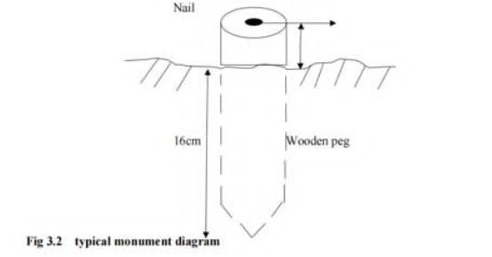

3.10. TRAVERSING

Total station was set up on the control, switched on and all temporary adjustments were carried out. Then, “Job” was set in the instrument, height of instrument and reflectors were measured with steel tape and stored in the instrument’s memory, and coordinates of the control stations were recalled from the instruments’ memory, it was bisected for orientation, and Total station was instructed to compute the bearing between the two stations which was confirmed with a prismatic compass. One of the reflectors was taken to pillar, the reflector’s cross hair was bisected with that of the telescope eye piece of the total station and “All” key was pressed so as to measure and record observation in the memory of the instrument. The above stated processes were carried out to coordinate the entire boundary points in X, Y, Z. The above process was repeated for other blocks shown on the plan including subsidiary traverses
CHAPTER FOUR

4.0 DATA DOWNLOADING AND PROCESSING

The coordinates of the observed boundary were downloaded into the computer and were compiled in Microsoft excel for further processing. A script file of boundary points of individual plot was prepared in note pad using Polyline command. These script file was run in AutoCAD and the area information of each plots as well the bearing and distances of each consecutive lines were obtained.

4.1 DATA PROCESSING & ANALYSIS

The acquired field data was downloaded to the computer in the office. This was done using a NTS software. The following procedure was followed:
i. Connecting the SET and host computer, using communication cable.
ii. Selecting “JOB” in Memory Mode.
iii. Selecting “comms” output to display the JOB list.
iv. Pressing OK.
v. Selecting the output formation
vi. At the end of the downloading, the data was displaced in the following format, Point No., Easting and Northing.

The data was then copied to other software such as Microsoft Excel for further processing. Here, the data was arranged and stored as formatted Text (space delimited), ready for plotting. The observed data were reduced and corrected, Master Survey programmer software was used to process the data.

4.2 PLOTTING AND PLAN PRODUCTION

Auto-CAD 2007 software was used for plotting all the set out pillars. The plotting procedure was as follows,

STEP ONE:
- Launch software ( Auto- CAD 2007)
- Go to format
- Set unit, point style and text style
- Then, click on unit.
- Under unit, set the following: type, precise, unit of scale, direction control.
- Then click clock wise
- Click OK

STEP TWO:
- Go back to format.
- Click point style.
- Then click on point scale e.g 1 : 500 - 1.2, 1 : 1000 - 2.4.

STEP THREE
- Go back to format
- Then, click text style
- Font name - Times New Roman
- Font style - Regular
- Height - it depends on the scale you use.
- Then click APPLY.
- Then Close.

STEP FOUR
- Select tool from the menu bar and highlight run script.
- Open the saved formatted Text from Microsoft Excel.
- Zoom extents, by pressing Z enter and E enter.

All the coordinated points are plotted and displayed on the screen and with the help of the Recce diagram; all the boundary points were joined for individual plots to produce the boundary lines and the existing features such as Roads.
The final Layout plan was plotted at scale of 1: 2,000

4.3 PROJECT STATISTICS

1. Total number of boundary beacons 4
2. Coordinate Properties UTM

4.4 TRAVERSE FIELD BOOK REDUCTION

Angular measurement made on the field were reduced thus: the face left observation taken to the back station was deducted from the left reading taken to the fore station, so as to obtain the angle between the line on face left. The face right reading taken to the back station was deducted from the face right observation taken to the fore station, so as to obtain the angle between the line on face right. If the reduced angle on face left or face right is greater than 360°. then 360° were subtracted from the reduced angle, the mean of the angle was obtained to give the angle at that station. The difference between the reduced angles are always negligible since angles measured on each face were measured in different zeros. The vertical circle reading was reduced by subtracting 90° or 270° from face left or face right of the vertical circle reading on which is close in magnitude to the measured vertical reading.

4.4.1 LINEAR MEASUREMENT
The distance was measured using tape for measured distance with the vertical (slope) angle taken simultaneously. The corrected horizontal distance was obtained having applied the slope correction.
H =-L (1 - cos 0)
Where H=
Corrected distance
L=
Measured distance
0 = Slope angle observed.

4.4.2 BACK COMPUTATIONS

The backward computation were done to the coordinates of the boundary pillar as show in the tables below;

Tab: 4.4. Back computation of the control used
STATION FROM | BEARING | DISTANCE | ∆N | ∆E | NORTHING | EASTING | STATION TO
 |  |  |  |  | 946917.784 | 678924.506 | Pil.1
Pil.1 | 170°22°48 | 127.08 | -9.309 | 128.023 | 946908.475 | 679052.529 | Pil.2
Pil. 2 | 00°35°14 | 150.42 | -148.788 | -22.117 | 946759.687 | 679030.412 | Pil.3
Pil.3 | 170°22°43 | 128.36 | 9.309 | -128.023 | 946768.996 | 678902.389 | Pil.4
Pil. 4 | 04°03°66 | 150.42 | 148.788 | 22.117 | 946917.784 | 678924.506 | Pil.1

4.5. AREA COMPUTATION
Area computation using double latitude and departure:
128.023
128.023. X -9.309. =. -1191.766107
________
256.046
-22.117
________
233.929
-22.117. X. -148.788. =. 13290.7444196
________
211.812
-128.023
________
83.789
-128.023. X. 9.309. =. -1191.766107
________
-44.234
22.117
________
-22.117
22.117. X. 148.788. = 3290.7444196
_______
0.00

Sum of (+) - Sum of (-) ÷. 2
6581.488392 - 2383.532214
———————————————. =. 4197.936178 ÷ 2
2

2098.97809
—————. =. 4.5127 hectares
465.165
LINEAR ACCURACY

LINEAR ACCURACY
The linear accuracy was computed using:
Starting Northing = 946321.8072
Closing Northing = 946321.8070
Misclosure in Northing = 0.002
Starting Easting = 679689.6697
Closing Easting = 679689.6696
Misclosure in Easting = 0.001
Total distance =556.280m
Linear Accuracy = 1
√∆E² + ∆N²
Total distance
Linear Accuracy = 1 ÷ √ (0.002² + 0.001²) ÷ (556.280)
Linear Accuracy = 1 ÷ √0.000004 × 0.000001 ÷ 556.280
Linear Accuracy = 1 x 556.280/0.00224
Linear Accuracy = 1: 248,348

4.6. DISCUSSION OF THE RESULT
The following were the results obtained at the end of the project exercise, they are:
▪ Perimeter Survey plan.
▪ Design plan
▪ Layout

4.6.1 PERIMETER SURVEY PLAN
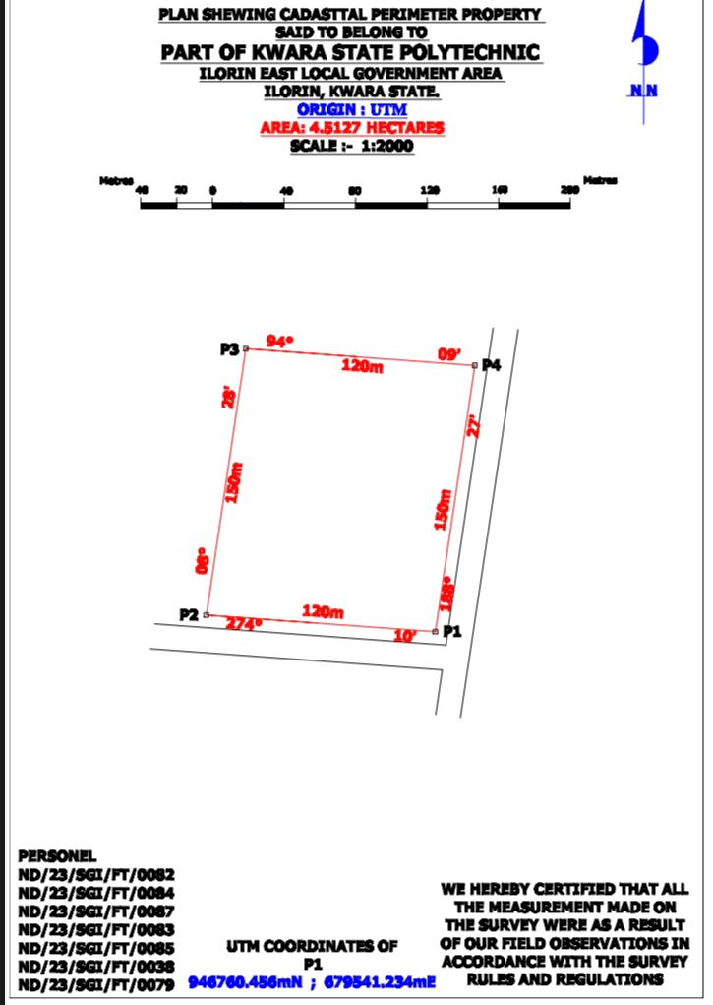

4.6.2 DESIGN PLAN

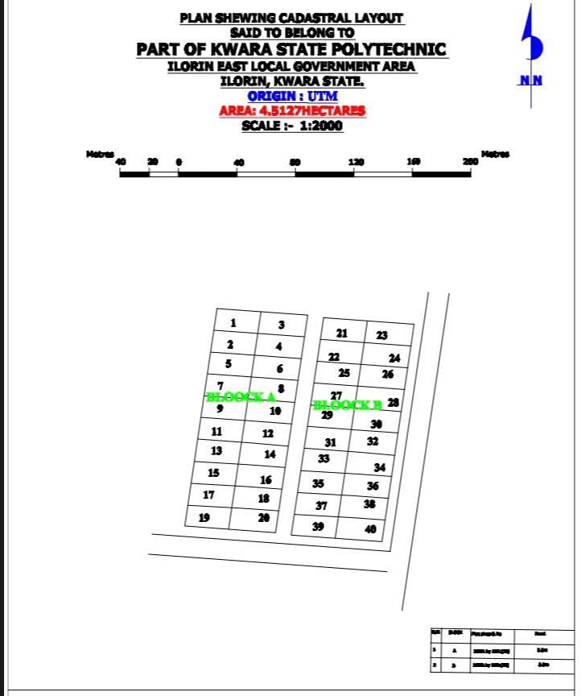

4.6.3 LAYOUT PLAN
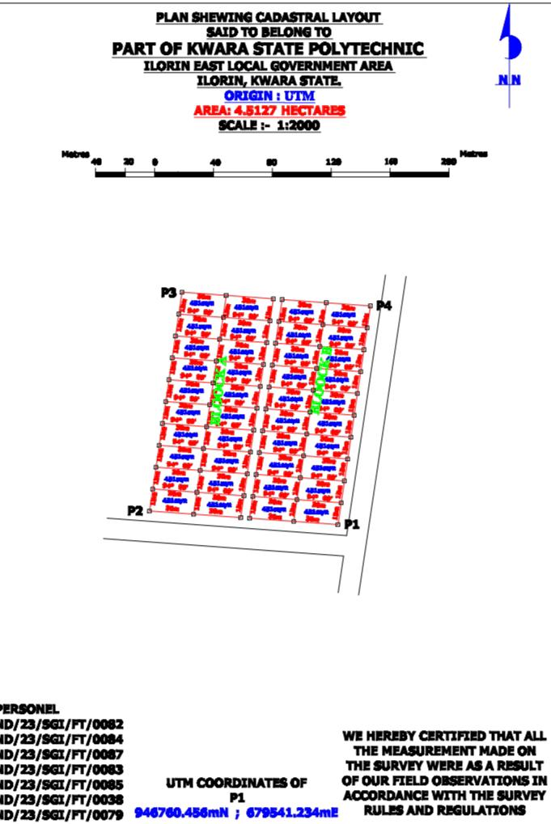

4.7 INFORMATION PRESENTATION IN GRAPHICAL FORM
This is the graphical presentation of all the processed information with a suitable scale using appropriate conventional signs and symbols.
This also involves preparation of plan showing all the features in their proper position with a suitable scale, and use the appropriate symbols to depict such information on the plan.
This was done atter obtaining the final adjusted coordinate of each point, then the coordinate
method was used to draw the plan.
The plan was produced in two forms namely
Analogue
Digital

4.7.1 ANALOGUE PLAN PRODUCTION
PREPARATION OF THE PLOTTING SURFACE
The material used was a cardboard, which was placed on a drawing table with the use of paper tape so as to enhance the stability of the plotting.

GRIDING OF THE SHEET
Based on the method of plotting used (coordinate method), and scale used, the sheet was gridded at an equal interval of 50m, along the northings and eastings axis. Searching for the
highest and the lowest nothing coordinate as well as the highest and lowest casting coordinate so as to determine the extent of the grid that will contain the plotting of the gridding. il
PLOTTING OF THE TRAVERSE POINTS
Coordinate system of plotting was adopted and plotting of the traverse point. The position of each point were plotted in their appropriate position on the grid

4.7.2. DIGITAL PLAN PRODUCTION
The digital plan was produced using AUTOCAD 2007 software, the under listed procedures were carried out
I The computer was switched on to allow boot
iiThe start menu was clicked on
iiiPrograms was clicked whereby notepad was selected
IV After the notepad was launched, a script file was prepared i.e_Pline, then the eastern and northern coordinate were inputed accordingly.
V The file was saved with an extension i.e. ser
VI AutoCAD was launched
Vii The file menu was clicked and “new was selected
Vill Format was clicked and the necessary settings were set
IX Tools was selected and “run script was clicked on
X The file save with an extension on notepad was then clicked on
Xi Escape key, was clicked. “Z” enter and “E” enter was pressed and the diagram was displayed
XII Then all the necessary details were fixed on the plan
The plan was then printed with the aid of a plotter or printer

CHAPTER FIVE

5.0 SUMMARY, CONCLUSION AND RECOMMENDATION

5.1 SUMMARY

This CADASTRAL LAYOUT SURVEY’ was carried out at part of Kwara state polytechnic, old institute of environmental studies (ies) and village, located in Moro local government area Ilorin,
The reconnaissance survey aspect was carried out properly and effectively in the office and the field, this is done purposely for proper planning of the operation by locating initial control that is within the project site for effective orientation the instrument to be used, and this plan is done using AutoCAD2007 and Surfer 10 respectively. The plan was drawn at a scale of 1: 2,000, and the hectares is 1.952

5.2 CONCLUSION

In conclusion the project task and exercise has been successfully excited since the result of the above operation agreed with the requirements and accuracy of third order job. Plan of the study were produced. The survey was executed. In the accordance and respect with the survey rules and the departments instructions in carrying out the project topics. And conclusively the report writing was done on how the entire project was executed both field and office work.

5.3 RECOMMENDATIONS

I hereby recommend this particular project practical’s to be done often to update the infrastructure features in the society for the development of that particular area. Also it should be carried out in school for the next development in the school premises, more over it is necessary for every surveying and Geo-Informatics students to be able to carried out this particular practical’s.

REFERENCE

- Larsson, G. (1991)_: “Land Registration and Cadastral Systems”
- Ting, L., & Williamson, I. P. (1999)_: “Cadastral Trends: A Synthesis
- Enemark, S. (2005)_: “Understanding the Land Management Paradigm
- Steudler, D., & Williamson, I. P. (2005)_: “Cadastre 2014 Revisited
- Land Administration by Dale, P. F., & McLaughlin, J. D. (1999): Discusses land administration and cadastral surveys.
- Cadastre 2014 by Kaufmann, J., & Steudler, D. (1998): Explores cadastral
systems and their importance
- Land Administration for Sustainable Development”* by Williamson, I. P., Enemark, S., Wallace, J., & Rajabifard, A. (2010): Covers cadastral surveying and land administration.
- Rajabifard, A., Williamson, I. P., Steudler, D., Binns, A., & King, M. (2007)_: “Assessing the Worldwide Comparison of Cadastral Systems”

APPENDIX

EASTING NORTHING

679435.094 946918.097 0.000
679465.100 946915.915 0.000
679497.105 946913.588 0.000
679432.883 946903.218 0.000
679463.221 946901.012 0.000
679494.894 946898.709 0.000
679430.671 946888.339 0.000
679460.798 946886.148 0.000
679492.682 946883.830 0.000
679428.459 946873.460 0.000
679458.784 946871.692 0.000
679490.470 946868.951 0.000
679426.248 946858.581 0.000
679456.253 946856.400 0.000
679488.259 946854.073 0.000
679424.036 946843.703 0.000
679453.841 946841.535 0.000
679486.047 946839.194 0.000
679421.824 946828.824 0.000
679451.829 946826.642 0.000
679483.835 946824.315 0.000
679419.612 946813.945 0.000
679449.618 946811.763 0.000
679481.623 946809.436 0.000
679417.401 946799.066 0.000
679447.406 946796.885 0.000
679479.412 946794.557 0.000
679415.189 946784.188 0.000
679445.194 946782.006 0.000
679477.200 946779.679 0.000
679412.977 946769.309 0.000
679442.983 946767.127 0.000
679474.988 946764.800 0.000
679503.106 946913.151 0.000
679533.112 946910.970 0.000
679563.117 946908.788 0.000
679500.895 946898.273 0.000
679530.838 946896.095 0.000
679560.905 946893.909 0.000
679498.683 946883.394 0.000
679528.688 946881.212 0.000
679558.694 946879.030 0.000
679496.471 946868.515 0.000
679526.477 946866.333 0.000
679556.482 946864.151 0.000
679494.260 946853.636 0.000
679524.265 946851.454 0.000
679554.270 946849.273 0.000
679492.048 946838.757 0.000

679521.984 946836.581 0.000
679552.059 946834.394 0.000
679489.836 946823.879 0.000
679519.842 946821.697 0.000
679549.847 946819.515 0.000
679487.624 946809.000 0.000
679517.630 946806.818 0.000
679547.635 946804.636 0.000
679485.413 946794.121 0.000
679515.418 946791.939 0.000
679545.423 946789.758 0.000
679483.201 946779.242 0.000
679513.206 946777.061 0.000
679543.212 946774.879 0.000
679480.989 946764.363 0.000
679510.995 946762.182 0.000
679541.000 946760.000 0.000

