

A PROJECT REPORT
ON
TOPOGRAPHIC INFORMATION SYSTEM OF PART OF JUDGES’ QUARTERS, TANKE, ILORIN, ILORIN SOUTH LOCAL GOVERNMENT, AREA OF KWARA STATE.

BY
IYANDA PHILIP AYOMIDE
HND/23/SGI/FT/0029

SUBMMITED TO:
THE DEPARTMENT OF SURVEYING AND GEO-INFORMATICS, INSTITUTE OF ENVIRONMENTAL STUDIES, KWARA STATE POLYTECHNIC ILORIN.

IN PARTIAL FULFILLMENT OF THE REQUIREMENT FOR THE AWARD OF HIGHER NATIONAL DIPLOMA IN SURVEYING AND GEO-INFORMATICS.

JUNE, 2025

CERTIFICATE
I hereby certified that the information given in this project was obtained as a result of the observation and measurement made by me and that the survey was carried out in accordance with survey laws, regulations and departmental instructions

_________________________________
IYANDA PHILIP AYOMIDE
Matric. No: HND/23/SGI/FT/0029

CERTIFICATION
This is to certify that this project was carried out by IYANDA PHILIP AYOMIDE with Matric No.: HND/23/SGI/FT/0029 under my instruction and supervision for the award of Higher National Diploma in Surveying and Geo-informatics, Kwara State Polytechnic, Ilorin, Kwara State Nigeria. I hereby declared that he has conducted himself with due diligence and honesty on the said duties.
………………………………… ………………………………
SURV. ADEBANJI AKINYEDE DATE
(Project Supervisor)

………………………………. …………………………
SURV. R.S. AWOLEYE DATE
(Project Coordinator)

……………………………… ………………………………
A.I ISAU DATE
Head of Department (H.O.D)
Surveying & Geo-informatics

……………………………….. ……………………………..
EXTERNAL EXAMINER DATE

DEDICATION
This project is dedicated to Almighty GOD, the author and the finisher of everything who gave me the grace and privilege to attain this stage in my education pursuit.

ACKNOWLEDGEMENT
I give thanks and glory to my Creator for the privilege bestowed on me that resulted in the accomplishment of this project work and also a big thanks to the management of Kwara State Polytechnic for the privilege and opportunity given to me to study in their great institution.
My sincere gratitude goes to my Head of Department (HOD); A.I ISAU and my Supervisor; SURV. ADEBANJI AKINYEDE for their support towards the success of this project work, I really appreciate you sir.
To all the lecturers in the department of Surveying and Geo-informatics; Abimbola I. Isau, Surv. Ayuba Abdulsalam, Surv. R.S Awoleye, Surv. R.O Asonibare, Surv. A.G Aremu, Surv. B.F Diran, Surv. Williams Kazeem, Surv. Kabir Babatunde who has imparted their knowledge in me in one area or the other during my year of study, I am grateful for all your effort and support. May Almighty GOD bless you all (Amen).
I'm deeply grateful to my parents; MR & DNS IYANDA for their unconditional love, support, and wisdom. Their encouragement and sacrifices have been the driving force behind my endeavors. Thank you, Mom and Dad, for being my pillars of strength and inspiration. I acknowledge this project to you, with love and appreciation.
Special thanks to my brother and sister for their unwavering love, care, and dedication that has shaped me into the person I am today. Their selfless love and their influence and values have guided me throughout this project, and I'm forever grateful.
I would like to extend my heartfelt thanks to the family of MR & MRS ADEKANYE who have supported me throughout the journey of this Higher National Diploma, I pray, may the Lord continue to bless and keep you in Jesus name.
I'm also grateful to my friends in the department, church, and all for their motivation, and help whenever I needed it. Their collective support has made this journey more enjoyable and fulfilling.
May Almighty GOD bless you all (Amen).

TABLE OF CONTENTS
Pages
Title Page i
Certification ii
Dedication iii
Acknowledgment iv
Table of contents v
List of Tables ix
List of Figures x
Abstract xi
CHAPTER ONE
General Introduction
1.1 Background to the Study 1
1.2 Statement of the Problem 3
1.3 Aim and Objectives of the Project 4
1.3.1 Aim 4
1.3.2 Objectives 4
1.4 Scope of the Project 5
1.5 Personnel 5
1.6 Significance of the Study 6
1.7 Study Area 7
CHAPTER TWO
Literature review
2.1 Historical Development of Topographic Mapping 8
2.2 Conceptual Framework 10
2.2.1 Role of GIS in Topographic Data Management 12
2.2.2 Remote Sensing Technologies in Topography 14
2.2.3 Digital Elevation Models (DEMs) and Terrain Analysis 16
2.3 Applications of Topographic Information Systems 18
2.4 Accuracy and Data Quality Issues 20
2.5 Advancements in 3D Topographic Visualization 22
CHAPTER THREE
Research Methodology
3.0 Methodology 25
3.1 Database Design 25
3.1.1 View of Reality 25
3.1.2 Conceptual Design 27
3.1.3 Logical Design 28
3.1.4 Physical Design 28
3.2 Reconnaissance 30
3.2.1 Office Planning 30
3.2.2 Field Reconnaissance 31
3.2 Equipment used/system selection and software 33
3.2.1 Hardware used 33
3.2.2 Software Component 33
3.3 Instrument Test 34
3.3.1 Horizontal Collimation Test 34
3.3.2 Vertical Index Error Test 35
3.3.3 Analysis of Collimation and Vertical Index Data 35
3.4 Control Check 36
3.5 Monumentation 37
3.6 Data Acquisition 38
3.6.1 Geometric Data Acquisition 38
3.6.2 Attributes Data Acquisition 40
3.7 Data Downloading and Processing 40
3.7.1 Data Downloading and Editing 40
3.7.2 Data Processing and Data Editing 40
3.7.3 Data Processing using ArcGIS 10.3 40
3.8 Database Implementation 50
3.8.1 Database Management Systems 50
3.8.2 Database Maintenance 51
3.8.3 Back computation 52
3.8.4 Area Computation 52
CHAPTER FOUR
Spatial Analyses and Presentation
4.1 Testing of Database 53
CHAPTER FIVE
Costing, Summary, Problem Encountered, Conclusion and Recommendations
5.1 Costing 57
5.2 Summary 60
5.3 Problem Encountered 60
5.4 Conclusion 60
5.5 Recommendations 61
References
Appendix

LIST OF TABLES
Pages
Table 3.1: Table showing Building and its attribute 28
Table 3.2: Table showing the Road and its attributes 29
Table 3.3: Table showing the Trees and its attributes 29
Table 3.4: Table showing the Electric Poles and its attributes 29
Table 3.5: Table showing the Vegetation and its Attributes 30
Table 3.6: Table showing the Coordinates of Controls 31
Table 3.7: Table showing the Horizontal Collimation Data 35
Table 3.8: Table showing the Vertical Index Data 35
Table 3.9: Table showing the back computation of the control coordinates 36
Table 3.10: Table showing the distance observation result of the control check 37
Table 3.11: Table showing the observation result of control check 37
Table 3.12: Building 47
Table 3.13: Road 47
Table 3.14: Trees 47
Table 3.15: Electric Poles 48
Table 3.16: Table showing the back computation 52
Table 3.17: Table showing the area computation 52
Table 5.1: Table showing the direct cost parameters 57

LIST OF FIGURES
Pages
Fig. 1.1: Maps Showing the Study Area 7
Fig. 3.1 Design and Construction Phases in Spatial Database 26
Fig. 3.2: E-R Diagram (Entity relationship diagram) 27
Fig. 3.3: Recce diagram of the study area (not drawn to scale) 32
Fig 3.4: Horizontal Collimation and Vertical Index error test. 34
Fig. 3.5: Pillar Description 38
Fig. 3.6 shows the spot height 48
Fig. 3.7: Shows the Tin creation 49
Fig. 3.8 shows the slope aspect 50
Fig. 4.1: Shows the attribute database 53
Fig. 4.2: Showing catalog, attribute table and table of content 54
Fig 4.3.: Retrieving Area whose height is greater than 3.007 meters 55

Fig 4.4: Result of area whose height is greater than 3.007 meters 55

Fig 4.5: Shows the building use for shop 56

ABSTRACT
This project developed a detailed Topographic Information System (TIS) for a section of Judges' Quarter, Tanke, within Ilorin South Local Government Area, Kwara State, Nigeria. Recognizing the critical need for accurate spatial data to support effective land use planning, infrastructure development, and environmental management in this rapidly urbanizing area, the study employed field surveys using GPS technology and Total Station (TS). Key topographic features, including elevation points, contours, slopes, drainage patterns, and significant man-made structures, were meticulously captured and integrated. The processed data was used to generate essential digital products, including a high-resolution Digital Elevation Model (DEM), detailed contour maps, slope classification maps, and a comprehensive topographic map of the study area. These outputs were systematically organized and managed within a Geographic Information System (GIS) environment, creating a robust spatial database. The resulting Topographic Information System provides a vital geospatial framework. It offers planners, engineers, environmental scientists, and local government authorities precise and readily accessible information on the terrain characteristics of Judges' Quarter. This system is fundamental for informed decision-making in site suitability analysis, flood risk assessment, road network planning, construction projects, and sustainable land management within the studied locality.

CHAPTER ONE
INTRODUCTION
1.1 BACKGROUND OF THE STUDY
A Topographic Information System (TIS) is a specialized form of Geographic Information System (GIS) that focuses on the detailed representation of the Earth's surface, including its natural and artificial features. The study of TIS is rooted in the need to accurately capture, store, analyze, and visualize spatial data related to the terrain, which is essential for a wide range of applications in fields such as urban planning, environmental management, disaster response, military operations, and infrastructure development.
The concept of topographic mapping dates back to ancient civilizations, where rudimentary maps were created to represent land features for navigation, agriculture, and territorial expansion. However, the systematic study and development of topographic information systems began in the 19th and 20th centuries with the advent of advanced surveying techniques, aerial photography, and cartography. The introduction of computers in the mid-20th century revolutionized the field, enabling the digitization of maps and the development of GIS, which laid the foundation for modern TIS.
The evolution of TIS has been closely tied to advancements in technology. The integration of remote sensing, Global Positioning Systems (GPS), and Light Detection and Ranging (LiDAR) has significantly enhanced the accuracy and resolution of topographic data. These technologies allow for the collection of high-resolution elevation data, which is crucial for creating detailed topographic maps. Additionally, the development of sophisticated software tools has enabled the efficient processing, analysis, and visualization of large datasets, making TIS an indispensable tool in various sectors.
Despite its numerous applications, the implementation of TIS faces several challenges. These include the high cost of data acquisition, the complexity of data processing, and the need for specialized skills to interpret and analyze topographic data. Additionally, the rapid pace of technological change requires continuous updates and upgrades to TIS infrastructure and software.
Looking ahead, the future of TIS is likely to be shaped by advancements in artificial intelligence (AI), machine learning, and big data analytics. These technologies have the potential to automate data processing, enhance predictive modeling, and improve the accuracy of topographic maps. Furthermore, the integration of TIS with other emerging technologies such as the Internet of Things (IoT) and augmented reality (AR) could open up new possibilities for real-time terrain analysis and immersive visualization.
Topographic information plays a crucial role in urban planning, land management, and infrastructure development. A Topographic Information System (TIS) integrates geospatial data to provide detailed insights into the physical features of a given area, including elevation, drainage patterns, land use, and built structures. The development of a TIS for a section of Judges’ Quarters, Tanke, Ilorin, is essential for effective planning and sustainable development.
Judges’ Quarters, Tanke, Ilorin, is experiencing rapid urbanization, necessitating accurate topographic data for informed decision-making. Traditional land survey methods, combined with modern geospatial technologies such as Geographic Information Systems (GIS) and Global Positioning Systems (GPS), enable efficient mapping and analysis of the estate’s terrain. This study aims to generate a topographic information system that provides a comprehensive understanding of the area's landform, aiding in flood control, infrastructure planning, and environmental management.
The research involves data collection through field surveys, GPS mapping, and GIS applications to produce a digital topographic map of the selected area. The findings will serve as a valuable resource for urban planners, engineers, and policymakers in making strategic land-use decisions. By implementing a TIS, stakeholders can ensure sustainable development while mitigating environmental risks such as erosion and poor drainage.
This study highlights the significance of topographic information systems in modern urban development, demonstrating their role in optimizing land use and enhancing infrastructural planning.
In conclusion, the study of Topographic Information Systems is a multidisciplinary field that combines elements of geography, computer science, engineering, and environmental science. It plays a crucial role in understanding and managing the Earth's surface, and its importance is expected to grow as we face increasingly complex challenges related to urbanization, climate change, and resource management.
1.2 STATEMENT OF THE PROBLEM
The rapid urbanization of Judges’ Quarters, Tanke, Ilorin, has led to increasing challenges in land use planning, infrastructure development, and environmental management. However, the absence of an accurate and comprehensive Topographic Information System (TIS) for the area has made it difficult for urban planners, engineers, and policymakers to make informed decisions.
One of the major issues in the estate is the lack of precise elevation and drainage data, which contributes to poor water management, frequent flooding, and soil erosion. Additionally, inadequate mapping of land features and infrastructure has resulted in inefficient land allocation, haphazard construction, and improper road network planning. These challenges hinder sustainable urban development and may lead to long-term environmental and infrastructural problems.
Moreover, the reliance on outdated or non-digital topographic data limits the effectiveness of planning efforts. Without a well-structured TIS, authorities and developers struggle to assess land suitability, optimize resource utilization, and mitigate environmental risks.
This study seeks to address these issues by developing a reliable Topographic Information System for a section of Judges’ Quarters, Tanke, Ilorin, By integrating field survey data, GPS mapping, and GIS applications, the research aims to provide accurate and up-to-date topographic information to support better decision-making in urban planning and land management.
1.3 AIM AND OBJECTIVES OF THE PROJECT
1.3.1 AIM
The aim of this project is to carry out the topographic information system of part of JUDGES’ QUARTERS, TANKE, ILORIN SOUTH LOCAL GOVERNMENT AREA OF KWARA STATE.

1.3.2 OBJECTIVES
The objectives of this study is to:
- conduct a detailed topographic survey of the study area using geospatial techniques such as GPS mapping and GIS applications.
- generate an accurate topographic map that represents the terrain characteristics, elevation levels, drainage patterns, and land use distribution within the estate.
- analyze the impact of topography on land development, infrastructure planning, and environmental risks such as flooding and erosion.
- create a digital database for storing and managing topographic information, which can be accessed for future planning and decision-making.
- provide recommendations on the application of topographic data in sustainable urban development, land administration, and disaster mitigation strategies.
1.4 SCOPE OF THE PROJECT
The project scopes are the stages that will be involve to achieve our aims.
- Project planning
- Recce
- Data acquisition
- Data processing
- Data analysis
- Data presentation
- Technical report writing
1.5 PERSONNEL
The students listed below were the members of this group who participated in the execution of the project.
NAME ROLE
IYANDA PHILIP AYOMIDE AUTHOR
UTHMAN BADIRAT BUKOLA MEMBER
EMMANUEL MERCY UNEKWUOJO MEMBER
ADENIYI AISHAT ADERAYO MEMBER
OLABOSOYE GIFT FUNMILAYO MEMBER
BELLO IBRAHIM OPEYEMI MEMBER

1.6 SIGNIFICANCE OF THE STUDY
The significance of studying a Topographic Information System (TIS) lies in its critical role in enhancing spatial decision-making and resource management across diverse sectors. By integrating detailed elevation data, landform features, and human-made structures, a TIS provides a comprehensive framework for analyzing terrain characteristics, which is vital for sustainable urban planning, environmental conservation, and disaster risk mitigation. In urban development, it aids in optimizing infrastructure design, zoning, and floodplain management, while in environmental sectors, it supports watershed analysis, habitat preservation, and climate resilience strategies. Additionally, the system’s ability to synthesize real-time geospatial data with advanced technologies like GIS and remote sensing enables governments, planners, and researchers to address challenges such as land degradation, deforestation, and emergency response with greater precision. By democratizing access to accurate topographic insights, a TIS fosters interdisciplinary collaboration, empowers evidence-based policymaking, and contributes to long-term ecological and socio-economic sustainability, ultimately bridging the gap between geospatial innovation and practical applications for community and environmental well-being.

  - STUDY AREA
The study area for this project is situated on Part of Judges’ Quarters, Tanke area of Ilorin South Local Government Area of Kwara State. The geographic location of the study area lies between latitude 08º 30' 00"N and latitude 08º 30' 05"N and between longitude 04º 36' 55" and longitude 04º 37' 05" and the total area covered was about 12.300 hectares.

Fig. 1.1: Maps showing the Study Area
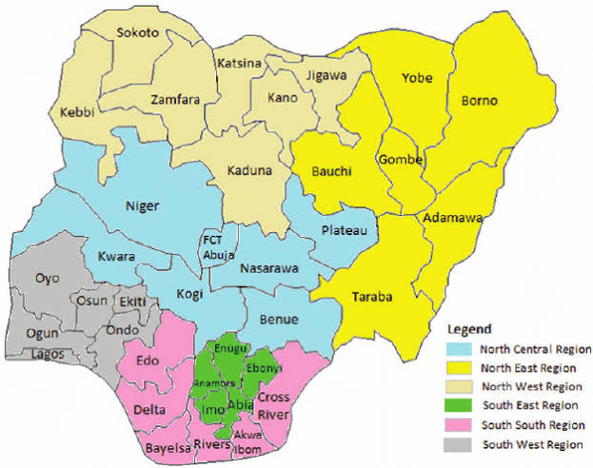
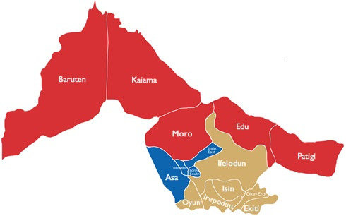
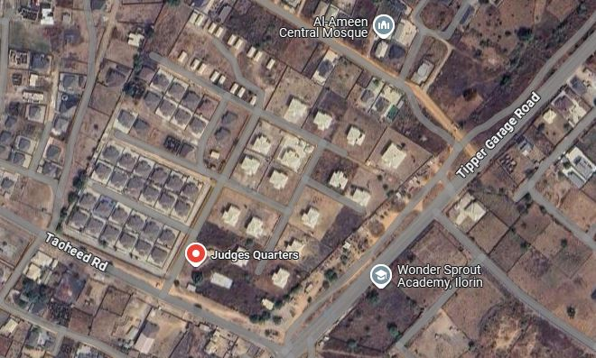

CHAPTER TWO
LITERATURE REVIEW
2.1 HISTORICAL DEVELOPMENT OF TOPOGRAPHIC MAPPING
The historical development of topographic mapping is a testament to humanity’s enduring quest to represent the Earth’s surface with precision and utility. Its origins trace back to ancient civilizations, where rudimentary tools like the groma and chorobates were used by Egyptians, Greeks, and Romans for land division, irrigation, and infrastructure projects such as road construction. These early efforts laid the groundwork for systematic cartography, which saw significant strides during the Renaissance. Innovations like Gerardus Mercator’s 1569 cylindrical projection revolutionized navigation by preserving directional accuracy, while Willebrord Snell’s formalization of triangulation in 1615 enabled large-scale terrestrial surveys through geometric principles. By the 18th and 19th centuries, topographic mapping became institutionalized with national initiatives such as France’s Cassini surveys—Europe’s first comprehensive topographic series—and Britain’s Ordnance Survey, established in 1791 to support military and administrative needs. In the United States, the founding of the U.S. Geological Survey (USGS) in 1879 marked a pivotal shift toward standardized mapping, driven by post-Civil War expansion and resource management demands.
Traditional methods of ground surveying dominated this era, relying on tools like theodolites, chains, and levels to measure angles, distances, and elevations manually. Techniques such as triangulation and traversing established control points across landscapes, though these approaches were labor-intensive and limited to accessible terrain. Concurrently, plane table surveying emerged as a hybrid method, combining field observations with real-time map drafting on portable tables, which remained popular for local-scale mapping into
the early 20th century. The late 19th century introduced photogrammetry, pioneered by figures like Nadar, who captured aerial photographs from balloons in 1858. This method evolved dramatically during the World Wars, as aerial reconnaissance photos and stereoscopic analysis allowed cartographers to reconstruct 3D terrain models from ovszerlapping images. Analog tools like stereoplotters, such as the Wild A7, mechanized the extraction of contour lines and features, enabling rapid mapping of vast, remote regions post-1945.
The 20th century ushered in transformative technological shifts. Electronic Distance Measurement (EDM) devices replaced manual chains with laser and radio wave technology, accelerating data collection. Satellite remote sensing, exemplified by NASA’s Landsat program (1972) and France’s SPOT satellites (1986), provided global, multispectral imagery that enriched topographic datasets. The integration of GPS in the 1980s–90s further revolutionized surveying by offering real-time georeferencing, reducing dependence on ground control points. By the late 20th century, digital photogrammetry replaced analog systems, allowing for computerized image processing and GIS (Geographic Information Systems) platforms that layered topographic data into dynamic digital maps. Airborne Lidar (Light Detection and Ranging), emerging in the 1990s–2000s, achieved centimeter-level elevation accuracy, while open-source tools like Google Earth democratized access to topographic information.
These historical advancements underscore a transition from labor-intensive, localized practices to automated, global-scale systems. Traditional methods like ground surveying and analog photogrammetry remain foundational, often integrated with modern technologies such as drone-based mapping and AI-driven analysis. Today, topographic mapping underpins critical applications like climate modeling, urban planning, and autonomous navigation, reflecting centuries of innovation shaped by exploration, conflict, and the relentless pursuit of spatial precision.
2.2 CONCEPTUAL FRAMEWORK
The concept of a Topographic Information System (TIS) is rooted in the integration of geospatial data, cartographic principles, and computational tools to model, analyze, and visualize terrain features. Early foundational work by Tomlinson (1967) in "An Introduction to the Geographic Information System of the Canada Land Inventory" highlighted the importance of systematic data layers (e.g., elevation, hydrology) for land management, laying the groundwork for modern TIS.
Burrough and McDonnell (1998), in their foundational work on geographic information systems (GIS), define TIS as a specialized subsystem of GIS focused on capturing, storing, and analyzing terrain-related data, emphasizing its capacity to model elevation, slope, and landform features through digital elevation models (DEMs) and contour mapping. They stress its utility in environmental modeling, hydrology, and urban planning, where terrain characteristics directly influence outcomes.
Longley et al. (2015) expand this definition by framing TIS as an integrative platform that combines topographic data with socio-economic or ecological datasets, enabling spatially explicit decision-making. They highlight its role in disaster management, where slope stability or floodplain mapping relies on precise topographic representations.
Tomlin (1990), known for his work on cartographic modeling, approaches TIS from an analytical perspective, emphasizing its ability to perform terrain-specific operations such as viewshed analysis, watershed delineation, or line-of-sight calculations. He argues that TIS

distinguishes itself from generic GIS through its focus on surface geometry and derivatives, which are critical for engineering and military applications.
Demers (2009) adds a user-centric dimension, defining TIS as a toolset designed for both technical experts and non-specialists, offering intuitive interfaces for generating topographic maps, cross-sections, and 3D visualizations. He underscores its educational value in teaching geomorphology and landscape evolution.
Chrisman (2002) introduces a critical social perspective, noting that TIS is not merely a technical system but a socio-technical construct shaped by institutional priorities and cultural perceptions of landscape. For instance, topographic data in a TIS may prioritize certain features (e.g., roads, political boundaries) based on funding or policy agendas.
Goodchild (2007), a pioneer in spatial science, positions TIS within the broader framework of cyberinfrastructure, emphasizing its role in democratizing access to high-resolution terrain data through open-source platforms and crowdsourced initiatives like OpenStreetMap. He envisions TIS as a dynamic, participatory system that evolves with advancements in remote sensing (e.g., LiDAR, satellite imagery) and computational power.
Meanwhile, Peng and Tsou (2003) focus on the technological evolution of TIS, particularly its transition from static paper maps to interactive web-based systems. They highlight real-time data integration, such as sensor networks monitoring landslides, as a frontier for modern TIS.
Kimerling et al. (2016), in their cartographic research, emphasize the symbology and standardization challenges inherent to TIS, advocating for universal conventions in representing relief, drainage, and vegetation to ensure interoperability across global datasets.

In synthesis, these definitions collectively portray TIS as a hybrid system blending geospatial technology, domain-specific analytics, and user-centered design. While technical authors stress its computational and data-handling capabilities, critical scholars remind us of its embeddedness in social and institutional contexts. Whether viewed as a tool for environmental science, a platform for civic engagement, or a repository of culturally contingent spatial knowledge, TIS remains indispensable for understanding and interacting with the Earth’s surface.
In summary, Topographic Information Systems represent a confluence of cartographic tradition and digital innovation, driven by contributions from geographers, engineers, and computer scientists. Their evolution—from manual contour mapping to AI-driven terrain analysis—reflects broader trends in geospatial technology, as noted by Rhind (1999) in "Framework for the World," who described TIS as a cornerstone of the "digital earth" paradigm, essential for addressing 21st-century environmental and infrastructural challenges.
2.2.1 ROLE OF GIS IN TOPOGRAPHIC DATA MANAGEMENT
The role of Geographic Information Systems (GIS) in topographic data management is transformative, revolutionizing how spatial information is stored, analyzed, and visualized. GIS serves as a centralized platform for integrating diverse topographic datasets—such as elevation models (e.g., DEMs, LiDAR), contour lines, hydrologic networks, and land cover—into a unified georeferenced framework. This integration enables efficient storage through structured spatial databases (e.g., geodatabases) that support large-scale data organization, versioning, and metadata management. For instance, Burrough and McDonnell (1998) emphasize that GIS’s relational database architecture allows seamless

layering of raster (elevation grids) and vector (streams, roads) data, ensuring interoperability and reducing redundancy.
In terms of analysis, GIS provides advanced tools to derive actionable insights from topographic data. Slope, aspect, and curvature calculations enable terrain characterization, while hydrological modeling tools simulate water flow and watershed delineation (Li et al., 2005). Spatial overlays of topography with socio-economic or environmental datasets (e.g., flood risk zones, infrastructure layouts) support decision-making in urban planning and disaster management. Longley et al. (2015) highlight how GIS facilitates 3D terrain analysis, such as line-of-sight visibility for telecommunications or military applications, and cut-and-fill calculations for engineering projects. Machine learning integration, as noted by Hengl and Reuter (2009), further enhances predictive modeling of erosion or landslide susceptibility by correlating topographic indices with historical data.
For visualization, GIS transforms raw topographic data into intuitive maps and models. Tools like hillshading, 3D rendering, and contour interpolation create dynamic visual representations of terrain, aiding in education, public engagement, and policy formulation. Platforms such as ArcGIS Pro or QGIS enable interactive web maps, allowing stakeholders to explore elevation profiles or simulate landscape changes (e.g., sea-level rise). Clarke (2003) underscores how GIS democratizes access to topographic information through user-friendly interfaces and open-source platforms like Google Earth, which combine satellite imagery with elevation data for global-scale visualization.
Moreover, GIS enhances collaboration by enabling real-time data sharing across disciplines. Cloud-based systems (e.g., ArcGIS Online) allow multiple users to update and analyze topographic datasets simultaneously, fostering transparency in projects like transportation planning or environmental conservation. However, challenges such as data resolution limitations and computational demands persist, as Fisher and Tate (2006) caution, necessitating rigorous error-checking and scalable infrastructure.
In summary, GIS bridges the gap between raw topographic data and actionable knowledge, empowering industries—from agriculture to defense—to leverage terrain intelligence with unprecedented precision. By harmonizing storage, analysis, and visualization, GIS has become indispensable in managing the Earth’s dynamic surface, as Rhind (1999) aptly describes in the context of the "digital earth" paradigm.
2.2.2 REMOTE SENSING TECHNOLOGIES IN TOPOGRAPHY
Remote sensing technologies have revolutionized topographic mapping by enabling the acquisition of high-resolution, large-scale geospatial data through satellite imagery, aerial photography, and advanced sensors. These tools overcome the limitations of traditional ground surveys, offering unparalleled efficiency, coverage, and precision in capturing terrain features. Satellite-based systems, such as NASA’s Landsat and the European Space Agency’s Sentinel missions, provide multispectral and radar data that underpin global elevation models like the Shuttle Radar Topography Mission (SRTM) and TanDEM-X. These datasets, as noted by Farr et al. (2007) in "The Shuttle Radar Topography Mission," achieve near-global coverage with resolutions as fine as 12 meters, enabling detailed slope and relief analysis even in remote or inaccessible regions.
Aerial remote sensing, including LiDAR (Light Detection and Ranging) and photogrammetry, complements satellites by delivering ultra-high-resolution topographic data. Airborne LiDAR systems, as highlighted by Axelsson (2000) in "DEM Generation from Laser Scanner Data," emit laser pulses to measure ground elevation with centimeter-level accuracy, penetrating vegetation to map bare-earth terrain—critical for floodplain mapping

and forestry. Similarly, unmanned aerial vehicles (UAVs/drones) equipped with photogrammetric cameras generate 3D point clouds and orthomosaics through Structure-from-Motion (SfM) algorithms, democratizing access to cost-effective, localized mapping (Westoby et al., 2012).
The integration of synthetic aperture radar (SAR) and interferometric SAR (InSAR) further enhances topographic accuracy. SAR satellites, such as ALOS-PALSAR, detect subtle elevation changes over time, useful for monitoring subsidence or volcanic activity (Rosen et al., 2000). InSAR’s phase difference measurements between radar images, as discussed by Massonnet and Feigl (1998), create deformation maps with millimeter precision, bridging gaps in dynamic terrain analysis.
Remote sensing also streamlines data processing and integration. Platforms like Google Earth Engine and ESA’s Copernicus leverage cloud computing to process petabytes of satellite data, automating the extraction of contour lines, drainage networks, and landforms. Machine learning algorithms, as explored by Zhu et al. (2017) in "Deep Learning in Remote Sensing," classify topographic features (e.g., cliffs, valleys) from imagery, reducing manual interpretation errors.
However, challenges persist, including cloud cover obscuring optical satellite data, the high cost of LiDAR surveys, and the need for ground control points (GCPs) to calibrate aerial photogrammetry. Despite these limitations, remote sensing remains indispensable for applications like disaster response, urban planning, and climate modeling. As Petrie and Kennie (1990) assert in "Terrain Modelling in Surveying and Civil Engineering," the synergy of satellite and aerial technologies has transformed topography from a static discipline into a dynamic, real-time science, underpinning sustainable development and environmental stewardship in the 21st century.

2.2.3 DIGITAL ELEVATION MODELS (DEMS) AND TERRAIN ANALYSIS
Digital Elevation Models (DEMs) are foundational tools in modern terrain analysis, providing a gridded or vector-based representation of the Earth’s surface elevation. Derived from remote sensing technologies such as LiDAR, photogrammetry, and radar (e.g., SRTM, ASTER), DEMs serve as the backbone for quantifying and visualizing topographic attributes, enabling precise analysis of slope, aspect, and watershed dynamics.
Slope Analysis:
DEMs calculate slope gradients by determining the rate of elevation change between adjacent pixels. This is critical for assessing terrain steepness, which informs landslide risk mapping, agricultural suitability, and infrastructure planning. For example, in urban development, slope maps derived from high-resolution LiDAR DEMs identify buildable land while avoiding unstable slopes. Algorithms like the Horn method or D8 flow direction compute slope values in degrees or percentages, enabling engineers to design road alignments or drainage systems that adapt to natural topography.
Aspect Analysis:
Aspect, defined as the compass direction a slope faces, is calculated by analyzing the orientation of the steepest descent from each DEM pixel. This parameter influences microclimates, vegetation patterns, and solar exposure. In renewable energy planning, aspect maps identify optimal locations for solar panels by highlighting south-facing slopes (in the Northern Hemisphere) that receive maximum sunlight. Similarly, ecologists use aspect data to study species distribution, as north-facing slopes in temperate regions tend to be cooler and more humid, supporting distinct ecosystems.

Watershed Delineation and Hydrological Modeling:
DEMs are indispensable for watershed analysis, which involves defining drainage basins, stream networks, and flow accumulation. Using hydrological correction techniques (e.g., filling sinks), DEMs simulate water movement across landscapes. Tools like the D8 algorithm or TauDEM derive flow direction and accumulation grids, enabling the delineation of watershed boundaries. This is vital for flood prediction, reservoir management, and soil conservation. For instance, the USDA employs DEM-based watershed models to design contour farming systems that reduce erosion in agricultural regions.
Integration with Advanced Technologies:
Modern DEMs, particularly those from airborne LiDAR (1–2 m resolution) or drone photogrammetry, enhance the accuracy of terrain analysis. Machine learning algorithms now automate feature extraction, such as identifying gully erosion or landslide scars from DEM derivatives. Open-source platforms like QGIS and GRASS GIS democratize access to these tools, allowing researchers to compute slope, aspect, and curvature indices at scale.
Challenges and Considerations:
Despite their utility, DEMs have limitations. Low-resolution datasets (e.g., 30 m SRTM) may overlook fine-scale terrain features, while errors in elevation data can propagate into flawed slope or flow models. Additionally, vegetated or urban areas require ground-filtered LiDAR DEMs to represent bare-earth topography accurately.
In summary, DEMs have transformed terrain analysis into a dynamic, data-driven discipline. By enabling precise slope, aspect, and watershed studies, they underpin sustainable land management, disaster resilience, and environmental science, illustrating the synergy between geospatial technology and Earth’s physical processes.

2.3 APPLICATIONS OF TOPOGRAPHIC INFORMATION SYSTEMS
Topographic Information Systems (TIS) are indispensable tools across diverse sectors, leveraging geospatial data to address complex challenges in urban planning, agriculture, infrastructure development, and disaster management. By integrating elevation models, terrain attributes, and spatial analytics, TIS enables data-driven decision-making, optimizing efficiency and sustainability.

1. Urban Planning
TIS supports smart city development by analyzing terrain for optimal land use, zoning, and infrastructure placement. Slope and aspect maps identify flood-prone areas or unstable slopes, guiding safe residential and commercial development (Burrough & McDonnell, 1998). For instance, 3D terrain models derived from LiDAR data help planners visualize urban sprawl, design drainage systems to mitigate flooding, and preserve green spaces. In cities like Singapore, TIS integrates with GIS to simulate shadow effects of skyscrapers or solar potential on rooftops, enhancing energy efficiency. Additionally, TIS aids in heritage conservation by modeling historic landscapes and assessing erosion risks to cultural sites.

2. Agriculture
In agriculture, TIS enhances precision farming and soil conservation. Slope analysis determines erosion-prone areas, enabling farmers to implement contour plowing or terracing, as practiced in the vineyards of Tuscany or rice paddies in Southeast Asia. DEMs combined with soil moisture data optimize irrigation systems, ensuring water reaches crops efficiently in regions like California’s Central Valley. Aspect maps identify microclimates for crop rotation, while elevation data assists in frost risk assessment for orchards. The

USDA’s National Resources Inventory uses TIS to monitor land degradation and promote sustainable practices (Hengl & Reuter, 2009).

3. Infrastructure Development
Engineers rely on TIS for route optimization and slope stability analysis in road, rail, and pipeline projects. DEMs calculate cut-and-fill volumes to minimize earthmoving costs during highway construction, such as in the mountainous terrain of the Swiss Alps. Hydrological models predict water flow to design resilient bridges and culverts, while LiDAR-derived elevation data ensures precise alignment of tunnels and dams. For example, China’s Three Gorges Dam project utilized TIS to assess reservoir capacity and landslide risks. TIS also aids in renewable energy projects, such as identifying optimal slopes for wind farms or solar arrays.

4. Disaster Management
TIS is critical for risk assessment and emergency response. Flood models using DEMs and watershed delineation predict inundation zones, as seen in the Netherlands’ flood defense systems. Landslide susceptibility maps, generated from slope, curvature, and soil data, guide evacuations in regions like Nepal’s Himalayas. Post-disaster, aerial LiDAR and satellite imagery rapidly assess damage, as demonstrated after Hurricane Katrina or the 2011 Tōhoku tsunami. Real-time TIS platforms, such as FEMA’s Flood Map Service Center, provide dynamic updates during crises, while InSAR monitors ground subsidence in earthquake-prone areas like Mexico City.

Cross-Sector Impact and Challenges
TIS fosters interdisciplinary collaboration—e.g., combining agricultural soil data with urban expansion models to address food security. However, challenges include data resolution gaps

(e.g., coarse DEMs in remote regions), computational costs for large datasets, and the need for localized calibration. Advances in AI-driven terrain analysis and crowdsourced geospatial data (e.g., OpenStreetMap) are addressing these barriers, democratizing access to TIS tools.
In conclusion, Topographic Information Systems are transformative across sectors, bridging the gap between terrain data and actionable insights. From designing climate-resilient cities to safeguarding food production and mitigating disasters, TIS exemplifies the convergence of geospatial innovation and real-world problem-solving, as emphasized by Longley et al. (2015): “Terrain intelligence is no longer a luxury—it is a necessity for sustainable development.”
2.4 ACCURACY AND DATA QUALITY ISSUES
The reliability of Topographic Information Systems (TIS) hinges on the accuracy and quality of underlying geospatial data, yet challenges related to resolution, consistency, and validation persistently complicate their application. Data resolution—the granularity at which terrain features are captured—directly impacts the precision of outputs. For instance, low-resolution DEMs (e.g., 30–90 m SRTM data) may fail to detect microtopographic features like gullies or small ridges, leading to flawed flood models or infrastructure designs in complex landscapes. Conversely, high-resolution LiDAR (1–2 m) or drone-derived DEMs improve detail but demand significant storage and computational resources, creating trade-offs between accuracy and practicality (Fisher & Tate, 2006). In urban planning, coarse resolution datasets can misrepresent building footprints or drainage networks, risking flawed zoning decisions.
Consistency issues arise when integrating multi-source or multi-temporal datasets. Disparities in coordinate systems, elevation benchmarks, or data collection methods (e.g.,
combining legacy contour maps with modern LiDAR) introduce errors during fusion. For example, satellite-derived DEMs may misalign with ground-surveyed control points due to georeferencing inaccuracies, skewing watershed delineation (Li et al., 2005). Temporal inconsistencies also pose challenges: vegetation growth or urban expansion can render older DEMs obsolete, as seen in rapidly developing regions like Mumbai or Lagos, where outdated topographic maps fail to account for new infrastructure.
Validation remains a critical yet underappreciated hurdle. Elevation data errors—stemming from sensor noise, interpolation artifacts, or incomplete ground truthing—propagate into slope, aspect, and hydrological models. Fisher and Tate (2006) emphasize that even minor DEM errors (e.g., 1–2 m vertical inaccuracies) can distort floodplain mapping, with cascading impacts on disaster preparedness. Validation often relies on ground control points (GCPs) or independent surveys, but these are resource-intensive and impractical in remote or hazardous areas like the Amazon rainforest or Himalayan glaciers. Automated validation tools, such as cross-comparison with ICESat satellite altimetry, offer partial solutions but struggle with scale-dependent biases.
Emerging technologies like AI-based error correction and crowdsourced validation (e.g., OpenStreetMap edits) are mitigating these challenges. However, issues like subjective data interpretation and algorithmic biases in machine learning models introduce new uncertainties. For instance, automated feature extraction from DEMs may misclassify natural vs. artificial slopes without human oversight, risking engineering failures.
Ultimately, addressing accuracy and data quality issues demands a holistic approach: adopting standardized metadata protocols, prioritizing high-resolution datasets for critical applications, and investing in hybrid validation frameworks. As Burrough and McDonnell (1998) assert, “The value of a topographic system lies not in its data, but in the
trustworthiness of its outputs.” Without resolving these foundational challenges, even the most advanced TIS risks generating misleading insights, undermining their role in sustainable development and resilience planning.
2.5 ADVANCEMENTS IN 3D TOPOGRAPHIC VISUALIZATION
The advent of 3D topographic visualization has redefined spatial interpretation, merging cutting-edge technologies like LiDAR (Light Detection and Ranging) and advanced 3D modeling to create immersive, high-fidelity representations of terrain. These innovations address the limitations of traditional 2D maps by providing dynamic, interactive views of landscapes, enhancing decision-making in fields ranging from urban planning to environmental conservation.
LiDAR technology lies at the core of this revolution, capturing sub-centimeter accuracy elevation data through pulsed laser measurements. Unlike traditional photogrammetry, LiDAR penetrates dense vegetation to map bare-earth topography, as demonstrated in Axelsson’s (2000) seminal work on DEM generation from laser scanner data. Airborne and terrestrial LiDAR systems generate dense point clouds, which are processed into Digital Surface Models (DSMs) and Digital Terrain Models (DTMs). These datasets form the foundation for 3D modeling, enabling the reconstruction of complex features like cliffs, river networks, and urban infrastructure with unprecedented precision. For example, the U.S. Geological Survey’s 3D Elevation Program (3DEP) leverages LiDAR to map floodplains and assess landslide risks, providing actionable insights for disaster management.
3D modeling software, such as Esri’s ArcGIS Pro, Blender, and CloudCompare, transforms raw LiDAR data into interactive visualizations. Techniques like texture mapping overlay satellite imagery onto 3D meshes, while voxel-based modeling adds
volumetric depth to subsurface features like caves or aquifers. Structure-from-Motion (SfM) photogrammetry, as explored by Westoby et al. (2012), further democratizes 3D visualization by using drone-captured images to build cost-effective, high-resolution terrain models. These tools empower planners to simulate urban growth in 3D, as seen in Singapore’s Virtual Singapore project, which integrates building models with terrain data to optimize energy use and emergency response.
The integration of Virtual Reality (VR) and Augmented Reality (AR) has elevated 3D visualization from static models to immersive experiences. Platforms like Unreal Engine and Unity enable users to “walk through” virtual landscapes, assessing slope stability or sightlines for infrastructure projects. Archaeologists, for instance, use AR to overlay historical terrain changes onto modern landscapes, revealing ancient settlement patterns obscured by urbanization. Similarly, Google Earth Engine combines global DEMs with real-time data streams, allowing scientists to visualize glacier retreat or coastal erosion in 3D, fostering public engagement with climate science.
Despite these advancements, challenges persist. The sheer volume of LiDAR data strains storage and processing systems, necessitating cloud-based solutions like AWS LiDAR Serverless. Additionally, disparities in data resolution—such as mixing low-resolution satellite DEMs with high-resolution LiDAR—can create visual inconsistencies. Hugenholtz et al. (2013) caution that UAV-based SfM models may suffer from “doming” distortions without proper calibration, underscoring the need for rigorous validation.
Looking ahead, machine learning algorithms are automating feature extraction from 3D models, identifying landslide scars or archaeological sites with minimal human intervention (Zhu et al., 2017). Meanwhile, 4D visualization (3D + time) is emerging, enabling dynamic tracking of terrain changes, such as post-volcanic deformation or urban subsidence. As Longley et al. (2015) note, these tools are transforming topography from a static discipline into a living, interactive science.
In essence, 3D topographic visualization bridges the gap between raw geospatial data and human intuition, offering a lens to explore Earth’s complexity with unmatched clarity. By merging LiDAR’s precision with the creative potential of 3D modeling, it empowers industries to navigate the planet’s challenges—one pixel, and one polygon, at a time.

CHAPTER THREE
- METHODOLOGY
This phase outlines the methods and procedures employed in the planning, data acquisition, data processing, and development of both the database and the database management system, as well as the presentation of information. These activities were systematically organized and executed in sequential stages, including the design of the database. The process typically involves a spatially referenced, structured digital database, along with suitable application software for geospatial analysis. It essentially highlights the techniques and principles applied throughout the project. Geographic Information System (GIS) methodologies were utilized to achieve the intended outcomes.
3.1 DATABASE DESIGN
The design of any database involves three stages namely;
- Conceptual design
- Logical design
- Physical design
3.1.1 VIEW OF REALITY
In database design, it is essential to consider reality, which refers to the actual physical phenomena that exist encompassing all elements, whether or not they are perceived by individuals. A view of reality, however, is a mental abstraction tailored for a specific application or set of applications.
For this project, the view of reality is based on the topographical features of the study area. Since it is not feasible to replicate the real world exactly, the approach involves conceptualizing and modeling the real-world environment in a structured way to allow for accurate representation and analysis.

The key features of interest in this project include:
- Roads
- Electric Poles
- Trees
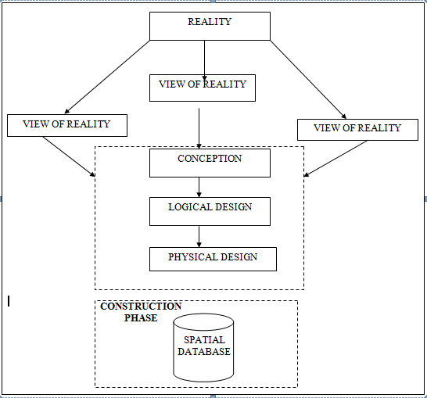
- Building
Fig. 3.1 Design and Construction Phases in Spatial Database

    - CONCEPTUAL DESIGN
Vector data model is the data type adopted for this project, which is represented, by points, lines and polygon. The identified entities are:-
      - Roads (line)
      - Electric poles (point)
      - Trees (point)
      - Buildings(polygon)
Fig. 3.2: E-R Diagram (Entity relationship diagram)
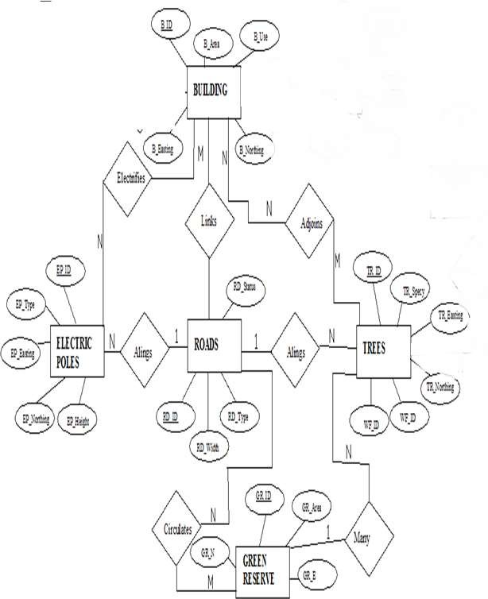

    - LOGICAL DESIGN
This is the design aspect of the database refers to the process of creating a conceptual framework or model that represents the structure and organization of spatial data within the system. It involves defining the data element, their relationship, and the rules for data manipulation and analysis. In this phase, the entities, their attributes and their relationships are represented in a single uniform manner in form of relation in such a way that would be no information loss and at the same time no unnecessary duplication of data. In this study, the logical database design is employed to generate a geo-relation database structure. Each entity has unique identifier in bold type. An attribute type or combination of attribute types that serves to identify an entity type is termed an identifier.
- Building( B_ID, B_Area, B_Name, B_Easting, B_Northing)
- Roads (R_ID, R_Width, R_Type, R-Condition, R_Easting, R_Northing )
- Vegetation (V_ID,GR_Area,)
- ree (TR_ID, TR_spp, TR_Importance, TR_Easting, TR_Northing )
- Electric Pole (EP_No, EP_Type, EP_Height,EP_Easting, EP_Northing)
    - PHYSICAL DESIGN
Table 3.1: Building and its attribute
ENTITY | DESCRIPTION
B_ID | Building Identification
B_name | Building Name
B_Area | Building Area
B_Easting | Building Easting
B_Northing | Building Northings

Table 3.2: Road and its attributes
ENTITY | DESCRIPTION
R_ID | Road Identifier
R_Length | Road Length
R_Width | Road Width
R_Type | Road Type
R_Condition | Road Condition

Table 3.3 : Trees and its attributes
ENTITY | DESCRIPTION
TR_ID | Tree Identifier
TR_Spp | Tree specy
TR_E | Tree_Easting
TR_N | Tree Northing

Table 3.4: Electric Poles and its attributes
ENTITY | DESCRIPTION
EP_ID | Electric pole Identifier
EP_Type | Electric pole Type
EP_Height | Electric pole Height
EP_E | Electric pole Easting
EP_N | Electric pole Northing

Table 3.5: Vegetation and its Attributes
ENTITY | DESCRIPTION
V_ID | Vegetation Identifier
V_Area | Vegetation Area
V_E | Vegetation Easting
V_N | Vegetation Northing

3.2 RECONNAISSANCE

This stage represents the groundwork laid prior to the execution of the project. It involves gathering all available and relevant information about the project area to ensure a smooth and effective implementation.
The necessary steps for the successful execution of the project are divided into two main phases:
- Office Planning
- Field Reconnaissance

3.2.1 OFFICE PLANNING
This phase entails the collection and review of information related to the study area. It also includes testing the instruments intended for use during the project, listing the required equipment, estimating the number of days needed for field activities, and outlining how each task will be performed. Additionally, responsibilities are assigned to team members based on the supervisor’s guidance and instructions.

Table. 3.6: Coordinates of Controls
Station | Northing (m) | Easting (m) | Height (m)
PBIL3306 | 940288.197 | 678281.701 | 355.212
PBIL3304 | 940275.508 | 678254.250 | 350.532
PL1 | 939677.97 | 678331.46 | 349.087
Source: Surveying and Geo-informatics Department Kwara state polytechnic.

3.2.2 FIELD RECONNAISSANCE

The field reconnaissance is the first visitation to the project site to get intimated with the environment.
- Boundary points was selected
- The distribution of features was studied
- Controls to be used were located
- Method and type of instrument to be uses was determined
- Subsidiary point for Ground control Points were picked and define using nail and bottle cock
- A diagram of the study area was drawn.

Fig. 3.3: Recce diagram of the study area (not drawn to scale)

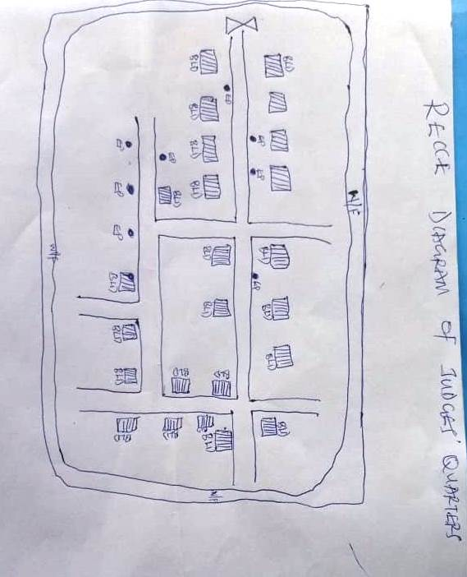
  - EQUIPMENT USED/ SYSTEM SELECTION AND SOFTWARE
    - HARDWARE USED
- Total station
- 1 reflector with a tracking rod.
- 1 Tripod
- One (1) 50m tape
- One (1) umbrella
- 1 cutlass
- Hand held GPS
- Hammer
- Nails and bottle cover
- Field book and writing materials
- 1-No of Personal Computer HP655 and its accessories
- 1-No of HP DeskJet K7100 A3 printer
- 1-No of HP DeskJet 1110 A4 printer
    - SOFTWARE COMPONENT
- Notepad.
- Microsoft Excel.
- AutoCAD 2007
- ArcGIS 10.3
- Surfer 2010
- Microsoft Word.

  - INSTRUMENT TEST
To ensure data quality, the Total Station used in this project was tested for both vertical index error and horizontal collimation error. These tests were conducted to confirm the instrument’s accuracy, efficiency, and overall reliability before use. The procedures followed are detailed below.
    - HORIZONTAL COLLIMATION TEST
This test was conducted to ensure that the line of sight was perpendicular to the trunnion axis. The Total Station was positioned over a specific point, and initial adjustments were made to ensure proper alignment, leveling, and focus (to eliminate parallax in the telescope). A vertical target was placed at a distance of 100 meters from the Total Station. To access the configuration menu of the Total Station, the menu key was pressed and held for approximately 2 seconds. From the main menu, the calibration sub-menu was selected, and within that, the horizontal collimation test option was chosen. The target was then observed and divided into two halves, with horizontal readings recorded for Face left and Face right. The readings are shown in Table 3.4.1 below.
Total Station

Fig 3.4: Horizontal Collimation and Vertical Index error test.
100m
REFLECTO R (TARGET)

STATION A
Fairly Level Ground
STATION B

Table 3.7: Horizontal Collimation Data
Station | Target | Face | Hz Reading | Difference | Error
A | B | L | 38˚42‟32”
 |  | R | 218˚42‟35” | 180˚00‟03” | 03”

    - VERTICAL INDEX ERROR TEST
This test was conducted to verify the accuracy of the vertical angle measurement when the line of sight is perfectly horizontal. The expected reading for this test is exactly ninety degrees (90°); any deviation from this value is known as the vertical index error.
The Total Station was set up over a designated point, with necessary temporary adjustments made to ensure proper alignment and functioning. A target was placed approximately 100 meters away, and the instrument was carefully aimed at it. The target was bisected by aligning the instrument in the Face Left position, and the corresponding vertical angle reading was recorded. The process was then repeated with the instrument in the Face Right position, and that reading was also documented. The recorded values are presented below.

Table 3.8: Vertical Index Data
Instrument Station | Target Station | Face | Vertical | Sum | Error
A | B | L | 90˚00‟00”
 |  | R | 270˚00‟02” | 360˚00‟02” | 02”

    - ANALYSIS OF COLLIMATION AND VERTICAL INDEX DATA
The reading obtain during calibration were reduced to obtain new collimation and vertical errors.
Horizontal collimation = {(FR – FL) – 180}/2 = {(00˚00‟03”}/2 = 1.5”

Vertical collimation = {(FL + FR) – 360} = (90˚00‟00” + 270˚00‟02”) - 360} = 02” The result shows that the instrument is still in good working condition.
  - CONTROL CHECK
Three control beacons (PBIL3306, PBIL3304) were utilized in this project. To verify their positions on-site, a check was performed by measuring the angles between these beacons and comparing the observed angles with those calculated from their known coordinates.
The Total Station was set up on the control beacon PBIL3304. After completing all necessary temporary adjustments, the reflector was positioned on the control beacon PBIL3306, designated as the back station. A horizontal angle reading was taken and recorded with the instrument set to Face Left.
Next, the reflector was moved to the control beacon PL1, the forward station. Horizontal angle readings were then recorded in both Face Left and Face Right positions. Finally, the reflector was returned to the back station, and a horizontal angle reading was recorded with the instrument set to Face Right.

Table 3.9: Table showing the back computation of the control coordinates
From STN | Bearing | Dist(m) | ∆N | ∆E | Northing (m) | Easting (m) | To STN
 |  |  |  |  | 940288.197 | 678281.701 | PBIL3306
PBIL3306 | 65°11'30'' | 30.242 | -12.689 | -27.451 | 940275.508 | 678254.250 | PBIL3304
PBIL3304 | 7°21'45'' | 602.506 | -597.538 | 77.21 | 939677.97 | 678331.460 | PL1

Table 3.10: Table showing the distance observation result of the control check
FROM | OBSERVED DISTANCE(m) | COMPUTED DISTANCE (m) | TO
PBIL3306 | 30.140 | 30.242 | PBIL3304
PBIL3304 | 602.451 | 602.506 | PL1

Table 3.11: Table showing the observation result of the control check
STN | SIGHT | FACE | OBSERVED HZ ANGLE | REDUCED HZ ANGLE | MEAN
 | PBIL3306 | L1 | 357° 08' 35''
PBIL3304 | PL1 | L2 | 291° 57' 00'' | 65°11'35''
 | PL1 | R2 | 111° 57' 1'' | 65°11'25''
 | PBIL3306 | R1 | 177° 08' 35'' |  | 65°11'30''

Difference in angle (observed - computed) =65° 11' 30''-65° 11' 25''
= 00° 00' 05''
Since the allowable accuracy (angular) of third order traverse of one station is 00° 00' 30'' and the result obtained from the control check (00° 00' 05'') is less than allowable error. Therefore, the controls were angularly intact.
  - MONUMENTATION
The boundary of the area carved out was demarcated with the precast concrete beacons, after clearing the required line of sights. The identified points of changes in directions were dug and beacons were buried on it, leaving about 15cm part of the beacon above the ground level. The beacons were buried at convenient distances as dictated by the nature of the boundary.

Fig. 3.5: Pillar Description
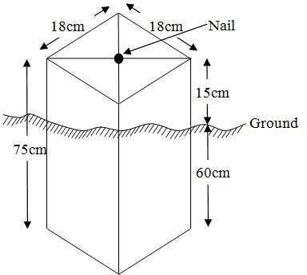
  - DATA ACQUISITION

PRIMARY DATA SOURCE
Field observation served as the primary data source for this project. A ground-based method was employed to collect data using a Total Station instrument, which involved recording X, Y, and Z coordinates from Ground Control Points (GCPs) established at prominent locations throughout the study area.

SECONDARY DATA SOURCE
An updated imagery of the area was obtained from Google Earth and used to determine the extent of coverage for the project area.
    - GEOMETRIC DATA ACQUISITION
The Total Station instrument was carefully set up on control point PBIL3304, with a back sight taken to PBIL3306 after performing the necessary station adjustments, which included centering, leveling, and focusing. The following procedures were then followed to determine the position of the next point (PL1), and this process was repeated sequentially until the entire site was covered. The data acquisition method used on site was the radiation method, where two or more points are coordinated from a single instrument station.
Procedure:
i. After setting up the instrument and completing temporary adjustments, the instrument was powered on, and a new job was created under the job menu in the instrument’s internal memory. The job was named GROUP 5A.
ii. The coordinates of the three control points were entered into the instrument’s memory, along with relevant codes such as:
- ‘RD’ for roads
- ‘SP’ for spot heights
- ‘BD’ for buildings, etc.
iii. The instrument height and reflector height were measured and saved in the instrument memory.
iv. In the coordinate menu, orientation was set by inputting the coordinates of the instrument station and the back sight. The reflector at the back station was carefully bisected before confirming the orientation by selecting ‘yes’.
v. After orientation, the reflector was bisected at the next point (nail), and the ‘obs’ (observe) option was selected. The three-dimensional coordinates (East, North, Height) of the point were displayed on the instrument’s screen, and ‘rec’ (record) was pressed to save the data. For subsequent observations, the ‘all’ option was used to streamline the process without separately pressing ‘obs’ and ‘rec’.
vi. It was ensured that the prism center of the reflector was precisely bisected and securely set on the tripod to minimize height measurement errors.
vii. The instrument was then moved to the next point after all details—including spot heights and boundary points visible from the current station—were recorded. Temporary adjustments were made after repositioning.
viii. This sequence was repeated until all boundary points and their heights were accurately coordinated.
ix. Spot heights in this project were acquired randomly rather than at regular grid intervals. Additionally, three edges of each building were surveyed.
x. Upon completion of the data acquisition, all collected details were properly recorded and mapped to their respective positions on the project plan.
    - ATTRIBUTES DATA ACQUISITION
Attribute data is information about spatial features. They provide the characteristics, description and nomenclature about spatial objects. Thus the attributes data acquired includes names of buildings and their uses such as classrooms, roads, water facilities and prominent natural features likes river and trees found and vegetation were properly identified within and around the study area.
  - DATA DOWNLOADING AND PROCESSING
    - DATA DOWNLOADING AND EDITING
This is stage whereby all data acquired which were automatically stored in the Total Station were downloaded into personal computer. This was done with the aid of downloading cable connected to the computer and some associated complementing software installed on the System.
    - DATA PROCESSING AND DATA EDITING
The geometric data downloaded were further processed in order to convert it to a useful format and to enhance its accuracy. The output coordinates, were edited and exported in *.txt, *.xls and *.pdf format. Thereafter, they were imported into Arc GIS 10.3 for further operations and to carry out spatial analysis.
    - DATA PROCESSING USING ARCGIS 10.3
Before launching ArcGIS, AutoCAD was used to plot feature data, which were saved separately in different files named road, boundary line, buildings, trees, and electric poles.
Steps to load and prepare data in ArcGIS 10.3:
- Launch ArcMap in ArcGIS 10.3.
- In the dialog box that appears, click A NEW EMPTY MAP to create a new project.
- On the menu bar, click Tools, then select Extensions. Check all available extensions, then close the window.
- On the left-hand side (LHS), right-click on Layers, and select Properties.
- In the Properties window, go to the Coordinate System tab to set the projection system to MINNA DATUM ZONE 31N. Then, go to the General tab to set the map units. Click Apply and then OK.
- Click Add Data on the toolbar, browse to the saved AutoCAD files, select all relevant files, and load them into the Table of Contents (Layer section).
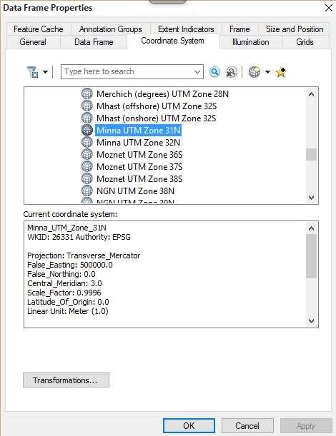
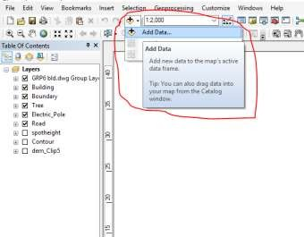
All drawing was exported to shape file. After the feature class has been creates, click on Editor to start Editing, and then click on the load object.
Creating Contours
- First, a Digital Elevation Model (DEM) was created by using the Natural Neighbor interpolation method. To do this, open the Search bar and type Interpolation, then select Natural Neighbor.
- Choose the XYZ data as the input for creating the DEM, setting the project boundary line as the extent for the interpolation.
- To generate contours, ensure that the Spatial Analyst toolbar is enabled. You can activate it by navigating to Customize > Toolbars > Spatial Analyst.
- Alternatively, open the search bar by clicking Windows > Search or by clicking the search icon and type relevant commands or tools.
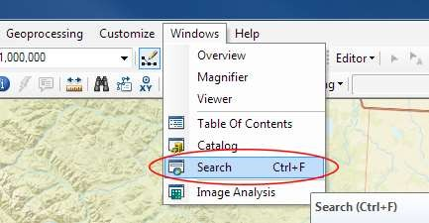
In the search bar type Contour, and select Contour (Spatial Analyst) from the search results list.

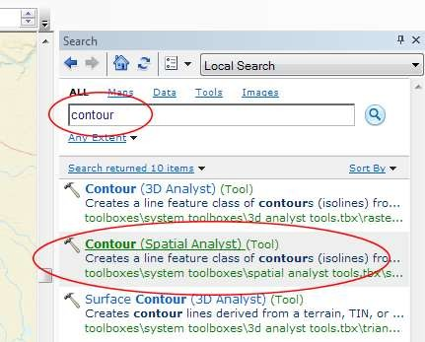
After choosing Contour, a dialogue window will appear, prompting you for five settings: Input raster: select the DEM file from which you want to generate contours by locating it on your hard drive or in the dropdown menu, showing layers present in the Table of Contents Output polyline features: indicate where you want to save your output contours Contour interval: set the distance between contour lines in meters – the smaller the number, the greater the number of lines Base contour (optional): the starting point from which the lines are generated – for example, the default is 0 so with an interval of 25 meters, the contours are generated at 25, 50, 75, 100…, but if the base contour is set at 40, then the contours are generated at 65, 90, 115, 140 and so on Z factor (optional): can be used to adjust the units of data; for example, if you have data in meters and you want to produce your contours in feet, use a z-factor of 3.28 because 3.28 feet equals one meter.

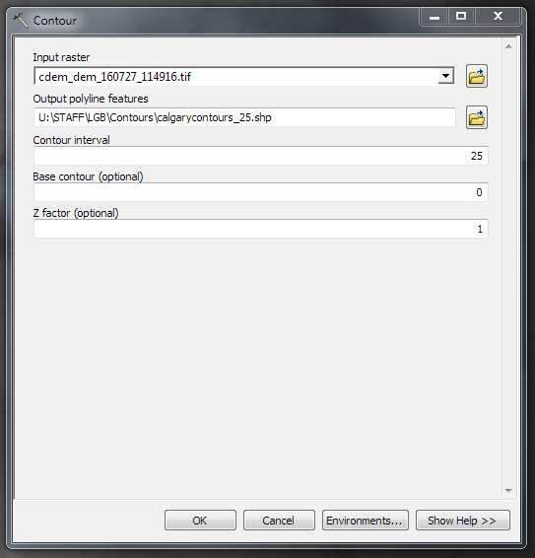
The generated contours will automatically be added to the map.
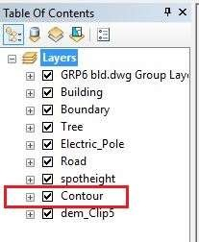
Input the data which is the AutoCAD drawing and select the feature type you want to load,
- Click Add and Next, then select the Target layer you want it to be
- Load it into from the feature class created on the ARCGLS.
- Click on Next, then select “only the features that satisfy the
- Query” and click on Query Builder to query for the feature to be loud e.g. “layer” = Boundary”.
- Click on Next. Then finish
Right click on the Boundary In the table of content and click on zoom to layer to display the feature.

EDITING, CONVERTING AND MERGING GEODATABASE
- Remove all necessary features by right clicking on it and press "REMOVE"
- Convert some features that are not in their correct „features -type‟ like point, line, and polygon features etc.
To convert a GOEDATABASE FEATURE CLASS to another the following steps were taken:
- FOR LINE FEATURE CLASS TO POLYGON FEATURE CLASS
- Go to WINDOW on the menu bar and select ARC Toolbox.
- Select DATA MANAGEMENT TOOLS, click on FEATURES, and then Select FEATURE TO POLYGON.
- ON INPUT FEATURES, select feature to be converted, on OUTPUT FEATURE CLASS, then save on the GRP6C FOLDER, press OK and CLOSE.
- Then remove the converted feature class in the LAYER Menu and ARC CATALOG files.
- On INPUT DATASETS, select features to be merged, on OUTPUT DATASETS, then save on the GRP6C folder, press OK and CLOSE.
- Then remove the converted feature class in the LAYER Menu and ARC CATALOG files.

TABLE CREATION
There is need to create attribute tables for the features so as to be used for queries. NOTE: The editor on the menu bar must be stopped before adding field to its table. THE FOLLOWING PROCEDURES WERE FOLLOWED:
- Right click on the feature class, then select OPEN ATTRIBUTES TABLE click on OPTIONS and select ADD FIELD.
- Give it FIELD NAME, click on TYPE and select [SHORT INTEGER or LONG INTEGER for SHORT or LONG WHOLE VARIABLES or DOUBLE FOR
DECIMAL VARIABLES OR TEXT variable or DATE for DATE], then enter precision or LENGTH for text width and scale for DECIMAL PLACES, and then click OK
- To input variables on the ATTRIBUTE TABLE, go to the EDITOR on Menu bar, select START EDITING,
- Click on ATTRIBUTE on menu bar [behind the TARGET], click on the features on the DATA VIEW display, and then input the variables of data acquired through SOCIAL SURVEY or DATA ACQUIRED ON THE FIELD.
- Save it after the input by selecting SAVE EDITS on the editor menu. To switch to other layers, select STOP EDITING on the EDITOR menu. Then repeat the above step to create other fields. Populate the table and save.

Table 3.12: Building
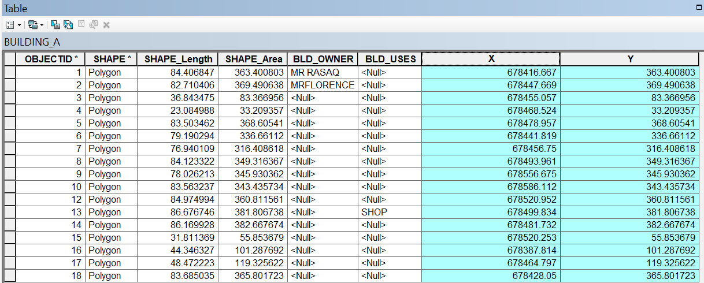

Table 3.13: Road
ENTITY | FIELD ALIAS | DATA TYPE | FIELD SIZE
R_ID | Road Identifier | Numeric | -
R_Length | Road Length | Numeric | -
R_Width | Road Width | Numeric | -
R_Type | Road Type | Text | 10
R_Condition | Road Condition | Text | 10

Table 3.14: Trees
ENTITY | FIELD ALIAS | DATA TYPE | FIELD SIZE
TR_ID | Tree Identifier | Numeric | -
TR_Spp | Tree specy | Text | 10
TR_E | Tree_Easting | Numeric | -
TR_N | Tree Northing | Numeric | -

Table 3.15: Electric Poles
ENTITY | FIELD ALIAS | DATA TYPE | FIELD SIZE
EP_ID | Electric pole Identifier | Numeric | -
EP_Type | Electric pole Type | Text | 10
EP_Height | Electric pole Height | Numeric | -
EP_E | Electric pole Easting | Numeric | -
EP_N | Electric pole Northing | Numeric | -

ADDING SPOT HEIGHTS DATA
- NOTE: STOP EDITING on the EDITOR MENU before adding data field,
- Go to FIELD ON THE MENU BAR, scroll to add Data and then ADD XYZ DATA
- Browse the EXCEL FILE for SPOT HEIGHTS, select EASTING VALUE on X - FIELD and NORTHING VALUE on Y - IELD and ELEVATION
- « Select DATA the EXPORT DATA, locate the folder created and give it name then YES AND OK, remove the previous layer by right clicking on it and select REMOVE.

Fig. 3.6 shows the spot height
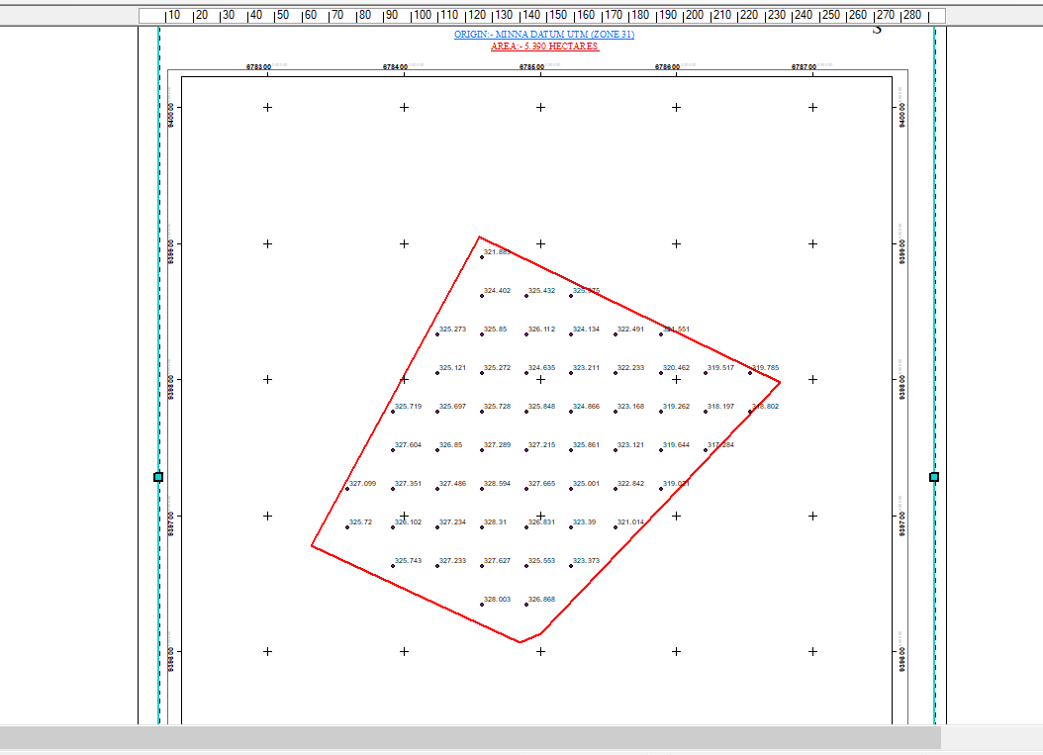

TIN, ASPECT AND SLOPE CREATION USING ARCMAP
NOTE: Making sure the 3D Analyst Extension is active, select VIEW on MENU bar, then click TOOLBARS and MARK the 3D Analyst EXTENTION Then X, Y Data

TO CREATE TIN
- Click on 3D Analyst arrow, select create TIN and then create TIN from FEATURE.
- On layers mark the SPOTHEIGHT LAYER, select height data on HEIGHT, then ok.

TO CHANGE THE FACE OF THE TIN ACCODING TO ITS ELEVATION
- RIGHT CLICK on the TIN, select PROPERTIES, and click on SYMBOLOGY.
- Then ADD, select FACE ELEVATION WITH COLOR RAMP, click ADD, and then select APPLY and OK.
Fig. 3.7: Shows the Tin creation
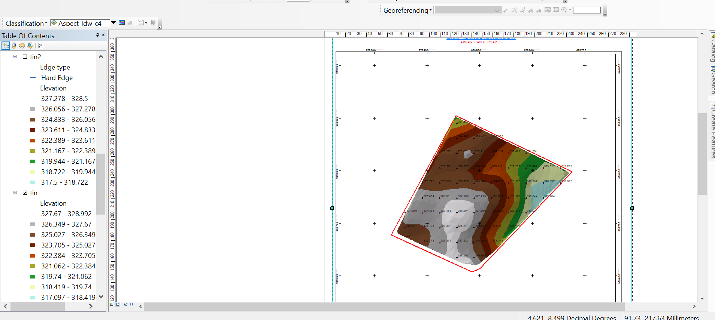

TO CREATE ASPECT
- Click on 3D analyst arrow, select SPATIAL ANALYST TOOLS, SURFACE and THEN DOUBLE CLICK on ASPECT.
- Browse to where the raster format of all the acquired data created from the surfer was saved to.
- Browse to where you want the OUTPUT RASTER to be saved
- You can change the OUTPUT MEASUREMENT to Degree OR percent
- Click OK [then it displays on the data view screen], then Close.
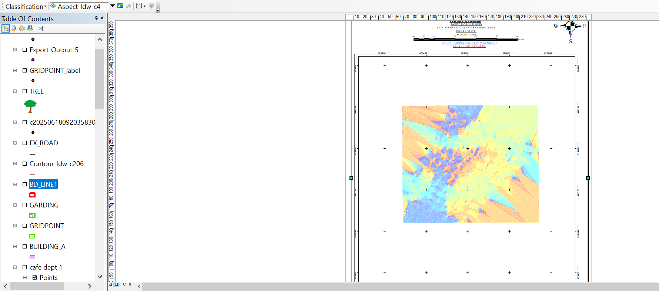
Fig. 3.8 shows the slope aspect

  - DATABASE IMPLEMENTATION
This is the database creation phase. Having completed the three stages of design phase (i.e. Reality, Conceptual and Logical design), the database was created using ArcGIS 10.3 software. It involves the combination and storage of acquired graphic data and attributes data in creating the database for the purpose of spatial analysis and query.
Database is an organized integrated collection of data stored so as to be capable of use by revenant application with data being accessed by different logical part. After the Attribute table was populated via the keyboard, some attributes such as areas of settlements were automatically displayed by special command in the ArcGIS 10.3 version. The ArcGIS software was used to link the graphic data and table for query generation.
    - DATABASE MANAGEMENT SYSTEMS
Database management refers to a collection of software designed for creating, storing, manipulating, updating, organizing, and querying information within a database (Kufoniyi, 1998). A Database Management System (DBMS) functions as intermediary software that manages the database on behalf of the user.
A good DBMS should provide the following key functions:
a. Efficient storage and retrieval of data.
b. Concurrent access by multiple users.
c. A standardized interface between the database and application programs.
d. Standardized data access and clear separation of data storage/retrieval from the application logic.
e. Maintenance of data security and integrity.
    - DATABASE MAINTENANCE
After creating the database, proper maintenance practices were implemented to ensure it met its stated objectives. Maintenance allowed for the addition of new data and removal of outdated or irrelevant information. Regular updates are essential to reflect physical changes in the landscape over time. Additionally, security and data integrity measures were enforced to maintain the database’s reliability and effectiveness.
Consistent updating and management of the database are crucial for maintaining its currency and quality, which in turn enhances its suitability as part of a Spatial Decision Support System (SDSS). The overall quality of a database depends on its timeliness and fitness for use within a decision support framework.
It is also important to periodically review the storage media to prevent data inaccessibility or deterioration due to physical damage. Care must be taken when populating the database, as its value directly depends on the accuracy and quality of the input data.
For long-term archiving, stable storage media should be used, such as:
- Computer-compatible tape readers
- Magnetic tapes
- Optical discs and compact discs

3.8.3 BACK COMPUTATION

Table 3.16: Back Computation
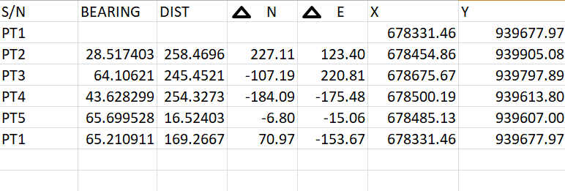

3.8.4 AREA COMPUTATION

Table 3.17: Area Computation
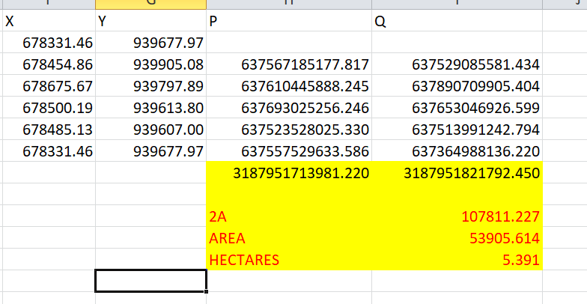

CHAPTER FOUR

4.0 SPATIAL ANALYSES AND PRESENTATION
GIS stands out among other information systems due to its powerful spatial analytical capabilities, including overlay operations, buffering, spatial search, topographic analysis, as well as neighborhood and connectivity operations. GIS leverages these capabilities to answer fundamental questions related to location, condition, trends, routing, patterns, and modeling through the manipulation and analysis of spatial data. In this project, the major analyses performed were overlay operations, topographic analyses, and spatial searches.

4.1 TESTING OF DATABASE
This test was conducted to evaluate the relationships between data modeled as entities in the spatial database and to assess the database’s retrieval capabilities. A sample query with specific conditions was designed and executed to verify whether the desired results could be obtained.
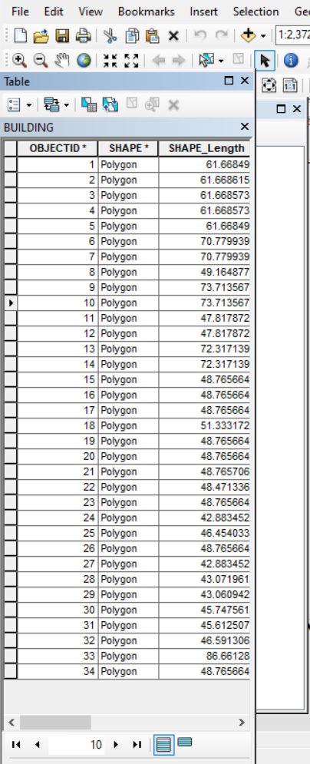
Fig. 4.1: Shows the attribute database

Fig. 4.2: Showing catalog, attribute table and table of content
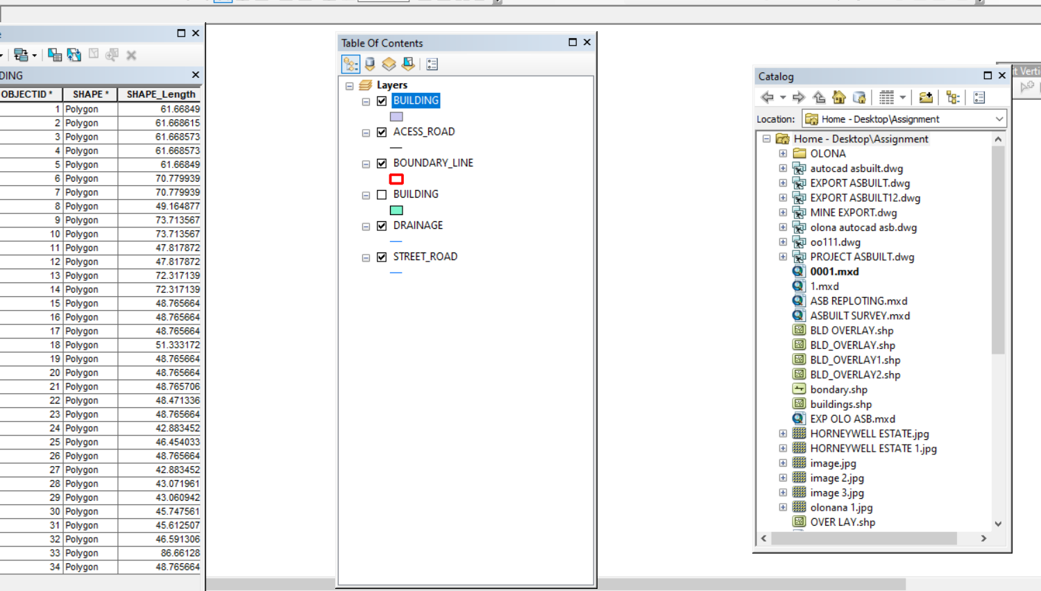

Analysis of Result
The query retrieved contours with elevation values greater than or equal to 350 meters, indicating areas likely to be less prone to flooding within the project area, as shown in Figure 4.5 (Query 1). These contours represent points with elevations above 350 meters.
The attribute table confirmed that the northeast part of the institute has the highest elevation. Elevation is a critical factor when considering terrain surface and slope. Conversely, the southwest part of the school has the lowest elevation and is therefore more susceptible to erosion. Buildings planned for this region should have foundations elevated significantly above ground level to mitigate potential damage.
The results of this query provide valuable information to the school management, enabling informed decisions about terrain characteristics and appropriate building designs across different regions of the project area.

SINGLE SELECTION CRITERION
Query 1: Retrieving Area whose height is Greater than 350 meters
SELECT* FROM Contour WHERE "CONTOUR">3.007
Fig 4.3.: Retrieving Area whose height is greater than 3.007 meters
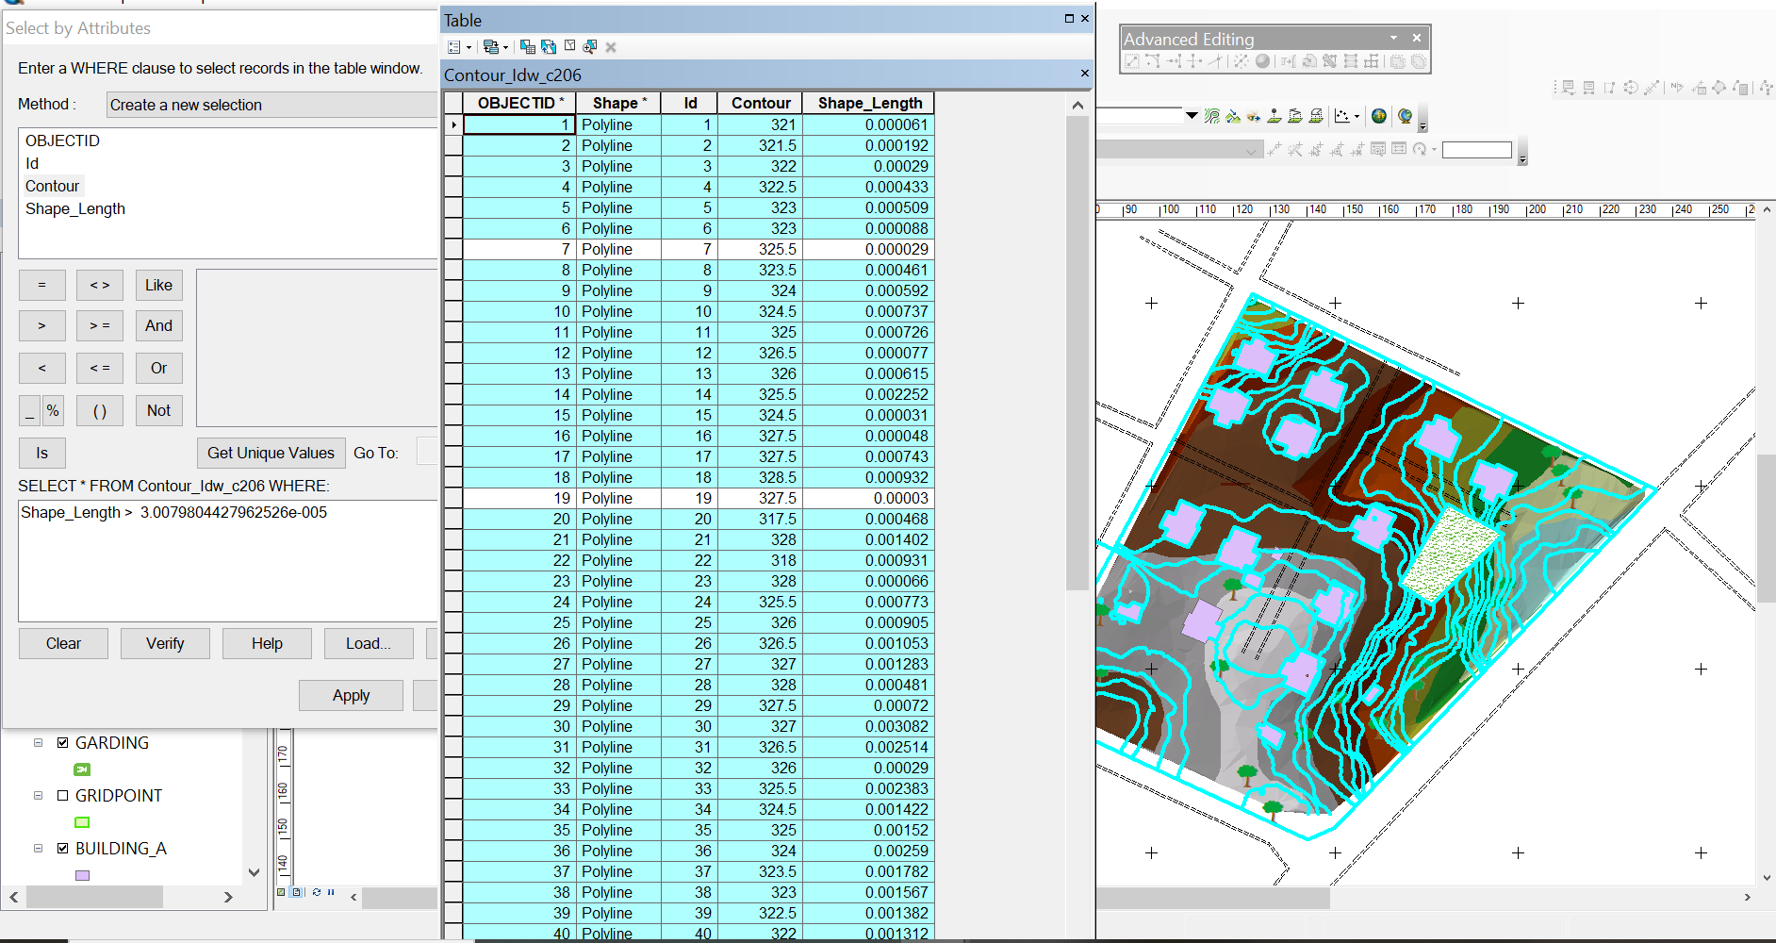

Fig 4.4: Result of area whose height is greater than 3.007 meters
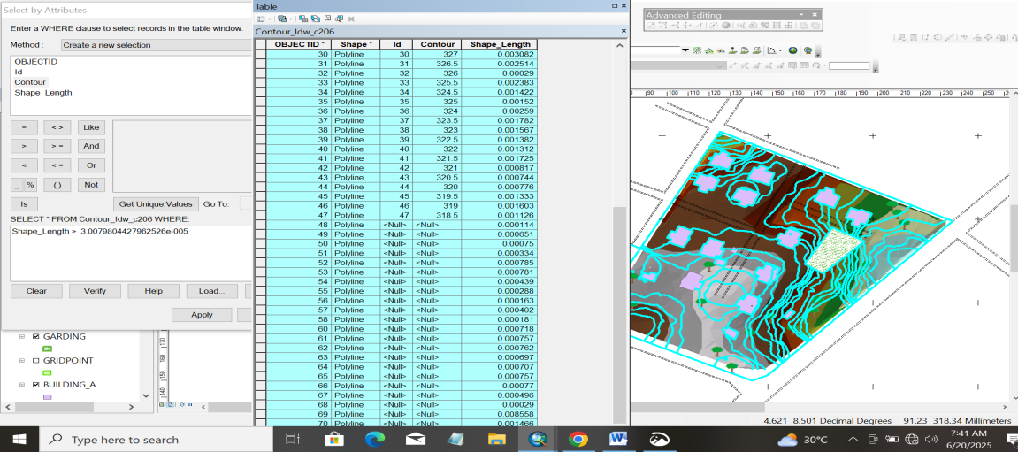

Fig 4.5: Shows the building use for shop
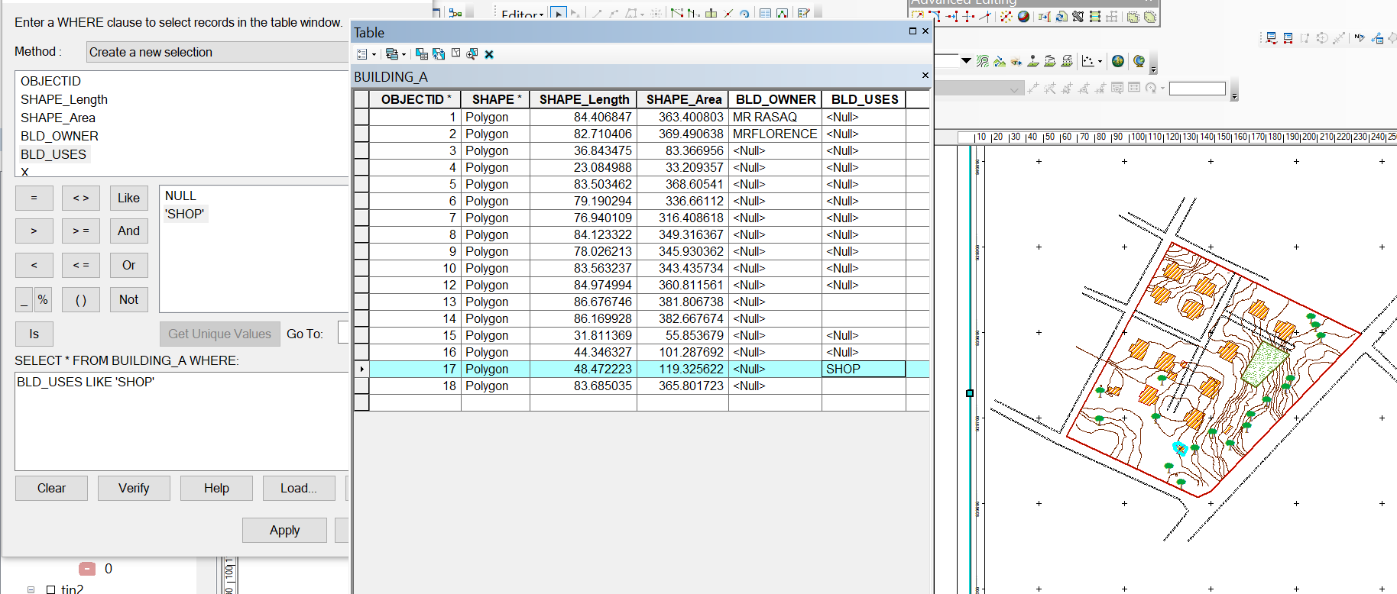

CHAPTER FIVE
COSTING, SUMMARY, PROBLEM ENCOUNTERED, CONCLUSION AND RECOMMENDATIONS
5.1 COSTING
This stage the total cost spent on the project from day one to the final stage.
Table 5.1.1: Direct cost parameters
S/N | DIRECT COST
1 | Reconnaissance (1 day)
 | PERSONNEL | Rate | Total Amount (N:K)
 | 1 x surveyor | 10500 | 10500
 | 1 x assistant surveyor | 7500 | 7500
 | 1 x technical officer | 6500 | 6500
 | 3 x skilled labour | 4000 | 12000
 | basic equipment | 5000 | 5000:00
 | transportation (vehicle, Driver and fuel) | 10000 | 10000:00
 |  | sub-total | 51,500
2 | Monumentation (1 day)
 | PERSONNEL
 | 1 x assistant surveyor | 7500 | 7500
 | 1 skilled labour | 4000 | 4000
 | transportation (vehicle, Driver and fuel) | 10000 | 10000
 | basic equipment | 5000 | 5000:00

 | Beacon (6) | 1000 | 6000
 |  | sub-total | 32,500
3 | Data acquisition (2 days)
 | PERSONNEL
 | 1 x assistant surveyor | 7500 | 7500
 | 1 x technical officer | 6500 | 6500
 | 3 x skilled labour | 4000 | 12000
 | Total Station and accessories | 15000 | 15000
 | transportation (vehicle, Driver and fuel) | 10000 | 10000
 |  | sub-total | 51,000
5 | Data Processing (2 days)
 | PERSONNEL
 | 1 x surveyor | 10500 | 10500
 | 1 x assistant surveyor | 7500 | 7500
 | 1 x technical officer | 6500 | 6500
 | computer / accessories | 15000 | 15000
 |  | sub-total | 39,500
7 | Technical Report (1 day)
 | PERSONNEL
 | 1 x surveyor | 10500 | 10500
 | 1 x assistant surveyor | 7500 | 7500

 | 1 x secretary | 5000 | 5000:00
 | computer / accessories | 15000 | 15000:00
 |  | sub-total | 38,000
TOTAL (DIRECT COST) 212,500 MOBILIZATION/DEMOBILIZATION = 5% of Direct Cost
= 0.05 × 212,500

= N10,625

CONTINGENCY ALLOWANCE
= 5% of Direct Cost
= 0.05 × 212,500

= N10,225

GRAND TOTAL = N212,500 + N10,625 + N10,625

= N233,750

VAT (@5% GRAND TOTAL) = 0.05 × 233750

= N11,687.5

TOTAL COST PAYABLE = GRAND TOTAL + VAT

= N233,750+ N11,687.5
= N245,437.5

5.2 SUMMARY
The main aim of the project is to carry out the topographical information system of Judges Quarter Estate, Taoheed Road Ilorin. Kwara State. It was done in accordance with the survey rule and regulation and the departmental instruction. A digital ground survey method was basically use for data acquisition. A data base was created to house all the relevant data collected on the field, AutoCAD, suffer Microsoft word, Microsoft Excel and Notepad were combined to carryout data processing manipulation, Analysis and retriever. The final presentation of information was produced in form of digital map both in hard copy/soft copy.
5.3 PROBLEMS ENCOUNTERED
During the execution of this project the problem encountered are the followings:
1. The pegs used for monumentation were removed repeatedly, but this was overcome by referencing each peg to a fixed mark with the distance of the peg from the reference mark noted.
5.4 CONCLUSION
The aims of the project were achieved as the expected accuracy and the obtained results conformed to required accuracy of a third order job also the task actually exposed and broadened my knowledge on the scope, concepts and skills, involved in topographical surveying, more so, the project has been successfully executed as adequate data were acquired processed and represented in plans.
This project was interesting in spite of the numerous problems encounter thought the execution of the project.
The exercise was not an easy task, it is much cumbersome. It consume money, energy, time and other tangible factors, but at the end of it, I realize that it had helped me in the practical aspect of land surveying and exposed me to that types of problem. Surveyors usually encounters on the field.
5.4 RECOMMENDATIONS
Having successfully carried out the project assignment, I hereby recommend that.
- The x, y and z coordinates of the features were which confirm the position of the features
- The topographical surveys of the area enhanced the use of various surveys of software’s such as AutoCAD; suffer e.t.c and the preparation of plan. Hence it is highly recommended for further studies.
- The authority should make modern instrument like global positioning system (GPS) receiver, total station, and digital level etc. available to the prospective student of Higher National Diploma so as to be widely exposed to them for easy operation.
- I also recommend that instrument should be released to the student on time for quick execution of the project.

REFERENCES
Burrough, P. A., & McDonnell, R. A. (1998). Principles of Geographical Information Systems. Oxford University Press.
Clarke, K. C. (2010). Getting Started with Geographic Information Systems (5th ed.). Pearson.
Collier, P. (2002). The Impact on Topographic Mapping of Developments in Land and Air Survey: 1900-1939. Cartography and Geographic Information Science, 29(3), 155-174.
DeMers, M. N. (2008). Fundamentals of Geographic Information Systems (4th ed.). Wiley
Ehsani, H. A., & Quiel, F. (2009). A semi-automatic method for analysis of landscape elements using Shuttle Radar Topography Mission and Landsat ETM+ data. Computers and Geosciences, 35, 373-389.
Idhoko, K. (2015). Topographic Information System as a Tool for Environmental Management: A Case of Part of Delta State Polytechnic Ogwashi-Uku, Aniocha South, Delta State, Nigeria. IOSR Journal of Environmental Science, Toxicology and Food Technology, 9(12), 117-122. DOI: 10.9790/2402-09112117122.
Maune, D. F. (Ed.). (2007). Digital Elevation Model Technologies and Applications: The DEM Users Manual (2nd ed.). American Society for Photogrammetry and Remote Sensing.
Longley, P. A., Goodchild, M. F., Maguire, D. J., & Rhind, D. W. (2015). Geographic Information Science and Systems (4th ed.). Wiley.
Nkeki, F. N. (2013). Mapping and Geovisualizing Topographical Data Using Geographic Information System (GIS). ResearchGate. DOI: 10.13140/RG.2.2.33351.04002.
Nkeki, F. N., & Ojeh, V. N. (2024). Mapping and Geovisualizing Topographical Data Using Geographic Information System (GIS). Journal of Geography and Geology, 6(1). DOI: 10.13140/RG.2.2.33351.04002.
Oladunjoye, P., & Olayiwola, A. M. (2023). Application of GIS in Topographic Analysis for Sustainable Urban Planning in Lagos, Nigeria. African Journal of Environmental Sciences, 12(2), 45-59.
Rine, C. M., Morales, J., Vanyukevych, A. B., Durand, E. G., & Schroeder, K. A. (2023). Using GIS Mapping to Assess Foster Care: A Picture Is Worth a Thousand Words. Social Service Review, 97(3), 321-340.
Wilson, J. P., & Gallant, J. C. (2000). Terrain Analysis: Principles and Applications. Wiley.

APPENDIX I
S/N | X | Y | Z
PT1 | 678457.2303 | 939634.3698 | 328.003
PT2 | 678490.0255 | 939634.3698 | 326.868
PT3 | 678391.6401 | 939662.7202 | 325.743
PT4 | 678424.4352 | 939662.7202 | 327.233
PT5 | 678457.2303 | 939662.7202 | 327.627
PT6 | 678490.0255 | 939662.7202 | 325.553
PT7 | 678522.8206 | 939662.7202 | 323.373
PT8 | 678358.8449 | 939691.0705 | 325.72
PT9 | 678391.6401 | 939691.0705 | 326.102
PT10 | 678424.4352 | 939691.0705 | 327.234
PT11 | 678457.2303 | 939691.0705 | 328.31
PT12 | 678490.0255 | 939691.0705 | 326.831
PT13 | 678522.8206 | 939691.0705 | 323.39
PT14 | 678555.6158 | 939691.0705 | 321.014
PT15 | 678358.8449 | 939719.4209 | 327.099
PT16 | 678391.6401 | 939719.4209 | 327.351
PT17 | 678424.4352 | 939719.4209 | 327.486
PT18 | 678457.2303 | 939719.4209 | 328.594
PT19 | 678490.0255 | 939719.4209 | 327.665
PT20 | 678522.8206 | 939719.4209 | 325.001
PT21 | 678555.6158 | 939719.4209 | 322.842
PT22 | 678588.4109 | 939719.4209 | 319.021
PT23 | 678391.6401 | 939747.7712 | 327.604
PT24 | 678424.4352 | 939747.7712 | 326.85
PT25 | 678457.2303 | 939747.7712 | 327.289
PT26 | 678490.0255 | 939747.7712 | 327.215
PT27 | 678522.8206 | 939747.7712 | 325.861
PT28 | 678555.6158 | 939747.7712 | 323.121
PT29 | 678588.4109 | 939747.7712 | 319.644
PT30 | 678621.206 | 939747.7712 | 317.284
PT31 | 678391.6401 | 939776.1216 | 325.719
PT32 | 678424.4352 | 939776.1216 | 325.697
PT33 | 678457.2303 | 939776.1216 | 325.728
PT34 | 678490.0255 | 939776.1216 | 325.848
PT35 | 678522.8206 | 939776.1216 | 324.866
PT36 | 678555.6158 | 939776.1216 | 323.168
PT37 | 678588.4109 | 939776.1216 | 319.262
PT38 | 678621.206 | 939776.1216 | 318.197
PT39 | 678654.0012 | 939776.1216 | 318.802
PT40 | 678424.4352 | 939804.4719 | 325.121
PT41 | 678457.2303 | 939804.4719 | 325.272
PT42 | 678490.0255 | 939804.4719 | 324.635
PT43 | 678522.8206 | 939804.4719 | 323.211
PT44 | 678555.6158 | 939804.4719 | 322.233
PT45 | 678588.4109 | 939804.4719 | 320.462
PT46 | 678621.206 | 939804.4719 | 319.517
PT47 | 678654.0012 | 939804.4719 | 319.785
PT48 | 678424.4352 | 939832.8223 | 325.273
PT49 | 678457.2303 | 939832.8223 | 325.85
PT50 | 678490.0255 | 939832.8223 | 326.112
PT51 | 678522.8206 | 939832.8223 | 324.134
PT52 | 678555.6158 | 939832.8223 | 322.491
PT53 | 678588.4109 | 939832.8223 | 321.551
PT54 | 678457.2303 | 939861.1726 | 324.402
PT55 | 678490.0255 | 939861.1726 | 325.432
PT56 | 678522.8206 | 939861.1726 | 325.375
PT57 | 678457.2303 | 939889.523 | 321.883

