TITLE PAGE
DESIGN AND CONSTRUCTION OF SOLAR-ENABLING RECHARGEABLE FAN WITH INTEGRATED PERIPHERAL FUNCTION
BY NAME
OLOYEDE QUAM OLAYINKA
(HND/23/EEE/FT/0108)
SUPERVISED BY ENGR. A.A JIMOH
SUBMITTED TO
DEPARTMENT OF ELECTRICAL/ELECTRONICS
ENGINEERING TECHNOLOGY (IOT), KWARA STATE POLYTECHNIC, ILORIN.
IN PARTIAL FULFILLMENT OF THE REQUIREMENTS FOR THE AWARD OF HIGHER NATIONAL DIPLOMA (HND) IN ELECTRICAL/ELECTRONICS ENGINEERING
TECHNOLOGY

JULY, 2025

CERTIFICATION
This is to certify that this project was carried out and submitted by OLOYEDE QUAM OLAYINKA
of matric number HND/23/EEE/FT/0108 and has been read and approved as meeting the requirements for the award of Higher National Diploma in the Department of Electrical/Electronics Engineering Technology(IOT), Kwara State Polytechnic, Ilorin.

ENGR. A.A JIMOH DATE
Project supervisor
ENGR. Z. A. ABDULKADIR DATE
Project coordinator
ENGR. DR. O. A. LAWAL DATE
Head of department
External Examiner DATE

ACKNOWLEDGEMENT
First and foremost, I give all thanks to God Almighty for the strength, wisdom, and grace to complete this project successfully.
I would like to sincerely appreciate my supervisor, [Engr A.A JIMOH], for the guidance, support, and corrections throughout the course of this project. Your encouragement helped shape this work from the early stages to the final completion.
I would also like to thank my project group members for their contribution collaboration. Their hard work and dedication have been crucial to the success of this project.
My heartfelt thanks also goes to the entire staff of the Department of Electrical/Electronics Engineering, for the knowledge and skills shared during my time in the program.
To my family and friends, thank you for your prayers, motivation, and supports both emotionally and financially.

DEDICATION
With a heart full of gratitude, I dedicate this project to Almighty Allah, the source of life, knowledge, and strength. His mercy and guidance have been my anchor through the challenges and triumphs of this academic journey.
To my loving parents, thank you for your sacrifices, prayers, and unwavering belief in me. Your support has been the foundation of my success.
To my siblings, I am grateful for your encouragement and understanding, even when the journey got tough.
Finally, to my friends, lecturers, and everyone who stood by me with words of motivation, assistance, and kindness this achievement is also yours.

TABLE OF CONTENT
CERTIFICATION i
ACKNOWLEDGEMENT ii
DEDICATION iii
TABLE OF CONTENT iv
LIST OF FIGURES AND TABLES viii
ABSTRACT XI
CHAPTER ONE
1.1 INTRODUCTION 1
1.2 THE PROBLEM STATEMENT 2
1.3 AIM OF THE PROJECT 3
1.4 OBJECTIVES OF THE PROJECT 3
1.5 SCOPE OF THE PROJECT 3

CHAPTER TWO
2.1 LITERATURE REVIEW 4
2.2 SOLAR CELL 5
2.3 TYPES OF SOLAR CELL 6
2.3.1 CRYSTALLINE SILICON CELLS 7
2.3.2 MONOCRYSTALLINE CELLS 7
2.3.3 POLYCRYSTALLINE SOLAR PANEL 8
2.3.4 THIN FILM SOLAR PANEL 9
2.4 RECHARGEABLE FAN 10
2.5 UNIVERSAL SERIAL BUS (USB) 11
2.6 LIGHT-EMITTING DIODE (LED) 12
2.6.1 DIFERENT TYPES OF LED 13
2.7 REVIEW OF RELATED PROJECT WORK ON SERF 16
2.8 THE BLOCK DIAGRAM OF THE PROJECT 18

CHAPTER THREE
3.1 METHODOLOGY 20
3.2 COMPONENT SELECTION 20
3.3 SYSTEM SIMULATION 22
3.3.1 SIMULATION OBJECTIVES 22
3.3.2 SIMULATION OUTCOME 22
3.4 ASSEMBLING 23
3.5 BLOCK DIAGRAM OF THE SYSTEM 23
3.5.1 EXPLANATION OF FLOW 24

CHAPTER FOUR
4.1 TEST AND ANALYSIS 26
4.2 ASSEMBLY OF THE SOLAR-ENABLED
RECHARGEABLE FAN COMPONENT 26
4.2.1 THE SOLAR PANEL (PHOTOVOLTAIC CELLS) 26
4.2.2 THE LION BATTERY 27
4.3 SUMMARY OF THE SYSTEM ASSEMBLY 28
4.4 CIRCUIT DIAGRAM 28
4.4.0 EXPLANATION OF MAJOR SECTIONS 28
4.4.1 SOLAR INPUT AND CHARGING STAGE 28
4.4.2 BATTERY STORAGE 29
4.4.3 FAN VOLTAGE CONTROL AND SPEED REGULATION 29
4.4.4 PERIPHERAL OUTPUT 29
4.4.5 PROTECTION AND SWITCHING 29
4.5 CONSTRUCTION PROCEDURE 30
4.5.1 SIMULATION AND LAYOUT DESIGN 30
4.5.2 VEROBOARD IMPLEMENTATION 30
4.5.3 COMPONENT PLACEMENT AND SOLDERING 30
4.5.4 SYSTEM INTEGRATION 31
4.5.5 ENCLOSURE SETUP 31

4.6 EVALUATION OF FAN PERFORMANCE 32
4.6.1 AIRFLOW MEASUREMENT (CFM) 32
4.6.2 EFFICIENCY CALCULATION 32

CHAPTER FIVE
5.1 CONCLUSION 33
5.2 RECCOMENDATION 33
REFERENCES 34

LIST OF FIGURES AND TABLES
LIST OF FIGURES
FIGURE 2.1: MONOCRYSTALLINE SOLAR PANEL 8
FIGURE 2.2: POLYCRYSTALLINE SOLAR PANEL 9
FIGURE 2.3: THIN FILM SOLAR PANEL 10
FIGURE 2.4.: UNIVERSAL SERIAL BUS 10
FIGURE 2.5: LED SYMBOL 13
FIGURE 2.6: SIMPLE LED CIRCUIT 13
FIGURE 2.7: MINIATURE LED 14
FIGURE 2.8: HIGH-POWER LED 14
FIGURE 2.9: FLASH LED 15
FIGURE 2.10: ALPHANUMERIC LED 15
FIGURE 2.11: LIGHTING LED 16
FIGURE 2.12 ASSEMBLING BLOCK DIAGRAM 18
FIGURE 3.1 ASSEMBLING BLOCK DIAGRAM 23
FIG.4.1: DIAGRAM OF SOLAR AND CHARGE CONTROLLER CONNECTION 27
FIG. 4.2: DIAGRAM OF LION AND CHARGE CONTROLLER CONNECTIONS. 27
FIG: 4.3 DIAGRAM OF SOLAR PANEL, CHARGE CONTROLLER AND BATTERY 28
FIG: 4.4 CIRCUIT DIAGRAM OF SOLAR POWERED DC FAN 30
LIST OF TABLES
TABLE 2.1: USB SPEED USB PROTOCOL RATE TYPICAL DEVICES 12
TABLE 3.1: SUMMARY OF THE KEY COMPONENTS USED AND THEIR RESPECTIVE FUNCTION 20

ABSTRACT
This project focuses on the design and construction of a solar-enabled rechargeable fan integrated with essential peripheral features such as LED lighting and a battery status indicator. The system was developed to provide a sustainable and energy-efficient solution for personal cooling and lighting, especially in off-grid and power-deficient areas.
The core objective was to harness solar energy as the primary source of power, thereby reducing dependence on the national grid and fossil fuels. The system includes a solar panel, a rechargeable battery, a DC fan motor, high-efficiency LEDs, and a voltage level indicator circuit for monitoring battery status. The design ensures efficient power management, portability, and ease of use, while emphasizing low maintenance and cost-effectiveness.
The methodology involved sizing the solar components based on load demand, integrating circuit protections, and optimizing the overall energy distribution for simultaneous fan operation and LED lighting. The fan system was housed in a durable casing with ventilation, ensuring both functionality and safety.
This project demonstrates the viability of small-scale renewable energy systems in solving daily energy needs. It also highlights the importance of incorporating peripheral functions into standalone devices to improve convenience and adaptability in diverse usage environments.

CHAPTER ONE
1.1 Introduction
The Solar-Enabled Rechargeable Fan (SERF) with Integrated Peripheral Functions is an innovative project that aims to provide a reliable, eco-friendly, and cost-effective solution for cooling and ventilation. This project helps ease the burden of limited access to electricity in many parts of the world, particularly in rural or off-grid areas, where traditional fans are rendered useless during power outages. The project's importance lies in its potential to improve indoor air quality by circulating air and reducing stagnation, thereby minimizing the risk of respiratory issues, reduce heat-related illnesses, particularly for vulnerable populations, it offers a reliable and independent cooling solution for areas with frequent power outages or limited access to electricity.
The recent power bands scheduled by the power utilities company and the hike in the general commodities in Nigeria has put to question, the financial status of every citizen on the continuous reliance of the conventional electrical fans system. Hence the citizen has sort means of cool air ventilation using solar renewable system. Similar initiatives have been ventured into developing solar-powered ventilation systems, but this particular project stands out with its integrated peripheral functions, such as a built-in power bank for charging small devices, LED lighting, and a battery status indicator. These features make the project more versatile and user-friendly, setting it apart from existing solar-powered fans.
The world's shift towards renewable energy and sustainable living makes our SERF a timely innovation. As the world’s focus intensifies on reducing carbon footprints and promoting eco-friendly practices, our solution is perfectly positioned to meet this need. By utilizing the power of solar energy, we can help reduce our reliance on fossil fuels and create a more sustainable future. our innovative fan is an important step in the right direction, most especially if all domestic gadgets can be placed on the used of renewable energy, it will create and free more power supply system for industrial usage and this practice is envisioned to boost our power supply chain and lower the competitiveness and need for the mains power supply system.
The industries sort after the need of effective power supply system for productive purposes such as manufacturing, processing of raw materials, preservation etc. This has the tendency to increase and scale up our local economy, while the renewable energy system can take care of the need of the citizen in areas that are not as financially productive as the industries (e.g for entertainment purposes) but essential for human existence and survival from boredom. This is evident in the influx of recent technology devices and the social media space that has grown in recent years. In-fact many Nigerians occupied the social media space more than their conventional offices and many of the small and medium business enterprises has flourished in advertisement using the social media space. Besides the aforementioned, event on the social media now create awareness of happening in the society space than the convention main stream media. The act has made the world indeed a global village.
The use of the Close Circuit Television (CCTV) cannot be left out and the camera of real time happening using the mobile phone has create awareness of virtually anything and everything happening in the society. This act has limited and curtail the excessiveness of many oppressors in the society. Therefore, power these gadget and technology using the solar renewable energy system will serve as a giant stride in the world of electronic system.
1.2 The Problem Statement.
Millions of people worldwide, especially in developing communities, face significant challenges in accessing reliable and sustainable cooling solutions. This leads to a range of issues, including increased discomfort and heat-related health risks, such as heat exhaustion and heatstroke, due to hot weather conditions, limited access to cooling solutions for vulnerable populations, including the elderly, young children, and those with pre-existing medical conditions. The absence of affordable, eco-friendly, and energy-efficient cooling solutions in these communities exacerbates these problems. In response to these challenges, the Solar-Enabled Rechargeable Fan project will be developed to provide a sustainable, accessible, and innovative solution to address these pressing needs.
1.3 Aim of the Project
This project aims to design and construct a solar-enabled rechargeable fan with integrated peripheral functions such as USB charging ports, LED lighting, and a battery status indicator.
1.4 Objectives of the project
The objectives of the project are to:
- Design a fan that can be powered by solar energy and rechargeable batteries.
- Integrate peripheral functions such as USB charging ports, LED lighting, and a battery status indicator into the fan.
- Construct the fan with attention to durability, functionality, and ease of use.
- Test the fan's performance under various environmental conditions and evaluate the efficiency of its solar charging system.
1.5 Scope of the Project
The scope of this project will leverage on the study of existing electrical rechargeable fan system to incorporated a solar charging system that will be independent of the mains power supply system. The proposed solar rechargeable fan system will not have the rotational ability of most fans to reduce the design complexity. However, this project will lays the groundwork for potential commercial production and future enhancements by focusing on the design, development, and testing of a solar-enabled rechargeable fan, this project seeks to provide an innovative solution for off-grid and developing communities, addressing their unique cooling needs while promoting sustainability and energy efficiency.
CHAPTER TWO
2.1 Literature Review
In theory, solar energy was used by humans as early as the 7th century B.C. when history tells us that humans used sunlight to light fires with magnifying glass materials. Later, in the 3rd century B.C., the Greeks and Romans were known to harness solar power with mirrors to light torches for religious ceremonies. These mirrors became a normalized tool referred to as "burning mirrors." Chinese civilization documented the use of mirrors for the same purpose later in 20 A.D.
Another early use of solar energy that is still popular today was the concept of "sunrooms" in buildings. These sunrooms used massive windows to direct sunlight into one concentrated area. Some of the iconic Roman bathhouses, typically those situated on the south-facing side of buildings, were sunrooms. Later in the 1200s A.D., ancestors to the Pueblo Native Americans known as the Anasazi situated themselves in south-facing abodes on cliffs to capture the sun's warmth during cold winter months.
In the late 1700s and 1800s, researchers and scientists had success using sunlight to power ovens for long voyages. They also leverage the power of the sun to produce solar-powered steamboats. Ultimately, it's clear that even thousands of years before the era of solar panels, the concept of manipulating the power of the sun was a common practice.
Solar energy is the most abundant energy resource on Earth. Each day, it’s harvested as electricity or heat, fueling homes, businesses, and utilities with clean, emission-free power. As the world pivots towards sustainable energy solutions, solar power is crucial in shaping our global energy landscape. But how does it work, exactly? Sun generates an infinite amount of power. Solar energy technologies capture and convert that power into electricity that we can use in our homes and businesses. If you’ve found Energy Sage, you probably already know that solar panels are one way to harness the power of the sun.
But they aren’t the only way. Solar panels, also known as photovoltaics, capture energy from sunlight, while solar thermal systems use the heat from solar radiation for heating, cooling, and large-scale electrical generation.
2.2 Solar Cell
A solar cell or Photo-Voltaic cell (PV cell) is an electronic device that converts the energy of light directly into electricity by means of the photovoltaic effect. It is a form of photoelectric cell, a device whose electrical characteristics (such as current, voltage, or resistance) vary when it is exposed to light. Individual solar cell devices are often the electrical building blocks of photovoltaic modules, known colloquially as "solar panels". Almost all commercial PV cells consist of crystalline silicon, with a market share of 95%. Cadmium telluride thin-film solar cells account for the remainder. The common single-junction silicon solar cell can produce a maximum open-circuit voltage of approximately 0.5 to 0.6 volts. Photovoltaic cells may operate under sunlight or artificial light. In addition to producing energy, they can be used as a photodetector (for example infrared detectors), detecting light or other electromagnetic radiation near the visible range, or measuring light intensity.
The operation of a PV cell requires three basic attributes:
- The absorption of light, generating excitons (bound electron-hole pairs), unbound electron-hole pairs (via excitons), or plasmons.
- The separation of charge carriers of opposite types.
- The separate extraction of those carriers to an external circuit.
In contrast, a solar thermal collector supplies heat by absorbing sunlight, for the purpose of either direct heating or indirect electrical power generation from heat. A "photo-electrolytic cell" (photoelectrochemical cell), on the other hand, refers either to a type of photovoltaic cell (like that developed by Edmond Becquerel and modern dye-sensitized solar cells), or to a device that splits water directly into hydrogen and oxygen using only solar illumination. Photovoltaic cells and solar collectors are the two means of producing solar power. Solar cells were first used in a prominent application when they were proposed and flown on the Vanguard satellite in 1958, as an alternative power source to the primary battery power source. By adding cells to the outside of the body, the mission time could be extended with no major changes to the spacecraft or its power systems. In 1959 the United States launched Explorer 6, featuring large wing-shaped solar arrays, which became a common feature in satellites. These arrays consisted of 9600 Hoffman solar cells.
By the 1960s, solar cells were (and still are) the main power source for most Earth orbiting satellites and a number of probes into the solar system, since they offered the best power-to-weight ratio. However, this success was possible because in the space application, power system costs could be high, because space users had few other power options, and were willing to pay for the best possible cells. The space power market drove the development of higher efficiencies in solar cells up until the National Science Foundation "Research Applied to National Needs" program began to push development of solar cells for terrestrial applications.
In the early 1990s the technology used for space solar cells diverged from the silicon technology used for terrestrial panels, with the spacecraft application shifting to gallium arsenide-based III-V semiconductor materials, which then evolved into the modern III-V multijunction photovoltaic cell used on spacecraft.
2.3 Types of Solar Cell
Solar cells are more complex than many people think, and it is not common knowledge that there are various different types of cells. When we take a closer look at the different types of solar cell available, it makes things simpler, both in terms of understanding them and also choosing the one that suits you best. There are Crystalline cells, Monocrystalline cells, Polycrystalline cells and Thin film solar cells
2.3.1 Crystalline silicon cells
Presently, around 90% of the world’s photovoltaics are based on some variation of silicon, and around the same percentage of the domestic solar panel, systems use the crystalline silicon cells. Crystalline silicon cells also form the basis for mono and polycrystalline cells. The silicon that is in solar cells can take many different forms. However, the thing that matters most is the purity of the silicon. This is because it directly affects its efficiency. What purity means, in this case, is the way in which the silicon molecules have been aligned. The better the alignment, the purer the resulting silicon is.
This, ultimately, leads to better conversion rates of sunlight into electricity. As previously mentioned, the levels of efficiency work alongside the purity of the silicon molecules – and purity can be quite a costly aspect to upgrade. However, it may come as a surprise to learn that efficiency is not the driving force for people who want to invest in solar energy. The cost and the amount of space it takes up tend to be the most important aspects to potential buyers.
2.3.2 Monocrystalline cells
Monocrystalline solar cells are made from single crystalline silicon. They are very distinctive in their appearance as they are often colored, and the cells hold a cylindrical shape. In order to keep the costs low and performance at optimal levels, manufacturers cut out the four sides of the monocrystalline cells. This gives them their recognizable appearance. Here are some of the advantages of monocrystalline solar cells, they have the highest level of efficiency at 15-20%, they require less space compared to other types due to their high efficiency, manufacturers state that this form of solar cell lasts the longest, with most giving them a 25-year warranty and they perform better in low levels of sunlight, making them ideal for cloudy areas.
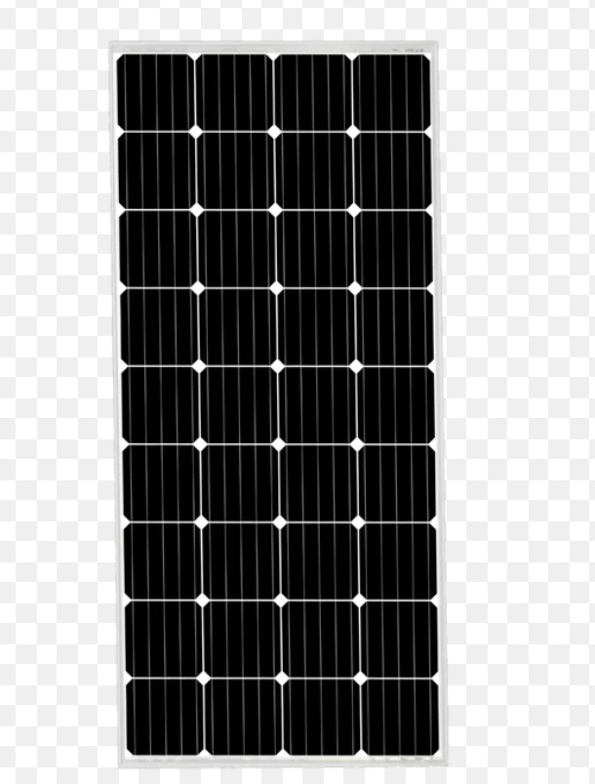
Here are some of the disadvantages to monocrystalline solar cells they are the most expensive solar cells on the market, and so not in everyone’s price range, the performance levels tend to suffer from an increase in temperature. However, it is a small loss when compared to other forms of solar cell, there is a lot of waste material when the silicon is cut during manufacture.
Figure 2.1: Monocrystalline solar panel
2.3.3 Polycrystalline Solar Panel
The polycrystalline solar panels were first introduced to the public in 1981. Unlike the monocrystalline cells, polycrystalline ones do not require each of the four sides to be cut. Instead, the silicon is melted and poured into square moulds. These then form perfectly shaped square cells. Here are some of the advantages of polycrystalline solar cells, the manufacturing process is cheaper and easier than the monocrystalline cells, it avoids silicon waste and high temperatures have less negative effects on efficiency compared with monocrystalline cells, This makes the polycrystalline cells more attractive to people in warmer areas as the price is lower. Here are some of the disadvantages to polycrystalline solar cells, efficiency is only around 13-16% due to low levels of silicon purity. So they are not the most efficient on the market.
- They have lower output rates which make them less space efficient. So more roof space is needed for installation.
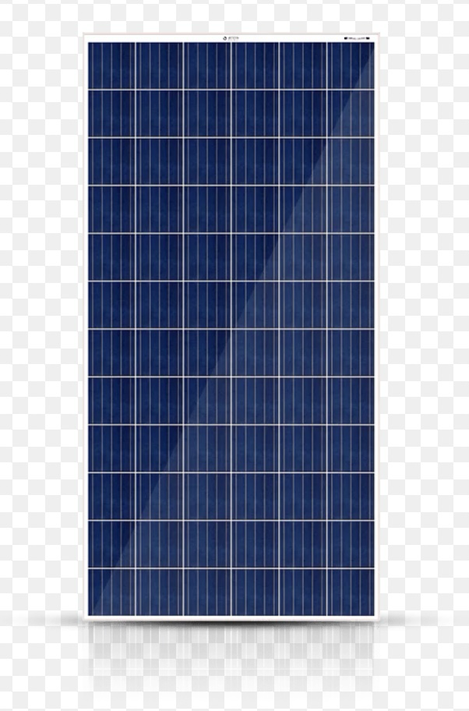
Figure 2.2: Polycrystalline Solar Panel
2.3.4 Thin Film Solar Panel
Thin film solar cells are manufactured by placing several thin layers of photovoltaic on top of each other to creates the module. There are actually a few different types of thin film solar cell, and the way in which they differ from each other comes down to the material used for the PV layers. The types are as follows, amorphous silicon, cadmium telluride, copper indium gallium selenide and organic PV cells.
Depending on the technology that has been used, the efficiency rates for thin film solar cells tends to vary from 7% to 13%. Since 2002, the knowledge levels and popularity for thin film solar cells has risen dramatically, which also means that research and development have been increased. Due to this, we can expect future models to hold efficiency rates of 10-16%. Here are some of the advantages of thin film solar cells, they can be manufactured to be flexible, making them widely applicable to a range of situations and building types, mass production is easy to achieve, making them potentially cheaper to produce than crystalline solar cells and shading has a similar effect on their efficiency
Here are some of the disadvantages of thin film solar cells, they are not ideal for
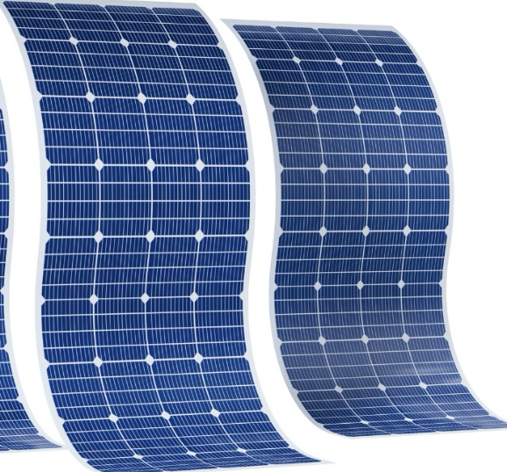
domestic use as thy take up a lot of space, low space efficiency means that they will cause
Figure 2.3: Thin film solar panel
further expenses in the form of enhancers, like cables of support structures and they have a shorter lifespan and so shorter warranty period.
2.4 Rechargeable Fan
Solar rechargeable fans become necessary for a common man. Especially, in summer, the power shortage is more. To overcome from the difficulties caused by power shortage this innovative project is designed.
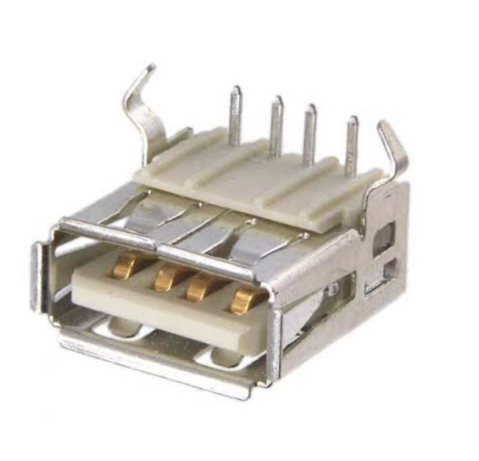
2.5 Universal Serial Bus (USB)
The development of the Universal Serial Bus (USB) started in 1995 by a group of companies which included Compaq, Digital, IBM, Intel, Microsoft, NEC, and Northern Telecom. These companies have later joined into the USB Implementers Forum, which published the first version of the USB standard. This forum, which has been extended with a large number of companies, continues to update the USB standards for USB controllers and various categories of devices that can be connected to the USB.
Figure 2.4.: Universal serial bus
USB grew from the requirement for a simple, inexpensive expansion bus for PCs. PCI solved and compatibility problems that existed with the ISA bus. But, the need to take the cover off the PC to add a peripheral was a hassle. And, though PCI made Windows plug-n-play possible, we have all experienced the frequent reality of “plug-n-pray” instead. Universal Serial Bus is a serial protocol (less costly than parallel) and physical layer link. Data is transmitted differentially on one pair of wires, providing relatively good noise immunity. Another pair carries DC power to downstream devices, allowing many low power devices to be bus powered. USB supports a high data rate and ‘hot swap’ connection for PCs without rebooting and provides easy connections to a wide variety of multimedia and network USB devices. Peripherals are simpler and less costly. AUSB master does not have to be a PC, but usually is.

Today, all versions of Windows and Linux support USB. An embedded device is a computer that does not look like a computer. Only sophisticated embedded devices with full operating systems will be USB masters.
Table 2.1: USB Speed USB Protocol Rate Typical Devices
Low speed | USB 1.1, 2.0, 3.0 | 1.5 Mbps | Ice, Keyboards, Joysticks
Full speed | USB 1.1, 2.0, 3.0 | 12 Mbps | Printers, Scanners, Webcams
High speed | USB 2.0, 3.0 | 480 Mbps | Multimedia, Zip drives

Some of the advantages includes, low power consumption, USB is less expensive, each device containing the USB port fits in with the USB and the USB can be of various sizes, and its connections come in several ways. Disadvantages includes, compared with other systems, data transmission is not much quicker, Single messages can only be exchanged between the peripheral and host, and the Universal Serial Bus does not include the broadcast functionality and performance and functionality of USB are within limits.
2.6 Light-Emitting Diode (LED)
Light Emitting Diode (LED) is a semiconductor device that emits light when an electric current flow through it. When current passes through an LED, the electrons recombine with holes emitting light in the process. LEDs allow the current to flow in the forward direction and blocks the current in the reverse direction. Light-emitting diodes are heavily doped p-n junctions. Based on the semiconductor material used and the amount of doping, an LED will emit colored light at a particular spectral wavelength when forward biased. As shown in the figure, an LED is encapsulated with a transparent cover so that emitted light can come out. The LED symbol is the standard symbol for a diode, with the addition of two small arrows denoting the emission of light.
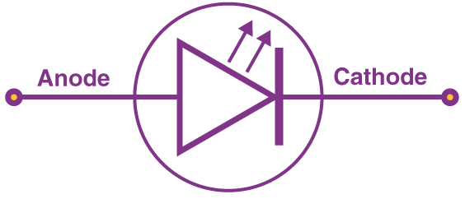
Figure 2.5: LED symbol
The figure below shows a simple LED circuit.
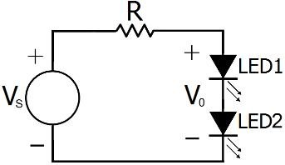
Figure 2.6: Simple LED Circuit
The circuit consists of 2 LED, a voltage supply and a resistor to regulate the current and voltage. When the diode is forward biased, the minority electrons are sent from p → n while the minority holes are sent from n → p. At the junction boundary, the concentration of minority carriers increases. The excess minority carriers at the junction recombine with the majority charges carriers. Classification of LED-based on sizes, miniature characterized with low-current standard and ultra-high output
2.6.1 Different Types of LED (Light-Emitting Diode)
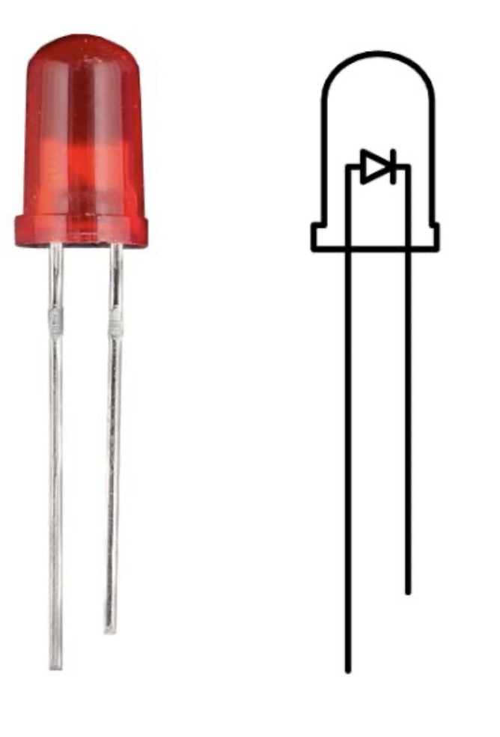
Miniature LED are mostly used now these days. These are available in single shape and color and are available in small sizes. It can be directly placed into a circuit board without the use of a heating or cooling device. These are classified into low-current, standard and ultra-high output depending upon various factors such as voltage, total watts, current, and manufacturer type. Miniature LEDs are used in small appliances such as remote controls, calculators and cell phones.
Figure 2.7: Miniature LED
High-Power LED uses of LED results in high output compared to normal LEDs. The light emitted is measured in terms of lumens. These are again categorized based on luminous intensity, wavelength and voltage.
These have a danger of overheating hence a heat-absorbing material is used to cool it down.
High-Power LEDs are used in high-powered lamps, automobile headlights, in various industrial and mechanical equipment.
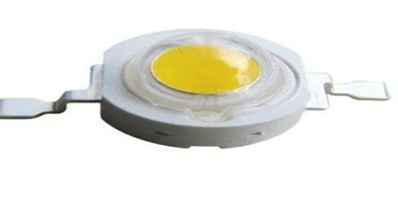
Figure 2.8: High-power LED
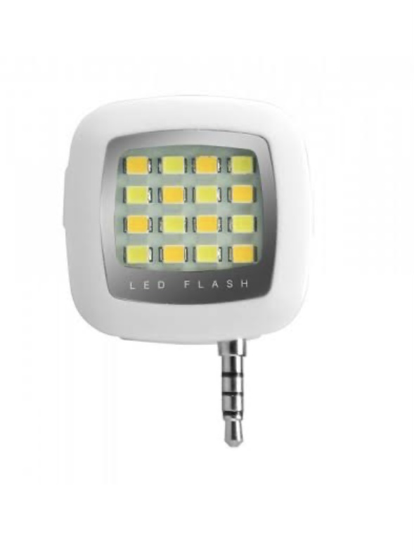
Flash led contains an integrated circuit which flashes the light at a particular frequency. These are directly connected to a power supply without the help of series resistors. It is used in signboards, vehicles etc.
Figure 2.9: Flash LED
Bi and Tri-Color lights consist of two light-emitting dies in a single case. The wiring is inversely parallel which means one is in the forward direction and another in backward which makes one die lit at one time. The flow of current alternates between two dies which results in color variation.
Tri-Color LED lights design lets the two dies to lit separately or together producing a third color. Red Green Blue LEDs, these emit red, green and blue light and also allows to combine these three primary colors and produce a new color. These are used in accent lighting, lights shows and status indicators.
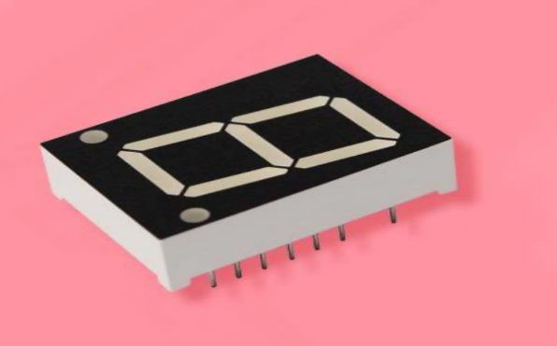
Alphanumeric LED
Figure 2.10: Alphanumeric LED
These consists of segments which offer greater flexibility and lesser power consumption. In it, it has various types of LEDs such as: 14 and 16 segment- they cover full 26 characters of the Roman alphabet in uppercase and with numerals 0-97 segment- covers all numbers and limited set of letters. Matrix segment- covers full alphabets (upper and lower), all number and a full variety of symbols.
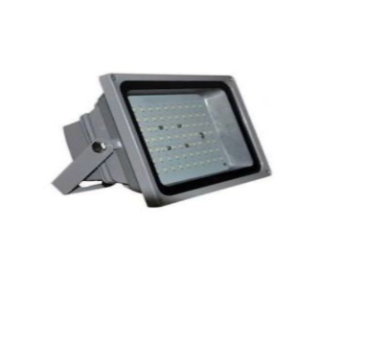
Lighting LED use aluminum/ceramic body which provides heat dissipation. One example is the Edison light bulb design.
Figure 2.11: Lighting LED
2.7 Review of Related Project Work On Solar-Enabled Rechargeable Fans
The increasing need for sustainable and reliable energy solutions, especially in off-grid and rural areas, has driven significant research into developing solar-enabled rechargeable fans. Over the years, various research projects have explored different aspects of solar-powered fans, including design optimization, energy efficiency, and integrated peripheral functions. This section reviews notable past projects to highlight advancements and challenges in the field.
Design and Implementation of Object Detection and Temperature Controlled Solar Powered Fan: This study presented a solar-powered fan integrated with object detection and temperature-based speed control using an Arduino microcontroller. The fan automatically activates when motion is detected and adjusts speed according to the ambient temperature. The system runs on a 12V rechargeable battery charged by a solar panel, designed primarily for domestic use in areas with unstable grid power. The research demonstrated effective energy-saving automation and practical off-grid usability for small spaces. However, it lacked integrated peripheral functions such as mobile charging ports or built-in lighting, limiting its utility in multifunctional household settings. Additionally, the system’s basic sensor setup restricted its adaptability to user-controlled operation (S. A. Akangbe et al., 2024).
Development of a Temperature-Controlled Solar Powered Ventilation System: The paper investigated a solar-powered fan controlled by temperature sensors to provide ventilation in enclosed spaces. An Arduino microcontroller was used to switch the fan on/off depending on ambient temperature, powered by a small solar panel and rechargeable battery. The design aimed at energy-efficient cooling in rural and off-grid locations. While the system proved effective in automatic ventilation control, it did not include additional functionalities like integrated lighting or device charging, restricting its versatility. The design also lacked user override options, limiting adaptability to varying user needs and preferences (N. H. Abdullah et al., 2024).
Solar Driven Prototype Model of Automatic Temperature Controlled Exhauster: This research developed a solar-powered exhaust fan prototype regulated by temperature using analog sensor circuitry instead of a microcontroller. The device offered a low-cost ventilation solution for greenhouses or rural households, utilizing direct solar power with no energy storage. The study showed the feasibility of analog control for temperature-based fan operation. However, the lack of a rechargeable battery limited fan usage to daylight hours only. Additionally, the device’s single-purpose design with no peripheral functions such as lighting or charging limited its applicability for multipurpose off-grid needs (D. Mukherjee, 2022).
A technical report on the construction of two-way powered solar fan: This study designed a 30W DC standing fan powered through an 80W solar panel and a 12V, 75Ah battery, with the capacity to operate continuously for up to 6 hours on a full charge. The dual-input system supported both direct solar charging and stored battery use, improving flexibility in energy sourcing. The design emphasized ease of use in off-grid or low-power areas. However, the system lacked integrated peripheral features such as USB ports or lighting, limiting its functionality beyond basic ventilation. Additionally, the fan operated at a single speed with no interface for adjusting modes or monitoring energy use. The absence of modular features or user customization reduced its practicality for varied user needs and multifunctional home use (A. A. Adediran et al., 2025).
Construction of a 12V standalone solar-powered DC fan for solar energy utilization: This study developed a standalone 12V DC fan powered by a solar PV panel and a 12V battery, aiming to provide ventilation in areas with unreliable electricity. Performance assessments were conducted using variable voltage inputs and airflow measurements. While effective in basic ventilation, the system lacked integrated peripheral functions such as USB charging and LED lighting. Additionally, the fan operated at a fixed speed without user-adjustable settings, and there was no user interface for monitoring or controlling the system. The absence of an energy management system further limited its efficiency and adaptability (M. I. Kolawole & J. Paudel, 2023).
2.8 The Block Diagram of the Project Work.
Solar Panel
Battery Charge Controller
Battery Bank
Dc Fan speed
Control
Integrated
Peripheral
Output

Fan Motor

Figure 2.12 Assembling block diagram
The subsections making up the inverter systems is as shown in the block diagram of Figure 2.12 The diagram shows the interconnection of one unit block to another, starting from the input solar panel to the output loads with various output range.
- ﻿﻿Solar Panels: These photovoltaic (PV) panels are installed to harness sunlight. They convert sunlight into Direct Current (DC) electricity.
- ﻿﻿Charge Controller: The DC electricity from the solar panels passes through a charge controller. This device regulates the voltage and current, preventing the batteries from overcharging.
- ﻿﻿Batteries: The electricity is stored in batteries, usually deep-cycle types, for later use when sunlight is not available, such as during nighttime.
- DC Fan Speed Control: This is a device or circuit that regulates the speed of a dc fan by adjusting the voltage or current supplied to it.
- Fan Motor: This is an electric motor that powers a fan’s blade to create airflow for cooling or ventilation.
- Integrated Peripheral Output: This refers to a built-in output or interface on a device or system that allows it to communicate or interact with external peripheral or devices like the following:
- Universal Serial Bus (USB) charging ports.
- Light Emitting Diode (LED) lightning.
- Battery status indicator.

CHAPTER THREE
3.1 METHODOLOGY
This chapter outlines the procedures used for designing and constructing a solar-enabled rechargeable fan that integrates additional peripheral functions such as LED lighting, USB charging, and a battery status indicator. The system was built to operate efficiently in off-grid conditions by utilizing solar energy as the primary power source and storing excess energy in a rechargeable lithium-ion battery.
The fan control was designed with a speed regulator, allowing users to adjust airflow levels conveniently. A battery charge controller was incorporated to manage safe and efficient battery charging from the solar panel while also protecting the system from overcharging and over-discharging. Each peripheral function was integrated to operate independently but harmoniously, making the entire system compact, user-friendly, and energy-efficient.
3.2 COMPONENT SELECTION
The selection of components for the system was guided by factors such as energy efficiency, reliability, availability, cost-effectiveness, and compatibility with the overall design goals. Each component was carefully chosen to meet the functional requirements of the solar-enabled rechargeable fan and its integrated peripheral outputs.
Table3.1: Summary of the Key Components used and their Respective Functions
COMPONENT | SPECIFICATION | FUNCTION
Solar panel | 20W, 18V | Converts solar energy into electrical energy
Rechargeable Battery | 7.5V Li-ion, 3700mAh | Stores energy for use when solar input is unavailable
Fan Motor | 6V, 0.5A DC | Generates airflow
Voltage Regulator | 7809,7812,7818 | Controls fan speed by regulating output voltage
Diodes | 1N4148 | Prevents reverse current and protects sensitive parts
Battery charge controller | 12V, 3A max | Regulates voltage and current from solar panel to prevent overcharging/discharging
Voltage regulator | 7809, 7812, 7818 | Provides fixed voltage outputs (9V, 12V, 18V) for stepwise fan speed control
Rotary switch | 3-position | Selects between the three voltage levels supplied by the voltage regulator
Variable resistor | 10kΩ potentiometer | Provides continuous fan speed adjustment within selected voltage level
USB Output module | 5V, 1A | Supplies a constant 5V for charging mobile devices or powering small gadgets
LED Light | 12V DC | Provides lighting as an auxiliary feature during blackout.
Battery status indicator | Digital voltmeter/LED bar | Display real-time battery voltage to monitor charge level

3.3 SYSTEM SIMULATION
The designed circuit was simulated using Livewire Pro Version to test for correctness and performance prior to hardware implementation. Simulation helped verify the proper operation of each component, the voltage regulation behavior, and the control logic, ensuring that faults could be corrected before physical construction.
3.3.1 Simulation Objectives
- To observe the switching behavior between the 7809, 7812, and 7818 voltage regulators via the rotary switch.
- To test the response of the variable resistor in regulating the fan motor speed at different voltage levels.
- To monitor the charging process from the solar panel through the battery charge controller into the lithium-ion battery.
- To verify the stability of the USB output and ensure a constant 5V output suitable for charging devices.
- To confirm the functionality of the LED lighting when powered from the battery.
- To observe the real-time response of the battery status indicator as the battery voltage changes during charging and discharging.
3.3.2 Stimulation Outcome
The simulation successfully demonstrated the expected performance of each unit:
- Switching between voltage regulators resulted in clear changes in fan motor speed.
- The variable resistor allowed fine-tuning of the fan speed within each voltage range.
- The battery charge controller responded properly by cutting off the charging line once the simulated battery voltage reached its limit.
- The USB module maintained a stable 5V output.
- The LED lighting remained consistently bright when toggled on.
- The battery voltage indicator tracked voltage fluctuations in real time.
This preliminary validation gave confidence to proceed with the physical construction, knowing the theoretical circuit design was sound.
3.4 ASSEMBLING
In this project work, we are mostly concern about designing and construction of solar enabling rechargeable fan. The main components required to be designed, the solar panel, charge controller, the battery and the coupled fan. It is the solar panel that produced a D.C voltage due to the energy received from the sun, thereby making the battery to charge. The charge controller serves as an interface between the current generated by the module and the battery. Through the help of the charge controller the battery is prevented from over charging the assembling diagram is shown below.
3.5 Block Diagram of the System
The block diagram below represents the functional layout of the solar-enabled rechargeable fan system with integrated peripheral functions. It outlines how the main components interact to achieve power input, energy storage, control, and output functionalities.
Solar Panel
Battery Charge Controller
Battery Bank
Dc Fan speed
Control
Integrated
Peripheral
Output

Fan Motor

Figure 3.1 Assembling block diagram
3.5.1 Explanation of Flow
- The solar panel charges the battery through the battery charge controller, which regulates current and voltage for safe charging.
- The battery bank stores energy and distributes power to all output units.
- The fan unit receives voltage through a selector switch that lets the user pick between 9V, 12V, or 18V using regulators. A potentiometer allows fine-tuned speed control.
- The USB port, LED lighting, and battery status indicator are powered directly from the battery and controlled through independent switches or circuits.
The design of the system was approached by dividing it into modular functional blocks, each responsible for a specific operation. This modular approach ensured easier troubleshooting, better organization, and improved overall system performance. The major functional sections include:
- Solar Input and Battery Charging Unit
- Battery Bank (Energy Storage)
- Fan Control Unit (Voltage Switch + Speed Regulator)
- Peripheral Output Units (LED Lighting, USB Charging Port, Battery Status Indicator)
Solar Input and Battery Charging Unit
This section involves a solar panel connected to a battery charge controller, which manages the flow of energy into the lithium-ion battery. The charge controller regulates the voltage and current coming from the solar panel to ensure the battery is charged within safe limits. It prevents overcharging, over-discharging, and reverse current flow back into the panel.
Battery Bank
The battery serves as the system’s energy reservoir. A 7.4V lithium-ion battery (3700mAh) was selected for its compact size, rechargeability, and suitability for DC applications. The battery supplies power to all system units during operation and stores solar energy for later use when sunlight is unavailable.
Fan Control Unit
This unit is responsible for controlling the speed of the DC fan. It consists of two components working together:
- Voltage Level Switch: A rotary switch selects between three fixed voltage outputs 9V, 12V, and 18V using three separate linear voltage regulators (7809, 7812, and 7818). This provides basic control over fan speed.
- Speed Regulator (Variable Resistor): A potentiometer is used to fine-tune the fan speed within each selected voltage level. This dual control setup allows both stepwise and smooth speed regulation for user comfort.

Peripheral Output Units
Each peripheral function is powered directly from the battery and operates independently of the fan:
- LED Lighting: A 12V DC LED light is connected with its own switch for manual control, providing illumination.
- USB Charging Port: A 5V USB output module is used to charge external devices like phones. It steps down battery voltage to a stable 5V output.
- Battery Status Indicator: A simple LED bar graph or digital voltmeter is connected across the battery terminals to show real-time battery voltage levels, helping users monitor battery health.

- All circuits are protected using diodes, and the outputs are isolated to avoid voltage interference across components.

CHAPTER FOUR

TESTING AND RESULT
4.1 TEST AND ANALYSIS
A solar-enabled rechargeable fan (SERF) requires proper construction and assembly. The assembling must be in accordance with the design analysis. After the assembly has been completed, the must be properly tested to ensure that the panels and other vital components of the solar -enabled rechargeable fan (SERF) are working optimally. After testing all the components and units of the solar -enabled rechargeable fan and one is assured that they are all working perfectly, the performance of the of the solar is then analyze. The output voltage, the charging hours, the running hours, and other qualities of a good solar -enabled rechargeable fan must be analyze to ensure that it is fit for use.
4.2 ​Assembly Of The Solar-Enabled Rechargeable Fan (Serf) Components
The components rating, types are prime factor in solar-enabled rechargeable fan (SERF) assembly. The main feature that a (SERF) must possess is the ability to provide electrical energy that will run for the expected amount of time. The following materials are therefore employed in the assembly of the solar -enabled rechargeable fan;
4.2.1 The Solar Panel (Photovoltaic Cells)
The basic unit of a solar PV generator is the solar cell. It is made from a semiconductor material, mostly silicon (Si). The mono-crystalline solar panel has two cables running from its circuit the first one is connected with a diode to the designated terminal on the charge controller. The function of this diode is to disallowed current from flowing back to the solar panel and the second cable is connected directly to the terminal without any semiconductor devices attached to it as shown in fig. 4.1.
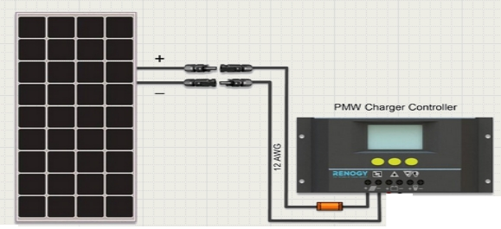
Fig.4.1: Diagram of solar and charge controller connections. (www.windofkeltia.com)
4.2.2 The lion Battery
The deep cycle battery is to store the power supplied by the solar panel for a later use and is connected to the battery icon on the charge controller. The terminals designated positive and negative in the deep cycle battery was connected to the positive and negative terminals of the charge controller respectively.
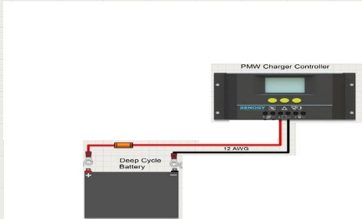
Fig. 4.2: Diagram of lion and charge controller connections. (www.windofkeltia.com)

4.3 SUMMARY OF THE SYSTEM ASSEMBLY
The following steps were taken in the assembling of the solar battery charger
  - Connect the battery according to the polarity shown on the battery and on the charge controller.
  - Connect the photovoltaic (or solar) panels with regards to the polarity. At this point, the solar panel ready for the action of providing power to the battery.
  - Connect the DC loads, probably inverter or dc loads.
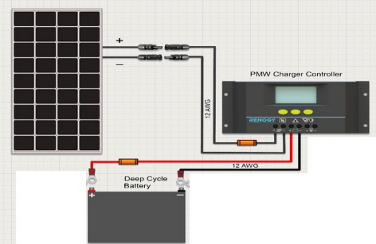
Fig: 4.3 diagram of solar panel, charge controller and battery (www.windofkeltia.com)

4.4 CIRCUIT DIAGRAM
The complete circuit diagram illustrates the interconnection between the major components of the system, including the solar panel, battery charge controller, lithium-ion battery, voltage regulators, DC fan motor, LED lighting, USB output, battery status indicator, and control switches.
4.4.0 Explanation of Major Sections
4.4.1 Solar Input and Charging Stage:
- The solar panel (18V, 20W) supplies DC power to the system.
- A diode (IN4148) is used to prevent reverse current flow.
- The battery charge controller regulates voltage and current going into the battery.
4.4.2 Battery Storage:
- A 7.4V lithium-ion battery (3700mAh) stores energy for use when solar input is unavailable.
- Battery terminals are protected and connected to both the output load and battery status indicator.
4.4.3 Fan Voltage Control and Speed Regulation:
- A rotary switch selects one of three fixed output voltages: 9V (7809), 12V (7812), or 18V (7818) — which controls fan speed.
- A 10kΩ potentiometer is connected to regulate the fan speed more precisely.
4.4.4 Peripheral Outputs:
- The USB module (5V, 1A) provides charging for external devices.
- A DC LED light is connected directly to the battery with its own control switch.
- A voltmeter or LED bar display is used to monitor battery level.
4.4.5 Protection and Switching
• Diodes (IN4148) are used at key nodes to prevent backflow current.
• Major output (fan, LED, USB) is controlled by a power switch.

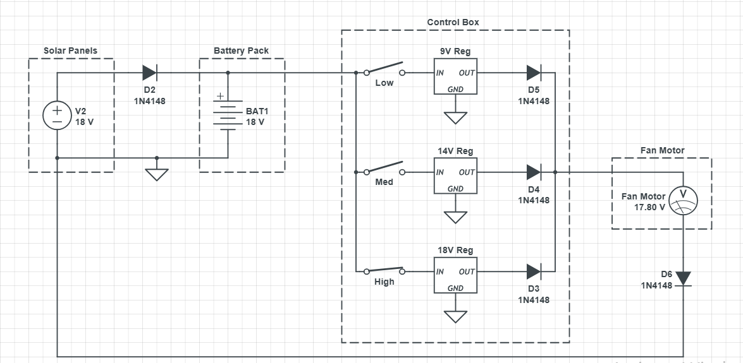
Fig: 4.4 Circuit diagram of solar powered DC fan

4.5 CONSTRUCTION PROCEDURE
The construction of the solar-enabled rechargeable fan system was carried out through organized phases to ensure proper alignment with the design schematic. Each stage from layout design to final casing was approached with testing and verification in mind.
4.5.1 Simulation and Layout Design
Before physical assembly, the circuit was simulated using Livewire software. This helped verify the circuit logic, test voltage regulation, switching behavior, and battery charging flow. After a successful simulation, the PCB layout was developed using PCB Wizard to guide component positioning.
4.5.2 Veroboard Implementation
A vero-board (stripboard) was used instead of a custom printed PCB due to its accessibility and ease of modification. The design from PCB Wizard was carefully mapped onto the vero-board.
4.5.3 Component Placement and Soldering
All components — including:
- the voltage regulators (7809, 7812, 7818),
- diodes
- potentiometer,
- fan motor
- USB port
- LED
- battery voltage monitor
were placed according to their positions on the schematic. Soldering was done carefully, ensuring no loose joints or short circuits.
4.5.4 System Integration
After basic component connections were completed, the modules were integrated:
- The solar panel was connected to the charge controller.
- The battery was linked with a protective diode and connected to power the system.
- The voltage selector switch was wired to the regulators, with the speed control potentiometer in series with the fan.
- The USB output, LED lighting, and battery indicator were connected to the battery via switches.

4.5.5 Enclosure Setup
A plastic casing was used to house the entire assembly. Openings were created for:
- the rotary switch (for voltage selection),
- power switch (for LED, fan, and USB),
- display modules (USB port, LED, voltmeter).
The solar panel was placed externally and connected via a detachable DC cable.

4.6 EVALUATION OF FAN PERFORMANCE
4.6.1 Airflow Measurement (CFM)
The airflow performance of the fan was evaluated using the Cubic Feet per Minute (CFM) formula:
CFM = Air Velocity (ft/min) × Cross-sectional Area (ft²)
Air velocity was measured using an anemometer, and the fan’s cross-sectional area was calculated based on the blade diameter. This provided an estimate of the volume of air moved per minute at different speed settings.
4.6.2 Efficiency Calculation
The overall system efficiency was evaluated using the ratio of output power to input power as shown below:
Efficiency (%) = (Output Power / Input Power) × 100
Input power was obtained from the battery or solar output, while output power was based on the electrical power consumed by the fan motor and its mechanical output performance

CHAPTER FIVE
5.1 CONCLUSION
In this paper we present a circuit to charge 7.5V, 3700mAh rechargeable Lion battery from the solar panel. This solar Charger has current and voltage regulation and also has over voltage cut Off facilities. This circuit may also be used to power the fan at Constant voltage because output voltage is adjustable. We bought the components and done the project practically
The successful development of a solar-enabled rechargeable fan with integrated peripheral functions demonstrates the feasibility of creating a cost-effective, standalone solution for ventilation and auxiliary needs in areas with unreliable or no access to grid electricity. The system efficiently harnesses solar energy to power a DC fan while also supporting basic functionalities such as device charging and lighting. Its simplicity, portability, and independence from the grid make it especially relevant for rural and off-grid environments.

5.2 RECCOMENDATION
To improve the system further, increasing battery capacity would support longer usage or additional loads. A more robust, weather-resistant casing is recommended to improve durability, and a user interface with indicators for battery level and charging status would enhance usability. Lastly, future work may explore the integration of basic automation for smarter power management without increasing system complexity.

REFERENCES
Abdulla Almazrouei. (2019). Solar charge controller.Evansille, Indiana. Pg 57-59
Abdullah, N. H., Salim, R., & Hassan, M. A. (2024). Development of a temperature-controlled solar powered ventilation system. Journal of Sustainable Energy and Environment, 11(1), 33–40.
Adediran, A. A., Ojo, F. T., & Afolabi, B. R. (2025). A technical report on the construction of two-way powered solar fan. Department of Electrical Engineering, Federal Polytechnic Offa.
Akangbe, S. A., Ibrahim, T. A., & Yusuf, K. M. (2024). Design and implementation of object detection and temperature-controlled solar powered fan. International Journal of Engineering Research and Technology, 13(2), 45–52.
Jabber A.Abu Qahouq,Yucong Jiang And Mohammed Orab. (2014). “Mppt control and architecture for solar panel with sub-module integrated converter” journal of power electronic, vol.14, no.6, pp 1281-1292.
Khan, H. R., Ahmed, W., Masud, W., Alam, U., Arshad, K., Assaleh, K., & Qazi, S. A. (2024). Design and Experimental Results of an AIoT-Enabled, Energy-Efficient Ceiling Fan System. Sustainability, 16(12), 5047. https://doi.org/10.3390/su16125047
Kolawole, M. I., & Paudel, J. (2023). Construction of a 12V standalone solar-powered DC fan for solar energy utilization. Energy and Power Engineering Journal, 15(3), 60–67.
Kovačević, M., Milinković, D., & Milinković, D. (2023).Deep Learning-Based Fault Detection in HVAC Fan Coil Units. Sensors, 23(15), 6717. https://doi.org/10.3390/s23156717
Xu, R., Chang, K., Xia, Y., Zhao, J., & Ding, Q. (2025). A Semi-Supervised Fault Diagnosis Method for Ventilation Fan Using Multi- Head Attention-Enhanced Generative Adversarial Network. Journal of Vibration and Control. https://doi.org/10.1177/10775463241313018
Kowalski, M., Nowak, P., & Zieliński, T. (2024). Energy Efficiency and Noise Reduction in Industrial Fans: A Review. Energies, 16(3), 1042. https://doi.org/10.3390/en16031042
Mukherjee, D. (2022). Solar driven prototype model of automatic temperature-controlled exhauster. International Journal of Renewable Energy Research, 8(4), 102–108.
Noor J. And Ayuni B.M. (2009). “Photovaltaic charge controller. University Malaysia pa-hang, Malaysia. Pg. 4-5.
U.S Department Of Energy.(2013).Renewable energy data book . http//www.nrel.gov/docs/fy13costi/54909 p.d.f..
Victro-Energy B.V.(2014). Article “which solar charge controller; pwm or mppt? www.victronenergy.com.
WWW.WIKIPEDIA. (2024). Electrical cables and its types. http//en.m.wikipedia.org.,

​

