
PROJECT REPORT
ON
TOPOGRAPHICAL SURVEY
OF
PART OF IFMS, KWARA STATE POLYTECHNIC
ILORIN ALONG OLD JEBBA ROAD, MORO LOCAL GOVERNMENT AREA, KWARA STATE.
BY
ADEYEYE FATIMOH OLUWATOSIN
ND23/SGI/FT/0034
SUBMITTED TO:
THE DEPARTMENT OF SURVEYING AND GEO INFORMATICS KWARA STATE POLYTECHNIC, ILORIN.
IN PARTIAL FULFILMENT OF THE REQUIREMENTS FOR
THE AWARD OF NATIONAL DIPLOMA IN SURVEYING
AND
GEO-INFORMATICS
JULY, 2025

CERTIFICATE

I, ADEYEYE FATIMOH OLUWATOSIN with Matric Number
ND/23/SGI/FT/034 hereby certify that the information contained in this project report were obtained as a result of observations and movements taken by me and the Topographical Survey was done in accordance to Surveying rules and
regulations and Departmental instructions.
Signature of student:
Name of student:
Date of completion:
Matric Number: ND/23/SGI/FT/0034

CERTIFICATION
This is to certify that ASHAOLU SAMUEL TEMIDAYO with Matric number ND/23/SGI/FT/0030 carried out this project work and has been approved as meeting the requirement for the award of National Diploma (ND) in Surveying and Geo-informatics in the Department of Surveying and Geo-informatics of the Institute of Environmental Studies, Kwara state polytechnic, Ilorin.
_______________________ | __________________
SURV. WILLIAMS KAZEEM  & SURV. AWOLEYE  (Project supervisor) | DATE
____________________________ | _________________
SURV. AWOLEYE RAPHAEL  (Project Coordinator) | DATE

SURV. AMBIMBOLA ISAU  Head of Department | DATE
___________________ | __________________
J.O OPALEYE | DATE
External Moderator

DEDICATION
This project is dedicated to Almighty God, the creator of heaven and earth, ancient of days, the I am that I am the beginning and the end whose supremacy in the knowledge of everything is absolute.

ACKNOWLEDGEMENTS
I will like to express my profound appreciation to almighty God who in his infinite mercy, that gave me the ability to complete my program in peace and God health, if not for God, where will I be today? Alhamdulillah. All things are possible because of him and through him for the knowledge, wisdom and understanding, protection and provision on me through my ND programme. I thank Him for the great things he has done, most especially for the success of this project, God be the glory.
My appreciation goes to my lovely parent in person of MR & MRS ADEYEYE
for their support and their prayer, throughout this journey thank for all the beautiful star and end through my ND program. I know I can’t repay you back but I have special prayer to offer you both, wishing you both long life and prosperity in good health and wealth, more success, blessing and happiness along with a lot of luck
(Amen). My thanks also goes to my group members e g Mubarak, dalyan, Sodiq , Kofoworola and others, and my course mates Also, may Almighty Allah help us and guide us to the right way.
My thanks also goes to my supervisors SURV. KAZEEM AND SURV. AWOLEYE, and Also goes to my lecturers SURV. KABIR, SURV. AYUBA,
SURV. ABIMBOLA, SURV BANJI, SURV. DIRAN, SURV. ASONIBARE
AND MRS ADEOTI may Almighty Allah continue to bless you.

TABLE OF CONTENTS
TITLE PAGE i
CERTIFICATION ii
DEDICATION iii

ACKNOWLEDGEMENT iv
ABSTRACT v
LIST OF FIGURES vi
TABLE OF CONTENT vii

CHAPTER ONE
1.0. INTRODUCTION 1
1.1. BACKGROUND OF THE STUDY 1
1.1. AIMS OF THE STUD 1
1.2. OBJECTIVES OF THE STUDY 5
1.3. PROJECT SPECIFICATION 6
1.4. SCOPE OF THE PROJECT 6
1.5. SIGNIFICANCE 7
1.6. PERSONNEL 8
1.7. STUDY AREA 8 CHAPTER TWO
2.0 LITERATURE REVIEW 10

CHAPTER THREE
3.0 METHODOLOGY 17
3.1 RECONNAISSANCE 17
3.1.1 OFFICE PLANNING 17
3.1.2 FIELD RECONNAISSANCE 17
3.2 EQUIPMENT USED 18
3.3 INSTRUMENT TEST AND ADJUSTMENT 19
3.4 CONTROL CHECK 20
3.5 GEOMETRIC DATA ACQUISITION 21
3.5.1 PERIMETER SURVEY USING TOTAL STATION 21
3.5.2 CONTOURING 21
3.5.3 SPOT HEIGHTENING 22
3.5.4 DETAILING 22
3.5.5 ATTRIBUTE DATA 23
3.6 DATA DOWNLOADING 25
3.7 DATA PROCESSING AND ANALYSIS 25
3.8 AREA COMPUTATION 27
3.9 BACK COMPUTATION 29
3.9.1 DATA BASE MANAGEMENT 29
3.9.2 DATA SECURITY 30
3.9.3 DATA INTEGRITY 30
CHAPTER FOUR
4.0 INFORMATION PRESENTATION AND RESULT ANALYSIS 31
4.1 TOPOGRAPHIC OPERATIONS 31
4.1.1 THE TOPOGRAPHIC PLAN (COMPOSITE PLAN) 31
4.1.2 THE PERIMETER PLAN 32
4.1.3 THE DETAILED PLAN 34
4.2 APPLICATION OF THE PRODUCT 36

CHAPTER FIVE
5.0 SUMMARY, CONCLUSION, AND RECOMMENDATIONS 38
5.1 SUMMARY 38
5.2 CONCLUSION 38
5.3 RECOMMENDATIONS 39
REFERENCES 40
CHAPTER ONE:
1.0 INTRODUCTION

1.1 BACKGROUND TO THE STUDY
Topographical surveying is generally known as the study of earth surface, and its features and shape. It also gives the description of the features (such as surface, shapes, vegetation cover & elevations), depicted in maps. In essence, topography mainly concerned with local details such as vegetative and man-made features including local history and culture. More specifically, topographic surveying involves the gathering information on terrain, three dimensional details of the surface including recognizing the specific landforms. In modern terms, it is the generation of data digitally or electronically. The outcome of topographic survey is the graphic representation of a given land parcel on a map using several techniques such as contour lines, Hypsometric tints and relief shading (i.e. topographic maps). There are varieties of methods used in topographic surveying. For example, direct surveying, remote sensing, aerial and satellite imagery, photogrammetry, radar and sonar. The most appropriate method to be used depends on the scale, size (extent of the area of interest), purpose and complexity of the subject to be study. Also, it depends on the accessibility and the quality of existing survey information (Olaniyi, 2013).
Features typically shown on a topographic survey include trees, slopes and changes in elevation, streams and rivers, streets and walkways, buildings, fences and walls, manholes, utility poles, and more. The elevation changes are indicated on the topographic map as contour lines, which are used by construction
contractors, engineers, and architects to design and plan improvements to the land.
Topographical surveying can be defined as the shape or configuration or relief or roughness or three-dimensional quality of the earth surface the object of topographical surveying is to produce a map showing elevations, natural and artificial feature and forms of the earth’s surface. It is drawn from field survey data or aerial photography’s. Modish, (2021)
Topographical surveying is a field of geosciences and planetary science comprising the study of surface shape and features of the earth and other observable astronomical objects including planets, moons and asteroids, it is also the description of such surface shapes and features (especially their depiction in maps).the topography of an area could also mean the surface shape and features themselves In general, topography is concerned with local details in general, including not only relief but also natural and artificial features and even local history and culture. The term topography originated in ancient Greece and continued in ancient Rome, as the detailed description of a place the word comes from the Greek words to one (Topos “place”) in the 20th century the term topography started to be used to describe surface description in other fields where mapping in a broader sense is used, particularly in medical fields such as neurology ( Modish, 2021)
Topographical surveying is the branch of surveying that determines the position of natural or artificial features of a locality, both in plane and elevation to represent them by means of conventional sign on a map known as topography. A typical topographical map is useful for the planning and designing of construction project like roads, bridges, building etc. It is also essential for professionals like military personnel, miners, engineers and agricultural practitioner’s e.t.c.
It is subdivided into three aspects. Namely:
- Hypsography – i.e relief features
- Hydrography – i.e the water and drainage features.
- Culture – i.e the man-made features.
Topographical surveying is the process of determining the physical features and characteristics of a piece of land. It involves measuring and mapping the natural and man-made features of an area, such as:
Features Measured
- *Elevation*: Heights and contours of the land.
- *Landforms*: Hills, valleys, and other natural features.
- *Water bodies*: Rivers, lakes, and other water features.
- *Vegetation*: Types and locations of vegetation.
- *Man-made structures*: Buildings, roads, and other infrastructure.

Methods Used
- *Field measurements*: Surveyors use instruments like total stations, GPS, and levels to collect data.
- *Aerial photography*: Drones or aircraft capture images of the land.
- *Satellite imagery*: Satellite data is used to create detailed maps.
Applications
- *Land development*: Topographical surveys inform construction, urban
planning, and infrastructure projects.
- *Environmental studies*: Surveys help assess environmental impacts and plan conservation efforts.
- *Mapping and navigation*: Accurate topographical data is essential for creating detailed maps.
Topographical surveying provides valuable information for various industries, including construction, engineering, and environmental management.

Key Aspects
- *Mapping terrain*: Determining the shape, elevation, and features of the land.
- *Identifying features*: Locating and mapping natural and man-made features like hills, valleys, rivers, roads, and buildings.
- *Creating detailed maps*: Producing accurate and detailed maps of the area, often using specialized software and equipment.

Techniques
- *Field surveys*: Collecting data using instruments like total stations, GPS, and
levels.
- *Aerial surveys*: Using drones or aircraft to capture images and collect data.
- *Data analysis*: Processing and interpreting collected data to create detailed maps and reports.
Topographical surveying is essential for various industries, including construction, engineering, and environmental management.

1.2 STATEMENT OF PROBLEM
Owning to the present growth of human population and the demand for topographical maps by individual, co-operate bodies, companies and government agency for various developmental uses at various times, there was need to carry out topographic survey to provide base map for future planning and development of
Kwara state polytechnic,Ilorin.

1.3 AIM AND OBJECTIVES OF THE STUDY

1.3.1 AIM OF THE STUDY
The aim of this project is to carry out a topographical survey in order to produce the topographical plan of part of Awe High School, Awe Oyo.

1.3.2 OBJECTIVES
The following objectives were pursued for the achievement of the aim as stated above:
- Reconnaissance operation which was done in two stages i.e Office and
Field reconnaissance.
- Third order theodolite Traversing iii. Detailing by radiation method iv. Spot heightening
v. Data Processing vi. Plan Production vii. Comprehensive report writing

1.4 PROJECT SPECIFICATION
The project specification refers to the requirements to be satisfied while carrying out surveying operation of any order. The specification that was put into consideration for this project goes thus;
- The traverse should be a third order theodolite traverse which should start from a known control point and close back on the same known points or another control points of the same order.
- All linear measurements should be carried out using steel tape or an
Electronic Distance Measurement by tachometry method.
- Horizontal length should be given to the nearest three decimal places and height of each traverse station should be determined by second order
leveling.
- The linear accuracy must not be less than 1:5000
- The accuracy of the leveling is ±24mm√k where k is the distance covered in
kilometer.
- The angular accuracy of the traversing is 30”√n where ‘n’ is the total number of station occupied vii. Detailing should be fixed by tachometry.

1.5 SCOPE OF THE PROJECT
The scope of this project exercise covered the following operations;
i. Reconnaissance ii. Control Check iii. Test of Instrument iv. Selection of station
v. Perimeter Traversing vi. Detailing and Spot heightening vii. Data Processing and Computation viii. Data Presentation ix. Comprehensive Report Writing

1.6 PERSONNEL
The following are the personnel that participated actively during the execution of the project.
S/N | NAMES | MATRIC NO
1. | ADEYEYE FATIMOH OLUWATOSIN | ND/23/SGI/FT/0034
2. | NURUDEEN MUBARAQ OPEYEMI | ND/23/SGI/FT/0023
3. | OLANREWAJU SODIQ ADEBAYO | ND/23/SGI/FT/0027
4. | AYODELE BOLUWATIFE VICTOR | ND/23/SGI/FT/0029
5. | YAHAYA ROHEEMAT KOFOWOROLA | ND/23/SGI/FT/0035
6. | AKURUYEJO DALYAN TOBI | ND/23/SGI/FT/0032
7. | IBRAHEEM OLAMIDE RUKAYAT | ND/23/SGI/FT/0038
8 | MUHAMMAD JAMIU DOTHIA | ND/22/SGI/FT/0036
1.7 STUDY AREA
Part of IFMS Kwara state polytechnic Ilorin Kwara state.

MAP OF STUDY AREA
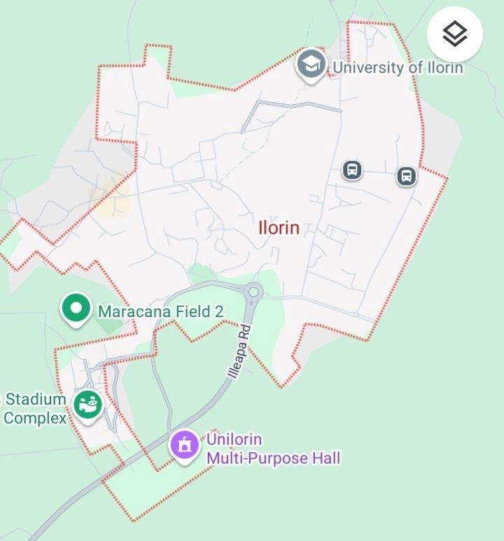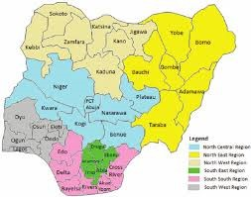
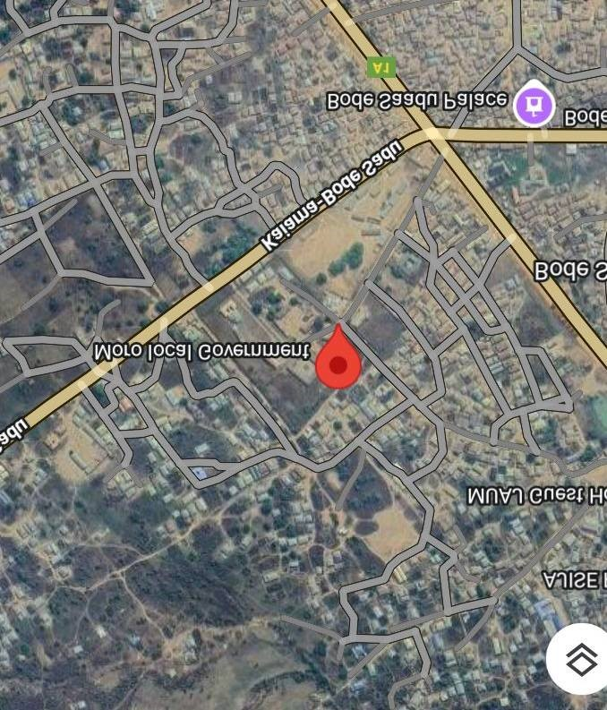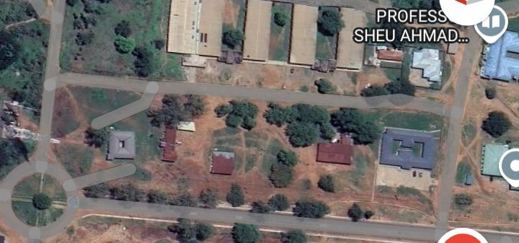
CHAPTER TWO

2.0 LITERATURE REVIEW
Surveying has been an essential element in the development of the human environment since the beginning of recorded history (about 5,000 years ago). It is required in the planning and execution of nearly every form of construction, communications, mapping, and the definition of legal boundaries for land
ownership.
According to Brinker and Wolf (1977), surveying is defined as the science and art of determining the position of points on, above or beneath the earth’s
surface.
Surveying can be defined as the science and art of making measurements of relative position of points above, on or beneath the earth’s surface and the plotting of these measurements to some suitable scale to form a map, plan or chart.
Ramsey,(1978).
Surveying generally is considered to be the bedrock of any meaningful development in the world. It plays a very important role in every aspect of human development and all activities of other allied professions are based on the laid down foundations by surveyors. In all part of socio-economic development, surveyors are usually the beginners and the final man in the development (Agor,R 1992).
According to Banister and Raymond(1998), surveying is defined as the act of making measurements of relative position of natural and artificial features of the earth and the representation of these information either graphically or numerically. But, much emphasis will be laid on topographical surveying as survey which is concern with the determination of the location both in plane and elevation of selected ground points which are necessary for contour lines and production of topographical maps
Ramsay J.P.W (1971) defined topographical surveying as the survey where physical features of the earth are measured and maps/plans are preferred to show their relative positions both horizontally and vertically. Basically topographical surveying entails the establishment of a basic framework of horizontal and vertical location of details in the vicinity of each station point. (Agor, 1992) defined topographical map as map produced on large scale to enable individual features shown on the map to be identified on the ground by shape and position.
Brinker and wolf (1997) analyze the subject of topographical survey as a surveying which is made to determine the configuration (relief) of the surface of the earth and to locate the natural and cultural features and thereon by means of conventional symbols.
Topographical map serves as a base map in aviation; charts being used over land are topographical maps but bear in addition, the location of radio beacons, airway and areas covered by beams of radio station. (Encyclopedia, 2002). (Encarta Encyclopedia 2002) defined topographical surveying as a survey that are of three dimensional(x,y,z coordinates), they employ the techniques of plane surveying and other special technique to establish both horizontal and vertical contour. The relief or configuration of the terrain and nature of artificial features are located by measurement depicted on a flat sheet to form a topographical map. Elevations in topographical maps are shown chiefly by the use of superimposed contour lines connecting points of equal height at a convenient interval to give a readable picture of the terrain.
Punmia Ashok Jain (2005) defined topographical surveying as the process of determining the position of natural and artificial features of a locality both on plan and elevation for the purpose of delineating them by means of conventional sign upon a topographic map.
The main objective of topographical survey is to locate the three dimensional relationship of a particular area. Hence, on a topographic map, the relative position of points are represented both horizontally and vertically.
A topographic survey may be made for variety of reasons. Military planning and geological exploration has been primary motivations to start survey programs, but detailed information about terrain and surface features is essential for the planning and construction of any major civil engineering, public works or reclamation
project.
Lastly, topographical surveying indicates three dimensional relationships for a particular area. It employs the techniques of plane surveying and natural or
artificial features. (Encarta, 2005).
This project essentially deals with topographical surveying. There are two major method of carrying out this survey which are:
- Aerial photogrammetry method and
- Ground survey method.
Topographical survey involves the demarcation of boundaries and determination of position and heights of natural and man-made features within the project area and plotting them on the plan with suitable scale.
Aerial survey was defined as extracted from Microsoft Encarta (B) (Encyclopedia 2002) as the study of earth’s surface using image taken by aerial camera mounted under an aircraft or by satellites. This method has become
extremely valuable in map making, military operations, agriculture, forestry etc.
Ground survey is still applicable but frequently used, most especially for preparing large scale maps of small extents of land. It is as well used to establish ground controls and field check of mapped features where photogrammetry is used for topographic mapping projects.
The approach for producing topographical map and topographical plan is somehow different as photogrammetry is not being used in topographical plan. The main method adopted for the execution of this topographical survey includes ground survey method which are traversing, leveling, detailing and tacheometry operation. Traversing survey consists of a series of connected straight lines, whose lengths and the directions are measured. Leveling is the determination of the relative height of point on the earth surface.
Topographical survey when properly performed is very useful and is applicable in the under listed areas of human endeavours:
Engineering: - Topographical survey is useful to determine the most desirable and economical location of highways, railways, bridges, buildings, canals, pipelines and transmission lines, e.t.c.
Ecology: - topographical survey is used in determining the type of soil and other available materials resources of a particular area.
Military: - It is also used for planning their welfare’s especially to determine terrain features, best position of defence and positions of attack on enemies.
There are various procedures involved in accomplishing topographical survey on ground. They are:
Traversing: - This is the act of establishing traverse station in a series and making the necessary measurement (Brinker and Wolf, 1977). It is also used to determine the position of points on the earth surface.
Leveling: - It is the act of determining the relative heights of different points on or below the surface of the earth (Basak, 2000). Thus leveling deals with measurement in the vertical plane.
Tacheometry:- This is the branch of survey where distances and height difference between ground points are obtained by optical means only with a special theodolite
called tacheometer in conjunction with graduated staff in field
observation(Ramsay,1976).
The process of carrying out tacheometry varies depending on the system employed. The systems are: Stadia system, Tangential system, Double image system and the Range finder system. In the execution of this project, stadia system was used for the obtaining of heights and distance of points on the project site.
A topographical plan is a large-scale representation of a portion of the earth’s surface showing the cultural relief, hydrograph and vegetation. It shows the natural and man-made features using conventional signs and symbols.
During any field project or mapping of topographical survey, it is very important to use a well established ground controls. The establishment of a good basic ground control is extremely an important aspect of the overall topographic mapping operation. As a result of its importance, the ground control phase of any topographic mapping project should be carefully planned and executed. This should be so because the accuracy of the finished topographical survey carried out cannot be better than the quality of the ground control upon which its production is based. Conclusively, topographical map/plans produced are very useful for: Planning, design, sitting of projects and engineering works, Location of natural and artificial features on the earth’s surface, Determining property boundaries and elevation of control points by operation of levelling.
CHAPTER THREE

3.0 METHODOLOGY
Different survey operations and techniques were employed in the execution of this topographic survey. The operations comprises the followings; reconnaissance, location of controls and checks, selection of stations, test of instrument, data acquisition which included traversing leveling, detailing by radiation method, data processing and information presentation.

3.1 RECONNAISSANCE
This is an essential of planning in surveying. It involves inspection by preliminary examination of the project site. It is a process in which analysis of the available information concerning the area to be surveyed (documents like topographical map, aerial photographs, plans etc) was made. It involves deciding the purpose of the survey, determining the accuracy expected and establishing the method to be used arrangement of work was done in order to accomplish the task in the shortest possible time as well as to efficiently use the available resources. There are two aspects of reconnaissance carried out before any work on the field was embarked on. These are office and field planning.

3.1.1 OFFICE PLANNING
This is an office work carried out before the actual field work. It entails the searching and collection of the necessary information relating to the project area vie; charts, maps, controls values and description, equipment to be used, deciding the choice of the method of technologies and continuous demand from library patrons. However, good leadership and cooperation among membership plays a bigger role in achieving a common goal. Having and working toward, a common goal, under dedicated, dynamic and faithful leadership with an active and energetic membership plays a great role in the success of a consortium field work. It entails the searching and collection of the necessary information relating to the project area visa; charts, maps, controls, values and description, equipment to be used, deciding the choice of the method of techniques to be used for measurement and the cost of the execution of the project. The project and practical unit of the school provided the coordinates of the control pillars used as shown in table below.
Table 3.1 shows the list of control coordinates collect from the office
STN | NORTHING(m) | EASTING(m) | HEIGHT(m)
KWPT 704 | 946555.504 | 680444.774 | 335.900
KWPT 727 | 945935.453 | 680445.930 | 334.561
KWPT 705 | 946400.317 | 680440.699 | 334.121

3.1.2 FIELD RECONNAISSANCE
The study area was visited for inspection by all members of the group so as to have a general view of the site for better planning and execution while the station points were selected and marked with pegs taking into consideration the
intervisibility of such points.

3.2 EQUIPMENT USED
i. Total station and its accessories ii. Tripod
iii. Reflector pole with prism iv. Field book
v. Cutlass vi. Concrete nail vii. Wooden peg viii. Linen tape 30m/5m ix. Beacon

3.3 INSTRUMENT TEST AND ADJUSTMENT
For the total station instrument temporary adjustment was carried out which involves the following;
i. Centering the total station on control point ii. Clearing of base plate using the 3 foot crew iii. Clearing of parallax by the making cross-hair visible iv. focusing of the object by adjusting the focusing knob until the
objects becomes clear.

3.4 CONTROL CHECK
The essence of carrying out this operation was to ascertain the reliability of all the controls to be used for the project. Because this will go a long way toward determining the accuracy of the project the check involved both angular and linear measurement using the total station and steel tape respectively. The instrument was set up on KWPT704 and all the necessary temporary adjustments (centering, leveling and focusing) performed on it. The target at back station was bisected on face left and the horizontal reading was recorded. The telescope was then pointed to fore station KWPT727 on the same face; target bisected and horizontal circle reading recorded. The face was then change to right and the target bisected on the same fore station. The horizontal circle reading was recorded. The back station target was re-bisected, the time on face right and the horizontal circle reading was recording.
Table 3.2 Shows the table for the result of control check.
 | STN | N | E | Z
Given | KWPT 704 | 946555.504 | 680444.774 | 335.900
Observed | KWPT 704 | 946555.501 | 680444.773 | 335.899
Difference | KWPT 704 | 0.003 | 0.001 | 0.001
Given | KWPT 727 | 945935.453 | 680445.930 | 334.561
Observed | KWPT 727 | 945935.451 | 680445.928 | 334.560
Difference | KWPT 727 | 0.002 | 0.002 | 0.001
Given | KWPT705 | 946400.317 | 680440.699 | 334.121
Observed | KWPT 705 | 946400.319 | 680440.695 | 334.119
Difference | KWPT 705 | -0.002 | 0.004 | 0.002
Source: Author, 2025

3.5 GEOMETIC DATA ACQUISITION
Three existing control points’ kwpt704, kwpt727 and kwpt705 were established control point used and they established beside the study area.
The job commenced by setting up the total station on kwpt 704 with all necessary temporary adjustments performed. Having set on kwpt 704, the
instrument was oriented.
The following were the procedures:
- Setting up (centering and leveling were perfectly performed on kwpt 704).
- The instrument was powered ON.
- MENU was pressed and the following were set into instrument.
- Job topographic survey
- OPERATOR – FATIMA
- DATE and TIME – this was automatically set by the instrument.
- DATA CAPTURE was selected and these options were displayed INST,
STATION, BACKSIGHT and FORWARD- SIGHT
- From this INST Station was clicked
- Then input was clicked and point ID and coordinates but also INST. HT
- After this, the REC was pressed
- The height of inst was measured from the trunnion axis of the instrument to the tip of the nail on the pillar & height
- The ESC key was pressed in order to get back to the BACKSIGHT
- ON this Backsight, input was clicked, Backsight ID, Reflector Height and coordinate of Backsight (kwpt 727) were keyed in.
- Having perfectly done this I turned the telescope to bisect the reflector and measure was clicked on.
- The coordinate were displayed in order to confirm whether it was the same or different from the given one.
- Yes option was clicked
- Following these steps: The ESC key was pressed to go back to the fore sight.
- On the foresight the reflector was set on the control (kwpt 705) and the observation was made to it.
- At this junction “All” was pressed when the cross hair had accurately
bisected the reflector.
- After these, the point ID was changed to pt01
- Then, the reflector was set in point 1 and the observation was made and “All” was clicked on
- And point ID as automatically change to PIL2 and reflector was set on the point 2, observation was made on it.
The same procedure was repeated for the capturing of all the details in the project site. All in all these procedure were repeatedly followed

3.5.1 PERIMETER SURVEY USING TOTAL STATION
Perimeter survey by traversing was carried out round the site area using total station, Easting and Northing of pillars were all measured on the field, stored and was later downloaded for further AutoCAD.
Table 3.3 Show Established co-ordinates of Boundary pillar.
STN | NORTHING(m) | EASTING(m) | HEIGHT(m) | CODE
KWPT 727 | 946654.018 | 680157.867 | 338.857 | Pillar
SGIFT 001 | 946547.726 | 680283.226 | 334.795 | Pillar
SGIFT 002 | 946540.574 | 680431.297 | 334.560 | Pillar
KWPT 704 | 946356.494 | 680428.919 | 338.360 | Pillar
SOURCE: AUTHOR 2025

3.5.2 CONTOURING
A contour is a line that is used to the topography area of training of equal height is also a method of dictating relief on flat surface of a map and are essential if the map is to provide a complete picture of the earth surface.

3.5.3 SPOT HIGHTENING
The site was gridded into 20meters griddles horizontally and vertical with spot height measured at every 25meters the spot height from the basics of
contouring.

3.5.4 DETAILING
Detailing of all natural, artificial such as roads, buildings, electric poles, trees using radiation method of traversing from known point rays shot to feature by obtaining the features coordinate which will be used in plotting.

3.5.5 ATTRIBUTE DATA
This data is acquired inform of question, which questions are asked from the people around the study about the name of buildings and some features in study
area.

3.6 DATA DOWNLOADING
First and foremost, the field observations were downloading from the station by connecting the data transfer cable to the laptop with application of the downloading software.

3.7 DATA PROCESSING AND ANALYSIS
The data were downloaded into notebook which is then run script into excel file to obtain the coordinate (Northings, Easting and Height) of all the measured points. The coordinate were then input into AutoCAD software which enable it to carryout plotting of all detailed features and contouring of the landscape. Suffer software was used for the contour lines generation to show the land configuration.
With the AutoCAD the total area of the site was computed as.

USING SURFER
The general steps to progress from a XYZ data set to finished, grid-based map are as follow:
- Create a XYZ data file. This can be created in a surfer worksheet window or outside of surfer (using an ASCII text editor, for example)
- Create a grid file (GRD) from the XYZ data file using the grid/data command.
- To create a map, select the map type from the map menu and use the grid file from step two. Grid based maps include contour, image, shaded relief, vector, wise frame and surface map.
- Use file/save to save the map as a surfer file/SRF/ that contains all the information needed to create the map, including the data file.

USING AUTOCAD
One of the quickest method to start Autocad is to double click on the Autocad 2013 or 2001, 2008 windows desktop icon. A second option is to pick the start button in the lower left corner of the windows desktop, then over or pick all programs then select the coordinate of what you need to plot by Easting and Northing distance then enter after that, Z enter, E enter C enter it will display your work then you safe it.
3.8 AREA COMPUTATION
The area was executed using double latitude method and checked by cross coordinate method.
ΔN ΔE PRODUCT (+ve)PRODUCT (-ve)
-6.292
-6.292 ˟125.359 788.759
-12.584
-7.152
-19.736
-7.152 ˟148.071 1059.004
-26.888
-184.080
-211.688
-184.080 ˟-2.378 437.742
-396.488
-104.980
-501.468
-104.980 ˟-2.522 264.703
-606.448
+1.235
-605.213
+1.235  -603.978  +301.269  -302.709 | ˟-275.430 |  | 340.156
301.269  301.269  0.000 | ˟+6.903 | 2079.660
2 × AREA= SUMATION OF POSITIVE – SUMATION OF
NEGATIVE
2 × AREA = 168841.916 – 5800.690
AREA = 163041.226
2
AREA = 81520.613 square meters
In hectares 81520.613/10,000
= 8.152 Hectares

3.9 BACK COMPUTATION
Table 3.5 showing the computation of boundary pillar
From  station | Bearing | Dist(m) | DN | DE | Northing | Easting | To station
 |  |  |  |  | 946654.018 | 680157.867 | KWPT  727
KWPT  727 | 95° 36’ | 252.61 | -6.292 | 125.359 | 946547.726 | 680283.226 | SGIFT001
SGIFT00  1 | 181° 52’ | 311.89 | -71.520 | 148.244 | 946540.574 | 680431.297 | SGIFT002
SGIFT00  2 | 270° 33’ | 252.90 | -184.080 | -2.378 | 946356.494 | 680428.919 | KWPT  704
KWPT  704 | 02° 40’ | 312.38 | -104.980 | -2.525 | 946654.018 | 680157.867 | KWPT  727

3.9.1 DATA BASE MANAGEMENT
The created database must be maintained and managed to retain its value. Data base maintained is vital from the beginning the maintenance routine should involve deletion of duplicate entries, Ibe (2006) maintained that database must be well manage with respect to quality, integrity and security and these was archived by making sure that all the data acquired was in conforming with the project and those data were saved to see that no repetition was done.

3.9.2 DATA SECURITY
The security of any database is almost important to the database administrations in a similar way, the topographical database is of paramount importance to the land administrators and this database was controlled by pass wording the system.

3.9.3 DATA INTEGRITY
Without given saying the use of digital total station to run the field job, these enable us to achieve good accuracy for the job. Because observation error is reduced to barest nominal unlike if theodolite is used to run the job.
Distance measurement is surveying is another major source of error if not property carried out. But with the use of total station, accurate distance measurement was achieved, hence error were minimized.
CHAPTER FOUR
4.0 INFORMATION PRESENTATION AND RESULT ANALYSIS

4.1 TOPOGRAPHIC OPERATIONS
The following plans were produced from the data took from the site

4.1.1 THE TOPOGRAPHIC PLAN (COMPOSITE PLAN)
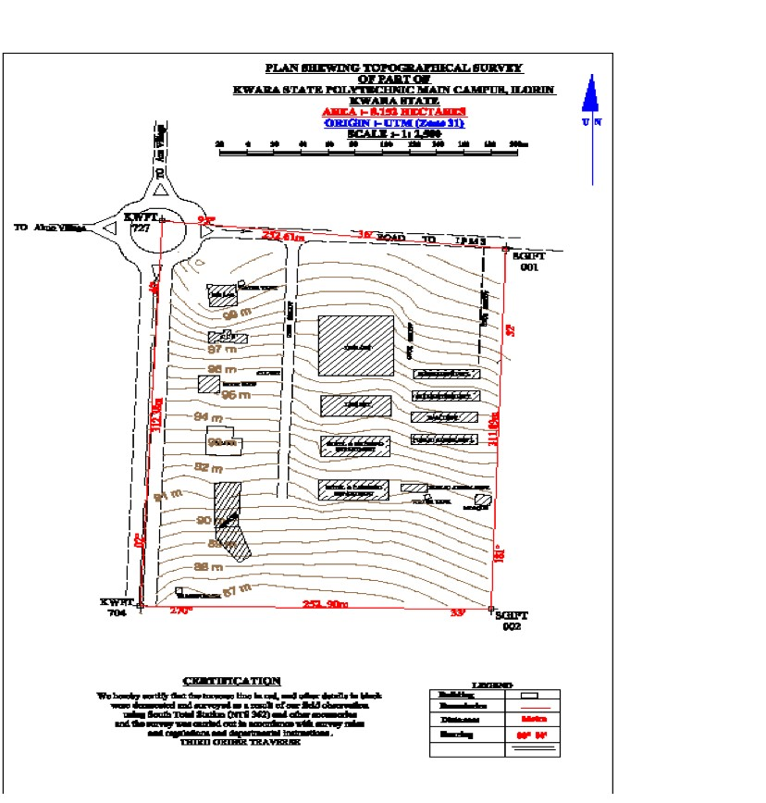

4.1.2 THE PERIMETER PLAN
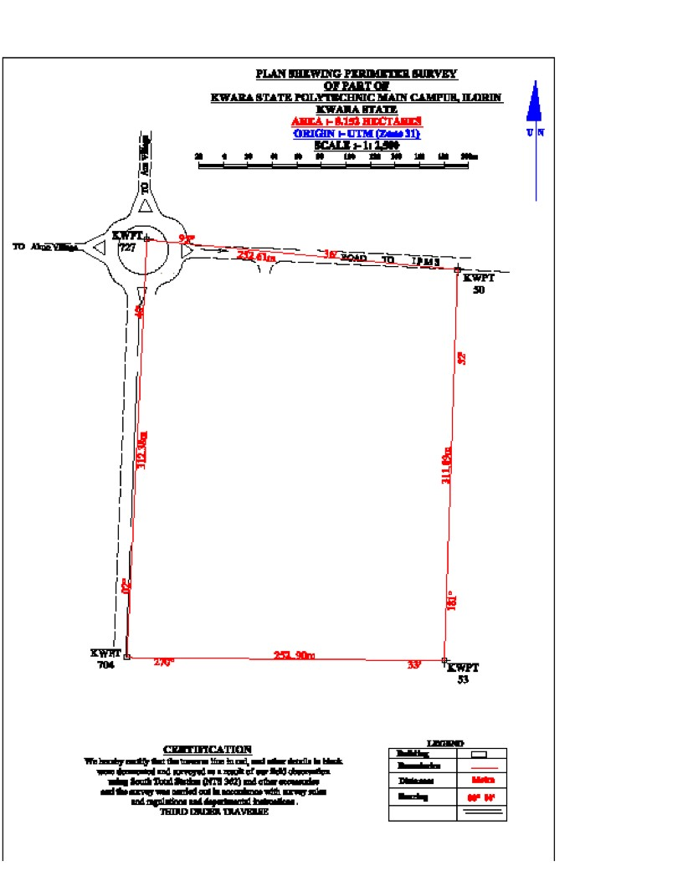

4.1.3 THE DETAIL
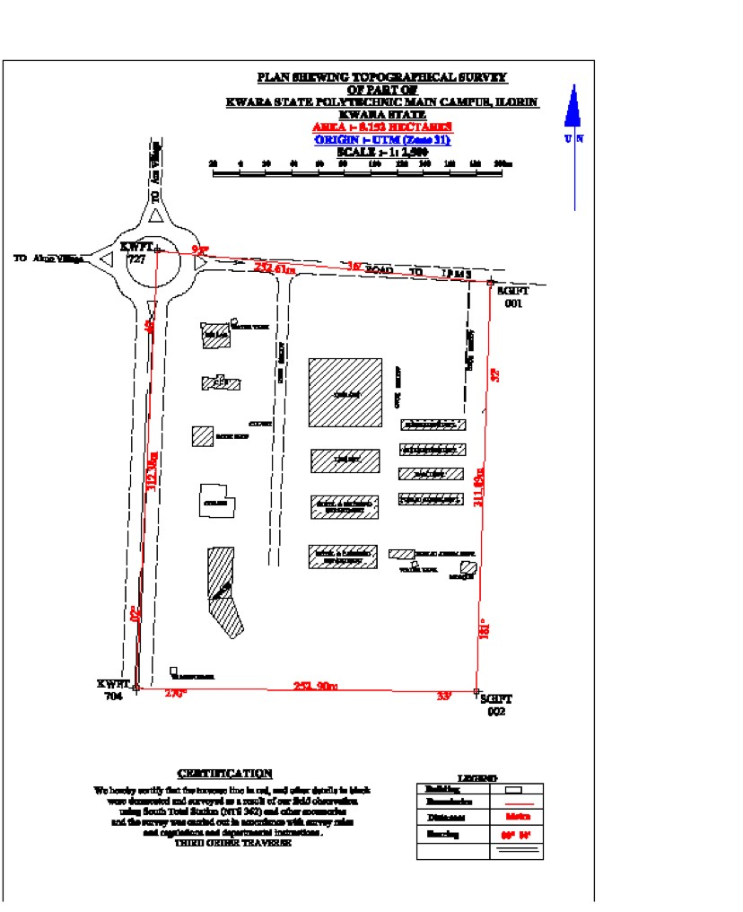

4.2 APPLICATION OF THE PRODUCT
The topographic plans and maps are drawings which show the main physical features on the ground such as buildings, fences, roads, rivers, lakes and forests, as well as the changes in elevation between land forms such as valleys and hill (called
vertical relief).
- The perimeter plan is a plan start from your control point extend to your site and carried out the boundary survey first with the suitable instrument you use.
- The detailed plan survey is used to determine and locate the features and improvements on a parcel of land. The word features here means both natural and man-made structures on a piece of land such as vegetation, types of soil, buildings, land utilities, fences and boundaries, roads, land marks and so on.
The details is how and method adopt to fix all the entity (features) within your site the equipment use.
- Spot height the site was gridded into 20meter griddles horizontally and vertical with spot height measured at every 25 meters. The spot height from the basic of contouring.
- Details plan can be defined as the man-made and natural features on the ground within the project site which are determined and obtained by the method using of total station and are finally represented with a suitable scale on plan.
CHAPTER FIVE
5.0 SUMMARY, CONCLUSION AND RECOMMENDATION

5.1 SUMMARY
The project ‘TOPOGRAPHICAL SURVEY’ was carried out at part of Kwara state polytechnic, Ilorin pacifically institute of environmental studies located in Moro local government area Ilorin,
The project area covered 8.152 Hectares. The project cut across
reconnaissance, perimeter traversing, spot heightening and detailing. Total Station was used for perimeter survey, spot heightening and detailing.The final adjusted coordinates were used for the production of periimeter plan and topographic plan using AutoCAD2007 and Surfer 10 respectively. The plan was drawn at a scale of 1:
2,500

5.2 PROBLEM ENCOUNTERED
- The project was executed on a very rugged terrain and a lot of obstruction which slowed down the work to some extent, but with the experience gained over the year, we were able to achieve success and completed the task.
- As the school was opened, students were roaming about the project site and also the pandemic which cause delay in our observation.

5.3 CONCLUSION
In conclusion, one can say that the project was carried out according to Survey rules and regulations and to departmental specification by proper choice of equipment, methodology, analysis of the result, the accuracy obtained, and the outcome of the final survey (i.e. Plan).The plan produced will serve as base map for decision making by the school (by their Planners, Engineers and the relevant professionals) in the design, construction and development of the land, hence the aim of the project has been achieved. The project has been successfully completed with the plans produced from acquired data. From all indications, the project as being successfully executed and adequate data acquired, processed and represented in plans, all necessary computation were carried out to meet specification given.

5.4 RECOMMENDATIONS
I recommend that such project like this should be continuous as it would be imparting great knowledge in the students who will be going to the labor market to sell such knowledge and won’t only fetch the students good but also ascribe more value to the school

REFERENCES
Agor, R. (1992): Surveying theory and leveling (6% Ed)Similar printer, new Delhi.
Pp 3.
Basak, N.N (2000): Surveying and Levelling, Great Britain, (4"h Ed), Pp. 14, 78.
Brinker and wolf. (1977): Elementary Surveying, 6h Edition.IEP - A Dun –
Donnelley New YorkP.274
Funk and Wagnalls: New encyclopedia (2000); 3d edition.
Kufoniyi O. and Ajibade S.A (1999) "Facing the challenge of spatial information system A paper presented at Nigeria Institution of Surveyors. Microsoft Encarta Encyclopedia (2002) Surveying USA.
Ramsay J.P.W (1976): Land Surveying, (3" Ed), Mac Donaldand Evans Pp. 12,178 and 259.
Ref. New Dwlli; Tata MeGrawhice: Publishing CompanyLimited Pp 1 Encarta
(2005).
Riester J. and Hughes S. (2008) Topographic Field Mapping www.usgs.com (2008) topographic mapping (U.S Department of interior - US Geological survey) APPENDIX
STN ID EASTING | NORTHING | HEIGHT
PT01 679746.22 | 946557.36 | 353.77
PT02 679754.45 | 946566.36 | 353.79
PT03 679825.26 | 946566.49 | 353.82
PT04 679872.96 | 946563.27 | 353.84
BLD1 679822.9 | 945941.98 | 328.16
BLD2 679821.61 | 945891.27 | 327.62
BLD3 679794.93 | 945892.33 | 328.88
BLD4 679768.08 | 945943.81 | 272.52
BLD5 679798.14 | 945942.63 | 299.43
BLD6 679794.93 | 945892.33 | 331.86
BLD7 679766.21 | 945893.47 | 334
BLD8 679683.61 | 946011.35 | 329.89
BLD9 679683.61 | 946011.35 | 333.7
BLD10679686.79 946014.7 333.48
BLD11679684.08 946020.02 334.77
BLD12679680.21 946021.18 341.12
BLD13679678.68 946026.34 338.41
BLD14679683.04 946026.86 338.4
BLD15679685.21 946032.04 333.03
BLD16679681.99 946036.7 336.31
BLD17679685.5 946041.72 336.07
BLD18679689.21 946037.9 339.28
BLD19679692.23 946039.58 342.2
BLD20679695.41 946040.93 343.22
BLD21679694.89 946046.26 340.39
BLD22679701.77 946047.46 343.2
BLD23679702.63 946041.96 346.23
BLD24679707.67 946040.31 346.63 BLD25679711.18 946045.33 351.08
BLD26679716.23 946041.35 354.41
BLD27679713.23 946036.83 354.46
BLD28679716.28 946030.67 358.1
BLD29679720.81 946031.02 356.67
BLD30679720.5 946026.19 353.29
BLD31679716.14 946025.17 360.68
BLD32679714.82 946017.65 357.75
BLD33679718.36 946014.66 355.38
BLD34679715.03 946009.48 352.57
BLD35679711.15 946012.13 356.81
BLD36679705.45 946009.44 354.68
BLD37679704.97 946004.76 354.72
BLD38679699.43 946004.24 354.62
BLD39679699.58 946008.91 351.86 BLD40679691.68 946010.05 354.33
BLD41679688.17 946006.69 348.7
BLD42679909.94 945947.57 347
BLD43679910.64 945920.8 348.26
BLD44679894.96 945921.08 348.19
BLD45679896.23 945947.74 350.04
BLD46679985.63 945936.75 349.14
BLD47679985.18 945922.19 348.78
BLD48679950.99 945923.42 345.72
BLD49679954.93 945943.03 343.47
BLD50679996.7 945949.85 348.19
BLD51679995.99 945936.09 304.32
EP01 679649.77 945900.37 327.95
EP02 679700.2 945902.38 328.16
EP03 679748.93 945899.76 327.62 EP04 679914.88 945893.11 328.88
SP01 679645.17 945960.65 327.91
SP02 679645.17 945950.65 327.56
SP03 679645.17 945940.65 327.25
SP04 679645.17 945930.65 327.08
SP05 679645.17 945920.65 326.9
SP06 679645.17 945910.65 326.73
SP07 679645.17 945900.65 326.56
SP08 679655.17 946010.65 329.51
SP09 679655.17 946000.65 329.16
SP10 679655.17 945990.65 328.82
SP11 679655.17 945980.65 328.47
SP12 679655.17 945970.65 328.13
SP13 679655.17 945960.65 327.78
SP14 679655.17 945950.65 327.44 SP15 679655.17 945940.65 327.15
SP16 679655.17 945930.65 327
SP17 679655.17 945920.65 326.85
SP18 679655.17 945910.65 326.7
SP19 679655.17 945900.65 326.55
SP20 679665.17 946060.65 331.44
SP21 679665.17 946050.65 330.92
SP22 679665.17 946040.65 330.41
SP23 679665.17 946030.65 329.98
SP24 679665.17 946020.65 329.65
SP25 679665.17 946000.65 328.98
SP26 679665.17 945990.65 328.65
SP27 679665.17 945980.65 328.32
SP28 679665.17 945970.65 327.98
SP29 679665.17 945960.65 327.65 SP30 679665.17 945950.65 327.32
SP31 679665.17 945940.65 327.04
SP32 679665.17 945930.65 326.92
SP33 679665.17 945920.65 326.79
SP34 679665.17 945910.65 326.67
SP35 679665.17 945900.65 326.54
SP36 679675.17 946120.65 334.57
SP37 679675.17 946110.65 334.03
SP38 679675.17 946100.65 333.49
SP39 679675.17 946090.65 332.94
SP40 679675.17 946080.65 332.4
SP41 679675.17 946070.65 331.86
SP42 679675.17 946060.65 331.32
SP43 679675.17 946050.65 330.78
SP44 679675.17 946040.65 330.23 SP45 679675.17 946030.65 329.81
SP46 679675.17 946020.65 329.49
SP47 679675.17 946010.65 329.17
SP48 679675.17 946000.65 328.85
SP49 679675.17 945990.65 328.53
SP50 679675.17 945980.65 328.22
SP51 679675.17 945970.65 327.9
SP52 679675.17 945960.65 327.58
SP53 679675.17 945950.65 327.26
SP54 679675.17 945940.65 327
SP55 679675.17 945930.65 326.89
SP56 679675.17 945920.65 326.78
SP57 679675.17 945910.65 326.66
SP58 679675.17 945900.65 326.55
SP59 679685.17 946180.65 338.68 SP60 679685.17 946170.65 337.96
SP61 679685.17 946160.65 337.23
SP62 679685.17 946150.65 336.51
SP63 679685.17 946140.65 335.78
SP64 679685.17 946130.65 335.05
SP65 679685.17 946120.65 334.46
SP66 679685.17 946110.65 333.92
SP67 679685.17 946100.65 333.38
SP68 679685.17 946090.65 332.83
SP69 679685.17 946080.65 332.29
SP70 679685.17 946070.65 331.75
SP71 679685.17 946060.65 331.21
SP72 679685.17 946050.65 330.67
SP73 679685.17 946040.65 330.12
SP74 679685.17 946000.65 328.82 SP75 679685.17 945990.65 328.53
SP76 679685.17 945980.65 328.24
SP77 679685.17 945970.65 327.94
SP78 679685.17 945960.65 327.65
SP79 679685.17 945950.65 327.35
SP80 679685.17 945940.65 327.1
SP81 679685.17 945930.65 326.98
SP82 679685.17 945920.65 326.86
SP83 679685.17 945910.65 326.73
SP84 679685.17 945900.65 326.61
SP85 679695.17 946250.65 342.8
SP86 679695.17 946240.65 342.28
SP87 679695.17 946230.65 341.76
SP88 679695.17 946220.65 341.24
SP89 679695.17 946170.65 337.74 SP90 679695.17 946160.65 337.04
SP91 679695.17 946150.65 336.34
SP92 679695.17 946140.65 335.64
SP93 679695.17 946130.65 334.93
SP94 679695.17 946120.65 334.35
SP95 679695.17 946110.65 333.81
SP96 679695.17 946100.65 333.26
SP97 679695.17 946090.65 332.72
SP98 679695.17 946080.65 332.18
SP99 679695.17 946070.65 331.64
SP100 679695.17 946060.65 331.1
SP101 679695.17 946050.65 330.55
SP102 679695.17 946000.65 328.8
SP103 679695.17 945990.65 328.53
SP104 679695.17 945980.65 328.26 SP105 679695.17 945970.65 327.98
SP106 679695.17 945960.65 327.71
SP107 679695.17 945950.65 327.44
SP108 679695.17 945940.65 327.21
SP109 679695.17 945930.65 327.07
SP110 679695.17 945920.65 326.94
SP111 679695.17 945910.65 326.8
SP112 679695.17 945900.65 326.67
SP113 679705.17 946310.65 345.91
SP114 679705.17 946300.65 345.35
SP115 679705.17 946290.65 344.8
SP116 679705.17 946280.65 344.24
SP117 679705.17 946270.65 343.69
SP118 679705.17 946260.65 343.13
SP119 679705.17 946250.65 342.58 SP120 679705.17 946240.65 342.02
SP121 679705.17 946230.65 341.47
SP122 679705.17 946220.65 340.92
SP123 679705.17 946170.65 337.53
SP124 679705.17 946160.65 336.85
SP125 679705.17 946150.65 336.17
SP126 679705.17 946140.65 335.49
SP127 679705.17 946130.65 334.82
SP128 679705.17 946120.65 334.24
SP129 679705.17 946110.65 333.69
SP130 679705.17 946100.65 333.15
SP131 679705.17 946090.65 332.61
SP132 679705.17 946080.65 332.07
SP133 679705.17 946070.65 331.53
SP134 679705.17 946060.65 330.98
SP135 679705.17 946050.65 330.44
SP136 679705.17 946000.65 328.77
SP137 679705.17 945990.65 328.52
SP138 679705.17 945980.65 328.28
SP139 679705.17 945970.65 328.03
SP140 679705.17 945960.65 327.78
SP141 679705.17 945950.65 327.53
SP142 679705.17 945940.65 327.31
SP143 679705.17 945930.65 327.17
SP144 679705.17 945920.65 327.02
SP145 679705.17 945910.65 326.87
SP146 679705.17 945900.65 326.72
SP147 679715.17 946380.65 347.14
SP148 679715.17 946370.65 346.97
SP149 946360.65 346.81 SP150 946350.65 346.64
SP151 946340.65 346.47
SP152 946330.65 346.31
SP153 679715.17 946320.65 346.14
SP154 679715.17 946310.65 345.9
SP155 679715.17 946300.65 345.31
SP156 679715.17 946290.65 344.72
SP157 679715.17 946280.65 344.13
SP158 679715.17 946270.65 343.54
SP159 679715.17 946260.65 342.95
SP160 679715.17 946250.65 342.36
SP161 679715.17 946240.65 341.77
SP162 679715.17 946230.65 341.18
SP163 679715.17 946220.65 340.59
SP164 946170.65 337.32 SP165 946160.65 336.66
SP166 946150.65 336.01
SP167 946140.65 335.35
SP168 679715.17 946130.65 334.7
SP169 679715.17 946120.65 334.13
SP170 679715.17 946110.65 333.58
SP171 679715.17 946100.65 333.04
SP172 679715.17 946090.65 332.5
SP173 679715.17 946080.65 331.96
SP174 679715.17 946070.65 331.42
SP175 679715.17 946060.65 330.87
SP176 679715.17 946050.65 330.33
SP177 679715.17 946000.65 328.74
SP178 679715.17 945990.65 328.52
SP179 945980.65 328.3
SP180 945970.65 328.07
SP181 945960.65 327.85
SP182 945950.65 327.62
SP183 679715.17 945940.65 327.42
SP184 679715.17 945930.65 327.26
SP185 679715.17 945920.65 327.1
SP186 679715.17 945910.65 326.94
SP187 679715.17 945900.65 326.78
SP188 679725.17 946440.65 348.69
SP189 679725.17 946430.65 348.28
SP190 679725.17 946420.65 347.87
SP191 679725.17 946410.65 347.46
SP192 679725.17 946400.65 347.16
SP193 679725.17 946390.65 347.03
SP194 946380.65 346.9 SP195 946370.65 346.77
SP196 946360.65 346.64
SP197 946350.65 346.5
SP198 679725.17 946340.65 346.37
SP199 679725.17 946330.65 346.24
SP200 679725.17 946320.65 346.11
SP201 679725.17 946310.65 345.89
SP202 679725.17 946300.65 345.26
SP203 679725.17 946290.65 344.64
SP204 679725.17 946280.65 344.01
SP205 679725.17 946270.65 343.39
SP206 679725.17 946260.65 342.76
SP207 679725.17 946250.65 342.13
SP208 679725.17 946240.65 341.51
SP209 946230.65 340.88 SP210 946220.65 340.26
SP211 946210.65 339.63
SP212 946200.65 339
SP213 679725.17 946190.65 338.37
SP214 679725.17 946180.65 337.74
SP215 679725.17 946170.65 337.11
SP216 679725.17 946160.65 336.47
SP217 679725.17 946140.65 335.21
SP218 679725.17 946130.65 334.58
SP219 679725.17 946120.65 334.01
SP220 679725.17 946110.65 333.47
SP221 679725.17 946100.65 332.93
SP222 679725.17 946090.65 332.39
SP223 679725.17 946080.65 331.85
SP224 946070.65 331.3 SP225 946060.65 330.76
SP226 946050.65 330.22
SP227 946040.65 329.68
SP228 679725.17 946030.65 329.32
SP229 679725.17 946020.65 329.12
SP230 679725.17 946010.65 328.92
SP231 679725.17 946000.65 328.72
SP232 679725.17 945990.65 328.52
SP233 679725.17 945980.65 328.32
SP234 679725.17 945970.65 328.12
SP235 679725.17 945960.65 327.92
SP236 679725.17 945950.65 327.72
SP237 679725.17 945940.65 327.52
SP238 679725.17 945930.65 327.35
SP239 945920.65 327.18
SP240 945910.65 327.01
SP241 945900.65 326.84
SP242 679735.17 946510.65 351.35
SP243 679735.17 946500.65 351.1
SP244 679735.17 946490.65 350.73
SP245 679735.17 946480.65 350.28
SP246 679735.17 946470.65 349.83
SP247 679735.17 946460.65 349.38
SP248 679735.17 946450.65 348.94

