FACILITIES MANAGEMENT OF PART OF KWARA STATE POLYTECHNIC, ILORIN, KWARA STATE, USING GIS APPROACH

BY
ABIDOYE AZEEZ OPEYEMI
HND/23/SGI/FT/0023

SUBMITTED TO

DEPARTMENT OF SURVEYING AND GEO-INFORMATIC, INSTITUTE OF ENVIRONMENTAL STUDIES (I.E.S), KWARA STATE POLYTECHNIC, ILORIN.

IN PARTIAL FULFILLMENT OF THE REQUIREMENTS FOR THE AWARD OF THE HIGHER NATIONAL DIPLOMA (HND) IN SURVEYING AND GEO-INFORMATIC.

JULY, 2025

TABLE OF CONTENTS
TITLE PAGE i
DEDICATION ii
CERTIFICATION iii
ACKNOWLEDGEMENT v
TABLE OF CONTENTS vi-vii
ABSTRACT viii
CHAPTER ONE
INTRODUCTION 1
  - STATEMENT OF THE PROBLEM 2
  - AIMS OF THE PROJECT 3
  - OBJECTIVE OF THE PROJECT 3
  - SCOPE OF THE PROJECT 3
  - PROJECT SPECIFICATION 4
  - STUDY AREA 4
  - PROJECT LOCATION 4
  - PERSONNEL NAMES 6
CHAPTER TWO
2.0 LITERATURE REVIEW 7
CHAPTER THREE
3.0 METHODOLOGY 15
3.1 PROJECT PLANNING 15
3.2 FIELD RECONNAISSANCE 15
3.3 SELECTION OF EQUIPMENT 18
3.31 HARDWARE EQUIPMENT USED 18
3.32 SOFTWARE EQUIPMENT USED 18
3.4 DATA ACQISITION 18
CHAPTER FOUR
4.0 DATA PROCESSING 21
4.01 DATA PROCESSING ON SURFER 21
4.02 DATA PROCESSING ON AUTOCAD 21
4.1 DISCUSSION OF RESULT 21
4.11 COMPOSITE PLAN 21
4.12 D.T.M PLAN (DIGITAL TERRAINE) 21
4.13 SPOT HIGHT PLAN 21
4.14 DETAILING PLAN 21
4.2 RESULT ANALYSIS 21
4.3 APPLICATION 21
CHAPTER FIVE
5.0 SUMMARY 22
5.1 PROBLEM ENCOUNTERED 22
5.2 CONCLUSION 22
5.3 RECONMMENDATION 23
REFERENCES 26
APPENDIX 26

DECLARATION
I hereby conclude that I ABIDOYE AZEEZ OPEYEMI with matriculation number HND/23/SGI/FT/0023 fully participated on this project and acquired more experience about facilities management of Part of Kwara State Polytechnic, Ilorin, Kwara State.

NAME OF STUDENT: I ABIDOYE AZEEZ OPEYEMI
STUDENT SIGNATURE:__________________________________
DATE:___________________________________________________

CERTIFICATION
I hereby certify that this project was carried out by I ABIDOYE AZEEZ OPEYEMI with Matriculation number HND/23/SGI/FT/0023 under my supervision and the report was submitted on _____________________ day of _____________________________ 2025

__________________________ _________________
SURV. AWOLEYE R.S DATE
PROJECT SUPERVISOR

________________________ _________________
SURV. AWOLEYE .R.S DATE
PROJECT COODINATOR

_________________________ _________________
SURV. ABIMBOLA I. DATE
HEAD OF DEPARTMENT

________________________ _________________
EXTERNAL SUPERVISOR DATE
DEDICATION
This project is dedicated to Almighty Allah for His goodness endures forever, for His wisdom, knowledge and understanding for the completion of the project.

ACKNOWLEDGEMENTS
With great encomium to Almighty ALLAH, The creator, Author the one who has given the rare privilege to be among the living soul thank you so much!
I am also grateful and thankful to my Supervisor SURV. AWOLEYE R.S. for his wonderful assistance and contributions despite his tight schedules; he still finds time to attend to vet my work.
To my lecturers, people of selfless interest, thanks so much my H.O.D. MR. ISAU IBRAHIM ABIMBOLA, SURV. BANJI, SURV. ABDULSALAM, SURV. KABIR, SURV. ASONIBARE, SURV. DIRAN, SURV. SURV. KAZEEM AND SURV. A.G AREMU. I pray that the good Lord will be with you and abide with you and your families always.
I will be nothing but an ungrateful if I fail to appreciate the efforts of my lovely, caring, incomparable PARENT MR. & MRS. ABIDOYE for their parental care and support since the inception of my educational carrier, you stood by me when things were tough and rough for me, you gave me hope when others mock me, I will forever be grateful for the motivation you always give to me at all time, if I will pray to have parents in my life again, I will pray to have people like you.
To my lovely friends, (KIKELOMO, ISAAC, AROWOLO, MUSTAPHA, MS, SHUAIB, MUIZ, OLONA) I so much appreciate your support, for their support and advice thank you so much.
MAY ALMIGHTY ALLAH BLESS YOU ALL [AMEN].

ABSTRACT
Facilities management (FM) in building construction plays a critical role in ensuring the functionality, sustainability, and operational efficiency of buildings throughout their life cycle. FM involves the integration of planning, design, construction, and operational processes to maintain and enhance the built environment, aligning it with organizational goals and user needs. At the design phase, early involvement of facilities management is essential to reduce future costs related to repairs and alterations during the operational phase. Facilities managers collaborate with clients, designers, and users to establish project briefs, review designs for functionality, maintainability, and serviceability, and ensure that materials and systems meet sustainability and operational efficiency criteria. They advise on the use of environmentally responsible materials, energy-efficient systems, and renewable energy sources to minimize environmental impact and operational costs. This early engagement helps in optimizing building performance and lifecycle costs while supporting sustainable building objectives. In the construction planning phase, facilities management contributes to improving the quality of the operating environment by coordinating resources, managing risks, and ensuring compliance with design specifications. FM supports the integration of project teams, communication protocols, and quality control measures, which are vital for achieving project goals on time and within budget. Facilities managers participate in design reviews, commissioning activities, and stakeholder communication to ensure the building meets operational requirements and user expectations. Their expertise bridges the gap between construction and long-term building management, enhancing project outcomes and sustainability. Overall, facilities management in building construction encompasses a comprehensive approach that integrates technical, environmental, and organizational aspects. It ensures that buildings are designed, constructed, and operated efficiently, sustainably, and in alignment with the needs of users and owners, ultimately adding value and minimizing lifecycle costs.

CHAPTER ONE
1.0. INRODUCTION
1.1. BACKGROUND OF STUDY
The technology in facilities management includes` both software and systems. Vast amounts of data are generated by built environments through Internet of Things (IOT) sensors, wi-fi, meters, gauges, and smart devices. The most effective solutions enable facilities management departments to make good ue of this data by infusing analytics and artificial intelligence (AI) into an Integrated Workplace Management System (IWMS). These technologies deliver cognitive capabilities that make computer-aided facilities management possible, so you can analyze and learn from data, enabling you to achieve real-time visibility, perform predictive facilities maintenance, and create more productive, cost-efficient environments.
Facilities management can be defined as the tools and services that support the functionality, safety, and sustainability of buildings, grounds, infrastructure, and real estate.
A GIS is a computerized tool for collecting, storing, retrieving at will, transforming, and displaying spatial data from the real world (Peter A. Burrough, 1986)
Facilities management helps ensure the functionality, comfort, safety and efficiency of buildings and grounds, infrastructure, and real estate.
Facility management is defined as the proactive management of constructed facilities and organizational assets to improve their efficiency and add value to their performance and services.
A facilities management company is a professional service provider, responsible for the overall functionality, maintenance and security of a building. They typically manage a large facility or complex. The company looks after a school, housing, office, or shopping complex, hospital or warehouse. Facility Management is all about easing out operations and boosting productivity with their complete assistance of all time-consuming daily tasks that are necessary for smooth functioning of a company or an individual.
Facilities are designed and created to serve a particular purpose in a convenient way. Catering facilities are created for catering services in a more hygienic and speedy way, toilet facilities are created to provide toilet services, educational facilities provide a good learning service, etc. Facility mapping is however the process of identifying the spatial locations of these facilities in relation to one another and to see at a glance their interactions. The process would help in improvement of space planning and general operational management.
Facility management (FM) is a multifaceted discipline involving the coordination of people, processes, and the physical workplace to ensure the efficient functionality of built environments.
The major importance of Facility Management application development is to provide a decision support system for the decision makers that will make utilities more efficient and effective. The components of the application vary with respect to the demand of the users. The components have become dynamic with the adoption of GIS in the mapping.
Facility Management application may be grouped into the following general categories: query and display; design/work order processing; equipment maintenance; network analysis and customer service/service call analysis. Two examples, query and display, and design/work order processing, should serve to illustrate the range of FM systems. Using GIS to integrate geographic with other corporate data has become absolute to this task, (ESRI).
The field of facility or facilities management (FM) focuses on assisting people. It guarantees the efficiency, sustainability, comfort, and functioning of the built environment, which includes the structures where we live and work as well as the infrastructure around them.
What is the importance of facilities management?
For people to do their best work and feel engaged in their environments, they need to be in buildings that are safe, welcoming, and efficient. Facilities management has a hand in everything that surrounds the people in facilities and on the grounds. Where they work, play, learn, and live should be comfortable, productive, and sustainable.
Superior facilities management will contribute to your organization’s bottom line, impacting the short- and long-term value of property, buildings, and equipment. Your efforts can be crucial to:
- Space optimization
- Guiding capital projects
- Energy management and maintenance
- Lease accounting
- Workplace experience.
A smart building with integrated systems can realize 30–50% savings in existing buildings that are otherwise inefficient.
What Does Facility Management Includes?
Facility management service provider is in charge of people, groups, locations, and infrastructure. Roles in people and organizations include those in marketing, accounting, hospitality, human resources, information technology, and cleaning.
Facility management includes a wide range of tasks and responsibility, these tasks may include:
· A facilities management service provider is also in charge of overseeing workplace construction, leasing, occupancy, maintenance, and furniture space and infrastructure accounts.
· Facility Management includes all sorts of mechanical, electric, and plumbing tasks to assure timely maintenance and efficient operations.
· The other major services provided range from the factory in factory model, employee transport, canteen services, and the list goes on.
· A corporate house can completely depend on a facility management company to keep the company operations running while they manage their productivity and daily tasks.
1.2. STATEMENT OF THE PROBLEM
The purpose behind the concept of facility mapping is to develop an improved way of matching the demand and supply subject to set objectives and constraints. Due to the increasing demand for better and easier systems, facility mapping requires frequent data and systems update. For the GIS created for utilities to be complete, there must be the availability of digital base-maps. These base-maps are basically lacking in our country. The experiences with GIS implementation in utilities in Nigeria reveal that each institution is now creating digital base-maps just for its own use. This creates unnecessary duplication of maps of varying scales and accuracy, so there is need to create not just a base-map but an accurate up-to-date automated/interactive facility map of the campus, because map should be interactive and dynamic since facilities are being added almost every day and everyone in the community should have access to this facility on the go i.e. the locations of these facilities and the services they render.
Managing the maintenance and lifecycle of physical assets can be complex and resource-intensive. In other to assist the school authority plan for emergencies, natural disasters, and other disruptions there is need for an up to date facilities management plan.
1.3. AIM OF THE PROJECT
The aim of the project is to map out facilities within our project location as well as analysis for proper maintenance and usage.
1.4. OBJECTIVES OF THE PROJECT
This will be achieved through the following objectives:
* To carry out Reconnaissance.
* To carry out Data Acquisition.
* To carry out Data Processing.
* To carry out Data Analysis.
* To carry out Information Presentation.
1.5. SCOPE OF THE PROJECT
- Reconnaissance.
- Boundary demarcation of the project area.
- Detailing by using differential GPS.
- Data analysis.
- Plan production.
- Comprehensive project report writing.

1.6. SIGNIFICANCE OF THE STUDY
The outcome of this project work would serve as data for engineering and construction purposes, this project presents a system to assist stakeholders, students and the general community in identifying where facilities are located. This model will also serve as a basis for future planning of the polytechnic.

TABLE 1.1 PERSONNEL INVOLVED
S/N | NAMES | MATRIC NO
1. | ABIOYE AZEEZ OPEYEMI | HND/22/SGI/FT/0023 | AUTHOR
2. | DAUDA AISHAT ADEBUKOLA | HND/22/SGI/FT/0015 | MEMBERS
3. | SALAWU KEHINDE NAOMI | HND/22/SGI/FT/016 | MEMBERS
4. | AKINSOLA VICTORIA OLUWA | HND/22/SGI/FT/017 | MEMBERS
5. | IBRAHIM IREWUMI FATIMAT | HND/22/SGI/FT/0018 | MEMBERS
l6. | SOLIU FATAI OLUSINA | HND/22/SGI/FT/0020 | MEMBERS
7. | ONI ISAAC AYODELE | HND/22/SGI/FT/0025 | MEMBERS

1.8. STUDY AREA
Part of Kwara State Polytechnic, Moro Local Government, Ilorin, Kwara State. It covers a total area of 26.808 hectares with geographical coordinates between latitude 008°33’ 14” N to 70 49’ 30.58” N and longitude 004°38’ 08” E to 030 58’19” E respectively.
ILORIN

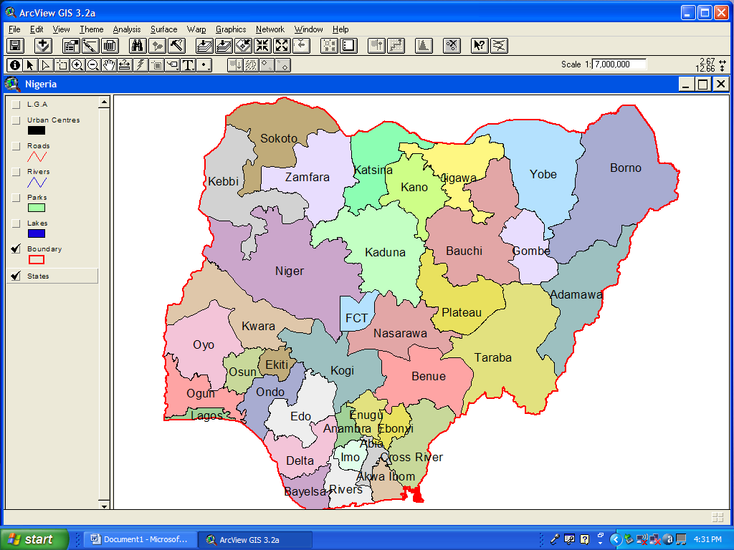
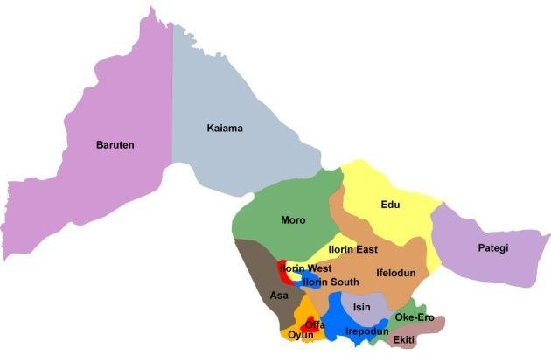
Figure 1.1.2
NIGERIA

N
KWARA

IBASS

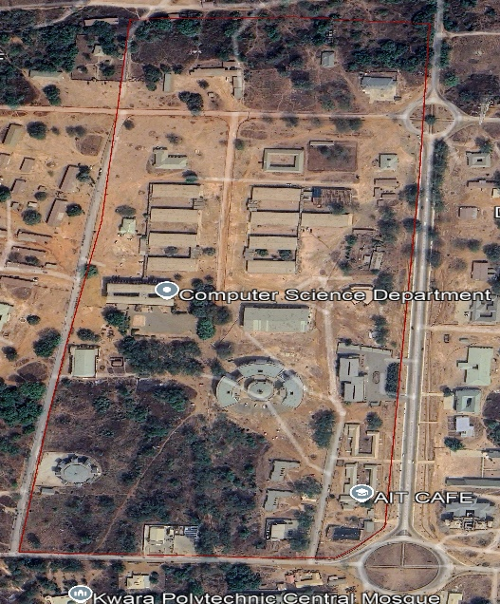
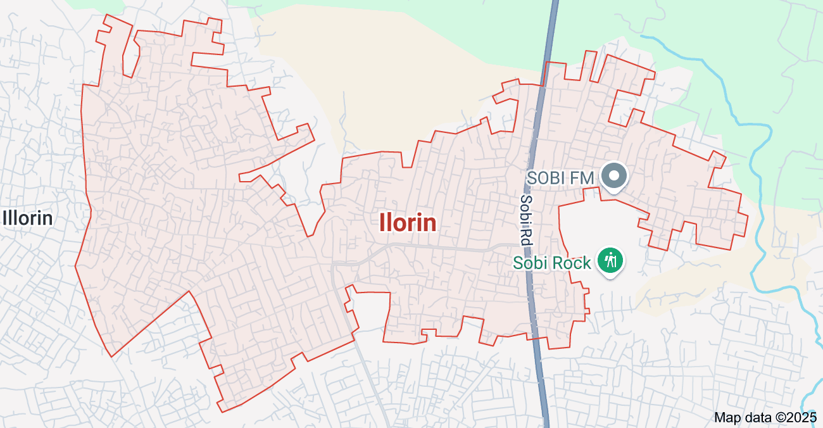

CHAPTER TWO
2.1. LITERATURE REVIEW
According to International Facility Management Association (IFMA) (1998) defines facilities management as a profession that encompasses multiple disciplines to ensure functionality, comfort, safety and efficiency of the built environment by integrating people, place, process, and technology.
Facilities management is the process by which an organization delivers and sustains support services and assets that are integral to its primary objective (Alexandra Knight and George Murray, 1994).
Facilities management involves the management of multi-disciplinary activities within the built environment. (Keith Alexander and Ian Coles, 2000).
According to British Institute of Facilities Management (BIFM) (1998) defines facilities management as the integration of processes within an organization to maintain and develop the agreed services which support and improve the effectiveness of its primary activities.
Facilities management is the integration of processes within an organization to maintain and develop the agreed services which support and improve the effectiveness of its primary activities. (Brian Atkin and Adrian Brooks, 2009).
In ancient civilizations, there we
re rudimentary forms of facilities management where individuals or groups were responsible for maintaining communal spaces, buildings, and infrastructure. However, these practices were often decentralized and lacked formalized structures. With the advent of the Industrial Revolution in the 18th and 19th centuries, the scale of facilities and infrastructure expanded dramatically. Factories, warehouses, and other industrial facilities required systematic maintenance and management to ensure smooth operations. This period marked the beginnings of formalized maintenance practices and the emergence of facility management as a distinct discipline.
During the early 20th century, as organizations grew in size and complexity, there was a greater need for centralized management of facilities and resources. The focus shifted towards improving efficiency, reducing costs, and optimizing space utilization. The concept of facilities management began to take shape within industries such as manufacturing, transportation, and healthcare.
Following World War II, there was a significant expansion of commercial and institutional facilities, including office buildings, schools, hospitals, and government complexes. This period saw the rise of professional associations and educational programs focused on facilities management. Organizations started recognizing the strategic importance of managing facilities effectively to support their core operations and enhance productivity.
In the latter half of the 20th century and into the 21st century, facilities management evolved into a multifaceted discipline encompassing various functions such as maintenance, operations, space planning, sustainability, safety, security, and technology management. Advancements in computer technology, automation, and data analytics have transformed the way facilities are managed, allowing for more proactive and data-driven decision-making.
With the rise of globalization and increasing environmental awareness, facilities management has faced new challenges and opportunities. There is a growing emphasis on sustainable practices, energy efficiency, green building standards, and corporate social responsibility within the field of facilities management.
Facilities management increasingly relies on technology solutions to streamline operations, enhance data-driven decision-making, and improve asset performance. This includes the use of computerized maintenance management systems (CMMS), building automation systems (BAS), Internet of Things (IOT) devices, and predictive analytics tools.
Facilities management encompasses a wide range of services aimed at supporting the needs of occupants and stakeholders, including maintenance, housekeeping, security, catering, transportation, and facilities helpdesk support. Service delivery involves establishing service level agreements (SLAs), monitoring performance metrics, and continuously improving service quality.
Day to day management of buildings and their contents has challenged succeeding generations for more than five millennia. Yet, it is within a period of rapid societal change, and following the evolution of highly complex, computer controlled and intensely serviced properties that FM has come to the fore. Initially founded within the office, health and defense sectors; it could be argued that this is a profession eminently suited to the care of contents and buildings that could be termed: special, cultural or iconic. Levels of care, environmental control and monitoring utilized within historic facilities; often have to be integrated and delivered to the highest possible standards if degradation of the contents and historic fabric is not to occur. (Francis, T. J., Geens, A. J. and Littlewood, J., 2010).
This will also require considerable administrative and managerial expertise to achieve the desired objective of preserving the historical identity and significance of such properties, to the highest practicable degree; the management must be effective and efficient in the utilization of resources in order to attain the set objectives through planning, organizing, directing and controlling available resources. (Management definition- Arazi El Al, 2009).
Facilities Management involves guiding and managing the operations and maintenance of buildings and community infrastructure on behalf of the property owners. Facilities Management is an age – old practice which has existed out of necessity since buildings were first constructed to support human activities. As an increasing number of multi-unit residential buildings have been developed over recent decades, the demand for facilities management has grown accordingly. (Facility Management Association of Australia 2012).
Within Facilities management, each type of facility brings its own particular challenges and demands particular skill sets. In the case of multi-unit serviced residential facilities, the large volumes of people living in close proximity to one another dramatically increases the emphasis required on effective communication and relationship building skills (IFMA 1996).
Facilities Managers are stewards of the built environment. The day to day running of a building is fundamental to facilities professionals. The Facilities Manager needs to be aware of the market costs and benefits of all aspects of facilities and equipment (Booty 2009).
Torbical and Stroh (2001) research suggested that service is the most important component in determining overall satisfaction. However, previous research have shown how residents of public housing have expressed dissatisfaction with their housing stock, being low quality housing that do not adequately match their needs, owing to lack of basic features such as good roads, schools, refuse disposal systems, security system, waste disposal, portable water, stable electricity, children playgrounds, community halls, car parks, facilities for the disables, fire escape route, fire prevention and fighting devices, adequate facilities management services, management response to repairs, and handling of residents’ complaints (Salleh et al 2011; David Jiboye, 2012; E. Eyiah-Botwe, 2015).
Facilities management practice in Nigeria is still in an early development cycle unlike in more developed countries like Europe, United States, e.t.c. where the practice has been on since 1980’s. Although facilities management in Nigeria has been embraced by some corporate organizations for effective productivity, some other sectors like the healthcare, manufacturing, educational and historic sectors are yet to explore the benefits of efficient facilities management on their performance. (Durodola, 2009).
Several organizations have been managing a number of assets in their facility portfolio using GIS for several years. In recent years, GIS has been applied in electricity distribution in an equitable and efficient manner, pavement management at airports and in utility management.
Stuart, R. and Kevin H. (2010) he discussed GIS applications adoption by US Air force to provide decision support system for the handlers of the Air Force bases management affairs.

Aerial Imagery or Global Positioning Systems (GPS) are the most commonly used primary sources of spatial data to be used for a facility geodatabase. While the aerial imagery gives a bird eye view of the nature of the facilities and through which the physical attributes of the facility can be derived from, the GPS fixed the relative position of the facility to the center of the earth surface. The limitations of these two data sources are often the fact that they could not penetrate the roof to see through what is inside a covered facility. This limitation led to increasing demand for more improved technologies to reduce the significant holes that this has left in the creation of facility geodatabases.
New technologies such as Computer Aided Design (CAD) floor plains or Building Information Model (BIM) are bridging the gap from the aerial imagery and GPS. The new technology provides inside information about the facilities to give a more complete description of the facilities. The integration of the new technology and geo-technology is making it gradually possible to unmask the business activities taking place inside the building (Stuart, R. and Kevin H., 2010).
Today, GIS provides a good alternative to analyze the spatial aspects of components of facility management workflows in a cost-effective manner. It provides support system that will optimize use of financial and human resources leading to optimal productivity.

However, according to (Stuart, R. and Kevin H., 2010) he said that no much achievement has been recorded in developing multidimensional visualization model that will provide a business support system. Such system will incorporate element of space, time and money in business decision making processes support systems. This system if developed will provide an advanced spatial analytic support system to support businesses that are situated in multiple geographical areas.
GIS provides platform that support the integration of information from spatial, temporal and informational dimensions. Such integrations provide solutions such as:
1) Optimal use of resources by integrating cost data with the visualization of space and occupancy.
2) Routing path for immediate evacuation during emergency.
3) Determining the total value of the land and property assets which the city has sold within a particular period of time.
4) Shortest route to deliver sold to the homes of new customers.
5) Model to determine and predict the spread and direction, effect of fire at any particular weather condition.
6) Visualization of energy consumption data at the room level while simultaneously managing maintenance workflows for mechanical, electrical and plumbing systems for a nationwide facility infrastructure.
Surface data such as topographical surfaces, aerial photos, parcel delineation. Paved and unpaved roads, wetlands, agricultural lands, soils map, building footprints, water bodies, CAD designs showing information not provided by aerial imagery can all be integrated using GIS to produce a base map of the area. The map could serve as a campus tour guide for the students and visitors. This map will assist in identification and collection of information about any features within the area. At Troy University, ArcGIS was used to generate the 3-D model of campus.
GIS tool provide efficient and effective management of surface and subsurface facilities. Subsurface facilities however create a daunting challenge to the managers, information such as exact location, network distribution and analysis, and management of sub surface facilities, are extremely tasking to the managers.
Adoption of GIS has simplified the problems associated with the management of these subsurface facilities. This can be identified by integration of aerial photo or any other ground feature with underground facilities, and then perform measurements; such as geographical location and the area extent. Also, GIS can provide network-based spatial analysis for utilities including flow direction and topology creation. Moreover, GIS can be used to track work orders such as landscape and utilities maintenance. For example, a list of maintenance tasks showing the description and location in the work order.
In landscape management, GIS mapping and display capabilities can be used to map out the landscape features such as flowers, trees and other plants and them displayed using the symbols embedded in ArcMap. The locations of these features will be collected using GPS and plotted for display in ArcMap. These features have symbols in ArcMap that depict them. These features can further be draped on the digital elevation model to give a more accurate surface model of the landscape. ArcMap has graphical representation for different kind of trees and the ability to include schedule for regular requirements of watering, pruning, weeding, and fertilizing. Thus, GIS can help in maintenance of landscape appearance and increases productivity of the facilities department staff (Weiss M. D., 2009).

GIS can be used in facility space planning such as emergency planning and response. In space planning, map can contain the parking spaces allocated for visitors and students, accessible buildings, routes, etc. These can further be reclassified into handicap parking space, buildings that are handicap accessible.
Ferries State University (FSU) in its adoption of GIS to provision of services for physical challenged students, it integrates aerial photographs with other mapping techniques to map out handicap accessibility facilities. The space planning was possible by delineating the suitable areas in ArcMap using the aerial photograph as the data source. Pedestrian and Transportation planning can also be carried out showing paths on campus such as different paths for bicycles, cars, motorcycles while also displaying visitors and students parking spaces. This can be color coded to differentiate one path from the other or one parking space from another.
Parking, Transit and Traffic services (PTTS) at Texas A & M University uses the campus GIS for mapping and managing bus routes, striping work on streets and parking lots, keeping track of signs, and managing parking lot allocations. PTTS is planning, with the Police Department, to implement a dispatching system for bus, police and 911 emergency uses (Bassham, C. R., 1994).
In emergency planning and response management, GIS can be used to show fire hydrants and display their locations. In the event of a fire or earthquake, a campus planner will be able to determine the area that are prone to fire risk and the area that are risk free. During the fire outbreak, GIS would be able to provide risk free path through which people can be evacuated from. In addition, it helps a campus planner under any emergency to quickly locate water and gas shut-off valves (Weiss, M. D., 2009).
Generation of 3D maps and events requires careful planning and design processes. The first process will be to examine the design process which will influence the look of the final outcome. The examination of the process is to have a better understanding of the application of the cues and resources to give a required output. The first step of the design process is data modelling. This involved data analysis, format conversion, etc. At this stage, geometric and semantic aspects are reshaped and aggregated and classified in the format required with the specific software used for designing and producing 3D maps.
Symbolization is the next step. This step involves defining the legend for both the Digital terrain model section and the thematic objects. The last step is visualization. Parameters are chosen for creating the image and completing the scenery that will become the final 3D map (Haeberling, C., 2002).
(Keith C. Clarke, 1995): -Define a GIS as a system of hardware, software, and procedures designed to support the capture, management, manipulation, analysis, modeling, and display of spatially-referenced data for solving complex planning and management problems.
(David G. Cotts, 1999): -He defined Facility management as the practice of coordinating the physical workplace with the people and work of the organization; it integrates the principles of business administration, architecture, and the behavioral and engineering sciences.
(Paul A. Longley, Michael F. Goodchild, David J. Maguire, David W. Rhind, 2005): - Defined a GIS as a powerful set of tools for collecting, storing, retrieving at will, transforming, and displaying spatial data for a particular set of purposes.
(Keith Alexander, 2003): - Define facility management as a profession that encompasses multiple disciplines to ensure functionality of the built environment by integrating people, place, process, and technology.
With growing environmental concerns, facility management has increasingly focused on sustainability. This includes implementing energy-efficient systems, reducing waste, and promoting sustainable practices. Studies have shown that sustainable facility management can lead to significant cost savings and environmental benefits (Elmualim et al., 2010).
The adoption of technology in FM, such as Building Information Modeling (BIM) and Computer-Aided Facility Management (CAFM) systems, has revolutionized the field. These technologies enhance the accuracy and efficiency of facility management practices by providing detailed data and analytics for decision-making (Kassem et al., 2015).
Future trends in facility management include a greater focus on smart buildings, increased use of artificial intelligence and machine learning for predictive maintenance, and a stronger emphasis on sustainability and resilience in the face of climate change (Roper & Payant, 2014).
According to Alkaabi and Saeed (2014), GIS-based mapping enhances the understanding of facility layouts and spatial distribution, aiding in efficient space utilization and planning.
GIS integrates various types of spatial data, including CAD drawings, satellite imagery, and sensor data, providing a comprehensive view of facilities. This integration supports more informed decision-making and efficient management of resources (Zhu et al., 2014).
GIS plays a critical role in emergency planning and safety management by providing detailed maps of facilities, including evacuation routes, fire exits, and hazard locations. This information is vital for developing effective emergency response plans and ensuring occupant safety (Tsou et al., 2005).
GIS can map and analyze energy consumption patterns within a facility, identifying areas of high energy usage and potential for efficiency improvements. This analysis supports the implementation of energy-saving measures and sustainability initiatives (Huang et al., 2010).
GIS enables the monitoring of environmental factors such as air quality, temperature, and humidity within facilities. This monitoring helps maintain optimal conditions for occupants and supports environmental sustainability efforts (Guan et al., 2015).
Integrating diverse data sources into a GIS platform can be challenging due to differences in data formats, scales, and accuracy. Ensuring high-quality, accurate spatial data is crucial for effective GIS applications in facility management (Alavi et al., 2014).
Implementing GIS technology requires significant investment in software, hardware, and training. Smaller organizations may face financial constraints that limit their ability to adopt GIS for facility management (Khorram et al., 2008).
Effective use of GIS in facility management requires specialized knowledge and skills. Providing adequate training for facility managers and staff is essential to maximize the benefits of GIS technology (Pfeffer et al., 2013).
Combining GIS with BIM can provide a more detailed and dynamic representation of facilities, enhancing capabilities for design, construction, and facility management. This integration supports more holistic and data-driven decision-making (Sebastian & van Berlo, 2010).
The incorporation of real-time data from Internet of Things (IOT) sensors into GIS platforms can provide up-to-date information on facility conditions, improving monitoring and responsiveness. This trend is likely to enhance the efficiency and effectiveness of facility management practices (Klein et al., 2017).
The move towards smart facilities involves leveraging GIS and other technologies to create more intelligent and sustainable buildings. This includes optimizing energy use, improving occupant comfort, and reducing environmental impacts (Aziz et al., 2016).
he Principles of Scientific Management book (Taylor, 1911) has profound influence to the evolving theory of management science over the past ten decades. According to Jones and George (2012), the management theory has evolved from the scientific management theory in the 1880s and 1890s through the development of administrative management theory, behavioural management theory, management science theory and organizational environmental theory towards the theoretical system of contemporary management. In the past several decades, the revolution of integrated lifecycle management of built assets has made the facilities management (FM) one of the most fast-growing profession in the global construction industry with regard to clients’ diverse needs and demands, and the formation of FM principles has been eventually in need for theory development for both research and practice for this profession.
The concept of total FM (Atkin and Brooks, 2015) has not only been adopted in practice, at Mitie for example, but also inspired management thought on three essential elements, including people, products and processes, to structure the FM body of knowledge (FMBOK) so as to derive a set of principles of FM. From FM profession point of view, people are FM professionals and their organisations, products are various FM services and processes are various management actions to provide FM services. A further review focussed on people, products and processes was therefore conducted into the evolution of management theory to set up a generic framework of management principles for FM. After looking into five major management theories summarised by Jones and George (2012), it has been found that the three essential elements as a whole set of essential elements of FM are well connected with key aspects inside the five management theories in terms of their coverage to all general management issues.
In the world of business, decisions are driven by pressures to improve quality, reduce costs and minimize risks. This means that organizations must frequently undergo deep cultural changes involving all business processes, often with fundamental shifts in their organizational structures and working patterns. In this climate of change, quality of life and environmental issues are involved which together with issues of heritage and of conservation become part of the business agenda. Facilities management is at the heart of this process. Facilities management is a key business discipline. Large corporations recognize its importance for business success. Smaller enterprises improve their performance by making better use of resources, often by forming networks and partnerships. Consultants and contractors in turn develop a variety of services to support this organizational effectiveness. When times are difficult in business, when there is increasing corporate restructuring and growing uncertainty, facilities management becomes an area of substantial growth. Evidence of this can be seen as those professional bodies of the construction, hospitality and information technology industries increasingly recognize the opportunities that facilities management provides to their members to develop new value-added services, better integrated with an organization's business needs. Many relevant professional associations consolidate and work together to promote the professional status and role of facilities managers. Facilities management consultants offer management and advisory services and undertake work on behalf of corporate and public sector clients on an agency or management contracting basis. Major contracting organizations offer contracted business services, either independently or in a 'total facilities management' package. Given the quest for improved effectiveness, especially when promoted by government policy, the market in both the public and private sectors expands rapidly. In a business context where the raised expectations of clients lead to enhanced customer awareness, where economic, technological and environmental issues are affected by proliferating legislation, and where traditiona! discipline boundaries are challenged by information technology, facilities management can have its greatest impact. Many of these contexts also involve a redefining of the roles of purchaser and provider, and a move towards a contract basis for service delivery. The informed buyer or intelligent client requires more management time at the interface with the user, more effective use of contracting out and less time administering inappropriate and cumbersome contracts. Effective quality systems, in which there is an appropriate balance between social, environmental, technical and economic issues, can release time to enable 'competition for quality', but who understands enough about the client's business that they can deliver quality facilities and so realize organizational effectiveness? Can such a person exist? Market research has identified the need in facilities management for a kind of hybrid manaager, a cross between professional manager and technical professional, combining the ability to make things happen with a level of technical understanding to enable facilities in organizations to be tuned to strategic needs. This requires the development of an appropriate balance of management and technical skills. Such a balance can lead to healthy and ecologically sound buildings in a business context, and resolve the relationships between organizations, the individual, the environment and the business community. Strategic facilities managers are judged by their managerial capabilities rather than their technical competence. In many cases this means adding business, social and personal skills to a technical skills base. New groups of management skills, covering people, marketing, purchasing and contract, are involved. In an applied field like this it is vital that these skills are exercised in a practical, industrially relevant context. The education and training of facilities managers, underpinned by research, must either be seen as part of general management development, or end up being marginalized. Facilities managers must have an understanding of facilities and services, recognize when further expertise is needed, contribute to strategic business planning and be in line for senior management posts in an organization. Occupational competency-based management standards for facilities managers are essential. An open, individual, corporate, continuing system for such standards has to register a demonstrable ability to manage at junior (operational), middle (tactical) or senior management (strategic) levels. The aim is a mix of technical competence, language skills, cultural sensitivity and, at the top, a controlling vision that can bind activities together in many different countries. The need for such able and experienced managers is strong and widespread. To meet the challenges of the next century the profession must organize in such a way as to be responsive to these needs. Professional associations in facilities management will flourish if they develop an open and positive approach to serving the needs of the consumer. United they could foster a strategy to: • define standards for quality of performance and service; • provide full support to practitioners by establishing a collective knowledge base and providing up-to-date information; • provide guidance to the educational sector to support the development of modular courses at undergraduate, postgraduate and post-experience level; • provide the means for an open exchange of experience and skills; • create the conditions to promote advancement of the discipline, receptive to new ideas arid supportive of a breadth of vision.* Advancement of the profession hinges upon the assurance of quality and upon the value added by the service. The agenda for a professional quality system includes creating a ladder of educational opportunity and establishing qualifications, promoting the continuous development of skills and experience, and creating and maintaining an accessible collective database. By establishing this quality system the profession can achieve a status and recognition that will provide an influence in business strategy and a strong voice in environmental politics. Such developments require close collaboration between academics, practitioners and researchers on a pannational basis. The mechanisms should be created to support the processes of professional development through research, education and training. If facilities management is to be acknowledged as a profession with its own rigorous discipline, it needs to sow the seeds for a strategy and infrastructure to promote development. 'Centres of excellence' should be created and linked into a network, to provide the focus for all this. The University of Strathclyde, through the Centre for Facilities Management, has been involved in facilities management education in the United Kingdom since the middle of 1980. The first short courses were jointly presented with DEGW in 1984. The MSc and Diploma in Facilities Management has been running since 1987, with the aim of graduating high quality, innovative thinkers with a balance of managerial and technical skills and understanding, capable of contributing to the development of facilities management research and practice. Since 1994, CFM has consolidated its role and diversified its courses still further. Its aims and objectives are met by providing a mix of quality learning opportunities, supported by quality learning materials, information and facilities with the support and guidance of well qualified core staff. It is working to create qualifications that provide a ladder of opportunity to bridge from functional to general management.
To ensure it is fully aware of and can anticipate change, and to maintain standards, CFM has an Advisory Board, comprising representatives from all sectors of the industry. It makes visiting appointments to benefit from the experience and expertise of the leading practitioners and researchers in the field and it has strong working relationships with prominent companies. Professional associations in the FM field are also represented. The Centre is a focus for research and discussion and seeks to create an atmosphere of enquiry and debate. It also provides the opportunity to meet leading experts from education, research and practice. CFM staff are well qualified, experienced professionals dedicated to supporting learning needs. They are all active in research, provide services to some of the leading companies in the UK, and bring up-to-date knowledge and recent experience to its courses. It is in the forefront of facilities management education in the United Kingdom and has a flourishing international reputation for its work. Its aim is to be recognized as a 'centre for excellence' in the field. *Professional qualifications and undergraduate and postgraduate courses are increasingly available. Associations have been formed to promote facilities management and to represent the interests of members in the United States (IFMA), Japan (JFMA), Australia (FMA) and in Europe in the United Kingdom (BIFM), the Netherlands (NEFMA), Germany (GEFMA), Denmark (DFM), Hungary (HUFMA) and Finland (FIFMA). The associations, academic institutions and research organizations in Europe collaborate through the European Facilities Management Network (EuroFM).
Facilities management - 'the process by which an organization delivers and sustains support services in a quality environment to meet strategic needs.' Centre for Facilities Management When organizations undergo the kind of deep cultural shifts that involve all their business processes, they inevitably make fundamental changes to their organizational structures and working patterns. In such circumstances, issues concerning the quality of life and the environment need to be addressed and heritage and conservation become an important part of the business agenda. Nevertheless, business pressures to improve quality, reduce costs and minimize risks will continue to drive decisions. Organizations of all kinds in different economies around the world recognize that the rising costs of occupying buildings, providing services to support business operations and improving working conditions are important factors in profitability. Success can depend upon reducing the costs of being in business. As buildings become more complex and house more technology, user expectations rise and the pressure on them to perform increases. Increasing legislation to ensure health, safety and welfare as well as to protect the environment has added new responsibilities on companies to manage the workplace. Facilities management is the process by which an organization ensures that its buildings, systems and services support core operations and processes as well as contribute to achieving its strategic objectives in changing conditions. It focuses resources on meeting user needs to support the key role of people in organizations, and strives to continuously improve quality, reduce risks and ensure value for money. It is clearly an important management function and business service. Major organizations world-wide are using it as part of their strategy for restructuring to provide a competitive edge. It can also ensure that buildings and support services improve customer responsiveness and contribute to business objectives. The scope of the discipline covers all aspects of property, space, environmental control, health and safety, and support services, and requires that appropriate control points are established in the organization. The facilities plan will set out these policies and identify corporate guidelines and standards. It will describe the organization, its structure, procedures and responsibilities. Facilities management policies lay out an organization's response to vital issues such as space allocation and charging, environmental control and protection, direct and contract employment. The policies will set a direction for the organization and establish the values of and attitudes towards the facilities users - the corporation, its operating units and customers, individual employees and the public. Facilities management is relevant to organizations in all sectors and in developed and developing countries. However, differences in culture and management style must be recognized when delivering the operating environment and services needed for business effectiveness in a particular context.
Strategic decisions in these organizations. including those about adapting to the changing market. restructuring and investment opportunity choices, will be made by their chief executives and the managing directors of their operating units. It is at board level that conditions are set within which facilities are operated and developed. Physical resources and support services may be treated as non-core activities and so not figure in boardroom considerations. However. sites and buildings project the identity of the organization and those who deliver support services are often the first line of contact with customers. If the lasting impressions of an organization are formed in the first five minutes contact. these 'moments of truth' are vital. Facilities include the space, environment. communications and services that enable the achievement of key business objectives. They may be looked at in one of two different ways in any organization - as property. the fixed assets that appear on the balance sheet. or as an administrative overhead, a business expense to be minimized. They are often overlooked as a source of competitive advantage. Even where facilities management has been introduced it may be seen as little more than collecting responsibilities under a convenient functional head. Buildings may be treated as liabilities rather than assets - a drain on scarce resources. Similarly general services may be seen as a support function - an overhead cost. Neither view enables organizations to use the full potential of buildings, communications and support services in improving business performance. Facilities need to be offered as a service, and provided. for a charge, to the operating units. Their scope may include business services, e.g. legal, accounting and administrative as well as space, environment. information and other support activities. However. many companies still view the provision. operation and maintenance of facilities from a technical and project base rather than from a business perspective. There is ample evidence of poor property management - research studies by the Oxford Brookes and Reading Universities concluded that 'property, though a key asset for operational organizations. is ill-considered and poorly managed by most'. They identified examples of good practice and raised the questions that organizations should address if they are to begin to make their property work for them. Researchers have written extensively on the management of operations and perfor mance in relation to property over the past decade. There is also evidence of inadequate service delivery and recognition of the adverse consequences of undervalued and under-utilized facilities for corporate performance. Few organizations in fact fully recognize the contribution that facilities can make to the business. and few can identify the opportunities they provide. There are many examples of the positive impact that effective facilities management can have on success as measured by key business indicators such as cost/income ratios. product lead time and process improvement. Corporate attitudes toward facilities must be towards their management. either as a business service or as a company asset. They must be developed as corporate assets to add value to core business activities and managed to offer service quality in support of business operations. Separate initiatives to improve facilities. to sharpen the corporate image, to enhance operational efficiency and increase cost effectiveness may make a marginal difference to company performance. Only by being tuned to business objectives and managed to a strategic plan can they be organized to encourage innovation and enterprise. This is a strategic role for organizations - to develop policy, contribute to strategic planning. negotiate service levels and arrange for the delivery of quality facilities.
Many organizations restructure to create more appropriate relationships in what are in effect 'new organizations'. Others review critical success factors and seek to improve business processes. Wholesale corporate reengineering concentrates on the improvement of all business processes. Surveys conducted by Frank Duffy and colleagues as part of the Responsible Workplace Study (Butterworths. 1993) identified the pressures for change (technology/telecommunications and organizational structure). workplace issues (location. servicing. layout. security/access) and decisions that organizations considered most important for the future (responsive adaptation for user needs). This particular study focused on innovative organizations introducing advanced information technology and devising organizational structures to cope with change. It also dealt with the search for ways of increasing productivity and of using time more effectively as well as responding to expectations for a safer working environment and taking environmental responsibilities seriously.
Journal, March 1991. pp. 231-341 ). could be seen as an example of this. However. in many cases. architects and suppliers of physical space are not given much opportunity to link the process of designing office space with such strategies. Business strategists need to simultaneously shape the form of their organizations as well as the working environment through which that future can be achieved. Paull Robathan. presenting his The effectiveness of organizations may be measured in different ways. depending on their mission. prime goals and objectives. as well as the relative influence of the stakeholders - those groups with an interest in it: • customers - customer care/customer first - 'moments of truth'; • employees - investing in people; • shareholders and creditors; • collaborators and suppliers; • the community. and society; • government. Stakeholder analysis is used by some firms to identify and classify their expectations. Organizational effectiveness may be described as: maintaining commitment amongst the members of the organization. communication amongst operating units. projecting a positive and responsible image. enabling change and improving productivity. Facilities have the potential to contribute and it is important to identify (and measure) the extent that they support. or can be adapted to. the changing needs of organizations. and contribute to productivity. profitability, service and quality. paper The Intelligent Perspective at the EuroFM Conference in Rotterdam in September 1992. has suggested that facilities managers are best placed in organizations for this kind of business re-engineering. However. the role of facilities management is broader than the design of the product and production of the physical workspace. It entails the integration of people. technology and support services so as to achieve an organization's mission. It is concerned primarily with the quality of service to all stakeholders in the organization. These management issues and their implications for the organization - concepts of excellence. teamwork. total quality and service - must be clearly recognized and understood if facilities are to be effectively managed to support the corporate mission and objectives. They have a fundamental impact on the workplace and upon delivering the facilities. In turn. the development of facilities in an organization can act as a catalyst to cultural change.
Companies are revisiting basic questions about the purpose of the organization. asking 'what business are we in?' 'who are our customers?' and developing a core business philosophy. Charles Handy suggests that the 'principal purpose of a company is not to make a profit - full stop. It is to make a profit in order to continue to do things or make things. and to do it even better and more abundantly. To say that profit is a means to other ends and is not an end in itself is not a semantic quibble, it is a serious moral point.' Handy's point is that. increasingly, companies will need to think about their social environmental performance. and how their products or services benefit a wider social good.
ORGANIZATIONAL DYNAMICS
As organizations respond to the business climate and adapt to legislative. political. social and economic influences. their facilities needs change. All organizations are dynamic and undergo differing levels of change, much of it structural. to adapt to an evolving business environment. With the accelerating pace of such change, balancing demand and supply in managing the operational environment has become a vital element in strategic planning. Privatization with restructuring is a good example. More and regular change, to adapt working patterns to give continuity of workflow by forming and reforming project teams. is another. As the rate of change in an organization increases. so does the importance of managing facilities as a factor of production. Organizational change affects the size and shape of organizations. working patterns and customer and supplier relations. These factors need to be constantly under review. Understanding the changing organization is similar to Mark Twain's description of the process of mapping the Mississippi - a constantly changing landscape. Continuity of production or service with reliable support and no disruption is important in all organizations. This entails assessing the business risks associated with the operating environment and having a plan to manage risks and deal with contingencies. The consequences of interruption could be disastrous. All business resources must be effectively utilized to ensure competitiveness. The significance to financial viability of the rising costs of occupying buildings and delivering support services is increasingly recognized. Facilities are an organization's second largest expense and can account for as much as 15% of turnover. The pressure to reduce costs is usually the main driver of a company's decisions about facilities. They are also the largest item on the balance sheet. typically over 25% of all fixed assets, so it is important that they are managed to add value to the organization. Many organizations realize that human resources are the key to success. Demographic trends suggest that. in Europe, a highly skilled workforce capable of using the potential of advanced technologies may well be in short supply. More attention has to be paid to ensure that companies can attract and retain the right quality of staff and a package of working conditions, including the facilities to support the quality of working life, will be a prerequisite for organizations who wish to compete. Increasing demands are being placed on buildings to provide an improved working environment with new information technologies. New approaches are needed as health and safety and environmental legislation requires managements to comply with improving standards. It is clear from all this that facilities management is not simply the operation and maintenance of buildings, the provision of cleaning services or the recording and rearranging of furniture in offices. From the highest level, in any organization, the strategic aspect of planning for the effective provision of services offers opportunities for economy, efficiency, effectiveness and competitive advantage.
FACILITIES MANAGEMENT PROCESSES
In these conditions, organizations must ensure that they are responsive to change, and able to take advantage of technological innovation. Facilities management is the application of the total quality techniques to improve quality, add value and reduce the risks involved in occupying buildings and delivering reliable support services. Such an approach is required to provide and sustain an operational environment to meet the strategic needs of an organization. An ambience of quality can ensure that core business processes are well integrated and supported in an operational environment - the workplace. The process is cyclical and relates needs to a result that can be tested against user satisfaction with the service: • space - adapted to changing needs and effectively utilized; • environment - to create healthy and sustainable working environments; • information technology - to support effective communications; • support services - to provide quality services to satisfy users; • infrastructure - to provide appropriate capability and reliability. Organizations should have a clear strategy and well developed policies for facilities management embodied in a facilities plan, and should establish a single point of responsibility. The way in which facilities are organized in relation to central functions and to other operating units will determine the extent to which facilities support strategic needs. Value is added to an organization at the workplace through the provision of services in the most efficient and effective way: by the development and management of quality managed systems. through the establishment of guidelines and service levels and, at the policy level, through the development of a strategy and a framework within which to deliver services. The facilities planning process identifies user needs and agrees service levels as the basis for designing the service. Effective planning of facilities will ensure that they are 'work-shaped' and support work processes. The services that are required can then be defined. specified and delivered. Quality systems ensure that all services are delivered to the required quality. provide value for money and minimize risks to the organization. Such customer response is a key indicator of facilities performance. Most leading organizations are engaged in a process of identifying their performance in key business areas as part of their quality initiatives. Increasing attention is now being given to the performance of facilities as a factor of production and as a business resource. Financial indicators still predominate but increasing interest is being shown in social and environmental indicators. As well as tracing historical performance. companies will seek to compare their performance against other similar organizations and against the 'best of breed - the benchmarking process. Such comparisons depend upon the availability of standard ways of measuring and representing performance and cost information.
FACILITIES MANAGEMENT ORGANIZATION
The level of responsibility and degree of autonomy provided to the facilities enterprise and the commitment and encouragement they receive to improve quality will determine the value that can be added through facilities management. Appropriate relationships should be established within which people are empowered and decisions about the use of facilities are taken closer to the customer. A single point of responsibility should be established as the informed buyer of services. concentrating management resources on the strategic role. A facilities director or senior manager will be primarily responsible for tuning facilities to the needs of the business. The facilities team must be organized to achieve strategic control. The model of an enabling organization will promote more effective businesslike management. which pays more attention to customer requirements and value for money. Responsibilities for policy formulation and service delivery are separated. This enables senior managers to concentrate on the core responsibilities of setting priorities and standards and finding the best ways of meeting them. Negotiating contracts for services makes managers accountable for performance against specified standards and allows them to achieve the best value for their resources.

CHAPTER THREE
3.0 METHODOLOGY
This are the methods and procedure employed in executing the project both in office and on the field. The method adopted for this project was based on the principle of surveying which was working from whole to part, aimed at acquiring reliable and accurate data needed for the computation and presentation of information in form of a plan.
The procedure adopted in carrying out the project followed a pattern in which one step leads to another. For easy execution and for the aim and objectives of the project to be realized, it was planned as under listed;
i. Reconnaissance survey.
iii. Data acquisition.
iii. Data downloading and processing.
iv. Data analysis.
v. Information presentation.
3.1. RECONNAISSANCE
This is a very important aspect of surveying that involves planning and preliminary inspection of the area before the commencement of the actual data acquisition of the project site, this was done for the purpose of planning on how to execute the project, fixing stations, locating controls, etc. Its importance prior to the actual survey operation, it cannot be underestimated as it enables the Surveyor to have a clear view of the project area so as to give the best method to carry out the task. The two phases of reconnaissance are;
i. Office planning
ii. Field reconnaissance
3.1.1. OFFICE PLANNING
This involved the office work carried out before the actual field work. This aspect involved the compilation and study of the available information about the project site as this helped in yielding result within the expected accuracy. It comprises of the following;
i. Understanding the purpose of the survey from the project instruction.
ii. Obtaining the specification for the accuracy required leading to the choice of a suitable
scale.
iii. Deciding the method to be employed for the measurements.
iv. The kind of instruments to be used in executing the project.
3.1.2. FIELD RECONNAISSANCE
The field reconnaissance was done after the office planning. It involved a visitation to the project site by all the group members to have a pre-requisite knowledge of how it looks like and how the field operations would be carried out. At the end of the visit, a sketch diagram known as “recce diagram” showing the physical appearance of the project site was drawn.
To sum it up, the reconnaissance facilitated the planning and execution of the actual survey as it was taking into consideration, the possible problems that are likely to be encountered, how such problems can be overcome or reduced to the barest minimum.
The diagram below shows the drawn recce diagram.
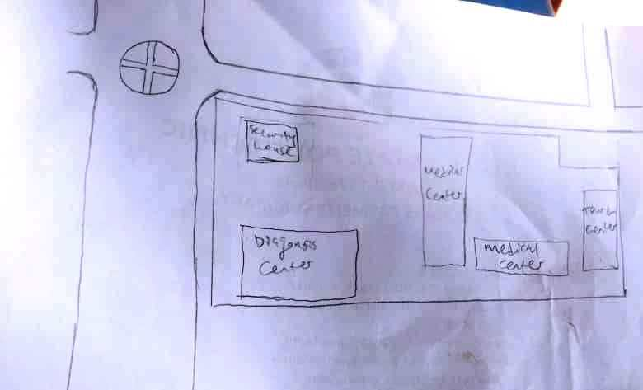

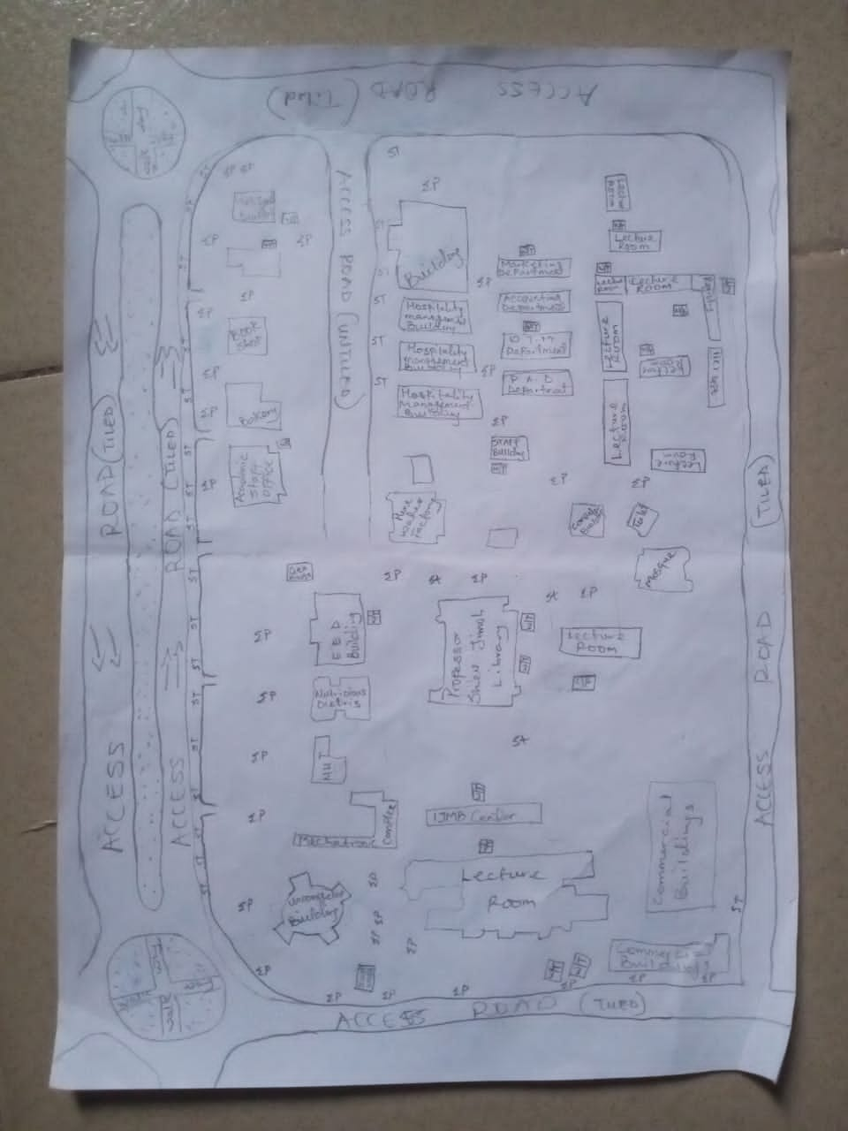

Fig. 3.1. Recci Diagram
3.2. BOUNDARY SELECTION AND MONUMENTATION
Pre-cast property beacons made of 18cm x 18cm x 75cm were used for the demarcation of the project site. In compliance with the specification for cadastral Survey as specified in CAP 194 of law of the Federation of Nigeria, the Beacons were made of concrete mixture of ratio 3:2:1 (3 parts of sand to 2 parts of granite to 1 part of cement) with water, so as to ensure that the pillars were strong. The beacons protruded 15cm above ground level, while the remaining part was inserted and fixed firmly into an undercut hole. An iron rod (80cm in lengths and 10mm in diameter) protruding at the centre of the beacon represents the centre of the station mark.
A total number of Nine (9) beacons were emplaced and prefixed with identification mark “PIL” where “PIL” represent property beacon, Pillar. The beacons were capped and numbered from Pil.1 to Pil.9 as obtained from the department of surveying, Kwara State Polytechnic, Ilorin and they were numbered in a clockwise direction with stencil.

Ground level
18cm
18cm
Beneath Ground level
75cm long
60cm
80cm Iron rod
Above Ground level
15cm

01
PIL

18cm
18cm

Figure 1.9: Pre- cast property beacon
3.3 EQUIPMENT SELECTION
The various equipment used for the acquiring of data and successful completion of this project were selected and was grouped in to two categories. They are;
3.3.1 Hardware Numbers
i. Total Station (South NTS-350R) with its accessories. 1 No.
ii. Tripod stand 1 No.
iii. Tracking Rod / Reflector 2 No.
v. Tape of 30m 1 No.
vi Cutlass 2 No.
vii Handed GPS (Garmin 72SC) 1 No.
viii Total Station Batteries 2 No.
ix. Laptop computer 1 No.
x HP DeskJet 1 No.
3.3.2. SOFTWARE USED
The software used for the project includes;
- ArcMap 10.3.
- Microsoft Excel
- Microsoft word
- NotePad

3.4 TEST OF INSTRUMENT
3.4.1 SOUTH (NTS-350R) TOTAL STATION TEST
Various tests were conducted on the South (NTS-350R) Total Station used, to ascertain its working condition prior to the commencement of the project execution. These tests are as follows:
3.4.2 PLATE LEVEL TEST
This test was to verify that the vertical axis of the instrument used was truly vertical when the plate level was at the centre of its run.
PROCEDURE: The Total Station (South NTS-350R) was set up firmly on a point arbitrarily. The plate bubble tube was turned parallel to two foot screws and leveled with two foot screws; the tube was then turned through 90º, now over the third foot – screw and level accordingly using the third foot screw. It was then returned to its former position and accurately leveled with the pair of the two initial foot – screws. To complete the test, the instrument was rotated through 180º and 360º and the bubble was still at the centre of its run, hence the plate bubble was in order.
3.5.3 HORIZONTAL COLLIMATION TEST
The aim of this test was to make sure that the line of sight is truly perpendicular to the trunion axis.
PROCEDURE: The Total Station instrument was set up on a point and all necessary temporary adjustments performed. The instrument was switched on, collimation program was selected from the menu and consequently the horizontal collimation test was chosen. This test was done by bisecting a well defined vertical target about 100m away and taking the horizontal readings on Face Left and Face Right. From the analysis of the results, the Total Station was in good adjustment.
3.5.4 VERTICAL INDEX ERROR TEST
This adjustment ensures that the vertical circle reading is exactly 90º when the line of sight is horizontal. Any deviation from this figure is termed vertical index error.
PROCEDURE: The instrument was set over a station point and all necessary temporary adjustments (centering, levelling and focusing) were performed. The vertical index error test was carried out by sighting a target at a distance of about 120m on Face Left. The Vertical Circle reading was recorded and the target was sighted and bisected again on Face Right and the vertical circle reading was recorded.

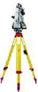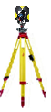
Total
Station
Reflector
Fairly Leveled Ground
Approximately 120m
Station B
Station A
Line of Sight
Figure 1.6. : Instrument set-up for horizontal collimation test and vertical index test
3.5.5 ANALYSIS OF COLLIMATION AND VERTICAL INDEX DATA
The readings obtained during the calibration were reduced to obtain the new horizontal collimation and vertical index errors. The results of the calibration data acquired for the total station used for this project are shown in the table below;
Table 1.2: Horizontal and Vertical Collimation Test Reading
Inst Stn. | Sight (Reflector) | Face | Hor.Circle Reading | Ver. Circle Reading
 | B | L | 87º 35’ 10’’ | 88º 26’ 15’’
A | B | R | 267º 35’ 12’’ | 271º 33’ 46’’
 |  |  | Diff= 180º 00’ 02’’ | Sum= 360º 00’ 01’
Horizontal Collimation = [(FR – FL) - 180º]/2
= [(180º 00’ 02’ - 180º 00’ 00’’) /2]
= 00º 00’ 02’’/2
= 00° 00’ 01’’
Vertical Collimation = [(FR – FL) - 360º]/2
= [(360º 00’ 01’’ - 360º 00’ 00’’)/2]
= 00º 00’ 01’’/2
= 00° 00’ 01’’
Table 1.3: Comparison of Old and New Values.
HORIZONTAL COLLIMATION | OLD | NEW
HORIZONTAL COLLIMATION | + 00º 00’ 02’’ | +00º 00’ 01’’
VERTICAL INDEX | +00º 00’ 00’’ | + 00’ 00’ 01’’

With the result obtained, it is evident that the instrument is in good working condition. Therefore, the new readings were adopted for the instruments Horizontal Collimation Error and Vertical Index Error respectively.

3.6. DATA ACQUISITION
3.6.1 OBSERVATION PROCEDURE
Geometric data was acquired using South (NTS-350R) Total Station. Total Station is an integrated system combining Electronic Theodolite and Electromagnetic distance measuring device. It is an instrument with inbuilt software for selected programs, which made it possible to compute data. The system also includes storing unit which serves as the survey field book.
This task was achieved through the following procedures;
- The instrument South (NTS-350R) was set up on a known station (KWPT733) and the bubble was centred and levelled.
- The instrument was switched on and menu button was pressed to display the programs on the total station.
- Data collect menu on the total station was selected to key in necessary information needed for commencement of the job. In the appeared dialogue box is Occp. Stn., Backsight and Fss. / SS
- The information of the known station (KWPT734)was keyed into the Total Station under the Data Collect sub-menu (Occp. Stn.) by opening a new file and naming the job. The station parameter N,E,H and height of instrument was entered in its appropriate space.
- The second option was selected, which is the Backsight, a submenu under the Data Collect. Here the information of the target position N,E,H and height of reflector was keyed into the Total Station. After this was achieved, Measure button was pressed for orientation and to compute the bearing, distance and N,E,H of the target position. The result was compared with the given coordinates, when the difference between the given and the observed was seen to be minimal, a centimetre difference, OK button was pressed.
- After the orientation. FS / SS menu was selected, which is a submenu under Data Collect and ALL button which captures and stores data automatically was pressed and observation to both natural and man-made features within the perimeter were fixed. A subsidiary traverse was run close to the interested feature and the above step was repeated at every point created until all the features were covered.
3.6.2 IN-SITU CHECK OF SURVEY CONTROL USED
The position of the control pillars used was checked before any other observation can be carried on. The check was done on control pillars (KWPT.733, KWPT.734 and KWPT.735). I set-up the Total Station instrument, centred and levelled it on KWPT.733 and the values control were keyed into the Total Station. The target position KWPT.734 was sighted and tracked and the result (Bearing, Distance, N, E, and H) was displayed as and checked finally recorded. The reflector was then positioned on KWPT.735 and was sighted and tracked and the results were also recorded and compared with given value of the pillar.
The result of the observed coordinates of pillar KWPT.733 was compared with the given coordinates. By specification the deviation in the distance and angle must not exceed 0.30m and 30’’ respectively. The summary of the computation between the given coordinates and observed is shown in the table below.

External angle
184⁰ 15’ 57’’

112ᴼ 50’ 07”
245.841m
KWPT733
288ᴼ 34’39”
143.780m
KWPT734
KWPT735

Fig. 1.6 Shows the computed check angle and check distance as obtained from the control pillars.

Table 3.1: Result of the computed survey control check from given coordinate.
FROM  STN | BEARING | DIST. (m) | DN | DE | NORTHING  (m) | EASTING  (m) | TO  STN
 |  |  |  |  | 946553.567 | 680054.213 | KWPT733
KWPT733 | 182ᴼ 32’08” | 182.734 | -182.555 | -8.084 | 946371.012 | 680046.129 | KWPT734
KWPT734 | 182ᴼ 05’27” | 493.386 | -493.058 | -18.001 | 945877.954 | 680028.128 | KWPT735
Source:Author, 2025.
The result was used to obtain the inclusive angle between KWPT733, KWPT734 and KWPT735 by finding the difference between the bearings of two lines.
KWPT734 KWPT733 => 002⁰ 32’ 08’’
KWPT734 KWPT735 => 182ᴼ 05’27”
Therefore (182ᴼ 05’27” - 002⁰ 32’ 08’’)
Check angle 179⁰ 33’ 19’’
Table 3.2: Result of the computed survey control check from given coordinate.
FROM  STN | BEARING | DIST. (m) | DN | DE | NORTHING  (m) | EASTING  (m) | TO  STN
 |  |  |  |  | 946553.567 | 680054.213 | KWPT733
KWPT733 | 182ᴼ 32’14” | 182.728 | -182.555 | -8.089 | 946371.012 | 680046.129 | KWPT734
KWPT734 | 182ᴼ 05’26” | 493.390 | -493.058 | -17.998 | 945877.954 | 680028.128 | KWPT735
Source:Author, 2025.
The result was used to obtain the inclusive angle between KWPT733, KWPT734 and KWPT735 by finding the difference between the bearings of two lines.
KWPT734 KWPT733 => 002⁰ 32’ 14’’
KWPT734 KWPT735 => 182ᴼ 05’26”
Therefore (182ᴼ 05’26” - 002⁰ 32’ 14’’)
Check angle 179⁰ 33’ 12’’

The difference between the Observed checked angle and the computed check angle
= (179⁰ 33’ 19’’- 179⁰ 33’ 12’’) = 00⁰ 00’ 07’’

3.6.3 PERIMETER SURVEY
A perimeter survey covering the entire area was ran using the three Survey control pillars found to in-situ and the area covered by the survey was 26.808 Hectares.
3.6.4 OBSERVATION PROCEDURE
The Total Station was setup on kwpt734 and all the necessary temporary adjustment were done like centring, levelling and parallax removal. Then instrument was switched on and the parameters of the instrument station (Station I.D, Height of instrument and the N,E,H coordinate) were keyed in. The reference control point kwpt733 was then bisected and the parameters (back station I.D, Height of reflector over the target station, and the N,E,H coordinate) were also keyed in. After this process, the measured button was pressed and orientation is set. Foresight was made to kwpt735, which was my forward station and the reflector was bisected and tracked to measure the N,E,H value of the point, all the obtained coordinates N,E,H were checked and found correct before proceed to next measurement. The instrument was then moved to kwpt735 as my new instrument station values were keyed in and back sight to kwpt734 was used as my reference station. The same process was repeated from one boundary station to the next pillar from kwpt735 to Pil.1. In this manner, the traverse was ran through the boundary beacons and finally closed back on Kwpt734. A closed loop traverse was carried out and all field data were later downloaded and processed. The data was later downloaded as show on the appendix table.
3.6.5 DETAILING SURVEY
Comprehensive details Survey of all natural and man-made features along the survey line were carried out. Ray method with the total station was used for the detailing. Subsidiary points were established around the project area to allow features that cannot be pick from the boundary points be picked easily. The X, Y and Z coordinates, angles (vertical and horizontal) and distance to the point to be detailed were measured.
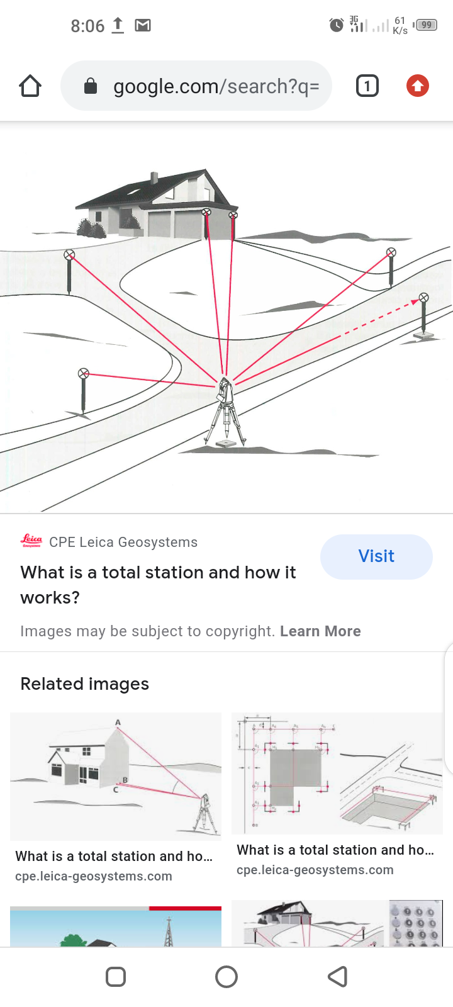
Fig. 1.8 Show the observation process of using total station.
3.6.6 PROCEDURES OF OPERATING SOUTH (NTS-350R) TOTAL STATION
The following steps were taken when operating South (NTS-350R) Total Station.
- The tripod was set-up on the occupied station and the shoes of the tripod legs were adequately marched down to ensure that it grips the ground firmly.
- The Total Station was mounted on the tripod and clamped adequately and the necessary adjustment was carried out to achieve centering and levelling of the instrument, the foot screws were used.
- The instrument was then switched on and MENU button was pressed to display list of all programs resident on the Total Station.
- DATA COLLECT was selected by pressing 1 on the key pad. Then the MEAS. & COORD.File dialogue box appears prompted me to name the job, I created the job by the name KWARAPOLY. [F3] was pressed to change the Numeric button to Alpha so as to key in my desired file name, and when this was done; [F4] was pressed to accept.
- After achieving step 4, the DATA COLLECT dialogue box appear with the following sub-menu (Occp. Pt., Backsight and Fs/ss). Then I pressed on the key pad and to lunch OCCP. PT. on the name FEDPOFFA_TOPO. dialogue box. Here all the parameters (Occp. Pt. ID, P code, Inst. Ht, N, E, N) for occupy station was keyed into the Total station and [F3] button (REC.) was pressed and then [F4] button (YES) to accept these parameters in the occupy point environment. i.e. Occupy point, Pt-I.D, Pcode, Instrument Height H.I. Values.
- The DATA COLLECT dialogue box re-appears when step 5 was completed and 2 was pressed on the keypad to activate BACKSIGHT sub-menu. In the appeared dialogue box, all the parameters (BKP. PT. ID, P code, R. Ht. And N, E, H) for backsight station was keyed in and [F3] (MEAS) button was pressed for orientation by sighting at the target station and bisecting it. By doing this, the orientation is set and the Total Station is ready for the coordination of new points. i.e
- 489spt,679717.405,946223.476,318.638
- 490confe,679724.363,946216.6,318.346
- 491spt,679712.324,946222.709,318.634
- 492spt,679700.275,946222.701,318.734
- 493conf,679695.032,946217.477,318.649

- After achieving step 6, the DATA COLLECT dialogue box reappears again and 3 was pressed on the keypad to lunch the FS/SS dialogue box. F4 (ALL) button was then pressed to make observations to points of interest. As soon as this [F4] button was pressed, the Total Station automatically measures, records and stores the data into the internal memory of the instrument. This setting is peculiar to Kolida (KTS-462) Total Station. Where
F.S means Fore sight
Meas mean Measure
N mean Northing Coordinate
E mean Easting Coordinate
H mean Height of Station

CHAPTER FOUR
4.0. DATA PROCESSING AND RESULT ANALYSIS
4.1. DATA PROCESSING
All the data acquired from the field are required to be processed. It is this processing that makes the acquired data meaningful. The processed data is then used for map production.
After downloading the data into the computer system, the data is converted from document to excel form and save as .csv format (facility management.csv). Then the ArcMap was launched and the necessary parameters are set up, after setting the parameters the saved data file was imported.
4.2 DATA DOWNLOADING
The acquired data were downloaded from the memory of the instrument via the Data Transfer Port into the computer. The collected data were downloaded using South Data Transfer Software. The explanation below shows the procedures involved during the downloading from the Total Station to the computer:
* The South (NTS 350R) Total Station was connected to computer before switching “ON” the computer and total station.
* The computer was switched “ON” and allowed to complete the booting operation.
* The Total Station was switched “ON”
* On the Total Station “MENU” key was pressed to open the program page
* F3 key was pressed to select “Memory Manager”.
* In the memory manager sub-menu, F1 key was pressed on the third page to select “Data Transfer”
* In the data transfer dialogue box, F1 key was pressed to select NTS -300 transfer mode. Then F3 key was pressed to select “COMM. PARAMETERS” where “BAUD RATE, PROTOCOL AND PARITY” was set to have the same setting parameters on the computer and on the Total Station to allow good communication between the Total Station and the Computer.
* Escape (ESC) key was pressed to go back to the previous menu (DATA TRANSFER) and F1 key was pressed to select the “SEND DATA”.
* In the appeared dialogue box F1 key was pressed to select the measured data option and the file name “KAM” which is to be downloaded was selected and F4 key was pressed to accept the file to be downloaded.
* On the computer system, in the NTS Total Station software environment, “COMM” menu was clicked on the menu bar and downloads 300 data option was selected on the pull down menu.
* On clicking the download 300 data on the pull down menu, a small dialogue box appear given an instruction to press enter (F4 key) on the Total Station and the (Enter) key on the computer. Once this was done sequentially, the data automatically start to download.
* After downloading the data, Transfer menu was selected on the menu bar and “CASS survey data 300” was selected and clicked to Transfer the data from Chinese Language to English Language for better interpretation and understanding.
4.2 COMPUTATION OF SURVEY DATA
Total Station Instruments, with their microprocessors, can perform a variety of computations, depending on how they are programmed. South (NTS -350R) Total Station is capable of assisting an operator, step by step, through several different types of basic surveying operations.
In addition to providing guidance to the operator, microprocessors of South (NTS -350R) Total Station can perform many different types of computations automatically and some standard computations include:
1) Averaging of multiple angles and distances observations;
2) Correcting electronically observed distances for prism constants, atmospheric pressure, and temperature;
3) Making curvature and refraction corrections to elevations determined by trigonometric leveling;
4) Reducing slope distances to their horizontal and vertical components;
5) Calculating point elevations from the vertical distance components (supplemented with keyboard input of instrument and reflector heights);
6) Making corrections to observed horizontal and vertical angles for various instrumental errors; and
7) Computing coordinates of surveyed points from horizontal angle and horizontal distance components (supplemented with keyboard input of coordinates for the occupied station, and a reference azimuth). Furthermore, the microprocessors of total station perform traverse computations and simultaneously calculate and store station coordinates and elevation.
4.2. PROCESSING IN ARCMAP 10.3
After acquiring the data from the field, it is then processed using the arcmap 10.3 software to produce a digital map of the project area. The following are the steps involved;
- Unit settings: - this is the setting up of the primary units for the drawing. In ArcMap 10.3 the following steps described below are the procedure to set up the primary unit.
STEPS
* Double click on the ArcMap10.3 icon on the desktop (allow the software to lunch).
* Then click on cancel button (to open new fresh ArcMap10.3).
* Right click on the ArcMap10.3 window and select Data Frame Properties, then the Data.
* Frame Properties dialog box appear.
* Then select Coordinates System from the list and go to Projected Coordinate Systems and select UTM.
* On the drop down select Africa and the drop down to select Minna Zone 31(as the Datum Reference).
* Then click Apply and then select ok (the dialog box disappears).
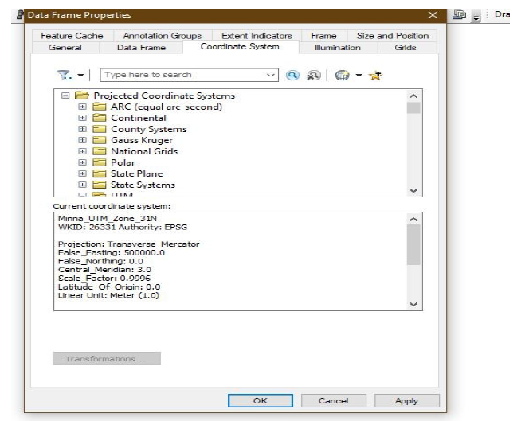
Note: the scale box under the processing Menu will be on.

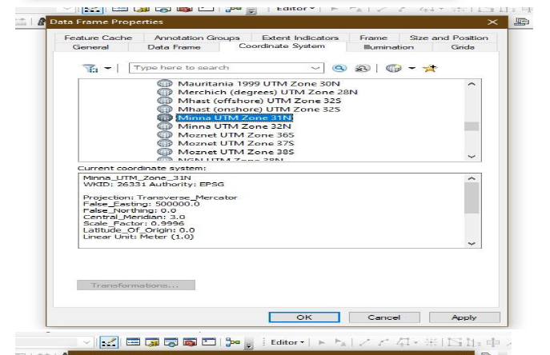
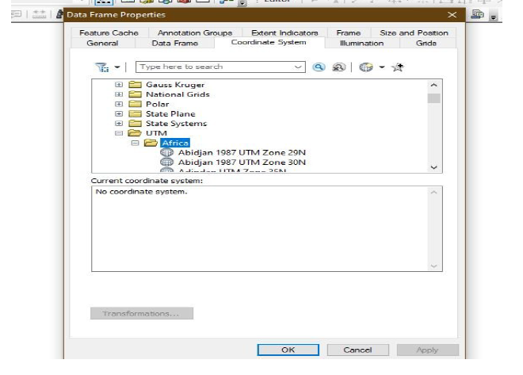

Fig 4.1. setting of units on ArcMap
✓ Adding data: - after setting up the primary units, then the data can be added to the
ArcMap10.3, at this stage there two options of data to be add to the ArcMap10.3 i.e. Vector data or Raster data. The practical comprises of Vector data procedures is as follows.
Adding Vector data.
STEPS
* Select File from the Menu, the go to Add data and the drop down show the following:
* elect Add XY data (then Add XY data Dialog box appear).
* Then click on the Folder icon to navigate to the store files.
* After navigate to the folder where the data was stored, select the required folders saved with name (facility management), and
* Click on add data and it will go back to the add XY data.
* Then select the necessary field to the data e.g. column of easting for X and column of northing for Y and column of Z field for Height.
* Then click ok and the point will display on the window.
* Go to table of content on the left corner of the window and right click on the layer of the point key.
* Then select label feature and the names of the features will be labeled according to how the data was saved during capturing.

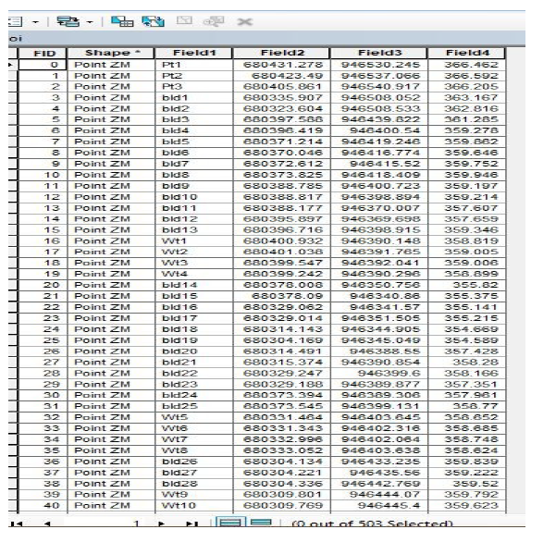

Fig 4.2. Adding of data

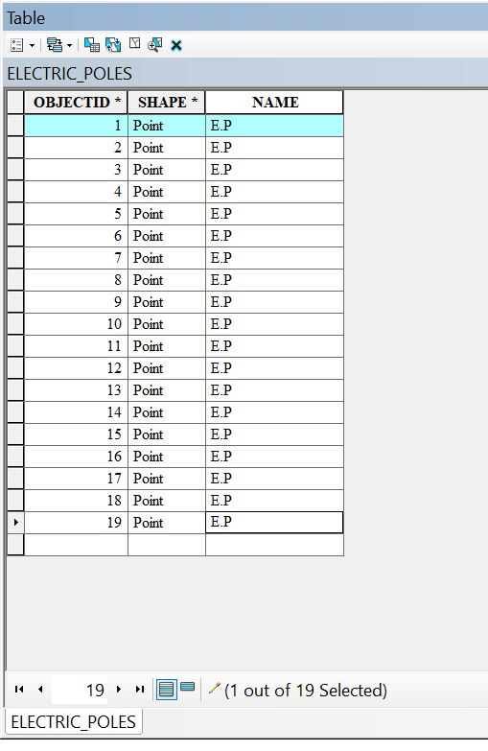
Electric poles

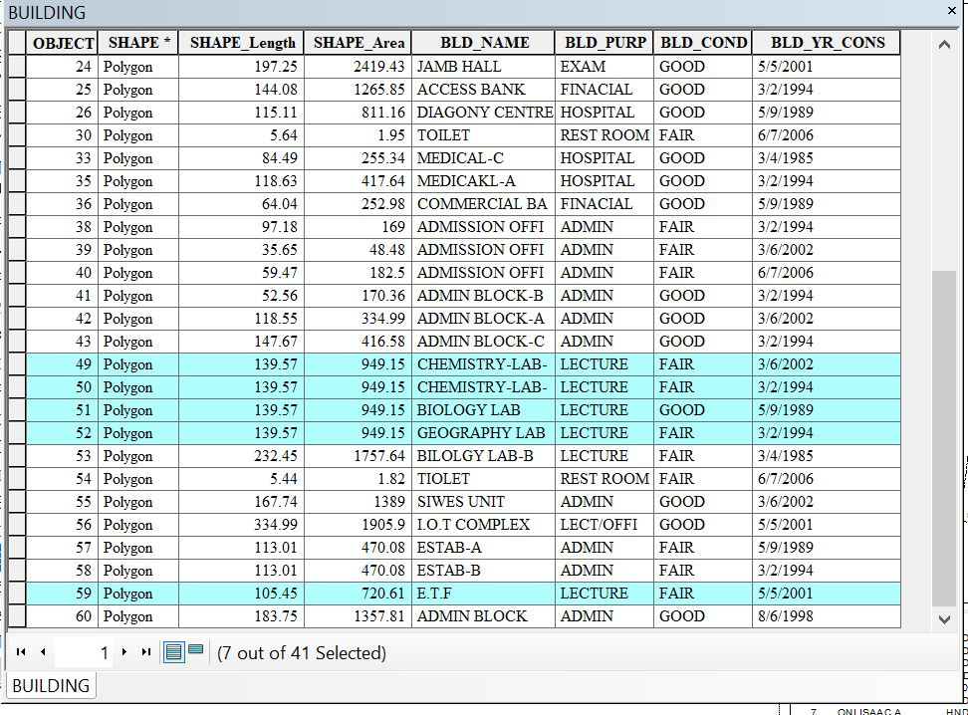
Building

✓ Layer creation or data base creation
STEPS
* Go to catalog on the right corner of the window.
* Navigate to the folder and right click on the folder.
* Then select new and click on file geo-database.
* Then right click on the file geo-database and select new then click on the new feature to create a new dataset.
* Type the name of the dataset and click next to select the unit as done during the primary unit setting, then click next twice and click finish.
* Then the new feature dataset will appear under the file geodatabase.
* Finally, right click on the new feature dataset and select new then select the feature class.
* The new feature class box appears (type in the layer name e.g. Road and copy it into the Alias box.
* Then select the feature type, e.g. line for road, polygon for building and point for electric poles.
* Then click next twice and click finish.
* Then the layer created will appear on the table of content.
* The same processes are repeated to create another layer.

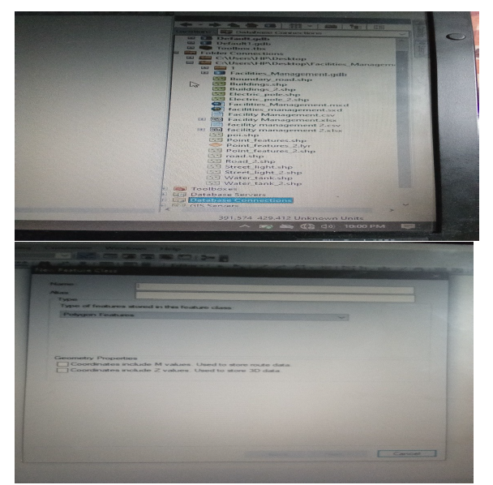

Fig 4.3. New dataset creation
✓ Digitizing: - the digitizing process is involved the tracing out the necessary features, as captured on the field to form the map feature.
STEPS
* Go to Editor, then click on starting editing.
* Then a create feature box appear, then select on the feature to digitize e.g. road, building, e.t.c.
* Then click on the window and trace out the feature outlines and double click when get to the end of the entity.
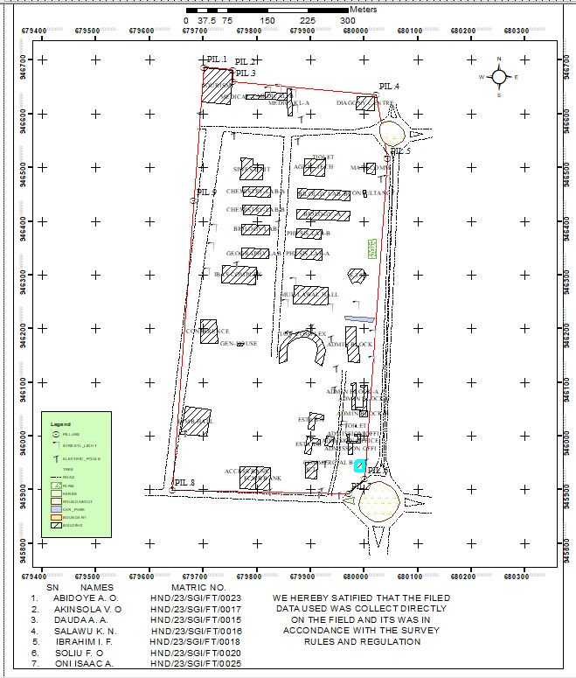
* Repeat the process above for all the features to be digitize and all will be saved in the data base table.

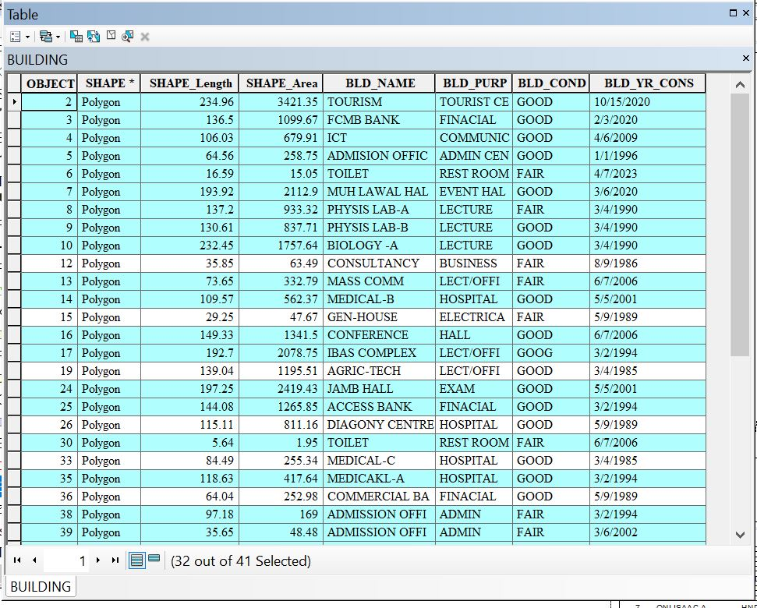
Fig 4.4. Digitizing on ArcMap
✓ Database Creation: - this is the process of populating the database.
STEPS
* Left click on the TOC on the layer to populate the table and then click on the open attribute table.
* The table appears.
* Then go to add field and the add field box appear.
* Set up the necessary information.
* And click ok, then the new field will be added to the table.
4.3. PREPARATION OF 3D MAP USING ARCSCENE
The 3D image was done on ArcScene using the created DEM, the created DEM was added to ArcScene and extruded with the heights gotten on the field. Extrusion incorporates the height of these features in their representation to give them 3D look and were made to float on DEM to have a true land representation. The created DEM was also added to ArcScene, the height of the buildings gotten from the field were added to the already created height field in the attribute table of each of the facility shape file in ArcMap. ArcScene was launched and all the shape files were added, from the table of content each shape file was right clicked on to access the property dialog box, from the property dialog box the shape files were extruded to give them 3D look and were made to float on the DEM to have a full 3D visualization.
* Open the ArcScene software and set necessary parameters.
* Go to arc tool box, click on spatial analytic tools.
* Then click on interpolation and then click IDW (Inverted Distance Way).
* Then it is going to generate 3D dimension value and set Z value point and press ok.
Note: - The IDW can be used to create contour and slope. But we are dealing with slope.
To creates slope, click on surface from interpolation and press slope and input raster(IDW) and press ok. The same procedure for contour also.
To set parameters for necessary facilities needed,
a. Select (IDW).
b. Go to source, click on property and press the base height.
c. Then click floating on a custom surface and press extrusion.
d. Click apply then ok.
4.4. PLAN PRODUCTION
The ultimate aim of the project is to produce a digital map (Facilities management plan) of the part of kwara state polytechnic. After processing the acquired data using the appropriate software, a digital map of the project area was produced. Thus, the aim of the project was achieved.

4.4.1. DIGITAL MAP
A digital map is the representation of cartographic features in a form that allows the value of their attributes to be stored, manipulated, and out-put by a computer system. A digital map is a data base or file that becomes a map when a GIS produces a hardcopy or screen display output.
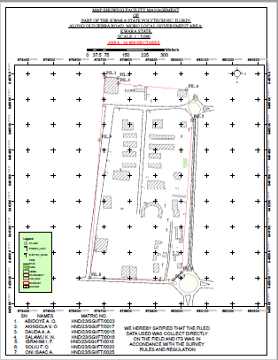
Finally, a hardcopy of the digital map of the project area was printed.

Fig 4.7. Facility Management map
4.5. RESULT ANALYSIS
The facility management project commenced with the usage of a South (NTS-350R) to capture the data of the project area. The captured data were then processed using software (ArcMap 10.3, ArcScene), employing photogrammetry technique to generate a high precision DSM and create a detailed 3D model.
ARCGIS software was employed to visualize and analyze the DSM data, facilitating spatial analysis and information Presentation.
The following maps were produced and their usefulness was stated,
4.6. QUERIES ANALYSIS
Queries analysis in GIS involves extracting information from spatial datasets by posing specific questions and then analyzing the data to gain insights or make decisions.
A query involves selecting features based on attributes or spatial relationship, while analysis may include tasks like spatial overlay, proximity analysis, spatial statistics or modeling.
4.6.1. SINGLE CRITERIA QUERY
A single criterion is carried out where one condition is used to design query. The condition is used to gather information from the database.

QUERY ANALYSIS (selection by attribute)
Query question: “To query for the building that construction year is less than or equal to 1990.”
Analysis Name: Database extraction
Analysis Type: Single criteria analysis
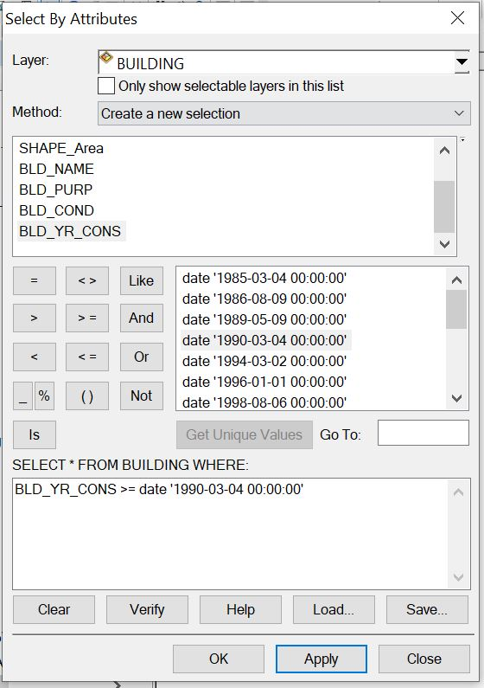
Syntax: “BLD_YR_CONS>=1990.

Fig. 4.12. single criteria query
Answer to query 1.
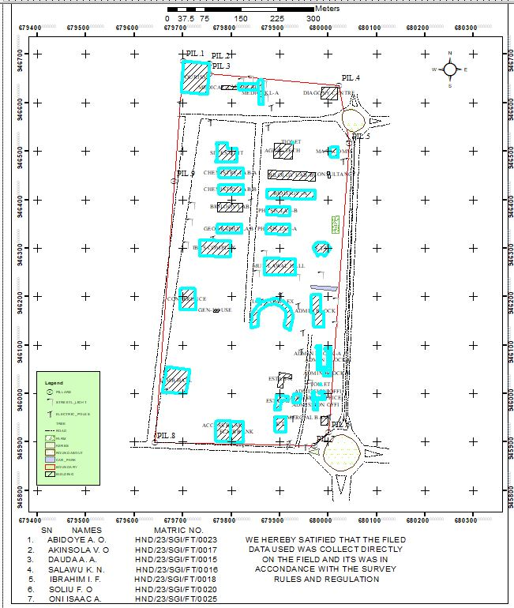

Query question: “To query for the building that has an area less than 470.08 meters square and their purpose is used for financial
Analysis Name: Database extraction
Analysis Type: Double criterion analysis
Syntax: “SHAPE_AREA<470.08AND BLD_PURP”.
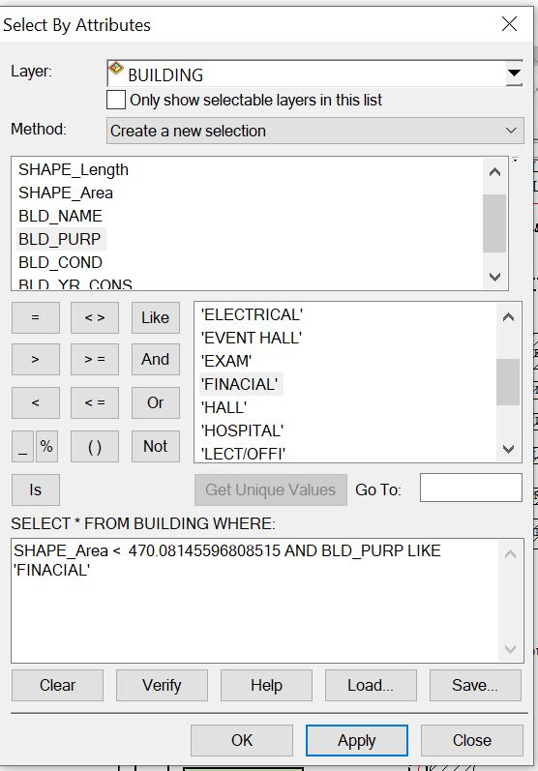
Answer to the query II.

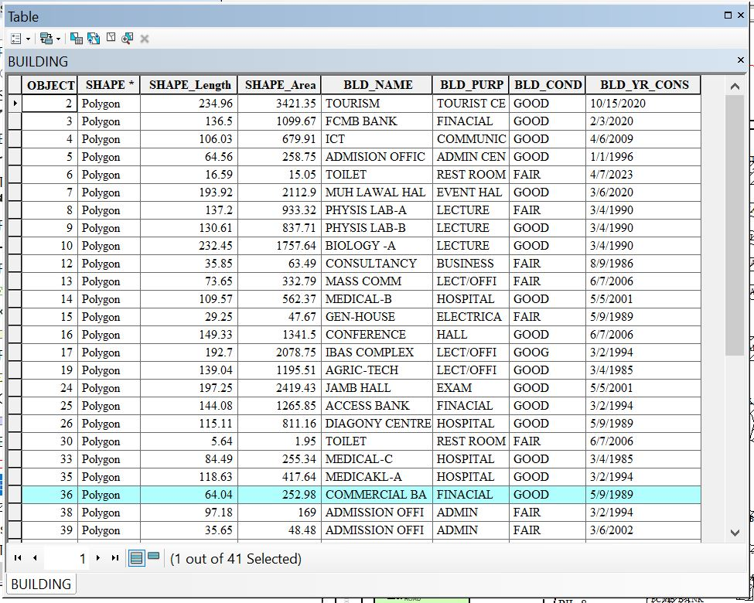
- Query question 3: “To query for the building purpose and that the area less than or equal to 192.69 meters square
- Analysis Name: Database extraction
- Analysis Type: Double criterion analysis
- Syntax: “BLD_PURP LIKE LECTURE AND SHAPE_LENGHT <= 192.69”.
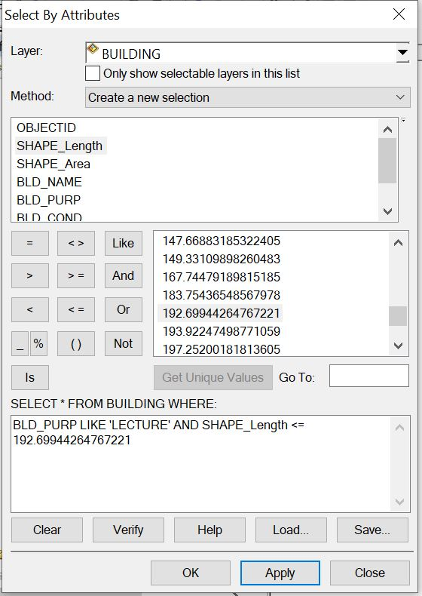

Answer to the query 3.
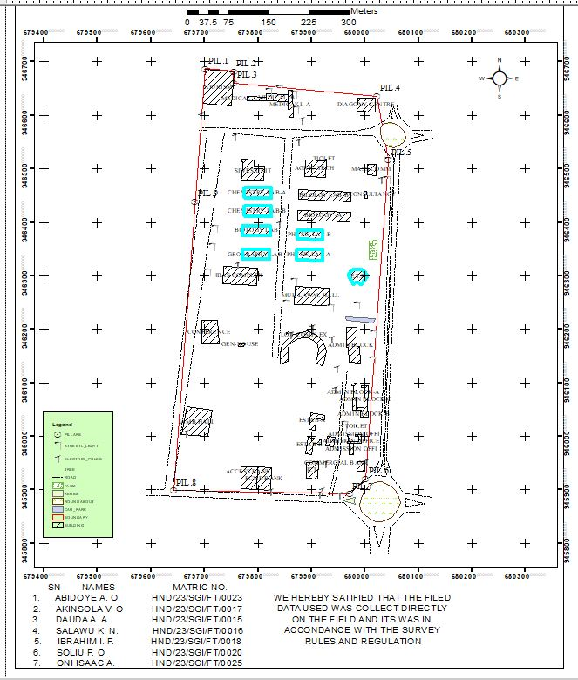

4.8. APPLICATION OF RESULTS
The result obtained can be applied to the following;
* Ensuring efficient use of resources.
* Maximizing occupant comfort and safety.
* Managing maintenance schedules.
* Optimizing space utilization.
* It's essentially a roadmap for maintaining and enhancing the functionality of a building or facility.

CHAPTER FIVE
5.0. SUMMARY, CONCLUSION, PROBLEM ENCOUTER AND RECOMMENDATION
5.1. COSTING
Table 5.1. PLANNING
S/N | PERSONNEL | UNIT | PRICE | DAYS | REMARK
1. | Principal Surveyor | 1 | #30,000 | 2 | #60,000
2. | Assistant Surveyor | 1 | #12,000 | 2 | #24,000
3. | Transport | 1 | #3,000 | 2 | #6,000
4. | Basic Equipment | 1 | #15,000 | 2 | #30,000
5. | Logistics | 1 | #10,000 | 2 | #20,000
 | Total | 1 |  |  | #140,000

Table 5.2. DATA CAPTURE
S/N | PERSONNEL | UNIT | PRICE | DAYS | REMARK
1. | Principal Surveyor | 1 | #30,000 | 5 | #150,000
2. | Assistant Surveyor | 1 | #12,000 | 5 | #60,000
3. | Chainman | 7 | #3,000 | 5 | #105,000
4. | Transport | 1 | #3,000 | 5 | #15,000
5. | Basic Equipment | 1 | #15,000 | 5 | #75,000
6. | Logistics | 1 | #10,000 | 5 | #50,000
 | Total |  |  |  | #455,000

Table 5.3. DATA DOWNLOAD
S/N | PERSONAL | UNIT | PRICE | DAYS | REMARK
1. | Principal Surveyor | 1 | #30,000 | 1 | #30,000
2. | Transport | 1 | #3,000 | 1 | #3,000
3. | Basic Equipment | 1 | #15,000 | 1 | #15,000
4. | Logistics | 1 | #10,000 | 1 | #10,000
 | Total |  |  |  | #58,000
Table 5.4. DATA PROCESSING
S/N | PERSONNEL | UNIT | PRICE | DAYS | REMARK
1. | Principal Surveyor | 1 | #30,000 | 8 | #240,000
2. | Assistant Surveyor | 1 | #12,000 | 8 | #96,000
3. | Transport | 1 | #3,000 | 8 | #24,000
4. | Basic Equipment | 1 | #15,000 | 8 | #120,000
5. | Logistics | 1 | #10,000 | 8 | #80,000
 | Total |  |  |  | #560,000
Table 5.5. DATA PRESENTATION
S/N | PERSONNEL | UNIT | PRICE | DAYS | REMARK
1. | Principal Surveyor | 1 | #30,000 | 1 | #30,000
2. | Assistant Surveyor | 1 | #12,000 | 1 | #12,000
3. | Transport | 1 | #3,000 | 1 | #3,000
4. | Basic Equipment | 1 | #15,000 | 1 | #15,000
5. | Logistics | 1 | #10,000 | 1 | #10,000
 | Total |  |  |  | #70,000

Table 5.6. REPORT WRITING
S/N | PERSONNEL | UNIT | PRICE | DAYS | REMARK
1. | Principal Surveyor | 1 | #30,000 | 10 | #300,000
2. | Transport | 1 | #3,000 | 10 | #30,000
3. | Basic Equipment | 1 | #15,000 | 10 | #150,000
4. | Logistics | 1 | #10,000 | 10 | #100,000
 | Total |  |  |  | #580,000
Table 5.7. SUMMARY
1. | Planning | #140,000
2. | Data Capture | #455,000
3. | Data Download | #58,000
4. | Data Processing | #560,000
5. | Data Presentation | #70,000
6. | Report Writing | #580,000
 | Total | #1,863,000
* Mobilization and demobilization 10%
1,863,000 * 10 ÷ 100 = #186,300
* V.A.T. 2.5%
1,863,000 * 2.5 ÷ 100 = #46,575
Total Cost
#1,863,000 + #186,300 + #46,575
= #2,095,875.
5.2. SUMMARY
The aim of this project is to carry out the facility management of part of Kwara State Polytechnic, Moro Local Government Area, Ilorin, Kwara state. The reconnaissance surveying was properly carried out, both the office reconnaissance and the field reconnaissance and this allowed for proper planning of the operation.
The fieldwork involved picking of points of all available facilities (buildings, water tank, street light, electric poles) of the project area with the use of South (NTS-350R) All necessary processing was done using the appropriate software and according to survey rules and regulations. The supervisor`s instructions and departmental instructions were equally strictly adhered to. All data computed were within the expected accuracy.
Finally, the facility map and the 3D map of the project area were produced on stable materials in both analogue and digital format. A comprehensive report was then written.
5.3. CONCLUSION
The aim of the project was achieved which is the production of a Facility map of the project area within the expected accuracy. Also, the project exercise exposed me and increased my knowledge on the scope and concept of facilities planning. More so, this project has been successfully executed as adequate data were acquired, processed and presented in maps.
This project result could be used by the school authority to plan and implement future developments. It could also be used by the students of the department of surveying and geo-informatics for practical and other survey operations.
This system will provide students, academic and administrative staff and other exterior users the necessary information about the location of the campus facilities. The spatial and non-spatial information about campus is stored in ArcGIS geodatabase, this can be updated and used for administrative purposes. Due to the continuous growth of the polytechnic there is a need for continuous and regular update of the polytechnic facility map and its geodatabase to keep up with the infrastructural needs of the polytechnic.
The integration of GIS in facility management offers numerous benefits, from enhanced spatial analysis and asset management to improved space utilization and sustainability. Despite challenges related to data integration, technical constraints, and user expertise, the future of GIS in facility management looks promising, with advancements in BIM, real-time data, and smart facility technologies paving the way for more efficient and sustainable practices.
Finally, the importance of the data obtained from this project cannot be overemphasized, because firstly, in order to tap the resources within the area, we must have an accurate knowledge of the area. This will help to make useful decisions. The study further emphasizes the importance of GIS in spatial analysis and planning.
5.4. PROBLEMS ENCOUNTERED
The following were the problems encountered during the execution of the project;
1. Inability to connect to the internet network.
2. There is also the problem of the instrument not connecting under the building and leads to spending excessive time in the acquisition of the data from the field.

5.5. RECOMMENDATION
Having successfully carried out this project assignment, I hereby recommend that the school should set a department for consultancy services such that useful project like facility mapping and other projects can be carried out by the students. Which could be used by the school authority for the planning and development of the school.
The GIS is served in this study as an “intelligent” database. GIS is used to provide a compact space where all sorts of data relevant to the study area can be stored in digital format, including images, maps, documents, and photographs. Data have already been arranged so that it can be incorporated into displays like maps, charts, and tables, and queried in the service of sophisticated analytical procedures.
Future analyses will be the basis for future planning, design, and site management decisions. The list of queries is endless, and unique to every potential user. A successful plan and implementation will provide an opportunity to local decision-makers to provide a synoptic and detailed planning of the study area.
REFERENCES
1. Alexander Knight and George Murray (1994). A strategy for facilities management. Journal facilities, 12(11), 6-10.
2. Alkaabi, K., & Saeed, R. (2014). The role of GIS in facilities management. Journal of Geographic Information System, 6(2), 111-118.
3. Arazi, I., D. K. H., & Pan, W. (2009). Performance evaluation for hospital facility management. Journal of Facility Management Education and Research, 37(110, 1091-1097.
4. Aziz, Z., Nawawi, A. H., & Ariff, N. R. M. (2016). Smart buildings: Toward sustainable facility management. Journal of Procedia - Social and Behavioral Sciences, 234, 519-528.
5. Brian, Atkin., &Adrian, Brooks. (2009). Total Facility Management. Wiley-Blackwell.
6. British Institute of Facilities Management (BIFM). (2014). Facilities management: Definition and scope. BIFM.
7. Durodola D. Oluwole (2009). Management of Hotel Properties in South-Western Nigeria: Facilities Management Perspective.
8. David, G. Cotts. (1999). The Facility Management Handbook. AMACOM.
9. Elmualim, A., Shockley, D., Valle, R., Ludlow, G., & Shah, S. (2010). Barriers and commitment of facilities management profession to the sustainability agenda. Building and Environment.
10. Guan, X., Zhang, S., & Jiang, C. (2015). Environmental monitoring in facilities management using Journal of Environmental Monitoring and Assessment, 187(10), 676.GIS.
11. Huang, Q., Lu, X., & Wu, J. (2010). GIS-based energy consumption analysis for facilities management. Journal of Cleaner Production, 18(15), 1543-1551.
12. International Facility Management Association (IFMA). (2009). What is Facility Management? IFMA.
13. Kassem, M., Kelly, G., Dawood, N., Serginson, M., & Lockley, S. (2015). BIM in facilities management applications: A case study of a large university complex. Built Environment Project and Asset Management.
14. Khorram, S., van der Meer, F. D., & Murphy, R. E. (2008). Remote Sensing and GIS in Facility Management. Springer.
15. Klein, L., Kwak, J., & Kavulya, G. (2017). Integration of GIS and IoT for facility management: A real-time approach. Journal of Automation in Construction, 81, 77-90.
16. Pfeffer, K., Baud, I., & Denis, E. (2013). Geographic information technologies and urban management in India. Journal of Future Cities and Environment, 2(1), 45-58.
17. Rondeau, E. P., Brown, R. K., & Lapides, P. D. (2012). Facility Management. John Wiley & Sons.
18. Roper, K. O., & Payant, R. P. (2014). The Facility Management Handbook. AMACOM.
19. Sebastian, R., & van Berlo, L. (2010). BIM and GIS for facility management: A case study. Journal of Facilities, 28(3/4), 145-159.
20. Tsou, K. W., Hung, J. C., & Chang, Y. L. (2005). A GIS-based decision support system for facility management.Journal of Automation in Construction, 14(3), 307-317.
21. Yiu, C. Y. (2008). A GIS-based maintenance management system for campus facilities. Journal of Facilities, 26(1/2), 29-46.
22. Zlatanova, S., Li, J., & Fabbri, A. G. (2013). Geoinformation for disaster management: Lessons from facility management. Journal of Contingencies and Crisis Management, 21(2), 66-77.
Akadiri, P. O., Chinyio, E. A., & Olomolaiye, P. O. (2014). Design of A Sustainable Building: A GIS-Based Approach. Journal of Building Engineering, 1, 44-56.
-22. Zhu, X., Renaud, E. J., & Carr, P. (2014). Facility management using GIS technology. Journal of Facilities Management, 12(4), 389-403.

APPENDIX 1
bnd1,680001.553,945920.709,305.03
2bld,679998.724,945935.038,305.427
3bld,679999.37,945952.393,305.747
4bld,679985.139,945953.611,305.899
5Ep,680002.449,945953.267,305.904
6bld,679969.713,945966.376,306.162
7bld,679978.467,945966.005,306.203
8str,679962.742,945980.018,306.873
9str,679963.074,945982.566,306.968
10str,679964.353,945982.451,306.955
11bld,679966.006,945987.485,307.213
12tree,679967.245,945904.712,304.414
13bnd2,679970.974,945892.196,303.848
14Ep,679951.406,945891.426,303.848
15tree,679946.62,945896.648,304.023
16DR,679940.237,945887.579,302.966
17DR,679939.218,945887.348,302.645
18Rd,679931.045,945888.016,303.114
19DR,679929.541,945887.406,302.639
20DR,679928.99,945887.693,302.628
21Ep,679919.632,945898.553,304.019
22Ep,679914.223,945892.929,303.664
23bank,679911.575,945920.464,304.7
24bank,679889.953,945921.531,304.753
25Ep,679915.076,945919.52,304.599
26tree,679931.218,945947.97,305.577
27Ep,679926.29,945949.63,305.493
28gtb,679915.953,945952.093,305.385
29bld,679900.379,945966.825,306.214
30bld,679888.661,945968.32,306.514
31bld,679917.742,945986.294,306.808
32bld,679918.61,945994.023,307.217
33bld,679892.925,945998.188,309.093
34tree,679927.623,946001.143,307.61
35mosq,679928.788,946000.146,307.496
36mosq,679926.197,945982.778,306.943
37mosq,679943.303,945998.462,307.366
38tree,679939.646,946005.798,307.642
39tree,679938.425,945999.848,307.45
40sl,679957.398,945996.07,307.502
41sl,679959.991,946015.805,308.185
42sl,679961.136,946023.735,308.413
43bld,679971.797,946037.722,308.565
44bld,679982.727,946039.467,308.674
45bld,679983.532,946015.505,308.485
46str,679984.655,946017.96,308.269
47str,679984.73,946019.205,308.241
48str,679983.214,946019.476,308.336
49spt,679988.212,946022.841,308.542
50spt,679992.515,946017.403,308.476
51spt,679987.166,946010.653,308.193
52spt,679987.891,946003.31,308.362
53spt,679983.968,946027.112,308.665
54spt,679987.104,946035.048,308.644
55bld,679990.722,946036.027,308.705
56bld,679992.34,946002.873,308.571
57bld,680006.482,946035.908,308.558
58bld,680002.833,946047.922,309.255
59bld,679976.883,946049.044,309.107
60sl,679968.892,946079.409,310.226
61sl,679968.826,946072.011,310.099
62spt,679970.913,946074.442,310.147
63spt,679973.054,946069.097,309.974
64spt,679968.906,946062.177,309.556
65spt,679975.594,946058.773,309.775
66spt,679965.543,946052.38,309.434
67spt,679971.841,946048.431,309.181
68spt,679972.043,946086.812,310.615
69spt,679967.188,946090.828,310.681
70spt,679964.664,946098.415,311.171
71spt,679957.51,946097.69,311.003
72bld,679974.621,946099.158,311.079
73tree,679999.806,946104.888,311.397
74tree,680010.315,946112.512,311.854
75tree,680011.129,946117.7,311.931
76tree,680011.712,946123.067,312.152
77spt,680010.009,946129.671,312.375
78spt,680002.863,946125.025,312.208
79spt,679999.388,946115.06,311.689
80spt,679996.786,946110.187,311.491
81spt,679992.748,946104.278,311.317
82spt,679988.481,946109.369,311.415
83spt,679986.602,946116.996,311.622
84spt,679986.322,946125.052,311.734
85spt,679980.628,946130.727,312.337
86sl,679982.536,946130.339,312.35
87tree,679974.682,946131.68,312.215
88spt,679972.411,946114.815,311.439
89tree,679953.554,946110.003,311.382
90tree,679953.104,946105.441,311.056
91tree,679950.595,946093.033,310.555
92Ep,679943.533,946087.757,310.126
93spt,679943.575,946076.168,309.424
94spt,679934.174,946078.961,309.626
95spt,679920.822,946073.274,309.835
96spt,679915.118,946068.241,310.027
97spt,679908.301,946060.959,310.158
98spt,679909.131,946051.957,309.678
99bld,679899.243,946043.445,309.387
100str,679896.051,946043.006,309.31
101str,679895.49,946040.816,309.26
102str,679893.879,946041.01,309.22
103bld,679894.41,946014.383,308.269
104spt,679890.712,946019.163,308.4
105spt,679895.133,946023.257,308.791
106spt,679896.372,946031.022,308.777
107spt,679888.733,946036.616,309.284
108spt,679892.145,946049.028,309.57
109spt,679898.83,946064.598,310.391
110spt,679896.11,946075.478,310.822
111spt,679899.352,946085.679,311.27
112spt,679900.45,946095.169,311.583
113spt,679889.678,946100.794,311.319
114spt,679879.884,946100.892,311.081
115spt,679875.602,946110.656,311.435
116spt,679860.786,946122.723,311.712
117str,679855.831,946126.252,311.908
118str,679853.412,946125.261,311.866
119str,679851.166,946129.422,312.287
120iotbld,679850.27,946130.672,312.546
121spt,679841.314,946135.195,312.355
122spt,679835.787,946144.524,312.647
123spt,679841.647,946151.983,313.49
124spt,679837.819,946164.575,313.736
125iotbld,679850.445,946177.42,313.803
126iotbld,679862.438,946189.159,314.463
127Ep,679861.389,946190.354,314.38
128genhouse,679858.56,946193.401,314.353
129genhouse,679853.433,946191.354,314.288
130genhouse,679852.175,946193.779,314.345
131spt,679847.82,946190.812,314.204
132tree,679841.606,946187.357,314.446
133spt,679844.792,946183.229,314.106
134spt,679850.527,946189.321,314.319
135spt,679851.064,946199.602,314.568
136spt,679855.333,946207.683,315.227
137tree,679853.54,946210.88,315.612
138spt,679879.319,946199.405,314.666
139spt,679891.519,946197.994,314.864
140Ep,679901.842,946203.883,314.81
141spt,679906.197,946211.283,315.013
142spt,679918.358,946215.481,315.733
143spt,679914.716,946201.78,314.945
144bld,679909.053,946189.322,314.736
145spt,679915.093,946183.095,314.709
146bld,679920.914,946177.103,314.765
147spt,679931.914,946179.877,315.059
148Ep,679936.655,946183.366,315.413
149spt,679939.43,946174.292,314.662
150iotbld,679928.413,946159.401,314.111
151iotbld,679921.013,946130.8,312.808
152spt,679938.628,946129.621,311.581
153Ep,679947.624,946126.676,311.676
154recbld,679969.467,946138.179,312.658
155recbld,679988.307,946136.553,313.33
156spt,680003.893,946140.158,312.992
157sl,680013.476,946142.779,313.247
158spt,680025.065,946145.5,313.202
159tree,680019.078,946151.97,313.464
160tree,680019.278,946156.925,313.322
161tree,680013.13,946162.19,313.762
162spt,680010.315,946170.357,314.334
163spt,680005.425,946192.509,314.898
164sl,680015.327,946192.955,315.007
165spt,680008.594,946202.369,315.172
166spt,679994.076,946204.672,315.339
167recbld,679984.189,946204.478,315.442
168spt,679978.443,946208.804,315.661
169park,679963.226,946223.944,316.333
170park,679964.43,946217.62,316.111
171recbld,679965.631,946205.542,315.672
172recbld,679964.989,946203.903,315.587
173str,679987.609,946220.723,316.05
174str,679987.4,946219.44,315.978
175str,679986.085,946220.984,316.003
176park,680015.108,946212.547,315.512
177tree,680018.861,946219.613,315.808
178spt,680014.758,946225.428,315.898
179tree,680006.385,946231.69,316.557
180spt,679999.351,946228.385,316.251
181spt,679987.348,946239.564,316.827
182sl,679984.519,946245.583,317.412
183spt,679971.822,946245.145,317.291
184spt,679960.457,946244.878,317.405
185spt,679948.429,946244.273,317.266
186sl,679935.524,946242.081,317.515
187HALL,679932.222,946244.134,317.601
188flw,679922.809,946241.583,317.165
189flw,679934.083,946241.146,317.366
190flw,679928.585,946241.375,317.343
191flw,679875.609,946243.447,316.237
192flw,679872.196,946243.686,316.26
193HALL,679868,946246.945,316.38
194spt,679863.1,946248.494,316.311
195spt,679862.028,946258.078,316.687
196sl,679852.432,946249.983,316.747
197spt,679850.85,946256.565,317.056
198spt,679846.943,946278.828,318.518
199spt,679854.526,946289.235,318.359
200sl,679867.033,946289.549,317.91
201HALL,679868.738,946279.925,317.789
202spt,679875.736,946286.279,317.778
203flw,679876.301,946290.444,317.899
204flw,679885.508,946289.456,317.913
205flw,679895.579,946289.105,317.971
206spt,679897.502,946286.067,317.98
207flw,679905.651,946288.569,318.113
208flw,679915.684,946288.166,318.223
209spt,679924.355,946288.183,318.401
210spt,679930.064,946294.245,318.596
211spt,679925.662,946304.69,318.877
212spt,679923.011,946317.638,319.168
213sl,679921.98,946322.967,319.781
214phylabB,679921.417,946328.408,319.794
215spt,679907.945,946324.134,319.139
216spt,679894.785,946323.517,319.075
217spt,679891.188,946313.417,318.748
218spt,679880.275,946316.353,318.837
219phylabB,679871.385,946330.846,319.702
220sl,679865.6,946330.835,320.257
221spt,679854.205,946333.648,320.415
222spt,679851.82,946346.503,320.943
223spt,679863.95,946357.107,320.773
224spt,679861.734,946371.907,321.531
225spt,679854.29,946388.65,322.545
226spt,679871.439,946348.487,320.843
227labB,679871.543,946348.617,320.786
228labB,679868.321,946362.215,320.778
229labA,679869.717,946368.262,321.46
230labA,679872.292,946369.447,321.375
231labA,679873.225,946386.362,321.477
232spt,679877.107,946391.721,321.835
233Ep,679877.207,946395.018,322.157
234spt,679888.942,946395.505,322.218
235sl,679897.92,946395.377,322.146
236spt,679908.405,946393.793,322.034
237Ep,679916.355,946392.766,322.051
238labA,679920.821,946385.067,321.317
239spt,679930.212,946384.164,321.562
240spt,679931.977,946378.503,321.441
241spt,679940.614,946374.718,321.435
242spt,679930.728,946359.746,320.828
243spt,679940.326,946348.681,320.555
244spt,679949.13,946340.51,320.505
245spt,679933.365,946327.57,319.537
246sl,679922.323,946323.282,319.617
247spt,679946.381,946312.41,319.53
248spt,679961.735,946307.531,319.868
249bld,679967.872,946302.28,320.124
250bld,679977.75,946283.855,319.443
251bld,679993.018,946283.593,319.27
252bld,680004.329,946300.539,320.369
253bld,679998.345,946309.339,321.432
254tree,680010.161,946301.343,320.357
255tree,680011.17,946307.794,320.944
256tree,680009.009,946293.252,319.737
257spt,680015.59,946297.693,319.74
258spt,680015.574,946289.681,319.16
259Ep,680022.041,946285.189,319.244
260spt,680022.367,946297.7,320.001
261spt,680020.231,946314.929,322.069
262farm,680021.584,946330.48,322.24
263farm,680022.711,946366.014,322.821
264spt,680027,946360.883,322.324
265spt,680031.595,946350.845,321.481
266spt,680024.335,946344.812,321.828
267spt,680031.067,946331.416,320.716
268spt,680028.347,946323.488,319.878
269spt,679977.281,946388.974,323.011
270labC,679972.044,946401.172,323.314
271labC,679973.272,946419.088,323.233
272labD,679973.871,946433.423,324.022
273labD,679974.748,946456.641,324.966
274spt,679980.711,946456.634,325.093
275spt,679988.131,946449.638,325.106
276spt,679996.524,946452.748,325.135
277spt,679997.235,946440.418,324.772
278spt,679989.428,946434.214,324.237
279tree,679980.064,946429.48,324.194
280masscom,679998.842,946444.882,325.33
281masscom,679998.304,946457.975,325.499
282masscom,680003.72,946445.049,325.531
283spt,680013.136,946456.603,326.05
284spt,680018.707,946450.098,325.732
285tree,680023.094,946448.891,325.958
286spt,680022.83,946462.642,326.321
287masscom,680019.616,946463.454,326.582
288spt,680026.965,946465.006,326.318
289spt,680035.748,946460.119,326.238
290tree,680040.409,946451.978,325.533
291spt,680040.567,946462.387,325.748
292spt,680035.476,946469.089,326.414
293sl,680042.413,946480.408,326.592
294Ep,680029.941,946480.736,326.896
295,680019.483,946471.675,326.482
296,679999.146,946471.334,325.945
297spt,679998.007,946481.651,326.093
298mask,679997.217,946490.219,326.913
299masscom,680003.856,946488.335,326.839
300spt,680012.837,946484.376,326.657
301masscom,680019.78,946487.755,326.977
302spt,680027.827,946490.813,327.234
303spt,680038.345,946495.925,327.444
304spt,680032.6,946507.278,327.747
305masscom,680020.028,946508.713,327.869
306spt,680034.704,946514.238,328.098
307sl,680043.577,946516.198,328.225
308spt,680040.037,946527.784,328.685
309Rd,680040.641,946530.175,328.466
310Rd,680049.621,946529.962,328.464
311Rd,680056.905,946529.803,328.469
312Rd,680066.174,946529.973,328.493
313Rd,680053.986,946539.521,328.665
314Rd,680076.521,946559.448,329.637
315Rd,680085.77,946561.146,329.847
316Rd,680085.395,946555.48,329.582
317Rd,680086.484,946549.999,329.342
318Rd,680085.656,946567.188,330.158
319Rd,680086.534,946572.799,330.393
320Rd,680054.639,946584.625,330.726
321Rd,680054.653,946593.432,331.035
322Rd,680061.27,946593.253,331.125
323Rd,680066.437,946595.111,331.226
324Rd,680050.053,946594.909,331.106
325Rd,680045.444,946596.765,331.157
326spt,680039.314,946597.149,331.337
327spt,680029.489,946601.468,331.371
328spt,680029.315,946607.711,331.316
329spt,680020.265,946607.672,331.059
330diag,680018.165,946606.693,331.033
331diag,680019.206,946631.691,331.924
332bnd,680022.153,946636.213,332.084
333diag,679986.934,946632.21,331.734
334str,679985.026,946628.196,331.654
335str,679984.992,946626.379,331.629
336str,679982.885,946628.303,331.694
337diag,679984.852,946607.814,330.549
338spt,679982.58,946605.019,330.415
339spt,679973.666,946603.998,330.397
340tree,679974.176,946601.549,330.353
341tree,679973.397,946589.542,330.078
342spt,679972.963,946584.72,329.732
343spt,679963.879,946586.222,329.788
344spt,679956.87,946595.672,330.023
345spt,679946.013,946601.875,330.038
346spt,679930.75,946619.622,330.885
347tree,679928.45,946620.919,331.284
348spt,679914.1,946611.046,329.64
349spt,679898.087,946597.825,329.061
350spt,679882.187,946591.781,329.079
351Ep,679875.747,946590.333,329.26
352tree,679868.701,946594.905,329.836
353med,679865.249,946596.022,329.607
354spt,679866.317,946613.264,330.764
355sl,679870.104,946611.749,330.448
356tree,679869.002,946620.45,330.338
357sl,679867.365,946640.719,331.482
358med,679863.455,946647.28,331.563
359sl,679838.988,946649.763,331.865
360sl,679820.621,946645.326,331.859
361med,679814.12,946640.925,331.792
362str,679807.614,946638.115,331.85
363med,679814.689,946627.061,331.338
364spt,679817.665,946616.079,330.645
365tree,679828.122,946614.044,330.841
366spt,679838.385,946613.781,330.356
367spt,679844.583,946621.483,330.737
368med,679855.856,946625.727,330.825
369med,679787.222,946631.296,331.769
370med,679779.997,946635.003,332.057
371spt,679780.163,946627.553,331.861
372spt,679770.268,946631.912,331.989
373spt,679762.184,946637.866,332.338
374bnd,679755.017,946660.031,333.075
375tourism,679754.057,946681.55,333.794
376bnd,679753.911,946682.645,333.981
377tourism,679750.219,946617.823,331.961
378spt,679748.369,946609.748,331.671
379spt,679726.428,946604.74,331.752
380spt,679711.234,946605.009,332.005
381tourism,679695.999,946619.976,332.841
382tourism,679701.524,946687.047,335.035
383bnd,679700.667,946687.499,335.004
384Ep,679692.385,946600.43,332.309
385bnd,679692.343,946579.706,331.427
386DR,679692.364,946578.639,331.36
387Rd,679703.943,946571.196,331.086
388Rd,679740.373,946576.544,330.725
389Rd,679738.515,946566.698,330.366
390DR,679737.454,946566.239,330.273
391Rd,679753.241,946565.427,330.238
392DR,679753.961,946565.058,330.165
393bnd,679759.686,946576.959,330.508
394DR,679759.724,946577.133,330.501
395DR,679759.861,946575.944,330.488
396Ep,679757.002,946560.945,330.053
397spt,679762.26,946554.368,329.652
398spt,679773.919,946545.447,329.265
399spt,679783.794,946545.283,329.106
400tree,679797.339,946532.097,328.547
401tree,679805.074,946530.922,328.508
402spt,679817.284,946535.3,328.231
403spt,679833.269,946524.568,327.689
404spt,679851.315,946542.722,327.869
405Rd,679850.677,946557.627,328.313
406Rd,679864.795,946556.813,328.179
407DR,679865.273,946555.801,328.113
408Ep,679875.386,946550.603,327.754
409spt,679888.512,946543.863,327.896
410spt,679891.642,946533.864,327.368
411spt,679888.834,946517.123,326.999
412masscom,679889.05,946517.058,326.937
413spt,679899.912,946522.355,327.064
414spt,679915.491,946519.935,326.838
415spt,679926.835,946515.582,326.717
416str,679926.944,946517.327,326.867
417str,679927.02,946518.465,326.937
418str,679925.635,946518.897,326.872
419masscom,679925.66,946484.247,325.628
420Ep,679922.207,946477.535,325.07
421spt,679912.947,946469.803,324.723
422spt,679898.424,946477.188,325.108
423phyD,679876.904,946460.337,324.493
424phyD,679875.601,946442.7,324.511
425phyD,679874.442,946422.755,323.12
426phyC,679874.342,946422.841,323.074
427phyC,679874.329,946404.951,323.035
428siwes,679811.118,946489.542,327.46
429siwes,679811.301,946504.852,327.813
430siwes,679794.779,946508.074,327.399
431siwes,679792.125,946517.124,328.323
432siwes,679778.86,946518.031,328.422
433spt,679757.972,946500.52,327.88
434spt,679747.861,946485.376,327.359
435spt,679765.4,946468.931,326.499
436lab,679773.686,946464.84,326.309
437spt,679786.077,946474.385,326.467
438spt,679800.348,946477.709,326.478
439spt,679808.88,946465.732,325.953
440lab,679825.205,946464.11,325.626
441spt,679832.263,946454.383,325.097
442tree,679841.479,946443.802,324.979
443spt,679836.611,946433.405,324.791
444spt,679840.71,946421.725,324.204
445sl,679843.568,946419.033,324.092
446str,679837.827,946407.144,323.659
447Ep,679839.873,946397.401,323.141
448spt,679833.502,946389.207,322.777
449spt,679839.897,946379.734,322.265
450spt,679828.421,946364.884,321.999
451spt,679836.122,946345.598,321.188
452lab,679821.687,946330.154,320.689
453spt,679819.882,946320.826,320.08
454spt,679812.306,946311.131,319.839
455ibasbld,679798.422,946314.969,320.305
456spt,679807.785,946295.85,319.677
457spt,679804.041,946284.353,319.198
458ibas,679796.616,946282.4,319.371
459spt,679780.583,946276.183,318.238
460spt,679772.829,946267.091,317.887
461spt,679755.961,946265.67,318.231
462spt,679749.541,946274.529,318.485
463spt,679734.099,946281.723,319.138
464spt,679733.006,946285.714,319.612
465spt,679723.714,946289.567,320.765
466sl,679706.427,946308.804,321.843
467spt,679719.407,946320.134,321.847
468ibas,679734.738,946318.282,321.374
469spt,679744.3,946332.602,321.916
470spt,679762.173,946330.736,321.611
471Ep,679762.223,946321.77,321.652
472str,679778.259,946321.119,321.018
473str,679780.514,946321.239,320.941
474str,679780.375,946319.129,321.025
475spt,679786.529,946328.307,320.588
476spt,679789.767,946319.323,320.675
477spt,679760.324,946343.063,321.974
478spt,679762.895,946357.967,322.449
479spt,679756.169,946379.483,323.445
480spt,679744.338,946388.777,324.37
481spt,679724.84,946387.462,324.48
482sl,679719.34,946389.328,324.635
483spt,679718.355,946368.399,323.298
484sl,679714.089,946355.145,323.126
485tree,679714.976,946332.789,322.782
486spt,679701.659,946277.468,320.652
487spt,679710.039,946259.778,319.527
488spt,679712.659,946245.359,319.17
489spt,679717.405,946223.476,318.638
490confe,679724.363,946216.6,318.346
491spt,679712.324,946222.709,318.634
492spt,679700.275,946222.701,318.734
493conf,679695.032,946217.477,318.649
494spt,679691.685,946207.163,318.352
495spt,679694.233,946192.327,317.707
496spt,679687.173,946179.679,317.446
497sl,679684.133,946171.226,317.288
498conf,679695.404,946173.152,317.111
499spt,679705.372,946164.723,316.326
500spt,679739.323,946169.855,315.974
501str,679761.513,946167.475,315.439
502str,679761.565,946165.877,315.361
503str,679763.633,946165.947,315.37
504toilet,679763.724,946168.653,315.318
505toilet,679764.159,946173.539,315.623
506toilet,679773.717,946173.249,315.333
507jamb,679667.644,946055.692,312.325
508jamb,679713.683,946049.057,311.138
509jamb,679657.435,946003.657,309.503
510str,679659.401,945994.96,309.083
511str,679673.217,945988.752,308.963
512str,679686.344,945995.935,309.356
513Ep,679665.236,946007.4,309.855
514bnd,679641.989,945898.537,304.249
515DR,679641.058,945898.56,304.298
516acbank,679767.196,945902.127,304.054
517acbank,679768.429,945942.749,304.927
518acbank,679797.233,945900.11,303.306
519fcmb,679823.157,945899.068,302.299
520Ep,679823.612,945897.795,302.293
521fcmb,679825.385,945940.806,303.377
522fcmb,679799.229,945942.602,304.032
523Rd,679960.583,945881.56,303.427
524Rd,679960.955,945885.462,303.397
525Rd,679960.597,945879.86,303.415
526Rd,679960.273,945876.384,303.311
527Rd,679980.368,945879.049,303.967
528Rd,679990.803,945880,303.78
529Rd,680065.766,945877.053,303.758
530Rd,680075.93,945877.731,304.157
531Rd,680073.689,945860.416,303.749
532Rd,680077.007,945858.284,303.83
533Rd,680074.737,945892.084,304.534
534Rd,680077.752,945894.679,304.644
535Rd,680048.003,945926.195,305.26
536Rd,680040.838,945925.336,305.266
537Rd,680031.644,945925.362,305.355
538Rd,680029.91,945915.743,304.974
539Rd,680019.595,945926.285,305.348
540Rd,680013.997,945929.263,305.319
541Rd,680019.203,945841.305,302.768
542Rd,680022.998,945831.059,302.63
543Rd,680015.023,945831.861,302.547
544Rd,680008.185,945829.006,302.226
545Rd,680037.147,945830.531,302.596
546Rd,680046.548,945829.766,302.324

APPENDIX 2

