COMPARISON OF THE STRENGTH OF CONCRETE PRODUCE WITH COARSE AGGRIGATE IN DIFFERENT LOCATION

BY

FALADE OLUWASEUN ABAYOMI
HND/23/CEC/FT/0250

SUBMITTED TO
THE DEPARTMENT OF CIVIL ENGINEERING,
INSTITUTE OF TECHNOLOGY,
KWARA STATE POLYTECHNIC, P.M.B 1375 ILORIN, NIGERIA

IN PARTIAL FULFILMENT OF THE REQUIREMENTS FOR THE AWARD OF
HIGHER NATIONAL DIPLOMA (HND) IN CIVIL ENGINEERING.

JULY, 2025

DECLARATION
I hereby declared that this Project titled Comparison of the Strength of Concrete Produce with Coarse Aggregate in Different Location is collection of my original work and it has not been presented for any other qualification anywhere. Information from other sources both published and unpublished has been duly acknowledged.

...................................................................... ..…………..........
FALADE OLUWASEUN ABAYOMI DATE
HND/23/CEC/FT/0250

CERTIFICATION
This is to certify that this research study was conducted by FALADE, Oluwaseun Abayomi (HND/23/CEC/FT/0250) and had been read and approved as meeting the requirements for the award of Higher National Diploma (HND) in Civil Engineering of the Department of Civil Engineering, Institute of Technology, Kwara State Polytechnic, Ilorin.

……………………………….. …………………………
ENGR. M. O. ASEBIODE DATE
Project Supervisor

………………………..……….. …………………………
ENGR. A. B. NA'ALLAH DATE
Head of Department

…………………………..……………….... .…….…………………
ENGR. DR. MUJEDU KASALI ADEBAYO DATE
External Examiner

DEDICATION
This work is wholeheartedly dedicated to Almighty God, whose enabling grace, guidance, and unending mercy have been my strength throughout this journey. Without His divine support, this achievement would not have been possible.

ACKNOWLEDGEMENT
I am deeply thankful to Almighty God for His grace, strength, and guidance throughout this academic journey.
I would like to express my deepest gratitude and indebtedness to my supervisor, Engr. M.O. Asebiode, for his invaluable guidance, constructive criticisms, and unwavering support throughout the course of my Higher National Diploma (HND) project. His mentorship has played a significant role in shaping the quality and direction of my academic work.
My sincere appreciation also goes to the Head of Department, Engr. A.B. Na’allah, for his leadership, encouragement, and contributions to my academic development. I am equally grateful to all the lecturers in the Department of Civil Engineering, whose collective knowledge, dedication, and encouragement have helped me grow both academically and professionally.
Special thanks also go to my parents, whose unwavering financial and moral support has been instrumental in the successful completion of my program. Their sacrifices and belief in my potential remain a constant source of inspiration.
To everyone who, in one way or another, supported me during this period — your encouragement has not gone unnoticed. Thank you all so much.

ABSTRACT
This study investigates the effects of different coarse aggregate sources on the physical and mechanical properties of concrete. Coarse aggregates were sourced from three distinct locations: Kaiama, Kosubosu, and Kulende (Ilorin), while sharp sand was used as the fine aggregate. A comprehensive series of tests were conducted to evaluate the particle size distribution, bulk density, water absorption, slump, and compressive strength of concrete mixes prepared with a 1:2:4 ratio and a water-cement ratio of 0.5. The results showed notable differences in the properties of aggregates from the different sources. Granite from Kulende exhibited the highest fineness modulus (6.57) and bulk density (1499.05 kg/m³), indicating better gradation and packing characteristics. It also recorded the lowest water absorption value (9.5%), reflecting its lower porosity and higher durability. Conversely, Kaiama and Kosubosu aggregates had higher water absorption values (20%), which can lead to internal micro-cracks and reduced strength. Compressive strength tests on concrete cubes revealed a steady increase in strength with curing age across all samples. At 28 days, the highest compressive strength (23.7 N/mm²) was observed in concrete made with Kulende granite, followed by Kosubosu (23.2 N/mm²) and Kaiama (22.7 N/mm²). The slump test also indicated improved workability in granite-based mixes compared to those using gravel. Overall, the study confirms that the geological source of coarse aggregate significantly affects the workability, durability, and strength characteristics of concrete. Aggregates with better gradation, lower porosity, and higher density—such as those from Kulende—are more suitable for structural concrete production.

TABLE OF CONTENTS
TITLE PAGE i
DECLARATION PAGE ii
CERTIFICATION iii
DEDICATION iv
ACKNOWLEDGEMENT v
ABSTRACT vi
TABLE OF CONTENTS vii-viii
LIST OF TABLE ix
CHAPTER ONE
1.0 INTRODUCTION 1
1.1 PROBLEM STATEMENT 2
1.2 AIM AND OBJECTIVES 3
1.3 JUSTIFICATION 3
1.4 SCOPE OF THE STUDY 4

CHAPTER TWO

2.0 LITERATURE REVIEW 5

2.1 PHYSICAL PROPERTIES OF COARSE AGGREGATE 8

2.2 CLASSIFICATION OF COARSE AGGREGATE 9
2.3 IMPACT OF AGGREGATE PROPERTIES ON CONCRETE STRENGTH 10

2.4 FACTORS AFFECTING CONCRETE STRENGTH 10

2.5 PREVIOUS STUDIES ON AGGREGATE SOURCES 11

2.6 STANDARDS AND TESTING METHODS 12

CHAPTER THREE

3.0 METHODOLOGY 14

3.1 RESEARCH DESIGN 14

3.2 SOURCES OF COARSE AGGREGATE 16

3.3 MATERIAL COLLECTION AND PREPARATION 18

3.4 MIX DESIGN 21

3.5 SAMPLE PREPARATION 23
CHAPTER FOUR
4.0 RESULTS AND DISCUSSIONS 29
4.1 PARTICLE SIZE DISTRIBUTION OF FINE AND COARSE AGGREGATES 29
4.2 BULK DENSITY OF AGGREGATES 34
4.3 WATER ABSORPTION TEST ON AGGREGATES 36
4.4 SLUMP TEST 37
4.5 DENSITY AND COMPRESSIVE STRENGTH OF THE
HARDENED CONCRETE CUBES 38
4.5 DISCUSSION OF RESULTS 42
CHAPTER FIVE: CONCLUSION AND RECOMMENDATION

5.1 CONCLUSION 44

5.2 RECOMMENDATIONS 44
REFERENCES 46

LIST OF TABLE
TABLE TITLE PAGE
4.1 THE PARTICLE SIZE DISTRIBUTION OF FINE
AGGREGATES (SHARP SAND) 29
4.2 THE PARTICLE SIZE DISTRIBUTION OF GRANITE
(KOSUUBOSU) 30
4.3 THE PARTICLE SIZE DISTRIBUTION OF GRANITE
(KAIAMA) 30
4.4 THE PARTICLE SIZE DISTRIBUTION OF GRANITE
(KULENDE AREA ILORIN) 31
4.5 BULK DENSITY OF GRANITE (KAIAMA) 34
4.6 BULK DENSITY OF GRANITE (KOSUBOSU) 35
4.7 BULK DENSITY OF GRANITE (KULENDE AREA ILORIN) 35
4.8 WATER ABSORPTION OF GRANITE (KAIAMA) 36
4.9 Water ABSORPTION OF GRANITE (KOSUBOSU) 36
4.10 WATER ABSORPTION OF GRANITE 37
4.11 DENSITY AND COMPRESSIVE STRENGTH TEST
RESULTS FOR 1:2:4 MIX (KAIAMA) 38
4.12 DENSITY AND COMPRESSIVE STRENGTH TEST
RESULTS FOR 1:2:4 MIX (KOSUBOSU) 39
4.13 DENSITY AND COMPRESSIVE STRENGTH TEST RESULTS
FOR 1:2:4 MIX ( KULENDE AREA ILORIN) 39

CHAPTER ONE
1.0 INTRODUCTION
Concrete remains one of the most versatile and widely used materials in construction due to its durability, cost-effectiveness, and adaptability. A critical component of concrete is coarse aggregate, which occupies approximately 60-80% of its volume and significantly influences its mechanical properties, including strength and durability (Neville, 2010). The performance of concrete can vary depending on the physical, mineralogical, and chemical properties of the aggregates used (Shetty, 2012).
Aggregates are derived from different geological formations, which may result in variations in size, shape, texture, density, and absorption capacity. These differences are known to affect key properties of concrete, such as workability, compressive strength, and resistance to environmental degradation (Mehta &Monteiro, 2014). For example, crushed granite aggregates typically provide higher compressive strength compared to limestone aggregates due to their angular shape and rough surface texture, which enhance the bond with cement paste (Alexander &Mindess, 2010).
Aggregates are very important constituent in construction work. They reduce shrinkage, give body to concrete and effect economy. (Shetty, 2005). In road construction, aggregates are combined with asphalt binding medium to form a compound material. It can also be use with a stabilizer or by self for base and sub-base courses.
Aggregates were earlier considered as a chemically inert material but now it has been found out that some of the aggregates are chemically active and also that some aggregate exhibit chemical bonds at the interface of aggregate and cement paste.
Aggregate can occur naturally or artificially. Naturally curing aggregates are particles resulting from the weathering of rocks. They can be gotten from rivers, say gravels and sand stone or crushed rock called chippings.
The mere fact that aggregate occupy 70-80 percent of the volume of concrete and 40 percent of asphalt concrete, has an impact on various characteristics and properties of concrete and asphalt.
In Nigeria, the basic sources of aggregate either for concrete work or road constructions are from those occurring naturally which are cheaper and readily available. The most widely used aggregate is crushed rock, which are blasted from natural depositions and crushed to different sizes depending on the purpose and use. The study of aggregates (their types, properties and test) is of great important to the Civil Engineering.
This study is to ascertain the different properties of aggregates used in construction works. This process of testing provides or establishes a common basis for comparison of aggregates from different sources and to interchange ideas between different locations.
1.1 PROBLEM STATEMENT
The variability in coarse aggregate properties across different locations poses a significant challenge to the construction industry, as it affects the strength, durability, and performance of concrete structures.
Despite the critical role of coarse aggregates in concrete production, there is a lack of comprehensive understanding of how different coarse aggregate sources impact concrete strength.

1.2 AIM AND OBJECTIVES
The aim of this study is to investigate and compare the compressive strength of concrete produced with coarse aggregate in different location. The objectives are:
i. To investigate the effect of coarse aggregate sources from different locations on the compressive strength of concrete.
ii. To evaluate the compressive strength of the concrete samples from different locations.
iii. To compare the compressive strength of concrete produced with coarse aggregates from different locations.
iv. To compare the workability and durability of concrete produced with coarse aggregates from different locations.
1.3 JUSTIFICATION
The comparative analysis of concrete strength using coarse aggregates sourced from different locations is a vital aspect of construction materials research, and it is justified for several key reasons.
Firstly, ensuring structural integrity is paramount in any construction project. Concrete is the backbone of modern infrastructure, and its compressive strength plays a crucial role in the stability, safety, and durability of buildings, bridges, and other civil structures. Since coarse aggregates constitute a major component of concrete, any variation in their physical or mechanical properties can significantly influence the final strength of the concrete. By analyzing and comparing aggregates from different locations, engineers can identify materials that consistently deliver high performance, thereby minimizing the risk of structural failure and protecting human lives.
Secondly, such analysis supports the optimization of concrete mix designs. Understanding how different aggregate sources affect concrete strength enables engineers to tailor mix proportions for maximum performance. This ensures that the concrete not only meets the necessary structural requirements but also adheres to relevant codes, standards, and regulatory frameworks. Optimized mix designs contribute to improved workability, durability, and long-term performance of concrete structures.
Lastly, conducting a comparative study of coarse aggregate sources can lead to significant cost reductions in construction. By identifying locally available aggregates that meet strength and quality requirements, project managers can reduce the need for long-distance transportation of materials, thereby lowering logistics expenses and associated environmental impacts. Moreover, selecting the most efficient and compatible aggregates helps optimize the use of other concrete constituents—such as cement and admixtures—leading to more economical and sustainable construction practices.
1.4 SCOPE OF THE STUDY
This study aims to investigate the compressive strength of concrete mixes using coarse aggregates sourced from three different locations. The scope of this study is limited to:
a) Comparing the compressive strength of concrete produced with coarse aggregate from three different locations (e.g., Location A, Location B, and Location C)
b) Analyzing the physical properties of the coarse aggregate from each location (e.g., particle size distribution, specific gravity, and absorption)
c) Evaluating the fresh and hardened properties of concrete made with coarse aggregate from each location (e.g., workability, density, and compressive strength)
d) Identifying the factors that contribute to the variations in concrete strength between locations.

CHAPTER TWO

2.0 LITERATURE REVIEW
Coarse aggregate is a vital constituent of concrete, comprising approximately 60 to 75 percent of its total volume. Its characteristics play a crucial role in determining the overall performance of concrete, including its strength, workability, and long-term durability. The quality of coarse aggregates is largely influenced by their geological origin, the method of production, and various physical attributes (Chukwuma& Adebayo, 2019).
Coarse aggregate plays a crucial role in defining both the strength and durability characteristics of concrete. Its physical and mechanical properties—such as size, shape, surface texture, specific gravity, porosity, and mineral composition—directly affect the strength development of the concrete mix. For instance, angular aggregates typically create better interlocking and stronger bond with the cement paste, leading to improved strength compared to rounded aggregates, which offer less mechanical interlock and are often associated with weaker concrete (Smith &Adewale, 2016).
Modern concrete consists of aggregate (fine & coarse), cement, water, admixture and other additives. Several factors are known to influence the strength of concrete. They include their batch ratios, processes, aggregate texture and shape and nature of other constituent materials (Woode, Amoah, Aguba, &Ballow, 2015).
The role of coarse aggregate in concrete has been a subject of considerable research due to its significant contribution to the mechanical and durability properties of concrete. According to Neville (2011), coarse aggregates occupy between 60 to 75 percent of concrete volume, making their characteristics central to the overall behavior of the composite material. The physical, mechanical, and chemical properties of coarse aggregates influence not only the strength and stiffness of concrete but also its long-term performance under different environmental and loading conditions.
One of the earliest comprehensive analyses of aggregate properties was provided by Shetty (2005), who emphasized the importance of particle shape, texture, and gradation. He noted that angular, rough-textured aggregates typically result in higher strength concrete due to better interlocking and bonding with the cement matrix. This view is supported by Mehta and Monteiro (2014), who further detailed the influence of surface characteristics on microstructural bonding, particularly in high-performance concrete. They argue that while rounded aggregates may improve workability, they often compromise strength compared to angular or crushed aggregates.
Chukwuma and Adebayo (2019) contributed a more recent perspective, analyzing locally sourced aggregates in Nigeria. Their findings highlighted that geological origin and processing methods significantly affect aggregate quality. Aggregates derived from igneous rocks, such as granite and basalt, exhibited superior hardness and abrasion resistance, making them more suitable for structural applications. In contrast, sedimentary rocks like limestone, while more workable, presented lower strength and higher porosity, raising concerns about their use in aggressive environments.
Gradation is another critical factor extensively studied in the literature. Neville and Brooks (2010) asserted that well-graded aggregates reduce void content and improve the cohesiveness of the concrete mix. This leads to better compaction, reduced segregation, and lower cement consumption, ultimately enhancing both the economy and performance of concrete structures. They also emphasized the importance of adhering to standard grading limits, such as those specified in ASTM C33 or BS EN 12620, to ensure consistent quality and performance.
Gambhir (2013) further explored the impact of physical properties like water absorption and specific gravity. He identified a strong correlation between high water absorption values and reduced concrete strength, as excess absorption alters the effective water-cement ratio. Aggregates with low porosity and stable specific gravity tend to yield better performance in both fresh and hardened states.
In terms of classification, aggregates are typically categorized by size, density, shape, and origin. Normal-weight aggregates, derived from natural rock or gravel, remain the most common due to their widespread availability and balanced performance characteristics (Neville, 2011). Lightweight and heavyweight aggregates, although less common, are increasingly used in specialized applications, such as thermal insulation and radiation shielding respectively (Gambhir, 2013).
Ajayi and Balogun (2018) emphasized the relevance of particle shape and surface texture in determining concrete strength and workability. Their research showed that angular aggregates provide superior mechanical interlocking, which leads to higher compressive strength, whereas rounded aggregates enhance the ease of mixing and placement but may compromise structural integrity. This trade-off between strength and workability has been a recurring theme in concrete research, as practitioners often need to balance the two based on application.
Johnson and Ibeh (2016) turned attention to the role of admixtures in modifying the interaction between aggregates and the cement matrix. Their findings suggested that superplasticizers can compensate for the reduced workability caused by angular aggregates, thus allowing for a more optimal balance between strength and flowability. However, they cautioned that improper dosage or incompatibility between admixtures and certain aggregate types could have adverse effects on strength development.
Moreover, the specific gravity and water absorption capacity of aggregates have been shown to be reliable indicators of concrete quality. Salisu and Gana (2021) noted that aggregates with higher specific gravity tend to produce denser and stronger concrete. Conversely, aggregates with high porosity and water absorption often require adjustments in mix design to maintain the desired water-cement ratio. Failure to do so can result in excessive shrinkage, reduced strength, and increased permeability, which are all undesirable traits in structural concrete.
From a geological standpoint, Eze and Okeke (2015) noted that the mineral composition and formation process of the parent rock heavily influence aggregate properties. For example, granite and basalt—both igneous rocks—exhibit high compressive strength and durability, making them preferable for structural concrete. In contrast, sedimentary rocks like limestone, though easier to crush and more workable, have lower hardness and may be more susceptible to weathering and chemical attack.

2.1 PHYSICAL PROPERTIES OF COARSE AGGREGATE
Several physical properties govern the suitability of coarse aggregates for use in concrete. One of the most significant is the size and grading of the aggregate. Standard coarse aggregates range in size from 4.75 mm to 37.5 mm. Well-graded aggregates, comprising a mix of different sizes, allow for better packing efficiency and reduce void content, thereby improving strength and minimizing the need for excess cement paste (Nwachukwu, 2020).
The shape and texture of aggregates also influence concrete properties. Angular aggregates offer better mechanical interlock, leading to higher strength, whereas rounded aggregates promote workability due to reduced internal friction (Ajayi&Balogun, 2018). In addition, rough-textured aggregates enhance the bond between the cement paste and the aggregate surface, further improving concrete strength (Omotayo& Bello, 2020).
Specific gravity and density are important because they affect the overall density and, indirectly, the strength of concrete. Normal-weight aggregates typically have a specific gravity between 2.5 and 2.9 (Ibrahim &Kole, 2017). Water absorption and porosity also impact concrete performance. Aggregates with high absorption rates may increase water demand, altering the water-cement ratio and negatively impacting strength and durability. Ideally, quality aggregates should have a water absorption rate of less than 2% (Salisu&Gana, 2021).
Another critical property is abrasion resistance, which indicates an aggregate’s durability under mechanical wear or traffic. This is particularly important for concrete used in pavements and industrial flooring. The Los Angeles abrasion test is commonly used to evaluate this characteristic (Bamidele et al., 2017).

2.2 CLASSIFICATION OF COARSE AGGREGATE
Coarse aggregates can be classified according to several criteria. Based on the source of origin, they may be natural, such as river gravel and crushed stone, or artificial, such as crushed bricks and recycled concrete. Lightweight aggregates, like pumice or expanded shale, are used where a reduction in concrete weight is necessary (Afolayan&Tunde, 2019).
Aggregates can also be categorized by geological type. Granite, basalt, and limestone are common examples. Granite is known for its hardness and durability, offering high strength due to its angular texture. Basalt, being dense and dark-colored, also contributes to strong concrete. Limestone, though softer, provides good bonding properties but less abrasion resistance. Gravel, typically sourced from riverbeds, is more rounded and smoother (Eze&Okeke, 2015).
Another classification is based on particle shape. Angular particles, such as crushed stone, are ideal for high-strength applications. Rounded aggregates, like river gravel, are preferred in mass concrete projects with lower cement demands. However, flaky and elongated particles are considered undesirable because they lead to poor compaction and weak bonding within the concrete matrix (Yusuf et al., 2014).

2.3 IMPACT OF AGGREGATE PROPERTIES ON CONCRETE STRENGTH
The relationship between cement paste and coarse aggregate is fundamental to the mechanical performance of concrete. High-quality aggregates that are clean, well-shaped, and possess favorable physical properties can significantly enhance the compressive strength and durability of concrete. In contrast, aggregates containing impurities or exhibiting high porosity can weaken the concrete matrix (Ahmed & Musa, 2018).

2.4 FACTORS AFFECTING CONCRETE STRENGTH
The compressive strength of concrete is a key indicator of its overall performance. Several factors, both material-related and environmental, influence the development of concrete strength. Understanding these factors is essential in the design of durable and high-performance concrete structures (Ogunleye et al., 2016).
One of the most influential factors is the water-cement (w/c) ratio. Lower w/c ratios lead to reduced porosity and therefore higher strength. However, too little water can hinder workability and lead to incomplete hydration (Ahmed & Musa, 2018). Commonly, a w/c ratio between 0.4 and 0.6 is employed.
The type and quality of cement also play a significant role. While Ordinary Portland Cement (OPC) is most commonly used, blended cements like Portland Pozzolana Cement (PPC) or slag cement influence strength development over time. Finer cement particles contribute to faster hydration and early strength gain (Chukwuma& Adebayo, 2019; Ibrahim &Kole, 2017).
Aggregate characteristics such as size, shape, texture, grading, and cleanliness have a direct impact on concrete strength. Angular and rough-textured aggregates improve mechanical interlock and bonding, resulting in higher compressive strength (Ajayi&Balogun, 2018). In contrast, aggregates with contaminants like clay or organic matter can severely weaken the concrete (Eze&Okeke, 2015).
Mix proportioning is another crucial element. Accurate proportions ensure that there is enough paste to fill the voids between aggregates while maintaining proper workability. Poor proportioning can cause segregation, bleeding, and inadequate strength development (Omotayo& Bello, 2020).
Curing conditions are essential for optimal strength development. Adequate moisture and temperature must be maintained after concrete placement. Curing periods typically involve testing at 7, 14, and 28 days, with most concrete achieving 70 to 75% of its final strength within the first 28 days (Salisu&Gana, 2021; Yusuf et al., 2014).
Environmental factors such as temperature and humidity also play a role. High temperatures may accelerate hydration but can result in thermal cracking, while low temperatures slow the hydration process. High humidity supports strength development, while dry environments can cause rapid water loss (Bamidele et al., 2017).
Admixtures are commonly used to modify concrete properties. When used appropriately, they can enhance workability, delay setting time, or accelerate strength gain. However, incorrect dosage or incompatible admixtures can adversely affect performance (Johnson &Ibeh, 2016).
Proper compaction and placement are also critical. Poor compaction leaves voids that reduce concrete density and strength. Using suitable vibration and placement techniques ensures that the concrete is dense and structurally sound (Afolayan&Tunde, 2019).

2.5 PREVIOUS STUDIES ON AGGREGATE SOURCES
Several studies have focused on how the source of coarse aggregate influences concrete strength, particularly in regions with varied geological formations. For instance, Yusuf et al. (2014) compared the compressive strength of concrete made with granite, basalt, and limestone from various Nigerian states. Granite produced the highest strength, followed by basalt, while limestone yielded the lowest. The differences were attributed to the inherent texture and hardness of the rock types.
Afolayan and Tunde (2019) examined aggregates from five quarry sites across southwestern and northern Nigeria. They found that aggregates from the southwest performed better due to lower porosity and higher specific gravity, suggesting that geological origin strongly influences aggregate performance.
Omotayo and Bello (2020) studied the effect of particle shape and texture on bonding characteristics. Their results showed that crushed, angular aggregates enhanced compressive strength by 12–18% compared to rounded river gravels, due to improved interlock. Similarly, Ajayi and Balogun (2018) found that flaky and elongated particles reduced packing efficiency and created weak zones in the concrete.
Mineralogical composition and impurities were the focus of Ibrahim and Kole (2017), who noted that quartz-rich aggregates offer greater durability, while those with high mica content result in weaker bonds with the cement matrix. Eze and Okeke (2015) demonstrated that aggregates containing more than 5% fines such as clay and silt reduced concrete strength by up to 20%.
Bamidele et al. (2017) emphasized the need for standard testing procedures and compliance with ASTM and BS codes. They recommended site-specific laboratory testing at intervals of 7, 14, and 28 days as a reliable method for assessing the suitability of aggregates.

2.6 STANDARDS AND TESTING METHODS
Standardized testing methods are essential for evaluating the properties of aggregates and concrete. These tests ensure that materials meet safety and performance standards for structural applications (Chukwuma& Adebayo, 2019).
For aggregates, several tests are commonly used. Sieve analysis determines particle size distribution and ensures compliance with grading standards, as outlined in ASTM C136 and BS 812-103.1. The specific gravity and water absorption test, per ASTM C127 and BS 812-2, measures aggregate density and absorption, which affect mix design. The Aggregate Impact Value (AIV) test, following BS 812-112, evaluates toughness, while the Los Angeles abrasion test (ASTM C131) assesses resistance to wear.
Concrete strength is evaluated using tests such as the slump test (ASTM C143 and BS EN 12350-2) to assess workability, and compressive strength tests (ASTM C39 and BS EN 12390-3) on standard cubes or cylinders. Mix design standards, like ACI 211.1 and BS 5328, guide the proportioning of materials based on performance requirements.
Proper sample preparation is vital. Samples must be labeled with source information, mixed with consistent water-cement ratios, cured under standard conditions (20–25°C, ≥95% humidity), and tested at regular intervals to ensure reliable results.

CHAPTER THREE

3.0 METHODOLOGY
This chapter presents the methodological approach adopted in investigating the strength characteristics of concrete produced using coarse aggregates from different geographical locations. The study aims to establish a relationship between the source of coarse aggregate and the resulting compressive strength of concrete.
The methodology outlines the research design, material sourcing, mix proportions, sample preparation, curing process, and strength testing procedures. By ensuring uniformity in other variables such as cement type, water-cement ratio, and curing conditions, the study isolates the aggregate source as the primary factor under investigation. This approach enables a reliable comparison of how coarse aggregate characteristics—such as texture, size, shape, and mineral composition—affect concrete strength.
The outcomes of this methodology will provide a basis for recommending suitable coarse aggregate sources for structural applications, particularly in regions with varied geological compositions.

3.1 RESEARCH DESIGN
The research design for this study is experimental, aimed at evaluating and comparing the compressive strength of concrete produced with coarse aggregates sourced from different locations. The primary objective of the experimental design is to determine how the variation in aggregate properties—such as size, shape, texture, and mineral composition—affects the mechanical properties of concrete.To achieve this, the study was structured as follows:

a. Experimental Setup
The study involved casting and testing concrete specimens using aggregates from three distinct locations with different geological formations. These locations were chosen to represent aggregates of varying mineral content and physical characteristics, which are believed to influence the overall strength of the concrete produced.

b. Control Variables
To ensure that the observed differences in concrete strength are primarily attributed to the aggregate source, the following variables were kept constant:
- Cement type: Ordinary Portland Cement (OPC) of grade 42.5 was used for all concrete mixes.
- Fine Aggregate: River sand, consistent in particle size and cleanliness, was used across all samples.
- Water-cement Ratio: A constant water-cement ratio of 0.5 was maintained for all concrete mixes, ensuring uniform hydration and workability.
- Mix Proportions: The concrete mix design followed a 1:2:4 ratio (cement:sand:coarse aggregate) by volume.

c. Sample Preparation
Each aggregate was used to prepare three sets of concrete specimens. For each set, nine concrete cubes (150 mm × 150 mm × 150 mm) were cast. This allowed for an accurate assessment of the compressive strength at different curing stages: 7, 14, and 28 days.

d. Curing Process
After casting, the concrete samples were cured under standard conditions. The specimens were submerged in a water tank at room temperature (approximately 23–25°C) for the duration of the curing period. This approach ensured consistent hydration and minimized the impact of environmental variables on the concrete’s development.

e. Testing Methods
The compressive strength of the concrete was tested using a universal testing machine in accordance with ASTM C39 and BS EN 12390-3. The strength tests were performed at 7, 14, and 28 days of curing, with three cubes tested per interval to ensure the accuracy of the results.

3.2 SOURCES OF COARSE AGGREGATE
The primary objective of this study is to evaluate and compare the compressive strength of concrete produced using coarse aggregates obtained from different geographical locations. Coarse aggregates play a critical role in determining the mechanical properties and overall performance of concrete. Variations in their mineral composition, particle size distribution, shape, and surface texture can significantly influence the strength, workability, and durability of concrete. Therefore, understanding how aggregates from different sources affect concrete properties is essential for optimizing mix designs and ensuring the structural reliability of concrete in various applications.
To achieve this goal, coarse aggregates were collected from three distinct quarry sites in Kwara State, Nigeria. Each site was selected to represent commonly used aggregate types in concrete production. While all three quarries were broadly categorized under granite sources, they were also studied for their geological differences and production methods, which influence the physical and mechanical characteristics of the aggregates. The selected locations are: Kosubosu, Kaiama, and Kulende (Sango area of Ilorin).

Location A: Kosubosu Granite Quarry
The first source of coarse aggregate used in this study was obtained from a granite quarry located in Kosubosu, a town in Kwara State, Nigeria. This quarry is notable for its use of mechanical crushing equipment, which enables efficient processing of large rock masses into uniformly sized aggregate particles. The mechanical crushing process produces aggregates with angular and irregular shapes, a factor that significantly enhances the mechanical interlock between the aggregates and the cement paste in concrete, thereby improving the overall strength of the hardened material.
Firstly, their specific gravity typically falls within the range of 2.6 to 2.7, which is indicative of a dense and robust material capable of contributing positively to the weight and strength of concrete. Secondly, the aggregates have a low water absorption rate, meaning they do not significantly alter the water-cement ratio during mixing. This contributes to better control over workability and strength development during curing. Lastly, the angular shape of the particles offers enhanced surface area for bonding, which is beneficial for achieving high-performance concrete.

Location B: Kaiama Granite Quarry
The second source of coarse aggregate used in this study was obtained from a quarry located in Kaiama, a town in Kwara State, Nigeria. Unlike the mechanized operations observed in other locations, the stone crushing processes in Kaiama are primarily manual, carried out by local laborers using basic tools such as hammers and chisels. This traditional approach to stone processing often results in aggregates that vary more in shape and size when compared to those produced by mechanical crushers.
The aggregates sourced from Kaiama exhibit several noteworthy characteristics. In terms of particle shape, the manually crushed stones are generally angular, which promotes good bonding with the cement paste and contributes to the overall strength of the concrete.
Their specific gravity typically ranges between 2.8 and 3.0, indicating a denser material than standard granite, which can positively impact the strength-to-weight ratio of the concrete. Furthermore, the water absorption capacity of the Kaiama aggregates is moderately low, reducing the risk of excessive moisture uptake that could alter the designed water-cement ratio and affect the hydration process.
However, the manual method of crushing may lead to inconsistencies in aggregate grading, which can affect concrete workability and uniformity unless carefully managed during mix preparation. Despite this, the high-density nature and durability of the Kaiama aggregates make them a viable option for high-performance and durable concrete, especially in projects where resistance to environmental stresses is a priority.

Location C: Kulende Granite Quarry (Sango Area, Ilorin)
The third source of coarse aggregate used in this study was obtained from a quarry located in Kulende, within the Sango area of Ilorin, the capital city of Kwara State, Nigeria. This quarry operates with mechanical crushing equipment, similar to the quarry at Kosubosu. The use of mechanical crushers ensures that the aggregates produced are relatively uniform in size, with consistently angular and sharp-edged particles. These properties are particularly advantageous for concrete production, as they promote strong mechanical interlock and bonding with the cement matrix.
Aggregates sourced from the Kulende quarry are characterized by a number of important physical properties. The particle shape is notably angular, which enhances interparticle friction and improves the cohesion of the concrete mix. The aggregates also exhibit high specific gravity, typically within the range of 2.6 to 2.7, indicating that the material is dense and capable of contributing to the structural integrity of the concrete. In addition, the water absorption capacity of Kulende aggregates is relatively low, which helps maintain the designed water-cement ratio and supports optimal hydration and strength development during curing.

3.3 MATERIAL COLLECTION AND PREPARATION
The collection and preparation of materials play a crucial role in ensuring the reliability and consistency of the concrete mix and the accuracy of the resulting compressive strength test. For this study, materials were sourced from selected locations to ensure uniformity in terms of grading, quality, and consistency. The steps involved in material collection and preparation are outlined below:

a. Collection of Coarse Aggregate
Coarse aggregates were collected from the three selected quarry sites:
- Granite aggregates were sourced from Kosubosu, Kwara State.
- Granite aggregates were sourced from Kaiama, Kwara State.
- Granite aggregates were sourced from Kulende Area Ilorin, Kwara State.
For each source, samples were taken from multiple stockpiles at the quarry to minimize variability. The aggregates were transported to the laboratory in sealed containers to prevent contamination and moisture loss during transit.
Upon arrival at the laboratory, the aggregates were carefully inspected for size, shape, and visible impurities. Only aggregates that met the criteria for cleanliness and uniformity were selected for further processing.

b. Washing and Sieving of Coarse Aggregate
To remove any dirt, dust, or clay particles, the aggregates were thoroughly washed using clean water. This process ensured that the aggregates did not contain impurities that could affect the hydration process and overall concrete performance. The washing was done

until the water drained from the aggregates was clear, indicating that all fines had been removed.
Following washing, the aggregates were sieved to ensure uniform particle size distribution. The sieve analysis was conducted according to ASTM C136 to determine the grading of the aggregates. The aggregates were separated into different size fractions to ensure a well-graded mix, which is important for achieving optimal packing density in the concrete mix.

c. Drying of Coarse Aggregate
After washing and sieving, the aggregates were dried in an oven at 110°C for a period of 24 hours to remove any excess moisture. The dried aggregates were allowed to cool to room temperature before being weighed and used for concrete mixing. The moisture content was carefully measured to ensure that the correct amount of water was added to the mix.

d. Fine Aggregate (Sand) Collection
The fine aggregate, river sand, was sourced from a local supplier. The sand was inspected for cleanliness and free from organic matter, as these impurities could negatively affect the bonding between the cement and the aggregates.
The sand was also sieved to ensure uniformity in particle size. It was stored in a dry, covered area to prevent moisture absorption prior to mixing.

e. Cement Collection
For this study, Ordinary Portland Cement (OPC) of Grade 42.5 was used. The cement was sourced from a reputable supplier to ensure consistency in quality. The cement was stored in a dry environment to avoid premature hydration or lump formation due to exposure to moisture.

f. Water Collection
The water used for mixing was clean, potable water free from any contaminants such as salts, oils, or organic matter. The water was measured and added to the mix according to the predetermined water-cement ratio of 0.5.

g. Preparation of Concrete Mix
For each set of concrete specimens, the materials were weighed according to the selected mix ratio of 1:2:4 (cement:sand:aggregate). The aggregates from each source (granite, basalt, and limestone) were mixed with cement and sand in a concrete mixing drum. The dry ingredients were thoroughly mixed to ensure even distribution before the water was added.
The water was gradually added to achieve the desired workability, determined by the slump test. Once the desired consistency was reached, the mix was thoroughly blended for approximately 10–15 minutes to ensure uniform distribution of the ingredients.

h. Casting of Concrete Specimens
Once the concrete mix was prepared, it was poured into 150 mm × 150 mm × 150 mm steel molds to form cubes for testing. The concrete was placed in three layers, each layer being compacted with a tamping rod to remove air voids and ensure uniform density. After compaction, the molds were covered and left to set for 24 hours at room temperature.

i. Demolding and Curing
After 24 hours, the concrete specimens were carefully removed from the molds. The specimens were then transferred to a curing tank filled with clean water, where they were kept submerged until testing at 7, 14, and 28 days. The curing process was carried out under standard conditions, with the temperature maintained at approximately 23–25°C and relative humidity above 95% to ensure proper hydration and strength development.

3.4 MIX DESIGN
The mix design for this study followed a nominal mix approach, ensuring consistency and comparability in the concrete specimens prepared with different sources of coarse aggregate. The primary objective of the mix design was to produce concrete with adequate workability and strength, while maintaining a constant water-cement ratio across all samples. The nominal mix ratio selected was 1:2:4 (cement:sand:aggregate), which is commonly used for medium-strength concrete applications.

a. Selection of Mix Ratio
A 1:2:4 mix ratio was chosen based on typical practice for medium-strength concrete (approximately 25–30 MPa), which is suitable for general construction. This mix ratio allows for adequate strength development while ensuring the concrete is workable enough for casting the specimen cubes.
The cement-sand-aggregate mix was prepared as follows:
- Cement: Ordinary Portland Cement (OPC), Grade 42.5, was used in all the mixes.
- Fine Aggregate: River sand, free of impurities, was used to provide the fine aggregate for the mix.
- Coarse Aggregate: Coarse aggregates were sourced from three different locations: granite, basalt, and limestone.
Each batch of concrete was designed with the following constraints:
- Water-Cement Ratio: A constant water-cement ratio of 0.5 was maintained throughout all mixes to ensure that hydration was adequate and to control the workability of the mix. The water was added gradually until the desired consistency was achieved.
- Total Aggregate Content: The total aggregate content (fine and coarse) was calculated to ensure the mix had sufficient volume to maintain the required workability without excess moisture.

b. Calculating Material Quantities
The quantities of materials for a single batch were calculated based on the 1:2:4 mix ratio. For a batch of concrete intended to fill one cubic meter, the amounts of each material were calculated as follows:
- Cement: Based on the ratio 1 part of cement to 2 parts of sand and 4 parts of coarse aggregate, the total mix is divided into 7 parts. Therefore, for every cubic meter of concrete:
Cement required=$\frac{1}{7}$​×1m³=0.1428m³
Considering the density of cement is approximately 1440 kg/m³, the weight of cement required per cubic meter is:
Weight of cement=0.1428m³×1440kg/m³=205.5kg
- Fine Aggregate (Sand):
Weight of fine aggregate=$\frac{2}{7}$×1m³=0.2857m³
The density of fine aggregate is approximately 1600 kg/m³, so the weight of sand required is:
Weight of sand=0.2857m³×1600kg/m³=457.1kg
- Coarse Aggregate:
Weight of coarse aggregate=$\frac{4}{7}$​×1m³=0.5714m³
The density of coarse aggregate varies but is typically around 1450 kg/m³. Therefore, the weight of coarse aggregate required is:
Weight of coarse aggregate=0.5714m³×1450kg/m³=828.5kg
- Water: The water-cement ratio for this study was 0.5, meaning the weight of water used will be half the weight of cement:
Weight of water=0.5×205.5kg=102.75kg
Thus, the quantities of each material for one cubic meter of concrete are:
- Cement: 205.5 kg
- Fine aggregate: 457.1 kg
- Coarse aggregate: 828.5 kg
- Water: 102.75 kg

c. Adjustments for Aggregate Sources
While the mix ratio remained constant across all concrete batches, adjustments were made for each type of coarse aggregate:
- Granite: The angular, dense nature of granite aggregate contributed to a higher packing density, requiring slightly less water for mixing.
- Basalt: The basalt aggregates, with their dense but slightly rougher texture, required a similar amount of water as granite, but the mix exhibited improved workability due to the higher angularity.
- Limestone: The rounded shape and lower density of limestone aggregates led to a slightly higher water requirement for workability and a more fluid mix.

d. Mixing Procedure
Once the materials were measured, the following steps were followed to prepare the concrete:
- The dry ingredients (cement, fine aggregate, and coarse aggregate) were first mixed together in a mixing drum to ensure uniform distribution.
- Water was added gradually, ensuring a consistent and workable mixture. The consistency was checked using the slump test to ensure that the concrete did not dry out or become too wet.
- After proper mixing, the concrete was ready for casting into molds.

3.5 SAMPLE PREPARATION
The preparation of concrete samples is a crucial step in ensuring the accuracy and reliability of the test results. This section outlines the procedure followed to prepare the concrete specimens, from mixing the ingredients to casting the specimens for compressive strength testing.

a. Preparation of the Concrete Mix
Once the required quantities of materials (cement, fine aggregate, coarse aggregate, and water) were calculated and ready, the materials were mixed according to the designated 1:2:4 mix ratio. The mixing process was done using a mechanical concrete mixer to ensure uniform distribution of the materials and consistency in the concrete mix.
- Dry Mixing: The cement, fine aggregate (sand), and coarse aggregate (from different sources) were initially mixed dry in the mixer for about 3–5 minutes to ensure uniform distribution of the components.
- Adding Water: The calculated quantity of water was gradually added to the dry mix while continuously mixing to achieve the desired consistency. The water was added in increments to control the mix’s workability, ensuring it was neither too dry nor too wet.
- Mix Consistency: The workability of the concrete was monitored using the slump test to ensure it met the specified requirement for casting. A target slump value of 25–50 mm was maintained to ensure that the mix was sufficiently workable for casting the specimens without segregation of the components.
- Final Mixing: Once the water was added, the mix was thoroughly mixed for an additional 10–15 minutes to ensure the ingredients were fully blended, and the concrete reached a homogeneous consistency.

b. Molding of Concrete Specimens
After mixing, the prepared concrete was ready for casting. The following procedure was followed for casting the specimens:
- Mold Preparation: Clean, dry steel molds (with dimensions of 150 mm × 150 mm × 150 mm) were used to cast the concrete cubes. The molds were lightly oiled to facilitate easy removal of the concrete after it had set.
- Pouring the Concrete: The mixed concrete was poured into the molds in three layers, each layer being compacted using a tamping rod. This step was essential to eliminate air voids and ensure the uniformity and density of the concrete. Each layer was compacted for approximately 25–30 times to achieve adequate consolidation.
- Leveling the Concrete: After pouring the final layer, the surface of the concrete was leveled using a steel trowel to ensure the specimens had a smooth, even surface.
- Surface Finishing: The top of the molds was leveled and finished to remove any irregularities or surface imperfections that might affect the test results.

c. Setting Time and Initial Curing
The molded concrete specimens were left undisturbed for 24 hours in a controlled room environment (around 23–25°C) to set and harden. During this time, the concrete began its initial hydration process.
- Demolding: After 24 hours, the specimens were carefully removed from the molds. This process was done slowly to avoid damaging the newly set concrete.
- Initial Curing: The specimens were then placed into a curing tank filled with clean, potable water to continue the hydration process. Proper curing is essential for the concrete to reach its desired strength.

d. Curing and Storage Conditions
The concrete cubes were submerged in water for curing until the scheduled testing times at 7, 14, and 28 days. The curing conditions were strictly controlled to ensure uniform hydration across all specimens. The temperature of the curing water was maintained at approximately 23–25°C to ensure optimal curing conditions.
- Continuous Curing: The specimens were kept completely submerged in water throughout the curing period to ensure that the concrete’s hydration process was not interrupted by drying or other environmental factors.
- Protection from Contamination: During the curing process, the specimens were regularly checked to ensure there was no contamination in the water, and the water level was maintained to cover the specimens entirely.

e. Labeling and Identification
To ensure proper identification during testing, each specimen was labeled with a unique code, which indicated the type of aggregate used, the casting date, and the curing time. This labeling was crucial to maintaining a clear record of which sample came from which mix.

3.6 TESTING PROCEDURE
The testing procedure for this study was designed to evaluate the compressive strength of concrete specimens prepared with different coarse aggregates. The concrete samples were tested at 7, 14, and 28 days to assess their strength development over time. The following sections outline the testing methods and equipment used to ensure accurate and reliable results.

a. Compressive Strength Test
The primary test for assessing the quality of concrete in this study was the compressive strength test, which measures the ability of the concrete to withstand axial loads. The compressive strength of concrete is an important indicator of its durability and suitability for structural applications.
- Test Method:
The compressive strength test was conducted according to ASTM C39 / C39M– "Standard Test Method for Compressive Strength of Cylindrical Concrete Specimens." In this study, however, concrete cube specimens of 150 mm × 150 mm × 150 mm were used instead of cylindrical specimens, as this is standard practice for many concrete laboratories.
- Testing Equipment:
The compressive strength of the concrete cubes was determined using a Hydraulic Compression Testing Machine capable of applying increasing axial load to the specimen until failure. The machine was calibrated regularly to ensure accurate load measurements.
  - The machine used had a maximum capacity of 2000 kN, far exceeding the maximum expected load to prevent machine overload.
  - The load was applied uniformly to the center of the top face of the cube to ensure an even distribution of force during testing.
- Test Procedure:
The concrete cubes were placed in the testing machine, one specimen at a time, ensuring the faces of the cubes were aligned parallel to the load plates. The following steps were followed:
  - Loading: The load was applied gradually at a uniform rate of 0.25 MPa/s until the specimen failed.
  - Failure Criteria: The test continued until the specimen exhibited visible cracks and eventually failed by crushing. The failure load was recorded at the point where the concrete could no longer withstand the applied stress.
  - Calculation of Compressive Strength: The compressive strength of each specimen was calculated using the following formula:
fc=PAf_c = \frac{P}{A}fc​=AP​
Where:
    - fcf_cfc​ = Compressive strength (MPa)
    - PPP = Maximum load at failure (N)
    - AAA = Cross-sectional area of the cube (mm²)
- Repeat Testing:
For each curing period (7, 14, and 28 days), the compressive strength test was conducted on three samples per aggregate type (granite, basalt, limestone) to obtain an average result. This repeated testing helped ensure the reliability and reproducibility of the results.

b. Preparation for Testing
Before testing, the concrete cubes were removed from the curing tank and cleaned to remove any excess water or debris on the surface. They were then carefully inspected for any visible defects or cracks that might have occurred during the curing process.
- The specimens were allowed to dry for a short period, ensuring that no excess moisture could influence the testing process.
- Any irregularities or surface defects were noted, but they were not expected to significantly affect the compressive strength results, as the tests were focused on the overall material properties rather than cosmetic issues.

c. Curing and Testing Conditions
To ensure that the concrete specimens had undergone the appropriate curing process before testing, all specimens were:
- Submerged in water for 7, 14, or 28 days.
- Tested at the specified curing times of 7, 14, and 28 days, according to standard procedures for compressive strength testing.
The tests were performed under normal laboratory conditions, with ambient temperature ranging from 23–25°C. Any deviation from the standard conditions could influence the results, so careful monitoring of the temperature and humidity was maintained.

d. Data Collection and Analysis
During the testing procedure, data was recorded for each specimen, including:
- The type of aggregate used (granite, basalt, or limestone).
- The age of the specimen at the time of testing (7, 14, or 28 days).
- The failure load at the point of fracture.
- The calculated compressive strength (MPa).
The data was then analyzed to compare the compressive strength values of concrete made with different coarse aggregates at different curing times. The average compressive strength was calculated for each type of coarse aggregate at each curing age.

CHAPTER FOUR
4.0 RESULTS AND DISCUSSIONS
4.1 PARTICLE SIZE DISTRIBUTION OF FINE AND COARSE AGGREGATES.
The result of the particle size distribution carried out on the aggregates (fine and coarse aggregates) as shown in table 4.1, 4.2, 4.3 and 4.4 indicate that the fine aggregate and coarse aggregate maximum size used for the study were 5mm and 20mm respectively. The size of aggregate particles (fine and coarse) normally used in concrete varies from 0.15 to 37.5mm (Theophilus, 2005).
Table 4.1: The particle size distribution of fine aggregate (sharp sand)
Sieve size  (mm) | Average Weight retained (g) | Cumulative Weight retained (g) | Percentage weight retained (%) | Percentage Cumulative weight retained (%) | Percentage weight passing (%)
8 | 0 | 0 | 0 | 0 | 100
4 | 4 | 4 | 0.63 | 0.63 | 99.37
2.38 | 10 | 14 | 1.57 | 2.20 | 97.80
1 | 34 | 48 | 5.33 | 7.53 | 92.47
0.5 | 48 | 96 | 7.52 | 15.05 | 84.95
0.4 | 58 | 154 | 9.09 | 24.14 | 75.86
0.3 | 164 | 318 | 25.71 | 49.85 | 50.15
0.25 | 153 | 471 | 23.98 | 73.83 | 26.17
0.063 | 140 | 611 | 21.94 | 95.77 | 4.23
PAN | 27 | 638 | 4.23 | 100 | 0.00
TOTAL |  |  |  | 369.0
 |  |  | Fineness modulus = 3.69

Table 4.2: The particle size distribution of granite (Kosubosu)
Sieve size  (mm) | Average Weight retained (g) | Cumulative Weight retained (g) | Percentage weight retained (%) | Percentage Cumulative weight retained (%) | Percentage weight passing (%)
20.0 | 200 | 200 | 6.67 | 6.67 | 93.33
14.0 | 1400 | 1600 | 46.67 | 53.34 | 46.66
10.0 | 875 | 2475 | 29.17 | 82.51 | 17.49
6.3 | 473 | 2948 | 15.77 | 98.28 | 1.72
PAN | 52 | 3000 | 1.73 | 100 | 0
TOTAL | 3000 |  | 100 | 340.80
 |  |  | Fineness modulus = 3.41

Table 4.3: The particle size distribution of granite (Kaiama)
Sieve size  (mm) | Average Weight retained (g) | Cumulative Weight retained (g) | Percentage weight retained (%) | Percentage Cumulative weight retained (%) | Percentage weight passing (%)
20.0 | 200 | 200 | 6.67 | 6.67 | 93.33
14.0 | 1400 | 1600 | 46.67 | 53.34 | 46.66
10.0 | 875 | 2475 | 29.17 | 82.51 | 17.49
6.3 | 473 | 2948 | 15.77 | 98.28 | 1.72
PAN | 52 | 3000 | 1.73 | 100 | 0
TOTAL | 3000 |  | 100 | 340.80
 |  |  | Fineness modulus = 3.41

Table 4.4: The particle size distribution of Granite (Kulende Area Ilorin)
Sieve size  (mm) | Average Weight retained (g) | Cumulative Weight retained (g) | Percentage weight retained (%) | Percentage Cumulative weight retained (%) | Percentage weight passing (%)
14.0 | 0 | 0 | 0.0 | 0.0 | 100.0
12.5 | 798 | 798 | 79.8 | 79.8 | 20.2
10.0 | 78 | 876 | 7.8 | 87.6 | 12.4
8.0 | 68 | 944 | 6.8 | 94.4 | 5.6
5.0 | 24 | 968 | 2.4 | 96.8 | 3.2
3.15 | 17 | 985 | 1.7 | 98.5 | 1.5
2.0 | 15 | 1000 | 1.5 | 100 | 0.0
PAN | 0 | 1000 | 0.0 | 100 | 0.0
TOTAL | 1000 |  |  | 657.1
 |  |  | Fineness modulus = 6.57

Fineness modulus $=\frac{∑(\%cummulative weight retained from 8mm to 0.063mm)}{100}$
=$\frac{0+79.8+87.6+94.4+96.8+98.5+100+100}{100}$
=$\frac{657.1}{100}$ = 6.57
From the grading curve, where
The effective size at 10% percentage passing = D₁₀
The effective size at 30% percentage passing = D₃₀
The effective size at 60% percentage passing = D₆₀
Therefore, D₁₀= 0.4, D₃₀ = 1.09mm and D₆₀= 1.59mm for fine aggregate (sand)
For coarse aggregate (granite, Kaiama and Kosubosu); D₁₀= 10.0mm, D₃₀ = 14.0mmand D₆₀= 14.0mm
And for coarse aggregate (granite, kulende Ilorin); D₁₀ = 8.15mm D₃₀= 12.0mm, D₆₀ = 17.0
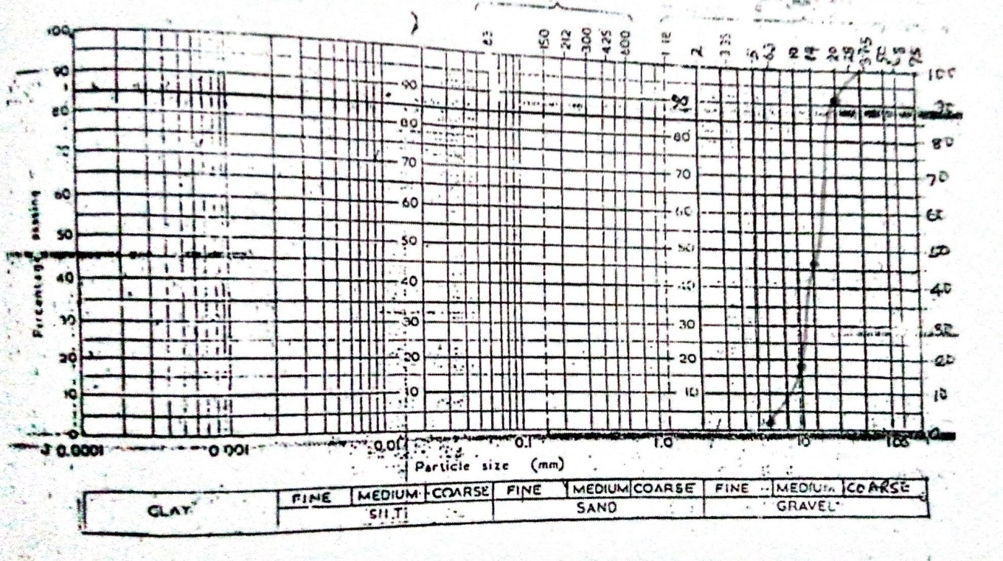
Figure4.1: Particle Size Distribution Curve of Coarse Aggregate (Granite)Kaiama
Therefore, for coarse aggregate (granite); D₁₀ = 8.15mm D₃₀= 12.0mm, D₆₀ = 17.0
Coefficient of uniformity, Cu $=\frac{D60}{D10}$ = $\frac{17.0}{8.15}$=2.09
Coefficient of curvature, Cc = $\frac{(D30)²}{D10 x D60}$ = $\frac{(12.0)²}{8.15 x 17.0}$ = 1.04
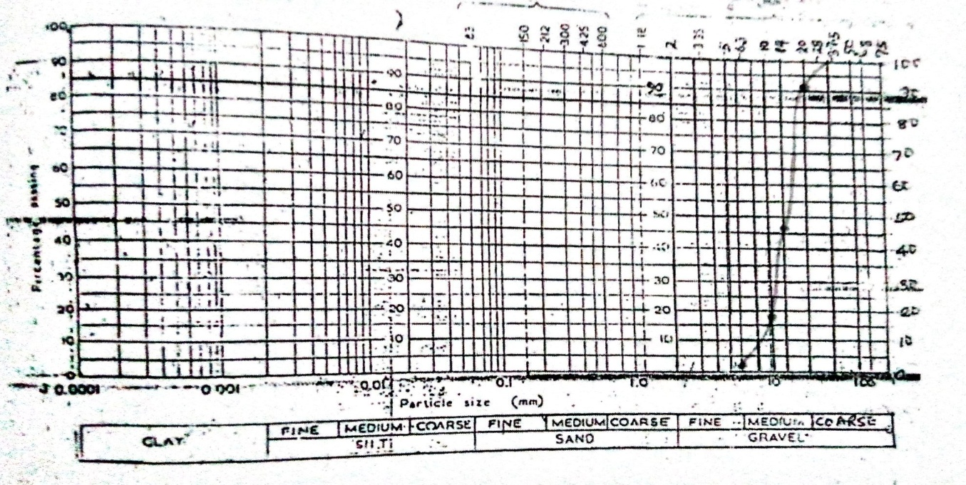
Figure4.2: Particle Size Distribution Curve of Coarse Aggregate (Granite)Kosubosu
Therefore, for coarse aggregate (granite); D₁₀ = 8.15mm D₃₀= 12.0mm, D₆₀ = 17.0
Coefficient of uniformity, Cu $=\frac{D60}{D10}$ = $\frac{17.0}{8.15}$=2.09
Coefficient of curvature, Cc = $\frac{(D30)²}{D10 x D60}$ = $\frac{(12.0)²}{8.15 x 17.0}$ = 1.06
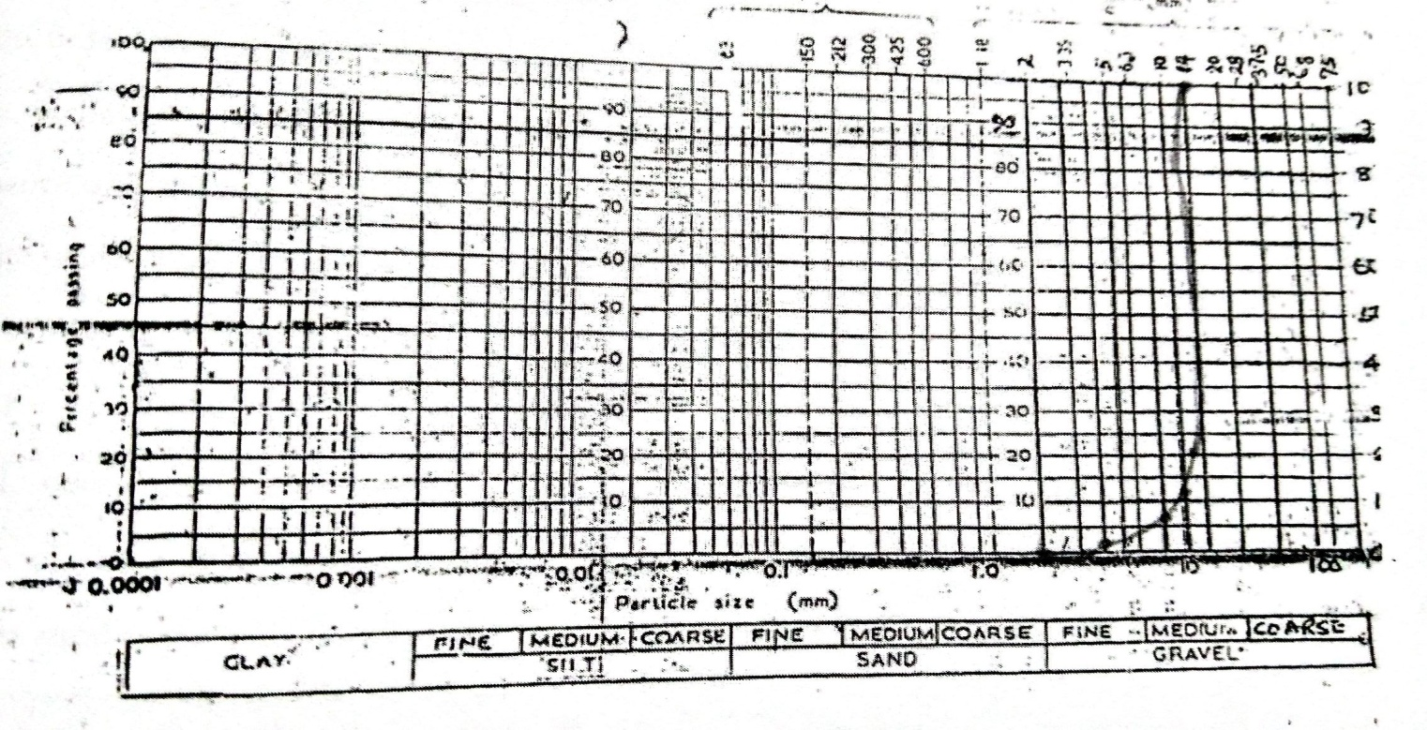
Figure 4.3: Particle Size Distribution Curve of Coarse Aggregate (Granite)Kulende Ilorin
Therefore, for coarse aggregate (granite); D₁₀= 10.0mm, D₃₀ = 14.0mm and D₆₀= 14.0mm
Coefficient of uniformity, Cu $=\frac{D60}{D10}$ = $\frac{14.0}{10.0}$=1.4
Coefficient of curvature, Cc = $\frac{(D30)²}{D10 x D60}$ = $\frac{(14.0)²}{10.0 x 14.0}$ = 1.40

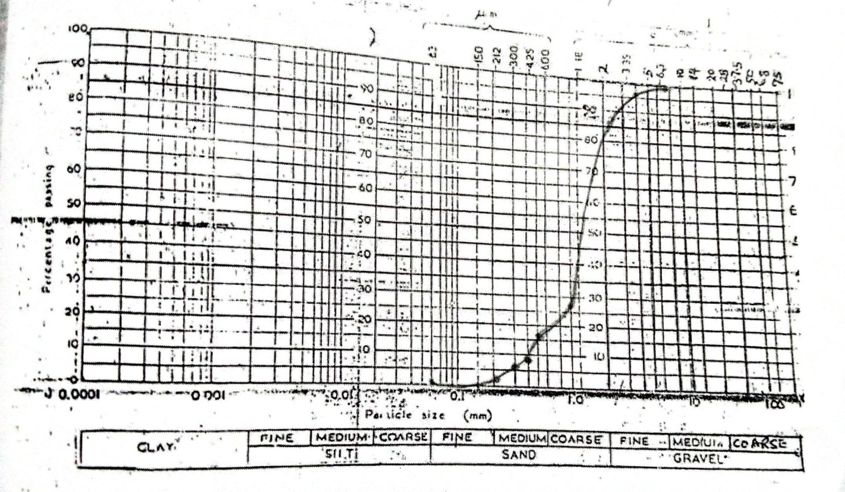Figure 4.3: Particle Size Distribution Curve of Fine Aggregate (Sand)
Therefore, D₁₀= 0.4, D₃₀ = 1.09mm and D₆₀= 1.59mm for fine aggregate (sand)
Coefficient of uniformity, Cu $=\frac{D60}{D10}$ = $\frac{1.59}{0.40}$=3.98
Coefficient of curvature, Cc = $\frac{(D30)²}{D10 x D60}$ = $\frac{(1.09)²}{0.40 x 1.59}$ = 1.87
4.2 BULK DENSITY OF AGGREGATES
Bulk density (kg/m³) = mass/volume
Where volume of the mold is equal to the volume of the sample = πr²h
Height of the mold (h) = 15.2cm and radius ® = 10.5cm
Volume = 3.142 x (0.105)² x 0.152
= 0.00527m³
Table 4.5 Bulk Density of Granite (Kaiama)
TEST (Kg) | 1 | 2 | AVERAGE
Mass of mold | 3.35 | 3.35 | 3.35
Mass of mold + wet sample | 10.80 | 10.80 | 10.80
Mass of wet sample | 7.50 | 7.45 | 7.48
Bulk density = mass/volume
Bulk density (kg/m³) = mass/volume
Where volume of the mold is equal to the volume of the sample = πr²h
Height of the mold (h) = 15.2cm and radius ® = 10.5cm
Volume = 3.142 x (0.105)² x 0.152
= 0.00527m³
Bulk density of granite = 7.48/0.00527
= 1419.35kg/m³
Table 4.6 Bulk Density of Granite (Kosubosu)
TEST (Kg) | 1 | 2 | AVERAGE
Mass of mold | 3.35 | 3.35 | 3.35
Mass of mold + wet sample | 10.80 | 10.80 | 10.80
Mass of wet sample | 7.50 | 7.45 | 7.48

Bulk density = mass/volume
Bulk density (kg/m³) = mass/volume
Where volume of the mold is equal to the volume of the sample = πr²h
Height of the mold (h) = 15.2cm and radius ® = 10.5cm
Volume = 3.142 x (0.105)² x 0.152
= 0.00527m³
Bulk density of gravel = 7.48/0.00527
= 1419.35kg/m³
Table 4.7 Bulk Density of Granite (Kulende Area Ilorin)
TEST (Kg) | 1 | 2 | AVERAGE
Mass of mold | 3.35 | 3.35 | 3.35
Mass of mold + wet sample | 11.00 | 11.50 | 11.25
Mass of wet sample | 7.65 | 8.15 | 7.90
Bulk density of granite = mass/volume
= 7.90/0.00527
=1499.05kg/m³
4.3 WATER ABSORPTION TEST ON AGGREGATES
Water Absorption test on aggregates
Water absorption (%) $=\frac{WA-WB}{WB}$ X 100
Where
W_{A} = weight of saturated surface dry sample
W_{B} = weight of sample
Table 4.8: Water Absorption of Granite (Kaiama)
S/N | TESTS | 1  Weight (g) | 2  Weight (g) | Average  weight (g)
1 | Weight of sample | 504.10 | 495.90 | 500
2 | Weight of saturated surface dry sample | 549.50 | 650.50 | 600
3 | Water absorption |  |  | 20%

Water absorption (%) = 600 - 500/500 x 100
= 100 /500 x 100 20%
Table 4.9: Water Absorption of Granite (Kosubosu)
S/N | TESTS | 1  Weight (g) | 2  Weight (g) | Average  weight (g)
1 | Weight of sample | 504.10 | 495.90 | 500
2 | Weight of saturated surface dry sample | 549.50 | 650.50 | 600
3 | Water absorption |  |  | 20%

Water absorption (%) = 600 - 500/500 x 100
= 100 /500 x 100 20%
Table 4.10: Water absorption of granite
S/N | TESTS | 1  Weight (g) | 2  Weight (g) | Average  weight (g)
1 | Weight of sample | 505.00 | 500.00 | 502.5
2 | Weight of saturated surface dry sample | 550.00 | 550.00 | 550.0
3 | Water absorption |  |  | 9.5%
Water absorption (%) = 550 – 502.5/502.5 x 100
= 9.5%
4.4 SLUMP TEST
The results represented in figure 4.4 revealed a slump value of 55mm and 65mm for gravel and granite respectively at ratio 1:2:4 mix. And figure 4.5 revealed a slump value of 53.5mm.


Figure 4.4: The slump value of concrete consisting of Manual and Machine (1:2:4).
4.5: DENSITY ANDCOMPRESSIVESTRENGTH OF THE HARDENED CONCRETE CUBES
Table 4.11: Density and Compressive strength test results for 1:2:4 mix (Kaiama)
Crushing  Days | Cube  marks | Wt before crushing (kg) | Area (mm²) | Density (kg/m³) | Crushing load (KN) | Compressive strength (N/mm²)
7 | B1 | 8.387 | 22500 | 2485 | 360 | 18.0
 | B2 | 8.316 | 22500 | 2464 | 380 | 19.9
 | B3 | 8.313 | 22500 | 2463 | 370 | 20.4
AVERAGE |  | 8.340 |  | 2471 | 370 | 19.9
14 | B1 | 8.171 | 22500 | 2421 | 480 | 21.3
 | B2 | 8.222 | 22500 | 2436 | 460 | 20.4
 | B3 | 8.235 | 22500 | 2440 | 470 | 20.9
AVERAGE |  | 8.209 |  | 2432 | 470 | 20.8
28 | B1 | 8.387 | 22500 | 2485 | 595 | 22.4
 | B2 | 8.330 | 22500 | 2468 | 600 | 22.7
 | B3 | 8.346 | 22500 | 2473 | 580 | 23.2
AVERAGE |  | 8.354 |  | 2475 | 591 | 22.7

Table 4.12: Density and Compressive strength test results1:2:4 mix (Kosubosu)
Crushing  Days | Cube  Marks | Wt before crushing (kg) | Area (mm²) | Density (kg/m³) | Crushing load (KN) | Compressive strength (N/mm²)
7 | B1 | 8.387 | 22500 | 2485 | 360 | 19.0
 | B2 | 8.316 | 22500 | 2464 | 380 | 19.9
 | B3 | 8.313 | 22500 | 2463 | 370 | 21.4
AVERAGE |  | 8.340 |  | 2471 | 370 | 19.9
14 | B1 | 8.171 | 22500 | 2421 | 480 | 21.3
 | B2 | 8.222 | 22500 | 2436 | 460 | 20.4
 | B3 | 8.235 | 22500 | 2440 | 470 | 20.9
AVERAGE |  | 8.209 |  | 2432 | 470 | 20.8
28 | B1 | 8.387 | 22500 | 2485 | 595 | 22.7
 | B2 | 8.330 | 22500 | 2468 | 600 | 23.2
 | B3 | 8.346 | 22500 | 2473 | 580 | 23.5
AVERAGE |  | 8.354 |  | 2475 | 591 | 23.2

Table 4.13: Density and Compressive strength test results for 1:2:4 mix (Kulende Area Ilorin)
Crushing  Days | Cube  marks | Wt before crushing (kg) | Area (mm²) | Density (kg/m³) | Crushing load (KN) | Compressive strength (N/mm²)
7 | A1 | 8.144 | 22500 | 2413 | 380 | 18.8
 | A2 | 8.181 | 22500 | 2424 | 390 | 19.2
 | A3 | 8.191 | 22500 | 2427 | 370 | 20.5
AVERAGE |  | 8.172 |  | 2421 | 380 | 19.2
14 | A1 | 8.292 | 22500 | 2457 | 450 | 20.0
 | A2 | 8.252 | 22500 | 2445 | 440 | 19.6
 | A3 | 8.309 | 22500 | 2462 | 470 | 20.9
AVERAGE |  | 8.284 |  | 2454 | 453 | 20.2
28 | A1 | 8.394 | 22500 | 2487 | 590 | 22.8
 | A2 | 8.319 | 22500 | 2465 | 605 | 23.2
 | A3 | 8.340 | 22500 | 2471 | 600 | 23.7
AVERAGE |  | 8.351 |  | 2474 | 598 | 23.7

Fig 4.5: The compressive strength of concrete against Hydration period containing gravel and granite with mix ratio (1:2:4) and water cement ratio 0.5
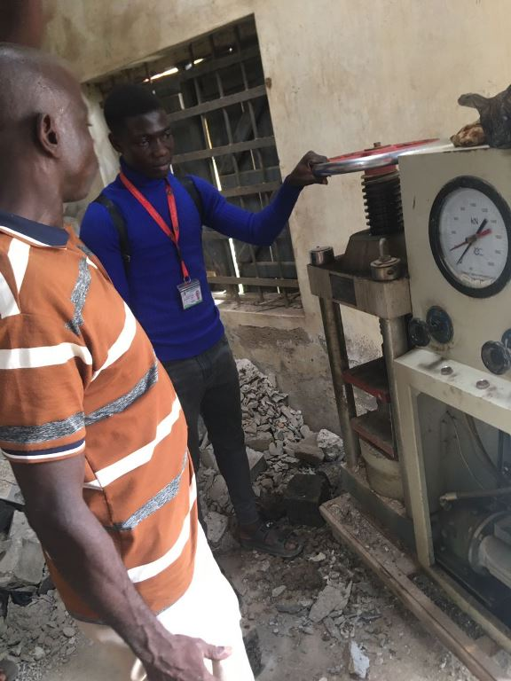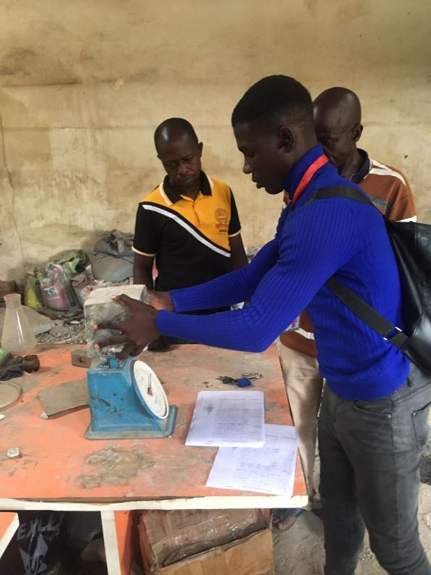
PLATE 1 COMPRESSIVE TEST MACHINE PLATE 2 WEIGHING OF CASTED CUBE
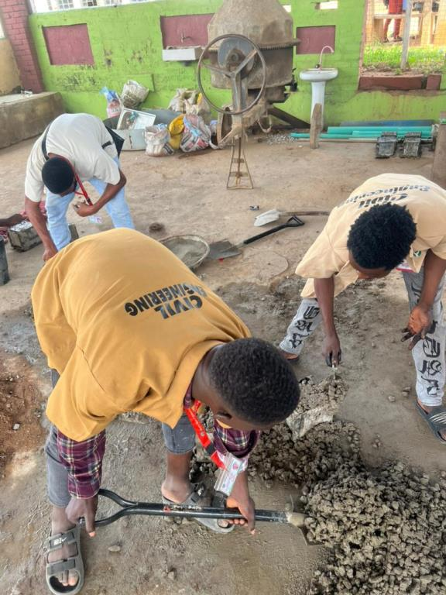
PLATE 3 CONCRETE MIXING
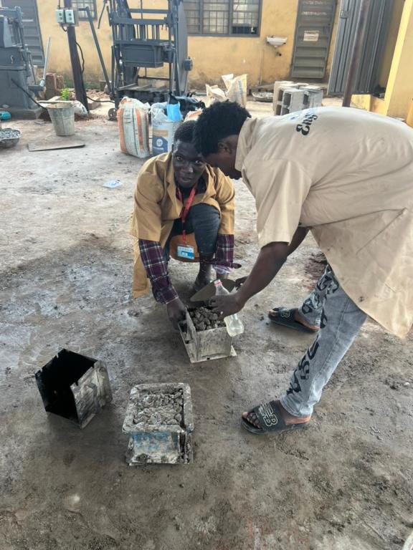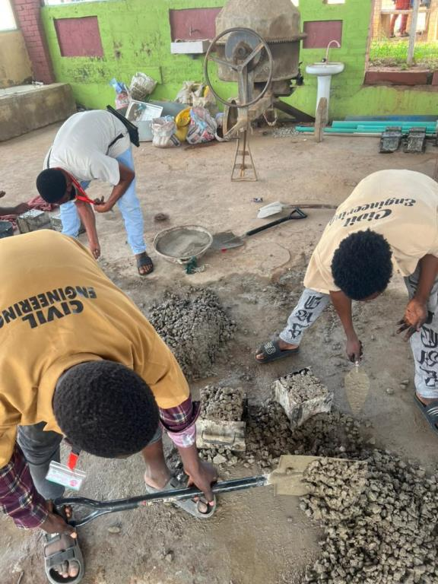
ca
PLATE 4 CUBE CASTING

4.5 DISCUSSION OF RESULTS
The average compressive strength of concrete produced using granite aggregate with a mix ratio of 1:2:4 is presented in Tables 4.16 to 4.19 and Figures 4.6 and 4.7. The results show a consistent increase in compressive strength with age of hydration. Granite aggregate demonstrated superior performance in terms of compressive strength. This can be attributed to the inherent properties of granite, such as its high strength, toughness, and rough surface texture, which promote better bonding between the cement paste and aggregate particles.
This variation in strength can also be explained by the results of the water absorption test. Aggregates with higher water absorption tend to induce internal stresses in the concrete matrix, ultimately compromising its durability (Theophilus, 2005).
Figures 4.1 to 4.4 illustrate the grading curves obtained for sharp granite and sharp sand. Preliminary tests on the constituent materials revealed that the sand used passed through the 4.75 mm sieve and was retained on the 0.063 mm sieve. It had a specific gravity of 2.4, a uniformity coefficient of 3.98, a coefficient of curvature of 1.86, and a fineness modulus of 6.56.
The granite aggregate ranged in size from 6.3 mm to 20.0 mm, with a specific gravity of 2.97, a uniformity coefficient of 2.09, a coefficient of curvature of 1.04, and a fineness modulus of 3.41. Another coarse aggregate tested ranged from 2.0 mm to 14.0 mm in particle size, with a specific gravity of 2.62, a uniformity coefficient of 1.4, a coefficient of curvature of 1.4, and a fineness modulus of 6.57.
The bulk density of granite was found to be 1499.05 kg/m³. According to Jackson and BS 812: Part 2 (1995), the bulk density of most natural aggregates ranges from 1350 to 1800 kg/m³, and granite falls within this acceptable range. A higher bulk density indicates a lower volume of voids to be filled by cement paste and sand (BS 5328: Part 1, 1997).
Water absorption values for granite are also presented in Tables 4.8 to 4.10. Granite aggregate exhibited lower water absorption values, indicating lower porosity and enhanced concrete durability.
The concrete produced with granite exhibited a slump of 65 mm for a 1:2:4 mix ratio. This suggests that the granite and sand combination offers better workability with less water demand compared to aggregates with higher surface area and porosity.

CHAPTER FIVE
CONCLUSION AND RECOMMENDATION

5.0 CONCLUSION
The experimental investigation carried out in this study clearly demonstrates that concrete produced with granite sourced from Kosubosu and Kulende in Ilorin exhibits superior compressive strength and compared to concrete made with other sources such as Kaiama. This makes the Kosubosu and Kulende granite aggregates more suitable for structural applications where high load-bearing capacity, long-term performance,
Granite from Kaiama, which exhibited lower compressive strength, is more appropriate for non-structural or light-duty construction works, where high strength is not a critical requirement. Examples of such applications include walkways, pavements, internal partitions, and similar low-load areas.
While strength and durability remain key considerations in the selection of coarse aggregates, practical factors such as cost of procurement, ease of access, and local availability must also be taken into account. In regions where high-quality granite is either scarce or costly, it may be necessary to use alternative aggregates in combination with admixtures or optimized mix designs to meet specific construction demands.

5.1 RECOMMENDATIONS
Based on the outcomes and observations from this study, the following recommendations are proposed to improve the quality and reliability of concrete in construction:
- To attain the full potential of concrete strength and ensure long-term durability, proper curing is essential. It is recommended that concrete be cured for a minimum period of 28 days. During this time, moisture should be adequately retained in the
- concrete matrix to promote complete hydration of the cement. Methods such as water spraying, ponding, wet coverings (like hessian), or the use of commercially available curing compounds should be employed, especially in hot and dry climates where premature drying can impair strength development.
- The selection and processing of aggregates must be governed by strict quality control protocols. Aggregates should be tested routinely for properties such as particle size distribution, specific gravity, surface texture, water absorption, and contamination. Ensuring that aggregates conform to established engineering standards (e.g., ASTM or BS specifications) helps minimize variability in concrete performance. Where necessary, inferior aggregates should be washed, screened, or replaced to maintain consistent concrete quality.
- Concrete mix designs should be tailored to the characteristics of the available aggregate. The proportioning of cement, sand, and coarse aggregates should be adjusted to achieve the desired workability, strength, and durability. Attention should be given to maintaining an appropriate water-cement ratio, which plays a significant role in both the fresh and hardened properties of concrete. In cases where natural aggregates vary in quality, admixtures such as superplasticizers, retarders, or pozzolanic materials can be introduced to enhance performance. Trial mixes and laboratory testing should be carried out before full-scale application to ensure the desired outcomes are achieved.

REFERENCES
Afolayan, A., &Tunde, O. (2019).“Comparative study of aggregate sources and their effects on concrete strength in Nigeria”. Nigerian Journal of Construction, 14(1), 12-25.
Afolayan, T. M., &Tunde, B. K. (2019).“Comparative Strength of Concrete Using Aggregates from Different Nigerian States”. Journal of Civil Engineering Research, 8(1), 45–52.
Ahmed, M., & Musa, S. (2018).“Role of coarse aggregates in concrete properties”. Journal of Civil Engineering, 30(4), 45-56.
Ajayi, L. A., &Balogun, F. O. (2018).“Effect of Aggregate Texture on Concrete Strength”. Journal of Materials in Construction, 7(2), 22–30.
Ajayi, M., &Balogun, T. (2018).“Impact of aggregate shape and texture on concrete strength”. Construction Materials Journal, 25(2), 110-118.
Akinmoladun, O. M., &Akinyemi, M. T. (2020).“Effect of aggregate types on the properties of concrete”. Journal of Civil Engineering and Construction Technology, 11(3), 45-53.
Alengaram, U. J., &Jumaat, M. Z. (2009).“Influence of coarse aggregate type on the properties of concrete”. Construction and Building Materials, 23(7), 2335-2342. https://doi.org/10.1016/j.conbuildmat.2008.10.031
Bamidele, R., Okon, J., & Yusuf, G. (2017).“Evaluation of Concrete Compressive Strength Using Local Aggregates”. Nigerian Journal of Engineering, 11(4), 89–95.
Chukwuma, E. K., & Adebayo, A. O. (2019).“Properties of Aggregates from Igneous Rocks”. African Materials Science Journal, 5(2), 33–40.
Duru, A. O., &Okeke, B. C. (2015).“Effect of aggregate characteristics on concrete strength in construction”. Journal of Building Material Science, 14(2), 102-110.
Eze, P. N., &Okeke, U. C. (2015).“Influence of Clay Impurities on Concrete Properties”. West African Journal of Engineering, 9(1), 56–63.
Eze, V., &Okeke, A. (2015).“Effects of impurities in aggregates on concrete strength”. Journal of Civil and Environmental Engineering, 38(4), 203-215.
Ibrahim, A., &Kole, D. (2017).“Geological Influence on Aggregates for Construction”. Journal of Geological Research, 6(3), 70–78.
Johnson, B., &Ibeh, E. (2016).“Standards and mix design procedures for high-strength concrete”. International Journal of Concrete Technology, 29(2), 77-83.
Johnson, I., &Ibeh, A. (2016).“Standards in Concrete Testing and Design”. Civil Engineering Digest, 3(4), 100–107.
Jones, T. M., & Garber, M. A. (2006).“Influence of aggregate properties on concrete strength: A comparative study”. Cement and Concrete Composites, 28(1), 1-10. https://doi.org/10.1016/j.cemconcomp.2005.05.004
Mehta, P. K., &Monteiro, P. J. M. (2014).“Concrete: Microstructure, Properties, and Materials” (4th ed.). McGraw-Hill.
Neville, A. M. (2012). “Properties of Concrete” (5th ed.). Pearson Education.
Nwachukwu, T. (2020).“Effects of aggregate shape and surface texture on concrete mechanical properties”. Construction Materials Science, 8(1), 33-40.
Ogunleye, S. T., Adebisi, A., &Kazeem, L. (2016).“Fundamentals of Concrete Technology”.Ibadan Technical Press.
Oluwatobi, T. I., &Olanipekun, E. A. (2013).“Effects of aggregate size distribution on the compressive strength of concrete”. International Journal of Civil Engineering and Construction, 5(4), 121-128.
Omotayo, A. A., & Bello, F. A. (2020).“Texture of Aggregates and Its Impact on Concrete Strength”. Concrete Research Review, 8(2), 41–48.
Poon, C. S., & Chan, D. (2006).“Influence of coarse aggregate types on the strength of concrete”. Cement and Concrete Research, 36(7), 1271-1277. https://doi.org/10.1016/j.cemconres.2005.12.006
Rao, S., & Reddy, V. V. (2010). “Effect of different types of coarse aggregate on concrete strength”. International Journal of Applied Engineering Research, 5(8), 1297-1303.
Salisu, M. M., &Gana, A. D. (2021).“Performance of Concrete with Local Aggregates”. Journal of Sustainable Construction, 10(2), 25–34.
Yusuf, K. J., Usman, L. I., & Farouk, M. O. (2014).“Impact of Aggregate Type on Concrete Strength”. Nigerian Building Research Journal, 2(3), 65–72.
Zhao, X., & Wang, X. (2012).“Comparative study on the performance of concrete produced with different types of coarse aggregates”. Journal of Civil Engineering and Management, 18(4), 481-487. https://doi.org/10.3846/13923730.2012.717462

