Enhancing Ransomeware Attack Detection using Transfer Learning and Deep Learning Ensemble Models on Cloud-Encrypted Data

BY
IBRAHIM SULYMAN OLAYINKA HND/23/COM/FT/0003

A Project Submitted to the Department of Computer Science, Institute of Information and Communication Technology, Kwara State Polytechnic, Ilorin

In Partial Fulfillment of the Requirements for the Award of Higher National Diploma (HND) in Computer Science

July, 2025
CERTIFICATION
This is to certify that this project was carried out by IBRAHIM, Sulyman Olayinka with matric number HND/23/COM/FT/0003 has part of the requirements for the award of Higher National Diploma (HND) in Computer Science.

………………………………. ……………………………….
Mrs. Akanbi, M. B. Date
(Project Supervisor)

………………………………. ……………………………….
Mr. Oyedepo, F. S. Date
(Head of Department)

………………………………. ……………………………….
External Examiner Date

DEDICATION
This project is dedicated to the creator of the earth and universe, the Almighty God. It is also dedicated to my parents for their moral and financial support.

ACKNOWLEDGEMENT
All praise is due to the Almighty God the Lord of the universe. I praise Him and thank Him for giving me the strength and knowledge to complete my HND programme and also for my continue existence on the earth.
I appreciate the utmost effort of my supervisor, Mrs. Akanbi, M. B., whose patience support and encouragement have been the driving force behind the success of this research work. She gave useful corrections, constructive criticisms, comments, recommendations, advice and always ensures that an excellent research is done. My sincere gratitude goes to the Head of the Department and other members of staff of the Department of Computer Science, Kwara State Polytechnic, Ilorin, for their constant cooperation, constructive criticisms and encouragements throughout the programme.
Special gratitude to my parents who exhibited immeasurable financial, patience, support, prayers and understanding during the periods in which I was busy tirelessly in my studies. Special thanks go to all my lovely siblings.
My sincere appreciation goes to my friends and classmates.

TABLE OF CONTENTS
Title Page i
Certification ii
Dedication iii
Acknowledgements iv
Abstract v
Table of Contents vi
CHAPTER ONE: GENERAL INTRODUCTION
  - Background to the Study 1
  - Statement of the Problem 3
  - Aim and Objectives of the Study 4
  - Significance of the Study 4
  - Scope of the Study 5
  - Organization of the Report 5
CHAPTER TWO: LITERATURE REVIEW
2.1 Review of Related Works 6
2.2 Review of Related Concepts 10
2.2.1 Overview of 10
2.2.2 11
2.2.3 12
2.2.4 13
2.2.5 14
CHAPTER THREE: RESEARCH METHODOLOGY AND ANALYSIS OF THE EXISTING SYSTEM
  - Research Methodology 15
  - Analysis of the Existing System 17
  - Problems of the Existing System 17
  - Description of the Proposed System 18
  - Advantages of the proposed system 29
CHAPTER FOUR: DESIGN, IMPLEMENTATION AND DOCUMENTATION OF THE SYSTEM
  - Design of the System 21
    - Output Design 21
    - Input Design 25
    - Procedure Design 27
  - Implementation of the System 28
    - Hardware Support 28
  - Documentation of the System 29
    - Maintaining the System 29
CHAPTER FIVE: SUMMARY, CONCLUSION AND RECOMMENDATION
  - Summary 30
  - Conclusion 30
  - Recommendation 31
References 32
Appendices
Appendix 1 Flowchart 32
Appendix 2 Flowchart 33
Appendix 3 Robot Direction Flowchart 34

ABSTRACT
Ransomware attacks have become increasingly prevalent and sophisticated, posing significant challenges to cyber security measures, particularly in cloud environments where data encryption adds another layer of complexity to detection and mitigation efforts. In this project, we propose a novel approach to enhance ransomware attack detection leveraging transfer learning and deep learning ensemble models tailored for analyzing cloud-encrypted data. The researcher employ transfer learning techniques to adapt pre-trained deep learning models to the specifics of ransomware detection in encrypted cloud data. Transfer learning enables the efficient leveraging of knowledge gained from unrelated tasks or domains, thereby reducing the need for extensive labeled data in the target domain. By fine-tuning pre-trained models on encrypted cloud data, we aim to extract relevant features and patterns indicative of ransomware activity, effectively addressing the data privacy concerns associated with directly analyzing encrypted data. We construct a deep learning ensemble framework to further boost the detection performance. Ensemble learning combines the outputs of multiple base models to improve prediction accuracy and robustness. Our ensemble architecture integrates diverse deep learning architectures, each specialized in capturing different aspects of ransomware behavior, thereby enhancing the model's ability to generalize across various attack scenarios and evade evasion tactics employed by sophisticated attackers. Our results demonstrate significant improvements in ransomware detection accuracy, sensitivity, and specificity compared to traditional single-model approaches. Moreover, our approach exhibits resilience to adversarial attacks aimed at evading detection, showcasing its robustness in real-world deployment scenarios.

CHAPTER ONE
INTRODUCTION
  - BACKROUND TO THE STUDY
Ransomware attacks have emerged as a significant threat to data security in cloud environments, posing substantial risks to organisations' sensitive information and operations. These attacks exploit vulnerabilities in cloud infrastructures, encrypting data and demanding ransom for decryption keys, thereby causing financial losses and operational disruptions. Detecting ransomware attacks in cloud-encrypted data poses a considerable challenge due to the dynamic nature of such attacks and the encryption of data, making traditional detection methods less effective (Okey et al., 2023).
Ransomware attacks have become increasingly sophisticated, with threat actors continuously evolving their tactics to bypass traditional security measures and exploit vulnerabilities in cloud infrastructures. The proliferation of cloud computing has provided cybercriminals with a broader attack surface, as organisations store vast amounts of sensitive data in cloud-based repositories. Consequently, the detection of ransomware activities within encrypted data streams in cloud environments has become paramount to safeguarding critical assets and maintaining operational resilience (Ngongolo, 2022).
Fernando, et al (2020) asserted that, the integration of transfer learning and deep learning ensemble models offers a novel approach to ransomware detection, leveraging the wealth of knowledge encoded in pre-trained models and the collective intelligence of diverse detection algorithms. Transfer learning enables the adaptation of pre-existing knowledge from related tasks to enhance the performance of detection models in ransomware scenarios, while ensemble learning combines multiple models to achieve greater robustness and accuracy. By harnessing the power of these advanced machine learning techniques, this study seeks to advance the state-of-the-art in ransomware detection and mitigate the growing threat posed by malicious actors in cloud environments.
Bello (2020) claimed that, in recent years, ransomware attacks have targeted a wide range of industries, including healthcare, finance, and government sectors, causing significant financial losses and reputational damage to affected organizations. The pervasive nature of these attacks underscores the urgent need for proactive detection mechanisms capable of identifying ransomware activities before they escalate into full-blown incidents. Moreover, the increasing adoption of cloud-based services amplifies the importance of securing data stored and processed in cloud environments, necessitating innovative approaches to ransomware detection tailored to the unique challenges of the cloud paradigm.
Traditional signature-based detection methods are often ineffective against ransomware attacks, as they rely on predefined patterns or signatures that may not capture the dynamic behavior of evolving ransomware variants. Furthermore, the encryption of data in cloud environments complicates the detection process, as it obscures the underlying content from traditional inspection techniques. Consequently, there is a pressing need for data-driven approaches that can analyze encrypted data streams and identify anomalous patterns indicative of ransomware activity, thereby enabling timely response and mitigation efforts (Kadavath & Thara, 2020).
In response to these challenges, the integration of advanced machine learning techniques, such as transfer learning and deep learning ensemble models, offers promising avenues for enhancing ransomware attack detection in cloud environments. By leveraging transfer learning and deep learning ensemble models, this project aims to bridge the gap between traditional detection methods and the evolving landscape of ransomware threats in cloud environments. The proposed approach holds promise for enhancing the accuracy, scalability, and adaptability of ransomware detection systems, empowering organizations to proactively defend against emerging cyber threats and safeguard their digital assets.
  - STATEMENT OF THE PROBLEM
Detecting ransomware attacks in cloud-encrypted data remains a critical challenge due to the evolving nature of ransomware variants and the complexity of cloud environments. Traditional detection methods often fail to accurately identify ransomware activities within encrypted data, leading to delays in response and mitigation efforts. Moreover, the lack of robust detection mechanisms exacerbates the vulnerability of cloud infrastructures to ransomware threats, jeopardizing the confidentiality, integrity, and availability of critical data assets. This project aim to develop an enhance ransomware attack detection in cloud encrypted data through transfer learning and deep learning.
1.3 AIM AND OBJECTIVES OF THE STUDY
The aim of this project is to enhance ransomware attack detection in cloud-encrypted data through the utilization of transfer learning and deep learning ensemble models. To achieve this aim, the objectives are to:
- design and implement deep learning ensemble models to leverage the complementary strengths of multiple detection algorithms;
- evaluate the performance of the proposed approach in terms of detection accuracy, false positive rate, and computational efficiency;
- validate the effectiveness of the developed models through real-world experimentation and comparative analysis with state-of-the-art methods; and
- explore the potential of transfer learning techniques for adapting pre-trained models to ransomware detection tasks in cloud-encrypted data.
1.4 SIGNIFICANCE OF THE STUDY
The proposed project holds significant implications for enhancing the security posture of cloud environments against ransomware threats. By leveraging transfer learning and deep learning ensemble models, organizations can improve the accuracy and timeliness of ransomware detection, thereby minimizing the impact of attacks on data confidentiality and operational continuity. Moreover, the findings of this study contribute to the advancement of machine learning-based security solutions, offering insights into effective strategies for combating emerging cyber threats in cloud infrastructures.
1.5 SCOPE OF THE STUDY
This study focuses specifically on enhancing ransomware attack detection in cloud environments using transfer learning and deep learning ensemble models. The research will involve the development and evaluation of detection algorithms tailored to encrypted data within cloud storage and processing systems. The scope encompasses the analysis of various ransomware attack scenarios and the assessment of detection performance under different encryption schemes and cloud configurations. However, the study does not delve into the decryption or mitigation of ransomware attacks but rather emphasizes proactive detection mechanisms to mitigate their impact.

1.6 ORGANIZATION OF THE REPORT
The project write-up is organized into five distinct chapters. Chapter one covers general introduction, which contains introduction to the research topic, statement of the problem, aim and objectives, significance of the study, scope and limitation and organization of the report. Chapter two covers literature review, which contains review of related past works, overview of network configuration, description of ransomware attack detection system and other related concepts. Chapter three explains the project methodology which includes analysis of existing system, problems of the existing system, and the description of the proposed system, advantages of proposed system and design and implementation techniques used. Chapter four explains the design, implementation and documentation of the system which contain system design output design, input design, database design and procedure design, implementation of the system hardware and software support and documentation of the new system installation procedure, operating the system and system maintenance. Lastly, chapter five explains the summary of the research, recommendations and conclusion.

CHAPTER TWO
LITERATURE REVIEW
2.1 REVIEW OF RELATED LITERATURE
Some past journals related to this topic of study were reviewed in this section.
Kadavath and Thara (2020) developed a network level detection of ransomware attacks using ensemble learning. In the journal, an approach is proposed which detects ransomware attacks by utilizing the network traffic information. After ransomware infection, the victim machine communicates with a C&C server controlled by the attacker to obtain the public key for encryption of victim data. This network traffic information was utilized to detect ransomware attacks and prevent encryption of victim data. An Ensemble Learning-based classifier is developed in which the network traffic dataset is trained and tested. The proposed classifier is compared with various other machine learning algorithms based on the performance.
Singh et al (2023) proposed an enhancing ransomware attack detection using transfer learning and deep learning ensemble models on cloud-encrypted data. The researchers presented RANSOMNET+, a state-of-the-art hybrid model that combines Convolutional Neural Networks (CNNs) with pre-trained transformers, to efficiently take on the challenging issue of ransomware attack classification. RANSOMNET+ excels over other models because it combines the greatest features of both architectures, allowing it to capture hierarchical features and local patterns. Their findings demonstrate the exceptional capabilities of RANSOMNET+. The model had a fantastic precision of 99.5%, recall of 98.5%, and F1 score of 97.64%, and attained a training accuracy of 99.6% and a testing accuracy of 99.1%. The loss values for RANSOMNET+ were impressively low, ranging from 0.0003 to 0.0035 throughout training and testing. They tested our model against the industry standard, ResNet 50, as well as the state-of-the-art, VGG 16. RANSOMNET+ excelled over the other two models in terms of F1 score, accuracy, precision, and recall. The algorithm’s decision-making process was also illuminated by RANSOMNET+’s interpretability analysis and graphical representations. The model’s openness and usefulness were improved by the incorporation of feature distributions, outlier detection, and feature importance analysis. Finally, RANSOMNET+ is a huge improvement in cloud safety and ransomware research. As a result of its unrivaled accuracy and resilience, it provides a formidable line of defense against ransomware attacks on cloud-encrypted data, keeping sensitive information secure and ensuring the reliability of cloud-stored data. Cybersecurity professionals and cloud service providers now have a reliable tool to combat ransomware threats thanks to the research.
Bello et al (2020) worked on detecting ransomware attacks using intelligent algorithms. The paper conducted a comprehensive survey on the detection of ransomware attacks using intelligent machine learning algorithms. The study analysed literature from different perspectives focusing on intelligent algorithms detection of ransomware. The survey shows that there is a growing interest in recent times (2016—date) on the application of intelligent algorithms for ransomware detection. Deep learning algorithms are gaining tremendous attention because of their ability to handle large scale datasets, prominence in the research community, and ability to solve problems better than the conventional intelligent algorithms. To date, the potentials of big data analytics are yet to be fully exploited for the smart detection of ransomware attacks. Future research opportunities from the perspective of deep learning and big data analytics to solve the challenges identified from the survey are outlined to give the research community a new direction in dealing with ransomware attacks.
Alotaibi and Ilyas (2023) implemented an ensemble-learning framework for intrusion detection to enhance internet of things’ devices security. In the research, the researchers aim to contribute to the literature by improving the Intrusion Detection System (IDS) detection efficiency. In order to improve the efficiency of the IDS, a binary classification of normal and abnormal IoT traffic is constructed to enhance the IDS performance. Our method employs various supervised ML algorithms and ensemble classifiers. The proposed model was trained on TON-IoT network traffic datasets. Four of the trained ML-supervised models have achieved the highest accurate outcomes; Random Forest, Decision Tree, Logistic Regression, and K-Nearest Neighbor. These four classifiers are fed to two ensemble approaches: voting and stacking. The ensemble approaches were evaluated using the evaluation metrics and compared for their efficacy on this classification problem. The accuracy of the ensemble classifiers was higher than that of the individual models. This improvement can be attributed to ensemble learning strategies that leverage diverse learning mechanisms with varying capabilities. By combining these strategies, we were able to enhance the reliability of our predictions while reducing the occurrence of classification errors. The experimental results show that the framework can improve the efficiency of the Intrusion Detection System, achieving an accuracy rate of 0.9863.
Nkongolo (2020) proposed a ransomware detection dynamics, insights and implications. The research investigated the utilization of a feature selection algorithm for distinguishing ransomware-related and benign transactions in both Bitcoin (BTC) and United States Dollar (USD). Leveraging the UGRansome dataset, a comprehensive repository of ransomware-related BTC and USD transactions, Through rigorous experimentation and evaluation, they demonstrated the effectiveness of their feature set in accurately extracting BTC and USD transactions, thereby aiding in the early detection and prevention of ransomware-related financial flows. They introduce a Ransomware Feature Selection Algorithm (RFSA) based on Gini Impurity and Mutual Information (MI) for selecting crucial ransomware features from the UGRansome dataset. They evaluated the RFSA using precision, recall, accuracy, and F1 score, achieving notable results. Insights from the visualization highlight the potential of Gini Impurity and MI-based feature selection to enhance ransomware detection systems by effectively discriminating between ransomware classes. The analysis reveals that approximately 68% of ransomware incidents involve BTC transactions within the range of 1.46 to 2.56, with an average of 2.01 BTC transactions per attack. Moreover, ransomware causes financial damages ranging from 4.38 to 172.36 USD, with an average damage of 88.37 USD. The RFSA identifies 17 ransomware types and their associated malware, such as CryptoLocker exclusively linked to one type of Blacklist malware, predicted as a Signature attack (S). Additionally, our study explores ransomware pricing, with TowerWeb demanding the highest fee at 135.26 BTC and CryptoLocker the lowest at 10.51 BTC. We also investigated the impact of ransomware duration on financial gains and netflow bytes, finding that extended duration correlates with higher financial gains. Successful attacks often employ the Transmission Control Protocol (TCP), particularly with NoobCrypt ransomware. The research achieved an outstanding accuracy of 95%, showcasing its superiority over existing studies.
Popryho and Popryho (2023) proposed a behaviour-based detection of ransomware attacks in the Cloud using machine learning. In the paper, the researchers aim to develop a behavior-based ransomware detection system for cloud environments, specifically focusing on Google Drive, using machine learning techniques. They created a dedicated Google Workspace and utilize the Google Cloud Platform for developing the anomaly detection classifier. They will review related work in ransomware detection and machine learning approaches to select suitable techniques for our research. Their anomaly detection classifier will analyze user activities in the cloud, such as file access patterns and permission changes, to detect deviations indicative of ransomware attacks. They validated their system’s performance by conducting experiments in our Google Workspace, emulating ransomware attacks, and comparing the classifier’s performance against existing techniques. Their contributed a novel, behavior-based detection system for ransomware attacks in cloud environments, advancing the state-of-the-art and providing a scalable solution for various cloud storage providers.
Fernando (2020) proposed a study on the evolution of ransomware detection using machine learning and deep learning techniques. The survey investigated the contributions of research into the detection of ransomware malware using machine learning and deep learning algorithms. The main motivations for the study are the destructive nature of ransomware, the difficulty of reversing a ransomware infection, and how important it is to detect it before infecting a system. Machine learning is coming to the forefront of combatting ransomware, so we attempted to identify weaknesses in machine learning approaches and how they can be strengthened. The threat posed by ransomware is exceptionally high, with new variants and families continually being found on the internet and dark web. Recovering from ransomware infections is difficult, given the nature of the encryption schemes used by them. The increase in the use of artificial intelligence also coincides with this boom in ransomware. The exploration into machine learning and deep learning approaches when it comes to detecting ransomware poses high interest because machine learning and deep learning can detect zero-day threats. These techniques can generate predictive models that can learn the behaviour of ransomware and use this knowledge to detect variants and families which have not yet been seen. In this survey, we review prominent research studies which all showcase a machine learning or deep learning approach when detecting ransomware malware. These studies were chosen based on the number of citations they had by other research. We carried out experiments to investigate how the discussed research studies are impacted by malware evolution. We also explored the new directions of ransomware and how we expect it to evolve in the coming years, such as expansion into IoT (Internet of Things), with IoT being integrated more into infrastructures and into homes.
Okey (2023) developed a transfer learning approach to IDS on cloud IoT devices using optimized CNN. The paper proposed a transfer learning IDS based on the Convolutional Neural Network (CNN) architecture that has shown excellent results on image classification. They used five pre-trained CNN models, including VGG16, VGG19, Inception, MobileNet, and EfficientNets, to train on two selected datasets: CIC-IDS2017 and CSE-CICIDS2018. Before the training, we carry out preprocessing, imbalance treatment, dimensionality reduction, and conversion of the feature vector into images suitable for the CNN architecture using Quantile Transformer. Three best-performing models (InceptionV3, MobileNetV3Small, and EfficientNetV2B0) are selected to develop an ensemble model called efficient-lightweight ensemble transfer learning (ELETL-IDS) using the model averaging approach. On evaluation, the findings show that the ELETL-IDS outperformed existing state-of-the-art proposals in all evaluation metrics, reaching 100% in accuracy, precision, recall, and F-score. We use Matthew’s Correlation Coefficient (MCC) to validate this result and compared it to the AUC-ROC, which maintained an exact value of 0.9996. To this end, our proposed model is lightweight, efficient, and reliable enough to be deployed in cloud IoT systems for intrusion detection.

2.2 REVIEW OF RELATED CONCEPTS
2.2.1 Transfer Learning Overview
Transfer learning is a machine learning technique that leverages knowledge acquired from solving one problem to improve performance on a related but different problem. In traditional machine learning approaches, models are trained from scratch on specific datasets for a particular task. However, transfer learning recognizes that pre-trained models developed for one task can be adapted and fine-tuned to perform well on a related task with minimal additional training. This process is particularly useful when the target task has limited labeled data or when training from scratch would be computationally expensive.
Transfer learning operates on the principle that knowledge learned by a model on one task often referred to as the source task—can be transferred to accelerate learning or improve performance on a different but related task, known as the target task. This knowledge transfer can occur at different levels of abstraction within the model, ranging from low-level features, such as edges and textures, to high-level concepts and representations. By leveraging pre-existing knowledge encoded in the parameters of the source model, transfer learning enables the target model to benefit from the insights gained during the training process for the source task.
There are several approaches to transfer learning, including feature extraction, fine-tuning, and domain adaptation. In feature extraction, the pre-trained model is used as a fixed feature extractor, where the learned representations from earlier layers of the network are extracted and fed into a new classifier trained specifically for the target task. Fine-tuning, on the other hand, involves updating the parameters of the pre-trained model by continuing the training process on the target task dataset, typically with a lower learning rate to prevent overfitting. Domain adaptation aims to adapt the knowledge learned from a source domain to a target domain with different distributions, such as transferring knowledge from a large dataset in one domain to improve performance on a smaller dataset in a related domain.
Transfer learning has demonstrated remarkable success across various domains, including computer vision, natural language processing, and healthcare. By enabling models to leverage pre-existing knowledge and generalize to new tasks with limited labeled data, transfer learning accelerates the development of robust and effective machine learning solutions, making it a valuable tool for addressing real-world challenges in data-driven applications (Atolaibi & Ilyas, 2023).
2.2.2 Overview of Deep Learning
Deep learning is a subset of machine learning that employs artificial neural networks with multiple layers to learn intricate patterns and representations from data. Unlike traditional machine learning algorithms, which often require manual feature engineering, deep learning algorithms autonomously extract relevant features from raw input data, enabling them to handle complex tasks with minimal human intervention. The depth of these neural networks, characterized by multiple layers of interconnected neurons, allows them to model hierarchical relationships and capture intricate dependencies within the data, making them particularly well-suited for tasks involving large volumes of unstructured data, such as image recognition, natural language processing, and speech recognition.
At the heart of deep learning are artificial neural networks, which are composed of interconnected nodes or neurons organized into layers. Each neuron receives input signals from neurons in the previous layer, applies a nonlinear transformation, and passes the transformed signal to neurons in the subsequent layer. Through a process known as backpropagation, the network adjusts the weights of connections between neurons during training to minimize the difference between predicted and actual outputs, thereby optimizing the model's performance on a given task. The architecture of a deep neural network, including the number of layers, the size of each layer, and the activation functions used, plays a crucial role in determining the network's capacity to learn complex patterns and generalize to unseen data.
One of the key advantages of deep learning is its ability to automatically learn hierarchical representations of data, effectively capturing both low-level features and high-level abstractions. This hierarchical feature learning enables deep neural networks to achieve state-of-the-art performance on a wide range of tasks, including image classification, object detection, and natural language understanding. Moreover, the scalability of deep learning algorithms allows them to handle massive datasets and exploit parallel computing architectures, making them well-suited for training on modern computing infrastructure, such as graphics processing units (GPUs) and distributed computing clusters.
Despite their remarkable success, deep learning models often require large amounts of labeled data and substantial computational resources for training, which can pose challenges in domains where labeled data is scarce or expensive to acquire. Additionally, deep neural networks are susceptible to overfitting, wherein the model learns to memorize training examples rather than generalize to unseen data, necessitating regularization techniques and careful model selection to mitigate this issue. Nevertheless, the continuous advancements in deep learning research, coupled with the availability of powerful computing hardware and frameworks, continue to drive innovation and adoption of deep learning techniques across diverse domains, promising transformative impacts on various industries and applications (Kadavath & Thara, 2020).

2.2.3 Overview of Ransomware
Ransomware is a type of malicious software designed to encrypt files or lock users out of their systems, demanding payment often in cryptocurrency in exchange for restoring access or decrypting the files. It represents a significant cybersecurity threat, targeting individuals, businesses, and even government entities worldwide. Ransomware attacks typically exploit vulnerabilities in computer systems or rely on social engineering tactics, such as phishing emails, to infiltrate networks and execute their malicious payloads. Once activated, ransomware encrypts files using strong encryption algorithms, rendering them inaccessible to the victim unless a decryption key is provided, which is held by the attackers.
The motivation behind ransomware attacks is primarily financial gain, with cybercriminals seeking to extort money from victims by exploiting their reliance on critical data and systems. The evolution of ransomware has seen the emergence of various tactics and techniques, including the use of ransomware-as-a-service (RaaS) platforms, which enable even non-technical individuals to launch ransomware attacks in exchange for a share of the profits. Additionally, some ransomware variants employ advanced evasion techniques to evade detection by security software and prolong their presence within compromised systems, exacerbating the impact on victims and complicating mitigation efforts.
Ransomware attacks can have devastating consequences for individuals and organizations, ranging from financial losses and reputational damage to operational disruptions and data breaches. In recent years, high-profile ransomware incidents have garnered widespread attention, highlighting the need for robust cybersecurity measures and incident response strategies to mitigate the risk of ransomware infections. Furthermore, the proliferation of ransomware-as-a-service models and the commodification of ransomware tools have lowered the barriers to entry for cybercriminals, resulting in an increase in the frequency and sophistication of ransomware attacks across various sectors and industries.
Addressing the ransomware threat requires a multi-faceted approach encompassing prevention, detection, response, and recovery strategies. This includes implementing proactive security measures such as regular software updates, network segmentation, and employee training to mitigate the risk of ransomware infections. Additionally, organizations must invest in robust backup and recovery solutions to ensure the timely restoration of data in the event of a ransomware attack. Moreover, collaboration between the public and private sectors, as well as international cooperation, is essential to combatting ransomware effectively and holding cybercriminals accountable for their actions (Bello et al, 2020).
2.2.4 Ransomware Attack Detection on Cloud Encrypted Data
Detecting ransomware attacks on cloud-encrypted data presents a unique challenge due to the combination of encryption, which obscures the content of data, and the dynamic nature of ransomware threats. Traditional detection methods often rely on inspecting the contents of files or network traffic for known ransomware signatures or behavioral patterns, which may be ineffective when applied to encrypted data. Furthermore, the decentralized and distributed nature of cloud computing environments introduces additional complexities, such as varying encryption schemes and access controls, which can hinder the detection of ransomware activities.
To address these challenges, researchers and practitioners have explored the use of advanced machine learning techniques, such as transfer learning and deep learning ensemble models, for enhancing ransomware detection on cloud-encrypted data. Transfer learning enables the adaptation of pre-trained models to ransomware detection tasks, leveraging knowledge learned from related domains or tasks to improve detection accuracy. By fine-tuning pre-trained models on encrypted data, transfer learning can overcome the limitations of traditional signature-based detection methods and identify ransomware activities based on subtle anomalies or patterns in encrypted data streams.
Deep learning ensemble models offer another promising approach to ransomware detection on cloud-encrypted data by combining the strengths of multiple detection algorithms. Ensemble learning techniques, such as bagging and boosting, allow multiple deep learning models to be trained independently and then combined to produce more robust and accurate predictions. By aggregating the outputs of diverse detection algorithms, deep learning ensemble models can effectively capture the complex relationships and patterns present in encrypted data, enhancing the detection of ransomware activities while minimizing false positives.
The integration of transfer learning and deep learning ensemble models holds significant potential for improving the effectiveness and efficiency of ransomware detection in cloud environments. By leveraging pre-existing knowledge and combining complementary detection strategies, these advanced machine learning techniques enable organizations to proactively identify and mitigate ransomware threats, safeguarding sensitive data and preserving the integrity of cloud-based infrastructures. However, further research and experimentation are needed to optimize and validate these approaches in real-world cloud environments, ensuring their scalability, robustness, and practicality for deployment in operational settings (Bello et al, 2020).
2.2.5 Deep Learning Models on Ransomware Attack Detection on Cloud Encrypted Data
Deep learning models have emerged as powerful tools for ransomware attack detection on cloud-encrypted data, offering the potential to overcome the challenges posed by the dynamic nature of ransomware threats and the encryption of data in cloud environments. These models leverage the hierarchical representations learned from vast amounts of labeled data to automatically extract relevant features from encrypted data streams, enabling them to discern subtle patterns indicative of ransomware activity. By analyzing the underlying structure and relationships within encrypted data, deep learning models can identify anomalous behaviors associated with ransomware attacks, even in the absence of explicit signatures or known patterns.
One approach to leveraging deep learning for ransomware attack detection on cloud-encrypted data involves the use of convolutional neural networks (CNNs) or recurrent neural networks (RNNs) to analyze encrypted data at various levels of abstraction. CNNs are well-suited for detecting spatial patterns in images or sequences of data, making them particularly effective for analyzing encrypted files or network traffic. On the other hand, RNNs are capable of modeling temporal dependencies in sequential data, enabling them to capture the dynamic behavior of ransomware activities over time. By combining CNNs and RNNs in hybrid architectures, researchers can exploit both spatial and temporal information to enhance the accuracy and robustness of ransomware detection models.
Another promising approach is the use of generative adversarial networks (GANs) for generating synthetic ransomware samples and augmenting training datasets. GANs consist of two neural networks—the generator and the discriminatorthat are trained adversarially to generate realistic samples and discriminate between real and synthetic data. By training GANs on encrypted data and generating synthetic ransomware samples, researchers can effectively increase the diversity and representativeness of training datasets, improving the generalization performance of deep learning models for ransomware detection. Moreover, GAN-based data augmentation techniques can help mitigate the challenge of limited labeled data in ransomware detection tasks, enabling models to learn more robust representations of ransomware activities in cloud-encrypted data.
The deployment of deep learning models for ransomware attack detection on cloud-encrypted data requires careful consideration of various factors, including model architecture, training data, and computational resources. Additionally, ongoing research is needed to evaluate the effectiveness and scalability of deep learning approaches in real-world cloud environments and to address potential challenges such as adversarial attacks and model interpretability. Despite these challenges, the integration of deep learning models holds promise for enhancing the security posture of cloud infrastructures and enabling organizations to detect and mitigate ransomware threats more effectively, thereby safeguarding critical data assets and preserving operational continuity (Bello et al, 2020).

CHAPTER THREE
RESEARCH METHODOLOGY AND ANALYSIS OF THE SYSTEM
3.1 RESEARCH METHODOLOGY
A ransomware detection methodology is proposed here using Ensemble Deep Learning Models in Machine Learning. There are two phases to this approach. The first phase is to develop a dataset using real ransomware network packet samples (PCAP files). The second phase is to train and test the dataset on the proposed ensemble learning-based classification model. Also, the proposed approach is to be compared with individual classifier models based on the performance parameters. Below are diagrams depicting ransomware attack process and system design framework for the proposed ensemble transfer learning model.
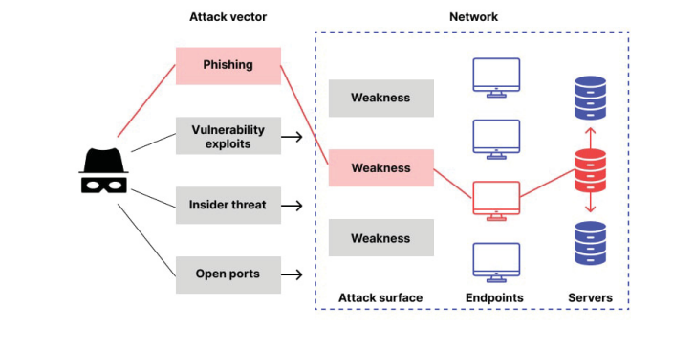
Figure 3.1: Ransomware Attack Process, Source: (Fernando et al., 2020).

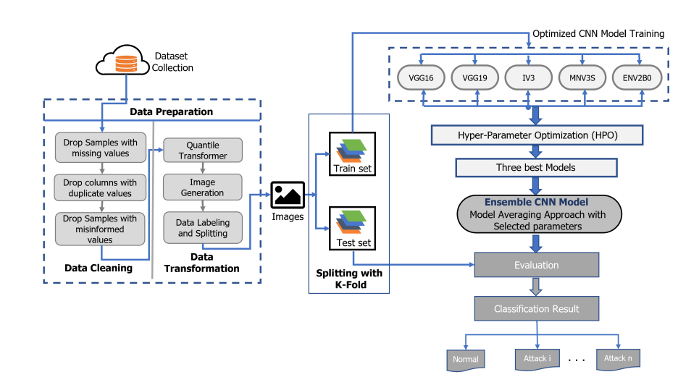
Figure 3.2: System Design Framework for the Proposed Ensemble Transfer Learning Model, Source: (Okey et al., 2022).
3.2 ANALYSIS OF THE EXISTING SYSTEM
In the existing system, ransomware attack detection on cloud-encrypted data typically relies on traditional methods such as signature-based detection and anomaly detection. However, these approaches often struggle to effectively detect ransomware activities within encrypted data due to the dynamic nature of ransomware threats and the encryption of data, which obscures the underlying content. Moreover, traditional detection methods may suffer from high false positive rates and limited scalability, particularly in the context of large-scale cloud environments where the volume and diversity of data pose significant challenges.

3.3 PROBLEMS OF THE EXISTING SYSTEM
The existing system faces several challenges in effectively detecting ransomware attacks on cloud-encrypted data. Firstly, traditional detection methods are often unable to discern ransomware activities within encrypted data streams, leading to delayed or inaccurate detection. Additionally, the reliance on predefined signatures or static rules may render traditional detection methods vulnerable to evasion techniques employed by sophisticated ransomware variants. Moreover, the lack of robust detection mechanisms exacerbates the vulnerability of cloud infrastructures to ransomware threats, risking the confidentiality, integrity, and availability of critical data assets.
3.4 DESCRIPTION OF THE PROPOSED SYSTEM
The proposed system aims to enhance ransomware attack detection on cloud-encrypted data by leveraging transfer learning and deep learning ensemble models. The integration of transfer learning and deep learning ensemble models forms the backbone of an advanced ransomware detection framework tailored specifically for cloud-encrypted data. Transfer learning plays a crucial role in adapting pre-trained models, which have been trained on related tasks or datasets, to the ransomware detection task in cloud environments. By fine-tuning these pre-trained models on encrypted data, the system can effectively leverage the knowledge encoded within the models' parameters to identify subtle patterns indicative of ransomware activities, thereby enhancing detection accuracy.
The deep learning ensemble models utilized in the proposed system enable the combination of multiple detection algorithms to achieve greater robustness and reliability. Ensemble learning techniques, such as bagging and boosting, facilitate the integration of diverse detection approaches, such as convolutional neural networks (CNNs), recurrent neural networks (RNNs), and generative adversarial networks (GANs). By aggregating the outputs of these complementary models, the system can effectively capture the complex relationships and patterns present in encrypted data, enhancing the detection of ransomware activities while minimizing false positives and false negatives.
The proposed system incorporates techniques for data augmentation and synthesis to address the challenge of limited labeled data in ransomware detection tasks. By employing generative adversarial networks (GANs) to generate synthetic ransomware samples and augment training datasets, the system can effectively increase the diversity and representativeness of training data, thereby improving the generalization performance of deep learning models. Additionally, data augmentation techniques such as random perturbations and transformations can further enhance the robustness and resilience of the system against adversarial attacks and evasion techniques employed by ransomware variants.
  - ADVANTAGES OF THE PROPOSE SYSTEM
The proposed system offers several advantages over the existing system. They are:
- By leveraging transfer learning, the system can adapt pre-existing knowledge from related tasks to enhance ransomware detection accuracy, even in the presence of encrypted data.
- Deep learning ensemble models enable the integration of multiple detection algorithms, enhancing the system's robustness and resilience against evolving ransomware variants.
- The proposed system's reliance on advanced machine learning techniques enables it to scale effectively to large-scale cloud environments and adapt to changing threat landscapes, thereby providing more comprehensive protection against ransomware attacks.
- The proposed system represents a significant advancement in ransomware detection capabilities, offering improved accuracy, scalability, and adaptability to mitigate the growing threat of ransomware in cloud infrastructures.

CHAPTER FOUR
DESIGN, IMPLEMENTATION AND DOCUMENTATION OF THE SYSTEM
4.1 DESIGN OF THE SYSTEM
This is the computation of the particulars of a new system and the determination of what the new system would be and the function it is to perform. This may involve changing from one system to another or modifying the existing system operation.
The most challenging phase of the system life cycle is the change from manual operation to a faster and more accurate one; system design stage covers the technical specifications that will be employed in the implementation of the new system in order to modify the previous system. Some factors are put in consideration. These factors include input design, output design, definitions file and procedure designs and other documentation.
4.1.1 OUTPUT DESIGN
This incorporates the objectives of solving the existing system problems and challenges. This involves the structuring of the desired information and also to enhance efficient and effective malware detection. Things taken into consideration in determining the output are represented below:

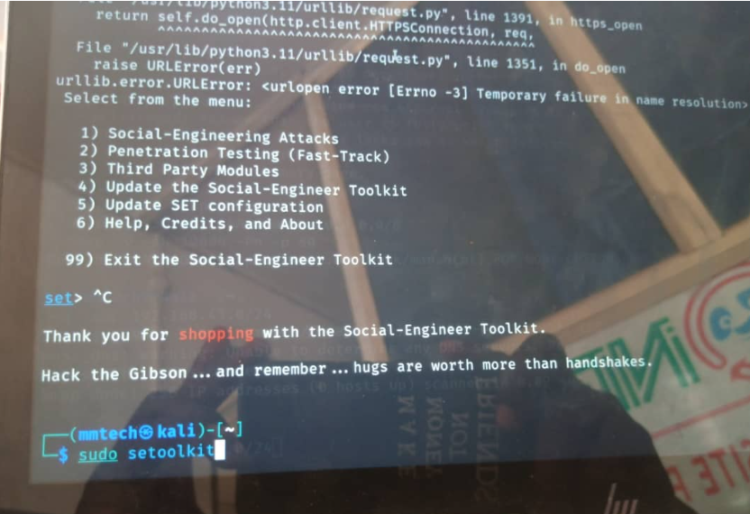
Figure 4.1: Kali Linux OS Terminal Command
This is a page where users enter their commands
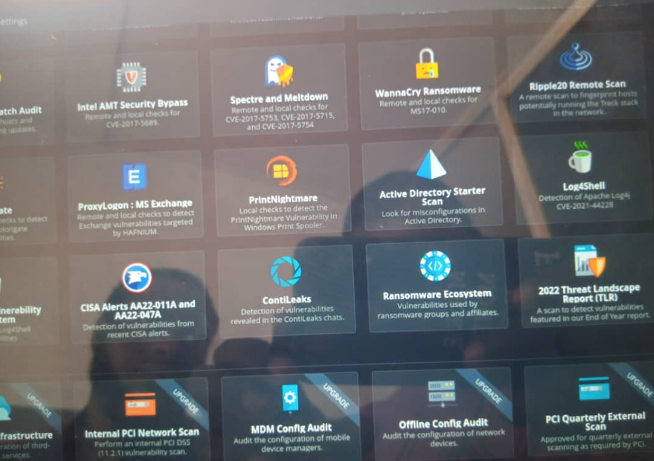
Figure 4.2: Nessus Interface for Ransomware Detection Dashboard.
This interface allows allow user to navigate within the Nessus environment
4.1.2 INPUT DESIGN
The input to run this software is obtained from Menstrual cycle monitoring system administrator. The administrator is expected to register any User information. He can achieve this by typing via the keyboard. The input required from the Users is their personal data and answer?
To the questions set by the administrator. It can serve as the various input layouts from the various modules first from the collection of data and module then from the assessment module and input from User respectively.
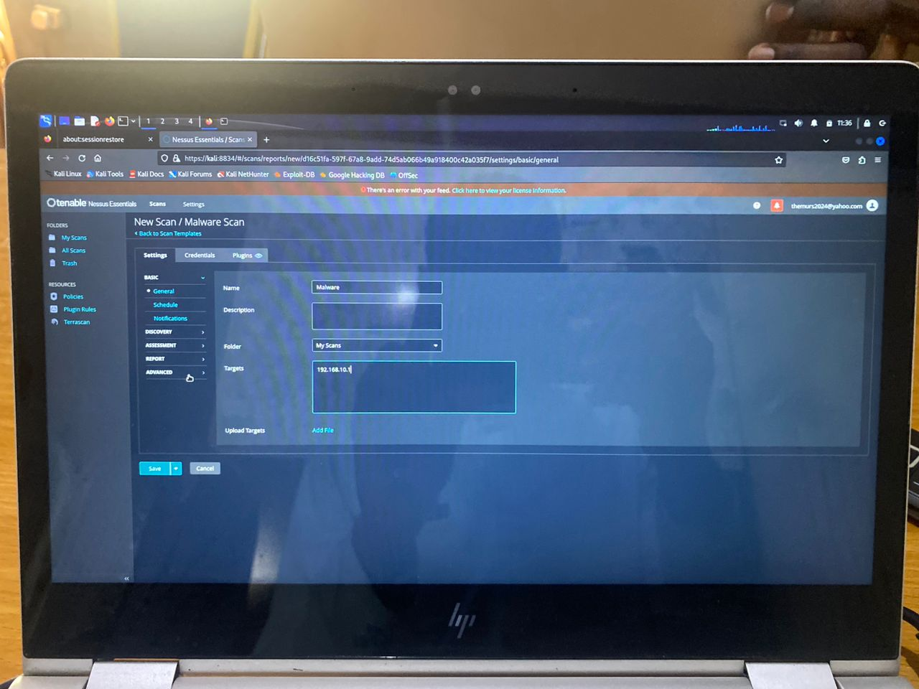

Figure 4.3: Malware detection
This is a page where Ransomware is been detected.
4.1.3 PROCEDURE DESIGN
These are the steps involved in unifying the whole process to produce the desired output. It involves computer procedures which start from the original input lessons to the output result file. This allows the processing of User information and result to be possible. Menu is provided to aid User in the processing of the output file.

4.2 IMPLEMENTATION OF THE SYSTEM
This entails the choice of the programming language employed to implement the software which should-be suitable for Ransomware detection. The software is designed for the use of Ransomware Detection which should serve as an assistant. It is also expected to be used in conjunction with the User. The Menstrual cycle monitoring system admin will prepare data base while the admin will provide personal data about the User.
4.2.1 CHOICE OF PROGRAMMING LANGUAGE
The Application was developed in a .net (dot net) integrated development environment (.net IDE). The Application IDE is chosen following the fact that extracted information needs to be presented in an enhanced pictorial/graphical format and easy communication with the database for program flexibility in windows platform.
4.2.2 HARDWARE REQUIREMENT
i. 500 Hz minimum with CD ROM drive etc.
ii. Hard disk of capacity 10GB Minimum
iii. 126-512 megabyte of RAM
iv. An Uninterrupted power supply (UPS)
v. A voltage stabilizer
vi. A power generating set etc.
4.2.3 SOFTWARE REQUIREMENT
i. Windows operating system such as Windows 7 etc
ii. Dream Weaver
iii. Server Query Language (SQL).
4.3 DOCUMENTATION OF THE SYSTEM
4.3.1 PROGRAM DOCUMENTATION
The program is packaged for use in any system irrespective of either it runs visual studio application or not. After developing a program in Visual studio, there is a facility provided in Microsoft Visual Studio suite called “Package and Deployment Wizard” that is used in Visual studio application packaging and deployment.
The Menstrual cycle monitoring system is packaged into an installable setup that can be run from any system.
4.3.2 MAINTAINING OF THE SYSTEM
The system maintenance refers to making modification to an already existing application/program without necessarily re-writing everything from start. Program maintenance of a program includes modification of the program to meet-up with certain requirements of the Users. In this course, additional features can be added, errors corrected, ambiguous interfaces redesigned to eliminate confusions and unnecessary features removed.
Maintaining this program can be done in a Visual studio environment. Any future modification can be by re-running the program source code in a visual studio environment making necessary changes and updates and recompile the application into an upgrade version of the existing version of the mini word processing application. Further versions of this program can be named following their year of release or it can be given a different version number.

CHAPTER FIVE
SUMMARY, CONCLUSION AND RECOMMENDATION
5.1 SUMMARY
The proposed approach for enhancing ransomware attack detection on cloud-encrypted data utilizes transfer learning and deep learning ensemble models to address the challenges posed by the dynamic nature of ransomware threats and the encryption of data in cloud environments. By leveraging transfer learning, pre-trained models can be adapted to the ransomware detection task, leveraging knowledge from related domains to improve accuracy. Deep learning ensemble models further enhance detection capabilities by combining multiple algorithms to achieve greater robustness and reliability. Additionally, techniques such as data augmentation and synthesis are employed to address the challenge of limited labeled data in ransomware detection tasks.
Transfer learning enables the adaptation of pre-trained models to the ransomware detection task, leveraging knowledge learned from related domains to enhance detection capabilities. By fine-tuning pre-existing models on encrypted data, the proposed system can effectively identify subtle patterns indicative of ransomware activities, thereby improving detection accuracy even in the absence of explicit signatures or known patterns. Moreover, deep learning ensemble models combine multiple detection algorithms to achieve greater robustness and reliability. By aggregating the outputs of diverse models, the system can capture complex relationships and patterns present in encrypted data, minimizing false positives and false negatives. The proposed approach offers a comprehensive and sophisticated solution to the problem of ransomware attack detection in cloud environments, promising improved accuracy, scalability, and adaptability to mitigate the growing threat of ransomware.
5.2 CONCLUSION
The proposed approach offers a promising solution to the problem of ransomware attack detection in cloud environments. By harnessing the power of transfer learning and deep learning ensemble models, the system can effectively detect ransomware activities within encrypted data streams, even in the absence of explicit signatures or known patterns. Moreover, the integration of data augmentation techniques enhances the system's generalization performance and resilience against adversarial attacks. Overall, the proposed system represents a significant advancement in ransomware detection capabilities, offering improved accuracy, scalability, and adaptability to mitigate the growing threat of ransomware in cloud infrastructures.
5.3 RECOMMENDATIONS
To further enhance the effectiveness and practicality of the proposed approach, several recommendations was made.
i. continued research and experimentation are needed to optimize and validate the performance of transfer learning and deep learning ensemble models in real-world cloud environments.
ii. efforts should be made to develop user-friendly interfaces and integration tools to facilitate the deployment and adoption of the proposed system by organizations of all sizes.
iii. ongoing collaboration between academia, industry, and government agencies is essential to address emerging challenges and advance the state-of-the-art in ransomware detection and cybersecurity more broadly.
RFERENCES
Alotaibi, Y. & Ilyas, M. (2023). Ensemble-Learning Framework for Intrusion Detection to Enhance Internet of Things’ Devices Security, Journal of Computer Cognitive Engineering. Vol. 3. Pp. 34-35.
Bello, I., Chiroma, H., Abdullahi, U., Gital, A. Y. Jauro, F., Khan, A., Okesola, J. O. & Abdulhamid, S. M. (2020). Detecting Ransomware Attacks using Intelligent Algorithms: Recent Development and Next Direction from Deep Learning and Big Data Perspectives, Journal of Ambient Intelligence and Humanized Computing. Vol. 1. Pp. 4-5. doi.org/10.1007/s12652-020-02630-7
Fernando, D. W., Komninos, N. & Chen, T. (2020). A Study on the Evolution of Ransomware Detection Using Machine Learning and Deep Learning Techniques, In Proceedings of the 2017 International Conference on Advances in Computing, Communications and Informatics (ICACCI), Udupi, India. Pp. 21-22.
Firdausi, C., Erwin, A & Nugroho, A. S. (2019). Analysis of Machine Learning Techniques used in Behavior-Based Malware Detection, Second International Conference on Advances in Computing, Control, and Telecommunication Technologies. Pp. 201–203.
Glorot, X., Bordes, A. & Bengio, Y. (2019). Deep sparse rectifier neural networks, In Proceedings of the Fourteenth International Conference on Artificial Intelligence and Statistics, Fort Lauderdale, FL, USA. Pp. 315–323.
Polat, H., Polat, O. & Cetin, A. (2020). Detecting DDoS Attacks in Software-Defined Networks through Feature Selection Methods and Machine Learning Models. Sustainability. Pp. 8-9.
Kadavath, R. & Thara, R. J. (2020). Network Level Detection of Ransomware Attacks using Ensemble Learning, Computer Fraud & Security. Vol. 7, Issue: 11, Pp. 76-79, E
Maniath, S., Ahok, A., Poornach, R. P., Sujadev, V. G., Sankar, P. & Jan, S. (2017). Deep Learning LSTM based Ransomware Detection, In Proceedings of the Recent Developments in Control, Automation & Power Engineering (RDCAPE), Noida, India. Pp. 442–446.
Nkongolo, M. N. (2020). Ransomware Detection Dynamics: Insights and Implications, Journal of Process Control. Vol. 9, Issue: 5. Pp. 79–89.
Okey, O. D., Melgarejo, D. C., Saadi, M., Rosa, R. L., Kleinschmidt, J. H. & Rodríguez, D. Z. (2022). Transfer Learning Approach to IDS on Cloud IoT Devices Using Optimized CNN, Journal of Machine Learning Research. Vol. 12, Issue: 4. Pp. 2825–2830.
Popryho, L. & Popryho, Y. (2023). Behaviour-Based Detection of Ransomware Attacks in the Cloud using Machine Learning, Journal of Chemical Information and Modeling. Vol. 62, Issue: 17. Pp. 3982–3992. doi.org/10.1021/acs.jcim.2c00765
Singh, A., Mushtaq, Z., Abosaq, H. A., Mursal, S. N., Irfan, M. & Nowakowski, G (2023). Enhancing Ransomware Attack Detection Using Transfer Learning and Deep Learning Ensemble Models on Cloud-Encrypted Data, 1st International Conference on Innovations in High Speed Communication and Signal Processing (IHCSP), Bhopal, India. Pp. 4–5.

