

A PROJECT REPORT
ON
TOPOGRAPHIC INFORMATION SYSTEM OF PART OF JUDGES’ QUARTERS, TANKE, ILORIN, ILORIN SOUTH LOCAL GOVERNMENT, AREA OF KWARA STATE.

BY
UTHMAN BADIRAT BUKOLA
HND/23/SGI/FT/0030

SUBMMITED TO:
THE DEPARTMENT OF SURVEYING AND GEO-INFORMATICS, INSTITUTE OF ENVIRONMENTAL STUDIES, KWARA STATE POLYTECHNIC ILORIN.

IN PARTIAL FULFILLMENT OF THE REQUIREMENT FOR THE AWARD OF HIGHER NATIONAL DIPLOMA IN SURVEYING AND GEO-INFORMATICS.

JUNE, 2025

CERTIFICATE
I hereby certified that the information given in this project was obtained as a result of the observation and measurement made by me and that the survey was carried out in accordance with survey laws, regulations and departmental instructions
_________________________________
UTHMAN BADIRAT BUKOLA
Matric. No: HND/23/SGI/FT/0030

CERTIFICATION
This is to certify that this project was carried out by UTHMAN BADIRAT BUKOLA with Matric No.: HND/23/SGI/FT/0030 under my instruction and supervision for the award of Higher National Diploma in Surveying and Geoinformatics, Kwara State Polytechnic, Ilorin, Kwara State Nigeria. I hereby declared that he has conducted himself with due diligence and honesty on the said duties.

………………………………… ………………………………
SURV. ADEBANJI AKINYEDE DATE
(Project Supervisor)

………………………………. …………………………
SURV. R.S. AWOLEYE DATE
(Project Coordinator)

……………………………… ………………………………
A.I ISAU DATE
Head of Department (H.O.D)
Surveying & Geo-informatics

……………………………….. ……………………………..
EXTERNAL EXAMINER DATE

DEDICATION
This project is dedicated to Almighty ALLAH, the author and the finisher of everything who gave me the grace and privilege to attain this stage in my education pursuit.

ACKNOWLEDGEMENT
I give thanks and glory to my Creator for the privilege bestowed on me that resulted in the accomplishment of this project work and also a big thanks to the management of Kwara State Polytechnic for the privilege and opportunity given to me to study in their great institution.
A project of such scope as this could not have been done without the assistance of proven professionals, consultancies, advisors, well wishers, family and friends.
My sincere gratitude goes to my Head of Department (HOD); A.I ISAU and my Supervisor; SURV. ADEBANJI AKINYEDE for their support towards the success of this project work, I really appreciate you sir.
To all the lecturers in the department of Surveying and Geo-informatics; Abimbola I. Isau, Surv. Ayuba Abdulsalam, Surv. R.S Awoleye, Surv. R.O Asonibare, Surv. A.G Aremu, Surv. B.F Diran, Surv. Williams Kazeem, Surv. Kabir Babatunde who has imparted their knowledge in me in one area or the other during my year of study, I am grateful for all your effort and support. May Almighty ALLAH bless you all (Amiin). May Almighty ALLAH bless you all (Amiin).
I'm deeply grateful to my parents; MR & MRS OLORUNDARE for their unconditional love, support, and wisdom. Their encouragement and sacrifices have been the driving force behind my endeavors. Thank you, Mom and Dad, for being my pillars of strength and inspiration. I dedicate this project to you, with love and appreciation.
Special thanks to my mother, MRS UTHMAN OMOLARA, for her unwavering love, care, and dedication that has shaped me into the person I am today. Her selfless love and Her influence and values have guided me throughout this project, and I'm forever grateful for her presence in my life.
I would like to extend my heartfelt thanks to my beloved family members and friends who have supported me throughout this project. Special appreciation to my selfless big sister; Mrs. Oyebamiji Mayowa and Mrs. Adeyemi Abidemi and my big brother; Mr Uthman Olawale, for their guidance, encouragement, and unwavering support.
I'm also grateful to my friends, Adekanbi bimbo, Pop Nur, Damilare, Mr Maruf,and Abdulwasiu Olaitan, for their camaraderie, motivation, and help whenever I needed it. Their collective support has made this journey more enjoyable and fulfilling.
May Almighty ALLAH bless you all (Amiin).

TABLE OF CONTENTS
Pages
Title Page i
Certification ii
Dedication iii
Acknowledgment iv
Table of contents v
List of Tables ix
List of Figures x
Abstract xi
CHAPTER ONE
General Introduction
1.1 Background to the Study 1
1.2 Statement of the Problem 2
1.3 Aim and Objectives of the Project 3
1.3.1 Aim 3
1.3.2 Objectives 3
1.4 Scope of the Project 4
1.5 Personnel 4
1.6 Significance of the Study 5
1.7 Study Area 6
CHAPTER TWO
Literature review
2.1 Foundational Concepts of Topographic Information System (TIS) 7
2.2 Conceptual Framework 8
2.2.1 Evolution and Technological Advancements 12
2.2.2 Data Acquisition and Processing in Topographic Information System 14
2.2.3 Data Storage and management in Topographic Information System 16
2.3 Applications of Topographic Information Systems 18
2.4 Integration of Topographic Information System 19
2.5 Challenges and Limitations 21
2.6 Emerging Trends and Future Directions 23
CHAPTER THREE
Research Methodology
3.0 Methodology 25
3.1 Database Design 25
3.1.1 View of Reality 25
3.1.2 Conceptual Design 27
3.1.3 Logical Design 28
3.1.4 Physical Design 28
3.2 Reconnaissance 30
3.2.1 Office Planning 30
3.2.2 Field Reconnaissance 31
3.2 Equipment used/system selection and software 33
3.2.1 Hardware used 33
3.2.2 Software Component 33
3.3 Instrument Test 34
3.3.1 Horizontal Collimation Test 34
3.3.2 Vertical Index Error Test 35
3.3.3 Analysis of Collimation and Vertical Index Data 35
3.4 Control Check 36
3.5 Monumentation 37
3.6 Data Acquisition 38
3.6.1 Geometric Data Acquisition 38
3.6.2 Attributes Data Acquisition 40
3.7 Data Downloading and Processing 40
3.7.1 Data Downloading and Editing 40
3.7.2 Data Processing and Data Editing 40
3.7.3 Data Processing using ArcGIS 10.3 40
3.8 Database Implementation 50
3.8.1 Database Management Systems 50
3.8.2 Database Maintenance 51
3.8.3 Back computation 52
3.8.4 Area Computation 52
CHAPTER FOUR
Spatial Analyses and Presentation
4.1 Testing of Database 53
CHAPTER FIVE
Costing, Summary, Problem Encountered, Conclusion and Recommendations
5.1 Costing 42
5.2 Summary 44
5.3 Problem Encountered 45
5.4 Conclusion 45
5.5 Recommendations 46
References
Appendix

LIST OF TABLES
Pages
Table 3.1: Table showing Building and its attribute 28
Table 3.2: Table showing the Road and its attributes 29
Table 3.3: Table showing the Trees and its attributes 29
Table 3.4: Table showing the Electric Poles and its attributes 29
Table 3.5: Table showing the Vegetation and its Attributes 30
Table 3.6: Table showing the Coordinates of Controls 31
Table 3.7: Table showing the Horizontal Collimation Data 35
Table 3.8: Table showing the Vertical Index Data 35
Table 3.9: Table showing the back computation of the control coordinates 36
Table 3.10: Table showing the distance observation result of the control check 37
Table 3.11: Table showing the observation result of control check 37
Table 3.12: Building 47
Table 3.13: Road 47
Table 3.14: Trees 47
Table 3.15: Electric Poles 48
Table 3.16: Table showing the back computation 52
Table 3.17: Table showing the area computation 52
Table 5.1: Table showing the direct cost parameters 57

LIST OF FIGURES
Pages
Fig. 1.1: Maps Showing the Study Area 7
Fig. 3.1 Design and Construction Phases in Spatial Database 26
Fig. 3.2: E-R Diagram (Entity relationship diagram) 27
Fig. 3.3: Recce diagram of the study area (not drawn to scale) 32
Fig 3.4: Horizontal Collimation and Vertical Index error test. 34
Fig. 3.5: Pillar Description 38
Fig. 3.6 shows the spot height 48
Fig. 3.7: Shows the Tin creation 49
Fig. 3.8 shows the slope aspect 50
Fig. 4.1: Shows the attribute database 53
Fig. 4.2: Showing catalog, attribute table and table of content 54
Fig 4.3.: Retrieving Area whose height is greater than 3.007 meters 55

Fig 4.4: Result of area whose height is greater than 3.007 meters 55
Fig 4.5: Shows the building use for shop 56

ABSTRACT
This project developed a detailed Topographic Information System (TIS) for a section of Judges' Quarter, Tanke, within Ilorin South Local Government Area, Kwara State, Nigeria. Recognizing the critical need for accurate spatial data to support effective land use planning, infrastructure development, and environmental management in this rapidly urbanizing area, the study employed field surveys using GPS technology and Total Station (TS). Key topographic features, including elevation points, contours, slopes, drainage patterns, and significant man-made structures, were meticulously captured and integrated. The processed data was used to generate essential digital products, including a high-resolution Digital Elevation Model (DEM), detailed contour maps, slope classification maps, and a comprehensive topographic map of the study area. These outputs were systematically organized and managed within a Geographic Information System (GIS) environment, creating a robust spatial database. The resulting Topographic Information System provides a vital geospatial framework. It offers planners, engineers, environmental scientists, and local government authorities precise and readily accessible information on the terrain characteristics of Judges' Quarter. This system is fundamental for informed decision-making in site suitability analysis, flood risk assessment, road network planning, construction projects, and sustainable land management within the studied locality.

CHAPTER ONE
INTRODUCTION
1.1 BACKGROUND OF THE STUDY
The study on the development of a Topographic Information System (TIS) for part of Judges Quarters in Tanke, Ilorin, Ilorin South Local Government Area (LGA) of Kwara State, Nigeria, is situated within the broader context of rapid urbanization, infrastructural development, and the growing need for precise geospatial data to support sustainable land-use planning. Ilorin, the capital of Kwara State, has witnessed significant population growth and urban expansion over recent decades, driven by its strategic location as a political, educational, and commercial hub. Tanke, a prominent district within Ilorin South LGA, hosts critical government and residential infrastructures, including the Judges Quarters, which serves as a residential zone for legislative officials. However, the absence of detailed and updated topographic information in this area poses challenges for effective urban management, environmental planning, and disaster risk mitigation.
A Topographic Information System (TIS)—a specialized GIS focusing on terrain and feature mapping—is critical to address these gaps. By integrating elevation data, hydrology, infrastructure networks, and land use patterns, a TIS enables precise visualization and analysis of the physical landscape, essential for sustainable development.
Topographic Information Systems, which integrate terrain elevation, hydrological features, land cover, and man-made structures, are essential tools for analyzing spatial patterns, assessing slope stability, managing drainage systems, and guiding construction projects. This study emerges against the backdrop of increasing demand for accurate geospatial frameworks to address issues such as flooding, erosion, unplanned settlements, and infrastructural decay in rapidly urbanizing regions like Tanke. By leveraging advanced geospatial technologies such as Geographic Information Systems (GIS), remote sensing, and Global Navigation Satellite Systems (GNSS), the research aims to produce a high-resolution topographic database that captures the physical and structural characteristics of the area. The findings are expected to provide policymakers, urban planners, and environmental managers with actionable insights to enhance land administration, optimize resource allocation, and promote resilient development in alignment with Kwara State’s urban renewal initiatives and Nigeria’s Sustainable Development Goals (SDGs). The study thus bridges a critical gap in spatial data availability, fostering evidence-based decision-making for sustainable urban growth in Ilorin South LGA.
The growth of Ilorin, particularly Tanke, has led to unplanned urbanization, straining existing infrastructure and natural resources. Issues such as haphazard construction, inadequate drainage systems, and encroachment on green spaces are prevalent. The Judges Quarters, despite its planned status, faces risks from flooding due to undulating terrain and poor drainage planning. Outdated topographic maps and fragmented land records exacerbate these challenges, hindering effective urban governance.
The development of a TIS for the Judges’ Quarters addresses a pressing need for modern spatial tools in Ilorin South LGA’s urban governance. By transforming raw topographic data into actionable intelligence, this study will foster resilience, efficiency, and sustainability in a rapidly evolving legislative and residential zone. It sets a precedent for similar systems in Nigeria’s urban centers, bridging the gap between urbanization and intelligent planning.
1.2 STATEMENT OF THE PROBLEM
Current spatial data for the Judges’ Quarters is either outdated or non-systematic, leading to:
- Inefficient land-use planning and disputes over allocations.
- Flood risks due to inadequate understanding of topography and drainage pathways.
- Uncoordinated infrastructure development, affecting utilities and transportation networks.
The absence of a centralized topographic database impedes the Ilorin South LGA’s ability to make informed decisions, necessitating a robust TIS for evidence-based planning.
1.3 AIM AND OBJECTIVES OF THE PROJECT
1.3.1 AIM
The aim of this project is to carry out the topographic information system of part of JUDGES’ QUARTERS, TANKE, ILORIN, ILORIN SOUTH LOCAL GOVERNMENT AREA OF KWARA STATE.

1.3.2 OBJECTIVES
The objectives of this study is to:
- conduct a detailed topographic survey of the study area using geospatial techniques such as GPS mapping and GIS applications.
- generate an accurate topographic map that represents the terrain characteristics, elevation levels, drainage patterns, and land use distribution within the estate.
- analyze the impact of topography on land development, infrastructure planning, and environmental risks such as flooding and erosion.
- create a digital database for storing and managing topographic information, which can be accessed for future planning and decision-making.
- provide recommendations on the application of topographic data in sustainable urban development, land administration, and disaster mitigation strategies.

1.4 SCOPE OF THE PROJECT
The project scopes are the stages that will be involve to achieve our aims.
- Project planning
- Recce
- Data acquisition
- Data processing
- Data analysis
- Data presentation
- Technical report writing
1.5 PERSONNEL
The students listed below were the members of this group who participated in the execution of the project.
NAMES ROLE
- UTHMAN BADIRAT BUKOLA AUTHOR
- IYANDA PHILIP AYOMIDE MEMBER
- UTHMAN BADIRAT BUKOLA MEMBER
- EMMANUEL MERCY UNEKWUOJO MEMBER
- ADENIYI AISHAT ADERAYO MEMBER
- OLABOSOYE GIFT FUNMILAYO MEMBER
- BELLO IBRAHIM OPEYEMI MEMBER

1.6 SIGNIFICANCE OF THE STUDY
Conducting a study on Topographic Information of Part of Judges’ Quarters will of good benefit for:
- Urban Planners: Streamlining land allocation and infrastructure projects.
- Environmental Managers: Mitigating flood risks through hydrological modeling.
- Local Government: Enhancing security planning and utility management.
- Residents: Improving livability through better-designed neighborhoods.
This study aligns with Kwara State’s urban resilience goals and Nigeria’s broader agenda for smart city development.

  - STUDY AREA
The study area for this project is situated on Part of Judges’ Quarters, Tanke area of Ilorin South Local Government Area of Kwara State. The geographic location of the study area lies between latitude 08º 30' 00"N and latitude 08º 30' 05"N and between longitude 04º 36' 55" and longitude 04º 37' 05" and the total area covered was about 12.300 hectares.
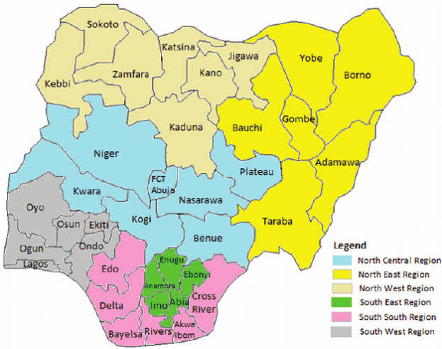
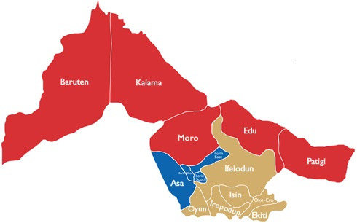
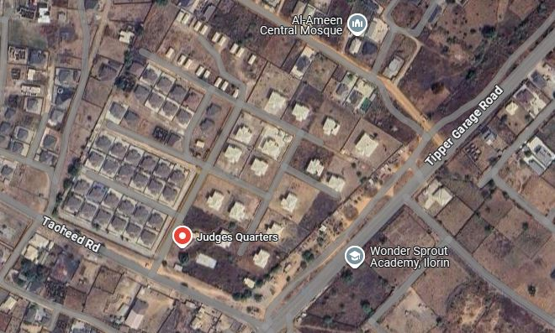
Fig. 1.1: Maps showing the study area.

CHAPTER TWO
LITERATURE REVIEW
2.1 FOUNDATIONAL CONCEPTS OF TOPOGRAPHIC INFORMATION SYSTEM (TIS)
Topographic Information Systems (TIS) are a specialized subset of Geographic Information Systems (GIS) that concentrate on the representation, analysis, and interpretation of the Earth's surface features, particularly elevation and terrain morphology. While GIS encompasses a broad range of spatial data applications—such as land use planning, environmental monitoring, and infrastructure development—TIS are uniquely focused on capturing, managing, and analyzing topographic information with high precision (Burrough & McDonnell, 1998). This distinction defines the narrower yet deeper scope of TIS, which is oriented towards applications requiring detailed surface modeling, such as hydrological modeling, slope analysis, and terrain-based navigation (Longley et al., 2015).
A core aspect of TIS is terrain representation, which involves translating the continuous surface of the Earth into digital form. This is achieved using specialized data models, most notably Digital Elevation Models (DEMs) and Triangulated Irregular Networks (TINs). DEMs represent elevation data in a raster format where each cell contains a single elevation value, making them suitable for grid-based analyses such as flow direction or hillshade generation (Li et al., 2005). On the other hand, TINs use irregularly spaced elevation points connected by triangles, allowing for more accurate representation of varied terrain features, especially in areas with abrupt elevation changes (Zhou & Chen, 2011).
Coordinate systems form another foundational element of TIS, enabling the precise georeferencing of topographic data. Both geographic coordinate systems (e.g., latitude and longitude) and projected coordinate systems (e.g., Universal Transverse Mercator) are employed to ensure spatial accuracy and consistency when integrating terrain data with other thematic layers. These systems are essential for tasks such as calculating slope gradients, determining visibility, and conducting terrain-based simulations (Snyder, 1987).
In sum, TIS extend the capabilities of general GIS by incorporating terrain-specific data structures and analytical functions tailored to elevation-based phenomena. The use of high-resolution terrain models, accurate coordinate frameworks, and dedicated analysis tools enables TIS to support complex geospatial tasks in engineering, environmental science, and defense sectors. By focusing on topography as the primary analytical dimension, TIS provide deeper insights into spatial problems where surface form and elevation play a critical role (de Smith, Goodchild, & Longley, 2020).
2.2 CONCEPTUAL FRAMEWORK
The concept of a Topographic Information System (TIS) has evolved significantly over time as scholars and practitioners have increasingly recognized the value of topographic data in geographic information science. According to Longley et al. (2015), TIS represents a specialized application of Geographic Information Systems (GIS) that is particularly focused on the representation and analysis of surface features, such as elevation, slopes, and natural terrain forms. These authors emphasize that topographic information is foundational to spatial thinking because it underpins nearly all geospatial analysis, from hydrological modeling to infrastructure design. They argue that TIS should not be viewed merely as a repository of map data, but as an analytical platform that facilitates understanding of how terrain influences human and environmental systems.
Burrough and McDonnell (1998) contribute a foundational perspective by highlighting the role of spatial data structures in TIS. They stress the importance of accurate data modeling techniques such as Triangulated Irregular Networks (TINs) and Digital Elevation Models (DEMs) in representing surface variability. Their work underscores the complexity involved in managing topographic data, especially when dealing with large-scale or high-resolution datasets. Furthermore, they assert that the utility of TIS is dependent not only on data quality but also on the algorithms used for interpolation, contour generation, and surface analysis. These technical insights help lay the groundwork for understanding the computational challenges that accompany topographic mapping.
Goodchild (2007) expands the discussion by addressing the social and technological transformations that have impacted TIS. He introduces the concept of "citizens as sensors," acknowledging that the rise of volunteered geographic information (VGI) and participatory mapping has brought new forms of topographic data into TIS environments. This shift, he argues, enhances the dynamism and accessibility of TIS, allowing non-experts to contribute observations and updates that may improve the accuracy of terrain-related information. However, Goodchild also warns of the potential for data inconsistency and stresses the need for robust validation mechanisms to maintain scientific integrity in TIS applications.
Longley et al. (2015) expand this definition by framing TIS as an integrative platform that combines topographic data with socio-economic or ecological datasets, enabling spatially explicit decision-making. They highlight its role in disaster management, where slope stability or floodplain mapping relies on precise topographic representations.
Tomlin (1990), known for his work on cartographic modeling, approaches TIS from an analytical perspective, emphasizing its ability to perform terrain-specific operations such as viewshed analysis, watershed delineation, or line-of-sight calculations. He argues that TIS distinguishes itself from generic GIS through its focus on surface geometry and derivatives, which are critical for engineering and military applications.
In the context of land use and environmental planning, Maguire, Goodchild, and Rhind (2005) discuss the integration of TIS with other spatial decision support systems. They argue that TIS is particularly powerful when combined with land cover data, demographic information, and temporal datasets, enabling multidimensional analyses that inform policy and development. For instance, they describe how terrain data can be overlaid with hydrological layers to model flood risks, a process that is essential for sustainable urban planning. Their work emphasizes the value of interoperability and data fusion in extending the functionality of TIS beyond topography alone.
More recently, Zhang and Li (2020) have explored the integration of artificial intelligence into TIS, focusing on the automation of topographic feature extraction from satellite imagery and LiDAR data. They argue that machine learning techniques, such as convolutional neural networks (CNNs), have dramatically improved the speed and accuracy of terrain classification. This advancement, they suggest, positions TIS as a key component of smart geospatial technologies, with applications in autonomous navigation, precision agriculture, and real-time environmental monitoring. Their work highlights the future-oriented trajectory of TIS and the growing role of automation in topographic analysis.
The system architecture of a TIS typically comprises several core components: data input, storage, processing, analysis, and visualization. Data acquisition may involve satellite imagery, aerial photography, GPS surveys, and ground-based measurements. These inputs are transformed into structured topographic data through processes such as digitization, georeferencing, and interpolation. The database management system (DBMS) forms the backbone of the TIS by ensuring that spatial and attribute data are efficiently stored and retrieved (Burrough & McDonnell, 1998). Analytical tools within a TIS enable users to perform terrain analysis, slope and aspect mapping, watershed delineation, and landform classification, which are essential for informed decision-making in various sectors.
A key aspect of the conceptual framework is interoperability, which allows TIS to integrate with other geospatial systems and datasets through standardized protocols and formats such as XML, GML, and GeoJSON. This interoperability enhances data sharing and collaboration among government agencies, research institutions, and private organizations. Moreover, the advancement of web-based TIS and cloud computing has significantly improved the accessibility and scalability of topographic data, allowing real-time updates and remote access to spatial information (Goodchild, 2007).
The effectiveness of a TIS also relies heavily on the accuracy and resolution of the data it manages. High-resolution topographic data, such as those derived from LiDAR (Light Detection and Ranging) and UAV (Unmanned Aerial Vehicle) surveys, contribute to precise modeling of surface characteristics. However, the development and maintenance of a TIS require substantial technical expertise, financial investment, and institutional coordination. Challenges such as data redundancy, lack of standardization, and limited technical capacity in developing regions often hinder the implementation of robust TIS frameworks (Maguire, Goodchild, & Rhind, 2005).
In summary, the scholarly discourse around Topographic Information Systems reflects a convergence of foundational theory, technological advancement, and applied research. From the early emphasis on data structures and cartographic modeling (Burrough & McDonnell, 1998) to the incorporation of public data sources (Goodchild, 2007) and AI-driven automation (Zhang & Li, 2020), TIS continues to evolve in scope and complexity. These diverse perspectives illustrate that TIS is not merely a mapping tool but a dynamic, interdisciplinary system that plays a critical role in spatial science, policy-making, and environmental stewardship.

2.2.1 EVOLUTION AND TECHNOLOGICAL ADVANCEMENTS
The evolution of the Topographic Information System (TIS) reflects a broader transformation in geospatial sciences, marked by a steady shift from traditional analog cartography to highly advanced digital systems. Initially, topographic mapping was a manual process, relying on field surveys, triangulation, and hand-drawn contour lines on paper maps. These analog methods, though foundational, were labor-intensive, time-consuming, and limited in spatial accuracy and temporal flexibility. With the advent of computer technology and Geographic Information Systems (GIS) in the late 20th century, TIS underwent a major transformation. Cartographic data were digitized, stored in spatial databases, and manipulated using software tools that allowed for efficient editing, analysis, and visualization (Burrough & McDonnell, 1998). This digital shift enabled the integration of topographic data with other thematic layers such as land use, hydrology, and infrastructure, greatly enhancing the analytical power and applicability of TIS across various sectors.
The incorporation of advanced data acquisition technologies has further revolutionized modern TIS. One of the most significant advancements is the use of Light Detection and Ranging (LiDAR), a remote sensing technique that uses laser pulses to generate high-resolution, three-dimensional representations of the Earth's surface. LiDAR provides unprecedented accuracy in capturing elevation data, making it especially valuable for terrain modeling, forest canopy analysis, flood risk assessment, and infrastructure planning (Zhang & Li, 2020). Alongside LiDAR, satellite-based remote sensing has played a pivotal role in the development of TIS by enabling consistent, large-scale data collection across time and space. Multispectral and hyperspectral imagery from platforms such as Landsat, Sentinel, and MODIS offer essential information on surface reflectance and terrain patterns, which can be analyzed to monitor environmental changes, assess landforms, and support digital elevation modeling (Campbell & Wynne, 2011).
Moreover, the rise of Unmanned Aerial Vehicles (UAVs), commonly known as drones, has brought a new dimension to TIS by allowing for flexible, cost-effective, and high-resolution topographic data collection in real time. UAVs are particularly useful in areas that are difficult to access or require frequent monitoring, such as construction sites, coastal zones, and disaster-affected regions. Equipped with high-definition cameras and photogrammetry software, UAVs can produce accurate orthophotos and digital surface models (DSMs), which can then be seamlessly integrated into TIS platforms for detailed analysis. The real-time capabilities and spatial precision offered by UAVs make them indispensable tools in modern topographic workflows, bridging the gap between ground truthing and remote sensing (Colomina & Molina, 2014).
Collectively, these technological advancements have transformed TIS from a static mapping tool into a dynamic and intelligent system capable of continuous data acquisition, real-time analysis, and decision support. The integration of LiDAR, remote sensing, and UAVs not only enhances the spatial and temporal resolution of topographic data but also enables more nuanced, multi-dimensional understanding of terrain and landscape processes. As these technologies continue to evolve, supported by machine learning and cloud computing, the future of TIS promises even greater automation, scalability, and interoperability—cementing its role as a critical component of geospatial science and sustainable development.
2.2.2 DATA ACQUISITION AND PROCESSING IN TOPOGRAPHIC INFORMATION SYSTEM
Data acquisition and processing form the core foundation of any Topographic Information System (TIS), as the accuracy, reliability, and resolution of topographic analyses depend largely on the quality of input data and the rigor of subsequent processing techniques. The primary methods for acquiring topographic data include satellite imagery, GPS-based surveys, and aerial photogrammetry, each offering unique advantages in terms of spatial coverage, resolution, and cost. Satellite imagery, particularly from high-resolution earth observation platforms such as Landsat, Sentinel-2, and SPOT, provides broad-scale, multispectral data suitable for terrain analysis, landform classification, and base mapping. These data are frequently used in combination with elevation products like the Shuttle Radar Topography Mission (SRTM) and the Advanced Spaceborne Thermal Emission and Reflection Radiometer (ASTER) for generating large-scale Digital Elevation Models (DEMs) (Campbell & Wynne, 2011).
Global Positioning System (GPS) surveys, especially those using Differential GPS (DGPS) or Real-Time Kinematic (RTK) methods, offer high-precision point elevation data. This method is particularly effective for ground truthing and supplementing remote sensing data in areas where satellite visibility is limited or where ultra-high accuracy is required. Meanwhile, photogrammetry, the science of extracting 3D information from overlapping 2D images, remains a critical tool in TIS. When applied through manned aircraft or drones, photogrammetric techniques generate detailed surface models and orthophotos, especially when integrated with ground control points (GCPs) to enhance georeferencing accuracy (Colomina & Molina, 2014).
Once acquired, the raw spatial data must undergo several processing steps to become usable within a TIS framework. One of the most important processing outputs is the Digital Elevation Model (DEM), which digitally represents the Earth’s surface elevation in a grid or raster format. DEM generation may involve stereo image matching from satellite or aerial imagery, laser scanning data from LiDAR, or ground survey points. Following generation, DEMs require rigorous error correction procedures to eliminate data inconsistencies such as voids, spikes, or artificial depressions that may arise from sensor errors or occlusions. These errors are often addressed through filtering techniques, terrain conditioning, or reference to auxiliary datasets.
Interpolation algorithms play a vital role in estimating elevation values in areas where data is sparse or missing. Techniques such as Inverse Distance Weighting (IDW), Kriging, and Spline interpolation are commonly applied, each with strengths depending on the spatial structure of the data and the terrain complexity. For example, Kriging not only interpolates but also provides estimates of uncertainty, making it suitable for applications requiring both precision and statistical reliability (Burrough & McDonnell, 1998). Additionally, hillshading, slope, and aspect derivations are performed on DEMs to support advanced topographic analyses within TIS environments.
In summary, the process of data acquisition and processing within Topographic Information Systems is both multifaceted and highly technical. By integrating satellite imagery, GPS data, and photogrammetric inputs with sophisticated processing techniques such as DEM generation, error correction, and interpolation, TIS enables the construction of accurate and analytically rich representations of the Earth's surface. This capability underpins a wide range of applications from infrastructure planning to environmental monitoring, reinforcing the role of TIS as a crucial tool in spatial data science and geoinformatics.
2.2.3 DATA STORAGE AND MANAGEMENT IN TOPOGRAPHIC INFORMATION SYSTEM
Effective data storage and management are critical to the functionality and scalability of a Topographic Information System (TIS), especially given the immense volume, diversity, and complexity of spatial data it handles. Topographic datasets—ranging from raw elevation points to processed Digital Elevation Models (DEMs), orthophotos, and vector layers—require robust and specialized storage architectures capable of supporting both high performance and long-term accessibility. Traditional file-based storage systems have increasingly given way to more sophisticated spatial databases such as PostgreSQL with PostGIS extensions, Oracle Spatial, and Microsoft SQL Server with spatial capabilities. These databases are designed to efficiently store, query, and manipulate geospatial objects such as points, lines, polygons, and raster layers, all while preserving spatial relationships and supporting complex topological operations (Shekhar & Xiong, 2008). Moreover, the emergence of cloud-based storage and computing solutions, such as Amazon Web Services (AWS), Google Earth Engine, and Microsoft Azure, has transformed how topographic data is managed and accessed. Cloud platforms offer virtually unlimited storage capacity, high-speed processing, and the flexibility to share data and computation across users and institutions in real time, which is especially valuable for collaborative projects and large-scale topographic modeling.
The challenge of managing large-scale datasets in TIS is compounded by the need for seamless data retrieval, real-time updates, and integrity across different formats and sources. High-resolution DEMs, LiDAR point clouds, satellite imagery, and UAV-derived models can quickly scale into terabytes, necessitating not only high-capacity storage but also efficient indexing and compression strategies. Tiling, pyramiding, and spatial indexing methods—such as quadtrees and R-trees—are commonly employed to improve data retrieval speed and enable interactive visualization of massive datasets. Furthermore, the integration of real-time streaming data, such as GPS updates or UAV feeds, introduces additional complexities in temporal data management, requiring dynamic databases and versioning systems to track changes over time.
Equally important to storage is the implementation of rigorous metadata standards, which ensure that topographic data can be accurately described, discovered, and shared. Metadata documents essential information about the dataset’s source, scale, resolution, coordinate system, projection, and data lineage. Standards such as the Federal Geographic Data Committee (FGDC) in the United States, the ISO 19115 international standard, and the INSPIRE directive in the European Union provide frameworks for documenting spatial metadata consistently across institutions and platforms (Nebert, 2004). Adhering to these standards not only facilitates interoperability among different TIS platforms but also enhances data transparency and usability, especially in multi-user or cross-border applications.
In summary, the architecture of data storage and management in Topographic Information Systems has evolved to accommodate the increasing demands of spatial data science. Through the use of advanced spatial databases, cloud computing, and international metadata standards, TIS platforms are now capable of handling vast, heterogeneous datasets with efficiency and precision. These advancements ensure that topographic information remains accessible, reliable, and scalable—cornerstones for its continued use in planning, analysis, and decision-making across disciplines.

2.3 APPLICATIONS OF TOPOGRAPHIC INFORMATION SYSTEMS
Topographic Information Systems (TIS) serve as essential tools across a wide range of practical and analytical domains, providing detailed terrain and elevation data that inform decision-making, risk assessment, and resource management. In urban planning, TIS supports the strategic development of infrastructure by helping planners assess terrain suitability for construction, identify flood-prone zones, and optimize transportation routes. By integrating topographic layers with demographic and land-use data, urban planners can model growth patterns, guide zoning decisions, and ensure the resilience of urban environments (Longley et al., 2015). In the field of disaster management, TIS plays a critical role in hazard assessment and emergency response. For instance, in flood modeling, Digital Elevation Models (DEMs) derived from TIS enable precise simulations of water flow and accumulation, allowing authorities to predict inundation zones, plan evacuation routes, and implement early warning systems (Chen et al., 2009). Similarly, in the context of landslides and earthquakes, topographic data can be used to identify vulnerable slopes and assess post-disaster terrain changes.
Environmental monitoring is another major application area where TIS proves invaluable. By combining topographic data with satellite imagery and time-series data, environmental scientists can monitor changes in vegetation cover, soil erosion, and watershed dynamics. For example, topographic gradients can influence microclimates and biodiversity distribution, making elevation data crucial for conservation planning and habitat modeling (Turner et al., 2001). In defense and military operations, TIS is used for terrain analysis, route optimization, surveillance planning, and line-of-sight calculations. Accurate elevation and surface models enhance situational awareness and strategic planning, particularly in rugged or unfamiliar terrain. The integration of TIS into geospatial intelligence systems further supports battlefield simulations and logistical coordination.
Beyond these general applications, TIS also supports specialized scientific analyses. In hydrological modeling, topographic data form the basis for delineating catchment areas, identifying stream networks, and modeling surface runoff. Elevation gradients directly influence hydrological processes such as water flow direction and speed, making DEMs essential for accurate water resource management and flood prediction (Wilson & Gallant, 2000). In slope stability analysis, topographic attributes such as slope angle, curvature, and aspect are used to assess the likelihood of landslides or soil movement, particularly in areas with significant elevation variation. These analyses are critical in infrastructure design, mining operations, and natural hazard mitigation. Tools such as GIS-integrated slope stability models (e.g., SINMAP or SHALSTAB) depend heavily on accurate terrain inputs from TIS.
In sum, the versatility of Topographic Information Systems across disciplines—from city planning and disaster preparedness to environmental science and military operations—demonstrates their foundational role in spatial analysis and decision-making. As data quality and processing capabilities continue to improve, the scope and precision of TIS applications will expand even further, reinforcing their importance in addressing complex geographic and environmental challenges.
2.4 INTEGRATION OF TOPOGRAPHIC INFORMATION SYSTEMS
The integration of Topographic Information Systems (TIS) with other digital frameworks represents a significant advancement in spatial data infrastructure, fostering more dynamic, precise, and context-rich geospatial applications. One of the most notable areas of synergy is with Building Information Modeling (BIM), where the combination of detailed terrain models from TIS and structural data from BIM enables seamless planning and simulation of infrastructure projects within their real-world topographic context. This integration supports more accurate site selection, earthwork calculations, and environmental impact assessments, allowing architects, engineers, and urban planners to visualize how buildings will interact with the surrounding landscape in three dimensions (Amirebrahimi et al., 2016). Furthermore, the incorporation of Internet of Things (IoT) technology enhances TIS by enabling real-time monitoring of environmental and infrastructure conditions. IoT sensors deployed across terrain—such as in smart cities or agricultural fields—can feed continuous data streams into TIS platforms, allowing for dynamic analysis of topographic changes, weather impacts, or land deformation, and facilitating responsive decision-making in fields like disaster risk reduction and precision farming (Li et al., 2020).
Additionally, TIS functions as a foundational layer in multi-layered Geographic Information Systems (GIS), where it integrates with thematic datasets such as land use, transportation, hydrology, and demographics. In such environments, TIS enhances spatial analytics by providing the elevation and surface structure upon which other geospatial data can be layered, modeled, and visualized. This multidimensional integration enables complex spatial queries, such as viewshed analyses, watershed delineation, or slope-based land suitability assessments, making TIS indispensable in sectors ranging from public health to environmental planning. However, successful interoperability between TIS and other systems hinges on adherence to standardized data protocols. Here, organizations such as the Open Geospatial Consortium (OGC) play a critical role by establishing interoperability standards like the Web Map Service (WMS), Web Feature Service (WFS), and the Geography Markup Language (GML). These standards ensure that spatial data can be shared, visualized, and manipulated across different platforms and software environments without loss of fidelity or function (Percivall, 2010). Compliance with OGC specifications also promotes open data ecosystems and cross-organizational collaboration, particularly important in large-scale governmental or international geospatial initiatives.
In conclusion, the integration of Topographic Information Systems with BIM, IoT, and GIS platforms, along with the enforcement of interoperability standards, significantly enhances the analytical power, accuracy, and real-world applicability of spatial data. These synergies not only expand the functional scope of TIS but also position it as a critical component in the future of smart infrastructure, environmental intelligence, and global spatial data infrastructures.
2.5 CHALLENGES AND LIMITATIONS
Despite their transformative role in geospatial analysis and decision-making, Topographic Information Systems (TIS) face several persistent challenges and limitations that impact their effectiveness and adoption. One of the foremost technical issues is data accuracy and resolution trade-offs. High-resolution topographic data, such as that derived from LiDAR or UAV photogrammetry, offers precise elevation models and surface details, but comes with substantial storage and processing demands. Conversely, lower-resolution datasets, such as SRTM-derived DEMs, are easier to handle and more widely available but may lack the granularity needed for detailed terrain analysis or local-scale modeling. This trade-off becomes particularly problematic in regions where fine-scale terrain variation is critical for applications such as flood modeling or infrastructure planning (Wilson & Gallant, 2000). Additionally, computational demands remain a limiting factor, as processing high-resolution datasets—especially over large geographic extents—requires advanced hardware, optimized software, and often, parallel computing environments. The rendering, analysis, and real-time updating of topographic data in interactive platforms can strain system resources and reduce performance, particularly in resource-limited settings.
Beyond technical constraints, ethical and governance-related issues pose significant barriers to the equitable use of TIS. One growing concern is data privacy, especially in urban environments where detailed elevation models and geospatial overlays can unintentionally reveal private property features or individual movements. As the resolution and integration of spatial datasets increase, so too does the risk of infringing on personal privacy or exposing sensitive infrastructure layouts (Crampton, 2010). In tandem with privacy issues, data sovereignty has emerged as a critical topic, particularly for Indigenous communities and nations with strict controls over territorial data. The collection, storage, and use of topographic data by foreign entities or third-party cloud platforms may conflict with national policies or cultural norms, raising questions about consent, control, and the long-term use of geospatial information (Kukutai & Taylor, 2016).
Another pressing challenge is accessibility. Advanced TIS platforms often require specialized technical skills, proprietary software, and high-bandwidth internet connections, creating barriers for users in developing regions or marginalized communities. The digital divide can prevent stakeholders from accessing, understanding, or contributing to topographic datasets, thereby limiting the inclusivity and effectiveness of TIS in participatory planning or disaster preparedness efforts. Even where open-source tools exist, the lack of training or localized data can hinder meaningful application. Finally, inconsistencies in metadata documentation and interoperability between different systems and data formats can result in fragmented datasets, duplicative efforts, or inaccurate analyses if users are unaware of underlying data assumptions and limitations.
In summary, while Topographic Information Systems have revolutionized terrain analysis and spatial decision-making, they are not without significant limitations. From the technical burdens of high-resolution data processing to ethical concerns over privacy and sovereignty, and socio-economic barriers to access, these challenges necessitate continuous innovation, policy development, and capacity building to ensure TIS can be both powerful and responsibly used tools in the geospatial landscape.
2.6 EMERGING TRENDS AND FUTURE DIRECTIONS
As technological innovation accelerates, Topographic Information Systems (TIS) are undergoing a transformative evolution marked by the integration of cutting-edge tools and paradigms that promise to redefine how terrain data is acquired, analyzed, and applied. One of the most impactful developments is the incorporation of Artificial Intelligence (AI) and Machine Learning (ML) algorithms into topographic workflows. These technologies facilitate automated terrain analysis, enabling faster and more accurate classification of landforms, detection of geomorphic features, and extraction of drainage networks from large-scale Digital Elevation Models (DEMs). For instance, convolutional neural networks (CNNs) and other deep learning models are increasingly used to interpret complex surface patterns, identify anomalies, and predict terrain-related hazards such as landslides or erosion zones with minimal human intervention (Zhu et al., 2017). The result is a significant reduction in manual processing time and an improvement in analytical precision, particularly over vast or remote areas.
In parallel, real-time data integration is revolutionizing the responsiveness and utility of TIS platforms. Advances in remote sensing technologies, sensor networks, and Internet of Things (IoT) devices now enable topographic systems to ingest and process continuously updated datasets from UAVs, satellite constellations, and ground-based sensors. This shift from static to dynamic TIS infrastructure supports applications such as real-time flood modeling, infrastructure monitoring, and adaptive urban planning, where terrain conditions must be monitored and analyzed as they change (Li et al., 2020). Alongside these analytical improvements, advanced visualization technologies such as Virtual Reality (VR) and Augmented Reality (AR) are enhancing how topographic data is experienced and communicated. Through immersive 3D environments, users—ranging from engineers to policymakers—can explore terrain features at true scale, simulate environmental scenarios, and interactively plan spatial interventions. These tools are especially beneficial in stakeholder engagement, education, and collaborative planning processes, where intuitive understanding of spatial relationships is essential (Billinghurst et al., 2015).
Furthermore, the future of TIS is increasingly being shaped by a growing emphasis on sustainability and ethical geospatial practices. Sustainable TIS development entails minimizing the environmental impact of data acquisition (e.g., reducing the carbon footprint of UAV and satellite missions), promoting the use of open-source platforms to reduce dependency on proprietary systems, and ensuring long-term data stewardship. In addition, initiatives such as the FAIR data principles (Findable, Accessible, Interoperable, Reusable) and support for community-led mapping are gaining traction as means to democratize access and promote equitable use of terrain data. There is also rising interest in energy-efficient computation, data storage strategies, and the application of green IT standards in geospatial processing infrastructure (Goodchild, 2018).
In conclusion, the future of Topographic Information Systems lies in their intelligent automation, real-time adaptability, immersive visualization, and sustainability. As these systems continue to integrate with AI, cloud computing, and interactive platforms, they will not only become more powerful in technical terms but also more inclusive, responsive, and aligned with the broader goals of environmental stewardship and equitable development.

CHAPTER THREE
- METHODOLOGY
This phase outlines the methods and procedures employed in the planning, data acquisition, data processing, and development of both the database and the database management system, as well as the presentation of information. These activities were systematically organized and executed in sequential stages, including the design of the database. The process typically involves a spatially referenced, structured digital database, along with suitable application software for geospatial analysis. It essentially highlights the techniques and principles applied throughout the project. Geographic Information System (GIS) methodologies were utilized to achieve the intended outcomes.
3.1 DATABASE DESIGN
The design of any database involves three stages namely;
- Conceptual design
- Logical design
- Physical design
3.1.1 VIEW OF REALITY
In database design, it is essential to consider reality, which refers to the actual physical phenomena that exist encompassing all elements, whether or not they are perceived by individuals. A view of reality, however, is a mental abstraction tailored for a specific application or set of applications.
For this project, the view of reality is based on the topographical features of the study area. Since it is not feasible to replicate the real world exactly, the approach involves conceptualizing and modeling the real-world environment in a structured way to allow for accurate representation and analysis.

The key features of interest in this project include:
- Roads
- Electric Poles
- Trees
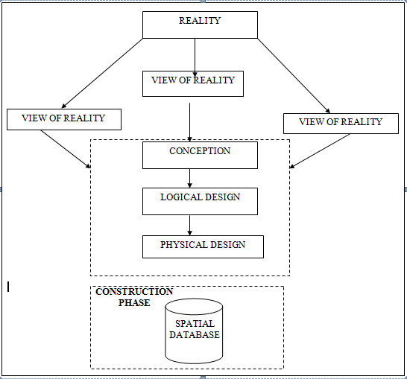
- Building
Fig. 3.1 Design and Construction Phases in Spatial Database

    - CONCEPTUAL DESIGN
Vector data model is the data type adopted for this project, which is represented, by points, lines and polygon. The identified entities are:-
      - Roads (line)
      - Electric poles (point)
      - Trees (point)
      - Buildings(polygon)
Fig. 3.2: E-R Diagram (Entity relationship diagram)
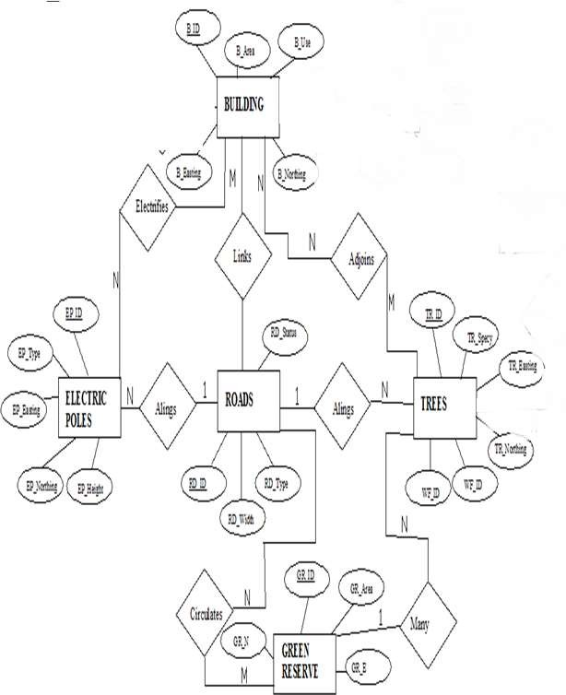

    - LOGICAL DESIGN
This is the design aspect of the database refers to the process of creating a conceptual framework or model that represents the structure and organization of spatial data within the system. It involves defining the data element, their relationship, and the rules for data manipulation and analysis. In this phase, the entities, their attributes and their relationships are represented in a single uniform manner in form of relation in such a way that would be no information loss and at the same time no unnecessary duplication of data. In this study, the logical database design is employed to generate a geo-relation database structure. Each entity has unique identifier in bold type. An attribute type or combination of attribute types that serves to identify an entity type is termed an identifier.
- Building( B_ID, B_Area, B_Name, B_Easting, B_Northing)
- Roads (R_ID, R_Width, R_Type, R-Condition, R_Easting, R_Northing )
- Vegetation (V_ID,GR_Area,)
- ree (TR_ID, TR_spp, TR_Importance, TR_Easting, TR_Northing )
- Electric Pole (EP_No, EP_Type, EP_Height,EP_Easting, EP_Northing)
    - PHYSICAL DESIGN
Table 3.1: Building and its attribute
ENTITY | DESCRIPTION
B_ID | Building Identification
B_name | Building Name
B_Area | Building Area
B_Easting | Building Easting
B_Northing | Building Northings

Table 3.2: Road and its attributes
ENTITY | DESCRIPTION
R_ID | Road Identifier
R_Length | Road Length
R_Width | Road Width
R_Type | Road Type
R_Condition | Road Condition

Table 3.3 : Trees and its attributes
ENTITY | DESCRIPTION
TR_ID | Tree Identifier
TR_Spp | Tree specy
TR_E | Tree_Easting
TR_N | Tree Northing

Table 3.4: Electric Poles and its attributes
ENTITY | DESCRIPTION
EP_ID | Electric pole Identifier
EP_Type | Electric pole Type
EP_Height | Electric pole Height
EP_E | Electric pole Easting
EP_N | Electric pole Northing

Table 3.5: Vegetation and its Attributes
ENTITY | DESCRIPTION
V_ID | Vegetation Identifier
V_Area | Vegetation Area
V_E | Vegetation Easting
V_N | Vegetation Northing

3.2 RECONNAISSANCE

This stage represents the groundwork laid prior to the execution of the project. It involves gathering all available and relevant information about the project area to ensure a smooth and effective implementation.
The necessary steps for the successful execution of the project are divided into two main phases:
- Office Planning
- Field Reconnaissance

3.2.1 OFFICE PLANNING
This phase entails the collection and review of information related to the study area. It also includes testing the instruments intended for use during the project, listing the required equipment, estimating the number of days needed for field activities, and outlining how each task will be performed. Additionally, responsibilities are assigned to team members based on the supervisor’s guidance and instructions.

Table. 3.6: Coordinates of Controls
Station | Northing (m) | Easting (m) | Height (m)
PBIL3306 | 940288.197 | 678281.701 | 355.212
PBIL3304 | 940275.508 | 678254.250 | 350.532
PL1 | 939677.97 | 678331.46 | 349.087
Source: Surveying and Geo-informatics Department Kwara state polytechnic.

3.2.2 FIELD RECONNAISSANCE

The field reconnaissance is the first visitation to the project site to get intimated with the environment.
- Boundary points was selected
- The distribution of features was studied
- Controls to be used were located
- Method and type of instrument to be uses was determined
- Subsidiary point for Ground control Points were picked and define using nail and bottle cock
- A diagram of the study area was drawn.

Fig. 3.3: Recce diagram of the study area (not drawn to scale)

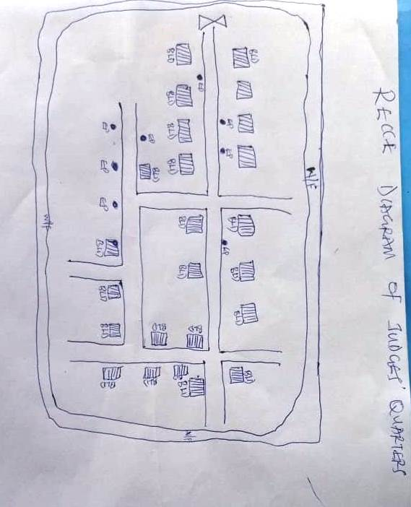
  - EQUIPMENT USED/ SYSTEM SELECTION AND SOFTWARE
    - HARDWARE USED
- Total station
- 1 reflector with a tracking rod.
- 1 Tripod
- One (1) 50m tape
- One (1) umbrella
- 1 cutlass
- Hand held GPS
- Hammer
- Nails and bottle cover
- Field book and writing materials
- 1-No of Personal Computer HP655 and its accessories
- 1-No of HP DeskJet K7100 A3 printer
- 1-No of HP DeskJet 1110 A4 printer
    - SOFTWARE COMPONENT
- Notepad.
- Microsoft Excel.
- AutoCAD 2007
- ArcGIS 10.3
- Surfer 2010
- Microsoft Word.

  - INSTRUMENT TEST
To ensure data quality, the Total Station used in this project was tested for both vertical index error and horizontal collimation error. These tests were conducted to confirm the instrument’s accuracy, efficiency, and overall reliability before use. The procedures followed are detailed below.
    - HORIZONTAL COLLIMATION TEST
This test was conducted to ensure that the line of sight was perpendicular to the trunnion axis. The Total Station was positioned over a specific point, and initial adjustments were made to ensure proper alignment, leveling, and focus (to eliminate parallax in the telescope). A vertical target was placed at a distance of 100 meters from the Total Station. To access the configuration menu of the Total Station, the menu key was pressed and held for approximately 2 seconds. From the main menu, the calibration sub-menu was selected, and within that, the horizontal collimation test option was chosen. The target was then observed and divided into two halves, with horizontal readings recorded for Face left and Face right. The readings are shown in Table 3.4.1 below.
Total Station

Fig 3.4: Horizontal Collimation and Vertical Index error test.
100m
REFLECTO R (TARGET)

STATION A
Fairly Level Ground
STATION B

Table 3.7: Horizontal Collimation Data
Station | Target | Face | Hz Reading | Difference | Error
A | B | L | 38˚42‟32”
 |  | R | 218˚42‟35” | 180˚00‟03” | 03”

    - VERTICAL INDEX ERROR TEST
This test was conducted to verify the accuracy of the vertical angle measurement when the line of sight is perfectly horizontal. The expected reading for this test is exactly ninety degrees (90°); any deviation from this value is known as the vertical index error.
The Total Station was set up over a designated point, with necessary temporary adjustments made to ensure proper alignment and functioning. A target was placed approximately 100 meters away, and the instrument was carefully aimed at it. The target was bisected by aligning the instrument in the Face Left position, and the corresponding vertical angle reading was recorded. The process was then repeated with the instrument in the Face Right position, and that reading was also documented. The recorded values are presented below.

Table 3.8: Vertical Index Data
Instrument Station | Target Station | Face | Vertical | Sum | Error
A | B | L | 90˚00‟00”
 |  | R | 270˚00‟02” | 360˚00‟02” | 02”

    - ANALYSIS OF COLLIMATION AND VERTICAL INDEX DATA
The reading obtain during calibration were reduced to obtain new collimation and vertical errors.
Horizontal collimation = {(FR – FL) – 180}/2 = {(00˚00‟03”}/2 = 1.5”

Vertical collimation = {(FL + FR) – 360} = (90˚00‟00” + 270˚00‟02”) - 360} = 02” The result shows that the instrument is still in good working condition.
  - CONTROL CHECK
Three control beacons (PBIL3306, PBIL3304) were utilized in this project. To verify their positions on-site, a check was performed by measuring the angles between these beacons and comparing the observed angles with those calculated from their known coordinates.
The Total Station was set up on the control beacon PBIL3304. After completing all necessary temporary adjustments, the reflector was positioned on the control beacon PBIL3306, designated as the back station. A horizontal angle reading was taken and recorded with the instrument set to Face Left.
Next, the reflector was moved to the control beacon PL1, the forward station. Horizontal angle readings were then recorded in both Face Left and Face Right positions. Finally, the reflector was returned to the back station, and a horizontal angle reading was recorded with the instrument set to Face Right.

Table 3.9: Table showing the back computation of the control coordinates
From STN | Bearing | Dist(m) | ∆N | ∆E | Northing (m) | Easting (m) | To STN
 |  |  |  |  | 940288.197 | 678281.701 | PBIL3306
PBIL3306 | 65°11'30'' | 30.242 | -12.689 | -27.451 | 940275.508 | 678254.250 | PBIL3304
PBIL3304 | 7°21'45'' | 602.506 | -597.538 | 77.21 | 939677.97 | 678331.460 | PL1

Table 3.10: Table showing the distance observation result of the control check
FROM | OBSERVED DISTANCE(m) | COMPUTED DISTANCE (m) | TO
PBIL3306 | 30.140 | 30.242 | PBIL3304
PBIL3304 | 602.451 | 602.506 | PL1

Table 3.11: Table showing the observation result of the control check
STN | SIGHT | FACE | OBSERVED HZ ANGLE | REDUCED HZ ANGLE | MEAN
 | PBIL3306 | L1 | 357° 08' 35''
PBIL3304 | PL1 | L2 | 291° 57' 00'' | 65°11'35''
 | PL1 | R2 | 111° 57' 1'' | 65°11'25''
 | PBIL3306 | R1 | 177° 08' 35'' |  | 65°11'30''

Difference in angle (observed - computed) =65° 11' 30''-65° 11' 25''
= 00° 00' 05''
Since the allowable accuracy (angular) of third order traverse of one station is 00° 00' 30'' and the result obtained from the control check (00° 00' 05'') is less than allowable error. Therefore, the controls were angularly intact.
  - MONUMENTATION
The boundary of the area carved out was demarcated with the precast concrete beacons, after clearing the required line of sights. The identified points of changes in directions were dug and beacons were buried on it, leaving about 15cm part of the beacon above the ground level. The beacons were buried at convenient distances as dictated by the nature of the boundary.

Fig. 3.5: Pillar Description
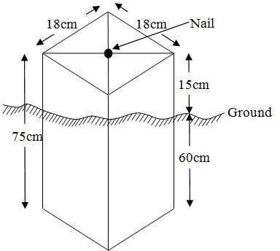
  - DATA ACQUISITION

PRIMARY DATA SOURCE
Field observation served as the primary data source for this project. A ground-based method was employed to collect data using a Total Station instrument, which involved recording X, Y, and Z coordinates from Ground Control Points (GCPs) established at prominent locations throughout the study area.

SECONDARY DATA SOURCE
An updated imagery of the area was obtained from Google Earth and used to determine the extent of coverage for the project area.
    - GEOMETRIC DATA ACQUISITION
The Total Station instrument was carefully set up on control point PBIL3304, with a back sight taken to PBIL3306 after performing the necessary station adjustments, which included centering, leveling, and focusing. The following procedures were then followed to determine the position of the next point (PL1), and this process was repeated sequentially until the entire site was covered. The data acquisition method used on site was the radiation method, where two or more points are coordinated from a single instrument station.
Procedure:
i. After setting up the instrument and completing temporary adjustments, the instrument was powered on, and a new job was created under the job menu in the instrument’s internal memory. The job was named GROUP 5A.
ii. The coordinates of the three control points were entered into the instrument’s memory, along with relevant codes such as:
- ‘RD’ for roads
- ‘SP’ for spot heights
- ‘BD’ for buildings, etc.
iii. The instrument height and reflector height were measured and saved in the instrument memory.
iv. In the coordinate menu, orientation was set by inputting the coordinates of the instrument station and the back sight. The reflector at the back station was carefully bisected before confirming the orientation by selecting ‘yes’.
v. After orientation, the reflector was bisected at the next point (nail), and the ‘obs’ (observe) option was selected. The three-dimensional coordinates (East, North, Height) of the point were displayed on the instrument’s screen, and ‘rec’ (record) was pressed to save the data. For subsequent observations, the ‘all’ option was used to streamline the process without separately pressing ‘obs’ and ‘rec’.
vi. It was ensured that the prism center of the reflector was precisely bisected and securely set on the tripod to minimize height measurement errors.
vii. The instrument was then moved to the next point after all details—including spot heights and boundary points visible from the current station—were recorded. Temporary adjustments were made after repositioning.
viii. This sequence was repeated until all boundary points and their heights were accurately coordinated.
ix. Spot heights in this project were acquired randomly rather than at regular grid intervals. Additionally, three edges of each building were surveyed.
x. Upon completion of the data acquisition, all collected details were properly recorded and mapped to their respective positions on the project plan.
    - ATTRIBUTES DATA ACQUISITION
Attribute data is information about spatial features. They provide the characteristics, description and nomenclature about spatial objects. Thus the attributes data acquired includes names of buildings and their uses such as classrooms, roads, water facilities and prominent natural features likes river and trees found and vegetation were properly identified within and around the study area.
  - DATA DOWNLOADING AND PROCESSING
    - DATA DOWNLOADING AND EDITING
This is stage whereby all data acquired which were automatically stored in the Total Station were downloaded into personal computer. This was done with the aid of downloading cable connected to the computer and some associated complementing software installed on the System.
    - DATA PROCESSING AND DATA EDITING
The geometric data downloaded were further processed in order to convert it to a useful format and to enhance its accuracy. The output coordinates, were edited and exported in *.txt, *.xls and *.pdf format. Thereafter, they were imported into Arc GIS 10.3 for further operations and to carry out spatial analysis.
    - DATA PROCESSING USING ARCGIS 10.3
Before launching ArcGIS, AutoCAD was used to plot feature data, which were saved separately in different files named road, boundary line, buildings, trees, and electric poles.
Steps to load and prepare data in ArcGIS 10.3:
- Launch ArcMap in ArcGIS 10.3.
- In the dialog box that appears, click A NEW EMPTY MAP to create a new project.
- On the menu bar, click Tools, then select Extensions. Check all available extensions, then close the window.
- On the left-hand side (LHS), right-click on Layers, and select Properties.
- In the Properties window, go to the Coordinate System tab to set the projection system to MINNA DATUM ZONE 31N. Then, go to the General tab to set the map units. Click Apply and then OK.
- Click Add Data on the toolbar, browse to the saved AutoCAD files, select all relevant files, and load them into the Table of Contents (Layer section).
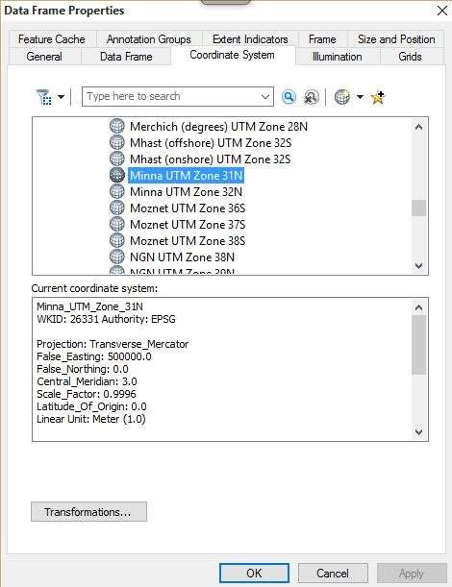
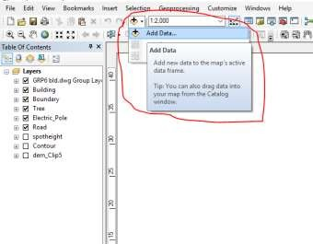
All drawing was exported to shape file. After the feature class has been creates, click on Editor to start Editing, and then click on the load object.
Creating Contours
- First, a Digital Elevation Model (DEM) was created by using the Natural Neighbor interpolation method. To do this, open the Search bar and type Interpolation, then select Natural Neighbor.
- Choose the XYZ data as the input for creating the DEM, setting the project boundary line as the extent for the interpolation.
- To generate contours, ensure that the Spatial Analyst toolbar is enabled. You can activate it by navigating to Customize > Toolbars > Spatial Analyst.
- Alternatively, open the search bar by clicking Windows > Search or by clicking the search icon and type relevant commands or tools.
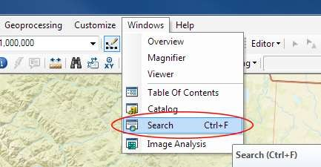
In the search bar type Contour, and select Contour (Spatial Analyst) from the search results list.

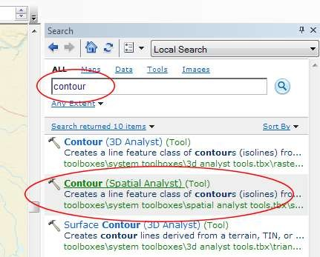
After choosing Contour, a dialogue window will appear, prompting you for five settings: Input raster: select the DEM file from which you want to generate contours by locating it on your hard drive or in the dropdown menu, showing layers present in the Table of Contents Output polyline features: indicate where you want to save your output contours Contour interval: set the distance between contour lines in meters – the smaller the number, the greater the number of lines Base contour (optional): the starting point from which the lines are generated – for example, the default is 0 so with an interval of 25 meters, the contours are generated at 25, 50, 75, 100…, but if the base contour is set at 40, then the contours are generated at 65, 90, 115, 140 and so on Z factor (optional): can be used to adjust the units of data; for example, if you have data in meters and you want to produce your contours in feet, use a z-factor of 3.28 because 3.28 feet equals one meter.

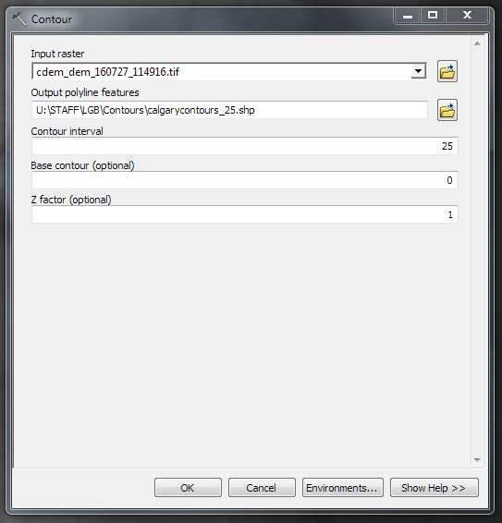
The generated contours will automatically be added to the map.
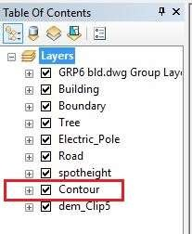
Input the data which is the AutoCAD drawing and select the feature type you want to load,
- Click Add and Next, then select the Target layer you want it to be
- Load it into from the feature class created on the ARCGLS.
- Click on Next, then select “only the features that satisfy the
- Query” and click on Query Builder to query for the feature to be loud e.g. “layer” = Boundary”.
- Click on Next. Then finish
Right click on the Boundary In the table of content and click on zoom to layer to display the feature.

EDITING, CONVERTING AND MERGING GEODATABASE
- Remove all necessary features by right clicking on it and press "REMOVE"
- Convert some features that are not in their correct „features -type‟ like point, line, and polygon features etc.
To convert a GOEDATABASE FEATURE CLASS to another the following steps were taken:
- FOR LINE FEATURE CLASS TO POLYGON FEATURE CLASS
- Go to WINDOW on the menu bar and select ARC Toolbox.
- Select DATA MANAGEMENT TOOLS, click on FEATURES, and then Select FEATURE TO POLYGON.
- ON INPUT FEATURES, select feature to be converted, on OUTPUT FEATURE CLASS, then save on the GRP6C FOLDER, press OK and CLOSE.
- Then remove the converted feature class in the LAYER Menu and ARC CATALOG files.
- On INPUT DATASETS, select features to be merged, on OUTPUT DATASETS, then save on the GRP6C folder, press OK and CLOSE.
- Then remove the converted feature class in the LAYER Menu and ARC CATALOG files.

TABLE CREATION
There is need to create attribute tables for the features so as to be used for queries. NOTE: The editor on the menu bar must be stopped before adding field to its table. THE FOLLOWING PROCEDURES WERE FOLLOWED:
- Right click on the feature class, then select OPEN ATTRIBUTES TABLE click on OPTIONS and select ADD FIELD.
- Give it FIELD NAME, click on TYPE and select [SHORT INTEGER or LONG INTEGER for SHORT or LONG WHOLE VARIABLES or DOUBLE FOR
DECIMAL VARIABLES OR TEXT variable or DATE for DATE], then enter precision or LENGTH for text width and scale for DECIMAL PLACES, and then click OK
- To input variables on the ATTRIBUTE TABLE, go to the EDITOR on Menu bar, select START EDITING,
- Click on ATTRIBUTE on menu bar [behind the TARGET], click on the features on the DATA VIEW display, and then input the variables of data acquired through SOCIAL SURVEY or DATA ACQUIRED ON THE FIELD.
- Save it after the input by selecting SAVE EDITS on the editor menu. To switch to other layers, select STOP EDITING on the EDITOR menu. Then repeat the above step to create other fields. Populate the table and save.

Table 3.12: Building
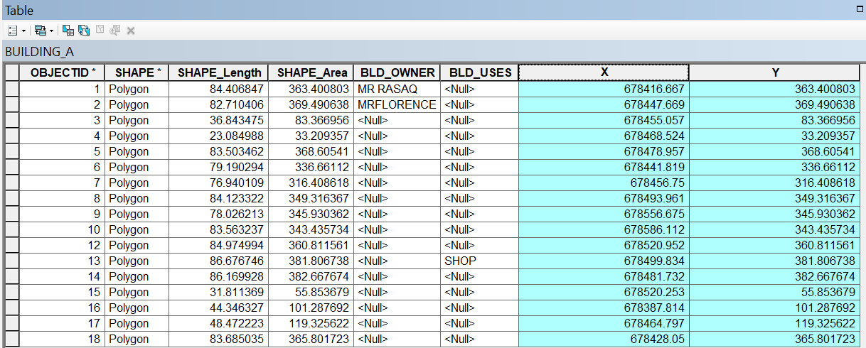

Table 3.13: Road
ENTITY | FIELD ALIAS | DATA TYPE | FIELD SIZE
R_ID | Road Identifier | Numeric | -
R_Length | Road Length | Numeric | -
R_Width | Road Width | Numeric | -
R_Type | Road Type | Text | 10
R_Condition | Road Condition | Text | 10

Table 3.14: Trees
ENTITY | FIELD ALIAS | DATA TYPE | FIELD SIZE
TR_ID | Tree Identifier | Numeric | -
TR_Spp | Tree specy | Text | 10
TR_E | Tree_Easting | Numeric | -
TR_N | Tree Northing | Numeric | -

Table 3.15: Electric Poles
ENTITY | FIELD ALIAS | DATA TYPE | FIELD SIZE
EP_ID | Electric pole Identifier | Numeric | -
EP_Type | Electric pole Type | Text | 10
EP_Height | Electric pole Height | Numeric | -
EP_E | Electric pole Easting | Numeric | -
EP_N | Electric pole Northing | Numeric | -

ADDING SPOT HEIGHTS DATA
- NOTE: STOP EDITING on the EDITOR MENU before adding data field,
- Go to FIELD ON THE MENU BAR, scroll to add Data and then ADD XYZ DATA
- Browse the EXCEL FILE for SPOT HEIGHTS, select EASTING VALUE on X - FIELD and NORTHING VALUE on Y - IELD and ELEVATION
- « Select DATA the EXPORT DATA, locate the folder created and give it name then YES AND OK, remove the previous layer by right clicking on it and select REMOVE.

Fig. 3.6 shows the spot height
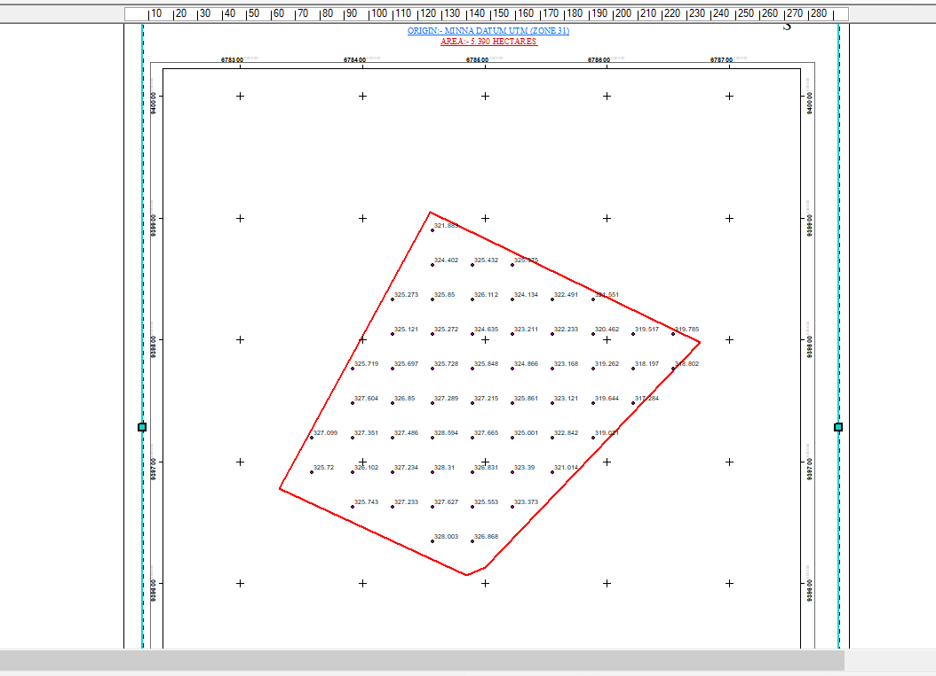

TIN, ASPECT AND SLOPE CREATION USING ARCMAP
NOTE: Making sure the 3D Analyst Extension is active, select VIEW on MENU bar, then click TOOLBARS and MARK the 3D Analyst EXTENTION Then X, Y Data

TO CREATE TIN
- Click on 3D Analyst arrow, select create TIN and then create TIN from FEATURE.
- On layers mark the SPOTHEIGHT LAYER, select height data on HEIGHT, then ok.

TO CHANGE THE FACE OF THE TIN ACCODING TO ITS ELEVATION
- RIGHT CLICK on the TIN, select PROPERTIES, and click on SYMBOLOGY.
- Then ADD, select FACE ELEVATION WITH COLOR RAMP, click ADD, and then select APPLY and OK.

Fig. 3.7: Shows the Tin creation
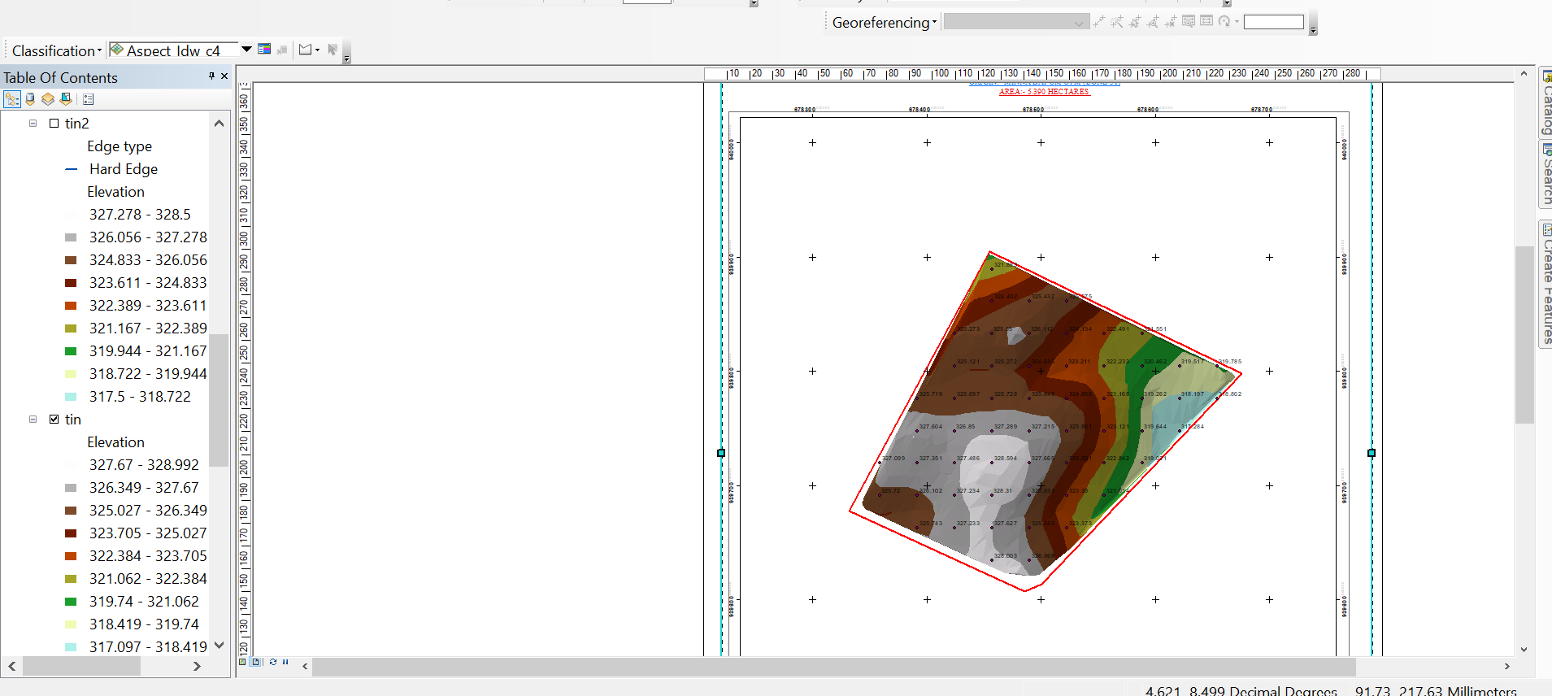

TO CREATE ASPECT
- Click on 3D analyst arrow, select SPATIAL ANALYST TOOLS, SURFACE and THEN DOUBLE CLICK on ASPECT.
- Browse to where the raster format of all the acquired data created from the surfer was saved to.
- Browse to where you want the OUTPUT RASTER to be saved
- You can change the OUTPUT MEASUREMENT to Degree OR percent
- Click OK [then it displays on the data view screen], then Close.
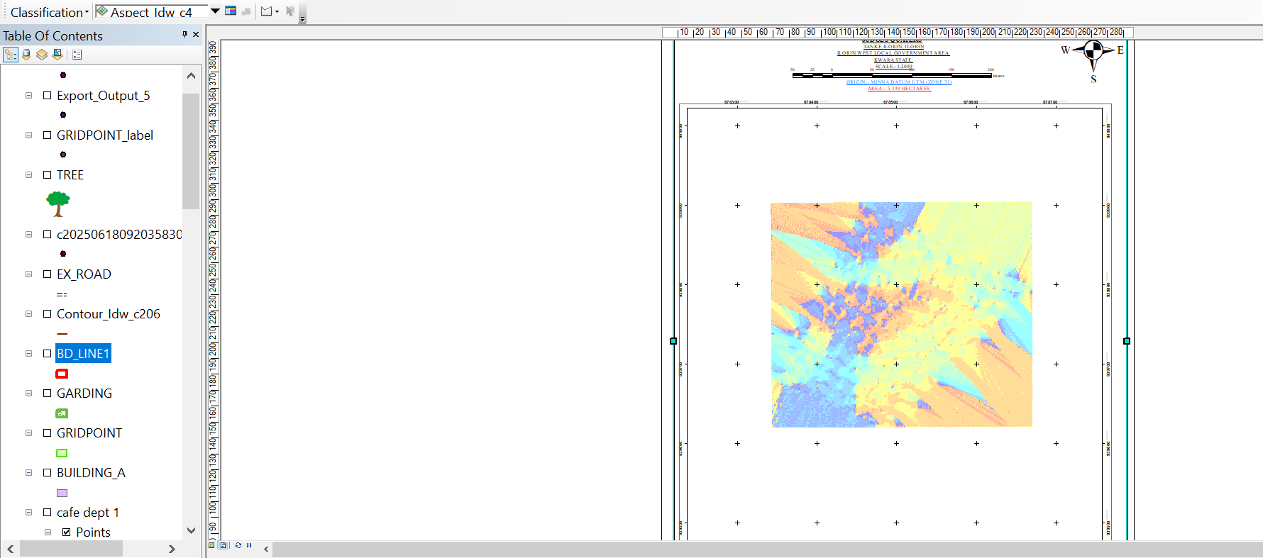
Fig. 3.8 shows the slope aspect

  - DATABASE IMPLEMENTATION
This is the database creation phase. Having completed the three stages of design phase (i.e. Reality, Conceptual and Logical design), the database was created using ArcGIS 10.3 software. It involves the combination and storage of acquired graphic data and attributes data in creating the database for the purpose of spatial analysis and query.
Database is an organized integrated collection of data stored so as to be capable of use by revenant application with data being accessed by different logical part. After the Attribute table was populated via the keyboard, some attributes such as areas of settlements were automatically displayed by special command in the ArcGIS 10.3 version. The ArcGIS software was used to link the graphic data and table for query generation.
    - DATABASE MANAGEMENT SYSTEMS
Database management refers to a collection of software designed for creating, storing, manipulating, updating, organizing, and querying information within a database (Kufoniyi, 1998). A Database Management System (DBMS) functions as intermediary software that manages the database on behalf of the user.
A good DBMS should provide the following key functions:
  - Efficient storage and retrieval of data.
  - Concurrent access by multiple users.
  - A standardized interface between the database and application programs.
  - Standardized data access and clear separation of data storage/retrieval from the application logic.
  - Maintenance of data security and integrity.
    - DATABASE MAINTENANCE
After creating the database, proper maintenance practices were implemented to ensure it met its stated objectives. Maintenance allowed for the addition of new data and removal of outdated or irrelevant information. Regular updates are essential to reflect physical changes in the landscape over time. Additionally, security and data integrity measures were enforced to maintain the database’s reliability and effectiveness.
Consistent updating and management of the database are crucial for maintaining its currency and quality, which in turn enhances its suitability as part of a Spatial Decision Support System (SDSS). The overall quality of a database depends on its timeliness and fitness for use within a decision support framework.
It is also important to periodically review the storage media to prevent data inaccessibility or deterioration due to physical damage. Care must be taken when populating the database, as its value directly depends on the accuracy and quality of the input data.
For long-term archiving, stable storage media should be used, such as:
- Computer-compatible tape readers
- Magnetic tapes
- Optical discs and compact discs

3.9.3 BACK COMPUTATION

Table 3.16: Back Computation
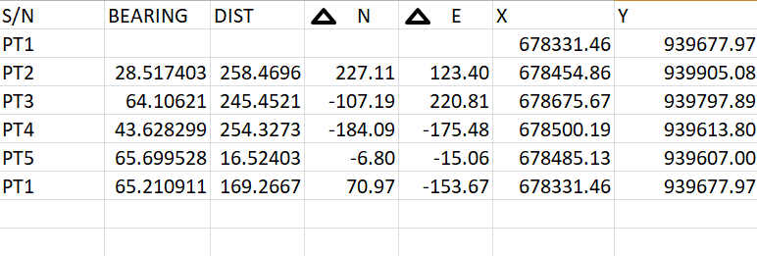

3.9.4 AREA COMPUTATION

Table 3.17: Area Computation
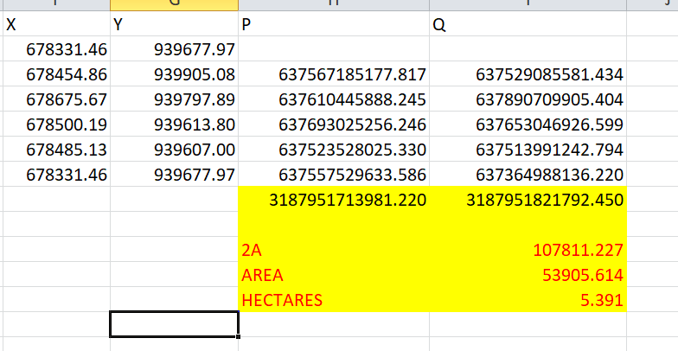

CHAPTER FOUR

4.0 SPATIAL ANALYSES AND PRESENTATION
GIS stands out among other information systems due to its powerful spatial analytical capabilities, including overlay operations, buffering, spatial search, topographic analysis, as well as neighborhood and connectivity operations. GIS leverages these capabilities to answer fundamental questions related to location, condition, trends, routing, patterns, and modeling through the manipulation and analysis of spatial data. In this project, the major analyses performed were overlay operations, topographic analyses, and spatial searches.

4.1 TESTING OF DATABASE
This test was conducted to evaluate the relationships between data modeled as entities in the spatial database and to assess the database’s retrieval capabilities. A sample query with specific conditions was designed and executed to verify whether the desired results could be obtained.
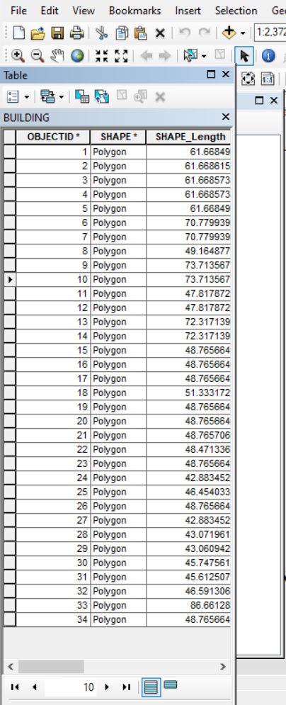
Fig. 4.1: Shows the attribute database

Fig. 4.2: Showing catalog, attribute table and table of content
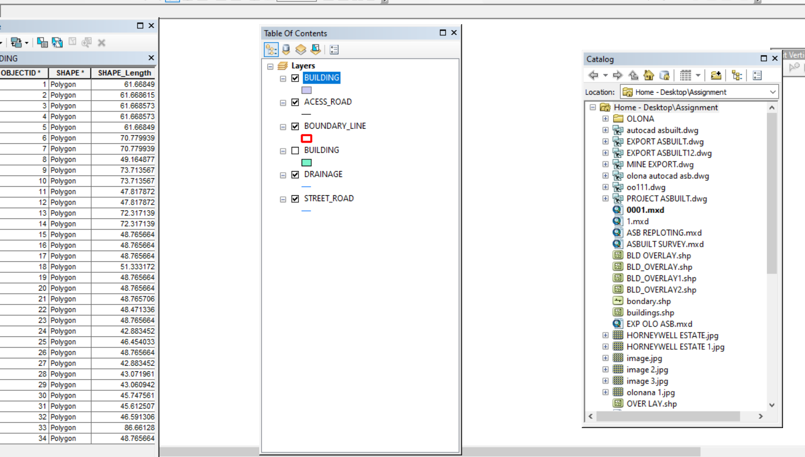

Analysis of Result
The query retrieved contours with elevation values greater than or equal to 350 meters, indicating areas likely to be less prone to flooding within the project area, as shown in Figure 4.5 (Query 1). These contours represent points with elevations above 350 meters.
The attribute table confirmed that the northeast part of the institute has the highest elevation. Elevation is a critical factor when considering terrain surface and slope. Conversely, the southwest part of the school has the lowest elevation and is therefore more susceptible to erosion. Buildings planned for this region should have foundations elevated significantly above ground level to mitigate potential damage.
The results of this query provide valuable information to the school management, enabling informed decisions about terrain characteristics and appropriate building designs across different regions of the project area.

SINGLE SELECTION CRITERION
Query 1: Retrieving Area whose height is Greater than 350 meters
SELECT* FROM Contour WHERE "CONTOUR">3.007
Fig 4.3.: Retrieving Area whose height is greater than 3.007 meters
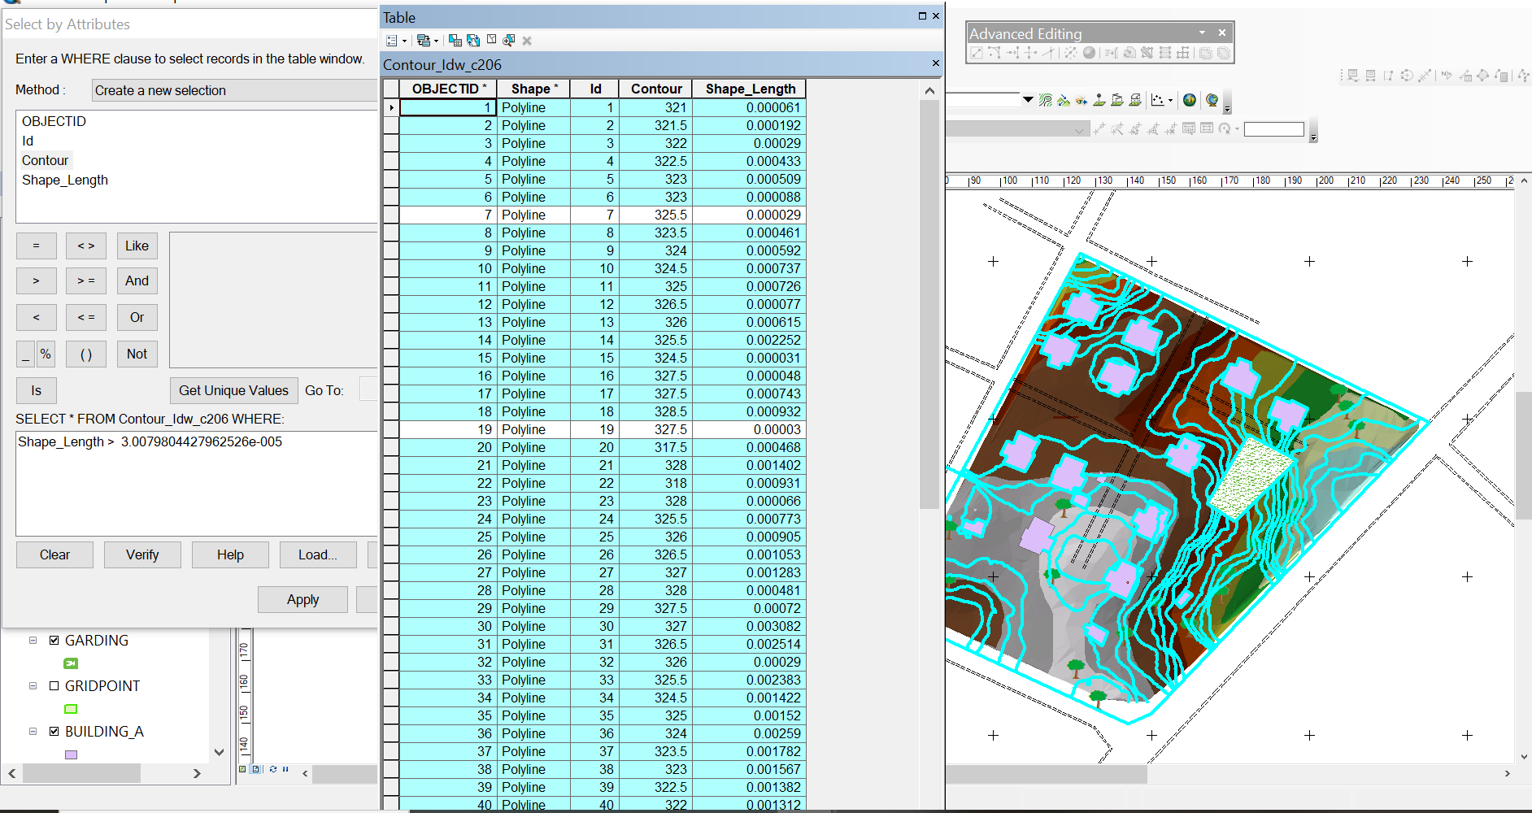

Fig 4.4: Result of area whose height is greater than 3.007 meters
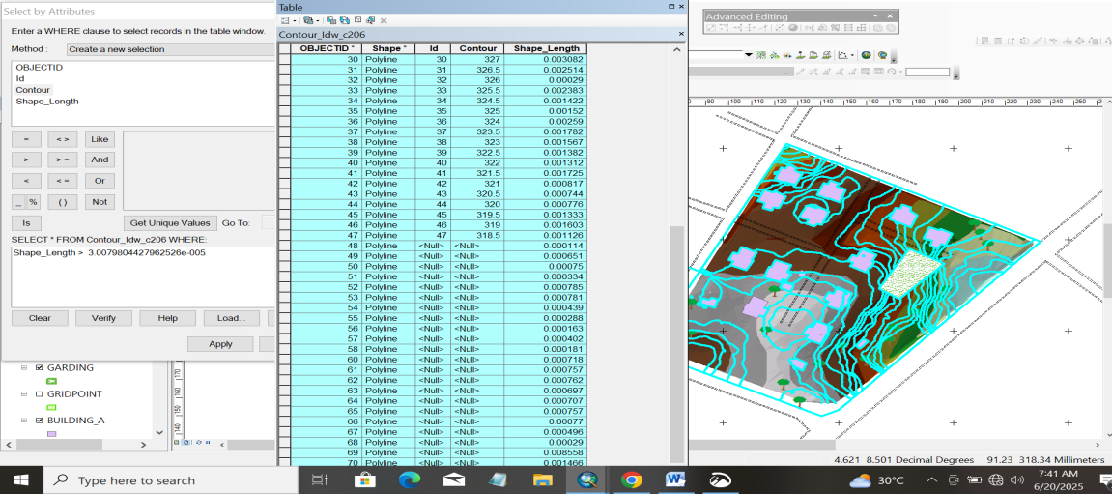

Fig 4.5: Shows the building use for shop
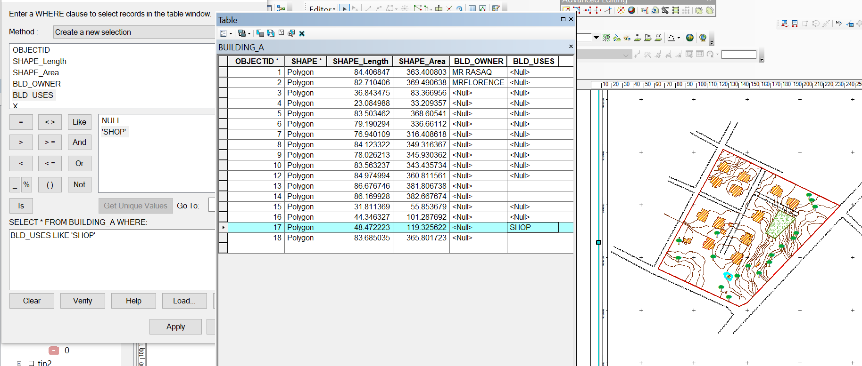

CHAPTER FIVE
COSTING, SUMMARY, PROBLEM ENCOUNTERED, CONCLUSION AND RECOMMENDATIONS
5.1 COST ESTIMATION
This stage the total cost spent on the project from day one to the final stage.
Table 5.1.1: Direct cost parameters
S/N | DIRECT COST
1 | Reconnaissance (1 day)
 | PERSONNEL | Rate | Total Amount (N:K)
 | 1 x surveyor | 10500 | 10500
 | 1 x assistant surveyor | 7500 | 7500
 | 1 x technical officer | 6500 | 6500
 | 3 x skilled labour | 4000 | 12000
 | basic equipment | 5000 | 5000:00
 | transportation (vehicle, Driver and fuel) | 10000 | 10000:00
 |  | sub-total | 51,500
2 | Monumentation (1 day)
 | PERSONNEL
 | 1 x assistant surveyor | 7500 | 7500
 | 1 skilled labour | 4000 | 4000
 | transportation (vehicle, Driver and fuel) | 10000 | 10000
 | basic equipment | 5000 | 5000:00

 | Beacon (6) | 1000 | 6000
 |  | sub-total | 32,500
3 | Data acquisition (2 days)
 | PERSONNEL
 | 1 x assistant surveyor | 7500 | 7500
 | 1 x technical officer | 6500 | 6500
 | 3 x skilled labour | 4000 | 12000
 | Total Station and accessories | 15000 | 15000
 | transportation (vehicle, Driver and fuel) | 10000 | 10000
 |  | sub-total | 51,000
5 | Data Processing (2 days)
 | PERSONNEL
 | 1 x surveyor | 10500 | 10500
 | 1 x assistant surveyor | 7500 | 7500
 | 1 x technical officer | 6500 | 6500
 | computer / accessories | 15000 | 15000
 |  | sub-total | 39,500
7 | Technical Report (1 day)
 | PERSONNEL
 | 1 x surveyor | 10500 | 10500
 | 1 x assistant surveyor | 7500 | 7500

 | 1 x secretary | 5000 | 5000:00
 | computer / accessories | 15000 | 15000:00
 |  | sub-total | 38,000
TOTAL (DIRECT COST) 212,500 MOBILIZATION/DEMOBILIZATION = 5% of Direct Cost
= 0.05 × 212,500

= N10,625

CONTINGENCY ALLOWANCE
= 5% of Direct Cost
= 0.05 × 212,500

= N10,225

GRAND TOTAL = N212,500 + N10,625 + N10,625

= N233,750

VAT (@5% GRAND TOTAL) = 0.05 × 233750

= N11,687.5

TOTAL COST PAYABLE = GRAND TOTAL + VAT

= N233,750+ N11,687.5
= N245,437.5

5.2 SUMMARY
The main aim of the project is to carry out the topographical information system of Judges Quarter Estate, Taoheed Road Ilorin. Kwara State. It was done in accordance with the survey rule and regulation and the departmental instruction. A digital ground survey method was basically use for data acquisition. A data base was created to house all the relevant data collected on the field, AutoCAD, suffer Microsoft word, Microsoft Excel and Notepad were combined to carryout data processing manipulation, Analysis and retriever. The final presentation of information was produced in form of digital map both in hard copy/soft copy.
5.3 PROBLEMS ENCOUNTERED
During the execution of this project the problem encountered are the followings:
1. The pegs used for monumentation were removed repeatedly, but this was overcome by referencing each peg to a fixed mark with the distance of the peg from the reference mark noted.
5.4 CONCLUSION
The aims of the project were achieved as the expected accuracy and the obtained results conformed to required accuracy of a third order job also the task actually exposed and broadened my knowledge on the scope, concepts and skills, involved in topographical surveying, more so, the project has been successfully executed as adequate data were acquired processed and represented in plans.
This project was interesting in spite of the numerous problems encounter thought the execution of the project.
The exercise was not an easy task, it is much cumbersome. It consume money, energy, time and other tangible factors, but at the end of it, I realize that it had helped me in the practical aspect of land surveying and exposed me to that types of problem. Surveyors usually encounters on the field.
5.4 RECOMMENDATIONS
Having successfully carried out the project assignment, I hereby recommend that.
- The x, y and z coordinates of the features were which confirm the position of the features
- The topographical surveys of the area enhanced the use of various surveys of software’s such as AutoCAD; suffer e.t.c and the preparation of plan. Hence it is highly recommended for further studies.
- The authority should make modern instrument like global positioning system (GPS) receiver, total station, and digital level etc. available to the prospective student of Higher National Diploma so as to be widely exposed to them for easy operation.
- I also recommend that instrument should be released to the student on time for quick execution of the project.

REFERENCES
Burrough, P. A., & McDonnell, R. A. (1998). Principles of Geographical Information Systems. Oxford University Press.
Clarke, K. C. (2010). Getting Started with Geographic Information Systems (5th ed.). Pearson.
Collier, P. (2002). The Impact on Topographic Mapping of Developments in Land and Air Survey: 1900-1939. Cartography and Geographic Information Science, 29(3), 155-174.
DeMers, M. N. (2008). Fundamentals of Geographic Information Systems (4th ed.). Wiley
Ehsani, H. A., & Quiel, F. (2009). A semi-automatic method for analysis of landscape elements using Shuttle Radar Topography Mission and Landsat ETM+ data. Computers and Geosciences, 35, 373-389.
Idhoko, K. (2015). Topographic Information System as a Tool for Environmental Management: A Case of Part of Delta State Polytechnic Ogwashi-Uku, Aniocha South, Delta State, Nigeria. IOSR Journal of Environmental Science, Toxicology and Food Technology, 9(12), 117-122. DOI: 10.9790/2402-09112117122.
Maune, D. F. (Ed.). (2007). Digital Elevation Model Technologies and Applications: The DEM Users Manual (2nd ed.). American Society for Photogrammetry and Remote Sensing.
Longley, P. A., Goodchild, M. F., Maguire, D. J., & Rhind, D. W. (2015). Geographic Information Science and Systems (4th ed.). Wiley.
Nkeki, F. N. (2013). Mapping and Geovisualizing Topographical Data Using Geographic Information System (GIS). ResearchGate. DOI: 10.13140/RG.2.2.33351.04002.
Nkeki, F. N., & Ojeh, V. N. (2024). Mapping and Geovisualizing Topographical Data Using Geographic Information System (GIS). Journal of Geography and Geology, 6(1). DOI: 10.13140/RG.2.2.33351.04002.
Oladunjoye, P., & Olayiwola, A. M. (2023). Application of GIS in Topographic Analysis for Sustainable Urban Planning in Lagos, Nigeria. African Journal of Environmental Sciences, 12(2), 45-59.
Rine, C. M., Morales, J., Vanyukevych, A. B., Durand, E. G., & Schroeder, K. A. (2023). Using GIS Mapping to Assess Foster Care: A Picture Is Worth a Thousand Words. Social Service Review, 97(3), 321-340.
Wilson, J. P., & Gallant, J. C. (2000). Terrain Analysis: Principles and Applications. Wiley.

APPENDIX I
S/N | X | Y | Z
PT1 | 678457.2303 | 939634.3698 | 328.003
PT2 | 678490.0255 | 939634.3698 | 326.868
PT3 | 678391.6401 | 939662.7202 | 325.743
PT4 | 678424.4352 | 939662.7202 | 327.233
PT5 | 678457.2303 | 939662.7202 | 327.627
PT6 | 678490.0255 | 939662.7202 | 325.553
PT7 | 678522.8206 | 939662.7202 | 323.373
PT8 | 678358.8449 | 939691.0705 | 325.72
PT9 | 678391.6401 | 939691.0705 | 326.102
PT10 | 678424.4352 | 939691.0705 | 327.234
PT11 | 678457.2303 | 939691.0705 | 328.31
PT12 | 678490.0255 | 939691.0705 | 326.831
PT13 | 678522.8206 | 939691.0705 | 323.39
PT14 | 678555.6158 | 939691.0705 | 321.014
PT15 | 678358.8449 | 939719.4209 | 327.099
PT16 | 678391.6401 | 939719.4209 | 327.351
PT17 | 678424.4352 | 939719.4209 | 327.486
PT18 | 678457.2303 | 939719.4209 | 328.594
PT19 | 678490.0255 | 939719.4209 | 327.665
PT20 | 678522.8206 | 939719.4209 | 325.001
PT21 | 678555.6158 | 939719.4209 | 322.842
PT22 | 678588.4109 | 939719.4209 | 319.021
PT23 | 678391.6401 | 939747.7712 | 327.604
PT24 | 678424.4352 | 939747.7712 | 326.85
PT25 | 678457.2303 | 939747.7712 | 327.289
PT26 | 678490.0255 | 939747.7712 | 327.215
PT27 | 678522.8206 | 939747.7712 | 325.861
PT28 | 678555.6158 | 939747.7712 | 323.121
PT29 | 678588.4109 | 939747.7712 | 319.644
PT30 | 678621.206 | 939747.7712 | 317.284
PT31 | 678391.6401 | 939776.1216 | 325.719
PT32 | 678424.4352 | 939776.1216 | 325.697
PT33 | 678457.2303 | 939776.1216 | 325.728
PT34 | 678490.0255 | 939776.1216 | 325.848
PT35 | 678522.8206 | 939776.1216 | 324.866
PT36 | 678555.6158 | 939776.1216 | 323.168
PT37 | 678588.4109 | 939776.1216 | 319.262
PT38 | 678621.206 | 939776.1216 | 318.197
PT39 | 678654.0012 | 939776.1216 | 318.802
PT40 | 678424.4352 | 939804.4719 | 325.121
PT41 | 678457.2303 | 939804.4719 | 325.272
PT42 | 678490.0255 | 939804.4719 | 324.635
PT43 | 678522.8206 | 939804.4719 | 323.211
PT44 | 678555.6158 | 939804.4719 | 322.233
PT45 | 678588.4109 | 939804.4719 | 320.462
PT46 | 678621.206 | 939804.4719 | 319.517
PT47 | 678654.0012 | 939804.4719 | 319.785
PT48 | 678424.4352 | 939832.8223 | 325.273
PT49 | 678457.2303 | 939832.8223 | 325.85
PT50 | 678490.0255 | 939832.8223 | 326.112
PT51 | 678522.8206 | 939832.8223 | 324.134
PT52 | 678555.6158 | 939832.8223 | 322.491
PT53 | 678588.4109 | 939832.8223 | 321.551
PT54 | 678457.2303 | 939861.1726 | 324.402
PT55 | 678490.0255 | 939861.1726 | 325.432
PT56 | 678522.8206 | 939861.1726 | 325.375
PT57 | 678457.2303 | 939889.523 | 321.883

