PROJECT REPORT

ON

IMPLEMENTATION OF RELATIONAL DATABASE SYSTEM FOR CADASTRAL INFORMATION PRODUCTION

OF IREWOLEDE ESTATE ALONG NEW YIDI ROAD, ILORIN. KWARA STATE
BY

IDRIS HALIMAT ALATA
HND/23/SGI/FT/0050

SUBMITED TO THE DEPARTMENT OF SURVEYING AND GOEINFORMATICS, INSTITUTTE OF ENVIROMENTAL STUDIES (I. E .S), KWARA SATE POLYTECHNIC, ILORIN

IN PARTIAL FULFILLMENT OF THE REQUIREMENTS FOR THE AWARD OF HIGHER NATIONAL DIPLOMA (HND) IN SURVEYING AND GEOINFORMATICS
JULY, 2025
CERTIFICATE
I hereby certify that all field work and information contained in this project report were obtained as a result of the observation and measurement carried out by me and my group member in the field and that the survey was executed in accordance with the Survey Regulations and Departmental Instructions

___________________________________
IDRIS HALIMAT ALATA
MATRIC NUMBER:-HND/23/SGI/FT/0050

CERTIFICATION
This is to certify that IDRIS HALIMAT ALATA with Matric No:-HND/23/SGI/FT/0050 has satisfactorily carried out her project under my instructions and direct supervision. I hereby declare that she has conducted herself with diligence, honesty and sobriety on the project.

SURV.R.S.AWOLEYE ___________________
(PROJECT SUPERVISOR) SIGNATURE AND DATE

____________________
(PROJECT COODINATOR) SIGNATURE AND DATE

MR ISAU ABIMBOLA ____________________
(HEAD OF DEPARTMENT) SIGNATURE AND DATE

EXTERNAL MODERATOR ____________________
SIGNATURE AND DATE

DEDICATION
This project is dedicated to Almighty GOD who saw me through the programme.

ACKNOWLEDEGEMENT
My profound gratitude goes to the Almighty GOD for his unfeigned admiration towards me, for the grace, guidance and opportunity given me to move forward against all odds. Also for his support that led to successful completion of this project.
My special ovation goes to my dearest, energetic, hardworking, caring and loving project supervisor SURV.R.S AWOLEYE, and other lecturers in surveying and geo-informatics for their unflinching support, moral advice and their unrelenting effort toward my education. SURV A.G AREMU, SURV R.O ASONIBARE, SURV WILLIAMS KAZEEM, SURV BELLO FELIX DIRAN, SURV BABATUNDE KABIR, MR A.I ISAU, SURV ABDUSALAM.
I also acknowledge my parents (Mr & Mrs Idris) brothers and sisters for their support though out this programme. And the whole of HND 2, 2024/2025 academic session for their cooperation, believe and understanding towards the successful completion of this project. I wish all of us success.
ABSTRACT
The project is aim at creating Implementation of a relational database system for cadastral information production of Irewolede Estate along new yidi road, Ilorin South Local Government Area, Kwara State. Satellite imagery were acquired for base map, Spatial data were acquired with the aid of DGPS, while attribute data were acquired by social surveys. The database of the project site was created by adopting a relational database method. Thereafter, the implementation of the database was done in the database environment. The graphic representation shall be done using AutoCAD software and ArcGIS for spatial analysis.

TABLE OF CONTENTS
Title Page
Certificate ………………………………………………………………. I
Certification ……………………………………………………………. II
Dedication ……………………………………………………………… III
Acknowledgement ……………………………………………………. IV
Abstract ………………………………………………………………. VII
Table of Contents …………………………………………………….. VIII
List of Tables …………………………………………………………. IX
List of Figures ………………………………………………………… X
Appendixes ………………………………………………………… XI
CHAPTER ONE
1.0 INTRODUCTION…………………………………………………… 1
1.1 BACKGROUND TO THE STUDY………………………………..........1
1.2 STATEMENT OF PROBLEM …………………………………..............3
1.3 AIM OF THE PROJECT ………………………………………................4
1.4OBJECTIVES OF THE PROJECT ……………………………................4
1.5 SIGNIFICANCE OF THE STUDY………………………………………..5
1.6 SCOPE OF THE PROJECT ………………………………………............5
1.7 THE STUDY AREA ………………………………………………..........6
1.8 PERSONNEL INVOLVED ………………………………………….......6
CHAPTER TWO
2.0 LITERATURE REVIEW…………………………………………. 7
CHAPTER THREE
3.0 METHODOLOGY………………………………………………… 15
3.1 DATABASE DESIGN……………………………………………..15
3.1.1 VIEW OF REALITY…………………………………....................16
3.1.2 CONCEPTUAL DESIGN...…………………………………...........16
3.1.3 LOGICAL DESIGN……………………….………….. ..................17
3.2 DATA SOURCE…………………………………………................17
3.3DATA ACQUISITION……………………………….............................17
3.3.1 RECONNAISSANCE ……………………………….....................18
3.3.1.1 OFFICE PLANNING ……………………………………….............18
3.3.1.2 FIELDRECONNAISSANCE ………………………………….........18
3.3.2 SYSTEM SELECTION ……………………………………................19
3.3.3 CONTROL POINTS CHECK ………………………………...........20
3.3.4 PROCESS OF CHECKING CONTROL POINT……………............20
3.5 GEOMETRIC DATA ACQUISITION ………………………............20
3.5.1 TRAVERSING WITH TOTAL STATION ……………………….........20
3.5.2 DETAILING …………………………………………………...............21
3.3.5.3 ATTRIBUTE DATA ACQUISITION ……………………….............21
3.4 PLOTTING/SCRIPT RUNNING …………………………….............22
3.4.1 ADDING AND GEO-REFERENCING OF DOWNLOADED IMAGERIES…...................................................................................................22
3.4.2 DIGITIZING OF THE EXISTING MAP……………………...........22
3.5 ATTRIBUTE DATA…………………………………………........23
3.6 GROUND TRUTHING ……………………………………….......23
3.7 CHANGES DETECTION ………………………………................23
3.8 MAP UPDATING ………………………………………................24
3.9 OVERLAY OPERATION……………………………...................25
3.10 PHYSICAL DESIGN………………………………..………............25
3.10.1 DATABASE IMPLEMENTATION …………................................26
3.10.2 DATA MANAGEMENT SYSTEM…………………………….........26
3.10.3 DATA SECURITY……………………………………......................26
3.10.4 DATA INTEGRITY……………………………………………..........27
3.10.5 DATABASE MAINTAINANCE………………………………..........27
CHAPTER FOUR
4.0 SPATIAL ANALYSIS AND INFORMATION PRESENTATION ….28
4.1 SPATIAL ANALYSIS……………………………………………........29
4.2 QUERY AND PRESENTATION OF ANALYSIS……………….........30
4.2.1 QUERIES ………………………………………………………….........31
4.2.2 PRESENTATION OF ANALYSIS……………………………..............32
4.3 CRITERION QUERY………………………………………………..........32
4.3.1 SINGLE CRITERION QUERY …………………………………….......32
4.3.2 THE MULTIPLE CRITERIA QUERY…………………………….........33
4.3.3 ANALYSIS ONE (SINGLE CRITERIA QUERY) ……………............33
4.3.4 ANALYSIS TWO (SINGLE CRITERIA QUERY)…………………….....34
4.4 TESTING OF DATABASE………………………………………………....34
4.4.1 WHY DO WE TEST A DATABASE……………………………………..35
4.4.2 DATA INTEGRITY………………………………………………............35
4.4.3 HOW TO TEST (DATABASE TESTING PROCESS)…………………...36
4.5 APPLICATION PROJECT……………………………………………….....36
CHAPTER FIVE
5.0 COSTING, PROBLEMS ENCOUNTERED, RECOMMENDATIONS AND CONCLUSION …………………...................................................37
5.0 SUMMARY………………………………………………………….......37
5.1 COSTING ………………………………………………………….......38
5.2 PROBLEMS ENCOUNTERED ………………………..........................40
5.3 RECOMMENDATIONS ……………………………………………............41
5.4 CONCLUSION…………………………………………………………........41
REFERENCES
APPENDIXES
Appendix I: Boundary of the Perimeter Survey
Appendix II: Coordinates of all Features that existed within the project area
LIST OF TABLES
Table 3.1:- Showing the Easting, Northing and Height coordinates of the control points……….35
Table 3.2:- Collimation test for the Total Station (Field Observation)…………………………..37
Table 3.3:- In-situ Check…………………………………………………………………………38
Table 3.4: - Control Points of the entire Boundary Pillars……………………………………….40
Table 3.5:- Primary datasets for implementation of relational database of Irewolede Estate, Ilorin…………………………………………………………………...…………………………42
Table 5.1:- Costing of the project………………………………………………………………59
LIST OF FIGURES

Fig. 1: The Study Area…………………………………………………………………………..12

Figure.2: Flowchart and procedure for the study……………………………………………….30
Figure.3 Designs and Construction Phase of Spatial Database ………………………...30
Figure.4 Entity Relationship diagram of building data base information system………………31
Figure.5: Node Entity and its Attribute…………………………………………………………31
Figure.6: Arc Entity and its Attributes………………………………………………………….32

Figure .7: Building Entity and its Attributes……………………………………………………32

Figure .8: Recce diagram (not drawn to scale)………………………………………………….38

Figure 9: Query of Building that is allocated to female occupants in the layout……………….45

Figure 10: Query of buildings that are bungalow with cream and ash colour………………….46
CHAPTER ONE
BACKGROUND TO THE STUDY
1.1 INTRODUCTION
The implementation of a relational database system for cadastral information production plays a critical role in the modern management and utilization of land-related data (P Krigsholm, K Riekkinen, P Ståhle - Land, 2018 - mdpi.com). Cadastral information refers to the official record of land ownership, boundaries, locations, and other related legal aspects (P van Oosterom, C Lemmen… - Best Practices 3D …, 2018 - research.utwente.nl). This data is vital for real estate transactions, land use planning, taxation, and property dispute resolution. A relational database system (RDBMS) offers a structured approach to organizing, storing, and managing cadastral data, ensuring consistency, security, and easy retrieval of information (J Shahidinejad, M Kalantari, A Rajabifard - … Journal of Geo-Information, 2024 - mdpi.com). It enables efficient handling of vast amounts of spatial data, which are essential for accurate and up-to-date cadastral records.
In the context of cadastral information, an RDBMS allows for the establishment of relationships between various data elements such as land parcels, ownership records, geographic locations, property transactions, and zoning regulations. Through the use of tables, primary keys, foreign keys, and relational queries, an RDBMS supports the creation, maintenance, and updating of cadastral databases in a way that ensures data integrity and minimizes redundancy.
The primary goal of implementing a relational database system in cadastral information production is to improve data accessibility, streamline administrative processes, and enhance the overall efficiency of land management. By leveraging advanced database design techniques and integration with geographic information systems (GIS), this approach can significantly improve decision-making and transparency in land administration. This system is not only beneficial for government agencies and municipal authorities but also supports land surveyors, developers, and citizens by providing reliable and easily accessible cadastral information.
The implementation of a relational database system (RDBMS) for cadastral information production involves the design and development of a robust, scalable infrastructure that efficiently manages and processes land-related data (SMK Soltanieh - 2008 - Citeseer). This data typically includes ownership details, property boundaries, land transactions, zoning laws, and geographic characteristics, which are fundamental for legal, economic, and social functions. As cities and populations grow, the complexity and volume of cadastral data expand, making manual systems outdated and inefficient. Traditional cadastral management methods often rely on paper-based records or basic computer files, which can be prone to errors, inconsistencies, and difficulties in sharing or accessing information. An RDBMS provides a modern solution by storing cadastral information in well-organized tables, making it easier to perform searches, updates, and queries, and to ensure the integrity and accuracy of data (N Hein, J Blankenbach - GI_Forum. Munster, 2021 - austriaca.at).
The management of cadastral information, which encompasses data related to land ownership, boundaries, and legal aspects of land transactions, has long been a fundamental component of land administration systems (C Lemmen, P Van Oosterom, R Bennett - Land use policy, 2015 - Elsevier). Traditionally, cadastral systems were based on paper records and manual processes, which, though functional, were prone to errors, inefficiencies, and lack of accessibility. As urbanization and population growth accelerate, there has been an increasing demand for more efficient, scalable, and accurate systems to manage this critical information. The need for these improvements has led to the development and implementation of modern information systems.
According to (SV Kuwar, MB Patil - 2024 - books.google.com) in recent years, advancements in information technology (IT) have paved the way for the adoption of Relational Database Management Systems (RDBMS) to manage cadastral data. An RDBMS is a software system designed to store, manage, and query structured data in the form of tables, allowing for more efficient data handling and retrieval. The relational model's ability to maintain data integrity, manage large datasets, and ensure data consistency makes it an ideal solution for managing the complexities of cadastral records.
Historically, cadastral systems in many countries were fragmented and often disjointed, with data spread across various departments or stored in inconsistent formats. These legacy systems made it difficult for government agencies, real estate professionals, and the general public to access reliable cadastral information quickly. As a result, land disputes, inaccurate tax assessments, inefficiencies in urban planning, and delays in property transactions were common problems.
Moreover, the global trend toward digital transformation and smart cities has emphasized the importance of integrating geospatial information with cadastral systems. The integration of Geographic Information Systems (GIS) with RDBMS enables the mapping of land parcels, enhances spatial analysis, and improves decision-making. The need for modern, integrated systems to provide accurate cadastral data for urban planning, land taxation, environmental management, and property transactions has never been more critical.
In many developing countries, there has also been a shift towards digital land administration as a means to combat land fraud, enhance transparency, and streamline administrative processes. RDBMS-based cadastral systems provide a secure, transparent, and efficient mechanism for tracking property ownership and transactions.
The World Bank and other international organizations have also recognized the importance of modernizing land administration systems, as effective land management is a key driver for economic development, poverty reduction, and sustainable urbanization (K Deininger, G Feder - The World Bank Research Observer, 2009). Countries that have adopted RDBMS-based systems report improvements in land registration accuracy, faster processing times, and better land governance. This study explores the implementation of a relational database system for cadastral information production, addressing the challenges faced by traditional cadastral systems and highlighting the benefits of an RDBMS approach. The study will examine the technical, operational, and policy implications of using RDBMS in cadastral data management, focusing on its potential to improve land administration practices, support urban and rural development, and enhance data accessibility and integrity.
By providing insights into the practical and theoretical aspects of relational databases in cadastral systems, this study aims to contribute to the ongoing transformation of land administration systems worldwide, particularly in regions where outdated methods still dominate. The goal is to create a modern, efficient, and sustainable cadastral information production system that meets the growing demands of urbanization, governance, and development. As cities expand and populations grow, the demand for more sophisticated land management practices has become apparent. Traditional cadastral systems are often prone to inefficiencies, inaccuracies, and difficulties in data retrieval, particularly when managing vast amounts of land information. Paper-based methods and file-based databases lead to challenges such as data loss, difficulty in updating records, and slow access to land information, and complications in resolving land disputes. Moreover, as more land transactions take place globally, the need for real-time, reliable, and accessible cadastral data becomes even more crucial for decision-making, urban planning, taxation, and legal processes (SR Isumba - 2018 - erepository.uonbi.ac.ke).
The evolution of cadastral systems from traditional manual methods to modern, technology-driven approaches is part of a larger global shift toward digital land administration. The accurate management of land data has become a critical aspect of governance, economic development, and legal systems across the world. As economies grow, land-related issues such as property rights, taxation, zoning, and urban expansion increasingly demand reliable, easily accessible data. Historically, manual cadastral systems often suffered from challenges such as incomplete or inaccurate records, slow data retrieval, and difficulty in sharing information across different institutions. These issues were especially prevalent in countries with underdeveloped land management infrastructure.
As cities expand and the need for effective land governance increases, land administration systems must transition to digital platforms that can manage vast amounts of spatial and legal data, the rise of Geographic Information Systems (GIS), which enable the integration of spatial data with tabular records, and Relational Database Management Systems (RDBMS), which offer efficient ways to store and retrieve structured data, presents a solution to these challenges.
Before the introduction of advanced IT systems, cadastral information was often fragmented, stored in different formats across multiple agencies, and lacked the capacity for efficient data analysis. In many cases, information was stored in isolated departments such as land registries, tax departments, or municipal offices without any unified system to connect them. As a result, land records could be difficult to verify, and disputes regarding property ownership, land use, and boundaries were common. In addition, the slow pace of updating land records left cadastral information outdated, resulting in inefficiencies in taxation, urban planning, and policy enforcement.
Furthermore, many countries still rely on legacy cadastral systems, which are unable to meet the demands of modern urbanization. The data in these systems is often hard to access, fragmented, and lacks integration with other government services. For example, the absence of integrated systems that combine land ownership data with tax records, zoning information, or land-use regulations can delay decision-making and lead to poor land governance.
In contrast, the implementation of RDBMS-based cadastral systems offers a range of solutions to these challenges. With a relational database, cadastral data is organized into structured tables, which can be easily updated, queried, and shared between different stakeholders. This method significantly reduces errors, redundancies, and inconsistencies that are often present in paper-based systems. Relational models allow cadastral data to be organized in a way that defines relationships between land parcels, ownership information, geographic locations, and transactions. The use of primary keys, foreign keys, and indexes enhances data integrity and allows for more efficient data retrieval and management.
The integration of spatial data through GIS further enhances the capability of cadastral systems. With GIS, users can view land records on digital maps, perform spatial analysis, and assess land-related patterns such as urban growth, land usage, and environmental changes. This spatial dimension, when paired with a relational database, enables users to conduct more sophisticated queries and generate reports that would be difficult or impossible in manual systems.
1.2 STATEMENT OF PROBLEM
Due to the management of cadastral information is a critical component of land administration systems, as it involves the accurate recording, updating, and retrieval of land ownership, boundaries, transactions, and land rights. Over the years, traditional methods of managing this data primarily paper-based records and outdated database systems have proven to be inefficient, error-prone, and incapable of handling the growing complexity and volume of land data. The implementation (RDBS) will help eliminate these problems.
1.3 AIM AND OBJECTIVES OF THE PROJECT
1.3.1 AIM
The aim of implementing a relational database system for cadastral information production is to develop an efficient, accurate, and scalable framework for managing and analyzing land-related data. This system seeks to enhance the integrity, accessibility, and usability of cadastral information, thereby supporting effective land administration, urban planning, and decision-making processes while ensuring compliance with legal and technical standards.
    - OBJECTIVES
Base on significance of this project the objective includes;
1. Project planning: which include office planning and field reconnaissance
2. Monumentation: (At least 5 hectares of land according to higher national diploma)
3. Data acquisition (geometric data with total station, social survey through oral interview for the purpose of query and building name, colors and some of vital documents on land
4. Data processing: this includes downloading and processing of data using appropriate software (GIS SOFTWARE)
5. Information presentation: It involved plotting of survey data both soft copy and hard copy showing correct location of a points
  - SCOPE OF THE PROJECT
- Project planning
- Monumentation
- Data downloading and data processing
- Program and Query
- Report writing
1.5 PERSONNEL
NAME MATRIC NO REMARKS
IDRIS HALIMAT ALATA HND/23/SGI/FT/0050 AUTHOR
JAMIU MUFTAU OPEYEMI HND/23/SGI/FT/0058 MEMBER
YUNUS ZAINAB TITILAYO HND/23/SGI/FT/0049 MEMBER
OLAREWAJU TOLULOPE O. HND/23/SGI/FT/0053 MEMBER
ADEBAYO UTHMAN DOLAPO HND/23/SGI/FT/0061 MEMBER
AINA SAMUEL AYOMIDE HND/23/SGI/FT/0062 MEMBER
ELIJAH TOYIN DEBORAH HND/23/SGI FT/0121 MEMBER
ODENIRAN KAYODE TAIWO HND/22/SGI/FT/086 MEMBER
1.6 STUDY AREA
The study area for the project is situated on part of Irewolede Estate Along New Yidi Road Ilorin, Ilorin west Local Government Area, Kwara State. The project lies between longitude 8°27'29.94"N 4°33'56.74"E and latitude 8°27'49.59"N 4°33'21.36" E Respectively
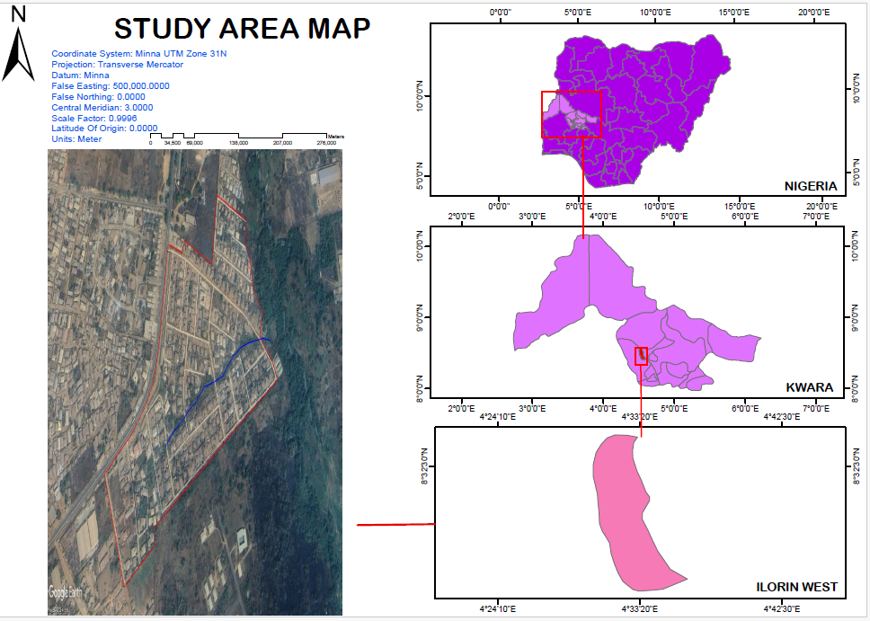

CHAPTER TWO
2.0 LITERATURE REVIEW
The implementation of relational database management systems (RDBMS) for cadastral information has been widely studied in the context of improving land administration systems (RM Bennett, M Pickering, J Sargent - Land Use Policy, 2019 - Elsevier). The following review highlights key research and scholarly work that has explored various aspects of cadastral data management, relational database systems, GIS integration, and the impacts of digitalization in land management practices.
2.1 CADASTRAL DATA MANAGEMENT SYSTEMS
Traditional manual cadastral systems have been a staple of land administration for centuries. These systems, often paper-based, involve recording land ownership, boundaries, transactions, and land use by hand or through simple records that are difficult to update and prone to error (Williamson, 2001). However, as cities have grown and urbanization has intensified, these systems have been increasingly criticized for their inefficiency and potential to generate data inaccuracies. Several studies have pointed out the limitations of traditional systems, such as inaccessibility, data redundancy, lack of integration, and insecurity of land records (Fitzpatrick, 2005).
To address these challenges, scholars have suggested the adoption of digital cadastral systems based on database management technology. The central argument for implementing a digital RDBMS lies in its ability to manage and store large amounts of land-related data in a structured and efficient manner. For instance, Sander and Koster (2007) argue that relational databases enable land registration systems to manage data more effectively, providing a framework for the integration of land ownership, spatial data, land transactions, and ownership rights.
2.2 ADVANTAGES OF RDBMS IN CADASTRAL SYSTEMS
Several researchers have highlighted the advantages of using RDBMS for cadastral management. One of the most significant advantages is the data integrity ensured by relational models. According to Chen (2013), the use of primary keys, foreign keys, and referential constraints ensures that cadastral records are consistent and that relationships between different data elements (e.g., land parcels and ownership) are maintained correctly. This minimizes the risks of data duplication and errors, which are often found in traditional systems.
Another major benefit of RDBMS-based cadastral systems is the scalability of these databases. As cities expand and the volume of cadastral data grows, relational databases are capable of handling increased data volumes without degrading system performance. This scalability is particularly important for countries with large land records or developing regions that are increasingly digitizing their land systems. According to Rajabifard et al. (2008), an RDBMS facilitates the smooth scaling of data storage and the seamless integration of new records, supporting long-term data management.
Furthermore, the querying and reporting capabilities of an RDBMS enable the efficient retrieval of cadastral data. Using Structured Query Language (SQL), administrators and users can easily retrieve, update, or analyze land records, creating customizable reports that assist in decision-making (Shekhar, 2006). This ease of access and flexibility makes relational databases an ideal solution for users with varying levels of technical expertise, from land administrators to policymakers and the public.
2.3 GIS INTEGRATION AND SPATIAL DATA MANAGEMENT
The integration of Geographic Information Systems (GIS) with RDBMS is another key topic in the literature. GIS technologies are invaluable for visualizing spatial information, such as property boundaries and land-use patterns. By integrating GIS with an RDBMS, cadastral systems can combine attribute data (e.g., ownership information, transaction history) with spatial data (e.g., geographic coordinates, boundaries), providing a comprehensive system for managing land information.
Several studies have demonstrated the benefits of integrating GIS with RDBMS in cadastral management. For example, Zhao and Qin (2011) highlight that integrating GIS allows users to visualize land data directly on maps, making it easier to understand land parcel distribution and zoning. This integration supports spatial analysis and planning decisions, enabling authorities to assess land use patterns, urban expansion, and environmental impacts with greater accuracy. Furthermore, GIS-RDBMS integration enables real-time updating of cadastral records, as changes in the spatial data are automatically reflected in the associated database (Goodchild, 2006).
Yao et al. (2012) argue that GIS-based cadastral systems not only provide improved visualization but also assist in better land management through advanced spatial analysis, including land suitability analysis, flood risk mapping, and land-use planning. This integration enables policymakers to make data-driven decisions on urban development, environmental management, and infrastructure planning.
2.4 INTERNATIONAL STANDARDS FOR CADASTRAL SYSTEMS
The adoption of international standards for cadastral data management is crucial for ensuring consistency, interoperability, and data exchange between countries. The Land Administration Domain Model (LADM), an ISO standard for land administration, is one of the most widely recognized frameworks for structuring cadastral data. LADM provides a model for organizing and representing land-related data in a relational database, ensuring that data is collected, stored, and processed consistently.
According to Steudler et al. (2007), the LADM facilitates the interoperability of cadastral systems across borders and between different governmental departments, enabling better data sharing between land registries, tax authorities, urban planners, and legal entities. The adoption of this standard helps align national land administration practices with global best practices, making land data management more transparent and efficient.
Moreover, several researchers, including Van Oosterom et al. (2015), have emphasized the need for harmonizing cadastral systems with open data standards, such as the Open Geospatial Consortium (OGC) standards, to allow public access to cadastral information and promote transparency. This trend is in line with international calls for open government data, enabling citizens to access information about land ownership, zoning, and environmental regulations online.
2.5 CHALLENGES IN IMPLEMENTING RDBMS FOR CADASTRAL INFORMATION
While the advantages of adopting RDBMS for cadastral systems are evident, several challenges exist. Data migration from paper-based or legacy systems to digital systems is one of the most significant barriers. Murtagh (2009) and Binns (2010) note that data conversion is a complex and resource-intensive process that may involve manually entering old records into the new system, which could lead to errors or omissions if not carefully managed.
Resistance to Change is another common obstacle in the implementation of digital cadastral systems. Government employees, landowners, and other stakeholders may be reluctant to adopt new technologies due to a lack of understanding, training, or fear of job displacement. According to Puri and Kothari (2014), successful adoption requires comprehensive training programs and awareness campaigns to facilitate the transition from traditional methods to digital systems.
Additionally, the cost of implementation can be a significant barrier in developing countries, where resources are limited. Implementing a digital cadastral system requires substantial investment in technology infrastructure, personnel training, and ongoing maintenance (Chadwick, 2015).
This extended literature review further explores key topics related to the implementation of relational database management systems (RDBMS) for cadastral information production, focusing on aspects such as implementation strategies, global experiences, technological advancements, and future directions in the field. In addition, the review emphasizes the challenges and best practices observed in the process of digitalizing cadastral systems.

2.6 GLOBAL EXPERIENCES IN CADASTRAL SYSTEM IMPLEMENTATION
Several countries have successfully implemented RDBMS-based cadastral systems, offering valuable lessons and examples for others. These case studies highlight different aspects of the adoption process, including system design, data integration, and user adoption.
2.6.1 ESTONIA’S LAND INFORMATION SYSTEM (E-ESTONIA)
Estonia is often cited as a model for digital land administration. The Estonian Land Information System integrates land ownership records, transactions, and cadastral data using RDBMS technology. According to Kraft (2010), Estonia’s success was largely due to early adoption of digital infrastructure, strong governmental support, and a commitment to ensuring public access to cadastral information. The system enables citizens to access land records online, streamlining processes such as land registration, property taxation, and legal documentation.
A key feature of the Estonian system is its use of blockchain technology alongside traditional RDBMS to ensure data integrity and protect cadastral records from tampering. This innovative approach has garnered attention worldwide as a potential solution to issues of data security and fraud prevention in cadastral systems (Mikk, 2016).
    - AUSTRALIA'S NATIONAL LAND AND WATER RESOURCES AUDIT
Australia has also made significant strides in using relational databases for cadastral and land management purposes. The National Land and Water Resources Audit (NLWRA), launched in the early 2000s, utilized GIS and relational databases to map and analyze land use patterns, water resources, and land tenure systems. Rajabifard et al. (2009) discuss the integration of spatial data with cadastral records through RDBMS in Australia, noting that the project led to improved policy development, environmental monitoring, and sustainable land management. Furthermore, the integration of cadastral data with environmental data and land use planning systems led to more informed decision-making, especially in addressing climate change and land degradation issues.
    - SOUTH AFRICA’S CADASTRAL SYSTEM TRANSFORMATION
South Africa has undertaken a substantial effort to transform its cadastral system, which historically faced challenges related to land restitution, inequality, and fragmented data. The Land Reform Program in South Africa, implemented through the Deeds Office, adopted RDBMS-based systems to handle the digitization of land ownership records and improve land tenure security. Du Plessis and van der Merwe (2015) discuss the move to digital cadastral records in South Africa, focusing on the improvement of land administration and transparency in the land reform process. The transition to RDBMS technology helped integrate historical records with modern land registration systems, ensuring that citizens could access more reliable and accurate property data.
2.7 TECHNOLOGICAL ADVANCEMENTS IN CADASTRAL SYSTEMS
As technology continues to advance, several new trends are emerging that are expected to influence the design and functionality of cadastral systems.
    - CLOUD COMPUTING AND BIG DATA ANALYTICS
One significant development is the integration of cloud computing with cadastral systems. By hosting cadastral data in the cloud, authorities can ensure that the system is scalable, cost-effective, and capable of handling large datasets. Cloud-based RDBMS solutions offer increased flexibility for storing, retrieving, and analyzing cadastral information, allowing real-time updates and global access.
The integration of big data analytics also plays a key role in modern cadastral systems. As land data continues to increase in volume and complexity, advanced analytics tools can be used to analyze trends, detect patterns, and support decision-making. For example, spatial analytics combined with RDBMS can help authorities monitor land use changes, identify areas at risk of natural disasters, or assess the environmental impact of urbanization (Shao et al., 2017).
    - Artificial Intelligence and Machine Learning
The use of artificial intelligence (AI) and machine learning (ML) in cadastral systems is an emerging field that could further enhance cadastral information management. AI and ML algorithms can automate tasks such as data validation, error detection, and automated updates, reducing the manual labor required for system maintenance. Zhang et al. (2020) suggest that machine learning algorithms can be used to predict land value trends, assess land use compatibility, and even identify fraudulent land claims based on historical patterns.
2.8 CHALLENGES AND OBSTACLES TO SUCCESSFUL IMPLEMENTATION
While the adoption of RDBMS for cadastral management offers numerous advantages, it is important to recognize and address several challenges that may impede the smooth implementation and operation of digital cadastral systems.
    - DATA QUALITY AND LEGACY DATA CONVERSION
One of the major challenges in implementing digital cadastral systems is the quality of legacy data. Many countries have outdated, fragmented, and inaccurate records, which may not easily convert to modern database formats. Miller et al. (2013) emphasize that the process of data cleaning and validation during migration from paper-based systems to digital databases is often time-consuming and resource-intensive. As a result, many digital cadastral systems initially suffer from incomplete or incorrect data, which can undermine the system’s credibility and effectiveness.
    - USER ACCEPTANCE AND CAPACITY BUILDING
In many developing countries, resistance to change from both land administrators and the general public can be a significant barrier to adopting digital systems. Landowners and rural communities may not be familiar with digital technologies, and without proper training and support, they may be reluctant to use the new system. Furthermore, land registry and cadastral office staff may require capacity building to operate and maintain the new systems effectively. According to Gibson et al. (2011), successful implementation relies on the development of comprehensive training programs, user engagement strategies, and awareness campaigns to help stakeholders understand the benefits and functionality of the digital system.
    - SUSTAINABILITY AND MAINTENANCE COSTS
While initial implementation of RDBMS-based cadastral systems can be costly, the long-term sustainability of the system is another concern. Continuous maintenance and updates to ensure the integrity, security, and accuracy of cadastral data are essential for the long-term success of the system. Cost recovery models, public-private partnerships, and long-term funding mechanisms are necessary to maintain the system and ensure that it remains relevant in a rapidly changing technological environment (Davies, 2014).
2.9 FUTURE DIRECTIONS IN CADASTRAL INFORMATION MANAGEMENT
Looking ahead, the future of cadastral systems is expected to be shaped by the integration of new technologies and the global adoption of best practices. Key areas for future development include:
2.9.1 Decentralized land administration: The potential of blockchain technology to provide secure, transparent, and immutable records for land ownership is gaining traction. Blockchain-based cadastral systems could allow for peer-to-peer verification and decentralized land transactions, reducing the risk of fraud and enhancing trust in the system (Ojo et al., 2017).
2.9.2Smart cities and cadastral systems: As cities increasingly embrace smart technologies, there is a growing demand for integrated urban management systems that combine real-time cadastral data, sensor networks, and urban planning tools. This could allow for more dynamic land use management, real-time property assessments, and improved infrastructure planning.
2.9.3Public access and transparency: There is increasing pressure on governments to make land data more accessible to the public. The future of cadastral systems lies in the open data movement, which seeks to improve citizen engagement, participation, and accountability in land administration by making cadastral data publicly available online.
This extended literature review further explores emerging technologies and socioeconomic impacts related to the implementation of relational database management systems (RDBMS) for cadastral information production. It delves into the interdisciplinary approaches, policy considerations, and future trends in the field of cadastral information systems (CIS) and land administration.
2.10 Interdisciplinary Approaches in Cadastral Systems
One of the key developments in modern cadastral systems is the interdisciplinary approach used in their design and implementation. This approach involves the integration of geospatial science, information technology, legal frameworks, and sociopolitical considerations to ensure that cadastral systems are robust, comprehensive, and equitable.
2.10.1 Geospatial Science and Cadastral Information
The integration of geospatial science with relational database systems is one of the most critical aspects of modern cadastral systems. Cadastral data is inherently spatial—it represents land boundaries, ownership rights, and land-use patterns. As such, geospatial technologies such as GIS, remote sensing, and GPS play a vital role in accurately mapping land parcels, verifying property boundaries, and updating cadastral records.
GIS integration with RDBMS allows for the storage of both spatial and attribute data in one unified system. This integration makes it easier to manage land-related data while providing an intuitive interface for mapping, analyzing, and visualizing the spatial characteristics of land parcels (Kresse & Danko, 2007). Remote sensing technologies, including satellite imagery and aerial photography, further aid in land parcel identification and boundary determination, particularly in regions where physical surveys may be challenging due to terrain or resource limitations (Aien et al., 2012).
Additionally, the introduction of 3D cadastres a concept that extends traditional 2D parcel management to three-dimensional data (i.e., including buildings, subterranean spaces, and air rights)—has opened new frontiers for cadastral information systems (Jovanovic et al., 2015). These systems can represent the full complexity of urban land use, including multi-story buildings and underground facilities, facilitating more accurate land management in urban areas.
2.10.2 Legal and Socio-Political Factors in Cadastral System Design
While the technical aspects of cadastral systems are often emphasized, legal and sociopolitical factors are also paramount in designing these systems. Land tenure, property rights, and the legal recognition of land ownership often vary significantly across jurisdictions, impacting how cadastral systems are structured and used.
For example, in many developing countries, informal land tenure systems (e.g., customary land ownership or squatter settlements) are widespread, which complicates the design of cadastral systems. In such contexts, digitalization efforts must not only record formal land transactions but also incorporate informal land rights into the system. RDBMS technologies, with their ability to integrate diverse data sources, can support such integration by linking both formal and informal land tenure systems into a cohesive framework (Anderson & McLaren, 2012).
Moreover, public participation and transparency are becoming central themes in cadastral system design. Digital systems provide an opportunity to make cadastral data more accessible to the public, ensuring that land records are open, auditable, and inclusive. This shift toward open government data aligns with broader e-governance trends, where transparency in land management is seen as a driver of accountability, fairness, and efficiency in land-related matters.

2.11 Economic and Social Impacts of Implementing RDBMS in Cadastral Systems
Implementing an RDBMS-based cadastral system can have profound economic and social impacts, both in terms of cost efficiency and land governance. The implementation of these systems supports the formalization of land tenure, which can have a cascade effect on the economy, social equity, and environmental sustainability.
2.11.1 Enhancing Economic Development
Accurate and transparent land records are essential for a functioning property market. Secure land titles promote property investment and facilitate the mortgage market, enabling property owners to leverage land as collateral for financing (Deininger & Jin, 2006). This increases access to credit and financing for small businesses, farmers, and homeowners. In many developing countries, land is often the primary asset that individuals and families own, and improving land tenure security through digital cadastral systems can unlock economic opportunities, stimulate investment, and support local development.
The revenue generation potential of a digital cadastral system is also significant. RDBMS-based systems improve the efficiency of property tax collection, which is a crucial source of local government revenue. Automated property assessments and better tracking of land transactions contribute to a more accurate and reliable tax system (Lemmen et al., 2016). These improvements can contribute to economic growth by increasing local government funding for infrastructure and social services.
2.11.2Social Impact and Inclusion
Cadastral systems have direct implications for social inclusion and equity. In many countries, informal settlements and illegal land tenure arrangements have led to land conflicts, unequal access to resources, and marginalized communities. By digitizing land records and integrating informal tenure systems into RDBMS-based platforms, governments can help formalize property rights for vulnerable groups, such as women, indigenous people, and rural populations (Pfeiffer, 2011).
Furthermore, cadastral systems that emphasize public access to information can empower citizens, increasing their awareness of their land rights and reducing the likelihood of land disputes. This greater social equity is an essential component of good governance and can help mitigate tensions related to land grabs and displacement
2.11.3Environmental Sustainability
Cadastral systems also have implications for environmental sustainability. By integrating land use zoning, property boundaries, and environmental data into a relational database, these systems can support better land-use planning. Geospatial data combined with land ownership records can help in identifying vulnerable lands, assessing land degradation, and managing natural resources effectively.
For example, governments can use cadastral systems to implement land conservation measures by identifying areas that require protection, such as wetlands, forests, or agricultural lands at risk of overuse (Ritchie et al., 2016). Moreover, spatial analysis tools can assist in urban planning by preventing urban sprawl, promoting sustainable development, and ensuring that environmental considerations are incorporated into land development policies.
2.1.2Emerging Trends in Cadastral System Implementation
As technology evolves and land administration becomes more complex, emerging trends suggest that the future of cadastral systems will involve a more holistic, integrated, and dynamic approach. Below are some of the critical emerging trends:
2.12.1Decentralized Land Administration and Blockchain
The concept of decentralized land administration is gaining momentum, particularly with the advent of blockchain technology. Blockchain promises to provide secure, transparent, and tamper-proof records of land ownership, ensuring that all land transactions are recorded and verified in a decentralized ledger. This removes the need for a central authority and reduces the risk of corruption and fraud (Ojo et al., 2017). The integration of blockchain with RDBMS could further enhance the security, immutability, and audibility of cadastral data, leading to increased trust in land systems.
2.12.2 Smart Cadastral Systems and IoT Integration
The future of cadastral systems also lies in smart technologies, which integrate Internet of Things (IoT) devices, big data, and cloud computing. These smart cadastral systems will collect real-time data on land usage, land transactions, and property conditions through sensors and smart devices embedded in land parcels, buildings, or infrastructure. This will enable dynamic, up-to-date monitoring of land-related activities, providing authorities with accurate and timely information (El Hage et al., 2020).
    - Artificial Intelligence for Predictive Analytics
With the increasing volume of land-related data, artificial intelligence (AI) and predictive analytics will become more prevalent in cadastral systems. AI can help authorities automate routine tasks, detect anomalies in land records, and predict trends such as land price fluctuations, land use patterns, and potential land disputes. By leveraging AI, land administration systems can become more intelligent, adaptive, and proactive in managing land data and ensuring policy effectiveness.

CHAPTER THREE

3.1 METHODOLOGY
` Methodology comprises of the method and procedure employed in executing the project both in office and on the field. The method adopted for this project was based on the principle of surveying which was working from whole to part, aimed at acquiring reliable and accurate data needed for the computation and presentation of information in form of a plan.

This chapter describes the systematic procedures and methods adopted in the design and implementation of a Relational Database System (RDBS) for the Cadastral Information System (CIS) of Irewolede Estate. The methodology highlights the research design, data collection methods, system analysis, database design, software tools used, and implementation techniques.

3.4 TESTS OF DIFFERENTIAL GPS
The two GPS receivers (Tersus Differential GNSS) were tested to ascertain its working capability on two known established points. The reference receiver (base) and rover receiver were setup using the RTK (Real Time Kinematics) mode with boosts from external radio to increase the communication linkup and range between the two receivers. The interface was access using S1 controller to set the parameter. The data acquired was downloaded using beam methods (Bluetooth) of the windows mobile platform in text format (.txt)
However, the result displayed the following on the controller:
Status (P): | Fixed
Horizontal Root Mean Square (H): | 0.014
Vertical Root Mean Square (V): | 0.021
Satellite Number (S): | 10+4
Communication Mode (Channel): | 4
Time (T) | 11:05:38

3.5 CONTROL CHECK
Control check was carried out on the beacons PT 02 and PT 03 in order to ensure whether they were still maintaining their original positions. The reference receiver (base receiver) was set on PT 01 while the rover receiver was set on PT 02 and PT 03 respectively. The following are the result obtained
Table 3.5.1: Coordinate of the observed and the original values of PT 02
PILLAR | NORTHING | EASTING | STATUS | REMARKS
PT 02 | 935768.084 | 670900.867 |  | ORIGINAL
PT 02 | 935768.099 | 670900.847 | FIXED | OBESRVED
DISCREPANCY | 0.015 | 0.020
Table 3.5.2: Coordinate of the observed and the original values of PT 03
PILLAR | NORTHING(m) | EASTING(m) | STATUS | REMARKS
SC/KW E4583R | 935791.554 | 670975.362 |  | ORIGINAL
SC/KW E4583R | 935791.575 | 670975.384 | FIXED | OBESRVED
DISCREPANCY | 0.021 | 0.022
The result shows that the control pillars were in Situ and in good condition for the survey operation. In the case of the instrument, it can be concluded to be in good working condition.
3.6 DATA SOURCE
Control coordinate were given from existing map, which is considered as secondary data. This was plotted using AutoCAD. The main source of data used is primary source.
3.7 GEOMETRIC DATA ACQUISITION
This involve the acquisition of both northing and easting value of features that are present on the project site. During the data acquisition, Real Time Kinematic method was employed coordinates of boundary points, as well as details and notable features along the perimeter using total station. Boundary pillars are established and accurately measured. These points serve as reference markers and are essential for maintaining consistency and accuracy throughout the survey. Additionally, these coordinates serve as valuable information for future reference, analysis, or planning purposes. They can also be used to assess potential impacts on the survey area and aid in making informed decisions during the project's development or construction phases.
Data Acquisition
To gather the necessary data for the project, observations and measurements were carried out. Obtaining the information needed to create the project plan was the focus of this stage. The processes listed below were completed.
- Selection of control points. Perimeter Traverse
- Detailing
Complete surveying programs with the ability to record data and set parameters are included with the instrument used. Additionally, it uses software modules with built-in memory and has convenient memory management capabilities.
Perimeter Traverse
The act of traversing is the survey of a group of interconnected lines, known as traverse legs, the ends of which have been marked in the field and the lengths and directions of which have been established by observation. Traverse stations are places of changes or turning. Open and Closed
Traverses are the two basic categories into which traversing can be placed.
Closed traverse always begins and end on sets of known points (points with known coordinates previously established). Perimeter are frequently encircled by shapes, such as polygons, in closed traverse surveying. Although this type is expected to be employed in all projects in surveying generally.
An open traverse consists of a collection of traverse lines that are connected but do not begin and end at a known point. When no controls are present where the traverse action is to stop, this type is typically utilized. In this kind of traverse, the observer's main responsibility is to make sure that the task is being checked at each stage. Surveys of this kind are frequently used in the engineering industry, such as route surveys.
The closed traverse type was employed in this project as it was started on an existing control point (PT 02) and closed on the same control (PT 02).
Base Station Setup
The base station is required in order to ensure an accurate position to be used in the topographic survey of Extension to Textile Factory. The use of a base station is now a standard routine in surveying practice; this is to validate the fundamental principle of carrying out a survey “from whole to part”. This means that networks of horizontal and vertical control points are first established. The temporary adjustment (centering and leveling) was performed on it. All the connections necessary for RTK mode stated below was carried out,
- The base station comprising of Tersus GNSS GPS receiver shown in figure 3.1 below was setup on a tripod stand on PT 02.

Figure 3.1 Tersus GNSS GPS receiver
NB: The position of the base station used is 935768.084mN, 670900.867mE. It was located in an area free from obstruction and interferences. It has been set to the WGS 84 system with Clarke 1880 ellipsoid.
The procedure for the data capturing is stated below;
- The instrument was switched on using the power button and also the data lodger (TC20).
- Then the instrument was placed on the tribrach which was already attached to the tripod and levelled.
- On the data lodger, the Nuwa app, Survey Office software was launched.
- The software was allowed to load and then, on the Project creation page, a project folder called ‘CIS’ was created and then opened.
- On the series of pages that followed however, the datum was selected as ‘Minna’, the mask angle as ‘15º’, while the minimum observation time was set at ‘5 minute’. After this page, the Base page was loaded.
- On the instrument Connect page (the Bluetooth connection page), the base station instrument serial number 52000754 was selected and down the page, the ‘connect’ button was clicked. This connects the lodger to the base instrument.
- On the Base page, the get location icon was click, and this bring the approximate coordinate of PT 2control, the coordinate was then corrected to the values obtained after this, the ‘start’ button was clicked and the base observation commenced.
- The Rover instrument’s battery was then fixed into it and switched on using the power button then mounted on the tracking rod (a single legged pole) and tightened.
- The tracking rod was set at 2.00m as height of the instrument.
- On the instrument Connect page (the Bluetooth connection page), the base station instrument serial number 52000754 was then disconnected and the Rover instrument serial number 52000764 was selected and down the page, the ‘connect’ button was clicked. This connect the lodger to the Rover instrument. The voice information FIXED was then heard from the instrument.
A complete setup of the base and the interface of the Project Creation page are shown
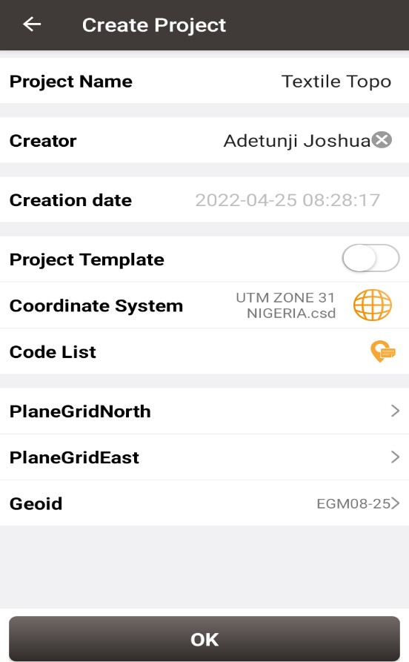
AINASVG/G13/13
CISSVG/G13/13
03-12-2024
Figure 3.2 Showing the project creation page on Nuwa app
FIELD OBSERVATION
- Aftersetting up the base, the rover instrument with serial number 52000764 was taken to site.
- NOTE: - Each station in a differential GPS observation is typically observed independently (though with direct reference to the base station), i.e., the instrument is placed on each station one at a time until the final point or detail in the site is observed.
- The instrument was placed on the first station i.e. the base of the tracking rod was placed on the center of the pillar.
- On the data lodger, the Nuwa app was launched and the Survey page of the app was click. On the Survey page, the get location icon was click to obtained the Northing and Easting of the station.
- NB: Given that the time segment of the instrument has been set to 5secs already, the observation automatically ends when its period of the time segment already pre-set elapsed
- The Station ID was then changed from pt1 to P1.
- After 5sec of observation, the observation stopped automatically and then the instrument was moved to the next station i.e. P2
- NOTE: - that the data lodger was not switched off after the first station had been observed since the stations are not far from one another i.e. not more than 50m from each another.
- On the data lodger with the Survey page on, the ‘get location’ icon was clicked and the observation started since the instrument had automatically given the next station name. The observation was allowed for 5sec again.
- The process in step (v) was repeated for all the subsequent stations and other details that were observed on the site.
- At the end of the observation, the instrument was switched off. The Survey page on the data logger was closed and the data lodger was also switched off (though in the warm boot mode).
- The data logger was taken to the base station and switched on again. The instrument’s serial number was selected on the Bluetooth page which also led to the Base station page.
- On the base station page, the ‘stop base’ button was clicked and then the instrument was
- switched off including the data lodger.
3.7.1 ATTRIBUTE/ SOCIAL SURVEY
This aspect of data acquisition entails the collection of other data which geometric in nature. Such data were directly related to the features to which geometric data was acquired. They included building names, the purpose of which the building is used for. etc.
To collect attribute data, survey was employed. This involves oral interviews, reading information from sign posts, wall signs, virtual observation, etc.
3.8 DATABASE CREATION/IMPLEMENT
For efficient and effective management of data in the computer environment, data item are usually arranged and stored in a database or databank. The content of this database could be in form of a text, number, polygon or graphics. The creation of this database involved the combination and storage of the acquired graphical and attributes data obtained in former designed GIS database of a generic structure for the purpose in spatial analysis and queries on project site
In the creation of a land information system data mode, a widely used technique called layering was employed. The features that are present within the project site have been classified into different layers in the AutoCAD software independently. The polyline entities were joined using the polyline tool while appropriate symbols were used for the point entities. These layers were then exported to ArcGIS environment where shape files were created using attributes fields as conceptualized in the schema. These attribute table were then populated accordingly with attributes values for each particular entity as observed in the field and from the social survey template (attached as appendix)
The personal Geodatabase was then created finally in Arc Catalog environment. Where other tables that are non-geometric where created while the already created shape files where imported. Relationship between these tables were also established and the tables were later populated in the Arc Map environment. The following are some of the tables created
3.8.1. DATABASE MANAGEMENT SYSTEM (DBMS)
According to Dale and McLaughlin (1998), database management system was defined as a computer program to control the storage, retrieval and modification of data in the database. DBMS comprises of set of programmers which are used to maintain and manipulate the data orderly and acts as the central control over all the interactions. It manages that data using alphanumeric data with limited capabilities of performing spatial queries
A DBMS must allow the definition of data and their attributes and relationships as well as providing security and on interface between the end users and their application and the data themselves it reduces redundancy. Therefore, Arc GIS 10.2 version was used to create, manipulate, maintain and access the database easily.

3.8.2. DATA QUALITY
Some forms of quality control and quality assurance were incorporated in the project at every phase. These include conformity with data templates, data competences and data accuracy. Conformity with data templates in this premises refers to the degree to which the captured data conformed with the designed templates, while data competence was understood as the degree to which the available data in the report and for which there are specific templates have been extracted.
3.8.3 DATA INTEGRITY
The data captured as exactly downloaded into the system then exported to AutoCAD via notepad and eventually into Arc GIS. The process involves ensuring that the data in the database were accurate and setting of certain constraint to prevent inconsistency in the database.
3.8.4 DATA SECURITY
Security is of great concern to land administration because of the legal implication of cadastral records. Security of the records is of almost importance to all concerned. These includes:
- Physical and system security
- Physical security: The use of burgling proof, fire-fighting equipment-controlled access, proper records of the moment of personal and our of the office circuit break
- System Security: Uninterrupted power supply (UPS) will be used to control voltage, use of passwords and backups
In view of the foregoing, locking mechanism was adopted to protect the data in the database from unconscious deletion. Password was used to prevent unauthorized user from breaking into the database and a backup was created for the whole project on the rentable DVD.
Having succeeded in analysis the methodology employed in the execution of this project to arrive at the successful completion. it is equally necessary to examine the processes undertaken to ascertain the reliability and effectiveness of the created land information system
CHAPTER FOUR
4.0 DATA PROCESSING AND PRESENTATION
4.1 SPATIAL ANALYSIS
Spatial analysis is a specialized function that distinguishes GIS from other information systems. It entails the examination of spatial and attributes characteristics of geographic features that are within the database to establish relationships from which spatial problems can be tackled. In this project work, spatial analyses were performed to select, combine and intersect existing geospatial data-sets in order to generate new information suitable for answering specific spatially-related questions.
The results from these analyses can be shown in a number of ways depending on the required output format. Where attribute information about map features is required, they can be presented as tables containing such valves as are needed from the query analysis. They can also be presented as maps with legend information showing the queried features and their topological relationships with other features shown on the map.
For this project AutoCAD 2007 was used to carry out the plotting of all the parcels. The drawing was exported to ArcGIS 10.3 where all other operations were carried out.
4.2 SPATIAL QUERY
Searching of data components using certain criteria of retrieving them from the database is known as spatial query. The information retrieved is used to support decision making. The Cadastral Information System (CIS) plays its role when a relational database is linked to graphics in real time.
A good Cadastral Information System (CIS) allows the user to select records or attributes in the database and to view the result on coverage displayed which can be printed on a hardcopy.
4.3 QUERY DESIGN
A query design is a precise definition of what is to be selected from the database. For example, the following queries designs were used in this project:
- Query by P Status=Developed, P use=commercial
- Query by P use = Residential
- Query by P use = Residential, P area = 1345.624sqm and Owners name = Mr Qudus
4.4 TESTING OF DATABASE
This is the test carried out to determine whether the relationship between the geometric data about the objects and their attributes is capable of being retrieved. This was done by designing a simple query and running the query to see if the desired result is achieved. The query ran, hence the database was confirmed fit for analysis.

4.5 EXISTING PARCELS AND BLOCKS
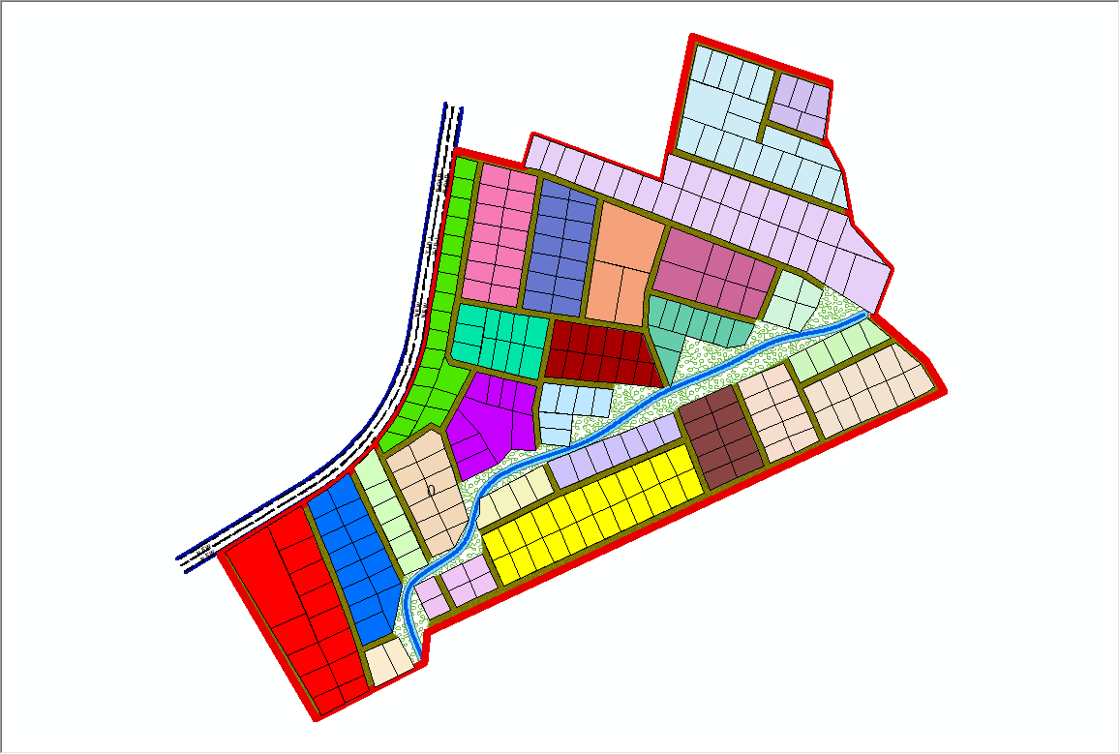

Fig 4.5.1:- the exported cadastral plan of the study area showing the blocks within the area
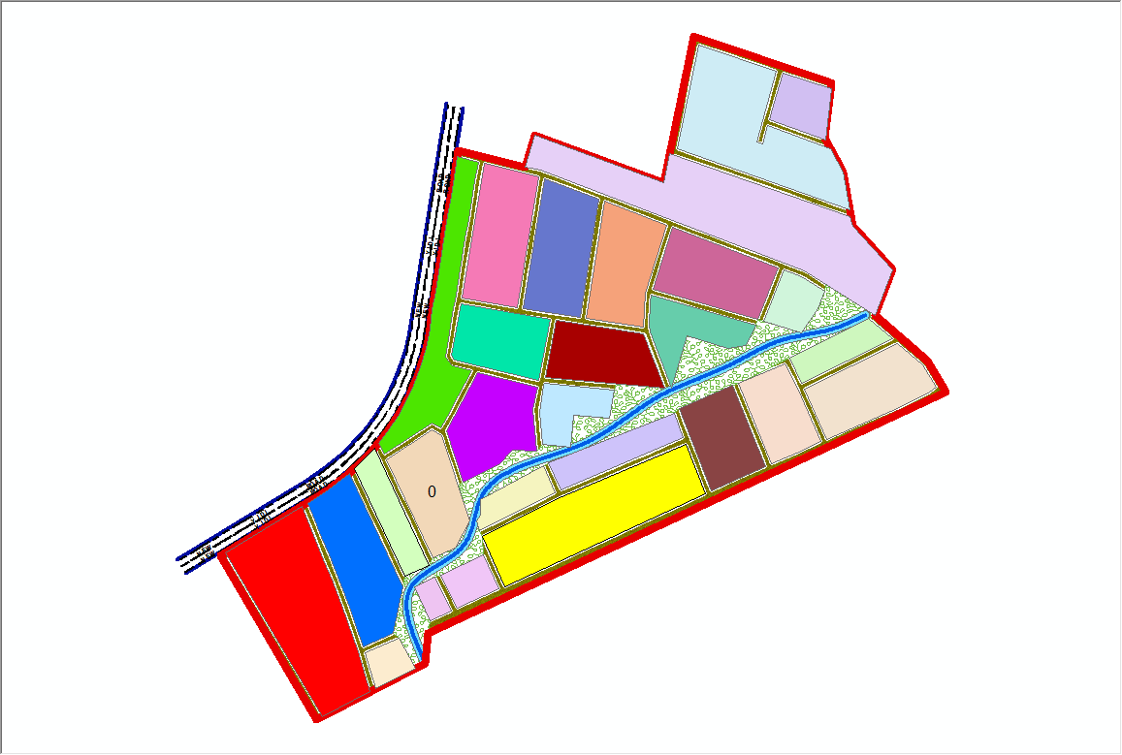
Fig 4.5.2:- the exported cadastral plan of the study area showing the all the parcels within the area.
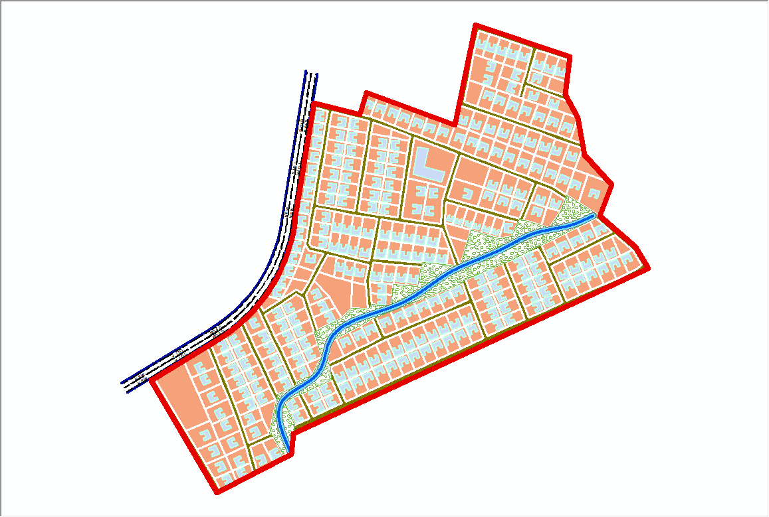

Fig 4.5.3:- the cadastral plan of the study area showing the boundary,
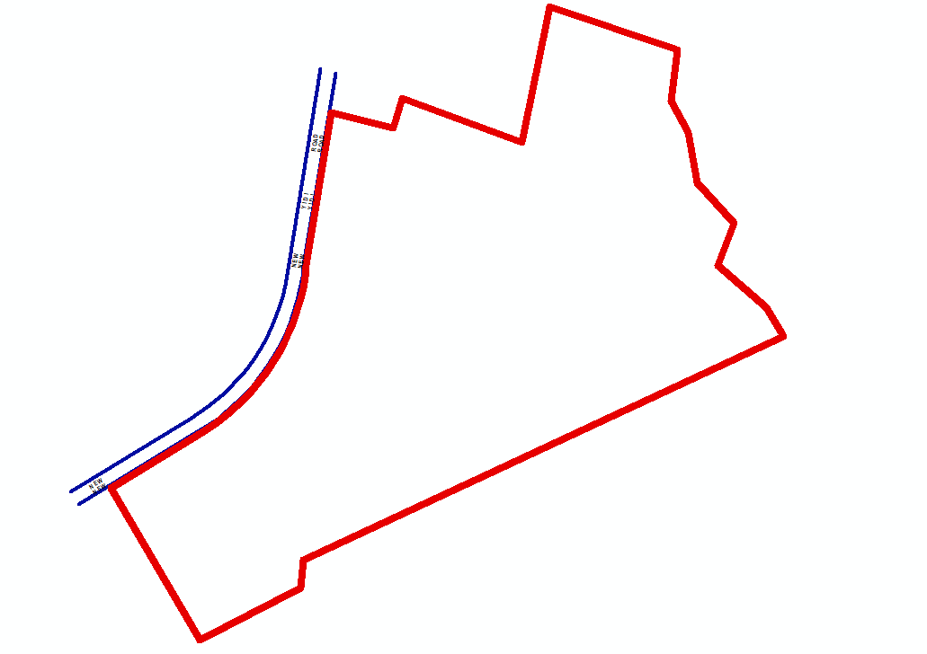

4.6 Spatial Query
Queries were designed for the purpose of retrieving information from the database. The queries performed in this project gave answers to certain generic questions asked from the database. This was made possible as a result of the implicit link of both the spatial and attributes data. The queries were based on the products from the analysis carried out on the database.
4.6.1 Single Criterion Query
A single criterion is carried out where one condition is used to design query. This condition is used to retrieve the information from the database.
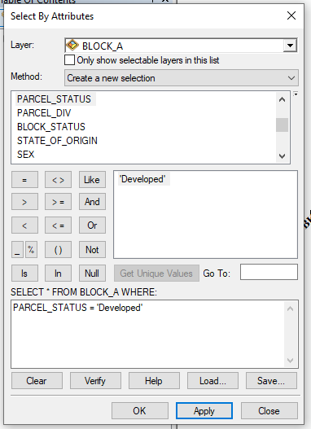
Fig 4.6.1.1:- Query for Parcel status for developed Purposes in the Study Area
SYNTAX; ([Parcel_status]) =’developed’)

4.6.2 Query by Parcel Status (Residential)
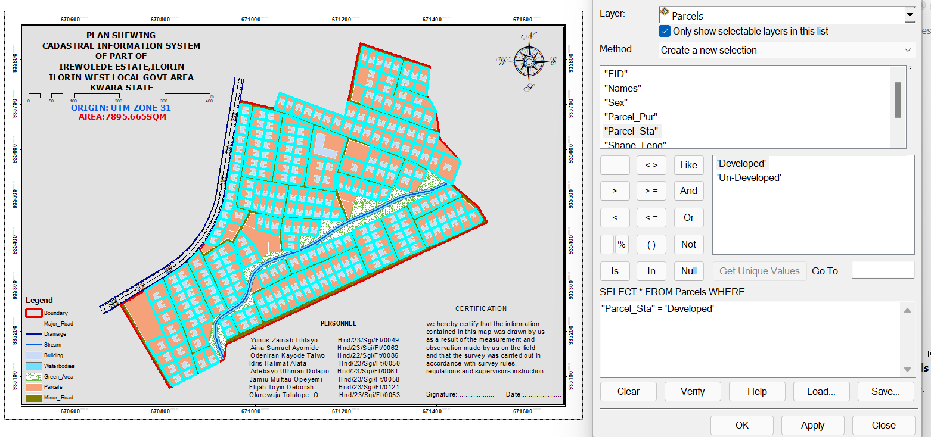
Fig 4.6.2.1: Result of Query for Parcel Used for residential area in block A in the study area
SYNTAX; ([Parcel_status]) =’developed’)
4.6.3 Discussion of Result
Figure 4.6.2.1 Shows parcels that are meant for developed purposes. It consists of the syntax model or the query builder box, attribute table as well as the map of the selected plot in light green color. The result shows that 8 parcels out of the 20 parcels are meant for commercial purposes.

4.6.4 Query by Parcel Status (commercial)
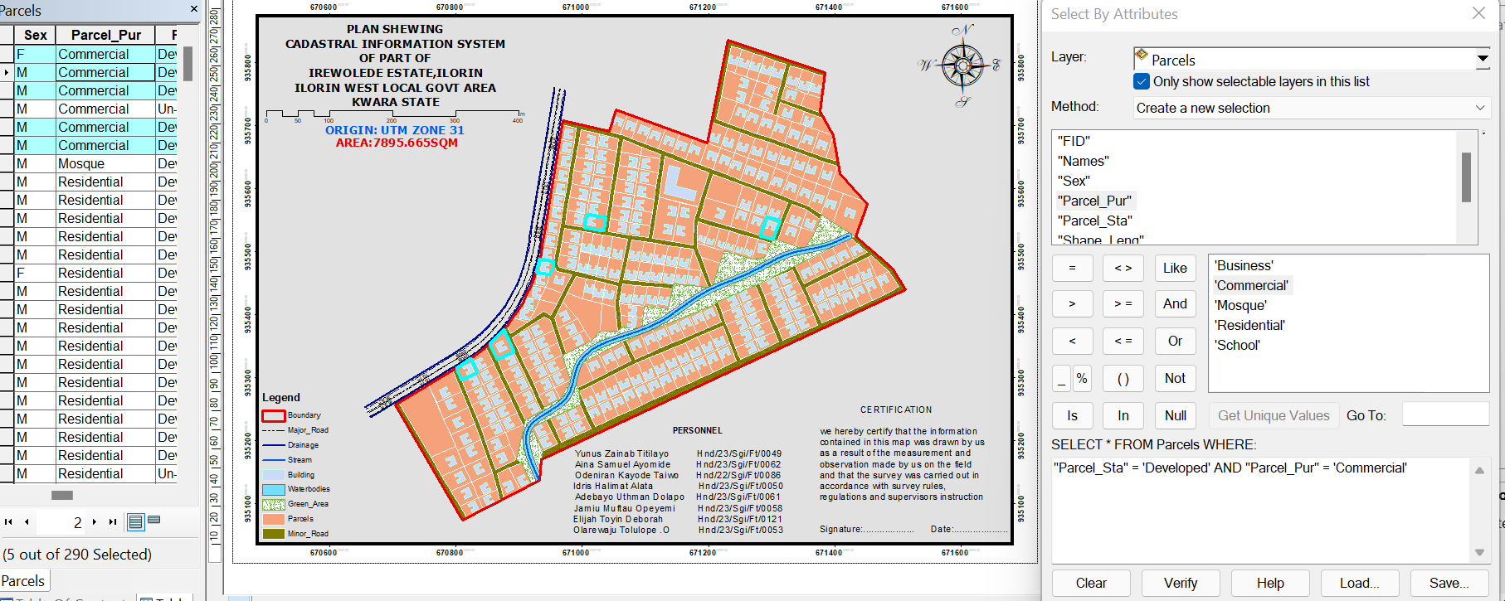
Fig 4.6.4.1: Result of Query for Parcels that are commercial purpose in the study area.
SYNTAX; ([Parcel status]) =’commercial’)
4.7 Discussion of Result
Figure 4.6.4.1 shows parcels that already have some type of commercial on it. It consists of the syntax model or the query builder box, attribute table as well as the map of the selected plot in light green color. The result shows that 5 parcels out of the 290 parcels have been developed. This information, however will help in informing the necessary quarters the level of development within the layout.
4.8 Multiple Criteria Query
The database created is then used for implementing several selection queries in determination of user-defined requirements such as parcels whose occupiers are actual owners, occupier’s citizenship, occupier’s occupation, number of residents in each flat, selection of unoccupied flats and other such security.
4.8.1 Query By Parcel Use And Parcel Status (Parcels meant for school, residential, commercial purposes that are “Developed”
Query was carried out in two stages, parcels meant for residential purposes were first queried by means of the parcel use field. In this case parcel use was selection criteria. The shapefile data of the query was exported as a layer and named accordingly. Next, the attribute table of the query result was queried by means of parcels meant for residential purposes that are yet to be developed i.e. Developed Parcels using the “Developed” selection criteria. This gives result for the parcels meant for residential purposes that are developed this also will help inform on the level of development within the layout.

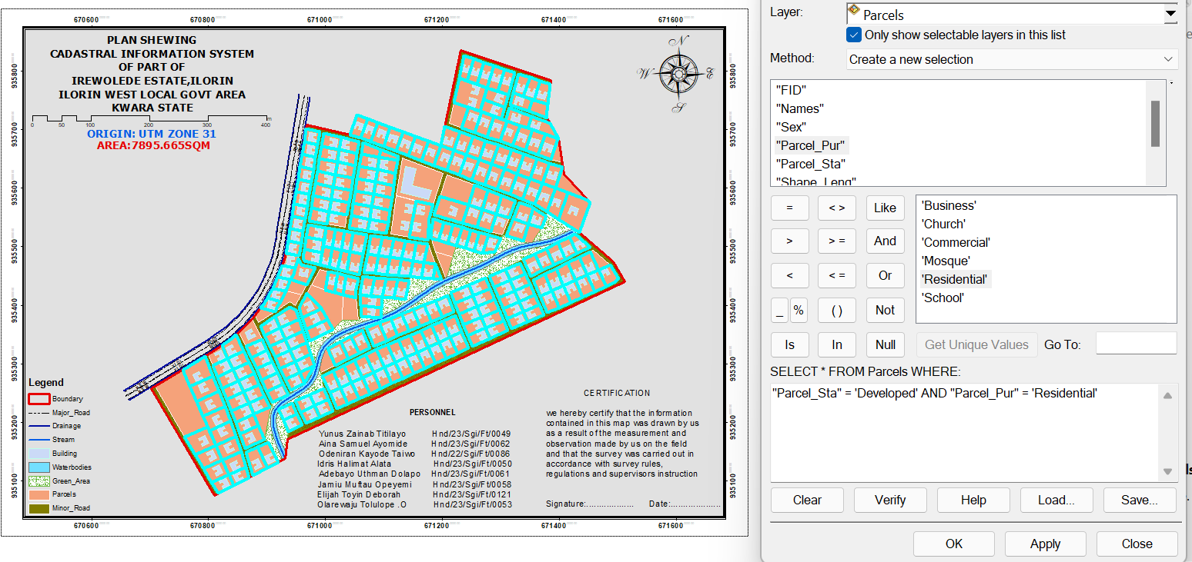
Fig 4.8.1.1: Screen print showing parcel use and parcel status in the layout.
SYNTAX;PARCEL_USE = 'Residential' AND PARCEL_STATUS = 'Developed’
Discussion of Result
Figure 4.8.1.1 shows the syntax modeled, the attribute table and the map of the multiple criteria queries ran on parcel meant for residential purposes and number of
Developed residential purpose parcels within the study area, they are highlighted in
Light green color. The result showed that 265 of the 290 parcels are developed.
4.8.2 Query By Parcel Use (Commercial) And Parcel Status (Parcels meant for commercial purposes that are “Developed”)
Following the procedure in the query for parcels meant for residential purposes that are yet to be developed. All parcels meant for commercial purposes were first queried and then, the resulting attribute table, query was carried out for parcel for which are Developed.
Fig 4.8.2.1: Screen print showing parcel meant for commercial purpose that are
Developed in the layout.
SYNTAX;PARCEL_USE = 'Commercial' AND PARCEL_STATUS = 'Developed'4.7.2.1
Discussion of Result
Fig 4.8.2.1 shows the result of syntax modeled, attribute table as well as unformatted map of developed parcels meant for commercial purposes. The table shows that all the 5 parcels meant for commercial purposes are developed. This is a pointer to the high rate of commercial developments in the study area.
4.8.3 Query By 10m Proximity to the stream (Parcel within 10m proximity to the stream).
Following the procedure in the query for parcels within close proximity to the stream (10m), query was carried out to show the parcels within close range to the stream.
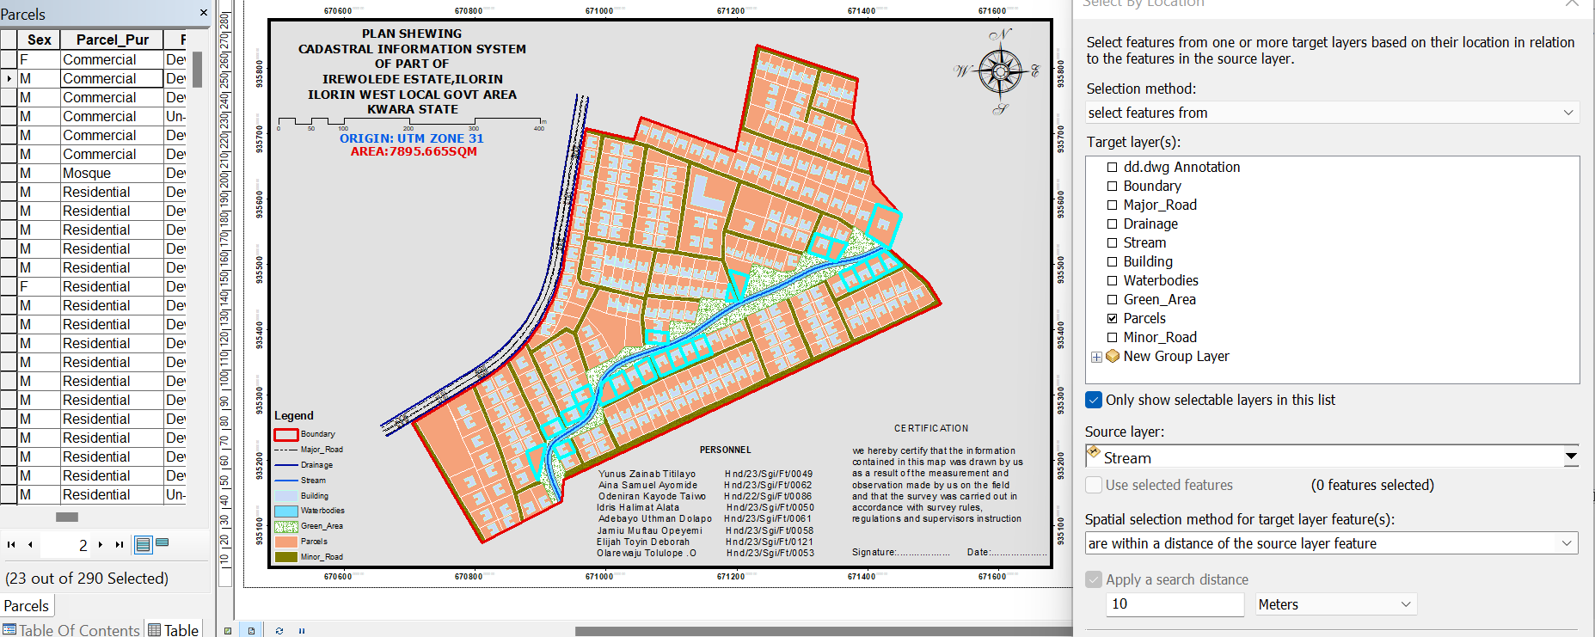
Fig 4.8.3.1: Screen print showing parcel parcel within 10m proximity to the stream
4.8.3.2 Discussion Of Result
Figure 4.8.3.1 shows the result of syntax modeled, attribute table. The table shows that only two out of all the parcels, only 25 parcel are within 10m proximity to the stream.

Fig4.8.5.4 Screen-shot showing the database created for the study area
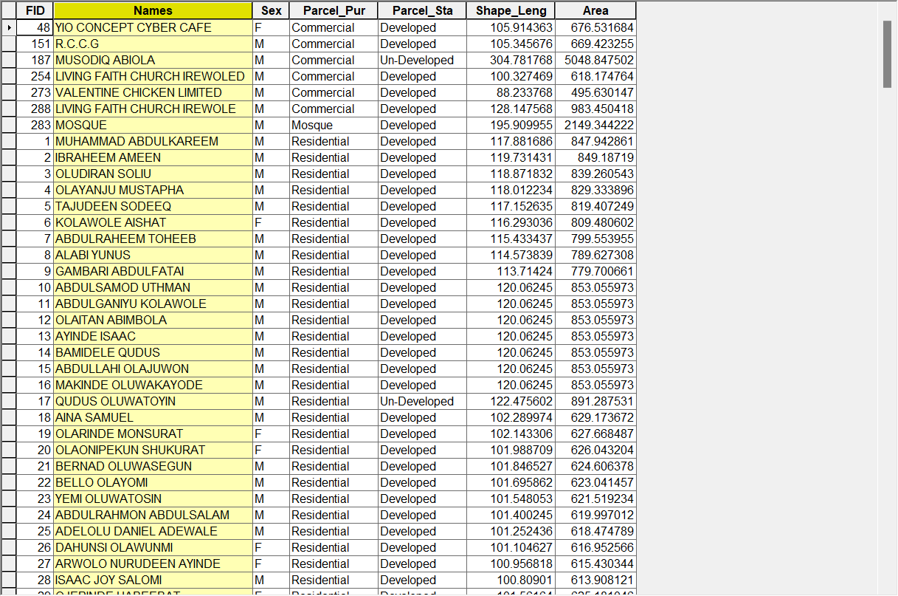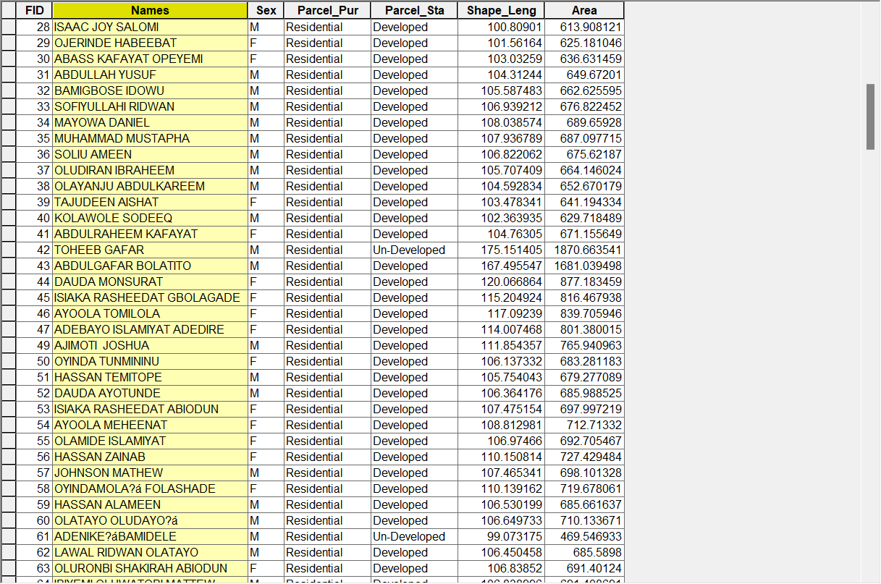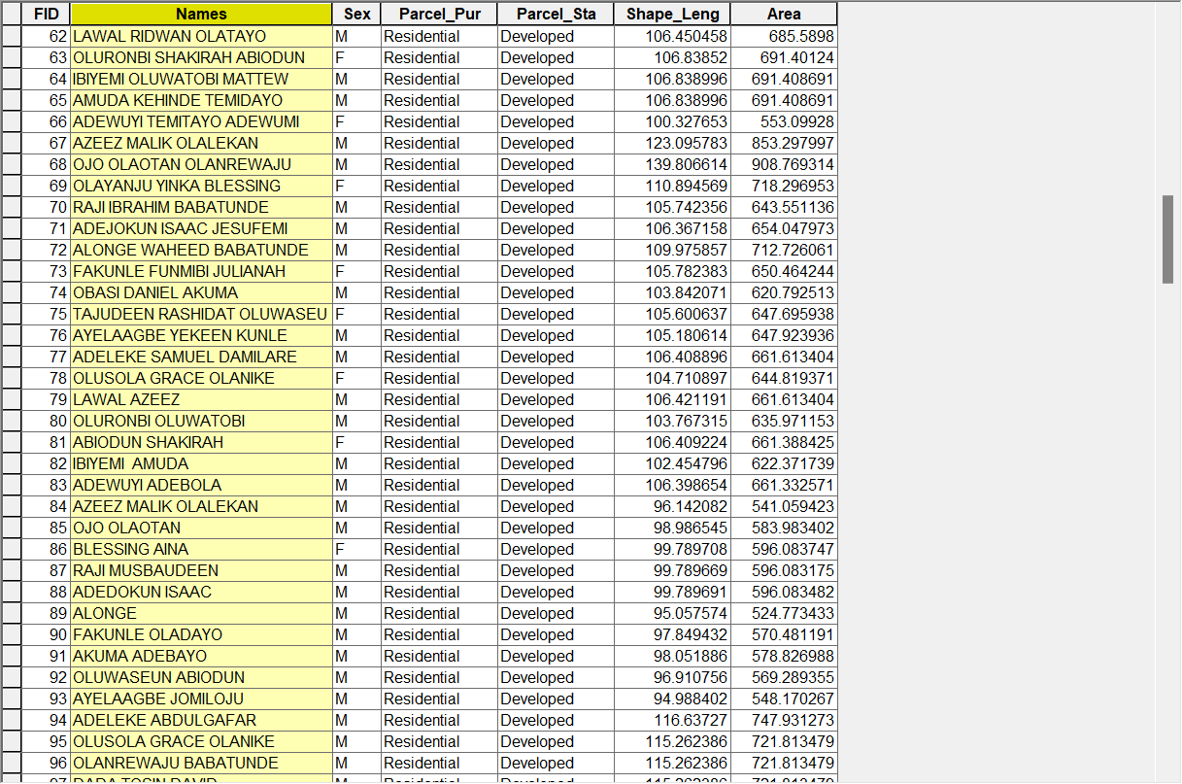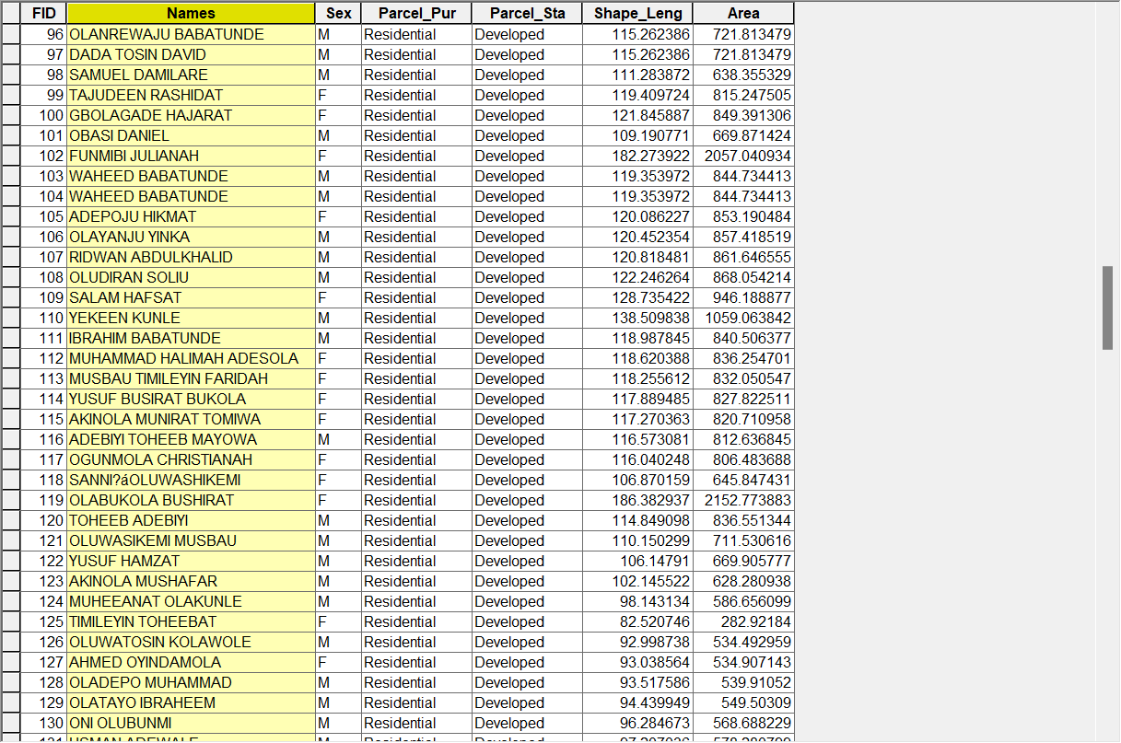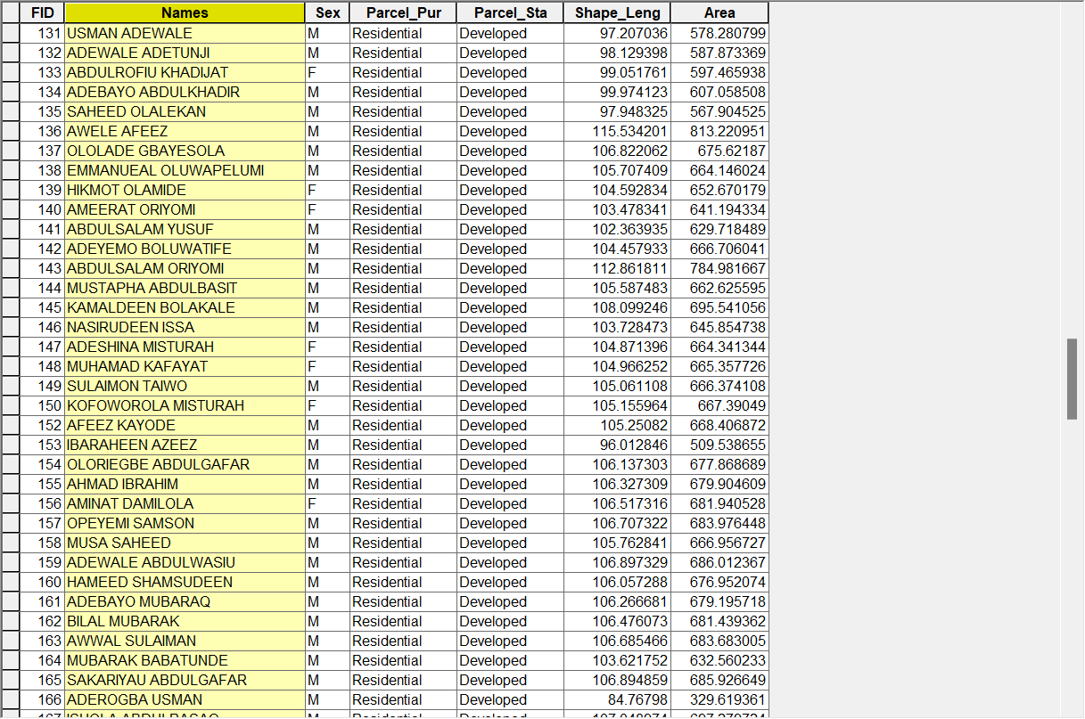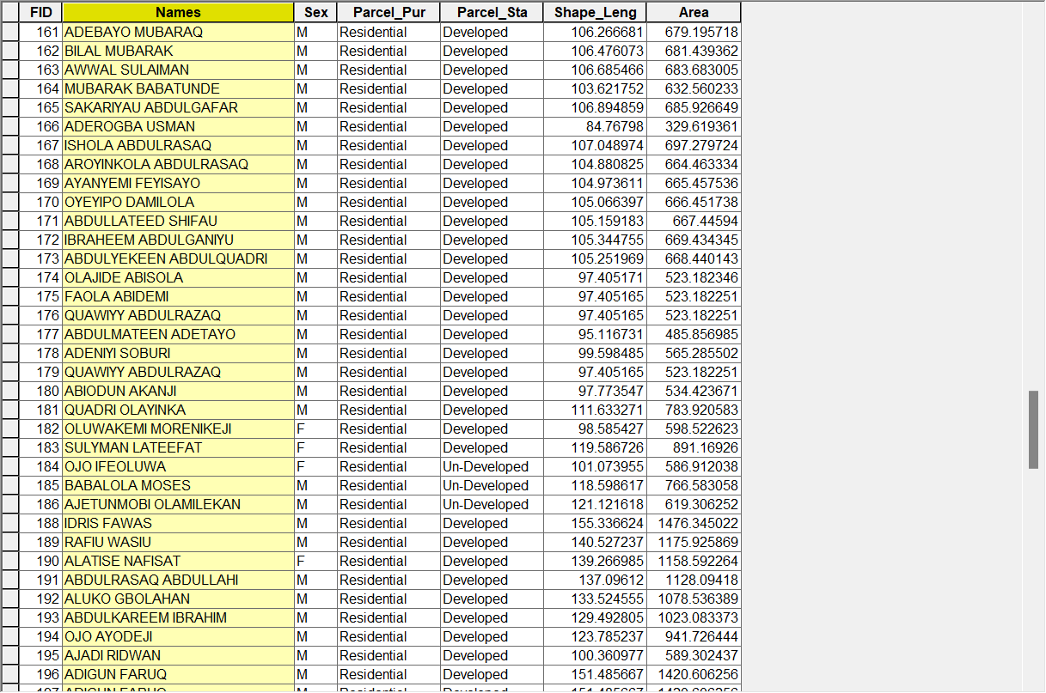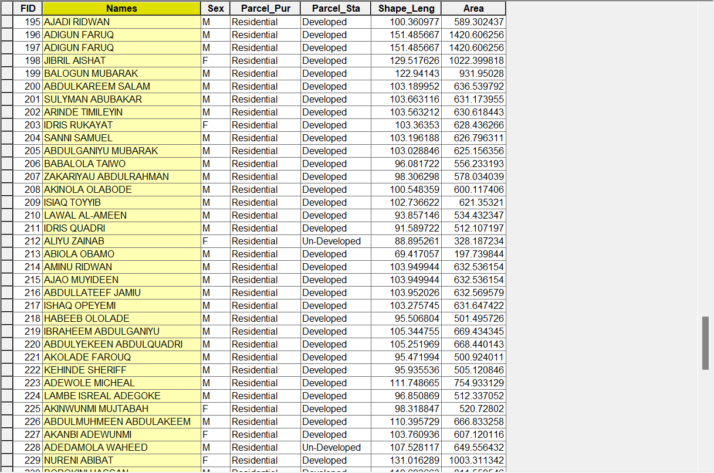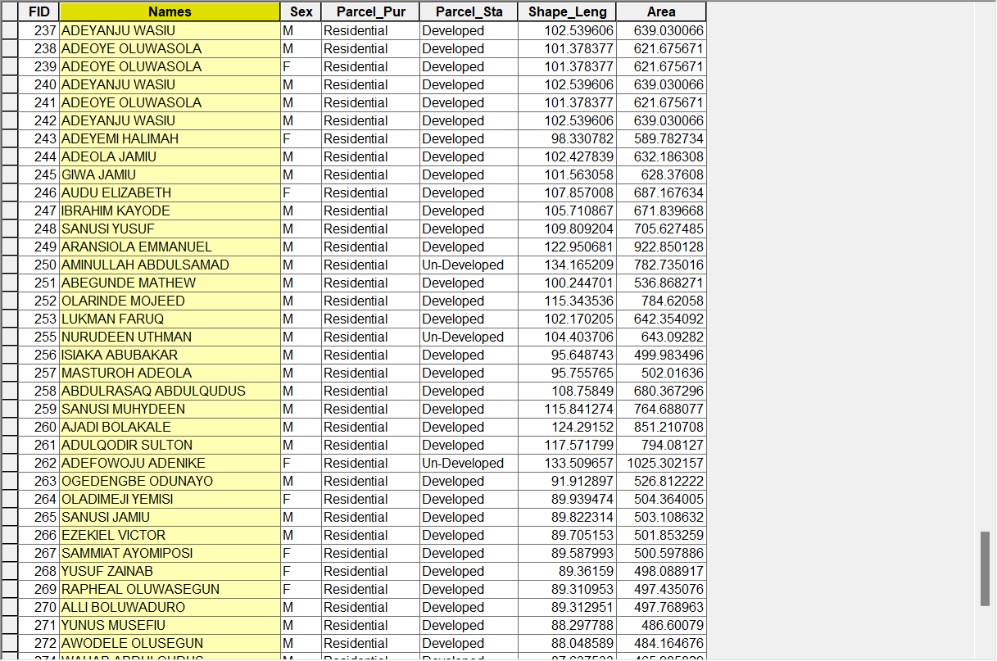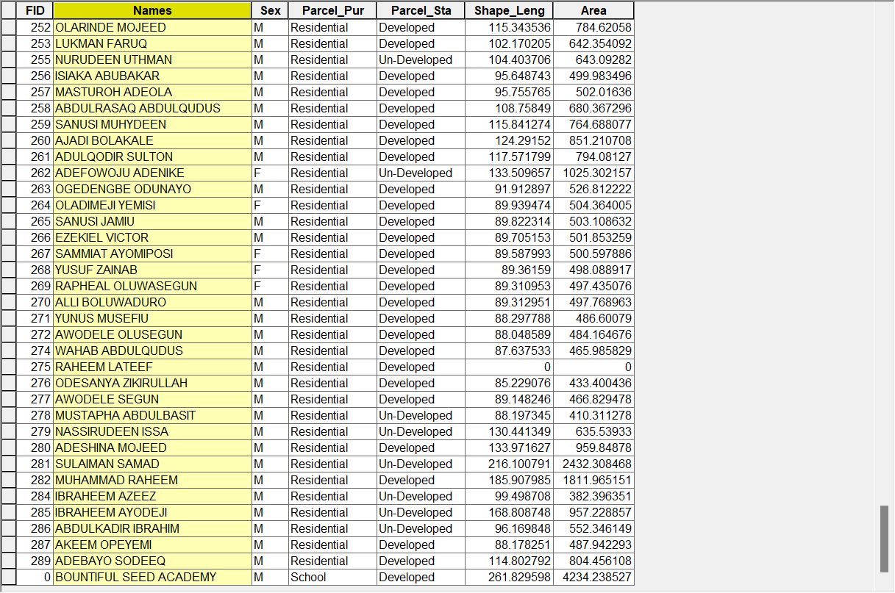

CHAPTER FIVE
SUMMARY, CONCLUSION, AND RECOMMENDATIONS
5.1 SUMMARY OF FINDINGS
This study investigated the implementation of a relational database system (RDBS) for managing cadastral information within Irewolede Estate, located along New Yidi Road, Ilorin, in Ilorin South Local Government Area. The investigation revealed that the estate’s previous system of managing land information was predominantly manual. This manual approach led to significant challenges such as loss of important documents, slow retrieval of land records, high risk of data redundancy, and difficulty in maintaining up-to-date information regarding land ownership and land use.
Through the design and implementation of a relational database, these challenges were effectively addressed. The system allowed for efficient storage, updating, and retrieval of cadastral data, ensuring that all records were organized systematically. Key entities such as plot numbers, owners' details, land usage types, and transaction histories were clearly captured and appropriately linked through relational tables. This design reduced data redundancy, enhanced data integrity, and simplified the process of managing large volumes of information.
Furthermore, the relational database system significantly improved accessibility and security. Information could now be retrieved with minimal effort, and user authentication features were incorporated to protect sensitive records. Estate administrators could also easily update the database to reflect changes such as ownership transfers, plot reallocation, or changes in land use. Overall, the findings demonstrate that the use of a relational database system provides a modern, reliable, and scalable solution for managing cadastral information in growing urban communities like Irewolede Estate.

SUMMARY OF THE COSTING
PROJECT QUATITY |  | UNIT RATE
Reconnaissance |  | 1,662,800
Traversing |  | 222,500
Data downloading |  | 311,200
Data processing |  | 1,272,000
Information Presentation |  | 270,000
VAT (5% of the Total Cost of Project) |  | 186,925
CONTIGENCY (5% of the Total Cost of |  | 186,925
Project)
TOTAL |  | N | 4,112,350:00

COSTING OF THE CADASTRAL INFORMATION SYSTEM (PROJECT) OF PART OF IREWOLEDE ESTATE, ILORIN
RECONNAISANCE
S/NO | PERSONEL OFFICER | DAYS | UNIT RATE | AMOUNT
1 | Senior Surveyor | 6 | 98,800 | 592,800
2 | Assistant Surveyor | 6 | 58,000 | 340,000
3 | Chain Mem | 6 | 30,000 | 180,000
4 | Transportation | 6 | 40,000 | 240,000
5 | Basic Equipment | 6 | 65,000 | 270,000
 | Total |  |  | 1,622,800
TRAVERSING

S/NO | PERSONNEL OFFICER | DAY(S) | UNIT RATE | AMOUNT
1 | Assistant Surveyor | 1 | 85,700 | 85,700
2 | Labourer Crew | 1 | 12,500 | 12,500
3 | Transportation | 1 | 40,000 | 40,000
4 | Basic Equipment | 1 | 65,000 | 65,000
5 | Consumable | 1 | 20,000 | 20,000
 | Total |  |  | 222,500

DATA DOWNLOADING

S/NO | PERSONNEL OFFICER | DAY(S) | UNIT RATE | AMOUNT
1 | Principal Surveyor | 1 | 95,000 | 95,000
2 | Senior Surveyor | 1 | 65,500 | 65,500
3 | Assistant Surveyor | 1 | 45,700 | 45,700
4 | Basic Equipment | 1 | 65,000 | 65,000
5 | Transportation | 1 | 40,000 | 40,000
 | Total |  |  | 311,200

DATA PROCESSING

S/NO | PERSONNEL OFFICER | DAY(S) | UNIT RATE | AMOUNT
1 | Senior Surveyor | 6 | 95,000 | 570,000
2 | Assistant Surveyor | 6 | 65,500 | 393,000
3 | Basic Equipment | 6 | 65,000 | 390,000
4 | Transportation | 6 | 45,000 | 270,000
 | Total |  |  | 1,272,000
INFORMATION PRESENTATION
S/NO | PERSONNEL OFFICER | DAY(S) | UNIT RATE | AMOUNT
1 | Principal Surveyor | 1 | 95,000 | 95,000
2 | Senior Surveyor | 1 | 65,500 | 65,000
3 | Basic Equipment | 1 | 65,000 | 65,000
4 | Transportation | 1 | 45,000 | 45,000
 | Total |  |  | 270,000

VAT (5% of the Total Cost of Project) | 3,738,500 * 0.05= 1,869,250
CONTEGENCY (5% of the Total Cost of Project) 3,738,500 * 0.05= 1,869,250

5.2 RECOMMENDATIONS
Based on the findings of this study, the following recommendations are made:
- Adoption and Integration: The developed relational database system should be fully adopted by the Irewolede Estate management authority for daily cadastral operations.
- Training: Staff members should be trained on how to use the new system efficiently, including data input, management, and retrieval processes.
- Regular Updates: The database should be regularly updated to reflect new developments such as new plot allocations, ownership transfers, and land use changes.
- System Maintenance: Routine maintenance should be conducted to ensure the database remains secure, reliable, and scalable as the estate continues to grow.
- Government Support: Local government authorities should support the digitalization of cadastral records across other estates within Ilorin South and beyond.
5.3 CONCLUSION
The implementation of RDBMS-based cadastral systems holds transformative potential for land administration, offering numerous benefits ranging from enhanced data management and transparency to economic development and social inclusion. As governments and stakeholders increasingly adopt digital cadastral systems, emerging technologies such as blockchain, AI, and IoT are set to further revolutionize the field. However, for these systems to be successful, interdisciplinary collaboration, capacity building, and addressing challenges like data quality and user acceptance will remain central to the success of digital land management strategies. The future of cadastral systems lies in making them more integrated, dynamic, and sustainable in the context of an ever-evolving global landscape.

5.4 SUGGESTIONS FOR FURTHER RESEARCH
Future research can explore:
- Integration of Geographic Information Systems (GIS) with the cadastral database to provide spatial visualization of plots.
- Development of a web-based portal allowing landowners to access limited information about their plots online.
- Incorporating blockchain technology to enhance the security and transparency of land transaction records.
- Conducting a comparative study on the effectiveness of relational databases versus NoSQL databases in managing cadastral information systems.
- Expanding the system to cover broader urban planning activities, including infrastructure development and environmental management.

REFERENCES
Ajayi, O. (2010). Introduction to Land Surveying and Cadastral Mapping in Nigeria. Lagos: Spectrum Books.
Aluko, B. T., & Amidu, A. R. (2006). Cadastral Records Management for Sustainable Land Administration in Nigeria. Journal of Land Use Policy, 23(4), 501–509.
Awotona, A. (1990). Housing Renewal, Urban Planning and Land Administration in Nigeria. Avebury Publishing.
Dale, P., & McLaughlin, J. (1999). Land Administration. Oxford: Oxford University Press.
Date, C. J. (2004). An Introduction to Database Systems (8th ed.). Boston: Pearson Addison- Wesley.
Elmasri, R., & Navathe, S. B. (2017). Fundamentals of Database Systems (7th ed.). Boston: Pearson.
Federal Ministry of Works and Housing. (1992). Urban and Regional Planning Standards Manual. Abuja: Federal Government Press.
Federal Republic of Nigeria. (1978). Land Use Act. Lagos: Government Press.
International Federation of Surveyors (FIG). (1995). Statement on the Cadastre. Copenhagen: FIG Publication No. 11.
ISO 19152:2012. (2012). Geographic Information — Land Administration Domain Model (LADM). Geneva: International Organization for Standardization.
Larsson, G. (1991). Land Registration and Cadastral Systems: Tools for Land Information and Management. Essex: Longman Scientific and Technical.
McLaughlin, J., & Nichols, S. (1989). Resource Management: The Role of Land Information Systems. Canadian Journal of Surveying, Engineering, and Remote Sensing, 43(2), 77– 85.
National Population Commission (NPC). (2006). Population and Housing Census of the Federal Republic of Nigeria: Priority Tables. Abuja: NPC.
Obi, S. N. (2014). Modern Land Law and Land Registration in Nigeria. Enugu: Chenglo Limited.
Oyeniyi, B. A. (2012). Land Administration in Nigeria: Case Studies of Lagos, Abuja and Port Harcourt. Land Use Policy Journal, 29(1), 134–140.
Ploeger, H. D., & van Loenen, B. (2007). Land Registration from Paper to Database: Challenges for Developing Countries. International Journal of Geographic Information Science, 21(7), 797–807.
Rajaraman, V. (2001). Fundamentals of Computers (4th ed.). New Delhi: Prentice-Hall of India.
Udoka, E. J. (2013). The Imperatives of Land Information System for Land Administration in Nigeria. Journal of Environmental Science and Resources Management, 5(1), 15–24.
United Nations Economic Commission for Africa (UNECA). (2005). Land Tenure Systems and their Impacts on Food Security and Sustainable Development in Africa. Addis Ababa: UNECA.
Williamson, I., Enemark, S., Wallace, J., & Rajabifard, A. (2010). Land Administration for Sustainable Development. Redlands, California: ESRI Press Academic.

APPENDIX
NORTHING EASTING NORTHING EASTING
935609.976 | 671158.208 | 935610.110 | 671030.195
935685.660 | 671212.601 | 935588.956 | 671026.735
935622.014 | 671387.359 | 935546.647 | 671019.817
935629.861 | 671365.636 | 935567.802 | 671023.276
935637.708 | 671343.913 | 935664.242 | 671076.822
935645.555 | 671322.190 | 935645.404 | 671074.784
935653.402 | 671300.467 | 935624.237 | 671071.395
935661.249 | 671278.745 | 935603.069 | 671068.005
935669.097 | 671257.022 | 935581.902 | 671064.616
935676.944 | 671235.299 | 935539.915 | 671057.753
935716.912 | 671249.292 | 935560.735 | 671061.227
935709.268 | 671271.086 | 935639.619 | 671105.861
935701.623 | 671292.881 | 935618.433 | 671102.569
935693.979 | 671314.675 | 935597.248 | 671099.278
935686.334 | 671336.469 | 935576.062 | 671095.987
935678.690 | 671358.263 | 935534.572 | 671089.394
935671.046 | 671380.057 | 935554.877 | 671092.696
935725.350 | 671227.181 | 935655.785 | 671106.863
935240.915 | 671022.720 | 935679.816 | 671010.043
935249.541 | 671041.425 | 935658.092 | 671006.633
935258.168 | 671060.131 | 935636.946 | 671003.128
935266.794 | 671078.837 | 935615.800 | 670999.623
935275.421 | 671097.543 | 935594.655 | 670996.117
935284.048 | 671116.249 | 935552.364 | 670989.106
935292.674 | 671134.955 | 935573.509 | 670992.612
935301.301 | 671153.660 | 935524.068 | 671205.203
935309.927 | 671172.366 | 935515.221 | 671235.964
935318.554 | 671191.072 | 935519.645 | 671220.583
935327.180 | 671209.777 | 935510.884 | 671250.773
935336.027 | 671228.624 | 935504.090 | 671283.194
935269.006 | 671010.266 | 935506.546 | 671265.582
935277.890 | 671028.849 | 935529.850 | 671189.894
935286.775 | 671047.415 | 935557.110 | 671337.973
935295.653 | 671065.988 | 935547.745 | 671361.057
935304.533 | 671084.563 | 935528.420 | 671327.953
935313.039 | 671103.241 | 935522.537 | 671351.230
935321.370 | 671122.060 | 935498.124 | 671202.080
935329.702 | 671140.880 | 935472.693 | 671203.593
935338.033 | 671159.699 | 935231.108 | 670754.994
935346.365 | 671178.518 | 935285.608 | 670781.967
935354.696 | 671197.337 | 935257.017 | 670793.476
935363.530 | 671216.911 | 935231.699 | 670804.245
935596.725 | 671224.596 | 935206.333 | 670814.776
935563.069 | 671214.309 | 935180.802 | 670825.001
935584.247 | 671260.588 | 935155.206 | 670835.135
935552.140 | 671250.658 | 935129.538 | 670844.802
935575.974 | 671284.398 | 935107.378 | 670852.546
935544.888 | 671274.792 | 935167.868 | 670786.896
935538.411 | 671297.333 | 935167.868 | 670786.896
935568.137 | 671307.769 | 935140.042 | 670801.171
935433.953 | 671370.158 | 935115.530 | 670813.691
935405.605 | 671382.624 | 935093.982 | 670824.527
935414.568 | 671402.715 | 935502.026 | 671084.189
935443.362 | 671390.053 | 935499.132 | 671103.593
935452.770 | 671409.947 | 935496.224 | 671123.004
935423.531 | 671422.806 | 935493.321 | 671142.406
935462.179 | 671429.842 | 935490.418 | 671161.809
935432.518 | 671442.880 | 935463.704 | 671136.585
935471.388 | 671449.462 | 935466.019 | 671117.070
935441.629 | 671462.734 | 935468.337 | 671097.552
935451.108 | 671483.132 | 935470.649 | 671078.036
935476.286 | 671467.271 | 935461.388 | 671156.099
935468.597 | 671353.972 | 935459.070 | 671175.602
935478.261 | 671373.662 | 935483.156 | 671177.142
935487.975 | 671393.422 | 935453.430 | 671189.700
935497.690 | 671413.182 | 935427.021 | 671129.515
935504.834 | 671432.220 | 935428.791 | 671109.892
935719.739 | 671329.150 | 935430.561 | 671090.268
935704.331 | 671369.279 | 935432.350 | 671070.662
935762.962 | 671371.238 | 935514.752 | 671006.514
935770.229 | 671352.385 | 935503.179 | 670980.879
935776.532 | 671334.275 | 935524.324 | 670984.384
935747.563 | 671333.903 | 935511.905 | 671021.844
935736.698 | 671363.979 | 935509.146 | 671037.212
935358.509 | 671292.218 | 935506.012 | 671056.247
935345.200 | 671261.646 | 935482.715 | 671001.291
935376.305 | 671285.023 | 935479.456 | 671016.515
935363.475 | 671254.509 | 935406.672 | 671077.743
935394.616 | 671277.589 | 935388.609 | 671077.778
935381.896 | 671247.186 | 935304.276 | 671001.256
935412.976 | 671270.160 | 935132.843 | 670881.560
935400.358 | 671239.962 | 935143.924 | 670901.723
935431.389 | 671262.824 | 935199.080 | 670944.115
935418.907 | 671232.943 | 935217.901 | 670935.258
935374.037 | 671327.634 | 935325.946 | 670882.117
935391.311 | 671320.459 | 935287.781 | 670900.075
935409.422 | 671312.917 | 935306.864 | 670891.097
935427.707 | 671305.270 | 935249.617 | 670918.034
935445.993 | 671297.622 | 935268.699 | 670909.055
935386.102 | 671355.184 | 935305.492 | 670850.972
935402.922 | 671348.018 | 935267.327 | 670868.931
935420.838 | 671340.270 | 935286.409 | 670859.952
935439.009 | 671332.411 | 935229.162 | 670886.889
935457.067 | 671324.282 | 935248.245 | 670877.910
935781.749 | 671308.542 | 935293.188 | 670824.574
935787.881 | 671290.829 | 935254.605 | 670841.591
935793.688 | 671273.367 | 935273.888 | 670833.084
935799.496 | 671255.905 | 935215.952 | 670858.275
935805.767 | 671239.660 | 935235.332 | 670850.059
935755.833 | 671291.382 | 935196.705 | 670865.611
935735.338 | 671285.147 | 935174.652 | 670873.956
935705.906 | 671056.621 | 935203.130 | 670893.197
935759.977 | 671246.836 | 935476.149 | 671031.692
935635.714 | 671245.297 | 935472.246 | 671050.137
935627.491 | 671266.888 | 935482.431 | 670977.757
935619.441 | 671288.540 | 935313.233 | 670816.342
935611.305 | 671310.162 | 935443.675 | 670992.243
935603.168 | 671331.783 | 935439.993 | 671009.974
935594.978 | 671353.413 | 935436.238 | 671025.075
935585.241 | 671374.680 | 935431.771 | 671042.892
935574.896 | 671395.501 | 935376.631 | 670980.972
935643.850 | 671223.675 | 935357.973 | 670989.395
935651.986 | 671202.055 | 935397.772 | 670970.938
935660.122 | 671180.433 | 935394.162 | 671041.033
935668.259 | 671158.812 | 935687.989 | 670976.739
935676.332 | 671137.182 | 935666.376 | 670973.276
935684.392 | 671115.525 | 935645.229 | 670969.777
935692.489 | 671093.889 | 935624.082 | 670966.277
935699.732 | 671074.318 | 935602.936 | 670962.778
935560.442 | 671424.725 | 935560.723 | 670955.792
935379.334 | 670934.082 | 935581.827 | 670959.299
935358.770 | 670942.090 | 935539.550 | 670952.250
935339.340 | 670949.618 | 935518.387 | 670948.846
935319.912 | 670957.145 | 935497.160 | 670945.233
935300.484 | 670964.672 | 935476.333 | 670940.522
935282.407 | 670967.180 | 935435.900 | 670925.461
935242.796 | 670988.892 | 935417.749 | 670916.522
935223.786 | 670997.339 | 935400.550 | 670906.629
935212.953 | 670973.883 | 935384.335 | 670893.462
935231.870 | 670965.236 | 935409.826 | 670937.803
935269.705 | 670947.943 | 935454.280 | 670960.722
935288.622 | 670939.296 | 935401.806 | 671004.824
935307.540 | 670930.650 | 935544.173 | 671162.659
935326.457 | 670922.003 | 935551.179 | 671132.073
935345.374 | 670913.356 | 935659.225 | 671395.568
935363.828 | 670905.558 | 935604.088 | 671414.051
935350.086 | 671086.877 | 935430.315 | 670949.641
935358.537 | 671107.690 | 935455.752 | 670933.596
935366.356 | 671126.728 | 935350.755 | 670871.399
935374.174 | 671145.766 | 935327.572 | 670841.425

