EXTRACTION OF VEGETABLE OIL FROM MELON SEEDS (EGUSI)

BY
IBITAYO PATIENCE BUKUNMI
ND/23/HMT/PT/0078

A PROJECT SUBMITTED TO THE DEPARTMENT OF HOSPITALITY MANAGMENT, INSTITUTE OF APPLIED SCIENCES (IAS), KWARA STATE POLYTECHNIC

IN PARTIAL FULFILLMENT OF THE REQUIREMENT FOR THE AWARD OF NATIONALDIPLOMA (ND) IN HOSPITALITY MANAGEMENT

JUNE, 2025

CERTIFICATION
This is to certify that this research work is carried out by IBITAYO PATIENCE BUKUNMI with Matric no. ND/23/HMT/PT/0078 and has been completed, read through and approved as meeting part of the requirements of the department of Hospitality Management, Institute of Applied Sciences (IAS), Kwara State Polytechnic for the award of National Diploma in Hospitality Management.

__________________ _____ ____________
MRS. ADEBAYO S.M. DATE
Project Supervisor

_________________ _________________
MRS. ADEBAYO S.M. DATE
Project Coordinator

____________________ __________________
MRS. ADEBAYO S.M. DATE
(Part Time coordinator)

DEDICATION
This project is dedicated to Almighty God the creator of heaven and earth the one who created all human kind who gave me knowledge to achieve this project work also my parent MR. AND MRS. IBITAYO who are supportive both spiritually and financial I say God bless you more.

ACKNOWLEDGEMENTS
All praise to Almighty God whose protection and favour was supreme in the course of my education.
I am highly indebted to my parents Mr. and Mrs. IBITAYO for their financially, morally and spiritual support towards the achievement of my National Diploma (ND).
My appreciation goes to my able and amiable Supervisor the person of MRS. ADEBAYO SHERIFAT M. who toke his time in guiding and support me in writing this project may almighty God always be with you and special thanks goes to HOD Hospitality Management Department in person of MS. ALABI R.A and Special gratitude goes to our able project Coordinator in person of MRS. ADEBAYO SHERIFAT M. and all Hospitality Management department lecturers.
Lastly my sincere appreciation goes to all my family and friends who support me in one way or others I say God bless you more.

TABLE OF CONTENTS
Title page i
Certification ii
Dedication iii
Acknowledgement iv
Table of contents v
Chapter One
1.1 background of the study 1
1.2 Statement of the Problems 2
1.3 Objectives of the Study 2
1.4 purpose of the study 3
1.5 Research Hypothesis 3
1.6 Significance of the Study 3
1.7 Scope and Limitation of the Study 3
1.8 Definition of the Key Terms 4
Chapter Two
Literature Review 6
2.1 Introduction 6
2.2 characterization of a high oleic extracted from papaya 7
2.3 Characterization of Bread friut seed 8
Chapter Three
Research Methodology 10
3.1 Manufacturing procedure/Distribution of integrated 10
3.2 Design Analysis 12
3.3 Design and selection of Transmission 14
3.4 Press Design and blow-dryer 16
3.5 Selection of Electric 17
Chapter Four
Data Presentation, Analysis and Interpretation 18
4.1 Introduction 18
4.2 Result Discussion 24
Chapter Five
Summary, Conclusion and Recommendation 29
5.1 Summary 29
5.2 Conclusion 30
References 31

CHAPTER ONE
INTRODUCTION
1.1Background to the Study
Due to increase in human population and industries, the use of plant oil has drastically increased and as a result, oil from plants is less available and costlier these days. Unsaturated triglycerides are the main constituents of plant oils (Ahmed, et al.,1999). Oils are classified into essential and fixed oils. Essential oils are volatile, and are usually derived from the non-seed parts of the plants while fixed oils are derived from the seeds (Evbuomwan et al.,2015). Essential oils are used to produce perfumes, flavours, deodorants, antiseptics and pharmaceuticals, while fixed oils are often edible because of their nutritional value (Kubow, 1990).The choice of the coconut and melon seeds in this work are due to their high yield of the oil compared to other plants. They are edible oils and have various applications in food, medicine and industries (Obasi et al.,2012). Oils from coconut and melon are commonly used in cooking, and are useful as feedstock for biodiesel production, in addition to being used as skin moisturizer (Clark,2011). Extraction is the process of separation of a substance from a matrix and it can be done either by mechanical extraction(expression) or chemical extraction (solvent extraction). It includes liquid-liquid and solid-liquid phase extraction( Young et al.,1994).In this work, extraction of oil from seed was a solid-liquid extraction. Acid Value is the amount of free fatty acid (FFA)present in oil or fat.
The acid value of an oil or fat is the amount of base in milligrams required to neutralize the free organic acid present in lg of fat or oil (Akoh and Nwosu.1992).Saponification value of oil or fat is the amount in milligrams of alkali required to neutralize the free fatty acids from complete hydrolysis of the sample. It is a measure of average molecular weights (chain length) of fatty acid present. Peroxide value is a measure of the peroxide contained in the oil. A solution of oil in the mixture of acetic acid and chloroform is titrated with solution of potassium iodide Mattson and Grundy(1985). Specific gravity or relative density refers to the ratio of the weight of sample to the weight of distilled water. It is given as weight of sample/weight of distilled water. It has no unit. The main objective of the study is to extract oil from melon and coconut seeds and characterize the oils by determining their chemical properties such as saponification value, peroxide value and iodine value in addition to the specific gravity of the extracted oil.
1.2 Statements of problem
A vegetable oil is a triglyceride extracted from a plant. Such oils have been part of human culture for millennia. The term "vegetable oil" can be narrowly defined as refering only to substances that are liquid at room temperature, or broadly defined without regard to a substance's state of matter at a given temperature. For this reason, vegetable oils that are solid at room temperature are sometimes called vegetable fats. vegetable oils are composed of triglycerides, as contracted with waxed which lack glycerin in their structure. Although many plant parts may yield oil, in commercial practice, oil is extracted primarily from seeds.
The statement of problem of this study can never be over emphasized:
- To know the problem associated with extraction of vegetable oil from melon seed.
- To access the problem attached to areas or segment in which melon seed can be converted into vegetable oil and how the problem can be solved.
- To know the problem of production of vegetable oil using melon seed and the challenges.
1.3Objectives of the study
- To examine the extraction of Vegetable Oil from melon seed
- To highlight the how vegetable Oil can be extracted from melon seed
- To enumerate the areas or segment in which melon seed can be covert into vegetable oil
- To explain the health benefit of vegetable oil extracted from melon seed
- Production of Vegetable Oil
1.4 Purpose of this Study
The purpose of this study is to determined and test the following
- The effect of extraction of Vegetable Oil from melon seed
- The result of extraction of Vegetable Oil from melon seed.
- The prospect of extraction of Vegetable Oil from melon seed to the future-development and our economy at large.
- Uncover the opportunities created through the transformation of melon seed to vegetable Oil
1.5 Research hypothesis
The context of hypothesis formulation basically covers the hull hypothesis(HO)and alternative hypothesis (HI),the hull hypothesis is principally derived from the general hypothesis.
HO: Efficiency and effectiveness is yet to be improved through extraction of Vegetable Oil from melon seed
HI: Efficiency and effectiveness is hospitality industry has been improved through extraction of Vegetable Oil from melon seed.
1.6 Significance of the study
To produce vegetable oils, the oil first needs to be removed from the oil-bearing plant components, typically seeds. This can be done via mechanical extraction using an oil mill or chemical extraction using a solvent. The extracted oil can then be purified and, if required, refined or chemically altered.
1.7 Scope and limitation of the study
The research work will be confined only to the extraction of Vegetable Oil from melon seed industries with special emphasis on the case study. There is some problems encounter during the course of this study. There include:
Lack Of Enough Time: The time consumed in putting together the information mostly in term of data collection.
Insufficiency of Data: The data used for this project work is not enough that the secondary and primary data. Moreover effort has been made to ensure the data contain and limitations do not affect the quality of the research. Inadequacy of Funds: The analysis and gathering of data involve much money. therefore the extent by which information is collected depend on the availability of fund in the hand of the researcher.
Uncooperative Attitude of the Respondent: The respondents refuse to give a good answer to question given to them.
1.8 Definition of terms
Vegetable oils: Vegetable fats, are oils extracted from seeds, or less often. from other parts of fruits. Like animal fats, vegetable fats are mixtures of triglycerides. Soybean oil, grape seed oil, and cocoa butter are examples of fats from seeds. Olive oil. palm oil, and rice bran oil are examples of fats from other parts of fruits. In common usage, vegetable oil may refer exclusively to vegetable fats which are liquid at room temperature. Vegetable oils are usually edible, non-edible oils derived mainly from petroleum are termed mineral oils.
Melon: Is any of various plants of the family Cueurbitaceae with sweet, edible, and fleshy fruit. The word "melon" can refer to either the plant or specifically to the fruit. Botanically, a melon is a kind of berry: specifically a "pepo". The word melon derives from Latin melopepo, which is the latinization of the Greek unλoπέπων (mēlopepōn), meaning "melon", itself a compound of μήλov (mēlon), "apple, tree
fruit (of any kind)" and πéπωv (pepōn), amongst others "a kind of gourd or melon". Many different cultivars have been produced, particularly of cantaloupes
Seed: Is an embryonic plant enclosed in a protective outer covering. The formation of the seed is part of the process of reproduction in seed plants, the spermatophytes including the gymnosperm and angiosperm plants.
Seeds are the product of the ripened ovule, after fertilization by pollen and some growth within the mother plant. The embryo is developed from the zygote and the seed coat from the integuments of the ovule. Seeds have been an important development in the reproduction and success of gymnosperm and angiosperm plants, relative to more primitiv'e plants such as ferns. mosses and liverworts, which do not have seeds and use water-dependent means to propagate themselves. Seed plant snow dominate biological niches on land. from forests to grasslands both in hot and cold climate.

CHAPTER TWO
LITERATURE REVIEW
2.1 INTRODUCTION
This paper carried out experimental study, through extraction and characterization of both crude and refined castor oil. Normal hexane was used as solvent for the extraction process. The oil produced was refined through degumming. neutralization and bleaching process using local adsorbent (activated clay). The characterization analysis revealed that tested parameters, which include specific gravity, refractive index, acid value, saponification value and iodine value for both crude and refined castor oil produced, were within the ASTM standard specifications. In fact the iodine value obtained (84.8)for the refined oil indicates that the oil could certainly be used as lubricant, hydraulic break fluid and protecting coatings. The oil vas modified via sulphation method to produce Turkey-red oil that was tested on wooden material, paper and cloth. The test revealed that the Turkey-red oil produced is suitable to be used as a good dying agent and polish.
Proximate Composition, Extraction, Characterization and Comparative Assessment of Coconut(Cocos nucifera)and Melon (Coloeyn this citrullus) Seeds and Seed Oils Proximate composition, extraction, characterization and comparative assessment of Cocos nucifera and Colocynthis citrullus seeds and seed oils were evaluated in thiswork using standard analytical techniques. The results showed the percentage (%)moisture, crude fibre, ash, crude protein, lipids and total carbohydrate contents of the seedsas 7.51 and 4.27,7.70 and 5.51,1.02 and 2.94,10.57 and 11.67,47.80 and 50.42 and32.84 and 29.47 while the calorific values were 553.99 and 567.32 Kcal/100 g for Cnucifera and C.eitrullus, respectively. The two seed oils were odorless and at room temperature (30°C) liquids, with a pale yellow to yellowish colouration. Lipid indices of the seed oils indicated the Acid Values (AV)as 2.06-6.36 mgNaOH g-1 and 2.99-6.17 mg NaOH g-1,Free Fatty Acids (FFA)as 1.03-3.18 and1.49-3.09%, Saponification Values (SV) as 252.44-257.59 and 196.82-201.03 mgKOH g-1,Iodine Values (IV) as9.73-10.99 and 110.93-111.46 mg of I2 g-l of oil and Peroxide Values (PV) as 0.21-0.21 and 1.53-2.72 mg O2 kg-l for soxhlet-mechanical extracted C.nucifera and C.citrullus seed oils, respectively. The studied characteristics of the oil extracts in most cases compared favourably with most conventional vegetable oils sold in the Nigeria markets; however, there were some observed levels of significant differences in the values at p≤0.05.These results suggest that the seeds examined may be nutritionally potent and also viable sources of seed oils judging by their oil yield. The data also showed that the seed oils were edible inferring from their low AV and their corresponding low FFA contents. Industrially, the results revealed the seed oils to have great potentials in soap manufacturing industries because of their high SV. They were also shown to be non- drying due to their low IV which also suggested that the oils contain few unsaturated bonds and therefore have low susceptibility to oxidative rancidity and deterioration as confirmed by their low PV which also serves as indicators of the presence or high levels of anti-oxidants in the oils
2.2 Characterization of a high oleie oil extracted from papaya (Caricapapaya L.) Seeds
The physicochemical characteristics, fatty acid, to copherol, and carotenoid composition of a crude oil extracted from papaya (Carica papaya L.)seeds, form of a variety, were investigated. The oil yield from the seeds was 29.16%. The data obtained for the analytical indexes were in agreement with those of other edible oils The oil obtained had high oxidation resistance (77.97 hours). The major fatty acids into tal lipid were oleic (71.30%), palmitic (16.16%), linoleic (6.06%),and stearic(4.73%) acid. The a and 8-tocopherol were the predominant tocopherols with 51.85and 18.89mg.kg-1,respectively.The β-cryptoxanthin (4.29 mg.kg-1)and B-carotene(2.76 mg.kg-1)were the carotenoids quantified, and the content of total phenolic compounds was 957.60 mg.kg-l. Therefore, the potential utilization of the papaya seeds for oil production seems favorable. However, toxicological studies need to be carried out before the oil is appropriate for food applications.
Extraction and characterization of vegetable oils from legume and palmae: using African oil bean (Pentaclethra macrophylla) and akwu ojukwu (ElaisGuineensis) respectively.
The extraction and characterization of vegetable oils from the seed of Pentaclethra macrophylla (oil bean)and Elaeis guineensis (Akwu Ojukwu) was done. Extraction was done by solvent extraction method using petroleum spirit as the solvent for Akwu Ojukwu fibre and petroleum ether for oil bean kernel. There was a significant increase (P≤0.05) in the oil yield of Akwu Ojukwu fibre (48%) when compared to oil bean seed (32%). Some Physico-chemical, vitamin and mineral parameters of both oils were analyzed. Results of the physico-chemical analysis showed no significant difference (P≤0.05) in the relative density, peroxide value and thiobarbituric acid value of both oils. The melting point and acid value (250C and7.35mg respectively) of Akwu Ojukwu oil increased significantly (P≤0.05) when compared with that of oil bean seed bil (220C and 3.62mg respectively).On the other hand, the moisture content (0.40%), iodine value (53.25mg)and saponification value(196.38mg) of Akwu Ojukwu oil decreased significantly to that of oil bean oil(8.80%,121.80mg and 213.10mg respectively). Akwu Ojukwu oil was red while oilbean oil had a light-yellow colour. The vitamin and mineral determination showed that P,Fe and vitamin C content increased significantly (P≤0.05) in oil bean seed oil The general result shows that Akwu Ojukwu oil is a non-drying oil, while oil bean oil is a semi-drying oil. Both oils could be used for edible (when processed), medicinal and industrial purposes.
2.3 Characterization of Breadfruit Seed Hull Ash for Potential Utilization in Metal Matrix Composites for Automotive Application.
Breadfruit seed hull (seed coat or seed shell) is an agricultural waste. The waste is produced in abundance globally and poses risk to health as well as environment. Thus their effective, conducive and eco-friendly utilization has always been a challenge for scientific applications. This paper mainly deals with characterization of breadfruit seed hull ash obtained from breadfruit seed hall using spectroscopic and microscopic analysis. The characterization of the breadfruit seed husk ash was investigated through scanning electron microscopy (SEM).X-ray diffracto meter (XRD),thermo gravimetric analysis (TGA/DTA),Fourier transform Infra red spectrometry (FTIR)and X-ray Fluorescent spectonetery (XRF).Density and refractoriness of the breadfruit seed hull ash were also found. The results were compared and it was observed that the ash possesses nearly same chemical phases and other functional groups as reinforcement like.

CHAPTER THREE
3.1 Manufacturing Procedure/Description of Integrated Melon Processing Machine
The integrated melon processing machine (Fig.1)comprises of three
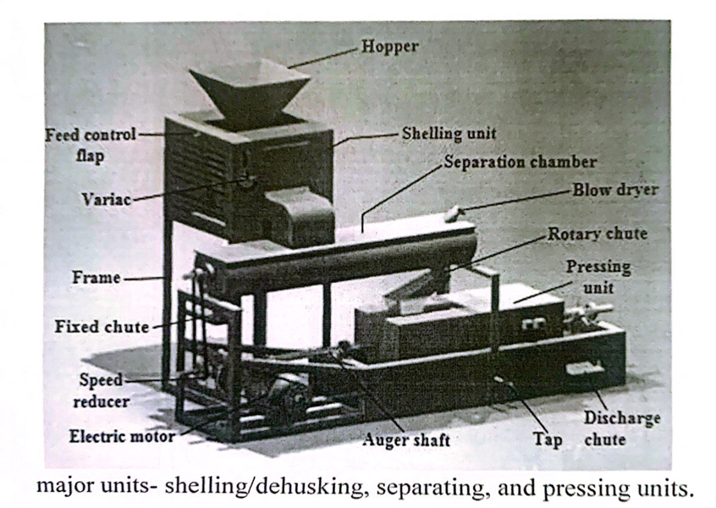
Major units- shelling/ dehusking, separating, and pressing units.
Fig.1:Integrated melono processing machine
All the components of this machine are mounted on a frame which was fabricated from a 5.08mm (2 inches)angle iron. The hopper through which moistmelon seeds are fed into the machine is an inverted pyramidal- frustum structure fabricated from a 2mm mild steel sheet metal with upper and lower cavities of300mm x 300mm and 100mm x 80mm respectively. Below the lower cavity of the hopper is a feed control flap which ensures intermittent supply of the melon seeds into the shelling unit. The shelling unit comprises of an externally-waned rotating drum, internally-waned cylindrical shaped casing, variable transformer and 1.5 HP electric motor. The rotating drum is a mild steel multi-vane blower wheel with diameter and height of 170mm and 230mm respectively upon which additional slanted vanes have been patterned longitudinally across its curved surface. The cylindrical casing with internal vanes have rectangular cavities of dimensions 50mmx 90mm and 100mm x 140mm which serves as the respective inlet for the melon seeds and discharge for the kemel/shell mix. Anticlockwise movement of the innerdrum in the casing with the melon in-between creates the shelling action. The 5 KVA variable transformers (variac) ensure this speed is varied for efficient shelling. Thereafter, the shell/cotyledon mix falls by gravity into the separation chamber.
The separation chamber is made up of a U-shaped trough. paddle conveyor, blow dryer and discharge chutes. The 250mm diameter separating trough was fabricated from a 2mm thick, 800mm long mild steel sheet. Two rectangular cavities of dimensions 80mmx50mm and 50mmx 40mm with fixed and rotary discharge chutes respectively were created at both ends of the trough for the discharge of the shell and kernel. When melon oil or flour are the desired products, the rotary chute is aligned with the top cavity of the hopper of the press barrel otherwise it is displaced 90° away from the barrel where the melon kernel can now be safely collected in a bag. The paddle conveyor on the other hand is an assembly of the paddle membrane fabricated from a 17mm diameter,800mm long mild steel pipe. paddles and the paddle shaft which is a 16mm diameter,1000mm long mild steel shaft.
The paddles (40mmx30mmx 2mm metal sheet fastened to a 40mmx 30mmx3mm leather pad) were placed across the longitudinal axis of the paddle membrane. Separation is achieved when hot air from the blow dryer blow against the direction of motion of the kernel/shell mixture as the paddle conveyor rotates.
The dual purpose press which serves as a mill and oil extractor comprises of hopper, auger conveyor, locknut-spring mechanism, cone, barrel, temperature controller and a heater. The barrel was fabricated from a standard 85mm diameter hollow stainless steel pipe of length and thickness 400mm and 3mm respectively This pipe was cut axially into two halves and a cavity of 20mm x 25mm was removed from the curved surface of each halve. This cavity was covered with1.27mm (1/2 inch) stainless steel square rods with a space of about Imm serving as an outlet for the oil. One end of this barrel is closed while the other is left open for articulation of the press cone (stainless steel conical frustum of height 70mm).The cone regulates the discharge of the melon flour or residual cake (by-product of the oil extraction process) by means of the spring-locknut mechanism placed behind it. The auger conveyor is made up of the auger membrane, helix and the auger shaft. The auger membrane is a 28mm diameter,400mm long stainless steel pipe while is helix is formed by scroll-welding four 5mm metal rods in spiral form on the pipe to form a flight and pitch of 45mm and 16.5mm respectively. The auger shaft is made from an18mm diameter and 1300mm long stainless steel shaft in which 350mm (from the right end) have been threaded for the locknut-spring mechanism. A 1000W hot plate is fixed under the press barrel to reduce the moisture content of the kernel with the temperature controller and thermocouple keeping the temperature within the desired value. When the desired end product is melon flour, the machine should be operated with the hot plate switched ·OFF'. The collector is a 550mm x 380mm x 100mmrectangular tray, made from a 2mm thick stainless steel sheet metal. It has been partitioned into two sections for the oil and melon cake/melon flour. It is directly underneath the press where it is welded in position to the structural frame. A tap is attached to the base of the collector for regulating the flow of oil from the collector.
3.2Design Analysis of Integrated Melon Processing Machine
3.2.1 Design considerations
The integrated melon processing machine was designed and developed based on the following considerations:
3.2.1.1 The shelling speed was regulated by a variable transformer so as to allow different species of melon seed to be processed efficiently.
3.2.1.2A blow-dryer whose terhinal velocity is less than that of melon seeds and shell was selected and used.
3.2.2 Analysis of the Weight Capacities of the Various Units
The volume capacity of the shelling unit, depends on the volume of the hopper; that of the separation chamber depends on the volume of the U-trough as well as the volume occupied by the paddle shaft/paddles integrated assembly while that of the press depends on the volume of the press barrel, auger membrane, helix and cone. The weight capacities were thus derived from the weight-density- volume relationship (Equation 1).
Where=density, = volume and g= acceleration due to gravity(9.8m/s2)
(1)
Considering 94% head space for the separation chamber and 25% head space for the shelling unit and press each, the effective weight capacities of the shelling unit.,
separation chamber, and press, were determined as
5.89N,5.89 N and 6.28 N from Equation (2),(3)and (4) respectively.
W1=2.45Hpm (LtWI+ LbWb +$\sqrt{ LrWrLbWb+(2)}$
W5=7.2pm ($\frac{1}{2}nr \frac{2}{3}3-(nr\frac{2}{p}1p+n\left(1fb+hf+bl h1\right)(3)$
W6 = 7.36pk $nr\frac{2}{c}1c-(nr\frac{2}{9} 1a+2n2r2n \sqrt{R2+\frac{2}{n}2+ \frac{1}{2}n (r\frac{2}{b}h-r2h}$
(4)
Where pm (600kg/m) and pe (640kg/m) are the respective bulk densities of unshelled nelon and melon cotyledon at moisture content between 9.53-24.08% (RAbu et al,2007);Lt (0.3m), (0.1m),(0.8m), (0.8m),(0.04m), (0.04m), (0.4m)and (0.4m)constitute the respective lengths of the top aperture of the hopper, base aperture of the hopper, separation trough, paddle shaft membrane, leather pad, flat bar, casing and auger membrane; (0.3m), (0.08m), (0.005m)and (0.003m) are the respective widths of the hopper's top aperture, hopper's base aperture. flat bar and leather pads; (0.125m), (0.0085m), 0.014m), (0.0425m).
(0.005m),R(0.045m), (0.0425m), and (0.02m)are the radius of the separation trough, paddle shaft membrane, auger membrane, barrel, rod used in forming the helix, helix, base of the cone frustum and top of the cone frustum respectively: (0.03m),H(0.15m), (0.03m),Z(0.09m), (0.08m)and=0.01m are the respective heights of the leather pad, hopper, flat bar, helix, complete cone and cone frustum while the number of paddles, n and revolutions of helix formed, N are 24 and 5 respectively.
3.3 Design and Selection of Transmission Systems
This machine is powered by two electric motors via four pulleys- one drives shelling unit while other drives the separating and pressing unit. Since the slower the press is run, the higher the extraction rate for oil, 24rpm was selected as the design speed of the auger while the electric motor operates at its rated speed of 1440rpmDue to its availability, cost and performance,125mm diameter mild steel pulleys were selected for aI1 the drives of this machine. A double output shaft speed reducer of gear ratio 1:60 was also used so as to achieve the required press torque with a portable design. Two pulleys are attached to each of the shafts of the speed reducer, while a pulley each is mounted on the prime mover and paddle conveyor shaft consequently forming the electric motor/speed reducer and speed reducer/paddle conveyor drives. The speed ratios of the electric motor/speed reducer and speed reducer/paddle conveyor drives were computer as 1:1 each using Equation (5).
(5)VR= $\frac{N1}{N2}=\frac{D2}{D1}$
Where N1 and N2 constitute the driving and driven pulleys' speed while DI and D2are the pulleys' respective diameters. The design center distances C, between the adjacent pulleys of the electric motor/speed reducer and speed reducer/paddle conveyor drives were determined as 250mm each using the relation in Equation (6) by Khurmi and Gupta (2005)
C = $\frac{D1+D2}{2}+ D1 (6)$
The design length of the belts' drives were computed as 892.5mm each using Equation (7), hence, type*A'V-belts of standard pitch lengths bf 925mm each were selected for drives since each drive transmits less than 3.75kw power (IS:2494-1974:Khurmi and Gupta 2005). Consequently, the exact center distances between the adjacent pulleys in each of these drives were determined as 266.25mm.The angle of lap (Ө) of each of the drives was computed as 180° (3.14rad), using Equation (8) while the belts' speed for the electric motor/speed reducer and speed reducer/paddle conveyor drives were determined as 9.42m/s and 0.16m/s respectively using Equation (9)Tensions on the tight side, /slack side, of the belts for electric motor/speed reducer and speed reducer/paddle drives were determined1 as; 160.52N/8.85N1 and170.10N/9.37N respectively from equation (10),(11),(12)and (13)
Tj=-Tmax -Tc (10)
Tmax =aa (11)
T6=Mv(12)
2.3 l0g$\frac{i}{t}=ue\cos{β}$
Where and are the respective maximum and centrifugal tension of the belts while the groove angle, β, coefficient of friction between the pulleys and thebelts,1,maximum safe stress,0,mass per unit length, m and the cross sectional area, of the belts were obtained from IS:2494-1974 standard Khurmi and Gupta (2005)as 0.3,19o,2.1N/mm2,0.108kg/m and 81mm2 respectively. Auto desk Inventor was used for the fore analysis (Fig. 2to4) of all the transmission shafts of this machine. and constitute the respective tight and slack side tensions of the speed reducer/paddle conveyor drive belt. The result of this analysis indicated 6.26mm,17.4377mm,and 15.811mm as the minimum diameters required of shelling drum, auger and paddle conveyor shafts respectively thus. standard 6.5mm,18mm,16mm and diameter shafts were consequently selected for the respective shaft.
3.4 Press Design and Blow-dryer selection
The decreasing depth and pitch screw threading system was adopted in the design of the auger. The difference between successive screw depiths dp was detemined as -1.25mm from the following relation;
Where the screw depth at the feed, af and discharge ends, Un are 43mm and 38mmrespectively. This implies that the screw depth would be decreased consistently by1.25 mm from the feed end to the discharge end of the press barrel. The pressure developed by the screw thread, as well as the maximum allowable pressure of the press barrel, were determined as 0.0025N/mm2 and 7.01 N/mm2 respectively using following relationship:
The torque transmitted by the auger shaft, mean thread diameter, dm; coefficient of friction,; thread lift angle, □ n tapering angle, □T; thickness of the barrel. t: inside diameter of the barrel, di and maximum yield stress of steel, o are890470Nmm,76mm,0.12,12°,6°,3mm,82mm and 355N/mm2 respectively. Since the maximum allowable pressure of the press barrel is greater than that developed by the screw thread, the barrel will not burst. Furthermore, stress analysis/simulation of the press barrel was carried out using Autodesk Inventor 2014 to determine the critical stress areas and fail points. Figure 5 shows the Von Mises stress distribution diagram obtained by Finite Element Analysis (FEA)
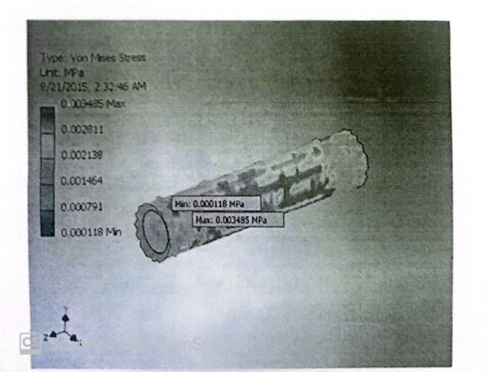
Fig.5:Finite Element Analysis of Press Barrel
The Von Mises stress is maximum towards the ends of the barrel as indicated by the light red coloration with value approximately 0.00035mpa. since this value is less than yield point value of steel, the design is safe.
According to Kassim et al. (2011),for efficient chaft/kemel separation, the air velocity in the separation chamber must be less than the terminal velocity of melon seeds and shell which was determined as 6.4m/s. Thus a hand blow-dryer with double-power setting 1500-1700 W, double-speed setting 1000-1200 rpn and terminal velocity of 5.8 m/s was selected and used.
3.5 Selection of Electric Motor
The power, required for the operation of the shelling unit was determined as815.74W (1.09 HP)using equations(18),(19),(20)and (21) by (Khurmi and Gupta,2005)
Where the mass of the shelling drum, m; radius of the shelling drum from the axis of rotation, r and design speed of cylindrical drum, o are 1.35kg,85mm and 99.48 rad/s(950rpm)respectively. The power requirement of separating and pressing units were determined as 25.72W (0.03 HP) and 1429.01W (1.92 HP) respectively from Equation (22) by Khurmi and Gupta,(2005).-) V (22)
Taking the load factor of electric motor, as 0.75,1.5 HP ana 3HP electric motors were selected for the operation of the shelling and separating chamber/pressrespectively.21

CHAPTER FOUR
4.1 PERFORMANCE ANALYSIS PROCEDURE
The effect of moisture content and shelling speed on melon de husking as well as paddle speed, blow dryer speed and heat on shell/kernel separation were first investigated. Thereafter, the oil extraction capacity,; extraction efficiency, ;and milling capacity were determined. The melon seeds used were procured from Ubani market in Umuahia, Abia state, Nigeria. In the first test, the moisture content and shelling speed at five levels were used. Moisture content determination was carried out using ASAE standard S.352 (ASAE,1982).The shelling speed was varied by regulating the varied while different moisture levels were achieved by removing a known quantity of the seeds periodically from a lot that have been soaked and dried. The initial moisture content of the seed was first used at five different inner drum speeds of 850,950,1000 and 1200 rpm. Thereafter, the shelling efficiency, and percentage seed damage, were evaluated using Equations (23) and (24) respectively.
(23)
(24)
Where, and, are the masses of seeds shelled (unbroken),unshelled seeds but broken, seeds shelled but broken and seeds put into the machine respectively Secondly, five different trials were carried out in which the speed of paddle conveyor was operated at 20,24,30,35 and 50 rpm and the blow dryer at the two speed and heat settings of 1000-1200 rpm and 1500-1700W respectively. The paddle conveyor speed was varied by changing the diameter of the driven pulley. In each trial a known mass of unshelled melon, at the moisture content and shelling speed obtained from the first experiment was introduced into the shelling unit and the time taken to the hull and separate the kernel/shell mix, was noted using a stop watch. Thereafter, the mass of melon kernel/seed received at the chaff outlet, as well as the mass of chaff received at the kernel outlet, were recorded as per each run and the separation efficiency, (%) and separation capacity,(kg/h) defined as the quantity of kernels cleaned per unit time were evaluated using equations (25) and (26) respectively.
(25)
(Kg/h) (26)
Finally, a completely randomized design involving five trials with the press temperature at five different levels was used. In the first trial, the press' initial/temperature of 25oC was first used. A stop watch was used to measure the time, takes the machine to process a known mass of moist melon seed, at the moisture content, shelling drum speed, paddle speed, blow dryer speed and heat obtained above. The mass of melon oil extracted, was also weighed and recorded as per each run, after which the extraction capacity, TP (kg/h)and milling capacity (kg/h) of the machine were determined using equation (27) and (28) respectively. This procedure was repeated with the press temperature at 30oC,65oC,90oC and 100oC23 heat settings of 1000-1200 rpm and 1500-1700W respectively.
Thereafter, melon oil losses to the chaff processed in each test were analyzed at Central Laboratory of College of Food Science and Technology, Michael Okpara University of Agriculture, Umudike using solvent extraction gravimetric method. The chaff from each test was wrapped separately in what man filter paper. Each wrapped sample was then placed in a soxhlet reflux flask before moanting the flask on a weighed oil extraction flask containing 250ml of n-hexane solvent. There after the extraction flask was heated after connecting the upper end of the reflux flask to a condenser. This causes the solvent to vaporize and condense into the reflux task to soak the wrapped sample until the flask was filled up and siphoned over. there by carrying the refluxed oil down into a boiling flask. This cycle of vaporization, condensation, extraction and siphon were repeated for five times in each case before removing the defatted sample carefully with a pair of forceps as the solvent condensed back into the reflux flask while leaving the oil extract in the boiling flask. The boiling flask with its content was then placed in an oven at 900 for 30 minutes, cooled in a desiccator and reweighed. The mass of oil lost to the chaff samples analyzed, was computed from the difference between the mass of the flask and the oil extract, and the mass of the empty flask, (133.48g) as expressed in equation(29). The melon oil extraction efficiency(%) of the integrated machine was also determined using the relationship in equation(30).24
fig. 6 effect of melon seed moisture content on seed/kernel breakage
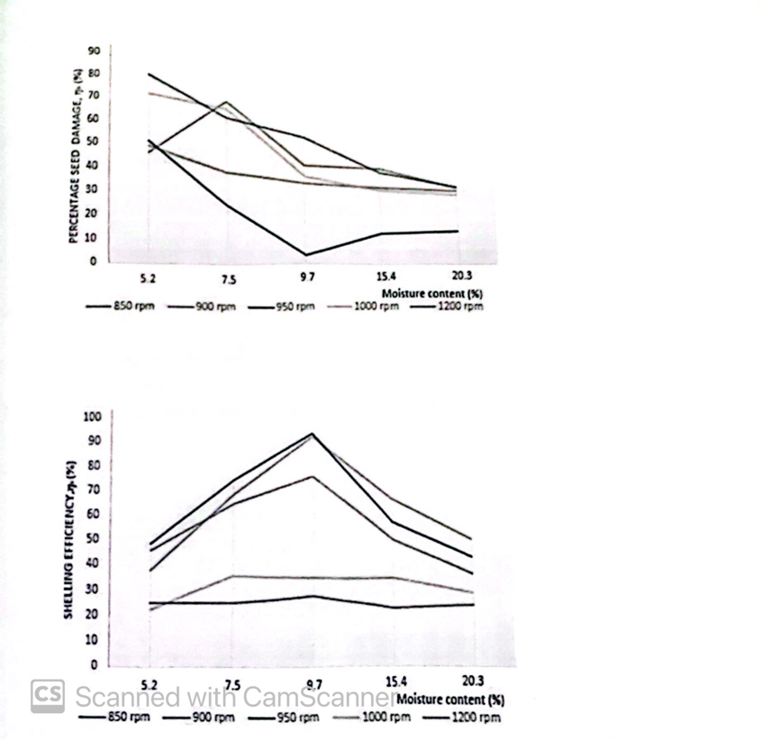
fig 7: effect of melon seed moisture content on shelling efficiency
Optimal shelling efficiency and melon kernel breakage of 93.0'% and 3.4% respectively were obtained at shelling speed and moisture level of 950 rpm and 9.7%respectively.These results are in consonance with the works of Kassim et al. (2011); Oluwole and Adedeji,(2012).
Shittu and Ndirika,(2012).The separation capacities and efficiencies when the blow-dryer is operated at the two speed (1000 and 1200 rpm)and heat (1500W and 1700W)settings are revealed in Figures 8-11.Inerease in paddle and blow-dryer speed increased the separation capacity but decreased the separation efficiency. However, with the paddle conveyor running at 24 pm, the optimal separation efficiency/capacity of89.3%/94.4kg/hr was observed at blow-dryer heat and speed settings of 1500W and1200pm respectively.
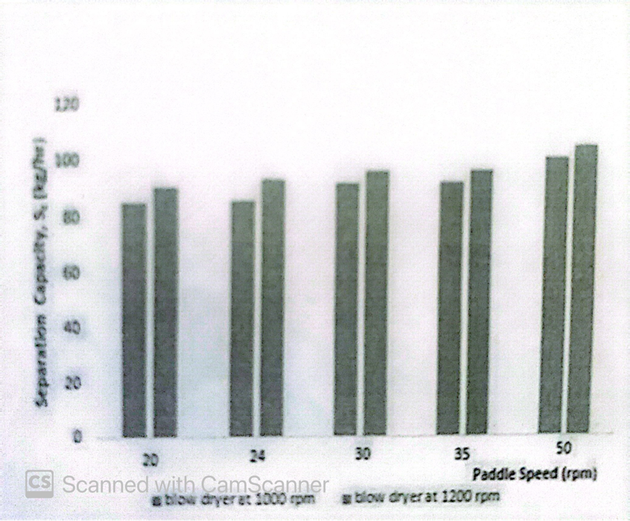
fig 8: effect of paddle conveyor speed and blow-dryer speed/heat (1500W) on melon kernel/shell separation capacity
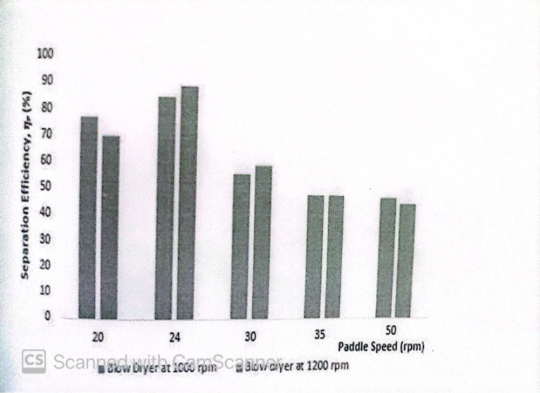
Fig: Effect of Paddle conveyor speed and blow-dryer speed/heat (1500W) on melon kernel/shell separation efficiency
fig. 10: effect of paddle conveyor speed and blow-dryer speed/heat (1700W) on melon kernel/shell
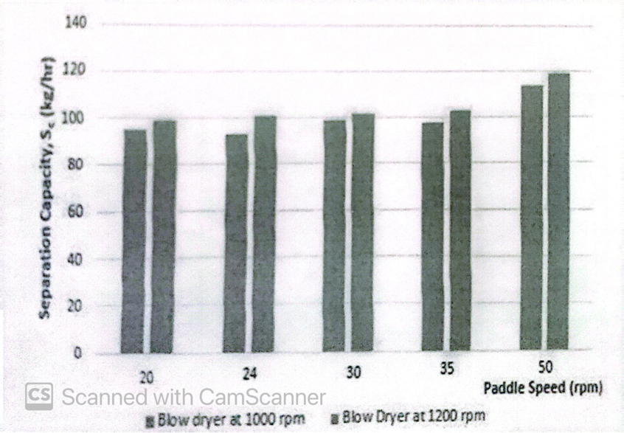
fig. 11 effect of paddle conveyor speed and blow-dryer speed/heat (1700W) on melon kernel/shell
 |  | Experimental Runs
Evaluation | Press Temperature (ºC) | 1 | 2 | 3 | Average
Mass of seed processed, (kg | 25 | 1 | 1 | 1
Process time t2 (mins) | 25 | 5.61 | 5.82 | 5.85
Mass of chaff (kg) | 25 | 0.81 | 0.86 | 0.76
Mass of oil collected (kg | 25 | 0.001 | 0.001 | 0.001
Mass of oil lost of chaff, (kg) | 25 | 0.49 | 0.47 | 0.47
Milling capacity, Cm (kg/hr) | 25 | 10.70 | 10.31 | 10.26 | 10.42
Oil Extraction capacity, TP (kg/hr) | 25 | 0.011 | 0.010 | 0.010 | 0.010
Extraction efficiency, (%) | 25 | 0.2 | 0.21 | 0.21 | 0.21
Mass of seed processed, (kg) | 30 | 1 | 1 | 1
Process time t2 (min) | 30 | 6.23 | 5.9 | 6.30
Mass of chaff, (kg) | 30 | 0.77 | 0.005 | 0.009
Mass of oil collected | 30 | 0.41 | 0.38 | 0.42
Oil extraction capacity TP (kg/hr) | 30 | 0.0067 | 0.051 | 0.086 | 0.068
Extraction efficiency (%) | 30 | 1.67 | 1.29 | 2.10 | 1.69
Mass of seed processed, (kg) |  | 1 | 1 | 1
Process time, ts (mins) | 65 | 5.60 | 6.10 | 5.80
Mass of chaff, (kg) | 65 | 0.62 | 0.58 | 0.55
Mass of oil, (kg) | 65 | 0.35 | 0.37 | 0.29
Mass of oil loss to chaff, (kg) | 65 | 0.21 | 0.17 | 0.15
Oil extraction Capacity TP (kg/hr) | 65 | 3.75 | 3.64 | 3.00 | 3.46
Extraction efficiency, (%) | 65 | 62.5 | 68.5 | 65.9 | 65.6
Mass of seed processed, (kg) | 90 | 1 | 1 | 1
Process 0 time, ts (mins) | 90 | 5.7 | 5.4 | 6.3
Mass of chaff (kg) | 90 | 0.35 | 0.31 | 0.40
Mass of oil collected (kg) | 90 | 0.42 | 0.40 | 0.45
Mass of oil lost to chaff (kg) | 90 | 0.06 | 0.03 | 0.04
Oil extraction capacity, TP (kg/hr) | 90 | 4.42 | 4.44 | 4.29 | 4.38
Extraction efficiency % | 90 | 87.5 | 93.0 | 91.8 | 90.8
Extraction of seed processed (kg) | 100 | 1 | 1 | 1
Process time ts (mins) | 100 | 5.5 | 5.7 | 5.9
Mass of chaff (kg) | 100 | 0.36 | 0.29 | 0.32
Mass of oil (kg) | 100 | 0.45 | 0.43 | 0.45
Mass of oil lost of chaff, (kg) | 100 | 0.03 | 0.05 | 0.04
Oil extraction capacity TP (kg/hr) | 100 | 4.91 | 4.53 | 4.58 | 4.67
Extraction efficiency % | 100 | 4.91 | 89.6 | 91.8 | 91.5
Table 1 shows the results of the extraction efficiency, capacity and milling capacity experiment. The oil extraction capacity and efficiency increased within crease in press temperature while 91.5%,4.67kg/hr and 10.+2kg/hr constitutes the respective average oil extraction efficiency, extraction and milling capacities. Table l: Evaluation of oil extraction efficiency, extraction and milling capacities.
Comparatively, the motorized melon oil expeller developed by Samaila andchukwu (2014) gave an average throughput and extraction efficiency of 10.12kg/hran1 60.83% respectively whereas traditionally, an average of two hours, thirty minutes is required to expel an average of 0.84 litres of melon oil from 5kg of melon seeds and two hours is required to manually dehull 1kg of whole egusi seed(Ogbonna and Obi,2007.
4.2 Result Discussion
Oil-Extraction Yield First, for a clearer idea about oil yield, it is important to consider seed parts that do not contain a significant composition in oil, which may contribute to reducing the yield value. In this sense, seed peel is mainly composed of a carbohydrates, especially fiber. The melon-seed peel constitutes about 30-40/100gf seed weight. Significant differences were found between cultivars (Table 1).Cv.biel de Sapo grown under conventional production (not organic) showed the lowest roportion of seed peel (30.65/100g) followed by the organic Piel de Sapo. Cv.Pielle Sapo grown under PGI conditions showed one of the highest proportions of seeded (39.00/100 g). Table 1. Proportion of seed peels and oil-extraction yield obtained with screw press in selected melon cultivars. PGI, Protected Geographical Indication. Cultivar Peel (g/100 g seeds) Oil-Extraction Yield (g/100 g seeds)Amarillo Oro Canario 36.02±0.47e21.43±1.65 de Arizo 39.51±0.33 ab 16.95±1.26 g Blanco de Ribatejo 37.41±0.49 d 19.64±0.77 ef Charentais 32.79±1.19f21.43±1.21 de Honeydew 38.15±0.12 cd 21.67±0.79 d Piñonet 33.00±0.21f29.90±0.54 a Tendral Valenciano 38.45 ±0.34 bcd 19.36±1.72 f Tendral Verde Tardío 39.85±0.23a 18.92±0.84 f Piel de Sapo conventional 30.65±0.10g24.59±0.73 bc Piel de Sapo organic 32.89±0.20·f24.08±0.81 cPiel de Sapo PGI 39.00±1.36 abc 26.23 ±1.08b Mean ± standard deviation; a-g different letters in same column represent significant differences, p<0.05 between samples.
Melon seeds were identified as a good source of oil, with percentages of lipids about30.7%-32.3% [8-10]. Oil yields from melon seeds were high enough to encourage their use for oil-production purposes when a screw press is used (Table 1). Obtained yields using the screw press were statistically different depending on the considered cultivar. Cvs. Piñonet and Piel de Sapo PGI showed the highest values,29.90 and26.23 g per 100 g, respectively. The lowest values were reported in the Arizo cultivar(16.95/100 g seeds). Negative but not statistically significant(r=-0.576,p=0.64)correlation was found between peel proportion and oil yield obtained with the screw press.
Oil-Extraction Methods, Oil Quality and Color To evaluate the diferences regarding extraction systems, seeds from cv. Pie de Sapo PGI were subjected to oil extraction with two presses, a hydraulic and a screw press. Extraction with the hydraulic press was performed under room temperature, while extraction with the screw press requires previous heating to obtain optimal performance. The data regarding oil yield, regulated quality (acidity and peroxide index) and color of the oils obtained are shown in Table 2. The pressure system selected for oil extraction had significant influence on oil quality and yield. Oil extraction in cv. Piel de Sapo PGI using the screw press resulted in an oil yield of 26.23/100g, while extraction with the hydraulic press was almost four times smaller (6.80/100g).This low yield makes the hydraulic press unsuitable for obtaining an economic benefit. Therefore, for analysis of the profile of fatty acids and vitamin E for the rest of the cultivars only oils extracted with the screw press were used, since this could be the most appropriate method for obtaining commercial oils in the industry.
Table 2. Oil yield parameters of regulated quality, and color of melon-seed oils (ev.Piel de Sapo PGI)according to extraction method. Parameters Hydraulic Press Screw Press Oilyield6.80±0.63b26.23±1.08 a Regulated quality--Acidity 0.30±0.04b0.41±0.05a Peroxide Index 0.00 0.00Color--L*91.28±0.59b92.75 ±0.60aa*-4.70±0.41a--7.40±0.90bb*20.97±1.44 b 29.62±1.46 a Mean± standard deviation; a. bdifferent letters in the same line represent significant differences p<0.05 between samples.
Regarding oil quality, Codex Alimentarius does not have specific regulation for melon-oil quality standards. Results showed that oils obtained with the hydraulic press were of slightly better quality than that of oils obtained with the screw press. In all cases, the values in oils obtained using pressure systems were significantly lower than the values reported for melon-seed oils obtained using solvent extraction.
Melon oils show a light yellow color. Nevertheless, CIELAB color parameters showed differences attending to the used extraction method. Oils obtained with the screw press showed more intense yellow colors, with higher values for the b* parameter (Table 2). Oil extraction using the screw press requires high temperatures applied on the barrel to ensure proper oil extraction. The processing temperature of screw press compared to room temperature used in hydraulic extraction may affect oil pigment content. Previous studies on plant oils showed that lute in, which provides the yellow color to oils, is more resistant to high temperature than other pigments are, such as chlorophylls. Furthermore, some studies even reported an increase in the content of lute in after the thermal processing of food products due to the inactivation of enzymes responsible for oxidizing carotenoids. Although the total content of carotenoids in melon oil was reported to be low, the balance of carotenoids In melon oil could be the reason for the observed change of color in melon oils depending on the extraction method. 3.3. Fatty Acids As previously reportedmelon-seed oils are mainly composed of linoleic (50.67%-69.22%) and oleie(15.23%-33.96%)acids. Saturated fatty acids, mainly palmitic and stearic, accounted for less than 15.62% in all studied cultivars (Table 3). Our data support previous results about the high variability of the fatty acid profile in melon-seed oils[5,7,8,10,11]. Some cultivars, such as Tendral Valenciano and Tendral Verde showed a high content of linoleic acid,69.22% and 69.15%,respectively, in comparison with cv.Piel de Sapo PGI, which showed the lowest values. As widely reported in other unsaturated plant oils, linoleic and oleic content were negatively correlated [31,32].
Extraction method had no effect on the fatty acid composition of the oils. When seeds from cv. Piel de Sapo PGI were used, oils extracted with the screw and hydraulic presses showed slight differences in fatty acid profile (Table 3).Similarly, small differences in the content of linoleic acid were found when the results for cv. Honey Dew were compared to those of the study of Bora, Narain, and de Melio [5], who used solvent extraction for the same cultivar. In all cases, the differences reported from the cultivars were deterninants compared to those small differences that could be attributed to the oil-extraction method. 3.4.Vitamin E Regarding vitamin E content, the studied melon-seed oils showed significant differences (Table 4). Cvs. Honey Dew and Blanco de Ribatejo showed the highest contents of vitamin E, with 530.62 and 468.19 mg/kg, respectively. y- and a-tocopherols were the main components of vitamin E. The amounts of a-tocopherol (37.42-74.71 mg/kg) was significantly higher than those in some previous studies for specific cultivars [9,10],but were in accordance with the data reported by Góma's and Rudzi 'nska [12]. a-tocopherol is crucial for oil quality, as it is the form preferentially absorbed and accumulated in humans. Cv. Tendral valenciano, which showed a small concentration of vitamin E, was, however, the one with the highest content in α tocopherol.
As reported with regard to oils from dicotyledonous plants, to cotrienol content was low compared to tocopherol content [33];however, it was higher than that reported in some oils with similar fatty acid profiles, such as walnutoil [34,35].y-tocotrienol was the main to cotrienol found, in agreement with the study of Górna's, Soliven, and Seglin, a [20].The total concentration of vitamin E in melon oil and content of the specific isoforms could be used for the authentication of products containing melon oils and flours as functional ingredients.
Oil-seed extraction methods significantly affect the concentration of to copherols in oils especially if solvent extraction is compared to pressing [36-38].Our results showed that significant differences appear in the concentration of tocopherol and tocotrienol forms, and in the total content of vitamin E. The vitamin E content of the Piel deSapo PGI cultivar, extracted by hydraulic pressing, was lower than the content obtained with screw pressing; however, as reported for fatty acids, cultivar had a larger effect on vitamin E content than extraction method did. 3.5. Principal-Component Analysis The reported variability in the oil composition of cultivars is reflected in principal-component analysis (Figure 1). Principal Component 1 (PC1)was mainly composed of fatty acids (C18:2n6c; C18:1n9e;C18:0) and tocotrienols (β-T3), while Principal Component 2(CP2)was composed of tocopherols (a-T:r-T)The negative correlation between linoleic and oleic acid was clear. Similar negative correlation could be observed for the a- and y-tocopherols. As y-tocopherol is the main component of vitamin E in melon-seed oils, and major interest exists for oils with a high content in unsaturated fatty acids, the cultivars in the top right of Figure 1are the most interesting for melon-seed-oil production. These are cvs. Charentais and Honey Dew. However, the provided information also encourages the production of oils with more monounsaturated fatty acids and with a higher concentration of the most active homologous a-tocopherol. In this case, the use of evs. Piñonet and Pielde Sapo PGI, in the bottom left of Figure1, is preferable

CHAPTER FIVE
SUMMARY, CONCLUSION AND RECOMMENDATION
5.1 SUMMARY
The specification value of vegetable oil and melon oil extraction are 254,0009.2 and 196.00 8.72mg KOH/g respectively. These values serve as important parameter in determining the stability of oil in soap making. According to Harwoodand Padley (2011), oils within this specification value yields soaps of soft consistency and hence could be used for making shaving creams. Acid values for both oils were low through the values obtained were significantly higher melon oil(2.80+1.02mgKOH/g)than in coconut oil (1.20+0.61mghlg).
The lower the acid value of oil, the few fatty acid, it contains which makes it less exposed to rancidity (Obase et al,2012).This means it will be easier for melon oil to become rancid than coconut oil. The iodine value of coconut oil (9.30 +0.91 mgiodine/ 100g). Was insignificantly lower than that omelon oil (17.80+1.02mgiodine/100g).the iodine value is a measure of the unsaturation of fats and oils and it is an indicator of double bonds in the molecular structure in terms of classification of non-drying (Akoh and Nwosu,1992),Hence coconut and melon oils are non-drying because their iodine values were lower than 100.
The proximate values of 0.40+0.02 (mg proximate /kg) and 3.20+0.91(mgperoxide/kg) obtained also served as an index of rancidity according to Okene and Evbumwan,(2014),high oxidative stability is possible when peroxide values is less than 10.00mg peroxide/kg, hence the two oil will be resistant to peroxidation during storage.
The specific gravity of 0.82+0.71 (kg/dm) and 0..95+0.80kg/dm were obtained from vegetable and melon oil respectively which implies that birth oil are less dense than water.
5.0 CONCLUSSION
An integrated melon processing machine with output options for three important processed forms of melon- melon kernel, melon flour and melon oil as desired by the end user was designed and developed. This machine reduces the set up cost, drudgery, improves hygiene and eliminates the wastage associated with deterioration. Performance test analysis revealed optimal shelling, separation and extraction efficiencies of93.0%,89.3% and 91.5% respectively while 94.4kg/hr,10.42kg/hr and 4.67kg/hr constitute the respective separation, milling and oil extraction capacities at shelling speed, moisture level, paddle conveyor speed, blow dryer heat/speed and press temperature of 950 rpm,9.7%,24 rpm,1500W/1200 rpm and 100oC respectively. Thus this innovation is recommended to both small and medium scale food processors.

REFERENCE
Adekunle A. S., Ohijeagbon 1.O.and Olusegun H. D.(2009). Development and Performance Evaluation of Manually and Motorized Operated Melon Shelling Machine using Impact Technique. Journal of Engineering Science and Technology. Review 2,12-17.
ASAE Standard. (1982). S. 352. Moisture measurement-grains and seeds. St.Joseph, Michigan.
FAO (2005). Small-scale Palm Oil Processing in Africa. Food and AgriculturalOrganization(FAO)AgriculturalSeries148.Pp.1-55.http://www.fao.org/document/Y4355E03.htm.
Justina Y.T.and Victor N.E.(2014).Physical and Chemical Evaluation of Oils fromSelected Underutilized Oilseeds. Der Chemica Sinica,Vol. 5(6), pp.9-12
Kassim M.J., Victor U. and Isaak. (2011). Development and Evaluation of a Melon Shelling and Cleaning Machine. Journal of Emerging Trends in Engineering and Applied Sciences,(JETEAS),Vol.2 (3),Pp.383-388.
Khurmi R.S. (2010). Strength of Materials -mechanics of soli1s. S. Chand publications, New Delhi.-110055.Khurmi, R.S. and Gupta, J.K.(200Đ5). A Textbook of Machine Design (S.I. Units) Eurasis Publishing House (PVT) Limited, New Delhi-110055.
Nwankwojike B.N., Agunwamba J.C. and Dti 0.(2014).Design and Development ofIntegrated Digester/Nut-Pulp Separator/Screw Press Machine. Patent No NG/P/2014/175.
Obafemi Ajibola. (2000). Adding Value to the Farmers' Harvest. Obafemi Awolowo University, Ile-ife, University Inaugural Lecture Series.
Ogbonna P.E. and Obi I. (2007). Effect of Time of Planting and Poultry Manure Application in Growth and Yield of Egusi Melon in a Derived Savanna in Agro-ecology. Agro-science 6,33-39
Olusegun H. D.and Adekunle A.S.(2008).The Design, Construction and Testing ofMelon Sheller. Global Jourmal of Engineering and Technology, Volume 1,Number4,pp.473-481.
Oluwole O.O. and Adedeji A.S.(2012).Effects of Moisture Content and Inner Drum Rotation Speed on the Shelling Performance of a Melon Sheller. Journal of Science and Technology,2(2):21-26.
Onwualu, A. P., Akubuo, C.O.. & Ahaneku, I. E. (2006). Fundamentals of Engineering in Agriculture.(1st edition.). Lagos: Immaculate Publications Ltd.
Oriaku E.C., Agulanna C.N., and Nwannewuihe H.U. (2013). Comparative Performance Analysis of Melon (Colocynthis Citrullus L.)De-Husking and Separation Machines by Principles of Impact and Atrition. International Journal of Multidisciplinary Sciences and Engineering, Vol.4,No.7,Pp.53-59.
Quadri M.A. and Fashina A.B.(2014). Throughput and Performance Evaluation of a Designed and Fabricated Egusi Shelling Machine. International Journal of Innovative Scientific & Engineering Technologies, Vol. 2(1),pp.1-8.39
Samaila R.S. and Chukwu O. (2014). Development of a Motorised Egusi Melon Seeds Oil Expeller. Journal of Agricultural Engineering and Technology (JAET).Volume 22,No. 2, pp.13-25.
Shitu S.K. and Ndrika, V.I.O.(2012).Development and performance tests of a melon (egusi)seed shelling machine. Agric Eng Int: CIGR Journal, 14(1),pp.1-11.Tuhin Das.(2015).Phttp://www.Onlyfoods.net/egusi.html.Assessed 25/9/2015.

