

A PROJECT REPORT
ON
TOPOGRAPHIC INFORMATION SYSTEM OF PART OF JUDGES’ QUARTERS, TANKE, ILORIN, ILORIN SOUTH LOCAL GOVERNMENT, AREA OF KWARA STATE.

BY
BELLO IBRAHIM OPEYEMI
HND/23/SGI/FT/0038

SUBMMITED TO:
THE DEPARTMENT OF SURVEYING AND GEO-INFORMATICS, INSTITUTE OF ENVIRONMENTAL STUDIES, KWARA STATE POLYTECHNIC ILORIN.

IN PARTIAL FULFILLMENT OF THE REQUIREMENT FOR THE AWARD OF HIGHER NATIONAL DIPLOMA IN SURVEYING AND GEO-INFORMATICS.

JUNE, 2025

CERTIFICATE
I hereby certified that the information given in this project was obtained as a result of the observation and measurement made by me and that the survey was carried out in accordance with survey laws, regulations and departmental instructions
________________________________
BELLO IBRAHIM OPEYEMI
Matric No.: HND/23/SGI/FT/0038

CERTIFICATION
This is to certify that this project was carried out by BELLO IBRAHIM OPEYEMI with Matric No.: HND/23/SGI/FT/0038 under my instruction and supervision for the award of Higher National Diploma in Surveying and Geoinformatics, Kwara State Polytechnic, Ilorin, Kwara State Nigeria. I hereby declared that he has conducted himself with due diligence and honesty on the said duties.

………………………………… ………………………………
SURV. ADEBANJI AKINYEDE DATE
(Project Supervisor)

………………………………. …………………………
SURV. R.S. AWOLEYE DATE
(Project Coordinator)

……………………………… ………………………………
A.I ISAU DATE
Head of Department (H.O.D)
Surveying & Geo-informatics

……………………………….. ……………………………..
EXTERNAL EXAMINER DATE

DEDICATION
This project is dedicated to Almighty ALLAH, the author and the finisher of everything who gave me the grace and privilege to attain this stage in my education pursuit.

ACKNOWLEDGEMENT
I give thanks and glory to my Creator for the privilege bestowed on me that resulted in the accomplishment of this project work and also a big thanks to the management of Kwara State Polytechnic for the privilege and opportunity given to me to study in their great institution.
My sincere gratitude goes to my Head of Department (HOD); A.I ISAU and my Supervisor; SURV. ADEBANJI AKINYEDE for their support towards the success of this project work, I really appreciate you sir.
To all the lecturers in the department of Surveying and Geo-informatics; Abimbola I. Isau, Surv. Ayuba Abdulsalam, Surv. R.S Awoleye, Surv. R.O Asonibare, Surv. A.G Aremu, Surv. B.F Diran, Surv. Williams Kazeem, Surv. Kabir Babatunde who has imparted their knowledge in me in one area or the other during my year of study, I am grateful for all your effort and support. May Almighty ALLAH bless you all (Amiin).
I'm deeply grateful to my parents; MR & MRS BELLO for their unconditional love, support, and wisdom. Their encouragement and sacrifices have been the driving force behind my endeavors. Thank you, Mom and Dad, for being my pillars of strength and inspiration. I acknowledge this project to you, with love and appreciation.
Special thanks to my Uncle; MR. ABDUL-QUADIR and my lovely brother; ESV. ADAM UMAR BABATUNDE for their unwavering love, care, and dedication that has shaped me into the person I am today. Their selfless love and their influence and values have guided me throughout this project, and I'm forever grateful.
I'm also grateful to my friends in the department, hostel and all, for their motivation, and help whenever I needed it. Their collective support has made this journey more enjoyable and fulfilling.
May Almighty ALLAH bless you all (Amiin).
TABLE OF CONTENTS
Pages
Title Page i
Certification ii
Dedication iii
Acknowledgment iv
Table of contents v
List of Tables ix
List of Figures x
Abstract xi
CHAPTER ONE
General Introduction
1.1 Background to the Study 1
1.2 Statement of the Problem 2
1.3 Aim and Objectives of the Project 3
1.3.1 Aim 3
1.3.2 Objectives 3
1.4 Scope of the Project 4
1.5 Personnel 5
1.6 Significance of the Study 5
1.7 Study Area 6
CHAPTER TWO
Literature review
2.1 Introduction 7
2.1.1 Fundamentals of Topographic Information System 9
2.2 Concept of Topographic Information System 10
2.2.1 Technologies in Topographic Data Collection 12
2.2.2 Data Integration in Geographic Information Systems (GIS) 14
2.2.3 Topographic Data Models and Formats 17
2.3 Application of Topographic Information Systems 18
2.4 Challenges in Topographic Information Systems 20
2.5 Recent Advances and Trends 23
CHAPTER THREE
Research Methodology
3.0 Methodology 25
3.1 Database Design 25
3.1.1 View of Reality 25
3.1.2 Conceptual Design 27
3.1.3 Logical Design 28
3.1.4 Physical Design 28
3.2 Reconnaissance 30
3.2.1 Office Planning 30
3.2.2 Field Reconnaissance 31
3.2 Equipment used/system selection and software 33
3.2.1 Hardware used 33
3.2.2 Software Component 33
3.3 Instrument Test 34
3.3.1 Horizontal Collimation Test 34
3.3.2 Vertical Index Error Test 35
3.3.3 Analysis of Collimation and Vertical Index Data 35
3.4 Control Check 36
3.5 Monumentation 37
3.6 Data Acquisition 38
3.6.1 Geometric Data Acquisition 38
3.6.2 Attributes Data Acquisition 40
3.7 Data Downloading and Processing 40
3.7.1 Data Downloading and Editing 40
3.7.2 Data Processing and Data Editing 40
3.7.3 Data Processing using ArcGIS 10.3 40
3.8 Database Implementation 50
3.8.1 Database Management Systems 50
3.8.2 Database Maintenance 51
3.8.3 Back computation 52
3.8.4 Area Computation 52
CHAPTER FOUR
Spatial Analyses and Presentation
4.1 Testing of Database 53
CHAPTER FIVE
Costing, Summary, Problem Encountered, Conclusion and Recommendations
5.1 Costing 42
5.2 Summary 44
5.3 Problem Encountered 45
5.4 Conclusion 45
5.5 Recommendations 46
References
Appendix

LIST OF TABLES
Pages
Table 3.1: Table showing Building and its attribute 28
Table 3.2: Table showing the Road and its attributes 29
Table 3.3: Table showing the Trees and its attributes 29
Table 3.4: Table showing the Electric Poles and its attributes 29
Table 3.5: Table showing the Vegetation and its Attributes 30
Table 3.6: Table showing the Coordinates of Controls 31
Table 3.7: Table showing the Horizontal Collimation Data 35
Table 3.8: Table showing the Vertical Index Data 35
Table 3.9: Table showing the back computation of the control coordinates 36
Table 3.10: Table showing the distance observation result of the control check 37
Table 3.11: Table showing the observation result of control check 37
Table 3.12: Building 47
Table 3.13: Road 47
Table 3.14: Trees 47
Table 3.15: Electric Poles 48
Table 3.16: Table showing the back computation 52
Table 3.17: Table showing the area computation 52
Table 5.1: Table showing the direct cost parameters 57

LIST OF FIGURES
Pages
Fig. 1.1: Maps Showing the Study Area 7
Fig. 3.1 Design and Construction Phases in Spatial Database 26
Fig. 3.2: E-R Diagram (Entity relationship diagram) 27
Fig. 3.3: Recce diagram of the study area (not drawn to scale) 32
Fig 3.4: Horizontal Collimation and Vertical Index error test. 34
Fig. 3.5: Pillar Description 38
Fig. 3.6 shows the spot height 48
Fig. 3.7: Shows the Tin creation 49
Fig. 3.8 shows the slope aspect 50
Fig. 4.1: Shows the attribute database 53
Fig. 4.2: Showing catalog, attribute table and table of content 54
Fig 4.3.: Retrieving Area whose height is greater than 3.007 meters 55

Fig 4.4: Result of area whose height is greater than 3.007 meters 55
Fig 4.5: Shows the building use for shop 56

ABSTRACT
This project developed a detailed Topographic Information System (TIS) for a section of Judges' Quarter, Tanke, within Ilorin South Local Government Area, Kwara State, Nigeria. Recognizing the critical need for accurate spatial data to support effective land use planning, infrastructure development, and environmental management in this rapidly urbanizing area, the study employed field surveys using GPS technology and Total Station (TS). Key topographic features, including elevation points, contours, slopes, drainage patterns, and significant man-made structures, were meticulously captured and integrated. The processed data was used to generate essential digital products, including a high-resolution Digital Elevation Model (DEM), detailed contour maps, slope classification maps, and a comprehensive topographic map of the study area. These outputs were systematically organized and managed within a Geographic Information System (GIS) environment, creating a robust spatial database. The resulting Topographic Information System provides a vital geospatial framework. It offers planners, engineers, environmental scientists, and local government authorities precise and readily accessible information on the terrain characteristics of Judges' Quarter. This system is fundamental for informed decision-making in site suitability analysis, flood risk assessment, road network planning, construction projects, and sustainable land management within the studied locality.
CHAPTER ONE
INTRODUCTION
  - BACKGROUND OF THE STUDY
The concept of topographic mapping dates back to ancient civilizations, where rudimentary maps were created to represent land features for navigation, agriculture, and territorial expansion. However, the systematic study and development of topographic information systems began in the 19th and 20th centuries with the advent of advanced surveying techniques, aerial photography, and cartography. The introduction of computers in the mid-20th century revolutionized the field, enabling the digitization of maps and the development of GIS, which laid the foundation for modern TIS.
The rapid urbanization of Ilorin, particularly in areas like Tanke, has brought about significant changes in land use patterns, creating a pressing need for accurate and reliable spatial data to support effective urban planning and management. Among the critical components of such data is topographic information, which provides essential insights into terrain characteristics, including elevation, slope, and drainage patterns. These factors play a crucial role in infrastructure development, flood risk assessment, and environmental sustainability, particularly in growing residential areas like Judges’ Quarters. Located within Tanke, Judges Quarters is a rapidly developing neighborhood that faces several challenges, including inadequate drainage systems, uneven terrain, and unplanned urban expansion. These issues underscore the importance of developing a detailed Topographic Information System (TIS) to address the unique needs of the area and support sustainable development.
Advances in geospatial technologies, such as Geographic Information Systems (GIS), Global Positioning Systems (GPS), and remote sensing, have revolutionized the way topographic data is collected, analyzed, and visualized. These tools enable the creation of accurate digital maps that can guide urban planning and decision-making processes. While previous studies have explored urban development in Ilorin, there is a noticeable gap in research focusing on the application of topographic information systems in specific neighborhoods like Judges Quarters. This study seeks to address this gap by developing a comprehensive TIS for part of Judges Quarters, providing a detailed spatial representation of its physical features and terrain characteristics.
The relevance of this study extends beyond local urban planning efforts, aligning with global and national goals for sustainable development. By offering a framework for managing land resources and mitigating environmental risks, the TIS can serve as a valuable tool for stakeholders, including government agencies, urban planners, and residents. Tanke, Ilorin, as a fast-growing community with a mix of residential, commercial, and institutional land uses, presents a unique context for this study. The development of a TIS for Judges Quarters not only addresses immediate challenges but also sets a precedent for similar urban areas facing rapid growth and development pressures. This study, therefore, highlights the critical role of topographic information systems in promoting sustainable urban development and informed decision-making in rapidly urbanizing environments.

1.2 STATEMENT OF THE PROBLEM
Judges Quarters in Tanke, Ilorin, is undergoing a rapid urbanization, characterized by unplanned and haphazard development that has led to significant challenges in infrastructure and land use management. One of the primary issues is the lack of detailed and accurate topographic data, which is essential for understanding the terrain and guiding sustainable development initiatives. Without this critical information, the area faces persistent problems such as frequent flooding due to poorly designed drainage systems and insufficient knowledge of natural drainage patterns and elevation changes. Additionally, the absence of reliable topographic data has resulted in inefficient land use planning, leading to the misuse of available land resources and increased vulnerability to environmental hazards.
The challenges extend to infrastructure development, where the lack of a comprehensive topographic information system hampers the design and implementation of essential infrastructure such as roads, buildings, and utilities. This not only affects the quality of life for residents but also contributes to environmental degradation, including soil erosion and the loss of natural vegetation. Furthermore, while urban development in Ilorin has been the focus of various studies, there is a noticeable gap in research specifically addressing the application of topographic information systems in neighborhoods like Judges’ Quarters. This gap limits the ability of stakeholders, including government agencies, urban planners, and residents, to make informed decisions that promote sustainable development and effective disaster risk management. The absence of a robust topographic information system underscores the urgent need for a solution that can address these multifaceted challenges and support the sustainable growth of Judges’ Quarters and similar urban areas.

1.3 AIM AND OBJECTIVES OF THE PROJECT
1.3.1 AIM
The aim of this project is to carry out the topographic information system of part of JUDGES’ QUARTERS, TANKE, ILORIN SOUTH LOCAL GOVERNMENT AREA OF KWARA STATE.
1.3.2 OBJECTIVES
In accomplishing this research work, the objectives of the study are to:
- conduct a detailed topographic survey of the study area using geospatial techniques such as GPS mapping and GIS applications.
- generate an accurate topographic map that represents the terrain characteristics, elevation levels, drainage patterns, and land use distribution within the estate.
- analyze the impact of topography on land development, infrastructure planning, and environmental risks such as flooding and erosion.
- create a digital database for storing and managing topographic information, which can be accessed for future planning and decision-making.
- provide recommendations on the application of topographic data in sustainable urban development, land administration, and disaster mitigation strategies.
1.4 SCOPE OF THE PROJECT
The project scopes are the stages that will be involve to achieve our aims.
- Project planning
- Recce
- Data acquisition
- Data processing
- Data analysis
- Data presentation
- Technical report writing

1.5 PERSONNEL
The students listed below were the members of this group who participated in the execution of the project.
NAME ROLE
BELLO IBRAHIM OPEYEMI AUTHOR
IYANDA PHILIP AYOMIDE MEMBER
UTHMAN BADIRAT BUKOLA MEMBER
EMMANUEL MERCY UNEKWUOJO MEMBER
ADENIYI AISHAT ADERAYO MEMBER
OLABOSOYE GIFT FUNMILAYO MEMBER

1.6 SIGNIFICANCE OF THE STUDY
The importance of carrying out this project can be enumerated as follows:
- Improved Urban Planning and Development.
- Enhanced Land Management.
- Disaster Risk Reduction.
- Infrastructure Development.
- Replicability of other Estates.

1.7 STUDY AREA
The study area for this project is situated on Part of Judges’ Quarters, Tanke area of Ilorin South Local Government Area of Kwara State. The geographic location of the study area lies between latitude 08º 30' 00"N and latitude 08º 30' 05"N and between longitude 04º 36' 55" and longitude 04º 37' 05" and the total area covered was about 12.300 hectares.
Fig. 1.1: Maps showing the study area
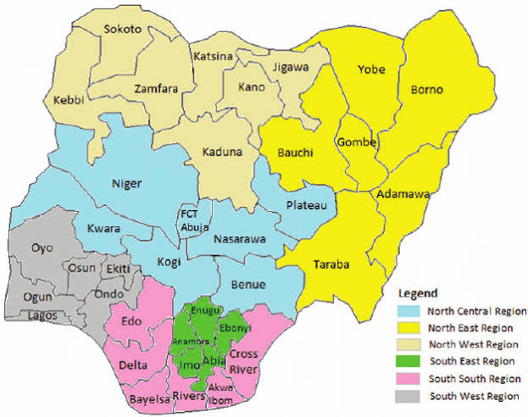
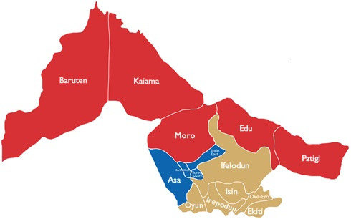
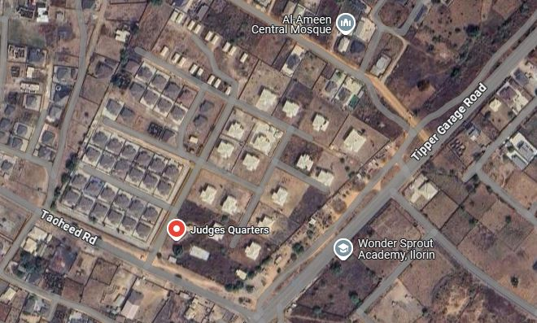

CHAPTER TWO
LITERATURE REVIEW
2.1 INTRODUCTION
A Topographic Information System (TIS) represents a critical framework in the geospatial sciences, integrating advanced technologies to capture, analyze, and visualize terrain data for diverse applications. Rooted in the evolution of Geographic Information Systems (GIS), TIS focuses specifically on representing the three-dimensional characteristics of the Earth’s surface, including elevation, slope, landforms, and natural or human-made features. The growing demand for precise topographic data in fields such as urban planning, environmental conservation, disaster management, and infrastructure development has driven the development of these systems, which combine traditional cartographic principles with modern computational tools. Recent advancements in remote sensing, LiDAR (Light Detection and Ranging), GPS (Global Positioning System), and machine learning have further enhanced the accuracy and accessibility of topographic modeling, enabling real-time data processing and dynamic spatial analysis. However, challenges persist in managing large-scale datasets, ensuring interoperability across platforms, and addressing the computational demands of high-resolution terrain modeling. This literature review explores the theoretical foundations, technological innovations, and practical implementations of TIS, while examining gaps in current research and emerging trends that could redefine its role in addressing global challenges such as climate change adaptation and sustainable land-use planning. By synthesizing interdisciplinary perspectives, this review aims to provide a comprehensive understanding of how TIS bridges geospatial science, engineering, and policy-making in the modern era.
The historical development of topographic mapping reflects a transformative journey from rudimentary manual techniques to sophisticated digital systems, shaped by technological innovation and evolving societal needs. Early topographic practices emerged in ancient civilizations, such as the Egyptians and Romans, who employed basic surveying tools like chains, levels, and theodolites to demarcate land boundaries and plan infrastructure. However, systematic topographic mapping gained momentum in the 18th and 19th centuries with the rise of national cartographic initiatives, exemplified by projects like the Cassini family’s Carte de France and the Ordnance Survey in Britain. These efforts relied on triangulation networks and plane-table surveys, producing highly detailed but labor-intensive paper maps that became foundational for military, administrative, and exploratory purposes. The 20th century marked a paradigm shift with the advent of aerial photography and photogrammetry, enabling the capture of large-scale terrain data from aircraft, which significantly improved map accuracy and coverage. Post-World War II advancements in computing catalyzed the transition from analog to digital methods, with the 1970s-1980s witnessing the integration of Geographic Information Systems (GIS), which allowed spatial data to be stored, analyzed, and visualized electronically. The proliferation of satellite-based technologies, such as GPS in the 1990s, and remote sensing tools like LiDAR (Light Detection and Ranging), revolutionized data acquisition, offering unprecedented precision in elevation modeling and 3D terrain representation. Concurrently, the development of open-source platforms and cloud computing democratized access to topographic data, fostering collaboration across disciplines. Today, digital topographic systems seamlessly blend real-time data streams, machine learning algorithms, and high-resolution sensors to support dynamic applications, from disaster response to autonomous navigation. This evolution underscores not only technological progress but also a broader shift toward interdisciplinary, data-driven approaches in addressing global geospatial challenges.
2.1.1 FUNDAMENTALS OF TOPOGRAPHIC INFORMATION SYSTEM
The fundamentals of Topographic Information Systems (TIS) rest on an integrated framework of core components—data acquisition, storage, processing, and visualization—that collectively enable the accurate representation and analysis of terrain features. Data acquisition forms the foundational step, encompassing diverse methodologies to capture spatial and elevation data. Traditional ground-based techniques, such as theodolite surveys and leveling instruments, have been augmented by advanced technologies like LiDAR (Light Detection and Ranging), aerial and satellite remote sensing, and GPS (Global Positioning System), which offer high-resolution, three-dimensional terrain data over vast areas. These methods are complemented by photogrammetric analysis of stereo imagery and the growing use of unmanned aerial vehicles (UAVs) for flexible, localized data collection. Once acquired, the data must be systematically stored in structured databases or geospatial repositories, often leveraging relational database management systems (RDBMS) or cloud-based platforms to handle the volume, variety, and velocity of modern topographic datasets. Efficient storage solutions ensure data integrity, scalability, and accessibility, facilitating seamless retrieval for downstream applications.
The processing component involves transforming raw data into actionable insights through algorithms and computational workflows. This includes generating digital elevation models (DEMs), calculating slope and aspect ratios, performing hydrological modeling to predict water flow patterns, and applying machine learning techniques to classify landforms or detect changes over time. Interoperability between software tools, such as GIS platforms (e.g., ArcGIS, QGIS) and specialized terrain analysis programs, is critical to streamline these processes.
Finally, visualization translates processed data into interpretable outputs, ranging from traditional 2D contour maps to dynamic 3D renderings and immersive virtual environments. Advances in computer graphics, web mapping services, and augmented reality (AR) have expanded the possibilities for interactive and real-time terrain visualization, aiding decision-makers in fields like urban planning, environmental monitoring, and disaster risk assessment. Together, these components form a cohesive pipeline that underscores the functionality of TIS, emphasizing not only technical precision but also user-centric design to bridge the gap between complex geospatial data and practical, real-world applications.
2.2 CONCEPT OF TOPOGRAPHIC INFORMATION SYSTEM
A Topographic Information System (TIS) has been extensively explored by scholars, reflecting its interdisciplinary significance. Longley et al. (2015) emphasize that TIS builds on the foundational principles of Geographic Information Systems (GIS), integrating terrain-specific data to model elevation, slope, and landforms, which are critical for applications such as hydrology and urban planning. They argue that the integration of digital elevation models (DEMs) and remote sensing data has revolutionized topographic analysis, enabling dynamic spatial modeling (Longley et al., 2015). Tomlin (2013) highlights the role of cartographic modeling in TIS, stressing that map algebra—a technique for raster-based spatial analysis—is indispensable for processing topographic data to derive derivatives like aspect and curvature. His work underscores the mathematical rigor required to transform raw elevation data into actionable insights (Tomlin, 2013).
Li et al. (2005) delve into advancements in data acquisition, particularly the shift from traditional surveying to LiDAR and photogrammetry. They note that LiDAR’s ability to penetrate vegetation and generate high-resolution DEMs has addressed longstanding limitations in terrain mapping, especially in densely forested or complex landscapes (Li et al., 2005).
Goodchild (2007) expands on the theoretical underpinnings of TIS, framing it within the broader context of geographic information science (GIScience). He posits that the accuracy and interoperability of topographic data depend on robust metadata standards and spatial reference systems, which are vital for cross-platform compatibility (Goodchild, 2007).
From a technological perspective, Vosselman and Maas (2010) explore the integration of airborne and terrestrial laser scanning in TIS, demonstrating how point cloud data can be processed to reconstruct 3D terrain models with sub-meter precision. Their work underscores the synergy between hardware advancements and algorithmic innovations, such as noise filtering and surface interpolation (Vosselman & Maas, 2010). Meanwhile, Zhou et al. (2017) focus on the application of TIS in disaster management, illustrating how real-time topographic data can enhance flood modeling and landslide prediction. They argue that the fusion of TIS with hydrological models has improved the predictive capacity of hazard assessments (Zhou et al., 2017).
Critically, Fisher and Tate (2006) address the challenges of data quality and error propagation in TIS, noting that uncertainties in DEMs—stemming from sensor limitations or interpolation methods—can significantly impact downstream analyses like slope stability or watershed delineation. They advocate for probabilistic modeling to quantify and mitigate these errors (Fisher & Tate, 2006). In contrast, Harvey (2008) critiques the over-reliance on technological solutions, cautioning that the complexity of TIS workflows may alienate non-technical stakeholders. He calls for user-centered design principles to enhance the accessibility of topographic tools for policymakers and community planners (Harvey, 2008).
Emerging trends in TIS are explored by scholars like Song et al. (2020), who discuss the role of artificial intelligence (AI) in automating feature extraction from topographic datasets. Their research demonstrates how convolutional neural networks (CNNs) can classify landforms or detect erosion patterns with minimal human intervention, marking a shift toward data-driven terrain analysis (Song et al., 2020). Similarly, Yang et al. (2020) highlight the potential of cloud-based TIS platforms to democratize access to high-resolution topographic data, enabling collaborative global initiatives like climate resilience planning.
In summary, the literature reveals TIS as a dynamic field shaped by advancements in geospatial technology, theoretical innovations in GIScience, and evolving societal demands. While authors like Li et al. (2005) and Vosselman and Maas (2010) emphasize technical progress, others such as Fisher and Tate (2006) and Harvey (2008) stress the importance of addressing data quality and usability challenges. Collectively, these contributions underscore the need for interdisciplinary collaboration to optimize TIS for both scientific rigor and practical relevance.
2.2.1 TECHNOLOGIES IN TOPOGRAPHIC DATA COLLECTION
The evolution of technologies in topographic data collection has revolutionized the way terrain and surface features are measured, analyzed, and represented, enabling unprecedented precision, efficiency, and scalability. Global Positioning System (GPS) technology, a cornerstone of modern geospatial data acquisition, provides real-time, centimeter-level accuracy in positioning through satellite-based triangulation. Differential GPS (DGPS) and Real-Time Kinematic (RTK) systems have enhanced reliability in challenging environments, such as dense forests or urban canyons, by correcting signal errors caused by atmospheric interference. GPS is integral to field surveys, enabling the georeferencing of ground control points (GCPs) that anchor aerial or satellite data to real-world coordinates, ensuring spatial consistency across datasets.
Remote sensing, spanning satellite and aerial platforms, offers synoptic and multi-temporal perspectives of the Earth’s surface. Optical sensors, such as those on Landsat or Sentinel satellites, capture multispectral and panchromatic imagery, which is processed to derive topographic indices like Normalized Difference Vegetation Index (NDVI) or land cover classifications. Synthetic Aperture Radar (SAR) systems, unaffected by cloud cover or darkness, penetrate vegetation and soil to map subsurface features or monitor ground displacement. Photogrammetric techniques, using stereo imagery from drones or aircraft, generate high-resolution digital elevation models (DEMs) by triangulating overlapping images, a method particularly effective for large-area mapping.
LiDAR (Light Detection and Ranging) represents a paradigm shift in topographic data collection, employing pulsed laser beams to measure distances between the sensor and the ground. Airborne LiDAR systems, mounted on planes or helicopters, produce dense point clouds that resolve fine-scale terrain features, even beneath vegetation, by distinguishing between canopy and ground returns. Terrestrial LiDAR, deployed on tripods or mobile platforms, captures intricate 3D models of structures, slopes, or archaeological sites with millimeter accuracy. The technology’s ability to generate digital terrain models (DTMs) free from vegetation interference has proven invaluable in floodplain mapping, forestry, and urban planning. Recent advancements in miniaturized LiDAR sensors for drones (UAV-LiDAR) have democratized access to high-resolution topographic data, enabling rapid surveys of inaccessible or hazardous areas.
Drone-based mapping, facilitated by unmanned aerial vehicles (UAVs), has emerged as a versatile and cost-effective tool for localized topographic data collection. Equipped with RGB cameras, multispectral sensors, or LiDAR payloads, drones capture ultra-high-resolution imagery and elevation data at scales previously unattainable with manned aircraft. Photogrammetric software, such as Structure-from-Motion (SfM), processes drone imagery into orthomosaics and 3D point clouds, enabling detailed volumetric analysis of landscapes, quarries, or construction sites. Drones excel in rapid response scenarios, such as post-disaster assessments, where real-time data on landslides or flood extents is critical. Their flexibility in deployment, combined with advancements in automation and AI-driven flight planning, reduces operational costs and human error, making them indispensable for both academic research and commercial applications.
The integration of these technologies has created synergies that enhance topographic data quality and utility. For instance, GPS provides the geospatial framework for aligning LiDAR and drone datasets, while remote sensing offers contextual layers (e.g., vegetation cover) that enrich terrain analysis. Challenges remain, including the computational demands of processing massive point clouds, the need for standardized data formats across platforms, and the high costs of advanced sensors like LiDAR. Nevertheless, ongoing innovations—such as AI-driven noise filtering in LiDAR data, edge computing for real-time drone analytics, and the fusion of SAR with optical datasets—continue to push the boundaries of what topographic systems can achieve. As these technologies mature, they promise to further democratize access to high-fidelity topographic information, empowering diverse sectors to address global challenges like climate resilience, sustainable infrastructure, and ecosystem conservation.
2.2.2 DATA INTEGRATION IN GEOGRAPHIC INFORMATION SYSTEMS (GIS)
Data integration in Geographic Information Systems (GIS) involves the harmonization of topographic data with diverse geospatial datasets to create cohesive, multi-layered analytical frameworks that support complex spatial decision-making. Topographic data, which includes elevation models, slope gradients, landforms, and hydrological features, serves as a foundational layer in GIS, anchoring other thematic data—such as land use, infrastructure, vegetation, or socio-economic information—to a spatially accurate terrain context. The integration process begins with ensuring compatibility in data formats and coordinate systems. Topographic datasets, often acquired through LiDAR, GPS surveys, or remote sensing, are typically stored in raster formats (e.g., Digital Elevation Models, or DEMs) or vector formats (e.g., contour lines, point clouds). GIS platforms like ArcGIS, QGIS, or open-source tools employ georeferencing and projection transformations to align these datasets with other spatial layers, such as satellite imagery or cadastral maps, ensuring geometric consistency across scales and sources.
Interoperability standards, such as those defined by the Open Geospatial Consortium (OGC), play a pivotal role in enabling seamless data exchange. For instance, web services like Web Map Service (WMS) or Web Feature Service (WFS) allow topographic data hosted on remote servers to be dynamically integrated into GIS workflows without requiring local storage. Topographic data is often fused with attribute data through spatial joins or overlay analyses, such as combining elevation data with soil type layers to assess landslide susceptibility or merging slope maps with transportation networks to optimize road planning. Advanced GIS platforms leverage geoprocessing tools—such as raster algebra, hydrological modeling extensions, or 3D visualization modules—to synthesize topographic inputs with environmental, urban, or climatic variables, enabling predictive analytics like flood risk simulations or solar potential mapping.
A critical challenge in integration lies in managing data resolution and accuracy disparities. High-resolution LiDAR datasets, for example, may conflict with coarser satellite-derived layers, necessitating resampling or generalization techniques to maintain analytical coherence. Semantic harmonization is equally vital; metadata standards (e.g., ISO 19115) ensure that parameters like vertical accuracy, sensor type, and acquisition dates are documented, allowing users to evaluate the fitness-for-purpose of integrated datasets. Cloud-based GIS platforms, such as Google Earth Engine or Esri’s ArcGIS Online, further streamline integration by offering centralized repositories where topographic data can be combined with global datasets in real time, facilitating large-scale analyses like continental-scale erosion modeling or cross-border infrastructure planning.
Emerging trends in data integration emphasize automation and artificial intelligence. Machine learning algorithms are increasingly used to automate feature extraction from topographic data—such as identifying river networks from DEMs or classifying urban structures from 3D point clouds—and link these features to external databases (e.g., census data or climate records). The rise of 3D GIS and Building Information Modeling (BIM) integration also highlights how topographic data is merging with architectural and engineering datasets to support smart city initiatives, where terrain dynamics inform everything from drainage systems to energy grids. Despite these advancements, issues like data sovereignty, computational scalability, and user accessibility persist, underscoring the need for collaborative frameworks that balance technical rigor with practical usability. Ultimately, effective integration of topographic data into GIS platforms transforms raw geospatial information into actionable intelligence, bridging the gap between terrain science and interdisciplinary applications in sustainability, disaster resilience, and resource management.

2.2.3 TOPOGRAPHIC DATA MODELS AND FORMATS
Topographic data models and formats serve as the structural backbone for representing terrain characteristics in digital environments, with raster and vector paradigms offering distinct approaches to capturing elevation and surface features. Raster-based models, such as Digital Elevation Models (DEMs), represent terrain as a grid of cells (pixels), where each cell stores an elevation value. DEMs are widely used due to their simplicity and compatibility with remote sensing data, enabling efficient computation of slope, aspect, and hydrological flow patterns. However, their fixed resolution can lead to large file sizes in high-detail applications and may oversimplify complex terrain features like cliffs or ravines. Vector-based models, on the other hand, use geometric primitives (points, lines, polygons) to represent terrain. Triangulated Irregular Networks (TINs) exemplify this approach, constructing a mesh of interconnected triangles where each vertex corresponds to a measured elevation point. TINs adapt dynamically to terrain complexity, using fewer points in flat areas and denser triangles in rugged regions, optimizing both accuracy and storage efficiency. This flexibility makes TINs ideal for engineering and hydrological modeling, where precise representation of breaklines (e.g., ridges, streams) is critical.
DEMs and TINs differ fundamentally in their data structures and applications. DEMs excel in large-scale, uniform terrain analysis, such as continental-scale elevation mapping or satellite-derived flood modeling, while TINs are favored for localized, high-precision projects like road design or landslide risk assessment. Hybrid approaches, such as converting DEMs to TINs for specific analyses, are common in GIS workflows to leverage the strengths of both models. Data formats for these models vary widely: raster formats like GeoTIFF, ASCII GRID, or proprietary formats (e.g., Esri’s GRID) dominate DEM storage, whereas TINs are often stored in vector formats such as shapefiles or specialized structures within GIS software. Emerging formats like LAS/LAZ (for LiDAR point clouds) and Cloud Optimized GeoTIFF (COG) enhance interoperability and cloud-based processing, addressing challenges of scalability and accessibility.
The choice between raster and vector models hinges on the project’s scale, resolution requirements, and computational resources. For instance, global climate models might rely on low-resolution DEMs for efficiency, while urban planners may use TINs to integrate infrastructure data with 3D terrain. Despite advancements, challenges persist, including balancing resolution with storage costs, managing error propagation in interpolated datasets, and ensuring compatibility across software platforms. Standards like the USGS DEM specification or OpenTopography initiatives promote consistency, while machine learning techniques are increasingly employed to refine DEM accuracy or automate TIN generation from point clouds. As topographic data grows in volume and complexity, the evolution of these models and formats continues to shape their utility in addressing geospatial challenges, from precision agriculture to disaster resilience, underscoring their foundational role in modern geospatial science.
2.3 APPLICATIONS OF TOPOGRAPHIC INFORMATION SYSTEMS
Topographic Information Systems (TIS) have become indispensable across diverse sectors by providing spatially explicit insights into terrain dynamics, enabling data-driven decision-making in urban planning, disaster management, environmental monitoring, and infrastructure development. In urban planning, TIS underpins the design of resilient cities by integrating elevation data, slope analysis, and 3D terrain models to optimize land-use zoning, mitigate flood risks, and plan transportation networks. For instance, digital elevation models (DEMs) and LiDAR-derived datasets are used to identify low-lying areas prone to inundation, guiding the placement of critical infrastructure away from floodplains. Urban planners leverage TIS to simulate scenarios such as stormwater runoff in proposed developments, ensuring compliance with sustainability standards. Additionally, 3D city models, enriched with topographic data, facilitate visual impact assessments for high-rise buildings or green spaces, balancing aesthetic, ecological, and functional priorities.
In disaster management, TIS plays a pivotal role in predicting, mitigating, and responding to natural hazards. Hydrological models built on high-resolution DEMs simulate flood propagation, enabling authorities to delineate evacuation routes and design retention basins. For example, Zhou et al. (2017) demonstrated how integrating LiDAR-derived terrain data with rainfall forecasts improves flood prediction accuracy in urban catchments. Similarly, landslide susceptibility maps, generated by analyzing slope stability and soil composition through TIS, inform early warning systems in mountainous regions. Post-disaster, drone-based topographic surveys rapidly assess damage, as seen in earthquake-affected areas where collapsed structures and blocked roads are mapped in near real-time to coordinate rescue operations. These applications highlight TIS’s capacity to transform raw terrain data into life-saving actionable intelligence.
Environmental monitoring leverages TIS to track ecological changes and inform conservation strategies. DEMs and multispectral satellite imagery are combined to monitor deforestation, soil erosion, and habitat fragmentation. For instance, topographic wetness indices derived from DEMs help identify critical wetland areas requiring protection, while LiDAR data reveals canopy height variations to assess forest health. In coastal zones, TIS analyzes beach morphology changes due to sea-level rise or storm surges, supporting adaptive management of shorelines. Researchers also use TIS to model sediment transport in river basins, aiding in the restoration of degraded ecosystems. The integration of time-series topographic data with climate models further enables the prediction of long-term environmental shifts, such as glacier retreat or desertification, fostering proactive policy interventions.
For infrastructure development, TIS ensures the engineering resilience and cost-effectiveness of projects such as highways, dams, and energy grids. Engineers rely on TINs (Triangulated Irregular Networks) to model cut-and-fill operations, minimizing earthwork costs during road construction in hilly terrain. Slope stability analyses, powered by DEMs and geotechnical data, prevent failures in railway or pipeline routes. In hydropower projects, TIS-driven watershed modeling optimizes dam placement by predicting water yield and sedimentation rates. Renewable energy sectors use topographic solar radiation models to identify optimal sites for solar farms, while wind corridor analyses inform turbine placement. Furthermore, TIS supports underground utility mapping, reducing risks during excavation by integrating subsurface LiDAR or ground-penetrating radar data with surface terrain models.
These applications underscore TIS’s transformative role in bridging geospatial science with practical solutions. Challenges such as data resolution mismatches, computational demands, and the need for interdisciplinary collaboration persist, yet advancements in AI, cloud computing, and sensor technologies continue to expand TIS’s potential. By harmonizing topographic data with socio-economic and environmental variables, TIS not only addresses immediate technical needs but also fosters sustainable development in an era of escalating climatic and anthropogenic pressures.
2.4 CHALLENGES IN TOPOGRAPHIC INFORMATION SYSTEMS
Topographic Information Systems (TIS) face significant challenges that hinder their effectiveness and scalability, despite their transformative potential. Accuracy remains a persistent concern, as errors propagate through every stage of data acquisition, processing, and analysis. Sensor limitations, such as LiDAR’s reduced efficacy over water surfaces or GPS signal degradation in urban canyons, introduce inaccuracies in raw datasets. Even advanced technologies struggle with environmental variables: dense vegetation can obscure ground returns in LiDAR, while cloud cover disrupts optical remote sensing. Post-processing steps, such as interpolating sparse elevation points into continuous DEMs (Digital Elevation Models), further amplify uncertainties. For instance, Fisher and Tate (2006) emphasize that small vertical errors in DEMs can drastically skew hydrological models, misrepresenting flood extents or watershed boundaries. Ensuring accuracy demands rigorous validation against ground truth data, which is often resource-intensive and geographically limited.
Data updating poses another critical challenge, as topographic datasets rapidly become obsolete due to dynamic natural and anthropogenic changes. Erosion, landslides, deforestation, and urban expansion alter terrain features, rendering existing models inadequate for time-sensitive applications like disaster response. Traditional update methods, such as aerial surveys, are costly and logistically complex, while satellite-based systems may lack the resolution or revisit frequency needed for localized changes. Although drones and crowd sourced geodata (e.g., OpenStreetMap) offer more agile alternatives, they often lack the standardization and coverage required for large-scale updates. This inconsistency creates gaps in monitoring long-term processes like glacial retreat or coastal erosion, where continuous, high-resolution data is essential.
Cost barriers further constrain the adoption and maintenance of TIS. High-resolution LiDAR surveys, for example, require significant investment in equipment, specialized personnel, and computational infrastructure. Storage and processing of massive datasets—such as terabytes of point clouds from airborne LiDAR—add to operational expenses, particularly for resource-limited organizations or developing regions. Proprietary software licenses for advanced GIS tools and machine learning platforms compound these costs, creating inequities in access. While open-source solutions like QGIS and cloud-based processing (e.g., Google Earth Engine) mitigate some financial burdens, they often lack the precision or support needed for specialized applications, such as engineering-grade slope stability analysis.
Interoperability issues arise from the heterogeneous formats, standards, and scales of topographic data. Integrating LiDAR point clouds with satellite imagery or legacy vector datasets demands laborious format conversions and spatial alignment, often resulting in data loss or misregistration. Divergent metadata standards—such as variations in vertical datums or coordinate systems—complicate cross-platform collaboration, as seen in cross-border infrastructure projects where national mapping agencies use incompatible frameworks. While initiatives like the Open Geospatial Consortium (OGC) promote standardization, proprietary systems and fragmented policies persist. For example, merging 3D city models (BIM) with TIS for smart city planning requires reconciling architectural and geospatial data paradigms, a task hindered by technical and institutional silos.
These challenges are interconnected: accuracy limitations drive up costs through repeated surveys, while interoperability gaps reduce the utility of updated data. Addressing these issues requires advancements in sensor technology, AI-driven error correction, and policy frameworks that incentivize open data sharing. Collaborative efforts, such as global DEM initiatives (e.g., NASA’s SRTM) and federated cloud platforms, exemplify progress, yet systemic barriers remain. Overcoming these hurdles is crucial to unlocking TIS’s full potential in fostering resilience, equity, and sustainability in an era of rapid environmental and urban change.

2.5 RECENT ADVANCES AND TRENDS
Recent advances and trends in Topographic Information Systems (TIS) reflect a convergence of cutting-edge technologies and interdisciplinary innovation, driving unprecedented precision, accessibility, and scalability in terrain analysis. Artificial Intelligence (AI) and Machine Learning (ML) have emerged as transformative forces, automating tasks such as feature extraction from LiDAR point clouds, landform classification, and error correction in digital elevation models (DEMs). Deep learning algorithms, including convolutional neural networks (CNNs), now enable rapid identification of geological hazards (e.g., landslides, sinkholes) and urban infrastructure from multispectral and 3D data, reducing reliance on manual interpretation. For instance, Song et al. (2020) demonstrated how AI can classify micro-topographic features in coastal zones, enhancing erosion prediction models. Cloud computing and edge processing have democratized access to high-performance topographic analytics, with platforms like Google Earth Engine and Microsoft Planetary Computer offering global-scale DEM processing and real-time hydrological simulations. Edge computing further empowers field devices, such as drones, to perform on-board LiDAR data filtering and 3D reconstruction, enabling instant decision-making in disaster response.
Advances in sensor technology continue to redefine data acquisition. Miniaturized LiDAR sensors integrated with unmanned aerial vehicles (UAVs) now deliver centimeter-level accuracy at a fraction of traditional costs, while hyperspectral drones capture terrain-vegetation interactions for precision agriculture. Satellite constellations (e.g., ICEYE, Capella Space) equipped with Synthetic Aperture Radar (SAR) provide frequent, all-weather topographic updates, critical for monitoring glacial dynamics or volcanic activity. Multi-sensor fusion—combining LiDAR, SAR, and optical imagery—has improved terrain modeling in challenging environments, such as dense forests or urban canyons, by compensating for individual sensor limitations.
The rise of 3D geospatial frameworks and digital twins has blurred the lines between TIS and smart city planning. High-resolution 3D city models, enriched with real-time topographic data, simulate urban growth, flood scenarios, and energy consumption patterns, fostering resilient infrastructure design. Augmented Reality (AR) and Virtual Reality (VR) tools now visualize terrain data immersively, aiding stakeholders in collaborative planning and public engagement. Open-source initiatives, such as OpenTopography and OpenStreetMap, coupled with FAIR (Findable, Accessible, Interoperable, Reusable) data principles, promote global collaboration, while blockchain technology is being explored to ensure data provenance and security in shared topographic repositories.
Ethical and sustainable trends are gaining traction, emphasizing equitable access to topographic resources and minimizing the environmental footprint of data collection. Low-cost UAVs and community-driven mapping projects empower marginalized regions to address local challenges, such as deforestation or water scarcity. Meanwhile, green LiDAR initiatives aim to reduce energy consumption in airborne surveys through optimized flight paths and sensor efficiency.
Looking ahead, the integration of TIS with Internet of Things (IoT) networks and 5G connectivity promises real-time terrain monitoring for adaptive climate resilience. As these trends evolve, they collectively address longstanding challenges in accuracy, cost, and interoperability, positioning TIS as a cornerstone of 21st-century geospatial intelligence.

CHAPTER THREE
- METHODOLOGY
This phase outlines the methods and procedures employed in the planning, data acquisition, data processing, and development of both the database and the database management system, as well as the presentation of information. These activities were systematically organized and executed in sequential stages, including the design of the database. The process typically involves a spatially referenced, structured digital database, along with suitable application software for geospatial analysis. It essentially highlights the techniques and principles applied throughout the project. Geographic Information System (GIS) methodologies were utilized to achieve the intended outcomes.
3.1 DATABASE DESIGN
The design of any database involves three stages namely;
- Conceptual design
- Logical design
- Physical design
3.1.1 VIEW OF REALITY
In database design, it is essential to consider reality, which refers to the actual physical phenomena that exist encompassing all elements, whether or not they are perceived by individuals. A view of reality, however, is a mental abstraction tailored for a specific application or set of applications.
For this project, the view of reality is based on the topographical features of the study area. Since it is not feasible to replicate the real world exactly, the approach involves conceptualizing and modeling the real-world environment in a structured way to allow for accurate representation and analysis.

The key features of interest in this project include:
- Roads
- Electric Poles
- Trees
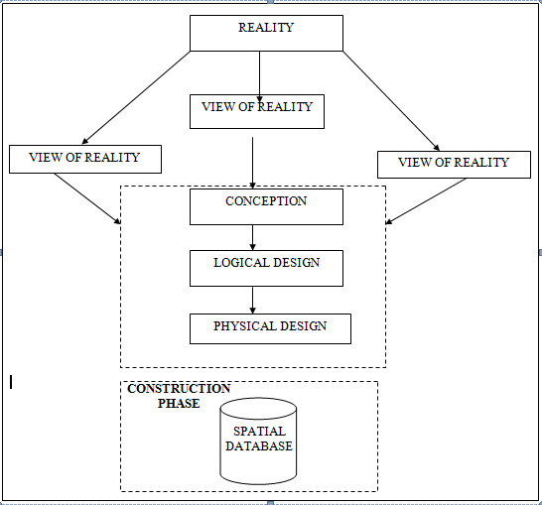
- Building
Fig. 3.1 Design and Construction Phases in Spatial Database

    - CONCEPTUAL DESIGN
Vector data model is the data type adopted for this project, which is represented, by points, lines and polygon. The identified entities are:-
      - Roads (line)
      - Electric poles (point)
      - Trees (point)
      - Buildings(polygon)
Fig. 3.2: E-R Diagram (Entity relationship diagram)
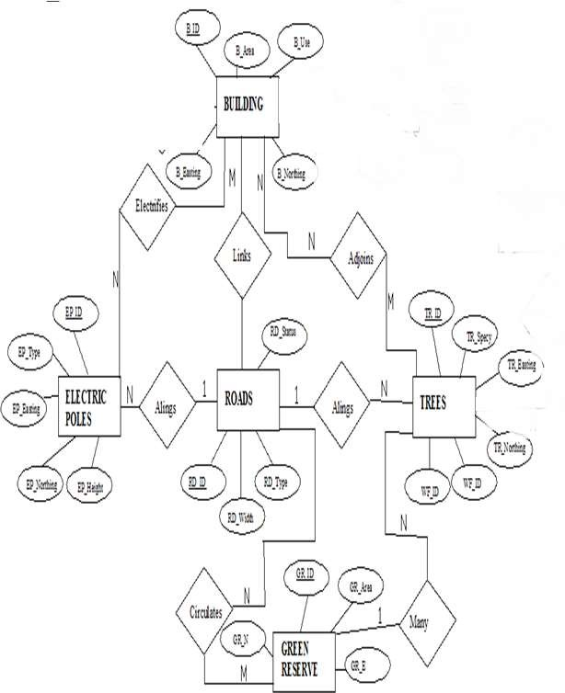

    - LOGICAL DESIGN
This is the design aspect of the database refers to the process of creating a conceptual framework or model that represents the structure and organization of spatial data within the system. It involves defining the data element, their relationship, and the rules for data manipulation and analysis. In this phase, the entities, their attributes and their relationships are represented in a single uniform manner in form of relation in such a way that would be no information loss and at the same time no unnecessary duplication of data. In this study, the logical database design is employed to generate a geo-relation database structure. Each entity has unique identifier in bold type. An attribute type or combination of attribute types that serves to identify an entity type is termed an identifier.
- Building( B_ID, B_Area, B_Name, B_Easting, B_Northing)
- Roads (R_ID, R_Width, R_Type, R-Condition, R_Easting, R_Northing )
- Vegetation (V_ID,GR_Area,)
- ree (TR_ID, TR_spp, TR_Importance, TR_Easting, TR_Northing )
- Electric Pole (EP_No, EP_Type, EP_Height,EP_Easting, EP_Northing)
    - PHYSICAL DESIGN
Table 3.1: Building and its attribute
ENTITY | DESCRIPTION
B_ID | Building Identification
B_name | Building Name
B_Area | Building Area
B_Easting | Building Easting
B_Northing | Building Northings

Table 3.2: Road and its attributes
ENTITY | DESCRIPTION
R_ID | Road Identifier
R_Length | Road Length
R_Width | Road Width
R_Type | Road Type
R_Condition | Road Condition

Table 3.3 : Trees and its attributes
ENTITY | DESCRIPTION
TR_ID | Tree Identifier
TR_Spp | Tree specy
TR_E | Tree_Easting
TR_N | Tree Northing

Table 3.4: Electric Poles and its attributes
ENTITY | DESCRIPTION
EP_ID | Electric pole Identifier
EP_Type | Electric pole Type
EP_Height | Electric pole Height
EP_E | Electric pole Easting
EP_N | Electric pole Northing

Table 3.5: Vegetation and its Attributes
ENTITY | DESCRIPTION
V_ID | Vegetation Identifier
V_Area | Vegetation Area
V_E | Vegetation Easting
V_N | Vegetation Northing

3.2 RECONNAISSANCE

This stage represents the groundwork laid prior to the execution of the project. It involves gathering all available and relevant information about the project area to ensure a smooth and effective implementation.
The necessary steps for the successful execution of the project are divided into two main phases:
- Office Planning
- Field Reconnaissance

3.2.1 OFFICE PLANNING
This phase entails the collection and review of information related to the study area. It also includes testing the instruments intended for use during the project, listing the required equipment, estimating the number of days needed for field activities, and outlining how each task will be performed. Additionally, responsibilities are assigned to team members based on the supervisor’s guidance and instructions.

Table. 3.6: Coordinates of Controls
Station | Northing (m) | Easting (m) | Height (m)
PBIL3306 | 940288.197 | 678281.701 | 355.212
PBIL3304 | 940275.508 | 678254.250 | 350.532
PL1 | 939677.97 | 678331.46 | 349.087
Source: Surveying and Geo-informatics Department Kwara state polytechnic.

3.2.2 FIELD RECONNAISSANCE

The field reconnaissance is the first visitation to the project site to get intimated with the environment.
- Boundary points was selected
- The distribution of features was studied
- Controls to be used were located
- Method and type of instrument to be uses was determined
- Subsidiary point for Ground control Points were picked and define using nail and bottle cock
- A diagram of the study area was drawn.

Fig. 3.3: Recce diagram of the study area (not drawn to scale)

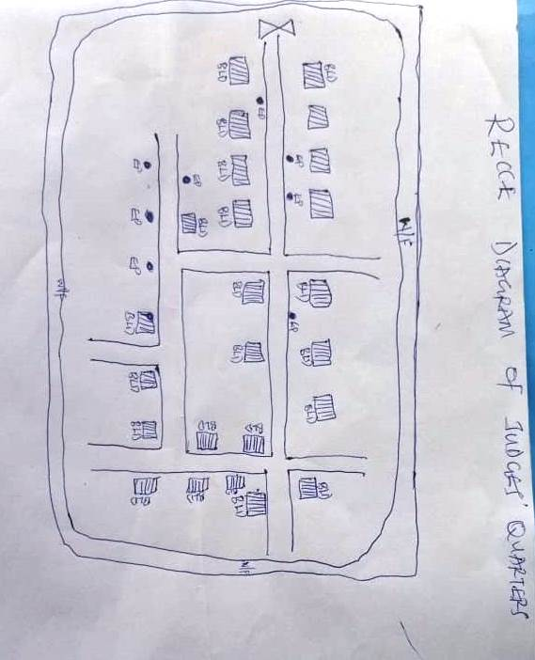
  - EQUIPMENT USED/ SYSTEM SELECTION AND SOFTWARE
    - HARDWARE USED
- Total station
- 1 reflector with a tracking rod.
- 1 Tripod
- One (1) 50m tape
- One (1) umbrella
- 1 cutlass
- Hand held GPS
- Hammer
- Nails and bottle cover
- Field book and writing materials
- 1-No of Personal Computer HP655 and its accessories
- 1-No of HP DeskJet K7100 A3 printer
- 1-No of HP DeskJet 1110 A4 printer
    - SOFTWARE COMPONENT
- Notepad.
- Microsoft Excel.
- AutoCAD 2007
- ArcGIS 10.3
- Surfer 2010
- Microsoft Word.

  - INSTRUMENT TEST
To ensure data quality, the Total Station used in this project was tested for both vertical index error and horizontal collimation error. These tests were conducted to confirm the instrument’s accuracy, efficiency, and overall reliability before use. The procedures followed are detailed below.
    - HORIZONTAL COLLIMATION TEST
This test was conducted to ensure that the line of sight was perpendicular to the trunnion axis. The Total Station was positioned over a specific point, and initial adjustments were made to ensure proper alignment, leveling, and focus (to eliminate parallax in the telescope). A vertical target was placed at a distance of 100 meters from the Total Station. To access the configuration menu of the Total Station, the menu key was pressed and held for approximately 2 seconds. From the main menu, the calibration sub-menu was selected, and within that, the horizontal collimation test option was chosen. The target was then observed and divided into two halves, with horizontal readings recorded for Face left and Face right. The readings are shown in Table 3.4.1 below.
Total Station

Fig 3.4: Horizontal Collimation and Vertical Index error test.
100m
REFLECTO R (TARGET)

STATION A
Fairly Level Ground
STATION B

Table 3.7: Horizontal Collimation Data
Station | Target | Face | Hz Reading | Difference | Error
A | B | L | 38˚42‟32”
 |  | R | 218˚42‟35” | 180˚00‟03” | 03”

    - VERTICAL INDEX ERROR TEST
This test was conducted to verify the accuracy of the vertical angle measurement when the line of sight is perfectly horizontal. The expected reading for this test is exactly ninety degrees (90°); any deviation from this value is known as the vertical index error.
The Total Station was set up over a designated point, with necessary temporary adjustments made to ensure proper alignment and functioning. A target was placed approximately 100 meters away, and the instrument was carefully aimed at it. The target was bisected by aligning the instrument in the Face Left position, and the corresponding vertical angle reading was recorded. The process was then repeated with the instrument in the Face Right position, and that reading was also documented. The recorded values are presented below.

Table 3.8: Vertical Index Data
Instrument Station | Target Station | Face | Vertical | Sum | Error
A | B | L | 90˚00‟00”
 |  | R | 270˚00‟02” | 360˚00‟02” | 02”

    - ANALYSIS OF COLLIMATION AND VERTICAL INDEX DATA
The reading obtain during calibration were reduced to obtain new collimation and vertical errors.
Horizontal collimation = {(FR – FL) – 180}/2 = {(00˚00‟03”}/2 = 1.5”

Vertical collimation = {(FL + FR) – 360} = (90˚00‟00” + 270˚00‟02”) - 360} = 02” The result shows that the instrument is still in good working condition.
  - CONTROL CHECK
Three control beacons (PBIL3306, PBIL3304) were utilized in this project. To verify their positions on-site, a check was performed by measuring the angles between these beacons and comparing the observed angles with those calculated from their known coordinates.
The Total Station was set up on the control beacon PBIL3304. After completing all necessary temporary adjustments, the reflector was positioned on the control beacon PBIL3306, designated as the back station. A horizontal angle reading was taken and recorded with the instrument set to Face Left.
Next, the reflector was moved to the control beacon PL1, the forward station. Horizontal angle readings were then recorded in both Face Left and Face Right positions. Finally, the reflector was returned to the back station, and a horizontal angle reading was recorded with the instrument set to Face Right.

Table 3.9: Table showing the back computation of the control coordinates
From STN | Bearing | Dist(m) | ∆N | ∆E | Northing (m) | Easting (m) | To STN
 |  |  |  |  | 940288.197 | 678281.701 | PBIL3306
PBIL3306 | 65°11'30'' | 30.242 | -12.689 | -27.451 | 940275.508 | 678254.250 | PBIL3304
PBIL3304 | 7°21'45'' | 602.506 | -597.538 | 77.21 | 939677.97 | 678331.460 | PL1

Table 3.10: Table showing the distance observation result of the control check
FROM | OBSERVED DISTANCE(m) | COMPUTED DISTANCE (m) | TO
PBIL3306 | 30.140 | 30.242 | PBIL3304
PBIL3304 | 602.451 | 602.506 | PL1

Table 3.11: Table showing the observation result of the control check
STN | SIGHT | FACE | OBSERVED HZ ANGLE | REDUCED HZ ANGLE | MEAN
 | PBIL3306 | L1 | 357° 08' 35''
PBIL3304 | PL1 | L2 | 291° 57' 00'' | 65°11'35''
 | PL1 | R2 | 111° 57' 1'' | 65°11'25''
 | PBIL3306 | R1 | 177° 08' 35'' |  | 65°11'30''

Difference in angle (observed - computed) =65° 11' 30''-65° 11' 25''
= 00° 00' 05''
Since the allowable accuracy (angular) of third order traverse of one station is 00° 00' 30'' and the result obtained from the control check (00° 00' 05'') is less than allowable error. Therefore, the controls were angularly intact.
  - MONUMENTATION
The boundary of the area carved out was demarcated with the precast concrete beacons, after clearing the required line of sights. The identified points of changes in directions were dug and beacons were buried on it, leaving about 15cm part of the beacon above the ground level. The beacons were buried at convenient distances as dictated by the nature of the boundary.

Fig. 3.5: Pillar Description
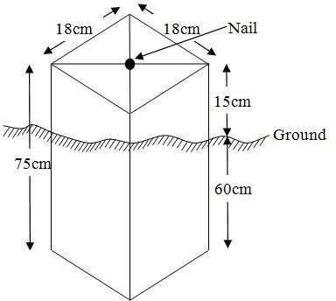
  - DATA ACQUISITION

PRIMARY DATA SOURCE
Field observation served as the primary data source for this project. A ground-based method was employed to collect data using a Total Station instrument, which involved recording X, Y, and Z coordinates from Ground Control Points (GCPs) established at prominent locations throughout the study area.

SECONDARY DATA SOURCE
An updated imagery of the area was obtained from Google Earth and used to determine the extent of coverage for the project area.
    - GEOMETRIC DATA ACQUISITION
The Total Station instrument was carefully set up on control point PBIL3304, with a back sight taken to PBIL3306 after performing the necessary station adjustments, which included centering, leveling, and focusing. The following procedures were then followed to determine the position of the next point (PL1), and this process was repeated sequentially until the entire site was covered. The data acquisition method used on site was the radiation method, where two or more points are coordinated from a single instrument station.
Procedure:
i. After setting up the instrument and completing temporary adjustments, the instrument was powered on, and a new job was created under the job menu in the instrument’s internal memory. The job was named GROUP 5A.
ii. The coordinates of the three control points were entered into the instrument’s memory, along with relevant codes such as:
- ‘RD’ for roads
- ‘SP’ for spot heights
- ‘BD’ for buildings, etc.
iii. The instrument height and reflector height were measured and saved in the instrument memory.
iv. In the coordinate menu, orientation was set by inputting the coordinates of the instrument station and the back sight. The reflector at the back station was carefully bisected before confirming the orientation by selecting ‘yes’.
v. After orientation, the reflector was bisected at the next point (nail), and the ‘obs’ (observe) option was selected. The three-dimensional coordinates (East, North, Height) of the point were displayed on the instrument’s screen, and ‘rec’ (record) was pressed to save the data. For subsequent observations, the ‘all’ option was used to streamline the process without separately pressing ‘obs’ and ‘rec’.
vi. It was ensured that the prism center of the reflector was precisely bisected and securely set on the tripod to minimize height measurement errors.
vii. The instrument was then moved to the next point after all details—including spot heights and boundary points visible from the current station—were recorded. Temporary adjustments were made after repositioning.
viii. This sequence was repeated until all boundary points and their heights were accurately coordinated.
ix. Spot heights in this project were acquired randomly rather than at regular grid intervals. Additionally, three edges of each building were surveyed.
x. Upon completion of the data acquisition, all collected details were properly recorded and mapped to their respective positions on the project plan.
    - ATTRIBUTES DATA ACQUISITION
Attribute data is information about spatial features. They provide the characteristics, description and nomenclature about spatial objects. Thus the attributes data acquired includes names of buildings and their uses such as classrooms, roads, water facilities and prominent natural features likes river and trees found and vegetation were properly identified within and around the study area.
  - DATA DOWNLOADING AND PROCESSING
    - DATA DOWNLOADING AND EDITING
This is stage whereby all data acquired which were automatically stored in the Total Station were downloaded into personal computer. This was done with the aid of downloading cable connected to the computer and some associated complementing software installed on the System.
    - DATA PROCESSING AND DATA EDITING
The geometric data downloaded were further processed in order to convert it to a useful format and to enhance its accuracy. The output coordinates, were edited and exported in *.txt, *.xls and *.pdf format. Thereafter, they were imported into Arc GIS 10.3 for further operations and to carry out spatial analysis.
    - DATA PROCESSING USING ARCGIS 10.3
Before launching ArcGIS, AutoCAD was used to plot feature data, which were saved separately in different files named road, boundary line, buildings, trees, and electric poles.
Steps to load and prepare data in ArcGIS 10.3:
- Launch ArcMap in ArcGIS 10.3.
- In the dialog box that appears, click A NEW EMPTY MAP to create a new project.
- On the menu bar, click Tools, then select Extensions. Check all available extensions, then close the window.
- On the left-hand side (LHS), right-click on Layers, and select Properties.
- In the Properties window, go to the Coordinate System tab to set the projection system to MINNA DATUM ZONE 31N. Then, go to the General tab to set the map units. Click Apply and then OK.
- Click Add Data on the toolbar, browse to the saved AutoCAD files, select all relevant files, and load them into the Table of Contents (Layer section).
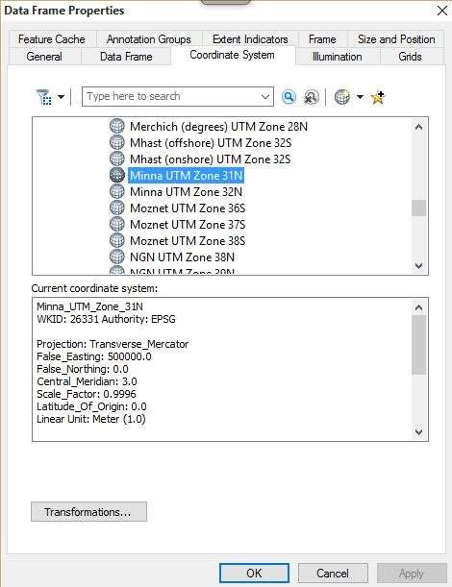
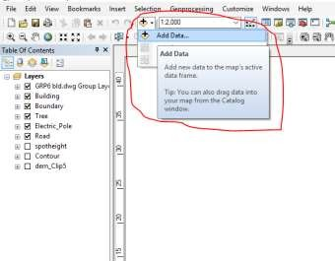
All drawing was exported to shape file. After the feature class has been creates, click on Editor to start Editing, and then click on the load object.
Creating Contours
- First, a Digital Elevation Model (DEM) was created by using the Natural Neighbor interpolation method. To do this, open the Search bar and type Interpolation, then select Natural Neighbor.
- Choose the XYZ data as the input for creating the DEM, setting the project boundary line as the extent for the interpolation.
- To generate contours, ensure that the Spatial Analyst toolbar is enabled. You can activate it by navigating to Customize > Toolbars > Spatial Analyst.
- Alternatively, open the search bar by clicking Windows > Search or by clicking the search icon and type relevant commands or tools.
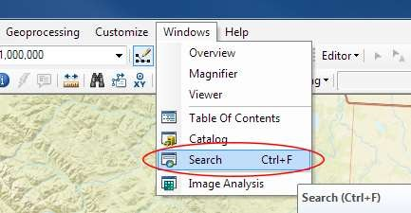
In the search bar type Contour, and select Contour (Spatial Analyst) from the search results list.

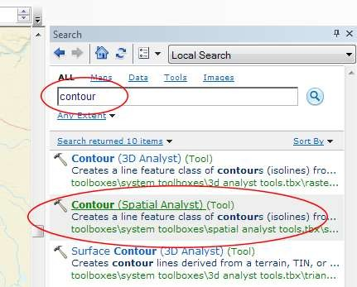
After choosing Contour, a dialogue window will appear, prompting you for five settings: Input raster: select the DEM file from which you want to generate contours by locating it on your hard drive or in the dropdown menu, showing layers present in the Table of Contents Output polyline features: indicate where you want to save your output contours Contour interval: set the distance between contour lines in meters – the smaller the number, the greater the number of lines Base contour (optional): the starting point from which the lines are generated – for example, the default is 0 so with an interval of 25 meters, the contours are generated at 25, 50, 75, 100…, but if the base contour is set at 40, then the contours are generated at 65, 90, 115, 140 and so on Z factor (optional): can be used to adjust the units of data; for example, if you have data in meters and you want to produce your contours in feet, use a z-factor of 3.28 because 3.28 feet equals one meter.

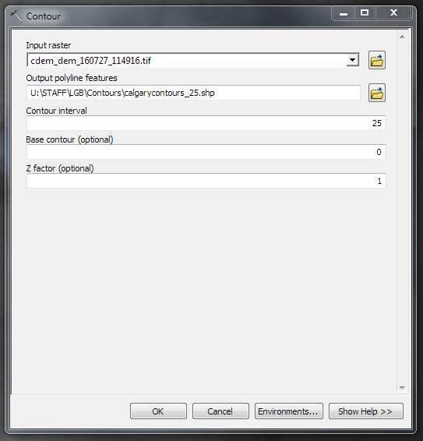
The generated contours will automatically be added to the map.
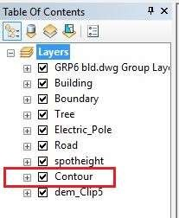
Input the data which is the AutoCAD drawing and select the feature type you want to load,
- Click Add and Next, then select the Target layer you want it to be
- Load it into from the feature class created on the ARCGLS.
- Click on Next, then select “only the features that satisfy the
- Query” and click on Query Builder to query for the feature to be loud e.g. “layer” = Boundary”.
- Click on Next. Then finish
Right click on the Boundary In the table of content and click on zoom to layer to display the feature.

EDITING, CONVERTING AND MERGING GEODATABASE
- Remove all necessary features by right clicking on it and press "REMOVE"
- Convert some features that are not in their correct „features -type‟ like point, line, and polygon features etc.
To convert a GOEDATABASE FEATURE CLASS to another the following steps were taken:
- FOR LINE FEATURE CLASS TO POLYGON FEATURE CLASS
- Go to WINDOW on the menu bar and select ARC Toolbox.
- Select DATA MANAGEMENT TOOLS, click on FEATURES, and then Select FEATURE TO POLYGON.
- ON INPUT FEATURES, select feature to be converted, on OUTPUT FEATURE CLASS, then save on the GRP6C FOLDER, press OK and CLOSE.
- Then remove the converted feature class in the LAYER Menu and ARC CATALOG files.
- On INPUT DATASETS, select features to be merged, on OUTPUT DATASETS, then save on the GRP6C folder, press OK and CLOSE.
- Then remove the converted feature class in the LAYER Menu and ARC CATALOG files.

TABLE CREATION
There is need to create attribute tables for the features so as to be used for queries. NOTE: The editor on the menu bar must be stopped before adding field to its table. THE FOLLOWING PROCEDURES WERE FOLLOWED:
- Right click on the feature class, then select OPEN ATTRIBUTES TABLE click on OPTIONS and select ADD FIELD.
- Give it FIELD NAME, click on TYPE and select [SHORT INTEGER or LONG INTEGER for SHORT or LONG WHOLE VARIABLES or DOUBLE FOR
DECIMAL VARIABLES OR TEXT variable or DATE for DATE], then enter precision or LENGTH for text width and scale for DECIMAL PLACES, and then click OK
- To input variables on the ATTRIBUTE TABLE, go to the EDITOR on Menu bar, select START EDITING,
- Click on ATTRIBUTE on menu bar [behind the TARGET], click on the features on the DATA VIEW display, and then input the variables of data acquired through SOCIAL SURVEY or DATA ACQUIRED ON THE FIELD.
- Save it after the input by selecting SAVE EDITS on the editor menu. To switch to other layers, select STOP EDITING on the EDITOR menu. Then repeat the above step to create other fields. Populate the table and save.

Table 3.12: Building
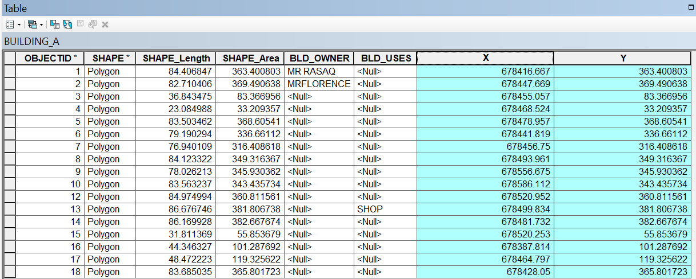

Table 3.13: Road
ENTITY | FIELD ALIAS | DATA TYPE | FIELD SIZE
R_ID | Road Identifier | Numeric | -
R_Length | Road Length | Numeric | -
R_Width | Road Width | Numeric | -
R_Type | Road Type | Text | 10
R_Condition | Road Condition | Text | 10

Table 3.14: Trees
ENTITY | FIELD ALIAS | DATA TYPE | FIELD SIZE
TR_ID | Tree Identifier | Numeric | -
TR_Spp | Tree specy | Text | 10
TR_E | Tree_Easting | Numeric | -
TR_N | Tree Northing | Numeric | -

Table 3.15: Electric Poles
ENTITY | FIELD ALIAS | DATA TYPE | FIELD SIZE
EP_ID | Electric pole Identifier | Numeric | -
EP_Type | Electric pole Type | Text | 10
EP_Height | Electric pole Height | Numeric | -
EP_E | Electric pole Easting | Numeric | -
EP_N | Electric pole Northing | Numeric | -

ADDING SPOT HEIGHTS DATA
- NOTE: STOP EDITING on the EDITOR MENU before adding data field,
- Go to FIELD ON THE MENU BAR, scroll to add Data and then ADD XYZ DATA
- Browse the EXCEL FILE for SPOT HEIGHTS, select EASTING VALUE on X - FIELD and NORTHING VALUE on Y - IELD and ELEVATION
- « Select DATA the EXPORT DATA, locate the folder created and give it name then YES AND OK, remove the previous layer by right clicking on it and select REMOVE.

Fig. 3.6 shows the spot height
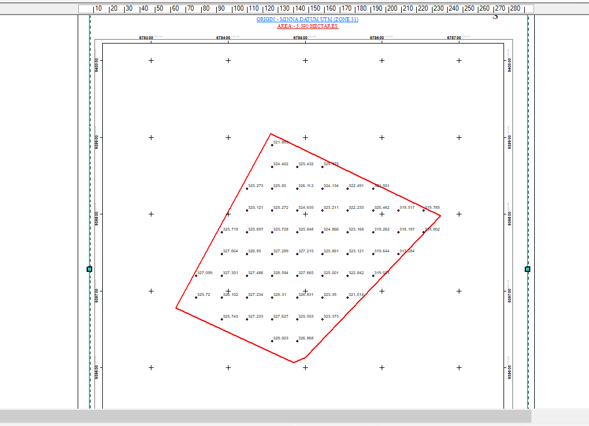

TIN, ASPECT AND SLOPE CREATION USING ARCMAP
NOTE: Making sure the 3D Analyst Extension is active, select VIEW on MENU bar, then click TOOLBARS and MARK the 3D Analyst EXTENTION Then X, Y Data

TO CREATE TIN
- Click on 3D Analyst arrow, select create TIN and then create TIN from FEATURE.
- On layers mark the SPOTHEIGHT LAYER, select height data on HEIGHT, then ok.

TO CHANGE THE FACE OF THE TIN ACCODING TO ITS ELEVATION
- RIGHT CLICK on the TIN, select PROPERTIES, and click on SYMBOLOGY.
- Then ADD, select FACE ELEVATION WITH COLOR RAMP, click ADD, and then select APPLY and OK.

Fig. 3.7: Shows the Tin creation
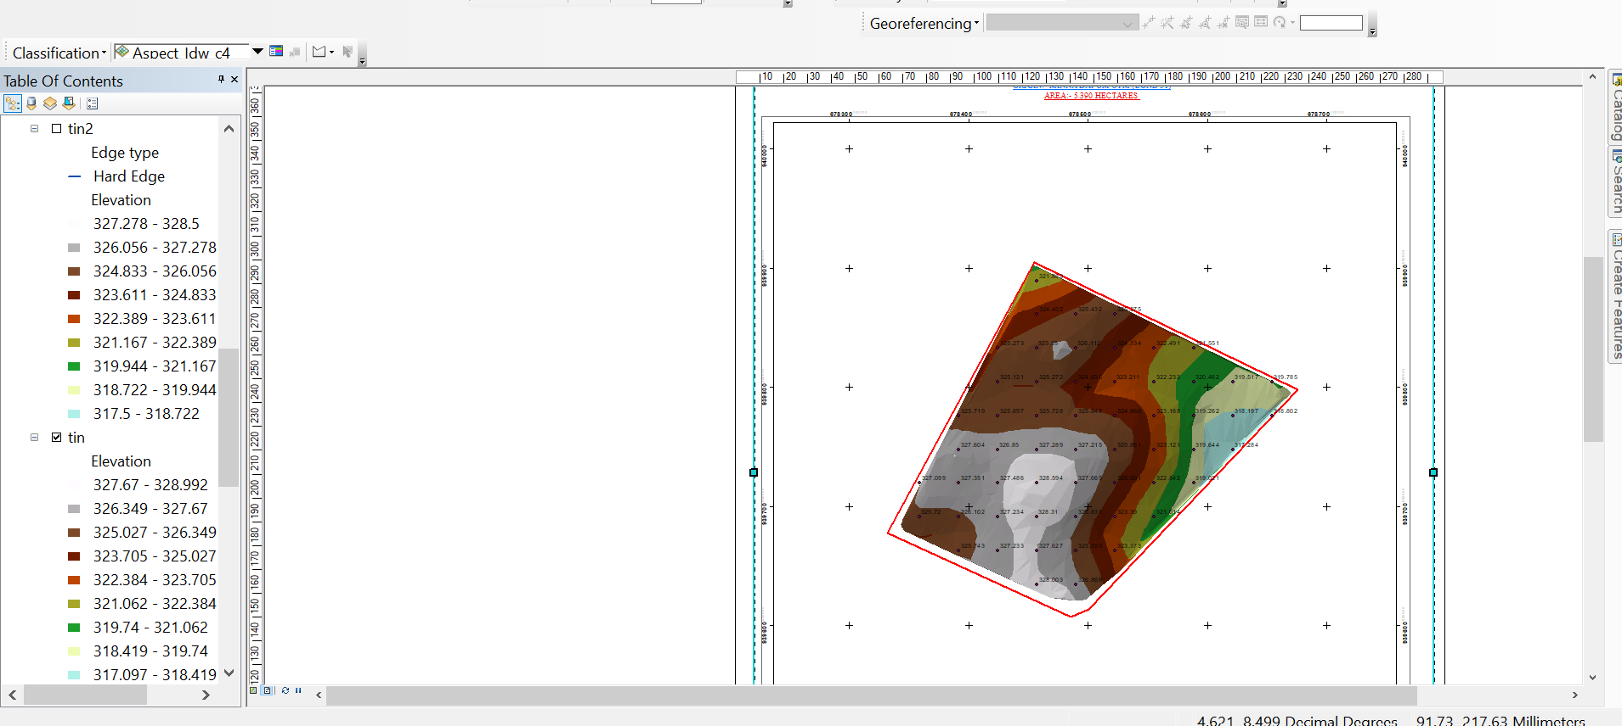

TO CREATE ASPECT
- Click on 3D analyst arrow, select SPATIAL ANALYST TOOLS, SURFACE and THEN DOUBLE CLICK on ASPECT.
- Browse to where the raster format of all the acquired data created from the surfer was saved to.
- Browse to where you want the OUTPUT RASTER to be saved
- You can change the OUTPUT MEASUREMENT to Degree OR percent
- Click OK [then it displays on the data view screen], then Close.
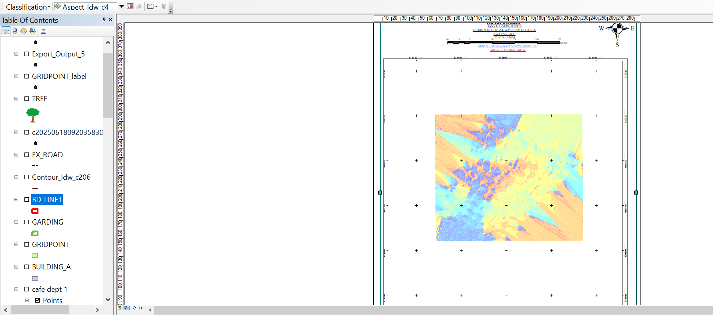
Fig. 3.8 shows the slope aspect

  - DATABASE IMPLEMENTATION
This is the database creation phase. Having completed the three stages of design phase (i.e. Reality, Conceptual and Logical design), the database was created using ArcGIS 10.3 software. It involves the combination and storage of acquired graphic data and attributes data in creating the database for the purpose of spatial analysis and query.
Database is an organized integrated collection of data stored so as to be capable of use by revenant application with data being accessed by different logical part. After the Attribute table was populated via the keyboard, some attributes such as areas of settlements were automatically displayed by special command in the ArcGIS 10.3 version. The ArcGIS software was used to link the graphic data and table for query generation.
    - DATABASE MANAGEMENT SYSTEMS
Database management refers to a collection of software designed for creating, storing, manipulating, updating, organizing, and querying information within a database (Kufoniyi, 1998). A Database Management System (DBMS) functions as intermediary software that manages the database on behalf of the user.
A good DBMS should provide the following key functions:
  - Efficient storage and retrieval of data.
  - Concurrent access by multiple users.
  - A standardized interface between the database and application programs.
  - Standardized data access and clear separation of data storage/retrieval from the application logic.
  - Maintenance of data security and integrity.
    - DATABASE MAINTENANCE
After creating the database, proper maintenance practices were implemented to ensure it met its stated objectives. Maintenance allowed for the addition of new data and removal of outdated or irrelevant information. Regular updates are essential to reflect physical changes in the landscape over time. Additionally, security and data integrity measures were enforced to maintain the database’s reliability and effectiveness.
Consistent updating and management of the database are crucial for maintaining its currency and quality, which in turn enhances its suitability as part of a Spatial Decision Support System (SDSS). The overall quality of a database depends on its timeliness and fitness for use within a decision support framework.
It is also important to periodically review the storage media to prevent data inaccessibility or deterioration due to physical damage. Care must be taken when populating the database, as its value directly depends on the accuracy and quality of the input data.
For long-term archiving, stable storage media should be used, such as:
- Computer-compatible tape readers
- Magnetic tapes
- Optical discs and compact discs

3.9.3 BACK COMPUTATION

Table 3.16: Back Computation
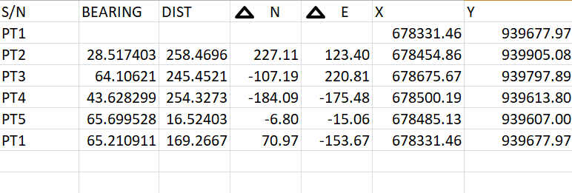

3.9.4 AREA COMPUTATION

Table 3.17: Area Computation
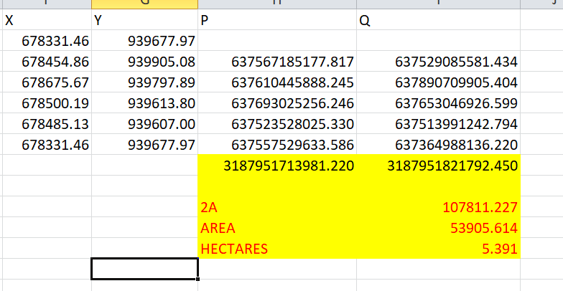

CHAPTER FOUR

4.0 SPATIAL ANALYSES AND PRESENTATION
GIS stands out among other information systems due to its powerful spatial analytical capabilities, including overlay operations, buffering, spatial search, topographic analysis, as well as neighborhood and connectivity operations. GIS leverages these capabilities to answer fundamental questions related to location, condition, trends, routing, patterns, and modeling through the manipulation and analysis of spatial data. In this project, the major analyses performed were overlay operations, topographic analyses, and spatial searches.

4.1 TESTING OF DATABASE
This test was conducted to evaluate the relationships between data modeled as entities in the spatial database and to assess the database’s retrieval capabilities. A sample query with specific conditions was designed and executed to verify whether the desired results could be obtained.
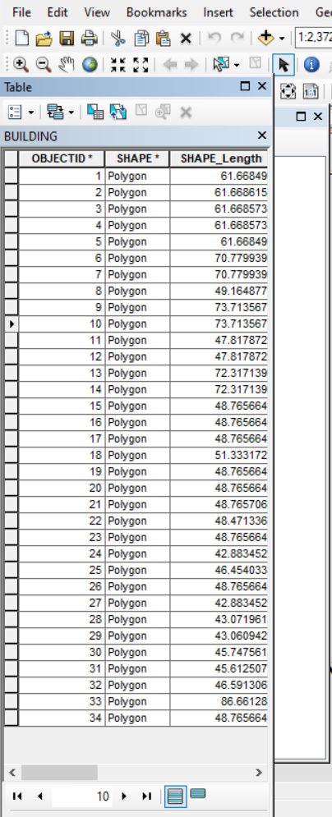
Fig. 4.1: Shows the attribute database

Fig. 4.2: Showing catalog, attribute table and table of content
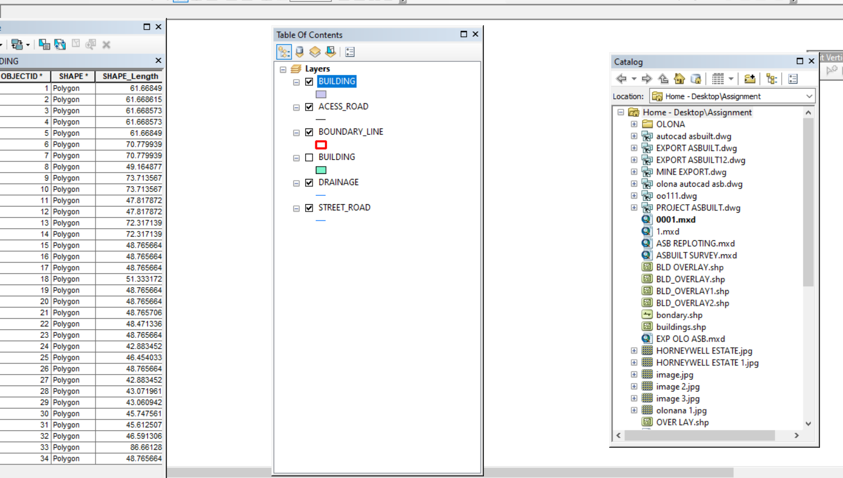

Analysis of Result
The query retrieved contours with elevation values greater than or equal to 350 meters, indicating areas likely to be less prone to flooding within the project area, as shown in Figure 4.5 (Query 1). These contours represent points with elevations above 350 meters.
The attribute table confirmed that the northeast part of the institute has the highest elevation. Elevation is a critical factor when considering terrain surface and slope. Conversely, the southwest part of the school has the lowest elevation and is therefore more susceptible to erosion. Buildings planned for this region should have foundations elevated significantly above ground level to mitigate potential damage.
The results of this query provide valuable information to the school management, enabling informed decisions about terrain characteristics and appropriate building designs across different regions of the project area.

SINGLE SELECTION CRITERION
Query 1: Retrieving Area whose height is Greater than 350 meters
SELECT* FROM Contour WHERE "CONTOUR">3.007
Fig 4.3.: Retrieving Area whose height is greater than 3.007 meters
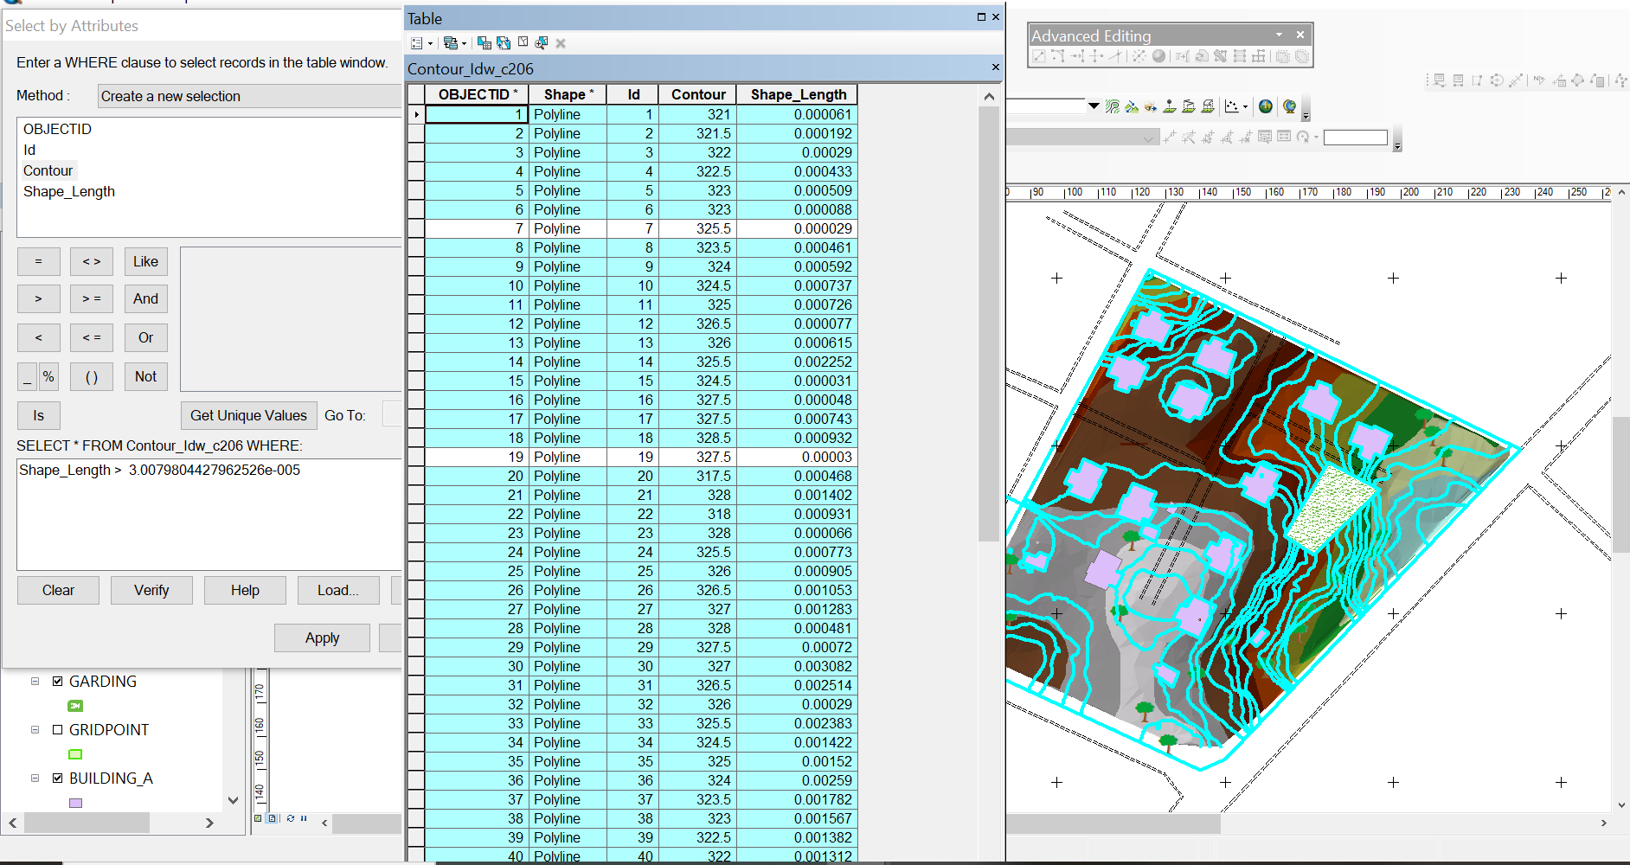

Fig 4.4: Result of area whose height is greater than 3.007 meters
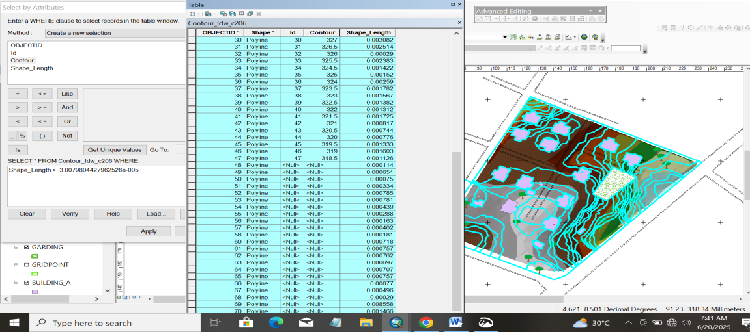

Fig 4.5: Shows the building use for shop
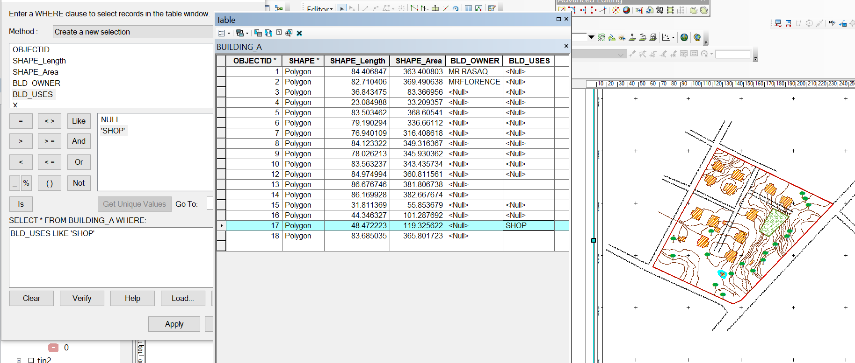

CHAPTER FIVE
COSTING, SUMMARY, PROBLEM ENCOUNTERED, CONCLUSION AND RECOMMENDATIONS
5.1 COST ESTIMATION
This stage the total cost spent on the project from day one to the final stage.
Table 5.1.1: Direct cost parameters
S/N | DIRECT COST
1 | Reconnaissance (1 day)
 | PERSONNEL | Rate | Total Amount (N:K)
 | 1 x surveyor | 10500 | 10500
 | 1 x assistant surveyor | 7500 | 7500
 | 1 x technical officer | 6500 | 6500
 | 3 x skilled labour | 4000 | 12000
 | basic equipment | 5000 | 5000:00
 | transportation (vehicle, Driver and fuel) | 10000 | 10000:00
 |  | sub-total | 51,500
2 | Monumentation (1 day)
 | PERSONNEL
 | 1 x assistant surveyor | 7500 | 7500
 | 1 skilled labour | 4000 | 4000
 | transportation (vehicle, Driver and fuel) | 10000 | 10000
 | basic equipment | 5000 | 5000:00

 | Beacon (6) | 1000 | 6000
 |  | sub-total | 32,500
3 | Data acquisition (2 days)
 | PERSONNEL
 | 1 x assistant surveyor | 7500 | 7500
 | 1 x technical officer | 6500 | 6500
 | 3 x skilled labour | 4000 | 12000
 | Total Station and accessories | 15000 | 15000
 | transportation (vehicle, Driver and fuel) | 10000 | 10000
 |  | sub-total | 51,000
5 | Data Processing (2 days)
 | PERSONNEL
 | 1 x surveyor | 10500 | 10500
 | 1 x assistant surveyor | 7500 | 7500
 | 1 x technical officer | 6500 | 6500
 | computer / accessories | 15000 | 15000
 |  | sub-total | 39,500
7 | Technical Report (1 day)
 | PERSONNEL
 | 1 x surveyor | 10500 | 10500
 | 1 x assistant surveyor | 7500 | 7500

 | 1 x secretary | 5000 | 5000:00
 | computer / accessories | 15000 | 15000:00
 |  | sub-total | 38,000
TOTAL (DIRECT COST) 212,500 MOBILIZATION/DEMOBILIZATION = 5% of Direct Cost
= 0.05 × 212,500

= N10,625

CONTINGENCY ALLOWANCE
= 5% of Direct Cost
= 0.05 × 212,500

= N10,225

GRAND TOTAL = N212,500 + N10,625 + N10,625

= N233,750

VAT (@5% GRAND TOTAL) = 0.05 × 233750

= N11,687.5

TOTAL COST PAYABLE = GRAND TOTAL + VAT

= N233,750+ N11,687.5
= N245,437.5

5.2 SUMMARY
The main aim of the project is to carry out the topographical information system of Judges Quarter Estate, Taoheed Road Ilorin. Kwara State. It was done in accordance with the survey rule and regulation and the departmental instruction. A digital ground survey method was basically use for data acquisition. A data base was created to house all the relevant data collected on the field, AutoCAD, suffer Microsoft word, Microsoft Excel and Notepad were combined to carryout data processing manipulation, Analysis and retriever. The final presentation of information was produced in form of digital map both in hard copy/soft copy.
5.3 PROBLEMS ENCOUNTERED
During the execution of this project the problem encountered are the followings:
1. The pegs used for monumentation were removed repeatedly, but this was overcome by referencing each peg to a fixed mark with the distance of the peg from the reference mark noted.
5.4 CONCLUSION
The aims of the project were achieved as the expected accuracy and the obtained results conformed to required accuracy of a third order job also the task actually exposed and broadened my knowledge on the scope, concepts and skills, involved in topographical surveying, more so, the project has been successfully executed as adequate data were acquired processed and represented in plans.
This project was interesting in spite of the numerous problems encounter thought the execution of the project.
The exercise was not an easy task, it is much cumbersome. It consume money, energy, time and other tangible factors, but at the end of it, I realize that it had helped me in the practical aspect of land surveying and exposed me to that types of problem. Surveyors usually encounters on the field.
5.4 RECOMMENDATIONS
Having successfully carried out the project assignment, I hereby recommend that.
- The x, y and z coordinates of the features were which confirm the position of the features
- The topographical surveys of the area enhanced the use of various surveys of software’s such as AutoCAD; suffer e.t.c and the preparation of plan. Hence it is highly recommended for further studies.
- The authority should make modern instrument like global positioning system (GPS) receiver, total station, and digital level etc. available to the prospective student of Higher National Diploma so as to be widely exposed to them for easy operation.
- I also recommend that instrument should be released to the student on time for quick execution of the project.

REFERENCES
Burrough, P. A., & McDonnell, R. A. (1998). Principles of Geographical Information Systems. Oxford University Press.
Clarke, K. C. (2010). Getting Started with Geographic Information Systems (5th ed.). Pearson.
Collier, P. (2002). The Impact on Topographic Mapping of Developments in Land and Air Survey: 1900-1939. Cartography and Geographic Information Science, 29(3), 155-174.
DeMers, M. N. (2008). Fundamentals of Geographic Information Systems (4th ed.). Wiley
Ehsani, H. A., & Quiel, F. (2009). A semi-automatic method for analysis of landscape elements using Shuttle Radar Topography Mission and Landsat ETM+ data. Computers and Geosciences, 35, 373-389.
Idhoko, K. (2015). Topographic Information System as a Tool for Environmental Management: A Case of Part of Delta State Polytechnic Ogwashi-Uku, Aniocha South, Delta State, Nigeria. IOSR Journal of Environmental Science, Toxicology and Food Technology, 9(12), 117-122. DOI: 10.9790/2402-09112117122.
Maune, D. F. (Ed.). (2007). Digital Elevation Model Technologies and Applications: The DEM Users Manual (2nd ed.). American Society for Photogrammetry and Remote Sensing.
Longley, P. A., Goodchild, M. F., Maguire, D. J., & Rhind, D. W. (2015). Geographic Information Science and Systems (4th ed.). Wiley.
Nkeki, F. N. (2013). Mapping and Geovisualizing Topographical Data Using Geographic Information System (GIS). ResearchGate. DOI: 10.13140/RG.2.2.33351.04002.
Nkeki, F. N., & Ojeh, V. N. (2024). Mapping and Geovisualizing Topographical Data Using Geographic Information System (GIS). Journal of Geography and Geology, 6(1). DOI: 10.13140/RG.2.2.33351.04002.
Oladunjoye, P., & Olayiwola, A. M. (2023). Application of GIS in Topographic Analysis for Sustainable Urban Planning in Lagos, Nigeria. African Journal of Environmental Sciences, 12(2), 45-59.
Rine, C. M., Morales, J., Vanyukevych, A. B., Durand, E. G., & Schroeder, K. A. (2023). Using GIS Mapping to Assess Foster Care: A Picture Is Worth a Thousand Words. Social Service Review, 97(3), 321-340.
Wilson, J. P., & Gallant, J. C. (2000). Terrain Analysis: Principles and Applications. Wiley.

APPENDIX I
S/N | X | Y | Z
PT1 | 678457.2303 | 939634.3698 | 328.003
PT2 | 678490.0255 | 939634.3698 | 326.868
PT3 | 678391.6401 | 939662.7202 | 325.743
PT4 | 678424.4352 | 939662.7202 | 327.233
PT5 | 678457.2303 | 939662.7202 | 327.627
PT6 | 678490.0255 | 939662.7202 | 325.553
PT7 | 678522.8206 | 939662.7202 | 323.373
PT8 | 678358.8449 | 939691.0705 | 325.72
PT9 | 678391.6401 | 939691.0705 | 326.102
PT10 | 678424.4352 | 939691.0705 | 327.234
PT11 | 678457.2303 | 939691.0705 | 328.31
PT12 | 678490.0255 | 939691.0705 | 326.831
PT13 | 678522.8206 | 939691.0705 | 323.39
PT14 | 678555.6158 | 939691.0705 | 321.014
PT15 | 678358.8449 | 939719.4209 | 327.099
PT16 | 678391.6401 | 939719.4209 | 327.351
PT17 | 678424.4352 | 939719.4209 | 327.486
PT18 | 678457.2303 | 939719.4209 | 328.594
PT19 | 678490.0255 | 939719.4209 | 327.665
PT20 | 678522.8206 | 939719.4209 | 325.001
PT21 | 678555.6158 | 939719.4209 | 322.842
PT22 | 678588.4109 | 939719.4209 | 319.021
PT23 | 678391.6401 | 939747.7712 | 327.604
PT24 | 678424.4352 | 939747.7712 | 326.85
PT25 | 678457.2303 | 939747.7712 | 327.289
PT26 | 678490.0255 | 939747.7712 | 327.215
PT27 | 678522.8206 | 939747.7712 | 325.861
PT28 | 678555.6158 | 939747.7712 | 323.121
PT29 | 678588.4109 | 939747.7712 | 319.644
PT30 | 678621.206 | 939747.7712 | 317.284
PT31 | 678391.6401 | 939776.1216 | 325.719
PT32 | 678424.4352 | 939776.1216 | 325.697
PT33 | 678457.2303 | 939776.1216 | 325.728
PT34 | 678490.0255 | 939776.1216 | 325.848
PT35 | 678522.8206 | 939776.1216 | 324.866
PT36 | 678555.6158 | 939776.1216 | 323.168
PT37 | 678588.4109 | 939776.1216 | 319.262
PT38 | 678621.206 | 939776.1216 | 318.197
PT39 | 678654.0012 | 939776.1216 | 318.802
PT40 | 678424.4352 | 939804.4719 | 325.121
PT41 | 678457.2303 | 939804.4719 | 325.272
PT42 | 678490.0255 | 939804.4719 | 324.635
PT43 | 678522.8206 | 939804.4719 | 323.211
PT44 | 678555.6158 | 939804.4719 | 322.233
PT45 | 678588.4109 | 939804.4719 | 320.462
PT46 | 678621.206 | 939804.4719 | 319.517
PT47 | 678654.0012 | 939804.4719 | 319.785
PT48 | 678424.4352 | 939832.8223 | 325.273
PT49 | 678457.2303 | 939832.8223 | 325.85
PT50 | 678490.0255 | 939832.8223 | 326.112
PT51 | 678522.8206 | 939832.8223 | 324.134
PT52 | 678555.6158 | 939832.8223 | 322.491
PT53 | 678588.4109 | 939832.8223 | 321.551
PT54 | 678457.2303 | 939861.1726 | 324.402
PT55 | 678490.0255 | 939861.1726 | 325.432
PT56 | 678522.8206 | 939861.1726 | 325.375
PT57 | 678457.2303 | 939889.523 | 321.883

