ASSESSING THE EFFECT OF BAMBOO AS PARTIAL
REPLACEMENT FOR COARSE AGGREGATE ON
CONCRETE WORKABILITY

BY
RAPHAEL EMMANUEL
ND/23/CEC/PT/0095

BEING A RESEARCH WORK SUBMITTED TO THE
DEPARTMENT OF CIVIL ENGINEERING, INSTITUTE OF TECHNOLOGY, KWARA STATE POLYTECHNIC, ILORIN.

IN PARTIAL FULFILMENT OF THE REQUIREMENT FOR THE
AWARD OF NATIONAL DIPLOMA (ND) IN CIVIL ENGINEERING DEPARTMENT

CERTIFICATION
This is to certify that this research study was conducted by RAHAEL EMMANUEL, (ND/23/CEC/PT/0095) and had been read and approved as meeting the requirement for the award of National Diploma (ND) in Civil Engineering, Institute of Technology, Kwara State Polytechnic, Ilorin.

……………………………………. …………………………..
ENGR. MRS KUDABO E. O DATE
Project Supervisor

……………………………………. …………………………..
ENGR, SANNI. A. DATE
Part time coordinator

……………………………………. …………………………..
ENGR. ABDULHAMEED A. A DATE
External Examiner

DEDICATION
I dedicate this project to my family for their support, my self for doing what is right and enduring the predicament that comes my way to ensure i participate in this project.

ACKNOWLEDGEMENT
My sincere thanks to Almighty Allah, the sustainer of my being and the reason I am all that I am, to the king of the angel armies. I am exceedingly grateful be able to participate in this project program.
To my number one fan that always got my back, Daddy, thanks for all your support. You are just the best. Cheers to more wins and milestones together, the sky is just the starting point!
To my ever-supporting siblings, thanks for always been there for me. I am blessed to have you all.
To ENGR Elizabeth, thank you ma for taking me as your student and making sure I get the best of all you can offer. I promise to make you proud.
To all my project colleagues, thanks for all the time we had together. We will all meet at the top.

ABSTRACT
This study assesses the effect of bamboo as a partial replacement for coarse aggregate on the workability of concrete. With the increasing demand for sustainable and eco-friendly construction materials, bamboo has gained attention due to its availability, lightweight nature, and renewable properties. The research investigates the impact of replacing conventional coarse aggregates with varying percentages of bamboo (0%, 10%, 20%, and 30%) on the workability of fresh concrete using standard slump tests. The study adopts an experimental methodology where concrete mixes are prepared and tested under controlled laboratory conditions. Results reveal that increasing the percentage of bamboo reduces the workability of the concrete, as shown by the decreasing slump values. This reduction is attributed to the higher water absorption rate and irregular shape of bamboo particles. Despite this, bamboo-replaced concrete within the 10% replacement level still maintains an acceptable workability level for structural applications. The findings suggest that bamboo can be used as a partial substitute for coarse aggregates in non-load bearing structures, promoting sustainability without significantly compromising workability. Further research is recommended to improve bonding and durability characteristics for broader structural use.

TABLE OF CONTENT

Title page i
Certification ii
Dedication iii
Acknowledgment iv
Abstract v
Table of contents vi

CHAPTER ONE
Introduction
  - Background of the study 1-3
  - Statement of the Problem 4-5
  - Aim and Objective 5
  - Justification of the study 5
  - Scope and Limitation of the study 6
CHAPTER TWO :
2.0 Introduction 7-10
    - Portland Cement 11
    - Aggregates 11-15
  - Historical Background of Bamboo 15-18

CHAPTER THREE: RESEARCH METHODOLOGY
3.1 Introduction 19
  - Materials 19
  - Experimental Design 20-21
  - Mix Proportions 21-22
  - Sample Preparation 22
  - Test Methods 22-23
  - Equipment and Instrumentation 23
  - Data Collection 23-24
  - Data Analysis 24
  - Quality Control 24
CHAPTER FOUR: DATA PRESENTATION AND ANALYSIS
  - Introduction 25
  - Physical Properties of Materials 25
  - Workability Test Results 26-27
  - Analysis of Result 27-28
  - Discussion of Findings 28-30
  - Statistical Analysis 30

CHAPTER FIVE: SUMMARY OF FINDINGS RECOMMENDATION AND CONCLUSION
  - Introduction 31
  - Summary of Findings 31-33
  - Conclusion 33-34
  - Recommendations 34-35
Reference 36-37

CHAPTER ONE
INTRODUCTION

1.1 Background of the Study
Concrete is a composite element consisting of aggregates enclosed in a matrix of cement paste including possible pozzolanic, has two major components-cement paste and aggregates. As a construction material, concrete can be in almost any shape desired, and once hardened, can become a structural (load bearing) element. The strength of concrete depends upon the strength of these components, their deformation properties, and the adhesion between the paste and aggregate surface. With most natural aggregates, it is possible to make concrete up to 120KN/mm2 a compressive strength by improving the strength of the cement paste, which can be controlled through the choice of water- cement ratio, and type and dosage of admixtures (Dwivedi 2006).
The high cost of conventional construction material is a dominating factor affecting housing system around the world. This has necessitated research work into alternative materials in the construction field. Since the cost of cement is many times more than the cost of other ingredients in concrete making. Recently, attention is mainly directed to use of as little cement as possible constituent with adequate strength and durability. Little research has been carried out to study the bamboo leaf waste as a pozzolanic material. Dwivedi (2006) reported the reaction between calcium hydroxide (CH) and bamboo for four hours of reaction using the differential scanning calorimetric (Dsc) technique. Singh et al (2000) discussed that eco friendly composite cements may be obtained by partial replacement of Portland cement (PPC) with low cost materials. They studied the hydration of bamboo in a blended Portland cement. It was concluded that bamboo is an effective pozzolanic materials. When 20 weight (wt) % of bamboo ash was mixed with PPC the compressive strength values of mortars at 28 day of hydration were found to be quiet comparable to those of PPC. Villar-cocina et al (2010) conducted a study on sugarcane leaf ash (SCLA). Hydration of 10 wt % SCLA composite Portland cement was studied by using powder xray diffraction, FTIR spectroscopy, and differential scanning calorimetric and other techniques. The result have show that the pozzolanic reaction of sugarcane leaf ash increases with time. They have been used to produce concrete having almost the same behavior as normal concrete.
In general, a pozzolanic material has little or no cementing properties. However, when it has a fine particle size, in the presence of moisture it can react with calcium hydroxide at ordinary temperatures to provide the cementing property. Bamboo (BLAsh) is one of the agro waste ashes whose chemical composition contains a large amount of silica and has high potential to be used as a cement replacement (Okere 2013). Most of the concrete produced today are a multi component product containing one or more admixtures in addition to the four basic components which is cement, fine aggregate, coarse aggregate and water. For every component, one usually as several choices that could influence the cost of the end product and its behavior in service. Among the constituent components, however, cement or cementitious materials as a whole, play a vital role in producing strong and durable concrete. Utilization of these waste materials is a partial solution to environmental and ecological problems. Use of these also helps in reducing the cost of concrete production by reducing the quantity of cement used. Consequently, this study presents the suitability of using bamboo (BLAsh) as a supplementary cementitious material. This work then investigates the effect of bamboo on the workability of fresh concrete and the compressive strength of added concrete.

1.2 Statement Of The Problem
Concrete plays an important role in the beneficial use of the material in construction industry. Many modifications and developments have been made to place material like Bamboo (BLAsh), wood wool, rice husk and marble powder as a cement replacement constituent, but it as an alternative to reveal that the replacement of Bamboo (BLAsh), in Portland cement affect the compressive strength of concrete. One of the main goal of sustainable waste management is to maximize recycling and reuse. With increasing environmental pressure to reduce waste and pollution and to recycle as much as possible, the concrete industry has begun adopting a number of methods to achieve these goals.
One of the suggestions in the forefront has been the sourcing, development and use of alternative, non-conventional local construction materials including the possibility of using some agricultural wastes and residues as partial or full replacement of conventional constructional materials. In countries where abundant agricultural wastes are discharged, these wastes can be used as potential material or replacement material in construction industries.
This has a significant impact by reducing the amount of quarrying and landfill space required, and acts as a cement replacement, reduces the amount of cement of required to produce a solid concrete. As cement production creates massive quantities of carbon dioxide, cement replacement technology such as this will play an important role in future attempts to cut carbon dioxide emissions and production of economical optimum strength concrete, so as to encourage the use of this ‘impressive’ waste product as construction material in low-cost housing.

1.3 Aim And Objectives
The aim of this project is to study the compressive strength of concrete with cement partially replaced with bamboo and the suitability of the material to be used as cement substitute.
The objectives of the projects are:

- To determine the percentage of BLAsh as a replacement for cement of 5%,
10%, 15%, 20%. To replace cement with known percentage of bamboo and
cast with it.
- To examine the workability of the fresh BLAsh concrete by slump test.

- To compare the strength of cubes cast at 100% of cement with cubes replaced with the known percentage of bamboo leaf. To suggest the use of bamboo as alternative supplement to cement so as to reduce cost of construction.

1.4 Justification Of The Study
In Nigeria today, an appreciable percentage of the entire population cannot afford to build their own houses especially modern types due to high cost of cement and the average percentage of the country’s population find it difficult or almost impossible to afford the cost. In order to curb this act, this project is targeting whether bamboo can be used as a partial replacement for cement in order to achieve optimum strength and economic concrete and the corresponding quantity of coir ash required.

1.5 Scope And Limitation Of Work
This study concentrated on investigation of compressive strength of bamboo leaf (BLAsh) concrete and pure cement (100% of cement) as a control sample. The Laboratory Tests include sieve Analysis, specific gravity natural moisture content and water absorption of each aggregate sample. Each samples of concrete were design for grade 20 (as mix ratio 1:2:4) and water cement ratio (w/c) of 0.55. The control sample composed of 100% cement, fine Aggregate, coarse aggregate and water. Then, other four samples were of the same mix design with bamboo as cement replacement that serves as an Unconventional mixes which comprises of
5%, 10%,15% and 20% of the total weigh of ordinary Portland cement.

CHAPTER TWO
REVIEW OF LITERATURE

2.1 PREAMBLE

Separately from industrial waste, ashes from agricultural sources like bamboo leaf ash (BLAsh) rice husk,coconut husk, peanut shell or fiber shell etc. have been used for making cement substitutes. Previously, numerous works have been carried out to look into the various aspects of ashes with pozzolanic behavior locally, and in many parts of the world. These materials have already been known as supplementary cementing materials. It is a well- known fact the increase in the fineness of pozzolanic materials would lead to significant increase in strength. The extremely fine particles in concrete acts as lubricant in the concrete mix and permit a reduction in water content. Thereby, increasing strength.
Little research has been carried out to study the bamboo leaf waste as pozzolanic materials Dwieidi(2006) reported the reaction between calcium hydroxide (CH) and bamboo leaf ash for four hours (4hr) of reaction, using the differential scanning calorimeter (DSC) technique.
Ernesto Villar (2010) was represents a characterization and study of the pozzolanic behavior between calcium hydroxide (CH) and bamboo leaf ash (BLAsh) which was also obtained by calcining bamboo lead at 6000c for two hours (2hr) in a laboratory electric furnace. To evaluate the pozzlanic behavior, conductometric method was used which is based on the measurement of the electrical conductivity in a Bash/CH solution with the reaction time.
Felix, et al., (2006) in their research, wood waste, saw dust and wood shaving
ash, wood waste ash (WWA) of pretreated timber of
0%,5%,10%,15%,20%,25% and 30% by weight of cement was added as a supplement to a concrete of mix proportion 1:2:4, 0.56 cement: sand : coarse aggregate: water cement ratio, and the strengths and the water absorption of the matrix were evaluated. Also, the metal leach ability of WWA was analyzed. The compressive and
the flexural strength of WWA concrete was 12.83N/mm2 to 28.66N/mm2 and
3.65N/mm2 to

5.57N/mm2 respectively, with the lowest values obtained at 30% additive level of Ash. Where compared with the strength of plain concrete control, the compressive and flexural strength of WWA concrete were between 62% and 91% and 61% and 98% respectively of the former.
Singh et al (2000) discussed that ecofriendly composite cements may be obtained by partial replacement of Portland cement with certain low cost materials. They studied the hydration of bamboo leaf ash in blended Portland cement. It was concluded that bamboo leaf Ash is an effective pozzolanic materials. When 20 wt.% of bamboo leaf ash was mixed with PPC the
compressive strength values of mortars at 28 days of hydration were found to be quite comparable to those of PPC.
Abdullah, M (2005) has studied the behavior of wood ash and ordinary Portland cement concrete, chemical analysis of wood ash, bulk density, sieve analysis and specific gravity of wood ash and aggregates, consistency, setting time and slump test of the fresh paste were conducted to determine the suitability of the materials for concrete making.
Oyekan, (2007) observed that when sugar was added in small quantities to laterized concrete, there was a significant increase in the compressive strength. 0.05% sugar added to a laterized concrete mix containing 25% fine laterite increased the 28 days compressive strength by nearly 17%. When the fine aggregate was wholly fine laterite, a 50% increase in compressive strength was obtained at percentage sugar content (by weight of cement 0.05%). Ashworth, (1965) in his study on use of sugar as admixture to concrete concluded that the addition of small qualities of sugar to a Portland cement concrete mix made with Portland cement,0.05% sugar retarded the setting time by 4 hours, increased the 7 â€“day and 28 â€“day compressive and flexural strength by approximately 8% and even increased the workability of the mix.

2.1 INGREDIENT OF CONCRETE

These are the ingredient of concrete material: Water, aggregate, cement

2.1.1 WATER

Combing water with a cementitious material forms a cement paste by the process of hydration. Hydration involves many different reactions often occurring at the same time, as the reaction proceed the products of the cement hydration process gradually bond together the individual sand and gravel particles, and other components of the paste gives the aggregate together, fills voids within it, and allows it to flow more easily. Less water in the cement paste will yield a stronger, more durable concrete while more water will give easier flowing concrete with a higher slump (Arowolo, 2013).
Impure water used to make concrete can cause problems, when setting, or in causing premature failure of the structure. Water used in mixing concrete must be clean and free from oils, alkalis, acids and organic material. Most specification recommends the mixing water be fit for drinking. This is because any water fit for drinking is usually satisfactory for use in mixing concrete but sea water may be used for reinforcement concrete (Arowolo, 2013).

2.1.2 PORTLAND CEMENT
Portland cement was invented and patented in 1824 by the Englishman Joseph Aspdin. Portland cement is used as a binding material in concrete and is a mix between limestone and shale or limestone and clay. Before it blends with water, it is a fine powder. When adding water, a chemical reaction occurs and together with aggregates, the setting of the concrete and the curing of the concrete starts.

2.1.3 AGGREGATES
Aggregates are things such as gravel, sand, or crushed stone. The purpose of the aggregates is to stuff the concrete and provide strength. They are divided into different types. For example, gravel is a rough one, and sand is a fine one.

HOW CONCRETE IS MADE
So, how is concrete made? The process of making concrete starts with Portland cement and ends with the curing. There are many different steps in the process, and here are some of them:
- The proportioning of the ingredients.
- The mixing of the ingredients.
- The hydration of the concrete.
- The placement process.
- The curing of the concrete.
We will now explain these steps further below.
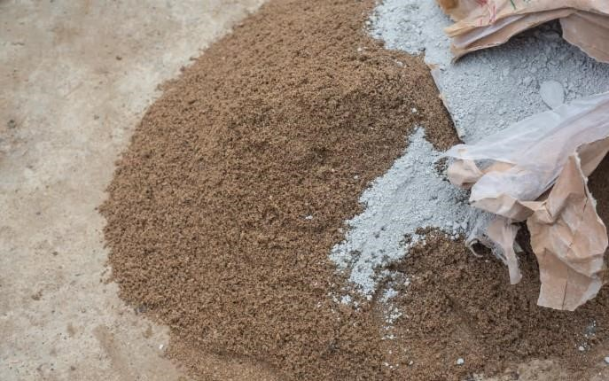

The Proportioning of the Ingredients
All ingredients must be perfectly proportioned for the concrete mix to be strong and workable. The chemical reaction between the different components happens differently depending on the amount of each ingredient that has been added in relation to each other.

The Mixing of the Ingredients
The mixing is when all the ingredients, water, Portland cement, and aggregate are mixed. It is very important to mix properly.

The Hydration of the Concrete
Hydration is an exothermic process in the making of concrete. It happens when the water and the cement are reacting with each other. This starts directly after the mixing process is done, which is also when the concrete starts to build its strength.

The Placement Process
When the hydration has started, it is very important to place the concrete. This is because it hardens fast, and the placement can’t be done if the hydration process has gone too far. The placement process determines how strong and durable the concrete will become when it is finished.
You can use many different techniques when placing concrete. The ideal technique varies depending on, for example, the type of concrete mix or what you will build with the concrete.

The Curing of the Concrete
Concrete curing is when the water and the cement bind together and build strength. The curing is dependent on the concrete staying damp as well as the temperature. If you pour concrete in cold weather, the concrete will cure slower, or if it's too cold, it will stop curing completely. If you, on the other hand, let the concrete cure in a temperature that is too hot, it will cure too fast, and you risk cracking.

2.2 Historical Background of bamboo
No definite records are available to establish the antiquity, history and origin of this craft in Assam.
However, it can be safely assumed that the crafts were practiced since the misty past with the very dawn of Civilization. In the early period in Assam, Bamboo was held with special reference and is forbidden to cut in “auspicious days”. It is a general belief that Bamboo possesses auspicious character and is of religious significance. An idea about the flourishing state of Cane and Bamboo products of Assam was found even during the time of Bhaskara Varman (early part of 7th century A.D),the king of Assam, may be had from the following extract. (An extract from “The History of Civilization of the People of Assam” by Dr P.C. Choudhury.)- “Early literature refers to the well-decorated and coloured sitalpatis (cool mats) used by the rich people. Mats were usually made of cane.
The classical writers testify the abundance of cane in the forests of Assam. Ptolemy, for instance, states that to the east of Serica, which we have identified with Assam, there were hills and marshes where canes were grown and used as bridges. Evidence of the production of other cane articles is also supplied by the
„ Harshacharita‟, which mentions stools of cane. The cultivation of bamboo and its use for various purposes are well known. Banabhatta again testifies to this highly developed craft. He states that Bhaskara Varman sent to Harsha „baskets of variously coloured reeds‟, „thick bamboo tubes‟ and various birds in „bamboo cages‟. All these prove that various industrial arts were developed in Assam at an early period and were continued to be practiced till recent times, based on that traditions like those of the craftsmen of other parts of India…” After the 13th century, Handicrafts had reached a very high point of perfection under the Ahom kings in Assam. The different professional classes like weavers, spinners, dyers, smith, workers in ivory, metal, wood, jewellery and pottery enjoyed state patronage and the villages were developed on the basis of these classes.
Most of the artisans follow their hereditary pursuits and they had local and traditional Technology. Crafts production was on local consumption level. The artisan made Handicrafts products for men the home consumption, but occasionally some surplus products were supplied to the king‟s household and some products were exchanged particularly for goods. In the mediaeval period, besides the professional craftsman, some villages started making a variety of Bamboo Baskets, fishing appliances and containers which were locally bartering, oil, areca nuts, and rice in such other necessaries of life. There were no guilds of craftsmen in Assam but the king made Khel system, specifying a particular profession. In the early seventeenth century, the Ahom king Pratap Singha, brought artisans from Koch Behar to teach new techniques and designs to the local artisans. In the mediaeval period, the Satra institution had played an important role for the development of various indigenous Crafts in Assam. In the Hills of Assam the tribal Handicrafts were interwoven with the social life of the family. Among the various crafts, the Cane and Bamboo works gained its popularity during the mediaeval period of Assam. The Ahoms, Kacharis, Kochs, Bodos, Mikirs, Miris and other ethnic groups have their own traditions on Cane and Bamboo handicrafts. The villagers made all sort of articles using Bamboo and Cane like roof of furnished kitchen using reed, fishing, farming as well as other utilitarian requirements of the households as well as the kingdom. These were used in the daily life of the Assamese people in the mediaeval period. In the mediaeval period, the Satra institution also contributed to the development of Cane and Bamboo Crafts in Assam. Training in Cane and Bamboo works were also provided by the Satras. The famous bichani made from Cane in AunatiSatra signifies the skills obtained by the craftsmen in the Satra institution. The artistic Cane and Bamboo works in the Satras bore the witness of high order of craftsmanship in Assam. Generally, Cane and Bamboo items were made for home consumption, but with the change of economic situations occasionally items were sold in the market. Bamboo is also used in making of mask since medieval time in satra institutions. Most of the Sonowal Kacharis has engaged themselves in Bamboo field. They use it for their own purpose and also make some utensils for domestic use as well as for marketing. The Sonowal Kacharis know how to prepare Bamboo products like Pasi ,Kharahi, Duli, Dala, Salani, Kula and tools for fishing, weaving, agriculture, food making and decorative products.

CHAPTER THREE

RESEARCH METHODOLOGY

3.1 Introduction
The method used to carry out this project work was to analyse the impact of concrete production by using crushed bamboo as partial replacement of coarse aggregate I.e. granite. This was initiated in order to achieve the objectives of this project by carrying out laboratory test on the particles of concrete materials by determine the size particles, mixing ratio and mix design, mass of materials involved, casting of cubes, curing of cubes, dry wet weight, dry density, sieve analysis, the workability of the concrete and the compressive strength of the casted cubes. These were carried out in accordance with British standard of specification.

3.2 Materials used
Cement
The cement used for this research work is Dangote Portland cement of grade 42.5R conforming to BS 8500-2 (2015), the cement was gotten from a local distribution Sawmill, Ilorin.
Fine aggregate
The fine aggregate used for this project work is sharp sand which was gotten from the nearest
Coarse Aggregate
The coarse aggregate to be used will be conforming to ACI committee 363(2011). The granite are angular in shapes and free from dust. It is bought at the nearest Quarry Company in Ilorin.
Crushed Bamboo
The bamboo was obtained mostly behind stream in Ganmo, Kwara State, Nigeria. The whole quality was clean out of the dirt material and impurities, and then crushed by machine and sieved.
Water
The water used in all mixes is potable water Conforming to BS EN 12620(2013).

3.3 Laboratory Testing of The Properties of Aggregates

3.3.1 Particles size distribution
Grading is the arrangement of the proportions of the particles in aggregate found by sieving. The sieves used should confirm to BS 410 or BS EN 933-2. The test were carried out in accordance with the procedure given in BS EN 933-1. An aggregate containing a high proportion of small particles as being coarsely graded and one containing a high proportion of small particles as finely graded.
Objective
• To determine the particle size distribution of the given aggregate
• I draw the various grading curves of the given aggregate.
Apparatus
• Test Sieves.
• Data sheet for recording results.
• ⁠The size of the different sieves used were 6•7 mm, 5.00mm, 44.75 mm, 3.6mm, 3.50mm, 2.36mm and 0.75mm respectively.
Procedure
The test sieves specified above were arranged from top to bottom in oder of decreasing aperture sizes with pan and lid to form a sieve column. The aggregate sample W then poured into the sieving column and thoroughly shaken manually.
The sieves were removed one by one starting with the largest aperture sizes, and each sieve shaken manually ensuring that no material is lost. All the material which passed each sieve was returned into the column before continuing with the operation with the sieve.
The retained material on the sieve with the largest aperture was weighed and its weight recorded with its corresponding sieve size. The same operation was carried out for successive sieves in the column and their weights recorded. The screened material that remained in the pan was weighed and its weight was recorded.

Calculations
1. The various masses were recorded in the test data sheet
2. The mass that retained on each sieve was expressed as a percentage of the original dry mass
3. The cumulative percentage of the original dry mass passing each sieve down to the smallest aperture size was calculated.

3.3.2 Design of concrete Mixes
This is the process of selecting the correct proportion of cement, fine and coarse aggregate (granite and crushed bamboo) and water to produce concrete having the properties specified and desired i.e workability, compressive strength, density and durability requirements by the means of specifying the minimum or maximum water cement ratio.

3.3.3 Principles of design
Strength Margin
Due to variability of concrete strengths, the mix must be designed to have higher means strengths than the characteristic strength. The difference between the two is the margin. The margin is based on the variability of concrete strengths from previous production data expressed as a standard deviation.
Workability
The workability of the concrete mix was determined by the slump test which is more appropriate for higher workability mixes.
Free Water
The total water in a concrete mix consists of water absorbed by the aggregate to bring it to saturated surface dry condition and the free water available for hydration of cement and for the workability of the fresh concrete. The workability of fresh concrete depends on a large extent on its free-water content. In practice, aggregate are often wet and they contain both absorbed water and free surface water so that the water added to the mixer is less than the free-water content. The strength of concrete is related to the free-water/cement ratio on this basis, the strength of concrete does not depend on the absorption characteristics of the aggregates.
Types of aggregates
Two characteristics of aggregates particles that affect the properties of concrete are particle shape and texture. Particle shape affects workability of the concrete and the surface texture affects the bind between the cement matrix and the aggregates particles and thus the strength of concrete. Two types of aggregates are considered for design on this basis crushed and uncrushed.
Aggregate grading
The design of the mixes must comply with specific grading curves of the aggregate. The curves of the fine aggregates mist comply with grading zones of BS 882.
Mix parameters
The approach adopted for specifying mix parameters will be with reference to the weights of materials in a unit volume of fully compacted concrete. This approach will require the knowledge of expected density of fresh concrete, which depends primarily on the relative density of the aggregate and the water content of the mix. This method will result in the mix being specified in term of the weights in kilograms of different materials required to produce one third (½) of finished concrete.

3.3.4 Stages in mix design
STAGE 1: Selection of target water/cement (w/c) ratio.
STAGE 2: Selection of free water content.
STAGE 3: Determination of cement content.
STAGE 4: Determination of total aggregate content.
STAGE 5: Selection of fine and coarse aggregate content.
STAGE 6: Mix proportioning.

3.4 Batching of Concrete Materials
Following the mix design process, concrete materials (cement, fine and coarse aggregates) should be prepared early enough before the concrete works begin. This allows the smooth running of the project. Batching of materials was done by weight basis. The advantage of weight method is that bulking of aggregates (especially fine aggregates) does not affect the proportioning of materials by weight unlike batching by volume method. Bulking of sand results in a smaller weight of sand occupying a fixed volume of the measuring container thus the resulting mix becomes deficient in sand and appears stony and the concrete may be prone to segregation and honeycombing. Concrete yield may be reduced.
Batching of concrete materials by weight is expressed as follows:
We. (C) + Wt. (CA) + Wt. (FA) + Wt. (Air) = Wt. (CC)
Where;
Wt. (C) = weight of cement
Wt. (CA) = weight of coarse aggregate
Wt. (FA) = weight of fine aggregate
Wt. (Air) = weight of entrained air
Wt. (CC) = weight of compacted concrete

3.5 Water Absorption
Water absorption is the amount of water that an aggregate can absorb. Water Absorption tends to be a excellent indicator of the strength of the aggregate. The absorption of the aggregate can influence such properties of concrete as the bond between it and the cement paste and may thus exert some influence on the strength of the concrete, chemical stability and resistance to abrasion. The method of measuring water absorption in aggregate was is described in B.S 812.
Objective
To determine the water absorption of crushed bamboo.
Procedure
Approximately 400g of aggregate sample was added to a clean container filed with water. The material was soaked for 24 hours after which the water was drained to achieve a saturated surface dry state. Wet sample of 300g was removed and then placed in an oven for 2 hours to dry after which it was weighed and mass of 238g was obtained.

Calculation
The water absorption was calculated by the weight of wet aggregate less the weight of oven dry aggregate over the weight of the oven dry aggregate and expressed as a percentage.
Water absorption = Weight of wet aggregate - Weight of oven dry aggregate / Weight of oven dry aggregate × 100

3.6 Slump Test
Slump test is used extensively in site work to detect variations in the uniformity of mix of given proportions. It is useful on the site as a check on the variations of materials being fed to the mixer. An increase in slump may mean that the moisture content of aggregate has increased or a change in grading of the aggregate, such as the deficiency of the fine aggregate. Too much or too low slump gives an immediate warning and enables the mixer operator to remedy the situation. The test was done according to BS 1881-102:1983 that described the determination of slump of cohesive concrete of medium to high workability. The slump test is sensitive to the consistency of fresh concrete. The test is valid if it yields a true slump, this being a stump in which the concrete remains intact and symmetrical.
Objective
To determine the slump of fresh concrete mix.
Apparatus
- A standard mould which is a frustum of a cone complying with BS 1881-102:1983
- A standard flat plate preferably steel.
- A standard tamping rod.
- Standard graduated steel rule from 0 to 300mm at 5mm intervals.
- A scoop approximately 100mm wide.
Procedure
The inside surface of the mould was cleaned and oiled to prevent adherence of fresh concrete on the surfaces. The mould was placed on the base plate and firmly held
The cone was then filled with fresh concrete in three layers with each layer compacted with 25 strokes of tamping rod. After filling the mould, the top layer was struck off by means of rolling action of the tamping rod. Immediately after filling, the cone was slowly and carefully lifted and after removal of the mould the slump of the unsupported concrete was measured and recorded.
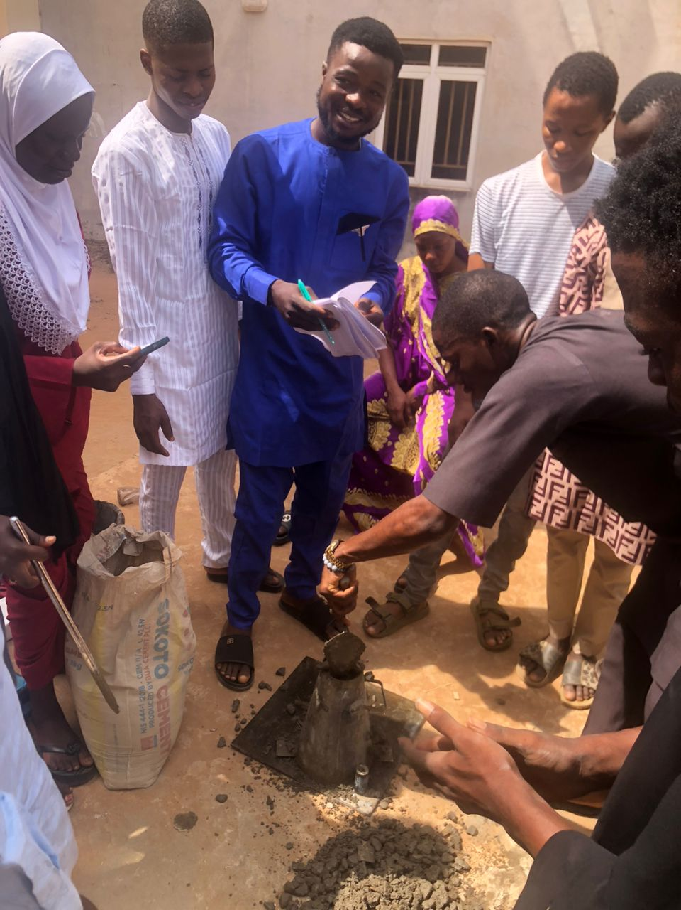
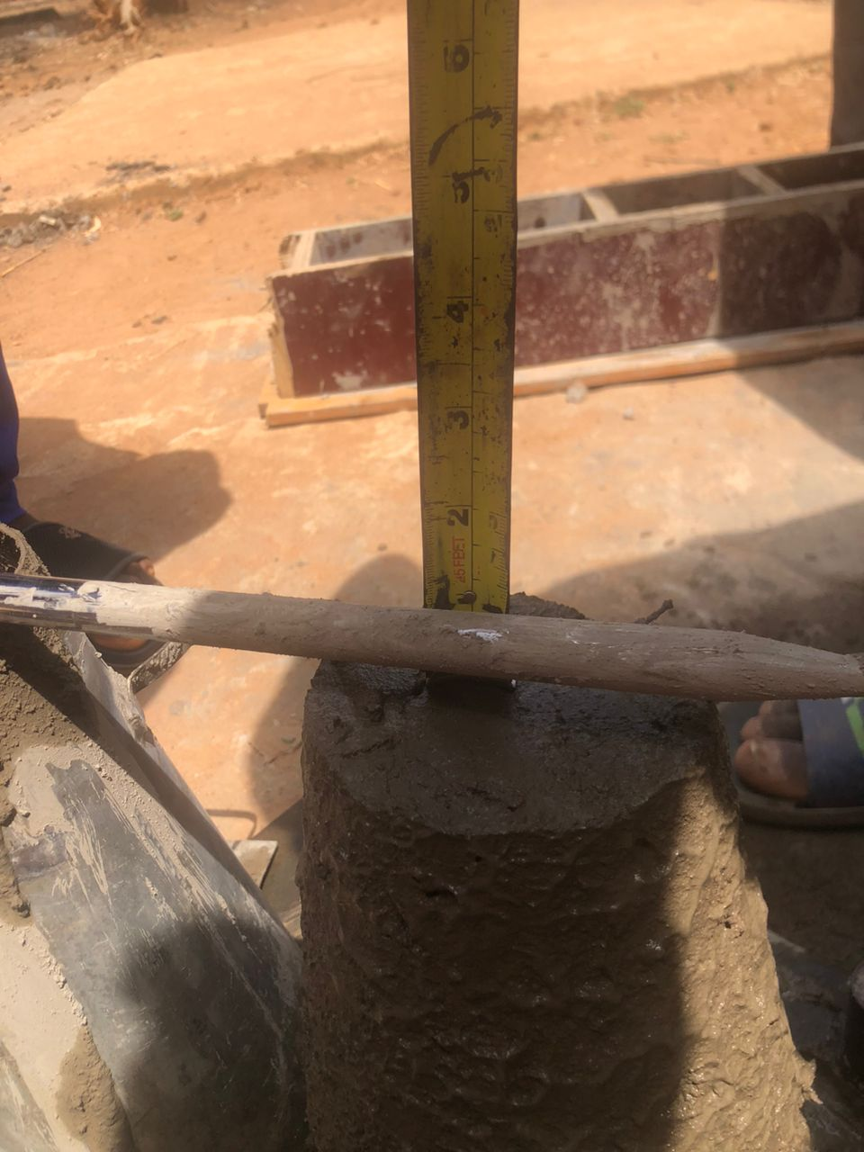

CHAPTER FOUR

RESULTS AND DISCUSSION

4.1 Physical Properties of Bamboo
The table below shows the summary of the results obtained from the various preliminary tests carried out on the crushed bamboo used in this study.
Table 4.1: Physical Properties of Bamboo
Properties | Value
Coefficient of curvature C_{c} | 1.06
Coefficient of uniformity C_{u} | 0.8
Specific gravity | 1.25
Water absorption capacity (%) | 1.9
Aggregate impact value (%) | 5.02
Aggregate abrasion value (%) | 5.32
Bulk density (Kg/m³) | 636.44

4.1.1 Specific gravity
A dry clean measuring cylinder density bottle of 155g was weighed W₁, small quantity of the air dry bamboo sample was introduced into the density bottle and was weight W₂. Distilled water was then added to the sample in the density bottle and stirred very well to allow the trapped air to be released and weighed as W₃. The bottle was then emptied and dried. Finally, the bottle was filled completely with distilled water and weighed as W₄.
$S.G=\frac{W_{2}-W_{1}}{\left(W_{4}-W_{1}\right)-\left(W_{3}-W_{1}\right)}$ (3.5)
Where:
W₁ = Weight of empty cylinder (g)
W₂ = Weight of saturated surface dry sample (g)
W₃ = Weight of sample + cylinder + water (g)
W₄ = Weight of cylinder + water (g)
The results of the specific gravity of the crushed bamboo is shown in Table 4.2
Table 4.2: Specific Gravity of Bamboo
Description | Value
Weight of empty cylinder (g)  Weight of saturated surface dry sample (g)  Weight of sample + cylinder + water (g)  Weight of cylinder + water (g)  Specific gravity | 155  1000  961  938  1.25

4.1.2 Water absorption capacity of Bamboo
Table 4.3: water absorption capacity result of the Bamboo
Description | Value
Weight of the oven dried sample (g)  Weight of the saturated sample after 24-hrs  Water absorption capacity | 1000  1190  1.9%

4.1.3 Aggregate impact value (AIV)
Table 4.4: Aggregate Impact Value of the Bamboo
Description | Value
Weight of empty mould (g)  Weight of mould + BAMBOO sample (g)  Weight of the BAMBOO sample (g)  Weight of BAMBOO sample passing 2.36mm sieve (g)  Weight of BAMBOO sample retained  Aggregate impact value | 2582  2861  279  14  265  5.02%

4.1.4 Aggregate abrasion value
Table 4.5: Aggregate Abrasion Value of the Bamboo
Description | value
Weight of Bamboo sample passing 1.70mm sieve (g)  Weight of Bamboo sample retained on 1.70mm sieve (g)  Aggregate abrasion value | 266  4734  5.32%

4.1.5 Bulk density
The result of the bulk density of bamboo is presented in table 4.6. The dimension of the mould used in the experiment is: r = 50mm and h = 115mm
Table 4.6: Bulk density of Bamboo
Description | Value
Volume of the mould (m³) | 0.0009036
Weight of the empty mould (g) | 2977
Weight of the bamboo sample (g) | 575
Bulk density = $\frac{mass of the PKS sample}{volume of the mould }$ (Kg/m³) | 636.44

4.2 Sieve Analysis
The particle size distribution is the analysis of soil samples which involves the determination of the percentage by mass of particles within the different size ranges. The particle size distribution of coarse aggregates used was determined by the method of sieving. 3000g of air-dried samples of palm kernel shell passed through series of standard test sieves having successively smaller mesh sizes. The mass of sample retained in each sieve was determined and the cumulative percentage by mass passing each sieve was calculated. This was used in analyzing uniformity and gradation of samples. The sieve analysis results for bamboo is shown in Table 4.7, while the graphical representation is shown in figure 4.1
Weight of the sample = 3000g
Table 4.7: Sieve Analysis of Bamboo
S/N | Sieve sizes (mm) | Weight of empty sieve (g) | Weight of sieve + sample (g) | Weight of sample retained (g) | % retained | % passing | Cumm. % retained
1  2  3  4  5  6  7 | 37.5  20  14  10  6.35  4.75  pan  Total | 1584  1455  1340  1380  1453  495  820 | 1584  1455  1458  2306  3051  695  978 | 0  0  118  926  1598  200  158  3000 | 0  0  3.93  30.87  52.27  6.67  5.27 | 100  100  96.07  69.13  12.93  6.21  1.0 | 0  0  3.93  34.8  87.07  93.79  99

From the sieve analysis chart below, the Coefficient of uniformity and the coefficient of curvature is calculated as shown below;
$C_{u= \frac{D_{60}}{D_{10}}}$ ,
$C_{c}=\frac{D_{30}^{2}}{D_{10}*D_{60}}$ ,
D₆₀= the grain diameter at 60% passing
D₁₀= the grain diameter at 10%
D₃₀= the grain diameter at 30%
C_{u}= coefficient of uniformity
C_{c}= coefficient of curvature

From the chart D₁₀ = 5.0 mm
Figure 4.1: Sieve analysis chart for Bamboo
D₃₀ = 4.6 mm and
D₆₀ = 4.0 mm
Coefficient of curvature C_{c} = $\frac{{\left(D_{30}\right)}^{2}}{\left(D_{10}\right)×\left(D_{60}\right)}$
= $\frac{{\left(4.6\right)}^{2}}{5.0×4.0 }=1.06$
Coefficient of uniformity C_{u} = $\frac{D_{60}}{D_{10}}= \frac{4.0}{5.0}$ = 0.8

4.3 Workability (Slump Test) Results
The slump test is carried out to evaluate the consistency and workability of freshly mixed concrete. This tells us how easy it is to work with during the pouring, and spreading of the concrete before it hardens. In this project, concrete was batched by weight, and different replacement of bamboo (0%, 10%, 20%, and 30%) were incorporated into the mix. A nominal mix ratio of 1:2:4 was used with a water-to-cement ratio of 0.4. The corresponding test results are presented in Table 4.8.
Replacement of Bamboo (%) | Slump Value (cm)
0 | 3
10 | 6
20 | 7
30 | 13
Table 4.2: Slump Test

Figure 4.2: Workability chart

CHAPTER FIVE

CONCLUSION AND RECOMMENDATIONS

5.1 Conclusion
From the results obtained during this study, the following conclusion can be made:
- The bamboo used in this research exhibited a specific gravity of 1.25, a bulk density of 636.44 kg/m³, water absorption capacity of 1.9%, aggregate impact value of 5.02%, and abrasion value of 5.32%. These values indicate that bamboo possesses lightweight characteristics with relatively low strength compared to traditional granite, making it more suitable for non-structural and lightweight concrete applications.
- From the physical property tests, bamboo showed a gradation that was not entirely uniform (Cu = 0.8, Cc = 1.06), suggesting it is less well-graded than conventional aggregates. However, its low impact and abrasion values signify it can be used as a partial substitute for coarse aggregate, especially in situations where reduced density and sustainability are desired over high strength.
- The slump test showed an increase in workability as the percentage of bamboo increased, this trend confirms that concrete mix becomes more workable as bamboo content increases, due to its low density and high water absorption rate. However, excessively high bamboo replacement (30%) may result in segregation or bleeding due to over-workability and reduced cohesion.

5.2 Recommendations
Based on the findings from this research, the following recommendations are made:
- Use crushed bamboo in non-load-bearing structures or lightweight concrete elements where workability is a major requirement, and structural strength is not the primary concern.
- An optimum bamboo replacement level of 10–20% is recommended to achieve balanced workability without compromising too much on strength and cohesion.
- Prior to usage, bamboo should be properly processed and dried to reduce variability in moisture absorption which could affect the consistency of concrete mix.
- Further studies should be conducted to examine the long-term durability and compressive strength of bamboo-replaced concrete under various environmental conditions.
- Policy makers and stakeholders in the construction industry should consider sustainable alternatives like bamboo to reduce the environmental and economic burden of concrete production.

REFERENCES
Ademola, S. A., & Buari, T. A. (2012). Behaviour of bamboo leaf ash blended cement concrete in sulphates environment. IOSR Journal of Engineering, 4(6): 1-8.
Adhavanathan, T., (2017). Studies on properties of coir fibre reinforced. International Journal of Science Technology and Engineering, 4(6), 37–40.
Al-Kutti, W., Saiful Islam, A. B. M. & Nasir, M. (2019). Potential use of date palm ash in cement based materials. J. King Saud Univ. Eng. Sci. 31, 26–31. https://doi.org/ 10.1016/j.jksues.2017.01.004.
Amirtharaj, J., (2017). Effects of coir fiber on self compacting concrete. International Journal for Scientific Research and Development, 5(6), 1373– 1374.
Anosike, N. M. (2010). Parameters for good site concrete production management practice in Nigeria. Phd Dissertation submitted to the Department of Building Technology, School of Environmental Sciences, College of Science & Technology, Covenant University, Ota, Nigeria.
Arum, C., Ikumapayi, C. M., & Aralepo, G. O. (2013). Ashes of biogenic wastes-pozzolanicity, prospects for use, and effects on some engineering properties of concrete. Materials Sciences and Applications, 4: 521-527.
Asha, P., Salman, A., & Kumar, R. A. (2014). Experimental study on concrete with bamboo leaf ash. International Journal of Engineering and Advanced Technology (IJEAT), 3(6):46-51. Attah, I. C., Etim, R. K., Alaneme, G. U. & Bassey, O. B. (2020). Optimization of mechanical properties of rice husk ash concrete using Schefe’s theory. SN Appl. Sci. 2, 928. https://doi.org/10.1007/s42452-020-2727-y.
Auwalu, F. K., & Dickson, P. D. (2019). Bamboo as a Sustainable Material for Building Construction in Nigeria. Civil and Environmental Research,11(8), 2224-5790. https://doi: 10.7176/cer.
Bashir, A., Gupta, C., Abubakr, M. A., & Abba, S. I. (2018). Analysis of Bamboo fibre reinforced beam. Journal of Steel Structures and Construction, 4, 146. doi:10.4172/24720437.1000146.
Bert-Okonkwor, C. B. N., Okolie, K. C., Ezeokoli, F. O., & Ohazulume, G. C. (2019). Comparative Analysis of Concrete Strength Made from Selected Brands of Cement in Anambra State, Nigeria. Archives of Current Research International, 19(4), 1-10. https://doi:10.9734/ACRI/2019/v19i430162.
Bhatt H. J., Prajapati D. P., Abarar A. K., & Mehul J. P. (2023). Advancements in Cement Technology: A Comprehensive Review of Additives and Their Impact on Material Properties. International Journal of Research Publication and Reviews, 4(12), 1105-1112
Damtoft J. S., Lukasik J., Herfort D., Sorrentino D. & Gartner E. M. (2008). Sustainable Development and Climate Change Initiatives. Cement and Concrete Research, Vol. 38(2), pp. 115 – 127.
Dewi, S. M., Wijaya, M. N., & Christin Remayanti, N. (2017). The use of bamboo fiber in reinforced concrete beam to reduce crack. AIP Conference Proceedings, 1887, 020003. doi:10.1063/1.5003486.
Dream Civil. (2023, May 17). Properties of cement. https://dreamcivil.com/properties-ofcement/ Dwivedi, V. N., Singh, N. P., Das, S. S., & Singh, N. B. (2006). A new pozzolanic material for cement industry: Bamboo leaf ash. International Journal of Physical Sciences, 1(3):106111.
Falade, F., Ikponmwosa, E., & Fapohunda, C. (2012). Potential of pulverized bone as a pozzolanic material. International Journal of Scientific and Engineering Research 3, 1–6. Frederick, M. L., & Thomas, O. M. (2024, March 10). Cement Building Material. Britannica. https://www.britannica.com/technology/cement-building-material/The-major cementscomposition-and-properties
Gagg, C. R. (2014). Cement and concrete as an engineering material: An historic appraisal and case study analysis. Elsevier Ltd. http://dx.doi.org/10.1016/j.engfailanal.
Gartner, E. (2004). Industrially Interesting Approaches to low-CO2 cements. Cem Concr Res 34(9): 1489–1498.
Gopal, Mishra. (n. d.). Fiber Reinforced Concrete – Types, Properties and Advantages of Fiber Reinforced Concrete. The Constructor. https://theconstructor.org/concrete/fiberreinforced concrete/150.
Karagüler, M. E. & Yatağan, M. S. (2018). Effect of aggregate size on the restrained shrinkage of the concrete and mortar. MOJ Civ. Eng. 4(1), 16–22. https://doi.org/10.15406/mojce.2018.04.00092.
Kiattikomol, K., Jaturapitakkul, C., Songpiriyakij, S. & Chutubtim, S. A., (2001). Study of Ground Coarse Fly Ashes with Different Fineness’s from Various Sources as Pozzolanic Materials. CemConcr Compos, 23(4–5): 335-343.
Matawal, D. O. (2014, January). Construction for Durability in Nigeria: The Strength of Building Materials. NBRRI Construction Digest No.3. P
Mbereyaho, L., Tubarimo, J. B., & Halera, J. (2018). Study on energy efficiency of earth blocks. INES Scientific journal, Volume 13, pp.98 – 114.
Mehta, P. K., (2009). Global Concrete Industry Sustainability. Concrete International, vol. 31 no.2, pp. 45–48.
Okereke, P. A. (2003). Construction materials testing and quality control in tropical climate. Gown Publishers Limited, Owerri.
Okeyinka, O. M., Olutoge, F. A., & Okunlola, L. O. (2018). Durability performance of cow-bone ash (CBA) blended cement concrete in aggressive environment. IJSRP 8. https://doi.org/10.29322/IJSRP.8.12.2018.p8408.
Okoye, F. N., & Odumodu, O. I. (2016). Investigation into the possibility of partial replacement of cement with bone powder in concrete production. International Journal of Engineering Research and Development 12, 40–45.
Sata, V., Jaturapitakkul, C. & Kiattikomol K., (2004). Utilization of Palm Oil Fuel Ash in High Strength Concrete. ASCE J Mater Civil Eng 16(6): 623-628.
Sharma, C. (2008). Effects of particle size on the compressive strength of concrete. Undergraduate Thesis-Environment Sciences-Pennsylvania State University.
Ukpata, J. O., Ephraim, M. E., & Godwin, A. A. (2012). Compressive strength of concrete using lateritic sand and quarry dust as fine aggregate. Asian Res. Publ. Netw. (ARPN) J. Eng. Appl. Sci. 7(1), 341–349.
Vilane, B. R. T., & Sabelo, N. (2016). The effect of aggregate size on the compressive strength of concrete. J. Agric. Sci. Eng. 2(6), 66–69.
Villar-Cocina, E., Morales, E. V., Santos, S. F., Savastano Jr., H., & Frías, M. (2011). Pozzolanic behavior of bamboo leaf ash: characterization and determination of the kinetic parameters. Cement Concrete Composites. 33, 68–73. https://doi.org/10.1016/j. cemconcomp.2010.09.003.

