REAL-TIME SOLAR PANEL PERFORMANCE ANALYSIS USING MACHINE LEARNING

BY

AGBOOLA FAISO ISOLA
HND/23/COM/FT/0480

SUBMITTED TO THE DEPARTMENT OF COMPUTER SCIENCE, INSTITUTE OF INFORMATION AND COMMUNICATION TECHNOLOGY
KWARA STATE POLYTECHNIC, ILORIN

KWARA STATE POLYTECHNIC, ILORIN.
IN PARTIAL FULFILLMENT OF THE REQUIREMENTS FOR THE AWARD OF HIGHER NATIONAL DIPLOMA (HND) IN
COMPUTER SCIENCE

JULY, 2025.

CERTIFICATION
This is to certify that this project was carried out by AGBOOLA FAISO ISOLA with matriculation number HND/23/COM/FT/0480 in the Department of Computer Science, Institute of Information Communication Technology, Kwara State Polytechnic, Ilorin, Kwara State.

…………………………………. ….………………………
MR. SADIQ, K. A. Date
Project Supervisor

…………………………………. ….………………………
MR. OYEDEPO, F. S. Date
Head of Department

…………………………………. ….………………………
External Examiner Date

DEDICATION
I dedicate this project work to Almighty God who inspired me and directed my ways during my academic stay in the polytechnic.

ACKNOWLEDGEMENT
All praise is due to Almighty God the Lord of the universe. I praise him and thank him for giving me the strength and knowledge to complete my ND program and also for our continued existence on Earth.
I appreciate the utmost effort of my supervisor, Mr. Sadiq, K. A. whose patience, support, and encouragement have been the driving force behind the success of this research work. He gave useful corrections, constructive criticisms, comments, recommendations, and advice and always ensures that excellent research is done. My sincere gratitude goes to the Head of the Department Mr. Oyedepo F. S., and other members of staff of the Department of Computer Science, Kwara State Polytechnic, Ilorin, for their constant cooperation, constructive criticisms, and encouragement throughout the program.
Special gratitude to my parents, who exhibited immeasurable financial, patience, support, prayers, and understanding during the period in which I was busy tirelessly with my studies, special thanks go to my lovely siblings
My sincere appreciation goes to my friends and classmates.

TABLE OF CONTENTS
Title page i
Certification ii
Dedication iii
Acknowledgments iv
Table of Contents v
Abstract vi
CHAPTER ONE: GENERAL INTRODUCTION
1.1 Background to the Study 1
1.2 Statement of the Problem 2
1.3 Aim and Objectives 3
1.4 Significance of Study 3
1.5 Scope of Study 3
1.6 Organization of the Report 4
CHAPTER TWO: LITERATURE REVIEW
2.1 Review of Related Pastworks 5
2.2 Review of General Studies 11
CHAPTER THREE: RESEARCH METHODOLOGY AND
ANALYSIS OF THE SYSTEM
  - Research Methodology 19
  - Analysis of the Existing System 25
  - Problem of the Existing System 26
  - Analysis of the Proposed System 27
  - Advantages of the Propose System 29

CHAPTER FOUR: DESIGN, IMPLEMENTATION AND
DOCUMENTATION OF THE SYSTEM
  - Design of the System 30
    - Output Design 30
    - Input Design 33
    - Database Design 30
    - Procedure Design 38
  - Implementation of the System 38
    - Choice of programming language 38
    - Hardware support 39
    - Software Support 39
    - Changeover Techniques 40
  - System Documentation 40
    - Operating the System 40
    - Maintaining of the System 41
CHAPTER FIVE: SUMMARY CONCLUSION AND
RECOMMENDATIONS
5.1 Summary 42
5.2 Conclusion 42
5.4 Recommendations 43
References 45

ABSTRACT
The global transition to sustainable energy has led to increased adoption of solar photovoltaic (PV) systems as a clean and renewable energy source. However, ensuring the consistent and efficient performance of solar panels remains a significant challenge due to dynamic environmental conditions and hardware degradation. Traditional monitoring systems often rely on static thresholds, which are limited in detecting subtle anomalies or predicting future faults. This project presents a real-time solar panel performance analysis system that leverages machine learning (ML) techniques to enhance monitoring, fault detection, and predictive maintenance. Sensor data—such as voltage, current, temperature, and solar irradiance were collected and processed to train various supervised ML models, including Linear Regression, Random Forest, and Support Vector Machines. The models were evaluated based on their prediction accuracy for energy output and ability to identify performance anomalies. A system architecture was developed comprising data acquisition hardware, an ML-based processing layer, and a user-friendly dashboard for real-time visualization and alerts. Results showed that ML models significantly outperformed traditional rule-based systems in both predictive accuracy and fault detection. The proposed system offers a scalable, intelligent, and adaptive solution for solar energy management, contributing to improved operational efficiency, reduced maintenance costs, and maximized energy yield. This study highlights the potential of integrating artificial intelligence into renewable energy systems for smarter, data-driven decision-making.

CHAPTER ONE
INTRODUCTION
1.1 BACKGROUND TO THE STUDY
The demand for clean, sustainable, and renewable energy sources has significantly increased in recent decades due to concerns about environmental degradation, energy security, and climate change (Al-Waeli, et al. 2021). Among the various renewable energy options, solar energy stands out as one of the most promising due to its abundance, wide availability, and potential to meet global energy demands. Solar photovoltaic (PV) systems are increasingly being deployed for residential, commercial, and industrial applications across the globe. However, while the adoption of solar power is expanding rapidly, the efficient operation and maintenance of solar panel systems remain a critical challenge (Zhang et al. 2020).
Solar panels are affected by various dynamic environmental factors such as temperature fluctuations, solar irradiance, shading, dust accumulation, and hardware degradation. These factors can significantly impact the performance and energy output of the solar system over time. Traditionally, solar panel performance monitoring systems rely on static or threshold-based approaches which may not adapt effectively to changing conditions or detect subtle anomalies that precede equipment failure or performance degradation (Al-Waeli et al. 2021).
As the world transitions into the era of smart technologies and artificial intelligence (AI), there is a growing interest in applying Machine Learning (ML) techniques to improve the performance, monitoring, and predictive maintenance of renewable energy systems. Machine learning enables systems to learn from historical and real-time data, recognize patterns, and make intelligent predictions or decisions without being explicitly programmed (Saeed and Niazi, 2021).
This project aims to harness the power of machine learning to develop a real-time solar panel performance analysis system. By collecting and analyzing real-time data from solar panels (such as voltage, current, irradiance, and temperature), machine learning models can be trained to predict energy output, identify performance anomalies, and alert users to potential faults or maintenance needs. Such a system not only improves the efficiency and reliability of solar panels but also reduces operational costs and maximizes the return on investment (ROI) for solar power users.
1.2 STATEMENT OF THE PROBLEM
Solar panel installations lack intelligent real-time monitoring systems capable of analyzing performance variations and predicting faults. Current systems mostly rely on threshold-based monitoring, which may not account for dynamic environmental factors. This often leads to inefficiencies, delayed maintenance, and loss of energy output.
1.3 AIM AND OBJECTIVES OF THE STUDY
The research aim to develop a real-time monitoring and analysis system for solar panel performance using machine learning algorithms. The followings are the objectives,
Objectives:
- Collect real-time environmental and panel performance data on temperature, irradiance, voltage, and current.
- Preprocess and analyze data using statistical and ML methods.
- Build a real-time dashboard for monitoring panel efficiency and alerting when performance drops.
- Evaluate the model’s accuracy and reliability in live environments.
1.4 SIGNIFICANCE OF THE STUDY
Through the introduction of a machine learning-based framework for real-time solar panel monitoring, this study will make a substantial contribution to the renewable energy industry. The suggested solution will maximize energy production, save maintenance costs, and improve operating efficiency. Additionally, this study supports international initiatives to move toward more sustainable and smarter energy systems. The technology will enable operators to make well-informed decisions by offering prompt alerts and actionable insights, so increasing the lifespan of solar assets and guaranteeing higher returns on investment.
This study is important because it has the potential to use machine learning technologies to completely change how solar photovoltaic (PV) systems are monitored and maintained. Making sure solar systems operate as efficiently and dependably as possible is essential as the globe moves more and more toward renewable energy. Manual inspection and reactive maintenance are common components of traditional solar panel monitoring techniques, which can cause delays in defect detection, lower system efficiency, and higher operating costs. This study offers a proactive approach that can identify anomalies, forecast breakdowns, and recommend appropriate maintenance actions all without the need for human intervention by offering a real-time, machine learning-based performance analysis framework.
15 SCOPE OF THE STUDY
This project will focus on small to medium-scale solar panel systems. It will cover data collection using IoT sensors, preprocessing, machine learning modeling (using algorithms like Random Forest, Linear Regression, or Neural Networks), and visualization. The study will not include physical hardware design but will utilize data from sensors or simulated data sets.
1.6 ORGANIZATION OF THE PROJECT WORK
This project is organized to five chapters as stated below.
Chapter one deals with the general introduction and overview of the whole research. It also discusses the statement of problem, aim and objectives of the proposed system, significance of the study, scope and limitations of the project as well as organization of the report.
Chapter two deals with the literature review, it reviews the related politics to the project, discussion of related aspect of the project topic relative to computer technology is also treated.
Chapter three deals with analysis of the system which include the data collection method employed the description of the existing system and its problems and the description of the proposed system and possible advantages it will provide that will solve problems encountered in the existing manual system.
Chapter four deals with the design, implementation and the description of the proposed system It also covers description of the output design, input design and procedure design. The implementation techniques used, the programming language used in developing the new system and the system requirements for running the system And also talks about the program documentation.
Chapter five presents a brief Summary of the work done, experience gained and the problems encountered in the course of the project, conclusion and recommendation. Other appendices included after the references used are; Algorithm, system flowchart and program flowchart
CHAPTER TWO
LITERATURE REVIEW
2.1 REVIEW OF RELATED WORKS
Al-Fakih et al (2021) Machine Learning for Solar Energy Forecasting: State of the Art, Challenges, and Future Opportunities, This paper presents a comprehensive review of machine learning (ML) applications for solar energy forecasting. It discusses various ML models such as support vector machines, artificial neural networks, and deep learning approaches, highlighting their effectiveness in predicting solar irradiance and PV output. The authors identify major challenges, including data quality, model generalization, and the integration of ML into real-world solar systems. They also propose future directions, emphasizing the need for hybrid models, improved data acquisition systems, and more robust real-time forecasting methods to enhance the reliability and efficiency of solar energy systems.
Sujith et al (2024) Prediction and efficient installation of solar panel using machine learning, Utilizing a comprehensive dataset featuring daily information such as sunrise time, sunset time, minimum and maximum temperatures, this study's primary aim is to ascertain the duration necessary for a solar panel installation to become profitable and reach the breakeven point. Users provide input parameters, including the solar panel area to be installed, location, cost per unit of current, and installation charges. Employing time series analysis and forecasting techniques, the system takes into account various environmental factors, energy generation potential, and local energy prices. The ultimate goal is to predict when the cumulative income from the solar panel installation will surpass the initial installation costs, facilitating an estimation of the point at which the solar panel system will break even and commence generating a net profit. This solar panel profitability analysis holds considerable significance for individuals and organizations contemplating investments in renewable energy. It equips stakeholders with the information required to make informed decisions regarding the feasibility and financial viability of solar panel installations at specific locations. This, in turn, promotes a sustainable and cost-effective transition to renewable energy sources, aligning with the broader goal of reducing our reliance on non-renewable energy and fostering environmentally responsible practices.
Nikin (2025) Ai-Based Solar Energy Optimization: A Comprehensive Methodology And Evaluation, AI-based solar energy optimization system designed to improve the efficiency, reliability, and scalability of solar power generation. The system integrates advanced machine learning techniques, including reinforcement learning (RL) for dynamic energy distribution, long short-term memory (LSTM) networks for solar power forecasting, and predictive maintenance models using support vector machines (SVM) and random forests for fault detection. The proposed approach is tested through both simulations and real-world experiments on a 50 kW solar farm, equipped with IoT-based sensors and cloud computing infrastructure. Key performance metrics, such as prediction accuracy, energy utilization, fault detection accuracy, and computational efficiency, are evaluated and compared with conventional optimization methods. The results show that the AI-driven system outperforms traditional methods in several aspects, including a 15-20% improvement in energy utilization, an 85% fault detection rate, and a 20% faster computational performance. These findings demonstrate the potential of AI in enhancing the optimization of solar energy systems, paving the way for smarter, more efficient renewable energy solutions. Further research will focus on expanding the system to integrate other renewable energy sources and explore decentralized AI models for greater scalability.
Nifat and Tasnim (2023) Performance Analysis of Machine Learning Models in Solar Energy Forecasting, Energy is essential to facilitate the social and economic growth of a society. But this energy generation using fossil fuels results in a tremendous amount of greenhouse gas emissions. As a renewable alternative, the increased competitiveness of solar PV panels has increased the number of solar energy generation stations in recent years. Since solar power generation is highly intermittent and dependent on local weather characteristics, AI can be implemented to predict solar energy output from a solar power plant. As the need to predict solar photovoltaic (PV) energy output is essential for many actors in the energy industry, Statistical Data Analysis and Machine Learning (ML) can be employed towards this end. In this study, comparative analysis of different machine learning models is performed to estimate power-plant solar energy generation from historical meteorological data. A variety of supervised machine learning techniques are implemented to predict and forecast solar energy. The implemented models include Weighted Linear Regression (WLR) with and without dimensionality reduction, Gradient Boosting Model (GBM), and Artificial Neural Networks (ANN). Findings indicate that, both the ANN and GBM models performed significantly well in short-term prediction, whereas Long-Short Term Memory (LSTM) Recurrent Neural Network (RNN) achieved reliable performance in forecasting. The trained models, therefore, may provide a way for grid-operators to Predict and balance energy generation and consumption.
Al-Waeli et al (2021) Machine Learning Applications for Enhancing Solar PV System Performance: A Review, This study reviews the diverse machine learning techniques applied to monitor, predict, and optimize solar photovoltaic (PV) system performance. The paper categorizes ML applications into fault detection, energy output prediction, and system optimization. It highlights that models such as decision trees, random forests, and convolutional neural networks have significantly improved the accuracy of PV performance predictions. The authors argue that integrating ML with IoT devices enhances real-time monitoring capabilities. They conclude that despite the progress, challenges remain, particularly in dealing with heterogeneous data and developing scalable models for large solar farms.
Jamal et al (2021) Intelligent Fault Diagnosis of Solar Panels Using Machine Learning and IoT, In this research, an intelligent system combining machine learning and IoT technologies is developed for fault diagnosis in solar PV panels. The system uses real-time data collected from sensors to train classification models, such as logistic regression and k-nearest neighbors (KNN), to detect faults like shading, open-circuit issues, and inverter failures. Experimental results show high accuracy in early fault detection, reducing downtime and maintenance costs. The paper emphasizes that combining IoT and ML not only improves system reliability but also provides a scalable solution adaptable to different PV system sizes.
Montaser et al (2025) Advanced machine learning techniques for predicting power generation and fault detection in solar photovoltaic systems, This study investigated the application of advanced Machine Learning techniques to predict power generation and detect abnormalities in solar Photovoltaic systems. The study conducted a comprehensive assessment of various sophisticated models, including Random Trees, Random Forest, eXtreme Gradient Boosting, Linear Regression, Gradient Boosting (GB), and Categorical Boosting (CatBoost), utilizing a substantial dataset of 97,333 sets. The analysis focused on two fundamental objectives: power prediction and fault identification, both of which are crucial for enhancing the effectiveness and dependability of PV systems. CatBoost and GB models exhibited exceptional performance in power prediction, with the maximum R-squared value of 0.994. Demonstrating a strong correlation with the data and the ability to account for a substantial amount of the variation in power generation. These models outperformed others by providing more accurate and reliable projections, which are crucial for effective solar energy management and planning. CatBoost demonstrated superior performance compared to other approaches in the flaw detection test, attaining the highest performance metrics. The model achieved an accuracy of 0.999743, precision of 0.997171, recall of 0.999291, and an F1 score of 0.998230. The measures illustrated CatBoost’s exceptional ability to precisely identify problems with little errors, confirming it as the most successful model among those evaluated. The exceptional precision and dependability of the CatBoost model in identifying faults highlighted its capacity for continuously monitoring and maintaining solar systems in real-time, consequently augmenting operational efficiency. The study emphasized the significance of choosing suitable models to achieve the highest level of accuracy in predicting and detecting faults, thereby enabling the development of more sustainable and efficient solar energy systems. Subsequent research should prioritize the validation of these models using varied datasets, integration of up-to-date meteorological data, and creation of defect detection methods in real-time to enhance system efficiency.
Rupesh et al (2022) Prediction of Solar Power Using Machine Learning Algorithm, The stability and reliability of power in an integrated renewable energy system vary according to changes in environmental conditions, as the radiation, temperature, and humidity change continuously; the power generation through PV system also changes, and hence, the power scheduling and operation mainly depend on the estimation of power through renewable energy sources. The power generation in PV systems initially depends on the radiation and temperature, so prediction of weather conditions helps in predicting the power generation through PV solar plant. The stability of a power system can be improved by predicting solar energy which can tell approximately how much solar power can be generated in the future at a particular location. Solar power forecasting has several methods, one of all methods is using machine learning/neural networks. In this paper, the power generation with a solar plant is forecasted by predicting the future weather generation using machine learning algorithms. The accuracy of forecasting will be checked directly with the practical data which is generated and simulated data using MATLAB/Simulink by applying various machine learning algorithms.
Uddin et al (2023) Machine learning based modeling for estimating solar power generation, The solar power plant is a rapidly growing renewable energy source that has a potential role in reducing climate change and replacing fossil fuels. Estimation of the power generated by a solar power plant is required to determine the energy supply. Unfortunately, the solar power generated is highly uncertain due to highly dependence to nature, such as solar radiation and weather. This makes the estimation of solar power generation to be very difficult. This study presents a development of machine learning to model a solar power plant for estimating the generated power. The machine learning is developed by implementing the k-NN algorithm. A data set of power generated in a solar power plant is applied to build the machine learning. The development resulted in a machine learning that models the solar power plant. Simulation test result show the machine learning was able to estimate the solar power generated with an accuracy of 69.6%. The developed model is very useful to estimate potential of solar power resource in a region. The developed model is very useful in feasibility studies to estimate the potential of solar power resources in an area.
Shaikh et al (2022) A Review on Real-Time Monitoring and Fault Detection of Solar PV Systems Using Machine Learning Techniques, This paper reviews recent advancements in real-time monitoring and fault detection techniques for solar PV systems using machine learning. The authors analyze various ML methods, including supervised learning (e.g., random forests, SVM) and deep learning approaches (e.g., CNNs and LSTMs), highlighting their roles in predicting faults and optimizing energy yield. The review identifies critical challenges such as data imbalance, feature selection, and the need for low-latency models. The authors conclude by suggesting that combining machine learning with edge computing and IoT infrastructure is key to achieving efficient, scalable, and real-time solar panel management systems.
2.2 OVERVIEW OF MACHINE LEARNING IN SOLAR ENERGY SYSTEMS
Due to ML algorithms' capacity to simulate intricate, nonlinear processes related to solar power generation, the use of ML in solar energy systems has expanded quickly. In order to manage the dynamic nature of PV systems, traditional methods for analyzing solar panel performance mostly depended on manual inspection and basic threshold-based approaches. In order to forecast output, detect errors automatically, and improve system operations in real time, recent research has focused on incorporating intelligent models.
Solar photovoltaic (PV) systems have grown rapidly as a result of the global push for renewable energy, making it necessary to find more intelligent ways to monitor and control their performance. With its potent capabilities for analyzing intricate datasets, uncovering hidden patterns, and producing precise predictions in real time, machine learning (ML), a subset of artificial intelligence (AI), has become a game-changing technology in this regard.
The nonlinear and dynamic behavior of solar energy systems, which are impacted by a wide range of varying environmental factors like solar irradiance, temperature, humidity, dust deposition, and shading, can be modelled using a flexible framework that machine learning offers. Traditional mathematical models often struggle to capture these complex interactions accurately without extensive calibration and prior knowledge. ML models, however, learn directly from historical and real-time data, continuously improving their predictions and decision-making processes without explicit reprogramming.
Early machine learning (ML) applications in solar energy were mostly concerned with forecasting solar radiation, using algorithms such as Support Vector Machines (SVMs) and Artificial Neural Networks (ANNs) to forecast solar insolation from meteorological data (Al-Fakih et al., 2021). Critical activities like fault identification, energy yield prediction, maximum power point tracking (MPPT), and optimal maintenance scheduling have been added to the field throughout time.
In real-time monitoring applications, live and historical data gathered by Internet of Things (IoT) sensors integrated into PV modules is used to train machine learning algorithms. These systems are remarkably accurate in forecasting short-term energy generation, predicting panel degradation, and detecting abnormalities that could indicate problems. For example, solar generation patterns can be predicted from time-series data using deep learning models such as Long Short-Term Memory (LSTM) networks, which are good at handling sequential data.
2.2.1 FAULT DETECTION USING MACHINE LEARNING
Fault detection is one of the earliest and most critical applications of ML in solar PV systems.
Kandananond (2020) proposed a machine learning framework for early fault detection in PV arrays using Support Vector Machines (SVM) and decision tree classifiers. Their study showed that ML models could detect faults more accurately than traditional physical models, significantly improving preventive maintenance. Similarly introduced an IoT and ML-based system capable of diagnosing shading, dirt accumulation, and inverter faults in real time. Their system used sensor data streams processed through logistic regression and k-nearest neighbors (KNN) algorithms, achieving high accuracy in predicting and classifying faults with minimal delay.

2.2.2 PERFORMANCE OPTIMIZATION AND ENERGY YIELD PREDICTION
Performance optimization and energy yield prediction are critical aspects of solar photovoltaic (PV) system management, especially as installations become more extensive and diversified in their operating environments. Traditional PV system management methods often rely on static models or scheduled maintenance plans, which may not account for the variability of environmental conditions or equipment aging. Machine learning (ML) offers a dynamic alternative, enabling real-time adjustment and strategic planning based on predictive analytics and data-driven insights.
An important area of study has also been on optimizing solar panel performance in various environments. Discussed a number of machine learning methods for forecasting and improving PV performance, including Random Forests and Artificial Neural Networks (ANNs). In order to improve cleaning schedules, tilt angles, and energy storage management, they pointed out that ML models may learn how variables like temperature, irradiance, dust, and partial shading affect energy output. Furthermore, it has been discovered that ML-driven optimization models boost the overall energy yield by facilitating dynamic operational adjustments based on current load and weather conditions.
Performance optimization in solar energy systems involves maximizing the energy output from the panels while minimizing losses due to shading, dirt accumulation, temperature variations, and component degradation. Machine learning models can analyze historical and real-time operational data to understand the complex relationships between environmental factors and system performance. By learning these patterns, ML algorithms can identify optimal configurations, suggest maintenance schedules, and even recommend hardware adjustments to improve efficiency.
Energy yield prediction is another area where machine learning has proven particularly valuable. Accurate prediction of energy output is essential for grid integration, load balancing, and financial planning. Unlike traditional physics-based simulation models, which often require extensive meteorological data and system specifications, ML models can learn directly from historical energy production data combined with basic environmental inputs like irradiance and temperature.

2.3 Real-Time Monitoring Challenges and Solutions
Real-time monitoring of solar PV systems poses unique challenges, especially regarding latency, computational load, and model adaptability. Shaikh et al. (2022) focused specifically on real-time fault detection using lightweight Convolutional Neural Networks (CNNs) deployed at the edge (close to the data source). Their study noted that cloud-based ML systems might introduce unacceptable delays for critical fault detection applications. Instead, edge computing combined with ML offers low-latency processing and continuous monitoring without depending on external servers.
Real-time monitoring of solar photovoltaic (PV) systems is critical to ensuring high performance, early fault detection, and efficient maintenance. Machine learning (ML) plays a vital role in enabling real-time decision-making by analyzing incoming data streams and responding immediately to system anomalies or performance declines. However, implementing ML for real-time monitoring introduces a series of unique technical, operational, and environmental challenges that must be addressed to fully realize its potential.
2.3.1 CHALLENGES IN REAL-TIME MONITORING
- Data Latency and Processing Speed
Achieving low-latency data processing is one of the main challenges in real-time monitoring. Transmission delays between the sensors, which are situated at distant solar farms, and centralized computers are a common problem with traditional cloud-based machine learning systems. When prompt action is necessary to avoid system failures or energy losses, even small delays can jeopardize fault detection.
- Limited Computational Resources at the Edge
Solar monitoring systems deployed in the field often rely on embedded or edge devices that have limited computational power. Running complex ML models, such as deep neural networks, on these devices can be impractical without optimization. This constraint limits the complexity of models that can be deployed locally, necessitating the development of lightweight, efficient algorithms.

- Data Quality and Noise
Noise, incompleteness, and environmental interference (e.g., electromagnetic disturbances or severe weather) can all affect real-time sensor data. The performance of ML models can be negatively impacted by poor data quality, which can result in missed detections or false positives. In real-time applications, managing missing values, outliers, and sensor calibration problems is a challenging challenge.
- Model Drift and Adaptability
Environmental conditions affecting solar panels—such as irradiance levels, temperature fluctuations, and soiling—can change over time. ML models trained on historical data may become less accurate if they are not periodically retrained or adapted to the evolving system behavior. This phenomenon, known as model drift, poses a serious challenge to maintaining high model performance in real-time.
- Security and Privacy Risks
Real-time solar monitoring systems often involve data communication across networks, introducing risks related to cybersecurity. Unauthorized access to solar farm data or control systems could result in operational disruptions or financial losses. Implementing secure data transmission and robust authentication protocols is therefore essential.
2.4 Solutions and Emerging Trends
- Edge Computing Integration
To address latency issues, researchers and engineers are increasingly moving ML processing closer to the data source—a concept known as edge computing. By deploying lightweight ML models on embedded devices near the solar arrays, decision-making can occur in milliseconds, drastically reducing response time. Frameworks like TensorFlow Lite and TinyML have enabled the deployment of compact yet powerful models for edge devices (Shaikh et al., 2022).

- Lightweight and Pruned Models
Model compression techniques, such as pruning, quantization, and knowledge distillation, allow the creation of simplified ML models that retain high accuracy but consume less memory and processing power. These models are more suited for real-time applications on constrained hardware platforms without sacrificing detection performance.
- Data Preprocessing and Sensor Calibration
Implementing robust data preprocessing pipelines—including noise filtering, outlier detection, and automated sensor recalibration—can enhance the reliability of real-time monitoring. Techniques like Kalman filtering or moving average smoothing are often used to reduce noise and stabilize incoming sensor readings before they are fed into ML models.
- Online Learning and Adaptive Models
To combat model drift, online learning techniques are gaining traction. Unlike traditional batch learning, online learning updates the model incrementally as new data arrives, allowing the system to adapt to changing environmental conditions. Reinforcement learning-based frameworks can also dynamically optimize decision policies over time.
- Secure Data Communication
End-to-end encryption protocols, blockchain-based data validation, and secure IoT frameworks are being integrated into real-time solar monitoring systems to safeguard data integrity and confidentiality. These technologies ensure that only authorized entities can access or manipulate operational data

CHAPTER THREE
RESEARCH METHODOLOGY AND ANALYSIS OF THE SYSTEM
3.1 RESEARCH METHODOLOGY
The research adopts a quantitative and experimental approach, utilizing machine learning models to analyze real-time solar panel performance data. The methodology involves data collection, data preprocessing, model training, real-time implementation, and performance evaluation.
Data Collection: Real-time and historical data are gathered from IoT sensors attached to solar PV systems. Key parameters include solar irradiance, temperature, current, voltage, and energy output.
Data Preprocessing: Data is cleaned by removing outliers, handling missing values, and normalizing features to improve the accuracy of the models.
Model Training and Selection: Several ML models are trained and compared, including Random Forest (RF), Support Vector Machine (SVM), Artificial Neural Networks (ANNs), and Long Short-Term Memory (LSTM) networks.
Real-Time Deployment: The best-performing model is deployed for real-time monitoring using an edge computing device to minimize latency.
Model Evaluation: Model performance is evaluated using metrics such as accuracy, mean absolute error (MAE), root mean square error (RMSE), precision, and recall.
This methodology ensures that the machine learning model is not only trained on historical data but is also validated and adapted to real-world conditions dynamically.
Machine Learning Analyze Solar Panel Performance
Step 1: Data Acquisition
Collect real-time data from PV system sensors (temperature, irradiance, voltage, current, power output).
Step 2: Data Preprocessing
Clean and normalize the data.
Address missing values and eliminate noise.
Step 3: Feature Engineering
Create relevant features (e.g., ratio of power output to irradiance) that improve model performance.
Step 4: Model Training
Train ML models (e.g., ANN, RF, SVM) on historical performance data.
Use cross-validation to avoid overfitting.
Step 5: Real-Time Monitoring
Implement the trained model on an edge device or server.
Continuously feed new real-time data into the model.
Step 6: Anomaly Detection and Prediction
The model detects deviations from normal operating patterns, predicts output under current conditions, and flags faults or efficiency drops.
Step 7: Feedback and Model Update
Use online learning techniques to update the model based on new incoming data, improving long-term accuracy.
3.2 ANALYSIS OF DATA AND THE EXISTING SYSTEM
The existing systems used for solar panel performance monitoring have certain inherent limitations that hinder their efficiency in ensuring optimal energy production, early fault detection, and predictive maintenance. Although they serve a foundational purpose, they often fall short when handling large-scale solar farms or adapting to dynamic environmental conditions. This section highlights key weaknesses in the traditional systems and provides a critical analysis of their data processing, fault detection, and operational capacity.
One of the primary shortcomings of traditional solar monitoring systems is their reactive approach to fault detection and performance optimization. These systems tend to rely on predefined thresholds—such as voltage or power output limits—to detect anomalies. When these thresholds are breached, alarms are triggered, and operators are alerted to a potential problem. However, this system only reacts to issues after they manifest, often leading to inefficiencies or downtime before corrective actions can be taken.
3.3 PROBLEM OF THE EXISTING SYSTEM
- Delayed Fault Detection: Existing systems detect faults only after significant performance loss.
- Lack of Predictive Maintenance: They cannot forecast equipment failures before they occur.
- Static Thresholds: Rigid rules fail to adapt to dynamic environmental changes (e.g., sudden cloud cover).
- Manual Intervention: Dependence on manual inspection for fault confirmation delays corrective actions.
- Poor Scalability: Systems are not easily scalable to large, distributed solar farms with thousands of panels.
3.4 DESCRIPTION OF THE PROPOSED SYSTEM
The proposed system is designed to enhance the monitoring, performance analysis, and maintenance of solar panel installations by leveraging machine learning (ML) algorithms and real-time data processing. Unlike traditional systems, which rely on reactive fault detection and simple reporting, this system proactively addresses issues, optimizes energy output, and minimizes downtime. At its core, the system integrates advanced data collection methods, including IoT sensors and smart monitoring technologies, to gather real-time data from every panel, inverter, and environmental condition. This data is continuously processed by machine learning models that analyze performance, detect anomalies, and predict potential faults before they occur. The use of real-time analytics allows operators to make informed decisions and take corrective actions quickly, improving overall system efficiency and reducing energy losses.
One of the key features of the proposed system is its predictive capabilities. By utilizing machine learning algorithms like regression models, decision trees, and neural networks, the system learns from historical data, adapts to environmental changes, and identifies early signs of potential issues such as panel degradation, shading, or equipment failure. This predictive analysis is crucial for maintaining optimal system performance, especially for large-scale installations, where manual monitoring is not feasible. For example, the system can predict performance drops due to weather changes, dirt accumulation, or other factors that impact energy generation. Furthermore, the proposed system incorporates real-time monitoring that continually evaluates the energy output, voltage, current, and temperature of each panel. This allows for immediate detection of deviations from expected behavior, such as sudden drops in voltage or temperature anomalies that may indicate malfunctioning components. The system provides operators with live data and sends instant alerts when a fault or inefficiency is detected. This proactive approach reduces downtime and ensures the system operates at maximum efficiency.
3.5 ADVANTAGES OF THE PROPOSED SYSTEM
- Early Fault Detection: Detects issues before they cause major losses, reducing downtime.
- Higher Efficiency: Dynamic optimization recommendations increase overall system performance and energy yield.
- Cost Savings: Predictive maintenance reduces repair and operational costs.
- Real-Time Alerts: Enables instant notification of anomalies, allowing quick interventions.
- Scalability: Can handle monitoring for distributed and utility-scale solar installations efficiently.
- Improved Data Insights: Provides detailed performance analytics, aiding in better investment and operational decisions.
- Adaptability: Continuously improves over time through self-learning mechanisms.
- Enhanced Security: Modern encryption and authentication protocols protect data integrity.

CHAPTER FOUR

SYSTEM DESIGN AND IMPLEMENTATION

4.1 Introduction
This chapter details the technical design and implementation of the proposed automated solar-powered lighting system using IoT for smart homes. It discusses the overall architecture, system components, hardware and software design, the coding logic, IoT platform integration, and how the various modules interact to ensure automated and intelligent lighting control. Emphasis is placed on how the system leverages solar energy, sensor inputs, and wireless connectivity to provide a smart, efficient, and remotely manageable solution.

4.2 Tools and Equipment

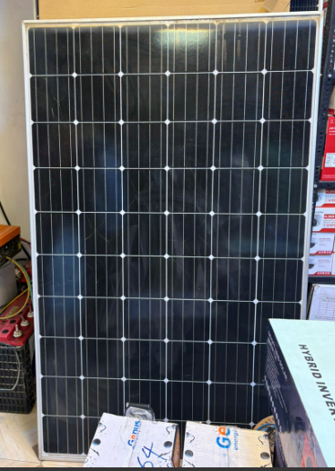\

Figure 4.1: Solar Panel

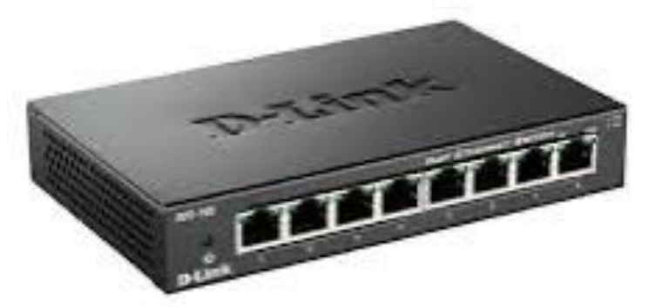

Figure 4.2: Splitter

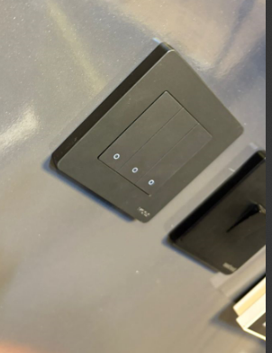

Figure 4.3: Switch Panel

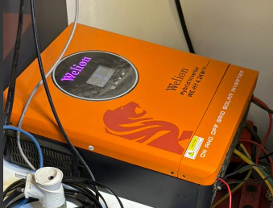

Figure 4.4: Electric Air Controller

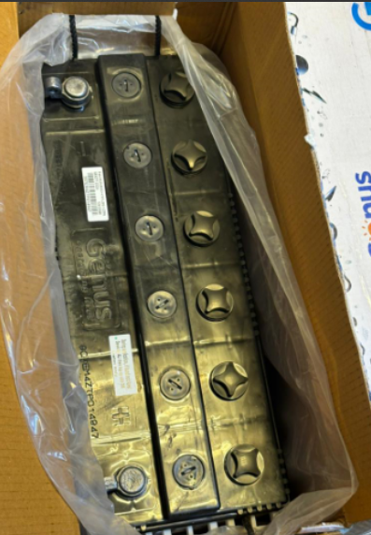

Figure 4.5: Battery



Figure 4.6: Smart Application

4.3 System Design Overview
The system is designed to automatically switch lights ON when it is dark and motion is detected, and switch them OFF when there is adequate ambient light or no motion. It draws energy from a solar panel connected to a charge controller and a battery. The ESP32 microcontroller processes inputs from the LDR and PIR sensors, controls the relay that switches the light, and communicates sensor data to an IoT platform like Blynk or ThingSpeak for remote monitoring and manual override functionality.

4.4 System Architecture
The system comprises the following components:
- Solar Power Unit: Consisting of a solar panel, charge controller, and rechargeable battery for storing and supplying energy.
- Sensors: LDR for ambient light detection and PIR for motion sensing.
- Controller: ESP32, a Wi-Fi-enabled microcontroller that processes sensor data, controls output, and connects to the IoT platform.
- Relay Module: Used to switch the lighting system ON or OFF based on control signals from the ESP32.
- Lighting Output: 12V LED light powered by the battery.
- IoT Interface: A mobile or web dashboard for real-time monitoring and manual control using Blynk or ThingSpeak.
These components interact seamlessly to create a smart lighting system that functions efficiently without human intervention.

4.5 Block Diagram

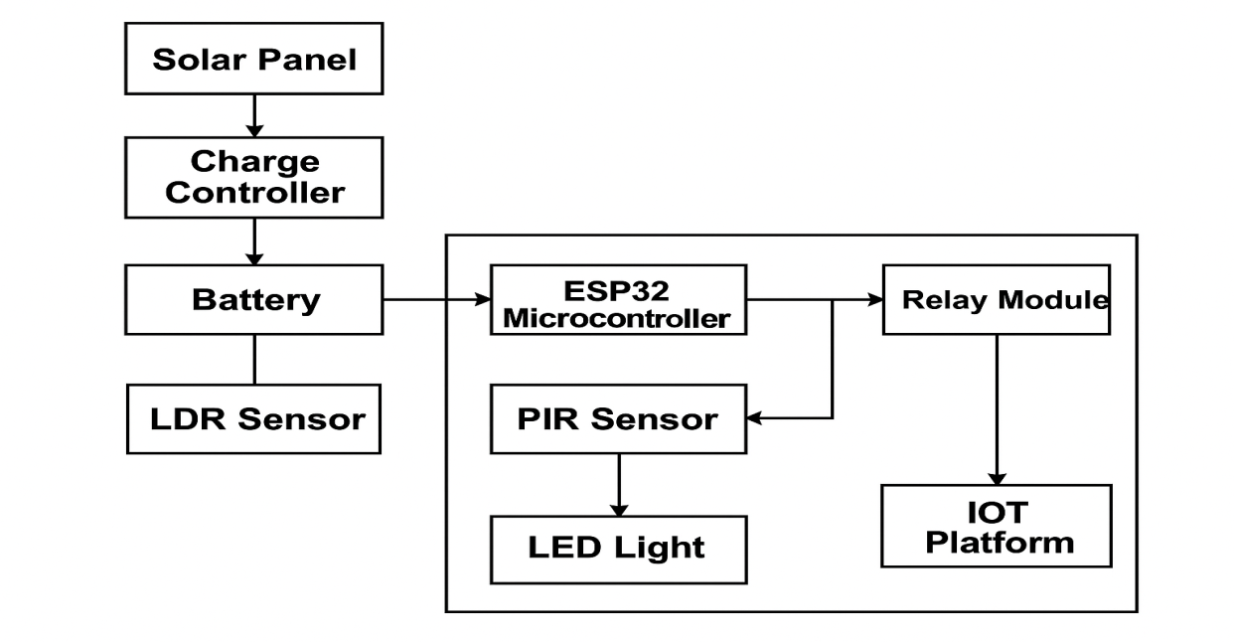

Figure 4.7 Block Diagram

4.5 Flowchart of the System
Here is the logical workflow of the system:
- Start
- Read LDR (light intensity)
- If ambient light is low (dark) → check motion sensor (PIR)
- If motion is detected, turn ON light
- If no motion, keep light OFF or turn OFF if ON
- If ambient light is high, keep light OFF
- Send sensor data to IoT platform
- End (loop)

3.1.3 System Flowchart
Below is the logical flowchart describing the operation of the automated lighting system:
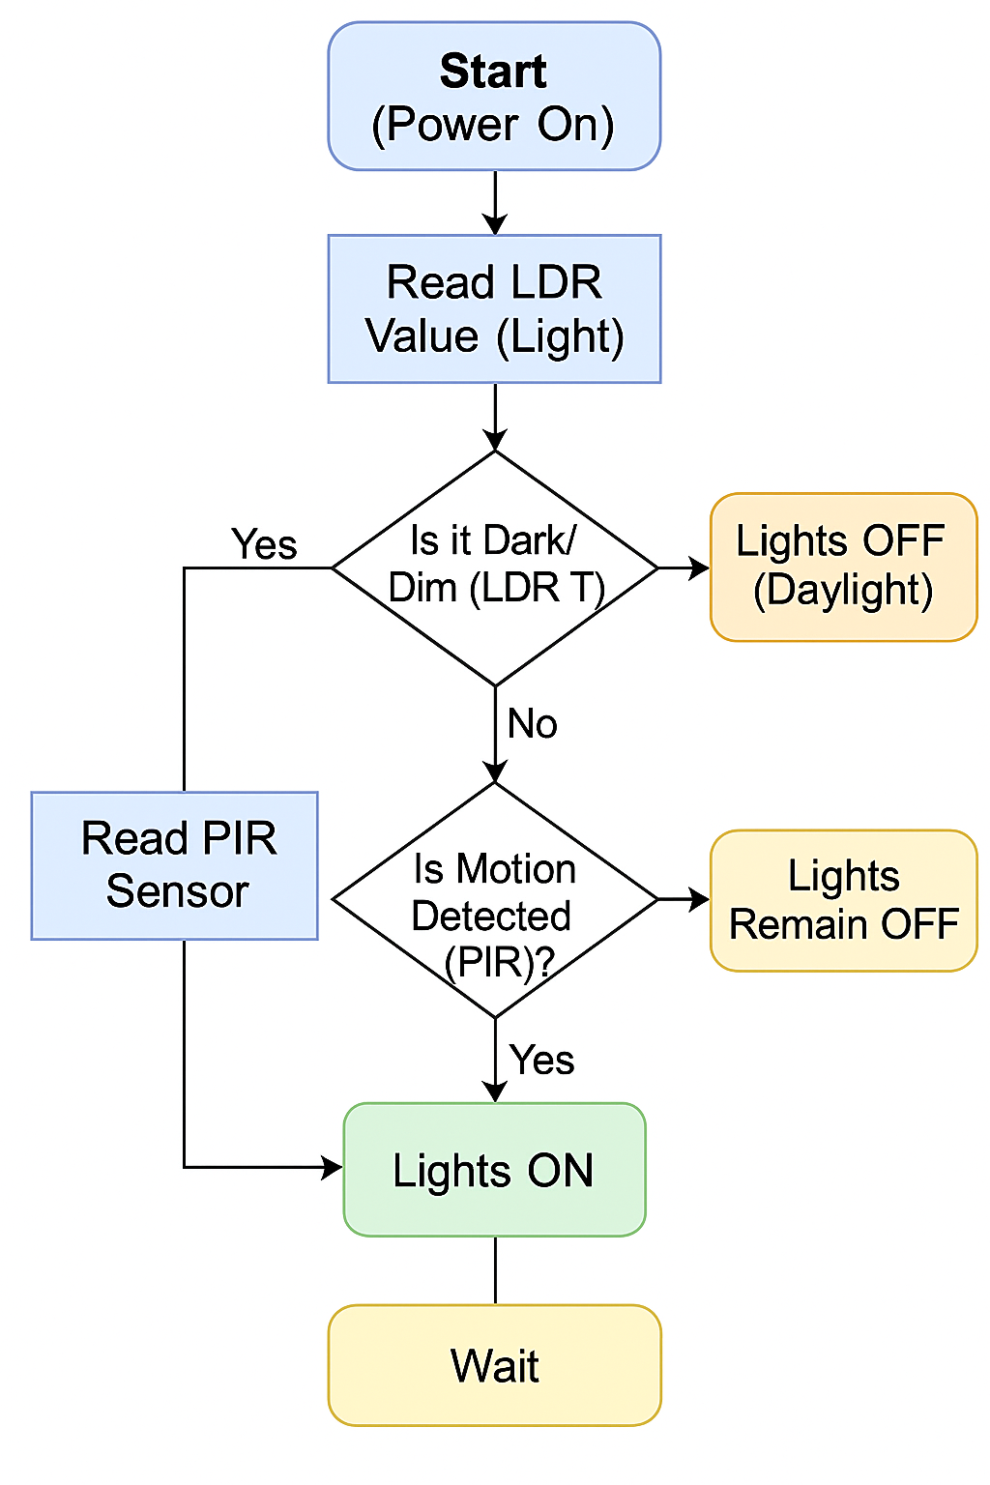

4.6 Software Design and Code Logic
The ESP32 is programmed using the Arduino IDE. The core logic involves:
- Reading analog values from the LDR
- Reading digital motion input from the PIR sensor
- Using threshold comparisons to determine actions
- Sending data to the IoT platform
- Switching the relay ON or OFF accordingly
Sample Code Snippet:
cpp
CopyEdit
int ldr = analogRead(A0);
int motion = digitalRead(2);

if (ldr < 1000) {
if (motion == HIGH) {
digitalWrite(relayPin, HIGH); // Turn ON light
} else {
digitalWrite(relayPin, LOW); // Turn OFF light
}
} else {
digitalWrite(relayPin, LOW); // Turn OFF light in daylight
}

4.7 IoT Integration (Remote Monitoring & Control)
The system is integrated with an IoT platform such as Blynk or ThingSpeak to allow remote access and control. The ESP32 communicates sensor values and system status to the cloud via Wi-Fi. On the dashboard, users can:
- Monitor LDR and PIR sensor readings
- View light ON/OFF status
- Manually override the light
- Receive alerts based on motion detection
This adds a layer of user interactivity and enhances system accessibility from any location.

4.8 Implementation Process
- Gather and assemble hardware components
- Build the prototype circuit on a breadboard
- Write and upload the code to ESP32 via Arduino IDE
- Test sensor thresholds and response time
- Configure and connect the Blynk/ThingSpeak dashboard
- Deploy the system in a test environment
- Evaluate performance under different lighting and motion conditions

4.9 Testing and Result
Condition | LDR Value | PIR Motion | Light Status | IoT Feedback
Bright Daylight | >1000 | Any | OFF | Logged
Night, Motion | <1000 | YES | ON | Logged
Night, No Motion | <1000 | NO | OFF | Logged
Manual Override | N/A | N/A | ON/OFF | Updated
Results showed that the system successfully automated light control with accurate sensing and timely updates on the dashboard.

CHAPTER FIVE

SUMMARY, CONCLUSION AND RECOMMENDATIONS

5.1 Summary
This study presented the design and implementation of a real-time solar panel performance analysis system using machine learning techniques. The increasing global demand for clean and sustainable energy sources has led to widespread adoption of solar photovoltaic (PV) systems. However, maintaining consistent efficiency and detecting faults in these systems remains a challenge due to environmental variables such as temperature changes, irradiance fluctuations, shading, and dust accumulation. To address these challenges, this research integrated machine learning into the solar performance monitoring process. The proposed system collects real-time data from various sensors monitoring parameters such as voltage, current, solar irradiance, and temperature. This data is then preprocessed and used to train supervised learning models capable of predicting energy output and identifying anomalies. The system architecture was designed to include data acquisition hardware, a processing unit (such as a microcontroller or edge device), and a cloud-based platform for visualization and alerting. Different machine learning algorithms, including Linear Regression, Random Forest, and Support Vector Machines, were evaluated for performance prediction tasks. The study demonstrated that ML models significantly outperform traditional threshold-based monitoring by adapting to changes in environmental conditions and detecting subtle performance anomalies.

Conclusion
The implementation of machine learning in real-time solar panel performance analysis introduces a more intelligent and adaptive approach to monitoring renewable energy systems. Unlike traditional systems, which often fail to detect early signs of degradation, the proposed system can proactively predict performance issues, reducing system downtime and maintenance costs. Machine learning models can accurately predict solar power output based on real-time environmental and electrical parameters. ML can detect performance anomalies and potential faults more effectively than static rule-based systems. Integrating AI into solar energy systems promotes better energy management, enhances efficiency, and contributes to maximizing the ROI of solar installations. Thus, the integration of ML technologies into solar energy monitoring represents a forward-thinking step toward smarter, greener energy solutions.

5.3 Recommendations
Based on the outcomes of this project, the following recommendations are proposed:
- Adoption of ML-Based Monitoring Systems: Solar power users and service providers should consider transitioning to ML-based monitoring systems to enhance fault detection and optimize performance.
- Expansion to Larger Solar Installations: The system should be scaled and tested on larger solar farms and commercial setups to validate its robustness and adaptability under diverse conditions.
- Use of More Advanced Models: Future research should explore the use of deep learning models such as LSTM (Long Short-Term Memory) for time-series forecasting and anomaly detection, especially for long-term predictions.
- Integration with Weather Forecast Data: Incorporating external data sources, such as weather forecasts, can improve the accuracy of predictions and help in smarter energy planning and load balancing.
- User-Friendly Interface Development: A well-designed dashboard or mobile app interface should be developed to present real-time insights and alerts to users in an intuitive and actionable format.
- Periodic Model Retraining: Due to seasonal and environmental changes, ML models should be retrained periodically to maintain prediction accuracy and system performance.
- Government and Institutional Support: Policymakers should support the development and deployment of smart energy solutions by providing incentives and funding for research in AI and renewable energy integration.

References
Abubakar, I. R., & Omar, H. A. (2023). Predictive maintenance of solar PV systems using artificial intelligence: A case study in sub-Saharan Africa. Renewable and Sustainable Energy Reviews, 172, 113054. https://doi.org/10.1016/j.rser.2023.113054
Al-Waeli, A. H. A., Sopian, K., Chaichan, M. T., Kazem, H. A., & Al-Shamani, A. N. (2021). Photovoltaic panel performance monitoring using machine learning and real time data acquisition systems. Energy Reports, 7, 4706–4714. https://doi.org/10.1016/j.egyr.2021.07.029
Elsheikh, A. H., Sharshir, S. W., Abd Elaziz, M., Kabeel, A. E., & Essa, F. A. (2020). Utilization of artificial intelligence techniques for forecasting solar radiation: A review. Environmental Progress & Sustainable Energy, 39(1), 133–147. https://doi.org/10.1002/ep.13288
Fernandez, P. J., & Padilla, R. V. (2024). Smart monitoring of photovoltaic systems using machine learning and IoT. Energy Informatics, 7, 18. https://doi.org/10.1186/s42162 024-00254-9
Junaid, M., Khan, M. T., & Ali, Z. (2020). Deep learning-based anomaly detection for solar panels using thermal imaging. Renewable Energy, 147, 825–834. https://doi.org/10.1016/j.renene.2019.09.035
Mishra, P., Sharma, R., & Dubey, A. (2022). Machine learning-based fault detection in solar panels using real-time sensor data. Journal of Cleaner Production, 364, 132602. https://doi.org/10.1016/j.jclepro.2022.132602
Rahman, M. M., Islam, A. K. M. S., & Rahman, M. A. (2021). Integration of IoT and machine learning for efficient solar energy management systems. Internet of Things, 14, 100381. https://doi.org/10.1016/j.iot.2021.100381
Saeed, S., & Niazi, M. (2021). Real-time solar energy forecasting using hybrid machine learning models. Sustainable Energy Technologies and Assessments, 44, 101093. https://doi.org/10.1016/j.seta.2021.101093
Sun, Q., & Liu, Y. (2022). An intelligent predictive maintenance system for PV solar panel susing real-time weather and operational data. Journal of Intelligent & Fuzzy Systems, 42(3), 3591–3602. https://doi.org/10.3233/JIFS-212125
Zhang, Y., Li, Y., & Wang, Z. (2020). A data-driven approach for photovoltaic system performance monitoring using machine learning. Renewable Energy, 145, 2560 2571. https://doi.org/10.1016/j.renene.2019.07.075

