KWARA STATE POLYTECHNIC, ILORIN

DEVELOPMENT OF CASSAVA GRATING MACHINE

BY

BALOGUN AYODEJI EMMANUEL
HND/23/MEC/FT/0109

A PROJECT REPORT SUBMITTED TO THE DEPARTMENT OF MECHANICAL ENGINEERING, INSTITUTE OF TECHNOLOGY IN PARTIAL FULFILLMENT OF THE REQUIREMENTS FOR THE AWARD OF HIGHER NATIONAL DIPLOMA IN MECHANICAL ENGINEERING TECHNOLOGY,

ILORIN, NIGERIA

JULY,

CERTIFICATION

The undersigned certify that this project report prepared by: BALOGUN AYODEJI EMMANUEL with matric: HND/23/MEC/FT/0109 Entitled: “The development of cassava grating machine” meets the requirements of Department of Mechanical Engineering for the award of Higher National Diploma (HND) in Mechanical Engineering.

______________________ ___________________
ENGR. YUSUF IBRAHIM.O DATE
Project Supervisor

______________________ ___________________
ENGR. AYANTOLA .A. A. DATE
Head of Department

_____________________ ___________________
EXTERNAL EXAMINER DATE

DEDICATION
This project report is dedicated to Almighty God for His protection over us, also to our team’s collective effort and perseverance. We also appreciate the contribution, insight, and support from each group members as well as the guidance and support from our supervisor [Engr.Yusuf Ibrahim.o].

ACKNOWLEDGEMENT
My heartfelt gratitude goes to the Almighty Allah for giving life and success on the completion of my program. The most gratitude goes to my family for their unwavering support and encouragement throughout this project write up.
My special thank goes to Mr. and Mrs. Balogun, for their love and guidance towards this program. My special thank also to my supervisor Engr. Yusuf Ibrahim .O. for his close and constructive accessing this project.

ABSTRACT
Aim: To improve the production rate of a grating machine through careful modifications to the design specifications of the existing one. The objective of the study was to develop a modernized cassava grating machine with a high-performance rate and high-quality output at a minimum time and economical cost. Study Design: The mesh surface area and the selection of proper construction materials were the two significant areas considered for modification. Stainless steel was chosen for fabricating the drum, perforated sheet, hopper, and shaft due to its reliability, durability, and resistance to corrosion.

TABLE OF CONTENTS
Title Page ……………………………………………………………………………….… i
Certification …………………………………………………………………………….… ii
Dedication ……………………………………………………………………………...… iii
Acknowledgement ……………………………………………………………………..… iv
Abstract …………………………………………………………………………...……… v
CHAPTER ONE: INTRODUCTION …………………………………………………… 1
1.1 Background of the Study …………………………………………………………..… 1
1.2 Problem Statement …………………………………………………………………… 2
1.3 Aim of the Study ……………………………………………………………..…….… 3
1.4 Objectives of the Study …………………………………………………………….… 3
CHAPTER TWO: LITERATURE REVIEW ………………………………………….… 4
2.1 Historical Overview of Cassava Processing …………………………………………. 4
2.2 Mechanical Cassava Graters …………………………………………………………. 5
2.3 Design Parameters in Grating Machine Development ………………………………. 6
2.4 Grating Efficiency and Performance Metrics ………………………………..………. 7
2.5 Gaps in Literature and Need for Improved Design ……………………….……….… 8
CHAPTER THREE: MATERIALS AND METHODS …………………………………. 9

3.1 Design Considerations …………………………………………………………….…. 9
3.2 Description of the Machine Components …………………………………………… 10
3.3 Materials Selection and Justification ……………………………………………..… 11
3.4 Machine Design ………………………………………………………………..…… 12
3.4.1 Hopper Inclination Angle ……………………………………………………… 12
3.4.2 Capacity of the Hopper ………………………………………………………… 13
3.4.3 Mass of the Grating Drum ……………………………………………………… 14
3.4.4 Power Required to Drive the Shaft ………………………………………..…… 15
3.4.5 Grater Shaft Speed Ratio ……………………………………………….……… 15
3.4.6 Tensions on Driven Pulley (T₁ & T₂) ……………………………………..…… 16
3.4.7 Shaft Diameter Determination ………………………………………….……… 17
3.5. Cost Estimation……………………………………………………………………13
Figure 3.1: Grater Drum Schematic ………………………………………..…………… 14
CHAPTER FOUR: FABRICATION AND TESTING ………………...……………..… 18
4.1 Fabrication Process ……………………………………………..…………………… 18
4.2 Testing Procedure …………………………………………………………………… 19
4.3 Performance Evaluation Criteria ……………………………….…………………… 20
CHAPTER FIVE: CONCLUSION AND RECOMMENDATIONS …………………… 21
5.1 Conclusion …………………………………………………………………………… 21
5.2 Recommendations …………………………………………………………………… 22
References

CHAPTER ONE
- Introduction
Cassava (Manihot esculenta) is a fundamental food crop in many tropical regions, including Nigeria, where it serves as a dietary staple for millions due to its high carbohydrate content and adaptability to diverse climatic conditions (Food and Agricultural Organization [FAO], 2005). Among the many cassava-based products, garri is perhaps the most consumed, requiring extensive processing that includes peeling, washing, grating, pressing, fermenting, sieving, frying, and packaging (Nnanna et al., 2023).

The grating stage is particularly crucial as it reduces the cassava into pulp suitable for further processing. Traditionally, this was done using hand graters made from perforated metal sheets or by pounding, which are inefficient, physically demanding, and unhygienic (Oyesola, 1981). These methods lead to high labor input, low productivity, and inconsistencies in product quality. With increasing demand for cassava products, especially in urban centers and for export, modern processing solutions have become imperative.

Several mechanical cassava graters have been introduced to improve processing efficiency, including pedal-powered machines (Ndaliman, 2006), electric-powered units (Adejumo, 1995), and dual-mode graters (Nnanna et al., 2023). However, these existing designs often present challenges such as dependence on unstable electricity supply, poor output rates, suboptimal material choices that result in corrosion, and lack of portability and ease of maintenance.

Such a machine should be efficient, affordable, easy to maintain, constructed with durable, food-safe materials, and adaptable to both rural and urban environments.

1.2 Problem Statement

Despite the importance of cassava in food systems, its processing remains constrained by inefficient technologies. Many existing cassava grating machines are either manually operated, which is labor-intensive and slow, or electrically powered, which renders them inoperative during power outages—a frequent issue in many developing countries.
Furthermore, substandard materials such as untreated steel or wood are commonly used in fabricating critical parts like grating drums and hoppers, which are prone to corrosion, wear, and contamination (Nnanna et al., 2023). In addition, small surface area of grating drums and poor ergonomic designs reduce throughput and pose safety risks to users.

There is, therefore, an urgent need for a robust, dual-powered cassava grating machine that delivers:

Improved grating efficiency,

Food-grade material safety,

Durability under diverse operational conditions, and

Affordability for widespread adoption, particularly among small-scale processors.

1.3 Aim of the Study

The aim of this study is to develop, construct, and evaluate a cassava grating machine.

1.4 Objectives of the Study

The specific objectives of this study are to:

1. To design and fabricate a cassava grating machine that will reduce stress and time consumption .

2. Optimize the grating mechanism through improved drum dimensions and increased mesh surface area to boost output capacity.

3. Utilize corrosion-resistant and food-safe materials—such as stainless steel—for all food-contact components.

4. Minimize the physical labor required for cassava grating through ergonomic machine design.

5. Fabricate cassava grating machine that use I.C.E regardless of electricity.

CHAPTER TWO

LITERATURE REVIEW

2.1 Historical Overview of Cassava Processing

Cassava has historically been a vital staple in Africa, especially in Nigeria, where it is extensively processed into products like garri,fufu, and flour. Traditional processing methods, especially grating, involved the use of local tools such as perforated metal sheets and grinding stones. These methods, while functional at a subsistence level, were labor-intensive, time-consuming, and offered poor hygiene control (Oyesola, 1981).

As early as the 1980s, the need to improve cassava grating led to initial attempts to mechanize the process. These included the use of locally fabricated hand-operated graters, often mounted on wooden frames (Adejumo, 1995). However, these early designs had limited durability and posed health risks due to contamination and corrosion.

2.2 Mechanical Cassava Graters

Several studies have focused on developing cassava graters that enhance productivity and reduce human labor. Ndaliman (2006) designed a dual-operational cassava grating machine that can function both manually and electrically. His design demonstrated efficiencies of 92.4% and 91.9% for manual and electric operations respectively, highlighting the versatility and potential of such hybrid systems.
Other efforts include the work by Oriaku et al. (2015), who developed a double-action cassava grating machine aimed at improving time efficiency. Similarly, Adetunji and Quadri (2011) proposed a portable grater with stainless steel construction, improving both mobility and hygiene. However, many of these machines still depend heavily on electricity and are unsuitable in rural areas where power supply is unreliable.

2.3 Design Parameters in Grating Machine Development
Critical parameters in the design of cassava grating machines include:
Grating drum size and mesh surface area: A larger surface area allows for faster processing of cassava tubers (Nnanna et al., 2023).
Power source: Machines powered by electricity offer convenience but may fail during outages. Dual-operational machines address this limitation by allowing manual input when electricity is unavailable (Ndaliman, 2006).
Material selection: Stainless steel is preferred for parts in contact with food because of its resistance to corrosion, ease of cleaning, and durability (Ajao et al., 2013).
Ease of disassembly: For hygiene and maintenance purposes, machines should be easy to clean and maintain.

2.4 Grating Efficiency and Performance Metrics

Grating efficiency is a key performance indicator in cassava processing. It is calculated based on the weight of pulp recovered versus the input weight of raw cassava (Ndaliman, 2006). A well-designed grater can achieve efficiencies over 90%, minimizing waste and processing time. Nnanna et al. (2023) recorded a production rate of 454.55 kg/h and an efficiency of 95.12% in their modernized grating machine—surpassing many earlier models.

2.5 Gaps in Literature and the Need for Improved Design
While prior studies have made significant contributions, gaps still remain:
Some designs continue to use low-quality materials susceptible to wear and contamination.
Few studies combine optimal drum sizing, ergonomic structure, and food-grade safety into a single machine.
The present study aims to bridge these gaps by integrating improved design specifications, better material choices, and operational functionality into a modern cassava grating machine suitable for both domestic and commercial use.

CHAPTER THREE

3.0 MATERIALS AND METHODS

This chapter presents the design methodology, material selection criteria, fabrication process, and performance evaluation procedure adopted in the development of the cassava grating machine.

3.1 Design Considerations

The design of the cassava grating machine was guided by the following key considerations:

Hygiene and food safety: All components in contact with cassava must be fabricated using corrosion-resistant, food-grade materials.

Efficiency and output rate: The grater must process large volumes of cassava within a short time.

Ease of operation and maintenance: The machine must be simple to operate, clean, and maintain, especially in rural settings.

Structural stability: The frame must support the dynamic loads during operation with minimal vibration.

3.2 Description of the Machine Components

The machine consists of the following major components:

Hopper: Rectangular stainless-steel inlet used to feed cassava into the grating drum.

Grating Drum: A cylindrical drum fitted with perforated stainless steel used to shred cassava into pulp.

Delivery Chute: An inclined stainless-steel outlet for pulp discharge.

Frame: Constructed from angle iron for structural stability.

Shaft and Bearings: Shaft transmits power to the drum; supported by plummer blocks.

Power Transmission Unit: A V-belt and pulley system that connects the Internal combustion engine to the grating drum.

3.3 Materials Selection and Justification

Materials were selected based on strength, corrosion resistance, durability, and cost-effectiveness:
Material choices align with recommendations by Nnanna et al. (2023) and Ajao et al. (2013) for improved hygiene and efficiency.

3.4 Machine Design

HOPPER INCLINATION
(Kolawole,2012) (1)
Where, α = angle of repose /inclination, µ = co-efficient offriction
µ = 0.680 for cassava mash / granular material (Kolawole, 2012)
but 45⁰ was used.
3.4.1 Determination of the capacity of the hopper
The density of the stainless steel use is 8000kg/m³ this was determined using
(kg)
=20.664kg
3.4.2. Determination of mass of the grating drum
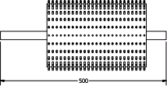
Fig.1:Grater drum schematics
Volume of the grater =
Where, diameter of the grater is 300mm, radius is 150mm, height is 410mm.
Velocity of the grater (V) was determined by

3.4.3 Determination of power (Ps) required to drive the grater shaft

This is determined using Ps =T ×
Ps =5.15kW
3.4.4 Determination of grater shaft speed ratio.
This was calculated using Khurmi and Gupta(2017):
N1D1=N2D2 (6)
Where N1 is the angular speed driving pulley which is1440 rpm, D1 is the diameter of the driving pulley which is 180 mm, N2is the angular speed of the driven pulley and D2is the diameter of the driven pulley.
3.4.5 Determination of tension acting on the driven pulley T1 and T2 The tension T1 and T2 on the driven pulley was calculated using
T₁/T₂= Khurmi and Gupta (2017) (7)
Where, T1is the tension at the tight side of the pulley, T2 is the tension at the slack side of the pulley,is the co-efficient of friction between the leather belt and metal pulley which is 0.3 and is the wrap angle which is 3.065⁰
3.4.6 Determination of shaft diameter

This was calculated using Khurmi and Gupta (2017);
(8)
Where, is the allow able shear stress of metal with key way which is given as 40×10⁶ N/m²,
Mb is the maximum bending moment which was 138 Nm,
Mt is the torsional moment calculated to be 69.33Nm,
Kb and Kt were the combined shock and fatigue factor applied to bending moment and torsional moment under sudden load which were 2.0 and 2.0 respectively, according to Allen et al .(2014).

3.5 Cost Estimation
BILL OF ENGINEERING MATERIALS FOR CASSAVA GRATING MACHINE

S/N | MATERIAL | QUANTITY | UNIT COST | TOTAL COST
 | 3mm m/s plate 1sheet.  2mm m/s plate  50 x 50 x 5mm Angle iron  50x50x4mm Angle iron.  1.2mm m/s plate.  30mm diameter shaft.  206 pillow bearing  Rubber tires.  Wood plank.  M6 bolts and nuts. | 1 SHEET  ½sheet.  2length  ½length  ½sheet.  30”length .  2nos.  2nos  ¼length  2dozen | 70,000  60,000  20,000  18,000  30,000  18,000  6,000  10,000  3,000  1,000.  Total = | 70,000  30,000  40,000  9,000  15,000  18,000  12,000  20,000  700  2,000  N223,000
 | CONSUMABLE MATERIALS  Electrode  Grinding disc.  Cutting disc.  Body filler.  Paint  Sandpaper  Filler wire.  Over head cost | 1pack  2nos  2nos  1coat  ½gallon  1sheet  2dozen  - | 8,000  2,000  2,000  2,000  12,000  800  1,000  -  Total =  GRAND TOTAL = | 8,000  4,000  4,000  2,000  6,000  800  2,000  30,000  N56,800  N279,800

CHAPTER FOUR

4.1 Fabrication Process

The fabrication was carried out in the following steps:

1. Frame Construction: Welding of angle iron to form the base and support structure.

2. Cutting and Shaping: Stainless steel sheets were cut for the hopper, drum, and chute.

3. Drum Assembly: Perforated stainless-steel plate was rolled and mounted on a rotating shaft.

4. Mounting of Components: Bearings, pulleys, electric motor, and manual drive were installed.

5. Finishing: Grinding of sharp edges, painting (where applicable), and assembly of the complete unit.

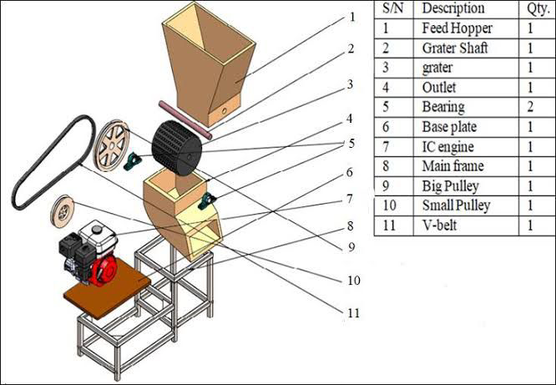

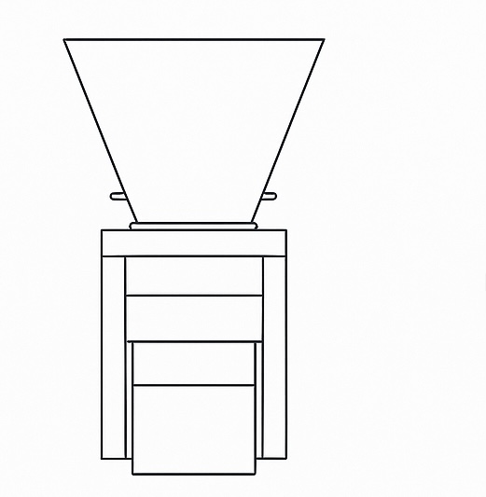
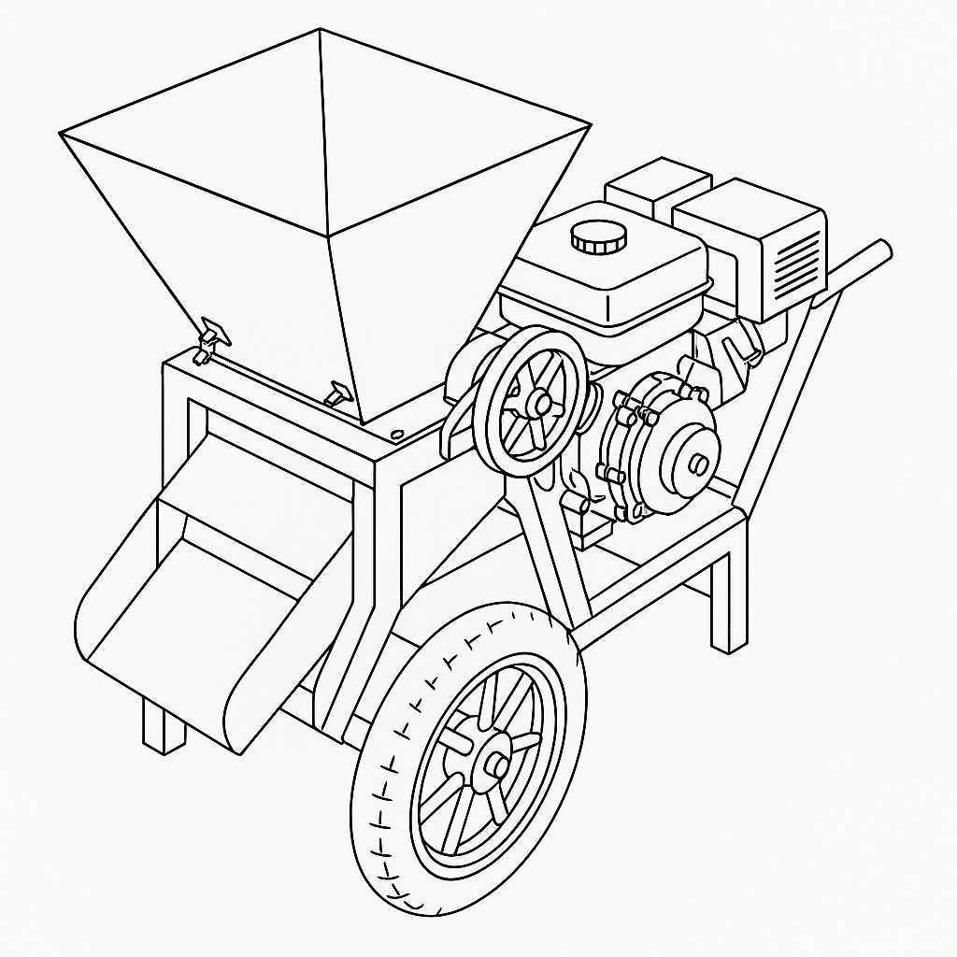

4.2 Testing Procedure

The machine was tested using freshly harvested cassava tubers. The testing involved the following steps:

1. Weighing 100 kg of peeled and washed cassava roots.
2. Feeding cassava into the hopper during both electric and manual operations.
3. Timing the grating process for each mode.
4. Collecting the pulp and measuring the quantity recovered.
5. Calculating the grating efficiency.

4.3 Performance Evaluation Criteria

The machine performance was assessed based on:

Grating efficiency (%)

Production rate (kg/h)

Power source adaptability

Ease of operation

Machine stability during use

The results were compared with prior designs documented in studies by Ndaliman (2006) and Oriaku et al. (2015).

CHAPTER FIVE
5.1 Conclusion
The cassava grating machine was successfully designed, fabricated, and tested to address the challenges faced by small and medium-scale cassava processors in Nigeria. The machine incorporates significant improvements in terms of material selection, efficiency, safety, and adaptability. By using stainless steel for food-contact parts, the machine enhances hygiene and durability, while the use of an internal combustion engine ensures operation even in areas with unreliable electricity supply.

During performance evaluation, the machine demonstrated high efficiency, stable output, and ease of operation, validating its suitability for both rural and urban use. This development proves that a well-designed grating system can significantly reduce processing time, increase productivity, and support the local cassava processing industry.

5.2 Recommendations
Based on the successful development and testing of the cassava grating machine, the following recommendations are made:
1.Adoption by Local Farmers and Processors: Government and non-governmental organizations should promote this machine among rural cassava farmers and cooperatives to boost food production and processing efficiency.
2.Further Optimization: Future designs should consider integrating solar-powered systems or hybrid energy options to further enhance sustainability.
3.Standardization and Mass Production: Local fabricators should adopt the design for mass production, ensuring adherence to food-grade material standards.
4.Operator Safety Measures: Safety guards and emergency stop mechanisms should be included in subsequent iterations to minimize operational hazards.
5.Training and Maintenance Education: Users should be trained on machine operation and basic maintenance to prolong service life and improve handling.
References
Adejumo, O. A. (1995). Design and Construction of a Cassava Grating Machine. Nigerian Journal of Agricultural Engineering.
Ajao, K. R., Ogunjimi, L. A. O., & Ahmed, S. O. (2013). Development and Performance Evaluation of a Cassava Grater. Agricultural Engineering International: CIGR Journal.
Allen, R. S., Kirkpatrick, B. A., & Zhao, J. (2014). Mechanical Engineering Design Standards. McGraw-Hill.
FAO. (2005). The Role of Cassava in Food Security in Sub-Saharan Africa. Food and Agricultural Organization.
Khurmi, R. S., & Gupta, J. K. (2017). A Textbook of Machine Design. Eurasia Publishing House.
Kolawole, O. (2012). Analysis of Friction and Material Flow in Cassava Processing. Agricultural Mechanization Research Journal.
Ndaliman, M. B. (2006). Development of a Motorized Cassava Grater. AU Journal of Technology.
Nnanna, M. A., Ezeaku, P. I., & Ogbuka, N. M. (2023). Design and Fabrication of a High-Efficiency Cassava Grating Machine. Journal of Food Engineering and Technology.
Oyesola, O. B. (1981). Traditional Methods of Cassava Processing in Rural Nigeria. Nigerian Institute of Agricultural Research Bulletin.
Oriaku, E. C., Obetta, S. E., & Ezeoha, S. L. (2015). Development of a Double-Action Cassava Grating Machine. International Journal of Engineering and Technology Innovation.

