FINAL YEAR PROJECT REPORT
ON

PERIMETER AND DETAILING SURVEY
OF
OLD INSTITUTE OF ENVIRONMENTAL STUDIES
(IES) AND VILLAGE, KWARA STATE POLYTECHNIC ILORIN ALONG OLD JEBBA ROAD,MORO LOCAL GOVERNMENT AREA, KWARA STATE.
BY
MUSA ZULU OLADIMEJI
ND/23/SGI/FT/017
BEING A PROJECT SUBMITTED TO THE DEPARTMENT OF
SURVEYING AND GEOINFORMATICS, INSTITUTE OF
ENVIRONMENTAL STUDIES. KWARA STATE POLYTECHNIC, ILORIN. KWARA STATE
IN PARTIAL FULFILMENT OF THE REQUIREMENTS FOR
THE AWARD OF NATIONAL DIPLOMA IN (ND) SURVEYING
AND GEOINFORMATICS
JULY ,2025
CERTIFICATE
I here by certified that this project is as a result of the field work in which I also participated and the survey was carried out in accordance with survey rules, using departmental instrument.

_______________________
MUSA ZULU OLADIMEJI
ND/23/SGI/FT/017

Certification
This is to certify that the project was an original work carried out by MUSA ZULU OLADIMEJI, from the department of Surveying and Geo-informatics, Institute of Environmental Studies, has been prepared in accordance with the regulation government and preparation and presentation of project in Kwara State polytechnic.
_______________________ |  |  | _______________________
SURV. AYUBA ABDULSALAM  Project supervisor |  |  | Date
____________________ |  |  | ____________________
SURV. R.S AWOLEYE  Project Coordinator |  |  | Date
_____________________ |  |  | ____________________
SURV. AMBIMBOLA ISAU Head of Department |  |  | Date
_____________________ |  |  | ____________________
EXTERNAL EXAMINER |  |  | Date
SURV. J.O OPALEYE

Dedication
This report is dedicated to Almighty God, Creator of Heaven and Earth for his mercy, guidance and protection throughout the period of my project program, and for giving me the strength, knowledge and understanding to be successful in this project report write up.
I also dedicated this report to my lovely parents (Mr&Mrs MUSA)
Acknowledgement
I give thanks to Almighty God, for always guiding me in every aspect of my life up to this very moment.
My appreciation goes to my school Kwara State Polytechnic Authority, for given me the opportunity to undergo this project.
My appreciation also goes to the Head of Department, the person of Surv. ABDULSALAM AYUBA, Surv. OGUNTAYO BENARD and the entire department staff of Survey and Geo-Informatics, the elder of department, surv. Ayuba Abdulsalam[My project supervisor], Surv. Asonibare, Surv. Abimbola, Surv. Felix diran, Surv. Benard Surv.
BabatundeKabir, surv. William kazeem, and to the special duty of IES , A.G AREMU
And special thanks to all my group members starting from my group leader, Fagbohun Isaac Olamide, and to others: Oyeniyi moshood,Mutiat Omowunmi,Rokeebat, AYOKA, Rosheed, Serah.
Thank you all.

ABSTRACT
This project is based on Perimeter and Detailing Survey of old institute of environmental studies Moro local government area, Ilorin, Kwara State. The project has been divided into five chapters, Chapter one: This includes introduction part about the project topic: to know about Perimeter and Detailing Survey, scope and aim of the project while Chapter two comprises of Literature Review of the project on what survey and Perimeter and Detailing Survey is all about also Chapter three discuss the Methodology which describes the whole of the project that was carried out using digital instrument e.g. Total Station and its accessories. Chapter four, this involves presentation of map/plan which consist of downloaded data, and plan produce in digital format and Chapter five comprises of summary, problem encounter, recommendation conclusions and reference.
Title page |  |  |  |  |  | i
Certificate |  |  |  |  |  | ii
Certification |  |  |  |  |  | iii
Dedication |  |  |  |  |  | iv
Acknowledgement |  |  |  |  |  | v
Abstract |  |  |  |  |  | vi
Table of contents  CHAPTER ONE |  |  |  |  |  | vii
1.0 Introduction |  |  |  |  |  | 1
1.1 Aims and Objectives |  |  |  |  |  | 2
1.1Aims |  |  |  |  |  | 2
1.1.2 Objective |  |  |  |  |  | 2
1.2 Scope of Project |  |  |  |  |  | 3
1.3 Specification of the Project |  |  |  |  |  | 3
1.5 Study Area |  |  |  |  |  | 4
1.5 Personnel Involves |  |  |  |  |  | 5

TABLE OF CONTENTS
CHAPTER TWO
2.0 Literature Review 6

CHAPTER THREE
3.0 Methodology 13
3.1 Reconnaissance 13
3.1.1 Field or Site Reconnaissance 13
3.1.2 Office Reconnaissance 14
3.5.1 Co-ordinates of Control Used 14
3.2 Instrument Test 15
3.2.1 In-Situ Check for Control 16
3.2.2 Data Acquisition 17
3.2.3 Geometric Data Acquisition 17
3.2.4 Attribute Data Acquisition 17
3.2.5 Equipment Used/ system 18
Selection and Software
3.2.6 Setting Out of Perimeter Boundary 18
3.3 Monumentation 19
3.4 Perimeter Traversing 21
3.4.1 Co-ordinates of the Boundary 22
3.5 Detail Survey 23

CHAPTER FOUR
4.0 Data Processing 24
4.1 Result Analysis 24
4.2 Back Computation 25
4.3 Compute for Total Area using 26
Double Latitude and Departure
4.4 Graphical Plotting 28

CHAPTER FIVE
5.0 Summery 29
5.1 Problems Encounter 29
5.2 Recommendation 29
5.3 Conclusion 30
References
Appendix

CHAPTER ONE

1.0 INTRODUCTION
Perimeter and Detailing survey is about mapping and determining the geometry values of a property, this type of survey is used to determine the total area of land, the size and the shape and it is also used to determine the location of the features i.e the natural and man-made features such as building, vegetation, land utilities, fences and boundary, road and improvement on a parcel of land.
Perimeter and Detailing survey is a survey that requires traversing of the details on the limit of height, depicting all details on the limit of the landed property which consist of both natural and artificial features on the earth surface. It can also be refers to as a cadastral survey because it contain coordinate of all corner point of the boundaries and determination of relative position of point both natural and artificial features on the earth surface and addicting them by the means of conventional symbols on the plan the measurement taken are plotted in order to produce a registerable cadastral instrument.
Moreover, a perimeter survey is similar to building a fence, it mainly for boundary demarcation, the only difference is that perimeter survey usually covers large area of land, in addition perimeter surveying is much more accurate way of setting boundaries while, detailing survey is the survey for the position of permanent features either natural or man-made within the cadastral boundary. It’s carried out within areas covered by control surveying being tied to the station established, detailing always follow control work, although the two stages can be carried out concurrently when electronic methods are used for both types of work.

1.2 AIMS AND OBJECTIVES

1.2.1 Aim
The aim of the project is to carry out perimeter and detailing survey in order to produce a current detail plan for Kwara State Polytechnic Girls Hostel, Westend, Ilorin, Kwara State.

1.2.2 Objectives
The following objectives were perused to actualize and realize the aim of the project:
- Reconnaissance which include both field and site planning.
- Identification of existing features.
- Stability of ground control to be used for orientation.
- Pegging out some selected points along the boundary line.
- Tertiary theodolite traverse to determine X and Y coordinate of the selected points.
- Fixation of details around the hostel using Total Station.
- Production of plan showing the boundary lines and all the details on the study area
- Project report writing.

1.3 SCOPE OF PROJECT
The entire project covered the following;
- Reconnaissance [field and site].
- Boundary demarcation of the projected area.
- Detailing using Total Station.
- Plan production.
- Project writing; this involves writing of detail report in connection with the entire project done in conformity with the outline given by the supervisor.

1.4 SPECIFICATION OF THE PROJECT
The following are the specification to be ascertained in the project
i. A third order total station traverse must be carried out. ii. The control check must be thoroughly done.
- The linear accuracy should not be less than 1:5000
- The carried out area must cover the entire land of study area
- The horizontal distance should be given in 3 decimal place.
- The consecutive station must be inter-visible and should be established where it would not be disturbed.

1.5 STUDY AREA
OLD INSTITUTE OF ENVIRONMENTAL STUDIES (IES) AND VILLAGE, KWARA STATE POLYTECHNIC ILORIN ALONG OLD JEBBA ROAD,MORO LOCAL GOVERNMENT AREA, KWARA STATE.
[08d 33’ 20.136”N, 04d 38’ 14.028”E]
- [08d 33’ 21.459”N, 04d 38’ 14.584”E]
- [08d 33’ 18.942”N, 04d 38’ 14.364”E]
- [08d 33’ 18.820”N, 04d 38’ 14.302”E]

MAP OF THE STUDY AREA
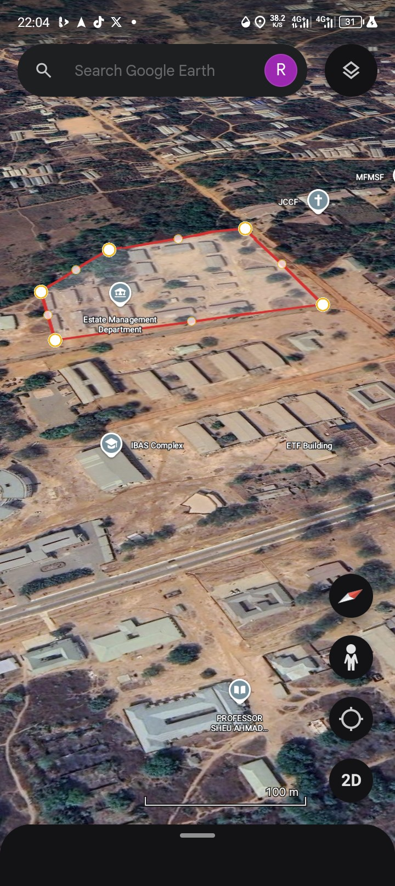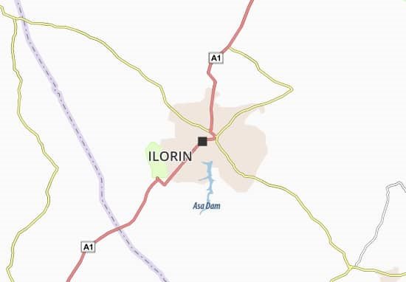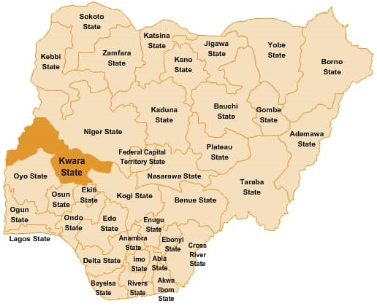

1.6 PERSONNEL INVOLVED
The under listed students of NDII 2023/2025 session are those who participated in the execution of this project.
S/N | NAMES | MATRIC NO | ROLE
1 | MUSA ZULU OLADIMEJI | ND/23/SGI/FT/017 | AUTHOR
2 | FAGBOHUN ISAAC OLAMIDE | ND/23/SGI/FT/014 | MEMBER
3 | OYENIYI MASHOOD  AKINOLA | ND/23/SGI/FT/019 | MEMBER
4 | SHEU ROKIBAT AYOKA | ND/23/SGI/FT/020 | MEMBER
5 | OJO SERAH ADESOLA | ND/23/SGI/FT/021 | MEMBER
6 | NINIOLA MUTIAT  OMOWUNMI | ND/23/SGI/FT/024 | MEMBER
7 | AWOYEMI MARIAM  DEBORAH | ND/23/SGI/FT/025 | MEMBER
8 | RAHEEM ROKIBAT ANIKE | ND/23/SGI/FT/026 | MEMBER
9 | ISHOLA ABDULROSHEED .O | ND/22/SGI/FT/028 | MEMBER

CHAPTER TWO

2.0 LITERATURE REVIEW
Perimeter surveying may be described as the type of survey made purposely for producing plan showing property boundaries or plan on which area necessary for the assessment of the property or land taxes may compute, it is also referred to as legal surveying because such survey forms the basis of a statutory registration of ownership and other rights on land. (Dashed 1987)
A perimeter is also a path that surround a two dimensional shape, the word is coined from a greek word “Peri” means around and “meter” means measure , this term may be used either for path or length, Perimeter survey is a type of survey that measured the distance along the boundary line of an area of land, a perimeter survey is important to find out the exact location of your property lines and you can also discover if there is any encroachment on your property, it can also serve like a simple survey where you just need to measure the length of your boundary .
Perimeter survey reality include mean other assumption and calculation in the use of approach, they have analyses, calculate and measured a wide race of factors which includes but not limit to;
- Boundary monumentation.
- Boundary encroachment
- Unresolved conflicts with existing property deeds maps
- Lines occupation fences walls, yards, hedges and natural element.
Boundary of perimeter survey defines the perimeter or whole property rather than say a sub division which might subdivide out one or two houses plot from a 50 to 10 acre property.
This clearly involves surveying the entire perimeter of the property to determine the exact geometry and acreage where the legal access to the property beneficial because:
- It determine your boundaries more accurately.
- Boundary mark are placed at all turning point on the property.
- Determines the acreage accurately.
- Legal survey plan is drawing and authenticated by the registered survey or when registered at the land registry then defines yours property.
Some technique and tools are used in perimeter survey that includes both the conventional and modern technologies.
Although there are some minor adjustment and improvement in the compass and tape, they still follow the same age old concept and technique, in addition to them surveyors will use GPS technology in a perimeter survey which is one of the greatest advancement in surveying industry.
Both of these two techniques if carried out by professional can results to detail analysis of your property with a small margin of error. Typically one will prefer to use bearing and distance technique when working on a small distance and use GPS technology on larger distance.
A detail survey is about defining the location and height of varieties of features on the property in question. A contour plan along with physical feature located, are show on a plan. This plan can be viewed electronically or a large format plot. This type of survey is regularly used when designing for roads, buildings extension and infrastructures.
Traversing is the process of connecting the series of lines with known bearing and distance. Subdividing into first order of precise measurement and
Second order control for the establishment of secondary control while the third order for survey of tertiary control and topographical features.
Alimental (1968) define traverse as an orderly sequence of measurement of length and direction of lines between points on earth’s surface to determine the position of points.
Detailing is define as the process of fixing topographical features to the survey lines, any of these listed method could be used
- Chain survey method (tie line and offset)
- Plane table method.

STAGES OF OPERATING IN PERIMETER AND DETAILING SUERVEY
Perimeter and detailing survey involves the following operation;
- Reconnaissance both in office and field
- Total station for detail fixing/ contouring
- Computation
- Plan production

DEFINITION OF TERMS IN PERIMETER AND DETAILING SURVEY
Reconnaissance: this is the preliminary visitation to the site in order to get familiar with the site and also establish the method of measurement to be adopted for the work.
It is further explained that once the purpose and precision of the survey has been decided upon during reconnaissance, is the first and perhaps the most important stage in surveying.
Traversing: is the “measurement of angles between two successive line or bearing of each line and length of each line” in a sequential order.
Total station: is a surveying instrument with combination of electro-magnetic distance measurement (EDM) instrument and an electronic theodolite that is used for measuring both horizontal and vertical angles. This surveying has two similar bits opposite functions.
- The determination of existing relative horizontal and vertical position such as that used for the process of mapping.
- The establishment of mark to control construction or to indicate land boundaries further analyzed that surveying has been essential in the development of man’s environment for so many centuries that importance is often forgotten.
It is an imperative requirement in the flaming and execution of nearly every form of construction. Surveying was essential as the door history and some of the significant scientific discoveries could never been implemented were if not for contribution of surveying. So believed that its principle modern uses are in the field of transportation, building appointment of land and communication inside which man can do without development is to mention in man’s environment.
Owing to the above stated fact, below are some notable terminologies which have been defined:
- Beacon means a permanent survey mark of any kind made of concrete iron or stone includes pillars and boundary point so made (SURCON, 2009).
- Demarcation means the defining of boundary line on ground by emplacement of property beacons or by such other methods as these regulation permit. ( SURCON, 2009)
- Boundary means a line marking the limit of an area or imaginary lines which marks the confines or line of division of two contiguous plots
- Property means something of value that is owned by someone, be it land or patent. (MICROSOFT Encarta)
- Property beacon means emplaced of the boundaries of parcel of land for the purpose of defining or demarcating the boundaries. (SURCON 2009)
- Coordinate means each numerical value used to indicate the position of a point. The position of any point in relation to axes usually intersected at right angle ( J.D.JDashe 1987).
- Control is the system of relatively precise measurement by triangulation, traversing or levelling to determine distances, direction or elevation, (Eruteya, 2013)
Encyclopedia Britannica (1973-1974) commented that bench mark or mark or mark point on the earth surface of the earth, connected to the elevation of bench marks given in terms of their height above a selected level surface called datum which is limited to horizontal and vertical control only because it is only two types. Voting that these controls used are in particular order depending on the specification given for their establishment ranging from first order and second order and third order respectively.
The network of first and second order and third, triangulation and traversing can be used to establish more controls when the need arises to provide enough or sufficient controls.

ESSENCE OF A PERIMETER AND DETAIL SURVEY
Dashe (1987) saw perimeter and detailing survey to provide the following; ✓ To determine the extent of an individual holding to avoid conflict over land.
- To provide vital information, which must be preserved for future management, maintenance, and modification and monitoring of both natural and artificial features.
- To locate portions of land on the physical surface of earth together with detail on it by means of survey beacons and that survey on plan.
- To determine the extent, size, value, ownership and transfer of land.
- To define the boundaries of a particular area of land showing them on a plan for the development of the area.

APPLICATION OF PERIMETER AND DETAIL SURVEY
Perimeter and detail survey are applicable in the following ways:
- The survey plan can be used to supply information for accessing and developing of construction works in the surveyed area.
- They can be used for updating existing plan of an area.
- Perimeter and detail survey plan aids cadastral surveyors in relocating existing property in relating them to existing details on the ground.
Also, a perimeter and detail survey is useful in the field of agriculture for the study of soil types and aid in soil conservation.

WAYS OF IMPROVING PERIMETER AND DETAIL SURVEY
With today’s technology is possible to generate personal map and plan on a own computer. Digital technique will continue to influence map making, enable more rapid production of accurate and current map. Indeed, perimeter and detail survey is greatly hampered by non-availability of good horizontal controls. In view of this, perimeter and detail survey can be improved upon by establishing basic triangulation, precise traverse or Global Positioning System (GPS).

CHAPTER THREE

3.0 METHODOLOGY
Methodology is a system or principle used in solving problem, with specific component such as task, method technique and tools.
This is also the techniques used to achieve the aims and objectives of this project work, the execution of this project was based on the following basic principles of surveying.
- Working from whole to part.
- The principle of choosing the method of survey most appropriate to meet the desire result.
- The principle of provision of adequate check to meet the require accuracy.

3.1 RECONNAISSANCE
Reconnaissance which is the first stage and vital aspect of any survey work
Carried out is as well the preliminary stage of this project.
This also is the initial operation or preliminary investigation undertaken by the surveyor in order to have a thorough overview of the site before the commencement of the actual survey ,it can also be abbreviated as “recci’’ as the project was concerned the reconnaissance was carried out in two ways.
- field reconnaissance
- Office reconnaissance

3.1.1 Field or Site Reconnaissance
This involves the actual [physical] visit to the site and was carried out before the actual operation. This project site was visited by the group in order to have a prior knowledge as well as true picture of the site and to ascertain the information collected during the office planning. The boundaries were marked with wooden peg driven into the ground to avoid disturbance or removal, taking into consideration the following factors.
- Inter-visibility of the selected traverse station.
- Safety of the selected station for future reference.
- Accessibility of the stations.

3.1.2 Office Reconnaissance
This involves knowing the type of instrument, purpose and accuracy required for the survey to be carried out. Information related to the given project was collected from various sources such as project supervisor. The specification/ instructions and coordinates of the control stations were collected from the department of surveying and geo-informatics Kwara State Polytechnic.

Table 3.1.3Co-ordinates of control used
STATION | EASTIN  GS (M) | NORTHINGS  (M) | STATION
KW/PT/2001 | 679647.4  47 | 946677.273 | KW/PT/2001
SC/KW/FRS/  4404 | 679449.4  08 | 946699.489 | SC/KW/FRS/  4404
3.2 INSTRUMENT TEST

HORIZONTAL COLLIMATION TEST
The aim of this test was to be sure that the line of sight is perpendicular to the trunion axis.
Procedure:
The Total Station instrument was set over a point and all necessary temporary adjustments (centering, leveling and focusing) performed. Then the configuration menu of the total station was accessed by pressing down the menu key for about two seconds and the calibration sub-menu and consequently the horizontal collimation test was chosen. This test was done by sighting and bisecting a well-defined vertical target about 100m away and taking the horizontal readings on face left and face right. From the analysis of the results, the total station was in good adjustment.

VERTICAL INDEX ERROR TEST
This adjustment ensures that the vertical circle reading is exactly 90° when the line of sight is horizontal. Any deviation from this figure is termed vertical index error.
Procedure:
The instrument was set over a point and necessary temporary adjustments (centering, leveling and focusing) performed. The vertical index error test was carried out by sighting a target at a distance of about 120m on face left. The vertical circle reading was recorded and on face right the target was sighted and bisected again and the vertical circle reading recorded.

3.2.1 IN-SITU CHECK FOR CONTROL
In-situ checks observations (angular and linear) were executed for the purpose of verifying the integrity of the existing controls. The following observational schedules were executed:
The instrument was set on KW3001PT and angular observations were made to targets on KW3002PT as back station and BPM1500 as forward station.
The results of the observations as shown below confirm that the controls were still in their original positions and therefore suitable for use.
TABLE 3.2.1 IN-SITU CHECK DATA ANALYSIS(control pillars).
STATION | COORDINAT  E (m) | KNOWN  VALUES  (m) | MEASURE  D VALUES (m) | DIFFERENC  E  (m)
SC/KW/FRS/44  04 | NORTHING EASTING | 946677.27 3  679467.44  7 | 946699.489  679449.408 | 0  0  0
KW/PT/2001 | NORTHING EASTING | 946677.27 3  679467.44  7 | 946699.489  679449.408 | -0.005m  +0.004m
SC/KW/FRS/4404. . KW/PT/2001
FIGURE 3.2.1 Diagram Showing Control Used

3.2.2 DATA ACQUISITION
This involves the processes in acquiring the data needed for the project. This involves the actual making of measurements and recording of observed data on the field. There are different methods of acquiring data in the site with different instrument such as Total station, Theodolite, Compass, Level Instrument etc.
3.2.3 Geometric Data Acquisition.
These are positional data, that is, they are data having the [x, y, and z] coordinates which is possible to locate their position on the surface of the earth.
3.2.4 Attribute Data Acquisition.
These data are acquired by social survey, these are data used for defining the purpose of features located on the earth surface.

3.2.5EQUIPMENT USED/SYSTEM SELECTION AND SOFTWARE
This comprises of two components, namely: the hardware components and software components.
HARDWARE COMPONENT: These are the physical equipment used for the execution of the project and they are:
- Total station (Sokkia)and its accessories
- Steel tape
- Nails and bottle corks
- Field book and pen
- Personal computer
- pegs

SOFTWARE USED FOR DATA PROCESSING
- AutoCAD 2017 for plotting the boundary and detailing
- Note Pad, and Microsoft Excel (for Script preparation, editing and restructuring of data and report writing).

3.2.6 SETTING OUT OF PERIMETER BOUNDARY
Based on the office planning and field reconnaissance conducted, the instrument was first set on Control Pillar KW2001PT being the closest control and all temporary adjustment performed. The coordinate of the control point SC/KW/FRS/4404 was key into the instrument.KW2001 PT was sighted as back sight.
The coordinates of the station KW2001PT was key-in the instrument via the keyboard. The instrument then computed the bearing between the two stations for orientation. Then coordinates of points to be set out were entered into the total station and the setting out program of the instrument was used to get the angle to turn in order to face the direction of the point after orientation, the instrument was rotated until horizontal angle read 0 00’ 00”, reflector was held along the direction and distance between the instrument and the reflector was measured. The instrument displayed the remaining of the point to be fixed distance as either positive or negative. Positive distance means that the reflector should move away from the instrument by that amount while negative distance means that the reflector should move towards the instrument. When the horizontal angle read 000’
00” and measured distance displayed 0.000m this marked the exact position 3.3 MONUMENTATION
The beacons measuring 18cm by 18cm by 75 cm were molded in-situ with a mixture of 1:2:3 of cement, sand and gravel respectively. A 12mm diameter Iron rod defines the center of the beacon was placed. The perimeter boundary line was cleared to ensure inter-visibility between the beacons. The numbering of the beacons was carried out after molding in a clockwise pattern with an arrow pointing to the succeeding station.Also, numbering as carried out accordingly as they were in the Title Deed Plan (TDP).However, the beacons were prefixed with identification mark KP220 where KP represents Kwara State Polytechnic.
KP
P T
220

FIGURE 3.2.2: PLAN VIEW
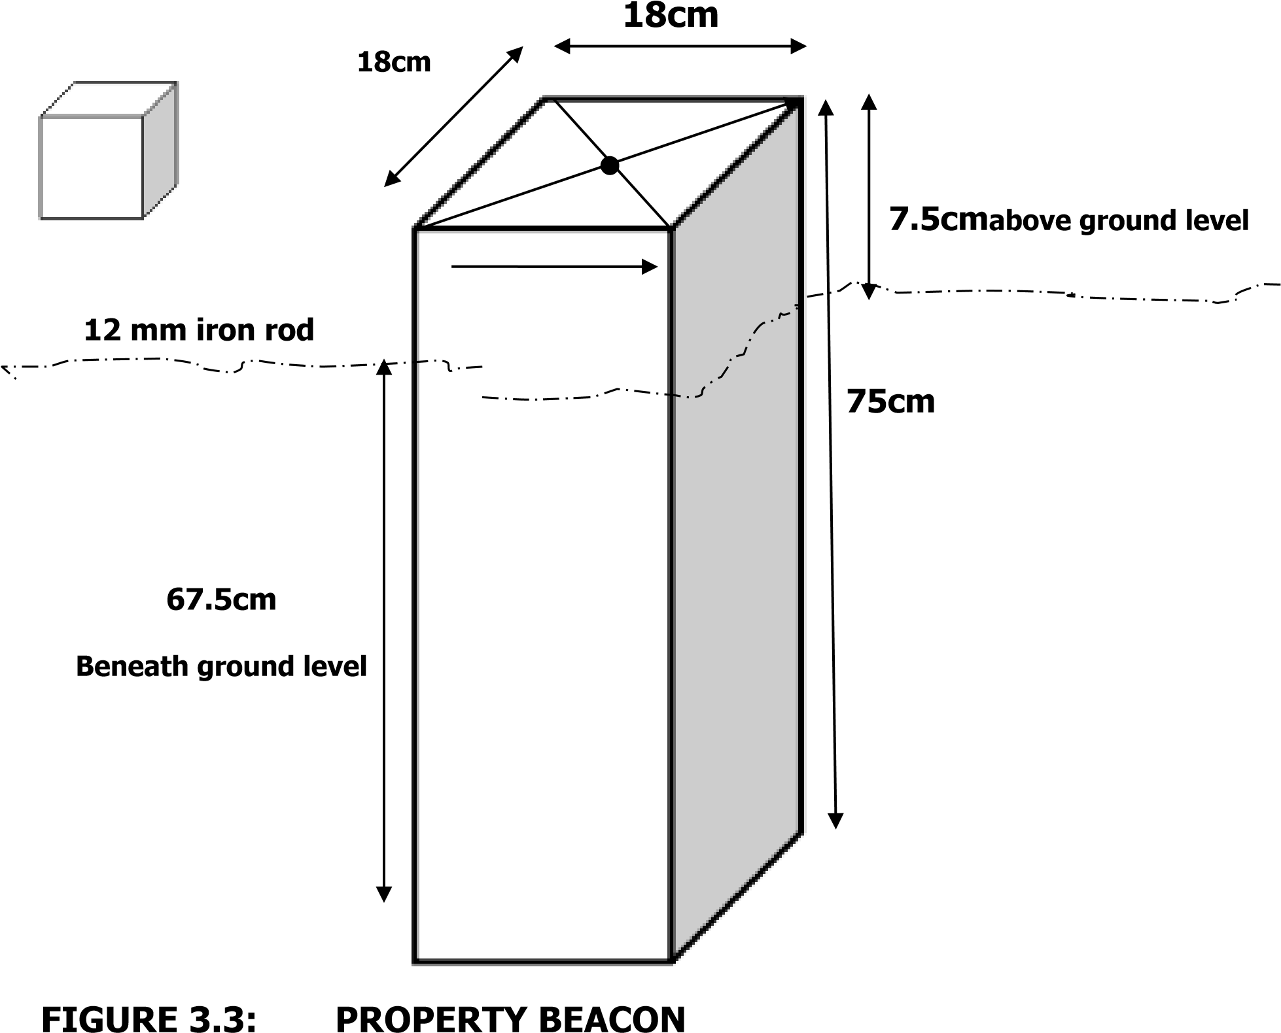

3.4 PERIMETER TRAVERSING
After the demarcation, capping and numbering of the beacons, the actual data acquisition using the total station Sokkia commenced. The traverse started from KW2001PT with SC/KW/FRS/4404 as reference point. The total station was set up over control KW2001PT, centered, leveled and telescope focused to eliminate parallax. The parameters of the instrument station i.e. station name, height of instrument over the station mark, and the XYZ coordinates of the station were keyed in. The reference control point was then bisected and the station , height of target over the station mark, and the XYZ coordinates of the station were key in. Though the total station was set in coordinate mode it actually measured and recorded horizontal readings, vertical readings and distances automatically into the internal memory of the instrument on both faces which it used to compute and display coordinates. At every set up of the total station, the temporary adjustment was carried out and the following parameters measured:
- Height of instrument
- Height of the back target
- Height of the fore target
- Distance to back and fore station
This is the determination of bearing and distance of series of connected lines from known coordinated point so as to obtain coordinate of the newly established station.
This include the following with formula
- Linear measurement : the difference between the coordinates were first derived using (∆E=E2-E1, E3-E2) etc. and the distance of end traverse leg was obtained using the formula: distance =√(∆E)^2
+(∆N)^2
- Angular measurement: to calculated the bearing after the difference in coordinates has been derived, the formula is Bearing=Tan-1 ∆E/∆N.
3.4.1. Coordinates of the boundary

The coordinates are as follows
S/n | Easting | Northing
1 | 679582.728 | 946429.840
2 | 679448.029 | 946465.672
3 | 679434.376 | 946560.036
4 | 679449.408 | 946699.489
5 | 679647.447 | 946677.273

3.5 DETAIL SURVEY
The detail survey involved a comprehensive documentation of all features within the site, both natural and man-made, utilizing advanced surveying techniques with precise instruments.
The survey commenced with the set-up of the Total Station at Station PT2001. Once the equipment was powered on, necessary adjustments were made to ensure optimal performance. The instrument's settings for the "Job" and "Station Name" were configured, allowing for easy retrieval of the boundary point coordinates stored in the instrument’s memory.
To ensure accuracy, the heights of the instrument above the survey station and the heights of the reflectors were meticulously measured using a steel tape measure. These measurements were then recorded in the Total Station’s memory. A reflector placed on beacon SCKWFRS4404 was bisected to facilitate proper orientation.
Subsequently, the Total Station was programmed to compute the bearing between the two designated stations, following the input of the orientation station name SCKWFRS4404. As part of the detailed surveying process, one of the site assistants positioned a reflector at the edge of a building. The crosshairs of the reflector were aligned with those of the Total Station's telescope, and the "DIST" key was activated to obtain the measurement, which was then displayed and recorded within the instrument.
In parallel, the width of a specific area, such as the building's façade, was accurately measured using a 50-meter steel tape. The procedure was consistently applied during the detailed survey of the expressway, where the Total Station was set up on another boundary beacon, PT2001. In this instance, all edges of the carriageway and certain buildings were thoroughly measured and documented.
This methodical approach ensured that every relevant feature within the surveyed site was captured accurately, providing a comprehensive dataset for subsequent analysis and project planning.

CHAPTER FOUR

4.0 DATA PROCESSING
After the data have been acquired the. Microsoft Excel 2007 Software was used to type the final coordinates of all points except the unwanted part of the data like the temporary controls which were later transported to Note pad and AutoCAD software 2017.

4.1 RESULT ANALYSIS
The data was analyzed and found to meet with the departmental standards and this is the main traverse result extracted from field, then it was arranged accordingly as the observation was held in the field. The results are as follows.

4.2 Table: Back Computation
From Station | Observer d Bearing | Horizo ntal  Distan ce(m) | - (E) | - (E) | Sum | - (N) | + (N) | Sum | Easting | Northing | To Stati on
 |  |  |  |  |  |  |  |  | 679582.7  28 | 946429.840 | A
A | 284°45' | 139.38  0 |  | 134.69  9 | 134 | 35.832 |  | 35 | 679448.0  29 | 946465.672 | B
B | 351°1646' | 95.450 |  | 13.653 | 147 | 94.364 |  | 129 | 679434.3  76 | 946560.036 | C
C | 06°09' | 140.26  0 | 15. 032 |  | 162 | 139.45  3 |  | 268 | 679449.4  08 | 946699.489 | D
D | 96°24' | 199.28  0 | 198  .03 9 |  | 360 |  | 22.21  6 | 290 | 679647.4  47 | 946677.273 | E
E | 194°39 | 255.76  0 |  | 64.719 | 424 |  | 247.4  33 | 537 | 679602.3  88 | 946505.003 | F

25

4.3 COMPUTE FOR TOTAL AREA USING DOUBLE LATITUDE AND DEPARTURE
∆E | ∆N | Easting | Northing
+134.699 | -35.832 | 679582.728 | 946429.840
+ 13.653 | -94.364 | 679448.029 | 946465.672
-15.032 | -139.453 | 679434.376 | 946560.036
-198.039 | +22.216 | 679449.408 | 946699.489
+64.719 | +247.433 | 679647.447 | 946677.273
Source: Writer, 2025
+134.699
+134.699 × -35.832 = -4826.535

+269.398
+013.653

+283.051
+013.653 × -94.364= 1288.352
+296.704
- 015.032

+281.672
-015.032 × 139.453= +2096.257
+266.640
-198.039

+068.601
-198.039+068.601
-198.039 × +22.216 = ̵ 4399.634

-129.438
+ 064.719
-064.719
+ 0.64.719 × +247.433 = +16013.616

0.00
SUM OF POSITIVE (+) - SUM OF NEGATIVE (-)
= 7595.352 - 10514.521

2
AREA = 4.265 square meters

4.4 GRAPHIC PLOTTING
This simply refers to the graphically representation i.e.plotting of plan. It was plotted using AutoCAD and other software in a computer system and a suitable scale was used to for the hard copy format. Presented information include boundary details and beg, conventional sign and symbol were also used in the plan.
The digital plan was produced using AutoCAD software and these are procedures followed.
- Switch on the computer and allow it to boost
- Select notepad, from notepad, a script file for the coordinate p -line easting, northing was structured. • File was saved with extension. SCR • AutoCAD was launched.
- Format was clicked and set the unit then press “OK”
- Press “Tool” and select Run script to pick your saved file then press escape and press zoom, extent and the image was displayed.
- The boundary line was changed to Red and necessary editing was done.

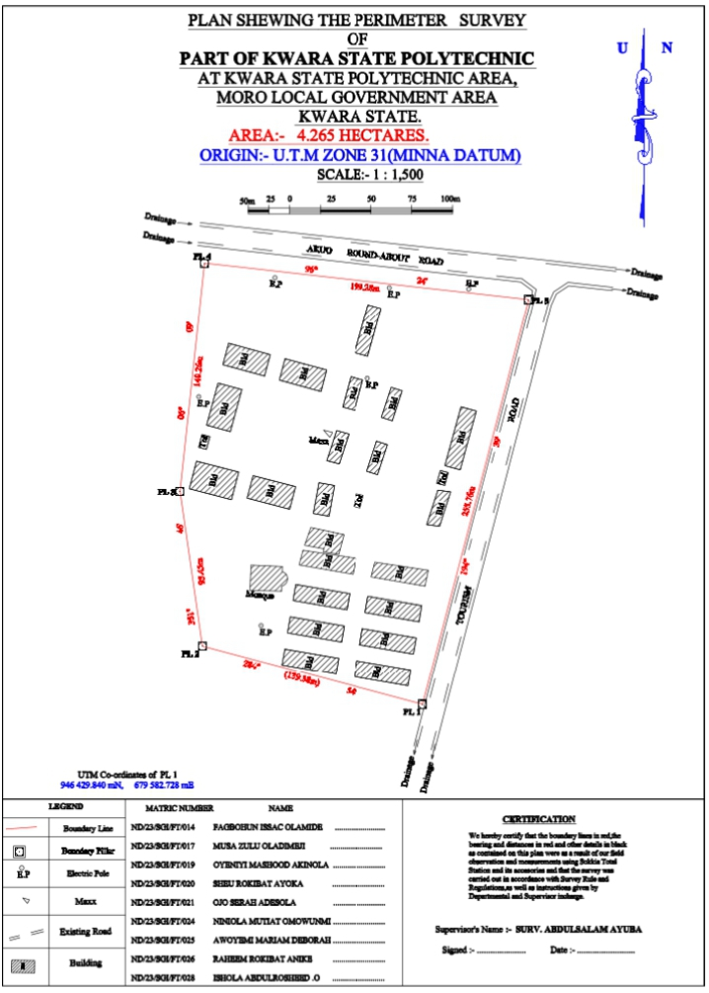

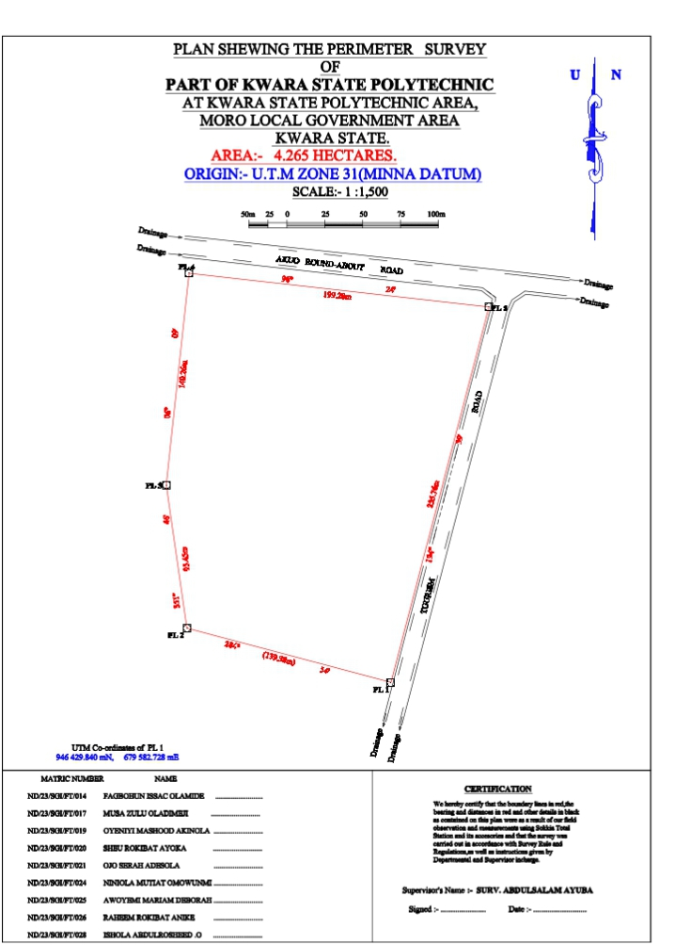

CHAPTER FIVE

5.0 SUMMARY
The aim of this project is to provide current perimeter and details plan for Kwara State Polytechnic, Old institute of environmental studies , Ilorin, Kwara State.

5.1 PROBLEMS ENCOUNTER
These are some of problems encounter during the processing of the execution of this project.
- The weather was not conducive, it was drizzling all day.
- Students passing by were obstructing sight of observer, causing disturbance.

5.2 RECOMMENDATION
Having successfully completed this project, I here by make the following recommendations on the result achieved from the project.
- The plan produced can be used as a means of information for further construction at the girls’ hostel, Kwara State Polytechnic.
- It gives a clear picture on how the hostel looks like, in other words it enhance planning and helps in decision making, also serves as a source of information for the school.

5.3 CONCLUSION
In conclusion, the project exercise has been successfully executed since the result of the above operation agreed with the requirement and accuracy of third job and the perimeter and details in the study area were produced. The survey was executed according to the specification and in accordance with the survey rules and departmental instructions.

REFERENCES
Oliver J.G Clending (1978) Principles of Surveying Working Ham Berkshire, England ppl.
Uren J and Price W.F (1994) Engineering survey, Richard and Day Limited BungayiSuffork pp.8
Igbokwe (1999) Digital mapping-a big stride vol-12 no 1 Magazine of Nigeria institution of Surveying Students University of Nigeria chapter.

APPENDIX
These are the data observed from the field work and we have BD as building, DR as drainage, BH as borehole, and WT as water tank also EP as electric pole.
ID | EASTING | NORTHING
PL1 | 679582.728 | 946429.840
PL2 | 679448.029 | 946465.672
PL3 | 679434.376 | 946560.036
PL4 | 679449.408 | 946699.489
PL5 | 679647.447 | 946677.273
BLD1 | 679549.274 | 946642.233
BLD1 | 679541.227 | 946644.456
BLD1 | 679549.407 | 946673.891
BLD1 | 679557.454 | 946671.668
BLD2 | 679606.155 | 946611.461
BLD2 | 679615.524 | 946608.893
BLD2 | 679605.691 | 946573.081
BLD2 | 679596.322 | 946575.649
BLD3 | 679564.348 | 946602.906
BLD3 | 679557.622 | 946604.990
BLD3 | 679563.626 | 946623.263
BLD3 | 679570.352 | 946621.179
BLD4 | 679541.131 | 946609.275
BLD4 | 679533.505 | 946611.284
BLD4 | 679538.580 | 946629.766
BLD4 | 679546.206 | 946627.757
BLD5 | 679498.379 | 946640.771
BLD5 | 679523.756 | 946633.877
BLD5 | 679520.271 | 946620.744
BLD5 | 679494.894 | 946627.638
BLD6 | 679463.996 | 946650.142
BLD6 | 679489.373 | 946643.248

BLD6 | 679485.888 | 946630.115
BLD6 | 679460.511 | 946637.009
BLD7 | 679457.544 | 946625.842
BLD7 | 679472.023 | 946621.924
BLD7 | 679465.087 | 946596.289
BLD7 | 679450.608 | 946600.207
BLD8 | 679529.818 | 946596.942
BLD8 | 679537.413 | 946594.907
BLD8 | 679531.409 | 946576.634
BLD8 | 679523.814 | 946578.669
BLD9 | 679554.668 | 946590.470
BLD9 | 679561.394 | 946588.386
BLD9 | 679555.390 | 946570.113
BLD9 | 679548.664 | 946572.197
BLD10 | 679592.068 | 946560.674
BLD10 | 679599.873 | 946559.664
BLD10 | 679593.075 | 946538.68
BLD10 | 679585.270 | 946539.689
BLD11 | 679519.000 | 946565.197
BLD11 | 679528.569 | 946563.532
BLD11 | 679525.179 | 946544.786
BLD11 | 679515.610 | 946546.451
BLD12 | 679478.939 | 946569.537
BLD12 | 679504.880 | 946562.819
BLD12 | 679501.237 | 946549.083
BLD12 | 679475.296 | 946555.801
BLD13 | 679444.388 | 946578.416
BLD13 | 679470.160 | 946571.719
BLD13 | 679465.756 | 946554.842
BLD13 | 679439.984 | 946561.539
BLD14 | 679510.302 | 946527.118
BLD14 | 679514.054 | 946537.943
BLD14 | 679534.343 | 946533.641
BLD14 | 679531.147 | 946521.705
BLD14 | 679521.697 | 946523.093
BLD14 | 679522.114 | 946524.897
BLD15 | 679509.302 | 946524.064
BLD15 | 679541.890 | 946519.170

BLD15 | 679539.930 | 946509.505
BLD15 | 679506.975 | 946515.133
BLD16 | 679553.651 | 946516.785
BLD16 | 679586.238 | 946511.89
BLD16 | 679584.278 | 946502.226
BLD16 | 679551.323 | 946507.854
BLD17 | 679504.954 | 946503.304
BLD17 | 679537.91 | 946497.676
BLD17 | 679536.226 | 946487.819
BLD17 | 679503.271 | 946493.447
BLD18 | 679549.303 | 946496.025
BLD18 | 679582.258 | 946490.397
BLD18 | 679580.575 | 946480.54
BLD18 | 679547.619 | 946486.168
BLD19 | 679545.936 | 946476.31
BLD19 | 679578.891 | 946470.682
BLD19 | 679577.208 | 946460.825
BLD19 | 679544.253 | 946466.453
BLD20 | 679501.588 | 946483.590
BLD20 | 679534.543 | 946477.961
BLD20 | 679532.859 | 946468.104
BLD20 | 679499.904 | 946473.732
BLD21 | 679498.221 | 946463.875
BLD21 | 679531.176 | 946458.24
BLD21 | 679529.493 | 946448.390
BLD21 | 679496.537 | 946454.018
BLD22 | 679542.569 | 946456.596
BLD22 | 679575.524 | 946450.968
BLD22 | 679573.841 | 946441.111
BLD22 | 679540.886 | 946446.739
MSQ | 679496.29 | 946502.143
MSQ | 679496.168 | 946499.145
MSQ | 679477.014 | 946499.605
MSQ | 679477.641 | 946514.971
MSQ | 679496.779 | 946514.133
MSQ | 679496.657 | 946511.135
MSQ | 679499.882 | 946506.709
TOI1 | 679447.828 | 946594.614

TOI1 | 679452.651 | 946593.297
TOI1 | 679450.521 | 946585.496
TOI1 | 679445.698 | 946586.813
TOI2 | 679593.536 | 946572.708
TOI2 | 679598.359 | 946571.391
TOI2 | 679596.229 | 946563.590
TOI2 | 679591.406 | 946564.907
E.P | 679492.26 | 946690.694
E.P | 679562.54 | 946684.428
E.P | 679610.758 | 946683.743
E.P | 679445.846 | 946617.55
E.P | 679483.807 | 946478.219
E.P | 679549.084 | 946628.813
RD | 679445.277 | 946712.177
RD | 679643.316 | 946689.961
RD | 679652.008 | 946683.482
RD | 679579.403 | 946403.808
RD | 679698.787 | 946684.724
RD | 679671.309 | 946687.806
RD | 679662.698 | 946681.966
RD | 679659.235 | 946674.342
RD | 679588.012 | 946402.041
RD | 679446.392 | 946722.115
RD | 679700.67 | 946694.575

