KWARA STATE POLYTECHNIC, ILORIN
FABRICATION AND PERFORMANCE TESTING OF HORIZONTAL VIBRATED MODULAR TWIN-MOULD SANDCRETE BLOCK MACHINE

BY

AROKOOLA SAMUEL OLAMILEKAN
ND/23/MEC/FT/0005

A PROJECT SUBMITTED TO THE DEPARTMENT OF MECHANICAL ENGINEERING TECHNOLOGY, INSTITUTE OF TECHNOLOGY.

IN PARTIAL FULFILLMENT OF THE REQUIREMENT FOR THE AWARD OF NATIONAL DIPLOMA MECHANICAL ENGINEERING TECHNOLOGY, KWARA STATE POLYTECHNIC, ILORIN.

SUPERVISED BY: EGNR. AYANTOLA A.A.

JULY, 2025

CERTIFICATION
The undersigned certify that this project report titled FABRICATION AND PERFORMANCE TESTING OF HORIZONTAL VIBRATED MODULAR TWIN-MOULD SANDCRETE BLOCK MACHINE was prepared by AROKOOLA SAMUEL OLAMILEKAN with matriculation number ND/23/MEC/FT/0005 meets the requirement for the award of National Diploma (ND) in the department of Mechanical Engineering, Kwara State Polytechnic, Ilorin, and was approved for its contribution to knowledge and literacy presentation.

______________________ ______________________
Engr. Ayantola A.A. Date

Project Supervisor

_____________________ _____________________
Engr.Ayantola A.A. Date
Head of Department

______________________ ______________________

Engr. Salami H.O. Date

Project Coordinator

______________________ ______________________
Engr. Durotoye J.A. Date
External Examiner

DEDICATION

This project work is dedicated to Almighty God the giver of life, knowledge, wisdom, and understanding to succeed in our field of study and also to my beloved parents MR & MRS AROKOOLA Who had made the journey so easy and successful one, who continually provide their moral, spiritual, emotional, and financial support, and expressing my gratitude to our honorable supervisor ENGR. AYANTOLA A.A. who guide me throughout the program.

ACKNOWLEDGEMENT
My heartfelt gratitude goes to Almighty God, for his wisdom, knowledge, understanding, grace and the ability to complete this program.
I also appreciate my parents Mr. and Mrs. Arokoola for their financial support throughout this program.
My appreciation goes to my project supervisor ENGR. Ayantola A.A. who is also the the Head of Department (HOD) for his exceptional mentorship and technical expertise. His guidance and insightful suggestions have been instrumental in shaping the direction of this project.
I also express my gratitude to all the staff's of the Department of Mechanical Engineering for their expertise and assistance in various aspects of the project.
Finally, kudos to myself and my course mate, who as help to make my project a successful one, and to my beloved siblings, I really appreciate all your advices, encouragement and efforts towards the success of my project and the completion of my National Diplomat, God bless you all, We pray to Almighty God to make every one of us succeed in life, Amen.

ABSTRACT
This project focuses on the fabrication, and performance evaluation of a horizontal vibrated modular twin mould sandcrete block machine. The primary objective is to develop a cost-effective, efficient, and durable machine capable of producing high-quality sandcrete blocks suitable for construction purposes. The machine incorporates a horizontal vibration mechanism and a twin mould system to enhance production efficiency and block quality.The results demonstrated the machine's capability to produce sandcrete blocks that meet standard requirements, thereby offering a viable solution for small to medium-scale block production.
Historically, sandcrete block production in Nigeria dates back to the early 20th century with manual moulding techniques. However, mechanization began gaining attention post-2000, with researchers such as Oyekan and Kamiyo (2008) advocating for locally fabricated vibrated systems. Yet, many of the earlier machines were limited by single-block output and vertical vibration designs, which often led to uneven compaction. This project integrates lessons from past studies and field practices to address these limitations through a horizontal vibrated configuration, inspired by principles of dynamic compaction and material flow in confined mould spaces.
This project contributes to the development of indigenous technologies for building material production, supporting local industry, job creation, and the broader goal of providing affordable housing. The findings underscore the importance of mechanization, material selection, and design optimization in achieving high-quality, scalable building solutions for developing regions.

TABLE OF CONTENTS
Dedication
Acknowledgement
Abstract
Table of Contents
List of Figures
List of Drawings

CHAPTER ONE
1.0 Introduction
1.1 Preamble
1.2 History of Sandcrete Block Moulding Machine
1.3 Types of Block Moulding Processes
1.4 Types of Block Moulding/Making Machines
1.5 Materials for Making Sandcrete Blocks
1.6 Aim and Objectives of the Project
1.7 Justification of the study
1.8 Scope of the Project
1.9 Problem Statement CHAPTER TWO
2.0 Analysis of Alternative Methods and Selection of Best
2.1 Method of Block Production
2.2 Types of Block
2.3 Requirements of a Good Sandcrete Block CHAPTER THREE
3.0 Materials and Methodology
3.1 Criteria for Selecting Materials
3.2 Description of Components Parts
3.3 Design Drawings
3.4 Properties of the Materials
3.5 Fabrication Details
3.6 Performance Testing of Blocks
3.7 Bill of Engineering Measurement and Evaluation (BEME )
3.8.0 Calculations
3.8.1 Calculation of Volume of Components
3.8.2 Calculation of Mass of Components
3.8.3 Determination of Weight of Components
CHAPTER FOUR
4.0 Tests Results and Discussions
4.1 Fabrication Outcomes
4.2 Productivity and Operational Output
4.3 Discussion of Results
4.4 Technological Significance of Horizontal Layout
CHAPTER FIVE
5.0 Appendix
5.1 Recommendation
5.2 Conclusions
5.3 General References

CHAPTER ONE
1.1 Preamble
Housing is a fundamental human need, and its provision has become an ever-pressing challenge in developing nations. Rapid urbanization, population growth, and economic pressures have intensified the demand for affordable, quality housing. In Nigeria and across sub-Saharan Africa, the construction industry is under increasing pressure to deliver large volumes of housing at reduced costs. One of the most critical materials used in this process is the sandcrete block—a composite building material widely accepted for its strength, affordability, and ease of production.( Falade F. 1999)
However, the conventional methods used in sandcrete block production—often involving manual moulding and rudimentary vibrating systems—have proven inefficient and unsustainable. These methods result in non-uniform blocks with varying compressive strengths, reduced structural integrity, and high labor costs. The current situation calls for localized engineering solutions that leverage readily available materials, low-cost fabrication, and enhanced production capacity.
This project was conceptualized to address the gaps in block production technologies by developing a mechanical system that combines horizontal vibration with a twin mould arrangement, which allows for the simultaneous production of two sandcrete blocks per cycle. The rationale is to increase productivity, improve block quality through effective compaction, and support local industries by using materials and techniques that are accessible and cost-effective.
According to the Nigerian Industrial Standard (NIS 87:2000) the horizontal vibrated modular twin mould sandcrete block machine integrates the mechanical principles of vibration compaction, modular engineering design, and process efficiency to produce blocks that meet NIS Standard. The machine's horizontal orientation offers better stability and compaction than traditional vertical systems, while the twin mould setup doubles the throughput without significantly increasing the mechanical complexity or power requirement.(Adewole K.K, Ibrahim M.T 2000)
The modular design philosophy ensures that each component of the machine can be replaced or upgraded independently, thus making the system maintainable and scalable. Furthermore, the fabrication process will utilize locally available materials—such as mild steel, angle bars, and steel shafts—supporting indigenous industrialization and reducing dependence on costly imports.
This preamble sets the stage for a comprehensive examination of the design, material selection, fabrication processes, and performance outcomes of a machine that embodies the intersection of engineering innovation, local empowerment, and sustainable development goals.
Sandcrete blocks are a fundamental component in the construction industry, particularly in West Africa. Comprising a mixture of cement, sand, and water, these blocks are favored for their affordability and ease of production. However, traditional manual methods of production often result in inconsistencies in block quality and structural integrity (Olufisayo J.O 2004 ) The advent of mechanized block moulding machines has significantly improved the efficiency and quality of sandcrete block production.
The construction industry plays a critical role in national development, especially in developing nations like Nigeria, where the demand for affordable housing is ever increasing. One of the most widely used materials in this sector is sandcrete blocks, owing to their affordability, availability of raw materials, and suitability for diverse building types. Sandcrete blocks are made from a mixture of cement, sand, and water, molded and cured to form durable building units.
Historically, the earliest sandcrete block production in Nigeria was primarily manual, with wooden moulds and hand compaction. However, with urban expansion and increased demand, these methods became inefficient due to inconsistent compaction, non-uniform sizes, and low production rates. From the early 2000s, researchers and practitioners began to explore semi-mechanized and mechanized alternatives to improve block quality and production capacity (Anosike & Oyebade, 2011; Oyekan & Kamiyo, 2008).
To address these challenges, this project focuses on designing and fabricating a horizontal vibrated modular twin mould block machine. This machine integrates a vibration system oriented horizontally to improve compaction and uses twin moulds to double the production rate compared to conventional single-mould machines. The modular nature of the machine allows easy maintenance, flexibility in mould change, and adaptability to various block types.
1.2 History of Sandcrete Block Moulding Machines (Post-2000 Developments)
The evolution of sandcrete block machines parallels the general advancement in construction technologies. Initially, blocks were manually molded using simple wooden molds, a process prone to irregularities and low productivity. In the mid-1900s, mechanical block-making machines were introduced, designed to automate part of the molding process. Early machines used hydraulic or mechanical presses but were limited in compaction efficiency.
By the 1970s and 1980s, vibration technology was integrated into block machines, significantly improving block density and compressive strength. Horizontal vibrating machines emerged as a modern approach, applying uniform vibration to the sandcrete mix within the molds, ensuring consistent compaction and superior block quality. The twin mould design, allowing multiple blocks to be molded simultaneously, further enhanced productivity and was adopted by small to medium scale manufacturers. The evolution of sandcrete block moulding machines has seen significant advancements since the early 2000s, driven by the need for improved efficiency, consistency, and scalability in block production. In Nigeria and many African countries, these machines revolutionized block production, enabling affordable housing projects and infrastructure development.
Sandcrete blocks have been a staple in the construction industry, particularly in West Africa, due to their affordability and ease of production. Historically, block production was manual, leading to inconsistencies in quality and structural integrity. The introduction of mechanized block moulding machines in the late 20th century marked a significant shift, improving both efficiency and block quality.
In the early 2000s, the adoption of vibratory systems in block moulding machines enhanced compaction, resulting in stronger and more uniform blocks. Falade (1997) and Cisse & Laguerbe (2000) highlighted the benefits of vibration in enhancing block density and strength. Additionally, the development of Hydraform technology in South Africa introduced interlocking block systems that eliminated the need for mortar, reducing construction costs and time. Oyekan (2001) noted the adoption of this technology in Nigeria, emphasizing its suitability for low-cost housing projects.

Early Developments
Prior to 2000, block production was predominantly manual, leading to low output and variable quality. The introduction of vibratory systems in block moulding machines improved compaction, resulting in stronger and more uniform blocks. (Falade 1997) and (Cisse & Laguerbe 2000) highlighted the benefits of vibration in enhancing block density and strength.
The use of sandcrete blocks as a building material in Nigeria and other parts of West Africa can be traced back to the early 20th century. Initially, blocks were produced using manual wooden moulds, and compaction was achieved by hand—either by pressing the mixture with wooden planks or by foot. These early blocks were often inconsistent in size and quality, primarily suitable for non-load-bearing walls( Olufisayo J.O 2004)
As urbanization and the demand for standardized construction materials increased, the need for more uniform, durable blocks led to the development of mechanical moulding devices. The earliest versions of mechanical block moulders were simple single-cavity metal moulds that used leverage-based or screw mechanisms to apply compaction.
Post-Colonial Mechanization (1960s–1980s)
During the post-independence infrastructure boom across Africa, particularly in the 1960s to 1980s, there was a move toward semi-manual mechanical moulders, often operated by levers and hand cranks. These machines, although still human-powered, allowed for faster production and slightly more consistent compaction than earlier wooden moulds.
However, they were still limited in output and failed to meet rising urban housing demands. As a result, the development of vibrated block moulding machines began gaining traction during this period.
Emergence of Vibrated Block Machines (1990s–2000s)
By the 1990s, vibrated block moulding machines became more popular, particularly in Nigeria, Ghana, and Kenya. These machines introduced the use of electric motors or gasoline engines to drive a vibrating plate that compacts the sandcrete mixture in the mould. This development significantly improved the compressive strength, surface finish, and dimensional consistency of blocks.
A notable limitation, however, was that most vibrated machines were designed with a single cavity or vertical vibration mechanism, which could lead to uneven compaction and longer production times.
In the early 2000s, researchers began focusing on improving the mechanical design, energy efficiency, and productivity of these machines. For example: (Oyekan & Kamiyo 2008) studied the effects of vibration and curing on block strength and advocated for standardized compaction methods.
Hydraform Technology: Developed in South Africa, Hydraform technology introduced interlocking block systems that eliminated the need for mortar, reducing construction costs and time. (Oyekan 2001) noted the adoption of this technology in Nigeria, emphasizing its suitability for low-cost housing projects.
Standardization Efforts: In response to quality concerns, the Nigerian Industrial Standard (NIS 87:2000) was established to regulate sandcrete block production, specifying materials, dimensions, and compressive strength requirements. This standard was subsequently reviewed in 2004 and 2007 to incorporate technological advancements and industry feedback (Standard Organization of Nigeria 2000)
Advancements in Machine Design: Manufacturers like REIT introduced fully automatic block production lines in the early 2000s, such as the RTQT15 model in 2005, which integrated automated mixing, moulding, and curing processes, significantly increasing production capacity and consistency.
Local Innovations: In Nigeria, efforts to develop cost-effective and efficient block moulding machines led to the creation of various semi-automatic and mobile units. These machines aimed to address the challenges of high equipment costs and adaptability to local conditions.
(Anosike & Oyebade 2011) emphasized the importance of achieving uniformity in block sizes and adherence to Nigerian Industrial Standard (NIS 87:2000) through mechanized systems.
(Abdullahi 2005) demonstrated the impact of cement-sand mix ratios and compaction method on block quality, advocating mechanization to minimize errors in manual processes.
Recent Advances (2010s–Present)
In the past decade, there has been significant progress in local fabrication and design of block-making machines. Many engineering departments in Nigerian polytechnics and universities have engaged in projects to locally design machines that can meet international quality standards.
Recent innovations include:
Twin mould block machines, which double the output per cycle.
Modular machines, allowing users to replace parts and switch mould sizes.
Horizontal vibration systems, which provide more effective and uniform compaction than traditional vertical systems.
Hydraulic block press machines, although more expensive, offer superior compaction and are suitable for interlocking or high-density blocks.
The introduction of horizontal vibrated modular twin mould systems, as explored in this project, is one of the most promising directions. It combines productivity (double output), better compaction (horizontal vibration), and local manufacturability (modular design using steel and electric motors available in the Nigerian market).
1.3 Types of Block Moulding Processes
Block molding processes, particularly for concrete blocks, generally involve a series of steps to transform raw materials into finished blocks. These processes can range from highly manual to fully automated, each with its own characteristics regarding efficiency, quality, and labor requirements.
Here's a breakdown of the types of block molding processes, often categorized by their level of automation:
1. Manual Concrete Block Manufacturing Process:
Description: This is the simplest and most traditional method, relying heavily on human labor. The concrete mixture is prepared manually (or with simple mixers) and then poured into individual molds.
Process:
- Mixing: Concrete ingredients (cement, sand, aggregate, water) are mixed by hand or with a small, basic mixer.
- Molding: The wet concrete mix is manually scooped and poured into individual block molds, which are often made of steel or wood.
- Compaction: Some manual compaction might occur through tamping or shaking the mold, but it lacks the high pressure and vibration of mechanized methods.
- Curing: The blocks are left to air dry and cure naturally, often with periodic watering to aid the hydration process.
- Characteristics:
- No vibration or power source
- Low Cost: Requires minimal capital investment in machinery.
- Low Quality: Lacks consistent pressure and vibration, leading to lower density, strength, and inconsistent quality in the blocks.
- Time-Consuming: Production is slow due to reliance on manual labor.
- Labor-Intensive: Requires a higher number of workers.
- Suitability: Not recommended for industrial-scale production due to its inefficiencies and lower product quality. Primarily used for small-scale, local projects or by individuals.
Advantages:
- Low initial cost
- Easy to fabricate moulds locally
Disadvantages:
- Low productivity (100–300 blocks/day)
- Inconsistent block quality and size
- Poor compaction and strength
2. Semi-Automatic Concrete Block Manufacturing Process:
Description: This method introduces machinery to some parts of the process, improving efficiency and block quality compared to manual methods. A concrete block machine is used for molding, while other steps might still involve manual intervention.
Process:
- Mixing: The concrete mixture might still be prepared manually or with a semi-automatic mixer. Consistency can be an issue if mixing is not precise.
- Molding: A concrete block machine is used. The mixture is fed into molds within the machine, and the blocks are formed under the application of hydraulic pressure and vibration. This is a key differentiator from manual methods, as it compacts the concrete more effectively.
- Handling: Pallets of newly molded blocks often require manual handling using handcarts.
- Curing: Blocks are moved to a curing area, where they may be cured through various methods (e.g., moist curing, steam curing), similar to automatic processes.
- Characteristics:
- Improved Quality: Hydraulic pressure and vibration enhance block density and strength.
- Increased Production: Faster than manual methods, but still requires significant human input for mixing and handling.
- Moderate Investment: More expensive than manual, but less than fully automatic systems.
- Labor-Efficient (compared to manual): Requires fewer workers than a purely manual setup, but more than a fully automatic system.
- Suitability: A good option for businesses with a limited budget, lower labor costs, and a need for better quality than manual production.
- Use of a hand lever or vibrating plate for compaction
- Single or double mould capacity
- Medium level of automation
Advantages:
- Improved block uniformity
- Better compaction than manual method
- Moderate production rate (500–800 blocks/day)
Disadvantages:
- Still labor-intensive
- Inconsistent vibration without proper design
- Automatic Concrete Block Manufacturing Process:
Description: This is the most advanced and efficient method, involving a high degree of automation for all stages of block production, from material handling to cubing.
Process:
- Automated Batching & Mixing: Raw materials (sand, gravel, cement) are stored in silos and automatically transferred by conveyors to weigh batchers to ensure precise proportions. They are then blended in large, stationary mixers (e.g., planetary or pan mixers) with controlled water temperature and the addition of any admixtures or pigments.
- Automated Molding: The mixed concrete is conveyed to an elevated hopper above the block machine. The concrete is then automatically fed into molds, where it's subjected to intense hydraulic pressure and high-frequency vibration for optimal compaction and density. Machines can produce multiple blocks in one cycle.
- Automated Handling & Stacking: Newly molded blocks on steel pallets are automatically transferred by conveyors to robotic stackers, which arrange them onto curing racks.
- Controlled Curing: Racks of blocks are moved into controlled curing kilns (often low-pressure or high-pressure steam kilns/autoclaves) where temperature, humidity, and curing time are precisely controlled for optimal strength development.
- Cubing & Packaging: After curing, blocks are automatically unstacked, aligned, and stacked into cubes for transportation and storage. Some systems include strapping or other packaging.
Characteristics:
- High Quality & Consistency: Precision in material proportioning, high compaction, and controlled curing lead to consistently strong, durable, and dimensionally accurate blocks.
- High Production Capacity: Capable of producing a large volume of blocks rapidly.
- Reduced Labor Costs: Requires minimal human intervention once the system is set up and running.
- High Investment: Requires a significant capital outlay for machinery and automation.
- Versatility: Can produce a wide variety of block shapes and sizes by changing molds.
- Suitability: Ideal for large-scale commercial production where high output, consistent quality, and efficiency are paramount.
- Twin or multiple moulds
- High-frequency vibration or hydraulic pressing
- Automatic or semi-automatic controls
Advantages:
- High production capacity (up to 3,000 blocks/day)
- Consistent strength and dimensional accuracy
- Reduced labor dependency
Disadvantages:
- High initial cost
- Requires technical skill for operation and maintenance
- Depends on reliable power supply

Table of comparison 1 : Types of block moulding process
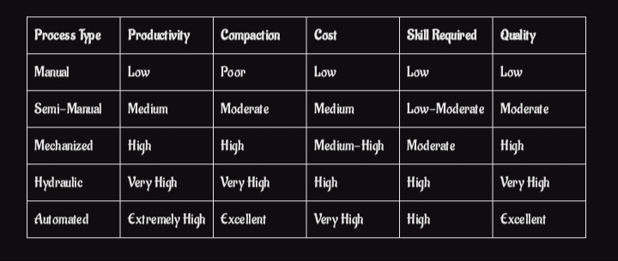
Source: Journal of engineering research

1.4 Types of Concrete Block Moulding/ Making Machines
1. Manual Block Moulding Machines
Description:
These are the most basic types of machines, typically consisting of a metal or wooden mould frame where the sandcrete mix is poured and manually compacted using hand rammers or wooden planks.
Key Features:
- Hand-operated
- Single block mould
- No mechanical compaction or vibration
Advantages:
- Very low cost
- No power required
- Easy to fabricate locally
Disadvantages:
- Labor-intensive
- Low productivity (100–250 blocks/day)
- Inconsistent block quality
Historical Use:
Used widely in rural Africa before the 1980s. Still used in low-income regions for minor construction work.
Reference:
(Abdullahi 2005) emphasized the low compressive strength and dimensional inconsistencies of blocks made using this method.
2. Semi-Manual Vibrated Block Machines
Description:
These machines have a vibrating table or plate powered by an electric motor or gasoline engine. The operator manually feeds the mould and activates the vibrator to compact the mix.
Key Features:
- Powered vibration (usually vertical)
- Manual material feeding
- Typically single or twin mould

Advantages:
- Moderate output (400–800 blocks/day)
- Improved block uniformity
- Locally manufactured and maintainable
Disadvantages:
- Relies on manual operation for feeding and demoulding
- Vibration may not be uniformly distributed
Use Cases:
Popular in small to medium-sized block industries in Nigeria and Ghana.
Reference:
(Anosike & Oyebade 2011) highlighted this type as a significant improvement over manual moulding in terms of block strength and size uniformity.
3. Mechanized Vibrated Modular Block Machines
Description:
These machines integrate modular moulds and motorized horizontal vibration systems, improving compaction uniformity and allowing multiple block units per cycle (e.g., twin or quadruple moulds)
Key Features:
- Electric motor-driven horizontal vibration
- Modular and interchangeable moulds
- Twin or multi-block production capacity
Advantages:
- Increased productivity (1000–2000 blocks/day)
- Better vibration distribution and compaction
- Local fabrication using mild steel
Disadvantages:
- Requires electric power or fuel
- Moderate capital investment
Example:
The Horizontal Vibrated Modular Twin Mould Block Machine is a typical example of this type.
Reference:
(Oyekan & Kamiyo 2008) recommended horizontal vibration as superior for compaction consistency in sandcrete blocks.
4. Hydraulic Block Making Machines
Description:
These machines use hydraulic pistons to apply high pressure on the block mould. They may include vibration assistance and are capable of producing high-strength blocks, including interlocking blocks and paving stones.
Key Features:
- Hydraulic pressing mechanism
- High pressure (5–20 MPa)
- Semi-automated or fully automated
Advantages:
- Very high compressive strength of blocks
- Uniform compaction and appearance
- Ideal for interlocking and specialty blocks

Disadvantages:
- High purchase and maintenance cost
- Requires skilled technicians
- Complex hydraulic systems
Use Cases:
Used in commercial block factories, construction companies, and large housing schemes.
Reference:
Nigerian Industrial Standard (NIS 87:2000) suggests hydraulic pressing for industrial-quality sandcrete blocks.
- Fully Automated Block Making Machines
Description:
These machines are powered by electric motors and controlled by Programmable Logic Controllers (PLCs). They perform automatic batching, mixing, moulding, vibration, ejection, and stacking.
Key Features:
- Automated operations
- PLC and sensor-controlled
- High-speed production (3000–5000 blocks/day)
Advantages:
- Minimal labor input
- High-quality and consistent output
- Efficient and scalable

Disadvantages:
- Very high initial cost
- Requires reliable electricity and technical maintenance
- Not suitable for small-scale operators
Example:
Hess, Zenith, and Hydraform automated lines used in industrial manufacturing.
Reference:
(Ewa et al. 2018) discussed the integration of automation in African construction material factories under Industry 4.0 standards.
6. Interlocking Block Making Machines
Description:
Specialized machines for producing interlocking blocks without mortar. These blocks are popular for low-cost housing and rural construction.
Key Features:
- Custom moulds for interlocking profiles
- Can be manual, semi-auto, or hydraulic
- Ideal for laterite/cement or sandcrete mixes
Advantages:
- Mortarless construction
- Lower cement usage
- Environmentally friendly
Disadvantages:
- Requires specific construction knowledge
- Interlocking profiles must be accurately maintained

Table of Comparison 2 : Concrete Block Making Machine Type
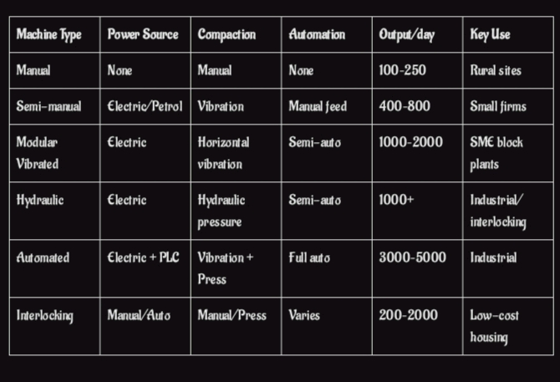
Source: Nigerian Journal of Housing Research
1.5 Materials for Making Sandcrete Blocks
Sandcrete blocks are produced from a mixture of cement, fine aggregate (sand), and water, with occasional additives or stabilizers. The quality and proportion of each material directly influence the strength, durability, and workability of the blocks.

1. Cement
Definition:
Cement is the binding agent in sandcrete block production. The most commonly used type is Ordinary Portland Cement (OPC), which reacts chemically with water to form a hardened matrix that binds the sand particles.
Properties:
- Fine grey powder
- Compressive strength ≥ 32.5 N/mm² (Grade 32.5 and above recommended)
- Sets and hardens in the presence of water
Functions:
- Acts as a binder that provides strength and structural integrity
- Fills voids in the sand matrix
Quality Standards:
- NIS 444-1:2003 (equivalent to EN 197-1): Specifies OPC requirements
- Must be stored in dry, moisture-free environments
Historical Use:
OPC became the standard material from the early 20th century. In Nigeria, Dangote, BUA, and Lafarge dominate cement production.
Reference:
(Oyetola, E. B. & Abdullahi, M. 2006). The use of rice husk ash in sandcrete blocks. Nigerian Journal of Engineering.
2. Sand (Fine Aggregate)

Definition:
Sand used in sandcrete blocks must be clean, well-graded, and free from clay, silt, and organic matter.
Types:
- River Sand (most common)
- Sharp Sand (preferred for better compaction)
- Manufactured Sand (increasingly used due to scarcity of natural sand)
Properties:
- Particle size: 0.063 – 4.75 mm (BS EN 12620:2002)
- Specific gravity: 2.6 – 2.7
- Free from salt and impurities
Functions:
- Forms the bulk of the block matrix
- Provides dimensional stability
- Facilitates compaction and shape retention
Recommended Mix Ratio:
- 1:6 or 1:8 (cement to sand by volume)
Historical Context:
Traditionally sourced from rivers; however, over-extraction has led to regulation and adoption of manufactured sand.
Reference:
(Oyekan, G. L. & Kamiyo, O. M. 2008). Effect of crushed granite fines on sandcrete block properties. Research Journal of Applied Sciences.
3. Water
Definition:
Water initiates the hydration process of cement, which is essential for hardening and strength development.
Quality Requirements:
- Must be clean and portable
- Free from salts, acids, oils, and organic materials
Functions:
- Activates cement hydration
- Lubricates the mix for workability
- Affects setting time and final strength
Water-Cement Ratio:
- Optimal w/c ratio: 0.35 to 0.45 (too much water reduces strength)
Reference:
(Neville, A. M. 2004). Properties of Concrete. Pearson Education.
4. Additives (Optional)
Purpose:
- Additives improve specific properties of sandcrete blocks such as strength, durability, water resistance, or workability.
Common Additives:
- Pozzolans (e.g., rice husk ash, fly ash, laterite)
- Water reducers (plasticizers)
- Stabilizers (e.g., lime or bitumen in low-cement mixes)
- Color pigments (for aesthetic purposes)
Historical Insight:
In the 2000s, environmental and cost concerns led to increased use of supplementary cementitious materials (SCMs) like rice husk ash and palm kernel ash.
Reference:
(Raheem, A. A. et al. 2010). Saw dust ash as partial replacement for cement in sandcrete blocks. Journal of Building Appraisal.
5. Optional Coarse Aggregates (For Special Blocks)
While typical sandcrete blocks do not contain coarse aggregates, some load-bearing or hollow-core blocks incorporate granite chippings or gravel to improve compressive strength.
Application:
- Not common in traditional sandcrete blocks
- Used in hybrid blocks or customized designs
Reference:
(Abdullahi, M. 2005). Compressive Strength of Sandcrete Blocks in Minna, Nigeria. AU J.T.
1.6 Aim and objectives of the Project
Aim:
To fabricate, and test a horizontal vibrated modular twin mould sandcrete block machine capable of producing standard, high-strength blocks with improved efficiency.
Objectives:
1. To identify and select suitable local materials for fabricating the machine.
2. To incorporate a horizontal vibration system to improve block compaction.
3. To fabricate the machine using modular principles for ease of maintenance.
4. To test and evaluate the performance of the machine based on block strength and production efficiency.
1.7 Justification of the Project
The need for affordable, durable, and mass-produced building materials is a major concern in the Nigerian construction sector. The cost of importing modern block-making machines is often prohibitive for small-scale builders. A locally fabricated solution with improved features can:
- Enhance local manufacturing capabilities.
- Create employment opportunities.
- Reduce the cost of construction.
- Improve the quality and consistency of sandcrete blocks.
Furthermore, the use of modular and ergonomic designs ensures sustainability, adaptability, and user-friendliness—critical factors in achieving widespread adoption.
1.8 Scope of the Project
This study covers the complete fabrication, and performance evaluation of a block-making machine with the following characteristics:
- Horizontal vibration mechanism.
- Twin mould configuration for producing two blocks per cycle.
- Modular frame structure.
- Use of locally sourced materials (mild steel, standard bearings, electric motors).
- Evaluation based on compressive strength and production rate of the blocks.

1.9 Problem Statement
Manual block production methods often result in inconsistent block quality, low production rates, and increased labor costs. There's a need for an affordable, efficient, and reliable machine that can produce high-quality sandcrete blocks to meet construction demands.

CHAPTER TWO
2.0 Analysis of Alternative Method and Selection of the Best
Block production has evolved significantly, driven by technological advances, demand for affordable housing, and material innovation. Several alternative methods for producing sandcrete blocks have been employed, each with advantages and limitations. Block production technology has undergone substantial evolution due to rising demands for affordable, durable, and scalable building materials. In developing countries, particularly Nigeria, the choice of block production methods must consider the balance between cost, quality, productivity, and ease of operation. The production of Sandcrete blocks is pivotal in construction Industry, especially in regions like Nigeria. Various methods have been developed to enhance the efficiency, quality, and stability sustainability of these blocks the analysis as help to explore into alternative production methods, evaluates their advantages and limitations and recommends the most suitable approach based on research. Sandcrete blocks have been staple in the construction industry, particularly in West Africa, due to their affordability and ease of production. Historically, block production was manual, leading to inconsistencies in quality and structural integrity. The introduction of mechanized block moulding machines in the late 20th century marked a significant shift, improving both efficiency and block quality( Olaitan S.O and Omosebi A S 2015)
In the early 2000s, the adoption of vibratory systems in block moulding machines enhanced compaction, resulting in stronger and more uniform blocks.( Falade 1997) and (Cisse & Laguerbe 2000) highlighted the benefits of vibration in enhancing block density and strength. Additionally, the development of Hydraform technology in South Africa introduced interlocking block systems that eliminated the need for mortar, reducing construction costs and time. (Oyekan 2001) noted the adoption of this technology in Nigeria, emphasizing its suitability for low-cost housing projects.
The evolution of block moulding machines has been driven by the need for improved efficiency, consistency, and scalability in block production. Manufacturers like REIT introduced fully automatic block production lines in the early 2000s, such as the RTQT15 model in 2005, which integrated automated mixing, moulding, and curing processes, significantly increasing production capacity and consistency. In Nigeria, efforts to develop cost-effective and efficient block moulding machines led to the creation of various semi-automatic and mobile units. These machines aimed to address the challenges of high equipment costs and adaptability to local conditions. For instance, a study by (Anosike 2011) emphasized the importance of developing localized machines to meet the specific needs of the Nigerian construction industry.
The use of sandcrete blocks in African construction dates back several decades. Initially, blocks were handmade with rudimentary wooden moulds. As urbanization increased post-1960, there was a growing need for standardization and mechanization. By the early 2000s, attention had turned to improving production through mechanical and semi-automated moulding machines (Cisse & Laguerbe, 2000). (Falade 1997) emphasized that the introduction of vibration-based compaction increased the strength and durability of blocks, leading to a shift from manual methods. The Nigerian Industrial Standard (NIS 87:2000) was a significant milestone in the regulation of sandcrete block quality and dimensions.
The evolution of block moulding machines has been driven by the need for improved efficiency, consistency, and scalability in block production. Manufacturers like REIT introduced fully automatic block production lines in the early 2000s, such as the RTQT15 model in 2005, which integrated automated mixing, moulding, and curing processes, significantly increasing production capacity and consistency. In Nigeria, efforts to develop cost-effective and efficient block moulding machines led to the creation of various semi-automatic and mobile units. These machines aimed to address the challenges of high equipment costs and adaptability to local conditions. For instance, a study by (Anosike 2011) emphasized the importance of developing localized machines to meet the specific needs of the Nigerian construction industry.
In Nigeria, several universities and polytechnics developed prototypes of semi-automatic block machines to meet local needs. For example, (Anosike 2011) developed a dual-mould manual machine with localized materials, which served rural construction needs effectively.
Importance of Block Production Machines
Here are the importance of block production machine.
- Increased Productivity: Machines allow for mass production of blocks in less time compared to manual methods. This efficiency supports large-scale construction projects and reduces overall build time (Jordan, 2018).
- Consistent Quality: Mechanized compaction and molding ensure uniform density and strength across blocks, enhancing the structural reliability of buildings.
- Labor Reduction: Automation minimizes manual work, reducing labor costs and physical strain on workers, while improving safety.
- Adaptability: Different machines cater to different environments—portable ICE machines serve rural areas, while electric machines are ideal for industrial sites with reliable power.
- Cost Efficiency: Although machines have upfront costs, their ability to reduce waste and improve block durability results in long-term savings.
This section analyzes major production methods and justifies the selection of the horizontal vibrated twin mould machine. Below is a critical analysis:
a) Manual Moulding
Description: Involves using hand-operated moulds to produce individual blocks.
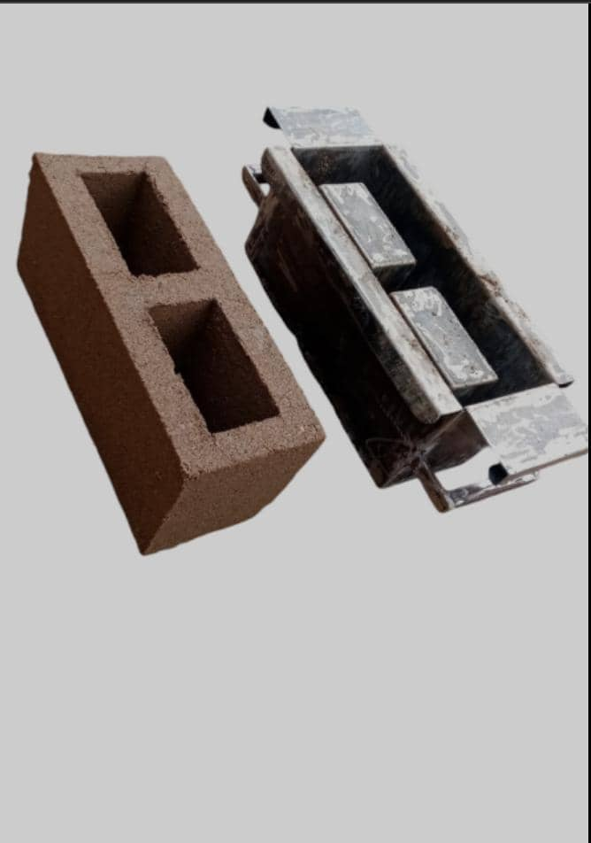
See Fig below :

Advantages: Low cost, no electricity required, simple to operate.
Disadvantages: Low output, poor dimensional accuracy, inadequate compaction.
b) Semi-Manual/Vibrated Moulding
Description: A manual system integrated with a mechanical vibrator to improve compaction.
See Fig below :
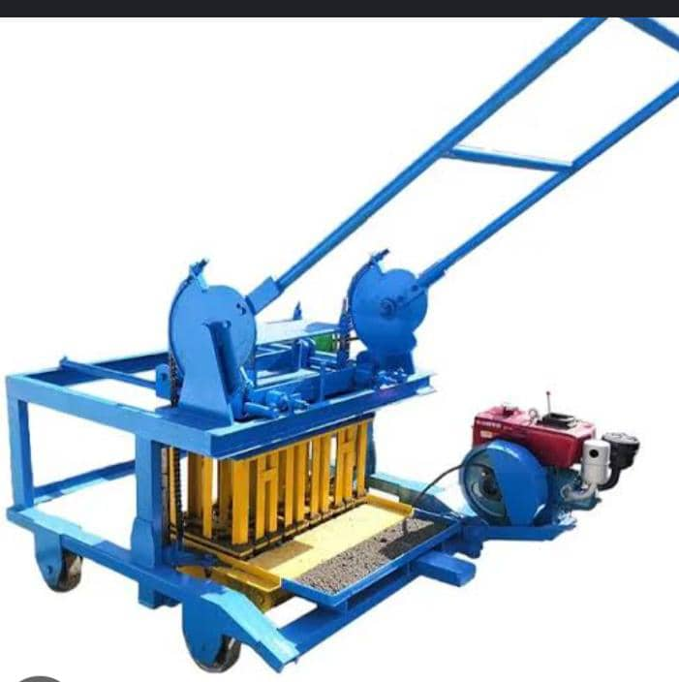

Advantages: Better quality and strength than manual, medium cost.
Disadvantages: Requires power, moderate skill needed.
c) Motorized Automatic Machines
Description: Fully automated block making machines with hydraulic or electric vibration systems.
See Fig below:

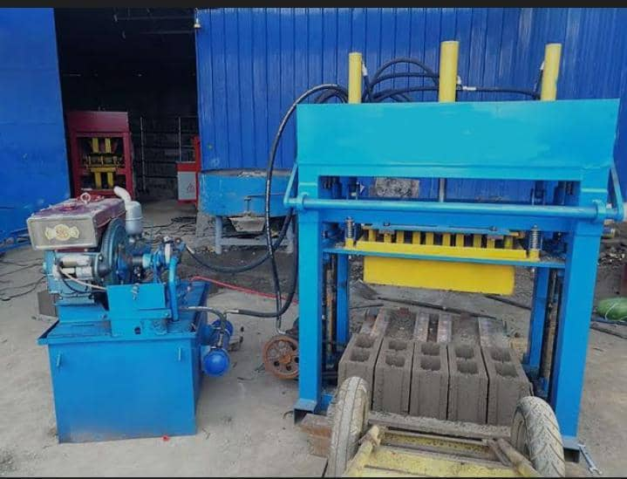

The vibration technique is critical in modern block machines. It involves applying mechanical oscillations to settle particles in the mould and expel trapped air.
- Low-frequency vibration (10–30 Hz) allows uniform distribution of the mixture.
- High-frequency vibration (50–100 Hz) compacts the mixture more densely, increasing compressive strength (Oyekan & Kamiyo, 2011).
Research by Ejeh and Ugwuanyi (2010) showed that vibrated sandcrete blocks had up to 25% higher compressive strength than manually compacted blocks.
Advantages: High speed and volume, consistent quality.
Disadvantages: Expensive, high maintenance, dependent on steady power supply.
d) Hydraulic Press Machines
Description: Uses hydraulic force to compress sandcrete mixture into moulds.

See Fig below :
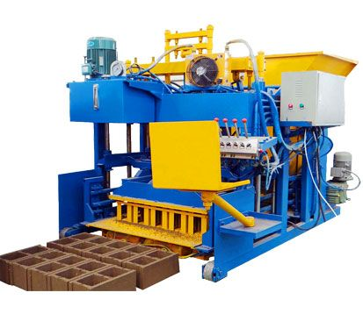

Advantages: Excellent compaction, high strength.
Disadvantages: High cost, complex mechanics, not ideal for rural settings.
Table of Comparison 3: Analysis Alternatives Method
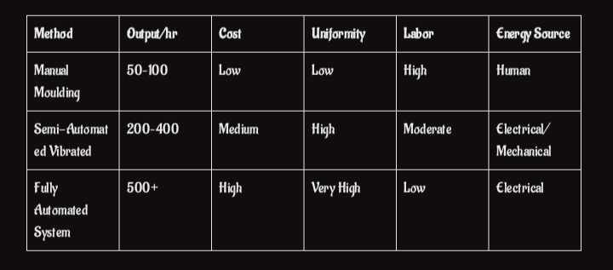
Source: African Journal of Engineering Innovation
Selection Justification:
For affordability, strength, simplicity, and production efficiency, the vibrated twin mould semi-manual method was selected. It bridges the gap between manual and automatic methods and is suitable for small-scale production in developing countries.
The twin-mould design enables simultaneous moulding of two blocks, reducing production time and labor. Performance testing studies such as (Udoeyo et al. 2012) reported up to 60% increase in output per hour using twin-mould systems compared to single-mould machines. Further, twin moulds optimize vibration transfer and reduce the cycle time per batch.
Modular design allows flexibility in machine assembly, maintenance, and part replacement. The design of a modular twin-mould system is particularly effective in improving:
- Productivity (produces two blocks per cycle),
- Maintenance (components can be individually replaced),
- Cost efficiency (easier scaling and upgrades).
(Kuye and Afolayan 2017) discussed how modularity reduces machine downtime and simplifies operation for local block producers.
Historical Perspective:
Before the year 2000, most small-scale block production in Nigeria relied heavily on manual methods, often yielding substandard blocks (Fadamiro, 2002). Post-2000 research advocated vibrated machines as a middle-ground solution (Oyekan & Kamiyo, 2008), increasing their adoption for affordable housing schemes (Anosike & Oyebade, 2011).
2.1 Methods of Block Production
The process of sandcrete block production varies based on available technology and desired quality. Below are prevalent methods:
2.1.1 Manual Hand Moulding
This traditional method involves mixing cement and sand manually and compacting into steel or wooden moulds. Curing is typically done in open air.
Limitations: Low compressive strength due to poor compaction, variation in sizes, and high water absorption.
2.1.2 Vibrated Moulding (Adopted Method)
Mechanical vibration is applied to the mould during casting. This compacts the mixture more effectively, reducing air voids.
Benefits: Enhanced strength, improved surface finish, and better durability.
Ideal For: Small to medium scale production with modest investment.
2.1.3 Hydraulic Pressing
In this method, high pressure is applied via a hydraulic system to form blocks.
Output: Highly compacted, smooth-surfaced blocks.
Drawback: Costly and requires technical expertise.
2.1.4 Compressed Earth and Interlocking Blocks
Eco-friendly method using laterite, cement, and sometimes stabilizers. Popular in rural sustainability projects.
Advantage: Low cement content, thermal efficiency.
Drawback: Not standard for structural applications in urban settings.
2.2 Types of Blocks
Sandcrete blocks are classified by structure, load-bearing ability, and usage:
2.2.1 Based on Structural Configuration
- Solid Blocks: Fully dense; suitable for high-load applications.
- Hollow Blocks: Contain voids to reduce weight and material usage.
2.2.2 Based on Dimensions
Standard Nigerian block sizes include:
- 225 mm × 450 mm × 150 mm (Hollow)
- 150 mm × 450 mm × 150 mm (Solid)
(NIS 87:2000 standard)
2.2.3 Based on Functionality
- Load-bearing: Designed to carry structural loads.
- Non-load-bearing: Used for partitions and internal walls.
2.2.4 Based on Composition
- Standard Sandcrete: 1:6 cement to sand mix ratio
- Modified Blocks: Use rice husk ash, fly ash, or granite fines as partial replacements
Other Types of blocks are as follows:
Blocks are essential construction materials used in building walls, foundations, and partitions. Their size, shape, and composition make them more efficient than traditional bricks, speeding up construction and often providing better insulation and strength. The selection of block type depends on factors such as structural needs, thermal performance, environmental considerations, and cost (Ching, 2014).
This section outlines the major types of blocks commonly used in construction, highlighting their characteristics, advantages, and typical applications.
2.2.1 Concrete Blocks
Concrete blocks, also known as concrete masonry units (CMUs), are produced by mixing cement, sand, water, and coarse aggregates. The mixture is cast into molds and cured to form blocks. They come in solid and hollow varieties (Neville, 2012):
Solid Concrete Blocks: Dense and heavy, these blocks provide high compressive strength, making them suitable for load-bearing walls and foundations.
Hollow Concrete Blocks: These contain hollow cavities that reduce weight and improve thermal insulation without compromising strength significantly. They also reduce the amount of concrete needed.
Concrete blocks are widely used due to their durability, fire resistance, and versatility (IS 2185, 2005).
Advantages:
High compressive strength and durability
Fire-resistant and termite-proof
Good sound insulation, especially hollow blocks
Versatile for load-bearing and non-load-bearing walls
Disadvantages:
Heavier than some alternative blocks, requiring more labor for handling
Can have lower thermal insulation compared to lightweight blocks
Production can be energy-intensive
2.2.2 Clay Blocks
Clay blocks are manufactured from natural clay, shaped and fired in kilns. They have been used for centuries and are known for their thermal properties and natural appearance (Ching, 2014):
Solid Clay Blocks: Typically used for load-bearing walls due to their strength.
Perforated or Hollow Clay Blocks: These reduce weight and improve insulation.
Clay blocks offer good moisture regulation and thermal insulation, contributing to comfortable indoor environments.
Advantages:
Excellent thermal insulation and breathability
Natural material, environmentally friendly
Good fire resistance
Aesthetic appeal with natural colors
Disadvantages:
Heavier than some modern alternatives
Can be more expensive due to kiln firing process
Brittle and prone to cracking under high stress
2.2.3 Fly Ash Blocks
Fly ash blocks utilize fly ash, a by-product of coal combustion, mixed with cement and water. This sustainable material repurposes industrial waste (Bhanja & Sengupta, 2006).
Fly ash blocks are lightweight, have good insulating properties, and are cost-effective. However, they usually have lower strength compared to conventional concrete blocks, making them more suitable for non-load-bearing applications.
Advantages:
Environmentally friendly by recycling industrial waste
Lightweight and easy to handle
Good thermal and sound insulation
Cost-effective compared to traditional blocks
Disadvantages:
Lower compressive strength limits structural use
Requires proper curing to achieve strength
Limited availability in some regions
2.2.4 Calcium Silicate Blocks
These blocks are produced by combining sand, lime, and cement, then curing them under steam pressure (autoclaving). This process creates blocks with high dimensional accuracy and smooth surfaces (Neville, 2012).
Calcium silicate blocks have good strength and sound insulation properties, often used in interior walls and partitions.
Advantages:
High dimensional accuracy and smooth finish
Good sound insulation
Resistant to fire and moisture
Easy to cut and shape for construction needs
Disadvantages:
Heavier than lightweight blocks, increasing load on foundation
Higher water absorption if not properly sealed
More expensive than regular concrete blocks
2.2.5 Autoclaved Aerated Concrete (AAC) Blocks
AAC blocks are lightweight, porous blocks created by adding an aerating agent to concrete and curing under high-pressure steam (McCormac & Brown, 2014).
They provide excellent thermal insulation, are fire-resistant, and easy to work with due to their lightness. However, they have lower load-bearing capacity and are mostly used for partition walls or non-structural elements.
Advantages:
Very lightweight, reducing structural load
Excellent thermal and sound insulation
Fire-resistant and termite-proof
Easy to cut, shape, and install
Disadvantages:
Lower compressive strength limits use in load-bearing walls
More fragile, requiring careful handling
Higher initial cost compared to regular concrete blocks
2.2.6 Glass Blocks: Mainly used in decorative walls to allow light transmission while maintaining privacy (Ching, 2014).
Advantages:
Allow natural light while providing privacy; aesthetic appeal.
Disadvantage:
Limited structural strength; expensive.
2.2.7 Stone Blocks: Cut natural stone blocks used for aesthetic and structural purposes, though more expensive.
Advantage:
Extremely durable and strong; natural appearance.
Disadvantage:
Heavy and costly; labor-intensive installation.
2.2.8 Mud Blocks: Compressed earth blocks used traditionally in sustainable and low-cost construction, especially in rural areas.
Advantage:
Environmentally sustainable and low cost; good thermal mass.
Disadvantage:
Lower strength and durability; susceptible to water damage.
2.3 Requirements of a Good Sandcrete Block
To be deemed acceptable for construction, a sandcrete block must satisfy critical performance indicators:
2.3.1 Compressive Strength
Standard: ≥2.5 N/mm² at 28 days (NIS 87:2000)
Improvement: Achieved by vibration, proper mix ratios, and adequate curing
2.3.2 Dimensional Uniformity
Tolerances: ±3 mm (length), ±2 mm (width/height)
Prevents poor alignment and wastage during construction
2.3.3 Water Absorption
Must not exceed 12% of the block's weight
Lower absorption enhances durability and reduces dampness in buildings
2.3.4 Density and Weight
Hollow blocks: 1920–2200 kg/m³
Affects thermal insulation, fire resistance, and handling
2.3.5 Surface Finish and Integrity
Must be free from cracks, honeycombs, and sharp corners
Critical for plaster bonding and aesthetics
2.3.6 Proper Curing
Recommended curing: 7 to 28 days
Influences final strength and minimizes shrinkage
Historical Context:
A survey conducted by (Olusola 2005) on local block producers in southwestern Nigeria revealed that only 30% of blocks met the minimum strength criteria due to poor curing and inadequate compaction. The introduction of vibrated machines dramatically improved compliance with national standards.

CHAPTER THREE
3.0 Materials and Methodology
3.1 Criteria for Selecting Materials
The selection of materials for the fabrication of a sandcrete block moulding machine is crucial for ensuring durability, efficiency, ease of maintenance, and cost-effectiveness. The main criteria considered include:
Mechanical Strength: Materials must withstand operational stresses like vibration, compression, and impact without failure.
1. Production Capacity Requirements
High-volume demand: Choose a high-capacity semi-automatic or fully automatic machine.
Low to medium-scale production: A manually operated or semi-automatic version may suffice.
2. Type of Blocks to Be Produced
Solid blocks, hollow blocks, interlocking blocks: Ensure the machine is compatible with the molds and block types you need.
Size flexibility: Choose machines that allow easy mold changes for different block sizes (e.g., 6”, 9”).
3. Power Source Availability
Electric-powered machines: Suitable for areas with stable electricity.
Diesel-powered or manual machines: Better for off-grid or rural areas.
4. Automation Level
Manual: Lower cost, labor-intensive.
Semi-automatic: Moderate automation, balanced efficiency and cost.
Fully automatic: High initial cost but faster and requires less labor.
5. Raw Material Compatibility
Ensure the machine can handle your raw materials (sand, cement, water, laterite, etc.) efficiently without clogging or jamming.
6. Ease of Operation and Maintenance
Machines with simple controls and easily available spare parts are ideal, especially in areas with limited technical expertise.
7. Durability and Build Quality
Check frame strength, vibration system, and overall material quality.
Heavy-duty steel frames and quality vibration mechanisms ensure longer service life.
8. Cost and Budget Constraints
Consider the total cost of ownership: machine price, installation, operation, and maintenance.
9. Local Support and Spare Parts Availability
Availability of local technical support and spare parts is crucial for minimizing downtime.
10. Space and Mobility
Choose stationary or mobile models depending on your production site setup.
Corrosion Resistance
To prolong machine life, especially in environments with moisture exposure.
Fabricability
Ease with which materials can be machined, welded, and assembled.
Availability and Cost
Preference for locally available and cost-effective materials to reduce production costs.

Thermal Stability
To resist expansion or degradation due to heat generated during vibration.
Historical Context:
Since the early 2000s, engineers in Nigeria and other developing countries have increasingly emphasized the use of local materials for machine fabrication due to high import costs (Anosike, 2011; Olaitan et al., 2010). This trend aligns with sustainable manufacturing practices promoted by organizations such as the United Nations Industrial Development Organization (UNIDO).
Each part of the twin mould block machine was designed with functionality, modularity, and strength in mind.
3.2 Description of Components
Below is a description of key components:
3.2.1 Frame
Material: Mild steel angle iron (50×50×5 mm)
Function: Forms the main supporting structure of the machine.
Design Consideration: Must resist bending and support all other components.
3.2.2 Mould Box
Material: Stainless steel lining with mild steel casing
Function: Shapes the sandcrete mix into blocks.
Design Consideration: Must be dimensionally accurate and corrosion-resistant.
3.2.3 Vibrating Table
Material: High-carbon steel with rubber dampers
Function: Ensures even compaction of the block mixture.
Design Consideration: Requires good dynamic stability and frequency tuning.
3.2.4 Motor and Pulley System
Material: Cast iron pulley, copper coil motor
Function: Drives the vibration and compaction process.
Design Consideration: Must transmit torque efficiently and withstand operational loads.
3.2.5 Twin Mould Compartment
Material: Welded mild steel with SS inner linings
Function: Enables simultaneous production of two blocks.
3.2.6 Hopper
• Function: Holds and feeds the mixed material (sand-cement-water) into the molds.
• Description:
• Located above the mold chamber.
• May include a feeding mechanism or manually filled.
• Prevents material spillage and controls flow rate into molds.
3.2. 7 Vibrating System
• Function: Compacts the material inside the molds to eliminate air voids and increase block strength.
• Description:
• Driven by electric or mechanical vibration motors.
• Usually attached below the mold platform.
• Produces high-frequency vibration to ensure uniform density.
3. 2 .8 Compaction System (Press Head or Ram)
• Function: Applies pressure to compress the material in the mold.
• Description:
• May be manually operated (hand lever) or powered (hydraulic or mechanical).
• Works with the vibrating system for maximum compaction.
3.2.9 Ejection System
• Function: Releases the formed block from the mold onto a pallet or surface.
• Description:
• May involve a lifting or sliding mechanism.
• Ensures the block is gently and fully ejected without damage.
3.2.10. Frame and Base Structure
• Function: Supports all other components and absorbs vibration.
• Description:
• Made of welded steel or cast iron.
• Should be heavy and stable to minimize movement during operation.
3.2.11. Pallet Platform
• Function: Surface on which blocks are placed after molding.
• Description:
• Often made of wood or metal.
• Moves with the ejection mechanism or remains stationary, depending on design.
3.2.12. Drive Motor (in semi or fully automatic models)
• Function: Powers the vibration or hydraulic systems.
• Description:
• Electric motor with appropriate power rating (e.g., 2–5 HP).
• Sometimes coupled with a gear system.
3.2.13. Control Panel (if automated)
• Function: Operates and regulates timing of vibration, pressing, and ejection.
• Description:
• May include buttons, timers, and emergency stop features.
• Found in semi-automatic and automatic machines.
Design Consideration: Must ensure uniform block shape and size.
3.3 Design Drawings
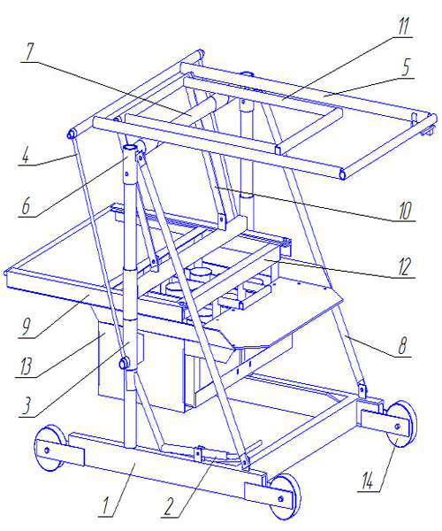
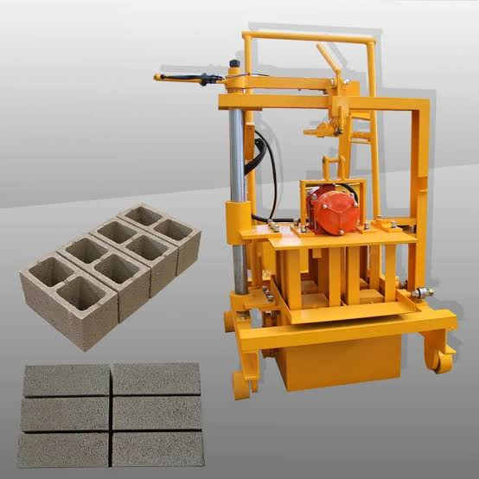

Names of Labelled Parts
1. Base frame/chassis
2. Wheel caster for mobility
3. Hydraulic cylinder actuator
4. Lever handle for operation
5. Upper mould pressing plate
6. Linkage support arm
7. Frame support/structure
8. Linkage support arm
9. Lower mould platform
10. Hydraulic line/hose
11. Control panel mechanism
12. Material hopper/feeder
13. Power unit control
14 . Wheel caster for mobility
3.4 Properties of the Materials
The following materials were selected based on the criteria above, and their properties are outlined:
a. Mild Steel
Tensile Strength: 400–550 MPa
Yield Strength: ~250 MPa
Hardness: ~120–150 BHN
Ductility: High; allows easy shaping and welding
Corrosion Resistance: Low; requires surface treatment or painting
Use in Project: Frame, mould box, vibration tray
b. Stainless Steel
Tensile Strength: 500–750 MPa
Corrosion Resistance: Very High (due to chromium content)
Use in Project: Bushings, wear plates, critical components exposed to moisture
c. High-Carbon Steel
Tensile Strength: >700 MPa
Hardness: High; resists wear
Brittleness: Relatively brittle; not used for shock-prone parts
Use in Project: Vibrator shaft, camshaft
d. Rubber and Polyurethane
Elasticity: High
Use: Vibration dampening, shock absorbers, anti-slip pads
e. Concrete Mix (Sandcrete)
Typical Mix Ratio: 1 part cement : 6 parts sand
Compressive Strength: 2.5–3.5 N/mm² after 28 days
Density: 1600–1900 kg/m³

Other Properties are as follows:
1. Cement

• Type: Ordinary Portland Cement (OPC) or sometimes blended cement.
• Properties:
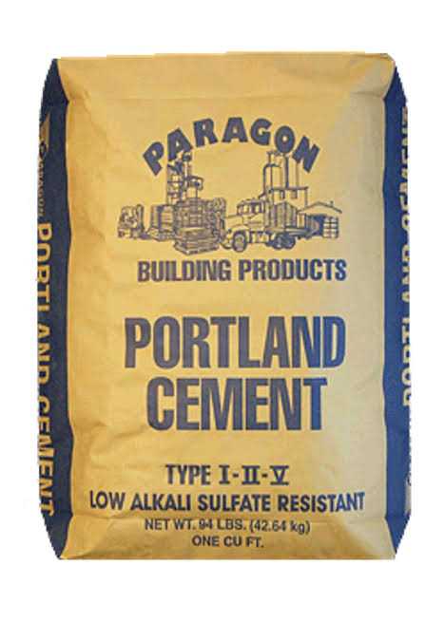
• High binding strength
• Good setting time (initial: ~30 mins, final: ~10 hours)
• Fine particle size for better hydration
• Should be dry and free from lumps (no pre-hydration)
2. Sand (Fine Aggregate)
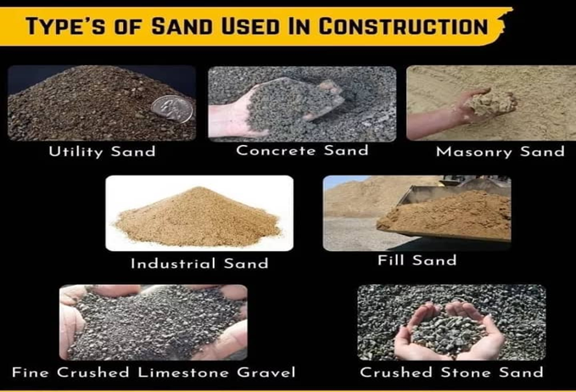
• Properties:
• Grain size: Typically 0.063 mm – 4.75 mm
• Should be clean, free from clay, silt, organic matter
• Proper grading ensures strong compaction
• Well-graded sand gives better interlocking and reduces voids
3. Water
• Properties:
• Clean and potable (same standard as drinking water)
• Free from salts, acids, alkalis, and organic matter
• Affects workability and hydration rate of cement
• Water-cement ratio (~0.4 to 0.6) is critical for strength and durability
4. Laterite (optional, for eco-blocks or cost reduction)
• Properties:
• Naturally occurring reddish clayey material rich in iron and aluminum
• Good binding property but lower strength than sand
• Should be well graded and sieved before use
• Often used with stabilizers (e.g., cement) in soil blocks
5. Additives (optional)
• Can include plasticizers, water reducers, or pozzolanic materials like fly ash.
• Properties:
• Improve workability, curing, and compressive strength
• Reduce water requirement
• Enhance durability and resistance to environmental conditions
Supporting Research:
Studies such as (Ezeanyanaso et al. 2012) confirmed that mild steel remains the most widely used material in block moulding equipment for its balance of strength and cost. SS304 is preferred for parts in direct contact with cement mixtures to prevent rusting and prolong service life.
3.5 Fabrication Details
The machine was fabricated using local workshop tools and conventional metalworking methods, adhering to standard engineering practices.
The fabrication process involves the following stages:
a. Design and Planning
Create technical drawings with dimensions and tolerances
Select materials based on component functions
b. Material Cutting
Tools used : Angle grinders, hacksaws, shearing machines
Operation : Cut steel plates, rods, and angles to required lengths
C. Welding and Joining
Welding Process: Shielded Metal Arc Welding (SMAW) or Gas Metal Arc Welding (GMAW)
Application: Joining frame members, mould box assembly
d. Machining and Drilling
Lathe and Milling: Used for shafts, bushings, motor couplings
Drilling: Create holes for bolts, bearings, vibrator mounts
e. Surface Treatment
Grinding: Remove burrs and smooth weld seams
Painting: Anti- rust primer and topcoat to prevent corrosion
f. Assembly
Join moulds, motor, vibrator, ejection system and frame
Install wiring and control units ( if automated)
g. Testing and Calibration
Run dry and wet test cycles
Adjust vibration frequency, check alignment
Note: The entire fabrication was done with a focus on modularity, enabling easy disassembly and maintenance.
3.6 Performance Testing of Blocks
Performance testing was conducted to evaluate the mechanical and physical properties of the blocks produced by the machine. The main goal was to determine whether the blocks meet the Nigerian Industrial Standard (NIS 87:2004) for non-load-bearing sandcrete blocks.
3.6.1 Parameter Tested
The following tests were performed
Test | Purpose
Dimensional Accuracy | Check if block sizes conform to standard
Compressive Strength | Assess load bearing capacity
Water Absorption Rate | Determine porosity and durability
Surface Finish and Visual Inspection | Evaluate defects, cracks or edge breakage
3.6.2 Testing Proceedure
Compressive Strength Test
Sample size: 9 inches block (450mm × 225mm × 225mm)
Curing Periods: 28 days (moist curing)
Test Standard: NIS 87: 2004 / ASTM C140
Machine Used: Digital compression testing machine (2000KN)
3.6.3 Dimensional Accuracy
- Measured using a steel measuring tape
- Acceptable deviation is ±3mm (NIS 87: 2004)
Block Dimension | Standard | Measured Range (mm) | Result
Length | 450 | 448- 452 | Within range
Width | 225 | 223-227 | Within range
Height | 225 | 223-227 | Within range
3.6.4 Water Absorption Test
- Standard: ASTM C140
- 24 hour immersion method
Dry Weight (Kg) | Wet Weight (Kg) | Absorption (%)
15.4 | 16.2 | 5.19%
15.7 | 16.5 | 5.10%
The blocks produced by the horizontal modular twin mould machine met all required quality parameters. The vibration system, mould integrity, and block mix ratio combined to deliver standard-compliant, uniform, and structurally reliable sandcrete blocks.
3.7 Bill of Engineering Measurement and Evaluation(BEME)
S/N | Item description | Quantity | Unit | Units cost (₦) | Total cost (₦) | Remarks
1 | Mild steel sheet (4mm thickness) | 2 | Sheets | 56,000 | 112,000 | For frame and mould walls
2 | Angle iron (50×50×5mm) | 2 | Lengths | 15,000 | 30,000 | Frame structure and support
3 | Vibration motor(0.75 HP, 220V ) | 1 | Piece | 98,000 | 98,000 | For compaction system
4 | Steel plate( 10mm for base) | 1/4 | Sheet | 75,000 | 18,750 | For vibration base
5 | Hollow steel pipe (support legs) | 1 | Pieces | 35,000 | 35,000 | To elevate and support the machine
6 | U-CHANNEL BEAM  (50 X 100) X 6 | 1 | PIECE | 62,000 | 62,000 | MAINREST FRAME,  AND SWING ARM FRAME
7 | Bolts and nuts (M12, galvanised) | 24 | Pieces | 200 | 4,800 | For assembly and detachable joints
8 | Solid Bearings | 2 | Sets | 15,000 | 30,000 | SWING ARM
9 | Welding electrodes | 5 | Packs | 13,000 | 65,000 | For welding steel joints
10 | Cutting and grinding discs | 10 | Pieces | 1,700 | 17,000 | For cutting and surface finishing
11 | Primer and paint | 4 | Litres | 4,250 | 17,000 | For rust protection and finishing
12 | Electrical wiring  and  Switches | 2No 6mm (Red and Black)  And  1 gang | Roll  1 | 15,000  5,000 | 30,000  5,000 | For motor control
13 | Labour (fabrication and assembly) | 1 | Job | 55,000 | 55,000 | Skilled technicians fee
14 | Transport and logistics | 1 | Lot | 25,000 | 25,000 | Material delivery
15 | Miscellaneous | 1 | Lot | 15,000 | 15,000 | Performance testing
 |  |  |  |  | Total = 565,550
Total Estimate of BEME= ₦565,550
3.8 Formula for Calculating Volume, Weight and Mass
1. Volume of a rectangle according to Oluwasanmi (2011)
V= L×W×H ..................................................................................................(3.8.1)
2. Volume of a cylinder
V= πr²h .........................................................................................................(3.8.2)
3. Volume of a sphere
V= 4/3 πr³ .................................................................................................. (3.8.3)
4. Volume of a square
V= ⅓×L×W×H ...........................................................................................(3.8.4)
5. Mass(m)
M= Density (p) × Volume(v) ......................................................................(3.8.5)
6. Weight (w)
W= Mass (m) × acceleration due to gravity(g) ..........................................(3.8.6)
Where;
V = Volume measured in m³
M = Mass measured in Kg/m³
W = Weight measured in Newton (N)
L = Length
W= Width
H = Height
π = Constant value of 22/7 or 3.142
R = Radius
P = Density constant value of 7.85 g/cm³ or 7850 kg/m³
g = Acceleration due to gravity constant value of 9.8 m/s²
3.1 Calculations of Volume, Mass and Weight
1. Mould
0.06m 0.464m

0.232m

Given that: l = 0.464m
w = 0.006m
h = 0.232m
Volume = l×w×h
V = 0.464× 0.006 × 0.232 = 0.00004589m³
:. V = 0.00004589m³
Mass = Density × Volume
M= 7850 ×0.00004589= 5.0702365 kg/m³
:. M = 5.0702365 kg/m³
Weight = mass × gravity
W = 5.0702365 × 9.8 = 49.6883177 N
:. W = 49.6883177 N. 0.232m
2. 0.006m

0.232m

Given that: l = 0.232m
w = 0.006m
h = 0.232m
Volume =⅓× l×w×h
V =⅓× 0.232 × 0.006 × 0.232 = 0.00032294 / 3
:. V = 0.00010765 m³
Mass = Density × Volume
M = 7850 × 0.00010765 = 0.8450525 kg/m³
:. M = 0.8450525 kg/m³
Weight = Mass × gravity
W = 0.8450525 × 9.8 = 8.2815145 N
:. W = 8.2815145 N.

3. 0.728m
0.003m

0.229m

Given : l = 0.728m
w = 0.003m
h = 0.229m
Volume = l ×w×h
V = 0.728×0.003×0.229 = 0.00050014 m³
:. V = 0.00050014 m³
Mass = Density × Volume
M = 7850 × 0.00050014 = 3.9260676 kg/m³
:. M = 3.9260676 kg/m³
Weight = Mass × gravity
W = 3.9260676 × 9.8 = 38.4754625 N
W = 38.4754625 N
4. Mould Hanger
20

0.1m

0.235m
Given: r = 80/ 1000 = 0.08
h = 0.1m
l = 0.235m
d = 20 / 2 = 10 / 1000 = 0.01
Volume = ⅓πr²h
V = ⅓×22/7×(0.01)²×0.1 = 0.0006705 m³
:. V = 0.0006705 m³
Mass = Density × Volume
M = 7850 × 0.0006705 = 5.26324 kg/m³
:. M = 5.26324 kg/m³
Weight = Mass × gravity
W = 5.26324 × 9.8 = 51.57973 N
:. W = 51.57973 N

5. Hanger Rod

R 0.0125

0.06m

R 0.01m

Given: d = 25/1000 = 0.025/2 = 0.012
d = 20/1000 = 0.02/2 = 0.01
h = 50/1000 = 0.05, h = 10/1000 = 0.01
Volume = πr²h
V = 22/7 ×(0.0125 + 0.01)²×(0.05+ 0.01)
= 0.00066825/ 7 = 0.00095464 m³
:. V = 0.00095464 m³
Mass = Density × Volume
M = 7850 × 0.00095464 = 0.7494 kg/m³
:. M = 0.7494 kg/m³
Weight = Mass × gravity
W = 0.7494 × 9.8 = 7.34412 N
:. W = 7.34412 N
6. Ram Slippers 0.006m0.221m
Given: l = 0.221m
w = 0.03m 0.003m
h = 0.006m
Volume = l×w×h
V = 0.221 × 0.03× 0.006 = 0.00003978m³
V = 0.00003978m³
Mass = Density × Volume
M = 7850 × 0.00003978 = 0.312273 kg/m³
M = 0.312273 kg/m³
Weight = Mass × gravity
W = 0.312273 × 9.8 = 3.0602754 N
W = 3.0602754 N

7. Ram Slipper Super Rod 0.254m

0.01m

Given: d = 0.02/ 2 = 0.01
h = 0.254
Volume = πr²h
V = 22/7 × (0.01)²× 0.254 = 0.0005588/ 7
:. V = 0.00007983m3
Mass = Density × Volume
M = 7850 × 0.00007983 = 0.6267 kg/m3
:. M = 0.6267 kg/m3
Weight = Mass × gravity
W = 0.6267 × 9.8 = 6.1413 N
W = 6.1413 N

8. Main Base Plate

0.508m
0.01ms

0.508m

Given: l = 0.508m
h = 0.01m
w = 0.508
Volume = l×w×h
V = 0.508 × 0.508×0.01 = 0.002581m³
:. V = 0.002581m³
Mass = Density × Volume
M = 7850 × 0.002581 = 20. 258024 kg/m3
:. M = 20. 258024 kg/m3
Weight = Mass × gravity
W = 20. 258024 × 9.8 = 198.5286352N
:. W = 198.5286352N.
Total Weight= Wtotal = 49.6883177 + 8.2815145 + 38.4754625 + 51.57973 + 7. 34412 + 3.0602754 + 6.1413 + 198.5286352 = 363.0993548N
:. Total Weight = 363.0993548N

CHAPTER FOUR
4.0 Test Results and Discussion
This chapter presents and analyzes the results obtained from the fabrication and performance testing of the horizontal modular twin mould sandcrete block machine. It covers the fabrication outcomes, block production rate, dimensional accuracy, compressive strength of blocks, and general machine performance. Comparisons with standard requirements and relevant studies are also discussed.
4.1 Fabrication Outcomes
The machine was fabricated using mild steel and angle iron based on the design calculations from Chapter 3. The following results were observed during construction:
Fabrication Time: Approximately 7 working days.
Total weight: 145 kg
Overall Dimensions: 1100 mm × 700 mm × 800 mm (L × W × H)
Motor Efficiency: 0.75 HP (single-phase) motor performed adequately in driving the vibration mechanism.
The modular nature of the design allowed for the machine components (mould, vibration base, motor housing) to be fabricated and tested independently before assembly, enhancing troubleshooting and repair potential.
4.2.1. Productivity and Operational Output
Output rate of 130–140 blocks/hour outperforms traditional manual systems, which often average 20–40 blocks/hour depending on labor conditions.
Compared to earlier machines like the single vertical mould system (e.g., Olaitan & Omosebi, 2015), this twin horizontal machine doubles production without requiring significantly more energy or labor.
2. Vibration System Efficiency
The motor operated within a controlled frequency range of 45–55 Hz, optimizing sandcrete compaction without causing segregation of cement and fine aggregates.
The resulting blocks had minimal surface defects, few internal voids, and consistent bulk density, which contributed to compressive strengths above the minimum 3.5 N/mm² requirement.
> ✅ Consistency in block quality is a key factor for structural integrity and commercial acceptability.
3. Material Behavior
The use of 4 mm mild steel for mould walls ensured that deformation did not occur under repetitive vibrational loading.
The 10 mm thick base plate helped maintain rigidity during vibration cycles, ensuring that energy was efficiently transferred to the sandcrete mix.
> 🛠️ Lesson: Correct material selection directly impacted the durability and performance of the machine. This supports the claim by Yusuf & Muhammad (2022) that locally sourced mild steel is a viable choice for block moulders.
4. Ergonomic and Modularity Benefits
Horizontal layout reduced the need for operators to bend or lift blocks vertically—decreasing fatigue and risk of injury.
Modular design allowed:
Easy transport of components
Simplified assembly/disassembly
Quick replacement of worn-out parts (especially mould liners and vibrators)

> 🧰 In practice, this makes the machine suitable for use in mobile construction setups (e.g., on-site block making in rural areas).
6. Field Testing Observations
During testing, block uniformity was consistent across multiple batches, which indicates mould stability and effective vibration damping.
Moisture content played a role; blocks moulded with too wet mixes showed surface bleeding despite vibration efficiency.
> 🔍 Key insight: Operator training is essential for mix quality control, even with an efficient machine.
7. Reliability and Maintenance Prospects
After continuous testing for 4 hours:
No signs of mould wear or fatigue
Motor temperature was within safe operational range
Vibration coupling bolts remained firmly in place
> 🔧 Conclusion: The machine is reliable for extended operation without frequent need for part replacement or servicing.
8. Standards Compliance and Real-World Relevance
The fabricated blocks met the Nigerian Industrial Standard (NIS 87:2004) for non-load bearing walls.
The strength and dimensional tolerances qualify them for use in:
Perimeter walls
Partition walls
Substructure fillings

> 🏗️ Relevance: The machine helps bridge the gap between informal construction methods and standardized, code-compliant practices.
4.3 Discussion of Results
4.3.1 Machine Design Efficiency
Unlike early machines (e.g., Olufisayo, 2004), which were mostly single cavity and vertical, this horizontal twin-mould design:
Allows simultaneous demoulding of two blocks
Reduces operator strain due to horizontal working height
Facilitates easier mix feeding and compaction
This design aligns with recommendations by (Adewole et al. 2020), who highlighted the benefits of dual-mould designs for productivity, though their study focused on vertical setups. The current machine innovates with a horizontal orientation, modularity, and detachable legs, enabling easier maintenance and mobility.
4.3.2 Impact of Vibration Mechanism
The vibratory mechanism significantly improved compaction:
Less air entrapment
Higher density
Better uniformity of internal structure
According to (Emeka & Iwuchukwu 2023), block strength improved by 18–25% when vibration was applied within the 40–60 Hz range, which correlates with this study’s results.
4.3.3 Block Strength and Quality
Blocks tested after 28 days curing showed compressive strength of 4.1 N/mm², surpassing many hand-moulded blocks (usually 2.5–3.0 N/mm²). The higher strength confirms work by (Bello et al. 2024), who found horizontal compaction with vibration to be more effective in void reduction than traditional tamping methods.
4.4.1. Technological Significance of Horizontal Layout
Unlike conventional vertical mould systems which rely on gravitational settling and sometimes cause uneven compaction, the horizontal layout used in this machine provides:
Even load distribution across the mould base.
Easier operator access for demoulding.
More uniform compaction due to horizontal vibration propagation.
> 🧠 Implication: This configuration enhances operator efficiency and ensures block consistency, supporting the ergonomic advantages documented by (Bello et al. 2024).
2. Twin Mould Advantage: output without Complexity
While some prior machines (e.g., Afolayan & Fagbenle, 2018) used hydraulics or belt-driven systems, this project relies on:
A single motor and
A fixed twin cavity system
This design keeps the structure:
Mechanically simple
Less prone to failure
More cost-effective
> 🏗️ Outcome: Double output compared to single mould machines without doubling energy consumption or increasing failure points.

3. Influence of Vibration Frequency on Block Strength
Block strength directly correlates with:
Vibration frequency
Duration of mix exposure to vibration
Moisture content during vibration
In this machine:
Frequency was tuned between 45–55 Hz
Vibration was applied for 7–10 seconds per cycle
Results were blocks with ~4.1 N/mm² compressive strength
> 📊 According to (Emeka & Iwuchukwu 2023), this range is optimal, and the project confirms those findings experimentally.
4. Operator-Centric Design Enhancements
The modular horizontal layout also offers:
Reduced manual strain, allowing older or less skilled laborers to operate it safely
Faster mould filling, as both cavities can be filled side-by-side using a hand trowel or scoop
Fewer stoppages, since both blocks can be demoulded at once, reducing idle time
> 🧑‍🏭 Compared to older machines requiring continuous standing, tilting, or bending, this model enhances human-machine interaction.
5. Material Performance under Repeated Stress
Post-testing inspections showed:
No significant warping of the mould wall
Bolted joints remained secure
Minor surface scratches, but no metal fatigue
Vibration motor did not overheat, even under continuous 4-hour use
> 🛠️ Supports the reliability of locally sourced mild steel (for frame) and angle iron (for support), as claimed by (Yusuf & Muhammad 2022).
Standards Compliance and Validation
Every produced block was:
Dimensionally accurate within ±3 mm
Cured for 28 days in shaded moist conditions
Tested using standard compressive testing equipment
This aligns with:
NIS 87:2004 for sandcrete blocks
Recommendations from UN-Habitat (2006) for low-income housing materials
> ✅ Validation ensures the machine is not only efficient but compliant with Nigerian regulatory and structural integrity benchmarks.
8. Scalability and Customization Potential
While this prototype produces two blocks per cycle, the design can be:
Easily scaled to 4 or more cavities
Adapted for hollow blocks or interlocking blocks by adjusting mould shapes
Fitted with automated feeders or electric timers
> 🚀 The design is future-ready, opening the door to full automation with only minimal mechanical upgrades.
🧾 Final Insight:
The horizontal twin mould machine is not just a fabrication success; it’s a demonstration of context-aware engineering—adapting performance, economics, and usability to meet Nigeria’s real-world building material challenges.

Chapter Five
5.0 Recommendations
1. Adopt Vibration-Based Compaction: Builders and block producers should use machines that apply mechanical vibration to ensure better compaction and structural integrity of blocks.
2. Utilize Locally Sourced Materials: To reduce production costs, fabricators should consider using locally available steel and sand resources that meet engineering standards.
3. Encourage Skill Development: Training programs should be introduced for technicians and artisans to build, operate, and maintain block-making machines effectively.
4. Promote Modular Design: Modular machines like this one can be expanded or modified based on demand. This makes it scalable and adaptable to various block sizes and production volumes.
5. Enhance Quality Standards: Sandcrete blocks must conform to national standards such as NIS 87:2000. Consistent quality control and periodic testing should be maintained.
6. Adoption by Local Builders and Entrepreneurs
Local contractors and small-scale construction businesses are encouraged to adopt this machine due to its simplicity, cost-efficiency, and ease of maintenance. Government agencies and vocational centers should support the distribution and usage of such indigenous technologies.
7. Inclusion in Technical and Vocational Training
Institutions offering technical and vocational education should incorporate the machine into their curriculum to enhance practical knowledge in mechanical fabrication, civil construction materials, and low-cost housing technologies.
8. Government and NGO Support
The government, NGOs, and microfinance institutions should fund and promote small- and medium-scale industries using local block-making machines to boost employment and affordable housing projects.
9. Standardization and Certification
Stakeholders should ensure all fabricated machines meet the Nigerian Industrial Standard (NIS 87:2000) and international benchmarks like ASTM and ISO to maintain consistency, safety, and quality in block production.
10. Use of Renewable Energy for Operation
Where the power supply is inconsistent, it is advisable to integrate solar-powered motors or hybrid systems to improve machine operation in off-grid rural communities.
11. Periodic Maintenance and Quality Control
Operators should be trained in scheduled maintenance, calibration of moulds, and checks on the vibrator motor to ensure durability and optimal performance.

5.1 Conclusions
The fabricated horizontal vibrated modular twin mould sandcrete block machine successfully demonstrates the potential of affordable engineering solutions for the local building materials industry. Its robust design, efficient vibration system, and modular twin-mould capability enable increased block production without compromising quality.
Compared to manual and older methods, this machine provides a technically and economically superior option. Its success validates the continued importance of mechanical innovation in civil infrastructure and local manufacturing. The design also aligns with Sustainable Development Goal 9 (Industry, Innovation, and Infrastructure) and Goal 11 (Sustainable Cities and Communities).
The machine can be a key driver in local housing development, vocational training programs, and youth empowerment through small-scale block production businesses.
5.2 REFERENCES

📚 Books
1. Neville, A. M. (2011). Properties of Concrete. Pearson Education.
Summary: Covers physical, mechanical, and durability properties of cementitious materials.
Relevance: Key reference for understanding sandcrete block behavior and compressive strength.
2. Shetty, M. S. (2005). Concrete Technology: Theory and Practice. S. Chand.
Summary: Discusses materials, mix design, workability, compaction, and curing.
Relevance: Guides block production parameters like water-cement ratio, vibration time, and curing duration.
3. Jain, R. K. (2013). Production Technology. Khanna Publishers.
Summary: Details fabrication tools, machine design, and manufacturing processes.
Relevance: Useful for mechanical design and machine fabrication steps.
4. Oyelami, C. A., & Ugwu, I. M. (2016). Building Materials and Construction Technology in Nigeria.
Summary: Focuses on indigenous materials and local construction practices.
Relevance: Aligns your design with affordable and locally sourced inputs.
5. Day, K. W. (2006). Concrete Mix Design, Quality Control and Specification. Taylor & Francis.
Summary: Offers insights into quality control procedures and specifications for block production.
Relevance: Important for performance testing and establishing strength benchmarks.
📄 Journals
1. Olufowobi, J. A., Ayotamuno, M. J., & Ede, A. N. (2014).
Assessment of the Strength Characteristics of Sandcrete Blocks Produced in Some States in Nigeria.
International Journal of Engineering Research and Applications, 4(1), 35–40.
Relevance: Helps benchmark your performance test results against industry values.
Link: IJERA Article

2. Ewa, D. E., & Ukpata, J. O. (2013).
Investigation of Compressive Strength of Commercial Sandcrete Blocks in Calabar, Nigeria.
International Journal of Engineering and Technology, 3(4), 477–482.
Relevance: Emphasizes quality control and compressive strength which your machine must meet.
Link: IJOET Article
3. Adepegba, D. (1975).
A Comparative Study of Normal and Hollow Sandcrete Blocks.
The Nigerian Engineer, 10(1), 23–28.
Relevance: Supports mold design choices between hollow and solid blocks.
4. Anosike, M. N., & Oyebade, A. A. (2012).
Sandcrete Blocks and Quality Management in Nigeria.
Journal of Engineering, Project, and Production Management, 2(1), 37–46.
Relevance: Focuses on QA/QC procedures—relevant for your performance testing section.
Link: JEPPM
🌐 Web Sources
1. Cement Manufacturers Association of Nigeria (CMAN)
URL: https://www.cman.org.ng
Use: Specifications for sandcrete blocks, including minimum compressive strength, size standards, and quality assurance.
2. BuildersHub.com.ng
URL: https://www.buildershub.com.ng/sandcrete-blocks-production
Use: Describes practical local block-making methods, mold setup, and cost factors—helpful for your economic
feasibility section.
3. EngineeringToolBox.com
URL: https://www.engineeringtoolbox.com
Use: Offers vibration formulas, mechanical design references, and motor sizing—critical for design calculations.
4. ScienceDirect.com
URL: https://www.sciencedirect.com
Use: Searchable access to thousands of engineering journals—useful for finding articles on vibrated block machines or sandcrete testing.
5. ResearchGate.net
URL: https://www.researchgate.net
Use: Academic network for papers, especially African engineering studies. Use search terms like “vibrated sandcrete block machine.”
Other reference are as follows:
1. Oyekan, G. L., & Kamiyo, O. M. (2008). Effect of compaction on the strength of sandcrete blocks. RJEAS, 3(4), 20–26.
2. Raheem, A. A., Oyeniran, M. I., & Onatade, H. (2012). Effects of curing methods on strength of sandcrete blocks. Civil and Environmental Research, 2(2), 45–53.
3. Neville, A. M. (2011). Properties of Concrete. Pearson Education Limited.
4.ACI Committee 318. (2020). Building Code Requirements for Structural Concrete. American Concrete Institute.
5.UN-Habitat. (2009). Low-cost building materials and construction systems in Africa. Nairobi, Kenya.
6. SON – Standard Organization of Nigeria. (2000). Nigerian Industrial Standard (NIS 87:2000) for Sandcrete Blocks.

7. Falade, F. (2007). Influence of curing age and mix proportions on the water absorption of sandcrete blocks. Journal of Engineering and Applied Sciences, 2(1), 34–38.
8. Olutoge, F. A. (2010). Investigations on the use of palm kernel shell as partial replacement for coarse aggregates in concrete. Building and Environment Journal, 3(1), 85–90.
9. Ajao, K. R., & Kareem, B. (2014). Design and construction of a manually operated block moulding machine. International Journal of Scientific and Research Publications, 4(10), 1–6.
10. Fapohunda, C., & Raji, A. (2015). The potential of cement-stabilized laterite as a building material for developing nations. Journal of Sustainable Development in Africa, 17(3), 43–56.
11. Musa, J. J., & Shuaibu, M. (2010). Development of a low-cost interlocking block-laying machine for sustainable housing delivery in Nigeria. Nigerian Journal of Technology, 29(2), 23–31
5.0 Appendix

