SMART SOLAR BASED CBT EXAMINATION
MONITORING SYSTEM
BY

AYANTUNJI EMMANUEL OLUWASHEYI.
HND/23/COM/FT/0402

SUBMITTED TO

DEPARTMENT OF COMPUTER SCIENCE
INSTITUTE OF INFORMATION AND COMMUNICATION
TECHNOLOGY (IICT)
KWARA STATE POLYTECHNIC, ILORIN.
IN PARTIAL FULFILMENT OF THE REQUIREMENT FOR THE AWARD OF HIGHER NATIONAL DIPLOMA (HND) IN COMPUTER SCIENCE.

JULY, 2025

CERTIFICATION
This is to certify that this project work was carried out by AYANTUNJI EMMANUEL OLUWASHEYI. With matriculation number HND/23/COM/FT/0402. The project has been read and approved as meeting part for the requirement award of Higher National Diploma in Computer Science.

DR. AGBOOLA O. M DATE
PROJECT SUPERVISOR

DR. FEMI OYEDEPO DATE
HEAD OF DEPARTMENT

EXTERNAL SUPERVISOR DATE

DEDICATION
This project is dedicated to the creator of the earth and universe, the almighty God. It is also dedicated to my parent for their moral and financial support.

ACKNOWLEDGEMENT
To God Almighty be the glory for his mercies endure forever. To him that has provided all the ability, knowledge and good health for the successful completion of my Higher National Diploma programme project, be the glory, honor and adoration.
I must express my sincere gratitude, thanks and appreciation to my lecturer and supervisor, DR. AGBOOLA O.M who contributed to the improvement of the work through personal discussion, constructive criticism, helpful comment and active supervision.
My special thanks go to the Head of Computer Science Department, DR. FEMI OYEDEPO for his advice and support. Also my special thanks go to all computer Science staff both teaching and none teaching; I say God bless you all.
A well deserved acknowledgement to my parents, EVANG & MRS SIMEON AYANTUNJI for their consistent care, love and financial support throughout my stay in the Polytechnic.
Great thanks to my family; MR. MICHEAL AYANTUNJI and MISS MARY AYANTUNJI for the unwavering support. I pray that God in his infinite mercy will continue to bless them.
Big thanks to MR. YUSUF M. ADENIYI (podolsky) for the brotherly care and support he show me throughout my programme, you are more than enough, thanks you sir.
Special thanks to MR. AHMED ABDULKADIR YUM YUM his a man of pure heart and always want success for everyone around him, thanks so much for being a brother.
I sincerely appreciate my spiritual cover, EVANG & PST MRS LIGHT AKINTOYE. I deeply thank you sir/ma for your prayer and advice, I pray may God continue to strengthen you in Jesus name
Lastly, my thanks go to all my friends for their support. Thank you all

TABLE OF CONTENTS
Title page i
Certification ii
Dedication iii
Acknowledgement iv
Table of contents v-vi
Abstract vii

CHAPTER ONE: GENERAL INTRODUCTION
1.1 Introduction 1-3
1.2 Statement of the problem 3-4
1.3 Aim and Objective 4
1.4 Significance of the study 4
1.5 Scope of the study 4-5
1.6 Organization of the study 5
1.7 Definition of the term 6

CHAPTER TWO: LITERATURE REVIEW
2.1 Related review 7-10

CHAPTER THREE: METHODOLOGY AND SYSTEM ANALYSIS
3.1 Research Methodology 11-12
3.2 Description Of The Existing System 12-13
3.3 Problems Of The Existing System 13
3.4 Description Of The Proposed System 13-15
3.5 Advantages Of The Proposed System 15

CHAPTER FOUR: DESIGN AND THE IMPLEMENTATION OF THE SYSTEM
4.1 Output Design 16-17
4.2 Input Design 18-28
4.3 Processing Design 29

CHAPTER FIVE: SUMMARY, CONCLUSION AND RECOMMENDATION
5.1 Summary 30
5.2 Conclusion 30-31
5.3 Recommendation 31-32
References 33

ABSTRACT
The term solar power is deriving energy from the sunlight , we present how we can use surveillance CCTV camera to monitor CBT examination Centre with the converted energy of solar power, So once you series the panel, it will definitely increase the voltage, it will boost more voltage at which solar panel generate energy from the sun-power. In terms of using the concept of converting Solar panel to generate our electricity to power and display the output need in our project. This requires the use of panels, Dc Cable: Power Box, we need switch for change over, inverter, charge controller, Batteries, in some case we can used a Hybrid inverter: this inverter can contain both inverter and charge controller, and it mostly come with high watts. This will enable and fast charge our battery from the panel and also give room for balancing load in our CBT examination Centre.

CHAPTER ONE
1.1 INTRODUCTION
According to the topic: SMART SOLAR BASE CBT EXAMINATION MONITORING STYTEM, this help to provide our community with consistence lightening and monitoring the CBT center for students and also for monitoring the hall when people are off the hall and when people are in with additional use of CCTV Cameras.
This will actually help our community and most of our schools to modernize their ways or habits of conducting their Examination in non challants ways. This will save human being energy and it will ease our world in term of supervision. Demand of electrical energy is increasing day by day. So, many different power sources are being used in modern power system. Researcher, are trying to make power system more and more efficient. The use of battery is involved as well, to help the energy and to support the lighting panel when the day is darkening. Solar monitoring system is also part of that research to make power source more efficient. Solar engaging is used to extract power from solar panel by giving solar panel maximum appearance to sun light.
The use of solar energy offers a viable solution to this challenge. Solar energy is a renewable energy source that is abundant in many parts of the world, particularly in rural and remote areas. The integration of solar energy into CBT center can provide a reliable and efficient source of power reducing the reliance on traditional energy source and minimizing the environmental impact associated with fossil fuel (NREL 2020).
Some studies have highlighted the potentials of solar energy in powering a CBT center and monitoring it. A study by kumar et al (2017) found that the use solar reduce the reliance on traditional energy sources and minimizes the environmental impact associated with fossil fuels. Another study by sarker et al. (2019) highlighted the potential of solar energy in providing a reliable and efficient source of power for CBT Centres.
The surveillance camera is one of the major way to detect the present and can easily play back your unwatched activities, most especially in our CBT examination Centres. This provide accurate and productive coordination, during every examination done in the CBT Center or Hall, this can require the use of indoor camera.
Notice: if there is use of outdoor camera surveillance inside the CBT hall, there might be obstruction in terms of communicating to the user, and this can result to failure and non-professional work done. But when you use indoor camera’s inside the CBT examination center, this will give you balancing and excellent work done, this are things need to considered in terms for installation.
In terms of using the concept of converting Solar panel to generate our electricity to power and display the output need in our project. This requires the use of panels, Dc Cable: Power Box, we need switch for change over, inverter, charge controller, Batteries, in some case we can used a Hybrid inverter: this inverter can contain both inverter and charge controller, and it mostly come with high watts. This will enable and fast charge our battery from the panel and also give room for balancing load in our CBT examination centre.
Time based solar tracking automatically adjust the position of solar panel to more optimum position base on time with the use of “SERVO MOTOR” connected to solar panel. We have the use of IOT to monitoring the power life; if the sunlight energy can sustain more hours or not. The objective of this project is to allow and monitor the CBT Examination Centre. In this project will inaugurate the use of solar panel, CCTV cameras, smart phone inverter’s, monitor, DVR batteries, cables, for the execution of the project.
  - STATEMENT OF THE PROBLEM
Generally, solar panels are stationary and do not follow movement of the sun. Because of this disadvantage of solar panel, the panel is not rotational and sometimes in day the sunlight might not fully face directly where you clip or plant your panel at your roof, and sometimes you might have a big building that has a big shadow which slow down your panel from allowing high and direct sunlight contact. This might be one of the challenges in this project.
And sometimes you might have building, which all the cable that run in the building are all underground and pipes was laid, and serve as insulator and allow cable to pass through. In some cases, pipe use might not be spacious, and client insist that he did not want cable to flyover, in this process of trying to take cable underground there might be a wire tension, which affect communication from CCTV cable to DVR
It can only work efficiently if the presence of the sun his strong contact and we all know that the incident of sunlight changes or moves with the time of the day.
Solar power plants need to be monitored for optimum power output. And naturally, there are variations. In temperature, solar irradiance, and other factor towering the power output like ‘faulty solar panel connections, and dust accumulated on the panels and other such issues affection solar performance.
Some season like raining season time can also reduce the rate of allowing panel of solar of generate power.in the absence of low sunlight it radially affects the rate the solar panel generate and project electrical energy.
Human Threat is somehow crucial as well, in a community or a school where it is not secure or engage some additional far cctv, this can lead to some looting and go away with the panel.
1.3 AIM AND OBJECTIVES
Design solar power CBT Centre Examination monitoring System
    - AIM
Design solar power CBT Centre Examination monitoring system
    - OBJECTIVES
- Design and implementation of CBT Examination system Installation of Solar Panel,
- Surveillance cameras and inverter for the monitoring of CBT Examination Centre
- Monitoring Solar Energy Production, Solar Energy Consumption,
  - SIGNIFICANCE OF THE STUDY
- This project helps solar panel to generate more electricity than their stationary counter parts due to increased direct exposure to solar rays.
This project will actually reduce stress from those invigilating the CBT center, and they can have saved capturing, in order to cross check if there is any substandard act in the process of use of CBT center for examination.
  - SCOPE OF THE STUDY
- This study involves the implementation of a solar power monitoring system to solar powered CBT center or houses to help owners keep watch and make preventive measures.
- Panel availability and solar energy absorption rate.
- Battery health and power storage.
- Current total load from appliance or total power consumption rate.
- Status notification to user.
- Check up solution by application when a problem has been encountered
- Storage of aggregated measure for historical data with daily, weekly, monthly and yearly reporting.
- Watching the play back of the save camera from CCTV
  - ORGANIZATION OF THE STUDY
This project is organized into five chapters, and a brief about each chapter is given below.
Chapter one introduces the background, statement of the problem, aim and objectives, significance of the study, scope of the study, organization of the study, and definition of terms.
Chapter two reviews related literature on CBT system, solar power and monitoring techniques.
Chapter three outlines the methodology used in designing and implementing the system.
Chapter four presents the result and discuss the funding of the study.
Chapter five summarizes the whole project work, the conclusion and recommendation for future work.

DEFINITION OF TERMS
SMART: Smart simply means to technology that incorporate advance features, often involving automation, connection and data analysis to improve efficiency and user experience, smart solar system can automatically adjust operating based real data. And this the systematically method applied in technology work and project.
SOLAR: refer to energy derived from the suns rays how solar energy can be harnessed using various technologies primary solar panel to generate electricity or heat.
PANEL: visually refer to a solar panel, it generates electrical energy. It converts sunlight to electrical energy. This is a device made up of many solar cells that convert sunlight into power supply for our personal used.
MONITORING: this refer to the process and act of observing and checking the performance of a system used, in this case solar energy system monitoring can involve tracking energy consumption and tracking energy production to ensure optimal performance
EXAMINATION: This is a formal and assessment to evaluate a student’ knowledge, skills or abilities in a particular or field examination are used to measured a person standard understanding, proficiency, or competence in a specific area.
CBT: this mean computer-Based Test this is the online mean of examine test through the uses of web, and online platform
CHAPTER TWO
LITERATURE REVIEW
2.1 RELATED REVIEW
Solar energy is established as an alternative source of energy known as renewable energy. In a developing country, the perspective of solar energy is important, as it supports a limitless source of energy. Based on the project topic; SMART SOLAR BASED CBT MONITORING SYSTEM, this is an installation of some gadgets to build and give us result of the proposed system.
Alexander (13, fed, 2024) worked on enchaining security for lot Based Smart Renewable energy remote monitoring systems. According to scientific research here energy is derived and produce from natural replenishable source which are solar rotation wind, water, flow, geothermal heat, and biomass Recognition. The IOT is a conceptual framework that contain a network of device equipment that used sensor software, and communication capabilities. The plantation of sensor software is to monitor and measure several performance indicators such as voltage, current, and temperature at the specific positioning of the solar gadget. This can be effectively used in our neighborhood. There are Some threats and problems facing it and the challenge involved. Stealing positioning location, selling unlasted material to be use like false battery and there about.
Isha (2nd June 2019) worked on Solar Panel monitoring and energy prediction for smart solar system.
Solar energy known as renewable energy, In a developing country like india; the perspective of solar of energy is important, as it support a limitless sources of energy. In this author book, methodology use is internet of things (IOT) and machine language use is internet are use as powerful tool for developing a smart solar system. The monitoring system collected data by sensor and solaar panels solar energy is tousty worthy and sustainability. Some threat involve include connectivity issues, interoperability of devices
D.D. Prasanna Rani (2021) Solar panel facility must be monitored for Restore economics power production from power plants by replacing defective star panel. We have habit of using of thing. Speak to sand alternate energy parameter to the IOT thing speak server’s net.
SMART SOLAR CBT EXAMINATION MONITORING SYSTEM
Ablishek (2015) worked on the continuous monitoring of the edition and detecting the stable power delivery of solar panel in remote area.
The solar power mentoring system is the most important system which is used from Removable energy of sunlight. This system has the large future scope because the electricity id the most important need to we human. Because electricity keeps us mobile, on diverse of way, apart from using solar of a thing. Giving and provision of electricity in a developing country is very important, because it will groom the country to be a developed country one day. The smart solar system is accessibility, it a hardware that can be visible. The propose system refers to the online display of the power usage of solar energy as a renewable energy. This monitoring is done through “raspberry P.” using flask framework. Smart monitoring display daily usage of renewable energy. This help the users to analysis of energy usage. Analysis impact on the renewable energy usage and electricity issues.
Dr lawanya Dhanesh; Abaina. M² , Janani M³ , preethical; K⁴ Solar Panel Monitoring System Using Smart Phone Technology
The marketing of energy has brought a lot of challenges in the last two decades and presently now in our 21st century. There are many cuber issues include monitoring and management system that people are extremely learning and studied. Produce system of monitoring of photo voltaic panel is in voltage and current. In which micro controller is connected to an IOR module.
In our system and method to use, the sunlight energy from the panel is converted into electrical energy using a light sensor which is analog form. The analog signal is converted into digital signal with the help of analog to digital converter. The aim of this project is to allow android phone to have and overview feedback of the proposed work.
Amit, Saurabh, tushar (2002) worked on IOT-based solar monitoring system by the system can be used to remotely regulate and maintain a photovoltaic system by monitoring its state over an IOT-based network. A Wi-Fi module is used to transfer the data from the sensors, the data is laboriously transmitted via a Wi-Fi module to the remote server before being made accessible to the user. In order to determine the position yielding the most throughput, the solar panel rotation mechanism scans from one horizon to the next. The battery is charged in the location with the highest energy value. In the manner, it can maximize solar energy production. The system will use real-time data collected by the panel’s voltage LDR, and temperature sensors as input for an Arduino Mega that spins the solar panel. While Arduino functions as the interface between the LCD and the input sensor, the LCD displays voltage and temperature. Arduino update the LCD display as the temperature around the solar panel rise the light-dependent resistor determines the amount of light surrounding the solar panel and displays the result on and LCD. With the aid of the LM35, which provides 10 mV for every 1 degree Celsius, temperature is measured. Where the solar panel is receiving the lightest intensity, the system rotates with respect to the LCR and stops.
Ankit and Suresh proposed a conceptual solar monitoring system composed of solar plant with a voltage sensor, a Hall Effect current sensor, aLM35 temperature sensor, GSM module, and an Arduino Uno microcontroller. MATLAB programming codes were created, and a website was developed for data visualization. The system can measure solar PV voltage, current, and temperature readings and transmit them over mobile networks to the internet for data logging and user inspection. The system cam also send SMS alerts ranges. The if the specified current, voltage, or temperature readings deviate from typical ranges. The solar PV voltage is measured using a voltage divider circuit, while the Hall Effect Current Sensor detects current, and the LM35 temperature sensor measures temperature. Data is processed using an Arduino Uno microcontroller and is serially entered into a SIM 900 GSM module before being transmitted to the internet. The collected data is stored in a specialized computer system for later review and reference. With the GSM module creating an IP and an internet connection, the data can be accessed from anywhere in the world.
Electronics projects and Hardware Projects suggested in a different survey article that solar power plants ought to be monitored for the maximum energy output. Thus, they proposed an automated IOT-based system for monitoring solar power that enables automated solar power monitoring from anywhere via the internet. The IOT system receivers the power output from the solar panel over the internet and the system continuously monitors the solar panel. They used IOT Gecko to send solar power parameters to the IOT Gecko server over the interner.
CHAPTER THREE
METHODOLOGY AND SYSTEM ANALYSIS
3.1 RESEARCH METHODOLOGY
This research employs a mixed approach combining both series and parallel methods to gather and analyze data.
The method helps the project to install and technically fix all the items required for implementation of the proposed system, series method of the installation is the system design, such as developed, incorporating technically and operational requirement. And this is the technicality of connecting our solar panel when is more than two panel. So once you series the panel it will definitely increase the voltage, it will boost more voltage at which solar panel generate energy from the sun-power
In the term, whereby we want to install more camera inside Kwara State Polytechnic, Computer Science CBT examination Centre which contain computer systems and some appliances inside. The installation of two 18volts solar panel and then we look for a better position where the photovalic(sun) can directly have contact with the ray, then after we connect DC cable which is 3mm to the panel and series the connection, whereby we combine the two energy in each of the panel, and it was series together, and to confirm our series connection, we use Metre(Mhz) to read the connection and it was perfectly accurate and after this we connect the DC cable to the charge controller. take note: it has the minimum number of panel voltage you can add up to the backup battery. So the battery was connect to the charge controller and it both communicating very well, and the battery start charging, after we make and electrical work, we also use the hart cable to connect from battery to charge controller to serve as backup. Naturally during the day time, when there is presence of sunlight, we can use the energy without battery, it called direct current(DC) from panel voltage(PV), and then the inverter was plug and this will display the communication of the , the way the battery is charging, and displaying the voltage level of your battery, and voltage level of LOAD use.
After the solar connection, then the DVR was connect to an extension box where DVR cable plug and after, we connect a coaxial cable, it consist of the shield, insulator, branded shield, we connect it with the camera EMI and connected back to the CAM 001, CAM 002, CAM 003 port at the back of the DVR respectively. We connected three cameras same method, and the monitor display Kwara State Polytechnic C0mputer Science CBT Examination Centre.
3.2 DESCRIPTION OF THE EXISTING SYSTEM
The solar monitoring system used for the existing system, some prefer to use parallel method connection, Some experts use substandard gadget and also result to connection failure, which result to lose of data.
Also, the existing system design to visit all capturing scenario in a storage, whereby will have to go back and replay from the beginning to the end. The gadget required for the installation this includes
Solar Panel, Cable, Battery, Tool Box, Power Supply Storage, Tv / Monitor / Phone, Personnel, Camera;
The installation will only save all the activities perform in CBT Examination Center, for future review
3.3 PROBLEMS OF THE EXISTING SYSTEM
The proposed smart solar-based CBT Examination Center monitoring system faces several challenges, including: -
- Technical issue such as server downtime network connectivity problem
- Software glitches such as User Error, Data Loss, Display Issues, Freezing or Gashing, Wrong Connection
- Time consumption
- Enough knowledge about the gadget such as, some equipment is not fit to be install outdoor base on the quality of gadget, once if install it might start malefaction after a short period of time of installation.
3.4 DESCRIPTION OF THE PROPOSED SYSTEM
The proposed smart solar based CBT Examination Centre monitoring system consists of the following component
- Solar Power System
- Solar Panel
- Battery
- Charge Controller
- inverter

- Monitoring Software / Hardware
- Cameras
- Monitor

- Internet Network / Communication
- Router
- Cable
- CBT Examination Center
- Monitor
- Student
- Keyboard
- Supervisor / Lecturer
Solar Panel: - it generates electrical energy. It converts sunlight to electrical energy made up of solar cell.
Battery: - This is an alternative power supply, that store power from solar panel
Charge Controller: - It regulate the flow of energy from solar panel to the battery bank.
Inverter: - It convert the DC (direct current) power generate by the solar panel into AC (Alternative current) power for homes and businesses uses.
Cameras: - Including securing, surveillance, videoing and picturing.
Monitor: - To display an output on the camera’s surveillance
Router: - A network device that connect multiple computer network
, including the internet
Cable: - This is a wire that connect wired part in our project installation
Student: - This are the one present in the CBT Centre for the examination
Keyboard: - this is computer hardware for inputting information
DVR: This is a hardware that accept all the cable that connect from the camera’s, it a very resemblance to DSTV decoder. It just look like a decoder and it consist of different component,
Supervisor / Lecture: - this is the person that monitor the student manually inside the CBT Centre
3.5 ADVANTAGES OF THE PROSPOSED SYSTEM
The proposed smart solar based CBT Centre examination monitoring system offers several advantages, Including
- The system is design to ensure continuous operation even in areas with unreliable power supply
- The system is design to save energy.
- It designs to generate electricity and reduce stress from the school management
- Design to watch over student during their examination period
CHAPTER FOUR
DESIGN AND THE IMPLEMENTATION OF THE SYSTEM
  - OUTPUT DESIGN
This is the result of implementing the method use in using the power of solar as energy to monitor CBT examination Centre.
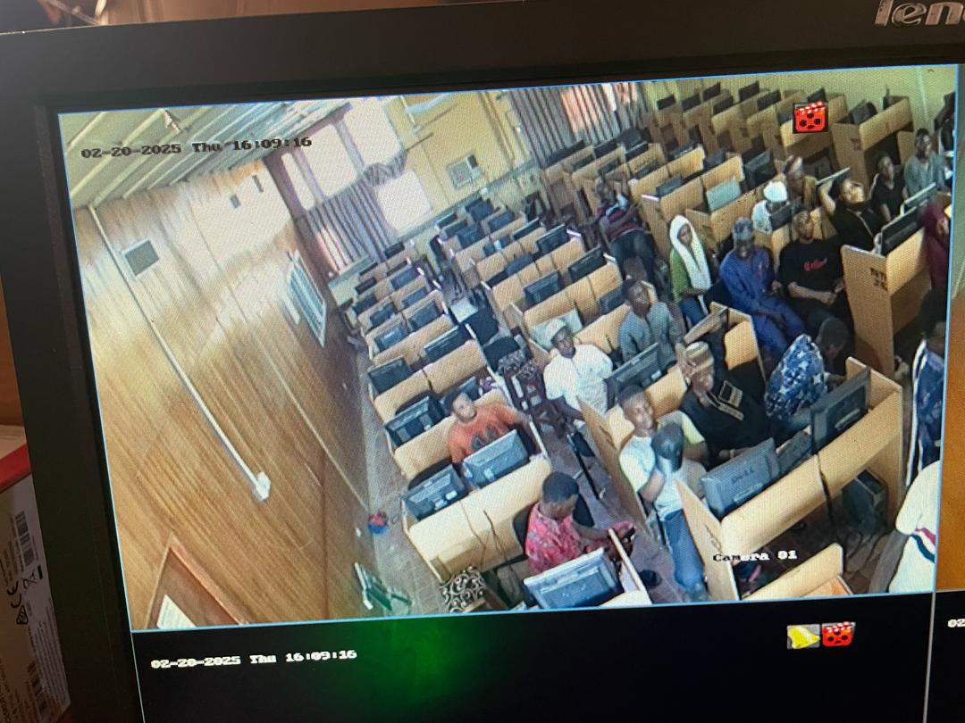
Figure 4:1: Captured CBT Examination Centre CAM 001
This display student during their examination

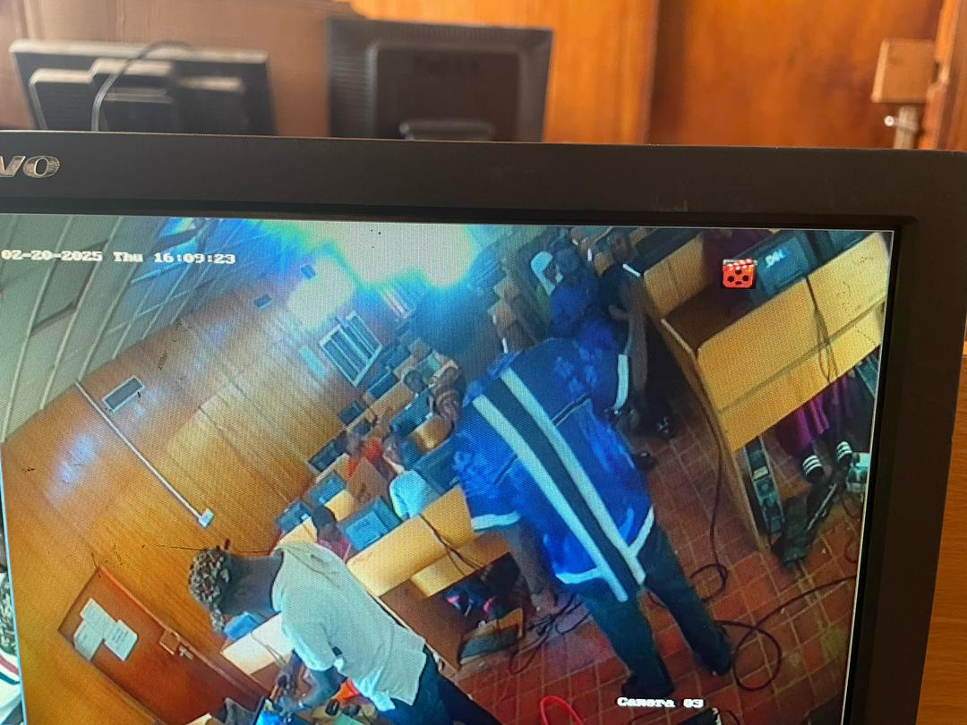
Figure 4:2: Captured CBT Examination Centre CAM 002
This display student during their examination

4.2 INPUT DESIGN
This is the hardware and software use to complete our project work, and engage some device which will be mention below, and this are the combination of devices that help us to complete our task , in the field of our project

- Solar Panel: solar panel is used to generate electricity from the sunlight.
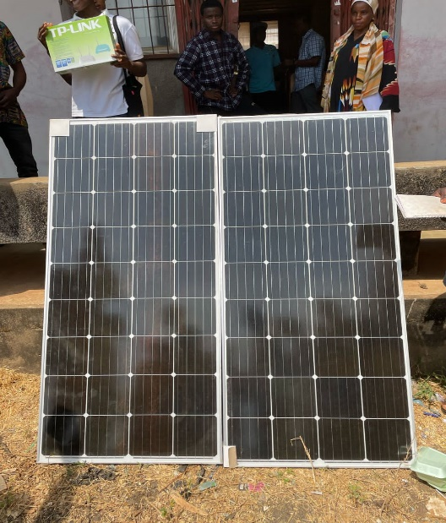
Figure 4:3: the two solar panel
- Cable: The cable use to connect current from the panel straight to the power Box and direct to charge controller. We have different DC cable e.g 2mm, 4mm, 6mm etc.
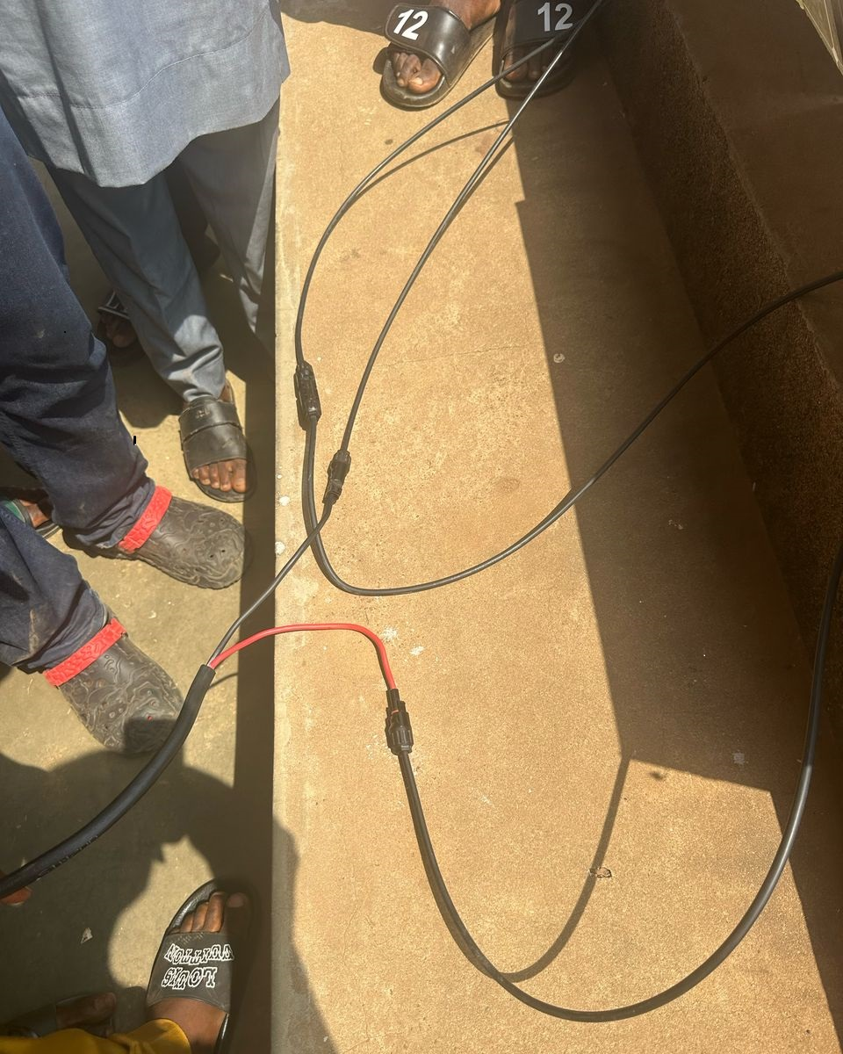

Figure 4:4: Twisted Cable
A twisted pair consists of two insulated copper wires, typically about 1mm thick. The wires are twisted in a helical form. Each pair would consist of a wire used for the positive (+ve) data signal and a wire for the negative (-ve) data
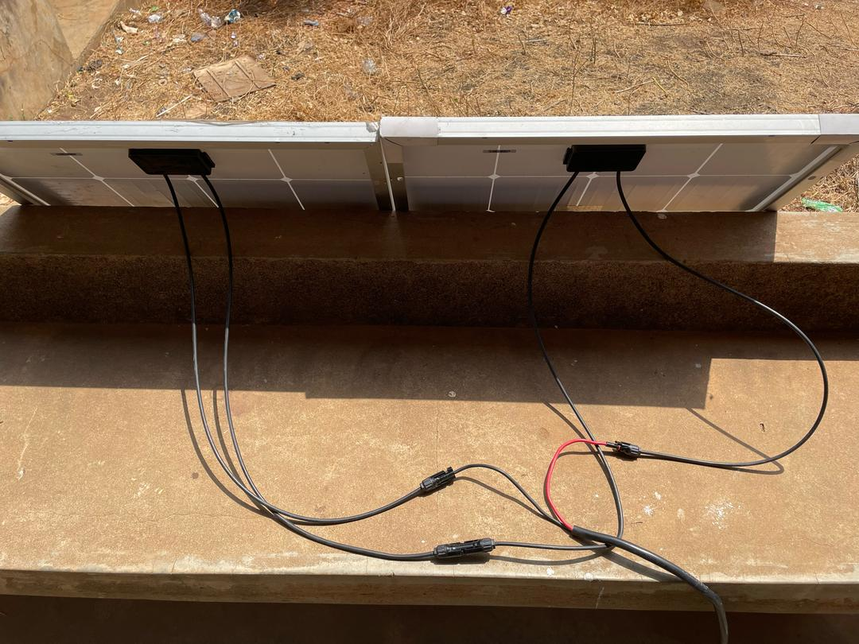
Figure 4:5: DC cable connect to solar panel Cable
Power Box: this is a protection box that has component that can guide our gadget, should incase we have high voltage or high current electricity, we have breakers inside the box, we have protector as well.

D.C: This is the direct current from the panel and it has it own breaker, for a protection as shown above in Fig .
A.C: this is the Alternative current from NEPA when there is light in the night time we can charge our battery through Nepa light as an alternative power supply.
- Coaxial Cable: This another communication wire that connect from cameras to DVR, and give it proper communication.
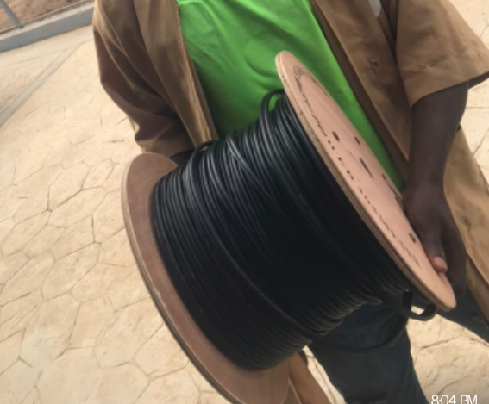
Figure 4:6. Shown J and J coaxial cable

- Charge Controller: This control the charging of battery from the panel and from A.C power supply
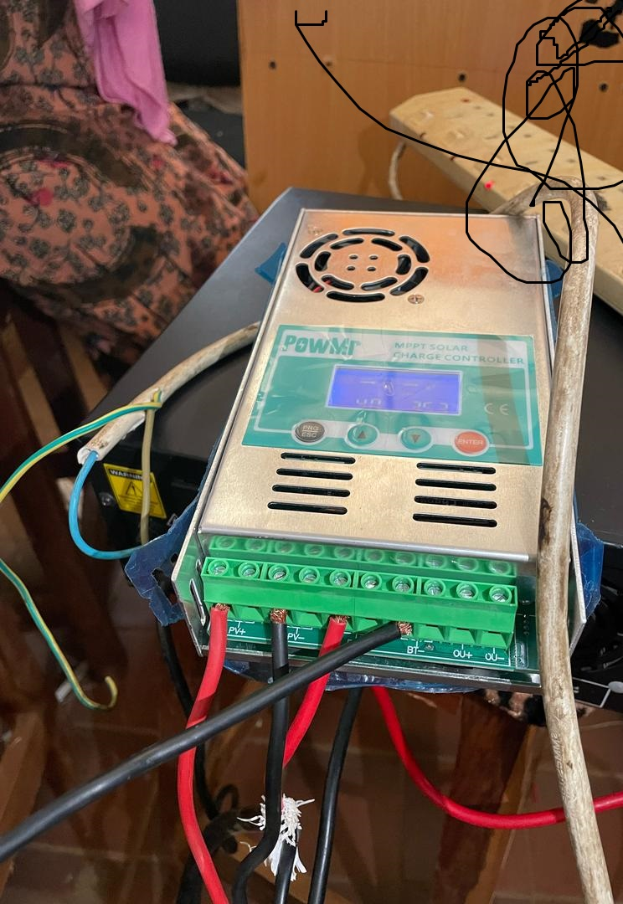
Figure 4:7: Shown PWM Charge Controller

Inverter: This is the part of system device that accept and regulate current both from the solar panel and from the battery directly. This can engage A.C which Nepa electricity as well and it will regulate everything without contradiction, once the connection is correct and perfect.
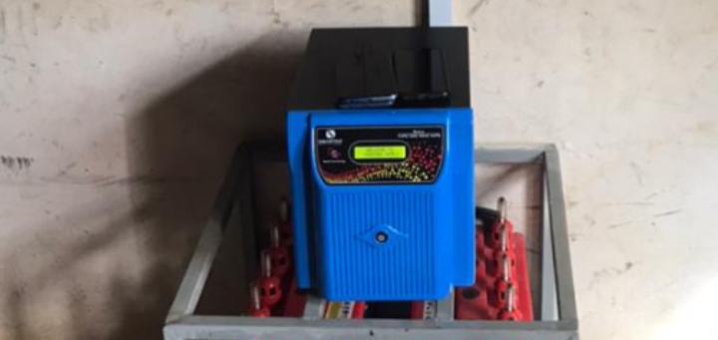
Figure 4:8: Shown Inverter

Battery: This serve as backup for supporting our solar panel, it also help to store energy, so it may be use when the suns goes down and during the night time when sun can never rise again, until the next day.
And we specification of batteries.
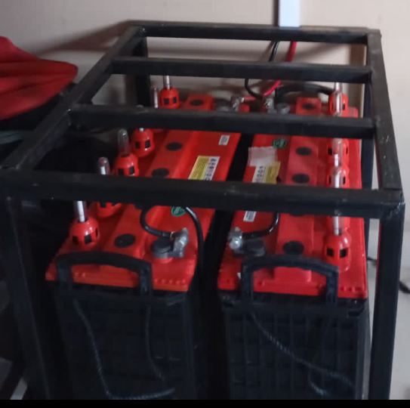
Figure 4:9: Shown batteries

Cameras: This is a caption that allow user to view and allow the lecturer to view both recent and previous activities in the examination Centre. And it can be further use by saving and accepting the audio of the captioning.
We have cameras by specification are:
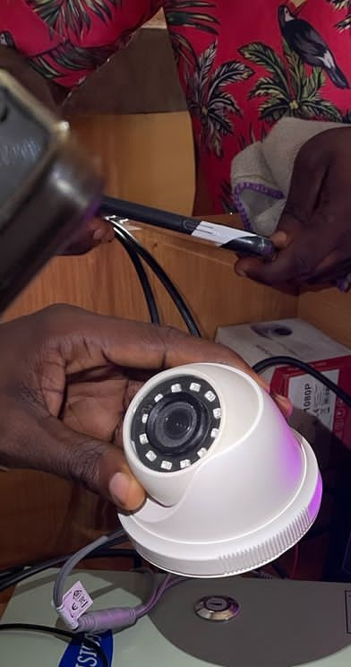
Fig 4.10. above an indoor Camera
DVR: This is a system that allow and accept more camera’s cable , to have capability to display and project each camera view and their audio. And it accept HDMI cable for display process. It description is like a decoder device
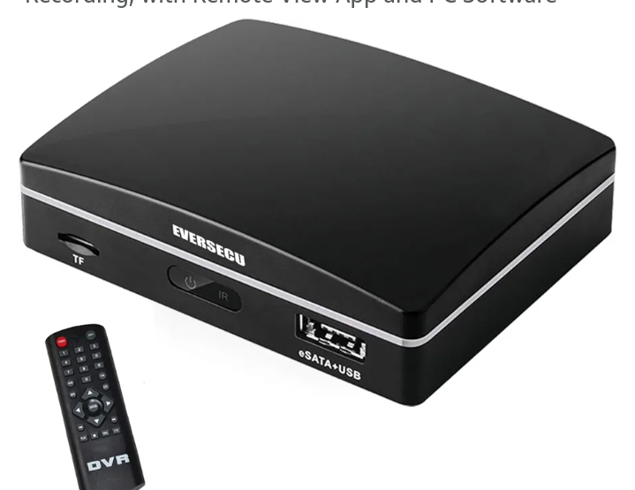

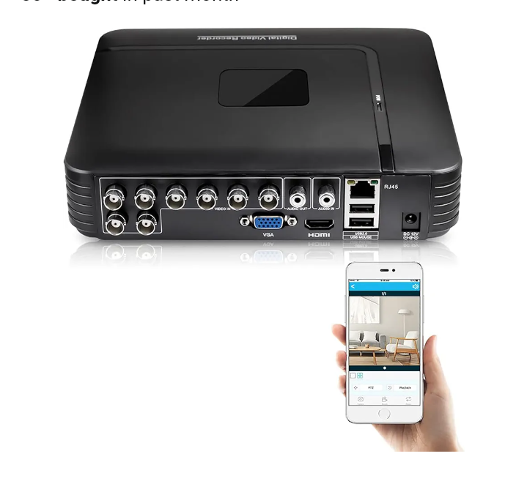
Figure 4:11: Shown DVR
Monitor: This is where our output is been display it might be TV, Desktop, Laptop, Smart phone,. This will display our output, and you can monitor your CBT examination Centre.
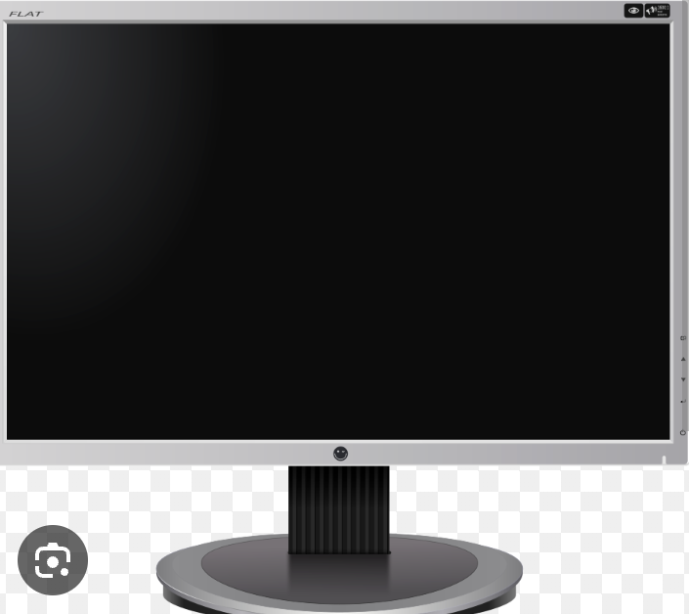
Figure 4:12: Shown the Monitor

Router: This is the internet device, that allow user to browse and communicate with the DVR to enable stable network for the user to download the software and monitor the activities.
It has specification. A router is a networking device that connects multiple network or subnetworks, and manage traffic between them. It acts as a hub and firewall.
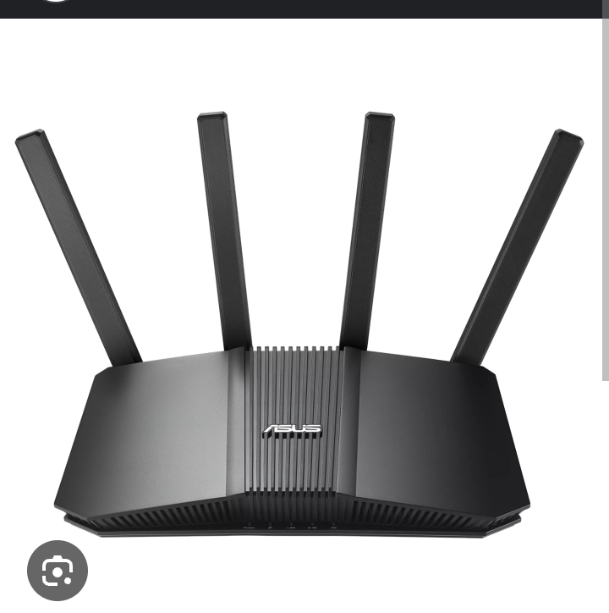
Figure 4:13: Shown the Router
4.3 PROCESSING DESIGN
When we are dealing with, execution of the project SMART SOLAR BASED CBT EXAMINATION CENTRE, MONITORING SYSTEM, it was periodically execute in a unique method.
Firstly, you need to open the solar panel from the cartonnage, and look thoroughly to the manual and check all round to the labelling part. Some of the things you note, is the compatible of the voltages, Ahms, Watts on the labelling part of the panel, if it is compatible with your inverter and your battery.
After then you connect your Direct Cable (DC) from your panel, and connect in, your prefer connection, either in series method , then you lay your cable pass it through the roof, then u signify your life current and the neutral, there is commonly used red and black insulator that allow current through them, most common, red is always serve as life and while black serve as neutral.
You nail your power box and we have more component inside, part of the component inside the box is BREAKER, PROTECTOR. Breaker serve as bodyguard to our devices, should incase the voltage coming in , is more higher the breaker will scrutinize it and check if the current is suitable for house load, hence it will stop the current from going beyond that boundary, and immediately the protector notice the action, it will start to beep continuous as a sign of notification.

CHAPTER FIVE
SUMMARY, CONCLUSION AND RECOMEMDATION
5.1 SUMMARY
In this project work, we present how we can use surveillance CCTV camera to monitor CBT examination Centre with the converted energy of solar power, So once you series the panel, it will definitely increase the voltage, it will boost more voltage at which solar panel generate energy from the sun-power. We connect the DC cable to the charge controller. Take note: it has the minimum number of panel voltage you can add up to the backup battery, After the solar connection, then the DVR was connect to an extension box where DVR cable plug and after, we connect a coaxial cable, it consist of the shield, insulator, branded shield, we connect it with the camera EMI and connected back to the CAM 001, CAM 002, CAM 003 port at the back of the DVR respectively.
which can be managed in our schools. However, we also identified various difficulties confronting our school’s in realizing its target, aims and objectives as well as making suggestion and recommendations to the management in order to improve it system generally.
5.2 CONCLUSION
The role of smart CCTV camera electrified by solar power to monitor CBT examination Centre has become an integral part of an establishment set up across advance country in the world, which Nigeria is included, that intended to keep good relationship between the school’s and some others organization. The result of this study coupled with the observation in similar school’s in other country and also in some part of the region in this country have shown an indication that, smart solar power CBT examination Centre monitoring system, as oxygen is to human lungs, is a function that can not be under-estimated and over ruled in any organization and school’s where efficiency of operation is a matter of consideration. The workforce of man power resource of an organization and in our school’s is the most valuable assets and as such, this aspect of managerial role requires urgent and special attention.
Therefore; For school’s and some private Centre to run effectively, it must have adequate finance, utilize it resources effectively to install and maintain this proposed system, in order that they could contribute quote towards achieving goals, and contribute to the growth of CBT Centre in our Country.
5.3 RECOMMENDATION
After a careful study of the smart solar CBT examination Centre monitoring system and its various functions in all our school’s Centre, the following recommendations should be taken into consideration.
If people consider the various problems and some obstructions in aspects of having manual monitoring, it distracts and gives some students lack of concentration, when there is movement of lecturer or invigilator in the examination hall. Hence, there is installation of the smart monitoring because it eases and save energy. Hence the need for the implementation of the monitoring software has been developed align with the gadget used for the project work.
Also, the public relation department should be advice on the best and most modern technique, technology and practices to provide a professional support and monitoring service in the area of this study.

REFRENCES
Alexander (13, fed, 2024) worked on enchaining security for lot Based Smart
Renewable energy remote monitoring systems.
Isha A. A (2nd June 2019) worked on Solar Panel monitoring and energy
prediction for smart solar system.
D.D. Prasanna Rani (2021) Solar panel facility must be monitored for Restore
economics power production from power plants by replacing defective star
panel.
Ablishek, (2015) worked on the continuous monitoring of the edition and
detecting the stable power delivery of solar panel in remote area.
Dr lawanya Dhanesh; Abaina. M² , Janani M³ , preethical; K⁴ Solar Panel
Monitoring System Using Smart Phone Technology
Amit, Saurabh, tushar (2002) worked on IOT-based solar monitoring system by
the system can be used to remotely regulate and maintain a photovoltaic

