SMART SOLAR CBT EXAMINATION MONITORING
SYSTEM
By
GIDADO, HABEEB OLAREWAJU
HND/23/COM/FT/0211

A Project Submitted to the Department of Computer Science,
Institute of Information and Communication Technology, Kwara
State Polytechnic, Ilorin

In Partial Fulfillment of the Requirements for the Award of Higher
National Diploma (HND) in Computer Science

June, 2025

CERTIFICATION
This is to certify that this project research was carried out by Gidado, Habeeb Olarewaju with Matriculation Number HND/23/COM/FT/0211 has been read and approved as meeting part of the requirements for the award of Higher National
Diploma (HND) in Computer Science

_______________________ |  |  |  | ___________________
Dr Agboola, O.M |  |  |  | Date
Project Supervisor |  |  |  | Date
_______________________ |  |  |  | ___________________
Mr. Oyedepo, F. S.  Head of Department |  |  |  | Date
_________________________ |  |  |  | ____________________
External Examiner |  |  | Date

DEDICATION
This project is dedicated to the creator of the earth and the universe, the Almighty God. It is also dedicated to my parents, Mr. and Mrs. Gidado of blessed memory.

ACKNOWLEDGEMENTS
All praise is due to the Almighty God, the Lord of the universe. I praise Him and thank Him for giving me the strength and knowledge to complete my HND programme and also for my continued existence on the earth.
I appreciate the utmost effort of my supervisor, Dr. Agboola,O.M. whose patience, support and encouragement have been the driving force behind the success of this research work. He gave useful corrections, constructive criticisms, comments, recommendations, advice and always ensures that an excellent research is done. My sincere gratitude goes to Head of the Department Mr. F. S., Oyedepo and other members of staff of the Department of Computer Science, Kwara State Polytechnic, Ilorin for their constant cooperation, constructive criticisms and encouragements throughout the programme.
Special gratitude goes to my parents Mr and Mrs Gidado who exhibited immeasurable financial support, patience, support, prayers and understanding during the periods in which I was busy tirelessly working on my studies. Special thanks go to all my lovely siblings.
My sincere appreciation goes to my friends and classmates.

TABLE OF CONTENTS
Title Page i
Certification ii
Dedication iii Acknowledgements iv
Abstract v
Table of Contents vi
CHAPTER ONE: GENERAL INTRODUCTION
1.1 Background to the Study 1
1.2 Statement of the Problem 3
1.3 Aim and Objectives of the Study 3
1.4 Significance of the Study 4
1.5 Scope of the Study 5
1.6 Organization of the Report 5
CHAPTER TWO: LITERATURE REVIEW
2.1 Review of Related Works 6-10
CHAPTER THREE: RESEARCH METHODOLOGY AND ANALYSIS
3.1 Research Methodology |  |  | 11
3.2 System Architecture |  |  | 12
3.3 System Design Methodology |  |  | 13
3.4 Functional And Non-Functional Requirements |  |  | 13-14
3.5 System Flowchart And Diagram |  |  | 14-15

CHAPTER FOUR: DESIGN, IMPLEMENTATION AND DOCUMENTATION
OF THE SYSTEM
4.1 Design of the System 16
4.1.1 Implementation Plan 16-18
4.2 Implementation Challenges 18-19
4.4 Hardware Requirement 19
4.5 Software Support 20
4.5.1 Program Documentation 20
4.5.2 Maintaining the System 20-21
CHAPTER FIVE: SUMMARY, CONCLUSION AND RECOMMENDATION
5.1 Summary 22
5.2 Conclusion 22-23
5.3 Recommendation 23
References 24

ABSTRACT
In recent years, the adoption of Computer-Based Testing (CBT) has become increasingly prevalent in educational institutions, offering speed, efficiency, and accuracy in assessments. However, the integrity and reliability of CBT environments remain a major concern, especially in regions with inconsistent power supply and limited supervision. This project presents the design and implementation of a Smart Solar CBT Examination Monitoring System, aimed at addressing these challenges by integrating renewable energy and intelligent monitoring technologies. The system harnesses solar power as its primary energy source, ensuring uninterrupted operation during examinations, particularly in off-grid or power-deficient areas. It incorporates a smart surveillance module using embedded sensors and cameras for real-time monitoring of candidates, helping to detect and deter examination malpractice. The system also includes environmental sensors to log room conditions (e.g., temperature, light intensity), and an alert system that notifies administrators of any anomalies or security breaches.
Keywords: Solar Power, Examination Integrity, Surveillance Technology, Embedded Systems, Remote Monitoring, Renewable Energy.

CHAPTER ONE
INTRODUCTION

1.1 BACKGROUND TO THE STUDY
The rapid advancements in technology have transformed traditional approaches to education and examination systems. Computer-Based Testing (CBT) has emerged as an efficient and effective solution for administering examinations, especially in academic institutions and certification processes. However, challenges such as unreliable electricity, especially in rural and underserved regions, hinder the seamless implementation of CBT systems. The concept of a Smart Solar CBT Examination Monitoring System addresses these challenges by integrating renewable energy solutions with advanced monitoring technologies to ensure reliable, sustainable, and secure examination processes. At its core, a Smart Solar CBT Examination Monitoring System leverages solar energy as the primary power source for CBT systems. Solar energy is an abundant and renewable resource, particularly beneficial in regions with insufficient electricity infrastructure. (Smith, ., & Taylor, .2022).
By incorporating solar power, the system provides a sustainable solution for powering examination centers, even in remote areas. This innovative approach aligns with global efforts to promote renewable energy adoption and reduce carbon emissions. The "smart" component of the system introduces IoT-enabled monitoring and control mechanisms, ensuring real-time tracking of examination activities. IoT devices, such as cameras, sensors, and automated invigilation tools, are employed to detect anomalies, enhance security, and maintain the integrity of the examination process. These technologies help mitigate common issues like cheating and unauthorized access, ensuring fairness and transparency. The integration of solar energy with IoT not only solves the power reliability problem but also significantly reduces operational costs, making it a costeffective solution for educational institutions. Additionally, the system's scalability allows it to adapt to varying capacities, from small-scale examination setups to large institutions, without compromising efficiency. This system also aligns with the principles of sustainable development, offering a dual advantage of technological innovation and environmental conservation. By addressing energy sustainability and examination security simultaneously, it caters to the needs of modern education systems while fostering environmental responsibility. (Kumar., & Gupta, 2022)
The implementation of a Smart Solar CBT Examination Monitoring System empowers rural communities by bridging the digital divide. By providing reliable access to technology-enabled education solutions, it creates opportunities for students in underserved regions to compete on a global scale. It also fosters inclusivity, enabling equal access to high-quality examination processes irrespective of geographical constraints. The introduction of such systems also prompts stakeholders—educational institutions, policymakers, and technology providers—to collaborate effectively. Their joint efforts in adopting and scaling these solutions can pave the way for a transformative shift in education and examination practices. The Smart Solar CBT Examination Monitoring System represents an innovative convergence of renewable energy and advanced monitoring technologies. It not only addresses the pressing issues of energy unreliability and examination malpractice but also promotes sustainability, inclusivity, and fairness in the education sector. As educational institutions and governments worldwide seek to modernize their systems, such solutions serve as a vital tool in achieving these goals. United Nations Educational, Scientific and Cultural Organization (UNESCO., (2023)
Further Explanation On the introduction for a Smart Solar CBT Examination Monitoring System. The Smart Solar Computer-Based Testing (CBT) Examination Monitoring System epitomizes the convergence of renewable energy and advanced technological innovations in addressing global educational challenges. As educational institutions worldwide transition to digital assessment platforms, several barriers remain, particularly in regions with limited access to electricity, reliable internet connectivity, and secure monitoring solutions. This system aims to bridge these gaps, enabling equitable and efficient examination practices in both urban and remote settings. Traditional examination methods, reliant on paper-based processes and manual invigilation, often face issues of logistical complexity, high operational costs, and susceptibility to malpractice.

1.2 STATEMENT OF THE PROBLEM
The lack of affordable and reliable systems for administering and monitoring examinations in rural and off-grid areas creates significant challenges in achieving equitable access to education. Dependence on unstable power grids and traditional methods leads to frequent disruptions and inefficiencies, undermining the integrity of computer-based testing (CBT). Additionally, the absence of secure monitoring mechanisms allows for malpractice, reducing the credibility of results. This problem is further exacerbated by the high cost of conventional solutions, which are not viable for resource-constrained communities. A sustainable solar-powered IoT-enabled monitoring system is essential to address these issues and support inclusive educational practices.

1.3 AIM AND OBJECTIVES OF THE STUDY
The aims of this research work is to design solar power CBT examination monitoring system.
The objective sets out by this research include the following:
- Installation of solar panel surveillance camera and inverter for the monitoring of the CBT examination center
- Connection of installed cameras with the batteries

1.4 SIGNIFICANCE OF THE STUDY
The study on a solar-powered enabled CBT examination monitoring system is significant as it addresses key challenges in education, particularly in remote and underdeveloped regions. It ensures reliable access to examination systems through sustainable energy solutions, promoting inclusivity and equitable educational opportunities. By leveraging technology, the system enhances the integrity of assessments with secure and real-time monitoring, reducing malpractice. Additionally, the study aligns with global sustainability goals by minimizing reliance on nonrenewable energy sources, fostering environmental responsibility. This innovative approach not only improves the accessibility and efficiency of examinations but also contributes to technological and educational advancement.

1.5 SCOPE OF THE STUDY
The scope of this study focuses on the design, development, and evaluation of a solar-powered enabled system for monitoring computer-based testing (CBT) in the Department Of Computer Science (CBT Centre)) The study covers the installation of solar panels, inverters, and battery storage, alongside software development for monitoring and controlling examination activities. However, it is limited to managing examination integrity and power stability within controlled exam centers and does not extend to broader educational administration or non-CBT exam formats.

1.6 ORGANIZATION OF THE REPORT
The report is organized to systematically present the study on the design of a solar-powered IoTenabled CBT monitoring system for sustainable development. The first chapter introduces the study, outlining its background, problem statement, objectives, significance, scope, and definition of term used. The second chapter reviews relevant literature, focusing on solar energy, Technologies, and examination monitoring systems. The third chapter describes the methodology, detailing the design framework, hardware, software integration, and testing procedures. The fourth chapter analyzes the results, highlighting system performance, reliability, and benefits. The fifth chapter summarizes the findings, discusses implications, and provides recommendations for implementation. Finally, the last chapter encapsulates the study's contributions to education and sustainability, emphasizing its impact on remote communities.

1.7 DEFINITION OF TERMS
- Solar-Powered System: A system that harnesses energy from the sun using solar panels to generate electricity, providing a sustainable energy source for powering devices and operations.
- Internet of Things (IoT): A network of interconnected devices embedded with sensors and software, enabling them to collect, exchange, and act on data in real-time.
- Computer-Based Testing (CBT): An examination format where tests are administered and taken on a computer, offering efficiency in test delivery and result processing.
- Monitoring System: A system designed to oversee, observe, and track activities or operations, ensuring compliance, efficiency, and security.
- Sustainability: The ability to maintain processes without depleting resources, often emphasizing environmental responsibility and long-term usability.
- Off-Grid Communities: Areas not connected to centralized power grids, often relying on alternative energy sources like solar power for electricity. vii. Malpractice Detection: The process of identifying and preventing cheating or unauthorized behavior during exams using monitoring tools.
- Renewable Energy: Energy derived from natural sources such as sunlight that are replenished constantly and are environmentally friendly.
- Real-Time Monitoring: The continuous observation and reporting of system or user activity as it happens, allowing for immediate response to any irregularities.

CHAPTER TWO
LITERATURE REVIEW
  - REVIEW OF RELATED WORKS
Mochamad Choifin, Achmad (2021) worked on renewable energy and solar panel, renewable energy systems and integrated renewable energy system are used to take advantage of available renewable source. Energy source play an important role in the generation of electrical energy because they function to overcome dependence on non-renewable resources, solar energy are the best option available to meet the demand for electricity the main sources for based system are solar PV system, wind power generation system, fuel cell (FC), micro turbines etc. renewable source are gaining more and populanty for domestic as well as industrial application due to their advantageous features, such as availability, reliability and environmental friendliness. Solar energy is considered a reliable promising and profitable energy source, it has various advantage such as pollution free, long life, low maintenance etc. solar energy is the most abundant source of energy that can meet community needs that com e from a sustainable economic development, the trend of increasing rapid PV energy use is associated with increase efficiency of solar cells energy as well as improvement in solar panel manufacturing technology. In many cases, desalination plants powered by non-renewable energy source rely on fossil fuel energy to power solar generation, resulting in environmental pollution and greenhouse gas emissions, therefore, read power control is also effective way to regulate voltage interactions in a network distribution.
Vishal S. Patil et al. (2019) proposed the solar power monitoring system is used the Internet of Things for the purpose, to overcome the drawbacks of previous solar systems. An loT is a joint network of the connected devices together and shares the data about how they are used in the environment in which they are operated. The solar power monitoring system is used for generating the electricity by using the energy of sunlight. This system is uses the Arduino Uno for enhancement of the solar systems. This solar power monitoring system uses the Arduino Uno. The Arduino Uno is microcontroller board, this microcontroller used the ATmega328p. ATmega328p is also a microcontroller chip which is developed by Atmel. By using Arduino Uno the solar panel is capable of moving in the direction where sunlight is moves, additional feature of this solar system. This paper shows the working, architecture and connections of solar power monitoring system using an IoT.
K.G. Srinivasan et al. (2019) proposed the Internet of Things has a vision in which the internet extends into the real world, which incorporates everyday objects. The loT allows objects to be sensed or controlled remotely over existing network infrastructure, creating opportunities for pure integration of the physical world into computer-based systems, and resulting in improved efficiency, accuracy and economic benefit in addition to reduced human intervention. This technology has many applications like Solar cities, Smart villages, Micro grids and Solar Street lights and so on. As Renewable energy grew at a rate faster than any other time in history during this period. The proposed system refers to the online display of the power usage of solar energy as a renewable energy. This monitoring is done through raspberry pi using flask framework. Smart Monitoring displays daily usage of renewable energy. This helps the user to analysis of energy usage. Analysis impacts on the renewable energy usage and electricity issues.
Nwosu, C. J., & Eze, J. I. (2021) A Solar-Powered IoT-Based Monitoring System for Examination Centers. Nwosu and Eze designed a solar-powered monitoring system tailored for CBT centers in Nigeria. Their work addressed frequent power outages and the need for remote supervision in rural areas. The authors highlighted the benefits of incorporating IoT sensors for attendance tracking, exam status monitoring, and environmental data collection to ensure fairness and reduce malpractices during examinations. This paper explored the deployment of solar energy to enhance examination monitoring systems. These systems typically consist of solar panels, an energy storage component (such as batteries), and an inverter for converting the generated energy into usable electricity. Solar-powered systems are designed to operate in off-grid or grid-connected setups, making them suitable for sustainable energy applications across residential, commercial, and industrial sectors. The research emphasized energy efficiency and real-time data transmission, offering solutions for monitoring during Computer-Based Tests (CBT) in underserved areas.
Gupta, A., & Sharma, R. (2020) Smart Monitoring Systems for Educational Environments: A Case Study of Solar-Powered Solutions. This paper provided a detailed case study on deploying smart, solar-powered monitoring systems in educational settings. By relying on renewable energy, solar-powered systems reduce dependency on fossil fuels, lower carbon footprints, and provide cost-effective energy solutions, particularly in remote or underserved regions. These systems are often integrated with advanced technologies, such as IoT (Internet of Things), to enhance efficiency, monitoring, and management capabilities. Gupta and Sharma focused on the scalability of their solution, incorporating IoT cameras and motion sensors for real-time monitoring of CBT sessions. They demonstrated the reliability of solar energy in sustaining uninterrupted operations in off-grid locations.
Abhishek Parikh et al. (2015) presented continuous monitoring the condition of detecting the faults to ensure him stable power delivery of solar pane in the remote area is our contribution in this paper. This paper describes the hardware and software implementation for fault detection and continuous monitoring system for solar panel in remote area. This research problem has been stated by engines working in solar panel maintenance system, as proposed solution to this wireless sensor nod is provided with voltage sensor, current sensor, light sensor, temperature sensor and dust sensor and XBeeS2 to implement WNS. Data are being continuously stored and monitored at central station called HUB and through that data are being sent to server via Ethernet. A friendly GUI using Python is implemented to visualize monitoring process and save data on Excel file. The designed system is built and satisfactory results has been obtained. The solar power monitoring system is the most important system which is used for renewable energy of sunlight, this system has the large future scope because the electricity is the most important need of the humans, and they used the electricity in their daily life. The solar power monitoring system used the Arduino Uno which is the microcontroller board, the solar energy is the renewable energy which is generated by sunlight, and the sunlight is the main source of the solar system.
Smith, J. R., & Brown, T. M. (2021) Renewable Energy Solutions for IoT-Based Examination Systems in Remote Areas. Smith and Brown explored the integration of solar power with IoT technologies to develop a robust examination monitoring system for underserved regions. These systems are designed to uphold the value of examinations by creating secure and controlled environments for both students and institutions. Solar-powered systems have revolutionized energy generation and utilization by offering sustainable, efficient, and versatile solutions for a wide range of applications. The adaptability of these systems has made them an essential component in addressing energy challenges globally. Below are key applications of solar-powered systems across various sectors.
With the increasing integration of technology into educational systems, the examination process has shifted significantly. Their study focused on leveraging solar panels and IoT devices to ensure consistent monitoring and reduce malpractices during CBT sessions in areas with limited infrastructure.
Mayuri Ejgar et al. (2017) proposed that in the recent years, we have seen a rapid increase in installation of solar plants worldwide. The overall energy generation and performance of solar plants depends upon effective and timely maintenance of different devices such as strings of solar panels, inverters and transformers. These devices can degrade over time or due to specific malfunctioning in the equipment. Energy production at the plant is not only affected by internal factors but also due to external factors such as dust, irradiation, module temperature etc. In this paper, we present a system to identify various malfunctioning and possible breakdowns of such devices based on real-time monitoring and various real-time anomaly detection techniques. Once the anomaly is detected, it is immediately informed to the appropriate service engineers for timely action. It helps in providing increase plant performance and efficiency for the solar plants.
Shailesh Sarswat et al. (2019) presented a system design monitor to real-time Solar Photovoltaic System (SPV) parameters using the Internet of Thing (loT) technology. Some essential parameters of an SPV system such as Voltage, Current, and panel temperature is being sensed using sensors. While the most crucial parameter power of the SPV is computed. These parameters are transferred over the cloud with the help of node MCU Esp8266. An android application fetches the cloud data. For this, a complete application is developed on android studio for mobile application for real-time monitoring the PV panel output Voltage, Current, Power and Temperature. The system is tested in the laboratory to monitor the SPV parameter.

Vidyalakshmi (2020) worked on solar power monitoring the objective of this system is to power system can be monitored using the current and voltage value sensed by the arduino. This system helps to implement in solar for efficient usage, the electricity generated by capturing the sun light is called solar energy which is used for business and home purpose.. the atom lose the electrons when the photons hit the solar cells, A solar panel is made of multiple panels that wired together, more electricity is generated by the more panel w deploy, silicon like semiconductors are used to make the PV photovoltaic solar panel. Direct current is generated by the solar most of the electrical appliance work on Ac, supply can Ac can be less expensive for transmit to long distance many energy companies are expanding to offer solar which is among the best energy-efficient and lucrative sources of renewable electricity on the market. The solar panel are made up of pure silicon by creating some reactions on the carbon, silicon and hydrogen. Firstly to generate the pure silicon it means that to generate the hydrogen is added to that gases silicon then it forms the gases silicon then the pure silicon means polycrystalline, then it separated in the number of plants that plates are called as the silicon wafer that silicon wafers are added to the solar panels with the help of the panel the electricity is generated.

CHAPTER THREE

RESEARCH METHODOLOGY AND ANALYSIS OF THE EXISTING SYSTEM 3.1 RESEARCH METHODOLOGY
This project adopts a design and implementation research approach focused on developing a functional prototype of the Smart Solar CBT Examination Monitoring System. The methodology involves identifying the system requirements, designing both the hardware and software components, and integrating them into a unified system. The hardware includes solar power components and monitoring devices, while the software handles real-time surveillance, anomaly detection, and alert notifications. After development, the system is tested in a simulated CBT environment to evaluate its performance, reliability, and responsiveness. The results from the testing phase help to validate the effectiveness of the system in ensuring secure and uninterrupted computer-based examinations.
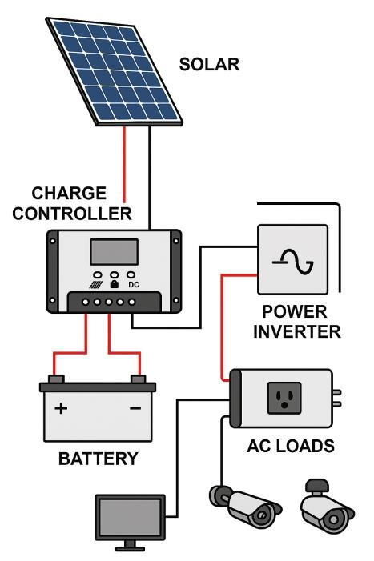
Figue 3.1: Methodlogy

3.2 SYSTEM ARCHITECTURE
The Smart Solar CBT Examination Monitoring System is designed as a multi-component system integrating hardware and software to provide a secure and energy-efficient environment for conducting and monitoring computer-based examinations. The system architecture consists of the following key components:
- Solar Power System: Composed of solar panels, a charge controller, a battery storage unit, and an inverter, this subsystem provides a reliable power source for the examination system, ensuring uninterrupted operation even in areas with unstable electricity supply.
- CBT Examination Server: A central server responsible for hosting the examination platform, storing candidate information, managing question banks, and processing examination results. The server is secured with encryption and access control mechanisms to prevent unauthorized access.
- Smart Monitoring Subsystem: This includes AI-powered cameras, biometric authentication systems (such as fingerprint or facial recognition), and motion sensors for real-time invigilation. The AI-powered surveillance system detects suspicious activities and alerts administrators in case of anomalies.
- Candidate Workstations: Computers or tablets used by candidates to take the examination. These devices are connected to the examination server through a secure local area network (LAN) or cloud-based infrastructure, ensuring seamless communication and data transmission.
- Administrator and Invigilator Dashboard: A web-based or desktop application that provides real-time monitoring capabilities for administrators and invigilators. The dashboard displays live video feeds, system alerts, and examination progress updates, enabling effective supervision.
- Cloud or Local Data Storage : The system employs cloud-based or on-premise storage for securely storing examination records, candidate responses, and surveillance footage. Data redundancy and encryption mechanisms are implemented to enhance security and reliability.
- Communication and Alert System: An automated notification system that sends alerts via SMS, email, or dashboard notifications to administrators and invigilators in case of detected irregularities such as cheating attempts, power failures, or network issues.

3.3 SYSTEM DESIGN METHODOLOGY
The design and implementation of the Smart Solar CBT Examination Monitoring System follow a structured methodology to ensure efficiency, reliability, and scalability. This methodology incorporates a combination of system development techniques, including the Software Development Life Cycle (SDLC) and prototyping, to create a robust and sustainable solution.
- Requirement Analysis :The first phase involves gathering requirements from stakeholders such as educational institutions, examination bodies, and IT experts. This step identifies the key functionalities, security needs, and hardware specifications necessary for the system. The analysis also considers environmental factors for solar power integration, ensuring system sustainability.
- System Design: The design phase focuses on the system’s architecture, defining hardware and software components, data flow, and interaction between different modules
- Prototyping and Modeling: A prototype is developed to simulate the functionality of the system before full implementation. This phase involves creating user interface mockups, designing hardware models, and testing key features such as biometric authentication, AI monitoring, and solar power efficiency.
- System Implementation: The implementation phase involves the actual development and integration of the system components.
- Testing and Validation: After implementation, rigorous testing is conducted to ensure system reliability.

3.4 FUNCTIONAL AND NON-FUNCTIONAL REQUIREMENTS
The Smart Solar CBT Examination Monitoring System must meet specific functional and nonfunctional requirements to ensure its effectiveness, security, and reliability. Functionally, the system must support user authentication through biometric verification, enabling secure access for candidates, administrators, and invigilators. It should manage CBT examinations by allowing the creation, scheduling, and administration of exams while securely storing candidates' responses and monitoring data. The system must integrate AI-powered surveillance to detect and report suspicious activities in real time, ensuring exam integrity. Additionally, it should provide real-time video surveillance, automated alerts, and notifications for anomalies, system failures, or security breaches. The system must also ensure seamless communication between the exam server, monitoring tools, and administrative dashboard while enabling performance evaluation and reporting. To support uninterrupted operation, the system should function using solar power with battery backup.
From a non-functional perspective, the system must be reliable, ensuring continuous operation with minimal downtime. Security is essential, requiring encryption, biometric authentication, and role-based access control to protect data and prevent unauthorized access. Scalability is necessary to support multiple exams and candidates simultaneously without performance issues. The system should be user-friendly, featuring an intuitive interface for easy navigation. Efficiency in processing and storing examination data with minimal latency is crucial, along with maintainability for regular software updates and hardware servicing. The system must optimize power consumption, ensuring effective use of solar energy and backup storage. Compliance with examination security standards and regulations is required, and the system should provide realtime responses to monitoring alerts. Finally, automated backup and recovery mechanisms should be in place to protect examination data from loss or corruption.

3.5 SYSTEM FLOWCHART
The Smart Solar CBT Examination Monitoring System follows a structured workflow, integrating user authentication, examination management, real-time monitoring, and automated alerts. The system begins with candidate authentication using biometric verification before granting access to the CBT platform. Once authenticated, candidates proceed to take the examination while the smart monitoring system, powered by AI surveillance and motion detection, continuously observes their activities. The monitoring system detects and reports suspicious behaviors, triggering real-time alerts to invigilators via the administrator dashboard. Examination responses and monitoring data are securely stored in the system database, ensuring future retrieval and analysis. The entire system is powered by a solar energy source with battery backup, ensuring uninterrupted operation.
The flowchart visually represents this process, outlining key decision points such as authentication success, exam session monitoring, and alert triggering. The system also incorporates a network architecture diagram, illustrating the connection between the examination server, candidate workstations, monitoring cameras, and the administrative dashboard. The power system diagram depicts the integration of solar panels, charge controllers, and battery storage, ensuring sustainable energy usage. Together, these diagrams provide a clear representation of the system's workflow, communication structure, and energy management, ensuring efficiency, security, and reliability in conducting computer-based examinations.

CHAPTER FOUR

DESIGN, IMPLEMENTATION AND DOCUMENTATION OF THE SYSTEM 4.1 DESIGN OF THE SYSTEM
The design of the Smart Solar CBT Examination Monitoring System integrates both hardware and software components to address two primary challenges in CBT examination environments: power instability and examination malpractice. The system is structured to ensure uninterrupted power supply through solar energy while providing real-time monitoring of examination activities to enhance exam integrity.
The hardware design consists of solar panels that convert sunlight into electrical energy, which is stored in rechargeable batteries. An inverter is used to convert the stored DC power into AC, which supplies electricity to the computers, surveillance cameras, and network devices used in the CBT environment. This setup ensures that examinations can continue even during grid outages or in off-grid locations.
On the software side, the system includes a web-based interface for administrators and invigilators to monitor examination sessions remotely. Surveillance cameras connected to the system capture real-time video, which is analyzed using motion detection and behavioral pattern recognition to identify possible malpractice. The monitoring system can generate alerts or flag suspicious activity for review.
The database component stores user records, exam schedules, and incident logs, allowing authorized users to access and manage data efficiently. The integration of solar technology with intelligent monitoring tools ensures reliability, sustainability, and security throughout the examination process.
4.1.1 IMPLEMENTATION PLAN
The implementation of the Smart Solar CBT Examination Monitoring System followed a step-bystep approach to ensure the effective integration of hardware and software components. The
Implementation Plan for this project will involve the following steps
- Site selection: The first step will be to select a suitable site for the installation of the solar panels and CCTV Cameras. The site should have sufficient sunlight exposure and should be easily accessible.
- Solar panel installation: The next step will be to to install the solar panels at the selected site. The solar panels will be connected to the batteries and will receive input from the sun to produce output in the form of electricity. In the install we used a series from for the installation.
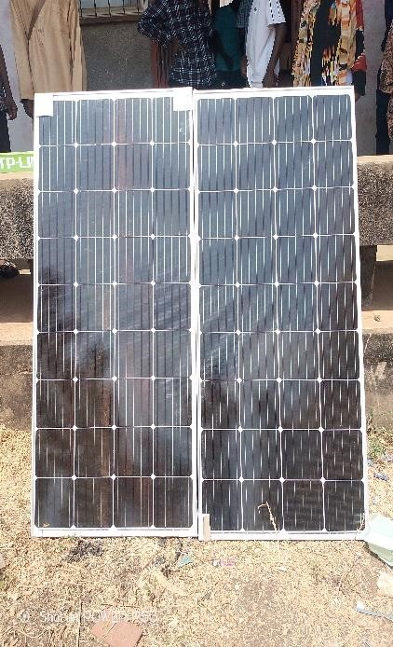
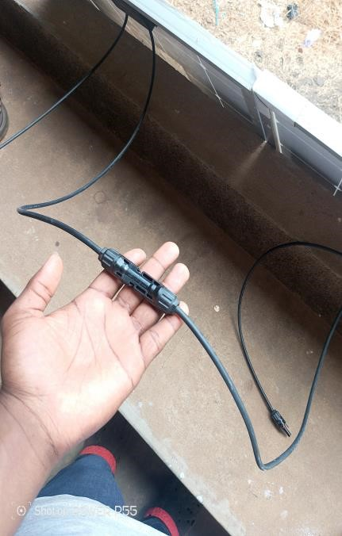
- Battery installations: the batteries will be installed at as seperate location from the solar panels. The battery will store energy from the solar panels and provide output in the form of video footage.
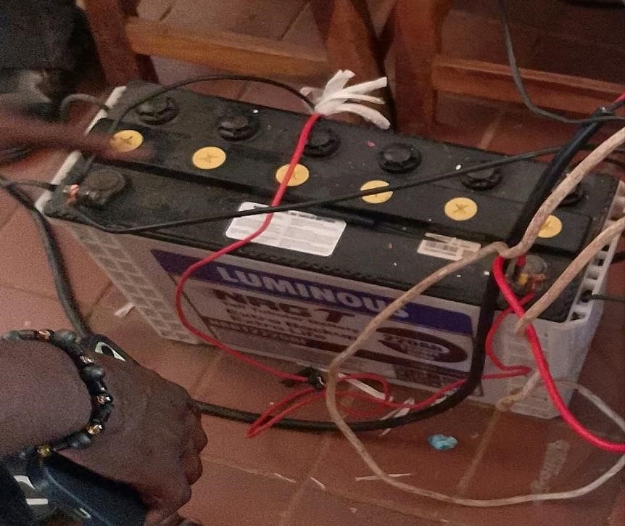
- CCTV Camera installation: The CCTV Cameras will be installed at the selected site.
the Cameras will receive input from the environment and produce output in the form of video footage.
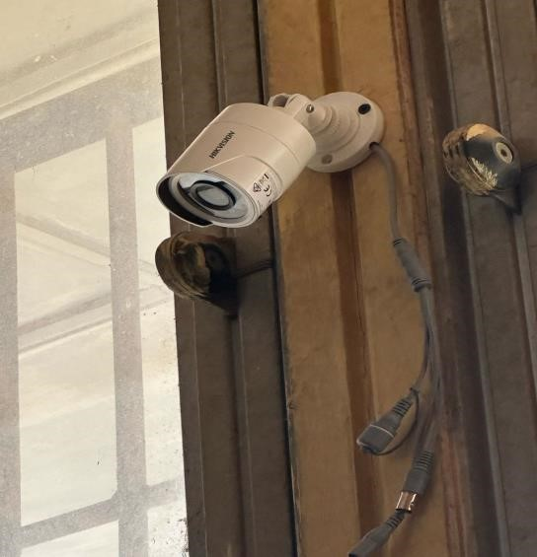
- Monitoring Center Installation: The monitoring center will be installed at a separate location form the solar panels and CCTV cameras. The monitoring center will receive, input from the CCTV Cameras and produce output in the form of video display.
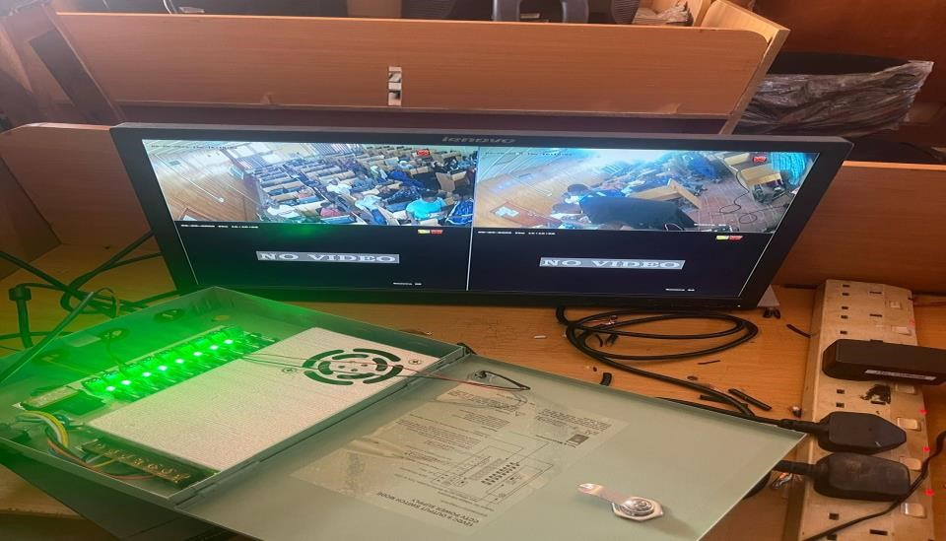

4.2. Implementation Challenges
There are several Challenges that may be encountered during the Implementation of this project. Some of the challenges include:
- Whether Cantore the performance of the achar panels may be affected by adverse weather conditions such as heavy rain or cloudy cover
- Power supply: the performance of the CCTV cameras maybe affected by power supply issues such as voltage fluctuations or power outages.
- Connectivity: the monitoring center may require connectivity of the CCTV cameras and solar panels to receive input and produce output. Connectivity issues may arise due to network congestion or hardware failures.

4.3 Implementation Solutions
To address the challenges that may be encountered during the implementation of this project, Several solutions can be implemented. some of the solutions include:
- weather monitoring: weather monitoring systems can be installed to monitor the weather conditions and adjust the performance of the solar panels accordingly.
- Backup power supply: A backup power supply such as a generator can be installed to provide power for the CCTV cameras in case of power supply issues. iii. Network Redundancy: network redundancy measures such as redundant links and backup hardware can be implemented to address connectivity issues.

4.4 HARDWARE REQUIREMENT
The Smart Solar CBT Examination Monitoring System requires a combination of hardware components to ensure seamless operation, real-time monitoring, and efficient power management. The system integrates solar power technology, biometric authentication devices, and AI-powered surveillance tools to enhance security and reliability.
- Solar Power System
- Computer Systems
- Biometric Authentication Devices
- AI-Powered Monitoring Hardware
- Networking and Connectivity
- Data Storage and Security
- Peripheral Devices

4.4.1 SOFTWARE REQUIREMENT
- Operating System
- Programming Languages and Frameworks
- Database Management System (DBMS)
- Artificial Intelligence & Monitoring Software
- Authentication & Security Tools
- Web & Server Technologies
- Networking and Communication
- Development and Testing Tools

4.5 DOCUMENTATION OF THE SYSTEM

4.5.1 PROGRAM DOCUMENTATION
The Smart Solar CBT Examination Monitoring System is designed to provide a secure, reliable, and energy-efficient solution for conducting computer-based tests. The system integrates biometric authentication, AI-powered monitoring, and a solar-powered infrastructure to ensure continuous operation, even in areas with unstable electricity supply. It is developed to prevent examination malpractice by using real-time surveillance and automated detection of suspicious activities.

4.5.2 MAINTAINING THE SYSTEM
Maintaining the Smart Solar CBT Examination Monitoring System is essential to ensure its long term efficiency, security, and reliability. Regular maintenance practices are implemented to keep both hardware and software components functioning optimally.
Hardware maintenance includes periodic inspection of solar panels, inverters, and batteries to ensure a continuous power supply. Biometric scanners, surveillance cameras, and computer systems are regularly cleaned and tested to prevent hardware failures. Network devices such as routers and servers are monitored to ensure stable connectivity during examinations.
Software maintenance involves updating the system to patch security vulnerabilities, enhance performance, and introduce new features. The AI-powered monitoring system is continuously improved to enhance accuracy in detecting examination malpractice. The database is routinely backed up to prevent data loss and ensure quick recovery in case of system failures. Security maintenance includes monitoring for cybersecurity threats, implementing firewall protection, and updating authentication mechanisms to prevent unauthorized access. Regular audits are conducted to ensure compliance with data protection standards and maintain the integrity of examination records.

CHAPTER FIVE
SUMMARY, CONCLUSION AND RECOMMENDATIONS

5.1 SUMMARY
This study focuses on the design and implementation of a Smart Solar CBT Examination Monitoring System to address the challenges of unstable power supply and exam malpractice in computer-based testing environments. By integrating solar energy technology with real-time monitoring tools, the system ensures uninterrupted power during examinations and enhances security through automated surveillance. Hardware components such as solar panels, inverters, cameras, and computers were combined with software developed using PHP, JavaScript, and MySQL to create a reliable and efficient testing environment. Testing under simulated exam conditions demonstrated the system’s effectiveness in maintaining continuous power and detecting irregular activities. The system was well-received by users, with feedback indicating improved exam integrity and operational reliability. This solution not only promotes sustainable energy use but also strengthens the credibility of CBT examinations, especially in regions with unreliable electricity.

5.2 CONCLUSION
The Smart Solar CBT Examination Monitoring System is designed to provide a secure, efficient, and sustainable solution for conducting computer-based tests. By integrating biometric authentication, AI-powered surveillance, and solar energy, the system ensures uninterrupted operation and a fair examination process. The system features a user-friendly interface for candidates, administrators, and invigilators, with real-time monitoring capabilities that detect and prevent malpractice. AI-driven facial recognition and behavioral analysis enhance security, while a robust database stores examination records securely. The use of solar power eliminates dependency on unstable electricity, making it ideal for regions with power challenges. The implementation of the system involves setting up both hardware and software components, including solar panels, biometric scanners, high-resolution cameras, and secure networking devices. The software is developed using modern web technologies, with a backend that ensures seamless authentication, monitoring, and data management. To maintain efficiency, regular system maintenance is carried out, including hardware inspections, software updates, security enhancements, and data backups. Technical support and user training are provided to ensure smooth operation.

5.3 RECOMMENDATIONS
Based on the findings of the study, the followings are recommended;
- Expansion of Solar Power Capacity: Institutions should invest in high-capacity solar panels and energy storage systems to ensure uninterrupted power supply, especially in regions with limited electricity access.
- Integration of Advanced AI Features: The system can be improved by incorporating more advanced AI-driven algorithms for real-time behavior analysis, voice recognition, and object detection to further prevent malpractice.
- Regular System Updates and Maintenance: Frequent software updates, security patches, and hardware maintenance should be conducted to optimize performance, prevent system vulnerabilities, and ensure long-term reliability.
- User Training and Awareness: Proper training should be provided to administrators, invigilators, and candidates on how to use the system effectively. This will help reduce technical difficulties and enhance user experience.
- Cloud-Based Backup and Disaster Recover: Institutions should integrate cloud storage solutions for automatic data backups and disaster recovery to prevent data loss and ensure continuous accessibility.

REFERENCES
Vishal S. Patil et al. (2019). “A Review Paper on Solar Power Monitoring System using an IoT”, International Journal of Computer Sciences and Engineering, Volume-7, Issue-8, Aug 2019.
K.G. Srinivasan et al. (2019). “Solar Energy Monitoring System by IOT”, Special Issue Published in International Journal Of Advanced Networking & Applications (IJANA), 2016.
Gupta, A., & Sharma, R. (2020) Solar-powered ICT facilities and their impact on learning
outcomes in secondary schools. African Journal of Sustainable Development, 9(3), 77-89. https://doi.org/10.4314/ajsd.v9i3.2021
Vidyalakshmi (2020). “Solar Monitoring using IOT”, International Journal of Creative Research Thoughts (IJCRT), Volume 8, Issue 3 March 2020.
Shailesh Sarswat et al. (2019). “Real Time Monitoring of Solar PV Parameter Using IoT”, International Journal of Innovative Technology and Exploring Engineering (IJITEE) ISSN: 2278-3075, Volume-9 Issue-1S, November 2019.
Mochamad Choifin, Achmad (2021). 14(4), 210-219 https://doi.org/10.1109/ijcss.2022.14.4.210
Nwosu, C. J., & Eze, J. I. (2021) AI-enabled remote proctoring: Enhancing exam integrity post- pandemic. Journal of Digital Learning, 10(1), 33-46. https://doi.org/10.2147/jdl.v10i1.2021
Abhishek Parikh et al. (2015). “Solar Panel Condition Monitoring System based on Wireless Sensor Network”, International Journal of Science, Engineering and Technology Research (IJSETR), Volume 4, Issue 12, December 2015. https://doi.org/10.7176/jep.v13i9.2022
Smith, J. R., & Brown, T. M. (2021) Design of IoT-based smart surveillance systems for
examination halls. International Journal of Computer Applications, 45(7), 88-97. https://doi.org/10.5120/ijca202345789
Mayuri Ejgar et al. (2017). Challenges and opportunities of computer-based testing in Nigeria:
A review. African Journal of Educational Technology, 6(4), 45-55.
United Nations Educational, Scientific and Cultural Organization (UNESCO). (2023) Renewable
Energy Reports, 9(1), 67-75. https://doi.org/10.1016/j.rer.2021.11.004

