DESIGN OF WIRELESS INTERCOM SYSTEM

BY
HORLARNIWUN MUPTAHU DAUD
ND/23/MCT/FT/0025

BEING A RESEARCH PROJECT SUBMITTED TO THE DEPARTMENT OF MECHATRONICS ENGINEERING, INSTITUTE OF TECHNOLOGY
KWARA STATE POLYTECHNIC, ILORIN

IN PARTIAL FULFILLMENT FOR THE AWARD OF NATIONAL DIPLOMA (ND) IN MECHATRONICS ENGINEERING

JULY, 2024

CERTIFICATION
This is to certify that this project has been completed, read through and approved as meeting part of the requirements of the Department of Mechatronics Engineering institute of Technology, Kwara State Polytechnic for the Award of National Diploma in Mechatronics Engineering

________________________ _______________
ENGR. LUKMAN SALIHU DATE
(Project Supervisor)

________________________ _______________
ENGR. MAHMUD M. KATUN DATE
(Project coordinator)

_________________________ _______________
ENGR. RAJI IDOWU A. DATE
(Head of Department)

_________________________ _______________
EXTERNAL EXAMINER DATE
DEDICATION
This work is dedicated to Almighty God for his abundant and lucrative projection over me and also to my parent Mr. and Mrs. Daud for their financial support and encouragement and my siblings I say a big thanks to you all, for your encouragement and support.

ACKNOWLEDGEMENNNT
To God be the glory! Great thing he has done and great thing he shall do. Above all things I thank the Almighty Allah. for sparing my life till this moment and for bestowing on me grace, goodness and mercy, good health and knowledge with which I started and complete this project “this effect, therefore I say may all glory, honor and adoration to the Almighty Allah.
To My Parent Mr. Mrs. and Daud, you have been my source of inspiration, support and guidance. You have taught me to be unique, determined, to believe in myself and to always preserve. I am truly thankful and honored to have you as my parent .
However, my grateful appreciation goes to my honorable supervisor. Engr. Lukman salihu. for his guidance and endless support have enable me to accomplish this task and to his wish to express my grateful appreciation .
I will like to show my appreciation to everyone who has contributed in whatever quantity to my success on this project . I am especially grateful to my Sibling who have stimulated and encourage the conception and orientation of this noble effort.
Once again I am grateful to God for his mercies, love and care for the great opportunity he gave me to accomplish the task of writing this project.

ABSTRACT
The primarily motive of this project is to develop a system for wireless message communication of text characters between two computers using 315MHz transceiver units. This project uses pair of 315MHZ transceiver modules powered by 5 volt D.C. and alarm circuits with 555 timers. The two systems are used for two way chat session using text characters between a personal computer, desktop computer and another personal computer or desktop computer wirelessly. A GUI (Graphical User Interface) developed in Cusing Visual Studio 2013 allows message sent and received to be displayed on a PC screen. When one user inputs a text character to trigger message, a signal is received first by a buzzer sound, a light is then displayed in the LED indicator at the receiver end.

1.5 REPORT OUTLINE 4
CHAPTER TWO 5
2.1 THE EVOLUTION OF WIRELESS TRANSCEIVERS 5
CHAPTER THREE 15
3.2 CIRCUIT DESIGN 19
4.2 RECEIVER CIRCUIT DIAGRAM 26
FIGURE 4.2 26
4.3 TRANSMITTER CIRCUIT DIAGRAM 26
Figure 4.3 26
4.3 TESTING 27
4.4 PACKAGING AND CASING 27
TRANSMITTER 28
RECEIVER 29
4.5 PROBLEM ENCOUNTER 30
5.0 CONCLUSION AND RECOMMENDATION 32
INTRODUCTION 32
REFERENCES: 34
LIST OF FIGURE
FIGURE 2.1 ……………………………………………………………………..…….9
FIGURE 2.2 ..………………………………………………………….12
FIGURE2.3…………….……………………………………….……12
FIGURE 2.4…………….……………………………………………13
FIGURE 2.5 …………………………..…………………………….14
FIGURE 2.6 …………………………………………...……………..15
FIGURE 3.1 ……………………………………………………..…..21
FIGURE 3.2 ………………………………………………………….23
FIGURE 4.1 ………………………………………………………….27
FIGURE 4.2 …………………………………………………………28
LIST OF TABLE
TABLE 1 ……………………………………………………….……13
ABREBIATION
A =AMPERE
Ω=Ohms
V=voltage
m=milli=〖10〗^(-3)
β=Gain
μ=micro=〖10〗^(-6)
M=Mega=〖10〗^6 F=Farad

PROPOSAL
INTRODUCTION:
Communication system is the network of electric circuit or devices used for the purpose of passing information over long distance by electrical means.
Communication system consists of the following part: source, input transducer, transmitter, communication channel, receiver, output transducer, and sink.
Source is the origin of the information. The source could be human or a machine interface and the information could be analogue or digital.
Input transducer the input transducer is a device which converts the non-electrical output of the source into electrical form. Example can be one of the following.
- A microphone which converts sound energy into electrical energy.
- A television camera which converts light energy into electrical energy.
- A tele printer whose mechanism also produces electrical energy that represent a particular character from a set of alpha numeric from the keyboard.
Transmitter this is made up of a network of voltage, current, power amplifier and oscillator. The amplifiers are provided to amplify the weak baseband output of the input transducer to have efficient electrical power to overcome the channel attenuation, while frequency generated by the oscillators permit by a process called modulation. The audio frequency signal to be propagated in the form of electromagnetic waves and also help in isolating the channel from each other.
Communication channel this is the medium through which communication is established. This medium could be free space (air), wave guides or optic fibers [6].
Receiver this sense the band of transmitted signal, select the desire information in the high frequency state. Extract the original information by a process called demodulation and amplifies the signal to give it sufficient power to operate the output transducer.
Output transducer: this convert the electrical output of the receiving equipment into the form understandable to a sink. The output transducer could be
- Loudspeaker which convert the receive electrical signal into sound energy.
- Tele printer which convert electrical energy into written form.
- Cathode ray tube which convert electrical energy into luminous energy.
Sink is the destination of the information signal. The sink could be human or machine.
Wireless internal communication system (wireless INTERCOM) is a system or device that allows people in different parts of a building, aircraft, or ship to speak to each other.A wireless intercom is an electronic device that enables voice communication without the need to run wires between intercom stations. A wired intercom system may incorporate wireless elements.Most wireless intercom systems communicate by radio waves using one of the frequencies allotted by various government agencies. There are also systems that advertise themselves as wireless, but communicate over existing building AC electrical wiring [6].

1.1 MOTIVATION:

Problem:
There is interference with other wireless network. There is high level of noise. The electric field from machine and synchronous motor interfere with the intercom.

SIGNIFICANCES:
- It provides student with opportunity to apply their theoretical knowledge in real life situation, thereby bridging the gap between the theory and actual practice.
- Expose student to work method and techniques in handling equipment and machineries that are useful in engineering practices.
- Prepare student, for work situation they are likely to meet
after graduation.

AIM AND OBJECTIVES

The aim of this project is to and design construct and test the wireless internal
Communication system.

The objectives are as follows
- To review related works on wireless communication.
- To achieve the above aim an articulated and schematic research was adopted.
- This is followed by step by step design.
- Scheming and assemble wireless network that will be use to transmits and Receive voice signal across the building and offices.
- Finally the complete system was constructed.
- Testing to make sure that the project comes off as design.
- The system was finally package.

METHODOLOGY:
This project is concerned on how the wireless internal communication system network can be set up, to work and permit the communication between two different individual. This project is going to be realizing through research, experiment, design, construction testing and verification.

SCOPE AND LIMITATION
The project will be one way wireless voice communication between two different wireless terminals. Limited area of coverage for the network, which cover about 10metres.

REPORT OUTLINE

Chapter one of the project deals with a brief overview of the wireless communication, chapter two covers the theoretical background of the project discussing the various component involved in the design. Chapter three detail the hardware design indicate the specification of the component use and the overall integration of the circuit. Chapter four covers the construction and testing procedure. Finally chapter five constitute the conclusion and recommendation.

CHAPTER ONE
1.0 INTRODUCTION:
Communication system is the network of electric circuit or devices used for the purpose of passing information over long distance by electrical means.
Communication system consists of the following part: source, input transducer, transmitter, communication channel, receiver, output transducer, and sink.
Source is the origin of the information. The source could be human or a machine interface and the information could be analogue or digital.
Input transducer the input transducer is a device which converts the non-electrical output of the source into electrical form. Example can be one of the following.
- A microphone which converts sound energy into electrical energy.
- A television camera which converts light energy into electrical energy.
- A tele printer whose mechanism also produces electrical energy that represent a particular character from a set of alpha numeric from the keyboard.
Transmitter this is made up of a network of voltage, current, power amplifier and oscillator. The amplifiers are provided to amplify the weak baseband output of the input transducer to have efficient electrical power to overcome the channel attenuation, while frequency generated by the oscillators permit by a process called modulation. The audio frequency signal to be propagated in the form of electromagnetic waves and also help in isolating the channel from each other.
Communication channel this is the medium through which communication is established. This medium could be free space (air), wave guides or optic fibers [6].
Receiver this sense the band of transmitted signal, select the desire information in the high frequency state. Extract the original information by a process called demodulation and amplifies the signal to give it sufficient power to operate the output transducer.
Output transducer: this convert the electrical output of the receiving equipment into the form understandable to a sink. The output transducer could be
- Loudspeaker which convert the receive electrical signal into sound energy.
- Tele printer which convert electrical energy into written form.
- Cathode ray tube which convert electrical energy into luminous energy.
Sink is the destination of the information signal. The sink could be human or machine.
Wireless internal communication system (wireless INTERCOM) is a system or device that allows people in different parts of a building, aircraft, or ship to speak to each other.A wireless intercom is an electronic device that enables voice communication without the need to run wires between intercom stations. A wired intercom system may incorporate wireless elements.Most wireless intercom systems communicate by radio waves using one of the frequencies allotted by various government agencies. There are also systems that advertise themselves as wireless, but communicate over existing building AC electrical wiring [6].

1.1 MOTIVATION:

Problem:
There is interference with other wireless network. There is high level of noise. The electric field from machine and synchronous motor interfere with the intercom.

SIGNIFICANCES:
- It provides student with opportunity to apply their theoretical knowledge in real life situation, thereby bridging the gap between the theory and actual practice.
- Expose student to work method and techniques in handling equipment and machineries that are useful in engineering practices.
- Prepare student, for work situation they are likely to meet
after graduation.

1.2 AIM AND OBJECTIVES

The aim of this project is to and design construct and test the wireless internal
Communication system.

The objectives are as follows
- To review related works on wireless communication.
- To achieve the above aim an articulated and schematic research was adopted.
- This is followed by step by step design.
- Scheming and assemble wireless network that will be use to transmits and Receive voice signal across the building and offices.
- Finally the complete system was constructed.
- Testing to make sure that the project comes off as design.
- The system was finally package.

1.3 METHODOLOGY:
This project is concerned on how the wireless internal communication system network can be set up, to work and permit the communication between two different individual. This project is going to be realizing through research, experiment, design, construction testing and verification.

1.4 SCOPE AND LIMITATION
The project will be one way wireless voice communication between two different wireless terminals. Limited area of coverage for the network, which cover about 10metres.

1.5 REPORT OUTLINE

Chapter one of the project deals with a brief overview of the wireless communication, chapter two covers the theoretical background of the project discussing the various component involved in the design. Chapter three detail the hardware design indicate the specification of the component use and the overall integration of the circuit. Chapter four covers the construction and testing procedure. Finally chapter five constitute the conclusion and recommendation.

CHAPTER TWO
2.0 THEORETICAL BACKGROUND AND COMPONENT DESCRIPTION

2.1 THE EVOLUTION OF WIRELESS TRANSCEIVERS
The wireless revolution has created a great demand for low-cost, mass-producible, and reliable circuits for communications. Not surprisingly, the past decade of research and development in both industry and academia has been concentrated in this area, particularly work associated with employing integrated circuits to replace bulky and expensive discrete and multichip solutions. Major advancements have been made and these efforts have focused primarily on voice communications over cellular networks and short-range WLAN data communication. The Internet revolution has created an appetite for high-speed data communication, and users worldwide demand an always-on link to the Internet. Today a wireless device needs to communicate in a heterogeneous environment, including current and next-generation cellular metropolitan area networks (MAN), medium-range high-speed WLANs, and short-range personal area networks (PANs). The common element in all future wireless communication systems is the requirement for spectral efficiency, low power, and multi standard interoperability. Cellular communication networks are now ubiquitous. Unfortunately, many disparate standards and frequencies are used and thus global connectivity is hard to achieve. The global system for mobile communication (GSM) standard is almost universal worldwide, and GPRS and enhanced data for GSM evolution (EDGE) have added medium data rate capability to the standard. Code division multiple access (CDMA) described by IS-95 is also common in the Nigeria, United States and other countries. These networks are the so-called 2G networks intended primarily for voice communication. They are also circuit-switched networks and therefore make very poor utilization of bandwidth for busty data, typical of Internet browsing. These networks have been allocated spectrum in the range of 800 MHz to 2 GHz. unfortunately, a given standard is often implemented in many different bands in different countries and regions, requiring multiband operation in the transceiver. Medium-range WLAN networks based on 802.11a/b/g have grown exponentially in the past few years. It is now possible to build a high-speed WLAN network in an office or residential environment using off-the-shelf inexpensive parts. Data rates vary from 1 to 108 Mb/s. fortunately; the frequency bands for WLANs are more standard and occur mostly in the 2.4 GHz industrial science Medical (ISM) bands for 802.11b/g. The Bluetooth standard is an example of a short-range PAN network. In theory, such a network can fulfill many tasks, such as providing connectivity to mice/keyboards, headphones, personal digital assistants (PDAs), and printers. One potential issue with Bluetooth is that it also operates in the 2.4 GHz band, with the possibility of interfering with the WLAN standards. With the adoption of the Multiband orthogonal frequency division multiplexing (OFDM) UWB standard, Bluetooth can also provide high data rate short-range communication and utilize less crowded frequencies between RF Building Blocks for the Next-Gen Wireless Systems 6 and 10 GHz. The Zigbee alliance has also created renewed interest in a reliable, cost-effective, low power wireless network for monitoring and controlling applications based on an open standard [12].

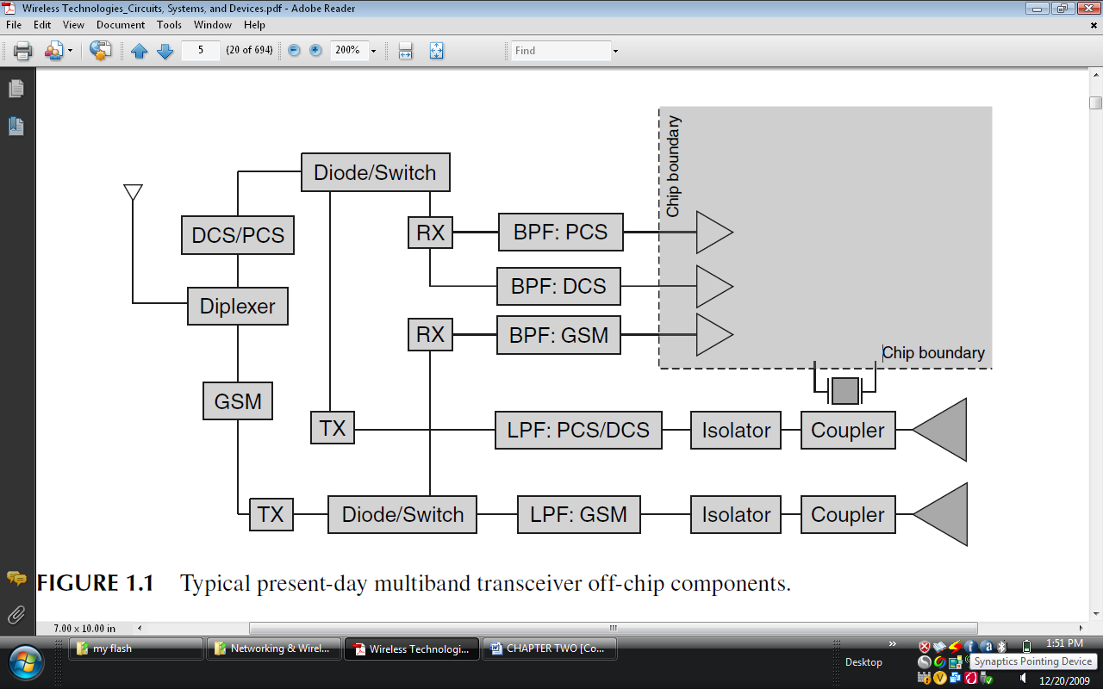Figure 2.1 Typical present day multiband receiver of chip components.
2.2 HISTORY OF INTERCOM
Intercom history has come a long way since these apparatus were first introduced as communication systems at the beginning of the 20th century. Descendants of the antique ring system used on trains, intercoms have evolved a great deal. In the beginning there was use of telephone technologies until eventually intercoms transformed into multi-way, multi-post communications systems and wireless appliances. Intercom systems were quickly put to use in functions that clearly went beyond their original communication role. From the 1950’s onward, intercom systems became the most ubiquitous access control tool in residential and commercial buildings. We all know the ritual of ringing at a building entry door and waiting for the buzz that will grant us access to the premises, after having dutifully identified ourselves. These entry intercom systems became a part of our everyday life, and helped to improve home security to a large extent. Video intercom was the next to appear. Once reserved only to large corporate customers, video intercom systems have literally conquered the market because they offer the ability to positively identify the person requesting entry greatly improving the security of people equipped with such a device. Nowadays, intercom security solutions no longer require costly maintenance and heavy hard wiring. Wireless intercoms are now available for easy installation and integration, to become at once, a part of a home intercom and entertainment system, a phone intercom, an entry intercom and even ensure that your baby is sleeping tight. Microphones and speakers can be set almost everywhere, depending on your needs.
Online-Intercom.com has set for itself the mission to follow those evolutions and inform you about them. An informed customer will end up making informed and wise decisions [12].
2.3 MODULATION
In electronics, modulation is the process of varying one or more properties of high frequency periodic waveform, called the carrier signal, with respect to a modulating signal. The three key parameters of a periodic waveform are its amplitude ("volume"), its phase ("timing") and its frequency ("pitch"), all of which can be modified in accordance with a low frequency signal to obtain the modulated signal. Typically a high-frequency sinusoid waveform is used as carrier signal, but a square wave pulse train may also occur. In telecommunications, modulation is the process of conveying a message signal, for example a digital bit stream or an analog audio signal, inside another signal that can be physically transmitted. Modulation of a sine waveform is used in view to transform a baseband message signal to a passband signal, for example a radio-frequency signal (RF signal) [6].

2.4 DEMODULATION
Demodulation is the act of extracting the original information-bearing signal from a modulated carrier wave. A demodulator is an electronic circuit used to recover the information content from the modulated carrier wave [6].
2.5TRANSMITTER
The transmitter or mouthpiece converts acoustic energy into electric energy bymeans of a carbon granule transmitter. The transmitter requires a direct-current(dc) potential, usually on the order of 3–5 V, across its electrodes. When sound impingeson the diaphragm of the transmitter, variations of air pressure are transferred tothe carbon, and the resistance of the electrical path through the carbon changesin proportion to the pressure. A pulsating direct current results [11].

2.6RECEIVER
The typical receiver consists of a diaphragm of magnetic material, often softiron alloy, placed in a steady magnetic field supplied by a permanent magnet,and a varying magnetic field caused by voice currents flowing through the voicecoils. Such voice currents are alternating (ac) in nature and originate at the farendtelephone transmitter. These currents cause the magnetic field of the receiverto alternately increase and decrease, making the diaphragm move and respondto the variations. Thus an acoustic pressure wave is set up, more or less exactlyreproducing the original sound wave from the distant telephone transmitter. Thetelephone receiver, as a converter of electrical energy to acoustic energy, has acomparatively low efficiency, on the order of 2–3% [11].
2.7TRANSISTOR
Transistor, in electronics, common name for a group of electronic devices used as amplifiers or oscillators in communications, control, and computer systems (Amplifier, computer electronics). Until the advent of the transistor in 1948, developments in the field of electronics were dependent on the use of thermionic vacuum tubes, magnetic amplifiers, specialized rotating machinery, and special capacitors as amplifiers [5].
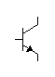
NPN PNP
Base
Emitter
Collector
Collector
Emitter
Base
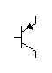
FIGURE 2.2
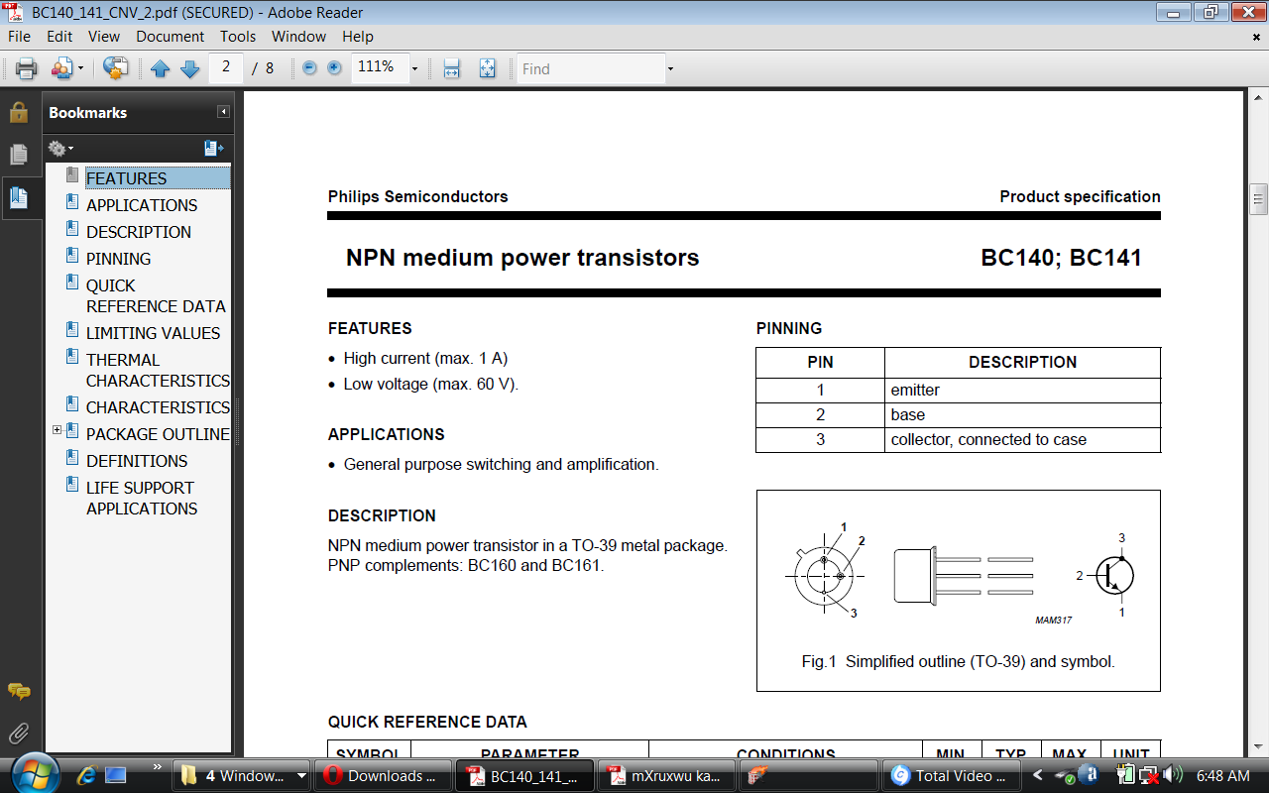
FIGURE 2.3

TABLE 1 Pinning
PIN | DESCRIPTION
1 | Emitter
2 | Base
3 | Collector

2.8AMPLIFIER
Amplifier, device for increasing the amplitude, or power, of an electric signal. It is used to amplify the weak electric current drawn from the antenna of a radio-receiving set, the weak output of a photoelectric cell (electric eye), the diminished current in a long-distance telephone circuit, the electrical signal representing sound in a public address system, and for many other purposes. One commonly used amplification device is the transistor. Other forms of amplifying devices are various types of thermionic vacuum tubes such as the triode, pentode, klystron, and magnetron [5].
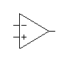FIGURE 2.4

LM386
FIGURE 2.5
2.7 INTEGRATED CIRCUIT
In electronics, an integrated circuit (also known as IC, microcircuit, microchip, silicon chip, or chip) is a miniaturized electronic circuit (consisting mainly of semiconductor devices, as well as passive components) that has been manufactured in the surface of a thin substrate of semiconductor material. Integrated circuits are used in almost all electronic equipment in use today and have revolutionized the world of electronics.
FIGURE 2.6 LM 386 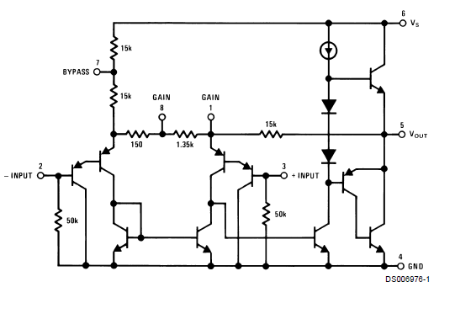
2.9ANTENNA
An antenna (or aerial) is a transducer designed to transmit or receive electromagnetic waves. In other words, antennas convert electromagnetic waves into electrical currents and vice versa. They are used with waves in the radio part of the electromagnetic spectrum, that is, radio waves, and are a necessary part of all radio equipment. Antennas are used in systems such as radio and television broadcasting, point-to-point radio communication, wireless LAN, cell phones, radar, and spacecraft communication. Antennas are most commonly employed in air or outer space, but can also be operated under water or even through soil and rock at certain frequencies for short distances.
Physically, an antenna is an arrangement of one or more conductors, usually called elements in this context. In transmission, an alternating current is created in the elements by applying a voltage at the antenna terminals, causing the elements to radiate an electromagnetic field. In reception, the inverse occurs: an electromagnetic field from another source induces an alternating current in the elements and a corresponding voltage at the antenna's terminals. Some receiving antennas (such as parabolic and horn types) incorporate shaped reflective surfaces to collect EM waves from free space and direct or focus them onto the actual conductive elements [6].
Antennas were used in 1888 by Heinrich Hertz (1857–1894) to prove the existence of electromagnetic waves predicted by the theory of James Clerk Maxwell. Hertz placed the emitter dipole in the focal point of a parabolic reflector. He published his work and installation drawings in Annalen der Physik und Chemie (vol. 36, 1889) [6].

CHAPTER THREE
3.0 DESIGN PROCEDURE AND ANALYSIS
INTRODUCTION
This chapter is aimed at the proper design of the project where the different characteristics of the various components of the circuit will be calculated as necessary.
3.1 DESIGN SPECIFICATION
This chapter concern with the design base on the specification of the project. The design specification for this project is divided into two. Design of power supply to the main circuit and design of the main circuit.
3.2 POWER SUPPLY
Most electronic devices require dc voltage to operate. Therefore, batteries are very useful in low power or portable devices but the operating time of such devices is limited unless the batteries are recharged or replaced constantly. The more readily available source of power is the 50Hz, 240v ac outlet. Where a dc voltage is required, a dc power supply circuit may be employed to convert the ac voltage to a dc voltage. A voltage regulation may be incorporated in a power supply circuit in order to eliminate the variation of power supply voltage with changing input current.The power unit converts 240v input alternating voltage of the supply into direct voltage of 9v.

- FILTER DESIGN
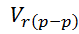= ………………………………………………1
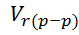=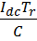 ……………………………………………2
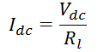........................................................................3
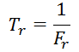…………………….……………………………4
=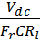 ………………..………………………….5
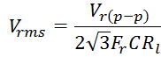 …………………………………….6
= ……………………………………………….7
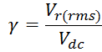 ……………………………………………8
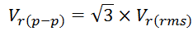 ……………………………...9
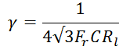 ……………………………………….10
Where
c load current
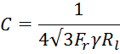
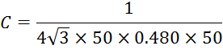
- REGULATOR DESIGN

USING 7809 FOR 9V

Maximum current from regulator= 1A
- FUSE DESIGN
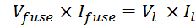 …………………………11
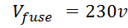
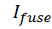=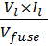 …………………………………………13
=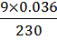
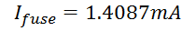
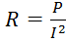 …………………………………………..14
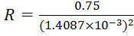=377941Ω

=377.941KΩ

3.2 CIRCUIT DESIGN

Designing of 90.1 MHz transmitter, with bandwidth 7.1 MHz, power output of 0.6 watts.
TRANSMITTER
Design of 90.1 MHZ, 7.1 Bandwidth, Gain of 30, voltage of 9v, collector current of 766$μ$A
For proper amplification $V_{CEQ}=1/2×V_{cc}$ and$V_{E}=1/{10}×V_{cc}$
FIGURE 3.1

$$V_{CC}=supplyvoltage$$
$$I_{C}=collectorcurrent$$
$$R_{C}=collectorcurrent$$
$$V_{BE}=Baseemmitervoltage$$
$$β=Gain=30$$
$V_{CEQ}=1/2×V_{cc}$…………………………..………..…15
$$V_{ceq}=1/2×9$$
$V_{ceq}=$4.5v
$$V_{BE}=0.7v$$
$V_{E}=1/{10}×V_{cc}$ ……………………………………..….16
$$V_{E}=1/{10}×9$$
$$V_{E}=0.9$$
$V_{CC}=I_{c}R_{C}+V_{CEQ}+V_{E}$ …………………………..….…17
$R_{C}=\frac{V_{CC}-V_{CEQ-V_{E}}}{I_{C}}$ ………………………………………18
$$R_{C}=\frac{9-4.5-0.9}{766×{10}^{-6}}$$
$$R_{C}=\frac{3.6}{766×{10}^{-6}}$$
$$R_{C}=4699.7Ω$$
$I_{B}=\frac{I_{C}}{β}$ …………………………………………………19
$$I_{B}=\frac{766×{10}^{-6}}{30}$$
$$I_{B}=25.53×{10}^{-6}A$$
$R_{B}=\frac{V_{CC}-V_{BE-V_{E}}}{I_{B}}$ ………………………………………20
$$R_{B}=\frac{9-0.7-0.9}{25.53×{10}^{-6}}$$
$$R_{B}=289855Ω$$
$R_{E1}=\frac{V_{E}}{I_{C}}$ ……………………………………………21
$$R_{E1}=\frac{0.9}{766×{10}^{-6}}$$
$$R_{E1}=1174.9Ω$$

$C_{o}=\frac{1}{2πF_{o}R}$ ………………………………………….22
$$C_{o}=\frac{1}{2π×90.1×{10}^{6}×1174.9}$$
$$C_{o}=1.5×{10}^{-6}F$$
$R_{E}=\frac{V_{E}}{I_{C}}$ ……………………………………………23
$$R_{E}=\frac{0.9}{766×{10}^{-6}}$$
$$R_{E}=1175Ω$$

FIGURE 3.2

$V_{BB}=V_{E}+V_{BE}$ ………………………………………24
$$V_{BB}=0.9+0.7$$
$$V_{BB}=1.6V$$
$R_{B2}=\frac{1}{10}×βR_{E}$ ………………………………….25
$$R_{B2}=\frac{1}{10}×30×270$$
$$R_{B2}=810Ω$$
Note: $R_{B2}=R_{2}R_{B1}=R_{1}$
$V_{BB}=\frac{R_{B2}}{R_{B1}+R_{B2}}×V_{CC}$ ……………………………26
$$R_{B1}+R_{B2}=\frac{V_{cc}×R_{B2}}{V_{BB}}$$
$$R_{B1}+R_{B2}=\frac{9×R_{B2}}{1.6}$$
$$R_{B1}+R_{B2}=5.625R_{B2}$$
$$R_{B1}=4.625R_{B2}$$
$R_{B1}=4.625×$810
$$R_{B1}=3746.25Ω$$
$C_{1}=\frac{1}{2πFReq}$…………………………..….……..27
$$C_{1}=\frac{1}{2π×90.1×{10}^{6}×Req}$$
$Req=\frac{R_{B1}×R_{B2}}{R_{B1}+R_{B2}}$ …………………………………..28

$$Req=\frac{3746×810}{3746+810}$$
$$Req=666Ω$$
$$C_{1}=\frac{1}{2π×90.1×{10}^{6}×666}$$
$C_{1}=2.65×{10}^{-12}$F
$$C_{2}=6.5×{10}^{-12}F$$

- RECEIVER
The receiver receives the transmitted frequency of 90.1 MHZ.
$F_{0}=\frac{1}{2π\sqrt{LC}}$ ……………………………………..29
$L_{3}=\frac{1}{4π^{2}{F_{o}}^{2}C_{3}}$ ………………………………….30
$$L_{3}=\frac{1}{4π^{2}{\left(90.1×{10}^{6}\right)}^{2}×4.7×{10}^{-6}}$$
$$L_{3}=0.664×{10}^{-12}H$$
$L_{4}=$31.2$×{10}^{-12}H$
$I_{D}=I_{DSS}{\left(1-\frac{V_{GS}}{V_{P}}\right)}^{2}$ ………………………….31
$$I_{DSS}=20mA$$
$$V_{P}=8V$$
$$V_{GS}=7.5V$$
$$I_{D}=20×{10}^{-3}{\left(1-\frac{7.5}{8}\right)}^{2}$$

$I_{D}=78.2×{10}^{-6}$A

CONCLUSION
In this chapter, the design of the various units of the system is built up, the theory of operations of the devices used are considered. The design is based on the availability of the components for the system realization. The various units were designed and tested separately.

CHAPTER FOUR
4.0 CONSTRUCTION AND IMPLEMENTATION
INTRODUCTION
There are certain necessary stages any finish design of any circuit or system must past through. These stages include the initial circuit design, selection of component, construction, testing and further design modification. This chapter illustrates the construction and testing procedure of the wireless intercom.
4.1 CONSTRUCTION
The elements were verify and tested using test equipment. The project circuit was temporarily assembled on the project board. The components were transferred to the main board. Certain component were taken into consideration such as spacing, shape and size of the component, jumpers, terminal points, and connection. The battery was selected due to the power supply may arise during normal operating time. The components and their connection are represented in the circuit diagram in figure 4.1, figure 4.2 and figure 4.3.
  - Power supply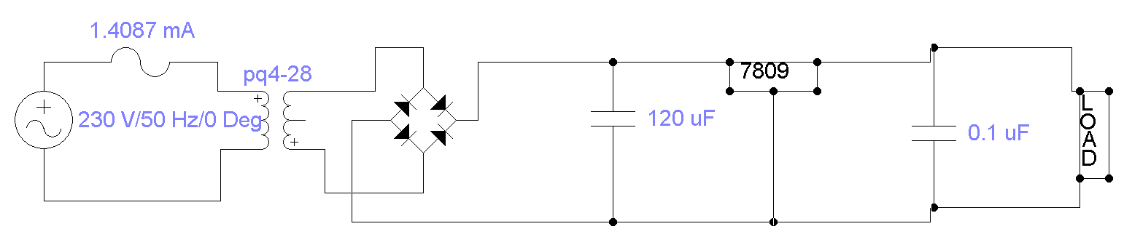

Figure 4.1

4.2 RECEIVER CIRCUIT DIAGRAM

FIGURE 4.2

4.3 TRANSMITTER CIRCUIT DIAGRAM

Figure 4.3

4.3 TESTING
Test techniques include, the process of executing the project with the intent of finding bugs or errors. After testing we find out that the receiver unit is working but the audio amplifier section has problem.

4.4packaging and casing
The project was properly package. Holes for switch and the fuse and output socket were constructed. The circuit board was laid on the floor of the casing. A hole was also provided on either side of the project box to allow air to adequately circulate through the box.

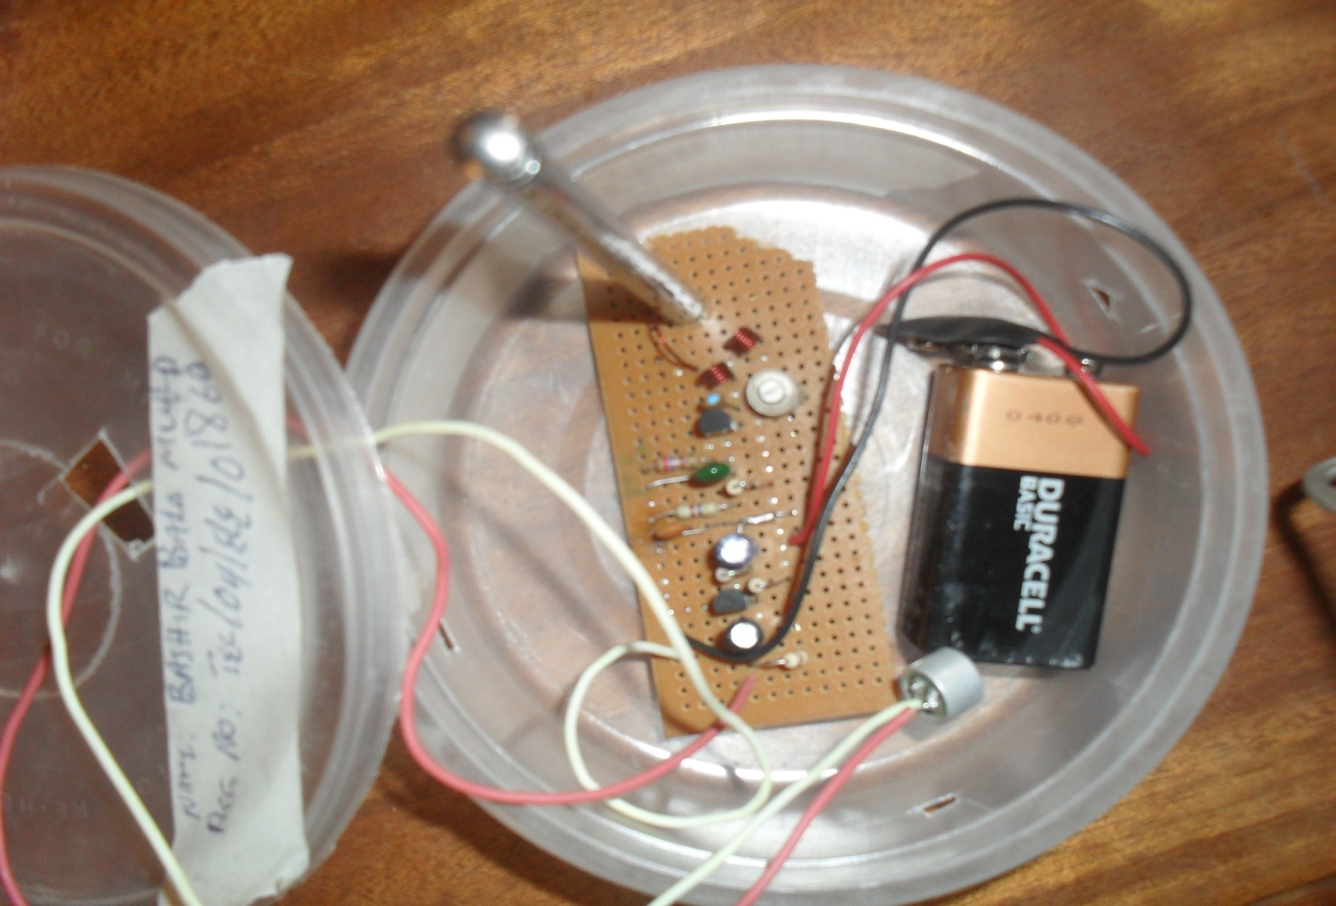

TRANSMITTER

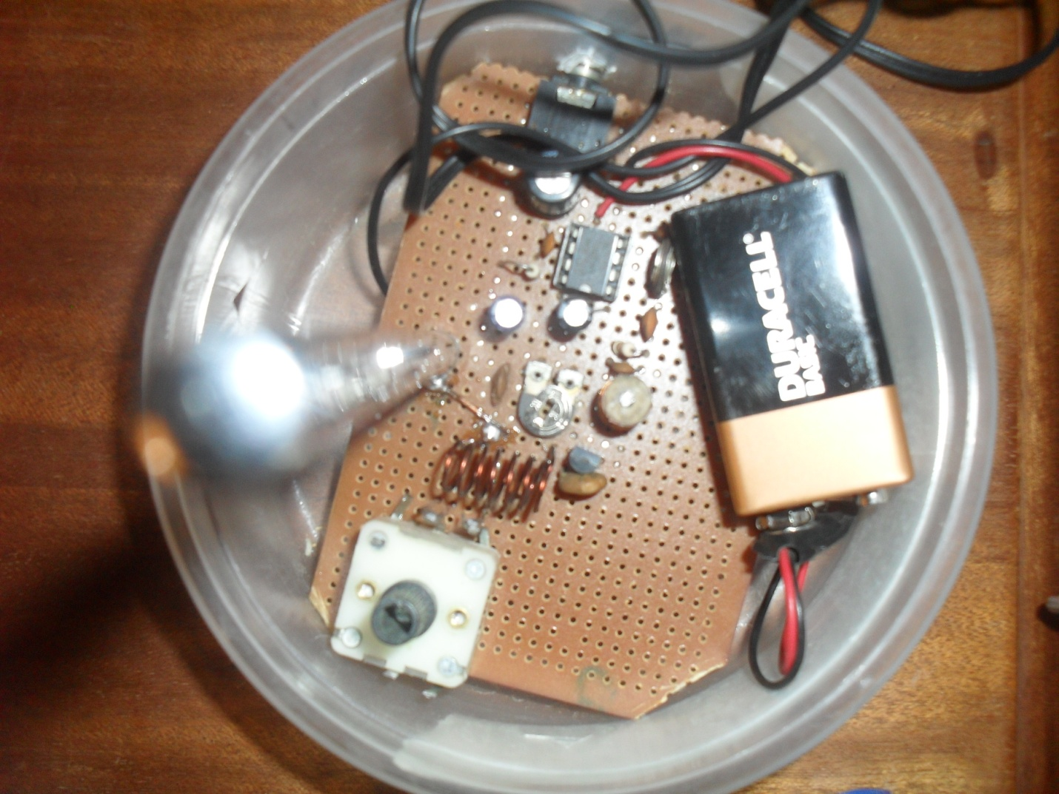

RECEIVER

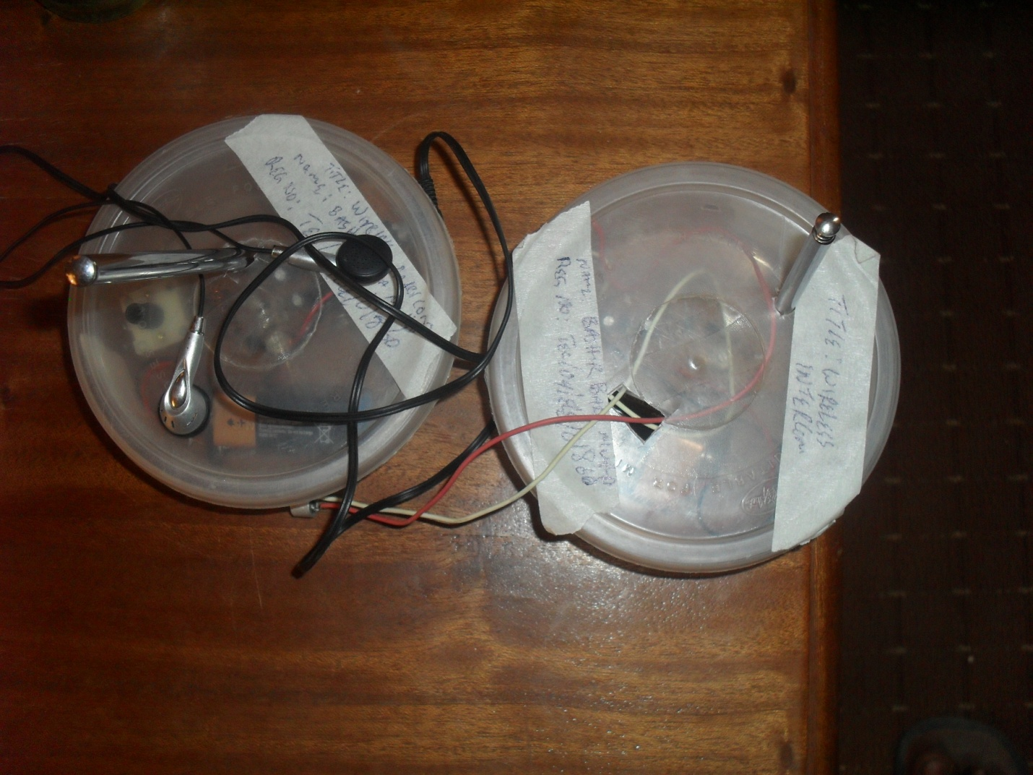

Transmitter and receiver

4.5 PROBLEM ENCOUNTER
Some of the problems are
- Initially there was problem from audio amplifier unit.
- There was battery problem.
- The audio amplifier IC burn during testing.

CONCLUSION
This chapter explains the working principle of the circuit, construction procedures of the circuit assembling, test that were carried out and the result obtained. As can seen the project use the battery power for simplicity and portability

CHAPTER FIVE
- CONCLUSION AND RECOMMENDATION

INTRODUCTION
This is the last chapter; it gives the limitation and problem encounter and the remedy during this work, as well as recommendation for further works. This chapter discus the conclusion and recommendation of the wireless intercom project.
5.2 CONCLUSION
The wireless intercom system has been design, constructed and implemented. The result obtain verify that the project met the expectation. Hence the aim and objective of the project was achieved. The result show that the wireless intercom can transmit and receive at frequency of 90.1 MHz, with transmission distance of 8 metres.
5.3 LIMITATION
This wireless network system is limited to one way communication. That is the communication is from transmitter to receiver only. It is half duplex communication.

5.4 RECOMENDATION
1. Transceiver can be employ to attain full duplex operation of the project.
2. The reliability and optimum performance of the project should be attaining by maintaining the following condition.
- Use of self regulating system.
- Rational design and use of wear resistance materials; this minimized the effect of energy related degradation of the system.
- Reliability can also be improved by the type of packaging mounting and ventilation of the system.
- Moisture and other contaminants should be minimized there by creating open line or changing the conductivities of the line.
- Mechanical shock and vibration of the circuit should be avoided.
The project was properly constructed and tested and result obtain indicate that the project meet the meet the expectation.

REFERENCES:
- S. B. Ibrahim, “Lecture on Final year Project” Unpublished, Department of Electrical Engineering, Bayero University Kano (2009).
- V. J. Utong, “Technical Writing and Presentation course hand book” Unpublished, Department of Mechanical Engineering, Bayero University Kano.
- S. O. Obeahon, “Technical Writing and Presentation” Unpublished, Faculty of Technology, Bayero University Kano (1997).
- M. T. Jimoh, “Technical Writing and Presentation Lecture” Unpublished, Department of Mechanical Engineering, Bayero University Kano (2007).
- Microsoft Encarta “Science and Technology encyclopedia",Microsoft Corporation, 2009.
- www.wikipedia.com, 2009.
- www.scripd.com 2010.
- www.redcircuits.com 2010.
- www.electronic-lab.com 2010.
- http://forumallaboutcircuit.com 2010.
- R. L. Freeman (2004), Basic Telephony, ISBN 0-471- 45133-9
- www.online-intercom.com 2010
- www. kpsec.freeuk.com/components/capac.htm
- E. Huges, "Huges electrical and electronic technology", Pearson education LTD, Delhi India, (2004).
- A.K Theraja and B.L Theraja, "A test book of Electrical Technology", S. Chand and and Company LTD, Second edition (2002).
- R. L. Boylestad and L. Nashelsky, "Electronic Devices and Circuit Theory", Prentice Hall, London, II, (1996).

