KWARA STATE POLYTECHNIC, ILORIN INSTITUTE OF TECHNOLOGY DEPARTMENT OF CIVIL ENGINEERING

ASSESSMENT OF PALM KERNEL OIL AS A NATURAL SURFACTANT IN HYBRID FOAM CONCRETE FOR BUILDING INSULATION APPLICATION

BY

BAMIDELE SIJIBOMI JOHNSON
HND/23/CEC/FT/0149

BEING RESEARCHED AND SUBMITTED TO THE DEPARTMENT OF CIVIL ENGINEERING, INSTITUTE OF TECHNOLOGY, KWARA STATE POLYTECHNIC, ILORIN

IN PARTIAL FULFILMENT OF THE REQUIREMENT FOR THE AWARD OF HIGHER NATIONAL DIPLOMA (HND) IN CIVIL ENGINEERING

JULY 2025

DECLARATION
I hereby declare that this project work titled ASSESSMENT OF PALM KERNEL OIL AS A NATURAL SURFACTANT IN HYBRID FOAM CONCRETE FOR BUILDING INSULATION APPLICATION is a work done by me, BAMIDELE SIJIBOMI JOHNSON with matric number, HND/23/CEC/FT/0149 of the Department of Civil Engineering, Institute of Technology, Kwara State Polytechnic, Ilorin.
______________ __________________
Signature Date

CERTIFICATION
This is to certify that this research study was conducted by BAMIDELE SIJIBOMI JOHNSON (HND/23/CEC/FT/0149) and had been read and approved as meeting the requirement for the award of Higher National Diploma (HND) in Civil Engineering, Institute of Technology, Kwara State Polytechnic, Ilorin.

_________________________ _______________
ENGR, R.O Sanni Date
Project Supervisor

_________________________ _______________
ENGR, A. B. NA’ALLAH Date
Head of Department

__________________________ _______________
ENGR. DR. MUJEDU KASALI ADEBAYO Date
External Supervisor

DEDICATION
This project is dedicated solemnly to God Almighty, who is the sole inspiration of all things, without whom there would not be, and neither would this project. Appreciation goes to my loving parents for their support in the fulfillment of my Higher National Diploma (HND) both orally and financially. May God allow them to eat the fruit of their labor (Amen)

AKNOWLEDGEMENT
I begin by expressing my deepest gratitude to the Almighty God, who has blessed me with the wisdom, strength, and resilience to complete this project.
I extend my sincere appreciation to my project supervisor, Engr. R.O Sanni for his invaluable guidance, support, and encouragement throughout this journey. His expertise and constructive feedback were instrumental in shaping this project.
To my family, I express my heartfelt gratitude for their unwavering support and love. My Dad, Mr. Bamidele Johnson and Mom, Mrs. Shola Roselyn especially Yeye Babajide who always motivates me to make this milestone a success, Mr. and Mrs. Abejide Solomon and Bamidele Bukola thank you for being a constant source of motivation, encouragement and financial support. I appreciate your love.
I also acknowledge the entire staffs of the department of Civil Engineering in the Institute of Polytechnic, Eng. R.O Sanni among others, for their dedication, enlightenment and support towards the success of my academics and others that I could not mention, thank you for your patience, understanding, and support.
To my friends, guardians and colleague, Kayode John, Ayinde Ridwan (Fabulous) among others, my favorite Moyo-Oluwa (Omolewa) who as always stood by me and the whole of Bamidele’s Family many others that their names could not be mentioned, I appreciate your encouragement, advice, and camaraderie.
Thank you all for being part of my journey. Bamidele Sijibomi Johnson

1. INTRODUCTION

1.1. Background of the Study

One of the methods of reducing the density of concrete relies on the introduction of stable voids within the hardened cement paste or mortar. The voids can be produced by gas or by air. Because a foaming agent introduces the air, the concrete produced is called foam concrete
Hybrid foam concrete (HFC) produced from cement, sand, water and foaming agent. It is a lightweight concrete with lower density of concrete (Hazlin et al., 2017). HFC has density of 400 kg/m³ to 1600 kg/m³ and a minimum of 20% entrapped air in volume. The micro air voids occupied in HFC has considerably reduced the weight as the air weight is negligible if compared to the concrete. The heavyweight problem of conventional concrete resolved and lead to a fast construction.
HFC has been used as a construction material for a long time due to its low density and low thermal conductivity (Thienel et al., 2020 & Elshahawi et al., 2021). The production of lightweight concrete is accomplished by introducing voids in the material matrix, which could be done by various methods, such as mixing with the lightweight aggregate or using pore-forming agents. Among different types of lightweight concrete, foam concrete has been developed and widely used in building construction applications. The air-containing voids in Foam concrete are typically created by hydrogen gas produced in-situ by the reaction between aluminum powder and calcium hydroxide (Ca(OH)₂) or alkalis (Fomina et al., 2018 & Suleymanova et al., 2019). Like many cementitious materials, Foam concrete is used in combination with agro-wastes such as rice husk ash (RHA) (Kunchariyakun et al., 2015), bagasse ash (BA) (Kunchariyakun et al., 2018 & Hussain et al., 2022) and palm oil fuel ash (POFA) (Ashteyat et al.,2024), to reduce costs and promote waste recycling.
Furthermore, the properties of foam concrete are affected by the production method and the materials used. Unlike other porous lightweight concrete, prefabricated foams with foaming agents are added to fresh cement paste and mortar. The air pores brought by the foams constitute 10–90% by volume of the hardened body. This porous structure forms the basis of the mechanical properties, thermal conductivity, acoustic and durability properties of foam concrete (Hou et al., 2021). One of the advantages of foam concrete is its weight reduction (up to 80%) compared to conventional concrete (Chica et al., 2019). The air bubbles are evenly distributed in the foam concrete body. The pore structure may be affected during the mixing, transportation and placement of fresh concrete, so it should have fixed walls. Air bubbles range in size from approximately 0.1 to 1 mm (Jalal et al., 2017). The density of foam concrete is mainly affected by the amount of foam and varies between 400 and 1600 kg/m³. It can be used for structural, partitioning, insulation and filling applications with excellent acoustic/thermal insulation, high fire resistance, lower raw material costs, easier pumping and finally no compaction, vibration or leveling (Chica et al., 2019). Other benefits of utilizing agro-wastes in lightweight concrete are their low specific gravity and pozzolanic reactions of agro-wastes.

1.2. Problem Statement
The construction industry is increasingly focused on the development of sustainable building materials to meet growing environmental concerns and energy efficiency goals. Among these materials, foam concrete is recognized for its lightweight, insulating properties, making it an ideal solution for thermal insulation in building applications. However, the production of foam concrete relies on synthetic surfactants that may have detrimental environmental impacts due to their petrochemical origins and non-biodegradability.
Palm kernel oil (PKO), a byproduct of palm oil extraction, has shown potential as a natural, biodegradable alternative surfactant in various industrial applications. However, limited research has explored its feasibility as a natural surfactant in foam concrete production, particularly for thermal insulation applications in the building sector. This research aims to assess the effectiveness of palm kernel oil as a sustainable surfactant in hybrid foam concrete, evaluating its impact on the material's properties such as density, thermal conductivity, and compressive strength.
The study will investigate whether PKO-based surfactants can reduce environmental impacts while maintaining or improving the performance of foam concrete for building insulation purposes. The findings could contribute to the development of eco-friendly, high-performance building materials, aligning with global sustainability goals in the construction industry.

1.3. Justification of the Study

Despite the growing interest in hybrid foam concrete as a sustainable building material, there is limited research on the effectiveness of palm kernel oil as a surfactant in improving the properties of foam concrete. The growing demand for sustainable construction materials has driven the exploration of lightweight concrete solutions, such as foam concrete, which offers significant advantages in terms of reduced density, enhanced thermal and acoustic insulation, and improved fire resistance. (Amran et al., 2015).
Foam concrete, which is produced by incorporating air voids through foaming agents or gas-producing reactions, presents a promising alternative to conventional heavy concrete, addressing the issues of weight and thermal inefficiency in building structures. However, despite its benefits, foam concrete’s performance is highly influenced by several factors, including the production method, the materials used, and the control of the pore structure during mixing, transportation, and placement.
The incorporation of agro-wastes, such as rice husk ash, bagasse ash, and palm kernel oil, into foam concrete offers potential environmental and economic benefits by reducing material costs and promoting waste recycling. Yet, the integration of these agro-wastes into foam concrete has not been fully optimized, and their effects on the mechanical properties, durability, and overall performance of foam concrete remain under-researched. Moreover, the stability and uniformity of the foam structure during the production process, particularly with varying foaming agent concentrations and types of agro-waste, pose challenges that need to be addressed to enhance the material's consistency and reliability for construction applications.
Specifically, the effectiveness of palm kernel oil (PKO) as a natural surfactant in HFC requires comprehensive investigation.

1.4. Aim of the Study
This study aim is to Assess Palm Kernel Oil as a Natural Surfactant in Hybrid Foam Concrete for Building Insulation Application.

1.5. Objectives
- Assess the mechanical and physical properties of palm kernel oil-based foam concrete, including compressive strength and workability.
- Investigate the thermal insulation performance of foam concrete incorporating palm kernel oil.
- Compare the thermal performance of foam concrete with conventional alternatives.
- Evaluate the feasibility of using palm kernel oil as a natural surfactant in hybrid foam concrete.

1.6. Scope of Study
The scope of this study will cover the following aspects.
This study will primarily focus on assessing the use of palm kernel oil (PKO) as a surfactant in hybrid foam concrete for building insulation applications within the context of tropical and sub-tropical regions, particularly where palm oil production is prevalent. However, the findings and conclusions may also be relevant to other regions where there is interest in sustainable building materials and natural surfactants.

1.6.1. Material Scope
- The study will investigate the impact of varying concentrations of palm kernel oil as a surfactant in foam concrete. PKO will be used as an alternative to synthetic surfactants commonly used in foam generation. The study will also examine the effects of PKO on the mechanical and thermal properties of foam concrete.
- This research will focus on foam concrete, which is lightweight and has enhanced thermal insulation properties. The control group for comparison will consist of foam concrete prepared with conventional synthetic surfactants, such as alkyl sulfonates or protein-based foaming agents.
- Different dosages of palm kernel oil will be tested to determine the optimal level for foam generation and its impact on the properties of the concrete.

1.6.2. Experimental Scope
- The study will evaluate the compressive strength and workabilty of foam concrete samples. Specimens will be tested at various curing ages to assess the long-term performance of the foam concrete.
- The thermal properties of foam concrete will be measured to determine its insulation efficiency. Since foam concrete is primarily used for thermal insulation in buildings, this parameter is critical for assessing the material's suitability for energy-efficient building applications.
- The workability of the foam concrete will be assessed to ensure that the inclusion of PKO does not negatively affect the mixing or handling characteristics of the material.

1.6.3. Limitations
- This study will focus exclusively on foam concrete, and the results may not be directly applicable to other types of lightweight or insulated concretes.
- While the study will explore the use of PKO, it will not delve into the comparative performance of other natural surfactants like coconut oil, which could be a potential avenue for future research.
- Although the study will primarily focus on regions where palm oil is produced in abundance (e.g., Southeast Asia, West Africa), the use of PKO in foam concrete could potentially be expanded globally. However, the availability and cost of PKO will vary by region.

2. LITERATURE REVIEW

2.1. Preamble
Hybrid foam concrete (HFC) is a relatively new construction material that has gained attention recently due to its unique properties. This material is not very heavy and low-density, making it easy to form into different shapes and sizes. Its excellent thermal insulation makes it popular for building walls, roofs, and floors. This review paper provides an in-depth examination of the properties and characteristics of HFC. Its composition typically consists of cement, water, foam, additives, and the various manufacturing methods used to produce it—the mechanical properties of HFC, including its compressive strength. The density of HFC can vary greatly, usually falling between 100 and 600 kg/m³. The diversity of this can be affected by different factors, such as the kind and number of additives applied and the methods of foaming and thickening employed. The paper highlights the various insulations applications of HFC in the construction industry.

2.1.1. Hybrid Foam Concrete
HFC is a cost-effective and commonly available lightweight construction material that incorporates air voids created by the addition of pre-made foam to the concrete combination (G. Calis et al., 2021). It contains basic components like cement, water, fine sand, and stable foam. The density of foamed concrete can be modified from 100 kg/m³ to 600 kg/m³ to suit various construction requirements (M. Alharthai et al., 2024). It is suitable for both load-bearing and non-load-bearing applications, with very low densities being particularly useful in providing fire resistance, sound absorption, and thermal insulation. HFC is a porous cement-based product with a dry density of about 300 kg/m3 and a porosity of more than 80 % (pore size is greater than a few hundred microns) (W. Sheet al., 2014). The mechanical performance of HFC with varying densities has reported performance increases as the dry density increases (D. Falliano., 2018).
HFC is a lightweight concrete typically produced by integrating pre-formed foam into freshly prepared cement paste or mortar (Hashim & Tantray 2021). HFC is formulated by amalgamating cement slurry, foaming agents, and pertinent additives. Its unique structure, characterized by numerous minuscule air or gas-induced bubbles, endows lightweight foam concrete with reduced density and increased porosity. Previous studies have demonstrated its superior thermal insulation capabilities and exceptional sound absorption effects (Yoon et al., 2020; Amran et al., 2015).

2.1.1.1. Properties of Hybrid Foam Concrete
In this paper, the properties of foamed concrete are classified into fresh, mechanical, physical, durability, and functional properties. Each property has its own specific characteristics influenced by the manufacturing process and performance quality. The fresh state of the foamed concrete includes the mixture consistency, rheology and stability. In the hardened state, the authors focus on physical, functional and mechanical properties as described in the following paragraphs.

2.1.1.1.1. Fresh properties
In the fresh state, the foam concrete mix has a flowing and self-compacting rheology (M.R. Jones, et al., 2005). Hence, different parameters such as consistency and rheology, stability, workability and compatibility should be taken into account. These parameters are mostly influenced by the proportion of either water to cement (w/c), supplementary materials, fine/course aggregate, plasticizers, and the volume and type of foam agents added.
- Consistency and rheology
The consistency and rheology are first assessments of fresh foamed concrete; they are usually measured by a flow cone and the flow marsh test to investigate the mixture performance (E.P. Kearsley, et al., 2001). The performance of consistency and rheology of foamed concrete is acceptable when the spread-ability of fresh concrete mixes is limited between 40% and 60% of the flowing time. The flowing time should be within 20s for a sufficient mix to be placed into molds and get self-compacted without any external aids (K. Ramamurthy, et al., 2008). Reportedly, different factors influence the consistency and rheology of the mix; which are basically related to the mix design constituents. One important factor that affects rheology and consistency of the fresh foamed concrete is the water content in the mix design. It was recommended that the water to cement ratio should be minimized because the excessive volume of water causes segregation of foamed concrete during casting which affects the workability performance (Jierula, A., et al., 2024).
- Stability
The state of stability is an adhesive behavior of foamed concrete mix design constituents, and their consistency and cohesiveness as a system. Foamed concrete is classified as a homogeneous foamed concrete when mixes have a creamy, easily pourable and closely fluid consistency which results in a fresh mix free of bleeding and segregation (Bayraktar, O. Y., & Demirboğa, R., 2022). It is reported that the mixture composition is prepared with a right mix design method and a correct calculation procedure when the difference between the achieved plastic density and the desirable plastic density does not exceed 2–7% (Oren, O. H., et al., 2020).
- Compatibility
The compatibility of foamed concrete is known as a situation of strong interaction between the mix design and its constituents specifically between chemical admixtures and foam agent. Therefore, where there was no collaboration between the mixture constituents, the compatibility of foam mortar would be reduced. Therewith, due to incompatibility of design admixtures, the segregation problem usually occurs when there is no interaction between the surfactant and plasticizers (K.C. Brady, et al., 2001).
- Workability
The workability of foamed concrete shows an excellent performance through the presence of air-voids in the fresh mix due to the addition of stable foam agent (Zhang, S., et al., 2023). Workability test, commonly conducted by a slump test for the normal concrete is not applicable for low density fresh concrete specified by BS EN 12350: Part 2, part 6. Foamed concrete workability performance is visually evaluated, which aims to achieve an appropriate viscosity of the mix. Besides, Brewer measured the workability of foamed concrete using a method called spreadability. Brewer recommended this test on a fresh mix of low-strength materials (e.g. foamed concrete) by measuring the spread in two directions of a sample placed in a 75 mm diameter and 150 mm long open-ended cylinder, after the cylinder was raised vertically. The average of the two measured diameters was calculated and reported to the nearest 5 mm (W.E. Brewer, 1996).

2.1.1.1.2. Mechanical properties
Mechanical properties are considered as the most important factors to measure applicability of foamed concrete at the hardened state. In this paper, compressive, flexural and tensile strengths, and modulus of elasticity are reviewed to provide the reader with the state of art of foamed concrete today. Furthermore, numerical models and empirical equations developed by researchers are briefly highlighted in Tables 2.1-4.
Table 2.1.
Empirical model for foamed concrete compressive strength determination
Equations | Annotations | Ref
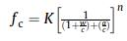 | K= empirical constants, n = strength to gel-space ratio | J.M. Durack, et al., 1998.
f _{c} = K_{S} In [P_{cr}/P] | Pcr = the critical porosity corresponding to zero strength  Ks = a constant, ‘‘Schiller’s equation” | M. Röbler, et al., 1985.
f _{c} = Kg^{n} | K = the intrinsic strength of the gel g = the gel-space ratio (Power’s gel-space ratio) | A.M. Neville, et al., 1995.
f _{c} = P_{O} (1 - P)^{n} | Po = the strength at zero porosity n = a constant (Balshin’s expression) | N. Narayanan, et al., 1999.
f _{c} = 1.27 f_{c7} + 2.57  f _{c} = 1.5 e^{5µ} _{con} | When using w/c = 0.5 and s/c = 0 and using polymer foam agent | K.J. Byun, et al., 1998.

Table 2.2.
Empirical model for foamed concrete tensile strength determination.
Equations | Annotations | Ref
f _{t} = 0.20(f_{c})^{0.70} | For density between 1400 and 1800 kg/m3 | F. Oluokun, et al., 1991.
f _{t} = 0.23(f_{c})^{0.67} | f_{c} = 28 days compressive strength, N/mm2 | Thomas Telford, 1993.
f _{t} = 1.03(f_{c})^{0.50} | When w/c = 0.5 and fc = 28 days compressive strength, N/mm2 | K.J. Byun, et al., 1998.
f _{t} = 0.23(f_{c})^{2/3} | f_{c} = compressive strength while using lightweight aggregate concrete | Bulletin D’Information (1990).

Table 2.3.
Empirical model for foamed concrete flexural strength determination.
Equations | Annotations | Ref
f_{cr} T = f_{cr} (-0.00526T + 1.01052)  f_{cr} T = f_{cr} (-0.025T + 1.8)  f_{cr} T = f_{cr} (-0.0005T + 0.6) | 20ºC < T < 400ºC  400ºC < T < 600ºC  600ºC < T < 1000ºC  f_{cr} T = flexural strength of foamed concrete at high temperature,  f_{cr} = at ambition temperature | Y. Anderberg & S. Thelandersson, 1976.
f_{cr} T = f_{cr} (-0.00526T + 1.01052)  f_{cr} T = f_{cr} (1-0.01T + 0.6) | 20ºC < T < 100ºC  20ºC < T < 100ºC | L.W.G. Zhenhai, 1993.

Table 2.4.
Empirical model for foamed concrete modulus of elasticity determination.
Equations | Annotations | Ref
E = 33W^{1.5} (f_{c}) ^{0.5} | It used Pauw’s equation | K. Ramamurthy, et al., 2009.
E = 0.99 (f_{c}) ^{0.67}  E = 0.42 (f_{c}) ^{1.18} | Used when fly ash utilized as fine aggregate  Used when sand is utilized as fine aggregate | F.C. McCormick, et al., 1967.
E = 5.32 x W - 853 | Density is ranged between 200 and 800 kg/m³ | A. Saint-Jalmes, 2005.
E = 632(µ_{con})^{1.5} (f_{c}) ^{0.5} | µ_{con} = unit weight of concrete  f_{ck} = compressive strength of concrete  Where average Poisson’s ratio = 0.2, and using polymer foam agent | K.J. Byun, et al., 1998.
E = 57,000(f_{c}) ^{0.5} | Density of normal concrete limited between 2200 and 2400 kg/m³ substituting with 80 kg/m³ for steel | M.E. Kamara, et al., 2008.
E_{c} = 9.10 (f_{c}) ^{0.33}  E_{c} = 1.70 x 10^{—6} p² (f_{c}) ^{0.33} | fc = compressive strength of concrete  P = plastic density (kg/m³ ) | R.E. Rowe, et al., 1987.

- Compressive strength
HFC is produced through the integration of foam into the concrete mixture, forming a distinct type of concrete, resulting in a highly porous and lightweight material. The compressive strength of HFC depends on several factors, such as the type and quantity of foam, aggregate type and size, water-to-cement ratio, curing conditions, and the addition of other materials, such as fibers and admixtures. The amount of water has a significant effect on the compressive strength of foamed concrete. It was reported that small changes in the water content of foam concrete do not affect the strength as in normal concrete (Ramamurthy, et al., 2009). An increase in the w/c ratio can provide an increase in strength. The reason for this can be demonstrated by the formation of pores that grow with the amount of water. With the increase in large pores and capillary pores, the density of the air voids decreases and the strength increases (Jaing, et al., 2016).
Liu et al. reported that the compressive strength of foam concrete showed an inverted V-shaped change with the increase in the water/cement ratio. If the w/c ratio is below the optimal limit, thinner-walled and irregular foams occur, and the compressive strength is negatively affected. The use of the w/c ratio above the optimal limit results in a poorer bubble holding ability. It causes pores to join and uneven distribution. This irregularity in the pore structure is subjected to stress concentrations. In addition, the increase in the amount of water triggers the formation of capillary channels, thereby reducing its strength (Liu, et al., 2016). The use of superplasticizer contributes to the increase in compressive strength by reducing the w/c ratio (Chandni, et al., 2018).
- Flexural and tensile strength
ACI Committee 523 recommends the expression for splitting tensile strength to be taken from the method described by ASTM C496. In foamed concrete, the tensile strength is lower than that of normal concrete. In general, it is reported that the ratio of tensile strength to compressive strength of foamed concrete ranges between 0.2 and 0.4 which is higher compared to normal concrete that possesses a ratio of splitting tensile to compressive strengths between 0.08 and 0.11 (Amran, Y. H. M., et al., 2015).
Flexural strength is a crucial mechanical property that measures a material’s capacity to resist bending and is a significant factor in deciding the applicability of HFC in structural projects (M.H. Sobuz, 2023). However, it has been identified as one of the limitations of HFC, which restricts its usage in specific structural applications. Therefore, understanding the factors that affect the flexural strength of HFC is important for optimizing its properties and expanding its use in various applications.
The impact of various protein foaming agents was examining by Falliano, et al., P1 and P2. The abbreviations P1 and P2 refer to two types of protein-based foaming agents, while the letter F denotes the inclusion of polypropylene microfibers. The flexural strength of ultra-lightweight fiber-reinforced concrete mixes that included polypropylene micro fibers indicated that adding microfibers significantly enhanced the flexural strength of the samples. The HFC P1 F mix exhibited the best flexural performance, with a mean flexural strength of 0.030 MPa, which was a significant improvement over the other blend. The inclusion of artificial polypropylene fibers created a network of connectivity in three dimensions, which improved the system’s overall performance while maintaining its stability and workability. Additionally, based on the capillary and water absorption test results, the flexural strength of HFC P1 F and HFC P2 F samples was determined to be 61 % and 74 %, respectively, of their peak flexural capacities (Falliano, et al. 2022). Table 2.3 illustrates the prediction of the flexural strength of foamed concrete reinforced with polypropylene fibers and fly ash under elevated temperatures. It was stated that the fibers increased the heat resistance of foamed concrete against crack propagation at temperatures up to 600 ºC at which 60% loss was observed in compressive strength of samples.
- Modulus of elasticity
Modulus of elasticity is associated with density of the foamed concrete. Based on the review of existing studies conducted, when dry densities of foamed concrete range between 500 and 1600 kg/ m³, the modulus of elasticity falls between 1.0 and 12 kN/m², respectively (K.C. Brady, et al., 2001). It is reported that the E-value of foamed concrete is four times lower than the normal concrete (M.R. Jones, et al., 2005), nonetheless, there are possibilities to compensate this reduction by addition of polypropylene fibers to the mix with the most marked increases reported at 0.50% rate (by mix volume) and 1400 kg/m3 density, as reported by M.R. Jones, et al., Polypropylene fibers (0.50% by mix volume) are considered as flexible fibers to be used in foamed concrete applications due to its lightness that does not influence the uniformity of foam bubbles. Table 2.4 shows the attributions between the three variables, compressive strength, modulus of elasticity and density. The empirical equations support that foamed concrete with high dry density results in higher compressive strength as well as higher modulus of elasticity.

2.1.1.1.3. Physical properties
Some physical properties of foamed concrete include density, drying shrinkage, and porosity.
- Density
The density of mix can be measured in two phases; fresh and dry densities. The difference between values of fresh and dry density is recommended to be limited to 100–120 kg/m³ (W.A. Thanoon, et al., 2004). The actual fresh mix density is usually measured by filling and weighing a pre-weighted standard container of known volume with the produced foamed concrete. Then, the variation between the design and achieved densities should be assessed. The most acceptable tolerance for dry density is limited to be ±50 kg/m³ which might reach the difference up to ±100 kg/m³ for high density foamed concrete mixes (i.e. 1600 kg/m³) (C. Bing, et al., 2011). The method is described in BS EN 12350: Part 6: 2000. The purpose to determine the fresh density is to prepare the actual volume for the design mix and the casting control while the dry density rigorously controls the mechanical, physical and durability properties of hardened foamed concrete.
- Dry shrinkage
Drying shrinkage is considered as one of drawbacks of foamed concrete that usually occurs during the first 20 days of casting time. The typical range of drying shrinkage of foamed concrete is between 0.1% and 0.35% of the total volume of the hardened concrete matrix (A.F. Roslan, et al., 2013). Also, drying shrinkage of foamed concrete is deemed as 4–10 times higher than normal concrete due to aggregate type in the mix design, higher cement and water contents and mineral admixture in foamed concrete. Actually, there is a lack of knowledge about the effect of cement content on the drying shrinkage of foamed concrete, but some researchers reported that cement content had negative influences on the performance of foamed concrete in terms of drying shrinkage which can be overcome by partial substitutions of Portland cement with other supplementary materials such as fly ash, silica fume, and lime due to a lower heat of hydration (P. Chindaprasir, et al., 2008).
- Porosity
The porosity of foamed concrete eases the transport of aggressive fluids inside hardened matrix of foamed concrete. The porosity depends on degree of infusion characteristics such as water absorption, sorption, and permeability (N. Narayanan, et al., 2000). Many factors can affect the porosity of hardened concrete such as the mix design compositions, foam agents and the curing type. It is reported that high w/c ratio significantly affects the foamed concrete and caused porosity (E.P. Kearsley, et al., 2002). Previous works indicated that the permeability and pore size distribution of Portland limestone cement pastes increased when w/c ratio was incremented from 0.3 to 0.9 at which considerable volumes of larger pores with larger diameters were observed (Zhang, P., & Li, Q. 2021).

2.1.1.1.4. Functional properties
Functional properties explain the actual behavior of lightweight foamed concrete in its life span; for instance, its acoustic and thermal insulation, and fire resistance. This section reviews the latest studies on the functional properties of the foamed concrete, albeit, more research is indispensable.
- Acoustic insulation resistance
Recent studies show that the foamed concrete demonstrates higher acoustic insulation than normal concrete due to its cell-like microstructures (N. Narayanan, et al., 2000). However, the sound insulation resistance or the reflected frequency volume basically depends on the actual rigidity of concrete mass (surface density). Based on the theory of solid wall sound resistance, it has been expressed that the frequency of sound reflection hypothetically relies on the thickness of the wall and its bulk density. (S. Tada, et al., 1986).

- Thermal insulation

Foamed concrete is one of the lightweight concrete materials that consist of closed-cell structure which has thermal conductivity of up to 0.66 W/mK at 1600 kg/m³ density. Normal concrete has thermal conductivity of 1.6 W/mK at 2200 kg/m³ (N. Mohd Zahari, et al., 2009); 59% higher than foamed concrete resistance.
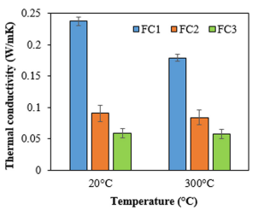Figure 2.1 Thermal conductivity value
Thermal conductivities of foam concretes are given in Fig. 2.1. The values vary between 0.058 and 0.237 W/mK. At ambient temperature, the specimens containing a high cement content present a high thermal conductivity coefficient. The foam volume is increased in the mixture, the value decreases. The foam concrete with low thermal conductivity presents a desirable thermal performance the fact that it has closed cellular body.
It was observed that the thermal conductivity reacts proportionally with a density and the thermal insulation characteristic decreases when the density volume increases. In another study by Jones & McCarthy (2006), it was shown that the thermal conductivity ranges between 0.23 and 0.42 W/mK at dry densities of 1000 and 1200 kg/m3. Besides, the moderate filling of porous mortar with polystyrene granules can produce foamed concrete with density range of 200–650 kg/m3 with thermal conductivity of 0.06–0.16 W/mK (A. Proshin, et al., 2005). It is specified that with each 100 kg/m3 reduction of density, the thermal insulation will drop by 0.04 W/mK of the total thermal insulation of foamed concrete. In practice, foamed concrete slabs demonstrate a superior thermal insulation behavior enhanced with minimized sorptivity and increased strength (A. Giannakou, et al., 2002). Also, another study on wall brick masonry revealed that using the foamed concrete with density of 800 kg/m3 in the inner leaf of the wall increased the thermal insulation by up to 23% comparing to normal concrete (Amran, Y. H. M., et al., 2015).
- Fire resistance
The available research works show that foamed concrete provides an acceptable fire resistance compared to normal concrete although it suffers from an excessive shrinkage due to high evaporation rates when exposed to elevated temperatures (J. Sach, et al., 1999). The capacity of foamed concrete to resist fire depends on its mixture proportions, compositions and constituents. In general, whenever, the density of foamed concrete decreases, its fire resistance proportionally increases. Foamed concrete has the capability to resist fire with a range close to normal concrete. Reportedly, concrete with densities of 950 kg/m³ and 1200 kg/m³ can withstand fire for 3.5h and 2h, respectively. Vilches et al. (2012) reported that foamed concrete with a density of 400 kg/m³ showed a rate of resistance to fire which was three times lower than the one with dry density of 150 kg/m³.

2.1.1.2. Applications of Hybrid Foam Concrete
Due to distinctive properties of foamed concrete including density reduction, low thermal conductivity, high flowability and self-compacting concrete, and given the ease of producers and its relatively cost-effectiveness, foamed concrete has found applications in many civil and structural engineering areas (Ramamurthy, K. et al., 2009). For example, the low density foamed concrete has been used for cavity filling and insulation while the high densities were used in structural applications (A. Just, et al., 2009).
Other applications of foamed concrete include (1) production of lightweight blocks and pre-cast panels, (2) fire insulation, (3) thermal and acoustic insulation, (4) road sub-base, (5) trench reinstatement, (6) soil stabilization and (7) shock absorbing barriers for airports and regular traffic (N. Uddin, et al., 2006 & Ramamurthy, K., et al., 2009). Also, due to flowability features, it is a superlative material for voids such as old sewers, storage tanks, basements, ducts and voids under roadways occurred by cliff of heavy rains (S. Mindess Ed., 2014).

2.1.2. Palm Kernel Oil (PKO) as a Natural Surfactant
Palm kernel oil, derived from the seeds of the oil palm tree, is rich in fatty acids and has long been recognized for its surfactant properties. It has been used in various industries, including food, cosmetics, and pharmaceuticals, due to its non-toxic nature and renewable origin. The chemical composition of PKO, primarily consisting of lauric acid and other saturated fatty acids, contributes to its excellent ability to stabilize foam in concrete mixtures, making it an ideal candidate for use as a bio-based surfactant. In foam concrete production, surfactants reduce the surface tension between air and water, promoting the formation of stable bubbles that result in a lightweight material with good thermal insulation properties.
Research on palm kernel oil-based surfactants has primarily concentrated on optimizing factors such as the oil-to-water ratio, pH levels, and mixing techniques to achieve stable and high-quality oil formulations. Findings indicate that these surfactants can enhance the stability of air voids in concrete, resulting in improved compressive and flexural strengths. However, further investigation is needed to understand their performance under varying curing conditions and at different densities. (Falliano, D. et al., 2018).
Numerous studies have highlighted that surfactants, particularly those derived from natural oils, contribute to better foam stability and allow for a reduced water-cement ratio. This, in turn, enhances the compressive strength and overall durability of foam concrete. ( Meera & Gupta, 2020). The incorporation of palm kernel oil in concrete production represents a significant step toward sustainable construction practices. By substituting synthetic surfactants with renewable, plant-based alternatives, the carbon footprint of foam concrete can be substantially lowered. This shift supports global initiatives aimed at enhancing sustainability within the construction industry, promoting the use of eco-friendly materials to reduce environmental impact.

2.1.1.3. Foaming Agent
Foam agents control the concrete density through a rate of air bubbles created in the cement paste mixture. Foam bubbles are defined as enclosed air-voids formed due to the addition of foam agent. The foam agents are commonly synthetic, protein-based, detergents, glue resins, hydrolyzed protein, resin soap, and saponin, (C. Bing, et al., 2011). Various foaming agents are utilized in the production of foam concrete, each possessing distinct characteristics that make them suitable for specific project needs. These agents can be broadly categorized into synthetic and protein-based types, each chosen based on their unique properties and application requirements.
Synthetic Foaming Agents:
Typically derived from chemical compounds such as sulfates and alkyl ethers, these agents are known for creating fine, uniform bubbles. They offer stability and perform effectively across a wide temperature range, making them ideal for both lightweight and structural concrete applications. However, their chemical composition often leads to lower biodegradability and a greater environmental footprint.
Protein-Based Foaming Agents:
Sourced from natural materials like animal proteins, these agents generate highly stable bubbles and are frequently used in scenarios demanding high-strength foam concrete. Studies, such as those conducted by Narayanan and Ramamurthy (2000), have demonstrated that protein-based foaming agents enhance the mechanical properties of foam concrete more effectively than their synthetic counterparts. The most common foam agents are synthetic and protein based. The protein based foam agents result in a stronger and a more closed-cell bubble structure which permits the inclusion of greater amounts of air and also provides a more stable air void network while the synthetic ones yield greater expansion and thus lower density (N. Beningfield, et al., 2005).
The performance of foamed concrete is heavily influenced by the type and amount of foaming agent used. Subsequently, protein-based and synthetic foaming agents are the most commonly employed in the production of foamed concrete. Protein-based foaming agents are typically derived from animal blood gum, while synthetic foaming agents often contain compounds such as sodium lauryl sulfate. Numerous studies have explored the impact of foaming agents on foamed concrete, revealing that compressive strength is closely linked to density. Specifically, a decrease in density tends to negatively affect compressive strength. (Falliano, D. et al., 2018).
Researchers have also investigated various factors that influence the strength properties of foamed concrete, including the water-cement ratio, foam volume, size of fine aggregates, curing methods, fiber addition, pore size, and the partial replacement of cement with materials like fly ash and other supplementary cementitious materials. These studies provide valuable insights into optimizing foamed concrete for different applications. (Amran, Y.H.M. et al., 2015). A study investigating the mechanical properties of foamed concrete using different types of foaming agents has produced somewhat mixed findings. Some researchers reported superior performance in protein-based foam concrete, while others observed better results with synthetic foamed concrete. These inconsistencies highlight the need for further research to better understand the factors influencing the performance of foamed concrete with different foaming agents.

3. METHODOLOGY

3.1. Materials
The primary raw materials used in this study included Portland Limestone Cement (PLC), fine aggregate (sand), hybrid stone dust, water, palm kernel oil (PKO), and sodium lauryl sulfate (SLS). PLC was the primary binder in foam concrete production. Fine aggregates, typically sand, were used in the foam concrete for their particulate properties and to assist in the cohesion of the mix. Water was mixed with the cement in specified proportions to achieve a workable mix consistency. PKO helped to stabilize foam in the concrete mixtures. SLS was used to create air bubbles and reduce the density of the material while maintaining its strength.
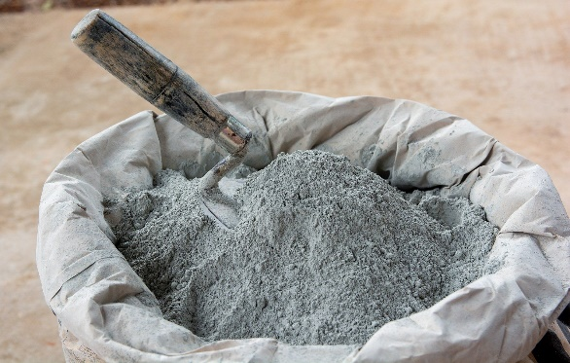 | 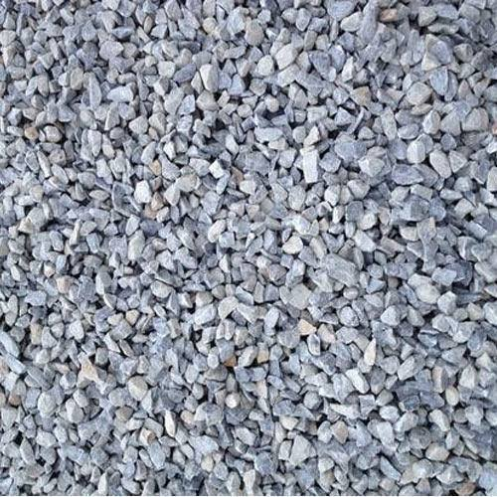
(a) | (b)
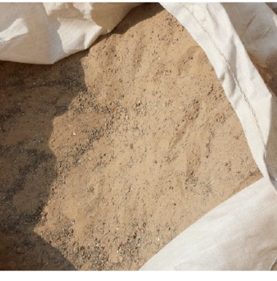 | 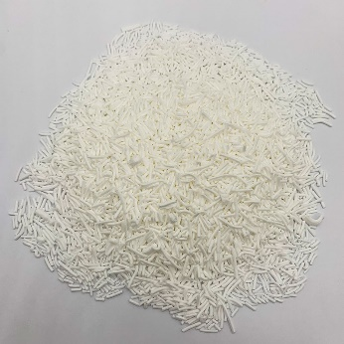
(c) | (d)
Fig. 3.1. Material appearance. (a) Portland limestone cement, (b) hybrid stone dust, (c) fine aggregate, (d) sodium lauryl sulfate.

3.1.1. Binder
The primary binder in foam concrete, known as cement, was sourced from a local supplier and conformed to the ASTM C150 standard for Portland limestone cement. The quality of the cement was checked for consistency in fineness, setting time, and compressive strength before use in the experiments. The physical and mechanical properties of the cement were presented in Table 3.1.
Portland limestone cement is a blend of clinker, limestone, and gypsum. The main chemical reactions during hydration are:
C₃S + H₂O → C-S-H + Ca(OH)₂​
Where:
C₃S (Tricalcium silicate)
C-S-H (Calcium-silicate-hydrate, the binding gel)
Ca(OH)₂ (Calcium hydroxide, also called Portlandite)
Table 3.1. Physical and mechanical properties of cement.
Properties | Results |  | Reference
Initial setting time (minute) | 100 | > 45 minutes | IQS: 5/1984
Final setting time (minute) | 320 | < 600 minutes | IQS: 5/1984
Fineness (Blaine m² /kg) | 300 | > 230 (m² /kg) | IQS: 5/1984
Soundness by Autoclave Method (%) | 0.02 | Not more than 0.8 | IQS: 5/1984
Compressive strength (MPa) |  |  | IQS: 5/1984
3 days | 21 | > 15 | IQS: 5/1984
7 days | 27 | > 2 | IQS: 5/1984

In addition, it is cheaper than other cement types such as high alumina cement, calcium sulfoaluminate cement and magnesium phosphate cement. Its chemical composition is given in Table 3.2.
Table 3.2. Chemical Composition.
Chemical composition of cement (%). | Reference
MgO 2.6 | ASTM C150
SiO₂ 18.7 | ASTM C150
Al₂O₃ 5.48 | ASTM C150
Fe₂O₃ 3.01 | ASTM C150
Na₂O 0.23 | ASTM C150
K₂O 1.22 | ASTM C150
SO₃ 3.25 | ASTM C150
CaO 62.3 | ASTM C150
Cl- 0.001 | ASTM C150
Loss on ignition 2.17 | ASTM C150
Insoluble residue 0.7 | ASTM C150

3.1.2. Fine Aggregates
A locally sourced river sand with particle sizes ranging from 0.075 mm to 4.75 mm was used. The sand was sieved and washed to remove impurities such as clay and organic matter to ensure quality. The grading was confirmed to conform to the requirements of ASTM C33 for fine aggregates.

3.1.3. Palm Kernel Oil
Palm Kernel Oil was used as a natural surfactant in foam concrete. PKO was derived from the seeds of the oil palm and was available from multiple suppliers in both raw and refined forms. The PKO used was sourced from a reputable supplier that provided oil suitable for industrial applications. The oil was filtered and stored in an airtight container to maintain its properties. The PKO was incorporated into the foam mix at varying concentrations to assess its impact on foam stability and concrete properties.

3.1.4. Water
Water used in the mix was potable and clean, sourced from a local supply, and in accordance with ASTM C94 standards for mixing concrete.

3.1.5. Sodium Lauryl Sulfate (foaming agent)
A commercial foaming agent, SLS, depending on the standard mix, was used to generate foam. The foaming agent was purchased from a supplier specializing in concrete additives, and its properties were verified according to ASTM C869 (Standard Specification for Foaming Agents). The foam produced by the agent was used in varying volumes to create foam concrete.

3.2. Methods
The methodology involved preparing foam concrete with varying concentrations of palm kernel oil and evaluating its properties. The experiments focused on assessing the impact of PKO on the foam stability, mechanical properties, and physical properties of foam concrete. The following outlined the key experimental procedures.

3.2.1. Mix Design Preparation
The first step in the experiment was preparing the foam concrete mix design. The mixes were prepared according to the following steps:
- The cement was weighed and mixed with fine aggregates (sand) at a specified weight ratio, typically 1:2 by weight of cement to sand, depending on the target density.
- Water was added in the amount necessary to achieve suitable workability for the mix. A water-to-cement ratio of 0.8 to 1.5 was used.
- The palm kernel oil was incorporated into the foaming agent at concentrations of 0%, 1%, and 1.5% by weight of cement. The PKO was mixed into the water phase of the foam concrete mix to ensure uniform distribution.
- The foaming agent was added in the correct amount to generate foam, which was then mixed with the slurry. The amount of foam was adjusted to achieve a target density (typically between 800 kg/m³ and 1,600 kg/m³) for the foam concrete.

3.2.2. Preparation of Foam
There are two primary techniques used in foam concreting: the pre-foaming method and the mix-foaming method. Both approaches regulate the mixing process and influence the quality of foamed concrete.
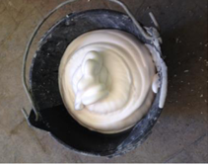
Fig. 3.2. Photograph of the foam generated.
The pre-foaming method was used and it involved separately producing the base mix and stabilizing the preformed aqueous foam before thoroughly integrating the foam into the base mix. The pre-formed foam was generated using wet method. The wet method generated foam by spraying the foaming agent solution through a fine mesh, producing bubbles typically ranging from 2 to 5 mm in size. However, wet foam was comparatively less stable than dry foam.

3.2.3. Mixing and Casting
Once the foam was prepared, it was carefully incorporated into the cement-sand-water mixture. The following procedure was used for mixing and casting:
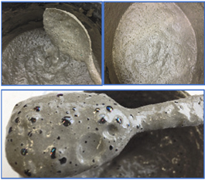
Fig. 3.3. Pictures depicting foam concretes incorporating foaming agent (SLS).
- The foam was gently folded into the wet mix to avoid collapsing the air bubbles in the foam.
- This step was critical to maintain the desired air content and stability of the foam. The resulting foam concrete was poured into molds of standard size (e.g., 150 mm × 150 mm × 150 mm for cube samples) and vibrated to ensure uniform distribution and minimal air pockets.
- The foam concrete was left to cure under standard conditions (ambient temperature of 20–25°C, with 60% humidity) for 24 hours before being demolded. The specimens were further cured in water for up to 28 days.

3.2.4. Testing of Foam Concrete
The various properties tests were carried out in the fresh state and after the foam concrete had been cured.

3.2.4.1. Slump Test
- Standard Code: ASTM C143 – The slump test was conducted in accordance with the Standard Test Method for Slump of Hydraulic-Cement Concrete.
- Procedure:
- A slump cone (base diameter: 200 mm, top diameter: 100 mm, height: 300 mm) was placed on a flat, non-absorbent surface.
- The cone was filled with foam concrete in three layers, each tamped 25 times with a standard tamping rod.
- After filling, the cone was carefully lifted vertically, allowing the concrete to slump under its own weight.
- The height difference between the original cone height and the highest point of the slumped concrete was measured to determine the slump value.

3.2.4.2. Thermal insulation Properties Test
The thermal insulation test was conducted under the following environmental conditions:
- Date of Test: 22th April 2025.
- Time of Exposure: 12:00 PM to 2:00 PM
- Location: I.O.T yard, Kwara State Polytechnic, Ilorin, Nigeria.
- Weather Condition: Clear skies with direct sunlight.
- Ambient Temperature: Ranged between 38°C and 42°C during the test.
To assess the thermal performance of the foam concrete, a cube specimen was exposed to direct sunlight under ambient outdoor conditions. The specimen was positioned on a flat, non-conductive surface to minimize heat loss through conduction to the ground. Temperature readings were taken at both the front (sun-exposed) and rear surfaces of the cube at regular intervals of 30 minutes using a digital infrared thermometer. This procedure was continued over a specified duration to monitor the progression of heat transfer through the material. The recorded data provided insight into the thermal insulating properties of the foam concrete and the influence of its composition on heat resistance.

3.2.4.3. Compressive Strength Test
- Standard Code: ASTM C39 – The compressive strength test was conducted in accordance with the Standard Test Method for Compressive Strength of Cylindrical Concrete Specimens.
- Procedure: Cube samples (150 mm x 150 mm x 150 mm) of foam concrete was tested for compressive strength after 7, 14, and 28 days of curing.
- The specimen was placed in a universal testing machine, and the load was applied gradually at a rate of 0.25 MPa/s until failure occurs. The compressive strength was calculated by dividing the maximum load by the cross-sectional area of the specimen.

3.3. Selected image of workplace moment

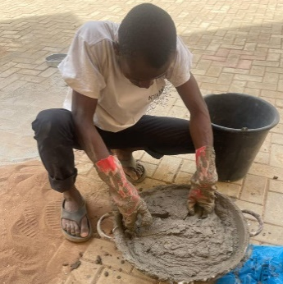 | 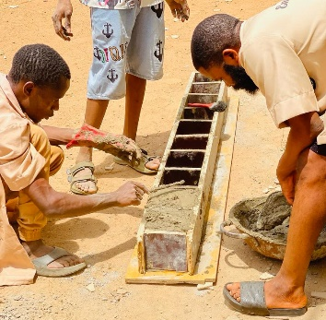 | 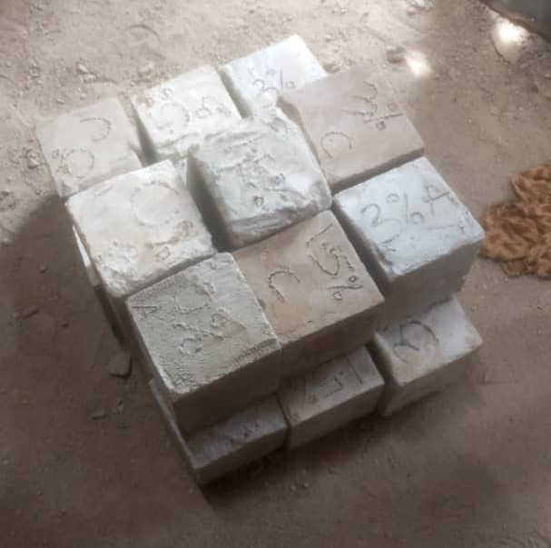
(a) | (b) | (c)
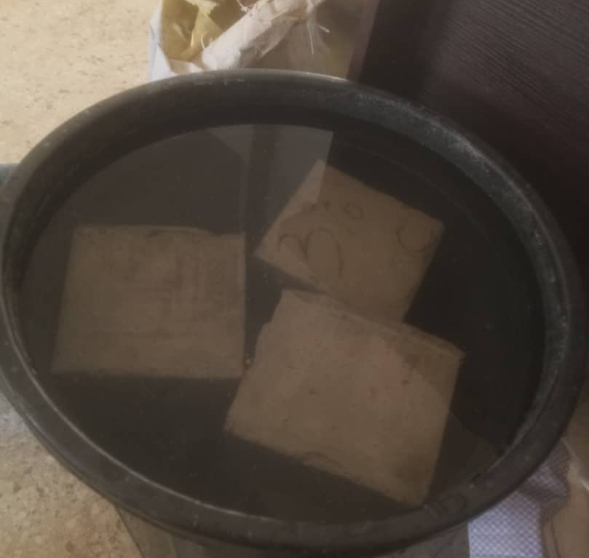 | 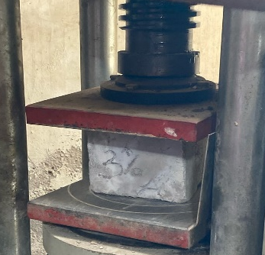 |   (g)
(d) | (e)
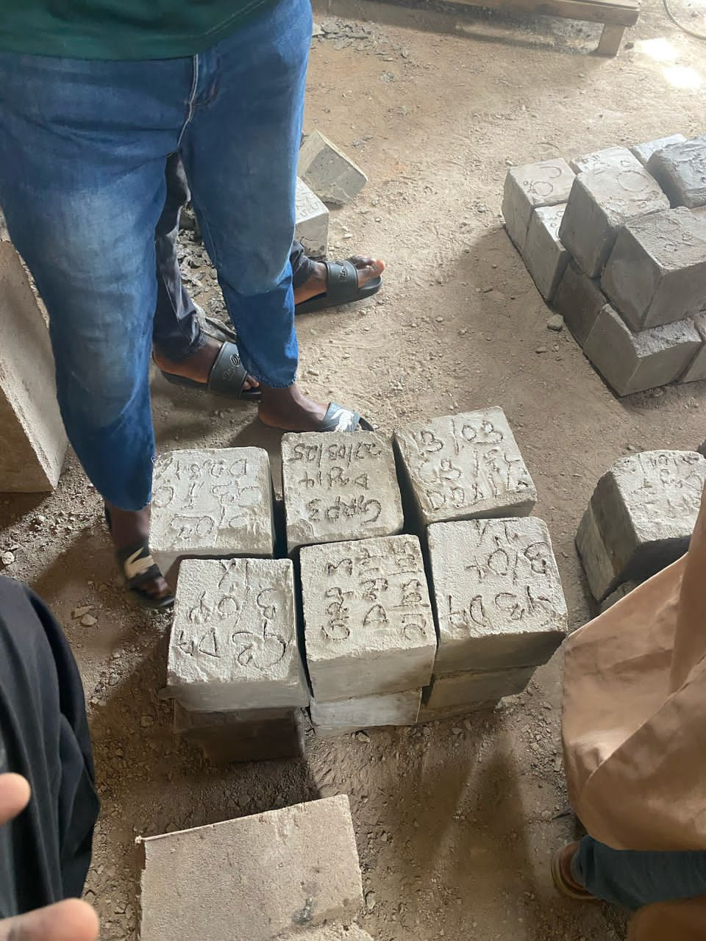
(f)
Fig. 3.4. Photographs (in alphabetical order from top left to bottom right) of the FC preparation, casting, curing and testing phases in cubic shapes of 150mm side.

4. RESULTS AND DISCUSSIONS

4.1. Properties of Hybrid Foam Concrete

4.1.1. Slump Test (Workability Test)
The slump test is carried out to evaluate the consistency and workability of freshly mixed concrete. The outcomes of this test serve as a reference for quality control during the proportioning and mixing, as well as for verifying conformity with specified requirements. In this project, concrete was batched by weight, and different proportions of PKO (0%, 0.5%, and 1%) were incorporated into the mix. A nominal mix ratio of 1:2 was used with a water-to-cement ratio of 0.8. The corresponding test results are presented in Table 4.1.
Table 4.1. Slump test
PKO Surfactant (%) | Wet weight of sample (g) | Dry weight of sample (g) | Water Absorption (%) | Slump Value (mm)
0 | 7001 | 6701 | 4.47 | 120
1.0 | 7150 | 6852 | 4.35 | 112
1.5 | 7280 | 6975 | 4.37 | 90

4.1.2. Thermal Insulation Performance
The thermal insulation property test is conducted on foam concrete to determine its ability to resist heat flow, which is a critical aspect of its performance in building applications. For this project, various cured concrete ages are tested which are incorporated with 1% of PKO and compared with conventional concrete.
The corresponding test results for the curing ages are presented in Tab1e 4.2.
Table 4.2. 7th, 14th and 28th Days Thermal Insulation Properties
Curing age (days) | Time (minutes) | Surface Temperature (ºC) | Opposite side Temperature (ºC) | Temperature Difference (ºC)
 | 0 | 27.00 | 27.00 | 0.00
 | 30 | 36.70 | 28.90 | 7.80
7 | 60 | 37.20 | 29.10 | 8.10
 | 90 | 40.20 | 30.50 | 9.70
 | 120 | 44.10 | 34.10 | 10.00
 | 0 | 27.00 | 27.00 | 0.00
 | 30 | 35.70 | 29.00 | 6.70
14 | 60 | 36.20 | 29.50 | 6.70
 | 90 | 38.80 | 31.20 | 7.60
 | 120 | 42.00 | 33.20 | 8.80
 | 0 | 27.00 | 27.00 | 0.00
 | 30 | 34.70 | 28.20 | 6.50
28 | 60 | 35.40 | 28.80 | 6.60
 | 90 | 38.20 | 31.10 | 7.10
 | 120 | 40.50 | 32.70 | 7.80
The corresponding test results obtain for Thermal insulation properties of conventional concrete is presented in Table 4.3.
Table 4.3. Thermal insulation properties of conventional concrete.
Curing age (day) | Time (minutes) | Surface Temperature (ºC) | Opposite side Temperature (ºC) | Temperature Difference (ºC)
 | 0 | 27.00 | 27.00 | 0.00
 | 30 | 37.40 | 30.00 | 7.40
28 | 60 | 40.60 | 32.50 | 8.10
 | 90 | 45.30 | 36.70 | 8.60
 | 120 | 52.00 | 42.20 | 9.80

Thermal insulation results obtained from the practical are given in the chart at Fig. 4.1. The more the day increases, the temperature value decreases.

Fig. 4.1.
The specimen containing foaming agent present a high thermal insulation performance. The temperature difference of hybrid foam concrete and conventional concrete is compared (Both cured for 28 days) In Fig. 4.2.

Fig. 4.2.

4.1.3. Compressive Strength Test
The compressive strength test is the most common test carried out on hardened concrete, because most of the desirable characteristics properties of concrete are qualitatively related to its compressive strength. The result of this test are used as a basis for quality control of concrete proportioning, mixing, placing operations and determination of compliance with specification. For this practical 150mmx150mmx150mm cube was use and the results are presented in Table 4.4.
Table 4.4. Compressive Strength of HFC cube at 7th, 14th and 28th days

Curing Age (Days) | Percentage of PKO (%) | Weight (g) | Failure Load (KN) | Compressive Strength (N/mm²) | Average Compressive Strength (N/mm²)
7 | 1 | 6801 | 40 | 1.778 | 1.8223
7 | 1 | 6853 | 42 | 1.867 | 1.8223
7 | 0.5 | 6977 | 47 | 2.089 | 2.045
7 | 0.5 | 6970 | 45 | 2.000 | 2.045
14 | 1 | 7015 | 50 | 2.222 | 2.311
14 | 1 | 7075 | 54 | 2.400 | 2.311
14 | 0.5 | 7094 | 55 | 2.444 | 2.556
14 | 0.5 | 7008 | 60 | 2.667 | 2.556
28 | 1 | 7281 | 70 | 3.111 | 3.000
28 | 1 | 7352 | 65 | 2.889 | 3.000
28 | 0.5 | 7377 | 72 | 3.200 | 3.134
28 | 0.5 | 7293 | 69 | 3.067 | 3.134

Fig. 4.3.

5. CONCLUSION AND RECOMMENDATION

5.1. Conclusion
From the results obtained during this study, the following conclusion can be made;
- The slump test results showed a reduction in slump value with increasing PKO content, indicating decreased workability as PKO dosage increased. This suggests that while PKO improves other properties, it may reduce the ease of placement of the mix.
- HFC demonstrated improved thermal insulation performance over conventional concrete. The temperature difference between the surface and rare side of HFC increased with curing age, indicating better heat resistance. At 28 days, HFC showed significantly lower backside temperatures compared to conventional concrete, confirming its superior thermal performance.
- The compressive strength increased with higher PKO content and longer curing periods. HFC with 1% PKO surfactant achieved the highest average compressive strength of 3.0 N/mm² at 28 days, showing a steady gain in strength over time.

5.2. Recommendation
Based on the findings of this project, the following recommendations are made:
- A PKO dosage of 1% is recommended for achieving a balance between compressive strength and thermal insulation in foam concrete.
- Due to its enhanced thermal insulation, HFC is recommended for building applications in hot climates where thermal resistance is critical for indoor comfort and energy efficiency.
- Additional investigations should explore the long-term durability of HFC, including water permeability, shrinkage, and resistance to environmental degradation.
- Given the reduced workability at higher PKO levels, future studies may investigate incorporating superplasticizers or adjusting the water-cement ratio to improve workability without compromising performance.

