GREEN SYNTHESIS OF SILVER NANOPARTICLE USING CALOTROPIS PROCERA LEAVES AND ITS ANTIMICROBIAL EFFECT ON SOME BACTERIAL AND FUNGAL ISOLATES.

BY
AKINYEMI TEMITOPE ELIJAH
ND/23/SLT/PT/0330
A PROJECT SUBMITTED TO THE DEPARTMENT OF SCIENCE
LABORATORY TECHNOLOGY, INSTITUTE OF APPLIED
SCIENCES (IAS), KWARA STATEPOLYTECHNIC, ILORIN

IN PARTIAL FULFILMENT OF THE REQUIREMENT FOR THE
AWARD OF NATIONAL DIPLOMA (ND) DEGREE IN
SCIENCE LABORATORY TECHNOLOGY, INSTITUTION OF
APPLIED SCIENCES (IAS), MICROBIOLOGY UNIT
KWARA STATE POLYTECHNIC ILORIN

JULY, 2025

i

CERTIFICATION

This is to certify that this project research was written by Akinyemi Temitope Elijah, ND/23/SLT/PT/0330 and submitted to the Department of Science Laboratory Technology, Microbiology Unit, Institute of Applied Science (IAS), Kwara State Polytechnic, Ilorin and has been read and approved IN partial fulfillment for the award of National Diploma (ND) in Science Laboratory Technology.

----------------------------- -------------------------
MRS. E.O OYAGBOLA DATE
(SUPERVISOR)

-------------------------------------- -------------------
MISS AHMED T DATE
(H.O.U MICROBIOLOGY UNIT)

------------------------------------- -------------------------
DR USMAN ABDULKAREEM DATE
(H.O.D SLT)

------------------------------------- -------------------------
EXTERNAL EXAMINER DATE

ii

DEDICATION
I dedicated this project work to the Almighty God, who has been my source of strength, wisdom and guidance throughout this journey.
I also dedicate this seminar work to my beloved late father (Ibironke Kayode Emmanuel), your memory continues to inspire me to strive for excellence, and I hope that this achievement would have made you proud.

iii

ACKNOWLEDGEMENT

I would like to express my deepest gratitude to the Almighty God, who has been my rock, my guiding light and my source of strength throughout this journey. Your divine providence, love and care have enabled me to persevere and complete this project.

To my family, especially my mother and step father, I am forever grateful for your unwavering support, love, and encouragement. Your sacrifices, prayers and words of encouragement have been a constant source of motivation for me. Thank you for being my pillar of strength and for believing in me.

My supervisor, Mrs. E.O Oyagbola, for her exceptional guidance, mentorship and support, your expertise, patience, and encouragement have been invaluable and I appreciate the time and efforts you invested in me.

I will also acknowledge my benefactor of knowledge for his fatherly roles and words of encouragement and to other viable lecturers in the department (microbiology unit), who has contributed in one way or the other and positively in planting me qualities, and moral values. May God reward you all!

To my big sister and her family, I appreciate your kindness, generosity and support. Your contributions, whether financial, emotional, or spiritual have made a significant impact on my Journey.

Special thanks to my best friend, Mohammed, for being a constant source of motivation, encouragement and support, your friendship has been a blessing and I am grateful for your presence in my life.

I am grateful to everyone who has contributed to my journey in one way or another. Your support, encouragement and prayers have made a significant impact on my life and I appreciate your presence in my life.

To crown it all, I congratulate myself on my successful completion of my programme in Kwara State Polytechnic.

TABLE OF CONTENT

Title page i
Certification ii
Dedication iii
Table of content iv
Abstract vi
CHAPTER ONE
1.0 Introduction 1
1.1 Literature Review 3
1.1.1 Overview of Silver nanoparticles and their antimicrobial properties. 6
1.1.2 Protocols for the Biosynthesis of Silver Nanoparticles (AgNPs). 13
1.1.3 Plant-mediated Biogenic Synthesis of AgNPs and their Antimicrobial Activity. 16
1.1.4 Calotropis procera’s medicinal properties and Potential Application. 26
1.2 Research Aim and Objectives. 33
1.3 Research Problems. 34
CHAPTER TWO
2.0 Materials and Methods. 35
2.1 Collection of Plant Extract and Bacterial and Fungal Isolates. 35
2.2 Preparation of Calotropis procera extract and Silver nitrate. 36
2.3 Synthesis of Silver nanoparticles using leaf extracts (Phytochemical properties) 37
2.4 Characterization of Silver nanoparticles. 40
2.5 Antimicrobial activity Assays. 47
CHAPTER THREE
3.0 Result 50
3.1 Phytochemical analysis. 50
3.2 Green synthesis of silver nanoparticle using leaf extract. 51
3.3 Characterization of synthesized nanoparticles. 52
3.4 Antimicrobial activity evaluation. 55

CHAPTER FOUR
4.1 Discussion. 58
4.2 Conclusion. 62
REFERENCES 65-73

V

ABSTRACT
In this study, Silver nanoparticles were successfully synthesized using Calotropis procera aqueous leaf extract. The effect of the whole extract and some of its phytochemicals on the particle distribution was determined while other characterizations such as UV-VIS spectrophotometer, Fourier transform infrared (FTIR) spectroscopy, Scanning electron microscopy (SEM) were carried out. The antimicrobial activity against selected microorganism was also studied using the agar diffusion method. The leaf extract showed the presence of phenols, flavonoids, saponins, steroid, terpenoids, alkaloids, and tannins. The UV-vis spectra displayed the characteristics Plasmon resonance at 400nm, The FTIR plots highlighted important functional groups including peaks between 3430.17 cm⁻¹, 2966.00 cm⁻¹, and 1753.00cm⁻¹ respectively confirming the formation of Silver oxide. Calotropis procera/AgNo₃ displayed significant antimicrobial activity against Klebsiella pneumoniae , Pseudomonas spp, Penicillum spp., Aspergillus spp,. Trichoderma spp., while no activity was recorded Escherichia coli ,Staphyloccus aureus, Salmonella typhi, Rhizopus spp. This study indicated that Calotropis procera was suitable for the synthesis of silver with properties that suggested that it could be potentially applied as antimicrobial nanofillers.

vi

CHAPTERONE

1.0 INTRODUCTION

"Nanotechnology is an emerging field in the area of interdisciplinary research, especially in biotechnology, that deals with the synthesis, manipulation, and the use of particles ranging in size from 1 to 100 nm." Such particles are called nanoparticles (NP) their unique physical, chemical and biological properties could be attributed to their small size and large surfacearea.Thesynthesisofnoblemetalnanoparticlesattractsanincreasing interest dueto theirnew and different characteristics as compared with those of macroscopic phase that allow attractive application in various fields such as antimicrobial, medicine biotechnology, microelectronics, catalysis, information storage and energy conversion.
Various literatures describe many ways to synthesis Nanoparticles, which include physical, chemical, and biological methods, have attracted significant attention across various domains due to their substantial impact on drug delivery and targeting, reducing toxicity, enhancing efficacy, and creating new avenues for pharmaceutical and drug delivery enterprises (Blanco et al., 2015; Jokerst et al., 2017). The physical and chemical methods used for the synthesis of nanoparticles are not only energy-consuming but also non-eco-friendly.
Green synthesis of nanoparticles has gained significant attention in recent years due to its eco-friendly and sustainable approach. This method utilizes plant extracts as reducing and stabilizing agents, eliminating the need for toxic chemicals.
Silver nanoparticles (AgNPs) are particularly notable for various biomedical applications. Studies have shown that AgNPs can be synthesized using plant extracts such as Calotropis procera leaf extracts, which exhibit significant antimicrobial activity (Kumar et al., 2022).
Capping agents play a vital role in functionalizing and stabilizing synthesized nanoparticles. These biologically acceptable reducing, stabilizing, or capping agents are carefully chosen to ensure compatibility with living systems (Ocsoy et al., 2018; Javed et al., 2020). They shield nanoparticles from agglomeration and enhance reduction kinetics by forming complex structures with metallic ions in precursor salts (Campisi et al., 2016; Sharma et al., 2021).
Silver nanoparticles have been widely explored for their potential application in biomedical fields such as antimicrobial coatings, wound dressing, and drug delivery systems. Their unique properties, including high surface area and reactivity, make them effective against a broad range of microorganisms (Singh et al., 2021).
Calotropis procera (Fig. 1), commonly referred to as the Apple of Sodom or Sodom Apple, belongs to the Apocynaceae family and the Asclepiadaceae subfamily (milkweed family) (Al-Rowaily et al., 2020). It is a perennial shrub or small tree native to North Africa, tropical Africa, and parts of Asia, reaching a height of up to 2.5 m. It holds significance in traditional medicinal practices across North Africa, the Middle East, South Asia, and Southeast Asia (Al Sulaibi et al., 2020).
Additionally, it has been employed for fiber, fuel, fodder, and timber purposes since ancient times (Batool et al., 2020). Numerous studies explore its antimicrobial, anti-inflammatory, analgesic, antidiabetic, antihypertensive, and anticancer properties. Plant extracts have been found to be useful in the synthesis of metal nanoparticles, as they possess phytocomponents like alkaloids, glycosides, flavonoids, tannins, saponins, and terpenoids, which act as reducing and capping agents (Rahman et al., 2016; Kalu et al., 2022).
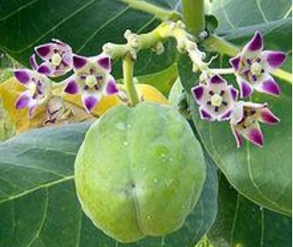

Fig. 1. Calotropis procera plant showing leaves, flowers, and fruit/pods.
There are a number of species of Calotropis procera, but the most commonly available species include C. sussuela, C. gigantea, and C. procera. Calotropis procera can withstand drought and salt tolerance, and it disperses seeds through wind and animals. It has been identified as a weed along roadsides and in overgrazed native pastures. It produces milky white latex, which possesses various curative properties.
The medicinal potential of Calotropis procera has been known to traditional systems of medicine for a while now, with its leaves being widely used. The use of the plant, plant extracts, and pure compounds isolated from natural sources has always provided a foundation for modern pharmaceutical compounds.
Owing to the growing need to reduce or eliminate the use of environmentally toxic substances, the synthesis of nanoparticles using biological entities has received increasing attention in the last decade. The biosynthetic procedure involves using microorganisms and plants. Among biological methods, the use of plant extract is the best—eco-friendly, cheaper, and relatively fast compared to microbe-assisted synthesis.
The aim of this study was to synthesize and characterize silver nanoparticles using Calotropis procera leaf extract and evaluate their antimicrobial activity. This research aims to explore the potential application of green synthesized AgNPs in biomedical fields.

Literature Review on Green Synthesis of Silver Nanoparticles Using Plant Extracts and Their Bio-Medical Applications
Synthesis of metal nanoparticles using plant extracts is one of the most simple, convenient, economical, and environmentally friendly methods that mitigate the involvement of toxic chemicals. Hence, in recent years, several eco-friendly processes for the rapid synthesis of silver nanoparticles have been reported using aqueous extracts of plant parts such as the leaf, bark, roots, etc.
This review summarizes and elaborates on the new findings in this research domain of the green synthesis of silver nanoparticles (AgNPs) using different plant extracts and their potential applications as antimicrobial agents, covering the literature since 2015.
While highlighting the recently used different plants for the synthesis of highly efficient antimicrobial green AgNPs, we aim to provide a systematic in-depth discussion on the possible influence of the phytochemicals and their concentrations in the plant extracts, extraction solvent, and extraction temperature, as well as reaction temperature, pH, reaction time, and concentration of precursor on the size, shape, and stability of the produced AgNPs.
Exhaustive details of the plausible mechanism of the interaction of AgNPs with the cell wall of microbes—leading to cell death and high antimicrobial activities—have also been elaborated. The shape and size-dependent antimicrobial activities of the biogenic AgNPs and the enhanced antimicrobial activities by synergistic interaction of AgNPs with known commercial antibiotic drugs have also been comprehensively detailed.
Nanotechnology is gaining enormous attention as a new area of research dealing with the development of nanomaterials and nanoparticles (NPs) for utilization in diverse fields such as catalysis, electrochemistry, biomedicine, pharmaceuticals, sensors, food technology, cosmetics, etc. (Ayelen et al., 2017; Frewer, 2016).
Nanoparticles (NPs) are nanometer-sized (<100 nm) atomic or molecular-scale solid particles having excellent physical properties compared to bulk molecules, depending on their size and morphology.
Among all types of NPs, metal and metal oxide nanoparticles have been thoroughly examined in science and technology due to their excellent properties such as high surface-to-volume ratio and high dispersion in solution (Frewer et al., 2014).
Owing to these properties, metal and metal oxide nanoparticles display enhanced antimicrobial properties. Currently, modified or fabricated NPs are widely utilized in industrially manufactured items such as cosmetics, electronics, and textiles (Ingle et al., 2020).
Furthermore, the rapid increase in the number of microbes resistant to existing antibiotic drugs has led to the need for novel medicines in the form of bare NPs or in conjunction with existing antibiotics to exert a favorable synergistic effect, resulting in the widespread use of NPs in several medical fields.
Nowadays, NPs have been utilized for molecular imaging to achieve highly resolved images for diagnosis. In addition, contrast agents are impregnated onto NPs for tumor and atherosclerosis diagnosis (Bagheri, 2018).
Furthermore, nanotherapeutics have been promoted worldwide after the first FDA-approved nano-therapeutic in 1990, leading to the development of different nano-based drugs.
At the beginning of the 20th century, various physical and chemical methodologies such as chemical reduction and milling were utilized for the synthesis of NPs and to enhance their efficiency (Vijayan et al., 2016).
However, these conventional techniques involve costly and toxic chemicals and cannot be considered environmentally benign. Taking this into account, researchers now show great interest in the synthesis of metal and metal oxide NPs employing biogenic routes using aqueous plant extracts and microbes, as they are environmentally friendly, stable, clinically adaptable, biocompatible, and cost-effective (Ahmed, 2016).
Therefore, bio-inspired technology for NP synthesis became a significant branch in the field of nanoscience and nanotechnology. To date, numerous metal and metal oxide NPs have been synthesized using plant extracts and microbes.
Owing to their wide availability, renewability, and eco-friendly nature—in addition to their vast applications in the synthesis of NPs—plant biomasses are also largely targeted by researchers as catalysts for chemical synthesis and biodiesel production.
Among metal NPs, silver NPs are gaining enormous interest in the research community due to their wide scope of application in microbiology, chemistry, food technology, cell biology, pharmacology, and parasitology. The morphology of silver NPs is the deciding factor of their physical and chemical properties.
Several techniques such as the sol–gel method, hydrothermal method, chemical vapor deposition, thermal decomposition, and microwave-assisted combustion method have been utilized for the synthesis of silver nanoparticles (Shen et al., 2012; Zhang et al., 2019).
Recently, biogenic synthesis of silver NPs (AgNPs) using biomaterials such as plant extracts and microbes as reducing agents—and their antimicrobial activity—is widely investigated. AgNPs are produced by the oxidation of Ag⁺ to Ag⁰ by different biomolecules such as flavonoids, ketones, aldehydes, tannins, carboxylic acids, phenolic compounds, and proteins in plant extracts.
UV-visible spectroscopy is a simple and widely used analytical technique to monitor the formation of AgNPs. Upon interaction with an electromagnetic field, the conducting electrons present in the outermost orbital of metal NPs collectively oscillate in resonance with certain wavelengths to exhibit a phenomenon called Surface Plasmon Resonance (SPR).
The excitation of SPR is responsible for the formation of color and absorbance in a colloidal solution of AgNPs. The SPR peaks at around 435 nm are usually taken to confirm the reduction of silver nitrate into AgNPs. In general, spherical NPs exhibit only a single SPR band in the absorbance spectra, whereas two or more SPR bands are observed for anisotropic particles depending on the shape. The absence of a peak in the region 335–560 nm in UV-Vis spectra is sometimes used as an indication of the absence of aggregation in NPs (Biswas et al., 2018).
Statistical data analysis in Fig. 2 depicts the increasing trend of published research papers in the field of biogenic synthesis of AgNPs. These data were collected in September 2020 from the “SciFinder Database” using the keyword “Green synthesis of silver nanoparticles.”
From a mere 259 publications in 2001, it increased exponentially to 3,374 publications in 2019. Thus, in this review, an attempt has been made to inspire researchers to explore natural resources to synthesize silver nanoparticles using diverse plants and their organs, interconnecting nanotechnology with biotechnology—termed nanobiotechnology.
This review will also unlock ideas to utilize different paths for the production of silver nanoparticles, which can help human health. We have comprehensively discussed the biogenic synthesis of silver nanoparticles using various plants and their application in antimicrobial activity. We also discussed the effect of the synthesized silver nanoparticles' size and shape on antimicrobial activity toward various pathogenic bacteria.
In an attempt to synthesize metal NPs, one must bear in mind that the success of NPs depends not only on their size and shape but also on the stability of NPs, as they tend to form large aggregates that lead to precipitation, thereby reducing their efficacy.

Fig. 2 Publications per year for green synthesis of AgNPs during the period 2001 to 2019 (data collected from SciFinder Database).
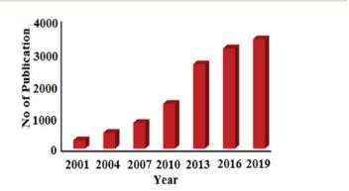

ProtocolsfortheBiosynthesisofSilverNanoparticles(AgNPs)

Biogenic synthesis of AgNPs is an easy single-step protocol without generating harsh and toxic chemicals; hence, they are save, economical and eco-friendly. In recent years, both plant and microbes are extensively investigated for the biosynthesis of AgNPs of varying size, shape, stability, and antimicrobial efficacy. (Ahmed et al., 2017; Korah et al., 2010).

Fromplant extract

Variouspartsofplantsuchasleaves,roots,flowers,fruits,rhizomesetc.,have beensuccessfullyutilizedforthesynthesisofAgNPs.Differentpartsofplant are collected from various sources, washed properly with ordinary water followed by distilled water to exclude debris and any other unwanted materials. After that, the portions are dried and ground to make powder or utilized as fresh to make the extract.
To preparetheextract,thechoppedpiecesorthegroundpowderoftheparts of the plant are put in deionized water or alcohol and usually heated below 60⁰C for few hours as high-temperature heating long time may leads to the decomposition of phytochemicals in the biomass extract. Plant extract of different pH is added to the solutions having a different concentration of Ag saltasmetalprecursorfollowedbyheatingatdifferenttemperatureledtothe synthesis of AgNPs. (Yousef et al., 2017; Rajesh et al., 2017).
The progress of the formation of AgNPs can be monitored by visual color changes or using UV-Vis. Spectroscopy, where a sharp peak due to surface Plasmonresonance(SPR)ofAgNPsataround430–450nmisclearly

observed.AftersuccessfulsynthesisoftheAgNPs,themixtureiscentrifuged at high rpm to separate the NPs followed by proper washing using solvents anddriedinanovenatlowtemperature.Thedifferentplantpartsextractsthat havebeensuccessfullyutilizedinthegreensynthesisofAgNPsaregivenin( Fig. 3). (Mankanda et al., 2015; Rave et al., 2016).

Fig 3. Different parts of plants used for biosynthesis of antimicrobial silver nanoparticles
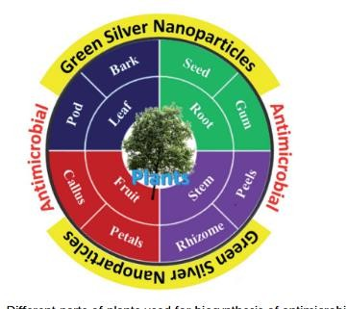

Frommicrobes

Nowadays, theuseof microbial cell for thesynthesisof metal NPs has come outasagreatapproach.Microbialcellsturntobeexcellentbiofactoriesfor

thesynthesisofAgNPs.Atfirst,theculturesareallowedtodevelopasculture suspension in disinfected distilled water having the culture medium. Then, different concentration of precursor of AgNPs is added into the cultured microbial followed by continuous mechanical stirringunder dark conditions.
sThe progress of the reaction is monitored by UV-Vis spectrophotometer. Finally, the resultant AgNPs is separated fromthe mixturevia centrifugation at around 3000 rpm for 10–15 minutes. (Shivaji et al., 2011).

Plant-mediated Biogenic Synthesis of AgNPs and their Antimicrobial Activity.
Owing to the environmental issue, biogenic synthesis of metal and metal oxide NPs is gaining immense attention from the past decades. Reported literature revealed that various plant parts such as leaf, roots, seed, fruits and stemetc.,havebeenutilizedforthebiosynthesisofNPs.ThesynthesisofNPs is fully dependent on the biomaterials/phytochemicals present in the extract. Thissectionaimstodiscussthevariousplantpartsextractmediatedsynthesis of AgNPs and their application as antimicrobial.

Fromleaf

To date, a numerous number of leaves extract have been utilized for the biosynthesisofAgNPsasshownin(Table1).Skimmialaureolawasreported forthesynthesisofsphericalAgNPswithsize38±0.27nmandtestedagainst
E. coli, K. pneumoniae, P. aeruginosa, P. vulgaris, S. aureus.( Miri et al), have utilized Prosopis farcta extract for the biosynthesis of AgNPs with an averagesizeof10.8nmatroomtemperature(RT).Theantimicrobialactivity of synthesized AgNPs was tested using disc diffusion method against the Gram-positive(Staphylococcusaureus(PTCC1431),Bacillussubtilis(PTCC 1420)) and Gram- negative bacteria (Escherichia coli (PTCC 1399), Pseudomonas aeruginosa (PTCC 1074)) and compared with the control.
The results showed that the inhibition diameter is increased for every tested pathogen, indicates that synthesized AgNPs induces cellular damage to the bacteria's, hence can be used as nanoantibiotics. Aloe vera, Eclipta alba, Momordicacharantia,Leptadeniareticulatearealsousedfortheproduction of spherical biogenic AgNPs. In another study, AgNPs were synthesized by using tea leaf extract.Bactericidal activityof the synthesized NPs was tested

against S. aureus and E. coli showed that inhibition action is more effective incaseofS.aureus(89%inhibitionrate)comparedtoE.coli(75%inhibition rate).Inaddition,treatmentoftheNPsagainstthebacterialeadstoimpairment of bacterial cell–cell adhesion.( Goswami et al., 2017).
Mukia maderaspatana leave extract was utilized for the biosynthesis of AgNPs with the size range of 58–458 nm. The synthesized nanoparticle was conjugated to the antibiotic ceftriaxone to investigate the antimicrobial activity towards the human pathogens such as B. subtilis, K. pneumonia, S. typhi, S. aureus and compared with the pathogen inhibition efficiency of the free nanoparticle and the antibiotic. The result obtained revealed that the AgNPs conjugated with ceftriaxone showed highest inhibition activity compared to the others. (Harshiny et al., 2015).
AgNPswerealsorecentlysynthesizedusingseveralleafextractofplantssuch as Artocarpus altilis, Crotalaria retusa, Cardiospermum halicacabum, Psidium guajava, and Terminalia chebula. (Bose et al., 2016).
In2016,Anandalakshmietal.reportedPedaliummurexleafextractmediated AgNPs.TheproducedNPsweretestedagainstseveralmicrobesanddisplayed

highest ZOI of 10.5 mm (in 15 mL mL1 scale) against E. coli and P. aeruginosa and least activity against Klebsiella pneumoniae (8.5 mm). The shapeandsizeoftheresultantAgNPswereelucidatedwiththehelpofTEM. The TEM micrographs showed that the sizes of the particles were around 50 nm and were predominantly spherical in shape. The PXRD pattern showed fcc crystal structure. Azadirachta indica promoted synthesis of AgNPs was reported.( Anandalakshimi et al., 2017).
The produced NPs displayed equal efficacy (9mm ZOI) against E. coli, S. aureus whereas the plant extract show no antimicrobial activity.
In 2016, a remarkable work on the synthesis of AgNPs using Urtica dioica leafextractthatshowedexcellentsynergisticeffectwithknownantimicrobial drugs was reported. ( Jyoti et al).
Interestingly, the synthesized AgNPs apart from showing high antimicrobial activities against several microbes, showed excellent synergistic effect in combination with antibiotics and displayed higher antibacterial effect as comparedwithAgNPsalone.Ahigh17.8foldincreaseinZOIwasobserved foramoxicillinwithAgNPsagainstS.marcescensprovingthesynergisticrole

of AgNPs. This work provides helpful insight into the development of new antibacterialagentstofightagainstseveralnewstrainofmicrobesresistantto existing antibiotic drugs. (Fig. 5) displayed the synergistic effect of AgNPs and common antimicrobial drugs.
The synergistic interaction between AgNPs and antibiotic drugs has been clearlyidentifiedusingUV-VisandRamanspectrometer.(McShanetal).The authorsclaimedthatthissynergisticinteractionspeeduptheejectionofAg+ from AgNPs which in turn boost its antimicrobial activities.

Fig. 5 Synergistic effect of Urtica dioica mediated AgNPs with several antibiotics. This figure has been reproduced from Elsevier, copyright 2016.
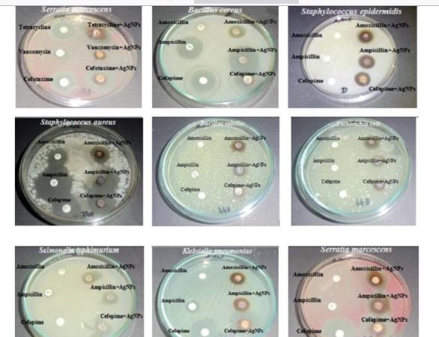

Numerous microbes such as skin bacteria are responsible for skin infection and body odor in feet, shoes, and/or socks mediated through the breakdown of amino acids present in sweat. Hence, proper medication is required for human’s wellbeing. (Shareen et al.,2015).

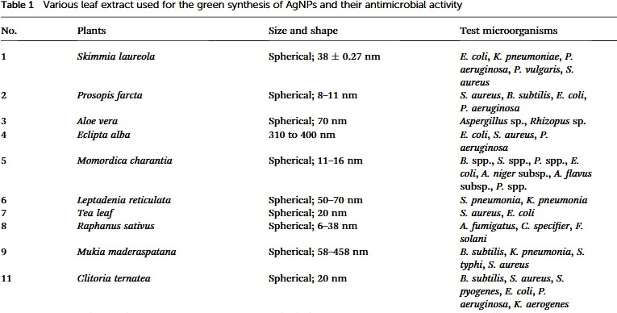

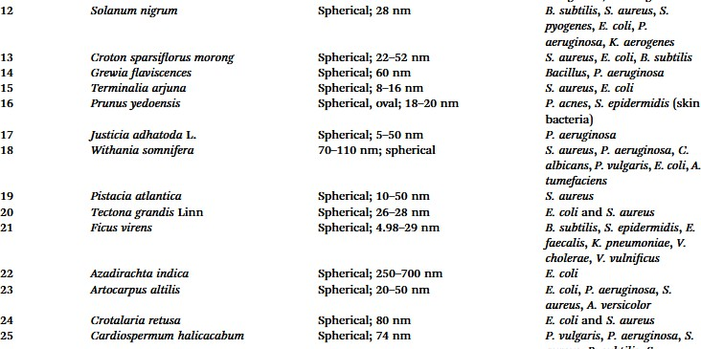

Recently,Manjamadhaetal,havereportedultrasonicassistedbiosynthesisof spherical AgNPs using Lantana camara L. leaf extract. Biosynthesis of AgNPs using ultrasonication improves the reaction conditions such as reducing reaction time and enhancing the reaction rate. Bactericidal activity of the synthesized AgNPs revealed that it shows excellent antibacterial activity against Gram-positive and Gram-negative bacteria. Leaves of Jatropha curcas collected from Micro model complex, Indian Institute of Technology Delhi campus was used for the production of AgNPs.
The transmission electron microscopy (TEM) analysis showed variation in particle shape and size (20–50 nm), whereas the diameter of NPs was found to be in range of 50–100 nm by scanning electron microscopy (SEM). Complete destruction of the microbial cell was visible using TEM examination.
The synthesized NPs were tested for their antimicrobial activities and based on ZOI data, the pattern of sensitivity was observed in the order as E. coli >
P. aeruginosa > B. cereus > S. enterica ¼ L. monocytogenes > S. aureus.(Chauhan et al.,2016; Zhang et al., 2016).

In2017,ArtemisiavulgarismediatedAgNPswerereportedbyRasheedetal. Antimicrobial test revealed that the AgNPs exhibited significant inhibition activities against tested pathogens with the highest value being recorded against S. aureus (18±0.27 mm inhibition zone).
In general, the reduction in the size of the metallic nanoparticles is expected to increase the antibacterial activity due to significantly large surface area of the smaller nanoparticles. grandiflora, Eucalyptus citriodora, Juniperus procera and Capparis zeylanica.
In recenttimes,highlyantimicrobial AgNPs were synthesizedusing Kleinia. Two different shapes structure in the form of sphere and cubic are observed inSEManalysisoftheAgNPsgeneratedfromJuniperusproceraleafextract. TheproducedNPsrecordedthehighestZOIagainst P.mirabilis measuredat 29±1.3 mm.
TheauthorsuggestedthatthehighantimicrobialactivityoftheNPsisdueto theinherentactivityoftheNPscoupledwiththeplantparticulatesattachedto the NPs, as the plant which contains high flavonoids and polyphenols are a well-known antimicrobial by themselves.

SynergisticantimicrobialactivityofLigustrumlucidummediatedAgNPsand Epoxiconazole under different conjugation ratio was studied against S. turcica, a common maize pathogen.
The antifungal activity of AgNPs was evaluated alone, and the synergistic inhibition effect was also measured at various conjugation ratios of AgNPs and epoxiconazole, where a prominent synergistic antifungal effect was observedat8:2and9:1(AgNPs/epoxiconazole)andtheinhibitiontoxicity ratio reached as high as 1.22 and 1.24, respectively. (Biswas et al., 2019).
In2020,greensynthesisofsphericalAgNPs,CuNPsandFeNPswithsize11– 19,28–35and40–52nm,respectivelyusingSyzygiumcuminileafextractwas reported. The order of anti- bacterial property against methicillin- and vancomycin- resistance S. aureus, A.flavus and A. parasiticus microbes was found to be Ag- > Cu- > Fe NPs, which linearly relates with the size of the NPs, thereby reinforcing the size-dependent activity of NPs.
Inaddition,thebioproductionofaflavatoxins(afamilyoftoxinsproducedby certainfungithatarefoundonagriculturalcropssuchasmaize(corn),

peanuts, cottonseed, and tree nuts) in A. flavus and A. parasiticus was also significantly inhibited by AgNPs when compared with the Fe and Cu NPs.
Interestingly, the pH of the plants extract reduced after the formation of NPs inallthecases.CleistanthuscollinusandCestrumnocturnumarealsoknown to have produced AgNPs.
ItisworthnotethattheAgNPsalsoconsistentlydisplayedabetteractivityin fungalstrain,Penicilliumsp.thanbacteriasuchasE.coliandStaphylococcus sp. which is hardly a case in any literature as bacteria are usually considered more sensitive to AgNPs than fungi.
1.1.3CALOTROPISPROCERA’SMEDICINALPROPERTIESAND POTENTIAL APPLICATION
Theuseofplant-basedremediestotreathumanandanimalillnessdatesback thousandsofyears.Inmanycultures,plantshavelongbeenrelieduponasan effective means of disease prevention and treatment.
Medicinal plants are still the primary source of healthcare in many developingworldareas.Worldhealthorganization(WHO)reportsthat80%

of the world’s population, mostly in developing nations, relies on traditional medicines to treat common health problems.
They are used medicinally and as a food source in almost every culture. What’s more impressive is that plants provide the basis for nearly 25% of today’s pharmaceuticals.
Theyareregardedasinvaluablesourcesofpharmaceuticalproductsincluding herbalmedicines,andtheirusecontributessignificantlytoprimaryhealthcare delivery.
Bioactive plant products have been a major research and development focus in the food and pharmaceutical industries.
Calotropis procera, it is common in Indonesia, Malaysia, China, and the Indian subcontinent. The medicinal properties of the plant have long been recognized, and its parts have been used to treat a wide range of conditions, including rheumatism, painful muscular spasms, fever, dysentery, diabetes, malaria, asthma, and more. In recent years, studying synergies in phytomedicine has emerged as an important new field of study.

Extensivepharmacologicalstudieswereconductedonthebiologicalactivities ofplantextractsandnaturalproductsderivedfromtheseplants.Exploringthe relevant scientific literature is essential for understanding the potential of industrial use of Calotropis procera. (Pattnaik et al., 2017).
This study aimed to compile a comprehensive literature review on the biological potential of its components.
This study will facilitate the dissemination of information about the plant’s potential applications, which in turn will guide future decisions in the fields of food science, herbal medicine, and pharmaceuticals.

Descriptionandorigin

Traditional medicine has used Calotropis procera, a plant belonging to the Asclepediaceaefamily.It’sashrubthatproduceslatexandthrivesinthewild despite the fact that it’s constantly exposed to adverse weather.
When damaged, the plant secretes milky latex that is most abundant in its aerial parts. It protects the plant from harm and is full of useful secondary compoundsandenzymes.SwallowwortinEnglish,madarinHindi,and

Tumpapiya in Hausa are just some of the common names for this plant. It reaches a height of 2.5–6 m and has a soft woody, upright form. It prefers warm climates, dry, sandy, and alkaline soils, and is therefore widespread across the globe (Fig 5) .(Chaudhary et al., 2015;Konno et al., 2011).It thrivesinavarietyofotherenvironments,includinglandfills,abandonedlots, wastelands, roadside ditches, and sand dunes.
Fig.5PicturesofCalotropisproceracollectedfromwild.

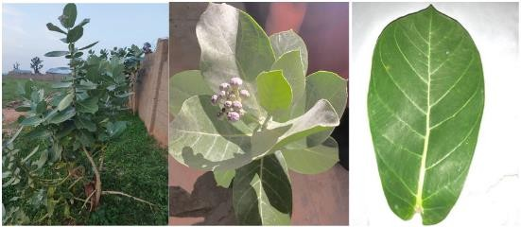

Multiple biological assessments of the plant’s constituent parts were performed,eachemployingauniqueassaytoconfirmtheplant’sefficacy,as discovered by the research.

Calotropis procera is known for its medicinal properties including antibacterial, antifungal, and antiviral activities. The plant’s latex and leaves containbioactivecompoundslikecardeniodes,flavonoidsandterpenoidsthat contribute to its therapeutic potentials. (Usman et al., 2020). Calotropis procera have been traditionally used to treat various ailments such as:

Anti-ulceractivity

Calotropisprocera hasbeentraditionallyusedtotreatulcerandresearchhas validateditsanti-ulcerproperties.Theplant’sextracthaveshownpotentialin managing gastric ulcers by:
- Reducinggastricacidsecretion.
- Enhancingmucosaldefense.

- Exhibitingantioxidantproperties.

Anti-oxidantactivity

Calotropis procera extract have strong antioxidant properties, attributed to their high phenolic content. Antioxidant helps protects cells from oxidative

stress, which can contribute to various diseases. The plant’s antioxidant activityhasbeen demonstratedthroughvarious assays. (Kumar et al., 2013).

Anti-inflammatoryactivity

Calotropis procera extracts have shown significant anti-inflammatory activity, which can help alleviate symptoms associated with various conditionsincludingarthritis,woundsandinflammatoryboweldiseases.The plant’s anti-inflammatory properties may be attributed to its ability to:
- Inhibitpro-inflammatoryenzymes.

- Reduceinflammatorymediators.

- Modulateimmuneresponse.(Mohammed etal.,2016).

AnthelminticActivity

Calotropis procera extracts have demonstrated anthelmintic activity against certain parasites including nematodes. The plant’s anthelmintic properties may be attributed to its phytochemical such as alkaloids and flavonoids. (Shivkar et al.,2015).

WoundHealing.

Calotropis procera has been traditionally used to treat wounds and research has confirmed its wound healing properties. The plants may enhance wound healing by:
- Promotingcollagensynthesis

- Increasingtissuestrength.
- Exhibitingantimicrobialactivity.

HepatoprotectiveActivity

Theplant’sextractprotectstheliverfromdamagecausedbytoxinsorharmful substances. The plant’s hepatoprotective properties may be attributing to its antioxidant and anti-inflammatory activities.

Anti-diarrhealActivity

Calotropis procera has been traditionally used to treat diarrhea and research has confirmed its anti-diarrheal properties. It may reduce diarrhea by:
- Inhibitingintestinalmotility
- Reducingfluidsecretion.

- Exhibitingantimicrobialactivity.(Kumaretal.,2010).

POTENTIALAPPLICATIONINCLUDES:

  - PharmaceuticalIndustry:Developmentofnewdrugsorherbal
formulationforvariousheathconditionssuchasUlcer,Malaria, and Wounds e.t.c.
  - TraditionalMedicine.

  - AgriculturalIndustry:Potentialuseasanaturalpesticideor
insecticideduetoitsanthelminticandinsecticidalproperties.

  - ResearchandDevelopment:Furtherstudiesontheplant’s
phytochemicalandbiologicalactivitiescouldleadtonew discoveries and application.

ResearchObjectives

    - TosynthesizesilvernanoparticlesusingCalotropisproceraleaf extract.
    - Tocharacterizethesynthesizednanoparticlesusingtechniquessuchas UV-VIS Spectroscopy, FTIR, SEM.

    - ToevaluatetheantimicrobialactivitiesofthesynthesizedAgNPs against some bacterial strains.
    - ToevaluatetheantimicrobialactivitiesofthesynthesizedAgNPsagainst some fungal strains.

ResearchProblems

    - LimitedstudiesonCalotropisproceramediatedgreensynthesisof silver nanoparticles.
    - Variabilityinnanoparticlesynthesismethodsandoutcome.

    - Need for more research on antimicrobial application ofgreen synthesized AgNPs

CHAPTERTWO

MATERIALSANDMETHODS

Collection and Identification of Plant Extract and Bacterial and Fungal Isolates.
CalotropisproceraleaveswereobtainedfromKwaraStatePolytechnicBoys Hostel Ilorin, Kwara State, Nigeria authenticated at the Department Of Botany, University Of Ilorin, Ilorin.
Clinical isolates: Staphylococcus aureus, Salmonella sp., Escherichia coli and,Klebsiellapneumoniae,Penicilliumsp.,Aspergilliusniger,Trichoderma sp., Rhizopus sp., were collected.

PreparationofAqueousCalotropisproceraExtracts.

Following the methods of Chhangte et al., (2021) with slight modifications, Calotropis procera leave was prepared by taking 60g of thoroughly washed leavesandfinelychoppedintosmallpieces,thenitwasmeshedusingmortar and pestle.

Aftermeshing,itwaspouredintoaconicalflaskand100mlofdistilledwater was poured into the flask containing the meshed leaves. The mixture was heated using a Bunsen burner at 60⁰C for an hour.
ThemixturewasallowedtocoolandthenitwasfilteredusingWhattmanNo 1Filterpaper.Thefiltratewascollectedandwasstoredat4ºCfurtheranalysis.

PreparationofAqueousSilverNitrate(AgNO3)

A1mMAgNO3(Silvertrioxonitrate(V))solutionwaspreparedbyweighing 0.0170g of AgNO3 using an analytical balance and dissolving it in distilled water to reach the 100ml mark of a 100ml volumetric flask.
SynthesisofSilvernitrateusingCalotropisproceraleafextract

The filtrate extracted from the leaf extract was collected and 10ml of the filtrate was added to 45ml of 1mM AgNO3 solution prepared in a 300ml conical flask.
The mixture was stirred using a stirring rod and the conical flask containing thesilvernanoparticlepreparedwascoveredwithafoilpaperandablack

polythene bag and placed in a dark box for bioreduction process and it was further observed for change in colour.
Note: Storing in a dark place was to prevent photosynthesis and photodecomposition because silver nanoparticle are sensitive to light and storing in a dark place can help reduce or minimize the effect of light and allowed the reaction to proceed slowly and consistently.
Afterthreedaysofstoringinadarkplace,thecolorchangedfromlightgreen to dark brown confirming the synthesis of AgNPs.
The synthesized Calotropis procera- AgNPs were obtained through centrifugation, eliminating the supernatant and then dried.

PhytochemicalScreening

The synthesis of silver nanoparticles(AgNPs) using Calotropis procera leaf extractinvolvesagreenreductionprocesswherephytochemicalpresentinthe extract act as reducing and stabilizing agents.

The leaf extract of Calotropis procera is rich in various phytochemicals, including flavonoids, terpenoids, alkaloids, saponin, glycoside, tannins steroid which have been reported to possess reducing properties.
ThesephytochemicalscreeningplaysacrucialroleinthesynthesisofAgNPs by reducing silver ion(Ag+) to silver nanoparticles (AgO). Phytochemical screening was performed using standard procedure.
By using different specific reagents, the presence of main groups of natural products was detected in the ethanolic extract of Calotropis procera.

Alkaloids.

Toafewmillilitersoftheplantsampleextract,twodropsofMayer’sreagent are added along the sides of the test tube. The appearance of a white creamy precipitate indicates the presence of alkaloids (Banu and Catherine, 2015).

Tannins

For the detection of tannins, 2mL of the extract is placed in a test tube and gentlyheatedfor2minutes.Anorangecolorobservedafteradding3dropsof ferric chloride indicates the presence of tannins. (Rashed et al., 2019).

Saponins

5mL of the extract sample was diluted with 15 mL of distilled water. The resultant mixture was shaken strongly; the appearance of foam indicates the presence of saponins (Oscar et al., 2020).

Flavonoids

A portion of the extract was dissolved in 2mL of 50% methanol. Metallic magnesium chips and a few drops of concentrated hydrochloric acid were added. The appearance of a red color indicates the presence of flavonoids. (Namadina et al., 2020).

Glycosides

Glycosides were detected by adding a few drops of glacial acetic acid, ferric chloride, and concentrated sulfuric acid to each sample through the side wall of the test tube. A reddish-brown color appeared at the junction of the two layers, and the upper layer appeared bluish-green (Rajitha et al., 2022).

Terpenoids

Asmallsampleoftheextractwastreatedwith1mLofaceticanhydride,1mL oftrichloromethane,and1mLofsulfuricacid.Theproductionofavioletcolor indicates the presence of terpenoids (Oscar et al., 2020).

CharacterizationofGreenSynthesizedNanoparticles

The synthesized silver nanoparticles (AgNPs) were characterized using Spectrumlab 752s UV-Vis spectroscopy, Fourier Transform Infrared Spectroscopy PerkinsElmer3000 MX model, Scanning Electron Microscopy(JSM-7600F)JEOL model.

FOURIER TRANSFORM INFRARED SPECTROSCOPY (FTIR).
Fourier transform infrared spectroscopy (FT-IR) analysis was performed in all samples isolated to have a prompt result regarding the biomineral. A few crystalsweremixedwithKBr(Merckforspectroscopy)andpulverizedinan agate mortar to form a homogenous powder from which, under a pressure of 7 tons, the appropriate pellet was prepared.

Allspectrawererecordedfrom4000to400cm1usingthePelkinElmer3000 MXspectrometer.Scanswere32perspectrumwitharesolutionof4cm1.The IR spectra were analyzed using the spectroscopic software Win-IR Pro Version 3.0 with a peak sensitivity of 2cm1.

FTIRPROCEDUREANDINSTRUCTION

- Signonthenotebook.

- Turnonthecomputerandsignin.

- Tuneonthepoweroftheinstrument,waituntiltheinitializationsucceeded.
In thesmall panel ofinstrument “Perkin ElmerSpectrum100 Series”will be shown if the initialization succeeded, otherwise come to see Jianhua first.
- CleanthesampleholderbyacetonewithKimwipes,makesurenotto splash the acetone on the instrument.
- Launchthe“spectrum”softwareonthedesktopwithUserNameof“Analyst” and Password “analyst”, then select “Spectrum 100”

- Select“Instrumentsetup”button,“ScanandInstrumentSetup”dialogwill popup,inputyoursamplename,scanrange(therangelimitis650-4500cm- 1), and scan number.
- Click the “back ground” button to collect back group information of the sample holder.
- Place you sample on the sample holder. If your sample is liquid, you can go ahead and press “Apply” and then “Start” to collect the spectrum. If your sampleissolid,clickthe“monitor”buttononthe“ScanandInstrumentSetup” dialog first, and then lower down the pressure arm, through the “monitor” dialog to monitor the total pressure applied to the sample, set the “Force Gauge” to be around 80, then click “finish”. Press “Apply” and then “Start” to collect the spectrum.
- Dataprocessing:Peaklabel:Select“view”fromthemenu,andthen“label peaks”.Ifyouwanttolabelaspecialpeak,“view”-------“cursor”“vertical
continuous”,then move the cursorto thepeakyouwant,andthen“view”----

-“labelcursor”.Datasaving: youcansaveyourdataas ASCIIby“File”------
---“Saveas”,theselect“ASCII(*.ASC)asthesaveastype.

- Turnoffthesoftware,logoffthecomputer,andswitchofftheinstrument.
MakesuretocleanthesampleholdercompletelybeforeyouleaveFTIR.

PRINCIPLEANDCAPACITIESOFSCANNINGELECTRON MICROSCOPE (SEM)
The types of signals produced by a SEM include secondary electron (SE), back-scattered electrons (BSE), characteristic X-rays, light (cathodoluminescence) (CL), specimen current and transmitted electrons.
SecondaryelectrondetectorsarestandardequipmentinallSEMs,butitisrare thatasinglemachinewouldhavedetectorsforallpossiblesignals.Thesignals resultfrominteractionsoftheelectronbeamwithatomsatornearthesurface of the sample.
Inthemostcommonorstandarddetectionmode,secondaryelectronimaging orSEI,theSEMcanproduceveryhigh-resolutionimagesofasamplesurface, revealing details less than 1 nm in size.
Due to the very narrow electron beam, SEM micrographs have a large depth offieldyieldingacharacteristicthree-dimensionalappearanceusefulfor

understanding the surface structure of a sample. This is exemplified by the micrograph of pollen shown above.
A wide range of magnification is possible, from about 10 times (about equivalenttothatofapowerfulhand-lens)tomorethan500,000times,about 250 times the magnification limit of the best light microscopes.
Back-scatteredelectrons(BSE)arebeamelectronsthatarereflectedfromthe samplebyelasticscattering.BSEareoftenusedinanalyticalSEMalongwith the spectra made from the characteristic X-rays, because the intensity of the BSE signal is strongly related to atomic number (Z) of the specimen.
BSE images can provide information about the distribution of different elementsinthesample.Forthesamereason,BSEimagingcancolloidalgold immune-labelsof5or10nmdiameter,whichwouldotherwisebedifficultor impossible to detect in secondary electron images in biological specimens.
Characteristics X-rays are emitted when the electron beam removes an inner shell electron from the sample, causing a higher-energy electron to fill the shellandreleaseenergy.ThesecharacteristicsX-raysareusedtoidentifythe composition and measure the abundance of elements in the sample.

SAMPLEPREPARATION

Allsamplesmustbeofanappropriatesizetofitinthespecimenchamberand are generally mounted rigidly on a specimen holder called a specimen stub. Several models of SEM can examine any part of a 6-inch (15 cm) semiconductor wafer, and some can tilt an object of that size to 45⁰.
Samplesarecoatedwithplatinumcoatingofelectricallyconductingmaterial, deposited on the sample either by low-vacuum sputter coating or by high- vacuumevaporation.SEMinstrumentsplacethespecimen in arelativehigh- pressurechamberwheretheworkingdistanceisshortandtheelectronoptical column is differentially pumped to keep vacuum adequately low at the electron gun.
The high-pressure region around the sample in the ESEM neutralizes charge and provides an amplification of the secondary electron signal. Low-voltage SEMis typicallyconducted in an FEG-SEMbecausethefield emission guns (FEG)iscapableofproducinghighprimaryelectronbrightnessandsmallspot size even at low accelerating potentials.

Embeddinginaresinwithfurtherpolishingtoamirror-likefinishcanbeused for both biological and materials specimens when imaging in backscattered electrons or when doing quantitative X-rays microanalysis.

UV-VISSPECTROPHOTOMETER

This method is based on the principle that molecules absorb light at specific wavelength. When a plant extract is exposed to UV-Vis light, the molecules withintheextractabsorbssomeofthelightwhiletherestpassesthrough.The amount of light absorbed is measured and plotted against the wavelength creating a spectrum.

PROCEDURE

      - Extracttheplantmaterialusingasuitablesolvent(ethanol,water).

      - Filtertheextracttoremoveanysolidparticle.
      - Dilutedtheextracttoanappropriateconcentrationsoitfallswithinthe instrument’s detection range.
      - TurnontheUV-Visspectrophotometerandallowittowarmup.
      - Setthewavelengthrangeyouwanttoscan
      - Calibratetheinstrumentusingablank.

      - Placeacurvettefilledwiththeblanksolutioninthespectrophotometer
      - Runascantoestablishabaseline.

      - Remove the blank and replace it with a curvette containing the plantextract.
      - Run the scan and the instrument will measure the absorbance of theextract at each wavelength.
      - Theinstrumentgeneratesaspectrumshowingabsorbanceversus wavelength.
      - Identifythepeaksinthespectrumwhichindicatethewavelengthwhere the extract absorbs the most light.
      - Usingtheabsorbancevaluesatspecificwavelengthtoquantifythe concentration.

Antimicrobialactivity

Itisawellknownfact,thatsilverionsandnanoparticlesarehighlytoxicand hazardoustomicroorganisms.Itisfoundoutthatthesilvernanoparticleshave many inhibitory and bactericidal effects and so its application is extended as anantibacterialagent.Theantibacterialactivityofsilvernanoparticlesis

estimated by the zone of inhibition. Many different studies have shown that silver nanoparticles can affect the membrane permeability and respiratory function by attaching to cell surface. Another possibility is that silver nanoparticlesnotonlyinteractwiththesurfaceofthemembrane,butcanalso penetratedeepinsidethebacteria.Anotherobservationexplainsthatthesilver nanoparticles have relatively higher antibacterial activity against gram negativebacteriathangrampositivebacteria,whichmaybeduetothethinner peptidoglycan layer and presence of beta barrel proteins called porins.
Ten microbial strains were used to screen the antimicrobial activity of Calotropisprocera/AgNO₃;onegram-positive(Staphylococcusaureus),four gram negative bacteria( Escherichia coli, Klebsiella pneumonia, Pseudomonas sp., Salmonella typhi) and five fungal isolates(Aspergillus niger, Penicillum sp.,Trichoderma sp., Rhizopus sp).
The level of susceptibility of each test organism was determined using the agar well diffusion method. Theplates were inoculated with thetest isolates. Afterwards, a sterile cork borer of 5mm diameter was used to make holes in

thePotatodextroseagar(PDA)plates.0.2mloftheextractwasfilledintoeach appropriately labeled well.
The inoculated plates were kept at roomtemperature for 30 minutesto allow the extract to diffuse into the agar and were then incubated at 37 °C for 24 hours. Antimicrobial activity was determined by zones of inhibition, which were quantified by measuring the diameter of the zone of inhibition in millimeters(mm)usingameterruleafterincubation(Okoronduetal.,2015).

CHAPTERTHREE

RESULTS

PhytochemicalAnalysis

Phytochemical analysis was carried out to test the contents of Flavonoids, Alkaloids,Saponin,Terpenoids,Glycosids,Tannins,Steriodsintheleavesof Calotropis procera . The phytochemical screening followed standardized method.
Table 1: Result of Qualitative phytochemical screening of Calotropis procera leaves
Test | Result
Flavonoids | +
Alkaloids | ++
Saponin | +
Terpenoids | +
Glycosides | +
Tannins | ++
Steroid | +

Key:

+ Present in trace form
++Moderately present

Table2:ResultofQuatitativephytochemicalscreeningofCalotropis procera leaves

Test | Result(mg/100g)
Flavonoids | 0.173±0.011
Alkaloids | 13.20±0.044
Saponin | 1.33±0.380
Terpenoids | 0.04±0.020
Glycosides | 0.18±0.120
Tannins | 12.77±0.253
Steroid | 0.32±0.142

GreensynthesisofSilverNanoparticle

To avoid photo-activation of silver nitrate, the mixture was incubated in the dark at room temperature for 72hours. The colour changed from light green to grey color that confirms the reduction of Ag⁺to Agº.
Fig1Colorchangeofleafextractscontainingsilveraftersynthesisof

silvernanoparticle.

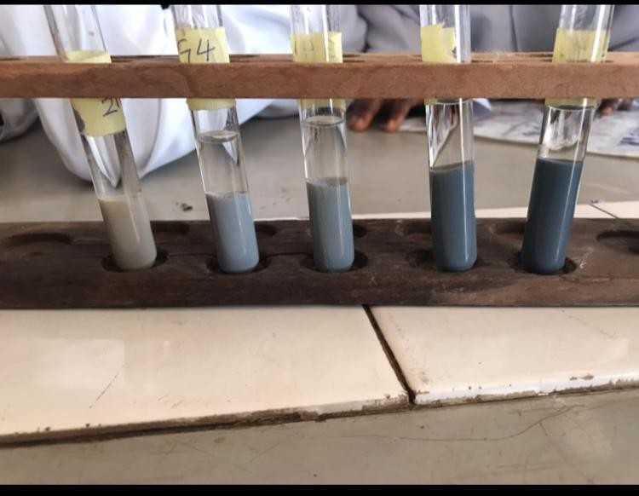

Characterizationofsynthesizedsilvernanoparticles.

UV-VISSpectroscopy

The formation of silver nanoparticles is characterized by discoloration that occursatthetimeofincubation.EachmixtureofAgNPsreactionwithleaves ofCalotropisprocerawasmeasuredatawavelengthof200-600nmgivingits peak at 350nm.

Fig2UV-VISabsorbtionspectraofsilvernanoparticlesynthesizedfrom
Calotropisproceraleavesat1Mmsilvernitrate.

Absorbance
2.55
2.5
2.45
2.4
2.35
Absorbance
2.3
2.25
2.2
0
500
1000

Wavelength(nm)

FOURIERTRANSFORMINFRAREDSPECTROPHOTOMETER

The FTIRspectroscopywas carriedout toidentifythe chemicalcomposition and nano silver particles of the test sample. The spectra were taken from resulting disk over the frequency range at 4400-250cm⁻1.

Fig 3. FTIR spectrum of silver nanoparticle synthesized by Calotropisprocera leaf extracts.

30.9
2357.63
2587.73
919.00
703.56
2538.00
4037.00
870.69
565.41 373.31
1077.61
1190.44
2966.00
1753.52
1027.45
1608.09
1309.00
3430.17
1686.39
1417.29
30
29

28

27
26

25

24
23

22

21
20

19

18
17

16
%T15
14

13

12
11

10
9

8

7
6

5

4
3

2

1
0.0
4400.0 4000 3600 3200 2800 2400 2000 1800 1600 1400 1200 1000 800 600 350.0
cm-1

SCANNINGELECTRONMICROSCOPY

A Scanning electron microscope was used to evaluate the morphology of samples containing AgNPs of Calotropis procera on a copper grid before being dried at room temperature giving a magnification both in 8000x and 9000x.

Fig 4 SEM images of magnification 8000x and 9000x of the silver nanoparticles synthesized by Calotropis procera leaf extracts
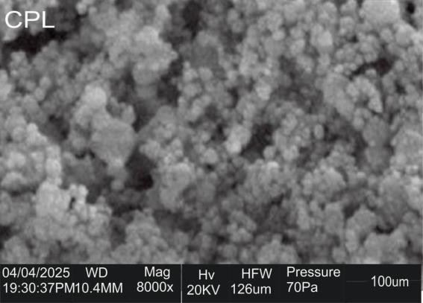

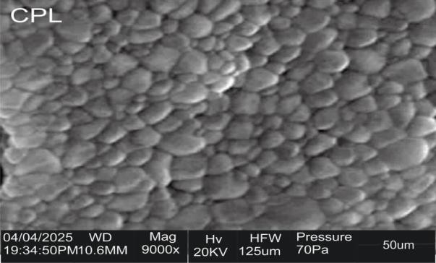

AntimicrobialActivityEvaluation.

Theantimicrobialactivityofsilvernanoparticlessynthesizedbyplantextracts were tested against some pathogenic bacteria isolates such as E. coli, P. aeruginosa, S. aureus, S. typhi, K. pneumoniae and against some pathogenic fungi;F.oxysporum,Rhizopussp.,A.niger,Penicillumsp.Usingwell

diffusion method.The diameter of inhibition zone (mm) around each wellwith silver nanoparticle solution is represented in table 3 and 4.

Table3Antibacterialactivity(Zoneofinhibition)ofC.p-AgNPsleaf extract

BACTERIA  SPECIES | 250ppm | 500ppm | 1000ppm
Klebsiella  pneumoniae | - | - | 24mm
Staphylococcus  aureus | - | - | -
Pseudomonasspp. | - | - | 17mm
Escherichiacoli | - | - | -
Salmonellatyphi | - | - | -

Table4Antifungalactivity(Zoneofinhibition)ofC.p-AgNPsleaf extracts.

FUNGI  SPECIES | 0.1ml | 0.2ml | 0.3ml | 0.4ml
Penicillumspp. | - | 23mm | 24mm | 23mm
Aspergillusspp. | - | 23mm | - | -
Trichoderma  spp. | 20mm | 19mm | 25mm | -
Rhizopusspp | - | - | 18mm | -

Fig 2. Effect of silver nanoparticle synthesized by leaf extract of Calotropis procera on K. pneumoniae,Pseudomonas sp., Staphylococcus aureus, Escherichia coli, Salmonella typhi.
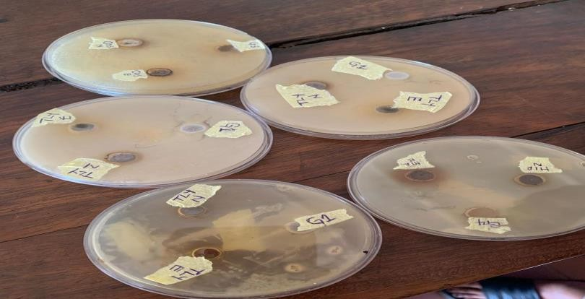

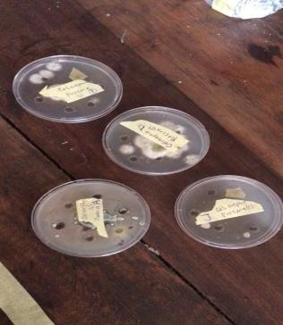
Fig3EffectofsilvernanoparticlesynthesizedbyleafextractofCalotropis procera on Pencillium spp,Trichoderma spp., Fusarium oxysporium, Rhizopus sp.

i

CHAPTERFOUR

DISCUSSIONANDCONCLUSION

DISCUSSION

QualitativeandQuantitativephytochemicalanalysis

The synthesis of silver nanoparticles (AgNPs) using Calotropis procera leaf extractinvolvesagreenreductionprocesswherephytochemicalpresentinthe extract acts as reducing and stabilizing agents.
The leaf extract of Calotropis procera is rich in various phytochemical including flavonoids, terpenoids, saponins, alkaloids, glycoside, steroids, phenolic compounds and alkaloids which have been reported to possess reducing properties.
These phytochemical plays a crucial role in the synthesis of AgNPs by reducingsilverions(Ag⁺)tosilvernanoparticles(AgO).Thepresenceofthese biomolecules in the leaf extract enables the formation of stable AgNPs, eliminating the need for additional stabilizing agents.

The phytochemical analysis was carried out to test the content of alkaloids, saponins, phenolics, tannins, flavonoids, steroids and terpenoids in leaf of Calotropis procera. The phytochemical screening followed standardization methodsgivingresultsbothinqualitativeandquantitativeanalysisinTable2 and 3.

GreensynthesisofSilver Nanoparticle

TheSilvernanoparticle(AgNps)synthesisreactionwascarriedoutusingleaf extract of Calotropis procera. The reaction is carried out in a dark condition to avoid the photoactivation reaction of silver nitrate.
An indication of AgNPs formation is the occurrence of discoloration in the solution.Aftersomeincubationtime,itwasreportedthattheAgNPssolution has discoloration to greyish color in fig 1.
Based on the result, it can be concluded that silver nanoparticle synthesized using Calotropis procera have been formed.

UV-VisSpectroscopy.

TheUV-VisSpectrophotometerdepictedin(fig2),revealsabsorbancepeaks at a ƛmax of 350nm, which is consisted with the characteristics absorption patternofAgNPs.ThisobservationalignswiththefindingofHaoandQingha (2017), who conducted a study on the green synthesis of silver nanoparticle and their antimicrobial activities.
In their research, the reported distinct surface Plasmon adsorption peak at approximately ƛmax 400nm indicative of silver nanoparticles.

FTIRSpectroscopy

The FTIR Spectrum (fig 3) of silver nanoparticle showed strong IR band characteristics of Hydroxyl (3430.17cm⁻¹), alkane (2966.00, 2587.73, 2538.00cm⁻¹),c=cofbenzene(1753.52cm⁻¹),aromaticamines(1190.44cm⁻¹) and aliphatic amines (1027.45cm⁻¹) functional groups.
The FTIR analysis strongly supported the capping behavior of bioreduced silver nanoparticle synthesized by Calotropis procera leaf extract which in turn imparted the high stability of the synthesized silver nanoparticle.

ScanningElectronMicroscopy(SEM)

(Fig 4) shows the SEM images of Calotropis procera/AgNO₃. The micrographs showed mainly irregular shaped particles with areas of uniform dispersion and areas of particles aggregation.
It has been suggested that these areas of aggregation can be attributed to yht interactionbetweentheformednanoparticlesandsomeofthephytochemical involved in its synthesis could be due to steric silver interaction between individualnanoparticles.Theseparticlesaggregationobservedcouldhowever limit its ability to disperse uniformly when applied as nanofillers.
AntimicrobialActivityofCalotropisprocera/AgNO3

(Table3and4),describestheantimicrobialactivityofCalotropisprocera

/AgNO₃ against isolated microorganisms. It can be observed that antimicrobial activity ranged between 17mm-24mm (zone of inhibition) against Klebsiella pneumonia, Pseudomonas sp., Penicillum sp., Aspergillus niger, Trichoderma, Fusarium while no activity was observed against Rhizopus sp., Staphylococcus aureus, Escherichia coli, Salmonella typhi.

The result in this study also showed the antimicrobial activity against gram negative ( Klebsiella pneumonia) was significantly higher than other microorganism tested while activity against fungal isolates was significantly higher than gram positive bacteria.
Overall,theantimicrobialactivityofsilveroxidenanoparticlesandsensitivity todifferentmicrobesvaryindifferentreports,thiscouldbeduetothemethods of synthesis, functionalization, particle size, silver concentration and microbial strain tested.

CONCLUSION

Thestudydemonstratesthebio-reductionofaqueoussilverionsusingtheleaf extract of the Calotropis procera plant. Characterization of the resulting productwascarriedoutthroughUV-Vis,ATR-FTIRandSEManalyses.The metalionswerereduced,leadingtotheformationofsilvernanoparticleswith an average particle size of as indicated by SEM analysis.
TheUV-VisanalysisofAgNPsrevealedasurfacePlasmonresonance(SPR) characteristic peak at 400nm. ATR-FTIR showed the disappearance of three distinctivepeaksat3430.17cm⁻¹,2966.00cm⁻¹,and1753.00cm⁻¹,withothers

exhibiting reduced and increased wave numbers. These changes are responsible for the reduction, capping, and stabilization of the synthesized C.p-AgNPs. The leaves of Calotropis procera emerge as a promising source for green synthesis of silver nanoparticles.
Furthermore, the antimicrobial activity of C.p-AgNPs was investigated, revealing dose-dependent inhibition. The C.p-AgNPs exhibited the best inhibition at 1000ppm against bacteria such as Klebsiella pneumoniae(24.0 mm) and Pseudomonas sp.,(17.0 mm), as well as the C.p-AgNPs exhibited the best inhibition at 0.3ml against fungi such as Penicillum sp., (23.0 mm) and Trichoderma sp.,(25.0mm).
The efficacy of the antimicrobial activity suggests the potential to eradicate resistant human pathogenic bacteria and fungi, and adjusting the concentration of C.p-AgNPs could further enhance their antimicrobial potential.
From this summary, it was concluded that plant mediated synthesis of silver nanoparticles possess potential antimicrobial applications. The characterizationanalysisprovedthattheparticlesoproducedin

nanodimensions would be equally effective as that of antibiotics and other drugs in pharmaceutical applications. The use of silver nanoparticles in drug delivery systems might be the future thrust in the field of medicine.

REFERENCE

Abdulrahman, M. D., Ali, A. M., Fatihah, H., Khandaker, M. M., & Mat, N. (2018). Traditional medicinal knowledge of Malays in Terengganu, Peninsular Malaysia. Malayan Nature Journal, 70, 349–364.
Abdulrahman,M.D.,Zakariya,A.M.,Hama,H.A.,Hamad,S.W.,Al-Rawi,
S. S., Bradosty, S. W., & Ibrahim, A. H. (2022). Ethnopharmacology, biological evaluation, and chemical composition of Ziziphus spina- christi (L.) Desf.: A review. Advances in Pharmacological and Pharmaceutical Sciences, 2022, 1–36. https://doi.org/10.1155/2022/4495688
Al-Rowaily,S.L.,Abd-ElGawad,A.M.,Assaeed,A.M.,Elgamal,A.M.,El Gendy,E.N.G.,&Mohamed,T.A.(2020).EssentialoilofCalotropis procera: Comparative chemical profiles, antimicrobial activity, and allelopathic potential on weeds. Molecules, 25(5203). https://doi.org/10.3390/molecules25225203

Al-Sulaibi, M. A. M., Carolin, T., & Thies,T. (2020). Chemical constituents and uses of Calotropis procera and Calotropis gigantea—A review (Part 1 - the as material and energy resources). Open Chemistry Journal, 7(1).
Banu, K. S., & Cathrine, L. (2015). General techniques involved in phytochemical analysis. International Journal of Advanced Research in Chemical Science, 2(4), 25–32.
Batool, H., Hussain, M., Hameed, M., & Ahmad, R. (2020). A review on Calotropis procera, its phytochemistry and traditional uses. Big Data in Agriculture, 2, 29–31.
Blanco, E., Shen, H., & Ferrari, M. (2015). Principles of nanoparticle design for overcoming biological barriers to drug delivery. Nature Biotechnology, 33(9), 941–951.
Campisi,S.,Schiavoni,M.,Chan-Thaw,C.E.,&Villa,A.(2016).Untangling the role of the capping agent in nanocatalysis: Recent advances and perspectives. Catalysts, 6(12), 185.

Chhangte, V., Samuel, L., Ayushi, B., Manickam, S., Bishwajit, C., & Samuel, L. R. (2021). Green synthesis of silver nanoparticles using plant extracts and their antimicrobial activities: A review of recent literature. RSC Advances, 11, 2804.
Dogara, A. M., Hamad, S. W., Hama, H. A., Bradosty, S. W., Kayfi, S., Al- Rawi, S. S., & Lema, A. A. (2022). Biological evaluation of Garcinia kola Heckel. Advances in Pharmacological and Pharmaceutical Sciences, 2022, 1–15. https://doi.org/10.1155/2022/3837965
Javed, R., Zia, M., Naz, S., Aisida, S. O., ul Ain, N., & Ao, Q. (2020). Role ofcappingagentsintheapplicationofnanoparticlesinbiomedicineand environmental remediation: Recent trends and future prospects. Journal of Nanobiotechnology, 18(1), 1–15.
Jokerst,J.V.,Jeanne,E.L.,&Hartanto,J.(2017).Nanoparticle-basedsensors for detecting analytes in liquids. Trends in Analytical Chemistry, 97, 445–458.

Kalu,A.O.,Egwim,E.C.,Jigam,A.A.,&Muhammed,H.L.(2022).Green synthesis of magnetite nanoparticles using Calotropis procera leaf extract and evaluation of its antimicrobial activity. Nano Express, 3.
Kareem, S., Akpan, I., & Ojo, O. (2008). Antimicrobial activities of Calotropis procera on selected pathogenic microorganisms. African Journal of Biomedical Research, 11, 105–110.
Kazemipour, N., Nikbin, M., Davarimanesh, A., & Sepehrimanesh, M. (2015). Antioxidant activity and mineral element contents of Calotropis procera from Iran: A traditional medicinal plant in Middle East. Comparative Clinical Pathology, 24, 1147–1150.
Kumar,S.,Gupta,A.,&Pandey,A.K.(2013).Calotropisprocerarootextract has the capability to combat free radical mediated damage. ISRN Toxicology, 2013, 1–8. https://doi.org/10.1155/2013/691372
Kumar, V. L., & Roy, S. (2007). Calotropis procera latex extract affords protectionagainstinflammationandoxidativestressinFreund’s

complete adjuvant induced monoarthritis in rats. Mediators of Inflammation, 2007, 1–7. https://doi.org/10.1155/2007/47523
Mahmoud, A. D., & Abba, A. (2021). Ethnomedicinal survey of plants used formanagementofinflammatorydiseasesinRingimlocalgovernment, Jigawa State,Nigeria. Ethnobotany Researchand Applications,22,1– 27.
Manikandan,R.,Manikandan,B.,Raman,T.,Arunagirinathan,K.,Prabhu,

N. M., Jothi Basu, M., Perumal, M., Palanisamy, S.,& Munusamy, A. (2015). Spectrochimica Acta Part A, 138, 120–129.
Namadina, M. M., Haruna, H., & Sunusi, U. (2020). Pharmacognostic, antioxidant and acute toxicity study of Ficus sycomorus (Linn) (Moraceae)rootandstembark.FederalUniversityDutsin-MaJournal of Science, 4(2), 605–614.
Ocsoy, I., Tasdemir, D., Mazicioglu, S., Celik, C., Kat, A., & Ulgen, F. (2018). Biomoleculesincorporated metallicnanoparticles synthesis and their biomedical applications. Materials Letters, 212, 45–50.

Oscar,S.A.,Antonio,C.N.,Marina,V.,Elsa,R.S.,&Gabriel,V.A.(2020). Phytochemical screening, antioxidant activity and in vitro biological evaluation of leaf extracts of Hyptis suaveolens (L.) from south of Mexico. South African Journal of Botany, 128, 62–66.
Prabha, M. R., & Vasantha, K. (2011). Antioxidant, cytotoxicity and polyphenolic content of Calotropis procera (Ait.) R. Br. flowers. Journal of Applied Pharmaceutical Science, 1, 136–140.
Rahman, M. A., Reichman, S. M., & Hasegawa, H. (2016). Analgesic, anti- inflammatory,andantipyreticactivitiesofCalotropisprocerarootbark extract. Avicenna Journal of Phytomedicine, 6(2), 149–157.
Rajitha, S. A. B., Mohan, C., Upendra, J. M., & Satya, P. K. (2022). Antimicrobial efficacy of G. hirsutum L. (Bt and Non-Bt) phytochemical extracts: The most widely cultivated species of cotton in the world. Systems Biology and Engineering, 2(1), 1–9.
Rashed, A., Shaeroun, A., Ahmed, A. B., Alqamoudy, H., Mohamed, K. S., Almunir,N.,Kushlaf,N.,El-Mahmoudy,A.M.,Misbah,A.A.,

Oshkondal, S. T. M., & Almesai, Z. R. (2019). Thin layer chromatography (TLC) and phytochemical analysis of Moringa oleifera methanol, ethanol, water and ethyl acetate extracts. Saudi Journal of Medical and Pharmaceutical Sciences, 5(10), 817–820.
Rasik, A., Raghubir, R., Gupta, A., Shukla, A., Dubey, M., Srivastava, S., Jain, H., & Kulshrestha, D. (1999). Healing potential of Calotropis procera on dermal wounds in guinea pigs. Journal of Ethnopharmacology, 68, 261–266.
Rathod, C. P., & Ghante, M. H. (2021). Pharmacological screening of mast cell stabilizing, anti-inflammatory and antioxidant activity of Calotropis procera extracts. Turkish Journal of Computer and Mathematics Education, 12, 4338–4352.
Rawat, P., Singh, P. K., & Kumar, V. (2017). Evidence-based traditional antidiarrhealmedicinalplantsandtheirphytocompounds.Biomedicine & Pharmacotherapy, 96, 1453–1464.

Sharma, P., Kumari, S., Ghosh, D., Yadav, V., Vij, A., & Rawat, P. (2021). Capping agent-induced variation of physicochemical and biological propertiesofα-Fe2O3nanoparticles.MaterialsChemistryandPhysics, 258, 123899.
Shivkar,Y.,&Kumar,V.(2003).AnthelminticactivityoflatexofCalotropis procera. Pharmaceutical Biology, 41, 263–265.
Shobowale, O., Ogbulie, N., Itoandon, E., Oresegun, M., & Olatope, S. (2013). Phytochemical and antimicrobial evaluation of aqueous and organic extracts of Calotropis procera Ait leaf and latex. Nigerian Food Journal, 31, 77–82.
Tsala, D. E., Nga, N., Thiery, B. N. M., Bienvenue, M. T., & Theophile, D. (2015).Evaluation oftheantioxidant activityand thehealing action of the ethanol extract of Calotropis procera.
Usman, A., Mohammad, R., Abdullahi, A., Zakari, A., & Usman, N. (2021). Isolationofdihydroquercetincytotoxicscreeningofthecrudeextracts. Journal of the Chemical Society of Nigeria, 46, 83–93.

Usman, A., Onore, R., Opaluwa, D., & Ibrahim, A. (2020). Phytochemical, antioxidantandcytotoxicscreeningoftheleavesofCalotropisprocera extracts. Trends in Science and Technology Journal, 5, 525–528.

