DEPARTMENT OF CIVIL ENGINEERING

DESIGN AND DETAILING OF A DUPLEX USING PROTA STRUCTURE SOFTWARE
BY
ZUBAIR JOSEPH MAYOWA
HND/23/CEC/FT/0057

SUBMITTED TO THE DEPARTMENT OF CIVIL ENGINEERING, INSTITUTE OF TECHNOLOGY, KWARA STATE POLYTECHNIC, ILORIN
IN PARTIAL FULFILLMENT OF THE REQUIREMENTS FOR THE AWARD OF THE HIGHER NATIONAL DIPLOMA (HND) IN CIVIL ENGINEERING
JULY 2025.
DECLARATION
I hereby declare that this project work titled DESIGN AND DETAILING OF DUPLEX USING PROTA STRUCTURE SOFTWARE USING (BS 8110 CODE) is a work done by me, ZUBAIR JOSEPH MAYOWA with matric number, HND/23/CEC/FT/0057 of the Department of Civil Engineering, Institute of Technology, Kwara State Polytechnic, Ilorin.

__________________ ______________
Signature Date

……………….. ……………
CERTIFICATION
This is to certify that this research study was conducted by Zubair Joseph Mayowa (HND/23/CEC/FT/0057) and had been read and approved as meeting the requirement for the Award of Higher National Diploma (HND) in Civil Engineering, Institute of Technology, Kwara State Polytechnic, Ilorin.
…………………………………………………. ……………………………….

ENGR. K. O. OLORUNFEMI DATE
Project Supervisor

……………………………………….. ………………………

ENGR, A. B. NA’ALLAH DATE
Head of Department
……………………….. …………… …………………….
ENGR. DR. MUJEDU KASALI ADEBAYO DATE
External Supervisor
DEDICATION
This project is dedicated solemnly to God Almighty, who is the sole inspiration of all things, without whom there would not be, and neither would this project.
Appreciation goes to my loving parents for their support in the fulfillment of my Higher National Diploma (HND) both orally and financially. May God allow them to eat the fruit of their labor (Amen)

AKNOWLEDGEMENT
I begin by expressing my deepest gratitude to the Almighty God, who has blessed me with the wisdom, strength, and resilience to complete this project.
I extend my sincere appreciation to my project supervisor, Engr. K. O. Olorunfemi for his invaluable guidance, support, and encouragement throughout this journey. His expertise and constructive feedback were instrumental in shaping this project.
To my family, I express my heartfelt gratitude for their unwavering support and love. My Dad, Mr. Zubair Sunday, who made me choose this interesting course, and Mom, Mrs. Zubair Christianah, my dearest brother and sisters, who motivates me to make this milestone a success, Sunday Comfort, Kehinde, Taiye, Deborah and also to my uncle Zubair Emmanuel thank you for being a constant source of motivation, encouragement and financial support. I appreciate your love.
I also acknowledge the entire staffs of the department of Civil Engineering in the Institute of Polytechnic, Ilorin, for their dedication, enlighten and support towards the success of my academics.
To my friends, guardians and colleagues, Akinpelu Emmanuel Bamidele Sijibomi, Ibironke Taiye Pelumi, Alatise Nafisat, Saliman Ayinde Ridwan, and many others that their names could not be mentioned, I appreciate your encouragement, advice, and camaraderie.
Thank you all for being part of my journey.

TABLE OF CONTENTS
Title page
Declaration i
Certification ii
Dedication iii
Acknowledgement iv
Table of contents vi
List of Figure xi
Abstract xii

CHAPTER ONE
1.0 INTRODUCTION 1
1.1 Background of the study 1
1.2 Problem statement 7
1.3 Aims of the study 9
1.4 Objective of the study 10
1.5 Justification of the study 11
CHAPTER TWO
2.0 Literature review 12
2.1 Computer-aided design (CAD) 12
2.2 Loads 17
2.3 Limit state design 18
2.3.1 Ultimate limit state 19
2.3.2 Serviceability limiit state 19
2.4 Design codes and specifications 20
2.5 Design analysis 24
2.6 Design calculation 24
2.7 Structural detailing 26
2.8 Structural analysis 26
2.9 Concrete 28
2.9.1 Factor of safety and load combination 20

CHAPTER THREE
3.0 Methodology 33
3.1 Data collection and architectural planning 33
3.2 Structural modeling in Protastructure 34
3.3 Load application and structural analysis 34
3.4 Design of structural members 35
3.5 Reinforcement detailing 36
3.6 Structural drawing and documentation 36
3.7 Evaluation and reporting 37
CHAPTER FOUR
4.0 Result and analysis 38
4.2 Result of slab design 41
4.3 Result of the beam design 41
4.4 Result of columns design 41
4.5 Design of stair case 41
4.6 Calculation and analysis report 42
4.7 Modeling 42
CHAPTER FIVE
5.1 Conclusion 69
5.2 Recommendation 70
REFERENCE 71

LIST OF FIGURE
FIG 4.1: Ground Floor 43
FIG 4.2: First Floor 44
FIG4.3: Left Side and Approach View 45
FIG 4.4: Right Side and Rear View 46
FIG 4.5: Structural Design 47
FIG 4.6: Slab Detailing 48
FIG 4.7: 3D View 50
FIG 4.8: 3D Modeling 50
FIG 4.9: Pad Foundation Datailing 51
FIG 4.10: Column Design 52
FIG 4.11: Beam Reinforcement Detailing 52
FIG4.12: Foundation Layout 53
FIG 4.13: Reinforcement Design 54
FIG 4.14: Staircase Detailing 55

ABSTRACT

The increasing demand for efficient, cost-effective, and structurally sound residential buildings has highlighted the need for modern tools in structural design and analysis. This project focuses on the design and detailing of a duplex building using ProtaStructure, a Building Information Modeling (BIM)-based structural engineering software. The study aims to demonstrate how ProtaStructure can be utilized to model, analyze, and design key structural components such as beams, columns, slabs, staircases, and foundations in compliance with the British Standard BS 8110 in a typical duplex. The methodology involves the importation of architectural plans into ProtaStructure, followed by structural modeling, load definition, analysis, and design of reinforced concrete elements. The software’s automated reinforcement detailing and drawing generation capabilities are employed to produce comprehensive structural documentation, including bar bending schedules and construction drawings.The outcome of the project shows that ProtaStructure significantly simplifies the structural design process, enhances accuracy, reduces manual errors, and shortens project timelines. In addition, the software provides a highly visual and integrated environment that supports effective decision-making during the design phase. The project concludes by evaluating the efficiency and practicality of using ProtaStructure in real-life duplex building design, offering recommendations for its broader adoption in structural engineering practice.

CHAPTER ONE
- INTRODUCTION

Prota Structure Software is an ideal tool for engineers involved in designing reinforced concrete buildings. It offers a 2D/3D modeling environment that enables automatic analysis, design, and drafting, streamlining the engineering process. Prota is suitable for projects of any scale and supports a wide range of concrete structural systems. A duplex building is a type of residential structure that contains two separate housing units within a single building. These units can be: Side-by-Side (sharing a common wall) One on top of the other (a storey building with one unit per floor).
Civil engineering, as a discipline, focuses on the design, construction, and maintenance of both physical and naturally built environments.
With this software, design engineers can input all project details, from modeling and load analysis to code specifications and output drawing requirements. The software's graphical interface provides essential tools for structural calculations and design procedures, making it a valuable asset for engineers.
Prota Structural is particularly effective for multi-story building designs, where floor layouts are repetitive. Engineers can model one floor and replicate it across multiple levels, significantly enhancing efficiency. The software accelerates the modeling, loading, analysis, and design processes, ensuring seamless handling of repetitive structures. Additionally, it aids in generating construction drawings, estimating material quantities, and calculating project costs in civil engineering.
Civil engineering, as a discipline, focuses on the design, construction, and maintenance of both physical and naturally built environments. This includes infrastructure such as roads, bridges, canals, dams, reservoirs, sewers, rail tracks, and buildings. Prota Structural Software plays a crucial role in optimizing these projects through its advanced design and analysis capabilities.
A Civil engineering structure is designed to cater for the worst condition of loading on the structure during normal conditions; the deformation of a member should not affect the appearance during the expected lifespan of the structure. Before any design achieves an acceptable state, it must be safe and economical for use during its lifespan. Analysis and design of a building or structural elements such as slabs, beams, columns, stairs, and foundations are carried out separately. However, when these components are subjected to different loadings in the building, they behave differently.
Every invention by man has been designed somehow, by someone, for behind every product lies a chain of decisions making up its actual physical presence. The historical lake dwellers of Europe and Africa built their structures with materials such as timber and clay to represent structural members like slabs, beams, walls, lintels, etc., and palm fronts to represent roof members. The engineers of the 19th century were unable to perceive that their structure had introduced an entirely new factor into the problems of designing.

Software plays a central role in almost all aspects of daily life. It can be defined as the instructions that provide functionality to the program, which requires performing a specific type of data processing in a professional manner to accomplish a task. The number, size, and application of computer programs have grown dramatically. As a result, hundreds of billions are being spent on...
Software development and the livelihood of most people depend on the effectiveness of the development.
Recently, many software developer companies are available in international markets such as Autodesk, Inc., Bentley System, S-FRAME Software Inc., GEO-SLOPE International Ltd., etc. These companies provide a variety of software packages exclusively for different disciplines of engineering that serve for design, construction, and operation of world infrastructure. Some of this software are AutoCAD, SAP2000, GIS, Prota structure, STAAD pro, GEOS, Hydro CAD, Autodesk, etc. The use of software in civil engineering works has contributed greatly in terms of evaluation, convenience, accuracy, and more economical design.
Software applications facilitate engineers’ tasks and enhance the quality of design, modeling, and analysis processes for civil engineering infrastructure. In addition, software general features make the work easier and faster to perform, more accurate, time-saving, and help reduce the total cost, workload, and manpower compared to manual design and works.
A duplex house is a residential building constructed on two floors. It has a single dining room and a kitchen. It has a common central wall with two living units, either side by side or on two floors, with separate entries. While there are...
Two floors are sold together and owned by an individual. It may have a separate entry point for both floors.
In India, duplexes generally have a kitchen, hall, and bedrooms on the lower floor, while the upper floor houses the master bedroom. A duplex has two floors and never three or four floors, in which case it would be called a multiplex. Duplex structures serve several needs in society, primarily as shelter, protection against weather, and security. Living space, privacy for storing belongings, and comfort in life and work are also important aspects.
A building as shelter represents the physical division of human habitant (a place of comfort and safety).

Structural detailing is a branch of structural work that transposes the ideal of a structural engineer into working drawings for easier utilization in building construction. Working drawings are drawings produced by project consultants, i.e., the structural engineer, to ensure the easy execution of a plan by the contractor. The drawing also shows the relationship between architectural and engineering design. It details all structural components as they are, in an orderly manner, without attempting to separate diverse materials.
The art and techniques of designing buildings, as distinguished from the skills associated with construction practices of architecture, emphasize spatial relationships, orientation, and support of activities within a design environment. Additionally, they focus on arranging the visual rhythm of structural elements as approved within the design structural system itself.
Appropriateness, uniqueness, a sensitive and innovative response to functional requirements, and a sense of place within its surrounding physical and social context distinguish the built environment as representative of cultural architecture.
Building designs are increasingly becoming more efficient to increase design efficiency. Lightweight floor systems utilize components such as joists and composite construction to increase strength and span length. While strength has no limit in the floor system, serviceability may be compromised due to decreased floor mass and longer span lengths.
Multiple tender schemes can be assessed in a fraction of the time taken by conventional software. Once the project is secure, detailed design and drafting time is dramatically reduced. Project changes are handled automatically by simply amending the central model or loading. Orion updates the rest, enabling companies to provide a responsive service to demanding clients.

1.2 PROBLEM STATEMENT
In many developing countries, including Nigeria, the demand for well-planned residential buildings such as duplexes is on the rise due to rapid urbanization, population growth, and the need for space-efficient housing. However, the traditional manual method of structural analysis and design is time-consuming, prone to human error, and often lacks the precision required to ensure safety, code compliance, and cost-effectiveness. Furthermore, many small to medium-scale construction projects still rely heavily on outdated methods, resulting in under-designed or over-designed structures that either compromise structural integrity or inflate construction costs unnecessarily.
There is also a significant gap in the integration of architectural and structural design processes. The lack of coordination between architectural intent and structural feasibility can lead to design clashes, rework, and project delays. In addition, modern structural systems demand the use of intelligent, model-based design software that can automate complex calculations, generate reinforcement details, and provide accurate construction documentation.
ProtaStructure, a Building Information Modeling (BIM)-based structural design software, offers a practical solution by enabling engineers to carry out modeling, analysis, design, and detailing in a unified environment. However, its application in local contexts, especially for residential duplex buildings conforming to British Standards (BS 8110), is still underexplored in academic and professional circles.
Therefore, there is a pressing need to demonstrate how ProtaStructure can be effectively applied in the structural design and detailing of a duplex building, ensuring code compliance, design accuracy, construction feasibility, and improved workflow efficiency.

AIM AND OBJECTIVES OF THE STUDY
The aim of this project is to design a duplex and produce detailed structural drawings using Prota Structure, a computer-aided design and analysis software.

The objectives of this project are as follows:
- To prepare the architectural layout of the duplex building.
- To model the structural elements of the building using Prota Structure.
- To carry out structural analysis and design based on standard codes.
- To create accurate reinforcement details for all structural members.
- To generate complete structural drawings using Prota Structure and AutoCAD.
- To assess how effective Prota Structure is in simplifying the design and detailing process.
This project enables the use of software in civil engineering works, which has greatly contributed to evaluation time, convenience, accuracy, and more economical designs. It facilitates an engineer’s tasks and enhances the quality of design, modeling, and analysis processes for civil engineering infrastructure.
In addition, software features make work easier and faster to perform, more accurate, and time-saving, while also reducing total costs, workload, and manpower compared to manual design and construction methods.

1.4 SCOPE OF THE STUDY
This project focuses on the design and detailing of a duplex using Prota Structure, considering the loads the structure will be subjected to the appropriate choice of construction materials, and the overall effectiveness and durability of the structure.

1.5 METHODOLOGY
The procedures for carrying out the project research work include:
- Estimation of loadings.
- Analysis of structural members.
- Design of the structural members.
- Checking the arrangement of structural elements.
- Detailing of structural members.
- Preparation of the Bill of Engineering Measurement and Evaluation (BEME) for the structure.

CHAPTER TWO

2.0 LITERATURE REVIEW
2.1 COMPUTER-AIDED DESIGN (CAD)
The overall goal of a civil engineering structure or design is to be able to cater to the worst condition of loading on the structure during normal conditions. The deformation of a member should not affect the appearance during the expected lifespan of the structure. Before any design achieves an acceptable state, it must be safe, economical, and efficient for use during its lifespan. Analysis and design of buildings or structural elements such as slabs, beams, columns, stairs, and foundations are carried out separately.
According to Narayan, K. Lalit (2008), Computer-Aided Design (CAD) is the use of computers (or workstations) to aid in the creation, modification, analysis, or optimization of a design. CAD software is used to increase the productivity of the designer, improve the quality of design, improve communication through documentation, and create a database for manufacturing. CAD output is often in the form of electronic files for printing, machining, or other manufacturing operations starting around the mid-1960s, with the IBM Drafting System, computer-aided design systems began to provide more capabilities than just the ability to reproduce manual drafting with electronic drafting. The cost-benefit for companies to switch to CAD became apparent. The benefits of CAD systems manual drafting are the capabilities one often takes for granted from computer systems today; automated generation of Bill of Materials, auto layout in integrated circuits, interference checking, and many others. Eventually, CAD provided the designer with the ability to perform engineering calculations.
During this transition, calculations were still performed either by hand or by those individuals who could run computer programs. CAD was a revolutionary change in the engineering industry, where draftsmen, designers and engineering roles begin to merge. It did not eliminate departments, as much as it merged departments and empowered draftsman, designers and engineers. CAD is an example of the pervasive effect computers were beginning to have on industry.
Current computer-aided design software packages range from 2D vector-based drafting systems to 3D solid and surface modelers. Modern CAD packages can also frequently allow rotations in three dimensions, allowing viewing of a designed object from any desired angle, even from the inside looking out. Some CAD software is capable of dynamic mathematical modeling.
Jennifer Herron (2010) states that CAD technology is used in the design of tools and machinery and in the drafting and design of all types of building from small residential types (houses) to the largest commercial and industrial structures (hospitals and factories). It is mainly used for detailed engineering of 3D models or 2D drawings of physical components, but it is also used throughout the engineering process from conceptual design and layout of ducts, through strength and dynamic analysis of assemblies to definition of manufacturing methods of components. It can also be used to design object such as jewelry, furniture, appliances, etc. Furthermore, many CAD applications now offer advanced rendering and animation capabilities so engineers can be visualizing their product designs. 4D BIM is a type of virtual construction engineering simulation incorporating time or schedule related information for project management. CAD has become an especially important technology within the scope of computer-aided technologies, with benefits such as lower product development costs and a greatly shortened design cycle. CAD enables designers to layout and develops work on screen, print it out and save it for future editing, saving time on their drawings.
Prota concrete Structural Software is ideal structural software for those involved extensively in the design of reinforced Concrete Building Structures. It has 2D/3D modeling environment from which automatic analysis, design and drafting is provided for the engineer. Prota structure is perfect for any size concrete building project and caters for a wide range of concrete structural systems. The design engineer will input everything into the software from modeling to loadings, analysis, codes used, and computer program with graphic interface, provides basic concepts for concrete structure calculations and procedures.
ProtaStructural is very good for multi-storey building design as the floors are repetitive and modeling of one floor can be repeated to many storeys imagine the speed of modeling, loadings, analysis and designs for such repetitive structures and most importantly for output of drawings, buildings quantities and costs. Multiple tender schemes can be assessed in a fraction of the time taken by conventional software. Once the project is secure, detailed design and drafting time is dramatically reduced. Project changes are handled automatically by simply amending the central model or loading. Prota updates the rest, enabling companies to provide a responsive service to demanding clients.
According to Blanke et al. (1993), the architect is usually taking the lead design on building, with a structural engineer employed. The degree to which each discipline actually leads the design depends heavily on the types of structure.
Hewson Nigel R. (2003), says that the structural design for a building must ensure that the building is able to stand safely, function without excessive deflection or movement which may cause fatigue of structural element and cracking or failure.
Mosley et al. (2007), states that continuous slab should in principle be designed to withstand the most unfavorable arrangement of load in the same manner as a beam. Because there are greater opportunities for redistribution of load. analysis may however often be simplified by the use of a load in term of bending moment coefficient based on the simplified method provided for slabs which span in one direction with an approximate equal to the span and also for flat slabs. The moment in the spanning of slabs in two directions can also be determined by using the coefficient table in the code of practice. Slabs which support irregular loading arrangement or which are not rectangular in plan may be analyzed by techniques such as the yield line method or the strip method.
2.2 LOADS
Loads that aet on structures can be divided into three general categories:
- Dead Loads
Dead loads are those that are constant in magnitude and fixed in location throughout the lifetime of the structure such as: floor fill, finish floor, beams, plastered ceiling for buildings and wearing surface, sidewalks, and curbing for bridges etc.
- Live or Imposed Loads
Live loads are usually variable or moving loads, they are usually temporary, manageable and dynamic. E.g. people, furniture, etc. The minimum live loads for which the floors and roof of a building should he designed are usually specified in building code that governs at the site of construction.
- Wind Loads
It occurs as a result of wind blowing against a building and it is the resulting force acting on the buildings. It typically depends on the wind velocity and the shape and surface of the building.

2.3 LIMIT STATE DESIGN
Limit state design can perhaps be seen as a concession between the permissible and load factors methods. It is in fact a more widespread approach which takes into account both methods in appropriate way and also in accordance with BS8110.
As limit state philosophy forms the basis of design methods in most modern code of practice for structure design. The aims of limit state design achieve acceptable probability that a structure will not become unfit for it ended use during its design life, that is the structure will not reach at limit state. There are many ways in which a structure could become unfit for use which include excessive conditions for ending, shear, compression, deflection and cracking. The two principal types of limit state designs are the ultimate limit state and serviceable limit.

2.3.1 ULTIMATE LIMIT STATE
This requires that the structure must be able to withstand, with an adequate factor of safety against collapse, overturning or buckling when subjected to the design loads.
2.3.2 SERVICEABILITY LIMIIT STATE
This requires that the structure should not become unfit for use due to excessive conditions of the following serviceability limit state.
- Deflection: The deformation of the structure should not adversely affect its efficiency or appearance.
- Cracking: Cracking should be kept within reasonable limits by correct detailing so as to affect the appearance, efficiency or durability of the structure.
- Excessive Vibration: This may cause discomfort or alarm to the occupants as well as the damage of the structure.
- Fatigue: This must be considered if cyclic loading is likely to occur.
- Fire Resistance: This must be considered in term of resistance to collapse, flame and heat transfer.
- Social Circumstance: Any special circumstances that the structure may be subjected to which are not covered by nay of the limit states. Such as earthquake resistance should be considered.

2.4 DESIGN CODES AND SPECIFICATIONS
According to Ching, Francis D.K.; and Winkel, Steven R. (2016-03-22), even defined a building code (also building control or building regulations) as set of rules that specify the standards for constructed objects such as buildings and nonbuilding structures. Buildings must conform to the code obtain planning permission, usually from a local council. The main purpose of building codes is to protect public health, safety and general welfare as the late to the construction and occupancy of buildings and structures. Building code becomes law of a particular jurisdiction when formally enacted by appropriate governmental or private authority. They are generally intended to constructor designers, by architects, engineers, interior applied for various purposes by safety used also regulators but inspectors, environmental scientists, real estate developers, subcontractors, manufacturers of building products and materials, insurance companies, facility. Managers, tenants, and others. Codes regulate the design and construction of structures were adopted into law.
Buildings must be designed and constructed according to the provisions of a building code, which is a legal document containing requirements related to which things as structural safety, tire safety, plumbing, ventilation. Accessibility to the physically disabled. A building code has the force of law and is administered by a governmental entity such as a city, a country, or for some are metropolitan areas, a consolidated government. Building codes do not give design procedures, but specify the design requirements and constraints that must be satisfied of particular importance to the structural engineer is the prescription of minimum live loads for buildings. While the engineer is courage to investigate the actual loading conditions and attempt to determine realistic values, the structure must be able to support this specified minimum.
Although some large cities write their own building codes, many municipalities will adopt a "model" building code and modify it to suit their particular needs. Model codes are written by various nonprofit organizations in arm that is easily adopted by a governmental unit. Among the more popular are BOCA National Building Code, the Uniform Building Code, the Standard building Code, and International Building Code (BE 8110). A related document, similar in form to a building code, is ASCE 7-10, Minimum Design loads for Buildings and other Structures. This standard is intended to provide load requirements in a format suitable for adoption by a building code.
I will understand the basic concepts behind code provisions for design, we will be able to:
- Approach the design in a more knowledgeable method, not like following a
black box; and
- Understand and adapt the changes in code provisions better and faster.
For concrete structures, we must determine not only the area of longitudinal and lateral reinforcement required in each member, but also the way to best arrange and connect the reinforcement to insure acceptable structural performance. This procedure can be made reasonably simple, if not easy. The Purpose of this is to establish a firm understanding of behavior of reinforced concrete structures, then to develop methods used in current practice and to achieve familiarity with codes and specifications governing practical design.
According to BS 8110 part 1: The Inspection of construction is to ensure the construction is in accordance with the design, materials, records, workmanship and construction.
BS 8110 part 1: 1997 section two (2) recommends the use of the limit state sign for the structure and it should be designed in such a way that adequate means exist to transmit the design ultimate dead, wind and imposed load safely om the highest support level to the foundation. The layout of the structure and the interaction between the structural members should be such that it will ensure stable design. The engineer responsible for the overall stability of the structure would ensure the compatibility of the design and detailing of the parts and components even where some or all of the design and details of these parts and component are not made by this engineer.
Test should be carried out on reinforcement and the constituent material of concrete in accordance with the relevant standard; the production and testing of concrete should obey BS8110 which is made up of suitable quality assurance schemes. Care should be taken to ensure that:
- There are clear instructions on inspection standard.
- The design and detail of the structure must be capable of being executed to a suitable standard in line for dimensional acceptance.
- There must be a system to verify that the quality is satisfactory in individual part of the structure especially critical ones. Etc.

2.5 DESIGN ANALYSIS
The analysis which is carried out to justify a given design according to BS8110, subsection 2.5 can be divided into two stages which are as follows: analysis of the structure and the analysis of the section.
• In the Analysis of the structure or part of the structure, the distribution within the structure is determined by assuming the properties of materials to be linked with their characteristic strength regardless of which limit state is being considered.
While in the analysis of the section within the structure, the properties of materials should be assumed to be associated with the strength of the design appropriate to the limit state being considered.
The method of analysis used should be based on the accurate representation of the behaviors of the structure as is reasonably practicable.

2.6 DESIGN CALCULATION
The working stress method, focusing on conditions at service load (that is when the structure is being used). was the principal method used from the early 1900s until the early 1960s. Today, with few exceptions, the strength design method is used, focusing on conditions at loads greater than service loads when failure may be immanent. The strength design method is deemed conceptually more realistic to establish structural safety.
Before embarking on a design calculation, the following things should be considered:
- The concrete grade to be employed for domestic buildings in this part of country, it is advisable that the concrete grade to be used must not exceed 20N/mm². However, if the contractor can achieve a higher grade and such higher grade can be ascertained through cube test to be regularly performed during the execution of the job, such higher grade can be used. The engineer should insist on grade not lower than 25N/mm²for concrete work of value for a good construction.
- The type of steel: for domestic buildings, mild steel round bars may be sufficient with steel stresses not exceeding 250N/mm' where however the client can guarantee the supply of high yield tensile bars. Tensile strength above 41 0N/mm" should be used only if it can be justified by testing each various size of reinforcement supplied to the site.

2.7 STRUCTURAL DETAILING
According to Victor Oyenuga (2001), detailing is the presentation of the design in a diagrammatic form for the purpose of executing the construction works. The detailed drawings are what the contractors or builders use on site and hence should be a complete and true reflection of the proposed structure.
2.8 STRUCTURAL ANALYSIS
According to BS 8110 Part 2, sub section 2.5.2, the primary objective of structural analysis is to obtain a set of internal forces and moments throughout the structure that are in equilibrium with the design load for required loading combination under design of ultimate loads, any applied redistribution of forces and moment should be compatible with the ductility of the member concerned.
Generally, it will satisfactorily to determine layers of force and moment by, linear elastic analysis of all or part of the structure and allow for redistribution possible buckling effect using the method described in section 3. Alternatively, plastic method e.g., yield line analysis may be used, for design. vice load; the analysis by linear elastic method will normally give as factory set of moment and force.
BS 8110 part 1:1985 section two (2), sub-section 2.1.1, recommends the of limit state design for the construction of a design work, it also recommends the use of suitable materials, and quality control and good supervision on any design work complement the serviceable and durable structure. A very good design but badly detailed can be disastrous and astrophic and it is necessary for the engineer to check the detailed drawing try well after the draughtsman must have finished working on them as example of the general concepts or notations used in structural detailing is as flows.
For slabs, foundations, walls etc. we have:
21-R1201-225mm c/c B
Where
21- Number of steel required in that panel
R-Steel type (R- mild steel round bars and Y/T-High tensile bars)
12- Bar mark (A special number starting from 01 to which is used to identify each bar irrespective of the diameters)
Note: a different bar mark should be given once the size, shape and length a bar differ. That is, two bars with the same bar mark must be of the same meter, length and shape. Otherwise, a different bar mark should be assigned.
225mm c/c—The bar will be placed at 225mm center to center B-The bars will be placed at the bottom.
Note: other notations include BTM (Bottom), T (Top), N.B or N.BTM (Near Bottom), N.T/ N Top (Near Top), B.W (Both Way), E.F (Each Face) etc.
For beams and columns, the notations are: 4Y 2006 +2Y 1602. Which means four numbers of 20mm diameter of high tensile bar with bar mark 06 in addition to two number 16mm diameter of high tensile bars with bar mark 02. It not a violation to combine mild steel and high yield tensile bar in the same element.

2.9 CONCRETE
Reinforced concrete (R.C) is one of the principal building materials used engineering structures because of its low cost, weathering and fire resistance, good compressive strength, formability etc. All these criteria make concrete an attractive material for wide range of structural applications such as buildings, dams, reservoirs, tanks, etc.
Reinforced concrete structures are one of the most popular structure systems. But there are many cases where there are architectural designs which are structurally questionable buildings all they are trying to do is to express their design ideas with limited knowledge about R.C. design. Frequently, the structural member design would not be their primary focus. Although there is the possibility that excessive structural considerations may be disturbing their search for unique designs, basic structural calculation is important for design structurally sound solutions can make their design concepts closer to reality.

2.9.1 FACTOR OF SAFETY AND LOAD COMBINATION
Most building structures are designed using the two principal types of limit state. The main difference in the load for the two states is the applied partial factor of safety. The Table 2.0 of BS 8110 part 1: 1997 gives the various values of the partial factor of safety.
Table 2.0: Load partial factor of safety for various load combination
S/N | COMBINATION | DEAD | IMPOSED | PRESSURE | WIND
1 | Dead, imposed, earth and water pressure | 1.4 | 1.6 | 1.4 | -
2 | Dead and wind (earth and water pressure) | 1.4 | - | 1.4 | 1.4
3 | Dead, wind and imposed (and earth and water pressure) | 1.2 | 1.2 | 1.2 | 1.2
Source: BS8110: Part I 1997

In general. the partial factor of safety is introduced to take account of unconsidered possible increase in load, inaccurate assessment of load effects, unforeseen stress distribution and variations in dimensional accuracy and the importance of the limit state being considered.
BS S110 allows the ultimate design of the support to be calculated from one loading condition with the entire span fully covered with the ultimate load.

CHAPTER THREE

3.0 METHODOLOGY
This project adopts a systematic and software-integrated approach to the design and detailing of a duplex building using ProtaStructure. The methodology involves several sequential stages, from data acquisition to final documentation, ensuring compliance with BS 8110 design standards and best practices in structural engineering. The stages are described below:

3.1 DATA COLLECTION AND ARCHITECTURAL PLANNING
- Client Requirement Assessment: The first step involved consultations with the client to gather essential requirements regarding the number of rooms, preferred structural layout, intended usage of spaces, and specific site constraints.
- Site Investigation: Information such as topography, soil condition (assumed or provided), and location-specific wind and seismic data were considered for proper planning.
- Architectural Layout Development: Architectural drawings including floor plans, elevations, and sections were prepared using AutoCAD or equivalent drafting software. These layouts formed the basis for structural modeling and analysis.

3.2 STRUCTURAL MODELING IN PROTASTRUCTURE
- Importation of Architectural Drawings: The prepared architectural plans were imported into ProtaStructure software to serve as an underlay for accurate placement of structural elements.
- Modeling of Structural Components: Structural elements such as:
  - Beams
  - Columns
  - Slabs
  - Staircases
  - Foundations
were modeled in ProtaStructure with appropriate geometry and positions based on the architectural plan. Material properties such as grade of concrete and steel reinforcement were also defined at this stage.

3.3 LOAD APPLICATION AND STRUCTURAL ANALYSIS
- Definition of Load Types:
  - Dead Loads: Self-weight of structural components calculated automatically by the software.
  - Live Loads: Imposed loads based on usage (residential category as per BS 8110).
  - Wind Loads: Applied in accordance with relevant codes based on building height, shape, and location.
  - Seismic Loads (if applicable): Considered based on the seismic zone of the building location.
- Load Combinations: Appropriate load combinations were applied following BS 8110 and software default settings.
- Structural Analysis: The structure was analyzed to determine internal forces, support reactions, bending moments, shear forces, and deflections using ProtaStructure’s built-in analysis engine.

3.4 DESIGN OF STRUCTURAL MEMBERS
- Beam and Slab Design: Beams and slabs were sized and reinforced based on internal forces and bending moments, ensuring serviceability and ultimate limit state checks.
- Column and Foundation Design: Columns were designed for axial and bending effects, while pad or strip foundations were sized based on column loads and assumed bearing capacity of soil.
- Design Code Compliance: All elements were designed according to the British Standard BS 8110: Part 1, ensuring structural integrity and safety.

3.5 REINFORCEMENT DETAILING
- Bar Arrangement: Detailed reinforcement layouts including longitudinal bars, stirrups, and distribution bars were automatically generated by ProtaStructure.
- Bar Bending Schedules (BBS): Reinforcement schedules were extracted for each element, indicating the size, type, length, and number of bars required.
- Modifications and Adjustments: Where necessary, reinforcement details were adjusted to enhance constructability while maintaining design compliance.

3.6 STRUCTURAL DRAWING AND DOCUMENTATION
- Preparation of Structural Layouts: Finalized structural layouts were exported from ProtaStructure and refined using AutoCAD for construction use.
- Annotations and Dimensioning: Drawings were annotated with appropriate notes, levels, dimensions, and section details for site implementation.
- Drawing Compilation: Drawings such as foundation layout, column schedules, floor framing plans, and roof framing plans were compiled into a complete set.

3.7 EVALUATION AND REPORTING
- Software Assessment: The efficiency and capabilities of ProtaStructure in terms of design accuracy, detailing quality, and time optimization were evaluated.
- Challenges Encountered: Issues such as modeling limitations, software interface complexity, or import/export errors were documented.
- Recommendations: Suggestions were made for better workflow integration, training, or potential alternatives for similar future projects.

CHAPTER FOUR

4.0 RESULT AND ANALYSIS
4.1 DESIGN CONSIDERATIONS
The design and the section of structural element, the details drawings and interactive modeling of the structure (2D/3D) within a short range of time at a better accuracy, efficiency and productivity. The Structural design and detailing of a duplex using Prota was carried out using the following information.
PROJECT: PROPOSED RESIDENTIAL BUILDING OF A DUPLEX
PREPARED BY: MAYORSTUDIO CONSULT
CHECKED BY: ENGR K.O OLORUNFEMI
DATE: JULY, 2025

DESIGN INFORMATION
Project | Proposed residential building of a duplex
Design Engineer | MAYORSTUDIO CONSULT
Relevant code | BS 8110
DESIGNED STRENGHT | Concrete Fcu=25N/mm² and steel Fy=460N0mm²
Fire resistance | 2hours for all element
Storey height | Ground floor and first floor (6.15m)
Exposure condition | Mild for all element
Cover | Slab and stair case=25mm  Beam and column=25mm  Foundation=50mm
Soil condition | Moderate dense sand
Allowance soil beraing | 50KN/m²
Capacity loading | Live load
General loading | Corridor and stair case 3.0KN/m²  Block load(live and dead)---1.50KN/m²  Floor finish---1.20KN/m²  Block wall and rendering ---3.2KN/m²
Design date | K’=0.156  K=M/Fcu bd²  La=0.5+(0.25-K/0.9)^{1/2}<_0.95  Z=Lad_<0.95  As=M/0.95FyZ  If K/K’_< 1  AS=(K-K)Fcubd²/0.95Fyz’+As’  Z’=d(0.5+(0.25-K/0.90^{1/2})  Design shear stress v= bd  Design concrete shear stress  Vc=0.632(100Asprov/bd)^{1/3}(400/d)^{1/4}  When v_<0.5vc provide minimum links  When 0.5vc>v<(vc+0.4) provide minimum links with Asv/sv=0.4b/0.9fyv  When (0.4+vc)v<0.8(fcu)^{1/2} provide links with Asv/sv=b(v-vc)/0.95fyv

4.2 RESULT OF SLAB DESIGN
There are two bays of slabs for the duplex, first floor result was attached because it is the critical bay. The result of the design is attached as follows
4.3 RESULT OF THE BEAM DESIGN
The result of ground floor and the first-floor beam results are attached as follows
4.4 RESULT OF COLUMNS DESIGN
The columns are categories into 3 types due to the similarity of the design result, the similar members can be observed from column layout.
4.5 DESIGN OF STAIR CASE
The result of the stair case is attached herewith.

4.6 CALCULATION AND ANALYSIS REPORT
The other result of the design analysis carried out the Prota structure software are also attached herewith.
4.7 MODELING
The 3D model produced from the Prota structure software is attached herewith and carefully caved and drafted out.

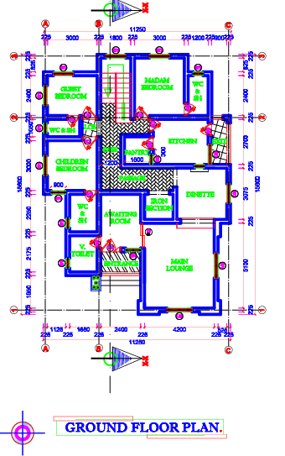
FIG 4.1: GROUND FLOOR PLAN
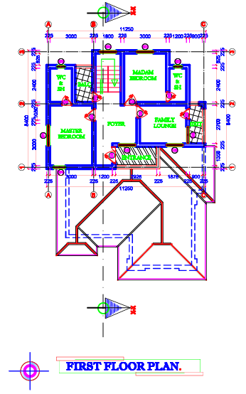
FIG 4.2: FIRST FLOOR PLAN
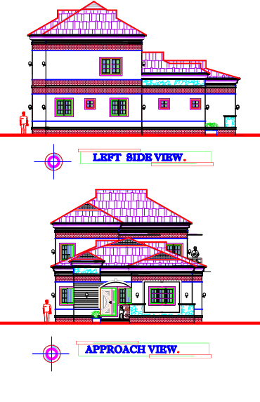
FIG 4.3: LEFT AND APPROACH VIEW
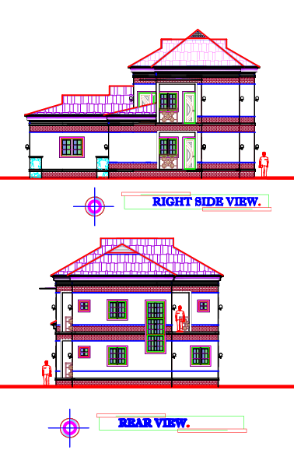
FIG 4.4: RIGHT SIDE AND REAR VIEW

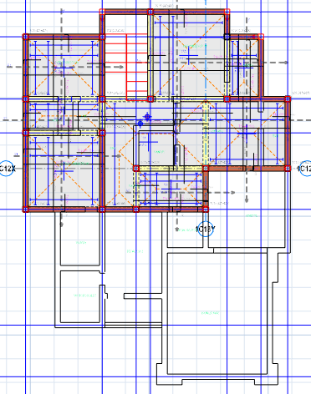
FIG 4.5: STRUCTURAL DESIGN

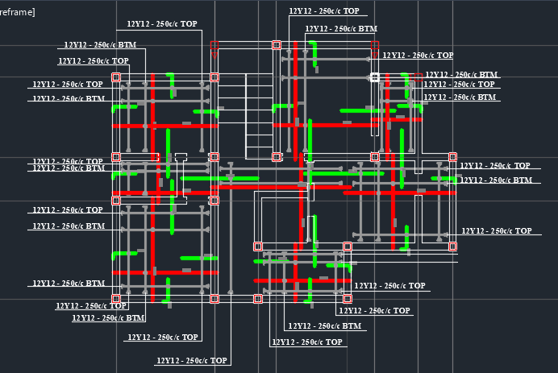
FIG 4.6: SLAB DETAILING

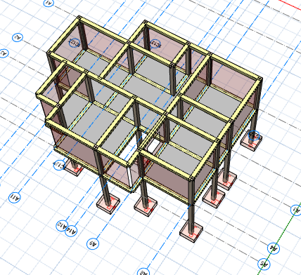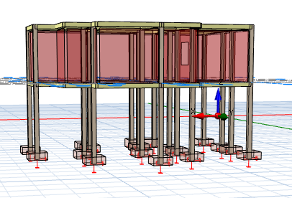
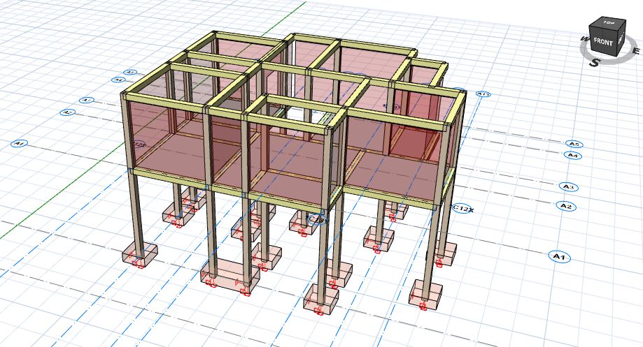
FIG 4.7: 3D VIEW

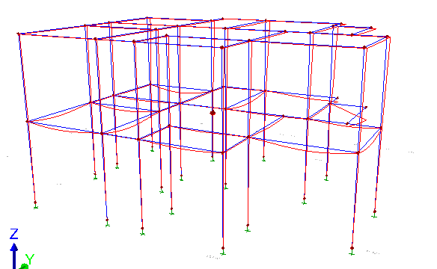
FIG 4.8: 3D MODELING

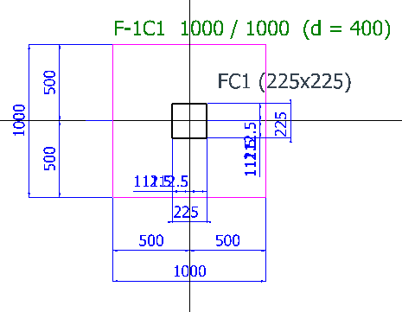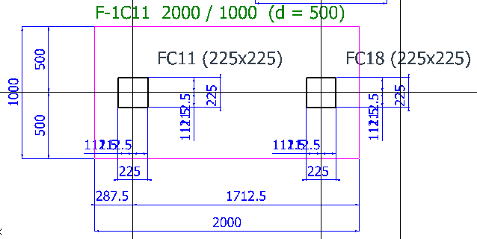
FIG 4.9: PAD FOUNDATION DATAILING
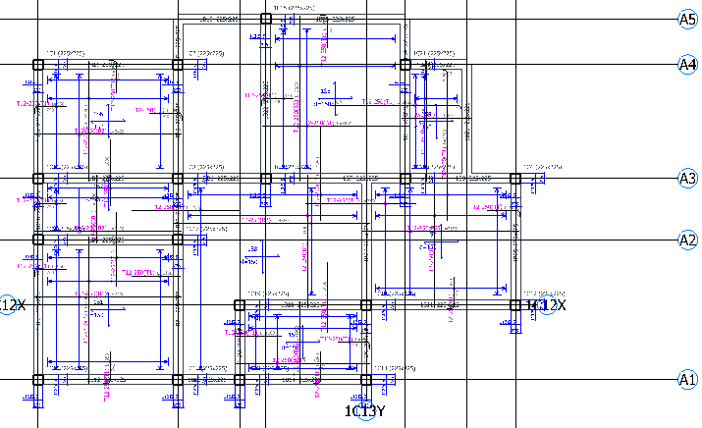
FIG 4.10: COLUMN DESIGN
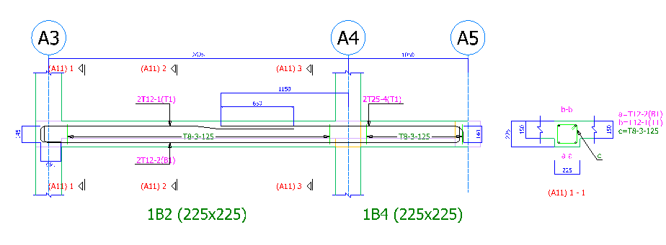
FIG 4.11: BEAM REINFORCEMENT DETAILING
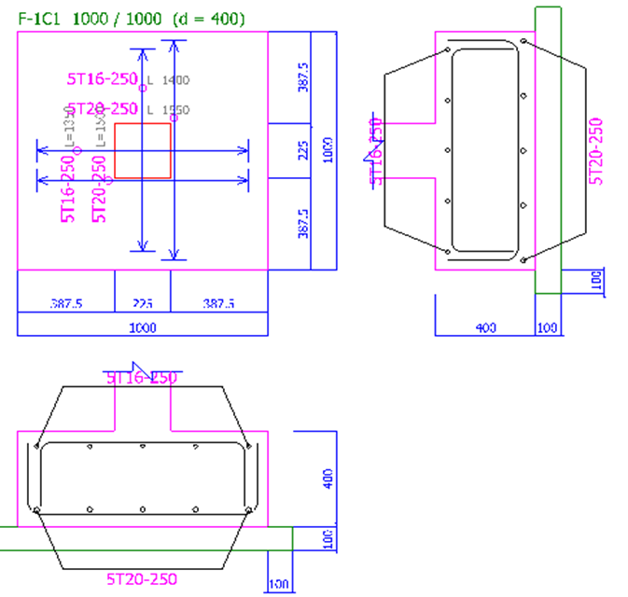
FIG 4.12: PAD FOUNDATION SIDE VIEW
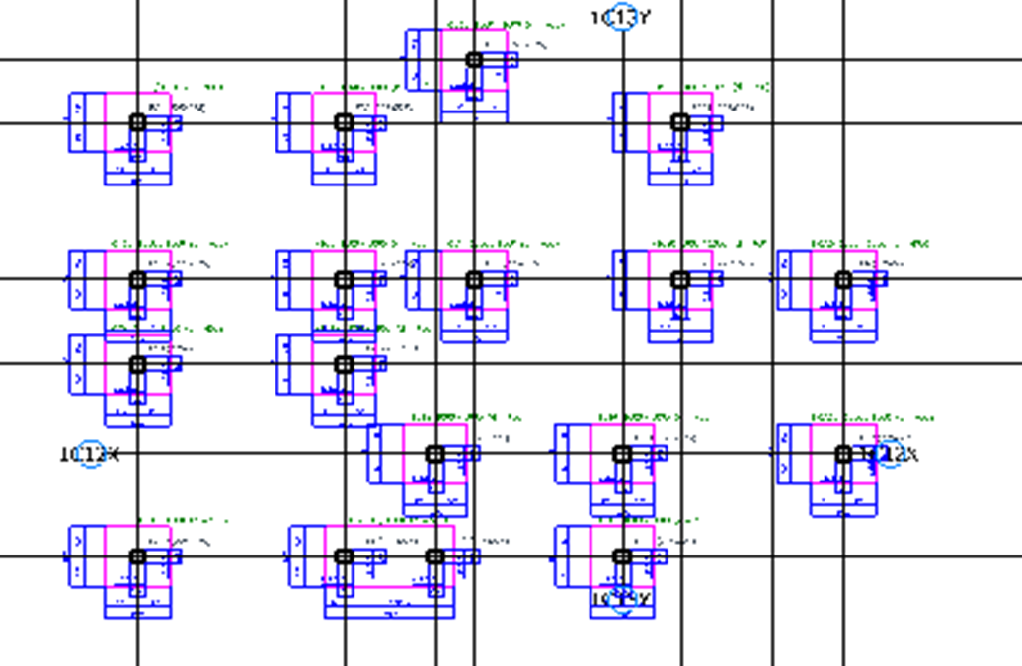
FIG 4.13: FOUNDATION LAYOUT
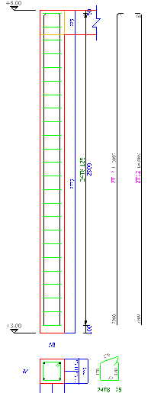
FIG 4.14: REINFORCEMENT DESIGN
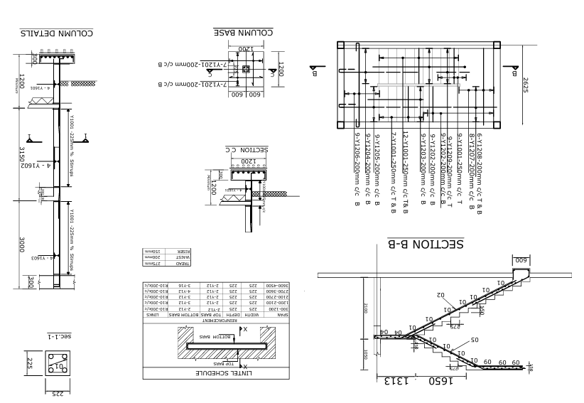
FIG 4.15: STAIRCASE DETAILING
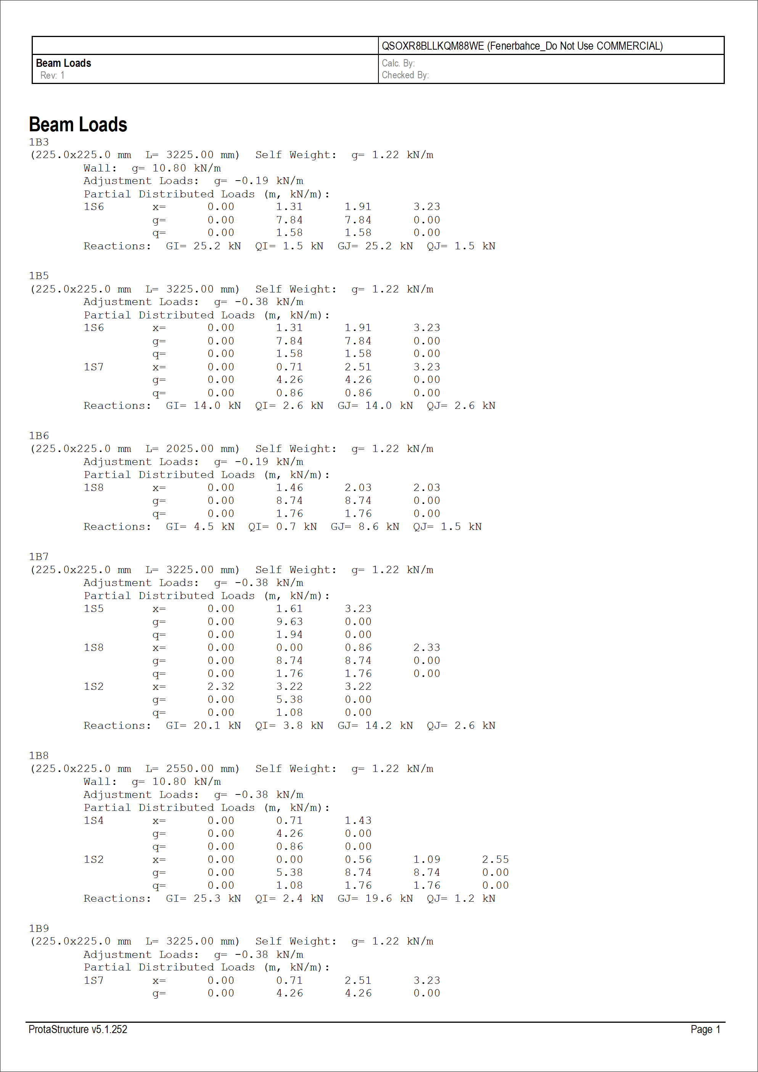
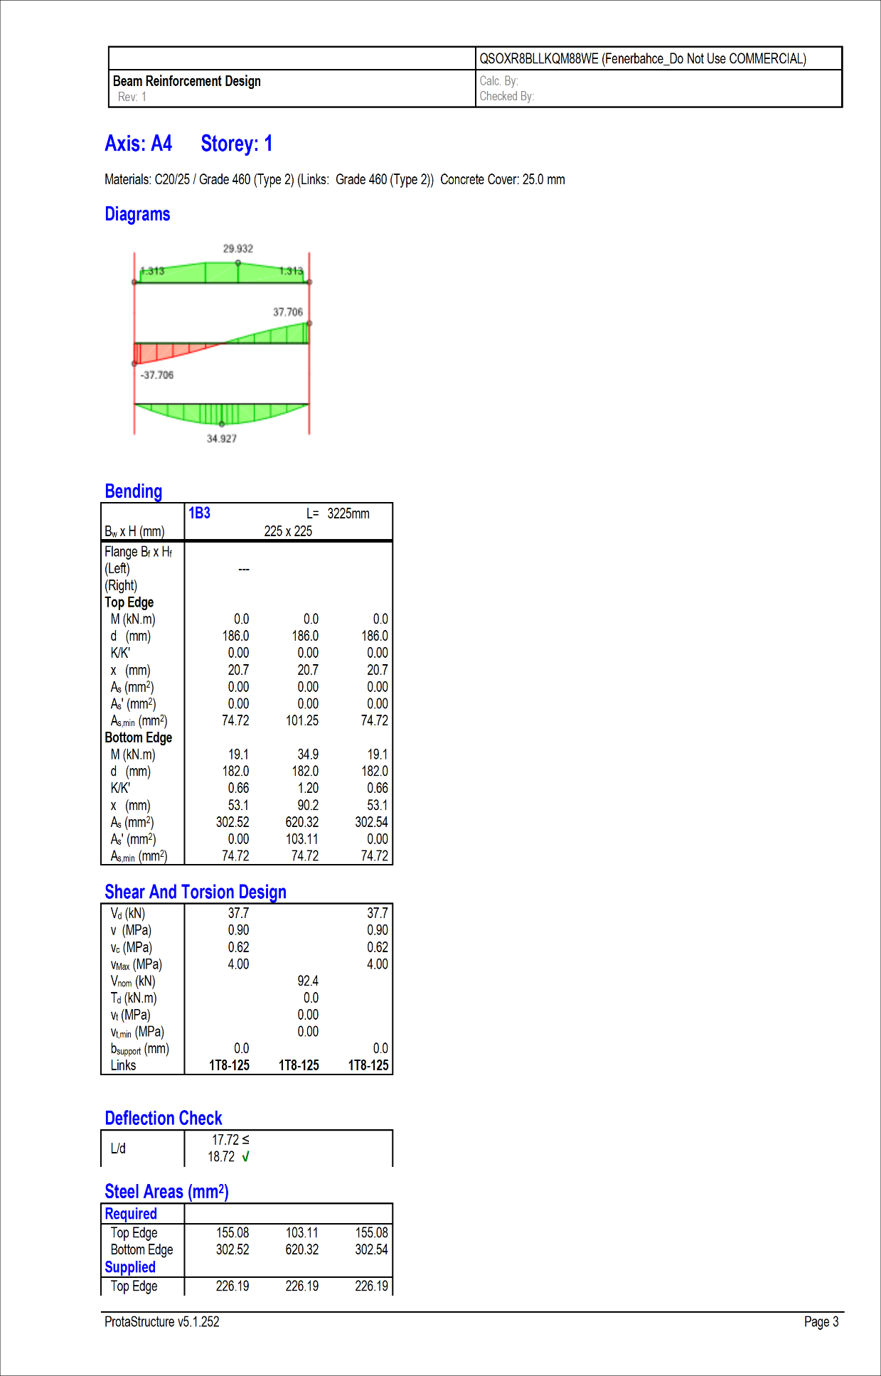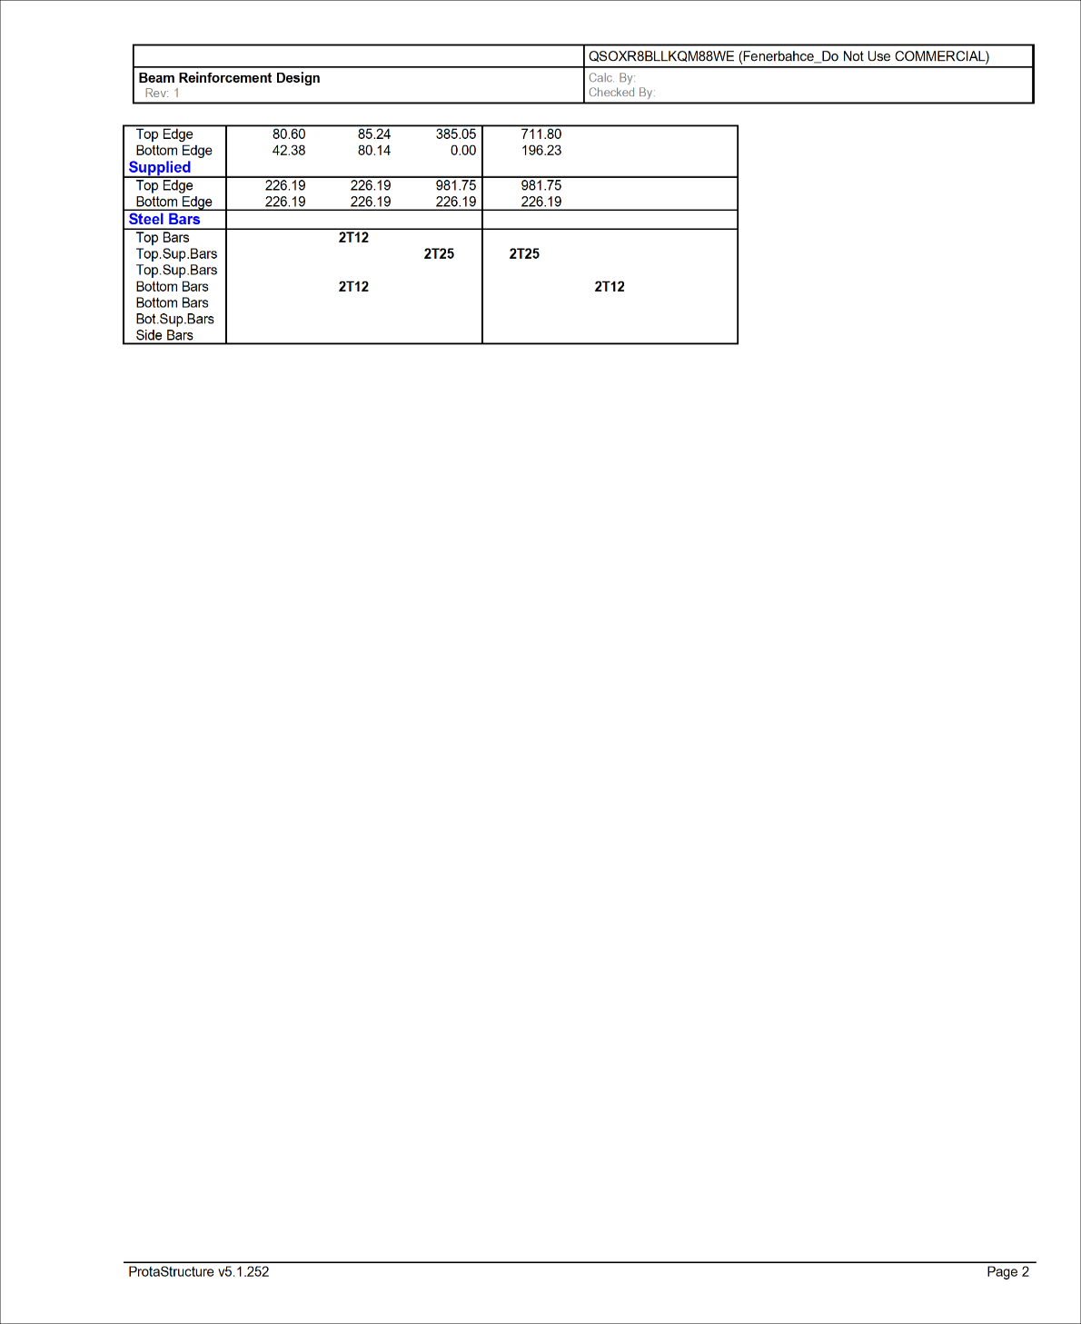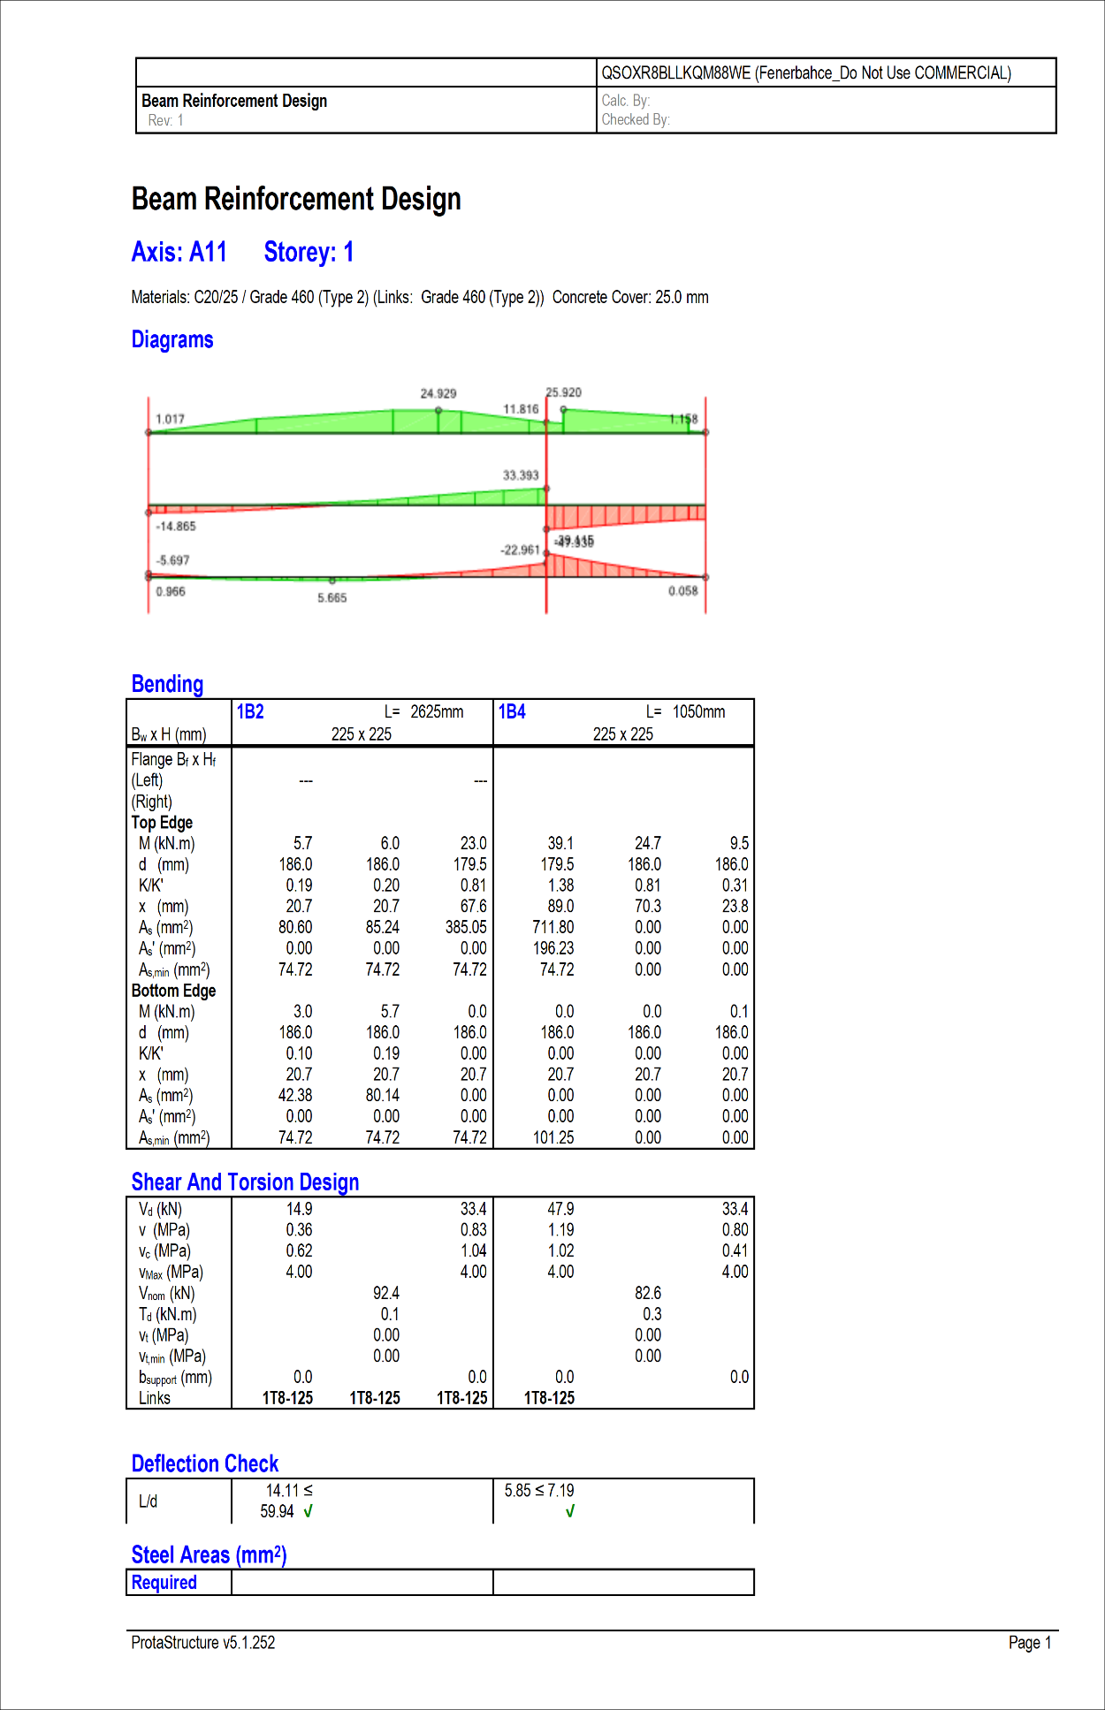
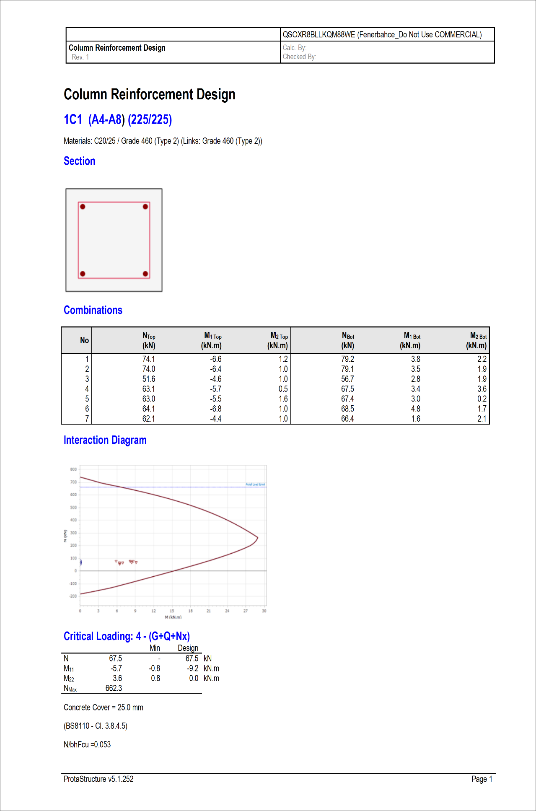
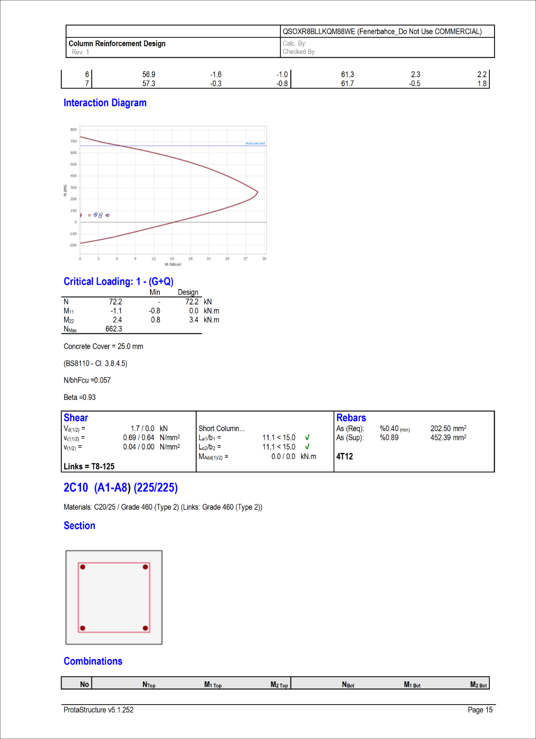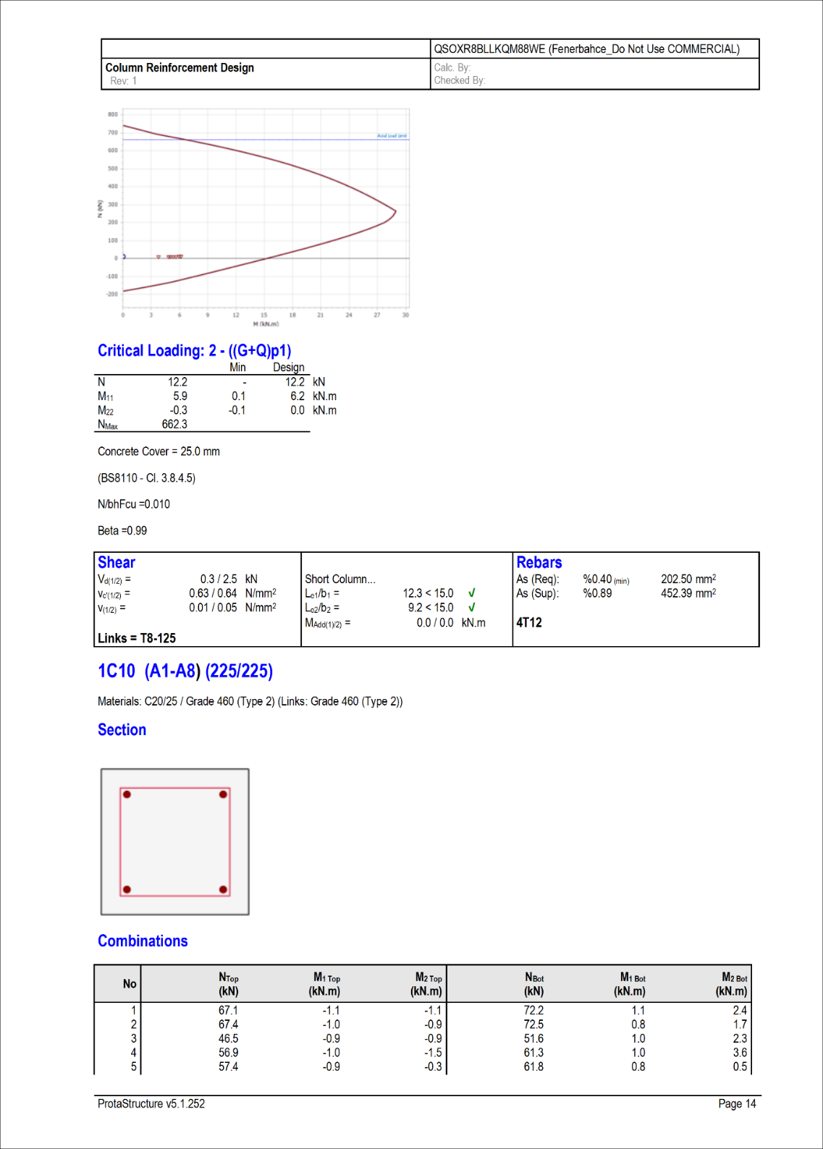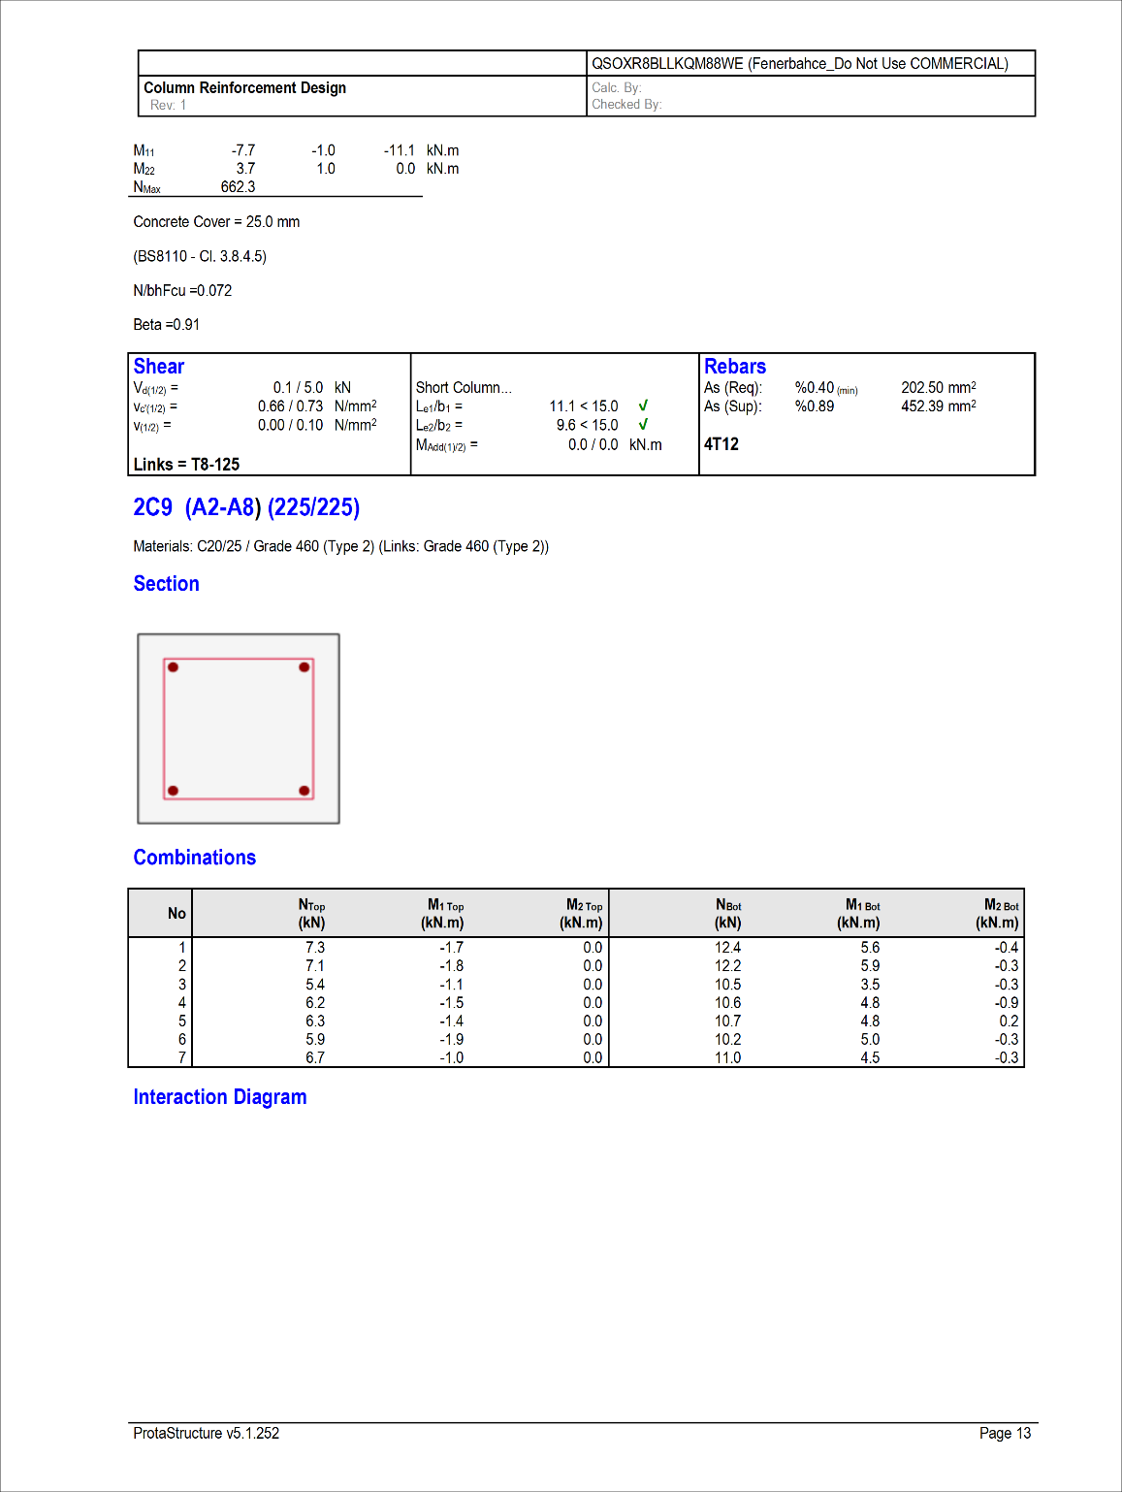
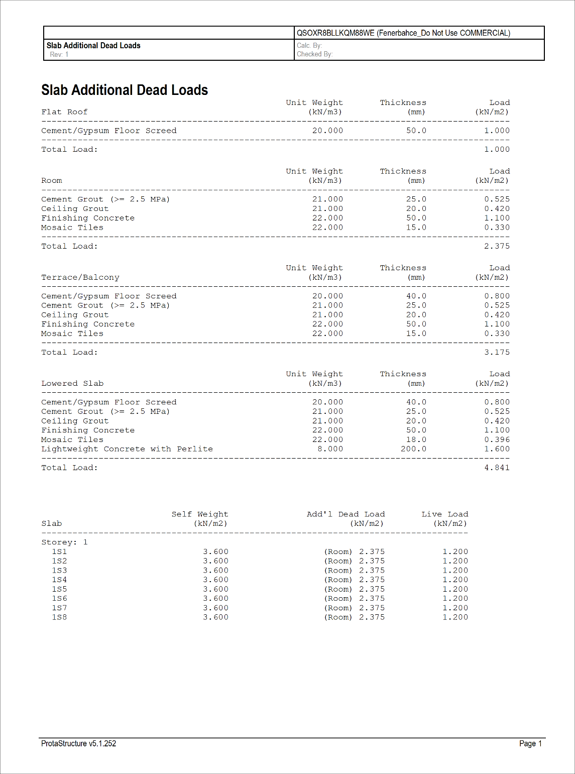
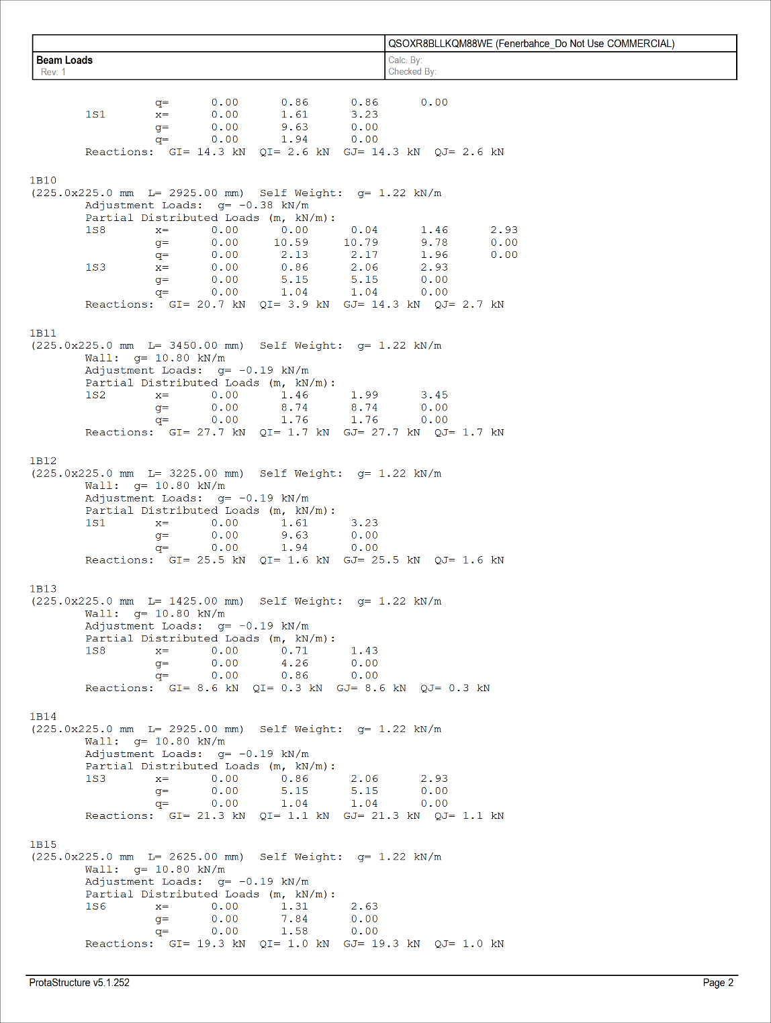
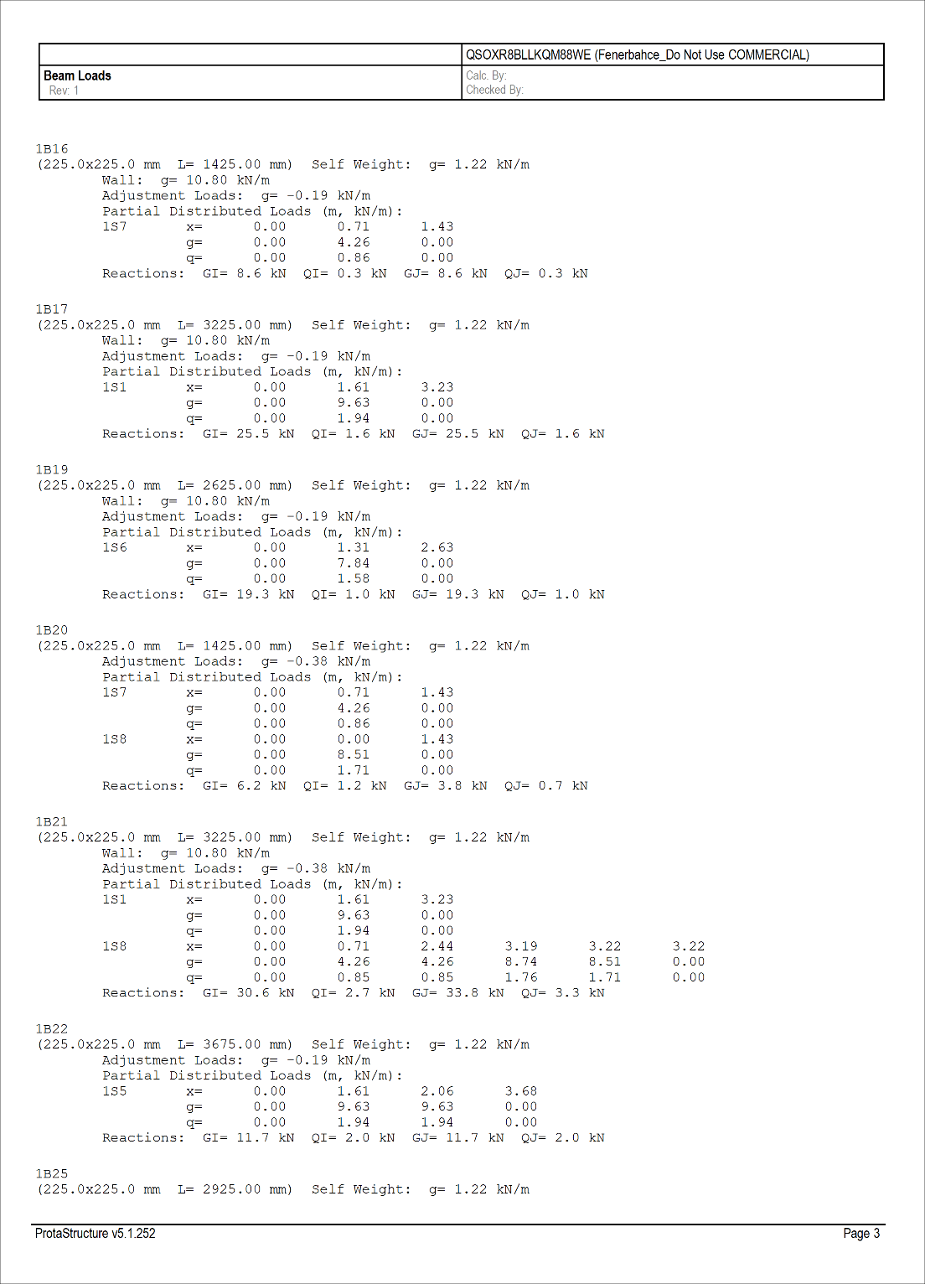
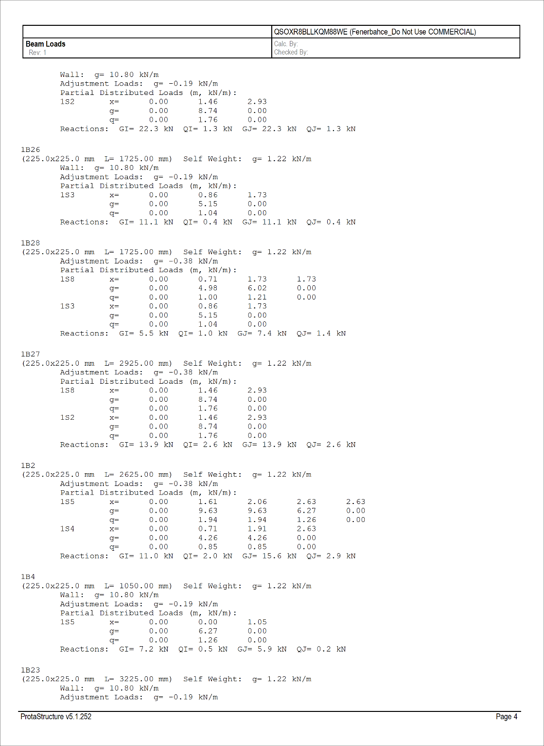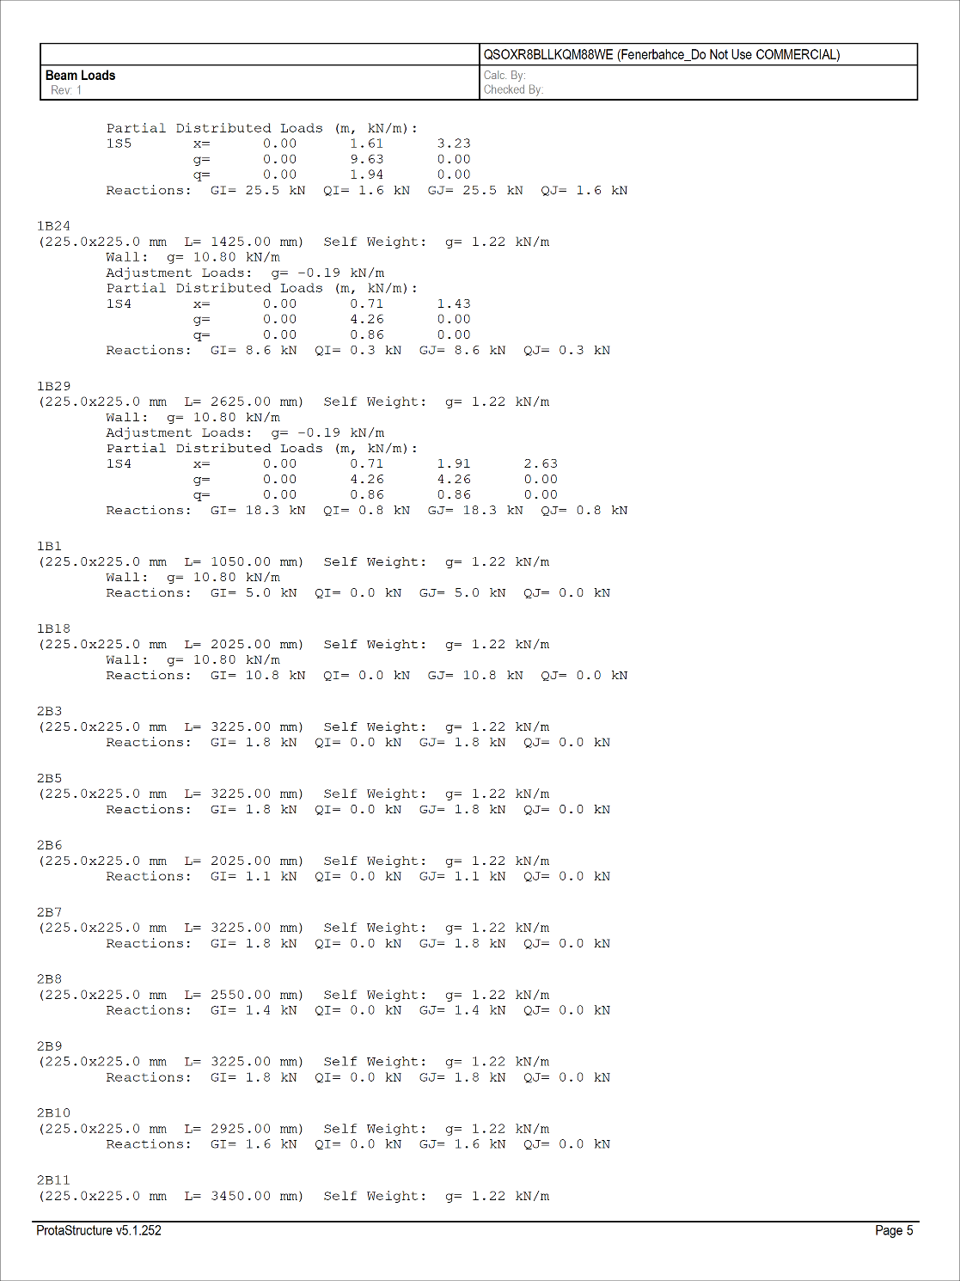
CHAPTER FIVE

5.0 CONCLUSION AND RECOMMENDTAION
5.1 CONCLUSION
A duplex building using ProtaStructure software, the structural layout plans of the structural member of the duplex using auto cad, the design and the section of structural element, the details drawings and interactive modeling of the structure (2D/3D) within a short range of time at a better accuracy, efficiency and productivity. The Structural design and detailing of a duplex using Prota was carried out using the information in the result and analysis. The size of the reinforcement specific for the structural members depend on the span and loadings as follows {for the slab Y12 @250mm c/c, Top (804mm²), Y12 @250mm c/c Bottom (804mm²) was provided}. {For the beam, 2Y16mm for both phases were provided}. {for the walls Y16 @250mm c/c near phases and both phases (804mm²)}. {for the base Y16 @250mm c/c was provided for both phases}. {for the stair case Y8 @200mm top(196mm²) and Y12 @200mm² bottom (196mm²)}.

5.2 RECOMMENDATION

Due to the rate of technological development and advancement in the world, the use of computer aided software like Auto-cad, ProtaStructure etc. in the design and detailing if structure as taking the place of manual method, It is therefore recommend that the civil engineering computer laboratory should be more equipped with computer facilities and trained personnel that will aid the use of these software by the students for their proper training and knowledge even right from their first year so as to produce students with excellent skills on the use of this software and that will make the teach and the course more practical

REFERENCE

Adewuyi, A. P., & Adegoke, T. (2008). Use of Structural Analysis Software for Building Design in Nigeria. Nigerian Journal of Technology, 27(2), 43–49.
Afolayan, J. O. (2008). Structural Analysis and Design of Buildings Using Computer Software. Ilorin: Unilorin Press.
Akintoye, O. A., & Ogunsemi, D. R. (2013). Design and Construction of Residential Buildings in Nigeria. Journal of Civil Engineering and Construction Technology, 4(2), 45–51.
Blanke et al. (1993), the architect is usually taking the lead design on building, with a structural engineer employed.
British Standards Institution. (1997). BS 8110-1:1997 – Structural use of concrete – Part 1: Code of practice for design and construction. London: BSI.
Hibbeler, R. C. (2015). Structural Analysis (9th ed.). Pearson.
Kiousis, P. D., & Al-Mahaidi, R. (2016). Structural Design Software Applications in Practice. Engineering Structures, 122, 270–278.
Karayannis, C. G., & Chalioris, C. E. (2013). Computer-Aided Structural Engineering: Tools and Applications. Open Journal of Civil Engineering, 3(1), 1–12.
Mosley, W. H., Bungey, J. H., & Hulse, R. (2012). Reinforced Concrete Design to Eurocode 2 (7th ed.). Palgrave Macmillan.
McCormac, J. C., & Nelson, J. K. (2014). Design of Reinforced Concrete (9th ed.). Wiley.
Narayan, K. Lalit (2008), Computer-Aided Design (CAD) is the use of computers (or workstations) to aid in the creation, modification, analysis, or optimization of a design.
Oyenuga, V. O. (2002). Simplified Reinforced Concrete Design. Lagos: Vico Press.
Oyenuga, V. O. (2006). Elementary Structural Analysis and Design Practice. Lagos: Asros Limited.
Olagunju, R. E. (2015). Development of Duplex Residential Buildings in Nigeria: Design Considerations and Challenges. International Journal of Civil Engineering and Technology, 6(2), 32–41.
Obiajulu, E. (2019). Structural Design of a Duplex Building Using ProtaStructure Software. Undergraduate Project Report, Department of Civil Engineering, Federal University of Technology.
Oyenuga, V. O. (2006). Elementary Structural Analysis and Design Practice. Lagos: Asros Limited.
Prota Software Inc. (2022). ProtaStructure User Manual and Design Guide. Retrieved from https://www.protasoftware.com
Park, R., & Paulay, T. (2004). Reinforced Concrete Structures. John Wiley & Sons.
Smith, P., & Coull, A. (2006). Tall Building Structures: Analysis and Design. John Wiley & Sons.
Taranath, B. S. (2010). Structural Analysis and Design of Tall Buildings. McGraw-Hill.

