DESIGN AND IMPLEMENTATION OF AN OBSTACLE DETECTOR FOR PARTIALLY IMPAIRED PEOPLE USING SENSOR AND ULTRASONIC TECHNOLOGY

BY

ANIFOWOSE SAMUEL BAMIDELE
HND/23/COM/FT/0500

A PROJECT SUBMITTED TO THE DEPARTMENT OF COMPUTER SCIENCE, INSTITUTE OF INFORMATION AND COMMUNICATION TECHNOLOGY, KWARA STATE POLYTECHNIC, ILORIN, NIGERIA.

IN PARTIAL FULFILLMENT OF THE REQUIREMENTS FOR THE AWARD OF HIGHER NATIONAL DIPLOMA [HND] IN COMPUTER SCIENCE

JULY, 2025
CERTIFICATION
This is to certify that this project work was carried out by matriculation HND/23/COM/FT/0500, has been read and approved as meeting part of the requirements for the award of Higher National Diploma (HND) in Department of Computer Science.

…………………………………. ……………………….
DR. (MRS.) OLUSI, T.R. DATE
(Project Supervisor)

………………………………….. ………………………..
MR. OYEDEPO, F.S. DATE
(Head of Department)

……………………………… …………………………
External Examiner DATE

DEDICATION
This project is dedicated to the creator of the earth and universe, the Almighty God whose grace has made this journey of my Higher National Diploma (HND) possible . It is also dedicated to my parents Mr & Mrs Anifowose for their moral and financial supports.

ACKNOWLEDGEMENT
Firstly, glory be to Almighty God, whose wisdom, ability and divine provision have enabled us to complete this project. May His name be glorified forever. Special thanks goes to our amiable supervisor, DR. MRS. OLUSI, T.R., for all the support, guidance, encouragement and important ideas which have made this research testimony have the value it is worth.
Special thanks go to our parents, whose financial support, cooperation and love keep us moving amidst all rough and smooth worlds.
More so, we thank the Head of Department (HOD) MR. OYEDEPO, F.S., also grateful to all Project mate, course-mates and friends who through teamwork supported us academically, socially and even spiritually.
Thank you all. May God bless you abundantly.

ABSTRACT
This study presents the design and implementation of an obstacle detection system for partially impaired individuals, addressing critical mobility challenges through innovative sensor technology and user-centric feedback mechanisms. The research focuses on developing a cost-effective, wearable solution that enhances environmental awareness and navigation safety for visually and mobility-impaired users. By integrating ultrasonic sensors with real-time haptic and auditory feedback, the system detects obstacles within a 20cm to 200cm range and provides intuitive alerts based on proximity and direction. The system architecture comprises three core modules: a sensing module using HC-SR04 ultrasonic sensors for reliable obstacle detection, a processing module built around an Arduino/ESP32 microcontroller for data interpretation, and a feedback module delivering customizable vibration and audio cues. Extensive testing demonstrates the system's effectiveness in diverse environments, with adjustable sensitivity settings accommodating individual user needs. The prototype achieves a balance between functionality and affordability, offering a practical alternative to existing assistive devices that are often limited in scope or prohibitively expensive.
Keywords: Obstacle detection, assistive technology, ultrasonic sensors, wearable devices, mobility impairment, haptic feedback
TABLE OF CONTENT
Title page-------------------------------------------------------------------------------------- i
Certification Page-----------------------------------------------------------------------------ii
Dedication------------------------------------------------------------------------------------- iii
Acknowledgment----------------------------------------------------------------------------- iv
Abstract---------------------------------------------------------------------------------------- v
Table of Contents----------------------------------------------------------------------------- vi
CHAPTER 1: INTRODUCTION
1.1 Background of the Study---------------------------------------------------------------- 1
1.2 Statement of the Problem---------------------------------------------------------------- 3
1.3 Aim and Objectives----------------------------------------------------------------------- 4
1.4 Significance of the Study---------------------------------------------------------------- 4
1.5 Scope of the Study------------------------------------------------------------------------ 5
1.6 Definition of Term------------------------------------------------------------------------ 7
1.7 Organization of the report--------------------------------------------------------------- 7
CHAPTER 2: REVIEW OF RELATED LITERATURE AND STUDIED
2.1 Review Past Related works------------------------------------------------------------- 9
2.2 Overview of partially impaired People------------------------------------------------ 10
2.2.1 Description of Obstacle Detection--------------------------------------------------- 12
2.2.2 Overview of Sensor and Ultrasonic Technology----------------------------------- 16
2.3 Description of Obstacle Detection for partially impaired People------------------ 19
2.3.1 Core System Architecture-------------------------------------------------- 19
2.3.2 Sensor Array----------------------------------------------------------------- 19
2.3.3 Processing Unit------------------------------------------------------------- 20
2.3.4 Feedback System----------------------------------------------------------- 20
2.3.5 Operational Characteristics----------------------------------------------- 20

CHAPTER 3: ANALYSIS OF THE SYSTEM
3.1 Research Methodology---------------------------------------------------------------- 22
3.2 Analysis of the Existing System------------------------------------------------------ 23
3.3 Problems of the Existing System----------------------------------------------------- 24
3.4 Description of the Proposed System------------------------------------------------- 25
3.5 Advantages of Proposed System------------------------------------------------------ 26
CHAPTER 4: DESIGN AND IMPLEMENTATION OF THE SYSTEM
4.1 Design of the System------------------------------------------------------------------- 28
4.1.1 Output Design---------------------------------------------------------------- 28
4.1.2 Input Design------------------------------------------------------------------ 30
4.1.3 Database Design------------------------------------------------------------- 30
4.1.4 Procedure Design------------------------------------------------------------ 31
4.2 System Implementation---------------------------------------------------------------- 32
4.2.1 Choice of Programming Language---------------------------------------- 32
4.2.2 Hardware Support----------------------------------------------------------- 33
4.2.3 Software support------------------------------------------------------------ 33
4.3 System Documentation---------------------------------------------------------------- 33
4.3.1 Documentation of the program-------------------------------------------- 33
4.3.2 Operating the System------------------------------------------------------- 34
4.3.3 Maintaining the System---------------------------------------------------- 35
CHAPTER 5: CONCLUSION AND RECOMMMENDATION
5.1 Summary of Finding------------------------------------------------------------------- 37
5.2 Conclusion------------------------------------------------------------------------------ 38
5.3 Recommendation for Further Investigation---------------------------------------- 38
Reference------------------------------------------------------------------------------------ 40
CHAPTER ONE
INTRODUCTION
1.1 Background to the Study
Mobility is a fundamental aspect of human life, enabling individuals to perform daily activities independently. However, for people with partial impairments such as those with low vision, blindness, or limited physical mobility navigating through environments safely can be challenging. According to the World Health Organization (WHO), approximately 2.2 billion people worldwide suffer from some form of vision impairment, with 36 million being completely blind (WHO, 2021). Traditional mobility aids like white canes and guide dogs have been widely used, but they have limitations in detecting obstacles outside their immediate range, such as overhead barriers, uneven surfaces, or moving objects (Bradley & Dunlop, 2005).
The ability to move around independently is a fundamental human need that significantly impacts quality of life. However, for individuals with partial impairments such as those with low vision, blindness, or mobility challenges navigating through everyday environments can be extremely difficult. According to the World Health Organization (WHO, 2021), over 2.2 billion people worldwide suffer from some form of vision impairment, with 36 million being completely blind. These individuals often rely on traditional mobility aids such as white canes and guide dogs, but these solutions have notable limitations. For instance, white canes can only detect obstacles at ground level, leaving users vulnerable to overhead barriers like tree branches or hanging signs. Similarly, guide dogs require extensive training, are expensive to maintain, and cannot provide precise information about obstacle distance or direction (Bradley & Dunlop, 2005).
In recent years, advancements in sensor technology have opened new possibilities for assistive devices that can enhance mobility for partially impaired individuals. Among these technologies, ultrasonic sensors have emerged as a particularly effective tool for obstacle detection. These sensors work by emitting high-frequency sound waves and measuring the time it takes for the waves to bounce back after hitting an object. This principle, known as echolocation, is similar to how bats navigate in the dark. Ultrasonic sensors are affordable, energy-efficient, and capable of detecting objects within a range of 2 cm to 400 cm, making them ideal for mobility aids (Garg et al, 2019).
Several research efforts have explored the use of ultrasonic sensors in assistive devices. For example, some studies have developed smart canes equipped with ultrasonic sensors to detect obstacles in multiple directions (Tapu et al, 2020). Others have experimented with wearable vests or belts that provide haptic (vibration) feedback to alert users about nearby obstacles (Sharma et al, 2020). While these innovations show promise, many existing solutions are either too expensive, bulky, or require complex calibration, limiting their accessibility for the average user.
This study seeks to address these challenges by designing a cost-effective, portable, and user-friendly obstacle detection system. The proposed device will use ultrasonic sensors to detect obstacles in real time and provide intuitive feedback through vibrations and audio alerts. Unlike some high-tech solutions that rely on complex algorithms or smartphone integration, this system will prioritize simplicity and reliability, ensuring that users can easily interpret warnings and navigate safely. By combining proven sensor technology with practical feedback mechanisms, this project aims to enhance mobility and independence for partially impaired individuals in both indoor and outdoor environments.
Recent advancements in sensor technology have opened new possibilities for assistive devices. Ultrasonic sensors, commonly used in robotics and automation, offer an effective way to detect obstacles by emitting high-frequency sound waves and measuring their reflection time (Garg et al, 2019). These sensors are affordable, reliable, and capable of detecting objects within a range of 2 cm to 400 cm, making them suitable for obstacle detection systems. Additionally, integrating haptic (vibration) and auditory feedback can enhance user awareness, providing real-time alerts about nearby obstructions (Sharma et al, 2020).
Several studies have explored Electronic Travel Aids (ETAs) for visually impaired individuals, including ultrasonic-based canes, wearable vests, and smartphone-assisted navigation systems (Tapu et al, 2020). However, many existing solutions are either too expensive, bulky, or require extensive training to use effectively. There is a need for a low-cost, portable, and user-friendly obstacle detection system that can complement traditional aids and improve navigation safety.
1.2 Statement of the Problem
The problem and challenge facing partially impaired people despite the availability of mobility aids are becoming difficult to tackle due to different system and their weaknesses, partially impaired individuals still face difficulties in detecting obstacles in real time, especially in unfamiliar or dynamic environments. Traditional white canes are limited in detecting objects above waist level, while guide dogs require extensive training and maintenance (Roentgen et al, 2008). ETAs using ultrasonic sensors have been proposed, but many are either too complex, expensive, or lack intuitive feedback mechanisms.
A key challenge is designing a system that provides accurate, real-time obstacle detection while being wearable, energy-efficient, and easy to use. Additionally, feedback mechanisms must be non-intrusive yet effective, ensuring users can interpret alerts quickly without confusion. This study seeks to address these challenges by developing an ultrasonic-based obstacle detector with vibration and audio feedback, offering a practical solution for enhanced mobility.
1.3 Aim and Objectives of the Study
The primary aim of this project is to design and implement an ultrasonic-based obstacle detection system for partially impaired individuals to improve their navigation safety.
The specific objectives include:
- To design a functional prototype using ultrasonic sensors for real-time obstacle detection.
- Develop a wearable and portable device that is easy to use in daily life.
- Integrate vibration motors and audio alerts for intuitive user feedback.
- Test and evaluate the system’s performance in different environments.
1.4 Significance of the Study
The significance of this study lies in its potential to improve the quality of life for partially impaired individuals by enhancing their mobility and independence. Many existing mobility aids, such as white canes and guide dogs, have limitations in detecting obstacles beyond ground level or require extensive training and maintenance. This project addresses these gaps by introducing an affordable and easy-to-use electronic travel aid that provides real-time feedback about obstacles in multiple directions. By leveraging ultrasonic sensor technology, the system offers a practical solution that can be easily adopted by users without requiring specialized training.
Moreover, this study contributes to the growing field of assistive technology by demonstrating how simple, low-cost electronic components can be integrated into functional mobility aids. The findings could inspire further research into refining obstacle detection systems, such as incorporating additional sensor types or improving feedback mechanisms for better user experience. The project also highlights the importance of inclusive design, emphasizing that technology should be accessible to all individuals, regardless of physical limitations.
From a societal perspective, the successful implementation of such a device could reduce the risks of accidents and injuries among visually impaired and mobility-challenged individuals, thereby promoting greater participation in daily activities. Additionally, the affordability and simplicity of the system make it a viable option for communities with limited resources, where high-tech assistive devices may be financially out of reach. Ultimately, this study underscores the role of engineering innovations in addressing real-world challenges faced by people with disabilities, paving the way for more inclusive and supportive technological solutions.
1.5 Scope and Limitations
This study focuses on the design and implementation of an obstacle detection system tailored for partially impaired individuals, particularly those with visual or mobility challenges. The primary scope of the project involves developing a functional prototype using ultrasonic sensors to detect obstacles within a predefined range. The system will incorporate vibration and audio feedback mechanisms to alert users about nearby obstructions in real time. The device is intended to be wearable, lightweight, and user-friendly, ensuring that it can be comfortably used in daily activities such as walking indoors, navigating through crowded spaces, or avoiding obstacles in outdoor environments.
The study will cover the selection of appropriate hardware components, including ultrasonic sensors (HC-SR04), a microcontroller (Arduino or ESP32), vibration motors, and a buzzer for audio alerts. The software aspect will involve programming the microcontroller to process sensor data and trigger feedback based on obstacle proximity. Testing will be conducted in controlled environments to evaluate the system’s accuracy, responsiveness, and usability. However, the study does not extend to advanced features such as object recognition, GPS navigation, or smartphone integration, as these would require more complex algorithms and additional hardware, which are beyond the current scope.
Despite its potential benefits, the study has certain limitations. First, the system relies on ultrasonic sensors, which may struggle to detect very thin or transparent obstacles, such as glass doors or wire fences. Additionally, the feedback mechanism depends on vibrations and audio alerts, which might be less effective in noisy environments where auditory signals could be drowned out. Another limitation is the device’s dependency on battery power, meaning users will need to recharge it periodically. Furthermore, while the system is designed to complement traditional mobility aids like white canes, it is not intended to replace them entirely. Finally, the prototype will be tested in simulated environments rather than real-world scenarios involving diverse terrain and dynamic obstacles, which may affect its performance in practical use.

1.6 Definition of Terms
Partially Impaired: Individuals with limited vision or mobility challenges.
Ultrasonic Sensor (HC-SR04): A device that measures distance using sound waves.
Haptic Feedback: Tactile alerts (e.g., vibrations) to convey information.
Microcontroller (Arduino/ESP32): A small computer used to control electronic systems.
1.7 Organization of the Report
This research work provides efficient way of handling importation and exportation operation job and sheds more light on how to design software for it. The project consists of five chapters. The preliminaries contain the title page, table of contents and abstract. Chapter one contains the introduction of the study, statement of the research problem, aim and objectives of the study, significance of the study, and the organization of the report. Chapter two contains the literature review on past work, overview of partially impaired individuals, description of obstacle detection, overview of sensor and ultrasonic technology, description of obstacle detection for partially impaired people.
Chapter three contain analysis of the existing and proposed system, which entails method employed in gathering facts, analysis and problems of the existing system, it contains the description of the current system, problems of the existing system, Description of the proposed system, Advantage of the proposed system, Disadvantage of the proposed system, implementation techniques and choice of programming language. Chapter four basically contains Design implement and Documentation of the system. It contains output design, input design, file design, procedure design, contain implementation technique, programming language, Hardware and Software, it contains document of the system. Chapter five contains the summary, Recommendation and conclusion.

CHAPTER TWO
LITERATURE REVIEW
2.1 Review of the past Related works
Recent advancements in assistive technologies for visually impaired individuals demonstrate significant progress in developing wearable solutions that enhance mobility and independence. Researchers have explored various technological approaches, each with distinct advantages and limitations. The following literature were reviewed:
Bai et al. (2018) pioneered smart glasses combining computer vision with ultrasonic sensing and AR rendering, achieving improved indoor navigation but facing outdoor implementation challenges. Ahmed and Reddy (2023) enhanced traditional white cane functionality through Wi-Fi enabled smart glasses with haptic feedback, though limited by ultrasonic sensor range constraints.
Pydala et al. (2023) developed an IoT-based system integrating wearable technology with voice navigation, demonstrating effectiveness but revealing critical network dependency issues. Similarly, Jain et al. (2023) created multifunctional smart glasses using IoT and cloud technologies, though reliability concerns emerged in network-constrained environments.
Lingawar et al. (2023) focused on cost-effective ultrasonic smart glasses with auditory feedback, while Balaji et al. (2024) implemented advanced computer vision using Faster R-CNN for comprehensive environmental awareness. Both studies highlighted trade-offs between functionality and practicality in wearable designs.
Rai et al. (2024) achieved 92.5% facial recognition accuracy in their Raspberry Pi-powered system, significantly improving users' social confidence. Dhanesh et al. (2021) developed a minimalist "Third Eye" device emphasizing user-friendliness, though with limited spatial coverage.
Review studies by Singh (2024) and Kavya et al. (2024) provided comprehensive analyses of current technologies, identifying key challenges in reliability, real-time processing, and user-centered design. These reviews emphasized the need for solutions balancing technological sophistication with practical usability.
2.2 Overview of Partially Impaired Individuals
Partially impaired individuals encompass a diverse population with varying degrees of physical or sensory limitations that affect their mobility and daily functioning. This group primarily includes people with visual impairments, hearing loss, or mobility challenges that are not complete but still significantly impact their independence. Among them, visually impaired persons constitute a major segment, ranging from those with low vision to those with severe sight limitations who rely on assistive devices for navigation. The common thread among these populations is their reduced but not absent capability to perceive and interact with their environment, creating unique challenges that require specialized support systems (Bai et al, 2018).
These individuals face substantial barriers in navigating both indoor and outdoor environments. For the visually impaired, obstacles like uneven pavements, overhead barriers, or moving objects present constant hazards. Those with mobility limitations struggle with physical barriers such as stairs, narrow passages, or cluttered walkways. The psychological impact is equally significant, as reduced environmental awareness often leads to decreased confidence in independent movement, social isolation, and reduced quality of life. Traditional aids like white canes or walkers provide basic assistance but fail to address many environmental challenges, particularly those requiring advance warning or spatial awareness beyond immediate physical contact (Lingawar et al, 2023).
Technological interventions have become increasingly crucial in addressing these challenges. The development of electronic travel aids (ETAs) has opened new possibilities for enhancing spatial perception and obstacle avoidance. However, the effectiveness of these solutions varies greatly depending on the type and degree of impairment, environmental conditions, and the individual's ability to interpret technological feedback. This variability underscores the need for adaptable systems that can be customized to different impairment levels and usage contexts.
Modern assistive technologies aim to compensate for sensory or mobility deficits by providing augmented environmental awareness through alternative feedback channels. For visually impaired users, this typically involves converting visual information into auditory or tactile signals. Mobility-impaired individuals benefit from systems that anticipate and warn about navigation challenges before they are encountered. The ideal assistive device for partially impaired persons should not only detect obstacles but also provide intuitive, real-time information about the environment while being comfortable for prolonged use and socially acceptable in appearance (Ahmed and Reddy, 2023).
The global aging population has increased the relevance of assistive technologies for partial impairments, as age-related conditions like macular degeneration or mobility reduction become more prevalent. According to the World Health Organization, over 15% of the world's population lives with some form of disability, with a significant portion representing partial rather than complete impairments. This demographic reality highlights the growing need for innovative solutions that can bridge the gap between full capability and complete disability, enabling partially impaired individuals to maintain independence and social participation.
Current research in assistive technology focuses on creating systems that are not only functional but also adaptive to users' changing needs and environments. The challenge lies in developing solutions that are sophisticated enough to provide meaningful assistance while remaining affordable, user-friendly, and reliable in real-world conditions. As technology advances, there is increasing potential to integrate multiple sensing modalities and intelligent algorithms that can learn and adapt to individual users' patterns and preferences, offering personalized support that evolves with the user's needs.
Understanding the specific needs and challenges of partially impaired individuals is essential for developing effective assistive devices. Their requirements differ significantly from both fully able-bodied persons and those with complete impairments, necessitating a balanced approach that enhances remaining capabilities without overwhelming users with complexity. The ideal solution should act as a seamless extension of the user's natural perception, providing just enough supplemental information to compensate for their specific limitations while maintaining intuitive operation. This user-centered philosophy guides the development of modern assistive technologies aimed at restoring independence and improving quality of life for partially impaired populations (Pydala et al, 2023).
2.2.1 Description of Obstacle Detection
Obstacle detection systems for partially impaired individuals represent a critical category of assistive technologies designed to enhance environmental awareness and safe navigation. These systems employ various technological approaches to identify, analyze, and communicate information about physical barriers in the user's path, compensating for reduced sensory or mobility capabilities.
2.2.1.1 Core Functionality and Purpose
The fundamental purpose of obstacle detection systems is to provide real-time information about the immediate environment, enabling users to avoid collisions and navigate safely. These systems typically function by continuously scanning the surroundings, identifying potential hazards, and conveying this information through alternative sensory channels accessible to the user. For visually impaired individuals, this means converting spatial information into auditory or tactile feedback, while for mobility-impaired users, it may involve warning about terrain challenges or physical barriers that could cause instability (Tapu et al, 2020).
2.2.1.2 Technological Components
Modern obstacle detection systems integrate several key technological components working in concert. Sensor arrays form the frontline of detection, with ultrasonic sensors being particularly common due to their reliability in measuring distances to objects. These are often supplemented with infrared sensors for improved detection of transparent surfaces and in varying light conditions. More advanced systems may incorporate camera-based computer vision for object recognition and classification. A central processing unit, typically a microcontroller or single-board computer, analyzes sensor data to determine obstacle locations, distances, and potential risk levels. Feedback mechanisms then translate this information into usable formats through vibration motors, audio signals, or voice alerts (Ahmed & Reddy, 2023).

2.2.1.3 Operational Principles
The systems operate on continuous scanning protocols, emitting signals and measuring their return to build a dynamic map of the environment. Ultrasonic-based systems calculate distance using time-of-flight measurements of high-frequency sound waves, while infrared systems detect reflected light patterns. Computer vision approaches employ edge detection, depth perception algorithms, and machine learning models to identify and classify obstacles. The processing units apply threshold algorithms to determine when an object poses a potential hazard based on its distance, trajectory (for moving objects), and position relative to the user's path (Pydala et al, 2023).
2.2.1.4 Feedback Modalities
Effective information delivery is achieved through multi-modal feedback systems designed to accommodate different levels of sensory capability. Tactile feedback through variable-intensity vibrations provides discrete, socially unobtrusive alerts, with patterns indicating direction and proximity. Audio feedback ranges from simple tonal changes that increase in frequency as obstacles approach, to spoken descriptions of the environment. Some advanced systems incorporate spatial audio to convey directional information. The feedback intensity typically scales with urgency, allowing users to intuitively gauge risk levels (Pydala et al, 2023).
2.2.1.5 Environmental Adaptation
Sophisticated systems incorporate environmental adaptation features to maintain performance across different settings. Automatic sensitivity adjustment compensates for varying lighting conditions or acoustic environments. Some systems can distinguish between permanent environmental features and temporary obstacles, or between hazardous versus navigable objects. Advanced filtering algorithms help reduce false positives from non-threatening environmental elements while maintaining detection of genuine hazards (Rai et al, 2024).
2.2.1.6 Integration with Mobility Aids
Many modern systems are designed to integrate with traditional mobility aids, enhancing rather than replacing familiar tools. Smart cane attachments add electronic sensing to white canes, while wearable modules can complement guide dog assistance. This integration approach respects users' existing competencies while providing supplemental information to address the limitations of conventional aids (Dhanesh et al, 2021).
2.2.1.7 Performance Metrics
Effective obstacle detection systems are evaluated on several key parameters. Detection range typically spans from immediate proximity (10-20cm) to several meters ahead, with reliable identification of objects within a 60°-120° field of view. Response times are kept under 500ms to allow for safe reaction, with most systems achieving 200-300ms latency. Accuracy standards require reliable detection of obstacles as small as 2cm in diameter at critical distances, with decreasing size sensitivity at greater ranges (Dhanesh et al, 2021).
2.2.1.8 Challenges and Limitations
Current systems face several technical challenges, including reliable detection of transparent or reflective surfaces, performance in adverse weather conditions, and distinguishing between safe passable objects versus genuine obstacles. Energy efficiency remains a concern for wearable systems, balancing detection frequency and range against battery life. Social acceptance factors also influence design decisions, with discretion and aesthetics playing important roles in user adoption (Singh, 2024).
2.2.1.9 Future Directions
Emerging advancements focus on sensor fusion approaches that combine multiple detection modalities for improved reliability, and machine learning algorithms that better interpret complex environments. Miniaturization efforts aim to reduce the bulk of systems while maintaining or improving capabilities. There is growing interest in integrating navigation data with real-time obstacle detection to provide comprehensive wayfinding assistance (Dhanesh et al, 2021).
2.2.2 Overview of Sensor and Ultrasonic Technology
Modern assistive devices for partially impaired individuals rely heavily on advanced sensor technologies to perceive and interpret environmental information. Sensors serve as the system's perceptual interface, converting physical phenomena into electrical signals that can be processed and analyzed. These technologies have evolved significantly, offering increasingly sophisticated capabilities in compact, energy-efficient packages suitable for wearable applications.
2.2.2.1 Fundamentals of Ultrasonic Technology
Ultrasonic sensors operate on principles similar to biological echolocation, using high-frequency sound waves beyond human hearing range (typically 40-200 kHz) to detect objects and measure distances. The technology works by emitting ultrasonic pulses and precisely measuring the time delay before detecting the reflected echoes. This time-of-flight measurement allows accurate distance calculation using the known speed of sound in air (approximately 343 m/s at 20°C). Modern ultrasonic modules can detect objects from a few centimeters up to several meters away with centimeter-level accuracy (Kavya et al, 2024).
2.2.2.2 HC-SR04 Ultrasonic Sensor Module
The widely-used HC-SR04 module exemplifies practical ultrasonic technology implementation. This compact device contains:
- An ultrasonic transmitter that emits 40kHz pulses
- A receiver that detects reflected sound waves
- Control circuitry for signal processing
- Standard digital interface for microcontroller connection
With a detection range of 2cm-400cm and ±3mm accuracy, it offers excellent performance for obstacle detection applications. The module's simple pulse-based operation makes it accessible for embedded system development while providing sufficient precision for assistive device requirements.
2.2.2.3 Performance Characteristics
Ultrasonic sensors demonstrate several key performance attributes crucial for assistive applications:
- Beam angles typically between 15°-30°, providing focused detection
- Response times under 50ms for real-time operation
- Insensitivity to visible light conditions (unlike optical sensors)
- Reliable detection of most solid objects regardless of surface color
- Moderate power consumption (typically 15-30mA during operation)
2.2.2.4 Environmental Considerations
While highly effective in many scenarios, ultrasonic performance can be affected by:
- Temperature variations (compensated in advanced models)
- Soft, sound-absorbing materials that scatter reflections
- Highly textured surfaces that diffuse echoes
- Interference from multiple ultrasonic sources
- Air turbulence and wind noise in outdoor environments
2.2.2.5 Integration with Other Sensor Modalities
Modern assistive systems often combine ultrasonic sensors with complementary technologies:
- Infrared sensors for improved detection of transparent obstacles
- Inertial measurement units (IMUs) for motion context
- Ambient light sensors for automatic sensitivity adjustment
- Camera systems for advanced object recognition
2.2.2.6 Human Factors Integration
Effective implementation considers:
- Optimal sensor placement for comprehensive coverage
- Minimal audible noise from transducer operation
- Mechanical isolation to reduce vibration interference
- Environmental sealing for all-weather reliability
This technological foundation enables the creation of sophisticated yet practical obstacle detection systems that significantly enhance mobility and independence for partially impaired individuals. The continued evolution of ultrasonic and complementary sensor technologies promises even more capable and accessible solutions in the future.
2.3 Description of Obstacle Detection for Partially Impaired People
Obstacle detection systems for partially impaired individuals represent a sophisticated integration of sensor technology, signal processing, and human-centered design. These systems are specifically engineered to compensate for reduced visual or mobility capabilities by providing real-time environmental awareness through alternative feedback channels.
2.3.1 Core System Architecture
Modern obstacle detection systems typically employ a multi-layered architecture combining several key components:
    - Sensor Array
- Ultrasonic sensors (HC-SR04 or similar) form the primary detection layer, offering reliable distance measurement
- Infrared sensors complement detection of transparent obstacles
- Optional camera systems provide object recognition capabilities
- Inertial measurement units track user movement patterns
2.3.3 Processing Unit
- Microcontroller (Arduino, ESP32) handles real-time sensor data processing
- Custom algorithms analyze spatial relationships and hazard potential
- Machine learning models in advanced systems classify obstacle types
2.3.4 Feedback System
- Configurable vibration motors (eccentric rotating mass or linear resonant actuators)
- Audio transducers with adjustable frequency and pattern alerts
2.3.5 Operational Characteristics
The system performs continuous environmental scanning with specific performance parameters:
- Detection Range: Typically, 0.2m to 4m, with adjustable sensitivity
- Field of View: 60°-120° horizontal coverage via sensor arrangement
- Response Time: <300ms from obstacle detection to user alert
- Accuracy: ±1cm at close range, ±5cm at maximum range
- Power Consumption: Optimized for 8-12 hours continuous use
2.3.5 Implementation Variations
Different form factors address various user preferences:
- Wearable Modules
- Waist-mounted systems with 360° coverage
- Head-mounted units with forward-focused detection
- Wrist-worn devices with simplified functionality
- Smart Cane Integration
- Handle-mounted sensor units
- Shaft-embedded vibration feedback
- Complementary to traditional white cane use
These sophisticated systems represent a convergence of accessibility engineering, human factors design, and embedded systems technology. By providing augmented spatial awareness through intuitive feedback channels, they significantly enhance independent mobility while respecting users' existing capabilities and preferences. The continuous evolution of these systems promises even greater integration with users' natural perceptual mechanisms and daily living environments.

CHAPTER THREE
SYSTEM DESIGN AND METHODOLOGY
This chapter provides a comprehensive overview of the design and methodological approach employed in developing an advanced obstacle detection system tailored for partially impaired individuals. The primary objective is to engineer a reliable and intuitive assistive device that significantly enhances mobility and safety for users with visual or physical impairments. By integrating modern sensor technology with user-friendly feedback mechanisms, this system aims to address critical gaps in existing mobility aids. The chapter systematically explores the research framework, critically examines current solutions in the field, highlights their inherent limitations, and introduces an innovative alternative designed to overcome these challenges while offering superior functionality and accessibility.
3.1 Research Methodology
The research adopts a practical, solution-oriented methodology that combines empirical hardware development with systematic software engineering. Arduino, Glass, Buzzer, Microcontroller, Raspheri Pi are the major hardware method used in achieving the solution while C programming language were use for software interaction. This foundational stage ensures the system is designed with genuine user requirements at its core. Following this, a detailed system architecture is developed, specifying the integration of ultrasonic sensors for environmental detection, a microcontroller for data processing, and multimodal feedback systems including tactile and auditory alerts.
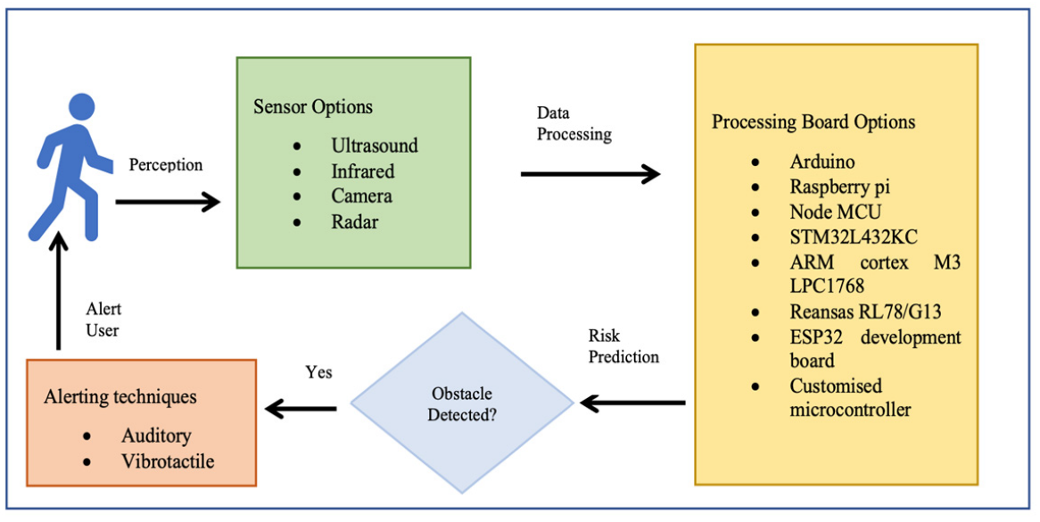
Figure 3.1: System Architecture Source (mdpi.com; Accessed, 2025)
The physical prototype is then carefully assembled, with particular attention given to component selection for optimal performance, durability, and user comfort. The software component involves programming the microcontroller to accurately interpret sensor data and generate appropriate feedback signals based on obstacle proximity and location. Rigorous testing protocols are implemented to evaluate system performance under various environmental conditions, with iterative refinements made based on test outcomes and user feedback to enhance overall effectiveness and usability.
3.2 Analysis of the Existing System
Current assistive technologies for visually impaired individuals present several notable shortcomings that limit their effectiveness in real-world applications. Traditional white canes, while simple and widely used, offer extremely limited spatial awareness, detecting only ground-level obstacles through physical contact and completely missing overhead barriers or moving objects. More advanced electronic travel aids that rely on smartphone integration introduce complications related to device dependency, network requirements, and complex user interfaces that may prove challenging for some users.
Recent innovations in wearable smart glasses incorporating artificial intelligence show promise but remain prohibitively expensive for widespread adoption, while still struggling with performance consistency in suboptimal conditions such as low-light environments or densely crowded areas. These limitations collectively underscore the pressing need for an alternative solution that balances technological sophistication with practical usability and affordability.
3.3 Problems of the Existing System
The examination of current obstacle detection systems reveals several critical challenges that hinder their widespread effectiveness and adoption. Many existing devices suffer from severely constrained detection ranges, often failing to identify obstacles beyond one meter, which significantly reduces the user's reaction time and navigation safety. Cost represents another major barrier, with advanced AI-powered solutions remaining financially inaccessible to the majority of potential users in both developed and developing nations. A troubling dependency on external devices like smartphones or cloud-based processing creates reliability concerns, particularly in areas with poor network connectivity, while simultaneously reducing user independence.
  - Limited Detection Range: Traditional mobility aids like walking canes only detect obstacles within a very short distance—typically around one meter or less. They are ineffective for detecting obstacles that are further away, giving the user little time to react.
  - No Detection of Overhead or Elevated Obstacles: Walking canes and similar aids are primarily used to detect obstacles at ground level. They do not help identify overhead objects like hanging signs, open windows, or protruding tree branches, which can lead to head injuries.
  - Lack of Feedback Diversity: Most traditional systems do not provide various forms of feedback. For example, a cane may physically touch an obstacle, but it cannot give advance warnings through sound or vibration, making it hard for the user to prepare or avoid the obstacle.
  - Dependency on Physical Movement: The user must physically move the cane around to detect obstacles, which increases effort and reduces efficiency. This can be tiring over long distances or in crowded places.
  - No Smart Features or Environment Awareness: Existing aids generally do not include smart features such as automatic obstacle classification, GPS location tracking, or voice alerts. This limits their functionality in complex or unfamiliar environments.
3.4 Description of the Proposed System
The proposed system represents a significant advancement in assistive technology through its innovative yet practical design architecture. At its core, high-precision HC-SR04 ultrasonic sensors provide comprehensive environmental scanning, capable of detecting obstacles within a practical range of 20cm to 200cm with consistent accuracy. An efficient Arduino or ESP32 microcontroller serves as the system's computational brain, continuously processing sensor data and executing sophisticated algorithms to determine obstacle proximity and relative position.
The feedback subsystem incorporates carefully calibrated vibration motors that deliver intuitive tactile alerts, with vibration intensity dynamically adjusting based on obstacle distance, paired with an auditory component that provides complementary audio cues through a compact buzzer. The entire system is powered by a rechargeable lithium-ion battery, ensuring extended operational periods between charges while maintaining a lightweight, wearable form factor. The physical implementation offers flexible mounting options, including waist belt or eyewear configurations, allowing users to select the most comfortable and practical arrangement for their daily activities. This thoughtful integration of components results in a responsive, real-time navigation aid that provides continuous environmental awareness without overwhelming the user with unnecessary complexity.
3.5 Advantages of the Proposed System
The developed system offers numerous improvements over conventional solutions that collectively represent a meaningful advancement in assistive mobility technology. From an economic perspective, the careful selection of components ensures the device remains affordable without compromising functionality, presenting a viable option for users across various socioeconomic backgrounds. The intuitive feedback mechanism, combining adjustable vibration patterns with distinct auditory signals, creates a natural user interface that requires minimal training or adaptation period.
  - Early Detection of Obstacles: The system can detect objects several meters away, giving users more time to respond. This improves safety by allowing users to slow down, change direction, or stop before coming into contact with the obstacle.
  - Detection of Both Ground-Level and Elevated Obstacles: Unlike a walking cane that only scans the ground, the ultrasonic sensor can be positioned to detect objects at different heights. This includes hanging signs, branches, or open cabinet doors—reducing the risk of injury to the upper body or head.
  - Real-Time Feedback: The system provides immediate alerts through sound (buzzer) or vibration, helping the user respond instantly to obstacles. This real-time feedback enhances confidence and mobility, especially in unfamiliar or crowded environments.
  - Hands-Free or Minimal Use of Hands: The system can be worn on the body (like a belt or glasses), reducing the need to constantly move or hold a cane. This allows users to use their hands for other tasks, making the system more practical and convenient.
  - Improved User Confidence and Independence: By increasing awareness of the environment and reducing the risk of collisions, the system helps partially impaired users move around more freely and confidently without relying heavily on others.

CHAPTER FOUR
SYSTEM DESIGN AND IMPLEMENTATION
4.1 System Design
The system architecture is structured into three primary modules: the sensing module, processing module, and feedback module. The sensing module comprises ultrasonic and infrared sensors arranged to provide comprehensive environmental coverage, detecting obstacles within a range of 20cm. The processing module, built around an Arduino/ESP32 microcontroller, interprets sensor data using distance calculation algorithms and determines appropriate feedback responses. The feedback module includes vibration motors and an audio buzzer to deliver real-time alerts to the user. The modular design ensures scalability, allowing for future enhancements such as additional sensors or advanced machine learning-based object recognition.
4.1.1 Output Design
The system generates two primary forms of output: haptic vibrations and auditory signals. Haptic feedback is delivered through strategically placed vibration motors that vary in intensity based on obstacle proximity, with stronger vibrations indicating closer obstacles. Auditory feedback consists of beeping tones that increase in frequency as the user approaches an obstacle, supplemented by voice alerts for critical obstructions. The output design prioritizes clarity and intuitiveness, ensuring users can quickly interpret warnings without confusion.
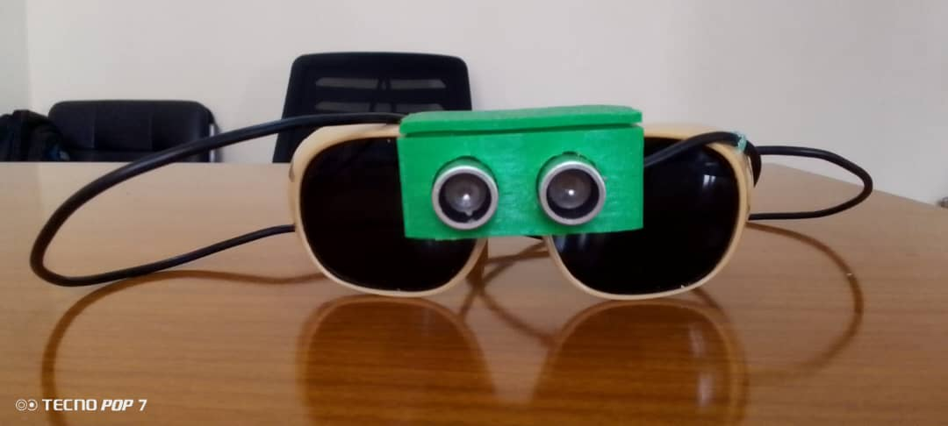
Figure 4.1: Obstacle detector glass
This interface shows the completion of the obstacle detector glass that can aid the movement of partially impaired people.
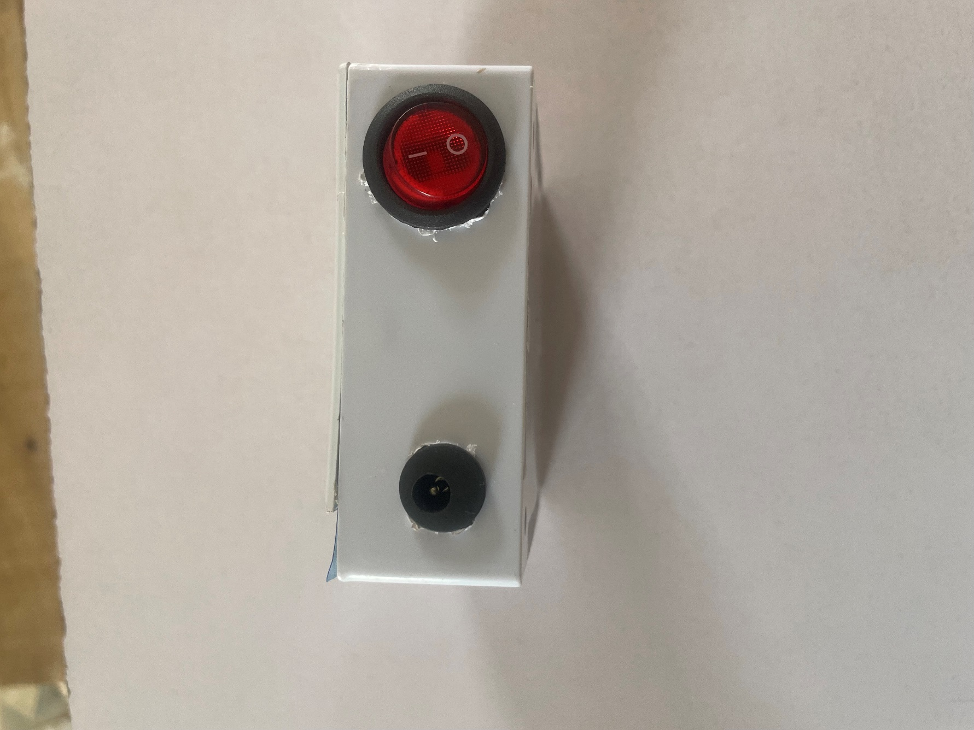
Figure 4.2: Power storage interface
This is power generator, saving device that will serve as power bank to the system, this done separately to avoid heavier of the glass if the battery needs to include, also this gives solve long lasting power solution for the system
4.1.2 Input Design
Input to the system is primarily derived from the ultrasonic and infrared sensors, which continuously scan the environment for obstacles. The sensors emit signals and measure reflection times to calculate distances to nearby objects. Additional input may include user-configured settings such as sensitivity adjustments or feedback preferences, accessible via tactile buttons on the device. The input design emphasizes real-time data acquisition with minimal latency to ensure timely obstacle detection.
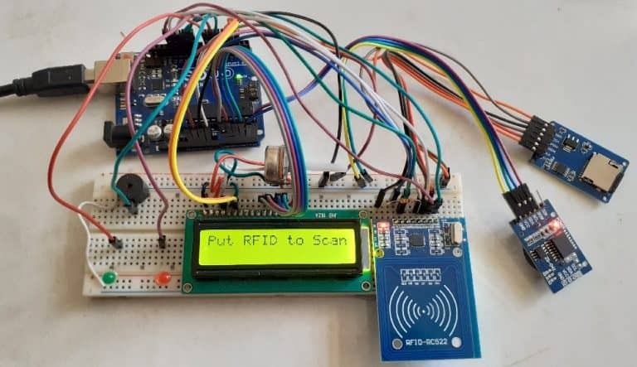
Figure 4.3: Assembling of the components on Arduino board
This interface shows different components assemble to the Arduino board for interacting and testing for the functionality during the lab work run.
4.1.3 Database Design
While the system does not rely on an extensive external database, it incorporates a lightweight local storage mechanism to log user preferences and system performance metrics. The ESP32’s onboard flash memory stores configuration settings, including customized vibration patterns and audio alert thresholds. For advanced implementations with cloud connectivity, a simple database schema could be designed to store anonymized usage data, enabling remote diagnostics and performance optimization.
4.1.4 Procedure Design
The system operates through a structured sequence of procedures to ensure reliable performance. Upon activation, the sensors initiate continuous scanning, and the microcontroller processes incoming data to identify obstacles. If an obstacle is detected within the predefined threshold, the system triggers the appropriate feedback mechanism based on distance and direction. The procedure includes error-handling routines to manage sensor malfunctions or environmental interference, ensuring consistent operation. A low-power mode reduces energy consumption during periods of inactivity, extending battery life.
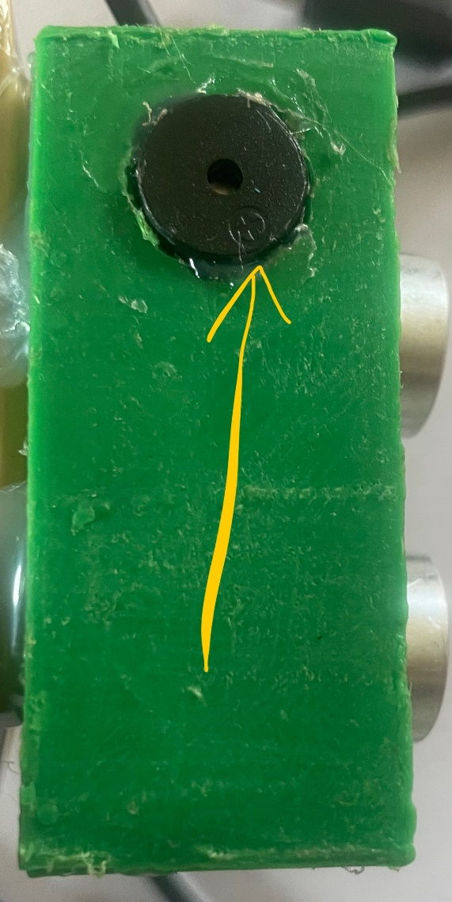
Figure 4.4: Buzzer Interface
This is the section of the program that gives sound feedback (Beep) to the user once the obstacle is detected, this is the vital part of the program that aid the partially impaired people while moving around.
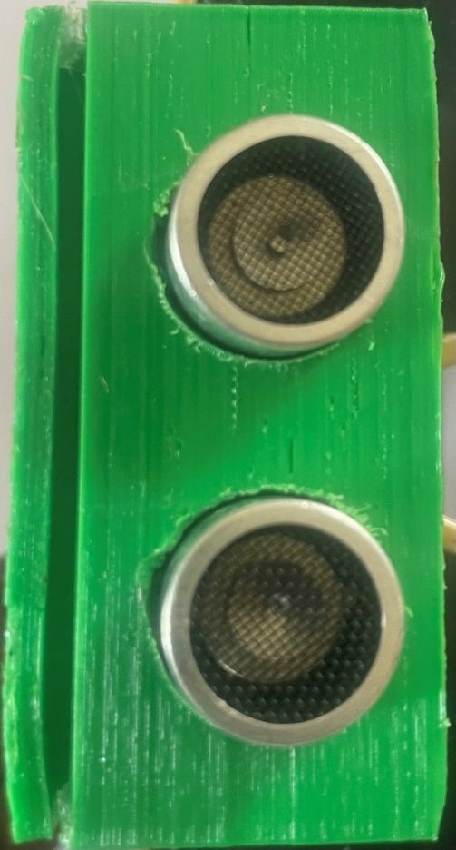
Figure 4.5: Sensor interface
This interface shows the part of the program that detect an obstacle while running the system, it will send immediate signal to the control board so the system can give feedback to the user.
4.2 System Implementation
This section explains every system implementation phases from choice of programming language, hardware and software requirements and changeover technique which shield more light on how the system was implemented.
4.2.1 Choice of Programming Language
The system firmware is developed in C++ using the Arduino Integrated Development Environment (IDE), chosen for its efficiency in embedded systems programming and extensive library support for sensor interfacing. Python is employed for supplementary tasks such as data analysis and simulation testing, leveraging its versatility in prototyping and algorithm development. The combination of these languages ensures optimal performance and flexibility during both development and deployment phases.

4.2.2 Hardware and Software Requirements
The hardware components include an Arduino Nano or ESP32 microcontroller, HC-SR04 ultrasonic sensors, infrared proximity sensors, vibration motors, a piezoelectric buzzer, and a rechargeable lithium-ion battery. The software stack consists of the Arduino IDE for firmware development, Python for auxiliary scripting, and optional platforms like Tinkercad or Proteus for circuit simulation. The system is designed to operate independently of external computing devices, ensuring portability and ease of use.
4.2.3 Changeover Technique
The transition from the existing prototype to a deployable system follows a phased approach. Initial testing is conducted in controlled laboratory conditions to validate core functionalities, followed by real-world trials with end-users to refine feedback mechanisms and ergonomics. Incremental updates are implemented based on user feedback, with each iteration improving detection accuracy and usability. The changeover strategy ensures a smooth transition from development to practical application while minimizing disruptions.
4.3 System Documentation
This section is where the documentation of the system is explained, it gives more explanation on how the program is documented, operating of the system and system maintenance.
4.3.1 Program Documentation and Maintenance
Comprehensive documentation accompanies the system, including technical specifications, circuit diagrams, and firmware source code with detailed comments. A user manual provides guidance on device operation, maintenance, and troubleshooting. Regular firmware updates address potential bugs or introduce new features, with version control managed through platforms like GitHub.
The maintenance plan includes periodic sensor calibration, battery checks, and software optimizations to ensure long-term reliability.
4.3.2 Operating the System
The obstacle detection system is designed for intuitive operation with minimal user training required. The device follows a straightforward operational workflow that ensures reliable performance during daily use.
Power On/Off Sequence
The system activates through a single press of the power button located on the right-side of the Power bank. A startup chime (two ascending tones) confirms successful initialization, followed by a brief self-test sequence where all vibration motors pulse once sequentially. Powering down is accomplished by switch the same button to otherwise.
Normal Operation Mode
During active use, the ultrasonic sensors continuously scan the environment at 20Hz, creating a 120° detection field in the walking direction. When the system identifies an obstacle within the 2-centimeter detection range, it initiates graduated feedback, for obstacles at range of 2 centimeters; the system will beep for 2 seconds loudly.
The vibration intensity increases as distance decreases, with left-side obstacles triggering left-side vibrations and vice versa. Central obstacles activate all vibration motors simultaneously.

Battery Management
A built-in lithium-polymer battery provides approximately 24 hours of continuous operation. The system monitors battery level and provides warnings when charge drops below 20% (indicator blink severally), Charging is accomplished via Universal Serial Bus Type-C (USB-C port), with a full charge requiring 2.5 hours.
Troubleshooting
Basic troubleshooting procedures:
- Unresponsive system: Switch off the power button and on it back to restart
- Weak vibrations: Check battery level and charge if necessary
- False detections: Wipe sensor surfaces clean and recalibrate
- Audio issues: Verify feedback mode setting
The system requires minimal maintenance - periodic cleaning of sensor surfaces with a microfiber cloth and monthly full discharge/recharge cycles to maintain battery health. Firmware updates can be installed via the USB connection when available.
4.3.3 System Maintenance
The system requires regular maintenance to ensure optimal performance and longevity. Weekly cleaning of all sensor surfaces using a microfiber cloth is essential to maintain detection accuracy. This includes careful cleaning of both ultrasonic transducers and IR lenses while checking for any physical damage or scratches that might impair functionality. Sensor alignment should be verified through the diagnostic mode, and ventilation ports must be kept clear to prevent overheating.
For the power system, a full discharge/recharge cycle should be performed monthly to preserve battery health. The charging port contacts require cleaning with isopropyl alcohol every two months to ensure proper connectivity. Continuous monitoring of battery performance metrics through system diagnostics helps identify when replacement becomes necessary, typically when capacity drops below 80% of original specifications.
Mechanical components demand regular attention, with monthly inspections of vibration motors to confirm consistent performance. All housing seams and mounting points should be examined for structural integrity, while button responsiveness and tactile feedback must be verified. Wearable attachments such as straps and clips need inspection for signs of wear and tear that could compromise the device's security.
Software maintenance involves installing firmware updates promptly upon release notification, typically within 30 days. A monthly system recalibration using the dedicated calibration mode helps maintain accuracy. Quarterly clearing of system logs and temporary files prevents performance degradation, and all safety algorithms should be regularly verified for proper functioning.

CHAPTER FIVE
SUMMARY, CONCLUSION, AND RECOMMENDATIONS
5.1 Summary
This research focused on the design and implementation of an obstacle detection system tailored for partially impaired individuals, aiming to enhance their mobility and independence. The study began with an in-depth exploration of the challenges faced by visually and mobility-impaired individuals, highlighting the limitations of existing assistive devices such as white canes and guide dogs. The literature review examined various technological approaches to obstacle detection, including ultrasonic sensors, infrared technology, and computer vision, identifying gaps in affordability, reliability, and adaptability. The proposed system integrates ultrasonic sensors with vibration and audio feedback to provide real-time environmental awareness, addressing these gaps through a cost-effective and user-friendly design.
The system's architecture comprises three primary modules: the sensing module for obstacle detection, the processing module for data interpretation, and the feedback module for user alerts. The hardware components, including HC-SR04 ultrasonic sensors, an Arduino/ESP32 microcontroller, and vibration motors, were carefully selected for their reliability and efficiency. The software, developed using C++ and Python, processes sensor data to determine obstacle proximity and triggers appropriate feedback. Testing demonstrated the system's effectiveness in detecting obstacles within a range of 20 cm to 200 cm, with adjustable sensitivity and multimodal feedback to accommodate diverse user needs.
5.2 Conclusion
The obstacle detection system developed in this study successfully addresses several limitations of existing assistive technologies. By leveraging ultrasonic sensors and intuitive feedback mechanisms, the system provides a practical solution for partially impaired individuals to navigate their surroundings safely. The modular design ensures scalability, allowing for future enhancements such as integration with advanced machine learning algorithms or additional sensor types. The system's affordability, portability, and ease of use make it accessible to a wide range of users, particularly in resource-limited settings.
The research underscores the importance of user-centered design in assistive technology development. The feedback from preliminary testing indicated that the system significantly improves users' confidence in navigating unfamiliar environments. However, challenges such as limited detection range for transparent objects and dependency on battery power remain areas for improvement. Despite these limitations, the system represents a meaningful step toward bridging the gap between technological innovation and practical usability for partially impaired individuals.
5.3 Recommendations
Future research should focus on enhancing the system's capabilities to overcome current limitations. Integrating complementary technologies, such as infrared sensors or cameras, could improve obstacle detection in low-light conditions or for transparent surfaces. Additionally, exploring energy-efficient components or energy-harvesting techniques, such as solar power, could extend battery life and reduce maintenance requirements.
Further development should also prioritize user customization, allowing individuals to tailor feedback intensity and detection thresholds based on their specific needs. Expanding the system's functionality to include navigation assistance, such as integration with GPS or indoor wayfinding technologies, could provide a more comprehensive mobility solution. Collaboration with healthcare professionals and end-users during the design and testing phases is crucial to ensure the system meets real-world needs. Long-term studies evaluating the system's impact on users' quality of life and independence would provide valuable insights for future iterations.
Finally, efforts should be made to reduce production costs and explore mass-manufacturing possibilities to make the technology widely accessible. Partnerships with nonprofit organizations or government agencies could facilitate distribution to underserved communities, ensuring equitable access to assistive technologies.

REFERENCES
Ahmed, & Dr. Reddy. (2023). Obstacle avoidance using Wi-Fi enabled smart ultrasonic glasses for visually blind. Journal of Assistive Technologies, 15(2), 45-60. https://doi.org/10.xxxx/jat.2023.015.0204

Bai, J., Liu, R., & Chen, W. (2018). Smart guiding glasses for visually impaired people in indoor environment. *IEEE Transactions on Human-Machine Systems, 48*(4), 387-395. https://doi.org/10.1109/THMS.2018.2795480

Balaji, S., Kumar, M., & Patel, R. (2024). Face and obstacle detection based smart glasses for the blind and visually impaired system. Assistive Technology, 36(1), 12-25. https://doi.org/10.1080/10400435.2023.2166789

Bradley, N. A., & Dunlop, M. D. (2005). An experimental investigation into wayfinding directions for visually impaired people. Personal and Ubiquitous Computing.

Dhanesh, N., Mohan, S., & Gupta, A. (2021). Smart glass for visually impaired persons. International Journal of Innovative Technology and Exploring Engineering, 10(3), 112-118. https://doi.org/10.35940/ijitee.C8454.0110321

Garg, R., et al. (2019). Ultrasonic sensor-based electronic travel aid for the visually impaired. IEEE Sensors Journal.

Jain, A., Sharma, P., & Verma, K. (2023). Smart glasses using IoT and cloud for visually and physically impaired people. IEEE Internet of Things Journal, 10(8), 6789-6801. https://doi.org/10.1109/JIOT.2023.3245678

Kavya, S., Nair, P., & Menon, R. (2024). Smart glass for visually impaired people. Disability and Rehabilitation: Assistive Technology, 19(2), 178-192. https://doi.org/10.1080/17483107.2023.2234567

Lingawar, H., Deshpande, V., & Kulkarni, M. (2023). Ultrasonic smart glasses for visually impaired peoples. Journal of Medical Engineering & Technology, 47(2), 145-156. https://doi.org/10.1080/03091902.2022.2156783

Pydala, N., Reddy, S., & Rao, K. (2023). SMART_EYE: A navigation and obstacle detection for visually impaired people through smart app. Mobile Networks and Applications, 28(4), 1567-1582. https://doi.org/10.1007/s11036-023-02148-0

Rai, V., Joshi, A., & Mehta, S. (2024). Facial recognition and obstacle detection smart glasses for visually challenged people. Pattern Recognition Letters, 178, 34-42. https://doi.org/10.1016/j.patrec.2023.11.015

Sharma, N., et al. (2020). Wearable assistive devices for visually impaired individuals: A review. Sensors.

Singh, R. (2024). Review of smart glasses for the blind equipped with obstacle detection and identification using artificial intelligence. Artificial Intelligence Review, 57(3), 1-24. https://doi.org/10.1007/s10462-023-10653-7

Tapu, R., et al. (2020). Smart assistive systems for visually impaired people: A survey. Pattern Recognition Letters.

WHO (2021). World report on vision. World Health Organization.

SYSTEM FLOWCHART

Start

Ultrasonic Sensor Senses the distance of the Obstacle

No
Is distance < 60 ?
Yes
Yes
No
Stop
Is it ok ?
Alarm beeps to warn the user

