

A PROJECT REPORT
ON
LAND INFORMATION SYSTEM OF PART OF ASA-DAM COMMUNITY AREA, ILORIN WEST LOCAL GOVERNMENT, KWARA STATE

BY
OCHOCHE EMMANUEL INALEGWU
HND/23/SGI/FT/0007

SUBMMITED TO:
THE DEPARTMENT OF SURVEYING AND GEO-INFORMATICS, INSTITUTE OF ENVIRONMENTAL STUDIES, KWARA STATE POLYTECHNIC ILORIN.
IN PARTIAL FULFILLMENT OF THE REQUIREMENT FOR THE AWARD OF HIGHER NATIONAL DIPLOMA IN SURVEYING AND GEO-INFORMATICS.
JUNE, 2025

CERTIFICATE
I hereby certified that the information given in this project was obtained as a result of the observation and measurement made by me and that the survey was carried out in accordance with survey laws, regulations and departmental instructions

_________________________________
OCHOCHE EMMANUEL INALEGWU
Matric. No: HND/23/SGI/FT/0007

CERTIFICATION
This is to certify that this project was carried out by OCHOCHE EMMANUEL INALEGWU with Matric No.: HND/23/SGI/FT/0007 under my instruction and supervision for the award of Higher National Diploma in Surveying and Geo-informatics, Kwara State Polytechnic, Ilorin, Kwara State Nigeria. I hereby declared that she has conducted herself with due diligence and honesty on the said duties.

………………………………… ………………………………
SURV. R.O. ASONIBARE DATE
(Project Supervisor)

………………………………. …………………………
SURV. R.S. AWOLEYE DATE
(Project Coordinator)

……………………………… ………………………………
A.I ISAU DATE
Head of Department (H.O.D)
Surveying & Geo-informatics

……………………………….. ……………………………..
EXTERNAL EXAMINER DATE

DEDICATION
This project is dedicated to Almighty GOD, the author and the finisher of everything who gave me the grace and privilege to attain this stage in my education pursuit.

ACKNOWLEDGEMENT
I give thanks and glory to my Creator for the privilege bestowed on me that resulted in the accomplishment of this project work and also a big thanks to the management of Kwara State Polytechnic for the privilege and opportunity given to me to study in their great institution.
My sincere gratitude goes to my Head of Department (HOD); A.I Isau and my Supervisor; Surv. R.O. Asonibare for their support towards the success of this project, I really appreciate you sir.
To all the lecturers in the department of Surveying and Geo-informatics; Surv. A.I. Isau, Surv. A. Ayuba, Surv. Banji, Surv. Awoleye, Surv. A.G. Aremu, Surv. Kabir, Surv. Kazeem, Surv. Asonibare and Surv. Diran who has imparted their knowledge in me in one area or the other during my year of study, I am grateful for all your effort and support. May Almighty GOD bless you all (Amen).
I sincerely wish to express my affectionate gratitude to my lovely and caring parent; Mr. & Mrs. Ochoche whose toils and struggles have helped a lot in transforming my life for better. May Almighty God grant them long life and enable them reap the fruits of their labor.
More so, I am grateful to my colleagues for their constructive discussions, collaborative spirit and moral support.
My heartfelt thanks also go to all my group members for their cooperation and understanding during the project, I pray that we will never fail in our life.
Finally, I wish to extend my deepest appreciation to my family and friends for their continuous understanding, patience, and encouragement. Their support was a constant source of motivation.
“No one can whistle a symphony alone; it takes a whole orchestra to play it" - H.E Luccock.
Thank you all.

TABLE OF CONTENTS
Pages
Title Page i
Certification ii
Dedication iii
Acknowledgment iv
Table of contents v
List of Tables ix
List of Figures x
Abstract xi
CHAPTER ONE
General Introduction
1.1 Background to the Study 1
1.2 Statement of the Problem 4
1.3 Aim and Objectives 5
1.4 Scopes of the Project 6
1.5 Specification of the Project 6
1.6 Limitation of the Project 8
1.7 Location of the Project Area 8
1.8 Personnel 10
CHAPTER TWO
Literature review
2.1 Literature Review 11
CHAPTER THREE
Research Methodology
3.1 Methodology 20
3.2 Reconnaissance 20
3.2.1 Office Reconnaissance 20
3.2.2 Field Reconnaissance 20
3.3 Equipment Used 21
3.3.1 Hardware 21
3.3.2 Software 21
3.4 Control Check 21
3.5 Data Source 22
3.5.1 Primary Source 22
3.5.2 Secondary Source 22
3.6 Geometric Data Acquisition 23
3.6.1 Perimeter 23
3.6.2 Detailing 23
3.6.3 Attribute/Social Survey 23
3.7 Database Creation/Implement 23
3.7.1 Database Management System (DDMS) 24
3.7.2 Data Quality 25
3.7.3 Data Integrity 25
3.7.4 Data Security 25
3.8 Data Processing 26
3.8.1 Drafting and plotting 26
3.8.2 Database Creation Procedures 27
CHAPTER FOUR
Spatial Analysis, Data Processing and Presentation
4.1 Spatial Analysis 28
4.2 Testing of Database 28
4.3 Queries 29
4.3.1 Spatial Query 29
4.4 Single Criterion Query 29
4.5 Multiple Criteria Query 34
4.6 Result Analysis 39
4.7 Application of Product 40
4.8 Spatial Search 40
4.9 Spatial Dependence 41
CHAPTER FIVE
Costing, Summary, Problem Encountered, Recommendations and Conclusion
5.1 Costing 46
5.2 Summary 51
5.3 Problem Encountered 52
5.4 Recommendations 52
5.5 Conclusion 53
References
Appendix

LIST OF TABLES
Pages
Table 3.4.1: Coordinate of the observed and the original values of PT 31 21
Table 3.4.2: Coordinate of the observed and the original values of PT 32 22
Table 3.4.3: Coordinate of the observed and the original values of PT 33 22
Table 4.1: Results Analysis​ 39
Table 5.1: Recci 46
Table 5.2: Beaconing 47
Table 5.3: Traversing 47
Table 5.4: Downloading Data and Plotting 48
Table 5.5: Information Presentation 48

LIST OF FIGURES
Pages
Fig. 1.1: Maps Showing the Study Area 9
Figure 4.1: Shows a single query made on the database of the project 30
Figure 4.2: showing the question made on the database for built _up _area <196.12msq/m² 31
Figure: 4.3 showing the result of the query made on the database for built _up _area <196.12msq/m² in form of a table 32
Figure 4.4: 4showing the result of the query made on the database for built _up _area <196.12msq/m²on the plan 33
Figure 4.5: Showing the question made on the database for built _up_ area > 403.99m² and their purpose are for commercial use. 34
Figure 4.6: Showing the result of the query made on the database for built _up_ area > 403.99 m² and their purpose are for commercial use in form of a table 35
Fig 4.7: Showing the result of the query made on the database for built _up_ area > 403.99 m² and their purpose are for commercial use on the plan 36
Figure 4.8: Showing the question made on the database for vacant_ area less than or equal to 901.93m²and are not fenced 37
Figure: 4.9: Showing the result of the query made on the database for vacant_ area <= 901.13m²and are not fenced in form of a table 38
Figure 4.10: Showing the result of the query made on the database for vacant_ area <= 901.93m²and are not fenced on the plan. 38

ABSTRACT
This project topic present the development of a land information system (LIS) designed to manage and analyze land-related data. The LIS integrates spatial and non-spatial data to provide comprehensive platform for land administration, planning, and decision making. Key feature includes data visualization, and mapping capabilities. The system aims to enhance land governance, reduce land dispute, and promote sustainable land use practices.
CHAPTER ONE
INTRODUCTION
1.1 BACKGROUND TO THE STUDY
Land has been a fundamental resource throughout human history, shaping societies, economics and even conflicts. The effective land management is essential for sustainable growth, hence The management of land information has been in existence since people first took to sedentary agriculture (Dale et al, 1988). When the Babylonians occupied the lands between the Tigris and the Euphrates and the Egyptians cultivated the fertile regions of the Nile, the need for orderly land management was recognized. Furthermore, the ancient civilization identified the importance of land records, the event resulted to cadastral surveys in ancient Egypt by re-establishing land boundaries after annual flooding of Nile, and the Roman land registers. .
Land is the most great value property of mankind. It is also an essential intelligence asset of any state or country. The welfare of the nation and its economic development are reliable on the state of the land and its practice. It is therefore, obvious that any information on land is crucial and serves as a foundation to financial investments, commerce, industry and agriculture.
Information management is critical for sound decision making in every facet of life. Harrison, as cited by Obongo (2003), opined that information is the lifeblood which flows into and out of an organization. The success of any enterprise or organization to a large extent depends on the accuracy and timing of the information supplied and its effective use. The Ministry of Lands, Survey and Town Planning especially in Nigeria, should effectively tap the potentials of communication and information technology to improve on its service delivery, revenue collection and physical land use planning.
Land information is a prime requisite for making decisions related to land investment, development and management. Information therefore reduces uncertainty by helping to identify and analyze problems and the strategies to overcoming them may be prepared and implemented. The value of the information and the effectiveness of the decision making process are directly related to the quality of the information and the manner in which it is made available and capable of supporting land administration, surveying, planning and taxation, as well as automated mapping systems capable of communicating with infrastructure and utilities planning, design and management systems. The records are very important because they form the basis for assignment and settlement of land titles, which should be flawless and pass all legal scrutiny.
Land Information System (LIS) is a "tool for legal, administrative and economic decision making and an aid for planning and development which consists of a database containing spatially referenced land related data for a defined area and of procedures and techniques for the systematic collection, updating, processing and distribution of that data". (Dale, 2000), (Chandrasekhar, 2000)
A Land Information System (LIS) is essentially a computerized tool for legal, administrative and economic decision making for land use planning and development. It consists of a structured database with spatial referenced land related attributes and spatial data for a defined area as well as procedures and techniques for systematic collection, processing, updating and distribution of the data to aid in solving land management problems (Pindiga, 2012).
Land use or physical planning can be described as a process aimed at achieving orderly physical development with the overall aim of evolving a functional and liveable environment where individual and common goals can be achieved. In urban centres, the essence of land use planning is to ensure that urban activities are organized and developed in physical space with due consideration for the protection of the public interest which include health, safety, convenience, efficiency, energy conservation, environmental quality, social equity, social choice and amenity (Adeagbo, 1998; Nnah et al., 2007).
Benefits Of Land Information System
Land information system offers several benefits including;
- Enhanced Transparency: LIS makes land information readily accessible to the public, promoting transparency in land transactions and reducing opportunities for fraud or corruption.
- Improved Land Administration: LIS streamlines land administration processes, automating tasks like land registration, transfer and permitting. This reduces processing time, paper work and administrative costs
- Improved Property Tax Collection: Precise land data allows for fair and accurate property taxation assessments, generating reliable revenue for government
- Improved Urban Planning: Access to detailed and use information enables better planning for infrastructure development, zoning and urban growth
- Formalized Land Right and Security: Facilitate the documentation and registration of land ownership and reliable land ownership information provides greater confidence for lenders, facilitating access to loans secured by property
- Land Market Monitoring: Tracking land transaction and market trends helps in informed decision-making for investors and policymakers
- Environmental Management: Integration of environmental data with land information can support sustainable land use planning and resource management
- Disaster Preparedness: Detailed land information aids in disaster preparedness and post disaster recovery efforts
- Informed Decision-Making: LIS provides valuable information for land use planning, and development control.
1.2 STATEMENT OF THE PROBLEM
Land is a critical asset, underpinning economic development, social stability and environmental sustainability. However, in many regions, land administration systems are plagued by inefficiency and inadequacies, hindering progress and creating numerous challenges. This project addresses the urgent need to modernize land administration through the development and implementation of a robust land information system [LIS].
The Ministry of Lands and Urban Development in most states comprises different departments which complement each other in the discharge of their core functions to the public. Improvement in their working relationships is imperative for better service delivery. But before such improvement is considered, review of present processes is very necessary. Such a review will identify the existing gaps and likely areas that require improvement.
1.3 AIM AND OBJECTIVES
The primary aim of this project is to implement and develop a Land Information system of part of Asa-Dam community area, Ilorin, Kwara State. Nigeria, to manage and analyze land-related information effectively.
The Objectives of this research are:
- To develop a comprehensive land information system [LIS] database for a defined area within the Asa Dam community, Ilorin Kwara state.
- To establish a spatial database of parcel boundaries and land use classification through the digitization of existing plans and field survey data
- Updating the manual records of land
- Digitizing all relevant Plans to create a spatial database.
- Creating a non spatial (attribute) database containing relevant land information
- Link the spatial data with its corresponding attribute information.
- Implement query and analysis functionalities within the LIS.
- Acquisition of Spatial Data through Field Survey, office & Interviews
- Demonstrating the Database Functionality
- Presentation of information (Graphic & Reports)
- Evaluate the systems performance and make appropriate recommendations for improvement and future development.

1.4 SCOPES OF THE PROJECT
- Field recce and office recce
- Data collection and digitization
- Database development
- Geographic Information System (GIS) Integration
- User interface and access control
- Analysis of the report
- Plan production
- Comprehensive report writing
1.5 SPECIFICATION OF THE PROJECT
In other to obtain the land information system of (Land Use), special key factors must be considered. These specifications include;
- Data Types:
Spatial data: Parcel boundaries ,property lines, topographic features and infrastructural networks
Attribute Data: Ownership details(owners names, addresses), land use classification(residential, commercial, agricultural), zoning regulations, property values and legal descriptions
- Data Collection Methods:
- Cadastral surveys(field measurements, aerial photographs)
- Existing land records digitization
- Remote sensing data integration
- Data Quality standards:
- Accuracy level for spatial data
- Data validation procedures
- Data accessibility and availability
- Database Design:
- Entity relationship diagrams defining data relationships
- Spatial data storage and indexing mechanisms
- Data integrity constraints to maintain data consistency
- System Functionalities:
- Data capture and integration
- Data storage and retrieval
- Spatial analysis tools(buffering, overlay analysis)
- Query and reporting functions for data retrieval
- Data editing and update
- Maps visualization and display options
- Reporting and visualization tools (maps, graphs, tables.)
- Integration with other systems (e.g tax assessment, property registration
- Access Controls And Security:
- User authentication and authorization levels
- Data encryption for sensitive information
When these specifications are adhered to properly it brings about Improved land title security and clarity, streamlined land registration process, Efficient land managements and planning, Reduced land disputes and fraud, and Facilitate informed decision-making for land development and land use projects.

1.6 LIMITATION OF PROJECT
The project shall be limited to the boundary dermarcated; land information system for part of Asa-Dam community area , Ilorin and all analysis of information shall be with part of Asa-Dam community area, Ilorin.

1.7 LOCATION OF PROJECT AREA
The location of project area is part of Asa-Dam community area, Ilorin, Asa local government area. It is located in zone 31 of the Universal Transverse Mercator (UTM) system between longitude 4º 55’ E and latitude of 8º 48’ N in the north central geopolitical zone of Nigeria.

Fig. 1.1: Maps showing the study area
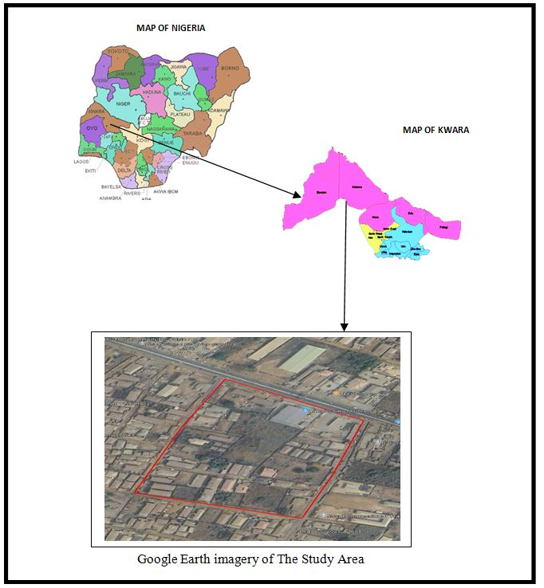

1.8 PERSONNEL
MATRIC NO ROLE
      - HND/23/SGI/FT/0007 Author
      - HND/23/SGI/FT/0006 Member
      - HND/23/SGI/FT/0009 Member
      - HND/23/SGI/FT/00011 Member
      - HND/23/SGI/FT/0012 Member
      - HND/23/SGI/FT/0013 Member
      - HND/23/SGI/FT/0014 Member

CHAPTER TWO
2.1 LITERATURE REVIEW
According to Blacks Law Dictionary: “Land” is defined as the solid part of the earths surface; the ground or the soil. It includes not only the surface of the earth but also everything permanently attached to it, whether by nature as trees, herbage and water or by man as building, fences, and other improvement. [Black,H.C, 2019]
Land Use Act [Nigeria, 1978]: This Act vests all land compromised in the territory of each state in the Governor of the state, whom shall hold such land in trust for the use and common benefit of all Nigerians in accordance with the provision of this Act.
Den ton, F.H.[1999].The Geography of Land Resources. Prentice Hall: geographers study land as a spatial entity, examine its physical characteristics, land use patterns, and human-environment interactions. They are concerned with the distribution of land resources, land cover change and the impact of human activities on land.
UN-HABITAT [United Nations Human Settlements Programme]: In the context of urban and regional planning, land is viewed as a resources to be managed and allocated for various use, including housing, infrastructure, recreation, and conservation.
Nigerian’s land history is rich and complex, reflecting the country's diverse ethnic groups, pre-colonial systems, colonial influences, and post-independence developments. Understanding this history is crucial for comprehending the current land administration challenges and the need for effective LIS.
- Pre-colonial Land Systems:
- Diverse practices: Before British colonization, Nigeria had a variety of customary land tenure systems. These systems varied significantly across different ethnic groups and regions.
- Communal Ownership: In many communities, land was held communally, with access rights allocated by traditional leaders or elders. Land was often not individually owned in the western sense, but rather held in trust for the community.
- Family Ownership: In some groups, land was owned by families or lineages, with inheritance right passed down through generations.
- Individual Ownership: In certain areas particularly in the south, individual ownership of land was more prevalent.
- Role of Traditional Leaders: Traditional rulers and chiefs played a crucial role in land administration, allocating of land, resolving dispute and safeguarding community land rights.
- Colonial Era and its Impact:
- Introduction of New Concepts: British colonization introduced new concepts of land ownership and administration, including the idea of individual ownership and the need for formal land registration.
- Land Use Ordinance: the colonial administration enacted various land ordinances, such as the land use ordinance, which aimed to regulate land ownership and administration.
- Disregard for Customary Rights: colonial land policies often disregarded existing customary land rights leading to land alienation and displacement of communities.
- Creation of Land Inequality: colonial land policies often favoured European settlers and commercial interest, contributing to land inequality and social tensions.

- Post-Independence Developments:
- Land Use Act of 1978: A major turning point in Nigerias land history was the enactment of the Land Use Act of 1978, this Act vested all land in the state governor, who could grant right of occupancy to individuals and organizations.
- Objectives of the Act: The Land Use Act aimed to unify land administration, promote equitable access to land and control land speculations.
The need for LIS implementation includes; transfer of legal rights on land, which could be attributed to three methods for processing such relevant records as follows:
- First method is by private Conveyance; a situation whereby the records and transfer of land are handled by private arrangement.
- Registration of Deed is another method that has copies of such records being maintained by the state Government.
- Registration of Title of Land is the third method; this is a situation where a state organization maintains the records of land ownership. Many of the defects in deeds based systems, currently in operations, can be curve by changing to Registration of Title under which the unit for registration is the land parcel, not the deeds. The register must be kept up to date at all time, so as to be a reflection of the legal position on ground (Dale and McLaughlin, 2008).
- Land Information System
Bernhardsen, T. [2002]. Geographical Information System: An introduction. John Wiley & Sons: “ A Land Information System is a system for capturing, storing, managing, analyzing and displaying geographical referenced land-related information”
The International Federation of Surveyors defines Land Information System (LIS) “as a tool for legal, administrative and economic decision making and an aid for planning and development which consist of procedure and techniques for the systematic collection, updating, processing and distribution of spatial data” .Shard and More (1989).
According to Dale et al (1988), an Information system may be formally defined as a combination of human and technical resources, together with a set of organizing procedures that produces information in support of some managerial requirement. Data relating to land may be acquired and held in alphanumeric form, graphically or digitally. To become information, the raw data must be processed so that they can be understood by a decision maker. A land information system gives support to land management by providing information about the land, the resources upon it and the improvement made on it.
The efficient and effective use of land and its associated resources depends on the availability of sound land information. Many nations are computerizing their cadastral records and creating large, national databases. Land-related data are now being integrated, analysed, and distributed in ways that until recently were not possible (Zegeye, 2019).
Kurwakumire (2007) submitted that without functional and up-to-date land information, it is difficult to implement planning, development and exploitation of land resources sustainably for the betterment of the communities. Land is unarguably one of the most valuable resources of any nation and land information management forms a major part of urban development. Likewise, the increasing growth in rural population and the massive migration of people to the cities (especially in the developing countries) have put increasing pressure on rural and urban lands and facilities (Dale & McLaughlin 1988). Therefore, a systematic record and rational use of the land should be of prime importance to planners and policy makers.
An ideal land administration must be able to include the provision of information on land in an effective and efficient way to correctly identify those people who have interest in real estate and providing information about these interests (such as duration of leases). It must also allow easy access to land for development where it is needed, increase efficiency in land use management through good planning, and promote greater social equity. It should also allow for revenue generation to the government (taxation), maintenance of environmental quality, and provide security of tenure.
The lack of adequate functional and coordinated land information system and networks underpins this weak system, requiring that land related agencies maintain up-to-date scientific data, maps, and plans. In a broad sense, land administration is defined as an operational system designed to implement land policies. Many definitions are found in the literature endorsing this meaning. For example, the United Nations (1996) defines land administration as “the process of determining, recording, and disseminating information about ownership, value and use of land when implementing land policies.” Similarly, land administration comprises the sub-systems that actualize strategies to implement land policy, and other related policies, within land management systems." Land administration is sometimes viewed as the management of land. From this perspective, the term ‘land administration’ is used to refer to “the processes of regulating land and property development and the use and conservation of the land, the gathering of revenues from the land through sales, leasing, and taxation, and the resolving of conflicts concerning the ownership and use of land” (Dale and McLaughlin, 2009). For this study, the author adopts Barry’s definition (1999) of land administration as a set of operational sub-systems that puts policies concerning land into action. This definition implies that the administration of land is not in itself a strategic process. In particular, land administration does not involve strategic planning or policy development; rather, it is merely an implementation system that follows regulations and rules stated in the policies.
A computer-based land administration system will force standardization in the collation and processing of land data; decrease the cost and space required for storing records; prevent unnecessary duplication; facilitate access to land related data; improve information distribution, reduce the time and cost involved in transferring property rights, processing mortgages, facilitates the monitoring and analysis of market and rental value of land and property; and provide built in mechanism for quality control. The system will permit the integration of records of land ownership, land values, and land use with sociological, economic, and environmental data in support of physical planning. This will allow spatial analysis of any kind - this is the power of the system as a generic tool. The use of a database system will allow managers to re-examine their current procedures and thereby improve delivery. It will also permit better monitoring of organizational performance, providing information on what is happening on the land in a better way so that problem areas are identified and appropriate remedial measures applied.
A Database Management System was used to accomplish this study. Specifically, a Structured Query Language (SQL) database containing information that describes or defines a plot of land among several others within a layout was designed. The SQL database has a client/server relationship whereby other stakeholders from a distance could access it. Interfaces
which are user friendly were used for the purpose of extracting the required information of a particular plot within a particular layout, in such a way that every plot involved would have its information coded, and displayed when needed from the database. GIS could then be described as an integrated computerized system for the storage, retrieval, manipulation, analysis and display of geographically referenced data (Burrough, 2010; Smith and Johan, 2011). It integrates spatial and other kinds of data or information within single system. It offers the consistent framework for analyzing geographic data by putting maps and other spatial data and information into digital forms. Geographic information allows geoscientist to apply general principles to specific condition of each location on the earth surface, allows for the tracking of what is happening at a place, and helps to explain and provide the understanding on how one place differs from another (Ojigi, 2009). GIS is relevant and valuable tool in the information harvest and planning of natural physical, bio-medical, socio-cultural, eco-climate economics, engineering sciences and business environments. The global community is now so dependent on computers and computerizedninformation that we scarcely can do without them. Computerization has opened vast new potential in the way we communicate, analyze our surroundings and make decision. The power of GIS comes from the ability to relate different information in a spatial context and reach a conclusion about this relationship. Most of the information we have about our world contain a location reference, placing that information at some point on the globe. When a parcel of land information is collected, it is important to know where the plot is located and its topology. This is done by using a location reference system, such as longitude and latitude and perhaps elevation. Comparing the parcel information with other information such as the location of roads in the vicinity, may show the strategic location of the parcel vis-à-vis the economic value, this fact may indicate that these roads are likely to assist the easy conveyance of building material to site, and this inference can help us make the most appropriate decision about how busy the road might be during physical development. A GIS therefore, can reveal important new information that leads to better decision making. Different kind of data in map form can be entered into a GIS. A GIS can also convert existing digital information, which may not be in map form into forms it can recognize and use. For example, digital satellite images can be analyzed to produce a map of digital information about land use and land cover. However, land information system is an important system to support administration of land. Land Information System as defined by FIG is a tool for legal, administrative and economic decision marking and aid for planning and development which consist on one hand a database containing spatially referenced land related data for a defined area, and on the other hand procedures and techniques for the systematic collection, updating processing and distribution of the data. The base of a land information system is a uniform spatial referencing system for the data in the systems, which also facilitate the linking of data within the system with other hand related data. Most countries in the world started with a manual system of recording land information, but from the 1970’s most countries began to initiate some form of computerized land information/automation and mapping system. This was pertinent due to the many problems and constraints that emerge as a result of increasingly complex land , tenure and registration issues.
The reviewed literature underscores the importance of integrating mutiple geospatial technologies in developing a robust and functional Land information system .Tools like Total Station and AutoCAD ensure precision in data collection and plotting,while Google Earth and ArcGIS enhance spatial anaysis and data integration. Together , these tools provide a comprehensive platform for effective land administration, especially in urban and peri-urban setting like the Asa Dam area in ilorin.

CHAPTER THREE
3.1 METHODOLOGY
​ The following are the methods adopted in carrying out land information system analysis of part of Asa-Dam area, Ilorin, Asa local government area,Nigeria.
3.2 RECONNAISSANCE
​ This is the preliminary field inspection of the project site to be surveyed. It involves the overall view of the entire land in question or the project site in order to plan on how to go about the surveying operation to achieve the aim of the work in accordance with the survey rules and regulation pertaining to the order of job required (i.e. first. Second or third order), the reconnaissance was done by considering the purpose of the survey operation and method of observation. There are the two types of reconnaissance that are carried out are:-
• Field Reconnaissance
• Office Reconnaissance
3.2.1 OFFICE RECONNAISSANCE
​ Information about the study area like existing map/plan of the project site and preferably historical data of the site in question, letter of notification, necessary information equipment needed to carry out the survey and coordinates of control point was carried out under this section.
3.2.2 FIELD RECONNAISSANCE
At this stage, we visited the project area and take note of the crucial points, locating of existing control points, drawing of the reconnaissance diagram and also the determination of the best method for the Survey.
3.3 EQUIPMENT USED
Total Station and its accessories.
3.3.1 HARDWARE
1. Laptop Computer
2. Mouse
3, Printer etc.
3.3.2 SOFTWARE
The following Software was used:
1. Microsoft word
2. Microsoft Excel
3. Note Pad
4. Google Earth
5. ArcGis 10.0
3.4 CONTROL CHECK
It is not enough to work from whole to part but it is equally expected that the set of controls to be used are properly checked to ascertain their suitability for the job. The insitu check for both linear and angular measurements as well as the coordinates.
Table 3.4.1: Coordinate of the observed and the original values of PT 31
PILLAR | NORTHING | EASTING | STATUS | REMARKS
PT 31 (KW/AW/ 1206) | 934630.687 | 668601.336 |  | ORIGINAL
PT 31 ( KW/AW/1206) | 934630.677 | 668601.356 | FIXED | OBSERVED
DISCREPANCY | 0.010 | 0.020
Source: Field Research Survey, 2025
Table 3.4.2: Coordinate of the observed and the original values of PT 32
PILLAR | NORTHING(m) | EASTING(m) | STATUS | REMARKS
PT32 ( KW/RB/37) | 934634.584 | 668590.327 |  | ORIGINAL
PT32 ( KW/RB/37) | 934634.563 | 668590.349 | FIXED | OBSERVED
DISCREPANCY | 0.021 | 0.022
Source: Field Research Survey, 2025
Table 3.4.3: Coordinate of the observed and the original values of PT 33
PILLAR | NORTHING(m) | EASTING(m) | STATUS | REMARKS
PT33 KW/RS/12210) | 934663.590 | 668506.841 |  | ORIGINAL
PT33 KW/RS/12210) | 934663.579 | 668506.861, | FIXED | OBSERVED
DISCREPANCY | 0.011 | 0.020
Source: Field Research Survey, 2025
3.5 DATA SOURCE
Control coordinate were given from existing map, which is considered as secondary data. This was plotted using AutoCAD. There are two main source of data used primary and secondary source.
3.5.1PRIMARY SOURCE
This involve the collection of the X,Y and Z coordinate (Spatial data) using land surveying Technique with Total Station and its accessories.
3.5.2 SECONDARY SOURCE
This type of source that was gotten from the google earth application for land information system of part of Asa Dam Agaka area. Ilorin, Kwara State.
3.6 GEOMETRIC DATA ACQUISITION
This Involve the acquisition of both Northing, easting and Height value of-features that are present m Project Site. The Instrument was set on control one of control point and back-sight and foresight to the other control points respectively after which the traversing was carried out and recorded such as ( angles & distances) . In the aspect of this project digital land survey method was adopted
3.6.1​ PERIMETER
This coordinate of the boundary pillar of the project site were obtained through perimeter traversing of the area
3.6.2DETAILING
​Detailing refer to fixing of features that are found in an area where survey operation had been carried out. Building, Roads, Electricity pole and other facilities located within the project area were detailed using land survey method.
    - ATTRIBUTE/ SOCIAL SURVEY
​ This aspect of data acquisition entails the collection of other data which Such data were directly related to the features to which geometric data was acquired. They included building names, the purpose of which the building is used for etc.
​To collect attribute data, questionnaire Survey was employed. This involve oral interviews, reading information from sign posts, wall signs, virtual observation, etc.
3.7 DATABASE CREATION/IMPLEMENT
For efficient and effective management of data in the computer environment, data item are usually arranged and stored in a database or databank. The content of this database could be in form of a text, number, polygon or graphics. The creation of this database involved the combination and storage of the acquired graphical and attributes data obtained in former designed GIS database of a generic structure for the purpose in spatial analysis and queries on project site
In the creation of a land information system data mode, a widely used technique called layering was employed. The features that are present within the project site have been classified into different layers in the AutoCAD software independently. The polyline entities were joined using the polyline tool while appropriate symbols were used for the point entities. These layers were then exported to ArcGIS environment where shape files was created using attributes fields as conceptualized in the schema. These attribute table were then populated accordingly with attributes values for each particular entity as observed in the field and from the social survey template (attached as appendix)
The personal Geo database was then created finally in Arc Catalog environment. Where other tables that are non-geometric where created while the already created shape files where imported. Relationship between these tables were also established and the tables were later populated in the Arc Map environment. The following are some of the table created
3.7.1 DATABASE MANAGEMENT SYSTEM (DBMS)
​ According to Dale and McLaughlin (1998), database management system was defined as a computer program to control the storage, retrieval and modification of data in the database. DBMS comprises of set of programmers which are used to maintain and manipulate the data orderly and acts as the central control over all the interactions. It is manages that data using alphanumeric data with limited capabilities of performing spatial queries
​A DBMS must allow the definition of data and their attributes and relationships as well as providing security and on interface between the end users and their application and the data themselves it reduces redundancy. Therefore, Arc GIS 10.0version was used to create, manipulate, maintain and access the database easily.
3.7.2​ DATA QUALITY
Some forms of quality control and quality assurance were incorporated in the project at every phase. These include conformity with data templates, data competences and data accuracy. Conformity with data templates in this premises refers to the degree to which the captured data conformed with the designed templates, while data competence was understood as the degree to which the available data in the report and for which there are specific templates have been extracted.
3.7.3 ​DATA INTEGRITY
​ The data captured as exactly downloaded into the system then exported to AutoCAD via notepad and eventually into Arc GIS. The process involves ensuring that the data in the database were accurate and setting of certain constraint to prevent inconsistency in the database.
3.7.4 DATA SECURITY
​ Security is of great concern to land administration because of the legal implication of cadastral records. Security of the records is of almost importance to all concerned. This includes:
• Physical and system security
• Physical security: The use of burgling proof, firefighting equipment controlled access, proper records of the moment of personal and our of the office circuit break
• System Security: Uninterrupted power supply (UPS) will be used to control voltage, use of passwords and backups
In view of the foregoing, locking mechanism was adopted to protect the data in the database from unconscious deletion. Password was used to prevent unauthorized user from breaking into the database and a backup was created for the whole project on the rentable DVD.
Having succeeded in analysis the methodology employed in the execution of this project to arrive at the successful completion. It is equally necessary to examine the processes undertaken to ascertain the reliability and effectiveness of the created land information system
3.8 DATA PROCESSING
AutoCAD and ArcGIS were used for plotting and database creation.
3.8.1 DRAFTING AND PLOTTING
​During plotting of the data, was firstly used to plot out all the points that are picked on the field. The downloaded data of those points were well arranged in the Microsoft excel. The following steps were carried out:
1. The data was save on the desktop for easy location
2. AutoCAD 2007 was launched
3. All the necessary parameters were set ranging from the drawing units, text, point style and others
4. The data was then located on the desktop through the Civil CAD and opened,
5. The refresh button was clicked and the data was refresh with a successful message displayed
6. Then the zoom extend was used to bring all the plotted point into view.
The Civil CAD plotted the coordinate along with their point ID and this make the detailing of the features (such as Roads, electric poles and other) quite easier when transfer into AutoCAD environment.
3.8.2 ​DATABASE CREATION PROCEDURES
​ The plan in the AutoCAD format was added as data on ArchMap10.0. on Arc Catalog, a file Geo-database was created and subsequently a feature classes such as the line feature for the roads and others and polygon feature for the buildings.
Below are the procedures:
1. A folder was created for the project on the desktop and the plan with Dwgextension was saved in it,
2. ArcMap in ArcGIS10.0 software was launched
3. Then an empty new map which was displayed after loading was clicked on the minimize catalog on the right side was then maximize to view the ready created folder which contain the drawing in the AutoCAD format. The drawing was dragged from the folder and placed on the empty map and then the coordinate system was set.

CHAPTER FOUR
4.0 SPATIAL ANALYSIS, DATA PROCESSING AND PRESENTATION
4.1 SPATIAL ANALYSIS
Spatial analysis is a specialized function that distinguish GIS from other information systems. It entails the examination of spatial and attributes characteristics of geographic features that are within the database to establish relationships from which spatial problems can be tackled. In this project work, spatial analyses were performed to select, combine and intersect existing geospatial data-sets in order to generate new information suitable for answering specific spatially-related questions.
The results from these analyses can be shown in a number of ways depending on the required output format. Where attribute information about map features are required, they can be presented as tables containing such valves as are needed from the query analysis. They can also be presented as maps with legend information showing the queried features and their topological relationships with other features shown on the map.
4.2 TESTING OF DATABASE
This is carried out to ascertain the quality of the database created, it was necessary to tryout the database so as to determine if information could be readily retrieved from it as required. Testing the database was important to determine whether the established relationships between features and their characteristics attributes are so represented on the database.

4.3 QUERIES
Queries are specific questions in the form of "what is where", "where is what", "when" or how long has it been there. This provides answer to the needed information through processing or manipulating spatial data.
4.3.1 SPATIAL QUERY
Queries were designed for the purpose of retrieving information from the database. The queries performed in this project gave answers to certain generic questions asked from the database. This was made possible as a result of the implicit link of both the spatial and attributes data. The queries were based on the products from the analysis carried out on the database.
4.4​ SINGLE CRITERION QUERY
A single criterion is carried out where one condition is used to design query. This condition is used to retrieve the information from the database. An example of a single criteria query is shown below

Figure 4.1: Shows a single query made on the database of the project
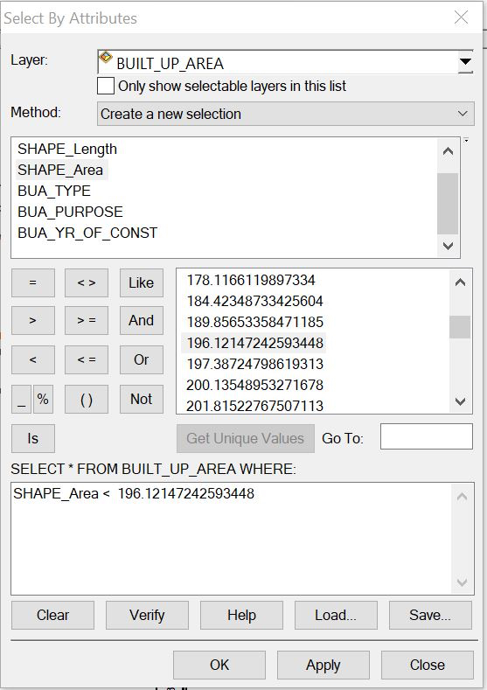

.

Query 1: The query one is interested in selecting or showing the built up area that have an area less than 196.12msq/m²
Syntax:built _up _area <196.12msq/m²
Figure 4.2: showing the question made on the database for built _up _area <196.12msq/m²

Figure: 4.3 showing the result of the query made on the database for built _up _area <196.12msq/m² in form of a table
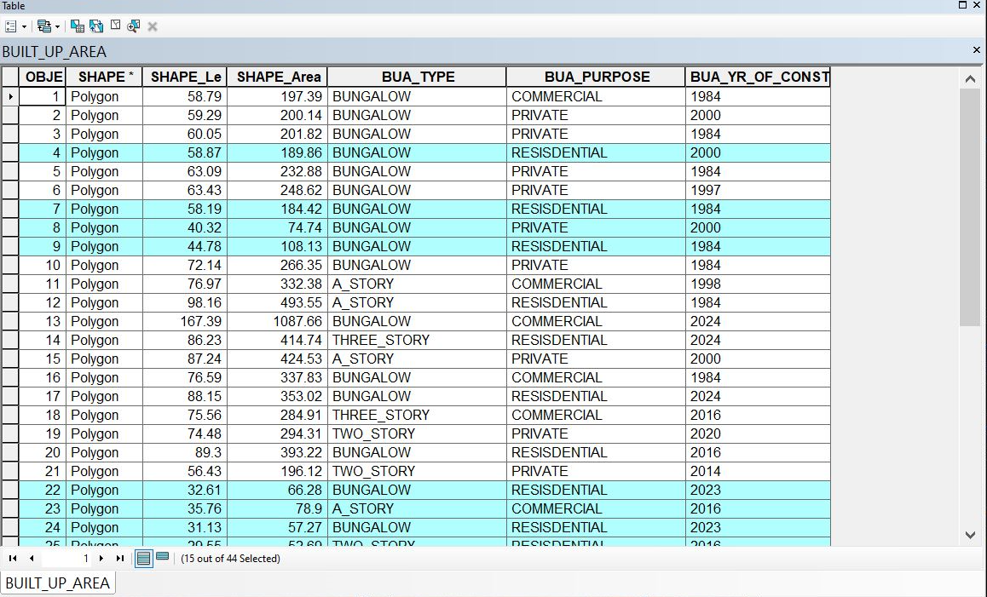

Figure 4.4: 4showing the result of the query made on the database for built _up _area <196.12msq/m²on the plan
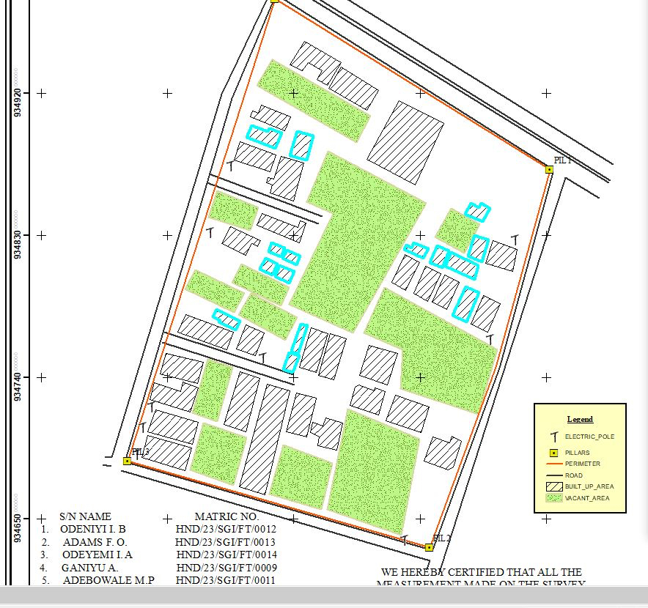

Discussion of Result
Figure 4.3 and 4.4 shows the built up area that have an area less than 196.12msq/m. It consists of the syntax model or the query builder box, attribute table as well as the map of the selected plot in mint bluecolor. The result shows that 15 built_up_areaout of the 44built _up _area have an area less than 196.12msq/m²
4.5 ​MULTIPLE CRITERIA QUERY
The database created is then used for implementing several selection queries in determination of user-defined requirements such as built up area whose purpose are for commercial or private use, year of construction, type of building (bungalow,2 story, duplex etc.) and other security which will be effective in planning in such environment.
Query2: The query 2 is interested in showing the building area that are greater than 403.99m²and their purpose that are used for commercial
Syntax:built_up_ area > 403.99 m²ANDtheir purpose arefor commercial use.
Figure 4.5: Showing the question made on the database for built _up_ area > 403.99m² and their purpose are for commercial use.
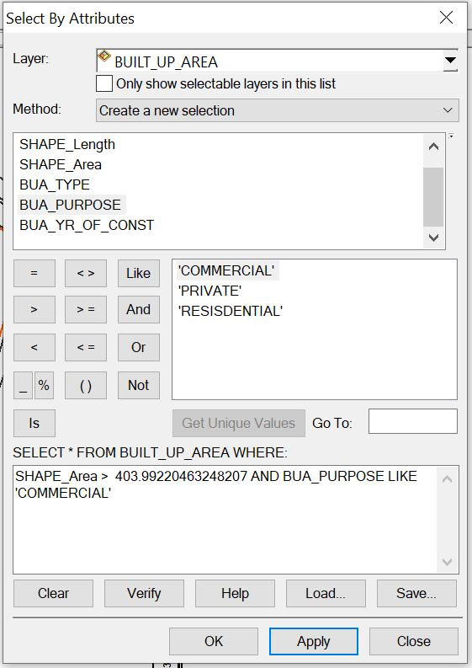

Figure 4.6: Showing the result of the query made on the database for built _up_ area > 403.99 m² and their purpose are for commercial use in form of a table
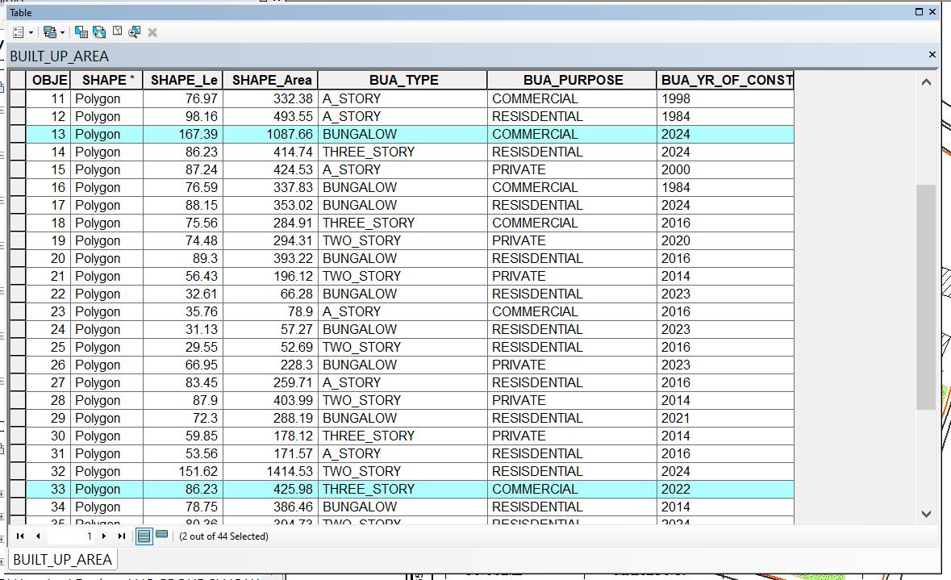
Fig 4.7: Showing the result of the query made on the database for built _up_ area > 403.99 m² and their purpose are for commercial use on the plan
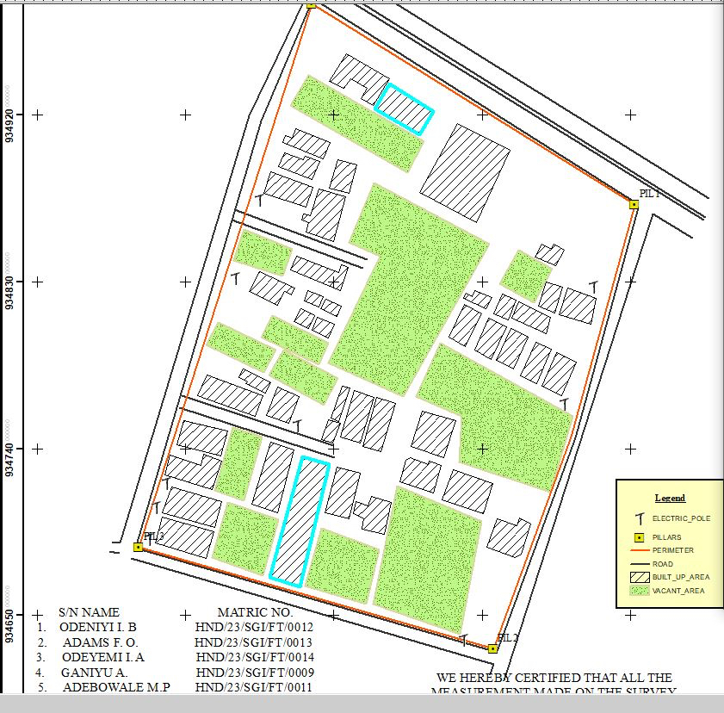

Discussion of Result
Figure 4.5.2 and 4.5.3 Shows the built _ up _ area > 403.99㎡and purpose are commercial on the planIt consists of the syntax model or the query builder box, attribute table as well as the map of the selected plot in mint blue color. The result shows that 2built _up _area out of the 44 built _up _area have an area greater than 403.99 m² and their purpose are for commercial use.
Query3: The query 3 is interested in showing the vacant area less than or equal to 901.99m and are not fenced to query about the vacant area of land less than or equal to 901.13m²and are not fenced
Syntax:vacant_ area <= to 901.13m²AND are not fenced
Figure 4.8: Showing the question made on the database for vacant_ area less than or equal to 901.93m²and are not fenced
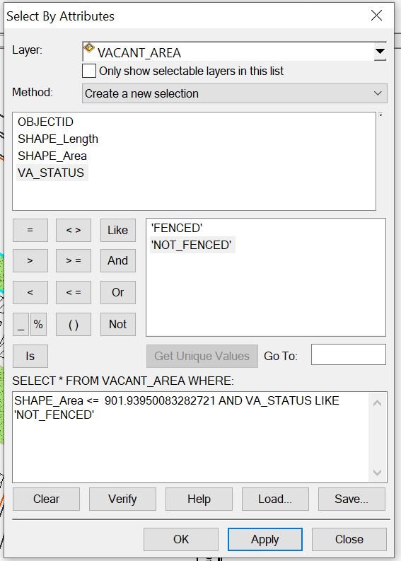

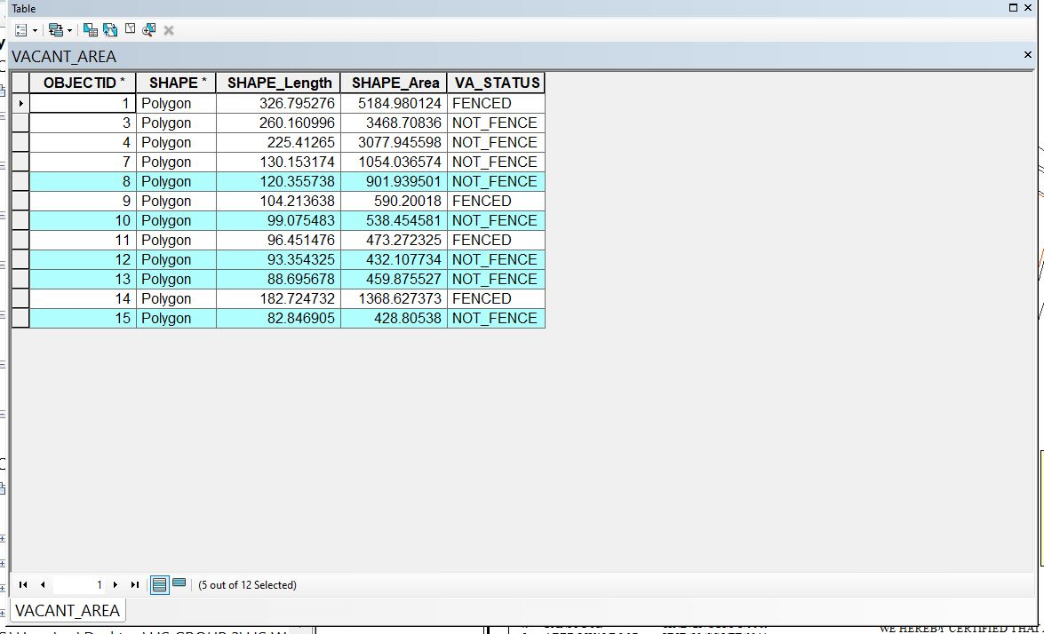
Figure: 4.9: Showing the result of the query made on the database for vacant_ area <= 901.13m²and are not fenced in form of a table

Figure 4.10: Showing the result of the query made on the database for vacant_ area <= 901.93m²and are not fenced on the plan.
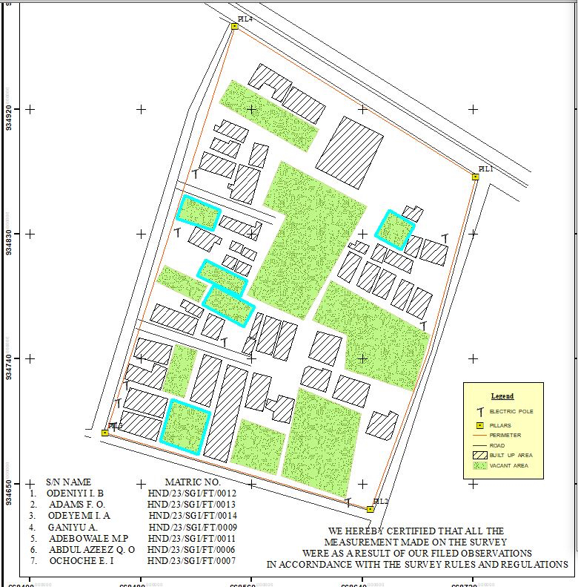

Discussion of Result
Figure 4.5.7 and 4.5.8 Shows the vacant area less than or equal to 901.93m²and are not fenced on the plan It consists of the syntax model or the query builder box, attribute table as well as the map of the selected plot in mint blue color. The result shows that 5 vacant_area out of the 12vacant _area have an area less than 901.93m² and are not fenced.

4.6 RESULTS ANALYSIS
The results analysis gotten from this project can be used by authority in charge to facilitate planning on the land available to also know certain features about the area in question such as the type of building, the purpose of the building etc. The pie chart shows the representation of the features that existing the project site, it also shows the percentage of the each features.
Table 4.1: RESULTS ANALYSIS​
LOCATION | SIZE | PERCETAGE
Total built Up Area | 1285.2724 | 42.3%
Vacant area | 48165.342 | 52.2%
Total Road Distance (meters) | 1685.195 | 5.5%

TOTAL ROAD DISTANCE
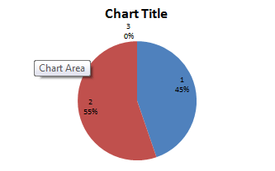

TOTAL BUILT-UPAREA
VACANT AREA

4.7APPLICATION OF PRODUCT
1. It facilitates the use of GIS for effective land management and physical planning.
2. It can be used for distribution of infrastructural facility in the study area.
3. It can be used for utility distribution, planning and operation.
4. The product will provide an integrated approach to analysis of land information.
5. It can be used for sustainable land development project in the study area
4.8 SPATIAL SEARCH
The database developed/created was queried in order to reduce the spatial variation in the various information categories ranging from built up area, vacant area, electric poles, and roads (as revealed by the database created) were used for the information system.

4.9 SPATIAL DEPENDENCE
Information system is not the same in every place, even within the project area, to talk of the whole institution neither the whole state, therefore, to detect the information increment/decrement within Part of AsaDam area,Agaka ( which is the study area) the strength of spatial relationships between the attributes must be established, the strength is known as "Spatial Dependence" and is based on Waldo Tabler's "First Law of Geography" whereby everything is related to everything else, but closer things are more related. Spatial dependence must be measured to establish a relationship limit between the environment and how the facilities is used by the people. This dependence willlikely changes over the study area as the environmental factors change (Haining, 2003). This is known as a spatial process, and when it changes across space it will non-stationery. This cannot be measured just by visually determining what is on ground because it is subjective and this must be done with a scientific approach to achieve a more concrete and precise information.

Screen-shot showing the database created for the study area
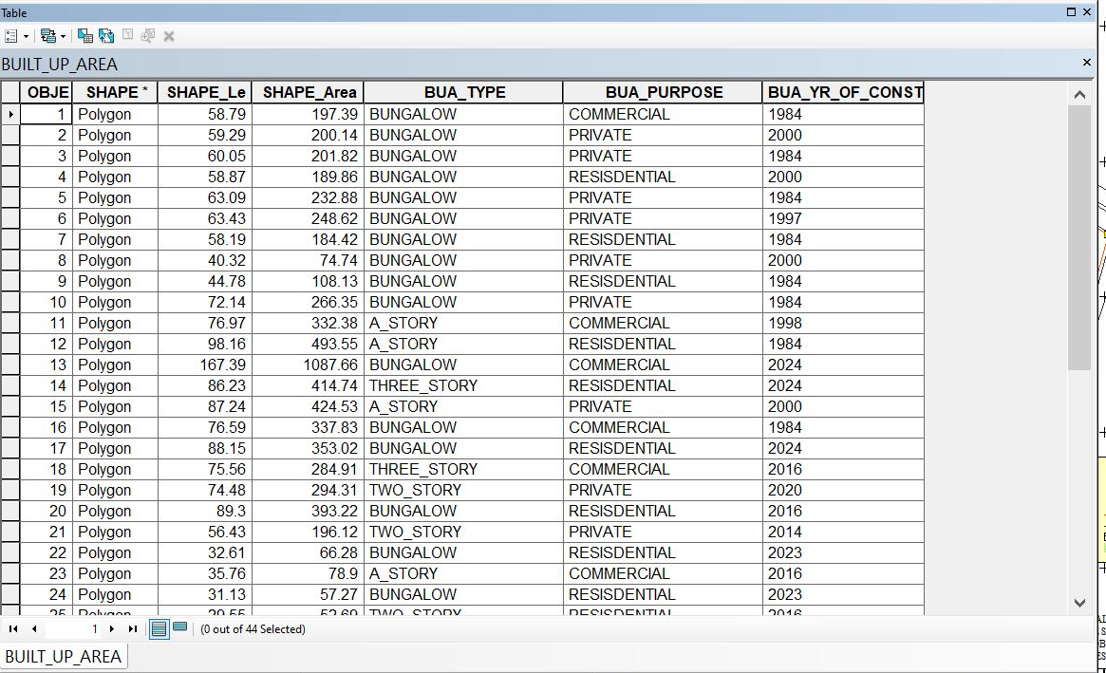

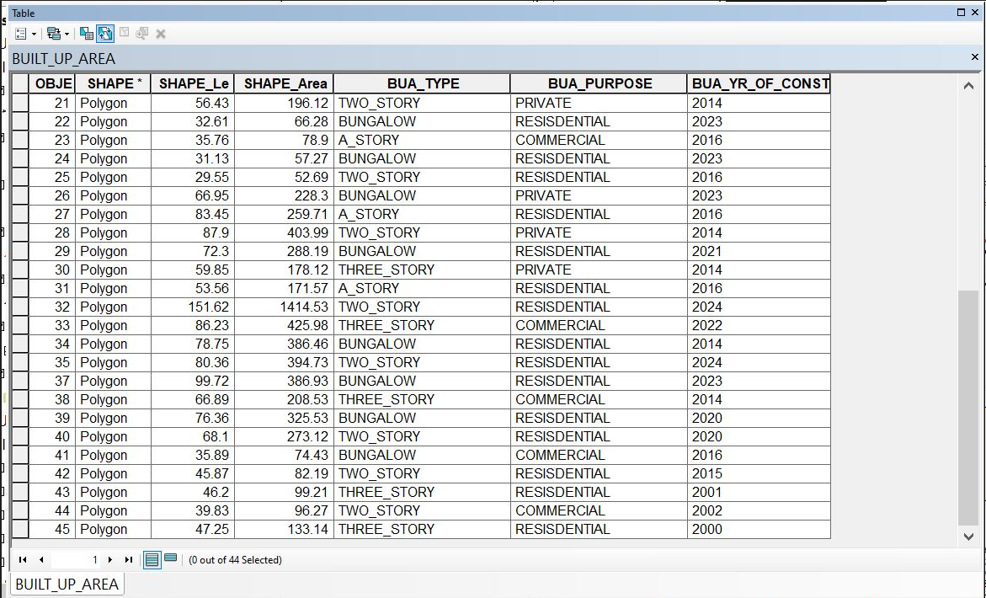

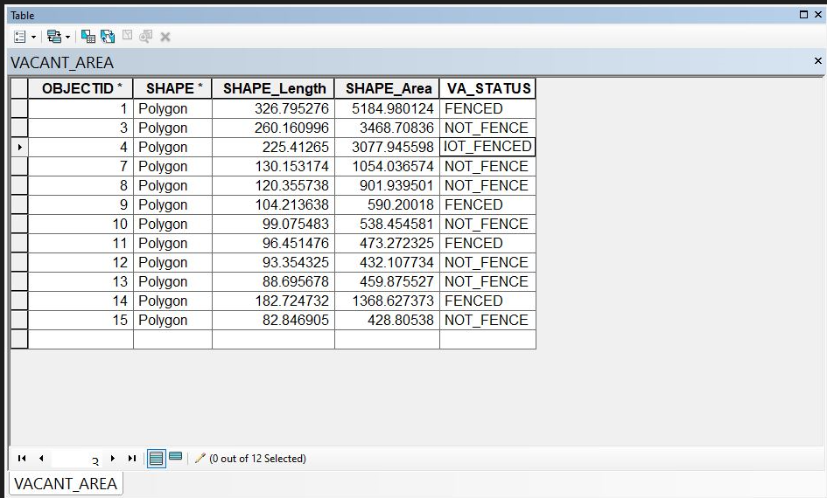

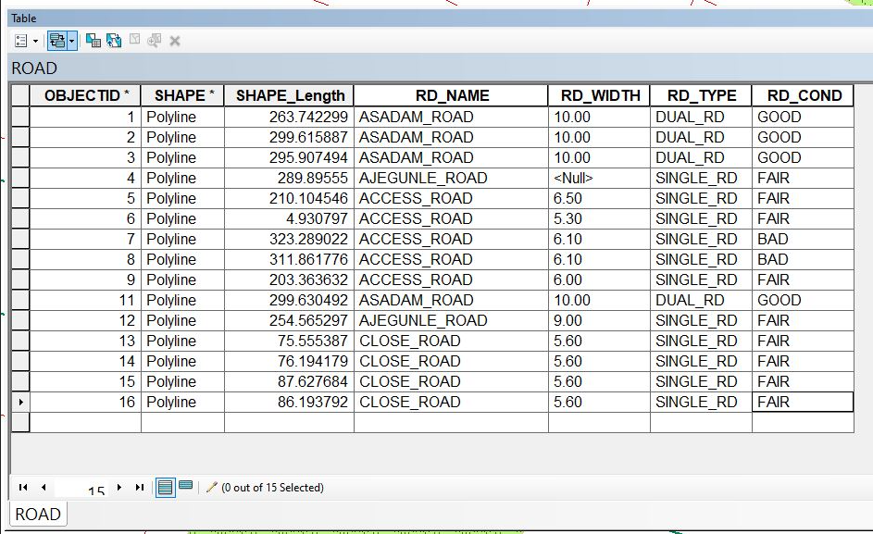

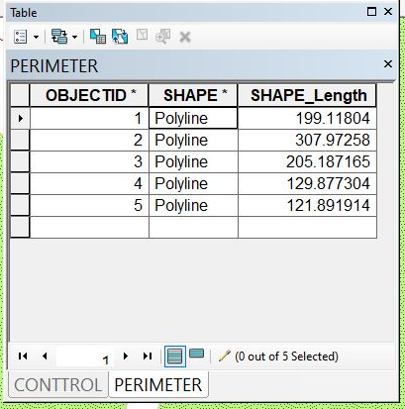
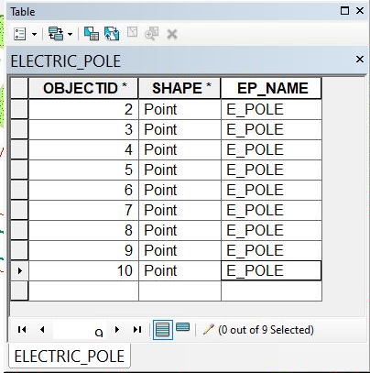
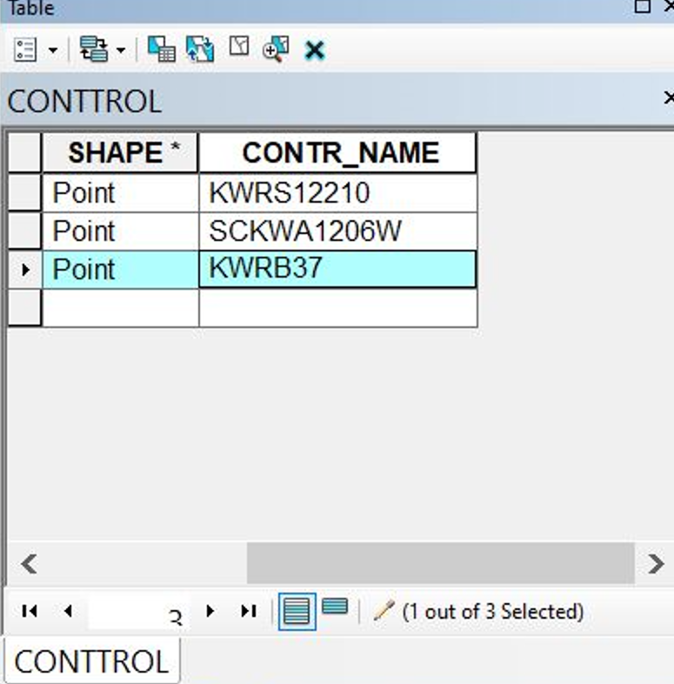
CHAPTER FIVE
COSTING, SUMMARY, PROBLEM ENCOUNTERED, RECOMMENDATION AND CONCLUSION
5.1 COSTING
Costing in a survey project involves estimating and managing expenses associated with conducting the survey. This includes:
Cost Components
1. Personnel costs: Salaries, benefits, and training for surveyors, data analysts, and other staff.
2. Equipment costs: Purchase or rental of surveying equipment, software, and technology.
3. Fieldwork costs:l Travel, accommodation, and logistics for field data collection.
4. Data analysis and reporting costs: Software, personnel, and other expenses related to data processing and report preparation.
Accurate costing ensures survey projects are completed within budget, on time, and to the required quality standard
Table 5.1: RECCI
PERSONAL/QUALITY | DAY(S) | UNITRATE(N) | TOTAL AMOUNT(N)
1 Senior Surveyor | 1 | 15,000.00 | 15,000.00
Assistant Surveyor | 1 | 8,000.00 | 8,000.00
Transportation | 1 | 7,000.00 | 7,000.00
Basic Equipment | 1 | 8,000.00 | 7,000.00
TOTAL |  |  | #38,000.00

BEACON= 2,100 × 5
= #10,500
Table 5.2: BEACONING
PERSONAL/QUALITY | DAY(S) | UNITRATE(N) | TOTALAMOUNT(N)
1Assistant Surveyor | 1 | 8,000.00 | 8,000.00
Basic Equipment(6) | 1 | 8,000.00 | 8,000.00
Transportation | 1 | 7,000.00 | 7,000.00
TOTAL |  |  | #23,000.00

Table 5.3: TRAVERSING
PERSONAL/QUALITY | DAY(S) | UNITRATE(N) | TOTALAMOUNT(N)
1 Assistant Surveyor | 2 | 8,000.00 | 16,000.00
Basic Equipment | 2 | 8,000.00 | 16,000.00
Transportation | 2 | 7,000.00 | 14,000.00
TOTAL |  |  | #46,000.00

Table 5.4: DOWNLOADING DATA AND PLOTTING
PERSONAL/QUALITY | DAY(S) | UNITRATE(N) | TOTALAMOUNT(N)
1Senior Surveyor | 2 | 15,000.00 | 30,000.00
1AssistantSurveyor | 2 | 8,000.00 | 16,000.00
Transportation | 2 | 7,000.00 | 14,000.00
Consumables | 2 | 7,000.00 | 14,000.00
TOTAL |  |  | #74,000.00

Table 5.5: INFORMATION PRESENTATION
PERSONAL/QUALITY | DAY(S) | UNITRATE(N) | TOTALAMOUNT(N)
1Assistant Surveyor | 1 | 8,000.00 | 8,000.00
Transportation | 1 | 7,000.00 | 7,000.00
TOTAL |  |  | #15,000.00

(1) # 38,000.00
(2) # 10,500.00
(3) # 23,000.00
(4) # 46,000.00
(5) #74,000.00
(6) # 15,000.00
TOTAL # 206,500.00

CONTINGENCIES=5%
206,500.00×5%÷ 100
= #10,325.00

V. A. T = 7.5%
206,500.00×7.5%÷100
= #15,487.50

MOBILIZATION AND DEMOBILIZATION =10%
206,500.00 × 10%. ÷ 100
= #20,650.00
ACCOMMODATION = 1.5%
206,500.00 ×1.5%÷100
= 3,097.50
TOTAL = 206,500.00
10,325.00
15.487.50
20,650.00
3,097.50
GRAND TOTAL = 256,060.00

5.2 SUMMARY
Land Information System (LIS) can provide us a better and more efficient system for land management.
A LIS is a digital system having spatial (graphical) and attribute data for each land holding since the two are maintained in a digital form, it is possible to edit, maintain, rectify and keep the record up to data with least efforts. It can give reprieve to both land owners as well as the Government, which requires information for planning and implementation whereas people have access to information regarding their own holdings; the government will be able to extract information for the entire area of interest. It will also be able to maintain and track changes, detect errors, make online correction, and make land management a process dependent activity rather than people dependent.
Advancement in the information communication technology has lessened the burden of carrying about large paper in the name of maps or plans; one must also not trouble himself with searching through old and dusty cupboards for worn out or form hard copies of maps or plans which may only take the grace of God to find at the end of the day.
From the database, other derived maps are possible due to the existence of the spatial database it is possible to get result of both spatial and non-spatial question with ease from the database.
Currently in Nigeria, cadastral surveys are tied to different origins and the scale at which the plans are charted may vary from state to state. In order to have data compatibility, for a seamless database of our cadastral maps, there is need for national coordination in order to harmonies the origin, scale and accuracy of our plans.
There is need for awareness to be created at all level of government towards deriving the benefits of GIS technology in Kwara state and Nigeria as a whole.
There is also the need for amendment of existing survey laws to accommodate the existence of new technologies.
A beginning has to be made and the first step in this direction is to provide the basic infrastructure. This can be done by making cadastral maps digital and also by taking the exercise of converting all record of rights in one language and again making the database available.
Success is a journey not a destination therefore one man’s success may be another’s beginning of the journey. There is need for projects like this to be carried out and improvements made upon.
5.3 PROBLEM ENCOUNTERED
- Obstructions from passersby, moving vehicles; it is a major problem for us because it is a commercial area it slow down our work because we were obstructed by these factors.
- System Compatibility: Ensuring compatibility with existing systems and software.
- Data Quality: Ensuring accuracy, completeness, and consistency of land data.
- Residents are seeking clarification on our work within their property boundaries.
5.4 RECOMMENDATION
The capabilities of land information system and its usefulness for study area were demonstrated through this research. Therefore;
1. I recommend that the State Government should acquire all the necessary computers, software and other relevant equipment for the implementation of land information system (LIS) operation in the relevant Ministries /Organization, such as Ministry of Land and Survey, etc.
2. The State Government should also directly embark on the conversion of their hard copy information to softcopies. The Local Governments should also be directed to do the same thing so that the entire state land records can be fully automated.
3. The State Government should also embark on training and retraining of staff. And also building of modern GIS Laboratory.
- Developing national land information management system which integrates the states’ land management systems as answer to the quest for national land database.
5.5 CONCLUSION
The study successfully developed a Land Information System (LIS) tailored for secondary school management, demonstrating the importance of GIS-based analysis in educational infrastructure planning. The integration of spatial and non-spatial datasets allowed for a comprehensive understanding of the school’s facilities, land use patterns, and terrain variations. The findings confirmed that GIS is a powerful tool for managing school environments, enabling authorities to make informed decisions on infrastructure development and maintenance planning.
One of the key conclusions drawn from the study is that spatial analysis can identify infrastructure challenges, such as classroom congestion, poor accessibility, and drainage issues, which might otherwise go unnoticed. The topographical analysis helped assess elevation variations, revealing areas requiring drainage improvements. Furthermore, the integration of non-spatial data with GIS facilitated efficient facility tracking, maintenance scheduling, and infrastructure optimization.
Query-based spatial analysis provided critical insights into facility allocation and emergency response planning. By analyzing building conditions, accessibility networks, and spatial distributions, decision-makers can develop strategic plans for sustainable school management. The results of this research demonstrate that GIS-based LIS is a valuable tool that can be adopted by educational institutions for improving facility management, enhancing infrastructure planning, and ensuring effective land use utilization.

REFERENCES
Abbas, I., Ben-Yayork, D., & Muhammad, N. (2014). Land information system (LIS) as an effective and efficient residential layout management strategy. Global Journal of Human-Social Science, 14(3), 32-40.
Akingbade, A. (2005). Improvement of availability of land registration and cadastral information in Ondo State, Nigeria: In department of urban and regional planning and geo-information management, international institute for geo-science and earth observation (ITC.), 137. Enschede: ITC.
Alshuwaikhat, H.M., & Nassef, K. (1996). A GIS-based spatial decision support system for suitability assessment and land use allocation. Arabian Journal for Science and Engineering, 21, 525-543.
Ball, (2002). Bojorquez-Tapia et al., (2001).Brazier & Greenwood, (1998).
Brown, P.M., & Moyer, D.D. (1990-1996). Multipurpose land information systems: The guidebook. Federal Geodetic Control Committee. (NOAA).
Chrisman, N.R. (1987). Design of Geographic Information Systems Based on Social and Cultural Goals. PE&RS, 53(10), 1367-1370.
Cromley & Hanink, (1999). (No full reference provided)
Dale, R.F., & McLaughlin, J.D. (1988). Land Information Management. Clarendon Press, Oxford.
Dale & McLaughlin (1999). (No full reference provided)
Deane, Owen, & Quaye (2017). (No full reference provided)

Dueker, K.J., & Kjerne, D. (1989). Multipurpose Cadastre: Terms and Definitions. Technical Papers, 1989 ACSM-ASPRS Annual Convention, Vol. 5, pp. 94-103.
Ezra Paul Hamawa and Sunday Olayiwola, S.O. GIS. A tool in the hand of a digital map maker (AutoCAD and Arcview software application).
Huxhold, W.E. (1991). An introduction to urban geographical Information system, Oxford University Press.
Kakaraparthi & Kockelman, (2011).Koomen et al., (2011).
Kufoniyi, O.T. (1995). Spatial coincidence modeling automated Database updating and data consistency in vector GIS.
Kuhlman, K. (1993). Building a Framework to Characterize Land Records Modernization. URISA 1993 Annual Conference Proceedings, vol. 2, pp. 146-151.
Malczewski, (2004). Ministry of Electronics and Information Technology India [MeitY], (2011).
National Research Council (1983). Procedures and Standards for a Multipurpose Cadastre. National Academy Press, Washington DC.
Paul R. Wolf and Charles D. Ghilani. Elementary surveying, an Introductory to geometrics, eleventh edition.
Pinto & Antunes, (2010). The Land Instruments Registration Laws of the various states and the federation...
Trung, Tri, Mensvoort, and Bregt (2006).UNFIG (1999).
Ventura, S.J. (1995). The use of geographic information systems in local government. Public Administration Review, 55(5), 463-469.
Zwart, P.R. (1988). Some Observations on the Real Impact of Integrated Land Information Systems upon Public Decision Making in Australia. Papers from the 1988 Annual Conference of the Urban and Regional Information System Association, 1988, Vol. 1, pp. 68-79.

APPENDICES
PT1,668548.191,934980.009,331.811
PT2,668547.444,934980.307,331.871
PT3,668544.293,934982.894,331.784
PT4,668544.636,934985.71,331.694
PT5,668548.811,934982.607,331.897
PT6,668552.283,934991.899,332.216
PT7,668553.984,934993.093,331.953
PT8,668558.627,935001.645,331.577
PT9,668612.439,934967.966,333.403
PT10,668607.837,934959.071,333.558
PT11,668606.116,934957.957,333.569
PT12,668601.641,934949.128,333.443
PT13,668722.519,934871.483,335.622
PT14,668723.124,934872.773,335.499
PT15,668724.097,934869.82,335.661
PT16,668731.395,934865.208,335.588
PT17,668732.254,934866.8,335.747
PT18,668741.023,934874.594,335.921
PT19,668742.62,934875.863,335.869
PT20,668745.124,934885.688,335.473
PT21,668698.61,934743.591,339.35
PT22,668689.78,934745.713,339.439
PT23,668648.259,934630.293,341.776
PT24,668646.292,934623.439,341.695
PT25,668644.216,934617.787,341.771
PT26,668651.595,934614.517,341.745
PT27,668653.983,934620.525,341.743
PT28,668656.616,934627.794,341.762
PT29,668646.138,934631.747,341.464
PT30,668615.759,934624.995,341.395
PT31,668601.356,934630.677,341.566
PT32,668590.349,934634.563,341.613
PT33,668506.861,934663.579,340.036
PT34,668508.229,934669.629,340.013
PT35,668454.711,934686.553,339.446
PT36,668452.802,934686.335,339.274
PT37,668450.44,934680.815,339.423
PT38,668443.943,934683.679,339.266
PT39,668444.292,934689.11,339.17
PT40,668440.342,934689.467,339.13
PT41,668439.062,934684.378,339.26
PT42,668477.787,934768.863,338.375
PT43,668472.675,934772.053,338.535
PT44,668501.603,934853.331,335.81
PT45,668495.835,934856.335,335.789
PT46,668503.845,934857.13,335.792
PT47,668503.181,934853.4,335.868
PT48,668520.586,934917.005,333.928
PT49,668514.356,934919.536,334.031
BLD1
668626.797,934915.257
668655.239,934900.925
66 8636.939,934862.120
66 8606.291,934878.436
BLD 2
668582.135,934923.274
668990.002,934936.997
111668613.526,934922.098
668606.012,934 909.257
BLDЗ
667581.284,934925.320
668574.434,934928.791
668577. 656,934934.690
668569.118,934939.551
668565.190,934934. 563
668557. 551,934938.348
668568.729,934953.110
668589.761,934939.436
BLD 4
668597.814,934905.349
668554.219,934896.160
668532.488,934905.191
668533.837,934908.841
668537.475,934907.355
668539.454,934912. 843
BLD5
668562.080,934896.001
668572.247,934893.172
668567.945,934877.615
668557.656,934880.406
BLD6
668543.561,934895.656
668544.532,934897.729
668552.168,934894.888
668548.215 ,934885.003
668530. 032,934 892.242
668533.088,934899.629
BLD7
668544.978,934870.182
668521.971,934877.929
668526.061,934889.496
668548.770,934881.029
BLD8
668559.781,934851.894
668544.682,934 886.634
668546.155,934862.120
668542.735,934863.153
668543.623,934866•627
668547.081,934865.723
668551.651,934880.294
668566.475,934875.936
BLD9
668562.491,934 834.992
668964.027,934837.372
668567.796,934837.618
668563.342,934825.139
668536.459,934836.463
668539.937,934843.647
BLD10
668536.937,934822.969
668533.127,934824.557
668529.634,934817.466
668514.029,934824.958
668519.686,934835.669
668538.900,934826.854
BLD11
668551.965,934816.506
668543.781,934819.752
668545.979,934825.341
668554.082,934822.151
BLDI2
668561.631,934811.073
668552.812,934815.377
668555.474,934820.635
668563.942,934816.676
BLD13
668542.087,934815.310
668949.672,93481.767
668546.497,934804.712
668538.560,934808.416
BLD14
668551.100,934810.930
668560.259,934807.005
668557.080,934799.773
668547.908,934803.653
BLD 15
668529. 661,934775.485
668522.839,934769.770
668512.546,934774.975
668513.168,934776.129
668508.446,934778.377
668510.780,934782.925
BLD16
668529.722,934772.970
668540.941,934767.996
668535.449,934753.535
668523.690,934758.048
BLD17
668491.411,934779.638
668521.573,934768.525
668517.552,934757.413
668486.436,934768.314
BLD 18
668478.664,934755.096
668502.586,934747.359
668498.769,934735.803
668475.179,934742.057
BLD19
668487.983,934130.863
668489.730,934736•840
668499.189,934733.242
668494.121,934717.669
668468.507,934725.914
668471.612,934736.6396
BLD20
668472.336,934719.302
668499.935,934711.471
668495.831,934692.394
668467.361,934705.332
BLD21
668467.256,934702.792
668495.090,934695•066
668490.856,934680.779
668463.763,934689.140
BLD22
668525.636,934743.364
668538.477,934739.131
668529.446,934705.264
668515.476,934710.062
BLD 23
668559.452,934742.918
668593.208,934710-062
668557.124,934738.618
668563.322,934793.646
BLD24
668559.452,934742.918
668593.208,934710-062
668557.124,934738.618
668563.322,934793.646
BLD25
668564.451,934773.631
668568.684,934772.572
668562.775,934754.757
668558.542,934756.433
BLD26
668570.724,934771.418
668581.413,934767.397
668574.005,934741.785
668563.422,934746.230
BLD27
668583.107,934767.820
668593.161,934764.539
668585.485,934738.500
668573.613,934741.282
BLD 28
668561.760,934729.818
668574.249,934726.854
668568.110,934702.089
668555.182,934705.424
BLD29
668587.315,934693.524
668575.195,934696.281
668576.094,934702.166
668570 476,934704.754
668577.928,934711.276
668578.490,934709.230
668580.112.934713.993
668591.013,934710.747
BLD 30
668607.730,934760.304
668625.546,934755.189
668619.141,934734.899
668601.380,934741•254
BLD31
668610.692,934731.438
668611.256,934733.153
668617.942,934731.041
668613.621,934716.224
668595.629,934721.868
668601.007
934733.501,934734.885
BLD 32
668624.192,934728.371
668645.831,934721.322
668 640.723,934705.011
668618.490,934712.150
BLD33
668568.579,934698.250
668659.944,934702.312
668666.124,934699.505
668660.908,934683.022
668657.963,934681.152
668462.464,934686.534
668648.293,934702.269
BLD 34
668672.141,934850.381
668674.343,934847.763
668678.185,934850.416
668684.180,934847.276
668679.638,934838.563
668668.569,934843.501
BID 35
668674.710,934829.943
668683.830,934827.209
668679.002,934813.262
668670.271,934816.702
BLD36
668674.467,934801.820
668656.126,934810.275
668 659.857 ,934819.077
668 677.052,934810.800
BLD 37
668650.907,934823.276
66865.185 ,934820.211
668654.187 ,934809.391
668646.128,934812.549
BLD38
68642.147, 934819.631
668829.937,934821.071
668631.150,934 823.646
668 634.793,934 822.211
668635.876,934825.218
66864.324,934821-704
BLD 39
668630.751,934795-092
668622.108,934800.031
668630. 574,934817.846
668639.747,934812.907
BLD 40
668643.627,934810.347
668653.152,934 805.940
668645. 038,934788.124
668 635.954,934793.151
BLD 41
668656.768,934783.009
668647.419,934787.419
668655.445,934804.881
668664.706,934800•031
BLD 42
668669.556,934775•248
668660.649,934779.393
668668.939,934797.385
668677.406,934793.592
BLD 43
668682.962,934768.369
668672.202,934773.749
668680.228,934791.140
668690.635,934786.937

