ASSESSMENT OF THE FUNCTIONALITY OF PRIVATE TRANPORT SERVICES IN ILORIN KWARA STATE, NIGERIA

BY:

ND/23/TPM/FT/0014
KAREEM AISHAT MOTUNRAYO

BEING A PROJECT WORK SUBMITTED TO THE DEPARTMENT OF TRANSPORT PLANNING AND MANAGEMENT, SCHOOL OF ENVIRONMENTAL STUDIES, KWARA STATE POLYTECHNIC, ILORIN. KWARA STATE.

JUNE, 2025.

ABSTRACT
The functionality of private transport service is measured by its quality attribute, which is the most synthetic and comprehensive indicator. However, it is difficult to identify this service quality attribute because it involves the various customer perceptions and it may be influenced by the passengers' preferences or by the travel behavior corresponding to a certain social category. The modal split of passenger transport is also influenced by the quality of supplied services which establishes a market share for the transport mode analyzed, in this case of private transport service in Ilorin city. The present research aims to identify specific indicators for assessing the functionality of private transport service in Ilorin city, and to characterize the performance of the transport supply. It is well-known that a quality service guarantees the success of a private transport operator, with direct implications on user behavior. A case study was carried out, highlighting the compliance of the private transport operator in Bucharest with the traffic program. Conclusions are formulated in order to improve service quality and, in this way, to increase the attractiveness of urban private transport and the quality of life.

CHAPTER ONE

INTRODUCTION

Background of the Study

Public transport operation in Nigeria is at the moment the joint responsibility of two broad groups, namely: the private sector and the public sector operators. The private sector operators are by far the largest providers of passenger services. They currently provide more than 90% of all urban passengers’ transport services (Armstrong, 1998). Within this group are the relatively few large-scale operators of bus fleet, who usually provide long-distance, inter-urban bus services and this sect have duly incorporated their business firm while, thousands of individual operators of small vehicle units such as minibuses, taxis, motor- cycles and adapted vehicles such as ‘Molue’ – which also provide both inter and intra urban passenger transport services are unincorporated but belong to one association or the others. More often than not, private registered companies are relatively better organized than the individual, small-scale operators.
Many of the registered private transport companies/ operators have their own maintenance workshops and garages. They train their staff and their operations are known to be viable. However, the economic recession and the spiraling costs of vehicle operation is seriously eroding their profit margins (Aderamo, 2004).
The majority of private sector transport operators in Nigeria provide transport services, which are primarily demand responsive and unscheduled in the urban centre. Most of these services are also operated on the basis of shared-ride, except for hired taxicabs. Moreover, road transport, the predominant mode used for providing services sometimes varies from one urban area to another, although the operating characteristics of the mode are similar. In Jos, for instance, there were 9,552

registered taxis for town service in 1999 as against 917 minibuses by the end of December 1995. In Bauchi town, there was virtually no minibus service, so majority of public transport passengers depended on taxis and motorcycles (Sumaila, 2004).
In spite of the efforts of the private sector operators at providing passenger transport services in order to meet the ever-increasing demand for them, the effects of the current economic recession and the Structural Adjustment Programme on their operation started to manifest in the latter part of the 1980s. In the road passenger transport sector, the available buses and taxis gradually reduced in size, while many of the available public trans-port vehicles showed apparent signs of ill- maintenance and steady deterioration in body condition. Indeed, the quality of services deteriorated further, and this situation remained unchanged (Azagba, 2004).
The available vehicle fleet in Nigeria including public transport vehicles fell from 614, 556 in 1984 to 218, 728 in 1992 (FOS, 2000). Over the same period of time, new commercial motor vehicle registration fell from about 120,000 to 30,000; a fall of about 33% (Komayer, 1993). In addition, the information obtained from Bauchi State Motor Licensing Authority and Central Motor Registry in Ilorin also showed the declining trend in vehicle Registration between 1998 - 2003 and 1995 - 2001.
The same trend was observed in Lagos State, where the number of newly registered commercial buses declined from 72,264 in 1982 to just 10,079 in 1988 (World Bank, 1991) . The total number of available buses for both public and private use in the Lagos metropolis fell from about 39,288 in 1983 to about 9,576 in 1989. This declining trend in the supply of all types of motor vehicles, and public transport vehicles in particular, affected private sector passenger transport operations quite considerably (Bolade, 1990).

The Structural Adjustment Programme (SAP) apparently led to sharp rises in the prices of vehicles and spare parts. For instance, between the time when SAP was introduced and now, the prices of Peugeot 504 station wagon and its spare parts had risen from between 105% to more than 6,000% (Ismaila, 2004).
In Nigeria, the dwindling economic fortunes affected virtually every sector of the economy, including the urban public transport sector. Many private sector operators are finding it increasing difficult to maintain and adequately manage their fleets of mini-buses and taxis and the scope for fleet expansion is seriously constrained by the exorbitant prices of vehicles, spare parts and high vehicle operating expenses.
What someone can readily observe today is the manner in which public transport operation has suffered severely, and the consequential effects of untold hardship that passengers and even transport operators themselves are experiencing.
The operations of the private sector transport providers are still terribly hampered by the exorbitant prices of vehicles and spare parts among others. Even, fairly used, second hand vehicles, popularly known as „Belgium’ or Tokunbo’ are no longer within their reach, when com-pared with the situation about three to five years ago, when the prices of fairly-used, „Tokunbo‟ vehicles were just about half of what they are today. Consequently, the private transport operators are hardly able to replace the existing aged vehicles.

Ilorin City has one of the quality private transport services in Nigeria which is located randomly within the city. Quality urban transport services in Ilorin city have been provided by public and private transport companies. This has no doubt as to improve the socio-economic development of Ilorin City and Kwara State large. This is evidence that transportation plays key role in the development of urban and rural areas. The role of transportation in economic development cannot

be overemphasized. Transportation is the engine block of any society and hence provides room for effective sociolect-economic development and societal improvement. This study is to be conducted to carry-out an assessment on the effect of private transportation companies/ services in Ilorin City, Kwara State.

  - Statement of the Problem

Transport can be viewed as a public utility which supplies essential goods and services, where essential means they cannot be cut off without danger of total or partial collapse of an economy (Dieter Bos, 2003). Along with power and communication, transport is one of the social overhead capitals which must be developed to a critical minimum level in order to facilitate investments in the other sectors globally.

Poor road transportation management is one major problem that is affecting the growth of the economy. Kootz and Donnel (2016) posit that poor road transportation management has led to the ineffectiveness and collapse of the Nigerian road system that supposes to carry bulky goods from one city to another and has made inflation to be high. This is in turn has bounced as the road transportation system characterized by heavy duty lorries overworking the road system and the resultant effect is damages of roads causing accidents and loss of lives and property. Poor management of road transportation systems has cost the nation a damaged image, loss of huge amount of money, loss of lives and properties and most road users are greatly dissatisfied with condition of road transportation in Nigeria (Kootz and Donnel, 2016).

Road transport is the principal mode of transportation in Nigeria accounting for the vast majority of freight and passenger travel. Over the years the road system has been subjected to heavy freight

which was beyond the carrying capacity of the roads. This made the condition of the roads deteriorate and the result is that much of the road system is barely usable (Nwakamma, 2006). Hence roads were built to carry freight that could conveniently be carried by railways.

In Nigeria the need for an effective transport system becomes more obvious if taken into consideration the large size of the country and the need to disperse development move (Ehrlich, 2017). The inability of Nigerians to device a better transportation system has been a detraction of the growth of the economic social and political life of the economy. Prominent among the problem, includes traveling difficulty lateness to work, movement of agricultural product, goods and services from area of production to area of utilization (Rachev, Svetlozar, and Ludger, 2008).

Several studies (such as Areola, 1999; Atubi and Onokala, 2003, 2004; Atubi, 2005a, 2006; Ejiofor, 2010, 2014, 2015; Donnel, 2011; Akapla, 2010, 2014; Bennett, 2008; Ijewere, 2000;
Ineigbenebor, 2005; Koontz, 2009; Kootz and Donnel, 2016; Robert, 2009; Tony, 2000; Vewere,

2000; Okakunori, 2006; Olakunori, 2006; Olakunle, 2006; Newton, 2017; Herrmann, 2017;) have focused on road transportation and how it affects businesses, government, industries, and its management techniques, but none of this research work has looked at the assessment of the effect of urban private transport services in Ilorin City, Kwara State. This research work is therefore carried out to fill the research gap that exists in this study.

Most private transport companies in Ilorin are delivery poor service quality, poor maintenance of fleet and unsafe service. Big share of the vehicle fleet consists of second-hand vehicles purchased from industrialized countries, ages of the vehicles are quite old and there is a low maintenance budget (Dimitrious, 2016). Research gap, convenience and travel time are considered to have a great impact of passenger satisfaction in relation with the type of the trip, but most

transport companies do not take it seriously. This research seeks to identify the problem and find out possible measures and solution to the problems of private transport companies in Ilorin metropolis.

  - Research Questions

The following research questions will be answered in due course;

    - What are the socio-economic characteristics of the passenger, drivers and the company’s management in Ilorin City?
    - What are the available transportation facilities and the level of functionality and their effectiveness in the selected private garage in Ilorin?
    - What are the challenges facing by the passengers, drivers and general management in the movement of goods and services in Ilorin City?
    - What are the appropriate measures to reduce the problems of private transport system in Ilorin?

  - Aim and Objectives of the Study

The aim of this study is to assess the functionality of private transport services in Ilorin City, with a view to enhance their level of modernity and effectiveness,

1.4.2 Objectives of the Study

However, in order to achieve the stated aim, the following specific objectives were formulated to:

- Examine the socio-economic characteristics of the passenger, drivers and others company’s management workers in Ilorin City;

- Assess the available transportation facilities and their level of functionality and effectiveness in the selected private transport services in Ilorin?

- Examine the challenges facing by the passengers, drivers and general management in the movement of goods and services in Ilorin City

- Evaluate the appropriate measures to reduce the problems of private transport system in Ilorin metropolis?

Scope of the Study

The scope of this research work was strictly based on the assessment of the functionality of private transport services in Ilorin City, Kwara State. And to offer suggestion(s) on the problems associated with private transport system. Examine the socio-economic characteristics of the passenger, drivers and others company’s management workers in Ilorin City; Assessing the available transportation facilities and their level of functionality and effectiveness in the selected

private transport services in Ilorin, Examine the challenges facing by the passengers, drivers and general management in the movement of goods and services in Ilorin City, Evaluate the appropriate measures to reduce the problems of private transport system in Ilorin metropolis

The scope of the study will be designed to cover only four (4) private transport companies in Ilorin City, which includes: Global Link Transport, Peace Mass Transit Limited, Kasmag line and Okin motors and sons. However, because of time and financial constraints, the scope will be scaled down. In this regard only selected major private transport companies would be covered in this study.

Significance of the Study

Transportation is a necessary end right from early history. The mobility of people and materials especially in the present days become one of the greatest needs that have to be adequately satisfied on our society and economy at large. Transportation is referred to as the engine of the economy (Kunri 2005:79). It then means that without transportation management system, the entire economy will suffer stagnation. Also, transportation helps to bridge the gap between producers, suppliers and industrials users as well as individual commuters.

Transportation unaccompanied account for about 46% of the total physical distribution costs for manufacturing companies and 28 % for reseller companies (Henry, 2014). Not much success can be accomplished in manufacturing, distribution of goods and services including the movement of people without transportation.

It is as a result of the great importance attached to transportation that man has over the years developed various transportation modes in other to facilitate the movement of people and

materials. The mode of transportation selected will greatly depend on price, time, delivery, condition and destination, customer’s patronage, and past purchase satisfaction. This poor transportation management jeopardizes the source of procurement of materials; goods and services, movement or people and even course increase in prices and loss of lives most especially in developing nations.

In recent times, some of this urban could not be said to be very healthy, being plagued with lot of transportation problems. Although it is often said that public authorities in Nigeria claim to have risen to the task of inadequate provision of public transportation system, they often claim to have responded to this problem by attempting to improve the range and structure of public transportation services. Transport problems since the last two decades in Nigeria have been serious especially in urban centers. These problems are been caused by the influx of population into the urban centers, growth in industries and the inability of transport facilities to cope with the demand. The problems manifest in terms of long waiting time for buses, traffic congestion, parking problems and accident.

There is a general shortage of public transport service in Nigeria relative to demand. The public owned transport operations in the few states where they exist are inefficient and the private sector operators of para-transit transport system are substandard and disorganized. In Nigeria, two distinct public transport systems can be identified. These are the municipal bus services provided by government owned transport corporations and the various para-transit services provided by the private operators. Public transportation in Nigeria has also been dominated by private operators. These private entrepreneurs operate in an uncontrolled manner and provide erratic and unreliable services (Adeniji, 1983).

Usually no clearly defined routes are being plied by these private operators who are essentially demand responsive. A World Bank report (1992) revealed that in 1987, more than 98 percent of all urban public transport journeys in Nigerian urban centers were provided by private operators using taxis, minibuses (danfos) and buses (molues). This contrasts sharply with the situation in most cities of the advanced countries where public owned bus operators have the monopoly of public transport provision (Nash, 1997; Ludlow, 1980).

In the early 1980s, government owned public transport companies operating were in Lagos, Kaduna and Port Harcourt. Although, several other state-owned transport corporations in Kwara, Rivers, Oyo and Edo States operated urban services in the past; these companies either ceased urban operations or closed down (Barret, 1992). However, this study will be useful to many sectors of the economy, as little research has been done on this most especially in the area under study. Thus, road transport companies, ministry of works, transport, and academic will benefit immensely from this study. Also, the commuters, manufacturing companies and businessmen especially the middlemen will equally benefit from the study to solve the urban transport problem of ilorin City. Also, this research work has academic significance due to its relevance in the field of educational institution most specifically undergraduates in transportation, marketing and geography and regional planning which is among the educational unit that trains future managers, administrators and planners. Etc. its findings and suggestion(s) are likely to generate academic debate on the matter and interest among scholars.

The study could also help the ministry of transport to better understand the current situation in road transportation management. And accordingly makes changes to address the factors that consequently help to formulate policies aimed at solving the problems of road transportation

management on road users and commuters. The study will be of great importance to private and public organization such as transport companies and individuals concerned with the business of transportation; it will serve as a guide on the area of implementing quality assessment of urban Private transport services, staff training on urban transport system, to address the obstacles hindering effect on road users and passengers.

Lastly, students and researchers would want to benefit from this study. Also, the study is to immense benefit in the area of recommendation that would help in improving the general performance of the company in question.

The Study Area

The study area Ilorin, the capital city of Kwara State is located on Latitude 80 30N and Longitude 4035 E, it lies in the plain of the North central part of Nigeria. The city which lies along Lagos Kaduna highway is about 306km from Lagos, 600km from Kaduna and about 500km from Abuja, the Federal Capital city of Nigeria. At present, the city of Ilorin cuts across three (3) Local Government Areas namely Ilorin West, Ilorin East and Ilorin South Local Government Areas, and it has about twenty (20) political wards. The evolution of Ilorin began with the early traditional areas built up around the township centre (Aderamo, 1990). The trend revealed that the city has four major residential districts which are clearly identifiable on the urban landscape, these are the traditional/core areas such as Oja-Oba, Okelele etc, the transitional/mixed residential zone such as Taiwo, Gaa-Akanbi, the Government Residential Areas (GRA) and the modern well planned housing estates such as Irewolede, Adewole housing estates etc.

The creation of Kwara State in 1967 and the choice of Ilorin as the state capital had resulted in its rapid population increase and area expansion. Today, Ilorin has witnessed more physical expansion and open-up of new road network resulting in the city enveloping many of the smaller settlements surrounding it. The absorbed settlements are Kulende, Elekoyangan and Polytechnic permanent site campus along Jebba road to the north east. GaaAkanbi, Ero-Omo, Olunlade and Ganmo which are found along IlorinAjasse-Ipo road to the south east, Ogidi along Ilorin-Kaiama road to the west, Sobi Barracks, Alagbado along Ilorin-Shao road to the north and Agunbelowo, Olorunsogo, Odota etc. along Ilorin-Lagos road to the south west (see Fig.1). Ilorin is very accessible both from outside and within the city, new roads are being constructed, while old ones are being rehabilitated, these accessibility roads are always clogged up when workers are going or returning from work. Ilorin population was projected with an annual growth rate of 2.84% (NPC.1991) and at the 2006 head counts; the city has reached 766,000 by population (NPC, 2006). Although, Ilorin developed as an administrative centre both economic and social activities have greatly influenced its growth in recent times. The major occupations of the indigene are farming, pottery making, and weaving. There are also a greater percentage of the people who engaged in trading activities, while others are self-employed in various other areas such as mechanics, carpentry, artisans among others.

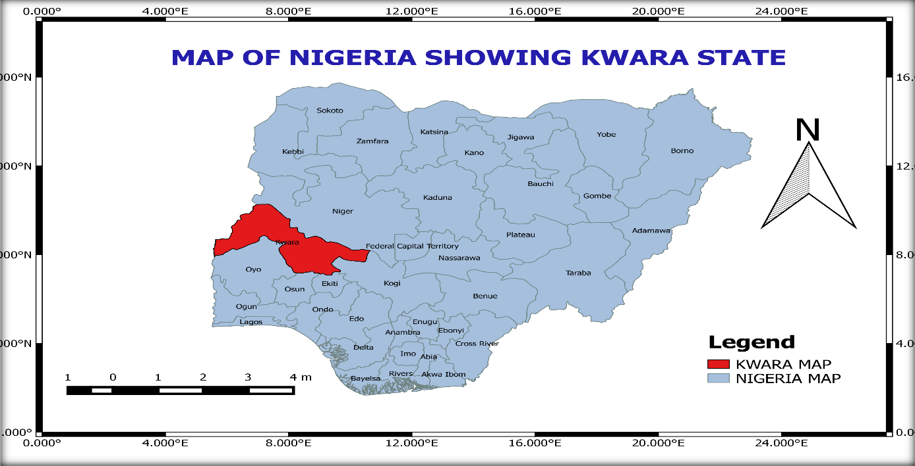
Figure1: Kwara State within the National Context
Source: - Kwara State Geographic Information Service Board (KW-GIS) (2025)
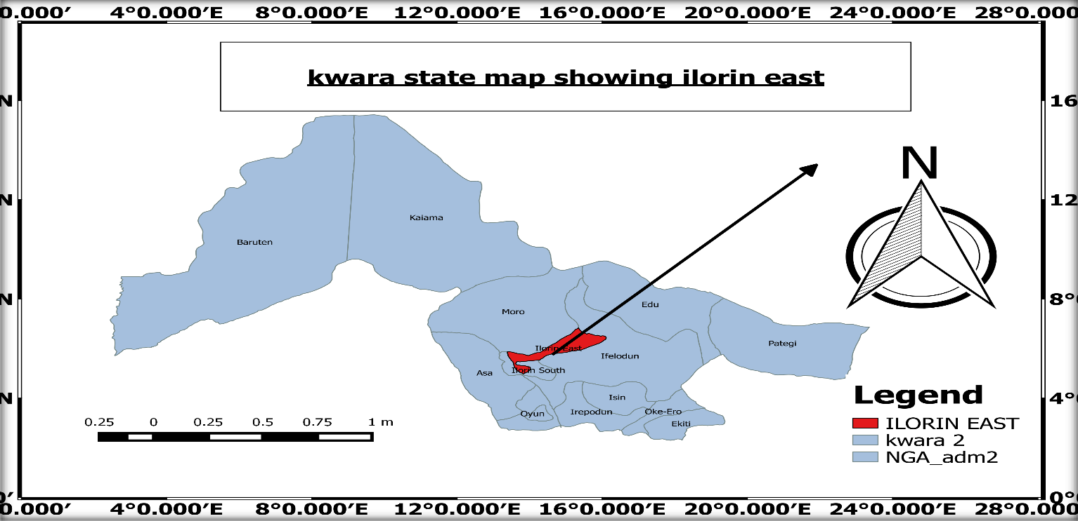

Figure2: Kwara State Township

Source: - Kwara State Geographic Information Service Board (KW-GIS) (2023).

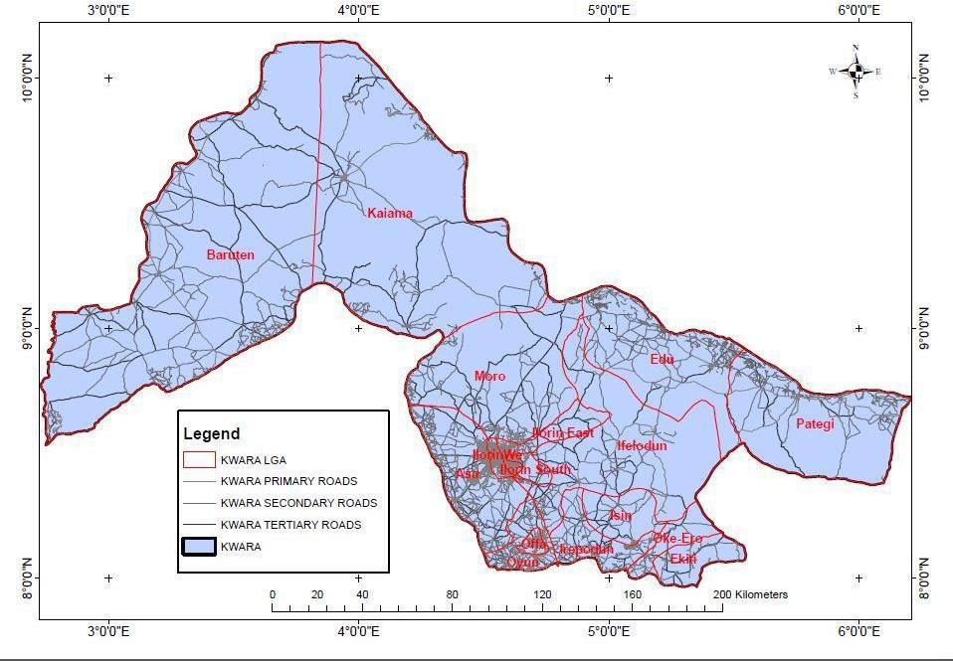

Figure2: Kwara State Township

Source: - Kwara State Geographic Information Service Board (KW-GIS) (2022).

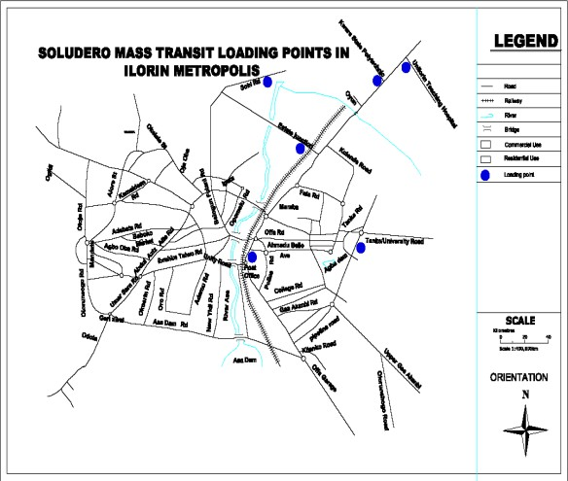

Figure 3: Road Network showing Mass Transit Terminals.

Source: - Kwara State Geographic Information Service Board (KW-GIS) (2025).

Definition of Terms

Transportation; Transportation is the movement of people, animals, goods and services from one location to another. It is also the action of movement from one point to another through various transportation modes. Also, Transportation in simple term, transportation could be defined as the movement of people, goods and services from one location to another.

Public Participation; it is the inclusion of the public in the activities of any organization or project, it is also any process that directly engages the public in decision making and gives full consideration of the public input in the making decision.

Public Transport System; it is a system of transport for passengers by group travel systems available for use by the general public. It is also a form of travel offered to enable people to travel together along designated routes. This transport system includes the use of passenger buses, trains, trams.
Private Transport System; it is the personal or individual use of transportation which are not available to be used by the general public. In this system, the user can decide freely on the time and route of transit. It includes the use of cars, motorcycles, bicycles, uber and pedestrians walk.

Transport Facilities; it refers to any physical facilities that assist in the proper movement of people, goods and services. These facilities include; roads, vehicles, alleys, traffic control devices, curbs, gutters, sidewalks, and street services amongst many others.

Transportation Companies; these are companies or organization who provides its owned or leased vehicles in order to render transport services to the public in other to make profit.

Transport Routes; they are planned or developed path, roads by which all types of transport modes channel their goods and services, people to reach their destination.

Commuters: One who travels regularly from one place to another, as from suburb to city and back to its origin concurrently.

Commuting is periodically recurring travel between one's place of residence and place of work, or study, and in doing so exceed the boundary of their residential community. It sometimes refers to any regular or often repeated traveling between locations, even whe

Transport: Transport can be viewed as a public utility which supplies essential goods and services, where essential means they cannot be cut off without danger of total or partial collapse of an economy (Dieter Bos, 2003). n not work-related (Omijie, 2017).

Mode of Transportation: This is any form of vehicle or system used to transport people or goods. Various modes of transportation exist, they include land, sea, air and pipeline. These are further broken down to various means including; road, railway, freight movement, airplanes etc.

\

CHAPTER TWO

LITERATURE REVIEW

Theoretical Framework

The concept of Quality is an offshoot of Management Science which is a contemporary extension of Scientific Management which was developed by Frederick Taylor. Scientific Management and Management Science use quantitative approach to raise organizational efficiency. Frederick Winslow Taylor introduced the concept of scientific management with emphasis on work output, labour efficiency and introduction of work study. This was followed by the era of quality control (1930-1950) when the principal focus was replacing inspection with more informative process control systems which aimed at reducing variation in outputs and delivering more consistency by focusing on inputs. Next was the total quality management (TQM) era which emphasized organizational quality driven by management.

Service Quality

A service is an activity or series of activities of more or less intangible nature. It normally, but necessarily, takes place in interactions between customers and service employees and/or physical resources or goods and /or systems of the service provider (Shahin, 2006). According to Douglas & Connor, (2003, p.166), Parasuraman et al., (1985, p.42), and Ladhari, (2008, p.172), the intangible elements of a service (inseparability, heterogeneity and perishability) are the critical determinants influencing service quality perceived by a consumer. This means that a service must be well defined by the provider in terms of its characteristics in order to understand how service quality is perceived by consumers. According to Johns, (1999, p.954), a service could mean an

industry, a performance, an output, an offering or a process and it is defined differently in various service industries. The differences in service industries are based on the characteristics of service which include; heterogeneity, perishability and Inseparability.

Service industries are playing an increasingly important role in the economy of many nations. In today’s world of global competition, rendering quality service is a key for success, and many experts concur that the most powerful competitive trend currently shaping marketing and business strategy is service quality. Since the 1980s service quality has been linked with increased profitability, and it is seen as providing an important competitive advantage by generating repeat sales, positive word-of-mouth feedback, customer loyalty and competitive product differentiation. As Zeithaml and Bitner (1996, p. 76) point out: . . . the issue of highest priority today involves understanding the impact of service quality on profit andother financial outcomes of the organization.

Service quality has since emerged as a pervasive strategic force and a key strategic issue on management’s agenda. It is no surprise that practitioners and academics alike are keen on accurately measuring service quality in order to better to understand its essential antecedents and consequences, and ultimately, establish methods for improving quality to achieve competitive advantage and build customer loyalty. The pressures driving successful organisations toward top quality services make the measurement of service quality and its subsequent management of utmost importance. Interest in the measurement of service quality is thus understandably high. However, the problem inherent in the implementation of such a strategy has been compounded by the elusive nature of service quality construct, rendering it extremely difficult to define and measure. This means that service providers must try to determine the level of

intangibility of services and try to include tangible elements that could aid understanding of expectation from the consumer’s perspective (Beamish & Ashford, 2007, p.240).

Heterogeneity means that difference which comes in at the level of delivery of service due to the difference in human behavior of those offering services and the consumer. Example occurs when salesperson offers assistance to one customer at the counter, that same person cannot offer exactly the same thing to the next customer because of differences in behaviors. This is why it is difficult to determine the quality and level of service provided since consumers and service providers are different, the same consumer could act differently with the same service provider (Beamish & Ashford, 2007, p.241).

Service quality is an approach to manage business processes in order to ensure full satisfaction of the customers which will help to increase competitiveness and effectiveness of the industry. Quality in service is very important especially for the growth and development of service sector business enterprises (Powell, 1995).

Parasuraman et. al (1985) and Zeithaml et., al (1990) noted that the key strategy for the success and survival of any business institution is the delivery of quality services to customers. The quality of services offered will determine customer satisfaction and attitudinal loyalty (Ravichandran et al. 2010)

Service quality is a comparison of expectations with performance. A business with high service quality will meet customer needs whilst remaining economically competitive. Improved service quality may increase economic competitiveness. This aim may be achieved by understanding and improving operational processes; identifying problems quickly and systematically, establishing

valid and reliable service performance measures and measuring customer satisfaction and other performance outcomes.

Service quality is an achievement in customer service, it reflects at each service encounter. Customers form service expectations from past experiences, word-of-mouth and advertisement. In general customers compare perceived service with expected service in which if the former falls short of the latter the customers are disappointed. Service quality can be related to service potential (for example, worker’s qualifications) service process for example, the quickness of service and service result (customer satisfaction).

According to Parasuraman, Zecthaml and Berry (1985) there are ten determinants that may influence the appearance of a gap between service expectation and service perception, namely:-

Competence: the possession of the required skills and knowledge to perform the service. For example, there may be competence in the knowledge and skill of contact personnel, knowledge and skill of operational support personnel and research capabilities of the organization.

Courtesy: the consideration for the customer’s property and a clean and neat appearance of contact personnel, manifesting as politeness, respect and friendliness.

Credibility: is the factor such as trustworthiness, belief and honesty. It involves having the customer’s best interest at prime position. It may be influenced by company name, company reputation and the personal characteristics of the contact personnel.

Security: Is the customer feeling free from danger, risk or doubt including physical safety, financial security and confidentiality.

Access: Is approachability and ease of contact, for example, convenient office operation hours and locations.

Communication: Means both informing customers in a language they are able to understand and also listening to customers. A company may need to adjust its language for the varying needs of its customers. Include explanation of the service and its cost, the relationship between services

and costs and assurances as to the way any problems are effectively managed.

Knowing the customer: means making an effort to understand the customer’s individual needs, providing individualized attention, recognizing the customer when they arrive and so on. This in turn helps in delighting the customers i.e rising above the expectations of the customers.

Tangible: are the physical evidence of the service. For instance, the appearance of the physical facility, tools and equipment used to provide the service. The appearance of personnel and communication materials and the presence of other customers in the service facility.

Reliability: Is the ability to perform the promised services in a dependable and accurate manner. The service is correctly on the first occasion.

Responsiveness: Is the readiness and willingness of employees to help customers in providing prompt timely services. For example setting up appointments quickly.

Customer Satisfaction

According to Fornell(1992) a key motivation for the growing emphasis on customer satisfaction is that high customer satisfaction lead to a stronger competitive position resulting in higher market

share and profit. Deng et al (2009) posits that the ability of a service provider to create a high degree of satisfaction is crucial for product differentiation and developing strong relationship with

customers. The service a brand offer and the price it charges actually determine the level of satisfaction among its customer than any other measure (Turel et al 2006). For this reasons Gustafsson, Johnson and Ross (2005) suggests a firm should concentrate on improving service quality and charge appropriate fair price in order to satisfy their customer which would ultimately help the firm to retain its customers. This study adopts various concepts and theory suitable for this research work. It also presents the review of related literature on the assessment of effect private urban transport services.

CONCEPTUAL FRAMEWORK

There is rarely a uniform concept to explain the assessment of the effect of urban private transport services in Ilorin City, Kwara State. This study adopts the concept of urban transport system to explain the operations of transportation management in urban areas.

The Concept of Urban Transport System

The concept of urban transport system as postulated by Gbujie (2003) states that “transport infrastructure has to be rationally developed to ensure that movement of people and goods takes place speedily, economically, safely, comfortably and in an environmentally-friendly manner” (Sumaila, 2012). As compliments, there must also be strategic transport infrastructural development to enable all available transport modes to be properly harnessed, stream-lined and integrated for socio-economic and defense purposes (Ashenfelter and Card, 2015).

Atubi and Onakala (2003) and Atubi (2005, 2011) later developed this concept by explaining that “road transportation is a factor of land transport which involves the movement of people and goods by motor cars, truck, buses, motorcycles and bicycles”. They posit that it is the most popular means of transport (Atubi and Onokala, 2003; Atubi, 2005a). As a popular form of land transport, road transportation can contribute greatly to national development when made efficient. However, road transportation in Nigeria is far from being efficient (Aweto, 2015). According to the Tyagi, et al., (2006) poor maintenance and years of heavy freight traffic have made much of the road system in Nigeria barely usable.

Studies over the years have shown that condition of urban transportation in Nigeria is in a deplorable state (Ogunsanya, 2003, Adeniji, 2010; Ademiluyi and Gbadamosi, 2004; Aweto, 2015). These scholars affirm that, more than 70% of Nigeria roads are substandard and hardly networked. Travelling on Nigerian roads is breathe taking and most un-pleasurable (Ehrlich, 2017). This stated condition emanates from combined effects of natural ageing of transport infrastructure, lack of maintenance, wrong use of available transport infrastructure, ineffective implementation and enforcement of traffic rules and regulations (Odufawa, 2003).

However, Atubi and Onokala (2003), in their study of road transportation and the socio-economic development in Warri metropolis, concluded that road transportation indeed contributes tremendously to the socio-economic development of that metropolis. But this some transport that builds a city, also in other ways if not properly managed causes some damage to the same city (Ogunsanya, 2002).

Plano (2017) noted that transportation is the life wire of any urban environment. It is central to the flow of knowledge, information and commercial goods. The type of available transport, and how

they are used, tells great deal about a society and its values (Oni, 2000, 2002). A transportation system can enhance the productivity and quality of life of a community if properly planned and managed. It the same time, development stimulates demand for transport. The rapid urbanization around the world means that more people will be making more trips in urban areas, since transportation is the life wire of any urban society (Ehrlich, 2017). It could make or the environment depending on the interactive measures and degree of responsiveness to transport planning and management in urban development (Yavuz and Welch, 2016).

Ehrlich (2017) noted that the transport system in Nigeria is the driving force behind her socio- economic development. It serves as the major artery of the movement and distribution of people, goods and services between towns, villages and regions. The quality of life and economic wellbeing of urban dwellers in Nigeria are dictated by the quality and extent of urban transport infrastructure and services (Plano, 2017). There is no gain-saying the fact that the live hood and wellbeing of many urban households in Nigeria, as in elsewhere, depend on unhindered and unfettered access by road to potable water, fuel wood, farm and other places of employment, heath facilities, schools, market and purchase of manufactured products (Bearse, 2016).

The successful execution of these economic activities and the attainment of the transport system have improved the transport system in most Nigerian cities (Aweto, 2015). Furthermore, the socio- economic transition of the rural dwellers from peasantry to material comfort is also tied to a good transport system. The role of transportation in general and urban transportation in particular, in the overall development of regions is incontrovertible. In Nigeria, urban transportation holds the key to the rapid development of both natural and human resources (Oni, 2000).

Atubi (1998) assert that “in human geography, one of the most fundamental increase is spatial interaction”. He stated that spatial interaction involves the movement of people, goods and services between various centers in space; he said that the most economical solution for one road link may not necessarily be the best solution for the network a whole.

Jack (2016) recently pointed out that every society requires a good transport system which is essential to support economic growth and development. He further opined that the attainment of independence in 1960, the problems of Nigerian transport system include bad roads, inadequate fleets of buses or trucks, increased crime rate, irregular, inadequate and over-crowed trains, and airplanes and congested ports (Aweto, 2015). These are common features of the developing world. In line with these are physical problems such as poor visibility, death of suitably-trained transport managers and planners, capital restructuring bottlenecks, serious issues of institutional reforms and ineffective traffic regulations (Jack, 2016).

This concept is relevant to this study since the quality urban services can only be attained if urban transport system is improved and properly managed. Urban transport system plays in key role in national development and the development of urban areas and contributes a greater percent to urban economy.

LITERATURE REVIEW

The review of related literature on the assessment of the effect of urban private transport services will be done under the following sub-topic;

Transportation System in Nigeria

According to Plano (2017), transportation system is a very important part of any modern economy and core element of daily human life. Our society and economy are challenged with new defiance’s like the concept of sustainable development (Tarnoff, et al., 2009). These new challenges also require new planning and management strategies in the area of transportation planning (David and Makafui, 2014). There are experts needed who know how to design a road, a traffic light and create public transport network, etc., but they must be also familiar with the concepts of transportation demand management, integrated land use and traffic management, freight logistic concepts and intermodal traffic management (Aweto, 2015). Tasks like providing optimal transportation conditions for people and economy and enhance a living quality of urban areas can only be met successfully in long term if the transportation system is considered as a part of a complex system (Bearse, 2016). Therefore, the interactions between transport, economy, land use and natural environment must be included into the transportation planning strategies (David and Makafui, 2014; Monahan, 2007; Tarnoff, et al, 2009; Mohan, et al, 2008; Tyagi, et al., 2012; HC, 2009; Khalid et al ,2008).

Transportation is the movement of people and goods from one location to the other (Clarke, 2016). It is a means by which goods (raw material, production equipment, operating inventories, semi- finished goods and finished goods) as well as people are able to get to or be made available where

they are needed for commercials or non-commercial purposes, as at when desired (Ejiofor, 2010; 2015). The mobility (transportation of people and materials) is therefore one of the greatest needs that have to be adequately satisfied in any society if any meaningful level of social interaction, co- operation, production activities, economic and other types of development, and the enhancement of human welfare is to be achieved (Dimitrious, 2016). This is the reason why road transport is popularly referred to as the engine and wheel of the society (Olakunori, 2006), it helps the world to go around and function actively.

Ehrlich (2017) posit that the necessity of road transport in the society can easily be realized when we consider the daily activities of an average person. He takes road transport to his place of work or business. The goods he bought are brought to him by means of road transportation. He moves around to interact with others and goes to church activities with the aid of road transport (Ineigbenebor, 2005). The police that ensure his peace and security depend greatly on road transport for him to carry-out their duties effectively.

Freeman, Grogger, and Sonstelie (2016) said that road transportation provides the essential activities of time and place. They went further to say that utility of time entails making things available when they are needed. One of the industries where time utility is of a major essence is that of the daily newspapers (Olakunle, 2016). This industry greatly depends on road transport to ensure that its vendors and papers get to passengers early in the morning when the news they carry is still regarded as fresh. As day wear on, the news becomes stale and lose its values and prices (Kootz and Donnel, 2016).

Glaeser, Sacerdote, and Scheinkman (2016) emphasized that road transport helps to provide and add place to goods by making consumers where they are needed. Most goods would be of no use

to consumers if they are not made available at the places where they are needed for sale, purchase and or consumption.

The history of road transport development in Nigeria dated back to the period before 1910 when the existing bush paths were developed into motorable routes. According to Herrmann (2017), the growth of road transport in Nigeria was a later development, which did not evolve through the state of animal-drawn carts. According to this institution, roads were not developed until the advent of motor vehicles to the 1920s and 1930s. The end of second world war (1945) actually marked the period when the country was served with adequate network of all-season roads for lorry and passenger car traffic (Ogunbodede, 2008).

According to Herrmann (2017), the road was designed to serve two major objectives. First, they were meant to extend the commercial hinterlands opened up by the government railway by linking up the nearest urban centers with the major railway stations. The second was to reduce the strains thrown on the inland provinces in the provision of porters for the British

colonial officers. The initial growth of road network was slowed down by the financial and labor constraints.

Jack (2016) noted that road is the major mode of transport system in Nigeria. Other means of intra- urban and inter-urban transport system are the use of inland waterways and rail transport which are of course limited to a very few urban centers with peculiar terrain (water) in Nigeria. Even in terms of haulage of goods, the advent of motor vehicles revolutionized transport and constituted a challenge to the railroads. According to Herrmann (2017), Road transport as at 1953 was carrying

50% of the total ten-miles increased to 62% while the total traffic carried by all forms of transport had more than doubled.

Studies in the area of urban transportation confirmed that more than 75% of population in cities depended on public transport while about 25% depended on private transport system (Herrmann, 2017). The federal government of Nigeria recognize that the development of road transport is essential to the growth of the economy and for this purpose, 13%, 15.8%, 19.0% and 12.7% of the total gross capital expenditure from 1955-1959 was devoted to road transport (Jack, 2016). Since then, the first, the second, third and fourth national development plans (1960-68; 1970-74; 1975- 80) also had more than 25% of the total allocation to development plans devoted to transport sector while allocation to rail was declining. The preference of government to the provision of road transport infrastructures later influenced the provision of transport services not only in the urban centers but as well, as inter urban services (Jack, 2016).

Hence the need for producers and marketers or business entrepreneurs to put in place an effective and efficient transport system for timely delivery of goods and services to adequately deliver satisfaction to the society is a necessary evil that can never be overemphasized (Ineigbenebor, 2005).

Role of Road Transport in the Nigerian Society

The role of road transport cannot be over-emphasized or exhausted. As already observed, it is indispensable if any meaningful level of economic development, social integration and development and the enhancement of standard of living is to be achieve in any society (Glaeser,

et al., 2016). Below are some of the important roles played by road transport, which makes it very indispensable in the modern society (Robert, 2009);

Communication

Road transport is a major vehicle for communication. People have taken it for them to be able to make contact with others and disseminate information. Mails and other materials for information dissemination are also taken to their destination by road transport (Tony, 2000).

Aid to the Mobility of People and Freight

According to Jack (2016), road transport is synonymous will mobility. People rely on the means of it to move from place to place for economic, social, political, religious and other purpose. They also use it to move their goods from one location to another. Without an efficient road transport system, the tempo of economic, educational, political, medical, religious, social and other activities in our society would grind to a half (Herrmann, 2017).

Road Maintenance

As observed by Jack (2016), no road is constructed to last forever, just like every other created by man. Roads get damaged with usage time. Changes in weather conditions overtime, floods usage and other factors have some damaging effect on roads right from the moment they are built. However, effect of these factors to a large extent depends on the quality of the material used for building specific roads, how well, they were constructed and the frequency of usage. Earth roads generally get damaged faster than their paved or tarred counterparts (Ejiofor, 2014). The types and culverts of vehicles that would use a road and the volume of traffic have to be put into consideration

when constructing it in addition to the nature of the soil on which it is to be built. Otherwise, the road would get damaged quickly and fail to give the desired service (Newton, 2017). Every road needs to be maintained in other to repair the damages occurring to it with time and usage (Ejiofor, 2015).

Road in Nigeria and other parts of Africa are generally not well maintained. Ehrlich (2017), which carried out a study on maintenance of roads for the World Bank in Sub-Saharan

Africa observed that by 1990, nearly a third of $150 billion invested on roads in the region had been eroded through lack of maintenance. It is common knowledge to all road users in Nigeria that poor, maintenance of roads in the bane of the roads transportation industry in the country. This problem affects all types of roads; federal, state and local death traps and have not received any maintenance attention for the past ten years, despite public outcry over the years (Jack, 2016).

Advantages of Road Transportation

As Newton (2017) notes, road transportation is carried out through the use of mini-buses, luxurious buses, pick up vans, saloon cars, stations wagon cars, tankers, truck trailers and motorcycles among others, the use of such a wide range of alternative vehicles for carrying passengers and cargoes gives the road mode of transportation many advantages when compared with others modes of transportation (Jack, 2016). The following are most important, among the advantages:

Ø Road transportation is the only mode that offers door to door services without any intermediate unloading of vehicles. Manufacturers and commuters’ route as a service very high because of the secrecy and convenience, which it affords.

Ø Motor vehicles generally on public highways and this makes the required terminal and right of ways cost less than what is obtained in most of the other modes such as air, water and rail.

Ø The commercial services of road transportation are the cheapest to operate among all modes.

Ø Road transportation is the most adaptable of all the modes of transportation. It combines with other mode more easily than any of the others.

Ø Road transport is the most available. It services can be obtained at any time of the day and almost everywhere.

Ø The cost of transportation by roads is generally much lower than that of air mode.

Ø Road mode of transportation is the most accessible mode to both urban and rural dwellers all over the world. Everybody can easily make use of it.

Disadvantages of Road Transportation

Despite many advantages associated with road mode of transportation. It has some disadvantages. The most prominent among the disadvantages are:

Ø The vehicles that are used for road are much unlimited in terms of their cargo capacity. Generally, ship, trains and aircraft carry higher volumes of cargoes than vehicles.

Ø Road transportation exerts more demand in limited urban space than other modes. It grabs for itself much of the limited urban space for the construction of streets highways ring roads, motor parks, parking spaces, garages, mechanic and other workshops and bus stops.

Ø Road vehicles are more prone to accident than other modes during transit activities. Many people who can afford to travel by other means but who are forced to travel by road because of its availability see it as a necessary evil. Accidents are common features on Nigerian roads because of inadequate maintenance of the vehicles on our roads. Lack of adequate parking space, carelessness and recklessness on the part of the drivers, and inadequate provision signs etc. are some of the causes of urban road accidents.

Ø Fuel a crisis which has remained intractable in the country for some years now makes transport service very unreliable.

Ø Because road is easily accessible, motor and passengers of transit are highly susceptible to attract by armed robbers in a country like Nigeria.

Ø For long journeys or trips, road transportation is very slow when compared with rail and air modes.

Problems of Road Transportation in Nigeria

A lot of problems are associated with operation of road transport service and road transportation in Nigeria (Newton, 2017). Most of these problems arose as a result of poor management of roads on the part of the government as well as poor attention to passengers on the part of the operators of road transportation service (Olakunle, 2006). Some of these problems are as follows:

ü Recklessness of motor vehicle drivers: Many road transportation drivers are illiterate and do not attach much importance to value of their passengers. Because of this, they are very careless

and reckless on the road. This often leads to unavoidable accidents and loss of lives and valuable as well as great damages to their vehicles (Robert, 2009).

Ø Inadequate number of transit vehicles: The number of road transit vehicles is too inadequate to cope with the demand for road transportation in the country. Because of this, most vehicles often carry excess passengers and cargo, leading to accidents, inconvenience of commuters and damage to vehicles.

Ø Inadequate Road network: The number and length of roads in the country is too inadequate to cope with the need for road transportation.

Ø Bad roads: The state of most roads in Nigeria is very bad. Most of the roads are filled with potholes and sharp pavement edges. These often cause accidents and damages to vehicles and cargoes as well as great inconveniences to commuters. This is the need for government at all level to give more attention to road maintenance in the country.

Ø Menace of highway robbery: The presence of numerous police checkpoints has not been able to put a check on this problem. Many innocent commuters’ losses their lives and property to highway robbers every day, despite the presence of police on the roads. This ugly situation has forced many road users to carry police escort, which increases the cost of road transportation.

Ø Inadequate maintenance of transit vehicles: Most of the transit vehicles on our roads are in poor state of maintenance. The prevailing adverse economic situation in the country. Poor maintenance culture and failure of the Ministry of Transport and Vehicle

Inspection Office to discharge their statutory responsibility have left commuters to depend on rickety “coffins-on-wheels” for their journeys.

Ø Traffic Congestion: Traffic congestion has become a permanent feature or urban roads and some highways in Nigeria. This is in spite of many attempts to reverse the situation. During rush when people are going to work valuable productive time is waste in traffic hold-ups. Hours that could have been utilized efficiently in work places such as companies, private organization, and government offices are spent on the urban roads and highways. There is also environmental pollution caused by traffic which affects the health of individuals and consequently their productivity. Though traffic congestion is a feature of urban centers throughout the world, the Nigerian situation is permanent due to the absence of an alternative means of transport such as railways.

Managing the Road Transportation

Management can be defined as the process of planning, organized, leading and controlling the work of organization members and of using all available organizational resources to reach organizational goals (Stoners, Freeman and Gilbert, 2016). According to Drucker (2000) management is the process of pulling together the effort of people in an organization towards the achievement of goals of that organization.

Whether a company operates its own fleet of vehicles or depends on the services of independents providers of carriers, it needs to transport department or unit and a capable manager or supervisor to take charge of it. In a typical manufacturing and marketing company, road transport is required for sourcing production input and distribution of finished goods. It is essential for organizational

people to note that basically, the same transportation activities are required for the inbound movement of production materials and outbound movement of finished goods (Tony, 2000).

The most important among the functions or responsibilities of a transport manager in a typical manufacturing and marketing company include the following:

Ø Routing: for a company making use of outside transport services, routing involves the choice of the mode of transportation to use for moving goods and personnel and the selection of a carrier or carriers within the mode. To a large extent, transport managers make this decision in consideration of the nature of the goods, the speed required, transport cost, service expected organizational resources and objectives, also passenger expectations among others (Akpala, 2014).

Ø Carrier selection: This is essentially part of routing the decision here should be taken, based on the transport need of the company, its resources and the efficiency of the alternative carriers available in the community concerned. A company should stick to the selected carrier for a relatively long period of time so as to benefit from accrued experience.

Ø Rate negotiation: rate negotiation has to do with the determination of transport charges for specific units of traffic and distance. The managers should ensure that his company obtained as low rate as possible, subject to the satisfaction of its transport needs.

Ø Transportation cost reduction: It is essential to transport managers who makes efforts to reduce the transport cost of his company. This can be done by transporting goods in bulk, engaging in pool car or pool truck management with others in order to transport car lead rather than less car load, packing goods in other to obtain rate reduction and effective rate negotiation among others (Koontz, 2009).

Ø Re-consignment: This involves changing the routing of consignment, its consignee and destination after it has been turned over to a carrier. Re-consignment is actually a type of diversion. When there is a need for diversion, the traffic manager needs to request the carrier to affect the necessary charges in routing and delivery on time before the consignment arrives at the original destination (Kootz and Donnel, 2016).

Ø Minimizing risk and making claims: Transportation involves risk. Claims are also necessary when damages or loses occur. The transport officer duty with respect to risk is essentially that of their minimization rather than complete elimination. One of the most effective means of minimizing transportation risk is by ensuring transport facilities and

the consignment in transit. It is the right of a manager to make claims when necessary and should be made on time and through the right formal channel (Newton, 2017).

Ø Personnel management: The personnel working in the transport department of organization include drivers, mechanics, electricians, drivers’ mate, clerk and clearing and forwarding officials. The transport managers need to see that their duties are properly spelt out and that they are organized and motivated to achieve the departmental goals and corporate goals of the organization itself (Ejiofor, 2015).

Ø Facilities maintenance: The transportation facilities should be kept in a good working condition at all times. It is good for a big company to have its own vehicles maintenance workshop.

The above maintained is a good and essential duties of a good manager.

Justification of Road Transport Regulation

The transport industry is a highly regulated industry. Though some modes of transportation are more regulated than other, there is no mode that does not feel the impact of government control measures in the country. Nigeria’s cases are not much different from that of any other country. However, the extent of government activities in the regulation and control of road transport in any place depends on the political and economic ideology by the government, the level of economic situation and the ability and maturity of the private and commercial providers of road transport services in the society concerned (Ejiofor, 2014). In the regulation of road transport, government hopes to ensure the safety of the general public and users of road transport services accelerate and appropriately channel the direction of the development of road transport operators and parties involve in transportation contractual relationship.

A number of reasons can be given to justify actions of government in regulating transport. The most popular among these reasons are as follows:

- Safety of general public and users of road transport: The vehicles used in the road transportation can sometimes pose great dangers to the member of the public and the users of their services. Some of these dangers (such as accidents) may be due to the use of faulty

vehicles or the carelessness of drivers. Accident resulting from these may lead to the loss of live and valuables (Ejiofor, 2010). Government tries to regulate transport by determining which vehicles are fit to be used for transportation and qualifies to operate. Through these and other measures, the public and users of road transport services are protected.

- Environmental protection: Some road transports pollute and degrade the environment.

Examples of these are the emission of dangerous gases from internal combustion engines, noisy and oil spillage from broken or vandalized pipelines.

- Economic stability: As we saw in chapter one growth of the economy of any nation depends heavily on road transport. Without a good road transport, no economy can develop or function properly (Ijewere, 2000). A mal function in the transport system can greatly jeopardize the interests of any nation’s economy. By controlling the excess of commercial, transport operators, government hopes on achieving and maintains economic stability (Donnel, 2011).

Several studies (such as Areola, 1999; Atubi and Onokala, 2003, 2004; Atubi, 2005a, 2006; Ejiofor, 2010, 2014, 2015; Donnel, 2011; Akapla, 2010, 2014; Bennett, 2008; Ijewere, 2000;
Ineigbenebor, 2005; Koontz, 2009; Kootz and Donnel, 2016; Robert, 2009; Tony, 2000; Vewere,

2000; Okakunori, 2006; Olakunori, 2006; Olakunle, 2006; Newton, 2017; Herrmann, 2017;) have focused on road transportation and how it affects businesses, government, industries, and its management techniques, but none of this research work has looked at the assessment of the effect of urban private transport services in Ilorin City, Kwara State. This research work is therefore carried out to fill the research gap that exists in this study.

CHAPTER THREE

RESEARCH METHODOLOGY

This study is will be to carry-out on the functionality of private transport services in Ilorin City, Kwara State. This chapter will present the procedures adopted in gathering data/information needed in this study. This will be presented under the following sub-topics;

RESEARCH DESIGN

The research is essentially empirical. It is case study research and it involves field survey using questionnaires administered on resident, drivers and other road user in the study area. Also, due to the complex nature of transportation system; particularly the road transportation system, several investigative methods were adopted to gather the necessary information. The method includes the social sampling survey method used for selecting people and personal observation.

The study will be carried out to examine the assessment of the functionality of private transport services in Ilorin City, Kwara State. The research design adopted in this study is the descriptive survey research design. This is to enable the researcher have a true reflection on the assessment of the quality of urban transport services in Ilorin City, Kwara State and truly point out the problems of private transport system in Ilorin metropolis.

    - Research Design Tables

S/N | Research Objectives | Sources of data collection | Methods of data collection | Method of data analysis | Methods of  data presentation

1 | To Examine the socio-economic characteristics of the passenger, drivers and others  company’s management workers in Ilorin City; | Primary sources of data | Administration of questionnaires aires and personal interview | Descriptive method using SPSS | Frequency, table percentage and charts
2 | To Assess the available transportation facilities and their level of functionality and effectiveness in the selected private transport services in Ilorin? | Primary sources of data | The use of structured questionnaires and personal administration in order to determine the efficiency of the infrastructural facilities provided within the  neighborhood | Descriptive method using analysis of variance | Frequency, table percentage and charts

3 | To Examine the challenges facing by the passengers, drivers and general management in the movement of goods and services in Ilorin City | Primary sources of data | Administration of both questionnaires, field survey and personal interview | Descriptive methods using SPSS | Frequency, table percentage and charts
4 | To Evaluate the appropriate measures to reduce the problems of private transport system in Ilorin metropolis. | Both primary and secondary sources of data | Administration of both primary and secondary methods of data collections such as Questionnaire, interview, relevant journals,  and past projects, | Descriptive methods using analysis of variance and SPSS | Frequency, table percentage and charts

Source: Field Research, 2025

  - Types of Data Used

    - Primary and Secondary types

Sources of Data

    - Primary and Secondary Sources

Data for the study were obtained from both primary and secondary sources.

Primary data

Primary data were collected directly from respondents through questionnaires, interviews, and field observations. These sources provided firsthand information on the general management of private transport services, challenges, and passengers’ perceptions.

Secondary data

Secondary data were sourced from existing documents, including government reports, environmental health records, previous research studies, and policy documents relevant to private transport services in Ilorin metropolis. The use of both data sources ensured the validity and depth of the study.

Sampling Technique

A combination of probability and non-probability sampling techniques was employed to select respondents for the study in order to ensure diversity and representativeness. Probability sampling methods were applied to select passengers, the company management staff. Residents of surrounding settlements, and business operators because of their level of involvement and engagement to the dynamics between the institutional setting and the surrounding settlements. giving each individual in these categories a known chance of being selected Randomly.

Sample Frame

The sample frame for this research including the population of the study comprises: passengers, the company management staff, Residents of nearby communities (e.g., , Maraba,, Saw- Mill, Taiwo road and Offa - garage Etc) and Business operators within the vicinity of the private transport firms, these groups were selected because they are directly affected by and contribute to the dynamic’s effectiveness of the private transport services in Ilorin metropolis.

Sample Size

Sample size of the study population was drawn from the sample frame of the entire recent projected population of passengers and management staff of private transport firm and business operator of nearby communities using sample size calculator. The sample size calculator will indicate the confidence level to be 90% and the confidence interval as 5%. The target sample size for the study was 160 respondents, which were shared to selected passengers and management staff of private transport firm and business operator of nearby communities whose roles and contribute to the dynamic’s effectiveness of the private transport services in Ilorin metropolis. which was deemed adequate for generating reliable and generalizable findings within the scope of the research.

Data Collection Instruments

The study employed a combination of structured and semi-structured data collection instruments to obtain both quantitative and qualitative data. Structured questionnaires were used to gather

standardized responses from passengers and management staff of private transport firm and business operator of nearby communities. These questionnaires included both closed- and open-

ended questions covering various aspects of the selected groups level of engagement and contribute to the dynamic’s effectiveness of the private transport services in Ilorin metropolis.

. In addition, semi-structured interview guides were used for key informant interviews with communities’ leaders and NURTW officials to gain in-depth insights into policy implementation, and infrastructural challenges. Direct observation checklists were also used to assess visible effectiveness and functionality of the private transport services in Ilorin metropolis in the study area.

Data Collection Procedure

The data collection process was carried out in three phases: preparation, implementation, and supervision. During the preparation phase, research assistants were trained on the administration of questionnaires and ethical considerations. In the implementation phase, questionnaires were distributed to selected respondents across passengers and management staff of private transport firm and business operator of nearby communities. Interviews with key stakeholders and direct observations were conducted concurrently to complement the survey data. The supervision phase involved regular field checks to ensure accuracy, completeness, and consistency in data gathering. Efforts were made to encourage voluntary participation and ensure informed consent from all respondents.

Methods of Data Analysis

After collection, the data were edited, coded, and tabulated for accuracy and completeness. Quantitative data from the questionnaires were analyzed using the Statistical Package for Social

Sciences (SPSS) version 21. Descriptive statistics such as frequencies, percentages, means, and standard deviations were used to summarize the data. Qualitative data from interviews and open-

ended responses were analyzed thematically, allowing the identification of patterns and key insights related to effectiveness and functionality of the private transport services in Ilorin metropolis, potential benefit and challenges in the study areas.

Ethical Considerations

Ethical approval for the study was obtained from the relevant institutional review board before the commencement of data collection. All participants were informed about the purpose, scope, and procedures of the research, and their informed consent was sought and obtained prior to participation. Respondents were assured of the confidentiality and anonymity of their responses, and all data collected were used solely for academic purposes. Participation in the study was voluntary, and respondents were informed of their right to withdraw at any stage without any consequences. These ethical measures were strictly adhered to throughout the research process to ensure integrity and respect for participants’ rights.

CHAPTER FOUR

DATA PRESENTATION AND ANALYSIS

Introduction

This chapter entails the presentation and analysis of relevant data obtained from the field with the aid of the research instrument which is this case is the self-structured and well-developed questionnaire. A total of 150 questionnaire were administered by hand to the respondents in the selected location of the study area. This is to acquire firsthand information on the assessment of the functionality of private transport services in Ilorin City, Kwara State.
Major focus was on the management, staff, passengers and business operators in the selected private transport companies. Thereafter, the data obtained were presented using tables, percentages and bar charts. This formed the preliminary analysis for this study

Data Presentation and Analysis

The information obtained from the field with the aid of research questionnaire is presented and analyzed below;

Personal Information of Respondents

From the table 4.1, 64% of the respondents are male while 36% comprise of the female respondents. This implies that the population of the study area comprise more of male than female. It could be deduced that the assessment of the functionality of private transport services in Ilorin City, Kwara State. is more known by male than the female.
It was also observed from the above analysis that there are more male passengers than female meaning that the male folk use the various transport facilities provided more than female.

Table 4.1: Sex of Respondents Sex

Sex | Frequency | Percentage (%)
Male | 96 | 64
Female | 54 | 36
Total | 150 | 100
Source: Researcher’s Fieldwork, 2025

The figure 4.1 shows the age composition of the respondents in the study area. The table shows that 10% of the respondents are 18-25yrs of age, 34% are between the age of 26-35yrs, 25% are 36-45yrs of age, 16% are 46-55yrs of age and 15% are between the age of 56yrs and above.
This implies that majority of the respondents which comprise of adults who have knowledge about the assessment of the functionality of private transport services in Ilorin City, Kwara State. It was also observed that the population of the study area comprise of active and productive labour force who are committed to duty and ready to promote the growth of the company.

figure 4.1: Age of Respondents
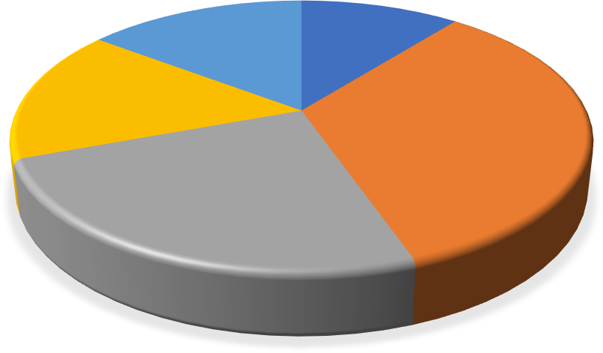
AGE OF RESPONDENTS
56yrs above
15%
18-25yrs
10%
46-55yrs
16%
26-35yrs
34%
36-45yrs
25%

Source: Researcher’s Fieldwork, 2025

The figure 4.2 clearly shows that majority of the respondents in the study area are still single. This is because those who affirm that they are single constitute 42% of the total respondents, married occupy 35% and other marital status such as those who are divorced, separated, widowed, clergy, etc make up the remaining 23% of the respondents who responded to this question.

Table 4.3: Marital Status of the respondents
marital status
70
60
50
40
30
20
10
0
Single
Married
Others
Frequency Percentage (%)

Source: Researcher’s Fieldwork, 2025

The table 4.4 shows the academic qualification of the respondents in the study area. From the table, it could be deduced that, 9% have First School Leaving Certificate (primary education), 22% have WAEC (secondary education), 8% are OND holders, 12% are NCE graduates, 11% are HND graduates, 33% are B.Sc. graduates, 3% have attained PhD qualification (Doctoral Degree) and 1% have other qualification (such as NABTECH, Certificate of Competency, ICAN, Midwifery, School of Health, etc) which were not mentioned in the table.
This implies that the population comprises of educated graduates from various institutions meaning that transport companies have adequate and qualified personnel as well as experienced drivers to effectively promote the company’s reputation through experienced and careful driving. This may be attributed to the reason why people use transport facilities provided in the study area.

Table 4.2: Academic Qualification

Qualification | Frequency | Percentage (%)
FSLC | 13 | 9
WAEC | 33 | 22
OND | 12 | 8
NCE | 18 | 12
HND | 17 | 11
B.Sc | 50 | 33
P.hD | 5 | 3
Others | 2 | 1
Total | 150 | 100
Source: Researcher’s Fieldwork, 2025

From the figure 4.4, majority of the respondents in the study area are civil servant (government workers). This is because civil servant occupies 25%, farmer occupy 13%, traders occupy 20%, students occupy 24% and other occupations occupy the remaining 18% of the total population.
It was observed that some of the transport workers in the study area were working and schooling (students) simultaneously. They were also government workers (civil servants). They also engage in farming and trading activities after work to sustain their family since the pay from the company could not be enough to sustain the family needs.
figure 4.4: Occupational Status
Civil Servant Student Traders Others Farmer
0%
0
10%
5
20%
10
40%
30%
15
50%
20
60%
25
70%
30
90%
80%
35
100%
40

Source: Researcher’s Fieldwork, 2025

The figure 4.5 shows the income level of the respondents in the study area. It could be deduced that 11% of the respondents fall below 18,000, 33% earn 19,000-35,000, 27% earn 36,000-45,000, 20% earn 46,000-65,000 and 9% earn above 65,000. This implies that the population comprise of low- and middle-income earners than the high-income earners. This is an indication that their

income rate which is on the low side may not be adequately enough to solve pressing needs. This is one of the major reasons why the respondents have to engage in other occupation.
Figure 4.5: Level of Income

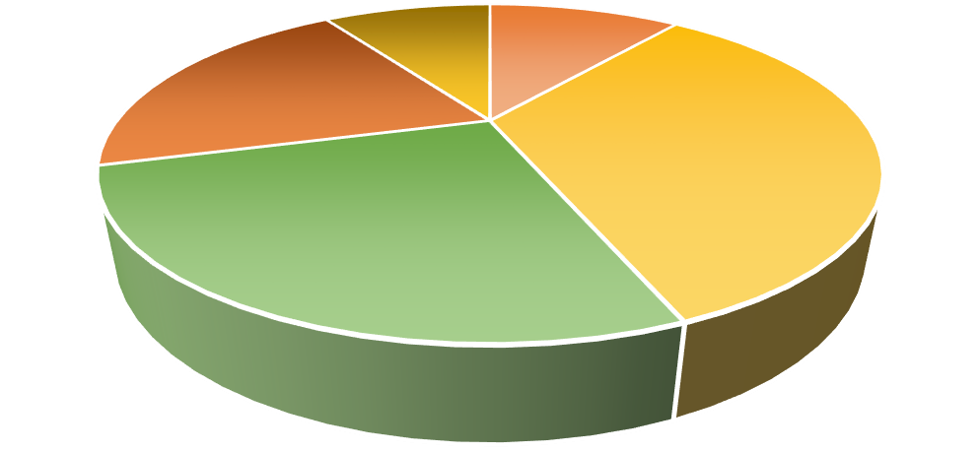
Frequency
65,000 abBoevleow 18,000
46,000-65,000
20%
9%
11%
19,000-35,000
33%
36,000-45,000
27%

Below 18,000

19,000-35,000

36,000-45,000

46,000-65,000

65,000 above

Source: Researcher’s Fieldwork, 2025

Functionality and Efficient of Private Transport Services in Ilorin City

The table 4.3 shows the working relationship between transport managers and passengers in transportation companies. It could be deduced that a cordial relationship exists between transport managers and passengers in transportation companies. This is because the respondents who attest that there is cordial relationship occupy 53% of the total population while those who said there is no cordial relationship make up the remaining 47% of the total population. This implies that there is a good rapport between transport managers and passengers in transportation companies.

Table 4.3: Working relationship between transport managers and passengers in study areas

Relationship | Frequency | Percentage (%)
Cordial | 79 | 53
Not Cordial | 71 | 47
Total | 150 | 100
Source: Fieldwork, 2025

Item (a) shows that about 65% of the respondents agreed that toilet facilities enhance functionality of transport services provided by private transport companies are efficient, 33% said it is inefficient while 2% said it is bad.
Item (b) shows that about 68% of the respondents agreed that well equipped buses which enhances quality transport services provided private transport companies are efficient, 15% said it is inefficient while 17% said it is bad.
Item (c) shows that about 35% of the respondents agreed that vehicle maintenance facilities which enhances quality of transport services provided private transport companies are efficient, 32% said it is inefficient while 33% said it is bad.
Item (d) shows that about 47% of the respondents agreed that speed limit/maintenance enhances efficient of transport services provided by private transport companies are efficient, 26% said it is inefficient while 27% said it is bad.

Item (e) shows that about 68% of the respondents agreed that fleet of buses which enhances quality of transport services provided private transport companies are efficient, 15% said it is inefficient while 17% said it is bad.
Item (f) shows about 35% of the respondents agreed that trained/qualified personal which enhances efficient transport services provided private transport companies are efficient, 32% said it is inefficient while 33% said it is bad.
Item (g) shows that about 47% of the respondents agreed that experience (driver) enhances quality of transport services provided by public and private transport companies are efficient, 26% said it is inefficient while 27% said it is bad. It could be deduced that their inadequate transport facilities provided in Ilorin City, Kwara State.
Table 4.5: Available private transport services/facilities provided in the study areas

S/N | Available Facilities | Efficient | Inefficient | Bad
a | Toilet facilities | 98 (65%) | 49 (33%) | 3 (2%)
b | Well-equipped buses | 102 (68%) | 22 (15%) | 26 (17%)
c | Vehicle maintenance | 52 (35%) | 48 (32%) | 50 (33%)
d | Speed limit/ maintenance | 70 (47%) | 39 (26%) | 41 (27%)

e | Fleet of buses  26 (17%) | 102 (68%) | 22 (15%) | 26 (17%)
f | Trained/qualified personnel | 52 (35%) | 48 (32%) | 50 (33%)
g | Experienced | 70 (47%) | 39 (26%) | 41 (27%)
Source: Fieldwork, 2025

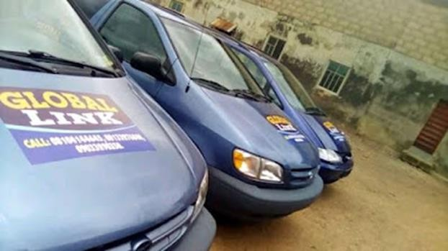

Plate 1: The available space buses at Global links private transport company in Ilorin Source: Fieldwork, 2025

Item (a) in table 4.6 above shows that 65% of the respondents agreed that driver’s skill is very good, 3% said good, 21% said satisfactory, and 10% said poor. Item (b) shows that 29% of the respondents indicated that drivers experience is very good, 25% said good, 23% said satisfactory, and 22% said poor. Item (c) shows that 39% of the respondents indicated that driver’s rapport with

passengers is very good, 22% said good, 19% said satisfactory, and 22% said poor. Item (d) shows that 38% of the respondents indicated that drivers speed limit is very good, 24% said good, 65% said satisfactory, and 32% said poor. Item (e) shows that 15% of the respondents indicated that driver’s concentration is very good, 3% said good, 25% said satisfactory, and 21% said poor. Item
(f) shows that 35% of the respondents indicated that drivers’ adherences to road signs and regulation is very good, 17% said good, 25% said satisfactory, and 23% poor.
Table 4.6: Assessment of driver’s ability and experiences by respondents

S/N | Options | Very Good | Good | Satisfactory | Poor
a. | Driver’s skills | 98  (65%) | 5  (3%) | 32  (21%) | 15  (10%)
b. | Driver’s experience | 44  (29%) | 38 (25%) | 35  (23%) | 30  (22%)
c. | Driver’s rapport with passengers | 59  (39%) | 33 (22%) | 28  (19%) | 33  (22%)
d. | Driver’s speed limit | 38  (25%) | 36 (24%) | 28  (19%) | 48  (32%)

e | Driver’s  concentration | 15  (10%) | 5  (3%) | 98  (65%) | 32  (21%)
.  f. | Driver’s adherence to road signs and regulation | 52  (35%) | 25 (17%) | 38  (25%) | 35  (23%)
Source: Fieldwork, 2025

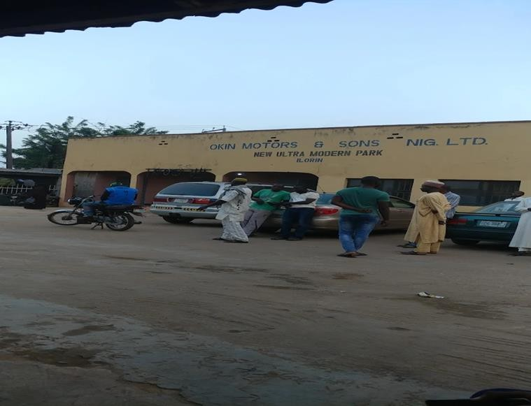

Plate 2: Assessment of driver’s ability and experiences at okin motors and sons in Ilorin Source: Fieldwork, 2025
The table 4.7 reveals that the sole aim of establishing urban transport system is not to make profit but to assist the poor masses who find it difficult to access transportation services provided by the private sector. This is because those who were of the view that the main goal of the company is to
assist the poor masses occupy a larger proportion (37%) of the total population while those who

affirm that the main aim is to provide transportation services not necessarily at profit follows respectively. It is important to note here that about 31% of the respondents still hold the view that the company was set up to maximize profit.

Table 4.7: Goal of Private Transport System of Respondents

From the figure 4.6. 29% of the respondents said the relationship between the transport managers and passengers has made the company more productive, 19% said it has no effect on the company, 28% said it makes the company less productive and 25% don’t know about the effect of their relationship on the company’s productivity. This means the relationship between the transport managers and passengers has been very positive and has made the company productive due to increased patronage
Table 4.6: How does the relationship between transport managers and passengers affect the transportation industries?






Frequency Percentage (%)
To assist the poor
masses
To provide
transportation service not necessarily at profit
To make the
maximum profit possible
30
20
10
0
32
31
37
40
48
47
50
55
60

Source: Fieldwork, 2025

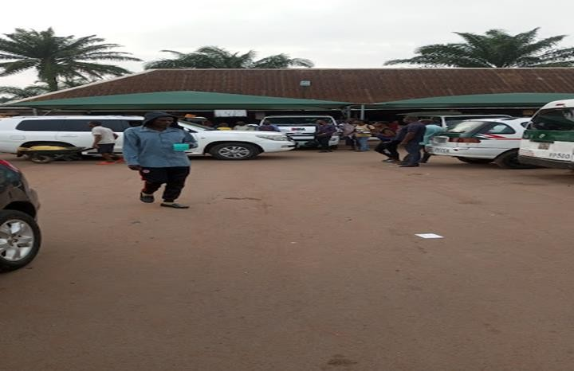

Plate 3: showing passenger’s interacting with management at peace mass transit in Ilorin Source: Fieldwork, 2025

From the table 4.7 above, 68% of the respondents agreed that drivers travel with manifest while 33% do not. About 71% of the respondents agreed that vehicles are properly checked before movement while 29% disagreed. About 92% of the respondents agreed that private transport services are provided in urban areas than rural areas while 9% did not agree. About 87% agreed that government/private individuals have played active role in transport management while 14% did not agree. About 66% of the respondents agreed that road transport management has significant impact on urban economy while 34% disagreed. About 79% of the respondents agreed that road transport management plays a key role in movement of goods and services while 21% did not agree.
From the table 4.12 above, 68% of the respondents agreed that transport companies have adequate modern technology and infrastructure to the satisfaction of passengers, and road users while 33% do not. About 71% of the respondents agreed that quality urban transport services provided in the

study areas serve as a source of employment while 29% disagreed. About 87% agreed that transport companies have well trained and efficient staff while 14% did not agree. About 92% of the respondents agreed that transportation has played a key role in urban development while 8% disagreed.
Table 4.7: Extent to which private transport services contribute of respondents

S/N | Options | Yes | % | No | %
a. | Drivers travel with manifest | 135 | 68 | 65 | 33
b. | Vehicles are properly checked before movement | 142 | 71 | 58 | 29
c. | Quality urban transport services are provided in urban areas than rural areas | 183 | 92 | 17 | 9
d. | Government/private individuals has played active role in transport management | 173 | 87 | 27 | 14
e. | Road transport management has significant impact on urban economy | 131 | 66 | 69 | 35
f. | Road transport management plays a key role in movement of goods and services | 158 | 79 | 42 | 21
g. | Transport companies have adequate modern technology and infrastructure to the satisfaction of passengers, and road users. | 135 | 68 | 65 | 33

h. | Quality private transport services provided in the area serve as a source of employment | 142 | 71 | 58 | 29
i. | Transport companies has well trained and efficient staff. | 183 | 92 | 17 | 9
j. | Transportation has played a key role in urban development. | 173 | 87 | 27 | 14
Source: Fieldwork, 2025

From the figure 4.7 27% of the respondents were of the view that the company enlighten the passengers on the need to always adhere to the slogan “safety first”. The company also educate the passengers on first aid measures before embarking on any journey. Though this is usually done once in a while, it has proven to be very effective to the company. About 27% of the respondents mentioned that the company advice passengers to always put on seat belt, 31% said the company sanction careless driver, 10% said the company management report cases of accident to the Nigeria Police Force (NPF) and the Federal Road Safety Commission (FRSC) and only 5% mentioned other safety measures adopted by the company to promote the growth of the company.

Figure 4.7: Safety Measures the enterprise gives
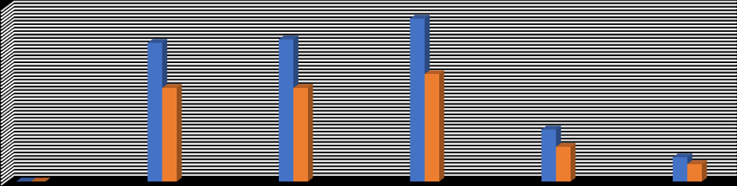
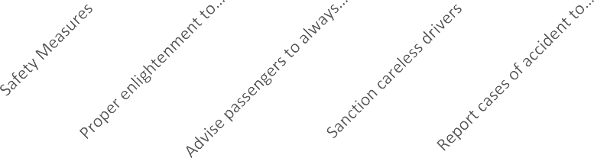


50
45
40
35
30
25
20
15
10
5
0

Series1 Series2 Series3

Source: Fieldwork, 2025

Item (a) shows that 38% of the respondents indicated that Finance/lack of capital as the major problems facing quality urban services is very severe, 24% said severe, 65% said mild, and 32% not affected.
Item (b) shows that 15% of the respondents indicated that mismanagement of fund as a major problem facing quality urban transport services is very severe way, 3% said severe, 25% said mild, and 21% not affected.
Item (c) shows that 35% of the respondents indicated that bad leadership as a major problem facing quality urban transport services is very severe, 17% said severe, 25% said mild, and 23% not affected.

Item (d) shows that 3% of the respondents indicated that poor road network as a major problem facing urban transport services is very severe, 8% said severe, 65% said mild, and 23% not affected.
Item (e) shows that 33% of the respondents indicated that poor communication as a major problem facing urban transport services is very severe, 17% said severe, 16% said mild, and 35% not affected.
Item (f) shows that 58% of the respondents indicated that poor vehicle maintenance as a major problem facing urban transport services is very severe, 8% said severe, 15% said mild, and 18% not affected.
From the above statistical analysis, it could be deduced that problems of urban transportation which pose serious constraints to quality urban transport delivery abound in Ilorin City, Kwara State. The following remedies stated in the next figure below were suggested to address the aforementioned transport problems.
Table 4.8: Problems of private transport services in the study areas

S/N | Options | Very Severe | Severe | Mild | Not affected
a. | Finance/lack of capital | 38  (25%) | 36 (24%) | 28  (19%) | 48  (32%)

b. | Mismanagement of fund | 15  (10%) | 5  (3%) | 98  (65%) | 32  (21%)
c. | Bad leadership | 52  (35%) | 25 (17%) | 38  (25%) | 35  (23%)
d. | Poor road network | 5  (3%) | 12  (8%) | 98  (65%) | 35  (23%)
e. | Poor communication | 49 (33%) | 25 (17%) | 24  (16%) | 52  (35%)
f. | Poor vehicle maintenance | 87  (58%) | 13  (8%) | 23  (15%) | 27  (18%)
Source: Fieldwork, 2025

From the figure 4.8 shows, 13% of the respondents suggested that the company should employ more qualified personnel to assist the already existing staff as the workload is too much for the company workers, 10% suggested that the company should train their staff for the future task ahead, 18% suggested that the company should organize leadership training to acquaint the management of the company with managerial skill, 14% suggested provision of adequate capital by the government, 35% suggested that the company should create awareness and enlighten the customers on the need to patronize private owned transportation company, 8% suggested that

proper maintenance and repair of the vehicle should be done regularly to keep the vehicles balance and fit for any journey and 2% mentioned other ways to solve the problems.
Figure 4.8: Remedies to solve the problems facing the company of respondents
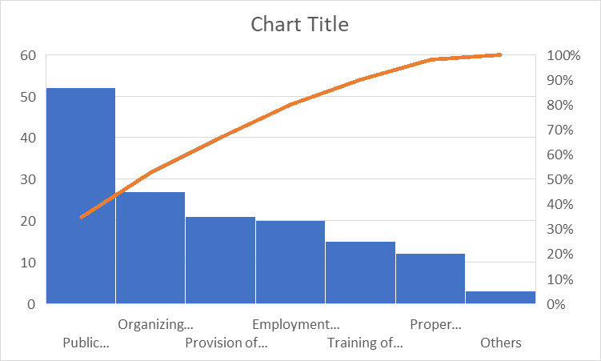

Source: Fieldwork, 2025

CHAPTER FIVE

SUMMARY OF FINDINGS, CONCLUSION AND RECOMMENDATION

  - SUMMARY OF FINDINGS

The researcher arrived at the following findings which include:

Road transportation management plays important role in the movement of goods and services. In recognition of this, intangible data collected on the role of transportation movement on the movement of goods and services show that transportation in any economy is a sector that cannot be over emphasized. The researcher discovered that transportation management plays a vital or major role in the movement of goods and services. This means that the mobility of people and material especially in the present days, is one of the greatest needs that have to be adequately satisfied in our society and economy at large.
Secondly, commuters always express dissatisfaction when there is any major breakdown of vehicle when they are on business appointment.
Thirdly, most commuters are to some extent satisfied when they cannot reach their destination as required. This could be because they understand that the delay may not directly come from the driver and the company management. It could be due to traffic induced problems and vehicular obstruction. Though, some still express dissatisfaction of not meeting up with business or other relevant appointment.
Fourthly, commuters are always not comfortable and skeptical when drivers drive at very high speed. This is one of the major reasons of fatal accident on our highways.

Finally, most private transportation companies lack modern infrastructure such road and road signs and facilities such control computer and air conditional in their organization to take good care of the customers.
most private transportation companies in the study areas did not upgrade the existing road infrastructure and construct more urban link (expansion of the road) roads so as to reduce the waiting time at the bus terminal to the barest minimum in Ilorin City. Enough Public enlightenment was not carried out on aspiring passengers on the tolerance while on the queue.
The private transportation companies within the study area should join the state government in provision of buses for inter-urban transport services so as to increase bus service frequency, then, the subsidized enterprises who have proved, beyond reasonable doubt that they can provide bus services. This will encourage private bus enterprise operators to ply more routes in the city as may be directed by the governments. Major areas of the study were not decongested by relocating some facilities such as markets, motor parks, offices and the like to the city peripheries to increase economic and social activities there which will generate more demand for bus.
The. city problems need city solutions and foreign practitioners are not best placed to understand local needs. A far better way of addressing these problems is to invest in the local research capacity needed to develop appropriate, innovative solutions required to solve local problems however, any investment in research must be matched by a local commitment to sustaining a research capability and must also include creating an environment that will attract and retain skilled professionals with an interest in research. Again, O’Neill, (2005), opined that governments in the developed world provide financial support to developing countries with the aim of helping them achieve the ultimate goal of economic self-sufficiency so that these nations can play a full part in world economic and trade activities rather than being perpetual recipients of aid.

However, over 50 years after achieving independence, Nigeria like many developing nations still rely on developed nations to conduct the research required to solve their problems in the transport sector. The provision of the relatively small amount of funding needed for researching solutions would appear to be a sound investment for most developing countries. Research effort is needed in most of the areas related to transport for the provision of safe and sustainable access and improved mobility for poor communities in developing countries. Yet, despite the large benefits from research in the transport sector as in the examples given in this paper, investment in transport research in woefully small and even non-existent in many developing counties. The current situation in which foreign entities carry out transport research for developing countries, even if it is in partnership, is neither sustainable in the longer term nor is it in the recipient country’s best interests (Parkash, 2008).
It is in the light of these that the paper aims at evaluating the benefits from investment in research in the private transport sector, describes programs designed to facilitate innovation and research in the sector in developing countries, identifies the research need and suggests ways in which donors and recipient country organizations can assist in establishing a framework for carrying out research. Similarly, all these will be assessed using empirical cases where appropriate, therein, conclusion will be drawn.

CONCLUSION

The roles of transportation in the study area cannot be overemphasized, it has enhanced the total functionality of all the activities of man, thus, it has contributed to economic development of the study area and also create employment. However, myriads of problems are affecting road private transportation in the area and this has resulted in various problems including congestion, accidents, among others. It is believed that if the below recommendations are put in place, it will help to enhance road circulation in the area.
  - RECOMMENDATIONS

Based on the research findings, the following recommendations/suggestions were made;

    - Knowing that road transportation is referred to as the engine of the economy, the private transportation management should get in more modern facilities for easy road transportation services and also maintain the equipment available to them.
    - The management of private transportation companies should make sure that the transport vehicles go through routine maintenance to reduce the rate of breakdown of transportation vehicle on the highway.
    - The management should as well computerize the company as to monitor the speed limits on the driver. This will help to reduce the rate of road accidents and make the company to have goodwill.
    - Traffic control device such as traffic light roads signs marking etc. should be provided in Ilorin City, and most especially at strategic locations where the identified traffic problem is more severe. These will help to curb and bring these problems under control.

    - Rehabilitation of existing parking facilities: the existing parking facilities should be rehabilitated to withstand the present volume of vehicles that ply the study area and also more off-street parking spaces should be provided to allow for vehicular parking using billing method.
    - Road’s rehabilitation is also method of the engineering approach. Traffic problems especially congestion can be minimized or eradicated in the study area of Ilorin City Road are through the rehabilitation method. The repair of roads especially in some part of Ilorin City roads with numerous pot holes will help to solve the problem of congestion.
    - Channelization of roads to enhance easy movement of vehicle, motorcycle and bicycle.

    - The management of private transportation companies should make sure that the transport vehicles go through routine maintenance to reduce the rate of breakdown of transportation vehicle on the highway.
    - Also, the management as well computerizes the company as to monitor the speed limits on the driver. This will help to reduce the rate of road accidents and make the company to have goodwill.
    - Finally, the private transportation management should also provide modern infrastructure and facilities to take adequate care of the commuters in Ilorin metropolis.

REFERENCES

Adesanya, O. (2011). Mass transportation and city sustainability, paper presented at the Nigerian Institute of Town Planners (NITP) and Town Planners Registration Council of Nigeria (TOPREC) Mandatory Continuing Professional Development Programme (MCPDP), 2011edition, Ibadan, Nigeria.
Ahukannah, L.I., Ndinaechi, G.I., &Arukwu, O.N. (2003). Commerce for Senior Secondary Schools. Onitsha:Africana-First Publishers Limited.
Akar, G., Flynn, C., Namgung, M. (2012). Understanding travel choices and links to TDM: a case study of the Ohio State University, Proceedings of the 91st Annual Meeting of the Transportation Research Board, Washington, DC.
Al-Fawzan, S. (2004). Evaluation and Improving Traffic at the Entrances of KSU Campus During Peak Hours.Journal of King Saud University – Architecture and Planning, 16.
Al-Hasan A.Z., Momoh S. and Jimah M.S. (2013). Campus Bus-Shuttles Services in Auchi Polytechnic: Analysis of Patronage Factors, Journal of Environmental Management and Safety, Vol. 4, No. 2, 51 – 59
Adefolalu, A.A. (2007) Traffic congestion in the city of Lagos. Nigerian Geography Journal, vol.

20, No.2 Pp 123-144.

Ademiluyi, I. and Gbadamosi, K. (2004) Geography of movement and mobility crisis in Nigeria.

International of Journal of Environment and Development. Vol. 7, No. 1. Pp. 22-29.

Adeniji.K. (2013) “Urban Development and Public Transport in Nigeria”. Third world planning review vol. 5 No. 4, pp 383-394.

Adeniji, K. (2010) Transport Challenges in Nigeria in the next two decades. Monograph of Nigerian Institute of Social and Economic Research (NISER), Transport studies unit.
Akpala, A. (2010). Management: An Introduction to Management and Nigeria Perspective. Enugu: Sunshine Lithographic Press.
Akpovi, S.U. (2005) “Multidimensional waste management strategies for urban Nigeria”: In Onokerhoraye, A.G. and Omuta G.E.D. (eds), Perspectives on Development. Centre for population
and Environmental Development (CPED), Benin City. Pp. 378-398.

Angenent, S., Haker, S. and Tannenbaum, A. (2013). Minimizing flows for the Monge- Kantorovich problem. SIAM J. Math. Analysis, vol. 35, Pp. 61-97.
Ashenfelter, O. and Card, D. (2015). Using the Longitudinal Structure of Earnings to Estimate the Effect of Training Programs. The Review of Economics and Statistics, Vol. 67, No. 4. pp. 648-660.
Bearse, P.M. (2016). Community, Youth Crime and Deterrence: A Quantitative Theoretical Analysis., Unpublished manuscript, University of North Carolina at Greensboro.
Bennett, C. (2008). Orientation to Work and Organization Analysis. Journal of Management studies, Vol. 15(2) Pp. 21-27.
Brinkhoff, F.T. (2010). City Population http://www.city population.de.

Clarke, R. (2016): Preventing Mass Transit Crime. Crime Prevention Studies Vol. 6: Monsey, NY: Willow Tree Press
David A. and Makafui R.A. (2014): The Role of Transportation in Achieving Customer Satisfaction in a Private Distribution Company, Munich, GRIN Verlag.

Delta State Ministry of transport (2015) workers statistics Achieved from the office of statistics and records. Delta State Urban Mass Transit scheme, Inadequate, Warri, Delta State.
Dimitrious H.T. (2016) “Transports and Third World City Development In Transportation Planning For Third World Cities”.
Donnel, C. (2011). Managerial Decision. New York: McGraw Hill Inc.

Efe, S.I. (2002a)” Urban Warming in Nigeria cities: The case of Warri metropolis”. African Journal of Environmental studies. Vol. 3 (1 and 2) pp 160-168.
Ehrlich, I. (2017). Road maintenance in Sub-Saharan Africa. Journal of Transportation Management; Vol. 65, pp. 397-421.
Ehrlich, I. (2017). The Deterrent Effect of Capital Punishment: A Question of Life and Death.

American Economic Review 65:397-421.

Ejiofor, P. I. (2010). Managing Government owned companies. Onitsha: Fourth Dimension Publishers.
Ejiofor, P. I. (2015). Foundation of Business Administration. Onitsha: African Feb Publishers.

Ejiofor, P. N (2014). Identifying Sources of Management Motivators in Nigeria: Managing the Nigerian Workers. Ikeja: Longman Nig. Ltd.
Ewhrudjakpor, C. Atubi, A. and Odemerho, F. (2006) Statistics for social investigation.

FBS (2007): Federal Bureau of Statistics, Population Statistical Bulletin, Census Figures, Federal Government of Nigeria Official Gazette, Abuja.
Federal Bureau of Statistics (2007). Population Statistics. available at www.nigeriansta.gov.ng.

Filani, M.O (2005) Rail Transportation as a mechanism for sustainable development of a nation.

Ago-Iwoye Journal of social and behavioural sciences. Vol.1 No1, Pp 4-10.

Freeman, S., Grogger, J. and J. Sonstelie (2016), Transport and economic development: a tool for urban development. Journal of Urban Economics, Vol. 40, pp. 216-231
Gbujie, P.O (2003). Evaluation of Implementation of Abuja master plan. A case study of road transport infrastructure unpublished M. Sc Thesis, school of professional studies, Nigerian institute of transport technology (NITT) Zaria.
Glaeser, E.L. Sacerdote, B. and Scheinkman, J. (2016). Road transportation network in Nigeria: Roadmap for economic development. Quarterly Journal of Economics; Vol. 111, pp. 508- 548.
Herrmann, C. (2017). The growth of road transport in developing countries of the world.

Unpublished PhD Thesis: New York: The City University of New York.

Hornby, A.S (2010) Oxford Advanced Leaner’s Dictionary of current English Oxford. Oxford University Press.
Ijewere, A. (2000). Business Management. Benin City: Nigeria Floreat System Publishers. Ineigbenebor, A. U. (2005) Introduction to Business. Benin City: Uri Publishing Ltd.
Jack, W. (2016): The Effect of Public Transportation on Crime: An Analysis of Durham’s Bull City Connector
John P; Nisha, K; Neha, M. and Neenu, I. (2005) Urban Transport crisis in India. Transport policy, vol. 12 No 3: 185-198.

Kaka, C.E, Awharitoma, A.O., and Okonji, J.N. (2002). Gastrointestinal Parasites of School Children in Benin City, Nigeria. Iranian Journal of Public Health; Vol. 29(1-4), pp. 1-12.
Kantorovich, L. (2012). On the translocation of masses. C.R. (Doklady) Acad. Sci. URSS (N.S.), 37:199–201.
Khalid A.S. Al-Khateeb, Jaiz A.Y. Johari and Wajdi F. Al-Khateeb (2008). "Dynamic Traffic Light Sequence, Science Publications". Journal of Computer Science 4 (7): 517–524.
Koontz, H. (2009). Motivation to Work. New York: John Willey and Sons Publisher.

Kootz, H. and Donnel C. (2016). A System and Contingency Analysis of Managerial Functions.

Kogatosha: Mc-Graw Hill Book Co. Inc. 6th Ed.

Mohan, P., Venkata N. Padmanabhan, P. and Ramachandran R.N. (2008): Rich monitoring of road and traffic conditions using mobile smartphones. Proceedings of the 6th ACM conference on Embedded network sensor systems.
Monahan, T. (2007). ""War Rooms" of the Street: Surveillance Practices in Transportation Control Centres" (PDF). The Communication Review 10 (4): 367–389.
National Population Commission (NPC) [Nigeria] and ORC Macro, (2009). Nigeria Demographic and Health Survey 2008. Abuja, Nigeria: National Population Commission and ORC Macro.
National Population Commission (NPC) [Nigeria], (2006). National policy on population for sustainable development. Abuja, Nigeria: National Population Commission.

Newton, A.D. (2017) Crime on Public Transport. In: Encyclopedia of Criminology and Criminal Justice. Springer, London, pp. 709-720. Nigerian National Population Commission (NPC) Report (2006).
NISER Review of Nigerian Development (2001) The state in Nigeria development (NISER), Ibadan.
NPC (2006). National Population Commission. 2006 Census Figures. Federal Government Official Gazette, Abuja-Nigeria.
Nwakamma, N. (2006) Modernizing Nigeria Railway. New Nigerian newspaper, Thursday, August 10, 2006.
Obi, R.U. (1994). Urban Agriculture in Benin City, Nigeria: A study of small-scale crop farmers.

Tri log; Vol. 4(43), pp. 40-43.

Odeleye, J.A. (2004) “Rail option in urban transportation” in 1. Vandu-chiko 10, A.A Ogusanya and A.G Sumalia (ed) perspectives on urban transportation in Nigeria. Published by Nigeria institute of transport (NITT) Zaria. Pp. 156-170.
Odeleye, J.A. (2004) “Rail option in urban transportation” in 1. Vandu-chiko 10, A.A Ogusanya and A.G Sumalia (ed) perspectives on urban transportation in Nigeria. Published by Nigeria institute of transport (NITT) Zaria. Pp. 156-170.
Odufawa, B.O. (2003) Transport poverty and the role of urban government in Nigeria. African Journal social and policy studies, vol 3. No1 and 2, Pp. 144-149.
Odufawa, B.O. (2006) Enhancing mobility of the elderly in sub-saharan African Cites: Through improved public transportation. IATSS research vol. 30 No 1, Pp. 6066.

Odufawa, B.O; Ademiluy, L.A and Adedeji (2008) Transport poverty and deviant driving behaviours in Nigerian intermediate cities. Ogun state university, Nigeria.
Ogunbodede, E.F. (2008) “Urban Road transportation in Nigeria from 1960 to 2006: problems, prospect and challenges. Ethiopian Journal of Environmental studies and Management, Vol. 1. No1. Pp. 7-18.
Ogunsanya. A.A (2002) Maker, and Breakers of cities 59th Inaugural lecture, university of Ilorin, Nigeria.
Ogunsanya. A.A (2003) “Transport policy and implementation problems in Nigeria” MIMEO.

Ojabo, L. (2007) FG and Road Construction since 1999. New Nigerian Weekly.

Okpala. D.C.I. (2011) “Urban traffic management in Nigeria cities-The necessity of mass transit priorities in transportation”. In Nigerian National Development. Proceeding of a national “Overland Transport” in Oguntoyibo, J.S. O.O. Areola and M, Filani (ed), OP. CIT.
Olakunle, K.O. (2016). Transportation Management. Enugu: Giovanni Publishers.

Olakunori, K. (2006). Business and Government Policy. New York: McGraw Hill Book Company.
Omuta, G.E.D. (2006). Environmental Planning, Administration Management in Nigerian Cities. The example of Benin City, Bendel State. Public Administration and Development; Vol. 8(1), pp. 1-44.
Onakomaiya, S.O. (2002) “Transport research and capacity Building in Nigeria: Ebenezer by a poor Teacher Turned Professor” valedictory lecture at Olabisi Onabanjo University, Ago- Iwoye.

Oni S.I (2002) “Metropolization of Urban Transport Development. Example of Lagos, Nigeria”. Department of Geography, University of Lagos, Akoka, Lagos, Nigeria Posted by Madayese Felix Jimoh.
Oni, S.I (2000) “Education and Training for Road Traffic Safety in Nigeria” In Proceedings of the International Conference CODATU IX, Mexico City 11-14, April, 2000. Edited by Oscar Diaz Gonzalez Palomas and Christian Jamet. Pp. 913-918.
Oyesiku, O. and Odufuwa, B.O. (2002) Gender perspective in travel behavior of motorcycle passenger in Nigeria Intermediate cities. In CODATUX Conference on urban for All Zeithinger, Netherlands.
Oyesiku, O.O. (2002). From womb to Tomb. 24th Inaugural Lecture, Olabisi Onabanjor University, Ago-Iwoyo.
Plano, S.L. (2017) “Transit-Generated Crime: Perception Versus Reality–A Socio-geographic Study of Neighborhoods Adjacent to Section B of Baltimore Metro.” Transportation Research Record 1402.
Rachev A., Svetlozar T., and Ludger R. (2008): Mass Transportation Problems: Theory.

Springer. Vol. 1. Pp,. 5-9.

Richard, I., and Ignatius, S. (2014) “Animal Transport in the early Indigenous market Economy of Northern Nigeria” International Journal of humanities social sciences and education (IJHSSE) Vol. 1. Issue 7, Pp. 148-156.
Robert, B.U. (2009). Business and Government Policy. New York: McGraw Hill Book Company.

Sah, E.C. and Okojie, O.H. (2007). Environmental Sanitation in an urban Community in Benin City, Edo State, Nigeria. Postgraduate Medical Journal; Vol. 14(1), pp. 5-12.
Sube, K.S. (2012) Selected Topics on Area Studies in Geography Unpublished Notes. Bamenda.

Sumalia. A.G. (2012). Sustainable Transportation Management for Federal Capital Territory (FCT) paper presented at a one-day retreat for staff of federal capital territory (FCT) Transportation secretariat, Abuja. 4th, August, 2012).
Tarnoff, P.J., Bullock, D.M, Young A., Stanley E, (2009) "Continuing Evolution of Travel Time Data Information Collection and Processing", Transportation Research Board Annual Meeting 2009 Paper #09-2030. TRB 88th Annual Meeting Compendium of Papers DVD.
Tony, A.I. (2000). Business Management. Benin City: Nigeria. Floreat System Publishers.

Tyagi, V., Kalyanaraman, S., Krishnapuram, R. (2012). "Vehicular Traffic Density State Estimation Based on Cumulative Road Acoustics". IEEE Transactions on Intelligent Transportation Systems. .
UN Habitat. (2013). Planning and design for Sustainable Urban Mobility: Global Report on Human Settlement2013. UN Habitat: Washington.
University of BATH. (2003). University of BATH Transport Strategy. University of BATH: BATH, UK.
Vewere T.A (2000). Business management. Benin city; Flovent system Publishers.

World Bank (2002). Cites on the move. A world Bank Urban Transport strategy review. The world bank Washington D.C.

Wang H, W (2015). Transport & Infrastructure Planning – Literature review, https://www.researchgate.net/publication/303753051
Whalen et al. (2013). Sustainable rural community development’, Planning, Practice & Research, vol. 25, no. 1, pp. 1-23. 6
Zalkow, D., & Renkens, S. (2010). Sustainable Transportation Planning at an Urban University. Association forthe Advancement of Sustainability in Higher Education: 2010 Conference Proceedings
Zheng, J., Scott, M., Rodriguez, M., Sierzchula, D., Guo, J. and Adams, T. (2009). Carsharing in a University Community –AssessingPotential Demand and Distinct Market Characteristics. Transportation Research Record: Journal of the Transportation Research Board,2110, 18-26.
Zhou, J. (2012). Sustainable commute in a car-dominant city: factors affecting alternative mode choices among university students, Transportation Research Part A: Policy and Practice, 46, 7 1013-1029.

APPENDIX

RESEARCH QUESTIONNAIRE

DEPARTMENT OF URBAN AND REGIONAL PLANNING, SCHOOL OF ENVIRONMENTAL STUDIES, KWARA STATE POLYTECHNIC, ILORIN.
Dear Sir/Madam,

A REQUEST TO COMPLETE QUESTIONNAIRE

I am undertaking the Study of “assessment of the quality of urban transport services in Ilorin City, Kwara State”. This question is a means of obtaining information from you concerning your present position and personal perceptions of the availability of these data. Answers to the question should be as much as possible reflect your individual opinion and situation.
In answering these questions, your name is not necessarily required. I am interested only on the data. All information obtained will be treated in confidence and utilized purely for academic purpose.
Thanks for your anticipation co-operation.

Section A:

Bio-Data (Personal Information of Respondent)

Instruction: Please tick [√] as a response to any option best in your opinion.

- Name of Residence…………………………………………

- Sex: Male [ ] Female [ ]

- Age: 18-25 [ ]26-35 [ ]36-45 [ ] 46-55 [ ]56 above [ ]

- Marital status: Single [ ] Married [ ] Others [ ]

- Academic qualification: FSLC [ ] WAEC [ ] OND [ ] NCE [ ] HND [ ] B.SC [ ] P.hD [ ] Others [ ]
- Occupational status: Farmer [ ] Trader [ ] Student [ ] Civil Servant [ ] Others (specify)…………………………..
- Level of Income: Below 18,000 [ ] 19,000-35,000 [ ] 36,000-45,000 [ ] 46,000-65,000 [ ] 65,000

above [ ]

Section B: Assessment of the quality of urban transport services in Ilorin City, Kwara State.

- What working relationship exists between transport managers and passengers in transportation companies? Cordial [ ] Not Cordial [ ]
- What is your assessment of the quality of urban transport services/facilities provided private transport companies?

S/N | Available Facilities | Efficient | Inefficient | Bad
a | Toilet facilities
b | Well-equipped buses
c | Vehicle maintenance

d | Speed limit/ maintenance
e | Fleet of buses  26 (17%)
f | Trained/qualified personnel
g | Experienced

- What is your assessment on the driver’s ability?

S/N | Options | Very Good | Good | Satisfactory | Poor
a. | Driver’s skills
b. | Driver’s experience

c. | Driver’s rapport with passengers
d. | Driver’s speed limit
e | Driver’s  concentration
.  f. | Driver’s adherence to road signs and regulation

- Which of these objectives do you consider to be main goal of the government/private individuals towards urban transport system? To make the maximum profit possible [ ] To provide transportation service not necessarily at profit [ ] To assist the poor masses [ ]

- How does the relationship between the transport managers and passengers of various transport companies affect urban transport services? It makes more productive [ ] It has no effect [ ] It makes less productive [ ] I don’t know [ ]
- Please indicate if you agree to the following or not

S/N | Options | Yes | % | No | %
a. | Drivers travel with manifest
b. | Vehicles are properly checked before movement
c. | Quality urban transport services are provided in urban areas than rural areas
d. | Government/private individuals has played active role in transport management
e. | Road transport management has significant impact on urban economy
f. | Road transport management plays a key role in movement of goods and services
g. | Transport companies have adequate modern technology and infrastructure to the satisfaction of passengers, and road users.
h. | Quality urban transport services provided in the area serve as a source of employment

i. | Transport companies has well trained and efficient staff.
j. | Transportation has played a key role in urban development.

Transportation has played a key role in urban development.

- What safety measures do transport companies give to commuters, road users, passengers and commuters?.....................................................
- What effect does the following transportation problems has in providing quality urban transport services in your area?

S/N | Options | Very Severe | Severe | Mild | Not affected
a. | Finance/lack of capital
b. | Mismanagement of fund

c. | Bad leadership
d. | Poor road network
e. | Poor communication
f. | Poor vehicle maintenance

- How will these problems be solved? i.……………………………………………………………………………… ii.……………………………………………………………………………… iii.…………………………………………………………………………… iv.……………………………………………………………………………

