A PROJECT REPORT
ON
ROUTE SURVEY MICHEAL IMODU AREA TO KANGU TOWARD OSHIN OLATUNJI AXIS.

PRESENTED BY
BABATUNDE SIDIKAT JOKOTOLA
HND/22/SGI/FT/113

SUBMITTED TO

DEPARTMENT OF SURVEYINGAND GEO-INFORMATIC, INSTITUTE OF ENVIRONMENTAL STUDIES (I.E.S), KWARA STATE POLYTECHNIC, ILORIN.

IN PARTIAL FULFILLMENT OF THE REQUIREMENTS FOR THE AWARD OF THE HIGHER NATIONAL DIPLOMA (HND) IN SURVEYING AND GEO-INFORMATIC.

JUNE, 2025

DECLARATION
I hereby conclude that I BABATUNDE SIDIKAT JOKOTOLA with matriculation number HND/22/SGI/FT/113 fully participated on this project and acquired more experience about facilities management of Part of Kwara State Polytechnic, Ilorin, Kwara State.

NAME OF STUDENT: I BABATUNDE SIDIKAT JOKOTOLA
STUDENT SIGNATURE:__________________________________
DATE:___________________________________________________

CERTIFICATION
I hereby certify that this project was carried out by I BABATUNDE SIDIKAT JOKOTOLA with Matriculation number HND/22/SGI/FT/113 under my supervision and the report was submitted on _____________________ day of _____________________________ 2025

________________________ _______________________
SURV. A.O AKINYEDE DATE
Project Supervisor

_________________________ ________________________
SUR. R.O AWOLEYE DATE
Project Coordinator

________________________ _________________________
MR. ABIMBOLA ISAU DATE
Head of Department

________________________ __________________________
External Examiner DATE

DEDICATION
This project is Dedicated to Almighty Allah, the victory giver and the best of mankind and my beloved parents MR. And MRS. BABATUNDE. May God continue to bless them and may they reap the fruit of their labor.

ACKNOWLEDGEMENTS
My profound gratitude goes to Almighty Allah for giving me the privilege, knowledge, wisdom, understanding, strength, mercies and divined enablement that see me through my project.
My appreciation goes to my humble and amiable supervisor SURV A.O. AKINYEDE who, despite his official engagements, created time to make valuable suggestions, corrections and advice. I pray that the presence of Allah will always be with him and his family (Amen).
My sincere gratitude also goes to my (H.OD) MR. ABIMBOLA ISAU and other lecturers at the Department of Surveying Geo-informatics (SURV. A.G AREMU, SUR. R.S ASONIBARE, SURV. R.O AWOLEYE, SURV. BANJI, SURV. AYUBA, SURV. DIRAN, SURV. KAZEEM, SUR. KABIRU), for nurturing me in my academic activities. May Almighty Allah continue to bless you all abundantly.
My appreciation also goes to my Wonderful Parent LATE CHIEF SAULI BABATUNDE AND MRS. BABATUNDE ADUNNI.
I am gratefully acknowledging the efforts and financial supports of my lovely Brother (MR. BANKOLE OLUSHOLA) and my Lovely Sister ( SEKINAT, NURAT,) Almighty Allah in His infinity mercy give them long life; and may they reap the fruit of their labour (Amen).

TABLE OF CONTENTS
TITLE PAGE i
DEDICATION ii
CERTIFICATION iii
ACKNOWLEDGEMENT v
TABLE OF CONTENTS vi-vii

ABSTRACT viii

CHAPTER ONE

1.0 INTRODUCTION

1.2. STATEMENT OF PROBLEM
1.3. AIM OF THE PROJECT

1.3.1 OBJECTIVES OF THE PROJECT
1.4. SCOPES OF THE PROJECT
1.5. PROJECT LOCATION
1.6 SPECIFICATION OF THE PROJECT

CHAPTER TWO

2.0 LITERATURE REVIEW

CHAPTER THREE

3.0. METHODOLOGY
3.1 PRELIMINARY PLANNING AND PREPARATION:

3.2. RECONNAISSAINCE SURVEY

3.3 OFFICE PLANNING
3.4. SELECTION OF THE EQUIPMENT AND SOFTWARE
3.4.1 HARDWARE USED
3.4.2 SOFTWARE USED
3.5. BENCH MARKS ESTABLISHMENT, CAPPING AND LABEL
3.6. INSTRUMENT TEST
3.6.1. COLLIMATION TEST
3.7 DATA ACQUISITION
3.7.1 IN-SITU CHECK
3.7.2 GEOMETRIC DATA ACQUISITION
3.7.3 TRAVERSE OF BM POINTS
3.7.4 DATA ACQUISITION
CHAPTER FOUR
4.0 DATA PROCESSING
4.1 DATA DOWNLOADING (CX- TOTAL STATION)
4.1.1 DOWNLOADING PROCEDURE
4.1.2 DOWNLOAD FROM SD CARD TO COMPUTER SYSTEM
4.2 DATA PROCESSING PROCEDURE
4.2.1 PLOTTING PROCEDURE IN CIVILCAD 2014
4.2.2 PROFILE / VERTICAL ALIGNMENT PLOTTING USING CIVILCAD
4.2.4 PLOTTING OF CROSS-SECTIONS USING CIVILCAD
4.2.5 GENERATING EARTHWORK TABLE USING CIVILCAD 2014
  - RESULT AND ANALYSIS
4.4 LINEAR ACCURACY
4.5 HEIGHT ACCURACY
4.6 PLAN PRODUCTION
    - HORIZONTAL ALIGNMENT PLAN
4.6.2 VERTICAL ALIGNMENT PLAN
    - CROSS SECTION PLAN
4.6.4 VOLUME OF EARTWORKS

  - PROJECT COSTING
CHAPTER FIVE
5.0. SUMMARY, CONCLUSION, PROBLEM ENCOUTER AND RECOMMENDATION
5.1 SUMMARY
5.2 CONCLUSION
5.3 PROBLEM ENCOUTER
5.4 RECOMMENDATION
REFERENCES

ABSTRACT
A route survey is a specialized land surveying process aimed at determining the most suitable path for linear infrastructure projects such as roads, railways, pipelines, and power lines. It involves a systematic collection and analysis of topographical, environmental, legal, and engineering data to establish the horizontal and vertical alignment of the proposed route. The survey process typically includes reconnaissance, preliminary, location, and construction surveys to ensure the route is feasible, cost-effective, and environmentally responsible. Route surveys provide critical information for planning, design, and construction phases, including terrain profiles, earthwork calculations, and identification of obstacles. By integrating modern surveying techniques and careful assessment of natural and man-made features, route surveys facilitate the development of infrastructure that balances technical requirements with environmental and legal considerations, thereby contributing to sustainable and efficient project execution.Unmanned Aerial Vehicle (UAV) are widely used in numerous field and the technology keeps growing. Generally, conventional method used in data collection for engineering work is tedious and requires a lot of manpower. This research focuses on the investigation of the suitability of UAV for route survey. Three stages involved: data collection, data processing and data analysis. By using Kama Beta, the data was collected. For data processing, Pix4D Mapper is used for point cloud and AutoCAD 2014 for the analysis stage. The result is mainly focused on extracting the road profile and test the point cloud data using Root Mean Square Error (RMSE). The result from both methods, conventional and UAV from the point cloud data using RMSE show only the small difference, with only 6.67% from total 60 points out of tolerance.

CHAPTER ONE

1.0 INTRODUCTION
Road is the most commonly used of all the means of transportation, and it made a crucial contribution to economic development and growth and bring important social benefits. Road transportation means transportation of goods and personnel from one place to the other on roads, which can also be seen as a route between destinations which provides access to employment, social, health and education services. Therefore, for the purpose of having a perfect road, an Engineering Survey is carried out which is the bedrock of any construction project. Engineering Survey is an important disciplinary field that serves construction projects which depicts road construction. This branch of Surveying entails the foundation of route construction projects that aids setting out of road networks. The term “Engineering surveying” can be described as a large scale survey operation carried out in order to provide special information for construction purposes. It involves measuring heights differences and angles on site either for the preparation of large scale plan or that engineering works can be located in their right position on the earth surface.(Barry Hawkes, 2013). As indicated from the definition of engineering surveying, survey operation are required for any construction of transportation facilities such as rail, road etc. therefore, route surveying is that part of engineering surveying required for the design and construction of transportation facilities. Therefore, (Mel Columcille Gerard Gibson 1995) stated that highways, railways, canals, tunnels, dams, pipelines and transmission lines are constructed works having linear shapes classified as routes. A unique system for expressing route geometry has developed that, once learned, can be applied without fail to this broad range of projects by all surveyors, designers and constructor. (Robert L.Gibson, 2000) definedroute survey as an aspect of engineering surveying which supplies data necessary to determine alignment, grading and earthwork quantities for the design and construction of various engineering projects such as roads, railways, pipelines, and utilities. Route surveys involve measuring and computing horizontal and vertical angles, elevations, and horizontal distance. The results of these surveys are used to prepare detailed plan and profile base maps of proposed road ways. In addition, the elevations determined in the survey serve as the basis for calculation of construction cut and fill quantities, and in determining road way banking.
It was narrated by (Vincent-Tao and El-Sheimy 2000) that the best way of acquiring data and information during the survey for the purpose of rehabilitation of a highway route could be done using mobile mapping system.
Engineering route design is a critical aspect of civil engineering that involves the planning and creation of transportation routes, including roads, railways, and pathways. This discipline integrates various engineering principles, geographic information systems (GIS), environmental considerations, and economic factors to develop efficient and safe transportation networks. The primary goal of route design is to optimize the movement of people and goods while minimizing environmental impact and construction costs. (Baker, S. 2016). The process of route design begins with a thorough analysis of the project area, including topography, land use, and existing infrastructure. Engineers utilize advanced software tools and modeling techniques to simulate different route options, assess their feasibility, and evaluate potential impacts. Key considerations in route design include alignment, gradient, curvature, and the integration of safety features. (Meyer, M. D., & Miller, E. J. 2001). Moreover, route design must comply with local, national, and international standards and regulations, ensuring that the constructed routes meet safety and operational requirements. Stakeholder engagement is also crucial, as it involves collaboration with government agencies, local communities, and environmental groups to address concerns and gather input. (Huang, H. 2014).In recent years, advancements in technology, such as drone surveying and automated design software, have revolutionized the field of route design, allowing for more precise planning and execution. As urbanization continues to rise and transportation demands increase, the importance of effective engineering route design becomes ever more critical in creating sustainable and efficient transportation systems. (Khan, M. A., & Kahn, M. A. 2018).
1.2. STATEMENT OF PROBLEM
It was found that road along Michea lImodu Street to Kangu Oshin, Kwara State needs further construction, and it was also found to be too narrow and needs to be expanded considering the volume of traffic plying the road. Rehabilitation of this road should be embarked upon in order to increase its carrying capacity, thereby increase the physical development and human activities along the road with other conveniences. Due to the necessary of the road rehabilitation, certain information about the road must be acquired which calls for route survey so as to get the base line data necessary for the road design.
1.3. AIM OF THE PROJECT
The aim of this project is to carry out the engineering route design from Micheal Imodu to Kongu toward OshinOlatunji. in other to produce both horizontal alignment, vertical alignment and cross section plans of the route. which will be used for construction phase of the road.

1.3.1 OBJECTIVES OF THE PROJECT
In other to achieve the mentioned aim, the objectives listed below was pursued:
- Design of the horizontal alignment plan which show the horizontal section of the route
- Esign of the vertical alignment plan which show the vertical sections of the route
- Design of the cross sectional area of the croute at interval of 25mete
- Production of details plan showing thee horizontal and all the existing features closed to the route .
- Computing the volume of the earth work of the route from the section include ditches
- Report writing
- Project costing for the engineering route
1.4. SCOPES OF THE PROJECT
The scopes of project are the activities carried out which include the following:
- Reconnaissance survey of the project site.
- Traverse of the horizontal section
- Data processing
- Plan production
- Report writing
1.5. PROJECT LOCATION
The location of the project site is the route from MichealImodu area to Kangu toward OshinOlatunji axis. The distance covered along the route is 4.5km. The project site was lying along Ifelodun to Ilorin West Local Government area Kwara State, Nigeria. The site lies between geographical coordinates of Long. 004° 35’ 28.089’’; Lat. 008° 25’ 52.667’’ to Long. 004° 34’ 19.879’’; Lat. 008° 26’ 22.548’’. The community is developed area and the population is well spread. The figure below show the description of the project site for MichealImodu to OshinOlatunji.

MAP OF THE LOCATION
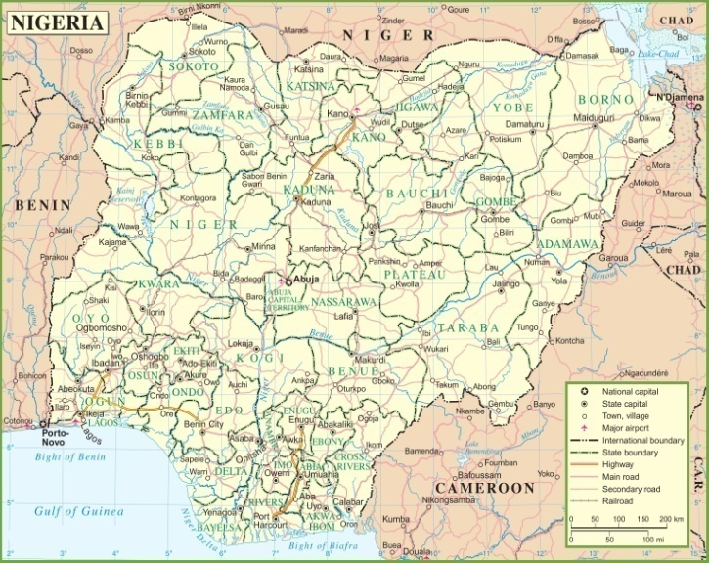
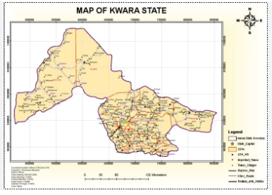

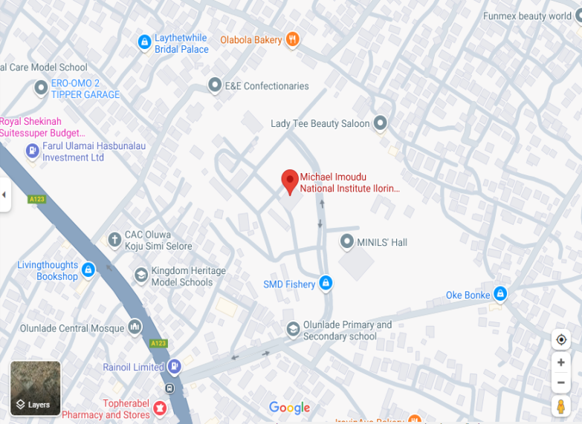

1.6 SPECIFICATION OF THE PROJECT
The following are the specification to be ascertained in the project.
- Three set of control points should be use, and the control point should connect to national framework.
- The control points must be connected to the third order control station.
- Set of bench marks should not more than one kilometer to each other.
- The cross section of the route center should at least not less than 20m from the existing centerline.
- Linear accuracy check should be check for each loops or the complete route alignment.
- The various plans should be produced at the end of the processing
- Horizontal alignment. b. Vertical alignment. c. cross section at 25m interval.
- Two set of the control points at 1km interval.
- Check must thoroughly done on the established control points.
1.7 PERSONNEL INVOLVED
S/NO | NAME | MATRIC NUMBER | ROLE
1 | BABATUNDE SIDIKAT JOKOTOLA | HND/22/SGI/FT/113 | WRITER
2 | AINA JOSEPH OLASUNKANMI | HND/23/SGI/FT/0116 | MEMBER
3 | OKUNOYE NAFISAT ADEYEMI | HND/23/SGI/FT/0111 | MEMBER
4 | SOLADOYE AMIDAT OLABISI | HND/23/SGI/FT/0109 | MEMBER
5 | SODIQ AYUBA ADEBAYO | HND/23/SGI/FT/0110 | MEMBER
6 | OJO SIMON ABAYOMI | HND/23/SGI/FT/0114 | MEMBER
7 | ROTIMI IYANUOLUWA ANU | HND/23/SGI/FT/0104 | MEMBER

CHAPTER TWO

2.0 LITERATURE REVIEW
Engineering surveying may be regarded as a specialty within the broader professional practice of engineering and includes all surveying activities required to support the conception planning, design, construction, maintenance, and operation of engineered projects. Engineering surveying excludes the of real property, for the establishment of land boundaries, right of way, easements, and the dependent or independent surveys or resurveys of the public land survey system. ASCE believes that this definition should be adopted by state engineering licensing boards.
Uren and Price (1994), defined engineering surveying as an expression for any survey work carried out in connection with the construction of civil engineering and building project. They also stated that engineers and surveyors involved in site surveying are responsible for all aspects of dimensional controls on such schemes. According to them, the main purpose of engineering surveying are-
To provide large scale topographical plan and other measurement used in design stage
To provide precise frame work at the construction stage
To monitor structural movement on major retaining structure at the post construction stage.
Also in another view, Basak (2000) wrote that when the question of constructing a new road arises due to public demand or some strategic reason, the procedures to be taken are
To find the necessity for the existence of the road
The marking of the tentative alignment.
The reconnaissance survey.
The preliminary location survey.
The final location survey
Report.
Route survey is an aspect of engineering survey work, which deals with the engineering construction works. The purpose of every engineering surveying is for social development route survey; though an aspect of engineering surveying is an extended scheme on its own. The surveyors that deals with engineering surveying are called engineering surveyors. The surveyors are involved in three stages of engineering construction works, which are:
- Investigation and planning stage.
- Design stage.
- Construction stage.
(Pumnia 2005) defined route surveying as a survey along of comparatively narrow stipe of territory for the location, design and construction of any route of transportation or communication. The route survey involves traversing, levelling and detailing.
(Rodgers, 2003) explained that Highways are vitally important to a country’s economic development. The construction of a high quality road network directly increases a nation’s economic output by reducing journey times and costs, making a region more attractive economically. The actual construction process will have the added effect of stimulating the construction market.
(Wright, 1996) started a highway survey which is also part of route survey may be accomplished either by conventional ground survey techniques or by remote sensing techniques. The basic task of a surveyor in highway survey using conventional method is to carry out route survey along the route which is the survey made along a line or narrow belt or strip of territory for location, design and construction of a route of transportation. The essence of the route surveying was to determine the ground configuration and the location of objects along the proposed route, establishing the line on the ground, computing volume of earthworks and also for designing purpose.
(Reginnal, 1998) wrote that route survey is the necessary survey for the location and construction of lines of transportation, communication, such as highways canals transmission lines and pipelines. He also said the location and construction survey involves the following:
- Creating center lines by setting at intervals, running level to determine profile of the ground along the center line.
- Picking cross section
- Plotting the profile and fixing grades.
- Calculating volume of earthwork.
- Measuring the drainage areas.
- Structuring structures such as bridges, culverts e.t.c.
All these cannot be embarked on without the basic process of acquiring data, such as traversing, levelling, detailing, curve designing.
(Anderson &Mikhali, 1985) refers route survey as the topographical and construction surveys necessary for location and construction of transportation lines or communication such as highways, railways, canals, transmission lines and pipeline. It is a reality that surveyors are the major professionals needed when it comes to working on any engineering project, for example, Building project. They provide special information, such as; the site location, size of the parcel, the dimension and total area. The finished product (plan) forms the basis upon which further development depends. (Anderson &Mikhali, 1985).
(Schofield, 2001) stated that route survey involves the determination of ground configuration and location of physical features both natural and artificial along the proposed route, establishing the line on the ground and computing volumes of earthwork involved where applicable. This kind of survey operation is very important on all road networks and in construction of new road which will increase the durability and carrying capacity of road networks. Finally, route survey are made to plan, design and construct railways, pipelines, highways and other linear projects. They usually begin at a known control point and end on another known control point in the most direct manner permitted by field conditions.
The following are the basic processes for execution of route surveying in data acquisition-
- Traversing
- Levelling
- Detailing
- Curve designation
A comprehensive route survey consists of some operations which are:
- Reconnaissance
- Preliminary survey
- Location survey
- Construction survey

Detailing- Process of fixing topographical features to the survey line. Any of these under listed methods could be used:
- Chain survey method (tie line and offset)
- Plane table survey method
- Compass survey method
- Tachometric method
- By the use of total station
The equipment which are used in the execution of a route survey project are said
to be a digital theodolite, a level instrument, levelling staves, tapes or E.D.M, ranging poles, writing materials, bottle cork and nails.
One of the disadvantages of not doing route surveying is that there would be difficulties in assessments of areas necessary, in which vehicles would not be able to access routes freely and conveniently, which leads to slow movements of goods and services.
Another major disadvantage is that, there is also going to be an introduction of irregular drainage pattern, whereby, drainage system would be poor and there would be water lodging along the routes which brings about the introduction of erosion and other factors yielding bad route access.
It was noted that some of the instruments used by the previous sets were not in perfect working conditions, in which errors were introduced in their Route Survey project, which was noted during our project job, and adequate tests of instruments were carried out.
Also there would be productions of Plans at the end of the project exercise, which would depict the features on ground to the features on paper.
There is also the introduction and use of Advanced Software which was also not used by the previous sets during their project, this makes our project work more convenient, easier and faster.
China Construction Company (CECCEC) in 2013 carried out the right of way and acquisition survey of the road from Orilowo-Ejigbo to Iyana-Oba and covers a total distance of about 60km approximately and it was carried out for the purpose of expanding the road. The survey was done with highly technological instrument such as GPS, Total station, EDM, Digital level etc.
Maharashtra State Road Development in 2002 carried out a route survey along the Mumbai-Pune Expressway, which covers a distance of approximately 94.5km, which was carried out for the purpose of linking the routes.
Highways England Construction Company also carried out a route survey on the expansion of rail line network, which started in 2009, and covers a distance of 42km.
Furthermore, Arab Construction Company in 2018/2019 carried out a route survey of a road which covers about 4km which was constructed in along the Ikorodu to Ogijo, for the purpose of expanding the road.
Also, Julius Berger Nigeria carried out a route survey along the Lagos-Ibadan expressway which covers about 127km approximately for passage access and expansion.
(Dentata and Sawoe) Nigeria limited were responsible for that of JibiakaroNamodaGusau road which covers 161km, which was done for the purpose of expanding the route.
Again, Efoba Construction Company in Ibadan in 2005/2006 carried out a route survey during the Ogunpa channelization project which was constructed in Ogunpa in Ibadan.
The plans produced for any construction projects must be large scales plan for better and accurate interpretation.

CHAPTER THREE

3.0. METHODOLOGY

Methodology is the set of methods and principles and instructions used to perform a particular activities or task. Its show the stages involved during the execution phase of the project research work. The methods involved in the execution of this project are includes traversing, detailing and contouring, processing and presentation. According to Oloyede et al. (2017), Total stations and GPS equipment are commonly used in Nigerian route surveys, providing precise measurements of distance, angles, and elevations. These tools allow surveyors to collect data on the terrain, which is essential for designing roads and other infrastructure projects
3.1 Preliminary Planning and Preparation:
- Route Selection: Based on preliminary maps and project requirements, a set of possible routes was identified and later the route from Michael Imodu to OshinOlatunji was chosen.
- Site Visit: All the team member of Surveyors crew and Engineers visited the potential sites to familiarize themselves with the terrain and environment.
- Other: other preliminary activities was done in the office by the surveyor team. These activities are check the condition of the surveying equipment for the project execution and son costing activities.

3.2. RECONNAISSAINCE SURVEY

Reconnaissance Survey was carried out by the members of Group 5C, were the necessary information about the project area were gathered which are paramount to the successful execution of this project work. It is pre-requisite for any survey project to be carried out. During the Recce. Survey the group member visited the site in order to have a good view of the site location with other relevant information, the selection of the bench marks point, the tracking of the existing route using handheld GPS (Garmin 72) to know the length of the road, and checking of the available with. This was continue from the starting chainage to the end and at the end of the Recce. Survey activities the reconnaissance diagram was drawn as show on the figure below.

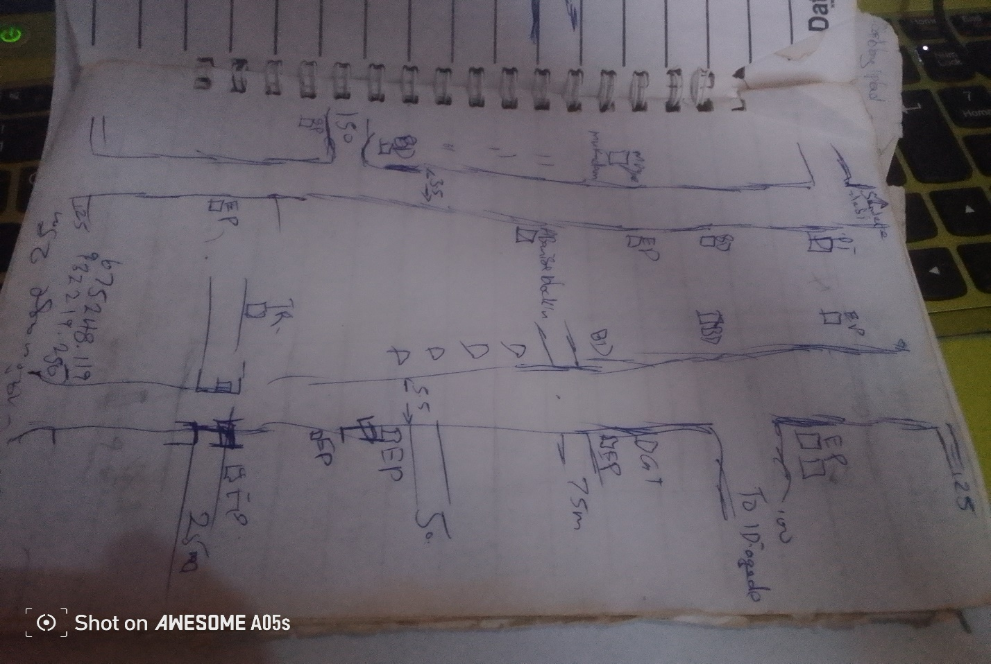Fig.3.1: Recce Diagram of the project location (Not drawn to scale)

3.3 OFFICE PLANNING

Having completed the field recce survey, then office planning was followed on the next day. It involves chosen the type of instruments, purpose and accuracy required of the survey be carried out. The collection of equipment needed for the project and also test of the instrument, mission planning, assembling and studying of all available data project of the relevant to the project, the costing of the operation was also done in the office. In executing the project, necessary information related to the project given such as the coordinates of the control. The prefix number of the controls used and the bench marks.

Table 3.1 shows the list of coordinates of existing control points
BEACON NO. | NORTHING(m) | EASTING(m) | HEIGHT(m) | LOCATION
BM.01 | 932229.902 | 675261.302 | 312.39 | Ilorin
BM.02 | 932225.637 | 675284.873 | 313.04 | Ilorin
BM.03 | 932207.160 | 675272.022 | 312.97 | Ilorin
Source: Author, 2025.
3.4. SELECTION OF THE EQUIPMENT AND SOFTWARE
The equipment, tools and software used for this project were grouped into two categories and they are:
- Hardware
- Software
3.4.1 Hardware Used
- Sokkia (CX105) Total Station 1 No.
- Hand held GPS receiver 1 No.
- HP Design jet 7100 series 1 No.
- HP Gateway laptop 1 No.
- Tracking rod 1No.
- Tripod 1 No.
- Linear tape (50m) 1 No.
3.4.2 Software Used
- Ts-link for (CX105) Total Station downloading software
- AutoCAD 2007
- CivilCAD 2014
- Note pad
- Microsoft Office package (Word and Excel)
3.5. BENCH MARKS ESTABLISHMENT, CAPPING AND LABEL
- Temporary bench marks (TBM) were established and coordinated along the entire route of the project, which were meant to serve as a check for data acquisition and controls for establishing centerlines chainages, setting out of curves and other road features during the actual construction.
- The positions of these beacons (TBMs) were selected and established at certain distances part not above 500m interval in such a way that they are inter-visible to each other, not too far from the proposed road and considerable number of centerline chainages can be set out from them.
- The property beacons used were precast with dimensions 18cm x 18cm x 75cm in length. Sixty five centimeters (65cm) of the precast beacon was buried beneath the surface and ten centimeters (10cm) above as shown in fig. 2.3.
- The numbering was done serially from the beginning to the end of the proposed road and was prefixed with identification number BM01, BM02, BM03 and so on. The values of those TBMs were shown on appendix
10cm
65cm
Ground level
18cm
BM
01
18cm
18cm
B
M

01

Figure 3.2: Show the Description Typical Bench Mark.

3.6. INSTRUMENT TEST
3.6.1. COLLIMATION TEST
The procedure undergone to perform instrument test is as explained thus:
The instrument (CX105 Total Station) was set up on TBM.01 and all temporary adjustments (centering, leveling and parallax elimination) were performed. A reflector prism was set-up at a distance of about 100m to the line of sight and bisected on both face left and face right. The instrument was switched on and program which is on-board of the micro-computer of the instrument was switched to the columniation program. Then horizontal columniation and vertical index were in sequence recorded and stored in the memory of the instrument. The telescope was transited and the same target was bisected. Both the new vertical index and columniation error were recorded and stored accordingly. It was transited to the same target with both horizontal and vertical readings recorded to check the instruments accuracy. The readings obtained were shown in the table below.
Table 3.2 Show the Horizontal Circle Readings
Station | Sights | Face | Horizontal Circle Readings | Diff. Between (FL & FR)
A | C  C | L  R | 204⁰ 36’ 42’’  024⁰ 36’ 36’’ | 180⁰00’ 06’’

Table 3.3 Show the result of the adjustment made.
 | OLD READING | NEW READING
Horizontal Columniation | 00° 00’ 18’’ | 00° 00’ 06’’
Vertical Index | 00° 00’ 11’’ | 00° 00’ 04’’

3.7 DATA ACQUISITION
3.7.1 IN-SITU CHECK
The in-situ check was carried out on the control TBM.01, TBM.02, and TBM.03, the result showed that the pillars were reliable enough to be used for the project. An analytical comparison of the measured data obtained from the check and the calculated values is as shown below.
Table 2.3 Show the observed coordinates of TBM.01 from TBM.02
STATION | NORTHING(m) | EASTING (m) | HEIGHT(m) | REMARK
TBM.01 | 932229.902 | 675261.302 | 312.39 | Observed
TBM.01 | 932229.896 | 675261.311 | 312.37 | GPS Given
Discrepancy | -0.006 | 0.009 | -0.017

Table 2.4: Show the observed coordinates of TBM.03 from TBM.02
STATION | NORTHING(m) | EASTING (m) | HEIGHT(m) | REMARK
TBM.03 | 932207.160 | 675272.022 | 312.97 | Observed
TBM.03 | 932207.164 | 675271.996 | 312.98 | GPS Given
Discrepancy | 0.004 | -0.006 | 0.006
Table 2.5: Result of the computed control check (from given GPS coordinates).
STATION FROM | BEARING | DISTANCE | DN | DE | NORTHING | EASTING | STATION  TO
 |  |  |  |  | 932229.896 | 675261.311 | TBM.01
TBM.01 | 349ᴼ59’59” | 23.953 | -4.255 | 23.478 | 932225.637 | 675284.873 | TBM.02
TBM.02 | 234ᴼ59’56” | 22.507 | -18.482 | -12.858 | 932207.164 | 675271.996 | TBM.03

The result was used to obtain the inclusive angle between TBM.01, TBM.02, and TBM.03 by finding the difference between the bearings of two lines.
TBM.02 TBM.01 => 169ᴼ59’59”
TBM.02 TBM.03 => 234ᴼ59’56”
Therefore (234ᴼ59’56”-169ᴼ59’59”)
Check angle 64⁰ 59’ 57’’

64⁰ 59’ 57’’

Fig.2.5 Show sketch of the check angle from three Given data
Table 2.6: Show result of the computed control check angle (from observed coordinate).
STATION FROM | BEARING | DISTANCE | DN | DE | NORTHING | EASTING | STATION  TO
 |  |  |  |  | 932229.902 | 675261.302 | TBM.01
TBM.01 | 350ᴼ01’01” | 23.954 | -4.264 | 23.570 | 932225.637 | 675284.873 | TBM.02
TBM.02 | 234ᴼ59’59” | 22.508 | -18.477 | -12.851 | 932207.160 | 675272.022 | TBM.03

The result was used to obtain the included angle between TBM.01, TBM.02 and TBM.03 by finding the difference between the bearings of two lines.
TBM.02 TBM.01 => 170ᴼ01’01”
TBM.02 TBM.03 => 234ᴼ59’59”
Therefore (234ᴼ59’58”-170ᴼ01’01”)
Check angle 64⁰ 59’ 58’’

TBM.02TBM.02
TBM.01TBM.01
TBM.03TBM.03
64⁰ 59’ 58’’

Fig.2.6 show the sketch of check angle from the observed data
The difference between the Observed check angle and the computed from given check angle was 00⁰ 00’ 01’’
- Computed distance from the given data (TBM.02 TBM.01) = 23.953m
- Computed distance from the observed data (TBM.02 TBM.01) = 23.954m
Difference obtained with the two result was compared as = 0.001m
- Computed distance from the given data (TBM.02 TBM.03) = 22.507m
- Computed distance from the observed data (TBM.02 TBM.03) = 22.508m
Difference of the two results = 0.001m
3.7.2 GEOMETRIC DATA ACQUISITION
3.7.3 TRAVERSE OF BM POINTS
Traverse was run round the established eleven (11) BM points. The CX105Total Station was set up on BM.02, a back sight was taken to BM.01 after the instrument is switched on and all temporary adjustments were carried out. The stations parameters (N, E and H) were enter into the memory of instrument for both occupied and reflector target station at back sight station (BM.02 and BM.01) respectively. Fore sight was taken to the first BM.03 and measurement stored, the instrument was then moved to the BM.01 as instrument station and reflectors were positioned at BM.02 and BM.03 as back sight and fore sight respectively. The occupied station (BM.01) parameter was entered into the Total Station and measurement was taken to CL-Road Centerline. This whole process continues and the traverse was closed back at BM.02. The numbers of BM are eleven (11) in total. The table below show the list of the benchmarks observed.
3.7.4 DATA ACQUISITION
The CX Total Station was set-up on BM.02, switched on and all temporary adjustments were carried out. The instrument was set on coordinates mode and the instrument parameters (Station name, Height of instrument, and N, E, H) as well as the target station parameters (Back sight station name, Height of reflector, and N, E H) were keyed into the Total Station. Then orientation was made to the reflector at station BM.01, and the measurement between the two stations was stored in the memory of the instrument. Foresight was made to 0+000m chainage centerline and then to the cross-sections at 20m away from the center line on both side and stored on the Total Station. Then the reflectors were now moved to the next chainage 0+025 and the same measurement performed for the first chainage is repeated here i.e. the centerline and the cross-section. Also details were fixed alongside traversing; IP points was also coordinated by moving the reflectors to the desired point of interest and denoted using a different code (CL, BLD, E.P, RT, LT, W.F, and DR. CV. Where CL means Centerline, BLD means Buildings, E.P. means Electric Poles, RT means Road Right Side, LT means Road Left Side, W.F. means Wall Fenced, DR mean Drainage line, CV mean Culvert ). This whole process continues until the reflector is no longer visible from the instrument. Then the instrument station was changed and the above process of data acquisition was repeated for the marked chainages and BM points till the end of the route was reached. The traverse was closed on BM11. The discrepancy between the observed and the given coordinates for the easting and northing is -0.099m and +0.102 respectively was used to compute for linear accuracy and found to be 1: 63,000, compare with the permissible accuracy of 1:5000.

TP2
TP1
CL
TP3

CH 0+000 CH 0+100 CH 0+200 CH 0+300

CHAPTER FOUR
4.0 DATA PROCESSING
The data processing follows immediately after the completion of the data acquisition and the selected software from the chapter three. This involved the methods used in downloading / retrieving, sorting and analyzing of acquired data (field data). Here the data downloaded was processed into information using appropriate methods and software. The steps involved are as follows;
4.1 DATA DOWNLOADING (CX- TOTAL STATION)
4.1.1 DOWNLOADING PROCEDURE
The data were transferred from the Total station to the SD Card via the SD card Slotted in into Total Station and later downloaded into the computer using Ts-Link Sokkia (CX105) Total Station software.
The following procedure was followed during the downloading from the Total Station to the computer;
The SD card was Slot in into the Total Station and the instrument was powered on. The job “Route” was selected from the list of JOBS to be downloaded then transfer to the SD Card following the steps below
- click on F4 which means transfer
- The following option displayed on the total station screen
- Comm. sends data
- Comm. receive data
- Comm. setting
- Memory to S.D card
- S.D card to memory
- S.D card to file manager
- Then the fourth (4th) option is selected since we are moving the job “Route” from Instrument memory to SD card
- Then press ok
- Click on F1 to create a new file
- Input the file name and press F5 (ok)
- Search for the file name then press enter and the data was successfully moved from instrument memory to SD card
4.1.2 DOWNLOAD FROM SD CARD TO COMPUTER SYSTEM
The Sokkia-link software was installed on the computer system and was used to download from the SD card to system.
The following procedures were followed
- Insert the memory card at the appropriate slot on the Computer system.
- Sokkia-link software was launched from the desktop screen.
- Click on the SD card on the software
- Scroll on import data
- Click on the file name
- Click on yes
The coordinates will display in the format
PT | N/X | E/Y | Z | CODE
- Then save the file as text file.
4.2 DATA PROCESSING PROCEDURE
The file was opened and point data were displayed. This was then copied to a notepad and Microsoft excel environment for further processing.
On notepad, data were well spaced to differentiate one column from the other and unwanted information deleted.
On Microsoft excel, data were prepared for scripting purpose in AutoCAD. A small programme was written to prepare point and text scripts files.
4.2.1 PLOTTING PROCEDURE IN CIVILCAD 2014
    - CIVILCAD 2014 was lunched and NEW PROJECT was clicked index FILE MENU and named e.g. Route Survey, the OPEN button was clicked.
    - CONFIGURATION was then clicked under file menu to carry out General settings (Language, System units, Angles units, and Printout font size etc.), drawing environment settings, and Coordinate format settings and File settings.
    - Having completed the configuration, TOPOGRAPHY MENU was clicked and COORDINATES was chosen in the pull down menu.
    - In the dialogue box, ‘Load menu from text file’ button was clicked to load raw data coordinates that was arranged in the format; Point ID, Easting, Northing, and Height.
    - After selecting the raw data file and clicked Open, REFRESH ALL button was clicked and the software automatically run the script and plot the whole data just exactly the way it was surveyed. Also layers were automatically created for all the point Ids, Heights and Symbols used. But layers for each feature that was fixed along the route were manually created, e.g. buildings, Electric poles, Drainages, Culverts etc.
    - Line, Polyline, points and Splines tools were used to join all the features that were fixed along the route path into its appropriate layers.

4.2.2 PROFILE / VERTICAL ALIGNMENT PLOTTING USING CIVILCAD
- In CivilCAD2014 environment, ROAD MENU was clicked and VERTICAL ALIGNMENT submenu under Road selected.
- The Options Button was clicked in the dialogue box to set the Slope format, Vertical curves’ factor, Data precision and super elevation maximum slope. After the settings of these parameters, OK button was clicked.
- Having done this, ‘Load sections from a text file’ button was clicked to load sections of the centerline data, which was prepared in notepad in this format;
Station Chainage leveling height
  - 0 312.870
  - 25 312.710
  - 50 312.540
  - 75 312.390......
- Zoom Extent was opted for under view menu to view the whole profile drawing.
- A design was carried out on the profile by selecting a polyline tool to pick points along the profile, and when this was completed, APPLY button was clicked and the software automatically generates design levels for the whole profile.
- The design level was then used to calculate the volume of CUT and FILL on each section of the centerline

4.2.3 LOGITUDINAL / HORIZONTAL ALIGNMENT PLOTTING USING CIVILCAD
- In CivilCAD2014 environment, Road Menu was clicked and HORIZONTAL ALIGNMENT chosen.
- Options button was clicked in the appeared dialogue box and Define Section was then clicked to choose the section format and the distance between the sections. Format 2 was chosen and the distance between sections was taken to be 25m
- Having chosen these options, OK was clicked twice.
- Pick tool was selected from the right pane dialogue box to pick all the intersection points (IPs), and appropriate radius values of curve was given to each IP as specified by the client.
- Apply button was then clicked to effect all the given parameters on the drawing. On each IP position, information about the IP is been displayed. Such information are; IP number, X coordinate, Y coordinate, Radius of curve, Length of curve, Deflection angle and so on.
4.2.4 PLOTTING OF CROSS-SECTIONS USING CIVILCAD
- In CivilCAD2014 environment, Road menu was clicked and CROSS SECTION selected. Then ‘Load sections from text file’ button was clicked to load the existing ground level data.
- Having uploaded the data file, Existing Ground Level was chosen to specify that the data coming in is for existing ground level.
- The same format of data was uploaded next but for Designed Level by choosing Designed Ground Level button. The design level data was calculated using 2.5% slope for cambering and 3% slope for the shoulder.
- The software then superimposed the two drawing together to calculate the volume of CUT and FILL at each cross sections.
- Then frame division was clicked and the Output scale, Paper size and range was chosen for the final output of the cross sections.
4.2.5 GENERATING EARTHWORK TABLE USING CIVILCAD 2014
- Under Road menu, EARTHWORK button was clicked and the Apply button to generate the volume of earthwork table.
- Having done this, a geometry report dialogue box appears on the screen showing the accumulated volume of Cut and Fill, which can be directly printed or exported to Microsoft Excel for further editing.
  - RESULT AND ANALYSIS
This is a systematic examination and evaluation of data obtained and processed as a result of my field observation. This was achieved by taking into consideration all the necessary survey procedures and adhering to survey rules and regulations while on field and during processing.
The final results were tabulated in appendix
The route survey traverse started from TBM.01, TBM.02 andTBM.03 but closed back on TBM.02.

Table 4.7: Abstract of BM coordinates
TBM.01 | 932229.902 | 675261.302 | 312.39
TBM.02 | 932225.637 | 675284.873 | 313.04
TBM.03 | 932207.160 | 675272.022 | 312.97
TBM.04 | 931583.654 | 674839.222 | 310.21
TBM.05 | 931589.824 | 674818.166 | 309.58
TBM.06 | 674441.073 | 931811.975 | 310.13
TBM.07 | 931823.719 | 674448.987 | 309.46
TBM.08 | 932238.880 | 673657.641 | 322.56
TBM.09 | 932216.454 | 673658.547 | 323.87
TBM.10 | 933121.878 | 673159.463 | 303.71
TBM.11 | 933124.483 | 673178.850 | 303.56

Finally the observed coordinates and the given coordinates were compared and the computation shows that the traverse closed.
4.4 LINEAR ACCURACY
The accuracy was computed with the formula below:
For the boundary traverse;
_____1_____
√(ΔE)² + (ΔN)²
Total Length

Starting Coordinate (TBM.02) 932225.637mN; 675284.873mE, Ht = 313.040m
Closed Coordinate (TBM.02) 932225.739mN; 675284.774mE, Ht = 312.068.m
Misclosure in Easting (E) = -0.099m
Misclosure in Northing (N) = + 0.102m
Total Length = 9000m

_____1_ _____
√ (0.099)² + (0.102)²
= 9000m
_1_ __
√ 0.020205
= 9000m
_____1_ _ _
0.1421443
= 9000m
____1_ _
= 0.00001579381
= 63,315

The computed accuracy is 1/63,000
The permissible accuracy is 1/5,000

4.5 HEIGHT ACCURACY
Obtained error in leveling traverse (Misclosure) = -0.028m
Minimum allowable error in leveling (Permissible) = 24mm√k
Where k = distance covered in kilometers is 9.0km
Allowable error over in height over km =
24mm√k = 24mm√9.0km = - 0.0026m
Therefore, it means that the job met the required specification.
From the above computations, the linear accuracy obtained was better than the allowable limits of 1:5000 according to SURCON specifications for third order engineering job.
4.6 PLAN PRODUCTION
The adjusted coordinates were plotted in AutoCAD 2007 and CivilCAD 2013 Environment to generate the centerline of the road, longitudinal profile and cross section. The details were also plotted.The essence of obtaining a detail plan is to provide a platform for horizontal curve and alignment design for the road expansion /rehabilitation. Information shown on the detail plan provides a vivid representation of the land mass for easy understanding of the route.
    - HORIZONTAL ALIGNMENT PLAN
AutoCAD Land Development software 2009 was used to transform the collected and already processed data into a plan for visual presentation. A hard copy of the plan was printed using the AutoCAD visual display graphical information. Plots of the cross-section, profile, and longitudinal section were made which was attached to this project.

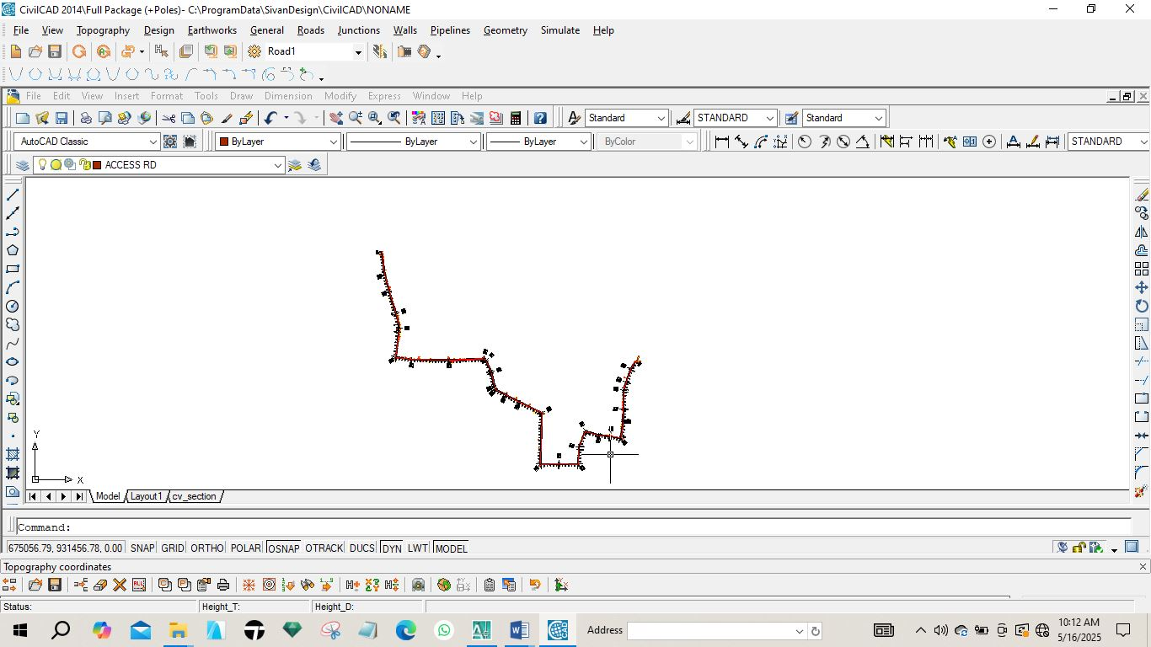
Fig 4.1: Horizontal plan of the route

4.6.2 VERTICAL ALIGNMENT PLAN
In order to give vertical height and terrain information along a route for vertical alignment and curve design, a profile was created. It gives a clear view of the terrain and helps decide where to fill or cut. It offers details like the existing level, formation level, tangent points, and slope.
The design of the route was done after the creation of the longitudinal profile. The longitudinal profile was created using AutoCAD Civil 3D 2022. The steps in the creation of the longitudinal profile shown in fig 4.2 are as follows:

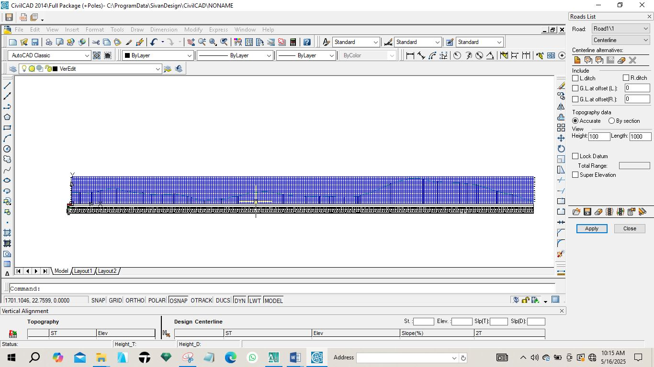
Fig 4.2: Vertical Profile of the route.
    - CROSS SECTION PLAN
The terrain information across the road chainage is shown in the cross-section. Details were displayed, including the height of the proposed and current center line and embankments. In cut and fill analysis, the area and, consequently, the volumes of earthwork were generated using the cross-section parameters.
The following process was carried out on the currently plotting on Auto CAD Civil CAD for generating cross section. The Cross Section icon was used to sample the sections from the existing ground, edit the values of the tangents, curves, and spirals, and create a current surface by clicking on surfaces and setting current surface. A template was created for the section and it was also edited under design control. Then, by clicking on section plot, all was selected, and all sections were created.
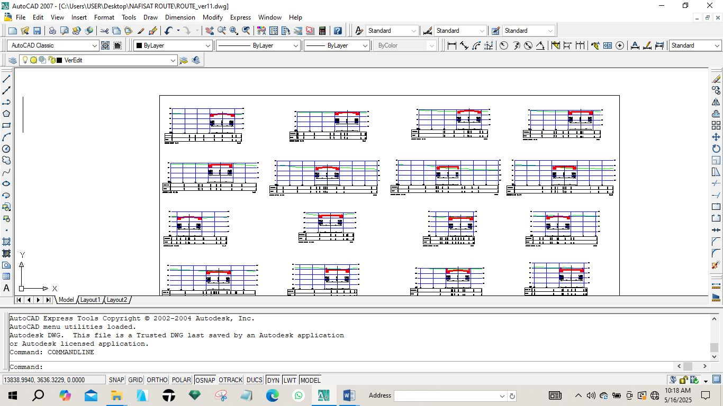
Fig. 4.3: Diagram showing generated cross section
4.6.4 VOLUME OF EARTWORKS
Volume computation in route surveying is a fundamental process used to estimate the quantity of earthwork required for road construction projects. Accurate volume calculations help engineers plan excavation and embankment activities efficiently, ensuring cost-effective and sustainable infrastructure development.
The software used for volume of earth work calculation is AutoCAD 2007and Civil CAD 2014, the process involves selecting specific areas for calculation and defining initial and final surfaces, which can be particularly useful in monitoring changes over time, such as material removal or deposition.
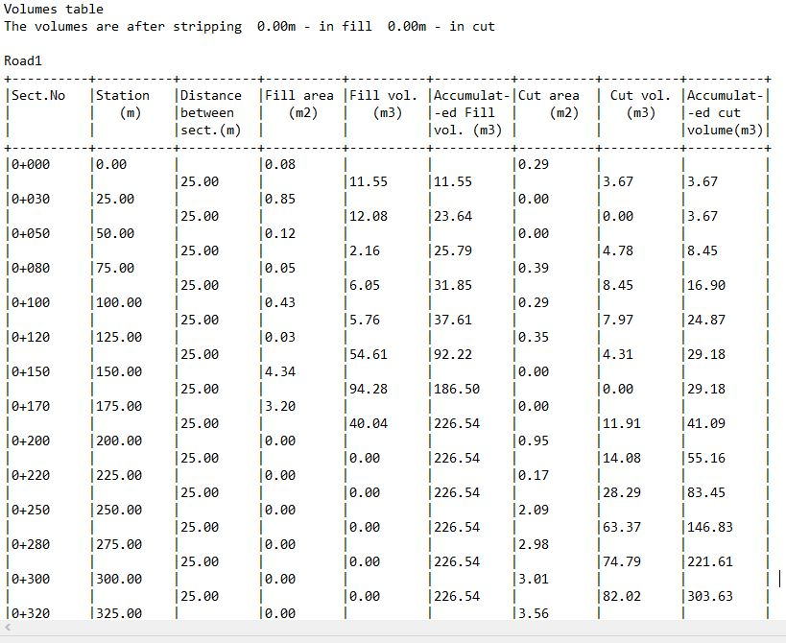
Fig. 4.4: Diagram showing generated volume computation

CHAPTER FIVE
5.0. PROJECT COSTING, SUMMARY, CONCLUSION, PROBLEM ENCOUTER AND RECOMMENDATION
5.1 PROJECT COSTING
Table 4.4.1: shows the worked out cost of the project
OPERATION | RATE / DAY | NO OF DAYS | UNIT COST (#) | AMOUNT (#)
RECCONNAISSANCE (DAY)
1 Senior Surveyor | 10,000 | 1 | 10,000 | 10,000
8 Technical officer | 5,000 | 1 | 40,000 | 40,000
1 skilled labour | 5,000 | 1 | 5,000 | 5,000
Transportation (Field vehicle + Driver/ Mechanic + fuel) | 20,000 | 1 | 20,000 | 20,000
Basic Equipment (Hand held GPS, Field Book etc.) | 5,000 | 1 | 5,000 | 5,000
SUB TOTAL |  |  |  | #83,000
DETAILING AND SPOT HEIGHTING 4DAYS
1 Senior Surveyor | 10,000 | 4 | 40,000 | 40,000
8 Technical officer | 5,000 | 4 | 20,000 x 8 | 160,000
Basic Equipment (Total Station, Reflector) | 20,000 | 4 | 80,000 | 80,000
Transportation (Field vehicle + Driver/ Mechanic + fuel) | 20,000 | 4 | 80,000 | 80,000
SUB TOTAL |  |  |  | #360,000
DATA PROCESSING 1WKS
1 Principal surveyor | 10,000 | 5 | 50,000 | 50,000
1 surveyor | 8,000 | 5 | 40,000 | 40,000
1 assistant technical officer | 5,000 | 5 | 25,000 | 25,000
Computer accessories (printer, internet, generator, fuelling etc.) | 15,000 | 5 | 75,000 | 75,000
SUB TOTAL |  |  |  | #190,000
INFORMATION PRESENTATION
1 Senior surveyor | 10,000 | 1 | 10,000 | 10,000
1 technical officer (CAD) | 8,000 | 1 | 8,000 | 8,000
Standard set (computer, plotter, Generator etc.) | 15,000 | 1 | 15,000 | 15,000
SUB TOTAL |  |  |  | #33,000
TECHNICAL REPORT
1 Chief surveyor | 30,000 | 1 | 30,000 | 30,000
2 Surveyors | 20,000 | 1 | 20,000 x 2 | 40,000
SUB TOTAL |  |  |  | 70,000

COST OF THE PROJECT | #736,000
MOBILIZATION / DEMOBILIZATION (10% of the project) | #73,600
CONTIGENCY (5% of the project) | #36,800
TOTAL COST OF THE PROJECT | #846,400
VAT) (5%oftheproject) | #42,320
GRAND TOTAL | #888,720
5.2 SUMMARY
The route survey was conducted to determine the most efficient and feasible path for the proposed infrastructure project (e.g., road, pipeline, transmission line). The survey involved reconnaissance, data collection using GPS and total station, terrain profiling, and identification of existing utilities and potential obstacles along the proposed route. Topographic features, environmental conditions, and accessibility were taken into consideration to ensure accuracy and reliability of the route alignment.
A route survey is a systematic process undertaken to determine the most suitable alignment for infrastructure projects such as roads, railways, or pipelines. The process typically involves several key stages: reconnaissance (to broadly identify feasible corridors), preliminary survey (to collect detailed topographic and geotechnical data), and detailed survey (to finalize the alignment and gather precise measurements for design and construction) The main objectives are to obtain horizontal and vertical alignments, assess the terrain, and produce plans and profiles necessary for design and construction The process utilizes various surveying techniques, including traversing, leveling, and tacheometry, and increasingly incorporates modern technologies such as GPS and aerial mapping for improved accuracy.
5.3 CONCLUSION
The survey successfully identified a viable route that meets the design and operational requirements of the project. The proposed alignment minimizes environmental impact, reduces construction costs, and avoids major obstacles. The gathered data provides a solid foundation for detailed engineering design, cost estimation, and project planning.
Route surveys are essential for the successful planning and execution of linear infrastructure projects. They ensure that the selected route is technically feasible, cost-effective, and minimizes environmental and social impacts. The survey results provide a foundation for design, construction, and future maintenance, ultimately contributing to the long-term
sustainability and functionality of the infrastructure. The adoption of advanced surveying technologies and thorough planning can significantly enhance the accuracy and efficiency of route surveys, especially in challenging or remote environments.
5.4 PROBLEM ENCOUTER
Weather Conditions: Inclement weather, such as heavy rains and fog, delayed the data collection process and reduced visibility.
Accessibility Issues: Some segments of the proposed route were difficult to access due to rugged terrain and lack of existing roads.
Equipment Malfunction: Temporary issues with GPS signal reception and battery drainage of surveying equipment caused slight delays.
Landowner Resistance: A few property owners along the route initially denied access to surveyors, requiring negotiation and coordination with local authorities.
Difficult Terrain and Accessibility: Surveying in remote or rugged areas can hinder movement and data collection due to steep slopes, dense vegetation, or lack of infrastructure.
Inaccurate or Outdated Data: Reliance on old maps or records can lead to errors in alignment and design, potentially causing costly mistakes.
Adverse Weather Conditions: Extreme weather can disrupt fieldwork and damage sensitive equipment.
Time Constraints: Tight project deadlines may pressure teams, risking reduced data quality or incomplete surveys.
Equipment Malfunctions: Technical failures or lack of appropriate tools can delay progress and compromise accuracy.
Safety Risks: Working in hazardous environments poses risks to personnel, requiring robust safety protocols.
5.5 RECOMMENDATION
Use of Advanced Equipment: Utilize drones or LiDAR in future surveys to overcome accessibility and visibility issues in challenging terrains.
Stakeholder Engagement. Engage local communities and landowners early in the process to minimize resistance and improve cooperation.
Contingency Planning: Include buffer days in the schedule to accommodate potential delays due to weather and equipment issues.
Regular Maintenance of Equipment: Conduct routine checks and carry spare parts to avoid equipment failure during critical survey activities.
Utilize Modern Technology: Incorporate GPS, drone mapping, and GIS tools to enhance data accuracy and facilitate surveys in difficult terrains.
Thorough Planning: Conduct comprehensive desk studies and reconnaissance to anticipate challenges and optimize resource allocation.
Regular Data Verification: Cross-check field measurements with existing records and use redundant methods to ensure data reliability.
Invest in Training: Equip survey teams with up-to-date training on equipment use, safety protocols, and emergency response, especially for remote or hazardous sites.
Engage Local Stakeholders: Collaborate with local communities and authorities for logistical support and to gain insights into the terrain and potential obstacles.
Flexible Logistics: Use portable, robust equipment and all-terrain vehicles to improve mobility and efficiency in challenging environments.
Effective Time Management: Develop realistie schedules, allocate sufficient resources, and monitor progress closely to meet deadlines without compromising quality.
By implementing these strategies, route surveys can be conducted more efficiently and accurately, reducing risks and ensuring successful project outcomes.
sustainability and functionality of the infrastructure. The adoption of advanced surveying technologies and thorough planning can significantly enhance the accuracy and efficiency of route surveys, especially in challenging or remote environments.

REFERENCES
A. Ahmad, K.A. Hashim, A.M. Samad, Aerial mapping using high resolution digital camera and unmanned aerial vehicle for Geographical Information System, 2010 6th International Colloquium on Signal Processing & its Applications, IEEE, Mallaca City, Malaysia, 2010, pp. 1-6.
A.M. Samad, N. Kamarulzaman, M.A. Hamdani, T.A. Mastor, K.A. Hashim, The potential of Unmanned Aerial Vehicle (UAV) for civilian and mapping application 2013 IEEE 3rd International Conference on System Engineering and Technology, IEEE, Shah Alam, Malaysia, 2013.
H. Eisenbeiss, A mini unmanned aerial vehicle (UAV): system overview and image acquisition. International workshop on processing and visualization using high-resolution imagery, institute for geodesy and photogrammetry, ETH, Hoenggerberg, Zurich, Switzerland: 2004.
H. Desa, M.A. Azizan, S. Suhaimi. Z. Ramli, M.S. Abdul Khadir, Z. Hat, Feasibility Study of UAV Implementation in Route Surveying, The 2019 International Conference on Artificial Life and Robotics (ICAROB2019), 24 (2019), 712-716.
J. Everaerts, The use of unmanned aerial vehicles (UAVs) for remote sensing and mapping International Archives of The Photogrammetry, Remote Sensing and Spatial Information Sciences (ISPRS Archives), Beijing, 2008, pp. 1187-1191.
M. Pérez, F. Agüera, F. Carvajal, Digital camera calibration using images taken from an unmanned aerial vehicle. International Archives of the Photogrammetry, Remote Sensing and Spatial Information Sciences, XXXVIII-1/C22, Conference on Unmanned Aerial Vehicle in Geomatics, Zurich, 2011, pp. 167-171.
V. Peterman, M. Mesarić, Land survey from unmanned aerial vehicle. International archives of the photogrammetry, remote sensing and spatial information sciences, XXXIX-B1 (2012), 447-451.

