

PROJECT REPORT
ON
LAND INFORMATION SYSTEM OF URBAN ESTATE ALONG
OKE-OSE/OKE OYI ROAD, ILORIN
ILORIN EAST LOCAL GOVERNMENT AREA
KWARA STATE

BY
AYEGBOYIN QUDUS A.
HND/23/SGI/FT/0071

SUBMITTED IN PARTIAL FULFILMENT OF THE REQUIREMENTS FOR THE AWARD OF HIGHER NATIONAL DIPLOMA IN SURVEYING AND GEO-INFORMATICS TO THE DEPARTMENT OF SURVEYING AND GEO-INFORMATICS, KWARA STATE POLYTECHNIC ILORIN, KWARA STATE

JINE, 2025

CERTIFICATE
I hereby certify that the information contained in this project report was obtained as a result of observations and measurements made by me on the field and that the survey was done in accordance with survey rules, regulations, and departmental instructions.

AYEGBOYIN QUDUS A.
HND/23/SGI/FT/0071

CERTIFICATION
This is to certify that AYEGBOYIN QUDUS A. with matriculation Number HND/23/SGI/FT/0071 has satisfactorily carried out his project under my instruction and supervision.
I here declare that He has conducted himself with diligence, honestly and sobriety on the project.

SURV.AKINYEDE ADEBANJI DATE
Project Supervisor

MR. A I ISSAU DATE
Head of Department

SURV.R.S AWOLEYE DATE
Project coordinator

External supervisor DATE

DEDICATION
This project is dedicated to Almighty God for his, protection and guidance and also to my caring parent in person MR&MRS. AYEGBOYIN

AKNOWLEDGEMENTS

Writing a project requires a lot of time and effort, but with encouragement from various quarters, I was able to overcome the challenges.
I am deeply grateful to Almighty God—the most merciful, protector, and custodian of all wisdom—for granting me the courage, strength, and insight to complete this HND programmed despite the many obstacles I encountered.
My heartfelt gratitude goes to my supervisor, SURV. AKINYEDE ADEBANJI,for his time, guidance, corrections, and direction throughout this project. May Almighty God reward you abundantly? (Amen) More so, my appreciation goes to my able HOD MR. A. I ISSAU and SURV. ASONIBARE R. O, SURV AYUBA ABDULSALAM, SURV A.G AREMU, SURV R.S AWLEYE, SURV. KAZEEM SURV. BABATUNDE KABBIR AND SURV BELLO DIRAN FELIX God bless you all.
I also extend my sincere thanks to all our amiable lecturers from whom I have learned so much. I remain forever grateful for your efforts in nurturing and educating me. Thank you all. May Almighty God bless you? (Amen)
Special thanks go to my loving and caring parent my one and only whose moral and financial support sustained me during my studies. May God continue to bless and protect you? Despite your busy schedule, you always made time to guide me with your wise counsel.
Finally, I thank everyone who contributed in one way or another to the success of my academic journey. May Almighty God reward you all abundantly? Big thanks once again. God blesses.

ABSTRACT
This study explores the development and implementation of a Land Information System (LIS) for the urban area of URBBAN ESTATE OPPOSITE GOVERNMENT CEMETRY ALONG OKE OSE/OKE OYI ROAD, KWARA STATE ILORIN. The existing system suffered from fragmented data management, leading to delays in accessing land information and hindering urban planning efforts. The new LIS, built using a [specify software or platform, e.g., GIS software, database management system], integrates spatial data from topographic maps, aerial imagery, and cadastral records with attribute data like land ownership, zoning regulations, and property assessments. The system allows users to query, visualize, and analyze land information through a web-based interface, enabling efficient decision-making for urban planning, resource management, and property tax assessment. The LIS is expected to improve transparency, reduce administrative burdens, and facilitate more informed land use planning in the study

TABLE OF CONTENTS
CERTIFICATE ii
CERTIFICATION iii
DEDICATION iv
AKNOWLEDGEMENTS v
ABSTRACT vi
CHAPTER 2 8
CHAPTERTHREE 14
3.0 METHODOLOGY 14
3.1 DATABASEDESIGN 14
3.1.1 VIEW OF REALITY 14
3.1.2 CONCEPTUALDESIGN 16
3.1.3 LOGICALDESIGN 17
3.1.4 PHYSICALDESIGN 18
3.2 RECONNAISSANCE 19
3.2.1 OFFICEPLANNING 19
3.2.2 FIELDRECONNAISSANCE 20
3.3 EQUIPMENTUSED/SYSTEMSELECTIONANDSOFTWARE 22
3.3.1 HARDWAREUSED 22
3.3.2 SOFTWARECOMPONENT 22
3.4 INSTRUMENTTEST 23
3.4.1 HORIZONTALCOLLIMATIONTEST 23
3.4.2 VERTICALINDEXERRORTEST 24
3.5 CONTROLCHECK 25
3.6 MONUMENTATION 27
3.7 DATAACQUISITION 28
3.7.1 GEOMETRICDATAACQUISITION 29
3.7.2 TTRIBUTESDATAACQUISITION 30
3.8 DATADOWNLOADINGANDPROCESSING 31
3.8.1 DATADOWNLOADINGANDEDITING 31
3.8.2 DATAPROCESSINGANDDATAEDITING 31
3.8.3 DATA PROCESSING IN AUTOCAD 31
3.8.4 DATAPROCESSINGUSINGARCGIS10.3 SOFTWARE 32
3.9 DATABASEIMPLEMENTATION 34
3.9.1 DATABASEMANAGEMENTSYSTEMS 34
3.9.2 DATABASEMAINTENANCE 35
3.9.3 BACK COMPUTATION Table 36
3.9.4 AREA COMPUTATION 37
CHAPTERFOUR 38
4.0 SPATIALANALYSESANDPRESENTATION 38
4.1 TESTINGOF DATABASE 38
APPENDIX 50

LIST OF TABLES
Table 1.1 shows the personnel involved in project 5
Table3.1: Buildingand itsattribute 18
Table3.2:Roadanditsattributes 18
Table3.3:Treesanditsattributes 18
Table3.4.:VegetationanditsAttributes 18
Table.3.5CoordinatesofControls 19
Table3.6:HorizontalCollimation Data 24
Table3.7:VerticalIndexData 24
Table3.8:Tableshowing thebackcomputationof thecontrolcoordinates 26
Table3.9: Tableshowingthedistanceobservationresultofthecontrolcheck 26
Table3.10: Tableshowing theobservation resultof thecontrol check 26
Table3.12:AreaComputation 37
37
37
Table 4.1 shows the land use percentage 41

LIST OF FIGURES
Figure 1.1 shows the project study area 6
Fig.3.2.:E-RDiagram(Entityrelationship diagram) 16
Fig.3.3: Reccediagramofthestudy area (notdrawn to scale) 21
Fig3.4;HorizontalCollimation andVerticalIndexerrortest. 23
Figure 3.6 shows the layout plan in AutoCAD 32
Figure 3.7 shows the attribute table 33
Figure 3.8 shows lay out view in ArcView windows 33
Fig4.1.:shows the building that have C of O 39
Fig4.2:shows the building that have R of O 39
Fig 4.3: show the area use for vegetation 40
Fig 4.4: show the developed area 40
Figure 4.5 shows the spot height 40
Figure 4.6 shows the slope aspect 41
Figure 4.7 shows the pie chart of land use 42
ure 1.1 shows the project study area 6
Fig.3.2.:E-RDiagram(Entityrelationship diagram) 16
Fig.3.3: Reccediagramofthestudy area (notdrawn to scale) 21
Fig3.4;HorizontalCollimation andVerticalIndexerrortest. 23
Figure 3.6 shows the layout plan in AutoCAD 32
Figure 3.7 shows the attribute table 33
Figure 3.8 shows lay out view in ArcView windows 33
Fig4.1.:shows the building that have C of O 39
Fig4.2:shows the building that have R of O 39
Fig 4.3: show the area use for vegetation 40
Fig 4.4: show the developed area 40
Figure 4.5 shows the spot height 40
Figure 4.6 shows the slope aspect 41
Figure 4.7 shows the pie chart of land use 42

CHAPTER ONE
- INTRODUCTION
1.1 BAKGROUND TO THE STUDY
The management of land information has been in existence since people first took to sedentary agriculture (Dale et al, 1988). When the Babylonians occupied the lands between the Tigris and the Euphrates and the Egyptians cultivated the fertile regions of the Nile, the need for orderly land management was recognized. This in turn led to the development of rudimentary land information systems. More recent examples include topographical and geological mapping programs, valuation and forest inventory surveys and land title survey and registration systems. These systems provide both the information infrastructure necessary for land allocation and settlement and the additional techniques and resource information needed for resource development. Land information is a prime requisite for making decisions related to land investment, development and management. Information therefore reduces uncertainty by helping to identify and analyze problems and the strategies to overcoming them may be prepared and implemented. The value of the information and the effectiveness of the decision-making process are directly related to the quality of the information and the manner in which it is made available and capable of supporting land administration, surveying, planning and taxation, as well as automated mapping systems capable of communicating with infrastructure and utilities planning, design and management systems. The records are very important because they form the basis for assignment and settlement of land titles, which should be flawless and pass all legal scrutiny. Land Information System (LIS) is a "tool for legal, administrative and economic decision making and an aid for planning and development which consists of a database containing spatially referenced land related data for a defined area and of procedures and techniques for the systematic collection, updating, processing and distribution of that data". (Dale, 2000), (Chandrasekhar, 2000)
1.2 STATEMENT OF PROBLEM
Due to the challenges faced in land management and administration, particularly in Nigeria, land administration faces significant challenges such as inefficiency, lack of accurate data, inadequate accessibility to land records, and poor management of land resources. The absence of an integrated and automated system to store, update, and retrieve land data often leads to confusion, land disputes, and ineffective policy implementation. The complexity of managing land ownership, boundaries, transactions, and land use further exacerbates issues like corruption, encroachment, and the illegal allocation of land.
This situation results in substantial economic losses, delays in infrastructure development, and an overall lack of transparency and accountability in land management processes. Traditional land management systems are outdated, paper-based, and prone to human error, making it difficult for land stakeholders, including government agencies, developers, and the general public, to efficiently access and manage land-related information. The absence of a comprehensive and digitized Land Information System (LIS) impedes sustainable development and poses a significant barrier to effective urban planning, investment, and governance in land-related matters.
This problem statement addresses key issues like inefficiency, poor data management, disputes, and outdated systems that can be alleviated with the implementation of a comprehensive Land Information System.
1.3 AIM AND OBJECTIVES OF THE PRACTICAL

1.3.1 AIM OF THE PROJECT
The aim of this project is to provide an integrated platform for managing, storing, and analyzing land-related data to support efficient land administration, planning, and decision-making.
1.3.2 OBJECTIVES OF THE PROJECT
The following objectives were considered in order to accomplish the above aim
1. Improving Land Management: To streamline processes such as land registration, land ownership verification, land use planning, and zoning by organizing and centralizing land data.
2. Enhancing Decision-Making: To provide accurate, up-to-date, and accessible land information for government authorities, urban planners, developers, and other stakeholders to make informed decisions regarding land use, development, taxation, and conservation.
3. Promoting Transparency and Accountability: To reduce land disputes and corruption by providing clear, reliable data on land ownership, boundaries, and transactions.
4. Supporting Sustainable Development: To facilitate the sustainable management and use of land resources by integrating environmental, economic, and social data.
5. Facilitating Land Policy and Planning: To aid in creating effective land policies and strategies for urban development, rural development, infrastructure planning, and environmental protection.
6. Fostering Public Access: To provide easy access to land information for the general public, ensuring transparency and enhancing stakeholder participation in land-related matters.

1.4 SCOPE OF THE PROJECT
The scope of the work involves detailed procedures for the development of Land Information System of Urban Estate Layout. It however entails the creation of functional Database of the present situation of the research Area and to display digital Information and to display Information such as Ownership details, Parcel information, Plot type, Land use, Status was developed and other attribute information. All these entities and attributes will form the base for database creation.
Base and significance of this project, the scope includes;
1. Project planning: which include office planning and field reconnaissance
2. Monumentation: (At least 5 hectares of land according to Higher National Diploma)
3. Data acquisition (geometric data with total station, social survey through oral interview for the purpose of query and building name and colors
4. Data processing: This includes downloading and processing of data using appropriate software (GIS software)
5. Information presentation: It involved plotting of survey data on both soft copy and hard copy showing correct location of a points.

1.5 PERSONNEL
The following are the personnel who participated in the execution of the project.

Table 1.1 shows the personnel involved in project
S/N | NAME | MATRIC NO | REMARKS
1 | AYEGBOYIN QUDUS A. | HND/23/SGI/FT/0074 1 | AUTHOR
2 | ABDULFATAI ABDULAFEEZ O. | HND/23/SGI/FT/0120 | MEMBER
3 | AYODELE TAIYE OPEYEMI | HND/23/SGI/FT/0072 | MEMBER
4 | ABOLADE BISOLA OPEYEMI | HND/23/SGI/FT/0073 | MEMBER
5 | AFOLAYAN IFEOLUWA MARY | HND/23/SGI/FT/0077 | MEMBER
6 | AKEEM HAMID AJAGBE | HND/23/SGI/FT/0074 | MEMBER
7 | ABDULQUADRI ABUBAKR S. | HND/23/SGI/FT/0075 | MEMBER
8 | ADEKUNLE FLORENCE A. | HND/23/SGI/FT/0123 | MEMBER

1.6 STUDY AREA
Urban estate opposite Ilorin East cemetery along OKE-OYI ROAD OKE-OSE ILORIN, KWARA STATE, ILORIN East Local Government Area.(683903E, 946221N). The project site is geographically defined by these parameters; Latitude 8° 33' 23.443"N and Longitude 4° 40' 15.384"E
N
KWARA STATE

NIGERIA

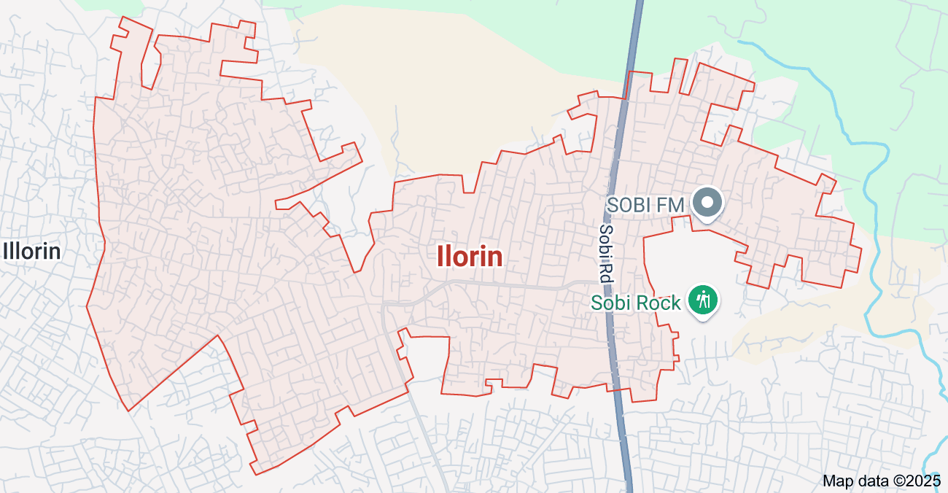
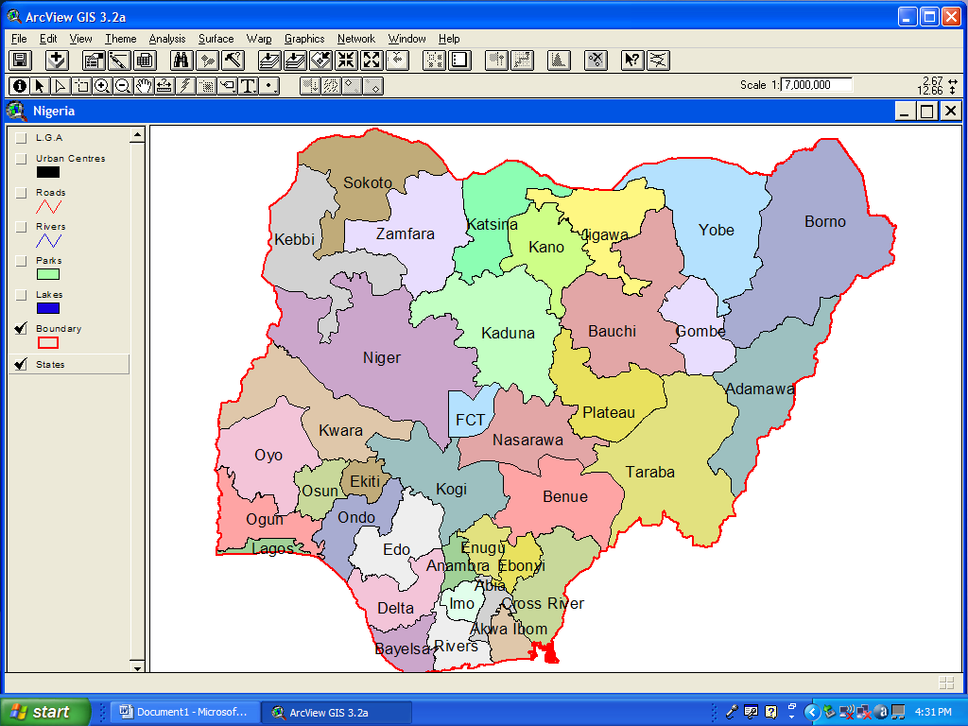

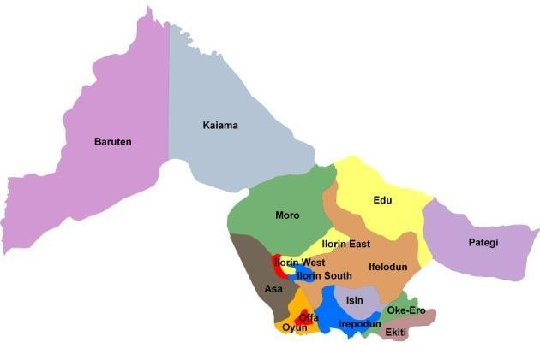
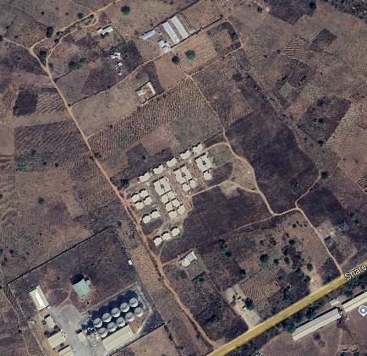

ILORIN

URBAN ESTATE

Figure 1.1 shows the project study area

1.7 SPECIFICATIONS
The project speciations were referenced to the speciation for land information system using total station which was sources from the Higher National Diploma. The specification includes the following:
- Total station
- Minimum number of datum control required- three (3)
- Traverse should run between secondary or higher order control point.

CHAPTER 2
Land parcel is basic unit for access and control of land, land use and decisions. Current reliable and information necessary for many public programs, for example: Land planning, Infrastructural development and maintenance, Environmental protection and resource management, Emergency services, Basis for land market, development, and other economic activities and Social services programs. However, all organizations need information in order to survive. Most organizations have a large number of data sources but are hampered by their inability to combine them in a meaningful way. Developing a good land information system in Nigeria has been hindered by so many obstacles as stated by Asoegwu, R.N. (unpublished 2000):
• Most parcels of land have not been located by proper surveys that are tied to the national framework of controls;
• The records of land already surveyed are either not available or faulty;
• The records that are pertinent to the parcels of land properly surveyed are not located in a central place;
• Inadequate laws that could enforce the compulsory collection of appropriate land data;
• Ignorance on the part of experts to appreciate the need for land records;
• Reluctance of some governments to fund adequately long-term projects that do not yield immediate profits;
• Initial high cost/financial barrier. Conventional paper-based map information, any information associated with a map feature has to be recorded separately.
A simple example is topographical map showing the parcels of land, and properties in a particular location where the details relating to these land and properties would need to be referred to other files and records. There is a need for a tool to manage the huge volume of map data. There is a need also for a system that will remain flexible enough to handle the sophisticated modern needs of mapping information. The solution is Land Information System.
A. Land Information System The International Federation of Surveyors defines Land Information System (LIS) “as a tool for legal, administrative and economic decision making and an aid for planning and development which consist of procedure and techniques for the systematic collection, updating, processing and distribution of spatial data” .Shard and More (1989).
According to DP Goyal (2014), an Information system may be formally defined as a combination of human and technical resources, together with a set of organizing procedures that produces information in support of some managerial requirement. Data relating to land may be acquired and held in alphanumeric form, graphically or digitally. To become information, the raw data must be processed so that they can be understood by a decision maker. A land information system gives support to land management by providing information about the land, the resources upon it and the improvement made on it.
Land Information systems cover such a wide variety of applications and contain such diverse data that they are difficult to categorize. The terms Geographical Information ' System (GIS) and Land Information System (LIS) are often used interchangeably. At a meeting in Montreux in 1981 the FIG defined an LIS as A tool for legal, administrative and economic decision making and an aid for planning and development which consists on the one hand of a data base containing spatially-referenced land-related data for a defined area, and on the other hand, of procedures and techniques for the systematic collection, updating, processing and distribution of the data. The base of a land information system is a uniform spatial reference system for the data in the system, which also facilitates the linking of data within the system with other land-related data.
This definition covers systems which are called 'land information'(LIS) systems (GIS). In and those called 'geographic information' fact though, the terminology is usually discipline-based. As a generalization it may be said that a GIS is usually concerned with natural resources, environmental, or demographic data which is presented at small scale and is analyzed on a grid cell basis. LIS, on the other hand, is usually concerned with large scale land administration data and is based on polygon’s which represent land parcels. This distinction is by no means rigid. In the 'multi-purpose' cadastre natural resources, environmental, and demographic data are linked to a parcel-based system; some administrativesystems environmental systems may be use raster graphics, while polygon-based. Part of the problem of classification is that no two systems are ·the 1 Hamilton A c and Williamson I P, A critique of the F.I.G. definition of "Land Information System", F.I.G. International Symposium on LIS, Edmonton, 1984.
same. Rhind2 states there is no dichotomy of the world into two ranges of map scales. In this thesis the term 'land information system'(LIS) will be used to cover all classes of spatial information systems. In functional terms two types of land information system may be distinguished: Systems integrating data from several organizations (Open systems) Systems using data internal to the organization (Closed systems) The first type is embodied in a national land information system or 'multi-purpose' cadastre. Many examples of the second type are found in development agencies.
On a technical level the differences are of scale rather than kind. National systems may be required to handle millions of land parcels and handling such large databases provides a great challenge to existing database technology. A more significant difference is on the organizational level. Personal and political problems inevitably arise when data has to be obtained from a number of different organizations and much of the effort in setting up a system goes into resolving these problems. Note that the open system is not limited to 'cadastral' or parcel-based systems. The Natural Research Environment Council (NERC) in the U.K. is an umbrella body which comprises such statutory bodies as the British Antarctic Survey, the Geological Survey of Great Britain, and the Institute of Oceanographic Sciences. This RhindDW,Geographical& Land Information Systems: Their Relationship, Shortcomings and Future Prospects, Conference of Southern African Surveyors, March 1989. 2 - 2 council recently carried out a study3 into the feasibility of a common LIS for NERC and into the implementation of such an LIS. This serves to illustrate that integration is taking place in the field of scientific applications as well as in the legal field.
The Cadastre 'Cadastre' is the technical term used to describe a system in which a legal record of property holdings is combined with a survey identifying the location of those holdings(A Przewięźlikowska - Land Use Policy, 2020 ). Rights in land have been recorded since men first gave up the nomadic life and settled as farmers and town-dwellers.
Land is immovable and varies in quality ~and suitability for the many uses to which it is put(AE Zolotareva, SJ Starodumova… - Journal of Advanced …, 2017 ). Disputes over land have often proved to be cause for war as well as lying at the root of many family feuds. To avoid such disputes therefore, it has proved necessary to demarcate the boundaries of land holdings and to record the rights of the owner or occupier in the land.
It is extremely· rare for an individual owner to possess the absolute right to do as he pleases with his land. He can I exercise no more rights than are given to him by the State which for its part guarantees his ownership through the maintenance of law and order. Egyptian writing almost five thousand years old refers to the registration of property rights. Later documents from the Ptolemaic period give much information about the measurement, registration and quality of land4.
Rhind DW. 61 Green NPA, Design of a Geographical Information System for a heterogeneous scientific community, Geographical Information Systems, Vol.2 No.2 June 1988. Dowson & Sheppard, Land Registration, HMSO 1952.
The Romans learnt a much from the Egyptians about land management. Cadastral surveys for the purpose of levying land taxes were undertaken in various parts of the Roman Empire, property registers were kept, and surveys were regularly carried out for the laying out of towns(RJP Kain, E Baigent - 1992 - ). The Chinese Empire separated from the Middle East by thousands of miles nevertheless developed a system for surveying and registering property rights.
Likewise, surveys for revenue purposes were carried out in Southern India in the eleventh century6. These examples serve to show that information about land has been regarded as very important from ancient times. In the past this information was used chiefly for taxation and for the avoidance of disputes over ownership. In modern times the pressure of increasing population has forced states to curtail the rights of owners in their land. e. g. to control land use so as to achieve a reasonable quality of life for all. Effective control requires knowledge. Planning is only meaningful when the existing patterns of land use, ownership and resources are known. How can a cadastre be defined? A brief definition was given above, but to quote Dale 11 Acadastre is a general, systematic and up-to-date register containing information about land parcels including details of their area, value and ownership:
A Course of Lectures Prepared for Third Year Survey Technicians (Cadastral) Studying for the National Diploma Examination, Vol.1 History and Legislation Relating to Land surveying in south and South West Africa, Director General Surveys, Mowbray, 1961. CanrnonweaIth Dale P F, Cadastral Surveys within the monwealth, HMSO, 1976. ibid, pl
mention a key element - the geographical position of the land. However, much information there may be about a piece of land, it is worthless unless the position of the land is known. In the early days of British administration in Sabah (North Borneo) land grants were· made in the form of "Provisional Leases". Such leases were for a specified area of land, the boundaries to be determined subsequently by survey. In some cases, the survey has never been carried out and it is obvious that there is not sufficient unallocated land in the district to cover the extent of the grant. Nevertheless, such leases are bought and sold (and registered and transferred) but at a very substantial discount on the price paid for surveyed land. A similar example may be quoted from Botswana - A block of farms in the Ghanzi District was allocated in 1891 on the basis of 'certificates of occupation' for 5000 morgens. Survey of the holdings was delayed until the 1950's with the consequence that the surveyor had a very difficult task to reconcile actual occupation with the area granted. such cases
illustrate that registration without survey has very little value. This fact is plain to land surveyors but unfortunately not always obvious to land administrators, otherwise the cases cited above could not have arisen. The definition quoted above could be improved as follows "A cadastre is a general, systematic and up-to-date register containing information about land parcels including details of their location, area, value and ownership."

CHAPTERTHREE

3.0 METHODOLOGY
Thisstageinvolvesthemethodsandprocedureusedinplanning,dataacquisition,dataprocessing, and creation of database, creation of database management system and informationpresentation.These operations were logically structured and carried out in stages involvingdatabase design. It is normally considered to involve a spatially referenced and structureddigital database and appropriate application software for geospatial analysis. This basicallydescribesthe techniquesandprinciples adopted incarrying out theproject.
Geographicinformationsystemmethodswereadoptedinaccomplishingthedesiredresults.

3.1 DATABASEDESIGN
Thedesignof anydatabaseinvolves threestages namely;
i Conceptualdesign
ii Logical design
iii Physicaldesign

3.1.1 VIEW OF REALITY
In database design, there is need for reality which is referred to as the phenomenon thatactually exists, including all aspects which may or may not be perceived by individuals. Theview of reality however, is the mental abstraction of the reality for a particular application orgroupofapplications.
For thisapplication, the view of reality ismadeof the topography of the project.Since itisnot possible to represent the real world, the only option is to conceptualize and model it in aspecifiedmanner torepresentthe realworld.Thearea of interesttousinthisproject Includes;GreenReserve,Roads,Electricpoles,Trees,WaterFacilities,Buildings,Footballpitch,Streams.

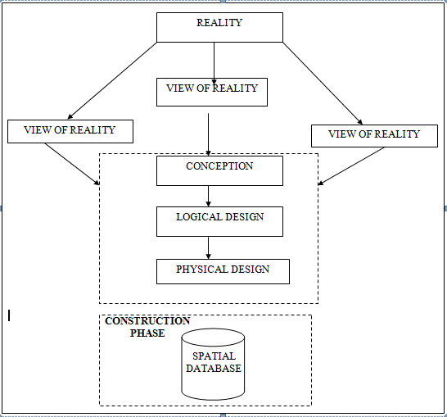
Fig.3.1Design andConstructionPhasesinSpatialDatabase

3.1.2 CONCEPTUALDESIGN
Vectordatamodelisthedatatypeadoptedforthisproject,whichisrepresented,bypoints,linesandpolygon. Theidentifiedentities are:-
      - Vegetation area (polygon)
      - Roads(line)
      - Trees(point)
      - Boundary line (polygon)
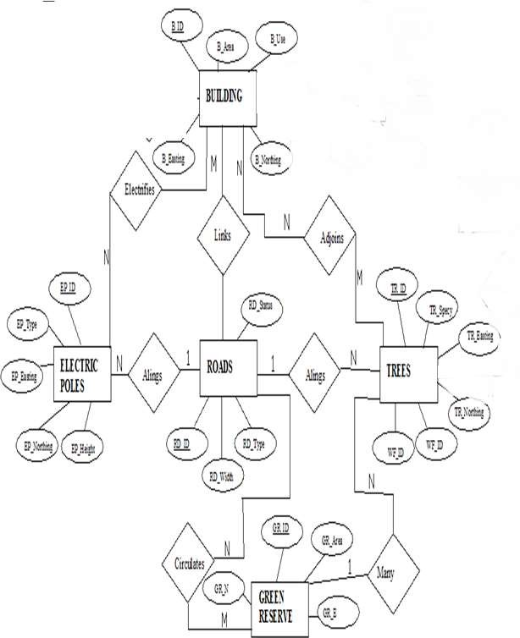
      - Buildings(polygon)

Fig.3.2.:E-RDiagram(Entityrelationship diagram)

3.1.3 LOGICALDESIGN
This is the design aspect of the database refers to the process of creating a conceptualframework or model that represents the structure and organization of spatial data within thesystem.Itinvolvesdefiningthedataelement,theirrelationship,andtherulesfordatamanipulation and analysis.In this phase, theentities, their attributes and their relationshipsare represented in a single uniform manner in form of relation in such a way that would be noinformation loss and at the same time no unnecessary duplication of data. In this study, thelogical database design is employed to generate a geo-relation database structure. Each entityhas unique identifier in bold type. An attribute type or combination of attribute types thatservesto identifyanentitytypeis termed an identifier.
- Building(B_ID,B_Area, B_Name,B_Easting,B_Northing)
- Roads(R_ID,R_Width,R_Type,R-Condition,R_Easting,R_Northing)
- Vegetation(V_ID,GR_Area,)
- Tree(TR_ID,TR_spp,TR_Importance,TR_Easting,TR_Northing)
- ElectricPole(EP_No,EP_Type,EP_Height,EP_Easting,EP_Northing)
- WaterFacility(WF_ID,WF_Depth,WF_Type,WF_Easting,WF_Northing)
- FootballPitch(FP_ID,FP_Area,FP_Status)
- Stream(S_ID,Length,Width)

3.1.4 PHYSICALDESIGN

Table3.1: Buildingand itsattribute
ENTITY | DESCRIPTION
B_ID | BuildingIdentification
B_name | BuildingName
B_Area | BuildingArea
B_Easting | BuildingEasting
B_Northing | BuildingNorthings

Table3.2:Roadanditsattributes
ENTITY | DESCRIPTION
R_ID | RoadIdentifier
R_Length | RoadLength
R_Width | Road Width
R_Type | RoadType
R_Condition | RoadCondition

Table3.3:Treesanditsattributes
ENTITY | DESCRIPTION
TR_ID | TreeIdentifier
TR_Spp | Treespecy
TR_E | Tree_Easting
TR_N | TreeNorthing

Table3.4.:VegetationanditsAttributes
ENTITY | DESCRIPTION
V_ID | VegetationIdentifier
V_Area | VegetationArea
V_E | VegetationEasting
V_N | VegetationNorthing

3.2 RECONNAISSANCE
Thisisthepreparatorystagebeforetheexecutionofthisproject;itinvolvescollectionofavailableinformation about theproject area.
Thenecessarysteptakenforthesuccessfulexecutionoftheprojectinvolvestwostages,whichare:-
- OfficePlanning
- Fieldreconnaissance

3.2.1 OFFICEPLANNING
This involves the collection of information about the study area, testing the instrument to beused in execution of the project and itemizing the numbers of equipment needed, number ofdays to be use, how each activity is to be carried out, delegation of works to each teammembersbased onsupervisor’sguide/instructions.

Table.3.5CoordinatesofControls
Station | Northing(m) | Easting(m) | Height(m)
KPT 120X | 945235.040 | 682280.278 | 211.976
KWCS102 | 945738.095 | 683583.702 | 201.532
SC/KWEAS5072 | 945974.041 | 684070.314 | 200.087
Source:SurveyingandGeo-informaticsdepartment Kwarastatepolytechnic.

3.2.2 FIELDRECONNAISSANCE
Thefieldreconnaissanceisthefirstvisitationtotheprojectsitetogetintimatedwiththeenvironment.
- Boundarypoints was selected
- Thedistributionoffeatureswasstudied
- Controlstobeusedwerelocated
- Methodandtypeof instrumenttobe useswasdetermined
- SubsidiarypointforGroundcontrolPointswerepickedanddefineusingnailandbottlecock
- Adiagram of the studyareawas drawn.
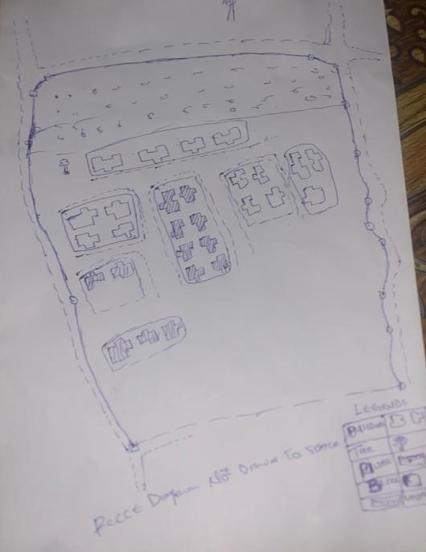

Fig.3.3: Reccediagramofthestudy area (notdrawn to scale)

3.3 EQUIPMENTUSED/SYSTEMSELECTIONANDSOFTWARE

3.3.1 HARDWAREUSED
- Totalstation
- 1reflectorwith atrackingrod.
- 1Tripod
- One(1)50m tape
- One(1)umbrella
- 1cutlass
- HandheldGPS
- Hammer
- Nailsandbottlecover
- Fieldbookandwriting materials
- 1-NoofPersonalComputerHP655 andits accessories
- 1-NoofHP DeskJetK7100 A3 printer
- 1-NoofHPDeskJet 1110 A4printer

3.3.2 SOFTWARECOMPONENT
- Notepad.
- MicrosoftExcel.
- AutoCAD2007
- ArcGIS10.2
- MicrosoftWord.

3.4 INSTRUMENTTEST
To ensure data quality,the TotalStationused for thisprojectwastested for bothverticalindex and horizontal collimation errors.It was also to ascertain the efficiency and reliabilityofthe instrument. Theprocedureused isdescribed below.

3.4.1 HORIZONTALCOLLIMATIONTEST
This test was conducted to ensure that the line of sight was perpendicular to the trunnion axis.The Total Station was positioned over a specific point, and initial adjustments were made toensureproperalignment,leveling,andfocus(toeliminateparallaxinthetelescope). Avertical target was placed at a distance of 100 meters from the Total Station. To access theconfigurationmenuoftheTotalStation,themenukeywaspressedandheldforapproximately 2 seconds. From the main menu, the calibration sub-menu was selected, andwithin that, the horizontal collimation test option was chosen. The target was then observedand divided into two halves, with horizontal readings recorded for Face left and Face right.Thereadings areshown in Table 3.4.1 below.
TotalStation
100m
REFLECTOR(TARGET)

STATIONA
FairlyLevelGround

STATIONB

Fig3.4;HorizontalCollimation andVerticalIndexerrortest.

Table3.6:HorizontalCollimation Data
Station | Target | Face | HzReading | Difference | Error
A | B | L | 38˚42‟32”
 |  | R | 218˚42‟35” | 180˚00‟03” | 03”
Source field work

3.4.2 VERTICALINDEXERRORTEST
This test was conducted to verify the accuracy of the vertical reading when the line of sight ishorizontal.Thedesiredmeasurementforthistestisexactlyninetydegrees(90˚),anydeviationfrom this valueis referred to asthevertical index error.
The Total Station was positioned over a specific point, and necessary temporary adjustmentswere made to ensure proper alignment and functionality. A target was placed approximately100 meters away fromthe TotalStation,and the instrumentwasaimedatthe target.Thetarget was bisected by aligning the instrument on the face left, and the corresponding readingwas recorded. Similarly, the target was then bisected on the face right, and the respectivereadingwasalso recorded.Therecordedreadingsareprovided below:

Table3.7:VerticalIndexData
InstrumentStation | TargetStation | Face | Vertical | Sum | Error
A | B | L | 90˚00‟00”
 |  | R | 270˚00‟02” | 360˚00‟02” | 02”
Source field work
3.4.3 ANALYSISOFCOLLIMATIONANDVERTICALINDEXDATA
Thereadingobtainduringcalibrationwerereducedtoobtainnewcollimationandverticalerrors.
Horizontalcollimation={(FR–FL)–180}/2={(00˚00‟03”}/2=1.5”

Verticalcollimation={(FL+FR)–360}=(90˚00‟00”+270˚00‟02”)-360}=02”Theresult shows thattheinstrument is stillin good working condition.

3.5 CONTROLCHECK
Three control beacons (KPT 120X, KWCS102 and SC/KWEAS5072) were used.In order toascertain the in-situ of the control beacons, a check was carried out on them by observing theangle between them and comparing the result obtained with the computed angles from thegivingcoordinates.
The total station instrument was set on the control beacon KWCS102. After performing allthenecessarytemporaryadjustment,thereflectorwasplacedonthecontrolbeaconKPT 120X which served as the back station. The horizontal angular reading was taken andrecorded while the instrument was on face left. The reflector was then taken to the controlbeacon SC/KWEAS5072 which serves as the forward station, the horizontal angle reading wasthen taken and recorded on both face left and face right. The reflector was taken back to thebackstation, the horizontal angle wasthenrecorded on face right.

Table3.8:Tableshowing thebackcomputationof thecontrolcoordinates
From STN | Bearing | Dist(m) | ∆N | ∆E | Northing(m) | Easting(m) | ToSTN
 |  |  |  |  | 945235.040 | 682280.278 | KPT 120X
KPT 120X | 68°53'46'' | 1397.130 | 503.050 | 1303.424 | 945738.095 | 683583.702 | KWCS102
KWCS102 | 64°07'57'' | 540.797 | 235.946 | 486.612 | 945974.041 | 684070.314 | SC/KWEAS5072
Source: office of surveyor general kwara state

Table3.9: Tableshowingthedistanceobservationresultofthecontrolcheck
FROM | OBSERVED  DISTANCE  (m) | COMPUTED  DISTANCE  (m) | TO
KPT 120X | 1397.029 | 1397.130 | KWCS102
KWCS102 | 540.694 | 540.797 | SC/KWEAS5072

Table3.10: Tableshowing theobservation resultof thecontrol check
STN | SIGHT | FACE | OBSERVEDHZANGLE | REDUCED HZANGLE | MEAN
 | KPT 120X | L1 | 357° 08'47''
KWCS102 | KPT 120X | L2 | 288° 14'07'' | 68° 54'40''
 | SC/KWEAS5072 | R2 | 108° 52'13'' | 68° 54'46''
 | SC/KWEAS5072 | R1 | 177° 46'59'' |  | 68° 54' 43''

Differenceinangle (observed -computed)=68°54'43''-68°54'40''

=00° 00'03''
Since the allowable accuracy (angular) of third order traverse of one station is 00° 00' 30'' andtheresultobtainedfromthecontrolcheck(00°00'03'')islessthanallowableerror.Therefore,thecontrols wereangularlyintact.

3.6 MONUMENTATION
Theboundaryoftheareacarvedoutwasdemarcatedwiththeprecastconcretebeacons,afterclearingtherequiredlineofsights.Theidentifiedpointsofchangesindirections were dug and beacons were buried on it, leaving about 15cm part of the beaconabove the ground level. The beacons were buried at convenient distances as dictated by thenatureof theboundary.
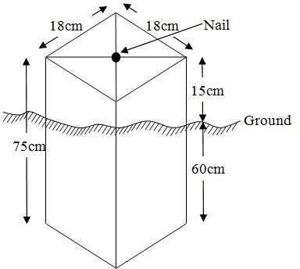
Fig.3.5:PillarDescription

DATAACQUISITION
It’s fundamental to digital mapping. Data acquisition here implies security coordinate data of map features in a computer compatible from there exist several topographical data collection techniques the choice of a particular technique depends on the source of data available hardware / software, envisage revel of accuracy, man power etc. apart from field and laboratory data acquisition data may be obtained from social survey, in this project, data acquisition it refers the ways and method through which the data used were obtained. There was divided in to two viz; geometric data and attribute data

PRIMARYDATASOURCE

Field observation was the primary source of data for this project. Ground based method wasused in acquiring data with the use of Total Station Instrument, which involved the collectionofX, Y, Z data through coordinated Ground control Points (GCP) established at conspicuouspoints within thestudyarea

SECONDARYDATASOURCE
AnimageryoftheareawasacquiredthroughUpdatedGoogleearth;thiswasusedtoascertaintheextent ofcoverageof theproject area.

3.7.1 GEOMETRICDATAACQUISITION
The total station instrument was set carefully on control point; KWCS102 back sight takento KPT 120X after necessary station adjustments has been carried out on it. Theadjustmentsincludes;centering,levelingandfocusing.Thefollowingprocedureswere then followed to determine the position of the next point SC/KWEAS5072 and the sameprocedure were repeated until all we come close to the site. The method used inacquiring data on site was radiation method where two or more points are coordinatedfromone point.
- Havingsetuptheinstrumentandtemporaryadjustmentcarriedout,theinstrument was powered „on‟ and a job wascreated under job menu in theinternalmemoryof theinstrument. Thejob createdwasnamed GRP5B
- On the job, the coordinates of the three (3) control points were keyed in to thememoryoftheinstrumentandsomecodeswerealsosaved.Thecodesinclude
„RD‟forroad,„SP‟forspotheight,„BDforbuildings,etc.

- The height of the instrument was measured and saved on the memory of theinstrumentas wellas thereflector height.
- On coordinate menu,orientation was set by inputtingthe coordinatesof theinstrument station and back sight. The reflector at the back station was perfectlybisectedbeforetheorientationwasconfirmedbyclicking„yes‟.
Having done the orientation, the reflector at the next nail; was bisected and „obs‟(observe)optionwasclicked.ThethreedimensionalcoordinateofthepointN, H) were displayed on the display unit of the instrument and „rec‟ (record) wasclickedtosavethedataintothememory oftheinstrument.Forsubsequentobservationafterthis,„all‟optionwasusedinsteadofpressing„obs‟andpressing
„Record‟later.

- It was ensured that the center of the prism of the reflector was bisected and that itwassetperfectlyonthetripodinordertominimizetheerroronheightdetermination.
- The instrument is been shifted to another nail after all details, spot height andboundary point visible from the instrument station have been picked, set over itandtemporaryadjustments carried out.
Nonetheless, the above operations were repeated until all the boundary points withheightswere coordinated.
In this project all spot height are not in grid intervals but randomly acquired. Threeedges (3) of building were picked. At the end of data acquisition process all detailswere acquired and properly recorded to be shown in their respective positions on theplan.

3.7.2 TTRIBUTESDATAACQUISITION
Attributedataisinformationaboutspatialfeatures.Theyprovidethecharacteristics,description and nomenclature about spatial objects. Thus the attributes data acquired includesnames of buildings and their uses such as classrooms, roads, water facilities and prominentnatural features likes river and trees found and vegetation were properly identified within andaroundthe studyarea.

3.8 DATADOWNLOADINGANDPROCESSING

3.8.1 DATADOWNLOADINGANDEDITING
This is stage whereby all data acquired which were automatically stored in the Total Stationwere downloaded into personal computer. This was done with the aid of downloading cableconnected to the computer and some associated complementing software installed on theSystem.

3.8.2 DATAPROCESSINGANDDATAEDITING
The geometric data downloaded were further processed in order to convert it to auseful format and to enhance its accuracy. The output coordinates, were edited and exportedin *.txt, *.xls and *.pdf format. Thereafter, they were imported into Arc GIS 10.3 for furtheroperationsand to carryout spatial analysis.

3.8.3 DATA PROCESSING IN AUTOCAD
The AutoCAD is tool that can be used for design and drawings, the software was built to general drawing standard hence the difficulty that comes with localizing this standard to various discipline.
Plotting in AutoCAD can be achieved using coordinate geometry (COGO)by either running script file (.scr) or using the command line (i.e. inputting the values using keyboard). In this project plotting was achieved by using command line in AutoCAD environment. The layout plan was produced as shown in figure below.
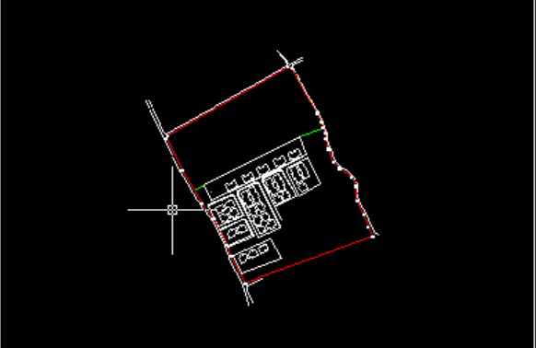

Figure 3.6 shows the layout plan in AutoCAD
Exporting to ArcView, cad file can be exported to GIs software environmental for final cartographic production. This requires that the graphic data can be in a standard exchange format. A standard graphic data exchange format AutoCAD dxf (data exchange format).

3.8.4 DATAPROCESSINGUSINGARCGIS10.3 SOFTWARE
Is one of the contemporary software that is easy and facilitate geographic system operation design, map production, analysis and result computation possibility in any spatial project. ArcView was lunched by double clicking on the desktop shortcut icon. See the attribute table in table 3.1

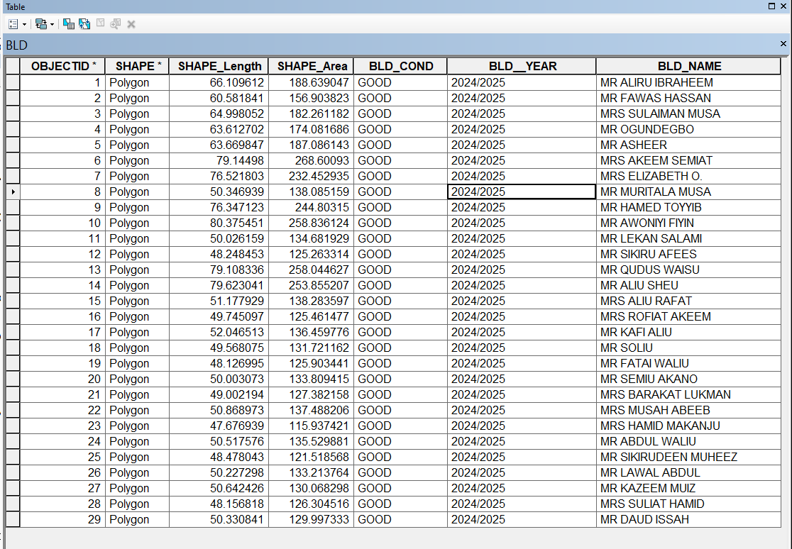

Figure 3.7 shows the attribute table

It demonstrates capability of carrying out a wide range of spatial analysis that may required in land administration. The land information system (LIS) was robust enoughto produce (spatial and non spatial). It was subjected to as show in figure 2 below;
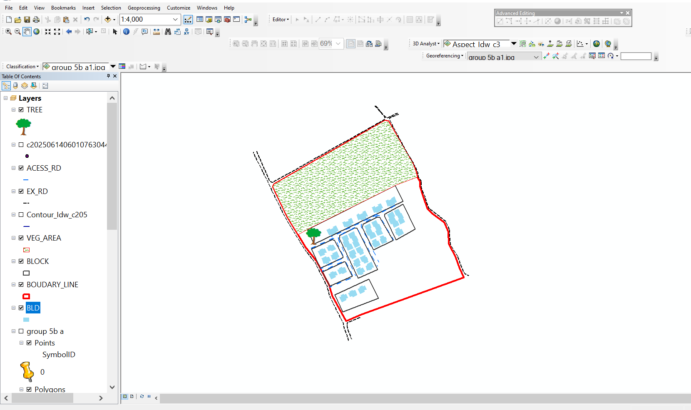

Figure 3.8 shows lay out view in ArcView windows

3.9 DATABASEIMPLEMENTATION
This is the database creation phase. Having completed the three stages of design phase (i.e.Reality,ConceptualandLogicaldesign),thedatabasewascreatedusingArcGIS10.2software. It involves the combination and storage of acquired graphic data and attributes dataincreating the database forthe purposeofspatial analysisand query.
Database is an organized integrated collection of data stored so as to be capable of use byrevenant application with data being accessed by different logical part. After the Attributetable was populated via the keyboard, some attributes such as areas of settlements wereautomaticallydisplayedbyspecialcommandintheArcGIS10.3version.TheArcGISsoftwarewas used to linkthe graphic dataandtableforquerygeneration.

3.9.1 DATABASEMANAGEMENTSYSTEMS
Databasemanagementisacollectionofsoftwareforcreating,storing,manipulating,updating, organizing and querying of information in a database (Kufoniyi, 1998). It is asoftwarepackagewhose function is tomanipulate adatabaseon behalfoftheuser.
Agood DBMS must provide the following functions:
- Storageandretrievalofdata.
- Accessto byseveral users at atime.
- Astandardizedinterfacebetweendatabaseandapplicationprogrammed.
- Standardized access to data and separation of data storage and retrieval functions fromtheprogram using the data.
- Maintenanceof datasecurityandintegrity.

3.9.2 DATABASEMAINTENANCE
Havingcreatedthedatabase,propermaintenancepracticewasmadetomeetitsstatedobjectives.Theabilitytoincludemoredataandremoveirrelevantdatawaspossiblebywayof maintenance. There is every need for the data to be updated regularly because of thephysical changes that may occur on the landscape with time. Both security and integrity werealsoexercised to ensure maintenanceand to meetits stated objectives.
Proper observance, updating and management of database ensure its currency and quality tostand a profound chance in Spatial Decision Support System (SDSS). The quality of anydatabase depends on the currency and fitness for use as a decision support system (SDSS).The quality of database depends on its ability to generally fit and use as a decision system(DSS). The storage media should be from time to time justified if otherwise could necessitatedata inaccessibility or physical deterioration of the storage media.Also care must be takenduring populating any database system, as a database is only good as the data supplied. Inarchivingstable media should be used. Examplesoftheseare
- Computercompatibletapereader
- Magnetictape
- Opticaldiscandcompactdisc

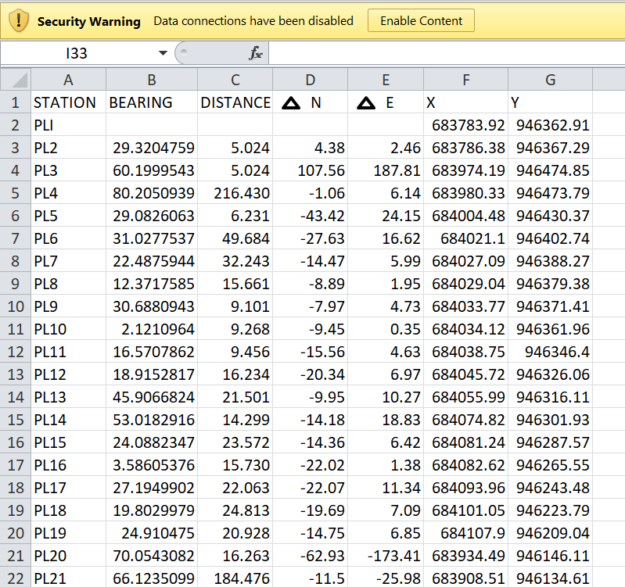
3.9.3 BACK COMPUTATION Table 3.11: Back Computation

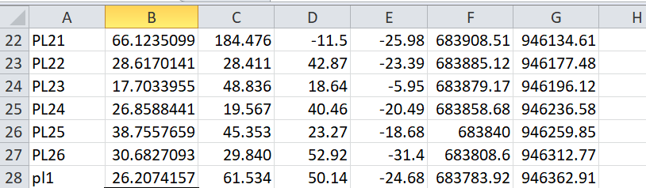

3.9.4 AREA COMPUTATION

Table3.12:AreaComputation
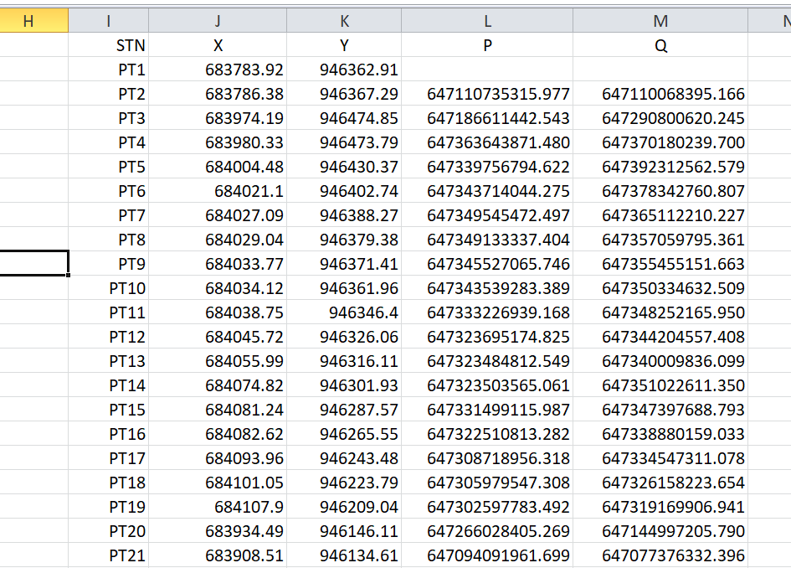

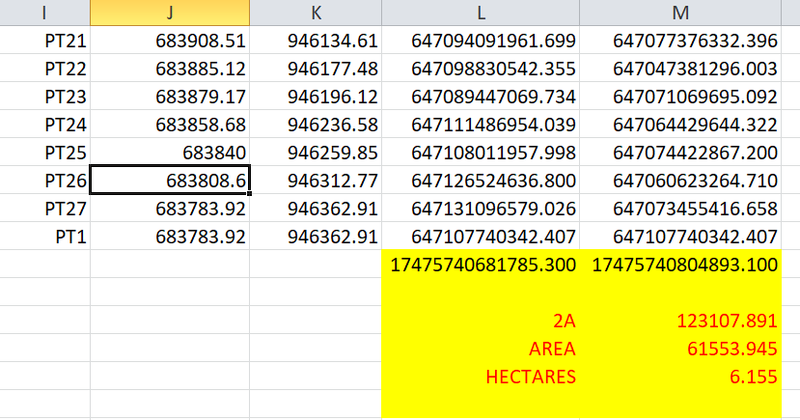

CHAPTERFOUR

4.0 SPATIALANALYSESANDPRESENTATION
GIS is distinct among other information system because of its spatial analytical capability;especiallyoverlayoperation,buffering,spatialsearch,topographicoperation,andneighborhoodandconnectivityoperations.GISusesthisspatialanalyticalcapabilitytoanswerfundamentalgenericquestionoflocation,condition,trend,routing,patternandmodeling by the manipulation and analysis of input data. The major analyses performed inthisproject wereoverlayoperations, topographic operations andspatial search.

4.1 TESTINGOF DATABASE
This is the test carried out to determine whether there exists a relationship between datamodeledaboutentitiesinaspatialdatabaseaswellasputtingintotestitsretrievalcapabilities. This was done by designinga sample query with certain conditions attached andthequerywill beran to seeif desired result is achieved.
Analysisof Result
Data captured were full to ensure standardization of task. Coordinated point were used in oreder to produce information required (LIS) and lastly to decision making and produce the output in digital form, while the attribute presented in tabular form. In most GIS operation package including arcview these include measurement techniques, query analysis and geometric operation in this project include questions such as:-
- Residential land use
- Vegetation area
- Developed area
- Slope aspect
- Building that does not have C of O
- Building that have C of O
- Building that have R of O
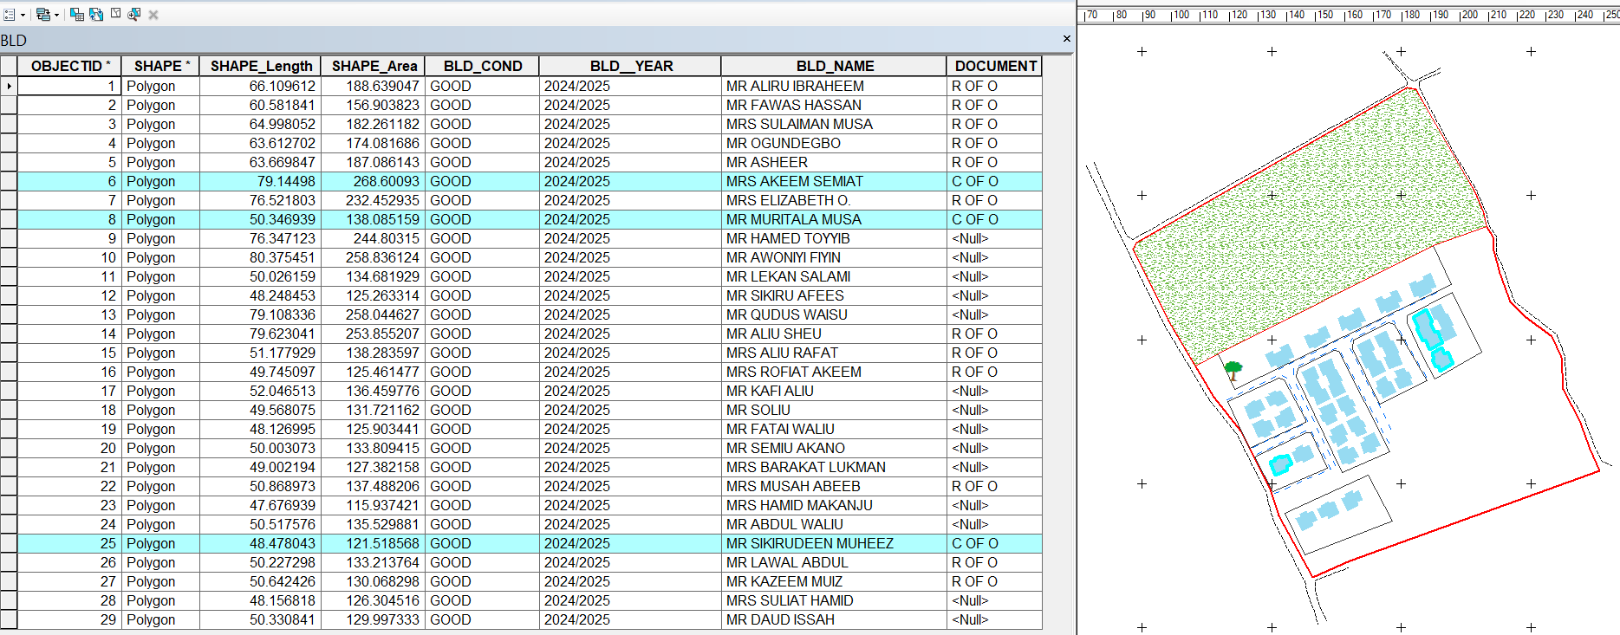
The above listed queries are shown in blue

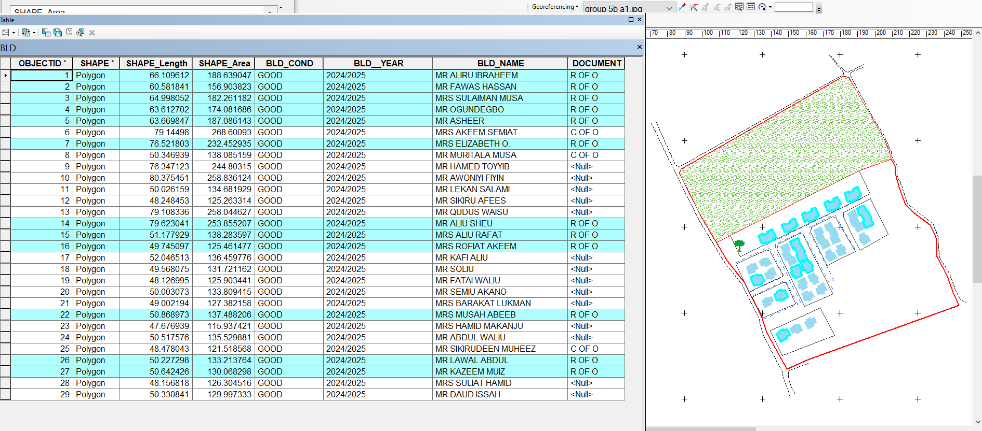
Fig4.1.:shows the building that have C of O

Fig4.2:shows the building that have R of O

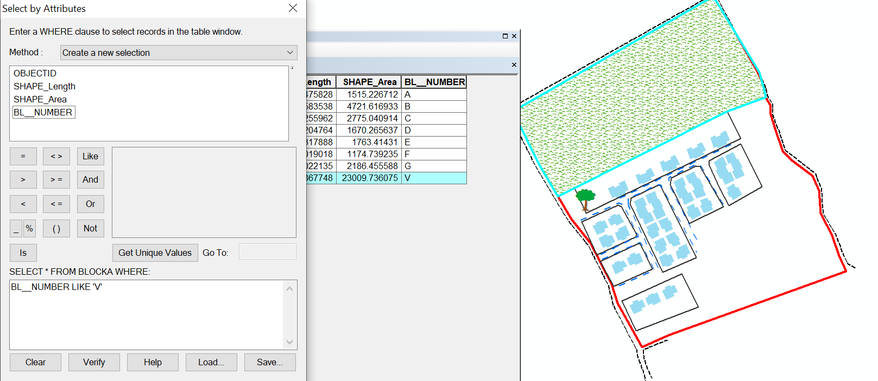

Fig 4.3: show the area use for vegetation
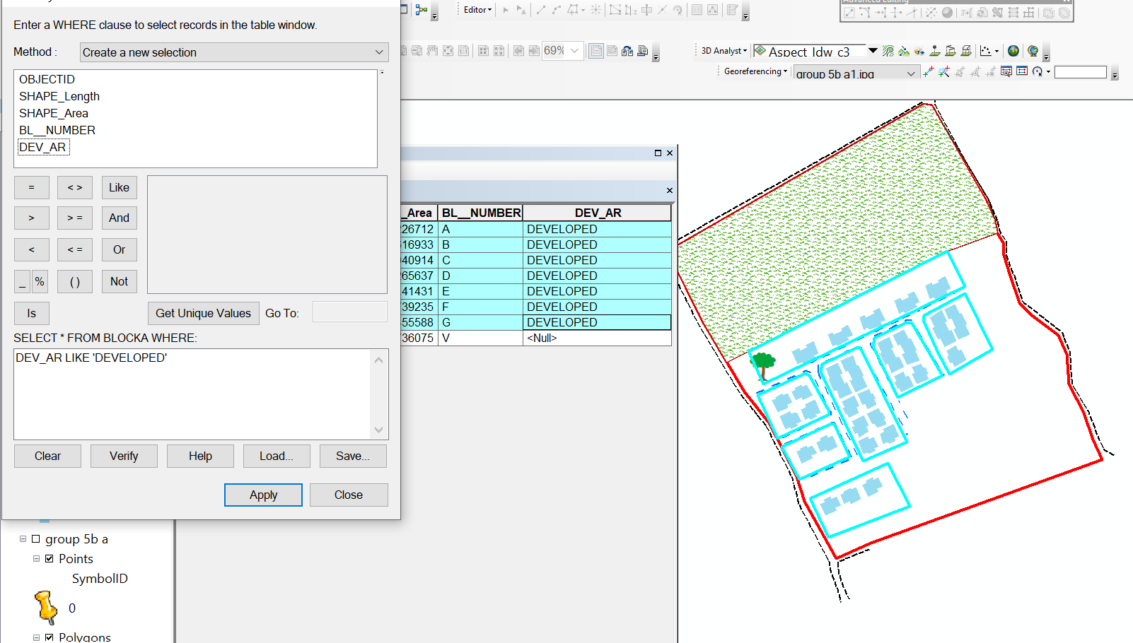

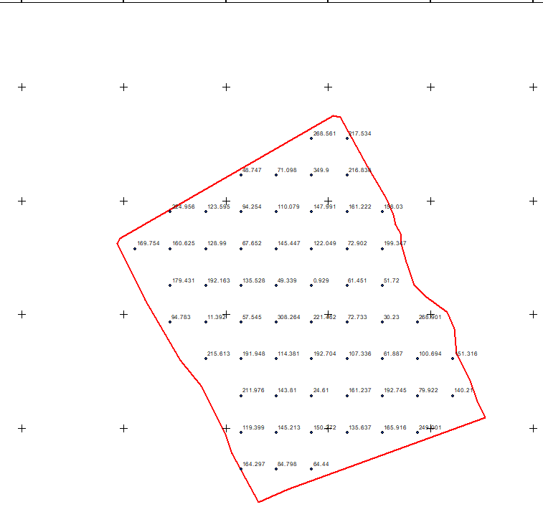
Fig 4.4: show the developed area

Figure 4.5 shows the spot height

This is the compass direction of that a slope faces and it plays a significant role in environmental and land management decision

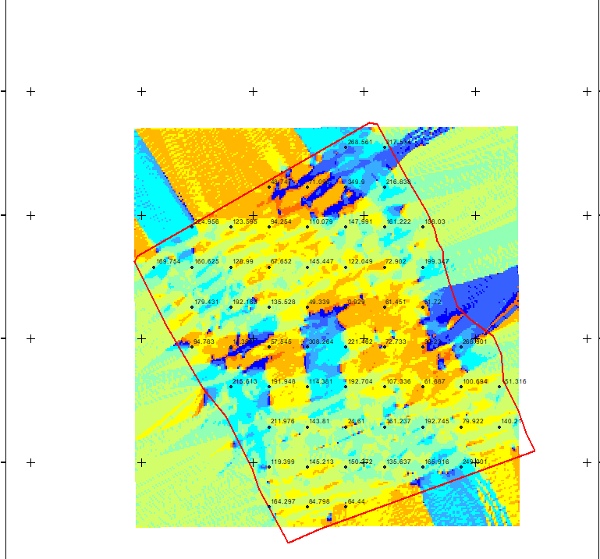

Figure 4.6 shows the slope aspect

The total number of building in the lay out are29 all of them are residential and vegetation area is 1, the table 4.1 below shows the land use percentage

Table 4.1 shows the land use percentage
Residential | 0.475266 percent
Vegetationarea | 2.292255 percent

Figure 4.7 shows the pie chart of land use

CHAPTER FIVE
5.0 Costing Estimation, Summary, Conclusion, Recommendation and Problem Encountered
5.1 Costing Estimation
RECCONNAISSANCE
S/N | PERSONNEL | QTY | DAILY RATE | NO OF DAYS | REMARK
1 | Group leader | 1 | 5000 | 1 | 5000
2 | Ass group leader | 1 | 2500 | 1 | 2500
3 | Basic equipment | 1 | 25000 | 1 | 25000
4 | Transportation | 1 | 3000 | 1 | 3000
Subtotal = #35,500
Monumentation
S/N | PERSONNEL | QTY | DAILY RATE | NO OF DAYS | REMARK
1 | Group leader | 1 | 5000 | 1 | 5000
2 | Ass group leader | 1 | 2500 | 1 | 2500
3 | Skilled labor | 3 | 1500 | 1 | 4500
4 | Basic equipment | 1 | 25000 | 1 | 25000
5 | Transportation | 1 | 7500 | 1 | 3000
Subtotal = #40,000

Beaconing
S/N | PERSONNEL | QTY | DAILY RATE | NO OF DAYS | REMARK
1 | Group leader | 1 | 5000 | 1 | 5000
2 | Ass group leader | 1 | 2500 | 1 | 2500
3 | Basic equipment | 1 | 5000 | 1 | 5000
4 | Transportation | 1 | 3000 | 1 | 3000
Subtotal = #5,500
Beacon
S/N | PERSONNEL | QTY | DAILY RATE | NO OF DAYS | REMARK
1 | Group leader | 1 | 5000 | 1 | 5000
2 | Ass group leader | 1 | 2500 | 1 | 2500
3 | Beacon | 10 | 1000 | 1 | 10,000
4 | Transportation | 1 | 3000 | 1 | 3000
Subtotal = #19,500
Traversing
S/N | PERSONNEL | QTY | DAILY RATE | NO OF DAYS | REMARK
1 | Supervisor | 1 | 6000 | 1 | 6000
2 | Group leader | 1 | 5000 | 1 | 5000
3 | Ass group leader | 1 | 2500 | 1 | 2500
4 | Skilled labour | 6 | 1500 | 1 | 10,000
5 | Basic equipment | 1 | 25000 | 1 | 5000
6 | Transportation | 1 | 10,500 | 1 | 10,500
Subtotal = #43,500
Spot Height
S/N | PERSONNEL | QTY | DAILY RATE | NO OF DAYS | REMARK
1 | Supervisor | 1 | 6000 | 2 | 12,000
2 | Group leader | 1 | 5000 | 2 | 10,000
3 | Ass group leader | 1 | 2500 | 2 | 5000
4 | Skilled labor | 6 | 1500 | 2 | 20,000
5 | Basic equipment | 1 | 25000 | 1 | 5000
6 | Transportation | 1 | 10,500 | 2 | 21,000
Subtotal = #73,000
Data processing
S/N | PERSONNEL | QTY | DAILY RATE | NO OF DAYS | REMARK
1 | Group leader | 1 | 5000 | 1 | 5000
2 | Ass group leader | 1 | 2500 | 1 | 2500
3 | Basic equipment | 1 | 10,000 | 1 | 10,000
4 | Generator and fuel | 1 | 10,000 | 1 | 10,000
Subtotal = #27,500
Technical report
S/N | PERSONNEL | QTY | DAILY RATE | NO OF DAYS | REMARK
1 | Group leader | 1 | 5000 | 1 | 5000
2 | Ass group leader | 1 | 2500 | 1 | 2500
3 | Basic equipment | 1 | 10,000 | 1 | 10,000
4 | Generator and fuel | 1 | 10,000 | 1 | 10,000
Subtotal = #27,500
Sum total = 271,500.00

Contingency allowance = 271,500.00 X 5 = 13,575
100

VAT = 271,500.00 X 7.5 = 20,362.5
100

ACCOMODATION = 271,500.00 X 1.5 = 4,072.5
100

MOB/DEMB = 271,500.00 X 10 = 27,150
100
GLEARANCE TAX = 65, 159.5

5.2 Summary
The project title land information of urban estate opposite government cemetery Okeose/OkeOyi road Ilorin, Ilorin Kwara State. The project was carried out in accordance with third order specifications, the reconnaissance [office and field] was properly carried out and this enhanced proper planning of the operations by locating initial controls for proper orientation, the instrument to be used, and selection of total station were put into consideration and finally drawing of sketched diagram of the area to be surveyed. This project covered the aspect of traversing, perimeter, leveling, detailing and spot heights by using Total Station as main instrument.
Traversing was done to determine the coordinate [Northing and Easting] of the stations while heights of the stations were obtained from the perimeter, leveling, tachometry was used to obtain the values of position of new points. Thereafter, data processing was done and the plan was produced in analysis [manual] and digital format title plan showing perimeter and details of all project area. Finally, a comprehensive report was written on how the entire project was executed.
5.3 Problems Encountered
The problem encountered on the site were unavoidable especially the movement of vehicles and the students of our site project were disturbing when working. Also, the total station battery was also getting weak time to time, so it consumes us more battery and stress before getting another battery.
5.4 Conclusion
Land Information Systems (LIS) are becoming indispensable tools for effective land management, urban planning, environmental conservation, and economic development. As GIS and technology continue to evolve, LIS is expected to play a critical role in ensuring sustainable land use and securing property rights for citizens worldwide. However, issues such as data quality, cost, and legal complexity still present challenges to the widespread implementation and success of LIS in some regions.
5.5 Recommendations
Having participated in this practical work and due to the experience, I had acquired during this project and products generated, I hereby make the following recommendations.
- The Government should use this plan available for decision making regarding the premises and as well fence the school premises because the school is bounded by many roads.
- The Government should give proper supervision to the available resource such as borehole, chairs and table as well as staff.
- Application of computer programming should be fully implemented so as to make the students carry out the data processing exercise more efficiently and faster.
- This project is available for review

References
- Allan, A. L. Hollwey, J.R. Marynes, J.H.B. (1968): Practical Field Surveying and Computation, Heinemann, London. Pg.201.
- BanisterA. andRaymondS. (1986): Surveying 4thEdition London, pitman publishing limited.
- Dashe J. P. (1987): cadastral surveying and practice in Nigeria.
- Encarta encyclopedia (2009): www.google.com
- Eruteya E. O. (2009): basic principles in surveying handout
- Oxford advance leaner’s dictionary (2001): 6th edition oxford university press Walton street.

APPENDIX
STN | X | Y | H
PT1 | 683783.92 | 946362.91 | 164.297
PT2 | 683786.38 | 946367.29 | 84.798
PT3 | 683974.19 | 946474.85 | 64.44
PT4 | 683980.33 | 946473.79 | 119.399
PT5 | 684004.48 | 946430.37 | 145.213
PT6 | 684021.1 | 946402.74 | 150.272
PT7 | 684027.09 | 946388.27 | 135.637
PT8 | 684029.04 | 946379.38 | 165.916
PT9 | 684033.77 | 946371.41 | 249.001
PT10 | 684034.12 | 946361.96 | 211.976
PT11 | 684038.75 | 946346.4 | 143.81
PT12 | 684045.72 | 946326.06 | 24.61
PT13 | 684055.99 | 946316.11 | 161.237
PT14 | 684074.82 | 946301.93 | 192.745
PT15 | 684081.24 | 946287.57 | 79.922
PT16 | 684082.62 | 946265.55 | 140.21
PT17 | 684093.96 | 946243.48 | 215.613
PT18 | 684101.05 | 946223.79 | 191.948
PT19 | 684107.9 | 946209.04 | 114.381
PT20 | 683934.49 | 946146.11 | 192.704
PT21 | 683908.51 | 946134.61 | 107.336
PT22 | 683885.12 | 946177.48 | 61.887
PT23 | 683879.17 | 946196.12 | 100.694
PT24 | 683858.68 | 946236.58 | 151.316
PT25 | 683840 | 946259.85 | 94.783
PT26 | 683808.6 | 946312.77 | 11.392
PT27 | 683783.92 | 946362.91 | 57.545
PT28 | 683893.31 | 946163.83 | 164.297
PT29 | 683924.4 | 946163.83 | 84.798
PT30 | 683955.5 | 946163.83 | 64.44
PT31 | 683893.31 | 946196.18 | 119.399
PT32 | 683924.4 | 946196.18 | 145.213
PT33 | 683955.5 | 946196.18 | 150.272
PT34 | 683986.59 | 946196.18 | 135.637
PT35 | 684017.68 | 946196.18 | 165.916
PT36 | 684048.77 | 946196.18 | 249.001
PT37 | 683893.31 | 946228.52 | 211.976
PT38 | 683924.4 | 946228.52 | 143.81
PT39 | 683955.5 | 946228.52 | 24.61
PT40 | 683986.59 | 946228.52 | 161.237
PT41 | 684017.68 | 946228.52 | 192.745
PT42 | 684048.77 | 946228.52 | 79.922
PT43 | 684079.86 | 946228.52 | 140.21
PT44 | 683862.22 | 946260.87 | 215.613
PT45 | 683893.31 | 946260.87 | 191.948
PT46 | 683924.4 | 946260.87 | 114.381
PT47 | 683955.5 | 946260.87 | 192.704
PT48 | 683986.59 | 946260.87 | 107.336
PT49 | 684017.68 | 946260.87 | 61.887
PT50 | 684048.77 | 946260.87 | 100.694
PT51 | 684079.86 | 946260.87 | 151.316
PT52 | 683831.13 | 946293.21 | 94.783
PT53 | 683862.22 | 946293.21 | 11.392
PT54 | 683893.31 | 946293.21 | 57.545
PT55 | 683924.4 | 946293.21 | 308.264
PT56 | 683955.5 | 946293.21 | 221.462
PT57 | 683986.59 | 946293.21 | 72.733
PT58 | 684017.68 | 946293.21 | 30.23
PT59 | 684048.77 | 946293.21 | 268.901
PT60 | 683831.13 | 946325.56 | 179.431
PT61 | 683862.22 | 946325.56 | 192.163
PT62 | 683893.31 | 946325.56 | 135.528
PT63 | 683924.4 | 946325.56 | 49.339
PT64 | 683955.5 | 946325.56 | 0.929
PT65 | 683986.59 | 946325.56 | 61.451
PT66 | 684017.68 | 946325.56 | 51.72
PT67 | 683800.03 | 946357.91 | 169.754
PT68 | 683831.13 | 946357.91 | 160.625
PT69 | 683862.22 | 946357.91 | 128.99
PT70 | 683893.31 | 946357.91 | 67.652
PT71 | 683924.4 | 946357.91 | 145.447
PT72 | 683955.5 | 946357.91 | 122.049
PT73 | 683986.59 | 946357.91 | 72.902
PT74 | 684017.68 | 946357.91 | 199.347
PT75 | 683831.13 | 946390.25 | 224.956
PT76 | 683862.22 | 946390.25 | 123.595
PT77 | 683893.31 | 946390.25 | 94.254
PT78 | 683924.4 | 946390.25 | 110.079
PT79 | 683955.5 | 946390.25 | 147.991
PT80 | 683986.59 | 946390.25 | 161.222
PT81 | 684017.68 | 946390.25 | 158.03
PT82 | 683893.31 | 946422.6 | 48.747
PT83 | 683924.4 | 946422.6 | 71.098
PT84 | 683955.5 | 946422.6 | 349.9
PT85 | 683986.59 | 946422.6 | 216.838
PT86 | 683955.5 | 946454.95 | 268.561
PT87 | 683986.59 | 946454.95 | 217.534

