IMPACT OF PETROLEUM PROFIT TAX ON THE ECONOMIC DEVELOPMENT OF NIGERIA
(A CASE STUDY OF FEDERAL INLAND REVENUE SERVICE, ILORIN)

BY

GANIU BASIT AYOMIDE
ND/23/ACC/FT/0082

BEING A RESEARCH PROJECT SUMBITTED IN PARTIAL FULFILMENT OF THE DEPARTMENT OF ACCOUNTANCY, INSTITUTE OF FINANCE AND MANAGEMENT STUDIES, KWARA STATE POLYTECHNIC, ILORIN.

IN PARTIAL FULFILMENT OF THE REQUIREMENT FOR THE AWARD OF NATIONAL DIPLOMA (ND) IN ACCOUNTANCY

JUNE, 2025

CHAPTER ONE

GENERAL INTRODUCTION

1.1 BACKGROUND TO THE STUDY
Sometimes we need the help of doctors immediately, but due to some reasons they are unavailable. In our project we propose a system that is user favourable to get guidance on health issues instantly through online health care system. In recent years, with reference to the Bayesian statistics and posterior distribution the puzzles are solved highly. Meanwhile, Bayesian statistics with success apply to economic, social science and a few different fields. In medical fields, the foreign students have solved some medical issues that are laborious to be settled in classic statistics by classification of Bayesian. Naive Layers is among the foremost common classification technique introduced by Reverend Thomas Bayes. With no extra information, classification rules are generated by the samples trained by themselves.
“Smart Health Disease Prediction System" is the automation of therapeutic information to help and upgrade
(1) Administration of health services
(2) Clinical care
(3) Medical analysis
(4) Training
It is the appliance of computing and communication technologies to optimize health information science by assortment, storage, capacity viable recovery in due time and spot. The planned system is especially employed by the all the folks wherever privacy and respectability of the data has most extreme significance. PC helped data recovery may help bolster quality in settling on choices and to keep away from human blunder. Imagine a doctor should examine five patient records; he or she is going to bear them with ease. If the quantity of records grows with a time constraint, it is basically limited that the precision with which the specialist conveys the outcomes won't be as high in light of the fact that they got once he had exclusively five records to be examined.

1.2 STATEMENTS OF THE PROBLEM
Many hospital information systems are designed to support patient billing, inventory management and generation of simple statistics. Some hospitals use decision support systems, but they are largely limited. They can answer simple queries like “What is the average age of patients who have heart disease?”, “How many surgeries had resulted in hospital stays longer than 10 days?”, “Identify the female patients who are single, above 30 years old, and who have been treated for cancer.” However, they cannot answer complex queries like “Identify the important preoperative predictors that increase the length of hospital stay”, “Given patient records on cancer, should treatment include chemotherapy alone, radiation alone, or both chemotherapy and radiation?”, and “Given patient records, predict the probability of patients getting a health disease.”
Clinical decisions are often made based on doctors’ intuition and experience rather than on the knowledge-rich data hidden in the database. This practice leads to unwanted biases, errors and excessive medical costs which affects the quality of service provided to patients. Wu, et al proposed that integration of clinical decision support with computer-based patient records could reduce medical errors, enhance patient safety, decrease unwanted practice variation, and improve patient outcome. This suggestion is promising as data modeling and analysis tools, e.g., data mining, have the potential to generate a knowledge-rich environment which can help to significantly improve the quality of clinical decisions.

1.3 AIM AND OBJECTIVES
The aim of this research work is to develop a smart health disease prediction system using Naïve Layers algorithm. The objectives are as follows:
- To go green and reduce paper work.
- To drastically reduce human efforts and increases diagnostic accuracy.
- To develop the system using C# as the programming language.
- To develop a prototype Smart Health Disease Prediction System (SHDPS) using Naïve Layers Algorithm.
- To develop SHDPS that can discover and extract hidden knowledge (patterns and relationships) associated with health disease from a historical heart disease database.
- To develop a system that can answer complex queries for diagnosing health disease and thus assist healthcare practitioners to make intelligent clinical decisions which traditional decision support systems cannot.
1.4 SIGNIFICANCE OF THE STUDY
The main importance of this system is that it predicts health diseases using Naïve Layers Algorithm. It helps provide effective treatments and reduce treatment costs.

1.5 SCOPE OF THE STUDY
The scope of this study focuses mainly on the development of a Smart Health Disease Prediction System (SHDPS) using Naive Layers Algorithm. This project does not go beyond this.

1.6 ORGANISATION OF REPORT
This report is divided to five chapters as stated below. Chapter one deals with the general introduction and overview of the whole research. It also discusses the statement of the problem, aim and objectives of the proposed system, significance of the study, scope and limitations of the project as well as organization of the report.
Chapter two deals with the literature review, it reviews the related topics to the project, discussion of related aspect of the project topic relative to computer technology is also treated.
Chapter three deals with analysis of the system which include the data collection method employed, the description of the existing system and its problems and the description of the proposed system and possible advantages it will provide the will solve problems encountered in the existing manual system.
While chapter four deals with the design, implementation and the description of the proposed system. It also covers description of the output design, input design, database design and procedure design. The implementation techniques used, the programming language used in developing the new system and system requirements for running the system. And it talks about the program documentation as well user documentation.
Finally, chapter five presents a brief summary of the work done, experience gained and problems encountered in the course of the project, conclusion and recommendation.

CHAPTER TWO
LITERATURE REVIEW
2.1 REVIEW OF RELATED WORKS
Jensen, Jensen, and Brunak (2017) “Mining electronic health records: towards better research applications and clinical care” Clinical data describing the phenotypes and treatment of patients represents anunderused data source that has much greater research potential than is currently realized. Mining of electronic healthrecords (EHRs) has the potential for establishing new patient-stratification principles and for revealing unknowndisease correlations. Integrating EHR data with genetic data will also give a finer understanding of genotype-phenotype relationships. However, a broad range of ethical, legal and technical reasons currently hinder the systematic deposition of these data in EHRs and their mining. Here, we consider the potential for furthering medical research and clinical care using EHR data and the challenges that must be overcome before this is a reality (Jensen, Jensen, & Brunak, 2017).
Chen et al. (2017), “Wearable 2.0: Enable Human-Cloud Integration in Next Generation Healthcare System,” With the rapiddevelopment of the Internet of Things, cloud computing, and big data, more comprehensive and powerful applications become available. Meanwhile, people pay more attention to higher QoE and QoS in a źterminal- cloudź integrated system. Specifically, both advanced terminal technologies (e.g., smart clothing) and advanced cloud technologies (e.g., big data analytics and cognitive computing in clouds) are expected to provide people with more reliable and intelligent services. Therefore, in this article we propose a Wearable 2.0 healthcare system to improve QoE and QoS of the next generation healthcare system. In the proposed system, washable smart clothing, which consists of sensors, electrodes, and wires, is the critical component to collect users physiological data and receive the analysis results of users health and emotional status provided by cloud-based machine intelligence (Chen et al., 2017).
Chen, Ma, Song, Lai and Hu (2016), “Smart Clothing: Connecting Human with Clouds and Big Data for Sustainable Health Monitoring,” Traditional wearable devices have various shortcomings, such as comfortableness for long-term wearing, andinsufficient accuracy, etc. Thus, health monitoring through traditional wearable devices is hard to be sustainable. Inorder to obtain healthcare big data by sustainable health monitoring, we design “Smart Clothing”, facilitatingunobtrusive collection of various physiological indicators of human body. To provide pervasive intelligence for smart clothing system, mobile healthcare cloud platform is constructed by the use of mobile internet, cloud computing and big data analytics. This paper introduces design details, key technologies and practical implementation methods ofsmart clothing system. Typical applications powered by smart clothing and big data clouds are presented, such asmedical emergency response, emotion care, disease diagnosis, and real-time tactile interaction. Especially,electrocardiograph signals collected by smart clothing are used for mood monitoring and emotion detection. Finally, we highlight some of the design challenges and open issues that still need to be addressed to make smart clothingubiquitous for a wide range of applications (Chen, Ma, Song, Lai & Hu, 2016),
Wang, Qiu, and Guo (2017), “Enabling real-time information service on telehealth system over cloud-based big data platform,”:We design a data coherence protocol for the PHR-based distributed system. We propose a flow estimating algorithm for the telehealth cloud system. We apply several predicting methods for the future bandwidth consumption. We present a telehealth framework for bandwidth balance on emergency. A telehealth system covers both clinical and nonclinical uses, which not only provides store-and-forward data services to be offline studied by relevant specialists, but also monitors the real-time physiological data through ubiquitous sensors to support remote telemedicine. However, the current telehealth systems do not consider the velocity and veracity of the big-data system in the medical context. Emergency events generate a large amount of the real-time data, which should be stored in the data center, and forwarded to remote hospitals. Furthermore, patients' information is scattered on the distributed data center, which cannot provide a high-efficient remote real-time service. In this paper, we proposes a probability-based bandwidth model in a telehealth cloud system, which helps cloud broker to provide a high performance allocation of computing nodes and links. This brokering mechanism considers the location protocol of Personal Health Record (PHR) in cloud and schedules the real-time signals with a low information transfer between different hosts. The broker uses several bandwidth evaluating methods to predict the near future usage of bandwidth in a telehealth context. The simulation results show that our model is effective at determining the best performing service, and the inserted service validates the utility of our approach (Wang, Qiu, & Guo, 2017).

Bates, Saria, Ohno-Machado, Shah, and Escobar (2014) “Big data in health care: using analytics to identify and manage high-risk and high-cost patients,” The US health care system is rapidly adopting electronic health records, which will dramatically increase the quantity of clinical data that are available electronically. Simultaneously, rapid progress has been made in clinical analytics techniques for analyzing large quantities of data and gleaning new insights from that analysis-which is part of what is known as big data. As a result, there are unprecedented opportunities to use big data to reduce the costs of health care in the United States. We present six use cases-that is, key examples-where some of the clearest opportunities exist to reduce costs through the use of big data: high-cost patients, readmissions, triage, decompensation (when a patient's condition worsens), adverse events, and treatment optimization for diseases affecting multiple organ systems. We discuss the types of insights that are likely to emerge from clinical analytics, the types of data needed to obtain such insights, and the infrastructure-analytics, algorithms, registries, assessment scores, monitoring devices, and so forth-that organizations will need to perform the necessary analyses and to implement changes that will improve care while reducing costs. Our findings have policy implications for regulatory oversight, ways to address privacy concerns, and the support of research on analytics. (Bates, Saria, Ohno-Machado, Shah, & Escobar, 2014)
Zhang, Qiu, Tsai, Hassan, and Alamri, (2017) “Healthcps: Healthcare cyber-physical system assisted by cloud and big data” The advances in information technology have witnessed great progress on healthcare technologies in various domains nowadays. However, these new technologies have also made healthcare data not only much bigger but also much more difficult to handle and process. Moreover, because the data are created from a variety of devices within a short time span, the characteristics of these data are that they are stored in different formats and created quickly, which can, to a large extent, be regarded as a big data problem. To provide a more convenient service and environment of healthcare, this paper proposes a cyber-physical system for patient-centric healthcare applications and services, called Health-CPS, built on cloud and big data analytics technologies. This system consists of a data collection layer with a unified standard, a data management layer for distributed storage and parallel computing, and a data-oriented service layer. The results of this study show that the technologies of cloud and big data can be used to enhance the performance of the healthcare system so that humans can then enjoy various smart healthcare applications and services (Zhang, Qiu, Tsai, Hassan, & Alamri, 2017)
Lin, Luo, Hu, Hossain, and Ghoneim (2016) “Localization based on social big data analysis in the vehicular networks,” Location-based services, especially forvehicular localization, are an indispensable component of most technologies and applications related to the vehicularnetworks. However, because of the randomness of the vehicle movement and the complexity of a driving environment, attempts to develop an effective localization solution face certain difficulties. In this paper, an overlapping and hierarchical social clustering model (OHSC) is first designed to classify the vehicles into different social clusters by exploring the social relationship between them. By using the results of the OHSC model, we propose a social-based localization algorithm (SBL) that use location prediction to assist in global localization in the vehicular networks. The experiment results validate the performance of the OHSC model and show that the presented SBL algorithm demonstrates superior localization performance compared with the existing methods (Lin, Luo, Hu, Hossain, and Ghoneim, 2016)
Oliver, Daly, Martin and McMurdo (2014), “Risk factors and risk assessment tools for falls in hospital in-patients: a systematic review,” A small number ofsignificant falls risk factors emerged consistently, despite the heterogeneity of settings namely gait instability, agitated confusion, urinary incontinence/frequency, falls history and prescription of 'culprit' drugs (especiallysedative/hypnotics). Simple risk assessment tools constructed of similar variables have been shown to predict falls with sensitivity and specificity in excess of 70%, although validation in a variety of settings and in routine clinical use is lacking. Effective falls interventions in this population may require the use of better-validated risk assessment tools, or alternatively, attention to common reversible falls risk factors in all patients. (Oliver, Daly, Martin & McMurdo, 2014)
Qian, Wang, Cao, Li, and Jiang, (2015), “A relative similarity based method for interactive patient risk prediction,” This paper investigates the patient risk prediction problem in the context of active learning with relative similarities. Active learning has been extensively studied and successfully applied to solve real problems. The typical setting of active learning methods is to query absolute questions. In a medical application where the goal is to predict the risk of patients on certain disease using Electronic Health Records (EHR), the absolute questions take the form of "Will this patient suffer from Alzheimer's later in his/her life?", or "Are these two patients similar or not?". Due to the excessive requirements of domain knowledge, such absolute questions are usually difficult to answer, even for experienced medical experts. In addition, the performance of absolute question focused active learning methods is less stable, since incorrect answers often occur which can be detrimental to the risk prediction model. In this paper, alternatively, we focus on designing relative questions that can be easily answered by domain experts. The proposed relative queries take the form of "Is patient A or patient B more similar to patient C?", which can be answered by medical experts with more confidence. These questions poll relative information as opposed to absolute information, and even can be answered by non-experts in some cases. In this paper we propose an interactive patient risk prediction method, which actively queries medical experts with the relative similarity of patients. We explore our method on both benchmark and real clinic datasets, and make several interesting discoveries including that querying relative similarities is effective in patient risk prediction, and sometimes can even yield better prediction accuracy than asking for absolute questions (Qian, Wang, Cao, Li, & Jiang, 2015)
Zhai, Chang, Zhang, and Zhang (2017), “Deepintent: Learning attentions for online advertising with recurrent neural networks” In this paper, we investigate the use of recurrent neural networks (RNNs) in thecontext of search-based online advertising. We use RNNs to map both queries and ads to real valued vectors, withwhich the relevance of a given (query, ad) pair can be easily computed. On top of the RNN, we propose a novel attention network, which learns to assign attention scores to different word locations according to their intentimportance (hence the name DeepIntent). The vector output of a sequence is thus computed by a weighted sum of the hidden states of the RNN at each word according their attention scores. We perform end-to-end training of both the RNN and attention network under the guidance of user click logs, which are sampled from a commercial search engine. We show that in most cases the attention network improves the quality of learned vector representations, evaluated by AUC on a manually labeled dataset. Moreover, we highlight the effectiveness of the learned attention scores from two aspects: query rewriting and a modified BM25 metric. We show that using the learned attention scores, one is able to produce sub-queries that are of better qualities than those of the state-of-the-art methods. Also, by modifying the term frequency with the attention scores in a standard BM25 formula, one is able to improve its performance evaluated by AUC (Zhai, Chang, Zhang, & Zhang, 2017).

2.2 REVIEW OF RELATED TERMS
Naive Layers Algorithm
Naïve Layers is a classification technique based on Bayes’ Theorem with an assumption of independence among predictors. In simple terms, a Naive Bayes classifier assumes that the presence of a particular feature in a class is unrelated to the presence of any other feature.
For example, a fruit may be considered to be an apple if it is red, round, and about 3 inches in diameter. Even if these features depend on each other or upon the existence of the other features, all of these properties independently contribute to the probability that this fruit is an apple and that is why it is known as ‘Naive’.
Naive Bayes model is easy to build and particularly useful for very large data sets. Along with simplicity, Naive Bayes is known to outperform even highly sophisticated classification methods.
Bayes theorem provides a way of calculating posterior probability P(c|x) from P(c), P(x) and P(x|c). Look at the equation below:
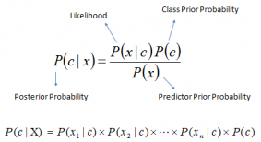
Above,
- P(c|x) is the posterior probability of class (c, target) given predictor (x, attributes).
- P(c) is the prior probability of class.
- P(x|c) is the likelihood which is the probability of predictor given class.
- P(x) is the prior probability of predictor.
Health
The meaning of health has evolved over time. In keeping with the biomedical perspective, early definitions of health focused on the theme of the body's ability to function; health was seen as a state of normal function that could be disrupted from time to time by disease. An example of such a definition of health is: "a state characterized by anatomic, physiologic, and psychological integrity; ability to perform personally valued family, work, and community roles; ability to deal with physical, biological, psychological, and social stress". Then in 1948, in a radical departure from previous definitions, the World Health Organization (WHO) proposed a definition that aimed higher: linking health to well-being, in terms of "physical, mental, and social well-being, and not merely the absence of disease and infirmity". Although this definition was welcomed by some as being innovative, it was also criticized as being vague, excessively broad and was not construed as measurable. For a long time, it was set aside as an impractical ideal and most discussions of health returned to the practicality of the biomedical model.
Prediction
A prediction (Latin præ-, "before," and dicere, "to say"), or forecast, is a statement about a future event. A prediction is often, but not always, based upon experience or knowledge. There is no universal agreement about the exact difference between the two terms; different authors and disciplines ascribe different connotations. (Contrast with estimation.)
Although future events are necessarily uncertain, so guaranteed accurate information about the future is in many cases impossible, prediction can be useful to assist in making plans about possible developments; Howard H. Stevenson writes that prediction in business "... is at least two things: Important and hard.
Database
A database is an organized collection of data, generally stored and accessed electronically from a computer system. Where databases are more complex they are often developed using formal design and modeling techniques.
The database management system (DBMS) is the software that interacts with end users, applications, and the database itself to capture and analyze the data. The DBMS software additionally encompasses the core facilities provided to administer the database. The sum total of the database, the DBMS and the associated applications can be referred to as a "database system". Often the term "database" is also used to loosely refer to any of the DBMS, the database system or an application associated with the database.
Computer scientists may classify database-management systems according to the database models that they support. Relational databases became dominant in the 1980s. These model data as rows and columns in a series of tables, and the vast majority use SQL for writing and querying data. In the 2000s, non-relational databases became popular, referred to as NoSQL because they use different query languages.

CHAPTER THREE
METHODOLOGY AND ANALYSIS OF THE SYSTEM
3.1 RESEARCH METHODOLOGY
Features of the system:
Module1: patient Module
So as to execute the Proposed System, we will specify graphs that cause us to comprehend the structure of the proposed framework.
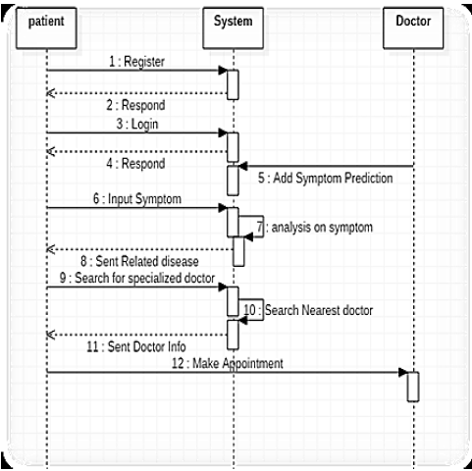
Fig 3.1: Sequence diagram for smart e-health prediction system using data mining.
Patient login: Patient login to the framework using ID and password
Patient registration: If a patient is a new client, the framework asks for personal details by giving client ID and secret key through which he can login to the framework
Prediction of the disease: The patient will show the side effects caused as a result of his ailment. The system will make certain request with respect to his ailment and after that anticipate the disease depending on the indications determined by patient and the framework will likewise propose specialists dependent on the illness.
Inquiry about Doctor: Patient can scan for specialist by indicating name, address or type.
Remark: Input: Patient will comment his view and this will be accounted to the administrator.
Module 2: Doctor Module
Specialist Login: Doctor will get to the framework utilizing his User ID and Password.
Details of the patient: Specialist can view the details of the patient that are given by the patient at the time of registration.
Notification: Doctor will get notice on what number of individuals had gotten to the framework and what all are the symptoms anticipated by the framework.
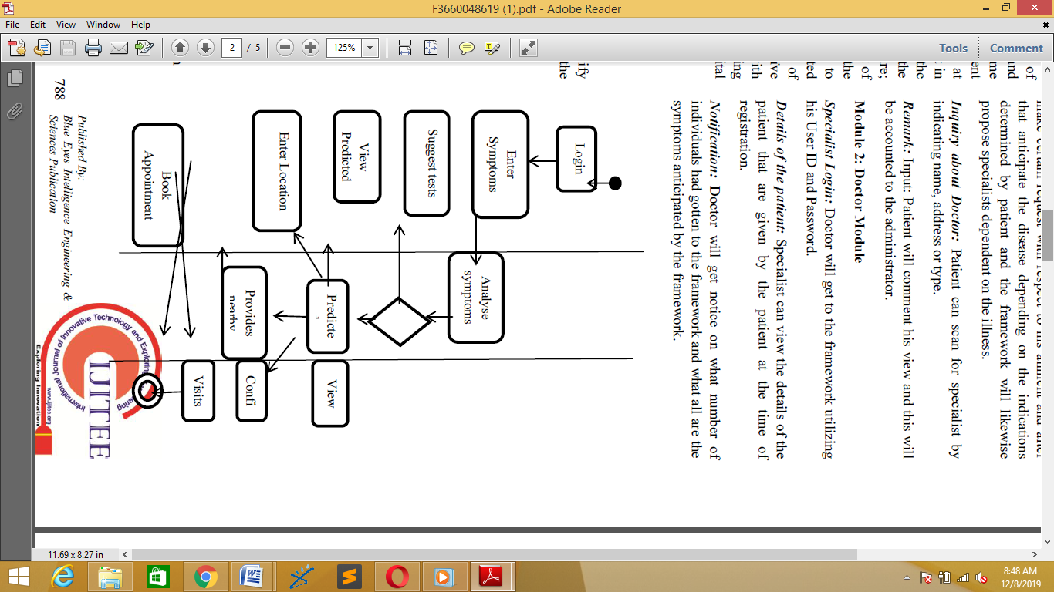
Fig 3: Activity diagram for smart e-health prediction system using data mining.

With the assistance of these structures, the framework is planned and executed which helps in mechanization of the wellbeing forecast framework.
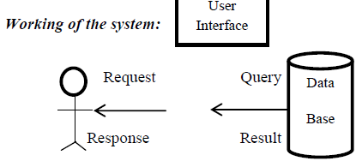
Fig 3.2: Working
As indicated by the charts, it is a two level design. We give a structure that demonstrates a rundown of side effects. The client will enter those side effects that he encounters. In view of picked symptoms the system will produce related ailment. The system will exhibit another structure that contains a couple of request if the information for the disorder isn't adequate. Based on the information an inquiry is made and the data will be based on the reactions to that inquiry.
Data Mining Architecture:
Data Mining utilized in the field of medicinal application can abuse the concealed examples present in voluminous therapeutic information which generally is left unfamiliar. The term Knowledge Discovery in Databases, or KDD for short, alludes to the wide procedure of discovering learning in information, and accentuates the "abnormal state" use of specific information mining techniques.
Naive Layers Algorithm:
The proposed framework utilizes a data mining strategy “Naive Layers classifier” for the development of the expectation framework. This framework includes a higher number of data indexes and characteristics which are legitimately gathered from specialist's data for the exact expectation of the symptom. “Naive Layers or Bayes” Rule is the reason for some, AI and information mining strategies. The standard is utilized to make models with prescient capacities. It gains from the "proof" by figuring the connection between's the objective (i.e., subordinate) and other factors
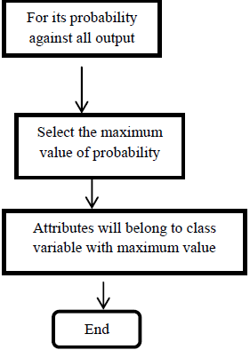
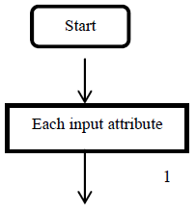

Fig 3: Naïve Layers Flow Chart
Naïve Layers Algorithm:
Following advances are actualized in Bayes calculation:-
Bayes’ Theorem : P(c | x) = P ( x | c) P(c) / P (x)
Where,
P (c | x) = Posterior Probability
P (c) = Prior probability
P (x | c) = probability of predictor
P(x) = Predictor’s prior probability
A lot of cases was taken in program was prepared with the data indexes to such an extent that the probabilities of the considerable number of classes with every one of the conditions were determined. Result was accumulate in database and when the test information was given we got the probabilities for the distinctive classes for the given side effect esteems based on which we infers that the patient fell into the class with the most elevated likelihood. Thus it is Naïve Layers order. By utilizing this stream diagram we can without much of a stretch presume that the patient has been experienced specific sickness or not .we will test this from the approaching ascribe which has a place with class variable with most extreme esteem. We initially process all conceivable individual probabilities adapted on the objective quality of specific illness contained all probabilities of trait of that malady. Register the conceivable probabilities for all condition choose that the p has part up into two cases one for Y and second for N. Subsequently, on the off chance that the contention of likelihood of P1 is more prominent than P2, at that point patient isn't having the illness.
  - ANALYSIS OF THE EXISTING SYSTEM
Everybody is a patient sooner or later, and we as a whole need great medical care. We accept that specialists are altogether therapeutic experts and that there is great research behind all their choices. That can't be the situation all the time. They cannot possibly focus on memory all the knowledge they require for each circumstance, and they probably try not to have it promptly available. Even on the off chance that they had access to the massive measures of information expected to look at treatment results for all the illnesses they experience, they would in any case need time and ability to analyze that data and incorporate it with the patient's own therapeutic profile. Be that as it may, this sort of inside and out research and measurable examination is past the extent of a doctor's work. They need a specialist who will converse with them, tune in to what they state and give them exhortation about how to show signs of improvement and secure their wellbeing later on. When in doubt, the craving for an answer is helper to the longing of being pondered. Drawback of a current framework would be that the patients need to visit the specialist face to face and still does not get appropriate treatment, as the specialists are unfit to foresee the accurate sickness. Human mistake can be dodged with the assistance of PC helped quality basic leadership. It is poor when there are colossal measures of information to be grouped. Also, proficiency and precision of choices will diminish when people are put into pressure and monstrous work. Envision a specialist who needs to look at five patient records; the person will experience them effortlessly.
In any case, if the amount of records increases with a period confinement, it is essentially certain that the precision with which the expert passes on the results won't be as high as the ones got when he had only five records to be dissected.

  - PROBLEMS OF EXISTING SYSTEM
Some problems of the existing system are as follows:
- It is time consuming.
- It is not reliable as it does not add to patients satisfactory.
- It is prone to errors.
  - DESCRIPTION OF THE PROPOSED SYSTEM
To beat the downside of existing framework we have created smart health Disease prediction System. We have built up a specialist framework called Smart Health Disease Prediction framework, which is utilized for improving the task of specialists. A framework checks a patient at initial level and proposes the possible diseases. It begins with getting some information about manifestations to the patient, in the event that the framework can distinguish the fitting sickness, at that point it proposes a specialist accessible to the patient in the closest conceivable territory. On the off chance that the framework isn't sufficiently sure, it asks few questions to the patients, still on the off chance that the framework isn't sure; at that point it will show a few tests to the patient. In light of accessible total data, the framework will demonstrate the result. Here we utilize some intelligent mining methods to figure the most precise disorder that could be associated with patient's appearances and dependent on the database of a couple of patients restorative record, calculation (Naïve Layers) is connected for mapping the side effects with conceivable diseases. This framework improves undertaking of the specialists as well as helps the patients by giving vital help at a soonest organize conceivable.
3.5 ADVANTAGES OF THE PROPOSED SYSTEM
The proposed system has the following advantages over the existing system:
- It causes diseases to be predicted more effectively.
- It consists of various suggestions such as doctor details and prescriptions.
- Cost of visiting the doctor in the initial stage could be avoided since the medications will be prescribed.
- The system is fast and effective.

CHAPTER FOUR

DESIGN AND IMPLEMENTATION OF THE SYSTEM

4.1 DESIGN OF THE SYSTEM
This is the process of designing the input, output and the processing steps to meet the user’s requirement identified in the system analysis. It starts with logical design, which produces a specification of major features of the system. These include the data, input, output, processing storage and other control requirements.
4.1.1 OUTPUT DESIGN
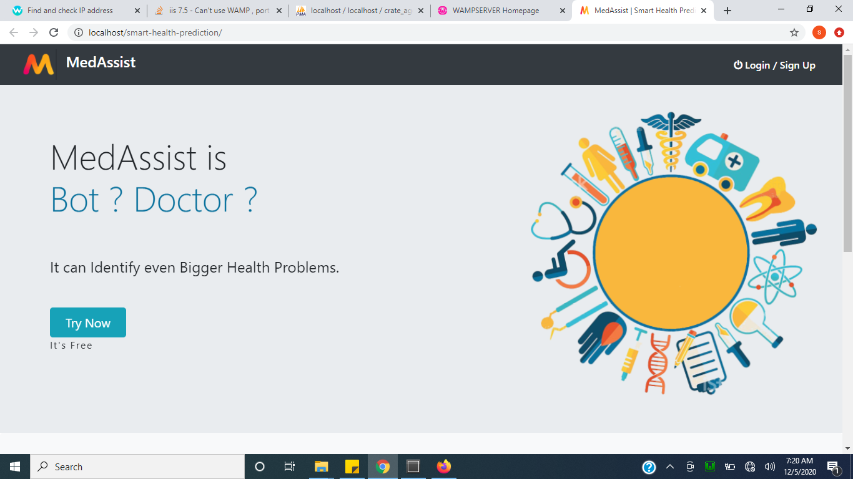
Figure 4.1: Homepage: This is the homepage for the website
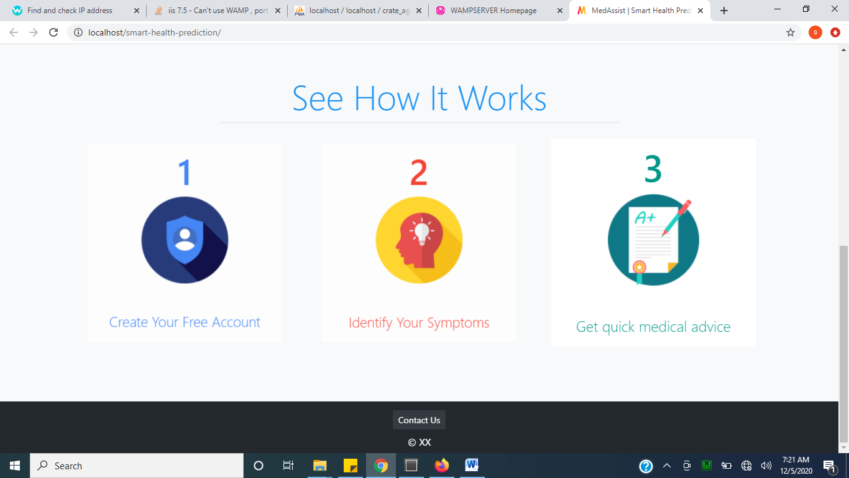
Figure 4.2: Prediction: This this shows the prediction steps
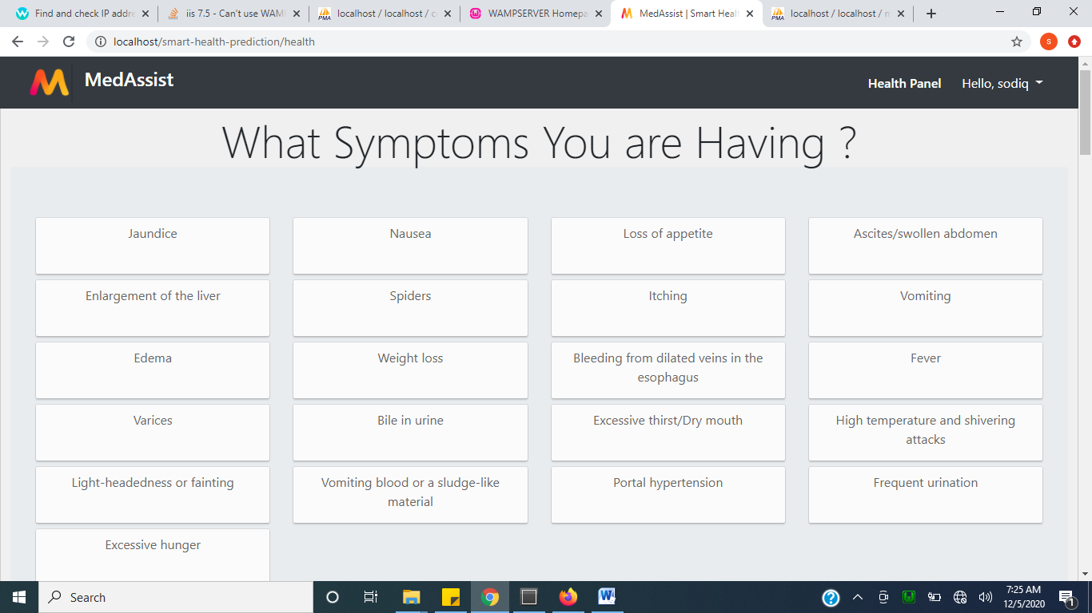
Figure 4.3: Symptoms: This is page that shows the symptoms.
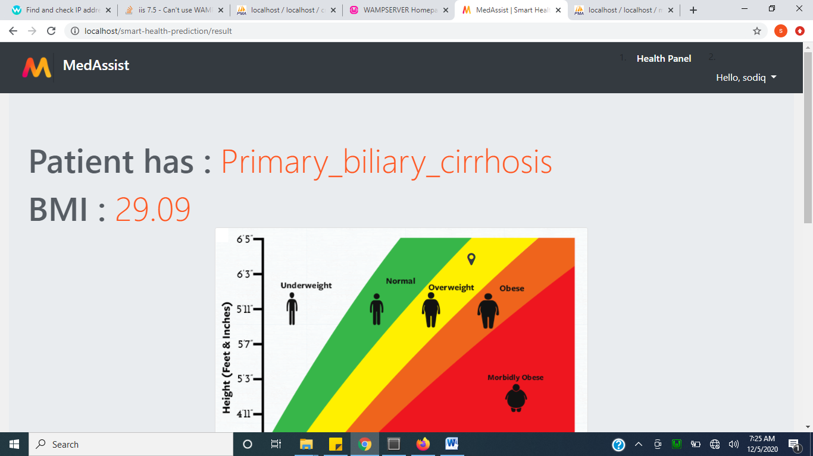
Figure 4.3: Result: This is the result of the diagnose.
4.1.2 INPUT DESIGN
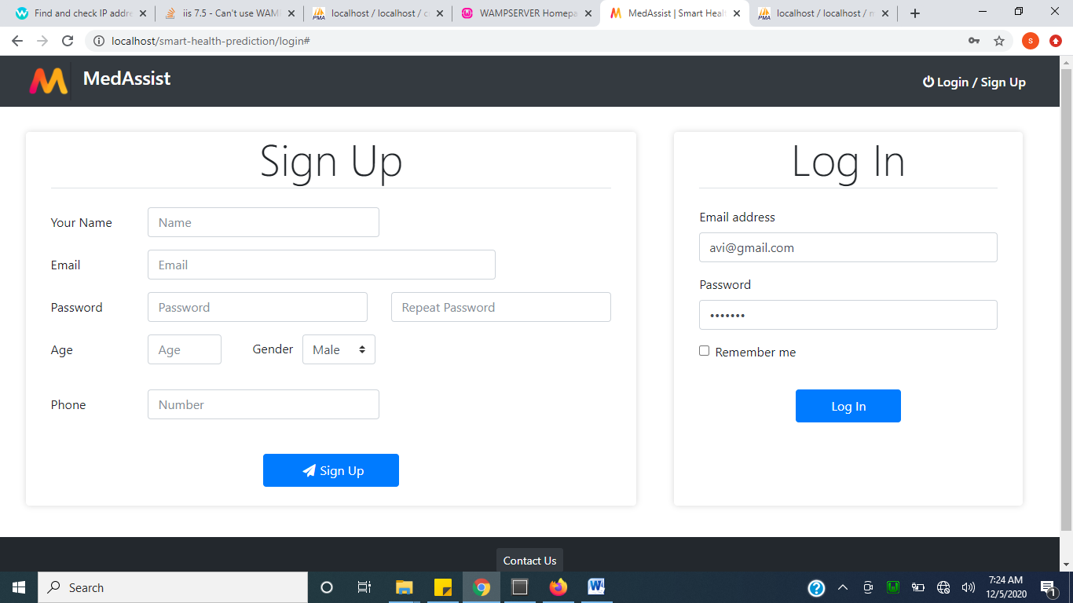
Figure 4.4: Sign up and login page: This is where patient can create assess .
4.1.3 DATABASE DESIGN
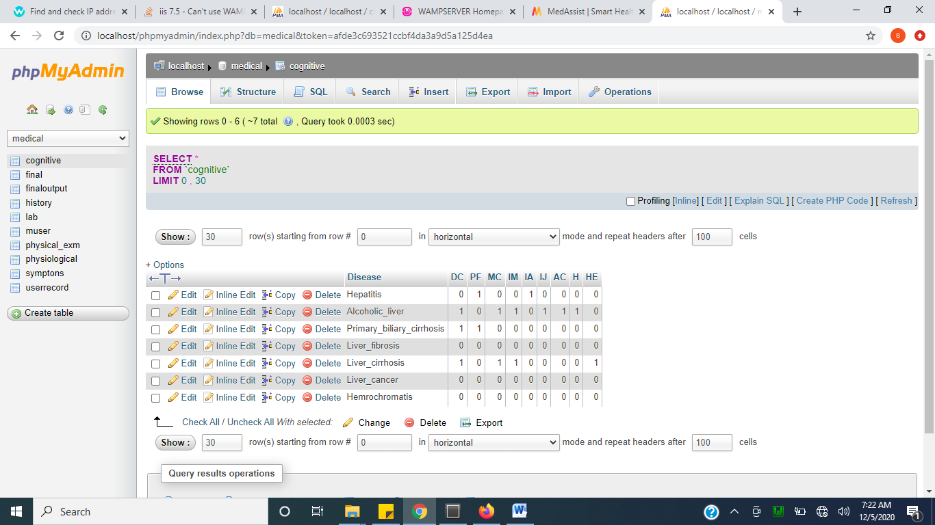
Figure 4.7: Cognitive: This handles all table which includes Cognitive.
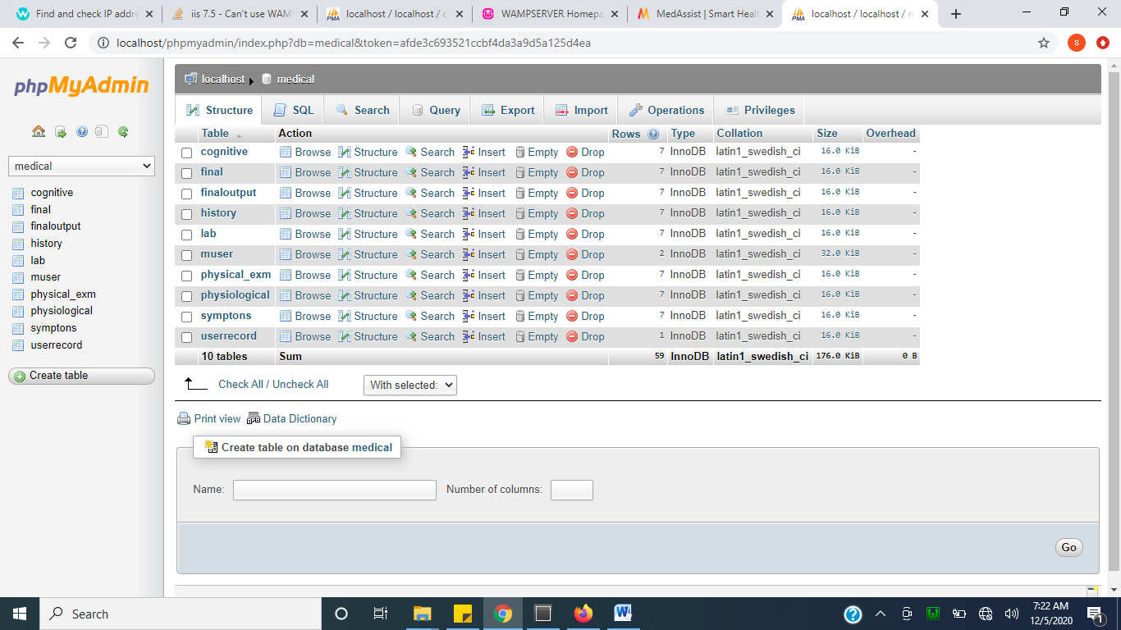
Figure 4.8: Database: This includes all the entire table in the database
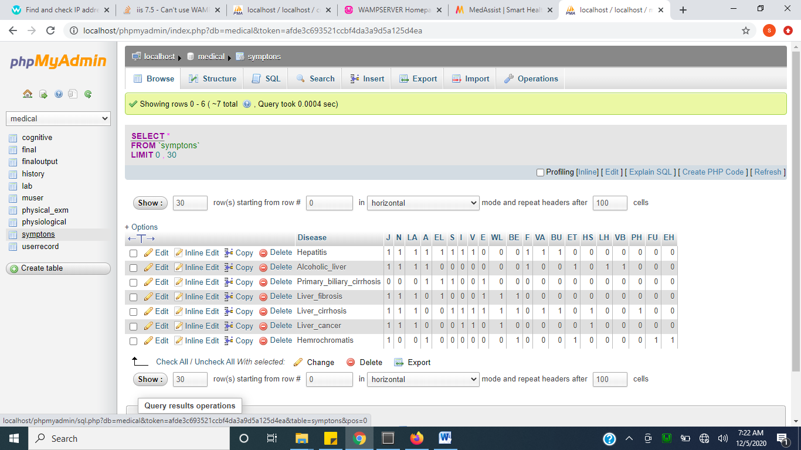
Figure 4.9: Symptoms Table: This hold all symptoms.
4.1.4 PROCEDURE DESIGN
This refers to the ways in which the proposed system will be used and the steps are as follows:
- Click start on the computer desktop
- Select all programs
- Select any browser e.g Mozilla Firefox , internet Explorer , Google Chrome e.t.c
- Type the url (Uniform Resource Locator) of the system into the address bar (http://localhost/ smart health prediction/index.php)

4.2 SYSTEM IMPLEMENTATION
The design system depends on the capabilities and power of the computer on which the application system is installed. However, selecting a choice of application support (Hardware and Software) depends much on:
- How readily the user is to interfere with the computer
- Cost and benefits
- Managements support for changes
Hence, choosing the appropriate hardware and software will enhance the performance of the system.
A most important requirement on which the running of the program basically depends on is the provision of internet facility. So any system that must run this program must be internet ready.
4.2.1 CHOICE OF PROGRAMMING LANGUAGE
The programming language used in the proposed system is php. PHP meaning (PHP Hypertext Preprocessor) is a server-side programming language. It is an open source server-side scripting language that has taken web-based development to a new level of sophistication. The PHP scripting engine is well optimized for the response times needed on web applications, it can even be part of the web server itself improving the throughput even more.
If it were only a matter of improving the speed of the scripts, then PHP will be one of many solutions. But there is more to the PHP equation than that. There is the simplicity and robustness of the language and the scripting engine. There is the connectivity to an ever increasing number of database servers, the shorter development cycles and the ease (encouraged by the syntaxes and constructs) of creating modular and reusable components.
4.2.2 HARDWARE SUPPORT
The hardware that is required in the successful completion of this project includes monitor, CPU, keyboard, mouse, printer and an uninterrupted power supply (UPS) and an internet access.
- An appropriate hard disk storage of at least 120 GB (for the dynamically expandable database)
- A minimum of 1.0 GHz processor
- Random access memory (RAM) of at least 1 GB
- An effective display unit (VGA monitor)
- A suitable printer
- Standard input devices such as keyboard, mouse, etc.
- CD-ROM drive or DVD-ROM drive (since the installation would be made through this medium)
- An uninterrupted power supply (UPS) unit (to prevent abrupt interruption due to power failure)
- A network modem (for internet connection).
4.2.3 SOFTWARE SUPPORT
The software required are basically any web browser (internet explorer, Firefox and the likes), WampServer and a network service, be it wired or wireless.
- A network operating system windows NT from Microsoft, Novell Netware.
- A DBM either PhpMyAdmin
- MySQL as the query language to query the database.
- Wambserver

4.2.4 IMPLEMENTATION TECHNIQUES
The system will be implemented using the parallel approach. This approach is considered because it ensures that the new system is tested along side with the old system to ensure the effectiveness and efficiency of the system.

4.3 SYSTEM DOCUMENTATION
It has to do with the installation and usage of the new system.
After the program has been well tested with input that the output has already been known, the next is to install the software in to the computer system for use.
The process of installing are been stated below
- Insert the CD into the system through the CD-ROM after the computer is switch on
- Locate the CD drive directory in my computer and click it to open
- After open, locate setup.exe, and then click to install the program by following the necessary step in installing the program.
- Ensure full installing of the software for effective operation of the system.
After the program has been fully install. The next thing is to locate the package install to put it into operation, to locate the package for expiration purpose the following step are to be taking
v. Click on start menu from task bar. Then select all program
From the display sub option, select by locating the software installed named http://localhost/smart health prediction /index.php personality check to load the software.

4.3.1 PROGRAM DOCUMENTATION
- HOME PAGE
- LOGIN/SIGN UP
- PREDICTION
- CONTACT US
4.3.2 OPERATING THE SYSTEM
- Click on the start button
- Click on control panel
- Click add/remove program
After the configuration, the folder called smart health prediction will be created in the local disk.
4.3.3 MAINTAINING OF THE SYSTEM
- Keeping the system free from virus so as not to corrupt the program installed on the system.
- Having an updated anti-virus.

CHAPTER FIVE
SUMMARY, CONCLUSION, AND RECOMMENDATIONS.
5.1 SUMMARY
Fuzzy logic is a powerful reasoning method that can handle uncertainty of data very well. One of the most important causes of death worldwide is heart attack. Therefore, diagnosis of the heart disease is important requirement in daily life but due to lots of uncertainty and risk factor sometimes heart disease diagnosis is hard for experts. When a heart attack is identified, the speed of detection is highly essential to save the life of heart attack patient and to prevent heart damage. According to the World Health Organization, 12 million deaths occur each year due to heart attack diseases.
5.2 RECOMMENDATION
This system is recommended to hospital and inexperienced doctors in the field who may want to work on heart disease diagnosing.
5.3 CONCLUSIONS.
This paper used fuzzy logic tool for diagnosis of heart diseases. To do this, fuzzy expert system is used with membership function, fuzzy input and output variables and fuzzy rule base. The proposed system has better performance and accuracy compared with the previous study to diagnosis heart disease. It is very easier expert system in the term of usability and also patient can used it by them.

REFERENCE
Bates, D.W., Saria, S., Ohno-Machado, L., Shah, A., & Escobar G., (2014). “Big data in health care: using analytics to identify and manage high-risk andhigh-cost patients,” Health Affairs, vol. 33, no. 7, pp. 1123–1131.
Chen, M., Ma, Y., Li, Y., Wu, D., Zhang, Y. & Youn, C. (2017) “Wearable 2.0: Enable Human-Cloud Integration in Next Generation Healthcare System,”IEEE Communications, Vol. 55, No. 1, pp. 54–61, Jan.
Chen, M., Ma, Y., Song, J., Lai, C. & Hu, B., (2017). ”Smart Clothing: Connecting Human with Clouds and Big Data for Sustainable Health”Monitoring,” ACM/Springer Mobile Networks and Applications’ Vol. 21, No. 5, pp.825C845.
Groves, P., Kayyali, B., Knott, D., & Kuiken, S.V. (2017). “The big data revolution in healthcare: Accelerating value and innovation big-data revolution”.
Jensen, P. B., Jensen, L. J., & Brunak, S. (2017). “Mining electronic health records: towards better research applications and clinical care”
Lin, K., Luo, J., Hu, L., Hossain, M.S., & Ghoneim A. (2016). “Localization based on social big data analysis in the vehicular networks,”IEEE Transactions on Industrial Informatics,
Oliver, D., Daly, F., Martin, F. C. & McMurdo, M. E. (2014) “Risk factors and risk assessment tools for falls in hospital in-patients: a systematic review,” Age and ageing, vol. 33, no. 2, pp. 122–130.
Qian, B., Wang, X., Cao, N., Li, H., & Jiang, Y.G. (2015). “A relative similarity based method for interactive patient risk prediction,” Data Miningand Knowledge Discovery, vol. 29, no. 4, pp. 1070–1093.
Wang, J., Qiu, M., & Guo, B. (2017). “Enabling real-time information service on telehealth system over cloud-based big data platform,” Journal of Systems Architecture, vol. 72, pp. 69–79.
Zhai, S., Chang, K.h., Zhang, R. & Zhang, Z.M. (2017) “Deep intent: Learning attentions for online advertising with recurrent neural networks”.
Zhang, Y., Qiu, M., Tsai, C.W., Hassan, M. M., & Alamri, A. (2017). “Healthcps: Healthcare cyber-physical system assisted by cloud and big data”.

