SMART SOLAR BASED CBT EXAMINATION MONITORING SYSTEM

BY
SANYA OMOTAYO JOSEPH
HND/23/COM/FT/0410

SUBMITTED TO THE DEPARTMENT OF COMPUTER SCIENCE, INSTITUTE OF INFORMATION AND COMMUNICATION TECHNOLOGY, KWARA STATE POLYTECHNIC, ILORIN

IN PARTIAL FULFILLMENT OF THE REQUIREMENTS FOR THE AWARD OF HIGHER NATIONAL DIPLOMA (HND) IN
COMPUTER SCIENCE

MAY, 2025.

CERTIFICATION
This is to certify that this project was carried out by SANYA OMOTAYO JOSEPH with the matriculation number: HND/23/COM/FT/0410, it has been read and approved meeting part of the equirements for the award of Higher National Diploma (HND) in Computer Science.

…………………………………. ….………………………
DR. AGBOOLA, O. M. Date
Project Supervisor

…………………………………. ….………………………
MR. OYEDEPO, F. S. Date
Head of Department

…………………………………. ….………………………
External Examiner Date

DEDICATION
I dedicate this project to the Almighty God, who inspired me and directed my ways during my stay in the polytechnic.

ACKNOWLEDGEMENTS
All praise is due to the Almighty God, the Lord of the universe. I praise Him and thank Him for giving me the strength and knowledge to complete my HND program and also for my continued existence on earth.
I appreciate the utmost efforts of my supervisor, Dr. Agboola, O. M. whose patience, support, and encouragement were the driving force behind the success of this research work. He gave useful corrections, constructive criticisms, comments, recommendations, and advice and always ensured that excellent research was done. My sincere gratitude also goes to the Head of Department, Mr. Oyedepo, F. S., and other members of staff of the Department of Computer Science, Kwara State Polytechnic, Ilorin for their constant cooperation, constructive criticisms, and encouragement throughout the program.
Special gratitude to my parents, who exhibited immeasurable financial, support, patience, prayers, and understanding during the period in which I was busy tirelessly with my studies. Special thanks go to my lovely siblings.
My sincere appreciation goes to my friends and classmates.

TABLE OF CONTENTS
Title page i
Certification ii
Dedication iii
Acknowledgments iv
Table of Contents v
Abstract vi
CHAPTER ONE: GENERAL INTRODUCTION
1.1 Background to the Study 1
1.2 Statement of the Problem 2
1.3 Aim and Objectives 2
1.4 Significance of the Study 2
1.5 Scope of the Study 3
1.6 Organization of the Report 3
1.7 Definition of Terms 3
CHAPTER TWO: LITERATURE REVIEW
2.1 Review of Related Works 5
CHAPTER THREE: RESEARCH METHODOLOGY AND
ANALYSIS OF THE SYSTEM
  - Research Methodology 9
  - Analysis of the Existing System 13
  - Problem of the Existing System 13
  - Descrition of the Proposed System 14
  - Advantages of the Proposed System 14

CHAPTER FOUR: DESIGN, IMPLEMENTATION AND
DOCUMENTATION OF THE SYSTEM
  - Design of the System 16

4.1.1 System Architecture 16

4.1.2 System Components 17

4.2 System Implementation 21

4.2.1 Installation of Solar Power System 21

4.2.2 Deployment of CCTV Cameras 21

4.2.3 Configuration of Monitoring System 21

4.3 System Testing and Evaluation 21

4.3.1 Functional Testing 21

4.3.2 Performance Evaluation 21

4.3.3 Maintaining the System 22

CHAPTER FIVE: SUMMARY CONCLUSION AND RECOMMENDATIONS
5.1 Summary 23
5.2 Conclusion 23
5.4 Recommendations 24
References 25

ABSTRACT
The integrity of Computer-Based Tests (CBT) in tertiary institutions is increasingly threatened by examination malpractice and insufficient monitoring systems. This project presents the design and implementation of a Smart Solar-Powered CBT Examination Monitoring System using CCTV Cameras, developed for the Computer Science Laboratory of Kwara State Polytechnic. The system aims to provide continuous, reliable surveillance during examinations while addressing the challenge of unstable power supply through the use of renewable solar energy. The methodology involved integrating a solar power system, comprising photovoltaic panels, charge controllers, batteries, and inverters, with a digital CCTV surveillance setup. CCTV cameras were strategically installed to monitor examination activities, with recordings stored in a network video recorder (NVR) for review and analysis. The system was tested in real examination conditions, including periods of power outage, to validate its efficiency. The results demonstrated that the system effectively maintained uninterrupted monitoring, minimized cases of examination malpractice, and ensured secure footage storage. Additionally, the solar component offered a sustainable, cost-effective power solution, reducing dependence on the public power grid. This project provides a scalable model for academic institutions seeking to enhance examination security and energy efficiency through smart technology and renewable energy.
Keywords: Examination monitoring, Examination malpractice prevention, Solar-powered CCTV and Surveillance technology.

CHAPTER ONE
INTRODUCTION
  - Background to the Study
The advent of technology has revolutionized various sectors of human endeavor, including education. In recent years, the adoption of Computer-Based Testing (CBT) in educational institutions has significantly transformed the assessment landscape. This mode of examination has gained popularity for its efficiency, accuracy, and ability to manage large volumes of candidates. However, with its increasing adoption, challenges such as examination malpractice, security breaches, and infrastructure inadequacies have surfaced. These issues underscore the need for robust monitoring and surveillance systems to ensure the credibility and integrity of the CBT process (Suleiman, and Nachandiya, 2018).
Solar-powered CCTV systems present a sustainable alternative by harnessing renewable energy to power surveillance systems. This approach not only addresses the challenge of erratic power supply but also aligns with global efforts to promote clean energy solutions. By integrating solar technology with CCTV systems, institutions can achieve continuous and reliable monitoring, even in remote or underserved locations. Kwara State Polytechnic, like many other higher institutions, has embraced CBT as a means of conducting examinations. Despite its advantages, the institution faces challenges related to examination malpractice and inadequate monitoring during tests.
Closed-circuit television (CCTV) systems have proven to be an effective solution for enhancing security and monitoring activities in various settings. CCTV technology enables real-time surveillance, recording, and analysis of activities, which can deter malpractice and provide evidence in case of disputes. However, the reliance on conventional power sources for CCTV systems poses a significant limitation, especially in regions where the electricity supply is unreliable or costly (Agwi, et al. 2020).

  - Statement of the Problem
The increasing prevalence of examination malpractice, particularly in Computer-Based Testing (CBT), poses a serious threat to these standards. Common forms of malpractice, such as impersonation, cheating through unauthorized electronic devices, and collaboration among candidates, have become significant concerns for institutions, including Kwara State Polytechnic. These practices not only compromise the integrity of the examination process but also undermine public trust in the institution’s credibility.
  - Aim and Objectives
This study aims to design and implement a solar-powered CCTV system to enhance the monitoring of Computer-Based Testing (CBT) examinations at Kwara State Polytechnic,
Objectives:
- Design a solar-powered CCTV system architecture that incorporates essential components such as solar panels, inverters, batteries, CCTV cameras, and charge controllers.
- Install and configure the solar-powered CCTV system within the CBT examination venues.
  - Significance of the Study
The deployment of a reliable surveillance system will deter examination malpractice, ensuring that assessments are fair and credible, the integration of solar power ensures continuous operation of the CCTV system, even during power outages, thereby eliminating disruptions in monitoring. Utilizing solar energy reduces reliance on expensive generators and conventional electricity, resulting in long-term cost savings for the institution. The success of this project at Kwara State Polytechnic can serve as a benchmark for other institutions facing similar challenges, encouraging the adoption of sustainable technological solutions.

  - Scope of the Study
This study focuses on the development and implementation of an automated exam invigilation system using CCTV technology powered by solar energy in the Department of Computer Science, Kwara State Polytechnic.
1.6 Organization of the Study
For easy study and proper understanding of this project write-up, it is planned and organized into five chapters. The description of what each chapter contains is explained below:
Chapter One: This contains an introduction to the whole write-up, a statement of the problem, the aim and objectives of the study, the significance of the study, the scope and limitation of the study, and the organization of the report.
Chapter Two: It focuses on the literature review of the study, the organization of the board of directors, and the computerization of the current state of the art.
Chapter three presents the method employed, analysis of data and existing system, advantages of the proposed system, design and implementation, and hardware support.
Chapter Four: Deals with the system design implementation result, discussion, documentation, design of the system, output design, input design, file system, procedural design, and documentation of the new system.
Chapter Five: This centers on the summary, conclusion, and recommendations.
1.7 Definition of Terms
Exam Invigilation: The process of overseeing and supervising examinations to ensure fairness, integrity, and compliance with regulations.
CCTV (Closed-Circuit Television): A system of video cameras that transmit signals to a specific set of monitors for surveillance and monitoring purposes.
Solar Power: Energy derived from sunlight through photovoltaic cells or solar thermal systems.
Automation: The use of technology to perform tasks or processes with minimal human intervention.
Camera: A camera is a device that captures images or videos either digitally or on film. In the context of CCTV systems, cameras are electronic devices equipped with lenses and sensors to record visual information.
Battery: A battery is a device that stores chemical energy and converts it into electrical energy. Batteries consist of one or more electrochemical cells that produce a direct current (DC) when connected to an external circuit.
Inverter: An inverter is a device that converts direct current (DC) electricity into alternating current (AC) electricity.
Cable Wire: A cable wire is a flexible, insulated conductor used to transmit electrical signals or power between devices or components within an electrical system.
Solar Panel: A solar panel, also known as a photovoltaic (PV) panel, is a device that converts sunlight into electricity through the photovoltaic effect.

CHAPTER TWO
LITERATURE REVIEW
2.2 Review of Related Works
Suleiman, & Nachandiya, (2018) Developed a Computer Based Testing (CBT) System for GST Exams at Adamawa State University, Mubi, the Computer Based Testing System (CBT) was designed and implemented to diminish the delay of student's examination results. The CBTS was designed using the Agile model of the Software Development Life Cycle (SDLC). Implementation was done utilizing open source technologies, like XAMPP server, MySQL, PHP, JavaScript, Cascading Style Sheet, and Hypertext Markup Language. This by implication can reduce the cost of buying examination materials (papers, printers, turners, etc) and students can have their results immediately after the examination. The developed system proved to be efficient and can be enhanced by adding other forms of questions like diagrammatic questions to make the test address more diverse areas.
Papageorgas, et al. (2013), Smart Solar Panels: In-situ monitoring of photovoltaic panels based on wired and wireless sensor networks. This article presents the design methodology for an in-situ solar panel monitoring system based on wired and wireless sensor network technologies. The proposed platform is based on wired networking technologies combined with short-range low-power wireless sensor nodes. By grouping the PV panels in clusters and the use of the single-wire LIN bus the complexity of the network deployed is kept at the minimum. The architecture proposed is fully scalable with the number of PV panels and takes advantage of open-source platforms for web-publishing of characterization data at a low cost.
Kumar, et al., (2021) An IoT‐Based Smart Monitoring Scheme for Solar PV Applications to help the environment to degrade the radiation of greenhouse gases and to deplete the ozone layer to achieve sustainable development in power generation. A set of PV modules is combined to arrange PV arrays. Those PV arrays are organized in parallel and serial combinations to form PV modules. Based on the PV modules, DC electricity can be generated. By using DC-DC converters like boost, buck-boost, SEPIC, and Luo converters, the adjustable DC voltage can be developed. Then, converts AC using three-phase voltage source inverters. Monitoring PV systems using IoT enables automated monitoring of solar power from any place with internet connections. It performs a significant role in accessing control over the PV system placed at remote locations or long distances from the control area.
Izuka, et al. (2023) work, unlocking Solar Power for Surveillance: A Review of Solar-Powered CCTV and Surveillance Technologies to revolutionize security measures, particularly in areas where access to conventional electrical grids is limited, unreliable, or simply non-existent. Solar-powered surveillance technologies encompass diverse, innovative systems designed to capture, process, and transmit visual and environmental data for security and monitoring purposes. Future trends include advanced energy storage solutions, AI integration, enhanced power efficiency, and cloud-based data analytics, promising to improve performance and sustainability.

Pius, (2021) worked on E-Invigilation as a Means of Curbing Examination Malpractice in Colleges of Education in Nigeria. The aim is to curb examination malpractice in colleges of education in Nigeria. The descriptive research design of a survey type was adopted in the study. The population comprises all students of the College of Education, Ikere Ekiti. The sample of 250 students which were randomly selected using a simple random sampling technique. A well-structured questionnaire was used to collect data and was validated by some experts and reliability of the instrument was tested using the Cronbach alpha coefficient and the result was found to have a reliability coefficient of 0.62 which indicated that the instrument was reliable in collecting the necessary data for the study. Data collected was analyzed using mean, standard deviation and t-test was used to test the hypothesis formulated at 0.05 level of significance. The study concluded that e-invigilation will reduce examination malpractices and thereby restore discipline among students in colleges of education since there was no significant difference in the mean responses of students on the impact of e-invigilation based on gender.

Fawzi, et al. (2018) is based on embedded a Real-Time Video Surveillance System based on Multi-Sensor and Visual Tracking, to detect and report vandalism, tampering, and theft activities before they take place via sms, email, or phone call. The proposed system hardware is composed of five categories: a processing and controlling unit, a multi-sensor box, a surveillance camera, system communication modules, and a power supply unit. Finally, this system is characterized by being flexible, portable, easy to install, expandable, and cost-effective. Therefore, it can be considered an efficient technology for different monitoring purposes.

Agwi, et al, (2020) developed a video surveillance in examination monitoring to provide enough evidence needed for the prosecution of the culprit and their conspirators that may have destroyed the evidence. This study on the use and effectiveness of CCTV Cameras relied on both field surveys and document information and analysis. The research process involved a literature review, data collection, data analysis, findings, and conclusion. It provides evidence for investigative reasons and also serves as a deterrence to intending offenders since they are aware that they are being watched.
Dong, et al. (2015) also worked on designed and implementation of solar tracking system to track the sun and trace the source of the sun. This paper uses two kinds of tracking schemes and carries on the comparative analysis. Two kinds of schemes adopt the same mechanical structure, controller, motor drive circuit, and DC motor. Finally, the author combines the two designs’ merits to overcome each other’s drawbacks. Therefore, it turns to the automatic tracing of the solar light source when the light is strong, otherwise, it would tend to track the scheme of the sun's trajectory. Such a device, according to experiments, is afforded to track light precisely.
Piza, et al. (2019) wrotes an article on CCTV surveillance for crime prevention, this article aims to present the results of our updated systematic review and meta-analysis of the crime prevention effects of CCTV. They used a rigorous approach for locating, appraising, and synthesizing evidence from prior evaluation studies. Studies were selected for inclusion in the review according to the following four criteria. 1) CCTV was the main focus of the intervention, 2) The evaluation used an outcome measure of crime, 3) The research design involved, at minimum, before-and-after measures of crime in treatment and comparable control areas, and 4) Both the treatment and control areas experienced at least 20 crimes during the pre-intervention period. They conclude that their analysis with a test of publication bias in our results. Similar to how a biased sample can generate invalid results in an individual study, a biased collection of studies can potentially lead to invalid conclusions in a systematic review.
Katyarmal, et al. (2018) also developed a solar power monitoring system using IoT to greatly enhance the performance, monitoring, and maintenance of the plant. The Internet of Things (IoT) platform integrates data from the different solar panels and applies analytics to share the most valuable information with applications built to address specific needs. As this system keeps continuous track of solar power plants, the daily weekly, and monthly analysis becomes easy and efficient also with the help of this analysis it is possible to detect any fault occurring within the power plant as the generated power may show some inconsistency in data of Solar power plant. Since the system requires an external power supply of 5 volts and 3.3 volts for its operation this can be taken rid of by utilizing the power generated by solar panels only. Also with the help of a motor and control, it is possible to track the sun for better power generation.

CHAPTER THREE
RESEARCH METHODOLOGY AND ANALYSIS
3.1 Research Methodology
The research methodology employed in implementing a solar-powered CCTV system for examination monitoring at Kwara State Polytechnic.
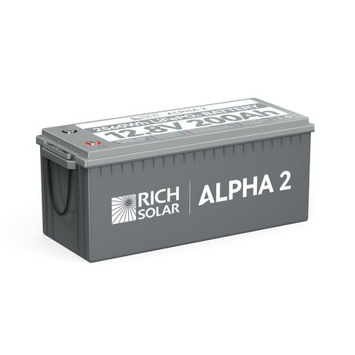
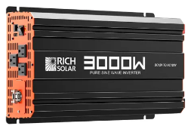
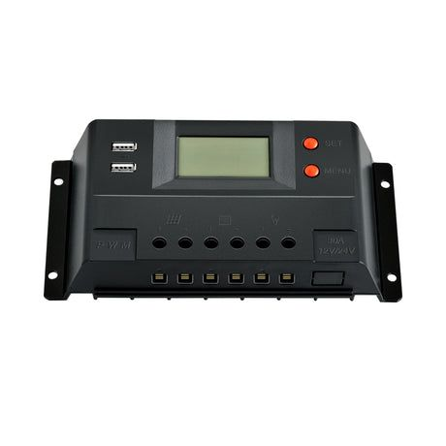

Solar Panels Charge Controller Inverter
Battery
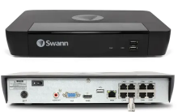

DVR

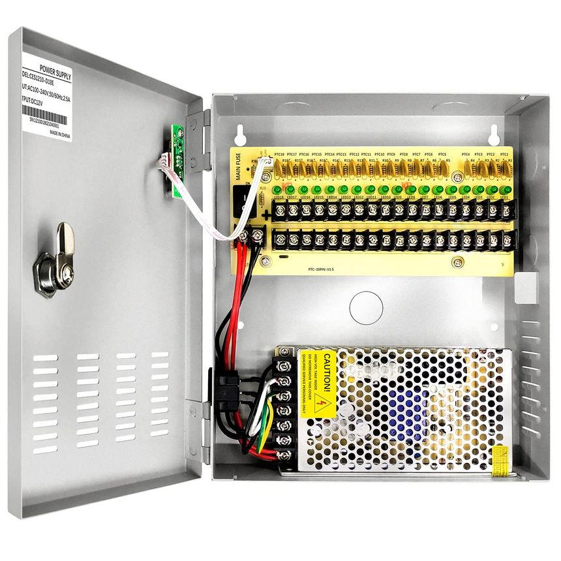

Power Box

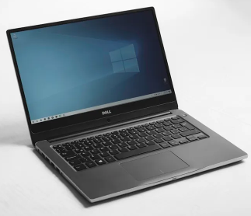
Monitoring Device

Figure 3.1: Schematic diagram of our CCTV Solar Power System

Description of the Diagram:
- The solar panels capture sunlight and convert it into electricity.
- The charge controller regulates the charging current to prevent overcharging the battery.
- The battery stores the generated solar energy to power the system during low sunlight periods.
- The security camera captures video footage of the monitored area.
- The NVR (optional) stores the recorded video footage for later playback and review.
- The wireless/cellular connection (optional) allows remote access to live video feeds and recordings.
- The monitoring device (phone, computer, tablet) displays the live video feed or recorded footage (if NVR is used and accessed remotely).
Tools You Will Need:
- Drill and Drill Bits (wood, metal, masonry)
- Wire Strippers and Crimpers
- Multimeter
- Screwdrivers (Phillips and Flathead)
- Cable Ties
- Electrical Tape (optional)
- Non-contact Voltage Tester
- Hammer (optional)
- Level
- Stud finder (optional)
- Tape Measure
- Pencil and Marker
- Ladder or Scaffolding (depending on height)
- Conduit Bender (optional)

Installation Steps:
1. Site Assessment and Planning:
Choose Locations: Select a location with maximum sun exposure throughout the year for the solar panels. Identify suitable mounting locations for the cameras, considering coverage needs and privacy concerns. Decide on the placement of the inverter, charge controller, battery, and power box (ideally indoors or in a weatherproof enclosure).
2. Solar Panel Installation:
Mount the Panels: Following the manufacturer's instructions, securely mount the solar panels on the designated location using appropriate brackets. Ensure proper tilt angle for optimal sun exposure in your region.
3. Wiring and Electrical Connections (Consult an Electrician):
- Connect Panels: Connect the solar panels in series or parallel (depending on voltage and current requirements) using MC4 connectors or following the manufacturer's recommended connection method.
- Run Solar Cables: Route solar cables from the panels to the charge controller. Use conduit for added protection (consult electrician for proper conduit sizing and routing).
4. Charge Controller and Battery Connection (Consult an Electrician):
- Connect Charge Controller: Following the manufacturer's guide, connect the solar cable from the panels to the charge controller's input terminals.
- Connect Battery: Connect the battery to the designated terminals on the charge controller, ensuring correct polarity (positive to positive, negative to negative).
5. Camera and Power Box Installation:
- Mount Cameras: Securely mount the cameras in the designated locations using appropriate brackets.
- Connect Cameras: Run cables from the cameras to the power box. Use appropriate connectors based on the camera type (e.g., BNC for traditional CCTV, ethernet cable for IP cameras).
- Power Box Connections: Inside the power box (consult electrician for proper setup), connect the camera cables to a power supply unit (PSU) with sufficient amperage for all cameras. The PSU will likely connect to the battery bank through the inverter.
6. Inverter Connection (Consult an Electrician):
- Connect Inverter: Connect the battery bank to the inverter's input terminals, ensuring correct polarity.
- AC Output: Connect the inverter's AC output to the power box or a designated circuit breaker in your building's electrical panel (consult electrician).
7. System Testing and Configuration:
- Power Up: Turn on the system and verify functionality of each component.
- Camera Test: Check the video feed from each camera on a monitor connected to the power box or remotely if the system allows it.
- Inverter Test: Ensure the inverter is functioning properly and converting DC battery power to AC power.
8. Laptop Connection (Optional):
If using a laptop for remote monitoring, connect it to the network according to the camera system's instructions. This might involve connecting the laptop to a network video recorder (NVR) or using software provided by the camera manufacturer.
9. System Maintenance:
Schedule regular maintenance for the system, including cleaning camera lenses, checking electrical connections, and performing software updates (if applicable).

3.2 Analysis of the Existing System
In recent years, automated invigilation systems have drawn increased interest as a potential means of combating exam cheating. When suspect activity is observed during exams, these systems use cutting-edge technologies like facial recognition, eye tracking, and screen recording to alert human examiners for additional investigation. The process of invigilation will be made more effective and efficient, and academic integrity will be improved. The traditional method of invigilation/examinations, involves in human invigilators to present in examination hall to monitoring the students. The more number of students requires more number of invigilators to bring the quality in education and for the fair conduction of examination. A invigilation system is required to prevent cheating and to avoid any malpractices in examinations as it directly impacts the students morality.

3.3 Problems of the Existing System
Manual examination invigilation, while common in numerous educational settings, can present several challenges and problems
- Human Error and Bias Invigilators can inadvertently make miscalculations or miss cases of cheating due to the volume of scholars and complexity of the test terrain. also, particular impulses may impact their observation and judgment.
- Inconsistency Different invigilators may apply rules and procedures inconsistently, leading to unstable treatment of scholars during examinations.
- Physical and Mental Fatigue Monitoring examinations for long ages can be physically and mentally demanding, which may compromise the effectiveness of invigilation.
- Limited Observation Coverage It's challenging for invigilators to cover every pupil contemporaneously, especially in larger test halls, adding the liability of misconduct going unnoticed. Invasion of Pupil sequestration Stricter invigilation styles, similar as constant monitoring or physical quests, can infringe on pupil sequestration rights.
- Security Risks Paper- grounded examinations can be prone to security pitfalls like cheating, leakage of test content, or tampering.

3.3 Description of the Proposed System
The proposed solar- powered CCTV examination monitoring system integrates renewable energy technology with advanced surveillance capabilities to enhance examination security and integrity within educational institutions. This innovative system harnesses solar panels to induce clean and sustainable energy, reducing reliance on grid- grounded power sources and minimizing functional costs. The solar energy is stored in batteries to insure nonstop operation of high- quality CCTV cameras stationed strategically throughout examination venues. These cameras are equipped with features similar as high- description videotape prisoner, night vision capabilities, and remote monitoring support to give comprehensive surveillance content. By using remote access capabilities and advanced monitoring outfit like Network Video Reporters( NVRs) or Digital Video Reporters( DVRs), authorized labor force can cover live camera feeds, review recorded footage, and admit real- time cautions on examination- related conditioning from any position with internet connectivity. The integration of power operation and control systems optimizes energy operation and ensures effective operation of the surveillance structure. Overall, the proposed system offers a sustainable, dependable, and technologically advanced result for enhancing examination security, inhibiting malpractice, and maintaining examination integrity within educational settings.
3.4 Advantages of the Proposed System
The proposed solar- powered CCTV examination monitoring system offers several advantages over traditional surveillance styles
- Sustainability and Cost Savings: One of the crucial advantages is its sustainability and cost- effectiveness. By exercising solar panels to induce clean energy, the system reduces reliance on grid- grounded electricity, performing in lower functional costs over time. Solar energy is abundant and renewable, making the system environmentally friendly while furnishing long- term savings on electricity charges.
- Reliable Power Supply The integration of battery storehouse ensures a dependable power force for CCTV cameras, indeed during ages of low sun or power outages. This continued power source maintains nonstop surveillance capabilities, enhancing examination security and integrity by barring dislocations due to power failures.
- Comprehensive Surveillance Coverage The system deploys high- quality CCTV cameras strategically throughout examination venues, furnishing comprehensive surveillance content of critical areas. With features similar as night vision capabilities and remote monitoring support, the cameras can effectively discourage malpractice and examiner examination conditioning in real- time, perfecting overall security.
- Remote Monitoring and Access Authorized labor force can ever cover live camera feeds, review recorded footage, and admit cautions on examination- related conditioning from any position with internet connectivity. This remote access capability enhances functional inflexibility and responsiveness, allowing for timely interventions in case of suspicious geste or security incidents during examinations.

CHAPTER FOUR
DESIGN AND IMPLEMENTATION OF THE SYSTEM

4.2 System Design
The system is designed to ensure continuous surveillance of examination halls by integrating solar power technology with CCTV cameras. The design consists of three major subsystems:
- Solar Power Supply System – Provides an uninterrupted power source.
- CCTV Surveillance System – Captures and records examination hall activities.
- Data Storage and Monitoring System – Stores and allows remote access to surveillance footage.

4.2.1 System Architecture
The system follows a four-tier architecture:
Tier 1: Solar Energy Generation – Solar panels convert sunlight into electrical energy.
Tier 2: Power Regulation and Storage – Charge controllers regulate power, and deep-cycle batteries store excess energy.
Tier 3: CCTV Recording and Transmission – Cameras capture video footage and transmit it to a recording unit.
Tier 4: Remote Monitoring and Access – Authorized personnel access footage via a secure network.

4.2.2 System Components
The system consists of:
Multimeter: A versatile tool for measuring voltage, current, and resistance to verify electrical connections and troubleshoot potential issues.
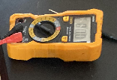
Figure 4.1: Multimeter
Solar Panels: Convert sunlight into direct current (DC) electricity.
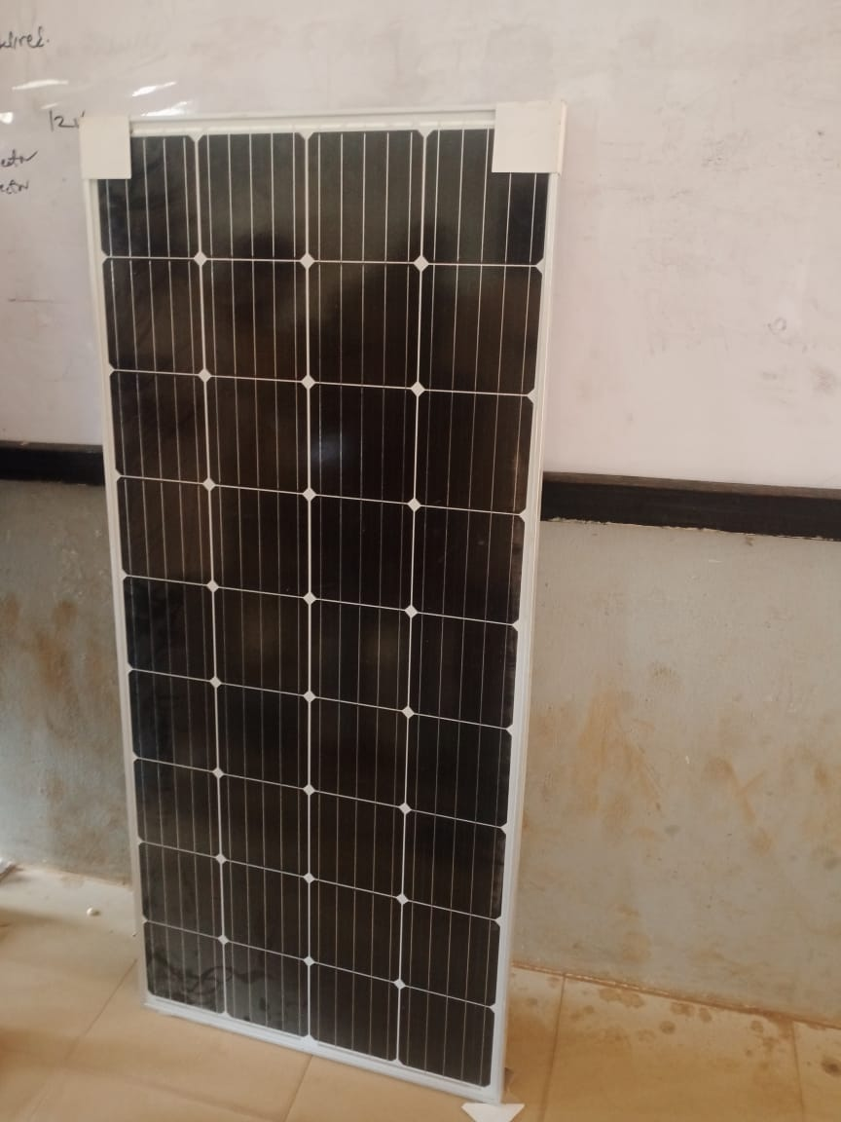
Figure 4.2: Solar Panels
Charge Controller: Regulates the flow of electricity from the solar panels to the battery.
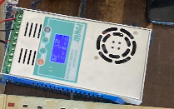
Figure 4.3: Charge Controller
Inverter: Converts the DC electricity from the battery into usable AC (alternating current) electricity.
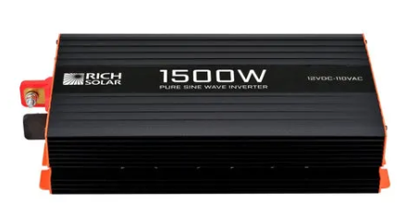
Figure 4.4: Inverter
Battery: Stores the DC electricity generated by the solar panels during the day to power the system during periods without sunlight (e.g., night time, cloudy days).
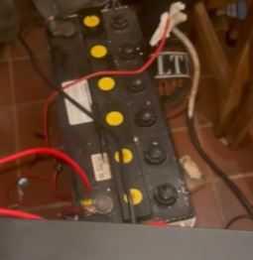
Figure 4.5: Battery
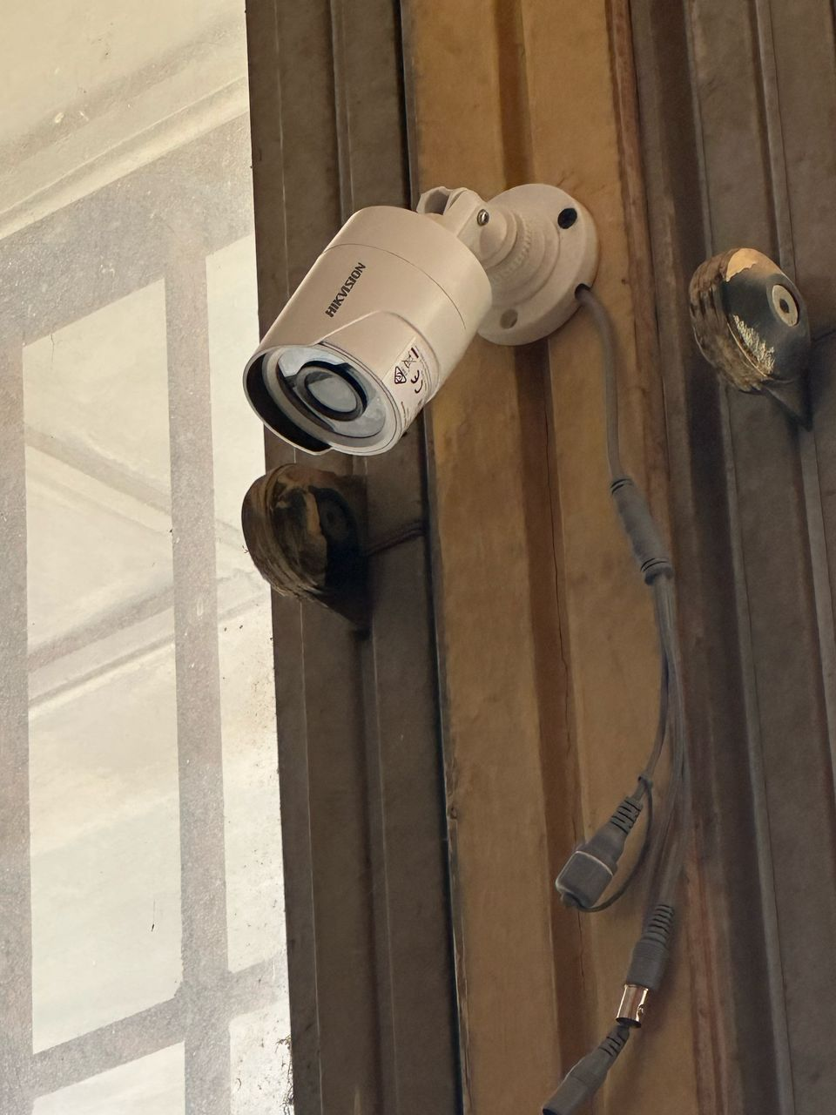
Figure 4.8: Frst Camera

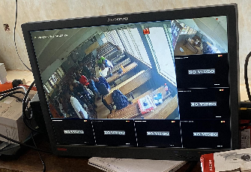
Figure 4.9: Monitor: Showing the output video of the first camera installed

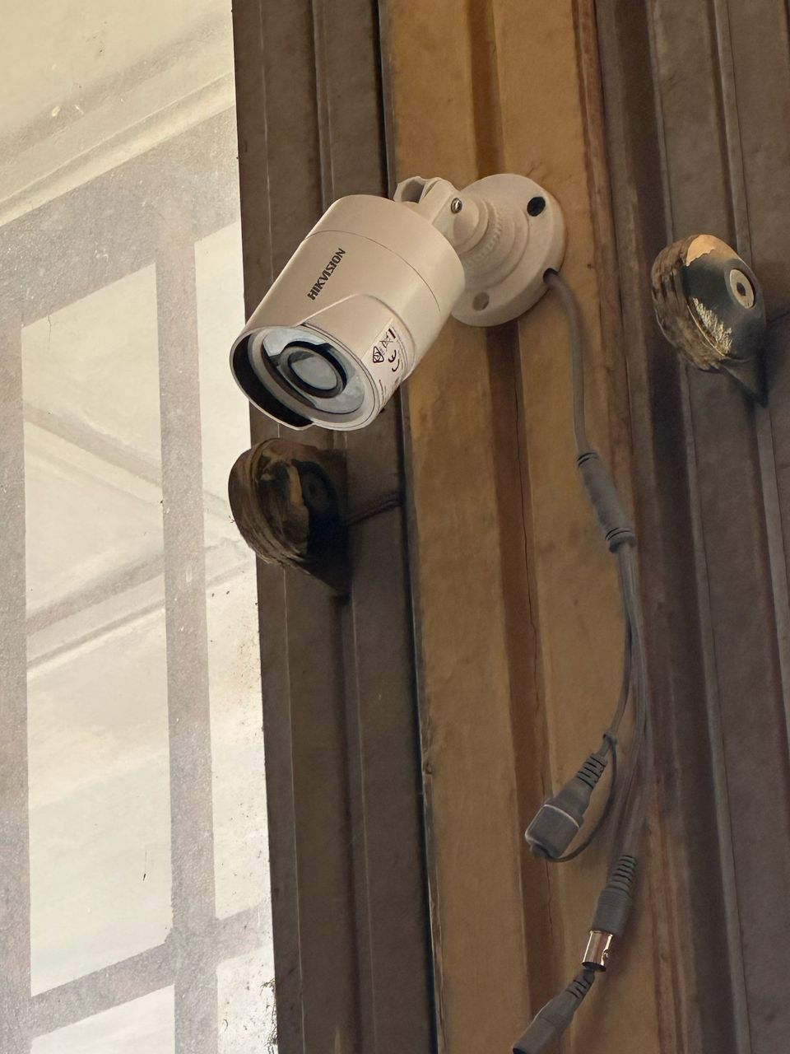
Figure 4.10 Second Camera.
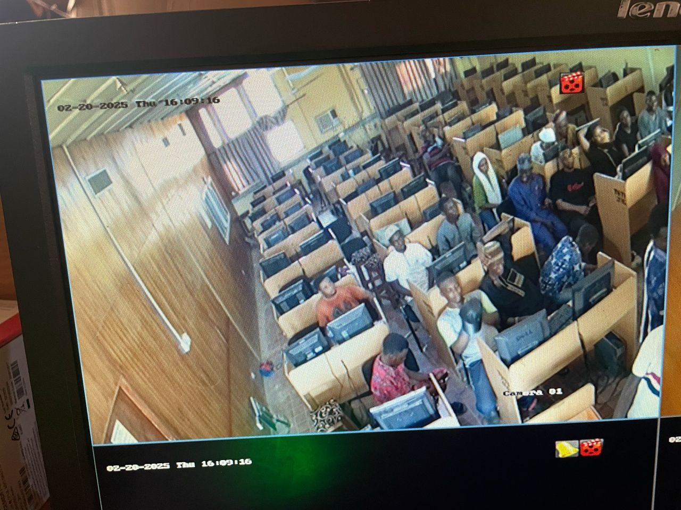
Figure 4.11: Montor: Showing the output of the second installed cameras

4.3 System Implementation

4.3.1 Installation of Solar Power System
- Solar panels were mounted on rooftops or poles with optimal sunlight exposure.
- Charge controllers and deep-cycle batteries were installed in a secure location.
- An inverter was connected to regulate AC output for powering CCTV devices.

4.3.2 Deployment of CCTV Cameras
- Cameras were placed at strategic points to cover examination halls.
- Wiring and wireless configurations were set up for video transmission.
- Cameras were integrated with DVR/NVR for real-time recording and playback.

4.3.3 Configuration of Monitoring System
- DVR/NVR storage settings were configured for continuous recording.
- Remote access features were enabled for real-time monitoring.
- Energy consumption was monitored to ensure efficient power usage.

4.4 System Testing and Evaluation

4.4.1 Functional Testing
- Camera Testing – Verified clarity, night vision, and motion detection.
- Power Supply Testing – Evaluated solar panel efficiency and battery backup.
- Network Connectivity – Ensured remote monitoring worked properly.

4.4.2 Performance Evaluation
- Uptime Monitoring – Measured system availability during power outages.
- Video Quality Assessment – Checked resolution, frame rate, and storage efficiency.
- Malpractice Detection Efficiency – Analyzed recorded footage to detect cheating incidents.

4.3.2 Maintaining the System
Maintaining your solar-powered CCTV system at Kwara State Polytechnic is crucial to guarantee its longevity, reliability, and effectiveness in exam monitoring. Here's a breakdown of key maintenance practices:
Regular System Checks:
- Visual Inspection: Periodically perform visual inspections of the entire system, including cameras, solar panels, cables, and recording equipment. Look for signs of wear, tear, dust buildup, or potential damage caused by weather or pests.
- Camera Lens Cleaning: Clean camera lenses regularly using a soft microfiber cloth to maintain optimal image quality. Avoid abrasive materials or cleaning solutions that could damage the lens coating.
- Recording Review: Occasionally review recorded footage to ensure all cameras are capturing clear video without any distortions or blind spots.
Scheduled Maintenance:
- DVR/NVR Maintenance: Refer to the manufacturer's recommendations for cleaning and maintenance procedures for the recording equipment (DVR/NVR). This might involve dusting internal components or checking for software updates.
- Battery Maintenance: Consult the battery manual for specific care instructions. Depending on the battery type, this might involve checking electrolyte levels (for lead-acid batteries) or monitoring battery health indicators.
- Solar Panel Maintenance: Periodically inspect solar panels for dust buildup, debris, or bird droppings that can affect their efficiency. If necessary, gently clean the panels with water and a mild soap solution. Avoid abrasive cleaners or high-pressure washing that could damage the panels.

CHAPTER FIVE

SUMMARY, CONCLUSION, AND RECOMMENDATIONS
  - Summary
This study focused on designing and implementing a solar-powered CCTV monitoring system to enhance the security of Computer-Based Testing (CBT) examinations at Kwara State Polytechnic. The study addressed two major challenges: examination malpractice and unstable electricity supply, both of which compromise the integrity of the examination process. A solar-powered surveillance system was proposed as a sustainable solution to ensure continuous monitoring without reliance on the national power grid. Key components such as solar panels, charge controllers, inverters, deep-cycle batteries, and high-resolution CCTV cameras were integrated to provide uninterrupted surveillance during examinations.
The implementation and testing of the system demonstrated its effectiveness in preventing examination malpractice while ensuring reliable power supply. The system successfully recorded examination activities, provided real-time monitoring, and operated efficiently without interruptions caused by power outages. The findings indicate that a solar-powered CCTV system is a cost-effective, sustainable, and scalable solution for securing CBT examinations. This study serves as a model for other institutions looking to enhance examination integrity through renewable energy-driven surveillance systems.

5.2 Conclusion
The integrity of Computer-Based Testing (CBT) examinations is crucial for maintaining academic standards, but challenges such as examination malpractice and unstable electricity supply threaten the credibility of the process. This study designed and implemented a solar-powered CCTV monitoring system to address these issues at Kwara State Polytechnic. By leveraging solar energy, the system ensures continuous surveillance, eliminating disruptions caused by power outages. The integration of solar panels, inverters, batteries, charge controllers, and CCTV cameras provided a self-sustaining solution that effectively monitored examination halls and deterred malpractice.
The successful implementation and testing of the system demonstrated its reliability, cost-effectiveness, and sustainability. The study proved that renewable energy-powered surveillance can significantly enhance examination security in institutions facing power supply challenges. With proper maintenance and potential AI-based enhancements, this system can serve as a long-term solution for securing CBT examinations. Institutions are encouraged to adopt similar technologies to uphold academic integrity and improve examination monitoring efficiency.

5.3 Recommendations
Based on the findings of this study, the following recommendations are proposed:
- Adoption of Solar-Powered CCTV Systems – Educational institutions should implement solar-powered CCTV surveillance in examination halls to ensure continuous monitoring, especially in areas with unstable electricity supply.
- Regular Maintenance and System Upgrades – Institutions should establish a maintenance schedule to clean solar panels, check battery efficiency, and update CCTV firmware to ensure long-term reliability.
- Integration of AI-Based Monitoring – Future enhancements should include facial recognition, motion detection, and real-time alerts to detect and prevent examination malpractice more effectively.
- Training for Examination Supervisors – Staff and invigilators should be trained on operating the CCTV system, reviewing surveillance footage, and responding to security incidents during examinations.
- Government and Institutional Support – Policymakers and educational stakeholders should fund and promote the use of solar-powered surveillance systems to enhance the integrity of CBT examinations nationwide.

References
Abas, K. (n.d.). Solar-Harvesting Wireless Smart Camera Research System For Efficient Sustainable Outdoor Video Analysis. https://www.researchgate.net/publication/279516151
Agwi, U. C., Irhebhude, M. E., & Ogwueleka, F. N. (2021). Video surveillance in examination monitoring. Security and Privacy, 4(2). https://doi.org/10.1002/spy2.144

Ali, S., Nawaz, R., Azad, S., Orakzai, M. S., Amin, S., Khan, Z. A., Akram, F., & Masud, U. (2022). Solar Powered Smart Irrigation System. Pakistan Journal of Engineering and Technology, 5(1), 49–55. https://doi.org/10.51846/vol5iss1pp49-55

dela Cruz, A. B., de Guzman, R. A. M., Diwa, B. J. E., Buan, R. P. M., Guanlao, R. I., Tangcuangco, A. L., & Soriano, M. E. C. (2024). Design and Performance of a Solar Powered Single-Phase Smart Energy Monitoring System. Asian Journal of Electrical Sciences, 13(1), 1–9. https://doi.org/10.70112/ajes-2024.13.1.4228

Dong, L., An, Z., & Hao, L. (2015). Design and Implementation of Solar Tracking System.

Fawzi, L. M., Ameen, S. Y., Alqaraawi, S. M., & Dawwd, S. A. (2018). Embedded real-time video surveillance system based on multi-sensor and visual tracking. Applied Mathematics and Information Sciences, 12(2), 345–359. https://doi.org/10.18576/amis/120209

Izuka, U., Daniel Bakare, A., Otibhor Olurin, J., Gbenga Ojo, G., & Augustine Lottu, O. (2023). Unlocking solar power for surveillance: a review of solar powered cctv and surveillance technologies. Acta Electronica Malaysia, 7(2), 54–61. https://doi.org/10.26480/aem.02.2023.54.61

Katyarmal, M., Walkunde, S., Sakhare, A., & Rawandale, M. U. S. (n.d.). Solar power monitoring system using IoT. International Research Journal of Engineering and Technology. www.irjet.net

Manurung, A., Fildzah, A., & Rajagukguk, J. (2019, October 11). Computer Based Test (CBT) System for Student Academic Examination. https://doi.org/10.4108/eai.18-10 2018.2287186

Papageorgas, P., Piromalis, D., Antonakoglou, K., Vokas, G., Tseles, D., & Arvanitis, K. G. (2013). Smart solar panels: In-situ monitoring of photovoltaic panels based on wired and wireless sensor networks. Energy Procedia, 36, 535–545. https://doi.org/10.1016/j.egypro.2013.07.062

Pius, O. O., Oluwadare, A. R., & Akinyemi, O. W. (2021). E-Invigilation as a Means of Curbing Examination Malpractice in Colleges of Education in Nigeria. International Journal of Recent Technology and Engineering (IJRTE), 10(4), 84–88. https://doi.org/10.35940/ijrte.A5918.1110421

Piza, E. L., Welsh, B. C., Farrington, D. P., & Thomas, A. L. (2019). CCTV surveillance for crime prevention: A 40-year systematic review with meta-analysis. Criminology and Public Policy, 18(1), 135–159. https://doi.org/10.1111/1745-9133.12419

Ramu, S. K., Irudayaraj, G. C. R., & Elango, R. (2021). An IoT-Based Smart Monitoring Scheme for Solar PV Applications. Electrical and Electronic Devices, Circuits, and Materials: Technological Challenges and Solutions (pp. 211–233). wiley. https://doi.org/10.1002/9781119755104.ch12

Suleiman, A., & Nachandiya, N. (2018). Computer Based Testing (CBT) System for GST Exams in Adamawa State University, Mubi. Asian Journal of Research in Computer Science, 1 11. https://doi.org/10.9734/ajrcos/2018/v2i124776

Temitayo, F. M., Adebisi, A. A., & Alice, O. O. (2013). Computer-Based Test (Cbt) System For University Academic Enterprise Examination. International Journal of Scientific & Technology Research, 2(8). www.ijstr.org

