A PROJECT REPORT
ON
TOPOGRAPHIC INFORMATION SYSTEM OF ODO-OKUN,
SECONDARY SCHOOL, ILORIN WEST LOCAL GOVERNMENT AREA KWARA STATE.

PRESENT BY:
HUSSEIN TAWAKALITU OLAMIDE
HND/23/SGI/FT/0046

SUBMITTED TO:
THE DEPARTMENT OF SURVEYING AND GEOINFORMATICS

INSTITUTE OF ENVIRONMENTAL STUDIES
KWARA STATE POLYTECHNIC P.M.B 1340
ILORIN, KWARA STATE.

IN PARTIAL FULFILLMENT OF THE REQUIREMENT FOR
THE AWARD OF HIGHER NATIONAL DIPLOMA IN SURVEYING
AND GEO-INFORMATICS

MAY, 2025
DECLARATION
I hereby certify that all the information given in this project was obtain as result of field observation and measurement made by me and that the survey was carried out in accordance with survey rules and regulation and department instructions.

NAME: HUSSEIN TAWAKALITU OLAMIDE
MATRIC NO: HND/23/SGI/FT/0046

DATE:

SIGNATURE:

CERTIFICATION
This is to certify that this project report was prepared and submitted by HUSSEIN TAWAKALITU OLAMIDE of Matric No: HND/20/SGI/FT/0046 to the Department of Surveying and Geo-Informatics, Institute of Environmental Studies Kwara State Polytechnic Ilorin, as a result of field observation and measurement using appropriate instrument and equipment to carry out the task.

---------------------------------------- --------------------------
SURV. A. O. ASONIBARE DATE
Project Supervisor

---------------------------------------- --------------------------
SURV. A.O AKINYEDE DATE
Project Coordinator

---------------------------------------- --------------------------
SURV. ABIMBOLA IBRAHIM ISAU DATE
Head of Department

---------------------------------------- --------------------------
EXTERNAL SUPERVISOR DATE

DEDICATION

This project work is dedicated to God Almighty Allah.

ACKNOWLEDGEMENT
I am grateful to almighty Allah for the successful completion of this program and for making this course a success in my life. To everyone around me come rain, come sunshine, I say thank you a million times. Also I appreciate my Parents Mr. and Mrs. Hussein for their support in the course to pursue surveying and Geo- Informatics to this level, word can’t be enough to appreciate you.
To my beloved Siblins Latifat, Maruf, Muritala and Rukoya I say thank you.
My gratitude goes to my project supervisor Surv. A.O. Asonibare for the knowledge been impact to me during the program may almighty Allah be with you and your family allahumo Aameen. I will not relent to Appreciate the effort of all the staffs in the department in person of Surv. Abimbola Ibrahim Isau (HOD), Surv. Babatunde Kabir, Surv. R. O. Asonibare, Surv. R.S. Awoleye, Surv. Ayuba Abdulsalam, Surv. Bello Felix (my Mentor), Surv. Williams Kazeem and my humble Surv. A.G. Aremu may almighty Allah enrich you all(Amin).
So also to my mention is the care, love and support received from colleagues in the class especially my project group members, and the rest. I pray that God will bless you all and all others who have contributed immensely to the successful completion of this course.
Finally, my profound gratitude goes to my amazing, caring and supporting love of my heart Aminu Shakiru Opeyemi for his Support towards this great achievement, I said A big thanks to you my Love.

ABSTRACT
This project is development of topographic information system of part of Odo-Okun Secondary School, Ilorin West Local Government, Ilorin. It was observed that the study area,
has an updated topographic plans and maps showing the relief of the school premises. Therefore, this project would provide a relevant data of the topography of the school. This project was therefore carried out with the aim of producing a tools for effective planning and proper environmental management of Odo-Okun Secondary School. Field and office reconnaissance survey were carried out in order to be familiar with the nature of the terrain and plan the methodology and equipment to be used for the acquisition and assembling of spatial and attribute data. Total station and its accessories was used in the acquisition of Geometric and Attribute data. The data processing were adequately and effectively done with the use of AUTOCAD2007, SURFER9, ARCGIS, Microsoft excel, note pad, and Microsoft Word software. using the data processing as the management phase, a spatial database was modeled and structured using the relational table format. The usefulness of the topographic information generated was highlighted and map revealed the true configuration of study site and vacant areas for future development. A digital terrain model was created to enhance further analysis on slope, aspect, contour, flow direction and flow accumulation analysis of the study site. The information is also available for query that will assist in the physical planning of the area under investigation. The study concluded that topographic information system is essential for physical and accurate decision making. The system allows easy updating of information and quick retrieval of information for better planning and environmental management.

TABLE OF CONTENTS
TITLE PAGE i
DECLARATION ii
CERTIFICATION iii
DEDICATION iv
ACKNOWLEDGEMENTS v
ABSTRACT vi
TABLE OF CONTENTS vii
LIST OF TABLES x
LIST OF FIGURES xi
CHAPTER ONE
- INTRODUCTION 1
1.1 BACKGROUND OF STUDY 1
1.2 STATEMENT OF PROBLEM 3
1.3.1 AIM OF THE PROJECT 3
1.3.2 OBJECTIVE OF THE PROJECT 3
1.4 SIGNICANCE OF THE STUDY…………………………………………………...4
1.5 SCOPE OF THE STUDY 4
1.6 PROJECT SPECIFICATION 5
1.7 STUDY AREA 5
1.6 PERSONNEL INVOLVED 7
CHAPTER TWO
2.0 LITERATURE REVIEW 9

CHAPTER THREE
3.0 METHODOLOGY 18
3.1 DATABASE DESIGN 18
3.1.1 VIEW VALIDITY 18
3.1.2 CONCEPTUAL DESIGN 19
3.1.3 LOGICAL DESIGN 21
3.1.4 PHYSICAL DESIGN 22
3.2 RECONNAISSANCE 23
3.2.1 OFFICE PLANNING 23
3.2.2 FIELD RECONNAISSANCE 23
3.3 EQUIPMENT USED/ SYSTEM SELECTION AND SOFTWARE 25
3.3.1 HARDWARE USED . 25
3.3.2 SOFTWARE COMPONENT 25
3.4 INSTRUMENT TEST 26
3.4.1 HORIZONTAL COLLIMATION TEST 26
3.4.2 VERTICAL INDEX ERROR TEST 27
3.4.3 ANALYSIS OF COLLIMATION AND VERTICAL INDEX DATA 28
3.5 CONTROL CHECK 28
3.6 MONUMENTATION 30
3.7 DATA ACQUISITION 30
3.7.1 GEOMETRIC DATA ACQUISITION 31
3.7.2 ATTRIBUTES DATA ACQUISITION 32
3.8 DATA DOWNLOADING AND PROCESSING 32
3.8.1 DATA DOWNLOADING AND EDITING 32
3.8.2 DATA PROCESSING AND DATA EDITING 33
3.8.3 DATA PROCESSING USING AUTOCAD 2007 33
3.8.3 DATA PROCESSING USING ARCGIS 10.3 33
3.9 DATABASE IMPLEMENTATION 44
3.9.1 DATABASE MANAGEMENT SYSTEMS 45
3.9.2 DATABASE MAINTENANCE 45
3.9.3 BACK COMPUTATION 46
3.9.4 AREA COMPUTATION 47
CHAPTER FOUR
4.0 SPATIAL ANALYSIS AND RESULT PRESENTATION 48
4.1 TESTING OF DATABASE 48
CHAPTER FIVE
5.0 COST ESTIMATION, SUMMARY, CONCLUSION AND RECOMMENDATION 52
5.1 COST ESTIMATION 52
5.2 SUMMARY 55
5.3 RECOMMENDATION 55
5.4 CONCLUSION 56
REFERENCE 57
APPENDIX 59

LIST OF TABLES
Table 3.1..4.1: Building and its attributes 22
Table 3.1.4.2: Road and its attributes 22
Table 3.1.4.3 : Trees and its attributes 22
Table 3.4.1.1: Horizontal Collimation Data 27
Table 3.4.2.1: Vertical Index Data 27
Table 3.5.1: Table showing the back computation of the control coordinates 29
Table 3.5.2: Table showing the distance observation result of the control check 29
Table 3.5.3: Table showing the observation result of the control check 29
Table 3.8.3.1: Building 40
Table 3.8.3.2: Road 41
Table 3.8.3.3: Trees 41
Table 3.8.3.4: Electric Poles 41
Table 3.9.3.1: Back Computation 46
Table 3.9.4.1: Area Computation 47
Table 5.1.1: Direct cost parameters 52

LIST OF FIGURES
Fig 1.1 Diagram of the study area 6
Fig. 3.1 Design and Construction Phases in Spatial Database 19
Fig. 3.1.2.1: E-R Diagram (Entity relationship diagram) 20
Fig. 3.2.2.1: Recce diagram of the study area (not drawn to scale) 24
Fig 3.4.1.1; Horizontal Collimation and Vertical Index error test 26
Fig. 3.6.1: Pillar Description 30
Fig 4.1.1: Retrieving Area whose height is greater than 320 meters 49
Fig 4.1.2: Result of area whose height is greater than 320 meters 49
Fig 4.1.3: Result of area whose height is greater than 320 meters 50
Fig 4.1.4 Query Result Of Buildings Used For Class Rooms 51
Fig 4.1.5 Query Result Of Buildings Used For Offices 51

CHAPTER ONE

1.0 INTRODUCTION

1.1 BACKGROUND TO THE STUDY
Today the importance of measuring and monitoring the environment is becoming increasingly critical as the population expands, land values appreciate, natural resources dwindle and human activities continues to stress the quality of the land, water, and air, therefore there is need for topographical information system which is an improvement on topographical surveying.
Surveying has been important since the beginning of civilization. Its earliest applications were in measuring and marking boundaries of property ownership. Throughout the years, its importance has steadily increased with the growing demand for a variety of maps and the expanding need for establishing accurate line and grade to guide construction operations.
Surveying which is also interchangeably called Geomatics has traditionally been defined as “the relative science, art, and technology of determining the relative positions of points above, on, or beneath the earth’s surface”-Charles D. Ghilani, and Paul R. Wolf, 2008.
In other word surveying may be defined as the science of determining the position in three dimensions of natural and man-made features on /or beneath the surface of the earth and represented in analog form as contoured map, plan or chart, or in digital form as a three- dimensional mathematical model stored in the computer.(W. Schofield, 2001).
In ancient period measurements in surveying were carried out using ground based method and until rather recently the transit and tape were primary instruments. Computations, analysis, and systems for quickly obtaining precise positions of widely spaced point, and modern aerial digital imaging and laser – scanning systems for quickly mapping and collecting other forms of data about the earth. In addition, computer systems are available that can process the measured data and automatically produce plans, maps, and other products at a faster rate.
In a more general sense, however, surveying (Geomatics) can be regarded as that discipline which encompasses all methods for measuring and collecting information about the physical earth and the environment, and processing that information and disseminating a variety of resulting product to a wide range of client.
Topography is the shape or configuration of the land, represented on a map by contour lines, hypsometric tints and relief shading.
Topographic surveying is “the method of determining the positions on the surface of the earth of human made and natural features”-Francis Scheied, 1985. It is also used to determine the configuration of the terrain. The purpose of a topographic survey is to find the data necessary for the construction of a graphical portrayal of topographic features, Information is a data that has been processed into a meaningful form for sound decision making. Topographic information can be defined as any information about the surface of the earth.Information system is an integrated set of component for collecting, storing, and processing data and for delivering information, knowledge and digital products. It is also a combination of hardware, software, infrastructure and trained personnel organized to facilitate planning, control, coordinates and decision making in an organization.
Topographic information system is defined as “a computer based system for collecting and maintaining, storing and re-organizing, modeling and analyzing topographic data as well as for the multimedia representation and visualization of these data” –Krause B.F. 2000. Topographic information system (TIS) is also a database system in which most of the data are spatially indexed, and upon which a set of procedures operated in order to answer queries about spatial entities in the database. Many information systems are primarily delivery vehicles for databases. A database is a collection of interrelated data (records) organized so that individual records or groups of records can be retrieved that satisfy various criteria.
The Internet is a network of networks, connecting millions of computers located on every continent. Through networking, personal computer users gain access to information resources, such as large databases, and to human resources, such as coworkers and people who share their professional or private interests.
Qualified people are a vital component of any information system. Technical personnel include development and operations managers, systems analysts and designers, computer programmers, and computer operators.
Procedures for using, operating, and maintaining an information system are part of its documentation. For example, procedures need to be established to run a payroll program, including when to run it, who is authorized to run it, and who has access to the output.
In summary, topographic information system is an integrated set of component for collecting, storing, processing and communicating information related to the measurement of the relief of the terrain and the natural or artificial features in a certain area.
The increasing popularity of topographic information system over ordinary topographic surveying is as a result of easy storage, retrieval, manipulation of data and the display of the result.
This project emphasized topographic surveying as regards terrain of both natural and cultural features, generating Digital Elevation Model (DEM) using: Spot-Height, Contour, Slopes, Aspect, Detailing, and technical reports with the acquired information management using a well-structured Geo-Database in accordance with the principle of surveying and Geographical Information System (GIS).

1.2 STATEMENT OF PROBLEM
It is an attempt to solve problems related to topographic map using analog system as the difficulties in retrieving information from analog system. Therefore, there is urgent need for topographic information system using digital approach in order to make updating and retrieval possible at any time for decision making.

1.3 AIM AND OBJECTIVES OF THE PROJECT

1.3.1 AIM
The aim of this research work is to create a Topographical Information System for Odo- Okun Secondary School Ilorin West Local Government Area of kwara state.

OBJECTIVES
- Office and field reconnaissance
- Acquisition of geometric and attribute data of the project area
- Creation of database of the project area
- Spatial analysis and queries
- Information presentation in both soft and hard copies
- Creating a Topographic Information System (TIS) as a decision support system (DSS).

1.4 SIGNIFICANCE OF THE STUDY
- The importance of this project is to produce a digital topographical map of the area.
- To update the existing map.
- To create a map for proper monitoring and maintenance within the project area.
- .Facilitation of periodic retrieval and updating of information within the project area.
- To prepare student ahead of the task before them outside school.
- To provide a suitable reference for other researchers as basis on which to carry out research work.

1.5 SCOPE OF THE PROJECT
The scope of the project involved data acquisition, creation of a spatial database, spatial analysis, and queries generation of the topographic database and processing of field data with the aid of computer hardware and software before performing analysis and information presentation in form of maps/plans and the project report.
i. Data acquisition: This involved data capture for both primary and secondary (Geometric and attribute data) using digital equipment such as Total Station and social survey respectively.
ii. Data processing: This is the transformation of data acquired from the field into different function using appropriate software. The data were downloaded from South Total Station with appropriate downloading cable and South software.
iii. Database creation: This is the conversion of data into AutoCAD, ArcGIS10.1version and Surfer software for easy processing, manipulation, analysis and retrieval of information/data.
iv. SPATIAL analysis: This centered on query and generation of information using ArcGIS10.1version.
v. Information presentation: It is based on the analysis in the form of map tables and project report.

PROJECT SPECIFICATION
This project was carried out in accordance to the Department of surveying and Geo-Informatics Kwara State Polytechnics as well as supervisor’s guide. The project falls into the 3rd order category of survey job. Hence the angular misclosure must not be greater than 30”√n where n refers to the number of stations and linear accuracy must not be less than 1:10,000, All maps and plan must be in colour (perimeter plan, contour map, perimeter and detail, query of important features, and Google image of the area), , All details on ground, All corner beacons must be buried in a suitable point. The location of the study area is Odo-okun Secondary School, Ilorin West Local Government, Kwara, Kwara State. The study area is geographically located within the latitude 08° 28’ 25.56” N and longitude 04° 30’ 52.15”E, latitude 08° 28’ 26.53”N, longitude 04° 31’ 45.56”E.

1.7 STUDY AREA
The study area is Odo-Okun Secondary School Adewole area, Ilorin Kwara State. The area falls on latitude 08° 28’ 25.56” N and longitude 04° 30’ 52.15”E, latitude 08° 28’ 26.53”N, longitude 04° 31’ 45.56”E, and the area is found to be 350805.456SQM. The site is a developed area with features, both natural and artificial made such as buildings, roads, trees, electricity lines.

Figure 1: Map of the Study Area

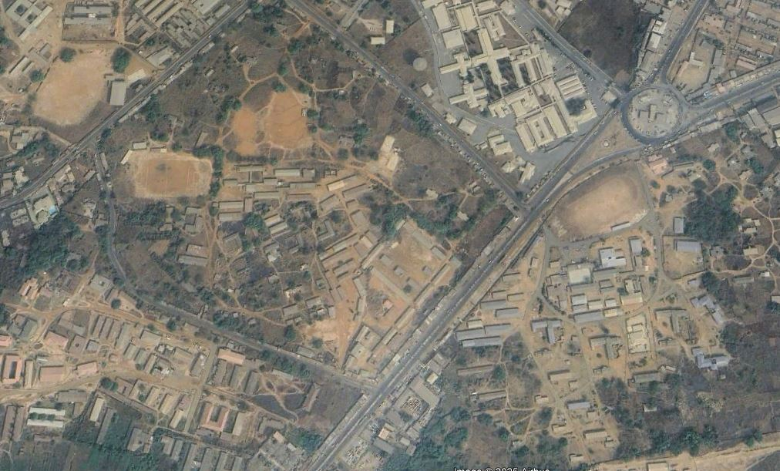
Source: Google Earth
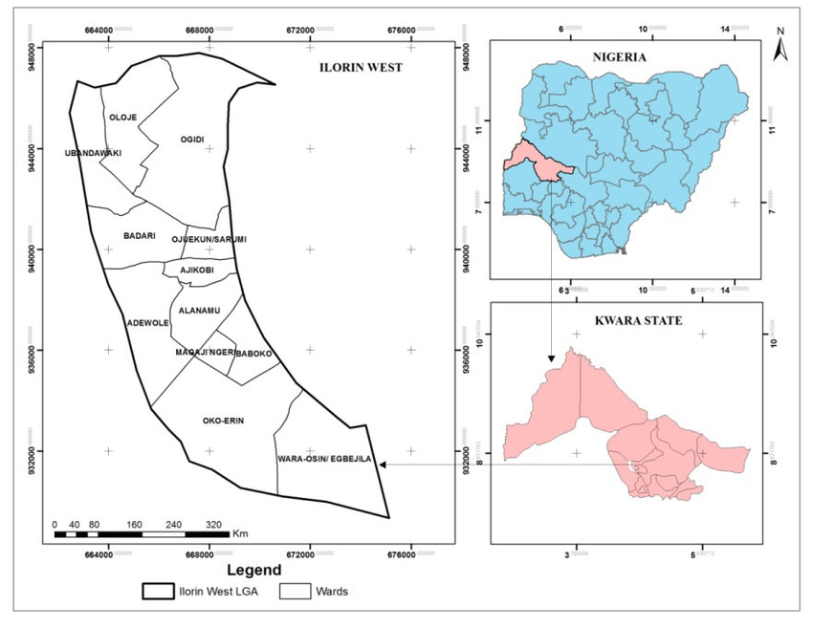

Source: Google Earth

1.8 PERSONNEL
The under listed names were the personnel involved in the execution of the project with their names and matriculation numbers.
NAMES MATRIC NUMBERS
- HUSSEIN TAWAKALITU OLAMIDE HND/23/SGI/FT/0046 (Author)
- IBITOYE MARYAM DAMILOLA HND/23/SGI/FT/0044
- FOLORUNSHO DAMILOLA HND/23/SGI/FT/0048
- ALFA AHMMED ALHAJI HND/23/SGI/FT/0052
- OKEDELE SAMSON OPEYEMI HND/23/SGI/FT/0054
- ABDULGANIYU MUSTAPHA HND/23/SGI/FT/0057
- ABDULSALAM GANIYAT YETUNDE HND/22/SGI/FT/0003

CHAPTER TWO

2.0 LITERATURE REVIEW

2.1 TOPOGRAPHIC INFORMATION SYSTEM
With ever growing interest in land information including numerous social, political, and economic changes occurring in the twenty-first century, it becomes imperative to introduce a modern way of managing land data termed Topographical Information System (TIS).
Land is a basic resource of any nation on which human and economic activities take place. It is a gift of nature intended for man’s habitation and enjoyment. By divine purpose, every man should have access to it and then maximize the space available to him. All that man possesses in life is a function of the land space available to him and all human activities are also dependent on this gift of nature. No other platform is as stable, reliable and permanent as land.

One of the most precious resources is land and it has never been under pressure as it is today because land is the abode of man and almost all his activities are land based. This has given rise to a major human need for geospatial information that centered on land especially on information that result from the study and mapping of features on the surface of the earth, including natural features, such as mountains, rivers and constructed features such as highways and rail roads which are used for 3D spatial planning and development (Kobel et al, 2005). Topographic surveying which is the foundation for topographic information system is defined by -Chandra, 2005- as “the process of determining the location of selected ground natural and man-made features of a given area, and determining the configuration of the terrain”
Punmia (2010) defined topographic surveying as the process of determining the positions, both on plan and elevation, of both natural and artificial features of a locality for the purpose of delineating them by means of conventional signs upon a topographic map.
A topographic survey is a survey carried out to obtain the data needed for the preparation of a topographic map.
The purpose of topographic survey is to gather data necessary for the construction of topographic maps which are very essential for the planning and designing of the most engineering projects such as location of highways, railways, design of irrigation and drainage systems, the development of hydroelectric power, layout of city planning and industrial plants, and landscape architecture. Topographic survey entails two basic operations:
- Establishing over the area to be mapped a system of horizontal and vertical control, which consists of selected stations connected by measurements of high precision.
- Locating details, including selected ground points, by measurements of lower precision from the control stations.
Information is set of data of some kind which help in decision making. Oyinloye, (2002), saw information as simply data that have been processed, interpreted and understood by the recipient. It can also be defined as the knowledge contained in a message, or it can be said to be a data which has been processed or refined into a form that is meaningful to the recipient and has a perceived value in current or prospective decision making. This means that information must be meaningful to the users in addition to being valuable in current needs since decisions are made based on present problems that need urgent solutions. Topographic information system must be meaningful both to the software employed and the users of the end products of information.
Topographic information system is a specialized type of Geographic Information System (GIS) which enable the capturing and maintenance of data in compact form for easy retrieval, manipulation of data either in graphic or non-graphic. It is the capability of geospatial analysis that distinguished GIS from other information system (Aronoff, 1991).
Topography as defined by Kraus (2000), is the physiographic relief of an area, it is a layout of natural and artificial features on the surface of the earth and the science of their detailed graphic representations on maps and charts. This shows the surface configuration of the earth which uniquely distinguishes the shape of the earth at different points. Topography can also be said to be a collective term for all the physical features of an area, particularly as represented on a topographic map.
Chandra (2008) defined topographic surveying as the process of determining the location of selected ground natural and man-made features of a given area, and of determining the configuration of the terrain. The location of the features is referred to as planimetry, and the configuration of the ground is referred to as topography or hypsography. The graphical portrayal of the features by conventional symbols is a topographic map. Such a map shows both the horizontal distances between the features and their elevations above a given datum. The representation of the difference in elevation is called relief. This implies that, the purpose of topographic survey is to gather data necessary for the construction of topographic maps which are very essential for the planning and designing of the most engineering projects, drainage systems, the development of hydro-electric power, layout of city planning and industrial plants, and land use architecture. Topographic maps are also helpful for directing military operations during a war. Data from topographic surveying forms the basic topographic database relevant for an information system, in this case, a topographical information system.
2.2 DATABASE
Dania (2002) defined Topographic database as an organized integrated collection of topographical data (about natural and artificial features in a particular locality and their relationship to each other) stored so as to be used for relevant applications with the data being accessed by different logical path.
A database is an organized collection of data. That is typically organized to model relevant aspects of reality in a way that supports processes requiring this information. For example, modeling the ability of an elevation or other features in the project area in a way that supports finding a particular elevation or other information about the feature in that area.
A database management system (DBMS) are specially designed software applications that interact with the user, other applications and the database itself to capture analyze data manages the database. A general purpose database management system (DBMS) is a software system designed to allow the definition, creation, querying, update, and administration of database.
Kraus (2000) defined TIS as a computer based system for collecting and maintaining, storing, reorganizing, modeling and analyzing topographic data as well as for the multimedia presentation and visualization of these data.
Adesina (2006) observed that Topographic information system is the combination of human effort and computer based tools for collection, storage, analysis, manipulation and the retrieval of various kind of data relating to geographical survey, the collection of data on geographic features (both natural and artificial) and processing of data to produce a topographic information which has a perceived value.
Topographic surveys are three-dimensional; it employs the techniques of plane surveying and other special techniques. The relief or configuration of the terrain and the natural or artificial features are located by measurement and depicted on a flat sheet to form a topographic map or in digital form as three dimensional mathematics model stored in computer otherwise referred to as Digital Terrain Model (DTM). Contour lines, connecting points of the same elevation are used to portray elevations at any one of various intervals measured in meters or feet.
Topography is the centre for “geographic information” Topographic survey information is historically based upon the notes of surveyors; in which they usually derived naming and cultural information from other local sources (for example, boundary delineation may be derived from local cadastral mapping). According to Pradeep, 2007 defined topographical map as “a map that uses colours and symbolic patterns to represent the general surface features of the earth, such as grassland, forest, marsh, agricultural, urban, and barren rock”. The information typically contained in a map consists of:
- Spatial data of one or more themes
- Points, lines, polygons and symbols describing the features
- Title, Captions, Legends, Key, etc.
- Textual information or attributes of the graphic features
- Map projection, scale, and geographic coordinates.
Since a topographic map is a representation of a portion of the surface of the earth, the distance between any two points shown on the map must have a known definite ratio to the corresponding distance between the points on the ground. The ratio is known as the scale of the map. The topographic maps fall roughly into three classes according to the map scale employed as follows:
- Large-scale maps: 1 in 1000 or larger
- Intermediate-scale maps: 1 in 1000 to 1 in 10,000
- Small-scale maps: 1 in 10,000 or smaller.
The scale to which a map is plotted depends primarily on the purpose of the map. For reconnaissance, a small scale maps are adequate, but for detailed planning the large-scale maps would be required. The scale is usually decided even before commencing the field work.
Gurugnaman, 2009 defined data as “a collection of facts or figures that pertain to places, people, things, events, and concepts. They are represented as numerical values, alpha numeric characters, symbols and signals.”
Pradeep, 2007 defined Data as “facts about real world entities organized for analysis” It includes results of observation or measurements of such entities. Three components of a datum are of direct relevance to Geographic Information System (GIS):
- Attribute information that describes the substance, characteristics, variables, values, and similar qualities of the entity.
- Geographical Information that describes the position of the entity in space relative to other things in space.
- Temporal information that describes the instant or period of time during which the entity is at a defined location or in an observed state or condition (attribute).
Maguire, D. J. Goodchild, M.F and Rhind, D. W (1991) argued that GIS exists in variety forms and embody the potential for an enormous range of application. Those which have been established for specific application are sometimes given other names such as Land Information System (LIS). There are various forms of topographic data through which Terrain can be modeled either using vector Triangulated irregular Network (TIN) or gridded (Raster Image) mathematical models. In the most applications in environmental sciences, land surface is represented and modeled using gridded models. In civil engineering and entertainment businesses the most representation of land surface employs some variant of TIN models. In geo-statistics, land surface is commonly modeled as a combination of the two signals – the smooth (spatially correlated) and the rough (noise) signal.
In practice, the Surveyors and Geomaticians first sample heights in an area, then use these to produce a Digital Surface Model (also known as digital elevation model). The Digital Land Surface Model (DLSM) can then be used to visualize terrain, drape remote sewing images, quantify ecological properties of a surface or extract land surface objects. The contour data or any other sampled elevation datasets are not a Digital Land Surface Model (DLSM). A DLSM implies that elevation is available continuously at each location of in the study area (The site of the project), i.e. that the map represents a complete surface.
Kraus (2000) described Topographic Information as a Computer based system for collecting, Maintaining, Storing, re-organizing, Modeling and analyzing topographic data as well as for the multimedia representation and visualization of these data. And it consists of a topographic database and application programs. He explained further that the topographic models and of the Database Management System (DBMS), which provide the means of communication between the data and the application programs, the application programs have to provide techniques for data analysis as well as for integration of additional data from external databases.
The base entities contained in the database are called topographic objects and they were captured using automated survey method comprising the size, shape, and slope of the terrain and the location of the roads, existing features, the edges of gullies, the hills on the site. He therefore asserted that modeling of the earth’s surface is central issue in topographic mapping.
The evolution of Geographic Information System is one of the most important recent breakthroughs in handling of information or simply in information technology. It is unique application software which can be used by many public and private organizations for various applications and the area of involvement are expanding rapidly.
GIS is a powerful set of tools for collecting, storing, organizing, retrieval at a will and displaying spatial data from the real world for a particular set of purposes (Burrough, 1986). Therefore, the application of GIS makes surveying gradually more sophisticated and map production flexible and resourceful. Analogue data are now not only converted by also topographically structured in a logical consistent manner whereby querying and analysis are made using some applicable software.
This system (GIS) is versatile and its application in Land Management and terrain evaluation has gained momentum all over the world. Land Information System (LIS) and topographic Information, which usually derived from topographic data, were developed in response to the growing need of using Land effectively to achieve sustainable development. Human activities have always depended on topographic Information. The decision makers have always needed locations, qualitative, statistical and Topographic Information regarding various types of social economic development projects.
2.3 TERRAIN MODEL (DTM)
However, Kraus (2000) emphasized that Digital Terrain Model (DTM) as valuable data source of any application and that DTM described the earth’s surface in the sense of a “bald earth” without human activities such as buildings, bridges, and drainage without vegetation.
Oyinloye (2002) described Digital Terrain Modeling (DTM) as the computer assisted technique of representing the nature of the terrain of an area. It can also be described as the numerical(digital) description of the terrain or surface of the earth based on the measured or derived co-ordinates of numerous points scattered all over the area in question, using both planimetric (x,y,z) quantities.
Therefore, Topographic information system is essential to economic planning and development and much a part of the nation infrastructure as its other elements such as the transport network, health care system, telecommunication etc should be accorded the required support and rightful place in the scheme of national planning and decision support system. The creation of Topographical information system cannot be possible without a dependable topographic database. This clearly shows why we must take a look at the database for topographic analysis.
In view of the foregoing, topographic information system products are useful in so many areas some of which includes:
Topographic maps which are useful in military operation
- Planning and designing engineering project like location of roads, railways, canals, drainage, irrigation etc.
- Airline operation safety
- Disaster management
- Generating and updating geo-information
- Forest planning and management
- Relief assessment
Biljecki (2012) defined Topographical Information System as “the process by which topographical data are collected, stored, checked, analyzed, modeled, referenced, retrieved and displayed. It is a tool for legal, administrative and economic decisions making and an aid for planning and development”. It consists of land and on the other hand a procedure and technique for the systematic collection, updating, processing and distribution of data. Topographical Information System major sources data include:
- Field surveying method using GPS and/or Total Station
- Digitizing of existing maps
- Scanning of existing maps
- Aerial photograph images
- Satellite imagery (Remote Sensing)
- Social survey.
All the methods of data sources depend upon the following factors:
- The size of the area to be survey
- Data accuracy
- Type of information which eventually be extracted from the model
- Availability of resources.
In conclusion, from the reviews carried out, most of the authors incorporated the use of Ground based Total Station of various make in the execution of their study. This method is usually very tedious and cost implicative. In this project, the use of DGPS (Differential Global Positioning System) shall be deployed because of its fast and efficiency.

CHAPTER THREE

3.0 METHODOLOGY

This stage involves the methods and procedure used in planning, data acquisition, data processing, creation of database, creation of database management system and information presentation. These operations were logically structured and carried out in stages involving database design. It is normally considered to involve a spatially referenced and structured digital database and appropriate application software for geospatial analysis. This basically describes the techniques and principles adopted in carrying out the project.
Geographic information system methods were adopted in accomplishing the desired results.

3.1 DATABASE DESIGN

The design of any database involves three stages namely;
i. Conceptual design
ii Logical design
iii Physical design

3.1.1 VIEW OF REALITY
In database design, there is need for reality which is referred to as the phenomenon that actually exists, including all aspects which may or may not be perceived by individuals. The view of reality however, is the mental abstraction of the reality for a particular application or group of applications.
For this application, the view of reality is made of the topography of the project. Since it is not possible to represent the real world, the only option is to conceptualize and model it in a specified manner to represent the real world. The area of interest to us in this project

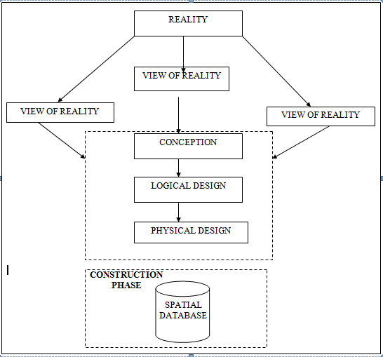
includes; Green Reserve, Roads, Electric poles, Trees, Water Facilities, Buildings, Football pitch, Streams.

Fig. 3.1 Design and Construction Phases in Spatial Database (R Sobh, C Perry)

3.1.2 CONCEPTUAL DESIGN

Vector data model is the data type adopted for this project, which is represented, by points, lines and polygon. The identified entities are: -
      - Green Reserve (polygon)

      - Roads (line)

      - Electric poles (point)

      - Trees (point)

      - Buildings(polygon)

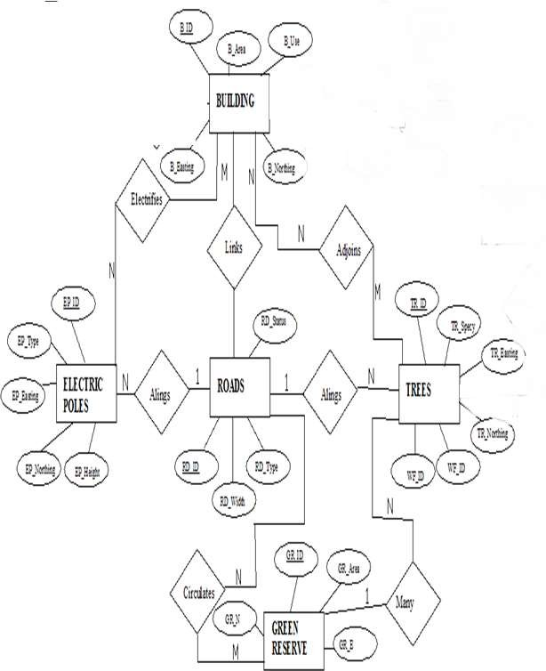
Google source

Fig. 3.1.2.1: E-R Diagram (Entity relationship diagram)

3.1.3 LOGICAL DESIGN
This is the design aspect of the database refers to the process of creating a conceptual framework or model that represents the structure and organization of spatial data within the system. It involves defining the data element, their relationship, and the rules for data manipulation and analysis. In this phase, the entities, their attributes and their relationships are represented in a single uniform manner in form of relation in such a way that would be no information loss and at the same time no unnecessary duplication of data. In this study, the logical database design is employed to generate a geo-relation database structure. Each entity has unique identifier in bold type. An attribute type or combination of attribute types that serves to identify an entity type is termed an identifier.
- Building (B_ID, B_Area, B_Name, B_Easting, B_Northing)
- Roads (R_ID, R_Width, R_Type, R-Condition, R_Easting, R_Northing )
- Vegetation (V_ID,GR_Area,)
- Tree (TR_ID, TR_spp, TR_Importance, TR_Easting, TR_Northing )
- Electric Pole (EP_No, EP_Type, EP_Height,EP_Easting, EP_Northing)
- Football Pitch (FP_ID, FP_Area, FP_Status)

3.1.4 PHYSICAL DESIGN
Table 3.1.4.1.: Building and its attribute

ENTITY | DESCRIPTION
B_ID | Building Identification
B_name | Building Name
B_Area | Building Area
B_Easting | Building Easting
B_Northing | Building Northings

Table 3.1.4.2: Road and its attributes

ENTITY | DESCRIPTION
R_ID | Road Identifier
R_Length | Road Length
R_Width | Road Width
R_Type | Road Type
R_Condition | Road Condition

Table 3.1.4.3: Trees and its attributes

ENTITY | DESCRIPTION
TR_ID | Tree Identifier
TR_Spp | Tree specy
TR_E | Tree_Easting
TR_N | Tree Northing

3.2 RECONNAISSANCE
This is the preparatory stage before the execution of this project; it involves collection of available information about the project area.
The necessary step taken for the successful execution of the project involves two stages, which are: -
- Office Planning
- Field reconnaissance

3.2.1 OFFICE PLANNING
This involves the collection of information about the study area, testing the instrument to be used in execution of the project and itemizing the numbers of equipment needed, number of days to be use, how each activity is to be carried out, delegation of works to each team members based on supervisor’s guide/instructions.
3.2.2 FIELD RECONNAISSANCE
The field reconnaissance stage involves conducting a physical survey of the project area. This typically includes visiting the site to gather firsthand information, assess the current conditions, and verify the accuracy of the existing data.
During field reconnaissance, the project team uses various tools and techniques to collect data, such as Hand held (GPS). We may also take photographs, make observations, and gather other relevant data about the project area.
- Boundary points was selected
- The distribution of features was studied
- Controls to be used were located
- The selection of the method and instrument type has been finalized
- Subsidiary point for Ground control Points were picked and define using nail and bottle cock
- A diagram of the study area was drawn.
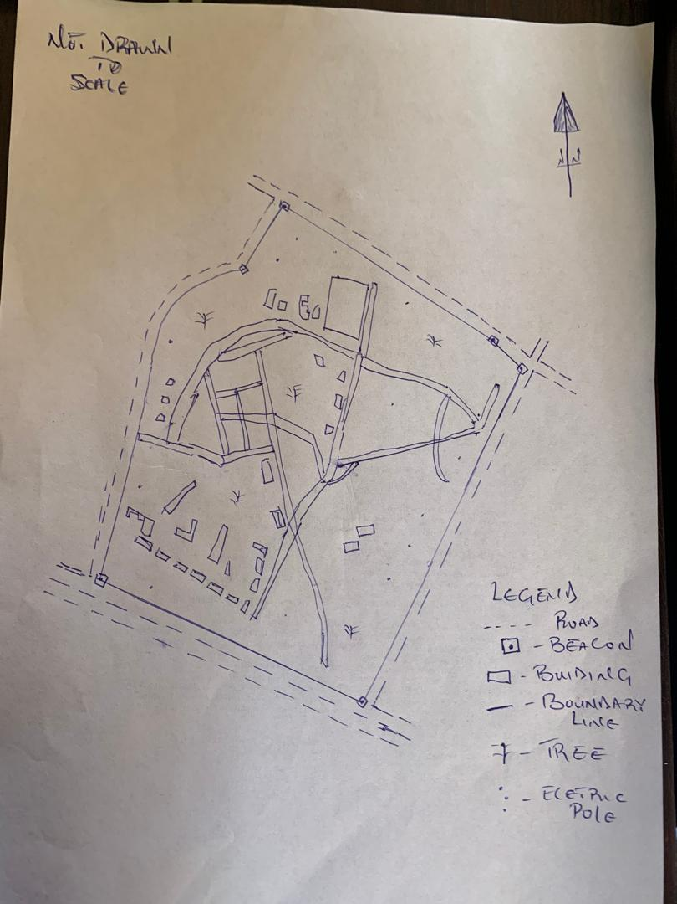

Fig. 3.2.2.1: shows Recce diagram of the study area (not drawn to scale)

3.3 EQUIPMENT USED/ SYSTEM SELECTION AND SOFTWARE
3.3.1 HARDWARE USED

- Total station

- 1 reflector with a tracking rod.

- 1 Tripod

- One (1) 50m tape

- One (1) umbrella

- 1 cutlass

- Hand held GPS

- Hammer

- Nails and bottle cover

- Field book and writing materials

- 1-No of Personal Computer HP655 and its accessories

- 1-No of HP DeskJet K7100 A3 printer

- 1-No of HP DeskJet 1110 A4 printer

3.3.2 SOFTWARE COMPONENT
- Notepad.

- Microsoft Excel.

- AutoCAD 2007

- ArcMAP10.2

- Surfer 25

- Microsoft Word.

3.4 INSTRUMENT TEST
To ensure data quality, the Total Station used for this project was tested for both vertical index and horizontal collimation errors. It was also to ascertain the efficiency and reliability of the instrument. The procedure used is described below.
3.4.1 HORIZONTAL COLLIMATION TEST
This test was conducted to ensure that the line of sight was perpendicular to the trunnion axis. The Total Station was positioned over a specific point, and initial adjustments were made to ensure proper alignment, leveling, and focus (to eliminate parallax in the telescope). A vertical target was placed at a distance of 100 meters from the Total Station. To access the configuration menu of the Total Station, the menu key was pressed and held for approximately 2 seconds. From the main menu, the calibration sub-menu was selected, and within that, the horizontal collimation test option was chosen. The target was then observed and divided into two halves, with horizontal readings recorded for Face left and Face right. The readings are shown in Table 3.4.1 below.

Total Station

REFLECTO R (TARGET)
100m

STATION A
Fairly Level Ground
STATION B

Fig 3.4.1.1; Horizontal Collimation and Vertical Index error test.

Table 3.4.1.1: Horizontal Collimation Data

Station | Target | Face | Hz Reading | Difference | Error
A | B | L | 25˚32‟32”
 |  | R | 205˚32‟35” | 180˚00‟03” | 0˚0’03”

3.4.2 VERTICAL INDEX ERROR TEST

This test was conducted to verify the accuracy of the vertical reading when the line of sight is horizontal. The desired measurement for this test is exactly ninety degrees (90˚), any deviation from this value is referred to as the vertical index error.

The Total Station was positioned over a specific point, and necessary temporary adjustments were made to ensure proper alignment and functionality. A target was placed approximately 100 meters away from the Total Station, and the instrument was aimed at the target. The target was bisected by aligning the instrument on the face left, and the corresponding reading was recorded. Similarly, the target was then bisected on the face right, and the respective reading was also recorded. The recorded readings are provided below:

Table 3.4.2.1: Vertical Index Data

Instrument Station | Target Station | Face | Vertical | Sum | Error
A | B | L | 95˚00‟00”
 |  | R | 275˚00‟02” | 360˚00‟02” | 0˚0’02”

3.4.3 ANALYSIS OF COLLIMATION AND VERTICAL INDEX DATA
The reading obtain during calibration were reduced to obtain new collimation and vertical errors.
Horizontal collimation = {(FR – FL) – 180}/2 = {(00˚00‟03”}/2 = 1.5”

Vertical collimation = {(FL + FR) – 360} = (95˚00‟00” + 275˚00‟02”) – 360} = 02” The result shows that the instrument is still in good working condition.

3.5 CONTROL CHECK
Three control beacons (SC/KW GI544AD, SC/KW GI545AD and SC/KW GI547AD) were used. In order to ascertain the in-situ of the control beacons, a check was carried out on them by observing the angle between them and comparing the result obtained with the computed angles from the giving coordinates.
The total station instrument was set on the control beacon PBIL3306. After performing all the necessary temporary adjustment, the reflector was placed on the control beacon PBIL3306 which served as the back station. The horizontal angular reading was taken and recorded while the instrument was on face left. The reflector was then taken to the NILL which serves as the forward station, the horizontal angle reading was then taken and recorded on both face left and face right. The reflector was taken back to the back station, the horizontal angle was then recorded on face right.

Table 3.5.1: Table showing the back computation of the control coordinates

From STN | Bearing | Dist (m) | ∆N | ∆E | Northing (m) | Easting (m) | To STN
 |  |  |  |  | 936467.388 | 668133.317 | SC/KW GI544AD
SC/KW GI544AD | 118°6'  1'' | 41.031 | 19.326 | -36.194 | 936486.714 | 668097.123 | SC/KW GI545AD
SC/KW GI544AD | 97°16'  21'' | 43.730 | -5.536 | 43.379 | 936481.178 | 668140.502 | SC/KW GI547AD

Table 3.5.2: Table showing the distance observation result of the control check

FROM | OBSERVED DISTANCE  (m) | COMPUTED DISTANCE  (m) | TO
SC/KW GI544AD | 41.041 | 41.031 | SC/KW GI545AD
SC/KW GI545AD | 43.741 | 43.755 | SC/KW GI547AD

Table 3.5.3: Table showing the observation result of the control check

STN | SIGHT | FACE | OBSERVED HZ ANGLE | REDUCED HZ ANGLE | MEAN
 | KWPT3009PT | L1 | 10° 42' 35''
ND20 | KWPT3009APT | L2 | 128° 48' 49'' | 118° 6' 14''
 | KWPT3009APT | R2 | 308° 48' 52'' | 118° 6' 11''
 | KWPT3009APT | R1 | 190° 42' 41'' |  | 118° 6' 13''

Difference in angle (observed - computed) =118° 6' 13''-188° 6' 9'' = 00° 00' 04''

Since the allowable accuracy (angular) of third order traverse of one station is 00° 00' 30'' and the result obtained from the control check (00° 00' 04'') is less than allowable error. Therefore, the controls were angularly intact.

3.6 MONUMENTATION
The boundary of the area carved out was demarcated with the precast concrete beacons, after clearing the required line of sights. The identified points of changes in directions were dug and beacons were buried on it, leaving about 15cm part of the beacon above the ground level. The beacons were buried at convenient distances as dictated by the nature of the boundary.
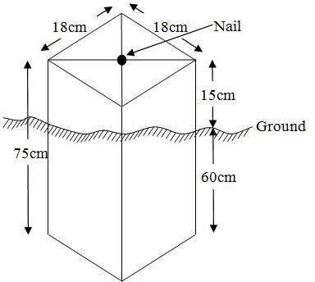

Fig. 3.6.1: Pillar Description

3.7 DATA ACQUISITION
PRIMARY DATA SOURCE
Field observation was the primary source of data for this project. Ground based method was used in acquiring data with the use of Total Station Instrument, which involved the collection of X, Y, Z data through coordinated Ground control Points (GCP) established at conspicuous points within the study area.

SECONDARY DATA SOURCE

An imagery of the area was acquired through Updated Google earth; this was used to ascertain the extent of coverage of the project area.

3.7.1 GEOMETRIC DATA ACQUISITION
The total station instrument was set carefully on control point SC/KW GI545AD, back sight taken to SC/KW GI544AD after necessary station adjustments has been carried out on it. The adjustments include; centering, leveling and focusing. The following procedures were then followed to determine the position of the next point (PL1) and the same procedure were repeated until all we come close to the site. The method used in acquiring data on site was radiation method where two or more points are coordinated from one point.

- Having set up the instrument and temporary adjustment carried out, the instrument was powered „on‟ and a job was created under job menu in the internal memory of the instrument. The job created was named GRP2B
- On the job, the coordinates of the three (2) control points were keyed in to the memory of the instrument and some codes were also saved. The codes include „RD‟ for road, „SP‟ for spot height, „BD for buildings, etc.
- The height of the instrument was measured and saved on the memory of the instrument as well as the reflector height.
- On coordinate menu, orientation was set by inputting the coordinates of the instrument station and back sight. The reflector at the back station was perfectly bisected before the orientation was confirmed by clicking “yes‟.
- Having done the orientation, the reflector at the next nail; was bisected and “obs‟ (observe) option was clicked. The three-dimensional coordinate of the point (E, N, H) were displayed on the display unit of the instrument and „rec‟ (record) was clicked to save the data into the memory of the instrument. For subsequent observation after this, „all‟ option was used instead of pressing “obs‟ and pressing „record‟ later.

- It was ensured that the center of the prism of the reflector was bisected and that it was set perfectly on the tripod in order to minimize the error on height determination.
- The instrument is been shifted to another nail after all details, spot height and boundary point visible from the instrument station have been picked, set over it and temporary adjustments carried out.

Nonetheless, the above operations were repeated until all the boundary points with heights were coordinated.

In this project all spot height is not in grid intervals but randomly acquired. Three edges (3) of building were picked. At the end of data acquisition process all details were acquired and properly recorded to be shown in their respective positions on the plan.

3.7.2 ATTRIBUTES DATA ACQUISITION
Attribute data is information about spatial features. They provide the characteristics, description and nomenclature about spatial objects. Thus, the attributes data acquired includes names of buildings and their uses such as classrooms, roads, water facilities and prominent natural features likes river and trees found and vegetation were properly identified within and around the study area.
3.8 DATA DOWNLOADING AND PROCESSING
3.8.1 DATA DOWNLOADING AND EDITING
This is stage whereby all data acquired which were automatically stored in the Total Station were downloaded into personal computer. This was done with the aid of downloading cable connected to the computer and some associated complementing software installed on the System.

3.8.2 DATA PROCESSING AND DATA EDITING
The geometric data downloaded were further processed in order to convert it to a useful format and to enhance its accuracy. The output coordinates, were edited and exported in *.txt, *.xls and *.pdf format. Thereafter, they were imported into Arc GIS 10.3 for further operations and to carry out spatial analysis.

3.8.3 DATA PROCESSING USING AUTOCAD 2007

Before lunched AutoCAD, we used Notepad to processed the coordinate data we observed in field after it copy it to AutoCAD and this following bellow is step by step were used for process in Autocad
- Launch AutoCAD on computer.
- Click on New from the application menu o
- Type UNITS in the command line and press Enter.
- Select the desired unit type (eg, decimal, architectural, engineering).
- Select poly line in menu bar
- Copy from notepad to Autocad and press Z enter E enter
3.8.4 DATA PROCESSING USING ARCGIS 10.3
Before launching of ArcGIS AutoCAD was used in plotting of feature data saving them separately in different file named road, boundary line, buildings, tree.
- Launch the ArcMap in ArcGIS 10.3
- Click on A NEW EMPTY MAP on the dialog box displayed after loading
- Click on Tools on the menu bar, then select extensions, mark all and close.
- At the LHS, right click on layers, and then select properties.
- Click on coordinate system to set the projection system to MINNA DATUM ZONE 31N and general to set the unit, then apply and okay.
- Add data was selected at the tool bar all saved AutoCAD fie was selected and load onto the table of content layer section
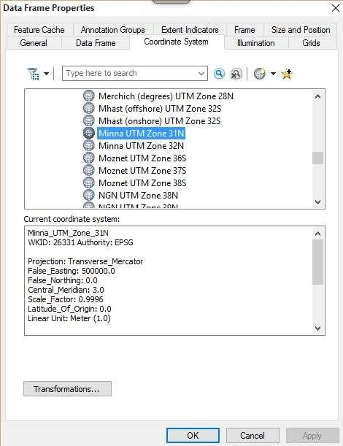
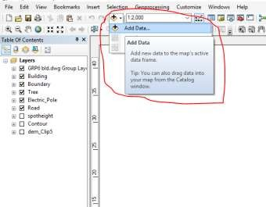
All drawing was exported to shape file. After the feature class has been creates, click on Editor to start Editing, and then click on the load object.

CRATING CONTOUR: Firstly, DEM was created by searching in the search icon INTERPOLATION> NATURAL NIGHBOR and selecting THE XYZ data for creation of DEM in respect to the boundary line as extent. In order to create contours, you will need to enable the Spatial Analyst toolbar, which can be found by going to Customize > Toolbars > Spatial Analyst or open the search bar. You can do this by clicking Windows >Search, or by clicking on the search icon.
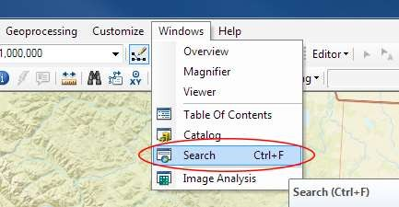

In the search bar type Contour, and select Contour (Spatial Analyst) from the search results list.
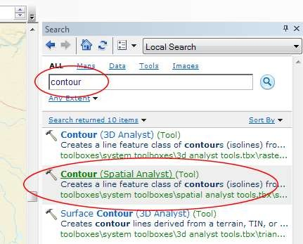

After choosing Contour, a dialogue window will appear, prompting you for five settings: Input raster: select the DEM file from which you want to generate contours by locating it on your hard drive or in the dropdown menu, showing layers present in the Table of Contents Output polyline features: indicate where you want to save your output contours Contour interval: set the distance between contour lines in meters – the smaller the number, the greater the number of lines Base contour (optional): the starting point from which the lines are generated – for example, the default is 0 so with an interval of 25 meters, the contours are generated at 25, 50, 75, 100…, but if the base contour is set at 40, then the contours are generated at 65, 90, 115, 140 and so on Z factor (optional): can be used to adjust the units of data; for example, if you have data in meters and you want to produce your contours in feet, use a z-factor of 3.28 because 3.28 feet equals one meter.

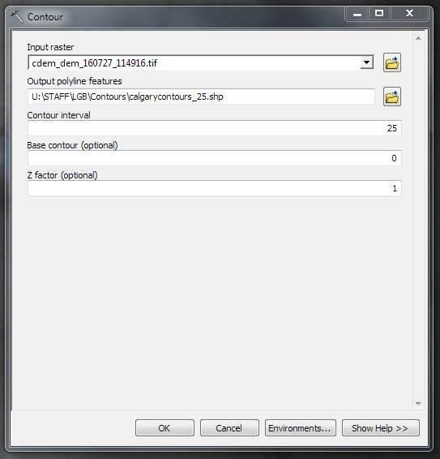

The generated contours will automatically be added to the map.
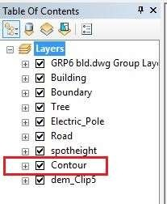

Input the data which is the AutoCAD drawing and select the feature type you want to load,

- Click Add and Next, then select the Target layer you want it to be

- Load it into from the feature class created on the ARCGIS.

- Click on Next, then select “only the features that satisfy the

- Query” and click on Query Builder to query for the feature to be loud e.g. “layer” = Boundary”.
- Click on Next. Then finish
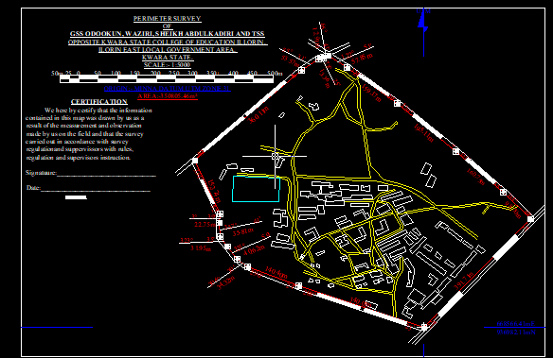
Right click on the Boundary In the table of content and click on zoom to layer to display the feature.

EDITING, CONVERTING AND MERGING GEODATABASE

- Remove all necessary features by right clicking on it and press "REMOVE"

- Convert some features that are not in their correct „features -type‟ like point, line, and polygon features etc.
To convert a GOEDATABASE FEATURE CLASS to another the following steps were taken:
- FOR LINE FEATURE CLASS TO POLYGON FEATURE CLASS

- Go to WINDOW on the menu bar and select ARC Toolbox.

- Select DATA MANAGEMENT TOOLS, click on FEATURES, and then Select FEATURE TO POLYGON.
- ON INPUT FEATURES, select feature to be converted, on OUTPUT FEATURE CLASS, then save on the GRP6C FOLDER, press OK and CLOSE.
- Then remove the converted feature class in the LAYER Menu and ARC CATALOG files.
- On INPUT DATASETS, select features to be merged, on OUTPUT DATASETS, then save on the GRP6C folder, press OK and CLOSE.
- Then remove the converted feature class in the LAYER Menu and ARC CATALOG files.

TABLE CREATION

There is need to create attribute tables for the features so as to be used for queries. NOTE: The editor on the menu bar must be stopped before adding field to its table. THE FOLLOWING PROCEDURES WERE FOLLOWED:
- Right click on the feature class, then select OPEN ATTRIBUTES TABLE click on OPTIONS and select ADD FIELD.
- Give it FIELD NAME, click on TYPE and select [SHORT INTEGER or LONG INTEGER for SHORT or LONG WHOLE VARIABLES or DOUBLE FOR
- DECIMAL VARIABLES OR TEXT variable or DATE for DATE], then enter precision or LENGTH for text width and scale for DECIMAL PLACES, and then click OK
- To input variables on the ATTRIBUTE TABLE, go to the EDITOR on Menu bar, select START EDITING,
- Click on ATTRIBUTE on menu bar [behind the TARGET], click on the features on the DATA VIEW display, and then input the variables of data acquired through SOCIAL SURVEY or DATA ACQUIRED ON THE FIELD.
- Save it after the input by selecting SAVE EDITS on the editor menu. To switch to other layers, select STOP EDITING on the EDITOR menu. Then repeat the above step to create other fields. Populate the table and save.

Table 3.8.3.1: Building

ENTITY | FIELD ALIAS | DATA TYPE | FIELD SIZE
B_ID | Building Identification | Numeric | -
B_name | Building Name | Text | 14
B_Area | Building Area | Numeric | -
B_E | Building Easting | Numeric | -
B_Northing | Building Northings | Numeric | -

Table 3.8.3.2: Road

ENTITY | FIELD ALIAS | DATA TYPE | FIELD SIZE
R_ID | Road Identifier | Numeric | -
R_Length | Road Length | Numeric | -
R_Width | Road Width | Numeric | -
R_Type | Road Type | Text | 14
R_Condition | Road Condition | Text | 14

Table 3.8.3.3: Trees

ENTITY | FIELD ALIAS | DATA TYPE | FIELD SIZE
TR_ID | Tree Identifier | Numeric | -
TR_Spp | Tree specy | Text | 14
TR_E | Tree_Easting | Numeric | -
TR_N | Tree Northing | Numeric | -

Table 3.8.3.4: Electric Poles

ENTITY | FIELD ALIAS | DATA TYPE | FIELD SIZE
EP_ID | Electric pole Identifier | Numeric | -
EP_Type | Electric pole Type | Text | 14
EP_Height | Electric pole Height | Numeric | -
EP_E | Electric pole Easting | Numeric | -
EP_N | Electric pole Northing | Numeric | -

ADDING SPOT HEIGHTS DATA

- NOTE: STOP EDITING on the EDITOR MENU before adding data field,

- Go to FIELD ON THE MENU BAR, scroll to add Data and then ADD XYZ DATA

- Browse the EXCEL FILE for SPOT HEIGHTS, select EASTING VALUE on X - FIELD and NORTHING VALUE on Y - IELD and ELEVATION
- « Select DATA the EXPORT DATA, locate the folder created and give it name then YES AND OK, remove the previous layer by right clicking on it and select REMOVE.

TIN, ASPECT AND SLOPE CREATION USING ARCMAP

Uses of tin in map
- High Accuracy: Represents terrain more precisely in areas with complex elevation changes.
- Efficient Modelling: Requires fewer data points in flat areas and more in rugged areas — making it efficient and detailed.
- 3D Modelling: Helps generate realistic 3D models of the earth's surface.
- Engineering Design: Used in road and site grading design, mining, and flood simulation.
- Volume Calculations: Useful in cut-and-fill analysis for construction or excavation
NOTE: Making sure the 3D Analyst Extension is active, select VIEW on MENU bar, then click TOOLBARS and MARK the 3D Analyst EXTENTION Then X, Y Data

TO CREATE TIN

- Click on 3D Analyst arrow, select create TIN and then create TIN from FEATURE.
- On layers mark the SPOTHEIGHT LAYER, select height data on HEIGHT, then ok.
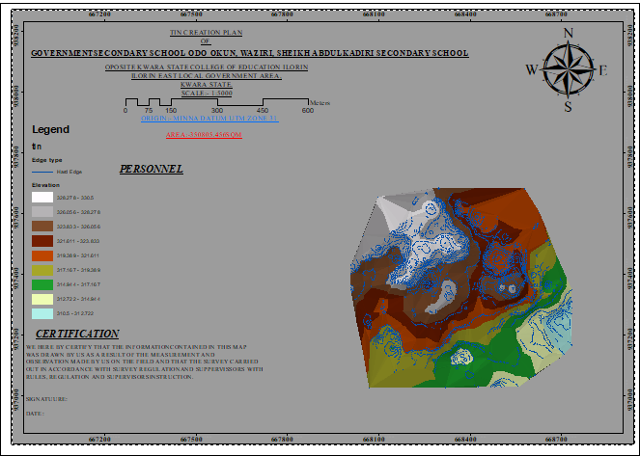

TO CHANGE THE FACE OF THE TIN ACCORDING TO ITS ELEVATION

- RIGHT CLICK on the TIN, select PROPERTIES, and click on SYMBOLOGY.

- Then ADD, select FACE ELEVATION WITH COLOR RAMP, click ADD, and then select APPLY and OK.

TO CREATE ASPECT

- Click on 3D analyst arrow, select SPATIAL ANALYST TOOLS, SURFACE and THEN DOUBLE CLICK on ASPECT.
- Browse to where the raster format of all the acquired data created from the surfer was saved to.
- Browse to where you want the OUTPUT RASTER to be saved

- You can change the OUTPUT MEASUREMENT to Degree OR percent

- Click OK [then it displays on the data view screen], then Close.

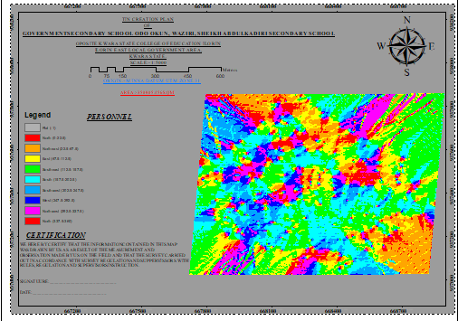

3.9 DATABASE IMPLEMENTATION

This is the database creation phase. Having completed the three stages of design phase (i.e. Reality, Conceptual and Logical design), the database was created using ArcGIS 10.3 software. It involves the combination and storage of acquired graphic data and attributes data in creating the database for the purpose of spatial analysis and query.
Database is an organized integrated collection of data stored so as to be capable of use by revenant application with data being accessed by different logical part. After the Attribute table was populated via the keyboard, some attributes such as areas of settlements were automatically displayed by special command in the ArcGIS 10.3 version. The ArcGIS software was used to link the graphic data and table for query generation.

3.9.1 DATABASE MANAGEMENT SYSTEMS
Database management is a collection of software for creating, storing, manipulating, updating, organizing and querying of information in a database (Kufoniyi, 1998). It is a software package whose function is to manipulate a database on behalf of the user.
A good DBMS must provide the following functions:

      - Storage and retrieval of data.

      - Access to by several users at a time.

      - A standardized interface between database and application programmed.

      - Standardized access to data and separation of data storage and retrieval functions from the program using the data.
      - Maintenance of data security and integrity.

3.9.2 DATABASE MAINTENANCE
Having created the database, proper maintenance practice was made to meet its stated objectives. The ability to include more data and remove irrelevant data was possible by way of maintenance. There is every need for the data to be updated regularly because of the physical changes that may occur on the landscape with time. Both security and integrity were also exercised to ensure maintenance and to meet its stated objectives.
Proper observance, updating and management of database ensure its currency and quality to stand a profound chance in Spatial Decision Support System (SDSS). The quality of any database depends on the currency and fitness for use as a decision support system (SDSS). The quality of database depends on its ability to generally fit and use as a decision system (DSS). The storage media should be from time to time justified if otherwise could necessitate data inaccessibility or physical deterioration of the storage media. Also, care must be taken during populating any database system, as a database is only good as the data supplied. In archiving stable media should be used. Examples of these are
- Computer compatible tape reader

- Magnetic tape

- Optical disc and compact disc

3.9.3 BACK COMPUTATION
Table 3.9.3.1: Back Computation
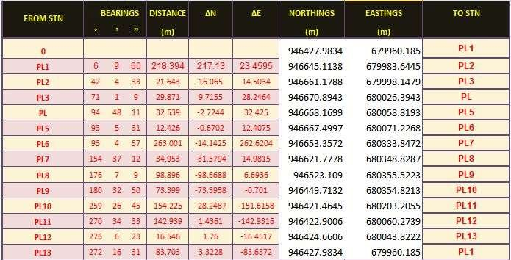

3.9.4 AREA COMPUTATION
Table 3.9.4.1: Area Computation
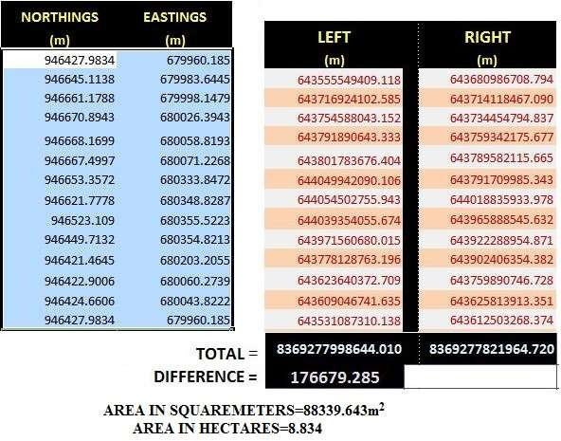

CHAPTER FOUR

4.0 SPATIAL ANALYSES AND PRESENTATION
GIS is distinct among other information system because of its spatial analytical capability; especially overlay operation, buffering, spatial search, topographic operation, and neighborhood and connectivity operations. GIS uses this spatial analytical capability to answer fundamental generic question of location, condition, trend, routing, pattern and modeling by the manipulation and analysis of input data. The major analyses performed in this project were overlay operations, topographic operations and spatial search.
4.1 TESTING OF DATABASE
This is the test carried out to determine whether there exists a relationship between data modeled about entities in a spatial database as well as putting into test its retrieval capabilities. This was done by designing a sample query with certain conditions attached and the query will be ran to see if desired result is achieved.

Analysis of Result

The contour whose value is greater or equal to 350 meters depicts the likelihood that such area may not be prone to flood in the project area as shown in Fig. 4.5(Query 1). This represents the elevation of points that are greater than to 350m. The displayed attribute table confirmed that North-East part of the institute had the highest elevation. Height is an important factor when considering the surface or slope of the terrain. The South-west part of the school had the lowest elevation which is very prone to erosion. Buildings that will be sited in that region must have a very high foundation above the ground level. The result of the query will afford the school management to decide concisely the terrain characteristics and the kind of building that should build in every region of the project area looking critically at the terrain of the area.

SINGLE SELECTION CRITERION

Query 1: Shows the retrieving Area whose height is Greater than 320 meters

SELECT* FROM Contour WHERE "CONTOUR">320

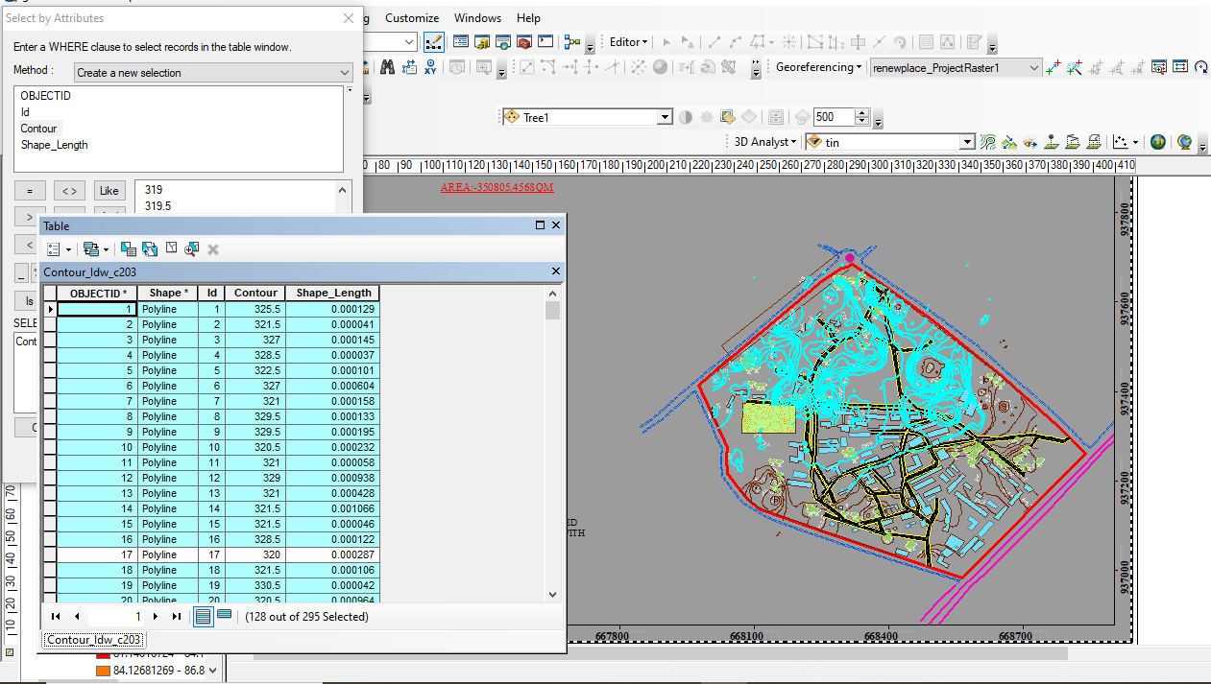

Fig 4.1.1: Shows the retrieving Area whose height is greater than 320 meters

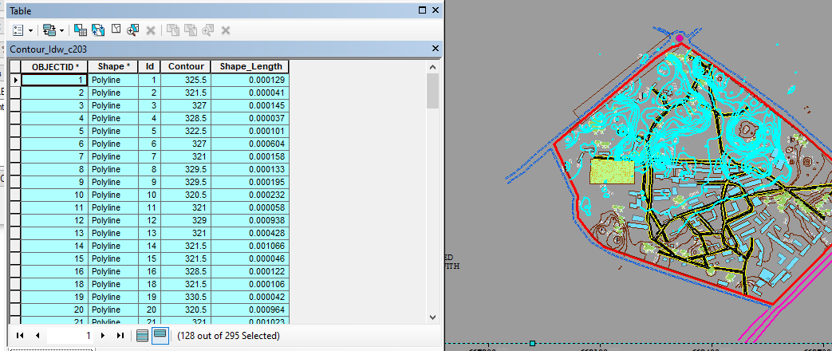

Fig 4.1.2: Shows the result of area whose height is greater than 320 meters

Fig 4.1.3: Show the result of area whose height is greater than 320 meters

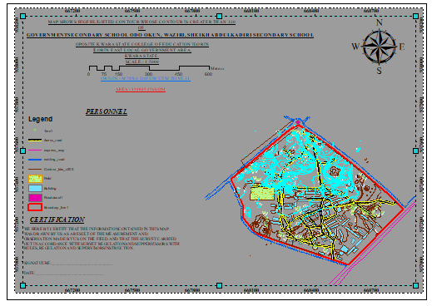
Fig 4.1.4 Query Shows the result of Buildings Used for Class Rooms (B_NAME = 'CLASS_ROOM')

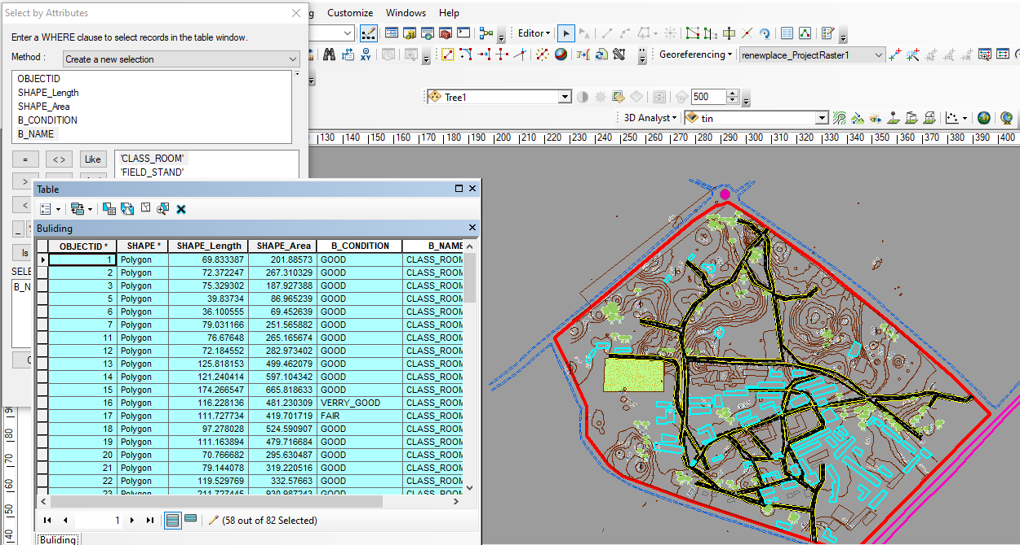

Fig 4.1.5 Query Shows the result of Buildings Used for Offices (B_NAME = 'OFFICE')

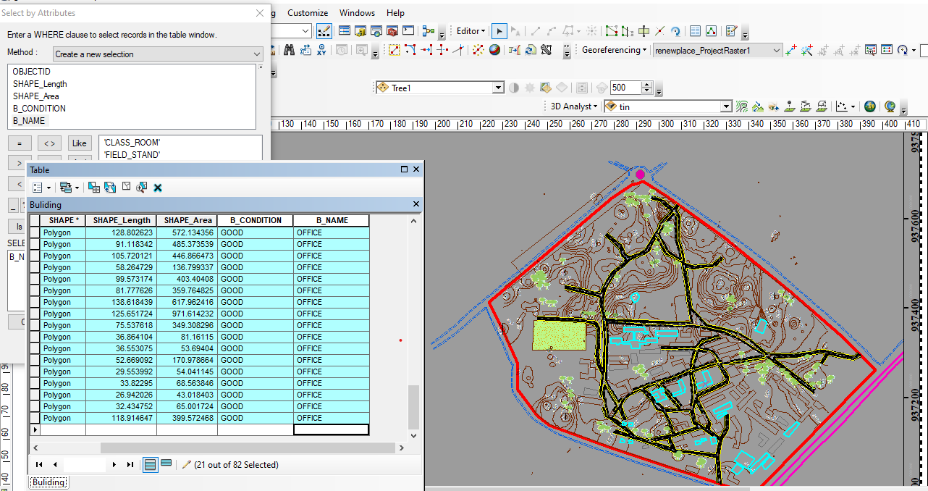

CHAPTER FIVE
5.0 COST ESTIMATION, SUMMARY, RECOMMENDATION AND CONCLUSION
5.1 COST ESTIMATION

This stage the total cost spent on the project from day one to the final stage.

Table 5.1.1: Direct cost parameters

S/N | DIRECT COST
1 | Reconnaissance (1 day)
 | PERSONNEL | Daily rate | Amount (N:K)
 | 1 x surveyor | 9814.20 | 9814:20
 | 1 x assistant surveyor | 7944.83 | 7944:83
 | 1 x technical officer | 6542.8 | 6542:80
 | 3 x skilled labour | 4078.66 | 12235:98
 | basic equipment | 5000 | 5000:00
 | transportation (vehicle, Driver and fuel) | 10000 | 10000:00
 |  | sub-total | 51537:81
2 | Monumentation (1 day)
 | PERSONNEL
 | 1 x assistant surveyor | 7944.83 | 7944:83
 | 1 skilled labour | 6542.8 | 6542:80
 | transportation (vehicle, Driver and fuel) | 10000 | 10000:00
 | basic equipment | 5000 | 5000:00

 | Beacon (6) | 1000 | 6000
 |  | sub-total | 43,644:95
3 | Data acquicision (2 days)
 | PERSONNEL
 | 1 x assistant surveyor | 7944.83 | 15889:66
 | 1 x technical officer | 6542.8 | 13085:60
 | 3 x skilled labour | 4078.66 | 24471:96
 | Total Station and accessories | 15000 | 30000:00
 | transportation (vehicle, Driver and fuel) | 10000 | 20000:00
 |  | sub-total | 103447:22
5 | Data Processing (2 days)
 | PERSONNEL
 | 1 x surveyor | 9814.2 | 19628:40
 | 1 x assistant surveyor | 7944.83 | 15889:66
 | 1 x technical officer | 6542.8 | 13085:60
 | computer / accessories | 15000 | 30000:00
 |  | sub-total | 78603:66
7 | Technical Report (1 day)
 | PERSONNEL
 | 1 x surveyor | 9814.2 | 9814:20
 | 1 x assistant surveyor | 7944.83 | 7944:83

 | 1 x secretary | 5000 | 5000:00
 | computer / accessories | 15000 | 15000:00
 |  | sub-total | 37759.03
TOTAL (DIRECT COST)1,170,205:09 MOBILIZATION/DEMOBILIZATION = 5% of Direct Cost
= 0.05 × 1,170,205:09

= N58,510:25

CONTINGENCY ALLOWANCE = 5% of Direct Cost

= 0.05 × 1,170,205:09

= N58,510:25

GRAND TOTAL = N1,170,205:09 + N58,510:25 + N58,510:25

= N1,287,225:59

VAT (@5% GRAND TOTAL) = 0.05 × 1,170,205:09

= N64,361:28

TOTAL COST PAYABLE = GRAND TOTAL + VAT

= N1,287,225:59 + N64,361:28

= N1,351,586:87.

5.2 SUMMARY
The primary objective of this project is to accurately determine the elevation differences in the terrain and identify the various features within the designated site area. This was achieved through the implementation of a ground survey method using specialized equipment like the Total Station instrument and its associated accessories. By utilizing the radiation method, the instrument efficiently collected precise data on coordinates and elevation.
The acquired data was then processed and analyzed to generate several informative outputs. Plans were created, offering a comprehensive visualization of the area in dimensions, effectively highlighting the variations in elevation. Additionally, a perimeter and detailed plan were developed to depict the boundaries and specific features present within the site. A wireframe plan was also constructed to visualize the surface and its contour lines, while a contour plan was generated to illustrate the different elevation levels across the entire area.
To facilitate the analysis and processing of the collected data, a range of software tools were employed. ArcGIS was utilized for spatial analysis and data manipulation, Surfer9 was employed for generating contour plots and visually representing the terrain, Microsoft Excel was used for efficient data management and analysis, and Notepad served as a text editor for handling data in a tabular format.
5.3 RECOMMENDATION
Throughout the execution of this project, a plethora of new insights and knowledge were acquired. Based on these experiences, I highly recommend conducting similar projects in a practical manner, as it offers students a profound understanding of the subject matter. Additionally, it is crucial to provide students with an enhanced learning environment equipped with digital tools and equipment to further enhance their educational experience.
5.4 CONCLUSION
- In conclusion, the topographical survey conducted in this project holds significant importance for future planning, design, and landscaping purposes. The accurate and comprehensive information gathered through the survey provides valuable insights for Engineers and Architects to make informed decisions and design infrastructure that is safe, accessible, and efficient. The project's adherence to survey rules and regulations further validates the credibility of the survey results and ensures the quality of the project's outcomes

REFERENCE
Burrough, P,A (1986) Principle Of Geographical Information System For Land Resources Assessment:- Oxford University Press, New york, pp194
Charles D. Ghilani, and Paul R. Wolf (2012) Elementary Surveying An Introduction To Geomatics, Thirteenth Edition Pearson Education, Inc. Upper Saddle River, New Jersey O7458 P.1 – 2.
Kraus, B.F. (2000): Topographic Information System, downloaded from www.pf.tuwien.ac.at/fr/buildi.g/didd/node 41.html Pp 1-2
Dania, C. J (2002): An Introduction to Database Systems, Addison-Wesley, Reading Seventh Edition.
Ghilani, C. D. and Wolf, P.R. (2008): Elementary Surveying, An Introduction to Geomatics, Twelfth edition, Pearson Education Inc., Upper Saddle River, New Jersey, P1
Adesina, J.G (2006): Geographic information system and implementation considerations. A paper presented at Rufus Giwa Polytechnic, Owo, Ondo State.
Adesina, J.G (2009): Mapping: A veritable tool for the actualization of Millennium Development goals in Nigeria. A paper presented at Inaugural lecture of Rufus Giwa Polytechnic,Owo, Ondo State.
Aronoff, S. (1991): Geographic information system; A management perspective WDI Publication, Ottawa, Canada. P 41
Chandra, A.M (2008): Higher Surveying, Revised Second Edition, New Age International(p) Limited, Publishers. New Delhi, www.newagepublishers.com , Pp 2-3.
Dania, C. J (2002): An Introduction to Database Systems, Addison-Wesley, Reading Seventh Edition.

Ghilani, C. D. and Wolf, P.R. (2008): Elementary Surveying, An Introduction to Geomatics, Twelfth edition, Pearson Education Inc., Upper Saddle River, New Jersey, P1
Kobel, T.H. (2005): City GML- interoperable access to 3D city models, proceedings of international Symposium on geoinformation for disaster management, Graz, Austria. P 55
Kraus, B.F. (2000): Topographic Information System, downloaded from www.pf.tuwien.ac.at/fr/buildi.g/didd/node 41.html Pp 1-2

Kufoniyi, O. (1998): Database Design and creation in C.U. Ezeigbo (Edited), Principles And Application of geographic Information System, series in Surveying and Geoinformatics, 1st Edition P 45.
Maguire, D. J. Goodchild, M.F and Rhind, D. W (1991): Geographic Information System,Principles and Applications: volume 1 John Wiley, New York, Pp 20. New Lexicon Webster Dictionary (1984), University Encyclopedia Lexicon Publication Inc,NewYork.

PT1 | PL1 | 668541 | 937014.6 | 288.648
PT2 | RD1 | 668538.5 | 937010.1 | 288.089
PT3 | RD2 | 668535.3 | 936996.6 | 288.064
PT4 | BLD1 | 668530.9 | 937021.2 | 288.522
PT5 | BLD2 | 668530.4 | 937018.7 | 288.799
PT6 | BLD3 | 668526.3 | 937022.9 | 288.681
PT7 | MAX1 | 668529 | 937031.8 | 288.687
PT8 | MAX2 | 668519.7 | 937034.5 | 288.786
PT9 | MAX3 | 668516.5 | 937024.5 | 288.921
PT10 | MAX4 | 668525.5 | 937021.7 | 288.846
PT11 | BLD4 | 668525.1 | 937020.4 | 288.89
PT12 | EP1 | 668516.2 | 937028.5 | 288.838
PT13 | TR1 | 668511.2 | 937028.2 | 289.111
PT14 | TR2 | 668508.7 | 937029.4 | 289.223
PT15 | MAX5 | 668504.4 | 937028.8 | 289.663
PT16 | MAX6 | 668494.8 | 937032.1 | 290.379
PT17 | MAX7 | 668497.7 | 937041.7 | 290.543
PT18 | MAX8 | 668507.1 | 937038.5 | 289.659
PT19 | EP2 | 668508.3 | 937040.9 | 289.707
PT20 | BLD5 | 668488 | 937044.4 | 290.681
PT21 | BLD6 | 668487.7 | 937042.8 | 290.832
PT22 | BLD7 | 668489.2 | 937039.2 | 290.717
PT23 | BLD8 | 668487.5 | 937037.6 | 290.673
PT24 | BLD9 | 668486 | 937037.5 | 290.949
PT25 | BLD10 | 668484.7 | 937035.1 | 290.526
PT26 | BLD11 | 668465.7 | 937052.5 | 290.962
PT27 | Sp1 | 668474.5 | 937056.7 | 290.995
PT28 | Sp2 | 668476.2 | 937061.3 | 290.814
PT29 | Sp3 | 668478.8 | 937066.2 | 290.835
PT30 | Sp4 | 668480.7 | 937071.7 | 290.708
PT31 | Sp5 | 668482.1 | 937077.3 | 290.632
PT32 | Sp6 | 668483.2 | 937083.2 | 290.764
PT33 | TR3 | 668482 | 937087.3 | 290.868
PT34 | TR4 | 668483.4 | 937092 | 291.047
PT35 | TR5 | 668489.4 | 937098.1 | 291.064
PT36 | TR6 | 668494.4 | 937094 | 290.989
PT37 | BLD12 | 668481.1 | 937097.6 | 290.953
PT38 | BLD13 | 668479.1 | 937103.4 | 291.285
PT39 | BLD14 | 668489.2 | 937107.2 | 291.299
PT40 | BLD15 | 668491.3 | 937107.8 | 291.384
PT41 | BLD16 | 668491.3 | 937101.5 | 290.749
PT42 | BLD17 | 668493.4 | 937101.8 | 291.186
PT43 | BLD18 | 668503.2 | 937105.4 | 291.106
PT44 | BLD19 | 668501.3 | 937111.3 | 291.359
PT45 | TR7 | 668503.1 | 937114.1 | 291.467
PT46 | SP7 | 668499.1 | 937116.2 | 291.457
PT47 | BLD20 | 668498.3 | 937120 | 291.399
PT48 | FLW1 | 668498.8 | 937121.5 | 291.53
PT49 | BLD21 | 668494.7 | 937130.5 | 291.857
PT50 | BLD22 | 668472.5 | 937123.1 | 292.028
PT51 | SP8 | 668467.4 | 937121.1 | 292.072
PT52 | SP9 | 668469.2 | 937114 | 291.881
PT53 | BLD23 | 668476 | 937112.6 | 291.388
PT54 | BLD24 | 668461.9 | 937107.8 | 291.866
PT55 | BLD25 | 668458.3 | 937118.2 | 292.121
PT56 | TR8 | 668456.4 | 937122.7 | 292.263
PT57 | SP10 | 668450.6 | 937120.7 | 292.389
PT58 | SP11 | 668442.8 | 937118.2 | 292.472
PT59 | BLD26 | 668436.2 | 937110.8 | 292.468
PT60 | BLD27 | 668439.6 | 937100.3 | 291.971
PT61 | SP12 | 668435.2 | 937099.2 | 292.358
PT62 | SP13 | 668428.8 | 937109.1 | 292.831
PT63 | SP14 | 668423.2 | 937110.3 | 292.67
PT64 | SP15 | 668417.2 | 937106.3 | 293.08
PT65 | SP16 | 668412.7 | 937108.2 | 292.866
PT66 | SP17 | 668405.7 | 937103.3 | 293.229
PT67 | BLD28 | 668391.4 | 937095.6 | 293.272
PT68 | BLD29 | 668381.7 | 937092.8 | 293.718
PT69 | BLD30 | 668383.4 | 937086.6 | 293.459
PT70 | BLD31 | 668393.3 | 937089.5 | 293.292
PT71 | TR9 | 668390.3 | 937083.2 | 293.226
PT72 | TR10 | 668379.5 | 937081.2 | 293.606
PT73 | SP18 | 668385.1 | 937104.7 | 293.661
PT74 | SP19 | 668394.9 | 937109.3 | 293.663
PT75 | SP20 | 668405 | 937112.5 | 293.543
PT76 | SP21 | 668415 | 937116.8 | 293.187
PT77 | SP22 | 668424.1 | 937121.2 | 293.215
PT78 | SP23 | 668428.7 | 937125.6 | 293.255
PT79 | BLD32 | 668507.7 | 937113.4 | 291.735
PT80 | BLD33 | 668518.3 | 937116 | 291.014
PT81 | BLD34 | 668521.4 | 937102.2 | 290.614
PT82 | BLD35 | 668510.9 | 937099.8 | 290.864
PT83 | SP24 | 668511.7 | 937093.6 | 290.606
PT84 | SP25 | 668516.4 | 937091.7 | 290.537
PT85 | SP26 | 668523.1 | 937090.3 | 290.504
PT86 | SP27 | 668522.7 | 937082.7 | 290.153
PT87 | SP28 | 668515.8 | 937079.4 | 289.894
PT88 | SP29 | 668526.9 | 937078.7 | 289.922
PT89 | SP30 | 668534.5 | 937085.3 | 289.954
PT90 | SP31 | 668538.9 | 937086.5 | 290.075
PT91 | SP32 | 668537.1 | 937089.4 | 290.192
PT92 | SP33 | 668535.2 | 937089.5 | 289.878
PT93 | SP34 | 668532.4 | 937090.4 | 290.259
PT94 | SP35 | 668532.9 | 937092.7 | 289.948
PT95 | SP36 | 668534 | 937094.8 | 290.331
PT96 | SP36 | 668537.5 | 937098.3 | 290.129
PT97 | SP38 | 668539 | 937100.7 | 290.594
PT98 | SP39 | 668542.3 | 937105.9 | 290.819
PT99 | SP340 | 668540 | 937110.2 | 290.891
PT100 | TR11 | 668545.3 | 937107.5 | 290.908
PT101 | TR112 | 668547.9 | 937120.7 | 291.223
PT102 | TR13 | 668540.8 | 937121.9 | 291.12
PT103 | BLD36 | 668538.2 | 937129.5 | 291.175
PT104 | BLD36 | 668520.8 | 937120.6 | 291.223
PT1041 | BLD37 | 668520.8 | 937120.6 | 291.215
PT1042 | BLD38 | 668509.8 | 937141 | 292.157
PT106 | BLD38 | 668512.9 | 937143.3 | 292.512
PT1061 | BLD39 | 668512.8 | 937143.3 | 292.497
PT107 | BLD40 | 668499 | 937168.7 | 292.979
PT108 | BLD41 | 668501.9 | 937170.9 | 293.564
PT109 | BLD42 | 668486.9 | 937198.4 | 294.556
PT110 | BLD43 | 668500.3 | 937206 | 295.287
PT111 | SP41 | 668500.1 | 937213.6 | 295.083
PT112 | SP42 | 668495.5 | 937218.9 | 295.229
PT113 | BLD44 | 668489.4 | 937222.1 | 295.332
PT114 | BLD45 | 668478.9 | 937244.6 | 296.274
PT115 | SP43 | 668482.9 | 937252.8 | 296.449
PT116 | SP44 | 668492.2 | 937257.9 | 296.301
PT117 | SP45 | 668497.2 | 937260.4 | 296.208
PT118 | BLD46 | 668500.8 | 937255.2 | 296.017
PT119 | BLD47 | 668511.5 | 937232.2 | 295.283
PT120 | SP46 | 668512.6 | 937227.9 | 295.154
PT121 | BLD48 | 668510.7 | 937211.8 | 294.555
PT122 | SP47 | 668519.1 | 937221.1 | 294.695
PT123 | SP48 | 668528.8 | 937226.7 | 294.799
PT124 | SP49 | 668538.3 | 937232.6 | 294.955
PT125 | SP450 | 668543.7 | 937236.6 | 295.074
PT126 | BLD49 | 668547.3 | 937232 | 295.055
PT127 | BLD50 | 668552.5 | 937223.7 | 294.547
PT128 | BLD51 | 668553.3 | 937218.6 | 294.486
PT129 | BLD52 | 668545.5 | 937212.5 | 294.018
PT130 | BLD53 | 668560.8 | 937192.7 | 293.436
PT131 | BLD54 | 668569 | 937199 | 293.465
PT132 | BLD55 | 668569.5 | 937208.3 | 293.734
PT133 | BLD56 | 668576.5 | 937214.8 | 293.911
PT134 | BLD57 | 668561.2 | 937230.8 | 294.338
PT135 | BLD58 | 668554.2 | 937224.4 | 294.641
PT136 | BLD59 | 668563 | 937232.5 | 294.458
PT137 | BLD60 | 668569.8 | 937239 | 295.216
PT138 | BLD61 | 668583.9 | 937224.6 | 294.735
PT139 | BLD62 | 668577.3 | 937218.2 | 294.261
PT140 | BLD63 | 668587.5 | 937218.1 | 294.048
PT141 | BLD64 | 668558.6 | 937183 | 293.328
PT142 | BLD65 | 668560.1 | 937181.5 | 293.498
PT143 | BLD66 | 668556.3 | 937177.2 | 293.455
PT144 | BLD67 | 668555.4 | 937177.8 | 293.357
PT145 | BLD68 | 668561.6 | 937169.7 | 293.421
PT146 | BLD69 | 668550 | 937182.9 | 292.943
PT147 | BLD70 | 668518.4 | 937165.5 | 292.326
PT148 | BLD71 | 668512.9 | 937174 | 292.681
PT149 | BLD72 | 668544.7 | 937191.4 | 293.572
PT150 | BLD73 | 668539.6 | 937200.8 | 293.701
PT151 | BLD74 | 668534.8 | 937209.6 | 293.934
PT152 | BLD75 | 668505.1 | 937197.2 | 294.334
PT153 | BLD76 | 668515.6 | 937202.9 | 294.262
jPT154 | BLD77 | 668539.7 | 937170.4 | 292.942
jPT155 | BLD78 | 668543.9 | 937163.6 | 292.295
jPT156 | BLD79 | 668525.2 | 937152.9 | 291.899
jPT157 | BLD80 | 668521 | 937160.2 | 292.08
jPT158 | BLD81 | 668507.4 | 937173.2 | 292.79
jPT159 | BLD82 | 668521.6 | 937147.2 | 292.13
jPT160 | BLD83 | 668528.4 | 937147.9 | 291.637
jPT161 | BLD84 | 668545.6 | 937157.7 | 292.183
jPT162 | BLD85 | 668553.3 | 937161.9 | 292.846
jPT163 | BLD86 | 668556 | 937139.8 | 291.819
jPT164 | BLD87 | 668560.1 | 937131.4 | 291.662
jPT165 | BLD88 | 668560.3 | 937128.1 | 291.959
jPT166 | BLD89 | 668557.2 | 937128.3 | 291.401
jPT167 | BLD90 | 668554.9 | 937108.4 | 291.101
jPT168 | BLD91 | 668557.2 | 937107.4 | 291.289
jPT169 | BLD92 | 668556.4 | 937102.4 | 291.716
jPT170 | BLD93 | 668553 | 937102.5 | 290.729
jPT171 | BLD94 | 668550.3 | 937092.8 | 290.301
jPT172 | BLD95 | 668561.2 | 937090.9 | 290.064
jPT173 | PL2 | 668564.2 | 937089.2 | 290.661
jPT174 | EP3 | 668564.7 | 937096.6 | 290.776
jPT175 | BLD96 | 668568.9 | 937135.8 | 291.775
jPT176 | BLD97 | 668563.6 | 937144.3 | 292.202
jPT177 | BLD98 | 668553.7 | 937161.5 | 292.771
jPT178 | BLD99 | 668562.2 | 937169.4 | 293.391
jPT179 | BLD100 | 668573.3 | 937172.4 | 292.923
jPT180 | BLD101 | 668634.1 | 937121.9 | 290.468
jPT181 | BLD102 | 668639.6 | 937128.9 | 290.424
jPT182 | BLD103 | 668579.3 | 937179.8 | 292.893
jPT183 | BLD104 | 668573.3 | 937173.1 | 292.801
jPT184 | BLD105 | 668564.5 | 937176.4 | 293.097
jPT185 | BLD106 | 668594.5 | 937212.7 | 293.827
jPT186 | BLD107 | 668587.7 | 937191.2 | 292.956
jPT187 | SP51 | 668585.5 | 937193.8 | 293.055
jPT188 | SP52 | 668588.9 | 937199.8 | 293.298
jPT189 | SP53 | 668592.3 | 937203.7 | 293.336
jPT190 | BLD108 | 668595 | 937200.2 | 293.223
jPT191 | BLD109 | 668608.6 | 937189.1 | 292.716
jPT192 | STR1 | 668605.6 | 937183.7 | 292.76
jPT193 | BLD110 | 668601.5 | 937179.9 | 292.675
jPT194 | FLW2 | 668594 | 937177.1 | 292.745
jPT195 | SP54 | 668587.9 | 937180.7 | 292.847
jPT196 | SP55 | 668601.2 | 937172.1 | 292.482
jPT197 | SP56 | 668605.9 | 937167.2 | 292.218
jPT198 | BLD111 | 668611 | 937172.2 | 292.283
jPT199 | BLD112 | 668618.2 | 937181.3 | 292.423
jPT200 | SP57 | 668614.8 | 937183.6 | 292.544
jPT201 | BLD113 | 668630.2 | 937171.8 | 292.002
jPT202 | BLD114 | 668623 | 937162.6 | 291.983
jPT203 | SP58 | 668619.2 | 937157.9 | 291.813
jPT204 | SP59 | 668626.3 | 937150.8 | 291.635
jPT205 | BLD115 | 668632.5 | 937154.8 | 291.428
jPT206 | BLD116 | 668638.1 | 937162.2 | 291.684
jPT207 | SP60 | 668642.3 | 937165.6 | 291.652
jPT208 | SP61 | 668648.3 | 937162.4 | 291.553
jPT209 | SP62 | 668659.3 | 937155.7 | 291.378
jPT210 | BLD117 | 668656.6 | 937147.9 | 290.71
jPT211 | SP63 | 668659.6 | 937144.3 | 290.828
jPT212 | SP64 | 668658 | 937144.6 | 290.532
jPT213 | SP65 | 668657.3 | 937143.8 | 290.705
jPT214 | BLD118 | 668650.2 | 937140.4 | 290.788
jPT215 | SP66 | 668645.9 | 937136.2 | 290.644
jPT216 | SP67 | 668641.6 | 937138.9 | 290.773
jPT217 | FLW3 | 668636.5 | 937142 | 291.097
jPT218 | SP68 | 668646 | 937126.5 | 290.274
jPT219 | SP69 | 668650.2 | 937131.3 | 290.436
jPT220 | SP70 | 668654 | 937135.9 | 290.704
jPT221 | EP4 | 668655.5 | 937137.4 | 290.837
jPT222 | SP71 | 668671.1 | 937157.1 | 291.081
jPT223 | SP72 | 668676.7 | 937162.9 | 291.255
jPT224 | EP5 | 668684.4 | 937172.1 | 291.483
jPT225 | BLD119 | 668675 | 937171.6 | 291.316
jPT226 | BLD120 | 668669.3 | 937164.6 | 291.288
jPT227 | BLD121 | 668658 | 937173 | 291.602
jPT228 | BLD122 | 668663.6 | 937180.3 | 291.696
jPT229 | SP73 | 668665.7 | 937183.3 | 291.702
jPT230 | SP74 | 668671.5 | 937190.6 | 291.75
jPT231 | SP75 | 668665.3 | 937196.7 | 292.084
jPT232 | SP76 | 668656.8 | 937191.8 | 291.999
jPT233 | SP77 | 668649.8 | 937196.2 | 292.2
jPT234 | SP78 | 668653.8 | 937205.4 | 292.485
jPT235 | SP79 | 668646.9 | 937211 | 292.761
jPT236 | SP80 | 668639.7 | 937203.7 | 292.529
jPT237 | SP81 | 668633.7 | 937208.7 | 292.791
jPT238 | SP82 | 668638.9 | 937217.9 | 293.115
jPT239 | SP83 | 668632.4 | 937226.3 | 293.532
jPT240 | SP84 | 668623.6 | 937225.1 | 293.501
jPT241 | SP85 | 668627.2 | 937231.6 | 293.889
jPT242 | BLD123 | 668616.1 | 937239.4 | 294.678
jPT243 | BLD124 | 668627.9 | 937254.2 | 294.276
jPT244 | BLD125 | 668629.5 | 937253.8 | 294.037
jPT245 | BLD126 | 668623 | 937246 | 294.347
jPT246 | BLD127 | 668636.7 | 937234.1 | 293.799
jPT247 | BLD128 | 668638.7 | 937233.5 | 293.654
jPT248 | BLD129 | 668643.6 | 937242.1 | 293.547
jPT249 | BLD130 | 668644.1 | 937240 | 293.534
jPT250 | BLD131 | 668673 | 937215.4 | 291.979
jPT251 | BLD132 | 668676.2 | 937212.7 | 291.731
jPT252 | BLD133 | 668667.2 | 937208.5 | 292.272
jPT253 | BLD134 | 668670.8 | 937206.1 | 292.203
jPT254 | BLD135 | 668690.1 | 937189.9 | 291.527
jPT255 | BLD136 | 668695.7 | 937196.3 | 291.572
jPT256 | BLD137 | 668707.6 | 937197 | 291.337
jPT257 | BLD138 | 668701.4 | 937189.2 | 291.245
jPT258 | BLD139 | 668697.2 | 937184.1 | 291.294
jPT259 | BLD140 | 668673.2 | 937155 | 290.954
jPT260 | BLD141 | 668670.3 | 937151.6 | 290.902
jPT261 | BLD142 | 668646.2 | 937122.9 | 290.198
jPT262 | BLD143 | 668640.6 | 937115.9 | 290.233
jPT263 | BLD144 | 668620.1 | 937111.3 | 290.246
jPT264 | BLD145 | 668612.7 | 937117.6 | 290.699
jPT265 | BLD146 | 668611.7 | 937118.6 | 290.77
jPT266 | BLD147 | 668601.7 | 937126.6 | 291.102
jPT267 | BLD148 | 668595.5 | 937119.7 | 291.12
jPT268 | BLD149 | 668605.4 | 937111.1 | 290.668
jPT269 | BLD15 | 668599.1 | 937101.6 | 290.295
jPT2691 | BLD150 | 668599.1 | 937101.6 | 290.287
jPT270 | BLD151 | 668606.6 | 937095.2 | 289.995
jPT271 | BLD152 | 668616.6 | 937087 | 289.686
jPT272 | BLD153 | 668613 | 937082.7 | 289.755
jPT273 | EP6 | 668598.9 | 937070.2 | 289.901
jPT274 | TR14 | 668588 | 937093.5 | 290.407
jPT275 | PL3 | 668597.9 | 937066 | 289.807
jPT276 | BLD154 | 668595.7 | 937060.7 | 289.669
jPT277 | BLD155 | 668593.7 | 937058.3 | 289.876
jPT278 | BLD156 | 668582.4 | 937038.1 | 289.524
jPT279 | PL4 | 668575.2 | 937027.5 | 289.103
jPT280 | PL5 | 668597.3 | 937013.1 | 288.835
jPT281 | EP7 | 668600.5 | 937021.7 | 288.892
jPT282 | EP8 | 668605.7 | 937024.9 | 288.834
jPT283 | EP9 | 668602.5 | 937028.8 | 288.919
jPT284 | BLD157 | 668586.4 | 937035.8 | 289.293
jPT285 | BLD158 | 668599.9 | 937053.1 | 289.351
jPT286 | BLD159 | 668602.2 | 937055.9 | 289.376
jPT287 | BLD160 | 668603.9 | 937054.1 | 289.398
jPT288 | BLD161 | 668611.8 | 937046.8 | 288.927
jPT289 | EP10 | 668630.3 | 937060.3 | 289.711
jPT290 | BLD162 | 668631.2 | 937069.3 | 289.769
jPT291 | BLD163 | 668622.9 | 937076.3 | 289.6
jPT292 | BLD164 | 668619.9 | 937077.3 | 289.589
jPT293 | BLD165 | 668623.2 | 937081.4 | 289.726
jPT294 | EP10 | 668649.4 | 937088.1 | 289.912
jPT295 | EP11 | 668662.8 | 937100.6 | 290.215
jPT296 | BLD166 | 668647.4 | 937110.3 | 290.15
jPT297 | BLD167 | 668653 | 937117 | 290.057
jPT298 | BLD168 | 668677.4 | 937145.7 | 290.868
jPT299 | BLD169 | 668680 | 937149.2 | 290.882
jPT300 | BLD170 | 668704.1 | 937178 | 291.048
jPT301 | BLD171 | 668714.6 | 937178.1 | 291.138
jPT302 | BLD172 | 668721 | 937185.8 | 290.992
jPT303 | PL6 | 668735.1 | 937182.4 | 291.563
jPT304 | PL7 | 668630.9 | 937272.1 | 294.766
jPT305 | BLD173 | 668565.1 | 937253 | 295.304
jPT306 | BLD174 | 668550.1 | 937243.9 | 295.195
jPT307 | BLD175 | 668537.7 | 937263.6 | 295.451
jPT308 | BLD176 | 668552.8 | 937272.8 | 295.808
jPT309 | BLD177 | 668548.2 | 937281 | 296.096
jPT310 | BLD178 | 668544.6 | 937289.6 | 296.428
jPT311 | BLD179 | 668530.1 | 937284.1 | 296.49
jPT312 | BLD180 | 668532.9 | 937275.3 | 296.131
jPT313 | EP12 | 668530.4 | 937286.5 | 296.522
jPT314 | BLD181 | 668526.9 | 937292.4 | 296.706
jPT315 | BLD181 | 668523 | 937302.4 | 296.82
jPT3151 | BLD182 | 668522.8 | 937302.4 | 296.795
jPT316 | BLD183 | 668561.9 | 937317.7 | 296.365
jPT317 | FLW4 | 668559.5 | 937323.8 | 296.766
jPT318 | TR15 | 668548.5 | 937332.7 | 297.11
jPT319 | BLD184 | 668543.8 | 937331.6 | 296.931
jPT320 | BLD185 | 668547.2 | 937323.1 | 296.845
jPT321 | BLD186 | 668500 | 937305.2 | 297.301
jPT322 | BLD186 | 668496.8 | 937313.9 | 297.365
jPT3221 | BLD187 | 668496.8 | 937313.9 | 297.375
jPT323 | BLD188 | 668487.5 | 937313.7 | 297.508
jPT324 | BLD189 | 668478.6 | 937313.5 | 297.666
jPT325 | BLD190 | 668478.1 | 937319.9 | 297.682
jPT326 | BLD191 | 668434.8 | 937318.6 | 298.521
jPT327 | BLD192 | 668434.4 | 937311.3 | 298.731
jPT328 | BLD193 | 668422.4 | 937316.1 | 298.827
jPT329 | BLD194 | 668422 | 937319.6 | 298.965
jPT330 | BLD195 | 668413.1 | 937309.5 | 298.365
jPT331 | BLD196 | 668413.4 | 937306.5 | 298.205
jPT332 | BLD197 | 668391.4 | 937314.7 | 299.053
jPT333 | BLD198 | 668390.9 | 937325 | 299.972
jPT334 | BLD199 | 668510.6 | 937298.2 | 297.031
jPT335 | BLD200 | 668514.3 | 937293.1 | 297.287
jPT336 | BLD201 | 668516.7 | 937292.5 | 296.836
jPT337 | BLD202 | 668517.3 | 937290.6 | 296.746
jPT338 | BLD203 | 668516.7 | 937289.6 | 297.136
jPT339 | BLD204 | 668518.5 | 937285.9 | 296.648
jPT340 | BLD205 | 668494.3 | 937270.8 | 296.709
jPT341 | BLD206 | 668486.4 | 937283 | 297.124
jPT342 | FD1 | 668296 | 937288.2 | 299.166
jPT343 | FD2 | 668179.7 | 937286.7 | 299.549
jPT344 | FD3 | 668150.7 | 937352.8 | 300.078
jPT345 | FD4 | 668162.8 | 937374.5 | 300.578
jPT346 | FD5 | 668165.2 | 937387.3 | 300.723
jPT347 | FD6 | 668189.1 | 937399 | 300.682
jPT348 | FD7 | 668306.4 | 937366.7 | 300.039
jPT349 | PL8 | 668463.4 | 937595.2 | 296.919
jPT350 | RD3 | 668466.3 | 937599.8 | 296.942

