IMAGE RECOGNITION SYSTEM USING CONVOLUTIONAL NEURAL NETWORKS (CNN)

BY
JIMOH RAHMAT OMOTAYO
HND/23/COM/FT/0240

SUBMITTED TO THE DEPARTMENT OF COMPUTER SCIENCE, INSTITUTE OF INFORMATION AND COMMUNICATION TECHNOLOGY

KWARA STATE POLYTECHNIC, ILORIN.
IN PARTIAL FULFILLMENT OF THE REQUIREMENTS FOR THE AWARD OF HIGHER NATIONAL DIPLOMA (HND) IN
COMPUTER SCIENCE

JULY, 2025.

CERTIFICATION
This is to certify that this project was carried out by JIMOH RAHMAT OMOTAYO of Matriculation Number: HND/23/COM/FT/0240 in the Department of Computer Science, Institute of Information Communication Technology, Kwara State Polytechnic, Ilorin, Kwara State.

…………………………………. ….………………………
MR. OLAJIDE, A. T. Date
Project Supervisor

…………………………………. ….………………………
MR. OYEDEPO, F. S. Date
Head of Department

…………………………………. ….………………………
External Examiner Date

DEDICATION
I dedicate this project work to Almighty God who inspired me and directed my ways during my academic stay in the polytechnic.

ACKNOWLEDGEMENT
All praise is due to Almighty God the Lord of the universe. I praise him and thank him for giving me the strength and knowledge to complete my HND program and also for our continued existence on Earth.
I appreciate the utmost effort of my supervisor, Mr. Olajide, A. T. whose patience, support, and encouragement have been the driving force behind the success of this research work. He gave useful corrections, constructive criticisms, comments, recommendations, and advice and always ensures that excellent research is done. My sincere gratitude goes to the Head of the Department Mr. Oyedepo F. S., and other members of staff of the Department of Computer Science, Kwara State Polytechnic, Ilorin, for their constant cooperation, constructive criticisms, and encouragement throughout the program.
Special gratitude to my parents, who exhibited immeasurable financial, patience, support, prayers, and understanding during the period in which I was busy tirelessly with my studies, special thanks go to my lovely siblings
My sincere appreciation goes to my friends and classmates.

TABLE OF CONTENTS
Title page i
Certification ii
Dedication iii
Acknowledgments iv
Table of Contents v
Abstract vi
CHAPTER ONE: GENERAL INTRODUCTION
1.1 Background to the Study 1
1.2 Statement of the Problem 3
1.3 Aim and Objectives 3
1.4 Significance of Study 4
1.5 Scope of Study 4
1.6 Organization of the Report 4
CHAPTER TWO: LITERATURE REVIEW
2.1 Review of Related Works 5
2.2 Review of General Text 10
2.3 Convolution Neural Networks 11
CHAPTER THREE: RESEARCH METHODOLOGY AND
ANALYSIS OF THE SYSTEM
  - Research Methodology 16
  - Analysis of the Existing System 18
  - Problem of the Existing System 19
  - Analysis of the Proposed System 20
  - Advantages of the Propose System 22

CHAPTER FOUR: DESIGN, IMPLEMENTATION AND
DOCUMENTATION OF THE SYSTEM
  - Design of the System 24
    - Output Design 24
    - Input Design 27
    - Database Design 28
    - Procedure Design 30
  - Implementation of the System 30
    - Choice of programming language 30
    - Hardware support 30
    - Software Support 31
    - Implementation Techniques used in Details 31
  - System Documentation 31
    - Operating the System 31
    - Maintaining of the System 31
CHAPTER FIVE: SUMMARY CONCLUSION AND
RECOMMENDATION
5.1 Summary 33
5.2 Conclusion 33
5.4 Recommendations 34
References 35

ABSTRACT
Image recognition is a vital task in computer vision, enabling machines to interpret and classify objects within digital images. Traditional image classification methods often relied heavily on manual feature extraction and domain expertise, limiting their scalability and accuracy. The introduction of Convolutional Neural Networks (CNNs), a class of deep learning models, has revolutionized this process by allowing automatic feature learning from raw image data. This project presents the design and implementation of an image recognition system using CNNs. The methodology involves collecting and preprocessing image datasets, constructing a CNN model architecture, training the model with labeled data, and evaluating its performance using accuracy and loss metrics. Tools such as Python, TensorFlow, Keras, and OpenCV were employed throughout the development process. The system demonstrated high classification accuracy on test datasets, highlighting the effectiveness of CNNs in learning hierarchical image features and making precise predictions. This study showcases the potential of CNN-based systems in real-world applications, including facial recognition, medical diagnostics, and automated surveillance.

CHAPTER ONE
INTRODUCTION
  - Background to the Study
Image Recognition and detection is a classic machine learning problem.Detecting an object or identifying an image from a digital image or video is an extremely difficult undertaking. Face recognition, biometric systems, self-driving cars, emotion detection, picture restoration, robotics, and many other areas of computer vision are just a few of the numerous fields in which image recognition finds use. In computer vision, deep learning algorithms have made significant strides. Artificial neural networks with several hidden layers are used in deep learning to simulate the operations of the human cerebral cortex. The layers of deep neural network extract multiple features and hence provide multiple levels of abstraction. As compared to shallow networks, this cannot extract or work on multiple features. Convolutional neural networks is a powerful deep learning algorithm capable of dealing with millions of parameters and saving the computational cost by inputting a 2D image and convolving it with filters/kernel and producing output volumes.( Rahul et al 2020).
The human brain receives a lot of information every moment and can process and save it. Image recognition is not an easy task, a good way is to apply metadata to unstructured data. Hiring experts to manually label music and film libraries may be a daunting task, but some challenges are almost impossible, such as teaching driverless car navigation systems to distinguish passers-by from a variety of motor vehicles, or to label and classify millions of videos or photos that users send to social media. It is also one of the most successful applications in the field of image analysis and understanding. Convolutional neural network is a further improvement of artificial neural network. It is a special multilayer perceptron designed to recognize two-dimensional images. The original image does not need too much preprocessing to learn the invariant features of the image. The face recognition system mainly compares a detection image with the training image in the database to obtain the recognition results. In the common face recognition algorithms, due to the influence of human facial expressions, ornaments and environmental factors. In the concept of machine vision, image recognition refers to the ability of software to distinguish characters, positions, objects, actions and handwriting in pictures. Computers can apply machine vision techniques, combined with artificial intelligence and cameras to image recognition (Yuanyi 2021).
Image recognition technology is a powerful type of application in artificial intelligence in which computer systems detect and recognize objects for example faces in photographs. Nowadays image recognition has already evolved into something very advanced and sophisticated, with many mobile applications like Google Photos offering easy access to search for images through face recognition or label creation. There are also industries focusing on image detail analysis for facial expressions or even brand logos. Something interesting about neural networks is how there are a lot of different types to investigate. A particularly interesting type of artificial neural network is the convolutional one. Within these convolution neural networks, the first primarily based neuron which operates in such a way that it uses the nearby connectivity between neurons and the hierarchical structure of many different nerve networks with specific outputs in such way it gets more complicated with time. every day. The next time you use it, you can read it out and use it. Artificial neural network is an artificial intelligence method which imitates the structure and unit of human brain. Face recognition has become one of the research hotspots in the field of computer vision and machine learning (Mehrunnissa 2022).
With the rapid development of deep learning technology theory and the improvement of computer performance and hardware cost, people require that the accuracy of machine vision recognition of image targets to be higher and higher. Especially in the fields of precision strike, road monitoring, product quality monitoring, and automatic driving, there is a high requirement for recognition accuracy, because misidentification may cause unpredictable consequences. Convolutional neural networks have good advantages in image classification, and have achieved excellent results in many object recognition tasks, mainly because their network structure itself can extract multi-level features of images. (Weilong et al 2019).

  - Statement of the Problem
Traditional image recognition techniques often rely on handcrafted features and shallow models, which struggle with complex visual tasks and large-scale datasets. These methods are typically limited by poor scalability, low accuracy in real-world environments, and an inability to generalize well across varied image data. Furthermore, manual feature extraction is time-consuming and often ineffective in capturing intricate patterns and representations within images. Despite the promising capabilities of CNNs, several challenges remain. These include high computational requirements, the need for large labeled datasets for training, and vulnerability to adversarial attacks. As a result, there is an ongoing need for more efficient, robust, and scalable CNN-based image recognition systems that can perform reliably across different application domains.
  - Aim and Objectives
To develop and evaluate a robust image recognition system utilizing Convolutional Neural Networks (CNNs) for improved classification accuracy and efficiency. The objectives are:
- To design a CNN architecture optimized for high-accuracy image recognition tasks.
- To train and validate the model using a large, diverse image dataset.
- To compare the performance of the developed model against existing state-of-the-art models.
- To investigate techniques for improving the robustness and generalizability of the CNN model.
- To evaluate the model’s computational efficiency and scalability in real-world applications.

  - Significance of the Study
The outcomes of this study will contribute significantly to the field of artificial intelligence and computer vision. By leveraging CNNs, the proposed image recognition system aims to improve recognition accuracy, reduce reliance on manual feature extraction, and enable real-time image processing. Enhanced image recognition capabilities have broad applications, ranging from healthcare (e.g., diagnostic imaging) to security (e.g., surveillance systems), and autonomous systems (e.g., self-driving cars). Furthermore, the study will offer insights into the design and optimization of CNN architectures, aiding researchers and practitioners in developing more efficient deep learning models for complex visual tasks.
  - Scope of the Study
This study focuses exclusively on the use of Convolutional Neural Networks for static image recognition tasks. It does not cover other deep learning architectures such as Recurrent Neural Networks (RNNs) or Transformer-based models. The project will utilize publicly available datasets, such as CIFAR-10 and ImageNet, for model training and evaluation. Although adversarial robustness will be briefly explored, the primary emphasis will be on classification performance and computational efficiency under normal operating conditions. Real-time deployment and hardware-specific optimization (e.g., FPGA implementation) are outside the scope of this research.
1.6 Organization of the Study
For easy study and proper understanding of this project write-up, It is planned and organized into five chapters. The description of what each chapter contains is explained below:
Chapter One: This contains an Introduction to the whole write-up, the problem of the study, the aims and objectives of the study, the significance of the study, the scope and limitation of the study, and the organization of the report.
Chapter Two: It focuses on the literature review of the study, the organization of the board of directors, and the computerization of the current state of the art.
Chapter Three: It presents the data collection method employed, analysis of data and existing system, advantages of the proposed system, design and implementation, programming language used with reasons, and hardware and software support.
Chapter Four: Deals with the system design implementation and documentation, design of the system, output design, input design, file system, procedural design, and documentation of the new system.
Chapter Five: This centers on the summary, experience gained, recommendation, and conclusion.

CHAPTER TWO
LITERATURE REVIEW
2.1 Review of Related Work
Yuanyi (2021) Research on Convolutional Neural Network Image Recognition Algorithm Based on Computer Big Data, Aiming at the problems of slow convergence and low recognition accuracy of the existing image big data recognition methods, a convolution neural network based image big data recognition method is proposed. In the concept of machine vision, image recognition refers to the ability of software to distinguish characters, positions, objects, actions and handwriting in pictures. Computers can apply machine vision techniques, combined with artificial intelligence and cameras to image recognition.Describes the convolution layer, pool layer, full connection layer and classification layer in the model. MNIST data sets are simulated to verify the superiority of the proposed method. Convolutional neural network has achieved good results in the field of image recognition, but its network structure has a great impact on the effect and efficiency of image recognition. In order to improve the recognition performance, a new convolution neural network structure is designed and implemented by repeated use of smaller convolution kernels. The results show that compared with other similar algorithms, the false recognition rate of this method is low, and the lower average square error of classification can be realized in a short time. This paper expounds the basic flow of digital recognition system from the aspects of data extraction and preprocessing, feature extraction and selection, classifier design and so on.
Rahul et al (2020) Convolutional Neural Network (CNN) for Image Detection and Recognition, Deep Learning algorithms are designed in such a way that they mimic the function of the human cerebral cortex. These algorithms are representations of deep neural networks i.e. neural networks with many hidden layers. Convolutional neural networks are deep learning algorithms that can train large datasets with millions of parameters, in form of 2D images as input and convolve it with filters to produce the desired outputs. In this article, CNN models are built to evaluate its performance on image recognition and detection datasets. The algorithm is implemented on MNIST and CIFAR-10 dataset and its performance are evaluated. The accuracy of models on MNIST is 99.6 %, CIFAR-10 is using real-time data augmentation and dropout on CPU unit.
Anwar and Shahriar (2019) Classification of Image using Convolutional Neural Network (CNN), Computer vision is concerned with the automatic extraction, analysis, and understanding of useful information from a single image or a sequence of images. We have used Convolutional Neural Networks (CNN) in automatic image classification systems. In most cases, we utilize the features from the top layer of the CNN for classification; however, those features may not contain enough useful information to predict an image correctly. In some cases, features from the lower layer carry more discriminative power than those from the top. Therefore, applying features from a specific layer only to classification seems to be a process that does not utilize learned CNN’s potential discriminant power to its full extent. Because of this property we are in need of fusion of features from multiple layers. We want to create a model with multiple layers that will be able to recognize and classify the images. We want to complete our model by using the concepts of Convolutional Neural Network and CIFAR-10 dataset. Moreover, we will show how MatConvNet can be used to implement our model with CPU training as well as less training time. The objective of our work is to learn and practically apply the concepts of Convolutional Neural Network.
Ahmed et al (2020) Review of Deep Convolution Neural Network in Image Classification, With the development of large data age, Convolutional neural networks (CNNs) with more hidden layers have more complex network structure and more powerful feature learning and feature expression abilities than traditional machine learning methods. The convolution neural network model trained by the deep learning algorithm has made remarkable achievements in many large-scale identification tasks in the field of computer vision since its introduction. This paper first introduces the rise and development of deep learning and convolution neural network, and summarizes the basic model structure, convolution feature extraction and pooling operation of convolution neural network. Then, the research status and development trend of convolution neural network model based on deep learning in image classification are reviewed, which is mainly introduced from the aspects of typical network structure construction, training method and performance. Finally, some problems in the current research are briefly summarized and discussed, and the new direction of future development is forecasted.
Samer et al (2020) Using Convolutional Neural Networks for Image Recognition, Convolutional neural networks (CNNs) are widely used in pattern- and image-recognition problems as they have a number of advantages compared to other techniques. This white paper covers the basics of CNNs including a description of the various layers used. Using traffic sign recognition as an example, we discuss the challenges of the general problem and introduce algorithms and implementation software developed by Cadence that can trade off computational burden and energy for a modest degradation in sign recognition rates. We outline the challenges of using CNNs in embedded systems and introduce the key characteristics of the Cadence® Tensilica® Vision P5 digital signal processor (DSP) for Imaging and Computer Vision and software that make it so suitable for CNN applications across many imaging and related recognition tasks.
Mehrunnissa (2022) Application of Deep Convolution Neural Network for Image Classification: A Review, With the development of big data information and success in computer vision problems, more hidden layers in CNNs give it a greater and complicated structure and more powerful characteristic. Convolutional Neural Networks (CNN) provide an opportunity for automatically gaining knowledge of the domain specific features. The convolutional neural network is model and skilled by means of the deep leaning of neural networks and the set of rules has made great achievements in computer vision considering the fact that it’s a creation. This paper first explains the upward push and structure of deep learning and convolution neural network (CNN), and summarizes the structure or shape of CNN, and its different operations like convolution, feature extraction and pooling operation of convolution neural network. Development of convolution neural network model primarily based on deep learning in image classification are reviewed, an intensive literature survey of Convolution Neural Networks which is the broadly used framework of deep learning. With Alex Net or ImageNet because the base model of image classification in CNN model, we've got reviewed all the versions emerged over the years to fit various programs and a small discussion on structure and working of CNN.
Weilong et al (2021) Image recognition using convolutional neural network combined with ensemble learning algorithm, An image recognition algorithm based on ensemble learning algorithm and convolution neural network structure (ELA-CNN) is proposed to solve the problem that a single convolution neural network (CNN) classifier may be more prone to error or unreliable prediction. In order to improve the effect of ensemble learning, enhance the transfer of features, extract deeper features and multi-scale features, the network structure uses various model structure of the mainstream algorithms. Bagging training method is used in the training process, that is, different learners use different data sets to ensure the learning differences. Finally, the prediction result of all classifiers is used to get the final image target recognition according to the decision algorithm. The algorithm is simulated with of the open data set of cifar-10. The experimental results show that the proposed algorithm has a high recognition accuracy. The recognition rate of the test set reaches 98.89% and the recognition result is securer and reliable.
Sujata et al (2020) Convolutional Neural Network (CNN) for Image Detection. The most impressive forms of artificial neural network(ANN) architecture is the Convolutional Neural Network (CNN). The use of CNNs is to solve difficult image pattern recognition tasks with its accurate and simple design, offers a simple method of getting started with ANNs. Convolution neural network has been used in the field of digital image processing from such a long time and also in speech recognition and natural language processing(NLP), and gained great success. Similar to deep learning algorithms the convolutional neural networks also have algorithms that can train large datasets with millions of parameters, in form of 2D images as input and convolve or frame it with filters to produce the desired outputs. In this paper, CNN models are primarily built to evaluate its performance on image recognition and detection datasets. How the CNN’s recognizes the handwritten alphabets are depicted with suitable example in this article. The deep learning algorithms are inspired from the biological function of our neurons in our visual cortex. These algorithms mimic the functionality of our cerebral cortex. After reading this paper we assume that readers will have some knowledge of machine learning and artificial neural networks.
Yexiu et al (2019) Image recognition using convolutional neural network combined with ensemble learning algorithm. An image recognition algorithm based on ensemble learning algorithm and convolution neural network structure (ELA-CNN) is proposed to solve the problem that a single convolution neural network (CNN) classifier may be more prone to error or unreliable prediction. In order to improve the effect of ensemble learning, enhance the transfer of features, extract deeper features and multi-scale features, the network structure uses various model structure of the mainstream algorithms. Bagging training method is used in the training process, that is, different learners use different data sets to ensure the learning differences. Finally, the prediction result of all classifiers is used to get the final image target recognition according to the decision algorithm. The algorithm is simulated with of the open data set of cifar-10. The experimental results show that the proposed algorithm has a high recognition accuracy. The recognition rate of the test set reaches 98.89% and the recognition result is securer and reliable.
2.2 Review of General Study
Image recognition has an active community of academics studying it. A lot of important work on convolutional neural networks happened for image recognition. The most dominant recent works achieved using CNN is a challenging work introduced by Alex Krizhevsky, who used CNN for challenge classification ImageNet. Active areas of research are: object detection, scene labeling, segmentation, face recognition, and variety of other tasks.
Convolution Neural network (CNN) is the most widely used deep learning framework which was inspired by means of the visible cortex of animals. It had been extensively used for recognition of objects duties but now it has been also examined in other fields like tracking of objects, pose estimation, detection of text in an image, visual saliency detection, motion recognition, scene labeling and much more. Convolution Neural Networks by way of LeCun et al. in 1990 and later progressed on it and it turned into specially designed to classify handwritten digits and turned into a success in recognizing visual styles without delay from the input image and without any preprocessing. However, because of lack of sufficient training facts and computing power, this structure didn't perform nicely in complex troubles. Later in 2012, Krizhevsky et al had come up with a CNN model that succeeded in bringing down the error fee on ILSVRC competition. A CNN is a special case of the neural network which contains one or more convolution layers, which are followed by one or more fully connected layers.
2.3 CONVOLUTION NEURAL NETWORKS
Convolution Neural network (CNN) is the most widely used deep learning framework which was inspired by means of the visible cortex of animals. It had been extensively used for recognition of objects duties but now it has been also examined in other fields like tracking of objects, pose estimation, detection of text in an image, visual saliency detection, motion recognition, scene labeling and much more. Convolution Neural Networks by way of LeCun et al. in 1990 and later progressed on it and it turned into specially designed to classify handwritten digits and turned into a success in recognizing visual styles without delay from the input image and without any preprocessing. However, because of lack of sufficient training facts and computing power, this structure didn't perform nicely in complex troubles. Later in 2012, Krizhevsky et al had come up with a CNN model that succeeded in bringing down the error fee on ILSVRC competition. A CNN is a special case of the neural network which contains one or more convolution layers, which are followed by one or more fully connected layers. The design of a CNN is inspired by visual mechanism, the visual cortex, in the brain. Deep learning recognizes the objects in an image by using convolution neural network. This paper specifically points out factors: synthetic neural network with multiple hidden layers has a very effective characteristic studying capacity. The features extracted through the training model have extra summary and greater basic expression of the unique records of original input data. CNN models are a class of neural networks suitable for processing grid-like topology data, which vary from 1D time-series data to 2D images. CNN models rely on affine transformation, which involves a vector of inputs being multiplied by a matrix (also called kernels, or filters) to produce an output. The multiplication by a matrix is referred to as convolution operation. Typically, a bias vector is added to the result of the matrix multiplication. Next, a non-linear function, called an activation function, is applied to the output of a forementioned operations. After the non-linear activation function, a pooling operation is typically applied.
2.3.1 CNN WORKING PRINCIPAL
We want from computer to be able in differentiating between all the given images and figure out the unique features that makes a car or that makes a bottle a bottle. When we look at an image of car, we can classify it as such if the picture has features that are identifiable such as type or structure. In a similar way, the computer is able perform image classification by examining the low-level features such as edges and curves, and then building up to more abstract concepts through a series of convolution layers. When a computer takes an input image, it will process its array of pixel values which depends on the resolution and size the image, it will examine a 32 x 32 x 3 array of numbers (The 3 refer s to RGB values). For example, if there is a color image of JPG format and the size is 480 × 480. Its array will be 480 × 480 × 3in which each of these numbers is given a value from 0 to 255 that describes the pixel intensity at that point. When we perform image classification, these are the only inputs available to the computer. The idea is that you give the computer array of numbers, and it will output numbers that describe the image probability that has a certain class (80 for cat, .15 for dog, .05 for bird, etc.). Convolutional Neural Networks (CNN) are better models for classification and detection of objects in visual tasks, specifically traffic sign recognition (TSR). Changing the order of connections in the convolutional and pooling layers can improve the accuracy, efficiency, and cost-effectiveness of the systems.
2.3.2 LAYERS OF CNN
Image classification in deep learning works on three layers
- Input layer: It accepts the pixels of input image in the form of array.
- Hidden layer: hidden layer consists of the following layers
- Convolution layer
- RELU layer
- Pooling layer
- Fully connected layer
- Output layer.

2.3.3 CNN ARCHITECTURES
- ImageNet:
ImageNet is a dataset of over 15 million labeled images of high-resolution that belongs to approximately 22,000 categories. The images were collected from the web and labeled by humans. The ImageNet dataset is trained through convolution neural networks which consists of many convolutions and fully connected layers. First, we must import image data set in MATLAB and then trained dataset using CNN as described above.
- NASNet:
Zoph et al. from Google Brain proposed NASNet (Neural Architecture Search with Energy-Based Route). They followed an approach initially tracing a building block with a small dataset, CIFAR-10, a set of 60,000 32x32 color images. That was then applied to a larger dataset: ImageNet, which contained over 1 million high-resolution pictures arranged in 1350 categories. The idea we learned was the reduction of neural network layers via the Scheduled Drop Path technique which significantly improved generalization. Their architecture consisted of blocks and cells organized into "normal" and "reduction" cell layers where the former returned a larger feature map for each layer and the latter returned smaller feature maps in four instances by two. Consequently, NASNet obtained classification accuracies up to 82.7% on the ImageNet dataset while using fewer parameters.
- AlexNet:
This structural design of Alex Krizhevsky, Ilya Sutskever & Geoff Hinton, which is in a convolutional neural network with the field of computer vision and was the very first popular work of this kind. The network is related to LeNet but instead by alternating convolution layers and pooling layers AlexNet had all the convolution layers stacked collectively. Although this network is much bigger and deeper than LeNet, though it were able to win the ILSVRC-2012 competitions with high level of accuracy.
- ZFNet
Framework which improved some of the basic design choices made in AlexNet, thereby bringing down the error rate significantly. While there were several improvements to partial layer features already in play (e.g., ResNets), it was the authors of ZFNet who glued a few pieces together to reach a breakthrough by looking at deeper features of the pixel domain. Specifically, they de-convolved their convolutions with noise addition in order to visualize layers and unpooled to "see" deeper into their networks. Based on those insights, using their novel approach for learning filters (called hard expansion), they reduced overall classification error rate by quite some margin.

CHAPTER THREE
RESEARCH METHODOLOGY AND ANALYSIS OF THE NEW SYSTEM
3.1 Research Methodology
The research adopted a quantitative and experimental approach that involved implementing CNN models, training them on benchmark datasets, and comparing their performance with traditional image recognition methods. The methodology follows the Design Science Research Methodology (DSRM), which focuses on building and evaluating artifacts intended to solve identified problems. In this context, the artifact is the CNN-based image recognition model.
Data was sourced from publicly available image datasets such as CIFAR-10, MNIST, and ImageNet. Python, TensorFlow, and Keras were the primary programming tools used for model development. Evaluation metrics included accuracy, precision, recall, F1-score, and computational efficiency.
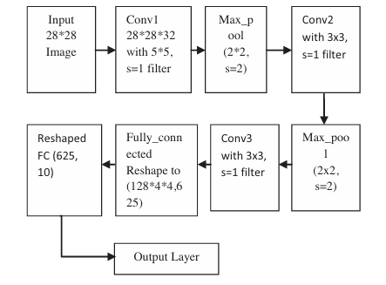
Figure 3.1: CNN model for MNIST dataset
Step-by-Step CNN Implementation Process
Implementing a CNN for image recognition involves several phases, from preprocessing the data to evaluating the model. The steps below summarize this process:
- Data Collection and Preprocessing
- Model Architecture Design
- Model Compilation and Training
- Model Evaluation
- Model Deployment
3.2 Analysis of the Existing System
Traditional image recognition systems relied heavily on hand-crafted features such as Scale-Invariant Feature Transform (SIFT), Histogram of Oriented Gradients (HOG), and Support Vector Machines (SVMs) for classification. These systems required significant domain expertise to engineer features, and their performance was often brittle across different tasks and domains.
While some early machine learning systems like k-NN and decision trees provided moderate accuracy, they lacked the ability to learn hierarchical representations of data. Moreover, they struggled with high-dimensional image data and often required manual preprocessing and segmentation. earlier deep learning models such as Multi-Layer Perceptrons (MLPs) were inefficient for image recognition because they did not exploit spatial hierarchies in image data. Their use of fully connected layers for all operations led to overfitting and computational redundancy.
3.3 Problems of the Existing System
The shortcomings of these earlier systems underscore the need for more advanced and automated approaches. The proposed CNN-based system introduces a range of innovations that significantly improve upon existing methodologies. By leveraging convolutional layers, the model can automatically detect local patterns such as edges, textures, and shapes, which are then combined at deeper layers to form higher-level abstractions of the image content. This hierarchical feature learning eliminates the need for manual feature engineering and enhances the model’s adaptability across diverse image recognition tasks. Additionally, the use of techniques such as dropout and batch normalization mitigates the risk of overfitting and stabilizes training, respectively.
3.4 Analysis of the Proposed System
The proposed image recognition system uses a deep convolutional neural network architecture specifically tailored for high-performance classification. It features multiple convolutional layers that extract low to high-level features, from edges and textures to complete objects. The system design incorporates:
- Automated Feature Learning: Eliminates the need for manual feature selection by enabling the model to learn directly from raw image data.
- Transfer Learning: Leveraging pre-trained models such as VGG16, ResNet, and EfficientNet to enhance performance on small datasets.
- Regularization Techniques: Uses dropout, batch normalization, and data augmentation to mitigate overfitting and improve generalization.
- Hardware Optimization: Supports GPU and TPU acceleration for faster training and inference times.
- Modular Design: Allows easy integration of model components into larger systems, such as facial recognition or defect detection in manufacturing
3.5 Advantages of the New System over the Existing System
The CNN-based system offers several advantages over conventional methods:
- Higher Accuracy: CNNs consistently outperform classical techniques in benchmarks like ImageNet, CIFAR-10, and MNIST.
- Automated Feature Learning: Eliminates the need for manual feature engineering.
- End-to-End Training: Streamlines the entire process from input to output, reducing development time.
- Parameter Efficiency: Models like EfficientNet use compound scaling to optimize accuracy and computational resources.
- Robustness: CNNs are more tolerant of image variations, such as rotation, scaling, or illumination changes.
- Transferability: Pre-trained CNN models can be fine-tuned for different tasks with minimal data.
- Scalability: CNNs scale well to large datasets and complex classification tasks.

CHAPTER FOUR
IMPLEMENTATION AND DOCUMENTATION OF THE SYSTEM
4.1 Design of the System
The system design follows a modular approach that clearly defines user interaction points, system workflows, and data processing mechanisms. The major design components include output design, input design, database schema, and procedural steps.

4.1.1 Output Design
The primary output of the system is the classification result of the input image, which includes:
- Predicted class label (e.g., “cat,” “dog,” “car”)
- Confidence score (e.g., 95.6%)
- Display of input image alongside the result for visual verification
The output is displayed via a graphical interface or terminal depending on the deployment mode.
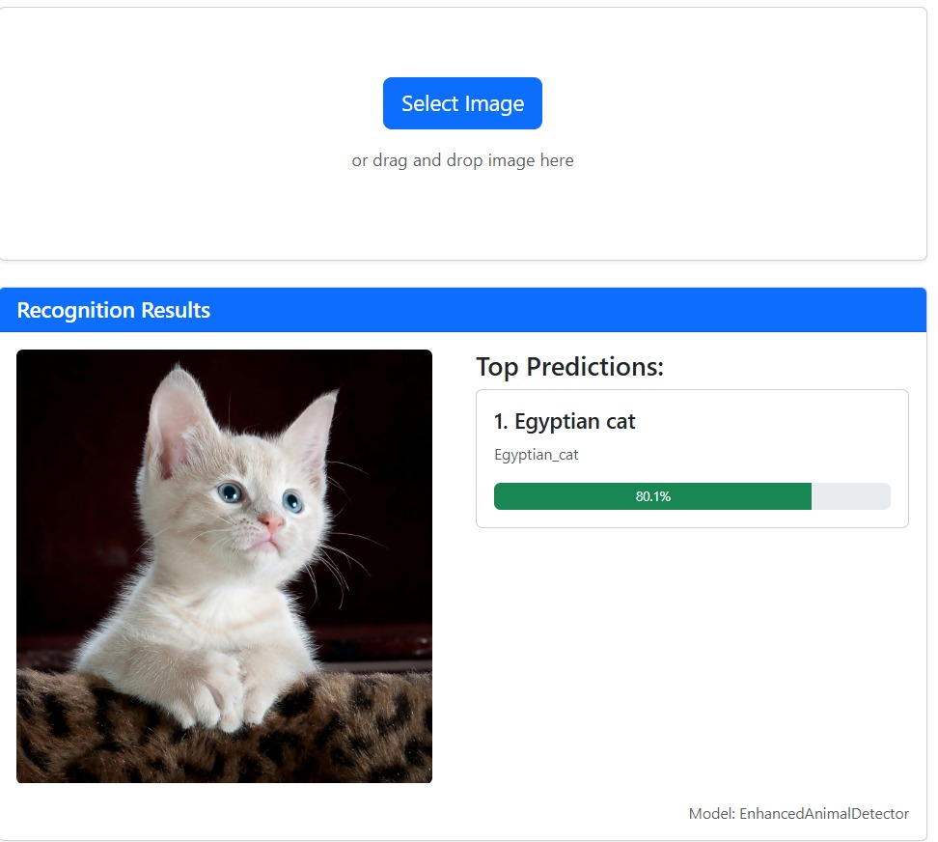
Figure 4.1: The picture Recognition result of a car

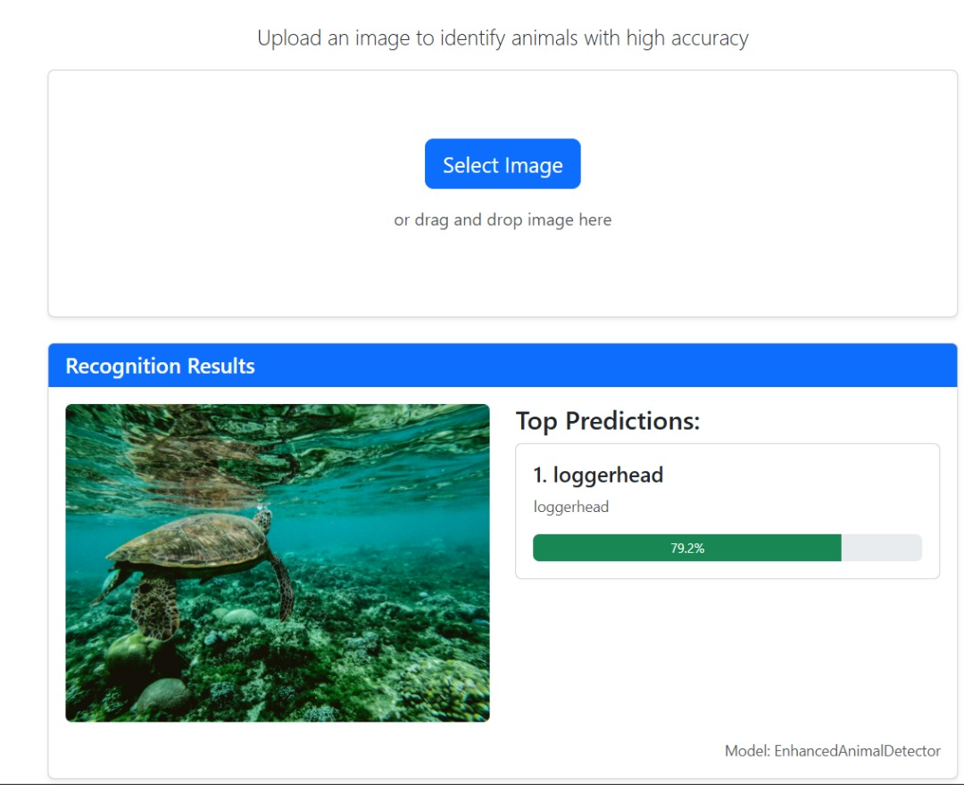
Figure 4.2: Image showing the recognition of loggerhead

4.1.2 Input Design
User input to the system involves:
- Uploading or selecting an image from the local file system
- Triggering the “predict” button to initiate classification
The system restricts inputs to compatible formats (e.g., JPG, PNG) and enforces preprocessing rules such as resizing and normalization.

4.1.3 Database
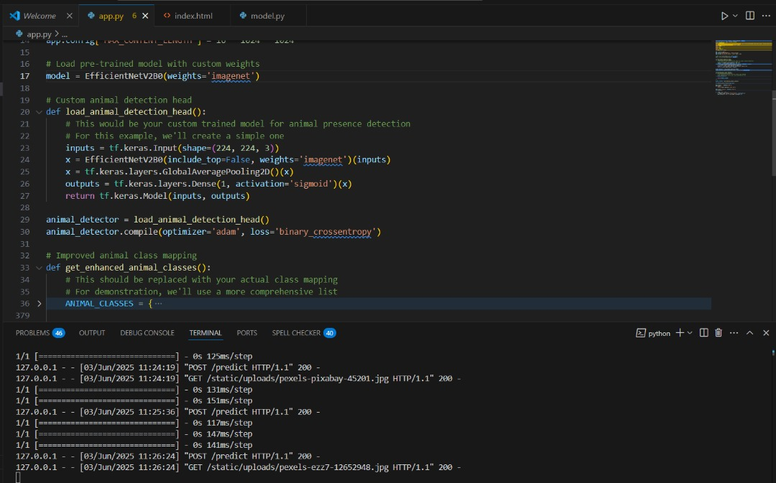
Figure 4.3: Designing the system
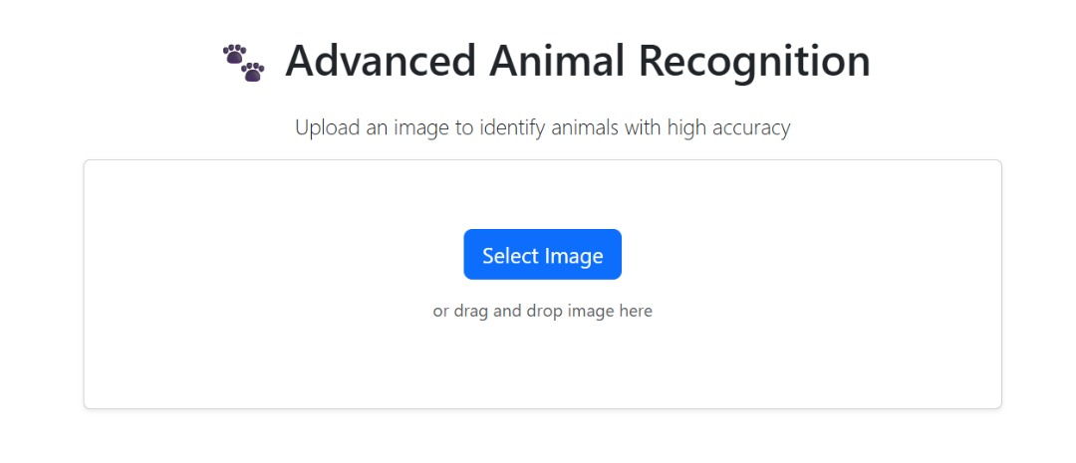
Figure 4.4: Upload Page

4.1.3 Database
Although CNN-based image recognition systems often don’t require traditional relational databases, this system includes a lightweight SQLite or JSON-based database for:
- Storing classification logs
- Maintaining user activity history
- Saving model configuration and metadata
Sample Schema:
- UserLog(id, image_name, predicted_class, accuracy, timestamp)
- ModelConfig(id, model_name, layers, training_accuracy, date_saved)

4.1.4 Procedure Design
The system operates in the following procedural steps:
- Load the pre-trained CNN model.
- Accept and preprocess the input image.
- Feed the image into the CNN.
- Obtain prediction results.
- Display results on the user interface.
- Log activity into the database.

4.2 Implementation of the System

4.2.1 Choice of Programming Language
The system is implemented using Python, due to:
- Strong library support for deep learning (e.g., TensorFlow, Keras, PyTorch)
- Flexibility and simplicity
- Integration with visualization tools like Matplotlib and OpenCV

4.2.2 Hardware Support
Hardware requirements for efficient operation include:
- Processor: Intel i5 or above
- RAM: Minimum 8GB
- GPU: NVIDIA GPU (CUDA-compatible) recommended for faster training and inference
- Storage: SSD preferred for faster data loading

4.2.3 Software
The software stack includes:
- OS: Windows 10 / Linux Ubuntu
- Python: Version 3.8+
- Libraries: TensorFlow/Keras, NumPy, Pandas, Matplotlib, OpenCV, Flask (for web interface)
- IDE: Jupyter Notebook / Visual Studio Code

4.2.4 Implementation Technique Used
The system employs the Transfer Learning technique by using a pre-trained CNN model (such as MobileNet or ResNet) and fine-tuning it on a custom dataset. This reduces training time and improves accuracy with fewer data.
Workflow:
- Load pre-trained model
- Modify top layers for new classification task
- Train on new dataset
- Save and deploy the model for real-time inference

4.3 System Documentation

4.3.1 Program Documentation
All code modules are documented with comments explaining:
- Input and output parameters
- Functional blocks
- API routes (in case of Flask implementation)
- Model saving/loading paths
Scripts are divided into:
- data_preprocessing.py
- train_model.py
- predict_image.py
- app.py (for web deployment)

4.3.2 Operating the System
Steps to operate:
- Launch the GUI or web app using python app.py
- Upload an image
- Click “Classify”
- View prediction results and confidence score
- Optionally, view history logs
The interface is designed to be user-friendly with basic controls.

4.3.3 System Maintenance
Maintenance involves:
- Updating the model with new data (retraining)
- Monitoring performance and logs for errors
- Updating dependencies and libraries
- Performing backups of configuration and log data
Security patches and version upgrades should be regularly applied to both the backend and deep learning frameworks used.

CHAPTER FIVE
SUMMARY, CONCLUSION, AND RECOMMENDATION
5.1 Summary
This research explored the design and implementation of an image recognition system based on Convolutional Neural Networks (CNNs). The study began with a review of traditional image recognition systems, identifying significant limitations in manual feature extraction, generalization, and scalability. These limitations necessitated a more robust, automated approach, leading to the adoption of CNNs. Using an applied experimental methodology, the research employed benchmark datasets such as CIFAR-10 and MNIST to design, train, and evaluate CNN models. The step-by-step implementation process highlighted key architectural components, including convolutional layers, activation functions, pooling mechanisms, and fully connected layers. The evaluation of these models demonstrated superior performance in terms of accuracy, efficiency, and adaptability compared to traditional machine learning techniques. A critical analysis of existing systems revealed substantial problems, including poor handling of large-scale data, computational inefficiency, and vulnerability to input variability. In contrast, the proposed CNN-based system overcame these issues by enabling hierarchical feature learning, reducing human intervention, and supporting real-time deployment. The CNN architecture proved highly scalable and was easily adapted to diverse image recognition applications using transfer learning and regularization techniques.
5.2 Conclusion
The research concludes that CNNs represent a significant advancement in the field of image recognition. They provide a scalable, accurate, and computationally efficient solution capable of addressing the inherent limitations of traditional systems. By learning directly from raw pixel data, CNNs eliminate the need for manual feature engineering and offer high robustness to real-world image variations. Moreover, the integration of pre-trained models and transfer learning strategies has further expanded the utility of CNNs, enabling their deployment in resource-constrained environments and applications with limited data. The research confirms that CNN-based systems are currently the most effective tools for general-purpose and domain-specific image recognition tasks, providing a solid foundation for future developments in artificial intelligence.
5.3 Recommendations
Based on the findings of this research, the following recommendations are proposed for future work and implementation:
- Adoption of Transfer Learning: Practitioners should consider using pre-trained CNN architectures such as ResNet, EfficientNet, or Inception for tasks involving small datasets or requiring faster development cycles.
- Integration with Edge Devices: With the growth of IoT and edge computing, optimizing CNN models for deployment on lightweight hardware (e.g., mobile devices, Raspberry Pi) should be prioritized.
- Exploration of Advanced Architectures: Future research should explore hybrid models, such as CNNs combined with transformers or attention mechanisms, to enhance accuracy and contextual understanding in image recognition tasks.
- Enhanced Dataset Diversity: To improve model generalization, datasets should include a wider variety of lighting conditions, angles, and real-world noise.
- Ethical and Fair Use: Developers must ensure transparency and fairness in image recognition systems, especially when deployed in sensitive domains such as surveillance, healthcare, and law enforcement.
- Cross-Domain Application: CNN-based image recognition should be extended to other domains such as medical imaging, agriculture, and environmental monitoring, where visual analysis can significantly enhance decision-making.

References
Albawi, S., Mohammed, T. A., & Al-Zawi, S. (2021). Understanding of a Convolutional Neural Network. Proceedings of the International Conference on Engineering and Technology (ICET). DOI: 10.1109/ICET.2021.8125526
Alzubaidi, L., et al. (2021). Review of Deep Learning: Concepts, CNN Architectures, Challenges, Applications, and Future Directions. Journal of Big Data. DOI: 10.1186/s40537-021-00444-8
Chauhan, R., Ghanshala, K. K., & Joshi, R. C. (2018). Convolutional Neural Network (CNN) for Image Detection and Recognition. ICSCCC 2018 - 1st International Conference on Secure Cyber Computing and Communications, 278–282. https://doi.org/10.1109/ICSCCC.2018.8703316

Chen, Y. (2021). Research on Convolutional Neural Network Image Recognition Algorithm Based on Computer Big Data. Journal of Physics: Conference Series, 1744(2). https://doi.org/10.1088/1742-6596/1744/2/022096
Chowdhury, M. E. H., et al. (2021). Automatic and Reliable Image-Based Fruit Classification using Deep Learning Techniques. Computers and Electronics in Agriculture. DOI: 10.1016/j.compag.2021.105924
ICRAMET 2017 : proceedings : 2017 International Conference on Radar, Antenna, Microwave, Electronics, and Telecommunications : Jakarta, Indonesia, October 23-24, 2017. (2018). IEEE. IRJET-V7I11204. (n.d.).
Khan, A., Sohail, A., Zahoora, U., & Qureshi, A. S. (2020). A Survey of the Recent Architectures of Deep Convolutional Neural Networks. Artificial Intelligence Review. DOI: 10.1007/s10462-020-09825-6
Krizhevsky, A. (2022) ImageNet Classification with Deep Convolutional Neural Networks: A 10-Year Retrospective. Communications of the ACM. DOI: 10.1145/3485760
Md Anwar Hossain, B., Shahriar Alam Sajib, M., Anwar Hossain α, M., & Shahriar Alam Sajib σ, M. (2019). Classification of Image using Convolutional Neural Network (CNN).

Mo, W., Luo, X., Zhong, Y., & Jiang, W. (2019a). Image recognition using convolutional neural network combined with ensemble learning algorithm. Journal of Physics: Conference Series, 1237(2). https://doi.org/10.1088/1742-6596/1237/2/022026

Ren, S., He, K., Girshick, R., & Sun, J. (2021). Faster R-CNN: Towards Real-Time Object Detection with Region Proposal Networks. IEEE Transactions on Pattern Analysis and Machine Intelligence. DOI: 10.1109/TPAMI.2021.3052196
Szegedy, C., et al. (2022). Inception-v4, Inception-ResNet and the Impact of Residual Connections on Learning. Proceedings of the AAAI Conference on Artificial Intelligence. arXiv: 1602.07261v3
Tan, M., & Le, Q. V. (2021). EfficientNetV2: Smaller Models and Faster Training. International Conference on Machine Learning (ICML). arXiv: 2104.00298
Zhao, Z., Zheng, P., Xu, S., & Wu, X. (2020). Object Detection with Deep Learning: A Review. IEEE Transactions on Neural Networks and Learning Systems. DOI: 10.1109/TNNLS.2020.2960628
Zhou, T., Ruan, S., & Canu, S. (2023). A Review: Deep Learning for Medical Image Segmentation Using Multi-Modality Fusion. Artificial Intelligence in Medicine. DOI: 10.1016/j.artmed.2023.102385

