

PROJECT REPORT
OF
IMPLEMENTATION OF RELATIONAL DATABASE SYSTEM FOR CADASTRAL INFORMATION PRODUCTION (RDBS)
OF
PART OF IREWOLEDE ESTATE, ALONG NEW YIDI ROAD, ILORIN
ILORIN WEST LOCAL GOVERNMENT AREA
KWARA STATE

BY
JAMIU MUFTAU OPEYEMI
HND/23/SGI/FT/0058

SUBMITTED IN PARTIAL FULFILMENT OF THE REQUIREMENTS FOR THE AWARD OF HIGHER NATIONAL DIPLOMA IN SURVEYING AND GEO-INFORMATICS TO THE DEPARTMENT OF SURVEYING AND GEO-INFORMATICS, KWARA STATE POLYTECHNIC ILORIN, KWARA STATE

JUNE, 2025

CERTIFICATE
I hereby certify that the information contained in this project report was obtained as a result of observations and measurements made by me on the field and that the survey was done in accordance with survey rules, regulations, and departmental instructions.

JAMIU MUFTAU OPEYEMI HND/23/SGI/FT/0058 NAME OF STUDENT MATRIC NUMBER

CERTIFICATION
This is to certify that JAMIU MUFTAU OPEYEMI with matriculation Number HND/23/SGI/FT/0058 has satisfactorily carried out his project under my instruction and supervision.
I here declare that He has conducted himself with diligence, honestly and sobriety on the project.

SURV.R.S AWOLEYE DATE
Project Supervisor

MR. A I ISSAU DATE
Head of Department

SURV.R.S AWOLEYE DATE
Project coordinator

External supervisor DATE

DEDICATION
This project is dedicated to Almighty God for his, protection and guidance and also to my caring parent in person MR&MRS. JAMIU

AKNOWLEDGEMENTS

The dream of becoming an achiever in life comes true, not only by one’s fortitude and hard work based on his knowledge, but it is also involving the positive influence of various factors and ideas of some people in the community.
First and foremost, all glory, honor and adoration is to Almighty God. I appreciate God for his grace upon my life, for keeping me safe since my advent in this school and most especially, during the execution of this project.
My next gratitude goes to my supervisor, SURV. R.S AWOLEYE for his useful guidance, understanding, patience, and professional advice during the execution of this project that led to the successful completion of the exercise. I pray that God will continue to bless you (amen). More so, my appreciation goes to my able HOD MR. AI ISSAU, SURV. RO ASONIBARE, SURV. A.G AREMU and SURV. AKINYEDE ADEBANJI and other lecturers in the school most especially SURV. BABATUNDE KABBIR AND SURV BELLO DIRAN FELIX God blesses you all.
I sincerely wish to express my affectionate gratitude to my lovely and caring parent MR&MRS. JAMIU whose toils and struggles have helped a lot in transforming my life for better may Almighty God grant them long life to enable her reap the fruits of their labor.
More so, I seize this opportunity in acknowledging the efforts and contribution for my HON TAIYE OLANIYE, MY (ACC) ASS. COMMANDANT M.S SALAHUDEEN and THE FORMER P.A TO THE MINISTER OF INTERIOR THE MAN OF HON TEJU OLORUNGBEBE for his support morally, financially and for the impartation of knowledge in me that pertains to surveying profession.
I will not forget to express my gratitude to my friends in the likes of AKEEM HAMID AJAGBE AL-ASWADU , YINUSA ZAINAB TITILAYO, AHMED TOYYIB, ,and all my classmates for their support, advice and love I really appreciate you all.
My heartfelt thanks also go to all my group members for their cooperation and understanding during the project, I pray that we will never fail in our life.

ABSTRACT
Analogue cadastral consist of paper maps and land register which have difficulties during development and updating. The study was aimed at creating of implementation of relational database for cadastral information system (CIS)for part of irewolede estate, Ilorin west local government area, kwara state. The spatial and non-spatial data used are local coordinates of the land parcels and entity information obtained from office of the surveyor general, Ilorin, kwara state. The Mercator (UTM) coordinate system using EXCEL spread sheet and were used in plotting the digital map in ArcGIS 10.2 the database design was done in phases which include conceptual design, logical design, the physical, and implementation of the database system. The attribute data were linked with the spatial data to build the digital CIS and some queries were performed to test the efficacy of the database. The study has established the capability of CIS in handling of spatial and non-spatial data. It is recommended that the digital CIS be adopted for proper record keeping and updating

TABLE OF CONTENTS
CERTIFICATE ii
CERTIFICATION iii
DEDICATION iv
AKNOWLEDGEMENTS v
ABSTRACT vi
CHAPTER ONE 1
1.0 INTRODUCTION 1
1.0.1 KEY COMPONENTS OF THE RDBS FOR CADASTRAL INFORMATION 1
1.0.2 KEY FEATURES OF IMPLEMENTING RDBS FOR CADASTRAL INFORMATION 3
1.0.3 BENEFITS OF IMPLEMENTING RDBMS IN CADASTRAL INFORMATION SYSTEMS 5
1.0.4 CHALLENGES AND CONSIDERATIONS IN IMPLEMENTING RDBMS FOR CADASTRAL SYSTEMS 6
1.1 BACKGROUND TO THE STUDY 7
1.2 STATEMENT OF PROBLEM 12
1.3 AIM AND OBJECTIVES OF THE PROJECT 13
1.3.1 AIM 13
OBJECTIVES 13
SCOPE OF THE PROJECT 13
1.5 PERSONNEL 15
1.6 STUDY AREA 16
1.7 SPECIFICATIONS 17
CHAPTER TWO 18
2.0 LITERATURE REVIEW 18
2.1. CADASTRAL INFORMATION SYSTEMS 18
2.2. THE ROLE OF RELATIONAL DATABASES IN CADASTRAL INFORMATION SYSTEMS 19
2.3. BENEFITS OF IMPLEMENTING RDBMS IN CADASTRAL SYSTEMS 19
2.4. CHALLENGES IN IMPLEMENTING RDBMS FOR CADASTRAL INFORMATION SYSTEMS 21
2.5. CASE STUDIES OF RDBMS IN CADASTRAL INFORMATION SYSTEMS 22
2.6. LEGAL AND INSTITUTIONAL CONSIDERATIONS IN RDBMS IMPLEMENTATION 23
2.7. CASE STUDIES OF RDBMS ADOPTION IN CADASTRAL INFORMATION SYSTEMS 24
2.8. CONCLUSION AND FUTURE PROSPECTS 25
CHAPTER THREE 27
3.1 METHODOLGY 27
3.2 DATABASE DESIGN 27
3.2.1 VIEW OF REALITY 27
3.2.2 CONCEPTUAL DESIGN 28
3.1.3 LOGICAL DESIGN 29
3.1.4 PHYSICALDESIGN 30
3.2 Reconnaissance 32
3.2.1 OFFICEPLANNING 32
3.2.2 FIELDRECONNAISSANCE 33
3.3 EQUIPMENTUSED/SYSTEMSELECTIONANDSOFTWARE 35
3. 4 TESTS OF DIFFERENTIAL GPS 36
3.5 CONTROL CHECK 36
3.6 DATA SOURCE 37
3.7 GEOMETRIC DATA ACQUISITION 37
3.7.1 ATTRIBUTE/ SOCIAL SURVEY 43
3.8 DATABASE CREATION/IMPLEMENT 43
3.8.1. DATABASE MANAGEMENT SYSTEM (DBMS) 44
3.8.2. DATA QUALITY 44
3.8.3 DATA INTEGRITY 45
3.8.4 DATA SECURITY 45
4.0 DATA PROCESSING AND PRESENTATION 46
4.1 SPATIAL ANALYSIS 46
4.2 Spatial Query 47
4.3 Query Design 47
4.4 Testing Of Database 48
4.5 Existing Parcels and Blocks 48
4.6 Spatial Query 50
4.6.1 Single Criterion Query 50
4.6.2 Query by Parcel Status (Developed) 52
4.6.3 Discussion of Result 52
4.6.4 Query by Parcel Status (commercial) 53
4.7 Discussion of Result 53
4.8 Multiple Criteria Query 53
4.8.1 Query By Parcel Use And Parcel Status (Parcels meant for school, residential, commercial purposes that are “RESIDENTIAL” 54
4.8.2 QueryByParcel Use (Commercial) And Parcel Status (Parcels meant for commercial purposes that are “Residential”) 55
4.8.3 Query By 10m Proximity to the stream (Parcel within 10m proximity to the stream). 56
4.8.3.2 Discussion of Result 56
CHAPTER FIVE 62
5.0 COSTING, SUMMARY, PROBLEMS ENCOUNTERED, CONCLUSION AND RECOMMENDATION 62
5.1 COSTING 62
5.2 SUMMARY 66
5.3 PROBLEM ENCOUNTERED 67
5.4 CONCLUSION 67
5.5 RECOMMENDATION 67
5.3 PROBLEM ENCOUNTERED 67
5.4 CONCLUSION 68
5.5 RECOMMENDATION 68
REFERENCE 69
APPENDIX I 71

LIST OF TABLES
Table 1.1 shows the personnel involved in project 15
Table3.1 Building and its attribute 30
Table3.2: Road and its attributes 30
Table3.3: Trees and its attributes 31
Table3.4: Electric Poles and its attributes 31
Table3.5: Vegetation and its Attributes 32
Table 3.6 shows the control coordinate 33
Fig.3.3: Recce diagram of the study area (not drawn to scale) 34
Table 3.7: Coordinate of the observed and the original values of PT 02 37
Table 3.8: Coordinate of the observed and the original values of PT 03 37
able 1.1 shows the personnel involved in project 15
Table3.1 Building and its attribute 30
Table3.2: Road and its attributes 30
Table3.3: Trees and its attributes 31
Table3.4: Electric Poles and its attributes 31
Table3.5: Vegetation and its Attributes 32
Table 3.6 shows the control coordinate 33
Fig.3.3: Recce diagram of the study area (not drawn to scale) 34
Table 3.7: Coordinate of the observed and the original values of PT 02 37
Table 3.8: Coordinate of the observed and the original values of PT 03 37

LIST OF FIGURES
Figure 1..1 showing map of study area 16
Fig.3.1Design and Construction Phases in Spatial Database 28
Fig.3.2 shows the conceptual design 29
Figure 3.4 Tersus GNSS GPS receiver 40
Figure 3.5 showing the project creation page on Nuwa app 41
Fig 4.1:- the exported cadastral plan of the study area showing the blocks within the area 49
Fig 4.2:- the exported cadastral plan of the study area showing the all the parcels within the area. 49
Fig 4.3:- the cadastral plan of the study area showing the boundary 49
Fig 4.6.1.1:- Query for Parcel status for developed Purposes in the Study Area 51
Fig 4.4: Result of Query for Parcel Used for developed area in block A in the study area 52
Fig 4.5: Result of Query for Parcels that are commercial purpose in the study area. 53
Fig 4.6: Screen prints showing parcel use and parcel status in the layout. 54
Fig 4.7: Screen print showing parcel meant for commercial purpose that are 55
Fig 4.8.: Screen print showing parcel parcel within 10m proximity to the stream 56

CHAPTER ONE

1.0 INTRODUCTION
The cadastral information system is crucial for managing land ownership, land use, and property boundaries, which is essential for urban planning, land administration, taxation, and resource management (P Krigsholm, K Riekkinen, P Ståhle - Land, 2018 - mdpi.com). Traditionally, cadastral information has been maintained through paper-based records or basic database systems. However, these methods often suffer from inefficiencies, inaccuracies, and difficulties in data retrieval, especially as the volume of land records grows.
To address these challenges, the implementation of a Relational Database Management System (RDBMS) for cadastral information production is becoming an essential solution. RDBMS offers a more structured, efficient, and scalable way of organizing, storing, and managing large volumes of cadastral data. An RDBMS provides the ability to organize land records in tables with relationships between different entities, ensuring consistency, data integrity, and faster access to information (N de Lange – Geo-informatics in Theory and Practice: An Integrated …, 2023 - Springer).

1.0.1 KEY COMPONENTS OF THE RDBS FOR CADASTRAL INFORMATION
- Tables: Represent various entities like land parcels, owners, transactions, boundaries, zoning information, etc.
- Relations: Define the links between different tables, ensuring that the system can cross-reference data, like linking ownership data with specific land parcels.
- Queries: Allow users to retrieve specific cadastral information based on criteria such as ownership details, boundary changes, or land transactions.
- Data Integrity: Ensures accuracy and consistency through the use of keys, constraints, and normalization.
- Security and Access Control: Manages who can view, edit, or delete cadastral data, ensuring the system is secure and only authorized users can make changes.
The adoption of RDBMS in cadastral information systems significantly improves data management, facilitates quick decision-making, enhances the accuracy of land records, and supports various applications such as land taxation, dispute resolution, and urban planning.
This paper explores the implementation of an RDBMS for cadastral information production, focusing on its architecture, benefits, challenges, and practical use cases in land administration systems.
A cadastral information system plays a pivotal role in land management by providing accurate and organized records of land ownership, boundaries, rights, and transactions (H Waqas, I Munir, W Ahmed, SYue… - Journal of building …, 2024 - ojs.omniscient.sg). Efficient management of such information is critical for effective urban planning, taxation, property dispute resolution, and overall land governance. As land records are becoming increasingly complex and voluminous, traditional methods of maintaining cadastral data, often involving paper records or basic non-relational databases, struggle to meet the demands of modern land management systems.
The Relational Database Management System (RDBMS) offers a robust and scalable solution for handling cadastral information. With its ability to store data in structured tables and create relationships between different entities, RDBMS enhances the speed, accuracy, and flexibility of managing land-related data. This system enables the seamless integration of diverse cadastral datasets, such as land parcel boundaries, ownership information, transactions, land usage, and more, into a single, easily accessible platform.

1.0.2 KEY FEATURES OF IMPLEMENTING RDBS FOR CADASTRAL INFORMATION
- Structured Data Organization:
RDBMS organizes cadastral data into clearly defined tables, each representing different entities like land parcels, property owners, cadastral surveys, transactions, and land rights. Each table holds related data, which is stored in columns and rows for easy retrieval, manipulation, and updating.
- Data Integrity and Normalization:
Ensuring the consistency and accuracy of cadastral data is crucial. RDBMS supports data integrity through the use of primary keys, foreign keys, and constraints, ensuring that relationships between tables are maintained. Data normalization, which eliminates redundancy and ensures that data is stored efficiently, further enhances the quality of the database and its use in cadastral systems.
- Scalability and Flexibility:
As the volume of cadastral data increases, the RDBMS is capable of scaling to accommodate growing datasets. Whether it's adding new land parcels, recording new transactions, or managing updates to land ownership information, the system can handle larger and more complex data structures while maintaining fast performance.
- Advanced Querying Capabilities:
The RDBMS provides advanced querying capabilities, allowing users to easily search, retrieve, and manipulate data. For instance, users can query specific land parcels by ownership, search for properties within a specific area, or analyze historical data of land ownership and land use changes over time. This query flexibility is crucial for urban planning, taxation, and land dispute resolution.
- Security and Access Control:
In a cadastral system, it’s essential to control who has access to sensitive land information. RDBMS offers built-in security features like user authentication, role-based access control, and permission settings. This ensures that only authorized personnel can make modifications to land records, while others can access only the relevant information.
- Support for Multi-User Access:
Cadastral systems often require concurrent access by multiple users across different locations. RDBMS supports multi-user environments, allowing for real-time updates and shared access, ensuring that all users are working with the most up-to-date information.
- Data Redundancy Reduction:
By using relational tables and enforcing data integrity through constraints and normalization, RDBMS minimizes data redundancy, making the system more efficient and reducing storage costs.

1.0.3 BENEFITS OF IMPLEMENTING RDBMS IN CADASTRAL INFORMATION SYSTEMS
- Improved Data Accuracy and Consistency:
With the relational structure of the database, the chances of data inconsistency and duplication are minimized, leading to higher accuracy in cadastral information. Relationships between various data entities are tightly controlled through keys and constraints, ensuring that each piece of information is connected correctly.
- Efficient Data Retrieval:
The ability to perform complex queries efficiently is a significant advantage. For instance, an RDBMS can generate reports on land ownership changes, zoning changes, or tax assessments within seconds, providing essential information for decision-making processes
- Enhanced Decision-Making:
By providing real-time access to accurate cadastral data, an RDBMS helps government agencies, urban planners, and land developers make informed decisions. Whether it's allocating resources, enforcing land use policies, or resolving disputes, the data's integrity and accessibility are critical.
- Transparency and Accountability:
Implementing an RDBMS in cadastral information systems ensures that records are accessible and auditable, fostering transparency. Stakeholders such as landowners, government officials, and legal entities can track changes in land records over time, helping to resolve disputes and ensure accountability.
- Integration with Other Systems:
RDBMS allows for the integration of cadastral data with other geographical information systems (GIS), land taxation systems, and urban planning software. This integration ensures that all related systems can work in harmony, creating a unified platform for land administration.

1.0.4 CHALLENGES AND CONSIDERATIONS IN IMPLEMENTING RDBMS FOR CADASTRAL SYSTEMS
- Data Migration:
One of the major challenges when implementing an RDBMS for cadastral systems is the migration of data from older systems or paper-based records into the database. This process can be time-consuming and prone to errors, requiring careful planning and validation to ensure data integrity is maintained.
- Initial Costs:
Implementing an RDBMS infrastructure can be costly in terms of software, hardware, and training. However, the long-term benefits, including improved efficiency and reduced administrative costs, often outweigh the initial investment.
- Complexity of Setup and Maintenance:
Setting up and maintaining an RDBMS requires specialized expertise, especially in the case of complex cadastral systems. Continuous updates, backups, and monitoring are essential to maintain system reliability.
- User Training:
Successful implementation of an RDBMS requires training for users on how to interact with the database effectively. Proper training ensures that users can take full advantage of the system's capabilities, reducing errors and improving operational efficiency.

1.1 BACKGROUND TO THE STUDY
Land records and cadastral information systems have long been at the heart of land administration across the world. These systems manage critical data about land ownership, boundaries, transactions, land use, and other aspects that support efficient land governance. Historically, cadastral systems relied on paper-based records, manual processes, and rudimentary data storage techniques. These methods, while useful in the past, are increasingly inadequate as urbanization accelerates and the need for precise, accessible, and up-to-date land information becomes more urgent.
As cities expand and populations grow, the demand for more sophisticated land management practices has become apparent. Traditional cadastral systems are often prone to inefficiencies, inaccuracies, and difficulties in data retrieval, particularly when managing vast amounts of land information. Paper-based methods and file-based databases lead to challenges such as data loss, difficulty in updating records, and slow access to land information, and complications in resolving land disputes. Moreover, as more land transactions take place globally, the need for real-time, reliable, and accessible cadastral data becomes even more crucial for decision-making, urban planning, taxation, and legal processes (SR Isumba - 2018 - erepository.uonbi.ac.ke).
The introduction of computer systems to land management in the 1980s marked the beginning of an era of digitalization in cadastral information systems. Over the years, these systems have evolved to include more advanced technologies such as Geographic Information Systems (GIS) and database management systems (DBMS). While GIS provides mapping and spatial analysis capabilities, Relational Database Management Systems (RDBMS) offer powerful tools for storing, organizing, and managing complex datasets, particularly when the data is highly structured and related in different ways.
Relational databases are designed to store data in tables, where relationships between data points can be easily established and queried (C Vicknair, M Macias, Z Zhao, X Nan, Y Chen… - … of the 48th annual …, 2010 - dl.acm.org). These databases are flexible, scalable, and capable of handling large volumes of data, making them an ideal choice for managing cadastral information that spans multiple categories such as land ownership, boundary lines, land rights, zoning, transactions, and more. By adopting an RDBMS for cadastral information production, land administrators and government bodies can overcome the shortcomings of traditional systems and improve the accuracy, accessibility, and integrity of land records.
In recent years, many countries have made significant strides in modernizing their cadastral systems by incorporating relational databases. These initiatives aim to streamline land registration processes, reduce disputes, and support efficient land administration policies. However, despite the advantages, the full-scale implementation of RDBMS in cadastral information production faces challenges such as the need for substantial investments, data migration from legacy systems, and the training of personnel to use the new technologies effectively.
This study seeks to explore the potential of RDBMS in transforming cadastral information production by examining its benefits, challenges, and the technical framework for its implementation. The research will provide insights into how adopting RDBMS can help improve land administration, ensure the integrity of land records, and ultimately lead to more efficient and transparent land management systems. Additionally, this study will highlight real-world case studies where RDBMS has been successfully implemented, providing valuable lessons for future projects in land governance.
The implementation of RDBMS for cadastral information is not only a technological advancement but also a critical step towards building more transparent, accessible, and accurate systems for managing land data, which has far-reaching implications for urban development, legal rights, and economic stability.
Land management and cadastral systems are foundational to the proper governance of a nation’s land and property. Cadastral information refers to records and data that describe the ownership, use, and boundaries of land parcels. These records are essential for a wide array of governmental and legal functions, including land taxation, planning, dispute resolution, and property transactions. The importance of an efficient and transparent cadastral system cannot be overstated as it is directly linked to the economic development and governance of any country.
Historically, many countries have relied on manual processes and paper-based records for cadastral information management. This method, although functional in earlier times, has several inherent challenges. As land transactions increased, the volume of data that needed to be managed grew exponentially. This resulted in issues such as data redundancy, inconsistent records, delayed processing of land transactions, difficulty in accessing up-to-date information, and a high potential for human error. Moreover, manual systems were often prone to misplacement of records and lacked an efficient means of ensuring data security and integrity.
The advent of computerization in the late 20th century paved the way for the development of computer-aided cadastral systems, which sought to digitize land records for more efficient management. The integration of Geographic Information Systems (GIS) with cadastral information provided a spatial dimension to land data, enabling better visualization, analysis, and decision-making. While GIS greatly enhanced the ability to analyze land data spatially, the storage, management, and integrity of the data itself still posed challenges for many land administration systems.
Relational Database Management Systems (RDBMS), with their ability to organize data into relational tables, brought about a significant shift in how land records could be managed (RM Bennett, M Pickering, J Sargent - Land Use Policy, 2019 - Elsevier). Unlike traditional methods, RDBMS allows for the efficient storage of large quantities of structured data in tables with predefined relationships. In the context of cadastral information, this means that data such as land parcel boundaries, ownership information, transaction histories, and land use records could be stored in a way that allowed for quick access, updates, and cross-referencing.
The key advantages of an RDBMS over traditional methods are numerous. Data consistency, accuracy, security, and efficiency are markedly improved. For example, the use of primary keys and foreign keys in relational databases ensures that each piece of information is uniquely identifiable and appropriately linked to other data. This system also reduces data redundancy, ensuring that the same information is not stored multiple times across different records, which helps save storage space and minimizes the risk of errors. Moreover, the ability to run complex queries to access specific data points or generate detailed reports empowers land administrators, planners, and legal entities to make informed decisions quickly and accurately.
As countries continue to urbanize and expand, the need for robust land management systems becomes even more pressing. For instance, land registration processes have become increasingly complex with the advent of land reforms, privatization, and changing land use patterns. As the number of transactions and the diversity of land rights increase, there is a growing need for systems that not only store vast amounts of data but also ensure that such data is accurate, up-to-date, and easily accessible.
Some countries have begun the process of modernizing their cadastral systems by adopting RDBMS technology. However, the transition to such systems is not without challenges. Data migration from legacy systems can be costly, time-consuming, and prone to errors. Furthermore, there are significant challenges related to training staff to effectively manage and use the new system, especially in countries where technical expertise in database management is scarce. Additionally, ensuring that the new system is adaptable and scalable to meet future demands is another critical consideration.
In this context, this study aims to investigate the implementation of RDBMS for cadastral information production and management. It seeks to understand the impact of RDBMS on the efficiency, accuracy, and accessibility of cadastral information systems, as well as identify the challenges and solutions involved in implementing these systems. By exploring real-life case studies and theoretical frameworks, the study will provide valuable insights into the adoption of RDBMS in cadastral applications.
This research is particularly timely as many developing and developed countries are considering or in the process of digitizing their land records. By examining how RDBMS can be applied to cadastral information production, the study will contribute to the broader body of knowledge on land governance and administration. Moreover, the findings of the study will be useful to policymakers, land administrators, and technology providers who seek to enhance land management practices using modern technological solutions.
Ultimately, the implementation of RDBMS in cadastral systems is not just about improving administrative efficiency. It is about ensuring transparency, reducing land disputes, increasing land tenure security, and contributing to sustainable urban development. As the importance of land as a resource grows globally, so too does the need for sophisticated systems that can ensure land is managed fairly, effectively, and securely. This study will explore how RDBMS can support this mission, leading to better outcomes for landowners, developers, governments, and societies at large.

1.2 STATEMENT OF PROBLEM
Due to the management of cadastral information is a critical component of land administration systems, as it involves the accurate recording, updating, and retrieval of land ownership, boundaries, transactions, and land rights. Over the years, traditional methods of managing this data primarily paper-based records and outdated database systems have proven to be inefficient, error-prone, and incapable of handling the growing complexity and volume of land data.

1.3 AIM AND OBJECTIVES OF THE PROJECT

1.3.1 AIM
The aim of implementing a relational database system for cadastral information production is to develop an efficient, accurate, and scalable framework for managing and analyzing land-related data. This system seeks to enhance the integrity, accessibility, and usability of cadastral information, thereby supporting effective land administration, urban planning, and decision-making processes while ensuring compliance with legal and technical standards.

OBJECTIVES
- Project planning
- Monumentation
- Data downloading and data processing
- Program and Query
- Report writing

SCOPE OF THE PROJECT
Base on significance of this project the scope includes;
1. Project planning: which include office planning and field reconnaissance
2. Monumentation: (At least 5 hectares of land according to higher national diploma)
3. Data acquisition (geometric data with total station, social survey through oral interview for the purpose of query and building name, colors and some of vital documents on land
4. Data processing: this includes downloading and processing of data using appropriate software (GIS SOFTWARE)
5. Information presentation: It involved plotting of survey data both soft copy and hard copy showing correct location of a points.

1.5 PERSONNEL

Table 1.1 shows the personnel involved in project
S/N | NAME | MATRIC NO | REMARKS
1 | JAMIU MUFTAU OPEYEMI | HND/23/SGI/FT/0058 | AUTHOR
2 | YUNUS ZAINAB TITILAYO | HND/23/SGI/FT/0049 | MEMBER
3 | IDRIS HALIMAT ALATA | HND/23/SGI/FT/0050 | MEMBER
4 | OLAREWAJU TOLULOPE O. | HND/23/SGI/FT/0053 | MEMBER
5 | ADEBAYO UTHMAN DOLAPO | HND/23/SGI/FT/0061 | MEMBER
6 | AINA SAMUEL AYOMIDE | HND/23/SGI/FT/0062 | MEMBER
7 | ELIJAH TOYIN DEBORAH | HND/23/SGI FT/0121 | MEMBER
8 | ODENIRAN KAYODE TAIWO | HND/22/SGI/FT/086 | MEMBER

1.6 STUDY AREA
The study area for the project is situated on Part of Irewolede Estate, Ilorin West Local Government Area, Kwara State. The geographic location of the study area lies between latitude 08º 27' 29.94"N to 08º 27' 49.59"N and longitude 04º 32' 56.74"E to 04º 33' 21.36"E. The area covered is approximately found to be 27.2 hectares.

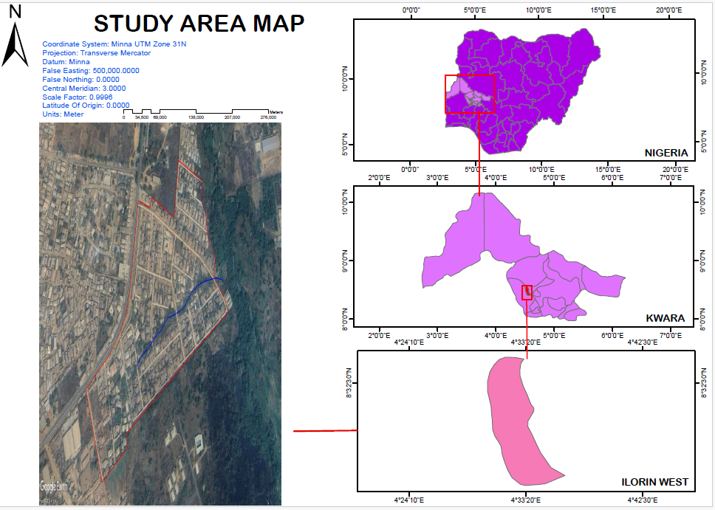

Figure 1..1 showing map of study area

1.7 SPECIFICATIONS
The project speciation’s were referenced to the speciation for land information system using total station which was sources from the Higher National Diploma. The specification includes the following:
- Total station
- Minimum number of datum control required- three (3)
- Traverse should run between secondary or higher order control point.

CHAPTER TWO

2.0 LITERATURE REVIEW
The implementation of Relational Database Management Systems (RDBMS) in cadastral information systems has been a significant step towards modernizing land administration processes worldwide (J Raikamo - 2024 - aaltodoc.aalto.fi). As urbanization increases and land management becomes more complex, the need for efficient, accurate, and accessible cadastral data is paramount. This literature review examines key themes and research related to the adoption of RDBMS in cadastral information systems, focusing on its benefits, challenges, and impact on land management
2.1. CADASTRAL INFORMATION SYSTEMS: Overview and Importance
Cadastral information systems (CIS) are essential for managing land-related data, including ownership, boundaries, rights, land transactions, and land use patterns. These systems enable governments and land administrators to make informed decisions related to land use, taxation, development, and policy enforcement. A well-functioning cadastral system is crucial for economic growth, resource management, legal certainty, and the protection of property rights (Ravindra et al., 2016). Traditional cadastral systems, often relying on paper-based records and manual processes, have significant limitations in terms of data accuracy, efficiency, and accessibility, making them ill-suited for the challenges of modern land management (Egbinola&Igbokwe, 2019).

2.2. THE ROLE OF RELATIONAL DATABASES IN CADASTRAL INFORMATION SYSTEMS
Relational databases are widely regarded as a powerful tool for organizing structured data, especially in systems where data entities have predefined relationships. In the context of cadastral systems, RDBMS store land-related data in tables, with each table representing a different entity (e.g., land parcels, owners, transactions, or boundaries). These entities are linked through primary keys and foreign keys, which help ensure data consistency and integrity (Benediktsson et al., 2006). RDBMS allows for easier management of data by eliminating redundancy, ensuring that updates and changes are reflected across the system in real time.
Several studies have highlighted the advantages of using RDBMS in cadastral systems. For instance, Kogbe et al. (2017) emphasize that RDBMS improves the accuracy and integrityof land records by enforcing constraints and relationships between tables. This makes it easier to track changes over time, such as shifts in ownership or modifications to property boundaries, and ensures that all related information is updated concurrently.

2.3. BENEFITS OF IMPLEMENTING RDBMS IN CADASTRAL SYSTEMS
- Data Integrity and Consistency
One of the primary advantages of using an RDBMS in cadastral information systems is the ability to ensure data integrity. Constraints like unique keysand foreign keys help maintain accurate relationships between various pieces of land data, preventing errors such as duplicate or inconsistent entries (Sui et al., 2017). For example, linking ownership data with land parcel information via a foreign key ensures that each land parcel is associated with the correct owner. This reduces data errors and enhances the quality of cadastral records.
- Improved Data Retrieval
RDBMS provides advanced query capabilities, allowing users to easily search and retrieve specific data. Complex queries can be run to extract detailed reports, such as identifying all land parcels owned by a specific individual or analyzing land use changes over time (Akinyemi&Olutayo, 2019). This ability to access land information quickly and accurately is crucial for decision-making processes related to urban planning, taxation, and legal proceedings.
- Efficient Data Storage and Scalability:
The relational model allows for efficient data storage and scalability. As cities expand and the volume of land-related data increases, RDBMS systems can handle large datasets without significant degradation in performance. Additionally, relational databases allow for easy integration of new data, such as new land parcels or ownership transfers, without disrupting the existing system (Liu et al., 2021).
- Security and Access Control:
Security is a major concern when managing sensitive cadastral information. RDBMS provides robust security features, including user authentication, role-based access control, and permission settings. This ensures that only authorized personnel can modify sensitive land records, reducing the risk of fraud or unauthorized alterations (Tadele et al., 2018).
- Data Integration
Another important benefit of RDBMS is the ability to integrate cadastral data with other systems, such as Geographic Information Systems (GIS) and land taxation systems. This integration facilitates a more comprehensive approach to land management, allowing for spatial analysis of land parcels alongside ownership and transaction data. For example, a GIS platform can visualize cadastral data, while an RDBMS can handle the backend data management, allowing for more effective land-use planning and decision-making (Raji et al., 2020).

2.4. CHALLENGES IN IMPLEMENTING RDBMS FOR CADASTRAL INFORMATION SYSTEMS
Despite the numerous advantages of RDBMS, several challenges need to be addressed for successful implementation in cadastral information systems:
- Data Migration from Legacy Systems:
One of the most significant challenges is migrating data from legacy paper-based or non-relational systems to an RDBMS. Data migration can be costly, time-consuming, and prone to errors, particularly when converting legacy records into a structured database format (Akinyemi et al., 2016). Ensuring that legacy data is accurate and properly mapped to the new system is a key consideration for successful implementation.
- High Initial Costs and Investment
Implementing an RDBMS requires a significant investment in hardware, software, and training. For many developing countries, these costs can be prohibitive. As noted by Gibson et al. (2019), the financial burden associated with transitioning to an RDBMS can be a barrier, especially when coupled with the need for ongoing maintenance and system upgrades.
- User Training and Technical Expertise:
The successful implementation of an RDBMS depends on the technical expertise of the staff operating the system. Training personnel to effectively use the database, manage updates, and perform system maintenance is crucial. Lack of expertise in database management can hinder the adoption of RDBMS, particularly in regions with limited access to skilled professionals (Kogbe et al., 2017).
- System Integration Issues
Integrating an RDBMS with other systems, such as GIS or tax administration systems, can present technical challenges. Ensuring that the relational database communicates effectively with these external systems is essential for the seamless management of cadastral data. Data synchronization between different platforms can sometimes be a complex task, particularly when legacy systems are involved (Sui et al., 2017).

2.5. CASE STUDIES OF RDBMS IN CADASTRAL INFORMATION SYSTEMS
Several countries have successfully implemented RDBMS in their cadastral systems, providing valuable case studies for others to follow:
South Africa: The South African land reform program has made extensive use of an RDBMS to manage land restitution claims and property registration. The system has enhanced the accuracy and transparency of land ownership records, making it easier for government authorities and citizens to access land-related information (Munyai et al., 2020).
- Estonia: Estonia has implemented an advanced cadastral information system that uses RDBMS and integrates cadastral data with GIS. The system has streamlined land registration and property transaction processes, significantly reducing administrative costs and improving the efficiency of land management (Raji et al., 2020).
- Brazil: In Brazil, the adoption of RDBMS for cadastral information management has helped improve land registration accuracy, reduce disputes over property ownership, and streamline property taxation processes, especially in urban areas experiencing rapid growth (Akinyemi&Olutayo, 2019).

2.6. LEGAL AND INSTITUTIONAL CONSIDERATIONS IN RDBMS IMPLEMENTATION
The success of implementing RDBMS for cadastral information also depends on the legal and institutional frameworks that govern land administration. Some of the key considerations include:
- Legal Recognition of Digital Land Records:
For an RDBMS to function as the primary tool for managing cadastral data, there must be legal recognition of digital land records as valid and enforceable. In many countries, land records are still treated as physical documents, and the transition to digital systems requires legislative changes to ensure that electronically stored records are legally binding. This legal recognition is especially important in property transactions, where digital records need to be accepted in courts of law (Nguyen et al., 2019).
- Institutional Capacity:
The successful implementation of RDBMS depends on the capacity of the institutions responsible for land administration. This includes the availability of trained personnel, access to technical resources, and an organizational structure that supports the effective use of technology. Many countries, especially in the Global South, face challenges related to limited institutional capacity in land governance. Strengthening the institutional framework is essential for ensuring the successful adoption of modern cadastral systems (Kassim&Oduwole, 2020).
- Public Access and Transparency
Another important consideration is the level of public access to cadastral information. Land records are crucial to ensuring transparency in land transactions and preventing corruption. Some countries have implemented open data policies that allow the public to access land records and related information via online platforms. The availability of cadastral data online can contribute to greater land tenure security, prevent illegal land grabbing, and promote efficient land market transactions (Turi et al., 2021). However, balancing transparency with privacy concerns (e.g., sensitive ownership details) remains a challenge.

2.7. CASE STUDIES OF RDBMS ADOPTION IN CADASTRAL INFORMATION SYSTEMS
In addition to the examples mentioned earlier (South Africa, Estonia, and Brazil), there are several other case studies that highlight the successful implementation of RDBMS in cadastral systems:
- Indian
In India, the National Land Records Modernization Program (NLRMP) aims to digitize land records across the country. The implementation of RDBMS has allowed for the establishment of a computerized land record system that integrates land ownership data with GIS. This modernization has reduced fraud, ensured more accurate land titles, and improved the transparency of land transactions. However, challenges remain in rural areas, where data entry errors and lack of access to technology continue to be barriers (Kashyap et al., 2018).
- Kenya:
Kenya has adopted an Automated Land Registration System (ALRS) that utilizes RDBMS for land record management. The system allows for faster processing of land transactions, easier access to land ownership information, and reduced delays in land transfers. Additionally, it has contributed to improving land security, especially for vulnerable populations. However, the country still faces challenges in ensuring full implementation across all regions, with rural areas lagging behind in the adoption of the new system (Ochieng&Okoth, 2020).
- Australia
Australia is a leader in the adoption of digital cadastral systems. The Land and Property Information (LPI) department of New South Wales has successfully implemented RDBMS integrated with GIS to manage land data. The system allows for easy and secure management of land titles, property boundaries, and transactions, significantly improving the efficiency of land administration. The use of RDBMS has also contributed to the reduction of disputes over land ownership by providing a clear, transparent record of property rights (Sung et al., 2019).

2.8. CONCLUSION AND FUTURE PROSPECTS
The literature review highlights that RDBMS is a powerful tool for modernizing cadastral information systems. By improving the accuracy, efficiency, security, and accessibility of land records, RDBMS can greatly enhance land administration practices. However, challenges such as data migration, system integration, cost, and the need for technical expertise must be addressed for successful implementation.
Technological advancements, such as cloud computing, blockchain, AI, IoT, and GIS integration, offer promising opportunities to further enhance cadastral systems. Additionally, strengthening legal and institutional frameworks will be essential for fully realizing the benefits of RDBMS in land management.
As more countries adopt digital land record systems, the potential for improved land governance, reduced land disputes, and more efficient urban planning grows. Future research and development should focus on overcoming existing challenges and exploring new technologies to create more dynamic, resilient, and transparent cadastral information systems that support sustainable land administration.

CHAPTER THREE

3.1 METHODOLGY
This project employed geographic information system (GIS) methods, encompassing a structured approach to planning, data acquisition, processing, database development, and information presentation. This involved a spatially referenced digital database and suitable software for geospatial analysis, reflecting the core techniques and principles guiding the project's execution.
Geographic information system methods were adopted in accomplishing the desired results.

3.2 DATABASE DESIGN
The design of any database involves three stages namely;
i Conceptual design
ii Logical design
iii Physical design

3.2.1 VIEW OF REALITY
In database design, there is need for reality which is referred to as the phenomenon that actually exists, including all aspects which may or may not be perceived by individuals. The view of reality however, is the mental abstraction of the reality for a particular application or group of applications.
For this application, the view of reality is made of the topography of the project. Since it is not possible to represent the real world, the only option is to conceptualize and model it in a specified manner to represent the real world. The area of interest to us in this project
includes; Green Reserve, Roads, Electric poles, Trees, Water Facilities, Buildings, Football pitch, Streams.
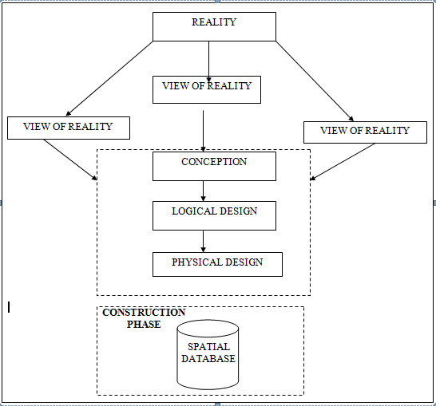

Fig.3.1Design and Construction Phases in Spatial Database

3.2.2 CONCEPTUAL DESIGN
Vector data model is the data type adopted for this project, which is represented, by points, lines and polygon. The identified entities are: -
- Green Reserve (polygon)
- Roads (line)
- Electric poles (point)
- Trees (point)
- Buildings(polygon)
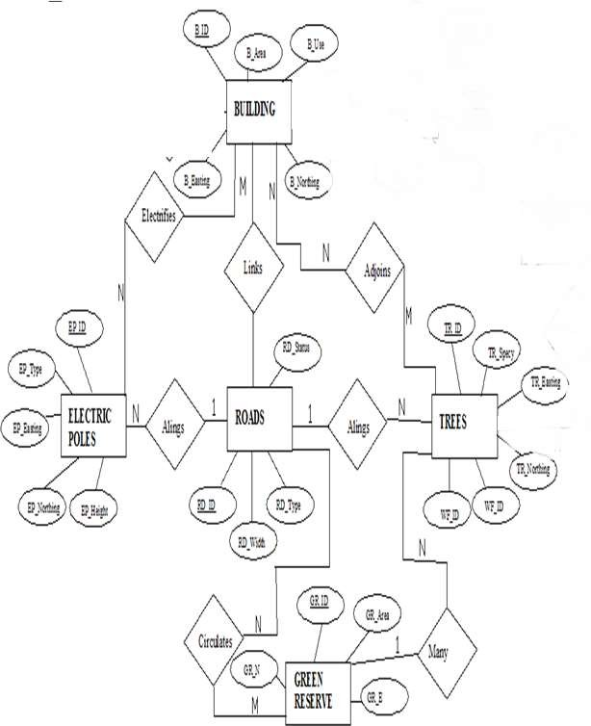

Fig.3.2 shows the conceptual design

3.1.3 LOGICAL DESIGN
This is the design aspect of the database refers to the process of creating a conceptual framework or model that represents the structure and organization of spatial data within the system. It involves defining the data element, their relationship, and the rules for data manipulation and analysis. In this phase, the entities, their attributes and their relationships are represented in a single uniform manner in form of relation in such a way that would be no information loss and at the same time no unnecessary duplication of data. In this study, the logical database design is employed to generate a geo-relation database structure. Each entity has unique identifier in bold type. An attribute type or combination of attribute types that serves to identify an entity type is termed an identifier.
- Building( B_ID, B_Area, B_Name, B_Easting, B_Northing)
- Roads (R_ID, R_Width, R_Type, R-Condition, R_Easting, R_Northing )
- Vegetation (V_ID,GR_Area,)
- Tree (TR_ID, TR_spp, TR_Importance, TR_Easting, TR_Northing )
- Electric Pole (EP_No, EP_Type, EP_Height,EP_Easting, EP_Northing)
- Water Facility (WF_ID, WF_Depth,WF_Type, WF_Easting, WF_Northing)
- Football Pitch (FP_ID , FP_Area, FP_Status)
- Stream(S_ID, Length, Width)

3.1.4 PHYSICALDESIGN

Table3.1 Building and its attribute

ENTITY | DESCRIPTION
B_ID | BuildingIdentification
B_name | BuildingName
B_Area | BuildingArea
B_Easting | BuildingEasting
B_Northing | BuildingNorthings

Table3.2: Road and its attributes

ENTITY | DESCRIPTION
R_ID | RoadIdentifier
R_Length | RoadLength
R_Width | Road Width
R_Type | RoadType
R_Condition | RoadCondition

Table3.3: Trees and its attributes

ENTITY | DESCRIPTION
TR_ID | TreeIdentifier
TR_Spp | Treespecy
TR_E | Tree_Easting
TR_N | TreeNorthing

Table3.4: Electric Poles and its attributes

ENTITY | DESCRIPTION
EP_ID | ElectricpoleIdentifier
EP_Type | ElectricpoleType
EP_Height | ElectricpoleHeight
EP_E | ElectricpoleEasting
EP_N | ElectricpoleNorthing

Table3.5: Vegetation and its Attributes

ENTITY | DESCRIPTION
V_ID | VegetationIdentifier
V_Area | VegetationArea
V_E | VegetationEasting
V_N | VegetationNorthing

3.2 Reconnaissance
Prior to project execution, a reconnaissance stage was conducted to gather existing information about the project area. This preparatory phase comprised two key steps:
- Office Planning and
- Field Reconnaissance.

3.2.1 OFFICEPLANNING

This involves the collection of information about the study area, testing the instrument to be used in execution of the project and itemizing the numbers of equipment needed, number of ays to be use, how each activity is to be carried out, delegation of works to each team members based on supervisor’s guide/instructions

Table 3.6 shows the control coordinate
PILLAR | NORTHING | EASTING | STATUS | REMARKS
PT 02 | 935768.084 | 670900.867 |  | ORIGINAL
PT 02 | 935768.099 | 670900.847 | FIXED | OBESRVED
DISREPANCY | 0.015 | 0.020

3.2.2 FIELDRECONNAISSANCE

The field reconnaissance is the first visitation to the project site to get intimated with the environment.
- Boundary points was selected

- The distribution of features was studied

- Controls to be used were located

- Method and type of instrument to be uses was determined

- Subsidiary point for Ground control Points were picked and define using nai land bottle cock
- A diagram of the study area was drawn.

Fig.3.3: Recce diagram of the study area (not drawn to scale)

3.3 EQUIPMENTUSED/SYSTEMSELECTIONANDSOFTWARE

HARDWAREUSED

- Totalstation

- 1reflectorwith atrackingrod.

- 1Tripod

- One(1)50m tape

- One(1)umbrella

- 1cutlass

- HandheldGPS

- Hammer

- Nailsandbottlecover

- Fieldbookandwriting materials

- 1-NoofPersonalComputerHP655 andits accessories

- 1-NoofHP DeskJetK7100 A3 printer

- 1-NoofHPDeskJet 1110 A4printer

SOFTWARECOMPONENT

- Notepad.

- MicrosoftExcel.

- AutoCAD2007

- ArcGIS10.3

- Surfer2010

- MicrosoftWord.

3. 4 TESTS OF DIFFERENTIAL GPS
The two GPS receivers (Tersus Differential GNSS) were tested to ascertain its working capability on two known established points. The reference receiver (base) and rover receiver were setup using the RTK (Real Time Kinematics) mode with boosts from external radio to increase the communication linkup and range between the two receivers. The interface was access using S1 controller to set the parameter. The data acquired was downloaded using beam methods (Bluetooth) of the windows mobile platform in text format (.txt)
However, the result displayed the following on the controller:
Status (P): | Fixed
Horizontal Root Mean Square (H): | 0.014
Vertical Root Mean Square (V): | 0.021
Satellite Number (S): | 10+4
Communication Mode (Channel): | 4
Time (T) | 11:05:38

3.5 CONTROL CHECK
Control check was carried out on the beacons PT 02 and PT 03 in order to ensure whether they were still maintaining their original positions. The reference receiver (base receiver) was set on PT 01 while the rover receiver was set on PT 02 and PT 03 respectively. The following are the result obtained

Table 3.7: Coordinate of the observed and the original values of PT 02
PILLAR | NORTHING | EASTING | STATUS | REMARKS
PT 02 | 935768.084 | 670900.867 |  | ORIGINAL
PT 02 | 935768.099 | 670900.847 | FIXED | OBESRVED
DISREPANCY | 0.015 | 0.020

Table 3.8: Coordinate of the observed and the original values of PT 03
PILLAR | NORTHING(m) | EASTING(m) | STATUS | REMARKS
PT 03 | 935791.554 | 670975.362 |  | ORIGINAL
PT 03 | 935791.575 | 670975.384 | FIXED | OBESRVED
DISREPANCY | 0.021 | 0.022
The result shows that the control pillars were in Situ and in good condition for the survey operation. In the case of the instrument, it can be concluded to be in good working condition.

3.6 DATA SOURCE
Control coordinate was given from existing map, which is considered as secondary data. This was plotted using AutoCAD.

3.7 GEOMETRIC DATA ACQUISITION
This involve the acquisition of both northing and easting value of features that are present on the project site. During the data acquisition, Real Time Kinematic method was employed coordinates of boundary points, as well as details and notable features along the perimeter using total station. Boundary pillars are established and accurately measured. These points serve as reference markers and are essential for maintaining consistency and accuracy throughout the survey. Additionally, these coordinates serve as valuable information for future reference, analysis, or planning purposes. They can also be used to assess potential impacts on the survey area and aid in making informed decisions during the project's development or construction phases.
Data Acquisition
To gather the necessary data for the project, observations and measurements were carried out. Obtaining the information needed to create the project plan was the focus of this stage. The processes listed below were completed.
- Selection of control points. Perimeter Traverse
- Detailing
Complete surveying programs with the ability to record data and set parameters are included with the instrument used. Additionally, it uses software modules with built-in memory and has convenient memory management capabilities.
Perimeter Traverse
The act of traversing is the survey of a group of interconnected lines, known as traverse legs, the ends of which have been marked in the field and the lengths and directions of which have been established by observation. Traverse stations are places of changes or turning. Open and Closed
Traverses are the two basic categories into which traversing can be placed.
Closed traverse always begins and end on sets of known points (points with known coordinates previously established). Perimeter is frequently encircled by shapes, such as polygons, in closed traverse surveying. Although this type is expected to be employed in all projects in surveying generally.
An open traverse consists of a collection of traverse lines that are connected but do not begin and end at a known point. When no controls are present where the traverse action is to stop, this type is typically utilized. In this kind of traverse, the observer's main responsibility is to make sure that the task is being checked at each stage. Surveys of this kind are frequently used in the engineering industry, such as route surveys.
The closed traverse type was employed in this project as it was started on an existing control point (PT 02) and closed on the same control (PT 02).
Base Station Setup
The base station is required in order to ensure an accurate position to be used in the topographic survey of Extension to Textile Factory. The use of a base station is now a standard routine in surveying practice; this is to validate the fundamental principle of carrying out a survey “from whole to part”. This means that networks of horizontal and vertical control points are first established. The temporary adjustment (centering and leveling) was performed on it. All the connections necessary for RTK mode stated below was carried out,
- The base station comprising of Tersus GNSS GPS receiver shown in figure 3.1 below was setup on a tripod stand on PT 02.



Figure 3.4 Tersus GNSS GPS receiver
NB: The position of the base station used is 935768.084mN, 670900.867mE. It was located in an area free from obstruction and interferences. It has been set to the WGS 84 system with Clarke 1880 ellipsoid.
The procedure for the data capturing is stated below;
- The instrument was switched on using the power button and also the data lodger (TC20).
- Then the instrument was placed on the tribrach which was already attached to the tripod and levelled.
- On the data lodger, the Nuwa app, Survey Office software was launched.
- The software was allowed to load and then, on the Project creation page, a project folder called ‘CIS’ was created and then opened.
- On the series of pages that followed however, the datum was selected as ‘Minna’, the mask angle as ‘15º’, while the minimum observation time was set at ‘5 minute’. After this page, the Base page was loaded.
- On the instrument Connect page (the Bluetooth connection page), the base station instrument serial number 52000754 was selected and down the page, the ‘connect’ button was clicked. This connects the lodger to the base instrument.
- On the Base page, the get location icon was click, and this bring the approximate coordinate of PT 2 control, the coordinate was then corrected to the values obtained after this, the ‘start’ button was clicked and the base observation commenced.
- The Rover instrument’s battery was then fixed into it and switched on using the power button then mounted on the tracking rod (a single legged pole) and tightened.
- The tracking rod was set at 2.00m as height of the instrument.
- On the instrument Connect page (the Bluetooth connection page), the base station instrument serial number 52000754 was then disconnected and the Rover instrument serial number 52000764 was selected and down the page, the ‘connect’ button was clicked. This connect the lodger to the Rover instrument. The voice information FIXED was then heard from the instrument.
A complete setup of the base and the interface of the Project Creation page are shown
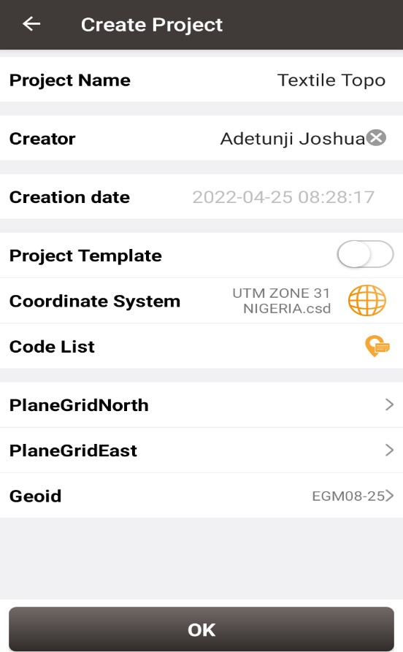
AINASVG/G13/13
CISSVG/G13/13
03-12-2024

Figure 3.5 showing the project creation page on Nuwa app
FIELD OBSERVATION
- Aftersetting up the base, the rover instrument with serial number 52000764 was taken to site.
- NOTE: - Each station in a differential GPS observation is typically observed independently (though with direct reference to the base station), i.e., the instrument is placed on each station one at a time until the final point or detail in the site is observed.
- The instrument was placed on the first station i.e. the base of the tracking rod was placed on the center of the pillar.
- On the data lodger, the Nuwa app was launched and the Survey page of the app was click. On the Survey page, the get location icon was click to obtain the Northing and Easting of the station.
- NB: Given that the time segment of the instrument has been set to 5secs already, the observation automatically ends when its period of the time segment already pre-set elapsed
- The Station ID was then changed from pt1 to P1.
- After 5sec of observation, the observation stopped automatically and then the instrument was moved to the next station i.e. P2
- NOTE: - that the data lodger was not switched off after the first station had been observed since the stations are not far from one another i.e. not more than 50m from each another.
- On the data lodger with the Survey page on, the ‘get location’ icon was clicked and the observation started since the instrument had automatically given the next station name. The observation was allowed for 5sec again.
- The process in step (v) was repeated for all the subsequent stations and other details that were observed on the site.
- At the end of the observation, the instrument was switched off. The Survey page on the data logger was closed and the data lodger was also switched off (though in the warm boot mode).
- The data logger was taken to the base station and switched on again. The instrument’s serial number was selected on the Bluetooth page which also led to the Base station page.
- On the base station page, the ‘stop base’ button was clicked and then the instrument was
- switched off including the data lodger.

3.7.1 ATTRIBUTE/ SOCIAL SURVEY
This aspect of data acquisition entails the collection of other data which geometric in nature. Such data were directly related to the features to which geometric data was acquired. They included building names, the purpose of which the building is used for. etc.
To collect attribute data, survey was employed. This involves oral interviews, reading information from sign posts, wall signs, virtual observation, etc.

3.8 DATABASE CREATION/IMPLEMENT
For efficient and effective management of data in the computer environment, data item are usually arranged and stored in a database or databank. The content of this database could be in form of a text, number, polygon or graphics. The creation of this database involved the combination and storage of the acquired graphical and attributes data obtained in former designed GIS database of a generic structure for the purpose in spatial analysis and queries on project site
In the creation of a land information system data mode, a widely used technique called layering was employed. The features that are present within the project site have been classified into different layers in the AutoCAD software independently. The polyline entities were joined using the polyline tool while appropriate symbols were used for the point entities. These layers were then exported to ArcGIS environment where shape files were created using attributes fields as conceptualized in the schema. These attribute table were then populated accordingly with attributes values for each particular entity as observed in the field and from the social survey template (attached as appendix)
The personal Geodatabase was then created finally in Arc Catalog environment. Where other tables that are non-geometric where created while the already created shape files where imported.Relationship between these tables were also established and the tables were later populated in the Arc Map environment. The following are some of the tables created

3.8.1. DATABASE MANAGEMENT SYSTEM (DBMS)
According to Dale and McLaughlin (1998), database management system was defined as a computer program to control the storage, retrieval and modification of data in the database. DBMS comprises of set of programmers which are used to maintain and manipulate the data orderly and acts as the central control over all the interactions. It manages that data using alphanumeric data with limited capabilities of performing spatial queries
A DBMS must allow the definition of data and their attributes and relationships as well as providing security and on interface between the end users and their application and the data themselves it reduces redundancy. Therefore, Arc GIS 10.2 version was used to create, manipulate, maintain and access the database easily.

3.8.2. DATA QUALITY
Some forms of quality control and quality assurance were incorporated in the project at every phase. These include conformity with data templates, data competences and data accuracy. Conformity with data templates in this premises refers to the degree to which the captured data conformed with the designed templates, while data competence was understood as the degree to which the available data in the report and for which there are specific templates have been extracted.

3.8.3 DATA INTEGRITY
The data captured as exactly downloaded into the system then exported to AutoCAD via notepad and eventually into Arc GIS. The process involves ensuring that the data in the database were accurate and setting of certain constraint to prevent inconsistency in the database.

3.8.4 DATA SECURITY
Security is of great concern to land administration because of the legal implication of cadastral records. Security of the records is of almost importance to all concerned. These includes:
- Physical and system security
- Physical security: The use of burgling proof, fire-fighting equipment-controlled access, proper records of the moment of personal and our of the office circuit break
- System Security: Uninterrupted power supply (UPS) will be used to control voltage, use of passwords and backups
In view of the foregoing, locking mechanism was adopted to protect the data in the database from unconscious deletion. Password was used to prevent unauthorized user from breaking into the database and a backup was created for the whole project on the rentable DVD.
Having succeeded in analysis the methodology employed in the execution of this project to arrive at the successful completion. it is equally necessary to examine the processes undertaken to ascertain the reliability and effectiveness of the created land information system

CHAPTER FOUR

4.0 DATA PROCESSING AND PRESENTATION

4.1 SPATIAL ANALYSIS
Spatial analysis is a specialized function that distinguishes GIS from other information systems. It entails the examination of spatial and attributes characteristics of geographic features that are within the database to establish relationships from which spatial problems can be tackled. In this project work, spatial analyses were performed to select, combine and intersect existing geospatial data-sets in order to generate new information suitable for answering specific spatially-related questions.
The results from these analyses can be shown in a number of ways depending on the required output format. Where attribute information about map features is required, they can be presented as tables containing such valves as are needed from the query analysis. They can also be presented as maps with legend information showing the queried features and their topological relationships with other features shown on the map.
For this project AutoCAD 2007 was used to carry out the plotting of all the parcels. The drawing was exported to ArcGIS 10.3 where all other operations were carried out.

4.2 Spatial Query
Searching of data components using certain criteria of retrieving them from the database is known as spatial query. The information retrieved is used to support decision making. The Cadastral Information System (CIS) plays its role when a relational database is linked to graphics in real time.
A good Cadastral Information System (CIS) allows the user to select records or attributes in the database and to view the result on coverage displayed which can be printed on a hardcopy.

4.3 Query Design
A query design is a precise definition of what is to be selected from the database. For example, the following queries designs were used in this project:
- Query by P Status=Developed, P use=commercial
- Query by P use = Residential
- Query by P use = Residenial, P area = 1345.624sqm and Owners name = MrQudus

4.4 Testing Of Database
This is the test carried out to determine whether the relationship between the geometric data about the objects and their attributes is capable of being retrieved. This was done by designing a simple query and running the query to see if the desired result is achieved. The query ran, hence the database was confirmed fit for analysis.

4.5 Existing Parcels and Blocks
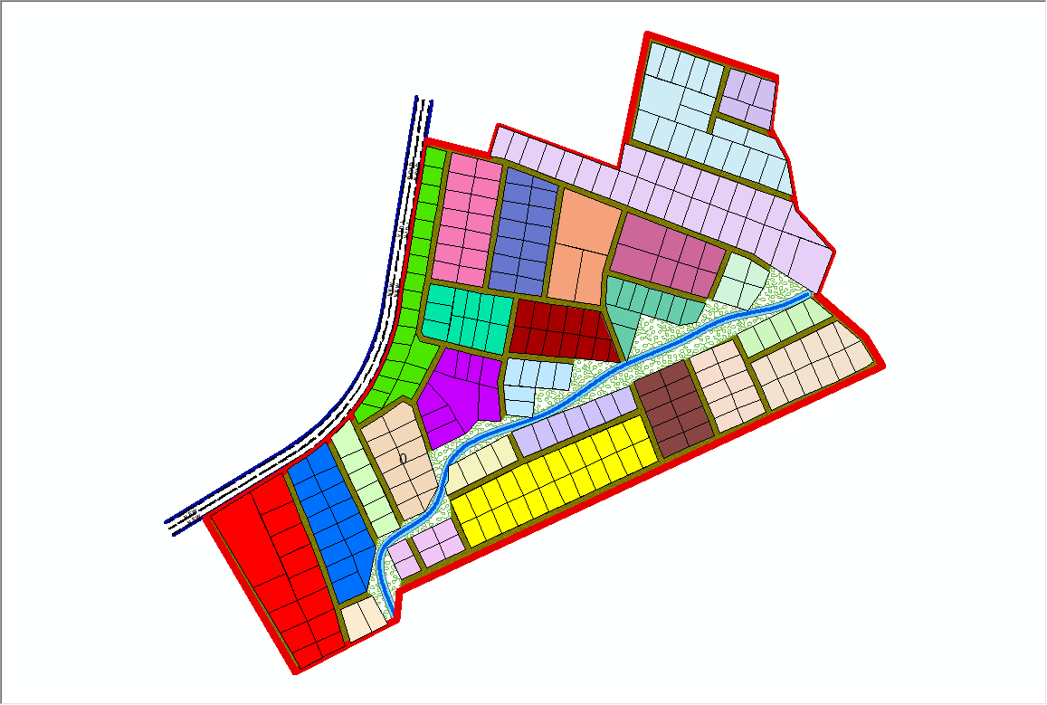

Fig 4.1:- the exported cadastral plan of the study area showing the blocks within the area
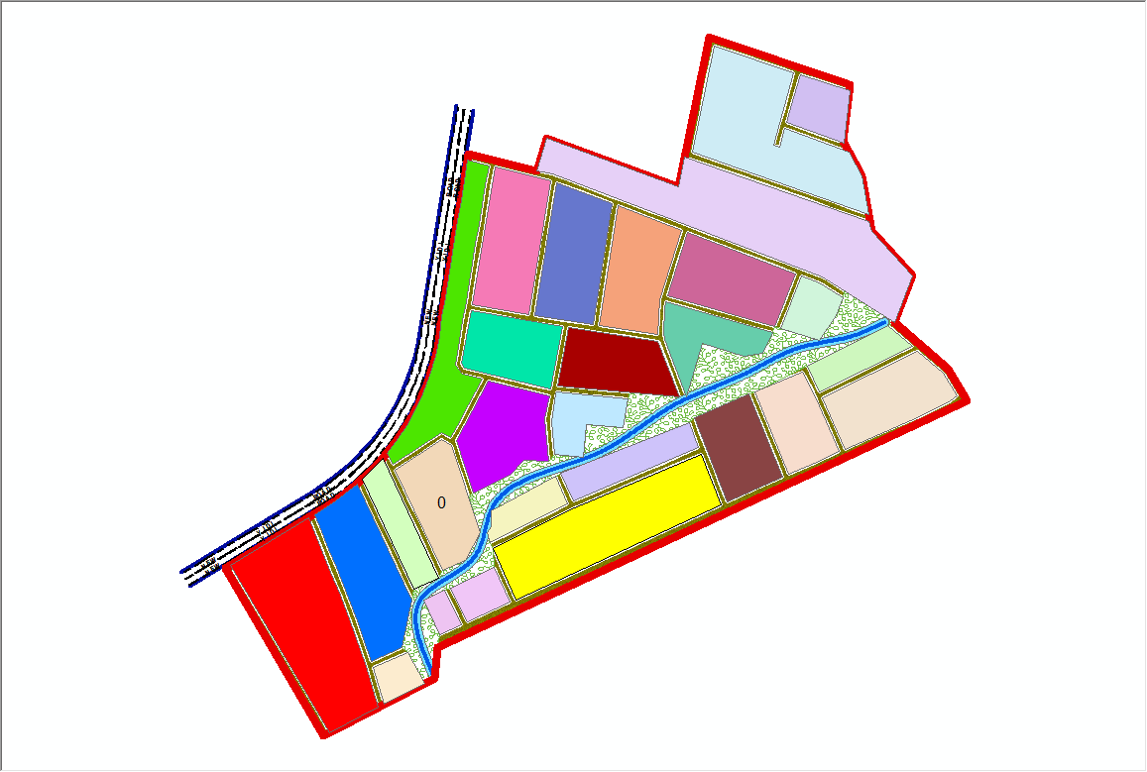

Fig 4.2:- the exported cadastral plan of the study area showing the all the parcels within the area.
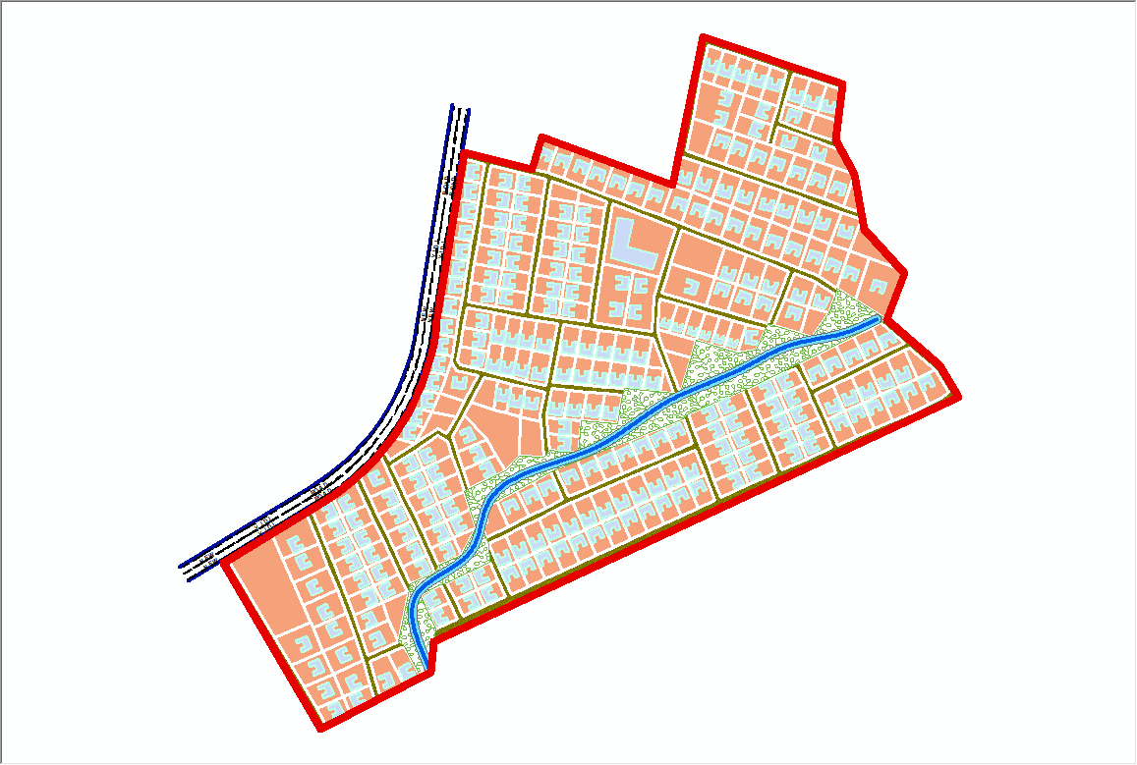
Fig 4.3:- the cadastral plan of the study area showing the boundary,
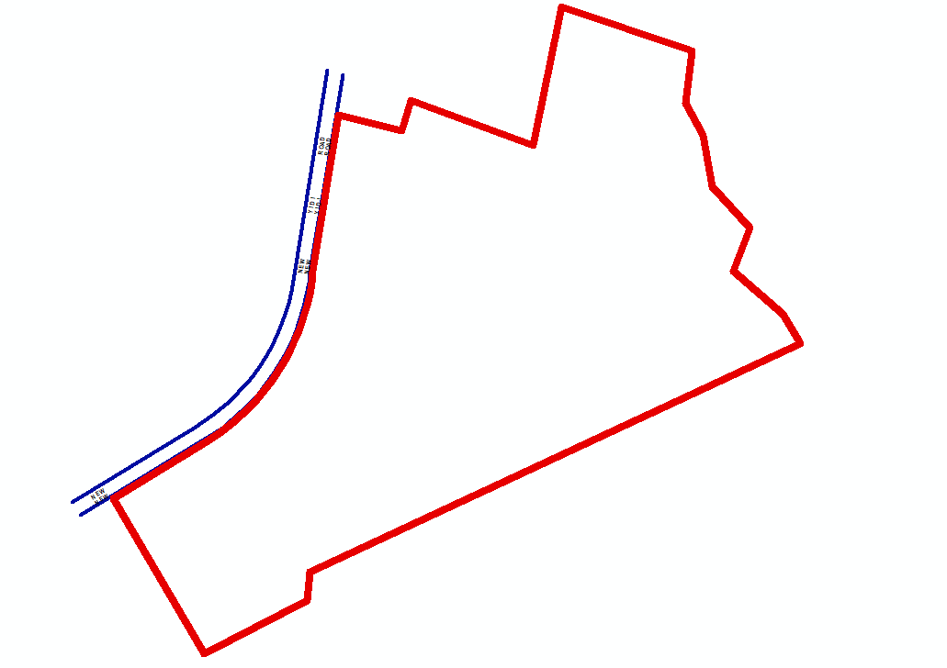

4.6 Spatial Query
Queries were designed for the purpose of retrieving information from the database. The queries performed in this project gave answers to certain generic questions asked from the database. This was made possible as a result of the implicit link of both the spatial and attributes data. The queries were based on the products from the analysis carried out on the database.

4.6.1 Single Criterion Query
A single criterion is carried out where one condition is used to design query. This condition is used to retrieve the information from the database.
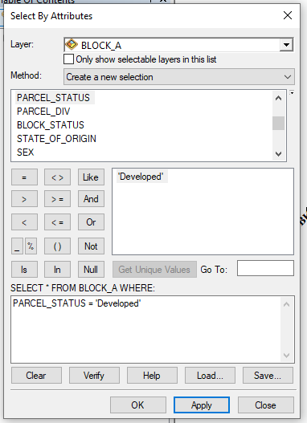

Fig 4.6.1.1:- Query for Parcel status for developed Purposes in the Study Area
SYNTAX; ([Parcel_status]) =’developed’)

4.6.2 Query by Parcel Status (Developed)
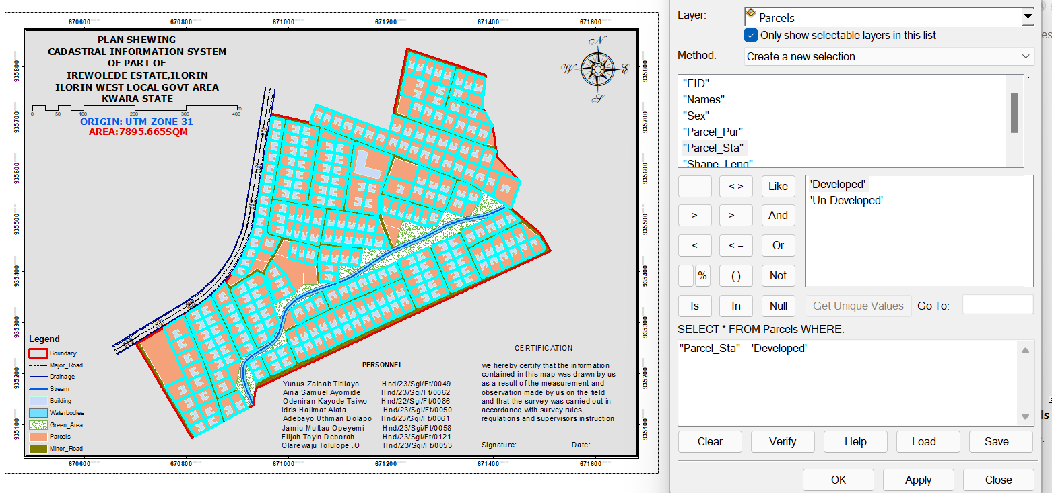

Fig 4.4: Result of Query for Parcel Used for developed area in block A in the study area
SYNTAX; ([Parcel_status]) =’developed’)

4.6.3 Discussion of Result
Figure 4.6.2.1 Shows parcels that are meant for developed purposes. It consists of the syntax model or the query builder box, attribute table as well as the map of the selected plot in light green color. The result shows that 8 parcels out of the 20 parcels are meant for commercial purposes.

4.6.4 Query by Parcel Status (commercial)
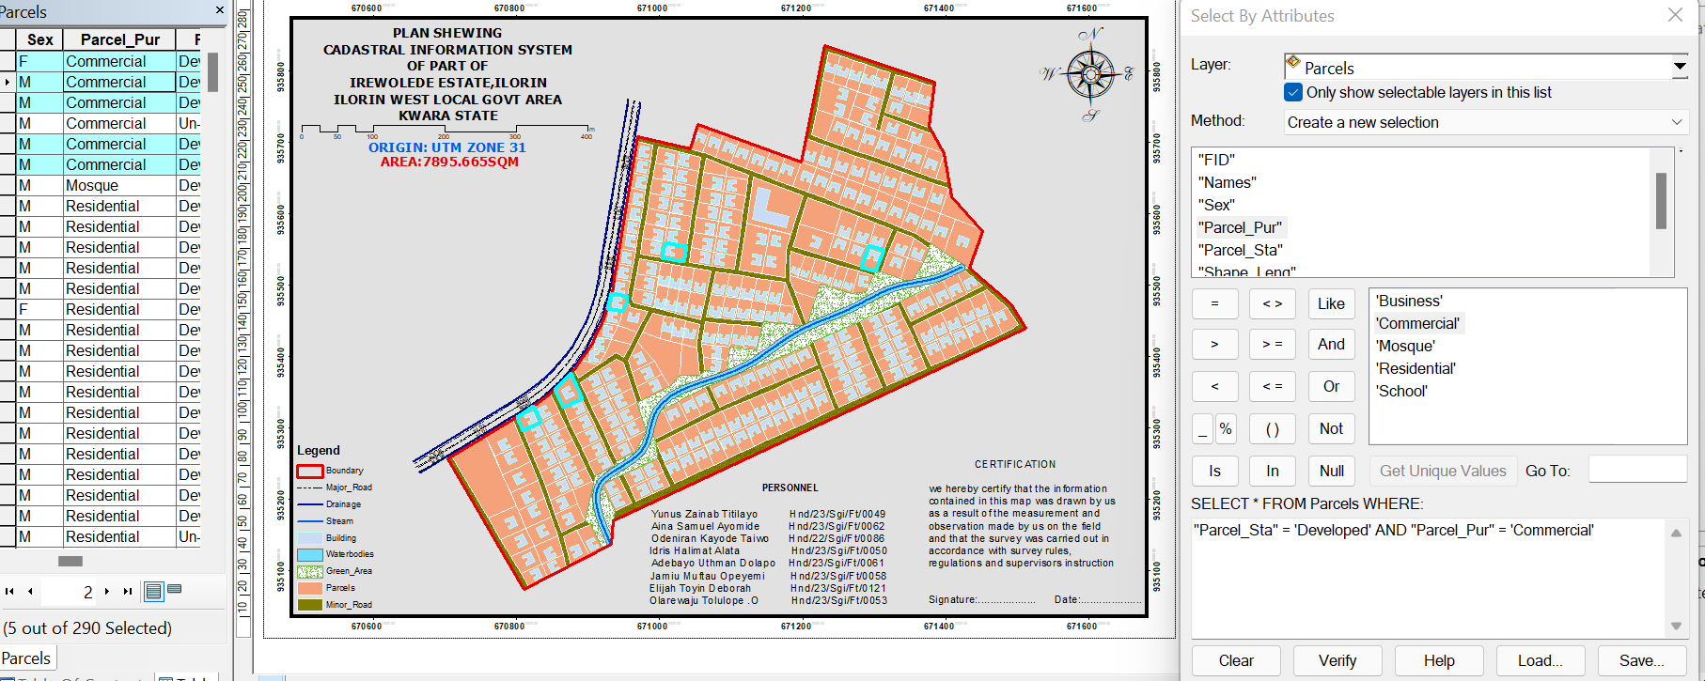

Fig 4.5: Result of Query for Parcels that are commercial purpose in the study area.
SYNTAX; ([Parcel status]) =’commercial’)

4.7 Discussion of Result
Figure 4.6.4.1 shows parcels that already have some type of commercial on it. It consists of the syntax model or the query builder box, attribute table as well as the map of the selected plot in light green color. The result shows that 5 parcels out of the 290 parcels have been developed. This information however will help in informing the necessary quarters the level of development within the layout.

4.8 Multiple Criteria Query
The database created is then used for implementing several selection queries in determination of user-defined requirements such as parcels whose occupiers are actual owners, occupier’s citizenship, occupier’s occupation, number of residents in each flat, selection of unoccupied flats and other such security.

4.8.1 Query By Parcel Use And Parcel Status (Parcels meant for school, residential, commercial purposes that are “RESIDENTIAL”
Query was carried out in two stages; parcels meant for residential purposes were first queried by means of the parcel use field. In this case parcel use was selection criteria. The shape file data of the query was exported as a layer and named accordingly. Next, the attribute table of the query result was queried by means of parcels meant for residential purposes that are yet to be developed i.e. Developed Parcels using the “Developed” selection criteria. This gives result for the parcels meant for residential purposes that are developed this also will help inform on the level of development within the layout.
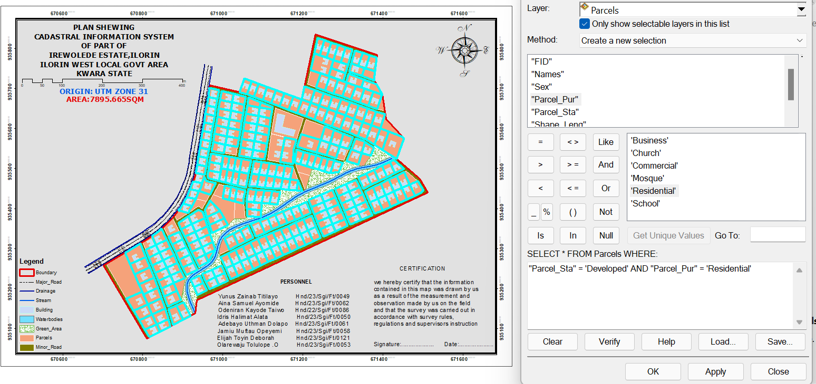

Fig 4.6: Screen prints showing parcel use and parcel status in the layout.
SYNTAX;PARCEL_USE = 'Residential' AND PARCEL_STATUS = 'Developed’
Discussion of Result
Figure 4.8.1.1 shows the syntax modeled, the attribute table and the map of the multiple criteria queries ran on parcel meant for residential purposes and number of
Developed residential purpose parcels within the study area, they are highlighted in
Light green color. The result showed that 265 of the 290 parcels are developed.

4.8.2 QueryByParcel Use (Commercial) And Parcel Status (Parcels meant for commercial purposes that are “Residential”)
Following the procedure in the query for parcels meant for residential purposes that are yet to be developed. All parcels meant for commercial purposes were first queried and then, the resulting attribute table, query was carried out for parcel for which are Developed.
Fig 4.7: Screen print showing parcel meant for commercial purpose that are Developed in the layout.
SYNTAX;PARCEL_USE = 'Commercial' AND PARCEL_STATUS = 'Residential'4.7.2.1
Discussion of Result
Fig 4...8.2.1 shows the result of syntax modeled, attribute table as well as unformatted map of developed parcels meant for commercial purposes. The table shows that all the 5 parcels meant for commercial purposes are developed. This is a pointer to the high rate of commercial developments in the study area.

4.8.3 Query By 10m Proximity to the stream (Parcel within 10m proximity to the stream).
Following the procedure in the query for parcels within close proximity to the stream (10m), query was carried out to show the parcels within close range to the stream.
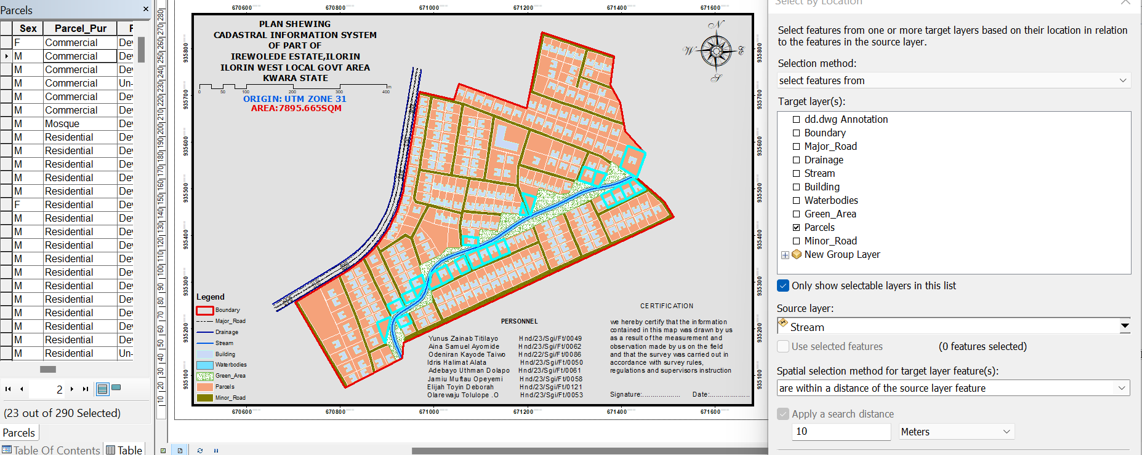

Fig 4.8.: Screen print showing parcel parcel within 10m proximity to the stream

4.8.3.2 Discussion of Result
Figure 4.8.3.1 shows the result of syntax modeled, attribute table. The table shows that only two out of all the parcels, only 25 parcel are within 10m proximity to the stream.
Fig4.8.5.4 Screen-shot showing the database created for the study area

Screen-shot showing the database created for the study area
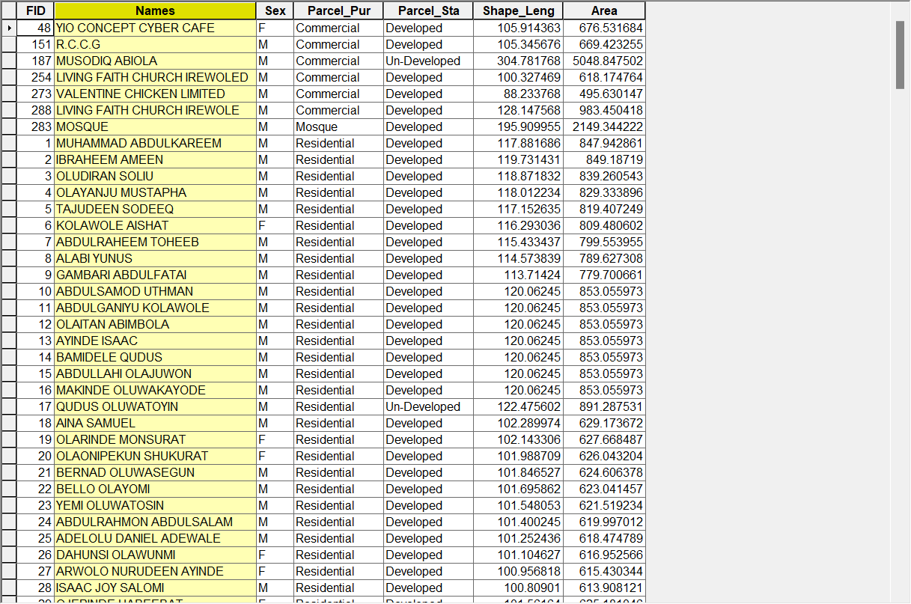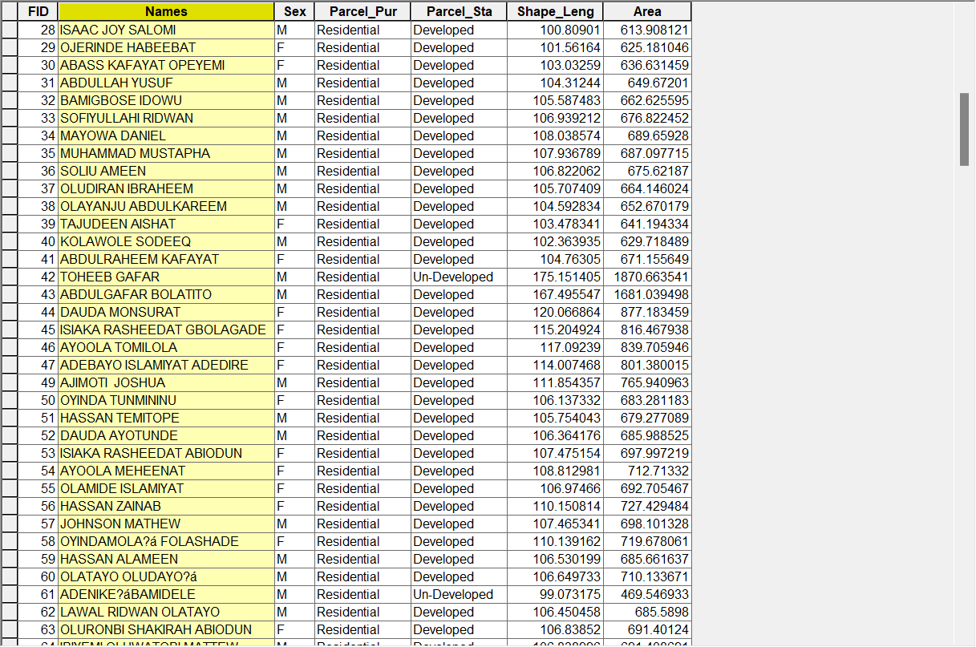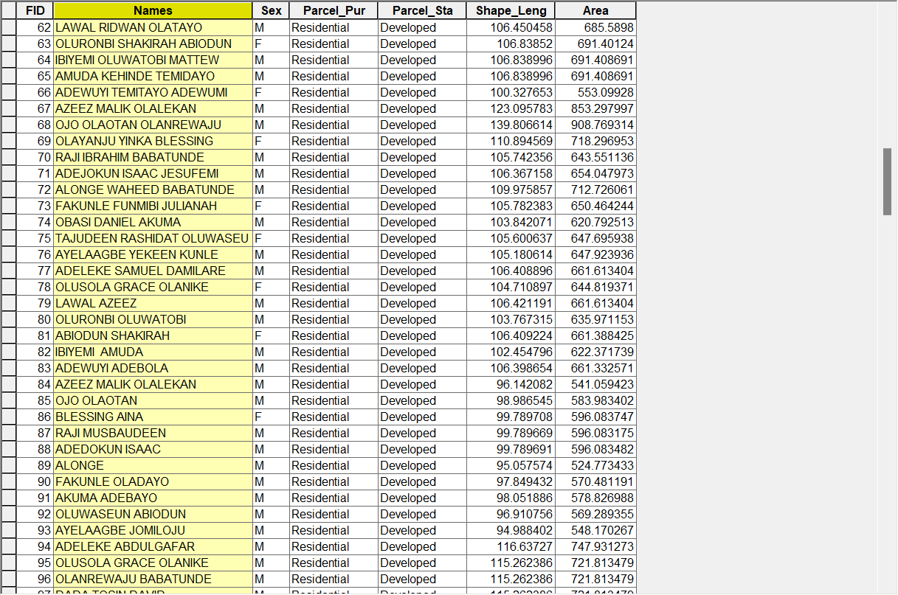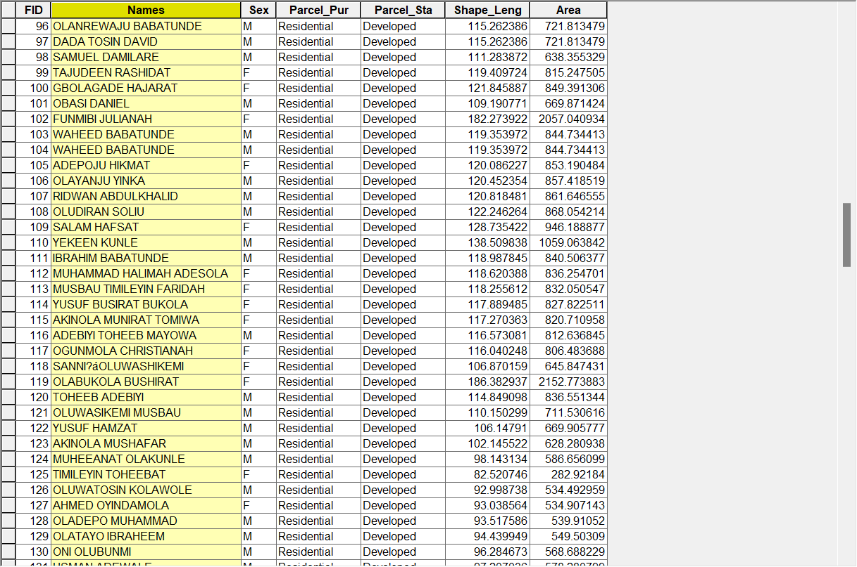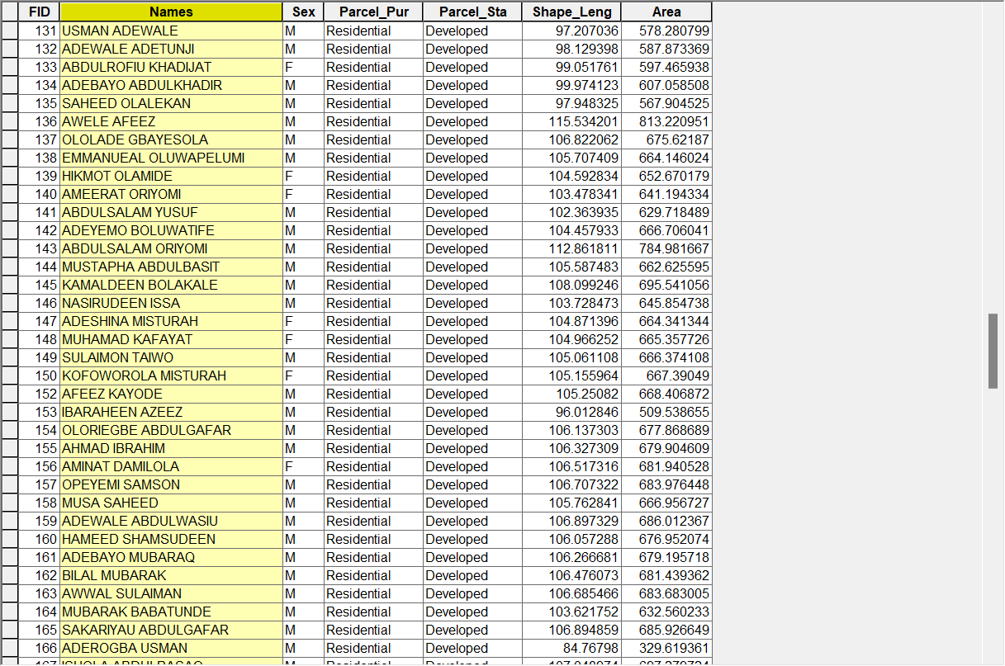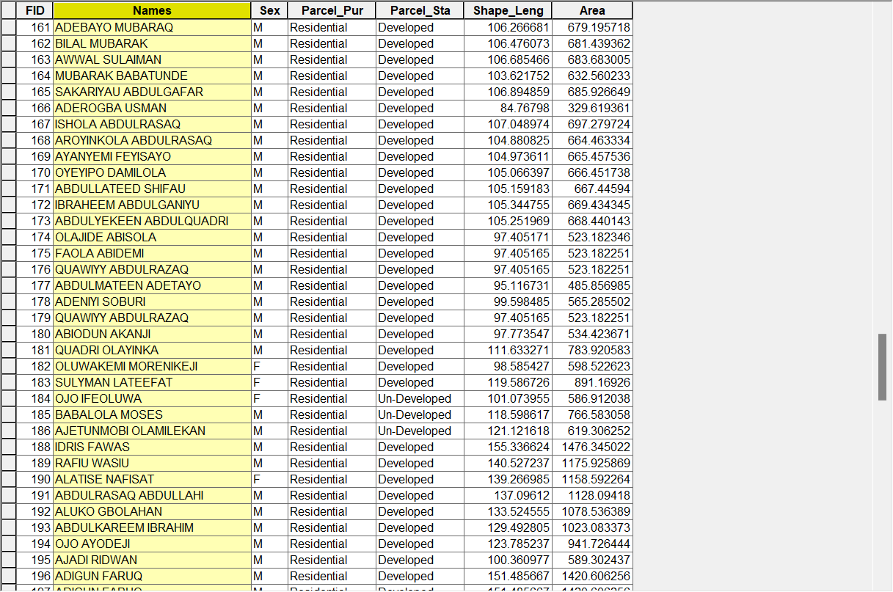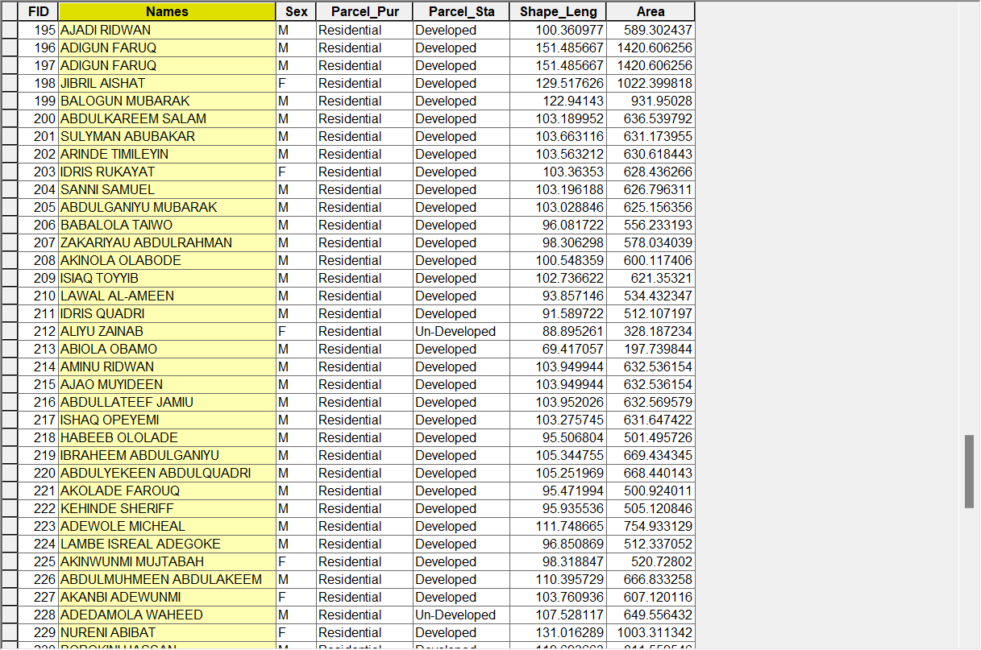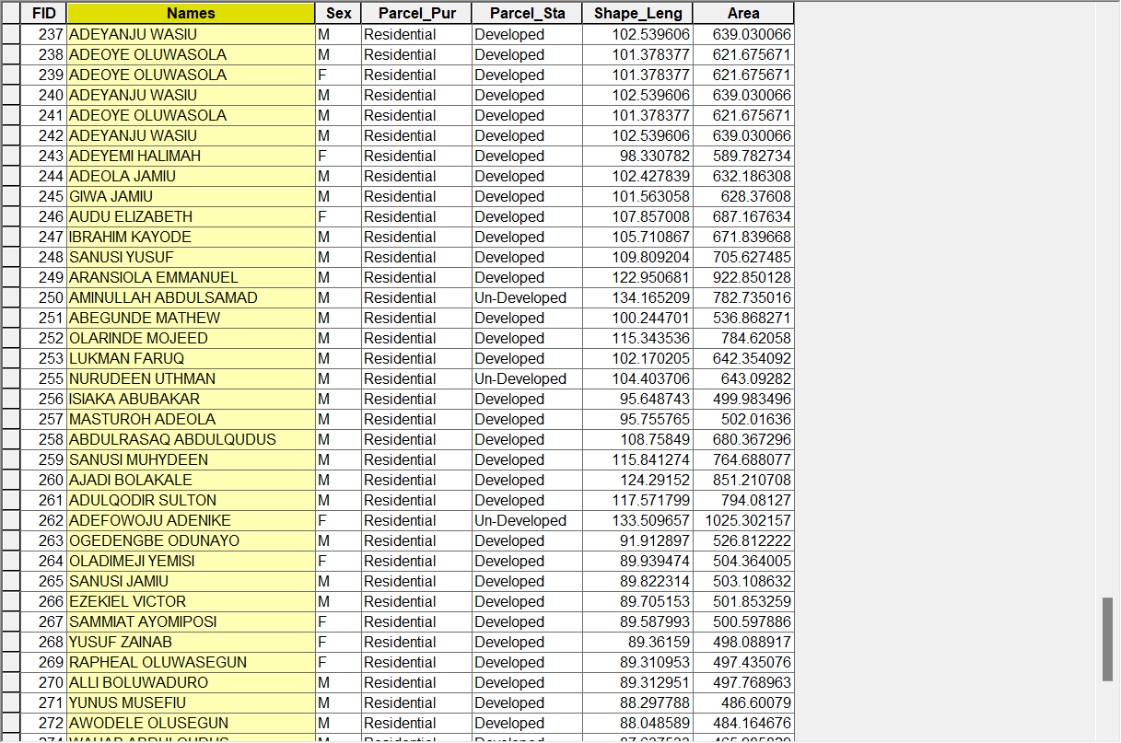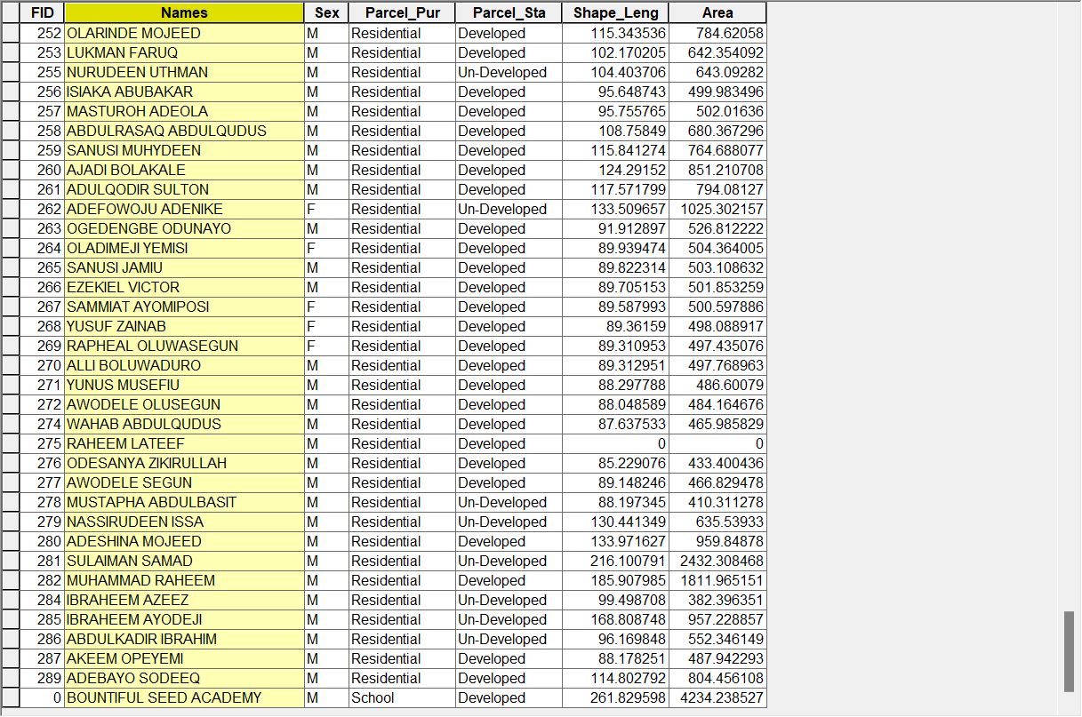

CHAPTER FIVE

5.0 COSTING, SUMMARY, PROBLEMS ENCOUNTERED, CONCLUSION AND RECOMMENDATION

5.1 COSTING
The project's costs were calculated in accordance with the Nigeria Institution of Surveyors' (NIS) fee scale for construction consultants. This summary outlines the total costs incurred from the project's initiation to its final stage.
RECONNAISSANCE
PERSONAL/QUALITY | DAY(S) | UNITRATE(N) | TOTAL AMOUNT(N)
1 Senior Surveyor | 1 | 18,443.92 | 18,443.92
Assistant Surveyor | 1 | 10,849.37 | 10,849.37
Transportation | 1 | 19,800.35 | 19,800.35
Basic Equipment | 1 | 19,800.35 | 19,800.35
Logistics | 1 | 8,000.00 | 8,000.00
TOTAL |  |  | #76,893.99k
TABLE: 5.1.1 shows the total amount spent for reconnaissance
BEACON= 2,100 × 8
= #16,800
BEACONING
PERSONAL/QUALITY | DAY(S) | UNITRATE(N) | TOTALAMOUNT(N)
1Assistant Surveyor | 1 | 10,849.37 | 10,849.37
1Assistant Surveyor | 1 | 9,500.22 | 9,500.22
2Labour Crew | 1 | 6,468.61 | 6,468.61
Transportation | 1 | 19,800.35 | 19,800.35
Basic Equipment (6) | 1 | 19,800.35 | 19,800.35
Logistics | 1 | 8,000.00 | 8,000.00
TOTAL |  |  | #74,418.9k
TABLE: 5.1.2 shows the total amount spent for beaconing
TRAVERSING
PERSONAL/QUALITY | DAY(S) | UNITRATE(N) | TOTALAMOUNT(N)
1 Senior Surveyor | 2 | 18,443.92 | 36,887.84
1 Assistant Surveyor | 2 | 10,849.39 | 21,698.74
1 Chain Man | 2 | 9,500.22 | 19,000.44
2 Labor Crew | 2 | 6,468.61 | 25,874.44
Transportation | 2 | 19,800.35 | 39,600.7
Basic Equipment | 2 | 19,800.35 | 39,600.7
Logistics |  | 8,000.00 | 16,000.00
TOTAL |  |  | #198,662.86
TABLE: 5.1.3 shows the total amount spent for traversing
DOWNLOADING DATA AND EDITING
PERSONAL/QUALITY | DAY(S) | UNITRATE(N) | TOTALAMOUNT(N)
1Principal Surveyor | 1 | 30,378.22 | 30,378.22
1SeniorSurveyor | 1 | 18,443.92 | 18,443.92
1AssistantSurveyor | 1 | 10,849.92 | 10,849.92
Basic Equipment | 1 | 19,800.35 | 19,800.35
Consumables | 1 | 13,927.00 | 13,927.00
Logistics | 1 | 8,000.00 | 8,000.00
TOTAL |  |  | #101,400.86
TABLE: 5.1.4 shows the total amount spent for downloading data and editing
PLOTTING
PERSONAL/QUALITY | DAY(S) | UNITRATE(N) | TOTALAMOUNT(N)
1Principal Surveyor | 1 | 30,378.22 | 30,378.22
1Senior Surveyor | 1 | 18,443.92 | 18,443.92
1Assistant Surveyor | 1 | 10,849.92 | 10,849.92
Basic Equipment | 1 | 19,800.35 | 19,800.35
Consumables | 1 | 13,927.00 | 13,927.00
Logistics | 1 | 8,000.00 | 8,000.00
TOTAL |  |  | #101,400.86
TABLE: 5.1.5 shows the total amount spent for plotting
INFORMATION PRESENTATION
PERSONAL/QUALITY | DAY(S) | UNITRATE(N) | TOTALAMOUNT(N)
1PrincipalSurveyor | 1 | 30,378.22 | 30,378.22
1SeniorSurveyor | 1 | 18,443.92 | 18,443.92
Transportation | 1 | 19,800.35 | 19,800.35
Basic Equipment | 1 | 19,800.35 | 19,800.35
Consumables | 1 | 13,927.00 | 13,927.00
Logistics | 1 | 8,000.00 | 8,000.00
TOTAL |  |  | #110,351.84
TABLE: 5.1.6 shows the total amount spent for information presentation
(1) # 76,893.99k
(2) # 74,418.99k
(3) # 198,602.86k
(4) # 101,400.86k
(5)#101,400.86k
(6) # 110,351.84k
TOTAL # 663,069.4K
MOBILIZATION AND DEMOBILIZATION =1.5%
: 1.5%. ÷ 100 × 663,069.4
= 0.015 × 663,069.4
= 9,946.041
V. A. T = 1.75%
: 1.75% ÷ 100 × 663,069.4
= 0.0175 × 663,069.4
= 11,603.7145
ACCOMODATION = 2%
: 2 ÷ 100 × 663,069,4
= 0.02 × 663,069.4
= 13,261.388
TOTAL = 663,069.4
9,946.041
11,603.7145
13,261.388
= 691,880.5435
Reconnaissance | #105,984.47
Cutting of line & Tracing of layout | #565,858.96
Ground Control Establishment | #216,649.21
Traversing | #216,649.21
Data Capture | #216,649.21
Data Processing | #270,195.88
Plotting using ARCGIS | #179,826.00
Technical Report | #210,195.88
Total | #1,982,008.82
TABLE: 5.1.4 shows the total amount spent for all tables

5.2 SUMMARY
The project is based on implementation of relational database for cadastral information (RDBs) of irewolede estate along new yidi road Ilorin, Ilorin south local government area, kwara state. The reconnaissance was done in order to have thorough sketch of an area, the data were acquired using total station survey method in a static mode. The pillar descriptions and detailing were done total station, the data processing involves transformation of reduction book and adjustment of acquired data using forward computation.
The survey was done in accordance to the specifications stipulated and a total number of thirty-two (5) pillars were buried all together and the final coordinate (X, Y, Z) value of all buried pillars were obtained. The plan was produced using AutoCAD and GIS software at a suitable scale and data were presented in both hardcopy and softcopy finally, a comprehensive report was written covering the whole procedures employed in the execution of the project using Microsoft word.

5.3 PROBLEM ENCOUNTERED
It is occasional for a successful project to start and end without facing any problem but every problem encountered was taking to be a challenge. The pole was given a problem during the project is not good at all and also, Communication between rover and reference was another serious problem encountered mobile phone was employed to resolve the problem.

5.4 CONCLUSION
Having completed the project successfully, the aims and land information system were achieved to serve as a base for further survey operations. The whole project was done in accordance with specification stipulated and direct supervision according to departmental instructions.

5.5 RECOMMENDATION
At this juncture, I hereby recommend that:
- More digital equipment should be bought by the school which could be used for the precise work so as to build up students to meet up with advanced technology and to make work easier for them.
- The school authority should try and find solution to the issue of instrument and the project should be issued on time to enable the student to meet up with the date specified.
- Finally, the (RDBs) should be extending to other part of the town by student for public and private uses and records should be kept in order to avoid land dispute of in our area.

5.3 PROBLEM ENCOUNTERED
It is occasional for a successful project to start and end without facing any problem but every problem encountered was taking to be a challenge. The pole was given a problem during the project is not good at all and also, Communication between rover and reference was another serious problem encountered mobile phone was employed to resolve the problem.

5.4 CONCLUSION
Having completed the project successfully, the aims and land information system were achieved to serve as a base for further survey operations. The whole project was done in accordance with specification stipulated and direct supervision according to departmental instructions.

5.5 RECOMMENDATION
At this juncture, I hereby recommend that:
- More digital equipment should be bought by the school which could be used for the precise work so as to build up students to meet up with advanced technology and to make work easier for them.
- The school authority should try and find solution to the issue of instrument and the project should be issued on time to enable the student to meet up with the date specified.
- Finally, the land information should be extending to other part of the town by student for public and private uses and records should be kept in order to avoid land dispute of in our area.

REFERENCE
Burrough (2006) - This is a reference to an author named Burrough who provided a definition of Geographic Information System (GIS) as a tool for collecting, storing, retrieving, and analyzing spatial data.
Charles (2012)-This is a reference to an author named Charles who discussed the importance of topographic maps with larger scales and digital map products for better planning.
Dowling (2000)-This is a reference to a author named Dowling who provide a definition of "data" as individual facts that have not been organized.
Lexicon Universal Encyclopedia (1989) - This is a reference to an encyclopedia that defines Topographic Information System as the combination of human effort and computer-based tools for collecting, storing, analyzing, and retrieving geographic data.
MacMillan Dictionary of Data Communication (1985)- This isa reference toa dictionarythatdefines the term"data"in thecontext ofdata communication.
Nick (2000) - This is a reference to an author named Nick who provided a definition of "data"asinformation that has been organized in a useful way.
Ndukwe (2001)-This is a reference to an author named Ndukwe who provide a definition of “information" as a useful data element for a specific application.
NOAA (2017)-This is a reference to the National Oceanic and Atmospheric Administration, which highlights the importance of topographic data for scientific and technical applications.
Onuigbo, Zita, Gbedu, Pious, & Samaila (2015)-This is a reference to multiple authors who discussed the use of GIS in analyzing topographic data and deriving topographic information systems.
Odo, Idhoko, Oha, Okoro, &Okafor (2015) - This is a reference to multiple author’s who discussed the evolution of GIS as a technology for spatial decision making using geographic and attribute data.
Otto&Rolf (2009)
Sharma E. O. (2006) - This is a reference to an author named Sharma who discussed thevalue-addedcapabilities ofGIS in organizingand analyzing spatialdata.

APPENDIX I
NORTHING EASTING NORTHING EASTING
935609.976 | 671158.208 | 935610.110 | 671030.195
935685.660 | 671212.601 | 935588.956 | 671026.735
935622.014 | 671387.359 | 935546.647 | 671019.817
935629.861 | 671365.636 | 935567.802 | 671023.276
935637.708 | 671343.913 | 935664.242 | 671076.822
935645.555 | 671322.190 | 935645.404 | 671074.784
935653.402 | 671300.467 | 935624.237 | 671071.395
935661.249 | 671278.745 | 935603.069 | 671068.005
935669.097 | 671257.022 | 935581.902 | 671064.616
935676.944 | 671235.299 | 935539.915 | 671057.753
935716.912 | 671249.292 | 935560.735 | 671061.227
935709.268 | 671271.086 | 935639.619 | 671105.861
935701.623 | 671292.881 | 935618.433 | 671102.569
935693.979 | 671314.675 | 935597.248 | 671099.278
935686.334 | 671336.469 | 935576.062 | 671095.987
935678.690 | 671358.263 | 935534.572 | 671089.394
935671.046 | 671380.057 | 935554.877 | 671092.696
935725.350 | 671227.181 | 935655.785 | 671106.863
935240.915 | 671022.720 | 935679.816 | 671010.043
935249.541 | 671041.425 | 935658.092 | 671006.633
935258.168 | 671060.131 | 935636.946 | 671003.128
935266.794 | 671078.837 | 935615.800 | 670999.623
935275.421 | 671097.543 | 935594.655 | 670996.117
935284.048 | 671116.249 | 935552.364 | 670989.106
935292.674 | 671134.955 | 935573.509 | 670992.612
935301.301 | 671153.660 | 935524.068 | 671205.203
935309.927 | 671172.366 | 935515.221 | 671235.964
935318.554 | 671191.072 | 935519.645 | 671220.583
935327.180 | 671209.777 | 935510.884 | 671250.773
935336.027 | 671228.624 | 935504.090 | 671283.194
935269.006 | 671010.266 | 935506.546 | 671265.582
935277.890 | 671028.849 | 935529.850 | 671189.894
935286.775 | 671047.415 | 935557.110 | 671337.973
935295.653 | 671065.988 | 935547.745 | 671361.057
935304.533 | 671084.563 | 935528.420 | 671327.953
935313.039 | 671103.241 | 935522.537 | 671351.230
935321.370 | 671122.060 | 935498.124 | 671202.080
935329.702 | 671140.880 | 935472.693 | 671203.593
935338.033 | 671159.699 | 935231.108 | 670754.994
935346.365 | 671178.518 | 935285.608 | 670781.967
935354.696 | 671197.337 | 935257.017 | 670793.476
935363.530 | 671216.911 | 935231.699 | 670804.245
935596.725 | 671224.596 | 935206.333 | 670814.776
935563.069 | 671214.309 | 935180.802 | 670825.001
935584.247 | 671260.588 | 935155.206 | 670835.135
935552.140 | 671250.658 | 935129.538 | 670844.802
935575.974 | 671284.398 | 935107.378 | 670852.546
935544.888 | 671274.792 | 935167.868 | 670786.896
935538.411 | 671297.333 | 935167.868 | 670786.896
935568.137 | 671307.769 | 935140.042 | 670801.171
935433.953 | 671370.158 | 935115.530 | 670813.691
935405.605 | 671382.624 | 935093.982 | 670824.527
935414.568 | 671402.715 | 935502.026 | 671084.189
935443.362 | 671390.053 | 935499.132 | 671103.593
935452.770 | 671409.947 | 935496.224 | 671123.004
935423.531 | 671422.806 | 935493.321 | 671142.406
935462.179 | 671429.842 | 935490.418 | 671161.809
935432.518 | 671442.880 | 935463.704 | 671136.585
935471.388 | 671449.462 | 935466.019 | 671117.070
935441.629 | 671462.734 | 935468.337 | 671097.552
935451.108 | 671483.132 | 935470.649 | 671078.036
935476.286 | 671467.271 | 935461.388 | 671156.099
935468.597 | 671353.972 | 935459.070 | 671175.602
935478.261 | 671373.662 | 935483.156 | 671177.142
935487.975 | 671393.422 | 935453.430 | 671189.700
935497.690 | 671413.182 | 935427.021 | 671129.515
935504.834 | 671432.220 | 935428.791 | 671109.892
935719.739 | 671329.150 | 935430.561 | 671090.268
935704.331 | 671369.279 | 935432.350 | 671070.662
935762.962 | 671371.238 | 935514.752 | 671006.514
935770.229 | 671352.385 | 935503.179 | 670980.879
935776.532 | 671334.275 | 935524.324 | 670984.384
935747.563 | 671333.903 | 935511.905 | 671021.844
935736.698 | 671363.979 | 935509.146 | 671037.212
935358.509 | 671292.218 | 935506.012 | 671056.247
935345.200 | 671261.646 | 935482.715 | 671001.291
935376.305 | 671285.023 | 935479.456 | 671016.515
935363.475 | 671254.509 | 935406.672 | 671077.743
935394.616 | 671277.589 | 935388.609 | 671077.778
935381.896 | 671247.186 | 935304.276 | 671001.256
935412.976 | 671270.160 | 935132.843 | 670881.560
935400.358 | 671239.962 | 935143.924 | 670901.723
935431.389 | 671262.824 | 935199.080 | 670944.115
935418.907 | 671232.943 | 935217.901 | 670935.258
935374.037 | 671327.634 | 935325.946 | 670882.117
935391.311 | 671320.459 | 935287.781 | 670900.075
935409.422 | 671312.917 | 935306.864 | 670891.097
935427.707 | 671305.270 | 935249.617 | 670918.034
935445.993 | 671297.622 | 935268.699 | 670909.055
935386.102 | 671355.184 | 935305.492 | 670850.972
935402.922 | 671348.018 | 935267.327 | 670868.931
935420.838 | 671340.270 | 935286.409 | 670859.952
935439.009 | 671332.411 | 935229.162 | 670886.889
935457.067 | 671324.282 | 935248.245 | 670877.910
935781.749 | 671308.542 | 935293.188 | 670824.574
935787.881 | 671290.829 | 935254.605 | 670841.591
935793.688 | 671273.367 | 935273.888 | 670833.084
935799.496 | 671255.905 | 935215.952 | 670858.275
935805.767 | 671239.660 | 935235.332 | 670850.059
935755.833 | 671291.382 | 935196.705 | 670865.611
935735.338 | 671285.147 | 935174.652 | 670873.956
935705.906 | 671056.621 | 935203.130 | 670893.197
935759.977 | 671246.836 | 935476.149 | 671031.692
935635.714 | 671245.297 | 935472.246 | 671050.137
935627.491 | 671266.888 | 935482.431 | 670977.757
935619.441 | 671288.540 | 935313.233 | 670816.342
935611.305 | 671310.162 | 935443.675 | 670992.243
935603.168 | 671331.783 | 935439.993 | 671009.974
935594.978 | 671353.413 | 935436.238 | 671025.075
935585.241 | 671374.680 | 935431.771 | 671042.892
935574.896 | 671395.501 | 935376.631 | 670980.972
935643.850 | 671223.675 | 935357.973 | 670989.395
935651.986 | 671202.055 | 935397.772 | 670970.938
935660.122 | 671180.433 | 935394.162 | 671041.033
935668.259 | 671158.812 | 935687.989 | 670976.739
935676.332 | 671137.182 | 935666.376 | 670973.276
935684.392 | 671115.525 | 935645.229 | 670969.777
935692.489 | 671093.889 | 935624.082 | 670966.277
935699.732 | 671074.318 | 935602.936 | 670962.778
935560.442 | 671424.725 | 935560.723 | 670955.792
935379.334 | 670934.082 | 935581.827 | 670959.299
935358.770 | 670942.090 | 935539.550 | 670952.250
935339.340 | 670949.618 | 935518.387 | 670948.846
935319.912 | 670957.145 | 935497.160 | 670945.233
935300.484 | 670964.672 | 935476.333 | 670940.522
935282.407 | 670967.180 | 935435.900 | 670925.461
935242.796 | 670988.892 | 935417.749 | 670916.522
935223.786 | 670997.339 | 935400.550 | 670906.629
935212.953 | 670973.883 | 935384.335 | 670893.462
935231.870 | 670965.236 | 935409.826 | 670937.803
935269.705 | 670947.943 | 935454.280 | 670960.722
935288.622 | 670939.296 | 935401.806 | 671004.824
935307.540 | 670930.650 | 935544.173 | 671162.659
935326.457 | 670922.003 | 935551.179 | 671132.073
935345.374 | 670913.356 | 935659.225 | 671395.568
935363.828 | 670905.558 | 935604.088 | 671414.051
935350.086 | 671086.877 | 935430.315 | 670949.641
935358.537 | 671107.690 | 935455.752 | 670933.596
935366.356 | 671126.728 | 935350.755 | 670871.399
935374.174 | 671145.766 | 935327.572 | 670841.425

