DEVELOPMENT OF AN INTELLIGENT HEART DISEASE PREDICTION MODEL BASED ON FUZZY LOGIC

BY
OLANREWAJU FUNMILAYO OLUWATOYIN

HND/23/COM/FT/0020

A RESEARCH PROJECT SUBMITTED TO THE DEPARTMENT OF COMPUTER SCIENCE
INSTITUTE OF INFORMATION AND COMMUNICATION TECHNOLOGY (IICT) KWARA STATE POLYTECHNIC, ILORIN.
IN PARTIAL FULFILLMENT OF THE REQUIREMENT FOR THE AWARD OF HIGHER NATIONAL DIPLOMA (HND) IN COMPUTER SCIENCE

MAY, 2025

CERTIFICATION
This is to certify that this project research was carried out by Olanrewaju Funmilayo Oluwatoyin with matriculation number HND/23/COM/FT/0020, has been read and approved as meeting the part of the requirement for the award of Higher National Diploma (HND) in Computer Sciences.

-------------------------- ----------------------------
Mr. Bolaji-Adetoro D.F. Date
Project supervisor

-------------------------- ------------------------------
Mr. Oyedepo F.S. Date
Head of Department

------------------------------ ------------------------------
External Examiner Date

DEDICATION
This project is dedicated to the Almighty God, whose divine guidance, grace, and blessings have been my unwavering source of strength and direction throughout this academic journey.

ACKNOWLEDGEMENT

The journey through this academic programme has been both intellectually challenging and personally enriching. I am deeply grateful to the Almighty God for His unfailing grace, divine protection, and continuous sustenance from the onset of this academic pursuit to its successful completion. It is by His mercy and guidance that I have been able to come this far, and for that, I give all glory, honour, and adoration to Him.
I wish to express my heartfelt gratitude to the Head of the Computer Science Department, Mr. Oyedepo F.S., for his unwavering support, fatherly guidance, and consistent encouragement throughout the course of my academic journey. His administrative leadership and personal interest in the success of students have been a source of great motivation to me.
My profound appreciation goes to my project supervisor, Mr. Bolaji-Adetoro D.F., for the invaluable role he played in the successful completion of this research project. His intellectual input, timely corrections, encouragement, and professional mentorship were instrumental in shaping the quality of this work. I consider it a great privilege to have worked under his supervision.
I also wish to extend my sincere appreciation to all the lecturers in the Department of Computer Science for their dedication to academic excellence and for imparting knowledge and discipline throughout my course of study. Each of you contributed uniquely to my academic and personal growth. Thank you sir/ma.
To my family, friends, and colleagues who stood by me in prayers, words of encouragement, and support during trying times, I say thank you.
Above all, I am grateful to everyone who, in one way or the other, contributed to the successful completion of this project.
Olanrewaju Funmilayo Oluwatoyin

TABLE OF CONTENTS
Title page i
Certification ii
Dedication iii
Acknowledgement iv
Table of contents v
Abstract vii

CHAPTER ONE: General Introduction
1.1 Background of the Study 1
1.2 Statement of the problem 2
1.3 Aim and Objectives 2
1.4 Significance of the study 3
1.5 Scope and Limitation of the study 3
1.6 Organization of the report 3

CHAPTER TWO: Literature Review
2.1 Introduction 5
2.2 Review of related past work 5
2.3 Fuzzy Logic 13

CHAPTER THREE: Research methodology and analysis of the study
3.1 Research Methodology 17
3.2 Analysis of the existing system 17
3.3 Problem of the existing system 18
3.4 Analysis of the proposed system 18
3.5 Advantage of the existing system 18

CHAPTER FOUR: Design, Implementation and Document of the system
4.1 Design of the system 30
4.1.1 Output Design 30
4.1.2 Input Design 32
4.2 Implementation of the system 33
4.2.1 Choice of programming language 33
4.2.2 Hardware support 34
4.2.3 Software support 34
4.2.4 Database 35
4.3 Documentation of the system 35
4.4 System testing 36
4.4.1 User acceptance testing 36
4.4.2 Unit Testing 37
4.4.3 Integration testing 37
4.4.4 Security and maintenance of the system 37

CHAPTER FIVE: Summary, Conclusion and Recommendation
5.1 Summary 38
5.2 Conclusion 38
5.3 Recommendations 39

REFERENCES 41

ABSTRACT
Heart disease remains a leading cause of mortality worldwide, necessitating the development of efficient and intelligent diagnostic tools to support early detection and timely intervention. This project presents the development of an intelligent heart disease prediction model based on fuzzy logic, aimed at enhancing the accuracy and interpretability of medical decision-making. The proposed system utilizes a fuzzy inference mechanism to handle the imprecision and uncertainty inherent in medical data, particularly in patient symptoms and risk factors such as age, blood pressure, cholesterol level, chest pain type, and resting electrocardiographic results.

The model was designed using a Mamdani-type fuzzy inference system, with carefully defined membership functions and rule sets developed in consultation with domain literature and clinical guidelines. MATLAB’s Fuzzy Logic Toolbox was employed for system modeling, simulation, and testing. The system accepts input parameters and provides a predictive output that categorizes the likelihood of heart disease as low, moderate, or high risk. Experimental evaluation demonstrates that the fuzzy logic-based model performs reliably and provides interpretable results that align closely with clinical expectations. The study concludes that fuzzy logic offers a promising approach for developing intelligent, rule-based diagnostic systems in healthcare, particularly in scenarios where data vagueness and uncertainty are prevalent.

Keywords: Heart Disease Prediction, Fuzzy Logic, Mamdani Inference System, Medical Decision Support , Intelligent Diagnostic System

CHAPTER ONE
GENERAL INTRODUCTION
- BACKGROUND OF THE STUDY
Heart disease encompasses a broad spectrum of medical conditions that impair the normal functioning of the heart and its associated structures. The term is frequently used interchangeably with cardiovascular disease, which refers to disorders involving the heart and blood vessels. These conditions include, but are not limited to, coronary artery disease (CAD), heart failure (HF), arrhythmias, and valvular disorders (Senthilkumar et al., 2019). The most prevalent forms of cardiovascular disease—namely, heart failure and coronary artery disease—often result from the narrowing or blockage of the coronary arteries, which are responsible for supplying oxygenated blood to the heart muscle.

A heart attack, or myocardial infarction, is one of the most serious manifestations of heart disease. Its primary symptom is intense chest pain, which may radiate to other parts of the body such as the jaw, teeth, stomach, shoulder blades, arms, and wrists. Additional symptoms can include shortness of breath, profuse sweating, dizziness, nausea or vomiting, anxiety, and a sense of impending doom (Kasapoğlu, 2017). These clinical manifestations result from a sudden obstruction in the coronary arteries, which deprives the heart muscle of oxygen and causes tissue damage. Atherosclerosis—the gradual accumulation of fats, cholesterol, and other substances on arterial walls—leads to the formation of plaques. Over time, these plaques may rupture, causing blood clots that obstruct blood flow and potentially trigger a heart attack.

Numerous risk factors contribute to the development of heart disease. These include tobacco use, excessive alcohol consumption, high levels of cholesterol and fat in the diet, obesity, diabetes, hypertension, advanced age (men over 40 and women over 50), chronic stress, use of illicit drugs, and a history of cardiovascular conditions or arrhythmias (Lu et al., 2015). Statistically, men are more prone to heart attacks than women, although the risk increases significantly for both genders with age.

Despite the advancements in medical science, diagnosing and managing heart disease continues to pose a significant challenge in both developed and developing countries. Limited access to qualified medical professionals and diagnostic tools hinders the timely identification and treatment of at-risk individuals. Moreover, the complexity and volume of patient data often obscure hidden patterns that could aid in accurate diagnosis.

To address these challenges, this study proposes the development of a fuzzy logic-based expert system for the prediction of heart disease risk. Fuzzy logic, with its ability to model uncertainty and approximate reasoning, offers a promising approach for handling the imprecision inherent in clinical data. The system aims to assist medical practitioners by evaluating multiple patient-specific risk factors and providing an interpretable output regarding the likelihood of heart disease. Given the increasing global burden of cardiovascular disease, such intelligent diagnostic tools are essential to enhance early detection, reduce diagnostic errors, and support clinical decision-making (Onat, 2001).

1.2 STATEMENT OF THE PROBLEM
Heart disease remains a leading cause of death globally, and its early diagnosis is often complicated by the complex and uncertain nature of medical data. Traditional diagnostic methods rely heavily on expert judgment and are not always effective in handling imprecise or incomplete information. Additionally, in many healthcare settings, especially in developing countries, there is a lack of adequate tools and medical personnel to support timely and accurate diagnosis.
There is a pressing need for an intelligent system that can assist in predicting heart disease using available patient data. This study aims to develop a fuzzy logic-based model that can process uncertain inputs and provide accurate, interpretable predictions to support medical decision-making.
1.3 AIM AND OBJECTIVES OF THE STUDY
The primary aim of this project is development of an intelligent heart disease prediction model based on fuzzy logic .
Objectives
- To apply fuzzy logic techniques for predicting the condition of a patient's heart based on key medical parameters.
- To design and implement a web application that enables efficient management, updating, and maintenance of patient records.
- To develop a user-friendly interface that ensures accessibility and ease of use for both medical professionals and patients.

1.4 SIGNIFICANCE OF THE STUDY
The significance of this study is that it provides home based check up for patient by predicting the state of his/ her heart. The system attempts to improve the chance of survival of the patient suffering from heart disease. It automates the medical administrative processes and reduces the stress associated with searching for information on a patient. It is specially designed to centrally predict and manage patient health. The system user can store the data of the patient. The system has a unique approach to tracking information and report generation which is vital in data handling. This makes the proposed system more robust, more reliable and efficient.

1.5 SCOPE AND LIMITATION OF THE STUDY
The scope of this project will only focus mainly on the design of a web based application that will uniquely predict and keep track of health disease record effectively.

1.6 ORGANIZATION OF THE REPORT
This is the overall organizational structure of the work as presented in this project write-up.
Chapter one of this project deals with the introduction to the general work in the project. It also entails the statement of the problem, aims and objectives of this project, the significance of the study, the scope and limitation of the study and the organizational report.
Chapter two focuses on the background of the study, review of related past work and review of the general text.
Chapter three covers the method used for data collection, description of the current procedure, problems of existing system, description of the proposed system, the basic advantages of the proposed web based application.
Chapter four entails design, implementation and documentation of the system. The design involves the system design, output design form, input design form, database structure and the procedure of the system. The implementation techniques used in details, choice of programming language used and the hardware and software support. The documentation of the system involves the operation of the system and the maintenance of the system.
Chapter five deals with the summary, conclusion, recommendation and references.

CHAPTER TWO
LITERATURE REVIEW
  - INTRODUCTION
This chapter deals with the review of related literature, journal and past work.
2.2 REVIEW OF RELATED PAST WORK
Several studies in the literature have explored the numerous factors contributing to heart disease and proposed various computational approaches for its prediction. Among these approaches, fuzzy logic has gained attention for its ability to handle uncertainty and imprecise data in medical diagnosis.
Harshit et al. (2021) conducted a comparative analysis of multiple machine learning algorithms, including K-Nearest Neighbors (KNN), Logistic Regression, and Random Forest classifiers, to support the accurate diagnosis of heart disease. Their study involved a comprehensive review of recent journals, published research, and cardiovascular disease datasets. The proposed methodology followed a systematic process: beginning with data collection, followed by feature selection to extract significant attributes, and then data preprocessing—which involved handling missing values, data cleaning, and normalization based on the selected algorithm.
After preprocessing, classification algorithms such as KNN, Logistic Regression, and Random Forest were applied to categorize patient data. The performance of each classifier was evaluated based on standard metrics, including accuracy. The result of this study was the development of an Effective Heart Disease Prediction System (EHDPS), which utilized 13 key medical parameters such as chest pain type, fasting blood sugar, blood pressure, cholesterol levels, age, and sex for predictive analysis.
In addition to machine learning models, fuzzy logic has emerged as a powerful technique for heart disease prediction, particularly in handling the ambiguity and uncertainty present in clinical data. Unlike traditional models that require crisp inputs, fuzzy logic systems interpret imprecise medical indicators—such as “high” blood pressure or “moderate” cholesterol—through linguistic variables and rule-based reasoning, which more closely mimics human expert judgment.
For instance, Senthilkumar et al. (2019) proposed a fuzzy expert system for the diagnosis of heart disease that utilized a Mamdani-type inference mechanism. Their model demonstrated high interpretability and adaptability, especially in scenarios where precise thresholds for diagnosis were difficult to define. Similarly, Lu et al. (2015) highlighted the effectiveness of fuzzy logic in integrating various patient parameters such as age, ECG results, and blood pressure into a cohesive risk evaluation framework. The fuzzy-based models achieved comparable, and in some cases superior, performance to conventional classifiers, while offering greater transparency in the decision-making process.
While Harshit et al. (2021) focused on maximizing classification accuracy through algorithmic optimization, fuzzy logic-based models prioritize interpretability, making them especially suitable for clinical decision support systems where understanding the rationale behind predictions is critical. Thus, this project aims to combine the robustness of computational intelligence with the clarity of expert systems by developing a fuzzy logic-based heart disease prediction model that is both accurate and interpretable.
From these results we can see that although most of the researchers are using different algorithms such as SVC, Decision tree for the detection of patients diagnosed with Heart disease, KNN, Random Forest Classifier and Logistic regression yield a better result to out rule them. The algorithms that we used are more accurate, saves a lot of money i.e. it is cost efficient and faster than the algorithms that the previous researchers used. Moreover, the maximum accuracy obtained by KNN and Logistic Regression are equal to 88.5% which is greater or almost equal to accuracies obtained from previous researches. So, we summarize that our accuracy is improved due to the increased medical attributes that we used from the dataset we took. Our project also tells us that Logistic Regression and KNN out performs Random Forest Classifier in the prediction of the patient diagnosed with a heart Disease. This proves that KNN and Logistic Regression are better in diagnosis of a heart disease. The following ‘figure 1’, ‘figure 2’, ‘figure 3’ shows a plot of the number of patients that are been segregated and predicted by the classifier depending upon the age group, Resting Blood Pressure, Sex, Chest Pain:
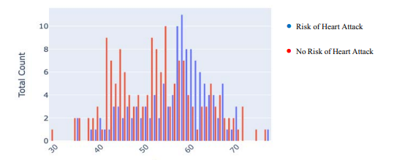
Fig. 1 Age (Shows the Risk of Heart Attack on the basis of their age)
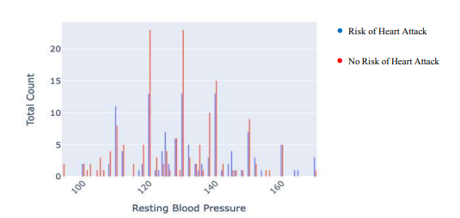
Fig. 2 Shows the Risk of Heart Attack on the basis of their Resting Blood Pressure.

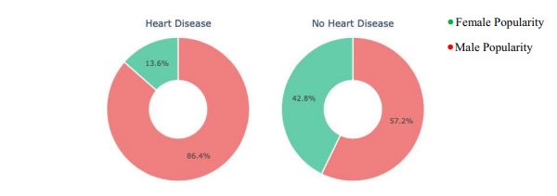
Fig. 3 Shows the patients having or not having Heart Disease on the basis of Sex
Senthilkumar et al. (2019), “Effective Heart Disease Prediction Using Hybrid Machine Learning Techniques” proposed by him was efficient technique using hybrid machine learning methodology. The hybrid approach is combination of random forest and linear method. The dataset and subsets of attributes were collected for prediction. The subset of some attributes were chosen from the pre-processed knowledge(data) set of cardiovascular disease .After prep-processing , the hybrid techniques were applied and disgnosis the cardiovascular disease.
Effective Heart Disease Prediction Using Hybrid Machine Learning Techniques. The paper introduces the HRFLM method, a Hybrid Random Forest with Linear Model, aiming to enhance heart disease prediction accuracy. Utilizing the Cleveland dataset, HRFLM combines features of Random Forest and Linear Model, outperforming existing methods with higher accuracy and lower classification errors. The study emphasizes HRFLM's potential, discusses related works, experimental setups, dataset evaluations, and proposes further research for real-world datasets and improved feature selection methods. Overall, the paper offers a comprehensive overview of HRFLM's efficacy in predicting heart disease, highlighting its potential for improved accuracy in machine learning-based predictions.
Mamatha A. et al., (2019) designed “Prediction and Diagnosis of Heart Disease Patients using Data Mining Technique”. This paper uses techniques of Artificial Neural Network, KNN, Random Forest and Support Vector Machine. Comparing with the above mentioned classification techniques in data mining to predict the higher accuracy for diagnosing the heart disease is Artificial Neural Network.
Bo Jin, et al. (2018) proposed a “Predicting the Risk of Heart Failure with EHR Sequential Data Modeling” model designed by applying neural network. This paper used the electronic health record (EHR) data from real-world datasets related to congestive heart disease to perform the experiment and predict the heart disease before itself. We tend to used one-hot encryption and word vectors to model the diagnosing events and foretold coronary failure events victimization the essential principles of an extended memory network model. By analyzing the results, we tend to reveal the importance of respecting the sequential nature of clinical records.
Aakash et al., (2018) presented “Heart Disease Prediction using Evolutionary Rule Learning”. This study eliminates the manual task that additionally helps in extracting the information (data) directly from the electronic records. To generate strong association rules, we have applied frequent pattern growth association mining on patient’s dataset. This will facilitate (help) in decreasing the amount of services and shown that overwhelming majority of the rules helps within the best prediction of coronary sickness.
Ashir J. et al. (2017) designed “An Intelligent Learning System based on Random Search Algorithm and Optimized Random Forest Model for Improved Heart Disease Detection”. This paper uses random search algorithm (RSA) for factor selection and random forest model for diagnosing the cardiovascular disease. This model is principally optimized for using grid search algorithmic program. Two forms of experiments are used for cardiovascular disease prediction. In the first form, only random forest model is developed and within the second experiment the proposed Random Search Algorithm based random forest model is developed. This methodology is efficient and less complex than conventional random forest model. Comparing to conventional random forest it produces 3.3% higher accuracy. The proposed learning system can help the physicians to improve the quality of heart failure detection.
Prasanna L. et al., (2015) designed “Fast Rule-Based Heart Disease Prediction using Associative Classification Mining”. In the proposed Stream Associative Classification Heart Disease Prediction (SACHDP), we used associative classification mining over landmark window of data streams. This paper contains two phases: one is generating rules from associative classification mining and next one is pruning the rules using chi-square testing and arranging the rules in an order to form a classifier. Using these phase to predict the heart disease easily.
Satish, et al. (2015) used different Data Mining techniques like Rule based, Decision Tree, Navie Bayes, and Artifical Neural Network. An efficient approach called pruning classification association rule (PCAR) was used to generate association rules from cardiovascular disease warehouse for prediction of Heart Disease. Heart attack data warehouse was used for pre-processing for mining. All the above discussed data mining technique were described.
Lokanath et al., (2015) “An Intelligent Decision Support System for Cardiac Disease Detection”, designed a cost efficient model by using genetic algorithm optimizer technique. The weights were optimized and fed as an input to the given network. The accuracy achieved was 90% by using the hybrid technique of GA and neural networks.
Boshra and Shirvani (2015), “Prediction and Diagnosis of Heart Disease by Data Mining Techniques”. This paper uses various classification methodology for diagnosing cardiovascular disease. Classifiers like KNN, SVO classifier and Decision Tree are used to divide the datasets. Once the classification and performance evaluation the Decision tree is examined as the best one for cardiovascular disease prediction from the dataset.
Devi and Anto (2014) conducted a study to diagnose coronary artery disease by designing a fuzzy expert system. A smart health system has been proposed for heart disease prediction using deep learning and fusion approaches. Fuzzy logic, which is a control system, is in the form of range to point or range to interval.
Kumar and Kaur (2013) created a fuzzy model for heart disease risk prediction using the Mamdani inference method.
Rustempasic and Can (2013) tried to diagnose Parkinson's disease using the fuzzy C-mean clustering method and pattern recognition method.
Samuel, et al., (2013) conducted a study diagnosing typhoid fever using fuzzy logic. Heart Disease Prediction using Machine Learning and Data Mining, the paper introduces a unique approach to heart disease prediction using machine learning and data mining techniques. Leveraging the Cleveland Heart Disease dataset, the study employs algorithms like K-Nearest Neighbors, Decision Trees, Naïve Bayes, Random Forest, and Support Vector Machines, achieving an 87% accuracy with the K-Nearest Neighbors algorithm. Notably, the authors develop a user-friendly web app using Flask in Python, enabling users to input attributes for heart disease prediction. The paper provides a thorough review of related work, dataset details, experimental outcomes, and discussions, showcasing the potential of these techniques in predicting heart disease and offering valuable insights for future research in the field.
Bhuvaneswari et al., (2012) use the Naive Bayes classifier for medical use. The authors used two well-known algorithms, the Back Propagation Neural Network (BNN) and the Nave Bayesian (NB) data mining classification, to study the previous experience and to calculate the probability of an object among all objects. Bayesian techniques have been developed for probability concepts. The previous backend is computed by bay rules based on the exact nature of the probability model, and the Naive Bayes classifier is used to study very efficiently in the supervised learning environment.
Lee and Wang (2011) conducted a study on diabetes using fuzzy expert system.
Apart from these studies, many studies have been conducted in the literature as a result of the increase in mortality rates due to heart diseases. Different techniques were used in these studies.
Adeli and Neshat (2010) designed a fuzzy system with 13 inputs and conducted a study to reveal heart disease, and as a result of this study, they reached 94% accuracy. Diagnosis and prediction of Heart Disease and Blood Pressure along with other attributes using the aid of neural networks was introduced by R. Subramanian et al. A deep Neural Network was built incorporating the given attributes related to the disease which were able to produce a output which was carried out by the output perceptron and almost included 120 hidden layers which is the basic and most relevant technique of ensuring a accurate result of having heart disease if we use the model for Test Dataset. The supervised network has been advised for diagnosis of heart diseases. When the testing of the model was done by a doctor using an unfamiliar data, the model used and trained from the previous learned data and predicted the result thereby calculating the accuracy of the given model.
Hongmei (2006), developed a multiplayer perceptron-based decision support system to support the diagnosis of heart disease. This system is well designed as an input layer of the system with 40 input variables and is categorized into four groups and then encoded using the proposed coding scheme,
Jianyong (2004), this study aimed to solve the problem of multi - class classification using binary classifiers. The binary classification tree design is done in such a way that the class group is divided into two different subgroups from one node. The node adopts the class module method to improve the binary classification ability. Partitioning is formulated as an optimization problem, and genetic algorithms are proposed to solve optimization problems. Heart murmurs were an important problem in pediatric cardiovascular disease, and this group had a high incidence of cardiac noise (77- 95% as reported), resulting in little congestion due to congenital heart disease.
Carlos Ordonez (2002), studied the prediction of heart disease with the help of association rules. They used a simple mapping algorithm. This algorithm treats attributes as numeric or categorical. It is used to convert medical records into transaction formats. Enhanced algorithms are used to minify restricted association rules. The mapping table is prepared and the attribute value is mapped to the item. Decision trees are used for data mining because they automatically divide numeric values. Split points selected in the decision tree are rarely used. Clustering is used to gain an overall understanding of the data.
Deepika (2001) studied Pruning-Classification Association Rule (PCAR) to extract association rules. PCAR based on analysis of Apriori algorithm. PCAR covers a set of minimum frequency entries, which Removes irregular items from a set of items. It then sorts the set of items based on the frequency of the set of items and finds a frequent set of items. Ordonez uses association rules in data mining to obtain better heart disease prediction results. The authors studied the limitations of association rules that mined the entire data set without verification of independent samples. We introduced algorithms that modified the search constraints to reduce the number of association rules and validated them using train and test approaches. They have studied two complementary tasks: predicting absence and predicting the presence of heart disease.
Akhita D. et al., (2000) propose a new algorithm that combines KNN and Genetic Algorithm for efficient classification. Optimal Solution Perform a global search for complex large and multiple modal data sets to provide genetic algorithms. It is also observed from the results that hybridization with KNN is well performed and provides great accuracy. Then proposed an efficient genetic algorithm mix using back propagation for cardiac disease prediction. They concluded that neural networks are the best of all classification techniques for nonlinear data. The BP algorithm is the best classifier of the Artificial Neural Network, a common training method. Where the primary system output is compared to the desired output and the system is adjusted until the difference between the two is minimized. However, there is a drawback to being trapped in local minima.
Shadab and Asma (2000) used the Naive Bayesian Classification technique to develop decision support in the heart disease prediction system. The system finds hidden knowledge from past heart disease databases. This is the most effective model for predicting heart disease. The model can respond to complex queries and has its own strength in terms of ease of model interpretation, access to more information and accuracy.

2.3 FUZZY LOGIC
In 1965 Lotfi A., proposed a fuzzy set theory that is more applicable to artificial intelligence, especially, for the problems that have uncertain input values. Fuzzy logic may be a sort of uncertain or many – valued logic. This logic provides approximate solutions instead of accurate because it handles the concept of partial truth where the reality values are often within the range between completely true and completely false.
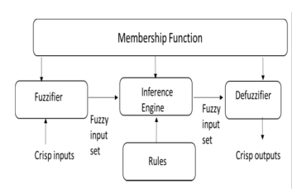
Fig 4. Fuzzy Logic
Fuzzy pure mathematics and symbolic logic are highly suitable for developing knowledge based systems in healthcare for diagnosis of diseases. In the proposed system, the input is that the set of all the chosen features and therefore the output of the system is to realize a worth 0 or 1 that indicates the absence or presence of heart disease in patients. In symbolic logic process, initially fuzzification is performed by collecting the crisp set of input file and converting it to a fuzzy set using fuzzy linguistic variables and membership functions. After that, an inference is formed supported a group of rules and lastly, defuzzification step is performed. This system generates the fuzzy rules supported the support sets obtained.

MEMBERSHIP FUNCTION
Fuzzy membership functions are devised supported the matter to be solved and therefore the fuzzy set chosen for the same. Membership function represents the fuzzy set and provides a measure of the degree of similarity of an entity to a fuzzy set. Most common shapes for design of membership functions are triangular, trapezoidal, linear, Gaussian, bell-shaped etc. Within the proposed work the Gaussian membership function is chosen because it is comprehensible and appropriate to the matter. A membership function for a fuzzy set A on the universe of discourse X is defined as µA: X → [0, 1], where each element of X is mapped to a worth between 0 and 1. This value, called membership value quantifies the grade of membership of the element in X to the fuzzy set A. Membership functions used to represent a fuzzy set graphically. The x axis represents the universe of discourse, whereas the y axis represents the degrees of membership within the [0, 1] interval.
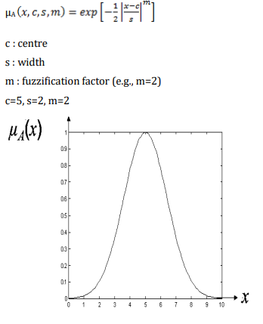
Fig 5. Fuzzy Logic Membership Function

FUZZY INFERENCE SYSTEM
A fuzzy inference system helps in mapping the inputs to the corresponding output using predefined fuzzy rules available within the knowledge domain . The knowledge domain consists of if-then rules that specify the connection between the input and output fuzzy sets. Because it requires the input in fuzzy values, the input is fuzzified and for the user to raised understand the output, the output from the inference system is defuzzified.
The inference system is developed with a series of activities like;
1. Developing the fuzzy rules.
2. Fuzzifying the input values supported the membership function.
3. Combining the fuzzy input and therefore the fuzzy rules to get the rule strength.
4. The rule strength consequence is again combined with the output membership function to generate the output distribution.
5. Finally the output is defuzzified to offer the output in crisp value.

FUZZY CLASSIFICATION
Fuzzy classification may be a supervised learning method where the fuzzy model understands the info with its rules and sophistication label of the training data and predicts the target value for the set of test data. The proposed work uses the stratified 10 fold technique which may be a popular choice for estimating the test error on classification algorithms. It divides the training set into 10 disjoint subsets. Each subset has roughly equal size and also an equivalent class proportions as within the training set. The steps involved within the process are to spot a subset for testing with all the opposite subsets as training subsets. Using the trained model the testing subset is assessed. This process continues for ten times with different training and testing data. Finally the typical accuracy if calculated. The proposed work contains different labels supported the values of the attributes available within the dataset. The fuzzy rules also supported these labels.

DEFUZZIFICATION
Defuzzification is that the process of manufacturing a quantifiable end in symbolic logic , given fuzzy sets and corresponding membership degrees. it's the method that maps a fuzzy set to a crisp set. it's typically needed in fuzzy control systems. the foremost commonly used defuzzification method is that the center of area method (COA), also commonly mentioned because the centroid method. This method determines the middle of area of fuzzy set and returns the corresponding crisp value. Defuzzification methods are used to convert the fuzzy values to their corresponding crisp and understandable values. There are five defuzzification methods . They are centroid, bisector, Smallest Of Maximum (SOM), Middle Of Maximum (MOM) and Largest Of Maximum (LOM).

CHAPTER THREE
RESEARCH METHODOLOGY AND ANALYSIS OF THE STUDY
3.1 RESEARCH METHODOLOGY
This paper uses web based application in predicting patient heart disease using fuzzy logic. The patient is asked up to six (6) questions and the patient will be required to pick among several options based on how he/she feels, the fuzzy logic is now used to predict whether or not the patient is prone to heart attack.
The sample rules of how the fuzzy logic is being used is as follows
Rule 1 : if a1 is 2 and a2 is 1and a3 is 1 and a4 is 2 and a5 is 2 and a6 is 2 and then result is “healthy”.
Rule 2 : if a1 is 2 and a2 is 1and a3 is 4 and a4 is 2 and a5 is 3 and a6 is 2 then result is “Sick”.
Rule 3 : if a1 is 2 and a2 is 1and a3 is 4 and a4 is 1 and a5 is 2 and a6 is 2 then result is “Sick” .
Rule 4 : if a1 is 1 and a2 is 1and a3 is 3 and a4 is 1 and a5 is 2 and a6 is 2 then result is “healthy”.
The logical design is followed by physical design or coding. Physical design produces the working system by defining the design specifications, which tell the programmers exactly what the candidate system must do. The program is written in the sense that it accepts input from the user, perform necessary processing on accepted data through the use of HTML, CSS, BOOTSTRAP and JAVASCRIPT as frontend, PHP (Laravel) as backend and MySQL as the database.

3.2 ANALYSIS OF THE EXISTING SYSTEM
Heart diseases are managed through conventional manual methods. i.e. the patient has to visit the hospital for checkup and this has been impacting negatively as many patient were killed by this deadly diseases out of ignorance (failure to visit clinic). The manual method of managing patient record in hospital is obviously not effective as it is attributed to data redundancy, difficulty in data update and difficulty in data recovery.

3.3 PROBLEM OF THE EXISTING SYSTEM
1. Difficulties in record management
2. Difficulty in tracking heart diseases status
3. The whole exercise is time-consuming and a waste of human and material resources

3.4 ANALYSIS OF THE PROPOSED SYSTEM
The proposed system predict whether or not a patient has heart disease thereby reducing the stress of going to hospital for checkup, reduce the number of sudden death caused by heart diseases and also ease the work of the doctors. The system has a unique approach to tracking information and report generation which is vital in data handling.
This makes the proposed system more robust, more reliable and efficient. Entire gamut of the system comprises of several questions to be answered by the user (patient) as the answers obtained from the user are used to predict using the fuzzy logic technique. The system uses one single central database to handle the complexity of patient health managements. The heart diseases prediction system is user-friendly application package specifically designed to predict, coordinate and look after all the processes of managing heart diseases.

3.5 ADVANTAGE OF THE EXISTING SYSTEM
- Ease tracking of heart diseases.
- Eliminate data redundancy.
- Enable easy tracking of record – assist in drug prediction.
- Time efficient and optimal utilization of resources.

CHAPTER FOUR
DESIGN, IMPLEMENTATION AND DOCUMENTATION OF THE SYSTEM
4.1 DESIGN OF THE SYSTEM
4.1.1 OUTPUT DESIGN
The effectiveness of the proposed system is assessed primarily through its outputs. This phase involves defining detailed specifications and procedures for data presentation and report generation, encompassing all necessary steps to process inputs and produce the intended results. Additionally, clear feedback messages and user guidance mechanisms are incorporated to minimize operational errors.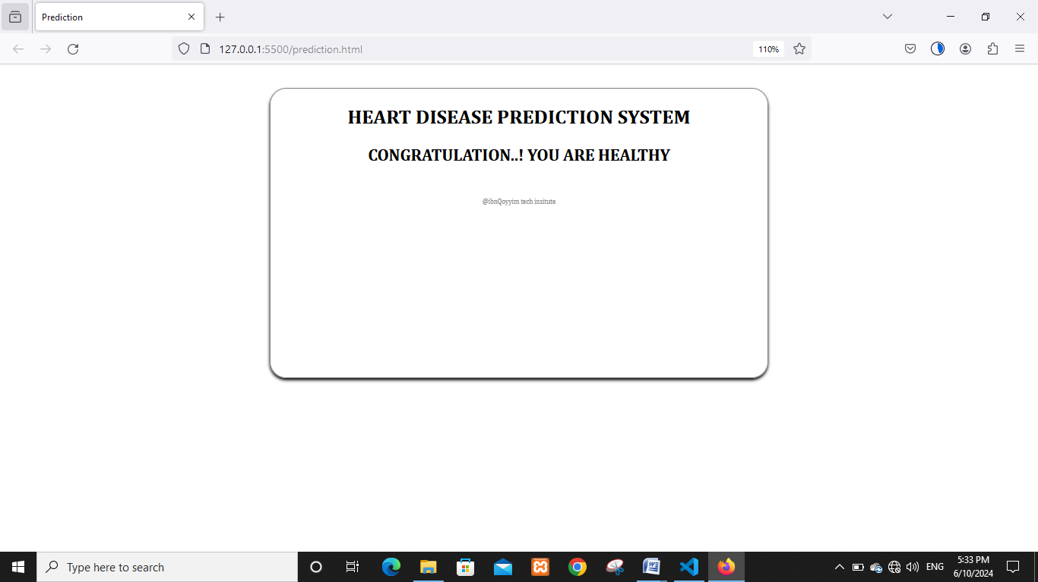
Table 1 Healthy patient (output)

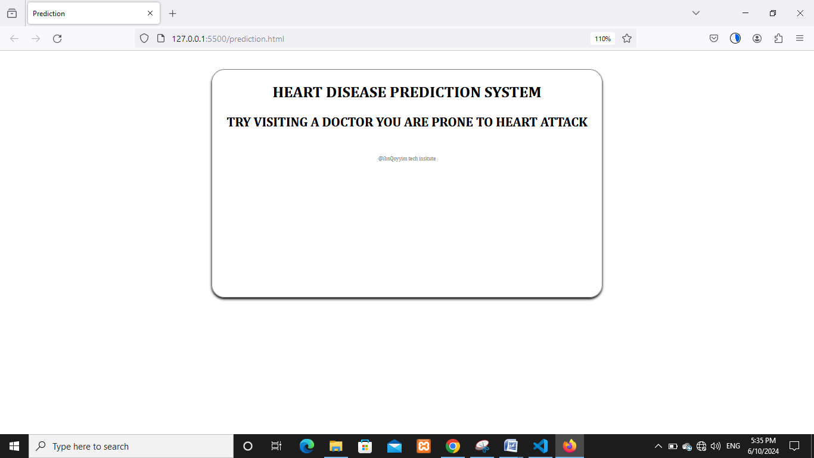

Table 2. Patient who is likely to have heart disease (output)
INPUT DESIGN
The design of input focuses on controlling the amount of input required, detecting errors, avoiding delay, avoiding extra steps and keeping the process simple. The system needs data regarding the asset items, depreciation rates, asset transfer, verification/validation checks, calculation and report generation. The error detection method included in the software helps to raise flag when wrong entry is fed into the system.
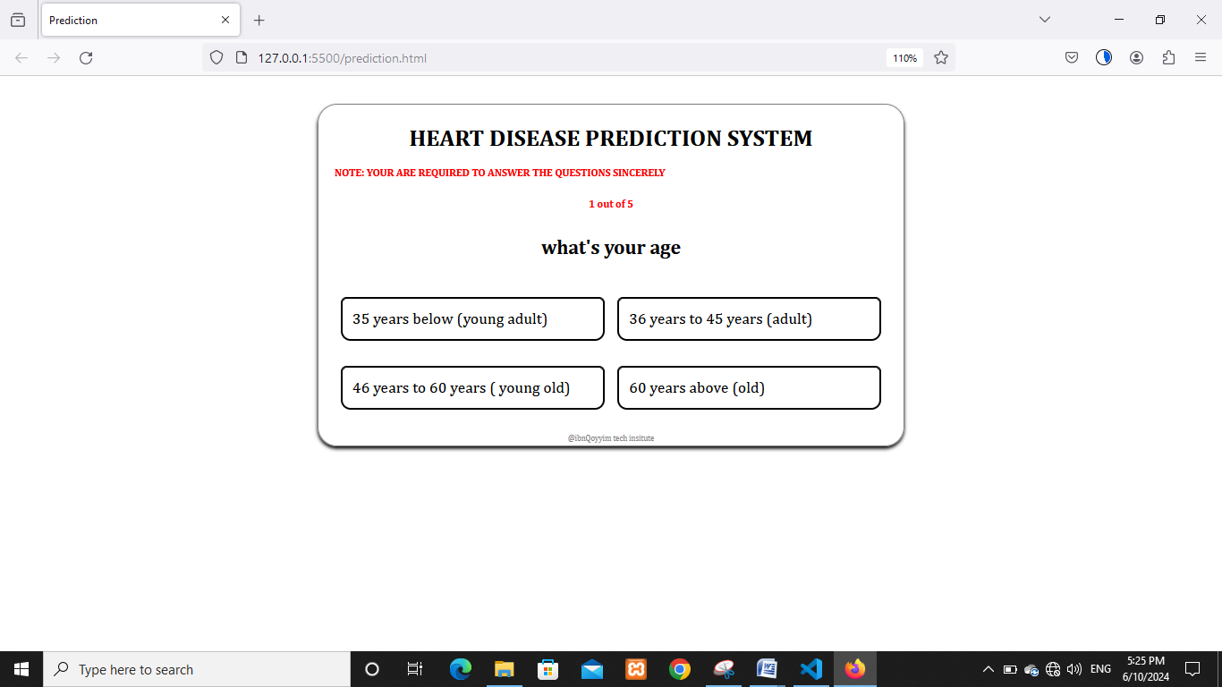
Table 3. Age
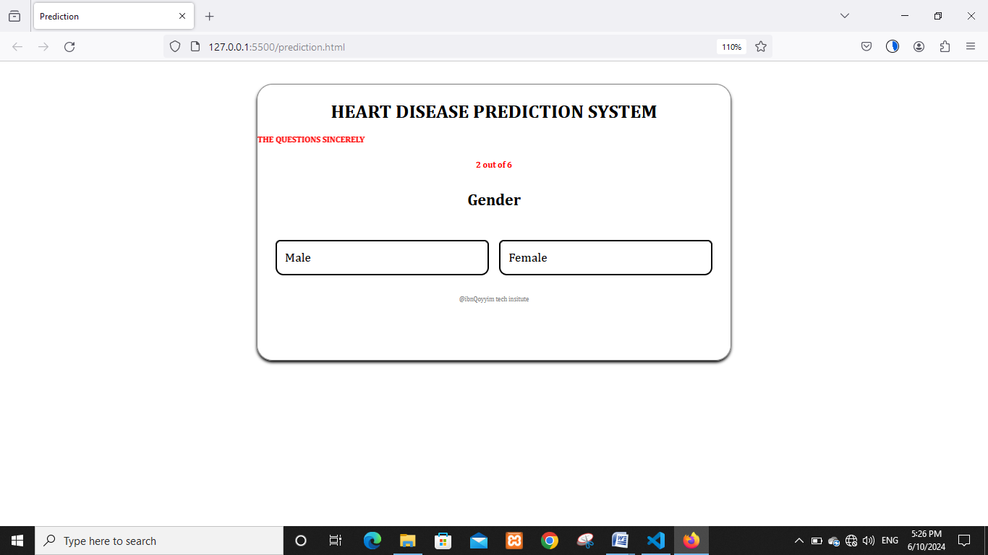
Table 4 Gender

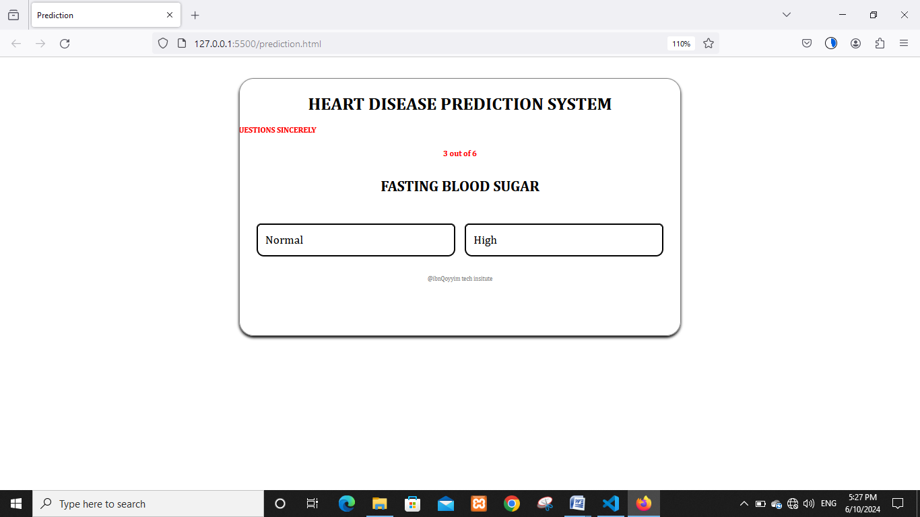
Table 5 Fast Blood Sugar

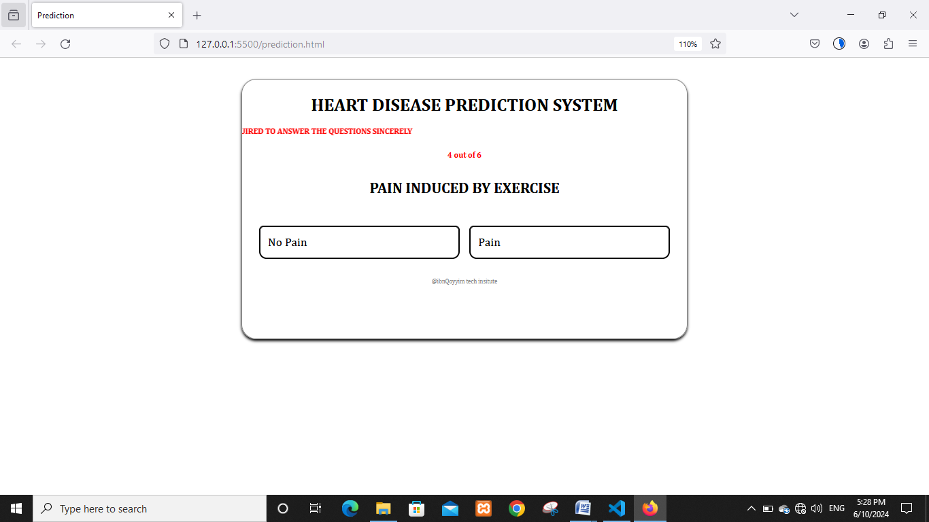
Table 6. Pain induced by exercise
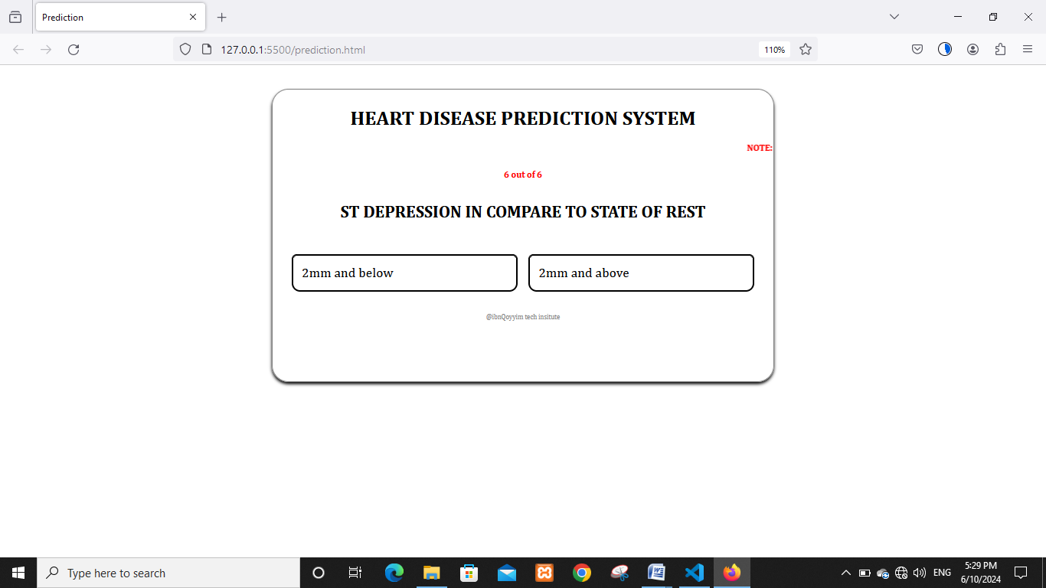
Table 7. ST depression in compare to state of rest

- IMPLEMENTATION OF THE SYSTEM
The implementation process involves converting the system design into a complete and tested EDP that is fully operational and that can be used by the system users to meet their needs. Hardware and software were implemented.
The steps involve are:
- Review design specification
- Code, test and documented programs
- Train users
- Perform system test
- Convert to new system
- Evaluate and maintain the new system.

- CHOICE OF PROGRAMMING LANGUAGE
The application is designed in Visual Studio Code using HTML, Bootstrap, CSS, Javascript as front-end, Laravel (PHP-Framework) as back-end and MYSQL as database. Hence, the program testing simply involves running it directly from chrome, Mozilla.
2. HARDWARE SUPPORT
- Processor – AMD / Intel
- Hard Disk – 500 GB
- Memory – 4GB RAM
- Monitor

- SOFTWARE SUPPORT
- Windows 8 or higher
- Laravel
- Composer
- XAMP/ WAMP
- Web Browser (e.g Chrome)
- DATABASE
- MySQL

DOCUMENTATION OF THE SYSTEM
- Program Documentation

OPERATING THE SYSTEM
Step 1: Boot your computer and click on start button on task bar
Step 2: Locate the browser on your system
Step 3: Enter ‘localhost:8000’
Step 4: Select the appropriate option
Step 5: Wait for your result

- SYSTEM TESTING
The proposed system was tested and results were compared with those results generated by existing systems. The various test performed were: unit test, integration test and user acceptance test.

- USER ACCEPTANCE TESTING
The proposed system was developed to meet user’s acceptance by subjecting the system to various considerations during development.
- UNIT TESTING
This tests the modules and routines that are assembled and integrated to perform a specific function. Unit testing focuses first on modules, independently of one another, to locate errors. This enables a system developer to detect errors in coding and logic that are contained within each module. This testing includes entering data and ascertaining if the value matches to the type and size supported. The various controls are tested to ensure that each performs its action as required.
- INTEGRATION TESTING
Data can be lost across any interface; one module can have an adverse effect on another. Integration testing is a systematic testing to discover errors associated within the interface. The objective is to take unit tested modules and build a program structure. All the modules are combined and tested as a whole. During this phase, we integrated and tested the Server module and Client module options.

- SECURITY AND MAINTENANCE OF THE SYSTEM
Maintenance means restoring something to its original condition. Maintenance follows conversion to the extent that changes are necessary to maintain satisfactory operations relative to changes in the user’s environment. Maintenance often includes minor enhancements or corrections to problems that surface in the system’s operation. Maintenance is also done by fixing the problems reported, changing the interface with other software or hardware, thus enhancing the software. Any system developed should be secured and protected against possible hazards.
Security measures are provided to prevent unauthorized access of the database at various levels. An uninterrupted power supply should be available so that the power failure or voltage fluctuations will not erase the data in the files. Password protection and simple procedures to prevent the unauthorized access are provided to the users. The system allows the user to enter the system only through appropriate user name and password.
CHAPTER FIVE
SUMMARY, CONCLUSION AND RECOMMENDATION
5.1 SUMMARY
This project focused on the development of an intelligent heart disease prediction system utilizing fuzzy logic to address the challenges of imprecise and uncertain medical data in diagnostic processes. Given the global burden of heart disease and the limitations of conventional diagnostic tools, there is a pressing need for intelligent systems that support early detection and informed clinical decision-making.
A Mamdani-type fuzzy inference system was designed using MATLAB, incorporating key clinical parameters such as age, blood pressure, cholesterol level, and chest pain type. The model translates these inputs into linguistic variables and applies a rule-based approach to assess the likelihood of heart disease, categorizing risk levels as low, moderate, or high.
The system demonstrated reliable performance and interpretability, offering a user-friendly decision support tool that aligns with clinical reasoning. It holds significant potential for integration into healthcare applications, especially in environments where medical expertise is limited. The project concludes that fuzzy logic provides an effective, transparent, and adaptable framework for the early prediction of heart disease and recommends further enhancements through hybrid models and real-world validation.
5.2 CONCLUSION
Heart disease remains one of the leading causes of death globally, making early detection and accurate diagnosis a top priority in modern healthcare. This project has presented the development of an intelligent heart disease prediction system using fuzzy logic, with the aim of improving diagnostic accuracy and addressing the limitations of conventional approaches that struggle with uncertain and imprecise medical data.
By leveraging a Mamdani-type fuzzy inference system and incorporating key clinical parameters such as age, blood pressure, cholesterol level, and chest pain type, the proposed model effectively simulates expert reasoning. The fuzzy logic approach not only enhances interpretability but also enables the system to handle ambiguous patient inputs that are common in real-world medical scenarios.
Experimental evaluations demonstrate that the system provides reliable and clinically relevant predictions, classifying patients into low, moderate, or high risk of heart disease. As such, the model offers valuable decision support for healthcare professionals and can serve as a useful tool in both clinical and remote care environments.
Future enhancements may include integrating real-time data sources, expanding the dataset, and combining fuzzy logic with machine learning algorithms to further improve performance and adaptability.

5.3 RECOMMENDATIONS
In the future, it is expected that studies will be carried out on different diseases using fuzzy logic method. In line with these studies, fuzzy logic will be of vital importance by increasing efficiency in health services and will become a powerful tool
The following recommendations are offered based on the findings of the study
Based on the findings and outcomes of this study, the following recommendations are proposed:
- Integration with Electronic Health Records (EHR):
The fuzzy logic-based prediction system should be integrated with electronic health record systems to facilitate seamless access to patient data and improve the efficiency of diagnosis and monitoring.
- Expansion of Input Parameters:
Future models should incorporate additional clinical and lifestyle-related parameters—such as physical activity, dietary habits, genetic history, and medication use—to enhance the accuracy and comprehensiveness of heart disease risk prediction.
- Hybrid System Development:
Combining fuzzy logic with other artificial intelligence techniques, such as neural networks or decision trees, could improve both prediction performance and adaptability in diverse clinical settings.
- Mobile and Remote Access:
To increase accessibility, particularly in underserved or rural areas, the system should be developed as a mobile application or web-based platform that supports real-time patient interaction and telehealth services.
- Clinical Validation and Deployment:
It is recommended that the system be tested in real-world clinical environments and validated by healthcare professionals to assess its practical utility, accuracy, and acceptance among users.
- User Training and Awareness:
Medical personnel and patients should be adequately trained to use the system effectively, ensuring correct interpretation of results and encouraging proactive health management.
REFERENCES
Aakash Chauhan , Aditya Jain , Purushottam Sharma and Vikas Deep, (2018) “Heart Disease Prediction using Evolutionary Rule Learning”, “International Conference on "Computational Intelligence and Communication Technology” (CICT 2018).
Ankita Dewan & Meghna Sharma (2015),” Prediction of Heart Disease Using a Hybrid Technique inData Mining Classification”, 2nd International Conference on Computing for Sustainable Global Development IEEE pp 704-706.
Ashir Javeed, et al , (2017) “An Intelligent Learning System based on Random Search Algorithm and Optimized Random Forest Model for Improved Heart Disease Detection” , IEEE Access .
Boshra Bahrami & Mirsaeid Hosseini, (2015) “Prediction and Diagnosis of Heart Disease by Data Mining Techniques”, Journal of Multidisciplinary Engineering Science and Technology (JMEST) ISSN: 3159-0040 Vol. 2 Issue 2, February–2015
Bo Jin ,Chao Che, Zhen Liu, Shulong Zhang, Xiaomeng Yin, And Xiaopeng Wei, (2018) “Predicting the Risk of Heart Failure With EHR Sequential Data Modeling” ,IEEE Access.
Carlos Ordonez, Edward Omincenski and Levien de Braal (2001),“Mining Constraint Association Rules to Predict Heart Disease”, Proceeding of 2001, IEEE International Conference of Data Mining, IEEE Computer Society, ISBN-0-7695-1119-8, 2001, pp: 433- 440
Chaitrali S Dangare & Sulabha S Apte. (2012)” Improved study of heart disease prediction system using data mining classification techniques”, International Journal of Computer Applications, 47(10):44–48.
Deepika. N, (2011) “Association Rule for Classification of Heart Attack patients ”, IJAEST, Vol 11(2), pp 253-257,
K.Prasanna Lakshmi, Dr. C.R.K.Reddy, (2015 ) “Fast Rule-Based Heart Disease Prediction using Associative Classification Mining”, IEEE International Conference on Computer, Communication and Control (IC4-2015).
Lokanath Sarangi, Mihir Narayan Mohanty & Srikanta Pattnaik, (2015 ) “An Intelligent Decision Support System for Cardiac Disease Detection”, IJCTA, International Press.
M.Satish, D Sridhar, (2015) “Prediction of Heart Disease in Data Mining Technique”, International Journal of Computer Trends & Technology (IJCTT).
M Akhil Jabbar, BL Deekshatulu & Priti Chandra, (2013)” Heart disease classification using nearest neighbor classifier with feature subset selection”, Anale. Seria Informatica, 11.
R. Bhuvaneswari and K. Kalaiselvi, (Jan 2012) “Naïve Bayesian Classification Approach in Healthcare Applications”, International Journal of computer Science and Telecommunication”, vol. 3, no. 1, pp. 106-112.
R. Alizadehsani, et al. (2012), "Diagnosis of coronary arteries stenosis using data mining," J Med Signals Sens, vol. 2, pp. 153-9,.
R. Setthukkarase & Kannan, (2012) “An Intelligent System for mining Temporal rules in Clinical database using Fuzzy neural network”,European Journal of Scientific Research, ISSN 1450-216, Vol 70(3), pp 386-395,.
Shadab Adam Pattekari and Asma Parveen, (2012)” PREDICTION SYSTEM FOR HEART DISEASE USING NAIVE BAYES”, International Journal of Advanced Computer and Mathematical Sciences ISSN 2230-9624, Vol 3, Issue 3, pp 290-294.
Senthilkumar Mohan, Chandrasegar Thirumalai, and Gautam Srivastava, (2019) “Effective Heart Disease Prediction Using Hybrid Machine Learning Techniques”, IEEE Access.
Usha. K Dr, (2011) “Analysis of Heart Disease Dataset using neural network approach”, IJDKP, Vol 1(5), Sep.
Harshit, S., Sumit, K., & Vinay, G. (2021). Analysis of machine learning algorithms for heart disease prediction. International Journal of Advanced Research in Computer Science, 12(2), 1–8.
Lu, Y., Wang, F., & Huang, J. (2015). Fuzzy logic-based diagnostic system for heart disease prediction. Journal of Medical Systems, 39(3), 20–29. https://doi.org/10.1007/s10916-015-0200-9
Senthilkumar, K., Gnanaprakasam, C., & Balaji, S. (2019). Diagnosis of heart disease using fuzzy logic inference system. International Journal of Scientific & Technology Research, 8(10), 1830–1834.

Appendix
Source code
<!DOCTYPE html>
<html lang="en">
<head>
<meta charset="UTF-8" />
<meta name="viewport" content="width=device-width, initial-scale=1.0"/>
<title>Heart Disease Predictor</title>
<link rel="stylesheet" href="style.css"/>
</head>
<body>
<div class="container">
<h1>Heart Disease Risk Predictor</h1>
<form id="heartForm">
<label>Age: <input type="number" id="age" required /></label>
<label>Blood Pressure (mmHg): <input type="number" id="bp" required /></label>
<label>Cholesterol (mg/dL): <input type="number" id="cholesterol" required /></label>
<label>Chest Pain (1-4):
<select id="cp" required>
<option value="1">Typical Angina</option>
<option value="2">Atypical Angina</option>
<option value="3">Non-anginal Pain</option>
<option value="4">Asymptomatic</option>
</select>
</label>
<label>Resting ECG (0-2):
<select id="ecg" required>
<option value="0">Normal</option>
<option value="1">Abnormal</option>
<option value="2">Probable/Definite</option>
</select>
</label>
<button type="submit">Predict Risk</button>
</form>
<div id="result"></div>
</div>

<script src="script.js"></script>
</body>
</html>
🎨 style.css
css
Copy
Edit
body {
font-family: Arial, sans-serif;
background: #f1f1f1;
padding: 20px;
}

.container {
max-width: 500px;
background: #fff;
padding: 25px;
margin: 0 auto;
border-radius: 10px;
box-shadow: 0 0 10px #ccc;
}

h1 {
text-align: center;
margin-bottom: 20px;
color: #333;
}

form label {
display: block;
margin-bottom: 10px;
}

input, select {
width: 100%;
padding: 8px;
margin-top: 5px;
}

button {
width: 100%;
padding: 10px;
background: #007bff;
border: none;
color: white;
font-size: 16px;
border-radius: 5px;
margin-top: 15px;
cursor: pointer;
}

button:hover {
background: #0056b3;
}

#result {
margin-top: 20px;
font-weight: bold;
text-align: center;
}
🧠 script.js
javascript
Copy
Edit
document.getElementById("heartForm").addEventListener("submit", function (e) {
e.preventDefault();

const age = parseInt(document.getElementById("age").value);
const bp = parseInt(document.getElementById("bp").value);
const cholesterol = parseInt(document.getElementById("cholesterol").value);
const cp = parseInt(document.getElementById("cp").value);
const ecg = parseInt(document.getElementById("ecg").value);

let riskScore = 0;

// Simple fuzzy-style scoring logic
if (age > 50) riskScore += 2;
if (bp > 140) riskScore += 2;
if (cholesterol > 240) riskScore += 2;
if (cp === 4) riskScore += 2; // asymptomatic chest pain
if (ecg > 0) riskScore += 1;

let riskLevel = "";

if (riskScore >= 6) {
riskLevel = "High Risk";
} else if (riskScore >= 3) {
riskLevel = "Moderate Risk";
} else {
riskLevel = "Low Risk";
}

document.getElementById("result").innerText = `Predicted Heart Disease Risk: ${riskLevel}`;
});

FLOWCHART
---------------------------+
| Start Application |
+------------+-------------+
|
v
+----------------------------+
| User fills form fields: |
| - Age |
| - Blood Pressure |
| - Cholesterol |
| - Chest Pain Type |
| - ECG Result |
+------------+-------------+
|
v
+----------------------------+
| User clicks "Predict" |
+------------+-------------+
|
v
+----------------------------+
| Read input values |
+------------+-------------+
|
v
+----------------------------+
| Initialize riskScore = 0 |
+------------+-------------+
|
v
+----------------------------+
| Evaluate Rules (if/else): |
| - Age > 50 → +2 |
| - BP > 140 → +2 |
| - Cholesterol >240 → +2 |
| - Chest Pain = 4 → +2 |
| - ECG > 0 → +1 |
+------------+-------------+
|
v
+----------------------------+
| Calculate riskLevel: |
| - Score ≥ 6 → High Risk |
| - Score ≥ 3 → Moderate |
| - Score < 3 → Low Risk |
+------------+-------------+
|
v
+----------------------------+
| Display Result to User |
| "Predicted Heart Disease |
| Risk: [RiskLevel]" |
+------------+-------------+
|
v
+----------------------------+
| End |
+----------------------------+

