LAND INFORMATION SYSTEM
(A CASE STUDY OF PART OF ASA-DAM COMMUNITY AREA, ILORIN WEST LOCAL GOVERNMENT, KWARA STATE.) (LAND USEAGE)

PRESENTED BY
ODEYEMI IKEOLUWA ADURAGBEMI
MATRIC NUMBER: HND/23/SGI/FT/0014

TO

THE DEPARTMENT OF SURVEY AND GEOINFORMATIC,
INSTITUTE OF ENVIROMENTAL STUDIES,
KWARA STATE POLYTECHNIC, ILORIN

IN PARTIAL FULFILMENT OF THE REQUIREMENTS FOR AWARD OF HIGHE NATIONA DIPLOMA IN SURVEYING AND GEOINFORMATICS.

JUNE, 2025.

CERTIFICATE
I Odeyemi Ikeoluwa Aduragbemi, with the Matriculation number HND/23/SGI/FT/0014 hereby certify that all the information given in this project work was carried out in accordance with the survey Laws, Regulations and departmental instructions. To be submit to the Department of Surveying and Geoinformatics, Institute of Environmental Studies, Kwara State Polytechnic, Ilorin. In partial fulfilment of the requirements for award of Higher National Diploma in Surveying and Geoinformatics.

Candidate’s Name: Odeyemi Ikeoluwa Aduragbemi,
Matric No: HND/23/SGI/FT/0014
Signature ............................................... and Date:…………………………...

CERTIFICATION

Surv. R. O. Asonibare ……………………………
Supervisor Signature & Date

Surv. R. S. Awoleye …………………………..
Project Coordinator Signature & Date

Surv. I. I. Abimbola ……………………………
Head of Surveying & Geoinformatics Department Signature & Date

DEDICATION
This project work is dedicated to Almighty God for His infinite mercy and protections over my life and my families.

ACKNOWLEDGEMENT
Glory, Honour, and adoration to the Almighty God, the creator of heaven and earth, the alpha and the omega, the one who is and the one who is to come. All Glory be to his name for his faithfulness upon my life throughout the period of the program starting from ND1, SIWES PERIOD, I T PERIOD, HND 1 & HND II UP till this moment
And to my Amiable H.O.D in the person of Surv. I.T Abimbola and my supervisor in the person of Surv. R.O Asonibare, for his professional supervision, may God continue to bless you and your family.(AMEN
My profound gratitude to my amiable parent Mr. & Mrs. Odeyemi for their effort since the day I was born till this moment. Word only cannot show how much I appreciate you and I pray the lord Almighty will continue to bless you, you will live to eat the fruit of your labour in Jesus name (AMEN).
I cannot but appreciate the love of my life, the shoulder I lean on. I say thank you for you for your support since day one till this moment. I pray the Lord Almighty will continue to enrich your pocket. (Amen).
I also appreciate the entire staff of the department of surveying and Geo- informatics most especially Surv. Kabir thank you, God bless you all.
And also to my friends and project group member greater height in Jesus name (Amen).
To the best crew (Christian, Tawa), thank you for all you do, I love you all. Greater height to us all, we will meet in higher places in Jesus name. (Amen)

ABSTRACT
The need for information , which is the best necessity for carrying out any planning development and management activity can hardly be over emphasized with regard to the need for having a reliable information base is even more important. The absence of the proper land records in the real market is another difficulty being faced by many developing countries. The reason may be unclear delimitation on individual or group rights , insecure ownerships e.t.c the necessity for a functioning land market opens the way not only other means of ensuring that land market open the way not only other means of ensuring that land is available nor dwelling and other urban needs. In this way, the development and complementation of county wide digital land information system in area that need urgent attention. It is felt that there is a need to at least initate efforts toward achieving this formidable task in an organized, manner. As land is one of the most fundamental of resources , with the above background , this project high lights all the information on land such as road, building s, street light ,electric poles, drainage, the creation of land information system of Asa Dam Community Area of Ilorin. All plans were produce in accordance to the survey rules and regulations.

TABLE OF CONTENT
Title page i
Certificate ii
Certification iii
Dedication iv
Acknowledgement v
Abstract vi
Table of content vii
List of tables xi
List of figures

CHAPTER ONE
INTRODUCTION 1
1.1 Statement of the problem 3
1.2 Aim of the project 5
1.3 Object of the Project 5
1.4 Scope of the Project 5
1.5 Study Area 6
1.6 Personnel 7

CHAPTER TWO
2.0 Literature review 8
CHAPTER THREE
3.0 Methodology 14
3.1 Reconnaissance 14
3.2.1 Office reconnaissance 14
3.2.2 Field Reconnaissance 14
3.3.1 Equipment Used
14
3.3.2 Hardware Requirement 14
3.3.3 Software requirements 15
3.4 Control check 16
3.5.1 Data source 16
3.5.2 Primary source 16
3.5.3 Secondary Source 16
3.6.1 Geometric Data Acquisition 16
3.6.2 Perimeter 16
3.6.3 Detailing 16
3.6.4 Attribute / Social Survey 16
3.7.1 Database Creation / Implement 16
3.7.2 Database Management System (DBMS) 17
3.7.3 Data Quality 17
3.7.4 Data Integrity 17
3.7.5 Data Security 17
3.8.1 Data processing 18
3.8.2 Drafting and plotting 18
3.8.3 Database Creation Procedures 18

CHAPTER FOUR
4.0 Spartial Analysis, Data Processing and Presentation 20
4.1 Spatial Analysis 20 4.2 Testing of Database 20
4.3.1 Queries
4.3.2 Spartial Query 20
4.4 Single Criterion Query 20
4.5 Multiple Criterial Query 24
4.6 Result Analysis 31
4.7 Application Of product 32
4.8 Spartial Search 32
4.9 Spartial Dependence 32

CHAPTER FIVE
5.0 Costing, Summary, Problem Encountered, Conclusion and Recommendation 38
5.1 Costing 40
5.2 Summary 40
5,3 Problem Encountered 40
5.4 Conclusion 40
5.5 Recommendation 41
References 42
Appendices

CHAPTER ONE
1.0 INTRODUCTION
Information management is critical for sound decision making in every facet of life. Harrison, as cited by Obongo (2003), opined that information is the lifeblood which flows into and out of an organization. The success of any enterprise or organization to a large extent depends on the accuracy and timing of the information supplied and its effective use. The Ministry of Lands, Survey and Town Planning especially in Anambra State, Nigeria, being the custodian of the state land wealth, should effectively tap the potentials of communication and information technology to improve on its service delivery, revenue collection and physical land use planning.
Land information system (LIS) is defined as the combination of human and technical resources, together with a set of organizing procedures that produce information on land in support of a broad range of managerial requirements. According to UN-ECE (2005) “Land Information System (LIS) is defined as a tool for legal, administration and economic decision making and an aid for planning and development which consists of one hand a database containing spatially reference lad related data for a defined area, and on the other hand procedures and techniques for the systematic collection, updating, processing and distribution of data. The base of a land information system is a uniform spatial referencing system for the data in the system which also facilitates the linking of data and with the system with other land related data”.
A Land Information System for state administration on land is expected to consist of the following components, Geo-spatial data Software and programs Hardware system (data server, workstation, computers, scanners, printers, plotters, computer network: LAN, WAN, UPS etc.) The operators (surveyors, land officers etc.) The integrated approaches and methods
These are diverse essence of Land Information System. Map-based Land Information Systems deliver real benefits of a range of organizations.
Land owners including estate managers, agribusiness cooperatives and government authorities. Local and central government requiring accurate land and building use inventories.
A Land Information Management System (LIMS) is essentially a computerized tool for legal, administrative and economic decision making for land use planning and development. It consists of a structured database with spatial referenced land related attributes and spatial data for a defined area as well as procedures and techniques for systematic collection, processing, updating and distribution of the data to aid in solving land management problems (Pindiga, A. and Orisakwe, K., 2013). Currently, the world has more or less become a global village and information on a particular phenomenon at one part of the globe may be required by someone at another part, at any point in time. The need for land information computerization and land titling procedure automation is more crucial now than ever before. A functional land information management system should not only ensure that all data relating to land are consistent, correct and up-to-date but should also avail different users their required information without necessarily engaging in generation of new datasets. This entails the availability of land information to government, industry, business, academia and citizens to meet their needs through easy and simple access solutions (Akingbade, 2005). In many countries, improvements to the existing land administration systems are driven by developments in technology. Land and property datasets grow larger in volume as population expands. Consequently, the need for a reliable means of storage and easy retrieval of land information in support of development becomes critical and ever more urgent. Both the administrators and users of land information need accurate and up-to-date data (Dale & McLaughlin, 1999). Additionally, information technology is dynamic; new ideas and inventions are released almost on a daily basis and this should equally reflect in the land information management system. In 2007, Anambra State Government of Nigeria developed and started the use of the Land Information Management System (commonly referred to as ALIMS) hoping to reduce corruption, delays in title registration and enhanced internal revenue generation from state land management. However, challenges of the state land management are still prevalent despite the system which has remained the same. Similar stories are obtained in different states of the federation. A scale up of the existing system may reasonably solve our problem. A holistic land information management system that captures the needs of all relevant stakeholders is expedient. 110 Article DOI: 10

1.1 STATEMENT OF THE PROBLEM
As the population of the world is increasing, the analogue method of map production and management has been in use over the years with its associated errors and limitation. More organization and institution are now clamoring for modernization in techniques for keeping and updating information relating to land.
This gives room for vital information about improper holding of data, encroachment, uneven distribution of basic facilities and method of operating such record is expensive, stressful, huge human effort required and time consuming. In order to facilitate its update with modern and necessary information, there is need for information system that will help in managing and achieving this aim, which is Land Information System (LIS).
Land Management System and allocation is confronted with a herd of problem with the use of analogue information recording of data. Hence the need to use the automation of spatial information record of the study area in order to solve such problem such as:
- Ambiguity in land description and allocation Difficulties faced by tax accessories in evaluating real properties since the real sizes and dimensions of properties are known.
- Slowness, inefficiency and obsolescence of the analogue (manual) system of record keeping with all other problem associated with it such as exposure of records files to fire, water and even theft.
- Difficulties encountered in retrieving ad updating information in an analogue database system.
To meet these challenges, there is need for the creating ad information system for these geographical entities. In view of the foregoing, there is a pressing need to create an avenue for the automation of spatial information record of Asa-Dam community area and implementation of Land Information System (LIS) which will serves as Spatial Decision Support System (SDSS) for efficient planning, allocations of amenities and proper development generally.

1.2 AIM OF THE PROJECT
The aim of the project is to produce a Digital Land Information System (LIS) of part of Asa-Dam Community Area , Ilorin West Local Government Area, Kwara State.

1.3 OBJECTIVES OF THE PROJECT
In order to attain to the aforementioned aim, the following objectives were precisely followed.
- Design and production of a standard Land Information System (LIS) database by integrating the two data sets.
- To produce an up-to-date Map of land use land cover covering the study area.
- Information presentation both in alphanumeric and graphic format in soft copy & hard copy.
- Comprehensive report of all the phases and facets of the project work.

1.4 SCOPES OF THE PROJECT
- The project scope consists of the followings:
- Reconnaissance (office and field)
- Station selection
- Data acquisition
- Perimeter traversing and Details
- Data processing and Data analysis
- Presentation (soft and hard copy)
- Report writing and printing

1.5. STUDY AREA
The project location covered the Agaka Filling Station toward the Egbejila Axis and returned back to the Asa-dam road, included the Lare Shittu Motor Company at Asa-Dam Community Area, Ilorin west local government area, Kwara State. The project location falls on Zone 31of the universal transverse Mercator (UTM) system between longitude 004° 31' 52.25’’E ; latitude of 008° 27' 11.97’’N to 004° 31' 45.70’’E ; latitude of 008° 27' 23.53’’N to 004° 31' 48.98’’E ; latitude of 008° 27' 23.53’’N and 004° 31' 54.72’’E ; latitude of 008° 27' 19.79’’N in the north central geopolitical zone of Nigeria.
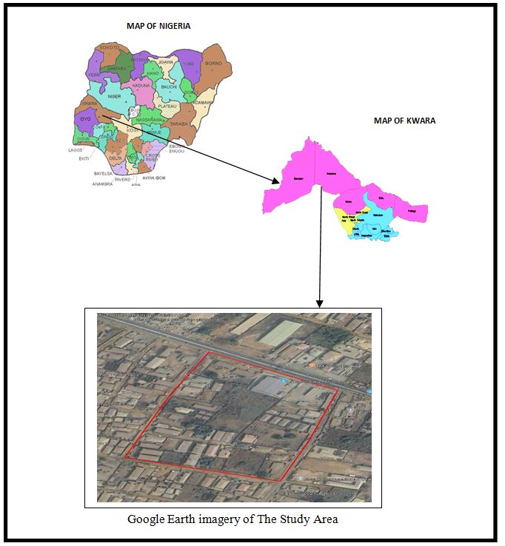

1.6. PERSONNEL
The personnel for this project are my classmates of Group 2A and we are seven in number. Their names, matric number are listed below:
- HND/23/SGI/FT/0014 Author
- HND/23/SGI/FT/006 MEMBER
- HND/23/SGI/FT/007 MEMBER
- HND/23/SGI/FT/009 MEMBER
- HND/23/SGI/FT/0011 MEMBER
- HND/23/SGI/FT/0013 MEMBER
- HND/23/SGI/FT/0010 MEMBER

CHAPTER TWO
2.0. LITERATURE REVIEW
Land is the ultimate resource of the biosphere which refers to a specific area of the earth surface with physical entity in terms of its topography and spatial nature, and one of the characteristics of space that is widely recognized as a significant for planning and management purposes (Abbas et al., 2010). Land Information Management System (LIMS) is defined as the combination of human and technical resources, together with a set of organizing procedures that produce information on land in support of a broad range of managerial requirements (FIG, 1995). Data are raw collection of facts. Data relating to land may be acquired and held in alphanumeric form (for example books), or graphically (for example, as maps or aerial photographs), or digitally (for example, using electronic methods). To become information, the raw data must be processed so that it can be understood by a decision maker. Land information management system may be designed to serve one primary function or they may be multifunctional for supporting strategic planning. The focus is on determining organizational objectives and on the resources employed to achieve them. Some provide or management control and are concerned with the effective use of resources so as to accomplish an organization’s objectives. Others are designed for operational control so that specific tasks can be carried out effectively and efficiently. Each requirement dictates a special set of information criteria and hence a special type of information system. Land information has been used in a variety of systems over the years; from register of deed, tract indexes to surveyors tie sheets or soil surveys. Today many organizations are moving land information into GIS.
Materials and Method use during the research work are the layout coordinates reading were carried out using the GPS while other details about the land parcels and owners were obtained from the Kaduna state ministry of lands, survey and town planning. The set of 1:50,000 topographic maps of Kaduna with sheet numbers 111 and 112 that were used for this study were also acquired from Kaduna state ministry of land survey and town planning. The topographic maps were scanned and geo-referenced using the coordinate obtained from the field. The coordinates obtained were UTM coordinates and the map geo-referenced in the UTM zone 32. The database was created using the four levels of reality, conceptual design, logical design and physical design.
Database Creation The database was created by inputting the spatial data and attribute data into the computer system. The attribute data were inputted and stored in a tabular form. The spatial data were acquired by scanning the hard copy map using A3 scanner with photo-plus, geo-referenced and digitized on-screen in Arc map environment under the following layers: point, line and polygons. The graphics were linked with the created spatial database after editing and GIS operation and analysis carried out. Conceptual Design, Logical Design and Physical Design were also carried out.
Results and Discussion According to Uluocha (2007), “Querying or searching a database is a common function of LIS. This involves probing the database to see if certain specified relationships or conditions exist among some features or data items”. Spatial query was carried out to get information about parcels. Different information can be accessed or realized depending on what the user wants. These can be realized with the help of queries as carried out and shown in figure. This study was carried out employing Geographic Information System (GIS) in developing a Land Information System (LIS) for the management of Tsaunin kura residential layout in Chikun Local Government area of Kaduna state, Nigeria. In order to achieve this, the study captured geographic data (coordinates) using Global Positioning System (GPS) receiver so as to provide geographic location for the layout plan. The study also provided a database of Tsaunin Kura residential area and linked the database to the layout plan. The study was able to generate the map of the layout and the exact location of the plots located at Tsaunin Kura residential layout (figure 3); was able to create a database for the area (figure 4). The study was also able to run a spatial analysis on the plots of land to query plots owners and status of development (figures 5, 6, 7 and 8).
Conclusion Land Information System (LIS) can provide us a better and more efficient system for land management. A LIS is a digital system having spatial (graphical) and attribute data for each land holding since the two are maintained in a digital form, it is possible to edit, maintain, rectify and keep the record up to data with least efforts. It can give reprieve to both land owners as well as the Government, which requires information for planning and implementation whereas people have access to information regarding their own holdings; the government will be able to extract information for the entire area of interest. It will also be able to maintain and track changes, detect errors, make online correction, and make land management a process dependent activity rather than people dependent.
According to Kasphia Nahrin and M. Shafiq-Ur Rahman (2009) define Land Information System (LIS) is the most feasible systematic approach for developing an efficient land administration and management system in Bangladesh. This paper focuses on the issues that are needed to be addressed in formulating a viable land administration and management policy for the planned and controlled growth in Bangladesh. However, the conventional land administration system cannot keep pace with the growing demand and changing situation of the land market. Inappropriate land administration and management system is the cause for unplanned growth, and this eventually generates problems in community life. Inadequate and improper land records increase difficulties in the security of land tenure and land transfer. For this, it becomes an obligation to establish a compatible land administration and management system by setting up a holistic approach.
Objectives and Methodology The main objective of the study is to determine potentialities of LIS for an effective land administration and management system in Bangladesh. Critically analyzing the pitfalls of present system in the country, the paper attempts to address the potentialities of introducing LIS. The research is mainly based on secondary information.
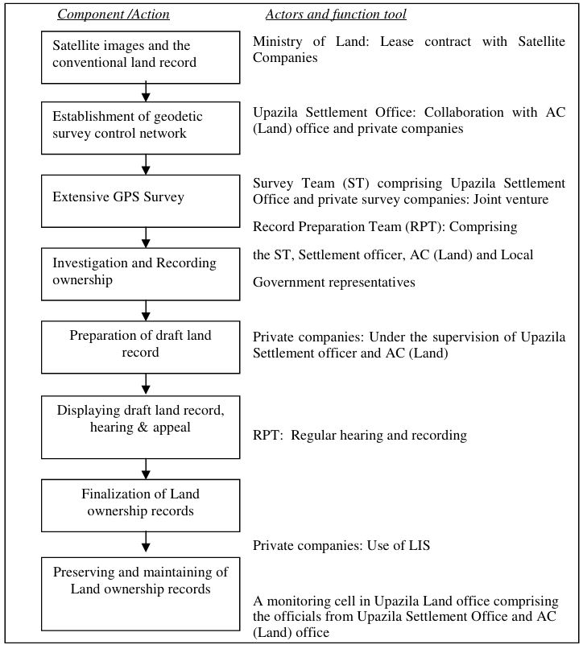
Conclusion Land administration and management system in the country is very complex and time consuming. LIS could bring an appropriate land administration and management in Bangladesh. However, the initiatives of LIS would face a great challenge regarding the legal and institutional matters of the country as well as for technical constraints. LIS responsive land reform, institutional arrangement, extensive privatization, sufficient training, and the over all political will would be needed for introducing the new system. Despite the huge installation and recurring cost of new technologies, once the land record is completely computerized, various space-specific parameters could be hooked-up to the land record. The same record could be utilized for various purposes such as taxation, subdivision planning and other tasks in urban, rural and regional level. For this purpose, demand responsive step-by-step approach within a timeframe would bring the effective results for land administration and management through LIS.

CHAPTER THREE
3.0 METHODOLOGY
​The following are the methods adopted in carrying out land information system analysis of part of Asa-Dam area, Ilorin, Asa local government area,Nigeria.
3.1 RECONNAISSANCE
​This is the preliminary field inspection of the project site to be surveyed. It involves the overall view of the entire land in question or the project site in order to plan on how to go about the surveying operation to achieve the aim of the work in accordance with the survey rules and regulation pertaining to the order of job required (i.e. first. Second or third order), the reconnaissance was done by considering the purpose of the survey operation and method of observation. There are the two types of reconnaissance that are carried out are:-
- Field Reconnaissance
- Office Reconnaissance
3.2.1 OFFICE RECONNAISSANCE
​Information about the study area like existing map/plan of the project site and preferably historical data of the site in question, letter of notification, necessary information equipment needed to carry out the survey and coordinates of control point was carried out under this section.
3.2.2 FIELD RECONNAISSANCE
At this stage, we visited the project area and take note of the crucial points, locating of existing control points, drawing of the reconnaissance diagram and also the determination of the best method for the Survey.
3.3.1 EQUIPMENT USED
Total Station and its accessories.
3.3.2 HARDWARE
1. Laptop Computer
2. Mouse
3, Printer etc.
3.3.3 SOFTWARE
The following Software was used:
1. Microsoft word
2. Microsoft Excel
3. Note Pad
4. Google Earth
5. ArcGis 10.0

3.4 CONTROL CHECK
It is not enough to work from whole to part but it is equally expected that the set of controls to be used are properly checked to ascertain their suitability for the job. The insitu check for both linear and angular measurements as well as the coordinates.
Table 3.4.1: Coordinate of the observed and the original values of PT 31
PILLAR | NORTHING | EASTING | STATUS | REMARKS
PT 31 (KW/AW/ 1206) | 934630.687 | 668601.336 |  | ORIGINAL
PT 31 ( KW/AW/1206) | 934630.677 | 668601.356 | FIXED | OBSERVED
DISCREPANCY | 0.010 | 0.020

Table 3.4.2: Coordinate of the observed and the original values of PT 32
PILLAR | NORTHING(m) | EASTING(m) | STATUS | REMARKS
PT32 ( KW/RB/37) | 934634.584 | 668590.327 |  | ORIGINAL
PT32 ( KW/RB/37) | 934634.563 | 668590.349 | FIXED | OBSERVED
DISCREPANCY | 0.021 | 0.022
Table 3.4.3: Coordinate of the observed and the original values of PT 33
PILLAR | NORTHING(m) | EASTING(m) | STATUS | REMARKS
PT33 KW/RS/12210) | 934663.590 | 668506.841 |  | ORIGINAL
PT33 KW/RS/12210) | 934663.579 | 668506.861, | FIXED | OBSERVED
DISCREPANCY | 0.011 | 0.020

3.5.1 DATA SOURCE
Control coordinate were given from existing map, which is considered as secondary data. This was plotted using AutoCAD. There are two main source of data used primary and secondary source.

3.5.2 PRIMARY SOURCE
This involve the collection of the X,Y and Z coordinate (Spatial data) using land surveying Technique with Total Station and its accessories.
3.5.3 SECONDARY SOURCE
This type of source that was gotten from the google earth application for land information system of part of Asa Dam Agaka area. Ilorin, Kwara State.

3.6.1 GEOMETRIC DATA ACQUISITION
This involve the acquisition of both Northing, Easting And Height value of features that are present on the project site. In the aspect of this project digital land survey method was adopted.

3.6.2 PERIMETER
This coordinate of the boundary pillar of the project site were obtained through perimeter traversing of the area

3.6.3 DETAILING
​Detailing refer to fixing of features that are found in an area where survey operation had been carried out. Building, Roads, Electricity pole and other facilities located within the project area were detailed using land survey method.

3.6.4​ATTRIBUTE/ SOCIAL SURVEY
​This aspect of data acquisition entails the collection of other data which Such data were directly related to the features to which geometric data was acquired. They included building names, the purpose of which the building is used for etc.
​To collect attribute data, questionnaire Survey was employed. This involve oral interviews, reading information from sign posts, wall signs, virtual observation, etc.

3.7.1 DATABASE CREATION/IMPLEMENT
For efficient and effective management of data in the computer environment, data item are usually arranged and stored in a database or databank. The content of this database could be in form of a text, number, polygon or graphics. The creation of this database involved the combination and storage of the acquired graphical and attributes data obtained in former designed GIS database of a generic structure for the purpose in spatial analysis and queries on project site
In the creation of a land information system data mode, a widely used technique called layering was employed. The features that are present within the project site have been classified into different layers in the AutoCAD software independently. The polyline entities were joined using the polyline tool while appropriate symbols were used for the point entities. These layers were then exported to ArcGIS environment where shape files was created using attributes fields as conceptualized in the schema. These attribute table were then populated accordingly with attributes values for each particular entity as observed in the field and from the social survey template (attached as appendix)
The personal Geo database was then created finally in Arc Catalog environment. Where other tables that are non-geometric where created while the already created shape files where imported. Relationship between these tables were also established and the tables were later populated in the Arc Map environment. The following are some of the table created

3.7.2 DATABASE MANAGEMENT SYSTEM (DBMS)
​According to Dale and McLaughlin (1998), database management system was defined as a computer program to control the storage, retrieval and modification of data in the database. DBMS comprises of set of programmers which are used to maintain and manipulate the data orderly and acts as the central control over all the interactions. It is manages that data using alphanumeric data with limited capabilities of performing spatial queries
​A DBMS must allow the definition of data and their attributes and relationships as well as providing security and on interface between the end users and their application and the data themselves it reduces redundancy. Therefore, Arc GIS 10.0version was used to create, manipulate, maintain and access the database easily.

3.7.3​DATA QUALITY
Some forms of quality control and quality assurance were incorporated in the project at every phase. These include conformity with data templates, data competences and data accuracy. Conformity with data templates in this premises refers to the degree to which the captured data conformed with the designed templates, while data competence was understood as the degree to which the available data in the report and for which there are specific templates have been extracted.

3.7.4 ​DATA INTEGRITY
​The data captured as exactly downloaded into the system then exported to AutoCAD via notepad and eventually into Arc GIS. The process involves ensuring that the data in the database were accurate and setting of certain constraint to prevent inconsistency in the database.

3.7.5​DATA SECURITY
​Security is of great concern to land administration because of the legal implication of cadastral records. Security of the records is of almost importance to all concerned. This includes:
- Physical and system security
- Physical security: The use of burgling proof, firefighting equipment controlled access, proper records of the moment of personal and our of the office circuit break
- System Security: Uninterrupted power supply (UPS) will be used to control voltage, use of passwords and backups
In view of the foregoing, locking mechanism was adopted to protect the data in the database from unconscious deletion. Password was used to prevent unauthorized user from breaking into the database and a back up was created for the whole project on the rentable DVD.
Having succeeded in analysis the methodology employed in the execution of this project to arrive at the successful completion. It is equally necessary to examine the processes undertaken to ascertain the reliability and effectiveness of the created land information system

3.8.1​. DATA PROCESSING
AutoCAD and ArcGIS were used for plotting and database creation.

3.8.2. DRAFTING AND PLOTTING
​During plotting of the data, was firstly used to plot out all the points that are picked on the field. The downloaded data of those points were well arranged in the Microsoft excel. The following steps were carried out:
- The data was save on the desktop for easy location
- AutoCAD 2007 was launched
- All the necessary parameters were set ranging from the drawing units, text, point style and others
- The data was then located on the desktop through the Civil CAD and opened,
- The refresh button was clicked and the data was refresh with a successful message displayed
- Then the zoom extend was used to bring all the plotted point into view.
The Civil CAD plotted the coordinate along with their point ID and this make the detailing of the features (such as Roads, electric poles and other) quite easier when transfer into AutoCAD environment.

3.8.3​DATABASE CREATION PROCEDURES
​The plan in the AutoCAD format was added as data on ArchMap10.0. on Arc Catalog, a file Geo-database was created and subsequently a feature classes such as the line feature for the roads and others and polygon feature for the buildings.
Below are the procedures:
1. A folder was created for the project on the desktop and the plan with Dwgextension was saved in it,
2. ArcMap in ArcGIS10.0 software was launched
3. Then an empty new map which was displayed after loading was clicked on the minimize catalog on the right side was then maximize to view the ready created folder which contain the drawing in the AutoCAD format. The drawing was dragged from the folder and placed on the empty map and then the coordinate system was set.

CHAPTER FOUR
4.0 SPATIAL ANAYSIS, DATA PROCESSIN AND PRESENTATION
4.1 SPATIAL ANALYSIS
Spatial analysis is a specialized function that distinguish GIS from other information systems. It entails the examination of spatial and attributes characteristics of geographic features that are within the database to establish relationships from which spatial problems can be tackled. In this project work, spatial analyses were performed to select, combine and intersect existing geospatial data-sets in order to generate new information suitable for answering specific spatially-related questions.
The results from these analyses can be shown in a number of ways depending on the required output format. Where attribute information about map features are required, they can be presented as tables containing such valves as are needed from the query analysis. They can also be presented as maps with legend information showing the queried features and their topological relationships with other features shown on the map.

4.2. TESTING OF DATABASE
This is carried out to ascertain the quality of the database created, it was necessary to tryout the database so as to determine if information could be readily retrieved from it as required. Testing the database was important to determine whether the established relationships between features and their characteristics attributes are so represented on the database.

4.3.1 QUERIES
Queries are specific questions in the form of "what is where", "where is what", "when" or how long has it been there.This provides answer to the needed information through processing or manipulating spatial data.

4.3.2 SPATIAL QUERY
Queries were designed for the purpose of retrieving information from the database. The queries performed in this project gave answers to certain generic questions asked from the database. This was made possible as a result of the implicit link of both the spatial and attributes data. The queries were based on the products from the analysis carried out on the database.
4.4 SINGLE CRITERION QUERY
A single criterion is carried out where one condition is used to design query. This condition is used to retrieve the information from the database. An example of a single criteria query is shown below
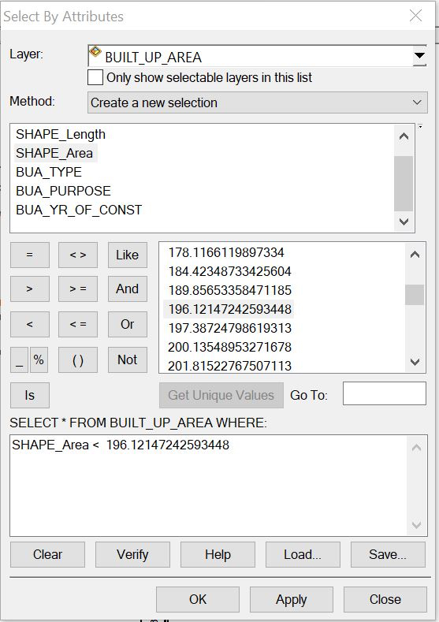

.

Figure: 4.4.1 Shows a single query made on the database of the project
Query 1: The query one is in interested in selecting or showing the built up area that have an area less than 196.12msq/m²
Syntax:built _up _area <196.12msq/m²
Figure: 4.4.2 showing the question made on the database for built _up _area <196.12msq/m²

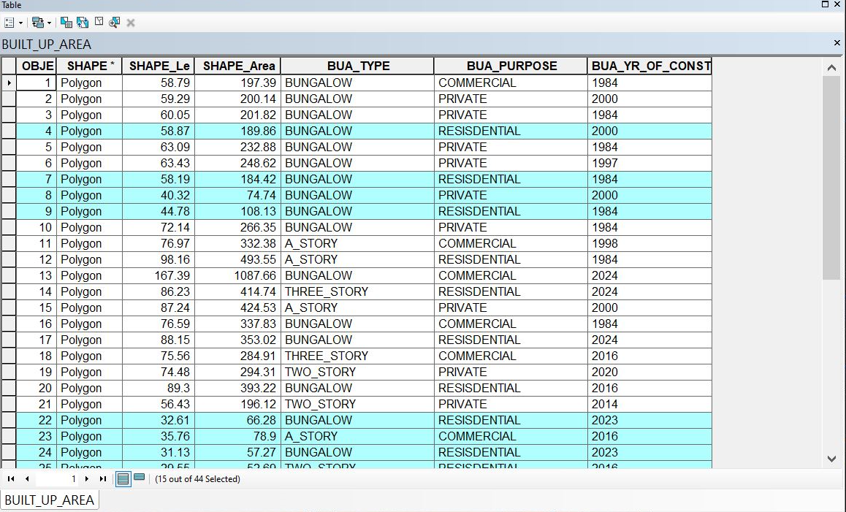

Figure: 4.4.3 showing the result of the query made on the database for built _up _area <196.12msq/m² in form of a table

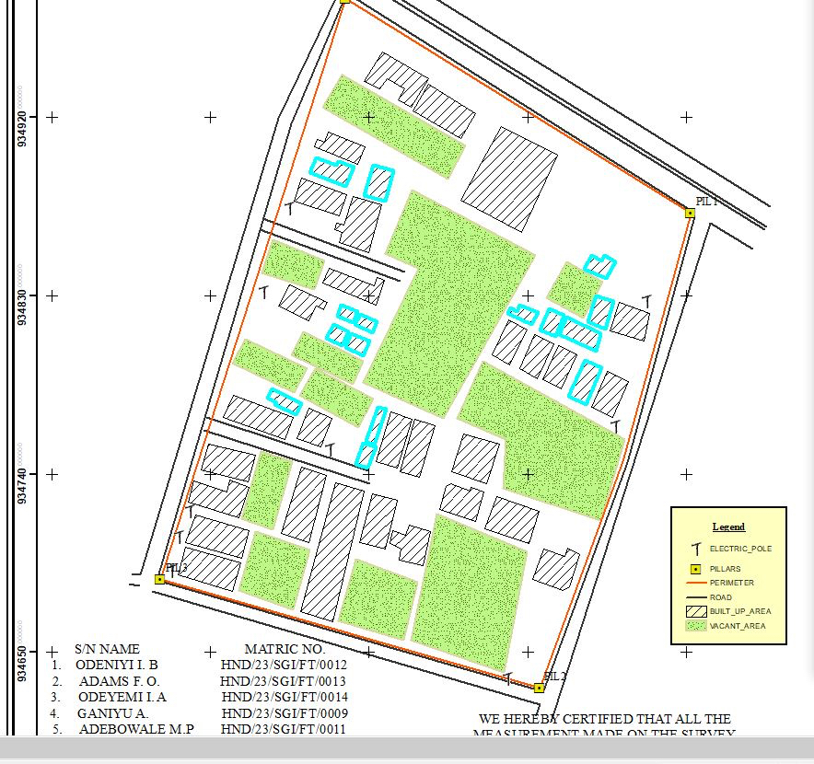

Figure: 4.4.4showing the result of the query made on the database for built _up _area <196.12msq/m²on the plan
Discussion of Result
Figure 4.4.3 and 4.4.4 Shows the built up area that have an area less than 196.12msq/m It consists of the syntax model or the query builder box, attribute table as well as the map of the selected plot in mint blue color. The result shows that 15 built_up_area out of the 44built _up _area have an area less than 196.12msq/m²

4.5 MULTIPLE CRITERIA QUERY
The database created is then used for implementing several selection queries in determination of user-defined requirements such as built up area whose purpose are for commercial or private use, year of construction, type of building (bungalow,2 story, duplex etc.) and other security which will be effective in planning in such environment.

Query2: The query 2 is interested in showing the building area that are greater than 403.99m²and their purpose that are used for commercial
Syntax:built_up_ area > 403.99 m²ANDtheir purpose are for commercial use.

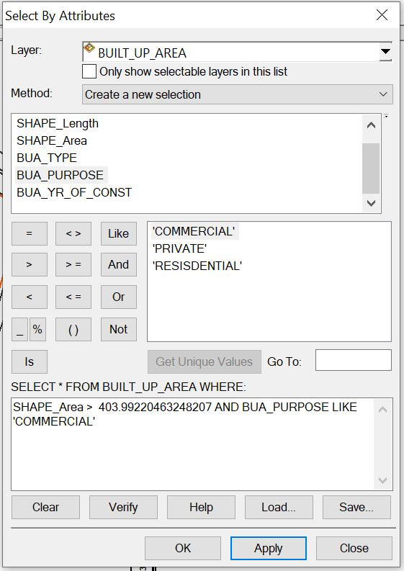
Figure:4.5.1 showing the question made on the database for built _up_ area > 403.99m² and their purpose are for commercial use.

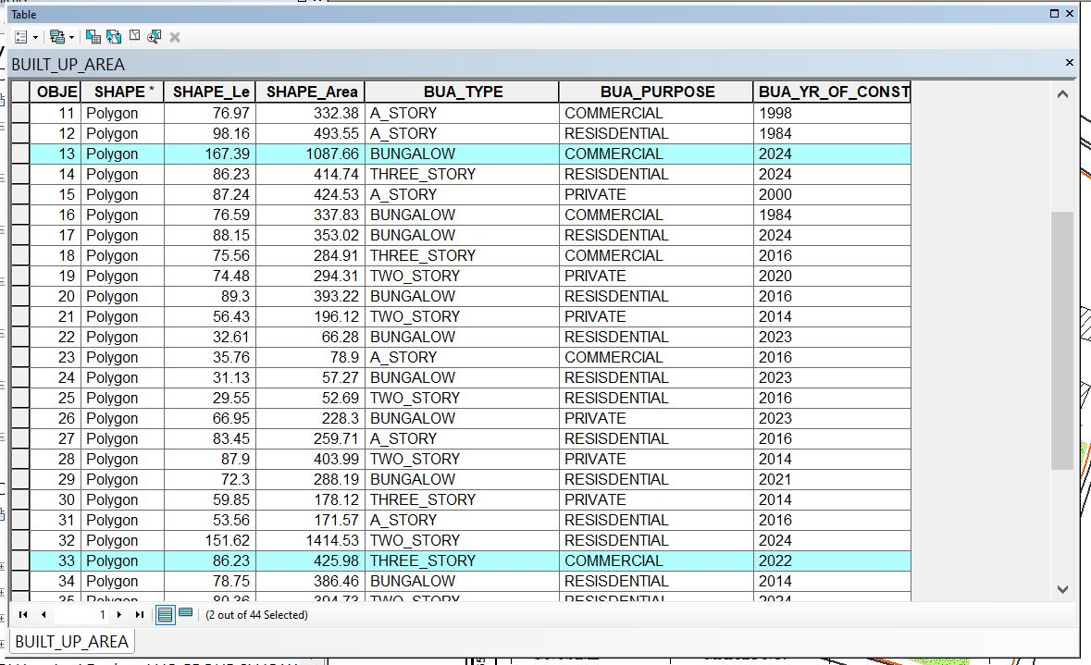

Figure: 4.5.2 showing the result of the query made on the databasefor built _up_ area > 403.99 m² and their purpose are for commercial usein form of a table
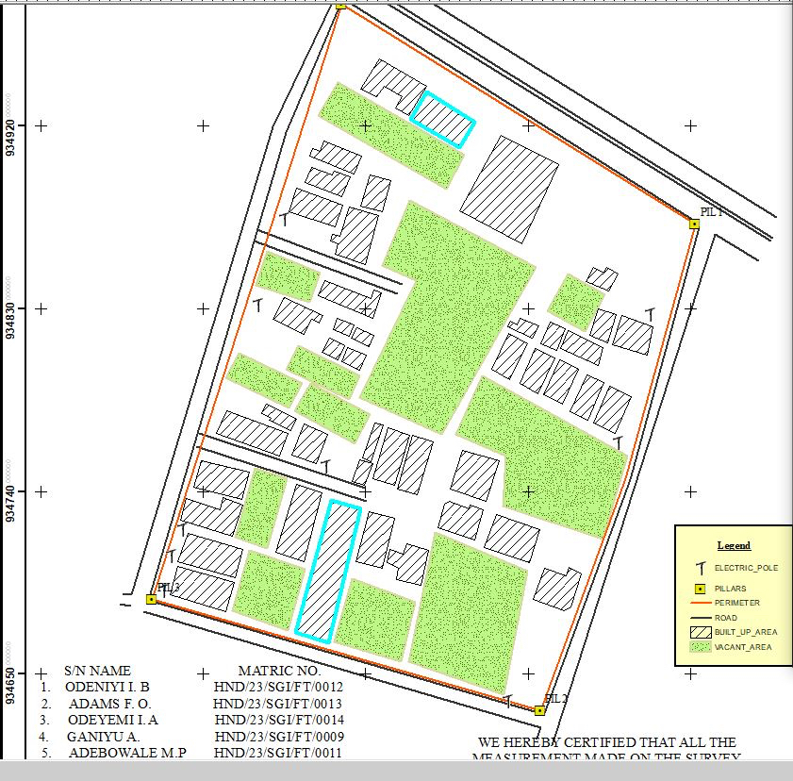

Fig: 4.5.3 showing the result of the query made on the database for built _up_ area > 403.99 m² and their purpose are for commercial use on the plan

Discussion of Result
Figure 4.5.2 and 4.5.3 Shows the built _ up _ area > 403.99㎡and purpose are commercial on the planIt consists of the syntax model or the query builder box, attribute table as well as the map of the selected plot in mint blue color. The result shows that 2 built _up _area out of the 44 built _up _area have an area greater than 403.99 m² and their purpose are for commercial use.
Query3: The query 3 is interested in showing the vacant area less than or equal to 901.99m and are not fenced to query about the vacant area of land less than or equal to 901.13m²and are not fenced
Syntax:vacant_ area <= to 901.13m²AND are not fenced

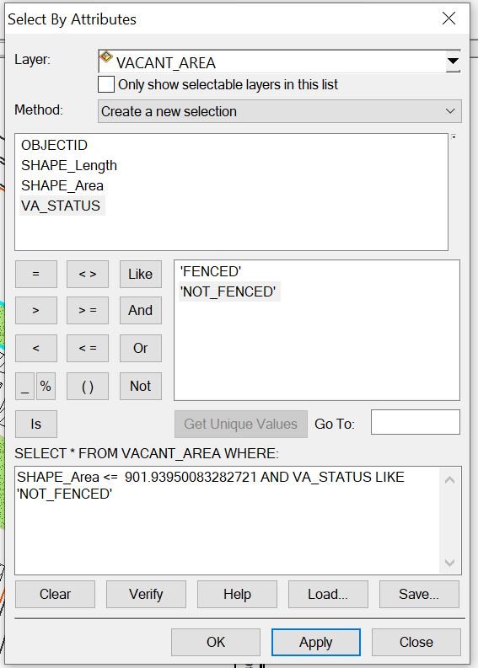

Figure: 4.5.6showing the question made on the database for vacant_ area less than or equal to 901.93m²and are not fenced

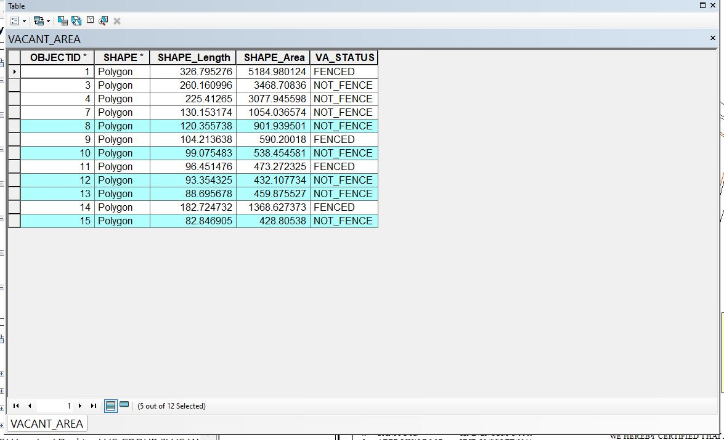

Figure: 4.5.7showing the result of the query made on the database for vacant_ area <= 901.13m²and are not fenced in form of a table
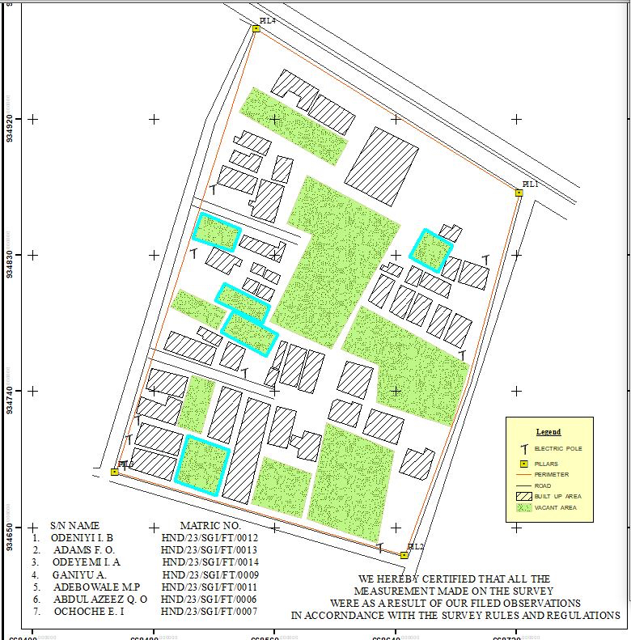
Figure: 4.5.8 showing the result of the query made on the database for vacant_ area <= 901.93m²and are not fenced on the plan.

Discussion of Result
Figure 4.5.7 and 4.5.8 Shows the vacant area less than or equal to 901.93m²and are not fenced on the plan It consists of the syntax model or the query builder box, attribute table as well as the map of the selected plot in mint blue color. The result shows that 5 vacant_area out of the 12vacant _area have an area less than 901.93m² and are not fenced.

4.6 RESULTS ANALYSIS
The results analysis gotten from this project can be used by authority in charge to facilitate planning on the land available to also know certain features about the area in question such as the type of building, the purpose of the building etc. The pie chart shows the representation of the features that existing the project site, it also shows the percentage of the each features.

Table 4.1: RESULTS ANALYSIS​
LOCATION | SIZE | PERCETAGE
Total built Up Area | 1285.2724 | 42.3%
Vacant area | 48165.342 | 52.2%
Total Road Distance (meters) | 1685.195 | 5.5%
TOTAL ROAD DISTANCE
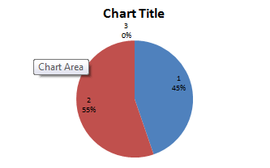
TOTAL BUILT-UP AREA
VACANT AREA

4.7 APPLICATION OF PRODUCT
- It facilitates the use of GIS for effective land management and physical planning.
- It can be used for distribution of infrastructural facility in the study area.
- It can be used for utility distribution, planning and operation.
- The product will provide an integrated approach to analysis of land information.
- It can be used for sustainable land development project in the study area
4.8 SPATIAL SEARCH
The database developed/created was queried in order to reduce the spatial variation in the various information categories ranging from built up area, vacant area, electric poles, and roads (as revealed by the database created) were used for the information system.

4.9 SPATIAL DEPENDENCE
Information system is not the same in every place, even within the project area, to talk of the whole institution neither the whole state, therefore, to detect the information increment/decrement within Part of Asa Dam area,Agaka ( which is the study area) the strength of spatial relationships between the attributes must be established, the strength is known as "Spatial Dependence" and is based on Waldo Tabler's "First Law of Geography" whereby everything is related to everything else, but closer things are more related. Spatial dependence must be measured to establish a relationship limit between the environment and how the facilities is used by the people. This dependence will likely changes over the study area as the environmental factors change (Haining, 2003). This is known as a spatial process, and when it changes across space it will non-stationery. This cannot be measured just by visually determining what is on ground because it is subjective and this must be done with a scientific approach to achieve a more concrete and precise information.\
Screen-shot showing the database created for the study area

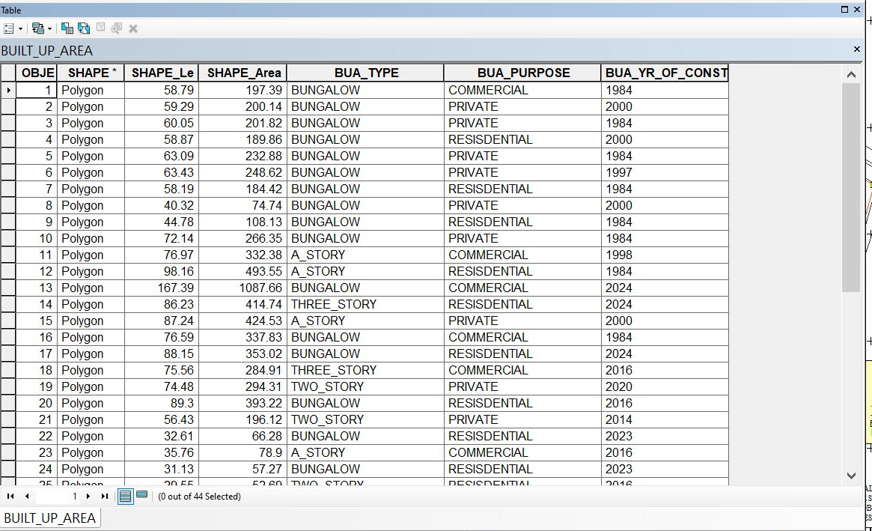

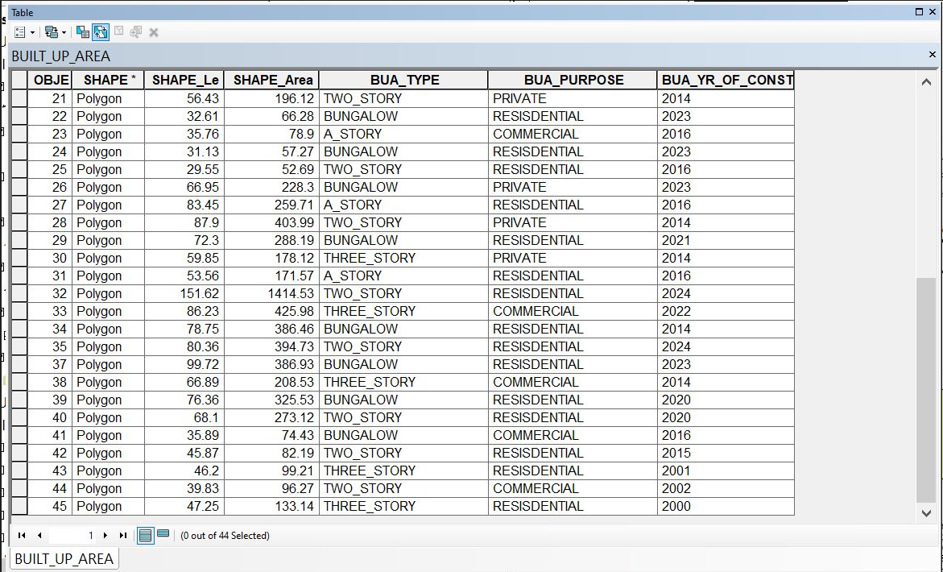

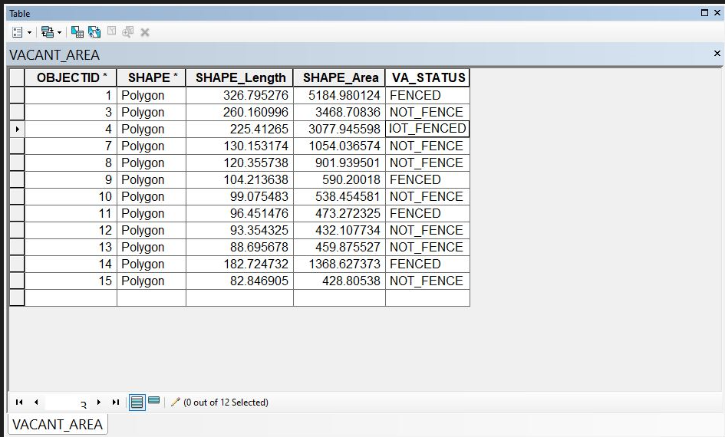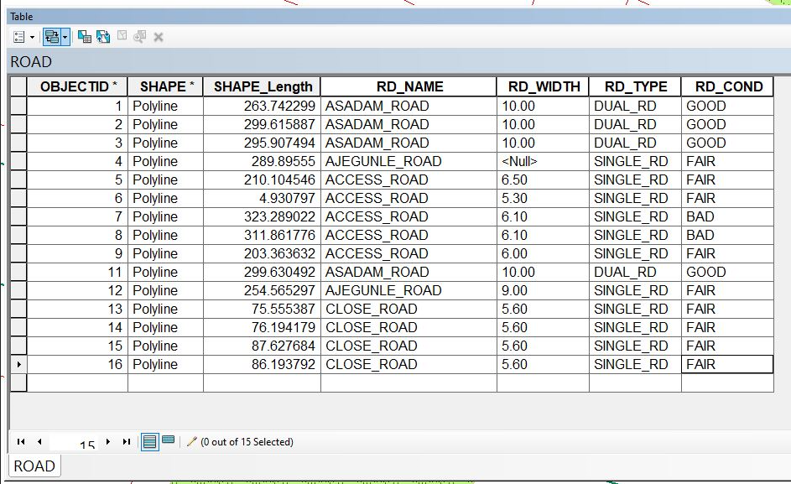
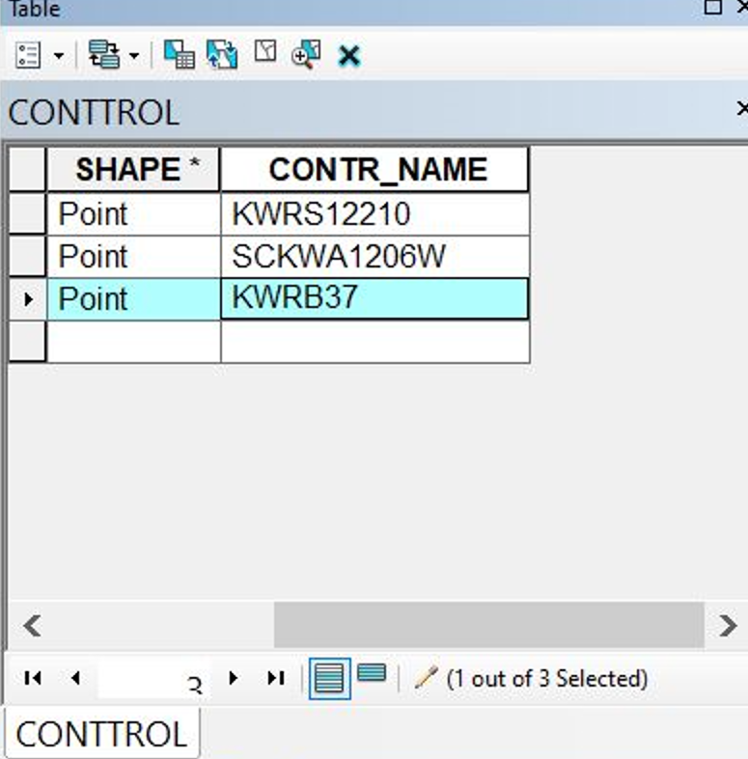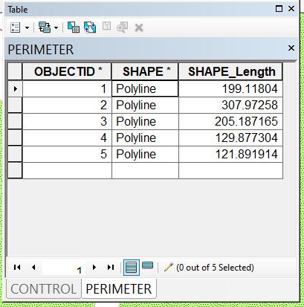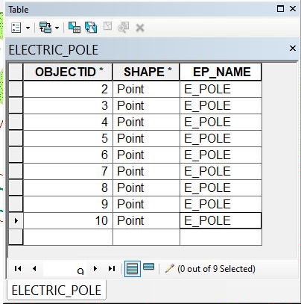

CHAPTER FIVE

5.0 COSTING, SUMMARY, PROBLEMS ENCOUNTERED, CONCLUSION AND RECOMMENDATION
5.1 COSTING
The costing of this project was done using the Nigeria Institution of Surveyor's (NIS) professional scale of fees for consultant in the construction industry. This stage shows the total cost that was spent on the project from day one to the final stage.

RECCI
PERSONAL/QUALITY | DAY(S) | UNITRATE(N) | TOTAL AMOUNT(N)
1 Senior Surveyor | 1 | 15,000.00 | 15,000.00
Assistant Surveyor | 1 | 8,000.00 | 8,000.00
Transportation | 1 | 7,000.00 | 7,000.00
Basic Equipment | 1 | 8,000.00 | 7,000.00
TOTAL |  |  | #38,000.00

BEACON= 2,100 × 5
= #10,500

BEACONING
PERSONAL/QUALITY | DAY(S) | UNITRATE(N) | TOTALAMOUNT(N)
1Assistant Surveyor | 1 | 8,000.00 | 8,000.00
Basic Equipment(6) | 1 | 8,000.00 | 8,000.00
Transportation | 1 | 7,000.00 | 7,000.00
TOTAL |  |  | #23,000.00

TRAVERSING
PERSONAL/QUALITY | DAY(S) | UNITRATE(N) | TOTALAMOUNT(N)
1 Assistant Surveyor | 2 | 8,000.00 | 16,000.00
Basic Equipment | 2 | 8,000.00 | 16,000.00
Transportation | 2 | 7,000.00 | 14,000.00
TOTAL |  |  | #46,000.00

DOWNLOADING DATA AND PLOTTING
PERSONAL/QUALITY | DAY(S) | UNITRATE(N) | TOTALAMOUNT(N)
1Senior Surveyor | 2 | 15,000.00 | 30,000.00
1AssistantSurveyor | 2 | 8,000.00 | 16,000.00
Transportation | 2 | 7,000.00 | 14,000.00
Consumables | 2 | 7,000.00 | 14,000.00
TOTAL |  |  | #74,000.00

INFORMATION PRESENTATION
PERSONAL/QUALITY | DAY(S) | UNITRATE(N) | TOTALAMOUNT(N)
1Assistant Surveyor | 1 | 8,000.00 | 8,000.00
Transportation | 1 | 7,000.00 | 7,000.00
TOTAL |  |  | #15,000.00

(1) # 38,000.00
(2) # 10,500.00
(3) # 23,000.00
(4) # 46,000.00

(5) #74,000.00
(6) # 15,000.00
TOTAL # 206,500.00
CONSTIGENCIES=5%
206,500.00×5%÷ 100
= #10,325.00

V. A. T = 7.5%
206,500.00×7.5%÷100
= #15,487.50

MOBILIZATION AND DEMOBILIZATION =10%
206,500.00 × 10%. ÷ 100
= #20,650.00
ACCOMODATION = 1.5%
206,500.00 ×1.5%÷100
= 3,097.50
TOTAL = 206,500.00
10,325.00
15.487.50
20,650.00
3,097.50
GRAND TOTAL = 256,060.00

5.2 SUMMARY
The purpose of the project was to create a database for Land Information System (LIS) using (GIS) Geography Information System tools of Kwara State along Asa-Dam Road Community Ilorin,The work covered data capturing, data processing and information presentation.
In this study, data were collected by direct field observation method using for geometric data, while attribute data were collected as primary data source.

5.3 PROBLEMS ENCOUNTERED

The following challenges were encountered during the execution of the project:

The use of a total station significantly increased the time required for measurements and observations, resulting in delays in the project timeline.

While collecting the coordinates of individual buildings, we faced harassment and persistent questioning from some members of the public, which further hindered our progress.

A change in our project location led to increased transportation costs, exceeding our initial budget.

5.4 CONCLUSION
It was a remarkable experience, as the project successfully achieved its objective. The goal was to create a comprehensive database for the Asa Dam Community in Ilorin, Kwara State, enabling easy access to information about land, buildings, industrial structures, offices, laboratories, roads, electric poles, and other infrastructure. The challenges encountered, along with the combination of simple and complex approaches used to overcome them, will remain unforgettable.

5.5 RECOMMENDATION
I recommend that the department be equipped with more surveying instruments and a dedicated laboratory to facilitate quicker project execution and improve the efficiency, accuracy, and speed of data processing and presentation..

Reference
- Dale, P.,& McLaughlin, J. (1999). Land administration. Oxford, Oxford University Press: USA.
- Akingbade, A. (2005). Improvement of availability of land registration and cadastral information in Ondo State, Nigeria: In department of urban and regional planning and geo-information management, international institute for geo-science and earth observation (ITC.),137.Enschede:ITC.
- Pindiga, A. & Orisakwe, K.(2013). Development of a land information system of tumpure residential and commercial layout in Akko Local Government Area of Gombe State. Journal Of Environmental Science, Toxicology And Food Technology, 3(1), 54-63.
- Pindiga, A. and Orisakwe, K. (2013). Development of a land information system of tumpure residential and commercial layout in akko local government area of gombe state. Journal of Environmental Science, Toxicology And Food Technology. 3(1): 54-63.
- Obongo, A. (2003). Computerized land information system as a tool of land record management(Master’s Thesis). Department of Land Development, University of Nairobi, Kenya.
- UN-ECE (2005): Land Administration in the UNECE Region – Development trends and main principles. UNECE, Geneva. http://www.unece.org/env/docum ents/2005/wpla/ECE-HBP-140-e.pdf

- Kasphia Nahrin and M. Shafiq-Ur Rahman (2009). Land Information System (LIS) for Land Administration and Management in Bangladesh. Journal of Bangladesh Institute of Planners Vol. 2, December 2009, pp. 116-125,  Bangladesh Institute of Planners ISSN 2075-9363 V
- Ian WILLIAMSON, Australia, Stig ENEMARK, Denmark, Jude WALLACE, Australia and Abbas RAJABIFARD, Australia (2010): Land Administration for sustainable development. https://www.researchgate.net/publication/242494736_
- Uluocha, N.O. (2007) Elements of Geographic Information Systems. San Iroanusi Publications, Lagos.

APPENDICES
PT1,668548.191,934980.009,331.811
PT2,668547.444,934980.307,331.871
PT3,668544.293,934982.894,331.784
PT4,668544.636,934985.71,331.694
PT5,668548.811,934982.607,331.897
PT6,668552.283,934991.899,332.216
PT7,668553.984,934993.093,331.953
PT8,668558.627,935001.645,331.577
PT9,668612.439,934967.966,333.403
PT10,668607.837,934959.071,333.558
PT11,668606.116,934957.957,333.569
PT12,668601.641,934949.128,333.443
PT13,668722.519,934871.483,335.622
PT14,668723.124,934872.773,335.499
PT15,668724.097,934869.82,335.661
PT16,668731.395,934865.208,335.588
PT17,668732.254,934866.8,335.747
PT18,668741.023,934874.594,335.921
PT19,668742.62,934875.863,335.869
PT20,668745.124,934885.688,335.473
PT21,668698.61,934743.591,339.35
PT22,668689.78,934745.713,339.439
PT23,668648.259,934630.293,341.776
PT24,668646.292,934623.439,341.695
PT25,668644.216,934617.787,341.771
PT26,668651.595,934614.517,341.745
PT27,668653.983,934620.525,341.743
PT28,668656.616,934627.794,341.762
PT29,668646.138,934631.747,341.464
PT30,668615.759,934624.995,341.395
PT31,668601.356,934630.677,341.566
PT32,668590.349,934634.563,341.613
PT33,668506.861,934663.579,340.036
PT34,668508.229,934669.629,340.013
PT35,668454.711,934686.553,339.446
PT36,668452.802,934686.335,339.274
PT37,668450.44,934680.815,339.423
PT38,668443.943,934683.679,339.266
PT39,668444.292,934689.11,339.17
PT40,668440.342,934689.467,339.13
PT41,668439.062,934684.378,339.26
PT42,668477.787,934768.863,338.375
PT43,668472.675,934772.053,338.535
PT44,668501.603,934853.331,335.81
PT45,668495.835,934856.335,335.789
PT46,668503.845,934857.13,335.792
PT47,668503.181,934853.4,335.868
PT48,668520.586, 934917.005,333.928
PT49,668514.356,934919.536,334.031
PT1,668548.191,934980.009,331.811
PT2,668547.444,934980.307,331.871
PT3,668544.293,934982.894,331.784
PT4,668544.636,934985.71,331.694
PT5,668548.811,934982.607,331.897
PT6,668552.283,934991.899,332.216
PT7,668553.984,934993.093,331.953
PT8,668558.627,935001.645,331.577
PT9,668612.439,934967.966,333.403
PT10,668607.837,934959.071,333.558
PT11,668606.116,934957.957,333.569
PT12,668601.641,934949.128,333.443
PT13,668722.519,934871.483,335.622
PT14,668723.124,934872.773,335.499
PT15,668724.097,934869.82,335.661
PT16,668731.395,934865.208,335.588
PT17,668732.254,934866.8,335.747
PT18,668741.023,934874.594,335.921
PT19,668742.62,934875.863,335.869
PT20,668745.124,934885.688,335.473
PT21,668698.61,934743.591,339.35
PT22,668689.78,934745.713,339.439
PT23,668648.259,934630.293,341.776
PT24,668646.292,934623.439,341.695
PT25,668644.216,934617.787,341.771
PT26,668651.595,934614.517,341.745
PT27,668653.983,934620.525,341.743
PT28,668656.616,934627.794,341.762
PT29,668646.138,934631.747,341.464
PT30,668615.759,934624.995,341.395
PT31,668601.356,934630.677,341.566
PT32,668590.349,934634.563,341.613
PT33,668506.861,934663.579,340.036
PT34,668508.229,934669.629,340.013
PT35,668454.711,934686.553,339.446
PT36,668452.802,934686.335,339.274
PT37,668450.44,934680.815,339.423
PT38,668443.943,934683.679,339.266
PT39,668444.292,934689.11,339.17
PT40,668440.342,934689.467,339.13
PT41,668439.062,934684.378,339.26
PT42,668477.787,934768.863,338.375
PT43,668472.675,934772.053,338.535
PT44,668501.603,934853.331,335.81
PT45,668495.835,934856.335,335.789
PT46,668503.845,934857.13,335.792
PT47,668503.181,934853.4,335.868
PT48,668520.586,934917.005,333.928
PT49,668514.356,934919.536,334.031

