COMPUTER BASED TEST USING SMART SYSTEM AND SOLAR TECHNOLOGY
(A CASE STUDY OF DEPARTMENT OF COMPUTER SCIENCE CBT CENTRE KWARA STATE POLYTECHNIC)

By
LAWAL GANIYAT OMOWUMI
HND/23/COM/FT/0081

A PROJECT SUBMITTED TO
THE DEPARTMENT OF COMPUTER SCIENCE, INSTITUTE OF INFORMATION AND COMMUNICATION TECHNOLOGY, KWARA STATE POLYTECHNIC, ILORIN.

IN PARTIAL FULFILLMENT OF THE REQUIREMENTS FOR THE AWARD OF HIGHER NATIONAL DIPLOMA (HND)
IN
COMPUTER SCIENCE.

JULY, 2025
CERTIFICATION
This is to certify that the project research was carried out by LAWAL GANIYAT OMOWUMI with the Matriculation Number HND/23/COM/FT/0081 as been read and approved as meeting part of the requirement for award of Higher National Diploma (HND), in Computer Science.

--------------------------- -------------------------
Dr Agboola, O.M Date
(Project supervisor)

----------------------------- --------------------------
Mr. F.S, Oyedepo Date
(Head Of Department)

--------------------------- ------------------------
(External Examiner) Date

DEDICATION
This project is dedicated to the creator of the earth and universe, the Almighty God. It is also dedicated to my parents for their moral and financial support.
ACKNOWLEDGEMENTS
My profound gratitude goes to the ALMIGHTY GOD, you are worthy of my praise for his protection, provision and support, Am very grateful for his mercy and grace during my programme, without you I am nothing.
My endless thanks go to my supervisor DR.AGBOOLA M.O for his contribution, correction and instructive attitude may God Almighty continue to be with you and your family Sir and also to the HOD and all the staff of department of computer science.

TABLE OF CONTENTS

TITLE PAGE

CERTIFICATION PAGE
DEDICATION
ACKNOWLEDGMENTS
TABLE OF CONTENTS
ABSTRACT

CHAPTER ONE: GENERAL INTRODUCTION
  - BACKGROUND TO THE STUDY 1
  - STATEMENT OF THE PROBLEM 3
  - AIM AND OBJECTIVES 3
  - SIGNIFICANCE OF THE STUDY 4
  - SCOPE OF THE STUDY 4
  - DEFINITION OF TERMS 4 - 5

CHAPTER TWO: LITERATURE REVIEW
2.1 REVIEW OF RELATED WORKS 6
2.2 REVIEW OF GENERAL TEXTS 12
2.3 EFFECTS OF EXAMINATION MALPRACTICE 15
2.4 TYPE OF SURVEILLANCE 16
2.5 BENEFIT OF SURVEILLANCE 18

CHAPTER THREE: METHODOLOGY AND ANALYSIS OF THE SYSTEM

3.1 RESEARCH METHODOLOGY 19
3.2 METHOD OF DATA COLLECTION 19

3.3 DESCRIPTION OF THE PROPOSED 20

3.4 ADVANTAGES OF THE PROPOSED SYSTEM 20

3.5 ADVANTAGES OF THE PROPOSED SYSTEM

CHAPTER FOUR: DESIGN AND IMPLEMENTATION OF THE SYSTEM

4.1 DESIGN OF THE SYSTEM 22
4.1.1 OUTPUT DESIGN 23
4.1.2 INPUT DESIGN 23
4.1.3 FILE DESIGN 23

4.2 SYSTEM IMPLEMENTATION
4.2.2 HARDWARE SUPPORT 24
4.2.3 SOFTWARE SUPPORT 24
4.2.4 IMPLEMENTATION TECHNIQUES 26

4.3 SYSTEM DOCUMENTATION
4.3.1 PROGRAM DOCUMENTATION 27
4.3.2 OPERATING THE SYSTEM 27
4.3.3 MAINTAINING OF THE SYSTEM 27

CHAPTER FIVE: CONCLUSION AND RECOMMENDATION
5.1 SUMMARY 29
5.2 CONCLUSION 29 - 30
5.3 RECOMMENDATION
REFERENCE SECTION
REFERENCES. 31

ABSTRACT
Video surveillance, closed-circuit TV and IP-camera systems became virtually indispensable for many organizations, businesses, and users. Their main purpose is to provide physical security, increase safety, and prevent crime. They also became increasingly complex, comprising many communication means, embedded hardware and non-trivial firmware. However, most research to date focused mainly on the privacy aspects of such systems, and did not fully address their issues related to cyber-security in general, and visual layer attacks in particular. In this project research, we conduct a systematic review of existing and novel threats in video surveillance, closed-circuit TV and IP-camera systems based on publicly available data. The insights can then be used to better understand and identify the security and the privacy risks associated with the development, deployment and use of these systems. We study existing and novel threats, along with their existing or possible countermeasures, and summarize this knowledge into a comprehensive table that can be used in a practical way as a security checklist when assessing cyber-security level of existing or new CCTV designs and deployments. I also provide a set of recommendations and mitigations that can help improve the security and privacy levels provided by the hardware, the firmware, the network communications and the operation of video surveillance systems. We hope the findings in this paper will provide a valuable knowledge of the threat landscape that such systems are exposed to, as well as promote further research and widen the scope of this field beyond its current boundaries.

Keyword: Surveillance, Malpractice, Security, CCTV, Examination

CHAPTER ONE
- INTRODUCTION
1.1 BACKGROUND TO THE STUDY
Examination is an organized assessment technique, which presents individuals with a series of questions or tasks geared towards ascertaining the individuals level of acquired knowledge and skills (Oduwaiye, 2014). The Oxford Advanced Learners Dictionary (2000) defines examination as spoken or practical test at schools or colleges, especially an important one that you need to do in order to get a qualification. The Wikipedia further assessed that a test or examination is an assessment intended to measure a test-takers knowledge or skill, aptitude, physical fitness or classification in many other topics.
Examination malpractice is defined as any deliberate act of wrong doing, contrary to the rules of examinations designed to give a candidate an undue advantage. Examination malpractice, also known as cheating, is the illegal action that students take during their examinations to try to make good grades by cutting corners. Examination malpractice is an act or irregular manner of testing candidates, which contravenes the rules and conventions guiding the conduct of examinations. Examination malpractice has done a lot of harm to students since many of them have neglected their books with the hope of performing the magic they are used to in every examination. Examination malpractice in Nigerian educational system has been widely discussed and viewed as a major challenge not only to examination bodies but to school administrators, the entire educational system, the government and the society at large. Examination malpractice, as defined by the West African Examination Council (WAEC) (2003), is any irregular behaviour or act exhibited by candidates or anybody charged with the responsibility of conducting examination in or outside the examination hall, before, during or after such examination with the aim of taking undue advantage. Many of these irregularities or misconducts surround examination and it came to an alarming rate in the last three decades.
The hue and cry about examination malpractice taking place at all levels of the Nigerian educational system is nothing but a reflection of the decay in the value system of the society. The Nigerian society is that which celebrates mediocrity and views cheating as being smart. The society does not want to know how an individual achieves success. The important thing is the success. In fact in Nigeria, the end justifies the means instead of the means justifying the end. In actual fact, examination malpractice is a variant of the wrongs and corruption in the society. The politicians employ rigging at elections and enjoy enviable political offices and so do students cheat from primary to tertiary institutions to move from one level of education to another. All sorts of misconducts take place in and around examination venues to take undue advantage of the process and achieve “success”. To make matter worse, it is not only students that are involved, business centres inside or around schools, parents, teachers, school heads, and examination officers all collude with students to perpetrate this misconduct. For example, it is common, during Joint Admission and Matriculation Board (JAMB) examination, to see up to 5000 people in examination centre that has 500 candidates. The other people who are not sitting the examination come around to crowd the venue as aids to those sitting the examination source The collusion between two or more of these agents makes it more difficult to combat. Even the penalties stipulated in Act 33 of the 1999 constitution of Nigeria ranging from cancellation of results to 21 years jail- term has failed to achieve any significant shift from the cheating culture due to the effect of collusion (Ijaiya, 2004; Oduwaiye, 2014).
Over time, the issue of tackling examination malpractices both within the formal school settings and other examinations has become a growing concern to the stakeholders; including the government, school administrators, and society. It has become so rampant that the core values of the school system are now been eroded. Besides youths are no longer convinced about the cultural values and reward for hard-work (Petter , 2014).
Several techniques such as the use of invigilators to monitor examination, accrediting candidates for examination with photo albums from examination regulatory bodies, use of candidate’s identity cards or biometric machines have been made to salvage the situations in the past(Ansong,2015). These techniques, however, seem not to have yielded the desired results as the cases of examination malpractice keeps increasing. In the event of a breach, these techniques may provide enough evidence needed for prosecution of the culprit and their conspirators that may have destroyed the evidence (Desai et al, 2018). This led to the introduction of a video surveillance system intended to complement the efforts of the human invigilators. Through video surveillance systems, the behavior and activities of people can be monitored using electronic equipment such as Close Circuit Television (CCTV) systems (Dimou et al 2012). CCTV system is surveillance infrastructure mounted at a predetermined location to ensure optimal coverage, which collects scene images that are transferred to a monitoring station or are stored for subsequent analysis and review, to prevent crime by deterring potential offenders, because of their awareness of the cameras that may be watching their activities. One of the objectives of using a CCTV system is to detect suspicious behaviors in real-time so that proactive measures can be taken. However, in examination scenarios in Nigeria, this is not the case, because detection of infringements or suspicious behaviors in real-time is subject to the operator’s uninterrupted vigilance. Some candidates perpetrate malpractice during examinations and get away with it without been caught despite the installation of a CCTV system. This is due to several factors such as fatigue on the part of the CCTV operator; this may cause distractions, human biasness, positioning of camera that my affect area of coverage or some candidates may be occluded from view to mention a few. All these challenges could influence the outcome of video surveillance.
1.2 STATEMENT OF THE PROBLEM
Exam malpractice is one of the biggest challenges facing educational system in Nigeria leading to a sharp drop in the rating of educational system (Ogunyi,2011). In a system which could help fetch out students using crib sheets or copying work. It would also help safeguard against substitute candidates sitting exams on behalf of others, and stop pupils claiming their poor grades were due to errors made by those supervising the tests.
1.3 AIM AND OBJECTIVES
The project aim at the use of security surveillance system to monitor examination malpractice in an academic institution using smart device
The objectives include to:
- install a CCTV system in and around examination hall;
- install inverter and battery as sources of power; and
- test the solar power examination monitoring system using CCTV.

1.4 SIGNIFICANCE OF THE STUDY
The installation of CCTV camera in an examination hall will curb examination malpractice. This is done by creating fear in the mind of intending criminal and at the same time capture the criminal when malpractice has been done. Students who engage in examination malpractice have been found to be academically good. It will produce evidence for the invigilating purposes.
1.5 SCOPE OF THE STUDY
The scope of this research work focuses on how to install and implement a security surveillance in an examination hall where as a means of eradicating exam malpractice in an academic environment. but not limited to; impersonation, disorderliness, cheating, giraffing, conspiracy and aiding, forging of results, machinery, microchips, smuggling of question papers out of examination venues, smuggling answer scripts into examination venues, sorting and rewriting.
1.6 ORGANIZATION OF THE REPORT
This report is organized as stated below.
Chapter one discusses the general introduction and overview of the whole project. It also discusses statement the problem, aim and objectives of the proposed system, significance of the study, scope and limitations of the study, organization of the report and definition technical terms used.
Chapter two deals with the literature review It reviews related topics to the project, discussion of related aspects of the project topic relative to computer technology.
Chapter three includes methodology with analysis of the system, data collection method employed, the description of the existing system and its problems, the description of the proposed system and possible advantages it will provide that will solve problems encountered in the existing manual system.
Chapter four deals with the result and discussion, as well as the description of the proposed system, It covers description of the output design, input design, data base design and procedure design. The implementation techniques used, the programming language used in developing the new system and system requirements for running the system. And also talks about the program documentation.
Lastly, chapter five presents a brief summary of the work done experience gained problems encountered in the course of the project, conclusion and recommendation. Other appendices included after the references used are; algorithm, system flowchart, program flow chart program source listing and generated computer output.

1.7 DEFINITION OF TECHNICAL TERMS

EXAMINATION: An examination is a formal test that you take to show your knowledge or ability in a particular subject, or to obtain a qualification. If you have a medical examination, a doctor looks at your body, feels it, or does simple tests in order to check how healthy you are.
MALPRACTICE: A dereliction of professional duty or a failure to exercise an ordinary degree of professional skill or learning by one (such as a physician) rendering professional services which results in injury, loss, or damage.
CCTV: also known as video surveillance, is the use of video cameras to transmit a signal to a specific place, on a limited set of monitors. It differs from broadcast television in that the signal is not openly transmitted, though it may employ point-to-point (P2P), point-to-multipoint (P2MP), or mesh wired or wireless links. Even though almost all video cameras fit this definition, the term is most often applied to those used for surveillance in areas that require additional security or ongoing monitoring. (Videotelephony is seldom called "CCTV"
SECURITY: An instrument of investment in the form of a document (such as a stock certificate or bond) providing evidence of its ownership.
CURB: a check or restraint on something, to check or control with or as if with a curb
CAMERA: A device that consists of a lightproof chamber with an aperture fitted with a lens and a shutter through which the image of an object is projected onto a surface for recording (as on a photosensitive film or an electronic sensor) or for translation into electrical impulses (as for television broadcast)
INSTALLATION: A work of art that usually consists of multiple components often in mixed media and that is exhibited in a usually large space in an arrangement specified by the artist.
SURVEILLANCE: the action, process, or occupation of supervising especially : a critical watching and directing (as of activities or a course of action)

CHAPTER TWO
2.0 LITERATURE REVIEW
2.1 REVIEW OF RELATED WORKS
Investigations have been performed by many researchers in the last few years on the installation of smart security surveillance as a means of improving examination supervision in an academic environment. In this section, the related research works are reviewed.

Amanze, Ononiwu, Nwoke and Amaefule (2016) worked on video Surveillance and Monitoring System for Examination Malpractice in Tertiary Institutions. The researchers revealed that Surveillance is the monitoring of the behavior, activities, or other changing information, usually of people for the purpose of influencing, managing, directing, or protecting them. This can include observation from a distance by means of electronic equipment (such as CCTV Cameras), or interception of electronically transmitted information (such as internet traffic or phone calls); and it can include simple, relatively low-technology methods such as human intelligence agents and postal interception. Surveillance is very useful in tertiary institutions so as to maintain social control, recognize and monitor threats and prevent / investigate malpractice activities. Surveillance cameras are video cameras used for the purpose of observing an area. They are often connected to a recording device or IP network, and may be watched by a security guard or law enforcement officer. Surveillance cameras are simple and inexpensive enough to be used in the tertiary institutions and also for everyday surveillance. Video surveillance is found in different areas. Traditionally, multiple security cameras are positioned throughout an area, linked to a computer.
Unfortunately, humans are unable to monitor huge crowd with a good number of population because that may lose focus over time. In this, I describe an automated multi-camera video surveillance system which is able to track students and detect suspicious situations. Automation is used in complex situations to reduce the workload put on the human operator and consequently to increase the productivity and enhance the performance. Workload assessment of operators while using an automatic surveillance system can provide system developers with information about the systems’ effectiveness. Furthermore, depending on automation is not only related to the accuracy of the system but also to the human operators’ reliance on automatic system. The design of automatic surveillance systems can determine the level of reliability and increase the effectiveness of the surveillance. Automatic surveillance systems are interactive systems and human operators play a central part. Therefore, applying principles of Interaction design should theoretically enhance the performance. There is immediate need for computerized surveillance systems in tertiary institutions. Mounting video cameras is cheap, but finding available human resources to observe the output is expensive.
It can be concluded that the proposed system can be very useful for the monitoring of students during examinations. It can be very useful to reduce the burden on the exam administrators. This system can play important role in current world of education. So, this system -"To develop a system to automatically detect suspicious activity during examination." can serve as a useful surveillance system for tertiary institutions. For a tertiary institution to progress and bring examination malpractice to a zero percent level, the surveillance and monitoring system can be a reliable and adequate system that provides a conducive and safer environment for the students and staff. Surveillance is an essential tool to ensure this objective. Overages, the human operative type of Surveillance system has been in use by the tertiary institutions in Nigeria.
Oko et al, (2016) worked on Examination Malpractice: Causes, Effects and Possible Ways of Curbing the Menace. The researchers revealed an array of factors responsible for examination malpractice and means of improving the examination supervision in Nigerian institution of learning which includes: wrong value system, quest for certification instead of knowledge and skills, Laziness, lack of preparation or in-adequate preparation for examination, lack of self confidence, poor school facilities, (Lack of or in-adequate examination hall) poor sitting arrangement, socio-economic factors, political- undertone, poor invigilation, weak parental function among others.
Factors identified as reasons why examination malpractices have not been eliminated or reduced are among others, the fact that the penalties as stipulated in Act 33 of 1999 constitution has not been fully applied. Some respondents however felt strongly that, just as jail term or public execution has not been able to deter armed robbers in Nigeria, a jail term as stipulated in the Act may not stop examination malpractice hence the advocated for the cut-off of the link that exists among the perpetrators of examination malpractice. Act 33 of 1999 Constitution stipulates cancellation of results, fines as much as N100, 000.00 to a jail term of up to 21 years. The Act however remains a toothless bulldog. Kwara State Polytechnic, stipulates a number of penalties such as rustication for academic session to expulsion to serve as deterrent to students. However, most students still go scot free after being revolved for some reasons.
The moral issues in the society and the quest for certificate in the face of poor academic performance has been identified as some of the major causes of examination malpractices in Nigeria. This research reviewed the remote causes, the various types and forms of examination malpractice especially at the polytechnic level, its effects and possible ways of curbing the menace. The research findings revealed an array of factors responsible for examination malpractice in Nigeria to includes what most respondents called “wrong value system which leads to serious quest for certification instead of knowledge and skills”, Laziness, lack of preparation or inadequate preparation for examination, lack of self confidence, poor school facilities, (Lack of or in-adequate examination hall) poor sitting arrangement, socio-economic factors, political- undertone,privatization and commercialization of education, poor invigilation, weak parental function e.t.c. Attitudinal or value change from certificate acquisition to knowledge acquisition, reduction in student population per invigilator, building of examination halls to accommodate sizeable number of students with wire net windows to forestall free flow of material to and fro the examination halls and a general change in societal value system and attitude in the educational system were advocated and recommended as measures to curve examination malpractice.
In Nigeria, millions of candidates participate in popular examinations such as the Senior School Certificate Examination (SSCE), Unified Tertiary Matriculation Examination (UTME) conducted yearly by various examinations regulatory bodies which include the West African Examination Council (WAEC), National Examination Council (NECO), and Joint Admission and Matriculation Board (JAMB). Similarly, institutes and universities such as the Institute of Chartered Accountants of Nigeria (ICAN), National Teachers Institute (NTI), Management of various Tertiary Institutions to mention a few also conduct various examinations. All of these examinations over the years have suffered from the menace of examination malpractices. Onuka and Durowoju defined examinations malpractice as any form of dishonest, unauthorized behavior or actions demonstrated by a student on himself or in collaboration with other persons such as fellow students, guardians, parents, teachers, examination officials, security officers, and anybody or group of people before, during or after examination to obtain undeserved marks or grades (Onuka, 2008). It is any deliberate act of wrongdoing, which undermines the rules for the conduct of examinations intended to give a candidate an unjustifiable advantage (Oko , et al 2016). The incidence of examination malpractices in Nigeria has become so common that every examination at all levels, anywhere and even outside the formal school system often witness one form of malpractice or the other(Jimoh et al; 2009). Examination malpractice is rated as one of the greatest problems that undermine the foundation of university education in Nigeria today.
Petters and Okon (2009) noted that the core values of the school system are been eroded, youths are no longer convinced about the culture, value, and reward for hard-work. The consequences of this situation are very obvious in our society today as we can see that mediocre students who do not have the requisite knowledge and competence to carry out their assignment and professional duties effectively are turned out from school into society. Besides, candidates with low morale and academic values are produced, because the good ones are dispirited from working hard in their educations (Amanze, et al; 2016).
Consequently, the standard of services in the country is generally affected, job efficiency decreases because the educational background of some prospective employees is built on a false foundation which leads to serious professional errors.
This was further being buttressed by findings from(Amanze BC and oko su, (2016))which stated in a related study that examinations malpractice is a negative orientation for future leaders who may end up being fraudulent and corrupt in their various offices, creating a poor national image, promoting dishonesty, unpatriotic, and a society that is not productive. The problem with existing monitoring methods discussed in section one (petter et al, 2014) is that adequate evidence may not be available for further prosecution. The candidate can easily deny being involved in such an act, the hall may even become rowdy when the candidate resists been apprehended by the invigilator either by destroying the material evidence or refusing to fill or sign the malpractice form. When commotion ensues in the examination hall it might create an avenue for other students in the hall to cheat as well. With all these inadequacies associated with existing monitoring techniques, there has been a clamor for the deployment of modern technology such as CCTV systems to tackle examination malpractice.

2.2 REVIEW OF GENERAL TEXTS
Bashir (2020) stated in his journal article tilted Impact of CCTV Surveillance on Crime Prevention: A Study in Dhaka City that: Since the very beginning of human civilization, people have considered their security as a very precious priority. Crimes have always appeared thus as a practical threat for the people from the dawn of their appearance. Therefore, the need for a surveillance process has been one of their major concerns always. With the advent of time, people have achieved their skills in science and technology and like all other aspects of life, managed the use of technology in the surveillance also (Farrington et al, 2002). In the context of a present completely complex society, it is very difficult for law enforcement agencies to maintain their surveillance on a whole community other than having a technological advantage. CCTV along with other security tools (like an intrusion or fire alarm, and access control) therefore, is being used widely by them to increase the efficiency in time management and broaden the coverage of the surveillance (Fennelly,2004 ; Kruegle,2011).
CCTV is a good instrument for starting an investigation and a great tool for making deterrent effects on probable offenders. Though its starting is not very new in this country, still a lack of well-organized set-up of this system is visible. A planned installation of a high-quality CCTV system with the capacity building of police personnel for taking the full utility of the system is thereby utmost necessary. Lack of a well documented approach in understanding the comparative advantage of CCTV is very difficult in the existing policing system of Dhaka city and the whole of Bangladesh as well. Therefore, a research-intensive strategic adaptation may help police to adopt this system within the organizational formality.
Matthew(2017) also worked on The Value of CCTV Surveillance Cameras as an Investigative Tool: An Empirical Analysis. It was discovered that Closed-circuit television (CCTV) surveillance cameras are widely used in policing, but that use is controversial. The United Kingdom (UK) government has described CCTV as “vital” for detecting offenders (Porter 2016), while the Washington, DC, Metropolitan Police Department (2007, p 2) argued that it is often “invaluable to police investigations”.On the other side of the debate, the campaign group (Liberty 2016) argued that extensive use of CCTV “poses a threat to our way of life” and that “widespread visual surveillance may well have a chilling effect on free speech and activity”. Similarly, the American Civil Liberties Union claimed that public CCTV surveillance creates “an almost Orwellian potential for surveillance and virtually invite[s] abuse” (Steinhardt,1999).
In the academic literature, there have been discussion on how CCTV fits into broader conceptions of surveillance (Hier,2004; Koskela,2003) and the extent to which it increases or changes the nature of state or corporate power over citizens (Fyfe & Bannister 1996; Norris& Armstrong, 1998). Concerns have been raised that CCTV surveillance may restrict the diversity and vibrancy of life in public spaces (Bannister et al. 1998), or contribute to the exclusion of some groups in society (Reeve 1998). There has also been political debate about the proper balance between ensuring the effectiveness of CCTV and protecting the privacy of citizens (Sheldon, 2011).
There has been extensive research on the value of closed-circuit television (CCTV) for preventing crime, but little on its value as an investigative tool. This study sought to establish how often CCTV provides useful evidence and how this is affected by circumstances, analysing 251,195 crimes recorded by British Transport Police that occurred on the British railway network between 2011 and 2015. CCTV was available to investigators in 45% of cases and judged to be useful in 29% (65% of cases in which it was available). Useful CCTV was associated with significantly increased chances of crimes being solved for all crime types except drugs/weapons possession and fraud. Images were more likely to be available for more-serious crimes, and less likely to be available for cases occurring at unknown times or in certain types of locations. Although this research was limited to offences on railways, it appears that CCTV is a powerful investigative tool for many types of crime. The usefulness of CCTV is limited by several factors, most notably the number of public areas not covered. Several recommendations for increasing the usefulness of CCTV are discussed.
CCTV Technology Handbook By the US Department of Home Land Security (July, 2013) revealed that, CCTV systems provide surveillance capabilities used in the protection of people, assets, and systems. A CCTV system serves mainly as a security force multiplier, providing surveillance for a larger area, more of the time, than would be feasible with security personnel alone. CCTV systems are often used to support comprehensive security systems by incorporating video coverage and security alarms for barriers, intrusion detection, and access control. For example, a CCTV system can provide the means to assess an alarm generated by an intrusion detection system and record the event. A CCTV system links a camera to a video monitor using a direct transmission system. This differs from broadcast television where the signal is transmitted over the air and viewed with a television. New approaches within the CCTV industry are moving towards more open architecture and transmission methods versus the closed circuit, hard-wired connection systems of the past. CCTV systems have many components with a variety of functions, features, and specifications. Key components include cameras, lenses, data distribution, power, and lighting, among others. CCTV technologies continuously undergo feature refinements to improve performance in areas such as digital equipment options, data storage, component miniaturization, wireless communications, and automated image analysis.
Following a sound design process enables organizations to make purchasing decisions that result in the procurement and installation of a CCTV system that meets functional and operational requirements. As CCTV is part of a multi-layered security approach, a system design should begin with a comprehensive needs assessment to ensure security risks and mitigation plans are identified. Clear requirements, a comprehensive site survey, and proper equipment selection and installation must all be considered when designing a CCTV system.
Oluwatoyin (2018) also worked on Closed Circuit Television Cameras (CCTV) and Curtailing Unlawful Actions in Kwara State College of Education Oro, Nigeria These past theories and conceptions are relevant as they give us some history and background information. We can see from these arguments that surveillance has always existed as social control. We can also see how theories expand and develop as surveillance does. I can now move on to look at how surveillance and CCTV is perceived in contemporary society and how it has affected it. CCTV has dramatically risen in Britain and therefore has different areas of research surrounding this. For example, fear of crime, risk society, public safety and crime prevention. Their main aim of the increase of CCTV in the UK was to reduce crime and use it as an effective crime prevention method. Therefore in 1995: “the government announced the establishment of a special fund, known as the ‘CCTV Challenge Competition’, to encourage local authorities to set up and part fund surveillance schemes” and “in the three years to the end of 1997 the Home Office and local authorities collectively invested £120 million in CCTV systems” (Guardian 9.1.1998 cited in Crawford, 1998: 41). These CCTV systems were put in place as a way of detecting and deterring crime, monitoring scenes and to cause self-discipline. They also suggest that CCTV "may prevent crime because potential offenders are deterred by their increased subjective probability of being detected" (Welsh &Farrington, 2009: 36). This is sometimes referred to as situational crime prevention and shows that the presence of CCTV could cause potential offenders not to commit a crime as the risk outweighs the benefits. Therefore, CCTV reduces offenders' opportunities to commit crimes. It also links to the idea that CCTV is used to produce self-discipline in victims and offenders. For potential victims CCTV is a “reminder of the ‘risk’ of crime, therefore altering their behaviour accordingly” (Armitage, 2002: 1) and controlling their safety.
This Research is formulated to investigate how the digital CCTV in conjunction with human operators within an academic institution will help to solve various security challenges being faced, a case study of Kwara State College of Education Oro. This research also intends to identify the underlying factors which boost or reduce the effectiveness of CCTV technology concerning technical failures of CCTV when used for security observation tasks performed by human operators and then examine how this will impact the Educational development and the effect on curtailing the unlawful acts in the institution. The findings of this research will also give birth to other technological research such as Face Identification, attendance management and their usefulness in the Academic environment.
Rita (2005) stated in her research titled "Multimedia Surveillance Systems" Nowadays, the majority of public opinion still conceives video surveillance systems as synonymous of CCTV systems: people imagine tens of cameras connected to tens of remote monitors, controlled by tens of bored and unheeding security employers which should pay attention to people, vehicles, objects and suspicious situations to prevent crimes or disasters. In alternative, many believe that surveillance systems are storage platforms to memorize multimedia data on the environment, video, photos, wiretapped speech, available for human forensic experts to support investigations. This is partially true, and the value of these systems is undoubted. It is known, for instance, that the Italian Brigate Rosse terrorists, that killed in Bologna the welfare consultant of Italian Ministry Prof. Marco Biagi in 2002, were identified also thanks to the analysis of about 52,000 hours of videos taken from surveillance cameras installed in the rail stations of Modena and Bologna. These systems are a concrete and profitable help to forensic investigations, although their potential capabilities are de-facto reduced by the limits of storage capabilities, the data compression and frame skipping. Instead, their effectiveness in prevention and real-time reactivity is still insufficient, since it is only in the hands of few human operators employed in the control that cannot manage all the huge amount of surveillance streams.
An overview of the recent research activities in multimedia surveillance systems has been presented. New generations of multimedia surveillance systems will cope with the problems of video, audio and sensor processing in order to real-time collect knowledge of the surveyed environment; they will deal with efficient annotation, display and access to surveillance multimedia data; they will address efficient policies for scheduling and controlling the sources of media streams loosely or tightly coupled. The final goal of these systems will be to enlarge and enhance the view of the visible scene and explore new views with active cameras and other sensors. The papers presented in VSSN05 represent the state of- the-art of this emerging research field.
Uche et al (2020) also worked om "Video surveillance in examination monitoring" they submitted that Over time, the issue of tackling examination malpractices both within the formal school settings and other examinations has become a growing concern to the stakeholders; including the government, school administrators, and society. It has become so rampant that the core values of the school system are now been eroded. Besides youths are no longer convinced about the cultural values and reward for hard-work. Several techniques such as; use of invigilators to monitor examination, accrediting candidates for examination with photo albums from examination regulatory bodies, use of candidate’s identity cards or biometric machines have been made to salvage the situations in the past. These techniques, however, seem not to have yielded the desired results as the cases of examination malpractice keeps increasing. In the event of a breach, these techniques may provide enough evidence needed for prosecution of the culprit and their conspirators that may have destroyed the evidence. This led to the introduction of a video surveillance system intended to complement the effort of the human invigilators. Through video surveillance systems the behavior and activities of people can be monitored using electronic equipment such as Close Circuit Television (CCTV) systems.
The use of CCTV surveillance systems for monitoring activities in the examination hall is gaining prominence because of its benefits which include providing evidence for investigative reasons and also serving as a deterrence to intending offenders since they are aware that they are being watched. The study assesses the efficacy of video surveillance in examination monitoring. Research questions were designed and analyzed to guide the study. The results of the analysis show that; CCTV systems are becoming more relevant in monitoring examination in Nigerian tertiary institutions and that the effectiveness of CCTV system when automated can be enhanced compared to conventional usage. Also, the analysis showed that the operational challenges faced by tertiary institutions significantly impact the deployment and use of CCTV systems. This study has shown that the effectiveness of the CCTV system in monitoring examinations will be significantly improved when automated.

CHAPTER THREE
METHODOLOGY AND ANALYSIS OF THE SYSTEM
  - RESEARCH METHODOLOGY
Method of implementation: the implementation that is best suitable for the proposed system is the use of smart security surveillance system for example the installation of CCTV camera in the examination hall and a smart device such as tablet to monitor the activities of the camera. Four cameras were installed for examination supervision purpose, three cameras inside the examination hall and one camera outside to monitor the hall environment. After successful installation of the cameras, monitoring the cameras using smart device is very essential as part of the project work, to monitor the CCTV the CCTV system using smart devices a router was connected to the DVR, HIK connector app was used by scanning the QR code on the DVR to connect the smart devices to the system and can be used to monitor remotely with the devices.
STEPS INVOLVED IN THE INSTALLATION OF THE CCTV
- Mounting the camera. Place the camera unit at the desired place, make guide marks for drilling.
- Placing the DVR. DVR of the CCTV is the place where the surveillance hard disk is present.
- Managing the cables.
- Power on the system
A multimedia surveillance system should simply be a surveillance system capable of accomplishing the output of the task in a multimedia format; they should provide distilled video, images and sounds of the monitored environment; videos should be possibly annotated in an efficient and standard way, to improve further querying to surveillance stored data, or possibly trans coded in another media, such as text or animation. Instead, the concept of multimedia surveillance systems must be enlarged: it is not only a system capable to furnish multimedia data, but also to collect, process in real-time, correlate and handle multimedia data coming from different sources.
The architecture of new generations of multimedia surveillance systems will be classified on the basis of different aspects:
THE STREAM GRANULARITY: coarse-grain, as video clips, medium grain as single images or single recorded audio stream, fine grain such as the on-off signals of PIR sensors;
THE DATA ABSTRACTION: the data can be handled and stored simply in a very raw format (as pixel matrixes, compressed videos or key-frames), or post-processed ( as a segmented moving shape, a segmented voice), or identified objects (like a person with known identity, after a biometric analysis);
THE STREAM CONNECTIVITY: the streams can be completely uncorrelated with the others; they can be taken in a loosely
coupled cooperative manner, such as videos of cameras with not overlapped field of view or can be tightly-coupled each other, like the video streams acquired by synchronized overlapped cameras.
3.2 PROBLEMS OF THE EXISTING SYSTEM
Malpractice is one of the biggest challenges facing educational system in Nigeria leading to drop in the rating of educational system. malpractice may not be limited to any one cause, but series of factors which act in concert. Identified such factors as value system of the society, factors, emphasis on paper qualification, psychological factors, poor and inadequate teaching-learning environment/facilities and admission policy as causes of malpractice in both internal and public examinations.
3.3 DESCRIPTION OF THE PROPOSED SYSTEM
The proposed system, installation of smart security surveillance as a means of improving supervision in an academic environment, will ensure proper monitoring of activities or any change in condition in an examination hall using CCTV camera.
Fig 3.1: diagrammatic analysis of the proposed system

3.4 ADVANTAGES OF THE PROPOSED SYSTEM
Closed Circuit Television Cameras are used in various circumstances to provide video surveillance. It is a useful tool for variety of reasons such as;
PREVENTING CRIMES: It helps you identify how a crime happened and to spot it in action for example, the case of cheating in Examination halls.
PROTECTING EMPLOYEES: It protects them against false allegations which are very common depending on the type of the business.
KEEPING RECORDS: It serves as an automated system for keeping records .
INSPIRING CONFIDENCE: It is also useful to the customers themselves by creating a safe feeling environment.
SETTLING DISPUTES: It helps to know who is wrong when a customer complains about your services. The benefits are numerous; however, it also aids the police and other security agencies in curbing situational crimes.

CHAPTER FOUR
DESIGN, IMPLEMENTATION ANDDOCUMANTATION OF THE SYSTEM
4.1 DESIGN OF THE SYSTEM
This is the process of designing the input, output and the processing steps to meet the user’s requirement identified in the system analysis. It starts with logical design, which produces a specification of major features of the system. These include the data, input, output, processing storage and other control requirement.
4.1.1 CCTV CAPTURING TOOLS
The design of input focuses on controlli
CHAPTER FOUR
4.1.1 INPUT DESIGN
This is the hardware and software use to complete our project work, and engage some device which will be mention below, and this are the combination of devices that help us to complete our task , in the field of our project
- Solar Panel: solar panel is used to generate electricity from the sunlight.
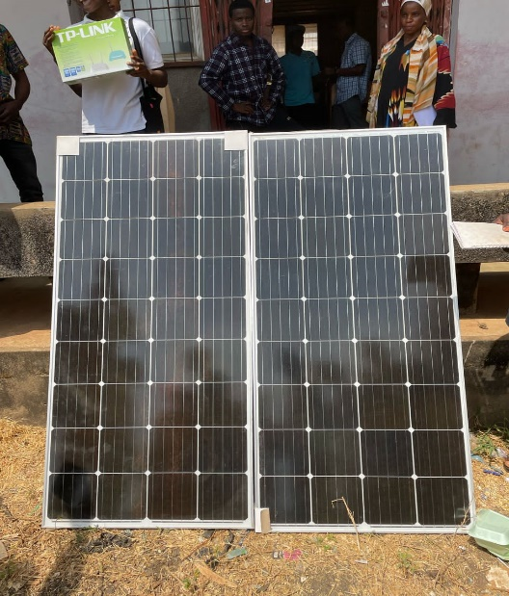
Figure 4:3: the two solar panel
- Cable: The cable use to connect current from the panel straight to thepower Box and direct to charge controller. We have different DC cable e.g 2mm, 4mm, 6mm etc.
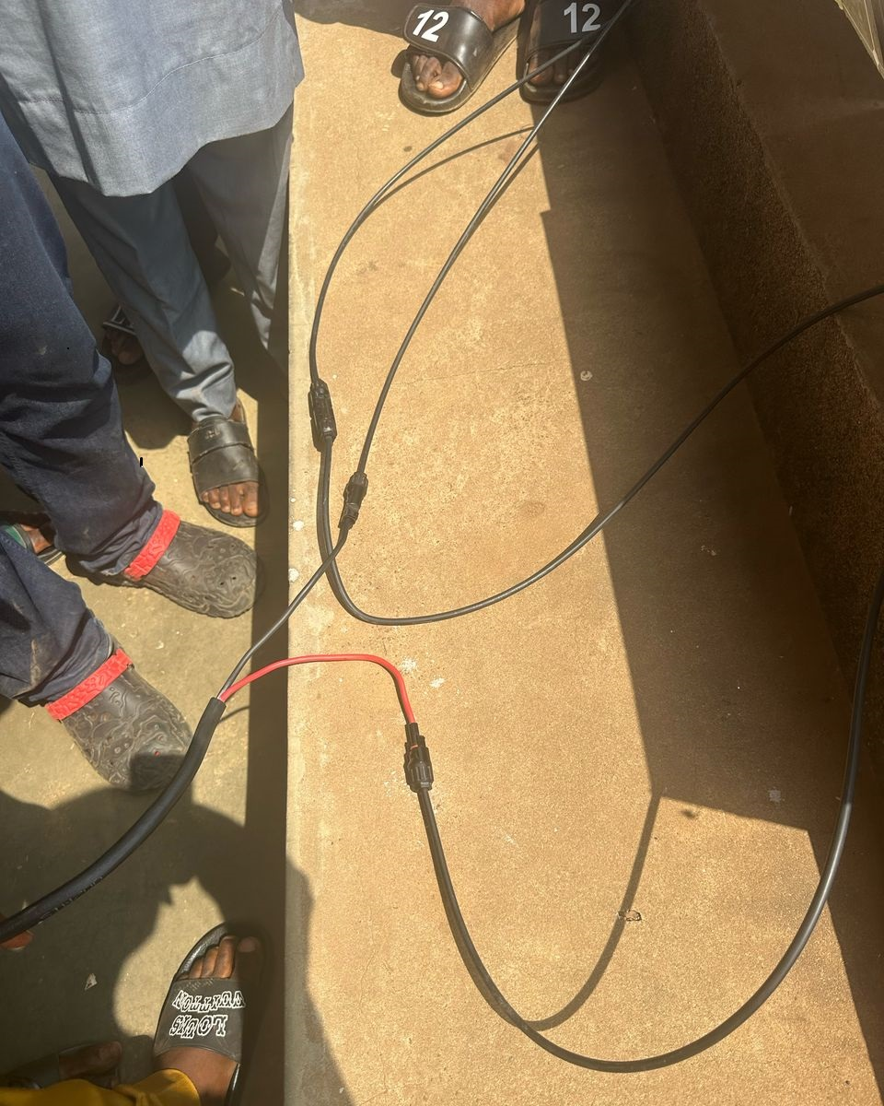

Figure 4:4: Twisted Cable
A twisted pair consist of two insulated copper wires, typically about 1mm thick. The wires are twisted in a helical form. Each pair would consist of a wire used for the positive (+ve) data signal and a wire for the negative (-ve) data
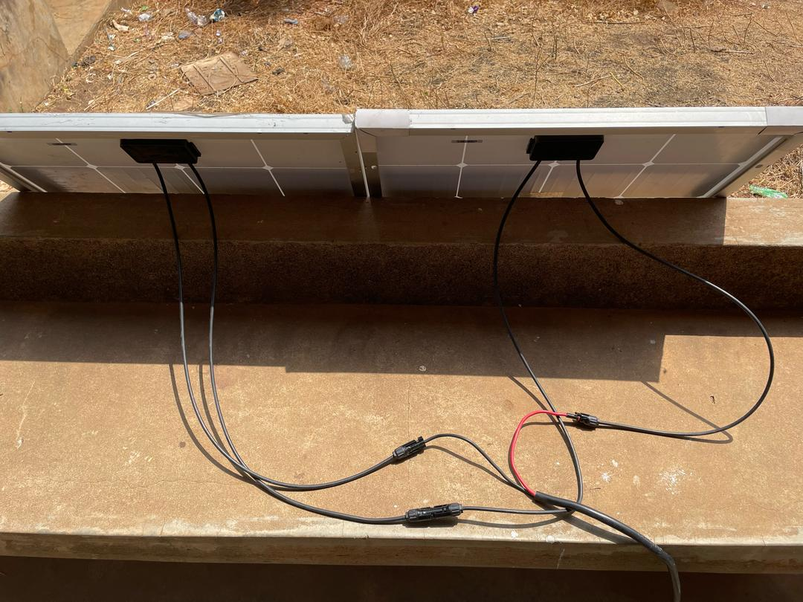
Figure 4:5: DC cable connect to solar panel Cable
Power Box: this is a protection box that has component that can guide our gadget, should incase we have high voltage or high current electricity, we have breakers inside the box, we have protector as well.

D.C: This is the direct current from the panel and it has it own breaker, for a protection as shown above in Fig .
A.C: this is the Alternative current from NEPA when there is light in the night time we can charge our battery through Nepa light as an alternative power supply.
- Coaxial Cable: This another communication wire that connect from cameras to DVR, and give it proper communication.
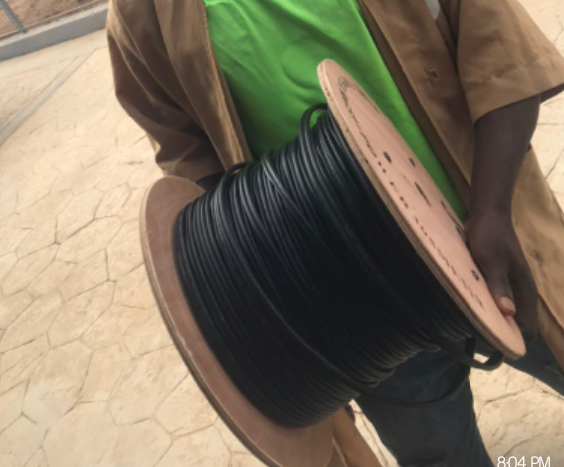
Figure 4:6. Shown J and J coaxial cable
- Charge Controller: This control the charging of battery from the panel and from A.C power supply
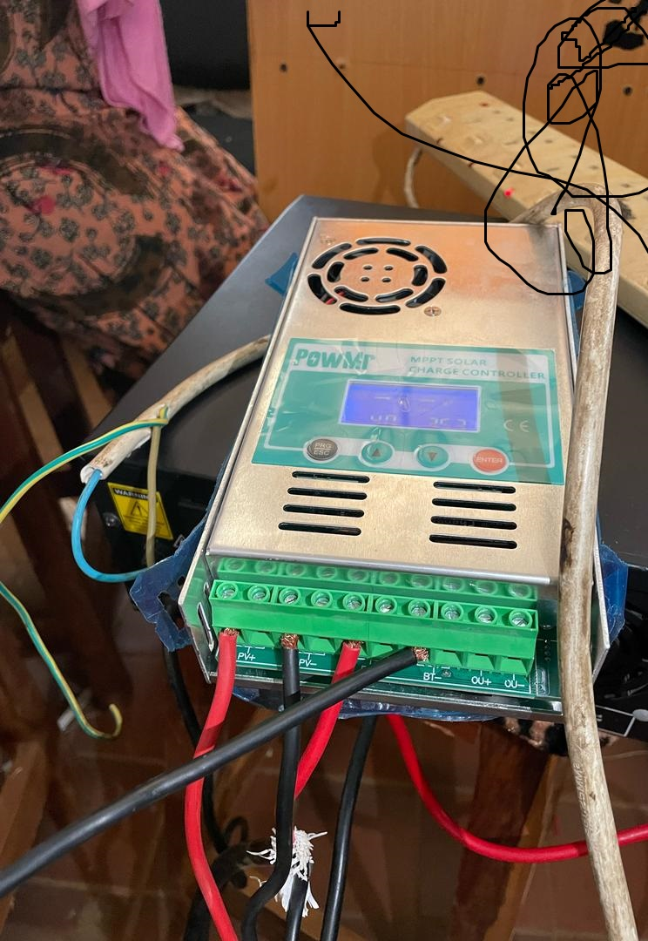
Figure 4:7: Shown PWM Charge Controller
Inverter: This is the part of system device that accept and regulate current both from the solar panel and from the battery directly. This can engage A.C which Nepaa electricity as well and it will regulate everything without contradiction, once the connection is correct and perfect.
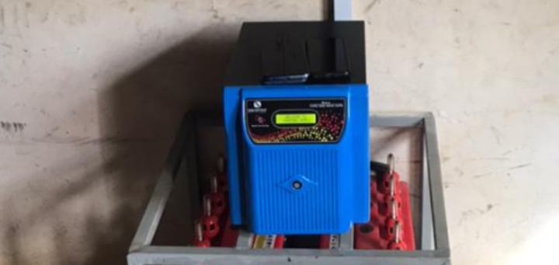
Figure 4:8: Shown Inverter
Battery: This serve as backup for supporting our solar panel, it also help to store energy, so it may be use when the suns goes down and during the night time when sun can never rise again, until the next day.
And we specification of batteries.The battery that was used in this project is a solar battery. Without the battery, the system could only power when the sun is shining. The power would interrupt each time the cloud passes, the system would become very frustrating. The solar battery provided constant electricity and the load discharges 80% of its charge.
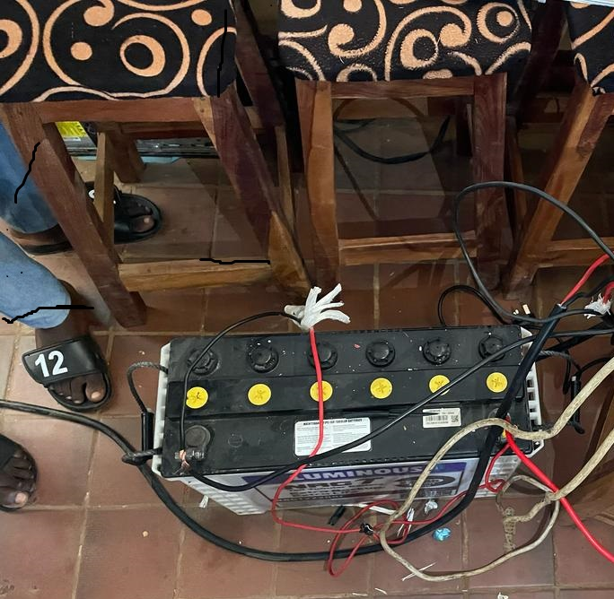
Figure 4:9: Shownbatteries
Cameras: This is a caption that allow user to view and allow the lecturer to view both recent and previous activities in the examination Centre. And it can be further use by saving and accepting the audio of the captioning.
We have cameras by specification are:

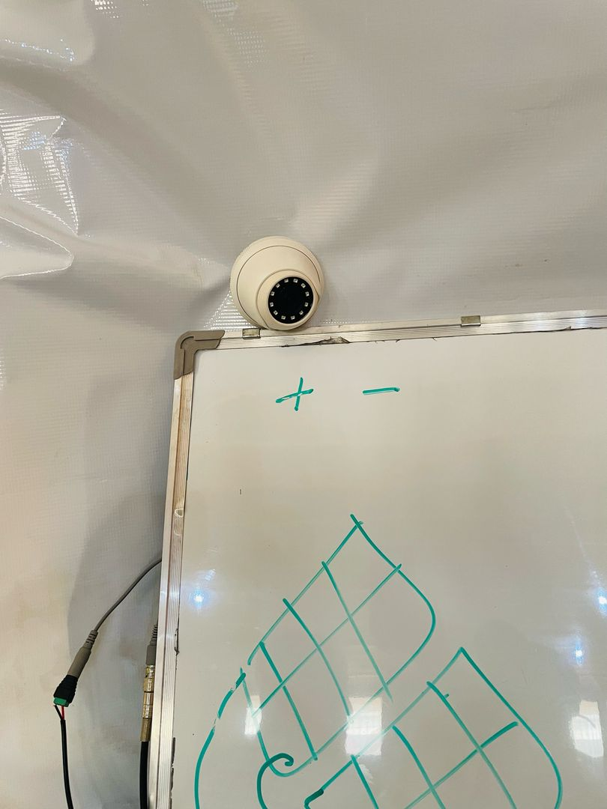
Fig 4.10. above an indoor Camera

DVR: This is a system that allow and accept more camera’s cable , to have capability to display and project each camera view and their audio. And it accept HDMI cable for display process. It description is like a decoder device
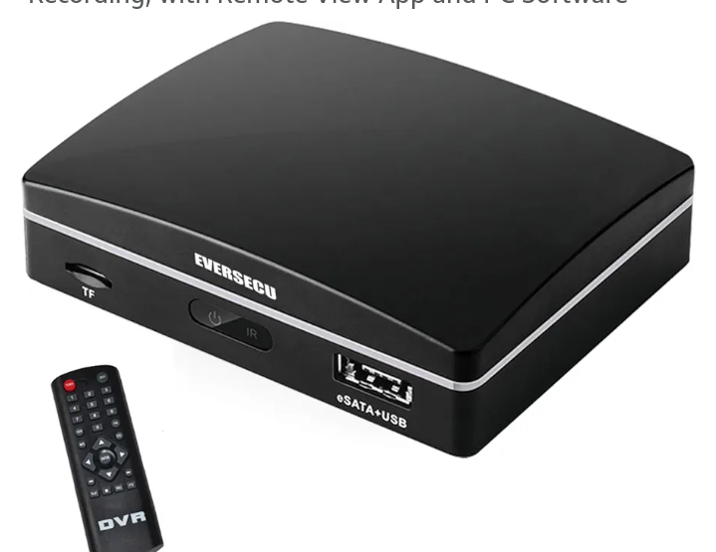

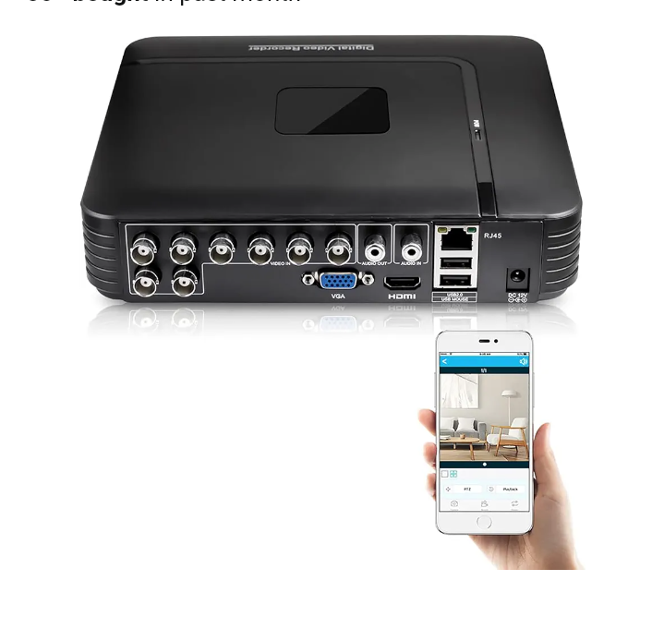
Figure 4:11: Shown DVR
Monitor: This is where our output is been display it might be TV, Desktop, Laptop, Smart phone,. This will display our output, and you can monitor your CBT examination Centre.
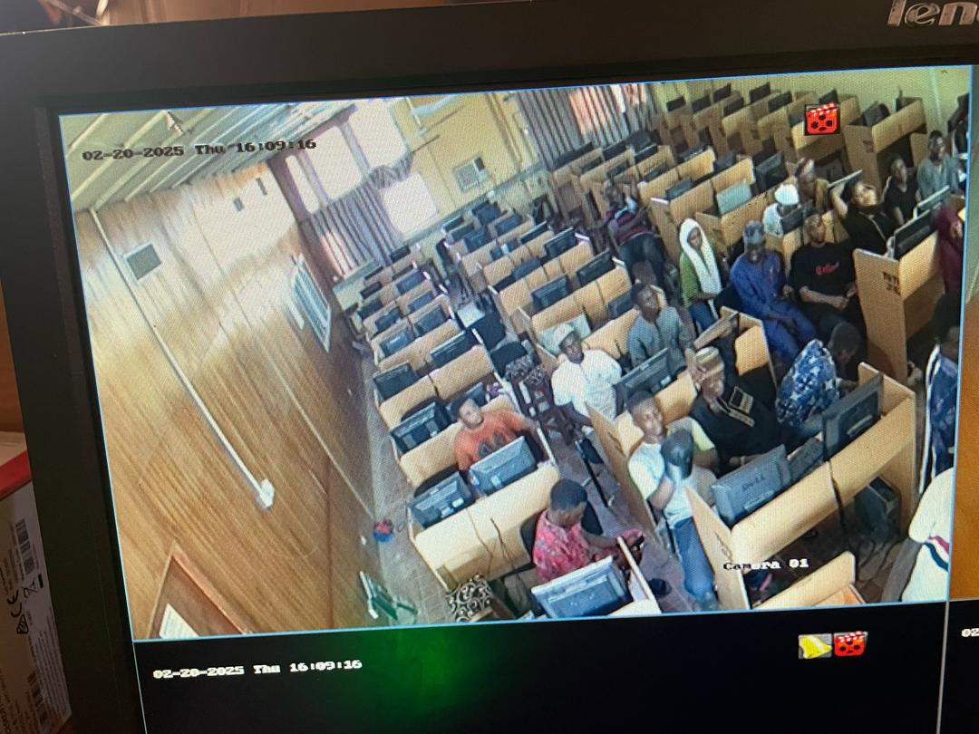
Figure 4:12: Shown the Monitor
Router: This is the internet device, that allow user to browse and communicate with the DVR to enable stable network for the user to download the software and monitor the activities.
It has specification. A router is a networking device that connects multiple network or subnetworks, and manage traffic between them. It acts as a hub and firewall.
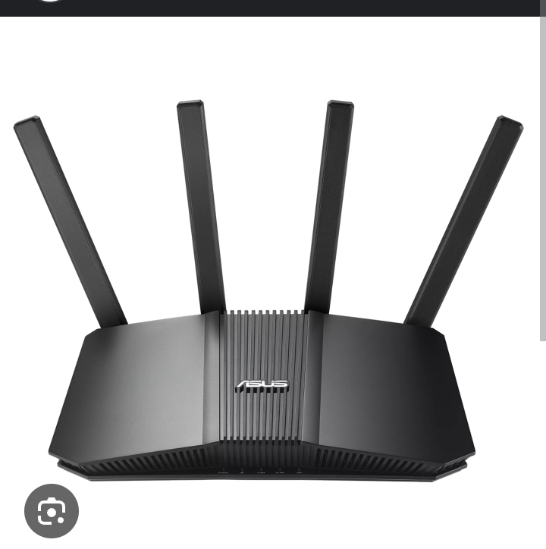
Figure 4:13: Shown the Router
  - OUTPUT DESIGN
This is the result of implementing the method use in using the power of solar as energy to monitor CBT examination Centre.
Figure 4:1: Captured CBT Examination Centre
This display student during their examination

CHAPTER FIVE
SUMMARY, CONCLUSION AND RECOMMENDATION
5.1 SUMMARY
In this project work, we present how we can use surveillance CCTV camera to monitor CBT examination Centre with the converted energy of solar power, which can be managed in our schools. However, we also identified various difficulties confronting our school’s in realizing its target, aims and objectives as well as making suggestion and recommendations to the management in order to improve it system generally.The integration of solar power panels into renewable energy systems and using CCTV cameras for monitoring offers a transformative approach to addressing the global demand for clean, sustainable energy. The advancements in photovoltaic technology have significantly increased the efficiency and viability of solar panels, making them a key component of modern energy strategies.
5.2 CONCLUSION
The role of smart CCTV camera’s electrifies by solar power to monitor CBT examination Centre has become an integral part of an establishment set up across advance country in the world, which Nigeria is included, that intended to keep good relationship between the school’s and some others organization. The result of this study coupled with the observation in similar school’s in other country and also in some part of the region in this country have shown an indication that, smart solar power CBT examination Centre monitoring system, as oxygen is to human lungs, is a function that can not be under-estimated and over ruled in any organization and school’s where efficiency of operation is a matter of consideration. The workforce of man power resource of an organization and in our school’s is the most valuable assets and as such, this aspect of managerial role requires urgent and special attention.
Therefore; For school’s and some private Centre to run effectively, it must have adequate finance, utilize it resources effectively to install and maintain this proposed system, in order that they could contribute quote towards achieving goals, and contribute to the growth of CBT Centre in our Country.
5.3 RECOMMENDATION
After a carefully study of the smart solar CBT examination Centre monitoring system and its various functions in all our school’s Centre, the following recommendation should be taken into consideration.
If people consider the various problem and some obstruction in aspect of having manual monitoring, it distracts and give some student lack of concentration, when there is movement of lecturer or invigilator in the examination hall. Hence there is installation of the smart monitoring it eases and safe energy. Hence the need for the implementation of the monitoring software has been developed align with the gadget used for the project work.
Also, the public relation department should be advice on the best and most modern technique, technology and practices to provide a professional support and monitoring service in the area of this study.
- Increase Investment in Advanced Photovoltaic Technology: Stakeholders should prioritize funding and research into high-efficiency solar panels. Continued innovation in photovoltaic technology is crucial to improving energy conversion rates and reducing the physical space required for solar installations.
- Expand Integration with Hybrid Systems: Energy providers should integrate solar power with other renewable sources like wind and hydropower. This hybrid approach will enhance system reliability and ensure a stable energy supply by balancing the intermittent nature of solar power with other renewable energy sources.
- Develop and Implement Advanced Energy Storage Solutions: Governments and private companies should invest in developing and deploying advanced energy storage technologies, such as lithium-ion batteries and emerging storage solutions. These systems are essential for storing excess solar energy generated during peak production times for use during periods of low sunlight.
- Provide Economic Incentives and Support: Policymakers should offer incentives such as tax credits, rebates, and low-interest loans to encourage both residential and commercial adoption of solar power. Financial support can help offset initial installation costs and improve the return on investment for solar energy systems.

REFERENCES

Amanze, B.C , Ononiwu C.C , Nwoke B.C & Amaefule I.A, (2016) video Surveillance and Monitoring System For Examination Malpractice In Tertiary Institutions.
Bashir, U.K,(2020) stated in his journal tilted Impact of CCTV Surveillance on Crime Prevention:
Desai, N .(2018) Students‟ Perception of Factors and Solution to Examination Malpractices in Nigerian Universities: A case study of the University of Ilorin. www.academia.edu
Fenelly, R. (2002) ‘To CCTV or not to CCTV: A Review of current research into the effectiveness of CCTV systems in reducing crime’, Nacro, [Online] Available at: http://epic.org/privacy/surveillance/spotlight/0505/nacro02.pdf (Accessed: 4 February).
Hier, K.(2015) Students‟ Perception of Factors and Solution to Examination Malpractices in Nigerian Universities: A case study of the University of Ilorin. www.academia.edu
Ijaye, M. (2014) Students‟ Perception of Factors and Solution to Examination Malpractices in Nigerian Universities: A case study of the University of Ilorin. www.academia.edu
Jimoh, C. (2011). Does CCTV Work? An Analysis of the Effectiveness of C C T V in Colchester Town Centre.
Krugle, M.P, & Bowers, K.J. (2012). A comparison of methods for temporal analysis of aoristic crime. Crime Science, 2(1), doi:10.1186/2193-7680-2-1.
Matthew, P.J. (2017), The Value of CCTV Surveillance Cameras as an Investigative Tool: An Empirical Analysis: European Journal on Criminal Policy and Research
Oduwaiye, R.O. (2014) Students‟ Perception of Factors and Solution to Examination Malpractices in Nigerian Universities: A case study of the University of Ilorin. www.academia.edu.
Oguniyi, E. (2011) Students‟ Perception of Factors and Solution to Examination Malpractices in Nigerian Universities: A case study of the University of Ilorin. www.academia.edu
Oko, R., & Sylvanus .U. (2016) worked on Examination Malpractice: Causes, Effects and Possible Ways of Curbing the Menace.
Oluwatoyin, S.A. (2018) Closed Circuit Television Cameras (CCTV) and Curtailing Unlawful Actions in Kwara State College of Education Oro, Nigeria
Onuka C. (2008). Implementation of a Motion Detection System. International Journal of Electrical and Computer Engineering.
Petter J.S, .(2014) Students‟ Perception of Factors and Solution to Examination Malpractices in Nigerian Universities: A case study of the University of Ilorin. www.academia.edu
Rita, C.W (2019) Students‟ Perception of Factors and Solution to Examination Malpractices in Nigerian Universities: A case study of the University of Ilorin. www.academia.edu
Sheldon, S. & Birchfield, S. (2016).Motion segmentation at any speed, Proc. of the British Machine Vision Conference.
Uche C. & Agwi. (2020) also worked on "Video surveillance in examination monitoring"
Welsh, J., Fyfe, N.R., & Kearns. A (2018). Closed circuit television and the city. In Norris, C., Moran, J., & Armstrong, G. (Eds.) Surveillance, closed circuit television and social control (pp. 21–39). Aldershot: Ashgate.

