AN AUTOMATED ATTENDANCE MANAGEMENT SYSTEM USING RADIO FREQUENCY IDENTIFICATION (RFID).

BY:
SOLARU AYOMIDE MICHAEL
HND/23/COM/FT/0413

SUBMITTED TO THE
DEPARTMENT OF COMPUTER SCIENCE, INSTITUTE OF INFORMATION AND COMMUNICATION TECHNOLOGY KWARA STATE POLYTECHNIC, ILORIN.

IN PARTIAL FULFILLMENT OF THE REQUIREMENT FOR THE AWARD OF HIGHER NATIONAL DILOPMA (HND) IN COMPUTER SCIENCE.

MAY, 2025.

CERTIFICATION
This is to certify that this project work was carried out by SOLARU AYOMIDE MICHAEL with matriculation number HND/23/COM/FT/0413 in the department of Computer Science, institute of Information and Communication Technology, Kwara State Polytechnic Ilorin, Kwara State. This project has been properly scrutinized, read, well supervised and approved as meeting part of the requirements for the award of Higher National Diploma in Computer Science.

________________________ ______________________
DR. RAJI A.K. DATE
SUPERVISOR

________________________ ______________________
MR. OYEDEPO F.S. DATE
(HEAD OF DEPARTMENT)

________________________ ______________________
EXTERNAL EXAMINER DATE

DEDICATION
This project is dedicated to Almighty Allah for his infinitive mercy on me and for making me to see the end of this program, Higher National Diploma (HND) and for his divine wisdom, knowledge and understanding throughout the academic sessions.
In addition, to my lovely and caring parent Mr. & Mrs. SOLARU for their financial and moral support throughout this programme and to my all my family members for there support. May Almighty God reward you all.

ACKNOWLEDGEMENT
All praise goes to the almighty Allah for giving me strength, inspiration, guidance and knowledge to complete this Higher National Diploma (HND) programme, without him nothing would have been possible.
My sincere appreciation goes my lovely parent Mr. and Mrs SOLARU for their immeasurable support and care also not to forget my family, who took most there time to help out. To my supervisor in person of DR. RAJI A.K who has been a great help through moral support and guidance to me throughout this project work, may Allah bless him, Amin.
A big thank you is also said to all my lectures in the department of computer science for their effort on impacting knowledge on me and I also thank the non-teaching staff for helping me in one way or the other.

ABSTRACT
Attendance is a crucial part of the student's entire academic record. Generally, the standard mode of taking attendance in the Nigeria university is the manual way, however this is not an efficient way since it is time consuming and some student might decide his/her friend as presence despite the fact that the student is presently absent. In Nigeria, most higher learning institutions require a minimum student percentage of class attendance before being eligible for the course examination. In this project an RFID based attendance is projected. RFID (Radio Frequency Identification) is a technology that uses radio waves to transfer data from an electronic tag called RFID tag or label, attached to an object through a reader for the purpose of identifying and tracking the object. The RFID will enable student to mark their attendance and conjointly also access and retrieve information using the RFID card.

TABLE OF CONTENT
Title page
Certification
Dedication
Acknowledgement
Abstract
Table of content
List of table
List of figure
CHAPTER ONE: GENERAL INTRODUCTION
  - Background of the Study
  - Statement of the Problem
  - Aim and Objectives
  - Significance of the Study
  - Scope of the Study
  - Definition of Terms
CHAPTER TWO: LITERATURE REVIEW
2.1 Review of Related Past Works
2.2 Write up on the gaps my methodology will filled
2.3 What is Attendance Management?
2.4 Benefits
2.5 Technology that Support Digital Attendance
2.6 Historical Background
CHAPTER THREE: RESEARCH METHODOLOGY AND ANALYSIS OF
EXISTING SYSTEM
3.1 Research Methodology
3.2 Analysis of the Existing System
3.3 Problem of the Existing System
3.4 Analysis of the Proposed System
3.5 Advantage of the Proposed System
CHAPTER FOUR: DESIGN AND IMPLEMENTATION OF THE DESIGN
4.1 Design of the System
4.1.1 Visitor Output Design
4.1.2 Admin Output Design
4.1.3 Visitor Input Design
4.1.4 Admin Input Design
4.1.5 Database Design
4.1.6 Procedure Design
4.2 Implementation of the System
4.2.1 Choice of Programming Language
4.2.2 Hardware Support
4.2.3 Software Support
4.2.4 Implementation Techniques used in Details
4.3 System Documentation
4.3.1 Proposed Documentation
4.3.2 Operating the System
4.3.3 Maintaining the System
CHAPTER FIVE: SUMMARY, CONCLUSION AND RECOMMENDATION
5.1 Summary
5.2 Conclusion
5.3 Recommendation
Reference
APPENDICES (if any)
CHAPTER ONE
INTRODUCTION
  - BACKGROUND OF THE STUDY
Attendance is a crucial part of the student's entire academic record. It is also a way of preserving student evaluation, encouraging regular school attendance, and maintaining each student's progress report within the institution against their respective scheduled classes is necessary. In Nigeria, most higher learning institutions require a minimum student percentage of class attendance before being eligible for the course examination (Oluwagbemiga et al., 2023). This policy byNigeria's Technical Education Board (NBTE) and the Nigerian University Commission (NUC) facesnumerous confronts presented by the conventional method of attendance taken(i.e., laborious to process, prone to error, and tolerating proxy attendance).All these challenges arise a need for an efficient and effective method of solving these problems. This seminar proposes Information Technology (IT) solution for student attendance monitoring and processing using Radio Frequency Identification (RFID) integrated with a software package with solutions tailored to Nigeria's Technical Education Board (NBTE) and the Nigerian University Commission (NUC) policy. RFID is an automated technology for identification and data collection that ensures data entry is more precise and timely.
RFID is a wireless identification technique used by the smart system to identify, secure, monitor, and record information by using radio waves to identify and track a tag fixed into an object, such as a school identification card, organization card, etc.(Lim et al., 2022). RFID component includes RFID Tags and RFID Reader. An RFID Tag can either actively or passively transmit electromagnetic signals to theRFID reader. When in its vicinity, the RFID reader reads the information stored on the RFID Tags through its antenna. (Nairan et al, 2013). The middleware consists of components that transmit data to the backend management system from the reader. It consists of hardware elements such as cable and communication ports and software features such as filters that monitor the network output of the device. The design and implementation of the RFID system will promote adequate management of students present in classes and lectures and aid automotive students' portability through pocket-based solutions. This attendance system operates such thatthe student passes the RFID tag close to the RFID reader. The reader will capture the RFID Tag's unique identification number and send it to the attendance application. The application designed at the backend will update the attendance database with arrival and departure time and collate the data gotten from the attendance to generate the average class attendance for each student enrolled in the software database.
1.2 STATEMENT OF RESEARCH PROBLEM
The problem associated with attendance management in the present-day institute has generated many academic settings challenges because of the various processes involved and the hurdles surrounding manual attendance management, such as capturing, processing, stressful, laborious,error-prone, and proxy attendance. Valuable lecture time is devoted to attendance, thereby losing time for actual lecture to commence and sometimes inefficient, time-consuming, and challenging.
1.3 AIM AND OBJECTIVES
This project aims to develop an automated attendance management system with the use of RFID. The objectives are as stated:
- Detect and authenticate an RFID card reader of each student
- Access and manage student attendance database for every student
- Automatically calculate the number of absentee and the percentage of students
1.4 SIGNIFICANCE OF THE STUDY
The RFID will undoubtedly help the institutions because of the inbuilt arrival and departure time feature in the system database, enabling students to report to class and sign out when they are leaving. When implemented, the system is more human friendly, less time consuming, more effective in generating the attendance, which will allow users to track record of student information easily.The system has higher accuracy on the identification part and eliminates the cheating issues associated with the manual attendance system, where students take attendance on behalf of their course mate.
1.5 SCOPE OF THE STUDY
This project designed work is to access and focused on the automated attendance management system using Radio Frequency Identification (RFID). This research work will focus on how manual attendance management work will reduce drastically to obtain detailed information on the number of times students attend lectures withradio frequency identification.
1.6 DEFINITION OF TECHNICAL TERMS
- RFID Reader: it is an RFID transceiver providing read and possibly writes access to RFID tag.
- RF: Radiofrequency.
- ATTENDANCE: The frequency in which a person is present in an event.
- RFID: is an automated identification and data collection technology that ensures more accurate and timely data entry.
- RFID Tags: it is a transponder, typically consisting of an RF coupling element and a microchip that carries identifying data. Tag functionality may range from simple identification to being able to form the ah-hoc network.
  - ORGANIZATION OF THE REPORT
The organization of this project work includes the following chapters.
Chapter one describes the background of the study, the statement of the research problem, significance of the study, aim and objective of the project, finally scope and limitation.
Chapter two contains the review of some related works, the overview of database system, database system concepts and design, concept of biometric finger print.
Chapter three includes method of data collection, analysis of data and the existing system, the problem of the existing system, description of the proposed system, the advantages of the proposed system, and design and implementation methodologies.
Chapter four discusses the design of the system, the output design of a system, the input design, and the implementation of the system, the choice of programming language and documentation of the system.
Chapter five contains summary, conclusion and recommendation, references, system flow chart, program source codes and outputs.

CHAPTER TWO
LITERATURE REVIEW
2.1. REVIEW OF PAST JOURNAL WORK
Ezema et al, 2022: The paper proposes a framework for fingerprint based attendance management. The researchers introduce fingerprint acquisition which consists of the enrolment process, verification process and data collection process. The enrolment process is responsible for students’ fingerprint registration using scanner to take the images of the fingers and determined the unique characteristics of the scanned images. The verification process compares the stored enrolment template with the newly scanned fingerprint images. If the comparisons of the fingerprint image and the stored template are successful, the system shows an acknowledgement in its display and grants the user access else access is denied. The last stage is the data collection process where the information collected can be collected after a period of time i.e. the number of times restricted, the student attendance e.t.c.
To implement this system, each classroom is equipped with fingerprint detecting machine which requires each student to swipe their finger across the sensor so as to indicate their presence in the class room or exam hall. The system helps to reduce the amount of work done by administrator since less processing is involved. Unfortunately, the system is not practicable in large students’ environment
Lodha et al, 2020: The paper proposed a Bluetooth smart based type of attendance system which makes use of tiny chips called tags. The tags transmit and contain piece of identifiable information to a Bluetooth smart enable device, then this tag are embedded into the student identification card (student ID card). The electronic tag can then be read during motion as well and this does not required any line of sight for wireless communication between the tag and the reader.Every student is required to use a specific tag which can be detected by the application via Bluetooth low energy. When student attends a lecture, a serial number (related to each students SAP number) of the tag is associated with the student database entry. Therefore every time a student carries his/she card and is attending a lecture the entries will be entered into the database with the time stamp as the lecturer moves around the class and the application detects the tags.
Also, the application is configured to work within a particular range to detect tag in order to avoid detection of tags that are outside the class. The system result obtained will enable the lecturer to make use of queries provided by the application to obtain more information about the attendance. But unfortunately, in as much as this system is accurate and ensures timely entry of data, it lack in some ways where student helps their course mates to carry their ID card to class just for their attendance to be taken.
Singh et al, 2021: The paper project a framework by using mobile based student attendance management system. The researcher’s work commenceby using Andriod studio php and MySQL wamp server, which is divided into two phases, the first phase is the admin module used to login for administrators. It monitors and manages the entire project while the second phase is the teacher’s module; the teachers use it to register on website to generate a user id and password. Through this process they are able login on their smart mobile based attendance application and submit the final data to the authorized web server of the admin panel.
The web based module is for the admin panel to control its all over activates such as updating, creation, deletion or any other database changes in the whole project by the admin and it’s also contains a teachers registration phase on website only through which they can generate a user id and password to login in the mobile based application which is connected through this admin panel server.
The mobile based application is created because of its competence as well its security whereby it send all information pertaining to any particular student to the authorized web based admin panel server as it is linked in the proposed mobile application. This android based application used by the teacher to login and through its subject id and class id display the digital register for the particular class students and finally submit it to the authorized admin panel. Since the web site is secured it can be subjected to changes by the admin panel to make changes in any database of the student as well as the teacher.
Ayu and Ahmed, 2020: The paper proposes a framework system of web based attendance system using Near Field Communication (NFC) technology and it is supported by three modes of operation which are: reader/writer mode, card emulation mode and peer to peer mode.The communication in reader/writer mode is between NFC device and a tag in which device either read from the tag or write to a tag. The peer to peer mode involves exchange of data between two NFC devices. While in card emulation mode the NFC device acts as a tag which will appear to an NFC reader as a contactless smart card. One popular application of NFC is smart poster. The system has two main units and they are the reader unit and web unit.
Reader Unit is in charge of taking account of valid student information like student ID from either student’s NFC- enable mobile device or tag if the student is using NFC- enable mobile device then the student ID is retrieved from a file stored in the device. But in the case of student using an NFC tag which might be in the form of card or wristband then the student ID will be retrieved from the tag. The concept of smart poster is to keep information like URL, phone number, SMS into the tag and attached the tag to a physical objects, all this information can be accessed by touching the tag with NFC enable device.
Different lecture classes in the university/colleges are then installed with NFC reader which is then connected to the teachers Pc and work while connected to the university’s network. The students and teachers must download the mobile application and install on their phones which will be automatically run upon touching by the reader. When the application is then activated by the lecturer for the lecture group, the students and lecturers will fill a form and transfer the data to the server through the reader, and receive a response also via the reader.
Sadly to say, this attendance based system is practicable but lack in the aspect in which the university Wi-Fi is not strong in some places and the password is unknown. This will leads to many students not to be able to login to register for attendance.
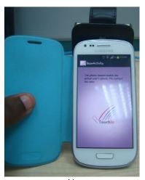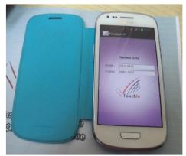
Plate 2.4: Beaming data between student’s and lecturer’s NFC-enable phones.
Abdulsada, 2020: His research work is basedSmart Attendance based on Raspberry pi. He proposed a system using Raspberry pi3 model and Arduino UNO for hardware which will both be implemented in the attendance system using RFID RC522. The system consists of terminal units and base station unit. The terminal unit includes the control unit, RFID unit and the communication units. The RFID unit is basically the tags and reader. The tag is in charge of getting information and sending it to the control unit. The control unit consists of the Raspberry pi and screen GUL user interface. The control units make comparison between the IDs received and the IDs stored in the database of SQL server. All database of students i.e. their names and serial numbers are built using SQL server in the Linux operating system. The unit is responsible for getting information pertaining to the ID from the RFID unit and process the information to obtain the necessary data needed for attendance system.
The system operation consist of five steps: the first step involves the student putting their tag near the reader and the reader send the tag an issue to get the ID’s. The second step is the tag receiving the issue and send its ID’s to the reader which is connected to the Raspberry pi. Third step send all the received ID’s to the reader to make comparison with the list on the SQL database to get the names of the absentees. Four steps send the ID’s of the absentee to the central unit (Arduino and GSM shield). The final steps receive all the information for the terminal units and make assessment on the absentees i.e. students.
In order to understand the fusion between Raspberry pi, RFID and GSM used in Abdulsada research work the figure below show the representation details
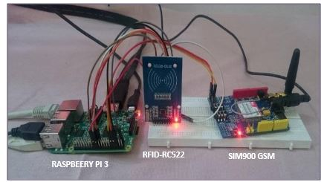
Plate 2.5: connection of Raspberry pi with RFID and GSM
The diagram above shows that Raspberry pi can be programmed using high level programming language which is the open source python language. The raspberry pi needs an operating system to startup, Linux operating system is more appropriate for Raspberry pi. A blank SD card is needed to flash the Linux operating system onto the card. After that, the internet is connected to the Raspberry pi inorder to download the required libraries. Mouse and Keyboard are also utilizedwiththe Raspberry pi which is needed to work with the operating system and hence the raspberry pi can be programmed.
Rathna and shamitha, 2020: The paper proposed a framework system of Android Based student Management System. The researcher proposed to develop a smart phone based application using a JavaScript and XML programming language to develop the Android based type of attendance. And the proposed work require new user to first register by filling in some columns on their android phone which are used in the database and while user logged in the application, by providing email id to sign-in and OTP is been send to the email if password is forgotten. The whole system of attendance management system is basically based on the student intention to either have the lecture or not because it is based on student stay in class. The system is design for online classes which enable student to apply for bonafide certificate through online. Regrettably the whole system is not applicable to Nigeria educational sector, since online classes is so hard to find due to reason know to be insufficiency capital to fund such a system, bad network, high tariff with network charges and lack of garget to use by student.
Khatum et al, 2019: The paper proposed a framework system of Iris recognition based attendance management system. The researcher’s work i.e. Iris recognition based attendance management system is based on biometric system which make used of web-cam to take images of different individuals, send the images taken to the computer for additional processing and then storing it for future reference. Once the images are taken and stored, MATLAB data analyzing software is used for the iris localization, iris image acquisition, iris adjustment, iris checking, iris extraction, iris matching, data storing, authentication and send to E-mail. The iris is then localized starting from the color around the edge of the pupil that is used in MATLAB coding to extract eye. MATLAB retrieve the image appropriate for the eye that is authentic and stored in the database. The system make used of different parameters to run the program such as the gray coding, color adjustment and pixel adjustment. MATLAB required certain parameters such as position, line width, line style, edge color to calculate the radius of the eye. Iris matching compares the image taken with the store database. Authentication process of provides access to a system for security reason based on individual’s identity. Authentication ensures who the right person is or who has right to access. But the data identity of a person has to store before in the database and when his or her image is given then the input images will be compared with stored image. If this process gets matched then it goes to the next steps. The next step involves the report gotten from the authentication process to a predefined E-mail address. The information send to the E-mail contain the attendance report.
Unfortunately, this system is not reliable because it requires certain position for the images to be taken so has to match the stored images in the database and if not taken right the whole process is repeated. The whole process of retaken images coupled with student restless attitude will make the attendance system not dependable.
Altafuddin 2022: He research on Online student attendance and feedback system using MVC framework. The Model View Controller(MVC) is a Web based type of application and the proposed work is divide into three components with each one specialized in a task. They are the Model- View-Controller, Model-View-Presenter, Model-View-View-Model .The Model-View-Controller is software pattern architecture that separate the information view from the user view. The Model-View-Presenter is an architecture that is the derivation from the MVC design pattern. The presenter component defines the association with the view component so that the reference view is generated. And lastly the Model-View-View-Model this model
2.2. WRITE UP ON THE GAP MY METHODOLOGY WILL FILLED UP
This project will focus on the elapses of the manual ways of attendance management and also the previous uses of various technologies to solve the problem of attendance. Different institutions has make use of different system to combat the challenges associated with attendance but even with their ways of trying to implement solution, still fall short in many ways. This project is proposing the use of radio frequency identification attendance registration system that does not required any device other than RFID tag and RFID reader. RFID card has a designated ID assigned to it, where database is developed so has to ensure the storage of student status on the RFID card. This project is mainly focus to reduce attendance time to about 3minutes and thereby remove human errors by reducing human obstruction with the system as much as possible. The attendance system will make use of radio frequency and micro controller smart graphical liquid crystal display (GLCD). Whenever student shows their RFID card to the RFID reader, the LCD connected with the micro controller will show the student status i.e. either present or absent. If the card is not registered with the database then the LCD will display a message indicating such user as unauthorized, this is to prevent impersonation from other student. This attendance system will work in a way that whenever a student passes the RFID card close to the RFID reader, the number associated with the card is captured by the reader and then sent to the attendance database application, which records the student attendance in the database. The attendance system will be in charge of the collation which will generate the percentage of student attendance. RFID technology offers flexibility of data integration, robustness and more efficient device investment.
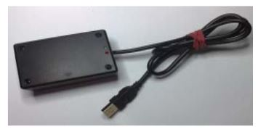
Plate 2.6: RFID Scanner
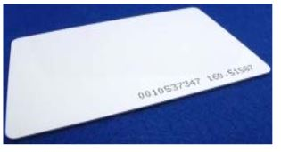
Plate 2.7: RFID Card
2.3. WHAT IS ATTENDANCE MANAGEMENT?
Attendance management system is software developed to keep track of daily student attendance in schools, colleges and institutions to maximize their performance. Lecturer in charge of a particular class will be able to access the attendance information of any particular student in any classes; this system will help to evaluate attendance eligibility requirement of a student.
2.4. BENEFITS
Student at higher institution of learning should be penalized by professors or the institution for lack of attendance because if students do not miss their classes, it will improve their academic performance
- Good attendance is needed to develop so as to encourage class participation
- Students will have to perfect time management skills to make sure that they get to class while meeting all other obligations
- Regular attendance to classes will help to create opportunity to develop student’s life skills
- Attendance management policy helps the department to know which students have been enrolled and the number of question paper to produce during examination
- Students learn self discipline due to mandatory attendance, which will help them in their professional as well as personal life.
2.5. TECHNOLOGIES THAT SUPPORT DIGITAL ATTENDANCE
Barcode
Gao et al (2019) define barcode has mode of encoding letters and numbers in a series of variable width bars and space that can be read, processed, retrieved and validated using computer. Barcode requires a refines device for decoding. The invention of 2D barcode ensures that large amount of data for storing in a small area to support information distribution and detection without accessing database. There are two types of 2D barcodes; stacked and matrix. Barcode are widely used because of the technology and process faster, it is simple, economical and accurate tool to enter data without the use of keyboard. Barcode can easily decode text information by the use of electronic reader. Drawback from different research work on attendance system using barcode is the seriality of the registration process and the unnecessary consumption of time.
Face Recognition

Kainz et al (2020) make use of face recognition in his research work, face recognition requires series of process that tries to match and detect a face from a digital image with data from an existing database. This will enable the comparison with the image gotten from the camera and that of the facial features from the database image. There are three component required which are; a camera, micro- controller and server. The camera is in charge of taking images which are taken at a predetermined time interval. Once the image is taken, it is then transferred to the micro controller, which will send information to the server. The server process the image, distinguish the feature of the image from that in the database, mainly the server evaluates the image provided. There are two approaches to face recognition algorithms include geometry, which is a method of searching for distinguishing features, and photometry, which is a statistical approach that distills an image into values and compares them to the templates to eliminate variances. Drawback from attendance management using face recognition is that in order to take images, each attendee will need to face the camera at a certain angle and this can only be influenced by the students’ attention in class.
Voice Recognition
The voice is a distinct feature that can be used to identify a user from an existing database, by utilizing the distinct characteristicsof the voice, including the pitch, time, amplitude and intensityMohammed and Hegarty (2019). The main advantage of voice recognition system is the low-cost and its utilization of voice as a unique user biometric feature. The most commonapproaches to voice recognition can be divided into two classes: template matching and feature analysis. Template matching is the simplest technique and has the highest accuracy when used properly, but it also suffers from the most limitations. The first step in template matching requires the user to speak a word or phrase into a microphone. The electrical signal from the microphone is digitized by an analog-to-digital (A/D) converter, and is stored into the memory. The computer attempts to match the input with a digitized voice sample, or template that has a known meaning. The program contains the input template, and attempts to match this template with the actual input using a simple conditional statement. Instead of trying to find an exact or near-exact match between the actual voice input and a previously stored voice template, this method first processes the voice inputusing Fourier transforms or linear predictive coding (LPC). Then it attempts to find characteristic similarities between the expected inputs and the actual digitized voice input. These similarities will be present for a wide range of speakers and so the system needs not be trained by each new user Klevans and Rodman (2021). The voice recognition must not be confused with speech recognition system that tries to predict the users’ speech. Drawback from voice recognition is that, it takes unnecessary long durations of time for the voice registration process to be done.
2.6. HISTORICAL BACKGROUND
Radio Frequency Identification is a growing technology that can be dated back to the early 1900’s and the origin of radio frequency technology can be track back to the World War II.Different countries such as Germans, Japanese, American and British all were making use of radar which was discovered by Scottish physicist Sir Robert Alexander Watson-Watt in 1934 to warn of approaching aircrafts while they were miles away. The problem associating with the radar used back then was that there was no way in which the planes can be identify to differentiate it from which country’s own pilots returning from a mission or the enemy. Later in the 1970s, Radio Frequency Identification (RFID) research and discovery was made and clear development works were made where vehicle tracking, factory automation etc. were the main intentions.RFID is commonly used to transmit and receive information without wires. RFID readers and tags communicate through a distance using radio waves. There are a lot of advantages in RFID system, included their price, size, memory capacity and their capability.All through the 1950s and 1960s the advancement in radar and RF communication continues.Electronic article surveillance tags, which are still used in packaging today, have a 1-bit tag. The bit is either on or off. If someone pays for the item, the bit is turned off, and a person can leave the store. But if the person doesn't pay and tries to walk out of the store, readers at the door detect the tag and sound an alarm Mohammed (2019).
The First RFID Patents Mario W. Cardullo claims to have received the first U.S. patent for an active RFID tag with rewritable memory on January 23, 1973, Mohammed (2021). Later, companies developed a low-frequency (125 kHz) system, featuring smaller transponders. A transponder encapsulated in glass could be injected under the cows’ skin. This system is still used in cows around the world today. Low frequency transponders were also put in cards and used to control the access to buildings Mohammed (2021).
Today, 13.56 MHz RFID systems are used for access control, payment systems (Mobile Speedpass) and contactless smart cards. They’re also used as an anti-theft device in cars. A reader in the steering column reads the passive RFID tag in the plastic housing around the key. If it doesn’t get the ID number it is programmed to look for, the car won't start Mohammed (2022).
In the early 1990s, IBM engineers developed and patented an ultra-high frequency (UHF) RFID system. UHF offered longer read range (up to 20 feet under good conditions) and faster data transfer. IBM did some early pilots with Wal-Mart, but never commercialized this technology. When it ran into financial trouble in the mid-1990s, IBM sold its patents to Intermec, a bar code systems provider. Intermec RFID systems have been installed in numerous different applications, from warehouse tracking to farming. But the technology was expensive at the time due to the low volume of sales and the lack of open, international standards Mohammed (2021).
Summarizing, RFID is a incredible technology that brings together a broad range of professionals and knowledge areas such as systems engineering, circuit technology, software development, integrated circuit design, network engineering, antenna theory, propagation theory, microware technology, materials technology, receiver and transmitter design, encryption theory and mechanical design.

CHAPTER THREE
RESEARCH METHODOLOGY
3.1 METHODOLOGY
The Attendance system works in such a format that RFID Tags which have unique numbers (identities) are matched to a student. This means that each student is given an RFID card that is unique to him/her. This Attendance system operates in such a way that when a student passes the RFID Tag close to the RFID reader, the number associated with the tag is captured by the Reader, and sent to the Attendance Application, which records the student’s attendance in the database. This system makes use of the RFIDREAD-RW-USB (125KHZ), which is designed to read and write tags. The RFID READ-USB module at its core generates a magnetic field through its integrated antenna at 125 kHz, or 134 kHz. When the tag comes near the range of the reader module, it draws power form the electromagnetic field to power itself. Once powered, they modulate the magnetic field which is detected by the RFID reader. This way, the Tags transmit their data to the Reader module. The Attendance system is based on the working principles of an RFID System, using Visual Studio as an IDE (Integrated Development Environment) to develop and MYSQL as the database backend to run the system.
3.2 ANALYSIS OF THE EXISTING SYSTEM
The manual method of taking attendance in Computer Science Department at Kwara State Polytechnic, Ilorin is purely paper based system, which contain a lot of errors and manipulations. In Computer Science Department, lecturers take attendance by calling out the names and surnames of students, and then marking them, while, sometimes, lecturers pass around a sheet of paper, asking students to sign in attendance sheet just next to their surnames. Both practices have their drawbacks. In the first case, if numerous students attend the lecture, checking all of these students by name or surname might take precious time of each lesson; in the second case, friends of absent students may help to write down their names and surnames. These practices place computer science department lecturers and their institutions at considerable disadvantages when it comes to taking attendance.
3.3 PROBLEMS OF THE EXISTING SYSTEM
The problems that the paper base student attendance system is facing cannot be over emphasized; the problems are day by day increasing. The following are the problems facing the paper base attendance system:
- Time consuming: This system wastes the lecturer precious time to write names and time a student resume for school, some may even be on queue for the sake of signing in.
- It’s difficult to process: It takes more effort to keep track of paper attendance, and to collate all attendance recorded by the lecturer during his/her lecture time at the end of the semester and to check the student’s eligible to sit for examination or any other activities.
- Proxy Attendance: By using this system, students will ask their course mate to write down their names when they are absent from the lecturer.
3.4 DESCRIPTION OF THE PROPOSED SYSTEM
With the design of this system, paper-based system will be eradicated. This system can save time and minimize the manpower for manual management. The administrators can easily trace the attendance of the students compare to manual paper recording and file keeping system. Besides, the students' records are more secure which are saved into the database. The developed system can trace the attendance of the students while they are coming and leaving for lectures. With the report, the administrator can easily analyze and detect the performance of the students in the schools.
The student attendance system is proposed to solve the current problems that occurred while using the manual based system. Therefore the administrator job to keep tracks the attendance and student records. There are some things that needed to put in consideration while developing the project. These are time, resources and experience. Student attendance monitoring system is important because it can estimate the time required to complete each milestone in project phase.
It is able to determine how much time needed to perform each task by referring to the schedule that given by the committee. In addition, this project is not a full time development because there will be other subjects to be concentrated. Therefore, time allocated is limited and tight.
3.5 ADVANTAGES OF THE PROPOSED SYSTEM
The following are the advantages of the proposed system:
Automation: - It automates the attendance process, reduces time and improves efficiency.
Convenience: - Traditional attendance system uses pen and paper. So it makes attendance calculation very hectic and also includes chance to human error. This automated system eradicated all this inconvenience and make process smooth.
Eradicate proxy attendance: -This system put end to a situation whereby students asked their friends to write down their names when they are absences from the lecturer.
It’s easy to process: -Whenever a student with RFID tag entered the classroom, the RFID reader automatically reads the tag and sends the information saved on the tag to the database, so at the end of the semester the system automatically calculate the attendance report and check eligibility of students.

CHAPTER FOUR
DESIGN, IMPLEMENTATION AND DOCUMENTATION OF THE SYSTEM
4.1 DESIGN OF THE SYSTEM
The proposed system is designed in modules with each modules working together to perform the goal of access control system in order to enhance the performance of the existing system as earlier discussed in chapter three. The ability to analyze and give focus to the system is explained in the following formats which are output design, input design, database design and procedure design.
4.1.1 OUTPUT DESIGN
The outputs to be extracted from the proposed system are as shown below:
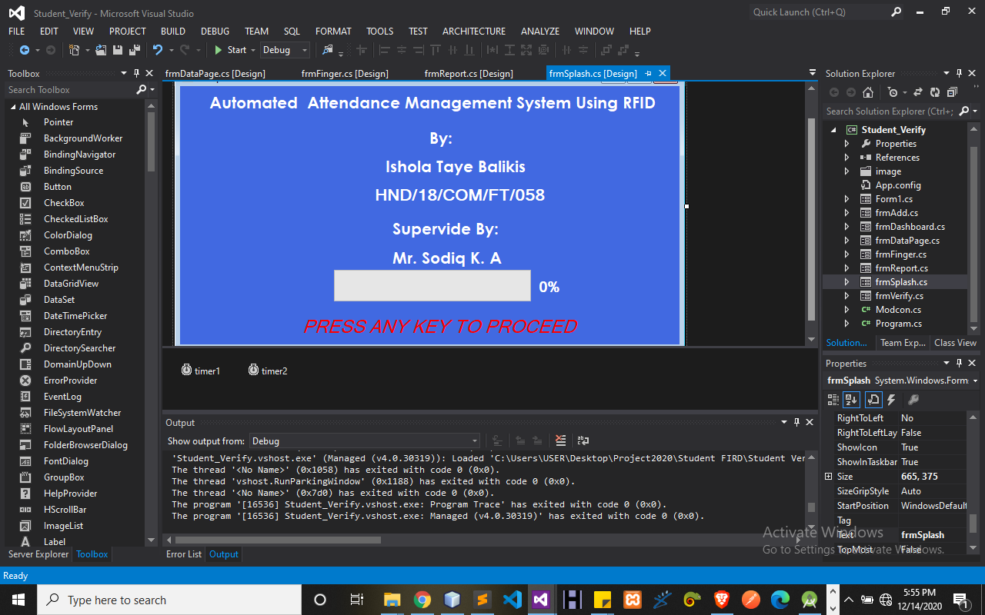
DEVELOPMENT OF STUDENT ATTENDANCE USING RADIO FREQUENCY
IDENTIFICATION (RFID)
Figure 4.1: Splash Screen Display
The page will display after the administrator successfully opens the software. This page shows all details of the developer and the supervisor in charge

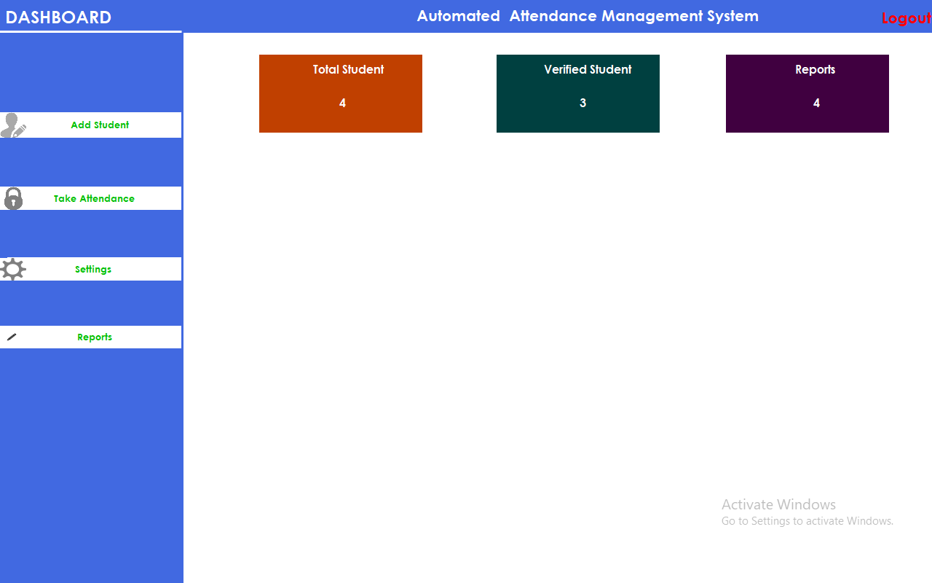
Figure 4.2: Main menu
The page will display after the administrator successfully opens the software. This page shows all operations that can be performed using this system. These operations are discussed below:
- Add Student: -This option allows lecturer to record student data into the database system.
- Take Attendance: - This option allows users to activate the port by clicking the port to open it so that it can receive the signal from RFID reader through USB serial communication. So that it can easily trace the student who attends the class according to the student name, date and the time.
- Settings: - This allow administrator to make settings on the application.
- Report: - This show all attendance details of all student.
- Close: - This option allows users to exit the software

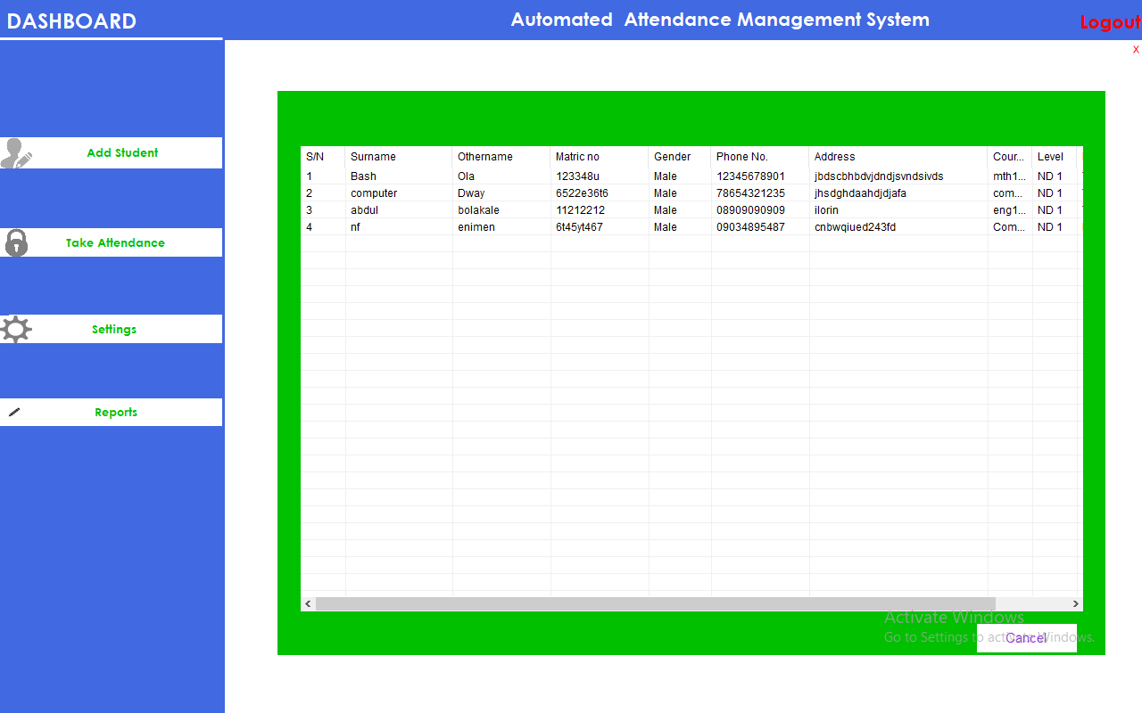
Figure 4.3: Report Display
Clicking report display all registered studentsinformation saved on database where lecturer can view, delete and edit students’ details. Such as Student ID, Name, Gender, course record, Department and Level. This page shows report on all registered student.

4.1.2 INPUT DESIGN
The inputs to be extracted from the proposed system are as shown in figure below:
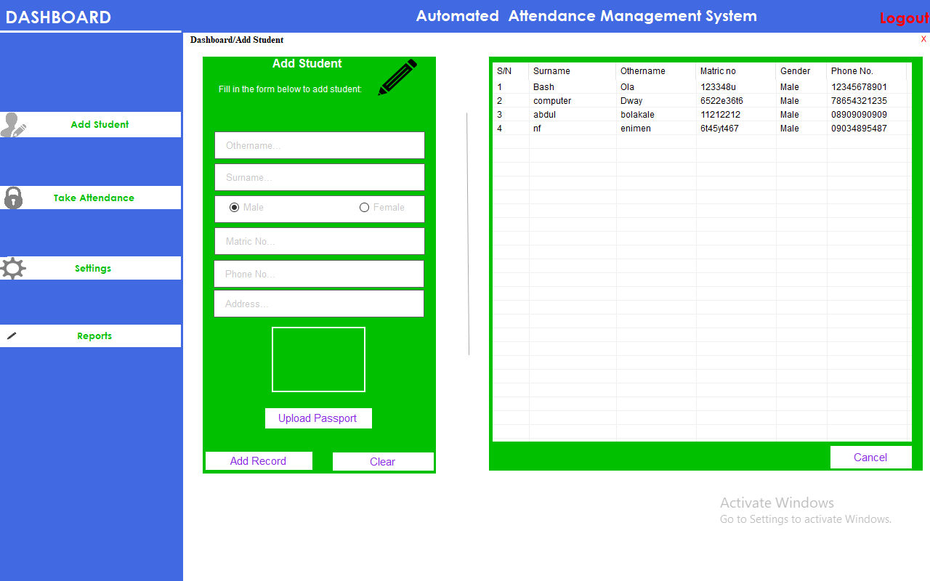
Figure 4.4: Registration of Eligible Student
Clicking the add student option from the navigation menu displays the page to register student details. This page accepts student information for the first time and saved on the database, so as to perform all other processes of the software.

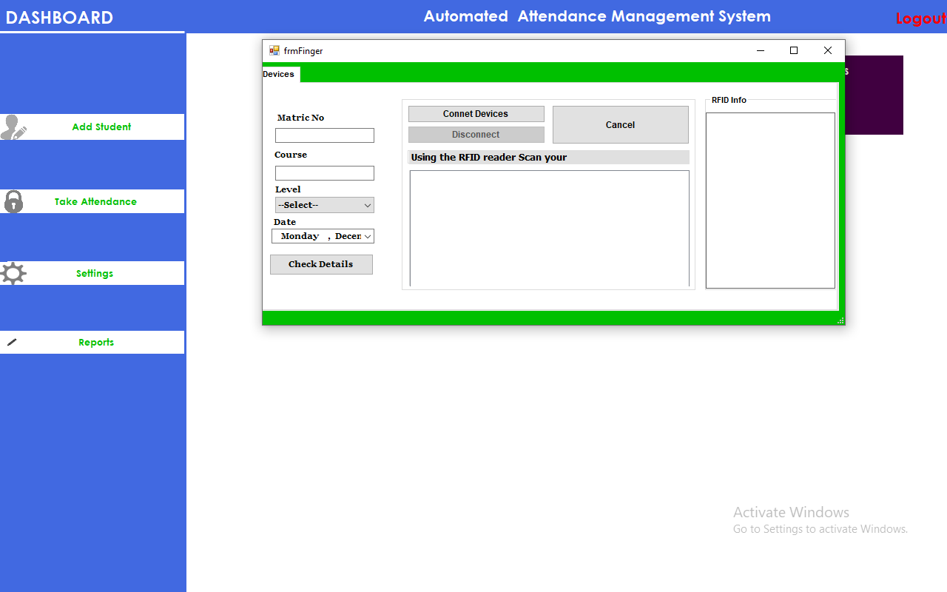
Figure 4.5: Connect RFID Page
4.1.3 Database Design
This involves the list of tables used in the database design the tables are listed as follows
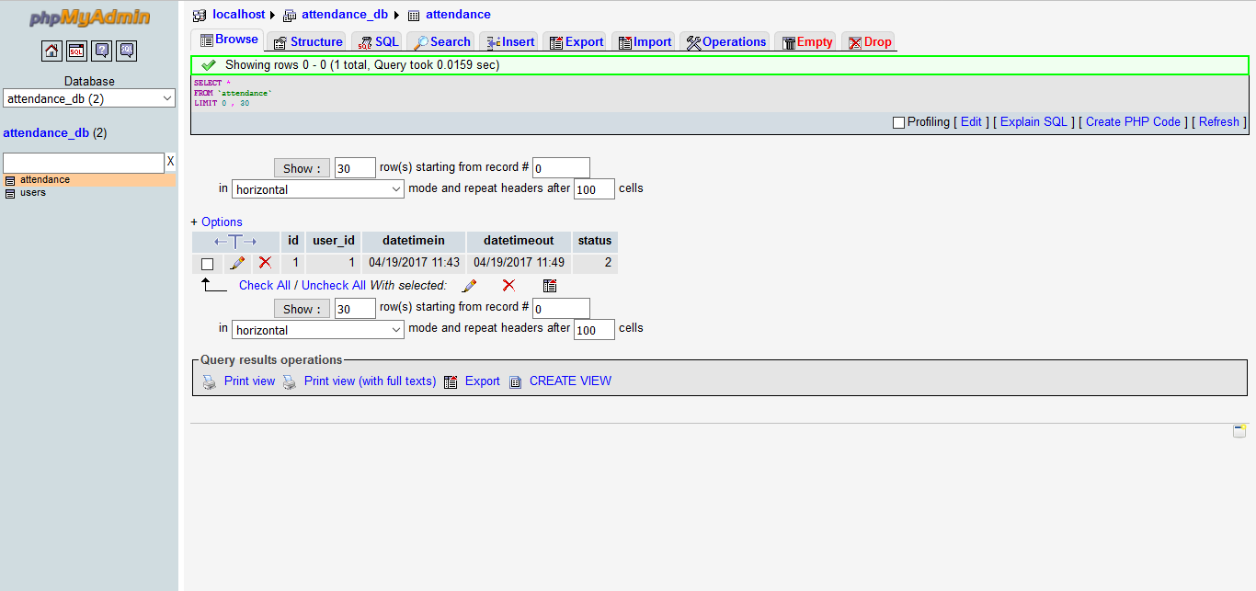
Table 4.1: Attendance database
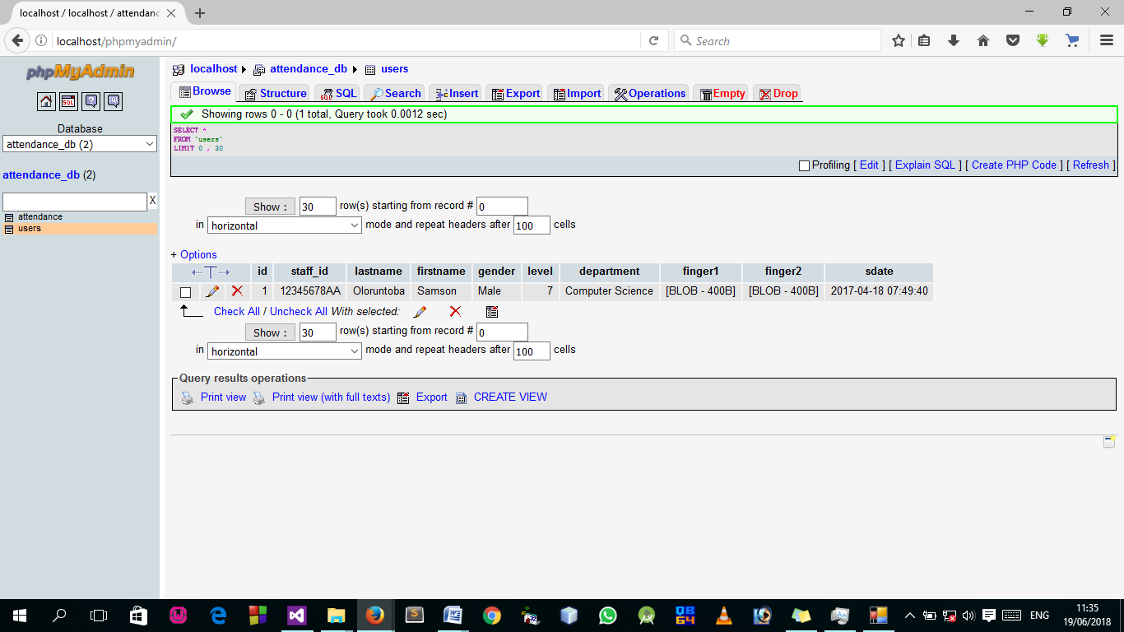
Table 4.2: RegDB database
MYSQL database: There are two databases designed using MYSQL database. The databases named “regDB” in (table 2) and “attendance”. The “regDB” in table 2) database stores information of registered users. This information is used by the administration to identify and manipulating attendance information. In the other hand, the “attendance” in (table 1) database stores all attendance related data. Besides that, there are three tables inside the “attendance” database which act as temporary data storage which are “users ID”, “data_time_in” and “data_time_out”. These tables are essential to the program flow. The database has a login password which allows access.
4.1.4 PROCEDURE DESIGN
Procedure design is the arrangement, steps and flow of a program. It involves how the commands and instructions grouped together to form the whole program. The methodology used for the program is an event driven programming language which makes the program more efficient in terms of execution, development time, storage utilization and maintenance.
4.2 IMPLEMENTATION OF THE SYSTEM
This section deals with the implementation and documentation of the new system. It involves the physical requirement of the machines on which it can run i.e memory capacity, operating system. It also provides a comprehensive user’s manual or guide with various screens (forms) as displayed to the user during the run-time.
4.2.1 CHOICE OF PROGRAMMING LANGUAGE USED
The programming language used in the developing of this student monitoring system is Microsoft Visual Studio as the compiler C# as the programming language and also coupled with the MSQL database.
4.2.2 HARDWARE SUPPORTS
For proper implementation of this system, the following requirements are recommended for the system on which this application is to be executed. An IBM compactable PC with the following configuration.
- Minimum of 586D x process or with 300MHz speed and 6.4 GD HDD
- Minimum of 64MB RAM
- VGA (640 x 480 x 16 or higher) color monitor
- Dot Matrix or laser printer
- Stabilizer, UPS
- Serial mouse, 101 key enhanced keyboard
- Air-conditioning
- 52 x CD-ROM Drive and diskettes
- Headphone
- RFID
4.2.3 SOFTWARE SUPPORT
The following are the minimum software required:-
- Window 10 Professional
- Microsoft VISUAL Studio
- MYSQL Database
4.2.4 IMPLEMENTATION TECHNIQUES USED IN DETAILS
The implementation technique used is parallel change over mode of implementation, modes which supports only the proposed system and leave the old system of operation.
  - DOCUMENTATION OF THE SYSTEM
After the program has been well tested with input that the output has already been known, the next is to install the software in to the computer system for use.
The processes of installing are being stated below
i. Insert the CD into the system through the CD-ROM after the computer is switch on
ii. Locate the CD drive directory in my computer and click it to open
iii. After open, locate setup.exe, and then click to install the program by following the necessary step in installing the program.
iv. Ensure full installing of the software for effective operation of the system.
After the program has been fully installed. The next thing is to locate the package installed to put it into operation, to locate the package for expiration purpose the following step are to be taking .
i. Click on start menu from task bar. Then select all program
ii. From the display sub option, select by locating the software installed named Dependency to load the software.
iii Follow the next instruction to operate the software
    - OPERATING THE SYSTEM
Proper and adequate documentation is part of the quality of a good program hence to work with the software. You click on start button then locate all programs and click on Staff on the login screen, input password and username; the welcome page will be display and then the home page. So you can select any menu from the list provided in other to perform any operation you desired to perform.
    - MAINTAINING THE SYSTEM
Proper maintenance of the system is required in other for the system to perform up-to expectation at all time to maintain the system properly the following measures should be taken.
- Keep away from unauthorized user:- by password or encoding the system to prevent unwanted user from having access to the system.
- The software package should not be disposed to dust:- in order to prevent virus and also make use of antivirus in the system where the packages is to be used to prevent the program from corrupting.
- You must have UPS: to prevent uninterrupted power supply from the system.

CHAPTER FIVE
SUMMARY, CONCLUSION AND RECOMMENDATION
5.1 SUMMARY
This project consists of an RFID based attendance system that allows for automatic attendance marking by using RFID tags. Every student is provided with a unique authorization tag that is used to record his/her attendance.
A lot of time is wasted in schools and colleges for manual attendance procedures, in such cases our system provides an instant and automated attendance marking system. Every authorized student is provided with a unique RFID tag with his/her details fed in it. The tag consists of a built in integrated circuit that stores this data through modulating and demodulating transmitted radio frequency signals.
The data thus stored in this card is the unique identification of that person. As soon as the card is placed in front of the RFID reader, the data in it is read and attendance for that student is registered. This is done with the help of an 8051 microcontroller interfaced with the reader.
If it is a registered student, then a confirmation is displayed on an LCD screen, else a rejection message is shown that denies the attendance.
All student attendance status can be later obtained from the system when the status button interfaced with the microcontroller is pressed. This saves a lot of time and effort in student attendance registration.
5.2 CONCLUSION
The design and implementation of a RFID based automatic attendance system which is the aim and objective of this research was successfully implemented. This system provides an effective and more convenient method of taking attendance when compared to the manual system. Data are more organized, the system is user friendly, data manipulation and retrieval is done via the graphical interface. The system can be implemented in any educational institution in Nigeria.
5.3 RECOMMENDATION
This system is recommended to all institutions and other access point, more so for upcoming developers who may want to work on RFID system on staff monitoring system.

REFERENCES
AmenaKhatum A.K.M, FazlulHaque, Sabbir Ahmed, Mohammed Mahfujur Rahman, (2015)” Design and Implementation of Iris Recognition Based Attendance Management https: // www. Researchgate. Net// publication/ 295813222.
Ezema L.S, C.K.A, Joe-Uzuegbu, Eneh J.N. and Amanze I. (2015),” fingerprint based attendance management system,” international journal of scientific & engineering research, Vol.6, Issue 7,
Harte, L, (2009)” Introduction to Bluetooth: Technology, Operation, Profiles and Services, Copyright ® by Altos Publishing. ISBN: 1-932813-72-1
HayderFadhilAbdulsada (2017)” Design and Implementation of Smart Attendance system Based on Raspberry,” Journal of Babylon University/ Engineering Science/ No. (5)/ Vol. (25).
Media AnugerahAyu and BarroonIsmaeel Ahmed (2014),” an NFC supported attendance system in a university environment,” international journal of information and education technology. Vol.4, No 5,
Mohammed S. &Hegarty M, (2017) ” Evaluation of Voice & Ear Biometrics Authentication System. International Journal of Education and Management Engineering (IJEME),.
Monika Singh, DivyaTripathi, Ashutosh Pandey, Rakesh Kumar Singh (2017), ” mobile based student attendance management system,” international journal of computer applications, Vol.165, No3,
Nainan S., Parekh R., Shah T. (2013), “RFID Technology Based Attendance Management System” International Journal of Computer Science Issues, Vol. 10, Issue 1, p. 516 - 521,
Ononiwu G, Chiagozie, OkoraforG.Nwaji (2012) “Radio frequency identification (RFID) Based attendance system with automatic door unit” in academic research international. ISSNL-L:2223-9553.;2(2).
QaziAltafuddinFarooqui (2017) Online student attendance and feedback system using MVC Framworkinternational research journal of engineering and technology (IRJET), Vol.4.issue 04
Recognition in Class, (2014). International Journal of Advances in Engineering & Technology (IJAET), 7(3): 974-979.
Riya Lodha, Suruchi Gupta, Harshil Jain, Harish Narula, (2015)” bluetooth smart based attendance management system,” international conference on advance computing technologies and applications(ICACTA) 524-527

