AN INVESTIGATION INTO WATER DEMAND AND DISTRIBUTION IN ILORIN WEST LOCAL GOVERNMENT
(A CASE STUDY OF EGBEJILA)

BY
SAAD ABUBAKAR AYOMIDE
HND/23/CEC/FT/0015

SUBMITTED TO
DEPARTMENT OF CIVIL ENGINEERING,
INSTITUTE OF TECHNOLOGY,
KWARA STATE POLYTECHNIC, ILORIN

IN PARTIAL FULFILLMENT OF THE REQUIREMENT FOR THE AWARD OF HIGHER NATIONAL DIPLOMA IN CIVIL ENGINEERING TECHNOLOGY

JULY, 2025

DECLARATION
I, hereby declared that this Project titled An Investigation Into Water Demand And Distribution In Ilorin West Local Government (A Case Study of Egbejila) is a collection of my original work and it has not been presented for any other qualification anywhere. Information from other sources both published and unpublished has been duly acknowledged.

…………………………………… -------------------------.
SAAD ABUBAKAR AYOMIDE DATE
HND/23/CEC/FT/0015
CERTIFICATION
This is to certify that this research study was conducted by SAAD Abubakar Ayomide (HND/23/CEC/FT/015) and had been read and approved as meeting the requirement for the award of Higher National Diploma (HND) in Civil Engineering of the Department of Civil Engineering, Institute of Technology, Kwara State Polytechnic, Ilorin.

……………………………………. …………………………..
ENGR. M.O. ASEBIODE DATE
Project Supervisor

……………………………………. …………………………..
ENGR. A. NAALLAH DATE
Head Of Department

……………………………………. …………………………..
ENGR. DR. MUJEDU KASALI ADEBAYO DATE
External Examiner

DEDICATION
This project work is dedicated to Almighty Allah, the author and the finisher of our faith who has assisted me throughout the course of this project.

ACKNOWLEDGMENT
I express my profound gratitude to Almighty Allah for giving me the privilege of completing my Higher National Diploma program.
My sincere appreciation goes to my project supervisor Engr. M.O Asebiode, who contributed immensely to the improvement of my work and whose constructive criticism at various stages of the work and his suggestions contributed immeasurably to the success of this project.
My profound gratitude also goes to the Head of Department Engr. A. NAALLAH, my departmental lecturers and non teaching staff of the institute.
I give thanks to my parent Mr. and Mrs. Abubakar who never stop believing in me for their spiritual and financial backing throughout my stay in the polytechnic. I remain indebted to you forever, not forgetting my brother Abdulhakeem and sisters Ganiyat, Mosunmola and Shukurah for their love, encouragement and financial backings, I really appreciate you all.
Not forgetting my friends and family who also contributed to my success morally and financially during the course of my study, may Almighty Allah bless you all abundantly.

ABSTRACT
This project work examined the water demand and supply in Egbejila area of Ilorin west local government, Kwara State. The three main users of water focused upon in the study area are residential, commercial (block industry, hair salon, food canteen) and agricultural water use. Also, the three main sources of water available to the users i.e. borehole, pipe borne water and well water supplies were investigated to determine the effectiveness of these sources of water in meeting up with the demands of the various group of users.
Questionnaires were administered to the users in which residential water use was the highest, followed by commercial and agriculture to determine their level of consumption of water and how their various sources of water have been able to meet up with the daily demands. It was determined that the three sources of water meet up with the daily demands of the various users in the study area. Although supply of water seems to meet up with the demand but more jobs have to be done by the ministry of Works and Water Corporation on pipe borne water supply in term of its availability and repair of distribution system appurtenances (i.e. various devices installed along the distribution system).
TABLE OF CONTENT
Content Page No
Title page i
Declaration ii
Certification iii
Dedication iv
Acknowledgment v
Abstract vi
Table of contents vii-viii
List of Table ix
List of Figure x
CHAPTER ONE
1.0 Introduction 1
1.1 Statement of the problem 3
1.2 Aim and Objective 3
1.3 Justification of the study 3
1.4 Scope and limitation of the study 4
1.5 Description of the study area 5
1.6 Methodology 5

CHAPTER TWO
2.0 Literature Review 6
2.1 Elements of a public water system 10
2.2 Factors affecting the use of water 10
2.2.1 Characteristics of Population 11
2.2.2 Climatic conditions 11
2.3 Living standards 11
2.4 Water scarcity and its associated problems 12
2.5 Problems associated with water scarcity 12
2.6 Causes of water scarcity 13
CHAPTER THREE
3.0 Methodology 15
3.1 Introduction 15
3.2 Research Design 15
3.2.1 Population 16
3.3 Data Collection Procedure 16
3.3.1 Reconnaissance Survey 16
3.3.1 Types of Data 16
3.3.2 Sources of Data 16
3.3.3 Methods of Data Analysis 17

CHAPTER FOUR
4.0 Results and Discussion 18
CHAPTER FIVE
5.0 Conclusion and Recommendations 24
5.1 Conclusion 24
5.2 Recommendations 24
References 25

LIST OF TABLES

Table Title Page
4.1 Age difference of the respondent 18
4.2 Gender group of the respondent 18
4.3 Occupation of the respondent 19
4.4 Rate of Water usage 19
4.5 Source of Water 20
4.6 Distance covered for collection of Water 20
4.7 Who is responsible for collection of Water? 21
4.8 Payment of Water 21
4.9 Storage of Water 22

LIST OF FIGURES
Figure Title page
4.1 Age difference of the respondent 18
4.2 Gender group of the respondent 18
4.3 Occupation of the respondent 19
4.4 Rate of Water usage 19
4.5 Source of Water 20
4.6 Distance covered for collection of Water 20
4.7 Who is responsible for collection of Water? 21
4.8 Payment of Water 21
4.9 Storage of Water 22

CHAPTER ONE
1.0 INTRODUCTION
Water is a fundamental natural resource essential for life, health, and economic development. In most urban centers of developing countries, access to clean and sufficient water is a growing challenge due to increasing population, urbanization, and poor infrastructural development. In Nigeria, and particularly in Ilorin West Local Government Area (LGA), many communities such as Egbejila experience irregular and insufficient water supply, which affects domestic, commercial, and agricultural activities.
Egbejila, a fast-growing community in Ilorin West, suffers from inadequate water infrastructure and erratic water distribution. Despite being under the jurisdiction of the Kwara State Water Corporation, most residents rely on boreholes, wells, and water vendors. Understanding the demand and distribution challenges is essential for sustainable water resource management.
Water is a chemical substance with the chemical formula H₂O. Its molecule contains one oxygen and two hydrogen atoms connected by covalent bonds. Water is a liquid at ambient conditions, but it often co-exists on earth with its solid state, ice, and gaseous state (water vapor or steam). Water covers 70.9% of the earth's surface, and is vital for all known forms of life on earth, it is found mostly in oceans and other large water bodies, with 1.6% of water below ground in aquifers and 0.001% in the air as vapor, clouds (formed of solid and liquid water particles suspended in air), and precipitation. Oceans hold 97% of surface water, glaciers and polar ice caps 2.4%, and other land surface water such as rivers, lakes and ponds 0.6%. A very small amount of the earth's water is contained within biological bodies and manufactured products.
The importance of water to man cannot be over emphasized. It holds the most important benefit to man’s sustenance besides shelter, food and clothing (Ajadi, 1996). It is recognized all over the world that water is a vital resource for human existence and it is a major factor in commanding the progress of civilization.
Nigeria is experiencing an increase in the rate of change in population growth coupled with increased urbanization and living standards. Thus, the increasing needs for domestic water and other uses, places an increasing demand on its water resources.
Water is very vital, resources is not in short supply in Nigeria and Ilorin in particular, but regulating its availability and ensuring even distributions is always a serious problem, (sule, et al., 1999). However, the quantity of portable water available for human consumption has been receiving attention. Two extreme views have often been expressed regarding availability of water to man. One view believes that man is in his critical period in water consumption, and that demand is overtaking supply. The other view is that water is sufficiently available all the time everywhere worldwide. Both views may be acceptable in terms of water resources availability across the geographical space. For instance, Sule and Okeola(2010) studied the performance assessment of a regional water supply arrangement in Kwara State, Nigeria. Ghali, (1992), Glieck (1996), Sule et al.,(2000), Shabam and Sharman (1981) and Oyegun (1983) studied water resources development in Kwara State and found out that increasing urbanization, population and ineffective management of water resources have been leading to water crisis.
The conventional practices of planning, designing and managing water systems require regular reviews and adjustment. For effective service delivery, many studies have been carried out in area of water supply management in developing countries. In a study conducted by Akinola and Areola (1980) in Ibadan, Nigeria, the basic per capital consumption for planned residential areas was found out to be 89 liters per day; this demand is however suppressed because of intermittent pumping. Water consumption varies from one area to another depending on socio-economic standard of the people, the level of education and development, nature of prevailing climate, the hygienic characteristics of the people, level of provision of sanitation facilities and general sanitary habits of the people. However, it is generally agreed that a minimum of 501/c/d is needed by an individual to satisfy his basic needs irrespective of socio-cultural background. Ilorin like many other cities in Nigeria does not have accurate water demand and distribution data that could be used for the design and improvement of the water distribution system.
Water is not only a vital environmental factor to all forms of life, but it also has a great role to play in socio-economic development of human population. it was in recognition of this that the 34TH World Health Assembly in 1981 made a resolution emphasizing that safe drinking of water is a basic element of “Primary Health Care” which is the key to the attainment of health of citizens of the world.
1.1 STATEMENT OF THE PROBLEM
Water is very important in mans day to day activities ,the use of water cannot be overlooked as it is used by both men and women, old and young.
In Egbejila, the demand for water surpasses the available supply. Households and institutions report difficulty accessing water for daily needs, often spending significant income on alternative sources. The inadequacies in the water distribution system point to infrastructural deficits, population growth, and poor policy implementation. This study investigates the extent and reasons for water demand challenges and distribution inefficiencies in Egbejila.
The problems people in Ilorin west local government area faced will be critically looked into so as to investigate the causes and provide adequate solutions to the problems like:-
(i) Poor water storage infrastructure
(ii) Poor piping network
(iii) Topography of the area
(iv) Vandalization of water network/distribution system

1.2 AIM AND OBJECTIVES
The main aim of this study is to investigate into the demand and distribution of water in Ilorin west local government
The specific objectives are
(1) To determine the various sources of water available in the study area.
(ii) To examine the effectiveness of the various sources of water in meeting the needs of the various uses in the study area.
(iii) To look into the distribution of water in the study area.

1.3 JUSTIFICATION OF THE STUDY
It is important to recognize the significance of water and its fundamental contribution to sustainable development. Water has strong linkages to the three pillars of sustainable development – economic, social and environmental. Its main contribution to socio-economic. Well–being is through its use in agriculture. Water for food production can improve poor people’s livelihoods and economic well-being through irrigation, industrial use and power generation. To this end, it effective management is essential both to reduce the vulnerability of poor people and achieve environment sustainability- through sustainable levels of abstraction, the preservation of bio-diversity, water shed management and control of pollution (Foster, et. Al, 2000, Klein, 1996, World Bank 1992; Dinar, et. al, 1997).

1.4 SCOPE AND LIMITATIONS OF THE STUDY
This study was confined to the Ilorin west local government in Egbejila and its environs in which the users of water were selected based on the various sources of water they make use of. This project work was limited to determining the efficiency of the various sources of water in meeting the demands of various consumers and provision of solution in cases where the demand exceeds the distribution.

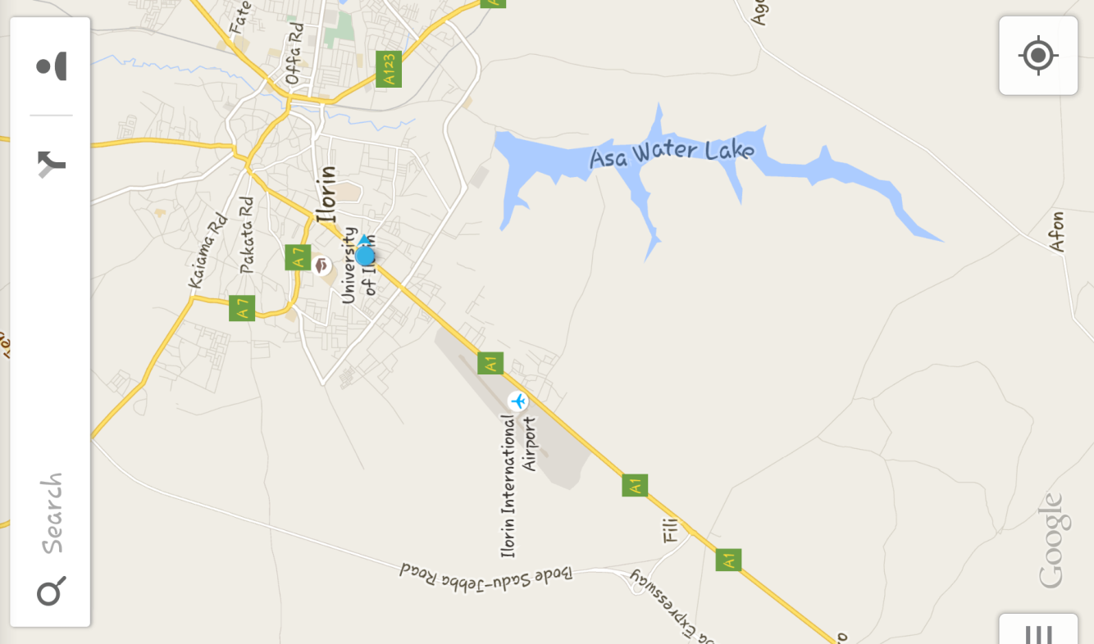
1.5 DESCRIPTION OF THE STUDY AREA
Ilorin west is a local government area in Kwara state, Nigeria. Its headquarters are in the town of Egbejila. It has an area of 105km and a population of 364,666 at the 2006 census.
Asa river basin which lies within Asa and Ilorin west local government in kwara state is located at the boundary of the state at the southern part of the state and it is surrounded by Moro local government of the north, Oyun and Offa local government to the south and Ilorin west local government to the east. The study area lies between latitude 4⁰ 12’N and 4⁰ 29’N and longitudes 8⁰ 7’E and 8⁰ 42’E with an area of 5036.625km²

1.6 METHODOLOGY
(1) Performed the reconnaissance survey of the study area.
- Determination of the various sources of water in the area such as well, pipe borne water and bore hole.
- Determination of various consumers of water in the area such as households, commercial/industrial in Ilorin west local government.
(2) Questionnaire
(3) Oral interview at water works
CHAPTER TWO

2.0 LITERATURE REVIEW
Ajadi (1996) viewed that in Nigeria and most developing countries, the water supply industry is managed by the state which transfers its ownership and administration to water agencies like water boards, water corporations etc. Increased urbanization, rapid growth of population and standard of living have been the major causes for the increase of urban and semi-urban water use resulting in changing supply pattern and more water consuming lifestyles. Increasing population, more household and industries connected to public water supply particularly in Ilorin, coupled with ineffective management of water resources have been leading to water crisis being experienced in the metropolis.
Sule, Ayanshola and Salami (2010) carried out a survey on water use pattern in Ilorin, Kwara state, Nigeria. The water use pattern study extends to various water consumers such as residential, institutional, commercial and industrial. The study was conducted by distribution of questionnaire and oral interview. The questionnaire contains questions related to water demand and distribution. The information obtained were analyzed and the results show that the residential water consumption varies from 461/c/d to 1151/c/d with low value for high and medium density area, while high value is for low density area because of high standard of living. Amao and Omonona (2010) carried out a research on household water security in which the study examined household water security in Ibadan Southwest Local Government Area of Oyo State. The study revealed that the number of children in the household was found to significantly affect household water consumption, while number of males was negatively significant.
Rainwater (26.2%) was the most common source of water available to households. Drinking water was mostly sourced from borehole (32.8%) and water rubber (keg) (70.0%) was mostly used as storage facility. Also, households collect water from less than 1km distance (57.5%); 60% use a maximum of 4 children and 85.5% involving at most 4 females to collect water for household consumption.Thus, more improved sources of water such as pipe borne water in-house was suggested to be made available to households in the study area to improve access to water for all household uses.
Aderibigbe, Awoyemi and Osagbemi (2008) carried out research on adequacy and quality of water supply in Ilorin metropolis where results shows that majority of the respondents (62.9%) had access to pipe-borne water although this was not adequate to meet their needs.
Other sources of water include wells, boreholes, rain water harvesting, rivers and packaged water (pure water). Respondents have to spend long hours and travel long distance to haul water daily. 64.8% of the respondents had access to less than the recommended 140 liters/day for all users. Also, 65.4% of the respondents use less than 40 liters/day for their domestic purpose alone. Respondents use water mainly for domestic and agricultural purpose. Most people in the environment use water which has taste, color or odor. Yet, only few of them practice any form of water treatment. It was then concluded that water is fairly available in Ilorin metropolis but it is quite inadequate with poor quality in terms of the biological component.
It is recognized all over the world that water is a vital resource for human existence and it is a major factor in commanding the progress of civilization. Nigeria is experiencing an increase in rate of change in her population coupled with increased urbanization and standard of living.
Thus, the increasing needs of water for domestic and other uses, places an increasing demand on our water resources. Water as a very vital resources is not in short supply in Nigeria and Ilorin in particular, but regulating its availability and ensuring even distributions is in fact a serious problem, (Sule, et al., 1999). However, the quantity of portable water available for human use has received cries of inadequacies. Two extreme views have often been expressed regarding availability of water to man. Some believe that man is in his critical period in water consumption, and that demand is already overtaking supply. The other view is that water is sufficiently available for all the time everywhere worldwide. Both views are acceptable in terms of water resources availability across the geographical space.
In a study conducted by Akinola and Areola (1980) in Ibadan, Nigeria, the basic per capital consumption for planned residential areas was found to be 89 liters per day; this demand is however suppressed because of intermittent pumping. Water consumption varies from one area to another depending on socio-economic standard of the people, the level of education and development, nature of prevailing climate hygiene characteristics of the people and level of provision of sanitation facilities and general sanitary habits of the people.
However, it is generally agreed that a minimum of 501/c/d is needed by an individual to satisfy his basic need irrespective of socio-cultural background. Ilorin like many other cities in Nigeria does not have accurate water demand and figures that could be used for the design and improvement of the water supply system.
The total domestic water needs in homes with piped water and inside sanitation is at least 115 liters per head per day. The actual amount used may be greater depending on the ease and convenience of supply (Ayoade Oyebode, 1983). According to World Health organization, 75 liters of water a day is necessary to protect against household diseases and 50 liters a day necessary for basic family sanitation. The international consumption figures released by 4" world water forum (March, 2006), indicates that a person living in an urban area, uses an average of 250 liters per day; but individual consumption varies widely around the globe (THD, 2007). WHO and UNICEF joint monitoring program currently estimates that 1.1 billion people (17% of the global population) lack access to water resources, where access is defined as the availability of at least 20 liters of water per person per day from an improved water source within a distance of 1km (Bates et al.,2008).
The number of people who rely on the earth's limited reserves is increasing every day. In fact scarcity of clean water is one of the world's most pressing environmental problems (Arms, 2008). At the 2002 world Summit on Sustainable Development in Johannesburg, South Africa.
Great concern was expressed about the 1.1 billion people in the world who do not have access to safe drinking water and the 2.4 billion who lives without proper sanitation (Cech, 2005). The resulting human toll is roughly 3.3 billion cases of illness and 2 million deaths per year.
Moreover, even as the world's population grows, the limited easily accessible fresh water resources in river, lakes and shallow groundwater aquifers are dwindling as a result of over exploitation and water quality degradation (IABA, 2004).
According to Morenikeji et al, (2000) access to portable water in Niger state has been in continuous decrease since 1980s. On the average, less than 20% of the inhabitants of the study area currently have access to portable water. Government had been making effort at providing safe water supply to the inhabitants of the then Niger state since 1966 in form of wells but till today according to Mohammed (2007) the scheme had not been successful to meet the demands of the populace. Despite that the domestic water supply dams constructed and commissioned in Minna, Bida and Suleja in 1995 to compliment the sources in the major towns, bi-water World Bank projects boreholes drilled in local government headquarters and wells in districts. Not sooner as the population increases, all these infrastructures of water supply could no longer meet the water demand of the inhabitants in Niger State. Increase pressure on the available safe water sources and frequent breakdown of public taps, pumping machines has been frequent over the years. In the whole state, about 45% of the public taps are damaged and 54% of the boreholes drilled are not functioning and about 65% of the wells are abandoned (Mohammed, 2007).
Ajibade, (2004) observed that since independence, many water supply schemes have been and are still being commissioned to satisfy political and aspirations without resources maintenance consideration. In view of this lack of achievement, the study by Ajibade was conducted to examine the domestic water use system and quality from medium-sized towns in Niger State, Nigeria with a view to suggest improvement specifications for a sustainable water resource management.
The World Health Organization (WHO) carried out a survey in 1975 which revealed that only 22% of the rural population in developing countries had access to safe drinking water. The findings which were published in 1976, led to the declaration of 1981-1990 as the International Drinking Water Supply and Sanitation Decade, by the United Nations Water Conference (Dada et al., 1988). According to IMF 2003), growing water scarcities and water pollution in developing countries alike have plunged the world into a water crisis.In Kaduna State, the per capital portable water supply in 1976 was 76.4 liters per day. While the average proportion for the whole state was 32.1%, that Kaduna Capital Territory was 65.3%, Zaria Local Government Area was 62% and Jema'a Local Government Area was 21.5% in 1986, the per capital portable water supply rose from 76.4 liters to 101.9 liters a day. The average proportion for the whole state was 35.1%, whereas, Kaduna capital Territory was 75.2%, Zaria Local Government Area was 68.5% and Jema'a Local Government Area was 18.3% in term of the proportion of the population of the state accessible to portable water, there was no significant change in 1986 from the situation in 1976 (Onokerhoraye 1995).
The demand for water is fast outpacing its availability for consumption and the supply of domestic water is seriously constrained by the rising population (Udoh and Etim, 2007). On account of this, the price of water, of whatever grade, increases daily and this is not helped by commercial water vendors who adopt arbitrary pricing of the product. for instance, a 25-liter can of water is sold for N30 in most parts of Lagos State. In Kano, as in most cities and towns in the Northern part of the country, a 25-liter can of water sells for N50 and is rising. The farther away the source of water supplies, the higher the cost (Oghifo,2008).

2.1 ELEMENTS OF A PUBLIC WATER SUPPLY
A public water supply is made up of six functional elements and they are:
- A source or sources of supply.
- Storage facilities such as surface reservoir and/or overhead tanks.
- Transmission facilities for transporting from the point of storage to the treatment plant.
- Treatment facilities for improving the water quality.
- Transmission and storage facilities for transporting water usage points.
- Distribution facilities for bringing water to individual users.

2.2 FACTORS AFFECTING THE USE OF WATER
Some of the factors that are responsible for non uniformity in the supply of water are:
- Population growth in the area
- Water supply infrastructure
- Rainfall and Climate conditions
- Economic factor e.g. cost of water from vendors
- Agricultural activities in the area such as farming and breeding of animals
- Water quality concerns e.g. contaminated water sources (poor sanitation or industrial waste) discourage usage of water
2.2.1 CHARACTERISTIC OF POPULATION
It is obvious that the consumption of water would be smaller in the towns and cities with smaller population and would be higher in towns with dense population. A smaller community has a smaller per head consumption while a bigger city has higher per head consumption.
The recommendation per head consumption for rural areas of population less than 5,000 are 60L per day while for urban areas of population greater than 20,000 are 150L per day. Also water usage is influenced by the economic status of the populace.

2.2.2 CLIMATIC CONDITIONS
Warm or hot weather condition leads to increase use of water whereas cold weather results to a lesser rate of water use. Regions subjected to extreme cold climate condition often report significant drafts to prevent freezing of water line. The correlation of the number of days prior to the last rainfall with days of high temperature offers a potential means for forecasting high water demands.

2.3 LIVING STANDARDS
Low, medium and high-income group consume water at different nte per capital water demand, which is a function of the economic status of the consumer. As the economic status improves, housing situation improves and residences acquire more gadgets e.g. washing machine, air condition and lawn sprinkling or gardening.
In Nigeria, the following are the recommended water use by world health organization for low, medium and high density areas.
- Low density area 150L/day
- Medium density area 100L/day
- High density area 40L/day

2.4 WATER SCARCITY AND ITS ASSOCIATED PROBLEMS
Water scarcity is defined as the point at which the aggregate impact of all users impinges on the supply of water under prevailing institutional arrangement to the extent that the demand by all sectors, including the environment cannot be satisfied fully. Water scarcity is a relative concept and can occur at any level of supply or demand. Scarcity may be a social construct (a product of affluence, expectations and customary behavior) or the consequence of altered supply pattern-streaming from climatic change for example (UN, 2011).
Water scarcity situation is severe in developing countries with an estimate of about 1.2billion people in developing countries without access to „safe water" (WHO, 1998). The World Commission for Water (2000) estimates that more than l billion people in developing countries do not have access to clean water whilst billion people lack adequate sanitation. In the case of Sub-Saharan Africa, Rosen and Vincent (1999) estimates that about 67% of the rural population (about 250million people lack safe and accessible water supply whilst 81% do not have aces to sanitation facilities. 20% of the urban population (322milion people) do not have access to water supply whilst 37% lack access to sanitation facilities (WHO/UNICEF and JMP, 2010).
In an attempt to enhance water security, households' device coping strategies that could enable them cope with water scarcity. And in most situations, the coping strategies are normally associated with some sort of costs, costs that can be of detriment to their health, time and social economy activities.

2.5 PROBLEMS ASSOCIATED WITH WATER SCARCITY
Water scarcity is the lack of sufficient available water resources to meet the demands of water usage within a region. It already affects every continent and around 2.8billion people around the world at least one month out of every year. More than 1.2billion people lack access to clean drinking water.
Water scarcity involves water stress, water shortage or deficits, and water crisis. While the concept of water stress is relatively new, it is the difficulty of obtaining sources of fresh water for use during a period of time and may result in further depletion and deterioration of available water resources. Water shortages may be caused by climate change, such as altered weather patterns including droughts or floods, increased pollution, and increased human demand and overuse of water. A water crisis is a situation where the available potable, unpolluted water within a region is less than that region's demand. Water scarcity is being driven by two converging phenomena: growing freshwater use and depletion of usable freshwater resources.
Water scarcity can be a result of two mechanisms: physical (absolute) water scarcity and economic water scarcity, where physical water scarcity is a result of inadequate natural resources to supply a region's demand, and economic water scarcity is a result of poor management of the sufficient available water resources. According to the United Nations Development Program, the latter is found more often to be the case of countries of regions experiencing water scarcity, as most countries or regions have enough water to meet household, industrial, agricultural, and environmental needs, but lack the means to provide it in an accessible manner.
The reduction of water scarcity is a goal of many countries and governments. The UN recognizes the importance of reducing the number of people without sustainable access to clean water and sanitation. The Millennium Development Goals within the United Nations Millennium Declaration state that by 2015 they resolve to "halve the proportion of people who are unable to reach or afford safe drinking water."

2.6 CAUSES OF WATER CRISIS
When there is not enough potable water for a given population, the threat of a water crisis is realized. The United Nations and other world organizations consider a variety of regions to have water crisis such that it is a global concern.
There are several principal consequences of water crisis.
- Inadequate access to safe drinking water for about 884 million people.
- Inadequate access to water for sanitation and waste disposal for 2. 5bilion people.
- Groundwater over drafting (excessive use) leading to diminished agricultural yields.
- Overuse and pollution of water resources harming biodiversity.
- Regional conflicts over scarce water resources sometimes resulting in warfare.
Waterborne diseases and the absence of sanitary domestic water are some of the leading causes of death worldwide. For children under age five, waterborne diseases are the leading cause of death. At any given time, half of the world's hospital beds are occupied by patients suffering from waterborne diseases. According to the World Bank, 88 percent of all waterborne diseases are caused by unsafe drinking water, inadequate sanitation and poor hygiene.
A 2006 United Nations report focuses on issues of governance as the core of the water crisis, saying "There is enough water for everyone" and "Water insufficiency is often due to mismanagement, corruption, lack of appropriate institutions, bureaucratic inertia and a shortage in both human capacity and physical infrastructure. Official data also shows a clear correlation between access to safe water and GDP per capita.

CHAPTER THREE
3.0 METHODOLOGY
3.1 INTRODUCTION
This chapter outlines research design; research techniques adopted in this research; data collection procedures and data analysis and presentation methods.
The main aim of this chapter is to outline how this study found answers to the research questions that were derived from the research problem. It looked at the data collection instruments and how they were employed so as to obtain accurate information and therefore achieve the research objectives.

3.2 RESEARCH DESIGN
Research design is the visualization of data and problems associated with the embodiment of the data in the entire research project (Leedy, 1996). It is the arrangement of conditions for the collection and analysis of data in a manner that aims to combine relevance to the research process with economy in procedure and it constitutes the blue print for the collection, measurement and analysis of data (Kothari, 2004).
This research undertook a research survey. Research survey des to the collection of information from a sample of individual’s trough their responses to questions (Weiss et al, 2001). Research ganey was employed in order to obtain accurate information that would describe the water demand and distribution in florin West Local Government area with respect to the residents living in the surrounding, the survey involved Kwara State Water Corporation (KWWC), Asa-dam Water Works and residents of the study area for the purpose of achieving the objectives. Various techniques of data collection such as questionnaires, observation and oral interviews among others were employed in the study to obtain the information required to meet the objectives. A questionnaire is a research instrument consisting of a series of questions and other prompts for the purpose of obtained information from respondents (Gillham, 2008). Whereas, photography is the art, science and practice of creating durable images by recording light or other electromagnetic radiation, either chemically by means of a light-sensitive material such as photographic film, or electronically by means dian image sensor (Schewe, 2012). It provides a less biased recording than observation, in addition, they can be analyzed by other in their original format. Observation refers to the systematic examination of real-time processes or operations with the goal of identifying needs/challenges or improving processes and practices that à hat can be seen. Observations typically incorporate a presented prod containing specific measures of observable behavior and the active recording of the program activities and their context (Lofland, 1995) the qualitative research interview seeks to describe the meanings of central themes in the life world of the subjects. The main task in interviewing is to understand the meaning of what the interviewees say (Kvale, 1996). It seeks to cover both a factual and a meaning level, though it is usually more difficult to interview on a meaning level (Kvale). Interviews are particularly useful for getting the story behind a participant's experiences. The interviewer can pursue in-depth information around the topic. Interviews may be useful as follow up to certain respondents to questionnaires, c.g., to further investigate their responses (McNamara, 1999).

3.2.1 POPULATION
Population is the total collection of elements about which one your wish to make some inferences (Lapin, 1990), It is composed of the entire set of objects, events or people that can be studied (Rea and Poker, 2005), In research, however, the interest is in the working or study population. The working population is that part of the general population that possesses the characteristics that the research aims to study, that is, fulfills the requirements of the research (Scheaffer et al., 2001).
3.3 DATA COLLECTION PROCEDURES
3.3.1 RECONNAISANCE SURVEY
A reconnaissance survey is the site visitation that were conducted to be well acquainted with the study areas and to properly identify the areas to be surveyed.
3.3.2 TYPES OF DATA
i. Basic demographic data like sex, age, marital status, occupation, level of education, household size and residential preference.
ii. Information on household socio-economic characteristics, access and sources of water, time spent daily in search for water, distance covered and the amount of income spent to get water daily.
iii. Information on respondent's water storage pattern.
3.3.3 SOURCES OF DATA
i. Primary Sources of Data
This provides first hand information that were derive through observations, questionnaire administration and oral interviews. The design questions were administered to elicit information base on water supply and demand.
ii. Secondary Source of Data
The secondary data were obtain from related books, journals, published and unpublished texts, documents magazines, conference articles, government ministries and agencies. The ministries concern are the ministry of water board, ministry of local government and Chieftaincy and ministry of information soured from published of the heated ion, world bank, world health organization etc.

3.4 METHOD OF DATA ANALYSIS
Descriptive and inferential statistics were use in the analysis of generated field data. This is because the data collected are both quantitative and qualitative in nature. The descriptive statistics that were employing include percentage and frequency distribution table. Equally, the inferential test like correlation were also employ in this research to determine whether or not people's demand for water is met by the supplied water by the water board in the study area.
Objective I: Analyze sources of water for domestic uses
These were analyzing using descriptive statistics like percentage, frequency distribution table, pie chart and bar chart
Objective II: Assess factors affecting water demand and distribution
These were assessing by employing descriptive statistics, frequency table, and percentage.

CHAPTER FOUR
4.0 RESULT AND DISCUSSION
Table 4.1: AGE GROUP OF THE RESPONDENT
Range | Frequency | Percentage %
20-30 | 25 | 33.3%
31-40 | 29 | 38.7%
41-50 | 13 | 17.3%
51 and above | 8 | 10.7%
Total | 75 | 100%
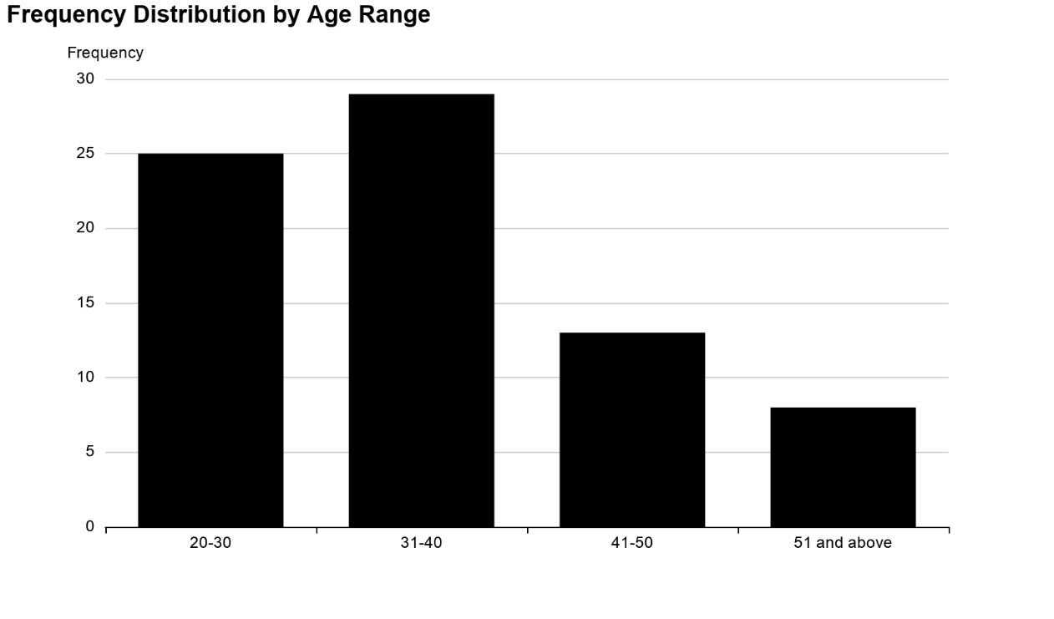

FIGURE 4.1: AGE GROUP OF THE RESPONDENT

Table 4.2: GENDER GROUP OF THE RESPONDENT
Sex | Frequency | Percentage %
Male | 30 | 40%
Female | 45 | 60%
Total | 75 | 100%
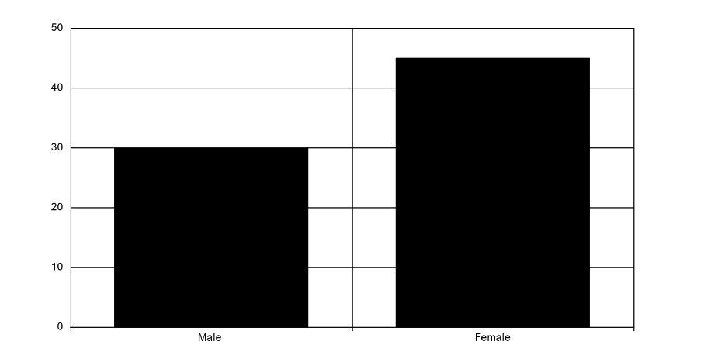

Figure 4.2: GENDER GROUP OF THE RESPONDENT
Table 4.3: OCCUPATION OF THE RESPONDENT
Occupation | Frequency | Percentage %
Student | 16 | 21.3%
Civil servant | 17 | 22.7%
Trader | 20 | 26.7%
Others | 22 | 29.3%
Total | 75 | 100%
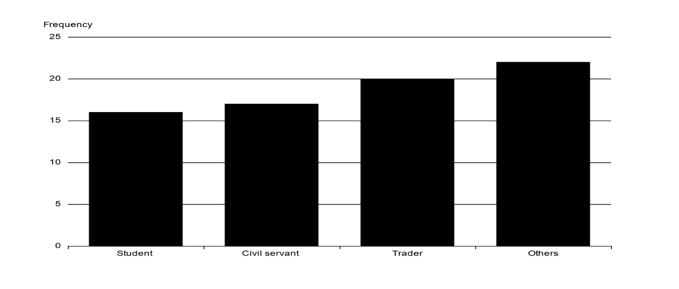

Figure 4.3: OCCUPATION OF THE RESPONDENT

Table 4.4: RATE OF WATER USAGE
Litres | Frequency | Percentage %
20 L | 19 | 25.3%
30 L | 30 | 40%
40 L | 7 | 9.3%
50 L | 19 | 25.3%
Total | 75 | 100%
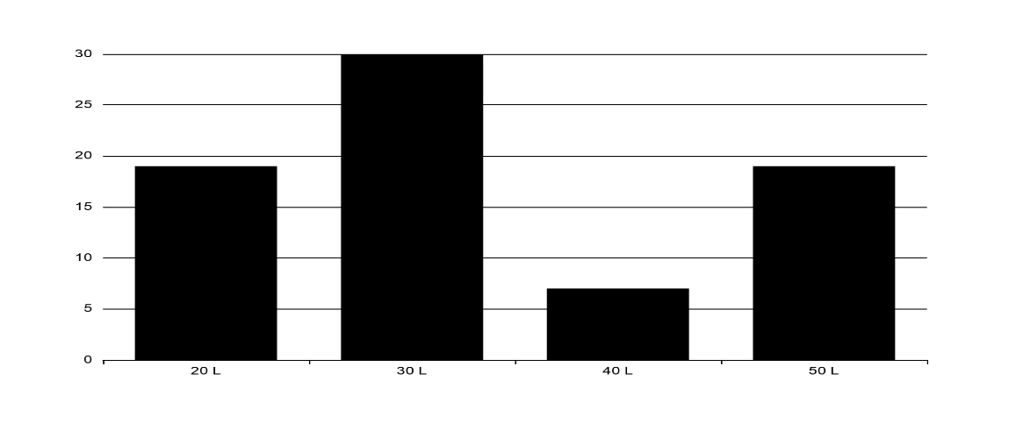

Figure 4.4: RATE OF WATER USAGE
Table 4.5: SOURCE OF WATER
Source | Frequency | Percentage %
Well | 35 | 46.7%
Borehole | 40 | 53.3%
River | - | -
Tap | - | -
Total | 75 | 100%
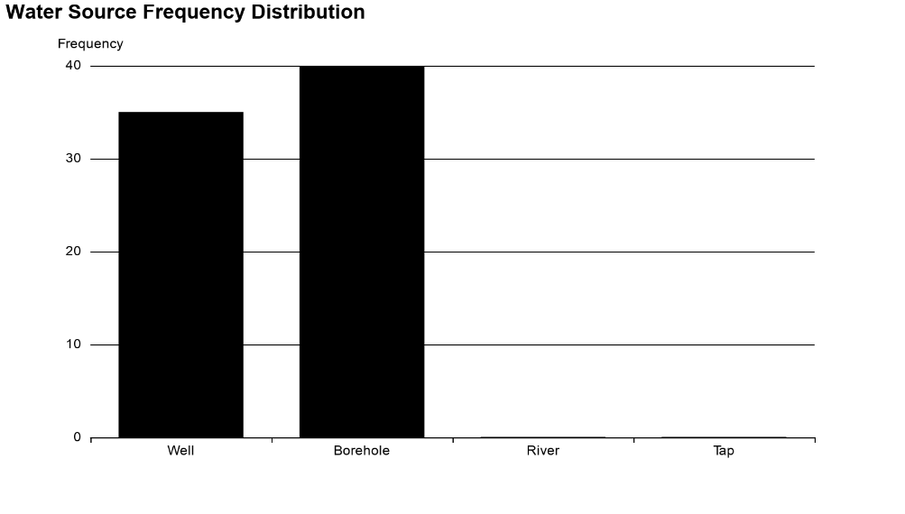

Figure 4.5: SOURCE OF WATER

Table 4.6: DISTANCE COVERED FOR COLLECTION OF WATER
Meters | Frequency | Percentage %
Below 1km | 52 | 69.3%
Below 2km | 9 | 12%
Below 3km | 12 | 16%
Below 4km | 2 | 2.7%
Total | 75 | 100%
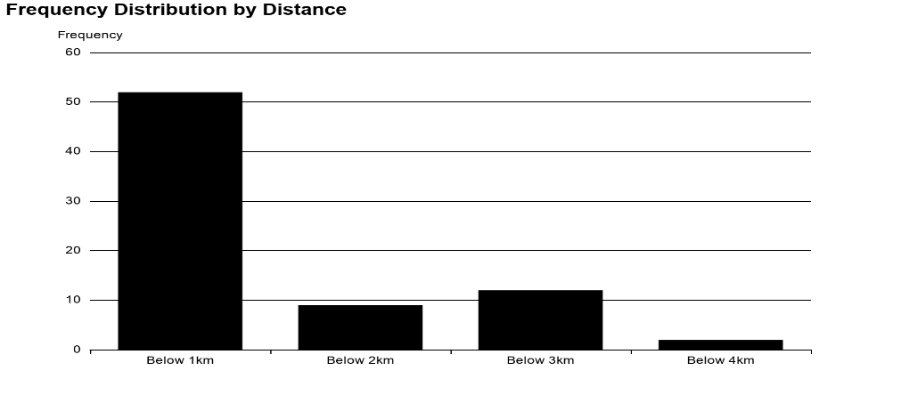

Table 4.6: DISTANCE COVERED FOR COLLECTION OF WATER
Table 4.7: WHO IS RESPONSIBLE FOR WATER COLLECTION?
 | Frequency | Percentage %
Husband | 5 | 6.7%
Wife | 30 | 40%
Children | 30 | 40%
Others | 10 | 13.3%
Total | 75 | 100%
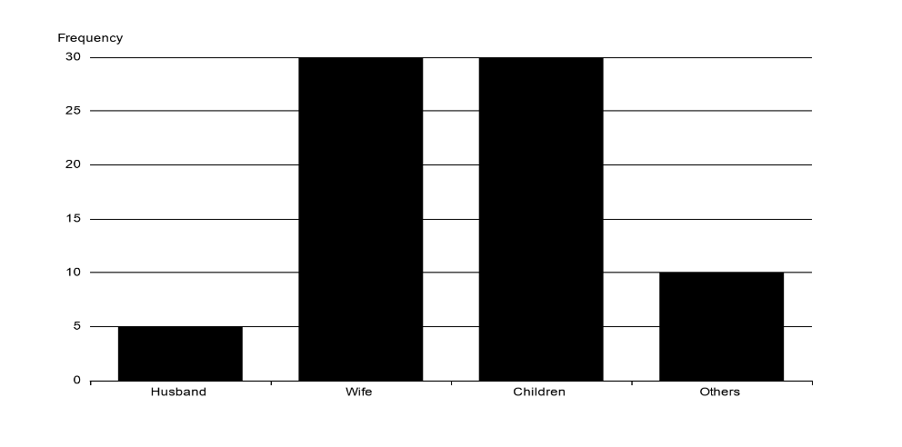

Figure 4.7: WHO IS RESPONSIBLE FOR WATER COLLECTION?

Table 4.8: PAYMENT OF WATER
Range | Frequency | Percentage %
Yes | 5 | 6.7%
No | 70 | 93.3%
Total | 75 | 100%
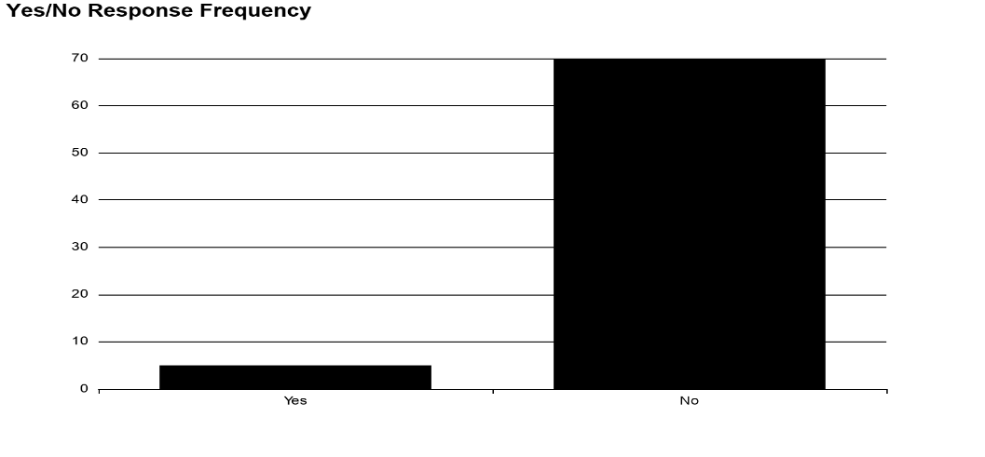

Figure 4.8: PAYMENT OF WATER

Table 4.9: THE STORAGE OF WATER
Methods | Frequency | Percentage %
Jeri can | 45 | 60%
Bucket | 30 | 40%
Overhead tank | - | -
Other specify | - | -
Total | 75 | 100%
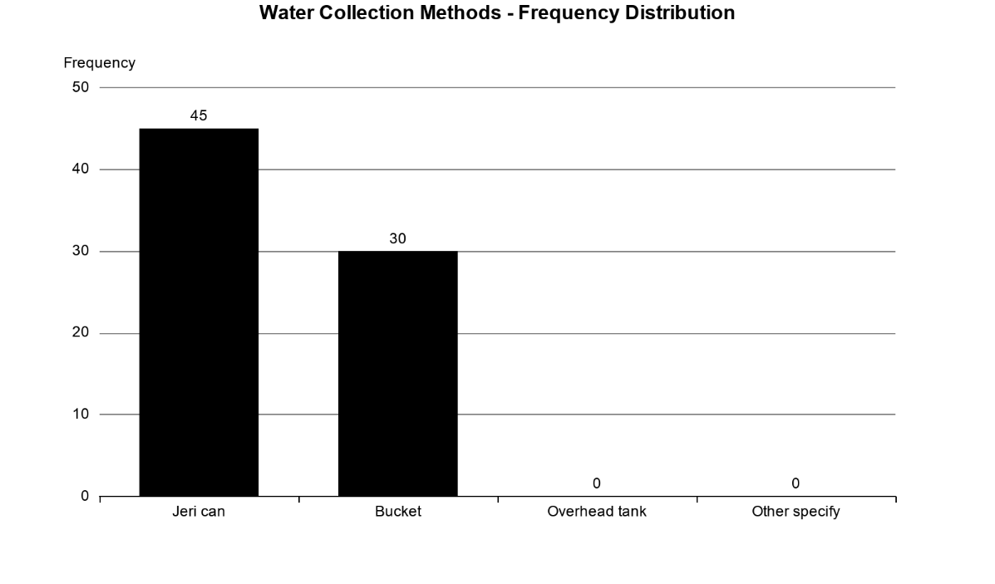

Figure 4.9: THE STORAGE OF WATER
DISCUSSION OF THE RESULT
Table 4.1 shows that age is unevenly distributed across the respondent in which 33.3% are the in range of 20 - 30 and 38.7% are in the range of 31 - 40. Table (4.1 to 4.3) shows that sex is unevenly distributed across the gender in which 40% are male and 60% are female. This reveals that majority of the respondent are female that struggle for water.
Further field investigation shows that 53.3% of the respondent source water from borehole (figure 4.5) and about 93.3% of them do not pay for water as their water source are borehole and well and within 1km from their respective location. (Figure 4.6) This implies that bucket and jerrycan are prominent methods used for the storage.
On the part of water board, the questionnaire reveals that the major source of water supply in the study area is through well and borehole, and dry season is the major factor affecting water supply which leads to scarcity of water in the area.
With respect to water demand, the questionnaire shows that water usage (table 4.4) 25.3% use 20 litres and 50 litres respectively, about 40% use 30 litres and 9.3% use 40 litres. Based on the oral interview conducted it was revealed that water demand according to consumer usage based on domestic purpose, the majority of the respondent use water for washing, cooking, and drinking in the study area

CHAPTER FIVE
5.0 CONCLUSION AND RECOMMENDATIONS
5.1 CONCLUSION
This study analysed the water demand and distribution in Ilorin west local Government, Kwara state with emphasis on Egbejila.
The study therefore, found that the study area depend mostly on borehole and well water, The percentage of respondent that source water through borehole and well is higher than other water source. The study also found that electricity and weather condition have been the strongest factor influencing water demand in the study area base on the respondent view, While dry season is one of the factor that hinder the availability of water in the study area.
The study further reveals that borehole in the study area is inadequate to meet the demand consumer and poor electricity supply also affects its inefficiency. In view of this, there should be provision for more borehole and more supply of electricity.

5.2 RECOMMENDATION
The following recommendation are suggested for effective demand and supply of water
- More boreholes should be provided by the state government for people in the community to gain easy access to drinkable water
- There should be constant repair of damage pipes and taps by the ministry of water corporation in the study area
- The inhabitant of the study area should be oriented on how to maintain the water structure
- There should be adequate electricity generation and supply, to solve the problem of water shortage in the study area
- The water board should change their attitude of bias in distributing water to consumers not to favor Government residential Areas at the expense of the masses in the town

REFERENCES
Adeleke. S. O. (2013) "Investigation into the strategies for attaining adequate water supply for domestic, industrial usage in |llorin metropolis" Unpublished HND project report, Department of Civil Engineering, Kwara Polytechnic, Ilorin -pg 16-26
Adeniran, A. E. (1997) "Mini Water Supply Scheme" Unpublished M.Sc. Project in Mechanical Engineering, University Of Ibadan, Ibadan, Oyo State Nigeria.
Adesogu,S. O. (2008) "Soil and water conversation : A challenge to young Engineers" Unpublished paper contest at Obafemi Awolowo University, Ile- ife, Osun State Nigeria.
Aderibigbe, S.A, Awoyemi, A.O, Osagbemi, G.k. (2008) Availability, Adequacy and Quantity of water supply in Ilorin Metropolis, Nigeria: European of Scientific Research, ISSN 1450-216X Vol.23 No.4 (2008), Pp. 528-526.
Alabi - Aganaba D, Osagbemi G.k. (2005) "Sources and Utilization of water in two selected Communities in Ilorin East Local Government Area of Kwara State". Afr. J Clin Exper Microbiol.2005;(7)1.
Ajadi, B.S. (1996): "pattern of water supply in Ilorin city", Unpublished B.Sc Thesis Department of Geography, Unilorin.
Amao, I.O and Omonona, B.T. (2010) "Household Water Security" : A case study of Ibadan South West Local Government: Continental J. Social Sciences 3: 18 - 23.
Akinola, F.O and Areola O.O (1980) "pattern and strategic of public water supply in Nigeria".'. Nigeria Journal of Economics and Social Studies, 22 (1)
Arms, k. (2008) "Environmental Science". Holts, Rinehart and Winston: A Harcourt Education Company, Austin, Texas. ISBN: 13: 978-0-03-078136-0, 10: 0-03-078136-1
Ayoade, J. (1985); "Water resources in Nigeria" Journal of Economic and Social studies 17(1):24-36
ALTAF, M. A. (1994) "The Economic of Household Respond to Inadequate water supplies" Third world Planning Review 16(1)pp 41 -57
Ayanshola, A. M. (2002) "Appraisal of water supply system in Ilorin Metropolis". A seminar paper, Civil engineering University of Ilorin, Ilorin Nigeria.
Azubike, G. "The challenges of Increased Access to Water In Nigeria" Retrieved from http: www.bleuprinting.com/new/2013/03/13. Retrieved 18/10/2013. Developing World Waters Grosvenor Press International, Hong Kong1988.
Falenmark M. (1993) "Water Scarcity"; Time for realism. Popli; 20 (6):11-12.
Oyegun, r.o (1983): "The use and waste water in the third World City" Geography Journal. Vol., 10.
Gule, B.F. (2000): Impact of Ilorin water Supply Expansion on Asa River Catchments. Journal of water supply and Research, AQUA. 43 (5)
Sule, B.F, Ayanshola, A.M and Salami, A.W. (2010): "Water Consumption pattern in Ilorin, kwara state, Nigeria"..20d Annual Civil Engineering Conference, University of Ilorin, Nigeria, 26 -28 July 2010.
United State Agency for International Development (USAID). 1990. "Strategies for drinking water and sanitation programmes s to Child survival". Washington D.C.; USAID;1-62.
WHO (1995) "Bridging the gaps", The World Health Report. (1995); 41. World Bank (WB) 1993. "Water Resources Management": A World Bank Policy Paper; 140.

World bank (1993): "Water Resources Management": A World Bank Policy Paper. Washington DC. The World Bank Kwara State Printing press, Ilorin.

