

PRJECT REPORT
ON
DIGITAL MAPPING OF INFRASTRUCTURAL FACILITIES OF PART OF ROYAL VALLEY ESTATE
AT KULENDE / AKEREBIATA ROAD, SANGO, ILORIN
ILORIN EAST LOCAL GOVERNMENT AREA
KWARA STATE

BY
ALAI ABDULLAH AKANNI
HND/23/SGI/FT/0105

SUBMITTED IN PARTIAL FULFILMENT OF THE REQUIREMENTS FOR THE AWARD OF HIGHER NATIONAL DIPLOMA IN SURVEYING AND GEO-INFORMATICS TO THE DEPARTMENT OF SURVEYING AND GEO-INFORMATICS, KWARA STATE POLYTECHNIC ILORIN, KWARA STATE
JUNE, 2025

CERTIFICATE
I hereby certify that the information contained in this project report was obtained as a result of the observations and measurements made by me on the field and that the survey was done in accordance with survey rules, regulations, and departmental instructions.

ALAI ABDULLAH AKANNI HND/23/SGI/FT/0105 NAME OF STUDENT MATRIC NUMBER

CERTIFICATION
This is to certify that ALAI ABDULLAH AKANNI with matriculation Number HND/23/SGI/FT/0105 has satisfactory carried out the survey duties contained in this project report under our direct supervision.
I hereby declare that He had conducted himself with due diligence, and honest on the project.

SURV.R.S. AWOLEYE DATE
Project Supervisor

MR. A. I. ISSAU DATE
Head of Department

……………………………………………….

Official Stamp
DEDICATION
This project is dedicated to Almighty God who has been there right from the beginning to this very point. Special dedication also to my ever supportive parents, MR / MRS ALAI, for their relentless support and compassion towards me and during the course of my study.

AKNOWLEDGEMENTS

The dream of becoming an achiever in life comes true, not only by one’s fortitude and hard work based on his knowledge, but it is also involving the positive influence of various factors and ideas of some people in the community.
First and foremost, all glory, honor and adoration is to Almighty God. I appreciate God for his grace upon my life, for keeping me safe since my advent in this school and most especially, during the execution of this project.
I sincerely wish to express my affectionate gratitude to my lovely and caring parent MR&MRS. ALAI whose toils and struggles have helped a lot in transforming my life for better may Almighty God grant them long life to enable her reap the fruits of their labor.
My next gratitude goes to my supervisor, SURV. R.S. AWOLEYE for his useful guidance, understanding, patience, and professional advice during the execution of this project that led to the successful completion of the exercise. I pray that God will continue to bless you (Amen). More so, my appreciation goes to my able HOD MR. ISSAU and other lecturers in the Department of Surveying and Geo-informatics most especially SURV. BABATUNDE KABBIR AND SURV BELLO DIRAN FELIX God bless you all (Amen).
More so, I seize this opportunity in acknowledging the efforts and contribution of my boss SURV KAREM, MR SULAIMAN TIAMIYU&MADAM OLUWAYEMISI OLUWABUKOLA BECKLY also known as (YSJ LIMITED) for their support morally, financially and for the impartation of knowledge in me that pertains to surveying and farming profession.
Finally, I thanks my family and friends like UMU MARIAM, UMU HAJARA, ADETAYO ABDULRAHMAN (DEYINDE), ENITAN OLUWASEGUN (GENERAL), ABDULMUHEEZ OLADITI (ABYEM), AHMED TOYYIB(ZUGLOOL), ABDULAKEEM HAMID(ASWAD), IDOWU HABEEB (OGA), NAFISAT OPEYEMI (PHEENARH), POPOOLA BLESSING, and all my classmates for their support, advice and encouragement and understanding throughout this journey, love I really appreciate you all.
My heartfelt thanks also go to all my group members for their cooperation and understanding during the project, I pray that we will never fail in our life (AMEN).

ABSTRACT
This paper shows a detailed methodology for creating 2D and 3D visual facility map of the campus. The purpose of this study work is to develop an interactive interface containing the 2 and 3-Dimensional features of all the facilities within the Royal Valley Estate. The spatial attributes of the facilities were collected with the aid of total stations. The most recent Google earth software was used as source of data to produce 2-dimensional facilities of the study area through digitization process. SRTM Digital elevation model image was downloaded from United State Geological Survey website to give the elevation data required for the 3-dimensional representation. All these data were processed with ArcGIS 10.2.1.

Table of Contents
CERTIFICATE ii
CERTIFICATION iii
DEDICATION iv
AKNOWLEDGEMENTS v
ABSTRACT vi
CHAPTERONE 1
1.0 INTRODUCTION 1
1.1 BACKGROUND TO THE STUDY 1
1.2 STATEMENT OF PROBLEM 5
1.3 AIM AND OBJECTIVES 5
1.3.1Aim: 5
1.3.2 OBJECTIVES: 5
1.4 SCOPE OF THE PROJECT 6
1.5 PERSONEL 7
1.6 STUDY AREA 8
CHAPTER TWO 10
2.0 LITERATURE REVIEW 10
CHAPTERTHREE 28
3.0 METHODOLOGY 28
3.1 DATABASEDESIGN 28
3.1.1 VIEWOF REALITY 28
3.1.2 CONCEPTUALDESIGN 30
3.1.3 LOGICALDESIGN 31
3.1.4 PHYSICALDESIGN 31
3.2 RECONNAISSANCE 32
3.2.1 OFFICEPLANNING 33
3.2.2 FIELDRECONNAISSANCE 33
3.3 EQUIPMENTUSED/SYSTEMSELECTIONANDSOFTWARE 35
3.3.1 HARDWAREUSED 35
3.3.2 SOFTWARECOMPONENT 35
3.4 INSTRUMENTTEST 36
3.4.1 HORIZONTALCOLLIMATIONTEST 36
3.4.2 VERTICALINDEXERRORTEST 37
3.4.3 ANALYSISOFCOLLIMATIONANDVERTICALINDEXDATA 37
3.5 CONTROLCHECK 38
3.6 MONUMENTATION 39
3.7 DATAACQUISITION 40
3.7.1 GEOMETRICDATAACQUISITION 40
3.7.2 ATTRIBUTES DATA ACQUISITION 42
3.8 DATADOWNLOADINGANDPROCESSING 42
3.8.1 DATADOWNLOADINGANDEDITING 42
3.8.2 DATAPROCESSINGANDDATAEDITING 42
3.8.3 DATAPROCESSINGUSINGARCGIS10.3 42
3.8.4 Topographical Map (DEM) 43
3.8.5 Facility Map Production 47
3.8.6 3D Map Production 49
3.8.7 Findings 49
3.8.9 DATABASEIMPLEMENTATION 53
3.8.10 DATABASEMANAGEMENTSYSTEMS 53
3.8.11 DATABASEMAINTENANCE 54
3.8.12 AREA COMPUTATIONTable 55
CHAPTERFOUR 56
4.0 SPATIAL ANALYSES AND PRESENTATION 56
4.1 TESTINGOF DATABASE 56
4.11 ANALYSIS OF RESULT 56
CHAPTER FIVE 60
5.0 Costing Estimation, Summary, Conclusion, Recommendation and Problem Encountered 60
5.1 Costing Estimation 60
5.2 Summary 64
5.3 Conclusion 64
5.4 Recommendations 64
5.5 Problems Encountered 65

LIST OF TABLES
Table 1.1: Shows the group personnel involved in project 7
Table 2.1 shows the comparative analysis of digital mapping vs traditional 19
Table 2.2 shows the benefits of digital mapping in infrastructure management 25
Table3.1: Buildingand itsattribute 31
Table3.2:Roadanditsattributes 32
Table3.3:Treesanditsattributes 32
Table 3.4CoordinatesofControls 33
Table3.5:HorizontalCollimation Data 37
Table3.6:VerticalIndexData 37
Table3.7:showing thebackcomputationof thecontrolcoordinates 38
Table3.8: showingthedistanceobservationresultofthecontrolcheck 38
Table 3.9 showing theobservation resultof thecontrol check 39
Table3.10: Building 52
Table3.11:Road 52
Table3.12:Trees 52
Table3.13:ElectricPoles 53
Table3.14: shows area computation 55

LIST OF FIGURES
1.7 SPECIFICATIONS 9
Fig.3.1Design andConstructionPhasesinSpatialDatabase 29
Fig.3.2.:E-RDiagram(Entityrelationship diagram) 30
Fig.3.3: Reccediagramofthestudy area (notdrawn to scale). 34
Fig.3.5:Pillar Description 40
Figure 3.6 showing the 2D facility map of the study area. 48
Figure 3.7 (a) Showing 3D model of the study area area 50
Figure 3.8 showing the 2D DEM (Digital elevation model) of the study area (derived from the field data). 50
Fig4.1:shows the completed building 57
Fig4.2: shows the 2D completed building 57
Figure 4.3 shows the 3D of completed building 58
Fig4.4Queryshows the 2D of uncompleted building 58
Figure 4.5 shows the 3D of uncomplted building 59

CHAPTERONE

1.0 INTRODUCTION
In today's rapidly evolving technological landscape, digital mapping has emerged as a crucial tool for managing and maintaining infrastructural facilities. Digital mapping refers to the process of creating computer-based representations of geographical and structural features, allowing for efficient planning, monitoring, and management of infrastructure such as roads, bridges, water supply networks, electrical grids, and public buildings. R Rathnayake - 2020 - researchgate.net
This technology leverages Geographic Information Systems (GIS), remote sensing, and real-time data collection to provide accurate and up-to-date visualizations of infrastructure. Digital maps enable governments, engineers, and urban planners to optimize resource allocation, enhance decision-making, and improve the resilience of essential services.
With the integration of artificial intelligence (AI) and the Internet of Things (IoT), digital mapping can now incorporate real-time monitoring, predictive maintenance, and automated updates. This not only reduces operational costs but also minimizes risks associated with infrastructure failures.
In summary, digital mapping of infrastructural facilities is transforming the way societies plan and maintain essential services, ensuring sustainability, efficiency, and enhanced public safety.

1.1 BACKGROUND TO THE STUDY
The rapid expansion of urbanization and the increasing complexity of infrastructural systems have necessitated the adoption of advanced technologies for efficient planning, monitoring, and management. Traditional methods of mapping and managing infrastructure, such as paper-based records and manual inspections, have proven to be time-consuming, costly, and prone to errors. Consequently, the demand for digital solutions has grown significantly.
Digital mapping of infrastructural facilities has emerged as a transformative approach to address these challenges. It integrates Geographic Information Systems (GIS), remote sensing, and real-time data analytics to create accurate, interactive, and easily accessible representations of physical assets. These digital maps help governments, urban planners, and engineers visualize infrastructure networks, assess their condition, and plan for future expansions or maintenance.
The evolution of technologies such as satellite imaging, drones, artificial intelligence (AI), and the Internet of Things (IoT) has further enhanced the capabilities of digital mapping. These advancements enable real-time monitoring of infrastructure, predictive maintenance, and automated updates, leading to improved efficiency and sustainability.
As cities and rural areas continue to develop, digital mapping provides a crucial tool for ensuring that infrastructural facilities remain functional, resilient, and adaptable to changing demands. By leveraging digital mapping, stakeholders can make informed decisions, optimize resource allocation, and enhance service delivery, ultimately improving the quality of life for communities.
The management and maintenance of infrastructural facilities are critical for the socio-economic development of any nation. Infrastructure such as roads, bridges, water supply systems, electricity networks, and telecommunication facilities form the backbone of modern society. However, the traditional methods of managing these assets have often been inefficient, leading to poor service delivery, high maintenance costs, and frequent failures.
Historically, infrastructure mapping relied on paper-based records, manual surveys, and static geographic representations, which were often outdated and difficult to update. These methods made it challenging to monitor changes, predict failures, or plan for expansions effectively. As urban populations grow and infrastructure becomes more complex, the need for a more efficient, accurate, and dynamic mapping system has become evident.
The emergence of digital mapping technology has revolutionized the way infrastructure is managed. Digital mapping integrates Geographic Information Systems (GIS), remote sensing, Global Positioning Systems (GPS), and advanced data analytics to provide real-time, interactive, and highly detailed representations of infrastructural assets. This technology allows for better planning, monitoring, and decision-making in urban and rural development.
Furthermore, the integration of Artificial Intelligence (AI) and the Internet of Things (IoT) has significantly improved digital mapping capabilities. AI-powered predictive analytics can anticipate infrastructure failures before they occur, enabling proactive maintenance. IoT devices, such as smart sensors, can provide continuous updates on the status of facilities, reducing downtime and improving efficiency.
Governments, urban planners, and private organizations are increasingly adopting digital mapping as a strategic tool for infrastructure development. The technology is being used to optimize transportation networks, monitor environmental changes, enhance emergency response systems, and improve public utilities management.
As global challenges such as climate change, population growth, and urbanization continue to put pressure on infrastructure, digital mapping provides a sustainable solution for improving resilience and adaptability. This study explores the significance of digital mapping in infrastructural development, its benefits, and the challenges associated with its implementation.
Infrastructure plays a fundamental role in economic growth, social well-being, and overall national development. Roads, bridges, water supply systems, power grids, telecommunications networks, and other critical facilities support modern societies by ensuring seamless connectivity, resource distribution, and service delivery. However, managing these infrastructural facilities has long been a challenge, especially with increasing urbanization, aging infrastructure, and the growing demand for sustainable development.
Traditionally, infrastructural facilities have been monitored and maintained using manual inspections, paper-based records, and static maps. These conventional methods often result in inefficiencies such as outdated data, lack of real-time monitoring, difficulty in planning upgrades, and delays in responding to failures. The limitations of these traditional approaches have highlighted the need for more advanced and automated systems for mapping and managing infrastructure.
Emergence of Digital Mapping Technology
Digital mapping technology has emerged as a solution to these challenges by providing accurate, interactive, and real-time representations of infrastructural assets. This technology leverages Geographic Information Systems (GIS), Global Positioning Systems (GPS), satellite imagery, drones, and remote sensing to create detailed digital maps that can be easily updated and accessed. By integrating digital mapping into infrastructure management, stakeholders can enhance decision-making, improve maintenance efficiency, and optimize resource allocation.
The evolution of digital mapping has been further enhanced by the integration of Artificial Intelligence (AI) and the Internet of Things (IoT). AI-powered analytics can predict infrastructure failures, allowing for proactive maintenance and reducing costly repairs. IoT-enabled smart sensors can continuously monitor the status of infrastructural facilities, providing real-time updates on their condition. These advancements make digital mapping a powerful tool for governments, urban planners, engineers, and utility providers in managing and maintaining infrastructure efficiently.
Growing Importance in Urban and Rural Development
As cities expand and rural areas seek improved infrastructure, digital mapping has become essential for sustainable development. Urban planners use digital maps to design smart cities, optimize traffic flow, and monitor environmental changes. Rural development programs leverage digital mapping to expand access to clean water, electricity, and transportation networks. In disaster-prone areas, digital mapping aids in emergency preparedness, helping authorities identify vulnerable infrastructure and plan effective response strategies.
Challenges in Implementing Digital Mapping
Despite its numerous benefits, the adoption of digital mapping technology faces several challenges. High implementation costs, the need for skilled personnel, data security concerns, and technical complexities can hinder widespread adoption. Additionally, integrating digital mapping with existing infrastructure management systems requires careful planning and investment.

1.2 STATEMENT OF PROBLEM
Due to the challenge faced by governments, urban planners, and utility providers worldwide. Traditional methods of infrastructure mapping and monitoring, which rely on manual inspections, paper-based records, and static maps, have proven to be inefficient, time-consuming, and prone to inaccuracies. These outdated approaches often lead to poor decision-making, delays in maintenance, and increased operational costs, ultimately affecting service delivery and public safety. This study seeks to address these issues by exploring the role of digital mapping in infrastructure management, identifying its benefits and challenges, and providing recommendations for its effective implementation.

1.3 AIM AND OBJECTIVES

1.3.1Aim:
The study aims to determine how digital mapping can enhance decision-making, optimize resource allocation, and improve the long-term sustainability of infrastructural facilities of ROYAL VALLEY ESTATE.

1.3.2 OBJECTIVES:
The following objectives were considered in order to accomplish the above aim:
1 Project planning which include office planning and field reconnaissance
2 Monumentation
3 Data acquisition (geometric data with TOTAL STATION, Social survey through oral interview and pillar description inclusive).
4 Data processing: This include downloading and processing of data using appropriate software
5 Information presentation: It involved plotting of survey data on both soft copy and hard copy showing correct location of points.

1.4 SCOPE OF THE PROJECT
Based on the purpose and significance of this project, the scope includes;
1 Project planning
2 Station selection and Monumentation
3 Data Acquisition
4 Data downloading and Data processing
5 Data Analysis and information presentation.

1.5 PERSONEL
The under listed students of HND II 2024/2025 set are the personnel that participated in the execution of this project. They are: -

Table 1.1: Shows the group personnel involved in project
S/N | NAMES | MATRIC | REMARKS
1 | ALAI ABDULLAH AKANNI | HND/23/SGI/FT/105 | AUTHOR
2 | POPOOLA BLESSING | HND/23/SGI/FT/094 | MEMBER
3 | ADEYEMO MARIAM O. | HND/23/SGI/FT/095 | MEMBER
4 | OGUNDEPO QUADRI O. | HND/23/SGI/FT/102 | MEMBER
5 | ADEKANBI ABIGEAL BIMBO | HND/23/SGI/FT/096 | MEMBER
6 | 6. OKE TEMITOPE JOHN | HND/23/SGI/FT/103 | MEMBER
7 | ALADA TOLUWANI O. | HND/22/SGI/FT/0126 | MEMBER
8 | OLANREWAJU OLUWATOSIN D. | HND/22/SGI/FT/131 | MEMBER

1.6 STUDY AREA
Royal valley estate Sango Ilorin, kwara state, Ilorin south local government area. Nigeria. It lies approximately within latitude 8°2927.87"N and longitude 4°30'53.02"E with an approximate area of 5 hectares. The project site has some embedded facilities such as road, parking space, class room, telecommunication mast, administration block, electric pole, street light, etc.

N

KWARA
NIGERIA
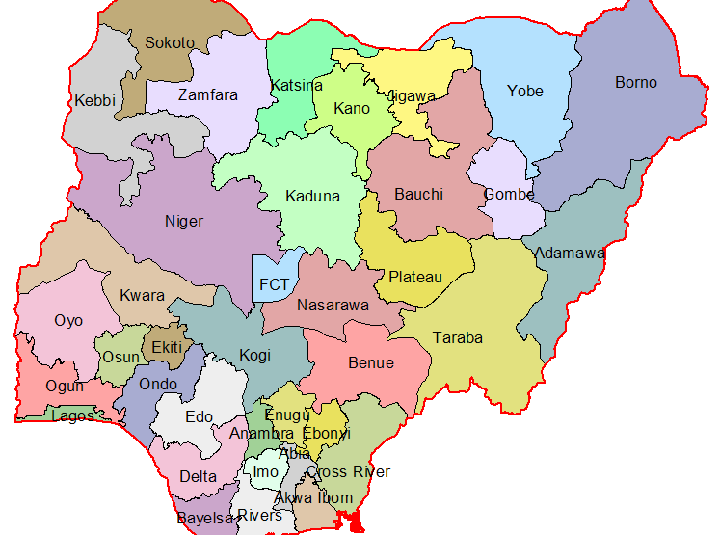
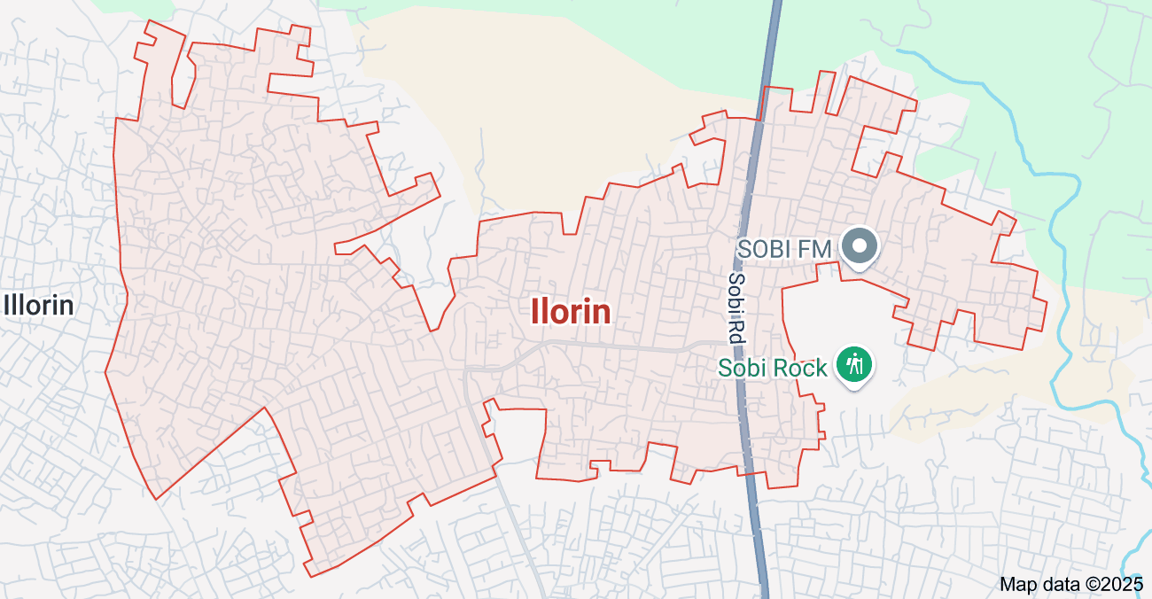

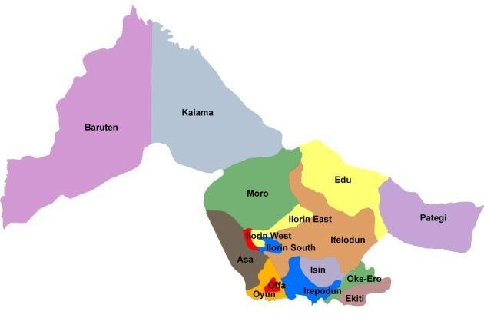
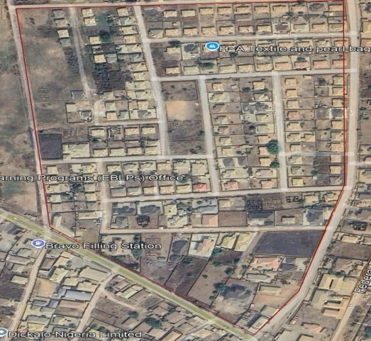

ROYAL VALLEY ESTATE
ILORIN

Figure 1.1: Map shows the study area of the project

1.7 SPECIFICATIONS
The project speciation were referenced to the speciation for land information system using total station which was sources from the Higher National Diploma. The specification includes the following:
- Total station (YE00240)
- Minimum number of datum control required- three (3)
- Traverse should run between secondary or higher order control points.

CHAPTER TWO

2.0 LITERATURE REVIEW
The digital mapping of infrastructural facilities has gained significant attention in recent years due to its potential to improve planning, monitoring, and maintenance. This section reviews existing literature on digital mapping, its applications, benefits, challenges, and future prospects in infrastructure management.
2.1 Concept of Digital Mapping in Infrastructure Management
Digital mapping is the process of representing physical infrastructure using computerized systems, integrating data from sources such as Geographic Information Systems (GIS), remote sensing, and Global Positioning Systems (GPS). According to Goodchild (2020), digital mapping enhances spatial visualization and decision-making in urban planning and asset management. Traditional mapping methods, which rely on manual surveys and paper-based records, are increasingly being replaced by digital technologies that offer real-time and dynamic data visualization.
2.2 Applications of Digital Mapping in Infrastructure Management
Several studies have highlighted the diverse applications of digital mapping in different sectors of infrastructure:
2.2.1 Urban Planning and Transportation: Batty et al. (2019) emphasize that GIS-based digital mapping supports smart city development by optimizing road networks, traffic management, and public transport planning. Digital maps help city planners assess traffic flow, road conditions, and alternative routes to reduce congestion.
2.2.2 Water and Sanitation System's: Studies by Rajabifard et al. (2021) indicate that digital mapping is crucial in water resource management. By using remote sensing and GIS, water supply networks can be monitored for leaks, contamination, and maintenance needs.
2.2.3 Power and Energy Infrastructure: According to Zhang et al. (2022), GIS mapping is extensively used in electricity grid management to optimize power distribution, identify faults, and plan expansions in rural and urban areas.
2.2.4 Disaster Management and Emergency Response: Research by Cutter et al. (2018) highlights how digital mapping assists in disaster preparedness, response, and recovery. Digital maps provide real-time data on infrastructure conditions during natural disasters such as floods, earthquakes, and wildfires, enabling better coordination of emergency services.
2.3 Benefits of Digital Mapping in Infrastructure Development
The integration of digital mapping in infrastructure management provides multiple advantages, as noted by various scholars:
2.3.1 Improved Efficiency and Accuracy: Unlike traditional methods, digital mapping provides precise and real-time data, reducing errors in planning and maintenance (Goodchild, 2020).
2.3.2 Cost Reduction: Studies by Rajabifard et al. (2021) show that predictive maintenance using digital maps minimizes infrastructure failures, thus lowering repair costs and preventing service disruptions.
2.3.3 Enhanced Decision-Making: GIS-based maps allow stakeholders to analyze spatial data, assess risks, and make informed decisions regarding infrastructure projects (Batty et al., 2019).
2.3.4 Sustainability and Environmental Management: Digital mapping supports green infrastructure planning by identifying areas for renewable energy projects, monitoring deforestation, and tracking pollution levels (Zhang et al., 2022).
2.4 Challenges in Implementing Digital Mapping for Infrastructure
Despite its numerous advantages, digital mapping faces several challenges, as identified in the literature:
2.4.1 High Implementation Costs: Initial costs for acquiring mapping software, satellite data, and training personnel can be expensive (Rajabifard et al., 2021).
2.4.2 Technical Complexity: Successful implementation requires expertise in GIS, AI, and data analytics, which may not be readily available in developing countries (Zhang et al., 2022).
2.4.3 Data Security and Privacy Concerns: Research by Cutter et al. (2018) highlights that the digital storage of infrastructure data is vulnerable to cyber threats, requiring robust cybersecurity measures.
2.4.4 Integration with Existing Systems: Many infrastructure sectors still use traditional record-keeping methods, making the transition to digital mapping a challenge (Goodchild, 2020).
2.5 Future Prospects of Digital Mapping in Infrastructure Management
The future of digital mapping is promising, with emerging technologies enhancing its capabilities. Advances in Artificial Intelligence (AI) and the Internet of Things (IoT) are expected to improve real-time data collection and predictive analytics for infrastructure maintenance. Block chain technology could enhance data security in digital mapping systems, while drone and satellite imaging will further refine data accuracy (Zhang et al., 2022).
The role of digital mapping in infrastructure management has been extensively studied in recent years due to its impact on planning, monitoring, and maintenance. This section reviews relevant literature on the concept of digital mapping, its applications across various infrastructural sectors, its benefits, challenges, and the future outlook of its adoption.
2.6 Concept of Digital Mapping in Infrastructure Management
Digital mapping is the process of using technology to represent geographic and infrastructural features in an interactive, real-time format. This technology incorporates Geographic Information Systems (GIS), remote sensing, Global Positioning Systems (GPS), and Artificial Intelligence (AI) to create, store, analyze, and visualize spatial data (Goodchild, 2020).
According to Batty et al. (2019), traditional methods of infrastructure mapping—such as paper-based blueprints, manual surveys, and static maps—have limitations in accuracy, efficiency, and scalability. Digital mapping, by contrast, offers a dynamic, real-time approach that allows for continuous updates and enhanced decision-making. The integration of AI and the Internet of Things (IoT) further enhances digital mapping by enabling predictive maintenance and automated monitoring of infrastructure assets (Zhang et al., 2022).
2.7 Applications of Digital Mapping in Infrastructure Development
2.7.1 Urban Planning and Smart Cities
Digital mapping plays a crucial role in modern urban development. Batty et al. (2019) highlight that GIS-based mapping supports smart city initiatives by enabling efficient transportation planning, land-use management, and environmental monitoring. Through digital mapping, urban planners can visualize traffic patterns, identify congestion hotspots, and design more sustainable transportation networks.
2.7.2 Road and Transportation Infrastructure
Several studies emphasize the importance of digital mapping in road infrastructure planning and maintenance. According to Smith et al. (2021), GIS and drone technology can be used to monitor road conditions, identify damage, and schedule repairs more effectively. Additionally, digital mapping aids in the design and construction of new road networks by assessing topographical and environmental factors in real time.
2.7.3 Water Supply and Sanitation Systems
Research by Rajabifard et al. (2021) indicates that digital mapping is critical in managing water resources. GIS technology enables the tracking of underground pipelines, detection of leaks, and optimization of water distribution networks. Digital mapping also assists in predicting water demand patterns and improving sanitation infrastructure in growing urban areas.
2.7.4 Electricity and Power Infrastructure
In the energy sector, digital mapping enhances the management of power grids, as noted by Zhang et al. (2022). GIS-based mapping of electrical networks allows energy providers to detect faults, plan grid expansions, and integrate renewable energy sources. The use of AI-driven digital maps also facilitates predictive maintenance of power infrastructure, reducing outages and operational costs.
2.7.5 Disaster Management and Emergency Response
Cutter et al. (2018) emphasize the role of digital mapping in disaster preparedness and emergency response. GIS-based maps help authorities identify vulnerable infrastructure, map evacuation routes, and deploy emergency resources effectively. During natural disasters such as floods or earthquakes, digital mapping provides real-time updates on infrastructure conditions, enabling faster and more efficient response efforts.
2.8 Benefits of Digital Mapping in Infrastructure Management
The adoption of digital mapping in infrastructure planning and management offers numerous advantages:
2.8.1 Improved Accuracy and Real-Time Data: Unlike static maps, digital mapping provides up-to-date, accurate representations of infrastructure, reducing errors in planning and maintenance (Goodchild, 2020).
2.8.2 Cost Savings and Resource Optimization: Rajabifard et al. (2021) found that predictive maintenance using digital mapping minimizes infrastructure failures, thereby lowering repair costs and preventing service disruptions.
2.8.3 Enhanced Decision-Making and Planning: GIS-based data analysis helps stakeholders assess risks, optimize land use, and plan infrastructure expansion projects more efficiently (Batty et al., 2019).
2.8.4 Increased Sustainability and Environmental Protection: Digital mapping supports eco-friendly infrastructure development by identifying environmentally sensitive areas and optimizing resource use (Zhang et al., 2022).
2.9 Challenges in the Implementation of Digital Mapping
Despite its benefits, the adoption of digital mapping in infrastructure management faces several challenges:
2.9.1 High Implementation Costs
One of the biggest barriers to widespread adoption is the high initial cost of acquiring digital mapping software, remote sensing technologies, and skilled personnel (Rajabifard et al., 2021). Developing countries, in particular, may struggle to invest in the necessary infrastructure.
2.9.2 Technical Complexity and Skills Gap
The successful deployment of digital mapping requires expertise in GIS, AI, and big data analytics, which may not be readily available in all regions (Zhang et al., 2022). Training professionals to handle these technologies is a crucial but often overlooked aspect of implementation.

2.9.3 Data Security and Privacy Concerns
Cutter et al. (2018) highlight the risks associated with digital mapping, particularly in terms of cybersecurity. Storing infrastructure data digitally makes it vulnerable to hacking, data breaches, and unauthorized access. Governments and organizations must implement strong cybersecurity measures to protect sensitive information.
2.9.4 Integration with Existing Systems
Many infrastructure sectors still rely on outdated record-keeping methods, making the transition to digital mapping a complex process (Goodchild, 2020). Ensuring compatibility between traditional and modern systems requires careful planning and investment.
2.10 Future Prospects of Digital Mapping in Infrastructure Management
As technology advances, the role of digital mapping in infrastructure development is expected to grow. Several key trends will shape the future of digital mapping:
2.10.1 Artificial Intelligence (AI) and Machine Learning (ML): AI-driven digital mapping will improve predictive analytics for infrastructure maintenance, helping detect faults before they lead to failures (Zhang et al., 2022).
2.10.2 Internet of Things (IoT) Integration: IoT-enabled sensors will provide real-time data on infrastructure conditions, allowing for automated monitoring and early warning systems (Rajabifard et al., 2021).
2.10.3 Blockchain for Data Security: Blockchain technology could enhance the security of digital mapping systems by providing tamper-proof records of infrastructure data (Smith et al., 2021).
2.10.4 Drone and Satellite Imaging: Advances in drone and satellite technology will enhance the accuracy of digital maps, particularly in hard-to-reach or rapidly changing environments (Cutter et al., 2018).
The adoption of digital mapping in infrastructure management is revolutionizing how assets are planned, monitored, and maintained. The literature on this subject highlights its significance, applications, benefits, challenges, and future prospects. This expanded review provides deeper insights into the theoretical foundations and technological advancements shaping digital mapping.
2.11 Theoretical Framework for Digital Mapping in Infrastructure Management
Digital mapping is rooted in several theoretical and technological frameworks:
Geographic Information Systems (GIS) Theory: GIS is a core technology in digital mapping, enabling spatial analysis, data integration, and decision-making for infrastructure management (Goodchild, 2020). GIS theory emphasizes the spatial relationships between physical assets, environmental factors, and human activities.
2.11.1 Remote Sensing and Spatial Data Infrastructure (SDI): Rajabifard et al. (2021) discuss how remote sensing and SDI frameworks support digital mapping by providing high-resolution imagery and standardized data-sharing protocols. These frameworks ensure that mapping data is accurate, accessible, and interoperable.
2.11.2 Smart City and Systems Theory: Batty et al. (2019) argue that digital mapping is integral to smart cities, where interconnected infrastructure and data-driven planning enhance efficiency, sustainability, and resilience.
2.11.3 Big Data and Artificial Intelligence (AI) Integration: Zhang et al. (2022) highlight the role of AI in analyzing vast amounts of infrastructure-related data, improving decision-making through machine learning algorithms.
These theoretical perspectives provide a foundation for understanding how digital mapping improves infrastructure planning and management.
2.12 Advanced Applications of Digital Mapping in Infrastructure Development
Digital mapping has applications across multiple infrastructure sectors. The following advanced use cases demonstrate its impact:
2.12.1 Digital Twins for Infrastructure Monitoring
A digital twin is a virtual replica of a physical infrastructure asset that updates in real time using sensor data. According to Smith et al. (2021), digital twins improve asset performance monitoring, predictive maintenance, and disaster response. For example, digital twins of bridges and highways can detect structural weaknesses before they become critical failures.
2.12.2 3D Mapping for Construction and Urban Development
The construction industry increasingly relies on 3D digital mapping for project planning, site analysis, and building design. Recent research (Ghaffarian&Samavati, 2020) suggests that Building Information Modeling (BIM) integrated with GIS allows for real-time updates and visualization of construction projects, reducing errors and improving efficiency.
2.12.3 Predictive Analytics for Infrastructure Maintenance
AI-powered digital mapping enables predictive analytics, which helps detect potential failures in infrastructure before they occur. Studies by Zhang et al. (2022) show that AI-driven GIS applications in road networks can predict pothole formation and suggest optimal repair schedules, reducing long-term maintenance costs.

2.12.4 Satellite and Drone-Based Mapping for Rural Infrastructure Development
Rajabifard et al. (2021) emphasize the importance of satellite imagery and drone-based mapping in remote and rural areas where infrastructure data is often scarce. These technologies enable governments and agencies to plan road networks, water supply systems, and energy distribution more effectively.

2.12.5 Smart Infrastructure and IoT-Based Mapping
The Internet of Things (IoT) plays a significant role in modern digital mapping by integrating real-time sensor data into maps. Cutter et al. (2018) discuss how IoT-enabled infrastructure, such as smart grids and intelligent water systems, uses real-time digital mapping to improve efficiency and sustainability.
2.13 Comparative Analysis of Digital Mapping vs. Traditional Mapping Methods

Table 2.1 shows the comparative analysis of digital mapping vs traditional
Aspect | Traditional Mapping | Digital Mapping
Data Collection | Manual surveys, paper-based records | Real-time GPS, satellite, and drone data
Accuracy | Prone to human errors | High precision, real-time updates
Cost Efficiency | High long-term costs due to maintenance inefficiencies | Lower costs due to predictive analytics and optimized planning
Decision-Making Speed | Slow | Fast, AI-driven insights
| Integration Capabilities | Limited | Easily integrates with GIS, AI, IoT, and smart city systems
Data Accessibility | Static, difficult to share | Cloud-based, accessible from multiple platforms
Studies (Goodchild, 2020; Zhang et al., 2022) confirm that while digital mapping requires an initial investment, it provides significant long-term savings and efficiency improvements compared to traditional methods.
2.14. Key Benefits of Digital Mapping in Infrastructure Management
The advantages of digital mapping go beyond efficiency and cost reduction:
2.14.1 Enhanced Environmental Impact Assessment (EIA): Digital mapping helps identify the environmental impact of infrastructure projects and supports sustainable development initiatives (Ghaffarian&Samavati, 2020).
2.14.2 Optimized Energy Distribution: GIS-based mapping aids in power grid expansion, renewable energy site selection, and real-time fault detection in power infrastructure (Zhang et al., 2022).
2.14.3 Improved Public Safety and Disaster Management: Digital maps assist emergency responders by providing up-to-date infrastructure status reports and evacuation route planning (Cutter et al., 2018).
2.15. Challenges Hindering the Adoption of Digital Mapping
Despite its advantages, digital mapping faces barriers to adoption:
2.15.1. Financial Constraints
Implementing digital mapping technology is capital-intensive. Infrastructure organizations in developing nations struggle with funding constraints, limiting widespread adoption (Rajabifard et al., 2021).
2.15.2. Lack of Skilled Workforce
The expertise required for GIS, remote sensing, AI, and IoT-based mapping is scarce, leading to a knowledge gap in infrastructure management (Smith et al., 2021).
2.15.3. Data Privacy and Security Risks
With increasing cyber threats, the risk of unauthorized access to critical infrastructure data is a major concern. Cutter et al. (2018) recommend stronger data encryption and blockchain integration to enhance security.
2.15.4. Resistance to Change
Many infrastructure organizations still rely on traditional methods and resist transitioning to digital solutions due to concerns about complexity and retraining costs (Goodchild, 2020).
2.16. Future Prospects of Digital Mapping in Infrastructure Management
The future of digital mapping will be driven by advancements in technology:
2.16.1AI-Driven Smart Infrastructure: AI algorithms will enhance predictive maintenance, reducing downtime and improving efficiency (Zhang et al., 2022).
2.16.2 Cloud-Based and Blockchain Secured Mapping: Cloud platforms will make digital mapping data more accessible, while blockchain will enhance security and data integrity (Smith et al., 2021).
2.16.3 Autonomous Vehicles and Infrastructure Mapping: Self-driving cars will rely on high-precision digital maps for navigation and real-time decision-making (Ghaffarian&Samavati, 2020).
2.16.4 Augmented Reality (AR) and Virtual Reality (VR) for Infrastructure Planning: AR and VR technologies will provide immersive simulations for urban planners and engineers, enhancing infrastructure visualization before implementation (Batty et al., 2019).
2.17. Digital mapping has revolutionized the management and planning of infrastructural facilities, providing real-time, data-driven insights for decision-making. This technology integrates Geographic Information Systems (GIS), Artificial Intelligence (AI), remote sensing, Internet of Things (IoT), and cloud computing to create, update, and analyze spatial data efficiently. Recent studies have explored digital mapping’s impact on urban planning, transportation systems, utilities management, disaster resilience, and smart infrastructure. This literature review delves into the theoretical foundations, technological advancements, practical applications, benefits, challenges, and future directions of digital mapping in infrastructure development
2.18 Theoretical Foundations of Digital Mapping
2.18.1. Geographic Information Systems (GIS) Theory
GIS technology underpins digital mapping, allowing for the spatial analysis and visualization of infrastructure. Goodchild (2020) explains that GIS provides structured layers of geospatial data, enabling infrastructure managers to assess relationships between physical assets, environmental factors, and human activities. GIS-based mapping enhances land-use planning, road network optimization, and utility management.
2.18.2. Remote Sensing and Spatial Data Infrastructure (SDI)
Rajabifard et al. (2021) discuss how remote sensing technologies, including satellites, LiDAR, and UAVs (drones), facilitate the real-time collection of infrastructural data. These technologies feed into Spatial Data Infrastructure (SDI) frameworks, ensuring data standardization and interoperability for infrastructure stakeholders.
2.18.3. Smart Cities and Systems Theory
Batty et al. (2019) argue that digital mapping is a fundamental component of smart city development, where interconnected infrastructure systems leverage real-time data for optimal functionality. This approach enhances energy distribution, traffic management, and emergency response efficiency.
2.18.4. Big Data and AI-Driven Predictive Analytics
Advancements in AI and machine learning (ML) enable predictive analytics for infrastructure maintenance. Zhang et al. (2022) demonstrate how AI-powered GIS applications forecast structural failures in bridges, water pipelines, and road networks, allowing for proactive maintenance strategies.
2.19. Digital Mapping Technologies and Methodologies
2.19.1. Geographic Information Systems (GIS)
GIS-based mapping provides a spatial database for infrastructure assets, integrating multiple layers of information, including terrain, utility networks, and demographic data (Smith et al., 2021). ArcGIS, QGIS, and Google Earth Engine are widely used GIS platforms for infrastructure mapping.
2.19.2. Remote Sensing and LiDAR (Light Detection and Ranging)
LiDAR technology offers high-resolution mapping of urban and rural environments. According to Rajabifard et al. (2021), LiDAR-based digital mapping has improved road design, flood risk assessment, and railway track monitoring.
2.19.3. IoT-Enabled Infrastructure Mapping
IoT sensors embedded in infrastructure provide real-time condition monitoring. Cutter et al. (2018) highlight how smart water systems use IoT and GIS to detect leaks, manage supply, and predict demand fluctuations.
3.4. Blockchain for Secure Infrastructure Data Management
Blockchain technology ensures the security and integrity of digital mapping data. Smith et al. (2021) discuss blockchain-based land registries, which prevent unauthorized modifications and fraudulent land transactions.
2.20. Applications of Digital Mapping in Infrastructure Development
2.20.1. Urban Planning and Land Use Management
Digital mapping supports sustainable urban development by optimizing land use, zoning regulations, and green space management (Batty et al., 2019). Real-time mapping enables dynamic city planning, reducing congestion and environmental degradation.
2.20.2. Transportation and Road Infrastructure
GIS-based digital mapping improves the design, monitoring, and maintenance of transportation networks. Smith et al. (2021) highlight how AI-driven traffic models analyze congestion patterns, reducing travel time and fuel consumption.
2.20.3. Water Resource and Utility Management
Rajabifard et al. (2021) emphasize the role of GIS in managing water distribution networks, detecting pipeline leaks, and optimizing water allocation. Smart water grids use real-time digital mapping for efficient resource management.
2.20.4. Power and Energy Infrastructure
GIS and digital twins enhance energy infrastructure planning by optimizing power distribution networks and renewable energy site selection (Zhang et al., 2022). Smart grids use AI-driven mapping to predict electricity demand and detect faults.
2.20.5. Disaster Management and Climate Resilience
Cutter et al. (2018) discuss how digital mapping enhances disaster response strategies by identifying vulnerable infrastructure and mapping evacuation routes. GIS-based early warning systems for floods, wildfires, and earthquakes save lives and reduce economic losses.
2.20.6. Smart Cities and Autonomous Vehicles
The future of autonomous vehicles (AVs) relies on high-resolution digital maps. AI-powered mapping systems ensure precise navigation, obstacle detection, and traffic management (Ghaffarian&Samavati, 2020).
2.21. Benefits of Digital Mapping in Infrastructure Management

Table 2.2 shows the benefits of digital mapping in infrastructure management
Benefit | Description
Enhanced Decision-Making | Real-time spatial analysis aids in optimizing infrastructure planning and resource allocation.
Cost Reduction | Predictive analytics minimizes maintenance costs and infrastructure failures.
Improved Public Safety | GIS-based emergency response mapping enhances disaster resilience.
Improved Public Safety | GIS-based emergency response mapping enhances disaster resilience.
Environmental Sustainability | Smart mapping promotes green infrastructure development and energy efficiency.
Data Accessibility & Transparency | Cloud-based GIS platforms enable multi-agency collaboration.
2.22. Challenges in Implementing Digital Mapping
2.22.1. High Initial Costs
The integration of GIS, IoT, and AI-based mapping requires significant financial investment(Rajabifard et al., 2021).
2.22.2. Technical Complexity and Skill Gaps
There is a lack of trained professionals in GIS analytics, AI-driven mapping, and remote sensing (Smith et al., 2021).
2.22.3. Data Security and Privacy Concerns
Infrastructure data is vulnerable to cyber threats. Cutter et al. (2018) recommend blockchain and AI-driven cybersecurity measures for digital mapping applications.
2.22.4. Resistance to Change
Many government agencies and industries still rely on traditional mapping methods, delaying digital adoption (Goodchild, 2020).
2.23. Future Trends and Innovations in Digital Mapping
2.23.1. AI-Powered Predictive Mapping
Machine learning algorithms will refine digital mapping for real-time infrastructure monitoring (Zhang et al., 2022).
2.23.2. Augmented Reality (AR) and Virtual Reality (VR) Mapping
AR and VR will allow city planners and engineers to visualize infrastructure projects before construction begins (Batty et al., 2019).
2.23.3. Blockchain-Based Land Management Systems
Blockchain-powered GIS systems will enhance land ownership transparency and reduce land disputes (Smith et al., 2021).
2.23.4. 6G and Edge Computing for Real-Time Mapping
Future 6G networks will support ultra-fast real-time data transmission for autonomous vehicles and smart city planning (Ghaffarian&Samavati, 2020).
2.24. Conclusion
The literature confirms that digital mapping is a transformative tool for infrastructure management. It enhances urban planning, resource efficiency, disaster resilience, and public safety. However, financial constraints, skill gaps, and cybersecurity risks must be addressed to maximize adoption. Future advancements in AI, IoT, blockchain, and 6G networks will further enhance the role of digital mapping in sustainable infrastructure development.

CHAPTERTHREE

3.0 METHODOLOGY
Thisstageinvolvesthemethodsandprocedureusedinplanning,dataacquisition,dataprocessing, and creation of database, creation of database management system and informationpresentation.These operations were logically structured and carried out in stages involvingdatabase design. It is normally considered to involve a spatially referenced and structureddigital database and appropriate application software for geospatial analysis. This basicallydescribesthe techniquesandprinciples adopted incarrying out theproject.
Geographicinformationsystemmethodswereadoptedinaccomplishingthedesiredresults.

3.1 DATABASEDESIGN
Thedesignof anydatabaseinvolves threestages namely;
i Conceptualdesign
ii Logical designiii Physicaldesign

3.1.1 VIEWOF REALITY
In database design, there is need for reality which is referred to as the phenomenon thatactually exists, including all aspects which may or may not be perceived by individuals. Theview of reality however, is the mental abstraction of the reality for a particular application orgroupofapplications.
For thisapplication, the view of reality ismadeof the topography of the project.Since itisnot possible to represent the real world, the only option is to conceptualize and model it in aspecifiedmanner torepresentthe realworld.Thearea of interesttousinthisproject

Includes;GreenReserve,Roads,Electricpoles,Trees,WaterFacilities,Buildings,Footballpitch,Streams.
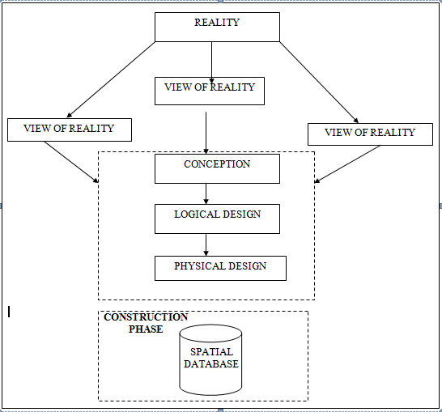

Fig.3.1Design andConstructionPhasesinSpatialDatabase

3.1.2 CONCEPTUALDESIGN

Vectordatamodelisthedatatypeadoptedforthisproject,whichisrepresented,bypoints,linesandpolygon. Theidentifiedentities are:-
      - Vegetation area (polygon)

      - Roads(line)

      - Trees(point)

      - Boundary line (polygon)

      - Buildings(polygon)
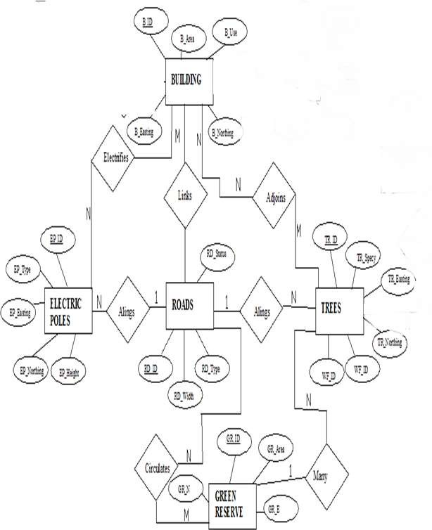

Fig.3.2.:E-RDiagram(Entityrelationship diagram)

3.1.3 LOGICALDESIGN

This is the design aspect of the database refers to the process of creating a conceptualframework or model that represents the structure and organization of spatial data within thesystem.Itinvolvesdefiningthedataelement,theirrelationship,andtherulesfordatamanipulation and analysis.In this phase, theentities, their attributes and their relationshipsare represented in a single uniform manner in form of relation in such a way that would be noinformation loss and at the same time no unnecessary duplication of data. In this study, thelogical database design is employed to generate a geo-relation database structure. Each entityhas unique identifier in bold type. An attribute type or combination of attribute types thatservesto identifyanentitytypeis termed an identifier.
- Building(B_ID,B_Area, B_Name,B_Easting,B_Northing)

- Roads(R_ID,R_Width,R_Type,R-Condition,R_Easting,R_Northing)

- Vegetation(V_ID,GR_Area,)

- Tree(TR_ID,TR_spp,TR_Importance,TR_Easting,TR_Northing)

- ElectricPole(EP_No,EP_Type,EP_Height,EP_Easting,EP_Northing)

- WaterFacility(WF_ID,WF_Depth,WF_Type,WF_Easting,WF_Northing)

- FootballPitch(FP_ID,FP_Area,FP_Status)

- Stream(S_ID,Length,Width)

3.1.4 PHYSICALDESIGN

Table3.1: Buildingand itsattribute

ENTITY | DESCRIPTION
B_ID | BuildingIdentification
B_name | BuildingName
B_Area | BuildingArea
B_Easting | BuildingEasting
B_Northing | BuildingNorthings

Table3.2:Roadanditsattributes

ENTITY | DESCRIPTION
R_ID | RoadIdentifier
R_Length | RoadLength
R_Width | Road Width
R_Type | RoadType
R_Condition | RoadCondition

Table3.3:Treesanditsattributes

ENTITY | DESCRIPTION
TR_ID | TreeIdentifier
TR_Spp | Treespecy
TR_E | Tree_Easting
TR_N | TreeNorthing

3.2 RECONNAISSANCE

Thisisthepreparatorystagebeforetheexecutionofthisproject;itinvolvescollectionofavailableinformation about theproject area.
Thenecessarysteptakenforthesuccessfulexecutionoftheprojectinvolvestwostages,whichare:-
- OfficePlanning
- Fieldreconnaissance

3.2.1 OFFICEPLANNING

This involves the collection of information about the study area, testing the instrument to beused in execution of the project and itemizing the numbers of equipment needed, number ofdays to be use, how each activity is to be carried out, delegation of works to each teammembersbased onsupervisor’sguide/instructions.

Table 3.4CoordinatesofControls

Station | Northing(m) | Easting(m) | Height(m)
KWCS 625T | 941451.040 | 674200.278 | 255.212
KWCS 623T | 941753.095 | 673845.702 | 250.532
KWCP 690 | 94I802.041 | 673810.314 | 249.087

Source:Surveyor general office Kwara

3.2.2 FIELDRECONNAISSANCE

Thefieldreconnaissanceisthefirstvisitationtotheprojectsitetogetintimatedwiththeenvironment.
- Boundarypoints was selected

- Thedistributionoffeatureswasstudied

- Controlstobeusedwerelocated

- Methodandtypeof instrumenttobe useswasdetermined

- SubsidiarypointforGroundcontrolPointswerepickedanddefineusingnailandbottlecock
- Adiagram of the studyareawas drawn.
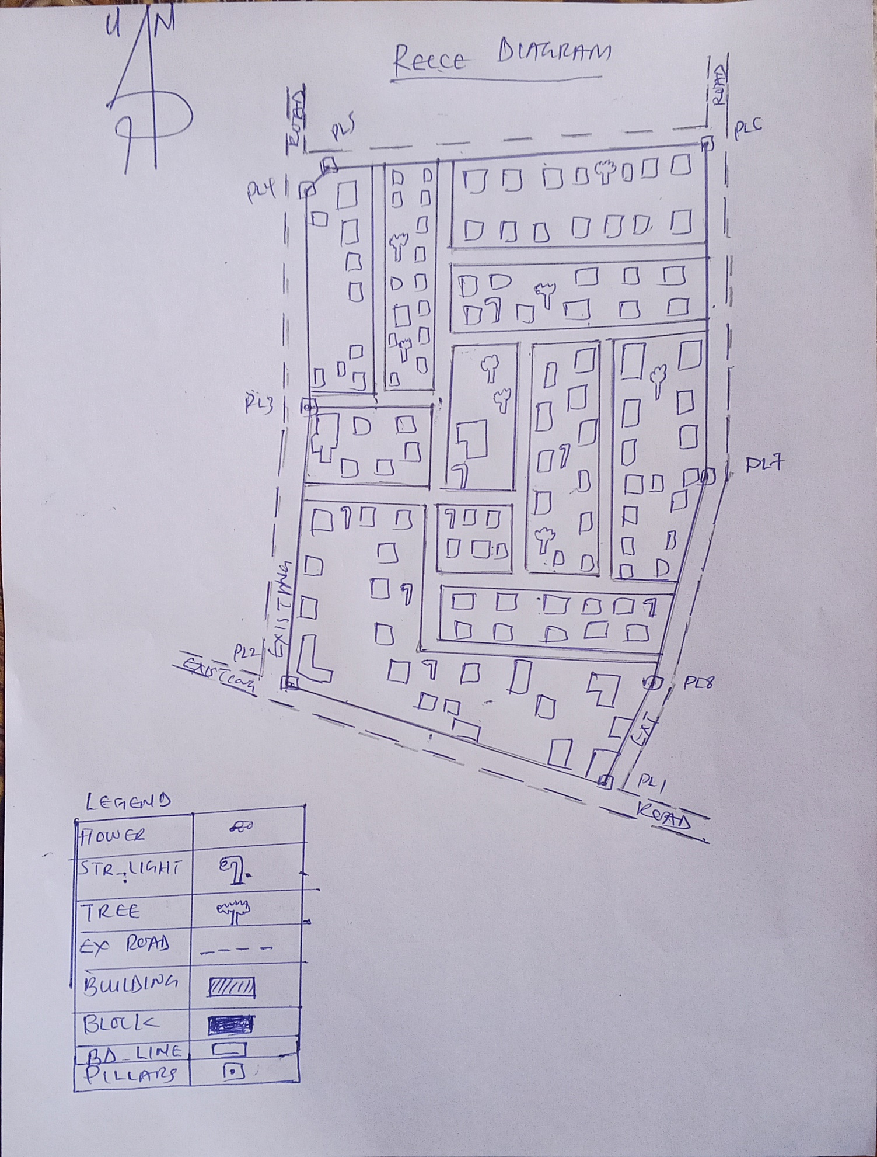

Fig.3.3: Reccediagramofthestudy area (notdrawn to scale).

3.3 EQUIPMENTUSED/SYSTEMSELECTIONANDSOFTWARE

3.3.1 HARDWAREUSED

- Totalstation

- 1reflectorwith atrackingrod.

- 1Tripod

- One(1)50m tape

- One(1)umbrella

- 1cutlass

- HandheldGPS

- Hammer

- Nailsandbottlecover

- Fieldbookandwriting materials

- 1-NoofPersonalComputerHP655 andits accessories

- 1-NoofHP Desk JetK7100 A3 printer

- 1-NoofHPDesk Jet 1110 A4printer

3.3.2 SOFTWARECOMPONENT

- Notepad.

- MicrosoftExcel.

- AutoCAD2007

- ArcGIS10.3

- MicrosoftWord.

3.4 INSTRUMENTTEST

To ensure data quality,the TotalStationused for thisprojectwastested for bothverticalindex and horizontal collimation errors.It was also to ascertain the efficiency and reliabilityofthe instrument. Theprocedureused isdescribed below.

3.4.1 HORIZONTALCOLLIMATIONTEST
This test was conducted to ensure that the line of sight was perpendicular to the trunnion axis.The Total Station was positioned over a specific point, and initial adjustments were made toensureproperalignment,leveling,andfocus(toeliminateparallaxinthetelescope). Avertical target was placed at a distance of 100 meters from the Total Station. To access theconfigurationmenuoftheTotalStation,themenukeywaspressedandheldforapproximately 2 seconds. From the main menu, the calibration sub-menu was selected, andwithin that, the horizontal collimation test option was chosen. The target was then observedand divided into two halves, with horizontal readings recorded for Face left and Face right.Thereadings areshown in Table 3.4.1 below.

TotalStation
100m
REFLECTOR(TARGET)

STATIONA
FairlyLevelGround
STATIONB

Fig3.4:HorizontalCollimation andVerticalIndexerrortest.

Table3.5:HorizontalCollimation Data

Station | Target | Face | HzReading | Difference | Error
A | B | L | 38˚42‟32”
 |  | R | 218˚42‟35” | 180˚00‟03” | 03”

3.4.2 VERTICALINDEXERRORTEST

This test was conducted to verify the accuracy of the vertical reading when the line of sight ishorizontal.Thedesiredmeasurementforthistestisexactlyninetydegrees(90˚),anydeviationfrom this valueis referred to asthevertical index error.
The Total Station was positioned over a specific point, and necessary temporary adjustmentswere made to ensure proper alignment and functionality. A target was placed approximately100 meters away fromthe TotalStation,and the instrumentwasaimedatthe target.Thetarget was bisected by aligning the instrument on the face left, and the corresponding readingwas recorded. Similarly, the target was then bisected on the face right, and the respectivereadingwasalso recorded.Therecordedreadingsareprovided below:

Table3.6:VerticalIndexData
InstrumentStation | TargetStation | Face | Vertical | Sum | Error
A | B | L | 90˚00‟00”
 |  | R | 270˚00‟02” | 360˚00‟02” | 02”

3.4.3 ANALYSISOFCOLLIMATIONANDVERTICALINDEXDATA

Thereadingobtainduringcalibrationwerereducedtoobtainnewcollimationandverticalerrors.
Horizontalcollimation={(FR–FL)–180}/2={(00˚00‟03”}/2=1.5”

Verticalcollimation={(FL+FR)–360}=(90˚00‟00”+270˚00‟02”)-360}=02”Theresult shows thattheinstrument is stillin good working condition.

3.5 CONTROLCHECK
Three control beacons (KWCS 625T, KWCS 623T and KWCP 690) were used.In order toascertain the in-situ of the control beacons, a check was carried out on them by observing theangle between them and comparing the result obtained with the computed angles from thegivingcoordinates.
The total station instrument was set on the control beacon KWCS 623T. After performing allthenecessarytemporaryadjustment,thereflectorwasplacedonthecontrolbeaconKWCS 625T which served as the back station. The horizontal angular reading was taken andrecorded while the instrument was on face left. The reflector was then taken to the controlbeacon KWCP 690 which serves as the forward station, the horizontal angle reading wasthen taken and recorded on both face left and face right. The reflector was taken back to thebackstation, the horizontal angle wasthenrecorded on face right.

Table3.7:showing thebackcomputationof thecontrolcoordinates

From STN | Bearing | Dist(m) | ∆N | ∆E | Northing(m) | Easting  (m) | ToSTN
 |  |  |  |  | 941451.040 | 674200.278 | KWCS 625T
KWCS 625T | 130°25'37'' | 465.791 | 302.055 | -354.576 | 941753.095 | 673845.702 | KWCS 623T
KWCS 623T | 149°38'02'' | 60.399 | 48.946 | -35.388 | 941802.041 | 673810.314 | KWCP 690

Table3.8: showingthedistanceobservationresultofthecontrolcheck

FROM | OBSERVED DISTANCE  (m) | COMPUTED DISTANCE  (m) | TO
KWCS 625T | 465.902 | 465.791 | KWCS 623T
KWCS 623T | 60.521 | 60.399 | KWCP 690

Table 3.9 showing theobservation resultof thecontrol check

STN | SIGHT | FACE | OBSERVEDHZANGLE | REDUCED  HZANGLE | MEAN
 | KWCS 625T | L1 | 195° 14'07''
KWCS 623T | KWCP 690 | L2 | 64° 47'29'' | 130°26'38''
 | KWCP 690 | R2 | 15° 14'13'' | 130°26'22''
 | KWCS 625T | R1 | 145° 40'35'' |  | 130°26'30''

Differenceinangle (observed -computed)=188°31'40''-188°31'36''

=00° 00'04''

Since the allowable accuracy (angular) of third order traverse of one station is 00° 00' 30'' andtheresultobtainedfromthecontrolcheck(00°00'04'')islessthanallowableerror.Therefore,thecontrols wereangularlyintact.

3.6 MONUMENTATION
Theboundaryoftheareacarvedoutwasdemarcatedwiththeprecastconcretebeacons,afterclearingtherequiredlineofsights.Theidentifiedpointsofchangesindirections were dug and beacons were buried on it, leaving about 15cm part of the beaconabove the ground level. The beacons were buried at convenient distances as dictated by thenatureof theboundary

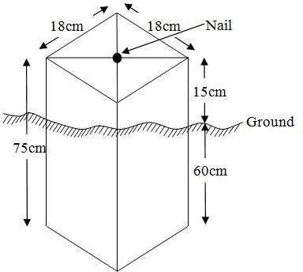

Fig.3.5:Pillar Description

3.7 DATAACQUISITION

PRIMARYDATASOURCE
Field observation was the primary source of data for this project. Ground based method wasused in acquiring data with the use of Total Station Instrument, which involved the collectionofX, Y, Z data through coordinated Ground control Points (GCP) established at conspicuouspoints within thestudyarea.
SECONDARYDATASOURCE
AnimageryoftheareawasacquiredthroughUpdatedGoogleearth;thiswasusedtoascertaintheextent ofcoverageof theproject area.

3.7.1 GEOMETRICDATAACQUISITION
The total station instrument was set carefully on control point KWCS 623T back sight takento KWCS 625T after necessary station adjustments has been carried out on it. Theadjustmentsincludes;centering,levelingandfocusing.Thefollowingprocedureswere then followed to determine the position of the next point KWCS 623T and the sameprocedure were repeated until all we come close to the site. The method used inacquiring data on site was radiation method where two or more points are coordinatedfromone point.
- Havingsetuptheinstrumentandtemporaryadjustmentcarriedout,theinstrument was powered „on‟ and a job wascreated under job menu in theinternalmemoryof theinstrument. Thejob createdwasnamed GRP6B
- On the job, the coordinates of the three (3) control points were keyed in to thememoryoftheinstrumentandsomecodeswerealsosaved.Thecodesinclude
- „RD‟forroad,„SP‟forspotheight,„BDforbuildings,etc.
- The height of the instrument was measured and saved on the memory of theinstrumentas wellas thereflector height.
- On coordinate menu,orientation was set by inputtingthe coordinatesof theinstrument station and back sight. The reflector at the back station was perfectlybisectedbeforetheorientationwasconfirmedbyclicking„yes‟.
- Having done the orientation, the reflector at the next nail; was bisected and „obs‟(observe)optionwasclicked.Thethreedimensionalcoordinateofthepoint(E,N, H) were displayed on the display unit of the instrument and „rec‟ (record) wasclickedtosavethedataintothememory oftheinstrument.Forsubsequentobservationafterthis,„all‟optionwasusedinsteadofpressing„obs‟andpressing
- „Record‟later.
- It was ensured that the center of the prism of the reflector was bisected and that itwassetperfectlyonthetripodinordertominimizetheerroronheightdetermination.
- The instrument is been shifted to another nail after all details, spot height andboundary point visible from the instrument station have been picked, set over itandtemporaryadjustments carried out.
- Nonetheless, the above operations were repeated until all the boundary points withheightswere coordinated.
- In this project all spot height are not in grid intervals but randomly acquired. Threeedges (3) of building were picked. At the end of data acquisition process all detailswere acquired and properly recorded to be shown in their respective positions on theplan.

3.7.2 ATTRIBUTES DATA ACQUISITION
Attributedataisinformationaboutspatialfeatures.Theyprovidethecharacteristics,description and nomenclature about spatial objects. Thus the attributes data acquired includesnames of buildings and their uses such as classrooms, roads, water facilities and prominentnatural features likes river and trees found and vegetation were properly identified within andaroundthe studyarea.

3.8 DATADOWNLOADINGANDPROCESSING

3.8.1 DATADOWNLOADINGANDEDITING
This is stage whereby all data acquired which were automatically stored in the Total Stationwere downloaded into personal computer. This was done with the aid of downloading cableconnected to the computer and some associated complementing software installed on theSystem.

3.8.2 DATAPROCESSINGANDDATAEDITING
The geometric data downloaded were further processed in order to convert it to auseful format and to enhance its accuracy. The output coordinates, were edited and exportedin *.txt, *.xls and *.pdf format. Thereafter, they were imported into Arc GIS 10.3 for furtheroperationsand to carryout spatial analysis.

3.8.3 DATAPROCESSINGUSINGARCGIS10.3

Before launching of ArcGIS AutoCAD was used in plotting of feature data saving themseparatelyin different filenamed road, boundaryline,buildings, trees andelectric poles.
- LaunchtheArc MapinArcGIS10.3
- ClickonANEWEMPTYMAPonthedialogboxdisplayedafterloading
- Clickon Toolsonthemenubar, thenselect extensions,mark alland close.
- Atthe LHS,rightclickonlayers,andthenselectproperties.
- ClickoncoordinatesystemtosettheprojectionsystemtoMINNADATUMZONE31Nand general to set theunit, then applyand okay.
- AdddatawasselectedatthetoolbarallsavedAutoCADfiewasselectedandloadontothetableof contentlayer section
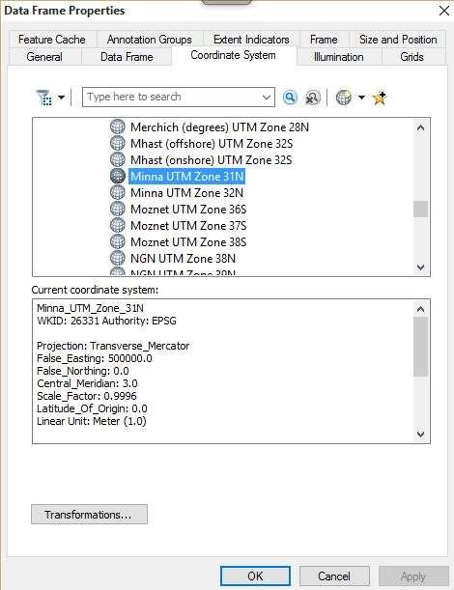

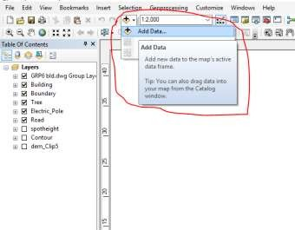
Alldrawingwasexportedtoshapefile.Afterthefeatureclasshasbeencreates,clickonEditorto start Editing, and then click on the load object.

3.8.4 Topographical Map (DEM)
CRATING CONTOUR: Firstly DEM was created by searching in the search icon INTERPOLATION> NATURAL NIGHBOR and selecting THE XYZ data for creation of DEM in respect to the boundary line as extent. In order to create contours, you will need to enable the Spatial Analyst toolbar, which can be found by going to Customize > Toolbars > Spatial Analyst or open the search bar. You can do this by clicking Windows > Search, or by clicking on the search icon.
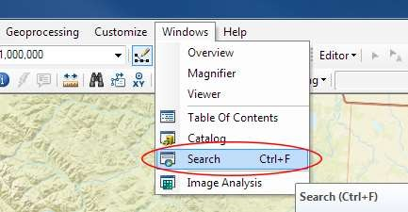

Inthesearchbartype Contour,andselect Contour(SpatialAnalyst) fromthesearchresults list

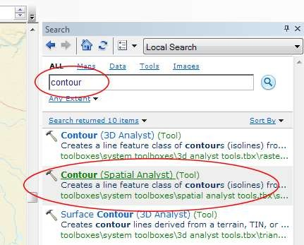

After choosing Contour, a dialogue window will appear, prompting you for five settings:Input raster: select the DEM file from which you want to generate contours by locating it onyour hard drive or in the dropdown menu, showing layers present in the Table of ContentsOutput polyline features: indicate where you want to save your output contours Contourinterval: set the distance between contour lines in meters – the smaller the number, thegreater the number of lines Base contour (optional): the starting point from which the linesare generated – for example, the default is 0 so with an interval of 25 meters, the contours aregenerated at 25, 50, 75, 100…, but ifthe base contour is set at 40, then the contours aregenerated at 65, 90, 115, 140 and so on Z factor (optional): can be used to adjust the unitsof data; for example, if you have data in meters andyou want to produce your contours infeet,useaz-factor of 3.28 because 3.28feet equals onemeter.

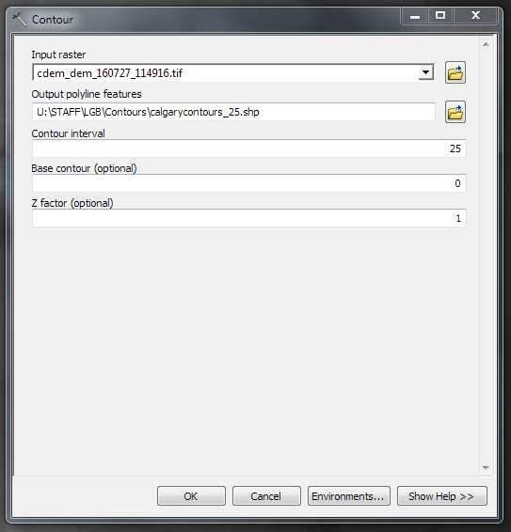

Thegeneratedcontourswill automaticallybe added tothemap.
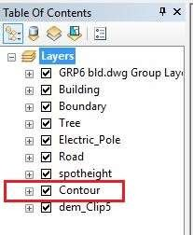

Inputthedatawhich istheAutoCADdrawingandselectthefeaturetypeyou wanttoload,

- ClickAddandNext,thenselecttheTargetlayer youwantit tobe

- LoaditintofromthefeatureclasscreatedontheARCGLS.

- ClickonNext,thenselect “onlythe featuresthat satisfythe

- Query”andclickonQueryBuildertoqueryforthefeaturetobeloude.g.“layer”=Boundary”.
- ClickonNext. Then finish

RightclickontheBoundaryInthetableofcontentandclickonzoomtolayertodisplaythefeature.

EDITING,CONVERTINGANDMERGING GEODATABASE

- Removeallnecessaryfeaturesbyrightclickingon itandpress "REMOVE"

- Convertsomefeatures that arenotin theircorrect„features-type‟likepoint, line, andpolygonfeaturesetc.
- ToconvertaGOEDATABASEFEATURECLASStoanotherthefollowingstepsweretaken:
- FORLINEFEATURECLASSTOPOLYGONFEATURECLASS
- GotoWINDOW onthe menu barandselect ARCToolbox.
- SelectDATAMANAGEMENTTOOLS,clickonFEATURES,andthenSelectFEATURETOPOLYGON.
- ONINPUTFEATURES,selectfeaturetobeconverted,onOUTPUTFEATURECLASS,then saveon theGRP6CFOLDER, pressOKand CLOSE.
- ThenremovetheconvertedfeatureclassintheLAYERMenuandARCCATALOGfiles.
- OnINPUTDATASETS,selectfeaturestobemerged,onOUTPUTDATASETS,thensaveon the GRP6C folder, pressOKand CLOSE.
- ThenremovetheconvertedfeatureclassintheLAYERMenuandARCCATALOGfiles.

ADDINGSPOTHEIGHTSDATA
- NOTE:STOPEDITINGontheEDITORMENU before addingdatafield,
- GotoFIELD ONTHE MENUBAR,scrolltoaddDataandthenADDXYZDATA
- BrowsetheEXCELFILEforSPOTHEIGHTS,selectEASTINGVALUEonX-FIELD andNORTHINGVALUEon Y-IELD andELEVATION
- « Select DATA the EXPORT DATA, locate the folder created and give it name thenYESANDOK,removethepreviouslayerbyrightclickingonitandselectREMOVE.

TIN,ASPECTANDSLOPECREATIONUSINGARCMAP
NOTE:Makingsurethe3DAnalystExtensionisactive,selectVIEWonMENUbar,thenclickTOOLBARS andMARK the3DAnalyst EXTENTION Then X,YData
TOCREATE TIN
- Clickon3DAnalystarrow,selectcreateTINandthencreateTIN fromFEATURE.
- OnlayersmarktheSPOTHEIGHT LAYER,selectheightdataonHEIGHT,thenok.

TOCHANGETHEFACEOF THETINACCODINGTOITSELEVATION
- RIGHTCLICKontheTIN,selectPROPERTIES,andclickonSYMBOLOGY.
- Then ADD, select FACE ELEVATION WITH COLOR RAMP, click ADD, and thenselectAPPLYand OK.

TOCREATE ASPECT
- Click on 3D analyst arrow, select SPATIAL ANALYST TOOLS, SURFACE andTHENDOUBLE CLICKon ASPECT.
- Browse to where the raster format of all the acquired data created from the surfer wassavedto.
- BrowsetowhereyouwanttheOUTPUTRASTERtobesaved
- Youcanchangethe OUTPUTMEASUREMENTtoDegree ORpercent
- ClickOK[then itdisplays onthedata viewscreen], thenClose.

3.8.5 Facility Map Production
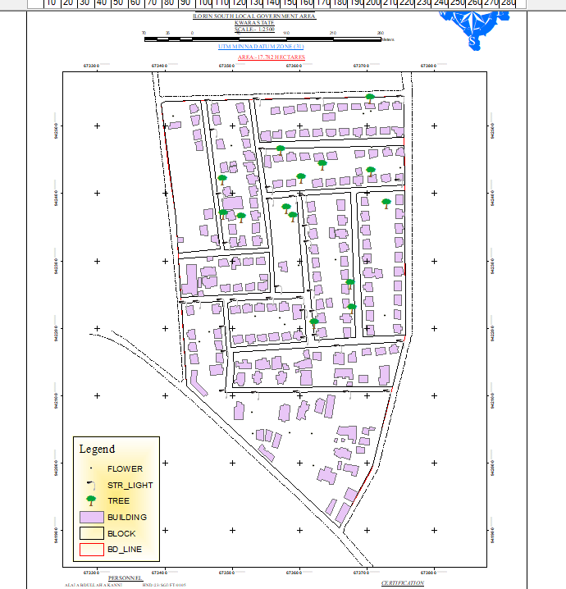
The buildings were digitized from the downloaded Google earth image using ArcGIS 10.2.1. Shape files for the facilities were created in Arc Catalogue. The created shape files were added to Arc Map and editor was started to digitize out to facilities. The road network, buildings are extracted using polyline and polygon respectively while street lights and trees are represented by point data for 3D map production the generated 2D map is shown in Figure 3.6, Figure 3.7 shows the old 2D CAD map of the campus.

Figure 3.6 showing the 2D facility map of the study area.

3.8.6 3D Map Production
The 3D image was done Arc Scene using the created DEM; the created DEM was added to Arc Scene and extruded with the heights gotten on the field. Extrusion incorporates the height of these features in their representation to give them 3D look and was made to float on DEM to have a true land representation.
The created DEM was also added to Arc Scene, The height of the buildings gotten from the field was added to the already created height field in the attribute table of each of the facility shape file in Arc Map. Arc Scene was launched and all the shape files were added, from the table of content each shape file was right clicked on to access the property dialog box, from the property dialog box the shape files were extruded to give them 3D look and were made to float on the DEM to have a full 3D visualization.

3.8.7 Findings
This study has demonstrated a capability of GIS in facility mapping with different visualizations techniques i.e. 2D and 3D visualization, Figure 3.6 shows the generated 2D map while Figure 4(a) and Figure 4(b) show cross-sections of the generated 3D map of the campus. All the facilities were geo-located with the aid of total station and imported into ArcGIS 10.2, the facilities were also digitized from the Google earth image downloaded for the study area. 3D topographic maps of the study areas were created from the point data gotten from field-work and also from the downloaded SRTM DEM image downloaded from USGS, Figure 5 shows the 2D Topographic map generated from the point data gotten from the field using Total station while Figure 6 shows the 3D topographic map generated using the same data source. Figure 7 shows the 2D topographic map generated from SRTM 30 m while Figure 8 shows the 3D topographic map generated using the same data source. The 2D facility map was produced by digitizing all the facilities out as features from the Google earth image downloaded using Google downloader. The 3D model of the campus was produced by exporting all the features created in Arc Map to Arc Scene for extrusion; the extruded features were made to float on the 3D topography map created through interpolation using Kriging method. The 3D visualization gives the study area a near real life view.
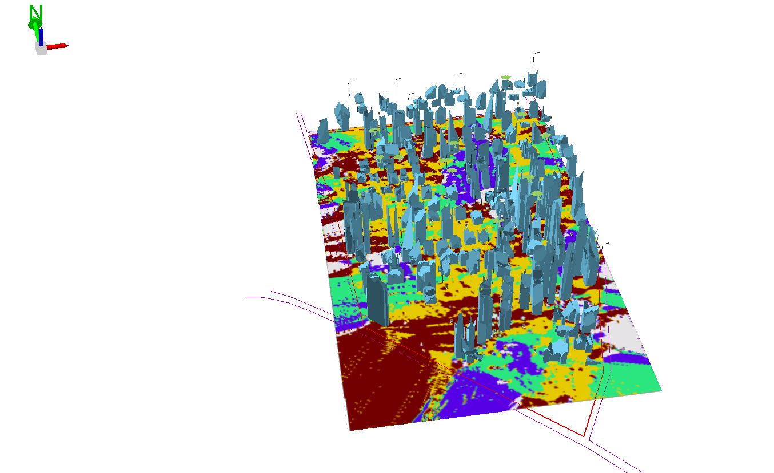

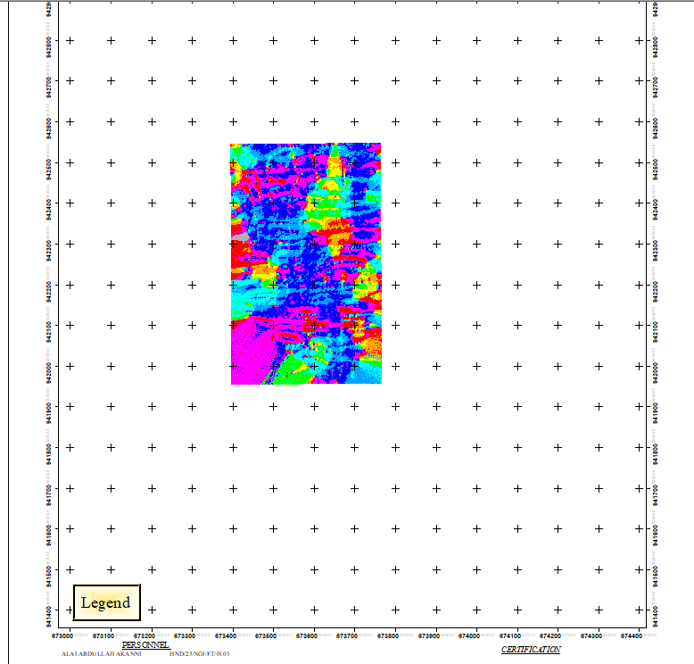
Figure 3.7 (a) Showing 3D model of the study area area

Figure 3.8 showing the 2D DEM (Digital elevation model) of the study area (derived from the field data).

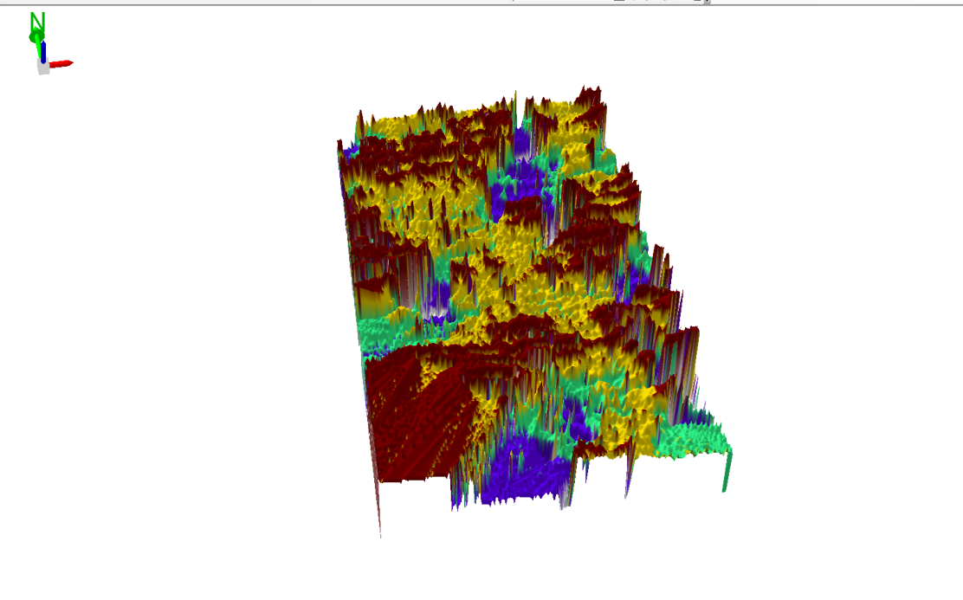

Figure 3.9 Showing 3D DEM (Digital Elevation Model) of the study area (derived from the field data).

3.8.8 Attribute data creation
There is need to create attribute tables for the features so as to be used for queries.NOTE: The editor on the menu bar must be stopped before adding field to its table.THEFOLLOWING PROCEDURES WERE FOLLOWED:
- Rightclickonthefeatureclass,thenselectOPENATTRIBUTESTABLEclickonOPTIONSand select ADD FIELD.
- GiveitFIELDNAME,clickonTYPEandselect[SHORTINTEGERorLONGINTEGERforSHORTorLONGWHOLEVARIABLESorDOUBLEFORDECIMALVARIABLESORTEXTvariableorDATEforDATE],thenenterprecision or LENGTH for text width and scale for DECIMAL PLACES, and thenclickOK
- To input variables on the ATTRIBUTE TABLE, go to the EDITOR on Menu bar,selectSTART EDITING,
- Click on ATTRIBUTE on menu bar [behind the TARGET], click on the features onthe DATA VIEW display,and then input the variables of data acquired throughSOCIALSURVEYor DATAACQUIRED ON THEFIELD.
- Save it after the input by selecting SAVE EDITS on the editor menu. To switch toother layers, select STOP EDITING on the EDITOR menu. Then repeatthe abovestepto createotherfields. Populatethe table and save.

Table3.10: Building
ENTITY | FIELDALIAS | DATATYPE | FIELDSIZE
B_ID | BuildingIdentification | Numeric | -
B_name | BuildingName | Text | 10
B_Area | BuildingArea | Numeric | -
B_E | BuildingEasting | Numeric | -
B_Northing | BuildingNorthings | Numeric | -

Table3.11:Road
ENTITY | FIELDALIAS | DATATYPE | FIELDSIZE
R_ID | RoadIdentifier | Numeric | -
R_Length | RoadLength | Numeric | -
R_Width | Road Width | Numeric | -
R_Type | RoadType | Text | 10
R_Condition | RoadCondition | Text | 10

Table3.12:Trees
ENTITY | FIELDALIAS | DATATYPE | FIELDSIZE
TR_ID | TreeIdentifier | Numeric | -
TR_Spp | Treespecy | Text | 10
TR_E | Tree_Easting | Numeric | -
TR_N | TreeNorthing | Numeric | -

Table3.13:ElectricPoles
ENTITY | FIELDALIAS | DATATYPE | FIELDSIZE
EP_ID | ElectricpoleIdentifier | Numeric | -
EP_Type | ElectricpoleType | Text | 10
EP_Height | ElectricpoleHeight | Numeric | -
EP_E | ElectricpoleEasting | Numeric | -
EP_N | ElectricpoleNorthing | Numeric | -

3.8.9 DATABASEIMPLEMENTATION
This is the database creation phase. Having completed the three stages of design phase (i.e.Reality,ConceptualandLogicaldesign),thedatabasewascreatedusingArcGIS10.3software. It involves the combination and storage of acquired graphic data and attributes dataincreating the database forthe purposeofspatial analysisand query.
Database is an organized integrated collection of data stored so as to be capable of use byrevenant application with data being accessed by different logical part. After the Attributetable was populated via the keyboard, some attributes such as areas of settlements wereautomaticallydisplayedbyspecialcommandintheArcGIS10.3version.TheArcGISsoftwarewas used to linkthe graphic dataandtableforquerygeneration.

3.8.10 DATABASEMANAGEMENTSYSTEMS
Databasemanagementisacollectionofsoftwareforcreating,storing,manipulating,updating, organizing and querying of information in a database (Kufoniyi, 1998). It is asoftwarepackagewhose function is tomanipulate adatabaseon behalfoftheuser.
Agood DBMS must provide the following functions:

      - Storageandretrievalofdata.
      - Accessto byseveral users at atime.
      - Astandardizedinterfacebetweendatabaseandapplicationprogrammed.
      - Standardized access to data and separation of data storage and retrieval functions fromtheprogram using the data.
      - Maintenanceof datasecurityandintegrity.

3.8.11 DATABASEMAINTENANCE
Havingcreatedthedatabase,propermaintenancepracticewasmadetomeetitsstatedobjectives.Theabilitytoincludemoredataandremoveirrelevantdatawaspossiblebywayof maintenance. There is every need for the data to be updated regularly because of thephysical changes that may occur on the landscape with time. Both security and integrity werealsoexercised to ensure maintenanceand to meetits stated objectives.
Proper observance, updating and management of database ensure its currency and quality tostand a profound chance in Spatial Decision Support System (SDSS). The quality of anydatabase depends on the currency and fitness for use as a decision support system (SDSS).The quality of database depends on its ability to generally fit and use as a decision system(DSS). The storage media should be from time to time justified if otherwise could necessitatedata inaccessibility or physical deterioration of the storage media.Also care must be takenduring populating any database system, as a database is only good as the data supplied. Inarchivingstable media should be used. Examplesoftheseare:-
- Computercompatibletapereader
- Magnetictape
- Opticaldiscandcompactdisc

3.8.12 AREA COMPUTATIONTable

Table3.14: shows area computation
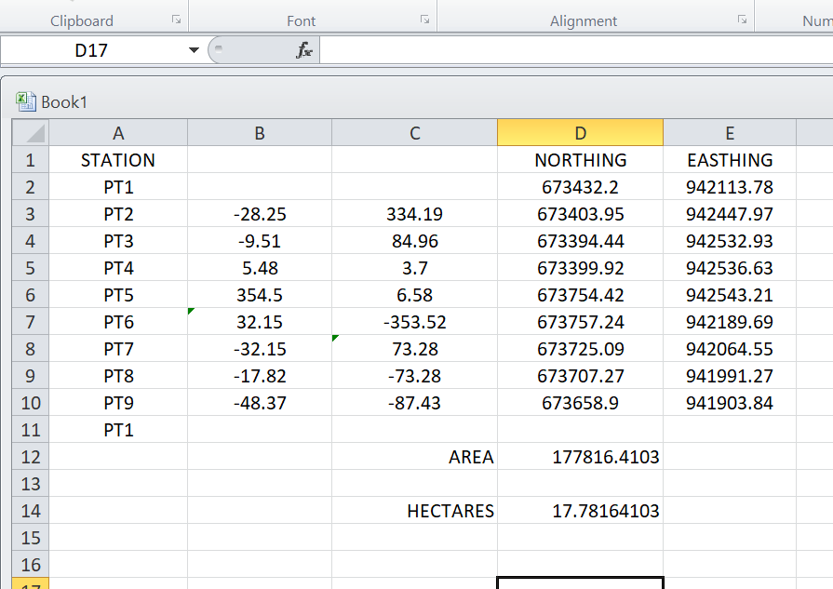

CHAPTERFOUR

4.0 SPATIAL ANALYSES AND PRESENTATION

GIS is distinct among other information system because of its spatial analytical capability;especiallyoverlayoperation,buffering,spatialsearch,topographicoperation,andneighborhoodandconnectivityoperations.GISusesthisspatialanalyticalcapabilitytoanswerfundamentalgenericquestionoflocation,condition,trend,routing,patternandmodeling by the manipulation and analysis of input data. The major analyses performed inthisproject wereoverlayoperations, topographic operations andspatial search.

4.1 TESTINGOF DATABASE

This is the test carried out to determine whether there exists a relationship between datamodeledaboutentitiesinaspatialdatabaseaswellasputtingintotestitsretrievalcapabilities. This was done by designinga sample query with certain conditions attached andthequerywill beran to seeif desired result is achieved.

4.11 ANALYSIS OF RESULT

The contour whose value is greater or equal to350 meters depicts the likelihood that sucharea may not be prone to flood in the project area as shown in Fig. 4.5(Query 1). Thisrepresents the elevation of points that are greater than to 350m. The displayed attribute tableconfirmedthatNorth-Eastpartoftheinstitutehadthehighestelevation.Heightisanimportant factor when considering the surface or slope of the terrain. The South-west part oftheschoolhadthelowestelevationwhichisverypronetoerosion.Buildingsthatwillbesited in that region must have a very high foundation above the ground level. The result of thequerywillaffordtheschoolmanagementtodecideconciselytheterraincharacteristicsandthe kind of building that should build in every region of the project area looking critically attheterrain of thearea.

SINGLESELECTIONCRITERION

Query1:shows the completed building

SELECT* FROM Building WHERE "BLD_STATUS" LIKE COMPLETED
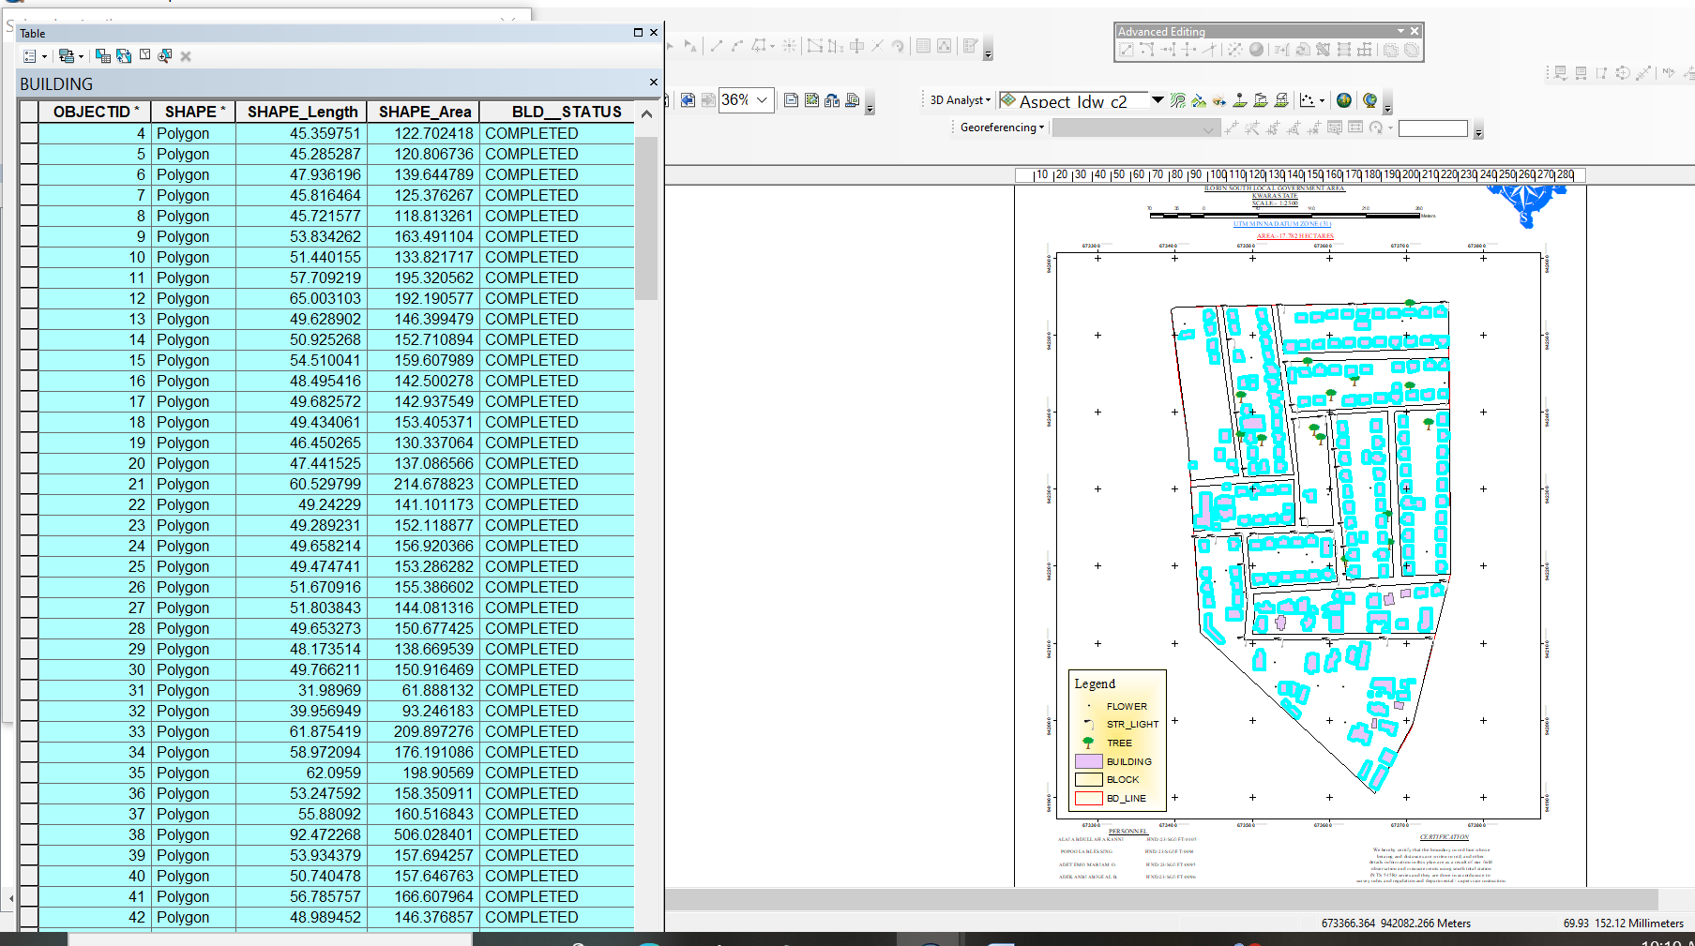

Fig4.1:shows the completed building

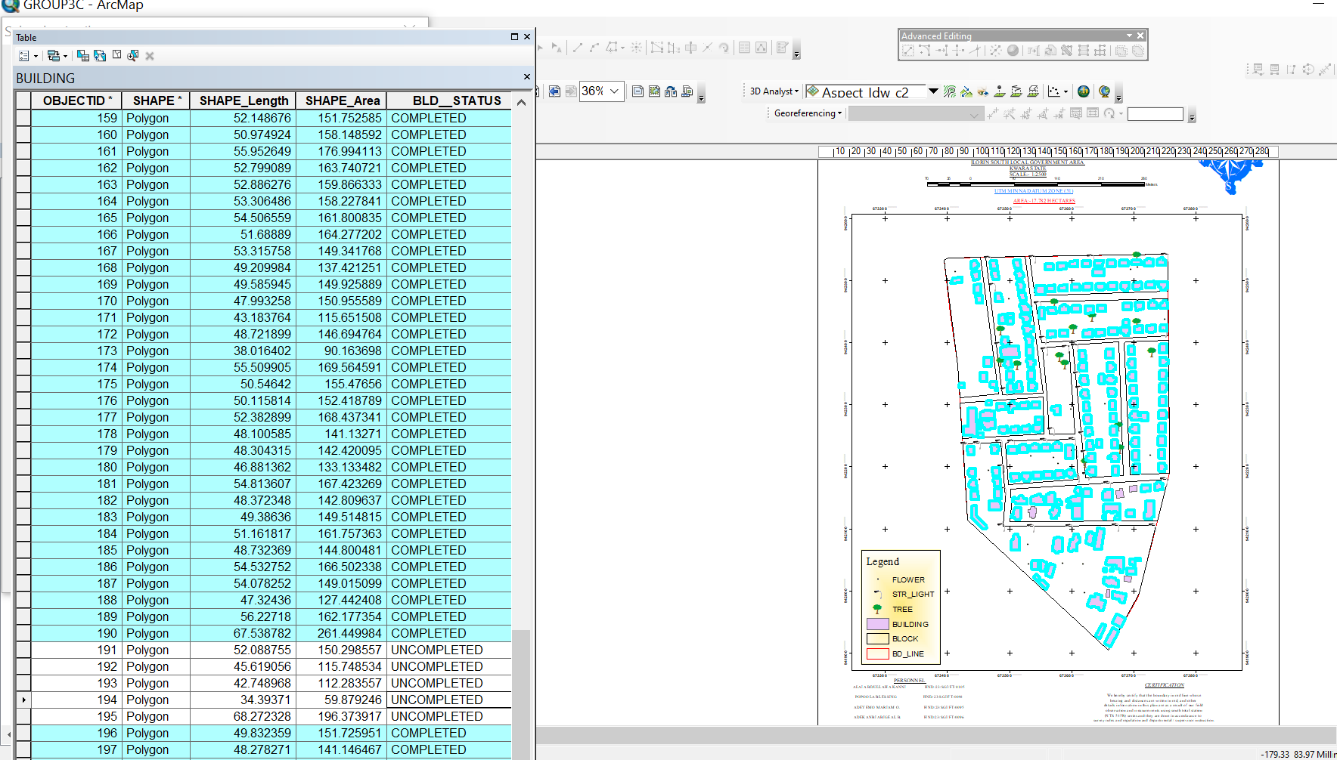

Fig4.2: shows the 2D completed building

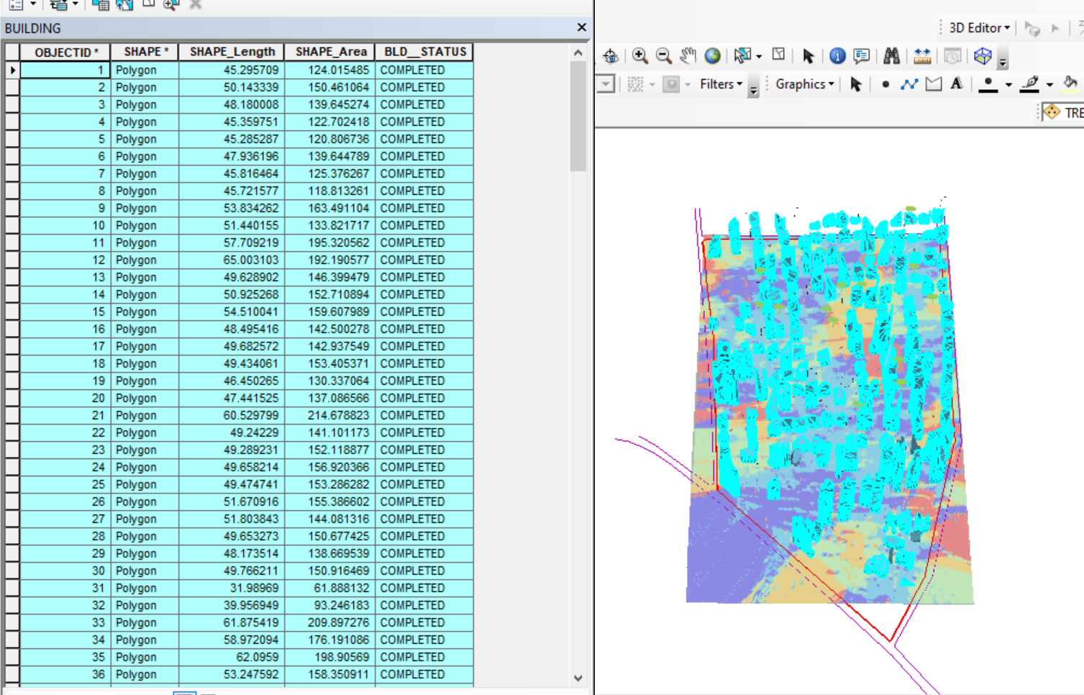

Figure 4.3 shows the 3D of completed building
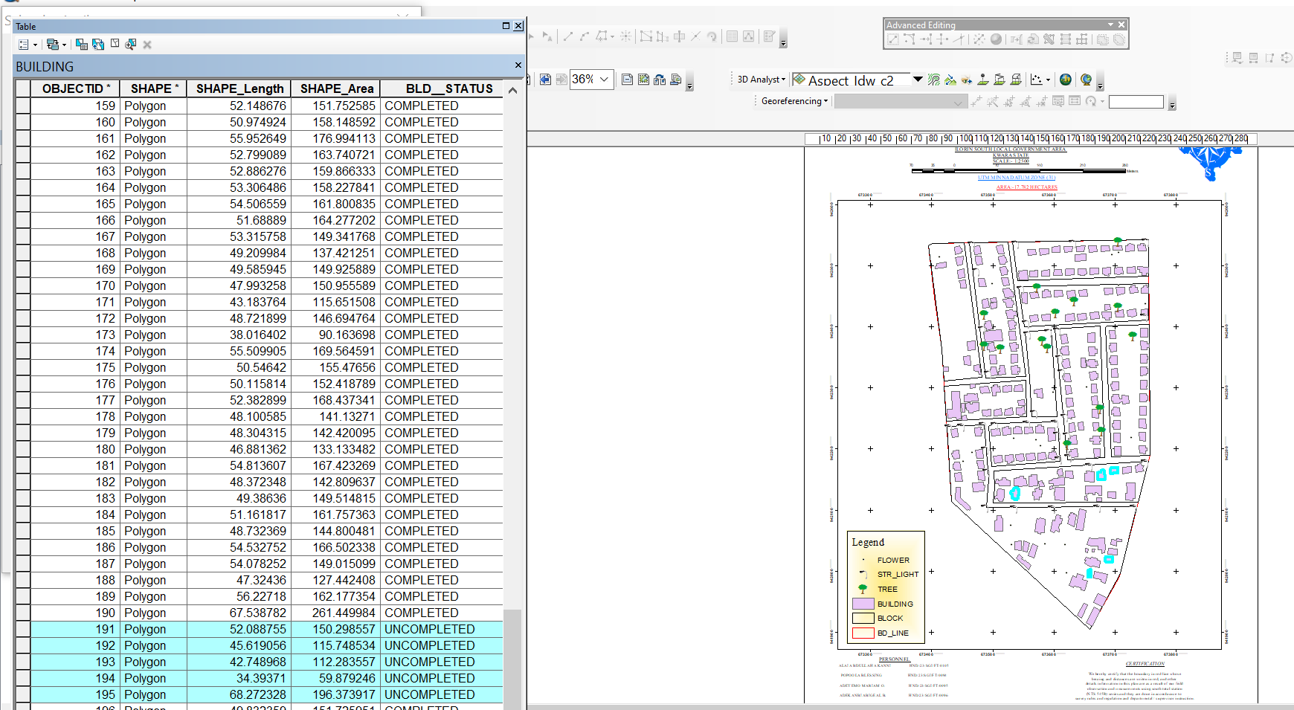

Fig4.4Queryshows the 2D of uncompleted building

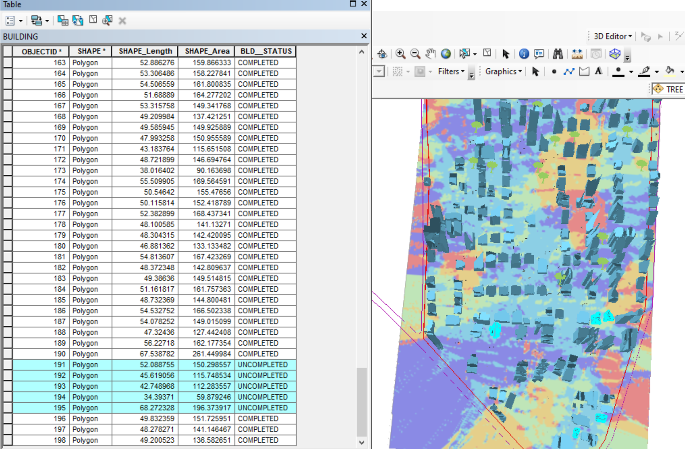

Figure 4.5 shows the 3D of uncomplted building

CHAPTER FIVE

5.0 Costing Estimation, Summary, Conclusion, Recommendation and Problem Encountered

5.1 Costing Estimation
RECCONNAISSANCE
S/N | PERSONNEL | QTY | DAILY RATE | NO OF DAYS | REMARK
1 | Group leader | 1 | 5000 | 1 | 5000
2 | Ass group leader | 1 | 2500 | 1 | 2500
3 | Basic equipment | 1 | 25000 | 1 | 25000
4 | Transportation | 1 | 3000 | 1 | 3000
Subtotal = #35,500
Monumentation
S/N | PERSONNEL | QTY | DAILY RATE | NO OF DAYS | REMARK
1 | Group leader | 1 | 5000 | 1 | 5000
2 | Ass group leader | 1 | 2500 | 1 | 2500
3 | Skilled labor | 3 | 1500 | 1 | 4500
4 | Basic equipment | 1 | 25000 | 1 | 25000
5 | Transportation | 1 | 7500 | 1 | 3000
Subtotal = #40,000

Beaconing
S/N | PERSONNEL | QTY | DAILY RATE | NO OF DAYS | REMARK
1 | Group leader | 1 | 5000 | 1 | 5000
2 | Ass group leader | 1 | 2500 | 1 | 2500
3 | Basic equipment | 1 | 5000 | 1 | 5000
4 | Transportation | 1 | 3000 | 1 | 3000
Subtotal = #5,500
Beacon
S/N | PERSONNEL | QTY | DAILY RATE | NO OF DAYS | REMARK
1 | Group leader | 1 | 5000 | 1 | 5000
2 | Ass group leader | 1 | 2500 | 1 | 2500
3 | Beacon | 10 | 1000 | 1 | 10,000
4 | Transportation | 1 | 3000 | 1 | 3000
Subtotal = #19,500
Traversing
S/N | PERSONNEL | QTY | DAILY RATE | NO OF DAYS | REMARK
1 | Supervisor | 1 | 6000 | 1 | 6000
2 | Group leader | 1 | 5000 | 1 | 5000
3 | Ass group leader | 1 | 2500 | 1 | 2500
4 | Skilled labour | 6 | 1500 | 1 | 10,000
5 | Basic equipment | 1 | 25000 | 1 | 5000
6 | Transportation | 1 | 10,500 | 1 | 10,500
Subtotal = #43,500
Spot Height
S/N | PERSONNEL | QTY | DAILY RATE | NO OF DAYS | REMARK
1 | Supervisor | 1 | 6000 | 2 | 12,000
2 | Group leader | 1 | 5000 | 2 | 10,000
3 | Ass group leader | 1 | 2500 | 2 | 5000
4 | Skilled labor | 6 | 1500 | 2 | 20,000
5 | Basic equipment | 1 | 25000 | 1 | 5000
6 | Transportation | 1 | 10,500 | 2 | 21,000
Subtotal = #73,000
Data processing
S/N | PERSONNEL | QTY | DAILY RATE | NO OF DAYS | REMARK
1 | Group leader | 1 | 5000 | 1 | 5000
2 | Ass group leader | 1 | 2500 | 1 | 2500
3 | Basic equipment | 1 | 10,000 | 1 | 10,000
4 | Generator and fuel | 1 | 10,000 | 1 | 10,000
Subtotal = #27,500

Technical report
S/N | PERSONNEL | QTY | DAILY RATE | NO OF DAYS | REMARK
1 | Group leader | 1 | 5000 | 1 | 5000
2 | Ass group leader | 1 | 2500 | 1 | 2500
3 | Basic equipment | 1 | 10,000 | 1 | 10,000
4 | Generator and fuel | 1 | 10,000 | 1 | 10,000
Subtotal = #27,500
Sum total = 271,500.00

Contingency allowance = 271,500.00 X 5 = 13,575
100

VAT = 271,500.00 X 7.5 = 20,362.5
100

ACCOMODATION = 271,500.00 X 1.5 = 4,072.5
100
MOB/DEMB = 271,500.00 X 10 = 27,150
100
GLEARANCE TAX =65,159.5

5.2 Summary
The project title digital mapping was carried out at Federal royal valley estate Sango Kulende area, Ilorin Kwara State. The project was carried out in accordance with third order specifications, the reconnaissance [office and field] was properly carried out and this enhanced proper planning of the operations by locating initial controls for proper orientation, the instrument to be used, and selection of total station were put into consideration and finally drawing of sketched diagram of the area to be surveyed. This project covered the aspect of traversing, perimeter, leveling, detailing and spot heights by using Total Station as main instrument.
Traversing was done to determine the coordinate [Northing and Easting] of the stations while heights of the stations were obtained from the perimeter, leveling, tachometry was used to obtain the values of position of new points. Thereafter, data processing was done and the plan was produced in analysis [manual] and digital format title plan showing perimeter and details of all project area. Finally, a comprehensive report was written on how the entire project was executed.

5.3 Conclusion
In conclusion, the project exercise has been successfully executed since the result of the above operation agreed the requirement and accuracy of third order job and adequate data acquired, processed and represented in plans, all necessary computation was carried out to a specification given and in accordance with the survey rules and departmental instructions.

5.4 Recommendations
Having participated in this practical work and due to the experience, I had acquired during this project and products generated, I hereby make the following recommendations.
- The Government should use this plan available for decision making regarding the premises and as well fence the school premises because the school is bounded by many roads.
- The Government should give proper supervision to the available resource such as borehole, chairs and table as well as staff.
- Application of computer programming should be fully implemented so as to make the students carry out the data processing exercise more efficiently and faster.
- This project is available for review

5.5 Problems Encountered
The problem encountered on the site were unavoidable especially the movement of vehicles and the students of our site project were disturbing when working. Also, the total station battery was also getting weak time to time, so it consumes us more battery and stress before getting another battery.

References
[1] Agbaje, G.I. and Omoyajowo, B. (2010) Generation of Geospatial Datasets for Facilities Management in Abuja, Nigeria. National Space Research and Development Agency, Abuja
[2] Bello, I.E. and Ikhuoria, I.A. (2015) 3D Cartographic Model And Animation of As-built Educational Landuse of UNIBEN, Nigeria. National Space Research and Development Agency (NASRDA), Abuja, Nigeria, University of Benin (UNIBEN), Benin City.
[3] Bassham, C.R. (1994) GIS/Municipal Management Information System at Texas A&M University. Texas A&M University.
[4] Haeberling, C. (2002) 3D Map Presentation—A Systematic Evaluation of Important Graphic Aspects. International Cartographic Association (ICA) Mountain Cartography Workshop “Mount Hood”, 15-19 May 2002, Timberline Lodge, Mt. Hood, Oregon.
[5] Khalil, R. (2013) The Accuracy of GIS Tools for Transforming Assumed Total Station Surveys to Real World Coordinates. Journal of Geographic Information System, 5, 486-491.
[6] Meyers J.R. (2000) GIS in the Utilities.
https://www.geos.ed.ac.uk/~gisteac/gis_book_abridged/files/ch57.pdf
[7] Nwilo, P.C., Peter, O.V. and Badejo, O.T. (2000) Geo-informatics as a Tool for Facilities Management. Proceedings of Technical Session NIS AGM Edo, University of Lagos, Lagos.
[8] Stanislawski, L., Finn, M.P., Usery, E.L. and Robinette, P.L. (2007) Development of a Blunder Detection Approach for Automated Point Matching During Vector to Image Data Integration. Proceedings of American Society for Photogrammetry and Remote Sensing Annual Conference, Tampa, FL, May 7-11 2007.

[9] Stuart, R. and Kevin, H. (2010) Geographic Information Systems (GIS) for Facility Management. IFMA Foundation.
http://www.ifmafoundation.org/
[10] Weiss, M.D. (2009) Ten Innovative Uses for GIS in Facility Management. Advanced-Infrastructure.
https://healthmap.wordpress.com/2009/05/15/ten-innovative-uses-for-gis-in-facility-management/
https://doi.org/10.4236/jgis.2013.55045

APPENDIX I
X | Y | Z
673600.438 | 941983.025 | 276.220
673637.669 | 941983.025 | 277.121
673674.900 | 941983.025 | 278.747
673525.976 | 942042.384 | 278.114
673563.207 | 942042.384 | 278.710
673600.438 | 942042.384 | 278.979
673637.669 | 942042.384 | 278.763
673674.900 | 942042.384 | 280.876
673712.131 | 942042.384 | 283.762
673451.515 | 942101.744 | 266.618
673488.745 | 942101.744 | 269.367
673525.976 | 942101.744 | 273.829
673563.207 | 942101.744 | 277.300
673600.438 | 942101.744 | 278.296
673637.669 | 942101.744 | 279.061
673674.900 | 942101.744 | 282.202
673712.131 | 942101.744 | 282.125
673451.515 | 942161.103 | 268.553
673488.745 | 942161.103 | 269.884
673525.976 | 942161.103 | 271.088
673563.207 | 942161.103 | 274.072
673600.438 | 942161.103 | 276.247
673637.669 | 942161.103 | 278.609
673674.900 | 942161.103 | 281.156
673712.131 | 942161.103 | 281.510
673749.362 | 942161.103 | 281.406
673451.515 | 942220.463 | 272.935
673488.745 | 942220.463 | 272.234
673525.976 | 942220.463 | 272.351
673563.207 | 942220.463 | 274.732
673600.438 | 942220.463 | 277.163
673637.669 | 942220.463 | 278.960
673674.900 | 942220.463 | 281.069
673712.131 | 942220.463 | 281.847
673749.362 | 942220.463 | 280.344
673451.515 | 942279.822 | 269.658
673488.745 | 942279.822 | 271.526
673525.976 | 942279.822 | 273.285
673563.207 | 942279.822 | 274.836
673600.438 | 942279.822 | 277.669
673637.669 | 942279.822 | 279.143
673674.900 | 942279.822 | 278.853
673712.131 | 942279.822 | 280.052
673749.362 | 942279.822 | 282.081
673451.515 | 942339.181 | 269.774
673488.745 | 942339.181 | 272.749
673525.976 | 942339.181 | 274.613
673563.207 | 942339.181 | 277.079
673600.438 | 942339.181 | 277.257
673637.669 | 942339.181 | 276.780
673674.900 | 942339.181 | 276.112
673712.131 | 942339.181 | 277.247
673749.362 | 942339.181 | 280.669
673414.284 | 942398.541 | 268.295
673451.515 | 942398.541 | 271.799
673488.745 | 942398.541 | 273.377
673525.976 | 942398.541 | 275.910
673563.207 | 942398.541 | 278.784
673600.438 | 942398.541 | 278.851
673637.669 | 942398.541 | 278.010
673674.900 | 942398.541 | 276.922
673712.131 | 942398.541 | 278.194
673749.362 | 942398.541 | 279.940
673414.284 | 942457.900 | 267.983
673451.515 | 942457.900 | 268.641
673488.745 | 942457.900 | 271.766
673525.976 | 942457.900 | 272.732
673563.207 | 942457.900 | 276.328
673600.438 | 942457.900 | 279.393
673637.669 | 942457.900 | 279.382
673674.900 | 942457.900 | 278.970
673712.131 | 942457.900 | 279.948
673749.362 | 942457.900 | 282.942
673414.284 | 942517.260 | 268.275
673451.515 | 942517.260 | 268.192
673488.745 | 942517.260 | 271.061
673525.976 | 942517.260 | 273.349
673563.207 | 942517.260 | 273.776
673600.438 | 942517.260 | 277.162
673637.669 | 942517.260 | 279.188
673674.900 | 942517.260 | 278.834
673712.131 | 942517.260 | 280.717
673749.362 | 942517.260 | 282.616

