

KWARA STATE POLYTECHNIC

DESIGN A LAPTOP ANTI-THEFT DEVICE

PRESENTED BY
ADEBAYO TOLUWANIMI BOLUWATIFE
ND/23/MCT/FT/0023

A PROJECT WORK SUBMITTED TO DEPARTMENT OF MECHATRONICS ENGINEERING, INSTITUTE OF TECHNOLOGY,
KWARA STATE POLYTECHNIC, ILORIN.

IN PARTIAL FULFILLMENT OF THE REQUIREMENT FOR THE AWARD OF NATIONAL DIPLOMA (ND) IN MECHATRONICS ENGINEERING.

SUBMITTED TO :
ENGR. CITP. LUKMAN SALIHU

2023/2024 SESSION
CERTIFICATION
This is to certify that the research work carried out by Adebayo Toluwanimi Boluwatife with matriculation number ND/23/MCT/FT/0023 in Department of Mechatronics Engineering, Institute Technology (IOT), Kwara State Polytechnic, Ilorin Kwara State, has meet the requirement for the award of National Diploma (ND).

________________________ _______________
Engr. Citp. Lukman Salihu Date
(Project Supervisor)

_________________________ ________________
Engr. Raji Idowu Adebayo Date
(Head of Department)

_________________________ ________________
Engr. Mahmud Katun Date
(Project coordinator)

_________________________ ________________
External Examinar Date

DEDICATION

This project is dedicated to Almighty God and to my parent MR &MRS ADEBAYO and all knowledge seekers

ACKNOWLEDGEMENT
The dignity of human is not the ability to shape his own destiny, but to contemplate and to lease each measure prevailing circumstance.In this regards, it is necessary to acknowledge with thanks to those who have contribute either directly or indirectly in no small measure to the success of this work.
Firstly, I am extremely grateful to my project supervisor, (HOD Computer Engineering) who is my mentor in person of Engr. Citp. Lukman Salihu for his attention, suggestion, direction and words of encouragement. I am grateful for your kind gesture sir.
My deep appreciation also goes to the body of mechatronics Engineering department from the H.O.D in person of Engr. Idowu Raji Adebayo and all members of the staff.
Also the moral and financial support from my parent Mr. Adebayo Idowu Joel and Mrs. Adebayo Bola Rachael cannot be over emphasize. How can I ever thank you both, who have done everything for me including sacrificing the joys of their own lives so that I could be happy. Thank you dad and mom.
I also want to express my sincere gratitude to my families, friends and course mates, the likes of my lovely and wonderful sisters and also my dynamic brothers, and also my success team.

ABSTRACT
This project is aimed at Designing a laptop anti-theft device. The project was undertaken using a water activated tilt switch for sensing the position of the laptop (vertical or horizontal) and giving a necessary feedback to the input of the inverter, a 555 timer in monostable mode of operation for producing the time delay necessary to produce an alarm for a specified period of time, a 7404 Hex inverter for inverting function and the buzzer for producing an alarm as an output based on the state of the tilt sensor. This project has ease and simplify of operation over previous similar projects. The aim and objective have been achieved by designing a working version of the project.

TABLE OF CONTENTS
TITLE PAGE...............................................................................................................................ii
CHAPTER ONE 1
GENERAL INTRODUCTION 1
1.1 INTRODUCTION 1
1.2 SIGNIFICANCE AND MOTIVATION OF STUDY 1
1.3 AIM AND OBJECTIVES 2
1.4 METHODOLOGY 2
1.5 ORGANISATION OF PROJECT 2
1.6 CONCLUSION 3
CHAPTER TWO 4
LITERATURE REVIEW 4
2.1 INTRODUCTION 4
2.2 REVIEW OF PREVIOUS LAPTOP ANTI-THEFT DEVICE INNOVATIONS 4
2.3 7404 HEX INVERTER 4
2.4 THE 555 TIMER 6
2.5 TILT SWITCH 10
2.6 SWITCH 11
2.7 BUZZER 12
2.8 CONCLUSION 12

CHAPTER THREE 13
3.1 INTRODUCTION 13
3.2 BLOCK DIAGRAM OF THE LAPTOP ANTI-THEFT DEVICE 13
3.3 BUZZER 13
3.4 ALARM UNIT 14
3.5 TILT SENSOR 15
3.6 POWER SUPPLY 15
3.7 CONCLUSION 17
CHAPTER FOUR 19
PACKAGING, TESTING AND RESULTS 19
4.1 INTRODUCTION 19
4.2 PACKAGING 19
4.3 TESTING 19
4.4 RESULTS 20
4.5 PROBLEMS ENCOUNTERED 20
4.6 CONCLUSION 20
CHAPTER FIVE 21
CONCLUSION AND RECOMMENDATIONS 21
APPENDIX A 21
APPENDIX B 22
5.4 REFERENCES 23
LIST OF FIGURES
TITLE PAGE
Fig 2.3 7404 hex inverter connection diagram…………………………………………………….7
Fig 2.4.1 internal configuration of 555 timer……………………………………………………. 10
Fig 2.4.2 Monostable mode of the timer………………………………………………………… 12

Fig 2.4.3 Trigger signal, capacitor voltage and output pulse diagram……………………………14
Fig 2.5 Water activated tilt switch in vertical position…………………………………………...15
Fig. 2.6 Symbol of the switch…………………………………………………………….............16
Fig 2.7 Electronic symbol for a buzzer…………………………………………………………...17
Fig 3.2 Block diagram of the circuit……………………………………………………………...18
Fig 3.3 Buzzer…………………………………………………………………………………….19
Fig 3.4 Alarm unit………………...………………………………………………………………20
Fig 3.5 Tilt sensor………………………………………………………………………………....23
Fig 4.2 Casing dimension…………………………………………………………………………26
APPENDIX A: COMPLETE CIRCUIT DIAGRAM…………………………………………...29

CHAPTER ONE

GENERAL INTRODUCTION

1.1 INTRODUCTION
Due to the growing number of laptop owners, there is increase in number of laptop theft incidences. As a result, there is need for laptop users to secure their laptops at this time. The aim of the project is to design a simple laptop anti-theft device that can assist laptop owners to better protect their valuables. This project is designed to be one of the products of electronic engineering used for the protection of laptop against theft and unauthorised tampering.
A number of components will be used in the realization of this project and they include; A water activated tilt switch that will be used as a sensor which will sense the position, horizontal or vertical, of the laptop and give the necessary input (high or low) based on what it senses to the input of 7404 hex inverter IC, A 7404 hex inverter with which will be used as a inverter. and for input signal smoothening, a 555 timer will be used in a monostable mode to produce a pulse delay for a given period of time, lastly a buzzer will be used as the means that will produce or sound the alarm as the of output.
The result of this laptop anti-theft device will be indicated by the alarm produced via the buzzer whenever the circuit assumes a position such that the wires (the one tapped from the supply and the one going to the input of the 7404 hex inverter IC) in the water activated tilt switch remains open.

1.2 SIGNIFICANCE AND MOTIVATION OF STUDY
With respect to the project undertaken on the design of anti-theft device, certain modifications and improvements such as the use and implementation of the popular 555 timer in its monostable mode will be made because of its simplicity and ease of operations. Similarly, A 7404 hex inverter will be implemented.
It is in view of the importance of laptops in our day to day activities and the alarming rate of theft of this valuable that this project was undertaken. The rate at which laptops are being stolen and or tampered with both in the comfort of our homes, schools and workplaces without our consent has necessitated the design of protective gadgets to help reduce theft incidents.

1.3 AIM AND OBJECTIVES
The project aims at designing a simple laptop anti-theft device using 555 timer monostable mode, a 7404 hex inverter and a buzzer that produces an alarm as the output. The project is designed to give an alarm whenever the wires in the tilt switch are open and in order to achieve this, the following objectives are set out:
- Design of inverting unit using the 7404 hex inverter.
- Design of the tilt switch.
- Design of the alarm unit.
- Provide 12v battery acting as source of power supply to whole circuit.

1.4 METHODOLOGY
A 555 timer in collaboration with a 7404 hex inverter and a water activated tilt switch will be used to produce an alarm signal indicated by the buzzer. The timer will be used in monostable mode (one shot). The tilt switch is used to sense whether the contacts are shorted or open and provide a feedback to the input of the 7404 IC. The 7404 inverter will then receive the fed voltage (either low or high) and produce the necessary invert function then pass the pulse obtained to the trigger pin 2 of the timer. Based on the pulse sent, the timer will then produce an output pulse at the pin 3 output that will consequently produce an alarm or not.
The 555 timer is used to produce the window time necessary for the alarm, the 7404 hex IC is used as an inverter while the tilt switch is more like a sensor that will make the decision on whether the alarm is to be produced or not via the buzzer.

1.5 ORGANISATION OF PROJECT
The rest of the report is organised as follows:
Chapter one presents the general introduction of the project, its aim and objectives, significance and the methodology used are discussed. Chapter two discusses the literature review and components used in the project. Chapter three presents design details for the project. In chapter four, constructional details are presented with result of the system test carried out after the final circuit construction. In chapter five, conclusion drawn from the study are presented and suggestions for possible improvement over it.

1.6 CONCLUSION
As discussed above, the intention of the project is to design and construct a simple laptop anti-theft device that will serve as a means of protection by using and implementing a monostable mode 555 timer, a 7404 hex inverter and a tilt switch that will sense and give necessary feedback to be used across the input of the inverter then an alarm will then be obtained based on the position of the tilt switch. The aim and objectives as well as the organisation of the project have also been outlined.

CHAPTER TWO

LITERATURE REVIEW

2.1 INTRODUCTION
A simple laptop anti-theft device is one of the products of electronic engineering mostly used for the protection of our valuables (in this case, a laptop). However, in this project, it involves the use of 555 timers in monostable mode and a 7404 hex inverter with inputs plus a couple of other components. This chapter will attempt to review past projects on the concept of the laptop anti-theft device, and will demonstrate the improvement of the laptop anti-theft device designed in this project over the others.

2.2 REVIEW OF PREVIOUS LAPTOP ANTI-THEFT DEVICE INNOVATIONS
Earlier projects undertaken on the design of a simple laptop anti-theft device was done using components like comparator and IC which is also a multivibrator (is an electronics circuit that generates oscillations or pulses). The comparator compares the voltages obtained from a water activated switch fed inverting terminals respectively and transfers it to its output then to the trigger pin where an alarm will then be produced based on the input.
The limitations of this design however include the weak performance of the comparator, the zero output obtained and the complex nature of the IC. However, in the design implemented in this project, the comparator was replaced with a 7404 hex inverter with inputs due to its higher efficiency and pulse smoothening capabilities thereby producing a jitter free output pulse to be fed into the timer. It was replaced with the popular 555 timer due to its simplicity and free from false triggering. This project has shown a great improvement of workability and performance over the one earlier done.

2.3 7404 HEX INVERTER
The 7404 IC package contains six independent positive logic NOT GATES (INVERTERS) each of which performs the logic invert function. Pins 14 and 7 provide power for all six logic gates.
NOT GATE Logic-Rules:
The output is the inverse of the input, in other words if the input is HIGH then the out put is LOW and if the input is LOW the output is HIGH.

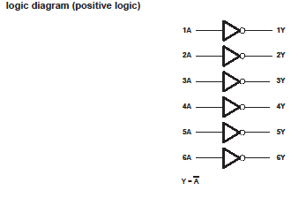

Fig 2.3 Logic Diagram [2]
.
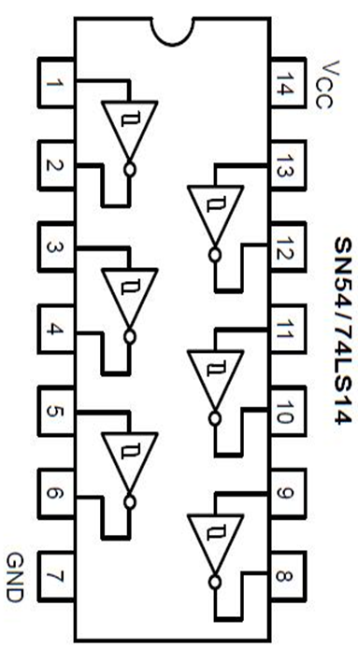
Fig 2.3 7404 hex inverter connection diagram

The 7404 IC is composed of six independent inverter gates as seen earlier.
Inputs are 1, 3, 5 etc while outputs are 2, 4, 6 etc. if the inputs are represented by A and the output Y, then
From the function table,
Input | Output
A | Y
L  H | H  L
Where:
H = High logic level
L = Low logic level

2.4 THE 555 TIMER
555 timers is one of the most remarkable integrated circuits ever developed, it comes in a single or dual package. It consists of two voltage comparators, a bistable flip flop, a discharge transistor and a resistor divider network. It’s a highly stable controller capable of producing accurate time delays, or oscillations. In the time delay mode of operation, the timer is precisely controlled by one external capacitor and resistor. In timer mode—better known as monostable mode—the 555 simply acts as a "one-shot" timer; when a trigger voltage is applied to its trigger lead, the chip's output goes from low to high for a duration set by an external RC circuit. Applications of the timer include precision timing, pulse generation, time delay generation etc. This project incorporates the timer in monostable mode (one shot) which requires only two external components R₃ and C₁ with respect to this project. The time period is determined by the relation t= 1.1RC.
The 555 Timer is available in 8 pin as shown in fig. below which is implemented in this project.
Below are the pin configurations.
- GND Ground, low level (0 V)
- TRIG A short pulse high-to-low on the trigger starts the timer
- OUT During a timing interval, the output stays at +VCC
- RESET A timing interval can be interrupted by applying a reset pulse to low (0 V)
- CTRL Control voltage allows access to the internal voltage divider (2/3 VCC)
- THR The threshold at which the interval ends (it ends if the voltage at THR is at least 2/3 VCC)
- DIS Connected to a capacitor whose discharge time will influence the timing interval
- V+, VCC the positive supply voltage which must be between 3 and 15
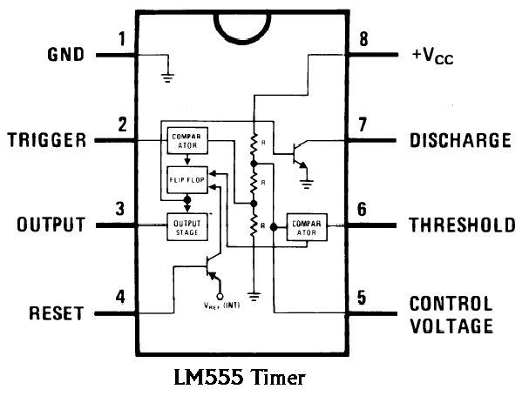

Fig 2.4. The 555 timer [3]
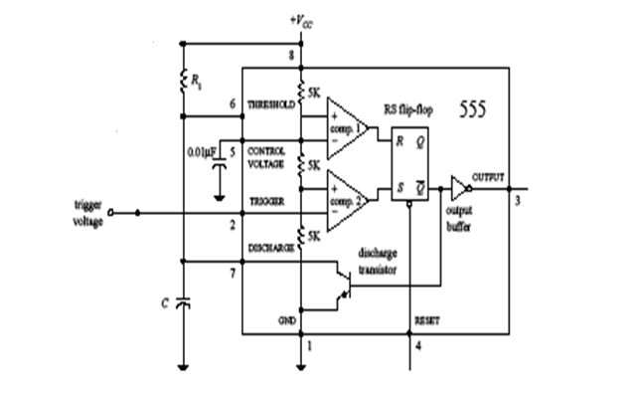
The above figure shows the internal configuration of the 555 timer used in this project. The 555 gets its name from the three 5-kΩ resistors shown in the block diagram. These resistors act as a three-step voltage divider between the supply voltage (V_{cc}) and ground.
The top of the lower 5-kΩ resistor (+ input to comparator 2) is set to 2/3 V_{cc} while the top of the middle 5-kΩ resistor (- input to comparator 2) is set to 1/3V_{cc}. The two comparators output either a high or low voltage based on the analog voltages being compared at their inputs.

555 timers have the following characteristics:
- Timing is from microseconds through hours.
- High Temperature Stability
- Duty Cycle is Adjustable
- Monostable and astable operations.

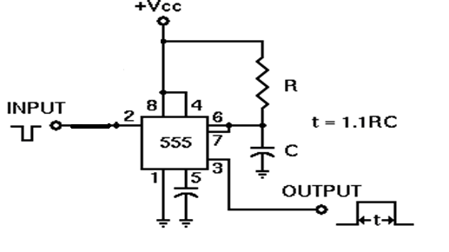
Fig 2.4.2 Monostable mode of the timer [3]
This circuit diagram shows how a 555 timer IC is configured to function as a basic monostable. In the monostable mode, the 555 timer acts as a “one-shot” pulse generator. The pulse begins when the 555 timer receives a trigger signal. The width of the pulse is determined by the time constant of an RC network, which consists of a capacitor (C) and a resistor (R). The pulse ends when the charge on the C equals 2/3 of the supply voltage. The pulse width can be lengthened or shortened to the need of the specific application by adjusting the values of R and C.

When capacitor C₁ as charged up to about 2/3 Vcc, the flip-flop is triggered once again, this time making the pin 3 output 'low' and turning on pin 7's discharge transistor, which discharges C₁ to ground. This circuit, in effect, produces a pulse at pin 3 whose width t is just the product of R1 and C1, i.e., t=R₁C₁. The figure below shows the voltage-time characteristic of the trigger signal, capacitor voltage ant the output time respectively.
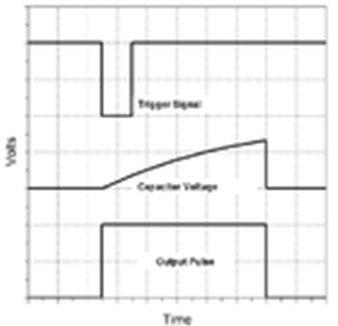

Fig 2.4.2 trigger signal, capacitor voltage and output pulse diagram

2.5 TILT SWITCH
The tilt switch is made using a small bottle with the wires (wires tapped from the positive supply terminal and the one to be fed into the input of the first ) as contacts. 2/3rd of the bottle is then filled with water such that the contacts never makes electrical path when the tilt switch is in vertical position.
The bottle is then fixed in the horizontal position and the whole unit is then fixed inside the laptop’s case in horizontal position. Positioning plays a vital role in the implementation of this project simply because it is based on the position (vertical or horizontal) of the unit that consequently makes the circuit to produce an alarm or not.
When the unit is in the horizontal position, there is an electrical contact between the two wires in the bottle as such the input to the trigger pin of the 555 timer is at high meaning that no trigger will occur and output of the timer is at high as such alarm will be silent.
When someone tries to take the laptop case, the unit takes the vertical position and the tilt switch break the electrical contact between the wires. Immediately the input of IC1 becomes low which causes trigger, then the IC will be triggered and consequently buzzer starts beeping.

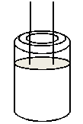
Fig 2.5 Water activated tilt switch in vertical position.

The figure shown above is the tilt switch. 2/3rd of it is filled with water and is in its vertical position with the wires open. When the switch is in horizontal position, the water will effectively short the wires thereby forming an electrical contact.

2.6 SWITCH
A switch is a button controlling electrical circuit: a mechanical or electronic device that opens, closes, or changes the connections in an electrical circuit, e.g. one used to turn a light on or off etc. in this project, a small on/ off switch is used. In electronics, a switch is an electrical component that can break an electrical circuit, interrupting the current or diverting it from one conductor to another. The most familiar form of switch is a manually operated electromechanical device with one or more sets of electrical contacts. Each set of contacts can be in one of two states: either 'closed' meaning the contacts are touching and electricity can flow between them, or 'open', meaning the contacts are separated and none conducting.
The two terminals are either connected together or disconnected from each other.
The switch incorporated in this project is switched on when the laptop’s case is in horizontal position.
Fig. 2.6 symbol of the switch

2.7 BUZZER
A buzzer or beeper is an audio signalling device, which may be mechanical, electromechanical, or electronic. Typical uses of buzzers and beepers include alarms, timers etc.
A piezoelectric element may be driven by an oscillating electronic circuit or other audio signal source. Sounds commonly used to indicate that a button has been pressed are a click, a ring or a beep.

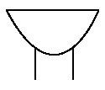
Fig 2.7 Electronic symbol for a buzzer

2.8 CONCLUSION
As presented earlier, this chapter gives in detail the literature review of the components involved in the realization of this project. The 555 timer used, the 7404 hex inverter with ed inputs, the sensor, which is the tilt sensor were all explained in detail. Review of the previous laptop anti-theft device innovation was presented. The limitations of the design were addressed and comparison between the earlier project done and the one to be done including the necessary improvements and shortcomings were all shown.

CHAPTER THREE

DESIGN AND CONSTRUCTION

3.1 INTRODUCTION
This chapter will dwell on the design of a simple laptop anti-theft device described on the previous chapter. The block diagram of the design and construction of the laptop anti-theft device is shown in section 3.2 below.

3.2 BLOCK DIAGRAM OF THE LAPTOP ANTI-THEFT DEVICE
This project is divided into three main functional units, these are the power supply, and the water activated tilt sensor and the alarm units respectively.
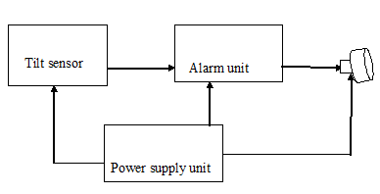
Fig 3.2 Block diagram of the circuit

3.3 BUZZER
From the data book,
I_{OL} () = 16 m A
I₁ = 11.25 m A @ 12V
From the values obtained from the data book above, it can be seen that I₁ < I_{OL}, since that is the case, then the buzzer is the best for this circuit.

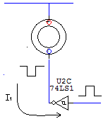
Fig 3.3 buzzer

3.4 ALARM UNIT

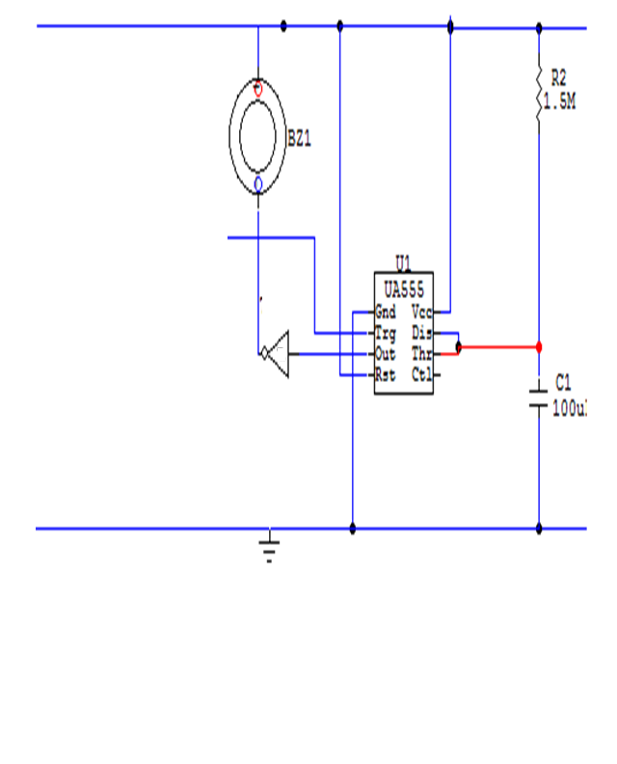
Fig 3.4 Alarm unit

3.5 TILT SENSOR
Since the tilt is water activated, when the probes have contact with the water, the resistance of the water R1 was measured using the multimeter and was found to be 3.4kΩ. It can be seen from the circuit diagram that a potential divider was formed by the resistors R₁ and R₂, we now try to obtain the value of R₂.
For 555 timer work, from the data book, it was seen that input voltage has a value of 5v.
From the potential divider,

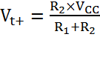 (3.2)
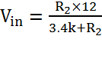
Vin = 5V, (Input to the 555 timer)
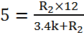
Simplifying the above yields:
R2= (3.4 x 5) / 7
R₂ = 3.4 KΩ
R₂ is then chosen to be 3.3 K (ohm).

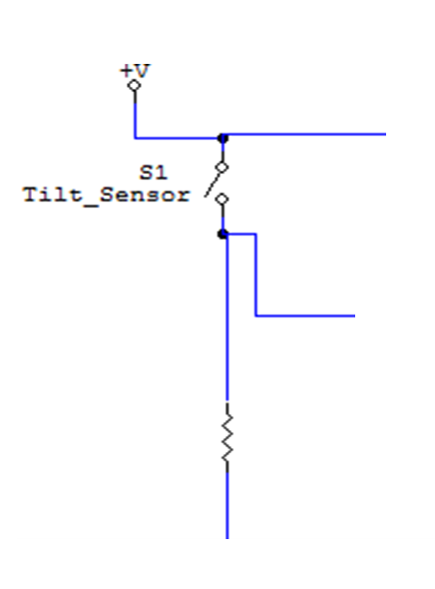
To timer pin 2

Fig 3.5 Tilt sensor

3.6 POWER SUPPLY
The electronic devices incorporated in this project all require direct power supply at low levels. A 12 v miniature battery is used as a direct current source.

V supply = 12 V
From the data book, the following values of currents are obtained,
I buzzer = 11.25 m A
I_{max} (555) = I_{ccl} = 15 m A
I_{max} (7404) = I_{ccl} = 60 m A
I SUPPLY MAX = I buzzer + I max (555) + I max (7404)
= (11.25 + 60 + 15) m A
= 86.25 m A

3.7 CONCLUSION
This chapter dwelled on the design of the simple laptop anti-theft device described on the previous chapter. The block diagram of the design and construction of the laptop anti-theft device was shown in section 3.2 above. The design procedures and specifications were also discussed in details. The procedures discussed were that of the tilt sensor, the power supply unit, the alarm unit which mainly consist the timer and the buzzer. Similarly, series of calculations were done in order to aid proper selection of components to be used and implemented.

CHAPTER FOUR

PACKAGING, TESTING AND RESULTS

4.1 INTRODUCTION
This chapter will focus on the packaging done to the already design simple laptop anti-theft device, the testing carried out will also be explained together with the results of the test obtained. Similarly, problems encountered in the course of constructing the circuit will be seen.

4.2 PACKAGING
The design of the complete circuit was neatly assembled in a specially constructed rubber casing so as to provide protection for the dc power supply, the 555 timer, the and the buzzer. The special casing and its dimensions are given in fig 4.2 below.
The assembled circuit of the Vero board soldered is then transferred to the special case is constructed using plastic, it has with height 1cm, width 7cm and 11.5 cm respectively. The tilt switch was separated from the main circuit.
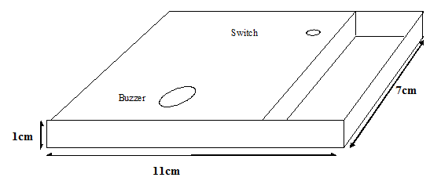

Fig 4.2 Casing dimension

4.3 TESTING
First and foremost, a general test of components involved was done using the multimeter so as to ensure proper working conditions. The whole circuit was tested after Vero board soldering. Firstly all the joints soldered were checked to ensure there were no dry joints as well as bridged joints. The circuit was connected to its dc source and the output obtained. Some procedures involved during construction procedures includes:
-The circuit was first tested on the bread board before the main construction begins. .
-Unnecessary distance was avoided during the design order to avoid short circuit.
-The IC sockets were soldered on the Vero board in places allocated to them.
-Soldering of the resistors and capacitors were done directly on the board.

4.4 RESULTS
Since the testing was more like a system testing because it was after the circuit was constructed, the battery was put on, the switch was switched on in the horizontal position and no alarm obtained. But, immediately after the case was tilted to vertical position, the output needed was obtained via the buzzer.

4.5 PROBLEMS ENCOUNTERED
A number of problems have been encountered during the course of this project.
1. Due to tolerance of the components, it was found that few weeks after construction, the timer failed and the switch incorporated with the circuit similarly became faulty and both were later replaced.
2. As a result of excessive heat from soldering, some components got burnt and had to be replaced.

4.6 CONCLUSION
This chapter focused on the packaging done to the designing project. The packaging was done using a plastic rubber to serve as a protection to the circuit and the components as a whole. The testing carried out was also presented together with the results of obtained. Similarly, problems encountered during constructing the circuit were seen and the necessary precautions and actions taken were presented.

CHAPTER FIVE

CONCLUSION AND RECOMMENDATIONS

The main objective of the project has been achieved since the simple laptop anti-theft device has been designed and constructed. The laptop anti-theft device sounds an alarm whenever the laptop is shifted to the vertical position and does not sound an alarm whenever the laptop is in the horizontal position.
The timer used in the circuit may be replaced by a more reliable and highly sensitive monostable multivibrator as a way of increasing the efficiency of the system. The system can be modified by using miniature components like the tilt switch, buzzer and the comparator which can serve the same purpose as the ones used in this project as a way of further reducing the size of the project.
Within the limits of experimental error, the aim and objectives of the designing this project have been met.
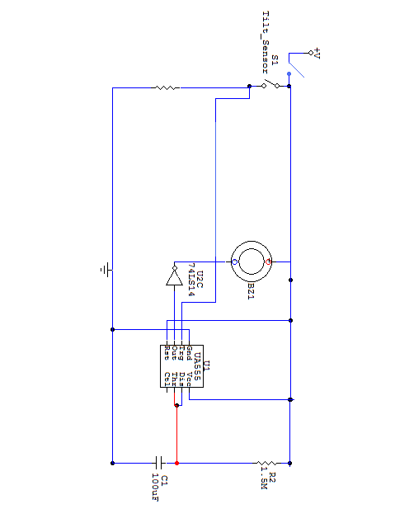
APPENDIX A

Complete circuit diagram.

APPENDIX B

7404 HEX INVERTER
IOL=16 mA
ICCH=38 mA
ICCL= 60 mA
VCC= 4.75-5.25v

555 TIMER
VCC=4.5-16V
ICC=6-15 mA
BUZZER
VCC=12V
I=11.25 mA

5.4 REFERENCES
www.google.com “555 timer, “switch”, 2009
www.wikipedia.com “, “7404 hex inverter”, 2009
http://www.abcofelectronics.com “buzzer, “tilt switch”, 2009
Boysen, E. and Muir, N. “Electronics Projects for Dummies” Wiley Publishing, Inc, 2006. Pages ( 31-55)
Giblisco, S. “Teach Yourself Electricity And Electronics” McGraw-Hill, 3rd Edition, 2005. Pages ( 383-392)
Scherz, P. “Practical Electronics for Inventors” McGraw-Hill, 2000. Pages (191-209)
Mallam Musa, H. “Electronics III lecture note”. Bayero University, Kano 2008/2009 Session

