

PROJECT REPORT
ON
LAND INFORMATION SYSTEM OF URBAN ESTATE ALONG
OKE-OSE/OKE OYI ROAD, ILORIN
ILORIN EAST LOCAL GOVERNMENT AREA
KWARA STATE

BY
AKEEM HAMID AJAGBE
HND/23/SGI/FT/0074

SUBMITTED IN PARTIAL FULFILMENT OF THE REQUIREMENTS FOR THE AWARD OF HIGHER NATIONAL DIPLOMA IN SURVEYING AND GEO-INFORMATICS TO THE DEPARTMENT OF SURVEYING AND GEO-INFORMATICS, KWARA STATE POLYTECHNIC ILORIN, KWARA STATE

JUNE, 2025

CERTIFICATE
I hereby certify that the information contained in this project report was obtained as a result of observations and measurements made by me on the field and that the survey was done in accordance with survey rules, regulations, and departmental instructions.

AKEEM HAMID AJAGBE
HND/23/SGI/FT/0074

CERTIFICATION
This is to certify that AKEEM HAMID AJAGBE with matriculation Number HND/23/SGI/FT/0074 has satisfactorily carried out his project under my instruction and supervision.
I here declare that He has conducted himself with diligence, honestly and sobriety on the project.

SURV.AKINYEDE ADEBANJI DATE
Project Supervisor

MR. A I ISSAU DATE
Head of Department

SURV.R.S AWOLEYE DATE
Project coordinator

External supervisor DATE

DEDICATION
This project is dedicated to Almighty God for his, protection and guidance and also to my caring parent in person MR&MRS. AKEEM

AKNOWLEDGEMENTS

The dream of becoming an achiever in life comes true, not only by one’s fortitude and hard work based on his knowledge, but it is also involving the positive influence of various factors and ideas of some people in the community.
First and foremost, all glory, honor and adoration is to Almighty God. I appreciate God for his grace upon my life, for keeping me safe since my advent in this school and most especially, during the execution of this project.
I sincerely wish to express my affectionate gratitude to my lovely and caring parent MR&MRS. AKEEM whose toils and struggles have helped a lot in transforming my life for better may Almighty God grant them long life to enable her reap the fruits of their labour.
My next gratitude goes to my supervisor, SURV. AKINYEDE ADEBANJI for his useful guidance, understanding, patience, and professional advice during the execution of this project that led to the successful completion of the exercise. I pray that God will continue to bless you (amen). More so, my appreciation goes to my able HOD MR. A I ISSAU and SURV. ASONIBARE R. O, SURV AYUBA ABDULSALAM, SURV A.G AREMU, SURV R.S AWLEYE, SURV. KAZEEM SURV. BABATUNDE KABBIR AND SURV BELLO DIRAN FELIX God bless you all.
More so, I seize this opportunity in acknowledging the efforts and contribution of my bossSURV. MUFTAU WASIU ISHOLA for his support morally, financially and for the impartation of knowledge in me that pertains to surveying profession.
I will not forget to express my gratitude to my friends in the likes of GANIYUAKEEM,MUFTAU JAMIU OPEYEMI, IDOWU HABEEBLOLADE, AHMED TOYYIB, AROWOLO NURUDEEN AYINDE, HUSSAIN TAWAKALITU OLAMIDE, ALAI ABDULLAHI AKANI and all my classmatesfor their support, advice and love I really appreciate you all.
My heartfelt thanks also go to all my group members for their cooperation and understanding during the project, I pray that we will never fail in our life.

ABSTRACT
Land management could be enhanced through effective land administration, which involves the processes of land registration, Cadastre, valuation and land inventory. Manual Land Administration has been in use by most of the Ministries of Lands and Survey in Nigeria since their inception. Most of the cities and their surroundings have been expanding rapidly beyond projections. With this rapid expansion, manual Land Administration has become inefficient, ineffective, time-consuming and prone to abuses, whereby some land officers siphon generated revenues, because of inefficient land transaction records; hence, there is need for a digital, scientific, and operational approach of Land Administration to be adopted in the development of an Integrated Land Information System. This paper gives an insight into a digital approach to Land Information System and Management of URBBAN ESTATE OPPOSITE GOVERNMENT CEMETRY ALONG OKE OSE/OKE OYI ROAD, KWARA STATE ILORIN. This has been achieved by conversion of existing land related information to digital formats with the aid of relevant software like MS Excel, MS Access, AutoCAD Land Development and ArcGIS 9.2 and the combination of necessary queries and analysis. The results show an efficient, effective and proper Land Administration and revenue generation procedure.

TABLE OF CONTENT
CERTIFICATE ii
CERTIFICATION iii
External supervisor DATE iii
DEDICATION iv
AKNOWLEDGEMENTS v
ABSTRACT vi
LIST OF TABLES xi
LIST OF FIGURES xii
CHAPTER ONE 1
1.0 INTRODUCTION 1
1.1 BACKGROUND TO THE STUDY 4
1.2 STATEMENT OF PROBLEM 6
1.3 AIM AND OBJECTIVES OF THE PRACTICAL 7
1.3.1 AIM OF THE PROJECT 7
1.3.2 OBJECTIVES OF THE PROJECT 7
1.4 SCOPE OF THE PROJECT 8
1.5 PERSONNEL 9
1.6 STUDY AREA 10
1.7 SPECIFICATIONS 11
CHAPTER TWO 12
2.0. LITERATURE REVIEW 12
2.1 Introduction to Land Information Systems (LIS) 12
2.2 Historical Development and Evolution 12
2.3 Technological Foundations of LIS 13
2.4 Applications of Land Information Systems 13
2.5 Challenges in Implementing and Managing LIS 14
2.6 Future Directions of LIS 15
2.7 Governance and Policy Issues in Land Information Systems 16
2.8 Global Perspectives on Land Information Systems 16
2.9 Social and Economic Impacts of Land Information Systems 17
2.10 Sustainability and Environmental Management 18
2.11 Data Standards and Quality Assurance 19
2.12 User Needs and Stakeholder Engagement 19
CHAPTERTHREE 24
3.0 METHODOLOGY 24
3.1 DATABASEDESIGN 24
3.1.1 VIEW OF REALITY 24
3.1.2 CONCEPTUALDESIGN 26
3.1.3 LOGICALDESIGN 27
3.1.4 PHYSICALDESIGN 27
3.2 RECONNAISSANCE 29
3.2.1 OFFICEPLANNING 29
3.2.2 FIELDRECONNAISSANCE 29
3.3 EQUIPMENTUSED/SYSTEMSELECTIONANDSOFTWARE 32
3.3.1 HARDWAREUSED 32
3.3.2 SOFTWARECOMPONENT 32
3.4 INSTRUMENTTEST 33
3.4.1 HORIZONTALCOLLIMATIONTEST 33
3.4.2 VERTICALINDEXERRORTEST 42
3.5 CONTROLCHECK 43
3.6 MONUMENTATION 44
3.7 DATAACQUISITION 45
3.7.1 GEOMETRICDATAACQUISITION 46
3.7.2 TTRIBUTESDATAACQUISITION 47
3.8 DATADOWNLOADINGANDPROCESSING 47
3.8.1 DATADOWNLOADINGANDEDITING 47
3.8.2 DATAPROCESSINGANDDATAEDITING 48
3.8.3 DATA PROCESSING IN AUTOCAD 48
3.8.4 DATAPROCESSINGUSINGARCGIS10.3 SOFTWARE 49
3.9 DATABASEIMPLEMENTATION 50
3.9.1 DATABASEMANAGEMENTSYSTEMS 51
3.9.2 DATABASEMAINTENANCE 51
3.9.3 BACK COMPUTATION Table 52
3.9.4 AREA COMPUTATION 53
CHAPTERFOUR 54
4.0 SPATIALANALYSESANDPRESENTATION 54
4.1 TESTINGOF DATABASE 54
CHAPTER FIVE 58
5.0 COST ESTIMATION, SUMMARY, CONCLUSION AND RECOMMENDATION 58
5.1 COST ESTIMATION 58
5.2 SUMMARY 61
5.3 PROBLEM ENCOUNTERED 62
5.4 CONCLUSION 62
5.5 RECOMMENDATION 62
REFERENCES 63
APPENDIX 65

LIST OF TABLES
Table 1.1 shows the personnel involved in project 9
Table3.1: Buildingand itsattribute 27
Table3.2:Roadanditsattributes 28
Table3.3:Treesanditsattributes 28
Table3.4.:VegetationanditsAttributes 28
Table.3.5CoordinatesofControls 29
Table3.6:HorizontalCollimation Data 42
Table3.7:VerticalIndexData 42
Table3.8:Tableshowing thebackcomputationof thecontrolcoordinates 43
Table3.9: Tableshowingthedistanceobservationresultofthecontrolcheck 44
Table3.10: Tableshowing theobservation resultof thecontrol check 44
Table3.12:AreaComputation 53
Table 4.1 shows the land use percentage 57

LIST OF FIGURES
Figure 1.1 shows the project study area 10
Fig.3.2.:E-RDiagram(Entityrelationship diagram) 26
Fig.3.3: Reccediagramofthestudy area (notdrawn to scale) 31
Fig3.4;HorizontalCollimation andVerticalIndexerrortest. 33
Fig.3.5:PillarDescription 45
Figure 3.6 shows the layout plan in AutoCAD 48
Figure 3.7 shows the attribute table 49
Figure 3.8 shows lay out view in ArcView windows 50
Fig4.1.:shows the building that have C of O 55
Fig4.2:shows the building that have R of O 55
Fig 4.3: show the area use for vegetation 55
Fig 4.4: show the developed area 56
Figure 4.5 shows the spot height 56
Figure 4.6 shows the slope aspect 57
Figure 4.7 shows the pie chart of land use 57

CHAPTER ONE

1.0 INTRODUCTION
A Land Information System (LIS) is a system used to manage and analyze land-related data. It integrates geographic information systems (GIS) with land data, providing a digital platform for managing information about land ownership, boundaries, land use, zoning, land value, taxation, and other spatial data.
LIS is used by government agencies, municipalities, urban planners, real estate professionals, and other stakeholders to streamline land management processes, improve decision-making, and ensure efficient land administration. By organizing and mapping land data, a LIS enhances the ability to track and update land-related information, making it easier to handle land disputes, land use planning, environmental monitoring, and development projects (MP Ralphs, P Wyatt - 2003).
Pindiga and Orisakwe (2013) developed a land information system of Tumpure residential and commercial layout in Akko Local Government Area of Gombe State. They created and tested a multimedia relational database of the attributes of the individual parcels and properties and linked them to the polygonised spatial positioning GIS software. On the other hand, video clips of properties within the studied neighborhood were obtained and linked to GIS software and the system developed afterwards was found to be efficient. The study recommended the use of Arc 3.2 GIS software in land administration.
Fourie (1999) looked at developing cadastre and land information systems for decision makers in the developing world. The study emphasized that African countries should design land information management systems without a cadastral layer due to the cost implications associated with putting up such a structure. He therefore recommended a national spatial framework solely for visualization.
Due to challenges such as cadastral maps problems and the insufficiency of paper maps and land registers, Ibraheem (2012) proposed the development of computerized land and geographic information systems (LIS/GIS). The system is poised on digital cadastral maps and digital cadastral data bases (DCDB). The methodology involved several phases which include data collection and conversion, LIS structure and analysis, and the assessment of the accuracy of the digital maps. The results showed that the developed system can present the structure and information content of the digital maps as well as its differences with analogue maps. This digital cadastral map can be the basis for additional thematic layers, successively converting it into a complex system for management of administrative units.
Ibraheem developed a large-scale land information system (LIS) by using geographic information systems (GIS) and field surveying. His work portrayed the problems of analogue cadastral maps, observing that the existing cadastre which consists of paper maps and land registers was highly insufficient. Here commended the creation of a land information system and a digital map.
According to (LS Macarringue, ÉL Bolfe, PRM Pereira -Geographic Information, 2022) Define a Land Information System (LIS) combines modern technology, such as Geographic Information Systems (GIS), with land data to create a comprehensive tool for managing and analyzing land resources. It typically includes databases, spatial data, and various tools to manage land-related information like property ownership, land use patterns, zoning regulations, and environmental features.
Key components of a LIS include:
1. Geospatial Data: This is the mapping layer that shows the physical boundaries of land parcels, topography, infrastructure, land cover, and other spatial data that helps in visualizing land features and their relationships to other geographical elements.
2. Attribute Data: This consists of descriptive information about the land parcels, such as ownership details, size, land use type (residential, commercial, agricultural), zoning regulations, land value, tax rates, and any other relevant land data.
3. Data Management: LIS includes databases to store, organize, and update large amounts of land-related data. These systems often have tools for data querying, analysis, and reporting.
4. User Interface: A friendly interface allows users to interact with the system, view maps, search for land information, and run analyses. This makes it accessible to both technical professionals and non-experts.
Functions and Benefits of LIS:
- Efficient Land Administration: LIS streamlines the processes of land registration, land transfer, and ownership verification, reducing paperwork and improving transparency.
- Urban Planning and Development: It assists urban planners and policymakers in making data-driven decisions about land use, zoning, infrastructure development, and environmental conservation.
- Taxation and Valuation: Local governments use LIS to assess property taxes, track land valuations, and ensure that properties are taxed fairly based on their usage and value.
- Environmental Management: LIS helps in monitoring land-use changes, protecting natural resources, managing protected areas, and supporting sustainable land practices.
- Conflict Resolution: LIS can play a critical role in resolving land disputes by providing accurate and up-to-date information on land boundaries, ownership, and usage rights.
- Disaster Management and Response: By integrating environmental and hazard data, LIS can help in planning and managing land resources during emergencies, like floods or earthquakes, by identifying vulnerable areas and optimizing evacuation routes.
- In summary, a Land Information System is a powerful tool that integrates land data and mapping technology, offering numerous advantages for governance, urban planning, resource management, and public service. It supports decision-making processes at various levels and ensures that land-related activities are efficient, transparent, and sustainable.

1.1 BACKGROUND TO THE STUDY
The background to the study of a Land Information System (LIS) typically explores the historical, technological, and socio-economic contexts that have led to the development and implementation of such systems. It highlights the importance of accurate, accessible land data for effective land management and governance. The study often examines existing land administration systems, their limitations, and how modern technologies like Geographic Information Systems (GIS) and database management systems can overcome these challenges.
1. Historical Context:
Land management has been a key concern for societies for centuries, from ancient times when land was used for agriculture and resource extraction to modern times, where urbanization and industrialization have increased the demand for efficient land use and administration. Traditional land record-keeping methods were paper-based, often inefficient, and prone to errors and disputes. As populations grew and land use became more complex, there was a growing need for more advanced and organized methods of managing land information.
2. Technological Advancements:
With the advent of GIS, remote sensing, and database technologies in the late 20th century, there was a significant shift in how land information could be collected, stored, analyzed, and disseminated. GIS technology, for instance, allows for the creation of digital maps that can be easily updated and analyzed, improving the accuracy and accessibility of land-related data. The integration of GIS with land administration processes resulted in the creation of Land Information Systems that combine spatial and non-spatial data for better decision-making.
3. Socio-Economic Needs:
The need for efficient land management systems is driven by several socio-economic factors. Rapid urbanization, population growth, and land development have led to the fragmentation of land ownership and increased pressure on land resources. In many countries, particularly in developing regions, land tenure systems can be complex, with unclear ownership rights and disputes over land use. An LIS helps streamline land registration, facilitates land transfers, and improves transparency, reducing the risk of fraud and conflicts.
Governments and urban planners need accurate, up-to-date information for effective land use planning, zoning, and policy-making. Furthermore, the rise of environmental concerns, such as climate change, resource management, and sustainable land use, calls for an integrated approach that considers both the physical and regulatory aspects of land.
4. Current Challenges in Land Management:
Despite the advancements in technology, many countries still rely on outdated land management systems that are fragmented, inefficient, and unable to handle the complexities of modern land governance. Some common challenges include:
- Lack of centralized and accurate land data.
- Problems with land ownership disputes and unclear land titles.
- Inadequate land use planning in rapidly growing urban areas.
- Limited access to land information by the public and stakeholders.
5. Purpose of the Study:
The purpose of the study of Land Information Systems is to examine how the integration of spatial and non-spatial land data can address these challenges. The study aims to explore the design, implementation, and effectiveness of LIS in improving land administration, increasing transparency, reducing disputes, and supporting informed decision-making in land use and management.
The study also investigates the role of LIS in promoting sustainable land use, supporting urban development, enhancing resource management, and contributing to national economic growth. Additionally, it may explore the potential barriers to LIS adoption, such as technological, financial, and institutional constraints, and provide recommendations for improving land governance through the use of these systems.

1.2 STATEMENT OF PROBLEM
Due to the challenges faced in land management and administration, particularly in Nigeria, land administration faces significant challenges such as inefficiency, lack of accurate data, inadequate accessibility to land records, and poor management of land resources. The absence of an integrated and automated system to store, update, and retrieve land data often leads to confusion, land disputes, and ineffective policy implementation. The complexity of managing land ownership, boundaries, transactions, and land use further exacerbates issues like corruption, encroachment, and the illegal allocation of land.
This situation results in substantial economic losses, delays in infrastructure development, and an overall lack of transparency and accountability in land management processes. Traditional land management systems are outdated, paper-based, and prone to human error, making it difficult for land stakeholders, including government agencies, developers, and the general public, to efficiently access and manage land-related information. The absence of a comprehensive and digitized Land Information System (LIS) impedes sustainable development and poses a significant barrier to effective urban planning, investment, and governance in land-related matters.
This problem statement addresses key issues like inefficiency, poor data management, disputes, and outdated systems that can be alleviated with the implementation of a comprehensive Land Information System.

1.3 AIM AND OBJECTIVES OF THE PRACTICAL

1.3.1 AIM OF THE PROJECT
The aim of this project is to provide an integrated platform for managing, storing, and analyzing land-related data to support efficient land administration, planning, and decision-making.

1.3.2 OBJECTIVES OF THE PROJECT
The following objectives were considered in order to accomplish the above aim
- Project planning
- Monumentation
- Data downloading and data processing
- Data analysis and information presentation
- Query
- Report writing

1.4 SCOPE OF THE PROJECT
The scope of the work involves detailed procedures for the development of Land Information System of Urban Estate. It however entails the creation of functional Database of the present situation of the research Area and to display digital Information and such as Ownership details, Parcel information, Plot type, Land use, Status was developed and other attribute information. All these entities and attributes will form the base for database creation.
Base and significance of this project, the scope includes;
1. Project planning: which include office planning and field reconnaissance
2. Monumentation: (At least 5 hectares of land according to Higher National Diploma)
3. Data acquisition (geometric data with total station, social survey through oral interview for the purpose of query and building name and colors
4. Data processing: This includes downloading and processing of data using appropriate software (AUTOCAD GIS software)
5. Information presentation: It involved plotting of survey data on both soft copy and hard copy showing correct location of points.

1.5 PERSONNEL
The following are the personnel who participated in the execution of the project.

Table 1.1 shows the personnel involved in project
S/N | NAME | MATRIC NO | REMARKS
1 | AKEEM HAMID AJAGBE | HND/23/SGI/FT/0074 | AUTHOR
2 | ABDULFATAI ABDULAFEEZ O. | HND/23/SGI/FT/0120 | MEMBER
3 | AYODELE TAIYE OPEYEMI | HND/23/SGI/FT/0072 | MEMBER
4 | ABOLADE BISOLA OPEYEMI | HND/23/SGI/FT/0073 | MEMBER
5 | AFOLAYAN IFEOLUWA MARY | HND/23/SGI/FT/0077 | MEMBER
6 | AYEGBOYIN QUDUS A. | HND/23/SGI/FT/0071 | MEMBER
7 | ABDULQUADRI ABUBAKR S. | HND/23/SGI/FT/0075 | MEMBER
8 | ADEKUNLE FLORENCE A. | HND/23/SGI/FT/0123 | MEMBER

1.6 STUDY AREA
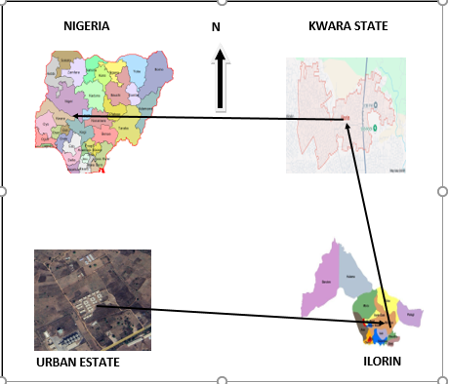
Urban estate opposite Government cemetery area along OKE-OYI ROAD OKE-OSE ILORIN, KWARA STATE, ILORIN East local government area. (683903E, 946221N). The project site is geographically defined by these parameters; Latitude 8° 33' 23.443"N and Longitude 4° 40' 15.384"E

Figure 1.1 shows the project study area

1.7 SPECIFICATIONS
The project specifications were referenced to the speciation for land information system using total station which was sources from the Higher National Diploma. The specification includes the following:
- Total station
- Minimum number of datum control required- three (3)
- Traverse should run between secondary or higher order control point.

CHAPTER TWO

2.0. LITERATURE REVIEW
A literature review on Land Information Systems (LIS) aims to provide a comprehensive overview of the evolution, technologies, applications, challenges, and future directions of these systems. The review will explore how Land Information Systems are used to manage land-related data, their integration with other spatial technologies, and their role in decision-making for land management.

2.1 Introduction to Land Information Systems (LIS)
Land Information Systems (LIS) are designed to collect, manage, and analyze land-related data, including information about land tenure, ownership, land use, and property boundaries (R OwusuAnsah - 2022 - essay.utwente.nl).
LIS are often seen as a tool for enhancing land management practices and providing stakeholders with accurate and up-to-date information for making informed decisions. They combine Geographic Information Systems (GIS) with land administration, cadastral data, and other spatial information (M BIRARO - 2022 - ris.utwente.nl).

2.2 Historical Development and Evolution
The concept of Land Information Systems emerged in the late 20th century as governments and organizations began to recognize the need for efficient land management tools. Traditionally, land records were kept in paper form, leading to issues of accessibility, accuracy, and duplication. Early LIS applications were developed to address these problems by digitizing land records and mapping the data onto digital platforms. Over time, advancements in GIS technology and database management systems have significantly enhanced the capabilities of LIS, enabling real-time data access, spatial analysis, and decision support.

2.3 Technological Foundations of LIS
LIS are built upon a combination of hardware, software, and data management systems. Key technological components include:
- Geographic Information Systems (GIS): GIS provides the spatial platform for mapping and analyzing geographic data, which is essential for visualizing land-related data.
- Database Management Systems (DBMS): These systems store and manage vast amounts of land-related information, including cadastral data, land tenure, and ownership records.
- Remote Sensing: Satellite and aerial imagery are often integrated into LIS to provide updated maps and support land use analysis.
- Global Positioning Systems (GPS): GPS is used for precise location-based data collection and mapping of land boundaries.
- Cloud Computing: Cloud platforms facilitate the storage, sharing, and processing of land data on a global scale.

2.4 Applications of Land Information Systems
LIS play a critical role in various sectors, including:
- Land Administration and Registration: LIS assist in recording and managing land ownership, transactions, and legal rights. This is crucial for ensuring transparency and preventing disputes.
- Urban Planning: By providing accurate land-use data, LIS supports zoning, land allocation, and infrastructure planning.
- Environmental Management: LIS helps monitor land cover changes, deforestation, and urban sprawl, aiding in sustainable development practices.
- Disaster Management and Risk Assessment: LIS are used to map vulnerable areas, assess risks, and assist in emergency response during natural disasters like floods or earthquakes.
- Agriculture: Farmers and agricultural planners use LIS for land suitability analysis, crop monitoring, and optimizing land use.
- Land Value Assessment and Property Taxation: Local governments utilize LIS for property tax assessments and to determine land values based on location and usage patterns.

2.5 Challenges in Implementing and Managing LIS
While LIS offer tremendous potential, several challenges hinder their widespread adoption and effectiveness:
- Data Quality and Accuracy: Ensuring the accuracy of land records and spatial data is a critical challenge, especially in regions with incomplete or outdated records.
- Interoperability: Integrating data from various sources (e.g., cadastral records, GIS layers, government databases) is often difficult due to differences in formats and standards.
- Legal and Institutional Barriers: In some countries, land tenure and property rights are poorly defined, complicating the implementation of LIS.
- Cost and Resource Constraints: Developing and maintaining a comprehensive LIS can be expensive, and many developing countries face budgetary constraints in building such systems.
- Data Security and Privacy: Protecting sensitive land data from unauthorized access and misuse remains a concern, particularly as more land information is digitized.

2.6 Future Directions of LIS
The future of LIS is marked by several key trends and advancements:
- Integration with Big Data and Artificial Intelligence (AI): By incorporating AI and machine learning algorithms, LIS could offer predictive analytics for land use planning and management.
- Block chain Technology for Land Registration: Block chain has the potential to provide a secure and immutable method for recording property transactions, ensuring transparency and reducing fraud.
- Crowd sourcing and Participatory Mapping: The use of mobile applications and crowd-sourced data can enhance the accuracy and timeliness of land information in remote areas.
- 3D Mapping and Modeling: As cities grow vertically, 3D GIS mapping is expected to play a larger role in representing land use and infrastructure in urban settings.
- Mobile Platforms: The increasing use of smartphones for collecting field data will facilitate the real-time updating of LIS and improve access to information in remote regions.

2.7 Governance and Policy Issues in Land Information Systems
The successful implementation of a Land Information System depends not only on technological capabilities but also on sound governance frameworks and policies. Land governance refers to the rules, processes, and institutions that regulate land use, access, and ownership. In the context of LIS, governance includes the legal and institutional structures that define how land data is collected, maintained, accessed, and shared.
- Legal Frameworks: A comprehensive legal framework is crucial for the establishment and functioning of LIS. This involves clear policies related to land tenure, property rights, dispute resolution, and land registration systems. In countries where land tenure is poorly defined or where land laws are unclear, the effectiveness of LIS can be significantly compromised.
- Institutional Coordination: Effective coordination between different stakeholders, including government agencies, local authorities, land surveyors, and private sector players, is essential for the successful implementation of LIS. In some regions, lack of institutional capacity or political will has slowed LIS adoption.
- Public Access to Information: The role of public participation and transparency in land information is becoming increasingly important. As more governments adopt open data policies, LIS systems are moving toward greater accessibility for the public, allowing citizens and communities to have a say in land governance.

2.8 Global Perspectives on Land Information Systems
Land Information Systems have been implemented in diverse contexts across the world. The effectiveness of LIS varies depending on the country’s level of technological development, institutional capacities, and legal frameworks.
- Developed Countries: In developed countries like the United States, Canada, and the European Union, LIS are often sophisticated and integrated into national cadastral systems. These systems tend to have high data quality, and public access to land information is often ensured through open data policies. For example, countries like the Netherlands and Finland have highly advanced LIS that integrate land registration, taxation, and spatial planning systems.
- Developing Countries: In developing countries, the situation is more complex. Many countries in Africa, Asia, and Latin America face challenges in terms of data availability, legal frameworks, and institutional coordination. In these regions, land tenure insecurity and inadequate land records are widespread, and LIS can provide solutions, especially when integrated with land reform efforts. However, challenges such as incomplete data, lack of funding, and political instability may hinder successful implementation.
- Post-Conflict and Transitional Societies: For post-conflict countries or nations in transition, LIS can play a critical role in land reform and reconciliation processes. Disputes over land ownership and use are often exacerbated in such contexts, and LIS can provide a transparent means of recording land claims and rights, supporting the peacebuilding process.

2.9 Social and Economic Impacts of Land Information Systems
LIS have broad socio-economic impacts, influencing not just land administration, but also economic development, poverty alleviation, and social equity.
- Economic Development: Effective land information management can facilitate investment in land and property, increase land market efficiency, and help businesses and investors make informed decisions. By reducing the time and costs associated with land transactions, LIS also promote a more efficient allocation of resources.
- Poverty Alleviation: In many rural and peri-urban areas, secure land tenure is a critical determinant of poverty. LIS systems can help improve land rights security, particularly for marginalized populations, by providing accurate and accessible land information. This is important for enhancing the economic prospects of communities, especially in regions where land is a primary asset.
- Social Equity and Inclusivity: LIS can help ensure social equity by enabling marginalized groups, such as women, indigenous people, and rural communities, to access land rights and manage resources. In some parts of the world, LIS have been used to promote gender equality in land rights, where women are often excluded from property ownership or land registration.

2.10 Sustainability and Environmental Management
Land Information Systems are vital tools in supporting sustainable land use and environmental management, particularly in the context of climate change and environmental degradation.
- Land Use Planning: LIS facilitate efficient land use planning by providing data on land use patterns, natural resources, and land suitability. This can guide decisions on zoning, urban expansion, and infrastructure development. For example, in cities experiencing rapid urbanization, LIS can assist in identifying areas for sustainable development and preventing urban sprawl.
- Environmental Monitoring: By integrating remote sensing data with land information, LIS can monitor environmental changes such as deforestation, soil erosion, and wetland degradation. This helps to track progress toward sustainability goals and provides early warning signs for environmental hazards.
- Climate Change Adaptation: In the context of climate change, LIS can assist governments and organizations in assessing vulnerability and planning adaptation strategies. This includes mapping areas at risk of flooding, droughts, or other climate-related events, and supporting land-use decisions that are more resilient to changing environmental conditions.

2.11 Data Standards and Quality Assurance
The successful integration and functioning of Land Information Systems depend heavily on the quality and consistency of the data used within the system. This has led to the development of various data standards and protocols to ensure interoperability and data quality.
- Data Standards: Establishing common standards for land data is essential to ensure that information from different sources (e.g., government agencies, private sector, or non-governmental organizations) can be integrated and used effectively. International standards, such as those developed by the International Organization for Standardization (ISO), are often adopted to guide LIS development.
- Data Quality: Data accuracy, precision, and currency are critical for the reliability of LIS. Ensuring high-quality data requires continuous updating, validation, and verification processes, particularly when dealing with dynamic land use changes or land ownership transactions. The use of technologies like GPS and remote sensing plays an important role in improving data accuracy.

2.12 User Needs and Stakeholder Engagement
The design and implementation of LIS should be tailored to the specific needs of the stakeholders who will be using them. Engaging stakeholders in the development process is crucial for ensuring that LIS meet the practical requirements of land administrators, policy makers, businesses, and the general public.
- Stakeholder Identification: Key stakeholders include government agencies responsible for land administration, urban planners, landowners, real estate developers, environmental organizations, and community groups.
- User-Centered Design: To ensure that LIS are user-friendly and meet stakeholder needs, their design should consider factors such as accessibility, ease of use, and language. This is particularly important in developing countries where literacy rates may be low, and complex technical interfaces can be a barrier to widespread use.
A Land Information System project is the work done by Dr. John Smith (hypothetical name), who conducted a study on the development and implementation of a LIS for land tenure management in (Kigali, Rwanda). The project aimed to improve land administration and secure property rights in urban areas by digitizing land records and implementing a GIS-based mapping system to monitor land use and ownership. The project was funded by international development agencies and local government support.
In regions where land conflicts are common, LIS systems are also being used to help resolve disputes. By digitizing land records and providing clear, accessible data, LIS can help resolve conflicting claims and improve land tenure security. In (Ghana), for example, the LIS project supports both land administration and conflict resolution by ensuring transparent land records are accessible to both authorities and landowners.
Contributions from Key Researchers and Projects:
Prof. Mohamed Ali Hamade (Hypothetical Name) conducted research on the integration of GIS and remote sensing technologies in (Egypt) to enhance land administration and improve property mapping in rural areas. His work helped design a hybrid system that integrated spatial data and legal land records, making land registration more efficient and reducing property disputes in regions with complex land tenure systems.
Dr. Sarah Ochieng (Hypothetical Name) worked on a project in (Kenya), focusing on the role of Land Information Systems in promoting sustainable land management practices and supporting the government’s vision for "smart cities." Dr. Ochieng's research emphasized the potential of using LIS to monitor urban sprawl, inform land policy decisions, and promote.
In Land Information System (LIS) implementation in Nigeria is (Dr. John A. O. Olayinka). He was instrumental in pioneering GIS and LIS efforts in Nigeria, particularly in the Lagos State Government.
- -Name: Dr. John A. O. Olayinka
- Location: Lagos State, Nigeria
- Area: Urban Planning and Development, Land Administration
Dr. Olayinka was part of the team that contributed to the development of a GIS-based Land Information System for Lagos State, beginning in the early 2000s. His work focused on integrating modern technologies to streamline land management, improve urban planning, and ensure efficient land resource management for the state.
The use of GIS and LIS in Lagos State has been a model for other regions in Nigeria, contributing significantly to land tenure security and effective land administration.
Land parcel is basic unit for access and control of land, land use and decisions. Current reliable and information necessary for many public programs, for example: Land planning, Infrastructural development and maintenance, Environmental protection and resource management, Emergency services, Basis for land market, development, and other economic activities and Social services programs. However, all organizations need information in order to survive. Most organizations have a large number of data sources but are hampered by their inability to combine them in a meaningful way. Developing a good land information system in Nigeria has been hindered by so many obstacles as stated by Asoegwu, R.N. (unpublished 2000):
• Most parcels of land have not been located by proper surveys that are tied to the national framework of controls;
• The records of land already surveyed are either not available or faulty;
• The records that are pertinent to the parcels of land properly surveyed are not located in a central place;
• Inadequate laws that could enforce the compulsory collection of appropriate land data;
• Ignorance on the part of experts to appreciate the need for land records;
• Reluctance of some governments to fund adequately long-term projects that do not yield immediate profits;
• Initial high cost/financial barrier. Conventional paper-based map information, any information associated with a map feature has to be recorded separately.
A simple example is topographical map showing the parcels of land, and properties in a particular location where the details relating to these land and properties would need to be referred to other files and records. There is a need for a tool to manage the huge volume of map data. There is a need also for a system that will remain flexible enough to handle the sophisticated modern needs of mapping information. The solution is Land Information System.

CHAPTERTHREE

3.0 METHODOLOGY
This stage involves the methods and procedure used in planning, data acquisition, data processing, and creation of database, creation of database management system and information presentation. These operations were logically structured and carried out in stages involving database design. It is normally considered to involve a spatially referenced and structured digital database and appropriate application software for geospatial analysis. This basically describes the techniques and principles adopted in carrying out the project.
Geographic information system methods were adopted in accomplishing the desired results.

3.1 DATABASEDESIGN
The design of any database involves three stages namely;
i Conceptual design
ii Logical design
iii Physical design

3.1.1 VIEW OF REALITY

In database design, there is need for reality which is referred to as the phenomenon that actually exists, including all aspects which may or may not be perceived by individuals. The view of reality however, is the mental abstraction of the reality for a particular application or group of applications.
For this application, the view of reality is made of the topography of the project. Since it is not possible to represent the real world, the only option is to conceptualize and model it in a specified manner to represent the real world. The area of interest to using this project

Includes;GreenReserve,Roads,Electricpoles,Trees,WaterFacilities,Buildings,Footballpitch,Streams.

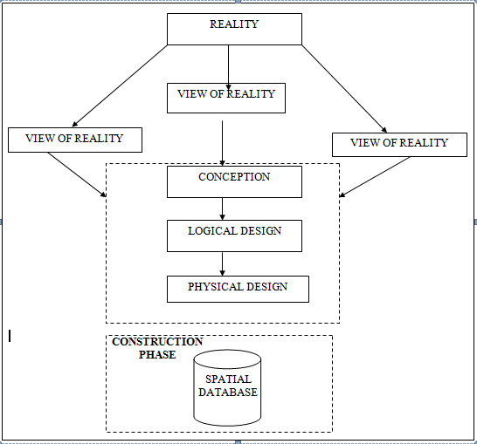
Fig.3.1Design and Construction Phases in Spatial Database

3.1.2 CONCEPTUALDESIGN
Vector data mode list the data type adopted for this project, which is represented, by points, lines and polygon. The identified entities are:-
      - Vegetation area (polygon)

      - Roads(line)

      - Trees(point)

      - Boundary line (polygon)

      - Buildings(polygon)
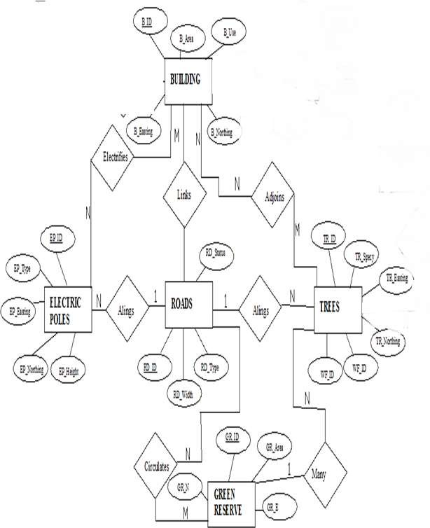

Fig.3.2.:E-RDiagram(Entityrelationship diagram)

3.1.3 LOGICALDESIGN

This is the design aspect of the database refers to the process of creating a conceptual framework or model that represents the structure and organization of spatial data within the system. It involves defining the data element, their relationship, and therules for data manipulation and analysis. In this phase, the entities, their attributes and their relationships are represented in a single uniform manner in form of relation in such a way that would be no information loss and at the same time no unnecessary duplication of data. In this study, the logical database design is employed to generate a geo-relation database structure. Each entity has unique identifier in bold type. An attribute type or combination of attribute types that serves to identify an entity typeis termed an identifier.
- Building (B_ID,B_Area, B_Name,B_Easting,B_Northing)

- Roads (R_ID,R_Width,R_Type,R-Condition,R_Easting,R_Northing)

- Vegetation (V_ID,GR_Area,)

- Tree (TR_ID,TR_spp,TR_Importance,TR_Easting,TR_Northing)

- Electric Pole (EP_No,EP_Type,EP_Height,EP_Easting,EP_Northing)

- Water Facility (WF_ID,WF_Depth,WF_Type,WF_Easting,WF_Northing)

- Football Pitch(FP_ID,FP_Area,FP_Status)

- Stream (S_ID,Length,Width)

3.1.4 PHYSICALDESIGN

Table3.1: Building and its attribute
ENTITY | DESCRIPTION
B_ID | Building Identification
B_name | Building Name
B_Area | Building Area
B_Easting | Building Easting
B_Northing | Building Nothings

Table3.2:Road an ditsattributes
ENTITY | DESCRIPTION
R_ID | RoadIdentifier
R_Length | RoadLength
R_Width | Road Width
R_Type | RoadType
R_Condition | RoadCondition

Table3.3:Treesand its attributes
ENTITY | DESCRIPTION
TR_ID | Tree Identifier
TR_Spp | Tree specy
TR_E | Tree_ Easting
TR_N | Tree Northing

Table3.4.:VegetationanditsAttributes
ENTITY | DESCRIPTION
V_ID | Vegetation Identifier
V_Area | Vegetation Area
V_E | Vegetation Easting
V_N | Vegetation Northing

3.2 RECONNAISSANCE
This is the preparatory stage before the execution of this project; it involves collection of available information about the project area.
The necessary step taken for the successful execution of the project involves two stages, which are:-
- Office Planning
- Field reconnaissance

3.2.1 OFFICEPLANNING
This involves the collection of information about the study area, testing the instrument to be used in execution of the project and itemizing the numbers of equipment needed, number of days to be use, how each activity is to be carried out, delegation of works to each team members based on supervisor’s guide/instructions.

Table.3.5CoordinatesofControls
Station | Northing(m) | Easting(m) | Height(m)
KPT 120X | 945235.040 | 682280.278 | 211.976
KWCS102 | 945738.095 | 683583.702 | 201.532
SC/KWEAS5072 | 945974.041 | 684070.314 | 200.087

Source: office of surveyor general kwara state

3.2.2 FIELDRECONNAISSANCE
The field reconnaissance is the first visitation to the project site to get intimated with the environment.
- Boundary points was selected

- The distribution of features was studied

- Controls to be used were located

- Method and type of instrument to be uses was determined

- Subsidiary point for Ground control Points were picked and define using nail and bottle cock
- A diagram of the study area was drawn.
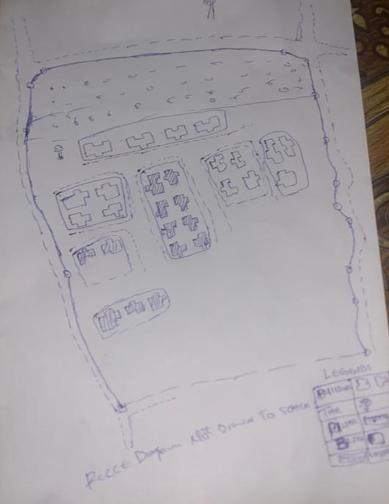

Fig.3.3: Reccediagramofthestudy area (notdrawn to scale)

3.3 EQUIPMENTUSED/SYSTEMSELECTIONANDSOFTWARE

3.3.1 HARDWAREUSED

- Total station

- 1reflectorwith a tracking rod.

- 1Tripod

- One(1)50m tape

- One(1)umbrella

- 1cutlass

- Handheld GPS

- Hammer

- Nails and bottle cover

- Field book and writing materials

- 1-NoofPersonalComputerHP655 and its accessories

- 1-NoofHP DeskJetK7100 A3 printer

- 1-NoofHPDeskJet 1110 A4printer

3.3.2 SOFTWARECOMPONENT

- Notepad.

- Microsoft Excel.

- AutoCAD2007

- ArcGIS10.2

- Microsoft Word.

3.4 INSTRUMENTTEST
To ensure data quality, the Total Station used for this project was tested for both vertical index and horizontal collimation errors .It was also to ascertain the efficiency and reliability of the instrument. The procedure used is described below.

3.4.1 HORIZONTALCOLLIMATIONTEST

This test was conducted to ensure that the line of sight was perpendicular to the trunnion axis. The Total Station was positioned over a specific point, and initial adjustments were made to ensure proper alignment, leveling, and focus (to eliminate parallax in the telescope). A vertical target was placed at a distance of 100 meters from the Total Station. To access the configuration menu of the Total Station, the menu key was pressed and held for approximately 2 seconds. From the main menu, the calibration sub-menu was selected, and within that, the horizontal collimation test option was chosen. The target was then observed and divided into two halves, with horizontal readings recorded for Face left and Face right. The readings are shown in Table 3.4.1 below.
Total Station
100m
REFLECTOR(TARGET)

STATIONA
Fairly Level Ground

STATIONB

Fig3.4; Horizontal Collimation and Vertical Index error test.

Table3.6: Horizontal Collimation Data
Station | Target | Face | Hz Reading | Difference | Error
A | B | L | 38˚42‟32”
 |  | R | 218˚42‟35” | 180˚00‟03” | 03”
Source field work

3.4.2 VERTICALINDEXERRORTEST
This test was conducted to verify the accuracy of the vertical reading when the line of sight is horizontal. The desired measurement for this test is exactly ninety degrees (90˚), any deviation from this value is referred to as the vertical index error.

The Total Station was positioned over a specific point, and necessary temporary adjustments were made to ensure proper alignment and functionality. A target was placed approximately100 meters away from the Total Station, and the instrument was aimed at the target .The target was bisected by aligning the instrument on the face left, and the corresponding reading was recorded. Similarly, the target was then bisected on the face right, and the respective reading was also recorded. The recorded readings are provided below:

Table3.7: Vertical Index Data
Instrument Station | Target Station | Face | Vertical | Sum | Error
A | B | L | 90˚00‟00”
 |  | R | 270˚00‟02” | 360˚00‟02” | 02”
Source field work
3.4.3 ANALYSISOFCOLLIMATIONANDVERTICALINDEXDATA
The reading obtain during calibration were reduced to obtain new collimation and vertical errors.
Horizontal collimation={(FR–FL)–180}/2={(00˚00‟03”}/2=1.5”

Verticalcollimation={(FL+FR)–360}=(90˚00‟00”+270˚00‟02”)-360}=02”Theresult shows that the instrument is still in good working condition.

3.5 CONTROLCHECK
Three control beacons (KPT 120X, KWCS102 and SC/KWEAS5072) were used.In order to ascertain the in-situ of the control beacons, a check was carried out on them by observing the angle between them and comparing the result obtained with the computed angles from the giving coordinates.
The total station instrument was set on the control beacon KWCS102. After performing all the necessary temporary adjustment, the reflector was placed on the control beacon KPT 120X which served as the back station. The horizontal angular reading was taken and recorded while the instrument was on face left. The reflector was then taken to the control beacon SC/KWEAS5072 which serves as the forward station, the horizontal angle reading was then taken and recorded on both face left and face right. The reflector was taken back to the back station, the horizontal angle was then recorded on face right.

Table3.8: Table showing the back computation of the control coordinates
From STN | Bearing | Dist(m) | ∆N | ∆E | Northing(m) | Easting(m) | ToSTN
 |  |  |  |  | 945235.040 | 682280.278 | KPT 120X
KPT 120X | 68°53'46'' | 1397.130 | 503.050 | 1303.424 | 945738.095 | 683583.702 | KWCS102
KWCS102 | 64°07'57'' | 540.797 | 235.946 | 486.612 | 945974.041 | 684070.314 | SC/KWEAS5072
Source: office of surveyor general kwara state

Table3.9: Table showing the distance observation result of the control check
FROM | OBSERVED  DISTANCE  (m) | COMPUTED  DISTANCE  (m) | TO
KPT 120X | 1397.029 | 1397.130 | KWCS102
KWCS102 | 540.694 | 540.797 | SC/KWEAS5072

Table3.10: Table showing the observation result of the control check
STN | SIGHT | FACE | OBSERVEDHZANGLE | REDUCED HZANGLE | MEAN
 | KPT 120X | L1 | 357° 08'47''
KWCS102 | KPT 120X | L2 | 288° 14'07'' | 68° 54'40''
 | SC/KWEAS5072 | R2 | 108° 52'13'' | 68° 54'46''
 | SC/KWEAS5072 | R1 | 177° 46'59'' |  | 68° 54' 43''

Difference in angle (observed -computed)=68°54'43''-68°54'40''

=00° 00'03''

Since the allowable accuracy (angular) of third order traverse of one station is 00° 00' 30'' and the result obtained from the control check (00°00'03'') is less than allow able error. Therefore, the controls were angularly intact.

3.6 MONUMENTATION

The boundary of the area carved out was demarcated with the precast concrete beacons, after clearing the required line of sights. The identified points of changes in directions were dug and beacons were buried on it, leaving about 15cm part of the beacon above the ground level. The beacons were buried at convenient distances as dictated by the nature of the boundary.
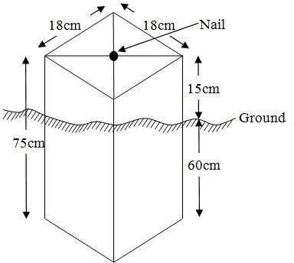

Fig.3.5: Pillar Description

DATAACQUISITION
It’s fundamental to digital mapping. Data acquisition here implies security coordinate data of map features in a computer compatible from there exist several topographical data collection techniques the choice of a particular technique depends on the source of data available hardware / software, envisage revel of accuracy, man power etc. apart from field and laboratory data acquisition data may be obtained from social survey, in this project, data acquisition it refers the ways and method through which the data used were obtained. There was divided in to two viz; geometric data and attribute data

PRIMARYDATASOURCE

Field observation was the primary source of data for this project. Ground based method was used in acquiring data with the use of Total Station Instrument, which involved the collection of X, Y, Z data through coordinated Ground control Points (GCP) established at conspicuous points within the study area

SECONDARYDATASOURCE

AnimageryoftheareawasacquiredthroughUpdatedGoogleearth;thiswasusedtoascertaintheextent ofcoverageof theproject area.

3.7.1 GEOMETRICDATAACQUISITION

The total station instrument was set carefully on control point; KWCS102 back sight taken to KPT 120X after necessary station adjustments has been carried out on it. The adjustments include; centering, leveling and focusing. The following procedures were then followed to determine the position of the next point SC/KWEAS5072 and the same procedure were repeated until all we come close to the site. The method used in acquiring data on site was radiation method where two or more points are coordinated from one point.

- Having setup the instrument and temporary adjustment carried out,the instrument was powered „on‟ and a job was created under job menu in the internal memory of the instrument. The job created was named GRP5B
- On the job, the coordinates of the three (3) control points were keyed in to the memory of the instrument and some codes were also saved. The codes include
„RD‟forroad,„SP‟forspotheight,„BD for buildings ,etc.

- The height of the instrument was measured and saved on the memory of the instrument as well as the reflector height.
- On coordinate menu, orientation was set by inputting the coordinates of the instrument station and back sight. The reflector at the back station was perfectlybisectedbeforetheorientationwasconfirmedbyclicking„yes‟.
Having done the orientation, the reflector at the next nail; was bisected and „obs‟(observe)optionwasclicked.ThethreedimensionalcoordinateofthepointN, H) were displayed on the display unit of the instrument and „rec‟ (record) was clicked to save the detain to the memory of the instrument. For subsequent to observation after this, “all‟ option was used instead of pressing „obs‟ and pressing
„ Record‟ later.

- It was ensured that the center of the prism of the reflector was bisected and that itwassetperfectlyonthetripodinordertominimizetheerroronheightdetermination.
- The instrument is been shifted to another nail after all details, spot height and boundary point visible from the instrument station have been picked, set over it and temporary adjustments carried out.
Nonetheless, the above operations were repeated until all the boundary points with heights were coordinated.
In this project all spot height are not in grid intervals but randomly acquired. Three edges (3) of building were picked. At the end of data acquisition process all details were acquired and properly recorded to be shown in their respective positions on the plan.

3.7.2 TTRIBUTESDATAACQUISITION

Attributedataisinformationaboutspatialfeatures.Theyprovidethecharacteristics,description and nomenclature about spatial objects. Thus the attributes data acquired includes names of buildings and their uses such as classrooms, roads, water facilities and prominent natural features likes river and trees found and vegetation were properly identified within and around the study area.

3.8 DATADOWNLOADINGANDPROCESSING

3.8.1 DATADOWNLOADINGANDEDITING
This is stage whereby all data acquired which were automatically stored in the Total Station were downloaded into personal computer. This was done with the aid of downloading cable connected to the computer and some associated complementing software installed on the System.

3.8.2 DATAPROCESSINGANDDATAEDITING
The geometric data downloaded were further processed in order to convert it to auseful format and to enhance its accuracy. The output coordinates, were edited and exportedin *.txt, *.xls and *.pdf format. Thereafter, they were imported into Arc GIS 10.3 for further operations and to carryout spatial analysis.

3.8.3 DATA PROCESSING IN AUTOCAD
The AutoCAD is tool that can be used for design and drawings, the software was built to general drawing standard hence the difficulty that comes with localizing this standard to various discipline.
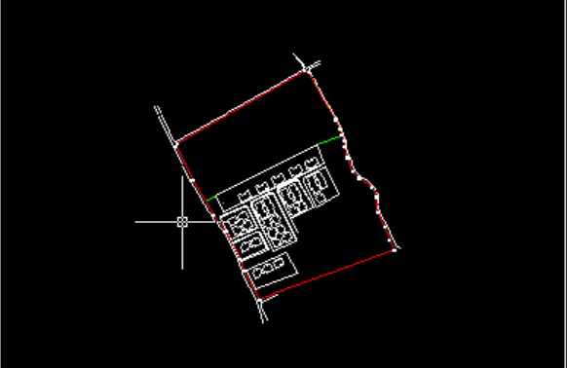
Plotting in AutoCAD can be achieved using coordinate geometry (COGO)by either running script file (.scr) or using the command line (i.e. inputting the values using keyboard). In this project plotting was achieved by using command line in AutoCAD environment. The layout plan was produced as shown in figure below.

Figure 3.6 shows the layout plan in AutoCAD

Exporting to Arc View, cad file can be exported to GIs software environmental for final cartographic production. This requires that the graphic data can be in a standard exchange format. A standard graphic data exchange format AutoCAD dxf (data exchange format).

3.8.4 DATAPROCESSINGUSINGARCGIS10.3 SOFTWARE
Is one of the contemporary software that is easy and facilitate geographic system operation design, map production, analysis and result computation possibility in any spatial project. Arc View was launched by double clicking on the desktop shortcut icon. See the attribute table in table 3.1
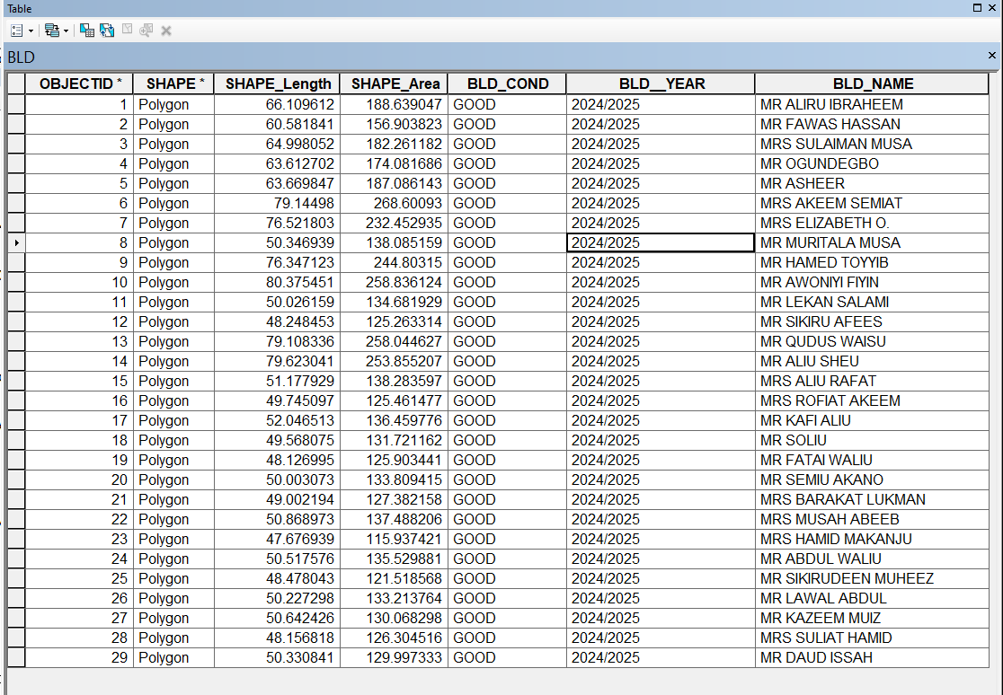

Figure 3.7 shows the attribute table

It demonstrates capability of carrying out a wide range of spatial analysis that may required in land administration. The land information system (LIS) was robust enoughto produce (spatial and non spatial). It was subjected to as show in figure 2 below;

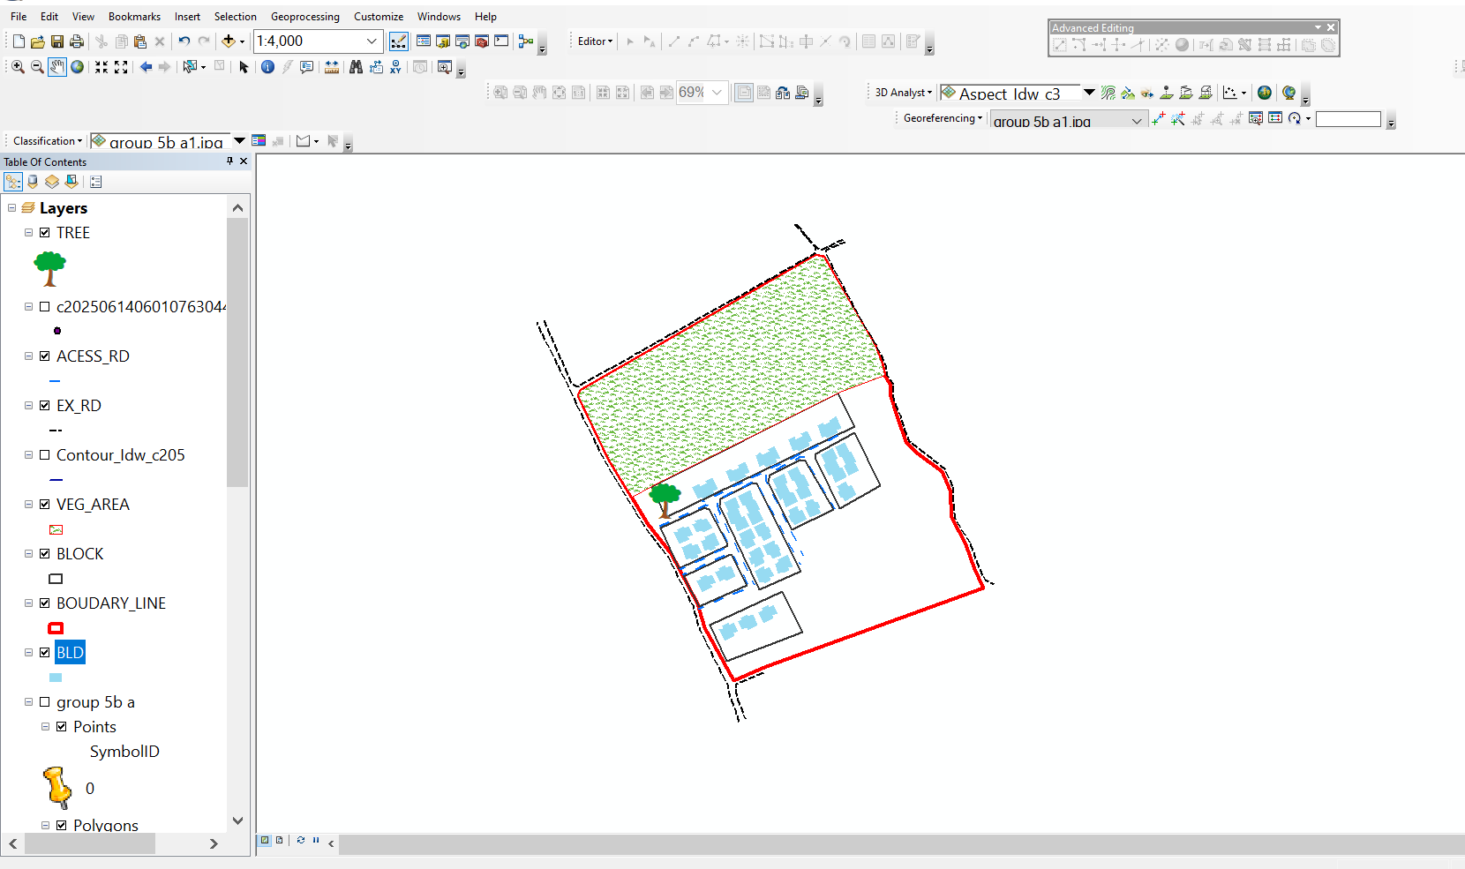

Figure 3.8 shows lay out view in Arc View windows

3.9 DATABASEIMPLEMENTATION

This is the database creation phase. Having completed the three stages of design phase (i.e .Reality, Conceptual and Logical design), the database was created using ArcGIS10.2 software. It involves the combination and storage of acquired graphic data and attributes detain creating the database for the purpose of spatial analysis and query.
Database is an organized integrated collection of data stored so as to be capable of use by revenant application with data being accessed by different logical part. After the Attribute table was populated via the keyboard, some attributes such as areas of settlements wereautomaticallydisplayedbyspecialcommandintheArcGIS10.3version.TheArcGISsoftwarewas used to link the graphic data and table for query generation.

3.9.1 DATABASEMANAGEMENTSYSTEMS

Database management is a collection of software for creating, storing, manipulating, updating, organizing and querying of information in a database (Kufoniyi, 1998). It is a soft ware package whose function is to manipulate a database on behalf of the user.
A good DBMS must provide the following functions:

- Storage and retrieval of data.
- Access to by several users at a time.
- A standardized interface between database and application programmed.
- Standardized access to data and separation of data storage and retrieval functions from the program using the data.
- Maintenance of data security and integrity.

3.9.2 DATABASEMAINTENANCE
Having created the database, proper maintenance practice was made to meet its stated objectives. The ability to include more data and remove irrelevant data was possible by way of maintenance. There is every need for the data to be updated regularly because of the physical changes that may occur on the landscape with time. Both security and integrity were also exercised to ensure maintenance and to meet its stated objectives.
Proper observance, updating and management of database ensure its currency and quality to stand a profound chance in Spatial Decision Support System (SDSS). The quality of any database depends on the currency and fitness for use as a decision support system (SDSS).The quality of database depends on its ability to generally fit and use as a decision system(DSS). The storage media should be from time to time justified if otherwise could necessitate data inaccessibility or physical deterioration of the storage media. Also care must be taken during populating any database system, as a database is only good as the data supplied. In archiving stable media should be used. Examples of these are
- Computer compatible tape reader

- Magnetic tape

- Optical disc and compact disc

3.9.3 BACK COMPUTATION Table 3.11: Back Computation
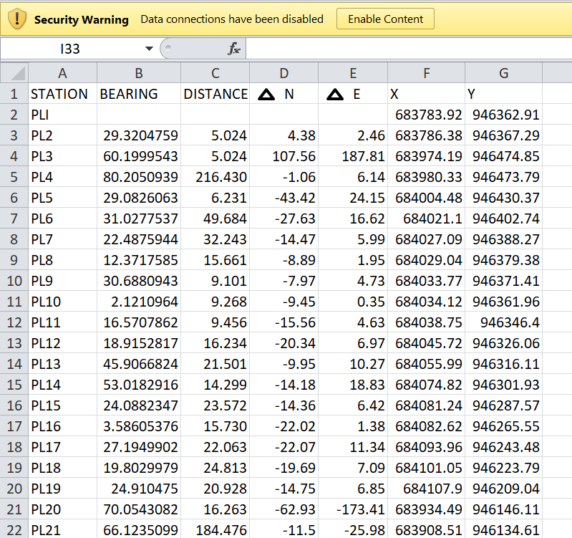

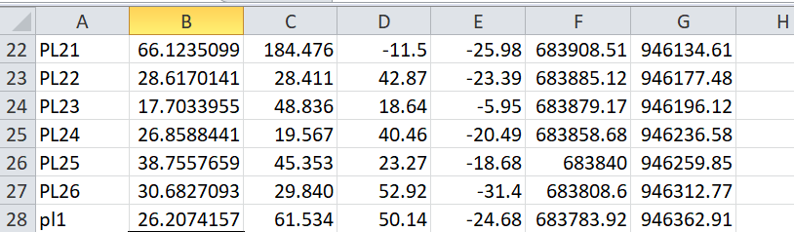

3.9.4 AREA COMPUTATION

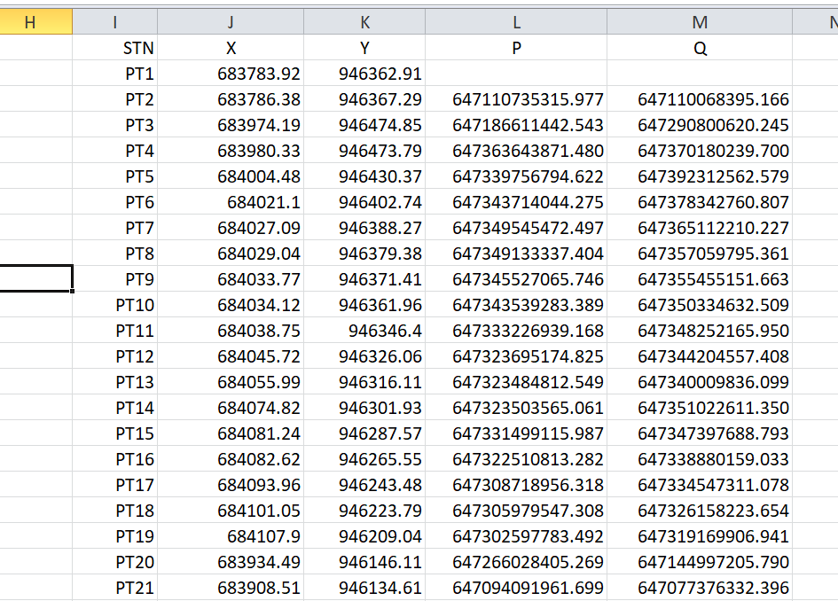
Table3.12:Area Computation

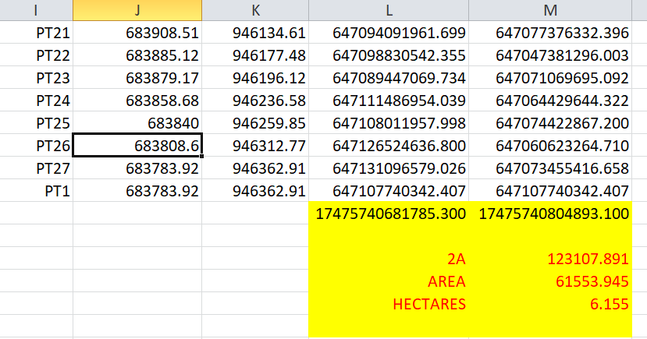

CHAPTERFOUR

4.0 SPATIALANALYSESANDPRESENTATION

GIS is distinct among other information system because of its spatial analytical capability;especiallyoverlayoperation,buffering,spatialsearch,topographicoperation,andneighborhoodandconnectivityoperations.GISusesthisspatialanalyticalcapabilitytoanswerfundamentalgenericquestionoflocation,condition,trend,routing,patternandmodeling by the manipulation and analysis of input data. The major analyses performed in this project were overlay operations, topographic operations and spatial search.

4.1 TESTINGOF DATABASE

This is the test carried out to determine whether there exists a relationship between datamodeledaboutentitiesinaspatialdatabaseaswellasputtingintotestitsretrievalcapabilities. This was done by designing a sample query with certain conditions attached and the query will began to see if desired result is achieved.
Analysis of Result
Data captured were full to ensure standardization of task. Coordinated point were used in order to produce information required (LIS) and lastly to decision making and produce the output in digital form, while the attribute presented in tabular form. In most GIS operation package including arc view these include measurement techniques, query analysis and geometric operation in this project include questions such as:-
- Residential land use
- Vegetation area
- Developed area
- Slope aspect
- Building that does not have C of O
- Building that have C of O
- Building that have R of O
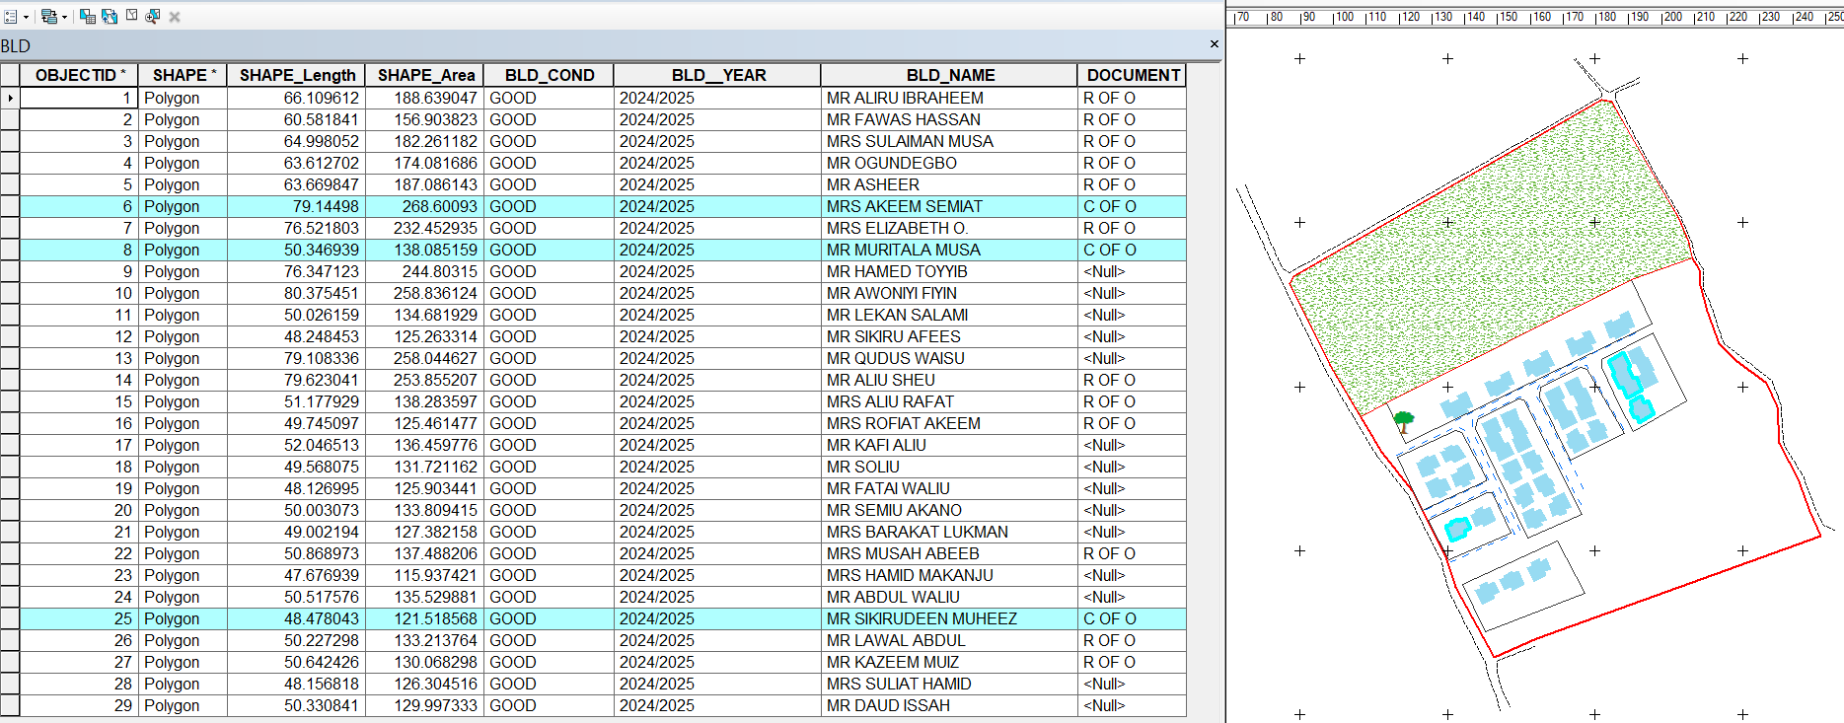
The above listed queries are shown in blue

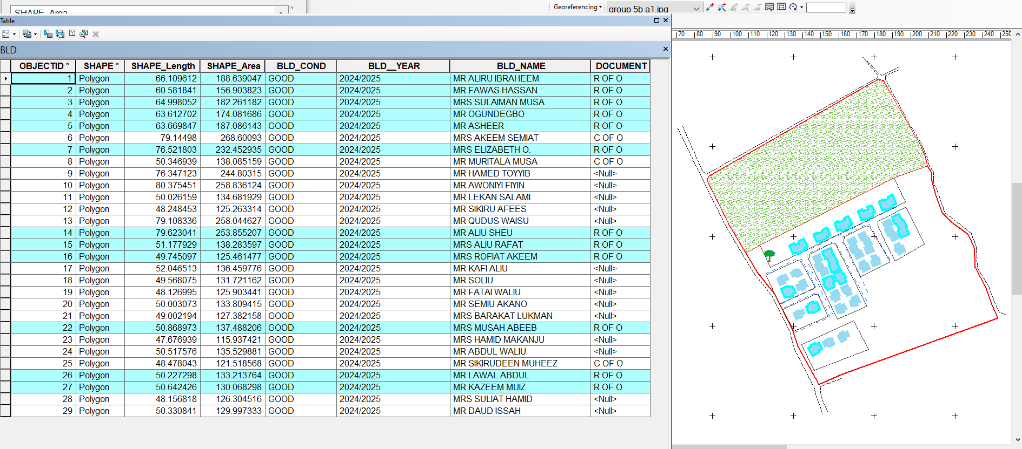
Fig4.1.:shows the building that have C of O

Fig4.2:shows the building that have R of O
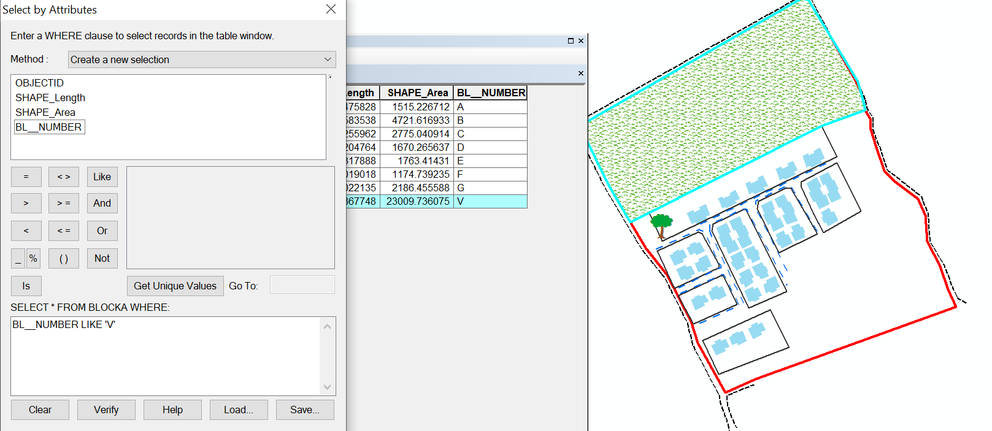

Fig 4.3: show the area use for vegetation

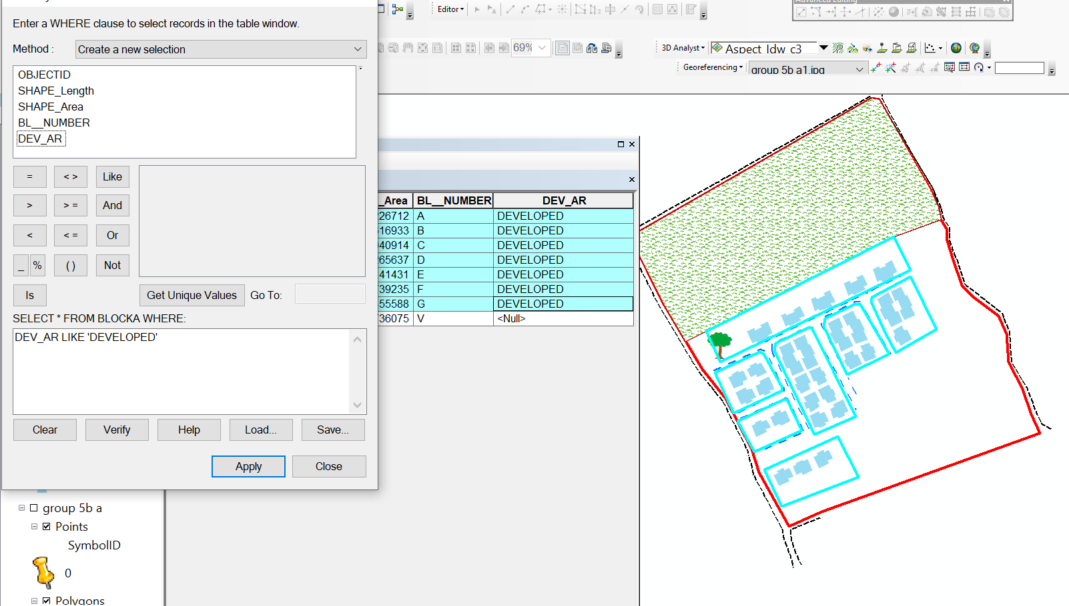

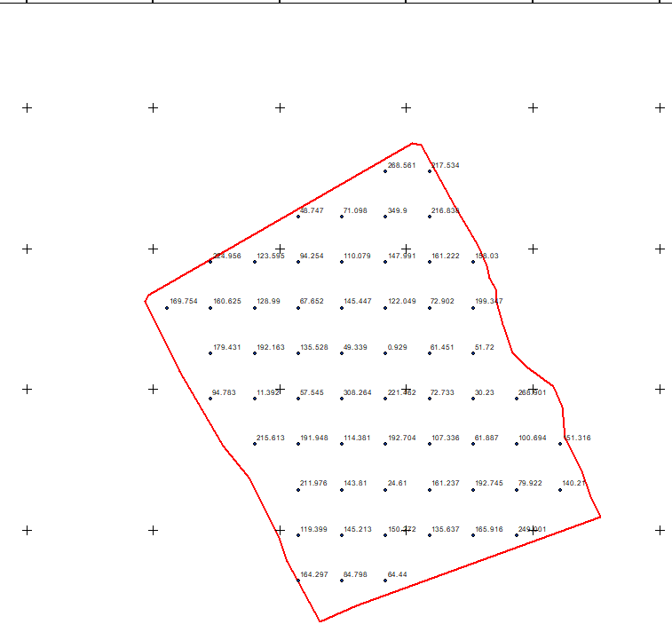
Fig 4.4: show the developed area

Figure 4.5 shows the spot height
This is the compass direction of that a slope faces and it plays a significant role in environmental and land management decision

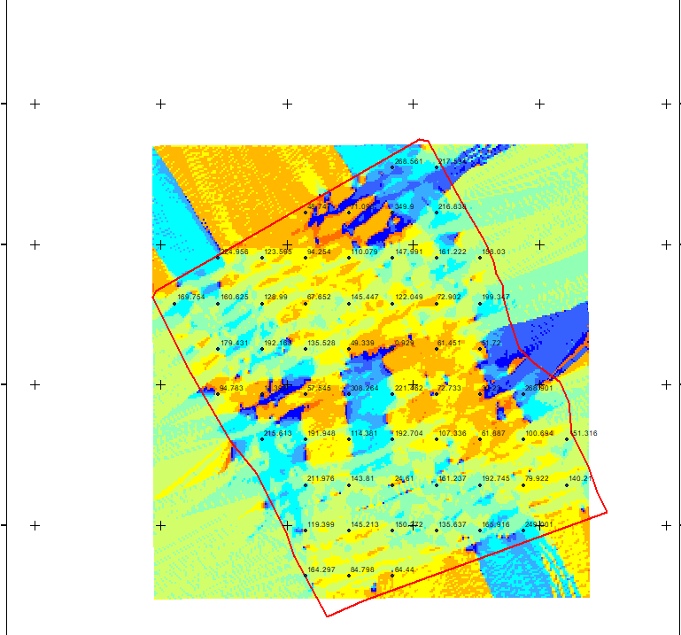

Figure 4.6 shows the slope aspect

The total number of building in the lay out are29 all of them are residential and vegetation area is 1, the table 4.1 below shows the land use percentage

Table 4.1 shows the land use percentage
Residential | 0.475266 percent
Vegetationarea | 2.292255 percent

Figure 4.7 shows the pie chart of land use

CHAPTER FIVE

5.0 COST ESTIMATION, SUMMARY, CONCLUSION AND RECOMMENDATION

5.1 COST ESTIMATION
RECCONNAISSANCE
S/N | PERSONNEL | QTY | DAILY RATE | NO OF DAYS | REMARK
1 | Group leader | 1 | 5000 | 1 | 5000
2 | Ass group leader | 1 | 2500 | 1 | 2500
3 | Basic equipment | 1 | 25000 | 1 | 25000
4 | Transportation | 1 | 3000 | 1 | 3000
Subtotal = #35,500
Monumentation
S/N | PERSONNEL | QTY | DAILY RATE | NO OF DAYS | REMARK
1 | Group leader | 1 | 5000 | 1 | 5000
2 | Ass group leader | 1 | 2500 | 1 | 2500
3 | Skilled labor | 3 | 1500 | 1 | 4500
4 | Basic equipment | 1 | 25000 | 1 | 25000
5 | Transportation | 1 | 7500 | 1 | 3000
Subtotal = #40,000
Beaconing
S/N | PERSONNEL | QTY | DAILY RATE | NO OF DAYS | REMARK
1 | Group leader | 1 | 5000 | 1 | 5000
2 | Ass group leader | 1 | 2500 | 1 | 2500
3 | Basic equipment | 1 | 5000 | 1 | 5000
4 | Transportation | 1 | 3000 | 1 | 3000
Subtotal = #5,500
Beacon
S/N | PERSONNEL | QTY | DAILY RATE | NO OF DAYS | REMARK
1 | Group leader | 1 | 5000 | 1 | 5000
2 | Ass group leader | 1 | 2500 | 1 | 2500
3 | Beacon | 10 | 1000 | 1 | 10,000
4 | Transportation | 1 | 3000 | 1 | 3000
Subtotal = #19,500
Traversing
S/N | PERSONNEL | QTY | DAILY RATE | NO OF DAYS | REMARK
1 | supervisor | 1 | 6000 | 1 | 6000
2 | Group leader | 1 | 5000 | 1 | 5000
3 | Ass group leader | 1 | 2500 | 1 | 2500
4 | Skilled labour | 6 | 1500 | 1 | 10,000
5 | Basic equipment | 1 | 25000 | 1 | 5000
6 | Transportation | 1 | 10,500 | 1 | 10,500
Subtotal = #43,500

Spot height
S/N | PERSONNEL | QTY | DAILY RATE | NO OF DAYS | REMARK
1 | Supervisor | 1 | 6000 | 2 | 12,000
2 | Group leader | 1 | 5000 | 2 | 10,000
3 | Ass group leader | 1 | 2500 | 2 | 5000
4 | Skilled labor | 6 | 1500 | 2 | 20,000
5 | Basic equipment | 1 | 25000 | 1 | 5000
6 | Transportation | 1 | 10,500 | 2 | 21,000
Subtotal = #73,000
Data processing
S/N | PERSONNEL | QTY | DAILY RATE | NO OF DAYS | REMARK
1 | Group leader | 1 | 5000 | 1 | 5000
2 | Ass group leader | 1 | 2500 | 1 | 2500
3 | Basic equipment | 1 | 10,000 | 1 | 10,000
4 | Generator and fuel | 1 | 10,000 | 1 | 10,000
Subtotal = #27,500
Technical report
S/N | PERSONNEL | QTY | DAILY RATE | NO OF DAYS | REMARK
1 | Group leader | 1 | 5000 | 1 | 5000
2 | Ass group leader | 1 | 2500 | 1 | 2500
3 | Basic equipment | 1 | 10,000 | 1 | 10,000
4 | Generator and fuel | 1 | 10,000 | 1 | 10,000
Subtotal = #27,500
Sum total = 271,500.00

Contingency allowance = 271,500.00 X 5 = 13,575
100

VAT = 271,500.00 X 7.5 = 20,362.5
100

ACCOMODATION = 271,500.00 X 1.5 = 4,072.5
100

MOB/DEMB = 271,500.00 X 10 = 27,150
100

GLEARANCE TAX = 65, 159.5

5.2 SUMMARY
The project is based on land information system (LIS) of Urban Estate at Oke-Ose Ilorin Opposite Government Cemetry Along Sango Oke-Oyi Road, Ilorin East local Government Area, Kwara State. The reconnaissance was done in order to have thorough sketch of an area, the data were acquired using TOTAL STATION survey method in a static mode. The pillar descriptions and detailing were done TOTAL STATION; the data processing involves transformation of reduction book and adjustment of acquired data using forward computation.
The survey was done in accordance to the specifications stipulated and a total number of thirty-two (5) pillars were buried all together and the final coordinate (X, Y, Z) value of all buried pillars were obtained. The plan was produced using AutoCAD and GIS software at a suitable scale and data were presented in both hardcopy and softcopy finally, a comprehensive report was written covering the whole procedures employed in the execution of the project using Microsoft word.

5.3 PROBLEM ENCOUNTERED
It is occasional for a successful project to start and end without facing any problem but every problem encountered was taking to be a challenge. The pole was given a problem during the project is not good at all and also, Communication between rover and reference was another serious problem encountered mobile phone was employed to resolve the problem.

5.4 CONCLUSION
Having completed the project successfully, the aims and land information system were achieved to serve as a base for further survey operations. The whole project was done in accordance with specification stipulated and direct supervision according to departmental instructions.

5.5 RECOMMENDATION
At this juncture, I hereby recommend that:
- More digital equipment should be bought by the school which could be used for the precise work so as to build up students to meet up with advanced technology and to make work easier for them.
- The school authority should try and find solution to the issue of instrument and the project should be issued on time to enable the student to meet up with the date specified.
- Finally, the land information should be extending to other part of the town by student for public and private uses and records should be kept in order to avoid land dispute of in our area.

REFERENCES
Caltrans and Smith, (2004): Holstead and Redmond Limited, Ontario Land Surveyors.
www.hrlimited.com.Date Accessed: 20th November, 2016
FIG commission 5th Publication. Pp 6 – 16. Zimmer, R. and Kirkpatrick, S. (2009): The American Surveyor, Elementary Surveying 8(1), Pp.28-38
Gresham and Associates Inc. Surveying and Mapping (2008): Amarillo Texas
www.gresurv.com Date Accessed: 20thNovember, 2016
Punmia, B.C and Arun Kumar Jain (2009): Plane and Geodetic surveying, New Delhi 6th Edition P.170 Http://www.Answer.com/what is Control surveying. Date Accessed: 22nd November, 2016
Robert, F. (2002): Engineering Surveying Showcase 2002, Issue One, GITC Publication, Pp.34-35.
Robert Sarib, Volker Schwieger, Mikael Lilje, (2009): International Federation of Surveyor, Article of the Month – December 2009 (Journal)
Robillard W.G, Wilson D.A & Brown C. (2006): Brown’s Boundary Control and LegalPrinciples (5thedition.). Hoboken Newjersey, U.S. John Willey and Sons, Inc. Pp. 18
SURCON (2003): Specification for Geodetic Survey in Nigeria Pp 38 – 46 and Pp 52
The American surveyor (2011): American surveyor publication archives retrieved September 28, 2013, http://www.americsurv.com/content/category/18/335/153
Date Accessed: 21st November, 2016
The American Congress on Surveying and Mapping ACSM in (2002): Definition of Surveying and Associated terms (ACSM) Pp. 314, ISBN 0-9765991-0-4 http://www.surveyingmagazineDate Accessed: 22nd November, 2016
Uren J. and Price W.F.(2001): Surveying and Mapping (3rd Edition),Macmillan Press Ltd, London, Pp.6-7.
Volker schiweiger and John Germany: Cost – Effective GNSS Positioning Technique.

APPENDIX
STN | X | Y | H
PT1 | 683783.92 | 946362.91 | 164.297
PT2 | 683786.38 | 946367.29 | 84.798
PT3 | 683974.19 | 946474.85 | 64.44
PT4 | 683980.33 | 946473.79 | 119.399
PT5 | 684004.48 | 946430.37 | 145.213
PT6 | 684021.1 | 946402.74 | 150.272
PT7 | 684027.09 | 946388.27 | 135.637
PT8 | 684029.04 | 946379.38 | 165.916
PT9 | 684033.77 | 946371.41 | 249.001
PT10 | 684034.12 | 946361.96 | 211.976
PT11 | 684038.75 | 946346.4 | 143.81
PT12 | 684045.72 | 946326.06 | 24.61
PT13 | 684055.99 | 946316.11 | 161.237
PT14 | 684074.82 | 946301.93 | 192.745
PT15 | 684081.24 | 946287.57 | 79.922
PT16 | 684082.62 | 946265.55 | 140.21
PT17 | 684093.96 | 946243.48 | 215.613
PT18 | 684101.05 | 946223.79 | 191.948
PT19 | 684107.9 | 946209.04 | 114.381
PT20 | 683934.49 | 946146.11 | 192.704
PT21 | 683908.51 | 946134.61 | 107.336
PT22 | 683885.12 | 946177.48 | 61.887
PT23 | 683879.17 | 946196.12 | 100.694
PT24 | 683858.68 | 946236.58 | 151.316
PT25 | 683840 | 946259.85 | 94.783
PT26 | 683808.6 | 946312.77 | 11.392
PT27 | 683783.92 | 946362.91 | 57.545
PT28 | 683893.31 | 946163.83 | 164.297
PT29 | 683924.4 | 946163.83 | 84.798
PT30 | 683955.5 | 946163.83 | 64.44
PT31 | 683893.31 | 946196.18 | 119.399
PT32 | 683924.4 | 946196.18 | 145.213
PT33 | 683955.5 | 946196.18 | 150.272
PT34 | 683986.59 | 946196.18 | 135.637
PT35 | 684017.68 | 946196.18 | 165.916
PT36 | 684048.77 | 946196.18 | 249.001
PT37 | 683893.31 | 946228.52 | 211.976
PT38 | 683924.4 | 946228.52 | 143.81
PT39 | 683955.5 | 946228.52 | 24.61
PT40 | 683986.59 | 946228.52 | 161.237
PT41 | 684017.68 | 946228.52 | 192.745
PT42 | 684048.77 | 946228.52 | 79.922
PT43 | 684079.86 | 946228.52 | 140.21
PT44 | 683862.22 | 946260.87 | 215.613
PT45 | 683893.31 | 946260.87 | 191.948
PT46 | 683924.4 | 946260.87 | 114.381
PT47 | 683955.5 | 946260.87 | 192.704
PT48 | 683986.59 | 946260.87 | 107.336
PT49 | 684017.68 | 946260.87 | 61.887
PT50 | 684048.77 | 946260.87 | 100.694
PT51 | 684079.86 | 946260.87 | 151.316
PT52 | 683831.13 | 946293.21 | 94.783
PT53 | 683862.22 | 946293.21 | 11.392
PT54 | 683893.31 | 946293.21 | 57.545
PT55 | 683924.4 | 946293.21 | 308.264
PT56 | 683955.5 | 946293.21 | 221.462
PT57 | 683986.59 | 946293.21 | 72.733
PT58 | 684017.68 | 946293.21 | 30.23
PT59 | 684048.77 | 946293.21 | 268.901
PT60 | 683831.13 | 946325.56 | 179.431
PT61 | 683862.22 | 946325.56 | 192.163
PT62 | 683893.31 | 946325.56 | 135.528
PT63 | 683924.4 | 946325.56 | 49.339
PT64 | 683955.5 | 946325.56 | 0.929
PT65 | 683986.59 | 946325.56 | 61.451
PT66 | 684017.68 | 946325.56 | 51.72
PT67 | 683800.03 | 946357.91 | 169.754
PT68 | 683831.13 | 946357.91 | 160.625
PT69 | 683862.22 | 946357.91 | 128.99
PT70 | 683893.31 | 946357.91 | 67.652
PT71 | 683924.4 | 946357.91 | 145.447
PT72 | 683955.5 | 946357.91 | 122.049
PT73 | 683986.59 | 946357.91 | 72.902
PT74 | 684017.68 | 946357.91 | 199.347
PT75 | 683831.13 | 946390.25 | 224.956
PT76 | 683862.22 | 946390.25 | 123.595
PT77 | 683893.31 | 946390.25 | 94.254
PT78 | 683924.4 | 946390.25 | 110.079
PT79 | 683955.5 | 946390.25 | 147.991
PT80 | 683986.59 | 946390.25 | 161.222
PT81 | 684017.68 | 946390.25 | 158.03
PT82 | 683893.31 | 946422.6 | 48.747
PT83 | 683924.4 | 946422.6 | 71.098
PT84 | 683955.5 | 946422.6 | 349.9
PT85 | 683986.59 | 946422.6 | 216.838
PT86 | 683955.5 | 946454.95 | 268.561
PT87 | 683986.59 | 946454.95 | 217.534

