INVESTIGATION INTO TRENDS AND CHARATERISTICS OF ROAD ACCIDENTS IN ILORIN METROPOLITAN

BY
ALAO COVENANT OLAWALE
HND/23/CEC/FT/0179

SUBMITTED TO:
DEPARTMENT OF CIVIL ENGINEERING,
INSTITUTE OF TECHNOLOGY
KWARA STATE POLYTECHNIC, ILORIN

IN PARTIAL FULFILMENT OF THE REQUIREMENTS FOR THE AWARD OF HIGHER NATIONAL DIPLOMA (HND) IN CIVIL ENGINEERING

JULY, 2025.

CERTIFICATION
This is to certify that this research study was conducted by Alao Covenant Olawale (HND/23/CEC/FT/0179) and has been read and approved as meeting the requirements for the award of Higher National Diploma (HND) in Civil Engineering of the department of Civil Engineering, institute of Technology, Kwara State Polytechnic, Ilorin.

…………………………. ……………………
ENGR. A. B. NAALLAH DATE
Project Supervisor

……………………………. ……………………..
ENGR. A. B. NAALLAH DATE
Head of department

……………………………. ……………………..
ENGR. DR. MUJEDU K. A DATE
External Supervisor

DEDICATION
This project is dedicated to Almighty God, for his mercy, favor, blessing and protection throughout the completion of my program and this project. I am also dedicating this project specially to my Parent

ACKNOWLEDGMENT
Firstly, I give all thanks, honor, adoration and praise to Almighty God who has made it possible for me to be alive to this very moment and for seeing me through the years of my education.
Secondly, my utmost thanks goes to my project supervisor, Engr. A. B. Naallah the successful completion of my project has been to his close supervision and assistance, Special thanks to the Head of Department, Engr.A. B Naallah for his love and support and to all the staff of the Civil Engineering Department.
My sincere gratitude goes to my Parent Mr and Mrs Alao for their moral, financial support and encouragement towards the success in the completion of my course.
Also, I can’t fail to appreciate my siblings, for their contribution and staying put through finance and moral advice. I can’t appreciate you less
Lastly, my special appreciation goes to my friends, colleagues and loved ones for their love, immensurable contribution and the support they gave me in times of facing academic challenges.
Thank you all

ABSTRACT
The focus of this research is to investigate the trends and characteristics of road accidents in Ilorin metropolitan. The study employed a mixed-method approach and data was collected using the secondary data by obtaining data from Federal Road Safety Corps and Nigeria police Force, Kwara State Ministry of Transportation and hospital facilities. The data collected comprises of number of accidents within 2020-2024 and data included were of number of victim which recorded 1455 in total. The study hereby concludes after the findings that a rising trend in the number and severity of road accidents, particularly from 2020 to 2024 and however, predominance of commercial vehicles and motorcycles in accident involvement, also there is a high level of relationship between road accidents and factors such as road design, traffic volume, and driver behavior as many accidents are caused by this factors

TABLE OF CONTENT
Title page
Certification
Dedication
Acknowledgement
Abstract
Table of content
CHAPTER ONE
- Introduction
  - Problem statement
  - Aim and objectives
  - Justification
  - Scope of the study
  - Research methodology
CHAPTER TWO
- LITRATURE REVIEW
  - Classification of road
  - Type of pavement
  - Cause of road accident
CHAPTER THREE
- METHODOLOGY
  - Study area
  - Data collection
  - Data analysis
CHAPTER FOUR
- RESULTS AND DISCUSSION
  - Introduction
  - Temporal distribution of road accidents
  - Characteristics of road accidents
  - The Relationship Between Road Accidents and Factors Such as Road Design, Traffic Volume, And Driver Behavior
CHAPTER FIVE
- CONCLUSION AND RECOMMENDATIONS
  - Conclusion
  - Recommendations
Reference

CHAPTER ONE
1.0 INTRODUCTION
Road transportation is a requirement seems it give a lot of benefit to a country and individual especially in access improving for workplace, economic resources, educational facilities and health center. Behind the importance of transportation to the community, it also gives negative effect which is road accident like fatal accidents. An injury caused by road accident is one of main killer in the world after a chronic disease such as heart disease, stroke, and lung infection and hard in breathing (Kamarudin et. al, 2018).

Road accidents have become a major public health concern globally, resulting in significant economic, social, and environmental costs (World Health Organization, 2018). In Nigeria, road accidents are a leading cause of death and injury, with the Federal Road Safety Corps (FRSC) reporting over 10,000 road crashes resulting in over 5,000 fatalities in 2020 alone (FRSC, 2020). Ilorin metropolis, the capital city of Kwara State, has experienced a significant increase in road accidents in recent years (Adeleye et al., 2019).

The World Health Organization (2018) estimates that road accidents cost Nigeria over $1 billion annually. Furthermore, road accidents have significant social and emotional impacts on victims, their families, and the community at large (Oluwadiya et al., 2017). The economic costs of road accidents in Nigeria are also significant, with estimates suggesting that the country loses over 2% of its GDP annually due to road accidents (African Development Bank, 2019).
Despite the significant impacts of road accidents, there is a lack of comprehensive studies on the trend and characteristics of road accidents in Ilorin metropolis. Previous studies have focused on national or regional trends, with limited attention paid to local-level analysis (Oluwadiya et al., 2017; Adeleye et al., 2019). This study aims to address this knowledge gap by investigating the trend and characteristics of road accidents in Ilorin metropolis.

Road accidents, also known as traffic crashes or collisions, occur when a vehicle collides with another vehicle, pedestrian, animal, road debris, or other stationary objects, resulting in damage, injury, or death (World Health Organization, 2018). These accidents can be classified into four main types: single-vehicle accidents, multi-vehicle accidents, pedestrian accidents, and cyclist accidents. Understanding the types of road accidents is crucial for developing effective prevention strategies.

The causes of road accidents are diverse and interconnected. Human factors, such as speeding, reckless driving, and fatigue, are major contributors (National Highway Traffic Safety Administration, 2020). Vehicle factors, including mechanical failure and poor maintenance, also play a significant role. Additionally, environmental factors like poor road conditions and adverse weather conditions can increase the risk of accidents (Federal Road Safety Corps, 2020).

The rapid population growth and increasing economic activities have resulted in the tremendous growth of motor vehicles. This is one of the primary factors responsible for road accidents in many metropolitan cities. The increasing number of road accidents is imposing considerable social and economic burdens on the victims, and various direct and indirect costs. Road accidents are essentially caused by improper interactions between vehicles, between vehicles and other road users and/or roadway features. The situation that leads to improper interactions could be the result of the complex interplay of a number of factors such as pavement characteristics, geometric features, traffic characteristics, road users’ behaviour, vehicle design, drivers’ characteristics and environmental aspects. Thus, the whole system of accident occurrence is a complex phenomenon. (Chakraborty and Sudip, 2015).

As in other developing counties, road traffic accidents in Nigeria are one of the most serious problems in need of pragmatic solutions. Yet this problem has been difficult to address probably because of the country’s level of development. Nigeria is said to have the highest road traffic accident rates in Africa According to one study, the proportion of deaths from road traffic accidents in Nigeria increased from 38.2 percent to 60.2 percent in ten years from 1991-2001 (Obinna, 2007).

The road accident generally can be defined as undesirable incident to occur caused of lost driving control until happens of collision with an object, or causing vehicle crash either causing property damage, injury to driver, passenger and the other road users or otherwise. where is the road accident is an incident that happen on the public road or private that caused either from negligence or lack of anybody or caused by environmental factors causing any collision that involve at least a moving vehicle where is damage or injury including death that faced by anybody, proper ty, vehicle, structure or animal that involve the incident and complained to the police (Kamarudin et. al, 2018).

The road accident usually caused by combination of five factors which is behaviour of driver, infrastructure of road quality, traffic volume and the environment [18-20]. The effort in resolve the problem of road accident more focused to aspect in road physical and vehicle shape. The goal is to provide better road and vehicle as a step to reduce the road accident rates. Despite that, the behaviour and prestige of driver also should be given attention because it is the aspect which is important in handling the problem of road accident (Kamarudin et. al, 2018).

1.1 PROBLEM STATEMENT
The increasing rate of road accidents in Ilorin metropolis has become a major concern, resulting in loss of lives, injuries, and economic losses. Despite efforts to reduce road accidents, the trend persists, necessitating a comprehensive study to investigate the trend and characteristics of road accidents in Ilorin metropolis.
1.2 AIM AND OBJECTIVES
Aim
The aim of the study is to investigate into the trend and characteristics of road accident in Ilorin metropolitan.
Objectives:
- To examine the trend of road accidents in Ilorin metropolis over the past five years.
- To identify the characteristics of road accidents in Ilorin metropolis.
- To investigate the relationship between road accidents and factors such as road design, traffic volume, and driver behavior.

1.3 JUSTIFICATION
This study is justified due to the alarming rate of road accidents in Ilorin metropolis, which has resulted in significant human, economic, and social costs. Understanding the trend and characteristics of road accidents in Ilorin metropolis is crucial for developing effective strategies to reduce the incidence and severity of road accidents. Furthermore, this study provides valuable insights for policymakers, transportation planners, and other stakeholders in Ilorin metropolis, ultimately contributing to the improvement of road safety and reduction of road accidents in the city.

1.4 SCOPE OF THE STUDY
The scope of this study focused on investigating the trend and characteristics of road accidents in Ilorin metropolis, Kwara State, Nigeria. Specifically, the study examines the trend of road accidents in Ilorin metropolis over the past five years, identify the characteristics of road accidents in Ilorin metropolis, including the types of vehicles involved, the causes of accidents, and the demographics of victims, investigate the relationship between road accidents and factors such as road design, traffic volume, and driver behavior.
1.5 RESEARCH METHODOLOGY
This study employs a descriptive and analytical research design, using a combination of quantitative and qualitative methods. The research design enables the collection of both numerical and non-numerical data, which be used to describe and analyze the trend and characteristics of road accidents in Ilorin metropolitan, the data collection process was involve both secondary and primary data sources.

CHAPTER TWO
2.0 LITRATURE REVIEW
According to Olawale & Adebayo (2018), work on road traffic accidents in Nigeria and analysis of the causes and consequences. The study found that road traffic accidents in Nigeria result in significant economic, social, and environmental costs, and that there is a need for effective strategies to prevent and mitigate the impacts of road accidents.
Kamarudin et. al, (2018), investigate on road traffic accident trends, selected underlying, determinants and status intervention. This study was conducted to study the rate of fatal accidents on roads in the state of Selangor and Perlis based on fatal accident data for a period of five years from 2013 to 2017. The data were analyzed using quantitative methods which took into account the research conducted by researchers last. Based on analyzed data, the state of Se langor recorded the highest accident rate while Perlis state recorded the lowest accident rate. Among other things being studied are fac tors affecting the rate of road accidents in both states.
Chakraborty & Sudip (2005), investigate on traffic accident characteristics. The study is primarily confined to the accident characteristics of passenger vehicles in Kolkata. Models for the projection of future accidents in terms of total accidents and fatality and injury types of accidents have also been developed. These models can be used as tools to measure the effectiveness of future safety improvements implemented in the city.

Oluwadiya et al. (2017), investigate road traffic accidents in Nigeria, a review of the literature. The study found that road traffic accidents are a major public health concern in Nigeria, resulting in significant morbidity and mortality.
According to Abdukareem and Adeoti (2007), the Nigerian road system is classified into four broad categories:
- The Federal Trunk „A‟ Roads: These are roads owned and maintained by the Federal Government of Nigeria.
- The Federal Trunk „F‟ Roads: These were roads formerly under state ownership, but were taken over by the Federal Government, with a view to upgrading them to Federal highway standards.
- The State Trunk „B‟ Roads: These are under owned and managed by states.
- The Local Government Trunk „C‟ Roads: These are owned and managed by Local Government. Each tier of government has the responsibility for planning, construction and maintenance of the network of roads under its jurisdiction.

2.2 CLASSIFICATION OF ROAD
The road can be classified in several ways, various classification are given as follows:
- Natural earth roads
- Gravel roads.
- Cement concrete roads.
- Stabilized soil roads.
- Bituminous roads
2.2.1 According to the volume of traffic they handle
- Light Traffic roads.
- Medium traffic roads.
- Heavy traffic road
2.2.2 According to the types of traffic they handle
- Foot paths or pedestrian way
- Cycle tracks.
- Motor carriage ways.
- Express way.

2.2.3 According to the number of lanes in the road
- Single lane roads.
- Double lane roads.
- Three lane roads.
- Multi-lane roads.
2.2.3 According to the area they travel
I. Minor roads
- Natural soil road
- Stabilized soil roads
- Gravel roads
- M.B.M roads
II. Medium type roads
- Bitumonous surface treated roads
- Cement bound macadam roads
III. High type roads
- Bituminous concrete roads
- Sheet asphalt roads
- Cement concrete roads.
2.2.5 According to the rigidity of road
- Flexible payment
- Rigid pavement
- Interlock pavement.

2.3 TYPE OF PAVEMENT
- Flexible Pavement
Flexible pavement: these consist of relatively thin wearing surface a base and subbase course which rest on a compacted sub-grade. The design of flexible pavement is based on the principle that load of any magnitude is dissipated by compacting it deep through the successive layer of granular materials. The intensity of the load diminishes in geometric progression as it is transmitted downward from the surface by spreading over increasing larger area.
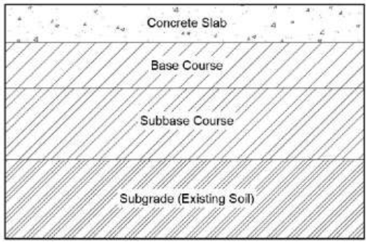
Fig. 2.1 Flexible pavement
- Rigid Pavement
Rigid pavement: The rigid pavements are usually made up of cement concrete and may not have a sense course between the surface and sub-grade. The design of this class of pavement is based on the principle of providing sufficient strength in the structural cement concrete slab to resist the destructive action of the traffic. Due to their rigidity and high modulus of elasticity they distribute the load over a relatively wide area of soil the rigid pavement can resist appreciable tensile stress, therefore the minor venations in the strength of sub-grade have no influence on the structural capacity of the pavement.
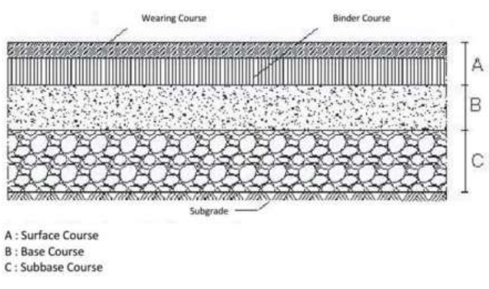
Fig. 2.2 Rigid pavement
- Interlock Pavement
Interlock pavement: This is also called paver generally form of pre-cast concrete block are often used for aesthetic purposes or sometimes at port, walkways, driving that see long duration pavement loading, paver are rarely used in an area that see high speed vehicle traffic, brick, cobble stone, and wood plank pavement were once common in urban area throughout the world, but fill out of fashion in most countries due to high cost of labour required to lay and maintain them and are typically only kept for historical or esthetic reasons.
Types of interlocks pavement
- Brick pavement.
- Concrete pavement.
- Ceramic pavement.
Diagrams of various types of interlock pavement and their laying patterns
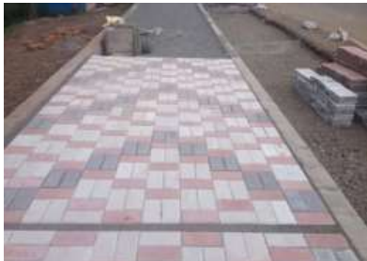
Fig. 2.3 Heptagal Interlock Fig. 2.6 Elegant Interlock pavement
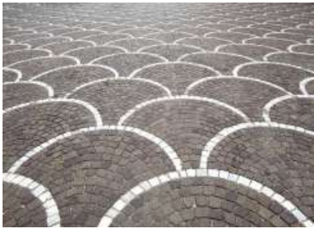
Fig. 2.5 Elegant Interlock pavement Fig. 2.4 Double Tee Interlock pavement

2.4 CAUSE OF ROAD ACCIDENT
Road accident is most unwanted thing to happen to a road user, though they happen quite often. The most unfortunate thing is that we don't learn from our mistakes on road. Most of the road users are quite well aware of the general rules and safety measures while using roads but it is only the laxity on part of road users, which cause accidents and crashes. Main cause of accidents and crashes are due to human errors. We are elaborating some of the common behaviour of humans which results in accident. (Ministry Of Road Transport & Highways Government of India)
- Over Speeding
- Drunken Driving
- Distractions to Driver
- Red Light Jumping
- Avoiding Safety Gears like Seat belts and Helmets
- Non-adherence to lane driving and overtaking in a wrong manner.
Various national and international researchers have found these as most common behavior of Road drivers, which leads to accidents.

- Over Speeding: Most of the fatal accidents occur due to over speeding. It is a natural psyche of humans to excel. If given a chance man is sure to achieve infinity in speed. But when we are sharing the road with another user we will always remain behind some or other vehicle. Increase in speed multiplies the risk of accident and severity of injury during accident. Faster vehicles are more prone to accident than the slower one and the severity of accident will also be more in case of faster the severity of accident will also be more in case of faster vehicles. Higher the speed, greater the risk. At high speed the vehicle needs greater distance to stop i.e. braking distance. A slower vehicle comes to halt immediately while faster one takes long way to stop and also skids a long distance due to law of notion. A vehicle moving on high speed will have greater impact during the crash and hence will cause more injuries. The ability to judge the forthcoming events also gets reduced while driving at faster speed which causes error in judgment and finally a crash.

- Drunken Driving: Consumption of alcohol to celebrate any occasion is common. But when mixed with driving it turns celebration into a misfortune. Alcohol reduces concentration. It decreases reaction time of a human body. Limbs take more to react to the instructions of brain. It hampers vision due to dizziness. Alcohol dampens fear and incite humans to take risks. All these factors while driving cause accidents and many a times it proves fatal. For every increase of 0.05 blood alcohol concentration, the risk of accident doubles. Apart from alcohol many drugs, medicines also affect the skills and concentration necessary for driving. First of all, we recommend not to consume alcohol. But if you feel your merrymaking is not complete without booze, do not drive under the influence of alcohol. Ask a teetotaler friend to drop you at home.

- Distraction to Driver: Though distraction while driving could be minor but it can cause major accidents. Distraction could be outside or inside the vehicle. The major distraction now a days is talking on mobile phone while driving. Act of talking on phone occupies major portion of brain and the smaller part handles the driving skills. This division of brain hampers reaction time and ability of judgement. This becomes one of the reasons of crashes. One should not attend to telephone calls while driving. If the call is urgent, one should pull out beside the road and attend the call. Some of the distractions on road are:
- Adjusting mirrors while driving
- Stereo/Radio in vehicle
- Animals on the road
- Banners and billboards.
The driver should not be distracted due to these things and reduce speed to remain safe during diversions and other kind of outside distractions.

- Red Light jumping: It is a common sight at road intersections that vehicles cross without caring for the light. The main motive behind red light jumping is saving time. The common conception is that stopping at red signal is wastage of time and fuel. Studies have shown that traffic signals followed properly by all drivers saves time and commuters reach destination safely and timely. A red-light jumper not only jeopardizes his life but also the safety of other road users. This act by one driver incites other driver to attempt it and finally causes chaos at crossing. This chaos at intersection is the main cause of traffic jams. Eventually everybody gets late to their destinations. It has also been seen that the red-light jumper crosses the intersection with greater speed to avoid crash and challan but it hampers his ability to judge the ongoing traffic and quite often crashes.

- Avoiding Safety Gears like seat belts and helmets: Use of seat belt in four-wheeler is now mandatory and not wearing seat belt invites penalty, same in the case of helmets for two-wheeler drivers. Wearing seat belts and helmet has been brought under law after proven studies that these two things reduce the severity of injury during accidents. Wearing seat belts and helmets doubles the chances of survival in a serious accident. Safety Gears keep you intact and safe in case of accidents. Two-wheeler deaths have been drastically reduced after use of helmet has been made mandatory. One should use safety gears of prescribed standard and tie them properly for optimum safety.

CHAPTER THREE
3.0 METHODOLOGY
This project employed a mixed- methods approach, combining quantitative and qualitative data collection and analysis to provide a comprehensive understanding of road accident trend and characteristic in Ilorin metropolis. the data collection process was involved both secondary and primary data sources. Secondary data was be collected from existing records of road accidents in Ilorin metropolitan, obtained from relevant sources such as the Federal Road Safety Corps, Nigerian Police Force, Kwara State Ministry of Transportation, and hospitals and healthcare facilities. Primary data was collected through a questionnaire survey administered to road users, including drivers, pedestrians, and cyclists, as well as through observational studies conducted at selected locations in Ilorin metropolitan and the data analysis process involve the use of descriptive statistics to summarize and describe the data, as well as inferential statistics to analyze the relationships between variables. Thematic analysis was also be used to identify patterns and themes in the qualitative data. The sampling technique involve purposive sampling to select sampling locations and participants based on their relevance to the study objectives, as well as random sampling to select participants for the questionnaire survey.
3.1 STUDY AREA
Description of the study area
Ilorin, the capital of Kwara State in North-Central Nigeria, serves as both a political and economic hub. It lies approximately between latitude 8°30'N and 8°50'N and longitude 4°20'E and 4°35'E. As a metropolitan city, Ilorin encompasses key urban districts such as Ilorin West, Ilorin East, and Ilorin South Local Government Areas. It also serves as a transit point between the northern and southern regions of Nigeria, which makes it a critical node in regional transportation.
The city is characterized by a growing population, increasing vehicle ownership, and a mix of road users including private vehicles, commercial transport (buses, taxis, motorcycles), and pedestrians. Major roads and highways, including the Ilorin-Jebba Road, Unity Road, Tanke-Tipper Garage Road, and the Ilorin-Ogbomosho Expressway, are often congested and known for high accident rates. These roads also connect to industrial layouts, schools, markets, and religious centers, increasing traffic volume and accident risks.

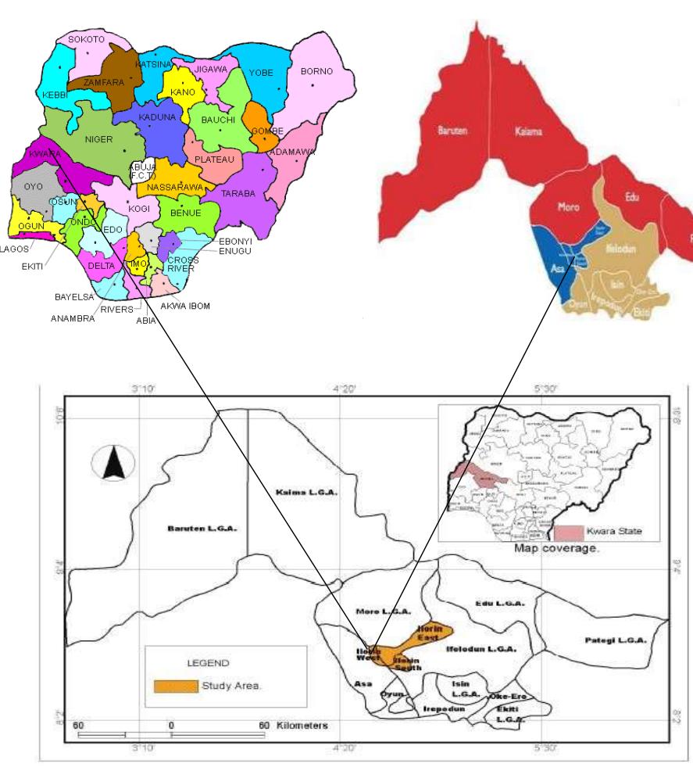

3.2 DATA COLLECTION
This research is based on secondary data covering the period from 2020 to 2024, sourced from multiple reputable agencies involved in road safety and traffic management in Ilorin.

3.2.1 DATA SOURCE
The sources include:
- Federal Road Safety Corps (FRSC), Kwara State Sector Command – Annual Road traffic crash reports, monthly summaries, and geo-located accident data.
- Nigerian Police Force (NPF), Ilorin Traffic Division – Incident reports, investigation records, and patrol logs.
- Kwara State Ministry of Transport and Vehicle Inspection Office (VIO) – Vehicle registration statistics, road safety enforcement data.

- Selected Government and Private Hospitals (e.g., University of Ilorin Teaching Hospital) – Records of accident victims, categorized by injury severity and treatment outcome.

The data collected include:
- Number of accidents per year from 2020 to 2024
- Geographic location of each accident (e.g., specific road or intersection)
- Type of vehicles involved (motorcycles, tricycles, private cars, commercial buses, trucks, etc.)
- Time and date of occurrence (day/night, weekday/weekend)
- Reported causes of accidents (e.g., speeding, brake failure, reckless driving, drunk driving)
- Demographic information of victims (age, sex, role as driver/passenger/pedestrian)
- Accident outcomes (number of fatalities, serious injuries, minor injuries, and property damage)

Data accuracy was verified through cross-referencing between sources and validating yearly reports with monthly breakdowns where available. Efforts were made to collect consistent and complete records, although gaps in some datasets due to underreporting or record loss were acknowledged.

3.3 DATA ANALYSIS
The analysis of the 2020–2024 data was carried out using both quantitative and visual methods, focusing on identifying trends, patterns, and relationships in accident occurrence.
The analysis involved the following steps:
- Temporal Trend Analysis: Annual and monthly accident frequencies were compared to identify any increasing or decreasing patterns over the five-year period.
- Spatial Analysis: Accident hotspots within Ilorin metropolitan were mapped based on frequently affected locations, helping to identify dangerous roads or junctions.

- Categorical Analysis: Data were grouped based on:
- Vehicle type
- Accident cause
- Injury severity
- Time and day of the week

- Descriptive Statistics: Used to calculate totals, averages, and percentages. For instance, the percentage of accidents involving commercial vehicles or accidents occurring during weekends.
- Graphical Representation: Bar charts, pie charts, and line graphs were used to visually present data for better interpretation.
- Tools Used: Microsoft Excel and, where applicable, SPSS were utilized for data entry, cleaning, analysis, and visualization.

CHAPTER FOUR
4.0 RESULTS AND DISCUSSION
4.1 INTRODUCTION
This chapter presents a detailed analysis of the data collected on road accidents within Ilorin metropolitan area. It explores the frequency, location, types, causes, severity, and temporal patterns of road traffic accidents (RTAs). The analysis is based on accident records obtained from relevant agencies such as the Federal Road Safety Corps (FRSC), Nigerian Police Force (NPF), and hospitals, complemented by field observations.
4.2 TEMPORAL DISTRIBUTION OF ROAD ACCIDENTS
4.2.1 ANNUAL TREND ANALYSIS
The accident data collected from 2020 to 2024 shows a fluctuating but generally increasing trend in the number of road accidents.
Figure 4.1: Annual Number of Reported Road Accidents in Ilorin (2020–2024)
Year | Number of Accidents | Fatal | Serious Injuries | Minor Injuries
2020 | 84 | 19 | 57 | 8
2021 | 96 | 14 | 69 | 13
2022 | 90 | 3 | 69 | 18
2023 | 111 | 34 | 69 | 8
2024 | 14 | 8 | 1 | 5
The increase in accident cases from 2021 onwards correlates with post-COVID economic recovery, which led to increased movement of people and goods.

Figure 4.2: Annual Number of Reported Road Accidents in Ilorin (2020–2024)
According to the data collected from 2020-2024, in 2020 the total number of accident recorded was 84, 19 were fatal, whereas there were 57 serious injuries and 8 minor injuries. In 2021 the total number of accident recorded was 96, 14 were fatal, whereas there were 69 serious injuries and 13 minor injuries. In 2022 the total number of accident recorded was 90, 3 were fatal, whereas there were 69 serious injuries and 18 minor injuries. In 2023 the total number of accident recorded was 111, 34 were fatal, whereas there were 69 serious injuries and 8 minor injuries. Lastly, in 2024 the total number of accident recorded was 14, 8 were fatal, whereas there were 1 serious injuries and 5 minor injuries
4.3 CHARACTERISTICS OF ROAD ACCIDENTS
4.3.1 TYPE OF VEHICLES INVOLVED
Figure 4.3: Annual Number of types of vehicles involved in Accidents in Ilorin (2020–2024)
Year | Motorcycle | Tricycle | Car | Minibus | Truck | Tanker | Total
2020 | 12 | 10 | 44 | 12 | 8 | 7 | 93
2021 | 33 | 2 | 52 | 9 | 10 | 6 | 112
2022 | 18 | 7 | 38 | 7 | 12 | 19 | 90
2023 | 30 | 9 | 48 | 8 | 17 | 19 | 123
2024 | 0 | 7 | 2 | 2 | 4 | 5 | 21
Data shows that a total of 93 vehicles are involved in the accident in 2020, in 2021 a total number of 112 vehicles were involved in accidents, in the year 2022, a total of 90 vehicles was involved in accidents, in 2023, 123 vehicles were involved in the accident and lastly in 2024, a reduced number of vehicles of 21 were involved in accident in the studied area.
4.3.2 NATURE AND TYPE OF ACCIDENTS
Common types of accidents included:
- Rear-End Collisions: Often caused by tailgating and poor road markings.
- Head-On Collisions: Common on single-lane roads without dividers.
- Vehicle-Motorcycle Crashes: Frequent in congested areas with mixed traffic.
- Pedestrian Knockdowns: High in residential areas lacking pedestrian walkways.
4.3.3 CAUSES OF ACCIDENTS
Figure 4.4: Various causes of Accidents in Ilorin (2020–2024)
Year | SPV | ROB | TBT | LOC | MDV | WOV | BFL | OVL | OTHERS | TOTAL
2020 | 15 | 0 | 7 | 27 | 7 | 9 | 2 | 1 | 21 | 89
2021 | 7 | 0 | 8 | 43 | 3 | 13 | 6 | 0 | 15 | 97
2022 | 4 | 0 | 3 | 15 | 6 | 11 | 4 | 0 | 22 | 65
2023 | 9 | 0 | 10 | 32 | 11 | 14 | 8 | 2 | 29 | 115
2024 | 4 | 0 | 2 | 2 | 0 | 1 | 6 | 0 | 110 | 26

Figure 4.4 above shows that from 2020-2024 the total number of accidents caused by SPV (Over-speeding) is 39, a total of 30 accidents were cause by busted tyre within the years, 119 accidents were cause by driver losing control of their car, 27 were caused by Mechanical Deficiency Vehicle, 48 were caused by Wrongful Overtaking, 26 were caused by Break Failure, 3 were caused by Overloading, and 10 accidents were caused by other forms of means
4.3.4 DEMOGRAPHICS OF VICTIMS
Figure 4.5: Demographic Characteristics of Road Accident Victims (2020–2024)
Demographic Variable | Category | Number of Victims | Percentage (%)
Gender | Male | 1,035 | 72%
 | Female | 420 | 28%
Age Group (Years) | 0–17 | 145 | 10%
 | 18–30 | 510 | 35%
 | 31–45 | 460 | 32%
 | 46–60 | 235 | 16%
 | 61 and above | 105 | 7%
Occupation | Commercial Drivers/Riders | 510 | 35%
 | Civil Servants | 215 | 15%
 | Students | 180 | 12%
 | Traders/Artisans | 270 | 19%
 | Unemployed | 160 | 11%
 | Others | 120 | 8%
Road User Category | Drivers | 440 | 30%
 | Passengers | 525 | 36%
 | Pedestrians | 300 | 21%
 | Motorcyclists | 190 | 13%
According to the figure 4.4 above, it can be seen that a total number of 1,035 (71%) victims were male while 420 (29%) were female. From the data, 145 (10%) of the victims were within the ages of 0-17, 510 (35%) were within ages of 18-30, 460 (32%) victims were of the ages of 31-45, 235 (16%) victims were within the ages of 46-60 and the remaining victim of 105 (7%) were of ages 61 and above.
From the data collected, it shows that 510 (35%) of the victims were commercial drivers and riders, 215 (15%) were civil servant, students were 180 (12%) and the remaining 270 (19%) were traders/artisans.
4.4 The Relationship Between Road Accidents And Factors Such As Road Design, Traffic Volume, And Driver Behavior.
Road accidents are a complex issue influenced by the interplay of road design, traffic volume, and driver behavior. Road design flaws can increase accident risk, while higher traffic volume often correlates with increased accident frequency, though potentially at a lower rate than the volume increase itself. Driver behavior, including speeding, impaired driving, and distracted driving, is a major contributing factor to accidents.
- Road Design:
Features like curves, intersections, and lane widths can significantly impact safety. For example, poorly designed curves can lead to loss of control, especially at higher speeds. The condition of the road surface, including its texture and presence of potholes, can affect vehicle handling and stopping distances, especially in adverse weather conditions. Adequate visibility, both during the day and at night, is crucial for drivers to perceive potential hazards and react accordingly.
- Traffic Volume:
Higher traffic volume generally leads to increased congestion, which can increase the likelihood of collisions. While higher traffic volumes are associated with more accidents, some studies suggest that the increase in accidents may not be directly proportional to the increase in traffic volume, potentially leading to a lower risk per vehicle at higher volumes. The relationship between traffic volume and accidents can vary based on road type. For example, multi-vehicle crashes on freeways may be more sensitive to traffic volume changes.
- Driver Behavior:
Exceeding speed limits is a major cause of accidents, often leading to loss of control, reduced reaction time, and increased severity of crashes. Driving under the influence of alcohol or drugs significantly impairs judgment and reaction time, increasing the risk of accidents. Also, activities like using cell phones, eating, or adjusting the radio while driving can divert a driver's attention from the road, leading to accidents. Actions like tailgating, reckless lane changes, and excessive speeding can create dangerous situations and increase the risk of collisions. Also, a wide range of human errors, including poor decision-making, inexperience, and failure to yield, can contribute to accidents

CHAPTER FIVE
5.0 CONCLUSION AND RECOMMENDATIONS
5.1 CONCLUSION
This study analyzed the trends and characteristics of road accidents in Ilorin metropolitan area over a five-year period. Key findings include:
- A rising trend in the number and severity of road accidents, particularly from 2020 to 2024. Concentration of accidents in high-traffic areas with inadequate infrastructure.
- However, predominance of commercial vehicles and motorcycles in accident involvement. Over-speeding, reckless driving, and poor road conditions as the leading causes and vulnerability of young adults, particularly male commercial drivers and riders.
- There is a high level of relationship between road accidents and factors such as road design, traffic volume, and driver behavior as many accidents are caused by this factors
It is noteworthy to say that the findings reveal an urgent need for a holistic approach to road safety that integrates infrastructure improvement, law enforcement, public awareness, and vehicle regulation.
5.2 RECOMMENDATIONS
Based on the data analysis and findings, the following recommendations are made:
- The Federal Road Safety Corps (FRSC) and Nigeria Police Force must increase patrols, enforce speed limits, and penalize traffic law violators. Use of speed detection cameras and breathalyzers should be intensified.
- Regular campaigns through media, schools, religious centers, and motor parks should be conducted to enlighten the public on road safety, the importance of seatbelts, speed limits, and the dangers of drunk driving.
- Government should prioritize the rehabilitation of major roads within Ilorin, provide adequate lighting, erect road signs, and implement lane demarcations. Areas identified as blackspots should be redesigned to improve safety.
- The issuance of driving licenses should be regulated more strictly. Prospective drivers must undergo proper training and pass certification exams. Periodic re-certification for commercial drivers is recommended.
- Create a centralized accident database for real-time accident tracking and forecasting. Also, establish emergency response units across identified accident-prone areas for prompt first aid and evacuation.
- Regulate motorcycle operations by mandating use of helmets, limiting passenger load, and designating separate lanes for two- and three-wheelers in busy areas.

REFERENCES
Ameratunga, S., Hijar, M., & Norton, R. (2006). Road-traffic injuries: Confronting disparities to address a global-health problem. The Lancet, 367(9521), 1533-1540.
Kareem, A. (2003). Review of global menace of road accidents with special reference to Malaysia-A social perspective. Malaysian journal of Medical Sciences, 10(2), 31-45.
Li, L. P., Li, G. L., Cai, Q. E., Zhang, A. L., & Lo, S. K. (2008). Improper motorcycle helmet use in provincial areas of a developing country. Accident Analysis and Prevention, 40(6), 1937-1942.
Mohamad, M., Kamarudin, M. K. A., Juahir, H., Ali, N. A. M., Karim, F., Badarilah, N., Muhammad, N., & Ridzuan, M. S. M. (2018). Development of spatial distribution model using GIS to identify social support index among drug-abuse inmates. International Journal of Engineering and Technology, 7(2.15), 1-7.
Mohan, D., & Romer, C. J. (1991). Accident mortality and morbidity in developing Countries. In M. Manciaux & C. J. Romer (Eds.), Accidents in Childhood and Adolescence: The Role of Research. Geneva: World Health Organization, pp. 31-38.
Mustafa, M. N. (2005). Overview of current road safety situation in Malaysia. Highway planning Unit, Road Safety Section, Ministry of Works.
Odero, W., Garner, P., & Zwi, A. (1997). Road traffic injuries in developing countries: A comprehensive review of epidemiological studies. Tropical Medicine and International Health, 2(5), 445-460.
Suriyawongpaisal, P., & Kanchanasut, S. (2003). Road traffic injuries in Toriman, M. E., Abdllah, S. N. F., Azizan, I A., kamarudin, M. K. A., Umar, R., & Mohamad, N. (2015).
Smith G S., & Barss P G. (1991). Unintentional injuries in developing countries: The epidemiology of a neglected problem. Epidemiology Reviews, 13, 228-266.
Thailand: Trends, selected underlying determinants and status of intervention. Injury Control and Safety Promotion, 10(1-2), 95-104.
Taket, A. (1986). Accident mortality in children, adolescents and young adults. World Health Statistics Quarterly, 39, 232-256.
World Health Organization (WHO). (2013). Global status report on road safety 2013. WHO.
Wong, T. W., Phoon, W. O., Lee, J., Yiu, I. P. C., Fung, K. P., & Smith, G. (1990). Motorcyclist traffic accidents and risk factors: A Singapore study. Asia Pacific Journu1 of Public Health 4, 34-38.

