KWARA STATE POLYTECHNIC ILORIN, KWARA STATE.
INSTITUTE OF TECHNOLOGY
DEPARTMENT OF CIVIL ENGINEERING

DESIGN AND CONSTRUCTION OF HOUSEHOLD
FURNITUER (DINING SETS)
BY
ISIAQ FARUQ AYOMIDE
ND/23/CEC/PT/0009
BEING IN RESEARCH WORK SUBMITTED TO THE DEPARTMENT OF CIVIL ENGINEERING, INSTITUTE OF TECHNOLOGY, KWARA STATE POLYTECHNIC, ILORIN

IN PARTIAL FULFILMENT OF THE REQUIREMENT FOR THE AWARD OF NATIONAL DIPLOMA (ND) IN CIVIL ENGINEERING

JULY 2025.

CERTIFICATION
This is to certify that this research study was conducted by Isiaq Faruq Ayomide (ND/23/CEC/PT/0009) and had been read and approved as meeting the requirement for the award of National Diploma (ND) in Civil Engineering of the Department Civil Engineering, Institute of Technology, Kwara State Polytechnic, Ilorin.

………………… ….…..………
ENGR. Adetunji. M.O DATE
Project Supervisor

………………..…… …………….
ENGR. A. SANNI DATE
Part-Time Coordinator

…………………. ……………..
ENGR.ABDULHAMEED. A. ADUAGBA DATE
External Examiner

DEDICATION
I dedicate this project to Almighty Allah for his supreme and unlimited mercy on me for the successful completion of this project.
Also, to my late mother and friends during this successful project.

ACKNOWLEDGEMENT
A huge gratitude to my parents Mr. & Mrs. Isiaq, families and friends for their immeasurable support and their unlimited loyalty, love and understanding of the successful completion of this project.
My sincere thanks and appreciation to my great supervisor in person of Enger. Adetunji. M.O for her kindness and advice and also her honest supervision and assistance, and also special thanks to the Head of Department (H.O.D) Engr. A. Sanni for his love and support and all our great and respected lecturers
Also, a big shout-out to my super women, Miss Salamah Seriki, Miss Omowumi, and also my step mum, and also to all my friends and loved ones that do support me both academically and financially.
Thank you all.

TABLE OF CONTENT.
CERTIFICATION--------------------------------------------------------------------------------2
DEDICATION------------------------------------------------------------------------------------3
ACKNOWLEDGEMENT-----------------------------------------------------------------------4
TABLE OF CONTENT--------------------------------------------------------------------------8
CHPTER ONE-------------------------------------------------------------------------------------8
1.1 INTRODUTION------------------------------------------------------------------------------8
1.2 AIM & OBJECTIVE ------------------------------------------------------------------------8
1.3 SCOPE OF THE PROJECT-----------------------------------------------------------------9
1.4 PURPOSE OF THE PROJECT ------------------------------------------------------------9
1.5 METHODOLOGY---------------------------------------------------------------------------10
CHAPTER TWO----------------------------------------------------------------------------------11
2.1 LITERATURE REVIEW--------------------------------------------------------------------11
2.2 TIMBER---------------------------------------------------------------------------------------11
2.3 PARTS OF A TREE-------------------------------------------------------------------------11
2.4 PARTS OF THE STEM---------------------------------------------------------------------11
2.5 SELETION OF TIMBER-------------------------------------------------------------------13
2.6 IDENTIVICATION BY INSPESCTION-------------------------------------------------13
2.7 SEASONING OF TIMBER ----------------------------------------------------------------14
2.7.1 REASONS FOR SEASONING OF TIMBER-----------------------------------------14
2.7.2 TYPES OF SEASONING METHODS--------------------------------------------------15
2.7.3 MERITS OF AIR SEASONING---------------------------------------------------------15
2.7.4 MERITS OF KILN SEASONING-------------------------------------------------------16
2.7.5 DEMERITS OF KILN SEASONING---------------------------------------------------16
2.8 DEFECTS IN TIMBER----------------------------------------------------------------------17
CHAPTER THREE--------------------------------------------------------------------------------18
3.1 DESIGN PROCEDURE----------------------------------------------------------------------18
CHAPTER FOUR----------------------------------------------------------------------------------29
4.1 MATERIAL USED FOR CONSTRUCTION----------------------------------------------29
4.2 CHOICE OF MATERIAL USED------------------------------------------------------------30
4.3.1 TIMBER---------------------------------------------------------------------------------------30
4.3.2 PLUWOOD -----------------------------------------------------------------------------------31
4.3.3 NAILS------------------------------------------------------------------------------------------31
4.3.4 GLUE ------------------------------------------------------------------------------------------32
4.3.5 THE MERITS AND DEMERITS----------------------------------------------------------32
4.3.6 DEMERITS------------------------------------------------------------------------------------32
4.4 TOOLS-------------------------------------------------------------------------------------------33
4.4.1 SAWS------------------------------------------------------------------------------------------33
4.4.2 PLANE-----------------------------------------------------------------------------------------32
4.4.3 CHISELS--------------------------------------------------------------------------------------33
4.4.4 FIXING TOOLS------------------------------------------------------------------------------34
4.4.5 MARKING AND TESTING TOOLS-----------------------------------------------------34
4.4.6 WOOD WORK BENCH--------------------------------------------------------------------34
4.5 PROPERTICES OF MATERIAL USED---------------------------------------------------34
4.5.1 PROPERTIES OF TIMBER----------------------------------------------------------------34
4.5.2 PROPERTIES OF PLYWOOD------------------------------------------------------------35
4.5.3 PROPERTIES OF NAIL--------------------------------------------------------------------35
4.6 TEST ON TIMBER----------------------------------------------------------------------------36
4.7 CONSTRUCTION AL DETAILS-----------------------------------------------------------37
4.8 JOINTS AND CONSTRUCTION IN TIMBER-------------------------------------------38
4.8.1 TYPES OF JOINTS--------------------------------------------------------------------------38
4.9 FINISHING--------------------------------------------------------------------------------------39
4.9.1 TYPES OF FINISHING---------------------------------------------------------------------39
4.9.2 PURPOSE OF FINISHING-----------------------------------------------------------------40
4.10 METHOD OF APPLICATION-------------------------------------------------------------41
4.10.1 SPRAYING----------------------------------------------------------------------------------41
4.10.2 ADVANTAGE OF SPRAYING OVER BRUSH
METHOD OF APPLICATION-----------------------------------------------------------------41
4.11 TABLE 1; BILL OF QUANTITY (B.O.Q) -----------------------------------------------42
CHAPTER FIVE------------------------------------------------------------------------------------44
5.1 CONCLUSION---------------------------------------------------------------------------------44
5.2 RECOMMENDATION------------------------------------------------------------------------45
REFFERENCES-------------------------------------------------------------------------------------46

CHAPTER ONE

1.1 INTRODUCTION.
Wood is a natural material which is being used for construction of various parts of building and furniture work. Timber as a material is inexhaustible in supply in as much as there are intelligent a forestation program with wide potential in a diverse range of construction field. The engineering design of any structure is important, any construction without design, does not have any value to modern days of engineering in carrying out construction works.

Furniture is usually made from wood of various types; the major types are hardwood and softwood. Timber is obtained from growth matured trees. Where there is abundant of good quality timber, timber can be use in range of structural application including construction of bridges, piles and in-situ concrete works etc. Timber has now been known all over the world as a good material that is mostly used for construction purposes because of its nature and properties like stability, durability and strength. Timber can be got in our surrounding unlike other construction materials like steal which are mostly imported.

Timber frame structure involves a lot of steps and procedure before it can be ready for various construction in building/building industry. Some of these steps are discussed in the project.

1.2 AIM AND OBJECTIVES.
The aim and objectives of this project are as follows:
- To design a timber structure that will be suitable for domestic use.
- To investigate suitability and importance of wood in construction work/building firm.
- To construct a timber structure i.e. table, chair, etc.

1.3 SCOPE OF THE PROJECT.
The scope of this project work is the design and construction of timber structure i.e. dinning set.

1.4 PURPOSE OF THE PROJECT.
This project deals with the design and construction of a timber frame structure. There are many of this frame structure in various homes a day with different sizes which they lack good qualities which render them not to stay long before they get spoilt or collapse.

This project is well designed and constructed in such a way that it can be used by an average man who may need it. Moreover, careful investigation was carried out on various materials used to achieve the aim of this project.

This project would motivate co-students and other people who witnessed its construction to be able to know the qualities and appropriate materials to be used for a well and deal structure of this frame structure.

1.5 METHODOLOGY.
The method adopted in this project is enumerated below

The design of the timber structural members is carried out using Bs 5268
The construction of the dinning set was thereafter constructed using the mahogany and following the process of construction as enumerated in chapter three.

CHAPTER TWO

2.1 LITERATURE REVIEW.

2.2 TIMBER.
Walter F.H et al (1996) mature trees of many species are sources of structural members which are used for construction works depending on the nature and type of construction. This is why it is important for the users to have knowledge of structural component of timber.
Basically, a tree consists three (3) main parts namely: the root, the stem, and the crown. The root system absorbs moisture containing good substances.

2.3 PARTS OF A TREE.
i. The crown: this consists of branches, twigs and foliage i.e. leaves, branches and twigs are the lifelines supplying the leaves with sap.
ii. The Root: The tree anchor firmly into the ground through many small root’s hair, absorb a solution of mineral salts known as sap they are also used to good.
Traditionally, wood has varieties. They are classified as hardwoods timber or softwood timber.

2.4 PARTS OF THE STEM.
- Heartwood (duramen): The natural non active part of the tree, often in color than sapwood gives strength and support to the tree and provides the most durable wood for conversion into timber.
- Sap; wood (Alburnum): The outer active part of the tree which as it implies, receives and conducts sap from the roots to the leaves. As this part of the tree matures, if gradually become heartwood.

- Pitch(medulla): this is the core or center of the tree, formed from the tree’s earliest growth as a sapling.

- Rays: These all appear faintly to originate from the center of the tree.

- Cambium: This is a thin layer of cells located between the sapwood and the phloem. These calls are responsible for the tree’s growth. As they formed, they become subdivided in such a way that new cells are added to both sapwood and phloem, thereby increasing the birth of the tree.

- Phloem (Bast): conducts food throughout the whole of the tree from these leaves to the root.

- Annual Ring: wood cells which have formed around the circumference of the tree during its growing season.

- Bank: This is the outer sheath of the tree it functions
- A thermal insulator
- A moisture barrier
- An amour plate against external attack e.g. by insects, animals’ fungi and extreme temperature.
2.5 SELECTION OF TIMBER.
The selection of timber for a particular purpose is governed by several considerations namely:
- Fitness for the purpose
- Cost
- Availability of supplies
- Cost of labor
- Machine preparation and shaping the timber

2.6 IDENTIFICATION BY INSPECTION.
i. Texture

ii. Surface

iii. Feel

iv. Oduor

v. Weight

vi. Hardness

vii. Color

viii. Grain

ix. Taste

2.7 SEASONING OF TIMBER.
This is the process of removing certain amount of water or moisture from timber. The water in the wood knows as moisture can be removed by two different methods namely: Artificial seasoning (Kiln seasoning), and natural seasoning (Air seasoning).

2.7.1 REASONS FOR SEASONING OF TIMBER.
The reasons why timber is to be seasoned are:
- It makes wood lighter in weight.
- It makes wood stronger because the drier the wood the stronger it becomes.
- It makes the wood easier to work on during construction.
- It makes the timber to be more durable.
v. To remove excess moisture content of the wood.

2.7.2 TYPES OF SEASONING METHODS.
- Natural method / Air seasoning

- Accelerated method / kiln seasoning

- Combined Air and kiln seasoning

Natural Seasoning (Air seasoning): This process involves stacking planks on top of each other with other pieces of wood called stackers between them. The stackers allow free circulation of air, these, stacker can either be under roof or in the open air, the area chosen must be clean and free from rubbish. The stack must be about 450mm from the ground. The stacker must be dried and must be of the same thickness and timber to be dried.

2.7.3 MERITS OF AIR SEASONING.
- Danger of fun gold attack
- The long time taken

Kiln Seasoning (Artificial Seasoning): In this method, the timber is stacked in the same way as with air seasoning but it is placed in a specially heated chamber.
The method is artificial because air, humidity and temperature can all controlled under this process wood is dried earlier and quicker and the exact amount of moisture content is removed.

2.7.4 ERITS OF KILN SEASONING.

- Reduces possibility of root and chemical staining

- it increases its profit

- kills any insect such as woodworm

- Moisture content can reduce to 12% and below

2.7.5 DEMERITS OF KILN SEASONING.

- There is a danger of honey combing

- it requires more attention

- The initial cost of the kiln and its requirement is rather high

2.8 DEFECTS IN TIMBER.

- Heart share

- Star shake: this is a collection of shares radiating from the hear

- Cup shake: This is a share which follows the path of a growth mug

- Twist

- Check

- Bow

CHAPTER THREE
3.1 DESIGN PROCEDURE FOR THE SLAB.

The strength class of the timber used, since it is hardwood is classes SC6-SC9.

Grade stresses and module of elasticity for strength classes for the dry exposure condition based on Bs 5268 under Sc7 for blending parallel to grain 15.ONmm-2.

Tension parallel to grain 9Nmm-2

Compression parallel to grain is 14.5Nmm-2

Assume the self-weight of the wood = 0.005KN/m2

Self-weight of the mattress = 0.16KN/m2

Live load =

= 1.1KN/m

Design load = 1.4(gk) + 1.6(qk)
1.4 (0.16) + 1.6 (1.1)

= 1.99KN/m2

Length = 1.875m

Load = 1.99 x 1.875m =- 3.75KN/m across the width.

1f00t = 30cm, 6 sect = 6 x 30 = 180cm

100cm = 1m

180cm = 1.8m

= 0.9m

Calculation

Weight at mid beam = 0.27 x 3.75 = 1.01KN/m

Along the edges beam = 0.51KN/m

Grid lime 4 – 4 M

m = self-weight of the wood + imposed load

1.4 (0.005) + 1.01KN/M

M = 1.02KN/m

K1 = = = = =

2

= 0.5

A B C D E

D.F 0.5 0.5 0.5

70.004

-0.004

-0.004 =0.004 +0.0205 +0.00475 -0.004

Calculation

1.02

1.08 Rby

Rn = -0.004 + 1.02 - Rby -0.18 + 0.004475

= 0.00075 + 0.016824 – Rby 0.18 = 0

0.017274 = Rby 0.18

Rby = = 0.096KN

Ray = 1.02 x 0.18 – 0.096
= 0.0876 = 0.088KN

= 1.02 (0.09)

Ray = 0.18KN

Rby Rcy

-0.00475 + + 0.002125 – Rcy 0.18

0.013899 = Rcy 0.18

Rcy =

Rcy = 0.077KN

Rby = 0.1006KN (1.02 x 0.18 – 0.070)

= 0.1818 – 0.076

Rby = 0.106KN
Rcy Rdy

-0.002125 = = 0.004245 – Rdy 0.18 = 0

0.018987 = RDy 0.18

RDy = = 0.106KN

RCy = 1.02 x 0.18 – 0.106 = 0.0s776KN

Rdy Rcy

-0.00475 + + 0.004 – Rcy 0.18

Rcy = 0.0876

Output

= 1.8 x 10-1

Total

Ray = 0.18KN

Rby = 0.096 + 0.1066

= 0.202KN

Rcy = 0.077 + 0.77

= 0.1546

Rdy = 0.106 + 0.096

= 0.202

Rcy = 0.18KN

0.09 0.18 0.18 0.18 0.18 0.09

0.202 0.16 0.202 0.18

Bending moment when x = 0.09

=

= 0.0041KN/m

When x 0.18

= -1.02 (0.18)2 + 0.18 (0.09)

=

When x = 0.27

= + 0.18 (0.27) + 0.202 x (0.09)

= -0.004779KN/m

When x = 0.36

= -1.02 (0.36)2 + 0.10 (0.27) + 0.202 x (0.09)

= 0.000684KN/m

Bending = 5mgk, k2 k3 k7 k8

8mg 90116 =

Zxx required =

= 197.9mm3 provide 20 by 25

When x = 0.54

=0.51 (0.54) – -0.007 (0.54)4 – 0.202

=0.165KN/m2

When x = 0.675

= 0.51 (0.675) – 0.101 (0.675) – (0.007) (0.6745)2

0.202 (4.05) – 0.202 (1.35)

= 0.1654KN/m

Om goal = 24.13

Zxx required = = 6854mm3

Try 50mm by 40mm

= = 13333mm2 (minimum dimension)

The section is also adequate in lateral buckling.

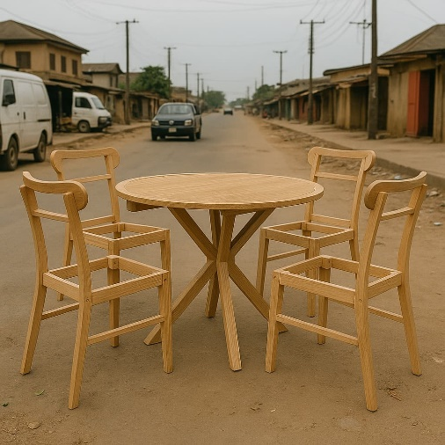

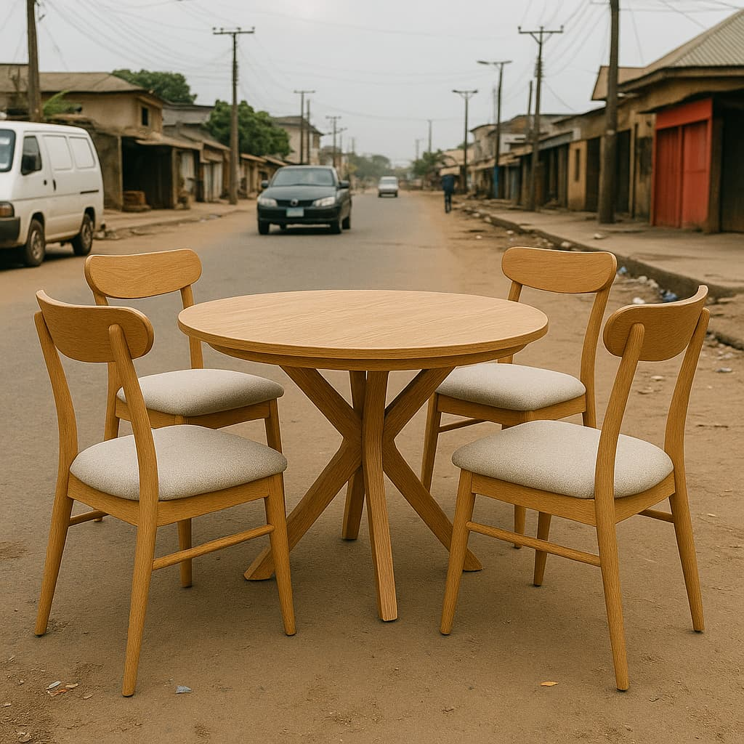
CHAPTER FOUR

4.1 MATERIAL USED FOR CONSTRUCTION

The principal materials used for the construction of household furniture are timber and plywood. The reason for the choice of these materials to be used for the construction of the household furniture is comparatively easy to work variable shapes, either by hand or by machine. It is also durable under appropriate condition, and it gives a good finish surface at a reasonable total cost.
Timber spaces are divided into softwoods and hardwoods. Softwood is derived from tree with needle-shape leaves and are usually evergreen e.g. hem lock, pine larch and fir. Likewise, hardwoods are derived from trees with broad’s leaves are can be usually deciduous. Examples of these are Elm, Oak, Ash, teak, Iroko green heart etc. obviously, the suitability of a perihilar timber type for any given purpose will depend upon different faction such as appearance, cost and performance. However, to make the job of the engineer easier, the timber spaces has been grouped into some strength classes for which typical design parameters have been produced.
The designs of timber are being carried normally in accordance with Bs. 5268. This is basically divided into various part which includes:
Fire resistance of timber structures
Code of practice for the preservative treatment of the timbers
Code of practice from permissible stress design, materials and workmanship.
Code practice for timber frame walk

4.2 CHOICE OF MATERIAL USED.
In other to attain the desire goals, the following must be put into consideration, physical qualities such as stability, strength and density. These highly determine the type of material to be used in the course of the construction.
In construction of the house hold furniture, hardwood and softwood (plywood) was majorly used because of its advantage over others. It doesn’t split when nailing.
Furthermore, the grains of wood help to give the finished work on excellent and pleasant color and even an attractive finishing. Also, the choice of materials to be used for construction to achieve the aim of the project, we must meet number of factors such as:
Availability materials: The availability of materials to be used have a great influence of the choice of material required in execution of the project. The material must be easily sourced and near to the construction site.
Durability of material: Durability of material to be span of the material must be bearable and the lasting features should not be ignored in construction work.
The service requirement: This entails the purpose dynamic or corrosives action. In static, the component is subjected to forces which vary with time where as in the dynamic conditions, the components and weather condition.
The cost of material: In selecting materials, cost also determines the quality of material used. It must not be too expensive, but rather consider those fair in price and quality.

4.3.1 TIMBER.
The type and size of timber to be used depend on the requirement i.e. the type of work and the purpose the work is to serve.

The various sizes include:
2inches by 4inches
2inches by 2inches
2inches by 3inches
1inches by 2inches
1inches by 6inches

4.3.2 PLYWOOD.
This is a sheet obtained from wood plies, glued together by heat and pressure to yield a thick sheet. The thickness and type of plywood will depend on the purpose of the timber structure and the type of timber used for the frame structure (i.e.) if mahogany timber is used for the frame, then Mahoney plywood should also be used.

4.3.3 NAILS.
Nails are made from metals, also they are narrow with jointed end and the base is flat for easy nailing. The range of nail made for various purposes is very wide and more suitable for one particular job.
The nails are classified in inches in accordance with the thickness and the length as ½ inch 1 inch 1 ½ inches, 2 inches, 3inches, 4inches. The type of nail used in the construction of furniture is ½ inch, 1inch and 1 ½inch.

4.3.4 GLUE.
This is a semi liquid material put into hole to make accurate fastening of joints and prevent hide out of insects such as cockroach.
VARNISH
These are finishing materials used for final coating of the table. The amount of varnish to be applied depends on the initial color of the timber.

4.3.5 THE MERITS AND DEMERITS.
Timbers generally have very high strength compared to its weight.
Timber can easily be conveyed from one place to another due to its light features
Timbers can easily be used for constructions, they can be dismantled and also modified to suit changing conditions.
Very good timbers are durable and the cost minimal
Timbers are easily workable upon.

4.3.6 DEMERITS.
Timber is resistant to stress for some period of timber depending on the type
Timbers can easily be attacked by different diseases if they are not properly seasoned.

4.4 TOOLS.
There are different wood working tools and pieces of small workshop equipment used in the design and construction of timber structures. These include;

4.4.1 SAWS.
Rip saw: it is used for cutting along the grain.
Panel saw: it is used for cutting across the grain.
Tenor saw: it is used for joints.

4.4.2 PLANE.
The stock body of most plane are either of wood or metal. The type include:
Jack plane: It is used for final cleaning up of timber.
Smooth plane: It is used for final cleaning up of timer.
Block plane: It is used for final cleaning up of timber.
Spoken Spare: Flat face for convex curves round face for concave shapes.
Rebate plane: for general rebating.

4.4.3 CHISELS.
Firmer: firmly substantial chisel for general trench work.
Mortise: for chipping mortise in wood.

4.4.4 FIXING TOOLS.
Hammer: It is used for nailing in nails.
Claw hammer
Crew driver

4.4.5 MARKING AND TESTING TOOLS.
Tri square
Meter square
Cutting gauge
Marking knife rule
Adjustable marking square

4.4.6 WOOD WORK BENCH.
G-clamp: This is a metal clamp used for holding small jobs to the bench while sawing or chiseling.
F-clamp: Also used for holding timbers while working

4.5 PROPERTIES OF MATERIAL USED.
4.5.1 Properties of Timber.
Strength: This is the ability of material to resist the application of forces. The force can be tensile, compressive, shear of flexure. The tensile stresses are the most common quote properly. It was explained that the timber anise-trophic, i.e. it varies in its internal make-up and strength in difference directions, accounting to the grand. The shear stress distribution in depth was stated to be parabolic, a point to hear in mind here is that timber is weak in shear along the grain (about 110 of the bending stress) and that if a maximum shear stress parallel to the grain is stated, the average shear stress of the section can only be 2/3 of this (i.e. the geometrical property for that paradox is that the mean heigh is 2/3 of the maximum).

4.5.2 PROPERTIES OF PLYWOOD.
To understand plywood, its properties and limitations, it is fitting to look briefly at its manufacture, much of the information given applies also to block board, batten board and lamina board.
4.5.3 Properties of Nail.
It is strong.
It is durable and reliable.
Properties of Give.
It is semi solid which is easily solidify.
It has the ability to faster two joints.
Properties of Adhesive.
It gives a very attractive appearance.
It easily evaporates.
It has a foul odor.
It can easily mix with gasoline.

4.6 TEST ON TIMBER.
In order to obtain information regarding timber proper has standard, physical and mechanical test are applied to the sample to measure their ability to resist various forces free from all deflect taken at least all its parts.

Physical Test: to determine the measurement such as density moisture content, durability, workability seasoning properties and the effect of temperature, the fitness or otherwise the timber for a specific use can be obtained from this test
Mechanical Test: this is the most important text from timbers used for construction works. They assess the various strength, stiffness strength etc. which enable the timber to resist the different forces or load. Bending strength and stiffness are closely related dermas referring to strength properties which are required when vertical and horizontal member carry loads. Bending test refer to ability of the timber to withstand dead and life load which tend to bend it when such structure is loaded, these are subjected to tensile, compressive and shear stresses. The measurement of these stress includes the bending strength which is called the modulus of rupture.
The load of individual structure members or group have to carry load to be considered so, that having selected timber processing known stresses properties then it can be calculated with the required size of timber.

The modulus of rupture pieces supported at each end are bent by applying increases load at the center until the fracture as deflection.
Shear Test: This is the ability of timber of resist separate of the fiber usually along the grain when the load tends to cause the fibers and bearer.

4.7 CONSTRUCTIONAL DETAILS.
For any piece of furniture, the length, width and height of the job are determined by its particular use whether it is a storage surface of sitting surface.

State 2 Development of ideas
There are based on construction of the proportion, materials and the construction as well as that of finishing.
Proportion: This the ration between the length, decided on the exact function of the project and often considering and standard or otherwise fixed dimension involved though must be given to the proportion.
Materials: The selection of the materials to be used should be based on the purpose to be used should be based on the purpose to be used should be based on the purpose of the project and the physical stability of the material.
Construction: The method of construction (joining and fixing) of all parts will depend the materials used and the type of wood work.
Stage 3 Arrangement of idea Proportion

Thus, when starting the drawing, lightly outline the lines ensuring that the overall proportion are correct.
Stage 4 The working Drawing

This brings about the detail drawing of the jobs. This can be done by reading through the drawing and ensuring that each part is mode in the right way to right size.

4.8 JOINTS AND CONSTRUCTION IN TIMBER.
Joint is the process which two members of wood are fixed together to give a required structure. However, the skill of assembling and fastening two or more pieces of wood together is called joinery. Joints used in construction work in timber are classified majority in to 3 parts, which are:

FARMING JOINTS: This is a type of joint used to join ends to edges of timber together to form a frame structure.
ANGLE JOINTS: This joint is formed by placing the members at right angle to each other.

WIDENING JOINTS: This joint involves the joining of edges of two members to produce a wide board

4.8.1 TYPES OF JOINTS.
BUTT JOINT: This method is the easiest and simplest to use, and it is commonly used in pre-fabricated house construction work, roofs and simple box construction. This is done by joining the end grain of time is the weakest part of wood for joining.
PLAIN BUTT: Dowels can be used to strengthen but joint at each joint. Many table tops, chair legs, bars, benches have this king of joint i.e. but joint reinforced with duel and corner glued backs
REBATED BUTT PLAN LAP JOINT:
The end of one piece of fitted into a rebate worked across the end of another piece. It is an improvement on the butt joint as it provides two nailing faces and gluing.

MORTISE AND TENSION JOINTS: This is one of the commonest joint used in woodwork and the strongest forms of mortise and tenon joints are
a Common or through mortise and tenon joint
b Hunched mortise and tenon joint

4.9 FINISHING.
The beauty of any wood depends on its final product. The finish applied will flatter or run the appearance of either a newly completed or and old object which has been done over. Before any attempt is made to finish a woodworking project, one should first become acquainted with the structural differences of many varieties of wood i.e. (hardwood and softwood).

The most important consideration is to use the finish that will bring out all the natural beauty of the wood, keeping in mind that the finish should not be too uneven in color

4.9.1 TYPES OF FINISHING.
The type of finishing used include varnish, sheliac, lacquers, wax
VARNISH: makes an excellent transparent finish on wood, it is in equaled for depth on build and possesses good durability and hardness. It is made by mocking tough synthetic resins in oil delivered vehicles, along with driers and other chemicals when the vehicles and drier evaporate, a durable film of resins remains which are heat, impact, abrasion, alcohol, chemical and water is dust free in 1 to 4 hours, ready for handling in about 8 hours, and dry enough for sanding and recoating in about 24hours.
LACQUERS: the principal feature of lacquers of lacquers is the very rapid drying (full hardened in 30 minutes to 2 hours), and there is no dust problem when using them. The film is hard, durable and water proof, and will not become also darken wood and least. This is especially true when a lacquer lightener is employed which will leave the wood almost at its sanded color.
SHELLAC: While shellac’s popularity as a top coat finish has decreases slightly in recent years, it is still favored by many craftsmen because of easy application and quick drying for many purposes, shellac is superior to varnish as a wood finish. It is a very hard and withstands a great deal of wear. It has a pleasant luster and brilliance not found in most varnishes, and can be rubbed to a fine finish. It penetrates into the surface of the wood, filling the pores thoroughly, and it help to bring out the wood’s natural beauty. A thin coat of shellac forms an excellent base for a wax finish. The advantages of shellac are that, it stains easily has poor resistance to water an none to alcohol.
WAX: The wax finish, is one of the oldest of wood treatments, has a pleasing eggshell glob and makes a satisfactory finish for furniture as well as floors its durability depends on its foundation, and in all cases demands periodic renewal to retain it appearance. Wax finishes will not withstand water or excessive heat, and should not be used where these may be a problem. Most important of the natural waxes is Canada or Brazil wax. Because of its brittleness it is seldom with other waxes such as beeswax, ceresin and paraffin.

4.9.2 PURPOSE OF FINISHING.
The purposes of finishing is to protect the surface of the wood from direct action of air, moisture, abrasion, soiling and similar accidents during storage, transport and under service conditions. In addition, it should preserve, strengthen and deepen the natural color, reveal the texture or on the contrary conceal it.

4.10 METHOD OF APPLICATION.
Finishing materials may be applied by brushing of spraying. Brushing is the commonest and most economical method. It is a slow method as compared with sparing but it has advantages in simplicity of equipment and ease of application with paints, varnish and other brushing medium the quality of the brushed finish, as judged by durability and appearance, is equal and in some cases suspensor to the same finish applied by spraying.

Quality is a very important factor in selection a brush regardless of the size of style needed for a particular project. A good brush with hold more finishing material and enable one to apply the material more smoothly and with less effort. In almost all types of brushed quality depends on resident of the bristles.

4.10.1 SPRAYING.
Spraying guns are used here. The spray is simple example of suction feed and some in expensive guns, use suction is crated the nozzles, and air from holes on the cap blows the paint out to form a fan pattern. The spray-gun stoke is made by moving the gun parallel to the work and at a right angle to the surface by flexing the wrist at each end of every stroke and the speed of stroking should be about the same as that of brushing.
4.10.2 ADVANTAGE OF SPRAYING OVER BRUSH METHOD OF APPLICATION.
Application of paint, varnish, enamel, lacquer, and other finished by means of a spray gun has many advantages over the brush method of application.

The advantage includes:
Economy of time and labor.
Speed of application.
Simplicity of operation which made the spray gun a good tool for the painter, finisher or handyman.

4.11 TABLE 1; BILL OF QUANTITY (BOQ).
ITEMS | DESCRIPTION | QTY | UNIT | RATE | AMOUNT
A | MDF Board | 3 | M³ | 12,000 | 36,000
B | Castor (small) | 6 | Kg | 700 | 4,200
C | Roller | 4 | Kg | 900 | 3,600
D | Angle joiner | 20 | Kg | 50 | 1,000
E | MDG Quarter Plywood | 2 | M³ | 3,100 | 6,200
F | Edge tape | 2 | M² | 3,000 | 6,000
G | Top bond glue | 1 | Mgs | 3,000 | 3,000
H | Planks | 2 | Kg | 3,500 | 7,000
I | 3 inches foam | 1 | M³ | 12,500 | 12,500
J | Leather | 7 | Yards | 1,500 | 10,500
K | Nails | 2 | Kg | 350 | 700
L | Castor (big) | 6 | Kg | 500 | 3,000
M | 6 by 22 foam | 2 | M³ | 7,500 | 15,000
N | Workmanship |  |  |  | 10,000
O | Miscellaneous |  |  |  | 5,000
 | Total |  |  |  | 125,600

CHAPTER FIVE

5.1 CONCLUSION.
Timber, structural steel and reinforced concrete are the major materials that are commonly used for used for structural construction. The selection of each of these materials for the construction a proposed structure at the earlier stage of planning depend majority on the availability of one over the others, the economy expected load on the proposed structure is to be sited as well as the durability of each material with age.

Steel is known as a good structural material bases out its high load bearing capacity. However, its initial cost as well at its maintenance cost as a result of regular painting require to prevent it from rusting cannot allow it to be general selected for structural construction especially for these structure that are for office use. Reinforced concrete is economical when compared to structural steel, but it cost more than timber. Timber the most available and most economical materials, has been used for structural construction from a time immemorial yet its selection among other materials have encounter many major set-back which are; its excessive defection under load, its decaying with age that reduce the life span of timber structure and from the fact that it’s readily attack by pest. Nevertheless, it has been shown that timber can be used for a medium load bearing structure in a good environmental condition when the proper processing stage of conversion and seasoning are followed at the early stage of conversion and seasoning are followed at the early state.

It is known that the availability of timber has made many users abuse its uses by providing a larger size. For what a small timber selection can carry. This is because many people skip the stage of design. It can now be concluded that timber can be used for most economical structure aimed for office use when the proper processing of conversion and seasoning have been gone through and when due consideration is given to its structural design.

5.2 RECOMMENDATION
From the experience gained during the construction and design of the timber frame structure, it will be lightly appreciated, it the civil Engineering Department could bring forward some research work for students to carry out mostly on timber design and construction, this will spread the student knowledge on the design of timber and not only steel and concrete design.

From the previous chapter the practical carried out, it is therefore necessary to recommend the construction of timber frame structure for the people.

Finally, the school should try their best to buy many textbooks on timber design and construction and also organize seminars and symposiums more often so that the student will be more enlightened.

REFERENCES
Aransiola (2006) “wood work technology I.O.T Kwara state polytechnic

Chamakya Arya (1994) Design of structural element british standard and euro codis first E. and F.N spon London

David Willacy (1971) “wood work 2 Second Edition, Thomas Neison and son ltd London

George Mitchell (1999) “Carpentry and Joinery” Third Edition bath, macmillan Press Ltd

Mary A.B.E (1994) “Carpentary Joinery and Machine Wood Working

Mc Kay W.B: Woodwork Construction Second Edition 1975 Published and Printed in Scotland

Seelay, I.H (1994) Civil Engineering Quantities” Third Edition, Macmillan Press Ltd

Spencer, W.J., (1997) “Fundamental Structural Analysis” fourth Edition, Macmillan Press Ltd

Wlater, F.H and Norman A.K (1996) Woodwork Technology Third Edition Mill and Boon Ltd.

