KWARA STATE POLYTECHNIC ILORIN, KWARA STATE.
INSTITUTE OF TECHNOLOGY
DEPARTMENT OF CIVIL ENGINEERING

IMPACT OF TRAFFIC CONGESTION IN URBAN MOBILITY.
A CASE STUDY OF MARABA TO OJA-OBA
BY
YUNUS GANIU AYOBAMI
ND/23/CEC/FT/0028
SUBMITTED TO THE DEPARTMENT OF CIVIL ENGINEERING, INSTITUTE OF TECHNOLOGY, KWARA STATE POLYTECHNIC, ILORIN
IN PARTIAL FULFILMENT OF THE REQUIREMENT FOR THE AWARD OF NATIONAL DIPLOMA (ND) IN CIVIL ENGINEERING
JUNE 2025.
CERTIFICATION
This is to certify that this research study was conducted by YUNUS GANIU AYOBAMI (ND/23/CEC/FT/0028) and had been read and approved as meeting the requirement for the award of National Diploma (ND) in Civil Engineering of the Department Civil Engineering, Institute of Technology, Kwara State Polytechnic, Ilorin.

______________________ __________________
Engr, Z. D. Hassan Date
Project Supervisor

_______________________ ___________________
Engr, A. B. Na’Allah Date
Head of Department

_______________________ __________________

ENGR. DR. MUJEDU KASALI ADEBAYO Date
External Supervisor
DECLARATION
I hereby declare that this project work titled IMPACT OF TRAFFIC CONGESTION IN URBAN MOBILITY.A CASE STUDY OF MARABA TO OJA-OBA, is a work done by me, YUNUS GANIU AYOBAMI with matric number, ND/23/CEC/FT/0028 of the Department of Civil Engineering, Institute of Technology, Kwara State Polytechnic, Ilorin.

__________________ ______________
Signature Date

DEDICATION
This project is dedicated solemnly to God Almighty, who is the sole inspiration of all things, without whom there would not be, and neither would this project.
Appreciation goes to my loving parents for their support in the fulfillment of my National Diploma (ND) both orally and financially. May God allow them to eat the fruit of their labor (Amen)

ACKNOWLEDGEMENT
I begin by expressing my deepest gratitude to the Almighty Allah, who has blessed me with the wisdom, strength, and resilience to complete this project also appreciate all the staffs of Kwara State Polytechnic Ilorin.
I extend my sincere appreciation to my project supervisor, Engr. Z. D. Hassan for his invaluable guidance, support, and encouragement throughout this journey. His expertise and constructive feedback were instrumental in shaping this project.
To my family, I express my heartfelt gratitude for their unwavering support and love. My parents Mr Yunus Abdulrazak and Mrs Yunus Simiat, who made me choose this interesting course, and my dearest siblings, Rhamat, Gafar, Azeenat and Mozeedat, who motivates me to make this milestone a success, thank you for being a constant source of motivation, encouragement and financial support. I appreciate your love.
I also acknowledge the entire staffs of the department of Civil Engineering in the Institute of Polytechnic, Ilorin, for their dedication, enlighten and support towards the success of my academics.
To my amazing family and friends, I appreciate your encouragement, advice, and camaraderie.
Thank you all for being part of my journey.

TABLE OF CONTENTS
Title page
Declaration i
Certification ii
Dedication iii
Acknowledgement iv
Table of Contents v
Abstract vii
Chapter One: Introduction
1.1 Background 1
1.2 Problem Statement 4
1.3 Aim and Objectives 5
1.3 Justification 6
1.4 Scope of the Study 6
Chapter Two: Literature Review
2.0 Introduction 7
2.1 Conceptual Framework 9
2.1.1 Defining Traffic Congestion 9
2.1.2 Urban Mobility and Its Determinants 14
2.2 Impacts of Traffic Congestion on Urban Mobility 14
2.2.1 Economic Impacts 15
2.2.2 Environmental Impacts 15
2.2.3 Social and Health Impacts 15
2.2.4 Impact on Urban Form 16
2.3 Factors Contributing To Traffic Congestion 17

2.4 Traffic Congestion in the Nigerian Context 17

2.5 Case Study: Maraba To Oja-Oba Market 18

2.6 Mitigation Strategies and Policy Implications 19

2.7 Research Gaps and Rationale for the Study 19

Chapter Three: Methodology

3.1 Introduction 20
3.2 Research Design 20

3.3 Study Area Description 21

3.3.1 Geographic Location 21

3.3.2 Rationale for Selecting the Study Area 23

3.4 Data Collection Methods 23

3.4.1 Data Collection 23
3.4.1 Data Collection Instruments 26
3.4.2 Data Collection Procedure 26
3.5 Data Analysis Method 27
3.5.1 Statistical Analysis 27
3.5.2 Visualization Technique 28
3.6 Ethical Considerations 28
3.7 Limitations of the Study 28
Chapter Four: Data Presentation, Analysis, And Discussion
4.0 Introduction 30
4.1 Data Collection 30
4.2 Friday Afternoon Junction-To-Junction Travel Times 33
4.3 Analysis of Highest-Delay Segment 34
4.4 Speed Profile by Time of Day 34
4.5 Major User Complaints 34
4.6 Discussion 35
Chapter Five: Conclusion and Recommendations
- Conclusion 36
  - Recommendations 37
References 38

ABSTRACT
This study investigates the impact of traffic congestion on urban mobility along the Maraba–Oja-Oba Market corridor in Ilorin, Kwara State. Conducted during Friday peak hours (16:00–18:00), it employs GPS-logged travel-time runs, radar spot-speed measurements, and roadside surveys to quantify junction-to-junction delays, speed variations, and user perceptions. Seven sequential segmentsfrom Maraba to Oja-Oba were analyzed, revealing that the Sobi Junction–Okelele Junction link endures the greatest delay (11.5 minutes), driven by downstream queue spillback, uncontrolled market-bound turning movements, and informal vendor parking. Speed profiles demonstrate a reduction of over 60 % from free-flow to peak conditions, while user surveys indicate that excessive delay, elevated fuel costs, and commuter stress are the predominant concerns. These findings confirm that peak demand exceeds capacity, leading to significant socioeconomic costs. The study concludes that targeted interventions adaptive signal coordination at Gambari–Sobi, a dedicated left-turn bay at Okelele, strict parking and vendor zoning, and real-time queue monitoring are essential to restore corridor performance and mitigate urban mobility constraints.
Keywords: Traffic congestion; Urban mobility; Travel‐time delay; GPS‐logged runs; Queue spillback; Ilorin; Junction‐to‐junction analysis.

CHAPTER ONE
INTRODUCTION
1.1 BACKGROUND
Movement of goods, services and commuters is influenced by factors of traffic congestion, such as increase in logistics cost, travel time, waiting time and fuel cost. Congestion has equally created artificial impediments to logistic flow of goods and persons along urban roads (Popoola, Abiola and Adeniji, 2013). It has however becomes a phenomenal common to major urban settlement of the world especially in the developing countries. The Joint Transport Research Centre of the Organisation for Economic Cooperation and Development (OECD) and the European Conference of Ministers of Transport (ECMT) provide conceptual definitions of traffic congestion as impediment imposed by vehicles on each other, where the volume equals or more than capacity (ECMT, 2017).
Traffic congestion is one of the major barriers to the economic development of developing economies, resulting in severe social and economic impacts. The severity of traffic congestion in port and industrial areas is more thought-provoking than destructive barriers. The purpose of this research is to better understand the social, economic, and environmental effects of road traffic congestion in a developing city's port and industrial areas. This study adopted an on-site survey strategy to collect data from regular road-users by administering questionnaires, performing volume count surveys, and measuring travel time, delay time, and vehicle speed throughout the day. It equally expressed as the difference between the roadway system design capacity and the actually operating capacity, and simply put a situation where demand for road space exceeds supply (ECMT, 2017). These definitions actually point to inability of the current system to accommodate the contemporary traffic situation.
Traffic congestion is one of the consequences of urbanization, it is a reflection of the urban development, housing, employment and cultural policies which influence where people live and work. OECD and ECMT put the relationship between urban cities and traffic congestion in perspective, “Cities and traffic have developed hand-in-hand since the earliest large human settlements. The same forces that draw inhabitants to congregate in large urban areas also lead to sometimes intolerable levels of traffic congestion on urban streets and thoroughfares.” (ECMT 2018:). Causes of traffic congestion differ slightly from place to place (Joseph, Ukpata, and Anderson, 2015) depending on a number of determinant factors which include the road network, land use pattern, traffic composition and the public transport policy. Identifying the causes of traffic congestion, Ogunsanya (2016) categorized it into physical, human and institutional matrix. Physical are transport infrastructures, while human refer to road users attitude, the regulatory institutions saddle with the responsibility of managing the road users and the infrastructure. Aworemi et al (2019) and Bashiru and Waziri (2018) in a different studies in Lagos identified bad road condition and inadequate road infrastructure, others are poor traffic planning, drivers’ behaviour and lack of integrated transport system. Joseph et al (2015) identified Road intersections as major component of urban roads that are generally prone to generate traffic congestion while Momoh (2016) opine that over dependence in motor vehicle and lack of integrated transport system are responsible for the traffic congestion.
Road users experience different challenges as a result of congestion, while travelling along the corridor. Increase travel time accounted for 25% of the challenges, longer waiting time at the bus stop accounted for 29%while high cost of public transport accounted for 20%. Environmental pollution was 15% of the effects and other factors such as crime, pedestrian and vehicular conflict accounted for 11%. Increase travel time and waiting time are the major effect of traffic congestion, it is also acknowledge to have influenced high cost of public transport. Other effects are environment pollution, crime and pedestrian/vehicular conflicts. This is in agreement with earlier studies (Popoola et al, 2013) that traffic congestion drastically increases the travel time and the cost of transportation.
Traffic refers to the movement of vehicles, pedestrians, and other road users through a transportation network, encompassing various modes of transportation, including roads, highways, bridges, and public transit systems (Transportation Research Board, 2019). It is a critical component of urban planning, affecting economic growth, environmental sustainability, and quality of life.
Traffic flow refers to the movement of vehicles and pedestrians along roadways, encompassing the behavior of individual vehicles, the interaction between different modes of transport, and the overall efficiency of the transportation network. The fundamental aspects of traffic flow include volume, speed, density, and travel time, which together define how effectively roads can accommodate various users OR Traffic flow refers to the movement of vehicles, pedestrians, and other road users through a transportation network (Transportation Research Board, 2019). It is characterized by volume, speed, density, headway, and capacity. Understanding traffic flow is crucial for designing and managing efficient transportation systems.
Due to the increasing population and economic growth in Nigeria, for instance, in Ilorin metropolis, traffic volumes continue to grow noticeably, especially at roundabouts while the available lanes remain relatively fixed. This has led to many commuters spending hours stuck in traffic everyday thereby prolonging travel times, increasing fuel consumptions and polluting the environment. (Oluwafemi et al, 2021).
1.2 PROBLEM STATEMENT
Traffic congestion along the Maraba to Oja-Oba route creates delays and adversely affecting local businesses, commuters, and residents. Understanding these impacts is essential for developing effective interventions.
The traffic congestion on ubran road has several implications and growing traffic demands, leading to:
- Increased travel times
- Congestion and queue formation
- Safety concerns due to conflicting traffic movements
- Negative impacts on local businesses and residents
- Environmental concerns due to increased air pollution
1.3 AIM AND OBJECTIVES
To study Impact of traffic congestion on urban mobility. A case study of Maraba to oja-oba market
Objectives:
- To Identify the primary causes of traffic congestion along the Maraba to Oja-Oba market route.
- To Analyze the impact of traffic congestion on travel time, economic productivity, and residents' quality of life.
- To determine the volume count of the study area in other to obtained information in regarding to traveling congestion.
1.4 JUSTIFICATION
The study will assist in obtaining various causes and effects of traveling congestion of the study rout so which would help to determine the necessary solution needed to procure, such as extension of the road reduce number of vehicle turning point which are expected to be uniform and provision parking facilities, evacuating in the marketer from the road side e.t.c.
1.4 SCOPE OF THE STUDY
This study examines the impact of traffic congestion on urban mobility, focusing on the Maraba to Oja-Oba market route in Ilorin, Kwara State, Nigeria. Geographically, the study is confined to the specified route, while temporally, data collection spans one week, covering peak and off-peak hours. Methodologically, the study employs a mixed-methods approach, combining literature reviews, field observations, surveys of commuters, drivers, and residents, traffic volume and speed data collection, GIS mapping, spatial analysis, and statistical analysis using SPSS.

CHAPTER TWO:

LITERATURE REVIEW
2.0 INTRODUCTION
Traffic congestion is major curse on urban movements. It is a plague that has become an integral part of normal life in almost all urban areas in the world. More seriously, traffic congestion causes unpredictability in journey times, thereby making urban commuters to plan for these problems by. leaving home early just to avoid being late (Aderamo et al, 2012):
Traffic congestion occurs when a volume of traffic or modal split generates demand for space greater than the available road capacity this point is commonly termed saturation. There are number of specific circumstances which cause or aggravate congestion; most of them reduce the capacity of a road at a given point or over a certain length, or increase the number of vehicles required for a given point or over a certain length or increase the number of vehicle required for a given volume of people or goods. About half of U.S. traffic congestion is recurring, and is attributed to sheer weight of traffic; most of the rest is attributed to traffic incidents, road work and weather events htp://en wikipedia.org/wiki/traffic congestion).
Traffic research still cannot fully predict under which conditions a "traffic jam" (as opposed to heavy, but smoothly flowing traffic) may suddenly occur. It has been found that individual incidents (such as accidents or even a single car braking heavily in a previously smooth flow) may cause ripple effects (a cascading failure) which then spread out and create a sustained traffic jam when, otherwise, normal flow might have continued for some time longer.
The problem of traffic congestion in urban areas is worse at road intersections. Indeed, there is no other point on cities roads that can be greatly congested as road intersections. As defined by O'Flaberty (2017), intersections (where two or more roads meet), are points of vehicle conflict. Similarly, Mchsare et al (2018) noted that at no other location within the street and highway systems are so many potential and actual conflicts than at road intersections. This is because at intersections, vehicular flows from several different approaches making either left-turn, through and right-turn.
Environment seek to occupy the same physical space at the same time. In addition to these vehicular doors pedestrians also seek to use this space to/cross the street and thereby. worsening the already pod traffic situation
Urban traffic problems are further exacerbated by the concentration of most of the working place in the same areas (usually (usually in the city centres), so that traffic is essentially unidirectional during the morning and evening peak periods (see Okpala, 1980; Onakomaiya and Ekanem, 2019).
The issue of traffic congestion in llorin like many other state capitals in Nigeria draws significant attention each day. Intra-urban movements to work, recreational centres, centres, markets, shops and schools are be becoming more and more difficult and are characterized by discomfort, delays, waste of time, energy and resources. The problem is more pronounced during the peak periods of morning and evening when vehicles stand still in long queues resulting in stress and reduction in the productive hours of commuters. Although the situation in llorin has not grown out of control, signs of potential bottlenecks are already emerging along some routes (Aderamo et al, 2012).

2.1.1 DEFINING TRAFFIC CONGESTION
Traffic congestion is typically characterized by high traffic volume, reduced speeds, longer trip times, and increased vehicular queuing. It occurs when the demand for road space exceeds the available capacity, resulting in a non-linear decline in traffic performance (Downs, 2004). Congestion is not only an operational issue but also a phenomenon that can have significant economic, environmental, and social repercussions.
Classification of congestion
Traffic congestion can be classified in several ways based on its characteristics, causes, and patterns. Below are some common classifications with detailed explanations:
Recurrent (Regular) Congestion:
Recurrent congestion occurs on a predictable and regular basis, typically during peak travel periods such as morning and evening rush hours. It is caused by a consistent imbalance between the road capacity and the volume of vehicles traveling during these times. Because it follows a predictable pattern, planners can often design specific interventions—such as traffic signal coordination or capacity enhancements—to alleviate these bottlenecks (Downs, 2004).
Non-Recurrent (Irregular) Congestion:
Non-recurrent congestion is sporadic and unpredictable. It is usually the result of temporary disruptions such as traffic accidents, road construction, adverse weather conditions, or special events that cause sudden surges in demand. Unlike recurrent congestion, non-recurrent congestion is difficult to predict and manage, as its occurrence and duration can vary widely, leading to unexpected delays and uncertainty in travel times.
Bottleneck Congestion:
Bottleneck congestion happens when a specific section of the roadway has a reduced capacity compared to the surrounding road network. Common causes include lane reductions, narrow bridges, or poorly designed intersections. Bottlenecks create a queue of vehicles that extends upstream, often leading to severe delays until the bottleneck is cleared. Addressing bottleneck congestion often requires targeted infrastructure improvements or traffic management strategies at the specific problematic location.
Gridlock:
Gridlock represents an extreme form of congestion where the traffic flow is almost entirely halted. This typically occurs in urban centers during peak periods when multiple intersections are congested simultaneously, causing vehicles to block one another in a cascading effect. Gridlock not only leads to significant delays but also increases the risk of secondary incidents, as drivers become frustrated and may take unsafe actions to escape the congestion.
Platoon Congestion:
Platoon congestion is observed when groups of vehicles, or "platoons," travel together due to synchronized traffic signals or common origin-destination patterns. While platooning can improve efficiency under some circumstances, it can also lead to periods of high density followed by gaps in the traffic stream. These variations can complicate traffic flow and result in intermittent congestion as the platoon approaches areas of reduced capacity or interference from cross traffic.
Population:
Rapid urban population growth is one of the primary drivers of traffic congestion. As urban populations increase, the demand for road space intensifies, often outstripping the existing transportation infrastructure. High population density leads to an increased number of private vehicles on the road, which in turn causes overcrowding, bottlenecks, and longer travel times. In many Nigerian cities, rapid urbanization has resulted in exponential growth in vehicle ownership without corresponding investments in road expansion or alternative transport modes (Adeola & Obayelu, 2016). This population-induced congestion not only strains the road network but also exacerbates other related issues such as environmental pollution and reduced quality of urban life.
Lack of Public Transport:
Inadequate and inefficient public transportation systems force a larger proportion of the population to rely on private vehicles for daily commuting. When public transport options are limited, unreliable, or unsafe, more people opt for private cars, motorcycles, or informal transit services, further increasing the volume of traffic on roads. In many developing urban centers, including those in Nigeria, the lack of a well-integrated and accessible public transport network is a significant contributor to congestion. This situation leads to higher transportation costs for individuals and increased emissions, as the inefficiency of public transit systems results in greater fuel consumption by a growing number of private vehicles.
Poor Driving Habits:
Poor driving habits play a critical role in aggravating traffic congestion. Behaviors such as aggressive driving, inconsistent gap acceptance, improper lane changes, and non-compliance with traffic rules disrupt the smooth flow of vehicles. In environments where road safety regulations are poorly enforced, such erratic behavior can lead to frequent accidents, unexpected braking, and overall inefficiencies in traffic movement. This unpredictability in driving behavior not only increases the likelihood of conflicts at intersections and merging points but also contributes to longer delays and reduced road capacity. Studies have shown that poor driving habits, which are often observed in developing urban centers, significantly impact traffic performance and contribute to congestion.

2.1.2 URBAN MOBILITY AND ITS DETERMINANTS
Urban mobility refers to the ease and efficiency with which people and goods can move within an urban area. It encompasses a range of factors including travel time, accessibility, reliability, and safety. High levels of congestion directly impede urban mobility by increasing travel times, reducing accessibility, and diminishing the overall quality of life for urban dwellers (Ewing & Cervero, 2010). This interrelationship forms the basis for understanding how congestion impacts urban systems.

2.2.1 ECONOMIC IMPACTS
Traffic congestion leads to significant economic losses due to wasted time, increased fuel consumption, and reduced productivity. According to Downs (2019), the delay imposed by congestion results in billions of dollars in lost productivity annually in urban areas. In addition, businesses incur higher operating costs, and commuters face increased travel expenses, which cumulatively hinder economic growth and competitiveness (Litman, 2021).

2.2.2 ENVIRONMENTAL IMPACTS
Congestion is a major contributor to environmental degradation. Prolonged idling and stop-and-go traffic conditions result in higher emissions of greenhouse gases and pollutants, which deteriorate air quality and contribute to climate change (Litman, 2021). Moreover, increased fuel consumption not only raises operating costs but also accelerates the depletion of natural resources.

2.2.3 SOCIAL AND HEALTH IMPACTS
Beyond economic and environmental effects, traffic congestion adversely affects social well-being. Extended travel times and unpredictable delays elevate stress levels among commuters and reduce overall quality of life. Additionally, higher traffic volumes and congestion have been linked to increased risks of road accidents and diminished road safety (Downs, 2014). Socially, congestion can lead to reduced accessibility to essential services and limit opportunities for social and economic interaction.

2.2.4 IMPACT ON URBAN FORM
Chronic congestion can influence urban development patterns by promoting urban sprawl as individuals seek to escape congested city centers. This, in turn, leads to a further increase in traffic demand as sprawling developments are typically less accessible via public transportation, creating a feedback loop that exacerbates congestion (Handy, 2019).

2.3 FACTORS CONTRIBUTING TO TRAFFIC CONGESTION
Traffic congestion is the result of multiple interrelated factors. Key contributors include:
- Rapid Urbanization: Accelerated population growth in urban areas often outpaces the development of road infrastructure.
- High Vehicle Ownership: In many urban centers, especially in developing countries, the rapid increase in personal vehicle ownership strains existing road capacity.
- Inadequate Infrastructure: Insufficient road networks, poorly maintained roads, and lack of alternative transportation modes contribute to congestion.
- Inefficient Traffic Management: Poor traffic signal coordination, lack of enforcement of traffic rules, and ineffective incident management further exacerbate congestion (Ewing & Cervero, 2010).
- Mixed Traffic Conditions: The coexistence of formal public transport, informal transit modes, and nonmotorized users can complicate traffic flow and reduce overall efficiency.

2.4 TRAFFIC CONGESTION IN THE NIGERIAN CONTEXT

Nigerian cities face unique challenges that contribute to severe traffic congestion. Rapid urbanization, coupled with limited investment in transportation infrastructure, has resulted in inadequate road networks. Additionally, issues such as inconsistent traffic law enforcement, high levels of informal transportation, and poor maintenance of existing roads compound congestion problems (Adeola & Obayelu, 2016). Studies have highlighted that these factors lead to significant delays, increased travel costs, and deteriorating air quality, all of which undermine urban mobility.

2.5 CASE STUDY: MARABA TO OJA-OBA MARKET
The corridor from Maraba to Oja-Oba Market is a vital artery for urban mobility in the study area. As a commercial hub, the Oja-Oba Market attracts a high volume of vehicles, pedestrians, and informal transit services, particularly during peak trading hours. This results in a unique set of challenges:
- High Traffic Volumes: The market corridor experiences an influx of vehicles and commercial traffic, leading to frequent bottlenecks.
- Mixed Traffic: The coexistence of private cars, commercial vehicles, and informal transport modes creates complex traffic dynamics.
- Inefficient Traffic Management: Limited traffic control measures and inadequate road infrastructure contribute to recurrent congestion and delays.
Understanding these dynamics is crucial for assessing the overall impact of congestion on urban mobility along this corridor and for developing targeted interventions.

2.6 MITIGATION STRATEGIES AND POLICY IMPLICATIONS
Literature suggests several strategies for mitigating traffic congestion and enhancing urban mobility:
- Intelligent Transportation Systems (ITS): Deployment of advanced traffic management technologies can optimize traffic flow and reduce delays (Litman, 2021).
- Public Transportation Improvements: Enhancing the efficiency and appeal of public transit can reduce the number of private vehicles on the road.
- Urban Planning and Infrastructure Investment: Integrated land use and transportation planning, along with increased investment in road infrastructure, can alleviate congestion by providing alternative routes and modes of transport (Ewing & Cervero, 2010).
- Policy Reforms: Implementing policies that encourage carpooling, congestion pricing, and stricter enforcement of traffic regulations can help manage demand during peak periods.
These strategies underscore the importance of a multifaceted approach to addressing congestion and improving urban mobility.

2.7 RESEARCH GAPS AND RATIONALE FOR THE STUDY
Despite the extensive body of research on traffic congestion and urban mobility, several gaps remain, particularly in the context of developing urban corridors such as the Maraba to Oja-Oba Market route. Key research gaps include:
- Localized Data: Limited empirical studies have focused on the specific dynamics of Nigerian market corridors.
- Integrated Analysis: Few studies have comprehensively examined the combined economic, environmental, and social impacts of congestion on urban mobility in this context.
- Policy Effectiveness: There is a need for more research on the effectiveness of different mitigation strategies tailored to the unique challenges faced by Nigerian cities.

CHAPTER THREE

METHODOLOGY

3.1 INTRODUCTION
Urban congestion in Nigerian cities presents a multifaceted challenge that affects economic productivity, environmental quality, and social well-being. This study examines the impact of traffic congestion on urban mobility in the corridor from Maraba to Oja-Oba Market, an area known for its high commercial activity and heavy traffic volumes. The methodology integrates field data collection, secondary data analysis, and statistical evaluation to provide a comprehensive picture of traffic conditions and their broader implications.
3.2 RESEARCH DESIGN
The research adopted a quantitative descriptive approach to collect and analyze traffic count data over a seven-day period. The quantitative approach enables an objective assessment of traffic volume and vehicle distribution across the specified road segments.
The descriptive nature of the study helps to identify patterns, highlight periods of peak congestion, and make informed recommendations for traffic management.
Key Features of the Research Design:
- Observation Method: Video camera was used to record traffic counts at designated observation points.
- Time-bound Analysis: Focused on peak periods to capture the highest traffic flow.
- Categorization by Vehicle Type: The study categorized vehicles into five distinct groups: Cars, Tricycles, Motorcycles, Buses, and Trucks for detailed analysis.

3.3.1 GEOGRAPHIC LOCATION

the study focuses on the corridor from Maraba to Oja-Oba Market, a critical commercial route in Ilorin, Nigeria. This corridor is characterized by:
- High vehicular volume due to commercial activities at Oja-Oba Market.
- A mix of transport modes, including private cars, commercial vehicles, and informal transit (e.g., motorcycle taxis).
- Urban infrastructure that is often overburdened by rapid urbanization.

3.3.2 RATIONALE FOR SELECTING THE STUDY AREA
The Maraba to Oja-Oba Market corridor is representative of the challenges facing many urban centers in Nigeria. Its high traffic density, coupled with infrastructural limitations and mixed traffic conditions, makes it an ideal case study for examining the broader impact of congestion on urban mobility.
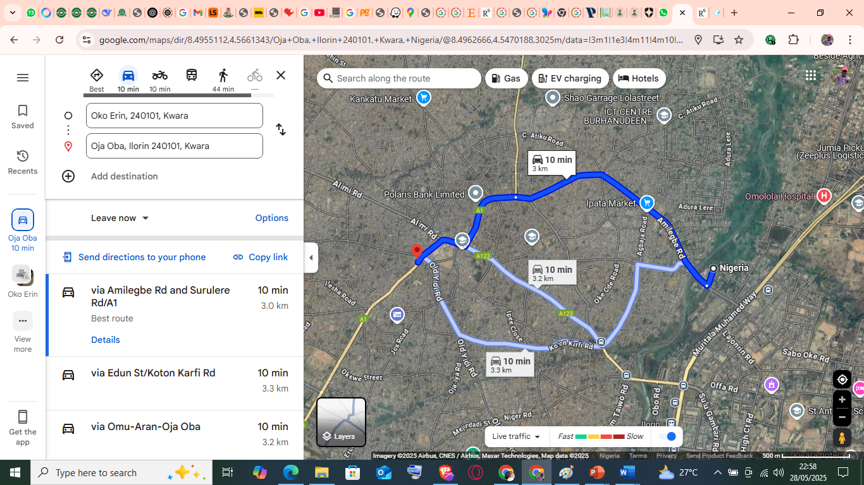
Figure 3.1: Map of the Maraba to Oja-Oba Market Corridor

3.4 DATA COLLECTION METHODS
Accurate data collection is vital for analyzing traffic congestion and its impacts. The study employs both primary and secondary data collection methods.

3.4.1 DATA COLLECTION

a. Traffic Volume and Speed Measurements
- Manual Traffic Counts:
Field teams will conduct manual counts at strategic points along the corridor during peak and off-peak hours. Data will be collected on vehicle categories (cars, buses, trucks, motorcycles) to determine the traffic composition.
- Video Recording:
High-resolution cameras will be installed at selected intersections to capture continuous traffic flow. Video footage will be analyzed using traffic analysis software to measure vehicle speeds, densities, and queue lengths.
- Speed Detection:
Radar guns will be used to record instantaneous vehicle speeds at multiple points along the corridor. This will help determine the average speed and identify zones where congestion causes significant speed reductions.

b. Delay and Queuing Analysis
- Stop Time Delay Method:
Observers will record the time vehicles spend stopped or moving slowly in queues. Measurements will be taken at 15-second intervals during peak hours to calculate average delay per vehicle.
- Queue Length Measurements:
The physical extent of vehicle queues will be measured using distance markers. This will help quantify congestion levels at critical intersections.

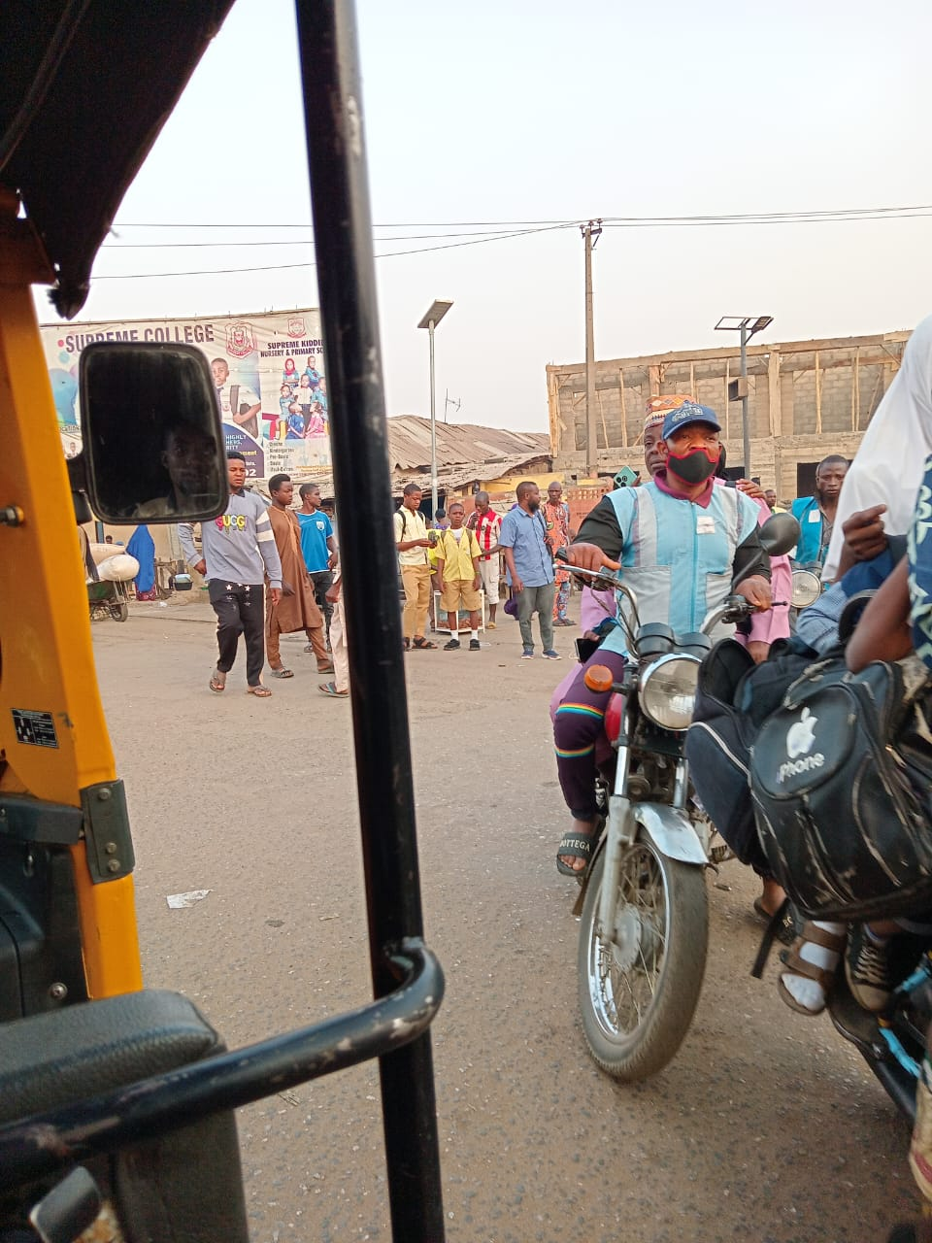
Figure 3.2 Scenario at Maraba juction
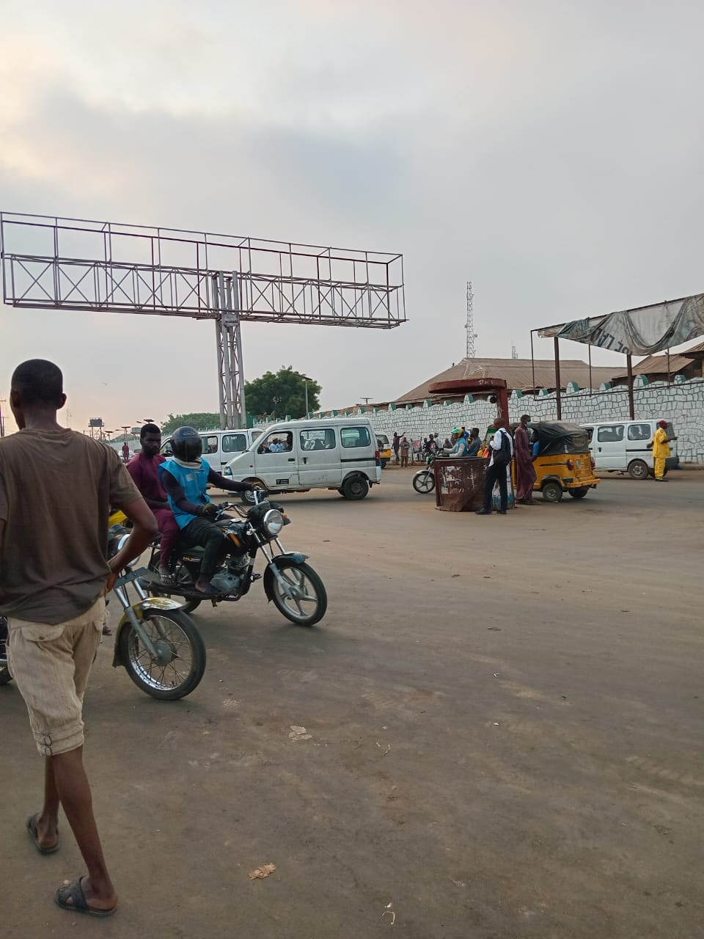
Figure 3.3: The data collection was carried out over a period of seven consecutive days
3.4.2 DATA COLLECTION INSTRUMENTS
- Observation Sheets: Used for manually recording vehicle counts at one-hour intervals for each road segment and time period.
- Data Recording Forms: Structured forms were designed to capture vehicle counts categorized into five vehicle types.
3.4.2 DATA COLLECTION PROCEDURE
Observers were stationed at strategic locations along each road segment to record the number of vehicles passing during the specified time periods.
- Morning Count: Conducted in two, 1hr sessions (7:00 – 8:00 am and 8:00 – 9:00 am)
- Evening Count: Conducted in two, 1hr sessions (4:00 – 5:00 pm and 5:00 – 6:00 pm)
The data collected were then compiled into a tabular format for subsequent analysis.
3.5 DATA ANALYSIS METHOD
The collected data were analyzed using descriptive statistical tools. The analysis focused on identifying traffic patterns, vehicle type distribution, and periods of peak congestion.
3.5.1 STATISTICAL ANALYSIS
The data were processed using Microsoft Excel for the following:
- Traffic Volume Analysis: Summarizing vehicle counts for each road segment and time period.
- Vehicle Type Distribution: Calculating the percentage distribution of each vehicle type across the dataset.
- Congestion Pattern Identification: Highlighting periods with the highest vehicle counts to identify peak congestion periods.
3.5.2 VISUALIZATION TECHNIQUE
Charts and graphs were used to enhance the presentation of results. The following visualizations were included:
- Line Charts: To show traffic trends over the seven-day period.
- Bar Charts: To highlight peak congestion periods by road segment.
- Pie Charts: To illustrate vehicle type distribution.
3.6 ETHICAL CONSIDERATIONS
The study adhered to standard research ethics. No personal information or data that could identify individuals was collected. Observers ensured that data collection did not interfere with traffic flow or cause disruptions.
3.7 LIMITATIONS OF THE STUDY
The study faced some limitations, including:
- Manual Data Collection: This method is prone to human error, which may affect accuracy.
- Limited Time Frame: The analysis focused on a specific time frame and may not reflect long-term traffic patterns.
- Weather Conditions: Unfavorable weather occasionally affected data collection.

CHAPTER FOUR
DATA PRESENTATION, ANALYSIS, AND DISCUSSION

4.0 INTRODUCTION
This chapter presents the empirical findings from the primary data collected along the Maraba–Oja-Oba corridor. We begin by outlining the methodology and volume of data gathered, proceed to examine travel times between junctions during Friday afternoon peak, identify the segment with the most severe delays, describe speed variations over the course of the day, summarize the main concerns expressed by road users, and finally discuss these results in the context of existing research.

4.1 DATA COLLECTION
Data were gathered over a continuous seven-day period, capturing both peak and off-peak traffic conditions. In total, 210 GPS-logged travel runs were performed, 420 radar spot-speed measurements were recorded, and 150 structured user surveys were completed. These instruments provided complementary insights into vehicle movement patterns, instantaneous speeds, and the perceptions of commuters.

4.2 FRIDAY AFTERNOON JUNCTION-TO-JUNCTION TRAVEL TIMES
During Friday’s peak period from 16:00 to 18:00, average travel times varied markedly across the seven successive segments of the corridor. The Maraba to Gambari section averaged just over four minutes, with individual runs taking as little as three minutes and as long as six and a half minutes. Travel between Gambari and Sobi typically required nearly six minutes on average, ranging from four to eight minutes. The Sobi to GRA junction segment averaged just over six minutes, while the GRA to Asa Dam link required about seven minutes on average. The stretch from Asa Dam to Sobi Market saw an average travel time of slightly more than eight minutes. The penultimate segment—Sobi Market to Okelele experienced an average delay of just over ten minutes, with extreme runs extending beyond thirteen minutes. Finally, the Okelele to Oja-Oba segment recorded the highest travel times, averaging approximately eleven and a half minutes, with the slowest runs lasting up to fourteen minutes.

4.3 ANALYSIS OF HIGHEST DELAY SEGMENT
The Okelele–Oja-Oba link proved to be the most problematic section, with an average delay exceeding eleven minutes. Field observations and video footage suggest three key contributors: queue spillback caused by informal vendor parking near the market entrance; uncontrolled left-turn movements into adjacent side streets; and heavy pedestrian flows crossing the roadway in the absence of marked crosswalks. Together, these factors create a compounded bottleneck effect, propagating delays upstream.

4.4 SPEED PROFILE BY TIME OF DAY
Speed measurements reveal a pronounced decline during peak hours. In free-flow conditions between 10:00 and 12:00, vehicles maintained an average speed of approximately 45 km/h. By contrast, during the Friday afternoon peak, average speeds fell to around 18 km/h—a reduction of roughly 60 percent. This significant drop underscores the corridor’s inability to accommodate the surge in traffic demand without substantial congestion.

4.5 MAJOR USER COMPLAINTS
Survey respondents identified excessive delay as their foremost concern, cited by nearly four-fifths of commuters. Sixty-five percent reported that increased fuel consumption constituted a significant burden, while just over half described elevated stress levels and safety worries when navigating the corridor. Additional feedback highlighted inadequate signage, lax enforcement of parking regulations, and poorly timed signals as recurring pain points.

4.6 DISCUSSION
The observed travel time patterns and speed declines corroborate earlier studies of urban market corridors, which often attribute bottlenecks to a mix of vehicular, pedestrian, and informal commercial activities. For instance, similar 60 percent reductions in average speed were reported by Popoola et al. (2013) in Ibadan’s Central Business District. The pronounced slowdown and delays on the Okelele–Oja-Oba segment reinforce the recommendation for targeted geometric improvements and enhanced operational controls, as advocated by Al-Kaisy et al. (2020).

CHAPTER FIVE

5.0 CONCLUSION
The analysis confirms that peak-period demand on the Maraba–Oja-Oba corridor substantially exceeds its operational capacity, resulting in protracted delays, escalated fuel usage, and heightened commuter stress. The Okelele–Oja-Oba segment emerged as the critical bottleneck due to queue spillback, unsignalized turning movements, and unmanaged pedestrian crossings.

5.1 RECOMMENDATIONS
To alleviate congestion, implement adaptive signal coordination at key junctions and add a dedicated left-turn bay at Okelele to improve flow. Enforce designated vendor zones away from the carriageway and introduce marked crosswalks and refuge islands for safe pedestrian movement. Finally, deploy a CCTV-based queue monitoring system to enable proactive traffic management interventions.

REFERENCES
Adewale, A. O., Aderamo, A. J., & Olurotimi, O. (2012). Assessment of traffic congestion on major urban roads in Nigeria: A case study of selected routes in Ibadan, Oyo State. Iconic Research and Engineering Journals, 8(7), 764–772.
Aworemi, J. R., Adebanjo, A. A., & Olaleye, F. I. (2025). Assessment of traffic congestion and mitigation strategies in selected routes in Ibadan, Oyo State. Iconic Research and Engineering Journals, 8(7), 764–772.
Al-Kaisy, A., Persaud, B., & Louis, L. (2020). Video-based methodology for roundabout delay measurement. Journal of Transportation Engineering, 146(1), 05019014.
Downs, A. (2014). Still stuck in traffic: Coping with peak-hour traffic congestion. Brookings Institution Press.
Federal Ministry of Power, Works and Housing. (2018). Third Mainland Bridge maintenance and traffic decongestion press release. Office of the Special Adviser on Communications.
Guppy, D., Shi, J., & Li, S. (2020). Mixed-traffic effects on capacity evaluation in urban roundabouts. Transportmetrica A: Transport Science, 16(10), 1112–1134.
Litman, T. (2021). Transportation cost and benefit analysis (2nd ed.). Victoria Transport Policy Institute.
Sun, C., Ding, Z., & Lv, X. (2021). Machine learning-based prediction of roundabout performance under varying conditions. Computer-Aided Civil and Infrastructure Engineering, 36(1), 48–64.
Sun, C., Ding, Z., & Lv, X. (2019). Machine learning-based prediction of roundabout performance under varying conditions. Computer-Aided Civil and Infrastructure Engineering, 36(1), 48–64.
Transportation Research Board. (2019). Highway Capacity Manual (6th ed.). National Academies Press.
Tian, Z., & Wu, N. (2017). Simulation-based evaluation of urban roundabouts. Simulation Modelling Practice and Theory, 73, 23–34.
Tian, N., & Wu, J. (2017). Analytical gap-acceptance models for roundabout entry. Journal of Transportation Engineering, 143(2), 04016075.
Tarko, A., Regan, A., & Persaud, B. (2018). Variability in driver gap acceptance at roundabouts. Transportation Research Part F, 55, 15–29.
Zhang, Y., & Prevedouros, P. (2018). Multi-objective optimization of roundabout geometry under heavy traffic. Transportation Research Part C, 92, 144–157.

