KWARA STATE POLYTECHNIC ILORIN, KWARA STATE.
INSTITUTE OF TECHNOLOGY
DEPARTMENT OF CIVIL ENGINEERING

EROSION CONTROL TECHNIQUES FOR PROTECTING INFRASTRUCTURES. A CASE STUDY OF EERO-OMO HEALTH CENTRE, OFFA GARRAGE, ILORIN.
BY
SAHEED MUHAMMED ADISA
HND/23/CEC/FT/0246

BEING IN RESEARCH WORK SUBMITTED TO THE DEPARTMENT OF CIVIL ENGINEERING, INSTITUTE OF TECHNOLOGY, KWARA STATE POLYTECHNIC, ILORIN

IN PARTIAL FULFILMENT OF THE REQUIREMENT FOR THE AWARD OF HIGHER NATIONAL DIPLOMA (HND) IN CIVIL ENGINEERING
JUNE 2025.

CERTIFICATION
This is to certify that this research study was conducted by SAHEED, MUHAMMED (HND/23/CEC/FT/0246) and had been read and approved as meeting the requirement for the award of Higher National Diploma (HND) in Civil Engineering of the Department Civil Engineering, Institute of Technology, Kwara State Polytechnic, Ilorin.

………………………. ……………………
ENGR, (MISS) M. F. RAJI DATE
Project Supervisor

……………………………………. ……………………..
ENGR. A. NAALLAH DATE
Head of Department

……………………………. ……………………..
ENGR. DR. MUJEDU KASALI ADEBAYO DATE
External Examiner

DECLARATION
I hereby declare that this project work titled EROSION CONTROL TECHNIQUES FOR PROTECTING INFRASTRUCTURES. CASE STUDY (ERO-OMO HEALTH CENTRE ROAD, ILORIN KWARA STATE). is a work done by me, SAHEED MUHAMMED with matric number, HND/23/CEC/FT/0246 of the Department of Civil Engineering, Institute of Technology, Kwara State Polytechnic, Ilorin.

__________________ ______________
Signature Date

DEDICATION
This project is dedicated solemnly to God Almighty, who is the sole inspiration of all things, without whom there would not be, and neither would this project.
Appreciation goes to my loving parents for their support in the fulfillment of my Higher National Diploma (HND) both orally and financially. May God allow them to eat the fruit of their labor (Amen)

ACKNOWLEDGEMENT
I express my profound gratitude to God in heaven, Alpha and Omega for the protection and support to finish the HND program successfully.
My sincere appreciation goes to my parents MR & MRS SAHEED for their for r immense contributions and love so far, I pray you both shall not be found dead when my glory shines higher.
I also recognize the effort of my coordinator and supervisor ENGR. A. O. SAADU for his guidance and full commitment during the course of this project. My gratitude also goes to my uncle and special ones, for their support both monetary and advising aspects, may God bless you and move you all higher in Jesus name.
My overall appreciate and thanks goes to my school mentor Engr., Mohammed Taofeeq Olabanji and Engr. Sanni Ridwan Olawale for their wonderful advice , mentorship and guidance so far. I came back for HND just as you wished for and I appreciate that a lot, I pray God reward and bless you big.
And to all my lecturers and my Departmental Head, in person of ENGR ABDULMUMEEN NA'LLAH, I acknowledged you contributions too and I say a very big thank you all.

TABLE OF CONTENTS
Title page
Declaration i
Certification ii
Dedication iii
Acknowledgement iv
Table of Contents v
Abstract vii
CHAPTER ONE
1.0 Introduction 1
1.1 Background of the Study 2
1.2 Problem Statement 3
1.3 Justification of the Study 4
1.4 Aim of the study 4
1.5 Objectives of the study 6
1.6 Scope of the Study 6
1.7 Description of the study 6
CHAPTER TWO
2.0 Literature Review 7
2.1 Preamble 7
2.2 Causes and Effects of Erosion in Urban Areas 7
2.2.1 Causes of Erosion in Urban Areas 7
2.2.1.1 Rainfall and Surface Runoff 8
2.2.1.2 Poor Drainage Infrastructure 8
2.2.1.3 Deforestation and Vegetation Loss 8
2.2.1.4 Uncontrolled Urbanization and Poor Land Use Planning 8
2.2.1.5 Soil Type and Topography 9
2.2.1.6 Poor Waste Management 9
2.2.1.7 Road and Construction Activities 9
2.2.2 Effects of Erosion in Urban Areas 10
2.2.2.1 Damage to Roads and Transportation Networks 10
2.2.2.2 Building and Structural Failures 11
2.2.2.3 Increased Flooding and Water Pollution 10
2.2.2.4 Loss of Arable Land and Reduced Agricultural Productivity 10
2.2.2.5 Increased Maintenance and Rehabilitation Costs 10
2.2.2.6 Public Health and Safety Hazards 11
2.2.2.7 Socioeconomic Disruptions 11
CHAPTER THREE
  - Methodology 12
3.1 Materials data collection methods 12
3.2 Photographic documentation 13
3.3 Oral interview 13
3.4 Field survey materials 14
CHAPTER FOUR
4.0 Presentation and analysis of result 15
4.1 Possible causes of erosion in ero-omo health center area in Ilorin, Kwara State. 18
4.2 Effect of erosion in the study areas 20
4.3 Controls of erosion in the study areas 21
CHAPTER FIVE
5.0 Conclusion and recommendation 23
5.1 Conclusion 23
5.2 Recommendation 24
REFERENCES 25

List of Tables
Table 4.1: Analysis of Questionnaire
Table 4.2: Age of Respondents
Table 4.3: Educational Background of Respondents
Table 4.4: Possible Causes of Erosion in Ero-Omo Health Center Area in Ilorin, Kwara State
Table 4.5: Effect of Erosion in the Study Areas
Table 4.6: Control Measure of Erosion in the Study Area

List of Figures
Figure 4.1: Age Grade (Bar Chart)
Figure 4.2: Educational Background of the Respondents (Bar Chart)
Figure 4.3: The Cause of Erosion in the Study Area
Figure 4.4: The Effect of Erosion
Figure 4.5: Control Measure of Flood

List of Plates (Photographic Evidence)

Plate 4.1: Study Area
Plate 4.2: Study Area

Abstract
Erosion poses a significant threat to urban infrastructure, particularly in rapidly developing regions with inadequate environmental planning. This study investigates erosion control techniques aimed at protecting infrastructures in the Offa Garage area beside Ero-Omo Health Center in Ilorin, Kwara State. The research adopts a mixed-method approach involving field surveys, photographic documentation, oral interviews, and structured questionnaires to assess the causes, effects, and mitigation strategies related to erosion in the study area. Data gathered from 65 respondents indicate that the major causes of erosion include inadequate drainage systems, improper waste disposal, non-channelization of stormwater, and illegal structures obstructing natural watercourses. The effects identified range from reduced commercial activities and socio-economic disruption to property damage and infrastructural instability. The study highlights that the most effective control measures, as recommended by respondents, include constructing adequately sized drainage channels, prohibiting waste dumping in water paths, and enforcing urban planning regulations. This research underscores the need for integrated erosion management strategies that combine engineering solutions with community engagement and government policy enforcement. The findings provide actionable insights for urban planners, engineers, and policymakers in developing resilient infrastructure and safeguarding vulnerable urban environments.

CHAPTER ONE
INTRODUCTION
1.1 Background of the Study
Erosion is a major environmental issue affecting both urban and rural areas, leading to significant land degradation, infrastructural damage, and economic losses. It is primarily caused by natural forces such as rainfall, wind, and surface runoff, but human activities like deforestation, poor drainage systems, unregulated land use, and improper construction practices have intensified its effects (Ighodalo et al., 2020). In many developing countries, rapid urbanization without adequate planning has led to increased soil exposure and loss, resulting in the formation of gullies, sediment deposition in waterways, and the destruction of roads, bridges, and buildings. Erosion affects agricultural productivity by removing the fertile topsoil, increases the risk of flooding due to sediment accumulation in drainage channels, and threatens human settlements by undermining the foundations of structures. In highly populated areas, these effects can lead to costly infrastructural repairs, loss of property, and displacement of communities. Governments and urban planners worldwide are continuously seeking effective erosion control measures to minimize its impact, as failure to address erosion issues could lead to long-term environmental and socio-economic consequences.
Ilorin, the capital of Kwara State, is particularly vulnerable to erosion due to its tropical climate, characterized by intense seasonal rainfall and a lack of well-structured drainage networks (Balogun et al., 2021). The expansion of roads, buildings, and other infrastructure without proper soil stabilization measures has contributed to increased runoff and sediment displacement (Salami et al., 2020). Erosion not only damages infrastructure but also leads to loss of arable land, destruction of property, and increased risk of flooding (Olaniyan et al., 2021).
One of the most affected areas in the vicinity of Ero-Omo Health Center. The area has witnessed significant erosion-related challenges, including road degradation, building foundation failures, and blocked drainage systems, which negatively impact mobility, economic activities, and public health (Fashola et al., 2020). Without effective intervention, the continuous expansion of gully erosion in this area could lead to more severe damage, posing a threat to both public and private infrastructure (Bello et al., 2020).
Erosion control measures have been implemented in various parts of Nigeria, including bioengineering techniques, construction of reinforced drainage systems, and the use of geotextiles to stabilize the soil (Lawal et al., 2020). However, the effectiveness of these measures varies based on site-specific conditions such as soil type, hydrological patterns, and maintenance practices (Oluwaseun et al., 2021). Evaluating the suitability and efficiency of these control measures in Ilorin West is necessary to develop sustainable solutions that can protect infrastructure and enhance environmental resilience (Adebisi et al., 2023).
This study focuses on assessing the effectiveness of existing erosion control techniques in Offa Garage and exploring more sustainable solutions to mitigate further infrastructure damage. By examining erosion patterns, evaluating current mitigation strategies, and proposing improved interventions, this research will contribute to informed decision-making for urban planning and environmental management in Ilorin and other erosion-prone areas in Nigeria (Okonkwo et al., 2020).

1.2 Problem Statement
The Offa Garage area beside Ero-Omo Health Center faces a severe environmental challenge due to erosion, triggered by poor drainage systems, uncontrolled runoff, and soil degradation, resulting in infrastructural damage, gully formation, sediment deposition, and structural instability that threatens transportation, economic activities, and public safety, with rapid urbanization and inadequate land management practices exacerbating the problem and underscoring the need for effective evaluation and implementation of erosion control techniques to ensure infrastructure sustainability.
1.3 Justification of the Study
This study is crucial in addressing the significant environment and infrastructural challenge posed by erosion, particularly along Ero-Omo Health Center Road. The escalating rate of soil degradation and structural instability of roads and buildings necessitates a comprehensive evaluation of erosion control measure. Infrastructure failure due to erosion results in increased maintenance costs, disrupted transportation networks, and heightened risks of accidents and flooding. By integrating geotechnical and hydrological evaluations, this research provides a scientific basis for assessing erosion control methods, generating empirical data on the effectiveness of structural and bioengineering techniques. The findings will offer practical recommendations for urban planners, engineers, and policymakers, ultimately improving living conditions for local communities by mitigating reduced accessibility, repair costs, health risks, and environmental hazards. This study will serve as a foundation for future research and practical interventions, contributing to sustainable urban development in Ilorin West and other erosion-prone regions in Nigeria.
1.4 Aim of the study
Aim:
To control erosion techniques for protecting infrastructures

1.5 Objectives of the study
The objectives are:
- To identify and determine the major causes responsible for erosion incidents in the study area.
- Effects of erosion in the infrastructure
- Suggest possible solutions to the problem.
1.6 Scope of the Study
This study focuses on evaluating erosion control techniques in Kwara State, specifically in Offa Garage beside Ero-Omo Health Center. The research will assess the causes, extent, and impact of erosion in the area, as well as the effectiveness of various control measures such as drainage systems, vegetation cover, and structural reinforcements.
The study will include soil analysis, hydrological assessments, and structural evaluations to determine the factors contributing to erosion. Field surveys and stakeholder interviews will be conducted to gather data on erosion patterns and control measures. The study is geographically limited to Offa Garage but will incorporate best practices from other regions for comparison.
1.7 Description of the study
The study is conducted in Offa Garage, Ilorin West, Kwara State, a rapidly urbanizing area prone to severe erosion.
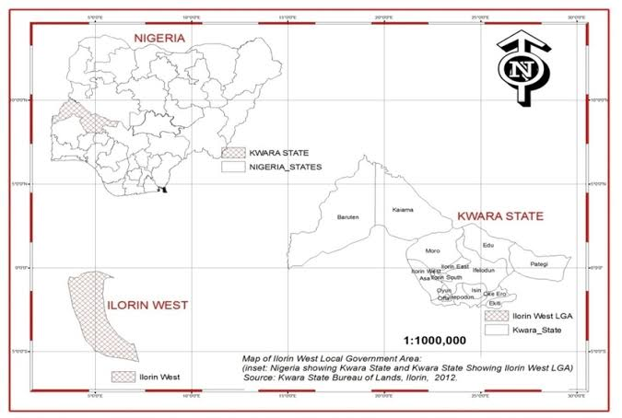
Source: Derived from O.Y Yahaya journal article (2018)

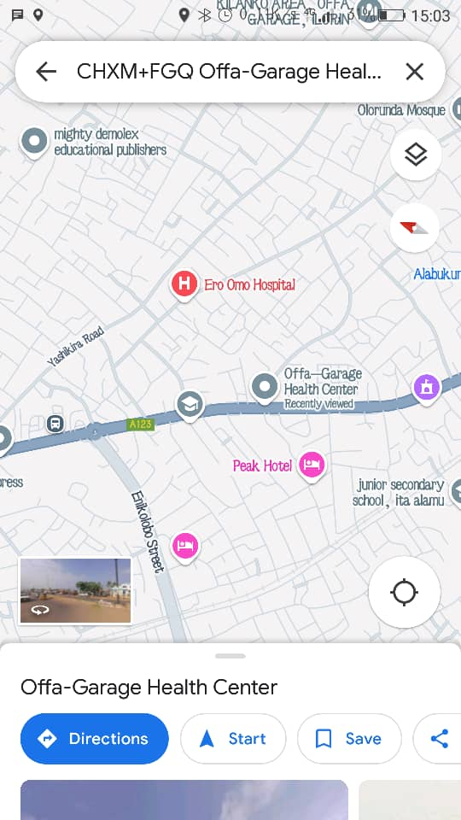

Source: GPS live location.

CHAPTER TWO
LITERATURE REVIEW
2.1 Preamble
Erosion is a natural process that involves the detachment, transport, and deposition of soil and rock materials by agents such as water, wind, and gravity (Morgan, 2009). However, human activities such as deforestation, poor land management, and urbanization have significantly accelerated erosion rates, leading to severe environmental and infrastructural challenges (Pimentel et al., 2013). Across the world, soil erosion is responsible for land degradation, reduced agricultural productivity, increased sedimentation in water bodies, and damage to roads, buildings, and drainage systems (Lal, 2019). In urban settings, the lack of proper stormwater management and inadequate erosion control techniques often result in infrastructure failures and economic losses (Poesen et al., 2019).
In Nigeria, erosion is a widespread problem, particularly in areas with heavy seasonal rainfall and poor drainage infrastructure (Igbokwe et al., 2008). States such as Anambra, Enugu, and parts of Kwara have experienced severe gully erosion, which has led to road collapses, building failures, and displacement of communities (Ofomata, 2001). Ilorin, the capital of Kwara State, is one of the urban centers where rapid development without proper land-use planning has contributed to increased erosion risks (Ogunbode et al., 2021). In particular, the Offa Garage area beside Ero-Omo Health Center has been significantly affected, with visible signs of road degradation, drainage blockages, and foundation failures in nearby buildings (Adeyemi & Olalekan, 2019).
Erosion control techniques play a crucial role in mitigating the adverse effects of soil displacement. Various engineering and biological methods have been employed to manage erosion, including the construction of drainage systems, use of retaining walls, afforestation, and application of geotextiles (Hudson, 1995). However, the effectiveness of these techniques varies depending on site-specific factors such as soil type, rainfall intensity, land slope, and maintenance practices (Lal et al., 2008). In Nigeria, many erosion control projects have failed due to inadequate planning, poor maintenance, and lack of community participation (Salami & Afolabi, 2020).

2.2 Causes and Effects of Erosion in Urban Areas
2.2.1 Causes of Erosion in Urban Areas
Erosion in urban areas results from a combination of natural factors and human activities, both of which accelerate soil displacement and degradation. The major causes of urban erosion include:
2.2.1.1 Rainfall and Surface Runoff
Rainfall intensity and frequency play a crucial role in soil erosion. In tropical regions such as Nigeria, heavy and prolonged rainfall generates high surface runoff, which removes topsoil and weakens the foundation of roads and buildings (Adeyemi & Olalekan, 2019). When rainfall exceeds soil infiltration capacity, water accumulates and flows over land, leading to rill and gully erosion (Balogun et al., 2021). In Ilorin West, poor drainage systems worsen the effects of rainfall, as water collects in streets and erodes unprotected surfaces (Fashola et al., 2020).
2.2.1.2 Poor Drainage Infrastructure
Inadequate or poorly designed drainage systems contribute significantly to urban erosion. When stormwater is not effectively channeled, it erodes road surfaces, weakens building foundations, and leads to flooding (Obafemi & Lawal, 2020). In Offa Garage, Ilorin West, many drainage channels are either too narrow, improperly constructed, or clogged with debris, preventing efficient water flow and increasing erosion risks (Ogunbode et al., 2021).
2.2.1.3 Deforestation and Vegetation Loss
Vegetation plays a vital role in stabilizing soil and reducing erosion. Trees and grasses slow down surface runoff, enhance soil permeability, and bind soil particles together (Blanco et al., 2008). However, urban expansion often leads to deforestation, as land is cleared for construction and roads. The removal of natural vegetation exposes soil to direct impact from raindrops, increasing erosion vulnerability (Afolabi et al, 2020).
2.2.1.4 Uncontrolled Urbanization and Poor Land Use Planning
Rapid urbanization without proper land-use planning is a major driver of erosion in developing cities (Hudson, 1995). In Ilorin, increasing population pressure has led to unregulated construction, expansion of paved surfaces, and land encroachments, which disrupt natural drainage systems (Adekunle et al, 2020). Improper siting of buildings on erosion-prone slopes further exacerbates soil instability and contributes to infrastructure failures .

2.2.1.5 Soil Type and Topography
Soil properties and land slope influence erosion severity. Sandy and silty soils are more susceptible to erosion due to their low cohesion and high permeability (Morgan, 2009). In contrast, clay soils, though more compact, can still experience erosion if subjected to excessive surface runoff. In Ilorin West, the combination of poorly consolidated soil and undulating terrain has created an environment where erosion is frequent and severe (Okonkwo et al., 2020).
2.2.1.6 Poor Waste Management
Improper disposal of solid waste can exacerbate erosion problems by blocking drainage channels and redirecting surface runoff onto vulnerable areas (Pimentel & Burgess, 2013). In Ilorin West, the accumulation of plastic waste, sand, and debris in storm drains has led to overflow and uncontrolled water movement, which accelerates erosion (Olaniyan et al., 2021).
2.2.1.7 Road and Construction Activities
Unregulated excavation and construction projects contribute to erosion by destabilizing soil structure and creating exposed surfaces (Lal, 2019). The use of heavy machinery, removal of topsoil, and inadequate compaction of embankments all increase the likelihood of soil displacement. In Offa Garage, ongoing road construction projects without sufficient erosion control measures have led to increased sediment transport during rainfall events (Fashola et al., 2020).

2.2.2 Effects of Erosion in Urban Areas
The consequences of erosion in urban environments are far-reaching, affecting infrastructure, economy, environment, and public health. The key effects include:
2.2.2.1 Damage to Roads and Transportation Networks
Erosion weakens road surfaces, creates potholes, and leads to road collapse in extreme cases (Boardman & Poesen, 2019). In Ilorin, unpaved roads in erosion-prone areas become impassable during rainy seasons, disrupting transportation and increasing vehicle maintenance costs (Adeyemi & Olalekan, 2019).
2.2.2.2 Building and Structural Failures
Foundation erosion is a critical issue in urban areas. When soil around buildings is washed away, structural integrity is compromised, leading to cracks, tilting, and even collapse (Ofomata, 2001). In Offa Garage, several buildings near erosion-prone areas have experienced foundation failures due to continuous soil loss (Balogun et al., 2021).
2.2.2.3 Increased Flooding and Water Pollution
Sediment from eroded land is often washed into rivers, lakes, and drainage channels, reducing their capacity to manage stormwater (Blanco & Lal, 2008). This leads to frequent urban flooding, which damages property and poses health risks to residents. Additionally, erosion transports pollutants such as heavy metals and pesticides into water bodies, deteriorating water quality (Obafemi & Lawal, 2020).

2.2.2.4 Loss of Arable Land and Reduced Agricultural Productivity
Urban expansion and erosion reduce the availability of fertile land for agriculture. Topsoil, which contains essential nutrients for plant growth, is often lost to erosion, leading to decreased agricultural yields (Pimentel & Burgess, 2013). In peri-urban areas of Ilorin, soil degradation due to erosion has made farming less viable (Ogunbode et al., 2021).
2.2.2.5 Increased Maintenance and Rehabilitation Costs
Erosion-induced damage to infrastructure results in high repair and maintenance costs for governments and private property owners (Salami & Afolabi, 2020). Roads require frequent resurfacing, buildings need reinforced foundations, and drainage systems must be continually cleared of sediment (Adebisi et al., 2023).
2.2.2.6 Public Health and Safety Hazards
Erosion can create hazardous environments, particularly when deep gullies form near residential areas (Hudson, 1995). These gullies pose risks of accidents, including vehicle crashes and pedestrian falls. Additionally, stagnant water in erosion-affected areas becomes a breeding ground for disease-carrying mosquitoes, increasing the prevalence of malaria and other vector-borne diseases (Adekunle & Bello, 2020).
2.2.2.7 Socioeconomic Disruptions
Erosion-related damage affects local economies by disrupting businesses, reducing property values, and increasing the financial burden on residents (Okonkwo et al., 2020). In Offa Garage, businesses near erosion-prone areas face reduced customer access and increased costs for road repairs and flood mitigation (Adeyemi & Olalekan, 2019).
CHAPTER THREE
METHODOLOGY
3.1 MATERIALS
The materials used in this study were selected to facilitate comprehensive field surveys, hydrological assessments, and structural evaluations of erosion control measures in Offa Garage beside Ero-Omo Health Center. Standard testing methods, including those specified by the American Society for Testing and Materials (ASTM), were adhered to for accurate and reliable results.
  - DATA COLLECTION METHODS
The data collection approach which was adopted is the descriptive field survey where questionnaire was administered to the respondent.
The questionnaires were administered using a list of the inhabitants of the environment and those that erosion have sent parking from the environment where the overflowing water in the drainage is causing a great havoc to the people. A total of 100 samples were obtained to which the questionnaires were administered. A total of 65 were completed and return.
The questionnaires were filled by the people residing in the area this includes teacher, Okada rider, the market women and men.
The questionnaire consists of 8 questions and was divided into two sections. In Section A, general questions about the respondent were asked. In Section B, question relating to the causes, effect and control measure of the erosion were asked. The entire questions are close ended questions.
Question 1-3 in Section A asked the people residing in the areas location, Age and Education background.
Question 4-6 in Section B is related to the view of people on the cause, effect and into measure of erosion. A respondent was asked to grade each question and scale of 1 to 5. ‘1’ correspond to the location of the respondent, ‘2’ correspond to the age of the respondent, ‘3’ correspond to educational background of the respondent, ‘4’ correspond causes of erosion, ‘5’ correspond to effect erosion, ‘6’ correspond to the control measure of erosion.
The concept that related to the erosion exact and the solution are choosing from the literature review and these include lack of inadequate drainage, dumping of refuse along the line drain. Illegal structure non-channelization and the solution to it are provision of drainage with adequate capacity of the drains, removal of illegal structure on erosion plain, prohibition of dumping of refuse along drainage channel. Construction of embankment to raise river bank. The rational of asking the above question in the format discussed above is because it gave greater charity into which state of development of the erosion and the criteria for finding solution to the effect of the flood that leads to erosion damages. The question will help to achieve the objective of the problem research work.

3.2 PHOTOGRAPHIC DOCUMENTATION
The selected area was visited and the picture of the causes and effect of rainfall disasters in the selected affected area was taken with digital camera to establish pictorial evidence of the causes and effect of the case study.

3.3 ORAL INTERVIEW
It is conducted to ascertain the structural and non-structural measure adopted to control flooding and erosion incidences, the presence state of the facilities in place and to know how the effective are measure.

3.4 FIELD SURVEY MATERIALS
The materials used to carry out this research work includes: Measuring Tape, Ranging Poles used for measuring gully dimensions (depth, width, and length), Camera/Drone used for capturing images of erosion sites for documentation and comparative analysis, Notebook and Field Data Sheets used for recording field observations, measurements and community responses.

CHAPTER FOUR
4.0 PRESENTATION AND ANALYSIS OF RESULT
Selected Area | Number of distributed questionnaires | Number of questionnaires received | % Of respondent
Ero-Omo Road | 30 | 25 | 38.5%
Ilorin-Ajasse-Ipo Road | 25 | 15 | 23.1 %
Yashikira Road | 25 | 15 | 23.1%
Kilanko Road | 20 | 10 | 15.3%
Total | 100 | 65 | 100%
Table 4.1: Analysis of Questionnaire

Age (year) | Number of respondents |  |  |  | Total number of age | % Score
 | A | B | C | D
20-30 | 5 | 3 | 7 | 3 | 18 | 27.7%
31-40 | 6 | 2 | 0 | 3 | 11 | 16.9%
41-50 | 8 | 4 | 6 | 3 | 21 | 32.3%
Above 50 | 6 | 6 | 2 | 1 | 15 | 23.1%
Total | 25 | 15 | 15 | 10 | 65 | 100%
Table 4.2: Age of Respondent

A | Ero-Omo Road
B | Ilorin-Ajasse-Ipo Road
C | Yashikira Road
D | Kilanko Road

FIGURE 4.1: Age Grade
A bar chart of Age of respondent
Table 4.2 shows the Age Grade of respondent. Out of the total numbers of 65 respondents, 18 respondents which represent 27% of the population are between 20-30 year, 11 respondents which represent 16.9% of the population are between 31-40 years, 21 respondents which represent 32.3 % of the population are between 41-50 year while the remaining 15 respondents which represent 23% of population are above 51 years.
Qualification | Number of Respondent |  |  |  | Total number of Qualification | % Score
 | A | B | C | D
WAEC | 8 | 4 | 6 | 3 | 21 | 32.3%
OND | 6 | 6 | 2 | 1 | 15 | 23.1%
HND/BSC | 6 | 2 | 0 | 3 | 11 | 16.9%
OTHER | 5 | 3 | 7 | 3 | 18 | 27.7%
Total | 25 | 15 | 15 | 10 | 65 | 100%

Table 4.3 Educational Background of Respondents

The table above shows the educational background of the respondents. 21 respondents which represent 32.3% of the population are WAEC holders, 15 respondents which represent 23.1 % of the population are OND holder, and 11 respondents which represent 16.9% of the population are HND/BSC holder while the remaining 18 respondents which represent 27.7% of the population are other qualification holder.

FIGURE 4.2: Educational background of the respondents.
A bar chart of number of qualifications obtained by the respondents
Figures 4.2 show that a total number of 21 have WAEC qualification which considered as the lowest qualification required for this study. This indicate that the majority of the respondents have adequate qualification required for the information about the evaluation of erosion control techniques for protecting infrastructure in Ero-Omo Health center road in Ilorin, Kwara State.
4.1 POSSIBLE CAUSES OF EROSION IN ERO-OMO HEALTH CENTER AREA IN ILORIN, KWARA STATE.
The causes of erosion/gully are represented in Table 4.4 and Figure 4.3.
Causes of erosion | Number of respondents | % Score
Inadequate drainage | 14 | 28%
Dumping of refuse along the lined drain | 22 | 44%
Non-channelization | 10 | 20%
Illegal structure | 4 | 8%
Total | 50 | 100%
Table 4.4: Possible Causes of Erosion in Ero-Omo Health Center Area in Ilorin, Kwara State.

Figure 4.3: The cause of erosion in the Study Area
Table 4.4 shows that 28% of the respondents claimed that erosion is caused by lack of inadequate drainage, 44 % of the respondents claimed that erosion is caused by dumping of refuse along the lined drain which is the principle causes of gully. 20% of the respondents claimed that erosion is caused by non-channelization while the remaining 8 % claimed that erosion is caused by illegal structure.

4.2 EFFECT OF EROSION IN THE STUDY AREAS
Table 4.5 and Figure 4.4 stated out the effect of erosion in the study area by respondents.
Effect of erosion | Number of respondents | % Score
Reduction in the rate of customer patronage | 15 | 30%
Hindering of socio-economic development | 20 | 40%
Damaging of properties | 15 | 30%
Total | 50 | 100%
Table 4.5: Effect of Erosion in the Study Areas

Figure 4.4 The Effect of Erosion
Table 4.5 shows that erosion has effect in almost all human activities and their belongings in the study area. 30% of the respondents claimed that gully results to the reduction in the rate of customer patronage in the study area, 40% of the respondents claimed that erosion hindering socio-economic development of the area while the remaining 30% claimed that erosion cause damages of properties.
4.3 CONTROLS OF EROSION IN THE STUDY AREAS
The Table 4.6 presents suggestions for erosion control in Ero-Omo Health Center Road in Ilorin, Kwara State.
Control measure | Number of respondents | % Scores
Provision of adequate capacity of drains | 14 | 28%
Prohibition of dumping of refuse along drainage channel | 22 | 44%
Removal of illegal structure on flood plains. | 10 | 20%
Construction of embankment to raise river bank | 4 | 8%
Total | 50 | 100%
Table 4.6: Control Measure of Erosion in the Study Area

Figure 4.5: Control Measure of flood
Table 4.6 show that 28% of the respondents recommended the provision of adequate drainage to eradicate erosion problem in the study area, 44% of the respondents recommended the prohibition of dumping of refuse along drainage channel for eradication of erosion problem, 20% of the respondents recommended the removal of illegal structure as a way of controlling erosion while the remaining 8% of the respondent suggest the construction of embankment to raise river bank.
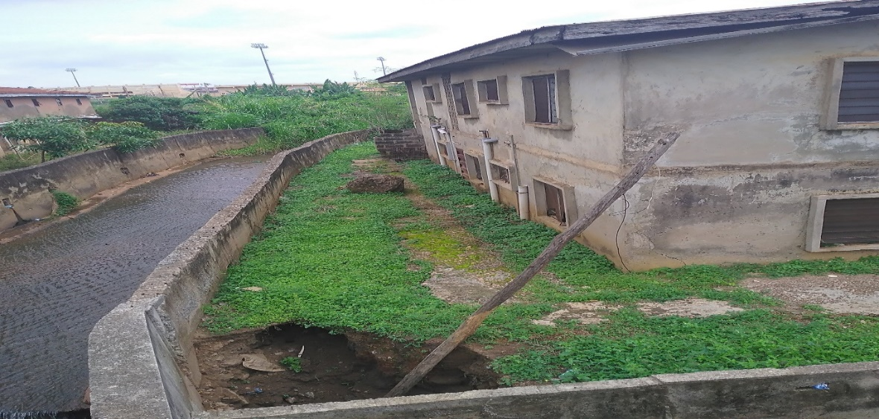
Plate 4.1 Study Area

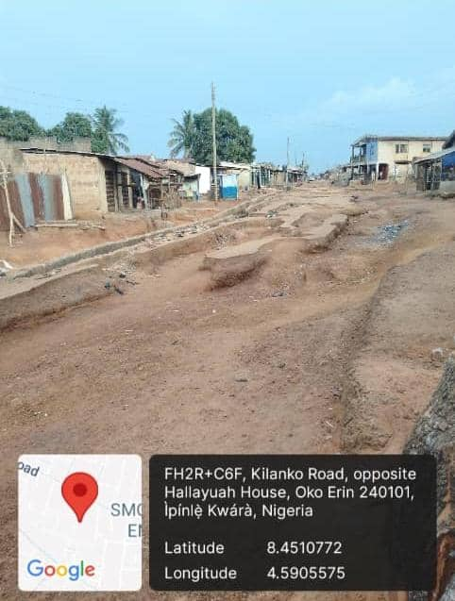

Plate 4.2 Study Area
CHAPTER FIVE
5.0 CONCLUSION AND RECOMMENDATION
5.1 CONCLUSION
From the responses of the respondent, we therefore concluded that there is frequent erosion in Ero-Omo Health Center Road, Ilorin Kwara State, this erosion is seasonal i.e., it comes whenever there is raining season.
The result obtained indicated that gully usually occurred due to the following events:
- Dumping of refuses along the lined drain
- Inadequate Drainage
- Non- Channelization
- Illegal Structure
On the other hand, it was also indicated that erosion incident has major effect such as reduction in the rate of customer patronage, hindering of socio-economic development and damaging of properties in the study area. Therefore, we concluded that the major cause of erosion is dumping of refuse along the lined drains and Inadequate drainage. Also, there is no doubt that erosion hindered the development of the study areas.
5.2 RECOMMENDATION
This research work made the following recommendation to help the federal government of Nigeria, Kwara State government and the entire people of Kwara State indecision making; some of the recommendations are stated as follows:
- The State Government should improve on the construction of drainage, because lack of drainage can affect the road of Kwara State and the day-to-day activities of the study area.
- The State Government should encourage most of the manufacturing companies to assist in building new drainage and renovation of existing ones.
- The Government should prohibit the act of dumping refuse along drainage channel.
- The Government should construct adequate embankment to raise the river bank.
- Law should be made by government to against the construction of illegal structure on erosion plains.

REFERENCES
Ighodalo et al., (2020): Stemming the Tide of Lagos Floods, in: The Guardian, Friday, July 20, pp:7.
Angela, K. Etuonovbe (2011): The Devastating Effect of Flooding in Nigeria. Bridging the Gap Between Cultures, FIG Working Week, Marrakech, Morocco,
Olaniyan T.O, Ariyanbandu, M.M. and Wackramasinghe, W.M. 2015. Gender Dimension in Disaster Management: A guide for South Asia: Sri Lanka.
Baiye, E., 1988. Numan in the Throes of Floods, in: The Guardian, Thursday, October 8, pp: 9.
Bhola A.M., Char N.V.V. and Khanna R.K., “Flood disaster and its management” Symposium on Preparedness, Mitigation and Management of Natural Disaster, New Delhi, August, 1989.
Brooks, N. Hall, J. and Nicholls R. (2006). Sea level rise: Coastal Impacts and responses. Report submitted to WBGU-Expert for NBGU on Ocean and Global change.
Carter, W. Nick. 1991. Disaster Management – Disaster Managers’ Handbook. Manila, Philippines: Publication of the Asian Development Bank.
Douben, J.K. 2006. Characteristics of River floods and Flooding: A Global Overview, 1985- 2003. Journal, 59:59-521.
Durotoye, B., 1999. Human Occupation of Hazard Areas in Nigeria, in: Oshuntokun, A. (ed.) Environmental Problems of Nigeria. Lagos: Friedrich Ebert Foundation. Edward-
French, G. T. Awosilla, L. F. and Ube, C. E. (1995) Nigeria: More than 3 million may have to move from lowlands in Nigeria. Climate Alert 8 (2) March-April, 1995.
Nicholls, R. J. & Mimura, N (1998) Regional issues raised by sea-level rise and their policy implications Climate Research; Vol. 11: 5–18
Nott, J. 2006. Extreme Events: A Physical Reconstruction and Risk Assessment. Cambridge University Press. New York.
Okeke, I. C (2003) Coastal Challenges and the Challenges of Coastal Education in a Paper Presented to Conek International. Lagos.
Oluduro, C., 1988. Grappling with the Problem of Flood, in: Daily Times, Tuesday July 5, pp: 11.
Oni, S. I. (2003). Owards Sustainable Coastal hazard management in Nigeria. Paper submitted at the International Conference on Estuaries and Coasts. Nov. 9 – 11 2003.

