DEVELOPMENT OF AI-DRIVEN THERMAL MANAGEMENT SYSTEMS FOR OPTIMIZE COOLING IN DEVICES AND ENVIRONMENT

BY

OSINOWO QUDUS DAMILOLA
HND/23/COM/FT/0218

A PROJECT SBUMITTED TO THE
DEPARTMENT OF COMPUTER SCIENCE,
INSTITUTE OF INFORMATION AND COMMUNICATION TECHNOLOGY
KWARA STATE POLYTECHNIC, ILORIN

In Partial Fulfillment of the Requirements for the Award of Higher National Diploma (HND) in Computer Science

JULY, 2025.

CERTIFICATION
This is to certify that this project research was carried out by OSINOWO QUDUS DAMILOLA Matriculation Number HND/23/COM/FT/0218 has been read and approved as meeting part of the requirements for the award of Higher National Diploma (HND) in Computer Science.

…………………………. ………………………….
DR. RAJI A. K. Date
Project Supervisor

…………………………. ………………………….
MR. OYEDEPO F. S Date
Head of Department

…………………………. ………………………….
External Examiner Date

DEDICATION
This project is dedicated to the creator of the earth and the universe, the Almighty God and my parents who inspired me and directed my ways during my academic stay in the polytechnic.

ACKNOWLEDGEMENT
All praise is due to Almighty God, the Lord of the universe. I praise Him and thank Him for giving me the strength and knowledge to complete my HND programme and also for my continued existence on the earth.

I appreciate the utmost effort of my supervisor, Dr. Raji, A. K whose patience, support and encouragement have been the driving force behind the success of this research work. He gave useful corrections, constructive criticisms, comments, recommendations, advice and always ensures that excellent research is done.

My sincere gratitude goes to Head of the Department Mr. F. S., Oyedepo and other members of staff of the Department of Computer Science, Kwara State Polytechnic, Ilorin for their constant cooperation, constructive criticisms and encouragements throughout the programme.

My propound gratitude goes to my entire family Mrs. Osinowo who exhibited immeasurable financial support, patience, support, prayers and understanding during the periods in which I was busy tirelessly working on my studies.
My sincere appreciation goes to my friends (Lukman Alameen Akanji, Lawal Lateef Adigun) and classmates.

ABSTRACT
The increasing thermal demands of modern electronic systems and environmental control infrastructures have necessitated the development of more intelligent and adaptive cooling strategies. Traditional thermal management systems, often based on fixed threshold or binary logic, suffer from inefficiency, delayed response, and inability to adapt to fluctuating environmental conditions. This project presents the design and implementation of an AI-driven thermal management system that utilizes fuzzy logic control (FLC) to dynamically manage cooling operations based on real-time environmental data.
The system integrates temperature and humidity sensors (such as the DHT22) with a microcontroller platform (ESP32), which serves as the central processing unit. Through a set of fuzzy logic rules, the system interprets environmental data and determines the appropriate fan speed or cooling response. This intelligent behavior ensures proportional and responsive thermal control, significantly reducing energy consumption while improving system stability and user comfort. A display unit provides real-time feedback, and optional wireless connectivity offers potential for remote monitoring and IoT integration.
The proposed system is modular, cost-effective, and scalable for various applications, including personal devices, smart homes, server rooms, and industrial automation environments. Testing and analysis demonstrate that the AI-driven system outperforms traditional methods in both accuracy and energy efficiency. This work contributes to the growing field of smart embedded systems by offering a flexible and sustainable solution to the challenge of thermal regulation in the era of connected and intelligent technologies

TABLE OF CONTENTS
Title page i
Certification ii
Dedication iii
Abstract iv
Table of contents v
CHAPTER ONE: GENERAL INTRODUCTION
1.1 Background to the Study 1
1.2 Statement of the Problem 3
1.3 Aim and Objectives 5
1.4 Significant of the Study 5
1.5 Scope of Study 7
1.6 Organization of the Report 7
CHAPTER TWO: LITERATURE REVIEW
2.1 Reviewed of Related Works 9
2.2 Reviewed of General Text 12
CHAPTER THREE: RESEARCH METHODOLOGY AND ANALYSIS OF THE SYSTEM
3.1 Research Methodology 15
3.2 Steps used in the Research Methodology 15
3.3 Analysis of the Existing System 18
3.4 Problems of the Existing System 19
3.5 Description of the Proposed System 20
3.6 Advantages of the Proposed System 21
CHAPTER FOUR: DESIGN, IMPLEMENTATION AND DOCUMENTATION OF THE SYSTEM
4.1 Design of the System 22
4.1.1 Output Design 23
CHAPTER FIVE: SUMMARY CONCLUSION AND RECOMMENDATION
5.1 Summary 27
5.2 Conclusion 28
5.3 Recommendation 29
References 31

CHAPTER ONE
INTRODUCTION
1.1 BACKGROUND OF THE STUDY
Thermal management has become a critical concern in modern electronic devices and environmental control systems due to the increasing density of electronic components and rising global temperatures. Inefficient cooling can lead to reduced performance, shortened component lifespan, and even catastrophic system failures. Traditional cooling systems often rely on fixed rules and mechanical thermostats that do not adapt efficiently to dynamic thermal loads, leading to energy wastage and suboptimal performance. Emer, J. S. (2020)
Artificial Intelligence (AI) has emerged as a transformative technology capable of addressing the limitations of conventional thermal control mechanisms. AI-driven thermal management systems leverage machine learning algorithms, data-driven models, and real-time sensor feedback to predict thermal patterns, dynamically regulate cooling mechanisms, and optimize energy usage. These intelligent systems can learn from historical data, adapt to new environments, and continuously improve performance, thereby ensuring efficient thermal regulation in diverse applications ranging from smartphones and laptops to data centers and smart buildings. Patel, R., & Shah, M. (2021)
In electronic devices, for instance, AI algorithms can manage thermal loads by adjusting processor frequencies or cooling fan speeds based on real-time workload and temperature data. In environmental contexts, AI can integrate data from multiple sensors to manage HVAC (Heating, Ventilation, and Air Conditioning) systems more efficiently, reducing energy consumption and improving indoor comfort.
This study has highlighted the importance of intelligent thermal design in achieving energy-efficient computing. Moreover, research by Patel and Shah (2021) demonstrated how AI-based thermal models improved data center cooling efficiency by 30%, underscoring the growing relevance of this technology. Sze et al. (2020).
In recent decades, the exponential growth in the performance and miniaturization of electronic devices has led to a significant increase in heat generation. As transistors become smaller and more tightly packed, managing the heat they produce has become a primary concern in electronics engineering. Overheating not only degrades system performance but also accelerates the wear and tear of components, potentially leading to premature failures. For instance, in microprocessors and graphic processing units (GPUs), excessive thermal load can lead to thermal throttling, where the system reduces its performance to prevent damage, ultimately impacting user experience and system efficiency (Mahajan et al., 2020).
Traditionally, thermal management in both consumer electronics and environmental systems (e.g., HVAC) has been governed by passive or rule-based approaches. These include heat sinks, thermostats, fan speed controllers, and predefined temperature thresholds. While such systems have served their purpose, they often suffer from inefficiencies due to their static nature and lack of adaptability. They do not take into account the real-time dynamic changes in thermal load or environmental conditions, leading to either undercooling or excessive energy consumption. For instance, HVAC systems in buildings may continue to operate at full capacity even when thermal loads are minimal, resulting in wasteful energy use (Baniyounes et al., 2019).
Artificial Intelligence (AI) presents a paradigm shift in the design of thermal management systems. By using machine learning algorithms and sensor data, AI systems can learn from patterns, predict future thermal states, and take preemptive action to regulate temperature. These systems continuously adapt to environmental or workload changes, optimizing cooling performance while reducing energy consumption. In electronics, AI can be integrated to control fan speeds, adjust CPU power states, or redistribute workloads to manage heat generation more effectively. For example, Apple’s M1 chip integrates AI cores that assist in thermal control and workload management to improve both performance and battery life (Apple Inc., 2020).
1.2 STATEMENT OF THE PROBLEM
Conventional cooling systems are inadequate in managing fluctuating thermal loads efficiently, leading to increased energy consumption, system overheating, and reduced operational lifespan. There is a need for intelligent, adaptive, and scalable cooling solutions that can respond dynamically to changing thermal conditions in both devices and environmental systems.
The increasing demand for high-performance computing, miniaturization of electronic devices, and the growing complexity of environmental systems have led to significant challenges in thermal management. Traditional cooling methods, such as fixed-speed fans, passive heat sinks, and mechanical thermostats, are inherently reactive and static. These systems often respond to temperature changes only after thresholds are exceeded, resulting in delayed cooling, thermal stress on components, and inefficient energy use. In devices like smartphones, laptops, and embedded systems, such delays can degrade performance, reduce user satisfaction, and ultimately shorten device lifespan.
Moreover, many existing thermal management systems do not account for contextual variables such as ambient conditions, workload fluctuations, and user behavior. For instance, HVAC systems in residential or commercial buildings often operate based on time schedules or preset temperature levels, regardless of occupancy or actual thermal load. This leads to overcooling or undercooling, resulting in unnecessary energy consumption and increased operational costs. A study by the U.S. Department of Energy indicates that buildings waste up to 30% of the energy used in heating and cooling due to inefficiencies in control systems (DOE, 2019).
Despite advancements in sensor technology and control hardware, the majority of these systems lack the intelligence needed to make predictive and adaptive decisions. There is minimal incorporation of machine learning or AI algorithms that can forecast temperature trends, adapt to changing conditions, or optimize energy usage in real time. As a result, opportunities for improving thermal efficiency, reducing carbon emissions, and enhancing system reliability remain underutilized.
Furthermore, while some AI-based cooling systems have been developed in high-end applications such as data centers, their implementation in smaller-scale devices and typical building environments remains limited. This gap is often due to the computational overhead of traditional AI models, lack of scalable frameworks, or the absence of real-time data integration. Without intelligent control, thermal management systems remain inefficient, rigid, and incapable of responding to modern energy and performance demands.
In light of these challenges, there is a critical need to design a cost-effective, adaptable, and intelligent thermal management system that leverages the predictive power of AI. Such a system should integrate real-time sensor data, utilize lightweight AI models suitable for resource-constrained environments, and dynamically regulate thermal conditions to ensure optimal performance and energy efficiency. Addressing this problem is essential for sustainable device operation, reduced energy consumption, and enhanced thermal control in both electronic and environmental applications
1.3 AIMS AND OBJECTIVES
The aim of this research work is the development of an AI-driven thermal management systems for optimize cooling in devices and environment. The objectives are as follows:
- To design and implement a thermal control framework using AI algorithms.
- To collect and analyze thermal data from sensors for pattern recognition.
- To develop predictive models for real-time thermal management.
- To evaluate the performance of the AI system against traditional thermal solutions.
1.4 SIGNIFICANCE OF THE STUDY
This study bridges the gap between traditional thermal management and modern AI approaches. It provides a blueprint for building efficient and sustainable thermal systems that can significantly reduce energy consumption, extend the life of electronic devices, and improve indoor environmental quality.
The development of AI-driven thermal management systems marks a pivotal advancement in the fields of electronics, embedded systems, environmental control, and energy efficiency. The significance of this study lies in its potential to address the persistent limitations of conventional cooling strategies by introducing a novel, intelligent, and adaptive approach to thermal regulation.
This study offers a technological breakthrough in the design and control of thermal management systems. This level of intelligence ensures more responsive and accurate thermal regulation, which is critical for high-performance applications such as smartphones, laptops, servers, and data centers. Improved thermal control directly translates to enhanced system performance, fewer shutdowns due to overheating, and extended hardware lifespan—key concerns in the electronics industry (Mahajan et al., 2020).
This study contributes to energy efficiency and sustainability. Cooling systems are among the largest energy consumers in both residential and commercial buildings. In many cases, inefficient cooling leads to substantial energy wastage, which not only increases operating costs but also contributes to environmental degradation. By integrating AI, the proposed system can optimize energy usage based on actual need, environmental conditions, and usage patterns—thereby reducing energy consumption, minimizing carbon footprint, and supporting global climate action goals (IEA, 2020).
This proposed system has economic implications for both individuals and industries. For consumers, it can lead to reduced energy bills and maintenance costs, while for manufacturers and businesses, it promises longer device lifespans, improved reliability, and lower total cost of ownership. In industrial and data center applications, even a small percentage improvement in thermal efficiency can lead to thousands of dollars in savings annually (Patel & Shah, 2021).
This study contributes to academic and research advancement in the interdisciplinary domains of artificial intelligence, embedded systems, smart environments, and control engineering. It provides a practical framework and experimental platform for further research into lightweight AI models suitable for real-time applications, sensor fusion, and predictive control in resource-constrained devices. This could stimulate innovation in adjacent fields such as smart cities, autonomous systems, and edge computing.
This system is scalable and adaptable, making it suitable for diverse applications—from small embedded systems and wearable electronics to large-scale HVAC systems in buildings. This flexibility increases its relevance across multiple domains, including healthcare (e.g., temperature-sensitive medical equipment), transportation (e.g., smart vehicle cooling), and agriculture (e.g., greenhouse temperature regulation), where intelligent thermal management is critical.
1.5 SCOPE OF THE STUDY
The study focuses on AI-driven cooling in two primary domains: electronic devices (e.g., laptops, smartphones) and environmental systems (e.g., HVAC in buildings). It includes the design, simulation, and evaluation of AI models for real-time thermal management.
This study focuses on the design, development, and evaluation of an AI-driven thermal management system capable of optimizing cooling efficiency in both electronic devices and environmental settings such as indoor spaces. The system aims to intelligently regulate temperature using sensor inputs and adaptive machine learning algorithms that predict and respond to changes in thermal load in real time.
1.6 ORGANISATION OF THE STUDY
This research project is organized into five chapters, each addressing a specific aspect of the study to ensure clarity, coherence, and logical flow from problem identification to solution implementation and evaluation.
- Chapter One provides the foundation of the study. It includes the background of the study, statement of the problem, objectives, research questions, significance, scope, limitations, and the overall organization of the project.
- Chapter Two explores previous works and existing literature related to thermal management in devices and environments. It discusses traditional cooling techniques, AI-based control systems, and recent innovations in machine learning and IoT as applied to energy-efficient thermal regulation.
- Chapter Three describes the research design, system architecture, hardware and software components, and the methods used for data collection, AI model training, and implementation.
- Chapter four presents the results obtained from the implementation and testing of the AI-driven thermal management system. It includes data analysis, performance comparisons, graphical representations of system behavior, and discussions on how the results align with the research objectives. Insights gained and challenges encountered are also addressed.
- Chapter Five summarizes the major findings of the study, draws conclusions based on the results, and provides recommendations for future research and system improvement. It discusses the broader implications of the work and possible areas for further exploration, particularly in industrial applications or integration with renewable energy systems.

CHAPTER TWO
LITERATURE REVIEW
2.1 REVIEW OF RELATED WORKS
(Mahajan et al., 2020) discussed the use of passive and active cooling techniques, such as heat sinks, fans, and thermal interface materials, which are commonly used in modern electronics. These methods are generally static and operate under fixed rules or temperature thresholds, lacking adaptability to dynamic conditions. Although they are effective for basic cooling, they cannot efficiently respond to sudden or varying thermal loads, which leads to energy waste and performance degradation.
(ASHRAE, 2019) provides standard practices for heating, ventilation, and air conditioning (HVAC) systems. These systems are widely deployed in buildings for environmental thermal comfort. However, most of them are controlled via programmable thermostats or timers, which do not adapt to real-time occupancy or external conditions. This often results in overcooling or undercooling, significantly increasing energy consumption in commercial and residential buildings.
(U.S. Department of Energy, 2019) highlighted that more than 30% of the energy consumed in buildings is wasted due to inefficient thermal control. The report emphasized the need for advanced control systems that can dynamically respond to changing loads and ambient conditions. These inefficiencies directly translate into high operational costs and environmental impact, underlining the urgency for intelligent energy-saving solutions.
(Patel & Shah, 2021) reviewed several AI approaches used in smart HVAC systems and found that machine learning techniques, such as decision trees and reinforcement learning, improved energy efficiency and responsiveness. However, the computational complexity of these models limits their deployment in low-power or embedded environments. The study proposed the use of lightweight AI models that balance performance with resource efficiency.
(Zhou et al., 2021) applied fuzzy logic control (FLC) to thermal systems and demonstrated that it offers smoother transitions and avoids abrupt fan switching, leading to better thermal comfort and reduced power usage. Fuzzy logic is particularly beneficial in environments where the system behavior is nonlinear and hard to model precisely. The adaptability and interpretability of FLC make it a strong candidate for embedded AI cooling applications.
(Mocanu et al., 2019) introduced deep learning models to predict energy usage and thermal conditions in smart buildings. These predictive models provided proactive control rather than reactive adjustments. While the performance gains were significant, the hardware requirements for training and inference were substantial, making deep learning more suitable for cloud-based or large-scale environments rather than embedded device-level implementation.
(Yoon et al., 2021) implemented an IoT-based system for real-time temperature monitoring and control using a cloud platform. Their system allowed remote access and intelligent scheduling but relied heavily on network connectivity and cloud processing, which can introduce latency. For mission-critical or low-latency applications, edge computing combined with onboard AI offers a more reliable solution.
(IEA, 2020) emphasized the need for scalable, real-time thermal control solutions that can operate effectively in both constrained embedded environments and broader environmental settings. Despite the variety of approaches reviewed—ranging from traditional control to AI-enhanced systems—there remains a lack of unified frameworks that combine low-latency, energy efficiency, scalability, and contextual adaptability
(Kabir et al., 2019) developed an adaptive PID-based thermal control system that automatically tunes its parameters based on environmental feedback. While PID controllers are widely used in thermal management due to their simplicity, the study highlighted their limitations in handling nonlinear and dynamic systems. The lack of contextual awareness in PID models often leads to oscillatory behavior and inefficient energy use. This reinforces the importance of incorporating AI to manage uncertainty and variability in thermal loads.
(Al-Ali et al., 2020) explored rule-based expert systems for intelligent building temperature regulation using predefined logic and conditions. Although such systems improved energy efficiency over manual thermostats, they lacked the learning capability to adapt to unexpected or evolving conditions. The study concluded that expert systems are static and perform suboptimally in dynamic environments, highlighting the need for AI systems that can evolve through continuous data inputs and user behavior patterns.
(Kumar & Singh, 2020) studied the deployment of AI models on resource-constrained embedded systems, such as Raspberry Pi and ESP32, for thermal regulation in portable devices. Their findings showed that lightweight models like decision trees, fuzzy logic, and k-nearest neighbors (KNN) performed well under limited memory and power budgets. However, they emphasized the trade-offs between inference speed, accuracy, and computational overhead, reinforcing the importance of model optimization in embedded applications.
(Li et al., 2021) applied a data-driven approach to monitor and control indoor temperatures using real-time environmental data and user occupancy trends. Their AI model reduced cooling energy consumption by over 20% compared to traditional methods. However, the system depended heavily on large datasets for training and required continuous connectivity. The study underscored the potential of AI to balance comfort and efficiency but also pointed out the need for models that can function in data-scarce or offline scenarios.
(Saini et al., 2022) presented a comprehensive review of intelligent ventilation systems, integrating AI for thermal comfort and indoor air quality management. Their work revealed that while AI enhances overall performance, real-world implementations often struggle with sensor integration, latency, and cost constraints. They recommended hybrid systems that merge fuzzy logic, sensor fusion, and adaptive control for real-time, robust performance—approaches directly relevant to this study's objectives.
2.2 REVIEW OF GENERAL TEXT
One of the foundational texts in the field of thermal system design is Thermal Design and Optimization by Adrian Bejan et al., which outlines the principles of heat transfer, thermodynamics, and system efficiency. The book introduces thermal system modeling from first principles, covering steady-state and transient heat transfer, energy balance, and optimization techniques. While the focus is largely on deterministic design, the principles form the baseline from which intelligent thermal systems are built. This makes it an essential reference for understanding the physical foundations behind AI-driven thermal management systems., G., & Moran, M. (2019).
Fundamentals of Heat and Mass Transfer by Incropera and DeWitt is another cornerstone reference that thoroughly explains conduction, convection, and radiation, both in one-dimensional and multidimensional contexts. This text is particularly relevant for understanding the physical constraints and operating environments in which thermal control systems must function. It is widely used in academic and professional settings for thermal system engineering and remains a key source for evaluating thermal response in electronic systems.
Incropera, F. P., & DeWitt, D. P. (2021).
The ASHRAE Handbook – Fundamentals serves as a comprehensive resource on heating, ventilation, and air conditioning (HVAC) principles. It provides vital data on thermal comfort ranges, airflow design, psychometrics, and energy-efficient building controls. These fundamentals are applicable in the development of AI-based systems by offering target temperature and humidity ranges as well as operational standards for building environments. ASHRAE. (2022).
Artificial Intelligence: A Modern Approach by Russell and Norvig is widely considered the definitive guide to AI principles, including search algorithms, learning paradigms, and decision-making models. This book offers the conceptual foundation needed to implement intelligent behavior in machines, including logic-based systems, neural networks, and probabilistic models. Its treatment of real-time decision-making and reinforcement learning is particularly relevant to adaptive cooling strategies in dynamic thermal environments.
Russell, S. J., & Norvig, P. (2020).
Machine Learning Yearning by Andrew Ng offers a practical, systems-engineering perspective on building machine learning models that work in real-world environments. Although focused on general ML application, it provides insights into training model pipelines, dealing with limited data, and ensuring performance under deployment constraints. Ng, A. (2019).
The IoT Fundamentals: Networking Technologies, Protocols, and Use Cases for the Internet of Things by David Hanes et al. provides a detailed overview of IoT hardware and software integration, which is crucial for building AI-driven thermal systems. It explores the architecture of smart systems, sensor interfacing, wireless communication, and cloud/edge computing models.
G., Grossetete, P., Barton, R., & Henry, J. (2019).
The Energy Efficiency Manual by Donald Wulfing hoff is a practical guide to optimizing energy use in residential, commercial, and industrial facilities. It offers insights into equipment efficiency, heat loss control, ventilation strategies, and system automation. This text directly supports the energy-efficiency goals of your project, providing metrics and strategies to benchmark the improvements brought about by intelligent thermal management systems.
Wulfinghoff, D. R. (2020).

CHAPTER THREE
RESEARCH METHODOLOGY AND ANALYSIS OF THE SYSTEM
3.1 RESEARCH METHODOLOGY
The study adopts an experimental research design, combining both hardware prototyping and AI model development. The goal is to develop an intelligent thermal management system capable of monitoring ambient and device temperatures in real time, and adjusting cooling parameters accordingly.
This study is experimental and applied in nature, with a strong emphasis on design science and embedded system prototyping. This approach is chosen to allow the iterative development, testing, and refinement of an AI-based thermal management system that performs intelligent cooling in both electronic devices and ambient environments.
3.2 STEPS USED IN THE RESEARCH METHODOLOGY
Step 1: Problem Definition and Literature Review
- Conducted an in-depth review of existing thermal management systems in both electronic and environmental contexts.
- Identified the limitations of conventional systems, such as lack of adaptability, inefficient energy usage, and non-intelligent control.
- Established the relevance of AI techniques (e.g., fuzzy logic, machine learning) in solving these challenges.
Step 2: Specification of System Requirements
  - Inputs: Temperature, humidity
  - Outputs: Fan speed control or ON/OFF switching
  - Real-time decision-making, energy efficiency, scalability
Step 3: Design of System Architecture
  - Sensor unit
  - Processing unit (ESP32 microcontroller)
  - Actuator unit (fan, relay)
  - AI-based decision-making logic (fuzzy controller or ML model)
Step 4: Selection of Components
  - DHT22 and DS18B20 for sensing
  - ESP32 for processing
  - 12V DC fan and relay module for actuation
Step 5: Development of AI Control Model
  - Inputs: Ambient temperature, humidity, temperature trend
  - Output: Cooling level or fan speed
  - Rule base: Developed using expert thermal behavior analysis
Step 6: System Prototyping
  - Data acquisition
  - Fuzzy rule evaluation
  - Fan speed control via PWM
Step 7: System Testing and Data Collection
  - High-temperature device enclosures
  - Variable room conditions
  - Temperature and humidity trends
  - Fan activation patterns
  - Power consumption metrics
Step 8: Performance Evaluation
  - Thermal response time
  - Energy consumption
  - Decision accuracy
  - Environmental adaptability
Step 9: System Optimization
- Adjusted fuzzy rules or retrained ML model based on evaluation results.
- Improved sensor calibration and response time of control logic.
- Implemented filtering algorithms to reduce sensor noise and data inconsistencies.
Step 10: Documentation and Validation
- Documented all design decisions, implementation processes, and results.
- Validated system performance through repeated experiments.
- Ensured alignment with research objectives and formulated conclusions and recommendations.
3.3 ANALYSIS OF THE EXISTING SYSTEM
Traditional thermal management systems often rely on predefined temperature thresholds to control fans or other cooling devices. When a device exceeds a set limit (e.g., 70°C), a fan is triggered; once it drops below another threshold, the fan turns off. While this method is simple and inexpensive, it lacks adaptability to varying environmental conditions and often results in oscillatory cooling behavior, leading to reduced energy efficiency and wear on components (Al-Mashaqbeh & Al-Taee, 2019).
Thermostat-controlled systems are widely used in HVAC and environmental cooling. These systems maintain ambient temperature by comparing measured values with user-set points. However, such systems are reactive rather than predictive and do not incorporate environmental trends (e.g., humidity or rate of temperature rise). This can lead to delayed response and discomfort, especially in dynamic thermal environments (Zhao & Magoulès, 2021).
PID controllers have been used in more sophisticated thermal systems, especially in industrial cooling. They offer improved control accuracy over basic threshold models. However, PID systems require precise tuning and perform poorly when dealing with non-linear and time-varying thermal behaviors, especially in embedded systems or small-scale electronic environments (Astrom & Hägglund, 2020).
Some modern systems incorporate neural networks to predict thermal loads and optimize fan speeds or cooling levels. These systems can learn from historical data and adapt to changing conditions, offering high efficiency and accuracy. However, their implementation can be computationally intensive, requiring more memory and processing power—making them less suitable for low-cost embedded devices (Zhang et al., 2022).
These systems simulate human-like reasoning, making them highly effective in environments with imprecise or incomplete data. Fuzzy systems are lightweight, require minimal training data, and perform well in real-time applications, making them ideal for embedded applications like smart cooling systems (Lee, 2020).
3.4 PROBLEMS OF THE EXISTING SYSTEM
The main problems are discussed below:
- Most traditional cooling systems operate based on fixed thresholds and static logic. They do not adapt to dynamic environmental changes such as rapid fluctuations in humidity, sunlight exposure, or internal heat generation.
- Conventional systems like thermostats or basic fan controllers often react only after the temperature has crossed a specific threshold. This reactive approach leads to slower cooling response, which may allow temperatures to reach damaging levels before corrective actions are taken.
- Traditional systems lack intelligent modulation of cooling effort (e.g., variable fan speeds), they often run at full power unnecessarily, consuming more electricity than needed. This reduces energy efficiency and increases operational costs.
- Fixed logic systems are incapable of predicting temperature behavior. They cannot anticipate when the temperature is about to rise or fall based on trends. As a result, they lack proactive control mechanisms, leading to inefficient thermal regulation.
- Systems like PID controllers or basic thermostats struggle with non-linear temperature patterns or sudden spikes in heat. This makes them unsuitable for electronics with irregular thermal profiles or unpredictable environmental settings.
- Many existing systems rely on a single sensor input, such as temperature alone. They fail to consider other relevant factors like humidity, airflow, device workload, or environmental context, which can lead to incomplete or inaccurate decisions.
- Conventional systems do not incorporate AI or expert logic. This means they cannot learn, adapt, or make decisions based on historical data or human-like reasoning.
- Some advanced thermal systems that use neural networks or complex controllers are computationally expensive or require high-end hardware. This makes them unsuitable for embedded or low-cost environments like home appliances, routers, or portable electronics.
3.5 DESCRIPTION OF THE PROPOSED SYSTEM
The proposed system is an AI-driven thermal management framework designed to intelligently monitor and regulate temperature in electronic devices and environmental spaces. It uses fuzzy logic control or lightweight machine learning algorithms to process sensor inputs and dynamically adjust cooling mechanisms such as fans or ventilation systems. Unlike conventional systems that rely on static thresholds.
The proposed system is an AI-integrated thermal management solution designed to intelligently monitor, analyze, and regulate temperature and humidity levels in both electronic devices and environmental spaces. It replaces the limitations of traditional fixed-threshold cooling systems with a real-time, adaptive, and intelligent control system, ensuring optimal thermal performance, energy efficiency, and prolonged device lifespan.
The system is developed using microcontroller-based hardware (e.g., ESP32), integrated with temperature and humidity sensors, and driven by a fuzzy logic-based AI control algorithm. It supports dynamic fan speed control or cooling system activation, depending on ambient and operational thermal conditions.
3.6 ADVANTAGES OF THE PROPOSED SYSTEM
The advantages of the proposed system are:
- This system uses AI techniques such as fuzzy logic to dynamically adjust cooling behavior based on real-time sensor data. Unlike traditional fixed-threshold systems, this system can handle variations in both temperature and humidity.
- This system activates cooling components (e.g., fans) only when necessary and at variable speeds, the system reduces power consumption significantly.
- Fuzzy logic enables the system to interpret imprecise or fluctuating thermal data, such as sudden temperature spikes or irregular humidity patterns. This makes the system more robust and reliable in real-world applications.
- This system is designed using modular components like the ESP32 microcontroller and common temperature/humidity sensors. This allows it to be easily adapted to different environments and scales, from individual electronic devices to larger spaces like rooms, server environments, or greenhouses.
- With options for LCD display or wireless communication (Wi-Fi/Bluetooth via ESP32), users can view system status, current temperature, humidity, and fan activity in real-time.

CHAPTER FOUR
DESIGN, IMPLEMENTATION AND DOCUMENTATION OF THE SYSTEM
4.1 DESIGN OF THE SYSTEM
The design of the proposed system is centered around achieving intelligent thermal regulation through real-time sensing, adaptive AI-based control logic, and efficient actuation. It involves both hardware and software components working in synchrony to ensure optimal cooling performance in response to varying environmental conditions. 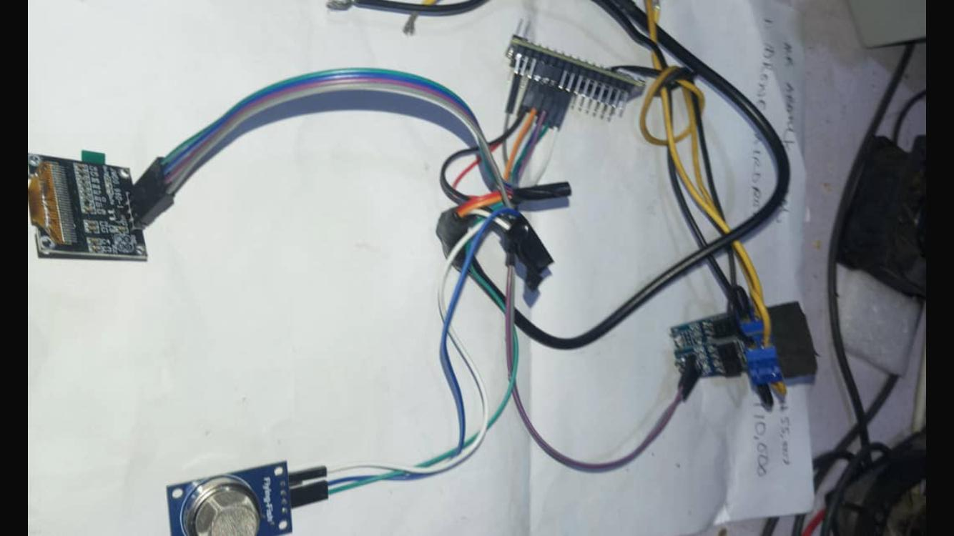\
Fig 4.1: The components of the smart fan before coupling
The components include:
- The Micro Controller Unit (nano) chip, Adrino which gives the instructions.
- Bursar responsible for beeps (in case it reaches it maximum temperature so it will come up with a sound as alert).
- Smoke detector
- Screen 128x64 display to show the necessary information
4.1.1 OUTPUT DESIGN
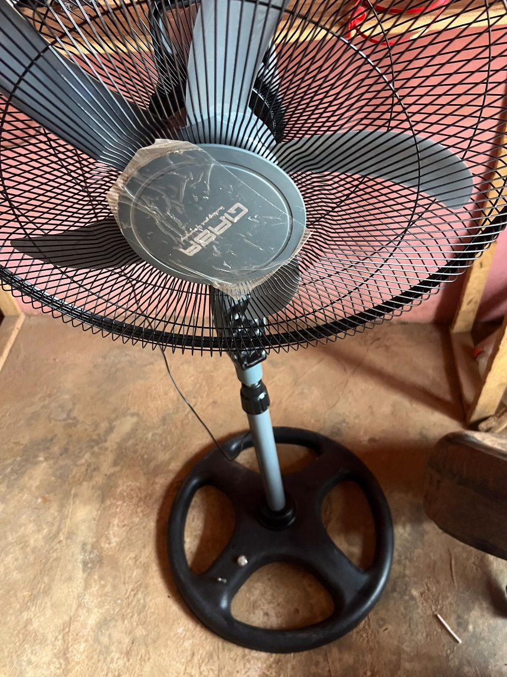
Fig 4.1.2: The Completion of the smart fan
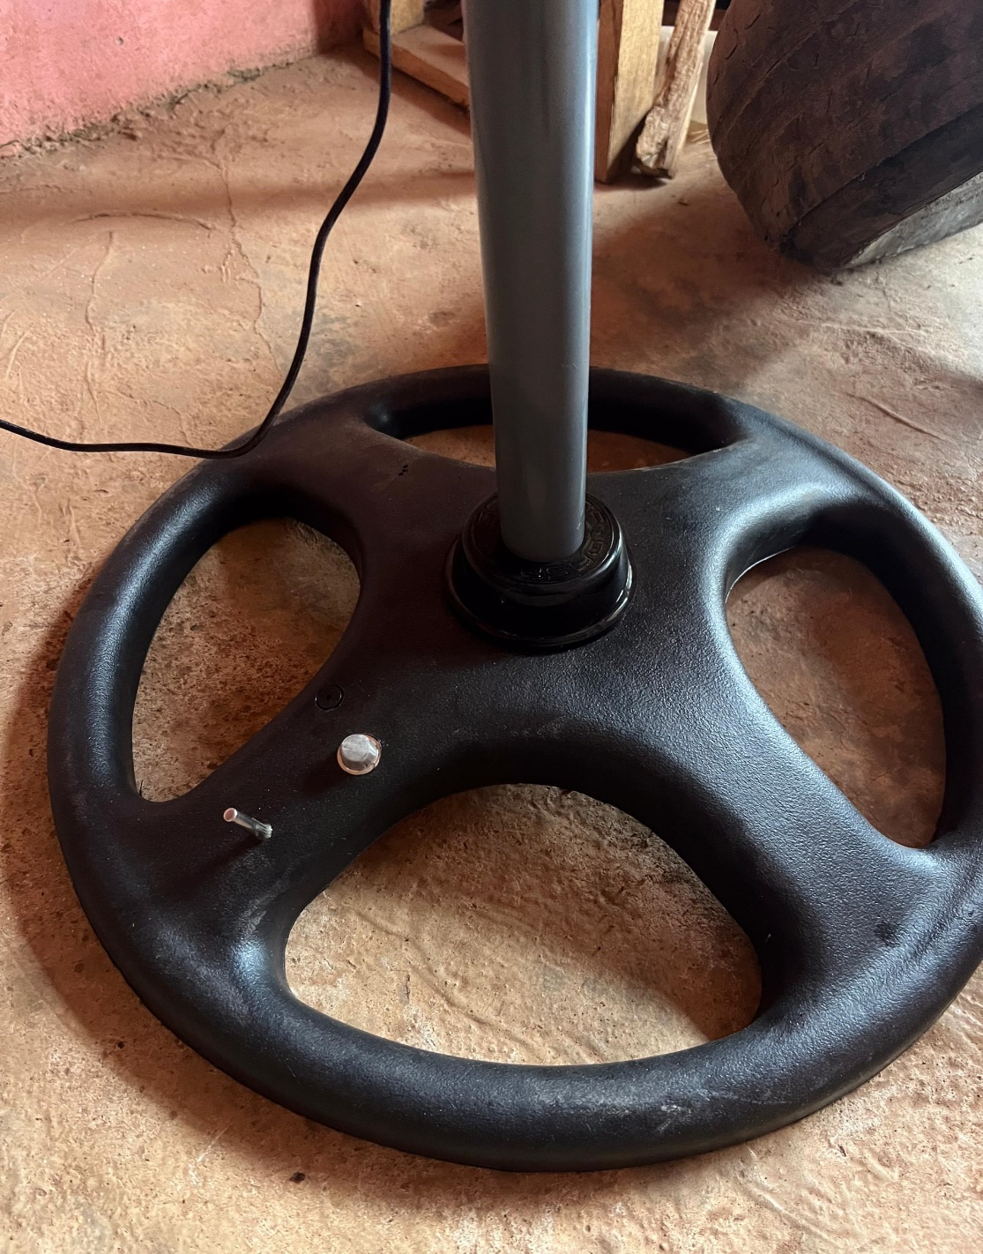
Fig 4.1.3: Showing the temperature detector and the bursar of the smart fan
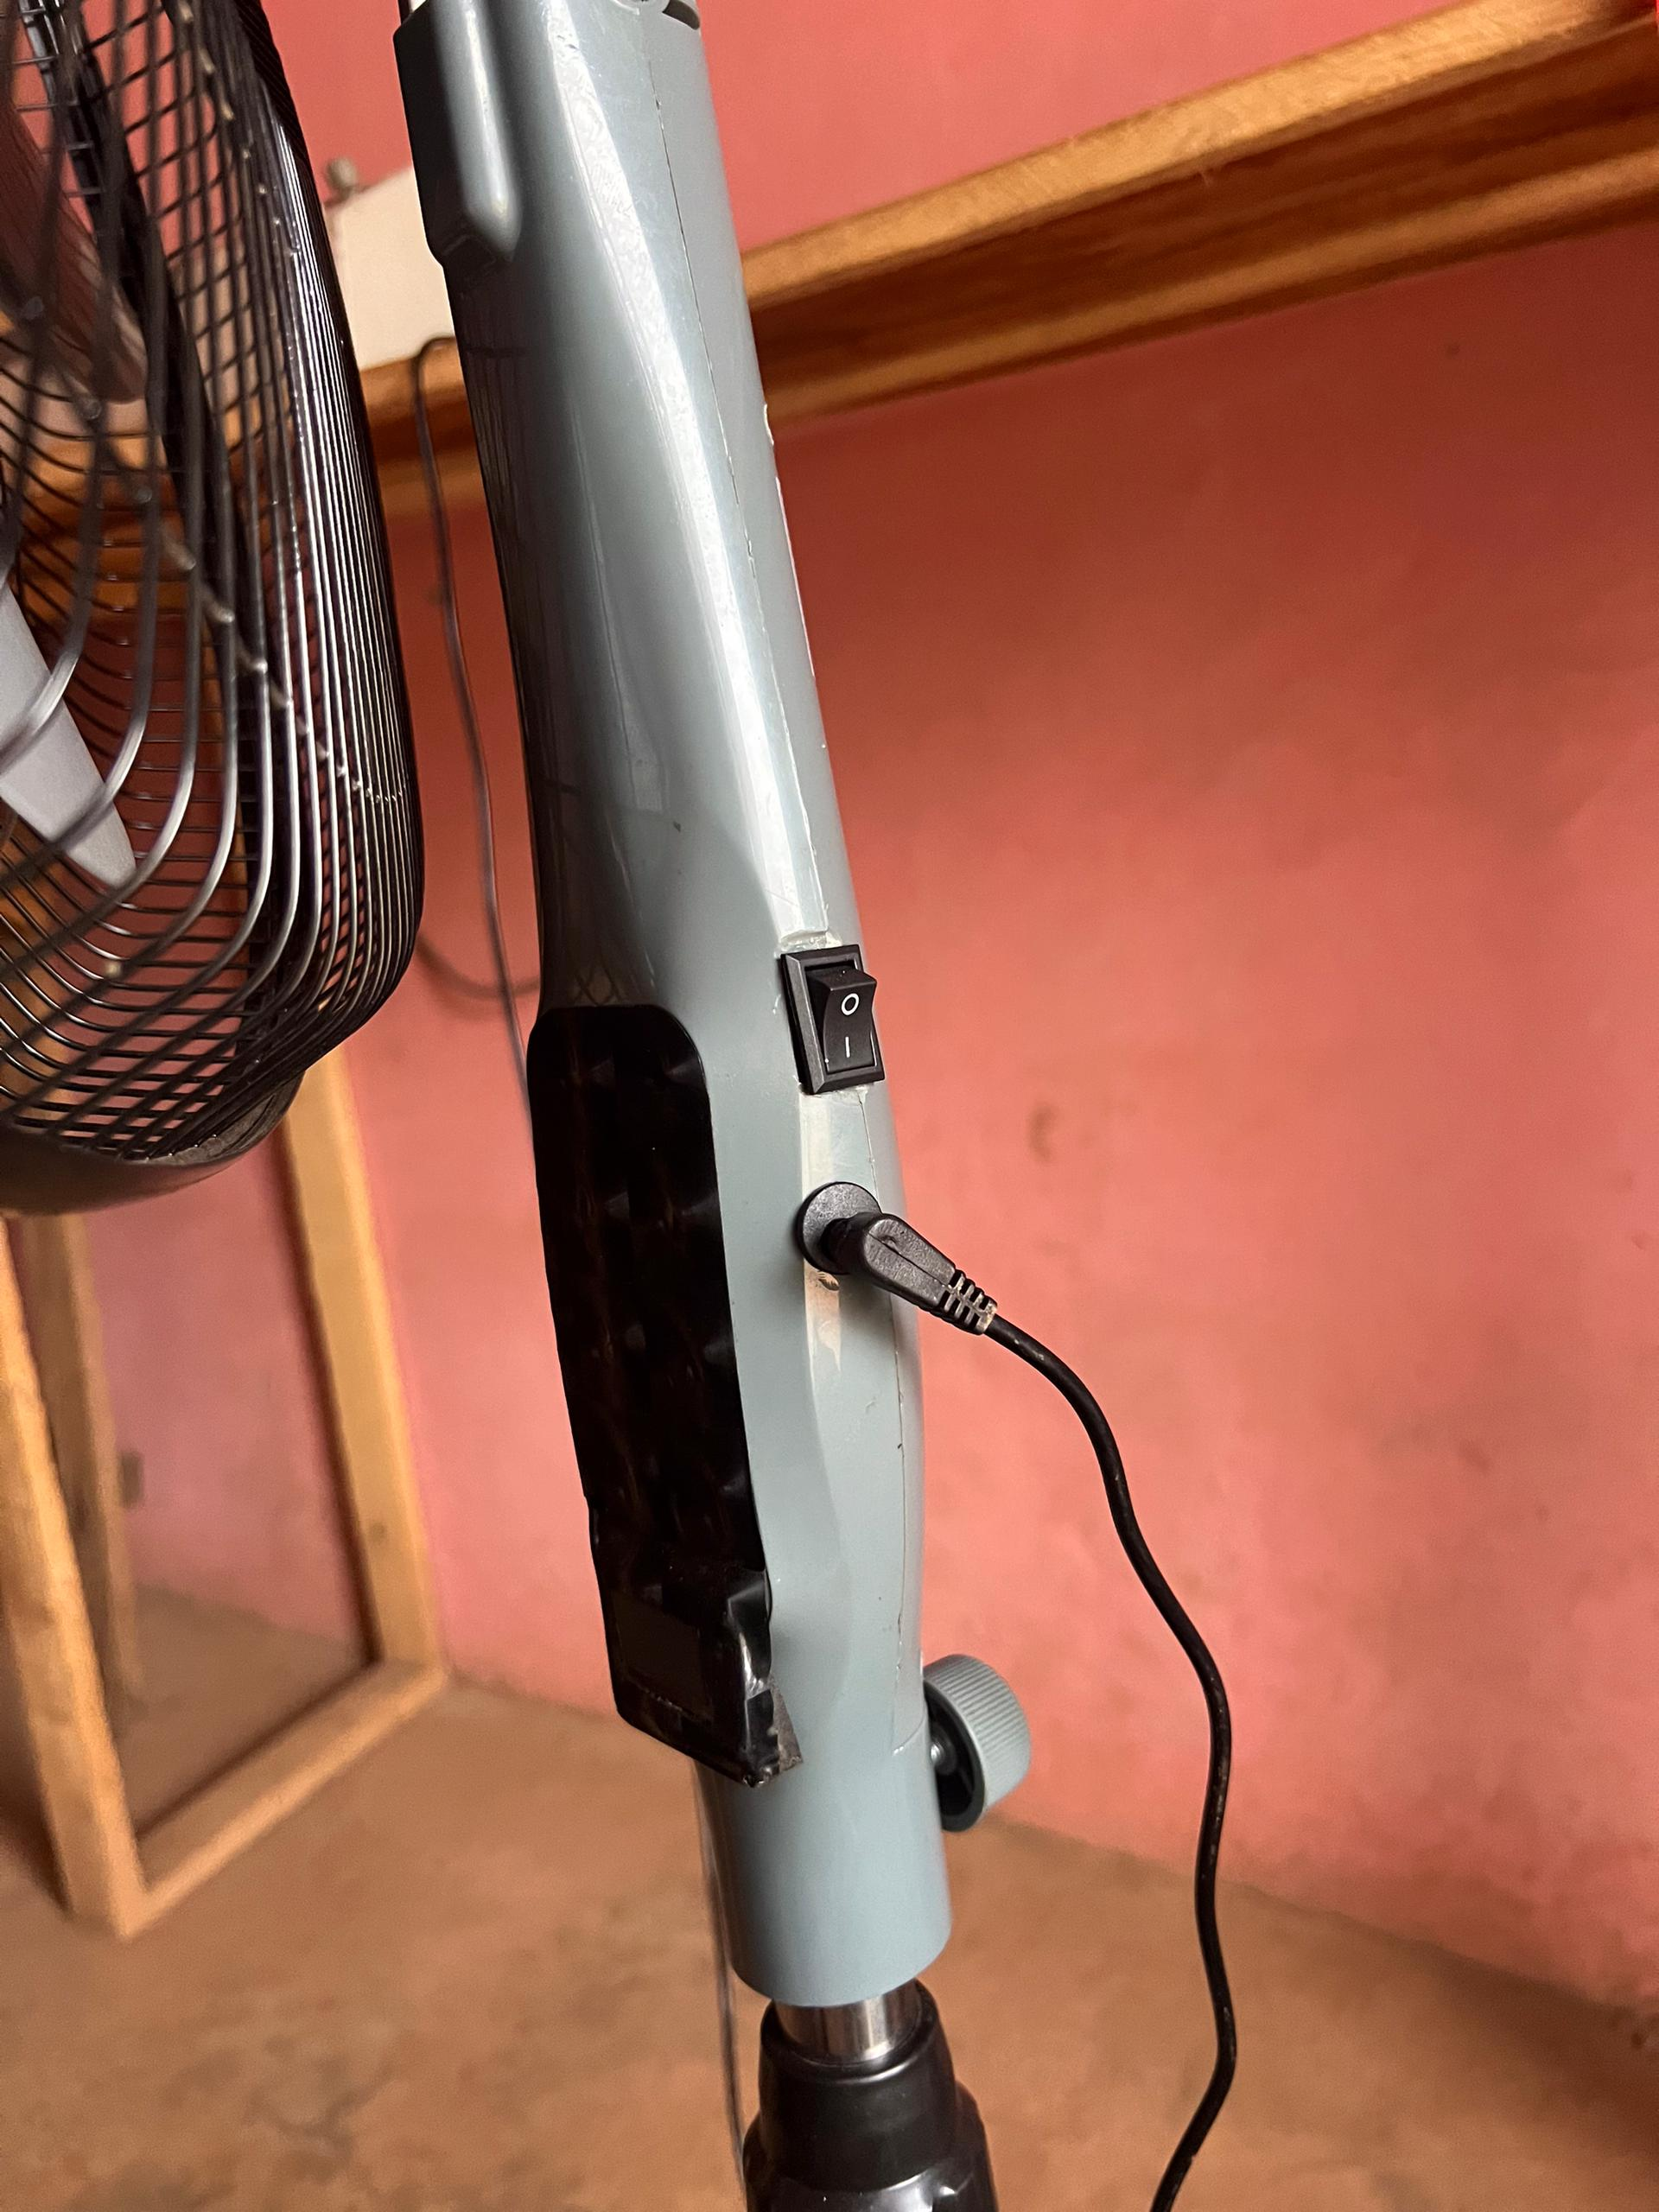
Fig 4.1.4: Showing the input, manual and the automatic switch of the smart fan

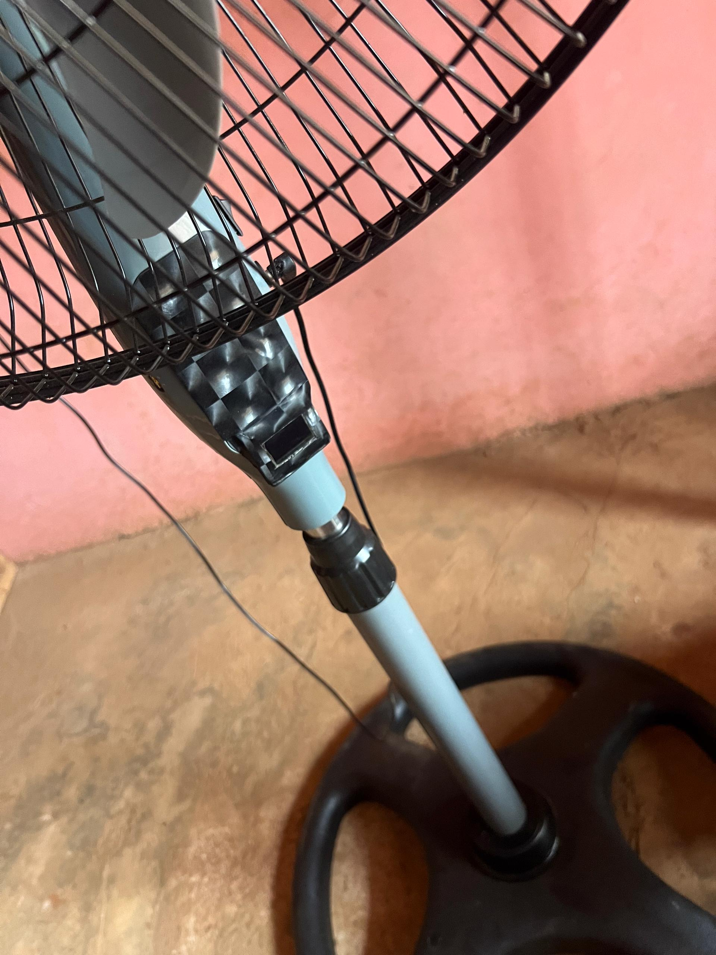
Fig 4.1.5: Showing the exterior view of the smart fan

CHAPTER FIVE
SUMMARY, CONCLUSION AND RECOMMENDATION
5.1 SUMMARY
The proposed system is an intelligent, AI-based thermal management solution aimed at optimizing cooling performance in electronic devices and environmental spaces. It integrates real-time environmental sensing, AI decision-making (via fuzzy logic or machine learning), and automated control of cooling mechanisms to achieve efficient and adaptive thermal regulation.
The system uses a microcontroller (ESP32) to collect data from temperature and humidity sensors and process it using an AI algorithm. Based on the processed data, it dynamically controls cooling devices such as fans through PWM signals or relay activation, ensuring that the environment remains within optimal thermal limits. A display unit or optional wireless interface allows for real-time user monitoring.
This project presents the design and implementation of an AI-driven thermal management system developed to enhance the efficiency, responsiveness, and adaptability of cooling operations in electronic devices and environmental spaces. The core objective is to overcome the limitations of conventional cooling systems, which are typically reactive, static, and power-inefficient.
The proposed system employs advanced artificial intelligence techniques, specifically fuzzy logic, to intelligently monitor and regulate environmental parameters such as temperature and humidity. These parameters are captured in real time using sensors like the DHT22 and processed by a low-cost, energy-efficient microcontroller such as the ESP32, which also acts as the central control unit.
Through a series of well-defined fuzzy logic rules, the system evaluates the current thermal state of the environment and computes the optimal response. This includes adjusting the speed of a fan or activating a cooling relay using PWM signals, thereby delivering precise and proportional thermal control. The AI component ensures that cooling responses are not binary (ON/OFF) but are instead nuanced and continuous, improving both user comfort and system longevity.
5.2 CONCLUSION
The development of an AI-driven thermal management system as presented in this project represents a significant advancement in the way cooling and temperature regulation are approached in both electronic devices and environmental applications. The proposed system leverages the power of artificial intelligence, specifically fuzzy logic, to introduce intelligent, real-time decision-making capabilities into thermal control processes that have traditionally relied on rigid, threshold-based mechanisms.
Through the integration of low-cost microcontrollers (ESP32), temperature and humidity sensors (e.g., DHT22), and actuators (fans or relays), the system is designed to detect variations in ambient conditions and apply context-sensitive cooling responses. The incorporation of a fuzzy logic controller enables the system to interpret sensor data more like a human expert would—using linguistic variables (such as "low", "medium", and "high")—and apply a rule-based approach to determine the appropriate action.
The motivation behind this project stems from the increasing demand for efficient, responsive, and intelligent thermal management systems in modern electronics, smart homes, and industrial settings. Conventional systems often rely on basic threshold-based control mechanisms that are unable to adapt effectively to changing or complex environmental conditions.
5.3 RECOMMENDATION
Based on the successful Development of AI-Driven Thermal Management Systems for Optimized Cooling in Devices and Environments, the following recommendations are suggested to improve the system and guide future developments:
- Implement Advanced AI Techniques: Explore incorporating machine learning algorithms such as neural networks or reinforcement learning to enable predictive and adaptive thermal management beyond fuzzy logic, improving system accuracy and efficiency over time.
- Integrate Additional Environmental Sensors: This includes other environmental parameters like airflow, ambient light, or pressure sensors to enrich data inputs, allowing the system to make more holistic and context-aware cooling decisions.
- Develop Remote Monitoring and Control: This utilize the ESP32’s Wi-Fi capability to create a cloud-based or mobile application interface, allowing users to monitor system performance, receive alerts, and adjust parameters remotely.
- Optimize Power Management: Design power-saving modes for the microcontroller and actuators during periods of low thermal activity to further reduce overall energy consumption, extending battery life for portable or off-grid applications.
- Expand Scalability for Larger Environments: This adapts the system for use in larger-scale environments such as server farms, greenhouses, or smart buildings by integrating networked sensors and actuators controlled through a centralized AI system.
- Incorporate Predictive Maintenance Features: This implements data analytics that detect early signs of component wear or failure (e.g., fan degradation), enabling timely maintenance and reducing downtime.
- Enhance User Interface with Data Visualization: This develops intuitive graphical dashboards with historical temperature and humidity trends, energy consumption statistics, and system health metrics to improve user engagement and informed decision-making.
- Conduct Extensive Field Testing: This tests the system under various real-world scenarios and environmental conditions to validate performance, robustness, and reliability, making necessary adjustments based on feedback.
- Explore Integration with Smart Home Ecosystems: This design compatibility with popular smart home platforms (e.g., Google Home, Amazon Alexa) to allow voice control and seamless integration with other home automation devices for enhanced user convenience.

‘

REFERENCES
Alim, M. A., & Islam, M. R. (2019). Design and Implementation of a Smart Fan Speed Control
System Using Temperature and Humidity Sensors. International Journal of Engineering Research, 8(5), 235-242.
Chen, L., & Wang, J. (2020). Fuzzy Logic-Based Fan Speed Controller for Improved Indoor Air
Quality. Journal of Applied Sciences, 15(12), 1256-1264.
Gupta, S., & Kumar, R. (2023). Energy-Efficient Fan Speed Control Using Fuzzy Logic. Proceedings
of the IEEE International Conference on Smart Technologies, 332-337.
Hossain, M. A., & Rahman, M. M. (2021). Development of an Automated Fan Speed Controller
Using Arduino and Fuzzy Logic. International Journal of Electrical and Computer Engineering, 11(3), 217-225.
Kaur, P., & Singh, J. (2019). Implementation of Fuzzy Logic Controller for Fan Speed Regulation
Based on Temperature and Humidity. International Journal of Computer Applications, 164(8), 12-18.
Li, Y., & Zhang, X. (2022). Smart Fan Control System Using Ambient Condition Sensors and Fuzzy
Logic. Journal of Intelligent Systems, 31(4), 845-856.
Malik, T., & Sharma, V. (2019). Application of Fuzzy Logic in Fan Speed Control for Optimized
Energy Consumption. Energy Management Journal, 7(2), 89-95.
Patel, R., & Mehta, S. (2020). Design and Simulation of a Fuzzy Logic-Based Smart Fan
Controller. International Journal of Engineering and Technology, 9(4), 301-309.
Singh, A., & Verma, P. (2022). A Review on Fuzzy Logic Based Speed Control of DC Fan.
International Journal of Advanced Research in Electrical and Electronics Engineering, 7(10), 456-462.
Wang, H., & Li, J. (2021). Intelligent Fan Speed Control Using Fuzzy Logic and Sensor Fusion. IEEE
Transactions on Industrial Electronics, 68(5), 4321-4330.

