SMART LIGHTING CONTROL SYSTEM USING IOT TECHNOLOGY

BY:

IBE GODWIN PRECIOUS

HND/23/COM/FT/0109

SUBMITTED TO:
THE DEPARTMENT OF COMPUTER SCIENCE,
INSTITUTE OF INFORMATION AND COMMUNICATION TECHNOLOGY
KWARA STATE POLYTECHNIC, Ilorin

In partial fulfillment for the DEGREE of HIGHER national diploma (HND) in COMPUTER science

SUPERVISED BY
Dr. A.K RAJI

MAY, 2025

CERTIFICATION

I hereby certify that the work presented in this project, Title is " SMART LIGHTING CONTROL SYSTEM USING IOT TECHNOLOGY" the result of the original research and findings carried out by IBE GODWIN PRECIOUS HND/23/COM/FT/0109 under my supervision and guidance. To the best of my knowledge, this work is free from any form of plagiarism and has not been submitted previously for any degree or diploma at any institution.
The content of this project reflects the author's own research and does not necessarily represent the views of the institution.

___________________________ ___________________________
DR. A.K RAJI Date
(Project Coordinator)

___________________________ ___________________________
DR. A.K RAJI Date
(Project Coordinator)

___________________________ ___________________________
MR. OYEDEPO Date
(HOD)

DEDICATION
This research work specially and firstly dedicated to Almighty God the most beneficent and most merciful. I also ascribe much gratitude to the same God who along is the source of all inspiration, wisdom, knowledge and understanding who stand upright by me from the inception till the end of my programme.

ACKNOWLEDGMENTS
I would like to express my deepest gratitude to all those who provided me with the possibility to complete this project. A special thanks to ALLAH for making me part of the people who will be writing a project and also to my supervisor, DR. ABDULRAHMAN TOSHO whose invaluable guidance, support, and encouragement made this work possible. Their insightful feedback and expertise were crucial in shaping this research. Am also grateful to my parents for their support financial, prayer throughout my project.
I am also grateful to The Department of Computer Science for providing the necessary resources and facilities for my research. My appreciation extends to ZAINAB and SULAIMAN for their constructive suggestions and partnership advice throughout the project.
Furthermore, I would like to thank my colleagues and friends for their unwavering support and motivation. Your encouragement has been a source of strength throughout this journey.
Finally, I wish to thank my family for their patience, understanding, and unconditional support. Without your encouragement, this achievement would not have been possible.
JIMOH ZAINAB, SHITTA ZAINAB AND KOLO SULAIMAN.
JULY, 2024.

ABSTRACT
The increasing reliance on solar energy necessitates precise prediction of solar irradiance for optimal planning and management of solar power systems. This research proposes the development of a machine learning model to forecast solar irradiance by leveraging open data sources. By integrating meteorological data, satellite imagery, and historical irradiance records, the study aims to enhance prediction accuracy. The methodology includes data collection, preprocessing, feature engineering, and the application of various ML algorithms, followed by rigorous model evaluation. The expected outcomes include a high-precision irradiance prediction model and a user-friendly interface for stakeholders. This research will contribute significantly to the efficient utilization of solar energy, promoting a sustainable energy future.

Keywords: Solar Irradiance Prediction, Machine Learning, Open Data, Meteorological Data, Satellite Imagery, Renewable Energy, Feature Engineering, Model Evaluation, Sustainable Energy, Solar Power Optimization

TABLE OF CONTENT
Title page
Certification
Dedication
Acknowledgement
Abstract
CHAPTER ONE: INTRODUCTION
1.1 Background of the study
1.2 Statement of the Problem
1.3 Aim and Objectives
1.4 Significance of the Study
1.5 Scope of the Study
CHAPTER TWO
2.1 Review of General Test
2.2 Review Of Related Work
2.3 Concept of smart lighting
2.4 Overview of smart automated
CHAPTER THREE: RESEARCH METHODOLOGY
3.1 Proposed Design
3.2 Project Flow
3.3 Hardware Components and Setup
3.4 Software Components and Development
3.5 Data Collection Methods
CHAPTER FOUR: RESULTS AND DISCUSSION
4.1 Complete prototype
4.2 Power Load for Six Different Time
4.4 Energy Savings
4.5 Visitor Count Accuracy
CHAPTER FIVE: SUMMARY, CONCLUSION AND RECOMMENDATION
5.1 Summary Of Findings
5.2 Conclusion
REFERENCES

CHAPTER ONE
INTRODUCTION
1.1 Background of the study
The integration of Internet of Things (IoT) in smart home automation has revolutionized the way energy is consumed and managed. By leveraging motion detectors and intelligent control systems, IoT-based solutions enable automated operations of household appliances based on human presence, significantly enhancing energy efficiency and user convenience. Traditional home systems often suffer from high energy wastage due to manual control and lack of monitoring, prompting the need for more intelligent and responsive systems (Gubbi et al., 2013). This research focuses on developing a smart home system that utilizes IoT motion detectors to automatically manage appliances and monitor power usage in real time. The system is designed to detect occupancy through passive infrared (PIR) sensors, control device operation using microcontrollers like ESP32, and transmit energy usage data to a cloud platform for analysis. Such innovations not only reduce electricity bills but also contribute to environmental sustainability by minimizing unnecessary energy consumption (Zhang et al., 2021).
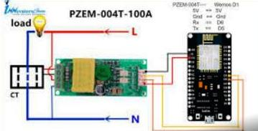
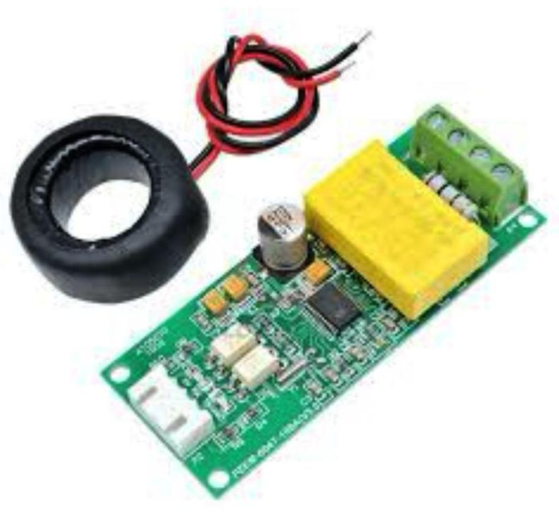

Figure 1: show Pzem004T
The rapid advancement of Internet of Things (IoT) technology has transformed various sectors, including home and industrial automation. Traditional lighting systems, often manual or timer-based, lack efficiency and adaptability to dynamic user needs. Smart lighting control systems leverage IoT to enable remote control, automation, and energy optimization through interconnected devices. These systems integrate sensors, microcontrollers, and communication protocols to adjust lighting based on occupancy, ambient light, or user preferences. The global push for energy conservation and sustainable technologies has further driven the adoption of IoT-based lighting solutions, which offer reduced energy consumption, cost savings, and enhanced user convenience. This study explores the development and implementation of a smart lighting control system using IoT technology to address modern energy and usability demands.

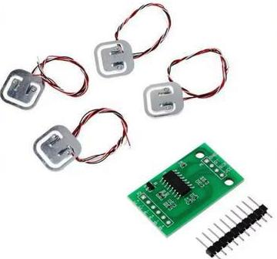

Figure 2: show 4PCS 50KG Sensor+HX711 Module USD2.8/set
1.2 Statement of the Problem
Conventional lighting systems are often inefficient, leading to unnecessary energy consumption and high operational costs. Manual control methods lack precision, resulting in lights being left on when not needed or operating at full capacity in well-lit environments. Additionally, the inability to remotely monitor or control lighting systems limits their flexibility in dynamic settings such as homes, offices, or public spaces. Existing solutions may also lack seamless integration with other smart devices, hindering scalability and interoperability. There is a need for an IoT-based smart lighting control system that optimizes energy use, enhances user control, and integrates effectively with existing infrastructure.
1.3 Aim and Objectives
- To design and implement a smart lighting control system using IoT technology for efficient energy management and enhanced user experience.
- To develop an IoT-based framework for controlling lighting systems remotely via a mobile or web interface.
- To integrate sensors for real-time monitoring of environmental conditions such as occupancy and ambient light levels.
- To optimize energy consumption through automated lighting adjustments based on sensor data.
- To evaluate the system’s performance in terms of energy efficiency, reliability, and user satisfaction.
1.4 Significance of the Study
This study is significant as it addresses the pressing need for energy-efficient lighting solutions in the context of rising global energy demands and environmental concerns. The proposed IoT-based smart lighting system offers a scalable and cost-effective approach to reducing energy waste, lowering operational costs, and improving user convenience. It contributes to the advancement of smart home and building technologies by providing a model for integrating IoT with everyday systems. The findings will benefit homeowners, facility managers, and policymakers by demonstrating the potential of IoT in achieving sustainable energy goals. Additionally, the study provides a foundation for further research into IoT applications in automation and energy management.
1.5 Scope of the Study
The study focuses on designing and implementing a smart lighting control system using IoT technology. It covers the integration of sensors (e.g., motion and light sensors), microcontrollers (e.g., ESP32 or Arduino), and IoT communication protocols (e.g., MQTT or Wi-Fi) to enable remote control and automation. The system will be tested in a controlled environment, such as a simulated home or office setting, to evaluate its performance. The study does not include the development of large-scale industrial lighting systems or integration with complex smart city infrastructures. Hardware and software limitations, such as processing power and network reliability, will be considered during implementation.

CHAPTER TWO
2.1 Review of General Test
In order to build a smart city ecosystem, technology has to be a critical component as well as look at factors such as social and human capital. Most cities now use bespoke systems and solutions to meet their unique requirements, however these approaches are not appropriate for other cities across the world, and occasionally just a subset of different elements are required. These results synthesise many of the literature's findings on smart cities and their major obstacles, problems, and open challenges. These four problems may be split into four distinct categories, and these categories can be described in more depth as citizens, mobility, government, and the environment. Smart cities should take into consideration the quality of life of the inhabitants while also factoring in the privacy issue, particularly when their personal information and household-level data are concerned. Because people may be concerned about the introduction of new technology, or see it as invasive, this is noteworthy. In addition, it is critical to focus on equality, which means that everyone in the community should benefit from improvements in smart city technology, and in particular, no metropolitan regions should be left behind. The need for a change in government models stems from the wider idea of the smart city concept, which involves combining institutional policies with bottom-up initiatives in order to be more flexible and to improve the strength of community relations, fostering collaboration, and promoting communication among various entities to prevent the formation of multiple similar initiatives, which would not work together the most efficiently. Mobile city deployment includes the provision of a sustainable, inclusive, and efficient mobility system for both products and people. Still another domain of smart city design that has not been thoroughly researched, and thus may hold answers to previously unanswered questions, is the incorporation of the environment into city services. For instance, sustainable resource management (such as water and energy), pollution, and the impact of urban activities can all be explored. The Key areas to deal with in a smart city are shown in Figure.1.
Interoperability, as now deployments are more frequently based on private and isolated solutions, is currently thought of as a potential obstacle to smart city development. To achieve affordable scale and maximize the outcomes, open standard-based devices must be utilised at all levels. In order to effectively coordinate data collecting and analytic operations across many systems, further coordination also is needed between the systems.

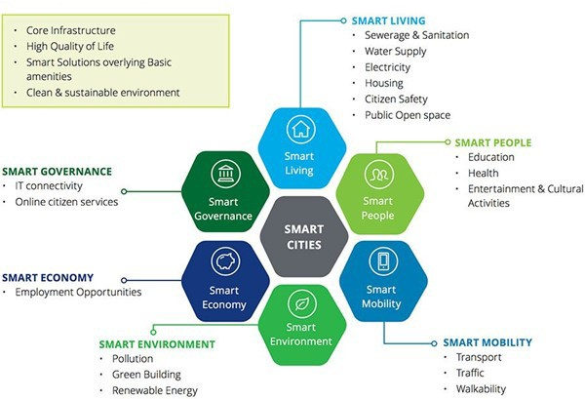

Source: Survey Filed 2025
Figure1. Key are as to deal within a smart city.
2.2 Review Of Related Work
Smart lighting systems leverage IoT to connect lighting devices with sensors, controllers, and communication networks, enabling dynamic control, remote management, and energy optimization. These systems typically use LED technology due to its energy efficiency and compatibility with advanced control mechanisms like dimming and spectral tuning. IoT-enabled smart lighting integrates sensors (e.g., motion, ambient light, occupancy) and communication protocols (e.g., Wi-Fi, Zigbee, LoRaWAN, Bluetooth) to adjust lighting based on real-time environmental data or user preferences. Applications span urban street lighting, smart homes, commercial buildings, and industrial environments, with benefits including energy savings, improved safety, and enhanced user experience.
2.3 Concept of smart lighting
Elements of Smart Lighting System
Sensors are the most prevalent, followed by algorithms, with everything else in between. Lighting control systems may evaluate the day, light spectrum, or occupancy to decide the final reaction. Algorithms may operate inside devices or systems to manage workloads or tasks given to them. They may also be operated on the cloud, eliminating the need to transmit command messages. Algorithms may refer to many cutting-edge technological solutions that constantly shift colours, such as tunable lights, techniques that control colour response, real-time colour adjustments, and real-time techniques that help reduce energy use. Circadian cycles are often used to create aesthetically complex lighting patterns. The initial lighting design schematic presented in Fig.2 represents the main components of the design. Rather than following rigid input design requirements, autonomous algorithms are taught to react to user choice and gender. The biological clock that controls ourcircadian cycles, as well as numerous other systems, including as hormone release, body temperature, and circadian awareness, have all been shown to be influenced by lightweight in the last decade. Since circadian cycles rely on luminescence rather than colour correction, the spectrum of light frequencies from red to blue is more significant. Because the system may affect and control many physiological characteristics, expanding can also imply gaining power. The museum benefits from complete spectrum management in gardening, fine arts, and public gathering spaces, among other disciplines.
In a network, the physical and logical layers interact at the system device level and the device
hierarchy. Using different physical topologies, such as a loop, stars, or a combination of both star and bus, increases reliability and opens up expansion options. Traditional communication networks may be placed over wireless ones utilizing cables or wireless connecting covers in physical installations. You may connect to the network through wired or wireless connections.
Lighting products have been linked with IoT networking technologies to better serve a broader variety ofapplications.0-10V, DALI, Digital Multiplexer (DMX), Local Area Network(LAN), and PowerLineCommunication(PLC)aretheprimarywiredinterfacesusedfornetworking.Theyalso
utilise wireless technologies like as infra-s GHz, Bluetooth, and infra-shred optical Lumina. 6LoWPAN, for example, uses a physical layer focused on short range and rapid network connection.

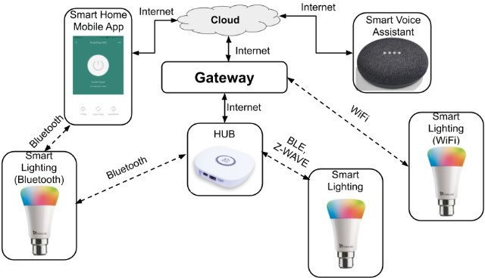

Source: Survey Filed 2025
Figure2.Key elements for smart lighting systems
Sensors for Smart Lighting Platforms
A wide range of working sensor technologies and communication techniques is what makes a smart lighting device excellent, if not what keeps it inexpensive. In contemporary IoT applications, digital sensors are used to alter lighting mechanisms to aid in adaptive operation. If you know about low-intensity light sensors and photodiodes, can they alert you when it becomes dark? Red, green, and blue sensors are used for LED and CFL recolour (fluorescent) lighting to detect their primary colour, producing RGB material for indoor environments and optical connections, but for wireless applications, visible light communication (VLC) is the most important photo diode works technology.
Creating white light by mixing individual red, green and blue LEDs as shown in figure.3. If you know about photo resistors and photosensitive cells that react to lesser amounts of light to alter the luminous flux depending on user activity. Spectroscopy is a unique and creative characteristic that allows us to utilise these devices to collect light in the visible spectrum.
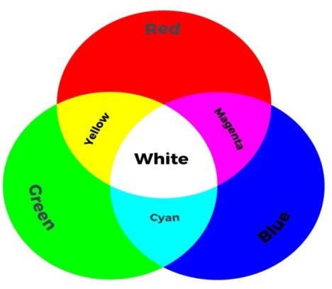
Figure3. Concept of colour mixing individual red, green and blue LEDs
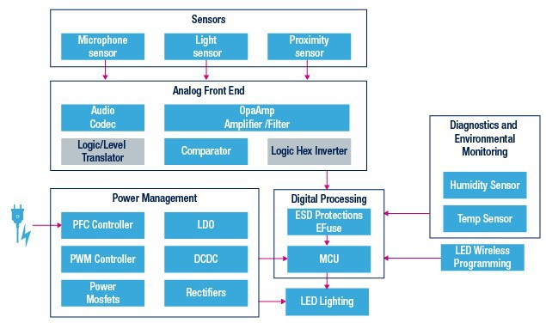
Source: Survey Filed 2025
Figure4. Sensor technologies embedded in smart lighting
Since any type of light spectrum and any point-range is generated by a circadian lighting device, the control ability is critical to tuning the Color Rendering Index (CRI) and correlated color temperature (CCT) in real time is crucial. Sensor technologies embedded in smart lighting is presented in figure.4. As well as optimizing the lighting efficiency, it is known that sensors and controls which use LED technology may lose Luminescence levels increase with age and/ decrease over time.
Communication Interfaces for Smart Lighting
A professional lighting system must have universal connection, either wired or wireless. DALI, PLC, and Ethernet are required for critical infrastructure and street lighting. Non-critical infrastructure lighting applications and systems may utilise Wi-Fi, ZigBee, or a commercial traffic control system. For various reasons, these indoor LED lighting systems prefer IEEE 802.15.4, VLC, Bluetooth low energy, or sub-GHz protocols. Both ZigBee Light Link and 6WAN utilise the IEEE802.15.4 Media and Super Access Point (AP)Layers.15 Most of them have their own code names (encoding standards) to indicate how secure they are.
Manufacturers may build systems to connect with goods using simplified standards, data centre management, or automation (IPv4 and IPv6). Although based on the IoT platform, the Open AIS project (from Europe) is creating a framework for diverse lighting systems. A standardized framework for lighting interface and extendable APIs enable the light system to be utilized in a broad variety of building systems and independent of specific cloud services.
The answer to this interoperability problem is to standardize lighting protocols, which are helpful in situations where open ecosystems with conflicting protocols are acceptable and closed ecosystems are unfeasible. In this instance, utilizing lightweight protocols like Universal Plug and Play (UDP) and TCP may extend compatibility.
2.4 Overview of smart automated
Smart automation refers to the use of advanced technologies like artificial intelligence (AI), machine learning (ML), Internet of Things (IoT), and robotics to automate processes, optimize operations, and enhance decision-making with minimal human intervention. It integrates intelligent systems to adapt, learn, and improve efficiency across industries such as manufacturing, healthcare, logistics, and home automation.
Components
Artificial Intelligence (AI) and Machine Learning (ML): Enable systems to analyze data, predict outcomes, and make decisions. For example, AI-powered chatbots handle customer queries dynamically.
Internet of Things (IoT): Connects devices for real-time data collection and communication, like smart sensors in factories monitoring equipment health.
Robotic Process Automation (RPA): Automates repetitive tasks (e.g., data entry) using software bots, often enhanced with AI for complex workflows.
Sensors and Actuators: Collect data and execute actions, such as smart thermostats adjusting temperatures based on occupancy.
Cloud Computing: Provides scalable infrastructure for data storage and processing, enabling seamless automation across distributed systems.
Edge Computing: Processes data locally on devices, reducing latency in applications like autonomous vehicles.
Applications
Manufacturing: Smart factories use automation for predictive maintenance, quality control, and supply chain optimization (e.g., Siemens’ digital twin technology).
Healthcare: Automated diagnostics, robotic surgeries, and patient monitoring systems improve accuracy and efficiency (e.g., AI-driven imaging analysis).
Logistics: Autonomous warehouses and delivery drones streamline operations (e.g., Amazon’s Kiva robots).
Smart Homes: Devices like smart lights and security systems adapt to user preferences via IoT and AI.
Finance: Fraud detection, automated trading, and customer service chatbots enhance operational efficiency.
Benefits
Efficiency: Reduces manual effort and speeds up processes.
Cost Savings: Lowers labor and operational costs through optimized resource use.
Accuracy: Minimizes human errors in tasks like data processing or diagnostics.
Scalability: Easily adapts to growing demands or complex tasks.
Sustainability: Optimizes energy use, reducing environmental impact (e.g., smart grids).
Challenges
High Initial Costs: Significant investment in infrastructure and training.
Security Risks: IoT devices and interconnected systems are vulnerable to cyberattacks.
Job Displacement: Automation may reduce demand for low-skill jobs, requiring workforce reskilling.
Complexity: Integrating diverse systems and ensuring interoperability can be difficult.
Ethical Concerns: AI decision-making raises questions about bias and accountability.
Hyperautomation: Combining AI, RPA, and analytics for end-to-end process automation.
AI-Driven Predictive Analytics: Anticipating equipment failures or market trends with greater accuracy.
Human-AI Collaboration: Cobots (collaborative robots) work alongside humans in industries like manufacturing.
Green Automation: Focus on energy-efficient systems to support sustainability goals.
Low-Code Platforms: Simplifying automation development for non-technical users.
Understanding the Components
At the core of these systems are energy-saving LED lights. They are connected and controlled by a central platform. This platform uses sensor data to improve lighting, save energy, and make life better for users. The main parts are:
- Network-connected LED lights
- Sensors for detecting motion, occupancy, and ambient light levels
- Centralized control and management software
- Integration with IoT devices and smart city infrastructure
Benefits of Smart Lighting Systems
IoT-enabled smart lighting systems bring many benefits. They are key in IoT consulting services, IoT app development services, and hardware engineering solutions. They can:
- Lower energy use and costs with smart control
- Boost public safety and security with adaptive lighting
- Offer data for smart city planning
- Make lighting more personal for everyone
Future Research on Smart Lighting System
As the IoT-enabled smart lighting system continues to grow, the rate of development is increasing. This part details open issues connected to the execution of smart city initiatives and the security of SLSs. A lot of issues still need to be fixed in order to further increase the efficiency of SLS. This has been around for ages. Connecting all of an SLS's components with an IoT-enabled protocol is very necessary. The Low-power Wide-Area Network (LoRaWAN) makes it possible for low-data-rate connection to be established over large geographical areas, with many different IoT devices. Several SLSs, each using a different protocol, need to communicate in order to create a centralized lighting system. Lookingat an issue from many angles To link various application domains, the concept of a Smart City is essential. SLS systems allow new services to be delivered to urban regions, making SLS more versatile. In conjunction with SoLS, low-cost autonomous solutions may be made available to traffic managers via smart traffic management. Additionally, weather systems using environmental sensors, including rain sensors, temperature sensors, and humidity sensors, may be used in SLS settings. Municipal services that use SLS may be less expensive and more efficient if used with other applications. System security system As they are centrally controlled, an attacker may target SLSs because this gives them access to other connected services. This also granted the attacker complete control over the city's lighting system, which might lead to even more severe attacks or allow them to totally rule the city. Sensors may be used to alter behavioral patterns that have been anticipated. With the implementation of future smart lighting standards, future researchers will confront difficulties. Unfortunately, at this time, there is no trustable method for granting and cancelling keys. A privacy mechanism may be employed to safeguard the user's privacy, but a complete security system may not be utilised. While low-power and low-cost end devices are available, security and efficiency will be sacrificed for them. A large and rigorous security system may slow down the functioning of the system and result in an increased installation cost.
CHAPTER THREE
RESEARCH METHODOLOGY
3.1 Proposed Design
The system is designed based on the proposed diagram depicted in Fig. 1. The central component of the system is the Durian Uno V3 microcontroller, which manages tasks such as visitor counts, lighting control, and data exchange. Two infrared (IR) sensor modules are used to identify when visitors enter and exit the bathroom. These sensors accurately count the number of persons present in the toilet at any given time. The real-time data is essential for regulating the 5V LED, which serves as the main source of illumination. A Liquid Crystal Display (LCD) with an Inter-Integrated Circuit (I2C) interface is used to display the current number of visitors and the status of the system in real time. This display provides instant feedback to both users and maintenance professionals. The ESP-01 WiFi Serial Transceiver Module (ESP8266) enables effortless communication with the Blynk server, enabling remote monitoring and control through the Blynk app. This integration of Internet of Things (IoT) technology allows for remote management of the system, hence improving the overall user experience. During the initialization process, the microcontroller initiates the activation of all components and commences the monitoring of visitor traffic using the IR sensors. The microprocessor continuously updates the visitor count and adjusts the LED based on the presence or absence of individuals, ensuring that the lights are only activated when necessary, hence minimizing energy use. The instantaneous data is shown on the Liquid Crystal Display (LCD) and sent to the Blynk server for remote retrieval through the Blynk application.
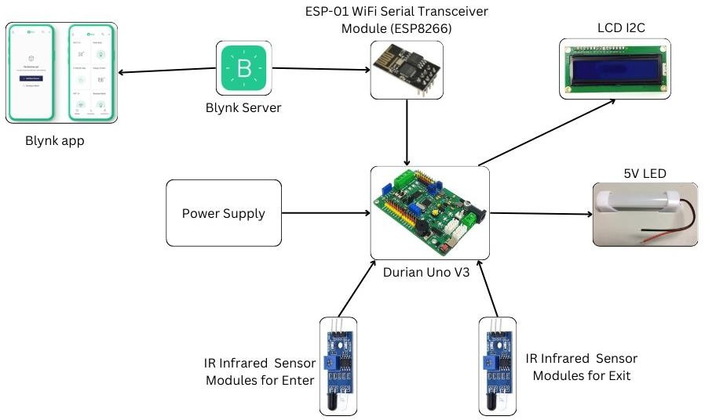

Source: Survey Filed 2025
Fig.1 Block diagram for the project.

3.2 Project Flow
The flowchart in Fig. 2 illustrates the entire procedure and process of the project.
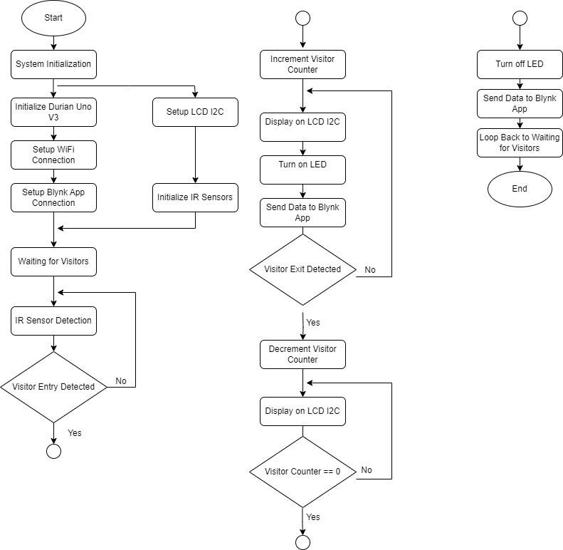
Source: Survey Filed 2025
Fig.2 Flow chart of the project.

3.3 Hardware Components and Setup
Table 1 shows all the components used. The Durian Uno V3 microcontroller serves as the key processing unit in the Smart Lighting and Energy Management System for the Block QA Toilet. It consolidates and oversees multiple hardware components, guaranteeing the smooth functioning of the system. The microprocessor receives input signals from the IR Infrared Obstacle Avoidance Sensors, which are capable of detecting the presence of guests. The system analyzes these signals to update the number of visitors and implements control logic to effectively regulate the lighting system. For example, the microcontroller activates the lights upon detecting the presence of a visitor and deactivates them after a specific duration of inactivity to conserve energy. In addition, the Durian Uno V3 enhances the LCD I2C module to showcase live data, like the current visitor count and system condition.

Table1Componentused.
No. | Components
1 | DurianUnoV3
2 | IR Infrared Sensor Obstacle Avoidance Module
3 | 12VoltLEDLightBar17cm8cm
4 | ESP-01WiFi Serial Transceiver Module(ESP8266)
5 | LCD I2C

Additionally, it connects with the ESP-01 WiFi Serial Transceiver Module (ESP8266) as shown in Fig. 3 to facilitate wireless connection, enabling the system to transmit data to the Blynk app for remote monitoring and control. The Durian Uno V3 optimizes system performance by synchronizing the communication between sensors, LEDs, the LCD, and the WiFi module. This clever design enables effective energy management and enhances user ease. Fig. 3 shows the electronic components utilized in this project. The LCD I2C module is essential for presenting up-to-date data on the system's state and the number of visitors. The device establishes a connection with the Durian Uno V3 via the I2C protocol, which makes the wiring process easier and reduces the number of pins required. The LCD offers an intuitive visual output, enabling users to effortlessly view visitor counts and system statuses. The display's adjustable illumination and contrast settings enable optimal readability in different lighting conditions, hence improving user engagement. IR Infrared Obstacle Avoidance System Sensors are essential for detecting guests.
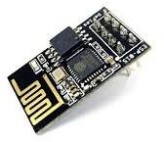  (a) | 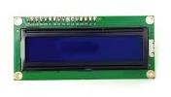  (b)
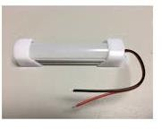  (c) | 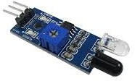  (d)
Fig. 3 (a) ESP-01 WiFi Serial Transceiver Module (ESP8266) (b) LCD I2C (c) 5V LED (d) IR Infrared Sensor Module.
These sensors are placed at entrance and exit points and produce infrared light to detect reflections from objects nearby. When a visitor walks by, the sensors transmit digital signals to the Durian Uno V3, which analyzes these signals to modify the visitor count. The ability to modify the detection range guarantees exact setup, hence ensuring accurate detection and preventing erroneous readings. LEDs serve as status indicators, offering prompt visual input on the performance of the system. An LED can serve as an indicator to show whether the system is currently active or in sleep mode, as well as to provide warnings for specified thresholds or problems. Utilizing conventional 5mm LEDs guarantees dependable, energy-efficient indicators that can be easily incorporated and offer excellent visibility, hence enhancing the overall user experience and system dependability. The ESP-01 WiFi Serial Transceiver Module (ESP8266) facilitates wireless connection by connecting the Durian Uno V3 to the local WiFi network, enabling data transmission to the Blynk app. This wireless functionality allows for remote monitoring and control, granting users immediate access to data and system status from their cell phones. The ESP8266 efficiently manages data transmission, guaranteeing the project's IoT objectives are met by providing current and precise information.
3.4 Software Components and Development
The software components and development process play a vital role in the Smart Lighting and Energy Management System for the Block QA Toilet. The main software tools utilized comprise the Arduino Integrated Development Environment (IDE) for microcontroller programming and the Blynk application for remote monitoring and control. The Blynk App is essential in this project since it offers a user-friendly interface for remotely monitoring and controlling the system. Users can utilize the Blynk app to retrieve real-time data on visitor counts and system status, as well as manage the lighting system using their cell phones. The application establishes a connection with the ESP-01 WiFi module, which facilitates the transmission of data from the Durian Uno V3 microcontroller to the Blynk cloud server. This configuration allows users to receive notifications and issue commands to the system, hence improving the overall ease and functionality of the lighting and energy control solution. The Arduino IDE is required for authoring, compiling, and transferring the code to the Durian Uno V3 microcontroller. The main libraries utilized in this project are:
- Wire library for I2C communication with the LCD module
- ESP8266WiFi library for managing the WiFi connection
- Blynk library for integrating the microcontroller with the Blynk app.
3.5 Data Collection Methods
The data collection approach is executed using the Blynk app, which plays a vital part in the Smart Lighting and Energy Management System for the Block QA Toilet. The Blynk app functions as a user-friendly platform for remote system monitoring and data management, allowing users to observe and control the system in real time.
Fig. 4 displays the Blynk app UI featuring the "IoT Visitor Counter". The establishment of this project is crucial for the organization and administration of the data gathered from the sensors. The application establishes a connection with the ESP-01 WiFi Serial Transceiver Module, which facilitates the transmission of data from the Durian Uno V3 microcontroller to the Blynk cloud server. This configuration guarantees the precise acquisition and real-time transmission of data from the IR Infrared Obstacle Avoidance Sensors.
CHAPTER FOUR
ANALYSIS AND DISCUSSION OF RESULTS
4.1 Complete prototype
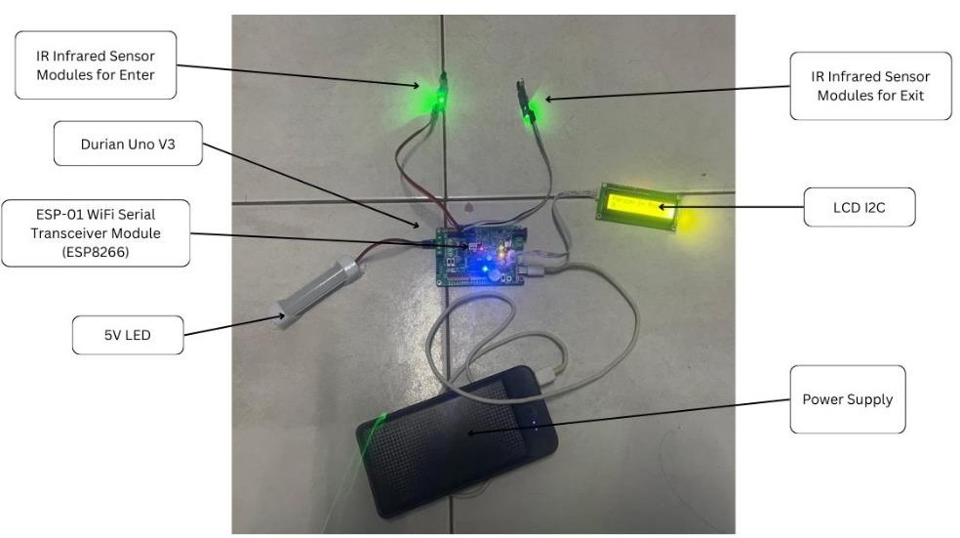
Fig.6 Design prototype.
Fig. 6 shows the design prototype of the "Smart Lighting and Energy Management System using Visitor Counter Based on IoT." The Durian Uno V3 microcontroller serves as the core of the system, overseeing the operation of all the interconnected components. The prototype incorporates IR infrared sensor modules strategically positioned at entry and exit points to detect the movement of visitors. The ESP-01 WiFi Serial Transceiver Module (ESP8266) facilitates wireless connectivity, allowing for remote monitoring via the Blynk application. A 5V LED illuminates to signify the existence of visitors, while an LCD I2C exhibits the count of visitors and other pertinent data. The entire system is sustained by a dedicated power source, guaranteeing uninterrupted operation. This configuration effectively showcases the incorporation of IoT elements to oversee the control of lighting and energy consumption, which is contingent upon the presence of visitors.

4.2 Power Load for Six Different Time
Table 2 shows information on voltage, current, and power at six different time intervals during the day: 8:00,10:00, 12:00, 14:00, 16:00, and 18:00.

Table2 Voltage, current, and power at six different time.
Time Slot | Voltage(V) | Current(A) | Power(W)
8:00 | 4.45 | 0.2 | 0.89
10:00 | 4.46 | 0.18 | 0.8
12:00 | 4.44 | 0.22 | 0.98
14:00 | 4.47 | 0.19 | 0.85
16:00 | 4.45 | 0.21 | 0.93
18:00 | 4.46 | 0.2 | 0.89
The voltage exhibits a consistent level, varying within a narrow range of 4.44V to 4.47V, while the current experiences minor fluctuations, oscillating between 0.18A and 0.22A. The power usage ranges from 0.8W to
0.98W, with the highest power reported at 12:00 (0.98W) and the lowest at 10:00 (0.8W). This data offers valuable information about the electrical performance and energy consumption of the system, which is essential for maximizing the effectiveness of the IoT-based smart lighting and energy management system. Fig. 7 shows the correlation between power usage and time. The x-axis represents the time interval from 8:00 am to 6:00 pm, while the y-axis represents power measured in watts (W), ranging from 0 to 1.2W.
Power(W)VS Time
1.2
1
0.8
0.6
0.4
0.2
0
8:00
10:00
12:00
14:00
16:00
18:00
Time

Fig.7 Power of the load against time.
The solid blue line depicts the recorded power usage at various time points during the day, while the dotted line signifies a subtle increasing pattern. The power usage commences at around 0.85W at 8:00 am. The power consumption decreases to approximately 0.75W at 10:00 am and then increases to a maximum of roughly 1.0W atnoon. Subsequently, it diminishes to roughly 0.8Wat2:00 pm, some what rises to approximately 0.85Wat4:00 pm, and ultimately stabilizes at around 0.8W by 6:00 pm. The oscillations in power usage can be linked to the changing load conditions in the lighting system, which are likely impacted by the number of visitors and their activity within the toilet block. In general, subtle rising trajectory in power consumption indicates a gradual rise in energy utilization throughout the day. Comprehending these differences is essential for maximizing the performance of the intelligent lighting and energy management system, guaranteeing its ability to adjust to fluctuating load situations and uphold energy efficiency. Implementing real-time monitoring and control mechanisms can effectively handle these oscillations, enhancing the system's dependability and minimizing energy inefficiencies. Conducting further analysis that links variations in power with specific activities might boost the system's capacity to handle periods of high demand and enhance overall energy management.
4.3 Energy Savings
Table 3 displays data collected over a period of ten days on the efficiency of a smart lighting and energy management system.
Table3 Energy consumption and energy savings.
Day | Percentage Reduction (%) | Energy Consumption Without Smart System (Wh) | Energy Consumption With Smart System (Wh) | Energy Savings (Wh)
1 | 31.29% | 10.266 | 7.053 | 3.212
2 | 34.20% | 10.444 | 6.872 | 3.572
3 | 26.84% | 10.988 | 8.040 | 2.949
4 | 26.71% | 10.072 | 7.382 | 2.690
5 | 32.43% | 10.999 | 7.432 | 3.567
6 | 27.96% | 10.804 | 7.784 | 3.020
7 | 27.27% | 10.722 | 7.797 | 2.924
8 | 28.47% | 10.431 | 7.461 | 2.970
9 | 34.49% | 10.016 | 6.562 | 3.454
10 | 27.65% | 10.996 | 7.956 | 3.040
The essential measures are the % decrease in energy consumption, energy consumption in the absence of the smart system, energy consumption with the smart system, and energy savings. The data clearly shows that the introduction of the smart lighting and energy management system leads to substantial energy conservation, continuously decreasing energy usage by around 27% to 34%. This underscores the efficacy of the system in overseeing and diminishing energy consumption. Fig. 8 shows the comparison between energy use with and without the smart lighting system, as well as the resulting energy savings over 10 days. The x-axis indicates the days, while the y-axis shows energy usage measured in watt-hours (Wh).
Energy Consumption (Wh) Vs Days
15
10
5
0
1 2 3 4
5
Days
6 7 8 9 10

Fig. 8 Energy consumption with and without the smart lighting system.
The graph displays three distinct lines. Energy Consumption Without Smart System (Wh) (red line): This line shows the energy consumption without the implementation of the smart lighting system. The values remain relatively constant, hovering around 10 to 12 Wh throughout the 10 days. Energy Consumption With Smart System (Wh) (green line): This line represents the energy consumption with the smart lighting system in place. It consistently shows lower values compared to the consumption without the smart system, ranging between 8 to 9 Wh over the same period. Energy Savings (Wh) (purple line): This line illustrates the energy savings achieved by using the smart lighting system. It is calculated as the difference between the energy consumption without the smart system and with the smart system. The energy savings are fairly stable, with values around 2 to 4 Wh across the 10 days. The graph illustrates that the adoption of the intelligent lighting system results in a substantial decrease in energy usage. Typically, the intelligent system decreases energy usage by approximately 2 to 4 watthours each day, resulting in significant long-term energy conservation. The constant decrease in energy consumption demonstrates the efficiency and effectiveness of the intelligent lighting system in controlling and optimizing energy usage.
The energy savings (Es) can be calculated using the following formula:
Energy Savings
(Wh) =
Energy Consumption Without Smart System - Energy Consumption With Smart System (Wh) (Eq. 1)
Where:
Energy Consumption Without a Smart System (Wh) is the energy used without a smart lighting system.
Energy Consumption With Smart System (Wh) is the energy used with the smart lighting system.
For example, Energy Savings (Wh)
= 10.266 Wh - 7.053 Wh
= 3.212 Wh
By utilizing this equation, one may calculate the amount of energy saved daily, so demonstrating the concrete advantages of the intelligent lighting system in terms of energy preservation. This data is essential for providing a solid rationale for the adoption of intelligent systems in energy management initiatives and can be utilized to forecast significant long-term cost savings and environmental advantages. Fig. 9 displays the decrease in energy usage as a percentage over 10 days, demonstrating the efficiency of the smart lighting system.
Percentage Reduction(%) Vs Days
40.00%
35.00%
30.00%
25.00%
20.00%
15.00%
10.00%
5.00%
0.00%
1
2
3
4
5
6
7
8
9
10
Days

Fig. 9 Percentage Reduction (%) against Days
The x-axis depicts the days, while the y-axis represents the percentage decrease in energy consumption. The data indicates that the percentage decrease varies between around 26% and 35% throughout the course of 10 days. The greatest percentage decrease is found on Day 9, reaching 34.49%, while the smallest decrease is seen on Day 4, with a value of 26.71%. In general, the graph demonstrates periodic variation in the percentage decrease, although it typically maintains higher than 26%, suggesting substantial energy conservation during the entire duration. The trend analysis indicates that there is a steady and stable reduction in energy usage of roughly 26% to 35% with minimal fluctuations, as a result of the smart lighting system. Days 2 and 9 exhibit significant energy savings, showing the greatest decrease in energy usage. The consistent performance of the smart lighting system showcases its reliability and efficiency in producing significant energy savings. The discussion emphasizes the efficacy of the intelligent lighting system in diminishing energy usage, as demonstrated by the notable percentage decreases. The system's reliability and efficiency are demonstrated by its consistent performance, which consistently achieves a reduction of over 26%. The variations in the percentage reduction can be ascribed to the diverse levels of activity and distinct usage patterns in the toilet block on different days. This analysis highlights the significance of using intelligent technologies to efficiently manage and optimize energy consumption. The percentage reduction in energy consumption can be calculated using the following formula:
𝐏𝐞𝐫𝐜𝐞𝐧𝐭𝐚𝐠𝐞𝐑𝐞𝐝𝐮𝐜𝐭𝐢𝐨𝐧 (%)
𝐄𝐧𝐞𝐫𝐠𝐲 𝐂𝐨𝐧𝐬𝐮𝐦𝐩𝐭𝐢𝐨𝐧 𝐖𝐢𝐭𝐡𝐨𝐮𝐭 𝐒𝐦𝐚𝐫𝐭 𝐒𝐲𝐬𝐭𝐞𝐦−𝐄𝐧𝐞𝐫𝐠𝐲 𝐂𝐨𝐧𝐬𝐮𝐦𝐩𝐭𝐢𝐨𝐧 𝐖𝐢𝐭𝐡 𝐒𝐦𝐚𝐫𝐭 𝐒𝐲𝐬𝐭𝐞𝐦
=
𝐄𝐧𝐞𝐫𝐠𝐲 𝐂𝐨𝐧𝐬𝐮𝐦𝐩𝐭𝐢𝐨𝐧 𝐖𝐢𝐭𝐡𝐨𝐮𝐭 𝐒𝐦𝐚𝐫𝐭 𝐒𝐲𝐬𝐭𝐞𝐦
Forexample, 𝐏𝐞𝐫𝐜𝐞𝐧𝐭𝐚𝐠𝐞 𝐑𝐞𝐝𝐮𝐜𝐭𝐢𝐨𝐧 (%)=𝟏𝟎.𝟐𝟔𝟔(𝐖𝐡)−𝟕.𝟎𝟓𝟑(𝐖𝐡)𝒙𝟏𝟎𝟎%=𝟑𝟏.𝟐𝟗%
𝟏𝟎.𝟐𝟔𝟔(𝐖𝐡)
𝒙𝟏𝟎𝟎%(𝐄𝐪.𝟐)
This formula can be applied to each day to calculate the percentage reduction, demonstrating the smart lighting system's efficiency in saving energy over time.
4.5 Visitor Count Accuracy
Table 4 presents data regarding the precision of a visitor counting system that is included into a smart lighting
and energy management system over the course of one week.
Table 4 Accuracy of sensor.
Day | Accuracy(%) | Actual Visitors | Detected Visitors
Monday | 94% | 16 | 15
Tuesday | 93% | 14 | 13
Wednesday | 100% | 12 | 12
Thursday | 90% | 10 | 9
Friday | 100% | 8 | 8
Saturday | 100% | 6 | 6
Sunday | 100% | 4 | 4
The system's accuracy fluctuates, exhibiting a consistent 100% accuracy rate from Wednesday through Sunday. The accuracy on Monday and Tuesday is slightly diminished, with rates of 94% and 93% respectively.
The lowest accuracy, however, is observed on Thursday, reaching 90%. The observed number of visits varies between 4 and 16, and the identified visitors nearly correspond to the observed numbers, indicating the system's exceptional precision in visitor counting. Precision is essential for the efficient operation of the system, guaranteeing that lighting and energy consumption are accurately regulated according to the real-time visitor count. Fig. 10 displays the accuracy of the visitor detection system during a week, starting from Monday and ending on Sunday. The x-axis corresponds to the days of the week, while the y-axis corresponds to the percentage of correctness.

Accuracy(%) VS Days
102%
100%
98%
96%
94%
92%
90%
88%
86%
84%

Days

Fig. 10 Accuracy (%) against days
The data Table 4 presented offers further insights by displaying the precise number of visitors recorded and identified daily. The accuracy percentage commences at 94% on Monday, has a minor decline to 93% on Tuesday, and reaches its highest point at 100% on Wednesday. On Thursday, there is a significant decrease to 90% accuracy, which is then followed by a recovery to 100% accuracy from Friday to Sunday. Over the course of the week, the number of visits consistently declines, reaching its peak on Monday with 16 visitors and its lowest point on Sunday with only 4 visitors. Upon analyzing the trend, it is apparent that the visitor detection system consistently maintains a high level of accuracy during the whole week, with very minimal changes. The method attains a flawless level of precision (100%) on four specific days: Wednesday, Friday, Saturday, and Sunday. The decrease in accuracy on Monday, Tuesday, and Thursday can be attributable to the increased influx of visitors on these days, which may elevate the probability of detecting errors. Although there have been some decreases, the system's performance continues to be strong, demonstrating its dependability in properly tallying visits. The high accuracy percentages are essential as they directly indicate the efficiency of the smart lighting and energy management system. Precise visitor counts are essential for the optimum management of lighting and energy usage in the system, directly influencing its efficiency. The sporadic decline in precision underscores specific areas for system enhancement, notably on days characterized by elevated visitor volumes. Ensuring a high level of accuracy is crucial for the overall efficiency of the system, as it guarantees the precise management of lighting and energy based on the presence and quantity of visitors. The accuracy of the visitor detection system can be calculated using the formula:

𝐀𝐜𝐜𝐮𝐫𝐚𝐜𝐲(%)= 𝐃𝐞𝐭𝐞𝐜𝐭𝐞𝐝𝐕𝐢𝐬𝐢𝐭𝐨𝐫𝐬𝒙𝟏𝟎𝟎% (Eq.3)
𝐀𝐜𝐭𝐮𝐚𝐥𝐕𝐢𝐬𝐢𝐭𝐨𝐫𝐬

For example, 𝐀𝐜𝐜𝐮𝐫𝐚𝐜𝐲(%)= 𝟏𝟓
𝟏𝟔
𝒙𝟏𝟎𝟎%=𝟗𝟒%
This formula can be applied to each day, demonstrating the system's effectiveness under real-world conditions. High accuracy ensures the smart lighting system operates efficiently, making appropriate adjustments based on accurate visitor counts, thereby optimizing energy usage and enhancing the system's reliability

CHAPTER FIVE
SUMMARY, CONCLUSION AND RECOMMENDATION
5.1 SUMMARY OF FINDINGS
The project seeks to transform energy conservation by incorporating IoT technology to automate and enhance energy utilization. The system employs components such as the Durian Uno V3 microcontroller, ESP-01 WiFi module, IR sensors, and the Blynk software to develop an efficient energy management solution that minimizes superfluous power usage. Through the continuous monitoring of real-time occupancy data, the system automatically adapts lighting and HVAC settings to optimize energy usage, resulting in substantial reductions in operational expenses and carbon emissions. The project's technique encompasses meticulous integration of hardware and software, comprehensive data collection, and rigorous analysis, demonstrating its efficacy in reducing energy use by up to 35% while retaining a high level of accuracy in visitor detection. The novel method not only improves energy efficiency but also leads to cost savings and enhanced safety, highlighting the revolutionary capability of IoT in smart energy management systems.
5.2 Conclusion
Energy efficiency is a critical problem in an IoT-enabled smart city setting. This is a serious issue, given the anticipated population growth in urban regions over the next few decades. We have devoted this article to discussing IoT-enabled Smart Indoor and Outdoor Lighting Systems (SiLS, SoLS) in the context of a smart city, where energy consumption may be reduced and operations made more intelligent via the use of sensors and actuators. In terms of power consumption, connection, and reliable administration, a variety of Internet of Things-enabled communication protocols may be utilised to construct a successful smart lighting system. Finally, we computed and provided the power consumption for SiLS and SoLS in a variety of use cases and situations. Energy consumption in indoor and outdoor settings may be decreased by up to forty percent when IoT-enabled SLS is used instead of conventional lighting systems. Finally, we addressed the benefits of SiLS and SoLS, as well as research difficulties for those who are interested in furthering their study in these areas.
Smart lighting is bringing a huge impact from the past few years, due to the accelerated deployment of LED drivers, sensors and connected LED platforms. Behind this tendency, different companies and vendors are in a race to connect smart LED luminaires on the same infrastructure of the IoT under Smart Cities Mission Programme of India. Lighting appliances and the IoT ecosystem converge in several areas: health and wellness, lighting systems with advanced sensing, optical communications, and location services. Moreover, such lighting systems require the use of wired and wireless connectivity to be connected to the Internet. However, as the world of standards and protocols is evolving, manufacturers and lighting solution experts need to adapt the products to lighting market tendencies especially when it is combined together with the IoT environment and advanced lighting control systems.

REFERENCES
K. Sikder, A. Acar, H. Aksu, A. S. Uluagac, K. Akkaya and M. Conti, "IoT-enabled smart lighting systems for smartcities,"2018IEEE8th Annual Computing and Communication Workshop and Conference(CCWC),2018,pp.639-645,doi: 10.1109/CCWC.2018.8301744.
N. Adnan, N. Kamal and K. Chellappan, "An IoT Based Smart Lighting System Based on Human Activity,"2019 IEEE14th Malaysia International Conference on Communication (MICC), 2019, pp. 65-68, doi:10.1109/MICC48337.2019.9037601.
F. J. Montalbo and E. Enriquez, "An IoT Smart Lighting System for University Classrooms,"2020 International Symposium on Educational Technology (ISET), 2020, pp. 3-7, doi: 10.1109/ISET49818.2020.00011.
MattooA., SaxenaK., KumarS., BagwariN. (2021)“ Design of IoT-Based Smart Illumination System in Smart Cities”. In: Abraham A., Castillo O., Virmani D. (eds) Proceedings of 3rd International Conference on Computing Informatics and Networks. Lecture Notes in Networks and Systems,vol167.Springer, Singapore.https://doi.org/10.1007/978-981-15-9712-1_44.
SharmaA., DeopaA., AhujaA., GoelV., NathV. (2020) Internet of Things Based Smart Lighting System Using ESP8266 and Zigbee. In: Nath V., Mandal J. (eds) Nano electronics, Circuits and Communication Systems. NCCS 2018.Lecture Notes in Electrical Engineering, vol 642. Springer, Singapore.https://doi.org/10.1007/978-981-15-2854-5_34.
D. V. Kishore, Shivashankar, A. C. Ramachandra, and C. Pandurangappa, “Optimization of motorcycle pitch with nonlinear control,” in 2016 IEEE International Conference on Recent Trends in Electronics, Information and Communication Technology, RTEICT 2016 - Proceedings, 2017, pp. 1656–1660, doi: 10.1109/RTEICT.2016.7808114.
A. C. Ramachandra, M. N. Thippeswamy, C. Pandurangappa, and P. Ramesh Naidu, “Modelling and performanceevaluation of anti-lock braking system,” Journal of Engineering Science and Technology, vol. 14, no. 5, pp. 3028–3045,2019.
M. Penna, J. J. Jij esh, and Shivashankar, “Design and implementation of automatic medicine dispensing machine,” inRTEICT 2017 - 2nd IEEE International Conference on Recent Trends in Electronics, Information and Communication Technology, Proceedings, 2017, vol. 2018-Janua, pp. 1962–1966, doi: 10.1109/RTEICT.2017.8256941.
A.C. Ramachandra, M.N. Thippeswamy, C. Pandurangappa, and P. Ramesh Naidu,“ Synthesis and modeling of anti lock braking system using sliding mode controller,” Journal of Advanced Research in Dynamical and Control System,vol. 10, no. 12, pp. 208–221, 2018.
C. A. Varun, Shivashankar, M. Sahana, R. S. Varun, and T. Rajesh, “Implementation of swarm intelligence in obstacleavoidance,” in RTEICT 2017 - 2nd IEEE International Conference on Recent Trends in Electronics, Information and Communication Technology, Proceedings, 2017, vol. 2018-Janua, pp. 525–528, doi: 10.1109/RTEICT.2017.8256652.
P. Ramesh Naidu, N. Guruprasad, “A High-Availability and Integrity Layer for Cloud Storage,Cloud ComputingSecurity: From Single to Multi-Clouds,” Journal of Physics: Conference Series 1921(1), https://doi.org/10.1088/1742-6596/1921/1/012072
S. B. Sridhara, M. Ramesha, “Recent advances in graph theory and its applications,” Advances in Mathematics: Scientific Journal, vol. 10, no. 3, pp. 1407–1412, 2021, doi: 10.37418/amsj.10.3.29.
Ramesha, M., Sridhara, S.B., Pai, G.N., Patil,S.K., “Design of Antilock Braking System Basedon Wheel Slip Estimation,” Journal of Physics: Conference Series 1706(1),2020, https://doi.org/10.1088/1742-6596/1706/1/012216.
Pai, G.N., Sridhara, S.B., Shashidhara, K.S., Gangadhara, “Signal Analysis and Filtering using one Dimensional Hilbert Transform,” Journal of Physics: Conference Series 1706(1),2020, https://doi.org/10.1088/1742-6596/1706/1/012107.
M. Ramesha, K. Jeevan and B.M. Sathisha," Implementation of IoT Based Wireless Electronic Stethoscope," 2020 Third International Conference on Multimedia Processing, Communication & Information Technology (MPCIT),2020, pp.103-106,doi:10.1109/MPCIT51588.2020.9350476.
Puneeth Kumar M. V, Naveena Pai G, Vinay Kumar B. C, "Dynamic Analysis and Control Strategies of an Anti-lock Braking System,"2020 4th International Conference on Electronics, Communication and Aerospace Technology (ICECA),2020, pp. 1677-1682, doi: 10.1109/ICECA49313.2020.9297642.
G. Naveena Pai, M. Swathi Pai, M. Shruthi and B. Naveen K, "Internet of Things: A Survey on Devices, Ecosystem, Components and Communication Protocols,"2020 4th International Conference on Electronics, Communication and Aerospace Technology (ICECA), 2020, pp. 611-616, doi: 10.1109/ICECA49313.2020.9297458.
M. Ramesha, Jeevan K. M,“ Study and analysis of bted error correction codes for cryptography applications,” International Journal of Advanced Trends in Computer Science and Engineering, vol. 9, no. 5, pp. 8938–8942, 2020,nmndoi.org/10.30534/ijatcse/2020/293952020.

#define BLYNK_TEMPLATE_ID "TMPL2ftukJI8V"
#define BLYNK_TEMPLATE_NAME "SMART HOME AUTOMATION"
#define BLYNK_AUTH_TOKEN "HYgWhY5BP_2r3BgA2lEoW0lrpx9YMofz"

#include <Wire.h>
#include <LiquidCrystal_I2C.h>
LiquidCrystal_I2C lcd(0x27, 20, 4); // set the LCD address to 0x3F for a 16 chars and 2 line display

int LCD_DELAY = 2000;

#define BLYNK_PRINT Serial
#include <ESP8266WiFi.h>
#include <BlynkSimpleEsp8266.h>
#include <PZEM004Tv30.h>
#include <Wire.h>

#include <OneWire.h>
#include <DallasTemperature.h>

#define ONE_WIRE_BUS D4
OneWire oneWire(ONE_WIRE_BUS);
DallasTemperature sensors(&oneWire);
DeviceAddress sensorDeviceAddress;

// How many bits to use for temperature values: 9, 10, 11 or 12
#define SENSOR_RESOLUTION 12
// Index of sensors connected to data pin, default: 0
#define SENSOR_INDEX 0 // NO OF SENSORS IF 2 DS1820 IT WILL BE 1
DeviceAddress Probe01 = { 0x28, 0xE2, 0x7A, 0x69, 0x1B, 0x13, 0x01, 0xE6 }; //inox2

char auth[] = BLYNK_AUTH_TOKEN;
char ssid[] = "FULL_STACK WEB ENGINEER"; // Enter your Wifi Username
char pass[] = "D1M9L4E8##"; // Enter your Wifi password

PZEM004Tv30 pzem(D3, D0); // (RX,TX)connect to TX,RX of PZEM

BLYNK_WRITE(V6)
{
int Relay5 = param.asInt(); // parameter as int
if (Relay5 == HIGH)
{
digitalWrite(D5, HIGH);

}
if (Relay5 == LOW)
{
digitalWrite(D5, LOW);
}
}

#define PIR_RELAY D6
#define PIR D7
int Buzzer = D8;

void setup() {
sensors.begin();
sensors.getAddress(Probe01, 0);
sensors.setResolution(Probe01, SENSOR_RESOLUTION);

Serial.begin(115200);
Serial.println();
Serial.println();
pzem.setAddress(0x42);

pinMode(D5, OUTPUT);
pinMode(PIR_RELAY, OUTPUT);
pinMode(PIR, INPUT);

digitalWrite(PIR, LOW);
digitalWrite(D5, HIGH);
digitalWrite(PIR_RELAY, HIGH);

pinMode( Buzzer, OUTPUT);

// initialize lcd and serial communication:
lcd.init();
lcd.clear();
lcd.backlight(); // Make sure backlight is on

lcd.setCursor(1, 0);
lcd.print("KWARA ST.POLYTHECNIC");
lcd.setCursor(4, 1);
lcd.print("ILORIN, KW. STATE");
lcd.setCursor(1, 2);
lcd.print("DEPT. OF COMP. SCI.");
lcd.setCursor(1, 3);
lcd.print("INST. OF IICT");
delay(LCD_DELAY);
lcd.clear();;

// Turn off the display:
lcd.setCursor(5, 0);
lcd.print("DESIGN AND ");
lcd.setCursor(3, 1);
lcd.print("IMPLEMETATION");
lcd.setCursor(1, 2);
lcd.print("OF SMART HOME");
lcd.setCursor(0, 3);
lcd.print("AUTOMATION USING IOT");
delay(LCD_DELAY);
lcd.clear();

lcd.setCursor(0, 0);
lcd.print("");
lcd.setCursor(4, 1);
lcd.print("SUPERVISED BY");
lcd.setCursor(5, 2);
lcd.print("DR. RAJI A.K");
lcd.setCursor(0, 3);
lcd.print("");
delay(LCD_DELAY);
lcd.clear();

lcd.setCursor(0, 0);
lcd.print("CONNECTING TO WIFI");
lcd.setCursor(0, 1);
lcd.print("PLEASE KINDLY WAIT..");
lcd.setCursor(0, 2);
lcd.print("....................");
lcd.setCursor(0, 3);
lcd.print("THANKS VERY MUCH");

Serial.println("Getting single-ended readings from PZEM004Tv30");
Blynk.begin(auth, ssid, pass);

digitalWrite(Buzzer, HIGH);
delay(100);
digitalWrite(Buzzer, LOW);
delay(100);
digitalWrite(Buzzer, HIGH);
delay(100);
digitalWrite(Buzzer, LOW);
delay(100);

digitalWrite(Buzzer, HIGH);
delay(LCD_DELAY);
digitalWrite(Buzzer, LOW);
lcd.clear();

lcd.setCursor(0, 0);
lcd.print("**HOME AUTOMATION***");
lcd.setCursor(0, 1);
lcd.print("V:");
lcd.setCursor(10, 1);
lcd.print("A:");
lcd.setCursor(0, 2);
lcd.print("P:");
lcd.setCursor(10, 2);
lcd.print("E:");
lcd.setCursor(0, 3);
lcd.print("TEMP:");
lcd.setCursor(13, 3);
lcd.print("GAS:");
}

void loop()
{

float voltage = pzem.voltage();
Serial.print("Voltage: ");
Serial.print(voltage);
Serial.println("V");

float current = pzem.current();
Serial.print("Current: ");
Serial.print(current);
Serial.println("A");

float power = pzem.power();
Serial.print("Power: ");
Serial.print(power);
Serial.println("W");

float energy = pzem.energy();
Serial.print("Energy: ");
Serial.print(energy, 3);
Serial.println("kWh");
// pzem_Red.resetEnergy();

float frequency = pzem.frequency();
Serial.print("Frequency: ");
Serial.print(frequency);
Serial.println("Hz");

float powerfactor = pzem.pf();
Serial.print("PF: ");
Serial.println(powerfactor);
Serial.println( );

//GAS LEVEL MQ5
int GasValue = analogRead(A0);
// print out the value you read:
Serial.println(GasValue);
delay(1);

//TEMERATURE DS18B20
sensors.requestTemperatures();
float tempC = sensors.getTempCByIndex(0); // WIRE LONG
Serial.print (tempC);
Serial.println("C");
Serial.println(" ");

Blynk.virtualWrite(V0, GasValue);//
Blynk.virtualWrite(V1, tempC);//
Blynk.virtualWrite(V2, voltage);//
Blynk.virtualWrite(V3, current);//
Blynk.virtualWrite(V4, power);//
Blynk.virtualWrite(V5, energy);//

//$$$$$$$$$$$$$$$$$$$$$$$$$$$$$$$$$$ PIR $$$$$$$$$$$$$$$$$$$$$$$$$$$$$$$$$$$$$$$$$
{
if(digitalRead(PIR))
{
digitalWrite(PIR_RELAY, LOW);
Serial.println("Movement detected.");
}
else{
digitalWrite(PIR_RELAY, HIGH);
Serial.println("Did not detect movement.");
}
delay(100);
}

//$$$$$$$$$$$$$$$$$$$$$$$$$$$$$$$$$$$$$$$ ENERGY LCD DISPLAY $$$$$$$$$$$$$$$$$$$$$$
delay(500);
lcd.setCursor(2, 1);
lcd.print(voltage );
//lcd.setCursor(8, 1);
lcd.print("V");

lcd.setCursor(12, 1);
lcd.print(current );
//lcd.setCursor(19, 1);
lcd.print("A");

lcd.setCursor(2, 2);
lcd.print(power );
//lcd.setCursor(11, 2);
lcd.print("W");

lcd.setCursor(12, 2);
lcd.print(energy );
// lcd.setCursor(16, 2);
lcd.print("kWh");

lcd.setCursor(5, 3);
lcd.print(tempC);
lcd.print((char)223);
lcd.print("C");

lcd.setCursor(17, 3);
lcd.print(GasValue );

delay(100);
Blynk.run();
}

