PRODUCTION OF NON ALCOHOLIC BEVERAGE FROM NIGERIA UNDERUTILIZED CEREAL (KUNU ACHA)

BY

SONIBARE HIKIMOT OMOWUMI
ND/23/HMT/PT/0046

SUBMITTED TO
THE DEPARTMENT OF HOSPITALITY MANAGEMENT,
INSTITUTE OF APPLIED SCIENCES

IN PARTIAL FULFILMENT OF THE REQUIREMENT FOR
THE AWARD OF NATIONAL DIPLOMA [ND]
IN HOSPITALITY MANAGEMENT

JULY 2025

CERTIFICATION
This is to certify that this project has been read and approved as meeting the requirements for the award of National Diploma (ND) in Hospitality Management, Department of Hospitality Management, Institute of Applied Sciences, Kwara State Polytechnic, Ilorin.

_______________________ _____________
MRS. ABDULKAREEM K.B DATE
(PROJECT SUPERVISOR)

______________________ _____________
MRS. ADEBAYO S.M DATE
(PROJECT COORDINATOR)

______________________ _____________
MRS. ADEBAYO S.M DATE
(PART-TIME COORDINATOR)

DEDICATION
I dedicate this project to Almighty Allah for the gift of life and for counting me among the living souls.

ACKNOWLEDGEMENTS
My appreciation goes to Almighty Allah, the giver of life, master of the universe, the unchangeable changer, the one who is and will be forever, for giving me the grace of completing this Project Report.
My profound gratitude goes to my dearest and beloved parents Mr. & Mrs. Sonibare My siblings. I appreciate the support be it financially, morally, spiritually, physically. Allah will continue to bless you all.
My acknowledgement also goes to my able supervisor Mrs. Abdulkareem K.B for her support, patient and encouragement toward the successful of my course of study.
My profound gratitude goes to Mrs. Aremu O.O the HOD of the department and my coordinator Haruna Z.A.B (Mrs.) and other lecturers, Adebayo S.M (MRS) Aiyedun C.F, Abdulkadir Jimada (MR) and to all the entire staff of Hospitality Management who one way or the other impact wisdom, knowledge and understanding with experience. I say a very big thanks.
My acknowledgement also goes to my special people, and all that I can’t mention here, I say a big thanks to you all. Love you all

ABSTRACT
Kunu acha is milky cream in appearance and are consumed within few hours of its production. The major part of the carbohydrate intake and about 30 percent of the energy content of an average world diet is provided by foods of cereal origin (Michael,2018).Unlike zobo that is produced from only one plant, Kunu can be prepared from several independent plants including sorghum (Sorghum bicolor), millet (Penisetum typhoides), maize (Zea mays), rice (Oryza sativa), wheat (Triticum aesstivum) acha (Digitalis exilis) (ukwuru et al., 2018).There are different types of Kunu depending on the feedstock used for processing. This include Kunu zaki, Kunu gyada, Kunu akamu, Kunu tsamiya, Kunu baule, Kunu jiko and Kunu gayamba.

TABLE OF CONTENT
Title Page i
Certification ii
Dedication iii
Acknowledgement iv
Abstract v
Table of Content vi
CHAPTER ONE
1.0 Introduction 1
  - Background of the study 1
  - Statement of the problem 3
  - Objective of the study 4
  - Research Question 4
  - Significance of the Study 4
  - Scope of the study 5
  - Limitation of the study 5
  - Definition of Term 5
CHAPTER TWO
Literature Review
2.0 Introduction 6
2.1 Literature Review Breakdown 6
2.1.1 Acha 6
2.2 Food Uses of Acha 9
2.2.1 Varieties of Acha in Northern Parts of Nigeria 10
2.2.2 Nutritive Value and Health Benefits of Acha 10
2.2.3 Health Benefits of Acha 11

CHAPTER THREE
3.1 Introduction 13
3.2 Research Design 13
3.3 Study Area 13
3.4 Target Population 13
3.5 Sampling Techniques 13
3.6 Sample Size 14
3.7 Research Instruments 14
3.8 Methods of Data Collection 15
3.9 Method of Data Analysis 15
3.10 Research Method 15
CHAPTER FOUR
4.1 Data Presentation, Analysis and Interpretation 18
4.2 Discussion of Findings 26
CHAPTER FIVE
5.0 Summary, Conclusion and Recommendations 29
5.1 Summary 29
5.2 Conclusion 29
5.3 Recommendations 29
References 30
Appendix 34

CHAPTER ONE
- Introduction
1.1 Background to the Study
The major part of the carbohydrate intake and about 30 percent of the energy content of an average world diet is provided by foods of cereal origin (Michael,2017).Cereal is monocot families which are cultivated largely to obtain edible component of their seed botanically called caryopsis (Ukwuru, 2018). Cereals are cultivated grasses and their grains are used as food. The cereal grain contains about10-14% moisture, 58-72% carbohydrate, 8-13% protein, 2-5% fat and 2-11% indigestible fiber. They also contain about 310-350 kcal / 100g of grain. Composition varies depending on varieties of the particular grain, geographical location, weather conditions, and other factors (Norman and Joseph, 2019). Cereals have a significant impact on the human diet throughout the world including Africa. Cereals are the staple food for many people everywhere on the globe particularly in developing countries because they are relatively cheap sources of calories and protein compared to meat. The major types of cereal grains include millet, barley, rye, wheat, maize, rice, maize, oat, and sorghum. A large number of the world population survives mostly on wheat, rice and maize (Micheal, 2019). These three kinds of cereal account for more than 42.5% of total cereal grain yield in the world. Other cereals apart from maize belong to minor cereal groups called coarse grains.
Cereals that are grown in Nigeria include maize, millet, sorghum, fonio, guinea corn and rice. Majority of cereals consumed in Nigeria are maize, sorghum and rice, while others are underutilized. Wholegrain cereals are good sources of essential micronutrients such as vitamin minerals and phytochemicals (Sarwar et al., 2018). Atypical cereal food is low in saturated fat but contains a greater amount of poly unsaturated fats like, linolenic acid, omega 3 fatty acid and cholesterol free. It is rich insoluble and insoluble fiber as well as resistant starch. It is also an excellent and significant source of protein, good sources of B-complex vitamins, including folate, good sources of many minerals such as iron, magnesium, copper, phosphorus and zinc as an antioxidant which help to reduce blood cholesterol level (Sarwar et al., 2018).
Cereals are known with different names in Nigeria. For instance, millet is known as ’gero’ in Hausa and ‘oka baba’in Yoruba. Maize is known as ‘masara’ in the northern area and ‘agbado’ in Yoruba (Adebayo, et al., 2018). Among the cereals, acha is the most nutritious grains containing crude protein(7%) and valine (5.8%).The methionine, sulphur, and other compounds are required for normal body metabolism and growth, while cysteine is a major constituent of the protein that makes up hair, nails, skin and involved in the major detoxification process in the body (Okeme, et al., 2018).
In West Africa particularly in Nigeria, cereals are utilized in various ways. Maize products includes; ogi, agidi, egbo, guguru, abari, tuwo, maza and pito. Sorghum is utilized in the production of kunu-zaki, burukutu, pito; millet products includes; kunu-zaki, koko, pito, fura, waina. Rice is processed into tuwo-cinkafa and maza (Ukuru, 2018).Apart from the commonly consumed cereals, other underutilized cereals grains are highly nutritious. These include fonio popularly called acha in the northern part of the country. Acha is used in the production of kunu-zaki, gwote, porridge and couscous. Finger millet and pearl millet are made into value-added products like kunu-zaki.
Kunu-zaki is a traditional non-alcoholic fermented beverage from cereal and consumed in the northern part of Nigeria (Ukuwu, 2018). It is of low viscosity and has a sweet milky sour taste. It is creamy in appearance and consumed by adults as a thirst quencher or as refreshment in some communities. The major cereal used in the preparation of kunu is pearl millet (Adelekan, 2018). Kunu is known for its moderate high carbohydrate content, sweet taste and low viscosity. It is produced mainly from millet (Pennisetum spp) normally flavoured with a combination of spices commonly called kanyanyaji which include ginger. (Zingiber officinale), clove (Eugenia aromatica), black pepper (Piper guineense) and cinnamon (Xylopia aethiopica) (Adebayo et al., 2018). The production process of kunu-zaki includes; steeping the grains in water for 8-48hours during which fermentation occurs (Egwin et al., 2019).Thereafter, the grains undergo a wet-milling process and the slurry is then sieved. The residual sediment obtained from this process is then divided into two parts. One portion will undergo a cooking process and this portion (i.e. the cooked portion) will then be mixed with the uncooked portion, which is then allowed to ferment for 8-10hours after which is then sieved using muslin cloth. Another method used is to malt one portion of the cereal, dried, ground and then mixed with the portion that had been cooked and then vigorously stirred. Fermentation is allowed to take place before sieving is done. The filtered kunu-zaki is then ready for consumption as a beverage and sugar can be used as a sweetener (Gaffa and Ayo 2019). Mineral such as manganese, iron, zinc and copper can be obtained from the intake of kunu-zaki (Ofudje et al., 2018).
1.2 Statement of Problems
Non-alcoholic beverages are consumed majorly by low-class people and are becoming widely accepted in all tribes in Nigeria. However, the over-dependence on maize and millet as major materials for production neglecting other underutilized cereals like acha.
In addition, overdependence on certain cereals for their production has increased their market price and in turn, makes them not to be affordable by the less-privileged and the vulnerable has prompted the researcher this research in using Acha to product Non-alcoholic beverages.
1.3 Objectives of the study
- To find out the best method of processing Acha into non-alcoholic beverages.
- To asses the consumer acceptability of the non-alcoholic beverages produced from Acha.
- To identify the health benefits of Acha.
1.4 Research Question
- Which method is best for processing Local Cereal Acha into non-alcoholic beverages?
- What is the level of acceptability of Local Cereal processed into non-alcoholic beverages?
- What are the health benefits of Local Cereal?
1.5 Significance of the study
Cereal crops like acha are good source of protein but unfortunately they are often neglected as they are less popular especially outside the core northern states and few north central states in Nigeria. While these crops continue to be influenced by traditional practices and cultural preferences, they remain inadequately characterized and neglected by research.
Lack of required attention has meant that their potential value is untapped and underestimated. It also places them in danger of continued obscurity which would further restrict development options for the poor. Many of these neglected and underutilized cereals are nutritionally rich and can have immediate consequences on the nutritional status and food security of the poor and also, their enhance use can bring about better nutrition and fight hidden hunger.
1.6 Scope of the Study
The production of non-alcoholic beverages from Nigeria underutilized cerel (Acha), will look at the result of the output, in Kunu Acha in Ilorin metropolitan area.
1.7 Limitation of the study
In carrying out this research work, so many difficulties were faced which stood as hindrance to this study. The problems encountered are as follows;
Time: Time is hunting factor as the students are given limited period to complete and submit his project.
Finance: It is another major problem as the researcher has to travel to various places in searching for materials and collecting data from respondents.
1.8 Definition Of Terms
Kunu-Zaki: is a popular drink from the northern part of nigeria. This drink has two form depending on the main ingredient used; Kunu Zaki from millet and Kunu Gyada from rice.
Acha: Scientifically known as Digitaria exilis is a neglected superfood that has grown in West Africa for over 5000 years. It is a tiny grass-plant belonging to the Gramineae family and is one of the world’s oldest best cereal.This wonder grain also commonly called hungry rice, petit mil, fundi grain, and fonio rice, is high in protein, fiber, and carbohydrates.
Kunu Acha: Made with fonio, you could have it with either milk, yoghurt, water or lemon juice.

CHAPTER TWO
LITERATURE REVIEW
2.1 Introduction
This chapter will review the various concepts of the research project that are of important to the research work
2.1 Literature Review Breakdown
2.1.1 Acha (Kunu)
“Acha (Kunu)” is a traditional Nigerian drink made primarily from acha (also known as fonio), which is a type of ancient grain commonly grown in West Africa. (Digitaria exilis and Digitaria iburua ) commonly known as fonio or hungry rice is a cereal grain in the family Gramineae (Adekunle and Abiodun, 2018 ). Fonio species belong to the Poaceae family, sub-family of Panicoideae, a tribe of Paniceae, and the genus Digitaria Halle. The genus Digitaria Haller comprises 230-325 annual and perennial grass species with a wide geographic distribution in the tropics and subtropics (Venerande et al., 2019). It is also known as findi (Okeme et al, 2017) which is a cereal grown in many parts of West African with a unique size of 0.4 - 0.5 mm.
The plant is characterized with a height of 0.5–3 feet and many of them are small long grains usually yellow and dark in color which makes its production tedious, coupled with the fact that its mechanization is virtually non-existence. The plant is known by different names in various communities in Africa: such as Acha in Nigeria, Findi in Senegal, Findo in Gambia, Folio in Serria–loan, Founde in Mali, Foni in Bukinafaso, Kpendo in Guinea, Podgi in Benin Republic and Pom-Polin in Cote-devior. Acha production has the potential to play an important role in the improvement of food security (Suleiman et al., 2018). It is widely grown in Nigeria in the cool region of Plateau, part of Bauchi, Kebbi, Taraba, Kaduna and Niger State.
According to (Gyang and Wuyep, 2017), the English name hungry rice, believed to have been coined by Europeans is considered misleading by some authors (Ibrahim, and Saidu, 2019). Acha (Digitaria exilis and Digitaria iburua) are similar in shape, size and nutritional composition, except for the differences in morphological characteristics of the kernel). They are annual cereal crop indigenous to West Africa where it is unique and it has greater methionine content than cultivated for its straw and edible grains. (Chukwu and Abdulkadir, 2017).
In West Africa, the common species cultivated are Digitaria exilis (white acha), and Digitaria iburua (black acha). Acha is now being gradually "rediscovered" and considered for improvement as cultivated species (Okeme, et al 2017). Acha or Fonio is a great crop of antiquity and the most ancient indigenous cereal of West Africa with cultivation history dating back to 7000 years (Cruz, 2018) but has low yield of 931 kgha-1(FAO, 2019). Acha is a low input demanding crop which tolerates a wide range of soils, including loamy, sandy, and stony and shallow but not water logged clayed soils (Philip and Itodo, 2017) indexes.
According to Belton and John (2018), acha is reported to have a lower glycemic index than sorghum, corn and white rice which are intermediary in glycemic. Acha has the potentials to improve human nutrition, boost food security, foster development and support land use'; being one of the world's fastest growing cereals that can mature in three to four months.
Digitaria iburua or black acha is one of the species of Digitaria that has few tillers, internodes, thicker stems, wide and longer leaves, bigger seeds with black seed coat and white seeds when processed. It is grown mainly in the Republic of Benin, Burkina Faso, Gambia, Mali, Niger, Nigeria, and Togo (FAO, 2017). The underutilized grain which Acha is considered as a member, are often indigenous ancient crops which are still used at some level within the local community, national or even international levels but they have the potentials to further contribute to the mix of food sources that they currently do (Okeme, et al., 2017). Among the different varieties of acha grown, the white acha (Digitaria exilis) is more popular in Nigeria and is more widely grown while the black acha (Digitaria iburua) is rarely cultivated.
According to Chukwu and Abdul-kadir (2019), acha is probably one of the oldest African cereals which have been cultivated for thousands of years across the dry Savannas of West Africa.
Acha (Kunu) is a very hardy crop and grows well on poor soils, it can even produce seed on soils with Aluminum levels that are toxic to other crops and can be relied on in dry savannah lands, where rains are brief and unreliable.
The tiny grains are gluten-free and rich in protein, and consumers outside Africa are beginning to recognize its flavor and nutritional qualities. Acha (Folio) is sometimes regarded as the “grain of life” as it provides food early in the farming season when other crops are yet to mature for harvest (Ibrahim, 2018). Among the native crop of Africa, it is selected as a target for biotechnology because of its exceptional culinary and nutritional properties. In Nigeria, fonio products are currently recommended as a choice of carbohydrate for diabetic patients. Today, it is the most expensive grain crop in Nigeria, providing resources for poor farmers and alleviating poverty (Chinwe et al., 2018).

2.2 Food Uses of Acha
Some varieties of traditional foods prepared from acha include; thick porridge (Tuwo), thin porridge (kunu), steamed product (brabusco or couscous), gwete and non-alcoholic beverages. The grains of acha can also be boiled like rice and eaten with stew. Flour can be prepared from acha which may be fortified with other cereals flour for the production of porridge or pudding cooked in various forms with fish, meat, legumes, or vegetables. In some part of Nigerian states such as plateau, Bauchi and Kaduna, Acha grain is not only consumed as food, but the straws are burnt to produce ash of which its filtrate is used for cooking indigenous delicacies. The grains could be used for cookies, crackers, and popcorn. Whole meal acha and digitaria iburua flours can be used in the preparation of some biscuits and snacks that could be useful for individuals with gluten intolerance (Ayo and Nkama, 2019).
As a Weaning Food: Whole Acha grains are used for quick-cooking non-conventional food products. It can be used as weaning food a staple food in various parts of West Africa. It is traditionally a prestige food (Chief’s Food) and a gourmet item in some communities. It is made into tick unfermented porridge ‘tuwo Acha’or fermented one ‘kunu’. A boiled whole grain of Acha is eaten with vegetables, fish or meat. Acha is also popped and can be mixed with other flours to make bread (Vodoule and Achigan, 2018). In the Dominican Republic, Acha flour is made into porridge and cream mixed with other cereal’s flour to make cookies and it is used in the preparation of candy fermented beverages aside from everyday meal. Acha can also be used in the production of dambu (Agu et al., 2018) a popular mid-day meal of Fulani sprinkled into fermented skimmed milk or whole milk with sugar.

2.2.1 Varieties of Acha in Northern Parts of Niger
1. Acha (Digitaria Iburua)
2. Acha (Digitaria exilis)
2.2.2 Nutritive value and Health Benefits of Acha
Acha (pronounced ah-cha) is a local West African name for an ancient grain known scientifically as Digitaria exilis. In English, it is commonly referred to as fonio. According to Ayo and Gidado (2018) acha contains low glycemic content of about 40% and low free sugar which makes it a good diet for diabetic patients as there is an increase in the rate of diabetes among teenagers and people have been advised to avoid refined grain products (Jideani,2018) reported that in-vitro, starch digestibility and glycemic property of acha iburu and maize porridge analyzed contain high crude protein content of about 8.7%,while in some black acha sample, it is up to 11.8% which is high in leucine (19.8%), methonine and cysteine of about 7% and valne (5.5%) of essential amino acid..
According to Sodiq and Abubakar(2018), black and white fonio were analyzedand the black species having the highest nutrient value. Black fonio contains crude fiber 1.3%, carbohydrate 79.72%, ash 2.31%, crude protein 8.75%, and moisture 7.0%. On the other hand, white fonio contains 7.11% crude protein, 3.0% crude fats, 0.79% crude fiber,79.72% and moisture 7.9%.The mineral composition are reported as follows; white fonio, sodium 20mg/100g, potassium 5.4mg/100g, calcium20mg/100g, iron1.0mg/100g, and zinc 0.65mg/100g,while black fonio, zinc 0.65mg/100g , iron 2.75mg/100g, calcium 30mg/100g, potassium 8.45mg/100g, and sodium 30mg/100g.
As reported by (Terna et al., 2019), different kinds of kunu produced from maize, rice, sorghum and millet were analyzed with the carbohydrate ranging from 2.66 to 7.92%, proteins 2.52 to 4.03%, fat 0.35 to 1.57%, soluble solid 0.50% to 7.76%, PH 3.12% to 5.41% and lastly acidity 0.02% to 0.11%. The difference in the variation was due to the following reasons; different method in processing, raw materials used, added ingredients and non standardized method of production.
2.2.3 Health Benefit of Acha
Acha has received an increasing interest by scientists in resent time. Acha grain is considered as a rich source of minerals, vitamins, fiber, protein, carbohydrate, amino acids, it contains cysteine and methionine. Health benefit of acha:
1. Rich in Energy
Acha provides a high amount of energy, making it suitable for people with high energy needs such as children, athletes, and laborers.
2. Aids Digestion
Its high fiber content supports digestive health and helps prevent constipation.
3. Good Source of Iron
Acha can help prevent and manage iron deficiency anemia due to its high iron content.
4. Supports Cardiovascular Health
Acha contains nutrients that help regulate blood pressure and improve heart function.
5. Diabetic-Friendly
Acha has a low glycemic index, making it a good option for people managing diabetes as it does not spike blood sugar levels rapidly.
6. Excellent for Weight Management
Its high fiber and protein content promote satiety, helping with weight loss and weight control.
7. Gluten-Free
Acha is naturally gluten-free, making it ideal for individuals with celiac disease or gluten sensitivity.
8. Promotes Muscle and Tissue Health
The presence of amino acids like methionine and cysteine contributes to healthy skin, hair, and tissue repair.
Flow Diagram: Acha (Fonio) – Overview and Health Benefits
What is Acha?
(Fonio, Ancient Grain)
Nutritional content
- Protein
- Fiber
- Carbohydrate
- Vitamins & Minerals
- Amino Acids (methionine, Cysteine)
Health Benefits
Cultural Role
- High in energy
- Aids digestion
- Iron rich
- Heart friendly
- Diabetic friendly
- Supports weight management
- Gluten-free
Ancient staple food in West Africa (Nigeria, Mali, etc).

CHAPTER THREE
3.1 Introduction
In this section of the research work, attempt is made to describe the methodology and framework used in attaining the stated objectives of the study, how the research hypotheses were empirically determined, the research design adopted, the study population/sample frame and its characteristics, and the types of sampling techniques used in this study. Also, types and sources of data were identified and procedure in testing these hypotheses and accomplishing the study objectives were defined. Concise efforts were made too to describe the choice of research instrument, questionnaire design, methods of data measurement, data collection techniques, and tabulation, analysis, and presentation of data.
3.2 Research Design
The research design refers to the overall strategy that you choose to integrate the different components of the study in a coherent and logical way, thereby, ensuring you will effectively address the research problem; it constitutes the blueprint for the collection, measurement, and analysis of data.
3.3 Study Area
The study area of this research work were drawn from the Department of Hospitality Management of Kwara State Polytechnic, Ilorin Kwara State Nigeria
3.4 Target Population
A target population is a certain group of the population from the Department of Hospitality Management Kwara State Polytechnic, Ilorin who assessed the Taste, Colour, Mouthful and general Acceptability of the product.
3.5 Sampling Techniques
These are techniques which are used in selecting samples from a given population. It is not easily possible or practicable to make use of the whole population of this study. In the course of this study, six methods of probability-sampling generally recognized in the literature were examined. According to Adedayo (2019), sampling techniques available in research are: simple random sampling, stratified sampling, systematic sampling, multi-stage sampling, cluster sampling, and quota sampling. However, simple random sampling method was chosen and used in the selection of multi-national and indigenous companies’ population 40 people respectively. The researcher adopted simple random sampling because of the homogeneous characteristics of population of study. The table of random numbers were used. Also, each element of the population has an equal chance of being selected and representational.
3.6 Sample Size
According to Adedayo (2019) a sample is that part of a population and thus consists of any sub-group drawn from the target population. Asika (2019) defined elements of the population as the individual items or subjects that make up the target population and they are the objects that possess the information sought by the researcher. Also Asika (2019) claimed sample size to be the number of elements that are included in the sample. The sample size for each set of the two groups of respondents were determined using Yard’s formula, which is concerned with the application of normal approximation with 95% confidence level and 5% error tolerance. In determining the sample size this research study, the researcher adopted the statistical formula postulated by Guilford and Fruchter (2018) as following.
3.7 Research Instruments
This is the technique used by the researcher to obtain data for analysis. The researcher used questionnaire and one on one collection to administer to drawing conclusion.
There are two basic procedure of gathering data; these are primary and secondary sources. The research work makes use of primary data. The primary data is sourced from questionnaires administered to respondents in the area of the study. These data are used to test the formulated research questions. The use of primary data for the study does not preclude the use of secondary data, which were used to compile chapter one and two of the study. These data are generated from text books, journal, articles, publications and internet.
3.8 Methods of Data Collection
The study make used of Sensory Evaluation Form for method of data collection so as to avoid bias and unreliability of data. The methods used was sensory Evaluation form.
3.9 Method of Data Analysis
Data analysis is used to summarizes collected data, It involves the interpretation of data gathered through the use of analytical reasoning to determine the outcome of the results.
  - Research Method

Equipment Used in the Production of Kunu Acha

1. Cleaning and Sorting Equipment
- Tray or flat basket – for manually sorting out stones, dirt, and bad grains.
- Sieve or mesh screen – for removing sand and tiny particles.

2. Washing and Soaking
- Large bowls or plastic basins – for washing and soaking the acha grain.
- Clean water source – essential for hygienic processing.
- Strainer or colander – to drain excess water after soaking.

3. Grinding and Blending
- Wet grinder or blender – for grinding soaked acha into a smooth paste (often with ginger, cloves, and other spices).
- Mortar and pestle (optional) – traditional method for small-scale production or spice grinding.

4. Cooking and Fermentation
- Cooking pot or saucepan – for partially cooking the blended mixture.
- Stove or cooking burner – source of heat.
- Wooden spoon or stirrer – for stirring while cooking.

5. Sieving and Filtering
- Fine muslin cloth or sieve – to strain the kunu mixture and remove chaff.
- Pressing tool or hand – to squeeze out the kunu liquid from the residue.

6. Cooling and Bottling
- Clean storage containers or jugs – for temporary storage of the kunu.
- Plastic or glass bottles with caps – for packaging and storage.
- Funnel – for easy transfer of the kunu into bottles.

7. Preservation and Storage
- Refrigerator or ice box – to keep the kunu chilled and fresh.
- Cool, clean storage area – for short-term storage in small-scale setups.
S/n | Equipment | Number | Purpose
- 14 | Tray or Sorting Basket | 1 | For sorting dirt and stones from the raw acha grain
 | Large Bowls or Basins | 2 | For washing and soaking the grain.
 | Sieve or Mesh Screen | 1 | For initial filtering of sand and particles.
 | Blender or Wet Grinder | 1 | To grind soaked acha with water and spices.
 | Blender or Wet Grinder | 2 | For cooking the blended mixture.
 | Cooking Stove or Burner | 1 | Heat source for cooking the kunu.
 | Wooden Stirring Spoon | 1 | For stirring during cooking.
 | Muslin Cloth or Fine Sieve | 2 – 3 pieces | For fine filtering and separation of chaff.
 | Funnel | 1 | For pouring the kunu into bottles cleanly.
 | Plastic/Glass Bottles | 5 | For packaging the final kunu product.
 | Cooler Box | 1 | For preserving the drink and extending shelf life.
 | Measuring Cups/Spoons | 1 set | For measuring ingredients accurately (ginger, cloves, etc.).

CHAPTER FOUR
  - Data Presentation, Analysis And Interpretation
The main objective of this chapter is to analyze, interpret and present the data that was obtained from the findings.
A total of 50 Sensory Evaluation form were sent out and were fully answered and returned.
Section A
Sensory Evaluation Form
Sensory evaluation is traditionally defined as a method used to evoke, measure, analyse and interpret those responses to products as perceived through the senses of Appearance, smell, touch, taste and Color (Stone and Sidel, 2017).
The production of Kunu Acha.
Table 4.2: Sex of Respondents
Variables | Frequency | Percentage %
Male | 20 | 40
Female | 30 | 60
TOTAL | 50 | 100
Source: researchers survey (2025)
The above analysis (Table 1) indicates that of the respondents who filled and returned the Evaluation form, males were 20 (40%) while females 30 (60%).

Table 4.3: Distribution of Respondents by Age
Variables | Frequency | Percentage %
16-20 | 15 | 30
21-30 | 20 | 40
31-40 | 5 | 10
40 and above | 10 | 20
Total | 50 | 100
Source: Researchers survey (2025)
The above analysis (Table 2) indicates that 16-20years 30%, While 21-30 years was 40%, 31-40 was 10% and 41 and above years were 20% of the respondents.
Table 4.4: Distribution of Respondents by Education Qualification
Variables | Frequency | Percentage %
OND | 30 | 60
HND | 20 | 40
BSC | - | -
MSC/Ma | - | -
TOTAL | 50 | 100
Source: Researchers survey (2025)
The above analysis indicates that most respondents were OND holders, accounting for 60%, while HND 40%.

Table 4.5: Distribution of Respondents by Department
Variables | Frequency | Percentage %
Hospitality | 15 | 30
Banking And Finance | 10 | 20
Accountancy | 15 | 30
Business Administration | 10 | 20
Total | 50 | 100
Source: Researchers survey (2025)
The above analysis indicates that most Hospitality were 30%, Banking and Finance 20%, Accountancy 30% and Business Administration was 20%
Section B
Table 4.6: Practical Evaluation (Acha 100%)
Options | Frequency | Percentage %
Excellent | 15 | 30
Very Good | 20 | 40
Good | 10 | 20
Poor | - | -
Fair | 5 | 10
Total | 50 | 100
Source: Researchers survey (2025)
The above analysis (table 4.6) shows that 30% was excellent, 40% was very good, 20% was good, nil for poor and 10% was fair.

Table 4.7: Practical Evaluation (50% Acha and 50% Tigernut)
Options | Frequency | Percentage %
Excellent | 25 | 50
Very Good | 10 | 20
Good | 15 | 30
Poor | - | -
Fair | - | -
Total | 50 | 100
Source: Researchers survey (2025)
The above analysis (Table 7) shows that 50% was excellent, 20% was very good, 30% was good, and nil for poor and fair.
Table 4.8: Practical Evaluation (70% Acha and 30% Tigernut)
Options | Frequency | Percentage %
Excellent | 10 | 20
Very Good | 30 | 60
Good | 10 | 20
Poor | - | -
Fair | - | -
Total | 50 | 100
Source: Researchers survey (2025)
The above analysis (Table 8) shows that 20% was excellent, 60% was very good, 20% was good and nil for poor and fair.

Table 4.9: Practical Evaluation (70% Tigernut and 30% Acha)
Options | Frequency | Percentage %
Excellent | 25 | 50
Very Good | 10 | 20
Good | 15 | 30
Poor | - | -
Fair | - | -
Total | 50 | 100
Source: Researchers survey (2025)
The above analysis (Table 9) shows that 50% was excellent, 20% was very good, 30% was good, and nil for poor and fair.
Table 4.10: Information Gathered from respondents on Appearance
Options | Frequency | Percentage %
Excellent | 15 | 30
Very Good | 20 | 40
Good | 10 | 20
Poor | - | -
Fair | 5 | 10
Total | 50 | 100
Source: Researchers survey (2025)
The above analysis (table 4.6) shows that 30% was excellent, 40% was very good, 20% was good, nil for poor and 10% was fair.

Table 4.11: Information Gathered from respondents on Taste
Options | Frequency | Percentage %
Excellent | 20 | 40
Very Good | 15 | 30
Good | 15 | 30
Poor | - | -
Fair | - | -
Total | 50 | 100
Source: Researchers survey (2025)
The above analysis (Table 4.7) shows that 40% of the taste was excellent, 30% was very good, 30% was good, and nil for poor and fair.
Table 4.12: Information Gathered from respondents on Texture
Options | Frequency | Percentage %
Excellent | 10 | 20
Very Good | 20 | 40
Good | 15 | 30
Poor | - | -
Fair | 5 | 10
Total | 50 | 100
Source: Researchers survey (2025)
The above analysis (Table 4.8) shows that 10% of the texture was excellent, 40% was very good, 30% was good, nil for poor and 10% was fair.

Table 4.13: Information Gathered from respondents on Aroma
Options | Frequency | Percentage %
Excellent | 25 | 50
Very Good | 10 | 20
Good | 15 | 30
Poor | - | -
Fair | - | -
Total | 50 | 100
Source: Researchers survey (2025)
The above analysis (Table 9) shows that 20% of the aroma was excellent, 57% was very good, 20% was good, and nil for poor and fair.
Table 4.14: Information Gathered from respondents on Acceptability
Options | Frequency | Percentage %
Excellent | 20 | 40
Very Good | 15 | 30
Good | 15 | 30
Poor | - | -
Fair | - | -
Total | 30 | 100
Source: Researchers survey (2025)
The above analysis (Table 10) shows that 40% was excellent, 30% was very good, 30% was good, nil for poor and fair.

Table 4.15: Information Gathered from respondents on Color
Options | Frequency | Percentage %
Excellent | 10 | 20
Very Good | 30 | 60
Good | 10 | 20
Poor | - | -
Fair | - | -
Total | 50 | 100
Source: Researchers survey (2025)
The above analysis (Table 11) shows that 43% was excellent, 43% was very good, 14% was good and nil for poor and fair.

4.2 Discussion
The preference of grains used in the production of Kunu Acha has always been on the sensory properties with less attention given to the nutritional quality and the shelf life of these grain.
The crude protein content in kunu acha is 7.89 which is higher than kunu produce from millet and maize as required by Adebayo et al., (2017) which implies that kunu acha can be used to combat deficiency of protein malnutrition. Furthermore it can be used for fortification and enrichment of food low in protein contents.
Crude fibre of kunu acha is 0.02%. The value is lower than that of aya reported by Musa and Hamza (2018) also lower than that reported by Essien et al., (2019). Lower crude fibre of kunu acha may cause less easy food digestibility.
Crude lipid of kunu acha is 0.027% which is lower than that of kunu sorghum has reported by Essien et al., (2019). The value of kunu acha is also lower than that of kunu aya as reported by Musa and Hamza (2018). The relativity higher content of crude lipid indicates that kunu acha cannot develop off flavour and color if stored at room temperature for few days.
Moisture content of kunu acha is 74.45% which is lower than that value of kunu millet and maize as reported by Adebayo et al., (2019). The less moisture content of kunu acha compared to that of millet and maize make it less substainable to microbial spoilage.
The Ash content of kunu acha is 3.37 which is higher than that value obtained in kunu millet and maize and Guinea corn reported by Adebayo et al., 2018. Ash content of food are indication of the amount of minerals present in the food. However, the high value of Ash content present in kunu acha implies the presence of high amount in mineral food that are rich in minerals are rarely consume or very expensive to purchase by the poor, therefore consumption of kunu acha can serve as a source of mineral in the diet of people so as to reduce the illness caused by deficiency of mineral.
The caloric value of kunu acha is 376.05kg/100g which is higher than the value obtained in kunu aya reported by Musa and Hamza (2019). The high value of caloric in kunu acha present it as a good source of energy which can be used to enrich food of patients lacking in caloric food such as marasmus child.

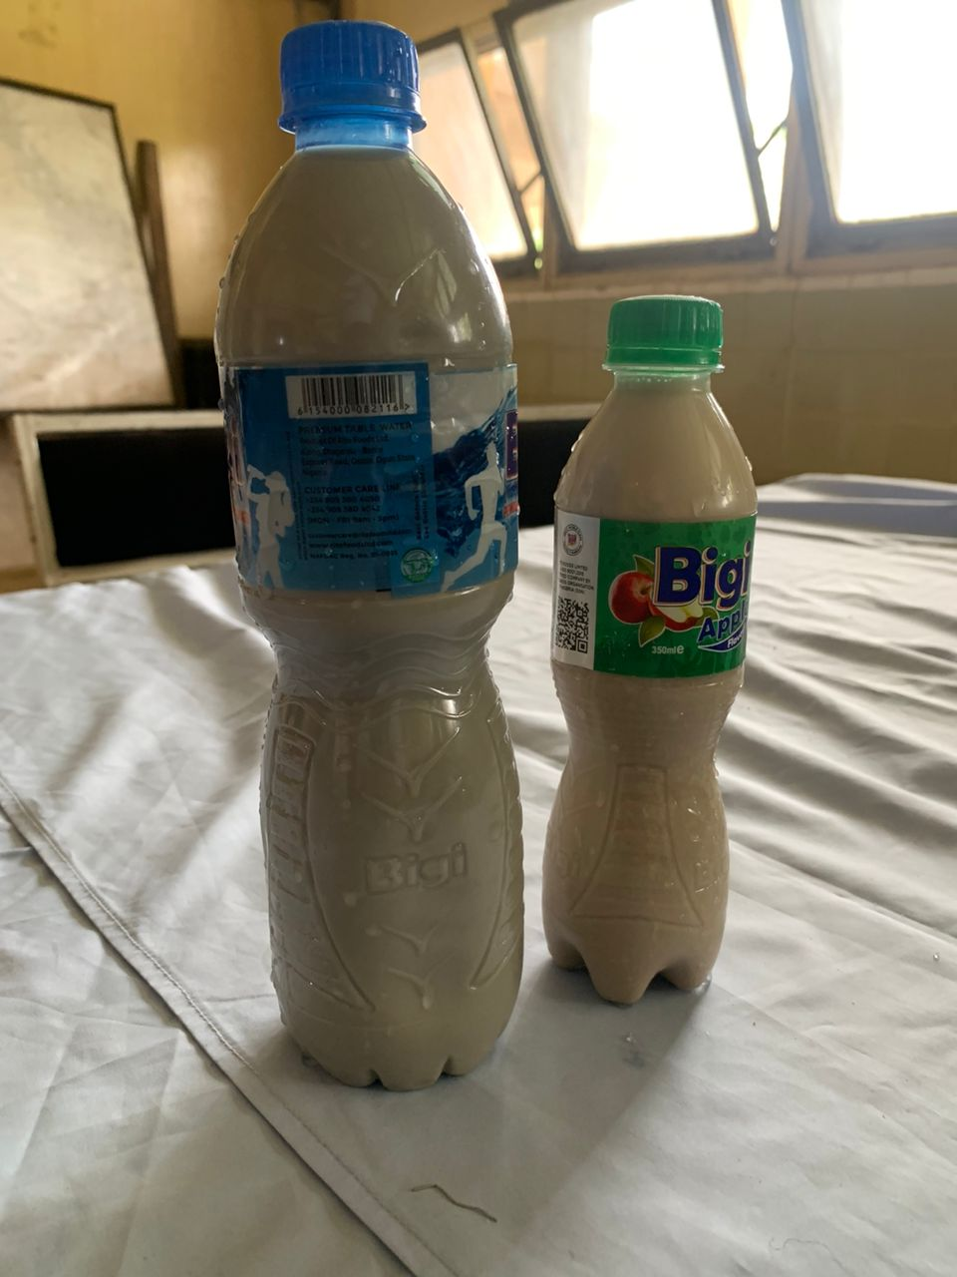
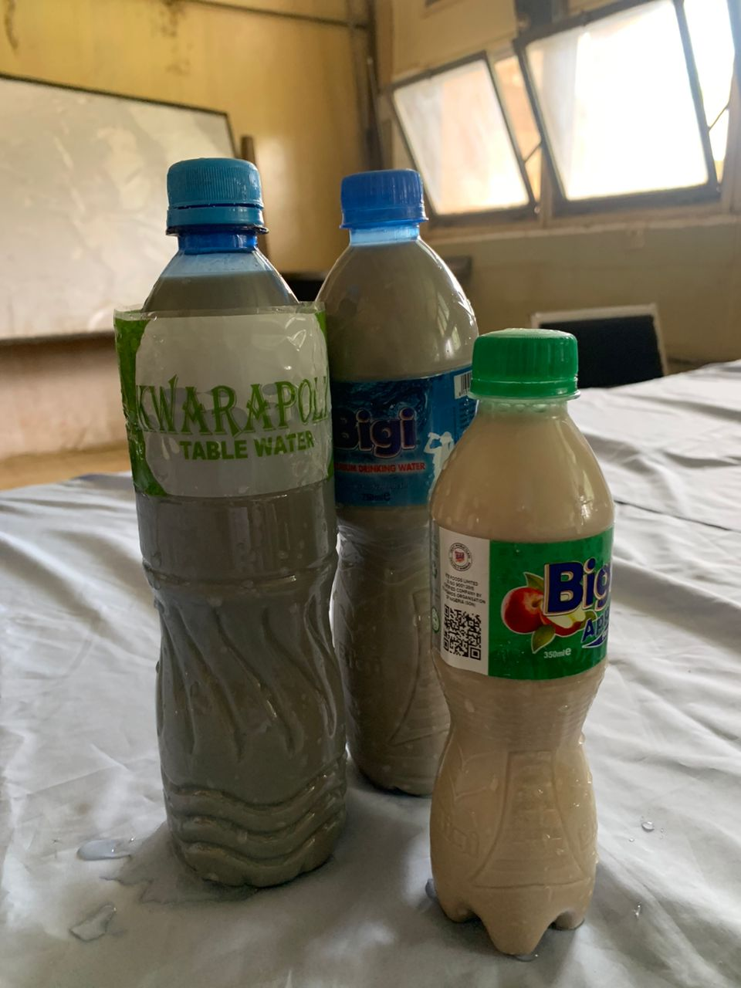

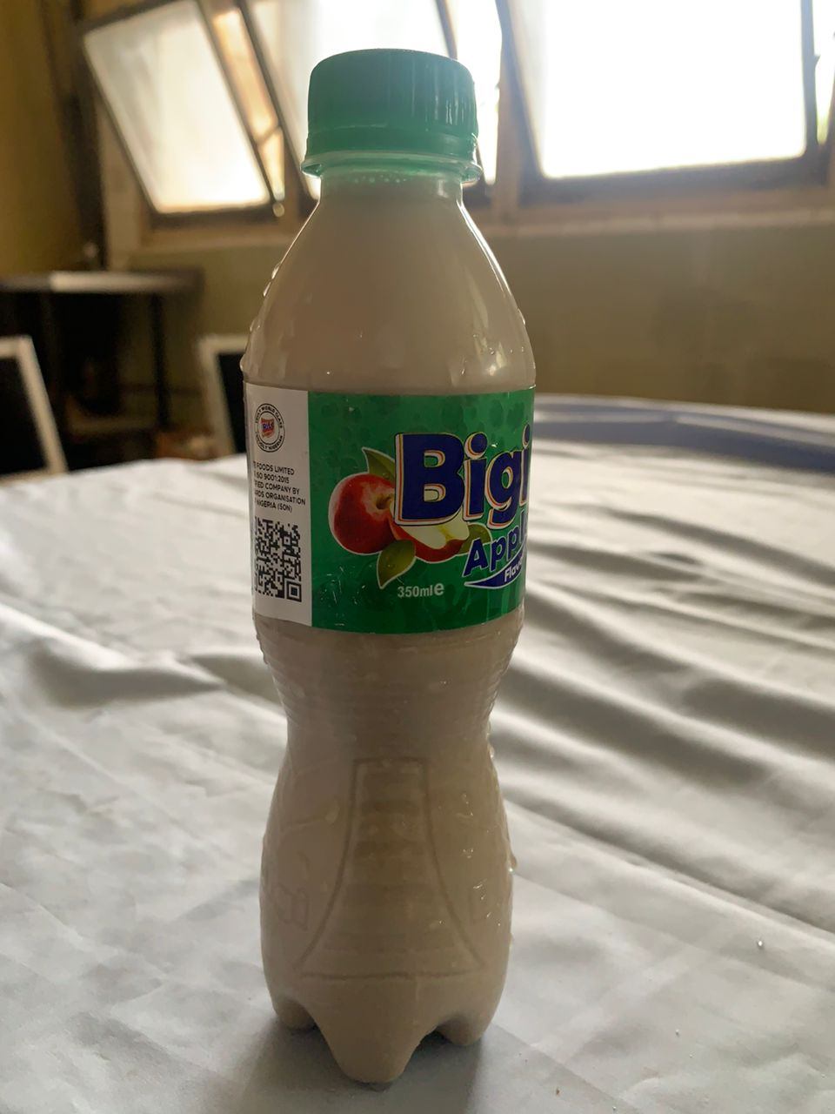

CHAPTER FIVE
5.0 Summary, Conclusion and Recommendations
5.1 Summary
The project work was based on production of non-alcoholic beverage from Nigeria underutilized cereal acha so as to create awareness on the use of cereal in our hospitality industry. Acha (digitaria xilis and digitaria iburna) is gotten from under utilized cereal grain. Acha is good source of protein which are of low fertility and has a sweet milky sour taste.
Acha production has the potential to play an important role in the improvement of food security. It is widely grown in Nigeria. The work also showcase history of acha, benefit and nutritive value.
5.2 Conclusion
Data from the study revealed that a commonly acceptable kunu zaki can be produced from acha which is highly nutritional. Adding to the various form in which acha could be used as a food source especially for children, pregnant women, nursing mothers and invalid who require a high caloric liquid diet and protein. Also it can serve as good source of food for a mal nourish child suffering from kwashiorkor because of it high content of protein.
5.3 Recommendations
Farmer should be encouraged to grow acha and also awareness should be created in the food uses and importance of acha in the production of food products to curb hidden hunger. Also, the production of kunu acha should be made known to schools, hospitals, homes and restaurants as non-alcoholic beverage due to the fact that their nutrient composition are very essential to the health; crude lipid, crude fiber, crude protein, and ash.

REFERENCES
AOAC (2019): Official method of analysis (25th edition). Association of Official and Analytical Chemist, Washington D.C
Bamigboye C.O., Amoo J.A., and Fadiora I.A., (2019): Nutritional quality, physiochemical properties and sensory evaluation of amarath kunu produced from fermented grain, Amals Food Science and Technology 20(2):114.
Cruz, F. (2017): Small grains with potential magazine on low external input and substantiable agriculture, 20(1):16-17.
Gyong J. and Jeffery A., (2018): Acha, the grain of life: bi-annual publication of raw materials research institute, pp 56-66
Ibrahim I. (2017): Hungry Rice Fonio a Neglected Cereal crop, NAOSAS newsletter 1(4):4-5.
F.A.O Food and Agricultural Organization (2017): Food outlook global market Analysis 1-112
Michael K.H., Ouedrago J.B and Philip R.D., (2018): Food science, nutrition and health, Bulletin (29):111-142.
Norman A.E and Sunday O., (2017): Good science, (1st edition), Indian
Adebayo Y.O,. Dosaa A.S., and Ahmed A., (2018): Physiochemical, microbiological and sensory characteristics of kunu prepared from millet, maize and Guinea corn and stored at selected temperature, Advance Journal of Food Science and Technology: 2(1); 41-46.
Adelekan A.O., Alamu, A.E., and Arisa N.U., (2017): Nutritional microbial and sensory characteristics of malted soya kunu zaki; an improved and traditional beverage, Journal of Advance in Microbiology 3(10);389-397.
Adekunle A.A., and Olajire S.O., (2018): Proximate, composition, physical and sensory quality of acha morings flour blend biscuits. Asian Food Science, Journal 5(2):1-17.
Agu H.O., Jideani I.A., and Yusuf I.Z., (2017): Nutrient and sensory properties of drinks produced from different cereals grains. Journal of Nutrient and food science, 37(4):272-281.
Ayo J.A., and Adewori R., (2017): Physiochemical and sensory evaluation of acha- carrot flours blend biscuits, Current Journal of Applied Science and Technology 25(5):1-15.
Ayo J.A., Ayo V.A,. and Popoola C., (2018): Effect of Acha (digitaria exils) grain flours on the physical and sensory quality of biscuits, Journal of Nutrition and Food Science 33(3):125-130.
Ballguo V.Y., Soumanou M.M., and Toukourou F., (2019): Structure and nutritional composition of food. International Research Journal of Biological Science 2(1):73-79.
Belton G., and Hamakar B.R., (2020): Psuedo cereal and less common cereal grains properties and utilization potential, Springe Ruerlay Berlin Heidelberg. Pp201
Chukwu O and Abdulkadir A.J., (2018): Proximate, chemical composition of acha grain, Journal of Food Technology 6(5):214-216.
Egwin, S.I.D., Onuh, O.J and Yusuf P.A., (2018): Effect of fermentation variable on nutritional and organoleptic scores of kunu Zaki produced from rice and of acha blends, Advanced Journal of Food Science and Technology, 5(9)1117-1119.
Essien V.G (2019): Evaluation of the Nutritional and microbiology quality of kunu (a cereal base non-alcoholic beverage) in River State, Nigeria, the Internet Journal of Nutrition And Wellness 10:1-10
Gaffa T., Jideani I.A., and Nkama I., (2020): Innovation in traditional kunu Zaki production process, Pakistan Journal of Nutrition 1(5):202-205.
Jideani I.A and Philip I., and Itodo I., (2017): Development on the cereal grains, Digitaria exiles and Digitaria Iburua, Journal of food science and technology 48(3):251-259.
Musa H., Muazu J, and Bhatia P.G., (2018): Comparative analysis of locally prepared kunu Aya tiger nut milk consumed by student of kaduna state University, Journal of World Science 8(2):1597-6343.
Ofudje J.O and Onuj J.K., (2018): Proximate, minerals contents and microbial analysis of kunu Zaki. A non-alcoholic beverages in ogun state, Nigeria, Journal of Advance in Biology and Biotechnology 7(1)1-8.
Okemu K., Ojo S.O and Ajibefan I.A., (2017): Acha production and utilization in West Africa: The way forward, International Journal of Agriculture Veterinary Scheme 3(2):16-25
Philip I. and Itodo I., (2018): Acha rediscovered indigenous crop of West Africa, International Journal of Agricultural Engineering, 23(8):1-8.
Suleiman F.J., Azeez K.Y and Hammed T.K., (2020): Economic of Acha production in Bauchi state, Nigeria. Journal of Agriculture 2(12):1-10
Teena V.J and Bassa J.D., (2017): Nutritional composition of different types of kunu produce in Bauchi and Gombe state of Nigeria, International Journal of Food Properties 5(2):251-357.
Ukim A.F., Umoren B.D and Okoye B.C., (2019): Nutrition and replacement value of hungry rice "acha" grain for maize grain in broiler starter chicks. Global Journal of Agriculture Science 12(2003):55-61
Ukwuru A.O., Chibike O. F and Emeka T.I (2018): Cereal utilization, Nigeria Journal of Food and Nutrition,2(3):1-12.

APPENDIX
Section A
Bio Data of Respondents
Kindly answer the questions provided in this questionnaire.
- Gender: A. Male B. Female
- Age: 16-20 years ( ), 21-30 years ( ), 31-40years ( ), 41year and above ( ).
- Educational qualification OND ( ), HND ( ), Bsc ( ), Msc/MA ( ).
- Department: Hospitality ( ), Banking and Finance ( ), Accountancy ( ), Business Administration ( ).

Section B
Sensory evaluation for production of Kunu Acha (100%)
Variable | Excellent | V. good | Good | Poor | Fair | Total
Appearance
Taste
Texture
Aroma
Acceptability
Color

Sensory evaluation for production of 50% Acha and 50% Tigernut
Variable | Excellent | V. good | Good | Poor | Fair | Total
Appearance
Taste
Texture
Aroma
Acceptability
Color

70% Kunu Acha, Tiger nut 30%
Variable | Excellent | V. good | Good | Poor | Fair | Total
Appearance
Taste
Texture
Aroma
Acceptability
Color

70% Tigernut and Kunu Acha 30%
Variable | Excellent | V. good | Good | Poor | Fair | Total
Appearance
Taste
Texture
Aroma
Acceptability
Color

