A TECHNICAL REPORT
ON
FACILITY MANAGEMENT OF PART OF KWARA STATE POLYTECHNIC USING GIS APPROACH

BY
ONI ISAAC AYODELE
HND/23/SGI/FT/0025

BEING A PROJECT RESEARCH SUBMITTED TO THE DEPARTMENT OF SURVEYING & GEO-INFORMATICS, INSTITUTE OF ENVIRONMENTAL STUDIES (I.E.S), KWARA STATE POLYTECHNIC, ILORIN

IN PARTIAL FULFILMENT FOR THE REQUIREMENTS OF THE AWARD OF HIGHER NATIONAL DIPLOMA IN SURVEYING AND GEO-INFORMATICS

JULY, 2025

CERTIFICATE
I hereby certified that all information given in this research project were obtained as a result of observation and measurement made by me that the survey was carried out in accordance with the survey rules, supervisor and departmental instruction.

…………………………. ……………………….
ONI ISAAC AYODELE DATE HND/23/SGI/FT/0025

CERTIFICATION
This is hereby certify that this project was carried out by ONI ISAAC AYODELE with the matriculation number HND/23/SGI/FT/0025 under my supervisor and the report was submitted on ___________ day of _____________ 2025.

……………………………… ….………………
SURV. AWOLEYE R.S DATE
PROJECT SUPERVISOR

…………………………….... ….………………
SURV. AWOLEYE R.S DATE
PROJECT COORDINATOR

………………………………. ….………………
SURV.ABIMBOLA I. DATE
HEAD OF DEPARTMENT

………………………………. ….………………
EXTERNAL SUPERVISOR DATE

DEDICATION
This project is dedication to Almighty God for seining me throughout this programme, and for the privilege of being alive to carry out this project from the start to the finish and for his loving kindness and mercy, also dedicated to my parent, sibling, friend and loved ones for their support towards the success of my educational pursuits.

ACKNOWLEDGEMENT
We great encomium to Almighty God. The creator, Author the one who has been the rare privilege to be among the living soul thank you so much!
I am also grateful and thankful to my supervisor Surv. Awoleye R.S for his grateful assistance and contribution despite his tight schedules; he still finds time to verified to vet my work.
To my lecturers, people of selfies interest, thank so much my HOD Surv, Abimbola, Surv, Ashonibare, Surv, Kabiru, Surv, Banji, Surv A.G AremuSurv, Kazeem,Surv, B.F Diran, SurvAyuba A. I pray that the lord will be and abide with you and your families always.
I be nothing but am ungrateful if I fail to appreciate the efforts of my lovely, caring and comparable Parent Mr. & Mrs. Oni and mroyewusi Abiodun O. and my lovely siblings. For their parental care and support since I start my educational career, you stood by me when things were tough and rough me, you gave me hope when others mock me, I will forever be grateful duration you always give to me at all time, if I will pray to have parents in my life again, I will pray to have people like you also, I will like to appreciate the support of SURV,AWOLEYE
To my lovely friends, I so much appreciate your support, for their support and advice they give me. Thank you so much,

MAY ALMIGHTY GOD, BLESS YOU ALL (AMEN)

ABSTRACT
Facility Management is a management concept that primarily evolved from Property Management out of the necessity to cut organizational costs well as to adding value to the overall chain of operational process. Facility Management focuses on harnessing the physical, spatial, environmental, human and financial resources in the ‘post-occupancy’ state of buildings. It is also concerned with its ‘pre-occupancy’ state. Facility Management has been defined as multidisciplinary approach to ensuring functionality of the built environment by integrating people, place, process and technology (IFMA). The aim of this project is to use GIS approach for better and efficient facility management.Facilities Management (FM) refers to the practice of coordinating the physical workplace with the people and work of an organization. It integrates principles of business administration, architecture, and the behavioral and engineering sciences. With the increasing complexity of infrastructure and the need for efficient space utilization and maintenance, Geographic Information Systems (GIS) have emerged as a critical tool in modern facilities management. This literature review discusses key themes, developments, applications, challenges, and future directions in the integration of GIS in FM.

TABLE OF CONTENTS
Title page i
Certificate ii
Certification iii
Dedication iv
Acknowledgement v
Abstract vi
Table of content viii
CHAPTER ONE
1.0 Introduction 1
1.1 Background of the project 1
1.2 Aim of the project 5
1.3 Objective of the Project 5
1.4 Scope of the project 5
1.5 Significance of the Study 5
1.6 Personnel Involved 6
1.7 Study area 6
CHAPTER TWO
2.0 Introduction 7
2.1 Conceptual framework 7
2.2 Geographic Information System (GIS) 13
2.3 Integration of GIS in Facilities Management 16
2.4 Spatial Data Infrastructure for Facilities 20
2.5 Benefits of GIS in Facilities Management 21
2.6 GIS applications for Facility Management 21

2.7 GIS-Based Facility Management Systems 21

2.8 Challenges of GIS Implementation in Facilities Management 23

2.9 GIS and Building Information Modeling (BIM) Integration 24

2.10 Case Studies and Empirical Evidence 25

2.11 Future Trends in GIS for Facilities Management 25
CHAPTER THREE
3.0 Methodology 27
3.1. Reconnaissance 27
3.2. Boundary Selection and Monumentation 31
3.3 Equipment Selection 32
3.4 Test of Instrument 33
3.5 Data Acquisition 36
CHAPTER FOUR
4.1. Data processing 44
4.2 Data downloading 44
4.3 Computation of survey data 44
4.4. Processing in Arcmap 10.3 45
4.5. Preparation of 3d map using Arcscene 47
4.6. Plan production 55
4.7. Result analysis 56
4.8. Queries analysis 57
4.9. Application of Results 66
CHAPTER FIVE
5.0. Costing, Summary, Conclusion, Problem Encountered and Recommendation
5.1. Costing 67
5.2 Summary 70
5.3 Conclusion 70
5.5 Problem Encountered 72
5.4 Recommendation 72
References 73-74
Appendix 75-88
CHAPTER ONE
1.0 INTRODUCTION
1.1 Background to the study
Facility Management is a management concept that primarily evolved from Property Management out of the necessity to cut organizational costs well as to adding value to the overall chain of operational process. Facility Management focuses on harnessing the physical, spatial, environmental, human and financial resources in the ‘post-occupancy’ state of buildings. It is also concerned with its ‘pre-occupancy’ state. Facility Management has been defined as multidisciplinary approach to ensuring functionality of the built environmentby integrating people, place, process and technology (IFMA).
Over the years, facility management has changed from individuals maintaining a small number of buildings to managers currently in charge of a sizable portfolio of facilities. In addition to overseeing capital projects, facility performance, space concerns, customer service, and amenities, today's managers are also heavily involved in and in charge of real estate transactions and efforts at strategic planning (Philip McLaughlin, Cadcorp 2019).
Facility management is a daily balancing act of purchasing, maintenance, and tracking assets – all while adhering to a stringent budget. It can make the job overwhelming and exhausting. Utilizing online calendars, tracking systems, robust inventory systems, and other tool sets can all help day-to-day operations of facility management go smoothly. Arguably one of the most powerful tools that can be implemented is a well-designed Geographic Information System (GIS).
Facilities Management (FM) is a multidisciplinary field that integrates people, place, processes, and technology to ensure the functionality, comfort, safety, and efficiency of the built environment. This includes managing physical assets such as buildings, spaces, utilities, equipment, and infrastructure. FM responsibilities encompass a wide range of tasks including space planning, maintenance, asset tracking, environmental management, and emergency preparedness.
Traditionally, FM relied heavily on manual data collection, 2D drawings, and spreadsheets to manage facilities. However, with the growth of complex infrastructures and increasing demand for efficiency and sustainability, there is a growing need for smart, data-driven management systems. This is where Geographic Information Systems (GIS) become a powerful tool.
A Geographic Information System (GIS) is a framework for gathering, managing, and analyzing spatial and geographic data. It integrates various data types and layers them spatially on maps to visualize relationships, patterns, and trends in a geographic context. GIS has been widely adopted in urban planning, environmental management, logistics, and now increasingly in Facilities Management.
GIS is uniquely positioned to support FM activities because most facility assets are tied to specific locations. Whether it’s a room in a building, a water pipe beneath a campus, or a fire exit on a floor plan—location matters. GIS provides a spatial dimension to traditional facilities data, enhancing analysis, visualization, and decision-making.
Geographic information system (GIS) is a technology that has many uses and advantages in many fields. One of the potential fields of utilization is Facility Management. GIS can be used by facility managers for space management, visualization and planning, and emergency and disaster planning and response, as well as many other applications (Schürle, D. Fritsch 2018).
GIS can be very helpful for facility managers in order to forecast for their future space, plan for yearly maintenance, response efficiently during emergencies and manage their facilities in an efficient manner (Stuart Rich & Kevin H. Davis 2010).
Given the importance of facilities and their place in society, a revolution in facilities management is occurring. Geographic information systems (GIS) are designed specifically for the management and analysis of spatial relationships, and offer many benefits to the facilities management community.
In the past, GIS was commonly used to help measure the impact of a facility on a natural ecosystem. Today, GIS is increasingly being used to plan, manage and operate the man-made ecosystem – the facility. Facilities managers are finding GIS tools, which have been used successfully for many years in fields such as environmental analysis and landscape planning, support a broad range of applications inside and outside of buildings, such as operations planning, emergency management, Americans with Disabilities Act (ADA) compliance, safety and security planning, space utilization and optimization, and more.
GIS can be used throughout the life cycle of a facility – from site selection, design and construction to use, maintenance and adaptation, and ultimately through closing, repurposing and reclamation. The challenge is to manage each step of the process in a way that maximizes the benefits of the facility to society while minimizing short- and long-term impacts on the natural environment. As an integrative platform for management and analysis of all spatial things, I believe, as the authors of this white paper have eloquently stated, GIS “is the only technology that has the ability to scale across any expanse, from the individual asset within a building to a virtually global context.”
Geographic information systems (GIS) are one technology that has many practical uses for facility managers. A GIS is a system that allows one to view, understand, question, interpret and visualize data in many ways that reveal relationships, patterns and trends in the form of maps, globes, reports and charts. A GIS can be used by facility managers for space management, visualization and planning, and emergency and disaster planning and response, as well as many other applications.
Modern GIS is an integrated system of computer software and data and information about the location and geography of things and phenomena and the relationships between them. GIS is used to interact with, manage and display geographic information.
GIS was first computerized in the 1960s (GIS.net 2010) as an effort to automate the landscape planning process of separating design influences, such as hydrography, vegetation, soils and ownership boundaries, into different layers. The approach before computerization was to draw each of the layers to scale on a separate page of acetate and then physically recombine them by stacking the pages in order to visualize different aspects of a proposed design. In the ensuing decades, GIS has matured into an enterprise-class technology platform that allows users to model the spatial relationships between and among many important aspects of our complex world.
1.2 Aim of the Project
The aim of this project is to use GIS approach for better and efficient facility management.
1.3 Objectives of the Project
- To improve spatial data management
- To enhance decision-making processes
- To optimizing resource allocation
- To increase operational efficiency
- To facilitate communication and collaboration among stakeholders.
1.4 Scope of Project
The scope of this project involved the;
- Illustrating the potential usage of GIS applications in facility management.
- Explorer case study and examples to support the study and to prove the efficiency of the integration between GIS & facility management.
1.5 Significances of the Project
- To help minimize the risk by accurately locating utility system.
- Provide support for all FM projects, and accessibility to accurate and up-to-date documentation and info.
- Enables deep analysis of location data helping to explain patterns, relationships, and situations to help make smarter more efficient and effective decisions.

1.6 Personnel Involved
The students listed below were the members of this group who participated in the execution of the project.
TABLE 1.1: Personnel Involved
NAME | MATRIC. NO. | Role Played
ONI ISAAC AYODELE | HND/23/SGI/FT/0025 | Author
ABIDOYE Azeez Opeyemi | HND/23/SGI/FT/0023 | Member
Dauda Aishat Adebukola | HND/23/SGI/FT/015 | Member
AKINSOLA Victoria Oluwabunmi | HND/23/SGI/FT/0017 | Member
SALAWU Kehinde Naomi | HND/23/SGI/FT/017 | Member
SOLIU Fatai Olusina | HND/23/SGI/FT/0020 | Member
IBRAHIM Irewunmi Fatimat | HND/23/SGI/FT/0018 | Member
Source: Field Survey, 2025
1.7 Study Area
The project is located inside Kwara State Polytechnic, Moro Local Government, Ilorin Kwara State, with Latitude 8.55395 and Longitude 4.63562 respectively.
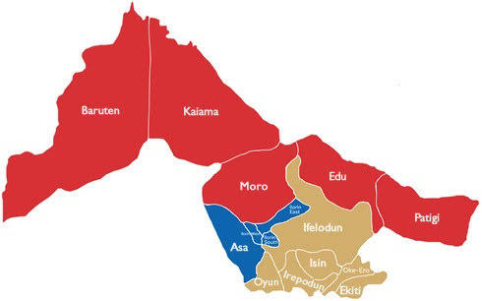
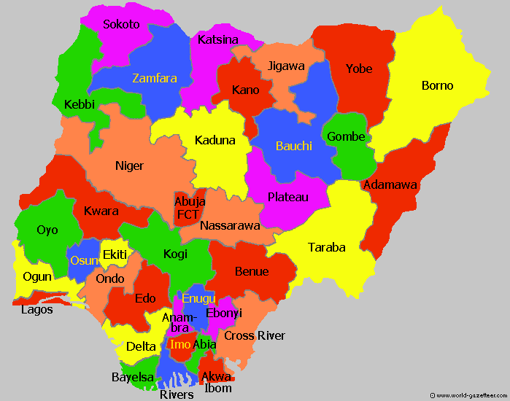
MAP OF NIGERIA
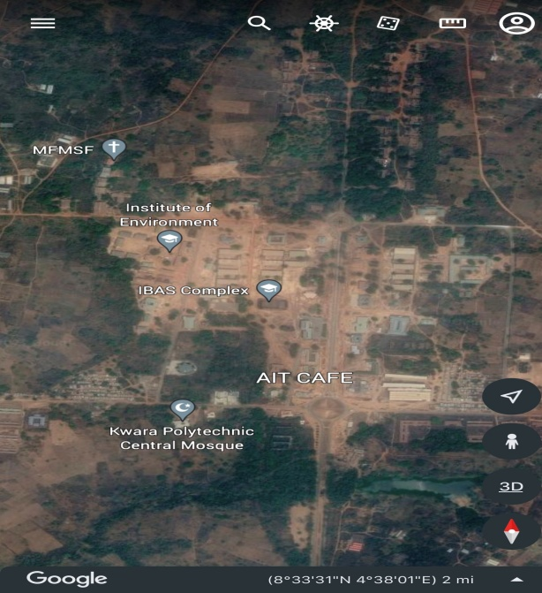
MAP OF KWARA STATE
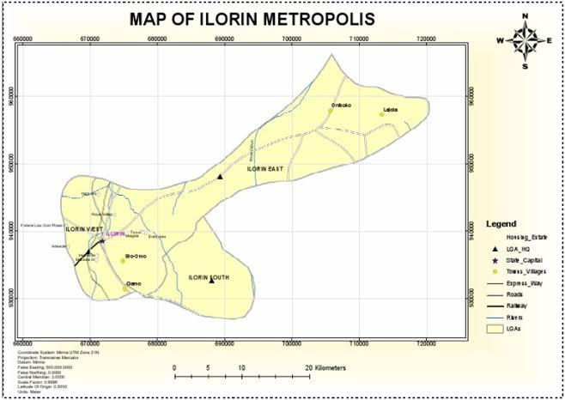

MAP OF ILORIN METROPOLIS
GOOGLE IMAGERY 0F THE STUDY AREA

Fig1.1: Map Showing Study Area

CHAPTER TWO
LITERATURE REVIEW
2.0 INTRODUCTION
Facilities Management (FM) refers to the practice of coordinating the physical workplace with the people and work of an organization. It integrates principles of business administration, architecture, and the behavioral and engineering sciences. With the increasing complexity of infrastructure and the need for efficient space utilization and maintenance, Geographic Information Systems (GIS) have emerged as a critical tool in modern facilities management. This literature review discusses key themes, developments, applications, challenges, and future directions in the integration of GIS in FM.
Facilities Management (FM) encompasses the integrated processes essential for maintaining, improving, and adapting the buildings and infrastructure of an organization in a way that ensures functionality, comfort, safety, and efficiency of the built environment (Alexander, 2003). Traditionally, FM relied on manual methods of asset tracking, maintenance scheduling, and space management. However, technological advancements have ushered in innovative tools, among which Geographic Information Systems (GIS) have emerged as a transformative asset.
Geographic Information Systems (GIS) refer to systems designed to capture, store, manipulate, analyze, manage, and present spatial or geographic data (Longley et al., 2015). GIS allows the layering of multiple data sets with geographic references, providing spatial relationships that aid decision-making. Initially applied in environmental studies and urban planning, GIS has found increasing utility in various disciplines, including FM.
The integration of GIS in FM allows facility managers to spatially analyze data, offering real-time visualization of infrastructure assets, utilities, and buildings (Shohet &Lavy, 2004). This spatial perspective enhances the ability to plan maintenance, allocate space, manage energy consumption, and respond to emergencies effectively.
Akinyemi and Aluko (2014) emphasized the value of GIS in managing complex facility portfolios by linking spatial data with facility asset databases. GIS-based FM systems can integrate with Building Information Modeling (BIM), Computer-Aided Facility Management (CAFM), and Enterprise Asset Management (EAM) systems, thereby offering a centralized platform for data access and decision-making (Becerik-Gerber et al., 2011).
GIS supports the scheduling and monitoring of routine and emergency maintenance by spatially locating assets requiring service. According to Shohet (2003), GIS improves maintenance response time and resource allocation by integrating with maintenance logs and sensor data.
Facilities often include complex utility networks like electrical, water, and HVAC systems. GIS can model these networks, identify problem points, and streamline fault diagnosis. Kamaruzzaman and Zawawi (2010) found that utility mapping with GIS improved the efficiency of fault detection and repair in public facilities.
GIS is invaluable in emergency planning and risk management. In hospitals and universities, for instance, GIS provides maps for evacuation routes, fire extinguisher locations, and access control points. According to Hegazy and Elhakeem (2011), GIS-based simulations help prepare for emergency scenarios, reducing response times and ensuring safety compliance.
2.1 Conceptual framework
Facilities Management is a multidisciplinary field that ensures the functionality, comfort, safety, and efficiency of the built environment by integrating people, place, process, and technology (IFMA, 2019). It encompasses a broad range of activities such as building maintenance, space planning, real estate management, and asset management. Traditionally, FM relied heavily on manual systems and spreadsheets, which often resulted in inefficiencies and data inaccuracies.
According to Atkin and Brooks (2015), FM includes both hard services (e.g., HVAC, plumbing, electrical systems) and soft services (e.g., custodial services, space management). The integration of digital tools like GIS has revolutionized this sector by enhancing the visualization and analysis of spatial data.
According to the International Facility Management Association (IFMA), Facility management is defined as a profession that encompasses multiple disciplines to ensure functionality of the built environment by integrating people, place, process and technology.
In another word, the facility manager rule involved the coordination and integration of workplace, occupants and work processes that ensures the continuity of the operation in a way that the facility will perform as designed and planned for it (Weller R., 2017).
The Facility Management sector acts as an umbrella, horizontally oriented market. It currently represents about 5% of global GDP. Because of its increasing relevance to the core business, it more and more takes the lead when developing a 'new world of work' and 'new ways of working'. As a result the need for convergence with Human Resources, Real Estate and Information Technology has increased dramatically. Also, the Facility Management sector has started taking its social responsibility, has become a strong driver of economy and proofed its role as integrator of people, place and processes. As a result Facility Management has become the leading business service able to integrate the tangible assets of real estate and facilities with the intangible assets of facility services.
The discipline of facility management and the role of facility managers in particular are evolving to the extent that many managers have to operate at two levels: strategic-tactical and operational. In the former case, clients, customers and end-users need to be informed about the potential impact of their decisions on the provision of space, services, cost and business risk. In the latter, it is the role of a facility manager to ensure corporate and regulatory compliance plus the proper operation of all aspects of a building to create an optimal, safe and cost effective environment for the occupants to function.
The facility manager should have two sorts of skills and knowledge areas in order to have a comprehensive background that qualifies him for successful facility management:
Hard skills: such as electrical distribution, civil, plumbing, operation, maintenance and spatial planning.
Soft skills: such as managerial skills, negotiations, time management, team building, problem solving and financial awareness.
According to Philip McLaughlin, Cadcorp (2009), there are several types of facility management services that can be provided to organizations to help them manage their facilities effectively and efficiently. These services may include:
1. Hard Facilities Management (Hard FM)
The management and upkeep of tangible building components, such as finishes, structures, and equipment, are included in hard management services. Hard FM involves overseeing all of the elements that make up a company's or infrastructure's physical structure, including its equipment, systems, processes, people, and technology.
The hard facility management is designed with an exceptional strategy, a particular strategy, and a customised strategy management to match the exceptional needs of every customer and cover the whole spectrum of physical management services.
The whole range of physical management services are covered by the hard FM, which is tailored with a special strategy, customised, and personalised strategy management to match the distinctive needs of each client, including-
- Heating
- Lighting/electrical
- Plumbing
- Fire safety systems
- Air conditioning
- Mechanical

2. Soft Facilities Management (Soft FM)
Soft services are activities and offerings that you can customise. They frequently aren't necessary and can be handled in a variety of different ways. The use and beneficiaries of soft services, however, are what matter most. Soft services can improve the working environment in ways that are advantageous to both people and the work they accomplish when properly implemented.
Soft services aren't built into the structure but are used by and directly benefit employees. They are not necessary; rather, they are intended to enhance the comfort, enjoyment, or security of the workplace. Several instances include:
- Building security
- Landscaping
- Cleaning
- Catering
- Office decorating
- Office moves
2.2 Geographic Information System (GIS)
Geographical Information System (GIS) - System of computer hardware, software, and procedures designed to support the capture, management, manipulation, analysis, modeling, and display of spatially referenced data for solving complex planning and management problems. GIS is a computer-based system used to capture, store, edit, analyze, display, and plot geographically referenced data. GIS was pioneered in the 1960s by the Canadian forestry mapping initiative and continued to develop as Canadian, U.S., and other government and university researchers sought to represent the earth’s geography using a computer database, display it on a computer terminal, and plot it on paper. They also developed computer programs to quickly search and analyze this data. The typical GIS is founded on several basic concepts. First, the real-world features on the earth’s surface are related to a map grid coordinate system and recorded in the computer. The computer stores the grid coordinates of these features to show where they are, and the attributes of these map features to show what they are. Second, map features can be displayed or plotted in any combination and at virtually any map scale, making computerized mapping data far more flexible to use than traditional paper maps. Third, the GIS can analyze the “spatial” (locational) relationships among map features.
The capability of GIS technology to process both spatial and attribute data offers the opportunity of using GIS in locational analysis. GIS facilitates effective decision-making by planners in planning. GIS goes beyond the limits of paper maps in manipulating and analyzing spatial data. The advantages of GIS in data documentation and processing include (Al-Ramadan &Aina 2004):
- Quick updating of information
- Automated cartography
- Integration of information by linking spatial and attribute data
- Spatial analysis
- Production of maps at different scales and
- Visualization.
For years, facility managers have been using GIS at the landscape level to manage a number of the assets in their facility portfolio. Some of the earliest applications of GIS in facility management were related to pavement management at airports, municipal water and wastewater infrastructure, and electric utility distribution. For example, facility managers of the US Air Force have developed a standardized set of GIS layers to support the management of Air Force bases.
Today, it is becoming possible with GIS to think about and analyze the spatial aspects of every component of facility management workflows to decrease cost and increase productivity. None of the enterprise applications used within the arena of facility management have advanced spatial analytic capabilities to support business processes that span geographic areas or provide complex scenario modeling that includes multidimensional visualization including 3D (space), 4D (time) and 5D (money).
Geographic information system (GIS) technology manages infrastructure both outside and inside buildings to provide full operational awareness. Use it to optimize existing space, move staff efficiently and map asset conditions. Throughout the facility life cycle,
GIS supports you in your mission, from site selection to space planning and maintenance, lease management and usage, safety issues, and continuity planning.
GIS gives organizations a look at their facilities across all scales using the same data and software, allowing them to analyze dependencies, decrease costs, makes better decisions, and improves performance management. GIS is a robust information system that supports a diverse set of analytic capabilities, workflows, and applications.
GIS is a platform that supports the integration of information from all of these spatial, temporal and informational dimensions. Examples of such integrations include:
• Combining cost data with the visualization of space and occupancy across the campus
• Analyzing routing barriers for disabled persons for use during evacuation planning and emergency action planning
• Conducting visualization of energy consumption data at the room level while simultaneously managing maintenance workflows for mechanical, electrical and plumbing systems for a nationwide facility infrastructure
• Managing security concerns both inside and outside buildings, across regions and continents, simultaneously (4D) and contiguously (3D)

2.3 Spatial Data Infrastructure for Facilities
As GIS is becoming more widely used inside buildings, facility managers are applying the insights gained from spatial data infrastructures to the spaces inside buildings. There are framework levels inside the building, just as there are framework levels at the landscape level, such as roads and parcels. A few examples of framework layers inside a building include floor levels, walls, windows, doors and the spaces that are defined by architectural structures.
Once the core architectural elements of the building have been established in the GIS, it is possible for many other layers to be derived from this foundation. Some of the layers that can be derived from basic floor plans include:
• Space use and type definitions
• Lease areas
• Security zones
• Management zones
• Asset locations
• Evacuation collection areas
• Navigable routes
Once this basic data has been added to the GIS, it is possible to provide geospatial support to a wide variety of information systems and business processes for the facility management community:
• Grouping multibuilding and multisite work orders by location to reduce transportation and logistics costs
• Visualizing energy consumption data at the room, building and/or enterprise level over time
• Analyzing space use, space availability and space optimization across campus or regional extents
• Conducting building condition assessments, fire safety inspections and asset inventories using handheld, location-aware (GPS-enabled) devices. These devices provide rapid data capture and precise location of issues, items and assets, supporting visualization, analysis and reporting.
• Analyzing and visualizing lease performance metrics across the portfolio, regardless of geographic extent
• Analyzing, route mapping and reporting of Americans with Disabilities Act (ADA) compliance and/or ADA facility and fixture availability across the campus or portfolio
• Visualizing the impact of proposed building projects on the campus environment
• Conducting line of sight analysis for special events
• Modeling the impact of proposed use changes on the supporting utility infrastructure
• Visualizing proposed space planning scenarios
In order to provide best practices guidance and support for facility managers interested in establishing facility GIS capabilities, an independent committee made up of software vendors, government users, higher education facility managers and facility managers from various levels of government formed the Building Information Spatial Data Model (BISDM) committee in 2007. This committee has published several versions of the Building Information Spatial Data Model and continues to enhance and extend the model and its tools, making them available to the community.
Modern GIS is an integrated system of computer software and data and information about the location and geography of things and phenomena and the relationships between them. GIS is used to interact with, manage and display geographic information. GIS was first computerized in the 1960s as an effort to automate the landscape planning process of separating design influences, such as hydrography, vegetation, soils and ownership boundaries, into different layers. The approach before computerization was to draw each of the layers to scale on a separate page of acetate and then physically recombine them by stacking the pages in order to visualize different aspects of a proposed design. In the ensuing decades, GIS has matured into an enterprise-class technology platform that allows users to model the spatial relationships between and among many important aspects of our complex world.
GIS for Facility Management
GIS integrates with the top facilities management (FM) software and consulting firms, making it easier than ever to extend the life of your FM data.
GIS can be used throughout the life cycle of a facility from deciding where to build to space planning (Esri 2010).

GIS helps you to:
- Streamline asset information collection, dissemination, maintenance, and use.
- Facilitate better planning and analysis.
- Allow efficient sharing of information in and out of the field, providing a comprehensive view of operations.
A Geographic Information System (GIS) is a computer-based tool for mapping and analyzing spatial data. GIS integrates hardware, software, and data for capturing, managing, analyzing, and displaying all forms of geographically referenced information (Longley et al., 2015). It allows users to visualize, question, analyze, and interpret data to understand relationships, patterns, and trends.
GIS is widely applied in fields such as urban planning, environmental monitoring, logistics, and infrastructure development. Its strength lies in its ability to combine layers of information, facilitating comprehensive spatial analysis (Burrough & McDonnell, 2019).
2.4 Integration of GIS in Facilities Management
2.4.1 Historical Development
The integration of GIS into FM began in the late 20th century, when facility managers started utilizing computer-aided design (CAD) and GIS for spatial data representation. Early efforts were focused on converting paper-based floor plans into digital formats (Shohet, 2003). With the advancement of GIS technologies, modern FM systems now offer real-time visualization of facilities, dynamic asset tracking, and integration with Building Information Modeling (BIM).
2.4.2 Applications in FM
GIS can support several FM functions, including:
Space Management: GIS helps in managing and optimizing space utilization in buildings by providing visual and spatial insights (Zhao et al., 2012).
Asset Management: By mapping the locations of assets, GIS supports preventive maintenance and lifecycle tracking (Elmualim et al., 2010).
Emergency Planning: GIS facilitates evacuation planning, risk analysis, and incident tracking by modeling the spatial distribution of hazards (Deng & Poon, 2011).
Infrastructure Monitoring: Utilities such as HVAC, plumbing, and electrical systems can be mapped and monitored using GIS for maintenance and upgrades (Ghosh, 2008).
Environmental Sustainability: GIS enables the tracking of energy usage, waste generation, and other environmental indicators, aiding in sustainability reporting (Lindholm &Nenonen, 2016).
2.5 Benefits of GIS in Facilities Management
2.5.1 Enhanced Decision-Making
GIS enhances strategic planning by providing spatially explicit information. Managers can visualize facility performance metrics, conduct spatial queries, and evaluate alternative scenarios (Bakis et al., 2017).
2.5.2 Improved Asset Tracking
GIS allows real-time tracking and inventory of physical assets. This helps reduce downtime, schedule preventive maintenance, and avoid unnecessary replacement (Teicholz, 2021).
2.5.3 Cost Efficiency
Through effective space utilization and maintenance scheduling, GIS can reduce operational costs. Studies have shown up to 15–30% cost savings in maintenance operations with GIS integration (Shohet &Lavy, 2004).
2.5.4 Enhanced Communication
GIS provides a shared visual interface for various stakeholders—engineers, managers, planners—facilitating better communication and coordination (Chung et al., 2009).
2.6 GIS applications for Facility Management
Compliance
Numerous software platforms have emerged integrating GIS with FM, including:
- ArcGIS by Esri: Offers robust spatial analytics and data integration for managing facility assets.
- FM: Systems: Combines space planning, asset management, and GIS visualization.
- AutoDesk Map 3D: Provides tools for designing and managing spatial data linked to engineering projects.
Each system varies in functionality, customization, and integration with other enterprise systems like ERP and BIM (Ma et al., 2009).
Meeting compliance codes ensures that a building or asset is safe and operates as intended. Building compliance can span from energy efficiency, safety, and zoning to issues dealing with conformity to laws such as the Americans with Disabilities Act (ADA) of 1990. Buildings and assets are inherently spatial; they are located somewhere on the earth.
GIS can be used to efficiently collect and store information based on their location, providing a means for query, analysis, and reporting when necessary.
Asset Management and Maintenance
GIS helps organizations gain efficiencies even in the face of finite resources and the need to hold down costs. Operations and maintenance staff can deploy enterprise and mobile workforce applications that provide timely information to the field for faster, more accurate work order processing.
Lease and Property Management
Revenue can be increased and operations and maintenance costs reduced when GIS helps manage space. Real estate and property managers can see and make queries about space including its availability, size, and special constraints for the most cost-effective use.
Space Usage
GIS helps facilities managers organize and spatially visualize space and how it can best be used. Operational costs can be decreased by more efficiently using space including managing the moves of personnel and assets as well as the storage of materials.
Disaster and Business Continuity Planning
Viewing buildings and the locations of assets along with emergency information, such as weather patterns and disaster zones, can give organizations the information they need to make decisions quickly.
Green Buildings
Increase a facility’s sustainability by using GIS to help reduce energy and water use, find better waste disposal, and decrease a building’s carbon footprint. By managing information both inside and outside buildings down to the asset level, a difference can be made in the environmental impact of development.

2.7 GIS-Based Facility Management Systems
Numerous software platforms have emerged integrating GIS with FM, including:
- ArcGIS by Esri: Offers robust spatial analytics and data integration for managing facility assets.
- FM:Systems: Combines space planning, asset management, and GIS visualization.
- AutoDesk Map 3D: Provides tools for designing and managing spatial data linked to engineering projects.
Each system varies in functionality, customization, and integration with other enterprise systems like ERP and BIM (Ma et al., 2009).

2.8 Challenges of GIS Implementation in Facilities Management
Despite its benefits, GIS integration in FM faces several challenges:

2.8.1 Data Integration
Integrating data from different sources (e.g., CAD, BIM, spreadsheets) into GIS can be technically complex and resource-intensive (Arayici et al., 2012).

2.8.2 Cost of Implementation
The initial cost of GIS infrastructure, including software licenses, hardware, and skilled personnel, can be a barrier to adoption (Elmualim et al., 2010).

2.8.3 Technical Expertise
The successful use of GIS requires trained personnel. Many FM teams lack GIS specialists, leading to underutilization of available tools (Zhao et al., 2012).

2.8.4 Data Accuracy and Maintenance
Maintaining up-to-date and accurate data is crucial for effective GIS use. Errors in spatial data can lead to misinformed decisions (Shohet, 2003).

2.9 GIS and Building Information Modeling (BIM) Integration
The integration of GIS with BIM has gained traction as it allows combining detailed building models with spatial context. BIM provides in-depth geometric and semantic building data, while GIS adds environmental and infrastructural context (Volk et al., 2014).
The synergy between GIS and BIM is useful in urban planning, disaster management, and sustainability projects. However, interoperability issues, such as differences in data formats and modeling standards, remain a challenge (Succar, 2009).

2.10 Case Studies and Empirical Evidence
Several case studies demonstrate the value of GIS in FM:
- University Campuses: Institutions like the University of California have implemented GIS to manage facilities across multiple campuses, improving space allocation and maintenance efficiency (Chung et al., 2009).
- Hospitals: GIS has been used in hospitals to monitor medical equipment, manage patient flow, and optimize emergency response (Sui & Holt, 2008).
- Corporate Buildings: Organizations such as IBM and Microsoft have used GIS for real-time monitoring of their data centers, improving energy efficiency (Lindholm &Nenonen, 2006).
These examples highlight the practical applications and measurable benefits of GIS in FM environments.

2.11 Future Trends in GIS for Facilities Management
Emerging trends include:
- Smart Cities and IoT: Integration of Internet of Things (IoT) sensors with GIS for real-time data collection and analysis (Batty et al., 2012).
- Mobile GIS: Use of smartphones and tablets for on-the-go access to facility maps and data.
- Cloud-Based GIS: Enables scalable and collaborative FM operations through cloud platforms.
- Artificial Intelligence: Predictive maintenance and anomaly detection using AI integrated with GIS platforms (Ghosh, 2008).
These advancements promise to further enhance the value of GIS in FM, making it a central component of digital transformation in infrastructure management.

Summary
The integration of GIS into facilities management offers transformative potential in terms of operational efficiency, strategic planning, and sustainability. While challenges remain in terms of cost, expertise, and data management, technological advancements and growing adoption across sectors signal a promising future. A deeper understanding of GIS functionalities, combined with organizational commitment, can unlock significant value for facility managers in both public and private sectors.

CHAPTER THREE
3.0 METHODOLOGY
This are the methods and procedure employed in executing the project both in office and on the field. The method adopted for this project was based on the principle of surveying which was working from whole to part, aimed at acquiring reliable and accurate data needed for the computation and presentation of information in form of a plan.
The procedure adopted in carrying out the project followed a pattern in which one step leads to another. For easy execution and for the aim and objectives of the project to be realized, it was planned as under listed;
i. Reconnaissance survey.
iii. Data acquisition.
iii. Data downloading and processing.
iv. Data analysis.
v. Information presentation.
3.1. RECONNAISSANCE
This is a very important aspect of surveying that involves planning and preliminary inspection of the area before the commencement of the actual data acquisition of the project site, this was done for the purpose of planning on how to execute the project, fixing stations, locating controls, etc. Its importance prior to the actual survey operation, it cannot be underestimated as it enables the Surveyor to have a clear view of the project area so as to give the best method to carry out the task. The two phases of reconnaissance are;
i. Office planning
ii. Field reconnaissance
3.1.1. OFFICE PLANNING
This involved the office work carried out before the actual field work. This aspect involved the compilation and study of the available information about the project site as this helped in yielding result within the expected accuracy. It comprises of the following;
i. Understanding the purpose of the survey from the project instruction.
ii. Obtaining the specification for the accuracy required leading to the choice of a suitable
scale.
iii. Deciding the method to be employed for the measurements.
iv. The kind of instruments to be used in executing the project.
3.1.2. FIELD RECONNAISSANCE
The field reconnaissance was done after the office planning. It involved a visitation to the project site by all the group members to have a pre-requisite knowledge of how it looks like and how the field operations would be carried out. At the end of the visit, a sketch diagram known as “recce diagram” showing the physical appearance of the project site was drawn.
To sum it up, the reconnaissance facilitated the planning and execution of the actual survey as it was taking into consideration, the possible problems that are likely to be encountered, how such problems can be overcome or reduced to the barest minimum.
The diagram below shows the drawn recce diagram.
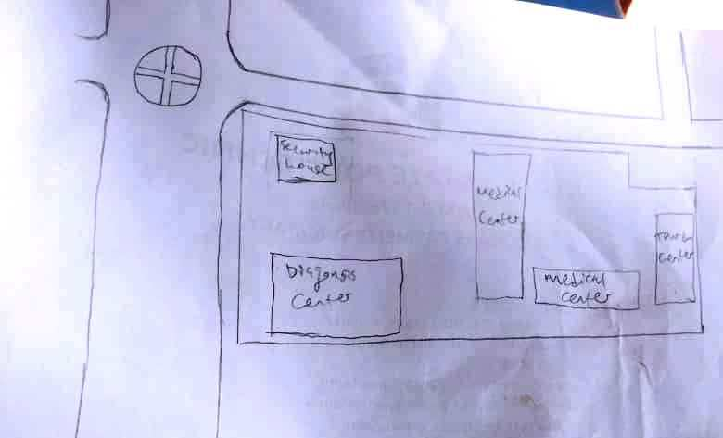

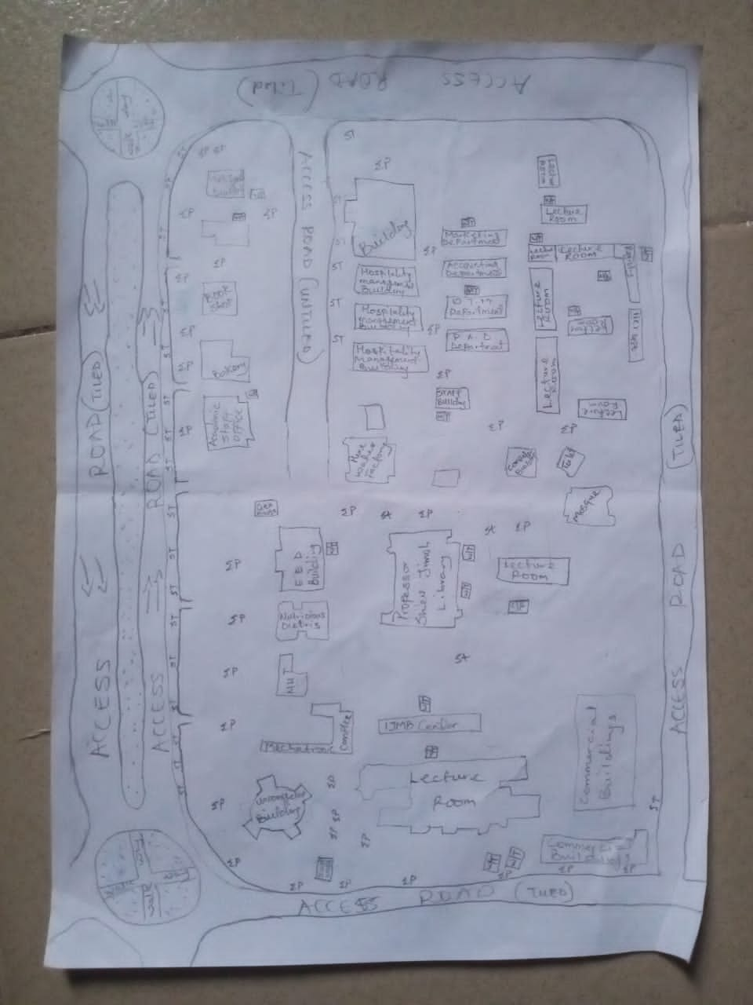

Fig. 3.1. Recci Diagram

3.2. BOUNDARY SELECTION AND MONUMENTATION
Pre-cast property beacons made of 18cm x 18cm x 75cm were used for the demarcation of the project site. In compliance with the specification for cadastral Survey as specified in CAP 194 of law of the Federation of Nigeria, the Beaconswere made of concrete mixture of ratio 3:2:1 (3 parts of sand to 2 parts of granite to 1 part of cement) with water, so as to ensure that the pillars were strong. The beacons protruded 15cm above ground level, while the remaining part was inserted and fixed firmly into an undercut hole. An iron rod (80cm in lengths and 10mm in diameter) protruding at the centre of the beacon represents the centre of the station mark.
A total number of Nine (9) beacons were emplaced and prefixed with identification mark “PIL” where “PIL” represent property beacon, Pillar. The beacons were capped and numbered from Pil.1 to Pil.9 as obtained from the department of surveying, Kwara State Polytechnic, Ilorin and theywere numbered in a clockwise direction with stencil.
Ground level
18cm
18cm
Beneath Ground level
75cm long
60cm
80cm Iron rod
Above Ground level
15cm

01
PIL

18cm
18cm

Figure 1.9: Pre- cast property beacon

3.3 EQUIPMENT SELECTION
The various equipment used for the acquiring of data and successful completion of this project were selected and was grouped in to two categories. They are;
3.3.1 Hardware Numbers
i. Total Station (South NTS-350R) with its accessories. 1 No.
ii. Tripod stand 1 No.
iii. Tracking Rod / Reflector 2 No.
v. Tape of 30m 1 No.
vi Cutlass 2 No.
vii Handed GPS (Garmin 72SC) 1 No.
viii Total Station Batteries 2 No.
ix. Laptop computer 1 No.
x HP DeskJet 1 No.
3.3.2. SOFTWARE USED
The software used for the project includes;
- ArcMap 10.3.
- Microsoft Excel
- Microsoft word
- NotePad

3.4 TEST OF INSTRUMENT
3.4.1 SOUTH (NTS-350R) TOTAL STATION TEST
Various tests were conducted on the South (NTS-350R) Total Station used, to ascertain its working condition prior to the commencement of the project execution. These tests are as follows:
3.4.2 PLATE LEVEL TEST
This test was to verify that the vertical axis of the instrument used was truly vertical when the plate level was at the centre of its run.
PROCEDURE: The Total Station (South NTS-350R) was set up firmly on a point arbitrarily. The plate bubble tube was turned parallel to two foot screws and leveled with two foot screws; the tube was then turned through 90º, now over the third foot – screw and level accordingly using the third foot screw. It was then returned to its former position and accurately leveled with the pair of the two initial foot – screws. To complete the test, the instrument was rotated through 180º and 360º andthe bubble was still at the centre of its run,hence the plate bubble was in order.
3.4.3 HORIZONTAL COLLIMATION TEST
The aim of this test was to make sure that the line of sight is truly perpendicular to the trunion axis.
PROCEDURE: The Total Station instrument was set up on a point and all necessary temporary adjustments performed. The instrument was switched on, collimation programwas selected from the menu and consequently the horizontal collimation test was chosen. This test was done by bisecting a well defined vertical target about 100m away and taking the horizontal readings on Face Left and Face Right. From the analysis of the results, the Total Station was in good adjustment.
3.4.4 VERTICAL INDEX ERROR TEST
This adjustment ensures that the vertical circle reading is exactly 90º when the line of sight is horizontal. Any deviation from this figure is termed vertical index error.
PROCEDURE:The instrument was set over a station point and all necessary temporary adjustments (centering, levelling and focusing) were performed. The vertical index error test was carried out by sighting a target at a distance of about 120m on Face Left. The Vertical Circle reading was recorded and the target was sighted and bisected again on Face Right and the vertical circle reading was recorded.
Total
Station
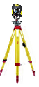
Reflector
Fairly Leveled Ground
Approximately 120m
Station B
Station A
Line of Sight
Figure 1.6. : Instrument set-up for horizontal collimation test and vertical index test
3.4.5 ANALYSIS OF COLLIMATION AND VERTICAL INDEX DATA
The readings obtained during the calibration were reduced to obtain the new horizontal collimation and vertical index errors. The results of the calibration data acquired for the total station used for this project are shown in the table below;

Table 1.2: Horizontal and Vertical Collimation Test Reading
Inst Stn. | Sight (Reflector) | Face | Hor.Circle Reading | Ver. Circle Reading
 | B | L | 87º 35’ 10’’ | 88º 26’ 15’’
A | B | R | 267º 35’ 12’’ | 271º 33’ 46’’
 |  |  | Diff= 180º 00’ 02’’ | Sum= 360º 00’ 01’
Horizontal Collimation = [(FR – FL) - 180º]/2
= [(180º 00’ 02’ - 180º 00’ 00’’) /2]
= 00º 00’ 02’’/2
= 00° 00’ 01’’
Vertical Collimation = [(FR – FL) - 360º]/2
= [(360º 00’ 01’’ - 360º 00’ 00’’)/2]
= 00º 00’ 01’’/2
= 00° 00’ 01’’
Table 1.3: Comparison of Old and New Values.
HORIZONTAL COLLIMATION | OLD | NEW
HORIZONTAL COLLIMATION | + 00º 00’ 02’’ | +00º 00’ 01’’
VERTICAL INDEX | +00º 00’ 00’’ | + 00’ 00’ 01’’

With the result obtained, it is evident that the instrument is in good working condition. Therefore, the new readings were adoptedfor the instruments Horizontal Collimation Error and Vertical Index Error respectively.

3.5. DATA ACQUISITION
3.5.1 OBSERVATION PROCEDURE
Geometric data was acquired using South (NTS-350R) Total Station. Total Station is an integrated system combining Electronic Theodolite and Electromagnetic distance measuring device. It is an instrument with inbuilt software for selected programs, which made it possible to compute data. The system also includes storing unit which serves as the survey field book.
This task was achieved through the following procedures;
- The instrument South (NTS-350R) was set up on a known station (KWPT733) and the bubble was centred and levelled.
- The instrument was switched on and menu button was pressed to display the programs on the total station.
- Data collect menu on the total station was selected to key in necessary information needed for commencement of the job. In the appeared dialogue box is Occp. Stn., Backsight and Fss. / SS
- The information of the known station (KWPT734)was keyed into the Total Station under the Data Collect sub-menu (Occp. Stn.) by opening a new file and naming the job. The station parameter N,E,H and height of instrument was entered in its appropriate space.
- The second option was selected, which is the Backsight, a submenu under the Data Collect. Here the information of the target position N,E,H and height of reflector was keyed into the Total Station. After this was achieved, Measure button was pressed for orientation and to compute the bearing, distance and N,E,H of the target position. The result was compared with the given coordinates, when the difference between the given and the observed was seen to be minimal, a centimetre difference, OK button was pressed.
- After the orientation. FS / SS menu was selected, which is a submenu under Data Collect and ALL button which captures and stores data automatically was pressed and observation to both natural and man-made features within the perimeter were fixed. A subsidiary traverse was run close to the interested feature and the above step was repeated at every point created until all the features were covered.
3.5.2 IN-SITU CHECK OF SURVEY CONTROL USED
The position of the control pillars used was checked before any other observation can be carried on. The check was done on control pillars (KWPT.733, KWPT.734 andKWPT.735). I set-up the Total Station instrument, centred and levelled it on KWPT.733 and the values control were keyed into the Total Station. The target position KWPT.734 was sighted and tracked and the result (Bearing, Distance, N, E, and H) was displayed as and checked finally recorded. The reflector was then positioned on KWPT.735 and was sighted and tracked and the results were also recorded and compared with given value of the pillar.
The result of the observed coordinates of pillar KWPT.733 was compared with the given coordinates. By specification the deviation in the distance and angle must not exceed 0.30m and 30’’ respectively. The summary of the computation between the given coordinates and observed is shown in the table below.

External angle
184⁰ 15’ 57’’

112ᴼ 50’07”
245.841m
KWPT733
288ᴼ 34’39”
143.780m
KWPT734
KWPT735

Fig. 1.6 Shows the computed check angle and check distance as obtained from the control pillars.

Table 3.1: Result of the computed survey control check from given coordinate.
FROM  STN | BEARING | DIST. (m) | DN | DE | NORTHING  (m) | EASTING  (m) | TO  STN
 |  |  |  |  | 946553.567 | 680054.213 | KWPT733
KWPT733 | 182ᴼ 32’08” | 182.734 | -182.555 | -8.084 | 946371.012 | 680046.129 | KWPT734
KWPT734 | 182ᴼ 05’27” | 493.386 | -493.058 | -18.001 | 945877.954 | 680028.128 | KWPT735
Source:Author, 2025.
The result was used to obtain the inclusive angle between KWPT733, KWPT734 and KWPT735 by finding the difference between the bearings of two lines.
KWPT734 KWPT733 => 002⁰ 32’ 08’’
KWPT734 KWPT735 => 182ᴼ 05’27”
Therefore (182ᴼ 05’27” - 002⁰ 32’ 08’’)
Check angle 179⁰ 33’ 19’’

Table 3.2: Result of the computed survey control check from given coordinate.
FROM  STN | BEARING | DIST. (m) | DN | DE | NORTHING  (m) | EASTING  (m) | TO  STN
 |  |  |  |  | 946553.567 | 680054.213 | KWPT733
KWPT733 | 182ᴼ 32’14” | 182.728 | -182.555 | -8.089 | 946371.012 | 680046.129 | KWPT734
KWPT734 | 182ᴼ 05’26” | 493.390 | -493.058 | -17.998 | 945877.954 | 680028.128 | KWPT735
Source:Author, 2025.
The result was used to obtain the inclusive angle between KWPT733, KWPT734 and KWPT735 by finding the difference between the bearings of two lines.
KWPT734 KWPT733 => 002⁰ 32’ 14’’
KWPT734 KWPT735 => 182ᴼ 05’26”
Therefore (182ᴼ 05’26” - 002⁰ 32’ 14’’)
Check angle 179⁰ 33’ 12’’

The difference between the Observed checked angle and the computed check angle
= (179⁰ 33’ 19’’- 179⁰ 33’ 12’’) = 00⁰ 00’ 07’’
3.5.3 PERIMETER SURVEY
A perimeter survey covering the entire area was ran using the three Survey control pillars found to in-situ and the area covered by the survey was 26.808 Hectares.

3.5.4 OBSERVATION PROCEDURE
The Total Station was setup on kwpt734 and all the necessary temporary adjustment were done like centring, levelling and parallax removal. Then instrument was switched on and the parameters of the instrument station (Station I.D, Height of instrument and the N,E,H coordinate) were keyed in. The reference control point kwpt733 was then bisected and the parameters (back station I.D, Height of reflector over the target station, and the N,E,H coordinate) were also keyed in. After this process, the measured button was pressed and orientation is set. Foresight was made to kwpt735, which was my forward station and the reflector was bisected and tracked to measure the N,E,H value of the point, all the obtained coordinates N,E,H were checked and found correct before proceed to next measurement. The instrument was then moved to kwpt735 as my new instrument station values were keyed in and back sight to kwpt734 was used as my reference station. The same process was repeated from one boundary station to the next pillar from kwpt735 to Pil.1. In this manner, the traverse was ran through the boundary beacons and finally closed back on Kwpt734. A closed loop traverse was carried out and all field data were later downloaded and processed. The data was later downloaded as show on the appendix table.
3.5.5 DETAILING SURVEY
Comprehensive details Survey of all natural and man-made features along the survey line were carried out. Ray method with the total station was used for the detailing. Subsidiary points were established around the project area to allow features that cannot be pick from the boundary points be picked easily. The X, Y and Z coordinates, angles (vertical and horizontal) and distance to the point to be detailed were measured.
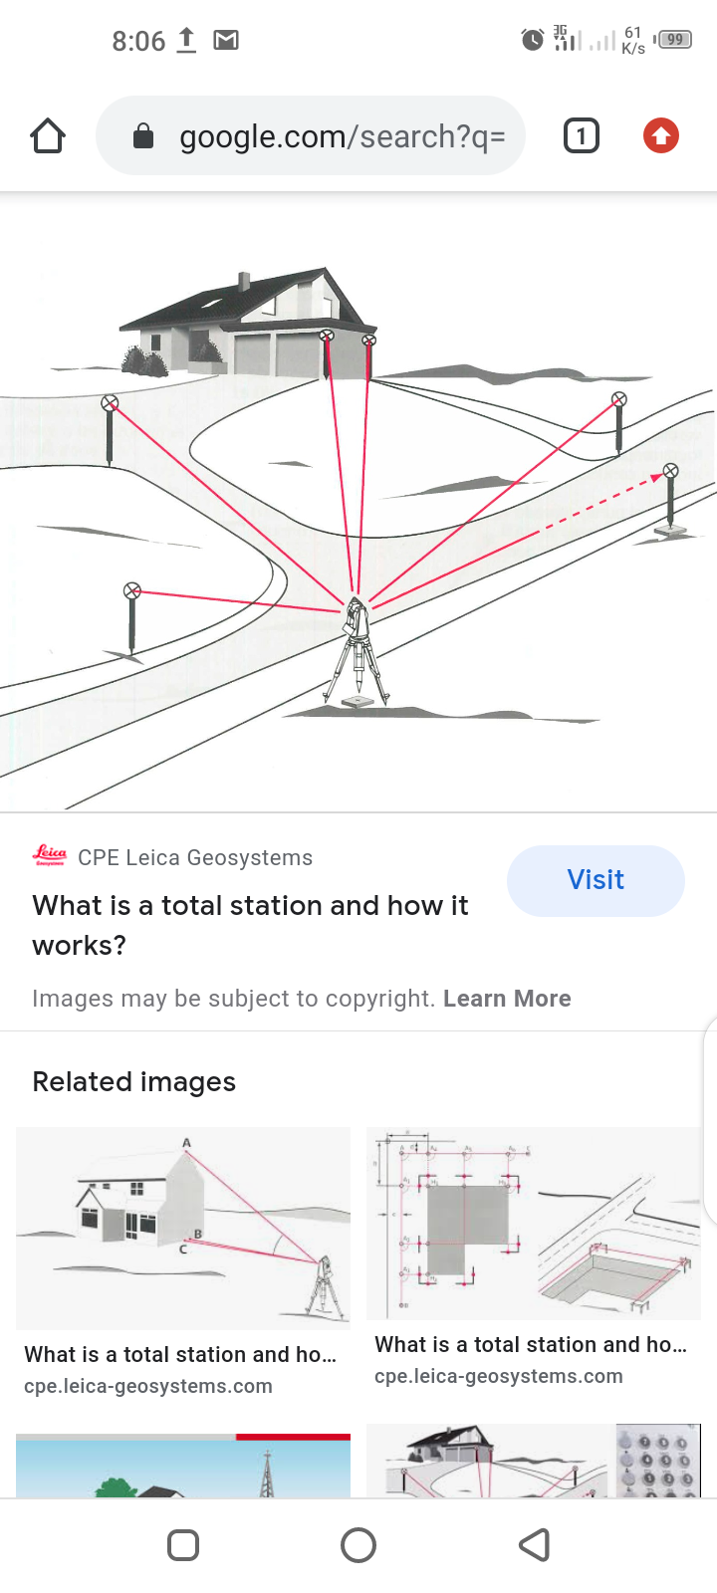
Fig. 1.8 Show the observation process of using total station.
3.5.6 PROCEDURES OF OPERATING SOUTH (NTS-350R) TOTAL STATION
The following steps were taken when operating South (NTS-350R) Total Station.
- The tripod was set-up on the occupied station and the shoes of the tripod legs were adequately marched down to ensure that it grips the ground firmly.
- The Total Station was mounted on the tripod and clamped adequately and the necessary adjustment was carried out to achieve centering and levelling of the instrument, the foot screws were used.
- The instrument was then switched on and MENU button was pressed to display list of all programs resident on the Total Station.
- DATA COLLECT was selected by pressing 1 on the key pad. Then the MEAS. &COORD.File dialogue box appears prompted me to name the job, I created the job by the name KWARAPOLY. [F3] was pressed to change the Numeric button to Alpha so as to key in my desired file name, and when this was done; [F4] was pressed to accept.
- After achieving step 4, the DATA COLLECT dialogue box appear with the following sub-menu (Occp. Pt., Backsight and Fs/ss). Then I pressed on the key pad and to lunch OCCP. PT. on the name FEDPOFFA_TOPO. dialogue box. Here all the parameters (Occp. Pt. ID, P code, Inst. Ht, N, E, N) for occupy station was keyed into the Total station and [F3] button (REC.) was pressed and then [F4] button (YES) to accept these parameters in the occupy point environment. i.e. Occupy point, Pt-I.D, Pcode, Instrument Height H.I. Values.
- The DATA COLLECT dialogue box re-appears when step 5 was completed and 2 was pressed on the keypad to activate BACKSIGHT sub-menu. In the appeared dialogue box, all the parameters (BKP. PT. ID, P code, R. Ht. And N, E, H) for backsight station was keyed in and [F3] (MEAS) button was pressed for orientation by sighting at the target station and bisecting it. By doing this, the orientation is set and the Total Station is ready for the coordination of new points. i.e
- 489spt,679717.405,946223.476,318.638
- 490confe,679724.363,946216.6,318.346
- 491spt,679712.324,946222.709,318.634
- 492spt,679700.275,946222.701,318.734
- 493conf,679695.032,946217.477,318.649
- After achieving step 6, the DATA COLLECT dialogue box reappears again and 3 was pressed on the keypad to lunch the FS/SS dialogue box. F4 (ALL) button was then pressed to make observations to points of interest. As soon as this [F4] button was pressed, the Total Station automatically measures, records and stores the data into the internal memory of the instrument. This setting is peculiar to Kolida (KTS-462) Total Station. Where
F.S means Fore sight
Meas mean Measure
N mean Northing Coordinate
E mean Easting Coordinate
H mean Height of Station

CHAPTER FOUR
4.0. DATA PROCESSING AND RESULT ANALYSIS
4.1. DATA PROCESSING
All the data acquired from the field are required to be processed. It is this processing that makes the acquired data meaningful. The processed data is then used for map production.
After downloading the data into the computer system, the data is converted from document to excel form and save as .csv format (facility management.csv). Then the ArcMap was launched and the necessary parameters are set up, after setting the parameters the saved data file was imported.
4.2 DATA DOWNLOADING
The acquired data were downloaded from the memory of the instrument via the Data Transfer Port into the computer. The collected data were downloaded using South Data Transfer Software. The explanation below shows the procedures involved during the downloading from the Total Station to the computer:
* The South (NTS 350R) Total Station was connected to computer before switching “ON” the computer and total station.
* The computer was switched “ON” and allowed to complete the booting operation.
* The Total Station was switched “ON”
* On the Total Station “MENU” key was pressed to open the program page
* F3 key was pressed to select “Memory Manager”.
* In the memory manager sub-menu, F1 key was pressed on the third page to select “Data Transfer”
* In the data transfer dialogue box, F1 key was pressed to select NTS -300 transfer mode. Then F3 key was pressed to select “COMM. PARAMETERS” where “BAUD RATE, PROTOCOL AND PARITY” was set to have the same setting parameters on the computer and on the Total Station to allow good communication between the Total Station and the Computer.
* Escape (ESC) key was pressed to go back to the previous menu (DATA TRANSFER) and F1 key was pressed to select the “SEND DATA”.
* In the appeared dialogue box F1 key was pressed to select the measured data option and the file name “KAM” which is to be downloaded was selected and F4 key was pressed to accept the file to be downloaded.
* On the computer system, in the NTS Total Station software environment, “COMM” menu was clicked on the menu bar and downloads 300 data option was selected on the pull down menu.
* On clicking the download 300 data on the pull down menu, a small dialogue box appear given an instruction to press enter (F4 key) on the Total Station and the (Enter) key on the computer. Once this was done sequentially, the data automatically start to download.
* After downloading the data, Transfer menu was selected on the menu bar and “CASS survey data 300” was selected and clicked to Transfer the data from Chinese Language to English Language for better interpretation and understanding.

4.3 COMPUTATION OF SURVEY DATA
Total Station Instruments, with their microprocessors, can perform a variety of computations, depending on how they are programmed. South (NTS -350R) Total Station is capable of assisting an operator, step by step, through several different types of basic surveying operations.
In addition to providing guidance to the operator, microprocessors of South (NTS -350R) Total Station can perform many different types of computations automatically and some standard computations include:
1) Averaging of multiple angles and distances observations;
2) Correcting electronically observed distances for prism constants, atmospheric pressure, and temperature;
3) Making curvature and refraction corrections to elevations determined by trigonometric leveling;
4) Reducing slope distances to their horizontal and vertical components;
5) Calculating point elevations from the vertical distance components (supplemented with keyboard input of instrument and reflector heights);
6) Making corrections to observed horizontal and vertical angles for various instrumental errors; and
7) Computing coordinates of surveyed points from horizontal angle and horizontal distance components (supplemented with keyboard input of coordinates for the occupied station, and a reference azimuth). Furthermore, the microprocessors of total station perform traverse computations and simultaneously calculate and store station coordinates and elevation.
4.4. PROCESSING IN ARCMAP 10.3
After acquiring the data from the field, it is then processed using the arcmap 10.3 software to produce a digital map of the project area. The following are the steps involved;
- Unit settings: - this is the setting up of the primary units for the drawing. In ArcMap 10.3 the following steps described below are the procedure to set up the primary unit.
STEPS
* Double click on the ArcMap10.3 icon on the desktop (allow the software to lunch).
* Then click on cancel button (to open new fresh ArcMap10.3).
* Right click on the ArcMap10.3 window and select Data Frame Properties, then the Data.
* Frame Properties dialog box appear.
* Then select Coordinates System from the list and go to Projected Coordinate Systems and select UTM.
* On the drop down select Africa and the drop down to select Minna Zone 31(as the Datum Reference).
* Then click Apply and then select ok (the dialog box disappears).
Note: the scale box under the processing Menu will be on.

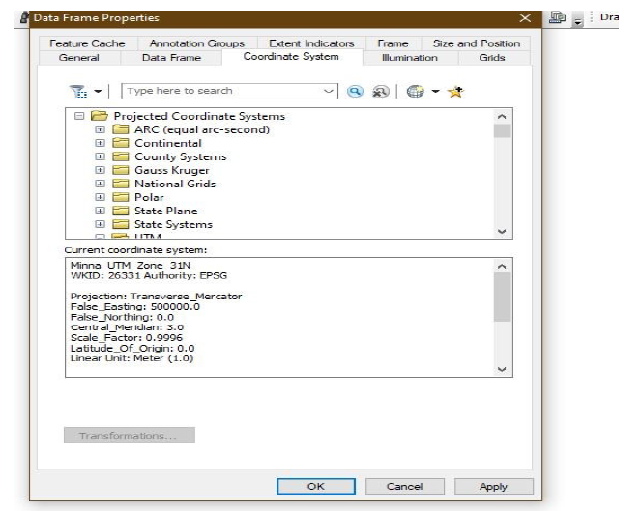

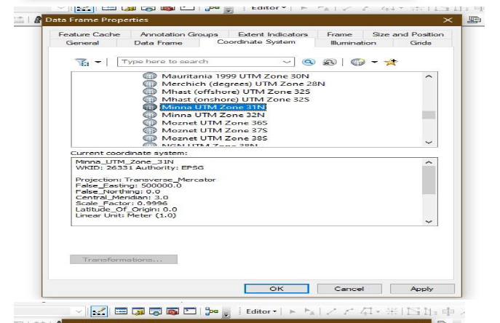

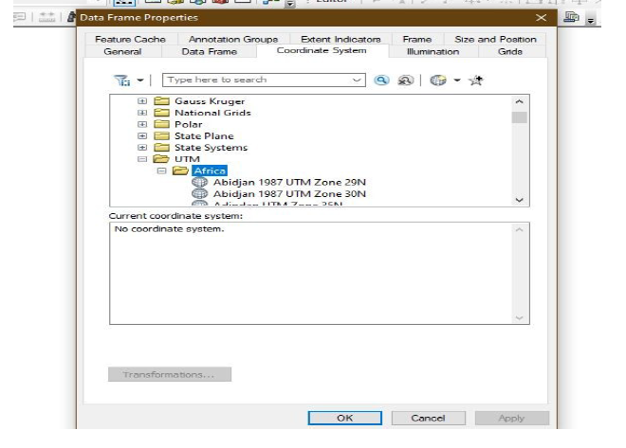

Fig 4.1. setting of units on ArcMap
✓ Adding data: - after setting up the primary units, then the data can be added to the
ArcMap10.3, at this stage there two options of data to be add to the ArcMap10.3 i.e. Vector data or Raster data. The practical comprises of Vector data procedures is as follows.
Adding Vector data.
STEPS
* Select File from the Menu, the go to Add data and the drop down show the following:
* elect Add XY data (then Add XY data Dialog box appear).
* Then click on the Folder icon to navigate to the store files.
* After navigate to the folder where the data was stored, select the required folders saved with name (facility management), and
* Click on add data and it will go back to the add XY data.
* Then select the necessary field to the data e.g. column of easting for X and column of northing for Y and column of Z field for Height.
* Then click ok and the point will display on the window.
* Go to table of content on the left corner of the window and right click on the layer of the point key.
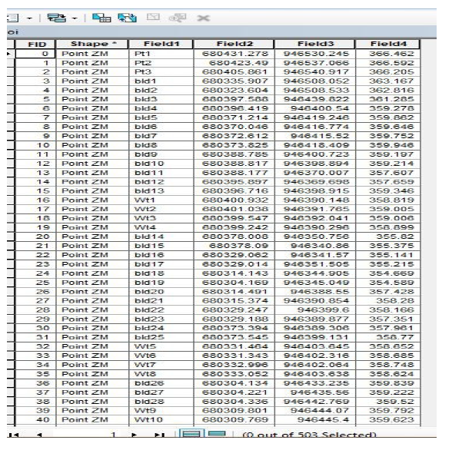
* Then select label feature and the names of the features will be labeled according to how the data was saved during capturing.

Fig 4.2. Adding of data
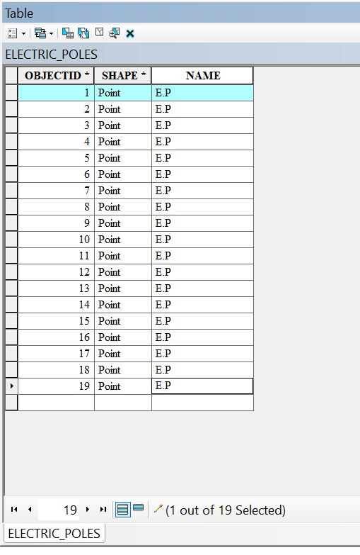
Electric poles

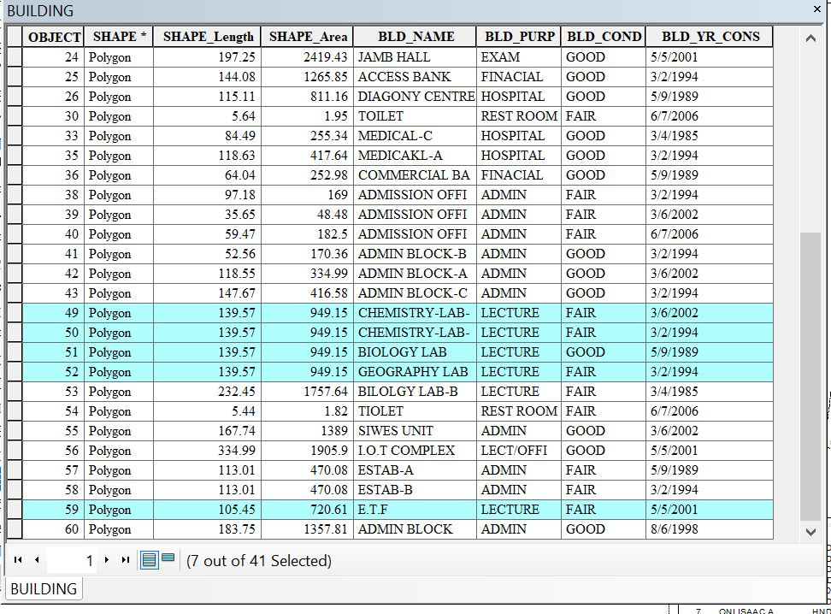
Building

✓ Layer creation or data base creation
STEPS
* Go to catalog on the right corner of the window.
* Navigate to the folder and right click on the folder.
* Then select new and click on file geo-database.
* Then right click on the file geo-database and select new then click on the new feature to create a new dataset.
* Type the name of the dataset and click next to select the unit as done during the primary unit setting, then click next twice and click finish.
* Then the new feature dataset will appear under the file geodatabase.
* Finally, right click on the new feature dataset and select new then select the feature class.
* The new feature class box appears (type in the layer name e.g. Road and copy it into the Alias box.
* Then select the feature type, e.g. line for road, polygon for building and point for electric poles.
* Then click next twice and click finish.
* Then the layer created will appear on the table of content.
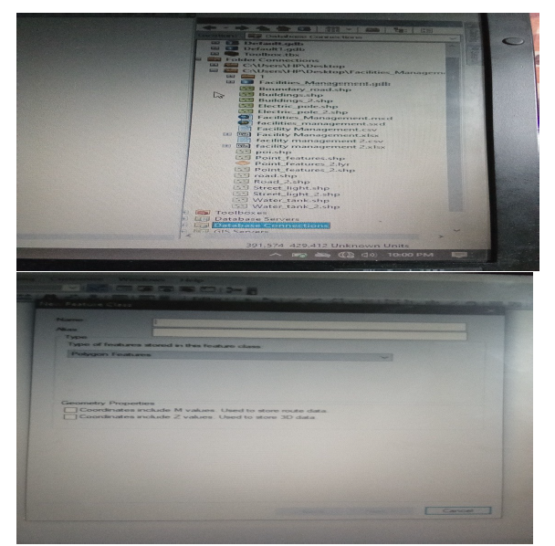
* The same processes are repeated to create another layer.

Fig 4.3. New dataset creation
✓ Digitizing: - the digitizing process is involved the tracing out the necessary features, as captured on the field to form the map feature.
STEPS
* Go to Editor, then click on starting editing.
* Then a create feature box appear, then select on the feature to digitize e.g. road, building, e.t.c.
* Then click on the window and trace out the feature outlines and double click when get to the end of the entity.
* Repeat the process above for all the features to be digitize and all will be saved in the data base table.
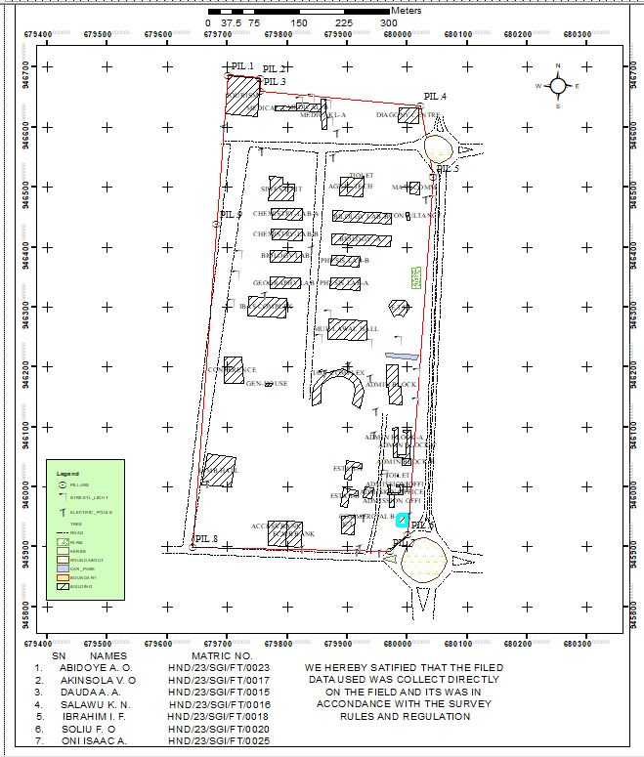

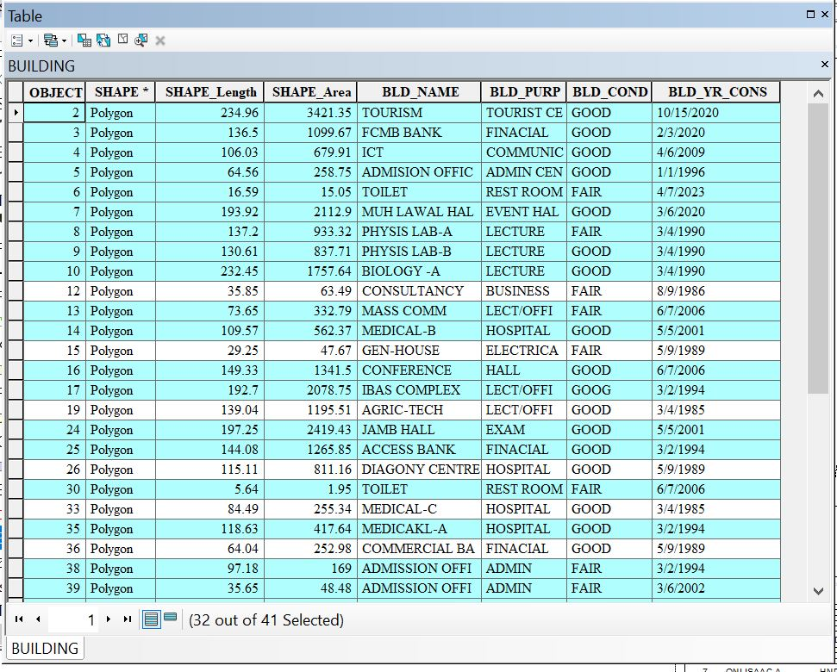
Fig 4.4. Digitizing on ArcMap
✓ Database Creation: - this is the process of populating the database.

STEPS
* Left click on the TOC on the layer to populate the table and then click on the open attribute table.
* The table appears.
* Then go to add field and the add field box appear.
* Set up the necessary information.
* And click ok, then the new field will be added to the table.
4.6 PREPARATION OF 3D MAP USING ARCSCENE
The 3D image was done on ArcScene using the created DEM, the created DEM was added to ArcScene and extruded with the heights gotten on the field. Extrusion incorporates the height of these features in their representation to give them 3D look and were made to float on DEM to have a true land representation. The created DEM was also added to ArcScene, the height of the buildings gotten from the field were added to the already created height field in the attribute table of each of the facility shape file in ArcMap. ArcScene was launched and all the shape files were added, from the table of content each shape file was right clicked on to access the property dialog box, from the property dialog box the shape files were extruded to give them 3D look and were made to float on the DEM to have a full 3D visualization.
* Open the ArcScene software and set necessary parameters.
* Go to arc tool box, click on spatial analytic tools.
* Then click on interpolation and then click IDW (Inverted Distance Way).
* Then it is going to generate 3D dimension value and set Z value point and press ok.
Note: - The IDW can be used to create contour and slope. But we are dealing with slope.
To creates slope, click on surface from interpolation and press slope and input raster(IDW) and press ok. The same procedure for contour also.
To set parameters for necessary facilities needed,
a. Select (IDW).
b. Go to source, click on property and press the base height.
c. Then click floating on a custom surface and press extrusion.
d. Click apply then ok.
4.7 PLAN PRODUCTION
The ultimate aim of the project is to produce a digital map (Facilities management plan) of the part of kwara state polytechnic. After processing the acquired data using the appropriate software, a digital map of the project area was produced. Thus, the aim of the project was achieved.
4.7.1. DIGITAL MAP
A digital map is the representation of cartographic features in a form that allows the value of their attributes to be stored, manipulated, and out-put by a computer system. A digital map is a data base or file that becomes a map when a GIS produces a hardcopy or screen display output.
Finally, a hardcopy of the digital map of the project area was printed.

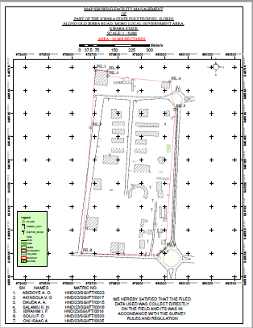

Fig 4.7. Facility Management map

4.8. RESULT ANALYSIS
The facility management project commenced with the usage of a South (NTS-35OR) to capture the data of the project area. The captured data were then processed using software (ArcMap 10.3, ArcScene), employing photogrammetry technique to generate a high precision DSM and create a detailed 3D model.
ARCGIS software was employed to visualize and analyze the DSM data, facilitating spatial analysis and information Presentation.
The following maps were produced and their usefulness was stated,
4.9. QUERIES ANALYSIS
Queries analysis in GIS involve extracting information from spatial datasets by posing specific questions and then analyzing the data to gain insights or make decisions.
Queries involves selecting features based on attributes or spatial relationship, while analysis may include tasks like spatial overlay, proximity analysis, spatial statistics or modeling.
4.9.1. SINGLE CRITERIA QUERY
A single criterion is carried out where one condition is used to design query. The condition is used to gather information from the database.
QUERY ANALYSIS (selection by attribute)
Query question: “To query for the building that construction year is less than or equal to 1990.”
Analysis Name: Database extraction
Analysis Type: Single criteria analysis
Syntax: “BLD_YR_CONS>=1990.

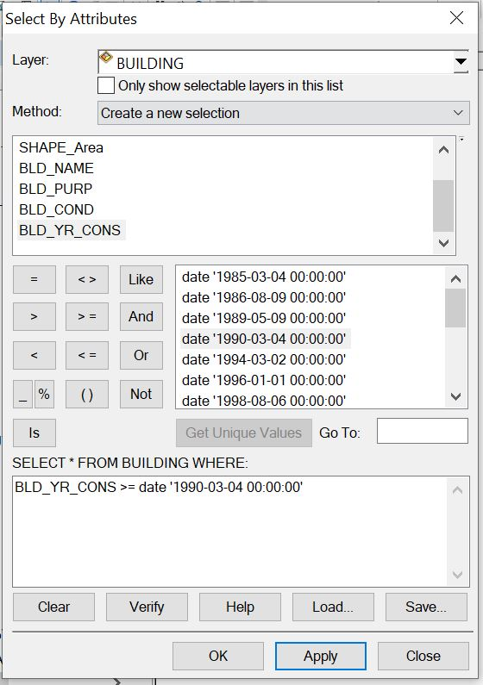

Fig. 4.12. single criteria query

Answer to query 1.

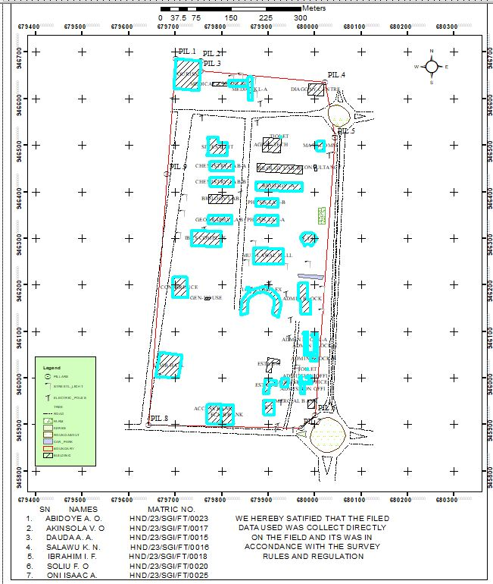

Query question: “To query for the building that has an area less than 470.08 meters square and their purpose is used for financial
Analysis Name: Database extraction
Analysis Type: Double criterion analysis
Syntax: “SHAPE_AREA<470.08AND BLD_PURP”.
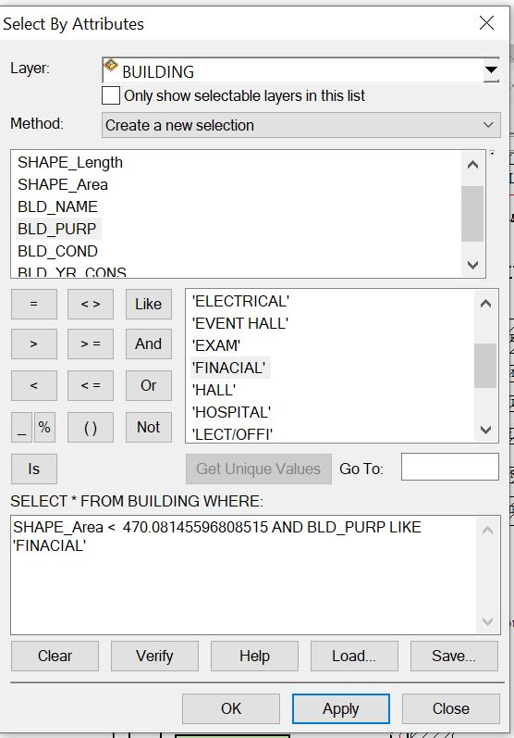
Answer to the query II.

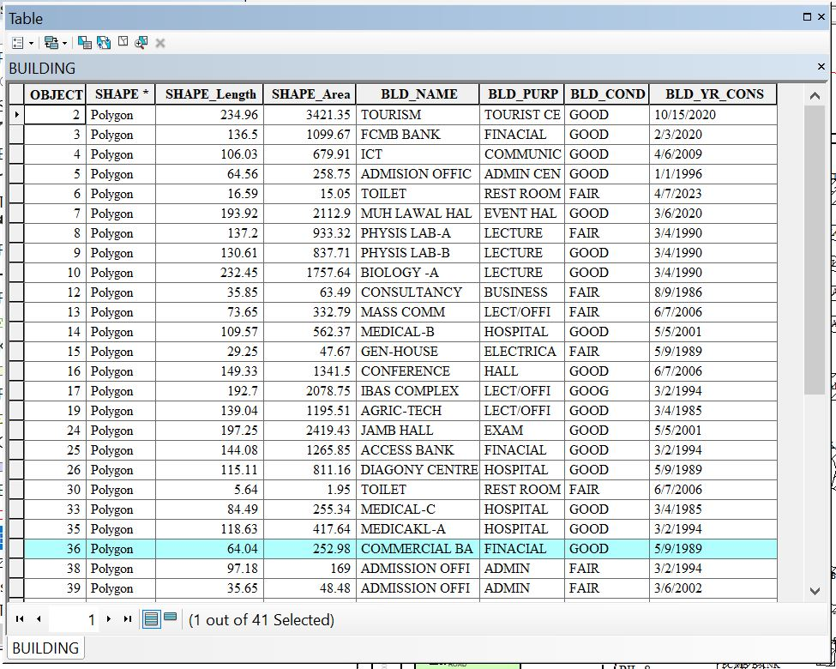
- Query question 3: “To query for the building purpose and that the area less than or equal to 192.69 meters square
- Analysis Name: Database extraction
- Analysis Type: Double criterion analysis
- Syntax: “BLD_PURP LIKE LECTURE AND SHAPE_LENGHT <= 192.69”.
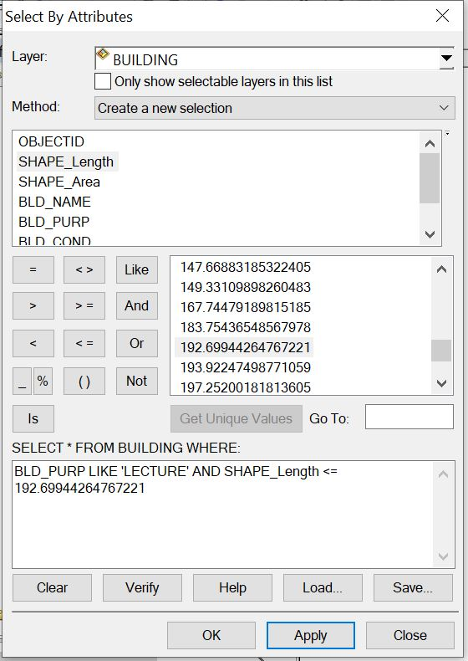

Answer to the query 3.
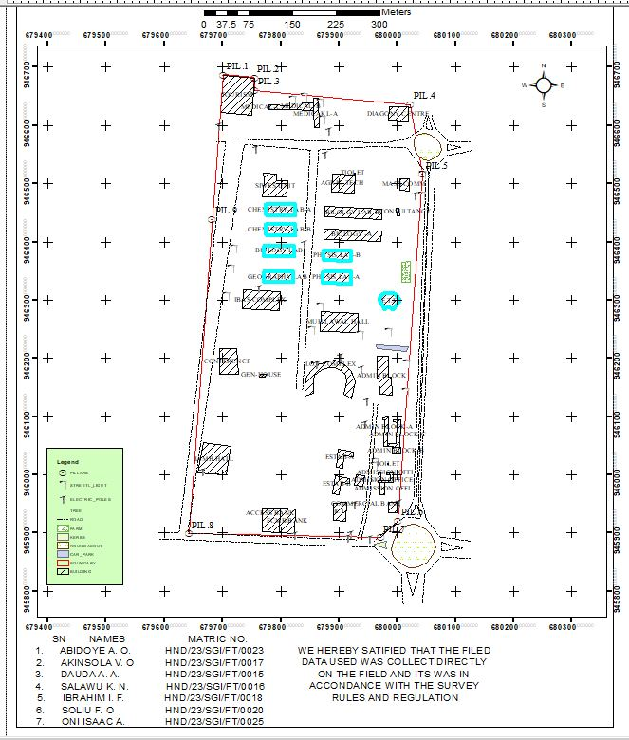
4.10 APPLICATION OF RESULTS
The result obtained can be applied to the following;
* Ensuring efficient use of resources.
* Maximizing occupant comfort and safety.
* Managing maintenance schedules.
* Optimizing space utilization.
* It's essentially a roadmap for maintaining and enhancing the functionality of a building or facility.

CHAPTER FIVE
5.0. COSTING, SUMMARY, CONCLUSION, PROBLEM ENCOUTER AND RECOMMENDATION
5.1. COSTING
Table 5.1. PLANNING
S/N | PERSONNEL | UNIT | PRICE | DAYS | REMARK
1. | Principal Surveyor | 1 | #30,000 | 2 | #60,000
2. | Assistant Surveyor | 1 | #12,000 | 2 | #24,000
3. | Transport | 1 | #3,000 | 2 | #6,000
4. | Basic Equipment | 1 | #15,000 | 2 | #30,000
5. | Logistics | 1 | #10,000 | 2 | #20,000
 | Total | 1 |  |  | #140,000

Table 5.2. DATA CAPTURE
S/N | PERSONNEL | UNIT | PRICE | DAYS | REMARK
1. | Principal Surveyor | 1 | #30,000 | 5 | #150,000
2. | Assistant Surveyor | 1 | #12,000 | 5 | #60,000
3. | Chainman | 7 | #3,000 | 5 | #105,000
4. | Transport | 1 | #3,000 | 5 | #15,000
5. | Basic Equipment | 1 | #15,000 | 5 | #75,000
6. | Logistics | 1 | #10,000 | 5 | #50,000
 | Total |  |  |  | #455,000

Table 5.3. DATA DOWNLOAD
S/N | PERSONAL | UNIT | PRICE | DAYS | REMARK
1. | Principal Surveyor | 1 | #30,000 | 1 | #30,000
2. | Transport | 1 | #3,000 | 1 | #3,000
3. | Basic Equipment | 1 | #15,000 | 1 | #15,000
4. | Logistics | 1 | #10,000 | 1 | #10,000
 | Total |  |  |  | #58,000
Table 5.4. DATA PROCESSING
S/N | PERSONNEL | UNIT | PRICE | DAYS | REMARK
1. | Principal Surveyor | 1 | #30,000 | 8 | #240,000
2. | Assistant Surveyor | 1 | #12,000 | 8 | #96,000
3. | Transport | 1 | #3,000 | 8 | #24,000
4. | Basic Equipment | 1 | #15,000 | 8 | #120,000
5. | Logistics | 1 | #10,000 | 8 | #80,000
 | Total |  |  |  | #560,000

Table 5.5. DATA PRESENTATION
S/N | PERSONNEL | UNIT | PRICE | DAYS | REMARK
1. | Principal Surveyor | 1 | #30,000 | 1 | #30,000
2. | Assistant Surveyor | 1 | #12,000 | 1 | #12,000
3. | Transport | 1 | #3,000 | 1 | #3,000
4. | Basic Equipment | 1 | #15,000 | 1 | #15,000
5. | Logistics | 1 | #10,000 | 1 | #10,000
 | Total |  |  |  | #70,000

Table 5.6. REPORT WRITING
S/N | PERSONNEL | UNIT | PRICE | DAYS | REMARK
1. | Principal Surveyor | 1 | #30,000 | 10 | #300,000
2. | Transport | 1 | #3,000 | 10 | #30,000
3. | Basic Equipment | 1 | #15,000 | 10 | #150,000
4. | Logistics | 1 | #10,000 | 10 | #100,000
 | Total |  |  |  | #580,000
Table 5.7. SUMMARY
1. | Planning | #140,000
2. | Data Capture | #455,000
3. | Data Download | #58,000
4. | Data Processing | #560,000
5. | Data Presentation | #70,000
6. | Report Writing | #580,000
 | Total | #1,863,000
* Mobilization and demobilization 10%
1,863,000 * 10 ÷ 100 = #186,300
* V.A.T. 2.5%
1,863,000 * 2.5 ÷ 100 = #46,575
Total Cost
#1,863,000 + #186,300 + #46,575
= #2,095,875.
5.2 SUMMARY
Facility Management (FM) using Geographic Information Systems (GIS) is an innovative approach that enhances the planning, operation, and maintenance of physical assets such as buildings, utilities, and infrastructure. The integration of GIS into facility management enables real-time visualization, data integration, spatial analysis, and informed decision-making.
This study examined the application of GIS in managing facilities efficiently, highlighting how spatial data and location intelligence improve asset tracking, space utilization, maintenance scheduling, and emergency response. Data were collected through surveys, interviews, and GIS mapping tools, and analyzed to demonstrate the practical benefits of GIS integration in facility operations.
The research focused on identifying current practices, benefits, challenges, and potential improvements in adopting GIS technology in facility management within selected institutions or areas.

5.3 CONCLUSION
The study concludes that GIS offers a transformative solution to traditional facility management challenges by enabling spatial visualization and data-driven insights. Key findings include:
- Improved Asset Management: GIS helps in locating and managing assets with accuracy.
- Efficient Space Utilization: Facilities can be better planned and optimized using spatial analysis.
- Enhanced Maintenance Planning: Predictive and preventive maintenance is facilitated through real-time data and location tracking.
- Emergency Response Preparedness: GIS supports faster and more coordinated responses in emergencies.
Overall, GIS enhances operational efficiency, reduces costs, and extends the lifespan of facility assets when properly implemented.

5.4 PROBLEMS ENCOUNTERED
- Many facility managers lack the training to operate GIS tools effectively.
- Setting up GIS infrastructure (hardware, software, and training) requires significant investment.
- Poor data quality or outdated spatial data can affect the reliability of the system.
- Some organizations are reluctant to adopt new technology due to entrenched traditional methods.
- Integrating GIS with existing Facility Management Systems (FMS) can be complex.

5.5 RECOMMENDATIONS
- Provide training and workshops for facility managers and staff on the use of GIS technology.
- Encourage funding and policy support for GIS adoption in facility management.
- Start with pilot programs to demonstrate the benefits before scaling up.
- Establish protocols for accurate data collection, updating, and validation.
- Ensure compatibility between GIS and other facility management tools (e.g., CAFM, BIM).
- Promote awareness of GIS benefits among decision-makers and end-users to foster acceptance.

REFERENCES
Arayici, Y., Coates, P., Koskela, L., Kagioglou, M., Usher, C., & O’Reilly, K. (2012). BIM adoption and implementation for architectural practices. Structural Survey, 30(2), 126–145.
Atkin, B., & Brooks, A. (2015). Total Facility Management (4th ed.). Wiley-Blackwell.
Bakis, N., Aouad, G., &Kagioglou, M. (2007). Towards distributed product data sharing environments – progress so far and future needs. Automation in Construction, 16(5), 586–595.
Batty, M., Axhausen, K., Giannotti, F., et al. (2012). Smart cities of the future. European Physical Journal Special Topics, 214(1), 481–518.
Burrough, P. A., & McDonnell, R. A. (1998). Principles of Geographical Information Systems. Oxford University Press.
Chung, L., Chiu, D. K., & Cheung, S. C. (2009). Understanding and automating requirements prioritization in software engineering. ACM Transactions on Software Engineering and Methodology, 19(3), 1–29.
Deng, X., & Poon, S. W. (2011). The use of GIS in facilities management. Facilities, 29(3/4), 118–126.
Ghosh, S. (2008). Analytical GIS: Techniques for Spatial Analysis. Taylor & Francis.
IFMA (2020). What is Facility Management? Retrieved from https://www.ifma.org/
Longley, P. A., Goodchild, M. F., Maguire, D. J., &Rhind, D. W. (2015). Geographic Information Systems and Science (3rd ed.). Wiley.
Pitt, M., Tucker, M., Riley, M., & Longden, J. (2009). Towards sustainable construction: promotion and best practices. Construction Innovation, 9(2), 201–224.
Shohet, I. M. (2003). Building evaluation methodology for setting maintenance priorities in hospital buildings. Construction Management and Economics, 21(7), 681–692.
Shohet, I. M., &Lavy, S. (2004). Healthcare facilities management: state of the art review. Facilities, 22(7/8), 210–220.
Succar, B. (2009). Building information modelling framework: A research and delivery foundation for industry stakeholders. Automation in Construction, 18(3), 357–375.
Sui, D. Z., & Holt, J. B. (2008). Visualizing and analyzing spatial-temporal patterns of space-time clusters. Computers, Environment and Urban Systems, 32(3), 137–150.
Teicholz, E. (2001). Facility Design and Management Handbook. McGraw-Hill.

APPENDICES
bnd1,680001.553,945920.709,305.03
2bld,679998.724,945935.038,305.427
3bld,679999.37,945952.393,305.747
4bld,679985.139,945953.611,305.899
5Ep,680002.449,945953.267,305.904
6bld,679969.713,945966.376,306.162
7bld,679978.467,945966.005,306.203
8str,679962.742,945980.018,306.873
9str,679963.074,945982.566,306.968
10str,679964.353,945982.451,306.955
11bld,679966.006,945987.485,307.213
12tree,679967.245,945904.712,304.414
13bnd2,679970.974,945892.196,303.848
14Ep,679951.406,945891.426,303.848
15tree,679946.62,945896.648,304.023
16DR,679940.237,945887.579,302.966
17DR,679939.218,945887.348,302.645
18Rd,679931.045,945888.016,303.114
19DR,679929.541,945887.406,302.639
20DR,679928.99,945887.693,302.628
21Ep,679919.632,945898.553,304.019
22Ep,679914.223,945892.929,303.664
23bank,679911.575,945920.464,304.7
24bank,679889.953,945921.531,304.753
25Ep,679915.076,945919.52,304.599
26tree,679931.218,945947.97,305.577
27Ep,679926.29,945949.63,305.493
28gtb,679915.953,945952.093,305.385
29bld,679900.379,945966.825,306.214
30bld,679888.661,945968.32,306.514
31bld,679917.742,945986.294,306.808
32bld,679918.61,945994.023,307.217
33bld,679892.925,945998.188,309.093
34tree,679927.623,946001.143,307.61
35mosq,679928.788,946000.146,307.496
36mosq,679926.197,945982.778,306.943
37mosq,679943.303,945998.462,307.366
38tree,679939.646,946005.798,307.642
39tree,679938.425,945999.848,307.45
40sl,679957.398,945996.07,307.502
41sl,679959.991,946015.805,308.185
42sl,679961.136,946023.735,308.413
43bld,679971.797,946037.722,308.565
44bld,679982.727,946039.467,308.674
45bld,679983.532,946015.505,308.485
46str,679984.655,946017.96,308.269
47str,679984.73,946019.205,308.241
48str,679983.214,946019.476,308.336
49spt,679988.212,946022.841,308.542
50spt,679992.515,946017.403,308.476
51spt,679987.166,946010.653,308.193
52spt,679987.891,946003.31,308.362
53spt,679983.968,946027.112,308.665
54spt,679987.104,946035.048,308.644
55bld,679990.722,946036.027,308.705
56bld,679992.34,946002.873,308.571
57bld,680006.482,946035.908,308.558
58bld,680002.833,946047.922,309.255
59bld,679976.883,946049.044,309.107
60sl,679968.892,946079.409,310.226
61sl,679968.826,946072.011,310.099
62spt,679970.913,946074.442,310.147
63spt,679973.054,946069.097,309.974
64spt,679968.906,946062.177,309.556
65spt,679975.594,946058.773,309.775
66spt,679965.543,946052.38,309.434
67spt,679971.841,946048.431,309.181
68spt,679972.043,946086.812,310.615
69spt,679967.188,946090.828,310.681
70spt,679964.664,946098.415,311.171
71spt,679957.51,946097.69,311.003
72bld,679974.621,946099.158,311.079
73tree,679999.806,946104.888,311.397
74tree,680010.315,946112.512,311.854
75tree,680011.129,946117.7,311.931
76tree,680011.712,946123.067,312.152
77spt,680010.009,946129.671,312.375
78spt,680002.863,946125.025,312.208
79spt,679999.388,946115.06,311.689
80spt,679996.786,946110.187,311.491
81spt,679992.748,946104.278,311.317
82spt,679988.481,946109.369,311.415
83spt,679986.602,946116.996,311.622
84spt,679986.322,946125.052,311.734
85spt,679980.628,946130.727,312.337
86sl,679982.536,946130.339,312.35
87tree,679974.682,946131.68,312.215
88spt,679972.411,946114.815,311.439
89tree,679953.554,946110.003,311.382
90tree,679953.104,946105.441,311.056
91tree,679950.595,946093.033,310.555
92Ep,679943.533,946087.757,310.126
93spt,679943.575,946076.168,309.424
94spt,679934.174,946078.961,309.626
95spt,679920.822,946073.274,309.835
96spt,679915.118,946068.241,310.027
97spt,679908.301,946060.959,310.158
98spt,679909.131,946051.957,309.678
99bld,679899.243,946043.445,309.387
100str,679896.051,946043.006,309.31
101str,679895.49,946040.816,309.26
102str,679893.879,946041.01,309.22
103bld,679894.41,946014.383,308.269
104spt,679890.712,946019.163,308.4
105spt,679895.133,946023.257,308.791
106spt,679896.372,946031.022,308.777
107spt,679888.733,946036.616,309.284
108spt,679892.145,946049.028,309.57
109spt,679898.83,946064.598,310.391
110spt,679896.11,946075.478,310.822
111spt,679899.352,946085.679,311.27
112spt,679900.45,946095.169,311.583
113spt,679889.678,946100.794,311.319
114spt,679879.884,946100.892,311.081
115spt,679875.602,946110.656,311.435
116spt,679860.786,946122.723,311.712
117str,679855.831,946126.252,311.908
118str,679853.412,946125.261,311.866
119str,679851.166,946129.422,312.287
120iotbld,679850.27,946130.672,312.546
121spt,679841.314,946135.195,312.355
122spt,679835.787,946144.524,312.647
123spt,679841.647,946151.983,313.49
124spt,679837.819,946164.575,313.736
125iotbld,679850.445,946177.42,313.803
126iotbld,679862.438,946189.159,314.463
127Ep,679861.389,946190.354,314.38
128genhouse,679858.56,946193.401,314.353
129genhouse,679853.433,946191.354,314.288
130genhouse,679852.175,946193.779,314.345
131spt,679847.82,946190.812,314.204
132tree,679841.606,946187.357,314.446
133spt,679844.792,946183.229,314.106
134spt,679850.527,946189.321,314.319
135spt,679851.064,946199.602,314.568
136spt,679855.333,946207.683,315.227
137tree,679853.54,946210.88,315.612
138spt,679879.319,946199.405,314.666
139spt,679891.519,946197.994,314.864
140Ep,679901.842,946203.883,314.81
141spt,679906.197,946211.283,315.013
142spt,679918.358,946215.481,315.733
143spt,679914.716,946201.78,314.945
144bld,679909.053,946189.322,314.736
145spt,679915.093,946183.095,314.709
146bld,679920.914,946177.103,314.765
147spt,679931.914,946179.877,315.059
148Ep,679936.655,946183.366,315.413
149spt,679939.43,946174.292,314.662
150iot bld,679928.413,946159.401,314.111
151iot bld,679921.013,946130.8,312.808
152spt,679938.628,946129.621,311.581
153Ep,679947.624,946126.676,311.676
154recbld,679969.467,946138.179,312.658
155recbld,679988.307,946136.553,313.33
156spt,680003.893,946140.158,312.992
157sl,680013.476,946142.779,313.247
158spt,680025.065,946145.5,313.202
159tree,680019.078,946151.97,313.464
160tree,680019.278,946156.925,313.322
161tree,680013.13,946162.19,313.762
162spt,680010.315,946170.357,314.334
163spt,680005.425,946192.509,314.898
164sl,680015.327,946192.955,315.007
165spt,680008.594,946202.369,315.172
166spt,679994.076,946204.672,315.339
167recbld,679984.189,946204.478,315.442
168spt,679978.443,946208.804,315.661
169park,679963.226,946223.944,316.333
170park,679964.43,946217.62,316.111
171recbld,679965.631,946205.542,315.672
172recbld,679964.989,946203.903,315.587
173str,679987.609,946220.723,316.05
174str,679987.4,946219.44,315.978
175str,679986.085,946220.984,316.003
176park,680015.108,946212.547,315.512
177tree,680018.861,946219.613,315.808
178spt,680014.758,946225.428,315.898
179tree,680006.385,946231.69,316.557
180spt,679999.351,946228.385,316.251
181spt,679987.348,946239.564,316.827
182sl,679984.519,946245.583,317.412
183spt,679971.822,946245.145,317.291
184spt,679960.457,946244.878,317.405
185spt,679948.429,946244.273,317.266
186sl,679935.524,946242.081,317.515
187HALL,679932.222,946244.134,317.601
188flw,679922.809,946241.583,317.165
189flw,679934.083,946241.146,317.366
190flw,679928.585,946241.375,317.343
191flw,679875.609,946243.447,316.237
192flw,679872.196,946243.686,316.26
193HALL,679868,946246.945,316.38
194spt,679863.1,946248.494,316.311
195spt,679862.028,946258.078,316.687
196sl,679852.432,946249.983,316.747
197spt,679850.85,946256.565,317.056
198spt,679846.943,946278.828,318.518
199spt,679854.526,946289.235,318.359
200sl,679867.033,946289.549,317.91
201HALL,679868.738,946279.925,317.789
202spt,679875.736,946286.279,317.778
203flw,679876.301,946290.444,317.899
204flw,679885.508,946289.456,317.913
205flw,679895.579,946289.105,317.971
206spt,679897.502,946286.067,317.98
207flw,679905.651,946288.569,318.113
208flw,679915.684,946288.166,318.223
209spt,679924.355,946288.183,318.401
210spt,679930.064,946294.245,318.596
211spt,679925.662,946304.69,318.877
212spt,679923.011,946317.638,319.168
213sl,679921.98,946322.967,319.781
214phy labB,679921.417,946328.408,319.794
215spt,679907.945,946324.134,319.139
216spt,679894.785,946323.517,319.075
217spt,679891.188,946313.417,318.748
218spt,679880.275,946316.353,318.837
219phy labB,679871.385,946330.846,319.702
220sl,679865.6,946330.835,320.257
221spt,679854.205,946333.648,320.415
222spt,679851.82,946346.503,320.943
223spt,679863.95,946357.107,320.773
224spt,679861.734,946371.907,321.531
225spt,679854.29,946388.65,322.545
226spt,679871.439,946348.487,320.843
227labB,679871.543,946348.617,320.786
228labB,679868.321,946362.215,320.778
229labA,679869.717,946368.262,321.46
230labA,679872.292,946369.447,321.375
231labA,679873.225,946386.362,321.477
232spt,679877.107,946391.721,321.835
233Ep,679877.207,946395.018,322.157
234spt,679888.942,946395.505,322.218
235sl,679897.92,946395.377,322.146
236spt,679908.405,946393.793,322.034
237Ep,679916.355,946392.766,322.051
238labA,679920.821,946385.067,321.317
239spt,679930.212,946384.164,321.562
240spt,679931.977,946378.503,321.441
241spt,679940.614,946374.718,321.435
242spt,679930.728,946359.746,320.828
243spt,679940.326,946348.681,320.555
244spt,679949.13,946340.51,320.505
245spt,679933.365,946327.57,319.537
246sl,679922.323,946323.282,319.617
247spt,679946.381,946312.41,319.53
248spt,679961.735,946307.531,319.868
249bld,679967.872,946302.28,320.124
250bld,679977.75,946283.855,319.443
251bld,679993.018,946283.593,319.27
252bld,680004.329,946300.539,320.369
253bld,679998.345,946309.339,321.432
254tree,680010.161,946301.343,320.357
255tree,680011.17,946307.794,320.944
256tree,680009.009,946293.252,319.737
257spt,680015.59,946297.693,319.74
258spt,680015.574,946289.681,319.16
259Ep,680022.041,946285.189,319.244
260spt,680022.367,946297.7,320.001
261spt,680020.231,946314.929,322.069
262farm,680021.584,946330.48,322.24
263farm,680022.711,946366.014,322.821
264spt,680027,946360.883,322.324
265spt,680031.595,946350.845,321.481
266spt,680024.335,946344.812,321.828
267spt,680031.067,946331.416,320.716
268spt,680028.347,946323.488,319.878
269spt,679977.281,946388.974,323.011
270labC,679972.044,946401.172,323.314
271labC,679973.272,946419.088,323.233
272labD,679973.871,946433.423,324.022
273labD,679974.748,946456.641,324.966
274spt,679980.711,946456.634,325.093
275spt,679988.131,946449.638,325.106
276spt,679996.524,946452.748,325.135
277spt,679997.235,946440.418,324.772
278spt,679989.428,946434.214,324.237
279tree,679980.064,946429.48,324.194
280masscom,679998.842,946444.882,325.33
281masscom,679998.304,946457.975,325.499
282masscom,680003.72,946445.049,325.531
283spt,680013.136,946456.603,326.05
284spt,680018.707,946450.098,325.732
285tree,680023.094,946448.891,325.958
286spt,680022.83,946462.642,326.321
287masscom,680019.616,946463.454,326.582
288spt,680026.965,946465.006,326.318
289spt,680035.748,946460.119,326.238
290tree,680040.409,946451.978,325.533
291spt,680040.567,946462.387,32g5.748
292spt,680035.476,946469.089,326.414
293sl,680042.413,946480.408,326.592
294Ep,680029.941,946480.736,326.896
295,680019.483,946471.675,326.482
296,679999.146,946471.334,325.945
297spt,679998.007,946481.651,326.093
298mask,679997.217,946490.219,326.913
299masscom,680003.856,946488.335,326.839
300spt,680012.837,946484.376,326.657
301masscom,680019.78,946487.755,326.977
302spt,680027.827,946490.813,327.234
303spt,680038.345,946495.925,327.444
304spt,680032.6,946507.278,327.747
305masscom,680020.028,946508.713,327.869
306spt,680034.704,946514.238,328.098
307sl,680043.577,946516.198,328.225
308spt,680040.037,946527.784,328.685
309Rd,680040.641,946530.175,328.466
310Rd,680049.621,946529.962,328.464
311Rd,680056.905,946529.803,328.469
312Rd,680066.174,946529.973,328.493
313Rd,680053.986,946539.521,328.665
314Rd,680076.521,946559.448,329.637
315Rd,680085.77,946561.146,329.847
316Rd,680085.395,946555.48,329.582
317Rd,680086.484,946549.999,329.342
318Rd,680085.656,946567.188,330.158
319Rd,680086.534,946572.799,330.393
320Rd,680054.639,946584.625,330.726
321Rd,680054.653,946593.432,331.035
322Rd,680061.27,946593.253,331.125
323Rd,680066.437,946595.111,331.226
324Rd,680050.053,946594.909,331.106
325Rd,680045.444,946596.765,331.157
326spt,680039.314,946597.149,331.337
327spt,680029.489,946601.468,331.371
328spt,680029.315,946607.711,331.316
329spt,680020.265,946607.672,331.059
330diag,680018.165,946606.693,331.033
331diag,680019.206,946631.691,331.924
332bnd,680022.153,946636.213,332.084
333diag,679986.934,946632.21,331.734
334str,679985.026,946628.196,331.654
335str,679984.992,946626.379,331.629
336str,679982.885,946628.303,331.694
337diag,679984.852,946607.814,330.549
338spt,679982.58,946605.019,330.415
339spt,679973.666,946603.998,330.397
340tree,679974.176,946601.549,330.353
341tree,679973.397,946589.542,330.078
342spt,679972.963,946584.72,329.732
343spt,679963.879,946586.222,329.788
344spt,679956.87,946595.672,330.023
345spt,679946.013,946601.875,330.038
346spt,679930.75,946619.622,330.885
347tree,679928.45,946620.919,331.284
348spt,679914.1,946611.046,329.64
349spt,679898.087,946597.825,329.061
350spt,679882.187,946591.781,329.079
351Ep,679875.747,946590.333,329.26
352tree,679868.701,946594.905,329.836
353med,679865.249,946596.022,329.607
354spt,679866.317,946613.264,330.764
355sl,679870.104,946611.749,330.448
356tree,679869.002,946620.45,330.338
357sl,679867.365,946640.719,331.482
358med,679863.455,946647.28,331.563
359sl,679838.988,946649.763,331.865
360sl,679820.621,946645.326,331.859
361med,679814.12,946640.925,331.792
362str,679807.614,946638.115,331.85
363med,679814.689,946627.061,331.338
364spt,679817.665,946616.079,330.645
365tree,679828.122,946614.044,330.841
366spt,679838.385,946613.781,330.356
367spt,679844.583,946621.483,330.737
368med,679855.856,946625.727,330.825
369med,679787.222,946631.296,331.769
370med,679779.997,946635.003,332.057
371spt,679780.163,946627.553,331.861
372spt,679770.268,946631.912,331.989
373spt,679762.184,946637.866,332.338
374bnd,679755.017,946660.031,333.075
375tourism,679754.057,946681.55,333.794
376bnd,679753.911,946682.645,333.981
377tourism,679750.219,946617.823,331.961
378spt,679748.369,946609.748,331.671
379spt,679726.428,946604.74,331.752
380spt,679711.234,946605.009,332.005
381tourism,679695.999,946619.976,332.841
382tourism,679701.524,946687.047,335.035
383bnd,679700.667,946687.499,335.004
384Ep,679692.385,946600.43,332.309
385bnd,679692.343,946579.706,331.427
386DR,679692.364,946578.639,331.36
387Rd,679703.943,946571.196,331.086
388Rd,679740.373,946576.544,330.725
389Rd,679738.515,946566.698,330.366
390DR,679737.454,946566.239,330.273
391Rd,679753.241,946565.427,330.238
392DR,679753.961,946565.058,330.165
393bnd,679759.686,946576.959,330.508
394DR,679759.724,946577.133,330.501
395DR,679759.861,946575.944,330.488
396Ep,679757.002,946560.945,330.053
397spt,679762.26,946554.368,329.652
398spt,679773.919,946545.447,329.265
399spt,679783.794,946545.283,329.106
400tree,679797.339,946532.097,328.547
401tree,679805.074,946530.922,328.508
402spt,679817.284,946535.3,328.231
403spt,679833.269,946524.568,327.689
404spt,679851.315,946542.722,327.869
405Rd,679850.677,946557.627,328.313
406Rd,679864.795,946556.813,328.179
407DR,679865.273,946555.801,328.113
408Ep,679875.386,946550.603,327.754
409spt,679888.512,946543.863,327.896
410spt,679891.642,946533.864,327.368
411spt,679888.834,946517.123,326.999
412masscom,679889.05,946517.058,326.937
413spt,679899.912,946522.355,327.064
414spt,679915.491,946519.935,326.838
415spt,679926.835,946515.582,326.717
416str,679926.944,946517.327,326.867
417str,679927.02,946518.465,326.937
418str,679925.635,946518.897,326.872
419masscom,679925.66,946484.247,325.628
420Ep,679922.207,946477.535,325.07
421spt,679912.947,946469.803,324.723
422spt,679898.424,946477.188,325.108
423phyD,679876.904,946460.337,324.493
424phyD,679875.601,946442.7,324.511
425phyD,679874.442,946422.755,323.12
426phyC,679874.342,946422.841,323.074
427phyC,679874.329,946404.951,323.035
428siwes,679811.118,946489.542,327.46
429siwes,679811.301,946504.852,327.813
430siwes,679794.779,946508.074,327.399
431siwes,679792.125,946517.124,328.323
432siwes,679778.86,946518.031,328.422
433spt,679757.972,946500.52,327.88
434spt,679747.861,946485.376,327.359
435spt,679765.4,946468.931,326.499
436lab,679773.686,946464.84,326.309
437spt,679786.077,946474.385,326.467
438spt,679800.348,946477.709,326.478
439spt,679808.88,946465.732,325.953
440lab,679825.205,946464.11,325.626
441spt,679832.263,946454.383,325.097
442tree,679841.479,946443.802,324.979
443spt,679836.611,946433.405,324.791
444spt,679840.71,946421.725,324.204
445sl,679843.568,946419.033,324.092
446str,679837.827,946407.144,323.659
447Ep,679839.873,946397.401,323.141
448spt,679833.502,946389.207,322.777
449spt,679839.897,946379.734,322.265
450spt,679828.421,946364.884,321.999
451spt,679836.122,946345.598,321.188
452lab,679821.687,946330.154,320.689
453spt,679819.882,946320.826,320.08
454spt,679812.306,946311.131,319.839
455ibas bld,679798.422,946314.969,320.305
456spt,679807.785,946295.85,319.677
457spt,679804.041,946284.353,319.198
458ibas,679796.616,946282.4,319.371
459spt,679780.583,946276.183,318.238
460spt,679772.829,946267.091,317.887
461spt,679755.961,946265.67,318.231
462spt,679749.541,946274.529,318.485
463spt,679734.099,946281.723,319.138
464spt,679733.006,946285.714,319.612
465spt,679723.714,946289.567,320.765
466sl,679706.427,946308.804,321.843
467spt,679719.407,946320.134,321.847
468ibas,679734.738,946318.282,321.374
469spt,679744.3,946332.602,321.916
470spt,679762.173,946330.736,321.611
471Ep,679762.223,946321.77,321.652
472str,679778.259,946321.119,321.018
473str,679780.514,946321.239,320.941
474str,679780.375,946319.129,321.025
475spt,679786.529,946328.307,320.588
476spt,679789.767,946319.323,320.675
477spt,679760.324,946343.063,321.974
478spt,679762.895,946357.967,322.449
479spt,679756.169,946379.483,323.445
480spt,679744.338,946388.777,324.37
481spt,679724.84,946387.462,324.48
482sl,679719.34,946389.328,324.635
483spt,679718.355,946368.399,323.298
484sl,679714.089,946355.145,323.126
485tree,679714.976,946332.789,322.782
486spt,679701.659,946277.468,320.652
487spt,679710.039,946259.778,319.527
488spt,679712.659,946245.359,319.17
489spt,679717.405,946223.476,318.638
490confe,679724.363,946216.6,318.346
491spt,679712.324,946222.709,318.634
492spt,679700.275,946222.701,318.734
493conf,679695.032,946217.477,318.649
494spt,679691.685,946207.163,318.352
495spt,679694.233,946192.327,317.707
496spt,679687.173,946179.679,317.446
497sl,679684.133,946171.226,317.288
498conf,679695.404,946173.152,317.111
499spt,679705.372,946164.723,316.326
500spt,679739.323,946169.855,315.974
501str,679761.513,946167.475,315.439
502str,679761.565,946165.877,315.361
503str,679763.633,946165.947,315.37
504toilet,679763.724,946168.653,315.318
505toilet,679764.159,946173.539,315.623
506toilet,679773.717,946173.249,315.333
507jamb,679667.644,946055.692,312.325
508jamb,679713.683,946049.057,311.138
509jamb,679657.435,946003.657,309.503
510str,679659.401,945994.96,309.083
511str,679673.217,945988.752,308.963
512str,679686.344,945995.935,309.356
513Ep,679665.236,946007.4,309.855
514bnd,679641.989,945898.537,304.249
515DR,679641.058,945898.56,304.298
516acbank,679767.196,945902.127,304.054
517acbank,679768.429,945942.749,304.927
518acbank,679797.233,945900.11,303.306
519fcmb,679823.157,945899.068,302.299
520Ep,679823.612,945897.795,302.293
521fcmb,679825.385,945940.806,303.377
522fcmb,679799.229,945942.602,304.032
523Rd,679960.583,945881.56,303.427
524Rd,679960.955,945885.462,303.397
525Rd,679960.597,945879.86,303.415
526Rd,679960.273,945876.384,303.311
527Rd,679980.368,945879.049,303.967
528Rd,679990.803,945880,303.78
529Rd,680065.766,945877.053,303.758
530Rd,680075.93,945877.731,304.157
531Rd,680073.689,945860.416,303.749
532Rd,680077.007,945858.284,303.83
533Rd,680074.737,945892.084,304.534
534Rd,680077.752,945894.679,304.644
535Rd,680048.003,945926.195,305.26
536Rd,680040.838,945925.336,305.266
537Rd,680031.644,945925.362,305.355
538Rd,680029.91,945915.743,304.974
539Rd,680019.595,945926.285,305.348
540Rd,680013.997,945929.263,305.319
542Rd,680022.998,945831.059,302.63
543Rd,680015.023,945831.861,302.547
544Rd,680008.185,945829.006,302.226
545Rd,680037.147,945830.531,302.596
546Rd,680046.548,945829.766,302.324

