ASSESSMENT OF WATER YIELD AND SURFACE
RUNOFF IN OYUN RIVER WATERSHED,
ILORIN KWARA STATE

(CASE STUDY OF OYUN RIVER WATERSHED, ILORIN KWARA STATE)

BY:
ADEBISI TESLIM ADEMOLA
HND/23/CEC/FT/0085

BEING A RESEARCH PROJECT SUBMITTED TO THE DEPARTMENT OF CIVIL ENGINEERING, INSTITUTE OF TECHNOLOGY (IOT) KWARA STATE POLYTECHNIC, ILORIN

IN PARTIAL FULFILLMENT OF THE REQUIREMENT FOR THE AWARD OF HIGHER NATIONAL DIPLOMA (HND) IN CIVIL ENGINEERING

JUNE 2025

CERTIFICATION
This is to certify that this research work carried out by ADEBISI TESLIM ADEMOLA HND/23/CEC/FT/0085 and has been read and approved as meeting part of the requirement for the award of Higher National Diploma (HND) in Civil Engineering by the Department of Civil Engineering, Institute of technology, Kwara State Polytechnic, Ilorin.

_________________________ |  |  |  |  | _______________
ENGR. A.W. MANSUR  (Project Supervisor) |  |  |  |  | DATE
____________________ |  |  |  |  | _______________
ENGR. A.B. NA’ALLAH  (Head of Department) |  |  |  |  | DATE
____________________________________ |  |  |  |  | _______________
ENGR. DR. MUJEDU KASALI ADEBAYO DATE
(External Examiner)

DEDICATION
This project is dedicated to the Almighty God who has been my backbone, my solid rock and he counted me worthy of graduating this year 2025.

ACKNOWLEDGEMENT
All praises and adoration goes to Almigthy ALLAH, the creator of all creatures, who give me the knowledge, wisdom and understanding, also the ability to liaise. If not for him what would I, a mere mortal would have achieved and his mercy over me and who have been providing for me and my family also for giving me the grace and privilege a scale of my life unscattered.
My inestimable appreciation goes to my wonderful and irreplaceable parent MR & MRS ADEBISI and my rare gold, my one in a million who have been taking care of me from my childhood you are such a good, loving, and wonderful mom. I genuinely appreciate their persistence and support toward my education career. If not for their insistence support, I would not have been a student of this prestigious institution. I pray to almighty God that you shall eat the fruit of your labour and you shall witness our testimony (Amen).
My sincere gratitude goes to my supervisor Engr. A.W Mansur for his valuable suggestions, comments, observation and encouragement throughout the completion of this project, may Almighty God bless you and your family. And also all my lecturer in the department of Civil Engineering, Kwara State Polytechnic, Ilorin, I express my gratitude to them for their good work, may God be with you and your family.

TABLE OF CONTENTS
TITLE PAGE​ i
CERTIFICATION​ ii
DEDICATION​ iii
ACKNOWLEDGEMENT​ iv
TABLE OD CONTENTS​ v
ABSTRACT viii

CHAPTER ONE: INTRODUCTION​
1.1​BACKGROUND OF STUDY 1​
1.2 PROBLEM STATEMENT​ 3
1.3 AIM AND OBJECTIVES​ 3
1.4 SIGNIFICANCE OF THE STUDY​ 4
1.5 SCOPE OF THE STUDY​ 4
CHAPTER TWO: LITERATURE REVIEW​
2.1 INTRODUCTION​ 5
2.2 WATER RESOURCES MANAGEMENT​ 5
2.3 OVERVIEW OF HYDROLOGICAL MODELLING​ 7
2.4 WATER YIELD AND DEMAND IN WATERSHEDS​ 7
2.5 WATER YIELD IN RIVER SYSTEMS​ 7
2.5.1​DEFINITION AND MEASUREMENT OF WATER YIELD​ 7
2.5.2​FACTORS AFFECTING WATER YIELD​ 8
2.6 SWAT MODEL APPLICATION IN WATER RESOURCE ASSESSMENT​ 9
2.7 IMPACTS OF LAND-USE AND CLIMATE CHANGE ON WATER
AVAILABILITY 9​
2.8 PREVIOUS STUDIES ON HYDROLOGICAL MODELLING IN
NIGERIA​ 10
CHAPTER THREE: METHODOLOGY​
3.1 DESCRIPTION OF THE STUDY AREA​ 11
3.2 MODEL SELECTION​ 11
3.3. MODELING TOOL AND GIS INTERFACE​ 12
3.4 MODEL INPUT DATA COLLECTION AND PROCESSING​ 12
3.4.1 DIGITAL ELEVATION MODEL (DEM)​ 12
3.4.2 LAND USE/COVER DATA​ 14
3.4.3 DIGITIZED SOIL DATA​ 14
3.4.4 WEATHER DATA​ 15
3.5 WATERSHED DELINEATION IN SWAT​ 15
3.6 WATERSHED DELINEATION INTO SUB-BASINS AND HYDROLOGIC
RESPONSE UNITS (HRUS):​ 16
CHAPTER FOUR: RESULTS AND DISCUSION​
4.1 PREDICTION OF WATER YIELD​ 17
4.2 PREDICTION OF SURFACE RUNOFF​ 18
4.3 WATER YIELD AND SURFACE RUNOFF ESTIMATION IN OYUN RIVER WATERSHED​ 23
CHAPTER FIVE: SUMMARY, CONCLUSION, AND RECOMMENDATIONS​
5.1 SUMMARY OF FINDINGS​ 26
5.2 CONCLUSION​ 27
5.3 RECOMMENDATIONS​ 28
REFERENCES 30

ABSTRACT
This study assesses water yield and surface runoff in the Oyun River Watershed, Ilorin, Kwara State, Nigeria. Using hydrological modeling SWAT and geospatial analysis, we evaluated the watershed's water balance, runoff characteristics, and potential implications for water resources management. The results show significant runoff potential, variability in water yield. The study's findings have important implications for water resource planning, flood risk management, and sustainable development in the watershed. This research contributes to the understanding of hydrological processes in tropical watersheds and informs strategies for effective water management in similar environments.

CHAPTER ONE
INTRODUCTION
  - BACKGROUND OF STUDY
Water is a fundamental resource necessary for human consumption, agricultural production, industrial processes, and ecosystem sustainability. The availability of water in a given region is influenced by hydrological processes such as precipitation, evapotranspiration, runoff, infiltration, and groundwater recharge. The balance between water availability (yield) and demand is crucial for sustainable water resource management, particularly in regions experiencing rapid urbanization and climate variability (Neitsch et al., 2011).
The Asa River is a vital freshwater resource supporting various activities in Ilorin, Kwara State, Nigeria. Its significance is highlighted by its role in supplying water to the Ilorin metropolis and surrounding areas. The river is dammed just outside the city for community water supply and is also utilized for irrigation along its course (Ahaneku & Animashaun, 2013).
Rapid urbanization, industrialization, and agricultural expansion have increased water demand, while pollution from industrial effluents and domestic waste has compromised water quality. Studies indicate that the river's water quality is deteriorating, with elevated pollutant levels affecting both human health and aquatic life (Kolawole et al., 2011).
Climate variability has introduced uncertainties in the river's hydrological patterns, impacting its water yield. Changes in rainfall and temperature patterns influence the river's flow regime, affecting its capacity to meet the growing water demands of Ilorin's population. A study on the water balance of the Asa Lake area emphasized the importance of rainfall and temperature in determining water availability, highlighting the need for comprehensive hydrological assessments.
Effective management of the Oyun River requires a thorough understanding of its water yield and current and projected water demands. Accurate assessments enable the development of sustainable water resource management strategies, ensuring a balance between supply and demand. Predictive models, incorporating hydrological data and demand forecasts, are essential tools for aiding policymakers in making informed decisions.
The river's centrality to Ilorin's socio-economic activities means any imbalance between water yield and demand could have profound implications. Potential consequences include water scarcity, conflicts over resource allocation, and adverse health outcomes due to compromised water quality. Assessing and predicting the water yield and demand of the Oyun River is both a scientific imperative and a critical component of regional planning and development.
The Oyun River's pivotal role in sustaining Ilorin's populace and economy underscores the importance of this study. By evaluating the river's water yield and forecasting future demands, this research aims to contribute to the sustainable management of the Oyun River, ensuring its viability as a resource for current and future generations
In Nigeria, water demand has increased significantly due to population growth, urban expansion, and intensification of agricultural activities. However, many river basins, including the Oyun River in Ilorin, Kwara State, experience seasonal fluctuations in water availability, which affect domestic water supply, irrigation, and industrial use. Understanding the hydrological dynamics of the Oyun River is essential for effective water resource planning and management.
The Soil and Water Assessment Tool (SWAT) is a widely used hydrological model designed to simulate and predict water balance components, sediment transport, and nutrient dynamics in a watershed (Arnold et al., 1998). By applying SWAT modeling, this study aims to assess the water yield and demand in the Oyun River watershed, providing a scientific basis for sustainable water resource management.
1.2 PROBLEM STATEMENT
The increasing demand for water resources in Ilorin, coupled with erratic rainfall patterns and land-use changes, has placed significant pressure on the Oyun River. Seasonal fluctuations, pollution from urban runoff, and excessive groundwater extraction further complicate the water balance in the watershed (Adeogun et al., 2015). Despite the growing challenges, limited research has been conducted to assess the hydrological characteristics of the Oyun River and its capacity to meet current and future water demands.
Understanding the water yield and demand through hydrological modeling can help policymakers and water managers develop strategies for water allocation, conservation, and infrastructure development. This study seeks to bridge the knowledge gap by applying SWAT modeling to evaluate water availability, demand distribution, and the impacts of land-use and climate variability on water resources in the Oyun River basin.
1.3 AIM AND OBJECTIVES
The aim of this study is to assess the water yield and demand of the Oyun River watershed using SWAT modeling. The specific objectives are:
- To predict the water yield of the study area.
- To predict the surface runoff in the study area.
- To estimate the water yield and surface runoff of the Oyun River using SWAT modeling.
1.4 SIGNIFICANCE OF THE STUDY
This study provides a data-driven approach to understanding water resource dynamics in the Oyun River watershed. The findings will be useful for water resource managers, urban planners, agricultural stakeholders, and policymakers in designing effective water allocation strategies, improving water conservation efforts, and mitigating the effects of climate change on regional water resources.
1.5 SCOPE OF THE STUDY
The study focuses on the Oyun River watershed in Ilorin, Kwara State. It includes hydrological data collection, SWAT model application, water demand assessment, and scenario analysis of land-use changes and climate variability. The study period covers multiple hydrological years to capture seasonal and interannual variations in water yield and demand.

CHAPTER TWO
LITERATURE REVIEW
2.1 INTRODUCTION
The Oyun River, located in Ilorin, Kwara State, Nigeria, serves as a critical water resource supporting domestic, agricultural, and industrial activities. Its effective management is essential for sustainable development, particularly in addressing challenges such as population growth and climate variability. This literature review explores existing studies on the assessment and prediction of water yield and demand, with a focus on river catchments. It examines key concepts, methodologies, and findings, emphasizing their application to sustainable water resource management and the unique characteristics of the Asa River catchment in Ilorin, Nigeria.
2.2 WATER RESOURCES MANAGEMENT
Water resource management is the comprehensive process of planning, developing, distributing, and managing the optimal use of water resources to meet the diverse needs of society and the environment. This multifaceted discipline encompasses various sectors, including hydropower, water supply and sanitation, irrigation and drainage, and environmental conservation. By adopting an integrated approach, water resource management ensures that social, economic, environmental, and technical dimensions are considered, promoting coordinated development and management of water, land, and related resources. The primary objective is to maximize economic and social welfare equitably without compromising the sustainability of vital ecosystems. (Chowdhury, 2018)
Effective water resource management is crucial for ensuring the availability of sufficient and high-quality water to meet the demands of modern society, including drinking water, sanitation, food production, recreation, and the sustenance of ecosystems. It involves a holistic approach to managing water supply and mitigating water-related risks, thereby supporting economic activities, maintaining public health, and preserving environmental integrity. (Cypress Environment & Infrastructure, 2023)
The field faces significant challenges that impede sustainable management. These challenges include population growth, which increases water demand; climate change, which alters hydrological cycles and exacerbates water scarcity; governance issues, which lead to inefficient water use and allocation; and economic factors, which can limit investment in necessary infrastructure. Addressing these challenges requires innovative approaches to water conservation, non-waterborne sanitation, and economic valuation of water resources (Savenije & Hoekstra, 2002).
In the context of the Asa River in Ilorin, Nigeria, effective water resource management is vital for assessing and predicting water yield and demand. Utilizing tools such as Geographic Information Systems (GIS) can aid in hydrological modelling, facilitating better planning and decision-making to ensure sustainable water availability for the region.
Water resource management is an essential practice that integrates various sectors and disciplines to ensure the sustainable use and availability of water resources. By addressing the inherent challenges through coordinated efforts and innovative solutions, it is possible to achieve a balance between human needs and environmental sustainability.
2.3 OVERVIEW OF HYDROLOGICAL MODELLING
Hydrological models are essential tools for simulating and predicting water flow, sediment transport, and nutrient dynamics in a watershed. SWAT, a semi-distributed hydrological model, has been widely applied in watershed-scale studies to assess the impact of land use, climate change, and management practices on water resources (Gassman et al., 2007).
2.4 WATER YIELD AND DEMAND IN WATERSHEDS
Water yield refers to the total amount of water produced by a watershed, including surface runoff, baseflow, and groundwater contributions. Water demand encompasses domestic, agricultural, industrial, and ecological needs. The balance between yield and demand determines the sustainability of water resources in a given region (Mango et al., 2011).
2.5 WATER YIELD IN RIVER SYSTEMS
Water yield in river systems represents the total volume of water generated from a watershed or catchment area over a defined period, typically measured in cubic meters per second (m³/s) or cubic meters per year (m³/year). This measurement includes all sources contributing to river flow, such as surface runoff, subsurface flow, and groundwater discharge. Accurate assessment of water yield is essential for effective water resource management, ecological sustainability, and planning, particularly in areas like the Asa River in Ilorin, Nigeria.
2.5.1 DEFINITION AND MEASUREMENT OF WATER YIELD
Water yield is quantified by measuring streamflow or discharge at a designated point along the river, taking into account contributions from precipitation, surface runoff, interflow, and groundwater baseflow. The standard technique for measuring streamflow involves using a flow meter to assess water velocity across various depths and widths of the river. By applying the continuity equation (Q = A × V), where Q denotes discharge, A is the cross-sectional area, and V is water velocity, one can calculate the discharge. Regular monitoring is vital to capture temporal variations in water yield, which can fluctuate due to seasonal changes, climatic events, and human activities. (Ranjana, 2009)
2.5.2 FACTORS AFFECTING WATER YIELD
Several factors significantly impact water yield in river systems
- Climate: Variations in precipitation, temperature, and evapotranspiration directly influence water entering and leaving a watershed. Elevated temperatures can heighten evapotranspiration, thereby diminishing water yield.
- Soil Characteristics: The texture, structure, and permeability of soil dictate infiltration rates and groundwater recharge, which in turn affect surface runoff and baseflow contributions. Soils with higher clay content may hinder infiltration, increasing surface runoff, while sandy soils enhance infiltration and recharge.
- Vegetation Cover: The type and density of vegetation influence processes such as interception, transpiration, and soil stability. Dense vegetation can improve infiltration and reduce surface runoff, whereas deforestation may result in increased runoff and diminished groundwater recharge.
- Topography: The slope gradient and morphology of a watershed affect the speed and volume of surface runoff. Steeper slopes typically lead to faster runoff, limiting infiltration opportunities.
- Land Use Practices: Changes in land use, including urbanization and agriculture, disrupt the natural hydrological cycle, altering infiltration rates, surface runoff, and evapotranspiration. Impervious surfaces in urban areas, for example, can exacerbate surface runoff and reduce groundwater recharge.
- Geology: The geological formations underlying a region influence groundwater storage and movement, impacting baseflow contributions to river systems. Permeable rock formations can store and gradually release groundwater, sustaining river flows during dry spells.
2.6 SWAT MODEL APPLICATION IN WATER RESOURCE ASSESSMENT
The SWAT model has been extensively used to analyze watershed hydrology, water quality, and the effects of land-use change. Key components of SWAT modeling include:
- Watershed delineation using Digital Elevation Models (DEMs).
- Climate data input for precipitation, temperature, and evapotranspiration.
- Land-use and soil parameterization to estimate hydrological processes (Neitsch et al., 2011).
2.7 IMPACTS OF LAND-USE AND CLIMATE CHANGE ON WATER AVAILABILITY
Changes in land cover, such as deforestation and urbanization, alter runoff patterns and groundwater recharge rates. Climate variability, including shifts in rainfall intensity and temperature, affects river discharge and water storage capacity (Arnold et al., 2012).

2.8 PREVIOUS STUDIES ON HYDROLOGICAL MODELLING IN NIGERIA
Several studies have applied SWAT modeling in Nigerian river basins to assess hydrological processes and water quality (Oke et al., 2017). However, limited research exists on the Oyun River watershed, necessitating further investigation.

CHAPTER THREE
METHODOLOGY
3.1 DESCRIPTION OF THE STUDY AREA
The study area is the Oyun River Basin, which has a terrain elevation of 259 meters above sea level and can be found between latitudes 9⁰ 5⁰1 and 8⁰ 24¹North and Longitudes 4⁰ 38¹ and 4⁰ 03¹ East. The river Oyun, which starts near Ila Oragun at an elevation of 465.003m above the sea level, flows for about 80 kilometres to the northeast and converges with the river Asa. The area of Oyun in Kwara State is located southeast of Ilorin and is known for its open and undulating terrain, rocky outcrops, and varying slopes in the northwestern portion. It is a region of Nigeria's grass plains that is mostly used for farming with only a small section of forest reserve.
The River Oyun is a major water source for Offa town and its neighboring areas, and it also supplies raw water for the University of Ilorin water supply scheme. Figure 1 shows a map of the Oyun River basin, which includes a network of rivers and catchment areas, with the catchment area of interest being enclosed within the thick black boundary line.
3.2 MODEL SELECTION
The model used in this study is the soil and water Assessment Tool, SWAT (neitsch et al., 2005). The selection of SWAT for this study was based on many reasons which are listed as follows
- SWAT is an existing software that is available for free on SWAT website.
- It also has several user groups e.g SWATworld, SWAT Africa and waterbase Goggle group which serves as plus to the acceptability of the tool among researchers.
- Its availability and efficacy in prediction of different hydrological processes has also been reported in many studies (Adeogun et al., 2015; Chen et al., 2021) which make it attractive to engineers and other users.
3.3. MODELING TOOL AND GIS INTERFACE
The selected modeling tool for this study is the Soil and Water Assessment Tool (SWAT). Developed by the United States Department of Agriculture (USDA), SWAT was designed to predict the impact of land management practices on water, sediment, and agricultural chemical yields within extensive basins where measurement data is lacking (Arnold et al., 1995). The establishment of sub-catchments and other spatial data manipulation was performed using MapWindow GIS. MapWindow GIS, devised by Leon (2011), serves as a compact resource for delineating watersheds based on Digital Elevation Models. It represents a window-oriented, open-source GIS client capable of visualizing, administering, editing, analyzing data, and composing printable maps. Its functionalities extend to robust analytical processes achieved through integration with GEOS and Geospatial Data Abstraction Library (GDAL).
3.4 MODEL INPUT DATA COLLECTION AND PROCESSING
The basic spatial input datasets used by the model include the Digital Elevation Model (DEM), Land use / cover data, soil data and weather data.
3.4.1 DIGITAL ELEVATION MODEL (DEM)
This is a map of the elevation of the terrain in the basin being modeled. It is used to calculate the slope and aspect of the land, which are important factors in determine the movement of water through the basin. Digital elevation model used in this study is of resolution 90m x 90m and was obtained from online database developed by [CGIAR (2012) SRTM 90m Digital Elevation Data (2012) April, 2013]. The CGIAR-CSI GeoPortal is able to provide SRTM 90m Digital Elevation Data for major part of the entire world.
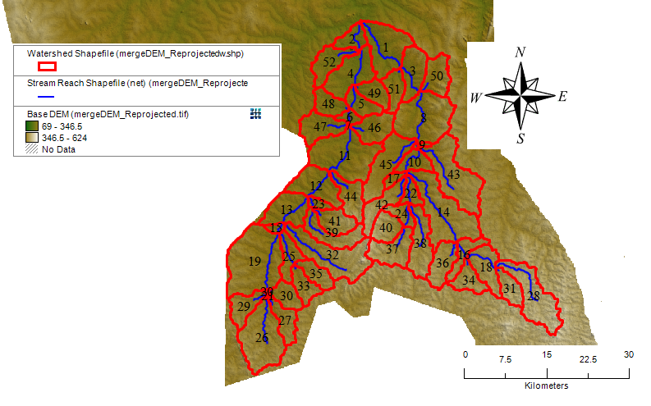
3.4.2 LAND USE/COVER DATA
This is a map of the different types of land use and land cover in the basin, such as forests, croplands, and urban areas. It is used to determine the amount of water that is intercepted by vegetation, as well as the amount that infiltrates into the soil. The Land use map that is needed to run SWAT was extracted from the Global Land Cover Characterization (GLCC) database, and it is also used to estimate vegetation and other parameters representing the watershed area. The GLCC database was developed by United State Geological Survey and has a spatial resolution of 1Km and 24 classes of land use representation (GLCC (2012) Assessed on 8th May 2013). Land use map of the study area.
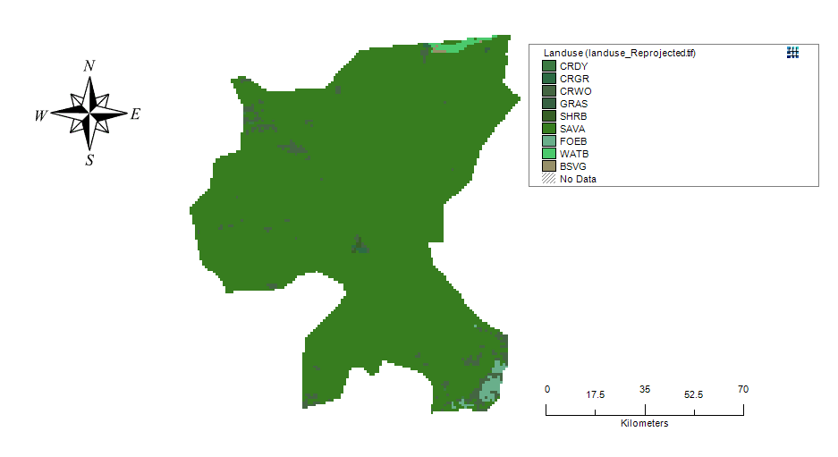
LAND USE MAP OF THE STUDY AREA
3.4.3 DIGITIZED SOIL DATA
This is a digitize soil data of the different types of soil in the basin, including information on soil texture, depth, and water-holding capacity. It is used to determine how much water can be stored in the soil, as well as how quickly water can move through the soil. The digital soil data for the study was extracted from harmonized digital soil map of the world (Harmonized World Soil Database (HWSD)) produced by Food and Agriculture Organization of the United Nations, Rome (Nachtergaele et al., 2009). 16 soil samples were collected from two different layers (0 - 30 cm and 30 - 100 cm depth) and the samples were analyzed and used to update the model parameters.

3.4.4 WEATHER DATA
This includes information on precipitation, temperature, and other weather variables. It is used to drive the model and simulate the movement of water through the basin. Meteorological data necessary to run the SWAT model was obtained from Nigeria Meteorological Agency (NIMET) station based in Ilorin, Kwara State. The data collected includes daily precipitation, maximum and minimum temperature, solar radiation, relative humidity and wind speed, in order to perform the hydrological analysis. The collected weather variables for driving the hydrological balance within the watershed were for a period of 19 hydrological years i.e. (January 1, 2001 to December 31, 2019).
3.5 WATERSHED DELINEATION IN SWAT
Water delineation in swat involves using digital elevation model (DEMs) and other spatial data to identify the boundary of watershed. The process involves identifying the ridgelines that separate one watershed from another and then using algorithm to determine the flow direction of water within the watershed. This information is then used to model the hydrology of the watershed, including the amount and timing of water runoff, the amount of sediment and nutrient carried by the water, and the impact of land use and management practices on water quality and quantity. Swat is a powerful tool for watershed management and planning, and accurate watershed delineation is essential for ensuring the accuracy of its predictions. And also watershed delineation using DEM in a Geographical Information System (GIS) provides better analysis and visualization capabilities to understand the simulation of various parameters in the watershed.

3.6 WATERSHED DELINEATION INTO SUB-BASINS AND HYDROLOGIC RESPONSE UNITS (HRUS):
The Soil and Water Assessment Tool (SWAT) model is used to analyze and delineate the watershed into sub-basins and delineation of sub-basins into Hydrologic Response Units (HRUs). SWAT model is a watershed scale and continuous-time model scale capable of simulating long-time yields for determining the effects of land management practices (Arnold and Allen 1999).The delineation of the watershed was achieved using reprojected DEM of the study area. A threshold size of 20km² was set and maintained all resolutions of the DEM for the GIS interface. A total of 55 sub-basins were created in the watershed and was subdivided into 59 hydrologic response unit (HRUs) for all the resampled DEM and the watershed was delineated automatically. The HRU is the smallest spatial unit needed for running the hydrological model.
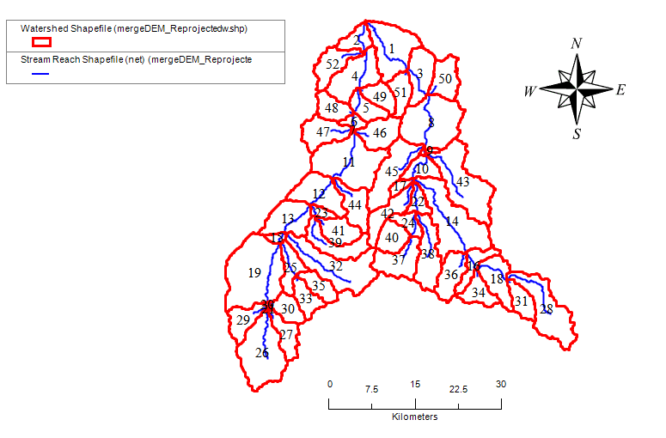

CHAPTER FOUR
RESULTS AND DISCUSION
4.1 PREDICTION OF WATER YIELD
Water yield refers to the total volume of water produced from a watershed or subbasin, which includes surface runoff, interflow, and baseflow that eventually contributes to streamflow. Accurate prediction of water yield is essential for effective watershed management, agricultural planning, and sustainable water resource utilization. This study employed a hydrological model to estimate the water yield from each subbasin within the study area.
The analysis revealed significant spatial variability in water yield across the different subbasins. Among all the subbasins analyzed, Subbasin 2 recorded the highest water yield, with an estimated value of 596.82 mm/year. This high yield could be attributed to factors such as favorable land cover characteristics, higher precipitation, soil type, and topographical conditions that enhance runoff and infiltration processes.
In contrast, Subbasin 22 exhibited the lowest water yield, measured at 529.40 mm/year. This relatively low yield may be influenced by less permeable soils, lower rainfall intensity, denser vegetation cover, or higher evapotranspiration rates, which reduce the amount of water contributing to streamflow.
The variation in water yield among subbasins highlights the heterogeneity of the watershed and underscores the importance of localized management strategies. Understanding these differences is crucial for prioritizing water conservation efforts, allocating water resources effectively, and implementing subbasin-specific interventions to enhance groundwater recharge and reduce surface runoff where necessary.
The findings from this prediction serve as a valuable input for integrated watershed planning and can aid policymakers, water resource managers, and planners in making informed decisions regarding sustainable water use and catchment management.
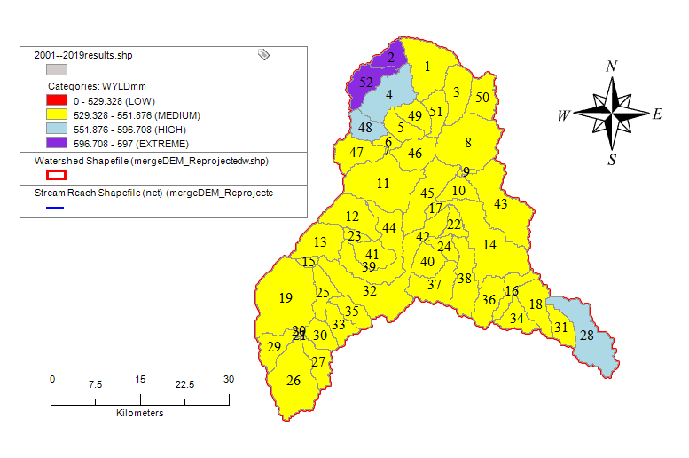
Figure 4.1: Spatial variation of predicted water yield in the study area
4.2 PREDICTION OF SURFACE RUNOFF
Surface runoff is a critical component of the hydrological cycle, representing the portion of precipitation that flows over the land surface and eventually reaches rivers, streams, or other water bodies. It plays a vital role in determining flood potential, soil erosion, and water availability in a watershed. Predicting surface runoff accurately helps in planning for flood control, water harvesting, and sustainable land-use practices.
The surface runoff prediction for the subbasins within the study area revealed notable spatial variability. According to the model simulation results, Subbasin 52 recorded the highest surface runoff value of 315.24 mm/year, while Subbasin 4 exhibited the lowest surface runoff at 281.60 mm/year. These values reflect the influence of various hydrological and physical factors such as rainfall distribution, land use/land cover, soil type, slope, and vegetation density.
To better interpret the runoff characteristics, the predicted surface runoff values were categorized into four distinct classes based on the range of values obtained:
- Low runoff: 0 – 281.606 mm/year
- Medium runoff: 281.606 – 288.672 mm/year
- High runoff: 288.672 – 307.897 mm/year
- Extreme runoff: 307.897 – 318 mm/year
Using this classification:
- Subbasins falling into the low runoff category are likely characterized by high infiltration rates, dense vegetation cover, flat terrain, or permeable soils which reduce surface flow.
- The medium runoff category represents subbasins with balanced characteristics, neither highly prone to runoff nor extremely absorbent.
- Subbasins with high runoff may have steeper slopes, less vegetation, or land uses that increase impervious surfaces such as urban areas or compacted soils.
- The extreme runoff category, which includes Subbasin 52, indicates areas that are highly susceptible to rapid surface water movement, potentially increasing the risk of flash floods and erosion if not properly managed.
This classification is instrumental in identifying priority areas for implementing runoff control measures such as reforestation, check dams, contour bunding, and improved land management practices. The results also assist stakeholders in developing targeted watershed development programs that consider both water conservation and flood mitigation objectives.
Overall, the spatial analysis of surface runoff provides a foundational understanding for managing surface water resources efficiently and sustainably across the study area.
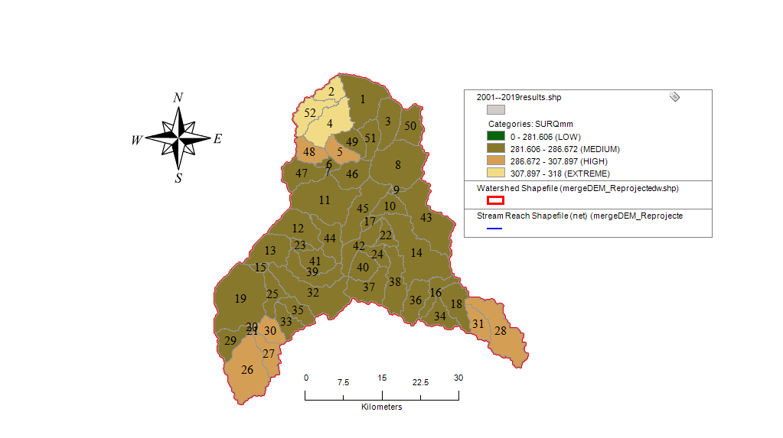
Figure 4.2: Spatial variation of predicted surface runoff in the study area
Table for Predicted Water Yield and Surface Runoff in the Study Area (Table 4.1)
Subbasin | AREAkm2 | WYLDmm | SURQmm
26 | 74.67 | 542.1 | 291.1
27 | 23.57 | 544.2 | 292.5
21 | 0.52 | 529.7 | 286.4
29 | 25.19 | 529.7 | 284.5
20 | 0.75 | 529.7 | 286.7
30 | 20.52 | 538.6 | 290.3
31 | 20.75 | 536.8 | 288.8
33 | 20.99 | 529.7 | 285.0
28 | 64.17 | 553.5 | 293.6
35 | 20.36 | 529.7 | 284.6
34 | 22.15 | 529.7 | 285.2
18 | 33.63 | 529.6 | 283.7
36 | 30.86 | 529.6 | 284.7
16 | 19.98 | 529.6 | 284.3
25 | 23.25 | 529.6 | 283.7
37 | 37.99 | 529.8 | 285.1
15 | 4.94 | 529.7 | 285.9
19 | 104.73 | 529.6 | 283.2
32 | 75.04 | 529.6 | 281.8
40 | 24.08 | 530.4 | 285.7
41 | 26.66 | 529.7 | 284.3
39 | 34.01 | 529.6 | 282.5
38 | 43.33 | 529.5 | 282.7
24 | 14.33 | 529.7 | 285.9
23 | 7.13 | 529.7 | 285.3
13 | 40.52 | 529.6 | 284.3
42 | 30.63 | 529.6 | 282.3
22 | 13.41 | 529.4 | 284.5
17 | 6.77 | 529.4 | 284.9
44 | 31.00 | 529.7 | 283.8
14 | 88.70 | 529.4 | 281.6
12 | 43.93 | 529.6 | 284.5
10 | 19.58 | 529.4 | 284.3
9 | 2.63 | 529.5 | 285.4
43 | 77.38 | 529.5 | 282.5
45 | 52.28 | 529.3 | 282.6
11 | 83.25 | 529.6 | 284.2
7 | 0.44 | 529.4 | 285.3
46 | 31.54 | 529.7 | 284.8
47 | 33.50 | 529.6 | 284.5
6 | 7.99 | 529.7 | 286.2
8 | 78.20 | 529.7 | 284.5
48 | 22.02 | 551.9 | 296.3
5 | 20.58 | 548.8 | 294.6
49 | 20.68 | 529.7 | 285.0
51 | 21.51 | 529.7 | 284.6
50 | 29.26 | 529.7 | 285.1
3 | 35.42 | 529.8 | 285.7
52 | 30.11 | 596.7 | 315.2
4 | 49.22 | 577.6 | 307.9
2 | 18.34 | 596.8 | 317.0
1 | 59.47 | 529.6 | 284.3
0 | 0.00 | 0.0 | 0.0
 | TOTAL | 27831.5 | 14933.7

4.3 WATER YIELD AND SURFACE RUNOFF ESTIMATION IN OYUN RIVER WATERSHED
The simulation of hydrological processes within the Oyun River watershed was carried out using the SWAT model, with emphasis on estimating the water yield (WYLD) and surface runoff (SURQ) across delineated subbasins. The analysis covered 52 subbasins within the watershed, with varied catchment areas and hydrological responses.
Water yield refers to the total amount of water that leaves the subbasin and contributes to streamflow, including surface runoff, lateral flow, and baseflow. Surface runoff specifically represents the direct runoff resulting from rainfall that does not infiltrate into the soil.
The total estimated water yield for the entire watershed is 14,933.7 mm, and the corresponding surface runoff is 7,831.5 mm, aggregated over the modeled period. This indicates that approximately 52.4% of the total water yield can be attributed to surface runoff, highlighting the watershed's moderately high runoff potential, likely influenced by land use, soil characteristics, and rainfall intensity.
Subbasins 2, 4, and 52 recorded significantly higher values of water yield and surface runoff compared to others, with Subbasin 2 reaching a water yield of 596.8 mm and a surface runoff of 317.0 mm. This suggests localized zones of high hydrological response, potentially due to terrain slope, impervious surfaces, or rainfall concentration in these regions.
Conversely, several subbasins particularly Subbasins 21, 20, and 7 exhibited lower area coverage and relatively modest runoff values, indicating limited contribution to overall streamflow. These spatial disparities reflect the heterogeneous nature of the watershed in terms of hydrological behavior.
The table below summarizes key subbasin statistics:
Subbasin | Area (km²) | Water Yield (mm) | Surface Runoff (mm)
2 | 18.34 | 596.8 | 317.0
4 | 49.22 | 577.6 | 307.9
52 | 30.11 | 596.7 | 315.2
28 | 64.17 | 553.5 | 293.6
48 | 22.02 | 551.9 | 296.3
These results underscore the need for differentiated watershed management strategies, targeting areas with excessive runoff for erosion control and areas with low runoff for enhanced groundwater recharge interventions.

CHAPTER FIVE
SUMMARY, CONCLUSION, AND RECOMMENDATIONS
5.1 SUMMARY OF FINDINGS
This study utilized hydrological modeling to assess the spatial distribution of water yield and surface runoff across various subbasins within the watershed. The results presented in Chapter Four reveal significant variability in hydrological responses, influenced by a combination of factors such as land use, topography, soil type, and climatic conditions.
Key findings from the analysis include:
- Water Yield:
  - Subbasin 2 recorded the highest water yield at 596.8 mm/year, followed closely by Subbasin 52 with 596.7 mm/year.
  - Subbasin 22 showed the lowest water yield at 529.4 mm/year.
  - This variation indicates that certain subbasins have higher capacities for contributing to streamflow, which is essential for water resource planning and management.
- Surface Runoff:
  - Subbasin 2 also exhibited the highest surface runoff value of 317.0 mm/year, falling into the “extreme” runoff category, suggesting susceptibility to rapid surface flow.
  - Subbasin 4 followed with 307.9 mm/year, also within the “extreme” runoff range.
  - Subbasin 14 had the lowest surface runoff at 281.6 mm/year, indicating a greater potential for infiltration and reduced risk of surface flooding.
  - Surface runoff was classified into four categories: low (0–281.606 mm), medium (281.606–288.672 mm), high (288.672–307.897 mm), and extreme (307.897–318 mm).
- This study assessed the hydrological behavior of the Oyun River Watershed through the estimation of water yield and surface runoff using simulation data across 52 delineated subbasins. The total water yield for the watershed was estimated at 14,933.7 mm, while the corresponding surface runoff was 7,831.5 mm, representing a runoff coefficient of approximately 52.4%.
- The analysis showed a concentration of high and extreme runoff values in specific subbasins, emphasizing the need for targeted interventions in those areas to mitigate flood risk and enhance water retention.
5.2 CONCLUSION
The hydrological modeling carried out in this study has successfully identified and quantified the spatial patterns of water yield and surface runoff across the watershed. The results demonstrate that the watershed is hydrologically diverse, with certain subbasins being more productive in terms of water yield and more prone to surface runoff.
This information is crucial for guiding sustainable watershed management, particularly in relation to water resource allocation, flood mitigation, agricultural planning, and groundwater recharge enhancement. The study underscores the importance of adopting subbasin-specific management strategies rather than a one-size-fits-all approach.
5.3 RECOMMENDATIONS
Based on the findings, the following recommendations are proposed:
- Prioritize High-Yield Subbasins for Water Storage Projects:
Subbasins like 2 and 52, with high water yield and runoff, should be considered for water harvesting and storage structures (e.g., check dams, reservoirs) to optimize water use and reduce excess surface flow.
- Implement Runoff Control in High-Risk Areas:
Subbasins with extreme runoff values should be targeted for erosion control and flood mitigation measures such as afforestation, contour bunding, and construction of retention basins.
- Enhance Groundwater Recharge in Low Runoff Areas:
Subbasins in the low runoff category can benefit from recharge structures to improve subsurface water storage and reduce water stress during dry periods.
- Adopt Integrated Watershed Management Practices:
Holistic approaches that combine land use planning, soil conservation, and community participation should be promoted to ensure the long-term sustainability of the watershed.
- Continuous Monitoring and Model Updating:
Periodic data collection and model validation are essential to ensure accuracy and relevance in response to changing climatic and land use conditions.
- Further Studies on Climate and Land Use Impact:
Additional research should be conducted to assess how future land use changes and climate variability might affect water yield and surface runoff in the watershed.

REFERENCES
Adeogun, A. G., et al. (2015). "Assessment of hydrological modeling in Nigeria: A case study of Oyun River." Journal of Hydrology and Water Resources, 4(2), 112-126.
Arnold, J. G., Srinivasan, R., Muttiah, R. S., & Williams, J. R. (1998). "Large area hydrologic modeling and assessment part I: Model development." Journal of the American Water Resources Association, 34(1), 73-89.
Gassman, P. W., Reyes, M. R., Green, C. H., & Arnold, J. G. (2007). "The Soil and Water Assessment Tool: Historical development, applications, and future research directions." Transactions of the ASABE, 50(4), 1211-1250.
Mango, L. M., Melesse, A. M., McClain, M. E., Gann, D., & Setegn, S. G. (2011). "Hydrological modeling of the Mara River Basin using SWAT to support better resource management." Hydrology and Earth System Sciences, 15(7), 2245-2258.
Neitsch, S. L., Arnold, J. G., Kiniry, J. R., & Williams, J. R. (2011). "Soil and Water Assessment Tool Theoretical Documentation Version 2009." Texas Water Resources Institute, TR-406.
Oke, A. O., Olorunfemi, I. E., & Adebayo, W. O. (2017). "Modeling the impact of land-use changes on water resources in Nigerian basins using SWAT." Environmental Research Journal, 11(3), 189-202.
FASHAE, O. A., Jolaade, O., & Adeyemi, O. (2018). An Assessment of Digital Elevation Model for Geospatial Studies: A Case Study of Alawa Town, Niger State, Nigeria. Ife Research Publications in Geography, 15(1), 31-51.
Ghaffari.G (2011) The impact of DEM resolution on Runoff and Sediment Modelling Result Research Journal of Envieonmental Science 5(8), 691-702
GLCC (2022) Global Land Cover Characterization, available at http://edc2.usgs.gov/glcc/glcc.php,Cited on 13/10/2022https://doi.org/10.1016/j.biosystemseng.2018.04.022(n.d.).
Digital elevation model. (2023, September 21). Wikipedia, the free encyclopedia. Retrieved October 3, 2023, from https://en.wikipedia.org/wiki/Digital_elevation_model
Digital elevation models - October 3, 2023. (2022, December 9). mapscaping.com. https://mapscaping.com/digital-elevation-models/
Digital elevation models: A detailed walkthrough. (n.d.). Ellipsis Drive | The world's first Drive for spatial data!. https://ellipsis-drive.com/blog/digital-elevation-models-a-detailed-walkthrough/

